1. Overview
ATOS
The Access to Opportunities and Services (ATOS) score is a quantitative measure indicating how easily residents can access essential key services and employment locations, without using a private vehicle (primarily using public transport and/or by walking). ATOS scores typically range from A (best accessibility) to E (worst accessibility). This methodology is adapted from the approach used by Transport for London (TfL), (see Section 3.6 of Assessing Transport Connectivity in London) which employs similar metrics to evaluate connectivity to a broad array of local facilities and employment opportunities across the city. Unlike measures that assess general proximity to public transport infrastructure (such as Public Transport Access Levels - PTAL), ATOS specifically evaluates accessibility to a defined "basket" of common destinations.

Adaptation for Victoria
The ATOS framework has been adapted for Victoria as a standardised tool to evaluate urban accessibility. It serves to identify locations across Victoria that are well-serviced by, and provide good access to jobs, shops, and essential community facilities and services. The deliberate focus on accessibility via walking and public transport addresses the challenges of sustainable urban growth; for higher-density housing development to be well-integrated, it must provide residents with viable alternatives to car travel, thereby mitigating road congestion.
The Victorian Government's long-term strategic plan, Plan for Victoria, emphasises creating a more liveable, equitable, and sustainable state. Key tenets often include managing population growth effectively, increasing housing supply in well-located areas with good access to jobs and services, and fostering the development of neighbourhoods where residents can meet most of their daily needs locally via walking, cycling, or public transport.
In particular, ATOS can directly support these strategic objectives by providing an evidence base to:
- Inform land-use planning and development decisions: By identifying areas with high existing accessibility, ATOS can help target locations for increased housing density and mixed-use development. This is outlined in Planning Practice Note 90: Planning for Housing.
- Guide transport infrastructure investment: Areas with lower ATOS scores, particularly those earmarked for growth, can be identified as priorities for transport network improvements or service enhancements.
- Introduce minimum standards for open space provision: ATOS can highlight disparities in accessibility of open spaces across different parts of Victoria, providing guidance for improving local open space provision for growing communities in established areas.
- Monitor progress: Over time, repeated ATOS assessments can track how changes in transport networks and land use affect accessibility, helping to measure the effectiveness of planning policies.

2. Tool Used to Calculate ATOS: r5r
The core of the ATOS methodology relies on estimating travel times between origins and destinations. This is performed using the r5r package in the R statistical computing environment. r5r acts as an interface to R5 (Rapid Realistic Routing on Real-world and Reimagined networks engine), a powerful, open-source multimodal transport network routing engine developed in Java by Conveyal.
Travel Time Calculation with r5r for ATOS
For the ATOS project, r5r's primary role is to generate detailed travel time matrices. These matrices provide the journey duration from many origin points to many destination points (locations of services and opportunities). This is achieved through the following processes:
- Network Construction:
  - Integrated Network Data: r5r first builds a comprehensive multimodal transport network graph. This requires:
    - Street and Pathway Network: Derived from an OpenStreetMap (OSM) data extract for Victoria (in .osm.pbf format). This provides the pathways for walking and cycling.
    - Public Transport Network: Derived from General Transit Feed Specification (GTFS) data for Victorian public transport services (trains, trams, buses). This includes routes, stop locations, and detailed operational schedules or service frequencies.
    - Elevation Data: A Digital Elevation Model (DEM) for the Victoria is incorporated. This allows r5r to account for the impact of slopes on walking and cycling speeds, making these estimates more realistic. The "TOBLER" hiking function is used to adjust speeds based on gradient.
- Calculating Travel Time Matrices:
  - Defining Origins and Destinations:
    - Origins: These are the centroids of the 100m x 100m grid cells covering the study area. The use of 100m grid cells gives sufficient resolution, and at the same time minimises the complexity and computational time for ATOS.
    - Destinations: These are the point locations of the various services and opportunities being assessed (e.g., schools, jobs, medical centres).
  - Snapping Points to the Network:
    - Origin and destination points (e.g., grid centroids or geocoded service locations) often do not lie precisely on a network link (a road, path, or transit route). Before routing, r5r "snaps" these points to the nearest accessible segment of the transport network.
    - r5r searches for the nearest network link within a predefined radius (the default search radius in R5 is typically around 1.6 km, though this can be influenced by internal parameters or specific function defaults). The find_snap() function in r5r can be used to investigate this process.
    - The walking (or cycling/driving if applicable) time from the original point's location to this "snapped" point on the network is calculated and forms the very first (access) or very last (egress) part of the total journey time.
  - Routing Algorithm:
    - r5r employs an advanced routing algorithm, which is an extension of RAPTOR (Round-Based Public Transit Optimized Router).
    - In simple terms, RAPTOR works iteratively. In each round, it explores journeys with one additional public transport trip.
    - It efficiently finds paths that minimise travel time by considering scheduled departure and arrival times from GTFS data, transfer possibilities between routes and modes, and associated walking times.
  - Departure Time and Time Window: Calculations are performed for a specific departure_datetime (e.g., a weekday morning peak period) and over a defined time_window (e.g., 60 minutes).
  - Modelling Travel Components:
    - Walking: Walking times are calculated based on the street/pathway network, considering distance and the configured walking speed (e.g., 3.6 km/h), adjusted for elevation where applicable. This includes:
      - Walk access from the original origin point to the snapped network location, then to the first public transport stop.
      - Walk egress from the last public transport stop to the snapped network location, then to the final destination point.
      - Walk transfers between public transport services.
      - Entire trips made only by walking (if this is the fastest option within constraints).
    - Public Transport: r5r considers:
      - Scheduled Services: For services with fixed timetables defined in GTFS stop_times.txt, r5r uses these exact schedules. It searches for the optimal trip departing within the specified time_window around the departure_datetime.
      - Frequency-Based Services: If a GTFS feed includes frequencies.txt (defining services by headway, e.g., "a bus every 10 minutes" rather than specific scheduled times), r5r performs Monte Carlo simulations. It samples multiple random departure minutes within each minute of the specified time_window (the number of draws_per_minute is configurable). This process helps estimate realistic travel times, including average waiting times. For the ATOS project, where detailed schedules are typically available in the GTFS, the routing primarily relies on these schedules. The Monte Carlo aspect related to service frequencies is less critical if services are fully scheduled. However, r5r still effectively samples different departure minutes across the overall time_window to find the best journey combination even with scheduled services.
      - Waiting Times: Derived from the difference between arrival at a stop and the next available service departure, considering the departure_datetime and time_window.
      - In-Vehicle Times: Based on the operational characteristics of the public transport services as defined in GTFS.
      - Transfers: Time taken for transfers between services is incorporated.
  - Constraints: Parameters such as max_walk_time (e.g., 60 minutes to access/egress PT or for a whole walk trip) and max_trip_duration (e.g., 120 minutes for the total journey) are applied. Trips exceeding these limits are typically considered inaccessible or assigned a very high travel time.
  - Output: The function returns a table
  - listing the travel time from each specified origin to each specified destination for the chosen mode(s) and percentile.
- Limitations:
  - Data Accuracy: Results are highly dependent on the quality and currency of the input OSM, GTFS, and destination datasets.
  - Computational Demand: Large-scale calculations require significant computational resources (memory and time).
  - Static Inputs: Assumes the network and schedules are fixed for the chosen departure window. Real-time variations (e.g., traffic incidents, service disruptions) are not dynamically modelled.

3. Workflow
The ATOS calculation process is a multi-stage workflow, largely automated through data processing and analysis scripts.

- Prepare Origin and Destination Datasets:
  - Origins:
    - A consistent grid of 100m x 100m cells is generated across the study area (e.g., Greater Melbourne, major regional cities , regional cities, regional service centres, regional and regional – other.
  - Destinations (Opportunities/Services):
    - Datasets representing diverse opportunities are collected (e.g., education facilities, employment locations, healthcare services, grocery stores, open spaces).
    - These raw datasets undergo significant pre-processing: cleaning, filtering to relevant types/locations, geocoding to assign geographic coordinates if necessary, and standardisation into a point-based spatial format.
    - All origin and destination datasets are projected to the WGS84 coordinate system (EPSG:4326) for compatibility with r5r.
- Calculate Travel Time Matrices (using r5r):
  - For each type of opportunity, travel times are computed from every origin grid cell centroid to all relevant destination points.
  - Calculations are performed for specific modes of transport – typically "WALK" only, and combined "WALK, TRANSIT".
  - A consistent departure date and time (e.g., weekday morning peak at 07:00) is used for all public transport calculations.
- Consolidate Travel Times:
  - The detailed travel time matrices (origin-to-every-destination) are summarised to create meaningful accessibility measures for each origin grid cell. This involves:
    - Nearest N Services: For services like schools or GPs, the travel time to the 1st, 2nd, and 3rd nearest facility is identified.
    - Cumulative Opportunities: For opportunities like employment or open space area, the travel time to reach a certain cumulative threshold (e.g., 10,000 jobs, 1 hectare of open space) is calculated.
- Calculate ATOS Score for Each Origin Grid Cell:
  - Each consolidated travel time metric is first categorised into an accessibility grade (A to E) based on its statistical distribution relative to all other grid cells
  - These individual measure grades are then combined into "Priority 1" and "Priority 2" composite grades.
  - Finally, an overall ATOS score (e.g., A1, A2, B, C, D, E) is assigned to each grid cell using a lookup matrix based on its Priority 1 and Priority 2 grades.

4. Settings for r5r
The travel time calculations underpinning ATOS rely on specific configurations within the r5r environment. These settings ensure consistency and define the assumptions for the analysis.
Parameter | Current Setting Used | Description
Network Data Source | Project-specific directory | Contains OpenStreetMap (.osm.pbf), GTFS (.zip files), and elevation (.tif) data for Victoria
Departure Date & Time | 19-03-2024 07:00:00 | The specific anchor point for public transport schedule lookups, typically representing a weekday morning peak.
Analysis Time Window | 60 minutes | Duration from the departure time within which r5r considers transit services. For Monte Carlo, departures are sampled across this window.
Travel Time Percentile | 50 (median) | For frequency-based transit, this percentile of the simulated travel times is returned. For scheduled services, it represents the median of optimal trips in the window.
Monte Carlo Draws | 1 | Number of random departure minutes sampled within each minute of the time window for services defined by headways (frequencies.txt in GTFS). Not critical if all services are fully scheduled.
Maximum Walk Time | 60 minutes | Maximum time assumed for walking to/from public transport, or for an entire walk-only trip.
Maximum Trip Duration | 120 minutes | Overall maximum duration for any calculated trip.
Elevation Model | "TOBLER" | Method to account for elevation's impact on walking/cycling speeds.
Java Memory Allocation | e.g., "-Xmx20G" | Sets aside system memory for the Java Virtual Machine that r5r runs on.
Transport Modes Used | Primarily "WALK" and "WALK, TRANSIT" | Defines the modes of travel allowed for journey calculation.

5. Assigning Scores
The ATOS scoring system translates complex travel time data into a more easily interpretable set of accessibility grades for each 100m origin grid cell. The methodology builds upon the foundational principles of the Transport for London (TfL) ATOS, where individual accessibility measures are graded based on their statistical distribution. The subsequent steps of grouping measures into priority categories and forming a composite score have been developed specifically by Department of Transport and Planning (DTP).
1. Individual Accessibility Measure Grades:
For each type of opportunity or service, specific accessibility metrics are calculated based on the consolidated travel times. These metrics are then graded from A to E. 'A' represents the highest accessibility (lowest travel times or easiest access), and 'E' the lowest. The grading is based on comparing an origin's travel time to a service against the average travel time for all origins to that same service, using standard deviations to define the boundaries, similar to the TfL ATOS approach.
Grade | Travel Time Range (minutes)
A | 0 up to the larger of 5 minutes or 1 standard deviation below the average
B | Greater than the A grade threshold up to the average
C | Average to 1 standard deviation above average
D | 1 to 2 standard deviations above average
E | More than 2 standard deviations above average

The origins with longer travel time than ‘Maximum Trip Duration’ specified during r5r configuration, will be assigned an E and are not included in the calculation of average and standard deviations.

The grade boundaries for each measure are relative to the specific dataset being analysed and are not fixed. For example, the distribution of travel times to the nearest primary schools is very different from that to the nearest tertiary institutions. Consequently, the travel time in minutes that constitutes an 'A' grade for primary schools will be different from the 'A' grade threshold for universities.

The opportunity types and the specific measures used for grading in ATOS are detailed below.
Table: ATOS Accessibility Measures (metropolitan Melbourne, Ballarat, Bendigo and Geelong)
Category | Sub-Category | Specific Measure | Mode
Education | Primary Schools | Travel time to the 3rd nearest Government Primary School | Walk and/or PT
Education | Secondary Schools | Travel time to the 3rd nearest Government Secondary School | Walk and/or PT
Education | Tertiary Education | Travel time to the 3rd nearest Tertiary Education Institution | Walk and/or PT
Education | Childcare | Travel time to the 3rd nearest Childcare Centre | Walk and/or PT
Employment | Blue Collar Jobs | Travel time to the 10,000th nearest Blue Collar jobs | Walk and/or PT
Employment | White Collar Jobs | Travel time to the 10,000th nearest White Collar jobs | Walk and/or PT
Medical | General Practitioner | Travel time to the 3rd nearest General Practitioner (GP) | Walk and/or PT
Groceries | Food Shopping | Travel time to the nearest Grocery Store or Supermarket | Walk and/or PT
Open Space | Open Space | Travel time to reach a cumulative 1 hectare (10,000 m²) of accessible Open Space | Walk only

2. Composite Priority Group Grades:
The individually graded measures are grouped into two categories: "Priority 1" and "Priority 2".
The separation reflects a strategic view of what constitutes fundamental versus daily accessibility.
- Priority 1 groups together schools and employment measures, which are often primary drivers for long-term household decisions.
- Priority 2 groups together measures that represent regular and essential daily needs. While critical for convenience and well-being, these services are often considered secondary to the foundational factors in Priority 1, when assessing strategic accessibility for growth.

Table: Grouping of Measures into Priority Categories (metro only)
Priority Category | Measures Included
Priority 1 | • 3rd nearest Primary School  • 3rd nearest Secondary School  • 10,000th Blue Collar Job  • 10,000th White Collar Job
Priority 2 | • 3rd nearest GP  • nearest Grocery  • 3rd nearest Childcare Centre  • 3rd nearest Tertiary Institution  • nearest 1ha Open Space

For each priority group, the composite grade is determined by the single worst-performing measure within it. This "weakest link" approach ensures that a location cannot be considered highly accessible if it has a critical service gap. For example, an area with excellent access to jobs but very poor access to schools will be penalised, reflecting the reality that both are essential.

3. Overall ATOS Score:
A final, overall ATOS score is assigned to each 100m origin grid cell. This score is determined by the combination of its Priority 1 and Priority 2 composite grades, using the following predefined lookup table:
Table: ATOS Score Lookup Matrix (Priority 1 (rows) and Priority 2 (columns))
 |  | Priority 2 (worst grade)
 |  | A | B | C | D | E
Priority 1 (worst grade) | A | A1 | A2 | B | C | D
Priority 1 (worst grade) | B | B | B | C | D | E
Priority 1 (worst grade) | C | C | C | C | D | E
Priority 1 (worst grade) | D | D | D | D | D | E
Priority 1 (worst grade) | E | E | E | E | E | E

The lookup matrix gives greater weight to the Priority 1 grade. An area cannot achieve a top-tier overall ATOS score (e.g., A1, A2) if its foundational accessibility (Priority 1) is poor, regardless of how well it performs on daily needs (Priority 2). This structure reinforces the importance of providing access to education and jobs as a prerequisite for creating well-serviced communities.
The A1/A2 distinction provides a finer-grained classification of top-tier locations. An A1 score signifies outstanding access to both foundational (Priority 1) and daily (Priority 2) services, while an A2 score indicates excellent foundational access but a minor gap in daily services.

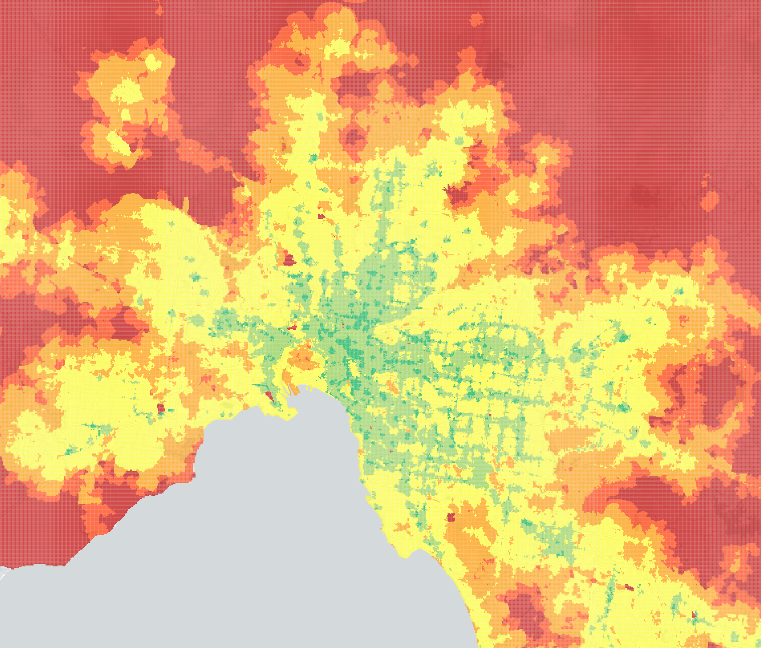
[Figure 1: map showing the distribution of ATOS Scores across a section of Melbourne's 100m grid cells]

5.1 Regional ATOS thresholds – ATOS is a stepped scale in the regions
The ATOS methodology applies consistent accessibility measures across Victoria, while recognising the significant differences in the scale and distribution of services and employment between metropolitan and regional areas. Metropolitan Melbourne and Major Regional City locations use the same thresholds, reflecting their larger populations and concentration of services and jobs.
Across the remainder of regional Victoria, thresholds are progressively adjusted to reflect the smaller scale and more dispersed nature of regional settlements. Without this adjustment, much of regional Victoria would inherently be assessed as having very poor accessibility, limiting the usefulness of ATOS in distinguishing relative levels of access between regional communities.

Table: ATOS Measurement Thresholds by LGA type
​ATOS Measurement Thresholds​
​Priority | Measures | Greater Melbourne​ | Major Regional City​ | Regional City​ | Regional Service Centre​ | Regional*​ | Regional - Other​
Priority 1 Measures​ | Primary School​ | 3​ | 3​ | 1​ | 1​ | 1​ | 1​
Priority 1 Measures​ | Secondary School​ | 3​ | 3​ | 1​ | 1​ | -​ | -​
Priority 1 Measures​ | White Collar Jobs​ | 10,000​ | 10,000​ | 5,000​ | 2,500​ | 500​ | 500​
Priority 1 Measures​ | Blue Collar Jobs​ | 10,000​ | 10,000​ | 2,500​ | 1,000​ | 500​ | 500​
Priority 2 Measures​ | Child Care / Kinder​ | 3​ | 3​ | 2​ | 2​ | 1​ | 1​
Priority 2 Measures​ | Tertiary Education​ | 3​ | 3​ | -​ | -​ | -​ | -​
Priority 2 Measures​ | General Practitioner​ | 3​ | 3​ | 1​ | 1​ | 1​ | 1​
Priority 2 Measures​ | Grocery​ | 1​ | 1​ | 1​ | 1​ | 1​ | 1​
Priority 2 Measures​ | Open Space​ | 1ha​ | 1ha​ | 1ha​ | 1ha​ | 1ha​ | 1ha​

Table: Grouping of ATOS application
Area | Measures Included
Greater Melbourne | All metropolitan LGAs. Mitchell Shire Council excluded.
Major Regional City | Locations categorised as a major regional city (as outlined in Plan for Victoria)
Regional City | Locations categorised as a Regional City (as outlined in Plan for Victoria)
Regional Service Centre | Locations categorised as a Regional Service Centre (as outlined in Plan for Victoria)
Regional | Settlements without a strategic designation outlined in Plan for Victoria (e.g. urban area that isn’t a major regional city, regional city or regional service centre)
Regional – Other | Areas excluded from HCAP housing capacity assessment due to incompatible zoning or other reasons.

The table sets out the measurement thresholds used in the Access to Opportunities and Services (ATOS) methodology. It defines the amount or number of different opportunities and services that need to be accessible from a location for each ATOS measure, with thresholds varying according to the type of place being assessed.
The measures are divided into two groups. Priority 1 measures represent core opportunities considered particularly important for accessibility: primary schools, secondary schools, white-collar jobs and blue-collar jobs. Priority 2 measures capture other important everyday services and opportunities: childcare/kindergarten, tertiary education, GPs, grocery stores and open space.
The columns recognise that the appropriate level of opportunity differs across Victoria's local government areas (LGAs). Greater Melbourne and Major Regional Cities locations use the highest—and largely the same—thresholds. For example, the employment measures assess access to 10,000 jobs, while access to three primary schools and three secondary schools is measured. This reflects the greater concentration and choice of opportunities expected in larger urban areas.
Thresholds are then stepped down across regional Victoria to reflect smaller populations, settlement sizes and the more dispersed distribution of services. For example, the white-collar jobs threshold reduces from 10,000 in Greater Melbourne and Major Regional Cities, to 5,000 in Regional Cities, 2,500 in Regional Service Centres and 500 in other regional areas. Some services, such as open space, retain a consistent threshold across all category types.
Importantly, the lower regional thresholds do not necessarily mean that a lower level of accessibility is considered desirable. Rather, they allow ATOS to provide a meaningful measure of relative accessibility within different contexts. Applying metropolitan thresholds uniformly across regional Victoria would result in large parts of regional Victoria being classified as having very poor accessibility simply because they do not have the population or service concentrations of metropolitan Melbourne.

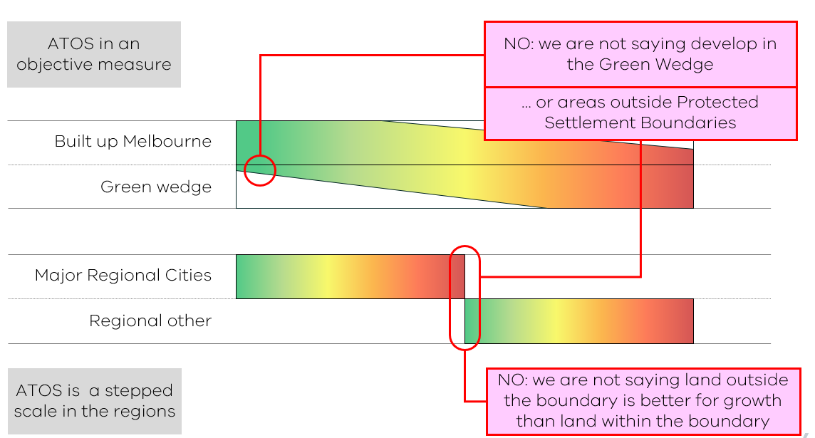
[Figure 2: ATOS stepped scale – like areas are compared with like areas]

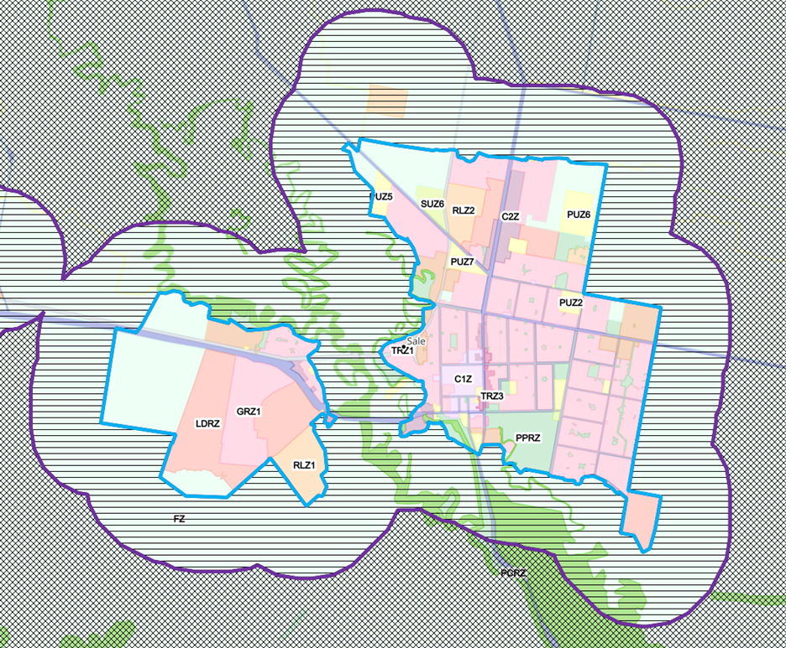
[Figure 3: Sale–Wurruk application of ATOS thresholds
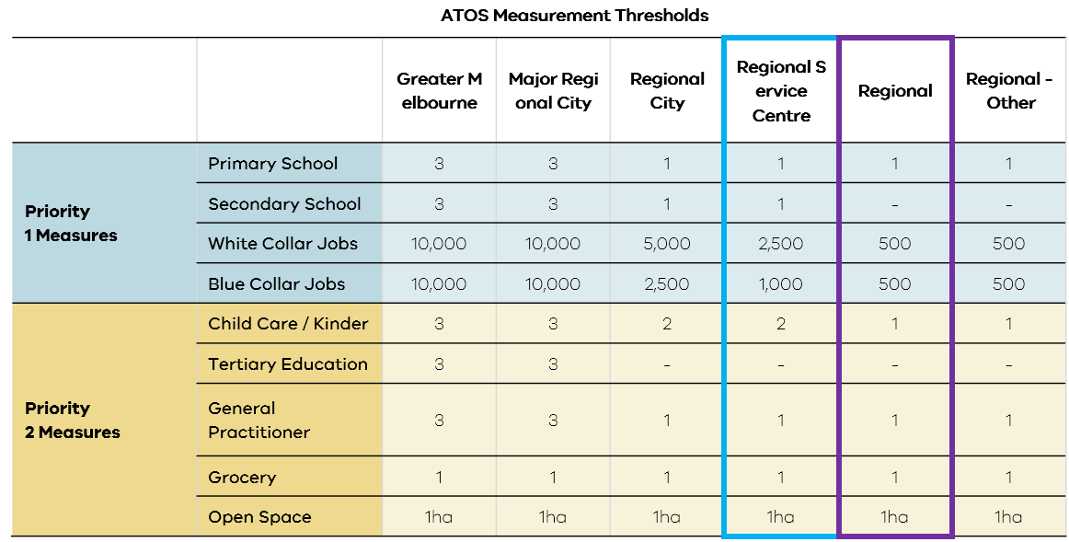

6. Datasets
The ATOS calculation relies on a variety of spatial and non-spatial datasets. All spatial data is standardised to the WGS84 (EPSG:4326) coordinate reference system for use with r5r.
6.1 Origin 100m x 100m Grids
- Data Foundation: Australian Bureau of Statistics (ABS) 2021 boundaries, including Significant Urban Areas (SUA), Urban Centres and Localities (UCL) for defining the Victorian regional centres, and Statistical Areas Level 2 (SA2) for delineating Greater Melbourne.
- Grid Generation Process:
  - A comprehensive 100m x 100m grid is initially created covering the landmass of Victoria, using a local projected coordinate system for gridding accuracy.

[Figure 4: 100m x 100m grid cells covering Melbourne near Port Phillip Bay]
  - The Greater Melbourne metropolitan boundary is established using the relevant SA2 polygons.
  - Only those grid cells from the master Victorian grid that fall within this Greater Melbourne boundary are selected for the Melbourne ATOS study. Major regional cities and other regional centres are placed in separate categories for regional analyses
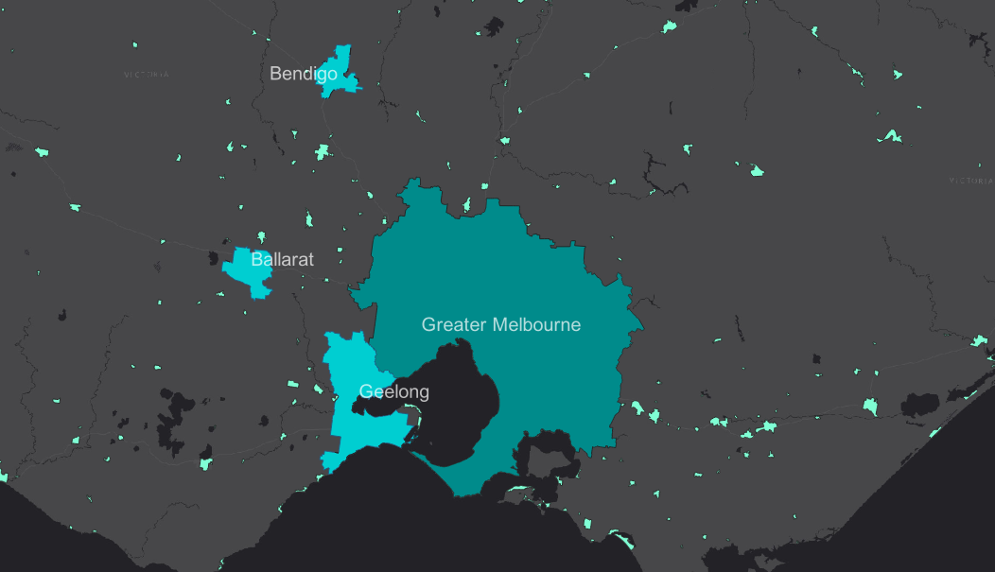
[Figure 5: Geographic boundaries of the three analysis groups—Greater Melbourne, Major Regional Cities, and Other Regional & Rural—derived from ABS definitions]
  - The centroids of these selected grid cells are used as the precise origin points for travel time calculations.
6.2 Network Data
- 6.2.1 GTFS (General Transit Feed Specification)
  - Source: Melbourne Metro Day 1. This is supplied in .zip format.
- 6.2.2 OSM (OpenStreetMap)
  - Source: A 15 June 2025 snapshot extract from OpenStreetMap covering the state of Victoria. This is supplied in the .osm.pbf format.
  - Usage: r5r uses this data to construct the detailed street, road, and pathway network necessary for modelling walking and other non-public transport travel legs.
- 6.2.3 Elevation Data
  - Source: The Vicmap Elevation Digital Elevation Model (DEM) at 10-metre resolution. This is provided as a GeoTIFF (.tif) file.
  - Usage: r5r incorporates this DEM to adjust walking and cycling travel times based on the steepness of slopes.
6.3 Education
- 6.3.1 Primary and Secondary Schools
  - Information Source: Find My School government school location data provided by the Department of Education Victoria (May 2025 snapshot).
  - Data Selection Criteria: the following filters are applied to the source data:
    - Sector: Only "Government" schools are included.
    - Status: Only "Operational" schools are included.
- Destination Groups: The filtered data is then classified into two destination groups based on its school type attribute:
    - Primary Schools: Includes records classified as 'Primary' or 'Pri/Sec'.
    - Secondary Schools: Includes records classified as 'Secondary' or 'Pri/Sec'.
- 6.3.2 Tertiary Education
  - Information Source: Vicmap Features of Interest (FOI) Index Centroids data.
  - Data Selection Criteria:
    - Records are selected where the FEATSUBTYP attribute is either 'university' or 'tertiary institution'.
    - A further filter is applied where child_exists is NULL. This step prevents a single campus from being represented by multiple access points.
- 6.3.3 Childcare Facilities
  - Information Source: Australian Children's Education & Care Quality Authority (ACECQA) National Quality Framework (NQF) Snapshot Q1 2025 (data as at 1 April 2025).
  - Data Selection Criteria:
- Services offering Long Day Care (in addition to any other service) are classified as Long Day Care.
- Services offering Preschool/Kindergarten (but not Long Day Care) are classified as Preschool/Kindergarten.
    - The analysis uses centre-based care services. Services classified as Family Day Care (FDC) or offering only Outside School Hours Care (OSHC) are excluded from the dataset.
6.4 Employment
- Information Source: Employment data is derived from the Small Area Land Use Projection (SALUP) future year 2026 – projections of population, households, jobs and enrolments at a spatial level (TZN) that align with the Victorian Integrated Transport Model (VITM) travel zones.
- Data Processing and Selection:
  - The SALUP data provides employment figures broken down into two broad categories: Blue Collar (BC) jobs and White Collar (WC) jobs.
  - These BC and WC job counts are then spatially joined to their respective TZN polygons.
  - The centroids of these TZN polygons are used as the point locations for employment opportunities, with each point attributed with its BC and WC job numbers.
6.5 Medical Facilities
- Information Source: Data for medical facilities is sourced from Healthmap. For the current ATOS iteration, General Practitioners (GPs) were selected as the sole measure. This is because GPs represent the primary and most frequent point of contact with the healthcare system for most of the population. Their widespread distribution makes them a good proxy for local healthcare accessibility.
6.6 Grocery Stores
- Information Source: The dataset of grocery stores and supermarkets is derived from the Foursquare Places dataset, using a data snapshot (May 9, 2025).
- Data Extraction and Processing Overview:
  - The process involves iterating through Foursquare Parquet files.
  - Records are filtered to include locations in Australia, Victoria, and are further refined based on Foursquare category labels for 'Retail > Food and Beverage Retail > Grocery Store' or 'Retail > Food and Beverage Retail > Supermarket'.
  - The dataset is enriched by identifying major supermarket chains (e.g., Woolworths, Coles, Aldi, IGA) based on store names and classifying supermarket types (e.g., standard format, express/metro variants).
- Limitations of the Dataset:
  - Source Accuracy: Relies on Foursquare's data, which can have errors, omissions, or outdated information.
6.7 Open Space
- Information Source: Vicmap Features of Interest (FOI) FOI_POLYGON dataset.
- Data Processing and Selection:
A multi-step process is used to identify and prepare suitable open spaces:
  - Initial Feature Selection (by FTYPE - Feature Type):
Features representing general public land, parks, and recreational areas are included.
    - reserve (e.g., parks, gardens)
    - sport facility
    - recreational resource
    - community space (e.g., public squares)
  - Specific Sub-Type Exclusions (by FEATSUBTYP - Feature Sub-Type):
From the initially selected features, numerous sub-types are excluded to ensure only genuinely free, public and accessible spaces remain.
Principle of Exclusion | FEATSUBTYP Categories Excluded (from the pre-filtered set)
Fee-Based or Restricted Access | zoo, caravan park, group camp, amusement centre, showground
Club or Membership-Based Sports | golf course, golf driving range, tennis court, bowling green, croquet green, sports complex, training track, athletic field, velodrome, equestrian facility
Specific-Use Public Land | cemetery (This sub-type can fall under the reserve FTYPE).
Ancillary or Non-Recreational Use | parking area (This is a supporting land use, not a recreational space itself.)
  - Geometric Processing for a Clean Layer:
    - Erase: If an excluded feature (e.g., a private club) is located inside an included public park, the excluded area is geometrically "cut out" from the park. This ensures only the truly accessible portion of the park remains.
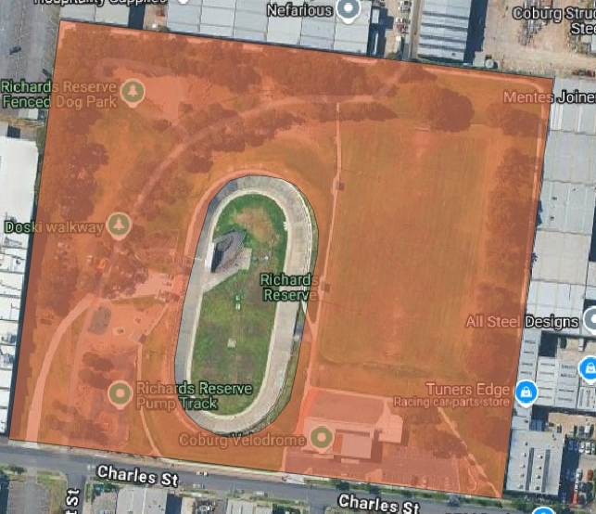
[Figure 6: map showing Coburg Velodrome being removed from Richards Reserve]
    - Dissolve: All valid, filtered open space polygons are then merged. This removes artificial boundaries between adjacent public spaces and resolves any overlaps.
  - "Access Point" Generation for Cumulative Area Analysis:
    - The filtered open space polygons are spatially intersected with the 100m origin grid cells.
    - For each segment where an open space polygon overlaps a grid cell, the area of this specific overlap is calculated.
    - A representative point (centroid) is then generated for each of these individual intersection polygons.
    - These points, each attributed with an area, serve as the "destinations" for open space accessibility. This method allows the ATOS calculation (specifically the cumulative opportunity for open space) to sum the area of open space reachable within certain travel times, rather than counting the number of open spaces.

