Victoria State Government Environment, Land, Water and Planning Logo

Planning for Melbourne’s Green Wedges and Agricultural Land

Consultation Paper

Department of Environment, Land, Water and Planning

May 2020

Contents

Aboriginal Acknowledgement 5

Message from the Minister 6

Abbreviations 8

Executive summary 9

Key options for planning reform 10

Next steps 10

1. Purpose 11

1.1 Melbourne’s green wedges and agricultural land 11

1.2 Why is this review needed? 13

1.3 Background to the consultation 14

1.4 Vision and guiding principles 15

2. Policies on Melbourne’s green wedges and agricultural land 16

2.1 Past policy settings 16

2.2 Current policy framework 17

2.3 The suite of rural zones in the study area 18

3. Challenges and proposed options 20

3.1 Strengthening the legislative and policy framework 20

3.1.1 Legislative and policy framework for Melbourne’s green wedges 20

3.1.2 Legislative and policy framework for Melbourne’s agricultural land 34

3.2 Supporting agricultural land use 38

3.2.1 Managing subdivision and dwelling development in agricultural areas 41

3.2.2 Improving decision‑making on agricultural land 46

3.2.3 Future‑proofing Melbourne’s food bowl 47

3.2.4 Strengthening referral and notice requirements 52

3.2.5 Supporting agricultural diversification, value‑adding and innovation 53

3.3 Managing use of green wedge and peri‑urban land 55

3.3.1 Managing the urban–rural interface 55

3.3.2 Planning for future infrastructure and energy needs 57

3.3.3 Managing discretionary uses 59

4. Improving the design of development in green wedges 67

4.1 Implementing design and development guidelines 67

4.2 Design requirements 68

Element 1 – Green wedge character 69

Element 2 – Site layout 69

Element 3 – Site coverage 70

Element 4 – Building height 70

Element 5 – Side and rear setbacks 71

Element 6 – Landscaping 71

Element 7 – Detailed design 72

Element 8 – Sustainable transport 73

Element 9 – Access 74

Element 10 – Vehicle parking facilities 74

Element 11 – Safety 75

Element 12 – Infrastructure 76

5. Next steps 77

5.1 Process 77

Glossary of terms 78

References 80

Appendices 82

Appendix 1: Summary of proposed options 82

Appendix 2: Planning policy framework for green wedge and peri‑urban areas 88

Policy background 88

Current policy 88

Appendix 3: Plan Melbourne 2017–2050 Desired planning outcomes for green wedge and peri‑urban areas 98

Desired planning outcomes for green wedges and peri‑urban areas 98

Appendix 4: Related government policies, strategies and plans 101

Water for Victoria – 2016 101

Biodiversity 2037 – 2017 101

Agriculture Victoria Strategy – 2017 101

Victoria’s Climate Change Framework – 2018 101

Statewide Waste and Resource Recovery Infrastructure Plan – 2018 102

Planning Reforms for Animal Industries – 2018 102

Integrated Water Management Forums Strategic Directions Statements – 2018 102

Emerging policies 102

Appendix 5: Planning Practice (Note 42: Applying the Rural Zones) 104

Applying the Rural Zones Planning Practice Note 42 ‑ June 2015 104

Appendix 6: Draft criteria for identifying Strategic Agricultural Land, public consultation 2019 119

Appendix 7: Typologies of green wedge and peri‑urban landscapes 121

Grassy plains 121

Woodland plains 121

Hinterland 121

Forested ranges 122

Coastal landscapes 122

Constrained or remnant landscapes 122

Modified landscapes 122

Contact

Department of Environment, Land, Water and Planning

PO Box 500

East Melbourne VIC 8002

Email [planning.implementation@delwp.vic.gov.au](mailto:planning.implementation@delwp.vic.gov.au)

© The State of Victoria Department of Environment, Land, Water and Planning 2020

This work is licensed under a Creative Commons Attribution 4.0 International licence. You are free to re-use the work under that licence, on the condition that you credit the State of Victoria as author. The licence does not apply to any images, photographs or branding, including the Victorian Coat of Arms, the Victorian Government logo and the Department of Environment, Land, Water and Planning (DELWP) logo. To view a copy of this licence, visit the [Creative Commons website](https://creativecommons.org/licenses/by/4.0/)[1].

Printed by Finsbury Green - Port Melbourne.

ISBN 978-1-76105-123-4 (Print)

ISBN 978-1-76105-124-1 (PDF)

Disclaimer

This publication may be of assistance to you but the State of Victoria and its employees do not guarantee that the publication is without flaw of any kind or is wholly appropriate for your particular purposes and therefore disclaims all liability for any error, loss or other consequence which may arise from you relying on any information in this publication.

# Aboriginal Acknowledgement

We acknowledge and respect Victorian Traditional Owners as the original custodians of Victoria’s land and waters, their unique ability to care for Country and deep spiritual connection to it. We honour Elders past and present whose knowledge and wisdom has ensured the continuation of culture and traditional practices.

We are committed to genuinely partner, and meaningfully engage, with Victoria’s Traditional Owners and Aboriginal communities to support the protection of Country, the maintenance of spiritual and cultural practices and their broader aspirations in the 21st century and beyond.

# Message from the Minister

Melbourne’s green wedges and the agricultural land beyond them have always been important to our city, which is one of the world’s most liveable cities.

That’s because our green wedges and agricultural areas are where our food and water come from. They literally feed and water us, while giving our city the room it needs to function.

Our green wedges and agricultural areas provide us with so much more than green space and fresh produce.

They are where we extract raw materials to build our houses, roads and train lines. They are home to our airports. In 2018, agriculture, fisheries and forestry sectors generated $5.79 billion in economic activity and directly employed 16,500 people. These areas are also where we treat our sewage, and where we send our garbage for recycling.

And, yes, our green wedges also include some of the world’s best parks, wetlands and nature reserves. Some attractions within our green wedges include Healesville Sanctuary and Puffing Billy. In addition to producing food, our agricultural land within 100km of Melbourne is also critical to our economic prosperity with thousands of jobs in agriculture, conservation, and tourism. These areas are also home to our best food and wine destinations on the Bellarine and Mornington Peninsulas, and in the Yarra Valley.

To fully understand the importance of Melbourne’s green wedges to our city’s future, though, you have to know their history – because our green wedges are as old as our suburbs.

They were created in the 1860s and 1870s when the first spokes of Melbourne’s suburban rail network were laid. As Melbourne’s industry and housing developed along those rail lines, the spaces in between were used for everything from agriculture to quarries to garbage. In the 1960s, with Melbourne in the midst of its second population boom, former Premier Sir Rupert Hamer formalised Melbourne’s green wedges – expanding the city’s planning area to a radius of 50 kilometres and protecting the spaces between those rail and road arteries for non-urban uses.

At the time, Melbourne realised it needed to protect its green wedges – together with other planning polices such as revitalising the inner city – so that the city remained liveable as its population grew to 5 million.

But, now that Melbourne has the liveable city of 5 million first envisaged in 1967, this generation needs to take the next step. We need to ensure our green wedges and our agricultural areas, are used in ways that that keep Melbourne liveable over the next 30 years as its population grows to 8 million.

Since 2017, the Government has – as part of the implementation of Plan Melbourne – investigated how the city is using its green wedges and its agricultural areas.

We’ve conducted public consultation on the strategic importance of Melbourne’s agricultural land. We’ve studied non-urban land uses within a 100-kilometre radius of the central business district. We’ve developed a deep knowledge of the different ways different parts of the green wedges and agricultural areas are used – from the rich farming soil of Koo Wee Rup, to the water catchment areas for our reservoirs, to the strawberries of the Yarra Valley, to the gateway of Melbourne Airport, to the market gardens and water treatment plants of Werribee.

And we’ve identified the challenges and opportunities our green wedges and agricultural areas face. Challenges like the need to guard against the gentrification of vital farmlands – and protect farming activities close to our urban centres.

The harder we’ve looked at the issue the more certain we’ve become of the fact that our green wedges and agricultural areas are the reason why Melbourne is the best part of the best place in the world.

In other words, our green wedges and agricultural areas make Melbourne work.

That’s why we will do whatever it takes to keep Melbourne’s green wedges and agricultural areas working.

Richard Wynne

Minister for Planning

# Abbreviations

BMO Bushfire Management Overlay

BMP Bushfire Management Plan

DELWP Department of Environment, Land, Water and Planning

DTPLI Department of Transport, Planning and Local Infrastructure

EIIA Extractive Industry Interest Areas

EPA Environment Protection Authority

GWMP Green Wedge Management Plan

LPP Local Planning Policy

LPPF Local Planning Policy Framework

LPS Localised Planning Statement

LUFP Land Use Framework Plan

MSS Municipal Strategic Statement

PPF Planning Policy Framework

RGP Regional Growth Plan

SERA Strategic Extractive Resource Area

SPPF State Planning Policy Framework

SWRRIP Statewide Waste and Resource Recovery Infrastructure Plan

UGB Urban Growth Boundary

VCAT Victorian Civil and Administrative Tribunal

VPP Victoria Planning Provisions

WID Werribee Irrigation District

# Executive summary

The green wedge and peri‑urban areas (the study area) surrounding Melbourne provide a range of different and important services, capabilities and values that have regional and state significance. This area, the subject of this consultation paper, is within a 100km radius from central Melbourne. It comprises 12 green wedge areas across 17 municipalities as well as a broader peri‑urban area that crosses 16 additional municipalities.

Major infrastructure such as airports and water treatment plants are located in these areas, as are sites of unique cultural heritage and biodiversity values. The natural features and open spaces in some of these areas also support a thriving tourist economy. Last but not least, these areas hold some of Victoria’s most productive agricultural land.

While these areas have been largely protected from urban encroachment, existing policy and planning measures are no longer effective as we see:

* increasing land speculation and pressure to convert farmland to other uses
* increasing appetite for rural lifestyles and use of these areas for a range of urban activities
* incremental and irreversible loss of land that is agriculturally productive or has important non‑urban uses
* more land use conflicts, particularly where urban areas adjoin rural areas.

Further, the changing needs of metropolitan Melbourne and of Victoria, as well as the challenges of a future posed by climate change, call for action today to ensure that our planning and policy strategies remain responsive to community and stakeholder needs and aspirations for these critically important areas.

The Victorian Government’s commitment to protecting Melbourne’s green wedge and peri‑urban areas is outlined in Actions 17, 72 and 73 of Plan Melbourne 2017–2050. To deliver on this commitment, in 2018 the Department undertook a technical assessment of the study area’s agricultural capability, followed by consultations that involved more than 800 people. Local government, water authorities, government agencies and industry bodies were also consulted. More information on this process can be found at the [Engage Victoria website](https://engage.vic.gov.au/gwal)[2].

Extensive feedback, from multiple workshops and more than 400 submissions, overwhelmingly highlighted stakeholder concerns and a wish that the planning system:

* protects and supports all of Melbourne’s agricultural land
* minimises land use conflicts and protects the right to farm
* recognises the importance of access to water to support agriculture
* factors in long‑term changes to safeguard the productive capability of land.

This consultation paper is informed by our work to date, including key stakeholder concerns conveyed to us in our consultations. Based on this work, we have refined our approach and outline in this paper a number of reform options that aim to deliver lasting protection of agricultural land and guide decision‑making on our green wedge areas. In addition to ensuring that farmers can continue to grow, adapt and innovate in our green wedge and peri‑urban areas, these options seek to:

* anticipate challenges to agricultural productivity under climate change
* realise the unique and strategic opportunities afforded by the study area’s unique natural attributes, proximity to Melbourne and infrastructure capabilities
* protect the special qualities and significant features of the environmental, economic, cultural and health values of the study area for our communities
* achieve greater certainty and consistency of planning and decision‑making across the study area to realise a sustainable future for our growing city and state.

This consultation paper, the technical assessment and findings of our previous consultations, are available at the [Engage Victoria website](https://engage.vic.gov.au/gwal)3.

## Key options for planning reform

The options proposed in this paper address four key aspects of land use and development in Melbourne’s green wedge and peri‑urban areas. The section detailing the reforms proposed for each aspect is detailed below. Specific options relating to the actions for each of the four aspects are detailed in Appendix 1 of this consultation paper.

## Next steps

Your views and ideas are important and will help shape a planning system that appropriately reflects community aspirations for Melbourne’s green wedge and peri‑urban areas, and adequately equips these areas for future challenges.

You are encouraged to make a submission and respond to the options raised.

|  |  |  |
| --- | --- | --- |
| Aspects addressed by reform options | Actions proposed | Section in this consultation paper |
| Strengthen legislative and policy frameworks to provide clear strategic direction | * strengthen legislative and policy framework for Melbourne’s green wedges * strengthen legislative and policy framework for Melbourne’s agricultural land | Section 3.1 |
| Support agricultural land use by strengthening rural zones and overlays | * manage subdivision and dwelling development in agricultural areas * improve decision‑making on agricultural land * future‑proof Melbourne’s food bowl * strengthen referral and notice requirements * support agricultural diversification, value‑adding and innovation | Section 3.2 |
| Manage green wedge and peri‑urban land through more consistent and coherent land use decision‑making | * manage the urban–rural interface * manage discretionary and other uses of land | Section 3.3 |
| Improving design and development in green wedges to respond to the surrounding landscape | * implement design and development guidelines * introduce design requirements | Section 4 |

# Purpose

The Department of Environment, Land, Water and Planning (DELWP or the Department) is seeking input and views from individuals, organisations and local communities on the planning of Melbourne’s green wedges and agricultural land.

This paper provides background information and rationale for our proposed planning options to protect these areas. It outlines:

* a background and context to the issues
* the policy context of Melbourne’s green wedges and peri‑urban areas
* challenges and proposed options for public consideration and feedback.

## Melbourne’s green wedges and agricultural land

Melburnians are fortunate to have productive land of high natural amenity within close proximity to the city. The non‑urban areas surrounding Melbourne are diverse and productive. This important hinterland surrounds the metropolitan area and is fundamental to food production, water supply, natural habitat and an environmentally sustainable and liveable city. They are also locations of important cultural heritage, tourism, recreation, open space, and mineral and stone resources.

The area that is the subject of this consultation paper consists of 12 designated green wedge areas across 17 municipalities surrounding the built‑up urban area of Melbourne, as well as a broader peri‑urban area that extends beyond the green wedges to a 100km radius from central Melbourne. There are a further 16 municipalities located all or partially in this peri‑urban area. Map 1 shows the extent of Melbourne’s green wedges and peri‑urban areas (the study area).

The green wedge and peri‑urban areas that we know and appreciate today are a legacy of the vision and planning decisions of the past. We need to continue to secure these valuable places in the face of increasing pressure from a growing population, a transitioning economy and changing climate.

Strategic planning for Melbourne’s green wedges and peri‑urban areas should ensure that their valued features, assets and industries are prioritised over other land uses. At the same time, it is important that the planning system balances economic, social and environmental considerations appropriately to secure a sustainable future for the city and the state.

The Victorian Government is committed to protecting and enhancing the range of natural values, productive uses and essential services provided by Melbourne’s green wedges and peri‑urban areas. This consultation paper outlines the challenges and opportunities for the green wedges and agricultural land that surround Melbourne and presents a range of planning options to ensure that the benefits and values we enjoy now will continue for the future generations of all Victorians.

The green wedges and peri‑urban areas covered by the study area are immensely important to the state’s economy, community and environment, and support diverse non‑urban land uses and activities.

Almost 30 per cent of the study area is public and Commonwealth land, including national parks, reserves and closed water catchments. This study area supplies clean drinking water and important ecosystem services, contributes significantly to the open space network and provides opportunities for people to connect with the natural environment. The green wedge and peri‑urban areas support thriving visitor economies attracted to natural and rural landscapes, food and wine experiences, recreation and tourism opportunities.

Map 1: The study area — Melbourne’s green wedge and peri‑urban areas

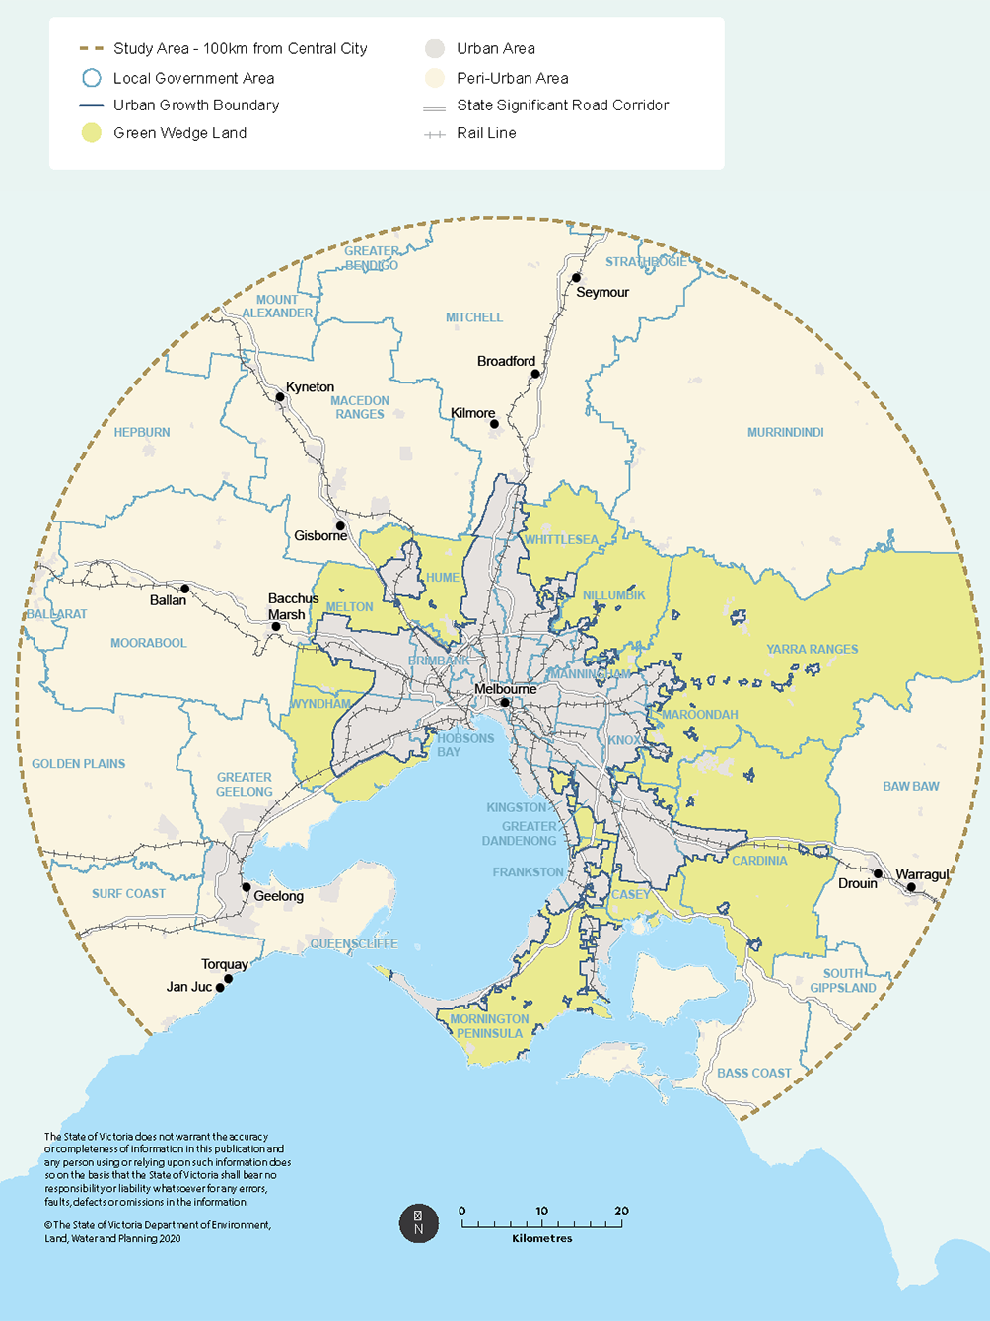

Some of Victoria’s most productive agricultural land is within the study area. A range of types, sizes and intensities of agriculture are undertaken, from commercial to hobby farming. Agricultural land on the city’s fringe is an important source of fresh food for Melbourne’s growing population, as well as a range of non‑food agricultural products, such as nurseries, flower and turf production. The study area is relatively small in size but produces around 10 per cent of Victoria’s gross value of agricultural production.

The study area also supplies sand and soil for Melbourne’s infrastructure, housing and development needs. It contains important transport corridors, infrastructure and businesses that need to be buffered from residential and other incompatible land uses, including airports, ports, waste and resource recovery facilities and water treatment plants.

## Why is this review needed?

Establishment of the green wedges and Melbourne’s urban growth boundary (UGB) have helped to protect farmland and the natural environment from residential and other urban uses.

However, the changing needs of the city and state and the diversity of non‑urban land uses mean that planning and management objectives of the study area will need to be reviewed to ensure its ongoing productivity and avoid irreversible changes to land use. It is also likely that current policies and planning controls are inadequate to meet the challenges of the future.

Planning controls for Melbourne’s green wedges and agricultural land need to be strengthened to:

* adequately respond to land speculation and continued pressure to convert farmland to other uses
* respond to the high demand for rural living and the desire to use green wedges and agricultural land for a range of urban activities, including ‘spillover’ land uses (traditionally located in urban areas) to service the growing population (Melbourne’s population is projected to reach 9 million by 2056)
* retain land for agriculture and other important non‑urban uses, and prevent the incremental loss of this asset – an increasingly rare and finite resource around Melbourne
* prevent land use conflict (for example, conflict arising due to sensitive uses such as dwellings being located too close to agriculture)
* ensure that the planning system continues to support our farmers to grow, adapt and innovate
* reflect the rising importance of, and need to protect, agricultural production near Melbourne as temperatures increase and rainfall decreases, particularly in the north of Victoria
* protect the significant features and assets of the study area to improve environmental, economic, cultural and health and wellbeing outcomes for our communities
* provide greater certainty and consistency across the study area and support local government decision‑making, robust planning controls and strategies to realise a sustainable growing city and state.

The Victorian Government has already introduced planning reforms for animal industries. New land use definitions and associated planning controls for animal industries came into effect in September 2018.

Importantly, the government has also committed to a comprehensive review of outer suburban and peri‑urban land to identify areas of conservation and open space for permanent protection. This commitment builds on priorities in Plan Melbourne 2017–2050 (Plan Melbourne) to develop a Metropolitan Open Space Strategy.

We have identified opportunities to align a number of our proposals relating to green wedges and agricultural land – outlined in this consultation paper – with the development of a robust and integrated framework that clearly and consistently defines appropriate land use across the diverse landscapes and communities of Melbourne’s hinterland. The options in this consultation paper seek to improve the Victorian planning system by supporting agricultural land use more broadly and guiding decision‑making on our green wedges.

## Background to the consultation

In November 2018, the Victorian Government reconfirmed its commitment to permanently protect Melbourne’s green wedges from ‘overdevelopment’ by strengthening statutory planning controls. The commitment consisted of clarifying the definition of ‘permitted land use’, determining the appropriate size and scale of uses in non‑urban settings, and establishing permanent planning controls and legislation to protect and support agricultural land surrounding Melbourne.

Melbourne’s metropolitan planning strategy, Plan Melbourne, outlines the Victorian Government’s blueprint to support jobs, housing and transport while building on the city’s legacy of distinctiveness, liveability and sustainability. The strategy delineates the importance of productive use of land and resources in Melbourne’s non‑urban areas, and the need to strengthen protection and management of these areas. Plan Melbourne’s desired planning outcomes articulate a vision for these important regions and is an important reference for policy formulation and decision‑making in relation to the study area (see Appendix 3).

The accompanying Plan Melbourne Five‑Year Implementation Plan (Plan Melbourne Implementation Plan) outlines three priority government actions to achieve the plan’s vision for green wedge and peri‑urban areas:

* Action 17: Support strategic planning for agriculture
* Action 72: Review green wedge planning provisions
* Action 73: Green Wedge Management Plans

To implement the government’s commitment, the Department has started work to better understand the study area, including stakeholder aspirations and concerns. This work is occurring over a number of phases (see Figure 1). Phase 1 was undertaken to understand how green wedge planning controls are performing and better understand the natural attributes of land surrounding Melbourne. This phase comprised a land capability assessment, land suitability modelling and targeted consultation with councils whose municipality includes green wedge land. Phase 1 was completed in 2018.

Phase 2 was undertaken during 2019 and focused on engaging with farmers, community members, industry, local government and stakeholders to test criteria for identifying strategic agricultural land around Melbourne. This phase was also undertaken to understand community aspirations for the planning of these areas. An independent report on the consultation findings, summarising what we heard, was released in September 2019.

In Phase 3 we used the consultation findings in Phase 2 to refine our approach and develop planning options for further community consultation. We considered the views and concerns articulated during the 2019 stakeholder consultation and identified key priorities as being critical to long‑term and sustainable agriculture.

Key messages from Phase 2 consultation

Support all types and scales of agriculture for the long term.

Safeguard agricultural land serviced by irrigation infrastructure.

Make the best use of productive soils for soil‑based agriculture.

Strengthen the ‘right to farm’.

Recognise the economic contribution of highly productive locations.

Maintain flexibility to respond to future recycled water or stormwater access opportunities.

Manage the interface between agriculture and non‑farming neighbours, and minimise the risk of land use conflict.

Ensure consistent decision‑making that prioritises agricultural use, its supporting industries and complementary land uses.

Build on local knowledge and strategic work around agricultural land use planning.

Support farmers to diversify, value‑add and adjust to changing conditions.

A full summary of consultation findings is available on the [Department of Environment, Land, Water and Planning website](https://www.planning.vic.gov.au/policy-and-strategy/green-wedges-and-agricultural-land#documents)[3].

We are currently in Phase 4 (see Figure 1). This public consultation paper incorporates the priorities identified in Phase 3 and proposes planning options to deliver lasting protection of agricultural land and to guide decision‑making in our green wedge areas. As a result of previous consultation our proposed planning options seek to strengthen legislation, policy and agricultural zones to protect and support all agricultural land, not just ‘strategic’ areas. We have also proposed additional policies to achieve the best use of soil and water resources, and better align agricultural land use planning with water management policy and infrastructure provision. We now seek input and views from individuals, organisations and local communities on the proposed options.

Following consideration of public feedback on these planning options, the Victorian Government will commence implementation of the preferred options (Phase 5).

Figure 1: Project timeline

* Phase 1:   
  Background and technical research
* Phase 2:   
  Public consultation on criteria to identify strategic agricultural land
* Phase 3:   
  Consideration of findings and development of planning options for public consideration
* Phase 4: (Current Phase)   
  Public consultation on planning options for Melbourne’s green wedges and agricultural land
* Phase 5:   
  Review consultation findings and implement preferred options

## Vision and guiding principles

The planning options outlined in this consultation paper are intended to help realise the Victorian Government’s draft vision for Melbourne’s green wedges and areas of agricultural land, outlined as follows.

In 2050, Melbourne’s urban footprint has been contained. A stable and consistently applied Urban Growth Boundary has sent a clear message to all stakeholders and underscored our commitment to protecting the values of non‑urban land and to retaining opportunities for productive agriculture. Consequently, land use speculation has reduced and farmers can invest in their farms with confidence.

The natural assets, open spaces and rural activities in our green wedge and peri‑urban areas are protected, ensuring the ongoing provision of water, food and other natural resources to support the population. The use and development of land respect and resonate with the identified values of the green wedge and peri‑urban areas in which they are located. These values include landscape and environmental values, non‑urban amenity and contribution to a sustainable rural economy. Likewise, state and regionally significant infrastructure that could not be located within Melbourne’s Urban Growth Boundary provides significant ongoing benefits to communities while respecting the non‑urban activities and values of the broader green wedge and peri‑urban areas.

Farming on the urban fringes continues to produce fresh healthy food for our growing population and contributes to the region’s economic prosperity. Opportunities to exploit and broaden re‑use of urban wastewater (recycled water and stormwater) have been realised, and long‑term certainty has facilitated new investment in recycled water infrastructure. Similarly, farmers have innovated and adapted to climate change, implemented sustainable farming techniques and responded to market demands to ensure that the land remains healthy and productive, even under intensive use patterns. Agricultural land in Melbourne’s food bowl has been protected in some of the state’s most drought‑resilient areas, and farmers have access to a secure supply of fit‑for‑purpose water.

Much of the natural biodiversity and unique landscapes of Melbourne in 2020 have been retained in 2050, as have the environmental values that have enabled the city’s vital ecosystem services. The city and its surrounding areas continue to be enjoyed by residents and visitors alike. The social and economic values of Melbourne’s local farms and agritourism are recognised, and leisure and recreational activities have strengthened local economies while supporting the diversification and viability of farming businesses.

The following principles underpin our approach to the challenges and proposed options in this consultation paper:

* Principle 1: The proposed options should be consistent with the desired planning outcomes for Melbourne’s green wedges and agricultural land as outlined in Plan Melbourne.
* Principle 2: The proposed options should recognise and strengthen agriculture as one of the primary land uses in Melbourne’s green wedge and peri‑urban areas.
* Principle 3: The proposed options should respond to pressure from urban and incompatible land uses that threaten green wedge values and productivity of Melbourne’s agricultural land.
* Principle 4: The proposed options should ensure that applications to develop or change the use of land addresses public and natural interests and respects the roles and values of green wedge and peri‑urban areas.

# Policies on Melbourne’s green wedges and agricultural land

## Past policy settings

Environmental, social and economic consequences of urban expansion across landscapes have prompted successive governments worldwide to contain urban development and protect the assets of, and access to, rural areas. The policy expression of non‑urban or ‘green wedge’ areas of metropolitan Melbourne first appeared in the Melbourne and Metropolitan Board of Works’ 1954 planning policy, Melbourne Metropolitan Planning Scheme 1954. In the seven decades that followed, policy on green wedge and peri‑urban areas of Melbourne has evolved to focus on land specifically reserved for non‑urban use and development.

With recognition of the strategic importance of agricultural production close to metropolitan markets, land use planning controls were introduced through the Victoria Planning Provisions (VPPs) and a Urban Growth Boundary established to delineate the outward limit of urban development. The Urban Growth Boundary continues to direct urban growth to areas with appropriate infrastructure and services and protect valuable green wedge and agricultural land from development pressures.

Appendix 2 contains a list of policy directions relating to the study area over the last 50 years.

## Current policy framework

The Victorian planning system uses a range of instruments to govern the use and development of land. These instruments include regulation, Ministerial Directions, Victoria Planning Provisions and planning schemes. Planning schemes are prepared by each municipal council in Victoria. All planning schemes must contain the Victoria Planning Provisions, but each council can also set rules specific to local context. Figure 2 outlines the structure of planning schemes.

Planning schemes contain both policies and planning provisions (for example zones and overlays), guide the implementation of long‑term strategies such as Plan Melbourne, and provide a framework for day‑to‑day decision‑making on land use and development.

Figure 2: Structure of Victorian planning schemes

Policy Settings: Purpose and vision, Municipal Planning Strategy, Planning Policy Framework

Decision Rules: Zones, Overlays, Particular provisions, General provisions

Operation: Operational provisions

Planning authorities use these instruments to achieve the desired outcomes that planning strategies and policies seek to realise. They are designed to guide land use practices and manage land use conflict for the benefit of the wider community.

Victoria’s state‑strategic land use policy is outlined in the Planning Policy Framework (PPF), which is a part of every planning scheme. The Planning Policy Framework identifies issues of state importance and establishes:

* the general principles for land use and development in Victoria
* the specific policies dealing with settlement, environment, housing, economic development, infrastructure, and particular uses and development.

Appendix 2 provides more detail on the planning framework for green wedges and peri‑urban areas.

There are additional existing and emerging government policies, strategies and plans that are relevant to social, economic and environmental issues affecting the study area, including:

* Water for Victoria — 2016
* Biodiversity 2037 — 2017
* Agriculture Victoria Strategy — 2017
* Victoria’s Climate Change Framework — 2018
* Distinctive Areas and Landscapes Legislation — 2018
* Helping Victoria Grow: Extractive Resources Strategy — 2018
* Statewide Waste and Resource Recovery Infrastructure Plan — 2018
* Planning Reforms for Animal Industries — 2018
* Integrated Water Management Forums Strategic Directions Statements — 2018
* Regional Tourism Review — 2019
* Land Use Framework Plans for Melbourne’s metropolitan regions (under development).

Appendix 4 details the above‑listed initiatives.

## The suite of rural zones in the study area

All rural zones in the study area provide for the use of land for agriculture (see list below). The primary use of land for farming is implicit in the Farming Zone, Rural Activity Zone, Green Wedge Zone, Green Wedge A Zone and Schedule 1 to the Special Use Zone (Horticultural Preservation – Cardinia Shire). However, in the Rural Conservation Zone and Rural Living Zone, farming is subordinate to other land uses or to the environmental values of the land.

Map 2 illustrates the distribution of these zones across the study area; Appendix 5 provides a full summary of the zones and their purposes.

|  |  |
| --- | --- |
| Zone | Description |
| Farming Zone | a zone that is strongly focused on protecting and promoting farming and agriculture |
| Rural Activity Zone | a mixed use rural zone that caters for farming and other compatible land uses |
| Rural Conservation Zone | a conservation zone that caters for rural areas with special environmental characteristics |
| Green Wedge Zone | a zone that provides for all agricultural uses and limits non‑rural uses to those that either support agriculture or tourism, or that are essential for urban development but cannot be located in urban areas for amenity or other reasons |
| Green Wedge A Zone | a zone that provides for all agricultural uses and limits non‑rural uses to those that support agriculture, tourism, schools, major infrastructure and rural living |
| Rural Living Zone | a zone that caters for residential use in a rural setting |
| Special Use Zone Schedule 1 (Horticultural Preservation – Cardinia Shire) | a special purpose zone designed to preserve land of high agricultural quality for horticulture and other farming activities |

Local councils apply zones to land based on the strategic objectives of the planning scheme and the purpose and provisions of each zone.

Map 2: Rural Planning Zones

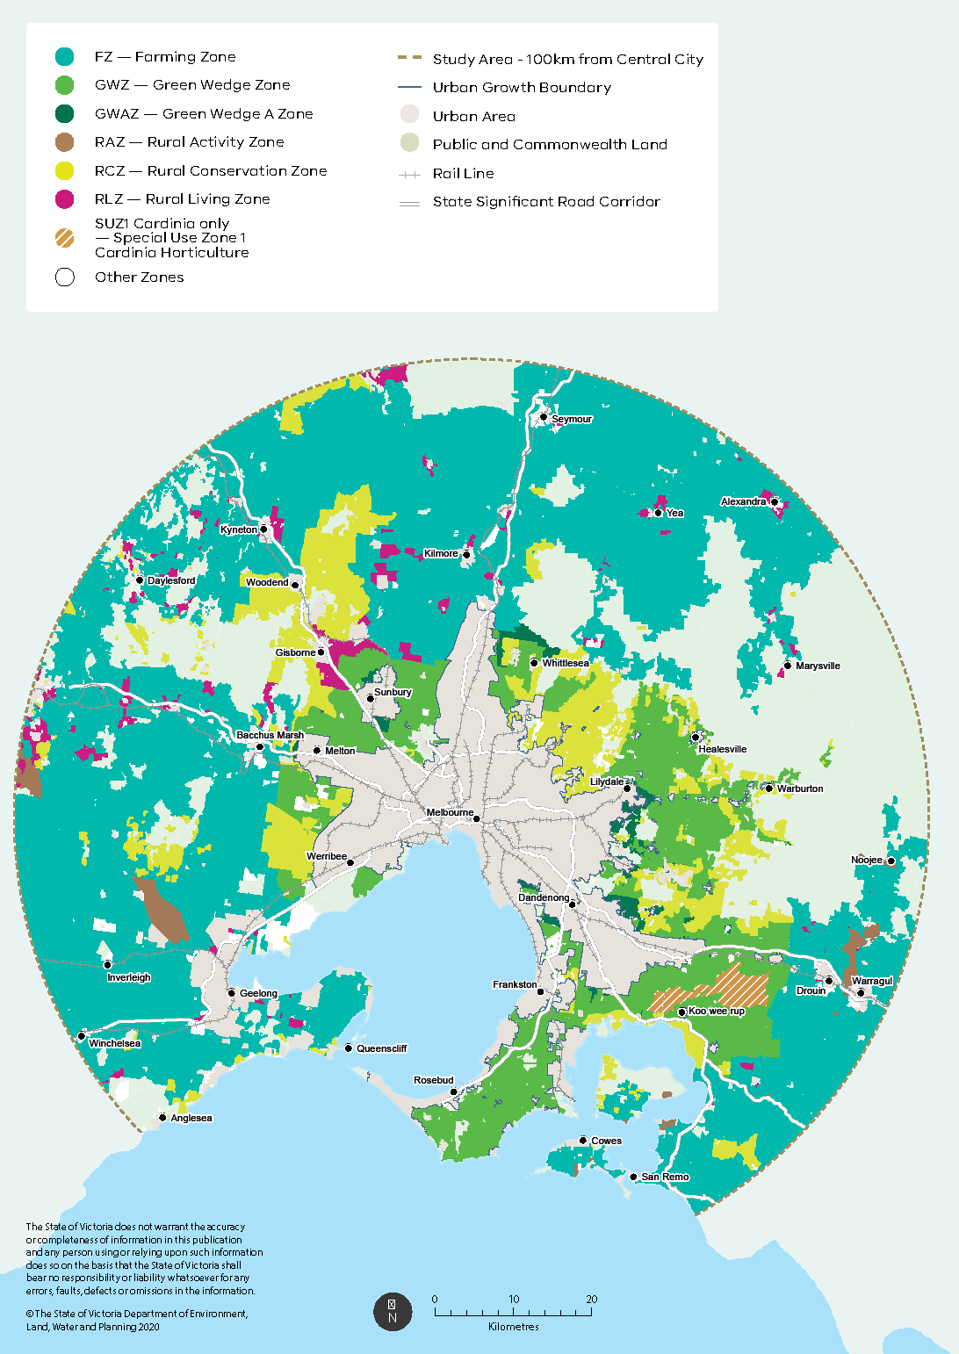

# Challenges and proposed options

A planning system that effectively provides for the non‑urban and agricultural roles of these areas will clarify priorities, enable better decisions about land use and development, and will help to balance competing policy objectives.

In this and the next chapter, we discuss and outline options that aim to improve coherence across the planning system in a way that provides practical guidance for planning authorities and balances different land interests for an equitable and sustainable future. These options address four key aspects of land use and development in green wedge and peri‑urban areas of Melbourne:

* strengthen legislative and policy frameworks to provide clear strategic direction
* support agricultural land use by strengthening rural zones and overlays
* manage the study area through more consistent and coherent land use decision‑making
* promote design and development in green wedges that are responsive to the surrounding landscape.

## Strengthening the legislative and policy framework

### Legislative and policy framework for Melbourne’s green wedges

Two significant challenges for decision‑making about land use and development proposals in Melbourne’s green wedges are:

* the varied functions of green wedges in agriculture, natural resources and open space
* the differing qualities of green wedge areas.

Existing policies and green wedge zones generally provide for a broad range of uses that may be appropriate in different contexts across the green wedges. However, some uses and their development outcomes can be inappropriate in some green wedge locations. That is, while state policy provides general guidance on the variety of roles and functions of Melbourne’s green wedges, there is opportunity to strengthen and amplify policy directions that:

* give non‑urban rural uses primacy, provide a non‑urban break between urban uses of land and green wedges, and protect land in green wedge areas from inappropriate use and development
* provide greater recognition of the diversity of, and differences between, green wedges by consistently identifying their regional assets and features in regional planning policy.

The options outlined in this section seek to implement Plan Melbourne policy. Importantly, they will provide councils, responsible authorities and landowners with a coherent framework for all green wedges that is also responsive to the unique regional assets and features of a green wedge when considering planning scheme amendments and permit applications.

#### Strengthening legislative protection of green wedges

Reforms to better protect green wedge land were introduced in 2002 with the release of the metropolitan planning strategy, Melbourne 2030 (Department of Infrastructure 2002). These reforms included a legislative amendment to the Planning and Environment Act 1987 (the Act) to define ‘green wedge’ land and tighten approval requirements for any movement of the Urban Growth Boundary or subdivision of green wedge land. Part 3AA of the Act (Metropolitan Green Wedge Protection) requires that any planning scheme amendment that amends or inserts a Urban Growth Boundary or that has the effect of altering or removing any controls over the subdivision of any green wedge land to allow subdivision of that land into more lots or into smaller lots than allowed in the planning scheme, must be approved by the Minister and ratified by both Houses of Parliament.

These legislative provisions have been successful in securing an Urban Growth Boundary and restricting subdivision of green wedge land. However, there is scope for stronger articulation and protection of the significant values and attributes of green wedges in these legislative provisions.

A recent example of legislative protection of sensitive land in Victoria relates to its distinctive areas and landscapes. Part 3AAB of the Act (Distinctive Areas and Landscapes) was introduced to strengthen recognition, at a state level, of the importance of distinctive areas and landscapes and protect their unique characteristics. The legislative amendment enables the protection of valued assets in the peri‑urban region of Victoria’s major regional cities and other areas for the future. It is a detailed articulation of the objectives for identified distinctive areas and landscapes and outlines the requirement to prepare a Statement of Planning Policy in relation to each declared area to ensure coordinated decision‑making by public entities.

The sections below discuss options to improve state and regional policy through amendments to Part 3AA of the Act to enshrine legislative protection of green wedge land. These options include:

* inserting an ‘Objects’ clause in the Act to articulate the State’s vision and objectives for Melbourne’s green wedges
* recognising the regional importance of green wedges and enshrining regional policy objectives for their protection in legislation (see further discussion on regional green wedge policy below)
* introduce legislative requirements to prepare and implement strategic plans for each green wedge (related to proposed reforms to the Green Wedge Management Plan process, discussed below)
* requiring ministerial approval for the adoption and implementation of strategic plans for green wedge areas prepared by local government authorities.

These options have the potential to:

* more clearly express in legislation the Victorian Government’s vision and objectives for the green wedges
* enshrine regional green wedge policy in legislation
* introduce legislative requirements to prepare and implement strategic plans for green wedge areas
* facilitate greater integration of planning policy objectives and controls in statutory planning frameworks (i.e. planning schemes)
* reduce uncertainty and ambiguity that can arise in planning matters, such as permit decision‑making and interpretation of requirements by decision makers
* deliver on Action 73 of the Plan Melbourne Implementation Plan, which commits to amending Part 3AA of the Act (Metropolitan Green Wedge Protection), by introducing a requirement that local governments prepare and review Green Wedge Management Plans.

Options

Amend Part 3AA (Metropolitan Green Wedge Protection) of the Planning and Environment Act 1987 to:

* clearly express the Victorian Government’s vision and objectives for green wedges
* enshrine regional policy for each green wedge in legislation
* introduce legislative requirements to prepare and implement strategic planning frameworks for each green wedge
* require ministerial approval for the adoption and implementation of strategic plans for green wedges prepared by local government authorities.

#### Clarifying state policy objective for green wedges

There is a single objective relating to green wedges contained in the Victorian Planning Policy Framework: ‘to protect the green wedges from inappropriate development’ (Clause 11.01‑1R). As the first principle and expression of state policy on green wedges, the current policy objective could be strengthened to more effectively implement Plan Melbourne by asserting a preference for non‑urban rural land use and development and clarifying expectations to maintain natural systems and rural landscapes.

Options

Update state planning policy to clearly articulate the preferred outcomes for Melbourne’s green wedges. The objectives of Clause 11.01 of the Victoria Planning Provisions (Green Wedges: Metropolitan Melbourne) can be potentially revised to include:

* ‘To maintain the important non‑urban purpose of the green wedges and avoid use and development that would adversely affect their future productive use or environmental significance’
* ‘To support preferred land uses and encourage uses that contribute to the non‑urban landscape and character’.

#### Reviewing Green Wedge Management Plans

Green Wedge Management Plans were introduced following Melbourne 2030 (Department of Infrastructure 2002) to implement the strategic policy vision for, and objectives of, land use and development for each green wedge (for more detail on Green Wedge Management Plans, see Appendix 2). When Green Wedge Management Plans were introduced, the Victorian Government envisioned they would support coherent planning and management of development in areas of metropolitan Melbourne.

Today, councils employ Green Wedge Management Plans to set strategic policy and objectives for land use and development on green wedge land in their municipality. Such an approach is consistent with broad state policy directions and recognises local variation in land conditions across diverse green wedge areas. The advantages of this approach include:

* opportunities to engage with local communities and understand their issues, expectations and needs
* ability to address local differences within and between green wedges
* expression of high‑level aspirational objectives and outcomes that can be used to guide planning policy at a local level.

The original intent of Green Wedge Management Plans was to have councils collaborate in the preparation of strategic policy, a vision and objectives for those areas where a green wedge straddles municipal boundaries. However, this has generally not eventuated.

In practice, Green Wedge Management Plans are developed by local councils to function as strategic policy frameworks for green wedge areas within their administrative boundaries, with little appreciation of, or links with, the strategic role and purpose that each green wedge or collection of green wedges play in a regional or metropolitan context.

Further, not all green wedge areas have a Green Wedge Management Plan. Map 3 illustrates the status of completion of Green Wedge Management Plans across the study area.

Map 3: Status of Green Wedge Management Plans

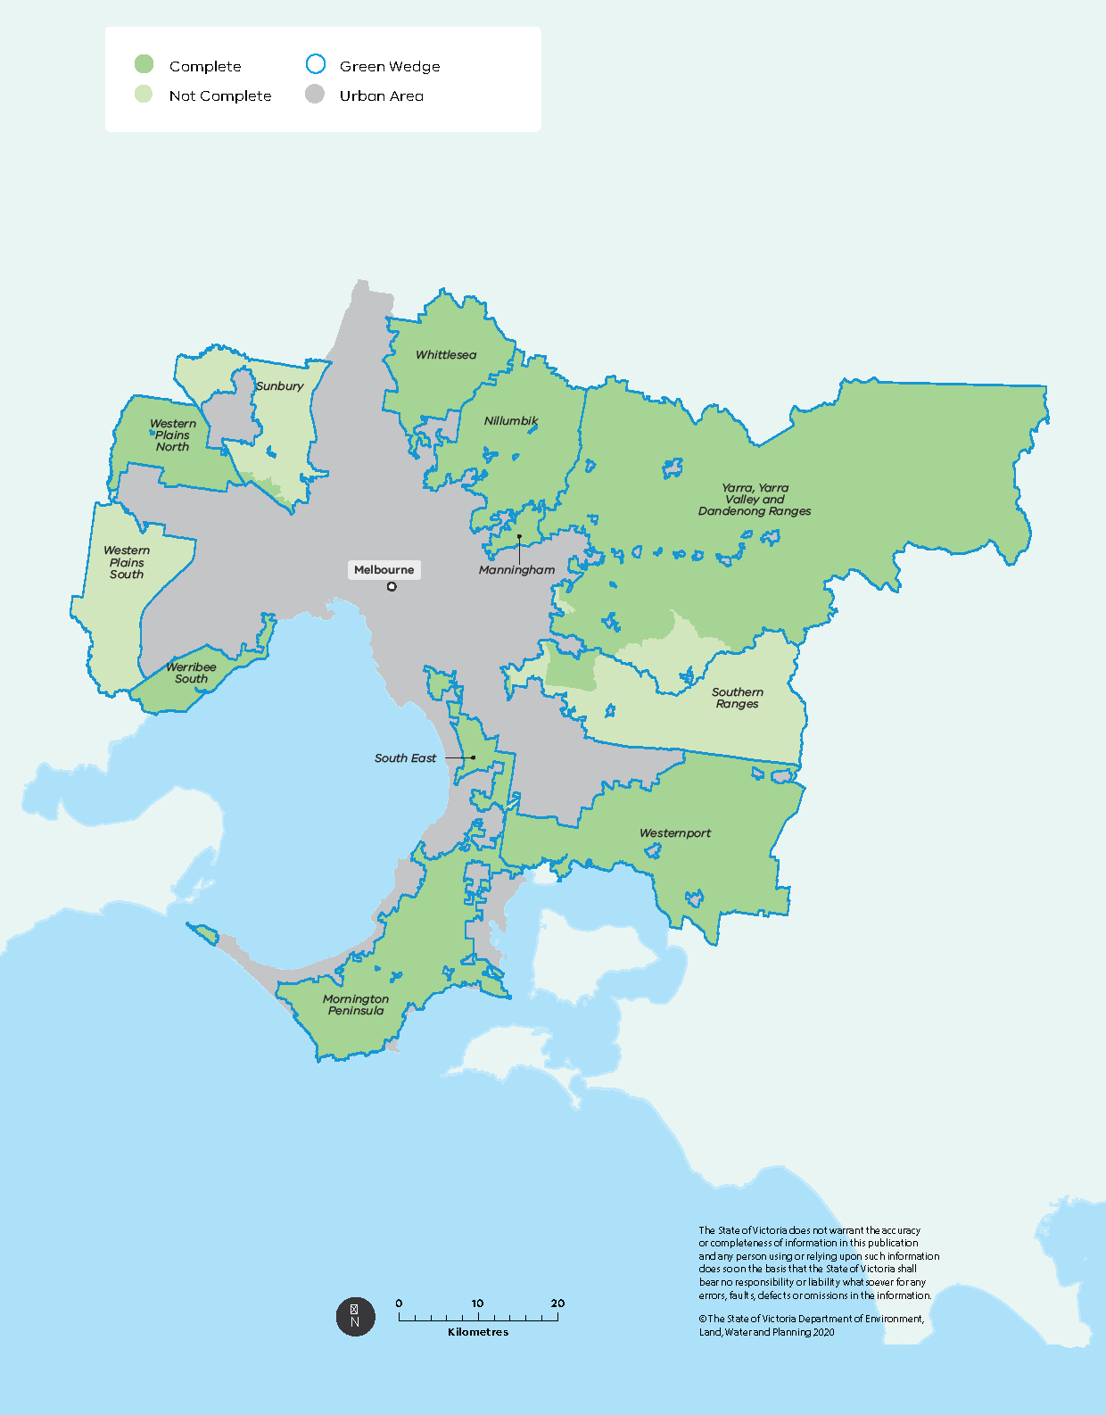

In addition, there is confusion as to whether Green Wedge Management Plans are land use strategies or land management plans, and perceptions differ on the statutory weight of these plans when considering planning permit applications for green wedge land.

PPN31 (Preparing a Green Wedge Management Plan, see Appendix 2) defines a Green Wedge Management Plan as being:

a council‑adopted strategy that identifies a vision, objectives and actions for the sustainable use and development of each green wedge. The plan will identify the values and features of each green wedge, the preferred future land use, environmental and resources that should be protected, and the needs of local communities (P. 1)

and provides that

To ensure the sustainable management of green wedges, a Green Wedge Management Plan should include a broad range of implementation tools that include regulatory and non‑regulatory measures. (P. 1)

Notably, PPN31 advances measures that sit within and outside the planning scheme framework, including education and incentive programs that encourage landowners to adopt sustainable land management practices:

Achievement of sustainable land use and land management practices are a critical element in the development of Green Wedge Management Plans. (P. 1)

Therefore, Green Wedge Management Plans were intended to achieve two important purposes:

* set the strategic planning direction on use and development of land in each green wedge with a view that these directions would be translated into local policy, zones and other planning provisions
* act as a framework for land management, action and practice.

In some planning schemes, there is an explicit link between the Green Wedge Management Plan, local policy and its implementation through appropriate zoning. This link often takes the form of a local policy directly addressing or referring to the green wedge. In other cases, the developed and adopted Green Wedge Management Plans are not referenced in the planning scheme.

Where Green Wedge Management Plans are not adopted, local policies may exist on topics such as the environment, landscapes, tourism and agriculture.

Clearly, there is an opportunity to clarify and strengthen the role of Green Wedge Management Plans so that they can consistently inform, and be informed by, planning policy and controls.

A key area for reform is to review the general form and structure that Green Wedge Management Plans should take, and improve their requirements for detailed environmental, landscape and land use inventory mapping. Improving their form, structure and requirements would inform development of Green Wedge Management Plans that more closely reflect the varying landscapes in a green wedge, provide appropriate strategic direction and enable planning controls to respond to local variation. Identification of the varying local conditions across rural landscapes is an important capability and component for implementing state, regional and local planning policy, and responding appropriately with land use and development controls.

Option

Review and update Planning Practice Note 31 ‘Preparing a Green Wedge Management Plan’ to improve the structure, form and content of Green Wedge Management Plans.

#### Introducing state‑backed regional policy for green wedges

While broad strategic policy on Melbourne’s green wedges is articulated in documents such as Plan Melbourne and the Planning Policy Framework, strategic direction for each of the green wedges has primarily been developed and implemented at the local government level through Green Wedge Management Plans (GWMPs). For various reasons, the efficacy of the current system of local Green Wedge Management Plans in realising preferred policy outcomes has been mixed. There is a need to better align state and local planning through regional recognition of land use opportunities and challenges relating to our green wedges.

Consultation with a range of stakeholders has also confirmed public desire for greater certainty in policy, zones and planning provisions on the use and development of land in the green wedges. This will in part be addressed by the Plan Melbourne Implementation Plan, which aims to progress regional planning by developing Land Use Framework Plans for each of Melbourne’s six metropolitan regions (Action 1).

To enhance coherent and consistent strategic planning on use and development of land in each green wedge, regional policy could be introduced in the Planning Policy Framework through state‑led Land Use Framework Plans (LUFPs). Such an approach would recognise the regional characteristics and significance associated with each green wedge.

Regional policy for each green wedge can cross local government boundaries, complement local policy and assist council decision‑making. Such a policy would be consistent with policy directions in Plan Melbourne, state government policy to ‘promote and encourage the key features and related values of each green wedge area’ (Clause 11.01‑1R, Planning Policy Framework) and existing regional policy directions for peri‑urban areas that are informed by Regional Growth Plans (Clause 11.01‑1R, Planning Policy Framework; see Appendix 2).

In addition to these identified policies, a state‑backed regional policy on green wedges can provide much needed guidance that is additional to that provided in state planning policy.

The form and structure of such regional policy could:

* identify the regional role and purpose of each green wedge
* articulate the distinctive attributes and the key regional features and assets of each green wedge that contribute to its state significance
* articulate the significance and role of Traditional Owners and identify the important sites of cultural heritage to be protected
* contain a map identifying those assets and features of state and/or regional significance, such as:
  + biodiversity and environmental values
  + state‑significant waterways and features
  + state‑significant infrastructure
  + landscape features
  + areas of important agricultural production
  + tourism assets of state and regional significance.

The intention is not that state and regional policy replace the important role of Green Wedge Management Plans. Rather, these policies are intended to:

* provide regional framework and guidance to guide council planning, management and decision‑making on green wedges within their municipality
* enhance coherent policy implementation across metropolitan and rural regions of Melbourne.

Local government is a vital partner in delivering and realising desired outcomes for green wedge areas. Councils have access to detailed and unique local knowledge of the land and the issues that require clear planning and management strategies. They also have close relationships with private landowners who are responsible for delivering land management and conservation outcomes in the area.

The expectation is for councils to continue to prepare and regularly update Green Wedge Management Plans that identify the local values and features of the green wedge land within their municipality, including its preferred land uses, the environmental and natural resources to be protected, and the needs of the local community. The important role of this strategic land use planning and management tool was reinforced in Plan Melbourne.

Option

Develop and introduce regional policy directions in the Planning Policy Framework for Melbourne’s green wedges in Clause 11.01‑1R (Victoria Planning Provisions) and through Land Use Framework Plans.

To catalyse public discussion on the proposal to have a regional policy for Melbourne’s green wedges in the Victoria Planning Provisions, we have drawn from currently existing Green Wedge Management Plans and identified the following regional features of Melbourne’s green wedges. We are interested in your views and feedback on the proposal to have a regional policy for Melbourne’s green wedges

#### Regional features of the study area – West

The western study area is an important non‑urban break between Melbourne and Geelong (Map 4).

This region features a mix of coastal grassy plains and volcanic plains, with some areas having more pronounced topography such as hills, ranges and woodlands.

The significant agricultural activity in this region is primarily serviced by recycled water and high‑quality soil, and consists of market gardens and horticulture, broadacre cropping, grazing, intensive agriculture and hobby farms.

The region features significant reserves with conservation, heritage and cultural values, including drystone walls, internationally significant and biologically diverse wetlands and marine sanctuaries, Aboriginal middens and burial sites, and tourism assets such as Werribee Mansion and Werribee Open Range Zoo.

Transport gateways and infrastructure in the region support other important economic sectors, such as quarries and water treatment plants.

Study Area – 100km from Central City

Principal agricultural zones are rural zones that include agriculture as one of the primary zone purposes. Incudes the Farming Zone, Rural Activity Zone, Green Wedge Zone and Green Wedge A Zone.

Map 4: Key features West

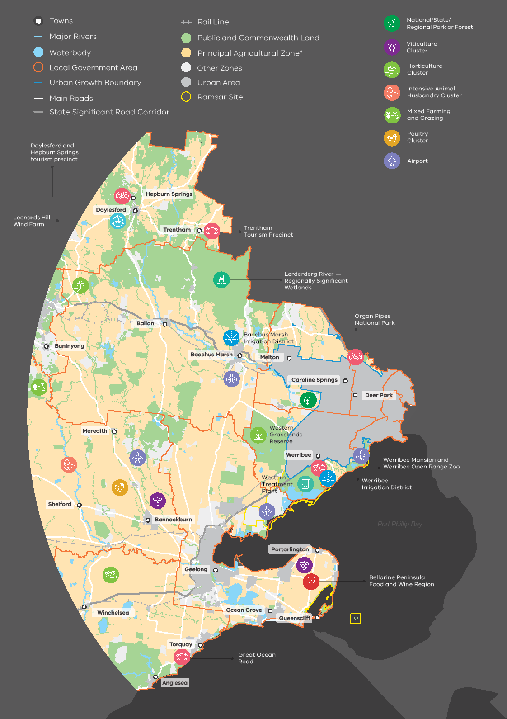

#### Regional features of the study area – North

The northern study area is characterised by strongly dissected slopes, gorges and valleys (including the south‑western slopes of the Great Dividing Range and Plenty Gorge), cleared rural and agricultural land, scenic hills, rocky and volcanic plains and grasslands, and forested areas (Map 5).

It holds significant environmental and biodiversity conservation values as well as open space features. The range of parks, reserves, cultural heritage, local food and network of trails throughout the northern green wedges support the region’s visitor economy.

The region contains important water storage catchment areas for Melbourne, wetlands and waterways. Cropping, orcharding, grazing, dairying, viticulture, equine uses and animal husbandry occur throughout the Northern Region’s green wedges.

Significant transport gateways, infrastructure and landfills in the region support other important economic sectors, such as freight and logistics, manufacturing, waste management and resource extraction.

Study Area – 100km from Central City

Principal agricultural zones are rural zones that include agriculture as one of the primary zone purposes. Incudes the Farming Zone, Rural Activity Zone, Green Wedge Zone and Green Wedge A Zone.

Map 5: Key features North

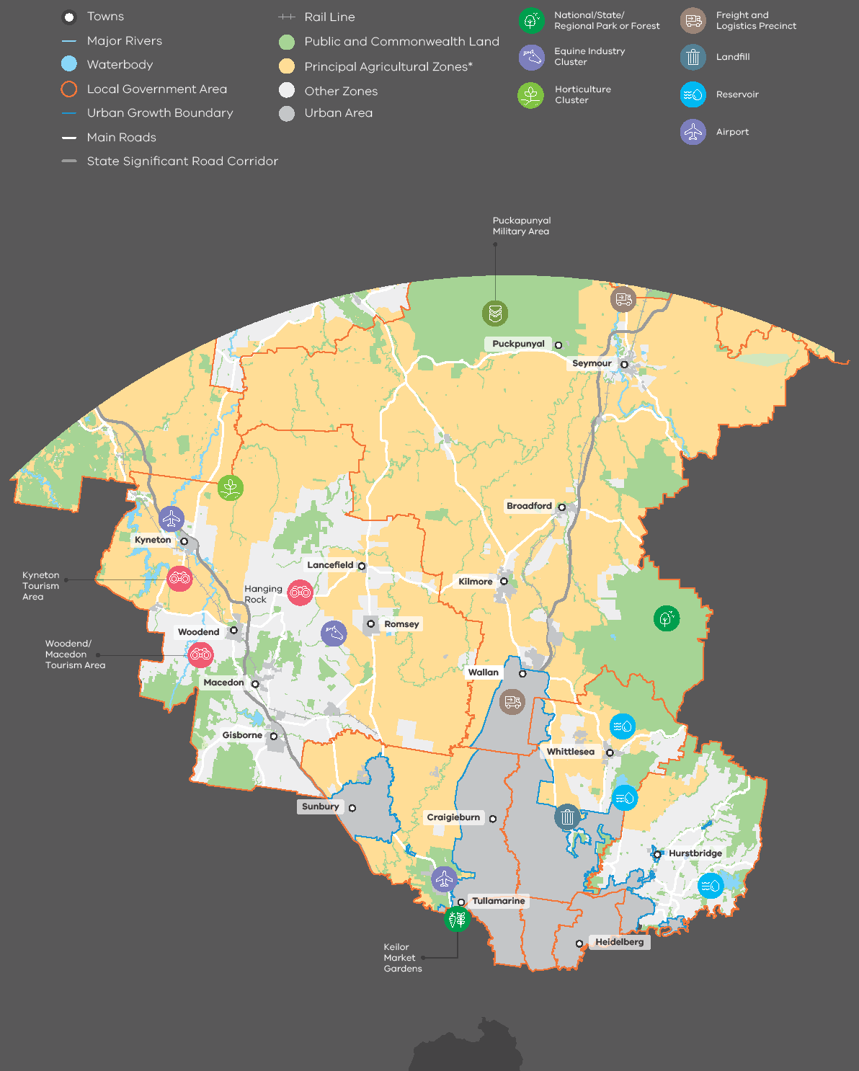

#### Regional features of the study area – East

The landscapes of the eastern study area include mountain ranges, valleys, waterway networks and forests with significant biodiversity and conservation value (Map 6).

Its environmental assets are embodied in Kinglake, Dandenong Ranges and Yarra Ranges national parks, Pauls Range and Yarra state forests, Lysterfield Park, and Kurth Kiln Regional Park.

The region contains areas of modified rural landscapes, such as cultivated croplands and rolling pastures. The region contains significant waterways, water catchments and storage areas, including the Yarra River, Mullum Mullum Creek and the Upper Yarra, Silvan, Maroondah and O’Shannassy reservoirs. The water catchments and storage facilities in this region are regionally significant assets and critical for potable water supply to greater Melbourne.

Agricultural produce from the region comprises flowers and nursery plants, berries and orchard fruits, wine grapes, beef and grain.

The region holds a range of cultural values, with a visitor economy that is based on its local wine and food, farmers and makers markets, bed and breakfast accommodation, environmental walks, parklands and river corridors, cycling and horseriding trails, and attractions such as Healesville Sanctuary and Puffing Billy.

Study Area – 100km from Central City

Principal agricultural zones are rural zones that include agriculture as one of the primary zonepurposes. Incudes the Farming Zone, Rural Activity Zone, Green Wedge Zone and Green Wedge A Zone.

Map 6: Key features East

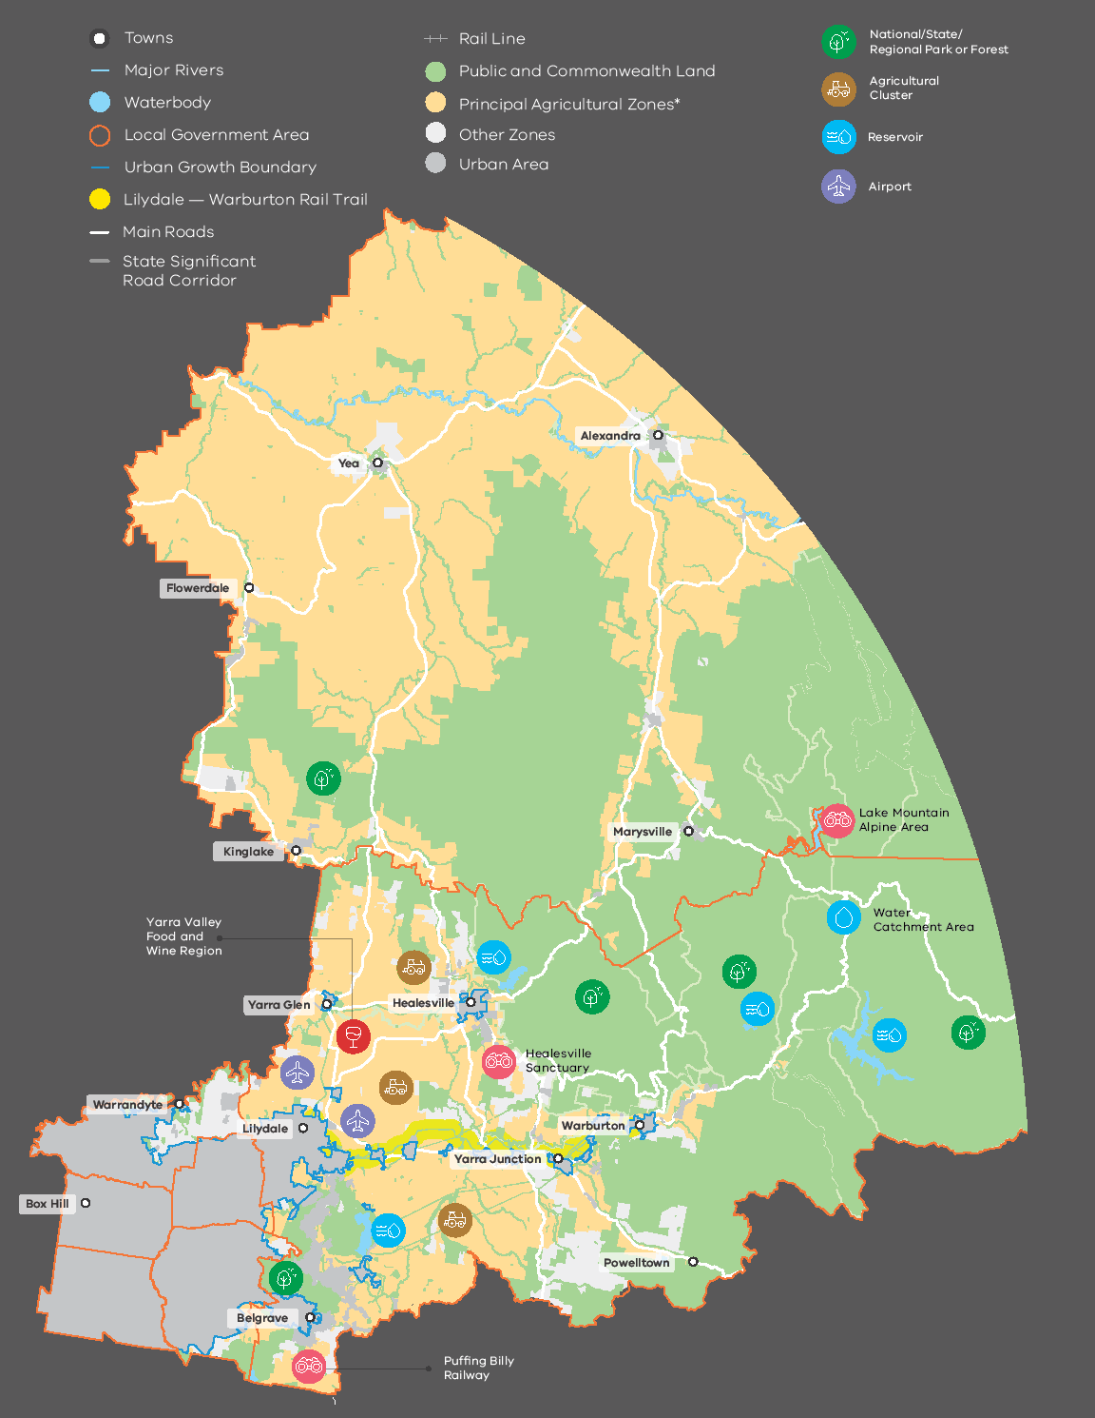

#### Regional features of the study area – South

The southern study area has distinctive rural landscapes and vistas, such as the Casey Foothills and Dandenong Ranges, as well as bushland and coastal landscapes (Map 7).

This region holds areas of significant environmental, biodiversity and conservation value, including Churchill, Point Nepean and Mornington Peninsula national parks; Dandenong Police Paddocks; Lysterfield and Braeside parks, Kurth Kiln Regional Park, Bunyip and Arthurs Seat state parks, Greens Bush and Devilbend Natural Features Reserve. It also contains numerous watercourses, the UNESCO Mornington Peninsula and Western Port Biosphere Reserve, and the Westernport and Edithvale–Seaford Ramsar wetlands.

The region — particularly in Koo Wee Rup — holds some of Victoria’s most productive soils, and supports grazing, agistment, nurseries and cut flowers, poultry farming, viticulture, market gardens and horticulture. It also supports extractive industries.

The region’s environmental and landscape assets provide important recreation opportunities and support the region’s tourism industry, which is centred around natural features, recreation, farm gate sales, local food and wine. The region also contains sites of Aboriginal and post‑contact cultural heritage, including scarred trees, scattered Aboriginal artefacts, heritage homesteads and farmhouses.

There is state‑significant infrastructure in the region, consisting of transport corridors, the Eastern Treatment Plant, Cardinia Reservoir and Moorabbin Airport. The feasibility of a south‑east airport in the region is also under current investigation.

Study Area – 100km from Central City

Principal agricultural zones are rural zones that include agriculture as one of the primary zone purposes. Incudes the Farming Zone, Rural Activity Zone, Green Wedge Zone, Green Wedge A Zone and Special Use Zone Schedule 1 (Cardinia – Horticultural Preservation).

Map 7: Key features South

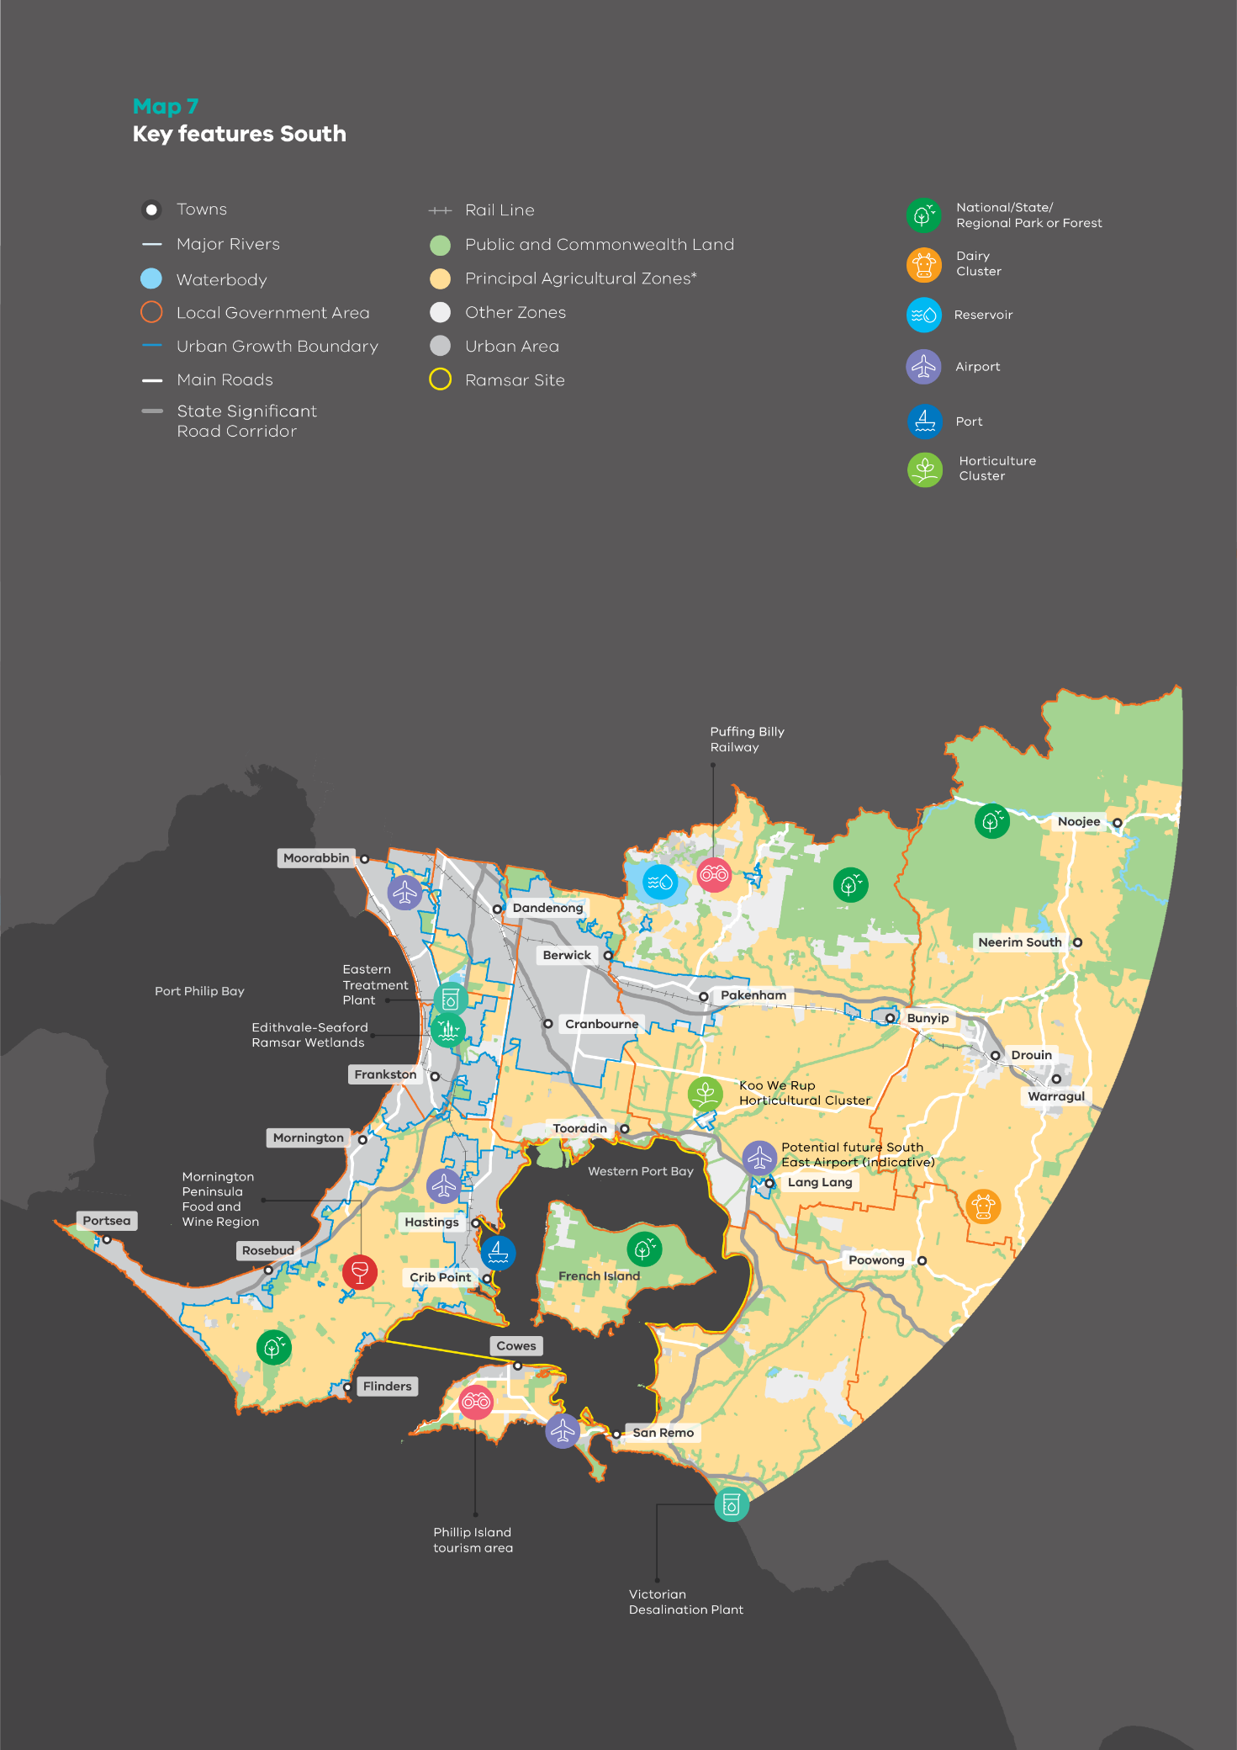

### Legislative and policy framework for Melbourne’s agricultural land

At the top of the Victorian planning system hierarchy is the Planning and Environment Act 1987 which outlines the planning objectives and establishes the statutory framework for the Victorian planning system.

Currently, Victoria does not have separate legislation that specifically protects farming activities. The Planning Policy Framework within the Victoria Planning Provisions sets out the state and regional planning policies that guide use and development of agricultural land surrounding Melbourne. The key relevant clauses are as follows:

|  |  |  |
| --- | --- | --- |
| Clause | Description | Objective |
| Clause 14.01‑1S | Protection of agricultural land | To protect the state’s agricultural base by preserving productive farmland. |
| Clause 14.01‑1R | Protection of agricultural land – Metropolitan Melbourne | To protect agricultural land in Metropolitan Melbourne’s green wedges and peri‑urban areas to avoid the permanent loss of agricultural land in those locations. |
| Clause 14.01‑2S | Sustainable agricultural land use | To encourage sustainable agricultural land use. |
| Clause 11.03‑3S | Peri‑urban areas | To manage growth in peri‑urban areas to protect and enhance their identified valued attributes. |
| Clause 14.02‑3S | Protection of declared irrigation districts | To plan and manage for sustainable change within irrigation districts declared under Part 6A of the Water Act 1989. |
| Clause 19.03‑3S | Integrated water management | To sustainably manage water supply, water resources, wastewater, drainage and stormwater through an integrated water management approach. |

The strategies identified for these clauses highlight the need to:

* identify and protect productive farmland, including productive farmland that is of strategic significance in the local or regional context
* prevent unplanned loss of productive farmlands from permanent changes in land use, dispersed urban activities, incompatible uses, new housing and further subdivision
* ensure that the economic importance of production, agricultural productivity, compatibility with surrounding land use, and land capability are considered in decision‑making
* encourage sustainable use and management, innovation, climate change adaptation, diversification and value‑adding, flexibility and adjustment, investment and infrastructure provision
* ensure appropriate management of animal industries
* avoid urban sprawl, provide for non‑urban breaks and contain development to established settlements
* protect agricultural land serviced by irrigation infrastructure to secure the future viability of irrigation districts, and encourage land uses that complement existing and future agricultural production
* protect areas with potential to use recycled water for forestry, agriculture or for other uses for which treated effluent of an appropriate quality can be used.

While being relatively sound, these policy objectives and their associated strategies have not prevented the loss of productive agricultural land to urban uses over time. Proposals to establish dwellings and other incompatible land uses in agricultural areas have been considered in a piecemeal and ad hoc manner, and are often decided in favour of individual outcomes over regional and/or community benefits.

#### Protecting all agricultural land surrounding Melbourne

References to ‘productive farmland’ and ‘farmland of strategic significance’ in state policies suggest that the protection of agricultural land should prioritise land considered to have higher agricultural quality. In the same vein, Action 17 of Plan Melbourne seeks to identify areas of ‘strategic agricultural land’.

During Department of Environment, Land, Water and Planning’s initial consultation in 2019, we presented a list of criteria that could be used to identify those agricultural areas with strategic significance for agriculture. The draft criteria (included in full in Appendix 6) included:

* land capability – naturally fertile land with minimal constraints and highly capable for intensive, soil‑based agriculture
* water access – farmland with access to a secure water supply
* resilience and adaptability – land that is resilient to the potential impacts of climate change
* existing land use and integration with industry – land that is currently used for intensive agricultural purposes or supports the viability of an agricultural area
* other considerations (constraints) – factors that may prevent land from being classified as strategic agricultural land.

While a broad range of views were communicated during the 2019 consultations, feedback overwhelmingly highlighted the importance of protecting all agricultural land, not just land deemed to be strategically significant. The key reasons given by stakeholders were twofold:

* protecting all agricultural land would mitigate further pressure on ‘non‑strategic’ agricultural land
* protecting all agricultural land would ensure enough land is safeguarded for agriculture to ensure that Melbourne retains sufficient flexibility and resilience for future challenges to the city’s food production.

In response to this feedback, this paper proposes options that recognise the value of all agricultural land in the planning system and that maintain an adequate amount of available agricultural land for the agricultural sector to continue to adapt to market pressures, respond to industry trends and opportunities, and prepare for climate change.

Option

Update the Planning Policy Framework to ensure that all agricultural land is protected.

#### Protecting the natural resources that underpin agricultural land use

Agriculture is a diverse land use that takes many forms. Some types of agriculture are highly dependent on natural factors such as climate, soil and access to water; others do not rely on high‑quality soil or rainfall for production (for example hydroponics in glasshouses or poultry farms). The location of non‑soil‑based industries is often driven by other factors such as distance to markets, access to infrastructure, topography and social factors.

While the protection of all agricultural land is proposed in this paper, it is equally important to recognise that high‑quality soils and water are scarce and finite resources. Climate change is increasing pressure on the availability of natural resources that underpin food production. The current Planning Policy Framework provides no guidance on the best use of natural resources to support agricultural production and build resilience to climate change.

Option

Update the Planning Policy Framework to encourage land uses that have limited or negligible reliance on soil as the basis of production, to be located in areas where soil‑based agriculture is likely to be constrained.

(Note: options to strengthen policy on secure water access for agricultural production are discussed in Section 3.2.3 of this paper.)

#### Improving regional policy protection of Melbourne’s agricultural land

Compared to statewide policy, current regional policy on the protection of agricultural land is very limited in scope. It consists of one singular policy statement, which is to ‘protect agricultural land in Metropolitan Melbourne’s green wedges and peri‑urban areas to avoid the permanent loss of agricultural land in those locations’.

However, agriculture surrounding Melbourne is highly significant to the state in terms of its value of production for what is a relatively small area of agricultural land. It holds unique opportunities thanks to its proximity to city markets and infrastructure, as well as urban waste streams that could be a source of water and nutrients for farming. It is proposed to strengthen regional agricultural policy to encourage sustainable agricultural production that builds on Melbourne’s competitive advantages.

Options

Update the Planning Policy Framework to include new regional policy for Melbourne’s agricultural land. The new policy should:

* support greater resilience of Melbourne’s food bowl by encouraging re‑use of valuable city waste streams, including recycled water, stormwater, nutrients and biogas
* encourage opportunities for growth and diversification of other activities complementary to agriculture that leverage the advantages of proximity to the city of Melbourne and its local markets
* support the establishment and expansion of infrastructure that benefits agriculture
* recognise the economic and employment contributions of Melbourne’s agricultural land to local communities, the region and the State of Victoria.

(Note: other proposed options to change state and regional policy on water for agriculture are discussed in Section 3.2.3.)

#### Legislating the right to farm

Land use conflicts that result from inappropriate use and development of farming areas were consistently highlighted as a key concern by stakeholders throughout our Phase 2 consultations. Stakeholders expressed strong support for protecting the ‘right to farm’, including:

* minimising land use conflicts that could constrain the ability to farm
* ensuring appropriate buffers separate agricultural land from sensitive land uses, such as residential development or other land uses, that would be potentially sensitive to emissions (dust, odour, noise, light) from agricultural activities
* ensuring planning regulations do not hinder farming activities.

In Australia, right‑to‑farm legislation has been implemented by Tasmania (the Primary Industries Activities Protection Act 1995) and was recently enacted by New South Wales (NSW) in November 2019 with the Right to Farm Act 2019.

A common feature in both the Tasmanian and NSW legislation is the protection of farmers against common law nuisance claims. NSW legislation also imposes penalties on trespassers found guilty of illegally entering farms, letting stock out or tampering with cattle grids.

To protect Melbourne’s remaining agricultural land, a proposed option is to introduce new legislation that strengthens the right to farm. Such legislation would ensure that farming activities are protected from encroachment by sensitive uses and delineate that primary responsibility for mitigating impacts of lawful agricultural operations (for example dust, noise and odour) rests with the ‘agent of change’ – the person or organisation who introduces a new use or development into an existing environment. In practice this means that an agent of a new sensitive use or development, such as residential development, that is established close to an existing farm will be responsible for adapting to the existing farming environment. Conversely, new or existing farms that seek to establish or expand, respectively, will be responsible for attenuating any effects caused by that change on nearby sensitive uses.

However, an agricultural activity that is supported within the zone as an as‑of‑right (Section 1) use would not be considered an ‘agent‑of‑change’.

While legislation has an important role to play, arguably the best way to protect the right to farm is to prevent incompatible uses and development from establishing in agricultural areas in the first place. To achieve this, other complementary measures, such as changes to policy, zones, overlays and planning guidelines, are also proposed as part of the package of changes presented in this paper.

Options

* Establish new right to farm legislation for Melbourne’s agricultural land that ensures primary production carried out on a farm does not constitute a nuisance, provided that it is conducted lawfully and the zoning of the land supports agricultural use as a primary purpose of the zone.
* Introduce the ‘agent of change’ principle into legislation to assign responsibility for mitigating impacts of lawful agricultural operations (for example dust, noise and odour) to the ‘agent of change’ – the person or organisation who introduces a new use or development in an existing environment.
* In conjunction with legislative changes above, update the Planning Policy Framework to encourage appropriate siting, design and scale of sensitive uses and developments within rural areas to avoid conflicts with agricultural uses and to maintain capability to intensify agricultural production.

What is the ‘right to farm’?

Complaints often arise when land uses in proximity to each other are incompatible and create conflict. In the case of farming, the use of land can generate dust, odour and noise through such activities as the application of chemicals and the running of farm machinery on roads.

The ‘right to farm’ refers to the concept that farmers should be able to conduct lawful agricultural activities without being hindered by complaints from neighbours or other land users. Generally, right‑to‑farm issues are more prevalent on the urban fringe, where urban and rural uses of land occur side by side as people move into a green wedge and peri‑urban area in search of amenity of a rural setting.

The right to farm does not mean that farming activities are exempt from other environmental regulations that safeguard risks to environment and community amenity (for example regulations that control chemical use, air pollution, noise and management of odours). The Environment Protection Authority Victoria (EPA Victoria) oversees environmental and amenity issues in accordance with the Environment Protection Act 1970. It regulates high‑risk industries through works approvals and has compliance and enforcement powers to ensure all industries, including farming, comply with legislated environmental standards.

## Supporting agricultural land use

Melbourne’s food bowl has significant competitive advantages, including proximity to markets, access to labour force and transport infrastructure, areas of high‑quality soils, proximity to sources of recycled water and stormwater, and a concentration of supporting businesses.

However, there are challenges for farm businesses in Melbourne’s green wedge and peri‑urban areas, such as high operational costs, limits to farm expansion and high levels of land use conflict.

A range of drivers also influence the agricultural sector as a whole, including climate change, changing markets and consumer preferences, advances in technology and innovation, declining terms of trade and government policy and investment decisions. As a result, agricultural practices are continually evolving and adapting, resulting in closer integration of the agrifood chain, increased efficiencies and innovation, more intensive production systems and, for some commodities, a trend towards larger farm sizes to achieve economies of scale (Figure 3). These factors have flow‑on effects on land use trends.

Given these macro trends and the specific challenges for agricultural business in Melbourne’s green wedge and peri‑urban areas, the industry will need to continue to adapt if risks are to be managed and opportunities realised.

All stakeholders have a role to play, and effective planning is vital if we are to prevent further loss of agricultural land around Melbourne, appropriately balance different competing land uses and ensure sectoral resilience to achieve long‑term and sustainable agriculture to service the needs of our city.

The study area makes a significant contribution to the Victorian economy through the agriculture, forestry and fishing sector. In 2018, its total economic output was $5.79 billion:

* Study area – North: $1,009.08 million
* Study area – East: $1,069.28 million
* Study area – South: $2,245.28 million
* Study area – West: $1,473.24 million.

Figure 3: Key drivers and trends affecting the agricultural sector

Key drivers:

Climate change, Domestic and global markets, Innovation and technology, Declining terms of trade, Government policy and investment.

Land use trends:

* fewer and larger farms
* increased concentration of farm output
* more intensive farming techniques
* closer integration of agri‑food chain
* competing land uses
* high levels of land use conflict
* increased land speculation
* high land prices
* limits to farm expansion

There are regions within the study area that are important locations for particular crops:

1. The unique rich peaty soils of the Casey Cardinia region produce almost 90 per cent of Australia’s asparagus.
2. The Werribee Irrigation District (representing 0.02 per cent of the state’s land) produces 10 per cent of Victoria’s vegetables, including 85 per cent, 53 per cent and 34 per cent of Victoria’s cauliflower, broccoli and lettuce, respectively.
3. Gippsland produces 32 per cent of Victoria’s milk (or 19 per cent of Australia’s milk).
4. The Yarra Valley produces approximately 78 per cent of Victoria’s strawberries.
5. The Bacchus Marsh Irrigation District, rich with the alluvial soils of the Lerderderg River and Werribee River flats, grows high‑value commodities such as fruit orchards.

The study area also generates significant employment in the agriculture, forestry and fishing sector, calculated in 2018 to be nearly 16,500 direct jobs.

Significant employment is also generated by associated processing, manufacturing, logistics, retail trade and accommodation and food services.

The study area has been identified as strategically important for agricultural production and covers declared irrigation districts and other areas with potential future access to recycled water infrastructure. It provides an important agricultural function for the regions and needs to be protected to ensure future productive capacity.

There are significant forward production linkages between the agriculture, forestry and fishing sector and the manufacturing sector – specifically meat product, dairy, fruit and vegetable processing and other factory‑based manufacturing. These productive supply chain relationships and value added processing activities are particularly evident in areas close to market where production, processing and distribution can occur locally. For every $1 of output generated by the agriculture, forestry and fishing sector in the northern area of Melbourne, $0.43 is sold into manufacturing.

This section explores a range of planning options to support and protect agricultural use of land through:

* managing the subdivision of, and development of dwellings on, agricultural land
* improving decision‑making in areas zoned for agricultural purposes
* anticipating the effects of climate change and water needs for agriculture
* strengthening referral and notice requirements
* supporting agricultural diversification.

In itself, a planning response is insufficient to ensure a sustainable food bowl for the long term. Non‑regulatory measures must also be employed to encourage agricultural use. While this paper is focused on getting the planning framework for agriculture right, a range of response options beyond planning have been identified during Phase 2 consultation and could be further explored by local and state government. These options include providing education and extension programs for farmers, research and development, incentivising land stewardship activities and applying differential rates for farmland that is actively farmed.

Map 8: Economic output and jobs – agricultural, forestry and fishing sector (2018)

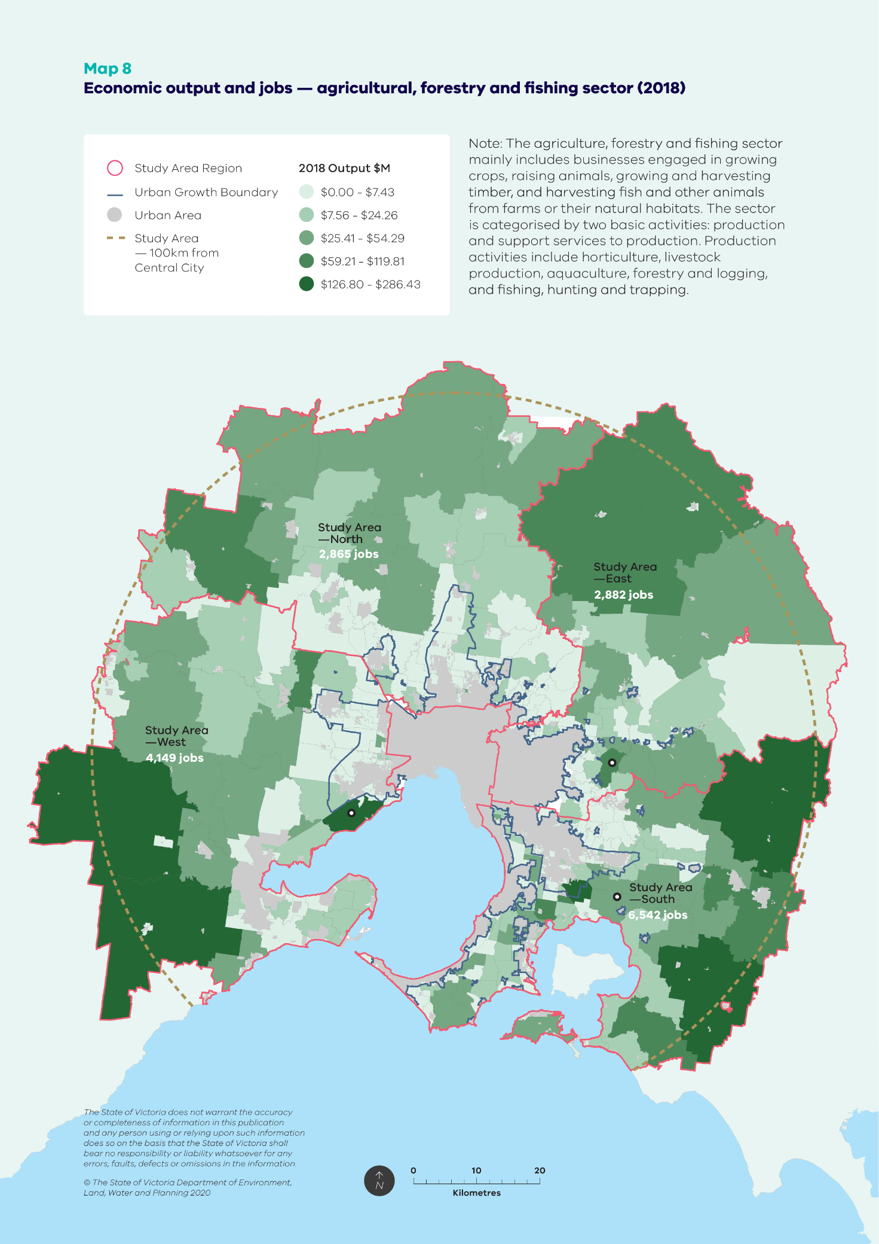

### Managing subdivision and dwelling development in agricultural areas

High levels of land speculation and pressure to accommodate urban development and non‑agricultural uses are principal sources of pressure on agricultural land. If not managed, these pressures can lead to the permanent loss of agricultural land, inflated land prices that are disproportionate to the income the land can generate from farming, higher operational costs (for example council rates), limits on agricultural uses and increases in land use conflicts.

Over past decades, Melbourne’s green wedge and peri‑urban areas have accommodated high levels of residential development. Although state policy seeks to limit new ‘lifestyle’ housing developments in rural areas, in practice many new dwellings constructed in rural areas do not have a farming purpose. Those areas with high levels of amenity, proximity to urban infrastructure and accessibility via major transport routes are popular locations for those seeking a ‘tree change’ or a ‘rural lifestyle’.

A study of eight Victorian peri‑urban councils found that a minimum lot size of 40 hectares for a dwelling would reduce rural development capacity on vacant rural lots from 48,261 to 5911 dwellings, the greatest reduction of 86% occurring in the farming zone.

— Carey & Buxton 2014

The number and spatial distribution of new housing in rural areas also influences the cost of infrastructure and service delivery, future land use potential and increases the number of people exposed to the threat of bushfire and natural hazards.

Following the Royal Commission into the Black Saturday bushfires, planning reforms introduced a requirement that development of land must prioritise the protection of human life and the safety of Victorian communities above all other considerations. In areas of high bushfire risk, the requirements of the Bushfire Management Overlay will mean that subdivision and dwelling applications may not be approved.

Previous subdivisions of rural land have created many small vacant lots across the study area.

Many councils have raised concerns that existing undeveloped lots — already below the minimum lot size — will be developed for housing and will lead to the unplanned and incremental conversion of agricultural to residential use.

#### Subdivision of rural landscapes

Map 9 shows the current extent of subdivision across the study area. A high degree of land fragmentation from subdivision is evident in areas with high amenity, while larger lots are generally clustered to the north and west of the study area.

Lots that are smaller do not necessarily prevent productive use or remove land permanently from production, particularly where the soil or production techniques enable intensive use. For example, the Werribee Irrigation District consists of small lots but is highly productive. However, as landholders commonly expect an entitlement to construct a dwelling on a rural lot, there is a perceived nexus between subdivision and housing. Therefore, larger lots are less likely to result in progressive loss of agricultural land, and more likely to retain versatility for current and future agricultural use.

Tenement controls have historically been used to limit development and rectify a legacy of inappropriate subdivisions. A tenement is a landholding (a group of contiguous lots, parcels of land or Crown Allotments) held in single ownership. Tenement controls work by restricting development to one dwelling per tenement (or specified land size within a tenement). Tenement controls have been used successfully in areas such as the Yarra Ranges Shire. However, as noted in the Panel report for Amendment C148 of the Yarra Ranges Planning Scheme (Lester & Victoria Planning Panels 2018), their administration can be complex, difficult to manage and lack transparency in the planning system.

Another technique historically used to prevent ongoing subdivisions from eroding the viability of farmland is the mandatory requirement on all subdivision permit applications to include a Section 173 Agreement between a council and a landowner. The Section 173 Agreement would encumber the land title and prevent future subdivision into smaller lots for a dwelling. This requirement was introduced in the Victoria Planning Provisions in 1997 but subsequently removed in 2013 as part of reforms to rural zones: it was seen as too onerous and blunt. The Advisory Committee that was appointed to review and report on these rural zone reforms supported the removal of Section 173.

Map 9: Distribution of lot sizes across the study area

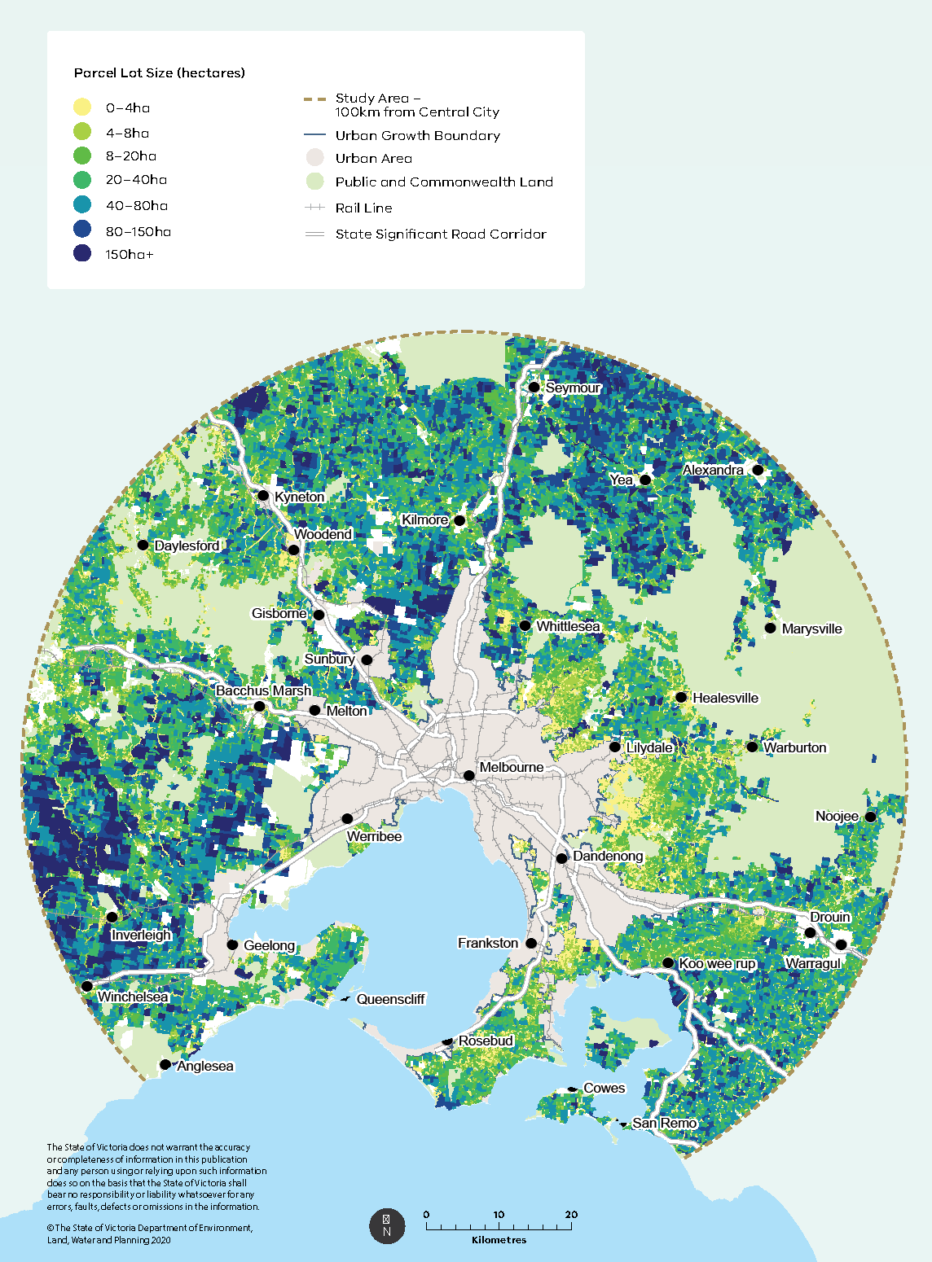

Agreements, but recommended a variation to the subdivision provisions in the Farming Zone and Rural Activity Zone to prohibit the creation of smaller lots for an existing dwelling. This recommendation was not supported by the Victorian Government as the proposed change had not been consulted on as part of the planning zones reform process.

Consequently, there are currently no planning controls in the Farming Zone and Rural Activity Zone that prevent the subdivision of agricultural land into smaller lots for an existing dwelling. The options proposed in this paper would bring the subdivision provisions in the Farming Zone and Rural Activity Zone in line with those in the green wedge zones and prevent small lot excisions in peri‑urban areas.

Options

* Reduce the subdivision potential of Melbourne’s agricultural land by requiring parliamentary ratification of proposals to subdivide land into more lots or smaller lots than currently provided for in the planning scheme in the Farming Zone and Rural Activity Zone within 100 km of Melbourne.  
  Currently, any amendment that increases the subdivision potential of green wedge land requires the approval of the Minister for Planning and ratification of both Houses of Parliament. This option extends the current requirement to agricultural land in peri‑urban areas.
* Amend the subdivision provisions of the Farming Zone and Rural Activity Zone to prohibit the creation of a lot for an existing dwelling that is smaller than the minimum lot size. This only applies within 100 km of Melbourne.

#### Dwellings in rural areas

In the Farming Zone, a dwelling is an ‘as of right’ use if the land meets the minimum lot size requirement of 40 ha and the dwelling is the only dwelling on the lot. If these conditions are not met, it becomes a discretionary use (i.e. permit is required). In the green wedge zones, a dwelling is a discretionary use.

Stakeholder feedback during our Phase 2 consultations indicated that decisions by councils – at times against the professional advice of their officers – have often favoured the approval of dwellings in rural areas and further confirm an assumed nexus between subdivision and housing. For example, during 2011 and 2018, approximately 81 per cent of all dwelling applications that were lodged were approved, with almost 4,500 permits approved for dwellings in rural zones within the study area (Map 10).

Between 2011 and 2018, an average of 560 dwellings per year were approved in rural zones within the study area. Most of these approvals were for dwellings in the Farming Zone (31.4 per cent) and the Green Wedge Zone (30.6 per cent), followed by the Rural Conservation Zone (24.3 per cent).

Figure 4: Percent of dwelling approvals by type of zone during 2011-2018

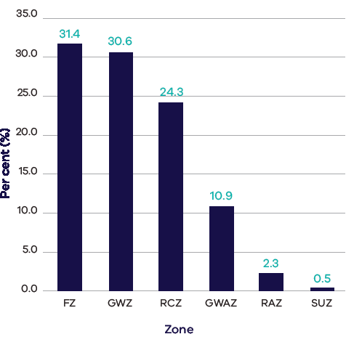

|  |  |
| --- | --- |
| Zone | Percentage of dwelling approvals |
| Farming Zone | 31.4% |
| Green Wedge Zone | 30.6% |
| Rural Conservation Zone | 24.3% |
| Green Wedge A Zone | 10.9% |
| Rural Activity Zone | 2.3% |
| Special Use Zone | 0.5% |

Map 10: Dwelling approvals during 2011-2018

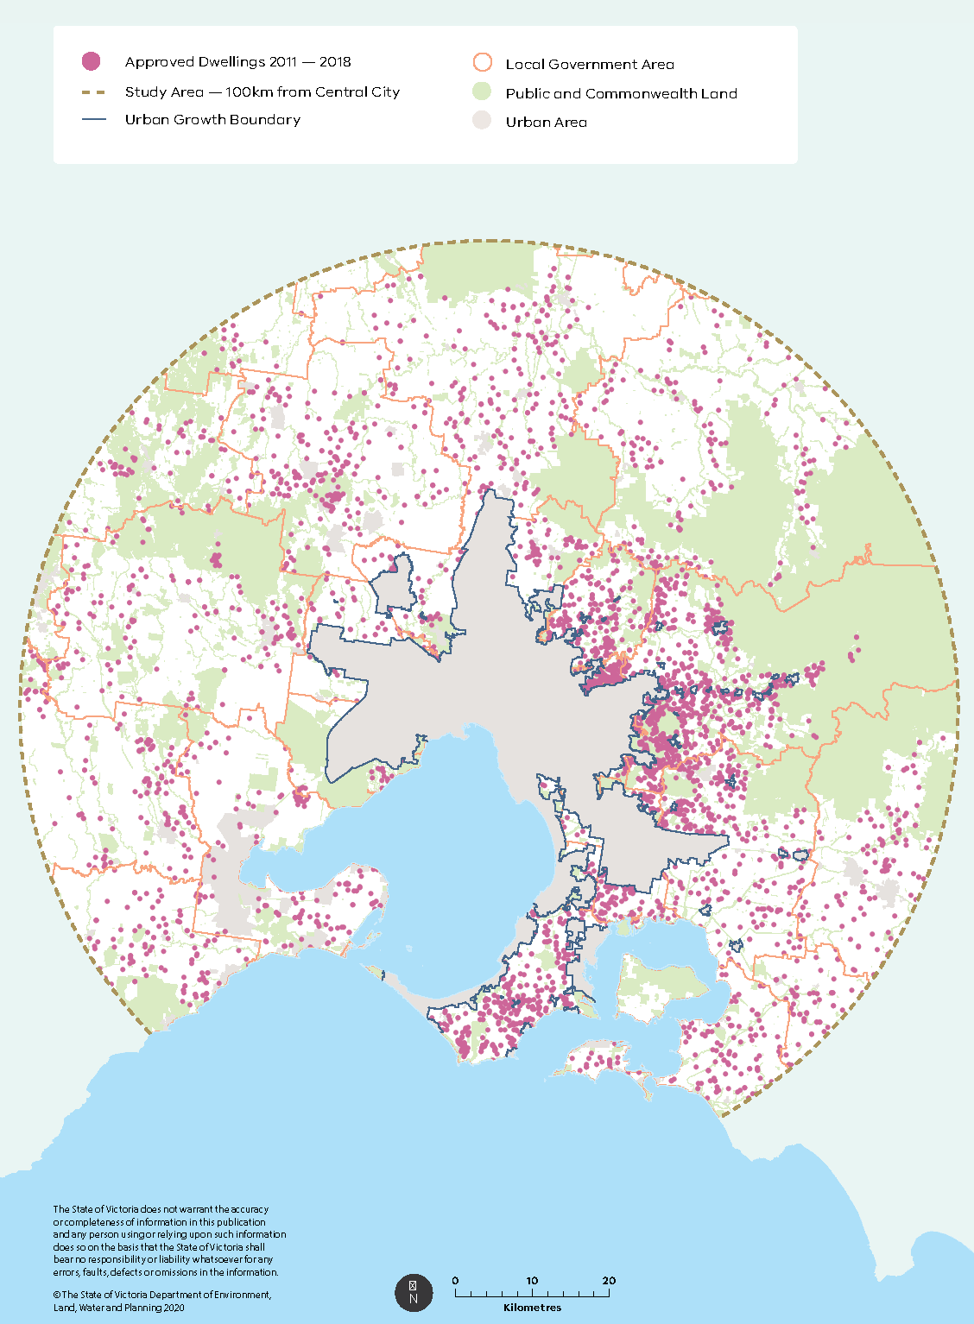

The risks and impacts that result from land fragmentation and proliferation of rural lifestyle living on agricultural land can be reduced if further subdivision and dwelling developments are more tightly controlled, and consolidation of small lots is encouraged. To achieve this, a number of options are proposed below.

In the first instance, these proposed options only apply to land within the study area (100 km from Melbourne’s CBD). However, extending the proposed controls to land beyond the study area could be the subject of further consideration and planning processes.

Options

Better control dwellings in Melbourne’s agricultural areas by:

* adding the following condition to the use of land for an as‑of‑right dwelling in the Farming Zone  
  must not be within 100 km of Melbourne.

This change would remove Dwelling as an as‑of‑right use in the Farming Zone within 100 km of Melbourne.

* Introducing decision guidelines for ‘Dwelling Issues’ into the Green Wedge Zone and Green Wedge A Zone. The decision guidelines would mirror the guidelines provided in the Farming Zone, which require the responsible authority to consider, as appropriate:
  + Whether the dwelling will result in the loss or fragmentation of productive agricultural land.
  + Whether the dwelling will be adversely affected by agricultural activities on adjacent and nearby land due to dust, noise, odour, use of chemicals and farm machinery, traffic and hours of operation.
  + Whether the dwelling will adversely affect the operation and expansion of adjoining and nearby agricultural uses.
  + The potential for the proposal to lead to a concentration or proliferation of dwellings in the area and the impact of this on the use of the land for agriculture and natural systems.
* Introducing application requirements for dwellings into the Green Wedge Zone and Green Wedge A Zone that require applications for dwellings to be accompanied by a written statement that explains how the proposed dwelling responds to the decision guidelines for dwellings in the zone.

This change allows dwellings to be considered but ensures the use does not compromise the long term productivity of surrounding farmland or limit the operation and expansion of agricultural uses.

### Improving decision‑making on agricultural land

Under the current regime of rural zones, councils (in their role as responsible authority) have discretion to issue permits for a range of uses that are considered secondary to the primary purpose of a zone.

In assessing the merits of an application, councils must examine how well the proposed use or development meets the planning scheme objectives set out by state, regional and local policies, and the zone or overlays applicable to the land. The zone includes decision guidelines by which the council assesses an application. For example, a general decision guideline in the current Farming Zone, Green Wedge Zone, Green Wedge A Zone and Rural Activity Zone requires councils to consider, among other matters, ‘Whether the site is suitable for the use or development and whether the proposal is compatible with adjoining and nearby land uses.’

However, no planning practice note exists to guide discretionary decision‑making on agricultural land. The combination of wide discretion and performance‑based provisions that have a degree of flexibility as to how planning scheme objectives are achieved, can lead to uncertainty and inconsistent decisions. Local governments would benefit from access to advice and clear guidelines to help them assess permit applications for their agricultural areas. Clearer guidelines that assist planning authorities to make appropriate discretionary decisions can also increase community confidence in the system.

An expert advisory service could be established to support decision‑makers and facilitate compliance with the planning scheme. Such a service could be shared and accessed by green wedge and peri‑urban councils on request. Advisers could assist local government by providing expert advice on development applications and input in localised strategic planning for agricultural land.

Options

Develop a practice note to guide council decision‑making on planning permits in agricultural areas. The practice note would support the interpretation of the planning scheme and guide discretionary decision‑making, and may outline:

* how to interpret the decision guidelines for zones relating to agriculture
* how to determine whether a discretionary use will lead to loss of agriculture as the primary use of land
* how to apply the ‘in conjunction with’ agriculture test • how to assess and minimise potential land use conflicts in development proposals, including proposals adjacent to agricultural land.

Establish an agricultural referral or expert advisory service to support decision‑makers and facilitate compliance with the planning scheme.

### Future‑proofing Melbourne’s food bowl

Any plans to protect agricultural land must take into account the impacts of climate change on agriculture – a sector highly dependent on natural systems. These impacts include lower rainfalls and reduced reliability of water resources, more frequent and intense flooding events and higher mean temperatures.

Climate change impacts are unlikely to be uniform, with the most severe impacts projected to occur in the north of the state. Compared with other regions, Melbourne’s agricultural land is projected to be less severely affected by climate change (Johnson, Sposito & Faggian 2018) – making the protection of its green wedge and peri‑urban areas ever more important as reliance on its productivity is likely to increase as suitability for agriculture declines in other parts of the state.

The region’s relative resilience to climate change is enhanced by its proximity to large volumes of recycled water and urban stormwater. As Melbourne’s population grows, so too does its volume of urban wastewater and urban stormwater run‑off. These alternative water sources are opportunities to secure water supply for agriculture, create new irrigation precincts, support economic growth and development opportunities in the agricultural sector, and increase the resilience and adaptability of the city’s food bowl.

Feedback from water authorities indicates that the relatively high costs of supplying recycled water (due to high infrastructure costs) have impeded use of this resource. Other challenges of recycled water include water storage during winter when demand for recycled water for agricultural purposes is likely to be low.

Alternative water supplies need to be fit for purpose, which means that it is of suitable quality for its intended use. Some farmers, notably those in the Werribee Irrigation District, have found inappropriately high levels of salt content in their recycled water, which can affect the quality of produce and lead to soil salinity issues. Investigating reducing recycled water salinity from the Western Treatment Plant has been identified as a key action in the Werribee Catchment Integrated Water Management Forum Strategic Directions Statement.

Case Study: Werribee Irrigation District

As recognition of the importance of recycled water increases (for example the Melbourne Sewerage Strategy), so too does experience with its use. These experiences have highlighted the issue of salinity in recycled water, which has implications for its affordability and viability.

The Werribee Irrigation District (WID), located south‑west of Melbourne and occupying over 3,000 hectares of land, is one of the largest market garden areas of Victoria. The Werribee Irrigation District relies on water from both natural river systems and recycled water from the Western Treatment Plant, and is a major producer of lettuce, broccoli and cauliflower. The Werribee Irrigation District’s recycled water scheme was introduced in 2004 following a period of prolonged drought and has become a vital supplier of water to the Werribee Irrigation District (approx. 40 per cent of its irrigation water is recycled water) due to ongoing shortage of river and ground water.

Reducing the salt content of recycled water in the Werribee Irrigation District is an ongoing challenge. The salt in recycled water from the Western Treatment Plant is higher than that of many other treatment plants, primarily from development of industrial uses west of Melbourne and associated ongoing saline‑rich trade waste discharges. The plant’s sewerage system is also affected by intrusion of saline groundwater from Port Phillip Bay.

The Western Treatment Plant currently does not specifically treat its recycled water for salt – the typical salinity of its recycled water is 900 to 1,100 mg/L total dissolved solids (or 1,600 to 2,000 electrical conductivity [EC]). By comparison, the most appropriate and sustainable uses of recycled water require a salinity level of 550 milligrams per litre total dissolved solids (or 1,000 electrical conductivity) (Department of Sustainability and Environment 2009).

A desalination plant was proposed to reduce salinity in the water supplied to Werribee Irrigation District irrigators. However, in 2007, Melbourne Water decided not to proceed with the plant. Its analysis found that to cover the cost of building and running the desalination plant, the price of desalinated water would need to be approximately $3,000 per megalitre – well above the commercial capacity of irrigators. In the meantime, reductions in salinity are achieved by mixing recycled water with river water to form a ‘shandy’ before supplying to irrigators. From time to time, river water is also affected by high salinity, pathogens and algal outbreaks, which also compromise the quality of water supplied to irrigators and is a cause of frustration for growers.

The future viability of the Werribee Irrigation District for agriculture hinges on availability of water that is of suitable quality and at a cost that is sustainable for vegetable growing. Melbourne Water is continuing to investigate options to reduce the salinity of recycled water from the Western Treatment Plant, with a combination of source control, diversion, blending with less saline water and salt‑reduction treatment likely to be the most viable approach.

All options come with considerable costs. In any justification to fund shortfalls, the broader value of agricultural enterprise for our common future, the costs and benefits of water management in a region, as well as the sale value of recycled water, need to be considered.

During our Phase 2 consultations, many farmers in Werribee South indicated that in the absence of a reliable supply of fit‑for‑purpose water, they would seek to convert use of their land to housing, believing it will enable them to sell their land at ‘residential value’ and fund investment elsewhere or alternatively, move out of farming.

#### Safeguarding agricultural land with potential access to alternative water

Access to fit‑for‑purpose water underpins productive agriculture and, in our Phase 2 consultation, was identified by farmers and other key stakeholders as the most important criterion for defining important agricultural land.

Melbourne has two main treatment plants in the east and west, as well as many smaller treatment plants located around Melbourne (see Map 11). Based on consultation with water authorities, we estimate that on average, approximately 700ML /day of recycled water is currently available but not utilised or committed, and this is forecast to grow as Melbourne’s population grows.

There are opportunities to expand irrigation infrastructure that delivers reliable water supply to farmers in Melbourne’s green wedge and peri‑urban areas. Safeguarding these opportunities and ensuring their future viability will require the effective alignment and integration of land use planning, water management policy and infrastructure provision.

A way of achieving such integration is to recognise areas with potential for water infrastructure and include this future potential as a factor for consideration in land use decision‑making today. Such an approach enables protection of land from encroachment in the short term while signalling its potential for water investment and access opportunities in the longer term.

Recent development on this front has been positive, such as the decision by Western Water to undertake a detailed planning phase for a new Western Irrigation Network. Once established, the Western Irrigation Network will support recycled water use that will not only protect the environment but will also add to the local economy and improve agricultural productivity in the west. It is important that our land use planning system effectively responds to current needs – and anticipates potential future investments in water infrastructure.

The options in this paper have the objective of anticipating, in our land use planning, those opportunities to expand use of recycled water and stormwater in the future. Only by building in or safeguarding such opportunities can we meet the dual challenges of ever‑increasing volumes of urban wastewater and realise the value and opportunities of this waste stream for a resilient food system in Melbourne.

The feasibility of opportunities for alternative water is continually being reviewed and assessed by water authorities. Indicative recycled water supply areas are shown on Map 11. These areas were identified from consultation with water authorities as locations that have potential access to alternative water in the future. In addition, areas in close proximity (1 km) to existing water infrastructure (for example existing wastewater treatment plants, recycled water pipe networks) are also considered to have potential access to alternative water in the future.

Making the best use of all water sources, including recycled water and stormwater, to minimise our call on rivers and to protect our environment, is an integral part of the Victorian Government’s Water for Victoria plan and further echoed in Plan Melbourne, which includes a policy to ‘Reduce pressure on water supplies by making the best use of all water sources’ (Policy 6.3.1).

Options

Develop a new regional policy, Clause 14.02‑3R of the Planning Policy Framework (Preserving opportunities for irrigated agriculture around Melbourne), with the following objective:

* safeguard land with potential for future growth in irrigated agriculture, based on alternative water use.

The new policy would:

* delineate areas with potential for future growth in irrigated agriculture
* ensure changes to land use in these areas do not limit potential opportunities for development and expansion of irrigation agricultural precincts
* maximise the beneficial re‑use of treated wastewater and stormwater for agricultural purposes.

Map 11: Water for agriculture – existing infrastructure and future opportunities

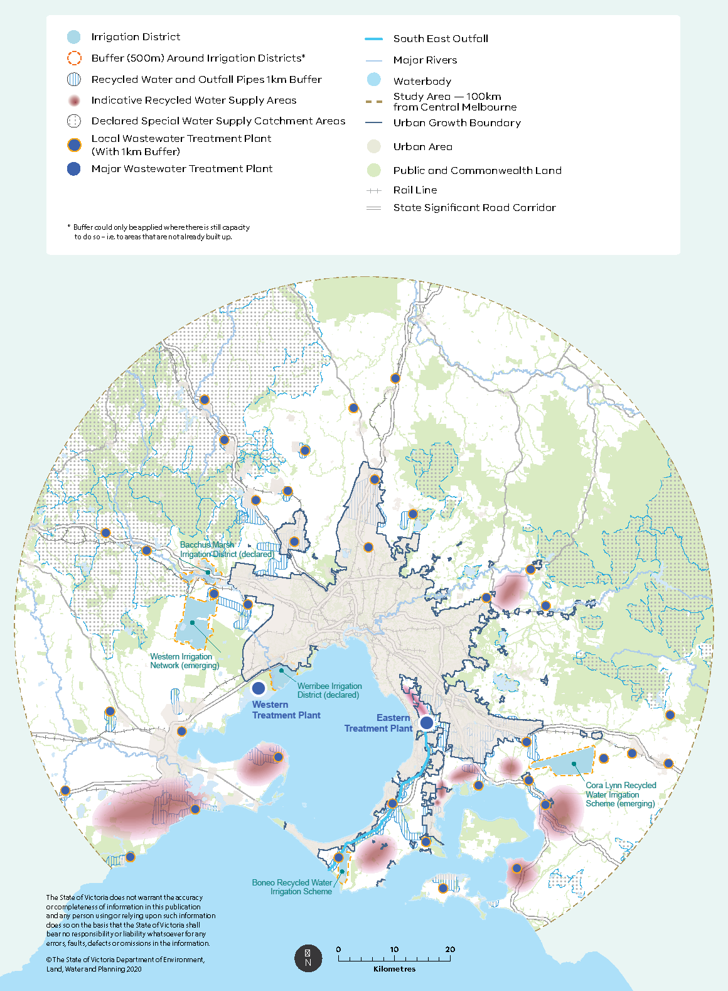

Note: This map does not depict the bulk water supply systems that can be used under some circumstances to support agriculture.

#### Supporting agricultural land use in Melbourne’s irrigated districts

In September 2019, the Victorian Government introduced a new state planning policy – Clause 14.02‑3S of the Planning Policy Framework (Protection of declared irrigation districts) – that outlines the objectives and strategies for managing and protecting irrigation districts declared under Part 6A of the Water Act 1989. The policy protects agricultural land currently serviced by irrigation infrastructure, by ensuring that non‑agricultural use of land does not undermine the integrity of irrigation infrastructure and complements existing and future agricultural production. By aligning agricultural use of land to available water infrastructure, this policy is key to protecting current access of agricultural land to water.

Around Melbourne, there are currently two existing declared irrigation districts: the Werribee Irrigation District and Bacchus Marsh Irrigation District. In addition, there is the Boneo Recycled Water Irrigation Scheme and two emerging irrigation districts, the Western Irrigation Network and the Cora Lynn Recycled Water Irrigation Scheme. These irrigation districts are shown on Map 11.

There are also a number of smaller recycled water schemes that operate throughout the study area, ranging from one‑off opportunistic operations located proximate to water recycling plants, to larger schemes involving many properties (for example areas on the Bellarine Peninsula and Surf Coast). Properties connected to smaller recycled water schemes are often dispersed throughout an area. Unlike the established and emerging irrigation districts, smaller recycled water irrigation schemes do not have defined precinct boundaries.

Surface water and groundwater resources are also important to agricultural use of land surrounding Melbourne. However, as Victoria becomes warmer and drier, there will be less run‑off entering rivers, streams and dams, and reduced groundwater recharge. This decrease in rainfall and reduction in water availability will have consequences for agriculture. Protecting agricultural land that has secure supplies of water and existing infrastructure will become increasingly important to mitigate the risks of reduced water availability.

This paper proposes to develop a new planning overlay applicable to food‑producing areas with access to secure water supplies and irrigation infrastructure. The proposed new overlay would be designed to align with and support the policy intent of Clause 14.02‑3S (Protection of declared irrigation districts).

The purpose of the overlay would be to:

* identify and protect areas with secure water resources for agricultural uses
* provide certainty that these areas will continue as key agricultural areas into the future
* protect areas of significant water infrastructure investment
* limit non‑farming and incompatible uses that would restrict ongoing productive use of the land for agricultural purposes
* protect buffers of identified areas from encroaching sensitive uses such as dwellings to ensure agricultural activities continue without restrictions
* facilitate agricultural uses in areas covered by the overlay by reducing permit requirements for buildings and works associated with agriculture and by providing exemptions from notice and review requirements.

In the first instance, the new overlay could apply to irrigation districts with defined boundaries, including Werribee and Bacchus Marsh irrigation districts, the Boneo Recycled Water Irrigation Scheme, the Western Irrigation Network and the Cora Lynn Recycled Water Irrigation Scheme. A process to guide application of the overlay to other areas could also be developed. Such an overlay would ensure all agricultural areas currently serviced by recycled water can be properly protected in the planning scheme. As new irrigation districts are established and alternative water use for food production is expanded, the overlay could be extended to these additional areas as they emerge over time.

Options

Introduce a new overlay designed to protect food‑producing areas with access to secure water supply and irrigation infrastructure. The purpose of the overlay would be to:

* identify and protect areas with secure water resources for agricultural uses
* provide certainty that these areas will continue as key agricultural areas into the future
* protect areas of significant water infrastructure investment
* limit non‑farming and incompatible uses that would restrict ongoing productive use of land for agricultural purposes
* protect buffers of identified areas from encroaching sensitive uses such as dwellings to ensure agricultural activities continue without restrictions
* facilitate agricultural uses in areas covered by the overlay by reducing permit requirements for buildings and works associated with agriculture and by providing exemptions from notice and review requirements.

In conjunction with the development of a new overlay, establish a process to determine where the new overlay should be applied. In the first instance, it is proposed to apply the overlay to irrigation districts with defined boundaries, including the Werribee and Bacchus Marsh irrigation districts, the Boneo Recycled Water Irrigation Scheme, the Western Irrigation Network and the Cora Lynn Recycled Water Irrigation Scheme. There is potential to cover further areas once a clear process and criteria for its application are confirmed.

### Strengthening referral and notice requirements

For the majority of planning permit applications, council has discretion to refer or notify the application to other agencies or third parties, depending on the relevant planning officer’s assessment of its potential for material detriment (i.e. potential to adversely affect a person’s use or enjoyment of their land). When an application is assessed as having, or likely to have, potential impacts on surrounding land uses, it is important that relevant agencies and third parties are consulted.

The key purpose of the referral process is to give a person or body whose interests may be affected by a permit application, the opportunity to advise the responsible authority whether a permit should be granted.

The Planning and Environment Act 1987 provides for three potential types of third parties in applications for planning permits:

* ‘determining referral authorities’ who have veto power and to whom council must send a copy of the permit application
* ‘recommending referral authorities’ who can provide recommendations only but must also be sent a copy of the application
* ‘affected persons’ who are sent a notice about the application — these persons are typically neighbours but can also be agencies or other entities specified in the planning scheme for certain applications.

Some of the key referral authorities specified in Clause 66 (Victoria Planning Provisions) who are consulted for a permit application, are:

* water supply authorities and catchment management authorities are determining referral authorities for applications in Special Water Supply Catchment Areas
* EPA Victoria is a determining referral authority for anything requiring a works approval, licence or licence amendment under the Environment Protection Act 1970
* the Minister for Agriculture is a determining referral authority for any application to use or develop land for a cattle feedlot
* the Secretary to the Department administering the Water Act 1989 is a recommending referral authority for renewable energy facilities located within a declared irrigation district.

Given the elevated risk of land use conflict between farming and non‑farming neighbours, strengthening referral and notice requirements for areas with intensive agricultural activity could be considered for applications relating to:

* uses that require a planning permit in protected irrigation districts and their associated buffers
* land identified as having potential for access to alternative water in the future.

Expert advice from water authorities and catchment management authorities on these applications will assist councils to consider:

* the compatibility of the proposed use or development with existing or potential access to water resources and
* whether the proposed use or development will adversely affect future development or expansion of recycled water infrastructure.

Option

Ensure water authorities have a clear role in the decision‑making process for applications to use or develop land in protected irrigation districts or in non‑urban areas identified as having potential for access to alternative water in the future.

### Supporting agricultural diversification, value‑adding and innovation

Land uses underpinned by an agricultural activity can provide opportunities for income diversification and value‑adding. This is recognised by the Planning Policy Framework, which ‘encourages diversification and value‑adding of agriculture through effective agricultural production and processing, rural industry and farm‑related retailing’ (Clause 14.01‑2S, Victoria Planning Provisions).

Such uses have proliferated in high amenity locations such as the Yarra Valley and Mornington Peninsula, where wine production has been combined with restaurants, tourist accommodation and other visitor experiences.

However, the success of such value‑adding in these areas also poses significant risks to the ongoing agricultural use of land. Demand for a rural lifestyle, shops and tourist accommodation may drive change in land use in these areas, potentially inflate land values above its productive value and could hinder commercial agriculture. There is a risk that only the agricultural activity that maintains the area’s amenity and rural ‘brand’ is maintained, while commercial agriculture is displaced. A balance is required to ensure that on‑farm diversification does not exceed a level beyond which agriculture becomes a subordinate use of the land.

#### Farm gate sales

The sale of primary produce through farm gates is one of the most traditional ways farmers sell their produce. Farm gate sales give farm businesses a direct link to their customer base and a viable direct route to market for their produce. Research into Australian food purchasing consumer trends indicates there is increased public interest in buying local artisan products, supporting local communities and industries, making healthy food choices and reducing environmental and carbon footprints (Woodburn 2014).

Findings from our Phase 2 consultations, as well as direct feedback from farmers to both state and local government, suggest there is scope to reform current planning provisions on farm gate sales.

Farm gate sales – referred to in the planning scheme as ‘Primary produce sales’ – is currently restricted to primary produce grown on the land or adjacent land, and may include the sale of processed goods made substantially from the primary produce.

In the Farming Zone, Rural Activity Zone, Green Wedge Zone and Green Wedge A Zone, no permit is required for ‘Primary produce sales’ providing:

* the use is not within 100m of a dwelling in separate ownership and
* the area used for the display and sale of primary produce does not exceed 50m2.

These conditions are designed to ensure that the as‑of‑right use is not too large in building footprint, is not poorly sited and minimises potential for adverse amenity impacts. If the use does not meet these conditions, the requirement for a permit is triggered in these zones.

Planning changes to broaden and promote primary produce sales may assist farming activity and remove unnecessary red tape. However, care must be taken to ensure the right balance is struck and to avoid farm gate sales from becoming de‑facto retail shop operations, which are not appropriate uses of rural land.

Options

Update the definition of ‘Primary produce sales’ to:

* allow sale of ancillary goods (such as crackers and bottled drinks) to be consumed with the primary produce (for example cheese or strawberries)
* allow sale of produce from land held in one ownership to support farms comprising divided holdings in the same ownership
* allow a percentage of produce sold to be sourced from local producers within 5 km of the use.

#### Host farms

A ‘Host farm’ is defined as ‘an agricultural property used to provide accommodation for persons, away from their normal place of residence, to experience living on land used for agricultural purposes’ (Clause 73.03, Victoria Planning Provisions). The purpose of host farms is to accommodate people for education, tourism or a visitor experience, such as students who visit to learn about agricultural production.

There are two major issues with the current definition of ‘Host farm’:

* it is unclear on the extent to which this use must be linked to agricultural use of land
* the definition is silent as to what is an appropriate scale of a host farm (for example the number of bedrooms within a host farm).

A balance between preserving environmental values while supporting value‑added tourism activities is needed, and a lack of guidance on this could detrimentally affect agricultural areas.

Concerns have been raised that proponents can seek development permits for this land use with limited justification and limited evidence of productive agricultural enterprise. Previous consultation undertaken with local government during Phase 1 has highlighted that the current definition of ‘host farm’ enables proponents to justify development of commercial accommodation in green wedge and peri‑urban areas.

It is proposed to clarify the definition of ‘host farm’ to emphasise its close connection to ongoing productive agricultural use of the land.

To further support host farms as a means to value‑add to existing productive farms, this land use could be changed to an as‑of‑right use on the condition that the scale of the development is restricted to accommodate 10 people at any one time. A similar threshold currently applies to bed and breakfast accommodation, which is an as‑of‑right use when limited to 10 people. If this condition for a host farm is not met, the use will require a permit.

Options

* Amend the definition of the land use term ‘Host farm’ to require a direct link to an ‘operating agricultural property’.
* Move ‘Host farm’ to a Section 1 (as‑of‑right) use in the Farming Zone, Rural Activity Zone, Green Wedge Zone and Green Wedge A Zone, providing it is undertaken in conjunction with agriculture and accommodates no more than 10 people away from their normal place of residence at any one time. If these conditions are not met, the use will require a permit.
* If the Host farm is within 100 km of Melbourne, the use must be in conjunction with Agriculture, Natural systems, Outdoor recreation facility, Rural industry or Winery.

## Managing use of green wedge and peri‑urban land

As Melbourne continues to grow, pressure to accommodate urban uses of green wedge and peri‑urban areas will increase. Urban uses of these areas can be problematic for various reasons:

* their use, scale and form may be inconsistent with the preferred non‑urban roles and values of these areas
* these uses may be more suited to urban areas where existing infrastructure and services are accessible
* some urban uses are more suited to mixed use or residential environments where choice of transport, such as walking, cycling and using public transport, is available
* there are risks due to natural hazards, such as bushfire, and a clear responsibility for planning to limit the potential loss of life due to inappropriately located development.

The green wedge and peri‑urban region extends across vast and diverse landscapes. Proposed land uses and associated development outcomes that are considered appropriate in one area may be inappropriate for another. For this reason, identifying the roles and values of these different areas across the region is vital.

A decision about what is appropriate use or development in a given area can be improved by considering the context and location of the relevant site. The inclusion of these factors for consideration would also promote integrated management of these important areas.

Section 3.1 of this paper discussed the value of developing regional policies for key regional features and assets of the green wedges to enhance alignment of state and local government planning policies.

This section focuses on the following three key areas:

* the urban–rural interface
* current and future infrastructure needs of the population
* discretionary uses of land in green wedge and peri‑urban areas.

### Managing the urban–rural interface

Land at the interface of urban areas and rural land tends to be highly contested and is most pressed to accommodate land uses to service an urban population. Conflicts often arise because land parcels are larger in size and more affordable relative to urban land, and there is ever‑increasing market pressure to convert rural to urban uses.

Pressure for urban expansion has contributed to the degradation of some green wedge and peri‑urban locations adjoining the Urban Growth Boundary, where land is often not properly managed in the hope of possible future urban expansion. Speculative land banking has also occurred, in which otherwise useful or productive rural land has been left idle, resulting in a range of negative outcomes (for example invasive weed species, domestic animal problems, rubbish dumping). In some cases, such banking has had deleterious effects on surrounding land and habitats that are still being used for agricultural and rural activities.

The planning and design of urban areas and rural land have historically been undertaken as discrete tasks without adequate attention to how urban development abutting rural land should interact (and vice versa). Local government planning authorities have struggled to resolve tensions at this interface, particularly as the primary pressures are the result of regional or metropolitan forces. In the Westernport GREEN WEDGE MANAGEMENT PLAN, Casey City Council attempted to manage this tension by examining how the permanent edge of its metropolitan area may be more recognisable and attractive through better definition and design, rather than just be a ‘temporary, line‑on‑a‑map’ boundary.

An integrated region‑ and/or metropolitan‑level response that acknowledges and plans for these interfaces can assist councils and improve consistency of management and decision‑making across the green wedges. In proposing a region‑based strategic planning model for green wedges (see Section 3.1 of this paper), a policy response to manage the urban—rural interface should be included in the process to develop regional Land Use Framework Plans (Action 1, Plan Melbourne).

The development of clear and strategic policy guidance on land use and development in these interface areas will support the Victorian Government’s commitment to maintain the integrity of the Urban Growth Boundary, promote policy certainty for decision‑makers and reduce expectations that green wedge and peri‑urban land is ‘urban land in waiting’.

Figure 5: Example of a ‘hard’ edge between urban and green wedge land (Hillside, north‑west Melbourne)

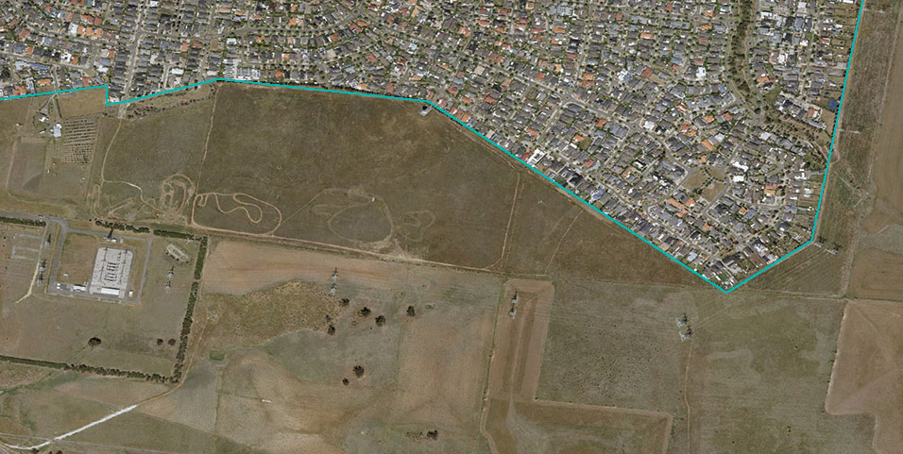

Options

Provide planning practice guidance for local authorities on how to consider and direct planning for urban–rural interface areas.

* Provide guidance on preferred transitional land uses for land at the urban–rural interface and provide urban design guidance that supports a permanent edge and buffer to the urban area through region‑level strategic policies (see proposed regional policy for green wedges, Section 3.1).
* Introduce conditions in land use zones for particular uses, such as public open space or uses serving urban populations (for example schools, places of worship and infrastructure), to be located in transitional locations only.
* To improve transition between rural and urban land use, introduce the ability to apply other rural zones more suited to the roles and land conditions of particular locations (for example Rural Living Zone, Farming Zone), provided the minimum green wedge subdivision provisions are retained.

### Planning for future infrastructure and energy needs

State policy recognises the importance of green wedges and some peri‑urban areas in the provision of significant state and regional infrastructure, such as airports, quarries, waste and resource recovery centres, water treatments, energy and utilities. These facilities provide important services for the population and are vital to the ongoing functioning of the city and state.

The core planning challenges of such infrastructure relate to where these facilities are to be located and how planning controls can be applied to ensure their safe and ongoing operation. These challenges will require work across different areas of government to provide integrated and coherent responses that anticipate future needs. It is also possible that land with potential for infrastructure competes with land use for agriculture. Therefore, while this paper does not propose any options for the planning of these uses, they are important to discuss in the context of planning for the green wedge and peri‑urban areas.

This section outlines the planning challenges posed by the following potential infrastructure in our green wedges and peri‑urban areas:

* waste and waste recovery facilities
* extractive industries
* renewable energy generation and facilities.

#### Waste and resource recovery

The green wedge and peri‑urban areas of Melbourne have historically accommodated many of Victoria’s waste and resource recovery facilities. Landfills and recycling infrastructure often require land with appropriate buffers to separate activities from other sensitive land uses, such as residential use. These sites represent significant investments in ensuring Victoria has the capacity to live sustainably, repurpose recyclable material and avoid unnecessary extraction of virgin resources elsewhere.

The recently released Recycling Victoria policy and action plan sets a range of ambitious goals and targets to improve recycling outcomes in Victoria. This includes diverting over 80 per cent of Victoria’s growing waste from landfill by 2030 and working with the Australian and other state governments to ban the export of waste materials.

Meeting our recycling targets and transitioning away from exporting our waste material means that we must process more recycled materials locally, which will require more appropriately located recycling and material processing infrastructure.

The Victorian Recycling Infrastructure Plan (VRIP), formally the Statewide Waste and Resource Recovery Infrastructure Plan, provides a roadmap for the waste and recycling infrastructure Victoria needs to safely manage our growing waste streams and to increase the amount of this waste we recycle. It also identifies hubs of State significance, which provide critical recycling services to the Victorian community.

Provision of these services needs to be balanced with the protection of natural assets to ensure sustainable and reliable waste and resource recovery infrastructure that minimises further development within natural areas.

Appropriate locations for waste and recovery infrastructure need to be identified and safeguarded, including those which are already in operation where they make a significant contribution to our resource recovery capacity. Options to re‑purpose suitable land, such as former extractive sites, in green wedge and peri‑urban land should be explored, so this important infrastructure can continue to be accommodated.

#### Extractive industries

Green wedge and peri‑urban areas contain a number of existing quarries as well as areas of extractive resources with potential for future development.

Extractive industries are integral to the growth and liveability of Melbourne and the State of Victoria. Relative to 2015, Melbourne’s demand for mineral and stone resources is expected to more than double by 2050 to over 100 million tonnes (Department of Economic Development, Jobs, Transport and Resources, 2018). Demand for these resources is driven by sustained growth in residential construction and major infrastructure projects, such as Fishermans Bend and the Metro Tunnel. To minimise the cost of infrastructure projects, it is important that these resources are located close to where they are needed. Failure to ensure a sufficient supply of extractive resources proximate to our growth areas and infrastructure projects – particularly in Melbourne – will likely increase project costs.

The importance of protecting and carefully planning for these vital resources is recognised in Plan Melbourne and in Clause 14.03‑1S (Planning Policy Framework). The protection of these resources must also be balanced with the potential impacts of extractive operations on local amenity and other important land uses.

Extractive Industry Interest Areas (EIIAs), which were established in the 1990s by the Geological Survey of Victoria, are used to define areas of extractive resource potential. However, the identification of Extractive Industry Interest Areas has not protected these areas from competing land use pressure.

The Victorian Government’s ‘Helping Victoria Grow: Extractive Resources Strategy’ (2018) has identified the need to refresh Extractive Industry Interest Areas. In addition, work is underway to identify and secure Strategic Extractive Resource Areas (SERAs) which contain extractive resources of strategic significance for Victoria’s future needs.

Planning for Strategic Extractive Resource Areas aims to secure strategically important resources as well as protect existing operations by preventing encroachment of incompatible uses. Similar to some agricultural activities, quarries can conflict with surrounding sensitive land uses. Planning controls designed to minimise potentially incompatible land uses in Strategic Extractive Resource Areas would complement the use of land for agricultural purposes. Within quarry buffer areas, many agricultural uses are considered complementary activities and are encouraged.

#### Renewable energy generation facilities

To meet the challenges of climate change, the Victorian Government is committed to accelerating the development of well‑sited and well‑designed renewable energy generation facilities in Victoria. This will help reduce emissions, create jobs, and put downward pressure on energy prices, while meeting legislated generation targets.

The government recently amended all of the state’s planning schemes to introduce new requirements for renewable energy facilities. It also released the Solar energy facilities design and development guidelines (Department of Environment, Land, Water and Planning 2019) to guide development of, and granting of a permit for, large‑scale commercial solar farms. Renewable energy generation facilities currently require a planning permit in the green wedges (with the exception of wind energy facilities). While these facilities could potentially lead to land use conflicts and concerns that they run counter to desired planning outcomes for green wedge and peri‑urban areas, the guidelines balance these concerns with opportunities to realise economic and environmental benefits.

Renewable energy generation facilities offer opportunities for using land for future infrastructure services while remaining compatible with green wedge and peri‑urban values. Site selection and local context is key in this regard. There may also be opportunities to re‑use sites where amenity has been adversely affected (for example redundant landfills) for renewable energy generation.

### Managing discretionary uses

The zones applicable to land across the green wedge and peri‑urban areas of Melbourne categorise land uses into three types:

* Section 1 uses, which are ‘as of right’
* Section 2 (discretionary) uses, which require proponents to seek a planning permit
* Section 3 uses, which are prohibited.

As‑of‑right uses are preferred primary land uses, while discretionary uses are considered appropriate when the proposal is considered to have satisfied the conditions prescribed in policies and planning controls of the planning scheme.

There are a considerable number of discretionary uses that are permitted on rural zoned land in green wedge and peri‑urban areas, subject to approval. Most of these uses are relevant and appropriate complementary uses that support the policy objectives and intent of agricultural, tourism, recreational, infrastructure, resource extraction and rural industry pursuits. However, regular review of the appropriateness of the conditions under which these uses are allowed is necessary to achieve the broader objective of protecting and enhancing green wedge and peri‑urban values.

Currently, state and local policy directions and planning controls seek to manage the location of discretionary land uses through evaluation of various – at times competing – considerations in state and local policy.

The key measures for managing discretionary use and development in rural zones applying to green wedge and peri‑urban land include:

* decision guidelines and conditions for specific uses
* managing the scale of development or linking it to preferred primary land uses through the ‘in conjunction with’ test
* managing ancillary use
* requiring a minimum lot size for a use to be considered for permit approval
* considering any identified separation distances (‘buffers’) to protect the ongoing operation of significant agricultural use.

These measures are intended to uphold the primary objectives and strategies of the relevant zone for the land.

It is generally agreed that land with extensive open space requirements that is used for outdoor recreation, such as golf courses and sports training facilities, can be appropriately situated in some green wedge locations rather than occupy scarce land close to transport and services within the Urban Growth Boundary. However, population growth and pressure for more intensive use of urban land brings with it a demand for a greater range of urban uses of green wedge land that would arguably be more appropriate in an urban environment.

Proximity to Melbourne and well‑developed tourism and visitation assets in select areas make them attractive and convenient destinations and have contributed to increased visitation and demand. This trend is further driven by population growth and state policy to encourage Victoria’s visitor economy. Demand for tourism and visitation is most prominent in the green wedges of the Mornington Peninsula, Yarra Valley and Dandenong Ranges and more specific locations elsewhere.

Options that support tourism businesses and promote new tourism products are vital for the state’s economy as well as for local communities of many green wedge and peri‑urban communities. However, a balance must be struck between servicing a visitor economy, ensuring productive land uses such as agriculture and rural industries, and protecting amenity, biodiversity and environmental values.

In its review for this consultation paper, the Department considered the broad classes of use across the study area. Some land uses have been identified as not requiring current reform, as they are deemed to satisfactorily realise state policy objectives – these include agricultural uses, rural industry, leisure and recreation and food and drink premises.

This section discusses some of the more contentious discretionary uses of Melbourne’s green wedge land and peri‑urban areas, and the challenges of determining their ‘appropriateness’ in these areas. These discretionary uses include:

* educational facilities
* places of assembly – a land use where people congregate for religious, spiritual or cultural activities, entertainment or meetings. This paper specifically considers ‘Places of worship’, ‘Halls’ and ‘Exhibition centres’.
* certain accommodation uses
* food and drink premises
* use of land for data centres.

While the options presented below primarily aim to increase protection of Melbourne’s green wedges, there is opportunity to further expand the controls to the peri‑urban area.

#### Educational facilities

Following a 2013 amendment to rural zones (VC103), primary and secondary schools became discretionary uses of land in rural zones applicable to green wedge and peri‑urban land. Since this amendment, there have been 39 permit applications for new schools on rural green wedge land – 35 per cent of these applications have been appealed to the Victorian Civil and Administrative Tribunal.

These uses often require large areas of open space for sports and recreation facilities. Buildings and grounds for primary and secondary schools need to be of sufficient scale to be commercially viable and to accommodate students and staff. Their scale often introduces significant built‑form outcomes in the rural landscape that has potential to be inappropriately large and obtrusive.

State planning policy on education facilities (Clause 19.02, Planning Policy Framework) seeks to ensure that these facilities are located to maximise access by public transport and safe walking and cycling routes. When these facilities are located in green wedge and peri‑urban areas, they can be remote from public transport, sustainable active transport options (for example walkable catchments) and from necessary infrastructure and services. Furthermore, these uses promote a significant amount of traffic and people movement, including children reliant on private vehicle travel.

Primary and secondary schools are also sensitive uses that:

* can conflict with many productive rural uses of land
* require significant modification of the natural environment
* can potentially introduce a significant number of people to incompatible land uses and natural hazards – particularly in areas of agricultural production, environmental significance or bushfire risk.

Options

* Amend the Green Wedge Zone, Green Wedge A Zone, Rural Conservation Zone and Clause 51.02 (Victoria Planning Provisions) to insert conditions of use requiring that primary and secondary schools must be located adjacent to the Urban Growth Boundary and adjoin, or have access to, a road in a Road Zone.
* Amend the Green Wedge Zone, Green Wedge A Zone, Rural Conservation Zone and Clause 51.02 (Victoria Planning Provisions) to insert conditions of use that prohibit schools in high bushfire risk areas (i.e. areas subject to the Bushfire Management Overlay).

#### Places of worship

Prior to the 2013 amendments to rural zones (VC103), places of worship were a prohibited use in green wedge zones. Following the amendments, these places became discretionary uses without conditions to manage location, relationship with rural land use, and the size and scale of the use and development.

More recently, a range of faiths and cultures have sought to establish community facilities in relatively remote locations where land is relatively affordable and can accommodate large gatherings without causing nuisance. Since 2014, there have been 34 applications for new places of worship on rural land across the green wedges.

Applications for places of worship in Melbourne’s green wedges have caused a degree of concern – nearly 40 per cent of all permit applications for new places of worship in the green wedges have been appealed to Victorian Civil and Administrative Tribunal. Some stakeholders consider the introduction of these uses, and the number of proposals and projects since its introduction, to have:

* eroded green wedge and peri‑urban values, character and landscapes
* resulted in loss of productive agricultural land
* created conflict between urban and non‑urban uses of land.

Recent experience with a number of proposals for places of worship in the green wedges have presented the government with an opportunity to consider how conditions that manage the size, scale and location of such use and development can be introduced.

Places of worship are also sensitive uses that can conflict with many productive rural uses, involve significant modification of the natural environment and potentially introduce a significant number of people to natural hazards if situated in areas of agricultural production, environmental significance or bushfire risk.

These uses also promote a significant amount of traffic and people movement that can strain infrastructure and risk negative effects on the rural amenity of areas.

Options

* Amend the Green Wedge Zone, Green Wedge A Zone, Rural Conservation Zone and Clause 51.02 (Victoria Planning Provisions) to insert conditions of use requiring that places of worship must be located adjacent to the Urban Growth Boundary and adjoin, or have access to, a road in a Road Zone.
* Amend the Green Wedge Zone, Green Wedge A Zone, Rural Conservation Zone and Clause 51.02 (Victoria Planning Provisions) to insert conditions of use that prohibit places of worship in high bushfire risk areas (i.e. areas subject to the Bushfire Management Overlay).

#### Halls

A ‘Hall’ is classified as a place of assembly and is generally considered a community space. This multipurpose space often has a range of diverse ancillary public uses.

While halls in green wedges do not attract land use conditions or development design standards – unlike function centres, which must satisfy the ‘in conjunction with’ test, minimum lot size requirements and maximum patron capacity – these spaces have potential significant impact on green wedge and peri‑urban values. Yet, as Melbourne’s population continues to grow, demand for such facilities will increase, as will the likelihood that green wedges are considered the ideal location for them.

In 2018, a number of submissions to the Land Use Terms Advisory Committee called for clarity in the definition and role of halls, given that they often serve the same purpose as a function centre and yet are treated differently in Green Wedge and Green Wedge A Zones.

The committee concluded there may be merit in further clarifying the definition of ‘Hall’ and introducing conditions of use to manage its location and scale. Simply mirroring the conditions that apply to Function centres with regard to minimum lot size requirements and maximum patron capacity offers the simplest approach (i.e. a maximum number of patrons specified in the schedule to the zone, or 150 patrons, whichever is the lesser).

Options

* Develop and implement a land use definition of ‘Hall’ in Clause 73.03 (Land use terms; Victoria Planning Provisions). One option is to define ‘community hall’ to differentiate those uses that provide community support services and activities for a local area from those activities that are purely commercial.
* Amend the Green Wedge Zone, Green Wedge A Zone, Rural Conservation Zone and Clause 51.02 (Victoria Planning Provisions) to insert conditions of use for halls that mirror the minimum lot size and maximum number of patron requirements applicable to ‘Function centre’ in the Green Wedge Zone.
* Amend the Green Wedge Zone, Green Wedge A Zone, Rural Conservation Zone and Clause 51.02 (Victoria Planning Provisions) to insert conditions of use that prohibit halls in high bushfire risk areas (i.e. areas subject to the Bushfire Management Overlay).

#### Exhibition centres

The planning scheme defines an exhibition centre as ‘land used to display works of art, artefacts, or historical, cultural, or other like works or artefacts’ (Clause 73.03, Victoria Planning Provisions). Exhibition centres are a discretionary use in the Green Wedge Zone and Green Wedge A Zone, while remaining a prohibited use in the Rural Conservation Zone.

When appropriately sited and developed, exhibition centres can significantly benefit cultural experiences of the rural environment. The main challenge for such use of land is its potential for overdevelopment, as it introduces a significant number of patrons into a rural environment with the attendant issues of a considerable influx of visitors. As with issues affecting places of worship and halls (discussed previously), there is a risk that exhibition centres can strain local infrastructure and detract from the area’s rural amenity.

In addition, these uses are often proposed in conjunction with other ancillary uses (for example a café or restaurant) to complement the operations of the exhibition centre, potentially increasing the number of visitors.

To improve consistency of approach to other similar uses involving a congregation of people, an option is to apply conditions of use in the green wedge zones to manage the scale of use of land for exhibition centres.

Options

* Amend the Green Wedge Zone, Green Wedge A Zone and Clause 51.02 (Victoria Planning Provisions) to insert conditions of use for exhibition centres that restrict the number of patrons to a maximum total of 150 at any one time.
* Amend the Green Wedge Zone, Green Wedge A Zone and Clause 51.02 (Victoria Planning Provisions) to insert conditions of use that prohibit exhibition centres in areas of high bushfire risk (i.e. areas subject to the Bushfire Management Overlay).

#### Certain accommodation uses

Tourism, visitor economy and certain residential building land uses, such as bed and breakfasts, hotels, group accommodation, host farms and camping and caravan parks, contribute to the productive functions and enjoyment of green wedge and peri‑urban areas. Such uses often complement primary land uses and are a fundamental component of identified roles and values of green wedge and peri‑urban areas.

As has been highlighted throughout this consultation paper, Melbourne’s green wedge and peri‑urban areas serve multiple purposes and policy objectives. The protection of agricultural land and maintenance of natural systems must be balanced with accommodation uses that serve the tourism and visitor economy.

Currently, there are conditions on a number of accommodation uses that link them to preferred primary land uses, such as Agriculture, Natural systems or Winery via the ‘in conjunction with’ test. However, there are other accommodation uses – such as ‘Group accommodation’ and ‘Residential hotels’ that currently do not have this condition applied to them.

In addition to conditions on its location, conditions for accommodation use in green wedge zones seek to manage the size and scale of some accommodation uses by limiting the total number of people who can be accommodated at any one time. For example, a ‘Residential hotel’ in a Green Wedge Zone is limited to 80 bedrooms, or a number specified in a schedule to the zone, whichever is the lesser. However, similar limits on the number of accommodated people or number of bedrooms are not applied to the same uses in the Rural Conservation Zone.

There is an opportunity to improve the consistency of conditions of use to control the scale of accommodation use in green wedge and peri‑urban areas to reduce confusion and provide greater certainty. The ‘in conjunction with’ test has proven effective: proponents and decision‑makers understand that while accommodation uses can be a necessary and integral part of the fabric of green wedges and peri‑urban areas, their indiscriminate use without a genuine, close and continuing functional relationship with preferred primary land uses is inappropriate in productive rural areas.

Options

Amend the Rural Conservation Zone to insert conditions of use for ‘Group accommodation’ and ‘Residential hotels’ to be consistent with Green Wedge Zone and Green Wedge A Zone (i.e. minimum lot size requirements, maximum number of bedrooms/dwellings, ‘in conjunction with’ test).

#### Camping and caravan parks

Camping and caravan parks have operated in green wedge and peri‑urban areas of Melbourne for many decades. These uses provide a relatively cost‑effective option for visitors to experience these regions and connect with the natural values of the area.

While the benefits of these uses are well understood, it has become apparent that disbenefits can and have resulted from the way certain camping and caravan parks have been allowed to establish and function within green wedges. There is concern that such land uses have introduced long‑term residential settlement that is inconsistent with the original intent of short‑term visitor accommodation. This ‘de facto’ residential settlement is also contrary to state and local policy intent to limit the extent of residential settlement in non‑urban green wedges.

It is notable that while many other uses nested under ‘Accommodation’ (for example ‘Motel’ and ‘Residential hotel’) in the planning scheme refer to land used to provide accommodation for persons away from their normal place of residence, ‘Camping and caravan park’ is not subject to such a requirement.

Recently, Department of Environment, Land, Water and Planning’s Building Policy Division held a public consultation on reforms to the registration requirements for caravan parks under the Residential Tenancies (Caravan Parks and Movable Dwellings Registration and Standards) Regulations 2010, which are made under Part 14 of the Residential Tenancies Act 1997. A discussion paper released in May 2019 sought comment on the proposed introduction of registration categories for caravan parks that reflect the diversity of types of parks and, specifically, on the following categories of registration:

* bush/primitive – short‑term camping and caravan sites with basic or no facilities
* tourist – traditional commercial caravan parks with no residents
* mixed use – both short‑term (under 60 days) holiday sites or cabins and long‑term (60 days or more) residents
* residential – resident sites only, all with self‑contained dwellings.

Once the Building Policy Division has finalised classification of camping and caravan parks, planning authorities will have greater opportunity to articulate the types of camping and caravan parks that are appropriate in Melbourne’s green wedge and peri‑urban areas and set appropriate conditions in the planning scheme.

Options

* Amend Clause 73.03 (Land use terms, Victoria Planning Provisions) to reflect new categories of camping and caravan parks in line with changes to the registration categories under the Residential Tenancies Act 1997.
* Amend the Green Wedge Zone, Green Wedge A Zone and Clause 51.02 (Victoria Planning Provisions) to establish conditions of use that permit ‘Camping and Caravan Parks’ only when such use falls within ‘bush/primitive’ or ‘tourist’ categories.

#### Food and drink premises

Local and international food and wine tourism is a significant element of tourism in green wedge and peri‑urban areas, and substantially contribute to the ongoing success and enjoyment of Melbourne’s hinterland. Supporting these uses delivers on economic development objectives and offers opportunities for businesses and landowners to add value and capture the benefits of a well‑developed visitor economy.

However, to ensure their sustainability, it is vital to ensure the development outcomes of these types of use continue to respect and contribute to the amenity and character of green wedges.

The provisions relating to food‑and‑drink‑focused uses of land (for example restaurants) that are applicable to green wedge areas (Clause 51.02 [Victoria Planning Provisions], Green Wedge Zone and Green Wedge A Zone), limit their scale by requiring that the number of patrons permitted in such a premise does not exceed 150, or a number specified in a schedule to the zone, whichever is the lesser.

While some stakeholders consider this an unfair imposition of what appears to be an arbitrary threshold that limits the viability of some proposals, the mandatory requirements in the provisions strike the right balance between facilitating use of land for tourism and visitation while appropriately managing the effects of such use and development on the landscape and on preferred primary land uses. The question to be asked is whether such thresholds – employed currently in a few zones – should be extended to other rural zones in green wedge and peri‑urban areas, such as the Rural Conservation and Farming zoned land within 100 km of Melbourne.

By judiciously applying conditions that tie food and drink premises to the preferred primary land uses through the ‘in conjunction with’ test and conditions limiting their size and scale (for example maximum patron capacity and minimum lot size requirements), the potential threat posed by these land uses to irreversible loss of rural land can be managed.

#### Soil and earth storage (‘clean fill’)

Increased levels of private and public investment have generated a significant volume of excavated earth that needs to be stored, reused or disposed. This is a state‑wide issue that is compounded in green wedge and peri‑urban areas due to proximity to metropolitan Melbourne.

The Recycle Victoria policy seeks to recycle and re‑use waste and divert it away from landfill. Repurposing soil materials can also be used to create a range of products such as engineering fill, sub‑base, sands, gravel and landscape material. This repurposing should be encouraged where possible.

‘Clean fill’ soil disposal in some situations can also improve amenity outcomes if done properly, such as refilling extractive sites, levelling land.

However, the filling of land can have damaging effects on environmental and landscape values. If not appropriately managed, disposal of fill material has the potential to pollute waterways, contaminate groundwater, give rise to geotechnical issues and erosion management problems, compromise native vegetation and cultural heritage values and result in visual impacts upon the landscape values. The filling of land can result in loss of otherwise productive agricultural farmland.

Except for the City of Hume’s Green Wedge and Green Wedge A Zones, no permit is required for proposals to move and deposit soil on a site as a primary land use, unless the proposal has specific environmental impacts (for example changing the rate of flow of water). In some areas, overlays can provide limited control, however the issue of filling is secondary to the key requirements of the overlays.

While existing planning and environmental legislation can be employed to address some of these issues, resolving the broader issue of soil and earth storage in our planning system will require a state‑wide approach (in conjunction with the EPA Victoria). This work is beyond the scope of this paper and the EPA Victoria will provide further guidance closer to commencement of the new Environment Protection Amendment Act 2018 (due to commence on 1 July 2021).

#### Data centres

In August 2019, the Minister for Planning approved amendment VC159 to introduce a new land use term, ‘Data centres’. A data centre is a physical facility in which computing and networking equipment is concentrated for the purpose of collecting, storing, processing, distributing or allowing access to large amounts of data. The introduction of this land use term was a response to emerging land uses that include facilities such as server farms for cloud computing and/or data storage and power services.

This land use is nested under ‘Utility installation’ (Clause 73.04, Victoria Planning Provisions) and is therefore a discretionary use in all green wedge zones. These kinds of facilities have the potential to occupy a large area of land. In addition, their appropriateness in, and effects on the values and priorities of, green wedge and peri‑urban areas are also in question.

It is worth considering whether the planning system should be clearer about the appropriateness of these land uses on green wedge and peri‑urban land. If it is determined that they are appropriate, given their potentially large built forms and development outcomes, the question may then be whether particular conditions should be introduced to ensure that they are appropriately sited and managed.

Options

* Amend the Green Wedge Zone, Green Wedge A Zone and Rural Conservation Zone to prohibit data centres or, alternatively,
* Amend the Green Wedge Zone, Green Wedge A Zone and Rural Conservation Zone to introduce a condition that requires data centres to be located adjacent to residential, commercial or industrial zoned land.

# Improving the design of development in green wedges

The quality of the public and natural realm is vital to the character and role of green wedges. Valued landscape characteristics and features can be threatened by obtrusive development that is insensitive or mismatched to the characteristics of its surroundings. The way buildings and development are sited and designed affects the appearance, image and character of a place. In addition, it can substantially compromise safety and impact on the environment, as well as the viability of adjacent agricultural land uses.

The planning system controls the design of developments through a range of measures:

* local plans and policies that seek to further clarify the desired outcomes of built form through policy objectives, guidelines or specific standards of development (for example Design and Development Overlays and Significant Landscape Overlays that outline specific design guidelines in locations where councils have sought to set clear objectives and outcomes)
* thresholds within zones that require conditions of use to be met before a permit is issued, such as seating capacity, minimum lot sizes and the maximum number of rooms for accommodation uses
* decision guidelines for zones that ensure the design and siting of a proposed development are aligned with identified landscape values, public realm characteristics or policy objectives relevant to the proposal.

Pressure for urban uses of land has resulted in large – in some cases, tall and bulky – buildings that have no or little association with agriculture, rural industry or other rural uses, seemingly in random locations and/or spread over the landscape in a manner that detracts from a non‑urban area. The impacts of such development often include vegetation removal and extensive hard‑surfaced parking areas built to either facilitate development or to meet natural hazard requirements (for example bushfire planning provisions).

A need for stronger and clearer guidance and certainty through state planning policy on the appropriate size, scale, siting and design of land use and development in Melbourne’s green wedge areas has been identified. Such guidance can enhance consistency in the planning and management of development in these areas, and improve clarity and confidence in the planning system for planning authorities and landowners.

Requirements for effective and sensitive design are an opportunity to implement the ‘agent of change’ principle where the agent proposing the development must also be responsible, through its design, for minimising impacts of a proposal on existing agricultural use of land.

This chapter discusses the design elements that can inform appropriate development and presents options for implementing design standards. How these guidelines are applied may vary from instance to instance, but it is intended that design requirements are applied to development associated with discretionary uses such as residential development in the first instance, as opposed to primary and preferred land uses, such as agriculture.

## Implementing design and development guidelines

Based on stakeholder consultation and technical work, Department of Environment, Land, Water and Planning has prepared preliminary design guidelines to assist decision‑makers and clarify what is appropriate development in Melbourne’s green wedge areas. These preliminary guidelines propose design requirements for development associated with discretionary uses and include fundamental design standards that can be implemented through core planning provisions (zones and particular provisions). It is proposed that the design guidelines and any changes to the Victoria Planning Provisions would only apply to land within green wedges areas.

The design standards do not include specific requirements, such as numeric standards, but rather offer guidelines on what is appropriate development design in green wedge areas. It is anticipated that a range of mechanisms could be used to implement the design standards and enable specific design requirements, such as setbacks and site coverage, to be implemented at a local level having regard to landscape characteristics of a particular area. The following options relate to the implementation of the design guidelines.

Options

* Introduction of a new planning practice note to assist responsible authorities assess development proposals on green wedge land.
* Adjust the decision guidelines (General Issues and Design and Siting) and introduce application requirements for development applications in Green Wedge zones.
* Update the form and structure of Green Wedge Management Plans (GWMPs) to require new or updated Green Wedge Management Plans to identify landscape typologies and detailed design guidelines. This would enable matters such as setbacks, siting and site coverage to be determined at a local level and could be used to inform changes to planning requirements.
* Introduce a new particular provision in the Victoria Planning Provisions that contains design guidelines and standards for development in green wedge areas. The provision could outline relevant considerations, objectives and standards similar to existing provisions in Clauses 54, 55, 56 and 58 of the Victoria Planning Provisions.
* Amend the schedule to Green Wedge zones to allow for matters such as site coverage, setbacks and building heights to be mandated for developments associated with discretionary uses.

## Design requirements

We have identified 12 design elements with corresponding requirements and standards. The identified design elements, requirements and standards seek to ensure that development of land is informed by the site’s context and location, the type of landscape within which it is set and any other preferred design outcomes applicable to the land.

There are a range of landscape types across the green wedges, including flat open plains, rolling hills, forested ranges, coastal environments, land constrained by urban development and land significantly modified from its natural condition by activities (for example resource extraction or landfill).

Having regard to landscape typology will ultimately inform the appropriate design of any proposed development. For example, identified high‑level landscape typologies could be used to inform and improve design outcomes (see Appendix 7 for examples).

The government recognises that some councils have undertaken strategic work for their green wedge and peri‑urban areas by identifying the particular landscape typologies in their rural areas and developing guidelines on appropriate design outcomes for development in those areas (for example see Shire of Yarra Ranges’ Vision 2020 by design). Further to this, many councils have implemented design and development controls for particular areas or precincts, using overlays such as Design and Development Overlays and Significant Landscape Overlays.

There is scope to require landscape typology to be identified as part of the preparation of Green Wedge Management Plans. This will ensure that landscape typology can be developed at a local level and potentially be the basis of planning scheme amendments to specify side and rear setbacks, site coverage and building heights.

It is intended that the design requirements strengthen and complement existing local policy and enable greater consistency of decision‑making across green wedge areas.

Some design requirements will apply generally across all land in green wedge areas, while others will be applied selectively depending on the landscape within which a proposed development is located. The following elements of design are used to determine the appropriateness of a development’s built form, design, siting and its impact on amenity and landscape.

### Element 1 – Green wedge character

#### What is the issue?

It is important to ensure that a proposal to use and/or develop land is appropriate in the landscape and aligned with the identified role and character of the area. Some developments in green wedge areas do not respond to their distinctive landscape setting and are inappropriate.

The setting of each landscape is different. The siting and design of building(s) need to respond to and protect and enhance the distinctive features and characteristics of the surrounding landscape.

#### Design response

The design response seeks to ensure the development responds to the applicable landscape typology of the area.

#### Objectives

* Protect and enhance the landscape character and values of a green wedge area.
* Respond to the features of the applicable landscape typology

#### Design requirements

Development should respond to the surrounding landscape typology. All development proposals associated with discretionary uses in green wedge areas should demonstrate that landscape typology has been considered in the design of the development.

### Element 2 – Site layout

#### What is the issue?

The setback of buildings from public vantage points can detract from sense of place and character of a rural environment. Buildings and structures that are sited too close to roads, boundaries, shared paths, parks and areas of public open space can have a detrimental impact on how a rural environment is experienced from the public realm. Inappropriate siting, combined with minimal landscaping, can result in development that is unresponsive to the character of the landscape.

Often a building or structure is sited without considering its impact on the visual amenity of the public realm and whether setbacks are consistent with those of neighbouring properties.

#### Design response

The design response seeks to ensure buildings and other structures do not dominate road frontage in their landscape setting by requiring that setbacks respond to the surrounding landscape typology. The retention or planting of vegetation is also emphasised, subject to it being responsive to the unique features of the applicable landscape typology.

#### Objectives

* Ensure that the setback of buildings and other structures from a road respects the existing landscape character of the green wedge area.
* Ensure buildings and other structures do not visually dominate the road frontage in their landscape setting.
* Minimise the visual impact of buildings and other structures on views from roads and key public vantage points.
* Ensure development is integrated with its landscape typology and setting.

#### Design requirement

The setbacks of development from roads and the public realm, and siting within the landscape should be informed by the identified landscape typology and setting, as well as the existing pattern of development in the area. The setbacks of development on adjoining and nearby properties should be used to assess the proposed siting of a development.

### Element 3 – Site coverage

#### What is the issue?

The amount of land converted from agricultural or natural systems to accommodate buildings and associated infrastructure can negatively affect a rural environment. Some developments in green wedge areas have extensive site coverage that does not respond to the existing context and location and require excessive clearing of vegetation. The result is that the development becomes a dominant feature of the landscape.

The cumulative effects of multiple structures or hardstanding areas scattered across a site can exacerbate the effects of site coverage. The overall development, including existing development, must be taken into account when considering the appropriate extent of site coverage.

#### Design response

The design response seeks to manage site coverage by requiring consideration of the landscape character, site features and extent of the site covered by development. Preferred site coverage will vary subject to landscape typology and the potential impact of the built form on the character of the landscape.

#### Objectives

Ensure site coverage of buildings and impermeable areas respects the existing character of the green wedge area, minimises loss of vegetation and responds to the landscape features of the site and surroundings.

#### Design requirement

The design requirements for site coverage should be informed by the applicable landscape typology and setting. Development should demonstrate that the area of the site covered by the building and impermeable area(s) will not adversely affect the landscape values of the area and respects the existing or preferred landscape character.

### Element 4 – Building height

#### What is the issue?

Melbourne’s green wedge area is characterised by a rural low rise environment. Across the landscape, hills and ridge lines can also have important cultural values that should be considered and impacts on these features should be reduced.

Occasionally, the height of buildings or structures – particularly on open and flat landscapes of green wedges – become unintended landmarks rather than blend with the landscape. This effect can be compounded by locating the building on prominent locations, such as ridge lines, skylines or prominent landforms.

#### Design response

The design response seeks to ensure the height of the building(s) responds to the surrounding landscape character and integrates with the site’s topographical features and limitations.

#### Objectives

* Ensure that the height of building(s) responds to the existing character of the applicable green wedge.
* Integrate the development with the surrounding landscape and avoid its prominence in the skyline.
* Minimise the visual impacts of building(s) and their siting, design, height and bulk on the natural environment, major roads, vistas and water features.

#### Design requirement

The height of building(s) should respond to the character of its surrounding landscape and integrate with the site’s topographical features, with taller forms located away from visually prominent locations.

### Element 5 – Side and rear setbacks

#### What is the issue?

The siting of a development can adversely affect the amenity of neighbouring properties if it is located too close to the side or rear boundaries. Sensitive uses such as residential settlement, or accommodation sited close to farming activities, can be a source of conflict and adversely affect amenity for residents and visitors.

There is also concern that buildings and works too close to waterways and identified environmental features can be detrimental to cultural and natural values of important natural assets.

Development should always seek to prevent or mitigate potential amenity impacts on and from adjoining uses and properties, by retaining or planting boundary vegetation.

#### Design response

Issues relating to side and rear setbacks can arise largely from a lack of guidance in the Victoria Planning Provisions. To bridge this gap, this guideline proposes minimum side and rear setbacks. Such requirements will both minimise potential amenity impacts on and from adjoining sites and enable the retention or creation of boundary planting.

#### Objectives

Ensure the siting of buildings is sensitive to neighbouring use and development.

#### Design requirement

The walls of the development(s) associated with discretionary uses should be set back at a sufficient distance from side and rear boundaries to minimise potential for amenity impacts and allow for retention and creation of boundary planting. The development(s), including supporting infrastructure, should be set back a sufficient distance from natural features such as waterways to minimise potential for environmental impacts.

### Element 6 – Landscaping

#### What is the issue?

Landscaping that accompanies development in green wedge areas is vital to the character of the landscape. In many instances, it can harm an area’s appearance and sense of place. For example, overplanting or planting of thick vegetation can progressively privatise views of highly scenic areas. In other instances, landscaping can soften and integrate the appearance of buildings and structures in the landscape.

Landscaping should respond to the typological and topographical features of a green wedge area. In significantly modified or cleared landscapes, it may be more appropriate to consider how a development can be an opportunity to remediate or improve landscape and environmental values.

#### Design response

The design response seeks to protect the predominant features and landscape typology of green wedges. It prescribes individual landscaping requirements – where appropriate – for each landscape typology.

#### Objectives

* Encourage development that respects the landscape character of an applicable green wedge.
* Encourage landscaping that resonates with the landscape typology of the applicable green wedge.
* Ensure that the dominant contribution to the character of the area is from vegetation and landscaping, not from buildings and structures.
* Protect existing vegetation.

#### Design requirement

The layout and design of landscaping should protect predominant features in the applicable landscape, consider soil type and drainage patterns of the site, allow adequate space for vegetation growth, maintain existing habitat and provide for new habitat for plants and animals.

Development should provide for the replacement of any significant trees that have been removed in the 12 months prior to the submission of the application.

### Element 7 – Detailed design

#### What is the issue?

The architectural style, choice of materials and finishes, and the size and scale of development are important to ensuring that built form responds to, and fits within, the existing character of the environment.

Insensitive choices on the form, style, colours, materials and other design details, such as urban style boundary treatments, can be inappropriate and detract from the appearance and character of rural landscapes.

Building design that amplifies light pollution and spill can also negatively affect wildlife and the character and amenity of rural areas. Conversely, buildings that are well positioned, respond to local topography, are of an appropriate scale with complementary materials and screening, can be welcome additions that contribute meaningfully to the landscape.

The design of buildings must be sympathetic and of a suitable architectural standard, with materials that are responsive to the surrounding character and environment. Where developments complement the overall character or sense of place, innovative designs are encouraged.

#### Design response

The design response aims to encourage architectural styles, built forms and choice of materials and finishes that respond to the existing character of the green wedge. To achieve this, development with sympathetic and/or innovative design and finishes in muted, earthy colours are encouraged. Secondary development, such as outbuildings, should be clustered near the primary development and designed to respond to the existing character of the surroundings.

#### Objectives

* Encourage architectural styles, built form and choice of materials and finishes that respond to the existing character of the applicable green wedge.
* Encourage boundary treatments that respect the existing character of the green wedge landscape.
* Limit light spill not directly associated with safety or community activity, so that impacts on nocturnal animals and on the night‑time amenity of the landscape are minimised.

#### Design requirements

Developments should be sympathetic and/or innovative in design and finished in muted, earthy colours. Where fencing is proposed, this should complement the non‑urban setting of the landscape and boundary treatments in the surrounding area.

Secondary development, such as outbuildings, should be clustered near the primary development and designed to respond to the existing character of the surroundings.

### Element 8 – Sustainable transport

#### What is the issue?

Some land uses necessarily entail a high frequency of trips to and out of a location, and may be inappropriate in green wedge areas which are typically poorly serviced by public transport. A particular example is schools, which should be located where sustainable transport options are available.

The location of use and development that generates a high frequency of trips in a green wedge area should be informed by existing and planned public transport services, which are typically more accessible and frequent at the urban edge.

The Victorian Government is committed to reducing reliance on fossil fuels, reducing carbon emissions and maximising the use of existing public and sustainable transport. In line with this commitment, policy on the use and development of land should promote the creation of 20‑minute neighbourhoods where residents can walk and access existing or planned public transport. This policy direction should also be extended to support decision‑making about development in green wedge areas.

#### Design response

Issues of sustainable transport predominantly relate to the location of development and accessibility of public transport services. The design response seeks to address these issues by requiring that development likely to generate need for, or reliance on, public transport should be located near existing or planned transport services and adjoin, or have access to, a road in a Road Zone.

#### Objectives

* Minimise reliance on fossil fuels.
* Encourage sustainable modes of transport.

#### Design requirement

Development associated with uses likely to generate significant demand for public or sustainable modes of transport should be located in an area that is accessible to existing or planned public transport infrastructure and adjoin, or have access to, to a road in a Road Zone.

### Element 9 – Access

#### What is the issue?

New development in green wedge areas can require new or additional access points to the property.

Frequent and wide vehicle crossovers that require vegetation removal can be visually disruptive and detract from the public realm and character of green wedge environments. To maintain the character of these areas and ensure the safe operation of the local road network, the following should be minimised:

* the amount of vegetation that is removed to facilitate an access point
* the number of access points to a property
* the total width of crossovers and access points.

#### Design response

The design response seeks to ensure crossovers have minimal impact on the character of the green wedge area.

#### Objective

Ensure the siting of vehicle access and crossovers respects the character and safe operation of the local road network.

#### Design requirement

The total width of crossovers and access points should be minimised. The creation and location of crossovers and driveways should maximise retention of existing vegetation and be informed by traffic engineering advice.

The number of access points to a road should be minimised.

### Element 10 – Vehicle parking facilities

#### What is the issue?

A range of land uses permitted in green wedge areas can require a significant amount of space to accommodate visitors. Large expanses of car parks located next to roads with minimal vegetation and landscape setbacks can have a detrimental impact on the character of the rural environment.

The provision of parking facilities can also require significant vegetation removal and irreversible loss of agricultural or natural land through the creation of large hardstanding areas that retain heat and increase water run‑off – often contaminated by vehicle excretions – into waterways and the natural environment.

#### Design response

To preserve the public realm and character of rural environments, the development should aim to:

* mitigate the disproportional effects of parking facilities on the public realm and character of rural environments
* minimise areas of extensive hardstanding.

The design response is to ensure that both the location and size of parking facilities are appropriate for the area, by limiting the visual impact of the facility when viewed from the surrounding public realm. Vegetation screening of the parking areas will be required, along with locating these areas to the rear of the site.

In addition, the guideline requires that the scale of the parking facility be minimised and, where extensive vehicle parking areas are proposed, these should be broken up into separate areas.

#### Objectives

* Limit the visual impact of vehicle parking areas when viewed from the surrounding public realm.
* Minimise the impact of vehicle parking areas on the character of the green wedge.

#### Design requirement

Parking facilities should be screened from public view with vegetation. They should be located towards the rear of the site, away from public roads and view.

The extent of vehicle parking areas should be minimised and, where extensive areas of vehicle parking are required, these should be either divided into separate parking areas or incorporate softening and screening elements (for example vegetation) within the area dedicated to vehicle parking.

Where the scale of the parking areas is considerable or extensive, it should use buildings and vegetation to screen these areas from public view.

The use of large expanses of hard paving for vehicle parking areas should be minimised. Instead, these areas should incorporate vegetation and permeable surfaces and provide for capturing of run‑off and sediment from hard surfaces.

### Element 11 – Safety

#### What is the issue?

Significant portions of green wedge areas are at risk of bushfire, and increased residential settlement and visitation to such areas endanger community members and can conflict with state policy objectives under Clause 13.02 (Bushfire planning, Victoria Planning Provisions), which seeks to:

* prioritise protection of human life over all other policy considerations
* direct population growth and development to low risk locations
* reduce bushfire vulnerability of communities by considering bushfire risk in decision‑making at all stages of the planning process.

Provisions of the Bushfire Management Overlay require a Bushfire Management Plan (BMP) to be prepared, which includes requirements for defendable space around sensitive uses, such as a dwelling. The requirement to remove vegetation under these provisions can conflict with protection of natural habitats and character values of the environment.

As a result of a changing climate, both the threat and severity of bushfires have escalated. Use and development of land likely to expose greater numbers of residents or visitors to significant risk must be reduced through clear planning controls. While the removal of vegetation may satisfy requirements for human safety, it can often endanger native flora and fauna habitats that are valued in green wedge areas.

#### Design response

A design response that balances the need to minimise bushfire risk and protect vegetation should ensure that the design and siting of a new building/development avoid/minimise the removal of established vegetation in a way that also addresses bushfire management controls of the Bushfire Management Overlay.

#### Objectives

* Ensure the development of land prioritises the protection of human life and property.
* Encourage development of land that does not require vegetation removal.

#### Design requirement

Set clear public expectations that development of land that exposes people to increased risk of natural hazards (such as bushfire) should be discouraged or prohibited.

### Element 12 – Infrastructure

#### What is the issue?

The provision of infrastructure such as roads, sewerage and utilities is an important consideration in all land use and development proposals.

Green wedge areas contain roads that vary in degree of development, from unpaved rural tracks to arterial roads to multilane freeways. Some roads have limited capacity for the number of vehicles and/or volume of traffic that may be generated by a development. Where there is insufficient water, power and waste capacity to accommodate the demand generated from a development, it may be more appropriate to modify the proposal so that reticulated services can be accessed. Providing for such infrastructure services in areas that currently are without them, can impose significant financial burden on authorities or proponents.

#### Design response

Infrastructure issues relate predominantly to the appropriateness of a proposal and its location in the green wedge. The likelihood that a proposal will generate traffic can be a factor to consider whether a use is appropriate in less accessible parts of a green wedge. The design response seeks to address this issue by requiring that development does not exceed existing or planned capacity of utility services and infrastructure, including reticulated services and roads, in the location.

This response also seeks to ensure that development likely to generate significant volumes of traffic are located on properties that adjoin, or have access to a road in a Road Zone.

#### Objectives

* Optimise the use of utility infrastructure proximate to the green wedge.
* Ensure the development does not exceed existing or planned infrastructure capacity.

#### Design requirement

Development should not exceed existing or planned capacity of utility services and infrastructure, including reticulated services and roads.

Uses that are likely to generate significant volumes of traffic should be located on properties that adjoin, or have access to, a road in a Road Zone.

Development should connect to and optimise proximate reticulated services.

# Next steps

This consultation paper has been released for public comment and feedback as part of the government’s commitment to implement Plan Melbourne and deliver on its election commitment to protect Melbourne’s green wedges and areas of agricultural land for the future.

The proposed options seek to remove ambiguity, provide certainty and clarify the policy and statutory framework for achieving identified planning outcomes for our green wedge and agricultural land, in a way that balances our aspirations for agricultural productivity and sustainability. They also seek to promote a more proactive integrated approach to planning for these areas to better guide our local planning officers and achieve better ‘on‑the‑ground’ outcomes.

## Process

You are invited to consider the issues and options raised in this paper and provide feedback in a submission.

While you are free to structure your submission and address topics openly, to ensure your views effectively inform the review, you are encouraged to prepare your response based on the structure of the paper.

Submissions can be made online at the [Engage Victoria website](https://engage.vic.gov.au/gwal)[4].

For any questions or assistance please contact [planning.implementation@delwp.vic.gov.au](mailto:planning.implementation@delwp.vic.gov.au)

# Glossary of terms

|  |  |
| --- | --- |
| Term | Definition |
| Agent of change | The person or organisation responsible for a land use change (and responsible for managing the impact of the change). |
| Agriculture | Land used to:  a. propagate, cultivate or harvest plants, including cereals, flowers, fruit, seeds, trees, turf, and vegetables;  b. keep, breed, board, or train animals, including livestock, and birds; or  c. propagate, cultivate, rear, or harvest living resources of the sea or inland waters. |
| Clean fill | Clean fill material is:   * any soils (including clay, silt, and/ or sand) from which any industrial waste has been removed as far as is practicable * any soils that have chemical contamination levels below the fill material criteria specified in Soil hazard categorisation and management (EPA publication IWRG621 in IWRG section 6). |
| Commercial farm | Farming businesses where agricultural production is undertaken for profit. |
| Discretionary land use | Land uses that are Section 2 (permit required) uses within a zone. |
| Farm gate sales | See primary produce sales |
| Fit‑for‑purpose water | Water of suitable quality for its intended use. |
| Green wedge land | Green wedge land is defined in Section 46AC of the Planning and Environment Act 1987 as ‘land that is described in a metropolitan fringe planning scheme as being outside an urban growth boundary.’ Map 1 shows where Melbourne’s green wedge land is located. |
| Hobby farm | Farms where the main intention of undertaking agricultural production is not to generate a profit, and where agricultural production is usually undertaken for enjoyment, on an ad hoc basis, and on a small scale. |
| Land fragmentation | In the context of agriculture, land fragmentation occurs when farmland is broken up by other uses over time. In areas affected by land fragmentation, farmers sometimes undertake agricultural production across multiple, non‑contiguous properties, which can be a barrier to efficiency and productivity. |
| Maximum patron capacity | The number of patrons present at a facility at any one time that must not be exceeded. |
| Natural systems | Land in substantially its natural state which is used to maintain ecological systems, or to preserve an area of historic, scientific, aesthetic, or cultural significance. |
| Non‑urban breaks | Non‑urban land which separates and/or surrounds towns, settlements and metropolitan land. |
| Peri‑urban land | Land beyond the green wedges but within 100 km of central Melbourne. These areas are predominantly rural with small townships. Map 1 shows where Melbourne’s peri‑urban land is located. |
| Preferred primary land use | Land uses that are Section 1 (permit not required uses within a zone. |
| Primary produce sales | Land used to display and sell primary produce, grown on the land or adjacent land. It may include processed goods made substantially from the primary produce. |
| Sensitive use | Land uses that are likely to be potentially sensitive to emissions (dust, odour, noise, light) from agricultural activities. |
| Site coverage | The proportion of a site covered by buildings. |
| Spillover land use | Land uses that are typically located in urban areas that, due to various pressures, ‘spill over’ into non‑urban areas. This can result in inappropriate use and development. |
| Transitional locations | Locations which act as a transition/change point between dominant land uses for example urban areas and farming areas. |

# References

amendment VC103

amendment VC159

Carey, R & Buxton, M 2014, The use of planning provisions and legislation to protect per‑iurban agricultural land, Australian Environment Review, viewed 23 December 2019, [Research Gate website](https://www.researchgate.net/publication/283257929_The_use_of_planning_provisions_and_legislation_to_protect_peri-urban_agricultural_land)[5].

City of Casey 2019, Western Port Green Wedge Management Plan, viewed 23 December 2019, [City of Casey website](https://www.casey.vic.gov.au/policies-strategies/western-port-green-wedge-management-plan)[6].

Department of Economic Development, Jobs, Transport and Resources 2018, Helping Victoria grow: extractive resources strategy, Melbourne.

Department of Environment, Land, Water and Planning 2016, Water for Victoria: water plan, viewed 29 January 2020, [Department of Environment, Land, Water and Planning website](https://www.water.vic.gov.au/water-for-victoria)[7].

Department of Environment, Land, Water and Planning 2017, Plan Melbourne 2017–2050: Five‑Year Implementation Plan, State of Victoria, Melbourne.

Department of Environment, Land, Water and Planning 2019, Caravan park and movable dwellings regulations: sunset review consultation paper, Victoria State Government, Melbourne.

Department of Environment, Land, Water and Planning 2019, Solar energy facilities: design and development guideline, State of Victoria, Melbourne.

Department of Infrastructure 2002, Melbourne 2030: planning for sustainable growth, viewed 23 December 2019, State of Victoria, Melbourne.

Department of Planning and Environment 1987, Shaping Melbourne’s future: the government’s metropolitan policy, Government Printer, Melbourne.

Department of Sustainability and Environment 2009, Quality recycled water for the Werribee Plains: salt‑reduction strategy, Melbourne.

Department of Transport, Planning and Local Infrastructure 2014, Plan Melbourne: Metropolitan Planning Strategy, State of Victoria, Melbourne.

Environment Protection Act 1970 (Vic).

Johnson M, Sposito V & Faggian R 2018, Land suitability assessment in Melbourne’s green wedge and peri‑urban areas, Centre for Regional and Rural Futures, Deakin University, Geelong.

Melbourne and Metropolitan Board of Works 1954, Melbourne Metropolitan Planning Scheme 1954, Melbourne and Metropolitan Board of Works, Melbourne.

Mornington Peninsula Shire Council, 2019, Mornington Peninsula Green Wedge Management Plan, viewed 3 February 2020, [Mornington Peninsula Green Wedge Management Plan April 2019 (PDF 12.9 MB)](https://www.mornpen.vic.gov.au/files/assets/public/new-website-documents/building-amp-planning/strategic-planning/docs/mornington-peninsula-green-wedge-management-plan-april-2019.pdf)[8]

Planning and Environment Act 1987 (Vic)

Primary Industries Activities Protection Act 1995 (Tas)

Residential Tenancies (Caravan Parks and Movable Dwellings Registration and Standards) Regulations 2010 (Vic)

Residential Tenancies Act 1997 (Vic)

Right to Farm Act 2019 (NSW)

Shire of Yarra Ranges 2008, Vision 2020 by design: a built environment framework for Yarra Ranges, viewed 23 December 2019, [Vision 2020 by Design (PDF 3MB)](https://www.yarraranges.vic.gov.au/files/assets/public/webdocuments/council/policies-strategies/vision_2020_by_design.pdf)[9].

Sustainability Victoria 2018, Statewide waste and resource recovery infrastructure plan, Sustainability Victoria, Melbourne.

Townsend, Lester & Victoria Planning Panels 2018, Planning and Environment Act 1987 Panel report pursuant to Section 25 of the Act, Yarra Ranges Planning Scheme Amendment C148 and Upper Yarra Valley and Dandenong Ranges Regional Strategy Plan Amendment 122 Planning Scheme Review, Planning Panels Victoria, Melbourne.

Water Act 1989 (Vic)

Woodburn V 2014, Understanding the characteristics of Australian farmers’ markets, RIRDC Publication No. 14/040, Project No. PRJ‑008999, Rural Industries Research and Development Corporation, Kingston, ACT.

# Appendices

## Appendix 1: Summary of proposed options

3.1 Strengthening the legislative and policy framework

3.1.1 Legislative and policy framework for Melbourne’s green wedges

* Amend Part 3AA (Metropolitan Green Wedge Protection) of the Planning and Environment Act 1987 to:
  + clearly express the Victorian Government’s vision and objectives for green wedges
  + enshrine regional policy for each green wedge in legislation
  + introduce legislative requirements to prepare and implement strategic planning frameworks for each green wedge
  + require ministerial approval for the adoption and implementation of strategic plans for green wedges prepared by local government authorities.
* Update state planning policy to clearly articulate the preferred outcomes for Melbourne’s green wedges. The objectives of Clause 11.01 of the Victoria Planning Provisions (Green Wedges: Metropolitan Melbourne) can be potentially revised to include:
  + ‘To maintain the important non‑urban purpose of the green wedges and avoid use and development that would adversely affect their future productive use or environmental significance’
  + ‘To support preferred land uses and encourage uses that contribute to the non‑urban landscape and character’.
* Review and update Planning Practice Note 31 ‘Preparing a Green Wedge Management Plan’ to improve the structure, form and content of Green Wedge Management Plans.
* Develop and introduce regional policy directions in the Planning Policy Framework for Melbourne’s green wedges in Clause 11.01‑1R (Victoria Planning Provisions) and through Land Use Framework Plans.

3.1.2 Legislative and policy framework for Melbourne’s agricultural land

* Update the Planning Policy Framework to ensure that all agricultural land is protected.
* Update the Planning Policy Framework to encourage land uses that have limited or negligible reliance on soil as the basis of production, to be located in areas where soil‑based agriculture is likely to be constrained.
* Update the Planning Policy Framework to include new regional policy for Melbourne’s agricultural land. The new policy should:
  + support greater resilience of Melbourne’s food bowl by encouraging re‑use of valuable city waste streams, including recycled water, stormwater, nutrients and biogas
  + encourage opportunities for growth and diversification of other activities complementary to agriculture that leverage the advantages of proximity to the city of Melbourne and its local markets
  + support the establishment and expansion of infrastructure that benefits agriculture
  + recognise the economic and employment contributions of Melbourne’s agricultural land to local communities, the region and the State of Victoria.
* Establish new right to farm legislation for Melbourne’s agricultural land that ensures primary production carried out on a farm does not constitute a nuisance, provided that it is conducted lawfully and the zoning of the land supports agricultural use as a primary purpose of the zone.
* Introduce the ‘agent of change’ principle into legislation to assign responsibility for mitigating impacts of lawful agricultural operations (for example dust, noise and odour) to the ‘agent of change’ – the person or organisation who introduces a new use or development in an existing environment.
* In conjunction with legislative changes above, update the Planning Policy Framework to encourage appropriate siting, design and scale of sensitive uses and developments within rural areas to avoid conflicts with agricultural uses and to maintain capability to intensify agricultural production.

3.2 Supporting agricultural land use

3.2.1 Managing subdivision and dwelling development in agricultural areas

* Reduce the subdivision potential of Melbourne’s agricultural land by requiring parliamentary ratification of proposals to subdivide land into more lots or smaller lots than currently provided for in the planning scheme in the Farming Zone and Rural Activity Zone within 100 km of Melbourne.

Currently, any amendment that increases the subdivision potential of green wedge land requires the approval of the Minister for Planning and ratification of both Houses of Parliament. This option extends the current requirement to agricultural land in peri‑urban areas.

* Amend the subdivision provisions of the Farming Zone and Rural Activity Zone to prohibit the creation of a lot for an existing dwelling that is smaller than the minimum lot size. This only applies within 100 km of Melbourne.
* Better control dwellings in Melbourne’s agricultural areas by:
  + adding the following condition to the use of land for an as‑of‑right dwelling in the Farming Zone
    - must not be within 100 km of Melbourne.

This change would remove Dwelling as an as‑of‑right use in the Farming Zone within 100 km of Melbourne.

* + Introducing decision guidelines for ‘Dwelling Issues’ into the Green Wedge Zone and Green Wedge A Zone. The decision guidelines would mirror the guidelines provided in the Farming Zone, which require the responsible authority to consider, as appropriate:
    - Whether the dwelling will result in the loss or fragmentation of productive agricultural land.
    - Whether the dwelling will be adversely affected by agricultural activities on adjacent and nearby land due to dust, noise, odour, use of chemicals and farm machinery, traffic and hours of operation.
    - Whether the dwelling will adversely affect the operation and expansion of adjoining and nearby agricultural uses.
    - The potential for the proposal to lead to a concentration or proliferation of dwellings in the area and the impact of this on the use of the land for agriculture and natural systems.
  + Introducing application requirements for dwellings into the Green Wedge Zone and Green Wedge A Zone that require applications for dwellings to be accompanied by a written statement that explains how the proposed dwelling responds to the decision guidelines for dwellings in the zone.

This change allows dwellings to be considered but ensures the use does not compromise the long term productivity of surrounding farmland or limit the operation and expansion of agricultural uses.

3.2.2 Improving decision‑making on agricultural land

* Develop a practice note to guide council decision‑making on planning permits in agricultural areas. The practice note would support the interpretation of the planning scheme and guide discretionary decision‑making, and may outline:
  + how to interpret the decision guidelines for zones relating to agriculture
  + how to determine whether a discretionary use will lead to loss of agriculture as the primary use of land
  + how to apply the ‘in conjunction with’ agriculture test
  + how to assess and minimise potential land use conflicts in development proposals, including proposals adjacent to agricultural land.
* Establish an agricultural referral or expert advisory service to support decision‑makers and facilitate compliance with the planning scheme.

3.2.3 Future‑proofing Melbourne’s food bowl

* Develop a new regional policy, Clause 14.02‑3R of the Planning Policy Framework (Preserving opportunities for irrigated agriculture around Melbourne), with the following objective:
  + safeguard land with potential for future growth in irrigated agriculture, based on alternative water use.

The new policy would:

* + - delineate areas with potential for future growth in irrigated agriculture
    - ensure changes to land use in these areas do not limit potential opportunities for development and expansion of irrigation agricultural precincts
    - maximise the beneficial re‑use of treated wastewater for agricultural purposes.
* Introduce a new overlay designed to protect food‑producing areas with access to secure water supply and irrigation infrastructure. The purpose of the overlay would be to:
  + identify and protect areas with secure water resources for agricultural uses
  + provide certainty that these areas will continue as key agricultural areas into the future
  + protect areas of significant water infrastructure investment
  + limit non‑farming and incompatible uses that would restrict ongoing productive use of land for agricultural purposes
  + protect buffers of identified areas from encroaching sensitive uses such as dwellings to ensure agricultural activities continue without restrictions
  + facilitate agricultural uses in areas covered by the overlay by reducing permit requirements for buildings and works associated with agriculture and by providing exemptions from notice and review requirements.
* In conjunction with the development of a new overlay, establish a process to determine where the new overlay should be applied. In the first instance, it is proposed to apply the overlay to irrigation districts with defined boundaries, including the Werribee and Bacchus Marsh irrigation districts, the Boneo Recycled Water Irrigation Scheme, the Western Irrigation Network and the Cora Lynn Recycled Water Irrigation Scheme. There is potential to cover further areas once a clear process and criteria for its application are confirmed.

3.2.4 Strengthening referral and notice requirements

* Ensure water authorities have a clear role in the decision‑making process for applications to use or develop land in protected irrigation districts or in non‑urban areas identified as having potential for access to alternative water in the future.

3.2.5 Supporting agricultural diversification, value‑adding and innovation

* Update the definition of ‘Primary produce sales’ to:
  + allow sale of ancillary goods (such as crackers and bottled drinks) to be consumed with the primary produce (for example cheese or strawberries)
  + allow sale of produce from land held in one ownership to support farms comprising divided holdings in the same ownership
  + allow a percentage of produce sold to be sourced from local producers within 5 km of the use.
* Amend the definition of the land use term ‘Host farm’ to require a direct link to an ‘operating agricultural property’.
* Move ‘Host farm’ to a Section 1 (as‑of‑right) use in the Farming Zone, Rural Activity Zone, Green Wedge Zone and Green Wedge A Zone, providing it is undertaken in conjunction with agriculture and accommodates no more than 10 people away from their normal place of residence at any one time. If these conditions are not met, the use will require a permit.
* If the Host farm is within 100 km of Melbourne, the use must be in conjunction with Agriculture, Natural systems, Outdoor recreation facility, Rural industry or Winery.

3.3 Managing use of green wedge and peri‑urban land

3.3.1 Managing the urban–rural interface

* Provide planning practice guidance for local authorities on how to consider and direct planning for urban–rural interface areas.
* Provide guidance on preferred transitional land uses for land at the urban–rural interface and provide urban design guidance that supports a permanent edge and buffer to the urban area through region‑level strategic policies (see proposed regional policy for green wedges, Section 3.1).
* Introduce conditions in land use zones for particular uses, such as public open space or uses serving urban populations (for example schools, places of worship and infrastructure), to be located in transitional locations only.
* To improve transition between rural and urban land use, introduce the ability to apply other rural zones more suited to the roles and land conditions of particular locations (for example Rural Living Zone, Farming Zone), provided the minimum green wedge subdivision provisions are retained.

3.3.2 Planning for future infrastructure and energy needs

No options proposed.

3.3.3 Managing discretionary uses

Education facilities

* Amend the Green Wedge Zone, Green Wedge A Zone, Rural Conservation Zone and Clause 51.02 (Victoria Planning Provisions) to insert conditions of use requiring that primary and secondary schools must be located adjacent to the Urban Growth Boundary and adjoin, or have access to, a road in a Road Zone.
* Amend the Green Wedge Zone, Green Wedge A Zone, Rural Conservation Zone and Clause 51.02 (Victoria Planning Provisions) to insert conditions of use that prohibit schools in high bushfire risk areas (i.e. areas subject to the Bushfire Management Overlay).

Places of worship

* Amend the Green Wedge Zone, Green Wedge A Zone, Rural Conservation Zone and Clause 51.02 (Victoria Planning Provisions) to insert conditions of use requiring that places of worship must be located adjacent to the Urban Growth Boundary and adjoin, or have access to, a road in a Road Zone.
* Amend the Green Wedge Zone, Green Wedge A Zone, Rural Conservation Zone and Clause 51.02 (Victoria Planning Provisions) to insert conditions of use that prohibit places of worship in high bushfire risk areas (i.e. areas subject to the Bushfire Management Overlay).

Halls

* Develop and implement a land use definition of ‘Hall’ in Clause 73.03 (Land use terms; Victoria Planning Provisions). One option is to define ‘community hall’ to differentiate those uses that provide community support services and activities for a local area from those activities that are purely commercial.
* Amend the Green Wedge Zone, Green Wedge A Zone, Rural Conservation Zone and Clause 51.02 (Victoria Planning Provisions) to insert conditions of use for halls that mirror the minimum lot size and maximum number of patron requirements applicable to ‘Function centre’ in the Green Wedge Zone.
* Amend the Green Wedge Zone, Green Wedge A Zone, Rural Conservation Zone and Clause 51.02 (Victoria Planning Provisions) to insert conditions of use that prohibit halls in high bushfire risk areas (i.e. areas subject to the Bushfire Management Overlay).

Exhibition centres

* Amend the Green Wedge Zone, Green Wedge A Zone and Clause 51.02 (Victoria Planning Provisions) to insert conditions of use for exhibition centres that restrict the number of patrons to a maximum total of 150 at any one time.
* Amend the Green Wedge Zone, Green Wedge A Zone and Clause 51.02 (Victoria Planning Provisions) to insert conditions of use that prohibit exhibition centres in areas of high bushfire risk (i.e. areas subject to the Bushfire Management Overlay).

Certain accommodation uses

* Amend the Rural Conservation Zone to insert conditions of use for ‘Group accommodation’ and ‘Residential hotels’ to be consistent with Green Wedge Zone and Green Wedge A Zone (i.e. minimum lot size requirements, maximum number of bedrooms/dwellings, ‘in conjunction with’ test).

Camping and caravan parks

* Amend Clause 73.03 (Land use terms, Victoria Planning Provisions) to reflect new categories of camping and caravan parks in line with changes to the registration categories under the Residential Tenancies Act 1997.
* Amend the Green Wedge Zone, Green Wedge A Zone and Clause 51.02 (Victoria Planning Provisions) to establish conditions of use that permit ‘Camping and Caravan Parks’ only when such use falls within ‘bush/primitive’ or ‘tourist’ categories.

Data centres

* Amend the Green Wedge Zone, Green Wedge A Zone and Rural Conservation Zone to prohibit data centres or, alternatively,
* Amend the Green Wedge Zone, Green Wedge A Zone and Rural Conservation Zone to introduce a condition that requires data centres to be located adjacent to residential, commercial or industrial zoned land.

4. Improving the design of development in green wedges

4.1 Implementing design and development guidelines

* Introduction of a new planning practice note to assist responsible authorities assess development proposals on green wedge land.
* Adjust the decision guidelines (General Issues and Design and Siting) and introduce application requirements for development applications in Green Wedge zones.
* Update the form and structure of Green Wedge Management Plans (GWMPs) to require new or updated Green Wedge Management Plans to identify landscape typologies and detailed design guidelines. This would enable matters such as setbacks, siting and site coverage to be determined at a local level and could be used to inform changes to planning requirements.
* Introduce a new particular provision in the Victoria Planning Provisions that contains design guidelines and standards for development in green wedge areas. The provision could outline relevant considerations, objectives and standards similar to existing provisions in Clauses 54, 55, 56 and 58 of the Victoria Planning Provisions.
* Amend the schedule to Green Wedge zones to allow for matters such as site coverage, setbacks and building heights to be mandated for developments associated with discretionary uses.

4.2 Design requirements

* Proposed options for implementation at 4.1

Implementing design and development guidelines.

## Appendix 2: Planning policy framework for green wedge and peri‑urban areas

### Policy background

The following key documents contain policy directions on the study area over the last 50 years:

* Melbourne Metropolitan Planning Scheme — 1954
* Planning Policies for the Melbourne Metropolitan Region — 1971
* Shaping Melbourne’s Future — 1987
* Living Suburbs — 1995
* Melbourne 2030: Planning for Sustainable Growth — 2002 (Melbourne 2030)
* Localised Planning Statements — 2011 (you can read more about these below)
* Regional Growth Plans — 2014 (you can read more about these below)
* Plan Melbourne — 2014 (you can read more about these below)
* Plan Melbourne 2017–2050 — 2017 (you can read more about these below).

### Current policy

#### Plan Melbourne 2017–2050

Plan Melbourne 2017–2050 (‘Plan Melbourne’) is the city’s current metropolitan strategy for supporting jobs, housing and transport, while building on its legacy of distinctiveness, liveability and sustainability. This document notes that population growth is a key challenge for Melbourne and that its green wedges and peri‑urban areas must be properly managed so that valued features and attributes are protected. A balance must be maintained between the needs of the community, the economy and the environment.

Plan Melbourne articulates the state government’s future vision and desired planning outcomes for Melbourne’s green wedges and peri‑urban areas. These planning outcomes were drawn from a range of state and local council policy statements and objectives, and are the basis for policy formulation and decision‑making.

Plan Melbourne contains directions, policies and actions that aim to protect and manage the city’s agricultural land and green wedges:

|  |  |
| --- | --- |
| Direction | Policy |
| Direction 1.4: Support the productive use of land and resources in Melbourne’s non‑urban areas | Policy 1.4.1: Protect agricultural land and support agricultural production |
| Direction 4.5: Plan for Melbourne’s green wedges and peri‑urban areas | Policy 4.5.1: Strengthen protection and management of green wedge land |

#### Regional Growth Plans

Regional Growth Plans (RGPs) provide broad direction for land use and development across the eight regional areas of Victoria. They apply to Melbourne’s peri‑urban areas but do not apply to the green wedges. Map 12 indicates where each Regional Growth Plan applies within the peri‑urban areas.

The Regional Growth Plans that abut metropolitan Melbourne are:

* G21 Geelong Regional Alliance
* Central Highlands
* Loddon Mallee South
* Hume
* Gippsland.

The Regional Growth Plans address the peri‑urban areas within their region to differing degrees. The Central Highlands, Loddon Mallee South, Hume and Gippsland Regional Growth Plans all contain a section on Melbourne’s peri‑urban areas, its context, opportunities and constraints. These four Regional Growth Plans highlight the need to protect and enhance state‑significant assets in their peri‑urban areas relating to extractive resources, forestry, productive agriculture, water catchments, transport, utilities, biodiversity, landscapes, parks and reserves, waterways, heritage and tourism.

#### Localised Planning Statements

Ministerial Direction 17 ensures that planning scheme amendments affecting certain peri‑urban areas have regard to the relevant adopted Localised Planning Statement (LPS) for the area. Each LPS identifies key valued attributes and provides strategic direction to protect and enhance these attributes. Localised Planning Statement are in place for the Bellarine Peninsula, the Mornington Peninsula, and the Yarra Valley and Dandenong ranges. The LPS for the Bellarine Peninsula (in development) will be updated and transitioned to a Statement of Planning Policy, following the declaration of the area as a distinctive area and landscape under the Planning and Environment Act 1987.

#### Core Planning Provisions

Clause 51.02 (Metropolitan Green Wedge Land) of the Particular Provisions in the planning schemes for the Melbourne metropolitan area seeks to protect metropolitan green wedge land from uses and development that would diminish its agricultural, environmental, cultural heritage, conservation, landscape natural resource or recreation values. Other key purposes of the clause are to protect productive agricultural land from incompatible uses and development, encourage the location of urban activities in urban areas and ensure that the scale of use is compatible with the non‑urban character of metropolitan green wedge land.

Map 12: Regional Growth Plan Regions

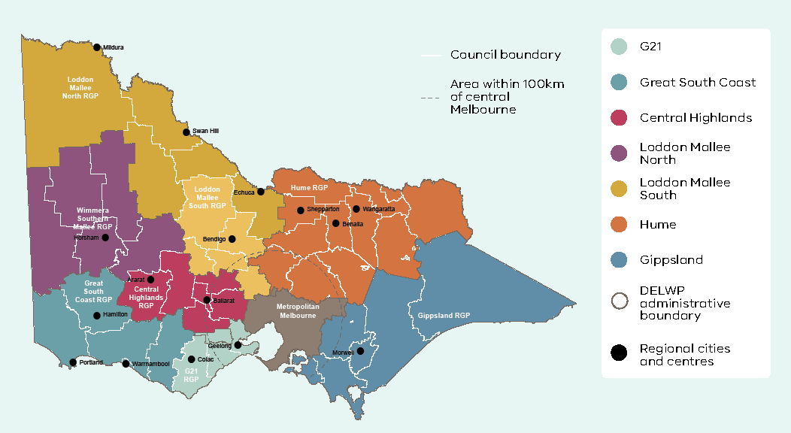

#### Planning Policy Framework

Clause 11.01‑1R (Green wedges – Metropolitan Melbourne, Victoria Planning Provisions) seeks to protect the green wedges of Metropolitan Melbourne from inappropriate development, safeguard key features and values, and support development that provides for environmental, economic and social benefits. Productive agricultural areas such as Werribee South, the Maribyrnong River flats, the Yarra Valley, Westernport and the Mornington Peninsula are highlighted for protection. Clause 11.01‑1R provides guidance on residential development, major state infrastructure and resource assets, agribusiness, forestry, food production, tourism, renewable energy generation, extractive industries, and areas of environmental, landscape and scenic value.

Clause 11.03‑3S (Peri‑urban areas; Victoria Planning Provisions) seeks to manage growth in peri‑urban areas to protect and enhance attributes that are strategically important for the environment, biodiversity, landscape, open space, water, agriculture, energy, recreation, tourism, cultural heritage, infrastructure, extractive and other natural resources. It provides for development in established settlements and promotes growth boundaries to avoid urban sprawl and protect agricultural land and environmental assets. Clause 11.03‑3S seeks to protect the character and amenity of peri‑urban towns, ensure non‑urban breaks are provided between urban areas, improve transport connections and ensure development is supported by physical and social infrastructure.

#### Zones

Land use in Melbourne’s green wedges and peri‑urban areas is controlled by six rural zones:

* Farming Zone (FZ) – a zone that is strongly focused on protecting and promoting farming and agriculture
* Rural Activity Zone (RAZ) – a mixed use rural zone that caters for farming and other compatible land uses
* Rural Conservation Zone (RCZ) – a conservation zone that caters for rural areas with special environmental characteristics
* Green Wedge Zone (GWZ) – a zone that provides for all agricultural uses and limits non‑rural uses to those that either support agriculture or tourism, or that are essential for urban development but cannot locate in urban areas for amenity or other reasons
* Green Wedge A Zone (GWAZ) – a zone that provides for all agricultural uses and limits non‑rural uses to those that support agriculture, tourism, schools, major infrastructure and rural living
* Rural Living Zone (RLZ) – a zone that caters for residential use in a rural setting.

Further information on rural zones can be found in Appendix 5.

#### Urban Growth Boundary

The metropolitan strategy released in 2002, known as Melbourne 2030, established an urban growth boundary (UGB) around Melbourne to better manage outward expansion in a coordinated manner. The purpose of the Urban Growth Boundary is to direct urban growth to areas equipped or capable of being equipped with appropriate infrastructure and services, and protect valuable green wedge and peri‑urban land (and environmental features) from development pressures. The legislative framework outlined in the Planning and Environment Act 1987 (see 2.3.2.1) sets out additional protection of the Urban Growth Boundary perimeter by requiring that any proposed alteration of its location be ratified by both Houses of the Parliament of Victoria.

#### Green Wedge Management Plans

Green Wedge Management Plans are council‑adopted strategies that identify a vision, objectives and actions for the sustainable use and development of each green wedge. Green Wedge Management Plans also identify the values and features of each green wedge, the preferred future land use, and environmental and natural resources that should be protected based on the needs of the local community. They also articulate the type, scale and form of preferred change in the green wedge and how those changes will be managed and facilitated. A Green Wedge Management Plan should be created and adopted by council whose municipality include green wedge land. Where relevant, aspects of the plan can be included or referenced in the Local Planning Policy Framework and will provide the strategic basis for reviewing planning provisions for a green wedge.

##### Preparing a Green Wedge Management Plan Planning Practice Note 31 ‑ June 2015

This practice note provides a guide for the preparation of Green Wedge Management Plans and sets out the general requirements that should be met. The practice note covers the policy context and basis for the plans, their content and status.

There are 12 green wedge areas in the municipal districts of 17 councils. There is substantial variation in the land management conditions and circumstances in each green wedge. The preparation of each Green Wedge Management Plan (GWMP) will need to recognise those variations including the area involved, the level of information available, the resources available, the range of land uses, the condition of the natural resource base and the needs of the local community.

###### What is a Green Wedge Management Plan?

A Green Wedge Management Plan is a council adopted strategy that identifies a vision, objectives and actions for the sustainable use and development of each green wedge. The plan will identify the values and features of each green wedge, the preferred future land use, environmental and natural resources that should be protected, and the needs of the local community. Green wedges, like any other place are dynamic and constantly evolving. Changes identified through the preparation of Green Wedge Management Plans may embrace new productive land uses, investments and developments consistent with state policies for green wedges, environmental enhancement and sustainable resource management initiatives.

To ensure the sustainable management of green wedges, a Green Wedge Management Plan should include a broad range of implementation tools that include regulatory and non‑regulatory measures. For example, regulatory actions may encompass changes to existing local planning schemes to encourage and facilitate land uses and developments that protect and enhance each green wedge. A Green Wedge Management Plan should also provide non‑regulatory actions focusing on education and incentive programs aimed at encouraging landowners to adopt sustainable practices. Achievement of sustainable land uses and land management practices are the critical elements in the development of Green Wedge Management Plans.

###### Why prepare a Green Wedge Management Plan?

Green wedges will experience change over time. In many cases the condition of their environment and natural resource base needs considerable improvement. A Green Wedge Management Plan provides a framework managing change and the actions that will facilitate it. The preferred direction for future change and improvements and how this will be managed is an essential element of the planning for the future of Melbourne’s green wedges.

A Green Wedge Management Plan provides the opportunity to clearly articulate the kinds of development or activities that are likely to be supported in the green wedge. It will provide clarity and greater certainty for all stakeholders, including landowners.

###### What is expected for green wedges?

The green wedges accommodate agricultural and recreational uses, as well as a variety of important functions that support Melbourne. These include major assets such as airports, sewage treatment plants, extractive industry and landfill sites – uses that support urban activity but which cannot be located amongst normal urban development. The green wedges include areas that have strong environmental, landscape, built and Koori heritage value for Victorians – many of which are of state, national or international significance. They provide important resources for recreation and tourism. Each green wedge has unique features and will require a management approach that promotes and encourages its diversity.

Collectively, green wedges have a broad range of purposes. This means that each Green Wedge Management Plan will need an individual, tailored approach to establish the clear role, purpose, objectives and related actions for each area. To ensure a metropolitan and regional approach, a Green Wedge Management Plan can be prepared either by an individual council or by a group of councils where appropriate.

A series of actions have been undertaken to establish and protect green wedges that includes:

* application of the Urban Growth Boundary around Melbourne and townships within the green wedges (this has been implemented)
* new planning measures including new green wedge zoning and the Core Planning Provisions at Clause 57 (this has been implemented).
* new legislation that ensures protection of green wedges (this has been implemented)
* development of individual action plans for each green wedge – the Green Wedge Management Plan (this is being implemented)
* management of residential development in green wedges (this is being implemented and will be further enhanced through the preparation of Green Wedge Management Plans)
* management of the outward growth of Melbourne
* identification of key features and related values for each green wedge (The Green Wedge Management Plan will provide an opportunity to further identify and refine key features and related values).

Opportunities in the green wedge include:

* agricultural uses, such as market gardening, viticulture and broad acre farming, as well as forestry and land‑based aquaculture
* assisting the preservation of rural and scenic landscapes
* ensuring the conservation of important environmental assets close to where people live
* managing renewable and non‑renewable resources and natural areas (such as water supply catchments)
* providing and safeguarding infrastructure sites that support urban areas (for example, sewage treatment plants)
* allowing industries such as sand and stone extraction to operate close to major markets
* providing opportunities for tourism and recreation
* recognising and conserving heritage features.

###### What are the aims of the Green Wedge Management Planning process?

The key task of a Green Wedge Management Plan is to articulate the type, scale and form of change in the green wedge and how those changes will be managed and facilitated. Many councils have already undertaken strategic planning, policy and resource management studies, projects and action in their green wedges. This work will provide a relevant basis for the finalisation of the plan.

In summary, a Green Wedge Management Plan should:

1. Develop a vision, role and purpose for the green wedge. This should be determined through community consultation and research.
2. Identify the values and features within the green wedge that are to be protected and enhanced. This should be based on a detailed environmental and land use inventory and community consultation.
3. Establish a strategic direction for land use and development within the green wedge that is consistent with government policies and strategies that will protect and enhance the values and features identified within the green wedge. This should be based on identification of key opportunities and constraints identified through research.
4. Articulate the strategic direction for the green wedge through the relevant planning scheme. This should involve:
   * ensuring the vision, role and purpose of the green wedge is identified in the Municipal Strategic Statement
   * confirmation of the green wedge zoning and the schedules to these zones
   * ensuring identified values, environmental assets and resources are appropriately identified and protected by the planning scheme by such tools as planning scheme overlays and local planning policies
   * consideration of the need to provide further guidance in relation to discretionary uses and developments within the green wedge through the Local Planning Policy Framework.
5. Establish a framework to encourage sustainable land management practices and appropriate resource management. This should involve:
   * reviewing the adequacy of resources and programs
   * assessing the effectiveness of existing incentive and education programs
   * developing new initiatives aimed at encouraging sustainable land management practices
   * identifying and supporting sustainable land use options
   * consideration of relevant plans and strategies related to natural resource management including fire management plans, catchment management plans and stream flow management plans.
6. Identify the needs of green wedge landowners and the wider community. Issues that should be examined include demographic considerations, economic sustainability, employment opportunities, sustainable land use options, community facilities and other required levels of infrastructure.
7. Establish a clear monitoring and review process to ensure the plan remains relevant and its performance can be measured. This should involve determining appropriate indicators and a commitment to review the plan in five years.

Broadly, the plan should focus on the following:

* support or incorporate existing plans, strategies and activities that align with green wedge policies, such as Regional Catchment Strategies, Regional Management Plans and Natural Resource Plans
* reflect Government policies and strategies
* examine opportunities for agricultural and alternative land use options
* involve key stakeholders and landowners in developing the plans, to reflect a range of expertise and knowledge
* promote community participation and ownership of the values and actions for the green wedge
* promote environmentally sustainable development and land management
* integrate resource development and management with fire management and protection plans
* have a monitoring process for actions built into the management process
* develop and expand land management programs and support mechanisms for landholders in achieving improved land stewardship
* develop new, and expand upon current, environmental enhancement initiatives
* identify and set priorities for investment in land use and development consistent with government policies and strategies.

###### What is the process for preparing a Green Wedge Management Plan?

Each green wedge is different. The nature of land uses and developments are diverse, the number of landowners and stakeholders varies. The level of knowledge about the quality of the natural resource base and the resource levels of each council also varies. These differences will influence the scope and detail of the process to be used in the preparation of each Green Wedge Management Plan. The following diagram provides a typical model for preparing a Green Wedge Management Plan.

A diagram showing a typical model for preparing a green wedge management plan. There are six steps involved in the process and throughout these six steps landowners, community and stakeholder engagement is sought.
Step 1. Preparation Work
Step 2. Information gathering
Step 3. Green Wedge Vision and Objectives
Step 4. Review existing policies and programs
Step 5. Developing Actions
Step 6. Implementation.
Once Step 6 Implementation is completed, a monitoring and review cycle begins, commencing back at Step 3 Green Wedge Vision and Objectives continuing through to Step 6.

Preparation work

Determine the key stakeholders, project teams, consultation methods, scope of tasks and resources.

Information gathering

Explore existing information, the policy context, identify gaps, undertake research and identify community views and issues.

Green Wedge Vision and Objectives

Develop a vision that outlines the preferred future direction for the green wedge. Determine objectives that will achieve the vision. Explore key indicators that will be able to measure whether the objectives are being achieved.

Review existing policies and programs

Review the existing policies and programs that apply or influence the green wedge. Will they deliver the vision and objectives? Do they need to be changed, enhanced and/or better resourced?

Developing Actions

Develop a series of actions that are designed to achieve the vision and objectives. Various options may need to be explored and tested with key stakeholders before arriving at the preferred actions.

Implementation

This process will identify responsibilities, priorities and time lines and required resources. It should identify whether additional work is required such as future planning scheme amendments.

Monitoring and Review

This process should be twofold. Firstly it should establish a mechanism to measure the progress of implementation. This may involve establishing an annual reporting process to council. Secondly, it should establish a process to review the Green Wedge Management Plan to ensure the plan remains relevant and to measure the success of the plan in achieving the agreed vision and objectives.

###### Principles that should underpin preparation of a Green Wedge Management Plan

Five principles have been developed that should underpin the preparation of a Green Wedge Management Plan. These principles will ensure that a Green Wedge Management Plan is consistent with government policy and it has been prepared using a collaborative and inclusive approach.

Consistency with Victorian State Government policies and strategies

* A Green Wedge Management Plan should be consistent with relevant state government policies and strategies.

A common basis for the preparation of plans

* A Green Wedge Management Plan should be prepared in partnership with government and councils, in their role as the funding agencies implementing government policies, and with landowners and the community, in their role as the custodians of the area who have a duty of care for the resource base.

A well informed, inclusive plan preparation process

* A Green Wedge Management Plan should reflect the regional and local circumstances and needs of each green wedge, as well as the circumstances and needs that are shared with other relevant green wedge areas. It should provide a clear purpose that council is able and willing to implement and defend.
* Preparation of a Green Wedge Management Plan should take into account the varying levels of knowledge about each green wedge area shared between the relevant councils, government departments and agencies, community groups and organisations, landowners and the general public.
* Previous relevant work that is consistent with the strategic and policy intent of state government policies and strategies can be included in the process and can provide a useful basis for the preparation of the plan.
* Information held by government sources can be made available to assist the preparation of the plan. A range of external information sources, such as Regional Catchment Strategies, Regional Management Plans, and ABS data can inform development of the plan.
* The process for the preparation of a Green Wedge Management Plan should involve a process of active engagement with the full range of stakeholders to assist commitment to long term resourcing and implementation of the plan. This may include groups of councils where values and attributes are shared.
* The processes used in the preparation of a Green Wedge Management Plan should demonstrate transparency, inclusiveness and consultation and seek to build partnerships and shared ownership.

A common approach to the preparation of Green Wedge Management Plans

While the circumstances of each green wedge area will vary, the points below set out the core components expected to be used in the process. This is summarised in the figure below.

* Council should establish a project steering group (chaired by the council), with representatives from key stakeholders to oversee the preparation of the plan. The project steering group should provide support guidance and oversight of progress and would have the following roles:
  + provide input into the preparation of a project plan
  + endorse key milestones of the Green Wedge Management Plan
  + oversee publicity and promotion about the preparation of the Green Wedge Management Plan and the process to be used
  + oversee project briefs for tasks to be undertaken to assist in the preparation of the Green Wedge Management Plan
  + ensure relevant and practicable levels of engagement and consultation to assist in research and preparation of the Green Wedge Management Plan
  + oversee a publicised program of public display of draft plans and formal input to the development of the Green Wedge Management Plan.
* Council should establish a working group to assist the project steering group in preparing the Green Wedge Management Plan.
* Council should identify the required actions to implement the Green Wedge Management Plan, such as partnership agreements with organisations, agencies or community groups and any other necessary mechanisms.
* Council should formally adopt the Green Wedge Management Plan.
* Council should identify appropriate mechanisms to oversee, monitor and evaluate the implementation and effectiveness of the Green Wedge Management Plan.

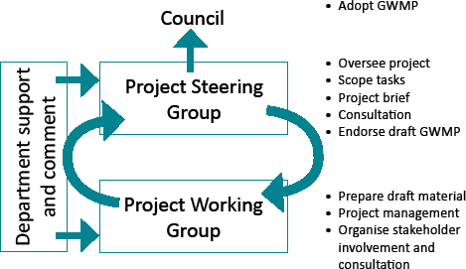

Involvement of stakeholders and landowners

The development of the plan is not intended to re‑open debates regarding existing government policies and strategies. While there are divergent views regarding green wedges, an important element in preparing a Green Wedge Management Plan is to ensure that representatives of all relevant stakeholders including landowners have been identified and effectively engaged. There is great diversity in green wedge areas in the number and range of landowners and the groups and organisations with direct and indirect interests in the ongoing management and future direction of particular areas and attributes. It is essential that these groups are informed and that realistic and meaningful measures have been implemented to engage them in the process. Any previous relevant consultation should be reflected in the final plan.

###### How will Green Wedge Management Plans be implemented?

Each Green Wedge Management Plan will set out a series of actions and measures that need to be undertaken, and identify resource requirements, roles and responsibilities, time lines, outcomes and evaluation. This implementation program will include council, government departments and agencies, relevant organisations, landowners and the community. A range of partnership agreements, memorandum of understanding and implementation tools may be utilised.

###### Status of Green Wedge Management Plans

A Green Wedge Management Plan should be adopted by Council. Where relevant, it is anticipated that aspects of the plan will be included or referenced in the Local Planning Policy Framework and will provide the strategic basis for reviewing existing planning provisions of the green wedge. Any proposed changes to a planning scheme will require a planning scheme amendment which involves separate consultation processes and other requirements specified under the Planning and Environment Act 1987. Similarly, any proposed changes to a council’s municipal laws will also require statutory processes required under the Local Government Act 1989.

Preparation of a Green Wedge Management Plan consistent with the practice note will enable government departments and agencies to recognise and reference it in their ongoing programs. As Green Wedge Management Plans are also likely to be recognised and referenced in other relevant land and resource management plans, such as Regional Catchment Strategies.

###### Role of the department

Department officers are available to assist councils in the preparation of a Green Wedge Management Plan. The department will provide support and assistance to councils by:

* participating in the project steering and working groups as needed
* liaising with councils and groups of councils
* contributing to partnership arrangements or funding programs where possible.

It is anticipated that the department will be involved in the development of each Green Wedge Management Plan and be provided with an opportunity to comment on the draft Green Wedge Management Plan prior to it being adopted by Council.

## Appendix 3: Plan Melbourne 2017–2050 Desired planning outcomes for green wedge and peri‑urban areas

### Desired planning outcomes for green wedges and peri‑urban areas

#### Environmental and biodiversity assets

Protect and enhance environmental and biodiversity assets, such as coastal areas, wetlands, rivers and creeks, forests and grasslands. Key features of international and national significance include Ramsar‑listed wetlands (Westernport, Edithvale‑Seaford wetlands, Port Phillip Bay [Western Shoreline] and Bellarine Peninsula), the Western Grassland Reserve, the UNESCO Mornington Peninsula and Westernport Biosphere Reserve, and a range of national and state parks.

Maintain and enhance the diversity of indigenous flora and fauna habitats and species and achieve a net gain in the quantity and quality of native vegetation.

#### Landscape and open space

Protect significant views, maintain non‑urban breaks between urban areas, and conserve the cultural significance, tourism appeal and character of scenic rural landscapes. Recognised high‑value landscape features include open farmed landscapes, sites of geological significance, ranges, hills and ridges and open coastal spaces. Iconic landscapes, such as the Great Ocean Road, Bellarine Peninsula, Macedon Ranges, Western Port, Phillip Island, Mornington Peninsula, the Yarra Valley and the Dandenong Ranges, attract high numbers of local and overseas visitors each year.

#### Water supply catchments

Manage and protect catchments (including Special Water Supply Catchments), groundwater, water infrastructure and storages, and waterways to improve water quality, protect the environment and provide a reliable and secure water supply.

Minimise any negative impacts from sedimentation or water pollution on the Port Phillip and Western Port coastal ecosystems.

#### Natural hazards

Avoid development in areas that are subject to high risk from bushfire or flooding and inundation so as to minimise potential risk to life, property and the environment.

Recognise, understand and prepare for the projected impacts of climate change and rising sea levels.

Avoid significant land disturbance, reduce the occurrence and impact of soil erosion and salinity and manage potentially contaminated land.

#### Agricultural land

Protect agricultural land from incompatible uses, maintain farm size, promote the continuation of farming and provide a secure long‑term future for productive and sustainable agriculture. Key agricultural areas include the Mornington Peninsula, the Yarra Valley and Dandenong Ranges, Werribee South, Keilor, Western Port and the Macedon Ranges.

#### Recreation

Provide land for a range of open space functions to meet community needs for active and passive recreation and for protection of the environment. State and metropolitan parks provide a focus for a range of recreation opportunities and include the Yarra River, Warrandyte, Lysterfield and Dandenong Police Paddocks Reserve, and Churchill and Bunyip national parks.

#### Tourism

Facilitate sustainable year‑round tourism, and new tourism development (including diverse attractions, accommodation and eating establishments) that maintains the integrity of the natural environment, provides social benefits for communities and visitors and contributes to local economies.

#### Cultural heritage

Provide for the protection and management of sites of Aboriginal and post‑European settlement cultural heritage to ensure that links with the past are preserved for present and future generations to appreciate. A wide range of cultural‑heritage assets are found in buildings, structures, scattered relics, trees and gardens, landscapes and geological formations, archaeological and fossil sites and areas associated with historical events.

#### State‑significant infrastructure

Protect regionally significant assets such as metropolitan landfills (for example, Clayton South and Wollert), wastewater management facilities (for example, Eastern and Western Treatment Plants), industrial areas and related odour and safety buffers (for example, Dandenong South), airports and flightpaths (Melbourne, Avalon and Moorabbin), and ports (Port of Hastings). Provide opportunities for renewable energy generation.

#### Mineral, stone and sand resources

Protect designated mineral resource areas such as the coal reserves in central and western Gippsland. Protect sand and stone resources for future extraction to ensure a continuous supply of construction material.

#### Economy

Maintain a strong, dynamic economy and employment base by building on the comparative advantages in agriculture, timber, transport, tourism, education, manufacturing, the service industry and commerce.

#### Population, settlements and local infrastructure

Plan and manage sustainable urban growth that is concentrated in and around major towns within Melbourne's peri‑urban area so as to provide employment, infrastructure, services and community facilities to new and established urban areas in an equitable manner.

Manage the growth and sustainable development of green wedge townships and settlements, having regard for their distinct character and environmental and servicing constraints.

Create socially sustainable communities and support an active community working towards reducing greenhouse gases and responding to climate change.

Protect and enhance the existing character, presentation and form of towns, including their main road entrances.

#### Rural living

Manage rural living to prevent negative impacts on agriculture, biodiversity and landscape values.

#### Transport and accessibility

Provide a high‑quality road and rail transport network with a range of sustainable, efficient, accessible and affordable transport options that readily connect neighbourhoods, workplaces, community facilities, services and enable people to participate in community life.

Facilitate improvements to transport networks and facilities that support tourism, such as airports.

#### Planning and governance

Facilitate integrated and balanced forward planning, involving all agencies, and having regard to the needs and aspirations of current and future generations.

Source: Green Wedge Management Plans, Localised Planning Statements and Council Municipal Planning Statements

## Appendix 4: Related government policies, strategies and plans

### Water for Victoria – 2016

The Victorian Government’s current water plan, Water for Victoria, recognises agriculture as the sector consuming the most water in the state. It notes that Victoria’s agricultural production will continue to grow despite water scarcity, and that the Government will continue to work with rural and regional communities to support agricultural development and change.

Water for Victoria acknowledges that water services must remain affordable for all customers, and seeks to reduce barriers to agricultural development and adapt irrigation district infrastructure so that it remains affordable and attractive to new business.

The document outlines a ‘water for agriculture’ objective:

Victoria’s water management arrangements will enable farmers to maximise the value of agricultural production with the available water, while supporting farming communities to adjust to change in a warmer and drier future.

Water for Victoria is a government commitment to investigate mechanisms that increase the uptake of recycled water in agricultural areas.

### Biodiversity 2037 – 2017

The Biodiversity 2037 Implementation Framework (April 2018) outlines as priority to ‘Help to create more liveable and climate‑adapted communities’ (Priority 7). Implementation Action 7.4 under this priority is:

Through the implementation of Plan Melbourne 2017–2050 support local government to complete and implement green wedge management plans to protect and enhance the agricultural, biodiversity, environmental, natural resource, tourism, landscape and other values of each of Melbourne’s green wedges.

### Agriculture Victoria Strategy – 2017

Agriculture Victoria released its ten year Agriculture Victoria Strategy in May 2017. This is a reform framework, articulating Agriculture Victoria’s priorities to enhance Victorian agriculture’s global competitiveness, innovation and resilience.

The strategy recognises the sector’s vital contribution to economic growth and its potential for enhancing social and economic wellbeing across Victoria. The plan provides direction and guidance for Agriculture Victoria’s activities, aligned with the Victorian Government’s aspirations for the agriculture sector and regional communities.

### Victoria’s Climate Change Framework – 2018

Victoria’s Climate Change Framework outlines a 2050 vision for Victoria and an approach to transition key sectors to zero net emissions and a climate‑resilient economy. The framework describes a vision for Victoria’s agriculture sector in 2050:

Victoria’s agriculture sector will be constantly adapting to climate change. The design of farm systems will feature both carbon sequestration and emission reduction approaches, supporting strong participation in markets. Victoria will have resilient regional communities, viable farming enterprises and growing international markets. Regionally relevant world‑class research and development will underpin adaptation and emissions reduction.

Initiatives to achieve this vision include investment in research and development, improvements to farm and regional infrastructure, support for capacity building and adaptation planning, and partnerships with industry to progress emissions reduction and offset opportunities.

### Statewide Waste and Resource Recovery Infrastructure Plan – 2018

The Statewide Waste and Resource Recovery Infrastructure Plan (SWRRIP) is prepared by Sustainability Victoria on behalf of the Victorian Government. It is a central component of Victoria’s Waste and Resource Recovery Infrastructure Planning Framework and Victoria’s integrated approach to waste and recycling.

The vision of the Statewide Waste and Resource Recovery Infrastructure Plan is to develop an integrated statewide waste and resource recovery system that continues to provide an essential community service.

### Planning Reforms for Animal Industries – 2018

The Victorian Government introduced planning reforms for animal industries in September 2018. The reforms deliver on key actions to clarify and simplify the planning framework to support the growth of animal industries, while protecting the environment and community amenity. Amendment VC150 introduced the changes to the Victoria Planning Provisions and all planning schemes.

### Integrated Water Management Forums Strategic Directions Statements – 2018

The Integrated Water Management Forums have been established across the state to identify, prioritise and oversee the implementation of collaborative water opportunities. The Forums bring together all organisations with an interest in water cycle, recognising that each has an important role to play in the management of our most vital resource.

Victoria’s Integrated Water Management Forums have produced a Strategic Directions Statement that captures the regional context, shared vision and water‑related outcomes for each of the Forum areas across metropolitan Melbourne and regional Victoria.

Each Strategic Directions Statement includes a list of integrated water management opportunities collaboratively developed by the Forum to bring local community views, values and priorities into practice through integrated water management.

### Emerging policies

#### Distinctive areas and landscapes – 2018

Policy 4.5.2 of Plan Melbourne protects and enhances Melbourne’s valued attributes of distinctive areas and landscapes. Statements of Planning Policy are being prepared and finalised to protect distinctive areas and landscapes around Melbourne, some of which are located in part in Melbourne’s green wedges and peri‑urban areas, including Macedon Ranges, Bellarine Peninsula, Surf Coast and Bass Coast.

#### Extractive resources – 2018

Policy 1.4.2 of Plan Melbourne identifies and protects extractive resources (such as stone and sand) important for Melbourne’s future needs. Work to effect Plan Melbourne’s Action 18 (Management of extractive industry) is underway to better protect extractive industries and future extractive resources from incompatible land uses through the planning system.

#### Regional Tourism Review – 2019

The state government is conducting a review of regional tourism to explore and identify new ways of growing tourism and supporting regional Victoria. Regional tourism has a vital role in creating more jobs for more Victorians, supporting thriving regions and strengthening inclusive communities. From a land use planning perspective, the government is interested in understanding options that support tourism businesses and create new tourism products that support communities and the economy while balancing the needs of the local community, other productive land uses and the environment.

#### Land Use Framework Plans (in development)

Land Use Framework Plans (LUFPs) for the six metropolitan regions are being developed to deliver Action 1 of Plan Melbourne. The purpose of Land Use Framework Plans is to improve alignment of state and local policy, and will include strategies for population growth, jobs, housing, infrastructure, major transport improvements, open space and urban forests.

While the Land Use Framework Plans focus on Melbourne’s metropolitan regions, four of the six metropolitan regions (Western, Northern, Eastern and Southern) contain green wedge and agricultural land. These corresponding Land Use Framework Plans will outline regional strategies and directions that will have bearing on green wedge and agricultural issues.

Map 13: Metropolitan Melbourne Regions

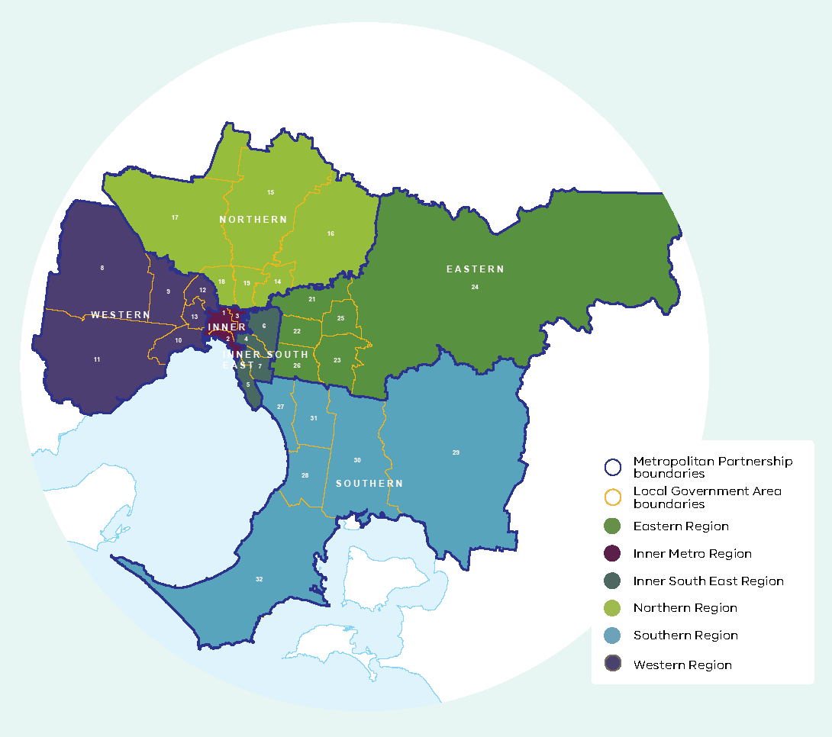

## Appendix 5: Planning Practice (Note 42: Applying the Rural Zones)

### Applying the Rural Zones Planning Practice Note 42 ‑ June 2015

The purpose of this practice note is to provide guidance to planning authorities about:

* the strategic work required to apply the Farming Zone, Rural Activity Zone, Rural Conservation Zone, Green Wedge Zone, Green Wedge A Zone and Rural Living Zone
* the purposes and features of each zone and where they may be applied.

The practice note seeks to ensure that the most appropriate rural zones are used to achieve a planning authority’s rural strategic planning objectives.

#### The suite of rural zones for Victoria

The rural areas of Victoria accommodate a range of farming, residential and commercial uses and contain many of the state’s significant natural resources, such as native vegetation, minerals and water. They also provide important resources for recreation, tourism and timber production.

The suite of rural zones for Victoria:

* recognise the state, regional and local importance of farming as an industry and provide greater protection for productive agricultural land
* provide a wide choice of zones with clear purposes and controls to match
* discourage ad hoc and incompatible use and development
* recognise the changing nature of farming and reduce the potential for conflict between farming and other land uses
* recognise that rural areas are places where people live and work
* recognise and protect rural areas that are environmentally sensitive.

#### The changing nature of farming

The nature of farming in Victoria is changing in ways that require careful consideration. It is:

* Becoming more diverse. Farming in Victoria is constantly changing and expanding in response to changing world and domestic consumption patterns and the need to remain profitable and sustainable.
* Becoming more industrialised. Modern farming practices may involve the use of heavy machinery and large scale irrigation and plant equipment, all‑hours operation, and the application of chemicals and fertilizers.
* Intensifying. Intensive farming enterprises, such as aquaculture, poultry farms and horticulture are growing in numbers and in their contribution to the economy.
* Aggregating. In western Victoria particularly, farms are becoming bigger to achieve the economies of scale for farm investment and to maintain productivity.
* Undergoing social change. More farmers are taking on off‑farm work, the economic value of off‑farm work is increasing, and there is a shift from full‑time to part‑time farming in some rural areas.

More changes in farming structures and practices are expected due to drier climatic conditions and growing community pressure for more efficient water use by all industries.

At the same time, more people are seeking to live in rural areas for a range of social, environmental and economic reasons. As a result, in some rural areas:

* there is more competition for rural land, which is affecting rural land prices and the capacity of farmers to expand their businesses and maintain productivity
* there is renewed interest in part‑time small‑scale farming
* more people are living in rural areas for lifestyle reasons not related to farming increasing the potential for land use conflicts because people pursuing a rural lifestyle often have amenity expectations that conflict with modern farming practices
* local rural economies are diversifying, as rural land is used for more diverse purposes (such as tourism or recreation).

Victoria’s changing rural landscape requires planning authorities to think strategically about their farming areas and rural settlement patterns, so that sustainable farming is promoted and potential conflicts between farming and other land uses are avoided.

#### Strategic planning for rural areas

Sound strategic planning for rural areas is essential to ensuring that land use and development achieves the planning authority’s vision, objectives and desired outcomes for an area. It can help ensure that:

* use and development in rural areas fits into the overall strategic planning of the municipality
* farmland and farming industries of state, regional or local significance are protected
* housing development in rural areas is consistent with the housing needs and settlement strategy of an area
* future use of existing natural resources, including productive agricultural land, water, and mineral and energy resources, is sustainable
* scarce resources, such as water, are protected
* social networks and infrastructure essential to rural communities are maintained
* existing visual and environmental qualities of rural areas are protected
* conflicts between farming and other land uses are avoided
* the most appropriate planning scheme tools (for example, the right rural zone) are used to achieve strategic planning objectives.

Applying a new rural zone or making adjustments to a schedule to an existing rural zone should be underpinned by clearly expressed planning policies in the planning scheme. If a proposed change is at odds with the existing policy framework, either a different planning tool or approach should be used or the policy framework itself might need re‑assessment.

The existing State Planning Policy Framework (SPPF) and Local Planning Policy Framework (LPPF) in the planning scheme should be the starting point for deciding whether the council’s strategic objectives are still valid and sound, or whether new strategic work is required. Many councils have already undertaken strategic planning, policies and resource management studies for their rural areas and used this work to articulate rural strategic objectives in their Municipal Strategic Statements (MSS).

New strategic work may not be required if the existing Municipal Strategic Statement addresses the key rural land use issues and adequately reflects the planning outcomes that the council wants to achieve. The scheme may already contain a sufficient strategic basis for applying a different rural zone or making adjustments to an existing rural zone.

However, if the Municipal Strategic Statement objectives are no longer relevant, they do not provide clear guidance for decision‑making, or there are strategic gaps, new strategic work for a part or parts of the municipality may be required.

Before commencing new strategic work, the council should review the policy components of its planning scheme, past and present council strategic work, relevant studies prepared by government departments and agencies, relevant recommendations of planning panels and past planning scheme review recommendations. This will help to establish whether new strategic work is required, the scope of the strategic work and the main issues to be focussed on.

There is no prescribed content or format for a rural strategy or study, however it should:

* develop a vision, role and purpose for the rural area
* identify the values and features within the rural area
* identify the key opportunities and constraints
* establish a strategic direction for land use and development within the rural area
* articulate how the strategic vision for the rural area is to be implemented through the planning scheme.

The information used to develop the strategy should be tailored to suit the area. In general it should include an assessment of:

* the state, regional and local strategic planning policies and objectives for the area, including relevant regional growth plans or strategies
* the housing needs of the municipality and likely future trends which is particularly relevant if one of the aims of the strategy is to provide for rural living development
* the physical attributes of the land and its capacity to support productive agricultural uses including soil type, climate, vegetation cover, access to water, slope and drainage
* agricultural trends in the area, including agricultural productivity, changes in farming practices and processes, and farm investment patterns
* the natural resources and environmental features in the area and their importance including flora and fauna, significant habitats, wetlands, scenic landscapes and sites of archaeological or cultural significance
* environmental hazards that could affect how the land is used and developed, such as erosion, salinity, flooding and wildfire risk
* the existing lot size and land use patterns
* infrastructure available for agriculture and other relevant land uses
* settlement patterns in the area.

#### Implementing rural strategic objectives

A planning authority may need to use a number of Victoria Planning Provisions tools to successfully implement its rural strategic objectives. There are circumstances where a zone and one or more overlays may be needed to deliver the desired outcome. Councils should think laterally about the mix of policies and controls required to achieve their objectives and be prepared to consider using a range of tools to achieve the desired strategic outcomes.

In deciding which rural zone should apply, the following principles should be considered:

* The zone should support and give effect to the State Planning Policy Framework.
* The zone should broadly support all relevant policy areas in the Municipal Strategic Statement (for example, economic, housing, environment and infrastructure policy).
* The rationale for applying the zone should be clearly discernible in the Local Planning Policy Framework.
* Implement the recommendations or actions of any relevant rural strategy or study.
* The zone should be applied in a way that is consistent with its purpose.
* The requirements of any applicable Minister’s Direction must be met.

The existing size or pattern of lots in an area should not be the sole basis for deciding to apply a particular zone. For example, it is not appropriate to decide that the Rural Living Zone should be applied to an area simply because it comprises small lots. Traditionally, farms have comprised multiple lots, sometimes contiguous, sometimes in different locations. The fact that an area may comprise many lots does not mean that it cannot be used productively or should not be included in a zone that supports and protects farming. Many factors will determine the suitability of an area for farming, rural living, rural industry, rural conservation or green wedge land.

##### Local planning policy

Wide discretion is available in the rural zones, particularly the Farming Zone, Rural Activity Zone and Rural Living Zone. To guide the exercise of this discretion and fully implement their strategic objectives, the planning authority should consider whether a Local Planning Policy (LPP) is necessary. An Local Planning Policy can help to establish realistic expectations about how land in an area may be used and developed, and provide the responsible authority with a sound basis for making consistent, strategic decisions. Refer to Planning Practice Note 8: Writing a Local Planning Policy for more guidance on using local planning policies.

#### The zones in detail

The six zones are summarised as follows:

* Farming Zone – a zone that is strongly focussed on protecting and promoting farming and agriculture
* Rural Activity Zone – a mixed use rural zone that caters for farming and other compatible land uses
* Rural Conservation Zone – a conservation zone that caters for rural areas with special environmental characteristics
* Green Wedge Zone – a zone that provides for all agricultural uses and limits non‑rural uses to those that either support agriculture or tourism, or that are essential for urban development but cannot locate in urban areas for amenity or other reasons
* Green Wedge A Zone – a zone that provides for all agricultural uses and limits non‑rural uses to those that support agriculture, tourism, schools, major infrastructure and rural living
* Rural Living Zone – a zone that caters for residential use in a rural setting.

##### The zone purposes

All of the zones provide for the use of land for agriculture; however while it is implicit in the purpose of the Farming Zone, Rural Activity Zone, Green Wedge Zone and Green Wedge A Zone that farming will be a primary land use activity, in the Rural Conservation Zone and Rural Living Zone, farming is subordinate to other land uses or the environmental values of the land.

##### Farming Zone Purpose

* To implement the State Planning Policy Framework and the Local Planning Policy Framework, including the Municipal Strategic Statement and local planning policies.
* To provide for the use of land for agriculture.
* To encourage the retention of productive agricultural land.
* To ensure that non‑agricultural uses, including dwellings, do not adversely affect the use of land for agriculture.
* To encourage the retention of employment and population to support rural communities.
* To encourage use and development of land based on comprehensive and sustainable land management practices and infrastructure provision.

##### Rural Activity Zone Purpose

* To implement the State Planning Policy Framework and the Local Planning Policy Framework, including the Municipal Strategic Statement and local planning policies.
* To provide for the use of land for agriculture.
* To provide for other uses and development, in appropriate locations, which are compatible with agriculture and the environmental and landscape characteristics of the area.
* To ensure that use and development does not adversely affect surrounding land uses.
* To provide for the use and development of land for the specific purposes identified in a schedule to this zone.
* To protect and enhance natural resources and the biodiversity of the area.
* To encourage use and development of land based on comprehensive and sustainable land management practices and infrastructure provision.

##### Green Wedge Zone Purpose

* To implement the State Planning Policy Framework and the Local Planning Policy Framework, including the Municipal Strategic Statement and local planning policies.
* To provide for the use of land for agriculture.
* To recognise, protect and conserve green wedge land for its agricultural, environmental, historic, landscape, recreational and tourism opportunities, and mineral and stone resources.
* To encourage use and development that is consistent with sustainable land management practices.
* To encourage sustainable farming activities and provide opportunity for a variety of productive agricultural uses.
* To protect, conserve and enhance the cultural heritage significance and the character of open rural and scenic non‑urban landscapes.
* To protect and enhance the biodiversity of the area.

##### Green Wedge A Zone Purpose

* To implement the State Planning Policy Framework and the Local Planning Policy Framework, including the Municipal Strategic Statement and local planning policies.
* To provide for the use of land for agriculture.
* To protect, conserve and enhance the biodiversity, natural resources, scenic landscapes and heritage values of the area.
* To ensure that use and development promotes sustainable land management practices and infrastructure provision.
* To protect, conserve and enhance the cultural heritage significance and the character of rural and scenic non‑urban landscapes.
* To recognise and protect the amenity of existing rural living areas.

##### Rural Conservation Zone Purpose

* To implement the State Planning Policy Framework and the Local Planning Policy Framework, including the Municipal Strategic Statement and local planning policies.
* To conserve the values specified in a schedule to the zone.
* To protect and enhance the natural environment and natural processes for their historic, archaeological and scientific interest, landscape, faunal habitat and cultural values.
* To protect and enhance natural resources and the biodiversity of the area.
* To encourage development and use of land which is consistent with sustainable land management and land capability practices, and which takes into account the conservation values and environmental sensitivity of the locality.
* To provide for agricultural use consistent with the conservation of environmental and landscape values of the area.
* To conserve and enhance the cultural significance and character of open rural and scenic non urban landscapes.

##### Rural Living Zone Purpose

* To implement the State Planning Policy Framework and the Local Planning Policy Framework, including the Municipal Strategic Statement and local planning policies.
* To provide for residential use in a rural environment.
* To provide for agricultural uses which do not adversely affect the amenity of surrounding land uses.
* To protect and enhance the natural resources, biodiversity and landscape and heritage values of the area.
* To encourage use and development of land based on comprehensive and sustainable land management practices and infrastructure provision.

#### What are the main features of each zone?

##### Farming Zone

The Farming Zone is primarily concerned with keeping land in agricultural production and avoiding land uses that could limit future farming or constrain agricultural activities. In this zone:

* farming is the dominant land use and all other land uses are subordinate to farming
* farming uses are encouraged to establish and expand with as little restriction as possible, subject to proper safeguards for the environment
* non‑farm dwellings and land uses not related to farming may be considered but should not limit the operation and expansion of agricultural uses
* farm‑related tourism and retailing uses may be considered
* uses that could lead to the loss or fragmentation of productive agricultural land, or which could be adversely affected by farming activities, are prohibited
* land subdivision that could take farmland out of production or limit future farming productivity is discouraged
* the minimum lot size for subdivision may be tailored to suit the farming practices and productivity of the land.

This zone provides a minimum lot size of 40 hectares unless an alternative is specified in a schedule to the zone. The creation of smaller lots is prohibited unless the subdivision is for an existing dwelling, is the re‑subdivision of existing lots or the creation of a small lot for a utility installation.

###### Productive agricultural land

Productive agricultural land generally has one or more of the following characteristics:

* suitable soil type
* suitable climatic conditions
* suitable agricultural infrastructure, in particular irrigation and drainage systems
* a present pattern of subdivision favourable for sustainable agricultural production.

The basic physical characteristics of the land, such as soil type and climate, access to water, and infrastructure are critical to determining the agricultural use of land and whether agricultural productivity can be sustained in the future. However, productivity is also affected by many other factors, including market demand, access to suitable storage and transport facilities, access to efficient processing and value adding capability, availability of technology, the skills of the farmer, research and development, access to capital, marketing, effective industry support, availability of land for expansion and farm labour costs.

Productive agricultural land is a finite resource that makes a significant contribution to the economy of the state and individual municipalities. Its significance is recognised in the State Planning Policy Framework.

Productive agricultural land should be clearly identified and protected in the planning scheme. If the protection and retention of this land for agricultural production is of primary strategic importance, then it should be included in the Farming Zone.

The Farming Zone is designed to encourage diverse farming practices, some of which can have significant off‑site impacts. For this reason, the level of amenity that can be expected in this zone will usually not be compatible with sensitive uses, particularly housing.

###### Decision guidelines

In reaching a decision on a proposal in this zone, the responsible authority must give significant weight to the farming productivity of the land and the relevance of the proposal to farming. There is an expectation that decisions will be made in favour of protecting and supporting farming. In relation to agricultural issues, the responsible authority must consider:

* whether the use or development will support and enhance agricultural production
* whether the use or development will permanently remove land from agricultural production
* the potential for the use or development to limit the operation and expansion of adjoining and nearby agricultural uses
* the capacity of the site to sustain the agricultural use
* the agricultural qualities of the land, such as soil quality, access to water and access to rural infrastructure
* any integrated land management plan prepared for the site.

In relation to dwellings, the responsible authority must also consider:

* whether the dwelling will result in the loss or fragmentation of productive agricultural land
* whether the dwelling will be adversely affected by agricultural activities on adjacent and nearby land due to dust, noise, odour, use of chemicals and farm machinery, traffic and hours of operation
* whether the dwelling will adversely affect the operation and expansion of adjoining and nearby agricultural uses
* the potential for the proposal to lead to a concentration or proliferation of dwellings in the area and the impact of this on the use of the land for agriculture.

The zone’s focus on farming does not mean that there should be little or no consideration of the impact of farming on the environment. The zone encourages farming based on comprehensive and sustainable land management practices and a planning permit is required to establish or expand certain farming enterprises. However, in these cases, the focus of the responsible authority’s decision will usually be on whether off‑site impacts that may result from the proposal are reasonable for a farming area.

##### Rural Activity Zone

The main feature of the Rural Activity Zone is the flexibility that it provides for farming and other land uses to co‑exist. In this zone:

* the purpose and provisions support the continuation and growth of farming but provide the opportunity for non‑farming uses to be considered in appropriate locations
* a wide range of tourism, commercial and retail uses are supported
* farming uses are encouraged to establish and expand, subject to proper safeguards for the environment and amenity considerations
* a planning permit is always required to use land for a dwelling.

Because the mix of uses that is supported in the Rural Activity Zone is wide‑ranging, the planning scheme should be clear about:

* what the planning authority wants to achieve in the area where the zone is to be applied
* how discretion in the zone will be exercised.

This can be done by:

* setting out clear objectives for the zone and explaining how discretion in the zone will be exercised in the Local Planning Policy Framework, or
* including a purpose statement in the schedule to the zone. If this option is chosen, the statement should be inserted above the table setting out minimum and maximum areas, it should not repeat or contradict the State Planning Policy Framework and Local Planning Policy Framework, and it should be more specific than the zone purpose.

If the planning scheme is clear about what is to be achieved in the zone, this will enable the responsible authority to make decisions on a consistent, strategic basis and avoid land use conflicts in the future.

A purpose statement in the schedule to the zone may describe:

* desired or preferred mix of land uses
* desired or preferred locations for particular land uses
* preferred approaches for managing off‑site land use impacts
* a specific need that a proposal should meet.

A good purpose statement should reference local conditions, be grounded in reality, and help the responsible authority to make planning decisions, for example:

To achieve a mix of nature‑based recreation facilities and tourist accommodation that complements the wilderness values of Gumnut National Park and is compatible with organic food production activities in the area.

The mix of uses that a planning authority may want to encourage in the zone could include:

* farming, rural industry and associated agribusiness
* farming and tourist facilities
* intensive animal husbandry and associated rural processing industries
* nature‑based tourism and recreation facilities
* agricultural and environmental education and research facilities.

The application of the Rural Activity Zone does not mean that protecting or maintaining farming activities will be of low importance. The zone caters for a wide range of farming activities, including intensive animal husbandry, rural processing industries and timber production, and a planning authority may want to apply the zone to encourage a particular mix of farming and non‑farming activities. However, the needs of farmers will need to be balanced with the council’s other planning objectives for the area.

The mix of uses that is encouraged in the zone should complement the environmental and landscape values of the land, and support the council’s overall urban and rural settlement strategies. It would be inappropriate to apply the zone to encourage a rural mixed use area if the land is required for urban development in the future, or if the particular uses would be better located in an existing town, where there is access to a wider range of urban services and infrastructure.

The zone should not be mistaken for a quasi rural residential zone. Housing is only one of a number of uses that may be considered in the zone, and, in some circumstances, it may be incompatible with the particular mix of uses that the planning authority is seeking to achieve.

###### Tourism

Rural Victoria is home to many trails, transport routes and nature‑based attractions that have strong tourist appeal and create demand for recreation and tourism facilities and services. Tourism can promote and facilitate economic activity that supports aspects of regional and rural life. For example, farm stays, cellar door sales and the sales of local produce support agriculture.

A range of farming‑related tourism uses may be considered in the Farming Zone (such as farm stays, group accommodation, market, residential hotel, restaurants, and primary produce sales). However, if a planning authority is keen to facilitate the establishment of larger scale tourism uses or a more diverse mix of tourism and recreation uses, the Rural Activity Zone may be a more appropriate zone to apply as hotel and tavern are permit required uses.

In deciding to apply the Rural Activity Zone to facilitate tourism in an area, matters to be considered include:

* the need to protect the agricultural, environmental and cultural values of the area
* the scale and mix of tourism and recreation uses to be encouraged
* whether there are opportunities to build alliances between tourism business operators, farmers, food and wine producers and trail network managers
* the product and infrastructure needs of tourists and the local community
* requirements for the siting, planning and design of tourism facilities.

In reaching a decision on proposals in the Rural Activity Zone, the responsible authority must consider whether the use or development will support and enhance agricultural production and other matters relating to protecting and enhancing farming. However, the weight that is given to these considerations will need to be balanced with other social, environmental or economic objectives and policies identified for the land in the scheme.

The schedule to the Rural Activity Zone requires the planning authority to nominate an appropriate minimum lot size and subdivision of land must be at least the area specified in the schedule to the zone (subject to certain exceptions). This will vary depending on the physical attributes of the land, the type of agricultural activities being encouraged and the mix of non‑farming land uses being sought.

The minimum lot size should promote effective land management practices and infrastructure provision and could be large or small.

##### Rural Conservation Zone

The Rural Conservation Zone is primarily concerned with protecting and conserving rural land for its environmental features or attributes. The conservation values of the land must be identified in the schedule to the zone and could be historic, archaeological, landscape, ecological, cultural or scientific values. In this zone:

* all uses are subordinate to the environmental values of the land
* farming is allowed provided that it is consistent with the environmental values of the area
* the minimum lot size for subdivision is tailored to suit the environmental features and values of the land.

Land use and development is controlled in the zone to safeguard the natural environment and conserve the identified environmental qualities of the land. Most agricultural uses require a planning permit. In general, there is an expectation that a proposal will only be permitted if it conserves the values identified for the land, the site is environmentally capable of sustaining the proposal, and it is compatible with surrounding land uses.

The zone provides a minimum lot size of 40 hectares unless an alternative is specified in a schedule to the zone. The creation of smaller lots is prohibited unless the subdivision is the re‑subdivision of existing lots or the creation of a smaller lot for a utility installation.

A permit is required to lease or license a portion of a lot for a period of more than 10 years for the purpose of Accommodation and must be on land of at least 40 hectares in area or as specified in a schedule to the zone.

Industrial uses other than Rural industry, Warehouse uses other than Rural store, most types of Retail premises, and Intensive animal husbandry are prohibited in the zone.

##### Green Wedge Zone

The Green Wedge Zone is primarily concerned with protecting and conserving non‑urban land outside of the Urban Growth Boundary (UGB) for its agricultural, environmental, historic, landscape, or recreational values, or mineral and stone resource attributes.

The zone provides opportunity for all agricultural uses and most farming uses and limits non‑rural uses to those that either support agriculture or tourism, or that are essential for urban development but cannot locate in urban areas for amenity and other reasons (such as airports, schools, waste treatment plants, land fills and reservoirs). A dwelling requires a permit and is restricted to one dwelling per lot.

The zone provides a minimum lot size of 40 hectares unless an alternative is specified in a schedule to the zone. The creation of smaller lots is prohibited unless the subdivision is the re‑subdivision of existing lots or the creation of a small lot for a utility installation.

A permit is required to lease or license a portion of land for a period of more than 10 years for the purpose of Accommodation and must be on land of at least 40 hectares in area or as specified in a schedule to the zone.

Industrial uses other than Rural industry, Warehouse uses (except Rural store), and most types of Retail premises are prohibited in the zone.

##### Green Wedge A Zone

The Green Wedge A Zone is primarily concerned with protecting and conserving non‑urban land outside of the Urban Growth Boundary (UGB) for its agricultural, environmental, historic, landscape, infrastructure, natural resource or rural living attributes.

The zone provides opportunity for all agricultural uses and limits non‑rural uses to those that either support agriculture or tourism, schools, major infrastructure and rural living. A dwelling requires a permit and is restricted to one dwelling per lot.

The zone provides a minimum lot size of eight hectares unless an alternative is specified in a schedule to the zone. The creation of smaller lots is prohibited unless the subdivision is the re‑subdivision of existing lots or the creation of a small lot for a utility installation.

A permit is required to lease or license a portion of a lot for a period of more than 10 years for the purpose of accommodation and must be on land of at least 8 hectares in area or as specified in a schedule to the zone.

Industrial uses other than Rural industry (except for Abattoir and Sawmill), Warehouse uses (except Rural store), most types of Retail premises, and Intensive animal husbandry are prohibited in the zone.

##### Rural Living Zone

This zone provides for residential use in a rural environment. It is designed to cater for lots in a rural setting that are large enough to accommodate a dwelling and a farming use. The farming use is likely to be carried on for reasons other than the need to provide a significant source of household income.

In this zone:

* it is not essential that a dwelling be genuinely associated with a farming use of the land
* some farming may take place on the land, however this will not always be the case
* residents have a reasonable expectation that their amenity will be protected
* a wider range of tourism, commercial and retail uses may be considered in the zone.

Although the Rural Living Zone is catering primarily for residential use, the allotment size and subdivision layout should provide the opportunity for farming activities to occur, without adversely affecting the natural environment or the amenity of surrounding land uses. This means that the minimum lot size could be quite large.

The zone provides a minimum lot size of 2 hectares unless an alternative is specified in a schedule to the zone. The creation of smaller lots is prohibited unless the subdivision is the re‑subdivision of existing lots, creating lot sizes consistent with the schedule or the creation of a smaller lot for a utility installation.

If the planning authority’s objective is to encourage rural residential development at densities that are defacto large residential lots or which would preclude farming activities, then it should consider applying the Low Density Residential Zone.

Because of the zone’s primarily residential function, a planning authority must be able to show that using the Rural Living Zone is part of its strategy to provide appropriate housing diversity and choice to meet housing needs.

In the Rural Living Zone, development must be provided with certain community infrastructure and services normally expected for residential areas. This is why land uses that are normally located in urban areas may be considered in the zone. These uses need to be considered carefully, to ensure that the zone does not become an unplanned urban area and farming on adjacent land is not compromised.

For more information about the key strategic and land capability requirements that a proposed Rural Living rezoning must meet refer to Planning Practice Note 37: Rural Residential Development

#### Potable water supply catchment areas

A potable water supply catchment provides water resources to a reservoir used primarily for domestic water supply purposes. Special water supply catchment areas are listed in Schedule 5 of the Catchment and Land Protection Act 1994.

There are two types of potable water supply catchments. An ‘open’ catchment is where part or all of the catchment area is in private ownership and access to the catchment is unrestricted. A ‘closed’ catchment means that the whole of the catchment area is publicly owned and public access is prohibited.

Water authorities do not have direct control over land use and development in open, potable water supply catchments. However because of the risks to public health, all use and development should be sited and managed to protect the quality of water collected from the catchment. Residential development and agriculture particularly have the potential to impact adversely on water quality through the discharge of contaminated runoff and wastes, nutrient contributions or sediment to waterways.

To protect water quality in open, potable water supply catchments, the preferred approach is to apply the Rural Conservation Zone. However, in deciding to apply this zone to these areas, a planning authority should carefully consider the type and extent of development expected in the area, the potential sources of pollutants, and the conditions or standards that new use and development would be required to meet to maintain an acceptable water quality. For further information about potable water supply catchments, refer to the Guidelines for Planning Permits in Open, Potable Water Supply Catchment Areas.

#### Where should the zones be applied?

Each zone’s purpose and provisions determine where the zone should be applied. Examples of candidate areas for each zone are provided below, however these are indicative only. The decision about which zone is applied should be driven by the strategic objectives in the scheme.

The Farming Zone is designed to be applied to rural areas where:

* farmers require certainty about undertaking normal farming practices and need the flexibility to change farming practices in the future
* farming is the principal activity in the area and the protection of productive farmland is of primary strategic importance
* the farmland is of state, regional or local significance in terms of agricultural production or employment
* the farmland has physical attributes that are scarce or essential to sustaining particular agricultural activities
* pressures to use and develop land for non‑farming purposes pose a significant threat to the supply and productivity of farmland in the area
* the scale, nature and intensity of farming uses in the area have the potential to significantly impact upon sensitive land uses, such as housing
* the efficient and effective use of agricultural infrastructure will be maximised.

Possible Farming Zone areas include:

* horticulture areas
* intensive animal husbandry areas
* irrigated areas
* dairying areas
* forestry plantation areas
* other broad hectare cropping areas
* areas where the consolidation, intensification or aggregation of farming activities is encouraged
* areas where non‑farming uses and development need to be strictly controlled so that potential land use conflicts can be avoided.

The Rural Activity Zone is designed to be applied to rural areas where:

* farming is an important activity in the area but the planning objectives identified for the land support the establishment of other land uses
* a mixed‑use function would support farming activities in the area, assist in preventing the unplanned loss of productive agricultural land elsewhere, or allow for the logical and efficient provision of infrastructure
* the use of land in the area for non‑farming purposes would not compromise the long term productivity of surrounding farmland
* appropriate buffers can be provided between different land uses so that land use conflicts are avoided
* the planning authority has developed a clear policy about how discretion in the zone will be exercised.

Possible Rural Activity Zone areas include:

* an existing mixed use rural area where the mix of uses complements the agricultural, environmental and landscape values of the area and supports the council’s urban settlement objectives
* rural areas where commercial, tourism or recreational development will complement and benefit the particular agricultural pursuits, landscape features or natural attractions of the area
* farming areas where complementary rural industry, intensive animal husbandry, agribusiness uses, and rural research facilities are encouraged.

The Rural Conservation Zone is designed to be applied to rural areas where:

* the protection of the environmental features of the land is of primary strategic importance including, for example, native vegetation, flora and fauna, significant habitats, or they could relate to the visual qualities of the land
* the environmental features of the land are scarce and strict controls are required to prevent the further loss or decline of those features
* land use and development could directly or indirectly threaten the environmental values of the land and strict controls are required to manage this.

If the environmental or landscape features cover a large rural area, the Rural Conservation Zone is likely to be suitable. However, if the features are widely dispersed or fragmented and the surrounding land has been substantially altered (for example, broadacre farming areas with wildlife corridors), the other rural zones may be more appropriate supplemented with overlays.

Possible Rural Conservation Zone areas include:

* relatively intact natural areas where land use and development could result in the loss of important environmental features or values
* areas of biodiversity or ecological significance
* rural areas that contain threatened species habitat, such as wetlands, water catchments and grasslands
* rural areas of high scenic or landscape value
* environmentally degraded areas where a cautious approach to land use and development is required to avoid further environmental damage
* rural areas that are unstable or prone to erosion or salinity
* open, potable water supply catchment areas.

The Green Wedge Zone is designed to be applied to green wedge land where:

* agriculture and farming is an important activity in the area, complemented by other land uses
* a mixed‑use function would support farming activities in the area, assist in preventing the unplanned loss of productive agricultural land elsewhere, or allow for the logical and efficient provision of infrastructure to service urban areas
* the use of land in the area for non‑farming purposes, such as tourism uses, would support the long term productivity of surrounding farmland
* the protection of the environmental features of the land is important including, for example, native vegetation, flora and fauna, cultural heritage, significant habitats, or they could relate to the landscape and visual qualities of the land
* significant mineral and stone resources are located in the area.

Possible Green Wedge Zone areas include:

* rural land defined as green wedge land
* areas of agricultural and farming land
* relatively intact natural areas where land use and development could result in the loss of important environmental features or values
* areas of biodiversity significance
* rural areas more remote from townships and township areas supporting a variety of land uses and lot sizes of around 40 hectares or greater
* rural areas of high scenic or landscape value
* areas for infrastructure provision or stone and mineral resources.

The Green Wedge A Zone is designed to be applied to green wedge land where:

* agriculture and farming is an important activity in the area but the planning objectives identified for the land support the establishment of other land uses
* a mixed‑use function would support farming and tourism activities in the area, assist in preventing the unplanned loss of productive agricultural land elsewhere, or allow for the logical and efficient provision of infrastructure to service urban areas
* the use of land in the area for non‑farming purposes, such as tourism uses, would support the long term productivity of surrounding farmland
* the protection of the environmental features of the land is important including, for example, native vegetation, flora and fauna, cultural heritage, significant habitats, or they could relate to the landscape and visual qualities of the land
* significant natural resources are located in the area
* rural living areas with lot sizes of around eight hectares or greater located on the periphery of, or between, townships.

Possible Green Wedge A Zone areas include:

* rural land defined as green wedge land
* relatively intact natural areas where land use and development could result in the loss of important environmental features or values
* areas of biodiversity significance
* rural areas surrounding townships supporting a variety of land uses with lot sizes of around eight hectares or greater
* rural areas of high scenic or landscape value
* areas with significant natural resources.

The Rural Living Zone is designed to be applied to areas where:

* the rural land has a mainly residential function
* farming may take place on the land but this is subordinate to the residential use
* residents require certainty about the residential amenity of the area and are protected from potentially incompatible land uses
* farming is of a nature or scale that will not conflict with housing
* residents will have access to most of the normal services and infrastructure provided in urban areas.

Possible Rural Living Zone areas include:

* rural areas that have been substantially subdivided and developed for dwellings in proximity to an urban area or township with a range of urban services and infrastructure.

#### Further information

More information is available on the [department's website](https://www.planning.vic.gov.au/)[10].

Other planning practice notes:

* PPN62: Green Wedge Planning Provisions
* PPN31: Preparing a Green Wedge Management Plan
* PPN37: Rural Residential Development
* PPN55: Planning in Open Drinking Water Catchments

## Appendix 6: Draft criteria for identifying Strategic Agricultural Land, public consultation 2019

|  |  |
| --- | --- |
| Item | Description |
| Natural fertile land with minimal constraints and highly capable of intensive, soil‑based agriculture | * Land identified as highly capable for intensive soil‑based agriculture, taking into account the following characteristics:   + High‑quality soil: soils that are high value due to their year‑round and multipurpose properties.   + Niche soil: soils that are particularly good for certain crops and support niche industries.   + Suitable terrain and landscapes: land with minimal slope, rock outcrop and no presence of coastal acid sulfate soils, salinity or other noxious components.   + Reliable rainfall: areas with reliable long‑term natural rainfall that provides adequate water supply for agricultural production.   + Low risk of land degradation: Land with very low risk of land degradation, such as flooding risk, inundation, landslips and erosion hazard. |
| Farmland with access to a secure water supply | * Access to irrigation infrastructure: access to existing irrigation infrastructure that provides a reliable water source for agricultural regions. Green wedge and peri‑urban irrigated areas include Werribee and Bacchus March irrigation districts. * High potential for access to alternative water sources:   + Areas identified as having potential access to alternative water, or areas in proximity to major wastewater pipelines and key sewerage treatment plants with potential capability to supply recycled water. * Access to good quality groundwater: access to a verified source of good quality groundwater in Groundwater Management Areas and Water Supply Protection Areas. |
| Land that is resilient to the potential impacts of climate change. | * Climate resilience:   + Highly versatile agricultural areas suitable for a greater range of cropping, horticulture and pasture purposes both currently and under forecast climate scenarios for 2030, 2050 and 2070. |
| Land that is currently used for intensive agricultural purposes or supports the viability of an agricultural area | * Existing intensive higher‑value agricultural land use: Areas that currently support intensive soil‑based agricultural industries, including dairy, horticulture, viticulture and general cropping. * Post‑farmgate processing and value‑adding: areas that support industries with critical links including processing plants and major packing houses. * Industry clusters: areas where industries have successfully clustered to achieve significant efficiencies. |
| Factors that may prevent land from being classified as Strategic Agricultural Land | * Limited size and extent of area: the size and extent of the area identified as potential Strategic Agricultural Land is a scale and size that is unlikely to support sustainable agricultural production. * Poor access: locations that are too remote to existing markets, labour and transport, including airports and logistics facilities. * Land set aside for other purposes or land use values: land already allocated for another defined use in planning schemes or set aside for conservation purposes. Only zones with an agricultural purpose are eligible for inclusion in SAL (i.e. Farming Zone, Rural Activity Zone, Green Wedge Zone, some Special Use Zones (Cardinia) and Rural Conservation Zone). |

## Appendix 7: Typologies of green wedge and peri‑urban landscapes

The seven major landscape typologies of Melbourne’s green wedge and peri‑urban areas that have been preliminarily identified by the Victorian Government are grassy plains, woodland plains, hinterland, forested ranges, coastal landscapes, constrained/remnant landscapes and modified landscapes.

Each typology is described in more detail below.

### Grassy plains

This landscape is generally found in the western area but also common in south‑eastern Melbourne. The grassy plains typology comprises the following key attributes:

* open
* cropped or grazing agriculture
* often flat
* spacious
* longer distance with panoramic views
* minimal or scattered vegetation
* open fencing
* some shelter belts.

### Woodland plains

Woodland plains are commonly found in locations across the green wedge and peri‑urban areas where the land is flat and significant vegetation has been generally undisturbed, which is mostly in eastern and northern areas. The woodland plain typology comprises the following key attributes:

* vegetated canopy
* shorter distance with screened views
* scattered clustering of vegetation and woods
* buildings partially or completely screened
* green links and habitat corridors
* buildings generally not prominent in the landscape.

### Hinterland

The hinterland typology covers areas with undulating topography that have historically seen vegetation removal for agricultural activity. The hinterland is common in the northern, eastern, parts of south‑eastern and southern green wedge and peri‑urban areas. The hinterland typology comprises the following key attributes:

* undulating/sloping topography
* scenic rolling landscape
* openness/spaciousness
* long range views towards rolling hills
* clustered and scattered vegetation with shelter belts, particularly along agricultural property boundaries and roadsides
* large areas of cleared agricultural landscape with pockets of remnant vegetation.

### Forested ranges

Forested ranges are generally found to the east of Melbourne, particularly in the Yarra and Southern ranges’ green wedge areas. The forested ranges typology comprises the following key attributes:

* undulating
* steep and shallow hill forms
* densely vegetated
* views screened or blocked by vegetation on slopes
* discrete vantage points and view lines
* buildings set amid and screened by vegetation
* capacity to hide new development.

### Coastal landscapes

Coastal landscapes are found primarily in the green wedge areas of Mornington Peninsula and Westernport, as well as in peri‑urban areas west of Melbourne down to the Bellarine Peninsula. The coastal landscape typology comprises the following key attributes:

* beaches, foreshores and headlands
* cliffs and escarpments
* exposed landforms
* feeling of openness/spaciousness
* long distance and panoramic views
* areas of high scenic quality
* highly sensitive landscapes
* wetlands, mangroves, swamps and mudflats
* remnant coastal vegetation
* pockets of heavily vegetated areas
* modified landscape
* piers, promenades and paths
* lighthouses.

### Constrained or remnant landscapes

Constrained/remnant landscapes are common in areas where urban development has encroached and has restricted the expansive sense of an extended rural landscape. This landscape is common in areas of green wedge land in Melbourne’s south‑east. The constrained/remnant typology comprises the following key attributes:

* remnant green areas that are largely encompassed by urban development and tend to be unconnected to an extended landscape
* areas with limited environmental attributes or agricultural purpose
* disrupted green wedge views to urban areas.

### Modified landscapes

The modified landscapes typology is found in various locations across green wedge and peri‑urban areas. The modified landscape typology comprises the following key attributes:

* wide‑ranging changes to the character and appearance of original landforms
* may have been subject to extensive extraction and/or filling
* may not reflect the original topography of the area
* vegetation established in patterns that reflect the extent of works.

End of Document

1. https://creativecommons.org/licenses/by/4.0/
2. https://engage.vic.gov.au/gwal
3. https://www.planning.vic.gov.au/policy-and-strategy/green-wedges-and-agricultural-land#documents
4. https://engage.vic.gov.au/gwal
5. https://www.researchgate.net/publication/283257929_The_use_of_planning_provisions_and_legislation_to_protect_peri-urban_agricultural_land
6. https://www.casey.vic.gov.au/policies-strategies/western-port-green-wedge-management-plan
7. https://www.water.vic.gov.au/water-for-victoria
8. https://www.mornpen.vic.gov.au/files/assets/public/new-website-documents/building-amp-planning/strategic-planning/docs/mornington-peninsula-green-wedge-management-plan-april-2019.pdf
9. https://www.yarraranges.vic.gov.au/files/assets/public/webdocuments/council/policies-strategies/vision_2020_by_design.pdf
10. https://www.planning.vic.gov.au/