Hazelwood Mine Rehabilitation project Environment Effects Statement (EES)
Scoping Requirements FAQs October 2023
- What is the Hazelwood Mine Rehabilitation project?
The Hazelwood Mine Rehabilitation project involves Engie’s rehabilitation of the former Hazelwood Mine to a safe, stable and sustainable landform capable of supporting productive land uses. The site of the former Hazelwood Power Station and Mine is on Gunaikurnai country in the Latrobe Valley in Victoria, immediately south of the township of Morwell, approximately 150 kilometres east of Melbourne (Figure 1).
The project consists of the following proposed components and activities:
- Filling of the mine void to a final level of up to RL +45m AHD, with a maximum depth of 116m and covering an area of 1,145 hectares, using predominately groundwater, surface water and any other approved water sources.
- Final rehabilitation and re-profiling works on the upper mine batters (i.e. above the surface of the future mine lake) to construct geotechnically and erosionally stable landforms and to ensure adequate surface and sub-surface drainage.
- Final decommissioning and drainage of the Hazelwood Cooling Pond and restoration of the natural alignment of Eel Hole Creek.
- Decommissioning remaining redundant infrastructure, such as redundant roads, car parks, buildings, pumphouses on the Hazelwood Cooling Pond and Saline Water Outlet Pipeline.
- Construction and operation of infrastructure necessary to maintain lake depth and water quality following completion of fill including potential Morwell River interconnection.
The project proposes a target mine filling period of between 10 and 20 years with a fill of up to 35 years under a worst-case scenario. The mine filling would require approximately 637GL of water for the full pit water body option (+45m AHD).
- Whose project is the Hazelwood Mine Rehabilitation project?
Hazelwood Power Corporation Pty Ltd and the Hazelwood Power Partnership (Hazelwood Pacific Pty Ltd, Australian Power Partners B.V., Hazelwood Churchill Pty Ltd and National Power Australia Investments Ltd) together, referred to “ENGIE Hazelwood”, are the proponent.
- What is the purpose of the EES scoping requirements?
ENGIE Hazelwood, the proponent, is preparing an environment effects statement (EES) for the Hazelwood Mine Rehabilitation project.
The scoping requirements set out the matters to be investigated and documented within the EES. The EES will include a description of the proposed project, rigorous assessment of its potential effects on the environment and approaches to manage those effects.
The EES scoping requirements have been issued by the Minister for Planning and are available on the Planning website:
https://www.planning.vic.gov.au/environment-assessment/browse-projects/projects/hazelwood-rehabilitation-project
- Did the public have an opportunity to comment on the scoping requirements?
Yes. Draft scoping requirements for the EES were exhibited on the Engage Victoria website from 19 April to 10 May 2023. Notice of the draft scoping requirements’ exhibition was advertised in metropolitan and local newspapers.
145 submissions were received during the public exhibition period, including from individuals, the Gunaikurnai Land and Waters Aboriginal Corporation, environmental groups, the Commonwealth Department of Climate Change, Energy, the Environment and Water, West Gippsland Catchment Management Authority, Mine Land Rehabilitation Authority and ENGIE Hazelwood.
Submissions received have been provided to ENGIE Hazelwood to inform the ongoing development of the EES.
- What issues were raised in public submissions on the draft scoping requirements?
Key issues raised by submitters included:
- Need to assess the technical feasibility of alternative rehabilitation options to the proposed pit lake;
- Concerns about impacts on water resources and water quality;
- Concerns about contamination impacts;
- Concern about the regional effects associated with the closure of the three Latrobe Valley mines;
- Need for greater recognition of the range of groundwater and surface water uses and values;
- Concerns about erosion and stability;
- Concerns about ecosystem and biodiversity impacts;
- Need for greater consideration of climate change impacts;
- Need for greater consideration of the potential for adverse effects on the health and condition of Country and opportunities to better reflect Traditional Owner values and perspectives;
- Need for greater consideration of community values and economic impacts and opportunities;
- Need to reference relevant regulations, guidelines, plans and agreements.
- What revisions have been made to the draft scoping requirements in response to public submissions?
Amendments have been made to the scoping requirements to address issues raised by submitters that had not been clearly described in the draft scoping requirements. These amendments clarify the matters that are to be addressed in the EES. These amendments included updates to:
- emphasise the need for the EES to consider alternatives to key aspects of the project such as the source(s) of water proposed to be used to fill the pit lake, interconnection with Morwell River and other feasible alternatives raised through stakeholder and community feedback;
- reinforce that there are a range of uses and values of groundwater and surface water including environmental, cultural, recreational and agricultural;
- recognise Traditional Owners’ connection to Country and potential for adverse effects on the health and condition of Country;
- strengthen that climate risks and the potential effects of climate change need to be accounted for in relevant technical studies for the EES;
- strengthen the requirement to assess the potential influence of overburden, ash dumps (including the HARA), landfills and pit wall-rock on water quality;
- reinforce the requirement to assess potential hazards and risks to public safety and existing and planned infrastructure and land-uses within, near and surrounding the mine site;
- strengthen the assessment of effects on biodiversity and ecological values;
- require assessment of project effects on socioeconomic values, employment and the local and regional economy and identification of measures to enhance benefits to local communities and the local and regional economy;
- reinforce that the cumulative impact assessment is required to consider the closure of Yallourn Mine and Loy Yang Mine, where relevant
- reference relevant regulations, guidelines, plans and agreements that need to be considered as a part of the assessment for the EES
- improve readability and consistency.
- What happens now the Minister has issued the final scoping requirements?
ENGIE Hazelwood will address the matters set out in the scoping requirements through investigating environmental impacts, gathering information and preparing EES documents, in consultation with the Department of Transport and Planning (formerly the Department of Environment, Land, Water and Planning) and a technical reference group. The technical reference group is comprised of representatives from government agencies, regional authorities, municipal councils and registered Aboriginal parties (RAPs) with a statutory or policy interest in the project and its effects.
ENGIE Hazelwood will also engage the public and stakeholders about the environmental effects of the project and its investigations and provide opportunities for input and feedback to inform the EES. ENGIE Hazelwood’s EES consultation plan can be viewed at: https://www.planning.vic.gov.au/environment-assessment/browse-projects/projects/hazelwood-rehabilitation-project#overview.
When the EES has been completed in accordance with the scoping requirements, the Minister for Planning will authorise the EES for exhibition and public comment, typically for a period of 30 business days.
The Minister will appoint an inquiry under the Environment Effects Act 1978 to consider the EES and submissions received. The inquiry may hold a formal hearing where the proponent and submitters can speak and present expert witnesses to inform a report to the Minister. The Minister will then make an assessment of the project’s environmental effects.
After the Minister has made an assessment, the inquiry report and the Minister’s assessment will be published on the Planning website.
The Minister’s assessment will be considered by statutory decision-makers responsible for the project’s approvals.
- What about the Commonwealth Environment Protection and Biodiversity Conservation Act?
The project was also referred to the Australian Government under the Commonwealth’s Environment Protection and Biodiversity Conservation Act 1999 (EPBC Act). The delegate for the Minister for the Environment and Water determined in February 2023 that the project is a ‘controlled action’ requiring assessment and approval under the EPBC Act. The provisions for the Australian Government’s controlled action decision under the EPBC Act are:
- Ramsar wetlands (sections 16 & 17B);
- listed threatened species and communities (sections 18 & 18A);
- listed migratory species (sections 20 & 20A); and
- a water resource, in relation to coal seam gas or a large coal mining development (sections 24D & 24E).
The EES process is accredited to assess impacts on matters of national environmental significance under the EPBC Act through the Bilateral (Assessment) Agreement between the Commonwealth and the State of Victoria. The EES for the project will be undertaken in accordance with the bilateral agreement; there will be no separate assessment by the Commonwealth. The Minister for Planning’s (Victorian) assessment will be provided to the Commonwealth to inform their decision about the approval required for the project under the EPBC Act. The final EES scoping requirements identify matters relating to the EPBC controlled action decision, so that the EES can appropriately address these matters of national environmental significance that need to be assessed.
- When does ENGIE Hazelwood expect to publicly exhibit its EES?
The EES is expected to be on public exhibition in late 2024. During this period, the public can make submissions on the EES.
- Why is an EES required for the Hazelwood Mine Rehabilitation project?
In February 2022, the former Minister for Planning determined that an EES is required for the Hazelwood Mine Rehabilitation project. This was because the project has the potential for a range of significant effects relating to:
- surface water and groundwater resources, including hydrology, water quality, availability and associated environmental values;
- existing land uses and landscape values;
- the Gippsland Lakes Ramsar site;
- native vegetation, listed ecological communities and species of flora and fauna; and
- Aboriginal and non-Aboriginal heritage values.
The project also has the potential for cumulative adverse effects on the above-mentioned values from the combination of proposed works, previous works and approved rehabilitation works at the site and other works/ projects yet to be undertaken in the area.
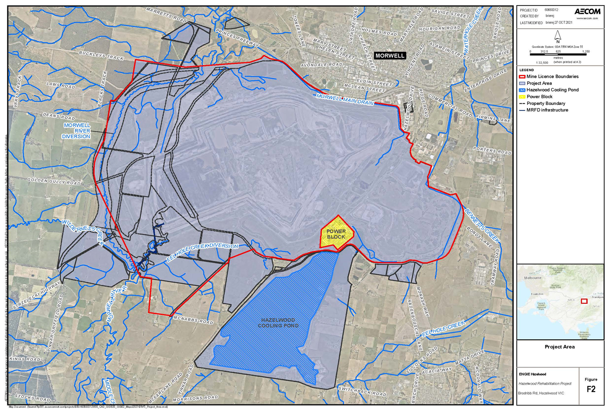
An EES is the most comprehensive and robust assessment process available in Victoria. The EES will provide an integrated and transparent examination of the proposed project and its environmental effects.

Figure 1: Project location (Hazelwood Mine Rehabilitation project)

Appendix A High level summary of key submission issues and updates made to Hazelwood Mine Rehabilitation Project EES scoping requirements
Submission issue | Relevant sections of scoping requirements | Changes to final scoping requirements
Need for greater consideration of climate change impacts | 3.3, 4.1, 4.3, 4.5 | Updated to strengthen that climate risks and the potential effects of climate change need to be accounted for in relevant technical studies for the EES.
Concern about the regional effects associated with closure of the three Latrobe Valley mines and the need for a regional study to assess these cumulative effects | 3.2 and 4.1 | Updated to reinforce that the cumulative impact assessment is required to consider the closure of Yallourn Mine and Loy Yang Mine, where relevant.  No other change to require a regional study as this is considered outside the scope of the scoping requirements.
Assess the technical feasibility of alternative rehabilitation options to the proposed pit lake by requiring an options analysis in the EES | 3.5 | Updated to strengthen project alternatives section to emphasise the need for the EES to consider alternatives to key aspects of the project such as the source(s) of water proposed to be used to fill the pit lake, interconnection with Morwell River and other feasible alternatives raised through stakeholder and community feedback.
Concerns that a number of groundwater and surface water uses and values were not adequately recognised in the scoping requirements | 4.1 | Updated to acknowledge the range of uses and values of surface water and groundwater that have the potential to be impacted by the project including environmental, cultural, recreational and agricultural.
Concerns about impacts on water resources and water quality, including that contamination in the pit could affect water quality | 4 and 4.1 | Multiple updates to reinforce the need to assess effects on water resources and their environmental, cultural, recreational and agricultural values and uses downstream of the project area.  Updated to strengthen the requirement to assess the potential influence of overburden, ash dumps (including the HARA), landfills and pit wall-rock on water quality.
Concerns about erosion, stability and subsidence including concerns for public safety and infrastructure damage | 4.2 | Updated to reinforce the requirement to assess potential hazards and risks to public safety and existing and planned infrastructure and land-uses within, near and surrounding the mine site associated with the project.
Concerns about ecosystem and biodiversity impacts | 4.1 and 4.3 | Updates to acknowledge the range of uses and values of surface water and groundwater that have the potential to be impacted by the project and to strengthen the assessment of effects on biodiversity and ecological values.

Submission issue | Relevant sections of scoping requirements | Changes to final scoping requirements
Need for greater consideration of the potential for adverse effects on the health and condition of Country and opportunities to better reflect Traditional Owner values and perspectives | 4.1-4.4 | Multiple updates to reinforce Traditional Owners’ connection to Country and potential for adverse effects on the health and condition of Country.  Updated to require that cumulative effects on the health and condition of Country including any Aboriginal intangible cultural heritage values associated with the project area be assessed.
Need for greater consideration of community values and economic impacts and opportunities | 4.5 | Updated to require assessment of project effects on socioeconomic values, employment and the local and regional economy and identification of measures to enhance benefits to local communities and the local and regional economy.
Need to reference relevant regulations, guidelines, plans and agreements | Throughout | Multiple updates to reference relevant regulations, guidelines, plans and agreements that need to be considered as a part of the assessment for the EES
Concerns about readability and consistency | Throughout | Multiple updates to improve readability and consistency across the scoping requirements.

