Regional Growth Plan

Background Report

Authorised and published by the Victorian Government, 1 Treasury Place, Melbourne

Printed by Finsbury Green, Melbourne

If you would like to receive this publication in an accessible format, please telephone 1300 366 356.

This document is also available in Word format at [www.dtpli.vic.gov.au/regionalgrowthplans](http://www.dtpli.vic.gov.au/regionalgrowthplans)

Unless indicated otherwise, this work is made available under the terms of the Creative Commons Attribution 3.0 Australia licence.

To view a copy of the licence, visit creativecommons.org/licences/by/3.0/au

It is a condition of this Creative Commons Attribution 3.0 Licence that you must give credit to the original author who is the State of Victoria.

**Disclaimer**

This publication may be of assistance to you, but the State of Victoria and its employees do not guarantee that the publication is without flaw of any kind or is wholly appropriate for your particular purposes and therefore disclaims all liability for any error, loss or other consequence which may arise from you relying on any information in this publication.

**April 2014**

Table of contents

1 Introduction 1

2 Project information 2

2.1 Frequently asked questions 2

2.2 Preparation and process 3

2.2.1 Workshops 3

2.2.2 Draft issues paper 4

3 Background information 5

3.1 Overview of the Southern Loddon Mallee Regional Strategic Plan 2010 5

4 Population, settlement and housing 8

4.1 Population 9

4.2 Housing 13

4.3 Disadvantage 21

5 Economic health and growth 23

5.1 Economic sectors 24

5.2 Structural drivers for regional growth 25

5.3 Exports 26

5.4 Employment change and growth 27

5.5 A changing regional economy 30

5.6 Major and emerging businesses 31

5.7 Agriculture 32

5.8 Natural resources 35

5.9 Challenges for the regional economy 37

5.10 Land supply – employment 38

5.10.1 Industrial land supply 38

5.10.2 Commercial and retail land supply 39

5.10.3 Rural land 39

6 Environment and natural resources 40

6.1 Environment and heritage assets 41

6.1.1 Cultural heritage assets 41

6.1.2 Significant landscapes 44

6.1.3 Terrestrial habitat 44

6.1.4 Waterways (rivers and wetlands) 46

6.1.5 Catchment health 47

6.1.6 Soils 49

6.1.7 Public land 50

6.2 Natural hazards and risks 51

6.2.1 Flood 51

6.2.2 Bushfire 52

6.2.3 Climate change 53

6.2.4 Soil health threats 54

7 Transport and infrastructure 57

7.1 Policy context transport 58

7.2 Transport in the Loddon Mallee South region 59

7.2.1 Road traffic flows 59

7.2.2 Train passenger traffic 61

7.2.3 Journey to work patterns 63

7.2.4 Guiding future transport opportunities 66

7.3 Urban water supply 68

7.4 Rural water supply 71

7.5 Waste management 71

7.6 Wastewater management 72

7.7 Communications and information and communication technology 73

7.8 Energy 73

8 Developing the regional growth plan 76

8.1 Planning considerations 76

8.2 Planned and future growth 79

8.2.1 Settlement growth 79

8.2.2 Planned growth 79

8.3 Growth types 83

8.4 Urban design considerations 85

8.5 Building on our strategic assets 85

8.6 Challenges for regional growth 88

9 References 90

10 Appendices 92

10.1 Appendix 1: Loddon Mallee South region, estimated industrial land supply (hectares) 92

10.2 Appendix 2: Settlement growth analysis 93

Figures:

Figure 1: Loddon Mallee South region 2

Figure 2: Hierarchy of plans 4

Figure 3: Recent growth Loddon Mallee South region, population totals and growth rates 9

Figure 4: Town population 2011 10

Figure 5: Australian Bureau of Statistics Urban centre/Locality for Bendigo 2011 11

Figure 6: Loddon Mallee South, Projected population 2016–2031 11

Figure 7: Age structures Loddon Mallee South, 2011 and 2031 13

Figure 8: Loddon Mallee South, Household composition 2011 13

Figure 9: Loddon Mallee South, Future household composition 2011–2031 15

Figure 10: Loddon Mallee South, Average household size 2011–2031 17

Figure 11: Loddon Mallee South, dwelling type 2011 17

Figure 12: Loddon Mallee South Index of Relative Socio-Economic Disadvantage 22

Figure 13: Sectoral contribution to employment, Loddon Mallee South, 2011 25

Figure 14: Exports, 2011 and annual average growth rate from 2001–2011 26

Figure 15: Local Government Area exports, 2011 and annual average growth rate, 2001–2011 27

Figure 16: Map of employment change, Loddon Mallee South local government areas, 2001–2011 28

Figure 17: Major regional employment sectors 28

Figure 18: Loddon Mallee South unemployment rate, September Quarter 2012 29

Figure 19: Selection of major businesses and enterprises in Loddon Mallee South 31

Figure 20: Extractive industries and primary production 33

Figure 21: Mining and extractive industries, tenements and licences 36

Figure 22: Cultural heritage 43

Figure 23: Terrestrial habitat assets of the region, reflected through native vegetation. 45

Figure 24: Significant waterways of the region 47

Figure 25: Declared water supply catchments (open potable water supply catchments) in the Loddon Mallee South region 48

Figure 26: Soil landscapes and land use defined by the North Central CMA 49

Figure 27: Public land in the Loddon Mallee South region 50

Figure 28: Flood overlays in the Loddon Mallee South region 51

Figure 29: Bushfire Management Overlays for the Loddon Mallee South region 53

Figure 30: Salinity Management Overlays for the Loddon Mallee South region 55

Figure 31: Traffic count data points, Loddon Mallee South region 60

Figure 32: Compound growth rates, two-way, 2006 to 2010, Loddon Mallee South region 61

Figure 33: Normal weekday rail patronage, estimate by station, Loddon Mallee South 62

Figure 34: Total boardings at Maryborough Station from July 2010 to November 2011 62

Figure 35: Journey to work within local government area boundaries, Loddon Mallee South, 2006 63

Figure 36: Loddon Mallee South public transport routes 64

Figure 37: Central Victoria’s transport network 65

Figure 38: Summary of water supply demand strategy outlooks for the Loddon Mallee South region 69

Figure 39: Major water supply and wastewater projects in the Loddon Mallee South region 70

Figure 40: NBN Loddon coverage 74

Figure 41: Loddon Mallee South utilities 75

Figure 42: Loddon Mallee South planning considerations 78

Figure 43: Planned population growth and potential population, nominated growth settlements 80

Figure 44: Examples of greenfields development 83

Figure 45: Example of infill development 84

Figure 46: Examples of brownfield development 84

# Introduction

The Loddon Mallee South Regional Growth Plan is one of eight regional growth plans being prepared across Victoria. It provides a long-term regional approach to strategic land use planning across the Loddon Mallee South region. Covering the municipalities of Greater Bendigo, Macedon Ranges, Mount Alexander, Central Goldfields and Loddon, the plan will provide a high level framework to manage growth and change across the region to 2041. It will also provide the means to implement the strategic land use and infrastructure directions that are set out in the Southern Loddon Mallee Regional Strategic Plan 2010.

The Loddon Mallee South Regional Growth Plan is supported by the following documents:

#### Loddon Mallee South Background Report – this document

The background report provides an outline of the development of the plan, as well as summarising the important issues arising from a draft issues paper which was developed to inform the plan’s strategic directions.

#### Loddon Mallee South draft issues paper

A draft issues paper was prepared as background research to inform the development of the plan.

#### Structure of the background report

Sections 1 and 2 **–** Introduction and project information

Sections 3–7 **–** Background information

Section 8 **–** Developing the regional growth plan

# Project information

## Frequently asked questions

#### Where is Loddon Mallee South?

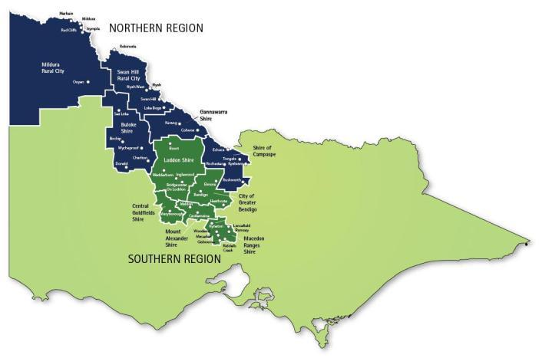Figure 1: Loddon Mallee South region

Source: Department of Transport, Planning and Local Infrastructure

The Loddon Mallee South region occupies the geographic centre of Victoria. It extends from Boort and Pyramid Hill in the north to the Macedon Ranges in the south-east. At its closest point, the region is 50 kilometres from the centre of Melbourne, with much of the region covering the hinterland of Melbourne. The Loddon Mallee South region has rich natural and built heritage, attractive towns, a pleasant climate, and both social and economic diversity. Its central location and excellent transport links allow safe and efficient travel to Melbourne and other centres.

The region is home to some of Victoria’s richest goldfields, and this history still influences the environment and settlements today. The region has significant historical and environmental assets with substantial forest surrounding the majority of towns. It is characterised by settlements nestled within forest and farms.

The total population of the region is 188,000 (Victoria in Future). Bendigo is the regional city and hub of the Loddon Mallee South region, providing quality healthcare, educational, cultural and economic services. With a population approaching 100,000, the city is experiencing steady growth.

#### Why do we need a regional growth plan?

The Loddon Mallee South region is experiencing a growth rate higher than many other areas of regional Victoria. The regional city of Bendigo is one of the fastest growing, and one of the four largest inland cities in the country. The region is experiencing change, from agricultural areas in the north-west to pressures on the peri-urban fringe in the south. There is strong population growth in some areas, with demand for ‘lifestyle living’ and pressure on land supply. Other areas have low or negative population growth. When combined with low population density and dispersed patterns of settlement, this presents different challenges. The plan provides an opportunity to manage these pressures through the development of a regional strategic land use framework for growth and change.

#### What will the plan do?

The growth of regional Victoria is essential to a vibrant and sustainable state. Regional growth plans will provide a long-term strategic land use and settlement framework that presents a broad outline for future change in the region.

Responding to directions provided in the Southern Loddon Mallee Regional Strategic Plan 2010, the plan shows how and where residential and commercial growth can be accommodated across the region to 2041. It also highlights the importance of our non-urban spaces for agriculture, recreation and as environmental assets.

In all regions, the regional growth plans will ensure there is linkage between economic development and strategic land use planning. Creating opportunities for economic growth is essential to maintaining the sustainability of services and facilities in cities, towns and communities of all sizes. Economic development will be supported by high level infrastructure analysis informed by current and future land patterns that will guide regional level infrastructure considerations, future planning and investment.

Planning for sustainable growth in regions also requires identification of the key regional assets to be preserved, improved or developed. This includes identifying areas for protection and constraints to growth such as flood, bushfire hazard, native vegetation and strategically important agricultural land.

## Preparation and process

### Workshops

The regional growth plan has been prepared in partnership with the shires of Central Goldfields, Loddon, Macedon Ranges, Mount Alexander and the City of Greater Bendigo, as well as state government departments and agencies including the Department of Transport, Planning and Local Infrastructure, the Department of Environment and Primary Industries, the Department of State Development, Business and Innovation, VicRoads catchment management authorities and water authorities.

A Project Steering Group and a Technical Working Group were formed to oversee the development of the plan. Four workshops were held with the Technical Working Group to canvas regional issues, settlement scenarios and potential Future Directions for the region. The outcomes of these workshops have been incorporated into the plan.

The second of the four workshops of the Technical Working Group worked through the development of a future settlement framework for the region. Rather than presenting alternative growth scenarios, four main theme areas were prepared and presented to participants. These four theme areas could be considered in isolation or combined: i) Regional City and centre growth, ii) Growing small towns and Bendigo’s hinterland, iii) Rural residential development; and iv) Places facing change.

The purpose of the second workshop was to explore the identified themes; understand the opportunities and barriers to achieving growth; explore if and how barriers could be removed; discuss preferred locations for future urban growth; and consider settlement management outside existing urban centres. Growth themes and scenarios were informed by existing settlement strategy work undertaken by local councils. A preferred scenario for further investigation was agreed and this formed the basis of the plan.

### Draft issues paper

A draft issues paper was prepared to provide input into the development of the plan. The draft issues paper outlines challenges and opportunities across the region under the key areas of:

* settlement and population
* economic health and growth
* environment and natural resources
* infrastructure.

Federal, state and local government policies and strategies were considered in developing the plan. Data and mapping sources include:

* Australian Bureau of Statistics (ABS) 2011 Census data
* Victoria in Future 2012 population projections
* Regional Urban Development Program data.

The following assumptions were used in the development of the plan:

* The plan is a regional plan and will not undertake localised planning.
* Current local government planning strategies are taken as given. The plan will not seek to change the directions contained in these.
* One job per household with no net increase in travel to Melbourne or outside the region.

#### Where does the plan fit?

The plan is consistent with state government policy, particularly the State Planning Policy Framework. Regional growth plans will integrate with the new metropolitan planning strategy, *Plan Melbourne* and the government’s Regional Cities agenda, as well as planning for Melbourne's peri-urban area (the area within 100km of Melbourne). Some regional cities and the peri-urban region may be influenced by the growth of metropolitan Melbourne.

The plan provides a regional view of land use planning and growth. It also provides a link between statewide and local policy (refer to Figure 2).

Figure 2: Hierarchy of plans

**Regional planning**

* **Regional Strategic Plans**Shorter to medium term priorities and directions for regions
* **Regional Growth Plans**Long-term strategic direction for land use planning for regions

**Local planning**

* **Council Plans**Shorter to medium term priorities and actions for councils
* **Municipal Strategic Statements**Long-term strategic direction for land use planning for councils

A Localised Planning Statement is being prepared for the Macedon Ranges to provide the basis for state recognition of the valued attributes of the area. This regional growth plan will provide broad strategic direction for land use in the Macedon Ranges Shire. The Localised Planning Statement will provide the basis for greater recognition and protection for the area and supplement the more general state level strategies and policies.

# Background information

## Overview of the Southern Loddon Mallee Regional Strategic Plan 2010

The Southern Loddon Mallee Regional Strategic Plan 2010 (the Regional Strategic Plan 2010) addresses the challenges and opportunities facing the region over the next 10 to 15 years. Released in 2010, it presents a framework for the region to manage future growth and change in a way that strengthens its economy, helps people thrive and protects the region’s rich natural and cultural heritage.

Developed collaboratively, the Regional Strategic Plan 2010 has the support of key local industries and community organisations, and has been endorsed by the region’s local councils, the Loddon Mallee Regional Management Forum and the Regional Development Australia Committee.

The Regional Strategic Plan 2010 establishes an agreed vision for the region. It is supported by six strategic directions underpinned by agreed priority actions and key initiatives.

#### Vision

The Regional Strategic Plan 2010 identifies the following vision for the region:

*Our communities will continue to enjoy regional liveability with urban accessibility. We will be a region with vibrant, innovative, sustainable and connected communities offering a diversity of lifestyles, building on our heritage and natural environment. Over the next 10 to 20 years, this Strategic Plan will assist us to build a region that has:*

|  |  |  |  |
| --- | --- | --- | --- |
| **Prosperous places** – our region’s towns and settlements, and the people within them, will form a network and continue to share in the region’s vibrancy, diversity and opportunity. They will retain great access to services and infrastructure in Bendigo and Melbourne. | **A vibrant provincial city** – the population of Greater Bendigo will grow towards 135,000 people. Arts, recreation and culture will thrive. The city will have quality infrastructure, educational opportunities, healthcare and other services. | **A thriving, diverse economy** – our region will continue to attract new investment and a diverse range of jobs, building on the region’s competitive advantages. Health, education, construction, retail, tourism, agriculture and renewable energy all provide opportunities for the region. Manufacturing will continue to prosper through investment in innovation. | **Enhanced natural and cultural heritage** – our natural, Indigenous and goldfields heritage is widely appreciated and protected. The forests of the Great Dividing Range and the goldfields interconnect and will provide linkages to the Murray River. |

#### Strategic directions

Six strategic directions were identified, with each strategic direction including agreed priority actions and key initiatives:

1. Manage our population growth and settlements
2. Strengthen our communities, especially in our small towns
3. Strengthen and diversify our economy
4. Improve our infrastructure
5. Improve education and training outcomes
6. Protect and enhance our natural environment

The Regional Strategic Plan Annual Report 2011–12 reports on the progress of initiatives put in place by agencies, local government and communities across the region. These documents can be found at <http://www.rdv.vic.gov.au/victorian-regions/loddon-mallee/loddon-mallee-south>.

#### Implications for the regional growth plan

The Loddon Mallee South Regional Growth Plan will provide the means to implement the strategic land use and infrastructure components of the Regional Strategic Plan 2010. It will do this by:

* providing broad direction for regional land use and development including detailed planning frameworks for key regional centres
* providing direction to accommodate growth and change in residential, employment, industrial, commercial, agricultural and other rural activities
* identifying important economic, environmental, social and cultural resources to be preserved, maintained or developed
* broadly mapping which areas of land can accommodate growth and which are to be maintained, including consideration of the infrastructure needed to support growth or change
* helping councils by streamlining planning policy as well as potentially reducing the amount of strategic work councils have to do.

Each of the six directions of the Regional Strategic Plan 2010 have land use and infrastructure implications as outlined below. These have been taken into consideration when developing the regional growth plan.

**Direction 1 – Manage our population growth and settlements**

* Protect non-urban breaks.
* Undertake detailed capacity analysis and growth area planning for settlements to protect their unique identities.
* Maintain a well-connected network of towns and settlements, which are the focus of high-quality development, activity, employment and living.
* Concentrate new urban development in existing towns and settlements that can accommodate growth, whilst preserving township/regional character.
* Provide a diverse range of housing options to meet the community’s needs.
* Develop physical infrastructure that keeps pace with growth.

**Direction 2 – Strengthen our communities, especially in our small towns**

* Improve access to social services and community infrastructure through improved land use and infrastructure planning.
* Build community connectedness and reduce areas of social disadvantage through best practice urban design.

**Direction 3 – Strengthen and diversify our economy**

* Ensure infrastructure supports the growth of current and emerging industries.
* Support more local employment opportunities throughout the region through the provision of appropriately zoned and serviced land.
* Maintain prosperous and sustainable agriculture.
* Ensure land use and infrastructure planning supports emerging and potential growth sectors such as tourism and ‘green’ industries.

**Direction 4 – Improve our infrastructure**

* Develop infrastructure and services that facilitate continued growth of the regional economy.
* Maintain liveability in towns and regional centres through proactive infrastructure provision.
* Improve road, rail and public transport access to Melbourne through continued investment and development in highways, local roads and rail infrastructure.

**Direction 5 – Improve education and training outcomes**

* Address the lack of student accommodation in Bendigo.

**Direction 6 - Protect and enhance our natural environment**

* Protect significant environmental and natural assets.
* Protect visually important landscapes.

#### Fast facts about the Loddon Mallee South region

|  |  |
| --- | --- |
| Current population Loddon Mallee South region (VIF 2012) | **188,000** |
| Current population – urban Bendigo | **82,794** |
| Distance from centre of Melbourne at its closest point | **50 kilometres** |
| Proportion of residents living in Bendigo | **56%** |
| Proportion of residents living in farming and rural locations | **22%** |
| Number of people within the region born overseas | **13,500 or 7%** |
| Growth rate for the region over the past 10 years | **1.2%** |
| Projected population in 2031 (VIF 2012) | **242,251** |
| Forecast average annual population growth | **1.3%** |
| Potential 2041 population of the Loddon Mallee South region with accelerated growth | **300,000** |
| Average household size for the region in 2011/estimated 2031 | **2.49 / 2.36 persons** |
| Population plans for urban Bendigo | **150,000 to 200,000** |
| Planned growth for Bendigo | **38,500 people** |
| Proportion of planned growth for Bendigo which comprises urban infill | **10,300 people** |
| Current total planned growth capacity for urban Bendigo | **121,375** |
| Industry sector with largest share of total economic output | **Manufacturing** |
| Number of jobs currently within the region | **58,317** |
| Percentage of population from Macedon, Woodend and Gisborne who commute to Melbourne for work | **>40%** |
| Unemployment rate | **4.9%** |
| Number of new jobs required to support the future additional regional population of 120,000 people | **48,000** |
| There are three main river catchments in the region – the Loddon, Campaspe and Avoca rivers | |
| Urban Bendigo is the only city of any size in Australia to be encircled by a national park[1] | |
| The region contains Australia’s only National Heritage Park at the Castlemaine diggings | |
| The City of Greater Bendigo is located at the junction of four highways and acts as a major transport hub for northern and north-western Victoria. Regional fast rail links Bendigo to Melbourne. | |

# Population, settlement and housing

#### Key findings – Population, settlement and housing

* Urban Bendigo has evolved into a specialised retail, health, education, financial and administrative centre for its wider region.
* Growth across the region is not uniform. Strong population growth is occurring in Bendigo and in many townships located on, or in close proximity to, the Calder corridor. Population growth has traditionally been much slower in Central Goldfields and Loddon shires.
* The number of households is increasing at a faster rate than the population.
* By 2031, nearly two-thirds of households in Bendigo and regional Victoria will consist of one or two people.
* The region’s population is ageing, with the highest population growth projected to be in age groups above 59 years of age.
* A high proportion of dwellings across the region are detached houses.
* There are a number of areas with high level of socio economic disadvantage, much of which coincides with areas of lower population growth. Measures of disadvantage are also divided along corridor and non-corridor lines, with much of the disadvantage located in areas away from the Calder corridor.

#### Key implications for the plan

* Some areas experiencing strong growth have limited capacity to accommodate significant population increases due to environmental planning considerations and natural hazards. The capacity to grow beyond existing settlement boundaries may be limited. This will influence how settlements can accommodate growth.
* Growth in households in areas experiencing strong population growth has resulted in increased demand for dwellings with subsequent implications for land supply.
* Some intervention may be needed to change the housing mix to meet the needs of future populations.
* Similar growth and change patterns to past trends are projected to continue in Central Goldfields and Loddon over the next 15 years without some intervention or ‘game changers’.
* An ageing population has implications for the provision of community and health services, and housing types.
* The capacity to grow population is heavily influenced by the capacity to provide appropriate infrastructure, for example, water, sewer, power and gas.

#### Key challenges

* Managing differing rates of growth and change across the region.
* Meeting the aspirations of some settlements for growth even though they have historically low growth rates.
* Achieving the right balance of housing types to meet changing household needs, both now and into the future.
* Providing a range of housing types, including infill opportunities and higher density housing, while respecting the regional and heritage character of towns.
* Reducing and managing the levels of social disadvantage.
* Attracting and maintaining a diverse population, including younger age groups and people of working age, for sustainable growth across the region.
* Considering initiatives and incentives for managing and stimulating growth.
* Exploring whether the current growth trends are desirable and able to be accommodated.
* Specific growth plans and other initiatives may be needed in areas of disadvantage across the region.
* Protecting settlement character.
* Improving the liveability of local communities, especially smaller towns.
* Investment is required for the provision of essential infrastructure services.

## Population

Bendigo is the regional city and hub of the Loddon Mallee South region and provides quality healthcare, educational, cultural and economic services. With a population approaching 100,000 people, the city is experiencing steady growth. The regional centres of Gisborne, Maryborough, Castlemaine and Kyneton serve surrounding smaller towns and non-urban populations. There are many small towns in the region with a diversity of roles. Some small towns play a key service role to outlying farming communities. The region also has a significant non-urban population, with people living on farms and in rural areas outside towns. Around 22 per cent of the population live outside these centres in farming and rural locations.

#### Current population and recent growth trends

According to the Australian Bureau of Statistics (Census 2011) the total population of the Loddon Mallee South region is 180,023 people (ABS Census 2011). The ABS Census of Population and Housing is the most complete survey of the Australian population undertaken. It provides in-depth information on the population, their location, their characteristics and behaviour – but it is a snapshot, and can be done only once every five years due to the enormous logistical effort it requires. However, the ABS, the state government and many other bodies require the count of population to updated more often than that, in order to plan services and conduct their business. For this reason, the ABS also calculates an official population number, known as the Estimated Resident Population (published quarterly for states and annually for Local Government Areas). In a Census year, for example 2011, this population is based on a Census count, but also takes into account the variation between what is counted on Census night – which includes people on holiday, or away for business – and where people are officially resident. Between Census years the ABS uses other administrative data (births, deaths, migration) to estimate the changes in population.

Based on this inter-Censusal data, the Victoria in Future (2012) population projections estimate a higher 2011 total population for the Loddon Mallee South region of 188,000. The Victoria in Future projections are relied upon by the Victorian Government to assist its planning and service delivery functions.

The region experienced strong population growth between 2006 and 2011, with the amount and rate of this growth varying considerably across the region (see Figure 3). Most growth is occurring in the corridor between Bendigo and Melbourne principally in Bendigo, Castlemaine, Gisborne, Romsey and Riddells Creek. There was a small amount of growth in Central Goldfields and a modest decrease in population in Loddon Shire. The region has a significant migrant population with overseas migration projected to stay strong.

Figure 3: Recent growth Loddon Mallee South region, population totals and growth rates

Greater Bendigo

* 2006 – 93,252
* 2011 – 100,617
* Average Annual Growth Rate – 1.53

Macedon Ranges

* 2006 – 38,360
* 2011 – 41,860
* Average Annual Growth Rate – 1.76

Mount Alexander

* 2006 – 17,066
* 2011 – 17,591
* Average Annual Growth Rate – 0.61

Central Goldfields

* 2006 – 12,323
* 2011 – 12,496
* Average Annual Growth Rate – 0.28

Loddon

* 2006 – 7836
* 2011 – 7459
* Average Annual Growth Rate – -0.98

Loddon Mallee South Region

* 2006 – **168,837**
* 2011 – **180,023**
* Average Annual Growth Rate – **1.29**

Source: Australian Bureau of Statistics Census 2006 and 2011

Figure 4: Town population 2011

Greater Bendigo

* Urban Bendigo, 82,794
* Heathcote, 1688
* Elmore, 668
* Marong, 351
* Axedale, 216
* Goornong, 261
* Non-urban balance, 14,639

Mt Alexander

* Castlemaine, 9124
* Maldon, 1236
* Newstead, 512
* Harcourt, 479
* Guildford, 244

Loddon

* Boort, 760
* Inglewood, 711
* Wedderburn, 680
* Pyramid Hill, 419
* Bridgewater, 363

Macedon Ranges

* Gisborne, 8057
* Kyneton, 4460
* Romsey, 3678
* Woodend, 3415
* Riddells Creek, 2976
* Macedon, 2631
* Lancefield, 1262
* Malmsbury, 612
* Tylden, 355

Central Goldfields

* Maryborough, 7174
* Carisbrook, 791
* Dunolly, 638
* Talbot, 258

Source: Department of Planning and Community Development and Australian Bureau of Statistics Census 2011

The population of urban Bendigo was calculated using the ABS Urban Centre/Locality for Bendigo 2011 (refer to Figure 5).

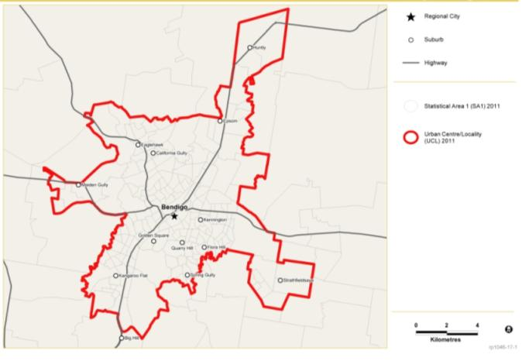Figure 5: Australian Bureau of Statistics Urban centre/Locality for Bendigo 2011

Source: Australian Bureau of Statistics Census 2011

#### Future population

As a whole, the Loddon Mallee South region is projected to continue to grow at a rate of 1.3 per cent per annum to reach 242,250 people by 2031 (see Figure 6) and 266,900 by 2041[2]. The regional growth plan considers the implications of the region growing to a population of 300,000 by 2041, with 150,000 to 200,000 people residing in Greater Bendigo.

Population growth is anticipated predominantly in the Melbourne to Bendigo corridor. As the largest regional centre in the region, Bendigo is expected to grow at a higher rate compared to other parts of the region, and regional Victoria as a whole.

Figure 6: Loddon Mallee South, Projected population 2016–2031

Greater Bendigo (C)

* 2016 – 113,948
* 2021 – 122,602
* 2026 – 131,357
* 2031 – 139,837

Central Goldfields (S)

* 2016 – 13,257
* 2021 – 13,467
* 2026 – 13,721
* 2031 – 13,988

Macedon Ranges (S)

* 2016 – 47,340
* 2021 – 51,279
* 2026 – 55,172
* 2031 – 58,944

Mt Alexander (S)

* 2016 – 19,269
* 2021 – 20,090
* 2026 – 20,986
* 2031 – 21,854

Loddon (S)

* 2016 – 7896
* 2021 – 7772
* 2026 – 7686
* 2031 – 7627

Loddon Mallee South region

* 2016 – 201,710
* 2021 – 215,210
* 2026 – 228,922
* 2031 – 242,250

Source: Victoria in Future 2012

Population growth is desired by many communities across the Loddon Mallee South region, although the locations for growth and the ability of settlements to accommodate additional residents needs to be considered and managed. Some settlements, such as those located in the Bendigo to Melbourne corridor, are experiencing high rates of growth which may not be able to be accommodated. Managing growth pressures whilst preserving the character of towns and settlements will continue to be important for the region. Other settlements have low growth projections but have the land supply to accommodate additional population growth.

Historically, growth has been slow in the Central Goldfields Shire where accelerated growth is desired. Proactive programs and strategies to stimulate growth are being implemented, such as the reintroduction of the Maryborough railway line. The decrease in population numbers in Loddon Shire is partially due to the consolidation of farming properties. Where settlements have low growth projections and are unlikely to experience population growth, the focus may be on reinforcing their current role and function. There may be an opportunity for growth in some hinterland towns to help sustain agricultural areas and provide additional support services to the broader community.

#### Age structure

Different age groups need different infrastructure and services, therefore understanding the region’s age structure is essential for service provision. The region’s age profile is similar to that of the rest of regional Victoria. However, differences in age profile within the region are pronounced, with Central Goldfields, Loddon and Mount Alexander having significantly older populations than Greater Bendigo and Macedon Ranges.

By 2031, the number of people in all age groups will increase. A decline in birth rates, combined with the continued rise in average life expectancy, will contribute to a population where the average age is increasing.

Figure 7 shows the region’s population age profile is projected to be older in 2031, with persons in age groups above 65 years increasing both in absolute terms and also as a higher proportion of the population when compared to 2011. Age groups below 65 years will therefore comprise a lower proportion of the population than they did in 2011.

Figure 7: Age structures Loddon Mallee South, 2011 and 2031

Source: Australian Bureau of Statistics Census 2011, Victoria in Future 2012

An ageing population means the percentage of working age people in the region will decrease, which will have implications for the labour force and provision of skilled workers. A challenge for the region will be attracting and maintaining a diverse age population, particularly those in younger age groups and people of a working age, to maintain a healthy economy, community diversity and social wellbeing.

## Housing

#### Households

The majority of households in the region are comprised of families, ranging from 63.7 per cent of households in Central Goldfields to 78 per cent in Macedon Ranges. There are a significant proportion of single or lone person households across the region (Figure 8).

Figure 8: Loddon Mallee South, Household composition 2011

**Family Households**

* Greater Bendigo
* Number – 26,279
* Percentage – 68.8
* Central Goldfields
* Number – 3341
* Percentage – 63.7
* Macedon Ranges
* Number – 11,356
* Percentage – 78.2
* Mount Alexander
* Number – 4600
* Percentage – 64.8
* Loddon
* Number – 1978
* Percentage – 65.1
* Loddon Mallee South region
* Number – 47,554
* Percentage – 69.8

**Single (or lone) person households**

* Greater Bendigo
* Number – 10,306
* Percentage – 27.0
* Central Goldfields
* Number – 1767
* Percentage – 33.7
* Macedon Ranges
* Number – 2900
* Percentage – 20.0
* Mount Alexander
* Number – 2280
* Percentage – 32.1
* Loddon
* Number – 980
* Percentage – 32.3
* Loddon Mallee South region
* Number –18,233
* Percentage – 26.8

**Group households\***

* Greater Bendigo
* Number – 1634
* Percentage – 4.2
* Central Goldfields
* Number – 140
* Percentage – 2.6
* Macedon Ranges
* Number – 267
* Percentage – 1.8
* Mount Alexander
* Number – 218
* Percentage – 3.1
* Loddon
* Number – 80
* Percentage – 2.6
* Loddon Mallee South region
* Number –2339
* Percentage – 3.4

**Total**

* Greater Bendigo
* Number – 38,218
* Percentage – 100
* Central Goldfields
* Number – 5248
* Percentage – 100
* Macedon Ranges
* Number – 14,523
* Percentage – 100
* Mount Alexander
* Number – 7098
* Percentage – 100
* Loddon
* Number –3038
* Percentage – 100
* Loddon Mallee South region
* Number – 68,126
* Percentage – 100

Source: Australian Bureau of Statistics Census 2011

*A group household is defined as a household consisting of two or more unrelated people where all persons are aged 15 years and over.

By 2031, nearly one third (31 per cent) of households in the Loddon Mallee South region will consist of one person, up from 27 per cent in 2011 (Figure 9).

Figure 9: Loddon Mallee South, Future household composition 2011–2031

**Family households**

* 2011
* Number – 51,720
* Percentage – 69.8
* 2021
* Number – 59,329
* Percentage – 68.2
* 2031
* Number – 66,394
* Percentage – 66.5

**Single (or lone) person households**

* 2011
* Number – 20,114
* Percentage – 27.2
* 2021
* Number – 25,243
* Percentage – 29
* 2031
* Number – 30,802
* Percentage – 30.8

**Group households\***

* 2011
* Number – 2230
* Percentage – 3
* 2021
* Number – 2430
* Percentage – 2.8
* 2031
* Number – 2716
* Percentage – 2.7

**Loddon Mallee South Total**

* 2011
* Number – 74,064
* Percentage – 100
* 2021
* Number – 87,002
* Percentage – 100
* 2031
* Number – 99,912
* Percentage – 100

Source: Victoria in Future 2012

The number of households will exceed population growth in both Melbourne and regional Victoria, based on current trends in age structure and household formation. Household growth is an outcome of population growth and is also related to the age structure of the population, partnering and de-partnering trends, the age at which children leave the parental home, and other socio-cultural factors. As the population changes, the living arrangements and household structures of Victorians are also projected to change. As the population ages, there is projected to be a lower proportion of families with children and a higher proportion of single person households.[3]

The faster growth of households compared with population is associated with a decrease in average household size. The average household size is projected to decrease in all municipalities within the region, consistent with the rest of regional Victoria and metropolitan Melbourne (see Figure 10).

Figure 10: Loddon Mallee South, Average household size 2011–2031

Local Government Area: Greater Bendigo

* Average household size 2011: 2.49
* Average household size 2021: 2.42
* Average household size 2031: 2.36

Local Government Area: Macedon Ranges

* Average household size 2011: 2.72
* Average household size 2021: 2.64
* Average household size 2031: 2.56

Local Government Area: Mount Alexander

* Average household size 2011: 2.29
* Average household size 2021: 2.22
* Average household size 2031: 2.16

Local Government Area: Central Goldfields

* Average household size 2011: 2.23
* Average household size 2021: 2.17
* Average household size 2031: 2.11

Local Government Area: Loddon

* Average household size 2011: 2.28
* Average household size 2021: 2.21
* Average household size 2031: 2.14

Source: Victoria in Future 2012

Changes in household types and size will have implications for the type of dwellings needed in the region (see Figure 11).

#### Dwelling types

Figure 11: Loddon Mallee South, dwelling type 2011

**Separate house**

* Greater Bendigo
* Number – 34,252
* Percentage – 89.6
* Central Goldfields
* Number – 4753
* Percentage – 90.5
* Macedon Ranges
* Number – 13,837
* Percentage – 95.3
* Mount Alexander
* Number – 6636
* Percentage – 93.5
* Loddon
* Number – 2885
* Percentage – 95.1
* Loddon Mallee South region
* Number – 62,363
* Percentage – 91.6

**Semi-detached, row or terrace house, townhouse etc.**

* Greater Bendigo
* Number – 1453
* Percentage – 3.8
* Central Goldfields
* Number – 157
* Percentage – 3.0
* Macedon Ranges
* Number – 184
* Percentage – 1.3
* Mount Alexander
* Number – 127
* Percentage – 1.8
* Loddon
* Number – 6
* Percentage – 0.2
* Loddon Mallee South region
* Number – 1927
* Percentage – 2.8

**Flat, unit or apartment**

* Greater Bendigo
* Number – 2203
* Percentage – 5.8
* Central Goldfields
* Number – 239
* Percentage – 4.6
* Macedon Ranges
* Number – 418
* Percentage – 2.9
* Mount Alexander
* Number – 262
* Percentage – 3.7
* Loddon
* Number – 53
* Percentage – 1.7
* Loddon Mallee South region
* Number – 3175
* Percentage – 4.7

**Other dwelling**

* Greater Bendigo
* Number – 301
* Percentage – 0.8
* Central Goldfields
* Number – 101
* Percentage – 1.9
* Macedon Ranges
* Number – 80
* Percentage – 0.6
* Mount Alexander
* Number – 71
* Percentage – 1.0
* Loddon
* Number – 91
* Percentage – 3.0
* Loddon Mallee South region
* Number – 644
* Percentage – 1.7

**Total**

* Greater Bendigo
* Number – 38,209
* Percentage – 100
* Central Goldfields
* Number – 5250
* Percentage – 100
* Macedon Ranges
* Number – 14,519
* Percentage – 100
* Mount Alexander
* Number – 7096
* Percentage – 100
* Loddon
* Number – 3035
* Percentage – 100
* Loddon Mallee South region
* Number – 68,109
* Percentage – 100

Source: Australian Bureau of Statistics Census 2011

Figure 11 shows that of the occupied private dwellings in the region, the overwhelming majority by type were separate houses (91.6 per cent). A total of 2.8 per cent were semi-detached, row or terrace houses, townhouses etc., 4.7 per cent were flats, units or apartments, and 1.7 per cent were other dwellings. An ageing population is expected to create greater demand for smaller allotments as well as a more diverse range of housing types including flats, units, apartments and supported accommodation, all of which are accessible and well-serviced with everyday needs.

The City of Greater Bendigo’s Positive Ageing Working Group on Housing has identified that the preferred housing type is a two bedroom dwelling on a smaller block that is accessible. The Audit of the Bendigo Residential Development Strategy found that since 2001 average house sizes have increased by 35 per cent which suggests that the market is not providing the housing needed for this age cohort. An important consideration for the plan is whether the region has the right type of housing stock to meet current and project dwelling demand.

#### Recent development trends

**City of Greater Bendigo**

The Bendigo Residential Development Strategy – Stage 1 Audit Report 2012 found that:

* Bendigo has experienced strong inward growth and infill development. Since 2004, minor infill (developments of less than four lot subdivisions) has accounted for 30 to 50 per cent of the net lots created each year, and this trend is likely to continue. The drivers of this growing trend include increased return due to land value, a growing population, and with an ageing population people appear to be seeking manageable sized allotments.
* There has been limited development in key nodes such as La Trobe University, Bendigo railway station, the CBD and the Bendigo Hospital precinct which were identified as opportunities for significant increases in density for residential uses to 4-6 storeys.
* Residential development occurring in new growth areas, while still in the early development stages, is not meeting the targets set for the distribution between detached dwellings (target 50 per cent), semi-detached dwellings (target 20 per cent) and multi-unit dwellings (target 30 per cent). The average distributions across all four new development areas is 97 per cent detached, 2.4 per cent semi-detached and 0.6 per cent multi-unit dwellings.
* Current inner urban housing stock tends to be in the higher market bracket, with examples of executive type developments being present.

Stage 2 of the review of Bendigo Residential Development Strategy is the development of an issues and options paper, which identifies options for future residential development and land provisions for growth. It also looks at strategies to deliver housing options to meet identified needs.

**Mount Alexander**

* According to the unpublished, Urban Development Program data (Department of Transport, Planning and Local Infrastructure) relating to Mount Alexander Shire, the majority (66 per cent or 75 per annum) of building approvals since July 2006 within the Statistical Local Area of Mount Alexander have been located within the urban centres of Campbells Creek, Chewton, Maldon, Newstead and Harcourt.
* The majority (30 per cent) of residential lot construction activity was located within Campbells Creek, followed by Castlemaine (28 per cent) and 8 per cent in both Maldon and Newstead.

**Macedon Ranges**

* According to unpublished Urban Development Program data relating to Macedon Ranges Shire, the vast majority of building approvals (97 per cent) since July 2006 have been separate houses, 3 per cent semi-detached dwellings and 0 per cent for units/apartments.
* The majority (53 per cent or 177 per annum) of building approval activity within the Statistical Local Area of Macedon Ranges since July 2006 has been located in the urban areas of Gisborne, Gisborne South, New Gisborne, Woodend and Macedon.
* The majority (32 per cent) of residential lot construction activity was located within Gisborne, followed by Kyneton (17 per cent), Riddells Creek (10 per cent) and Romsey (9 per cent).

**Central Goldfields**

* According to the Review of the Central Goldfields Planning Scheme Draft, August 2012, the number of building permits issued for new dwellings in the Shire has fluctuated between 40 and 80 dwellings per annum, with recent strong levels of activity, particularly in Maryborough.
* The number of non-residential building permits issued in the Shire has fluctuated between 2002 and 2011, with a high number of permits issued in the mid 2000’s.
* The value of non-residential works has fluctuated significantly over the period, with an average just under $8 million per annum from 2002 to 2011.
* There were spikes in 2006 and 2008 reflecting the commencement of large individual construction projects in these years.
* On average, approximately 90 per cent of non-residential building works have taken place in Maryborough.

**Loddon**

* According to the Loddon Shire Council Rural Zones Review April 2012, Loddon exhibits some significant differences in land use trends between the north and south of the shire. These differences are largely attributed to the different agricultural prospects of these two areas and their relative proximity to Melbourne and Bendigo. The main change in land use apparent in these areas relates to rural farmland being converted to rural living, with this trend being stronger in the south.
* In 2010/2011 a total of 77 new permit applications were made. In 2011/2012 this number increased to 108. Of the 108 permit decisions in 2011/2012, 37 were for a land use change.
* In 2011/12 there were 27 additional dwellings approved, and an estimated 21 lots created from subdivision approval.

With a high proportion of detached dwellings (both existing and under construction) across the region, intervention may be needed to change the housing mix in some municipalities to meet the needs of future populations.

## Disadvantage

The Australian Bureau of Statistics Index of Relative Socio-economic Disadvantage shows the Loddon Mallee South region has a number of areas with high levels of socio economic disadvantage, characterised by lower levels of income, lower educational attainment, high levels of unemployment and unskilled occupations.

* Disadvantage is clustered in different localities across the region. Each appears to have a different mix of people. Some are predominantly ageing populations, some working populations and some concentrations of welfare recipients. Some areas have a significant multicultural mix, while others do not. These differences are the result of economic and demographic changes occurring across the region that are resulting in:
  + a decrease of economic opportunities for residents in some areas, particularly for unskilled workers (of which there is a greater proportion in Loddon Mallee South – a trend likely to perpetuate due to lower than state average educational outcomes across early years, secondary and tertiary education)
  + population growth, decrease or change that is causing a need for the restructure of services (putting pressure on services, creating a need for new services or making services in some areas not viable)
  + the concentration of disadvantage in certain areas because of rising housing costs in some areas and falling housing prices (trapping residents) in others (Change and disadvantage in the Loddon Mallee region, Victoria, Department of Planning and Community Development2011page 40).

There are 40 towns or suburbs in the Loddon Mallee South region which are classified as disadvantaged (Figure 12). Areas of disadvantage can generally be divided along the Melbourne to Bendigo corridor and non-corridor lines with much of the disadvantage located in areas away from the corridor. Disadvantage in the region also coincides with areas of lower population growth. However, there are significant areas of disadvantage in the southern and western suburbs of Bendigo as well as in Heathcote, Castlemaine and Kyneton.

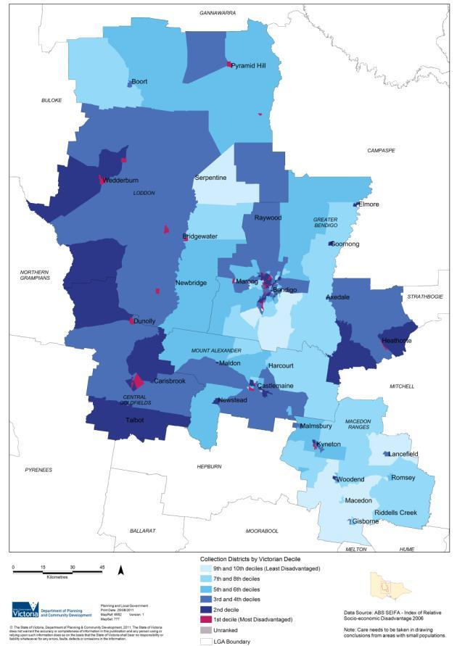Figure 12: Loddon Mallee South Index of Relative Socio-Economic Disadvantage

Source: Department of Transport, Planning and Local Infrastructure

# Economic health and growth

#### Key findings – Economic health and growth

* The Loddon Mallee South region has a strong relationship with the Loddon Mallee North region, particularly via the Calder corridor, a significant transport route for freight and domestic travel within Victoria and beyond to New South Wales and South Australia. Ease of access to and from Melbourne provides a competitive advantage to the region.
* The region is undergoing economic change, with the structure of employment having changed significantly. Retail, health and manufacturing are now the dominant industry employment sectors.
* From 2011 to 2031, the regional employment profile is projected to be heavily concentrated in the services sector – the projected top five employment sectors for the region are healthcare, retail trade, accommodation and food services (including tourism), education and construction. By 2031, these top five sectors are projected to account for 59 per cent of total employment in the region.
* Rural production is a significant contributor to the economy, although the nature of agriculture is changing. Climate change may impact on the agricultural sector, potentially changing the mix of agricultural enterprises in the region.
* There is a high rate of commuting to work outside of Macedon Ranges.
* Growth of the region’s population by 120,000 people will mean approximately 48,000 extra jobs will be required across the region.
* Most of the output and employment growth is expected to be in Bendigo and Macedon Ranges, leaving other municipalities such as Loddon and Central Goldfields economically vulnerable in the medium-to long-term.
* The comparative affordability of housing to Melbourne is a population attractor.
* Due to its environmental and heritage assets, including landscapes and lifestyle opportunities, the region is a key tourist destination and recreation area for metropolitan residents.
* Large capital projects create jobs within the region while also bringing an economic benefit to local communities. Future capital projects within the region will strengthen infrastructure and services while boosting local economies.

Note: Compelling Economics is undertaking a propulsive economic study within the Loddon Mallee South region. As the name suggests the study will identify new and fast growing industries across a variety of sectors.

#### Key implications

* Growth pressures on towns may result in some towns not being able to accommodate the anticipated amount of population growth.
* There could be an insufficient labour force to support the ageing population, as there is likely to be a high dependency ratio, the ratio of young children and post-retirement age adults to working age residents.
* There may be opportunities to further capitalise on the benefits provided by strong transport links throughout the region.
* Increased economic activity and a diversity of jobs within the region would create further opportunities to live and work within the region as an alternative to Melbourne.
* Further supplies of industrial, commercial and retail land will be needed to service a population increase of 120,000 people.
* The siting, form and management of future urban and rural living settlement growth should consider the impacts to existing (and potential future) industries and environmental assets and the risks from natural hazards, especially bushfire and flood, in both planning and implementation.

#### Key challenges

* Creating new economic activity and diversifying the economy such as expanding the tourism industry.
* Providing new local jobs to keep pace with population growth, to reduce the level of commuting to Melbourne, and to ensure communities are economically, socially and environmentally sustainable.
* Leveraging from and expanding the health, education and professional services sectors, and further developing the tourism sector.
* Attracting and retaining a skilled workforce.
* Planning for land supply and potential locations for industry, especially new and fast growing industries, and protecting existing industry from population and land use changes.
* Identifying additional well-sited commercial and retail land.
* Maintaining prosperous and sustainable agriculture and ensuring zones support agricultural practices and can enable adaptation, for example, to climate change.
* Limiting the impacts of population growth and land fragmentation on rural production areas.
* Limiting the impacts of population growth and land fragmentation on environmentally sensitive areas.
* Managing the risks to settlements from natural hazards, especially bushfire and flood, while enabling population growth.
* Introducing flexibility and adaptation to support the ongoing viability of agriculture.
* Ensuring that land use planning aids rather than hinders economic development.
* Managing the uneven distribution of both population and economic growth across the region.
* Identifying further tourism opportunities and niche markets by capitalising on the region’s strengths in heritage, agriculture and natural environments.

## Economic sectors

Diversity and strength is a characteristic of the Loddon Mallee South regional economy. Some of the region’s competitive advantages when attracting businesses and industries include:

* access to raw materials (including mineral, sand and stone resources and timber)
* utilising the agricultural products of the region and nearby regions
* investment security offered in the region, for example, biosecurity, potential for growth and expansion, and access to support services
* supply chain linkages within the region and to other regions and Melbourne
* tourism associated with history and heritage, arts, culture, food and wine.

The key economic sectors in the region are:

* tourism – associated with goldfields heritage
* high value agriculture – poultry and equine
* manufacturing – metals and engineering, building products, food processing and transport
* business and financial services – particularly in Bendigo
* high quality health and education services – complex care, higher education and research.[4]

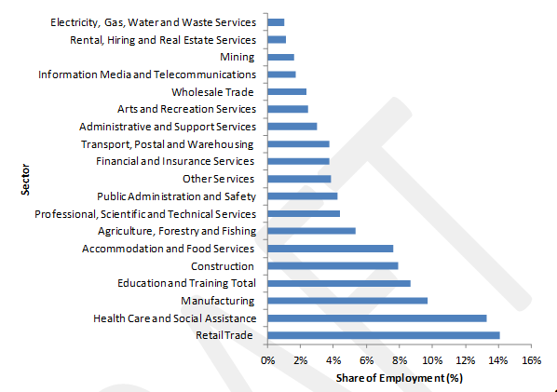Figure 13: Sectoral contribution to employment, Loddon Mallee South, 2011

Source: National Institute of Economic and Industry Research

While the Loddon Mallee South region is less dependent on agriculture than other regions of Victoria, with 6 per cent of the agribusiness in the state, agriculture is still an important part of the regional economy (Figure 13). The gross value of regional agricultural production (in 2006) was about $408 million, which was just 4.7 per cent of the state’s total. Intensive animal production (chickens, eggs, pigs) accounted for over a quarter of the regional value of production and 18.5 per cent of the state’s production. Production from dry land farming areas accounted for almost 50 per cent of the region’s output.[5]

Bendigo is one of Victoria’s most significant regional cities, and is a leading service centre for the region and beyond. The economy is driven by an expanding population and growth in the health and community services sectors, secondary, higher, vocational education and training, government services, finance, business and technical services.

## Structural drivers for regional growth

The Loddon Mallee South region has a relatively strong and diverse economy, which has grown faster than the rest of Victoria over the past decade.[6] The three structural drivers of this growth are:

1. Population: The region’s population growth rate over the past decade has been higher than other regional areas.
2. Labour force participation: The region’s labour force participation rate, while below the state average, has been improving. The region’s latest unemployment figures were lower than the state average.
3. Productivity: The region has performed relatively well in terms of productivity growth, with Gross Domestic Product (GDP) per worker higher than the state average. This suggests the region is more productive than other areas of the state.

However, there remains significant variability in socio economic conditions and employment across the region, with distinct differences in employment and participation rates between the municipalities, and various influences on productivity. The growth of the region is dependent on a strong and diverse economy. With increased population, new jobs need to be created. Access to training and employment, and creating a diverse, adaptable and strong economy is essential for regional growth.

## Exports

According to analysis undertaken by Regional Development Victoria (2012) the main exporting sectors of the region are manufacturing, mining (includes minerals and extractive industries), agriculture, finance and information and communications technology (ICT) (Figure 14). Most of the region’s exports are estimated to come from Greater Bendigo (approximately 63 per cent of the region’s 2011 exports). The Mount Alexander and Macedon Ranges shires accounted for 13 per cent and 10 per cent of the region’s total 2011 exports, respectively. The region’s exports have grown at an average annual rate of 3.6 per cent from 2001 to 2011 which is above the regional Victorian average.

Figure 14 graph showing Exports, 2011 and annual average growth rate from 2001–2011 including fastest annual average growth rate (exports) and largest sectors (exports)Figure 14: Exports, 2011 and annual average growth rate from 2001–2011

Source: National Economics

Figure 15 graph showing Local Government Area exports, 2011 and annual average growth rate, 2001–2011 including Loddon (7%), Mount Alexander (13%), Macedon Ranges (10%), Central Goldfields (7%) and Greater Bendigo (63%)Figure 15: Local Government Area exports, 2011 and annual average growth rate, 2001–2011

Source: National Economics

Loddon Shire is the only local government area where the majority of exports are from the agricultural sector. In 2011, 68 per cent of Loddon Shire’s exports were from the agriculture sector. In 2011, manufacturing was the top export sector for Macedon Ranges, Mount Alexander and Central Goldfields while mining was the major export sector for Bendigo (Figure 15).

## Employment change and growth

The structure of employment in the region has changed significantly since 1996, with retail, health and manufacturing the dominant industry employment sectors. Employment has grown by over 30 per cent in: construction; retail trade; accommodation and food services; professional and technical services; public administration and safety; and healthcare and social assistance. Employment in mining (including minerals and extractive industries) has experienced rapid growth over the past 10 years, with the workforce directly employed in the sector rising from 221 to 595 (a 270 per cent increase) between 2001 and 2006. In 2011, the industry employed 616 persons[7], representing less than one per cent of the total workforce in the Loddon Mallee South region.

As would be expected, employment opportunities within the region are concentrated in and around the major centres, particularly Bendigo. The majority of employment growth is within the City of Greater Bendigo and Macedon Ranges Shire (Figures 16 and 17). Central Goldfields Shire relies more on employment in the manufacturing sector, whilst Loddon Shire relies on the agricultural sector, where employment is in decline. There are also large numbers of residents within the Calder corridor who travel outside the region for work.

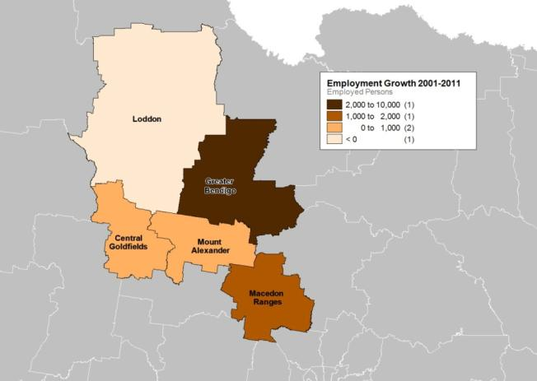Figure 16: Map of employment change, Loddon Mallee South local government areas, 2001–2011

Source: National Economics; Department of Education, Employment and Workplace Relations Small Area Labour Market Data

Figure 17: Major regional employment sectors[8]

Central Goldfields

* Accommodation & food services – 5.2% (8)
* Retail – 14.3% (2)
* Manufacturing – 21.0% (1)
* Health – 12.3% (3)
* Education – 9.0% (4)
* Construction – 6.2% (6)

Greater Bendigo

* Accommodation & food services – 5.7% (7)
* Retail – 13.7% (2)
* Manufacturing – 10.9% (3)
* Health – 13.9% (1)
* Education – 8.4% (5)
* Construction – 9.1%(4)

Loddon

* Accommodation & food services – 3.2% (10)
* Retail – 5.6% (5)
* Manufacturing – 9.2% (2)
* Health – 6.6% (4)
* Education – 7.2% (3)
* Construction – 4.4% (6)

Macedon Ranges

* Accommodation & food services – 8.6% (6)
* Retail – 13.3% (1)
* Manufacturing – 10.1% (4)
* Health – 9.9% (5)
* Education – 10.4% (3)
* Construction – 11.0% (2)

Mount Alexander

* Accommodation & food services – 5.7% (6)
* Retail – 11.5% (3)
* Manufacturing – 23.4% (1)
* Health – 11.9% (2)
* Education – 7.0% (5)
* Construction – 7.3% (4)

Southern region

* Accommodation & food services – 6.1% (6)
* Retail – 13.0% (1)
* Manufacturing – 12.5% (3)
* Health – 12.6% (2)
* Education – 8.6% (5)
* Construction – 8.9% (4)

Unemployment rates in the Loddon Mallee South region have generally been steady over the past four years, but skills and availability has not necessarily been well matched to the needs of employment. Labour and skills shortages are an issue of concern for future regional economic development. Unemployment rates in 2012 ranged from 2.8 per cent in Macedon Ranges Shire to 9.1 per cent in Central Goldfields Shire.

Figure 18: Loddon Mallee South unemployment rate, September Quarter 2012

* Municipality Greater Bendigo, unemployment rate: 5.1
* Municipality Central Goldfields, unemployment rate 9.1
* Municipality Macedon Ranges, unemployment rate 2.8
* Municipality Mount Alexander, unemployment rate 5.2
* Municipality Loddon, unemployment rate 4.3

Source: Department of Education, Employment and Workplace Relations Small Area Labour Markets Statistics, September Quarter 2012. Smoothed Series.

Strong and growing service sectors are emerging across the Loddon Mallee South region, which are diversifying the economy. From 2011 to 2031, the regional employment profile is projected to be heavily concentrated in the services sector. The projected top five employment sectors for the region are healthcare, retail trade, accommodation and food services (including tourism), education and construction. The creative development of heritage assets leads to increased tourism and improved liveability. By 2031, these top five sectors are projected to account for 59 per cent of total employment in the region (Regional Development Victoria 2012, unpublished analysis). Manufacturing is projected to decline over this period, although it will remain important to the regional economy. Agriculture is projected to grow at a relatively faster rate of 1.3 per cent over the same time period. Economic growth is expected to be distributed unevenly, with the bulk of the output and employment growth expected in Bendigo and Macedon Ranges.[9]

Workforce skills gaps have been identified in key economic growth areas including construction, education, transport and logistics, and health, suggesting the region should better integrate secondary school and post-secondary education with regional economic development. Ongoing training will also be required to ensure workers’ skills continue to meet the changing needs of industry and are positioned to take advantage of any emerging industry opportunities.

Tertiary education facilities such as La Trobe and Monash universities in Bendigo offer an alternative to studying in Melbourne and other regions. Increasing tertiary enrolments will contribute to the region’s economy, attract new people, and potentially encourage a skilled workforce and younger people to settle in the region. A current inhibitor to increasing tertiary participation is the lack of student accommodation in Bendigo, the establishment of which is a key priority in the Southern Loddon Mallee Regional Strategic Plan 2010. Beyond this, further development and investment in university programs and facilities will be required to drive the growth and participation in tertiary education in the region.

Whole-of-life education and training is critical to overall health and wellbeing. Educational attainment brings personal, social and economic benefits to individuals and communities. It also creates opportunities through increased access to employment for individuals and helps to address regional skill shortages and assists in strengthening and diversifying the economy.

## A changing regional economy

Historically, the Loddon Mallee South regional economy was strongly influenced by the agricultural, mining and manufacturing sectors. Over the past 30 years, the increased capitalisation and scale of the agricultural sector has led to population losses in some rural areas, with severe weather events, drought and global economic factors impacting on the productivity of agriculture.

Manufacturing such as food processing and printing, KR Castlemaine and MacPhersons Printing Group, have been significant to the economy and employment, but are also changing. While manufacturing is still one of the most significant economic sectors of the region, it has remained subdued over the past decade. “In 2011, the sector contributed 11 per cent to the regional output compared to the 15 per cent contribution in 2001.” (Regional Development Victoria 2012). Although the decline in manufacturing is generally statewide, there are opportunities to attract new businesses to the region from metropolitan Melbourne due to lower costs and locational advantages. One example is the relocation of True Foods to Maryborough.

Compared to other regions, the Loddon Mallee South economic structure is relatively less dependent on the agriculture sector. However, this does not lessen the importance of agriculture in the region, in particular for Loddon Shire which has a long tradition of broadacre farming along with irrigated agriculture in the north of the shire. Dry land areas support beef and sheep livestock enterprises, as well as the production of broadacre crops such as grain and oil seeds. Across the region, dairy, pork, and chicken (broiler and egg) and the equine industries are strong as is horticulture, including viticulture. Apples, olives, nuts and wine grapes are the dominant plant industries.

Regions supported by more than one industry are less likely to be severely affected by external economic shocks.

## Major and emerging businesses

While the trends in economic sectors show a slowdown in manufacturing and agriculture in terms of economic output, there are opportunities to build existing strengths in these sectors. Figure 19 shows that the majority of businesses listed take advantage of raw material produced in the region.

Figure 19: Selection of major businesses and enterprises in Loddon Mallee South

**Greater Bendigo**

* Major businesses in key sectors
* Bendigo Health
* Bendigo and Adelaide Bank
* Hazeldene’s Chicken Farm
* Thales Australia (formerly Australian
* Defence Industries) Australian Defence
* Apparel Keech Australia
* La Trobe University
* Excelior/Serco
* Parmalat
* Jimmy Possum Furniture
* Australian Turntable Company
* Hy‐Line Australia
* BMS Retail Group
* Industry sector
* Healthcare
* Financial services
* Poultry meat production and processing
* Defence and transport equipment/systems
* Clothing Metal fabrication and foundry manufacture
* Tertiary education
* Employment services
* Dairy products
* Wood products/furniture manufacture
* Equipment manufacturing
* Table egg poultry breeder production
* Supermarket retailing

**Mount Alexander**

* Major businesses in key sectors
* George Weston Foods (trading as Don KR Castlemaine Smallgoods)
* Flowserve Pty Ltd (formerly Thompson, Kelly and Lewis)
* Victoria Carpets
* Harcourt Coolstores Cooperative
* Industry sector
* Smallgoods manufacture
* Pump and valve manufacture
* Floor covering manufacture
* Fruit processing

**Macedon Ranges**

* Major businesses in key sectors
* G.J. and V.Hardwick
* AAMI Insurance
* Barker Trailers
* McKibbin Transport
* Industry sector
* Meat processing
* Insurance services
* Automotive equipment manufacture
* Road Transport

**Loddon**

* Major businesses in key sectors
* Loddon Valley Eggs
* Solar Systems Pty Ltd
* Laucke Flour Mills
* Southern Stock Feeds
* Cobram Estate
* Industry sector
* Poultry table egg products
* Electricity, gas and water
* Food manufacturing
* Stock feed manufacturing
* Olive horticulture

**Central Goldfields**

* Major businesses in key sectors
* McPherson’s Printing Group
* True Foods
* Broad Poultry Group
* Maryborough District Health
* Industry sector
* Paper and printing products manufacture
* Bakery food products manufacturing
* Poultry processing
* Healthcare and social assistance

Source: Street Ryan & Associates 2012 p27

## Agriculture

Agriculture is an important sector of the Loddon Mallee South regional economy. The region has good soils, efficient flexible farming systems, access to water (provided rainfall and inflows are occurring at long term averages) and vast tracts of land that deliver high value agriculture production and added value processing. The irrigation area in the north of the region produces livestock, grains, milk, fruit and vegetables. Dry land farming areas are generally used for broadacre cropping (grains and livestock) and mixed farming (Figure 20).

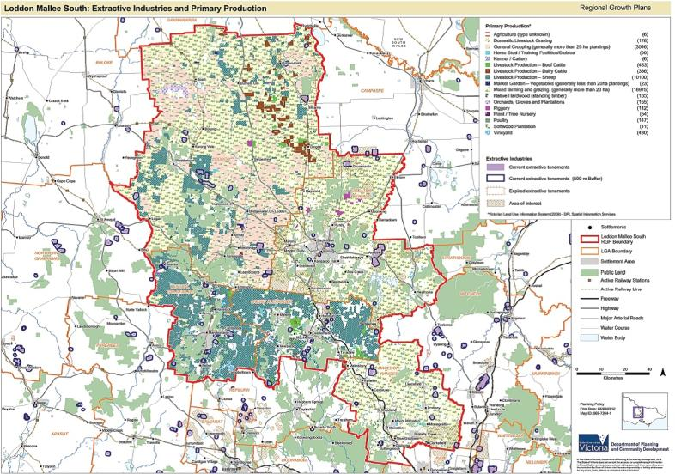Figure 20: Extractive industries and primary production

Source: Department of Transport, Planning and Local Infrastructure

Agriculture is particularly significant for the Loddon Shire, with 30.4 per cent of employed people aged 15 years and over being employed in the sheep, beef cattle, dairy cattle and grain farming areas.[10] The irrigation area in the north is being upgraded to become more efficient, which will result in some areas no longer being part of the irrigation district. For those areas retaining their irrigation, there will be a greater need to increase value and significance in terms of food production.

The Loddon Shire Rural Zones Review 2012 identified that investment in intensive agriculture, such as poultry and egg production, piggeries, dairy farming and some types of horticulture, is likely to increase in the future in response to increased demand, particularly for chicken meat and eggs. Increasing residential development pressures on traditional areas of intensive agriculture around Melbourne’s fringe may also drive development of intensive agriculture within the Loddon Shire. Significant opportunities exist for future investment in intensive agriculture throughout the municipality.

The future of agriculture in Loddon Shire is likely to include:

* a steady position within the dry land sector with farms continuing to expand over time and possibly an adjustment in the production mix in response to climate change
* a reduced irrigation footprint
* areas no longer irrigated will revert to some form of dry land agriculture
* a shift to high value enterprises, for example, more dairy and horticulture on better soil types
* an increase in intensive agriculture.[11]

The equine sector is of particular importance to the Macedon Ranges Shire, generating an economic impact of $140 million in the 2009–10 financial year. It is the seventh largest industry in the Macedon Ranges Shire in terms of local jobs.[12] Macedon Ranges is experiencing substantial growth in requests for planning and building approvals for equine-related infrastructure and facilities. Macedon Ranges Shire Council aims to grow the equine sector in a strategic and sustainable manner.

Increasing productivity and competition pressures on the agricultural sector and permanent trade in water shares is accelerating the consolidation of smaller dry land and irrigation farms in the north and west of the region into larger landholdings. The trend of farm consolidation and business expansion is likely to continue into the future. The ability for farmers to acquire additional land will be a key factor in terms of their ongoing viability, although high land prices in the south make it difficult to expand holdings to maintain a commercially viable scale[13]. Demand for urban and rural residential development is putting pressure on agricultural land, particularly near major settlements and in the Calder corridor. This will only increase with population growth.

Agricultural production continues to adapt and change to ensure increases in profitability and productivity through the development and uptake of emerging and new technologies, and the intensification of farming. At the same time the region is facing significant challenges and opportunities from growth and diversification to farming systems, geographic changes to industry are occurring in order to mitigate risk. Diversification opportunities are increasingly available for agricultural enterprises, particularly with the emergence of initiatives that support national and global action to reduce greenhouse gas emissions, such as a price or a tax on carbon, and market systems for paying landholders for protecting environmental assets and values. There are numerous existing and emerging opportunities in the region for clusters of intensive agricultural production, such as piggeries.

## Natural resources

#### Mining and extractive industries

Much of the history of the Loddon Mallee South region, including its many heritage buildings, is based around the gold rush of the 1800s. The discovery and exploitation of rich deep gold deposits in quartz reefs in the late 19th century led to large mining operations which then gave rise to the development of the region’s manufacturing industry. Although not of the same scale today, the mining industry is still significant. Perseverance Mining Pty Limited operates a significant gold mine in the region. New technologies have improved yields and enabled some former mine sites to be re-mined. The region is still being actively explored for gold. Gold mining and prospecting continues to play an important industrial and tourism role for the region and represents an important link to the initial development of central Victoria.

There is a variety of different mineral and mining resources throughout the region, such as mineral sands in the north of the Loddon Shire. The region also contains significant extractive industries, especially sand and stone resources. The protection of future extractive resources, such as potential clay and stone resources is significant to local industry and infrastructure, particularly as the availability of locally sourced sand and stone resources helps to manage construction costs. Potential sites need to be managed to protect their use, and to prevent pressures from other land uses including residential development.

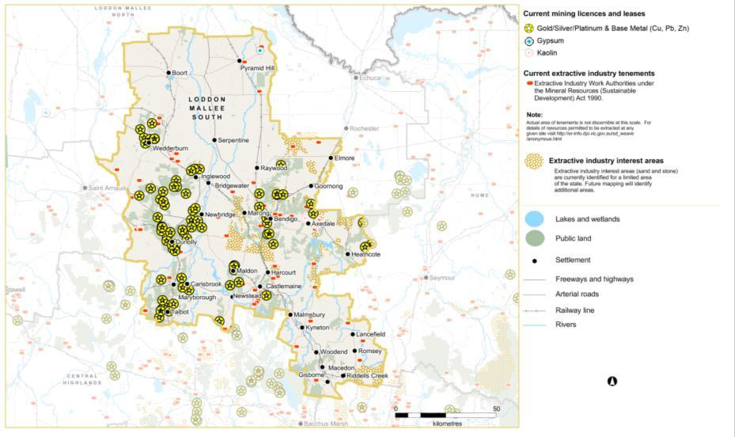Figure 21: Mining and extractive industries, tenements and licences

Source: Department of Environment and Primary Industries

In May 2012, the Economic Development and Infrastructure Committee of the Parliament of Victoria tabled the results of its inquiry into the benefits and drivers of, and possible barriers to, greenfields[14] mineral exploration and project developments in Victoria. The Victorian Government’s response to the Inquiry was released in May 2013, supporting all recommendations. Key aspects of the response include:

* establish Minerals Development Victoria as a single point of entry for investors and to be the link between investors and the State Government
* actions to reduce regulatory burden imposed by legislation
* actions to build community confidence through greater engagement and clearer communication of information
* additional funding for geosciences research and greater investment attraction
* steps to improve mechanisms to maintain appropriate access to extractive resources while supporting ongoing development and optimum land use.

While it is important to acknowledge these and other aspects of the response, it is beyond the scope of the regional growth plans to deal with the majority of the commitments and they will need to be addressed through other suitable government initiatives. The response did include a commitment to incorporate existing extractive industry interest areas into regional growth plans. The plan recognises these areas accordingly.

Current minerals and extractive industry activities, along with the extractive industry interest areas and other potential earth resources that occur with the region are shown in Figure 21.

#### Forestry

Forest industries on crown land, timber production and private forestry such as farm-forestry, are an important component of the regional economy due to the extent of Box-Ironbark forest throughout the region. While the creation of Greater Bendigo National Park and the Heathcote-Graytown National Park has resulted in less forestry on public land, timber production on private land (particularly small-scale farm-forestry) can generate economic and environmental benefits, especially as strategic approaches to revegetation can provide economic benefits to landowners.

The region’s state forests provide employment and support other forest-based industries such as apiculture, eucalyptus oil production, extractive industry and mining. The Box-Ironbark forests of the central Victorian Goldfields are a significant statewide source of limited durable timbers, honey, gold and extractive materials. On a local basis these forests are the main source of durable fencing timbers and at a regional level they supply domestic firewood.[15]

Many of the region’s settlements are surrounded by Box-Ironbark forest. Pressure from population growth and other land uses such as mining will need to be carefully managed to protect this resource as both an environmental and economic asset.

## Challenges for the regional economy

Challenges for the regional economy include building workforce skills (professional, trade and skilled labourers), reducing carbon pollution (particularly construction and energy technologies), high levels of commuting from Macedon Ranges and Mount Alexander shires, and financial pressure on the agricultural sector. Priority actions identified by Regional Development Victoria to build on the region’s economic strengths and address these challenges are:

* land for employment and enabling infrastructure
* high value agriculture and value adding
* tourism development.[16]

The regional growth plan needs to address land supply and potential locations for industry as well as infrastructure and economic directions that can support businesses locating and remaining in the region. It also needs to provide adequate protection for productive agricultural land from inappropriate land use change to enable this sector to remain strong.

Working toward a ‘regional’ economy has benefits for each of the local government areas. The continued growth of Bendigo as a regional city and an alternative to Melbourne for employment and services is a key factor of the region’s economic success. Leveraging off and building on the city’s economic strengths will be beneficial to the region as a whole.

## Land supply – employment

The regional growth plan will need to consider the supply of land for employment as well as its residential population, and ensure that land use planning and policy aid rather than hinder economic development. It is worth noting the region does not have an economic development strategy.

### Industrial land supply

An adequate supply of industrial land is needed for jobs and services, such as manufacturing, service industrial, logistics and warehousing, to support continued economic development. Urban Development Program data suggests industrial lot supply across the region is generally sufficient to meet current consumption rates for 15 years. However, this may change due to factors such as global economy trends, private business activity and population trends. Appendix 1 provides more detail about industrial land supply at a regional, municipal and settlement scale. In summary:

**Greater Bendigo:** There is in excess of 15 years of industrial zoned land within the City of Greater Bendigo, with the Bendigo Urban Area also having in excess of 15 years of zoned industrial land supply. Beyond 15 years, an additional supply of future industrial land will be needed.

**Mount Alexander:** There is an adequate stock of zoned (greater than 15 years) and unzoned (12 to15 years) industrial land stock to meet trend and accelerated consumption rates across Mount Alexander Shire, and within the towns of Castlemaine and Maldon. However, the Urban Development Program notes there is a lack of small lots to enable small businesses to locate affordably within the shire, and recommends that some small lots are encouraged in future subdivisions.

**Macedon Ranges:** There is in excess of 25 years of industrial zoned land across the Macedon Ranges Shire. There is also approximately a 12 year supply of future (unzoned) industrial land stocks. However, at a township level, there are several supply issues. The majority of supply is in one location, Kyneton, which has a significant amount of industrial land with a variety of lot sizes. Romsey has between seven and 10 years of supply of industrial zoned land. Woodend and Riddells Creek both have little activity or consumption of industrial land stocks which is likely due to the lack of land. Given this, the Urban Development Program identifies that further industrial land is needed within the Woodend area.

**Loddon:** Preliminary data indicates that there are 28 hectares of zoned industrial land available in Loddon Shire, located in Boort, Inglewood and Wedderburn. There is an additional 47 hectares of future (unzoned) industrial land stock, all of which is located in Bridgewater. Data indicating the number of years of industrial land supply in the Central Goldfields Shire is not yet available.

**Central Goldfields:** Preliminary data indicates there is 363 hectares of zoned industrial land available in Central Goldfields Shire, the majority of which is located in Carisbrook (250 hectares). There are also smaller amounts of zoned industrial land available in Bet Bet, Dunolly and Maryborough. No future (unzoned) industrial land stock has been identified. Data indicating the number of years of industrial land supply in the Central Goldfields Shire is not yet available.

Looking beyond 15 years, an additional supply of industrial land will be needed across the Loddon Mallee South region.

### Commercial and retail land supply

Retailing and commercial activities form an important part of the region’s economic base, providing a wide range of retailing, commercial and professional services.

The City of Greater Bendigo Commercial Land Strategy 2005 estimated that 116,720 square metres of additional floor space will be required for retail and office based services over the period 2004–2021, of which 60,090 square metres will be required over the period 2012–2021.[17] This equates to a net land requirement of approximately 15.6 hectares for the period 2004–2021, broken down as follows:

* for the Bendigo central business district, a total of about 2.9 hectares, comprised of approximately one hectare for office requirements and 1.9 hectares for retail stores and services
* for Bendigo Marketplace and the Centro Lansell Precinct (known as regional centres in the Strategy), approximately 7.7 hectares for retail and commercial services requirements
* for significant suburban community centres (known as village centres in the Strategy), approximately 4.2 hectares
* for local and convenience centres, approximately 0.8 hectares.

Currently, there are a number of under-utilised areas within the Bendigo CBD, including the railway station precinct and the Gillies and Ice Crystal sites.

The Castlemaine Commercial Centre Study 2012 estimated there would be demand for approximately 6300 square metres of additional retail floor space, and approximately 2000+ square metres of additional commercial office space for the period 2011–2026.[18] The study found there is sufficient land in the Business Zone of Castlemaine’s town centre to meet demand through to 2026 although some of the land was under-utilised. It also identified land immediately adjacent to the town centre that could be rezoned for business purposes if required.

Information on the future commercial and retail needs for Loddon, Central Goldfields and Macedon Ranges shires was not available.

In order to provide for an additional 120,000 people across the region, further commercial and retail opportunities (at both a regional and a local scale) will need to be planned for.

### Rural land

Much of the rural land use in the region is dedicated to agricultural production. This land is increasingly under pressure from the demand for rural living and associated lot fragmentation. Settlement strategies prepared by the region’s various councils have already sought to minimise ad-hoc rural residential dwellings to ensure greater efficiencies in infrastructure spending and better provision of infrastructure and services related to settlement planning.

Identifying areas for intensive animal industries should consider areas less likely to cause conflict with rural living and urban residential areas, especially for loud, odour-producing activities such as piggeries.

Continued attention and management of land is important to ensure the interface between urban and rural settlements is well defined and the settlement future of the Loddon Mallee South region is clear. Settlement growth should consider the impacts to existing, and potential future, industries including facilities such as Water Reclamation Plants and Landfill sites, and environmental assets and natural hazards, especially flood and bushfire, in both planning and implementation.

Given the constraints and opportunities for the use of rural land in the region, future planning should seek to assist primary producers to adjust to change and facilitate productivity growth.

# Environment and natural resources

**Key findings – Environment and natural resources**

* The Loddon Mallee South region contains areas of public land which are important for maintaining Victoria’s biodiversity and its mix of ecosystem types. These areas are also important tourism and recreational assets.
* The region’s environmental assets provide critical environmental values, including provision of fresh water; provision of high quality soils; air filtration; and filtering of nutrients and pollutants.
* Development pressure is occurring in highly attractive areas of the region which often are exposed to natural hazards, such as bushfire or flood.
* Many towns, including Bendigo, Castlemaine and Woodend, are directly adjacent to significant vegetated areas on both public and private land. Careful planning is required to protect these environmental assets.
* There is significant bushfire threat from both large treed areas and grasslands within the region.
* The region is at risk from severe flood events.
* Increased development has the potential to detract from some of the region’s highly valued landscapes.
* Climate change may bring new economic opportunities, such as in renewable energy, as well as considerations for increased risks from some extreme events and natural hazards.
* The Calder corridor boasts many historic heritage features in the region’s towns as well as on the old highway and railway line. Some of these features date from the gold rush era when these routes were busy main thoroughfares to the goldfields.
* Cultural heritage is an asset in community, economic and social terms. The region has a rich and diverse history comprising Aboriginal cultural heritage and historic heritage sites, including the national and international story of the Victorian Gold Rush.
* Much of the region consists of open potable water supply catchments, which has implications for any potential land use change in non-urban areas.

**Key implications**

* The ability for some settlements to expand may be limited by environmental assets and natural hazards.
* The requirement to prioritise the protection of human life over other policy considerations will impact on settlement planning.
* Strong population growth may result in increased pressure to clear native vegetation.
* Increasing the linkages between remnant native vegetation is critical to ensure biodiversity can be maintained. Careful consideration will need to be given to the preferred locations of vegetation corridors in light of other regional plans.
* Long-term consequences of climate change for the region include implications for: water supply and availability; altered agricultural commodities; damage to infrastructure, industries and agriculture from severe weather events and natural hazards; pressures on natural ecosystems; and communities.
* Designated water supply catchments need to be considered when proposing land use change.
* Land use planning decisions should be based on the best quality information on flood and bushfire hazards to minimise risk to life, property, community infrastructure and environmental assets.
* Consistent identification and protection of visually important landscapes is needed across the region.
* The region’s rich history and heritage provides a major tourism opportunity. The potential benefits of the ‘Goldfields – Australia’s Premier Heritage Region’ initiative are significant. This initiative must continue to be supported through regional and local land use planning.
* Opportunities to develop cultural and other tourism throughout the region should be supported through continued strategic land use planning, particularly around goldfields-related heritage assets and tourism infrastructure opportunities within national parks.

**Key challenges**

* Protecting the region’s important environmental assets.
* Determining on a regional scale what types of land uses are appropriate or inappropriate in open potable water supply catchments.
* Developing a regional approach to settlement planning that considers natural hazards, particularly bushfire and flood.
* Improving the region’s resilience and adaptability to climate change as impacts emerge.
* Supporting the development of cultural and other tourism opportunities throughout the region through appropriate strategic land use planning.
* Coordinating planning of natural resource management activities with regional growth planning.

## Environment and heritage assets

### Cultural heritage assets

The Loddon Mallee South region has a rich and diverse representation of heritage values capturing both Aboriginal and historic heritage sites, including the national and internationally significant story of the Victorian Gold Rush. The most significant heritage assets in the region have been identified by Aboriginal Affairs Victoria and Heritage Victoria below, and some of these are mapped in Figure 22:

* Lake Boort - numerous Aboriginal scarred trees, occupation sites and historic heritage places
* Mount Tarrengower - the location of an important creation story
* Terrick Terrick National Park - contains numerous Aboriginal occupation sites
* Maryborough Railway Station - architecturally significant for its design and grand scale
* Duke and Timor Deep Lead Gold Mine - 19th century ruins of one of Victoria’s most successful gold mines
* Tarnagulla Public Hall - built in 1861 as the Victoria Hotel and Theatre
* Eucalyptus Distillery, Inglewood - rare example of a eucalyptus oil distillery that is now operating as a museum
* Bendigo Post Office and Law Courts - two grand and flamboyant buildings at the heart of historic Bendigo
* Maldon Railway Station Complex - constructed in 1888 and now the home of the Victorian Goldfields Railway – a regional tourist destination
* Castlemaine Market - a fine and rare colonial market building from 1862
* Malmsbury Botanic Gardens - one of Victoria’s earliest royal botanic gardens
* Cameron Memorial Cross, Mount Macedon - Landmark memorial dedicated in 1935 to Australians killed in World War One
* Castlemaine Diggings National Heritage Park - proposed world heritage nomination
* Streetscapes such as Pall Mall/View Street in Bendigo.

It is acknowledged that this list is not exhaustive and many other places of significance occur throughout the region. Approximately 310 State-significant heritage places in the region are listed on the Victorian Heritage Register.

In addition to these individual sites, much of the region has a strong goldfields heritage that can be seen in the fabric of regional towns and in relics dotted throughout the landscape. The bulk of Victoria’s accessible gold rush localities are in the Loddon Mallee South and Central Highlands regions. Goldfields heritage continues to strongly influence settlement and growth.

The goldfields heritage is seen as a key opportunity for both the Loddon Mallee South and Central Highlands regions. The Loddon Mallee and Grampians Regional Development Australia Committees have developed a joint initiative to create worldwide awareness of the area as Australia’s premier heritage region, and to obtain World Heritage listing for the Castlemaine Diggings National Park. The initiative ‘Goldfields – Australia’s Premier Heritage Region’ looks to promote heritage-based tourism throughout these regions. Heritage tourism is viewed by these regions as a key driver for economic diversification and development, population growth and improved quality of life. The continuing protection and development of heritage assets will advance tourism, settlement and economic diversification.

Many tourists seek heritage and nature-based tourism experiences. History, heritage places and Aboriginal community organisations and enterprises contribute to regional economies and employment through: expenditure and job creation; inward migration of creative, skilled and entrepreneurial/high income households; and enhancing the quality and diversity of the service sector.

Cultural heritage is protected by the *Aboriginal Heritage Act 2006* and the *Heritage Act 1995*. The *Planning and Environment Act 1987* requires that state and local government planning take cultural heritage and its management into account. Cultural heritage is both fragile and non-renewable and cannot be easily relocated, restored or replaced.

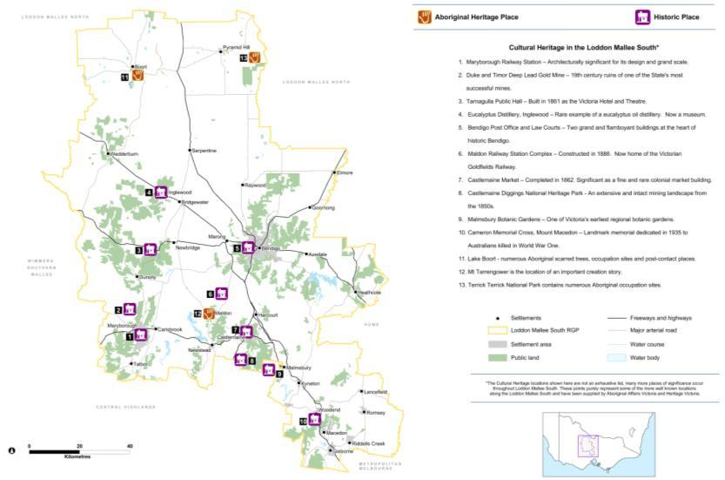Figure 22: Cultural heritage

Source: Office of Aboriginal Affairs and Heritage Victoria

### Significant landscapes

Landscapes may be deemed significant for a combination of historic, aesthetic, scientific, religious and social reasons, where these landscapes are deemed integral to the amenity of the area. There are many significant landscapes in the Loddon Mallee South region. Stand-out areas that are already acknowledged as significant landscapes in planning schemes include the Macedon Ranges, Hanging Rock, the Campaspe River Valley, the Maldon region, mineral springs areas and various geological features (ridges, escarpments and volcano cones). Many of these areas of high landscape value are also under pressure for increased rural residential development.

The development pressures within some highly valued landscapes need to be carefully managed so that development does not detract from the values that have attracted people to these areas (including significant landscapes, water supply catchments, public land and terrestrial habitat). Many other parts of Victoria have benefitted from wide-ranging landscape assessment studies, for example, the Coastal Spaces and South West Victoria landscape assessment studies. These studies identify significant landscapes, determine their relative significance, for example, national, state, regional, local significance, and consider using policies and guidance in local planning schemes to protect and manage these landscapes into the future. There is the opportunity to identify and protect significant landscapes across the Loddon Mallee South region in a similar, consistent way. These significant landscapes could help with strategic planning of appropriate locations for future rural residential development.

### Terrestrial habitat

Native vegetation and habitats (terrestrial habitat) are important as they provide a range of values (such as filtering nutrients, habitat regeneration and climate regulation) that underpin the health of land and water, flora and fauna, and natural communities. Terrestrial habitats help by providing clean water, carbon sequestration, timber, firewood and the health of soils. They also provide important spiritual and aesthetic values at various scales and are a key to many of the tourism values in the region. Loss of habitat (extent and quality) through clearing of native vegetation, or from other threatening processes for urban and rural purposes has been, and continues to be, a significant threat to native vegetation and habitats across Victoria.

The catchment management authorities in the region have identified the highest value native vegetation and habitat assets within each of their boundaries. Each catchment management authority across Victoria has identified their highest value native vegetation and habitat assets using different methodologies. For consistency across the regional growth plans, the Department of Transport, Planning and Local Infrastructure has used the highest three levels of the Department of Environment and Primary Industry’s NaturePrint v2.0[19] mapping to identify significant clusters of vegetation across the state (refer to Figure 23). These align very closely to the biodiversity assets identified by the North Central Catchment Management Authority, which were identified using the INFFER methodology[20] in conjunction with NaturePrint to identify priorities for investment (also shown in Figure 23).

There are numerous individual plant and animal threatened species that occur in the Loddon Mallee South region, however they are too many and their locations too specific to be considered and mapped at a regional scale. Threatened plant and animal communities are considered sufficiently captured at a broad level by NaturePrint for regional-scale planning. Finer scale planning, for example, precinct structure plans or individual planning assessments, should always consider threatened species and communities appropriately.

Natural resource management activities within the region include actions to protect the high value habitat assets, along with waterway, wetland and soil assets. These activities involve actions on both public and private land, but have limited strategic land use (zoning) planning interaction. There are also emerging economic opportunities on private land centred on environmental values, such as in carbon markets, offset markets and providing ecosystem services through market based approaches.[21]

Natural resource management activities in the region will also include actions to increase the vegetation within the region by creating vegetation corridors in strategic areas. The preferred locations for these corridors may overlap with areas that may experience a future change in land use or a change in industry. There is the opportunity to coordinate planning of the locations of these activities to maximise potential benefits. It is not likely that local government or the Department of Transport, Planning and Local Infrastructure would lead many of these activities, but it would be beneficial for them to collaborate with other agencies, such as catchment management authorities, on preferred locations to target natural resource management initiatives. Careful consideration would need to be given to the preferred locations of vegetation corridors in light of other regional plans. This would include consideration of the balance of values and the environmental hazards that may change as a result of these corridors being established, for example, increasing bushfire or flood risk.

Planning tools such as the Environmental Significance Overlay and the Vegetation Protection Overlay are used across the Loddon Mallee South region to identify where the development of land may be affected by environmental constraints, to protect environmental values, including significant native vegetation, and to ensure that development is compatible with identified environmental values.

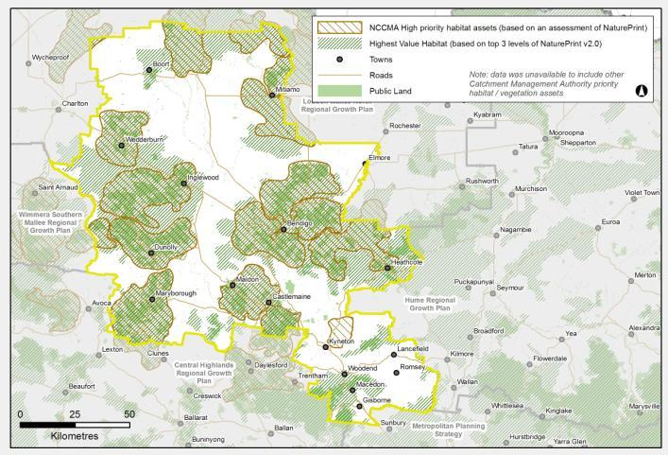Figure 23: Terrestrial habitat assets of the region, reflected through native vegetation.

Source: Department of Transport, Planning and Local Infrastructure

### Waterways (rivers and wetlands)

Waterways (rivers, wetlands and floodplains) provide the region with its water supply. This water is critical to support the region’s towns, industry and agriculture, as well as the environmental values within and adjacent to the rivers, wetlands and floodplains themselves. Rivers and wetlands are the centre of many social and recreational activities and often associated with Aboriginal heritage sites and historical settlement patterns.

Protecting and improving waterways in Victoria is a long-term goal of the State Government.[22] The management and improvement of waterway assets generally falls to catchment management authorities and/or public land managers, often in partnership with private landholders. Many natural resource management activities are aimed at improving the health of waterways. Much of this activity is often focused on improving land management practices.

The Loddon Mallee South region contains parts of the Avoca, Loddon, Campaspe, Goulburn, Maribyrnong and Werribee rivers (refer to Figure 24). Each of these catchments contains the main river and its various tributaries. All waterways provide a water supply role to communities with some like the Loddon, Campaspe and Coliban rivers being major sources of water supply with some protected by declared water supply catchments

There are numerous wetlands and wetland complexes throughout the region. Some of these have national recognition through listing on the Directory of Important Wetlands. The North Central Catchment Management Authority has identified regionally-significant wetland complexes as part of developing its regional catchment strategy (other catchment management authorities in the region only identify nationally-recognised wetlands). These are illustrated in Figure 24. Some of the wetlands in the region contain important cultural assets, while others are important tourism assets, including Lake Boort and Little Lake Boort. Some also have a water supply role.

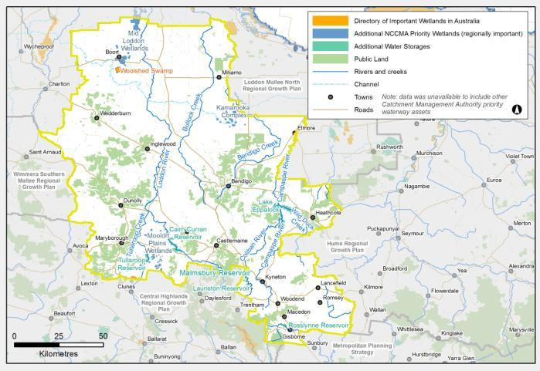Figure 24: Significant waterways of the region

Source: Department of Transport, Planning and Local Infrastructure

Appropriate land use planning can help minimise threats to rivers and wetlands from inappropriate catchment development, urban stormwater runoff, waste and wastewater, and reduced wetland connectivity. Some planning mechanisms, such as overlays, can be used to detail specific considerations around regionally and locally important waterway assets. This is of particular relevance for wetlands, given the prominence of wetlands on private land and the high occurrence of land-forming activities in irrigation areas which can remove shallow natural wetlands.

### Catchment health

There are numerous declared water supply catchments in the Loddon Murray South region (refer to Figure 25). Some water catchments are designated for the specific purpose of supplying water and are protected under the *Catchment and Land Protection Act 1994*. These catchments have significant values as a source of water supply, both for domestic and for stock and domestic use.[23] These catchments therefore have specific protection, including land use and subdivision controls to protect water supply and quality. Guidelines exist to inform planning decisions in these catchments, where they are considered to be open to public access and generally contain private land.

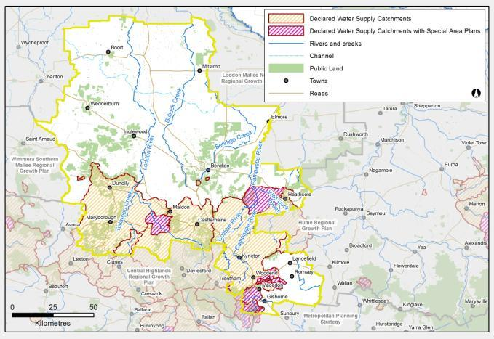Figure 25: Declared water supply catchments (open potable water supply catchments) in the Loddon Mallee South region

Source: Department of Transport, Planning and Local Infrastructure

Domestic and stock water use continues to be an ‘as of right’ use if used for the purposes defined in the *Water Act 1989.* Domestic and stock use could undermine the reliability of supply for all water users, particularly as in dryer conditions these dams intercept a greater percentage of rainfall.[24] In 2009, Victoria introduced policies to improve the management of these uses by, among other measures, requiring the registration of new or altered domestic and stock dams within rural residential areas.[25] These measures aim to monitor interception activities and ultimately reduce the impact of small catchment dams on overall water availability. However, the proliferation of domestic and stock dams is occurring in rural residential areas across the state. Ongoing investigation of these impacts and potential management should be supported.

Declared water supply catchments need to be considered when proposing land use change, particularly when considering significant unsewered subdivision and the number of dwellings that can be built in these areas. The regional growth plan recognises the need for these considerations. Strategic direction is required to identify where development and particular land use activities may be supported and where development or particular land uses are not supported due to catchment management objectives. This direction is required not only within settlements but also within rural areas and is most needed within the peri-urban parts of the region where development pressures occur both within and outside existing settlements.

Developing Special Area Plans for some of these catchments that occur over private land may assist with this strategic planning. Councils within these catchment areas may need to update their domestic wastewater management plans in line with the new Guidelines for Planning Permits in Open Water Supply Catchment Areas 2012. Water corporations will need to play a role in identifying land use planning activities and changes.

### Soils

Productive soils are essential to support the profitability of agricultural enterprises in the region. If soils are mismanaged soil threats such as soil structure decline and nutrient deficiency can impact their productive value. Depleted soil health can also lead to threats that cause off-site impacts to public assets, such as sediments from a soil erosion site threatening the quality and environmental value of a downstream waterway (discussed in Section 6.2: Natural hazards and risks).

The soils in the region vary depending on the geological and land formation history they have experienced. The North Central Regional Catchment Strategy has defined six soil-landscape classes for the region that are predominantly linked to various land use types (often reflective of soil type in a general sense). These are shown in Figure 26. Most of these occur to some extent in the Loddon Mallee South region.

Soil, along with water, vegetation and fauna, is defined as an integral part of land under the *Catchment and Land Protection Act 1994*. Private landholders have primary day-to-day management responsibility for soil health on their property and must take all reasonable steps to conserve soil and avoid doing anything that would cause or contribute to land degradation on someone else’s land. Governments can play a role where markets fail to encourage the long-term preservation of soils and the values and services they provide.[26]

Figure 26: Soil landscapes and land use defined by the North Central CMA

* **Soil landscape:** Alluvial Plains of northern Victoria.  
  **Description:** Alluvial sediments of the Riverine Plains and the Natte Yallock Basin.  
  **Principle agricultural land use**: Mixed cropping and grazing.
* **Soil landscape:** Victorian Riverine Plains.  
  **Description:** Mainly red and yellow duplex soils, with red and grey clays that are highly suitable for agriculture.  
  **Principle agricultural land use:** Irrigated pastures and crops.
* **Soil landscape:** Eastern Mallee Plains.  
  **Description:** Aeolian sands over marine sediments in the semi-arid lands of northern Victoria.  
  **Principle agricultural land use:** Cropping with some grazing
* **Soil landscape:** Basaltic plains and scoria cones.  
  **Description:** Soils formed on Quaternary basalts in the upper catchments.  
  **Principle agricultural land use:** Grazing, cropping and horticulture.
* **Soil landscape:** Foothills of the Western Uplands.  
  **Description:** Red sodosols on weathered meta-sedimentary rocks.  
  **Principle agricultural land use:** Mixed cropping and grazing.
* **Soil landscape:** Hilly terrain of the Western Uplands.  
  **Description:** Red and yellow sodosols on moderate to steep hilly terrain.  
  **Principle agricultural land use:** Grazing.

Source: North Central Catchment Management Authority

Land use planning can assist in the protection of the Victoria’s soil resource by ensuring that land use change does not disturb soils to a level that could result in deterioration of the soil assets within each region, or further contribute to pollution of waterways in any significant volume, for example by applying the Erosion Management Overlay. Continued development of information to support decision-making, such as regional soil plans and capability mapping, will be important to enable growth in productive agriculture and settlements into the future.

Land capability is a commonly used measure of the value of soil for agricultural production. While land capability measured on indicators such as soil quality is useful to profile land and help inform broader strategic planning, it is not the only indicator or driver of the productive capacity of land. Sometimes proximity or security of feed, roads, processors, power and water are more important considerations. Not all agriculture requires good soil or water to be productive for agricultural purposes, therefore soil capability should not be the only indicator of potential of farmland, nor should soil capability be used to discriminate between different types of legitimate agricultural land uses in rural areas.

Land use planning can identify strategically important agricultural land (high quality productive agricultural land) and specify its protection for future agricultural production or to protect it from inappropriate development. The City of Greater Bendigo has mapped agricultural versatility, but there is no consistent mapping of strategically important agricultural land across the region. Each of the catchment management authorities will be developing a regional soil health plan. Land use considerations would be beneficial to those plans.

### Public land

There is an extensive network of public land reserves in the Loddon Mallee South region that protect various environmental, economic and social values (refer to Figure 27). These values including conserving flora and fauna, protecting water catchments and water supply, providing timber for sustainable forestry, protecting landscape, archaeological and historic values, and providing recreational and educational opportunities.

Also shown in Figure 27, public land captures many of the significant natural values of the region, but not all.

Public land is an important asset for protecting regional ecosystems, and for providing amenity benefits to the region, including through tourism. Public land may also generate income through sustainable forestry.

Opportunities may arise for tourism development associated with or linked to public land. The Loddon Mallee South Regional Growth Plan seeks to foster these opportunities such as the ‘Goldfields – Australia’s Premier Heritage Region’ initiative. There are emerging opportunities for private sector investment in tourism infrastructure within national parks across Victoria. Such opportunities should be encouraged, where appropriate within the region.

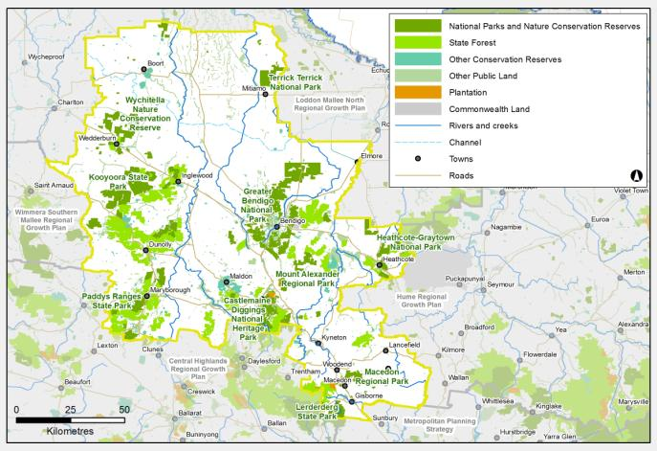Figure 27: Public land in the Loddon Mallee South region

Source: Department of Transport, Planning and Local Infrastructure

## Natural hazards and risks

### Flood

While floods are usually a natural event, and important to maintain biological diversity, they become a serious problem for the community when water damages property, endangers lives and causes loss of amenity. The Loddon Mallee South region has an extensive history of flood. Recent floods in 2010–11 were the most extensive ever experienced in the region. The Victorian floods of January 2011 were the biggest on record for catchments in the west and north-west of the state and some areas recorded three to four times the January average rainfall. This event has re-focussed efforts on the need to effectively plan for and manage such emergencies, including appropriate consideration of flood in land use planning.

Existing flood overlays in the Loddon Mallee South region are shown in Figure 28. Flood studies have been released for various areas of the region by the catchment management authorities although some will require updating in light of the most recent floods. The Victorian Floods Review notes that the “North Central CMA advised the VFR that no towns within its catchment had adequate flood mapping, in particular, it noted that for Carisbrook and Creswick, two towns that flooded in the 2010–11 floods, only anecdotal mapping existed” (p 194). The Victorian Floods Review also noted that the North Central Catchment Management Authority identified that new developments in the Central Goldfields, particularly in Carisbrook, had not been referred to them for flood advice. During the floods, these new houses experienced repeated flood over flood level.

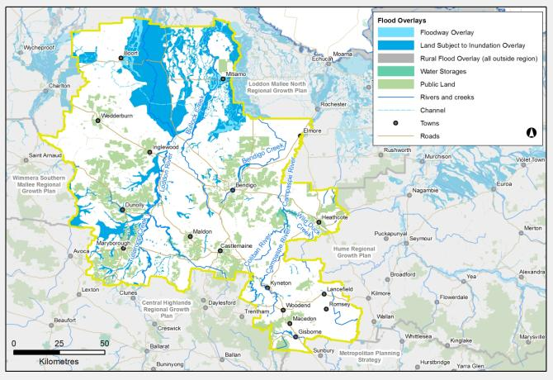Figure 28: Flood overlays in the Loddon Mallee South region

Source: Department of Transport, Planning and Local Infrastructure

Land use planning is the most effective means of reducing future risks and damages from flood. The North Central Catchment Management Authority is currently undertaking flood studies for those areas that experienced severe flood in 2010–11. This information will be used to update flood overlays in planning schemes where relevant. Further understanding of flood in the region will also need to be incorporated into planning decisions as future research and modelling is released over time.

Climate change predictions indicate more extreme flood events may occur in the future. Existing flood risk assessments do not take account of these likely increases in the intensity of storm and flood events. The future increase in flood risk should be considered in strategic planning.

Regional land use planning must explicitly consider the implications of flood on growth, particularly settlement growth. The regional growth plan shows where flood is a key consideration for the growth of specific settlements, and the settlement framework for Bendigo has explicitly considered flood risk in determining future development areas. Flood is also an issue across the broader landscape.

Land use planning decisions should be based on the best quality information on flood hazard to minimise risk to life, property, community infrastructure and environmental assets. Flood provisions in planning schemes should be used consistently across the region to avoid inappropriate development, or redevelopment, or require appropriate development responses, as well as apply design responses through the building code. New development will be directed away from areas of highest floodplain hazard and development should not be supported if it increases the flood risk for other sensitive areas or development.

Flood mapping and planning schemes need to be updated to accurately reflect available information about flood hazard and to prevent future development in flood prone areas.

### Bushfire

Bushfire hazard is a key consideration for future development, particularly given recent changes to planning regulations as a result of the 2009 Victorian Bushfires Royal Commission.[27] The implications of these changes are still emerging and have been included, where possible, as a consideration in growth planning. Of major significance for land use planning is the requirement to prioritise the protection of human life over other policy considerations, reinforced by an explicit requirement to apply the precautionary principle in decision-making when assessing the risk to life, property and community infrastructure.

Predictions indicate that as the climate changes there will be an increase in the number of extreme fire index days each year. Bushfire frequency and intensity is likely to increase as a result of climate change.

The Loddon Mallee South region has significant bushfire hazard, not just from large treed areas, but also from grasslands in the region. Many landscapes that are most attractive to residents and tourists are at the highest risk from bushfire. The application of the existing Bushfire Management Overlay to the region is shown in Figure 29. This overlay is to be updated to reflect the most recent understanding of bushfire hazard.

Pressures to develop in highly attractive areas in the Loddon Mallee South region are likely to continue, and present significant challenges for land use planning. Regional and localised planning should consider bushfire hazard in detail, with the assistance of planning tools, such as the Bushfire Management Overlay, Regional Bushfire Planning Assessments and the mapping of Bushfire Prone Areas, as well as input from key stakeholders such as the Country Fire Authority.

In line with 2009 Victorian Bushfires Royal Commission recommendations, new development should be substantially restricted in the areas of highest bushfire risk, while giving due consideration to biodiversity conservation. Strategic and settlement planning need to clearly demonstrate how bushfire risk has been considered and how a response to risk has informed that planning.

The regional growth plan shows where bushfire risk is a key consideration for growth of specific settlements. The settlement framework for Bendigo has explicitly considered bushfire risk in determining future areas for new development. Bushfire risks to tourism and landscape values also need to be considered when considering non-urban changes in land use in the region.

Bushfire risk will need to be assessed to a finer level when more detailed planning is underway at a municipal level. Regional Bushfire Planning Assessments identify where a significant bushfire hazard may affect land use planning, and identify features such as settlements, urban interfaces and single access roads. They are a resource to assist councils to support community resilience to bushfire with their strategic planning such as preparing a planning scheme amendment.

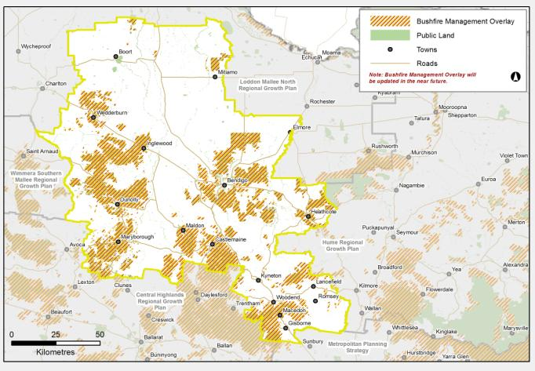Figure 29: Bushfire Management Overlays in the Loddon Mallee South region

Source: Department of Transport, Planning and Local Infrastructure

### Climate change

Predicted changes in rainfall, temperature and evaporation as a result of climate change suggest the Loddon Mallee South region will be hotter and drier than it is today. Bushfire risk is expected to increase, and although rainfall is expected to decline, the intensity of heavy rainfall is likely to rise, potentially resulting in severe floods. Drought may become more common. This will have long-term consequences for the region, including:

* implications on watersupply and reliability, as detailed in the relevant water supply demand strategies
* altered agricultural commodities within the region, particularly in dry land farming areas. Irrigation areas may need to consider less water in the longer term, but the irrigation system will still be present within the 30 year timeframe of the regional growth plan
* damage to infrastructure, industries and agriculture from severe weather events and natural hazards
* pressures on natural ecosystems
* implications for communities, such as human health, energy use, housing needs and service provision[28]
* an increasing likelihood of more extreme events such as heat waves, bushfire and flood.[29]

Regional and local planning should respond to opportunities for innovation and industry development arising from climate change and initiatives that support national and global action to reduce greenhouse gas emissions and where appropriate remove any barriers to such action.

A key consideration for the regional growth plan is how land use planning can help improve the region’s resilience and ability to adapt to change as its impacts emerge, rather than the magnitude of potential change. For example, land use in rural areas will still predominantly be farming, but commodities that can successfully be cultivated on that land may change as the climate changes. Economic diversification may also occur to include other commodities and industries, for example, carbon farming, renewable energies or new industries. There will also be a likely increase in exposure to natural hazards.

In terms of supporting the region’s resilience, key questions for the Loddon Mallee South region include:

* As commodities shift, what effect might this have on the supporting industries and freight task within the region?
* What land use implications might these changes have?
* What implications might these potential changes have on the settlements in the region?
* What adaptability does the regional growth plan need to include to enable this shift to occur, and ultimately strengthen the region’s economy?

Consideration should also be given to the appropriate design of urban areas to address potential risks of climate change on settlements (such as increased urban heat island effects).

### Soil health threats

#### Salinity

Since Victoria was extensively settled, the replacement of native vegetation with crops and pastures, along with the rise of irrigation developments has resulted in changes to the water balance. Throughout many areas of Victoria, this altered water balance has seen an increase in the height of saline groundwater, resulting in groundwater discharging to the surface in some areas. Discharge areas become saline, often waterlogged, which results in soil erosion and the ability to support only salt-tolerant vegetation. Rising groundwater is as much an environmental problem as it is an issue to agriculture and urban areas.

Urban salinity is an emerging problem across Victoria, causing damage to many natural and built assets including buildings, bridges, pipelines, cemeteries, parks and gardens, lakes and waterways. Salinity also affects private homes and gardens. Salinity in urban areas can cause significant damage to structures such as pavements, roads, bricks and mortar, and can corrode and damage underground pipes. It can also result in dying gardens, bare soils or soils that can only support salt-tolerant species.

The impacts of salinity both in urban and rural areas decreased during the extended drought but the problem was only temporarily halted. The return to wetter years has seen a return of many salinity-related problems.

Salinity issues are a key consideration for some settlements within the Loddon Mallee South region. The history of urban salinity in Bendigo is well documented and an ongoing issue. Specific planning tools and guidelines have been developed with the City of Greater Bendigo to help with land use planning. These tools are used across the state, and are found on the Victorian Resources Online website.[30]

The Salinity Management Overlay (Figure 30) is used in some local government areas to highlight salinity issues. It is generally used to identify areas subject to saline ground water discharge or high ground water recharge. Part of the purpose of this overlay is to prevent damage to buildings and infrastructure from saline discharge and a high watertable. Salinity Management Overlay could be used more consistently across the region to assist planning decisions in urban areas and areas of rural residential development. The presence and use of the Salinity Management Overlay for specific local government areas has informed the mapping of salinity considerations for urban growth in the regional growth plan. The impacts of salinity on new development and the impacts of new development on salinity management need to be carefully considered.

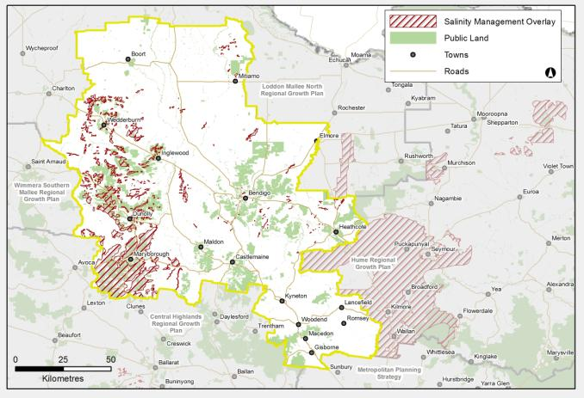Figure 30: Salinity Management Overlays in the Loddon Mallee South region

Source: Department of Transport, Planning and Local Infrastructure

#### Potentially contaminated land

Contaminated sites are land, and often also groundwater, where chemical and metal concentrations exceed those specified in policies and regulations. Contaminated sites may pose immediate or longer-term risks to human health and the environment, depending on the type and extent of contamination and on how the site is used.

There are many areas that may contain contaminated land in the Loddon Mallee South region, particularly as a result of the region’s gold mining history. Many of these areas could be subject to development pressures, either through infill or urban expansion, given the high occurrence of historic mining sites associated with existing settlements. There are also many individual properties that may have contaminated land due to historic land use and management.

Given that the exact location of many potentially contaminated sites is not known, this poses a direct challenge for land use planning, particularly as residential development expands and infill development occurs on sites with a complex history. The existence of contamination can significantly restrict the viable uses of affected land, unless the contamination is remediated, which often involves costly removal and treatment. Consideration of potential contamination in planning for future growth is needed particularly when planning is occurring at a more detailed level.

#### Acid sulfate soils

According to mapping available on the Australian Soil Resource Information System, there is a high probability that acid sulfate soils might occur in the Loddon Mallee South region, predominantly associated with wetland sites.[31]

Acid sulfate soils can pose significant threats to human health, agricultural production and infrastructure, and is an important consideration in land use planning. Generally these soils should not be disturbed. The Victorian Best Practice Guidelines for Assessing and Managing Coastal Acid Sulfate Soils has been produced to guide landowners, developers, planners and decision-makers through a risk identification approach to assist with the assessment and management of coastal acid sulfate soils, and may have some applicability to inland acid sulfate soils.

It is important that land use planners and managers identify areas where development is best avoided due to acid sulfate soils. Already, there are many examples of costly mistakes in Australia involving considerable damage to land, buildings and waterways as a result of disturbing these soils in coastal areas. The regional growth plan identifies the need to include consideration of acid sulfate soils in future land use planning. These soils should not be disturbed.

# Transport and infrastructure

**Key findings**

* The geographical location of the region is a strength. Freeways and regional fast rail mean the City of Greater Bendigo and the wider region are networked into the fast-growing central Victorian region as well as metropolitan Melbourne. The trunk rail and road routes forming the spine of the corridor provide access to national and overseas destinations for people and freight as well as for carrying local and regional traffic.
* The growth potential of the City of Greater Bendigo’s hinterland towns will be influenced by provision of sewerage which must be weighed against the appropriateness of a Domestic Wastewater Management Plan and associated costs to the landowner.
* Provision of sewerage to small towns and rural settlements is not often a viable solution and not always a solution to water supply catchment health.
* There are likely to be water supply reductions due to climate change.
* Consultation during development of the regional growth plan noted the importance of having a secure and high quality water supply to support the economy of the region, in particular intensive industries.
* There are significant gaps in the region’s telecommunications infrastructure, which is a competitive disadvantage.
* The majority of waste generated within the region is disposed of at sites outside the region.

**Key implications**

* Proximity and access to Melbourne creates ‘commuter towns’ with many people living in the region but travelling to Melbourne for employment.
* The costs associated with infrastructure improvements may not be feasible, for example, sewer per lot delivery.
* Increased population growth will put further pressure on water supply.
* Integrated water cycle strategies will influence and refine the future directions and growth proposed in the regional growth plan as they are developed and revised into the future. In addition, the plan will need to adapt to any updated predictions of water supply as Sustainable Water Strategies are implemented.
* The amount of waste generated in the region will continue to increase with further population growth, with limited regional options for disposal.

**Key challenges**

* Maximising the strategic position of the transport network to encourage settlement and economic growth close to existing transport infrastructure.
* Ensure that the current and future operation of major infrastructure of state and regional significance, including highways, railways, airports, communications networks and energy generation and distribution systems, is not adversely affected by urban development in adjacent areas.
* Improving and upgrading transport and infrastructure to keep pace with increasing population growth.
* Setting aside land to future proof road and rail projects using zoning and overlays.
* Maintaining liveability in towns and regional centres through proactive infrastructure provision.
* Providing improved transport connectivity between the network of settlements to support population and employment growth.
* Planning for flexible and adaptable freight connectivity to the transport network to cater for changes in commodities and freight logistics into the future.
* Ensuring long-term water supply for urban and rural use.
* Enabling and supporting land use changes that relate to structural adjustment in agricultural industries and other rural industries as a result of changes in water availability and distribution, including land use planning support for new dry land areas to determine an appropriate future for them.
* Determining barriers to infrastructure provision as well as planned investment.
* Developing an integrated approach to future waste management and resource recovery as the region grows.
* Encouraging and supporting advanced technology developments that can convert waste into energy or fuel products in the region.
* Ensuring that current and future operation of major transport infrastructure of national, state or regional significance is not adversely affected by development.
* Directing growth to locations with the capacity for infrastructure enhancement.
* Land use planning that enables sufficient urban density to support a viable and effective public transport system.

## Policy context transport

#### Victorian Freight and Logistics Plan

The Victorian Freight and Logistics Plan (Victoria the Freight State) was released in 2013. This plan examines long-term freight forecasts for Victoria up to the year 2050 and uses these forecasts to create and model a wide range of freight network scenarios to inform decision-making for future projects and initiatives. It also encompasses previous policy such as Growing Freight on Rail and the Transport Solutions Framework.

#### Victoria’s submission to Infrastructure Australia (2012)

The State Government submitted a number of projects to Infrastructure Australia in 2011. The 2012 submission updated this submission, and includes a number of projects arising from the development of the new metropolitan planning strategy, *Plan Melbourne*, regional growth plans and the Victorian Freight and Logistics Plan. Projects submitted to Infrastructure Australia that are relevant to the Loddon Mallee South region include:

* Managed motorways
* Port of Hastings
* Calder Freeway
* Calder Highway Alternative
* Metropolitan Intermodal System
* Rail Revival Study
* Upgrade regional passenger lines.

#### The National Airports Safeguarding Framework (2012)

The federal government’s 2009 Aviation White Paper proposed the development of a national land use planning framework that would:

* improve community amenity by minimising aircraft noise-sensitive developments near airports including through the use of additional noise metrics and improved noise-disclosure mechanisms
* improve safety outcomes by ensuring aviation safety requirements are recognised in land use planning decisions through guidelines being adopted by jurisdictions on various safety-related issues.

In 2012 the National Airports Safeguarding Advisory Group started work on developing the National Airports Safeguarding Framework. The framework has a number of guidance notes including:

* the principles of the framework
* measures for managing impacts of aircraft noise
* managing the risk of building generated windshear and turbulence at airports
* managing risk of wildlife strikes in the vicinity of airports
* managing the risk of wind turbines as physical obstacles to air navigation
* managing the risk of intrusions into the protected airspace of airports.

The national land use planning framework will ensure future airport operations and their economic viability are not constrained by incompatible residential development.

Each state government is to implement the framework into its respective planning system.

## Transport in the Loddon Mallee South region

The backbone of the transport network in the Loddon Mallee South region is provided by the major interstate transport corridor that forms part of the ‘National Land Transport Network’ (as designated by the Federal Government) – the Calder corridor. This corridor has a major freeway/highway and railway line that runs in parallel and provides for passenger and freight movement.

The most populous settlements in the region, Bendigo, Gisborne, Castlemaine and Kyneton, are located in this corridor as well as settlements such as Woodend, Malmsbury and Harcourt. This access route has shaped the Loddon Mallee South region since the early gold rush of the 1800s and this is likely to continue into the future.

Apart from the Calder corridor, a number of other important transport links form part of the transport network in the region.

### Road traffic flows

The region benefits from its geographical location, being in the centre of a relatively compact state, as well as the existing road network connecting it to other regional areas and to Melbourne. This road infrastructure is critical to the export performance of the region, and the efficiency of its labour market. There are seven major highway corridors within the region:

* Calder Freeway/Calder Highway (south from Bendigo to Melbourne and north-west from Bendigo to Mildura)
* Midland Highway (south from Bendigo to Ballarat and east from Bendigo to Shepparton)
* Northern Highway (north from Bendigo to Echuca)
* Pyrenees Highway (west from Castlemaine to Ararat )
* Loddon Valley Highway (north to Kerang and Swan Hill)
* McIvor Highway (south to Kilmore and Melbourne)
* Wimmera Highway (west to Horsham and South Australia.

These seven thoroughfares serve as the region’s main links to the neighbouring regions of Loddon Mallee North, Hume, Central Highlands and to Melbourne. The region’s arterial routes are shown in Figure 31, along with the seven traffic count data points used by VicRoads to assess traffic volumes.

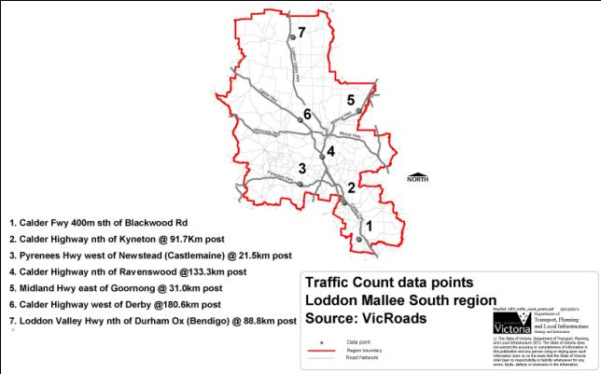Figure 31: Traffic count data points, Loddon Mallee South region

Source: VicRoads

Of the four major arterial roads, the Calder Freeway had the highest annual average daily traffic and rate of growth between 2006 and 2010 (see Figure 32).

This data clearly illustrates the importance of the Calder Freeway as the regional link to Melbourne and other regional areas such as Loddon Mallee North. The Calder Highway and Freeway traffic data points are part of the top 10 routes in Victoria with the highest annual average daily traffic in 2010 for all vehicles and trucks.[32]

Bar graph showing compound growth rates, two-way, 2006 to 2010, Loddon Mallee South region including Annual Average Growth Rage, 2006-2010 and Traffic Count Data PointsFigure 32: Compound growth rates, two-way, 2006 to 2010, Loddon Mallee South region

Source: VicRoads

### Train passenger traffic

Another asset for the region is the extent of railway coverage to and from Melbourne. Passenger rail enables daily or regular commuting to Melbourne. The region has 14 railway stations, half of which are in Macedon Ranges Shire. The City of Greater Bendigo has four railway stations, Central Goldfields Shire has two, while Loddon Shire and Mount Alexander Shire have one each. The region is served by the Bendigo Line, Swan Hill Line and Mildura Line (through the Maryborough station in Central Goldfields Shire).

Figure 33 shows the estimated normal weekday rail patronage by station. In 2010–11, 32 per cent of the estimated normal weekday patronage originated from Bendigo station, with 12 per cent from Castlemaine station. Railway stations in Macedon Ranges Shire as a whole (Clarkefield, Riddells Creek, Gisborne, Macedon, Woodend, Kyneton and Malmsbury) accounted for 46 per cent of the estimated normal weekday patronage in 2010–11, up from 42 per cent in 2005–06.

Bar chart showing normal weekday rail patronage, estimate by station, Loddon Mallee South including stations Clarkefield, Riddells Creek, Gisbourne, Macedon, Woodend, Kyneton, Castlemaine, Malmsbury, Kangaroo Flat, Bendigo, Eaglehawk, Dingee, Pyramid and ElmoreFigure 33: Normal weekday rail patronage, estimate by station, Loddon Mallee South

Following recent improvements in regional rail services, there has been a substantial increase in V/Line patronage across the major rail stations in the region. The growth in normal weekday rail patronage, especially in Macedon Ranges Shire, could likely indicate an increase in journey to work from the region to Melbourne.

V/Line passenger rail services were extended to Maryborough station in 2010. Figure 34 shows total monthly boardings at the station from July 2010 to November 2011. This station gives the region another railway access point to Melbourne via Ballarat. The patronage growth from this station, together with journey to work data showing a higher journey to work pattern to Ballarat and Pyrenees rather than Bendigo from Central Goldfields, indicates interconnectivity between surrounding local government areas in the Central Highlands region.

Graph showing total boardings at Maryborough Station from July 2010 to November 2011Figure 34: Total boardings at Maryborough Station from July 2010 to November 2011

### Journey to work patterns

Aside from being a valuable input to model current and future transport planning and service provisions,[33] journey to work data can also provide an indication of the economic flows and linkages within the region and between surrounding areas. Of the five local government areas, only Central Goldfields and Greater Bendigo have a high journey to work containment, with more than 80 per cent of journeys to work within their boundaries (Figure 35).

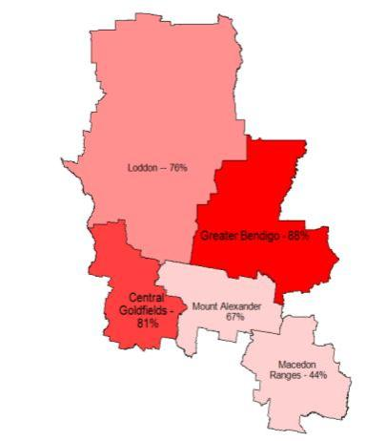Figure 35: Journey to work within local government area boundaries, Loddon Mallee South, 2006

Source: Australian Bureau of Statistics, based on place of usual residence.

In terms of interactions between local government areas in the region:

* around five per cent of journeys to work from Central Goldfields were to areas outside the region (Ballarat – three per cent and Pyrenees – two per cent) – higher than the journey to work percentage share for Loddon (one per cent) and Macedon Ranges (one per cent), and similar to Greater Bendigo (two per cent) and Mount Alexander (three per cent)
* in Macedon Ranges, 43 per cent of journeys to work in 2006 were to areas in metropolitan Melbourne
* Mount Alexander and Loddon are similar journeys to work pattern towards Greater Bendigo – In 2006, 13 per cent and 12 per cent of journeys to work from the local government areas were to Greater Bendigo.

The journey to work patterns of local government areas within the Loddon Mallee South region, highlight the advantages of the region’s geographic location in the middle of the state. This data indicates three broad functional economic areas within the region. A sub-region organised around the regional city of Greater Bendigo, Macedon Ranges drawn toward Melbourne, and Central Goldfields relatively contained (with similar marginal interactions with Bendigo and Ballarat). Figure 36 and Figure 37 show the public transport routes and services, and transport network within the Loddon Mallee South region.

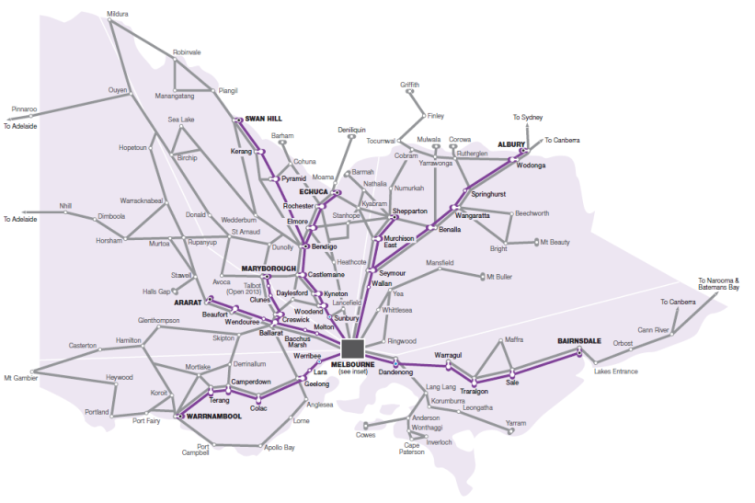Figure 36: Loddon Mallee South public transport routes

Source: Public Transport Victoria

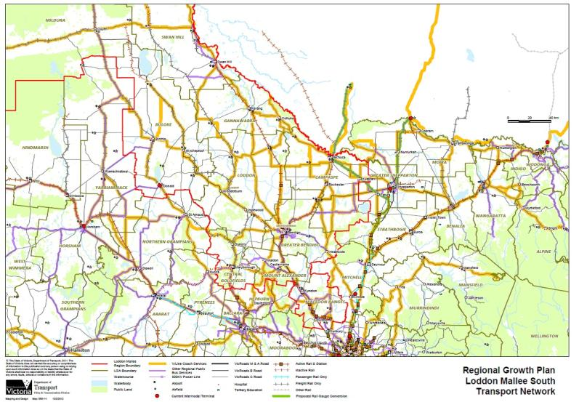Figure 37: Central Victoria’s transport network

Source: Department of Transport, Planning and Local Infrastructure

There are a number of other transport considerations that should be noted:

#### Local roads

Local roads in the Loddon Mallee South region are part of the regional transport network, providing connectivity within and between settlements. Often they are used by freight vehicles in order to reach the arterial road network.

#### Airports

Due to Bendigo’s close proximity to Melbourne, passenger and freight movement mainly occurs on the road and rail network. Bendigo Airport is a central location for air ambulance and other medical air services and also caters for some freight movement. The City of Greater Bendigo is investigating a centre of aviation excellence and business park in the vicinity of the airport. It is also anticipated that improvements to the existing runway will provide for increased freight usage and potential passenger services in the future.

### Guiding future transport opportunities

There are differing needs for freight and people movement, and future planning of the transport network in the Loddon Mallee South region needs to be considered in this light. It will be important to build on existing infrastructure to ensure access and connectivity. Future directions for transport form part of the regional growth plan. Some of the issues that inform these future directions are outlined in the following sections.

#### People movement

##### Network capacity

An objective in growing urban centres, such as Bendigo is to encourage public transport, walking and cycling as an alternative to the car. Settlement planning that incorporates public transport accessibility, cycling and walking is preferred. Settlement planning that encourages higher urban densities support a viable and efficient public transport system. There are also a number of demand management measures that could contribute to improved liveability in towns and centres including park and ride facilities, parking restrictions, bus lanes and shared zones.

##### Access and connectivity

The region’s transport network provides for accessible inter-regional and cross-regional travel. These connections will be crucial into the future as they will provide access to employment and a range of services and facilities such as health and education for those in the Loddon Mallee South region and adjoining regions.

The region has a number of smaller, dispersed communities. Maintaining access to services from smaller population centres is a challenge the region will need to address into the future. Options include consideration of flexible transport and mobile services that come into small communities so that accessibility is maintained.

Some smaller towns are not earmarked to receive major growth. From a regional perspective, some may even decline into the future. With this in mind it will be important for transport links to keep pace with growth and changing demographics.

##### A reliable and resilient network

Economic development scenarios will be important to ensure a vibrant regional economy, particularly those that focus on ease of access for the tourism sector, such as improving the region’s cycling network. In order to achieve this, the transport network will need to offer reliability to both passenger and freight vehicles and withstand disasters and emergencies such as bushfire. Reliable access to Bendigo will continue to be crucial due to its higher order services and facilities such as medical services.

##### Technological advancements

Future information and communication technology improvements, such as the National Broadband Network rollout, will provide access to faster and more reliable internet connections. The health and education sectors are leading the way in terms of people being able to access services and facilities remotely, rather than in a fixed location. Online training courses and rehabilitation via remote monitoring service are two examples. As the population ages (a population familiar with the technology), distance service provision will be critical particularly in rural and remote areas. With improved information and communication technology services people may not need or want to travel long distances as frequently. The National Broadband Network may offer a ‘mix and match’ communication style, for example, physical train journeys for some purposes and internet access for others.

##### Amenity and useability

The region’s transport network is used by a variety of people for both business and pleasure. Ensuring the network is well maintained into the future will be important. There is a need to consider facilities such as rest areas for tourists and commuters. This will be necessary to support a more diverse economy and make best use of tourism products and opportunities.

#### Freight movement

##### Freight gateways and hubs

There is a preference to use higher productivity vehicles in moving goods around the nation. The use of higher productivity vehicles will increase throughout Victoria over time. These vehicles may consist of Higher Mass Limit vehicles and Higher Productivity Freight Vehicles. Roads will need to be maintained to a high standard to enable an increasing freight road task. At this stage, some of these longer and heavier vehicles need to be dismantled into smaller freight trucks to drive into Melbourne. There is an opportunity in the Loddon Mallee South region, for example at Marong or Maryborough, to provide a truck gateway facility, with truck rest stop, de-coupling and maintenance services.

##### Network capacity

The Calder corridor is an important link in the freight network. Maintaining the efficiency of this freight network and planning for possible infrastructure enhancements into the future, through appropriate land use protection is needed. While the Calder corridor is critical for north-south freight travel, the region lacks an equivalent east-west link. Opportunities exist to improve the key east-west link along the Midland Highway so that it could carry an increased freight load. There is a need to build on existing work to prioritise strategic freight routes in the region.

The Calder corridor provides opportunities to exploit its location and increase employment opportunities. For example, the City of Greater Bendigo is investigating Marong as a potential industrial precinct. Marong’s location on the Calder Highway means it could act as a gateway to region, making use of existing infrastructure and creating economic opportunities for the region.

##### Connectivity for freight

Ensuring freight access for current commodities, such as agricultural produce, will be important into the future, along with looking for new opportunities where freight access will be needed. The creation of a network of logistics precincts with various facilities, for example intermodal terminals, will create opportunities for the distribution of freight within the region, to other regions and potentially interstate. Examples of potential locations may include Marong and Maryborough.

##### A reliable and resilient network

The Loddon Mallee South region has a number of rural areas with business related activities such as those related to horticulture and milk production that require freight access via the local road network. In many circumstances local roads are used by heavy trucks to collect and distribute commodities. This puts a strain on the maintenance of local roads. Into the future, with the advent of larger and potentially heavier trucks and the consolidation of farming practices, local road designations may need to be reviewed to allow for continued freight access.

## Urban water supply

Victoria has an integrated and adaptive planning framework, which ensures urban water customers and the broader community have secure supplies of high quality water. These supplies support drinking and non-drinking needs such as healthy recreational facilities, parks and gardens.

The State Government’s Living Victoria program was launched in April 2012 and has direct implications for water and urban planning across the state. Although its immediate focus is on metropolitan Melbourne, the overarching directions of Living Victoria are intended to apply more broadly across the state over time. As this occurs, the plans and strategies produced under this program will gradually supersede and replace existing strategies.

The Living Victoria program recognises that:

* water needs to be better integrated into urban landscapes
* the community needs to be better engaged in water planning
* improved evaluation frameworks, capable of capturing a broader range of costs and benefits, are needed to effectively assess the wide array of options for the provision of urban water services.

By implementing the Living Victoria program, the Office of Living Victoria will develop and coordinate new integrated urban and water planning frameworks as well as develop tools which will apply across the state (such as changes to the Victoria Planning Provisions).

At present, the key plans and strategies that guide urban water planning in regional Victoria are:

* water supply demand strategies (which will be superseded by integrated water cycle strategies)
* regional sustainable water strategies
* drought response plans.

#### Water supply demand strategies

Water supply demand strategieswere initially released in 2007. These strategies evaluated future water supply and demand scenarios and identified the mix of water supply and demand management measures needed to secure safe and reliable town water supplies, with a 50-year outlook. Urban water corporations released updated strategies in early 2012, which included new features to increase their alignment with the Living Victoria program including an Alternative Water Atlas and an annual Water Security Outlook.

Climate variability can have a profound impact on the amount of water available. This is expected to be exacerbated by the potential longer-term impacts of climate change such as a general reduction in water availability for the environment and water users. Water supply demand strategies consider how water supplies can be managed under a range of climate scenarios.

Based on the water supply demand strategies across the Loddon Mallee South region, there are likely to be shortfalls in supply across some service areas at some stage during the life of the regional growth plan. These issues are summarised in Figure 38. Solutions to any shortages within these areas are proposed in the water supply demand strategies and managed by the water corporations. These solutions include water demand management measures, improving supply system efficiency, the use of water savings rules, and purchasing more water.

Figure 38: Summary of water supply demand strategy outlooks for the Loddon Mallee South region

**Water corporation:** Coliban Water

* **Supply system:** Coliban system northern
* **Availability of supply to meet demand to 2041:** Supply adequate to meet growth forecast in water supply demand strategy
* **Solution for supply shortage proposed in water demand strategies:** Yes
* **Supply system:** Coliban system southern
* **Availability of supply to meet demand to 2041:** Shortfall in supply by 2030. Level of shortfall mainly dependent on climatic conditions
* **Solution for supply shortage proposed in water demand strategies:** Yes
* **Supply system:** Loddon system
* **Availability of supply to meet demand to 2041:** Shortfall in supply from 2020. Level of shortfall mainly dependent on climatic conditions
* **Solution for supply shortage proposed in water demand strategies:** Yes
* **Supply system:** Campaspe system
* **Availability of supply to meet demand to 2041:** Supply adequate to meet growth forecast in water supply demand strategy
* **Solution for supply shortage proposed in water demand strategies:** Yes
* **Supply system:** Elmore groundwater system
* **Availability of supply to meet demand to 2041:** Supply adequate to meet growth forecast in water supply demand strategy
* **Solution for supply shortage proposed in water demand strategies:** Yes
* **Supply system:** Wimmera system
* **Availability of supply to meet demand to 2041:** Already experiencing shortfalls, which are forecast to remain unless intervention taken
* **Solution for supply shortage proposed in water demand strategies:** Yes
* **Supply system:** Goulburn system
* **Availability of supply to meet demand to 2041:** Supply adequate to meet growth forecast in water supply demand strategy
* **Solution for supply shortage proposed in water demand strategies:** Yes

**Water corporation:** Western Water

* **Supply system:** Various within region
* **Availability of supply to meet demand to 2041:** Shortfalls in most areas either already or within 10 years
* **Solution for supply shortage proposed in water demand strategies:**

**Water corporation:** Central Highlands

* **Supply system:** Maryborough system
* **Availability of supply to meet demand to 2041:** Significant shortfalls. Currently these shortfalls are alleviated through use of a temporary groundwater licence. Central Highlands Water is seeking a permanent allocation of groundwater which should meet growth forecast in the water supply demand strategy (along with other measures)
* **Solution for supply shortage proposed in water demand strategies:** Yes

*Note: Grampians Wimmera Mallee Water also services some areas in the far north-west of the region, but there are no towns receiving urban supplies in this area. Therefore its water supply demand strategy does not apply to these areas.*

Integrated water cycle strategies, to replace water supply demand strategies, will identify the best mix of measures to:

* maintain a balance between the demand for water and the supply of water in cities and towns
* facilitate efficient investment in all water cycle services, including recycling sewage or trade waste, stormwater capture and re-use, and demand management
* improve the resilience of water supply systems, including fit-for-purpose, through scenario-based planning and adaptive management, having regard to risk and uncertainty.

#### Sustainable water strategies

Water supply issues for the Loddon Mallee South region are being managed through sustainable water strategies, predominantly the Northern Region Sustainable Water Strategy, but also the Western Region Sustainable Water Strategy, and the various water authority water supply demand strategies to secure the water for urban, industrial, agricultural and environmental water users in the long term.

These sustainable water strategies identify threats to reliability of water supply and quality of water, and ways to improve supply and quality of supply for existing and future consumptive users. They also identify ways to improve, protect and increase environmental water reserves. Most of the actions in the Northern Region Sustainable Water Strategy have been completed or are being refined and pursued in line with the Murray-Darling Basin Plan. The Western Region Sustainable Water Strategy is still relatively new and is now being implemented.

#### Drought response plans

Drought response plans manage temporary water shortages caused by prolonged periods of below average rainfall or other causes such as poor water quality. They outline a range of options to balance supply and demand, which may include imposing water restrictions. The water restriction framework was reviewed in late 2011 to meet community expectations and to apply consistent restriction rules across the state.

#### Water supply projects

Water supply throughout the region will have a strong influence on the type of industries that can operate in both rural and urban areas, and on the sustainability of settlements into the future. Upgrades to Coliban Water’s supply network are affecting much of the rest of the region. Major capital works and asset renewal programs to maintain and improve the quality and reliability of water and sewerage infrastructure are identified in Figure 39.

Figure 39: Major water supply and wastewater projects in the Loddon Mallee South region

#### Current projects

* Harcourt Rural Modernisation Project: Investigation is underway to replace the current open irrigation channel system in the Harcourt area with a network of pipes, and will reduce transfer losses that can exceed 50% through evaporation and leakage, provide reliability to irrigators and enhanced water security to urban supply.

#### Completed Projects

* Raywood – Sebastian Pipeline Project: Connection of the townships of Raywood and Sebastian to the Bendigo water supply system.
* Bendigo Creek Sewer Duplication: Major sewer main upgrade for Bendigo to create more capacity for the city’s growing population.
* Back Creek Siphon Upgrade: Upgrading of the pipeline transferring water from the Coliban catchment storages in Malmsbury to meet the water supply needs of Castlemaine and Bendigo, keeping the historical integrity of the pipeline intact.
* Eppalock to Sandhurst Augmentation: Duplication of sections of the existing Eppalock-Sandhurst pipeline that connects Lake Eppalock to Sandhurst Reservoir in Bendigo.
* Goldfields Superpipe: Construction of a 46.5 kilometre pipeline to connect the Waranga Western Channel with the water supply system near Lake Eppalock to improve water security in Bendigo, Kyneton, Castlemaine and Heathcote.
* Epsom-Spring Gully Recycled Water Project: Construction of a 14.5 kilometre pipeline from Bendigo Water Reclamation Plant (WRP) in Epsom to Spring Gully Reservoir and the construction of a Recycled Water Factory at Epsom, to produce more than 4 billion litres of water annually for use on public gardens, sporting facilities and irrigation in the Bendigo area.

Source: <http://www.coliban.com.au/projects/>

## Rural water supply

Water supply throughout the region is changing as a result of climate variability, as well as changes to water policy. In particular, irrigation system reform and the Murray-Darling Basin Plan are driving significant change in the region. The full implications of the Murray-Darling Basin Plan are still emerging although anticipated implications include a potential reduction in the amount of water available for irrigation over time.

Significant changes to the irrigation system are occurring as result of the Goulburn-Murray Water Connections Program (formerly known as the Northern Victoria Irrigation Renewal Project). The geographic footprint of irrigated areas in the region will be reduced as a result of this program and through water trade, including the federal government’s water buy backs.

Water availability is a concern both for maintaining environmental water supplies and for use by people and industry. Water supply throughout the region will have a strong influence on the type of industries that can operate in both rural and urban areas, and on the future sustainability of settlements. Water supply to rural areas is changing as part of water reform across the state which should provide a more secure water future for the region for the next 30 years and beyond.

Structural adjustment to the agricultural industry, as a result of these and other drivers, may result in land use change as the industry adapts to changes in water availability and distribution.

## Waste management

Effective waste and resource recovery management is an essential service that protects environmental and public health. The Victorian waste management system includes waste generation, collection and transport, sorting and processing, recycling and reprocessing, export, re-use and disposal. The waste management system operates across all activities in the Loddon Mallee South region, household or municipal, commercial and industrial, and construction and demolition.

The state government is responsible for policy development and regulation around waste management, and for promoting environmental sustainability. Local governments are responsible for providing waste collection, transport and reprocessing, or disposal to landfill services. Regional Waste Management Groups are responsible for planning and coordinating municipal solid waste for local governments within their regions, as well as helping them to reduce waste, maximise recovery and reduce environmental harm.

Victorian waste generation is expected to increase by around four per cent per year. The Loddon Mallee South Regional Growth Plan considers how to plan for and manage the waste associated with proposed population and economic growth. The Victorian Waste and Resource Recovery Policy[34] (page 16) states:

“*As our cities grow, securing land for our waste management facilities is a challenge. As population increases our waste generation increases and as we strive for world’s best practice environmental standards, finding and securing land for waste management facilities is likely to become even more difficult*.”

There are many existing and emerging industries in waste management, particularly in terms of recovery, re-use and recycling of waste. Energy generation from waste is an expanding industry in the state. There are also opportunities to promote waste recovery for use in other production processes, either as recycled waste for re-manufacturing or as new products created from recycled materials, including generating energy from waste.

Promoting these opportunities would help reduce the amount of waste going to landfill. There are opportunities to encourage and support investment in advanced technology that can convert waste into energy or fuel products in the region. Business and industry within the region should be supported in their efforts to realise the economic benefits of boosting resource productivity through waste recovery and re-use, including the exchange of waste materials for re-use and mutual benefit.

As towns expand, they often encroach on land that is close to landfills. Conflicts are common between landfills and incompatible neighbouring land use, such as residential development. The regional growth plan can encourage future strategic land use planning of councils to include consideration of waste management such as protecting buffer zones around these sites from incompatible development.

The majority of waste generated within the region is disposed of at sites outside the region. Disposal of waste from the Macedon Ranges Shire is to the Sunbury landfill within the City of Hume and the Shire of Mount Alexander’s landfill at Castlemaine.[35] The Sunbury landfill has a limited remaining lifespan based on current filling rates, while the Castlemaine landfill is estimated to use all available airspace by 2020.[36] Central Goldfields Shire no longer operates landfills, with all waste being transferred by road to either a recycling facility or landfill elsewhere.

Currently most waste generated within Central Goldfields Shire is disposed of at the Stawell landfill in the Wimmera Southern Mallee region. This may not be available in the medium to longer term future. The City of Greater Bendigo’s main landfill at Eaglehawk is expected to reach full capacity within three to five years. There are no further sites approved to receive and dispose of the large amount of waste that is generated locally. To reduce pressure on the Eaglehawk landfill, over half of Greater Bendigo’s landfill waste is sent to sites located outside the municipality.[37] The City of Greater Bendigo is currently developing a Waste and Resource Management Strategy.

## Wastewater management

Reticulated sewer is provided by urban water corporations. Outside reticulated areas councils are responsible for preparing on-site wastewater management and domestic wastewater management plans. The need for water corporation participation in domestic wastewater management plans is apparent when sewerage is identified as the only option for wastewater treatment, however on-site treatment solutions must be given due consideration. Peri-urban areas that have experienced significant growth without the provision of appropriate infrastructure, and small isolated towns, make up the bulk of these cases.

Provision of reticulated sewerage is very reliant upon adequate density and flows which are not always available in Low Density Residential Zones. Provision of a form of reticulated sewerage system as an alternative to on-site wastewater disposal is not always a solution to catchment management concerns. Alternatives to reticulated sewer systems are always available; however the business cases of the various systems, including that of On-site Wastewater Management, need to be evaluated and considered.

Many rural towns that rely upon waterways as a source of drinking water do not have protection under legislated mechanisms such as declared water supply catchments. This results in the raw water supply being vulnerable to impacts from excessive development density, inappropriate siting and poorly maintained on-site systems. Significant improvements are required to council domestic wastewater management plans which formulate a business case for upgrading, repairing, managing and levying on-site systems as compared to alternative options that typically involve implementing a reticulated sewerage scheme.

Business cases for wastewater management projects need to be measured against growth predictions and contribute toward Municipal Strategic Statements and Local Planning Policy that are directing the future of a township.

Provision for rural living must be approached cautiously in declared water supply catchments to limit exceeding principal thresholds of one dwelling per forty hectares, the ratio being established at a local scale.

## Communications and information and communication technology

There are significant gaps in the telecommunications infrastructure of the Loddon Mallee South region. Region-wide mobile phone coverage and high speed broadband access are critical to providing access to a wide range of services, including healthcare, education, finance, training and retail services. These services are also required for business growth and as a key means of maintaining social connections and reducing social disadvantage.

The development of the National Broadband Network is likely to make possible new and improved ways of connecting with one another, regardless of geography, from business and lifestyle to medical and education purposes. Figure 40 shows the proposed National Broadband Network in the region.

Access to superfast broadband will give businesses the opportunity to increase productivity, save time and money and to compete on a global scale. It will also increase opportunities for people to access services and products outside the region, potentially impacting on the economy. This impact may need to be considered.

## Energy

Regional electricity and gas transmission networks connect the Loddon Mallee South region to the national electricity grid and gas produced from the Bass Strait fields. Bendigo, Castlemaine, Gisborne, Kyneton, Maryborough and Woodend have access to natural gas. Other towns which have been identified for future gas rollout include Heathcote, Marong, Maldon and Huntly.

The existing power network is adequate to serve the growth of towns. The opportunities for alternative sources of energy generation are starting to be recognised by communities, and in government policy and strategies. The region is well resourced in alternative energy sources, particularly solar and bioenergy. Large-scale alternative energy production occurs outside the region’s urban centres, in rural areas. Many of these technologies are complementary to farming activities. As well as offering green energy and benefiting the environment, alternative energy provides another potential income source for farmers.

Figure 41 shows the location of key utility installations in the Loddon Mallee South region.

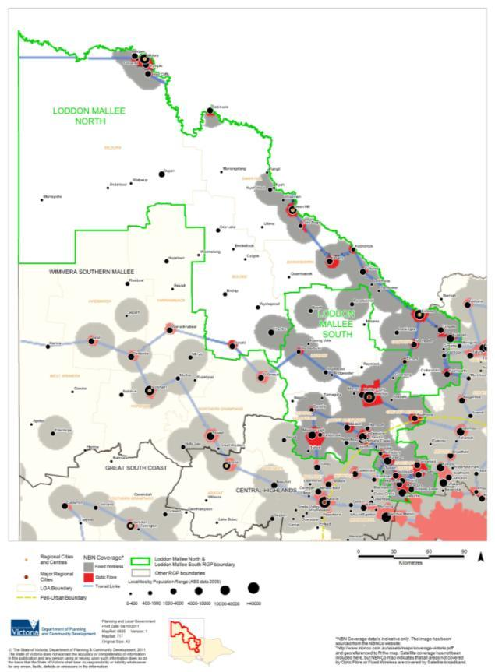Figure 40: NBN Loddon coverage

Source: National Broadband Network Company

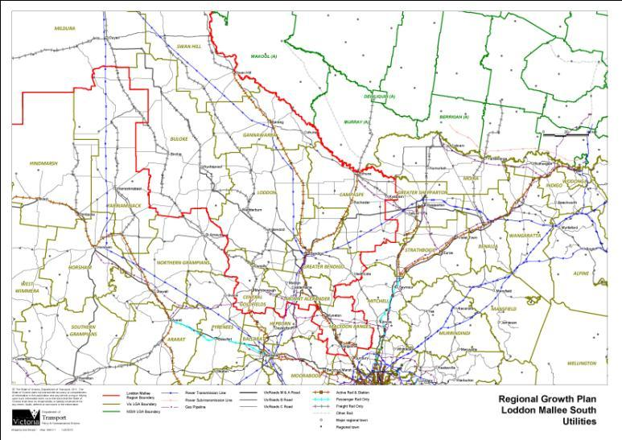Figure 41: Loddon Mallee South utilities

Source: Department of Transport, Planning and Local Infrastructure

# Developing the regional growth plan

## Planning considerations

Figure 42 was produced to provide a broad indication of areas within the Loddon Mallee South region that are relatively unconstrained for future urban growth and those areas that require more detailed planning consideration due to the constraints, environmental assets and natural hazards in those areas. These in turn, have informed the development of Future Settlement Growth Directions.

**Significant Planning Considerations** are those areas which require detailed planning consideration and must consider protection of assets in planning decisions.

These areas include:

* Parks and conservation reserves
* Ramsar wetlands
* Sites listed in the Directory of Important Wetlands within Victoria
* Watercourses
* Public land
* Floodway Overlay
* Land Subject to Inundation Overlay
* Bushfire Management Overlay (inclusive of the Wildfire Management Overlay).

**Medium Level Planning Considerations** are areas where growth may occur in balance with planning considerations, and include:

* Environmental Significance Overlay
* Vegetation Protection Overlay
* Significant Landscape Overlay
* Erosion Management Overlay
* Salinity Management Overlay
* Areas of High Habitat Value (based on the top three levels of NaturePrint)
* Designated Water Supply Catchment
* Current Mining Licences
* Current Extractive Tenements
* Excavation Sites.

Other localised planning considerations are those that need to be considered as part of the normal planning approval process. These factors are considered in detail, for example, in the framework growth plan for Bendigo, in the regional growth plan.

#### Drivers of growth

Drivers of growth range from global economic trends and impacts, to state and regional considerations. Critical drivers of population growth in the region include:

* Bendigo’s housing affordability and regional lifestyle which will continue to attract new residents  
  and ‘tree-changers’
* Bendigo as a regional city, providing many of the services and becoming an alternative to Melbourne
* regional migration from Melbourne and overseas
* proximity to Melbourne and strong transport links
* improved road and rail links and supporting social infrastructure
* changes in economic sectors, particularly agriculture and manufacturing
* more jobs and investment.

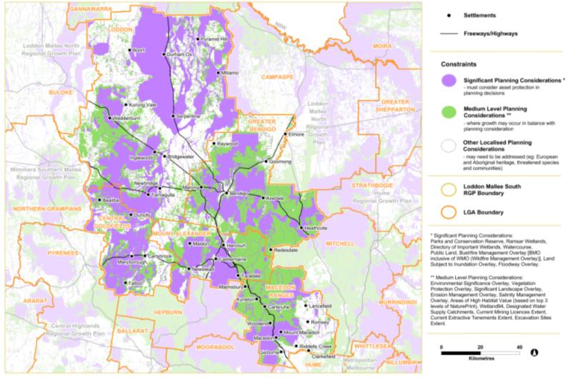Figure 42: Loddon Mallee South planning considerations

Source: Department of Transport, Planning and Local Infrastructure

## Planned and future growth

### Settlement growth

The basis for the settlement growth directions in the regional growth plan is strategic work already been undertaken by councils, including structure plans, outline development plans and settlement strategies that were developed with broad community consultation, as well as the regional Urban Development Program prepared by the Department of Transport, Planning and Local Infrastructure.

An analysis of the individual capability of each settlement for growth was undertaken based on a range of factors including infrastructure, environmental considerations, natural hazards, character issues and community aspirations. From this, settlements were identified as having capacity for significant, moderate or low/no growth. For other settlements which are likely to experience only small-scale residential, commercial and industrial development, the focus will be on reinforcing the role of the settlement to support sustainable communities.

Appendix 2 provides further background to the growth analysis of settlements.

**Descriptors of growth have been identified and matched to cities and towns based on consideration of growth constraints and opportunities:**

**Significant Growth:** Bendigo

**Manage / Support Growth:** Castlemaine, Kyneton, Gisborne, Maryborough

**Encourage growth in Bendigo’s hinterland:** Inglewood, Bridgewater, Harcourt, and Marong

**Areas within 100km of Melbourne:** Riddells Creek, Macedon, Woodend, Romsey, Lancefield, Malmsbury

### Planned growth

An analysis of opportunities for broadacre development, major and minor infill, and potential future residential development was undertaken across the region. From this, an indication of the number of potential lots available for development was obtained. This was further refined to produce an indication of the number of lots available for those settlements identified as having the capacity for significant or moderate growth. This work is termed ‘planned growth’ for the purposes of the regional growth plan.

In identifying planned growth for the region, all settlements were examined. While some settlements may have the capacity to grow in terms of available land supply, in reality they may be unlikely to grow due to factors such as low or no population growth, remoteness and lack of services. For these smaller settlements, there may be occasional opportunities for small infill development but essentially they will retain their existing role, size, services and character. Therefore, only settlements identified as having the capacity for significant or medium growth were considered when determining the actual planned growth capacity of the region.

In its nominated growth areas, the Loddon Mallee South region has enough planned growth areas to accommodate an additional 63,400 people. It is estimated that in the urban area of Bendigo, approximately 38,500 people are able to be accommodated, 10,300 of which would be through infill. The Loddon Mallee South Regional Growth Plan Technical Working Group considered the implications of Bendigo growing to a population of 200,000 people by 2041. For a population of this order to be accommodated, a significant amount of land supply will need to be identified, including additional infill opportunities. The Bendigo Residential Development Strategy review will examine the adequacy of residential land supply stocks and estimate additional land requirements to accommodate demand until 2030, having regard to the current level of supply.

The Macedon Ranges Settlement Strategy states that towns in Macedon Ranges Shire have sufficiently zoned land out to 2036 to accommodate the recommended population projection, with the exception of Riddells Creek. Additional land supply will need to be identified for Riddells Creek and Talbot (in Central Goldfields Shire) if these settlements are to grow. Figure 43shows the theoretical land supply for those settlements identified for significant and medium growth, and the population this supply could potentially support.

Figure 43: Planned population growth and potential population, nominated growth settlements

**Locality – Mount Alexander (S) TOTAL**

* No. lots 2011 – 1418
* Household size –
* Planned population growth** –3746
* Existing 2011 population (LGA) – 17,591
* Total population capacity – 21,337

Locality – Castlemaine

* No. lots 2011 – 749
* Household size – 2.5
* Planned population growth** – 1873
* Existing 2011 population (LGA) – 9124
* Total population capacity – 10,997

Locality – Harcourt

* No. lots 2011 – 669
* Household size – 2.8
* Planned population growth** – 1873
* Existing 2011 population (LGA) – 479
* Total population capacity – 2352

**Locality – Macedon Ranges (S) TOTAL**

* No. lots 2011 – 5051
* Household size –
* Planned population growth** – 14,340
* Existing 2011 population (LGA) – 41,860
* Total population capacity – 56,200

Locality – Kyneton

* No. lots 2011 – 1270
* Household size – 2.56
* Planned population growth** – 3251
* Existing 2011 population (LGA) – 4460
* Total population capacity – 7711

Locality – Riddells Creek

* No. lots 2011 – 486
* Household size – 3.04
* Planned population growth** – 1477
* Existing 2011 population (LGA) – 2976
* Total population capacity – 4453

Locality – Romsey

* No. lots 2011 – 702
* Household size – 2.98
* Planned population growth** – 2092
* Existing 2011 population (LGA) – 3678
* Total population capacity – 5770

Locality – Gisborne

* No. lots 2011 – 2593
* Household size – 2.9
* Planned population growth** – 7520
* Existing 2011 population (LGA) – 8057
* Total population capacity – 15,577

**Locality – Greater Bendigo (C) TOTAL**

* No. lots 2011 – 17,496
* Household size –
* Planned population growth** – 42,919
* Existing 2011 population (LGA) – 100,617
* Total population capacity – 143,536

Locality – Bendigo Urban Area only

* No. lots 2011 – 15,433
* Household size – 2.5
* Planned population growth** – 38,581
* Existing 2011 population (LGA) – 82,794
* Total population capacity – 121,375

Locality – Heathcote

* No. lots 2011 – 1300
* Household size – 2.3
* Planned population growth** – 2990
* Existing 2011 population (LGA) – 1688
* Total population capacity – 4678

Locality – Marong

* No. lots 2011 – 539
* Household size – 2.5
* Planned population growth** – 1348
* Existing 2011 population (LGA) – 351
* Total population capacity – 1698

**Locality – Loddon (S) TOTAL**

* No. lots 2011 – 301
* Household size –
* Planned population growth** – 713
* Existing 2011 population (LGA) – 7459
* Total population capacity – 8171

Locality – Bridgewater

* No. lots 2011 – 10
* Household size – 2.57
* Planned population growth** – 26
* Existing 2011 population (LGA) – 363
* Total population capacity – 389

Locality – Inglewood

* No. lots 2011 – 291
* Household size – 2.36
* Planned population growth** – 687
* Existing 2011 population (LGA) – 711
* Total population capacity – 1398

**Locality – Central Goldfields (S) TOTAL**

* No. lots 2011 – 710
* Household size –
* Planned population growth** – 1686
* Existing 2011 population (LGA) – 12,496
* Total population capacity – 14,182

Locality – Maryborough

* No. lots 2011 – 590
* Household size – 2.3
* Planned population growth** – 1357
* Existing 2011 population (LGA) – 7171
* Total population capacity – 8528

Locality – Carisbrook

* No. lots 2011 – 120
* Household size – 2.74
* Planned population growth** – 329
* Existing 2011 population (LGA) – 791
* Total population capacity – 1120

Locality – Talbot

* No. lots 2011 – 0
* Household size – 2.17
* Planned population growth** –
* Existing 2011 population (LGA) –
* Total population capacity –

**Locality – TOTAL LODDON MALLEE SOUTH REGION\*\***

* No. lots 2011 – 24,976
* Household size –
* Planned population growth** – 63,403
* Existing 2011 population (LGA) – 180,023
* Total population capacity – 243,426

**For those settlements nominated for growth NOT whole LGA

NO. DWELLINGS - Assumption 1 lot = 1 dwelling

HOUSEHOLD SIZE - ABS Census 2011. Where no household data is available, a reasonable assumption has been made

EXISTING POPULATION - ABS Census 2011

Note that for Talbot while the potential yield has been identified as zero lots, there is some capacity for small-scale growth – six hectares of zoned land has been identified as having the potential for future growth. However, in terms of potential subdivision, the actual number of lots cannot be determined at this time. A zero lot yield has also been identified for several of the smaller settlements in the shires of Loddon and Central Goldfields.

## Growth types

There are three main forms of urban development that take place in the Loddon Mallee South region and other regions:

#### Greenfields development

New or future development on undeveloped rural or non-urban land, generally located on the urban fringe.

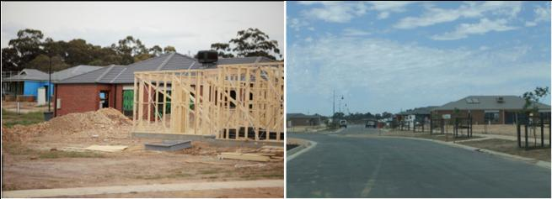Figure 44: Examples of greenfields development

Photos coutesy of Imagine Pictures

#### Infill development

Development of land within the existing urban area for residential purposes, either on previously undeveloped land, or through redevelopment of an existing site, often to increase dwelling density. This generally includes continued development of hinterland towns from small urban or rural townships to ‘towns’.

Infill development will be the focus of the majority of future growth in Bendigo and will play a significant part in urban containment. Infill development will also occur in other towns.

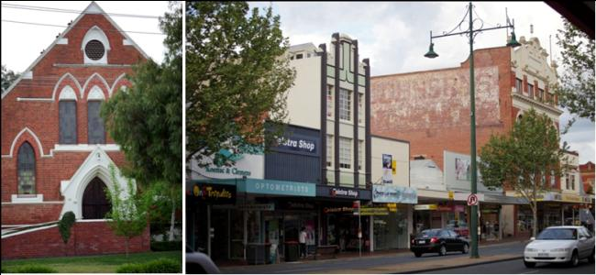Figure 45: Example of infill development

Photos courtesy of Imagine Pictures

#### Brownfield development

Development or re-use of land previously used for industrial or commercial purposes.

Brownfield development is less prevalent in the region, although there may be some future opportunities in Bendigo.

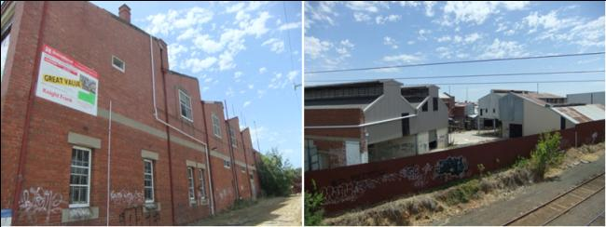Figure 46: Examples of brownfield development

Photos courtesy of Imagine Pictures

Cities with higher densities and smaller urban footprints (‘compact cities’) are more likely to provide equitable access to essential infrastructure and services, as well as being more sustainable in the face of climate change. Compact cities provide higher density housing near places of employment, education and existing community facilities and are well-connected to good transport networks. Encouraging infill development is one mechanism to achieve higher densities.

Compared to similar regional centres, Bendigo has experienced strong inward growth. Infill development is a major contributor to urban growth, with minor infill accounting for 30-50 per cent of net lots created each year.[38] There are large tracts of underutilised land, including private land holdings, surplus crown land and other public land including former mining areas within the existing urban area that could potentially support increased urban consolidation. Urban consolidation will continue to be a significant element in the forward planning of residential growth for the region, particularly for Bendigo and those centres whose outward growth may be constrained and presents both opportunities and challenges for the future.

## Urban design considerations

The design quality of the urban environment is more important than ever. Good urban design will be necessary when deciding how to provide for the region’s growing population. When a place is designed well it provides measurable social, cultural, economic and environmental benefits, making places that are valued and significant for those who use them. It is important to provide residents and visitors to the region with a sense of place and quality of life.

The settlements within the region each have a unique character, influenced by their built form and heritage, and their natural landscapes and settings. Generally, settlements within the region have a low density pattern, consisting mainly of single detached dwellings, and they rely on cars as the principal means of transport. In accommodating growth and change across the region, urban design principles appropriate for regional areas need to be taken into consideration.

**Liveable communities** provide easy access to services and jobs, a clean and healthy environment and attractive and engaging urban environments.

**Safe communities** provide urban environments that enhance personal safety and property security and where people feel safe to live, work and move at any time.

**Connected communities** connect destinations through the provision of good transport networks (road, public transport, pedestrian and cycle), and the structuring of walkable communities through measures such as mixed use planning.

Quality built environments, and the arrangement of land use in urban areas (urban structure), support the social, cultural, economic and environmental wellbeing of our communities, cities and towns. All new land use and development will need to respond appropriately to its landscape, valued built form and cultural context, and protect places and sites with significant heritage, architectural, aesthetic, scientific and cultural value. Sustainability will continue to be a significant element in planning for future residential growth. All elements of sustainable housing options and urban structure will need to be investigated including embodied energy in materials, quality design, liveability (including travel) and land supply, in addition to water and energy.

The Bendigo Residential Development Strategy review will address these issues for the City of Greater Bendigo, however these elements also need to be incorporated into planning across the region.

## Building on our strategic assets

The region, particularly Bendigo, is fortunate to have major services and infrastructure, making it a viable alternative to Melbourne and other regions as a place to live and work. The opportunities resulting from these assets need to be maximised in order to grow the region and its economy. We need to build on these assets, while at the same time protecting and enhancing them when managing expected population growth. Major strategic assets across the region are listed below:

#### Social infrastructure

Bendigo is a service centre for both the region and beyond into northern Victoria and southern New South Wales. A strong health and education sector, both secondary and higher education, exists in Bendigo as part of this role.

##### Health sector

The high quality and diversity of services provided by Bendigo Hospital offers an alternative to Melbourne for healthcare. Established health infrastructure is also provided in Maryborough, Castlemaine, Kyneton, Boort, Maldon, Inglewood and Heathcote. The region’s ageing population, combined with rising levels of preventable chronic disease and disadvantage, is expected to result in a significant increase in demand for hospital services.

With continued investment in infrastructure and services, particularly in smaller towns, there is the potential to establish a strong, interconnected health sector throughout the region, minimise dependence on Melbourne for higher order services, and meet the needs of an ageing population.

##### Bendigo Hospital redevelopment

A total of $630 million has been committed to the redevelopment of the Bendigo Hospital and other health sites. The new Bendigo Hospital will include a regional, integrated cancer centre with four radiotherapy bunkers and the capacity to expand to six, additional inpatient and same-day beds, two additional operating theatres, a mother-baby service specialising in care for post-natal depression and related conditions, as well as expanded educational facilities to support the teaching and training role of the hospital.

Precinct planning will be undertaken to improve access and linkages to Bendigo’s central business district. Of statewide significance, the redevelopment is expected to be completed in 2016. The Minister for Regional Cities announced the formation of a working group, consisting of Bendigo business leaders, the City of Greater Bendigo and the State Government to maximise opportunities for growth associated with the hospital’s redevelopment, and to ensure that a significant portion of the $630 million flows directly into the regional economy. The project will generate a large number of employment opportunities in the construction and operational phases, with 735 new jobs estimated to be generated in the construction phase.

##### Education sector

Quality education is provided throughout the region through a network of schools and kindergartens. Challenges are experienced in the provision of quality education in the north-west of the region due to the low population density and dispersed pattern of settlement.

La Trobe and Monash universities provide tertiary education facilities in Bendigo, and offer an alternative to studying in Melbourne or other regions. An objective of the Regional Strategic Plan 2010 is to establish Bendigo as a centre of excellence for post-secondary education. A current inhibitor to increasing tertiary participation is the lack of student accommodation in Bendigo, the establishment of which is a key priority.

Attracting and retaining younger age groups to the region for both education and further employment will be critical for maintaining community diversity and a vital economy. Priorities include the continued growth of La Trobe University and the provision of student accommodation.

##### Library services

The region’s library services rate as some of its most used public facilities. With over 475,000 visitors each year, and nearly 55,000 library members in Greater Bendigo, the existing library building is currently under performing and will not be able to meet future needs. The $7.25 million Bendigo Library Redevelopment project will create a new community facility incorporating a vibrant library precinct to meet the current and future needs of the community. The redevelopment is expected to be completed in 2014.

#### Recreation and tourism

##### Goldfields

The discovery of gold in Victoria over 150 years ago shaped the region we know today. This rich and lasting legacy resulted in a significant number of heritage buildings throughout the region, including the celebrated Victorian streetscapes of Bendigo with its grand hotels and public buildings as well as the charm of settlements such as Maldon, Castlemaine, Heathcote and Dunolly.

The region is one of Victoria’s major cultural and heritage destinations. Australia’s only National Heritage Park can be found at Castlemaine, which is also only the second site in Victoria to be nominated by the state government for World Heritage listing. Maldon is Australia’s first notable heritage town and the world’s largest gold nugget was found in the region.

The Regional Strategic Plan 2010 (page 22) identifies a need for major new infrastructure to ensure touring routes and trails across the goldfields meet visitor expectations. There is a need for: directional and interpretative signage to tell the rich stories of the goldfields; underground power to protect the historic streetscapes of the goldfields villages; and new infrastructure to conserve and protect heritage sites.

##### The arts, culture and festivals

Participation in arts and culture is strong across the region, with rates of participation exceeding the Victorian average in all municipalities except Central Goldfields. The region boasts a rich calendar of festivals and events which range from music, wine and dancing to sport, food and antiques.

While arts and cultural activities make a vital contribution to the health and wellbeing of communities by fostering social connection and communication, it is important to provide the infrastructure, and connections, to enable these activities to flourish. Towns along the Calder corridor are typically better serviced with arts and cultural infrastructure than other parts of the region.

##### Bendigo Art Gallery

One of the oldest and largest regional galleries in Australia, Bendigo Art Gallery is renowned for its ability to attract exclusive exhibitions such as *The Golden Age of Couture*, *The White Wedding Dress* and *Grace Kelly: Style Icon*, which attracted significant numbers of tourists from Melbourne and outside the region. *Grace Kelly: Style Icon* attracted visitors and media attention nationally and internationally, with more than 135,000 people visiting the collection, and an estimated economic impact of approximately $17 million.

Bendigo Art Gallery is about to undergo a $7.55 million expansion to provide more exhibition and storage space to capitalise on Bendigo’s burgeoning reputation as a cultural destination. The project is expected to be finished by the end of 2013.

##### Bendigo’s Sandhurst Theatre

Originally commissioned in 1861, the former Bendigo Gaol is undergoing a $25.8 million redevelopment as a state-of-the-art theatre complex including a 1000-seat theatre, music, dance and drama studio spaces, general learning areas and a commercial learning kitchen.

Supported by local, state and federal governments as well as local education, arts, entertainment, tourism and other business sectors, the development is expected to be completed by mid-2014. The project will enable Bendigo Secondary College to significantly enhance what it can offer students in terms of music and theatre performance. With high levels of public access, the theatre will encourage community participation in a wide range of performing arts, educational and other activities.

##### The Great Stupa

The largest stupa (structure containing Buddhist relics) in the western world is currently being built near Bendigo. Known as the Great Stupa of Universal Compassion, it will be 50 square metres at its base and nearly 50 metres high, with construction estimated to cost around $20 million. While still under construction, the stupa is open for visitors to view progress. Once complete, it will be a major drawcard to Bendigo, and aims to be a place of pilgrimage for Buddhists from around the world.

##### Food and wine

A contemporary food and wine sector flourishes in the region, with fresh regional produce and two major wine regions – Bendigo and Heathcote. In particular, the Heathcote area is known for the exceptional quality of its shiraz wines. This has resulted in substantial investment that is rivaling the nationally known Coonawarra region in South Australia.

##### Tourism and recreation

Tourism is a growing industry, and regional assets include recreation, leisure activities, the natural environment, wineries, heritage and landscape features. One of the most popular tourist destinations in the region is Hanging Rock (Mount Diogenes) located near the townships of Woodend and Mount Macedon. It is renowned as the site where a party of schoolgirls disappeared in February 1900 in the fictional novel and film *Picnic at Hanging Rock*. It is also home of the Hanging Rock Cup and Races, and a wide array of native flora and fauna. A rare volcanic formation attracting over 120,000 visitors per annum, it is listed on the Register of the National Estate.

To help develop the regional tourism industry, Tourism Victoria has developed the Regional Marketing and Development Plan – Goldfields, which outlines priority activities such as investment attraction and marketing activities. With the region’s strong background in agriculture and rural production, nature-based and agri-tourism are emerging industry sectors which have the potential for further development.

#### Agricultural sector

Agriculture is an important contributor to the regional economy. While growth in the agricultural sector has declined over time, the region, through its Southern Loddon Mallee Strategic Plan 2010, has a clear position of supporting and promoting the growth of its agricultural sector.

There are numerous existing and emerging opportunities for clusters of intensive agricultural production, broiler farms, egg production and piggeries in the region. Future expansion of these industries is sought with strong links to other emerging strengths in food processing and freight-related industries. One of the region’s priorities is to attract investment in high value agriculture production and added value processing, including in intensive agriculture industries. This would leverage off the region’s strengths of good soils, efficient flexible farming systems and vast tracts of land to deliver new jobs and encourage efficient resource use.[39]

## Challenges for regional growth

The beauty of the Loddon Mallee South region, the lifestyle it offers and its proximity to Melbourne make it highly attractive for growth. However, this growth presents challenges on a regional level which the regional growth plan seeks to manage or address:

#### Ensuring land supply for employment and housing

Provision of sufficient land supply in appropriate areas is needed to accommodate anticipated growth in nominated growth areas. The provision of land for employment areas across the region is important to provide for local employment opportunities and to reduce dependency on commuting. Achieving the right balance of housing types to meet changing household needs, both now and into the future, will be vital, particularly in light of the region’s ageing population. With growth opportunities in many settlements constrained by natural elements, investigation of alternative housing supply opportunities, including infill, will be necessary.

#### Managing growth within a naturally hazardous landscape, particularly in consideration of flood and bushfire risk

The rich and diverse natural landscapes across the region are fundamental to its character and attractiveness but also present very real risks to people, property and the region’s economy. The increasing likelihood of flood and bushfire will only increase this risk. Land use conflicts will need to be identified and growth managed in a way that protects the environmental assets of the region and minimises any risk as much as practical.

#### Protection of settlement character

The natural environment, rural landscapes and heritage features are critical to the region’s attractiveness and liveability. Settlement character is an intrinsic part of this. Growth pressure on some settlements threatens the very nature of these settlements and will need to be carefully managed so that it does not overwhelm the environmental and social attributes that are attracting growth.

#### Managing the ‘two speed’ economy, or ‘two extremes’ of economic structure, that make up Loddon Mallee South

There is an uneven distribution of both population and economic growth across the region, with Greater Bendigo, Macedon Ranges and Mount Alexander at one extreme and Central Goldfields and Loddon at the other. Managing strong population growth in some areas to ensure growth does not overwhelm environmental and social attributes, whilst stimulating sustainable population and economic growth over the long term in areas with low or negative population growth will be challenging. Some settlements may have aspirations for growth but in reality have low growth rates. Consideration of initiatives and incentives for managing and stimulating growth will be important.

#### Planning, funding and delivering necessary infrastructure and services to support growth

Strong population growth is anticipated for the region, particularly in Bendigo. Increased movement into Bendigo from outlying centres, for employment, health, education and access to other services and goods is also likely. This increased movement needs to be supported by public transport and an urban walking and cycling system to enable equitable access to goods and services and minimise congestion in urban centres. Land use planning can support transport and infrastructure enhancements, by directing population growth to areas with the capacity for enhancement, protecting existing important transport corridors, strategically reserving land for capacity enhancement and increasing urban density to support an effective urban public and active transport system.

The region’s intra‐regional public transport services and road links will need to be strengthened to enable equitable access for communities to high level services in Bendigo, such as the hospital and higher education. One aim of the regional growth plan is to ensure that all growth is supported by sustainable reticulated or independent infrastructure services, water, power and waste and resource recovery in particular.

#### Adapting to changing climate

Increased risk of flood and bushfire, combined with warmer temperatures and likely water supply reductions, will impact on agricultural land and urban communities. Combined with the changing nature of agricultural production and practices, the region faces a challenge to maintain a prosperous and sustainable agricultural sector. Flexibility and adaptation to support the ongoing viability of agriculture will be necessary.

It will also be important to limit the impacts of population growth and land fragmentation on rural production areas. Land use planning will need to help improve the region’s resilience and ability to adapt to change as impacts emerge. This includes appropriate design of urban environments to manage extreme heat and urban heat island effects.

# References

Australian Bureau of Statistics Census 2006 and 2011

Australian Bureau of Statistics (ABS) Index of Relative Socio-economic Disadvantage

Australian Soil Resource Information System 2011, Australian Soil Resource Information System

Central Goldfields Shire (2011) *Waste Management Strategy*

City of Greater Bendigo (2011) *The Marong Plan*

City of Greater Bendigo (2012) Bendigo Residential Development Strategy – Stage 1 Audit Report

City of Greater Bendigo (2005) *Commercial Land Strategy*

Coliban Water (2012) Water Plan 2012-2018

Comrie, N. (2011) Review of the 2010–11 Flood Warnings & Response, State of Victoria.

Department of Planning and Community Development (2009) City of Greater Bendigo Urban Development Program Regional Residential Report

Department of Planning and Community Development (2011) Change and disadvantage in the Loddon Mallee Region, Victoria

Department of Planning and Community Development (2011) *Macedon Ranges Regional Urban Development Program Residential Report* (unpublished)

Department of Planning and Community Development (2011) *Mt Alexander Regional Urban Development Program Residential Report* (unpublished)

Department of Planning and Community Development (2012) *Victoria in Future 2012*

Department of Planning and Community Development (2011) *Loddon Mallee – NBN Coverage*

Department of Sustainability and Environment, Improving Our Waterways: An overview of the draft Victorian Waterway Management Strategy

Department of Sustainability and Environment *Nature Print v.2.0*

Department of Sustainability and Environment (2009) *Northern Region Sustainable Water Strategy*

Department of Sustainability and Environment (2011) *Western Region Sustainable Water Strategy*

Department of Transport (2012) Regional Growth Plan Loddon Mallee South Utilities

Inbakaran, C. and Harwood, S. Journey to Work Patterns in Regional Victoria Analysis of Census Data 1996 to 2006

Loddon Shire Council (2012) *Rural Zones Review*

Macedon Ranges Shire (2007) Macedon Ranges Waste Management Strategy

Macedon Ranges Shire (2009) Romsey Outline Development Plan

Macedon Ranges Shire (2011) Macedon Ranges Settlement Strategy

Macedon Ranges Shire (2012) *Equine Strategy*

Macedon Ranges Shire (2012) Gisborne/New Gisborne Outline Development Plan

Mount Alexander Shire (2011) Harcourt Town Centre Masterplan

Mount Alexander Shire (2010) Residential Land Demand and Supply Analysis

Mount Alexander Shire (2010) Waste Management Strategy 2010–2015

North Central Catchment Management Authority (2013) *2013–19 North Central CMA Regional Catchment* Strategy

Planisphere (2012) Understanding Smaller Settlements in Victoria

Port Phillip and Westernport Catchment Management Authority (2013) Port Phillip and Western Port Regional Catchment Strategy

Regional Development Victoria (2010) Loddon Mallee Regional Strategic Plan

Regional Development Victoria (2012) Southern Region – Regional Strategic Plan Annual Report 2011/12

SGS Economics & Planning (2012) (for Mt Alexander Shire) *Castlemaine Commercial Centre Study*

Street Ryan & Associates (2012) Loddon Mallee South Region Economic Profile and Outlook

2009 Victorian Bushfires Royal Commission

Victorian Government (2013) Getting Full Value: the Victorian Waste and Resource Recovery Policy

Victorian Government (2013) Victorian Climate Change Adaptation Plan

Victorian Government (2013) Economic Development and Infrastructure Committee, Inquiry into greenfields mineral exploration and project development in Victoria, Government response

# Appendices

## Appendix 1: Loddon Mallee South region, estimated industrial land supply (hectares)

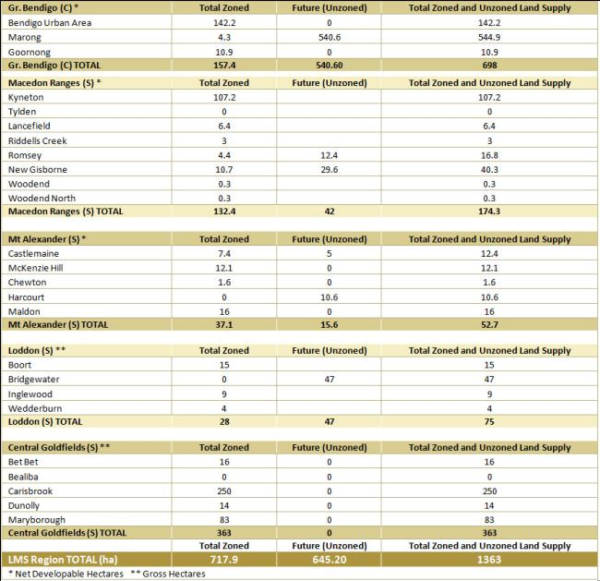Estimated industrial land stocks (ha)

Source: Greater Bendigo Urban Development Program Regional Industrial Report 2009

Macedon Ranges Urban Development Program Regional Industrial Report 2011 UNPUBLISHED

Mt Alexander Urban Development Program Regional Industrial Report 2011 UNPUBLISHED

Loddon Urban Development Program Draft Data 2012 UNPUBLISHED

Central Goldfields Urban Development Program Draft Data 2012 UNPUBLISHED

## Appendix 2: Settlement growth analysis

**Settlement: Bendigo**

* LGA – Greater Bendigo
* Settlement Type – Regional City
* 2011 Pop (ABS 2011 Census) – 82,794: Bendigo urban locality
* Projected Population 2031 (1) ERP – 125,027: Greater Bendigo LGA
* Current planned growth capacity (2) – 37,038
* Total population capacity (3) – 118,971
* Planned future population (4) – 200,000: Predicted 2041 population if accelerated growth occurs in the regional city
* Source of planned growth figure – Loddon Mallee South Regional Growth Plan Technical Working Group Workshop 29/2/12
* Comments –
* Major growth centre for region.
* Relative to other similar regional cities, Bendigo has experienced relatively high rates of infill development, low broadacre/greenfield development and high low density development on its periphery.
* New types of infill development will need to be identified as current infill supply taken up.
* Surrounding forest constrains greenfield development.
* Beyond forest ring is a supply of low-density land in non-urban areas. New greenfield development has jumped the forest boundary to areas such as Strathfieldsaye and Marong.
* City of Greater Bendigo reviewing its Residential Development Strategy which will be an important input.
* The predicted 2041 population needs strategic justification.
* Growth Type Recommendation (5) as per Future Settlement Growth Directions Map 9 Regional Growth Plan – Significant growth

**Settlement: Marong**

* LGA – Greater Bendigo
* Settlement Type – Town
* 2011 Pop (ABS 2011 Census) – 351
* Projected Population 2031 (1) ERP – Not available
* Current planned growth capacity (2) – 1294
* Total population capacity (3) – 1659
* Planned future population (4) – 8000 in 3500 homes by 2030
* Source of planned growth figure – Marong Plan
* Comments –
* Identified as a growth area in the Bendigo Residential Development Strategy 2004.
* 15km from Central Bendigo.
* Major industrial area identified for western side of Marong. Will provide local employment opportunities.
* On rail freight line.
* Potential intermodal terminal.
* Growth Type Recommendation (5) as per Future Settlement Growth Directions Map 9 Regional Growth Plan – Encourage sustainable growth in Bendigo’s hinterland towns

**Settlement: Heathcote**

* LGA – Greater Bendigo
* Settlement Type – Town
* 2011 Pop (ABS 2011 Census) – 1688
* Projected Population 2031 (1) ERP – Not available
* Current planned growth capacity (2) – 2730
* Total population capacity (3) – 4385
* Planned future population (4) – Not available for smaller towns
* Source of planned growth figure – n/a
* Comments –
* 45km from Central Bendigo.
* Loddon Mallee South Regional Growth Plan Regional Technical Working Group meeting recommended growth of Heathcote.
* Within lifestyle and wine area.
* Closed rail line.
* Growth Type Recommendation (5) as per Future Settlement Growth Directions Map 9 Regional Growth Plan – Low growth

**Settlement: Elmore**

* LGA – Greater Bendigo
* Settlement Type – Town
* 2011 Pop (ABS 2011 Census) – 668
* Projected Population 2031 (1) ERP – Not available
* Current planned growth capacity (2) – 0
* Total population capacity (3) – 656
* Planned future population (4) – Not available for smaller towns
* Source of planned growth figure – n/a
* Comments –
* 45km from Central Bendigo.
* Agricultural town.
* Has not attracted the "lifestyle" market to date.
* On Midland Highway.
* On train line.
* Growth Type Recommendation (5) as per Future Settlement Growth Directions Map 9 Regional Growth Plan – Low growth

**Settlement: Axedale**

* LGA – Greater Bendigo
* Settlement Type – Town
* 2011 Pop (ABS 2011 Census) – 216
* Projected Population 2031 (1) ERP –
* Current planned growth capacity (2) – 309
* Total population capacity (3) – 521
* Planned future population (4) – Not available for smaller towns
* Source of planned growth figure – n/a
* Comments –
* 21km from Central Bendigo.
* Small-town alternative to Bendigo.
* Relatively few constraints.
* Growth Type Recommendation (5) as per Future Settlement Growth Directions Map 9 Regional Growth Plan – Low growth

**Settlement: Goornong**

* LGA – Greater Bendigo
* Settlement Type – Town
* 2011 Pop (ABS 2011 Census) – 261
* Projected Population 2031 (1) ERP –
* Current planned growth capacity (2) – 122
* Total population capacity (3) – 502
* Planned future population (4) – Not available for smaller towns
* Source of planned growth figure – n/a
* Comments –
* 29km from Central Bendigo.
* Small-town alternative to Bendigo.
* Relatively few constraints.
* Rail-line but no stop.
* Growth Type Recommendation (5) as per Future Settlement Growth Directions Map 9 Regional Growth Plan – Low growth

**Settlement: Raywood**

* LGA – Greater Bendigo
* Settlement Type – Town
* 2011 Pop (ABS 2011 Census) – <200
* Projected Population 2031 (1) ERP –
* Current planned growth capacity (2) – 40
* Total population capacity (3) – <240
* Planned future population (4) – Not available for smaller towns
* Source of planned growth figure – n/a
* Comments –
* 29km from Central Bendigo.
* Small-town alternative to Bendigo.
* Relatively few constraints.
* Rail-line but no stop.
* Growth Type Recommendation (5) as per Future Settlement Growth Directions Map 9 Regional Growth Plan – Low growth

**Settlement: Maryborough**

* LGA – Central Goldfields
* Settlement Type – Regional Centre
* 2011 Pop (ABS 2011 Census) – 7174
* Projected Population 2031 (1) ERP – 8924
* Current planned growth capacity (2) – 1434
* Total population capacity (3) – 8573
* Planned future population (4) – 14,000 (Estimated capacity based on existing land supply)
* Source of planned growth figure – Regional Urban Development Program
* Comments –
* Loddon Mallee South RGP Technical Working Group identified Maryborough as having the capacity and desire to grow.
* Not much actual growth. May need drivers to achieve desired growth.
* Has land supply capacity.
* Geographically located on the edge of the "lifestyle" belt from Melbourne.
* Ranks low on the SEIFA scale.
* Growth Type Recommendation (5) as per Future Settlement Growth Directions Map 9 Regional Growth Plan – Manage and support growth

**Settlement: Carisbrook**

* LGA – Central Goldfields
* Settlement Type – Town
* 2011 Pop (ABS 2011 Census) – 791
* Projected Population 2031 (1) ERP – Not available
* Current planned growth capacity (2) – 180
* Total population capacity (3) – 908
* Planned future population (4) – Not available for smaller towns
* Source of planned growth figure – n/a
* Comments –
* Satellite town to Maryborough - 7km from Maryborough.
* Flooding constraints.
* Good surrounding agricultural land.
* Growth Type Recommendation (5) as per Future Settlement Growth Directions Map 9 Regional Growth Plan – Low growth

**Settlement: Talbot**

* LGA – Central Goldfields
* Settlement Type – Town
* 2011 Pop (ABS 2011 Census) – 258
* Projected Population 2031 (1) ERP – Not available
* Current planned growth capacity (2) – 0
* Total population capacity (3) – 243
* Planned future population (4) – Not available for smaller towns
* Source of planned growth figure – n/a
* Comments –
* 14km from Maryborough.
* Closer to Ballarat than Bendigo.
* On Maryborough to Ballarat rail line. Station to be re-opened to passenger rail which will connect people to Ballarat and then to Melbourne by rail.
* Becoming attractive to "lifestylers" with active cafe culture and spillover from Clunes.
* No land supply.
* Growth Type Recommendation (5) as per Future Settlement Growth Directions Map 9 Regional Growth Plan – Low growth

**Settlement: Dunolly**

* LGA – Central Goldfields
* Settlement Type – Town
* 2011 Pop (ABS 2011 Census) – 638
* Projected Population 2031 (1) ERP – Not available
* Current planned growth capacity (2) – 342
* Total population capacity (3) – 986
* Planned future population (4) – Not available for smaller towns
* Source of planned growth figure – n/a
* Comments –
* On edge of "lifestyle" belt from Melbourne.
* No passenger rail. On Mildura freight rail line.
* Growth Type Recommendation (5) as per Future Settlement Growth Directions Map 9 Regional Growth Plan – Low growth

**Settlement: Castlemaine**

* LGA – Mt Alexander
* Settlement Type – Regional Centre
* 2011 Pop (ABS 2011 Census) – 9124
* Projected Population 2031 (1) ERP – 11,371
* Current planned growth capacity (2) – 1786
* Total population capacity (3) – 10,751
* Planned future population (4) –
* Source of planned growth figure –
* Comments –
* Strong lifestyle growth.
* Constrained by natural environment, especially National heritage areas.
* Growth Type Recommendation (5) as per Future Settlement Growth Directions Map 9 Regional Growth Plan – Manage and support growth

**Settlement: Maldon**

* LGA – Mt Alexander
* Settlement Type – Town
* 2011 Pop (ABS 2011 Census) – 1236
* Projected Population 2031 (1) ERP – Not available
* Current planned growth capacity (2) – 251
* Total population capacity (3) – 1476
* Planned future population (4) – Not available for smaller towns
* Source of planned growth figure – n/a
* Comments –
* Declared as Australia's first Notable Town by the National Trust in 1966.
* Heritage status likely to exclude any major development.
* Forest constraints.
* Growth Type Recommendation (5) as per Future Settlement Growth Directions Map 9 Regional Growth Plan – Low growth

**Settlement: Harcourt**

* LGA – Mt Alexander
* Settlement Type – Town
* 2011 Pop (ABS 2011 Census) – 479
* Projected Population 2031 (1) ERP – Not available
* Current planned growth capacity (2) – 626
* Total population capacity (3) – 2088
* Planned future population (4) – 1100 by 2021
* Source of planned growth figure – Harcourt Town Masterplan 2011
* Comments –
* TRG identified Harcourt for growth.
* Possible growth alternative to Castlemaine.
* Rail station currently closed. Possible re-opening if town becomes large enough.
* High-value agricultural production in the area - apples.
* Growth Type Recommendation (5) as per Future Settlement Growth Directions Map 9 Regional Growth Plan – Encourage sustainable growth in Bendigo’s hinterland towns

**Settlement: Gisborne**

* LGA – Macedon Ranges
* Settlement Type – Town
* 2011 Pop (ABS 2011 Census) – 8057
* Projected Population 2031 (1) ERP – 13,110
* Current planned growth capacity (2) – 7520
* Total population capacity (3) – 15,426
* Planned future population (4) – 14,700 by 2036
* Source of planned growth figure – Macedon Ranges Settlement Strategy
* Comments –
* Rapid recent rate of growth.
* Strongly related to Melbourne as a commuter town. 54km from centre of Melbourne.
* Growth in Gisborne influenced by growth and change in metropolitan area.
* Growth Type Recommendation (5) as per Future Settlement Growth Directions Map 9 Regional Growth Plan – Manage and support growth

**Settlement: Kyneton**

* LGA – Macedon Ranges
* Settlement Type – Town
* 2011 Pop (ABS 2011 Census) – 4460
* Projected Population 2031 (1) ERP – Not available
* Current planned growth capacity (2) – 2972
* Total population capacity (3) – 7321
* Planned future population (4) – 8600 by 2036
* Source of planned growth figure – Macedon Ranges Settlement Strategy
* Comments –
* On Melbourne - Bendigo rail line.
* Attractive as a "lifestyle" town.
* Commuter town to both Melbourne and Bendigo.
* Growth Type Recommendation (5) as per Future Settlement Growth Directions Map 9 Regional Growth Plan – Manage and support growth

**Settlement: Romsey**

* LGA – Macedon Ranges
* Settlement Type – Town
* 2011 Pop (ABS 2011 Census) – 3678
* Projected Population 2031 (1) ERP – Not available
* Current planned growth capacity (2) – 2113
* Total population capacity (3) – 5691
* Planned future population (4) – 6000 by 2036
* Source of planned growth figure – Macedon Ranges Settlement Strategy
* Comments –
* Out of main Melbourne - Bendigo corridor.
* More limited infrastructure available.
* No rail service.
* A need to protect both the character of the town and its surrounding higher quality agricultural land.
* Growth Type Recommendation (5) as per Future Settlement Growth Directions Map 9 Regional Growth Plan – Low growth

**Settlement: Riddells Creek**

* LGA – Macedon Ranges
* Settlement Type – Town
* 2011 Pop (ABS 2011 Census) – 2976
* Projected Population 2031 (1) ERP – Not available
* Current planned growth capacity (2) – 1463
* Total population capacity (3) – 4342
* Planned future population (4) – 6100 by 2036
* Source of planned growth figure – Macedon Ranges Settlement Strategy
* Comments –
* On Melbourne - Bendigo rail line.
* Attractive town for commuters.
* Has a potential fire risk to the north and other environmental constraints.
* Growth in this settlement needs to consider these constraints however there is considered to be scope for growth.
* Not enough land supply to accommodate MRSS recommended population projection.
* Growth Type Recommendation (5) as per Future Settlement Growth Directions Map 9 Regional Growth Plan – Low growth

**Settlement: Lancefield**

* LGA – Macedon Ranges
* Settlement Type – Town
* 2011 Pop (ABS 2011 Census) – 1262
* Projected Population 2031 (1) ERP – Not available
* Current planned growth capacity (2) – 1164
* Total population capacity (3) – 2380
* Planned future population (4) – 3000 by 2036
* Source of planned growth figure – Macedon Ranges Settlement Strategy
* Comments –
* More limited infrastructure available.
* A need to protect both the character of the town and its surrounding higher quality agricultural land.
* Not as well serviced as nearby towns of Kilmore, Romsey and Riddells Creek.
* Growth Type Recommendation (5) as per Future Settlement Growth Directions Map 9 Regional Growth Plan – Low growth

**Settlement: Malmsbury**

* LGA – Macedon Ranges
* Settlement Type – Town
* 2011 Pop (ABS 2011 Census) – 612
* Projected Population 2031 (1) ERP – Not available
* Current planned growth capacity (2) – 277
* Total population capacity (3) – 922
* Planned future population (4) – 900 by 2036
* Source of planned growth figure – Macedon Ranges Settlement Strategy
* Comments –
* On Melbourne - Bendigo rail line, with train stop.
* Has more limited opportunities when hazards, environmental constraints, character issues and infrastructure limitations are considered.
* Growth Type Recommendation (5) as per Future Settlement Growth Directions Map 9 Regional Growth Plan – Low growth

**Settlement: Woodend**

* LGA – Macedon Ranges
* Settlement Type – Town
* 2011 Pop (ABS 2011 Census) – 3415
* Projected Population 2031 (1) ERP – Not available
* Current planned growth capacity (2) – 1210
* Total population capacity (3) – 4599
* Planned future population (4) – 5000 by 2036
* Source of planned growth figure – Macedon Ranges Settlement Strategy
* Comments –
* On Melbourne - Bendigo rail line.
* Has limitations relating to flooding, native vegetation and significant wildfire risk as well as demands to preserve the tourism role of the town.
* Growth Type Recommendation (5) as per Future Settlement Growth Directions Map 9 Regional Growth Plan – Low growth

**Settlement: Macedon / Mount Macedon**

* LGA – Macedon Ranges
* Settlement Type – Town
* 2011 Pop (ABS 2011 Census) – 2631
* Projected Population 2031 (1) ERP – Not available
* Current planned growth capacity (2) – 166
* Total population capacity (3) – 2747
* Planned future population (4) – Macedon 1400 Mt Macedon 1100
* Source of planned growth figure – Macedon Ranges Settlement Strategy
* Comments –
* MRSS recommends restricted development in recognition of the high wildfire risk and environmental constraints, which are such that no growth should be facilitated.
* Growth Type Recommendation (5) as per Future Settlement Growth Directions Map 9 Regional Growth Plan – Low growth

**Settlement: Inglewood**

* LGA – Loddon
* Settlement Type – Town
* 2011 Pop (ABS 2011 Census) – 711
* Projected Population 2031 (1) ERP – Not available
* Current planned growth capacity (2) –
* Total population capacity (3) – 722
* Planned future population (4) – Not available for smaller towns
* Source of planned growth figure – n/a
* Comments –
* 45km from Bendigo.
* On outer edge of Bendigo's hinterland.
* Close to forest areas with fire risk to western side of the town.
* On freight only rail line.
* Growth Type Recommendation (5) as per Future Settlement Growth Directions Map 9 Regional Growth Plan – Encourage sustainable growth in Bendigo’s hinterland towns

**Settlement: Bridgewater**

* LGA – Loddon
* Settlement Type – Town
* 2011 Pop (ABS 2011 Census) – 363
* Projected Population 2031 (1) ERP – Not available
* Current planned growth capacity (2) – 21
* Total population capacity (3) – 344
* Planned future population (4) – Not available for smaller towns
* Source of planned growth figure – n/a
* Comments –
* 38km from Bendigo.
* Significant flood risk.
* Valuable agricultural land on river flats surrounding town.
* Possible small town alternative lifestyle alternative to Bendigo.
* Growth Type Recommendation (5) as per Future Settlement Growth Directions Map 9 Regional Growth Plan – Encourage sustainable growth in Bendigo’s hinterland towns

**Settlement: Boort**

* LGA – Loddon
* Settlement Type – Town
* 2011 Pop (ABS 2011 Census) – 760
* Projected Population 2031 (1) ERP – Not available
* Current planned growth capacity (2) – 33
* Total population capacity (3) – 773
* Planned future population (4) – Not available for smaller towns
* Source of planned growth figure – n/a
* Comments –
* Agricultural centre.
* Distant from regional centres.
* Low growth.
* Growth Type Recommendation (5) as per Future Settlement Growth Directions Map 9 Regional Growth Plan – Low growth

**Settlement: Wedderburn**

* LGA – Loddon
* Settlement Type – Town
* 2011 Pop (ABS 2011 Census) – 680
* Projected Population 2031 (1) ERP – Not available
* Current planned growth capacity (2) –
* Total population capacity (3) –
* Planned future population (4) – Not available for smaller towns
* Source of planned growth figure – n/a
* Comments –
* 73km from Bendigo.
* Farming town.
* Not on rail line.
* Growth Type Recommendation (5) as per Future Settlement Growth Directions Map 9 Regional Growth Plan – Low growth

1. Projected Growth and Change – The growth shown in the Victoria in Future 2012 data which is based on demographic trends and changes. It also includes population decrease.
2. Current Planned Growth Capacity – The growth that can be accommodated by existing zoned land and land identified and reported in approved strategies - calculated from Regional Urban Development Program data.
3. Total Population Capacity - 2011 Population plus Current Planned Growth Capacity.
4. Planned Future Population - The growth predicted for a region, town or community based on consideration of data including settlement plans, ABS data or population projections. It requires policy or development justification to support the planned targets. For Macedon Ranges these are recommended maximum population based upon the Macedon Ranges Settlement Strategy.
5. Growth Type Recommendation as per Future Settlement Growth Directions (refer to Map 9 in the Loddon Mallee South Regional Growth Plan).

1. Regional Development Victoria 2010 Southern Loddon Mallee Regional Strategic Plan p.7
2. Victoria in Future 2012 population projections cover the period 2011 to 2031 for Local Government Areas (LGAs) and are based on the 2011 Australian Bureau of Statistics population estimates.
3. Department of Planning and Community Development, Victoria in Future 2012 Brochure 2011–2031
4. Regional Development Victoria 2012 unpublished analysis, page 6
5. Regional Development Victoria 2010 Regional Strategic Plan, p.7
6. Regional Development Victoria 2012 unpublished analysis, p.8
7. Census 2011
8. Reference to Southern region in the table is to the Loddon Mallee South Region.
9. Regional Development Victoria 2012 unpublished analysis
10. Australian Bureau of Statistics Census 2011
11. Loddon Shire Rural Zones Review 2012 page32
12. Macedon Ranges Shire 2012 Equine Strategy page 4
13. Regional Development Victoria Regional Strategic Plan page 22
14. Greenfields sites are those areas without known mineral deposits.
15. City of Greater Bendigo Municipal Strategic Statement
16. Regional Development Victoria 2012 unpublished analysis
17. City of Greater Bendigo Commercial Land Strategy 2005 page 39
18. Castlemaine Commercial Centre Study 2012 page 53
19. NaturePrint v2.0 conveys information on relative habitat value for all areas in Victoria (excluding marine), not just those with native vegetation. In its most commonly used form, NaturePrint is illustrated as a map showing relative habitat value (Strategic Natural Values map) showing areas that most contribute to biodiversity conservation. Further information on NaturePrint can be found at http://www.depi.vic.gov.au/conservation-and-environment/biodiversity/natureprint
20. INFFERTM is a tool for developing and prioritising projects to address environmental issues such as reduced water quality, biodiversity, environmental pests and land degradation. It is designed to help environmental managers achieve the most valuable environmental outcomes with the available resources. (www.inffer.org)
21. Providing ecosystem services through market based approaches (including competitive tenders such as Eco Tender and Bush Tender) can provide farmers with income for undertaking environmental works that conserve and enhance the environment.
22. Department of Sustainability and Environment, Improving Our Waterways: An overview of the draft Victorian Waterway Management Strategy, Victorian Government, October 2012
23. <http://vro.dpi.vic.gov.au/dpi/vro/vrosite.nsf/pages/landuse-water-supply-catchments>
24. Northern Region Sustainable Water Strategy, p57
25. Western Region Sustainable Water Strategy, p58.
26. Department of Sustainability and Environment, Soil Health Strategy: Protecting soil health for environmental values on public and private land, Victorian Government, July 2012
27. 2009 Victorian Bushfires Royal Commission, <http://www.royalcommission.vic.gov.au/Commission-Reports/Final-Report>
28. <http://www.climatechange.vic.gov.au/regional-projections/north-central>
29. <http://www.climatechange.vic.gov.au/what-is-climate-change>
30. [http://vro.dpi.vic.gov.au/dpi/vro/vrosite.nsf/pages/lwm_salinity_management_urban](http://vro.dpi.vic.gov.au/dpi/vro/vrosite.nsf/pages/lwm_salinity_management_urban%20)
31. ASRIS - Australian Soil Resource Information System (2011) <http://www.asris.csiro.au>
32. Across 51 Regional Victoria data points with 2010 data out of 62 Regional Victoria traffic data points
33. Inbakaran and Harwood, Journey to Work Patterns in Regional Victoria Analysis of Census Data 1996 to 2006
34. Victorian Government, Getting Full Value: the Victorian Waste and Resource Recovery Policy, The Victorian Government Department of Sustainability and Environment, April 2013
35. Macedon Ranges Shire 2007 Macedon Ranges Waste Management Strategy
36. Mount Alexander Shire 2010 Waste Management Strategy 2010–2015, p.16
37. <http://www.bendigo.vic.gov.au/News/Current_Projects/Waste_and_Resource_Management_Strategy>
38. Bendigo Residential Development Strategy – Stage 1 Audit Report 2012
39. Regional Development Victoria 2012 unpublished analysis, page 7