

BLUE HILLS QUARRY – WA7639
COMMUNITY CONSULTATION PLAN v2

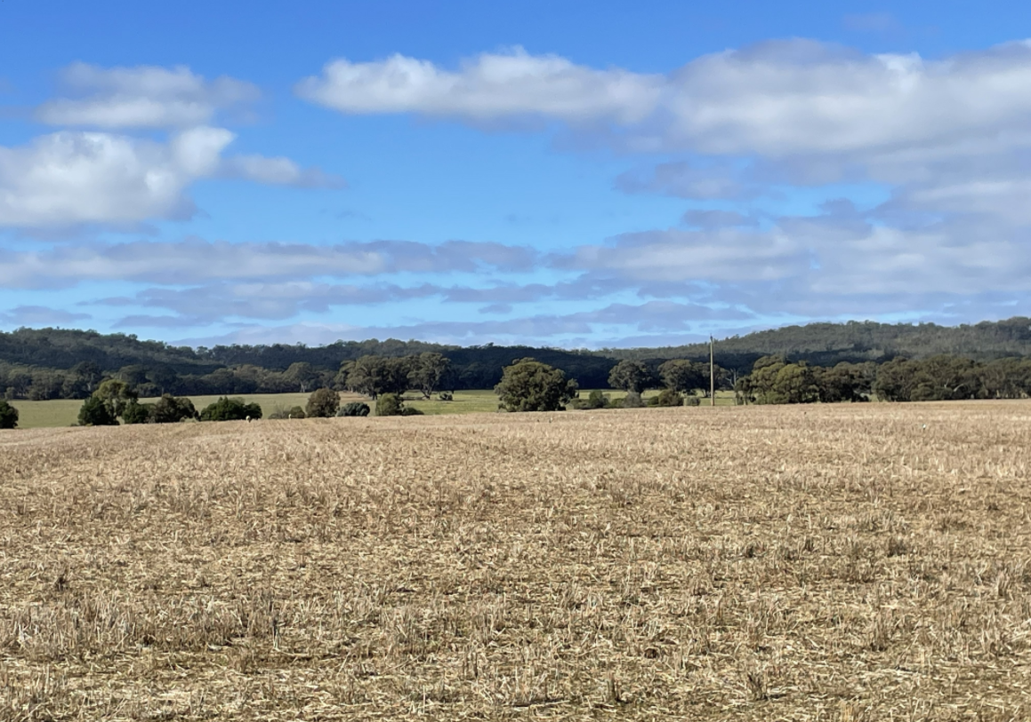

 | Title | Name | Date
Creator | Resource Development Advisor | A Mawson | 14/01/2026

Contents

1 Introduction 3
1.1 Background 3
1.2 Site Description 4
2 Communication and Engagement Activities 5
2.1 Goals 5
2.2 Objectives 5
3 Stakeholders 6
3.1 Community Profile 6
3.2 Stakeholder Identification 7
3.3 Stakeholder Analysis 8
3.4 Consultation To Date 10
4 Consultation Methods 12
5 Schedule of Activities 12
6 Evaluation and Review of Community Engagement 13
7 Version Control 14

Introduction
The Environmental Effects Statement (EES) Consultation Plan for Blue Hills Quarry has been developed in response to item (vi) of the Minister for Planning’s decision under Section 8B(3) (a) of the Environmental Effects Act 1978 (Vic), which requires the proponent (E B Mawson & Sons Pty Ltd) ‘to prepare and submit to DTP its proposed EES Consultation Plan for engaging with the public and stakeholders during the preparation of the EES. Once completed to the satisfaction of DTP, the EES consultation plan is to be implemented by the proponent, having regard to advice from DTP and the TRG.’
In October 2025, the Minister for Planning determined that the Blue Hills Quarry project required an EES to assess the potential environmental and social impacts of the project and provide an opportunity for community involvement.
Consultation is a key aspect of the environment assessment process in Victoria. It helps build understanding around the issues and implications of the project. Consultation allows stakeholders’ knowledge and views to be considered in both project planning and formal decision making.
This Community Consultation Plan aims to identify key stakeholders, their issues, how they will be informed, consulted and involved during the preparation of the EES and how their views and input will be documented and responded to.
During the EES process there are both formal and informal opportunities for engagement with community and stakeholders.Project Description

Background
Blue Hills Quarry is a proposed hornfels quarry, located in Bradford in the Mount Alexander Shire LGA. The proponent, EB Mawson & Sons Pty Ltd (Mawsons), seeks to quarry high quality hornfels aggregate at Blue Hills to support the population growth and development of the Loddon Campaspe Region.
The proposed quarry would involve a:
- staged development of 34.5 ha;
- 3 ha area for processing, stockpiling, vehicle workshop and office area;
- 4.5 km access road from the quarry site to the Bridgewater-Maldon road via private land; and
- On-site power and water reticulation.

The quarry development would occur in three stages. This allows for a staged native vegetation clearing approach combined with planting across the broader property to minimise the loss of habitat for impacted species as the quarry development proceeds.
Over the life of the project, Mawsons expect to extract approximately 500,000 tonnes per annum (tpa) of hornfels aggregate and employ 6 full time staff. The operational life of the quarry would be 70 to 100 years.
Progressive rehabilitation will be undertaken over the successive operation stages, allowing the site to be re-purposed for environmental conservation.

Site Description
The proposed quarry is in central Victoria, within a land parcel (SPI: 9~11\PP2216) totalling approximately 345 hectares (ha) in area. Mawsons also own the adjacent 215 ha parcel (10~11\PP2216). The two allotments are locally known as Blue Hills and are located at 910 and 912 Lakeys Road Bradford, Victoria 3463, within the Mount Alexander Shire Local. of the allotments, with most of the site to be used as buffer land to manage potential amenity impacts from quarrying activities.

Currently the land is zoned as farming, having historically been used as a timber plantation site, however recent exploration has indicated the presence of hard rock hornfels resources. The quarry is located within the surrounding hills, nearby to the Calder Highway, which links to the Loddon Valley Highway to the north and the Midland Highway to the south. The Wimmera Highway also provides good access to the western region, which means that the site is well placed to service a large market area. Figure 1 indicates the location of the Blue Hills Quarry site and proximately to closest occupied houses and the township of Maldon.

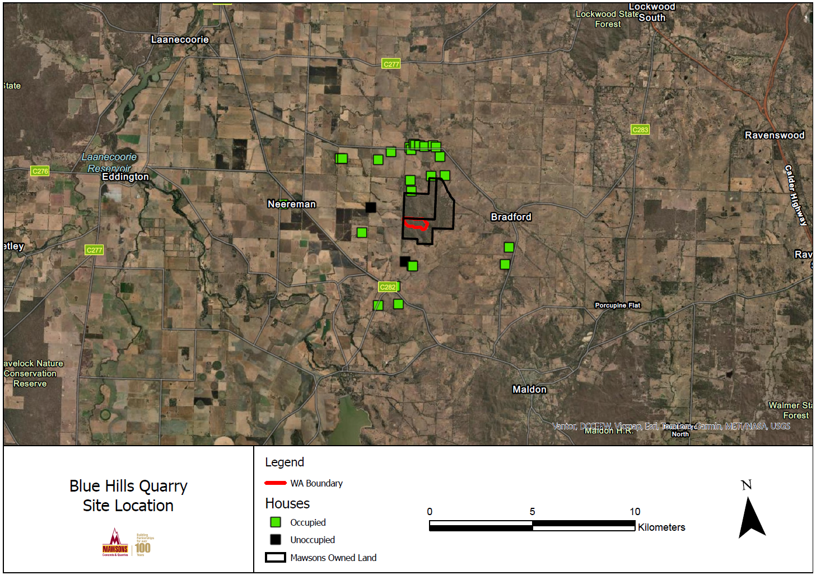
Figure 1 Blue Hills Quarry Site Location
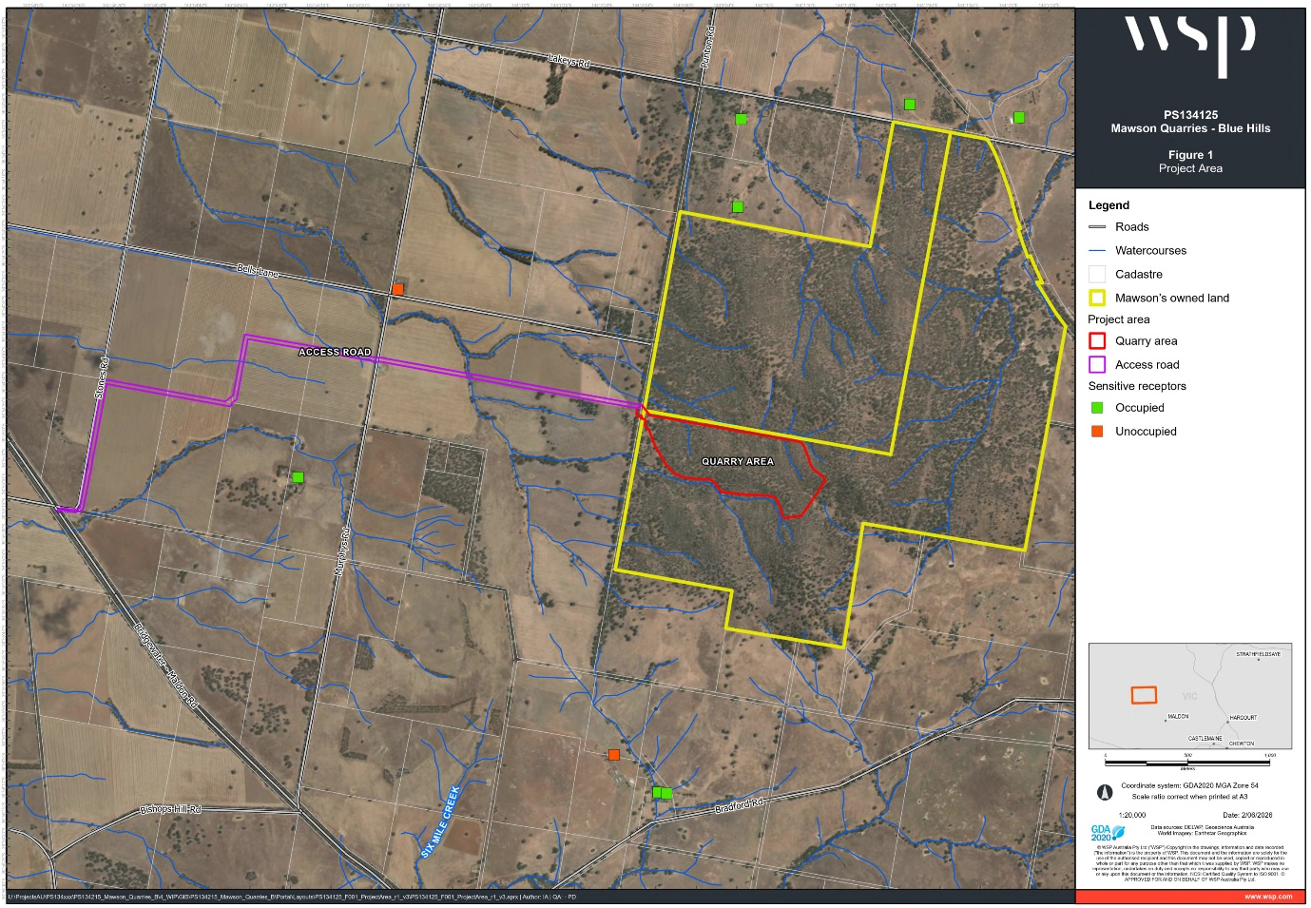
Figure 2 Blue Hills Quarry Project Area

Communication and Engagement Activities
The Consultation Plan aims to effectively engage with the community and stakeholders in an open and transparent manner to assist their understanding of and contribution to the project’s progress and outcomes.

Goals
The goals of this plan are to understand and address community concerns while maintaining and improving Mawsons standing in the local community through,
- Identifying stakeholders and the wider community with an interest in the project
- Establishing and maintaining strategies for open and proactive communication by establishing linkages with stakeholders and the wider community and providing opportunities for them to be informed about the project
- Engaging with community and stakeholders to gain an understanding of stakeholder concerns by providing opportunities to capture their views and feedback, and

- Responding to enquiries and feedback in a timely manner

Objectives
To achieve the goals of this plan, the objectives are to:
- Establish and maintain, through regular review a stakeholder register
- Analyse stakeholder feedback regularly and use the results to modify design, construction and operational activities and behaviours and rehabilitation outcomes where appropriate and practicable.
- Respond to all enquiries and feedback as soon as practicable after receiving them

Stakeholders

Community Profile
Blue Hills Quarry is located within postal area 3463 within the Mount Alexander Shire LGA, and its area of influence is expected to be within the LGA. The demographics of postal area 3463 land Mount Alexander LGA are summarised in Table 1.
Table 1 Postal Area 3463 and Mount Alexander Shire LGA demographic summary (ABS, 2021)
Area | Item | Response
Postal Area 3463 | Population | 2,588
Postal Area 3463 | Median age | 57
Postal Area 3463 | Number of families | 714
Postal Area 3463 | Private dwellings | 1,473
Postal Area 3463 | Labour force participation rate | 47.8%
Postal Area 3463 | Median weekly household income | $1,127
Postal Area 3463 | Home ownership (outright or with a mortgage) | 86.8%
Mount Alexander LGA | Population | 20,253
Mount Alexander LGA | Area | 1,530 km²
Mount Alexander LGA | Population density | 13.2 people/km²
Mount Alexander LGA | Median age | 51
Mount Alexander LGA | Number of families | 5,449
Mount Alexander LGA | Private dwellings | 10,124
Mount Alexander LGA | Labour force participation rate | 51.2%
Mount Alexander LGA | Median weekly household income | $1,252
Mount Alexander LGA | Home ownership (outright or with a mortgage) | 81.9%

The main town in postal area 3463 is Maldon (population 1,665). The main towns in the wider Mount Alexander LGA are Castlemaine (population 7,506), Campbells Creek (population 2,071), and Harcourt (population 1,038).

Stakeholder Identification
As stated in the Environment Effects Act 1978 EES Consultation Plan Advisory Note stakeholders include all parties who are either affected by or have an interest in a project.
Stakeholders have been identified as follows:
Table 2 Stakeholder Identification
Agency | Community
Earth Resources Regulator  Department of Transport & Planning  DEECA  North Central Catchment Management Authority  Heritage Victoria  Environmental Protection Authority (EPA)  Goulburn Murray Water  CFA | Adjacent landowners and residents  CFA  Dja Dja Wurrung Clans Aboriginal Corporation (DDWCAC)  Baringhup Landcare Group  Maldon Community (including local social media groups)  Broader community within Mount Alexander Shire (including local social media groups)  Tarrangower Times  Baringhup News  Local media (e.g. ABC, Central Vic)

Stakeholder Analysis

Table 3 Stakeholder Analysis
Stakeholder Group | Level of Engagement | Issues and Concerns, Areas of Interest
Adjacent Landholders and Residents | Inform/ Involve | Operational activities including noise, dust and truck routes, water availability, habitat removal, land values, rehabilitation process
Maldon community | Inform/ Involve | Truck routes, operational activities including noise and dust, water availability, habitat removal, land values, rehabilitation process
Mount Alexander Shire community | Inform/ Involve | Truck routes, operational activities including noise and dust, water availability, habitat removal, land values, rehabilitation process
Baringhup Landcare Group | Inform/Involve | Operational activities including noise, dust and truck routes, habitat removal, impacts on fauna, access to bird watching on property.
Dja Dja Wurrung Clans Aboriginal Corp. | Inform/ Involve | Heritage management
CFA | Inform/ Involve/ | Access tracks for fire trucks, water, vegetation management, fire breaks, operational fire risk controls
Tarrangower Times | Inform | Publication of community information
Baringhup News | Inform | Publication of community information
Earth Resources Regulator | Inform/Involve/ Consult | Approvals and compliance  Commitment to act on environmental compliance.
Dep Transport and Planning | Inform/Involve/ Consult | Approvals and compliance
Heritage Victoria | Inform/Involve/ Consult | Approvals and compliance, cultural heritage values
DEECA | Inform/Involve/ Consult | Approvals and compliance
North Central CMA | Inform/Involve/ Consult | Approvals and compliance  Water, vegetation
EPA | Inform/Involve/ Consult | Approvals and compliance  Pollution – Dust, Noise, Sediment runoff
Goulburn Murray Water | Inform/Involve/ Consult | Approvals and compliance  Water
Mt Alexander Shire | Inform/Involve/ Consult | Land use and offsite impacts, truck routes, planning issues, local employment, economic benefits to region

Consultation To Date
Community Engagement for the Blue Hills Quarry began in July 2021 with an information session on site. Since then, community sessions have been run annually with presentations from technical experts and Mawsons staff who were on hand to answer any concerns raised. These sessions have been advertised in local newspapers The Tarrangower Times and the Baringhup News. Letter drops to landowners adjacent to the site also took place. Between sessions, Mawsons staff have spent time one-on-one with individuals who have expressed concerns about the impacts of the project. On several occasions, additional information sessions were run, for those who were unable to attend the community days, at Mawsons’ office in Bendigo.

Table 4 Prior Engagement Activities
Stakeholder | What was discussed | Why were they engaged | When did engagement take place
The Mount Alexander Shire | Land use and offsite impacts  Traffic, roads | Planning approvals  EES | Commencement and at various occasions since
ERR | Approvals  Compliance | Work Authority approvals  EES | Commencement and at various occasions since  EES site visit – 26/05/2026
DTP | Approvals  Compliance | Planning Approvals, EES | Commencement and various occasions since  EES kick-off meeting – 29/04/2026  EES site visit – 26/05/2026
Adjacent landowners and residents | Operational activities including noise, dust and truck routes | Proximity to activity and/or direct complaint or enquiry | Ongoing since operations commenced, community meetings, one-on-one conversations
North Central Catchment Management Authority | Water licensing – management of water supply catchment | Water licensing  EES | Initial WA site meeting – 14/07/2021  Ongoing to discuss concern / solutions  EES site visit – 26/05/2026
DEECA | WA -planning flora and fauna | WA application  EES | Initial WA site meeting  EES site visit – 26/05/2026
Heritage Victoria | WA – heritage management and protection | WA application  EES | Apology for WA initial site meeting – 14/07/2021  EES site visit – 26/05/2026
Dja Dja Wurrung Clans Aboriginal Corporation (DDWCAC) | WA – heritage management and protection | Registered Aboriginal Corporation | At site visit during 2023, ongoing
Environmental Protection Agency (EPA) | WA – water discharge/noise/ dust | Discharge licencing  EES | Initial WA site meeting – 14/07/2021  Ongoing to discuss concern / solutions  EES site visit – 26/05/2026
Goulburn Murray Water | WA - water groundwater use or management | Water licencing | Initial WA site meeting - 14/07/2021  Ongoing to discuss concern / solutions
CFA | Fire Risk | Community concern  EES | Commencement and various occasions since  EES site visit – 26/05/2026
Baringhup Landcare Group | Habitat Loss, access to bird watching | Interested in the ecology of the site | Commencement and various occasions since
Maldon Community | Truck routes around Maldon | Expressed concerns | At community information session 2024

Table 5 Community Information Sessions to date.
Date/Venue/Attendees | Topics Presented | Concerns raised
July 2021  On site  30+ | Introduction to the project  Description of the approval process | The timing of the project and the size of the proposed Quarry.  Transport, questions were asked about what roads would be used.  Public amenity.
December  2021  On site  30+ | Approval process  Haul road options  Dust Management  Ecology Surveys  Geology  Processing Plant  Waterway Determination | Ground water  Dust and noise, from northern landholders.  One of the environmental groups had questions about our weed control mainly based around cactus.
November  2022  On site  40+ | Pit Design  Flora and Fauna  Heritage  Noise modelling  Dust Deposition  Rehabilitation  Surface water | Silica Dust – not a risk to those outside the quarry  Noise – modelling shows levels are below criteria.  Ecology – ongoing ecological assessments  Surface and Ground water
July 2023  On site  35+ | EES / EPBC approval processes  Land management activity- fencing, tree hollows, tree planting, weed control | At this meeting we discussed the approval process. Transport, truck routes, haul roads.  Dust and noise modelling  Land management, flora and fauna, weed control
December  2024  Baringhup Community Hall  50+ | Changes to haul routes  Transport routes through surrounding towns  Ongoing Ecological surveys  EES process, habitat offsets | Many concerns raised about transport routes through Maldon.  Explanation of diversion routes for Mawsons trucks

Consultation Methods
A variety of engagement techniques and communications channels have been used and will continue to be in order to meet the goals and objectives of this plan. These will include:
- One on one engagement.
- Where appropriate the distribution of written information (letter drops, public notices, etc.).
- Routine meetings for groups of stakeholders, including the Shire.
- The scheduling of specific meetings or forums associated with individual issues when required.
- Responding to enquiries and complaints.
- Media Releases, including social media posts and engagement.
- Mawsons’ Website.
During each engagement activity, Mawsons will clearly communicate:
- The purpose of the engagement.
- The aspects of the project that stakeholders can influence.
- The aspects that are prescribed or constrained.
- How stakeholder input can inform the project.
Feedback will be collected and recorded in a community feedback database, which will record:
- Stakeholder details.
- Key issues raised.
- Date and method of engagement.
- Any requested actions or follow-up.
The attitudes and issues recorded in the community feedback database will be regularly reviewed. Outcomes of stakeholder engagement will be communicated via:
- Direct responses to stakeholders where appropriate.
- Updates during subsequent engagement activities.
- Project communications (e.g. website updates, newsletters.
- Reporting to the Technical Reference Group (TRG) as part of regular project updates and EES documentation.

Schedule of Activities
The following stakeholder engagement plan has been developed to respond to the issues identified in the stakeholder issues analysis.
This plan has been developed in line with the International Association for Public Participation (IAP2) best practice.
Table 6 Scheduled Activities
Stakeholder | Issue | Level of engagement (IAP2) | Key message | Method of engagement | Timing  (weekly, monthly, as required)
Community Groups, adjacent land holders, Maldon Community, Media, Local government | Noise  Dust  Blasting  Habitat Removal  Project timelines  Truck routes | Inform/  Involve | Project updates, presentation of new information gathered by consultants, plans | Community meetings  Mawsons website  Media Release  Phone calls | As required
State and Local Government, Dja Dja Wurrung Clans AC, CFA, Goulburn Murray Water | EES Process  Environment Effects  Compliance | Inform/  Consult/  Involve | Project Updates, ongoing technical studies and TRG review | Face to face meeting (including TRG meetings)  Phone calls  Email communications  TRG review process | As required

Mawsons will facilitate key consultation activities for the EES, which will occur during key stages of the EES process as summarised in Table 7.
Table 7 EES consultation approach
EES stage | Key EES activities | Consultation | Method of engagement | Timing
EES scoping | Draft scoping requirements available for public comment for at least 15 business days  Final scoping requirements published on DTP website | Provide information about the draft scoping requirements  Provide opportunity for community and stakeholders to provide feedback on the scoping requirements. | Community meetings  Mawsons website update  Media release  Phone calls and email communications | 19 June – 10 July 2026
EES preparation | Preparation  Completion of EES technical studies | Provide information about the project and Technical Studies including existing conditions, assessment methods, impacts and mitigation measures  Provide opportunity for communities and stakeholders to discuss the project and give feedback. | Community meetings  Mawsons website update  Media release  Phone calls and email communications | As required
Public review | Exhibition of EES  Submissions made on EES. Independent Assessment Panel considers submissions. | Public Exhibition of EES  Provide information about the EES exhibition and how to make submissions  Receive submissions  Support Independent Assessment Panel to consider submissions, public hearing | Community meetings  Mawsons website update  Media release  Phone calls and email communications | TBC
Assessment | Preparation of inquiry report  Minister’s assessment | Provide update on EES progress, results and next steps | Community meetings  Mawsons website update  Media release  Phone calls and email communications | TBC

Evaluation and Review of Community Engagement
The Consultation Engagement Plan will be treated as a live document and will be reviewed and updated at key project milestones, including:
- Following completion of key EES technical studies.
- Prior to major engagement phases (e.g. exhibition).
- Following TRG feedback.
- Where significant project changes or emerging issues arise.
Evaluation will consider:
- Level and diversity of stakeholder participation, as recorded in the community feedback database.
- Quality and relevance of feedback received.
- Responsiveness to stakeholder concerns.
- Stakeholder satisfaction with engagement processes (where practicable).
Findings from this evaluation will be used to refine the consultation processes and inform potential improvements. Any updates to the consultation processes will be:
- Included in this Community Engagement Plan. Updated versions to the Plan will be recorded in the Version Control table in Section 7.
- Communicated to stakeholders and the TRG as appropriate.

Version Control

Version | Date | Comments
V1 | 14 January 2026 | Draft
V2 | 17 June 2026 | Updated in response to TRG comments

