Guidance document

**Clause 54 One dwelling on a lot and small second dwelling on a lot**

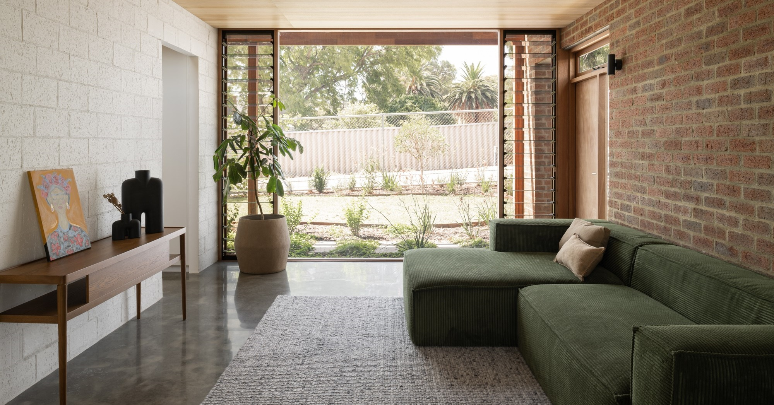One dwelling and small second dwelling guidelines

Version 1 – September 2025

Contents

UNDERSTANDING CLAUSE 54 STANDARDS 2

APPLICATION OF RESIDENTIAL DEVELOPMENT STANDARDS 3

CLAUSE 54 4

54.02 NEIGHBOURHOOD CHARACTER 5

Standard A2-1 Street setback 5

Standard A2-2 Building height 10

Standard A2-3 Side and rear setbacks 11

Standard A2-4 Walls on boundaries 13

Standard A2-5 Site coverage 17

Standard A2-6 Tree canopy 19

Standard A2-7 Front fences 22

Standard A2-8 Building setback for small single dwellings 23

54.03 LIVEABILITY 24

Standard A3-1 Street integration 24

Standard A3-2 Private open space 25

Standard A3-3 Solar access to open space 29

Standard A3-4 Daylight to new windows 31

Standard A3-5 Safety and access for small second dwellings 33

54.04 EXTERNAL AMENITY 35

Standard A4-1 Daylight to existing windows 35

Standard A4-2 Existing north-facing windows 38

Standard A4-3 Overshadowing secluded open space objective 40

Standard A4-4 Overlooking 43

54.05 SUSTAINABILITY 47

Standard A5-1 Permeability 47

Standard A5-2 Overshadowing domestic solar energy systems 49

Standard A5-3 Rooftop solar energy generation area 51

Standard A5-4 Solar protection to new north-facing windows 54

Notes.

*This document is not a substitute for meeting the requirements of clause 54 in planning schemes.*

*This document incorporates the standards as approved by Amendment VC282.*

# UNDERSTANDING CLAUSE 54 STANDARDS

**Meeting the requirements of clause 54**

Clause 54 applies to an application to construct or extend one dwelling on a lot less than 300 square metres and construct or extend a small second dwelling on a lot less than 300 square metres specified in:

32.04-5 and 32.04-6, Mixed Use Zone,

32.05-6 and 32.05-7, Township Zone,

32.07-4 and 32.07-5, Residential Growth Zone,

32.08-5 and 32.08-6, General Residential Zone,

32.09-5 and 32.09-6, Neighbourhood Residential Zone,

32.10-3 and 32.10-4, Housing Choice and Transport Zone.

Clause 54specifies objectives that must be met. The objective describes the outcome to be achieved in the completed development. A development must meet all of the applicable objectives of the clause before a permit can be issued.

Each objective contains a relevant standard. A standard contains the requirements to meet the corresponding objective.

If a development meets a standard:

* The corresponding objective is deemed to be met;
* The responsible authority is not required to consider the corresponding decision guidelines or other policies or decisions guidelines pertaining to that matter.

If a development does not meet a standard, the responsible authority must consider the applicable decision guidelines in determining whether the corresponding objective is met.

If a zone or an overlay specifies a requirement of a standard, different from a requirement set out in the clause, the requirement of the zone or overlay applies.

Clause 54 sets out matters that a responsible authority is exempt from and is not required to consider in determining applications to which clause 54 applies.

For detailed information on the operation of the objectives, standards and decision guidelines, refer to clause 54 of the planning scheme.

# APPLICATION OF RESIDENTIAL DEVELOPMENT STANDARDS

# CLAUSE 54

|  |  |  |  |  |
| --- | --- | --- | --- | --- |
| Clause | Standard |  | Clause | Standard |
| 54.01 Application requirements | |  | **54.04** | **External Amenity** |
| 54.01-1 Site description | |  | **54.04-1** | A4-1 Daylight to existing windows |
| 54.01-2 Design response | |  | **54.04-2** | A4-2 Existing north-facing windows |
| 54.02 Neighbourhood Character | |  | **54.04-3** | A4-3 Overshadowing secluded open space |
| 54.02-1 | A2-1 Street setback |  | **54.04-4** | A4-4 Overlooking |
| 54.02-2 | A2-2 Building height |  | **54.05** | **Sustainability** |
| 54.02-3 | A2-3 Side and rear setbacks |  | **54.05-1** | A5-1 Permeability |
| 54.02-4 | A2-4 Walls on boundaries |  | **54.05-2** | A5-2 Overshadowing domestic solar energy systems |
| 54.02-5 | A2-5 Site coverage |  | **54.05-3** | A5-3 Rooftop solar energy generation area |
| 54.02-6 | A2-6 Tree canopy |  | **54.05-4** | A5-4 Solar protection to new-north facing windows |
| 54.02-7 | A2-7 Front fences |  |
| 54.02-8 | A2-8 Building setback for small second dwellings |  |
| 54.03 Liveability | |  |
| 54.03-1 | A3-1 Street integration |  |
| 54.03-2 | A3-2 Private open space |  |
| 54.03-3 | A3-3 Solar access to open space |  |
| 54.03-4 | A3-4 Daylight to new windows |  |
| 54.03-5 | A3-5 Safety and accessibility for small second dwellings |  |

**CLAUSE 54 STANDARDS**

# 54.02 NEIGHBOURHOOD CHARACTER

## Standard A2-1 Street setback

Why is this important

The setback of buildings from the street defines the spatial relationship between buildings and the street and is a key determinant of neighbourhood character by contributing to the overall aesthetic, pedestrian experience, and sense of openness in the street.

Importantly, the street setbacks provide space for the planting and growth of canopy trees. This standard relates the front setback to neighbouring setbacks, so all new buildings respond to the street’s character and make efficient use of the site.

Street setback objective

To ensure that the setbacks of buildings from a street respond to the existing or preferred neighbourhood character and make efficient use of the site.

Standard A2-1

Walls of buildings are set back from streets:

* At least the distance specified in a schedule to the zone if the distance specified in the schedule is less than the distance specified in Table A2-1; or
* If no distance is specified in a schedule to the zone, the distance specified in Table A2-1.

Porches, pergolas and verandahs that are less than 3.6 metres high and eaves may encroach not more than 2.5 metres into the setbacks of this standard.

Table A2-1 Street setback

|  |  |  |
| --- | --- | --- |
| Development context | Minimum setback from front street | Minimum setback from a side street |
| There is an existing building on both the abutting allotments facing the same street, and the site is not on a corner. | The same distance as the lesser front wall setback of the existing buildings on the abutting allotments facing the front street or 6 metres, whichever is the lesser. | Not applicable |
| There is an existing building on one abutting allotment facing the same street and no existing building on the other abutting allotment facing the same street, and the site is not on a corner. | The same distance as the setback of the front wall of the existing building on the abutting allotment facing the front street or 6 metres, whichever is the lesser. | Not applicable |
| There is no existing building on either of the abutting allotments facing the same street, and the site is not on a corner. | 6 metres for streets in a Transport Zone 2 and 4 metres for other streets. | Not applicable |
| The site is on a corner. | If there is a building on the abutting allotment facing the front street, the same distance as the setback of the front wall of the existing building on the abutting allotment facing the front street or 6 metres, whichever is the lesser.  If there is no building on the abutting allotment facing the front street, 6 metres for streets in a Transport Zone 2 and 4 metres for other streets. | Front walls of new development fronting the side street of a corner site are setback at least the same distance as the setback of the front wall of any existing building on the abutting allotment facing the side street or 3 metres, whichever is the lesser.  Side walls of new development on a corner site are setback the same distance as the setback of the front wall of any existing building on the abutting allotment facing the side street or 2 metres, whichever is the lesser. |

Decision Guidelines

Before deciding on an application, the responsible authority must consider:

* Any relevant neighbourhood character objective, policy or statement set out in this scheme.
* The design response.
* Whether the siting of the building is constrained by the shape, dimensions, slope or other conditions of the site.
* Whether a different setback would be more appropriate taking into account the prevailing setbacks of existing buildings on nearby lots.
* The visual impact of the building when viewed from the street and from adjoining properties.
* Whether a different setback affects the ability to retain or plant canopy trees.

Applying the standard

|  |  |
| --- | --- |
| Existing buildings on both the abutting allotments/lesser setback  New buildings take their reference for front setback from the abutting dwellings or 6 metres, whichever is the lesser. | **Aerial view of three lots and three dwellings with different setbacks.** |
| If the abutting building setback is less than 6 metres, the new building can have a minimum setback that is the same. |
| If the abutting dwelling setback is greater than 6 metres, the new building can have a minimum setback of 6 metres. | Aerial view of three lots and three dwellings with different setbacks. |
| Front setback where there is only one existing abutting dwelling  A new building takes its reference for front setback from the abutting dwelling or 6 metres, whichever is the lesser.  If the abutting dwelling setback is greater than 6 metres, the new building can have a setback of 6 metres. | Aerial view of three lots and two dwellings with different setbacks. |

|  |  |
| --- | --- |
| Setbacks on a corner lot  Either street frontage may be selected as the front setback on a corner lot.  *Front street setback (A)*  New buildings are to be set back the same distance as the front setback of the abutting dwelling facing the same street or 6 metres, whichever is the lesser.  There is only one front street setback for the purposes of this standard.  If there is no building on the abutting allotment facing the front street, 6 metres for streets in a Transport Zone 2 and 4 metres for other streets. | Aerial view of three lots showing setbacks for the lot on the corner. |
| *Side street setback (B)*  New developments fronting a side street are set back:  The same distance as an adjoining development facing the side street (if lesser) or 3 metres (if lesser).  New developments with a side wall to a side street are set back:  The same distance as an adjoining development facing the side street (if lesser) or 2 metres (if lesser). | |

|  |  |
| --- | --- |
| **Applying the standard to a small second dwelling**  Small second dwellings should be setback from the front street behind the main dwelling. (See also Standard A2-8) | Aerial view of three lots showing the setback for a small second dwelling. |

|  |  |
| --- | --- |
| Allowable encroachments  Porches, pergolas, and verandahs can encroach up to 2.5 metres into the front setback, provided they are less than 3.6 metres high.  Eaves can also encroach up to 2.5 metres into the front setback. | Side view of a house with a verandah and eaves showing allowable encroachments into the setback. |

## Standard A2-2 Building height

Why this is important

Building height is an important aspect of both character and amenity in residential areas. The standard protects the amenity of properties near new development and ensures that excessive building height does not diminish the character of neighbourhoods.

Building height objective

To ensure that the height of buildings respond to the existing or preferred neighbourhood character.

Standard A2-2

The maximum building height does not exceed the maximum height specified in the zone, schedule to the zone or an overlay that applies to the land.

If no maximum height is specified in the zone, schedule to the zone or an overlay, the maximum building height does not exceed 9 metres, unless the slope of the natural ground level at any cross section wider than 8 metres of the site of the building is 2.5 degrees or more, in which case the maximum building height does not exceed 10 metres.

Decision Guidelines

Before deciding on an application, the responsible authority must consider:

* Any relevant neighbourhood character objective, policy or statement set out in this scheme.
* Any maximum building height specified in the zone, a schedule to the zone or an overlay applying to the land.
* The design response
* The effect of the slope of the site on the height of the building.
* The relationship between the proposed building height and the height of existing adjacent buildings.
* 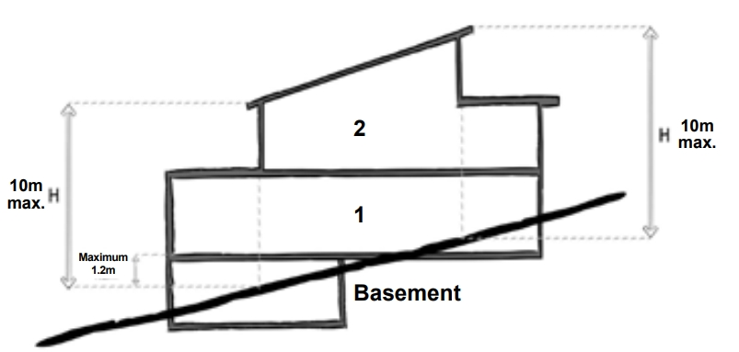The visual impact of the building when viewed from the street and from adjoining properties.

Applying the standard

The slope of land is measured through any cross section (greater than 8 metres) of the building.

If the slope of the land is greater than 2.5 degrees through the cross section, the maximum building height may be up to 10 metres.

**Working out the slope of a building site**

Where the slope of the ground is 2.5° or more across an 8 metre cross section of the building site, this is equal to a ratio of 1:23 or 350 mm (when expressed as a rise or fall over an 8 metre cross section).

Supporting documents

The natural ground level and maximum building height should be clearly shown on elevations and sections. The Australian Height Datum (AHD) of natural ground level and maximum building height should be clearly shown on plans. Any area greater than 8 metres with a slope greater than 2.5 degrees should be clearly shown on the plans and sections as relevant.

## Standard A2-3 Side and rear setbacks

Why this is important

This standard ensures adequate separation between dwellings and small second dwellings on adjacent lots, particularly above ground floor level. Adequate setbacks ensure privacy, sufficient daylight, and enhanced amenity.

Side and rear setbacks objective

To ensure that the height and setback of a building from a boundary responds to the existing or preferred neighbourhood character and limits the impact on the amenity of existing dwellings or small second dwellings.

Standard A2-3

A new building not on or within 200mm of a boundary is set back from side or rear boundaries, at least 1 metre, plus 0.3 metres for every metre of height over 3.6 metres up to 6.9 metres, plus 1 metre for every metre of height over 6.9 metres.

Sunblinds, verandahs, porches, eaves, facias, gutters, masonry chimneys, flues, pipes, domestic fuel or water tanks, and heating or cooling equipment or other services may encroach not more than 0.5 metres into the side and rear setbacks.

Landings that have an area of not more than 2 square metres and less than 1 metre high, stairways, ramps, pergolas, shade sails and carports may encroach into the side and rear setbacks.

Diagram A2-3 Side and rear setbacks

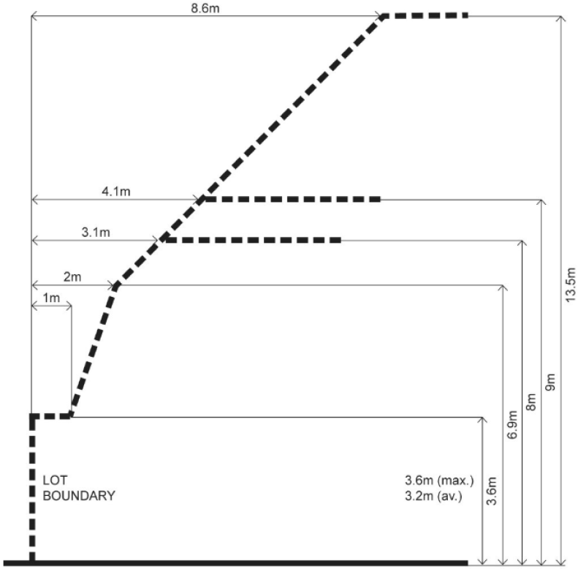

Decision guidelines

Before deciding on an application, the responsible authority must consider:

* Any relevant neighbourhood character objective, policy or statement set out in this scheme.
* The design response.
* The impact on the amenity of the habitable room windows and private open space of existing dwellings or small second dwellings.
* Whether the wall is opposite an existing or simultaneously constructed wall built to the boundary.
* Whether the wall abuts a side or rear lane.
* Whether a different setback in a rear yard affects the ability to retain or plant canopy trees.

Applying the standard

New buildings must be designed to meet the setback requirement of standard A2-3.

**Standard A2-3**

Where the wall height is between 3.6 metres and 6.9 metres, the formula for calculating side and rear setbacks is:

**1m + [0.3m x (h – 3.6m)]**

(h = wall height)

Where the wall height is greater than 6.9 metres, the formula is:

**1m + [0.3m x (6.9m – 3.6m)] + [1m x (h – 6.9m)]**

Using the above example, if the wall height is 6.9 metres, the required setback is calculated as follows:

**1 m + [0.3 x (6.9 m – 3.6 m)]**

= 1 m + [0.3 x 3.3 m]

**Allowable encroachments**

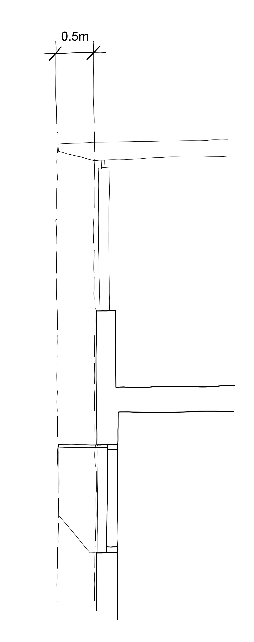**= 1 m + 0.99 m**

**= 1.99 m (rounded up to 2 m) setback**

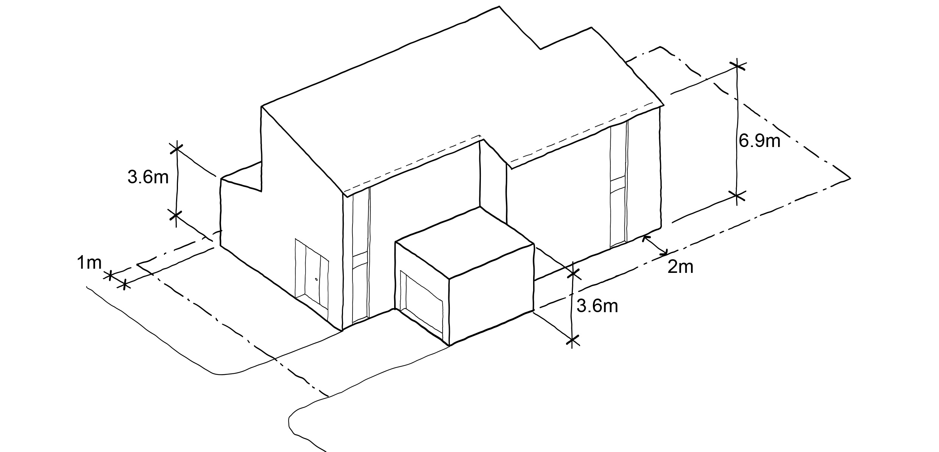

Supporting documents

Side and rear setbacks (including the natural ground level at site boundary, setback distances, and wall heights) should be clearly shown on plans, elevations and sections.

## Standard A2-4 Walls on boundaries

Why this is important

This standard limits the height and length of walls on lot boundaries, to reduce the amenity impact of housing on neighbouring properties. The length and height of walls on lot boundaries also impacts neighbourhood character.

Walls on boundaries objective

To ensure that the location, length and height of a wall on a boundary responds to the existing or preferred neighbourhood character and limits the impact on the amenity of existing dwellings and small second dwellings.

Standard A2-4

A new wall constructed on or within 200mm of a side or rear boundary of a lot or a carport constructed on or within 1 metre of a side or rear boundary of a lot does not abut the boundary for a length that exceeds the greater of the following distances:

* 10 metres plus 25 per cent of the remaining length of the boundary of an adjoining lot, or
* The length of existing or simultaneously constructed walls or carports abutting the boundary on an abutting lot.

A new wall or carport may fully abut a side or rear boundary where slope and retaining walls or fences would result in the effective height of the wall or carport being less than 2 metres on the abutting property boundary.

A building on a boundary includes a building set back up to 200mm from a boundary.

The height of a new wall constructed on or within 200mm of a side or rear boundary or a carport constructed on or within 1 metre of a side or rear boundary does not exceed an average of 3.2 metres with no part higher than 3.6 metres unless abutting a higher existing or simultaneously constructed wall.

Decision guidelines

Before deciding on an application, the responsible authority must consider:

* Any relevant neighbourhood character objective, policy or statement set out in this scheme.
* The design response.
* The extent to which walls on boundaries are part of the neighbourhood character.
* The impact on the amenity of existing dwellings or small second dwellings.
* The opportunity to minimise the length of walls on boundaries by aligning a new wall on a boundary with an existing wall on a lot of an adjoining property.
* The orientation of the boundary that the wall is being built on.
* The width of the lot.
* The extent to which the slope and retaining walls or fences reduce the effective height of the wall.
* Whether the wall abuts a side or rear lane.
* The need to increase the wall height to screen a box gutter.

Applying the standard

When applying the standard, ’new wall’ means the total length of any existing and proposed wall when calculating the length of a wall on a boundary.

|  |  |
| --- | --- |
| **Walls on boundaries where there is one adjoining lot**  The formula for calculating walls on boundaries is:  **10 m + [(length of boundary of an adjoining lot – 10 m) x 0.25]**  This formula is separately applied to each boundary of the lot to determine the permissible walls on each boundary of the lot.  On a lot of 44 metres in length, the walls on boundaries along this boundary are calculated as follows:  **10m + [(44m – 10m) x 0.25]**  **10m + [34m x 0.25]**  **10m + 8.5m**  **18.5m permissible wall on boundary**  This example complies as it has less walls on boundaries than permissible under the standard. Other considerations such as neighbourhood character may be the reason for not using the maximum allowable walls on boundaries | Diagram showing an aerial view of a building showing how to measure the walls on boundaries where there is one adjoining lot. |
| **Walls on boundaries where there is more than one adjoining lot**  Where there is more than one adjoining lot along a boundary, walls on the boundary may be constructed up to 10 metres plus 25 per cent of the remainder of the adjoining boundary abutting the lot, for each adjoining boundary.  The walls on boundaries permitted along the boundary are:   * 16.5 metres along the adjacent lot boundary A * 8 metres along the adjacent lot boundary B.   As can be seen in this example, while the length of the boundary of the lot is the same as in the previous example (44 metres), a longer wall along this boundary is possible because of the abuttal to two properties.  The standard is applied to each adjacent lot boundary individually. | Diagram showing an aerial view of a building showing how to measure the walls on boundaries where there is an existing or simultaneously constructed wall on the boundary. |
| **Walls on boundaries where there is an existing or simultaneously constructed wall on the boundary**  Where there is an existing wall on the adjoining boundary, the length of the permissible wall on the boundary is able to exceed 10 metres plus 25 per cent of the remainder of the boundary provided that it is the same or a lesser length of the existing wall on the boundary.  To meet the standard, no part of the new wall on the boundary can be built to extend beyond the extent of the existing wall on the boundary, even though the new wall may be the same length as the existing wall on the boundary.  To meet the standard, simultaneously constructed walls on the boundary must be the same length and cannot be staggered. | Diagram showing an aerial view of a building showing how to measure the walls on boundaries where there is and existing or simultan |
| **Walls on boundaries where there is a small second dwelling.**  Where there is a small second dwelling (SSD) on a lot, the same walls on boundaries calculations are applied and the small second dwelling is included in the total walls on boundary calculation. | Diagram of a building showing how to measure the effective wall height. |
| **Effective wall height**  Effective wall height means the height of the wall from the top of the wall to the ground measured on the boundary from the adjoining property.  In this example, cutting and filling of the cross slope has resulted in an effective wall height of less than 2 metres on the boundary for the wall constructed on the boundary.  Where the effective wall height is less than 2 metres on the boundary, the building may abut the full length of the boundary. | Drawing of a house showing how to measure the effective wall height |
| **Height of wall on boundary**  When calculating the average height of a wall on a boundary the formula is:  **Average height = Area of wall divided by Length of wall**  It is important to include all aspects of the wall on the boundary in the calculation, including the wall above and below the internal floor and ceiling heights of the wall. | Building elevation showing how to measure the height of a wall on boundary. |

Supporting documents

Walls on boundary dimensions (including the natural ground level at site boundary, wall heights, lengths and average heights) should be clearly shown on plans, elevations and sections.

## Standard A2-5 Site coverage

Why this is important

The standard limits the proportion of any lot that can be built on, to provide outdoor space for residents and to protect the amenity and character of neighbourhoods.

Site coverage objective

To ensure that the site coverage responds to the existing or preferred neighbourhood character and responds to the features of the site.

Standard A2-5

The site area covered by buildings does not exceed:

* The maximum site coverage specified in a schedule to the zone; or
* If no maximum site coverage is specified in a schedule to the zone, the percentage specified in Table A2-5.

If the maximum site coverage is specified in a schedule to a zone, it must be greater than the percentage specified in Table A2-5.

**Table B2-5 Site coverage**

|  |  |  |
| --- | --- | --- |
| Zone | Area | |
| Neighbourhood Residential Zone  Township Zone | 60 per cent |
| General Residential Zone | 65 per cent | |
| Residential Growth Zone  Mixed Use Zone  Housing Choice and Transport Zone | 70 per cent |

Decision guidelines

Before deciding on an application, the responsible authority must consider:

* Any relevant neighbourhood character objective, policy or statement set out in this scheme.
* The design response.
* The existing site coverage and any constraints imposed by existing development or the features of the site.
* The site coverage of adjacent properties.
* The effect of the visual bulk of the building and whether this is acceptable in the neighbourhood.
* Whether a different area of site coverage affects the ability to retain or plant canopy trees.

Applying the standard

**Site coverage (%) = Total building area multiplied by 100 divided by Total site area.**

The definition of a building includes a dwelling, a small second dwelling, a garage or carport, a verandah and any other roofed building such as a garden shed. When calculating site coverage, if the upper storey projects over the ground floor, that part of the upper storey is also added onto the ground floor area. This does not include an underground basement that is constructed wholly underground.

Outdoor paving, driveways, pathway or building eaves are not included when calculating the amount of site coverage.

When calculating site coverage in this example, the total building area includes the dwelling, small second dwelling, garage, garden shed and verandah.

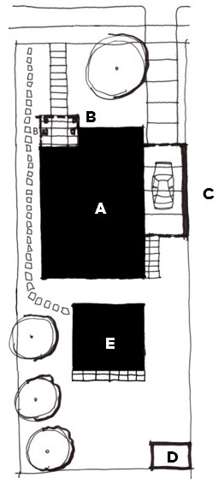

A: Dwelling

B: Verandah

C: Garage

D: Garden shed

E: Small second dwelling

The new development must meet the garden area requirements specified in a residential zone as required.

#### Supporting documents

Site area and coverage should be clearly identified on plans.

## Standard A2-6 Tree canopy

Why this is important

This standard encourages canopy cover in residential areas to enhance quality of life. Tree canopies provide shade, reduce the urban heat island effect, and improve the streetscape by creating an attractive environment that complements neighbourhood character.

Tree canopy objectives

To provide tree canopy that responds to the neighbourhood character of the area and reduces the visual impact of buildings on the streetscape.

To preserve existing canopy cover and support the provision of new canopy cover.

To ensure new canopy trees are climate responsive, support biodiversity, wellbeing and amenity, and help reduce urban heat.

Standard A2-6

Provide a minimum number of trees as specified in Table A2-6.

**Table A2-6 Minimum tree requirement**

|  |  |
| --- | --- |
| ****Site area**** | ****Tree**** |
| 100 square metres or less | One tree |
| Above 100 square metres to 200 square metres | Two trees |
| Above 200 square metres to 300 square metres | Three trees |

A tree must meet the following:

* Reach a height of at least 6 metres at maturity.
* Achieve a canopy width of at least 4 metres at maturity.
* Planted in a minimum deep soil area of 12 metres with a minimum plan dimension 2.5 metres or in a planter with a minimum volume of 12 cubic metres with a minimum depth of 0.8 metres of planter soil.

Existing trees to be retained meet all of the following:

* Has a height of at least 5 metres,
* Has a trunk circumference of 0.5 metres or greater at 1.4 metres above ground level,
* Has a trunk that is located at least 4 metres from proposed buildings.

Existing trees that are retained can be used in calculating canopy cover.

Any tree required to be planted under this standard must be of species to the satisfaction of the responsible authority, having regard to the location and relevant geographic factors.

Decision guidelines

Before deciding on an application, the responsible authority must consider:

* Any relevant neighbourhood character objective, policy or statement set out in this scheme.
* The site context and design response.
* The extent to which the existing and proposed canopy trees contribute to a greener environment and reduce urban heat.
* Whether the growth characteristics of existing trees and proposed canopy trees will provide the required canopy cover.
* The suitability of the planting location, deep soil areas and planter soil volume for proposed canopy trees.
* Whether the species of canopy tree is suited to the soil conditions of the site.
* Whether an alternative combination of the canopy trees will provide the required canopy cover.

Applying the standard

Provision of tree canopy should be an integral part of a development’s design and planning phase, rather than an after-thought when space for landscaping and solar access is constrained.

New trees are approved species, considering local climate and geography. To determine the typical tree size category at maturity for the chosen species, refer to tree planting guidance issued by relevant local council or use the authoritative online guide: Which Plant Where website at [whichplantwhere.com.au](http://www.whichplantwhere.com.au/).

Supporting documentation

***Architectural and tree canopy drawings***

Architectural and tree canopy drawings should be consistent and demonstrate compliance with the standard.

The architectural drawings need to show how the structure will accommodate the tree canopy.

***What should be shown on the drawings***

Architectural drawings should include:

* A site plan that indicates:
  + the required canopy tree(s) including retained and proposed canopy trees and their size in diameter.
  + the location of existing trees 5 metres in height or greater, with a trunk circumference of 0.5 metres or greater at 1.4 metres above ground level, on the site to be retained (as required by the Site description)
  + deep soil areas and planters
  + sections indicating the location and dimensions of the required canopy trees, deep soil areas and planters
* A development summary table which includes:
  + the site area
  + the required number of canopy trees for the site and their size in diameter
  + the required deep soil area for the site, the amount provided and/or the planter soil volumes provided.
  + the tree species selected having regard to the location and relevant geographic factors.

**Design response landscape plan**

In addition to this standard, the design response requires preparation of a landscape plan that details the proposed:

* Retention and planting of canopy trees,
* Planting of other vegetation including location, species, number and size at maturity of vegetation,
* Where required, areas of deep soil and root barriers,
* Irrigation system to support existing and planted vegetation including details of any alternative water supply sources,
* Selection of vegetation that responds to the site’s environment and geographic factors,

When preparing the design response and landscape plan consider:

* Locating canopy trees;
  + where they will receive solar access (as they will perform better)
  + within deep soil areas (as they will have access to groundwater and nutrients)
* Plan the form of the development around the location of these canopy trees, as well as any requirements for setbacks from boundaries and allocations for communal or private open space.
* If deep soil areas are not available, use constructed planters.

**Example site plans**

Canopy trees located in deep soil in a suburban context achieve the required canopy cover.

A 300 square metre site requires three canopy trees.

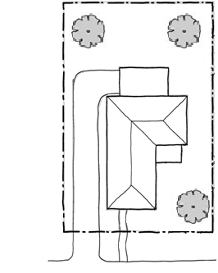

Canopy trees

## Standard A2-7 Front fences

Why this is important

This standard provides for front fences to be lower than other fences, so that houses and vegetation can be seen from the street and contribute to the streetscape.

Front fences objective

To encourage front fence design that responds to the existing or preferred neighbourhood character.

Standard A2-7

A front fence within 3 metres of a street is:

* The maximum height specified in a schedule to the zone, or
* If no maximum height is specified in a schedule to the zone, the maximum height specified in Table A2-7.

Table A2-7 Maximum front fence height

|  |  |
| --- | --- |
| Street context | Maximum front fence height |
| Streets in a Transport Zone 2 | 2 metres |
| Other streets | 1.5 metres |

This standard does not apply to a small second dwelling.

Decision guidelines

Before deciding on an application, the responsible authority must consider:

* Any relevant neighbourhood character objective, policy or statement set out in this scheme.
* The design response.
* The setback, height and appearance of front fences on adjacent properties.
* The extent to which slope and retaining walls reduce the effective height of the front fence.
* Whether the fence is needed to minimise noise intrusion.

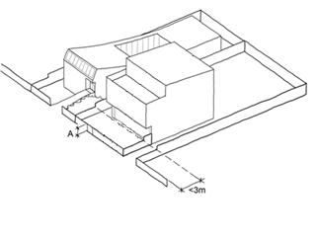Applying the standard

A front fence includes any fence within 3 metres of the street. The fence height (A) should not exceed the maximum fence height specified in Table B2-8.

Supporting documents

Fence heights must be clearly shown on elevations.

## Standard A2-8 Building setback for small single dwellings

Why this is important

This standard provides consistency between the presentation of the main dwelling to the front street and the small second dwelling on the lot.

Building setback for small single dwellings objective

To ensure that small second dwellings are sited to respond to the existing or preferred neighbourhood character.

Standard A2-8

Walls of a small second dwelling are setback behind the front wall of the existing dwelling on the lot, facing the frontage.

Porches, pergolas, verandahs, and eaves do not encroach into the setback of this standard.

Decision guidelines

Before deciding on an application, the responsible authority must consider:

* Any relevant neighbourhood character objective, policy or statement set out in the scheme.
* The design response.
* The visual impact of the building when viewed from the street and from adjoining properties.

Applying the standard

This standard only applies to a small second dwelling.

The building setback for a small second dwelling is established by taking the front wall of the existing dwelling on the lot, facing the frontage and setting back the small second dwelling behind this wall.

Porches, pergolas, verandahs and eaves should not be closer to the frontage than the front wall of the existing dwelling on the lot.

For a small second dwelling on a corner lot, a small second dwelling is only required to be set back behind the front wall of the existing dwelling on the same lot, facing the frontage. The standard does not require a small second dwelling to be set back behind the side wall of the existing dwelling on the same lot facing the side street.

Standards A2-1 and A2-3 continue to apply to small second dwellings.

Supporting documents

The setback of a small second dwelling from the front wall of the main dwelling should be clearly shown on the application plans.

# 54.03 LIVEABILITY

## Standard A3-1 Street integration

Why this is important

This standard promotes innovative, high-quality design outcomes that enhance safety and the amenity of residents. The standard encourages passive surveillance and external lighting, while ensuring that site services do not dominate the development's frontage.

Street integration objective

To integrate the layout of development with the street to support the safety and amenity of residents.

Standard A3-1

Where a development fronts a street, a vehicle accessway or abuts public open space, passive surveillance is provided by a direct view from a balcony or a habitable room window to each street, vehicle accessway and public open space.

This standard does not apply to a small second dwelling.

Decision guidelines

Before deciding on an application, the responsible authority must consider:

* Any relevant neighbourhood character objective, policy or statement set out in this scheme.
* The design response.

Applying the standard

Any adjoining streets, vehicle accessways and public open space should be clearly visible from adjoining balconies or habitable room windows.

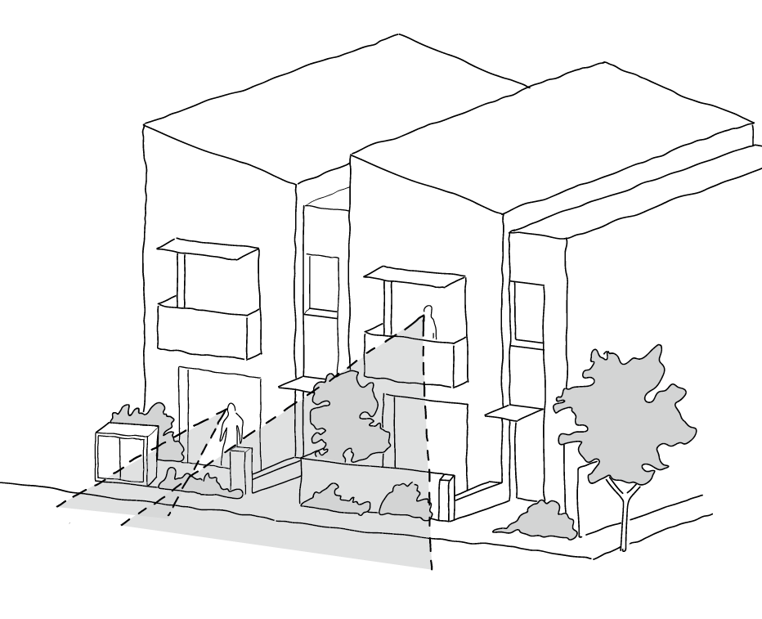

Supporting documents

The location of windows, balconies, must be shown on plans and elevations.

## Standard A3-2 Private open space

Why this is important

This standard ensures that all residents of new dwellings have usable and adequate private open space accessible from living areas. Private open space offers residents an exclusive area for relaxation and recreation, enhancing the overall functionality and liveability of a dwelling and contributes to the character of residential areas.

Private open space objectives

To provide adequate private open space for the reasonable recreation and service needs of residents.

Standard A3-2

A dwelling or small second dwelling has private open space of an area and dimensions specified in a schedule to the zone.

If no area or dimension is specified in a schedule to the zone, a dwelling has private open space with direct access from a living area, dining area or kitchen consisting of:

* An area of 20 per cent of the area of the lot, but not less than 25 square metres. At least one part of the private open space consists of secluded private open space with a minimum area of 25 square metres and a minimum dimension of 3 metres width; or
* A balcony with at least the area and dimensions specified in Table A3-2; or
* An area on a roof of at least 10 square metres, with a minimum dimension of 2 metres width.

If the area and dimensions of the private open space or secluded private open space is specified in a schedule to the zone;

* The area and dimensions specified for private open space and secluded private open space must be less than the area and dimensions specified in this standard, and
* The area and dimensions specified for a balcony or an area on a roof must be less than the area and dimensions specified in this standard.

A small second dwelling has secluded private open space consisting of an area of 8 square metres with a minimum dimension of 1.6 metres and convenient access from a living area, dining area or kitchen.

If a cooling or heating unit is located in the secluded private open space or private open space the required area is increased by 1.5 square metres.

Where ground level private open space is provided an area for clothes drying is provided.

**Table A3-2 Private open space for a balcony**

|  |  |  |  |
| --- | --- | --- | --- |
| Orientation of dwelling | Dwelling type | Minimum area | Minimum dimension |
| North (between north 20 degrees west to north 30 degrees east) | All | 8 square metres | 1.7 metres |
| South (between south 30 degrees west to south 20 degrees east) | All | 8 square metres | 1.2 metres |
| Any other orientation | 1 bedroom dwelling | 8 square metres | 1.8 metres |
| 2 bedroom dwelling | 8 square metres | 2 metres |
| 3 bedroom dwellings | 12 square metres | 2.4 metres |

Decision guidelines

Before deciding on an application, the responsible authority must consider:

* The design response.
* The useability of the private open space, including its size and accessibility.
* The availability of and access to public open space.
* The orientation of the lot to the street and the sun.

Applying the standard

**Private open space areas with direct access from a living area, dining area or kitchen consisting of:**

|  |  |
| --- | --- |
| * An area of 20% of the area of the lot, but not less than 25 square metres of secluded private open space, with a minimum dimension of 3 metres width; or | Drawing of the aerial view of a building showing the private open space requirement. |
| * A balcony with at least the area and dimensions specified in Table A3-2; or | Aerial view of the inside of a room and a balcony showing the area of the balcony. |
|  |  |
| - An area on a roof of at least 10 square metres, with a minimum dimension of 2 metres width. | Drawing of a building showing the calculation of the roof top area. |
| - A small second dwelling has a secluded private  open space area of 8 square metres with a minimum  dimension of 1.6 metres. | Drawing showing an aerial view of a lot with a dwelling and small second dwelling showing the private open space areas. |

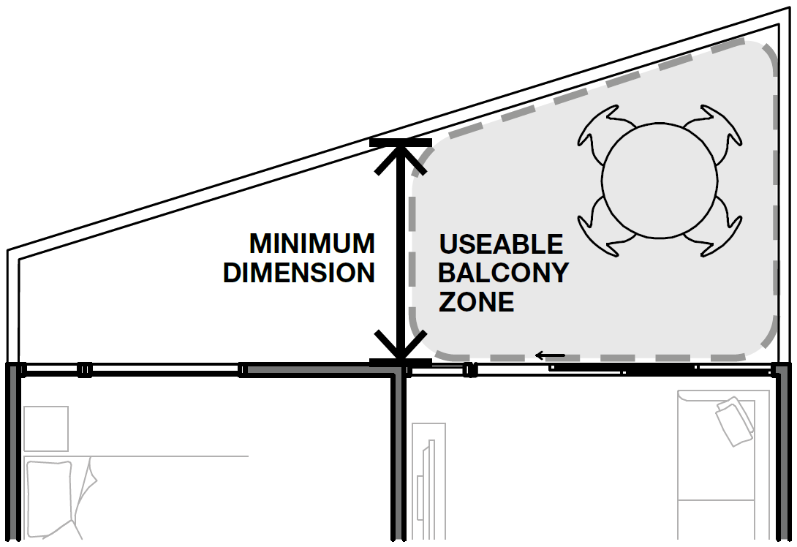 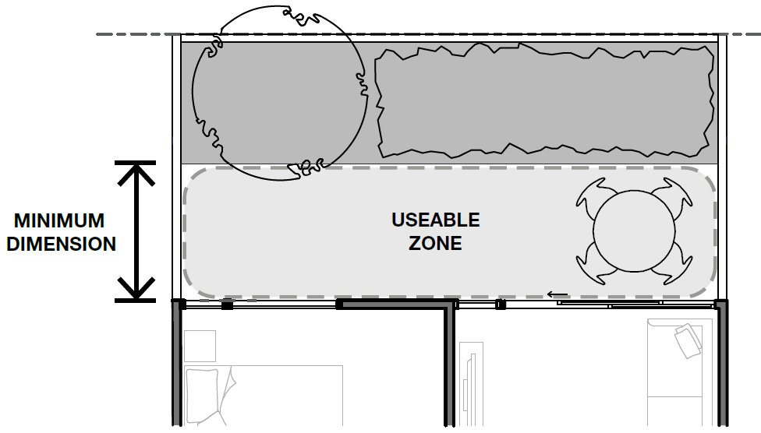

Where planting areas are included in ground floor or rooftop private open spaces, provide a clear usable space which meets the minimum dimensions and areas included in Table A3-2.

The minimum area must be provided in a single usable space. Other balcony areas may be provided in addition.

The additional area for an air conditioning unit does not need to meet the minimum balcony dimension.

Storage integrated into balcony design is not included in the minimum area requirements.

Where irregular shaped balconies are proposed, only the portion of the balcony which meets the minimum dimension will be calculated towards the minimum area.

Design solutions include:

* Continuous overhanging balconies to shade windows from direct summer sun.
* Inset balconies to allow living rooms to be located at the building edge increasing daylight to the room.
* Limiting the depth of south facing balconies where they are located to the front of living spaces.
* Inset or semi screened balconies, rather than projecting balconies, to provide greater wind protection.
* Locate balconies to avoid exposure to noise sources.

**Supporting documentation**

Provide minimum dimensions and areas to all private open spaces.

## Standard A3-3 Solar access to open space

Why this is important

This standard is a key amenity requirement that ensures all secluded private open spaces receive adequate sunlight, enhancing their usability throughout the day. Solar access improves overall amenity and supports healthy outdoor living environments.

Solar access to open space objective

To allow solar access into the secluded private open space of new dwellings.

Standard A3-3

The southern boundary of secluded private open space is set back from any wall on the north of the space at least (2 + 0.9h) metres, where ‘h’ is the height of the wall.

**Diagram A3-3 Solar access to open space**

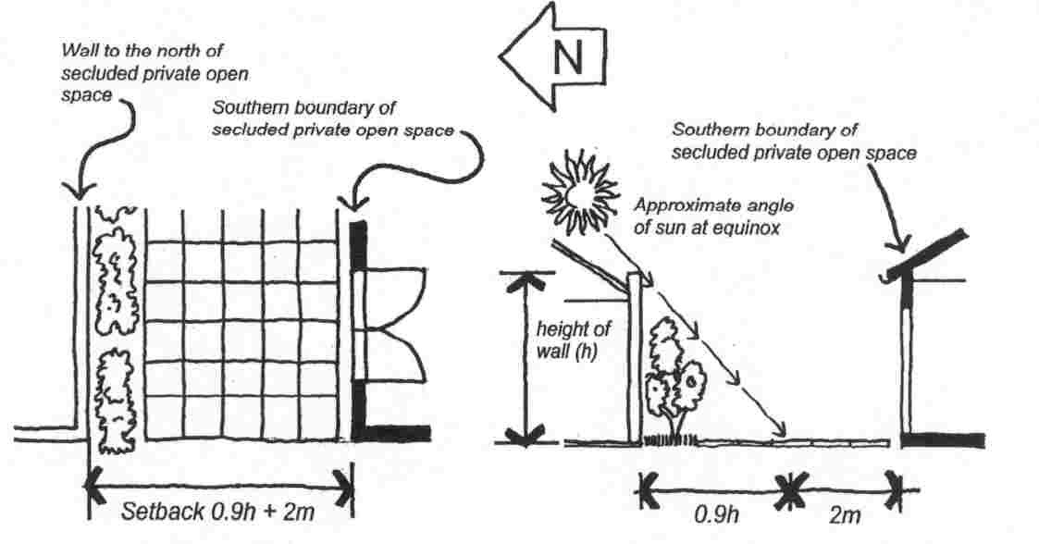

This does not apply to a small second dwelling.

Decision guidelines

Before deciding on an application, the responsible authority must consider:

* The design response.
* The useability and amenity of the secluded private open space based on the sunlight it will receive.

Applying the standard

The standard requires the southern boundary of the secluded private open space (SPOS) to be set back at least 2m+0.9m(h) metres from any wall on the north, where h is the height of the wall.

Formula: **2m+0.9m(h)**

Where the height of the wall on the north is 6.5m (h) this is the formula:

**Required setback = 2m+0.9m(6.5m)**

**= 2m+(0.9m×6.5m)**

**=2m+5.85m**

**=7.85 metres**

If a dwelling has its SPOS located directly south of a 6.5m tall northern wall, the southern boundary of this space must be at least 7.85 metres away from the northern wall to comply with the standard.

Supporting documentation

Identify wall heights and setbacks on plans, elevations and setbacks.

## Standard A3-4 Daylight to new windows

Why this is important

This standard is a fundamental amenity standard that ensures that all new windows of habitable rooms receive adequate daylight. Quality daylight minimises the need for artificial lighting, enhancing energy efficiency and creating a more comfortable living environment.

Daylight to new windows objective

To allow adequate daylight into new habitable room windows.

Standard A3-4

A window in an external wall of the building is provided to all habitable rooms.

Habitable rooms in a dwelling have a window that faces:

* An outdoor space clear to the sky or a light court with a minimum area of 3 square metres and minimum dimension of 1 metre clear to the sky, not including land on an abutting lot; or
* A verandah provided it is open for at least one third of its perimeter; or
* A carport provided it has two or more open sides and is open for at least one third of its perimeter.

**Decision guidelines**

Before deciding on an application, the responsible authority must consider:

* The design response.
* The extent to which habitable rooms are provided with reasonable daylight access through the number, size, location and orientation of windows.
* The useability and amenity of the dwelling based on the layout, siting, size and orientation of habitable rooms.
* Whether there are other windows in the habitable room which have access to daylight.

Applying the standard

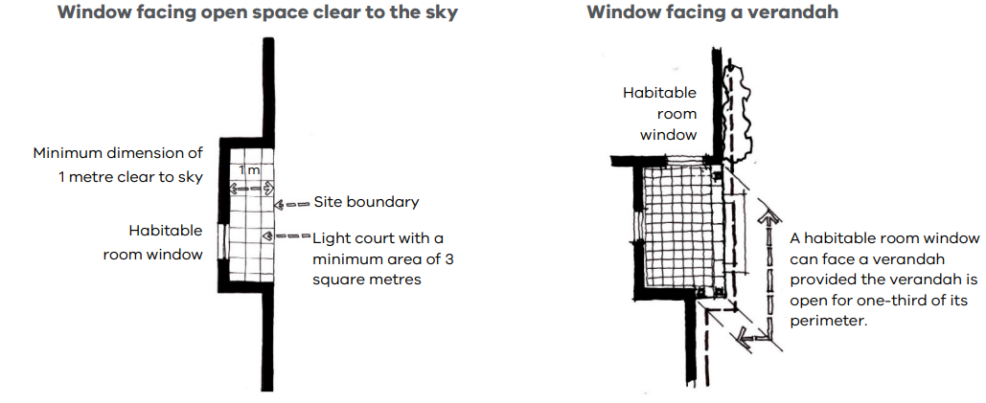

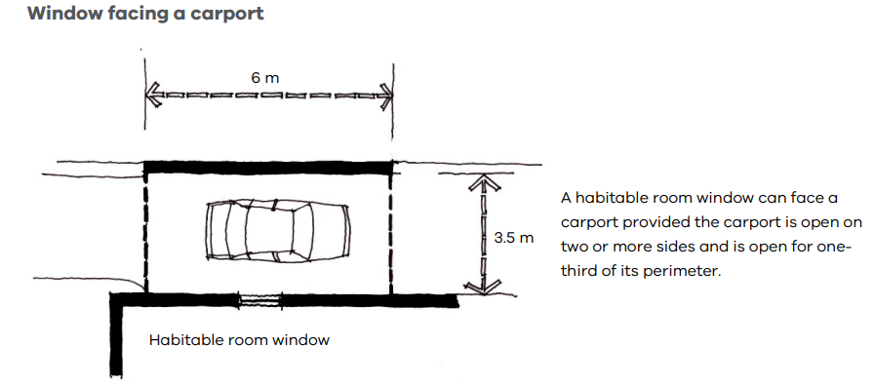

**Supporting documentation**

Identify widths and heights of structures adjoining habitable room windows.

## Standard A3-5 Safety and access for small second dwellings

Why this is important

This standard ensures that a small second dwelling can be accessed independently from the primary dwelling.

Safety and access for small second dwellings objective

To ensure access to a small second dwelling is safe, convenient and meets the needs of residents.

Standard A3-5

A small second dwelling is provided with a clear and unobstructed path from the frontage that:

* Has a minimum width of at least 1 metre, with no encroachments. If the path is longer than 30 metres, the minimum width of the path is at least 1.8 metres.
* Has a minimum clear height of at least 2 metres, with no encroachments.
* Has a gradient no steeper than 1 in 14.
* Has a cross fall no steeper than 1 in 40.
* Is sealed or has all-whether access.

Decision guidelines

Before deciding on an application, the responsible authority must consider the safety and accessibility of the small second dwelling.

Applying the standard

This standard ensures that all paths to small second dwellings from the site’s frontage are clear and unobstructed, with minimal gradient and crossfall and a clear height of 2 metres, while also protecting from the weather.

For paths that are less than 30 metres, a minimum path width of 1 meter is provided. For paths longer than 30 metres, the minimum path width is increased to 1.8 metres.

If the path is proposed to be from a side street, laneway or other roadway, the decision guidelines should be used to determine if the access arrangements are appropriate.

|  |  |
| --- | --- |
| * Path shorter than 30 metres have a minimum width of 1 metre. | A drawing showing an aerial view of a dwelling and small second dwelling on a lot with a path to a small second dwelling less than 30m. |
| * Paths longer than 30 metres have a minimum width of 1.8 metres. | A drawing showing an aerial view of a dwelling and small second dwelling on a lot with a path to a small second dwelling longer than 30m. |

Supporting documentation

Identify width and length of paths to small second dwellings.

# 54.04 EXTERNAL AMENITY

## Standard A4-1 Daylight to existing windows

Why this is important

This standard ensures that all new dwellings provide adequate daylight to existing windows. Maximising daylight is important for energy efficiency and comfort of indoor spaces.

Daylight to existing windows objective:

To allow adequate daylight into existing habitable room windows.

Standard A4-1

Buildings opposite an existing habitable room window provide for a light court to the existing window that has a minimum area of 3 square metres and minimum dimension of 1 metre clear to the sky. The calculation of the area may include land on the abutting lot.

Walls or carports more than 3 metres in height opposite an existing habitable room window are set back from the window at least 50 per cent of the height of the new wall if the wall is within a 55 degree arc from the centre of the existing window. The arc may be swung to within 35 degrees of the plane of the wall containing the existing window.

Where the existing window is above ground floor level, the wall height is measured from the floor level of the room containing the window.

**Diagram A4-1 Daylight to existing windows**

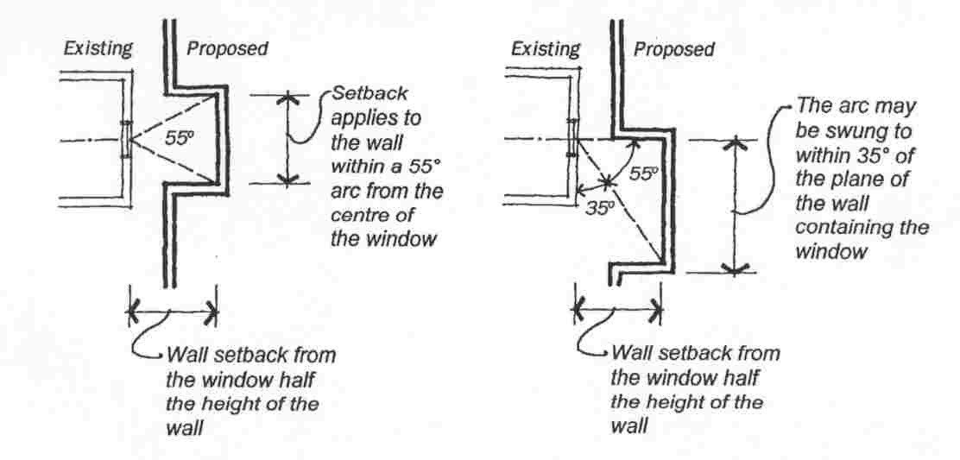

Decision guidelines

Before deciding on an application, the responsible authority must consider:

* The design response.
* The extent to which the existing dwelling or small second dwelling has provided for reasonable daylight access to its habitable rooms through the siting and orientation of its habitable room windows.
* The impact on the amenity of existing dwellings or small second dwellings.

Applying the standard

**Building opposite an existing habitable room window**

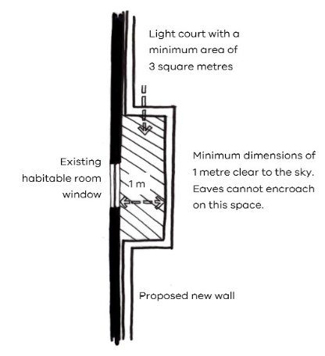

**55-degree arc from centre of an existing window**

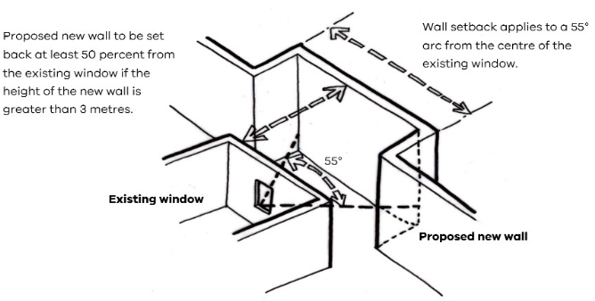

**35 degree arc from plane of an existing window**

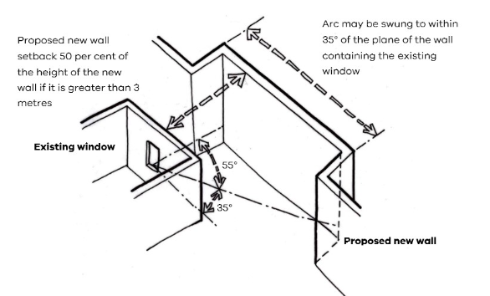

Supporting documentation

Identify widths and heights of built form proposed adjoining existing habitable room windows.

## Standard A4-2 Existing north-facing windows

Why this is important

This standard protects the energy efficiency of existing dwellings or small second dwellings which use north-facing windows for passive solar heating.

Existing north-facing windows objective

To allow adequate solar access to existing north-facing habitable room windows.

Standard A4-2

Where a north-facing habitable room window of a neighbouring dwelling or small second dwelling is within 3 metres of a boundary on an abutting lot, a new building is to be set back from the boundary by at least 1 metre, plus 0.6 metres for every metre of height over 3.6 metres up to 6.9 metres, plus 1 metre for every metre of height over 6.9 metres. This setback is to be provided for a distance of at least 3 metres from the edge of each side of the window.

For this standard a north-facing window is a window with an axis perpendicular to its surface oriented from north 20 degrees west to north 30 degrees east.

**Diagram A4-2 North-facing windows**

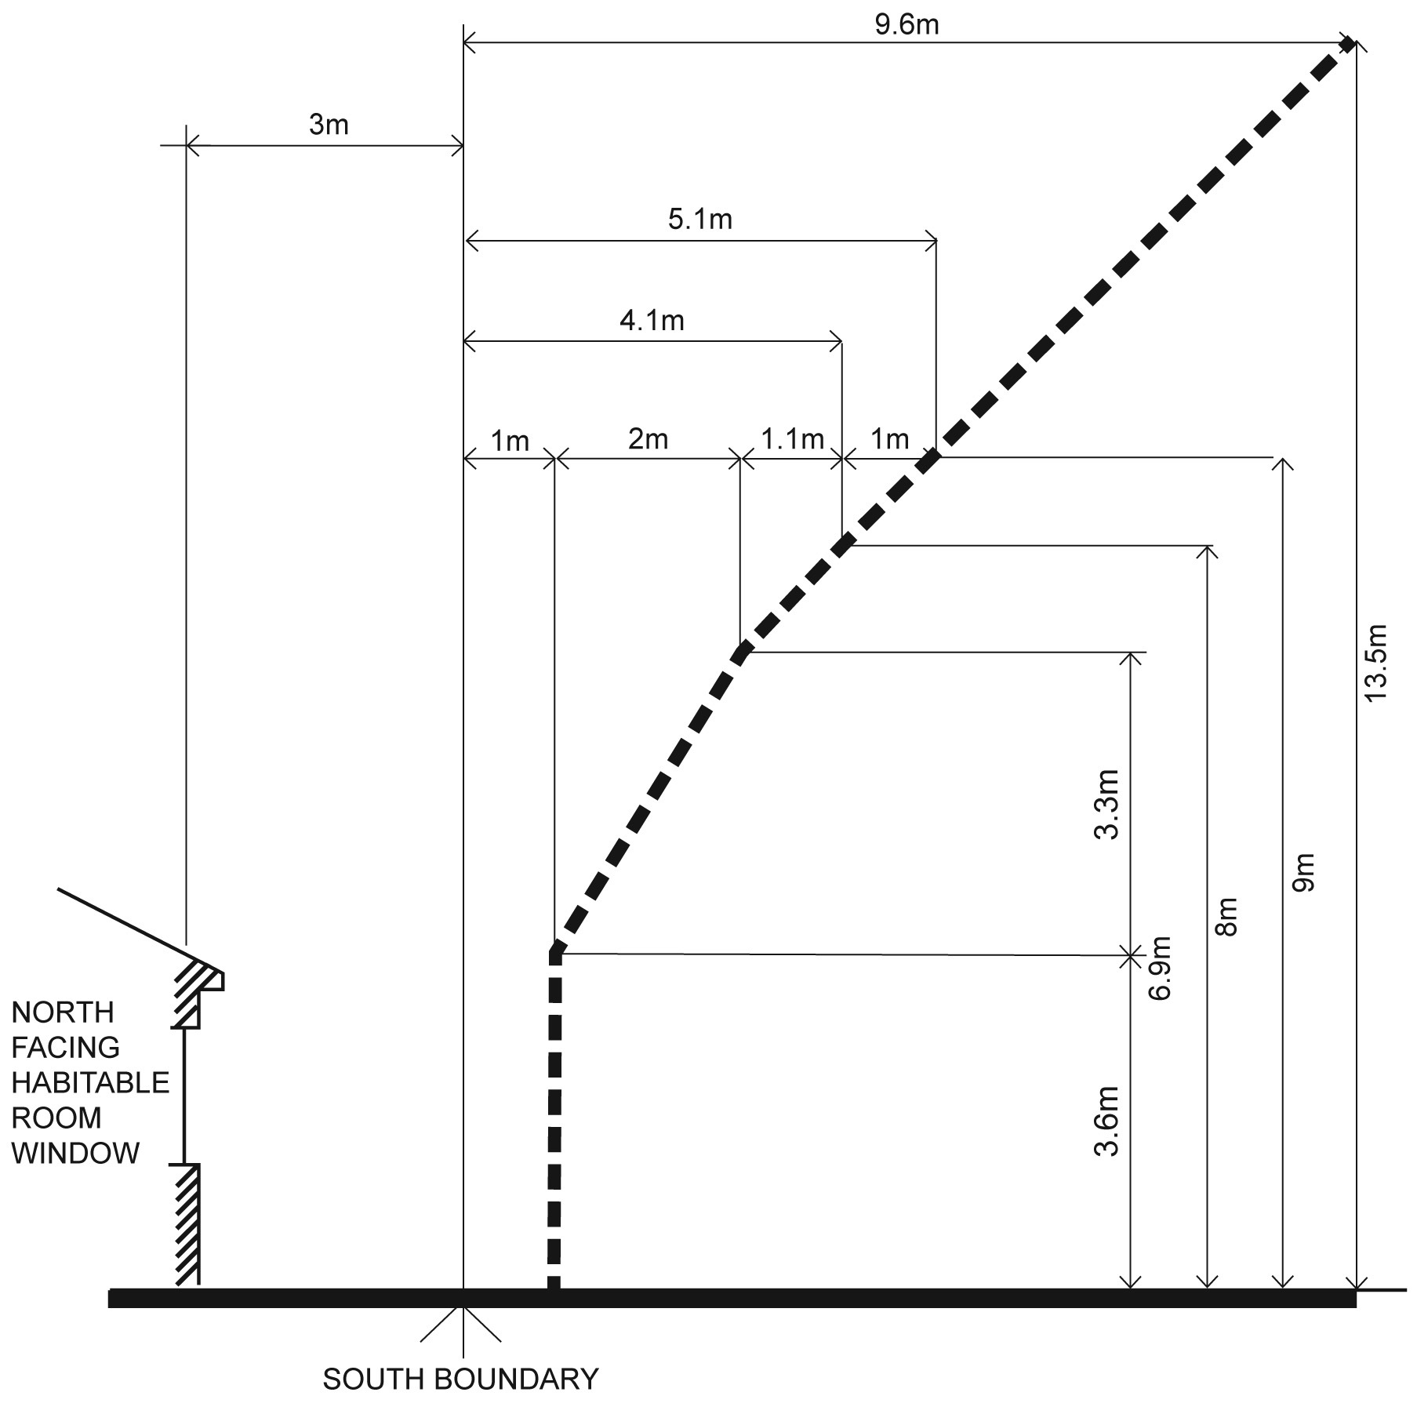

Decision guidelines

Before deciding on an application, the responsible authority must consider:

* The design response.
* Existing sunlight to the north-facing habitable room window of the existing dwelling or small second dwelling.
* The impact on the amenity of existing dwellings or small second dwellings

Applying the standard

The formula for calculating the required setback where the building height is between 3.6 metres and 6.9 metres is:

***1m + [0.6m x (h – 3.6m)] (h is the wall height)***

If the wall height is greater than 6.9 metres, the formula is:

***1m + [0.6m x (6.9m – 3.6m)] + [1m x (h – 6.9m)]***

Applying the formula to the same dwelling used in the side and rear setbacks standard example above (see Standard A2-1), the upper storey will need to be set back a further 1 metre from the southern boundary to protect sunlight to north-facing windows on an existing dwelling located to the south.

***1 m + [0.6 x (6.9m – 3.6m)]***

***= 1m + [0.6 x 3.3m]***

***= 1m + 1.98m***

***= 2.98m (rounded up to 3m) setback***

Supporting documentation

Identify wall heights and setbacks on plans, elevations and setbacks.

## Standard A4-3 Overshadowing secluded open space objective

Why this is important

This standard protects existing secluded private open space from overshadowing from new developments. Secluded private open space areas should receive adequate natural light for the comfort of residents and to promote the use of the space.

Overshadowing secluded open space objective

To ensure buildings do not significantly overshadow existing secluded private open space.

Standard A4-3

The area of secluded private open space that is not overshadowed by the new development is greater than 50 per cent, or 25 square metres with a minimum dimension of 3 metres, whichever is the lesser area, for a minimum of five hours between 9 am and 3 pm on 22 September.

If existing sunlight to the secluded private open space of an existing dwelling or small second dwelling is less than the requirements of this standard, the amount of sunlight will not be further reduced.

Decision guidelines

Before deciding on an application, the responsible authority must consider:

* The design response.
* The impact on the amenity of existing dwellings or small second dwellings.
* Existing sunlight penetration to the secluded private open space of the existing dwelling or small second dwelling.
* The time of day that sunlight will be available to the secluded private open space of the existing dwelling or small second dwelling.
* The effect of a reduction in sunlight on the existing use of the existing secluded private open space.

Applying the standard

**Overshadowing at 9am**

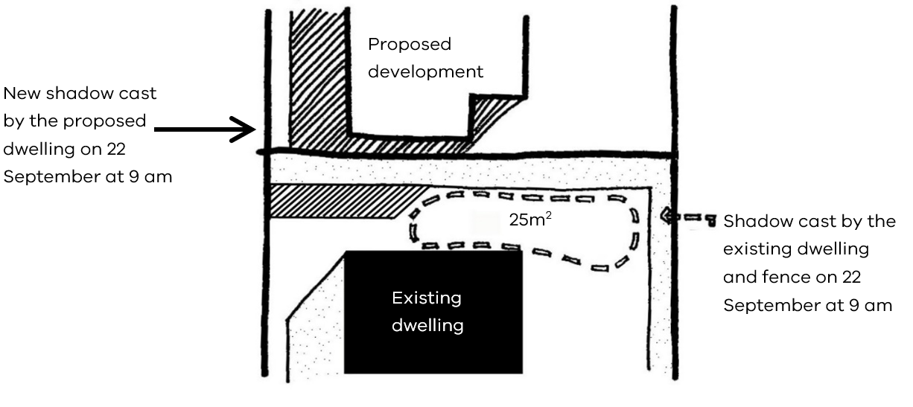

**Overshadowing at 3pm**

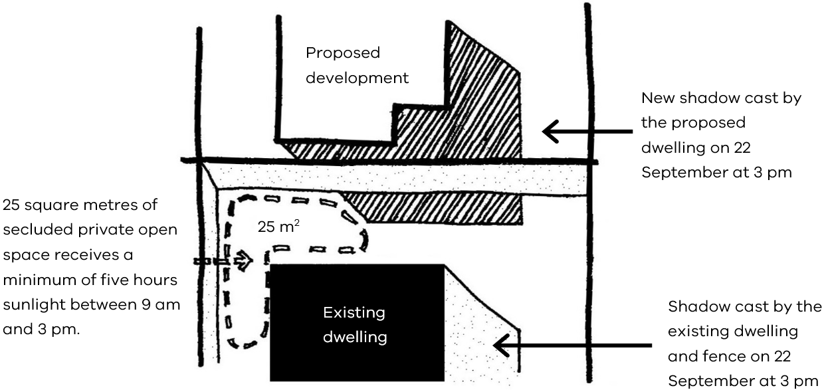

**Existing overshadowing greater than allowed by the standard**

In a typical inner city scenario many private open spaces have existing overshadowing greater than allowed by the requirements of this standard.

In these instances, the amount of sunlight should not be further reduced.

This example shows how Development A can be extended without further reducing the amount of sunlight to the private open space of Development B by designing for the shadow of the proposed extension to fall within the shadow of the existing fence.

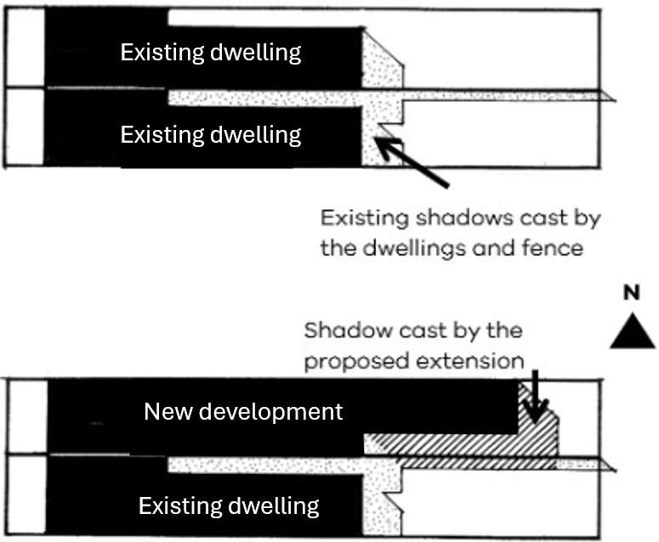

**Length of shadow on 22 September**

|  |  |  |
| --- | --- | --- |
| Time | Sun altitude (degrees) | Shadow length of a 1 metre high post (m) |
| 9.00 am | 32° | 1.60 |
| 10.00 am | 41° | 1.15 |
| 11.00 am | 49° | 0.87 |
| 12.00 noon | 52° | 0.78 |
| 1.00 pm | 50° | 0.84 |
| 2.00 pm | 45° | 1.00 |
| 3.00 pm | 36° | 1.38 |

As a simple guide, the table above gives an indication of shadow lengths at various times of the day based on the height of a 1 metre post and assuming flat ground.

To roughly calculate the length of shadow cast by a 4.5 metre high wall at 9:00 am, you simply multiply 4.5 metres x 1.6 metres = 7.2 metres (shadow length).

**Sunlight to private open space**

There are a range of commercial packages available to assist in measuring and producing overshadowing diagrams.

**Angle of shadow 22 September**

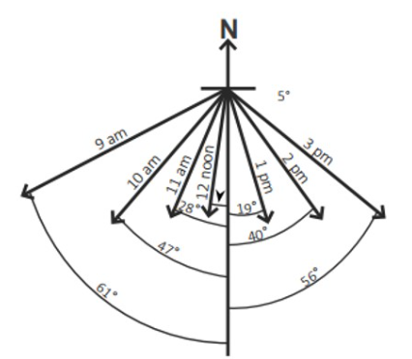

Supporting documentation

Provide existing and proposed shadow diagrams.

## Standard A4-4 Overlooking

Why this is important

This standard protects existing windows and private open spaces from overlooking, ensuring privacy, security, and the overall amenity of a space for the well-being and usability of its occupants.

Overlooking objective

To limit views into existing secluded private open space and habitable room windows.

Standard A4-4

In clause 54.04-4 a habitable room does not include a bedroom.

A habitable room window, balcony, podium, terrace, deck or patio is located and designed to avoid direct views into the secluded private open space of an existing dwelling or small second dwelling within a horizontal distance of 9 metres (measured at ground level) of the window, balcony, terrace, deck or patio. Views are measured within a 45 degree angle from the plane of the window or perimeter of the balcony, terrace, deck or patio, and from a height of 1.7 metres above floor level.

A habitable room window, balcony, terrace, deck or patio that is located with a direct view into a habitable room window of an existing dwelling or small second dwelling within a horizontal distance of 9 metres (measured at ground level) of the window, balcony, terrace, deck or patio:

* Is offset a minimum of 1.5 metres from the edge of one window to the edge of the other; or
* Has sill heights of at least 1.7 metres above floor level; or
* Has fixed, obscure glazing in any part of the window below 1.7 metre above floor level; or
* Has permanently fixed external screens to at least 1.7 metres above floor level and be no more than 25 per cent transparent; or
* Has fixed elements that prevent the direct view, such as horizontal ledges or vertical fins.

Obscure glazing in any part of the window below 1.7 metres above floor level may be openable provided that there are no direct views as specified in this standard.

Screens used to obscure a view are:

* Perforated panels or trellis with a maximum of 25 per cent openings or solid translucent panels.
* Permanent, fixed and durable.
* Designed and coloured to blend in with the development.

This standard does not apply to a new habitable room window, balcony, terrace, deck or patio which faces a property boundary where there is a visual barrier at least 1.8 metres high and the floor level of the habitable room, balcony, terrace, deck or patio is less than 0.8 metres above ground level at the boundary.

**Diagram A4-4 Overlooking**

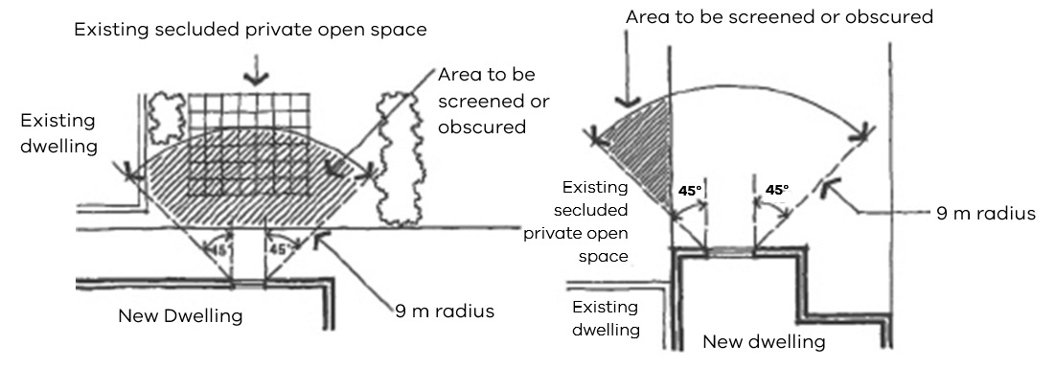

Decision guidelines

Before deciding on an application, the responsible authority must consider:

* The design response.
* The impact on the amenity of the secluded private open space or habitable room window.
* The existing extent of overlooking into the secluded private open space and habitable room windows of existing dwellings or small second dwellings.
* The internal daylight to and amenity of the proposed dwelling or small second dwelling.

Applying the standard

**Overlooking into secluded private open space**

You should only consider any direct line of sight within the defined area of view when considering overlooking from a proposed habitable room window into neighbouring secluded private open space.

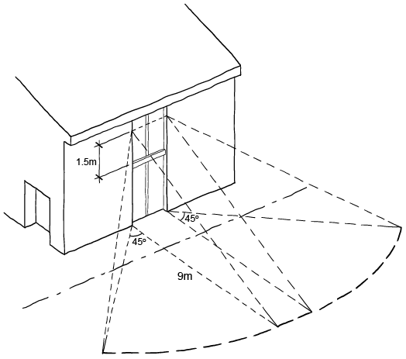

|  |  |
| --- | --- |
| A cross section of a multi storey building beside a single storey building that does not meet the overlooking standard. | A cross section of a multi storey building beside a single storey building that meets the overlooking standard. |
| Overlooking available into neighbouring secluded private open space and habitable room windows | Windows elevated to restrict views into neighbouring secluded private open space and habitable room windows |

Fixed elements that prevent direct views, such as angled vertical fins can be used to restrict views.

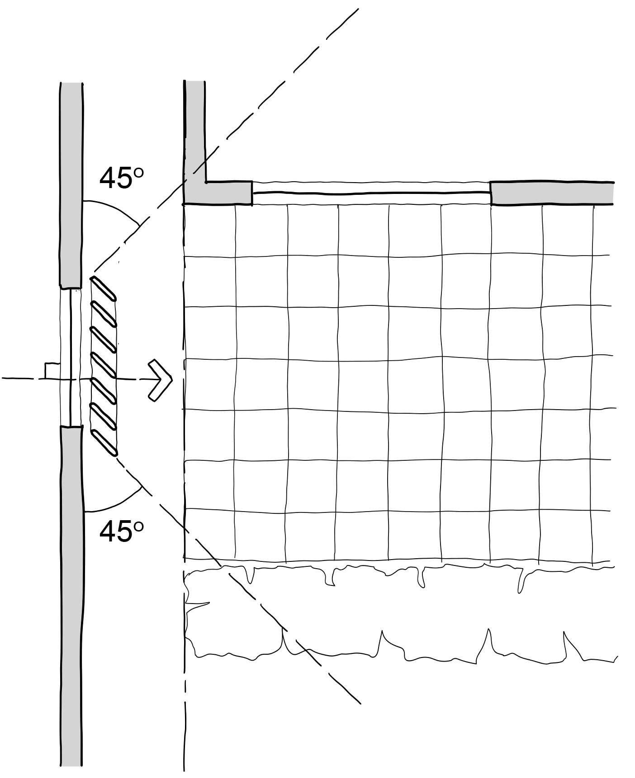

**Offsetting a new window**

A new habitable room window should be offset 1.5 metres from the edge of an existing window.

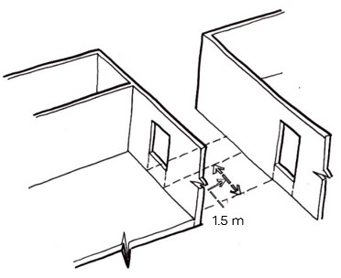

Supporting documentation

Identify existing habitable windows on site plan.

Demonstrate overlooking is mitigated in accordance with standard on plans, elevations and sections, as relevant.

# 54.05 SUSTAINABILITY

## Standard A5-1 Permeability

Why this is important

This standard limits the amount of hard surfaces that can surround a new development.

This helps to make best use of all water sources, reduce pollution of waterways, minimise the contribution of stormwater runoff to localised flooding and support cooling and greening of urban environment in the face of a changing climate.

Permeability objective

To reduce the impact of increased stormwater run-off on the drainage system and downstream waterways.

To facilitate on-site stormwater infiltration.

To contribute to urban cooling.

Standard A5-1

The site area covered by the pervious surfaces is at least 20 percent of the site.

Decision guidelines

Before deciding on an application, the responsible authority must consider:

* The design response.
* The existing site coverage and any constraints imposed by existing development.
* The capacity of the drainage network to accommodate additional stormwater.
* The practicality of achieving the minimum site coverage of pervious surfaces.

Applying the standard

**Permeability**

**Permeability is calculated as the total pervious area multiplied by 100 divided by total site area.**

Water cannot penetrate an impervious surface. An impervious surface includes a dwelling, a small second dwelling, a garage or carport, a verandah, a garden shed, a path, a swimming pool, outdoor paved areas, a driveway or any other sealed surface.

At least 20 per cent of the site should have surfaces that can allow penetration of water to deep soil such as garden beds, lawn and other unsealed surfaces. This can include driveways, pathways and outdoor entertaining areas, provided the materials used for their construction are pervious.

At least 20 per cent of the site should have permeable surfaces

Supporting documentation

Provide a site plan demonstrating permeability.

## Standard A5-2 Overshadowing domestic solar energy systems

Why this is important

This standard ensures that reasonable solar access is provided to existing domestic solar energy systems on the roofs of buildings.

Overshadowing domestic solar energy systems objective

To ensure that the height and setback of a building from a boundary allows reasonable solar access to existing domestic solar energy systems on the roofs of buildings.

Standard A5-2

Any part of a new building that will reduce the sunlight at any time between 9am and 4 pm on 22 September to an existing domestic solar energy system on the roof of a building on an adjoining lot be set back from the boundary to that lot by at least 1 metre at 3.6 metres above ground level, plus 0.3 metres for every metre of building height over 3.6 metres up to 6.9 metres, plus 1 metre for every metre of height over 6.9 metres.

This standard applies to an existing building in a Township Zone, General Residential Zone or Neighbourhood Residential Zone.

In clause 54.05-2 domestic solar energy system means a domestic solar energy system that existed at the date the application was lodged.

Decision guidelines

Before deciding on an application, the responsible authority must consider whether the domestic solar energy system has been sited to optimise efficiency and protection from overshadowing.

Applying the standard

To comply with this standard, a **new building** must be designed to **minimise overshadowing** of any existing **solar energy system** on a neighbouring lot. The building should be **set back** from the boundary at increasing distances as its height increases.

Where the new building height is 3.6 metres above ground level, the set back from the boundary is 1 metre.

Where the new building height is between 3.6 metres and 6.9 metres, the formula is:

**1 m + [0.3 m x (h – 3.6 m)]**

*(h = wall height)*

Where the wall height is greater than 6.9 metres, the formula is:

**1 m + [0.3 m x (6.9 m – 3.6 m)] + [1 m x (h – 6.9 m)]**

*(h = wall height)*

Using the above example, if the new building height is 8.5 metres, the required setback is calculated as follows:

**1 m + [0.3 x (6.9 m – 3.6 m)]**

**= 1 m + [0.3 x 3.3 m]**

**= 1 m + 0.99 m**

**= 1.99 m (rounded up to 2 m) plus**

**= 1 m x (8.5 m – 6.9 m)**

**= 1 m x 1.6 m**

**= 1.6 m**

**2 m + 1.6 m = 3.6 metres total setback of building height at 8.5 metres**

**New building setback from the boundary of an existing domestic solar energy system on the roof of a building on an adjoining lot**

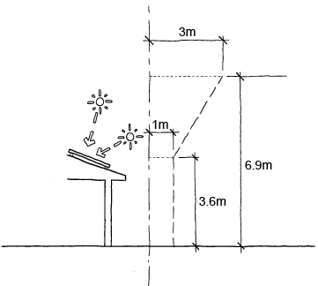

Supporting documentation

Identify existing domestic solar energy systems on the roofs of buildings on the existing context plan.

Demonstrate setbacks on plans and elevations.

## Standard A5-3 Rooftop solar energy generation area

Why this is important

This standard supports the future installation of appropriately sited rooftop solar energy systems for a dwelling. Rooftop solar panels allow occupants to generate their own electricity, reducing dependence on external energy providers and decrease greenhouse gas emissions, reduce air pollution, and help combat climate change.

Rooftop solar energy generation area objective

To support the future installation of appropriately sited rooftop solar energy systems for a dwelling.

Standard A5-3

In clause 54.05-3 rooftop solar energy area means an area provided on the roof of a dwelling to enable the future installation of a solar energy system.

An area on the roof is capable of siting a rooftop solar energy area for each dwelling which:

* Has a minimum dimension of 1.7 metres.
* Has a minimum area in accordance with Table A5-3.
* Is oriented to the north, west or east.
* Is positioned on the top two thirds of a pitched roof.
* Can be a contiguous area or multiple smaller areas.
* Is free of obstructions on the roof of the dwelling within twice the height of each obstruction (H), measured horizontally (D) from the centre point of the base of the obstruction to the nearest point of the rooftop solar energy area.

**Diagram A5-3 Allowable distance between obstructions and the rooftop solar energy area**

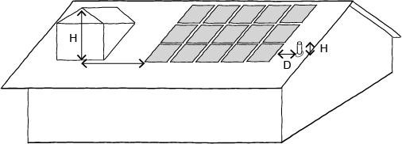

Obstructions located south of all points of the rooftop solar energy area are not subject to the horizontal distance requirements.

**Table A5-3 Minimum rooftop solar energy generation area**

|  |  |
| --- | --- |
| Number of bedrooms | Minimum roof area |
| 1 bedroom dwelling | 15 square metres |
| 2 or 3 bedroom dwelling | 26 square metres |
| 4 or more bedroom dwelling | 34 square metres |

This standard does not apply to a small second dwelling.

Decision guidelines

Before deciding on an application, the responsible authority must consider:

* The design response.
* The size and orientation of the building.
* The availability of solar access to the rooftop.
* The extent to which the rooftop solar energy generation area is overshadowed by existing buildings, other permanent structures or equipment on the rooftop.

Applying the standard

A rooftop solar energy generation area must be provided with a minimum area specified in Table A5-3 and minimum dimension of 1.7 metres.

The rooftop solar energy generation area must be:

* Orientated north, west or east.
* Positioned high on the roofline.
* Free of obstructions.

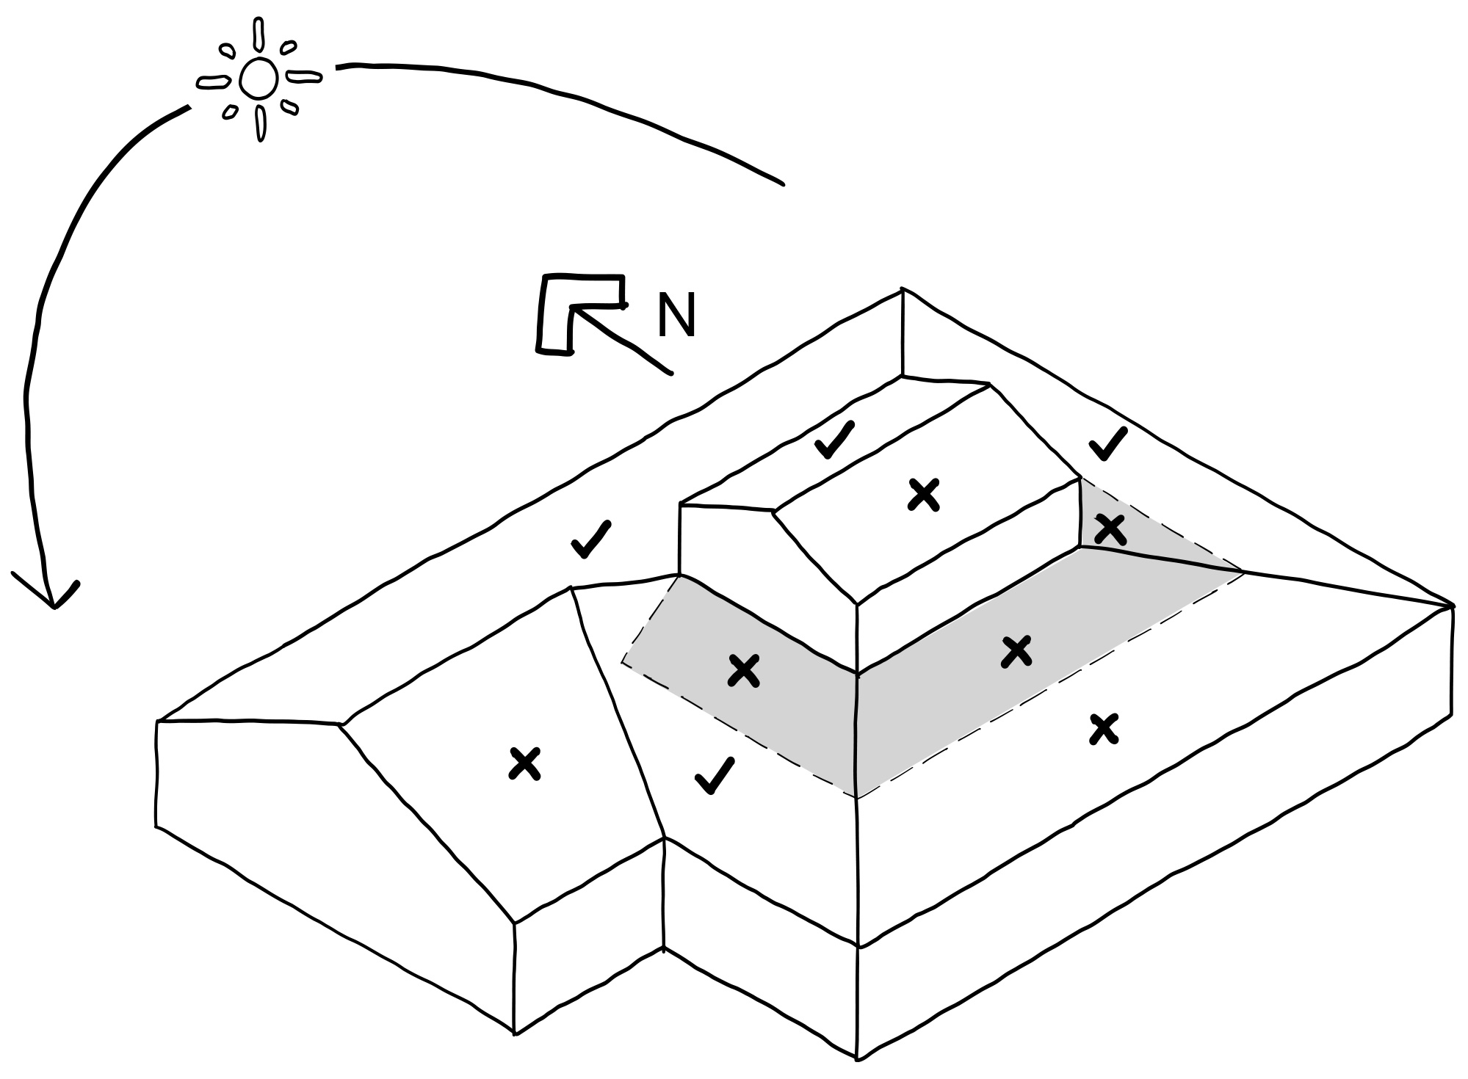If an existing building overshadows the building from the North, the East and West will be better locations for energy generation.

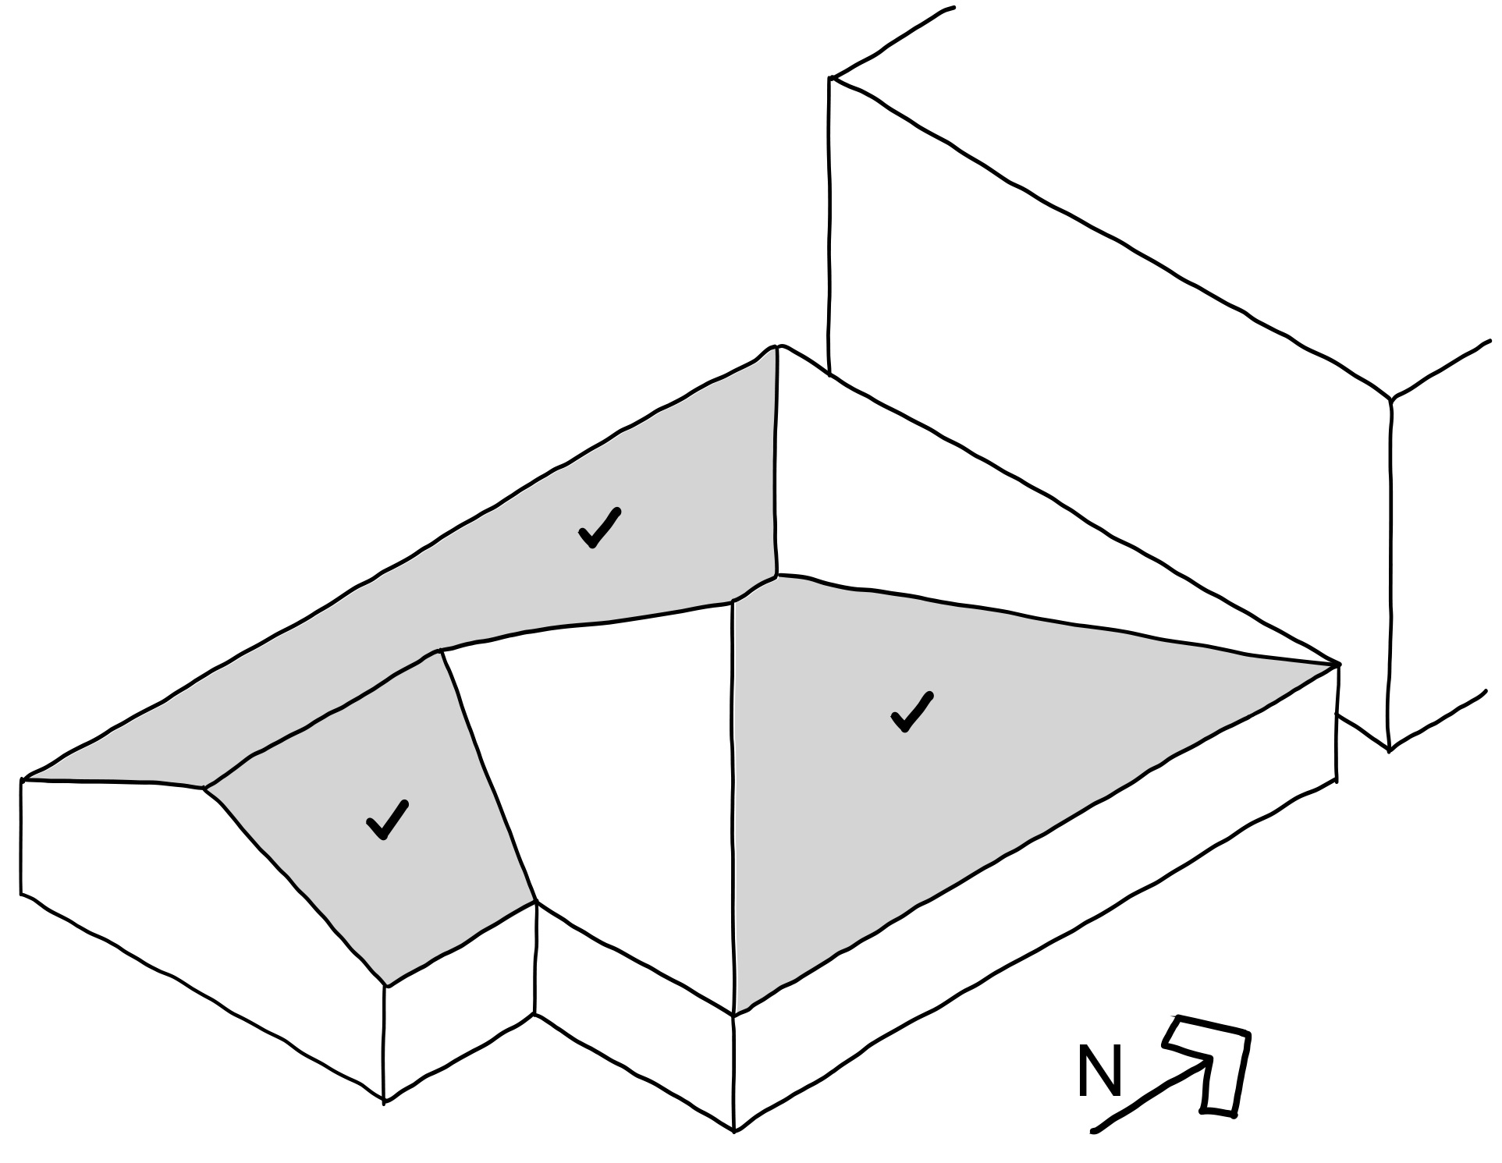

Supporting documentation

Identify location of the rooftop solar energy generation area on plans, as relevant.

## Standard A5-4 Solar protection to new north-facing windows

Why this is important

This standard ensures that north facing windows are designed to optimise solar access and thermal comfort.

Solar protection to new north-facing windows objective

To encourage external shading of north facing windows to minimise summer heat gain.

Standard A5-4

North facing windows are shaded by eaves, fixed horizontal shading devices or fixed awnings with a minimum horizontal depth of 0.25 times the window height.

This standard does not apply to a small second dwelling.

Decision Guidelines

Before deciding on an application, the responsible authority considers:

* The design response.
* The size and orientation of the lot.
* The type and use ability of external solar shading devices, including alternative design responses.

Applying the standard

External fixed sun shading and solar control devices should be integrated into the building design where possible.

North facing sun shading should be designed to allow winter sun and shade summer sun.

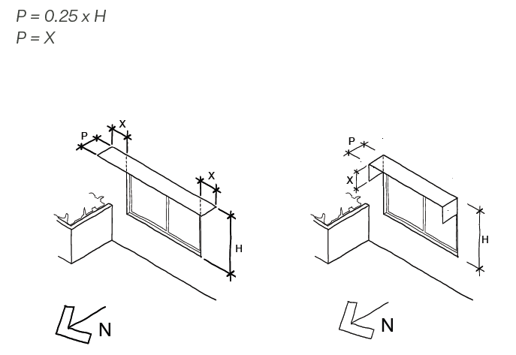

P = 0.25 x H

P = X

Supporting documentation

Show solar protection to north-facing windows on plans, elevations and sections.

|  |  |
| --- | --- |
| Version | Date |
| 1 | 8 September 2025 – Initial publication |

|  |  |
| --- | --- |
| © The State of Victoria - Department of Transport and Planning, September 2025  LogoThis work is licensed under a Creative Commons Attribution 4.0 International licence. You are free to re-use the work under that licence, on the condition that you credit the State of Victoria as author. The licence does not apply to any images, photographs or branding, including the Victorian Coat of Arms, the Victorian Government logo and the Department of Transport and Planning (DTP) logo. To view a copy of this licence, visit <http://creativecommons.org/licenses/by/4.0/>  ISBN 978-0-7311-9371-4 (pdf/online/MS word)  Disclaimer  This publication may be of assistance to you but the State of Victoria and its employees do not guarantee that the publication is without flaw of any kind or is wholly appropriate for your particular purposes and therefore disclaims all liability for any error, loss or other consequence which may arise from you relying on any information in this publication. | Accessibility  If you would like to receive this publication in an alternative format, please go to [planning.vic.gov.au](https://www.planning.vic.gov.au/) or email [planning.systems@transport.vic.gov.au](mailto:planning.systems@transport.vic.gov.au) |

