GROWTH AREAS INFRASTRUCTURE CONTRIBUTION
WORK-IN-KIND AGREEMENTS
GUIDELINES

JANUARY 2014

Table of Contents
ABBREVIATIONS iv
GLOSSARY v
INTRODUCTION 1
PART 1 ABOUT THE GAIC 2
PART 2 WORK-IN-KIND AGREEMENTS 8
A. RATIONALE FOR WORK-IN-KIND 8
B. BENEFITS OF WORK-IN-KIND 8
C. THE WORK-IN-KIND AGREEMENT 9
D. PARTICIPANTS 11
E. TIMING AND STAGING 12
F. PERFORMANCE OF WIK AGREEMENTS AND DEFAULT 13
G. PUBLIC ACCOUNTABILITY 14
H. SUBMITTING A WIK PROPOSAL 15
I. MORE INFORMATION 15
PART 3 CRITERIA FOR WIK AGREEMENTS 16
Criterion 1 – Situated in a growth area 16
Criterion 2 – The land or works must be capable of being funded from the GAIC Funds 16
Criterion 3 – Meets Government objectives and priorities 17
PART 4 SIMPLE LAND TRANSFERS 19
A. PROCESS FOR LAND TRANSFER 19
B. ADMINISTRATION OF LAND TRANSFER AGREEMENTS 23
PART 5 WIK PROPOSALS INVOLVING WORKS 25
A. PROCESS FOR WIK PROPOSALS INVOLVING WORKS 25
PART 6 ADMINISTRATION OF WORKS WIK AGREEMENTS 33
A. CAN WORKS BE STAGED? 33
B. STAGING UNDER A WORKS WIK AGREEMENT 33
C. DETERMINING COMPLETION 36
D. DISCHARGING A GAIC LIABILITY UNDER A WORKS WIK AGREEMENT 38
E. VARYING WORKS AFTER A WORKS WIK AGREEMENT IS ENTERED INTO 38
F. VALUATION MECHANISMS USED IN MODEL AGREEMENTS 39
G. AVOIDING DEFAULT 41
H. WHAT SECURITY IS REQUIRED? 43
I. THE END OF A WORKS WIK AGREEMENT 44
J. DISPUTES 44
ATTACHMENT A ROLES OF KEY PARTICIPANTS IN THE MODEL WORKS WIK AGREEMENT 46
ATTACHMENT B DETAILED PROPOSAL FOR GAIC WIK LAND TRANSFER 50
ATTACHMENT C EXPRESSION OF INTEREST FOR GAIC WIK PROPOSAL FOR WORKS AND LAND 52
ATTACHMENT D COMPLIANCE SCHEDULE 56
CHART A ASSESSMENT PROCESS FOR WIK PROPOSALS INVOLVING LAND TRANSFER (WITHOUT WORKS) 60
CHART B ASSESSMENT PROCESS FOR WIK PROPOSALS INVOLVING WORKS (WITH OR WITHOUT LAND) 61
CHART C FOR STAGES INVOLVING WORKS 62
CHART D FOR STAGES INVOLVING HANDOVER OF WORKS AND/OR TRANSFER OF LAND 63
CHART E DEFAULT NOTICE 64

ABBREVIATIONS

DCP | an approved Development Contributions Plan, as defined in section 46H of the PE Act, developed by the MPA and administered by the local government of a particular growth area
DTPLI | Department of Transport, Planning and Local Infrastructure
EOI | an Expression of Interest for a WIK proposal
GAIC | Growth Areas Infrastructure Contribution
GLE | GAIC Liable Entity, the person liable to pay a GAIC contribution under the PE Act
GLM | Government Land Monitor
MPA | Growth Areas Authority, being the body established under section 46AQ of the PE Act, trading as the Metropolitan Planning Authority
PE Act | the Planning and Environment Act 1987 (Vic)
PSP | an approved Precinct Structure Plan which forms part of the planning scheme
SRO | State Revenue Office
TA Act | the Taxation Administration Act 1997 (Vic)
UGB | Melbourne’s Urban Growth Boundary
VGV | Valuer-General Victoria, being the business name of the office of the Valuer-General appointed under the VL Act
VL Act | the Valuation of Land Act 1960 (Vic)
WIK | Work-in-Kind – either works or land or a combination of both that a GLE provides under a WIK agreement in lieu of paying a GAIC in cash

GLOSSARY
Commissioner | the Commissioner of State Revenue
current market value | the estimated amount for which a property should exchange on the date of valuation between a willing buyer and a willing seller in an arm’s-length transaction after proper marketing wherein the parties had each acted knowledgably, prudently, and without compulsion
GAIC Funds | the Growth Areas Public Transport Fund and the Building New Communities Fund, established under section 201V of the PE Act
GAIC credit | the credit the GLE receives toward its GAIC liability when it satisfactorily performs its obligations under a WIK agreement (or a stage under a WIK agreement)
GLM Policy | Policy and Instructions for the purchase, compulsory acquisition and sale of land (August 2000), published by the Government of Victoria, as amended from time to time
Government Entities | the Minister, the MPA and the Receiving Agency
Minister | the Minister for Planning, unless the context indicates otherwise
model agreement | the model Works WIK Agreement and/or the model Land Transfer WIK Agreement, as the context requires
model Works WIK Agreement | the model Work-in-Kind Agreement (Land and Works), a model agreement which provides for the GLE to deliver capital infrastructure works (with or without land) in lieu of a cash payment of a GAIC
model Land Transfer WIK Agreement | the model Work-in-Kind Agreement (Land Transfer), a model agreement which provides for the GLE to transfer land in lieu of a cash payment of a GAIC
Receiving Agency | the Victorian Government agency that receives the land or works provided under a WIK agreement and assumes ongoing responsibility for the land or works
Valuer-General Victoria or VGV | Valuer-General Victoria, being the business name of the office of the Valuer-General appointed under the VL Act
Victorian Code | the Victorian Code of Practice for the Building and Construction Industry (March 1999), published by the Victorian Government
Victorian Guidelines | the ’Implementation Guidelines to the Victorian Code of Practice for the Building and Construction Industry (2012), published by the Victorian Government

INTRODUCTION
The Growth Areas Infrastructure Contribution (GAIC) is a charge designed to fund essential State infrastructure in Melbourne's growth areas. These Work-in-Kind Guidelines (WIK Guidelines) relate to the establishment and administration of WIK agreements. WIK agreements allow a GAIC Liable Entity (GLE) to provide land and/or capital infrastructure works in a growth area in lieu of a cash payment of GAIC.
To assist GLEs considering entering into a WIK agreement, and to facilitate the negotiation of agreements, the Department of Transport, Planning and Local Infrastructure (DTPLI) has prepared two model agreements:
- A model agreement which provides for the GLE to deliver capital infrastructure works (with or without land) in lieu of a cash payment of a GAIC (the model Works WIK Agreement)
- A model agreement which provides for the GLE to transfer land in lieu of a cash payment of a GAIC (the model Land Transfer WIK Agreement).
These WIK Guidelines explain why the model agreements are drafted as they are and how the model agreements work.
There are five parts to these WIK Guidelines:
Part 1: describes the purpose and principles of the GAIC.
Part 2: provides a rationale for a GLE to provide WIK in lieu of a cash payment of a GAIC.
Part 3: sets out the key criteria for WIK agreements.
Part 4: explains the process of approving a WIK proposal involving a simple transfer of land (without any associated works), and details the administration of the associated model Land Transfer WIK Agreement.
Part 5: explains the process for approving a WIK proposal involving the delivery of works (with or without the transfer of land).
Part 6: explains the form and administration of the model Works WIK Agreement.
These WIK Guidelines should be read in conjunction with Part 9B of the Planning and Environment Act 1987 (Vic) (the PE Act) and the model WIK agreements. If there is any inconsistency between these WIK Guidelines and the model agreements concerning the operation of the model agreements then the model agreements prevail.
These guidelines were prepared by DTPLI and the Metropolitan Planning Authority (MPA), in consultation with the Department of Treasury and Finance and the State Revenue Office (SRO). The development industry was consulted during the preparation of these WIK Guidelines.
These WIK Guidelines may be subject to revision, particularly in light of experiences gained from entering into WIK agreements.

ABOUT THE GAIC

The GAIC came into effect on 1 July 2010 and applies to land in a declared growth area that was brought within the Urban Growth Boundary (UGB) in 2005–06, 2010 or 2012, and is zoned for urban development. The GAIC is administered under Part 9B of the PE Act and the Taxation Administration Act 1997 (Vic) (TA Act).

Growth areas infrastructure
Plan Melbourne, the Victorian Government’s metropolitan planning strategy released in 2013, states that Melbourne will be a very different city in 2050. Melbourne could grow by another 2.5 million people, to be a city of 6.5 million by 2050. A significant portion of this rapidly growing population lives in Melbourne’s new growth areas. These areas are located in the municipalities of Casey, Cardinia, Whittlesea, Hume, Mitchell, Melton and Wyndham.
Providing essential infrastructure, facilities and services is vital to establishing liveable new communities in growth areas. This includes infrastructure that supports the economic, social and environmental needs of residents.
This infrastructure includes:
- Neighbourhood infrastructure – this is infrastructure delivered by the developer when land is subdivided, to service the particular development. It includes:
- Infrastructure required to connect individual lots within a development to utility services such as water, sewerage, energy and telecommunications
- Landscaping and paths within a development
- Local drainage, flood mitigation works and open space within a development.
- Local infrastructure – this is infrastructure to service multiple developments within a municipality. It includes:
- Multi-purpose community centres, district parks and sporting facilities
- Local roads that will be vested in the relevant council (this includes the first carriageway of roads that may be identified for future upgrade to an arterial road)
- Connections of collector roads to arterial roads
- Utility trunk infrastructure to service multiple developments.
Funding for local infrastructure is sourced primarily from levies on development under Development Contributions Plans (DCPs), utility infrastructure development services schemes administered by utility service providers, or statutory charges under legislation such as the Water Industry Act 1994.
- Regional infrastructure – this is infrastructure to service broader catchment areas that may extend beyond municipal boundaries, such as regional parks and community facilities. Regional infrastructure is normally funded by councils in combination with grants from the Australian and Victorian governments.
- State infrastructure funded by the Victorian Government – this is infrastructure in a growth area that services the broader community at or beyond a regional level. It includes:
- Arterial roads and freeways
- Principal public transport networks
- Community infrastructure such as health facilities and education facilities
- Environmental infrastructure such as regional open space, trails and creek protection
- Economic infrastructure such as infrastructure providing access to information technology, and infrastructure supporting the development of commerce and industry.
State, regional or local infrastructure needs in growth areas are identified in various planning and policy documents, including:
- Plan Melbourne (2013), the Victorian Government’s metropolitan planning strategy
- The Victoria Planning Provisions and local planning policy framework documents such as Municipal Strategic Statements
- Growth Area Corridor Plans, Precinct Structure Plans (PSP) and DCPs
- Transport plans prepared by DTPLI, which generally identify only State infrastructure (and exclude local infrastructure).
The MPA estimates the Victorian and local governments will need to invest approximately $36 billion in infrastructure to service growth areas over the next 30 years. The Victorian Government plans to invest in transport infrastructure and services, and infrastructure needed to provide schools, education services, health facilities and community facilities such as regional parks, major recreation facilities and regional community centres in the growth areas.
The GAIC was introduced in 2010 to fund a portion of this State infrastructure and State funded infrastructure in growth areas. It is estimated the GAIC will meet only 15% of the total costs of providing this infrastructure. The Victorian Government will continue to meet the bulk of costs for State infrastructure and State funded infrastructure in new growth area communities.

Purpose of the GAIC
Money raised by the GAIC is paid by the Commissioner of State Revenue (Commissioner) into two special purpose accounts established to fund State infrastructure and services in the growth areas. These are called the Growth Areas Public Transport Fund and the Building New Communities Fund (the GAIC Funds), which are established under section 201V of the PE Act.
Under the PE Act, funds from the two GAIC Funds can only be used for the purposes of State funded infrastructure. This includes State funded public transport infrastructure, other transport infrastructure such as walking and cycling infrastructure, and regional community, environmental or economic infrastructure that is funded by the Victorian Government, as set out in sections 201VA and 201VB of the PE Act. GAIC payments cannot be used to fund neighbourhood or local infrastructure, or infrastructure funded through development contribution payments.
Similarly, the works or land delivered under a WIK agreement must be of a type able to be funded from one of the two GAIC Funds. This is a requirement of the PE Act.
The Victorian Government has developed criteria against which proposals to deliver works or land under a WIK agreement are assessed. They include factors to be considered in determining whether particular works or land constitute State funded infrastructure that could be funded from the GAIC Funds. These criteria are described in Part 3 of these WIK Guidelines.

The contribution area
The GAIC is a charge on land that since November 2005 is:
- Included within the contribution area (within Melbourne’s UGB) and
- Zoned for urban development (an Urban Growth Zone).
Further information about the contribution area is provided on the MPA website at www.mpa.vic.gov.au/growth-areas-infrastructure-contribution-gaic.
Part of the rationale for imposing GAIC on land within the contribution area is that land values significantly increase when included in the contribution area, partly reflecting buyer expectations that key infrastructure to support its urban development will be provided.
The GAIC does not apply to land included within the UGB that is not zoned for urban development. However, if that land is subsequently rezoned for development GAIC becomes payable in respect of the land at the first trigger event after the rezoning. See below for more on trigger events.

GAIC is a broadhectare charge
The amount of GAIC payable on a particular parcel of land is calculated on the total area of the land. In other words, it is a broadhectare contribution, as opposed to being calculated on a net developable hectare basis. The GAIC is applied uniformly to land in the contribution area, on a per hectare basis indexed annually.
Indexed GAIC rates for the 2013-14 financial year are:
- $86,580 per hectare for type A land
- $102,810 per hectare for type B and C land.
The GAIC rates are available on the MPA website at www.mpa.vic.gov.au.

Triggering the obligation to pay GAIC
The obligation to pay GAIC is triggered when land in the contribution area is developed or sold. There are three types of trigger events, and the obligation to pay is triggered on the first trigger event to occur after the land is brought within the contribution area, and zoned for urban development.
Trigger event | Who pays | When
Dutiable transaction – GAIC triggered by the transaction | Purchaser | Within 3 months of settlement and before the transfer of land is registered by the Registrar of Titles
Subdivision of land – GAIC triggered by the issue of a statement of compliance for the subdivision | Land owner | Within 3 months of the statement of compliance being issued, and before registration of the plan of subdivision by the Registrar of Titles
Building permit – GAIC triggered by the building permit application | Land owner | Before the issue of the building permit

The reason the obligation to pay the GAIC is triggered at the time of sale or development is to match the timing of the payment to the substantial economic advantage that arises due to the land being developed. Development of the land also triggers the need to provide associated State infrastructure which is to be part funded through the GAIC, to service the new communities created.

Minor matter exclusions
The PE Act provides for certain types of events and subdivisions that are “exceptional” or “minor” in nature to be excluded from triggering the obligation to pay a GAIC liability. These are known as “excluded events”, and include:
- Excluded subdivisions, which includes (among others):
- Subdivisions for the sole purpose of creating a lot for a utility installation, or for the sole purpose of providing land for transport infrastructure or some other public purpose
- Subdivisions for the purpose of creating a lot of up to 2 hectares to excise an existing dwelling on the land
- Applications for a building permit for work with a value of less than $1 million (indexed from 2010-11).
The Commissioner is responsible for determining whether an event constitutes an excluded event.
In the case of subdivisions to create a lot for a utility installation, or provide land for transport infrastructure or some other public purpose, the subdivision will only constitute an excluded subdivision if that is the sole purpose of the subdivision. For example, if the plan of subdivision creates roads, but the plan of subdivision is prepared in the context of a broader residential subdivision, the SRO will not consider the subdivision to be for the sole purpose of providing land for transport infrastructure. This aligns with the purpose of the GAIC as a broadhectare charge, not a charge on a net developable area. Exclusions are not to be used to circumvent this purpose.

Timing of GAIC payments
Ordinarily, GAIC must be paid in full within three months after the GAIC trigger event occurs. However the PE Act makes provision for GAIC liabilities to be paid over time, so payments are received as sale or development of the land generates cash flow for the GLE.
A purchaser may elect to defer up to 100% (or 70% for transactions before 30 June 2011) of the GAIC until the next trigger event. An election to defer must be made in writing on the appropriate form to the SRO before the day on which the contribution is payable.
More information about deferral of a GAIC liability is provided in Division 2 – Subdivision 3 of Part 9B of the PE Act. Application forms for an election to defer are available from the SRO website at www.sro.vic.gov.au.
A GLE who proposes to subdivide the land or apply for a building permit can seek approval to pay the GAIC in stages. This includes a purchaser who has elected to defer the GAIC liability as described above.

It is Victorian Government policy that:
- Staged payment approvals generally require an initial payment of at least 30% of the total GAIC liability payable at the first subdivision stage to help fund key State infrastructure to support development of a growth area.
- The remaining liability can be paid in instalments when subsequent stages are developed, calculated on a pro-rata basis.
- The final payment date for a staged payment should be no later than 17 years after the staged payment is approved.
- Individual staged payment dates can be altered to better align with the release of land for development, provided all payments are made within 17 years from approval of the staged payment.
More information on staged payment approvals is provided in Division 2 – Subdivision 4 of Part 9B of the PE Act. Application forms for a staged payment approval are available from the MPA website at www.mpa.vic.gov.au.
Where a GAIC liability is deferred, or a staged payment approval is given, the GAIC liability will attract interest (at approximately 4.2% at publication of these WIK Guidelines in December 2013). This is calculated from the date the GAIC was originally due to the date the payment (or part payment) is actually made, in accordance with sections 201SO and 201ST of the PE Act.
Failure to pay a GAIC payment on time
The PE Act is specific about the consequences of failing to make a GAIC payment on time. This applies to deferred payments, staged payments and a failure to meet due dates under a WIK agreement. If the GLE fails to make the payment (or perform the WIK agreement) by the nominated due date, then the whole of the GAIC liability becomes immediately payable as if the deferral was never made, the staged payment approval was never given and/or the WIK agreement was never entered into.
Administration of the GAIC
GAIC is administered under Part 9B of the PE Act, and the TA Act.
Primary responsibility for administering the GAIC legislation rests with the SRO. The SRO is responsible for collecting GAIC payments from GLEs, issuing various types of certificates and notices relating to GAIC liabilities, and administering the provisions of Part 9B of the PE Act and the TA Act (including the interest and penalty tax provisions and the refund provisions of the TA Act as they relate to GAIC).
Primary responsibility for approving expenditure from the two GAIC Funds rests with the Minister for Planning and the Treasurer.
Primary responsibility for determining GAIC-related policy rests with DTPLI and the MPA. The PE Act also gives responsibility for entering into WIK agreements to the Minister for Planning, and for administering WIK agreements to the MPA.

WORK-IN-KIND AGREEMENTS

RATIONALE FOR WORK-IN-KIND
The amendments to the PE Act brought in by the Planning and Environment Amendment (Growth Areas Infrastructure Contribution) Act 2011 (Vic) provided for a GLE to offset part or all of its GAIC liability by providing land or infrastructure works to the State, or a combination of land and works. This is known as Work-in-Kind (WIK).
The WIK provisions were included within the PE Act to more effectively align the provision of State infrastructure to the timing of development in growth areas.
By providing an alternative to cash payments of GAIC, WIK is intended to provide the State with works or land that would otherwise be developed and/or funded by the State through the Growth Areas Public Transport Fund or the Building New Communities Fund (the GAIC Funds), which are established under section 201V of the PE Act.
WIK agreements provide an alternative way for a GLE to discharge its tax liability. WIK proposals are therefore initiated by the GLE. A WIK proposal must be approved by the Minister for Planning, who must consult with the Receiving Agency (and, where required, the Treasurer) before entering into a WIK agreement.

BENEFITS OF WORK-IN-KIND
WIK can benefit developers, landowners, growth area communities and the State in a number of ways, including:
- For the growth area community:
- WIK enables State funded infrastructure or the land where that infrastructure will be built to be provided earlier than would otherwise be scheduled. Where land is transferred to a Receiving Agency for future State infrastructure, the community can see that the land has been set aside to enable the State infrastructure to be built at a time when growth has reached a level that requires that infrastructure.
- For GLEs and developers:
- WIK provides them with an opportunity to fast-track critical infrastructure that would otherwise be provided or funded by the State (without which they may not be able to start their development).
- It can give them greater control over the design and timing of State infrastructure facilities associated with their development, which in turn may result in that development being more attractive to purchasers.
- It can result in savings in the cost of constructing State infrastructure if a developer can link construction of the State infrastructure to adjacent land development works. The GLE will retain the benefit of costs savings if the GLE delivers the works for less than the pre-agreed value of those works.
- WIK can enable the GLE and developer to provide a transfer of land instead of works to discharge some or all of its GAIC liability. The GLE then has reassurance the government has obtained the land footprint required for the State infrastructure to be delivered when it is required. This will also assist a GLE and/or developer to market its development, as it can indicate the land footprint of future State infrastructure.
- For the State and landowners:
- WIK reduces the time taken and cost of acquiring land for State infrastructure (which might otherwise involve lengthy and complex compulsory acquisition processes) and for building that infrastructure.
- For all stakeholders:
- WIK provides opportunities for better integration of public and private facilities in new communities, and for improving value for money through the efficiencies gained from GLEs and developers providing State infrastructure works as part of their development.
Awareness of obligations
While there can be considerable benefits arising from a WIK agreement, WIK agreements are by their nature more complex than the direct cash payment of the GAIC liability. GLEs need to be fully aware of the obligations they will assume under a WIK agreement and mindful of the risks involved. Some of the areas of potential risk could include:
- For WIK proposals involving the delivery of works, the GLE will need to manage the construction program to ensure costs are contained and time frames met
- There is a risk of being in breach of the agreement and triggering the penalties under the agreement and the legislation.
- In the event of a breach of a WIK agreement, the overall costs to the GLE to ensure final completion of the agreement are likely to escalate.
- If a GLE enters into a WIK agreement this can make the land more difficult to sell until such time as the WIK agreement has been completed.
Through the use of the model WIK agreements, these WIK Guidelines and Part 9B of the PE Act, the Victorian Government is seeking to balance these benefits for all stakeholders. The Government has also sought to develop a streamlined process that provides transparency and accountability in relation to decisions on WIK, whilst ensuring the State receives value for money.

THE WORK-IN-KIND AGREEMENT
GLEs that choose to discharge a GAIC liability through cash payments are not required to enter into contractual arrangements with the Government.
However, in recognition that constructing assets or transferring land carries additional risks over a payment of cash, GLEs discharging a GAIC liability through the provision of WIK are required to enter into a legally binding agreement formalising the GLE’s obligations to provide the WIK, the value of the GAIC credit and the timetable and staging of delivery and transfer of the works and/or land to the Receiving Agency.
This agreement will take the form of either a:
- Works WIK Agreement, in the case of the provision of works (with or without land) or
- Land Transfer WIK Agreement, in the case of a simple transfer of land without works.
A model Works WIK Agreement and model Land Transfer WIK Agreement have been prepared to facilitate the negotiation process.
The transfer of land without any associated infrastructure works is a simpler transaction with limited risks for the participating parties. Consequently, the model Land Transfer WIK Agreement is a much simpler form of agreement than the model Works WIK Agreement.
Where possible, the model agreements have sought to adopt industry standard practice. However, it is important to recognise that WIK agreements are for discharging a legislative liability, which reduces the flexibility of the agreement in some respects. The model agreements also reflect a risk allocation broadly consistent with the Victorian Government’s policy relating to the provision of State infrastructure.
Mechanisms have been incorporated into the model WIK agreements to assist a GLE to prevent default, in recognition of the benefit of early delivery of State infrastructure through WIK agreements, the statutory protections available to the Government under the legislation and the relatively severe statutory penalties that apply if a GLE defaults under a WIK agreement. These mechanisms are discussed in detail in Part 6 Section G of these WIK Guidelines. The Government will also work with the GLE during the WIK proposal stage to develop a realistic timetable for delivery of works and reduce the risk of a GLE defaulting on due dates during delivery of the project.
Flexible arrangements
The Government recognises that each WIK proposal is unique. It is not a ‘one size fits all’ process, and some variation may be required from the model agreements. The Government is open to considering changes to the model agreements requested by the GLE where these changes:
- Are warranted given the nature of the particular WIK proposal
- Ensure statutory requirements and obligations are still met
- Ensure Government interests are still appropriately protected.
In some cases the GLE may wish to have a developer actively engaged in the process and included within the WIK agreement. Although the standard agreement does not have the developer as a party to the agreement it may be suitable in certain occasions for this to occur to ensure delivery of the infrastructure.
In addition, the land transfer WIK Agreement is based on one title per agreement where in fact a number of titles may be used to meet the GAIC liabilities. The use of multiple titles will be acceptable in a WIK contract. In making changes to the standard contracts a practical approach will be adopted while ensuring the risk to the Government is appropriate for the circumstances.
The Government will consider reasonable proposals by a GLE or a developer to modify model agreements, to suit particular arrangements that may exist between the GLE and the developer, on a case by case basis, where the circumstances warrant.
The GLE bears the costs of making material amendments to the model agreements the GLE requests.
Model Works WIK Agreement
The model Works WIK Agreement is intended to be used for WIK proposals involving the delivery of works. It can also be used for proposals which involve a combination of works and the transfer of the underlying land on which the works are constructed, or the transfer of other land which is not the subject of the proposed works.
Clauses that are likely to apply in the majority of cases are included in the main body of the model Works WIK Agreement. The model Works WIK Agreement incorporates extensive use of schedules, which deal with matters that may vary depending on the specific nature of the proposal. Schedule 1 includes any special conditions that may need to be included in addition to, or to vary, the provisions in the main body of the agreement. The administration of the model Works WIK Agreement is described at Part 6 of these WIK Guidelines.
Model Land Transfer WIK Agreement
The simpler model Land Transfer WIK Agreement is intended to be used for proposals involving a transfer of land with no works. The administration of the model Land Transfer WIK Agreement is described at Part 4 of these WIK Guidelines.

PARTICIPANTS
WIK agreements will be entered into between the:
- GLE
- Minister for Planning
- MPA
- Receiving Agency, being the relevant Victorian Government department or agency that will take ongoing responsibility for the asset that is being delivered by the GLE under the agreement.
A table summarising the main role and obligations of each of the parties under the model Works WIK Agreement is contained at Attachment A of these WIK Guidelines.
If the GLE intends to engage a developer or other subcontractors to carry out works under a Works WIK Agreement, the GLE will need to enter into a separate agreement, and manage that relationship, to ensure the works are completed in accordance with the Works WIK Agreement. Although the standard agreement does not have the developer as a party to the agreement it may be suitable in certain occasions for this to occur to ensure delivery of the infrastructure. The Government may require material subcontractors to enter into a direct deed with the Government relating to the delivery of the works in appropriate circumstances. However this will not alter the GLE’s obligations under a Works WIK Agreement to deliver the works to the Receiving Agency.
Similarly, where the GLE is not the owner of land to be transferred to the Receiving Agency, or upon which the works are to occur, the GLE will need to acquire sufficient title to, or rights in respect of, that land to enable it to comply with its obligations under the WIK agreement. The Government does not intend for the landowner to be party to the WIK agreement.
The Valuer-General Victoria (VGV) and the Government Land Monitor (GLM) will also be involved in the assessment of WIK proposals, although they will not be a party to a WIK agreement. VGV will provide the Government with an objective expert assessment of the value of the land component of a WIK proposal, and assist with resolving land valuation disputes that may arise after the WIK agreement is entered into. GLM approval will be required for transactions involving a land component that is valued over the thresholds in the GLM Policy.

TIMING AND STAGING
Staging of the delivery of works under a Works WIK Agreement
Staged payment of the GAIC was introduced into the PE Act to give a GLE the flexibility to align payment of its GAIC with the development of its land. Consequently, a GAIC timeline for a staged payment arrangement will generally be aligned with the GLE’s plans to release and sell land. The timeframe specified in a staged payment arrangement may cover many years, based upon the expected timeframe for development of the land.
However, when a staged payment arrangement is entered into by a GLE in conjunction with a Works WIK Agreement, the staging of payments will need to be driven primarily by the stages of works to be delivered by the GLE. The timeframe for delivery of the works will generally need to be far shorter than a staged payment arrangement without a Works WIK Agreement (which can extend to up to 17 years).
Consequently, where the GLE enters into a Works WIK Agreement, it may lose some flexibility to align payment of the GAIC (through delivery of the works) with the staged development of its land, particularly where it proposes to deliver one large State infrastructure asset rather than a package of smaller discrete pieces of State infrastructure (or land) that could be staged over several years. When considering a WIK proposal, a GLE will need to carefully consider if the staging of the delivery of the WIK can be aligned with the GLE’s preferred staging of payments.
Staging of works under a Works WIK Agreement is discussed in more detail at Part 6 Section B of these WIK Guidelines.
The 30% requirement
The Government recognises that where the GLE enters into a WIK agreement, the provision of the infrastructure or land (and hence the payment of the GAIC) is usually brought forward. Therefore, the requirement to pay at least 30% of the total GAIC liability at the first subdivision stage is unlikely to apply where the GLE enters into a staged payment arrangement in conjunction with a WIK agreement.
Streamlining processes
Ideally, several things need to be in place before a WIK agreement is entered into. For instance, it is the Government’s preferred position that an approved PSP is already in place when a WIK proposal is put forward, and that the proposal reflects the strategic planning needs for the area as identified in the PSP or other strategic document of the Government. The GLE may also wish to seek approval for a staged payment arrangement in connection with a GAIC liability that it proposes to discharge by way of a WIK agreement.
These various processes can be streamlined, to ensure there are no unnecessary delays associated with the assessment and approval of WIK proposals. The Government will work proactively with a GLE to ensure this can be achieved.
Triggering the obligation to pay a GAIC liability
A WIK agreement can be entered into at any time before the due payment date of a GAIC liability. Entering into a WIK agreement will not bring the GAIC liability forward if the GAIC has not been triggered in accordance with the trigger events set out in the PE Act.
However, the model agreements are drafted so that the agreement will only commence when the GAIC liability has been triggered. The reason for this is that it is necessary to tie the performance of the agreement to meeting the GAIC liability. Further, if the GAIC liability is triggered, the Government has additional protections under the legislation (particularly section 201SLN) if the GLE fails to perform its obligations under the agreement.
If a GLE can demonstrate that making the agreement conditional on the GAIC liability being triggered is not justified in the circumstances, the Government is prepared to consider that position and discuss it with the GLE.
It should also be noted that a WIK agreement could be entered into part way through a staged payment arrangement if a GLE decides to complete the payment of its staged payment arrangement by performing WIK.
Release of land on completion of stages under a WIK agreement
Once a GLE has fully completed performance of a WIK agreement (or a stage under a WIK agreement), the GLE notifies the MPA in writing. If the MPA determines performance has been completed, it informs the Commissioner. At this point, the GAIC liability is discharged, allowing the release of the land to which the GAIC applied. Interest payable on the GAIC (or that stage of the GAIC) under the PE Act also ceases at this point. This process is discussed further in the description of the administration of the WIK agreements later in these WIK Guidelines, and in the attached flowcharts.

PERFORMANCE OF WIK AGREEMENTS AND DEFAULT
Statutory penalties on default
The PE Act provides for a penalty to be imposed on GLEs that fail to perform a WIK agreement within the required timeframe and to the required standard. In the worst case, default under a WIK agreement will trigger the following consequences:
- Payment of the entire residual GAIC liability (total GAIC minus the value of the completed works) including any interest accrued by way of the deferral or staged payment plan (ss. 201SO and 201ST).
- Liability to pay default interest under the TA Act on the amount of the contribution unpaid, calculated on a daily basis from the end of the date for payment until the date it is paid on, at the interest rate under the TA Act.
- Liability to pay penalty tax under the TA Act in respect of the tax default.
- The GLE must complete the provision of the WIK under the WIK agreement.
Avoiding defaults
The Government recognises the severity of the statutory penalties that apply on default under a WIK agreement, and will work constructively with a GLE to avoid a default. A number of mechanisms are included in the model Works WIK Agreement to assist in avoiding a default. These are discussed in detail in Part 6 Section G of these WIK Guidelines.
Keeping staging plans aligned with staged payment arrangements
The model agreements include various mechanisms for extending due dates under a staging plan in a WIK agreement. To ensure that staged payment arrangements are updated to reflect any changes to due dates under a staging plan, the amended staging plan must be submitted to the Minister for approval under section 201SR(7) of the PE Act. It is Government policy that, wherever due dates are extended under a staging plan, the extension is also approved under section 201SR(7) to ensure the staging plan under the WIK agreement and the staged payment arrangements are kept in alignment.
Refunding overpaid GAIC and releasing land after default
When the GLE satisfactorily completes the WIK after a default, the GLE is entitled to apply to the SRO for a refund of overpaid GAIC. This is because once the WIK is completed, the GLE will have effectively paid a portion of its contribution twice (by paying the residual GAIC liability on default, and then completing the WIK). An application for a refund of overpaid GAIC must be made to the SRO within 5 years of the date of completion of the works (taken to be the date of the overpayment).
It is also important to note that even after default, once the GAIC and any relevant interest or penalty tax is paid in full, the GLE is entitled to a GAIC credit and a release of the charge over the related land (although the Minister’s consent may be required to any dealing with the land before the works are completed and the agreement ends).

PUBLIC ACCOUNTABILITY
As the provision of WIK will affect GAIC revenues, it is important there is appropriate transparency and accountability relating to WIK agreements. WIK agreements are recorded on property titles in accordance with the requirements of the PE Act.
The MPA will also maintain a public register of WIK arrangements and include a summary of all new WIK agreements entered into in its annual report.
The information to be included in the public register will include:
- The land to which the GAIC liability applies
- The parties to the WIK agreement
- The nature of land and/or works to be provided under the WIK agreement
- The dates by which the land or works are to be transferred to the Receiving Agency
- The amount of the GAIC credit to be granted on satisfactory performance of the GLE’s obligations under the agreement.
WIK agreements are also subject to public disclosure consistent with Victorian Government procurement policy, which requires full disclosure of contracts worth more than $10 million and a summary of contracts greater than $100,000 and less than $10 million. For further information, refer to the Government’s Contracts Publishing System at www.procurement.vic.gov.au.

SUBMITTING A WIK PROPOSAL
A formal proposal to enter into a WIK agreement must be submitted to the Minister for Planning via the MPA. A written application can be lodged at the office of the MPA (Level 29, 35 Collins Street, Melbourne VIC 3000). Alternatively the proposal can be submitted electronically to WORK IN KINDproposal@mpa.vic.gov.au.

MORE INFORMATION
For further information in relation to any aspect of these WIK Guidelines, contact the Growth Areas Authority on 03 9651 9600 or www.mpa.vic.gov.au.

CRITERIA FOR WIK AGREEMENTS

Entering into a WIK agreement is at the discretion of the Government. A proposal for a WIK agreement must meet three broad criteria to be considered:
- The works or land to be provided under the WIK agreement must be located in a growth area
- The works or land must be of a type that may be funded from the Growth Areas Public Transport Fund under section 201VA of the PE Act, or the Building New Communities Fund under section 201VB of the PE Act
- The proposal must meet Government objectives and priorities.
The first two criteria are set out in the legislation, but the third criterion encapsulates the principle that a WIK proposal will only be suitable if it is for land or infrastructure the State would likely choose to fund and if it is required in the timeframe suggested by the WIK proposal.

Criterion 1 – Situated in a growth area
Growth areas are areas of land declared ‘growth areas’ by the Minister for Planning in the Government Gazette, under section 46AO of the PE Act. Growth areas are located in the cities of Hume, Casey, Cardinia, Melton, Whittlesea, Wyndham and Mitchell.

Criterion 2 – The land or works must be capable of being funded from the GAIC Funds
The land and works to be provided under a WIK agreement must be State funded infrastructure of a type that could be funded from the Growth Areas Public Transport Fund or from the Building New Communities Fund (the GAIC Funds).
Sections 201VA and 201VB specifically allow the following types of land and works to be funded from the GAIC Funds:
- Capital works for State funded public transport infrastructure
- Capital works for State funded transport infrastructure including walking and cycling infrastructure
- Capital works for State funded community infrastructure including health facilities, education facilities, regional libraries, neighbourhood houses and major recreation facilities
- Capital works for State funded environmental infrastructure including regional open space, trails and creek protection
- Capital works for State funded economic infrastructure including providing access to information and technology and infrastructure supporting the development of commerce and industry
- Land and other infrastructure necessary or required for the establishment of any of these types of infrastructure.
However, this is not an exhaustive list of the types of ‘State funded infrastructure’ that may be funded solely from the two GAIC Funds. Other projects which could attract funding from either of the two GAIC Funds will also be considered.
State infrastructure identified in a PSP or other planning document
Generally speaking, a WIK proposal to provide infrastructure that is identified as State infrastructure (or land needed for State infrastructure) in a PSP, Growth Area Corridor Plan or subsequent infrastructure planning document undertaken by DTPLI or the MPA is likely to be approved, provided it meets Government priorities (see criterion 3 below).
Roads example
Provided it meets Government objectives and priorities, a WIK proposal for the delivery of a road is likely to be approved if:
- at the time the road will be delivered to the Receiving Agency under the WIK agreement, the road will be declared as an arterial road under the Roads Management Act 2004 (Vic)
- the land on which the road is to be constructed is State owned or is subject to a Public Acquisition Overlay under the applicable planning scheme, with VicRoads (or another State agency) identified as the acquiring authority or
- the land is shown as being a future arterial road in a PSP or Growth Area Corridor Plan, and is of a type that Government determines would be appropriate to be funded from either of the two GAIC Funds.
Infrastructure that is not likely to be funded by the State from the GAIC Funds
As a guide, the Government considers the following is not infrastructure that would be funded by the State from either of the two GAIC Funds. WIK proposals involving the delivery of these types of works or land are not likely to be approved:
- Local infrastructure and land which are funded by developer contributions under a DCP. Examples include local open space, road and traffic management costs, and other local community facilities.
- Works funded by a levy or charge imposed under specific legislation such as the Water Act 1989 (Vic) or Roads Management Act 2004 (Vic). For example, infrastructure required to connect developments to utility services or the arterial road network.
- Works which primarily enhance only the value of the adjacent land (in other words, to be ‘State funded infrastructure’ the works must be to service a regional area beyond the immediate neighbourhood).
- Transfers of land that cannot be developed due to issues such as biodiversity, flooding or other constraints. These will generally not be considered suitable unless the land has been identified for acquisition by the Victorian Government or a State government agency for a public purpose.

Criterion 3 – Meets Government objectives and priorities
The Government’s decision to enter into a WIK agreement is also based on whether the WIK proposal meets a priority need in a growth area, and represents value for money.
A WIK proposal can be put forward whether or not a PSP is in place for the land to which the GAIC applies. However, the Government considers that generally speaking, it is preferable for a WIK agreement to be entered into after the PSP is approved. This will ensure that works or land to be delivered under a WIK agreement are consistent with the strategic planning needs for the area.
This is not to say the Government will not enter into a WIK agreement ahead of an approved PSP. Where a PSP has not yet been approved, the Minister for Planning will consider existing planning documents to assess whether to enter into a WIK agreement. These planning documents can include Growth Area Framework Plans, Growth Area Corridor Plans and any published transport or other infrastructure strategies.
The MPA normally prepares the PSPs and DCPs for growth areas and if requested can provide guidance on what could normally be included in these documents.
Some factors the Government considers when assessing if a WIK proposal meets Government objectives and priorities include whether the proposal:
- Is aligned with the sequencing of land development and current and future investments in transport
- Complements other investments in the growth area or broader transport network
- Provides essential benefits to the region such as stimulating economic growth by opening up transport corridors
- Contributes to social and environmental sustainability
- Demonstrates a readiness for delivery within a reasonable timeframe
- Is a priority for the region based on identified community need.
The MPA can assist and guide GAIC Liable Entities (GLEs) in determining if a particular project will be likely to be considered to meet Government objectives and priorities. GLEs are encouraged to discuss this with the MPA in the early stages of developing a WIK proposal.
The value for money assessment of a WIK proposal is discussed in detail in Parts 4 and 5 of these WIK Guidelines.

SIMPLE LAND TRANSFERS

The simplest form of a WIK proposal is one where the GLE proposes to discharge its GAIC liability by transferring land to a Receiving Agency in lieu of paying its GAIC (or part thereof) in cash. The land must be suitable for use by the Government for a State infrastructure project of a type that could be funded from the Growth Areas Public Transport Fund or the Building New Communities Fund (the GAIC Funds), and the GLE must hold title to (or have sufficient rights to) the land in order to transfer it to the Receiving Agency.
The criteria applied to assess a WIK proposal are set out in Part 3 of these WIK Guidelines. Importantly, if the land is identified in a document such as a PSP as being required for a State infrastructure project (such as for Regional Rail Link or schools) then, depending on the priority of that project for the State, it is likely the proposal will be considered appropriate for a Land Transfer WIK Agreement.

PROCESS FOR LAND TRANSFER
The steps in the approval of a WIK proposal involving a straight transfer of land (without works) are:
- Preliminary discussions and initial scoping approval – the GLE identifies land that may be suitable for an eligible State infrastructure project, and discusses the proposal with the MPA. The MPA consults with relevant agencies (including the proposed Receiving Agency), and makes a preliminary assessment of whether the WIK proposal meets the criteria set out in Part 3 of these Guidelines. The MPA writes to the GLE advising of its assessment.
- Detailed WIK proposal – the GLE submits a detailed WIK proposal (see Attachment B), including a valuation report of the current market value of the proposed transfer land, prepared by a certified practicing valuer. The MPA procures a valuation of the land from VGV. If the valuers do not agree, VGV may invite the GLE’s valuer to make a presentation to VGV to try to resolve the matter.
- Determination – the MPA determines the amount of the GAIC credit to offer the GLE, based on VGV’s assessment of the current market value of the proposed transfer land (taking into account any presentation from the GLE’s valuer). The GLE determines whether it accepts the MPA’s offer of a GAIC credit. If the GLE decides to proceed, the MPA seeks the required formal approvals for the WIK proposal.
- Negotiation and signing of the WIK agreement – the parties negotiate any proposed amendments to the model Land Transfer WIK Agreement before the final form of the agreement is signed.
Further details of each of these steps are set out below. The steps are also set out in a flowchart in Chart A.
Step 1 – Preliminary discussions and initial scoping approval
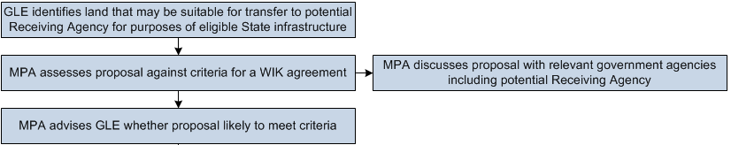

The scoping approval determines if a potential WIK proposal will likely meet the criteria for a WIK agreement (described in Part 3 of these WIK Guidelines) before the GLE invests in preparing a detailed WIK proposal.
During the initial scoping phase, the GLE identifies and discusses with the MPA any land that may be appropriate to transfer to a Receiving Agency in lieu of the GLE paying its GAIC liability in cash. Importantly, the land must be eligible for a WIK agreement – in other words, it must be in a declared growth area, and must be suitable for a State infrastructure project that could be funded by the State from the Growth Areas Public Transport Fund, or the Building New Communities Fund. GLEs can identify land that may be suitable for eligible State infrastructure projects by examining any applicable PSP or Growth Area Corridor Plan.
The MPA assesses whether the proposal meets the statutory requirements for a WIK agreement. The MPA discusses the proposal with relevant agencies, including the proposed Receiving Agency to assess if the proposal meets Government priorities.
The MPA then writes to the GLE advising if the proposal will be likely to meet the criteria for a WIK agreement, and (if so) invites the GLE to submit a detailed WIK proposal.
Step 2 – Detailed WIK proposal
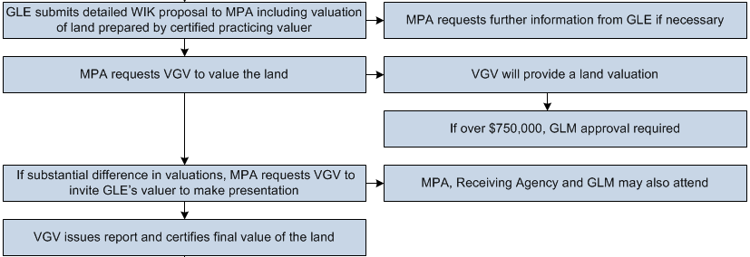

The main purpose of the WIK proposal is to provide sufficient detail to enable the Government to determine whether to proceed with the proposal. This includes assessing if the proposal represents value for money.
What is the GLE required to submit in a detailed WIK proposal?
A detailed WIK proposal involving a simple land transfer must outline:
- Details (and any plans) of the GAIC land
- Details of the GLE
- Details of the proposed Receiving Agency
- Details of the proposed transfer land and confirmation the transfer land is in a declared growth area
- The proposed purpose for which the transfer land could be used by the Receiving Agency
- If the GLE does not own the proposed transfer land, details of how that land would be procured or the legal rights the GLE has in relation to transferring the land to the Receiving Agency
- Details of any other relevant third parties and their relationships with the GLE (for instance, the owner of the proposed transfer land where it is not owned by the GLE)
- A valuation report of the current market value of the proposed transfer land, prepared by a certified practicing valuer
- Any other reports about the land that may be required (for instance, to satisfy requirements of the GLM Policy).
It is anticipated that most land to be transferred under a WIK agreement will be farming land. The MPA is therefore unlikely to require the GLE to submit any additional reports relating to the proposed transfer land, beyond a valuation report. However, if any other reports are required (for instance, to meet the requirements of the GLM Policy), the MPA will advise the GLE of these requirements.
The format for submitting a detailed WIK proposal involving a simple land transfer is set out in Attachment B of these WIK Guidelines.
Land valuation
The detailed WIK proposal stage involves two valuations of the land: one prepared by a certified practicing valuer retained by the GLE, and another independent valuation conducted by VGV on behalf of the MPA.
VGV’s valuation provides an independent expert assessment of the current market value of the proposed transfer land. This enables the Government to assess if the proposal represents value for money, and enables the MPA to determine the amount of GAIC credit to offer the GLE.
The GLE nominates the valuer it wishes to use in this process, and retains the valuer. However, to ensure that valuations undertaken by the GLE’s valuer and by VGV are conducted on a consistent basis, the MPA may determine it appropriate for VGV to instruct the GLE’s valuer about the basis on which the valuation should be undertaken. This does not undermine the independence of the GLE’s valuer – it simply ensures that valuations are conducted on the same basis to enable an efficient process.
Where the value of the land is likely to exceed the thresholds in the GLM Policy, the GLM is also involved in the valuation process, in accordance with the requirements of the GLM Policy. Involving the VGV and GLM enables the Government to assess WIK proposals on a consistent basis, and to meet appropriate governance and transparency requirements.
The basis on which the land is to be valued
The MPA will request VGV to assess the value of the land in accordance with the Valuation of Land Act 1960 (VL Act), the GLM Policy and Guidelines for Government Agencies Procuring Services from the Valuation Services Panel.
The VL Act sets out the principles for determining the value of land. These include:
- The use to which the land is being put at the relevant time, and the highest and best use to which the land might reasonably be expected to be put at the relevant time
- The effect of any Act, regulation, local law, planning scheme or other such instrument, which affects or may affect the use or development of the land
- The shape, size, topography, soil quality, situation and aspect of the land
- The situation of the land with respect to natural resources and to transport and other facilities and amenities
- The extent, condition and suitability of any improvements on the land that will be retained when the land is transferred to the Receiving Agency
- The actual and potential capacity of the land to yield a monetary return.
Valuation requirements under the GLM Policy
It is important to note the following principles and practices that will be adhered to, consistent with the requirements of the GLM Policy. In addition to the valuation prepared by the GLE’s valuer:
- A valuation will be obtained from VGV for all transactions (VGV may elect to use a valuer from VGV’s panel of valuers)
- Where the market value of the land is less than $750,000, generally only one valuation (from VGV) will be required, although VGV and/or the GLM may consider it appropriate to obtain a second valuation on behalf of the Government. The second valuation would be obtained from the Government’s panel of valuers
- Where the market value of the land is over $750,000, two valuations will be required, and GLM approval is required for the proposed GAIC credit the MPA offers the GLE.
What if the valuers do not agree?
If the GLE’s valuer and VGV do not agree on the current market value of the land, the MPA may request VGV to invite the GLE’s valuer to make a presentation to VGV. The GLM, MPA and Receiving Agency may also be invited to attend. VGV will consider if its valuation of the proposed transfer land should be adjusted in light of the presentation from the GLE’s valuer, and will issue a report and certificate which identifies the current market value of the proposed transfer land.
Step 3 – Determination and formal approval
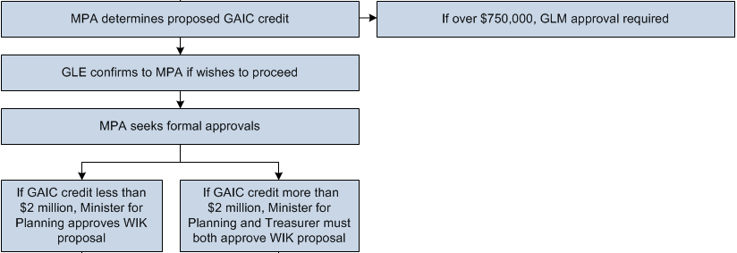

In this stage in the process:
- The MPA determines (on behalf of the Minister) the final amount of the GAIC credit to offer the GLE
- The GLE determines if it accepts the MPA’s offer of a GAIC credit and wishes to proceed with a WIK agreement
- The MPA obtains the formal approvals required under the PE Act to enable the WIK agreement to be entered into.
Formal offer from the MPA of a GAIC credit
Once the MPA has VGV’s final valuation, it determines (on behalf of the Minister) the amount of the GAIC credit to offer the GLE in return for the GLE transferring the land to the Receiving Agency. The amount of the MPA’s offer will not exceed VGV’s valuation of the land. Where required by the GLM Policy, the MPA will seek the GLM’s approval before putting an offer to the GLE.
Acceptance of the GAIC credit by the GLE
The GLE will need to decide if it accepts the amount of the GAIC credit offered, and if it wishes to proceed with the WIK proposal. Once agreed, the amount of the GAIC credit cannot change except as provided for in the model Land Transfer WIK Agreement. For example, the amount of the GAIC credit may be adjusted if the boundaries of the transfer land are adjusted before its transfer to the Receiving Agency.
Formal approvals
The PE Act requires the following formal approvals before a WIK agreement can be entered into:
- If the proposed GAIC credit is under $2 million, the Minister for Planning can approve the WIK proposal
- If the proposed GAIC credit is over $2 million, the Minister for Planning must seek approval from the Treasurer before approving the WIK proposal
- In all cases regardless of the proposed GAIC credit amount, the Minister for Planning must consult with other Ministers with a relevant interest in the WIK proposal (such as the Minister in charge of the proposed Receiving Agency).
Once formal approvals are given, the MPA writes to the GLE on behalf of the Minister for Planning advising it can start negotiating a Land Transfer WIK Agreement.
Step 4 – Negotiating and signing a WIK agreement
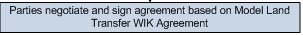
For a WIK proposal involving a simple land transfer, the WIK agreement will take the form set out in the model Land Transfer WIK Agreement.
Because the purpose of the transfer of the land is to discharge a GAIC liability, the parties to the agreement must include the Minister for Planning and the MPA, as well as the GLE and the Receiving Agency. The MPA leads negotiations on any changes to the model Land Transfer WIK Agreement on behalf of Government agencies.
The model Land Transfer WIK Agreement was drafted to capture the requirements of the legislation. There is therefore limited scope to amend the model Land Transfer WIK Agreement. However, the Government recognises that each proposal is unique, and will consider changes to the model agreement that are warranted given the nature of the particular proposal. Any variations to the model agreement must meet statutory requirements and obligations, and Government interests must be appropriately protected. The GLE is expected to bear the costs of making material amendments to the model agreement the GLE proposes.
Once any changes to the model agreement are negotiated and agreed, the parties sign an appropriate number of copies of the agreement to enable exchange of original signed counterparts.

ADMINISTRATION OF LAND TRANSFER AGREEMENTS
A Land Transfer WIK Agreement may provide for the transfer of a single parcel of land, or for the transfer of multiple parcels. Where multiple parcels are involved:
- There may be more than one Receiving Agency party to the agreement
- The agreement may be staged (with different parcels to be transferred in different stages).
The steps for administering a Land Transfer WIK Agreement are summarised below. The steps are set out in the flowchart at Chart A.
Step 1 – Joint inspection
Before land is transferred to the Receiving Agency, the MPA conducts a joint inspection of the land with the GLE and Receiving Agency to ensure the land is in transfer condition. To be in transfer condition, the land must be:
- In the same condition as when it was valued
- Able to be transferred pursuant to the agreement.
Step 2 – If the land is not in transfer condition
If the MPA is not satisfied that land is in transfer condition, the MPA provides the GLE with a list of tasks to perform so the land is in transfer condition. Once the GLE completes these tasks, the MPA conducts a further joint inspection of the land with the GLE and Receiving Agency to confirm the land is in transfer condition.
Step 3 – Land transfer
Once the MPA is satisfied the land is in transfer condition, it notifies the GLE to transfer the land to the Receiving Agency.
Step 4 – MPA issues a section 201SLL determination
Once the GLE has transferred the land to the Receiving Agency, the MPA issues a determination under section 201SLL of the PE Act and notifies the Commissioner that the WIK agreement (or the relevant stage of the WIK agreement) has been performed. It also notifies the Commissioner of the GAIC credit. The GLE is then taken to have discharged its GAIC liability by the amount of the GAIC credit.
The GLE can then apply to the Commissioner for a certificate of release, and is free to deal with the land to which the GAIC applies (or, in the case of a staged arrangement, the relevant part of the land).
Once the WIK agreement is fully performed, the Minister for Planning applies to the Registrar of Titles to remove the WIK agreement from the title to the land.
Expected timeframes for a WIK proposal involving a simple land transfer
It is in the interest of all parties to a WIK Land Transfer Agreement that land is transferred soon after its value is agreed and when the WIK agreement is entered into. This reduces the risk the land is no longer in transfer condition. The administration of a Land Transfer WIK Agreement could be completed within 6 months of the agreement being entered into.

WIK PROPOSALS INVOLVING WORKS

Developing and assessing a WIK proposal involving the provision of works can require significant time, effort and cost. The process for WIK proposals involving works is designed to ensure all parties have confidence that the proposal will succeed before a detailed proposal is prepared.
The criteria against which a WIK proposal is assessed are set out in Part 3 of these WIK Guidelines. Importantly, if the proposed State infrastructure project is identified in a document such as a PSP then, depending on the priority of that project for the State, it is likely the proposal will be considered appropriate for a Works WIK Agreement.

PROCESS FOR WIK PROPOSALS INVOLVING WORKS
The process consists of the following key steps:
- Preliminary discussions and initial scoping approval – the GLE identifies and discusses with the MPA an eligible State infrastructure project the GLE could potentially deliver in lieu of paying its GAIC (or part thereof) in cash. The GLE may also identify land that could be transferred to the State for an eligible State funded project. The MPA consults with relevant agencies (including the proposed Receiving Agency) and makes a preliminary assessment of whether the WIK proposal meets the criteria for a WIK agreement (refer to Part 3 of these WIK Guidelines). The MPA writes to the GLE advising of its assessment.
- Expression of Interest (EOI) – the GLE completes an EOI form (see Attachment C of these WIK Guidelines) which includes a preliminary estimate of the costs of works (and, if the proposal also involves the transfer of land, an estimate of the current market value of the land). After discussing the EOI with relevant agencies, the MPA makes a preliminary assessment of whether the proposal is likely to represent value for money to the Government. The MPA seeks ‘in principle’ approval of the proposal from the Minister for Planning and writes to the GLE advising if the proposal has ‘in principle’ support.
- Detailed WIK proposal – the GLE submits a detailed proposal including fully-costed works based upon a design and specifications agreed with the Receiving Agency, and a detailed land valuation report prepared by a certified practicing valuer (where applicable).
- Assessment – the GLE’s costings of the works are reviewed and assessed by the MPA based on advice from the proposed Receiving Agency and, where appropriate, an independent quantity surveyor. The MPA will request VGV to prepare a valuation of any land (for more detail regarding the land valuation process, see Part 4 Section A above).
- Determination – the MPA determines the amount of the proposed GAIC credit to offer the GLE, based on the advice of the Receiving Agency and the independent quantity surveyor (regarding the cost of the works) and VGV (regarding the value of the land). The GLE determines whether it accepts the MPA’s proposed GAIC credit, and if it wishes to proceed. If the GLE wishes to proceed, the MPA seeks the formal approvals required for the proposal.
- Negotiating and signing the WIK agreement – the parties negotiate any proposed amendments to the model Works WIK Agreement proposed by the GLE before the final form of the agreement is signed.
More information on these steps is provided below. Chart B sets these steps out in a flowchart.

Step 1 – Preliminary discussions and initial scoping approval
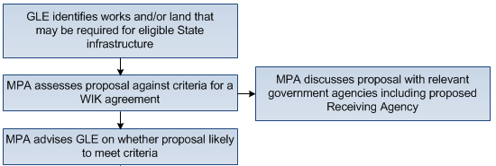

The initial scoping approval determines if a potential WIK proposal will be likely to meet the criteria for a WIK agreement (described in Part 3) before the GLE invests in preparing an EOI.
During this stage, the GLE identifies and discusses with the MPA a potential State infrastructure project the GLE could undertake pursuant to a WIK agreement. The project must be in a declared growth area, and eligible to be funded by the State from the Growth Areas Public Transport Fund or the Building New Communities Fund (the GAIC Funds). GLEs can identify eligible State infrastructure projects likely to meet the criteria for a WIK agreement by examining a PSP, a Growth Area Corridor Plan, or any State infrastructure identified in a transport plan prepared by DTPLI.
The MPA will assess whether the proposal meets the statutory requirements for a WIK agreement. The MPA discusses the proposal with relevant agencies, including the proposed Receiving Agency to assess if the proposal meets Government priorities.
The MPA then writes to the GLE advising whether the proposal will be likely to meet the criteria for a WIK agreement, and (if so) invites the GLE to submit an EOI.
Step 2 – Expression of Interest (EOI)
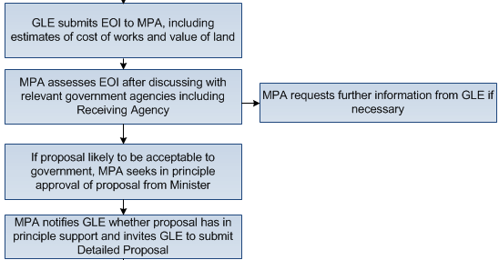

The EOI provides sufficient detail from the GLE to enable the Government to decide if the WIK proposal will be likely to succeed. This includes assessing the project’s early design and whether the proposal represents value for money. This provides the GLE with confidence before investing time in expensive design and costing work to develop a WIK proposal.
During this stage, the MPA and the Receiving Agency work with the GLE to build the GLE’s understanding of the Receiving Agency’s standards, specifications and requirements for any proposed works to be provided.

What the GLE must include in an EOI
The EOI for a WIK proposal involving works must outline:
- Overview details:
  - Details of the GLE
  - Details (area and title references) of the land parcel(s) to which the GAIC applies which is to be offset by the proposed WIK
  - The amount of the GAIC payable on these land parcels
  - A general description of the nature of the works and/or land that the GLE proposes to provide in lieu of part or all of the GAIC payment
  - Details of the proposed Receiving Agency
  - Proposed staging of the release of the land to which the GAIC applies.
- Works:
  - Preliminary plans and designs for the proposed works, if available, and if not, a concept plan based on information provided by the Receiving Agency
  - Details of any planning permits or other development approvals that may be required for the works
  - Proposed development time lines (including proposed staging of the works)
  - A preliminary cost estimate of the proposed works, including any general breakdown of the works if stages are proposed
  - An acknowledgement that the GLE (or its nominated builder) will comply with the Victorian Code and Victorian Guidelines
  - A warranty that the GLE is not precluded from performing the works (if the WIK proposal is approved by the Minister).
- Works land:
  - Details of the land on which the works are proposed to be constructed, including ownership, area and title references, and confirmation the works land is in a declared growth area
  - If the GLE does not own the proposed works land, details of how that land would be procured or the legal rights the GLE has in relation to delivering the land to the Receiving Agency
  - An estimate of the value of any works land proposed to be transferred to the Receiving Agency.
- Other transfer land:
  - Details of any other land the GLE proposes to transfer to the State, including ownership, area and title references, and confirmation the transfer land is in a declared growth area
  - If the GLE does not own the proposed transfer land, details of how that land would be procured or the legal rights the GLE has in relation to delivering the land to the Receiving Agency
  - An estimate of the value of any transfer land.
The format for submitting an EOI is set out in Attachment C of these WIK Guidelines.

The GLE may also need to confirm its financial position, including advising how it proposes to fund the costs of developing the WIK proposal.

The GLE must complete the Compliance Schedule contained in Attachment D of these WIK Guidelines and attach the completed Compliance Schedule to its EOI.
The MPA will assess the EOI in consultation with relevant agencies, and seek ‘in principle’ approval for a WIK proposal from the Minister for Planning. The MPA will write to the GLE advising if the proposal has ‘in principle’ support or not. If the EOI is successful, the GLE will be invited to proceed to the detailed WIK proposal stage.

Step 3 – Detailed WIK proposal
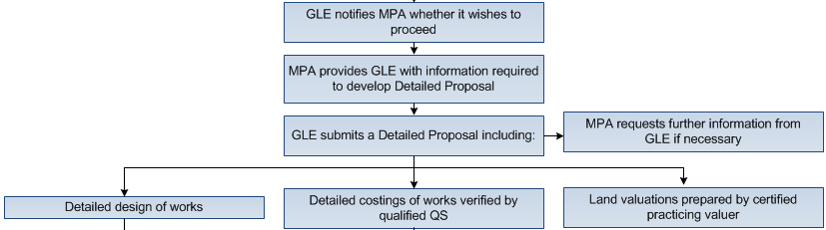

The detailed WIK proposal provides the Government with sufficient information from the GLE to enable the Government to assess if the WIK proposal meets the Receiving Agency’s requirements in terms of detailed design, and to assess if the proposal represents value for money.
The detailed WIK proposal must include:
- Confirmation of (or details of any changes to) the details submitted by the GLE with the EOI
- Detailed costings of the works
- Detailed design of the works
- Compliance with the Code of Practice for the Building and Construction Industry
- A valuation report of the current market value of any land proposed to be transferred as part of the proposal, prepared by a certified practicing valuer
- Any other reports about the land that may be required (for instance, to satisfy GLM requirements).
The development of a detailed WIK proposal is likely to involve refinements, particularly to the detailed design of the project. The GLE should consult regularly with the MPA (and, through the MPA, the Receiving Agency) during development of the detailed WIK proposal to help ensure the proposal satisfies the requirements of the MPA and the Receiving Agency.
Detailed costings of the works
The detailed costings of the works must include the GLE’s estimate of the total value of the proposed works which the GLE seeks to recover with a GAIC credit. Requirements to be addressed are:
- Detailed costings of the works, which have been verified by a qualified quantity surveyor and set out in a report explaining the basis of the costings
- The amount of any contingency factored into the estimate
- Payments to external consultants and advisers retained by the GLE regarding the project (financial, legal, engineering, other)
- Costs that Government advises the GLE it intends to pass on to the GLE (note that any such costs will be fully recoverable through the GAIC credit).
The detailed costings of the works should include:
- Costs incurred in designing the project
- Land and other development costs (purchase, lease)
- Raw materials
- Payments to external providers (such as payments to subcontractors or the cost of performance bonds)
- Costs of the procurement process (including project development, documentation and contract management)
- Plant and equipment (such as machinery and core IT platforms).

Detailed design of the works
The MPA and the Receiving Agency will provide the GLE with any specific requirements it needs to develop the detailed design, particularly any specifications, standards or requirements. The Receiving Agency will advise if it requires engineering drawings and architectural plans to be included in the agreed plans and specifications for the works.
In some cases, the Receiving Agency may require additional expert information such as proof engineering, safety audits and risk assessments to assess if the detailed design is appropriate. Similarly, in some cases a statement may be required confirming the design meets applicable legislative requirements relating to safety. Where this is the case, the MPA will advise the GLE to include this additional information in the detailed design.
Compliance with the Code of Practice for the Building and Construction Industry
All contractors undertaking public building and construction works under a WIK agreement must comply with the Victorian Code and the Victorian Guidelines. All applicable requirements of the Victorian Code and the Victorian Guidelines must be satisfactorily completed at the detailed WIK proposal stage, including submission of a workplace relations management plan.
Copies of the Victorian Code and Victorian Guidelines are available at www.dtf.vic.gov.au.
Land valuation
If a WIK proposal involving works also involves the transfer of any land to the Government (whether it is land on which the works are to be constructed, or other vacant land that could be suitable for an eligible State funded infrastructure project), the GLE must attach a valuation report prepared by a certified practising valuer to its detailed WIK proposal. The requirements and processes that apply to WIK proposals involving simple land transfer apply to the land components of any WIK proposal involving works. For a discussion of these requirements and processes, refer to Part 4 Section A above.
Government assistance
The MPA and Receiving Agency will assist the GLE to prepare a detailed WIK proposal by providing:
- Full details of any design requirements, standards and specifications the Receiving Agency requires to be met in relation to the works
- Any additional information required to accompany the detailed WIK proposal
- The form this information must be provided in
- Information about any costs incurred by the Government in assessing and approving a WIK proposal and which the Government expects to pass on to the GLE (such as the Receiving Agency’s costs in assessing the WIK proposal and approving the plans and specifications for the works). Note the GLE is entitled to fully recover these costs as part of the GAIC credit.

Step 4 - Assessment of the detailed WIK proposal
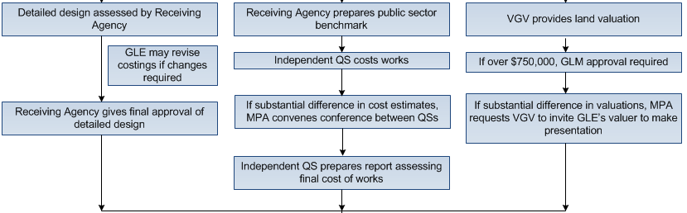

The detailed WIK proposal is assessed by the MPA and Receiving Agency in consultation with other relevant Government agencies. An assessment is made of the design of the works (and whether they meet the Receiving Agency’s requirements) and whether the proposal represents value for money for the Government. The MPA seeks the advice of:
- The relevant Receiving Agency about the estimated cost of providing the equivalent works at Government standards through the usual Government procurement processes (the ‘public sector benchmark’)
- An independent quantity surveyor, who assesses the GLE’s costings of the works in light of the public sector benchmark
- DTF and other relevant agencies
- VGV and (where required) the GLM with respect to any land components
- Any other Minister with a relevant interest in the proposed WIK (such as the Minister in charge of the proposed Receiving Agency).
In assessing value, any net additional value offered by a bid is considered and, if relevant, whether this value justifies a cost higher than that for which the public sector could deliver the WIK.
Valuing the works component
A detailed WIK proposal is unlikely to be approved unless the GLE’s cost estimate of the works component is within a range acceptable to the Government, having regard to the public sector benchmark for equivalent works.
The public sector benchmark is established by the Receiving Agency and used to assess if the works represent value for money. In addition, an independent quantity surveyor may be engaged to assess the costs of the works, having regard to the public sector benchmark. The identity of the independent quantity surveyor is agreed between the Receiving Agency, the GLE and the MPA.
If there is a substantial difference between estimates from quantity surveyors retained on behalf of the GLE and Government, the MPA convenes a conference between the quantity surveyors. The Government’s independent quantity surveyor is then asked to prepare a report describing whether he/she agrees or disagrees with the main areas of costing in dispute and whether he/she agrees to his/her costings being revised. The quantity surveyor’s report, along with the public sector benchmark, forms the basis of the MPA’s assessment of the final value for the works, and the amount of the GAIC credit offered for the works component.
Valuing the land component (if included)
For a discussion of requirements and processes for valuing the land component of a WIK proposal, and the process the MPA adopts to determine the amount of the GAIC credit offered for the land component, refer to Part 4 section A above.

Step 5 – Determination
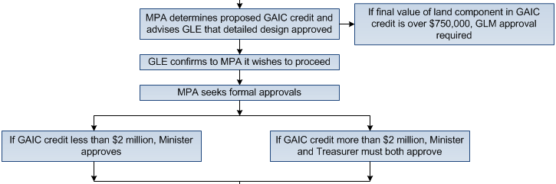

In this stage of the process:
- The MPA determines (on behalf of the Minister) the final amount of the GAIC credit to offer the GLE
- The GLE determines whether it accepts the MPA’s offer and wishes to proceed by entering into a WIK agreement
- The MPA obtains the formal approvals required under the PE Act to enable the WIK agreement to be entered into.
Formal offer from the MPA of a GAIC credit
Once the MPA determines the value of the works as described above and obtains VGV’s final valuation of any land component (refer to Part 4 Section A above), the MPA (on behalf of the Minister) determines the amount of the GAIC credit to offer the GLE.
Acceptance of the GAIC credit by the GLE
The GLE must decide if it accepts the amount of the GAIC credit offered and whether to proceed with the WIK proposal. Once agreed, the GAIC credit amount will not change except as provided for in the model Works WIK Agreement. For example, the amount of the GAIC credit may be adjusted to reflect approved variations to the works, or agreed adjustments to the boundaries of any land to be transferred to the Receiving Agency.
Formal approvals
The PE Act requires formal approvals before a WIK agreement is entered into. If the proposed GAIC credit is under $2 million, the Minister for Planning can approve a WIK proposal. The Minister may also consult with the Treasurer (although this is not required under the PE Act). If the proposed GAIC credit is over $2 million, the Minister is required to seek approval from the Treasurer before approving a WIK proposal.
Because the WIK proposal receives ‘in principle’ approval from the Minister for Planning at EOI stage, the GLE should have confidence that formal approvals will be given to the proposal.
The Minister for Planning must also consult with other Ministers with a relevant interest in the proposed WIK (such as the Minister in charge of the proposed Receiving Agency), although this consultation will generally already have occurred in Step 4 of the process (the Assessment stage).
Once the formal approvals are given, the MPA writes to the GLE on behalf of the Minister for Planning advising that it can start negotiating a Works WIK Agreement.

Step 6 – Negotiating and signing a WIK agreement
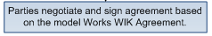
For WIK proposals involving works, the agreement takes the form set out in the model Works WIK Agreement.
Because the purpose of the agreement is to discharge a GAIC liability, the parties to the agreement must include the Minister for Planning and the MPA, as well as the GLE and Receiving Agency. The MPA leads negotiations on any changes to the model agreement.
The model Works WIK Agreement was drafted to capture the requirements of the legislation. There is therefore limited scope to amend the model Works WIK Agreement. However, the Government recognises that each WIK proposal is unique, and will consider changes to the model agreement that are warranted given the nature of the particular WIK proposal. Any variations to the model agreement must meet statutory requirements and obligations, and Government interests must be appropriately protected. The GLE is expected to bear the costs of making material amendments to the model agreement the GLE proposes.
Once any changes to the model agreement are negotiated and agreed, the parties sign an appropriate number of copies of the agreement to enable exchange of original signed counterparts.

ADMINISTRATION OF WORKS WIK AGREEMENTS

This section provides further information on key queries or issues that may arise during the operation of a Works WIK Agreement.

CAN WORKS BE STAGED?
Section 201SR of the PE Act allows GAIC Liable Entities (GLEs) to seek the Minister’s approval for the staged payment of GAIC liability for subdivisions or building works. The model Works WIK Agreement also provides for the staged delivery of works and/or land and includes a pro forma staging plan in Schedule 4.
Stages must allow for the regular and timely delivery of works. For example, it would generally not be appropriate for works involving a three year construction program to be delivered in a single stage. Further discussion of timing and staging of a Works WIK Agreement is included at Part 2 Section E of these WIK Guidelines.
Where a GLE proposes to stage completion of works and/or land transfer in a Works WIK Agreement, the GLE must consult with the Minister and the Receiving Agency to develop a staging plan which sets out, among other things, details of the works and/or land to be delivered in each stage and the agreed value of the works and/or land comprised in each stage.
Before entering into the Works WIK Agreement, the GLE will need to formally submit the proposed staging plan to the Minister for approval under section 201SR of the PE Act. It is intended that the approved staging plan will then constitute the notice given by the Minister for the purposes of section 201SU of the PE Act. It is for this reason that the information to be included in the staging plan (as set out in the pro forma in Schedule 4 to the model Works WIK Agreement) is aligned to match the notification requirements of section 201SU of the PE Act.
Any amendment of the staging plan in accordance with the terms of the Works WIK Agreement (for example, as a consequence of an extension of a due date for completion) will require the GLE to submit the amended staging plan to the Minister for further approval under section 201SR(7) of the PE Act. It is Government policy that any extension to a due date under a staging plan will be approved under section 201SR(7), to ensure that the staging plan and the GLE’s staged payment arrangements are aligned.

STAGING UNDER A WORKS WIK AGREEMENT
A staging plan constitutes a section 201SU notice
The staging plan in Schedule 4 of the model Works WIK Agreement is drafted so that it can constitute a staged payment approval notice for the purposes of section 201SU of the PE Act (once it has been approved by the Minister under section 201SR). This streamlines processes for GLEs.
Because the staging plan constitutes a staged payment approval under section 201SR, the value of each stage of WIK (which is identified in the staging plan) must be no less than the corresponding GAIC liability in respect of the relevant part of the GAIC land (also identified in the staging plan).
Works or land provided in stages under a Works WIK Agreement can either be completed in non-discrete stages or discrete, stand-alone stages.
Non-discrete staged works
In this case, the model Works WIK Agreement is drafted to apply to proposals involving delivery of works in non-discrete stages – in other words, where each stage is not stand alone and is only fit to be transferred to the Receiving Agency when all stages are completed.
A simplified example of this type of proposal might involve a works package for a road grade separation project to create a rail underpass. These works would comprise a number of stages identified in a staging plan such as:
Stage 1: works to lower train lines
Stage 2: construction of new train platform
Stage 3: construction of new road
Stage 4: completion of traffic signaling works and any integration works.
Stage 5: transfer of the complete works package and the underlying works land to the Receiving Agency.
For non-discrete staged works, the GLE will not transfer the works comprised in any single stage to the Receiving Agency until all stages are completed (and the underlying works land is in the transfer condition).
In the above example, the second last stage requires completion of the last parcel of works (the traffic signaling works) and any other works required to integrate the various stages. This is so the MPA can assess the completed package of works. The final stage requires transferring the complete package of works and the underlying works land to the Receiving Agency.
Although it is not essential to do so, there may be various reasons for separating the last parcel of works and the transfer of the complete package of works (and the underlying works land) into separate stages. Firstly, it allows the MPA to determine that the entire package of works has been satisfactorily completed before needing to determine whether the land is in transfer condition (allowing more time for these processes to be undertaken). It also reduces the complexity of the GLE’s performance requirements for the final stage (ensuring the land is in transfer condition is likely to be simpler once the works are complete). If the GLE considers that it has achieved completion of both the final two stages at the same time, there is no reason why the MPA cannot assess completion of both stages simultaneously.
Discrete staged works
Alternatively, a WIK proposal may involve discrete parcels of works in each stage, where the different items of works are stand-alone and can be constructed and transferred to the Receiving Agency at different times. For example, discrete staged works might comprise:
Stage 1: construction of a roundabout
Stage 2: transfer of the roundabout and the underlying works land to the Receiving Agency
Stage 3: construction of a rail car park
Stage 4: transfer of the car park and the underlying works land to the Receiving Agency.
Once the construction works comprised in each stage of discrete staged works are completed, the next stage requires the transfer of the completed works and underlying works land to the Receiving Agency. The reasons for separating the completion of the works and the transfer of the works into separate stages are explained above.

Land release
When the works for a stage are completed (or, where relevant, works and/or land is transferred to the Receiving Agency) by the due date, the GAIC liability for that stage is discharged and the GLE can apply for a certificate of release from the Commissioner. The GLE is then entitled to sell any lots in the released land, as it is free from any GAIC liability.
Road example
This is an example of how a staged Works WIK Agreement may work. The GAIC land in the example comprises five titles, each with a $2 million GAIC liability. The proposal is to construct works for the duplication of an existing local road to become an arterial road. The works will be constructed over part of the land in Title 1, and will be delivered to VicRoads (the Receiving Agency) in three stages over three years. The works are valued at $7 million in total, so when the works are complete the GLE will receive a GAIC credit of $7 million towards its total $10 million GAIC liability. The text should be read in conjunction with the diagram below.
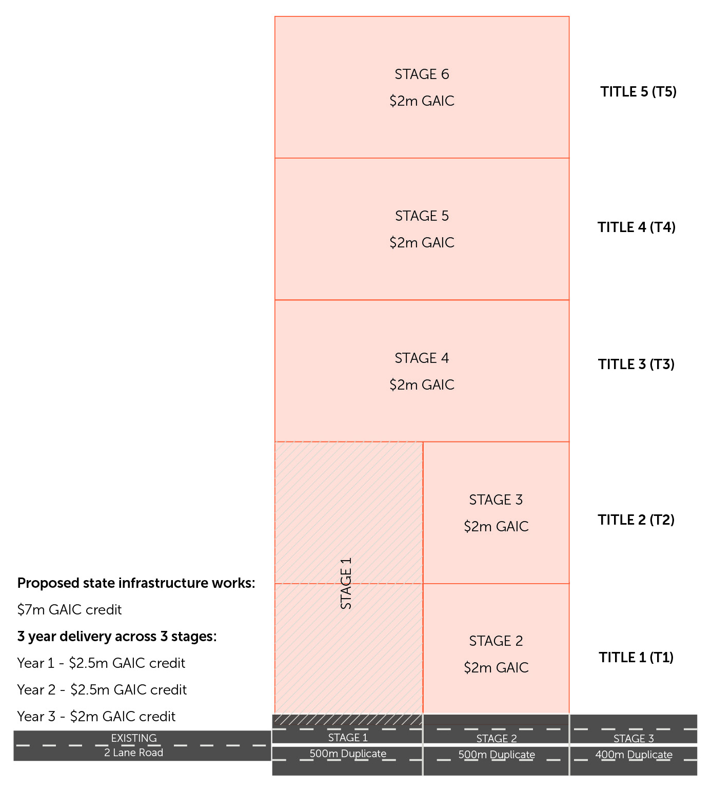
- Stage 1 of the WIK agreement involves the first 500m section of duplication works. The Stage 1 works are valued at $2.5 million, and (when complete) will result in a GAIC credit of $2.5 million, which could be used to fully offset the $2 million GAIC liability on Title 1, and part of the GAIC liability on Title 2.
- However, rather than wait for the delivery of the Stage 1 works under the WIK agreement (due at the end of year 1), the GLE chooses to pay the $2 million GAIC liability on Title 1 in cash (to clear that title of its GAIC encumbrance and allow the release of Title 1). The GLE wants to use the $7 million GAIC credit available under the WIK agreement to offset the balance of its GAIC liability (ie the $8 million liability attached to Titles 2, 3, 4 and 5).
The GLE’s proposal is:
  - The GLE will pay the $2 million GAIC liability on Title 1 in cash, reducing its total liability to a balance of $8 million.
  - The $7 million GAIC credit available in respect of the works will be used to:
    - fully offset the $2 million GAIC liability on Title 2; and
    - partially offset the balance $6 million GAIC liability on Title 3, Title 4 and Title 5,
leaving the GLE with a balance GAIC liability of $1 million, to be paid in cash.
  - At the end of year 1 of the WIK staging program (assuming successful delivery), the $2.5 million GAIC credit clears 100 per cent of the $2 million GAIC liability on Title 2, and $500,000 of the GAIC liability on Title 3. The GAIC encumbrance on Title 2 is then removed by the SRO, and interest stops completely on Title 2 and partially on Title 3.
  - At the end of year 2 of the WIK staging program (assuming successful delivery), the $2.5 million GAIC credit in respect of the Stage 2 works clears the balance of the $1.5 million GAIC liability on Title 3. The remaining $1 million GAIC credit is used to partially offset the GAIC liability on Title 4 (leaving a balance of $1 million owing on Title 4). The GAIC encumbrance on Title 3 is then removed by SRO and interest stops completely on Title 3 and partially on Title 4.
  - At the end of year 3 of the WIK staging program (assuming successful delivery), the $2 million GAIC credit in respect of the Stage 3 works clears the balance of the $1 million GAIC liability on Title 4 and offsets $1 million of the Title 5 liability. The GAIC encumbrance on Title 4 is then removed by SRO and interest stops completely on Title 4 and partially on Title 5.
  - The balance of the $1 million GAIC liability for Title 5 is to be paid in cash by the GLE as required and agreed with the MPA.

DETERMINING COMPLETION
The process for the MPA determining whether a stage under a Works WIK Agreement is complete comprises two basic steps:
- Assessment – the assessment process will vary depending on whether the particular stage involves the construction of works or the transfer of land (with or without works) to the Receiving Agency.
- Determination – the MPA issues a determination regarding whether or not the works are completed or the land is in transfer condition and has been transferred to the Receiving Agency.

Step | Description of process
Assessment | Notice  The GLE advises Government Entities in writing that the works (or the relevant stage of the works) are completed, or that the land is in transfer condition.  Inspection and assessment  The Government Entities conduct a joint inspection of the works or land with the GLE. The MPA consults with the Receiving Agency and may require additional work before it determines if the works are satisfactorily completed, or if the land is in transfer condition.  Assessment for works  The MPA assesses whether the works are completed by the due date for that particular stage.  Assessment for transfer of land  The MPA assesses whether the works land or transfer land to be transferred in that particular stage is in transfer condition:  - If so, the MPA directs the GLE to transfer the land to the Receiving Agency  - If not, the MPA advises the parties of the tasks the GLE needs to perform to ensure the land is in transfer condition
Determination | Determination of completion  If the MPA determines that works are completed by the due date, or the land is in transfer condition and has been transferred to the Receiving Agency by the due date:  - The MPA issues a determination to that effect and notifies the Commissioner  - The GLE is entitled to a GAIC credit equal to the value of the works and/or land relating to that stage.  - The GLE can apply for a GAIC Certificate of Release or Partial Release  - When the GAIC is fully discharged the Commissioner will request that the Registrar remove the GAIC Notice from the title  Determination of non-completion  If the works are not completed or the land is not in transfer condition or has not been transferred to the Receiving Agency:  - The MPA advises the parties of the tasks the GLE needs to perform to ensure satisfactory performance  - If due dates have not passed, the GLE has opportunity to complete the tasks and avoid a default  - If the relevant due dates have expired:  - a GAIC default event occurs  - the GLE is liable for penalties and interest under the PE Act and the TA Act  - the GLE must still complete its obligations under the WIK agreement.  The default procedures are set out in a flow chart in Chart E of these WIK Guidelines.

DISCHARGING A GAIC LIABILITY UNDER A WORKS WIK AGREEMENT
Merely entering into a Works WIK Agreement will not satisfy a GLE’s obligation to pay its GAIC liability.
The GLE only discharges its GAIC liability when the Works WIK Agreement is satisfactorily performed (as determined by the MPA in consultation with the Receiving Agency). The design and standard of construction of works must fully conform to the specification agreed to before the Works WIK Agreement was entered into.
The GLE is entitled to a GAIC credit once the MPA determines the GLE has satisfactorily performed its obligations under the Works WIK Agreement. The MPA must notify the Commissioner of completion before the agreed GAIC credit is granted. The model Works WIK Agreement requires the MPA to notify the Commissioner expeditiously.
Where the WIK is staged, the procedures for assessing and determining completion of the works will apply to each stage.

VARYING WORKS AFTER A WORKS WIK AGREEMENT IS ENTERED INTO
Works can be changed or varied after the Works WIK Agreement is entered into, either:
- At the request of the Receiving Agency (see clause 13 of the model Works WIK Agreement)
- At the request of the GLE (see clause 14 of the model Works WIK Agreement).
Receiving Agency variations
The Government acknowledges that variations to the works at the request of the Receiving Agency may have significant indirect effects on a GLE, including impacts on construction programs and other projects. Accordingly, variations will only be explored by the Receiving Agency when regarded as essential. The model Works WIK Agreement includes protections to ensure the GLE is not disadvantaged by a Receiving Agency variation:
- The Receiving Agency must consult with the GLE at least 30 business days before requesting a variation under a Works WIK Agreement.
- Where a Receiving Agency variation results in a net cost increase, the GLE will be paid the amount of that increase.
- Where the Receiving Agency variation will delay the GLE in performing the works by the due date, the GLE is entitled to claim an extension of time.
- Where the GLE and the Receiving Agency cannot reach agreement in relation to the Receiving Agency variation, the GLE is entitled to refer the matter for dispute resolution in accordance with the process set out in the model Works WIK Agreement. This includes referral to an independent quantity surveyor for a decision on the net cost saving or increase associated with the variation. Where possible, the independent quantity surveyor to determine the dispute between the parties should be the independent quantity surveyor engaged to help the MPA determine the value of the works before entering into the Works WIK Agreement.
- Receiving Agency variations would not receive a GAIC credit and are to be funded by the Receiving Agency.
Required variations
Certain events occurring after a Works WIK Agreement is entered into may give rise to a requirement to vary the works. To ensure the GLE obtains the benefit of the protections listed above (including payment for increased costs and an extension of time), these variations are treated as Receiving Agency variations.
The relevant events (defined in the model Works WIK Agreement as a State Risk Event) include:
- Where works are being carried out on State-owned land:
  - The identification of land conditions that could not have been reasonably foreseen by a skilled, prudent and competent contractor acting in accordance with good construction industry practice or
  - The State fails to provide the GLE with access to the land
- A legal requirement to suspend or vary the works due to the presence of native title or cultural artefacts
- Inclement weather.
GLE variations
- The GLE may also request a variation (provided this does not decrease the scope of the works) by providing the Receiving Agency with a variation notice. The notice must explain the proposed variation and describe its impact. If the Receiving Agency approves the variation, the GLE may proceed to implement that variation and the plans and specifications are amended accordingly. The GLE bears all costs and other risks (including time impacts) associated with implementing a GLE variation. GLE variations would not receive a GAIC credit and are to be funded by the GLE.

VALUATION MECHANISMS USED IN MODEL AGREEMENTS
The table below describes the valuation mechanisms that might be required to be used once a WIK agreement has been entered into. The table does not include the valuation processes that occur in relation to WIK proposals; these are described in Parts 4 and 5 of these WIK Guidelines.
Scenario and type of mechanism | Reference in model Works WIK Agreement
Boundary adjustments  A party may make a request to the other parties to the WIK agreement to make adjustments to the works land or transfer land before the due date for the transfer of the land.  Where the parties approve a boundary adjustment of less than 5% (a Minor Boundary Adjustment), the GAIC credit is adjusted by deducting or adding the value of the affected area (calculated on the value per square metre used to determine the original GAIC credit) to the original land value.  Where the parties approve a boundary adjustment of 5% or more (a Major Boundary Adjustment), the adjustment to the GAIC credit is calculated on the current market value of the affected area at the time of the boundary adjustment (the original value of the part of the land unaffected by the boundary adjustment remains unchanged).  Where there is disagreement on valuation for a Major Boundary Adjustment, the Government Entities seek a valuation from VGV. The GLE must also engage a land valuer to assess the land value. If the parties cannot agree on the land value, VGV will arrange a valuer’s conference. Following this conference, VGV prepares a written report certifying the land value the boundary dispute affects. | Clauses 21 and 35.6
Receiving Agency variations  For an overview of the process involving Receiving Agency variations, see section E of Part 6 above.  The methodology for the GLE to value the requested variation is based on the principles for calculating costs and savings set out in Schedule 9 of the model Works WIK Agreement.  If the parties cannot agree on variation costs, the parties engage a quantity surveyor to assess the variation to work value. The same quantity surveyor engaged in the initial assessment of costs should be engaged. | Clauses 13.6 – 13.8 and 35.
GLE variations  For an overview of the process involving GLE variations, see section E of Part 6 above.  The GLE must set out the matters relating to costs as provided in clause 14.1 of the model Works WIK Agreement and must comply with the principles for calculating costs and savings as outlined in Schedule 9 of the model Works WIK Agreement. | Clauses 14.1 – 14.3
Required variations  For an overview of the process involving required variations, see Section E of Part 6 above. The same valuation methodology for Receiving Agency variations is used. | Clause 14.4
Partially completed works  The MPA determines the value of partially completed works based on advice which it deems necessary to make such a determination. The amount is determined by the value of the works, with the completion costs subtracted. | Clauses 16.2, 16.4

AVOIDING DEFAULT
The timing of and standard for delivery of works or land are critical to the Works WIK Agreement. If the GLE fails to perform its obligations under the Works WIK Agreement, section 201SLN of the PE Act and the model Works WIK Agreement state the GLE is liable to:
- Pay the residual GAIC, being the residual GAIC liability after valuation of the partially completed works, together with any interest due under the PE Act
- Continue to perform its obligations under the agreement
- Pay interest and penalty tax as set out in the TA Act.
Importantly, there are no provisions in the PE Act which allow penalties and interest to be waived or reduced. However, the Commissioner has some discretion around setting the amount of interest and penalty tax in respect of a tax default under the TA Act. For more information, refer to Revenue Ruling TAA.007 available on the SRO website at www.sro.vic.gov.au.
The consequences of default by the GLE reflect the importance of on-time and on-specification performance. However the Government recognises the severity of the statutory consequences of default, and will work constructively and in good faith with GLEs to seek to avoid defaults.
A number of mechanisms are incorporated into the model Works WIK Agreement to allow the Government and GLEs to collaborate and avoid default by providing GLEs with opportunities to rectify defaults before termination rights are triggered. These mechanisms are summarised below.
Mechanism | Description
Project Steering Committee (PSC) (clause 4.3) | A PSC is convened to monitor and review progress of the works. The PSC includes representatives from the MPA (1), Minister (1), GLE (2), Receiving Agency (2) and other members agreed between the parties (e.g. subcontractors). The PSC meets 20 business days before a works due date, or any other times agreed following a request by the GLE or Receiving Agency.  The PSC facilitates dialogue between the WIK participants and promotes open communication between the parties. For example, the PSC may convene meetings to undertake inspections and review progress of works.
Extensions of time (clause 15) | If circumstances beyond the GLE’s control arise which mean it is unlikely the GLE can deliver the works by the due date, the GLE should work with the Government Entities to attempt to resolve the situation and may, where applicable, request an extension to the date for performance.  The GLE is entitled to an extension to the due dates for performance under the model Works WIK Agreement where the GLE is actually delayed by an “Extension Event” and the cause of that delay was beyond the GLE’s reasonable control. The list of “Extension Events” which may allow a time extension are:  - A breach of the Works WIK Agreement by the Minister or the Receiving Agency  - An act or omission of a Government Entity (unless permitted under the WIK agreement or caused by the GLE)  - Industrial action  - A “State Risk Event”, which includes inability to access works land owned by the State, or a lawful requirement to stop works due to the discovery of cultural heritage or artefacts  - Land conditions that could not have been reasonably foreseen by a competent and prudent operator  - A change in law  - A force majeure event.  Where the GLE is granted a time extension, the staging plan is amended and re-submitted to the Minister for approval under section 201SR of the PE Act to reflect the revised due dates.  In addition, the Minister has a power to unilaterally extend time pursuant to clause 15.11 of the model Works WIK Agreement.
State Risk Events (clauses 14 and 15) | Where a State Risk Event occurs, the GLE is entitled to:  - seek a required variation to the works  - seek an extension of time.  See the discussion of required variations in Section E above for more detail.
Staging plan (Schedule 4) | The Government will work with the GLE to develop a realistic timetable for delivery of works under a staging plan, to reduce the risk of a GLE defaulting on due dates during delivery of the project.  Any changes to a staging plan during the course of a Works WIK Agreement will require further approval from the Minister under section 201SR. Where the staging plan is amended (such as where the GLE is granted extensions of time to the due dates for a stage), the Minister will approve the changes under section 201SR to ensure the staging plan and the GLE’s staged payment arrangements are kept aligned.
Substitute cash payments (clause 20) | The model Works WIK Agreement includes a “Substitute Cash Payment” mechanism to allow the GLE, in certain circumstances, to decouple its obligations to discharge the GAIC liability from its contractual obligations to complete the works relating to a particular stage, so that a failure to complete the works by the due date does not trigger a GAIC default.  If the Minister consents to a substitute cash payment relating to a particular stage and the GLE makes this payment by the due date, the GLE is deemed to have satisfied its obligations relating to the GAIC liability for that stage. However, this does not relieve the GLE of its obligations to complete the works. Once the GLE has completed the works, it is entitled to apply to the SRO for a refund of the overpaid GAIC.  The substitute cash payment is intended to be available for interim stages under a WIK agreement. It is not intended to allow changes to the final stage delivery date for the works.
Joint inspections and the completion process (clause 16) | After a joint inspection, the MPA determines the extent to which the works are completed (or the land is in transfer condition) in a particular stage. If the MPA determines that completion is not achieved, the MPA identifies the tasks that need to be undertaken for completion to be achieved. If the due date has not yet passed, the GLE has the opportunity to complete the outstanding tasks before the due date.
GAIC credit upon default, and refund of overpaid tax on completion (clauses 19 and 27.3) | If the GLE has not achieved completion by the due date, a GAIC default event occurs. The MPA’s determination will include:  - The MPA’s assessment of the value of any partially completed works  - A cure period (set in consultation with the Receiving Agency) for completing the remaining works.  The GLE is entitled to a partial GAIC credit (for the value of the partially completed works) immediately after the MPA notifies the Commissioner of its determination.  Once the following occurs, the GLE can also apply to the SRO for a refund of overpaid tax:  - The GLE has paid the residual GAIC  - The GLE has paid the interest and penalties required under the PE Act and TA Act  - The GLE has completed its obligations to complete the works under the Works WIK Agreement  - The MPA has advised the Commissioner the WIK has been performed.  (As the residual GAIC would have already been paid pursuant to section 201SLN, the performance of works is considered an overpayment of GAIC by the GLE.)  An application for a refund must be made within 5 years of the date of overpayment, and in accordance with the TA Act.

NB: The table above is a summary only, and is not an exhaustive description of the relevant clauses. Refer to the model Works WIK Agreement for a more detailed understanding of the applicable mechanisms.

WHAT SECURITY IS REQUIRED?
When a default event occurs and the GAIC liability is deferred or staged, the unpaid GAIC becomes a charge on the land and is not removed until the GAIC liability is discharged. In addition, the model Works WIK Agreement requires performance bonds. The agreed bond amount will be consistent with market practice. As set out earlier in these WIK Guidelines, the GLE can include the costs of providing security bonds in its detailed costing submitted to the Government for its consideration at the outset of the process, and can be recovered by way of the GAIC credit.

THE END OF A WORKS WIK AGREEMENT
Unless terminated earlier, a Works WIK Agreement ends on the later of:
- Full discharge by the GLE of its obligations under the Works WIK Agreement
- Expiry of the defects liability period.
In some cases, the GLE’s obligation to rectify defects during the defects liability period may be removed from the Works WIK Agreement and instead be included in a simple transition agreement between the GLE and Receiving Agency. This may be appropriate in cases where, for example, it is important for the record of the Works WIK Agreement to be removed from the title of the relevant land as soon as the works and works land are handed over to the Receiving Agency and the GAIC credit is given. If this alternative arrangement to defect rectification applies, the Works WIK Agreement ends upon full discharge by the GLE of its obligations under the Works WIK Agreement.
A WIK agreement may also end at any time with agreement from the parties. In these circumstances, the MPA determines the extent to which the Works WIK Agreement has been completed on the date the Works WIK Agreement ends (i.e. value the partially completed works), and any corresponding GAIC credit the GLE may be entitled to.

DISPUTES
Clause 35 of the model Works WIK Agreement sets out a comprehensive process to be followed when a dispute or difference arises between the parties.
Generally, any party to a Works WIK Agreement can issue a dispute notice to the other parties. Initially, the parties will appoint executive negotiators to attempt to resolve the dispute through good faith negotiations. Failing this, an independent expert is appointed to resolve the dispute. Litigation may not proceed until other dispute resolution avenues set out above are exhausted.
Dispute notices cannot be issued in relation to certain types of disputes which the PE Act provides must be determined by the Minister or the MPA in its discretion. In particular, a dispute notice cannot be issued in respect of:
- Determinations required to be made by the MPA under the PE Act, including those relating to the completion of works, transfer of works land, the value of the works or GAIC credit, or default events.
- Decisions required to be made by the Minister, including those relating to substitute cash payments and impacts on the amount of GAIC credit.

It would be contrary to the legislation for the Works WIK Agreement to fetter the MPA’s or the Minister’s discretion relating to these decisions. Refer to clause 35.1(b) of the model Works WIK Agreement for a comprehensive list of these decisions.

Attachments
Attachment A – Roles of key participants in the Model Works WIK Agreement
Attachment B – Detailed proposal for GAIC WIK Land Transfer
Attachment C – Expression of interest for GAIC WIK proposal for Works and Land
Attachment D – Compliance schedule

Charts
Chart A – Assessment process for WIK proposals involving Land Transfer (without Works)
Chart B – Assessment process for WIK proposals involving Works (with or without Land)
Chart C – For stages involving works
Chart D – For stages involving handover of works and/or transfer of land
Chart E – Default Notice Process

ROLES OF KEY PARTICIPANTS IN THE MODEL WORKS WIK AGREEMENT
Participant | Role
Minister for Planning  (these functions may be delegated) | - Monitoring the GLE’s progress in performing its obligations under the agreement, including participating in Project Steering Committee meetings and procuring the MPA to undertake inspections of the works at key milestone dates (these functions are shared with the MPA and the Receiving Agency).  - Approving variations requested by a Receiving Agency which may reduce the scope of the works (and therefore the amount of the GAIC credit).  - Approving extensions to dates in a staging plan under section 201SR(7).  - Considering any requests for changes to boundaries of the works land or transfer land, including considering any resulting adjustments to the value of the land (this is a shared function of all the parties).  - Considering requests by the Receiving Agency to terminate the agreement.  - Ending the agreement where all parties agree.  - Ensuring the agreement is registered on title, and applying to the Registrar to amend or remove the recording of the agreement on title if the agreement is amended or ended.
Receiving Agency | The Receiving Agency’s role under the model Works WIK Agreement is primarily to work with the GLE and the other Government Entities to ensure that works provided under the agreement are delivered. The Receiving Agency’s role also includes:  - Approval of standards, specifications and designs (functional and detailed designs) for proposed works (these are approved before the agreement being entered into), and approving any variations to the approved specifications  - Monitoring the GLE’s progress in performing its obligations under the agreement, including participating in the Project Steering Committee, progress inspections, final inspections and defects liability inspections of works being performed under the agreement  - Requesting and negotiating variations to the works (a variation request may be initiated by either the Receiving Agency or the GLE) – note that any variation proposed by the Receiving Agency which reduces the scope of the works requires the Minister’s approval  - Granting extension requests to the due dates for performance of the works under the agreement  - Accepting handover of completed works and the transfer of land that is in transfer condition  - Considering any requests for changes to boundaries of the works land or transfer land, including any resulting adjustments to the value of the land (this is a shared function of all the parties)  - Serving default notices (except where the default constitutes a GAIC default event – these are the responsibility of the MPA), and managing the cure process and determining if the GLE has cured the default within the required cure period (in consultation with the MPA)  - Terminating the agreement if the GLE fails to remedy a default (this requires the consent of the Minister, and the Receiving Agency can only terminate the agreement after the due dates for performance)  - Terminating the agreement for an immediate termination event (for example, the GLE failing to obtain the approvals it needs to perform works within the required period). This also requires the consent of the Minister.
MPA | Part 9B of the PE Act requires the MPA to determine the extent to which the agreement has been performed by the GLE. Hence it is important the MPA is a party to the agreement as it effectively makes all determinations relevant to performance of the agreement.  To be in a position to discharge this responsibility, the MPA also needs to be able to inspect the works and the land, and this is provided for in the agreement. In particular, the MPA’s role under the agreement includes:  - Convening, chairing and participating in Project Steering Committee meetings  - Monitoring the GLE’s progress in performing its obligations under the agreement, including conducting joint progress inspections and final inspections of works being performed under the agreement  - Determining whether the GLE has performed its obligations under the agreement (including determining whether works have achieved completion and whether land to be transferred to the Receiving Agency is in the appropriate condition before transfer)  - Issuing statutory determinations required to be issued under Part 9B of the PE Act in relation to performance  - Determining the amount of the GAIC credit, in accordance with its statutory obligations under Part 9B of the PE Act  - Issuing default notices in relation to GAIC default events (i.e. GLE defaults which constitute a failure to perform its fundamental obligations under the agreement to discharge its GAIC liability)  - Consulting with the Receiving Agency in relation to the process for curing defaults, and providing final sign-off as to whether defaults have been satisfactorily remedied  - Determining the extent of the GLE’s performance under the agreement where a default occurs, or where the agreement is ended early by the mutual agreement of the parties.
GLE | The fundamental obligations of the GLE under a Works WIK Agreement include:  - Obtaining all approvals required to perform its obligations under the Works WIK Agreement from each relevant authority in a timely manner (including all planning permits, planning scheme amendments and consents under the Road Management Act2004)  - Designing, constructing, completing and (where appropriate) commissioning the works by the due date for completion of the works  - Handing over the works and transferring the underlying works land to the Receiving Agency by the relevant due dates for performance, along with all necessary documentation  - Assuming, during the risk period, all liability for the care of the works, the transfer land and the works land, as well as all materials brought onto the works land for the purposes of the works  - Monitoring the performance of its subcontractors  - Participating in the Project Steering Committee  - Providing financial security for the performance of its obligations  - Rectifying defects in the works  - Transferring any transfer land to the Receiving Agency by the due date for performance  - Assigning and/or licensing relevant intellectual property rights to the Receiving Agency and the Minister  - Effecting and maintaining appropriate insurances in respect of the works.
Subcontractors | Engaging subcontractors to deliver a WIK asset  The GLE may subcontract any or all of its obligations under a Works WIK Agreement to a related entity or a pre-approved subcontractor. It may subcontract to another entity, provided it has the consent of the Receiving Agency.  The engagement of a subcontractor to perform any or all of the GLE’s obligations under the agreement does not limit the GLE’s obligations or liabilities under the agreement. The GLE must notify the Minister and the Receiving Agency of its intention to subcontract, and must monitor and ensure compliance by each subcontractor with the subcontract and any related direct deed (see below), as relevant.  The GLE must not enter into any subcontract, unless the subcontract contains provisions expressly recognising and permitting the exercise by the Minister and the Receiving Agency of their rights under the Works WIK Agreement.  In addition, the GLE may be required to:  - Give the Minister and the Receiving Agency copies of any subcontracts it proposes to enter into  - Require that any of its material subcontractors enter into a direct deed with the Minister and the Receiving Agency which will create a direct contractual relationship between the material subcontractor and the Minister and the Receiving Agency for the purpose of ensuring delivery of the work-in-kind  - Ensure that subcontractors attend Project Steering Committee meetings (if requested by the Minister or the Receiving Agency).  If the Building and Construction Industry Security of Payment Act 2002 (Vic) (Security of Payment Act) applies to the subcontract, the GLE must ensure that, within:  - 2 business days after any notice under the Security of Payment Act is given to, or received by, the GLE from the subcontractor  or  - 1 business day after notice of the subcontractor's intention to suspend work under the subcontract pursuant to the Security of Payment Act is given to, or received by, the GLE from the subcontractor  a copy of that notice is given to the Minister and the Receiving Agency.  If the subcontractor becomes entitled to suspend work because of the GLE’s failure to pay the subcontractor, the Minister and Receiving Agency are entitled to step in and pay the subcontractor, and the amount paid becomes a debt due and payable by the GLE to that party.
Government Entities generally | All of the Government Entities have general obligations under the agreement to:  - Provide information, directions or instructions reasonably required by the GLE to assist it to perform its obligations under the agreement in a timely manner  - Assist the GLE to obtain approvals – in some cases, the Receiving Agency may also be the agency responsible for granting the approval (for example, VicRoads is responsible for granting road management consents).

DETAILED PROPOSAL FOR GAIC WIK LAND TRANSFER
To enable assessment of the strategic fit of a WIK proposal relating to the proposed development area the landowner must provide the following details.
Section numbers refer to sections of the Planning and Environment Act 1987. Capitalised and abbreviated terms have the meaning given in these WIK Guidelines.
 | Information required | Response
1 | Details of the land parcels to which the GAIC applies which is to be offset by the WIK (the GAIC Land)  Please provide details of the location (i.e. street address), size, title and plan reference(s).
2 | Details of the GLE (owner of the GAIC Land).  Where the GLE is a company, please include details of the ownership of the company.
3 | Details of the GAIC liability.
4 | Please identify the proposed transfer land.  Please provide details of the location (i.e. street address), size, title and plan reference(s).  Please provide a plan of the proposed transfer land showing all registered and unregistered easements and the location of any aboveground or underground services.  Please provide ownership details of the proposed transfer land. Where the GLE is not the owner of the transfer land, please provide details of ownership of transfer land. Where the transfer land is owned by a company (other than the GLE), this includes:  - Details of the ownership of the company;  - The nature of the GLE's interest in the transfer land; and  - Evidence of the landowner's agreement to the WIK proposal.
5 | Please confirm that the transfer land is in a declared growth area (to satisfy requirements of s.201SLB(3)(a)).
6 | Name of proposed Receiving Agency to whom the transfer land will be transferred.  Note that these required details should have been discussed with the MPA and Receiving Agency in initial scoping phase.
7 | Proposed purpose for which the transfer land will be used by the Receiving Agency.  (i.e. to satisfy the requirements of s. 201SLB(3)(b), the land must be suitable for use for infrastructure that would be funded by the State under the funds established and described at s. 201VA/s201VB).  Note that these required details should have been discussed with the MPA and Receiving Agency in initial scoping phase.
8 | Value of the proposed transfer land and Valuation Report  Please annex a valuation report prepared by a certified practicing valuer.
9 | Details of other relevant parties.  For example, where the proponent is not the GLE, but instead a developer that has option rights or similar over the GAIC land.

EXPRESSION OF INTEREST FOR GAIC WIK PROPOSAL FOR WORKS AND LAND
To enable a preliminary assessment of the strategic fit of the WIK proposal relating to the proposed development area the landowner must provide the following details.
Section numbers refer to sections of the Planning and Environment Act 1987. Capitalised and abbreviated terms have the meaning given in these WIK Guidelines.
 | Information required | Response
Details of the land to parcels to which the GAIC applies which is to be offset by the WIK (the GAIC Land).
Please provide details of the location (i.e. street address), size, title and plan reference(s).
Details of the GLE (owner of the GAIC Land).
Where the GLE is a company, please include details of the ownership of the company.
 | Details of the GAIC liability.
Outline of the proposed works to be completed.
This includes a brief summary of the proposed infrastructure or building works.
The description of infrastructure and building works should outline the nature of the proposed works (e.g. construction of a railway station or section of State road) along with their proposed scale/capacity and indicative provision standards (e.g. are any proposed road works to be provided in accordance with VicRoads design and construction standards).
Are preliminary plans and designs available for the proposed works? If so, please provide a copy.
Note: it is not required that detailed plans and designs are produced for the purpose of the EOI and GLEs are encouraged not to incur unnecessary expenditure before the EOI has been approved by the Government.
Details of the proposed works land.
Please provide details of the location (i.e. street address), size, title and plan reference(s) of the land on which the proposed works are to be constructed.
Please provide a plan of the proposed works land showing all registered and unregistered easements and the location of any aboveground or underground services.
Please provide ownership details of the proposed works land. Where the GLE is not the owner of the works land, please provide details of ownership of works land. Where the works land is owned by a company (other than the GLE), this includes:
- Details of the ownership of the company
- The nature of the GLE's interest in the works land
- Evidence of the landowner's agreement to the WIK proposal.
 | Please confirm that the works land is in a declared growth area (to satisfy requirements of s. 201SLB(3)(a)).
Name of proposed Receiving Agency to whom the Works, works land and/or transfer land will be transferred.
Note that these required details should have been discussed with the MPA and Receiving Agency in initial scoping phase.
If multiple assets or parcels of transfer land are to be provided, please specify each Receiving Agency to whom each asset or parcel of transfer land will be transferred.
Are the work-in-kind proposed to be staged?
State if the proposed work-in-kind are to be staged or provided in one tranche. If works are proposed to be staged what is the basis of the proposed staging?
What is the proposed timing of provision of work-in-kind?
Detail the expected timing of provision of the work-in-kind (i.e. the timing of the transfer of the land or works to the Receiving Agency).
Details of the proposed transfer land.
Please provide details of the location (i.e. street address), size, title and plan reference(s).
Please provide a plan of the proposed transfer land showing all registered and unregistered easements and the location of any aboveground or underground services.
Where the GLE is not the owner of the transfer land, please provide details of ownership of transfer land. Where the transfer land is owned by a company (other than the GLE), this includes:
- Details of the ownership of the company
- The nature of the GLE's interest in the transfer land
- Evidence of the landowner's agreement to the WIK proposal.
Proposed purpose for which the transfer land will be used by the Receiving Agency.
Note that to satisfy the requirements of s. 201SLB(3)(b), the land must be suitable for use for infrastructure that would be funded by the State under the funds that are established and described at s. 201VA/s201VB.
Note that these required details should have been discussed with the MPA and Receiving Agency in initial scoping phase.
Please confirm that the transfer land is in a declared growth area (to satisfy requirements of s. 201SLB(3)(a)).
Details of other relevant parties.
For example, where the proponent is not the GLE, but instead a developer that has option rights or similar over the GAIC land.
 | Please provide conceptual plans showing how the proposed land or works to be provided relates to the overall development proposal.
Preliminary estimates of the cost of works.
Please provide an estimate of the cost of infrastructure or building works that are proposed to be provided as work-in-kind and an explanation of the basis on which such cost estimates have been prepared (e.g. ‘preliminary estimate of expected construction cost’).
Preliminary estimates of the value of the works land.
Please provide an estimate of the current market value of the proposed works land to be transferred to the Receiving Agency, and an explanation of the basis on which the estimate has been prepared.
Preliminary estimates of the value of the transfer land.
Please provide an estimate of the current market value of the proposed transfer land to be transferred to the Receiving Agency, and an explanation of the basis on which the estimate has been prepared.

COMPLIANCE SCHEDULE

Proposal: | [insert proposal reference/project reference]
Proponent: | [insert full legal name, including Australian Business Number (ABN) and, where applicable, Australian Company Number (ACN) of proponent]
Proponent's authorised representative: | [insert full name and title of the natural person completing this Compliance Schedule on behalf of the proponent]

COMPLIANCE SCHEDULE
- Primary acknowledgments and undertakings
- By completing this Compliance Schedule and submitting a WIK proposal, the proponent:
- Acknowledges that the Victorian Government’s Code of Practice for the Building and Construction Industry (Victorian Code) and the Victorian Government's Implementation Guidelines to the Victorian Code of Practice for the Building and Construction Industry (Victorian Guidelines) apply to the Works the subject of this proposal.
- Undertakes that it, and its related entities, will comply with the Victorian Code and Victorian Guidelines on:
      - the Works the subject of this proposal
      - any privately and publicly funded building and construction work to which the Victorian Guidelines apply, on and from the date of submitting this proposal (if not already required to comply on such privately and publicly funded projects).
- Confirms that it and its related entities have complied with:
      - the Victorian Code and Victorian Guidelines on all its other projects to which the Victorian Guidelines apply or have applied
      - all applicable legislation, court and tribunal orders, directions and decisions, and industrial instruments.
- Confirm that, where it and its related entities are, or have been, required to comply with the National Code of Practice for the Construction Industry (National Code) and the Australian Government Implementation Guidelines for the National Code of Practice for the Construction Industry as amended from time to time (National Guidelines), they have done so.
- Confirms that neither it, nor any of its related entities, are subject to a sanction or other circumstance that would preclude the proponent from submitting a proposal, or, if the proposal is approved by the Minister, performing the Works.
- Sanctions for non-compliance
- The Department of Treasury and Finance, through the Construction Code Compliance Unit (CCCU), has responsibility for enforcing, and ensuring compliance with, the Victorian Code and Victorian Guidelines.
- The proponent acknowledges that where it, or a related entity, fails to comply with the Victorian Code or Victorian Guidelines, a sanction may be imposed on the proponent or its related entity or both. The sanctions that can be imposed include, but are not limited to, one or more of the following:
- A formal warning that a further breach will lead to severe sanctions
- Referral of a complaint to the relevant industry organisation for assessment against its own professional code of conduct and appropriate action
- Reduction in tendering opportunities at either agency or Government-wide level, for example, by exclusion of the breaching party from tendering for Government work above a certain value, or for a specified period
- Reporting the breach to an appropriate statutory body
- Publicising the breach and identity of the party.
- Disclosure of information
- The proponent agrees and gives its consent (or reaffirms its consent), and confirms that its related entities agree and give their consent (or reaffirm their consent), to the disclosure of information concerning the proponent's, and the proponent's related entities', compliance with the Victorian Code, Victorian Guidelines, National Code and National Guidelines, including disclosure of details of past conduct relating to the Victorian Code and Victorian Guidelines and whether or not sanctions have been imposed on a proponent or its related entities.
- The proponent confirms that it has obtained, or will obtain, the consent of each subcontractor or consultant it proposes to use in respect of the Works, or that it will use if its proposal is successful, to the disclosure of information concerning the subcontractor's and consultant's compliance with the Victorian Code, Victorian Guidelines, National Code and National Guidelines including disclosure of details of past conduct relating to the Victorian Code and Victorian Guidelines and whether or not sanctions have been imposed on the subcontractor or consultant or its related entities.
- The consent (or reaffirmation of consent) by the proponent, its related entities and any proposed or subsequent subcontractors, is given to the State of Victoria, its agencies, Ministers and the CCCU (and its authorised personnel) for purposes including:
- The exercise of their statutory or portfolio responsibilities
- Investigating and checking, claims and assertions made by the proponent in any documents provided as part of its proposal (including, but not limited to, any Workplace Relations Management Plans or Health and Safety Management Plans)
- Monitoring, investigating and enforcing the Victorian Code and Victorian Guidelines
- Ensuring, facilitating and promoting compliance with the Victorian Code and Victorian Guidelines.
- The proponent acknowledges that this consent is not limited to this proposal, or these Works, as parties are expected to comply with the Victorian Code and Victorian Guidelines on future projects to which they apply.
- Positive obligations
- Without limiting the obligations and requirements in the Victorian Guidelines, the proponent acknowledges and undertakes to comply with its positive obligations under the Victorian Code and Victorian Guidelines, including to:
- Comply with any Workplace Relations Management Plan and Health and Safety Management Plan
- Allow Victorian Government authorised personnel to:
      - access the works land and other premises
      - monitor and investigate compliance with the Victorian Code and Victorian Guidelines
      - inspect any work, material, machinery, appliance, article, or facility
      - inspect and copy any record relevant to the Works
      - interview any person
as is necessary to demonstrate compliance with the Victorian Code and Victorian Guidelines.
- Notify the CCCU (or nominee) and the Receiving Agency of any alleged breaches of the Victorian Code and Victorian Guidelines and of voluntary remedial action taken, within 24 hours of becoming aware of the alleged breach.
- For principal contractors only, report any grievance or dispute relating to workplace relations or OHS&R matters that may impact on project costs, related contracts or timelines to the CCCU (or nominee) and the Receiving Agency within 24 hours of becoming aware of the grievance or dispute and to provide regular updates on the grievance or dispute.
- Report any threatened or actual industrial action that may impact the Works, project costs, related contracts or timelines to the CCCU (or nominee) and the Receiving Agency within 24 hours and provide regular updates about the steps being taken to resolve the threatened or actual industrial action.
- Take all steps reasonably available to prevent, or resolve, industrial action which adversely affects, or has the potential to adversely affect, the delivery of the Works or other related contracts on time and within budget.
- Take all reasonably available steps to prevent, or bring to an end, unprotected industrial action occurring on, or affecting the Works, including by pursuing legal action where possible. Any such legal action must be conducted (and where appropriate, concluded) in a manner consistent with the guiding principles and objectives of the Victorian Guidelines, namely supporting outcomes of compliance with the law, productivity in delivering the Works on time and within budget, maintaining a high standard of safety and protecting freedom of association.
- Without limiting the obligations and requirements of the Victorian Code and Victorian Guidelines, the proponent acknowledges its obligation to ensure, through contract, that subcontractors and consultants similarly do, or allow for, each of these applicable positive obligations.
- Privately funded work
- The proponent acknowledges and agrees that in respect of its privately funded building and construction work (to which the Victorian Guidelines apply) it, and its related entities, will:
- Comply with the Victorian Code and Victorian Guidelines
- Maintain adequate records of compliance with the Victorian Code and Victorian Guidelines (including by contractors)
- Allow Victorian Government authorised personnel to:
      - access the sites and premises
      - monitor and investigate compliance with the Victorian Code and Victorian Guidelines
      - inspect any work, material, machinery, appliance, article, or facility
      - inspect and copy any record relevant to the project
      - interview any person
as is necessary to demonstrate compliance with the Victorian Code and Victorian Guidelines.
- Ensure contractors and consultants similarly do, or allow, for each of these obligations.
- Declaration by proponent and authorised representative
- By signing this declaration on behalf of the proponent, the authorised representative declares that they have full authority to execute it and have obtained any necessary consents and approvals to do so.

Signature of authorised representative: …………………………………………………

Name of authorised representative: …………………………………………………………
[print full name of authorised representative]
Date: ………/……../20…..

ASSESSMENT PROCESS FOR WIK PROPOSALS INVOLVING LAND TRANSFER (WITHOUT WORKS)
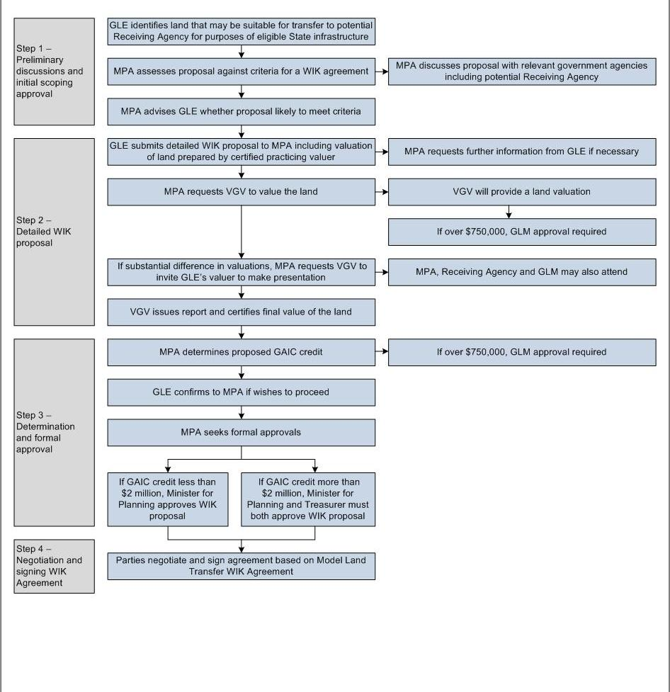

ASSESSMENT PROCESS FOR WIK PROPOSALS INVOLVING WORKS (WITH OR WITHOUT LAND)
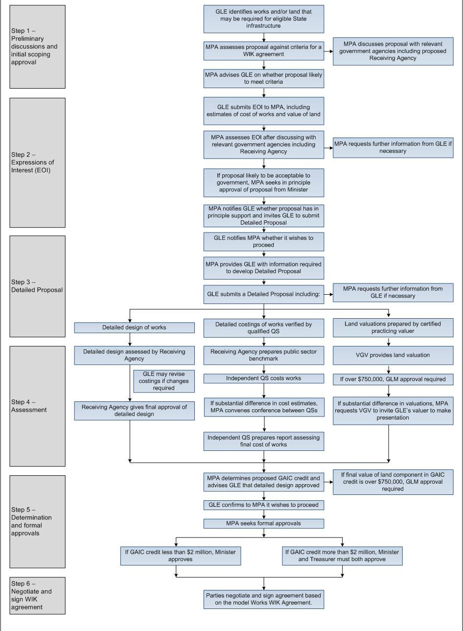

FOR STAGES INVOLVING WORKS
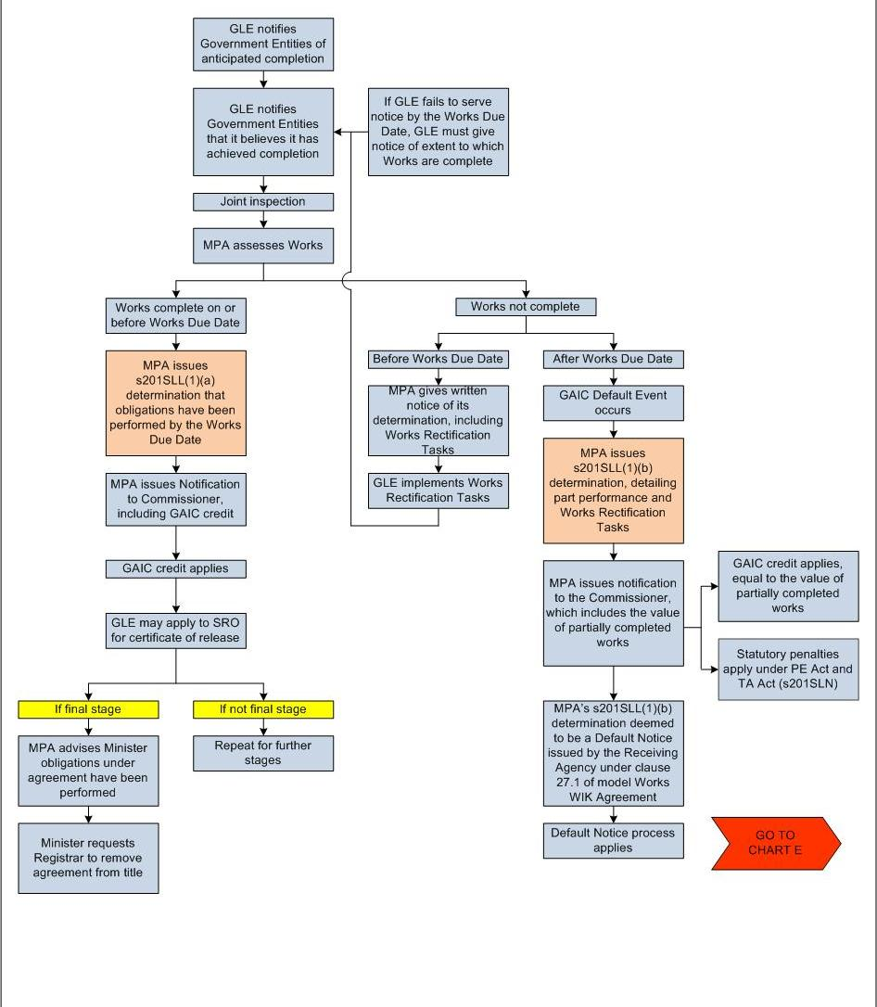

FOR STAGES INVOLVING HANDOVER OF WORKS AND/OR TRANSFER OF LAND
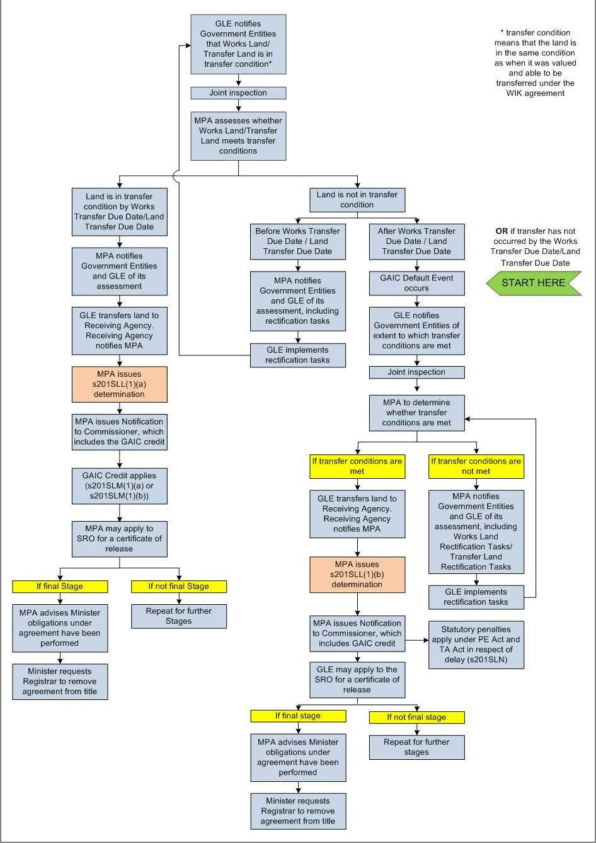

DEFAULT NOTICE
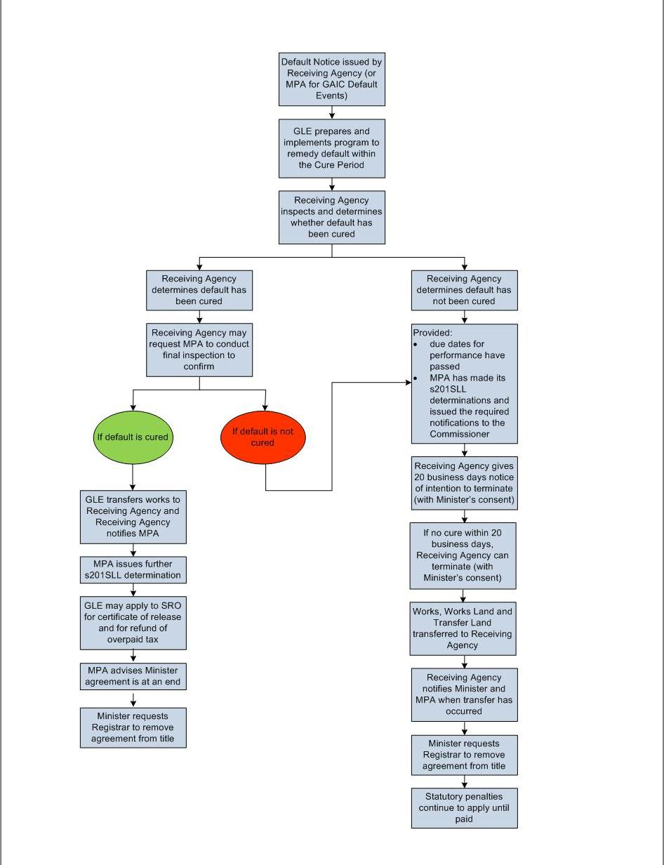

Refer to section 201RC of the PE Act for a definition of type A land, type B-1 land, type B-2 land and type C land.
The purchaser of the land, or the person making a significant acquisition under s201RE of the PE Act.
The purchaser of land in the contribution area that is zoned for urban development, or the person making a significant acquisition under s201RE of the PE Act.
This rate is the average of the daily yields for the 10-year Treasury Corporation of Victoria bond for the month of May in the financial year preceding the financial year the day occurs in. See the SRO website for more information at www.sro.vic.gov.au.
Refer to section 201SLB(3) of the PE Act.
Refer to section 201SLB(7)(b) of the PE Act.
Note that for proposals under $2 million, the Minister for Planning may still seek advice from the Department of Treasury and Finance, although the Treasurer’s formal approval may not be required under the PE Act.
Refer to section 201SLJ of the PE Act.
Refer to sections 201SLK, 201SLL and 201SLM of the PE Act.
Note that Ruling TAA.007 currently does not refer to GAIC. The SRO is in the process of redrafting this ruling to incorporate GAIC and other minor technical changes. The revised ruling will replicate the existing policies on interest and penalty tax in TAA.007.

