Plan Melbourne 2017-2050

Draft Eastern Metro Land Use

Framework Plan

Summary

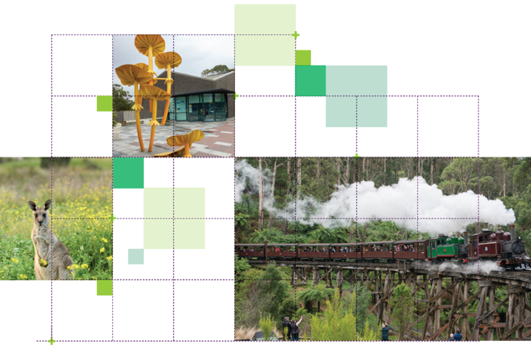

## Great cities aren’t born. They’re made.

Melbourne is a great city. It’s a great place to live, work and raise a family. It’s a great place for investment and creativity. It’s a great place to visit and enjoy.

The Victorian Government has developed land use framework plans for each of the six metropolitan regions that are all about ensuring Melbourne remains a great city as it grows.

These plans mark a new era in the planning of Melbourne, building on the efforts of generations of Victorians to shape the way land is used around Port Phillip Bay.

The Eastern Metro Land Use Framework Planis a 30-year strategy for action across six local government areas – Knox, Manningham, Maroondah, Monash, Whitehorse and Yarra Ranges.

It’s about making the long-term plans and investments that protect and enhance local areas and communities while ensuring Melbourne’s east grows more prosperous, liveable, affordable and sustainable.

The Eastern Metro Land Use Framework Plan is also about maximising the social, economic and environmental benefits of transformational city-shaping investments such as Metro Tunnel, Melbourne Airport Rail and Suburban Rail Loop.

This plan is all about keeping Melbourne’s east marvellous – from the forests and trails of the Yarra Valley, to the parks and backyards of diverse local communities and families, to the dynamic industries and local businesses of the region’s suburbs and shopping strips. It’s also about building the best possible future for the Eastern Metro region.

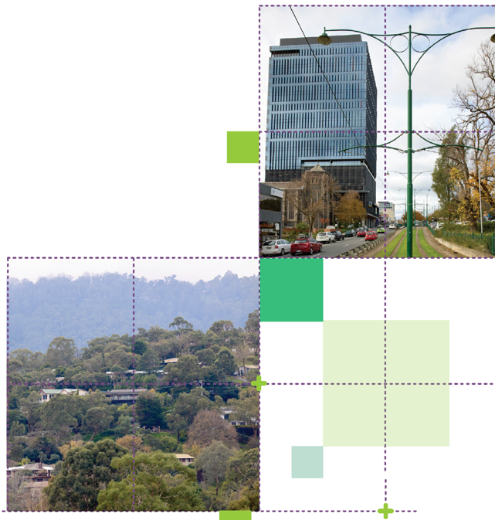

# What the Eastern Metro Land Use Framework Plan means for you

## Productivity

* You will see strong economic growth and job creation headlined by the Monash National Employment and Innovation Cluster (NEIC), Box Hill and Ringwood metropolitan activity centres, Suburban Rail Loop precincts, major activity centres, and health and education precincts.

## Housing Choice

* You will see more housing choice and diversity in accessible locations, including Suburban Rail Loop precincts, activity centres and transport corridors.

## Integrated Transport

* You will find it easier to get around due to major transport investments such as Suburban Rail Loop, North East Link and a better regional cycling network.

## Strong Communities

* You will have access to well-connected public, civic and natural spaces.

## Sustainability and Resilience

* You will find the region is still Melbourne’s primary food bowl because its agricultural areas will be protected, and its produce and natural attractions promoted.

## Climate

* You will be cooler because Eastern Metro region will have 30 per cent tree canopy cover.

## Liveability

* You will still be living in a part of the city known for its open spaces, parks, forests and healthy waterways.

## Regional Victoria

* And you will continue to enjoy the region’s tourism offer based on wine and food, farmers’ and makers’ markets, overnight accommodation and outdoor activities, including in vibrant townships such as Healesville, Warburton and Yarra Glen.

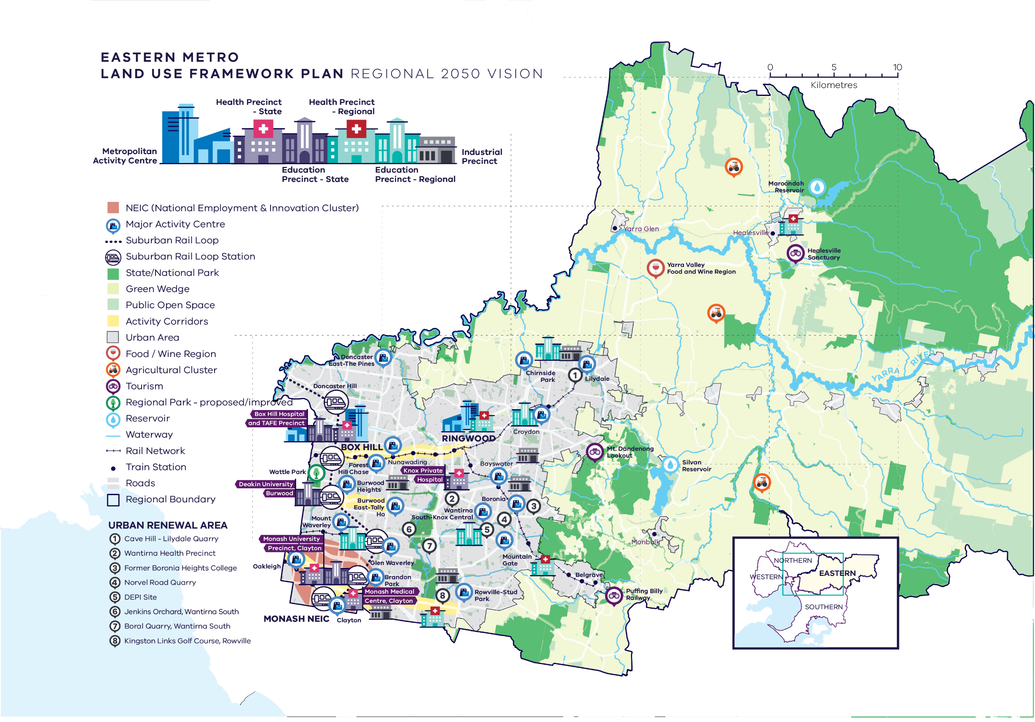

**Summary Eastern Metro Region – Regional 2050 Vision**

**A schematic map of the Eastern Metro Region in 2050 showing:**

1. **The region’s boundary, the urban area, and green wedge land.**
2. **Locations for growth and investment, including:**

* The location and indicative boundary of the Monash NEIC in the south of the region
* Industrial precincts located through the western part of the region, within its urban areas
* Ringwood and Box Hill Metropolitan Activity Centres
* The network of major activity centres predominantly located on the rail and road network
* State and regionally-significant health and/or education precincts, highlighting those at Knox, Monash, Burwood, Clayton, Box Hill, Ringwood, Healesville, Mulgrave, Upper Ferntree Gully, Wantirna, Lilydale, Croydon and Glen Waverley
* The 8 urban renewal areas of:

Cave Hill - Lilydale Quarry

Wantirna Health Precinct

Former Boronia Heights College

Norvel Road Quarry

DEPI Site

Jenkins Orchard, Wantirna South

Boral Quarry, Wantirna South

Kingston Links Golf Course, Rowville

* Suburban Rail Loop (East) (Cheltenham to Box Hill) stations at Monash and Burwood, and interchange stations at Clayton, Glen Waverley and Box Hill. Suburban Rail Loop (North) (Box Hill to Airport) station at Doncaster.

1. **Key transport linkages and movement network including:**

* New underground railway lines and train stations for Suburban Rail Loop
* The road network including the state-significant road corridors of the Eastern Freeway, Eastlink and the Monash Freeway.

1. **State and regional natural and cultural assets, including:**

* State and National parks, the improved regional park at Wattle Park, and other public open space
* Major waterway of the Yarra River corridor
* Reservoirs including Maroondah Reservoir and Silvan Reservoir in the northeast and east of the region
* Tourism areas including the Yarra Valley and Dandenong Ranges.

# What is the Eastern Metro Land Use Framework Plan?

The Eastern Metro Land Use Framework Plan is an extension of *Plan Melbourne 2017-2050*.

Plan Melbourne is a blueprint to ensure Melbourne grows more sustainable, productive and liveable as its population approaches 8 million by 2050. It includes nine principles that outline the Victorian Government’s vision for the future of the city that *Melbourne will continue to be a global city of opportunity and choice*.

1. **A distinctive Melbourne**
2. **A globally connected and competitive city**
3. **A city of centres linked to regional Victoria**
4. **Environmental resilience and sustainability**
5. **Living locally in 20-minute neighbourhoods**
6. **Social and economic participation**
7. **Strong and healthy communities**
8. **Infrastructure investment that supports balanced city growth**
9. **Leadership and partnership.**

Plan Melbourne also divides the city into six metro regions:

* Inner
* Inner South East
* Eastern
* Southern
* Western
* Northern

The Department of Environment, Land, Water and Planning (DELWP) is leading the development of land use framework plans. The purpose of the plans is to guide the application of Plan Melbourne’s nine principles, seven outcomes, 32 directions and 90 policies at a regional and local level.

The plans will support a regional approach to planning across state and local government.

This document summarises how the Eastern Metro Land Use Framework Plan will:

* Shape population and industry growth
* Inform plans for service and infrastructure development
* Guide public and private investment
* Protect the distinctive characteristics of the Southern Metro region
* Improve environmental resilience.

The plan covers six themes:

* Productivity
* Housing
* Integrated transport
* Liveability
* Strong communities
* Sustainability and resilience.

Map of Eastern Metro Region

This map shows the Eastern Metro Region boundary, urban growth boundary and local government areas boundaries. 
The Eastern Metro Region includes Knox, Manningham, Maroondah, Monash, Whitehorse and Yarra Ranges local government areas.

# About the Eastern Metro Region

The Traditional Owners of Eastern Metro region are the Wurundjeri Woi Wurrung people of the Kulin Nation as well as the Taungurng people in the north-east part of the region, and the Bunurong people in the southern part of the region.

The region includes six local councils and extends from the busy middle suburbs of Doncaster, Box Hill and Glen Waverley out to the picturesque farms, forests, towns and water catchments of the Yarra Valley. The Eastern Metro region comprises an established urban area in the western third of the region with development densities generally decreasing towards the Dandenong Ranges and foothills.

The other two-thirds of the region’s land area, beyond the Urban Growth Boundary, contains extensive green wedges of high scenic value with agricultural land and rural townships, state forest reserves and state-significant designated water supply catchments. Eighty-four per cent of the Eastern Metro region is designated as green wedge land.

The region has no new greenfield growth areas.

**Urban areas include:**

* Established urban areas that extend from the Yarra River at Templestowe in the north to Monash University and Rowville in the south, and corridors of urban development extending east along the arterial road corridors of Maroondah Highway and Canterbury Road and rail corridors to Lilydale, Belgrave and Glen Waverley
* Rural townships and small established settlements throughout the Dandenong Ranges and Yarra Valley including Healesville, Yarra Glen, Warburton and Emerald
* Increasing densities of development along key east-west transport corridors focused on Box Hill and Ringwood in the north, Burwood and Knox, and Clayton to the south
* Strong connections to important industrial and commercial precincts via Monash Freeway, Maroondah Highway, Eastern Freeway and Eastlink
* Suburbs in bushland along the Yarra River and in the foothills of the Dandenong Ranges – Warrandyte, Kilsyth, Montrose, Lysterfield.

By 2051, the Eastern Metro region’s population is projected to increase by 41 per cent from around 0.96 million to 1.35 million people and the number of dwellings is projected to increase from 347,440 in 2016 to 539,590 in 2051. By 2031, employment is projected to increase from 396,000 to 483,000 jobs.

## Geographically

its footprint covers 33 per cent of metropolitan Melbourne.

## Demographically

19 per cent of Melbournians, more than 959,100 people, live in the region.

## Economically

it generates $52 billion a year in economic activity and employs more than 396,000 people.

## Environmentally

it has 19.5 per cent of metropolitan Melbourne’s open space and 25.9 per cent tree canopy cover, and its catchments deliver 70 per cent of Melbourne’s water supplies.

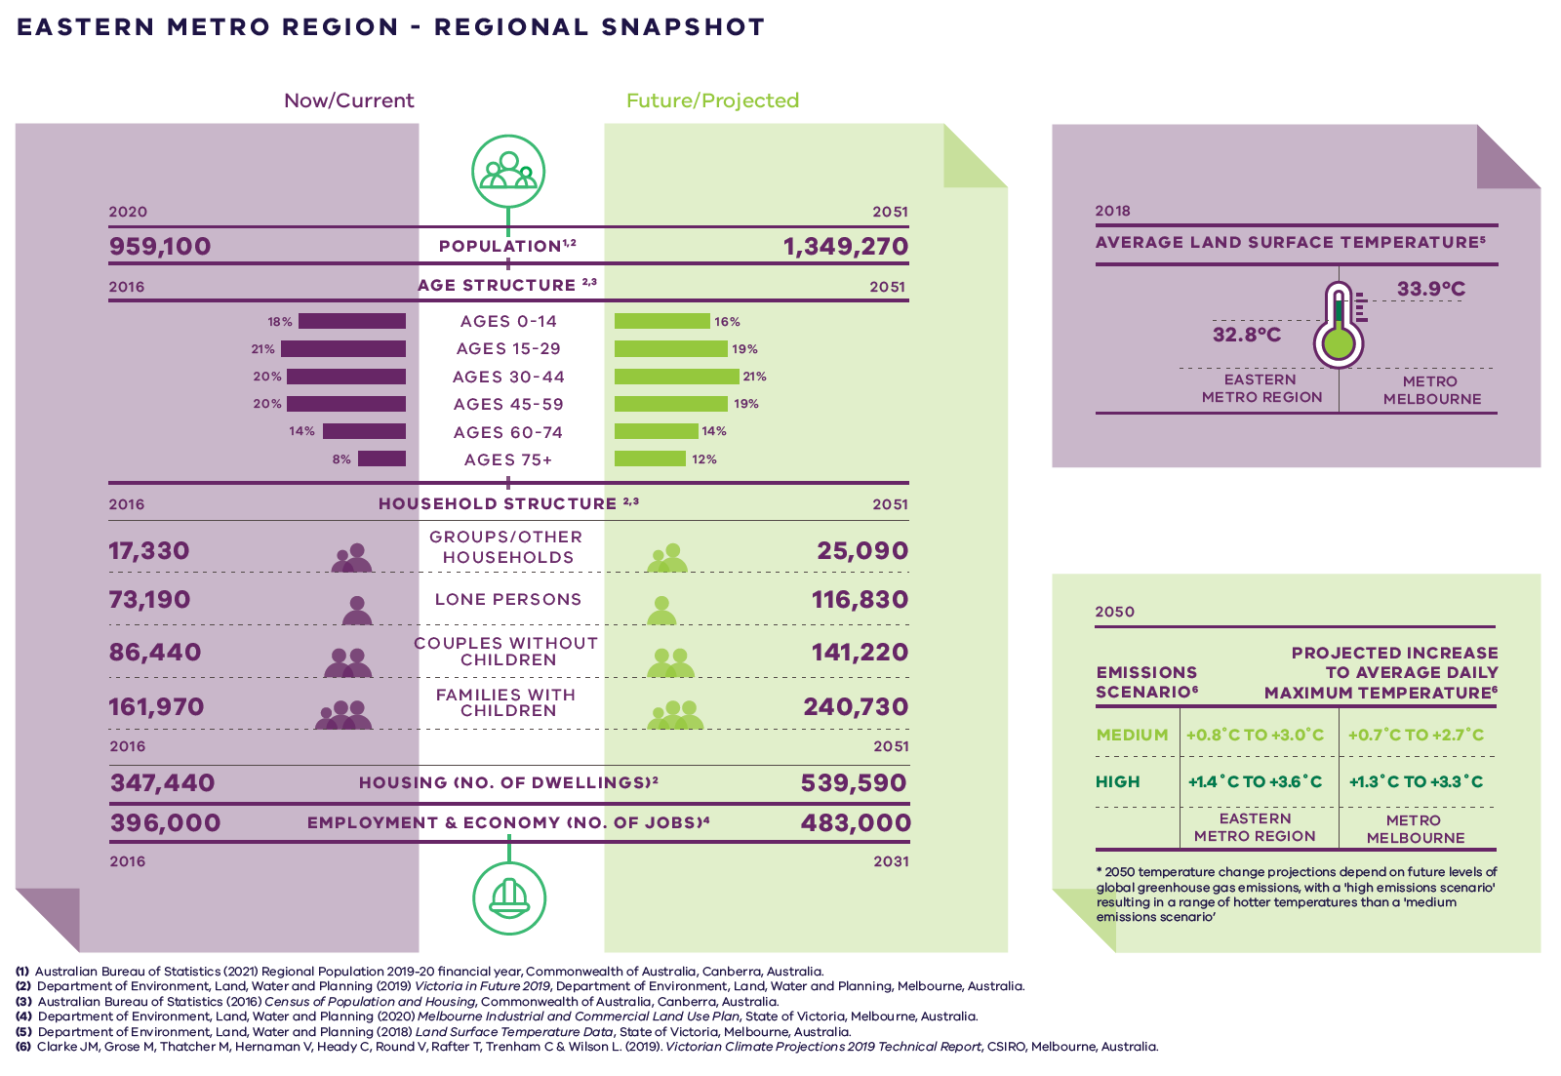

**Eastern Metro Region – Regional Snapshot**

|  |  |  |
| --- | --- | --- |
| **Eastern Metro region population**  Sources:  Australian Bureau of Statistics (2021) Regional Population 2019-20 financial year, Commonwealth of Australia, Canberra, Australia.  Department of Environment, Land, Water and Planning (2019) *Victoria in Future 2019*, Department of Environment, Land, Water and Planning, Melbourne, Australia. | **2020:**  959,100 inhabitants | **2051:**  1,349,270 inhabitants |
| **Eastern Metro region age structure**  Sources:  Department of Environment, Land, Water and Planning (2019) *Victoria in Future 2019*, Department of Environment, Land, Water and Planning, Melbourne, Australia.  Australian Bureau of Statistics (2016) *Census of Population and Housing*, Commonwealth of Australia, Canberra, Australia. | **2016:**  18 per cent – Ages 0 to 14  21 per cent – Ages 15 to 29  20 per cent – Ages 30 to 44  20 per cent – Ages 45 to 59  14 per cent – Ages 60 to 74  8 per cent – Ages 75 plus | **2051:**  16 per cent – Ages 0 to 14  19 per cent – Ages 15 to 29  21 per cent – Ages 30 to 44  19 per cent – Ages 45 to 59  14 per cent – Ages 60 to 74  12 per cent – Ages 75 plus |
| **Eastern Metro region household structure**  Sources:  Department of Environment, Land, Water and Planning (2019) *Victoria in Future 2019*, Department of Environment, Land, Water and Planning, Melbourne, Australia.  Australian Bureau of Statistics (2016) *Census of Population and Housing*, Commonwealth of Australia, Canberra, Australia. | **2016:**  Groups/other households – 17,330  Lone persons – 73,190  Couples without children – 86,440  Families with children – 161,970 | **2051:**  Groups/other households – 25,090  Lone persons – 116,830  Couples without children – 141,220  Families with children – 240,730 |
| **Eastern Metro region housing (number of dwellings)**  Source:  Department of Environment, Land, Water and Planning (2019) *Victoria in Future 2019*, Department of Environment, Land, Water and Planning, Melbourne, Australia. | **2016:**  347,440 dwellings | **2051:**  539,590 dwellings |
| **Eastern Metro region employment and economy (number of jobs)**  Source:  Department of Environment, Land, Water and Planning (2020) *Melbourne Industrial and Commercial Land Use Plan*, State of Victoria, Melbourne, Australia. | **2016:**  396,000 jobs | **2031:**  483,000 jobs |
| **2018 average land surface temperature**  Source:  Department of Environment, Land, Water and Planning (2018) *Land Surface Temperature Data*, State of Victoria, Melbourne, Australia. | **Eastern Metro region:**  32.8 degrees Celsius | **Metro Melbourne:**  33.9 degrees Celsius |
| **2050 projected increase to average daily maximum temperature**  *2050 temperature change projections depend upon future levels of global greenhouse gas emissions, with a ‘high emissions scenario’ resulting in hotter temperatures than a ‘medium emissions scenario’  Source:  Clarke J.M., et al. (2019). *Victorian Climate Projections 2019 Technical Report*, CSIRO, Melbourne, Australia. | **Eastern Metro region:**  Medium emissions scenario – plus 0.8 to plus 3.0 degrees Celsius  High emissions scenario – plus 1.4 to plus 3.6 degrees Celsius | **Metro Melbourne:**  Medium emissions scenario – plus 0.7 to plus 2.7 degrees Celsius  High emissions scenario – plus 1.3 to plus 3.3 degrees Celsius |

# City-shaping projects

The Victorian Government is currently implementing the largest transport infrastructure program in the state’s history.

**City-shaping projects include:**

* The West Gate Tunnel – creating a second river crossing to link the Western Metro region with the Port of Melbourne, CityLink and the CBD, and taking traffic pressures off the West Gate Bridge
* Level crossing removals including along the Belgrave and Lilydale railway lines, reducing congestion and unlocking land for development
* Metro Tunnel – linking Melbourne’s south-east and Gippsland to the Sunbury line in Melbourne’s west and north-west
* North East Link – connecting Melbourne’s south-east to the Eastern Freeway, the Western Ring Road and Hume Freeway
* Melbourne Airport Rail – connecting Melbourne Airport to Victoria’s regional and metropolitan train network
* Suburban Rail Loop – connecting every major passenger railway line in Melbourne from the Frankston line in the south to the Werribee line in the west.

These city-shaping projects will improve access to jobs, education and social opportunities for residents in the Eastern Metro region by better connecting the region with other areas of Melbourne and Victoria. They will create opportunities to maximise social, economic and environmental benefits.

**Socially** – Suburban Rail Loop station precincts will create a focal point for public transport connections, hubs and new housing along the western spine of the region, making employment and services more accessible.

**Economically** – Suburban Rail Loop will attract investment and create jobs by accelerating the development of the Monash NEIC, the Box Hill Metropolitan Activity Centre, the Glen Waverley and Clayton major activity centres, the Monash Station precinct and the Burwood education precinct.

**Environmentally** – Suburban Rail Loop will cut congestion by reducing the region’s reliance on cars, creating new opportunities to connect bike paths and encouraging the development of 20-minute neighbourhoods (ensuring most of the daily needs of people are a 20-minute walk from home).

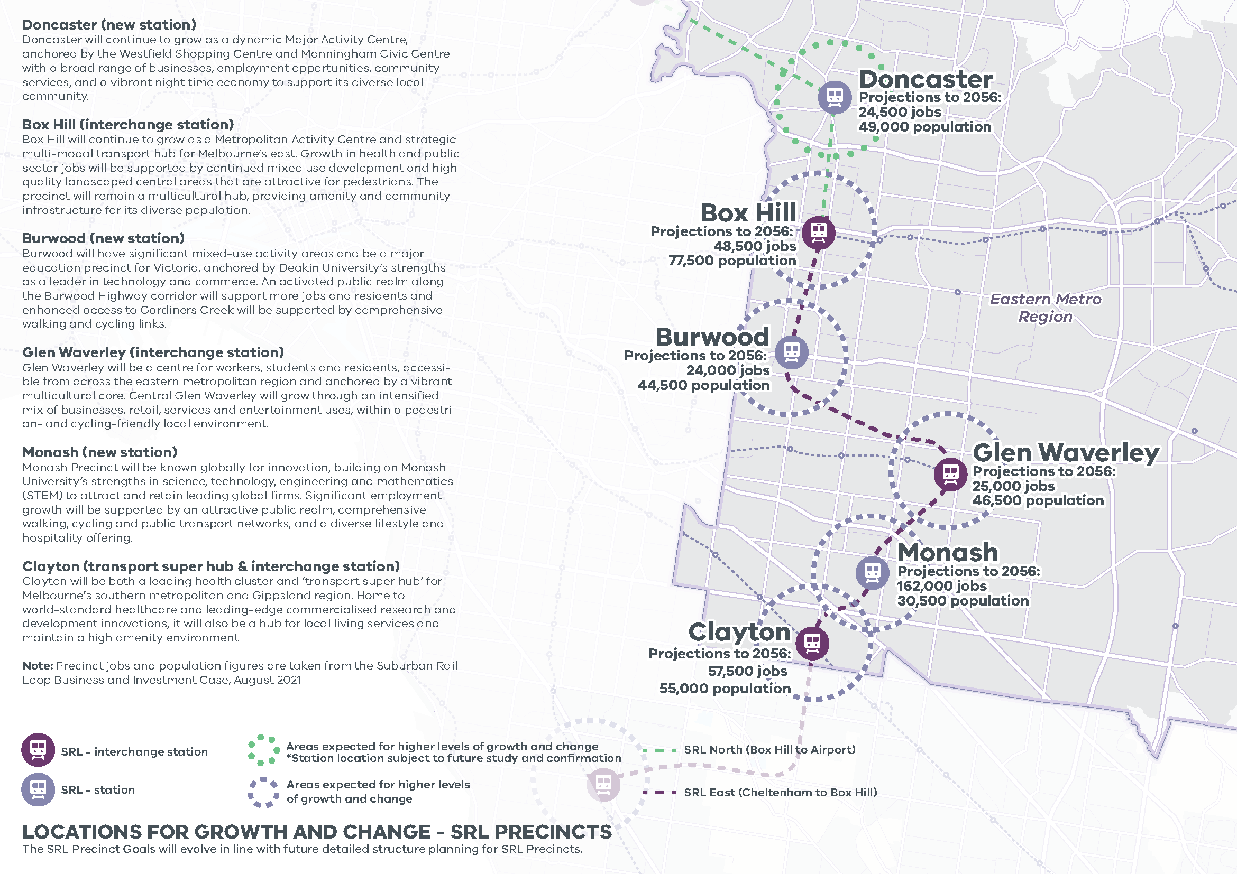

|  |
| --- |
| **LOCATIONS FOR GROWTH AND CHANGE - SRL PRECINCTS**  **Doncaster (new station)** Doncaster will continue to grow as a dynamic Major Activity Centre, anchored by the Westfield Shopping Centre and Manningham Civic Centre with a broad range of businesses, employment opportunities, community services, and a vibrant night time economy to support its diverse local community.  **Box Hill (interchange station)** Box Hill will continue to grow as a Metropolitan Activity Centre and strategic multi-modal transport hub for Melbourne’s east. Growth in health and public sector jobs will be supported by continued mixed use development and high quality landscaped central areas that are attractive for pedestrians. The precinct will remain a multicultural hub, providing amenity and community infrastructure for its diverse population.  **Burwood (new station)** Burwood will have significant mixed-use activity areas and be a major education precinct for Victoria, anchored by Deakin University’s strengths as a leader in technology and commerce. An activated public realm along the Burwood Highway corridor will support more jobs and residents and enhanced access to Gardiners Creek will be supported by comprehensive walking and cycling links.  **Glen Waverley (interchange station)** Glen Waverley will be a centre for workers, students and residents, accessible from across the eastern metropolitan region and anchored by a vibrant multicultural core. Central Glen Waverley will grow through an intensified mix of businesses, retail, services and entertainment uses, within a pedestrian- and cycling-friendly local environment.  **Monash (new station)** Monash Precinct will be known globally for innovation, building on Monash University’s strengths in science, technology, engineering and mathematics (STEM) to attract and retain leading global firms. Significant employment growth will be supported by an attractive public realm, comprehensive walking, cycling and public transport networks, and a diverse lifestyle and hospitality offering.  **Clayton (transport super hub & interchange station)** Clayton will be both a leading health cluster and ‘transport super hub’ for Melbourne’s southern metropolitan and Gippsland region. Home to world-standard healthcare and leading-edge commercialised research and development innovations, it will also be a hub for local living services and maintain a high amenity environment. |

**LOCATIONS FOR GROWTH AND CHANGE - SRL PRECINCTS**

**Eastern Metro Region**

The SRL Precinct Goals will evolve in line with future detailed structure planning for SRL Precincts.

|  |  |  |  |
| --- | --- | --- | --- |
| **Station** | **Projections to 2056** | **Growth** | **SRL** |
| Doncaster | 24,500 jobs  49,000 population | Areas expected for higher levels of growth and change  *Station location subject to future study and confirmation | SRL North (Box Hill to Airport) |
| Box Hill | 48,500 jobs  77,500 population | Areas expected for higher levels of growth and change | SRL East (Cheltenham to Box Hill) |
| Burwood | 24,000 jobs  44,500 population | Areas expected for higher levels of growth and change | SRL East (Cheltenham to Box Hill) |
| Glen Waverly | 25,000 jobs  46,500 population | Areas expected for higher levels of growth and change | SRL East (Cheltenham to Box Hill) |
| Monash | 162,000 jobs  30,500 population | Areas expected for higher levels of growth and change | SRL East (Cheltenham to Box Hill) |
| Clayton | 57,500 jobs  55,000 population | Areas expected for higher levels of growth and change | SRL East (Cheltenham to Box Hill) |

# Eastern Metro Region strengths and challenges

|  |  |
| --- | --- |
| **Productivity** | Eastern Metro region has a strong network of activity centres, industrial areas, and health and education precincts – as well as the Monash National Employment and Innovation Cluster (NEIC). The region does not have any growth areas, with productive green wedges extending beyond the Urban Growth Boundary. Consequently, existing employment land must be retained and opportunities to create and intensify jobs must be found. |
| **Housing Choice** | Suburban Rail Loop will create new opportunities for new medium- and higher-density housing.  The LUFPs also respond to the need to:   * Keep up with the demand for new housing * Create a more diverse range of housing including key worker and student accommodation * Ensure housing choices keep up with the needs of an ageing population * Balance housing development with employment. |
| **Integrated Transport** | Eastern Metro region has strong road connections and a good bus network, with multi-modal connections at train stations. However, the region has a high rate of private vehicle use, limited opportunities to improve, expand or extend existing major roads, and an east-west disparity in public transport access.  There is a need to improve north-south connections between Doncaster Hill, Ringwood and Box Hill in the north of the region and Monash NEIC in the south, as well as better connect the Monash NEIC to the region’s transport network. The Suburban Rail Loop will help with this. |
| **Liveability** | The Eastern Metro region benefits from extensive open space and recreational trails. There is an ongoing need to protect the region’s heritage, landscape and biodiversity values from the impacts of climate change and as it accommodates growth. |
| **Strong Communities** | The region is well serviced by a wide range of social, health, education and recreation facilities. However, there is an uneven distribution of facilities and services across the region, particularly in rural areas. |
| **Sustainability and Resilience** | The Eastern Metro region has the highest tree canopy coverage in metropolitan Melbourne, but also the highest rates of tree canopy loss.  In addition:   * Water supply catchments must be protected * Waterway health and bushfire hazards need to be managed * Green infrastructure needs to be integrated into mixed-use areas * Urban stormwater management and water harvesting need to be improved to minimise flooding and support green infrastructure. |

# Planning for the Eastern Metro Region

## Productivity

* Facilitate the development of the Monash NEIC.
* Support land use change and higher-density development in Suburban Rail Loop precincts.
* Encourage investment that will attract major anchor tenants, start-ups and specialised labour in the region’s health and/or education precincts.
* Facilitate high-value jobs and higher-density development in the Box Hill and Ringwood metropolitan activity centres, as well as well-suited major activity centres.
* Retain commercial-zoned land and identify areas that can support future demand for new investment.
* Retain industrial-zoned land at the Bayswater Business Precinct, Scoresby-Rowville Industrial Area and the Clayton-Mulgrave Industrial Precinct (within Monash NEIC).
* Support start-ups and/or creative industries across the activity centre network and within the Bayswater Business Precinct, Scoresby-Rowville Industrial Area and Clayton-Mulgrave Industrial Precinct (within Monash NEIC).
* Identify future enterprise precincts that are well serviced by public transport, contain identified locally-significant industrial land, and are close to services and amenities.
* Develop activity corridors that support increased employment and housing opportunities along:
  + Burwood Highway near the future Suburban Rail Loop station at Burwood
  + Wellington Road from Caulfield to Rowville Major Activity Centre, the future Suburban Rail Loop station at Clayton, and Monash NEIC
  + Whitehorse Road between Box Hill and Ringwood metropolitan activity centres
  + Dandenong Road/Princes Highway between Chadstone Major Activity Centre, Oakleigh Major Activity Centre, the Monash NEIC and the future Suburban Rail Loop station precinct at Clayton.
* Protect high-quality agricultural land in the Yarra Valley and Yarra and Dandenong Ranges green wedge, the Manningham green wedge, and the Southern Ranges green wedge.

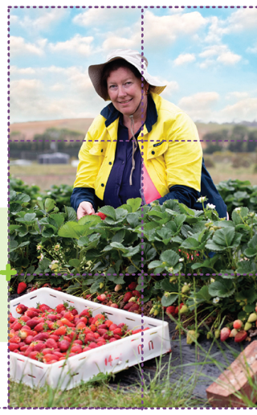

## Housing Choice

* Maximise housing development in the established areas of the Eastern Metro region to achieve the aspirational 70/30 housing distribution scenario for metropolitan Melbourne.
* Ensure new housing in and around the Monash NEIC does not encroach on the primary employment and innovation role of the NEIC.
* Increase the supply of medium- and higher-density housing around the Monash NEIC, in and around metropolitan and major activity centres, urban renewal areas, Suburban Rail Loop precincts, activity corridors, and neighbourhood activity centres with good public transport.
* Encourage substantial housing change and a genuine mix of dwelling types and sizes, particularly in the western part of the region and along Suburban Rail Loop corridor.
* Maximise the opportunities for student accommodation and key worker housing around health and/or education precincts in the Eastern Metro region.
* Build more affordable housing across the region, particularly in locations with access to jobs, services and public transport.

## Integrated Transport

* Improve public transport and walking and bike paths:
  + To Monash NEIC, Box Hill and Ringwood metropolitan activity centres and along activity corridors that link major activity centres
  + To Suburban Rail Loop precincts
  + To Bayswater, Boronia, Brandon Park, Croydon, Doncaster East (The Pines), Doncaster Hill, Forest Hill Chase, Glen Waverley, Lilydale, Mount Waverley, Mountain Gate, Oakleigh, Rowville (Stud Park) and Wantirna South (Knox Central)
  + North-south between Doncaster Hill, Ringwood and Box Hill activity centres and Monash NEIC
  + East-west between Knox local government area and Burwood, Glen Waverley and Clayton.
* Provide access to regionally-significant industrial precincts and health and/or education precincts by public transport, walking and cycling.
* Improve walking, cycling and public transport in the Monash NEIC, activity centres and health and education precincts.
* Ensure the planning and design of Suburban Rail Loop precincts maximises public and active transport connections, and provides bus service connectivity prior to the delivery of Suburban Rail Loop.
* Create pedestrian-friendly neighbourhoods and build a network of cycling links for local trips.

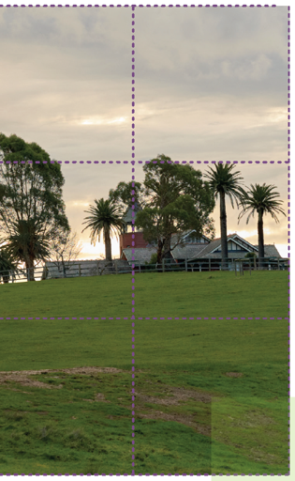

## Liveability

* Work with Traditional Owners to protect and enhance the Eastern Metro region’s significant landscapes and biodiversity including waterways, waterway corridors, wetlands, mountain ranges, forests and rural landscapes.
* Ensure the design of new buildings within green wedge areas responds to natural landscape features and biodiversity values.
* Identify, enhance and protect places and spaces that contribute to the understanding and enjoyment of the region.
* Ensure public spaces in new developments are well designed and create a strong sense of place.
* Upgrade key pedestrian streets and public spaces, protect parklands and open-space corridors, and create new open spaces close to residential areas and activity centres.
* Improve the region’s shared trail network and support active recreation and cycling trails in the green wedges.

## Strong Communities

* Support provision of a range of sporting and active recreation facilities across the Eastern Metro region.
* Expand the network of health and education facilities and precincts across the region.
* Encourage planning for major social infrastructure (such as libraries, recreation facilities, cultural centres or community hubs) to be undertaken in conjunction with neighbouring regions to maximise co-location of facilities.
* Encourage the use of public land such as school grounds or golf courses for open space, recreation activities or trail connections, at times and in ways that do not jeopardise their primary purpose.
* Plan existing and new activity centres to deliver 20-minute neighbourhoods.
* Support the role of neighbourhood activity centres to provide retail, community and allied health services within local areas.

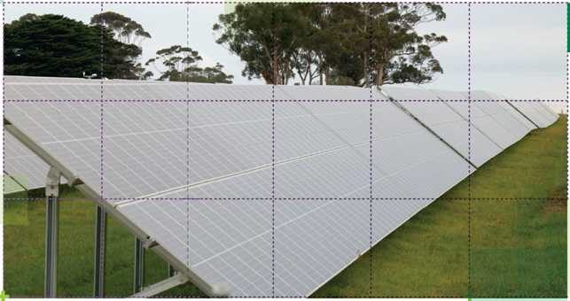

## Sustainability and Resilience

* Avoid housing growth and sensitive land uses in the Eastern Metro region within and in proximity to bushfire prone areas, provide new and upgraded regional social infrastructure to provide refuge in extreme bushfire and weather events, and manage bushfire risk posed by vegetation within waterway corridors.
* Increase the urban tree canopy to 30 per cent coverage by 2050, including on streetscapes, public land, large developments in activity centres, along urban waterways, open spaces and road reserves, and large commercial and industrial sites.
* Design and develop outdoor spaces that are cool on hot days, particularly in the Monash NEIC and in the Box Hill, Ringwood, Clayton, Glen Waverley, Bayswater, Boronia and Croydon activity centres.
* In areas with high urban heat, encourage green roofs and green structures on apartment developments, and on large commercial and industrial sites.
* Minimise threats to catchment health including better protection of the mid-Yarra open water supply catchment.
* Facilitate stormwater harvesting and support water recycling, particularly for agriculture and around Coldstream in the Yarra Valley.

**©** The State of Victoria Department of Environment, Land, Water and Planning 2021

This work is licensed under a Creative Commons Attribution 4.0 International licence. You are free to re-use the work under that licence, on the condition that you credit the State of Victoria as author. The licence does not apply to any images, photographs or branding, including the Victorian Coat of Arms, the Victorian Government logo and the Department of Environment, Land, Water and Planning (DELWP) logo. To view a copy of this licence, visit http://creativecommons.org/licenses/by/4.0/

ISBN 978-1-76105-654-3 (pdf/online/MS word)

#### Disclaimer

This publication may be of assistance to you but the State of Victoria and its employees do not guarantee that the publication is without flaw of any kind or is wholly appropriate for your particular purposes and therefore disclaims all liability for any error, loss or other consequence which may arise from you relying on any information in this publication.

#### Credits

Green Scribble (graphic design); Tim Bell Studio (photos) and Department of Jobs, Precincts and Regions (photos).

#### Accessibility

If you would like to receive this publication in an alternative format, please telephone the DELWP Customer Service Centre on 136 186, email customer.service@delwp.vic.gov.au or via the National Relay Service on 133 677 www.relayservice.com.au. This document is also available on the internet at www.delwp.vic.gov.au

Submissions can be made online at engage.vic.gov.au

For any questions or assistance please contact lufp@delwp.vic.gov.au