Plan Melbourne 2017-2050

Draft Inner South East Metro

Land Use Framework Plan

Acknowledgement
We acknowledge and respect the Traditional Owners of Victoria’s lands and waters, their unique ability to care for Country and deep spiritual connection to it. We honour Elders past and present whose knowledge and wisdom has ensured the continuation of culture and traditional practices.
We are committed to genuinely partner and meaningfully engage with Traditional Owners to support the protection of their Country, the maintenance of spiritual and cultural practices and their broader aspirations in the 21st century and beyond.

Aboriginal self-determination
Pupangarli Marnmarnepu - Wadi Wadi and Mutti Mutti language for ‘Owning Our Future’ - is DELWP’s Aboriginal Self-Determination Reform Strategy 2020-2025. As the framework for supporting and enabling Aboriginal self-determination for all DELWP projects, Pupangarli Marnmarnepu forms the basis of an ongoing dialog and partnership with Traditional Owners to influence metropolitan planning and the implementation of Plan Melbourne 2017-2050 in each of the six metropolitan regions.
Ongoing partnership opportunities with Traditional Owners are currently being explored. This process will determine the preferred involvement and level of influence Traditional Owners would like to have in shaping the outcomes and implementation of the land use framework plans.

Abbreviations
ABS | Australian Bureau of Statistics | NEIC/s | National Employment and Innovation Clusters
BIFT | Beveridge Interstate Freight Terminal | OMR | Outer Metropolitan Ring/E6 Transport Corridor
BMO | Bushfire Management Overlay | PBN | Principal Bicycle Network
BPA | Bushfire Prone Area | PFN | Principal Freight Network
CBD | Central Business District | PPTN | Principal Public Transport Network
DELWP | Department of Environment, Land, Water and Planning | PSP/s | Precinct Structure Plans
DJPR | Department of Jobs, Precincts and Regions | RSIP | Regionally-Significant Industrial Precinct
DOT | Department of Transport | SBO | Special Building Overlay
EIIA/s | Extractive Industry Interest Areas | SEIFA | Socio-Economic Indexes for Areas
EPWG | Economy and Planning Working Group | SERA/s | Strategic Extractive Resource Areas
ESD | Environmentally Sustainable Development | SRL | Suburban Rail Loop
GRP | Gross Regional Product | SRLA | Suburban Rail Loop Authority
HVI | Heat Vulnerability Index | SSIP | State-Significant Industrial Precinct
LGA | Local Government Area | TAFE | Technical and Further Education
LSIO | Land Subject to Inundation Overlay | UDP | Urban Development Program
LST | Land Surface Temperature | UGB | Urban Growth Boundary
LUFP | Land Use Framework Plan | VIF | Victoria In Future
MICLUP | Melbourne Industrial and Commercial Land Use Plan | VPA | Victorian Planning Authority
MRF | Materials Recovery Facility | WIFT | Western Interstate Freight Terminal

Introduction
Melbourne is the fastest growing city in Australia. The city’s population is projected to reach 8 million by 2050. This growth, in combination with a changing climate, increased globalisation and congestion, is testing the resilience of Melbourne’s built and natural environment. Victoria needs to plan for this growth and change. That is why Plan Melbourne 2017-2050 is important.
Plan Melbourne has a clear vision:
‘Melbourne will continue to be a global city of opportunity and choice.’
What this vision demonstrates is that Plan Melbourne is more than a planning document. It is a blueprint, guiding the actions of planners, councils, landowners and developers – ensuring Melbourne grows more sustainable, productive and liveable.
Plan Melbourne seeks to deliver seven outcomes. How these will be delivered in each of the six metropolitan regions is the subject of the land use framework plans (LUFPs).
Outcome 1 | Melbourne is a productive city that attracts investment, supports innovation and creates jobs
Outcome 2 | Melbourne provides housing choice in locations close to jobs and services
Outcome 3 | Melbourne has an integrated transport system that connects people to jobs and services and goods to market
Outcome 4 | Melbourne is a distinctive and liveable city with quality design and amenity
Outcome 5 | Melbourne is a city of inclusive, vibrant and healthy neighbourhoods
Outcome 6 | Melbourne is a sustainable and resilient city
Outcome 7 | Regional Victoria is productive, sustainable, and supports jobs and economic growth

Land use framework plans
Plan Melbourne identifies six metropolitan regions within the city as illustrated in Figure 1:
- Inner (Melbourne, Port Phillip and Yarra Local Government Areas or LGAs)
- Inner South East (Bayside, Boroondara, Glen Eira and Stonnington LGAs)
- Eastern (Knox, Manningham, Maroondah, Monash, Whitehorse and Yarra Ranges LGAs)
- Southern (Cardinia, Casey, Frankston, Greater Dandenong, Kingston and Mornington Peninsula LGAs)
- Western (Brimbank, Hobsons Bay, Maribyrnong, Melton, Moonee Valley and Wyndham LGAs)
- Northern (Banyule, Darebin, Hume, Mitchell, Moreland, Nillumbik and Whittlesea LGAs).
The Victorian Department of Environment, Land, Water and Planning (DELWP) has led the development of an LUFP for each region, supported by six Economy and Planning Working Groups (EPWGs).
The six EPWGs are chaired by a chief executive officer from a council within each region and include senior representatives from the region’s local councils, DELWP, the Department of Jobs, Precincts and Regions (DJPR) and the Department of Transport (DoT).
Through the EPWGs, councils have helped shape the vision for their regions – providing local insight into the regional opportunities and challenges that require joint action by state and local government.
Responding to these regionally-specific opportunities and challenges, the LUFPs:
- are 30-year strategic land use and infrastructure plans for Melbourne’s six metropolitan regions
- provide a common long-term framework to manage growth and land use pressures in each region
- are spatial plans that translate Plan Melbourne and Plan Melbourne Addendum to the regional level
- focus on resolving metropolitan regional issues
- provide context for planning at the precinct or local level
- ensure the review and update of local planning schemes align with Plan Melbourne
- provide directions and strategies for state- and regionally-significant projects that are implemented through state planning policy and local planning schemes.
- drive the accommodation of the majority of Melbourne’s growth into established areas through a land use framework that identifies places of state and regional significance, and integrate greenfield growth area planning with wider metropolitan planning.
The LUFPs support the implementation of Plan Melbourne – guiding the implementation of Plan Melbourne’s nine principles, seven outcomes, 32 directions and 90 policies at a regional and local level.
- Location of the Inner South East Metro Region
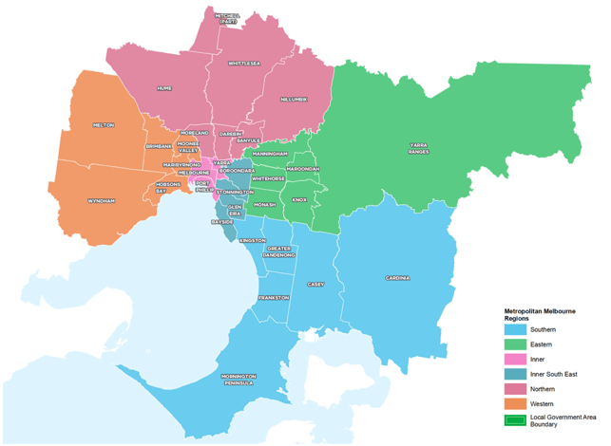

How will the land use framework plans be used?
The LUFPs will be used to:
- Drive the majority of Melbourne’s population growth into established areas through a land use framework that identifies places of state and regional significance
- Guide the strategic integration of land use and infrastructure (including housing and jobs aspirations) in key areas and precincts
- Guide the development of Melbourne’s greenfield growth areas
- Facilitate collaboration by state and local government, key agencies and partners on regional planning and regional priorities
- Inform priority places for state-led planning
- Enable metropolitan councils to update their municipal strategies and policies within a clearly defined land use framework.
The LUFPs will set regional-level planning policy to be implemented into planning schemes. They will inform local councils in decision-making for precinct planning, local and regional planning strategies, and infrastructure and servicing projects.
The LUFPs include a number of short- to medium- term actions for state and local government, which will contribute to planning outcomes in each region alongside existing actions under Plan Melbourne and other government programs and initiatives. Action monitoring will be led by DELWP in partnership with the metropolitan region through the EPWGs, and the actions will be formally reviewed every five years in conjunction with Plan Melbourne 2017-2050 Five-Year Implementation Plan.
Annual progress reports outlining the status of actions will be published by DELWP as a part of Plan Melbourne monitoring. These progress reports will be publicly available.
The chapter on implementation provides further details on how the LUFPs will be used to deliver Plan Melbourne outcomes across the regions.
Appendix 01 identifies the range of related initiatives already underway by state and local government to support the implementation of Plan Melbourne. The LUFPs are designed to complement these initiatives.
The land use framework
Places of state significance (as identified in Plan Melbourne) | Places of regional significance
- Central City  - National employment and innovation clusters (NEICs)  - Metropolitan activity centres  - State-significant industrial precincts (SSIPs)  - Transport gateways  - State-significant health and/or education precincts  - Major urban renewal precincts | - Major activity centres  - Activity corridors  - Regionally-significant industrial precincts (RSIPs)  - Enterprise precincts  - Regionally-significant health and/or education precincts  - Inter-regional environmental features  - Regional open space  - Growth corridors  - Urban renewal areas  - Housing opportunity and investigation areas  - Green wedges

The land use framework
The LUFPs establish a common land use framework across the region (Table 1).This common framework confirms places of state significance as identified in Plan Melbourne and introduces places of regional significance for each metro region.
The land use framework will direct land use decisions and investment, better align state and local government planning, and inform the development of local council planning strategies (including housing strategies). In the process, this common framework will also ensure land use, planning and development all support the vision of Plan Melbourne.

Regional planning and collaboration
Planning at a regional level is an opportunity for state and local governments to work together to manage long-term growth and change across Melbourne (Figure 2).
While the Inner South East Metro Region has many unique opportunities and challenges, there are some opportunities and challenges common across all metropolitan regions, such as ensuring jobs are available close to public transport; increasing housing supply in areas with access to jobs, services and public transport; and mitigating and adapting to climate change. The LUFP allows for these differences and recognises regional initiatives already underway.
The LUFPs will guide regional planning and collaboration vertically (between state and local government) and horizontally (across local councils in partnership with other stakeholders, including Traditional Owners).
- Inter-relationship between state and local planning
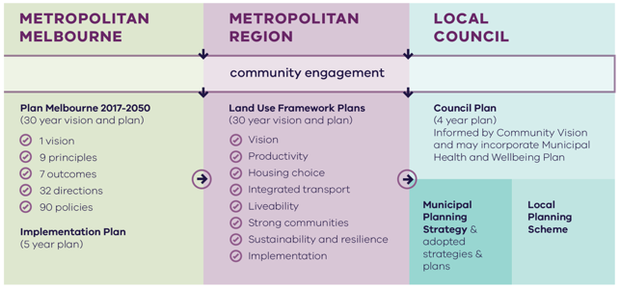
Metropolitan Melbourne | Metropolitan Region | Local Council
Is informed by community engagement. | Is informed by community engagement and Metropolitan Melbourne planning. | Is informed by community engagement, Metropolitan Melbourne planning and Metropolitan Region planning.
Includes:  - Plan Melbourne 2017-2050 (30 year vision and plan)  - 1 vision  - 9 principles  - 7 outcomes  - 90 policies  - Implementation Plan (5 year plan) | Includes:  - Land Use Framework Plans (30 year vision and plan)  - Vision  - Productivity  - Housing choice  - Integrated transport  - Liveability  - Strong communities  - Sustainability and resilience  - Implementation | Includes:  - Council Plan (4 year plan)  - Informed by Community Vision and may incorporate Municipal Heath and Wellbeing Plan  - Municipal Planning Strategy & adopted strategies & plans  - Local Planning Scheme

State-led planning
The Victorian Government has identified priority areas for state-led planning. The purpose of state-led planning in those areas is to maximise land use and infrastructure integration, attract investment, and deliver housing, jobs and services within established urban areas.
State-led planning often involves the Victorian Government partnering with local councils and other stakeholders to develop or implement strategic plans, plan for change or respond to an investment, and/or identify key catalyst projects or programs that support growth and attract investment.
The current place for state-led planning in the Inner South East Metro Region is the Cheltenham-Southland Major Activity Centre as part of the SRL led by the Suburban Rail Loop Authority.

The broader context

Climate change – the need for both mitigation and adaptation
Victoria’s Climate Change Strategy (2021) translates the Climate Change Act 2017 into concrete action by introducing ambitious but achievable interim emissions reduction targets to keep Victoria on track to net zero emissions by 2050. The Strategy includes actions to reduce emissions now and lay the foundations for future reductions across the economy, including but not limited to the following: continuing the transition to clean, renewable energy production; establishing a light vehicle sales target of 50 per cent zero emissions vehicles by 2030; investing in land restoration and carbon farming initiatives; supporting Victorian farmers to respond to the impacts of climate change; and, creating new jobs by promoting growth within the waste recycling and renewable energy sectors. These measures will help reduce the size of Melbourne’s carbon footprint and improve its resilience to the impacts of climate change.
Land use and transport integration – such as locating homes close to public transport, and bike and walking paths – is critical to achieving net-zero emissions. In 2018, cars made up just over half of all transport emissions, with road vehicles responsible for almost 90 per cent of those transport emissions. Transport emissions by mode and road transport sub-categories are shown in Figure 3.
In Melbourne, despite increased public transport usage and significant public transport investment, cars remain the dominant mode of transport. In 2016, for example, private vehicles accounted for 67 per cent of trips in Melbourne. To achieve net-zero emissions, Victoria’s private vehicle use must be dramatically reduced.
The Victorian Government is working towards a more sustainable built environment through reforms to construction, planning and energy provision across metropolitan Melbourne and Victoria. These regulatory reforms will reduce the energy consumption of appliances, require improved environmentally sustainable development (ESD) outcomes in new buildings and subdivisions, and improve the efficiency of energy production and distribution.
- Transport emissions by mode and road transport sub-categories – Victoria 2018
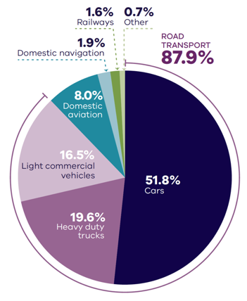
DELWP (2020) Victorian Greenhouse Gas Emissions Report 2018, State of Victoria: Melbourne, Australia.

Figure 3. Transport emissions by mode and road transport sub-categories – Victoria 2018
Cars | 51.8 per cent
Heavy duty trucks | 19.6 per cent
Light commercial vehicles | 16.5 per cent
Domestic aviation | 8.0 per cent
Domestic navigation | 1.9 per cent
Railways | 1.6 per cent
Other | 0.7 per cent
Source: Victorian Greenhouse Gas Emissions Report 2018, DELWP, 2020, State of Victoria: Melbourne, Australia.

In Melbourne, despite increased public transport usage and significant public transport investment, cars remain the dominant mode of transport. In 2016, for example, private vehicles accounted for 67 per cent of trips in Melbourne. To achieve net-zero emissions, Victoria’s private vehicle use must be dramatically reduced.
The Victorian Government is working towards a more sustainable built environment through reforms to construction, planning and energy provision across metropolitan Melbourne and Victoria. These regulatory reforms will reduce the energy consumption of appliances, require improved environmentally sustainable development (ESD) outcomes in new buildings and subdivisions, and improve the efficiency of energy production and distribution.
The Victorian Government recently released its Environmentally Sustainable Development of Buildings and Subdivisions – A Roadmap for Victoria’s Planning System (the Roadmap). This document outlines updates to the planning system that support broader, state-level ESD policy objectives. It sets out additional ESD objectives and standards for the design of new buildings, as well as the layout of large-scale residential subdivisions proposed through the Victoria Planning Provisions.
The Roadmap also sets out other initiatives, including new approaches to energy management – such as renewable and distributed energy technologies, microgrids and battery farms, better stormwater management, increased landfill diversion practices and the promotion of sustainable modes of transport.
Victoria is actively decarbonising the energy sector through the construction of better buildings and the transition to renewable energy generation (including onsite solar photovoltaic and large-scale renewable energy projects). Victoria’s planning policies will also facilitate appropriate development of low emission and zero emission energy supply infrastructure.
Good precinct structure planning can also reduce greenhouse gas emissions and make communities more climate resilient. That is why affordable and clean energy infrastructure should be used to support sustainable development and sustainable transport.

20-minute neighbourhoods
The LUFPs aim to create more 20-minute neighbourhoods in Melbourne’s six metropolitan regions by planning for established areas, growth areas and major transport infrastructure projects. The LUFPs also provide the regional direction and strategies to inform the delivery of 20-minute neighbourhoods through structure planning.

City-shaping transport projects
The Victorian Government is currently implementing the largest transport infrastructure program in the state’s history. City-shaping projects (Figure 4) include:
- The West Gate Tunnel – creating a second river crossing to link the Western Metro Region with the Port of Melbourne, CityLink and the CBD, and take traffic pressures off the West Gate Bridge
- Level crossing removals, including along the Frankston and Dandenong lines, reducing congestion and unlocking land for development
- Metro Tunnel – linking Melbourne’s south-east and Gippsland to the Sunbury line in Melbourne’s west and north-west
- North East Link – connecting Melbourne’s south-east to the Eastern Freeway, the Western Ring Road and Hume Freeway
- Melbourne Airport Rail – connecting Melbourne Airport to Victoria’s regional and metropolitan train network
- Suburban Rail Loop (SRL) – connecting every major passenger railway line in Melbourne from the Frankston line in the south to the Werribee line in the west. SRL East (Cheltenham to Box Hill) is scheduled to begin in 2022. SRL East will also connect key employment and education precincts, and facilitate uplift and intensive development of station precincts.
These city-shaping projects will improve access to jobs, education and social opportunities in the Inner South East Metro Region. They will also connect the Inner South East Metro Region with other areas of Melbourne and Victoria. In addition, they are also creating opportunities to make the Inner South East Metro Region more prosperous, sustainable and liveable through the integration of land use and transport planning.
The purpose of integrated land use and transport planning is to bring jobs, services and leisure opportunities closer to where people live. This means shorter trips, the option to use active transport and less time spent travelling – leading to a better quality of life and the creation of 20-minute neighbourhoods. In addition, this integrated approach also frees up capacity for freight, public transport and active transport journeys – reducing transport emissions.

Coronavirus (COVID-19) impacts
The coronavirus (COVID-19) pandemic is having dramatic impacts on Victoria’s population, economy and society.
With movement restricted, migration to Victoria has been reduced almost to zero. The Australian Government’s expectations for overseas migration losses will see Victoria’s population decline slightly in 2020-21, compared with average growth of 2 per cent for most of the previous decade. International migration is expected to resume within one to two years but not return to normal until the mid-2020s at the earliest.
This interruption to growth is not expected to change the long-term future direction of Melbourne.
However, the global pandemic has had significant impacts. This includes the shift to work-from-home arrangements for large parts of the metropolitan workforce, a greater uptake of online retail services and a shift to local living, with more people are relying on their activity centres and neighbourhoods to meet their day-to-day needs. Many industry sectors impacted by COVID-19 restrictions, including tourism, the arts and international education, are still recovering.
The LUFPs will help Melbourne’s metropolitan regions manage the economic and social impacts of the pandemic especially in specific areas such as Melbourne’s CBD and the Monash and Bundoora education precincts.
The progress of each LUFP will be monitored and revisited to ensure each regional land use pathway continues to contribute to Plan Melbourne’s outcomes.
- City-shaping transport projects
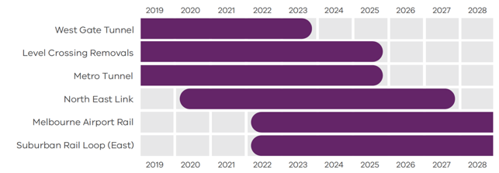
Department of Environment, Land, Water and Planning 2021

Figure 4. City-shaping transport projects
West Gate Tunnel | Pre-2019 to 2023
Level Crossings Removals | Pre-2019 to 2025
Metro Tunnel | Pre-2019 to 2025
North East Link | From 2020 to 2027
Melbourne Airport Rail | From 2022 to post-2028
Suburban Rail Loop (East) | From 2022 to post-2028
Source: Department of Environment, Land, Water and Planning 2021

Regional Snapshot
The Inner South East Metro region includes the local government areas (LGAs) of Bayside, Boroondara, Glen Eira and Stonnington. The region is bordered by the Yarra River (Birrarung) in the north, Port Phillip Bay in the south, the Inner Metro Region to the west and the Eastern and Southern metro regions to the east.
- Inner South East Metro Region
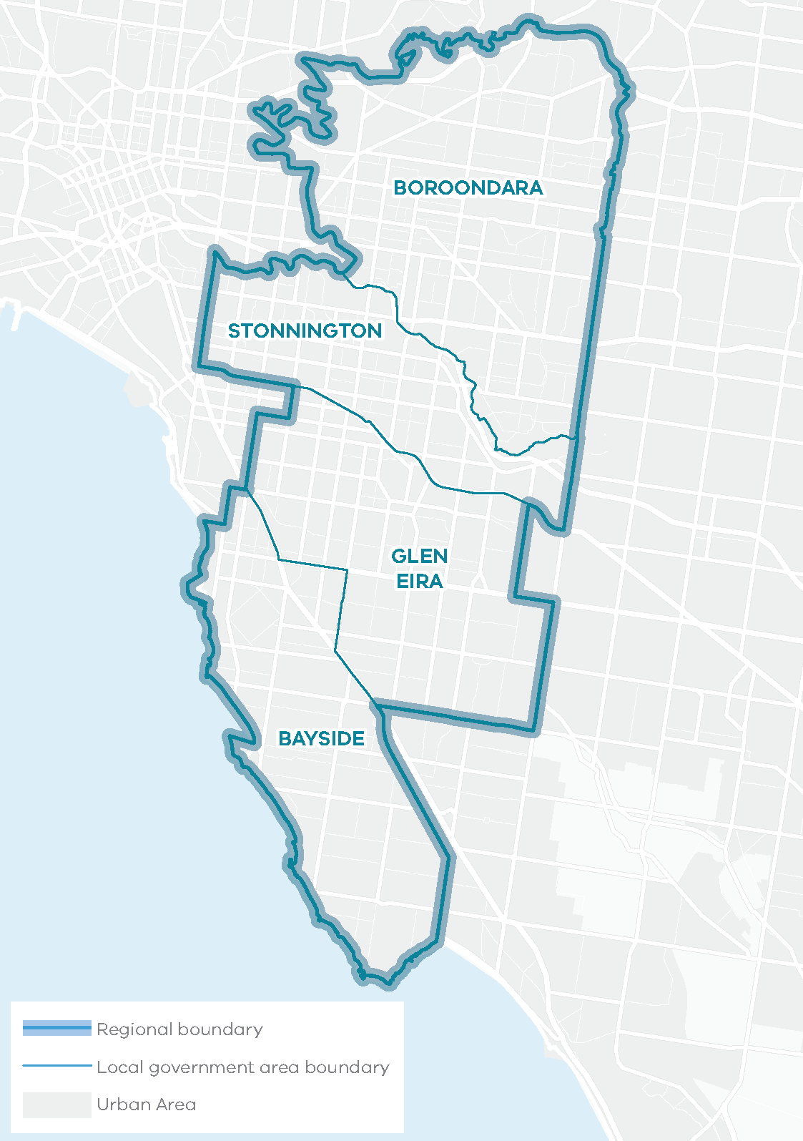
Total area: 16,198HA
2% of Metropolitan Melbourne
The region has no green wedge land
The Inner South East Metro Region is Melbourne’s second smallest region by area but is one of the most prosperous, with some of the city’s highest land values and a greater proportion of residents being professional workers. This is driven by the region’s strong access to Melbourne’s CBD where most professional jobs are located and its established, high amenity neighbourhoods.
The Wurundjeri Woi Wurrung and Bunurong peoples of the Kulin Nation are the Traditional Owners of the lands that now make up the majority of the Inner South East Metro Region, which includes Port Phillip Bay and the Yarra River environs.

Urban structure
The Inner South East Metro Region’s urban geography and structure is characterised by the Yarra River and rolling hills to the north, hills and undulating terrain to the east and the coastline of Port Phillip Bay. The region has a distinctive grid pattern of development with commercial and retail strips that are synonymous with the region such as Chapel Street in Prahran, High Street in Armadale and Glenferrie Road, Hawthorn.
The Inner South East Metro Region is predominantly residential and does not have any new greenfield growth areas or green wedge land. The region has a rich heritage of Victorian and Edwardian architecture. Parts of Kew, Hawthorn, Elsternwick, Brighton and Toorak are well-known for their elegant residences and tree-lined neighbourhoods. Commercial uses are generally focused along main roads and there is limited industrial land. The Yarra River, Gardiners Creek (Kooyongkoot) and Port Phillip Bay are key environmental features and valuable open space for the region. The urban areas include:
- Established inner areas with a distinctly compact urban form including apartments and higher-density development – South Yarra, Prahran, Caulfield
- Established urban areas with a more suburban character of single dwellings set in tree-lined streets in other parts of the region – Camberwell, Brighton, Bentleigh
- Caulfield Racecourse located centrally within the region on the Princes Highway connecting to Chadstone Shopping Centre, a defining feature of the region’s east
- Rail corridors running eastwards to Lilydale, Belgrave, Alamein and Glen Waverley, and southwards to Sandringham, Frankston, Cranbourne and Pakenham, and an extensive tram network
- Monash Freeway and Eastern Freeway connecting to neighbouring regions.

Population and demographics
In 2020 the Inner South East Metro Region had a population of 567,390 people or approximately 11 per cent of Melbourne’s total population.
The region’s population is projected to increase by over 216,000 people between 2020 and 2051 to a total of 784,040 people. From 2016 to 2051 an additional 119,170 dwellings will be needed to accommodate this growth. Consistent with metropolitan Melbourne, the most prevalent household type is families with children and this is expected to remain so until 2051.
Outlined below are some of the key demographics and land use features of the Inner South East Metro Region.

Inner South East Metro Region – Regional Snapshot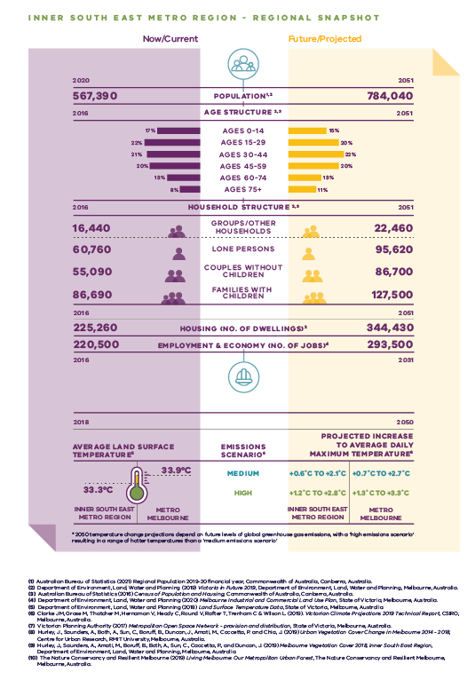
Inner South East Metro Region population  Sources:  Australian Bureau of Statistics (2021) Regional Population 2019-20 financial year, Commonwealth of Australia, Canberra, Australia.  Department of Environment, Land, Water and Planning (2019) Victoria in Future 2019, Department of Environment, Land, Water and Planning, Melbourne, Australia. | 2020 (now/current):  567,390 inhabitants | 2051 (projected/future):  784,040 inhabitants
Inner South East Metro Region age structure  Sources:  Department of Environment, Land, Water and Planning (2019) Victoria in Future 2019, Department of Environment, Land, Water and Planning, Melbourne, Australia.  Australian Bureau of Statistics (2016) Census of Population and Housing, Commonwealth of Australia, Canberra, Australia. | 2016 (now/current):  17 per cent – Ages 0 to 14  22 per cent – Ages 15 to 29  21 per cent – Ages 30 to 44  20 per cent – Ages 45 to 59  13 per cent – Ages 60 to 74  8 per cent – Ages 75 plus | 2051 (projected/future):  15 per cent – Ages 0 to 14  20 per cent – Ages 15 to 29  22 per cent – Ages 30 to 44  20 per cent – Ages 45 to 59  13 per cent – Ages 60 to 74  11 per cent – Ages 75 plus
Inner South East Metro Region household structure  Sources:  Department of Environment, Land, Water and Planning (2019) Victoria in Future 2019, Department of Environment, Land, Water and Planning, Melbourne, Australia.  Australian Bureau of Statistics (2016) Census of Population and Housing, Commonwealth of Australia, Canberra, Australia. | 2016 (now/current):  Groups/other households – 16,440  Lone persons – 60,760  Couples without children – 55,090  Families with children – 86,690 | 2051 (projected/future):  Groups/other households – 22,460  Lone persons – 95,620  Couples without children – 86,700  Families with children – 127,500
Inner South East Metro Region housing (number of dwellings)  Source:  Department of Environment, Land, Water and Planning (2019) Victoria in Future 2019, Department of Environment, Land, Water and Planning, Melbourne, Australia. | 2016 (now/current):  225,260 dwellings | 2051 (projected/future):  334,430 dwellings
Inner South East Metro Region employment and economy (number of jobs)  Source:  Department of Environment, Land, Water and Planning (2020) Melbourne Industrial and Commercial Land Use Plan, State of Victoria, Melbourne, Australia. | 2016 (now/current):  220,500 jobs | 2031 (projected/future):  293,500 jobs
2018 average land surface temperature  Source:  Department of Environment, Land, Water and Planning (2018) Land Surface Temperature Data, State of Victoria, Melbourne, Australia. | Inner South East Metro Region:  33.3 degrees Celsius | Metro Melbourne:  33.9 degrees Celsius
2050 projected increase to average daily maximum temperature  *2050 temperature change projections depend upon future levels of global greenhouse gas emissions, with a ‘high emissions scenario’ resulting in hotter temperatures than a ‘medium emissions scenario’  Source:  Clarke J.M., et al. (2019). Victorian Climate Projections 2019 Technical Report, CSIRO, Melbourne, Australia. | Inner South East Metro Region:  Medium emissions scenario – plus 0.6 to plus 2.1 degrees Celsius  High emissions scenario – plus 1.2 to plus 2.8 degrees Celsius | Metro Melbourne:  Medium emissions scenario – plus 0.7 to plus 2.7 degrees Celsius  High emissions scenario – plus 1.3 to plus 3.3 degrees Celsius

Inner South East Metro Region vs Metro Melbourne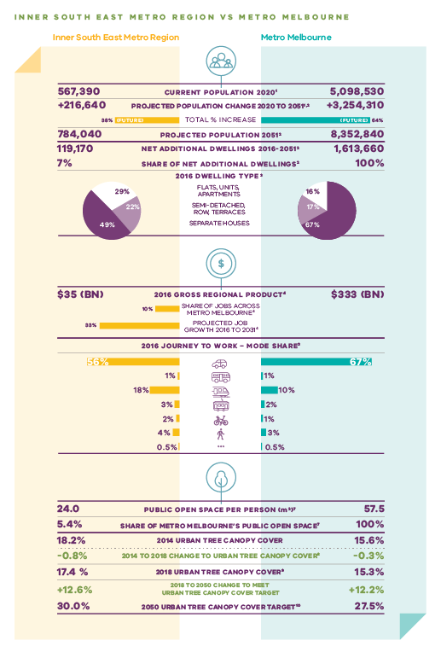
 | Inner South East Metro Region | Metro Melbourne
Current population 2020  Source:  Australian Bureau of Statistics (2021) Regional Population 2019-20 financial year, Commonwealth of Australia, Canberra, Australia. | 567,390 inhabitants | 5,098,530 inhabitants
Projected population change 2020 to 2051  Sources:  Australian Bureau of Statistics (2021) Regional Population 2019-20 financial year, Commonwealth of Australia, Canberra, Australia.  Department of Environment, Land, Water and Planning (2019) Victoria in Future 2019, Department of Environment, Land, Water and Planning, Melbourne, Australia. | Plus 216,640 inhabitants | Plus 3,254,310 inhabitants
Total per cent population change (future) | 38 per cent | 64 per cent
Projected population 2051  Source:  Department of Environment, Land, Water and Planning (2019) Victoria in Future 2019, Department of Environment, Land, Water and Planning, Melbourne, Australia. | 784,040 inhabitants | 8,352,840 inhabitants
Net additional dwellings 2016 to 2051  Source:  Department of Environment, Land, Water and Planning (2019) Victoria in Future 2019, Department of Environment, Land, Water and Planning, Melbourne, Australia. | 119,170 dwellings | 1,613,660 dwellings
Share of net additional dwellings  Source:  Department of Environment, Land, Water and Planning (2019) Victoria in Future 2019, Department of Environment, Land, Water and Planning, Melbourne, Australia. | 7 per cent | 100 per cent
2016 dwelling type  Source:  Australian Bureau of Statistics (2016) Census of Population and Housing, Commonwealth of Australia, Canberra, Australia. | Flats, apartments, units – 29 per cent  Semi-detached, row, terraces – 22 per cent  Separate houses – 49 per cent | Flats, apartments, units – 16 per cent  Semi-detached, row, terraces – 17 per cent  Separate houses – 67 per cent
2016 gross regional product  Source:  Department of Environment, Land, Water and Planning (2020) Melbourne Industrial and Commercial Land Use Plan, State of Victoria, Melbourne, Australia. | $35 billion | $333 billion
Share of jobs across Melbourne  Source:  Department of Environment, Land, Water and Planning (2020) Melbourne Industrial and Commercial Land Use Plan, State of Victoria, Melbourne, Australia. | 10 per cent
Projected job growth to 2031  Source:  Department of Environment, Land, Water and Planning (2020) Melbourne Industrial and Commercial Land Use Plan, State of Victoria, Melbourne, Australia. | 33 per cent
2016 journey to work – mode share  Source:  Australian Bureau of Statistics (2016) Census of Population and Housing, Commonwealth of Australia, Canberra, Australia. | Private motor vehicle – 56 per cent  Bus – 1 per cent  Train – 18 per cent  Tram – 3 per cent  Bicycle – 2 per cent  Walking – 4 per cent  Other – 0.5 per cent | Private motor vehicle – 67 per cent  Bus – 1 per cent  Train – 10 per cent  Tram – 2 per cent  Bicycle – 1 per cent  Walking – 3 per cent  Other – 0.5 per cent
Public open space per person (metres squared)  Source:  Victorian Planning Authority (2017) Metropolitan Open Space Network: Provision and Distribution, State of Victoria, Melbourne, Australia. | 24.0 | 57.5
Share of metro Melbourne’s public open space  Source:  Victorian Planning Authority (2017) Metropolitan Open Space Network: Provision and Distribution, State of Victoria, Melbourne, Australia. | 5.4 per cent | 100 per cent
2014 urban tree canopy cover  Source:  Hurley, J., et al. (2019) Urban Vegetation Cover Change in Melbourne 2014 - 2018, Centre for Urban Research, RMIT University, Melbourne, Australia. | 18.2 per cent | 15.6 per cent
2014 to 2018 change to urban tree canopy cover | Minus 0.8 per cent | Minus 0.3 per cent
2018 urban tree canopy cover  Source:  Hurley, J., et al. (2019) Melbourne Vegetation Cover 2018, Inner South East Region, Department of Environment, Land, Water and Planning, Melbourne, Australia. | 17.4 per cent | 15.3 per cent
2018 to 2050 change to meet urban tree canopy cover target | Plus 12.6 per cent | Plus 12.2 per cent
2050 urban tree canopy cover target  Source:  The Nature Conservancy and Resilient Melbourne (2019) Living Melbourne: Our Metropolitan Urban Forest, The Nature Conservancy and Resilient Melbourne, Melbourne, Australia. | 30.0 per cent | 27.5 per cent

Vision: Inner South East Metro Region in 2050
The Inner South East Metro Region will contribute significantly to the Plan Melbourne vision that “Melbourne will continue to be a global city of opportunity and choice.”
The region’s diverse urban character – from inner city to coastal – and its cultural heritage, strong sense of place and proximity to the Melbourne CBD will continue to attract residents and investment. Residents will enjoy access to high-quality education, health, recreation and community facilities, transport connections, shopping and employment, and prized natural features of its coastline and waterways.
By 2050 the region will balance the needs of a growing population and evolving economic base, while protecting its natural assets and urban character. Specifically:
- The region’s renowned high streets and shopping centres will continue to attract locals and visitors from further afield. Chadstone Shopping Centre, along with Chapel Street, Toorak Road, Prahran Market, Camberwell, High Street/Glenferrie Road, Malvern and Glenferrie Road/Burwood Road, will continue to provide a range of world-class retail and leisure experiences.
- Monash University Caulfield and Swinburne University Hawthorn remain highly-regarded centres of entrepreneurial activity, integrating research, new business development and commercialisation.
- Key regional employment hubs, including the Bayside Business District, Prahran/South Yarra/Windsor, Glenferrie, Caulfield and Carnegie, will support a diverse range of enterprises from start-ups to major businesses.
- Medium- and higher-density housing will be clustered around activity centres, urban renewal areas, transport corridors and education precincts. Elsewhere, more modest redevelopment will protect the region’s valued neighbourhood character, streetscapes and heritage.
- The region’s network of 20-minute neighbourhoods will provide local housing, employment, health and education services and opportunities for social connection.
- An extensive and high-quality public transport network will link residents to opportunities in the CBD, Monash National Employment and Innovation Cluster (NEIC) and outer regions.
- More journeys will be undertaken by walking and bicycle, as the region’s shared trail network links people to the Yarra River, creek corridors and Port Phillip Bay, and a safe commuter cycling network is developed.
- The health of the region’s iconic natural waterways and Port Phillip Bay coastline will be protected and enhanced and will support healthy aquatic and terrestrial biodiversity.
- The region’s iconic tree canopy will be protected and extended to shade its streetscapes and assist in urban cooling.
- An extensive open space network will provide opportunities for relaxation, recreation and connection to nature within the city.
For a more detailed picture of how land use in the Inner South East Metro Region is expected to change by 2050 refer to Map 1.
- Inner South East Metro Region 2050 Plan
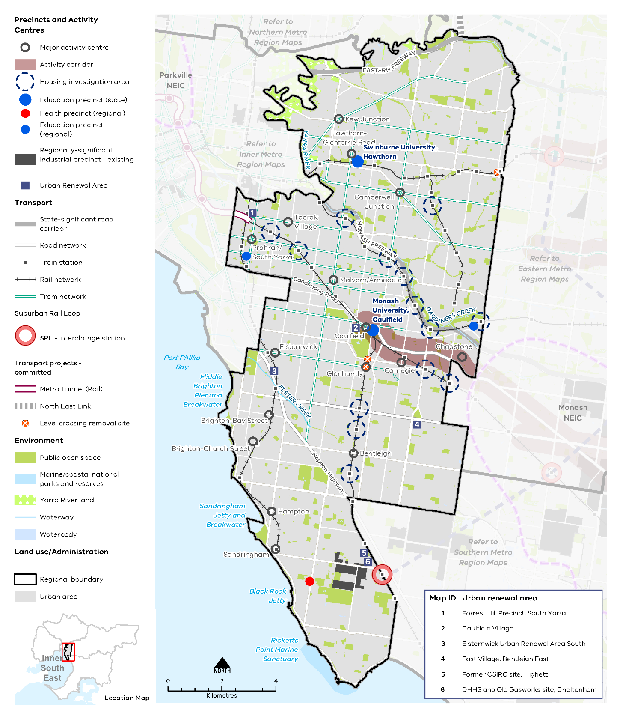

Map 1 Inner South East Metro Region 2050 Plan

A plan of the Inner South East Metro Region in 2050, showing -
- The region’s boundary and established urban areas.

- Locations for growth and investment, including:
- Existing regionally- significant industrial precinct of the Bayside Business District in the south of the region
- The network of existing major activity centres predominantly located on the rail and tram network, as listed in table 2
- State- and regionally-significant education precincts at Caulfield, Hawthorn, Holmesglen and Prahran and a regionally-significant health precinct at Sandringham (see table 9)
- Activity corridor between Caulfield and Monash NEIC (outside the region), which includes Chadstone activity centre
- Six urban renewal areas of:
Forrest Hill Precinct, South Yarra
Caulfield Village
Elsternwick Urban Renewal Area South
East Village, Bentleigh East
Former CSIRO site, Highett
DHHS and Old Gasworks site, Cheltenham
- Housing investigation areas as listed in table 7
- Suburban Rail Loop (East) (Cheltenham to Box Hill) interchange station and precinct at Cheltenham.

- Key transport linkages and movement network including:
- Railway lines and train stations including the start of Suburban Rail Loop (East), level crossing removal sites, proposed Metro Tunnel
- The road network including the state-significant road corridors of the Eastern Freeway and Monash Freeway
- Tram network
- Proposed road upgrades of North East Link.

- State and regional natural assets, including:
- Yarra River land, Ricketts Point Marine Sanctuary, and other public open space.

Productivity
Plan Melbourne Outcome 1: Melbourne is a productive city that attracts investment, supports innovation and creates jobs
The Inner South East Metro Region contributes around 10 per cent of metropolitan Melbourne’s total Gross Regional Product (GRP) and adds $35 billion to the Victorian economy. The majority of contributions come from the business service sector with a value-add worth an estimated $13.7 billion. The region does not have many remaining traditional industries, with the manufacturing and industrial sector contributing an estimated $5.7 billion value-add to the region’s economy.
Plan Melbourne creates a city structure that strengthens Melbourne’s competitiveness for jobs and investment. It identifies national employment and innovation clusters (NEICs), state-significant industrial precincts (SSIPs), a network of metropolitan and major activity centres, transport gateways and state-significant health and education precincts to ensure employment growth occurs outside the Central City and is linked by sustainable transport.

State of play
The Inner South East Metro Region is largely a service-oriented economy with a strong retail sector. It is renowned for significant commercial areas along major roads such as Chapel Street (South Yarra), High Street (Armadale), Glenferrie Road (Malvern) and Burwood Road/Glenferrie Road (Hawthorn). Chadstone, Melbourne’s largest freestanding shopping centre, is located at the region’s east.
The region is well-served by public transport while the key roads of Nepean Highway, Dandenong Road-Princes Highway, Monash Freeway and the Eastern Freeway keep the region well connected to the Central City and other parts of metropolitan Melbourne.
The region’s high level of amenity and access, professional workforce, strong presence of creative industries and proximity to the Central City creates a foundation on which to build a vibrant local economy and attract a greater proportion of knowledge-based, high-value jobs. The location of other key employment areas adjacent to the region, such as Monash and Dandenong NEICs, and SRL precincts, will also attract new residents and a strong local workforce. Very little traditional industry, which includes manufacturing, warehousing and other industry, remains in the region.
The Inner South East Metro Region’s employment and activity centres comprise:
- State-significant education precincts at Swinburne University (Hawthorn) and Monash University (Caulfield)
- A network of 16 major activity centres, most of which are street-based centres, as well as Chadstone Shopping Centre
- Numerous neighbourhood activity centres, many of which are based around tram lines and railway stations
- The regionally-significant industrial precinct of Bayside Business District, and East Village in Bentleigh East.
In 2016, there were a total of 220,500 jobs in the Inner South East Metro Region, which accounted for 10 per cent of all employment across metropolitan Melbourne.
The South East Metro Region’s top five employment industries are: healthcare and social assistance; retail trade; education and training; professional, scientific and technical services; and accommodation and food services (Figure 6). These industries are expected to experience the strongest employment growth. The region’s 16 major activity centres and a significant number of neighbourhood activity centres will contribute to employment growth across the region. Chadstone Shopping Centre will continue to provide a significant retail and entertainment offer.
The Bayside Business District has the largest area of industrial land within the region. It provides a range of manufacturing and industrial uses and is gradually transforming towards a more professional services-oriented business area. East Village in Bentleigh East is a former industrial site transitioning into a mixed-use precinct, with an innovative employment and education focus.
By 2031, it is projected that 73,000 additional jobs will be accommodated in the region, with most employment growth in Boroondara and Stonnington LGAs.
- Projected employment growth for the Inner South East Metro Region 2016 to 2031
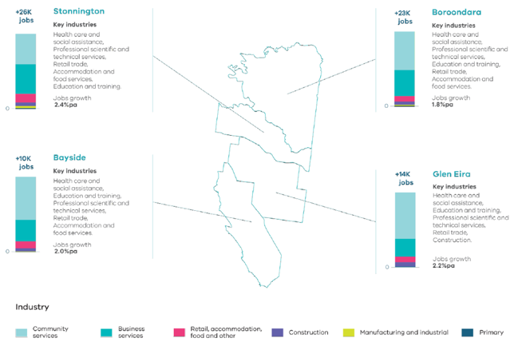
Source: Melbourne Industrial and Commercial Land Use Plan, DELWP, 2020

Figure 6. Projected employment growth for the Inner South East Metro Region 2016 to 2031
Stonnington | Plus 26,000 jobs | 2.4 per cent jobs growth per annum | Key industries: health care and social assistance, professional scientific and technical services, retail trade, accommodation and food services, education and training
Bayside | Plus 10,000 jobs | 2.0 per cent jobs growth per annum | Key industries: health care and social assistance, education and training. professional scientific and technical services, retail trade, accommodation and food services
Boroondara | Plus 23,000 jobs | 1.8 per cent jobs growth per annum | Key industries: health care and social assistance, professional scientific and technical services, education and training, retail trade, accommodation and food services
Glen Eira | Plus 14,000 jobs | 2.2 per cent jobs growth per annum | Key industries: health care and social assistance, education and training. professional scientific and technical services, retail trade, construction
Source: Department of Environment, Land, Water and Planning (2020) Melbourne Industrial and Commercial Land Use Plan, State of Victoria, Melbourne, Australia.

Melbourne Industrial and Commercial Land Use Plan Regional strengths
- The region has a strong network of major activity centres that support vibrant local economies and can continue to improve the provision of local employment opportunities.
- Significant, well-connected education precincts at Hawthorn and Caulfield provide local jobs and service the population.
- The region benefits from proximity to the Melbourne CBD and other significant employment precincts such as Monash NEIC and Alfred Medical Research and Education Precinct in Prahran which are located just outside the region.

Regional challenges
- There are no growth areas within the region, so existing employment land needs to be protected and new opportunities to expand, intensify and diversify employment activity need to be provided within the existing urban context.
- As the region has a limited supply of industrial land it either needs to be retained or transitioned to commercial business uses that can effectively complement the region’s economy.
- The region has to manage strong competing land use pressures to ensure adequate employment land is identified and retained from conversion to residential uses.

Directions and strategies
The directions identified to achieve the 2050 vision for the Inner South East Metro Region in terms of Productivity and Outcome 1 of Plan Melbourne are:
Direction 1 | Provide local jobs by retaining existing employment land and identifying opportunities to expand, intensify and diversify employment activity in activity centres
Direction 2 | Ensure health and/or education precincts continue to provide local jobs while supporting the region’s growing population
Direction 3 | Retain regionally-significant industrial precincts as generators of economic activity and employment
Each direction is implemented through regionally-specific strategies identified in this land use framework plan.
Map 2 shows how productivity will be enhanced across the Inner South East Metro Region by 2050 as a result of these directions and strategies, together with Plan Melbourne and other strategies and initiatives as outlined in Appendix 01.
- Inner South East Metro Region productivity 2050
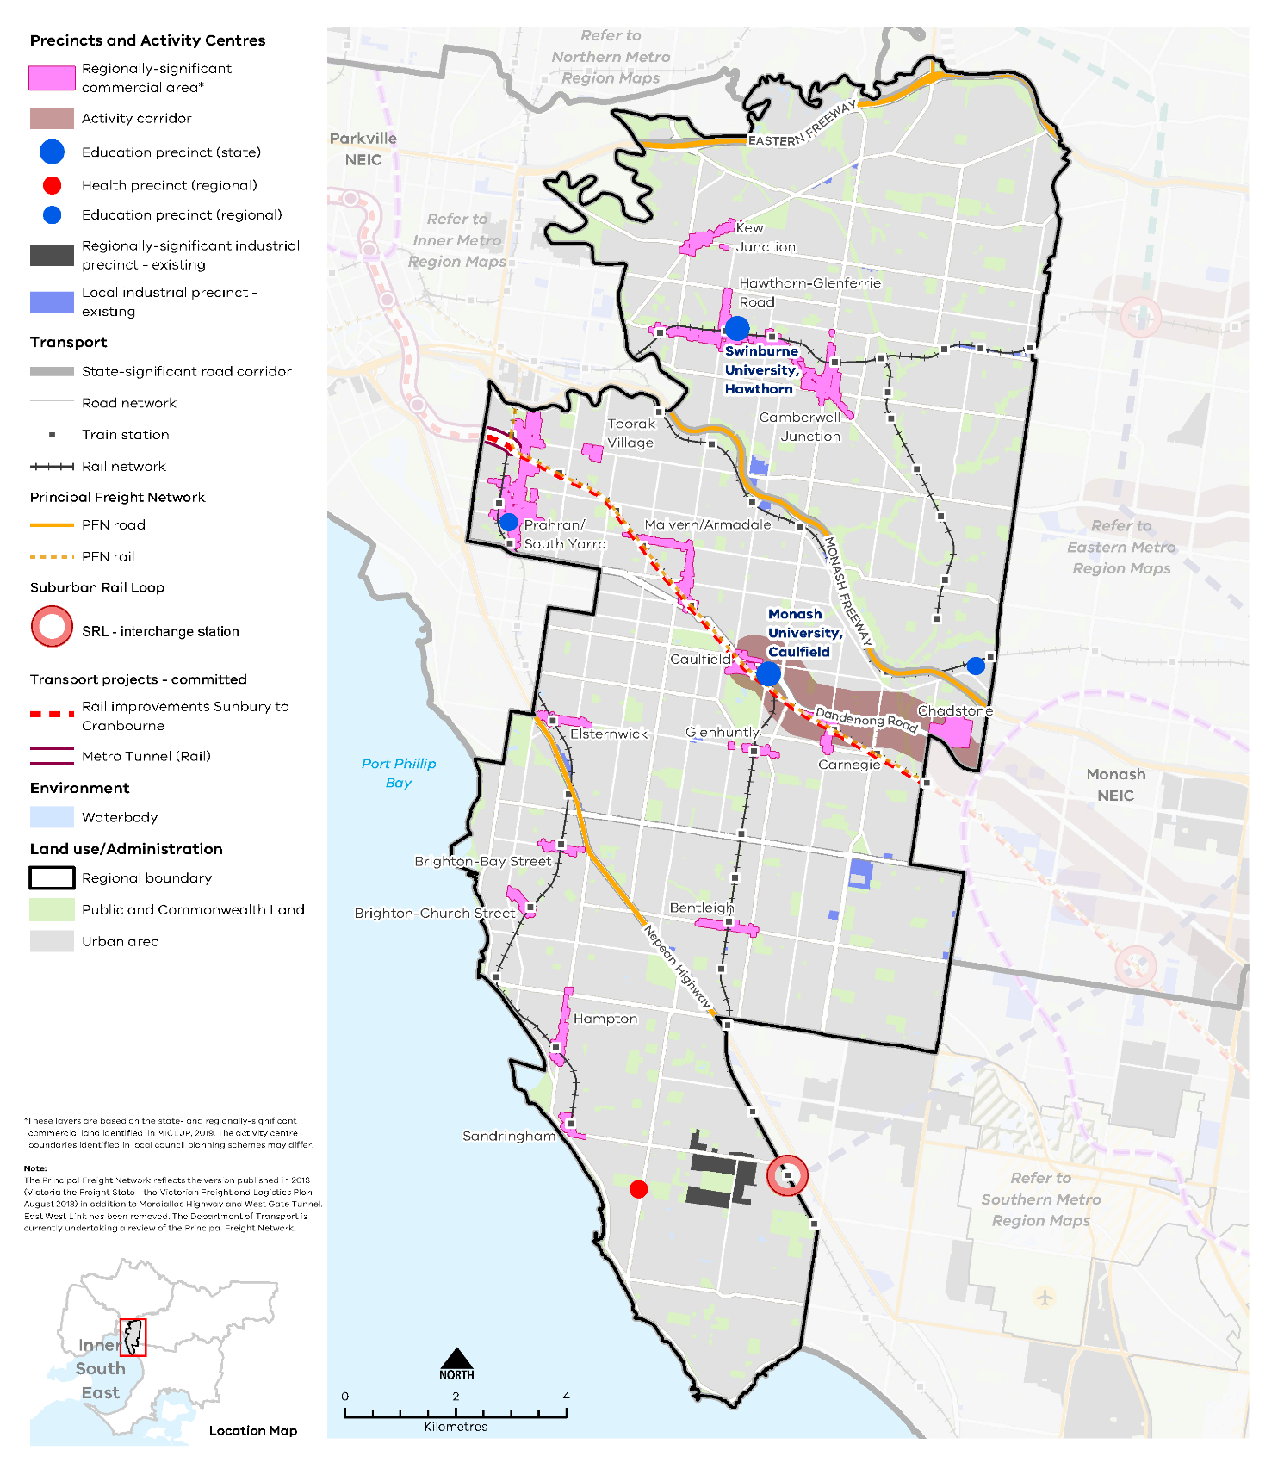

Map 2 Inner South East Metro Region productivity 2050

A plan of productivity in the Inner South East Metro Region in 2050, extracting the productivity features identified on Map 1 above, with the addition of:
- Existing regionally-significant commercial land dispersed throughout the region and based around activity centres*
- Existing locally-significant industrial precincts
- Principal freight networks (PFN) – road and rail
- Rail improvements – Sunbury to Cranbourne

*These layers are based on the state and regionally significant commercial land identified in MICLUP, 2019. The activity centre boundaries identified in local council planning schemes may differ.

NOTE: The Principal Freight Network reflects the version published in 2013 (Victoria the Freight State – the Victorian Freight and Logistics Plan, August 2013) in addition to Mordialloc Highway and West Gate Tunnel. East West Link has been removed. The Department of Transport are currently undertaking a review of the Principal Freight Network.

- Provide local jobs by retaining existing employment land and identifying opportunities to expand, intensify and diversify employment activity in activity centres
The region’s network of 16 major activity centres has a critical role to play in terms of delivering jobs, housing and services, and meeting projected commercial floorspace demands. Only 32 per cent of Inner South East Metro Region residents currently work in the region, the lowest workforce containment levels in metropolitan Melbourne. The region’s major activity centres are where most future employment-generating uses need to be located to improve local employment.
By 2031, around 783,000 square metres of additional commercial floorspace will be required across the region, with 73 per cent of the additional commercial floorspace required for office use and 23 per cent required for retail use (Figure 7). Commercial activity across the region needs to be prioritised over residential development, particularly in activity centres, to ensure the region can accommodate its future needs and improve its provision of local employment opportunities. It is anticipated that 70 per cent of the required additional floorspace will be located in Boroondara and Stonnington LGAs.
The Inner South East Metro Region also has an emerging ‘activity corridor’ along Dandenong Road/Princes Highway, commencing at the Caulfield Major Activity Centre and extending via the Chadstone Major Activity Centre to the Monash NEIC and SRL precincts at Clayton and Monash University (in the Eastern Metro Region). This corridor runs parallel to the Dandenong rail line and would align with the route of the potential Caulfield to Rowville link.
Plan Melbourne supports the development of a network of activity centres linked by transport. This includes encouraging increased diversity and density of developments on the PPTN, particularly at interchanges, activity centres and where principal public transport routes intersect. Activity corridors are locations for increased investment and development opportunities, aligned to strategic land use objectives, that connect and service job-rich locations along strategic corridors. The high levels of accessibility offered by these city-shaping infrastructure upgrades present an opportunity to provide local-scale employment and higher-density housing. The Chadstone Major Activity Centre also needs to be planned within this strategic context.
The region’s major activity centres are supported by a range of smaller neighbourhood activity centres, which also provide local employment and contribute to the character of the region. Table 2 details the activity centres within the region as well as their strategic role.
- Retain existing commercial zoned land and identify areas that can support future demand for commercial floorspace and new investment with a focus on major activity centres.
- Prioritise opportunities for commercial uses in major activity centres over residential development to retain employment land in regionally-significant locations.
- Encourage increased investment and development along the Dandenong Road/Princes Highway activity corridor, between Caulfield Major Activity Centre, Chadstone Major Activity Centre and the Monash NEIC.
- Existing and future commercial floorspace requirements for the Inner South East Metro Region
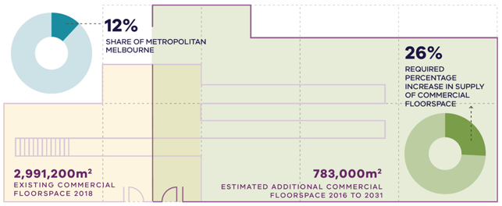
Department of Environment, Land, Water and Planning (2020) Melbourne Industrial and Commercial Land Use Plan, State of Victoria, Melbourne, Australia.

Figure 7. Existing and future commercial floorspace requirements for the Inner South East Metro Region
Inner South East Metro Region | 12 per cent share of metropolitan Melbourne | 2,991,200 square metres – existing commercial floorspace 2018 | 783,000 square metres – estimated additional commercial floorspace 2016 to 2031 | 26 per cent – required percentage increase in supply of commercial floorspace
Source: Department of Environment, Land, Water and Planning (2020) Melbourne Industrial and Commercial Land Use Plan, State of Victoria, Melbourne, Australia.

- Ensure health and/or education precincts continue to provide local jobs while supporting the region’s growing population
The healthcare and social assistance sector, and the education and training sector, are two of the top three employment sectors in the Inner South East Metro Region. This is expected to continue at least through to 2031. Both sectors are important for employment in the region while also providing essential facilities and services. Additionally, an ageing population will generate further demand for health-related facilities and social services, as well as other population-based services in the region.
Monash University (Caulfield) is located in a strategic area of the region adjacent to Caulfield Station, the gateway to the Metro Tunnel, making it highly accessible from any direction. It is adjacent to the Caulfield Racecourse, which has significant opportunities for development and re-use, and the potential Caulfield to Rowville tram link could connect Monash University’s Caulfield campus to the Monash NEIC as well as to the University’s Clayton campus. The Monash University campus is expected to expand and develop into a major innovation and knowledge hub complemented by other uses and civic services, including active recreational facilities, student housing and a night-time economy.
As the connectivity and demand for land continues to increase, strategic planning for Caulfield will need to ensure adequate land is provided to allow the health and education sectors to continue to develop while also planning for a cohesive precinct to build and diversify the economy of the region. The state-significant Alfred Medical Research and Education Precinct (located nearby in the Inner Metro Region) and its teaching and employment links to the Monash University campuses should be considered.
Swinburne University in Hawthorn is also a state-significant education precinct and a major focus for employment and economic activity, including complementary commercial and retail services and student accommodation. The Holmesglen College of TAFE in the region’s outer east is a major provider of vocational skills-based training. While Swinburne University has a strong relationship with the Hawthorn-Glenferrie Road Major Activity Centre, the Holmesglen campus has the potential to be better integrated with the Holmesglen neighbourhood activity centre and the Chadstone Major Activity Centre and surrounding economic activity.
Long-established health facilities across the region will continue to provide a significant employment base, including Sandringham Hospital and St Vincent’s Hospital (Kew). Private health facilities as well as allied health services should be coordinated and located near existing regionally-significant health facilities to access the benefits of having complementary sectors located in proximity.
The continued growth of tertiary education campuses in the region also provides co-location and collaboration opportunities for innovative start-ups and established businesses. The region’s state and private schools will also continue to be major employers.
- Coordinate state and local government planning for the Monash University (Caulfield) to ensure it continues to develop as a major innovation and knowledge hub. This includes planning for the Caulfield Station Precinct, Caulfield Major Activity Centre, Caulfield Racecourse and Reserve and strategic linkages and connections beyond the region to the Monash NEIC.
- Support Monash University (Caulfield) and Swinburne University (Hawthorn) in their role as major employment precincts in the region.
- Support convenience retail, service and business uses in health and/or education precincts to provide ancillary business opportunities and amenities.
- Retain regionally-significant industrial precincts as generators of economic activity and employment
While the Inner South East Metro Region has a diminished industrial role in comparison to other parts of Melbourne, existing industrial land is important for providing local employment opportunities and contributing to the region’s economy.
The region has a total of 143 hectares set aside for industrial uses, with 141 hectares occupied and just over 2 hectares currently vacant (Figure 8). No land has been identified in the region for future industrial purposes. The region is not a preferred location for many traditional industrial uses due to relatively high land costs and limited availability of larger vacant lots compared to other regions. Many traditional industrial areas are transitioning into general business areas with a mix of activities.
Between 2000-01 and 2017-18 a total of 29 hectares of industrial land was rezoned across the region, with the majority of land rezoned for mixed-use or residential development. While traditional industrial uses may not be suited to the region, existing industrial land needs to be retained for employment-generating uses.
The Bayside Business District is the largest area of industrial land in the region and the only one identified as regionally significant. It provides employment for approximately 5000 people and supports a range of manufacturing and industrial uses. It will transition to a business services focus over time to accommodate commercial uses and provide employment opportunities suited to the local skills base. The Bayside Business District should be retained for industrial purposes and protected from incompatible uses so it can continue to accommodate businesses unsuited to activity centres due to potential off-site impacts, land size or access requirements.
The Bayside Business District will play an important role in the local economy and support the growth of nearby activity centres, particularly the Cheltenham-Southland Major Activity Centre. Warehousing and wholesale trade activities service the growing retail sector and service businesses associated with Cheltenham-Southland. Many commercial businesses require a solely commercial location with a larger footprint. Given this, leasable floor areas within the Bayside Business District need to be appropriately sized to ensure they can accommodate a range of commercial uses.
Existing local industrial land will continue to provide important employment land for the region. Industrial land at East Village in Bentleigh East is transitioning into a new mixed-use precinct, with a focus on innovative employment and education opportunities. This includes gradually transitioning existing industrial and services business into commercial and other employment uses.
Industrial land along the Nepean Highway (Brighton East/Bentleigh), Canterbury Road (Canterbury/Surrey Hills), High Street and in Tooronga off the Monash Freeway are other notable local industrial areas that should be retained as employment land.
- Protect the Bayside Business District from encroachment of incompatible uses that would fragment the land and could compromise its development and efficient operation as a business location.
- Support East Village, Bentleigh East to provide local employment as it transitions from traditional industrial to commercial uses.
- Retain local industrial areas that contribute to employment land and support local communities in the Inner South East Metro Region.
- Existing and future industrial floorspace requirements for the Inner South East Metro Region
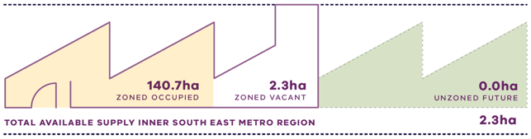
Department of Environment, Land, Water and Planning (2020) Melbourne Industrial and Commercial Land Use Plan, State of Victoria, Melbourne, Australia.

Figure 8. Existing and future industrial floorspace requirements for the Inner South East Metro Region
Inner South East Metro Region | 140.7 hectares zoned occupied | 2.3 hectares zoned vacant | 0.0 hectares unzoned future | 2.3 hectares total available supply
Source: Department of Environment, Land, Water and Planning (2020) Melbourne Industrial and Commercial Land Use Plan, State of Victoria, Melbourne, Australia.

Actions – Productivity
- Identify activity centres where commercial development should be prioritised to accommodate future needs and generate local employment opportunities. Review the capacity of the identified major activity centres within the region to feasibly accommodate additional commercial floorspace within their relevant precinct boundary.
- Undertake Precinct Planning for the Cheltenham Suburban Rail Loop Precinct with local councils and other stakeholders to guide land use change, transport integration and the creation of a liveable, walkable and prosperous precinct.
- Implement a program of State Government-led planning projects, in partnership with local government to ensure major activity centres and urban renewal areas maximise their respective strategic opportunities. Priority will be given to those which deliver significant jobs and housing; leverage investment in state infrastructure; and play an important role in the growth corridor and/or region. State-led planning for these state- and regionally-significant places will contribute to creating liveable communities and achieving more dwellings and jobs in established areas and identify implementation and coordination actions that support growth and economic investment.
Major activity centres: existing attributes and strategic opportunities
Existing attributes | What needs to be considered | Future role/strategic opportunities
Major Activity Centres
Bentleigh (Glen Eira)
- Strip-based centre on Centre Road between Jasper Road and Wheatley Road  - A focus on mixed retail, commercial and hospitality  - Train (Bentleigh, McKinnon and Patterson stations) services | - Heritage significance  - Flooding risk in parts of the activity centre | - Provide a broad range of retail, commercial and community uses to serve the local population  - Encourage a complementary mix of smaller-scale office, business and service uses to support the activity centre’s role as a community focal point  - Support emerging vibrant café and restaurant culture and opportunities for employment-generating uses  - Encourage a mix of housing types, with a particular focus on higher-density housing above active commercial ground floor uses in the core of the activity centre and on sites adjoining the commercial areas  - Support transit-oriented development around the train station
Brighton – Bay Street (Bayside)
- Strip-based centre on Bay Street between Nepean Highway and Cochrane Street, dissected by the Sandringham railway line  - A focus on specialty retail, commercial, restaurant and café uses, and a cinema  - Train (North Brighton Station) service | - Heritage significance  - Flooding risk in parts of the activity centre | - Encourage a broad range of retail, commercial and community uses to serve the local population, focused in the existing shopping area between Hillcrest Avenue and Asling Street  - Encourage office and employment uses at the western end of the activity centre  - Provide opportunities for community activity, based around a vibrant public realm  - Encourage a mix of housing types, with a particular focus on medium-density housing above active commercial ground floor uses in the core of the activity centre and on sites adjoining the commercial areas  - Retain heritage character and scale  - Support transit-oriented development around the train station
Brighton – Church Street (Bayside)
- Strip-based centre on Church Street between New Street and Male Street, dissected by the Sandringham railway line  - A focus on specialty retail and commercial with restaurant and café uses, and a cinema  - Notable visitor attraction, Brighton Bathing Boxes, located on Middle Brighton Beach within close proximity  - Train (Middle Brighton Station) service | - Heritage significance  - Flooding risk in parts of the activity centre | - Support the activity centre’s role as a local focal point for retail, commercial and community uses, within the existing shopping area between St Andrews and Male streets  - Encourage allied health services to complement the role of the hospital  - Encourage a mix of housing types, with a particular focus on medium-density housing above active commercial ground floor uses in the core of the activity centre and on sites adjoining the commercial areas, particularly the at-grade carparks behind the shops  - Retain heritage character and scale  - Support transit-oriented development around the train station
Camberwell Junction (Boroondara)
- Hybrid centre at the intersection of three major arterial roads – Burke, Camberwell and Riversdale roads  - Speciality and higher-order retail, commercial, restaurant and hospitality uses, including a cinema and fresh food market, and The Well Shopping Centre  - Civic and community functions around council offices  - Train (Camberwell, East Camberwell, Riversdale, Auburn and Willison stations) and tram services | - Heritage significance | - Strengthen the distinctive offer of Camberwell Junction’s mixed-use retail, commercial and hospitality/entertainment  - Recognise Camberwell Junction’s role as a high-profile office location in the eastern suburbs  - Encourage a complementary range of social, cultural, entertainment, recreational and other community-related facilities, set around a vibrant and active public realm  - Encourage a mix of housing types, with a particular focus on medium-density housing above active commercial ground floor uses in the core of the activity centre and on sites adjoining the commercial areas  - Retain the traditional strip shopping centre character  - Support transit-oriented development around Camberwell station
Carnegie (Glen Eira)
- Strip-based centre on Koornang Road, between Neerim Road and Dandenong Road  - A mix of retail, cafés and restaurants, civic and community uses  - Train (Carnegie and Murrumbeena stations) and tram services | - Heritage significance  - Flooding risk in parts of the activity centre  - Potential redevelopment site at the council library car park | - Strengthen the activity centre’s role in providing for a range of retail, hospitality and employment-generating uses to serve the local community and supporting a range of businesses  - Encourage a mix of housing types, with a particular focus on medium-density housing above active commercial ground floor uses in the core of the activity centre and on sites adjoining the commercial areas  - Support opportunities for higher-density housing and commercial development along the Dandenong Road/Princes Highway activity corridor  - Encourage opportunities for community and cultural spaces
Caulfield (Glen Eira)
- Hybrid centre on Derby Road, Dandenong Road and Normanby Road  - A mix of retail, commercial, hospitality and community uses, including Caulfield Plaza Shopping Centre  - State-significant education facility at Monash University  - Regionally-significant recreation facilities at Caulfield Racecourse and Caulfield Park  - Train (Caulfield Station) and tram services | - Heritage significance  - Flooding risk in parts of the activity centre  - Metro Tunnel will connect Caulfield to city stations and north-west suburbs, provide a direct link to ANZAC Station and Caulfield Station will be a major interchange station  - Potential Caulfield to Rowville Link  - Caulfield Village urban renewal  - Redevelopment of Caulfield Racecourse as a major recreational facility | - Encourage the activity centre’s role as a regional destination for education, employment and events, anchored by Monash University  - Encourage a mix of housing types, with a particular focus on medium-density housing above active commercial ground floor uses in the core of the activity centre and on sites adjoining the commercial areas  - Encourage mixed-use development of Caulfield Village urban renewal site  - Encourage opportunities for student housing in proximity to Monash University  - Support opportunities for higher-density housing and commercial development along the Dandenong Road/Princes Highway activity corridor  - Maximise integration and transit-oriented development opportunities with future role of Caulfield Station and potential Caulfield to Rowville Link via Monash University, Clayton
Chadstone (Stonnington)
- Freestanding shopping centre on Dandenong Road  - Higher-order and speciality retail, recreation and entertainment uses, as well as high-rise hotel and office developments  - Major tourism site for its specialty retail offer (fashion)  - Holmesglen TAFE regional education facility  - Train (Holmesglen Station) and SmartBus services  - PPTN interchange | - Potential Caulfield to Rowville Link | - Improve integration with Holmesglen TAFE and nearby commercial uses along Dandenong Road
Elsternwick (Glen Eira)
- Strip-based centre on Glen Huntly Road, between Nepean Highway and Shoobra Road, dissected by the Sandringham train line  - A wide range of retail, commercial and hospitality uses  - Significant heritage/tourism site of Ripponlea House and Gardens  - Cultural role for the Jewish community, with the Jewish Holocaust Centre and several Jewish schools  - Train (Elsternwick Station) and tram services | - Heritage significance  - Flooding risk in parts of the activity centre  - Elsternwick Urban Renewal Area South  - Heritage Overlay and Neighbourhood Character Overlay in residential areas surrounding the commercial core | - Encourage a broad range of retail, commercial, cultural and community uses to serve the local and visitor populations  - Enhance the activity centre’s role as a vibrant cultural and entertainment precinct, with active streetscapes and historic character  - Ensure protection of heritage buildings and streetscapes  - Support allied health services to complement the role of the regional health facility  - Encourage a mix of housing types, with a particular focus on medium-density housing above active commercial ground floor uses in the core of the activity centre and on sites adjoining the commercial areas  - Encourage higher-density housing along Nepean Highway within the urban renewal area  - Support transit-oriented development around the train station
Glen Huntly (Glen Eira)
- Strip-based centre on Glen Huntly Road, between Booran Road and Grange Road, dissected by the Frankston train line  - A wide range of retail, commercial and hospitality uses  - Train (Glenhuntly Station) and tram services | - Level crossing removals at Neerim and Glenhuntly roads  - Flooding risk in parts of the activity centre  - Redevelopment of Caulfield Racecourse Reserve as a major recreational facility | - Encourage a broad range of retail, commercial and community uses with a local community focus  - Encourage a mix of housing types, with a particular focus on medium-density housing above active commercial ground floor uses in the core of the activity centre and on sites adjoining the commercial areas  - Strengthen links to the Caulfield Racecourse Reserve  - Support transit-oriented development around the train station
Hampton (Bayside)
- Strip-based centre on Hampton Street, between South Road and Beach Road, dissected by the Sandringham train line  - A range of retail, commercial, hospitality and recreational uses  - Train (Hampton Station) service | - Heritage significance  - Flooding risk in parts of the activity centre | - Encourage a range of retail, commercial and community uses between Willis Street and the railway line, extending to the upgraded Willis Street precinct, to serve the local population  - Encourage a mix of housing types, with a particular focus on medium-density housing above active commercial ground floor uses in the core of the activity centre and on sites adjoining the commercial areas  - Support a community-focused, active streetscape setting with a safe and attractive public realm  - Support transit-oriented development around the train station
Hawthorn – Glenferrie Road (Boroondara)
- Strip-based centre around the intersection of Glenferrie and Burwood roads, dissected by the Lilydale/Belgrave train line  - A range of specialty and large-format retail, commercial, hospitality and recreational uses  - Civic, arts and cultural activities around the Hawthorn Town Hall  - State-significant education precinct at Swinburne University of Technology  - Train (Glenferrie and Auburn stations) and tram services | - Heritage significance  - Flooding risk in parts of the activity centre | - Support the activity centre’s regional role as a retail, commercial, community, civic and cultural focal point, and continued investment in education, innovation and allied businesses  - Encourage a mix of housing types, including student accommodation, with a particular focus on medium-density housing above active commercial ground floor uses in the core of the activity centre and on sites adjoining the commercial areas  - Retain the distinctive heritage character while supporting high-quality new development  - Support the activity centre’s vibrant hospitality and entertainment role, set around a safe and attractive public realm  - Support transit-oriented development including higher-density development, where appropriate, around the train station, train line and Swinburne University of Technology
Kew Junction (Boroondara)
- Strip-based centre based around High Street and Cotham Road  - Mixed retail, commercial, community, cultural and recreational uses and some large-scale offices  - Tram services | - Heritage significance | - Strengthen the activity centre’s mixed retail, commercial and hospitality/entertainment offer, and its role as a high-profile office location  - Encourage a complementary range of social, cultural, entertainment, recreational and other community-related facilities  - Provide a high-quality pedestrian environment with improved pedestrian links and public spaces  - Encourage a mix of housing types, with a particular focus on medium-density housing above active commercial ground floor uses in the core of the activity centre and on sites adjoining the commercial areas  - Encourage development of key sites, such as surface car parks and the VicRoads site, for mixed-use development and an improved public realm
Malvern/Armadale (Stonnington)
- Hybrid centre based around High Street (between Glenferrie Road and the Frankston/Pakenham train line) and Glenferrie Road (south of High Street to Dandenong Road)  - A range of specialist and higher-order retail, commercial, community, cultural and recreational uses with a focus on antiques and furnishing retailers, and Malvern Central Shopping Centre  - Train (Armadale and Malvern stations) and tram services | - Heritage significance  - Flooding risk in parts of the activity centre | - Support the mix of specialty and other retail, commercial, cultural and community uses  - Support allied health services to complement the role of the regional health facility  - Encourage a mix of housing types, with a particular focus on medium-density housing above active commercial ground floor uses in the core of the activity centre and on sites adjoining the commercial areas  - Encourage higher-density housing along Dandenong Road  - Support transit-oriented development around the train stations
Moorabbin (Bayside part of the activity centre)
- Strip-based centre at the intersection of the Nepean Highway and South Road  - A focus on big box retail, commercial uses and civic facilities  - Regionally-significant industrial land located to the east  - Train (Moorabbin Station) service | - At the junction of three LGA boundaries (Kingston, Glen Eira and Bayside) and divided by major arterial roads  - Proximity to SRL Cheltenham Precinct | - Support appropriate growth in retail, commercial and civic use  - Encourage a mix of housing types, with a particular focus on medium-density housing above active commercial ground floor uses in the core of the activity centre and on sites adjoining the commercial areas  - Encourage higher-density housing along Nepean Highway within the urban renewal area  - Activate and enhance cultural uses  - Support transit-oriented development around the train station
Prahran/South Yarra (Stonnington)
- Strip-based centre along Chapel Street, between Toorak Road and Dandenong Road  - A regional retail and entertainment role including specialty and higher-order retail, hospitality and vibrant night-time economy  - Arts, cultural and civic uses  - State-significant health precinct at the Alfred Hospital, and regional education precinct at Melbourne Polytechnic Prahran  - Visitor attractions of Como House, Prahran Market and Chapel Street shopping and entertainment precinct  - Train (South Yarra, Prahran, Hawksburn and Windsor stations) and tram services | - Heritage significance  - Flooding risk in parts of the activity centre  - South Yarra Station which is undergoing master planning and station upgrades  - Forrest Hill Precinct urban renewal area with significant higher-density residential developments | - Reinforce the role as a visitor destination and regional retail, entertainment, hospitality and entertainment focus  - Encourage commercial and employment land uses, including new incubator and creative businesses (specifically the digital and craft industries)  - Strengthen and expand cultural and education role  - Revitalise former light industrial areas behind Chapel Street to provide high-quality mixed-use development opportunities  - Ensure an activated, safe and attractive public realm to support the role as a focus for local community activity and as a visitor destination
Sandringham (Bayside)
- Strip-based centre between Bay Road, Beach Road and Abbott Street  - A range of retail, commercial, hospitality, community and recreational uses  - Adjacent to Port Phillip Bay  - Train (Sandringham Station) service and bus depot adjacent to train station | - Close to Hampton Major Activity Centre  - Heritage significance  - Flooding risk in parts of the activity centre | - Consolidate the local retail, hospitality and service role  - Encourage a broad range of retail, commercial and community uses  - Encourage a mix of housing types, with a particular focus on medium-density housing above active commercial ground floor uses in the core of the activity centre and on sites adjoining the commercial areas  - Retain the scale and character, with well-designed buildings set within a safe and attractive public realm  - Support transit-oriented development around the train station
Toorak Village (Stonnington)
- Strip-based centre on Toorak Road, between Orrong and Williams roads  - A range of specialty retail, commercial, hospitality and recreational uses, and visitor attraction at Como House  - Tram services | - Heritage significance  - Flooding risk in parts of the activity centre | - Consolidate the local retail and service role  - Encourage a broad range of retail, commercial and community uses  - Encourage a mix of housing types, with a particular focus on medium-density housing above active commercial ground floor uses in the core of the centre and on sites adjoining the commercial areas

Housing Choice
Plan Melbourne Outcome 2: Melbourne provides housing choice in locations close to jobs and services.
Plan Melbourne seeks to increase the supply of housing in established areas close to jobs, services and public transport to accommodate the anticipated increase in population over the next 30 years while ensuring Melbourne remains liveable, sustainable and accessible.
The Inner South East Metro Region is renowned for its established activity centres, heritage streetscapes, connection with Port Phillip Bay, tree-lined streets and extensive public transport network, particularly the tram network that services most of the activity centres in the region.
However, a lack of affordable housing is a major issue for the region. High land values are driven by the region’s proximity to Melbourne’s CBD and its reputation for amenity and character. This also affects the value of apartments that command significantly higher prices than comparable stock in other regions across metropolitan Melbourne. There is a need to provide a diversity of housing to cater for vulnerable Victorians, the ageing population, students and people attracted to the region for its proximity to existing infrastructure.
A significant proportion of land within the Inner South East Metro Region is protected by heritage or neighbourhood character policies which may impact on the density, height and built form of new residential development. This includes areas within and close to activity centres, along the Principal Public Transport Network (PPTN) and urban renewal precincts and sites. The ongoing challenge is to identify locations for housing growth, without compromising the characteristics, assets and values that define the Inner South East Metro Region.

State of play

Metropolitan Melbourne
Strong demand has led to increased competition for housing in Melbourne’s inner and middle ring suburbs which have good access to jobs, services and public transport.
The residential development industry is responding to higher demands for housing by increasing supply across metropolitan Melbourne. The number of dwellings and location of additional housing being developed depends on the availability and suitability of land and the willingness and ability of households to afford it. A significant number of homes are developed in Melbourne’s outer suburban growth areas, due to the availability of land zoned for residential uses in these areas. This has enabled residential developers to meet the demand for relatively affordable housing.
There has also been an increase in the supply of apartments in the Central City – and increasingly in inner suburbs of Melbourne – driven by investors purchasing apartments to meet increased demand for rental accommodation in the inner city. In other areas, particularly middle ring suburbs, which have been established residential areas for some time, the supply of housing is relatively fixed compared to other metro regions and is less able to respond to the increasing demand for housing in Melbourne.

Inner South East Metro Region

Regional demographics
Forecast population growth in the Inner South East Metro Region is more modest than in other metropolitan regions. In 2051 the region’s population is expected to be 784,040, an increase of approximately 216,640 on the 2020 population of 567,390. A further 119,170 dwellings will be required from 2016 to accommodate this growth across the region (DELWP, 2019).
The Inner South East Metro Region comprises 11 per cent of metropolitan Melbourne’s population of 5,098,530 at 2020. It is expected to be around 9 per cent of metropolitan Melbourne’s projected population of 8,352,840 by 2051. Population growth in the region is anticipated to be at a lower rate than metropolitan Melbourne average, with an expected annual population growth of approximately 1.0 per cent in the region compared with 1.5 per cent across Melbourne. Given the region is geographically smaller compared to other metropolitan regions, growth will likely be accommodated at higher average densities than the metropolitan regions with greenfield growth areas.
In 2016 the most prevalent age group was the 20-34 year olds (Figure 9). This is consistent across metropolitan Melbourne. This statistic is likely to change over time, with the region’s largest age cohort projected to be people aged 35-49 by 2051. In 2016, 21 per cent of the region’s population was over the age of 60, which is greater than the metropolitan Melbourne average of 18.4 per cent. By 2051, 24 per cent of the region’s population is projected to be over the age of 60 (DELWP, 2019b). This is comparable to the projections for metropolitan Melbourne overall.
In 2016, the most prevalent household group in the Inner South East Metro Region was families with children. By 2051 it is expected there will be a marginal decrease in the number of households with children from 40 per cent in 2016 to just over 38 per cent and an increase in households comprising lone persons and couples without children, consistent with projections for metropolitan Melbourne (DELWP, 2019b).
In 2036, Boroondara will continue to accommodate the greatest number of people across the region with 32 per cent of the region’s population, followed by Glen Eira with 28 per cent (Table 3). Bayside will accommodate the smallest amount of the region’s population at 18 per cent of the region’s total.
Actual and projected population by Local Government Area, 2016 - 2036
LGA | 2016 | 2020 | 2026 | 2031 | 2036
Bayside | 102,910 | 107,540 | 113,650 | 118,040 | 122,710
Boroondara | 177,280 | 183,020 | 195,520 | 204,550 | 213,840
Glen Eira | 148,580 | 158,220 | 168,760 | 178,840 | 188,210
Stonnington | 111,000 | 118,610 | 129,370 | 137,810 | 146,890
Inner South East Metro Region | 539,770 | 567,390 | 607,300 | 639,230 | 671,650
Victoria in Future, DELWP, 2019 and Regional Population, Australian Bureau of Statistics, 2021
- Regional actual and projected population by age, 2016 - 2051
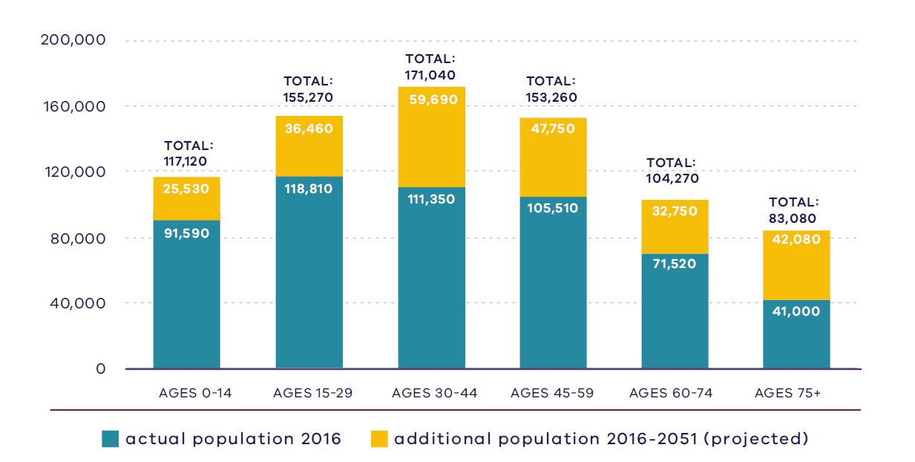
Victoria in Future, DELWP, 2019

Figure 9. Regional actual and projected population by age, 2016 - 2051
2016:  91,590 – Ages 0 to 14  118,810 – Ages 15 to 29  111,350 – Ages 30 to 44  105,510 – Ages 45 to 59  71,520 – Ages 60 to 74  41,000 – Ages 75 plus | 2051:  117,120 – Ages 0 to 14  155,270 – Ages 15 to 29  171,040 – Ages 30 to 44  153,260 – Ages 45 to 59  104,270 – Ages 60 to 74  83,080 – Ages 75 plus
Source: Department of Environment, Land, Water and Planning (2019) Victoria in Future 2019, Department of Environment, Land, Water and Planning, Melbourne, Australia.

Housing stock
In 2016, separate houses made up almost 50 per cent of the Inner South East Metro Region’s housing stock, compared to 67 per cent for metropolitan Melbourne. Flats, units and apartments comprised around 30 per cent, and semi-detached and terrace dwellings comprised 22 per cent of the region’s housing stock compared to 16 per cent for both of these housing types across metropolitan Melbourne (DELWP, 2019b).
The region includes a wide range of heritage places and precincts, including some of the grandest Victorian and Edwardian era homes in Melbourne, streetscapes of workers cottages and art deco-style apartments. The region is highly regarded for its heritage streetscapes and European-style architecture.
In more recent years, there has been an increase in high-rise, mixed-use development in Prahran/South Yarra Major Activity Centre which has significantly altered the urban structure in Stonnington, offering a higher-density lifestyle compared to other activity centres in the Inner South East Metro Region.
The existing subdivision pattern of relatively small lots, while reflecting the diversity of housing styles found in the region, is one of the factors limiting the opportunity for increased housing density. Some suburbs contain larger lots and older housing stock which is being replaced with larger homes or, in some cases, medium-density housing developments, where planning controls allow. Restrictive covenants apply to some areas that limit development to single dwellings.

Projected housing requirements
Victoria in Future (VIF) projections are published at LGA level for a 20-year horizon from the most recent Census data – currently from 2016 to 2036. Beyond this period knowledge of land supply, dwelling construction and population distribution trends be less certain.
VIF projections indicate that based on the continuation of current trends, and knowledge of long-term greenfield land supply, approximately 66 per cent of net additional dwellings across metropolitan Melbourne are expected to be in established areas and 34 per cent in greenfield areas. The housing distribution figures between established areas and greenfield areas are shown in Table 4.
Plan Melbourne provides an alternate aspirational housing distribution scenario based on achieving 70 per cent of new housing in Melbourne’s established areas and the remaining 30 per cent accommodated in greenfield areas. This scenario assumes a total of 70,000 dwellings across metropolitan Melbourne, which VIF 2019 projections allocated to greenfield areas, can be accommodated in established areas to realise the aspirational 70/30 distribution between 2019 to 2051 (Table 5).
The aspirational housing distribution scenario provides for a redistribution of 5000 dwellings from greenfield areas across metropolitan Melbourne to be accommodated in the Inner South East Metro Region.
Table 6 shows the aspirational housing distribution scenario for each LGA to 2036. This is achieved by apportioning the net dwelling additions in the established area for each metropolitan region and distributing the amount between LGAs in the region. The aspirational scenario is based on the locations where most housing growth is anticipated across the established metropolitan area such as the Central City, NEICs, metropolitan and major activity centres, major urban renewal precincts and future SRL precincts. The 70/30 dwelling redistribution for the region will provide guidance for each LGA to accommodate housing growth that achieves the aspirational housing distribution for metropolitan Melbourne.
Scenario 1 VIF 2019
Region | Net dwelling additions 2016 to 2051 – Total | Net dwelling additions 2016 to 2051 – Established | Net dwelling additions 2016 to 2051 – Greenfield
Inner Metro | 225,000 | 225,000 | 0
Western | 412,000 | 177,000 | 235,000
Northern | 352,000 | 167,000 | 185,000
Inner South East | 119,000 | 119,000 | 0
Eastern | 192,000 | 192,000 | 0
Southern | 313,000 | 184,000 | 129,000
Total Melbourne | 1,613,000 | 1,064,000 | 549,000
 | 100% | 66% | 34%
Scenario 2 Aspirational scenario
Region | Net dwelling additions 2016 to 2051 – Total | Net dwelling additions 2016 to 2051 – Established | Net dwelling additions 2016 to 2051 – Greenfield
Inner Metro | 235,000 | 235,000 | 0
Western | 402,000 | 197,000 | 205,000
Northern | 347,000 | 182,000 | 165,000
Inner South East | 124,000 | 124,000 | 0
Eastern | 202,000 | 202,000 | 0
Southern | 303,000 | 194,000 | 109,000
Total Melbourne | 1,613,000 | 1,134,000 | 479,000
 | 100% | 70% | 30%
Note: For the purpose of these figures, greenfield areas include land in a growth area council that is either currently under development or identified for future development
Inner South East Metro Region 70/30 redistribution by LGA to 2036
LGA | VIF2019 dwellings – 2021 | VIF2019 dwellings – 2036 | Including 70/30 dwellings – 2036 | 70/30 dwelling redistribution | Share of regional redistribution
Bayside | 44,400 | 51,900 | 52,600 | 700 | 28%
Boroondara | 75,100 | 87,700 | 88,100 | 400 | 16%
Glen Eira | 68,900 | 82,900 | 83,600 | 700 | 28%
Stonnington | 61,200 | 74,900 | 75,500 | 600 | 24%
Inner South East Metro | 249,600 | 297,400 | 299,800 | 2500 | 100%

Locations for housing growth
Housing strategies prepared by all LGAs in the Inner South East Metro Region encourage greater-density development around activity centres, along residential activity corridors and potential urban renewal sites. Together these locations are also critical to help meet employment, service and infrastructure needs for the region’s growing population.
The region is unique in terms of having a substantial tram and train network servicing its major activity centres and some neighbourhood activity centres. Locating housing along or close to tram and train networks will improve access to local jobs and services. Major housing in the Inner South East Metro Region that is proposed in or within 400 metres of an activity centre is shown in Figure 10.
Between 2005 and 2016 a substantial amount of residential development in the Inner South East Metro Region occurred in or within 400 metres of activity centres. During this period Stonnington provided for the largest proportion of residential development, with 84 per cent of new dwellings located within an activity centre (DELWP, 2018a). All other LGAs in the region provided for approximately 45 per cent of new dwellings to be constructed in or within 400 metres of an activity centre and the balance outside of these areas. This uptake of housing development in proximity to activity centres is much higher than other regions (DELWP, 2018a).
Heritage and neighbourhood character are highly valued in the Inner South East Metro Region and make a significant contribution to the region’s identity and amenity. Each of the region’s local councils have undertaken extensive heritage and neighbourhood character studies across their municipalities and applied heritage and neighbourhood character overlays and policy to ensure that new development continues to respect and protect the existing built-form aesthetic, streetscapes and historic legacy.

Housing demand and its impact on affordability
Housing affordability is an issue in the Inner South East Metro Region. The region is highly desirable thanks to its wealth of amenities including entertainment precincts, valued open space and a concentration of prestigious public and private secondary schools, and access to good public transport. High land value is also driven by the region’s proximity to Melbourne’s CBD which means even smaller dwellings, such as apartments or flats, command prices significantly higher than comparable stock in other regions. These factors drive up demand and prices for purchase and rent in the region.
All four LGAs in the Inner South East Metro Region are among the least affordable council areas in metropolitan Melbourne for rental affordability. Bayside, Boroondara and Glen Eira have some of lowest proportion of affordable rental properties with less than 1 per cent of dwelling stock being affordable, while Stonnington has between 1 and 2 per cent of dwelling stock being affordable (DHHS, 2020). These relatively high housing costs can bring about housing stress for households’ mortgage and/or rental properties.
The Inner South East Metro Region has limited affordable housing available for key workers such as childcare and aged care workers and teachers. Approximately 50 per cent of key workers in the region have low or moderate incomes (MGS Architects, 2020).
There are several existing Victorian Government initiatives in place to improve the supply of affordable housing, including social housing. These include Victoria’s Big Housing Build, the Social Housing Growth Fund, 1000 Homes initiative and the Redevelopment of Public Housing Estates. Boroondara LGA has been identified as a priority area to increase the supply of social and affordable housing in the Inner South East Metro Region as part of Homes Victoria’s Big Housing Build program.
- Major housing in the redevelopment pipeline in or within 400 metres of an activity centre
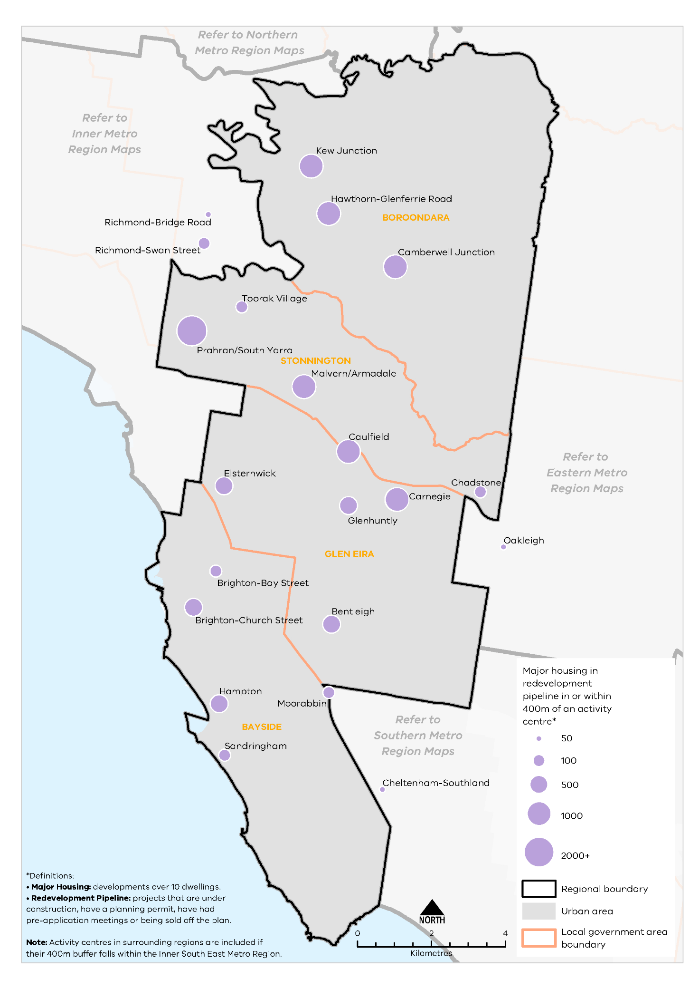
Urban Development Program 2019, Department of Environment, Land, Water and Planning
Figure 10. Major housing in the redevelopment pipeline in or within 400 metres of an activity centre
This map shows:
- Major housing redevelopment pipeline in or within 400m of an activity centre.
- Regional boundary
- Urban area covering the local government areas.
- Local government areas including Boroondara, Stonnington, Glen Eira and Bayside.
*Definitions:
• Major Housing: developments over 10 dwellings.
• Redevelopment Pipeline: projects that are under construction, have a planning permit, have had pre-application meetings or being sold off the plan.
Note: Activity centres in surrounding regions are included if their 400m buffer falls within the Inner South East Metro Region.
Location | Major housing development pipeline in or within 400m of an activity centre*
Kew Junction | 501-1000
Hawthorn-Glenferrie Road | 501-1000
Camberwell Junction | 501-1000
Richmond-Bridge Road | 11-50
Richmond-Swan Street | 51-100
Toorak Village | 51-100
Prahran/South Yarra | 2000+
Malvern/Armadale | 501-1000
Caulfield | 501-1000
Chadstone | 51-100
Elsternwick | 101-500
Carnegie | 501-1000
Glenhuntly | 101-500
Brighton-Bay Street | 51-100
Brighton-Church Street | 101-500
Bentleigh | 101-500
Hampton | 101-500
Moorabbin | 51-100
Sandringham | 51-100
Oakleigh | 50
Cheltenham-Southland | 50

Regional strengths
- Opportunities exist to locate medium- and higher density housing in and around major activity centres, identified urban renewal areas, and in locations supported by good public transport.
- Highly valued heritage and neighbourhood character contributes to the identity of the region.

Regional challenges
- Balancing housing development with employment uses is a challenge, particularly in major activity centres.
- A greater diversity of housing is required to reflect community needs, especially providing adaptable housing options for the ageing population to ‘age in place’.
- Housing prices are exceptionally higher in the Inner South East Metro region than other metro regions.
- The supply of affordable housing is disproportionate to the number of lower income residents in the region.

Directions and strategies
The directions identified to achieve the 2050 vision for the Inner South East Metro Region in terms of Housing choice and Outcome 2 of Plan Melbourne are:
Direction 4 | Increase the supply of housing in the Inner South East Metro Region
Direction 5 | Prioritise housing growth in areas with access to jobs, services and good public transport
Direction 6 | Provide greater choice and diversity of housing in the Inner South East Metro Region
Direction 7 | Increase the supply of social and affordable housing
Each direction is implemented through regionally-specific strategies identified in this LUFP.
Map 3 shows how housing choice will be enhanced across the Inner South East Metro Region by 2050 as a result of these directions and strategies, together with Plan Melbourne and other strategies and initiatives as outlined in Appendix 01.

- Inner South East Metro Region housing choice 2050
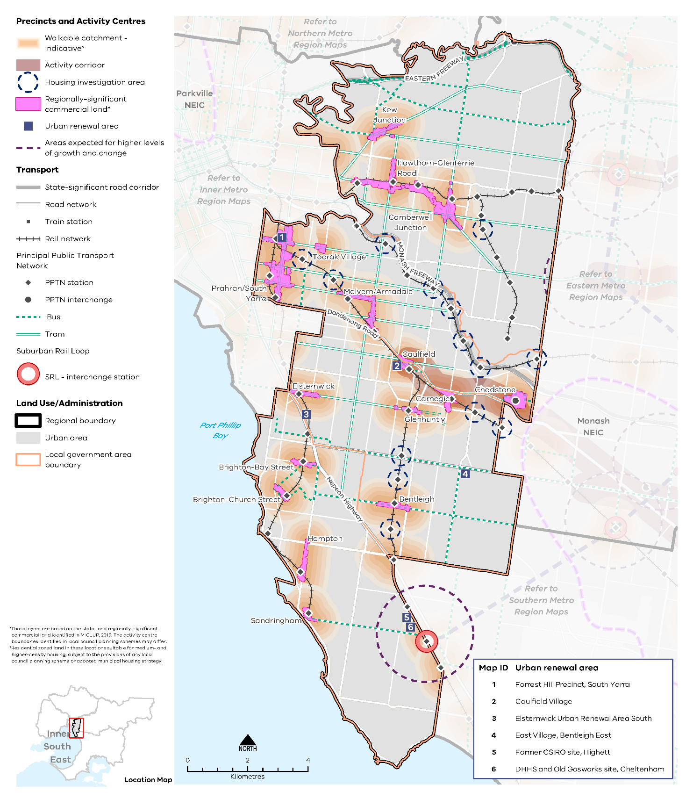

Map 3 Inner South East Metro Region housing choice 2050
A map of housing choice in the inner South East Metro Region in 2050, extracting the locations for medium- and higher-density dwellings identified on Map 1 above and detailed in Table 12, with the addition of 800m walkable catchments around existing and proposed metropolitan and major activity centres°. Another addition is the indication of expected higher levels of growth and change around the SRL station at Cheltenham.

°Residential zoned land in these locations suitable for medium- and higher-density housing, subject to the provisions of any local council planning scheme or adopted municipal housing strategy.

- Increase the supply of housing in the Inner South East Metro Region
Plan Melbourne aims for 70 per cent of net additional dwellings to be provided in Melbourne’s established areas, with the balance being provided in greenfield areas. There are no greenfield sites in the Inner South East Metro Region, which means it must accommodate additional housing in existing urban areas.
The region provides opportunities for well-located medium- and higher-density housing in established areas, particularly in and around activity centres and activity corridors, and in urban renewal areas and other locations with good public transport. There is also some opportunity for additional housing in greyfield areas where housing stock is near, or has reached, the end of its useful life and could be redeveloped.
Substantial and incremental change areas will experience varying degrees of change relative to the existing context and not only increase the supply of housing, but also the diversity in housing types and built form outcomes. Lower-density areas in the region are expected to accommodate housing growth within the context of the existing or preferred character. Minimal housing change areas are identified for their special characteristics such as neighbourhood, heritage, environmental or landscape characteristics that should be protected. Councils will need to ensure that the planning controls (zoning and overlays) correspond to the expected housing change so that there is clear messaging around where housing growth can occur (substantial and incremental change areas) and where growth is limited (minimal change areas).
Large parts of the Inner South East Metro Region, including Prahran/South Yarra, Hawthorn-Glenferrie Road, Kew Junction and Elsternwick major activity centres and the surrounding residential areas have Heritage or Neighbourhood Character Overlays. While these overlays may constrain built form, building heights and densities, they will still allow new housing development that is well-designed and respects heritage and neighbourhood character values.
- Maximise housing development within the established areas of the Inner South East Metro Region to achieve the aspirational housing distribution scenario for metropolitan Melbourne.
- Prioritise housing growth in areas with access to jobs, services and good public transport
Plan Melbourne recommends that medium- and higher-density housing be prioritised in areas that have access to public transport and provide opportunities for employment, such as in and around activity centres, and health and/or education precincts. The Inner South East Metro Region is well serviced by the PPTN, which covers land that is wholly or partly within 400 metres of public transport.
Higher-density development around the region’s major activity centres and activity corridors, neighbourhood activity centres, along main roads with PPTN and on urban renewal sites is encouraged. These areas are critical to meeting the employment, service and infrastructure needs of the region’s growing population. Opportunities for new medium- and higher-density housing should be considered within an 800-metre walkable catchment area of activity centres where residents can meet their daily needs in a 20-minute return walk from their homes. The appropriateness of residential development in these walkable catchments will depend on other planning controls and incompatible zoning. The councils are responsible for determining the suitability in these locations.
Cheltenham is identified as the southern gateway for SRL East (Cheltenham to Box Hill) and a proposed new interchange station is being planned as part of SRL East. There will be increased opportunities for housing growth in and around Cheltenham-Southland Major Activity Centre as SRL creates closer and more efficient connections to jobs and services in job-rich locations such as Monash and La Trobe NEICs. As the activity centre borders Bayside and Kingston LGAs, collaboration between these two metropolitan councils will be needed to ensure planning for Cheltenham is integrated, holistic and maximises land use opportunities. Moorabbin Major Activity Centre is located on the boundary between Bayside LGA, Glen Eira LGA and Kingston LGA and will benefit from inter-regional planning.
Locations identified by local councils for substantial and incremental housing change are expected to accommodate more housing growth and will experience varying degrees of change relative to the existing context. The expected change in these areas will increase the supply of housing across the region to meet the projected housing need while also providing opportunities for diverse housing types.
Table 7 identifies locations for medium- and higher-density housing in the Inner South East Metro Region.
Locations for medium- and higher-density housing in the Inner South East Metro Region
Classification | Locations | Role/function for housing
Major activity centres | Bentleigh  Brighton-Bay Street  Brighton-Church Street  Camberwell Junction  Carnegie  Caulfield  Chadstone  Elsternwick  Glen Huntly  Hampton  Hawthorn-Glenferrie Road  Kew Junction  Malvern/Armadale  Moorabbin  Prahran/South Yarra  Sandringham  Toorak Village  Cheltenham-Southland (parts within Bayside LGA) | - Major activity centres are locations for medium- and higher-density housing and mixed-use development. Substantial housing change opportunities may extend to a walkable catchment of 800 metres around the centre (depending on the local context) based on the 20-minute neighbourhood principle of locating housing close to jobs, services, amenities and public transport. While all major activity centres will accommodate housing change, the degree of change is relative to the existing context and characteristics of each major activity centre (Table 2)  - Structure planning will identify the preferred locations, densities and types for housing and development constraints or limitations in each centre.
Neighbourhood activity centres |  | - Some neighbourhood activity centres may be locations for mixed-use medium- and higher-density housing, particularly when they are serviced by good public transport. Housing opportunities may also extend to a walkable catchment of 800 metres around the centre (depending on the local context) based on the 20-minute neighbourhood principle of locating housing close to jobs, services, amenities and public transport.
Urban renewal areas and greyfields | Caulfield Village  East Village, Bentleigh East  Elsternwick Urban Renewal Area South  Forrest Hill Precinct, South Yarra  Former CSIRO site, Highett  Homes Victoria and Old Gasworks site, Cheltenham | - Urban renewal areas identified in the LUFP are locations nominated by the Victorian Government or LGAs with opportunities for medium- and higher-density mixed-use development. These locations have regional value based on one or more the following characteristics: land size, proximity to the PPTN or future transport infrastructure, government-owned, or require cross-municipal planning. These areas will be planned according to 20-minute neighbourhood principles. A coordinated approach to planning for these areas will maximise their development opportunity and any infrastructure needs.
Suburban Rail Loop precincts | Cheltenham (interchange) within the Southern Metro Region | - SRL precincts are opportunities for medium- and higher-density housing development due to their proximity to future SRL train stations. Housing development in the SRL precincts will be supported by other uses such as commercial, retail and services and maximise their potential as transit-oriented development. They will undergo substantial change and will be subject to further detailed precinct planning.
Activity corridors | Dandenong Road/Princes Highway between Caulfield Major Activity Centre, Chadstone Major Activity Centre and the Monash NEIC (SRL stations in the Eastern Metro region) | - Activity corridors are linear areas that are heavily used by commuters or undergoing city-shaping infrastructure upgrades. They contain a mix of commercial, retail, residential and industrial uses. Residentially zoned land in locations along the activity corridors may support medium- and higher-density housing due to its proximity to existing or future public transport.  - Regionally-significant industrial land will be retained for employment.  - Locally-significant industrial land may transition to residential uses if suitable and not required for employment purposes.  - Activity corridors are consistent with Plan Melbourne which encourages increased diversity and density of developments on the PPTN, particularly at interchanges, activity centres and where principal public transport routes intersect.
Housing investigation areas | Darling (Malvern East) Station East Malvern Station Gardiner Station Glen Iris Station Hawksburn Station Holmesglen Station Hughesdale Station Kooyong Station McKinnon Station Murrumbeena Station Ormond Station Patterson Station Toorak Station Willison Station | - Housing investigation areas are areas within an 800 metre walkable catchment around existing and future railway stations that have the potential to support medium- and higher-density housing development in line with maximising access to public transport and 20-minute neighbourhood principles. These areas are outside designated metropolitan and major activity centres and are based on their access to rail infrastructure, existing zones that allow residential development and the absence of ‘special characteristics’ such as heritage, landscape, bushfire values or airport environs.  - A further assessment to determine locations within housing investigation areas suitable for substantial housing change and rezoning, in response to the local context, will be required.
Housing opportunity areas | High Street (between Punt Road and Charles Street)  Commercial Road (west of Punt Road; between Mathoura Road and Orrong Road)  Toorak Road (between Prahran/South Yarra and Toorak Village major activity centres)  Malvern Road (between Tooronga Road and Burke Road)  Power Street, Riversdale Road, Glenferrie Road (south of activity centre)  Wattletree Road (from Dandenong Road to Glenferrie Road)  Dandenong Road (between Chapel Street and Glenferrie Road)  Punt Road | - Housing opportunity areas are identified by local councils as areas where substantial or incremental housing change is anticipated as a result of being located on the PPTN or along main roads. These locations are generally zoned as Residential Growth Zones where housing at increased densities and housing diversity is expected.
- Increase the supply of medium- and higher-density housing in and around major activity centres, urban renewal areas, SRL precincts, along activity corridors, and in and around neighbourhood activity centres serviced by good public transport.
- Support substantial housing change in locations where transport upgrades and improvements such as Suburban Rail Loop or level crossing removals create opportunities to locate housing closer to jobs, services and infrastructure.
- Maximise development potential in housing investigation areas around existing train stations to leverage access to the Principal Public Transport Network.
- Support adaptive and innovative approaches in the design of new residential development that respects the heritage and neighbourhood character of the locality.
- Provide greater choice and diversity of housing in the Inner South East Metro Region
Housing growth in established residential areas contributes to the projected housing supply for the Inner South East Metro Region. Most housing stock in the region comprises separate dwellings which is typical for an established urban area and contributes to housing diversity in the region.
As the existing housing stock ages, opportunities for infill development should be leveraged to provide greater choice and diversity. Activity centres and corridors currently provide most unit and apartment dwellings and will continue to provide opportunities for medium- and higher-density dwellings. Shop-top residential development and mixed-use developments in activity centres and corridors should also be encouraged to provide more diversity in housing stock.
With projected demographics for the region showing a decline in families with children and an increase in single persons or couples without children, the demand for dwellings with one or two bedrooms is likely to increase. New housing should respond to these changing household compositions and consider the provision of greater choice in the size of dwellings.
Smaller dwellings should also provide for more affordable arrangements and flexibility to allow ‘ageing in place’ in response to an ageing population. Adaptable floor plans in new developments will give residents the flexibility to remain in their family homes as they age. Residential aged care facilities and retirement homes will also be important for the region and give people the choice to remain in their existing communities.
The impacts of climate change are likely to have a profound financial impact on lower income households and vulnerable households. New housing development, particularly affordable and social housing developments, will need to be environmentally sustainable with innovative technologies that can reduce household costs.
With two state-significant tertiary campuses in the region, Swinburne University (Hawthorn) and Monash University (Caulfield), a demand for student accommodation close or well connected to these institutions is anticipated. As both universities are in or close to major activity centres, they are well-serviced with existing amenities, services and public transport, and suitable for increased housing. Demand for a variety of housing types that provide low-cost rental, supported accommodation and social housing will also grow.
- Encourage a genuine mix of dwelling types and sizes in the Inner South East Metro Region, including provision of adaptable housing options, to accommodate the changing future needs of the region.
- Support alternative and sustainable residential development formats, such as co-housing or build-to-rent in appropriate locations, and car-free residential developments models in locations with good access to alternative transport modes.
- Ensure new residential development is well-designed, durable, resilient to climate change and built to a high-quality standard.
- Adopt a place-based approach to the delivery of infill housing developments to replace ageing housing stock, ensure a high-quality of design that is appropriate for the local context and contributes to housing supply and diversity.
- Increase the supply of social and affordable housing
Affordable housing is defined in the Planning and Environment Act 1987 as housing appropriate for the needs of very low-, low- and moderate-income households, and includes social housing provided by the government or a registered housing agency. The provision of social and affordable housing is not solely a planning issue, and a range of programs and measures across all levels of government are required to deliver more social and affordable housing.
Housing affordability is affecting an increasing number of residents across metropolitan Melbourne. Planning should facilitate the delivery of affordable housing in the Inner South East Metro Region by considering opportunities to develop underutilised or disused government-owned land for social housing. Facilitating the supply of affordable housing in locations that are closer to jobs, services and public transport – in addition to sustainable design – will lower household costs, which is particularly important to the very low-, low- and moderate-income households.
The social and affordable housing system, consisting of the government, community housing sector and industry, provides housing options for those unable to access the private housing market. There are currently 116,351 people living in social housing owned or managed by Homes Victoria (Director of Housing) or a registered housing corporation across Victoria. Victoria has the lowest proportion of social housing in Australia and will require 4000 homes per year for Victoria’s social housing to reach the national average of 4.2 per cent of social housing to total dwellings.
The Victorian Government’s Big Housing Build program aims to increase existing social housing stock across Victoria by 10 per cent and, in the next five years, over 12,000 new dwellings will be built. The program is Victoria’s largest investment in social and affordable housing and Homes Victoria has been established to deliver the program as well as ensure an ongoing pipeline of social and affordable housing development beyond the Big Housing Build. In addition, existing social housing dwellings will be upgraded, maintained or replaced under the program. The Victorian Government has identified 21 priority LGAs for social housing development including in Boroondara LGA in the Inner South East Metro Region.
- Facilitate more affordable housing across the region, particularly in locations that have good access to jobs, services and public transport.
- Redevelop existing government-owned land (where there are not necessarily proposed transport upgrades) to deliver affordable housing.
- Renew and, where appropriate, intensify the existing social housing stock in the Inner South East Metro Region.

Actions – Housing choice
- Update planning schemes to align with housing policies in Plan Melbourne and the Inner South East Metro Land Use Framework Plan and the implementation of the reformed residential zones. This includes:
- Providing capacity for 15 years of regional housing supply focusing on locations identified for housing growth in the LUFP
- Reviewing planning controls in housing investigation areas as potential locations for substantial or incremental housing change.
This may require strategic planning work to support these changes, such as preparing or updating local housing strategies or preparing structure plans to further investigate where increased densities can be supported, and determine specific changes required to planning schemes.
- Identify underutilised and surplus government land that has potential to deliver additional social housing.
- In partnership with councils, identify a pipeline of sites in the Inner South East Metro Region for social and affordable housing.

Integrated Transport
Plan Melbourne Outcome 3: Melbourne has an integrated transport system that connects people to jobs and services and goods to market.
As the Inner South East Metro Region grows, it will require better integration of land use and transport planning, better use of existing roads, and increased investment in public transport, walking and cycling. Making better use of transport infrastructure, complemented by good precinct design, can improve connections without necessarily the expense and disruption of delivering new infrastructure. Land use decisions, as well as mode shift opportunities, can significantly improve access and reduce transport-generated emissions.
Melbourne Metro Tunnel, SRL and the North East Link, as well as upgrades to the Monash Freeway, level crossing removals and additional rail improvements, will improve the connectivity of the Inner South East Metro Region to other parts of metropolitan Melbourne.

State of play
Map 4 outlines the current state of play for transport in the Inner South East Metro Region.

Road network
The region’s road network is largely organised on a grid pattern with most arterial and connector roads following a north-south or east-west alignment. The exception to the grid pattern is an ‘off-centre’ street layout in Brighton, and several arterial roads and freeways of state significance which pass through the region as they radiate from Melbourne’s CBD through the Inner South East Metro Region to other parts of Greater Melbourne and beyond.
The radial road network of the region is defined by the Eastern Freeway (in the north of the region), the Monash Freeway and Dandenong Road (in the central part of the region) and the Nepean Highway (in the southern part of the region). These roads provide connectivity to, and through, the region from Melbourne’s CBD to areas further to the east and south-east, and from the key freight routes that run through the region.
Limitations exist in terms of the future capacity of the region’s roads. North East Link and the Chandler Highway upgrade will provide key benefits at a regional and metropolitan level but may increase vehicular traffic in the northern part of the region, with the additional traffic likely to be heading in a southerly or south-westerly direction.
Congestion is increasing particularly during peak hours, as many residents commute beyond the region. By 2031, traffic volumes in the inner part of the Inner South East Metro Region are expected to increase by 17 per cent from 2015 (KPMG & ARUP, 2017, p. 15). Most of the region’s arterial roads will be approaching or at capacity by 2031 (KPMG & ARUP, 2017, p. 18).

- Inner South East Metro Region integrated transport state of play
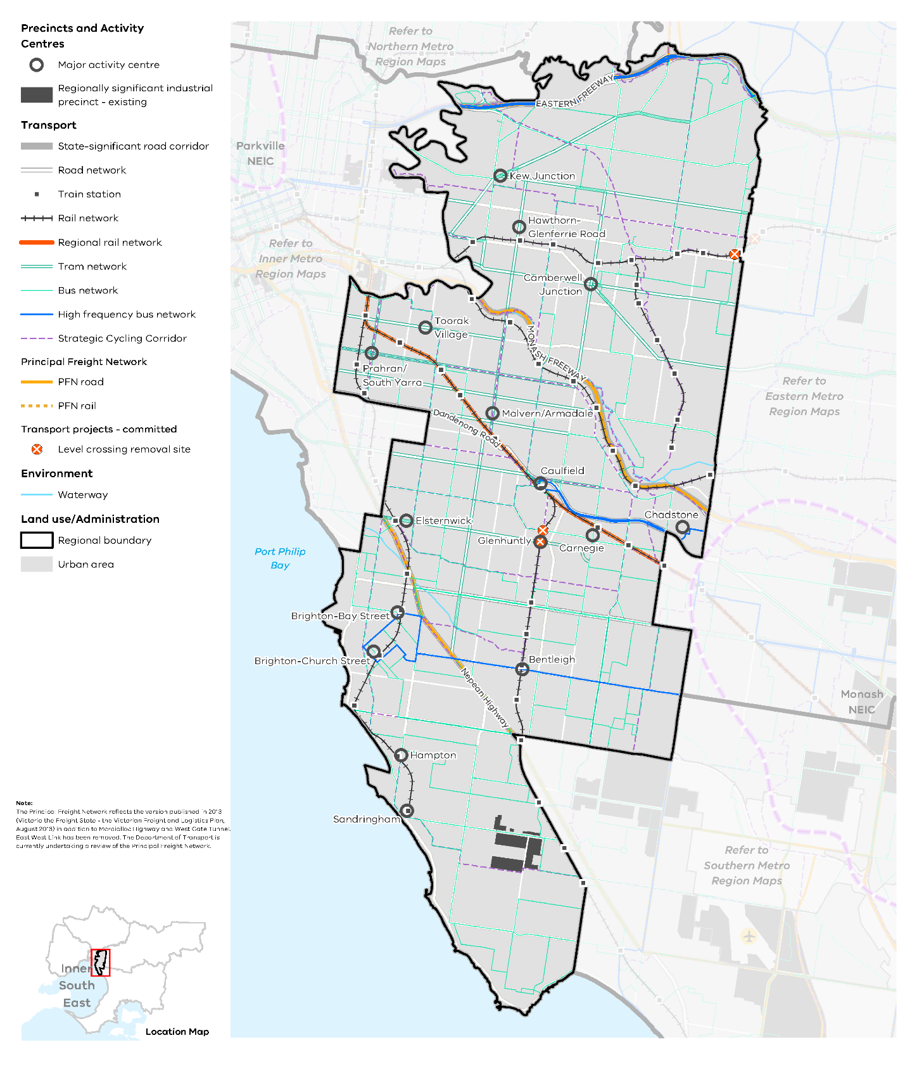

Map 4 Inner South East Metro Region integrated transport state of play
A map showing the key transport features of the region in 2021, as extracted from Map 1, and also highlighting:
- The route of the regional rail network on the Cranbourne and Pakenham lines
- The tram, bus and high frequency bus network throughout the region
- The strategic cycling corridor network through the region
- The principal rail and road freight network.
Note: The Principal Freight Network reflects the version published in 2013 (Victoria the Freight State - the Victorian Freight and Logistics Plan, August 2013) in addition to Mordialloc Highway and West Gate Tunnel. East West Link has been removed. The Department of Transport is currently undertaking a review of the Principal Freight Network.

Public transport network
The rail and tram network provide fixed rail public transport coverage across much of the region. While the inner areas have a higher level of public transport accessibility compared to the outer areas, the region as a whole is very accessible compared to other regions. Figure 11 shows the accessibility to public transport for people who live within the region based on how far they need to walk to access train, tram and bus services.
The rail network in the region radiates out from Melbourne’s CBD. It forms part of Melbourne’s broader commuter rail network that connects Melbourne’s eastern, and south-eastern suburbs. The region is served by the Alamein, Belgrave, Cranbourne, Frankston, Glen Waverley, Lilydale, Pakenham and Sandringham lines, some of which become rail groups as they pass though the Inner South East Metro Region. As a result, the region’s stations benefit from a higher frequency of services than many other regions. Caulfield Station also provides access to Gippsland via the Pakenham/Cranbourne lines.
The tram network consists of 13 tram routes connecting the region to Melbourne’s CBD and generally follows the road network in a grid-like pattern.
These modes are complemented by bus routes, with over 20 bus routes serving the region. The three orbital SmartBus routes include Altona-Mordialloc which provides a north-south connection, Rowville-Caulfield which provides an east-west connection, and the Middle Brighton-Blackburn, which travels east-west and then north.
As well as a comparatively high level of public and active transport infrastructure, other attributes of the Inner South East Metro Region include a good distribution of activity centres, open space, community infrastructure and access to employment. These attributes provide an opportunity to significantly increase the proportion of trips undertaken by sustainable transport modes. Currently the region has a more sustainable journey to work mode share compared to the Melbourne metropolitan average. In 2016, 23 per cent of those living in the Inner South East Metro Region travelled to work by public transport, whereas the metropolitan Melbourne average was 16 per cent.

Active transport network
The Inner South East Metro Region’s active transport network provides cyclists, runners and pedestrians with access to key attractors in the region and in the adjoining Inner, Eastern and Southern metro regions.
In 2016, 4 per cent of residents walked to work in the Inner South East Metro Region. This compares to 3 per cent for metropolitan Melbourne. Two per cent cycled to work in the Inner South East Metro Region, which compares to 1 per cent for metropolitan Melbourne. Much of the bicycle network is on road although the level of road separation from vehicles varies across the region.

Freight network
The Inner South East Metro Region is a key transit point for a number of Principal Freight Network (PFN) roads including the Monash Freeway and Dandenong Road. The PFN provides transparency to local government and community regarding the primary way goods will be moved throughout the region. This allows government to consider freight needs during the planning process to protect the end-to-end freight journeys from conflicting land uses.
The industrial precincts that have a manufacturing base or key commercial districts which rely on movement of goods include the Bayside Business District, Chadstone Major Activity Centre and the Prahran-South Yarra Major Activity Centre.
Freight volumes are predicted to increase in Victoria from around 360 million tonnes in 2014 to nearly 900 million tonnes in 2051, making efficient management of urban deliveries a key element of the region’s freight task.

- Public transport accessibility in the Inner South East Metro Region
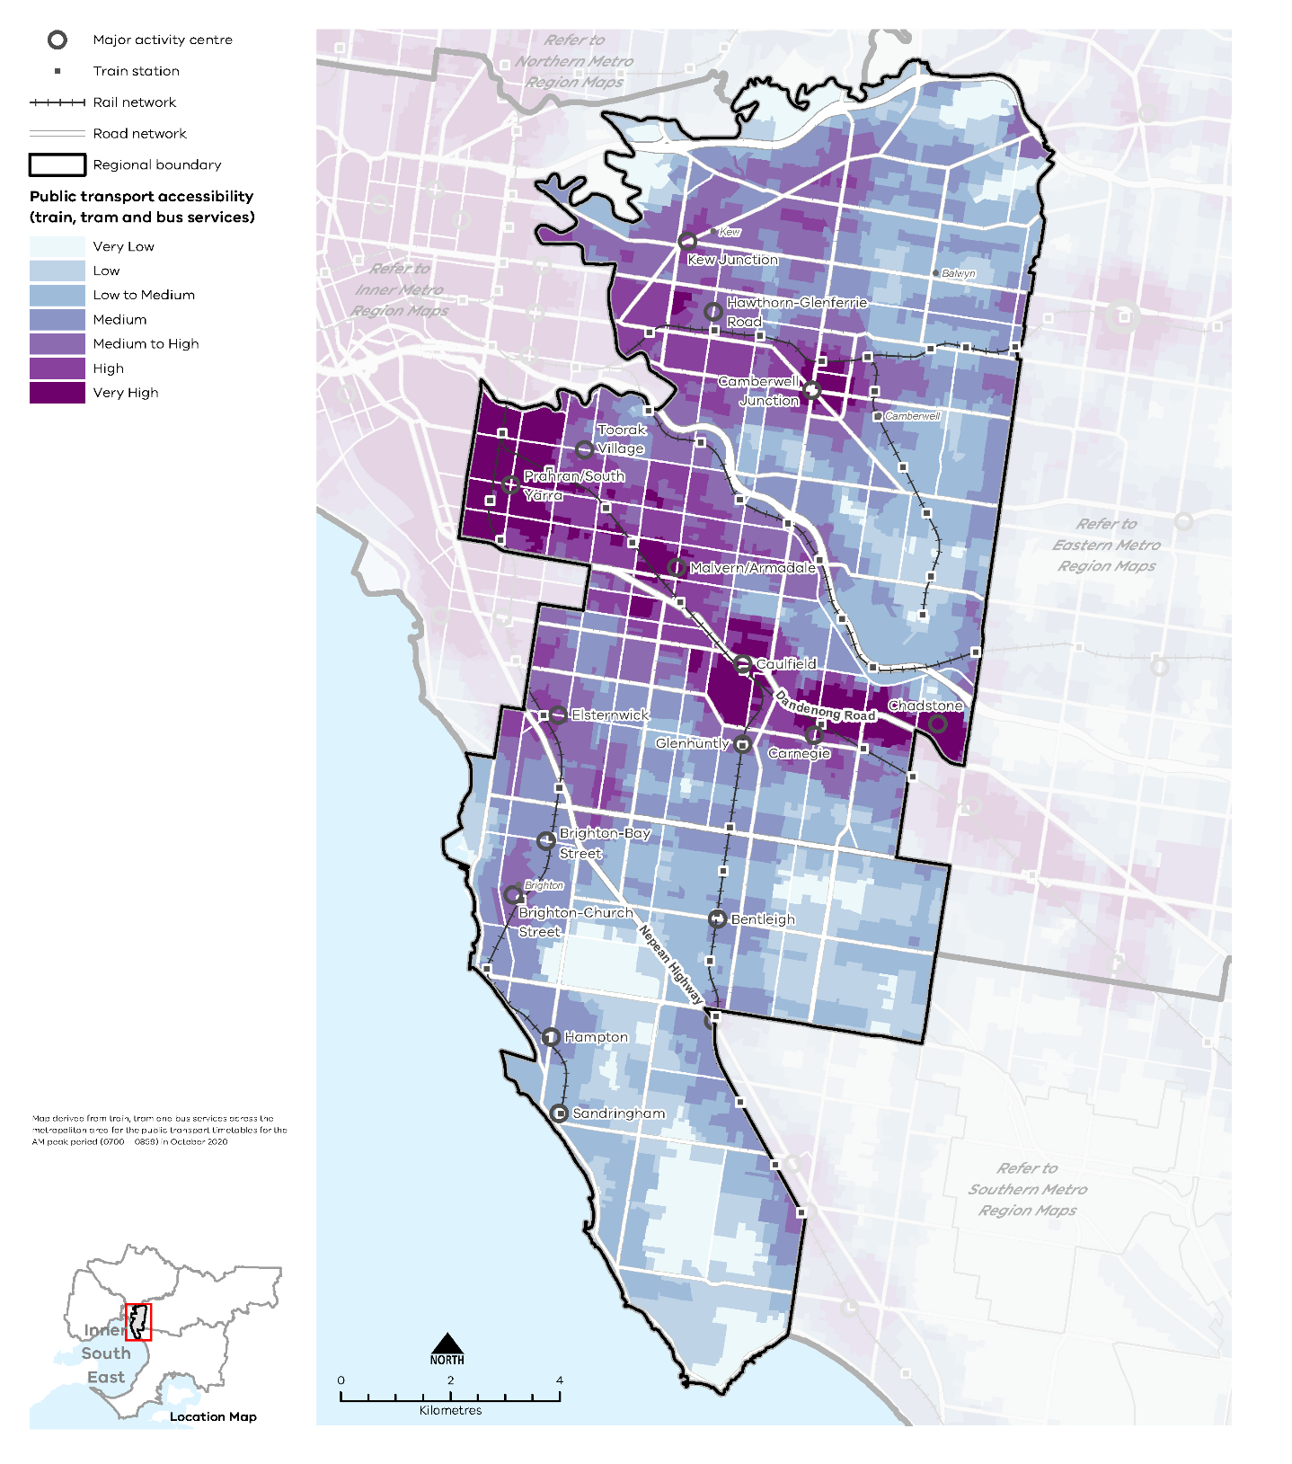

Regional access and movement
Thirty-five per cent of Inner South East Metro Region residents work in the region (Figure 12). Compared to the other regions, the Inner South East Metro Region has the lowest proportion of residents who also work within the region. The region also has little connection with the north and west of Melbourne. In 2016, the most common work destination was the Inner Metro Region, specifically the City of Melbourne (SGS, 2019, p. 40).
The proportion of movement to the Inner Metro Region is higher than those who live and work in the Inner South East Metro Region. The most common origin of people working in the Inner South East Metro Region, after the region itself, was workers from the Eastern Metro Region, notably the Kingston and Monash LGAs (SGS, 2019, p. 40).
- Journey to work in and out of the Inner South East Metro Region
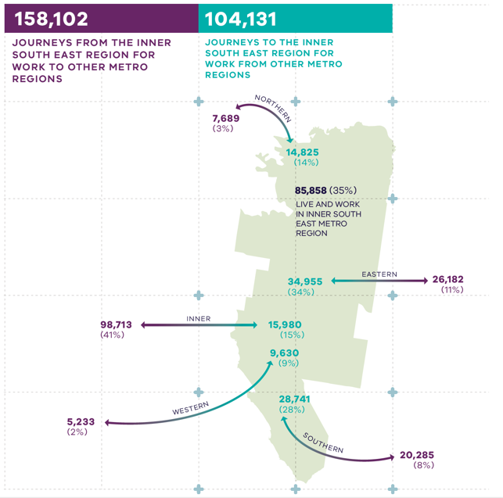
Australian Bureau of Statistics (2016) Census of Population and Housing, Commonwealth of Australia, Canberra, Australia.

Figure 12. Journey to work in and out of the Inner South East Metro Region
85,858 (35 per cent) live and work in the Inner South East Metro region | 158,102 – Journeys from the Inner South East Metro region for work to other metro regions:  - 7,689 (3 per cent) – Journeys to the Northern Metro Region  - 26,182 (11 per cent) - Journeys to the Eastern Metro Region  - 20,285 (8%) – Journeys to the Southern Metro Region  - 5,233 (2%) – Journeys to the Western Metro Region  - 98,713 (41 per cent) – Journeys to the Inner Metro Region | 104,131 – Journeys to the Inner South East Metro region for work from other metro regions:  - 14,825 (14 per cent) – Journeys from the Northern Metro Region  - 34,955 (34 per cent) - Journeys from the Eastern Metro Region  - 28,741 (28%) – Journeys from the Southern Metro Region  - 9,630 (9%) – Journeys from the Western Metro Region  - 15,980 (15 per cent) – Journeys from the Inner Metro Region
Source: Australian Bureau of Statistics (2016) Census of Population and Housing, Commonwealth of Australia, Canberra, Australia.

Regional strengths
- The region benefits from a strong freeway network and access to arterial roads.
- Strong existing public transport and active transport networks in comparison to other regions provide a foundation to shift more trips to sustainable forms of transport.
- Planned major transport investments will further increase access to road and public transport networks and assist in reducing congestion.

Regional challenges
- Elements of the region’s transport infrastructure are ageing or at capacity and require replacement or upgrading.
- Transport networks have become more congested as movement has increased, both within and through the region.
- Improvements to roads and footpaths are required to increase pedestrian and cycling safety and to make better use of road space.

Directions and strategies
The directions identified to achieve the 2050 vision for the Inner South East Metro Region in terms of integrated transport and Outcome 3 of Plan Melbourne are:
Direction 8 | Improve transport connections to support the productivity of the Inner South East Metro Region
Direction 9 | Improve the efficiency of the road network
Direction 10 | Improve active and public transport options to promote mode shift and support 20-minute neighbourhoods
Direction 11 | Allow a more flexible use of the existing road network
Direction 12 | Support more efficient and sustainable urban deliveries
Each direction is implemented through regionally-specific strategies identified in this land use framework plan.
Map 5 shows how integrated transport will be enhanced across the Inner South East Metro Region by 2050 as a result of these directions and strategies, together with Plan Melbourne and other strategies and initiatives as outlined in Appendix 01.
- Inner South East Metro Region integrated transport 2050
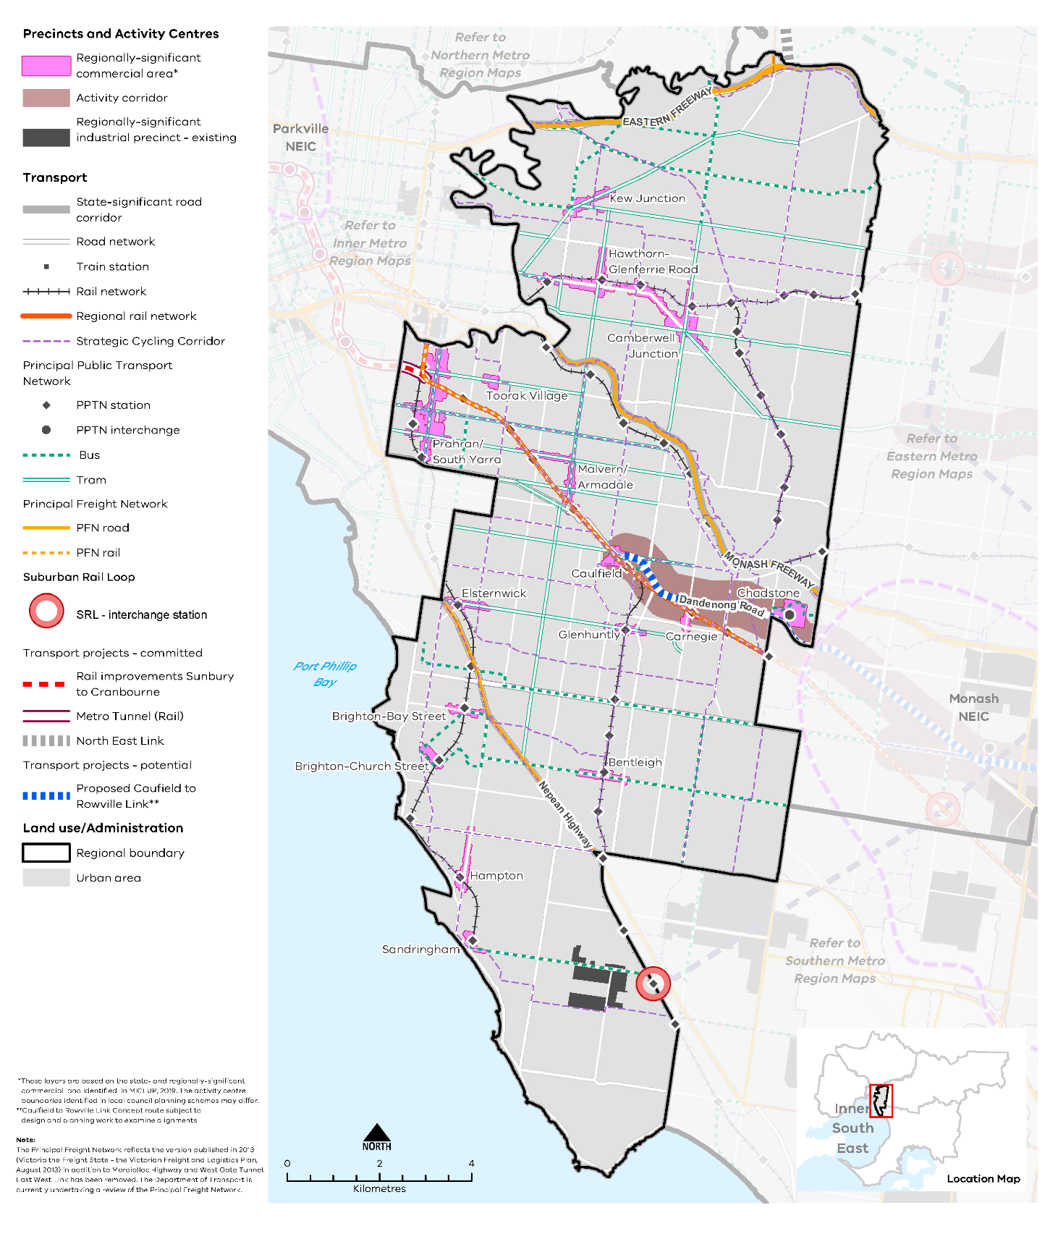

Map 5 Inner South East Metro Region integrated transport 2050
A map showing the key transport features of the region in 2050, as extracted from Map 1, and also highlighting:
- PPTN stations and interchanges
- SRL interchange station and precinct at Cheltenham
- Transport projects – committed:
  - Rail improvements from Sunbury to Cranbourne
  - Metro Tunnel
  - North East Link
- Transport projects – potential
  - Proposed Caulfield to Rowville link

Note:
**Caulfield to Rowville Link Concept route subject to design and planning work to examine alignments

- Improve transport connections to support the productivity of the Inner South East Metro Region
Improvements to the existing public transport network will help to achieve modal shift by encouraging a greater proportion of the population to use trains, trams, buses and active transport over motor vehicles. In the longer term, city-shaping projects such as SRL will also enhance public transport accessibility within the region and beyond.
The Metro Tunnel, Caulfield to Dandenong Level Crossing Removal Project and upgraded signalling will deliver improved service frequencies and capacity on the Cranbourne and Pakenham rail lines and, in turn, provide for extra services on other lines that run through the region.
Upgrades to key transport hubs, such as Caulfield and South Yarra stations, will improve intermodal connectivity and help move people within the station precincts. By integrating and maximising land use and development outcomes around these public transport improvements, modal shift will occur as businesses and people seek locations close to public transport.

Caulfield Station
Caulfield Station will be a key transport interchange for the Inner South East Metro Region. The station will have lines running through both the City Loop and the Metro Tunnel, enabling Frankston line users to use Caulfield to transfer to Metro Tunnel stations. As well as playing a key interchange role, Caulfield Station will continue to be a key destination for both Caulfield Racecourse and Monash University.
The first stage of the proposed Caulfield to Rowville Link will join Caulfield Station to Monash University Clayton via Chadstone Major Activity Centre. This connection is key to the proposed expansion of Monash University’s Caulfield campus and the growing importance of the Monash NEIC. A direct connection between Caulfield and the Monash NEIC will provide an integrated public transport network to education and employment nodes that are of regional and state importance.
This alignment will provide rail-based public transport to Chadstone, facilitate ongoing development of the Dandenong Road corridor to Clayton and reduce reliance on car-based travel. Connections should be considered to the nearby major activity centres of Carnegie and Oakleigh in the adjacent region. The growth of major education, research, health and corporate employment in the area around Monash University Clayton adds further impetus to the need for a fixed rail connection to Caulfield.

Suburban Rail Loop
SRL will transform the way people move around Melbourne’s metropolitan area. Even though the likely project alignment is outside the Inner South East Metro Region, the impact on travel patterns will be profound and will stimulate major changes in land use and development in those activity centres directly served by the new rail line. With orbital movement possible between the various lines, and no need to travel to or near Melbourne’s CBD to change lines, a long-term impact is likely to flow on to a broader number of rail-based activity centres across Greater Melbourne. As SRL stations will be key attractors, it will be important to establish good public and active transport links to them from the Inner South East Metro Region.

Other key enhancements
The key regional linkages for this region are shown in Figure 14. Decisions regarding appropriate modes for these links should consider the capacity of existing infrastructure, ongoing sustainability and providing travel choices over a longer time period including evening and late-night travel.
A potential connection between Caulfield Station and the northern part of the Inner South East Metro Region would provide greater north-south public transport connectivity. Detailed planning is also required to investigate a potential link north of Caulfield towards Camberwell.
Gaps in east-west public transport connections have also been identified including:
- Elsternwick to Monash NEIC and Clayton
- Caulfield to Monash NEIC and Clayton.
Elsternwick Major Activity Centre is located on the Sandringham train line, which connects to activity centres in the Bayside LGA.
The coverage, frequency and performance of the region’s bus network should also be continually improved to make buses a feasible alternative to the private car. The bus network should provide access to those parts of the region not serviced by the fixed rail network and should integrate with different transport modes. The bus network provides an important connector to and from railway stations, tram lines and employment areas, including activity centres. Another consideration is identifying on-demand bus services to alleviate traffic congestion across the sub-region by providing targeted services to residents lacking access to public transport.
Strategic Cycling Corridors will connect state-significant locations and activity centres. Priority active transport projects will promote increased safe use of the region’s cycling and walking network (see Figure 13).
Primary routes provide a core network of Strategic Cycling Corridors that connect places of state significance – the Central City, metropolitan activity centres and NEICs within metropolitan Melbourne. Main routes are Strategic Cycling Corridors that provide additional connections to state-significant destinations as well as connections to major activity centres and key train stations across metropolitan Melbourne.
- Improve public and active transport connections between major activity centres.
- Plan for public and active transport connections to link into the Suburban Rail Loop.
- Improve north-south public transport connections where gaps exist, especially between Camberwell and Caulfield.
- Improve east-west public transport connections where gaps exist, particularly from Elsternwick and Caulfield to Monash NEIC and Clayton.
- Improve the performance, coverage and frequency of the region’s bus and tram network.
- Support cycling for transport through the development of Strategic Cycling Corridors in the Inner South East Metro Region.

- Strategic Cycling Corridor network – Inner South East Metro Region
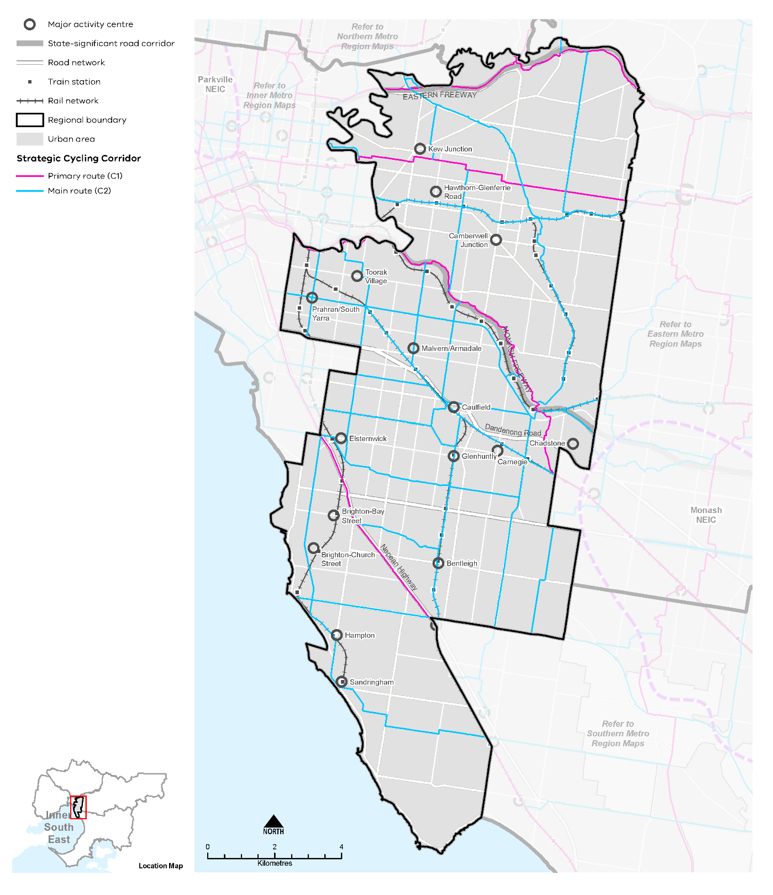

- Key regional linkages – Inner South East Metro Region
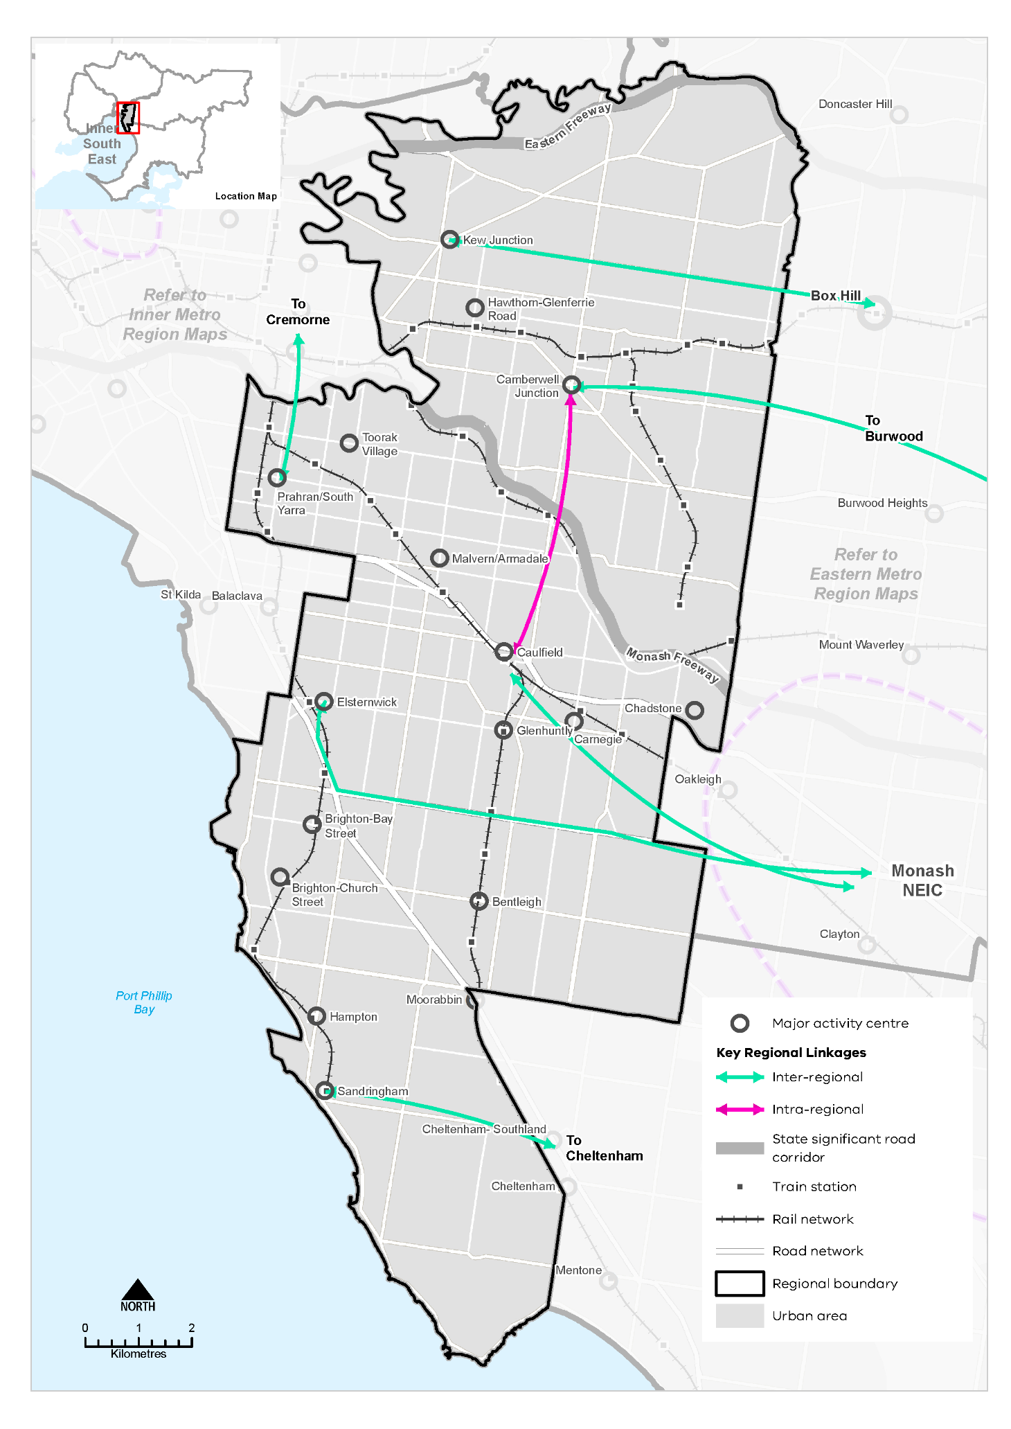
- Improve the efficiency of the road network
Given the highly urbanised nature of the Inner South East Metro Region and the high value of land, there is limited scope for transformational road projects to ease road congestion. Within the confines of the road network, measures such as transit lanes, staggered vehicular access to freeways at interchanges, the use of clearways and improved traffic signalisation all represent ways of improving the efficiency of the road network.
Recent level crossing removals have already improved traffic flow in the region. Other level crossings scheduled to be removed are Union Road in Surrey Hills by 2023, and Glen Huntly Road and Neerim Road in Glen Huntly by 2024. Planning is also underway for intersection upgrades on South Road, which links Nepean Highway to the Dingley Bypass and is used by approximately 40,000 people a day. The plan is to upgrade intersections and investigate peak period clearways to ease road congestion. In the longer term, the impacts of city-shaping transport projects such as North East Link and SRL on the region’s existing road network should be considered and ameliorated.
- Improve vehicular flow on the region’s arterial and connector road network.
- Improve active and public transport options to promote mode shift and support 20-minute neighbourhoods
Improvements to local transport options, including bus, cycling and pedestrian access, are needed to support the delivery of 20-minute neighbourhoods across the Inner South East Metro Region. More sustainable transport options and choices will make it easier for people to move within the region.
A total of 38 per cent of people in the region used a car when making a short trip under 5 kilometres in the region, whereas 33 per cent of people walked, and only 2 per cent of people cycled for short trips (DELWP, 2021b). To reduce dependence on private vehicles, public transport, cycling and walking need to be more accessible. This means significant upgrades to public transport access, and improvements to pedestrian and cycling accessibility, better linking neighbourhoods to employment, and social and community services.
The different needs of users making these trips should be considered in the planning and design of new links along with safety, which is paramount to increase uptake of cycling. Bicycle parking and end-of-trip facilities should also be considered at key destinations to improve the proportion of cycling trips.
Although there are limited places to provide new off-road links, identification and provision of Strategic Cycling Corridors is important to connect trip generators within and outside the region. Trip generators such as schools are dispersed across the region. Along with the region’s relatively high urban density they require a well-integrated active transport network. Although many active transport journeys, particularly those of cyclists, follow familiar peak hour patterns to or from the inner city, the dispersed nature of the region’s activity centres and educational and health facilities means that active transport plays an important role in local transport movements.
Improving north-south active transport links in the Inner South East Metro Region to provide safe and convenient connections from residential areas to the rail and tram network is important. In addition to the Strategic Cycling Corridor network, the following new or improved links are needed
- Between Highett and Kew (an identified gap in the north-south connectivity of the region)
- An alternative cycling route to Chapel Street as a north-south connection in the western part of the region
- From Hawthorn along Camberwell and Toorak roads, to establish a connection to Deakin University and SRL.
- Create pedestrian-friendly neighbourhoods by enhancing major pedestrian links and expanding the network.
- Create a network of walking and cycling links for local trips that link to public transport.
- Prioritise sustainable transport in activity centres and health and education precincts to support higher density mixed-use walkable precincts.
- Provide walking and cycling routes and drop-off zones to health and community services and recreation facilities.
- Allow a more flexible use of the existing road network
As an established region, space is constrained. To accommodate future travel needs and support the shift to active, sustainable modes of transport, flexible use of the existing road network will be required.
This should balance the needs of transport users and place users, and design a mix of transport modes appropriate to how roads and places are used by communities.
Opportunities to increase the capacity of the existing road network are limited although some gains can be made through better use of existing roads for public and active transport. These alternatives need to be easier, more convenient and cheaper than car travel to increase the proportion of people using public transport, walking or cycling.
While there is a substantial tram network in the region, many of these routes operate in mixed traffic on undivided roads which makes them slow. One of the slowest trams is Route 78 along Chapel Street which averages 12 kilometres per hour (City of Stonnington, 2018). Designating road space for trams and buses will make these modes more efficient and help drive mode shift from cars to public transport.
A more efficient allocation of road space including car parking will also improve safety for cyclists. Over 40 cyclists are seriously injured or killed on roads across the region, on average, each year (Jacobs, 2019, p. 3). Chapel Street and Beach Road are the main areas where cyclist accidents occur. On-street parking has contributed to a relatively high level of car dooring incidents for cyclists. Additionally, incidents occur at intersections where cyclists interact with turning vehicles. Removing conflicts in road space between traffic and cyclists will increase safety for cyclists as well as the perception of safety.
- Improve existing road infrastructure to provide for public transport, walking and cycling.
- Balance movement and place when designing and upgrading the region’s road network.
- Support more efficient and sustainable urban deliveries
Metropolitan freight volumes are expected to grow at an average annual rate of 2.6 per cent each year between 2014 and 2051. The flow-on effect of population growth and higher levels of e-commerce will increase the potential for conflicting land uses, requiring state and local government to work together to plan for more efficient use of the existing transport network.
Ongoing assessment of how planning influences urban freight outcomes is needed. This is particularly relevant for inner city areas where high competition for available road space between vehicles, bicycles and service delivery vehicles, parking, loading zones and delivery docks is impacting the reliability and efficiency of freight deliveries.
More efficient and effective freight movement reduces congestion and the amenity and environmental impacts of higher freight volumes.
- Balance the need for first and last mile freight delivery with other demands on road space.
- Facilitate efficient and sustainable regional freight movements.

Actions – Integrated transport
- Investigate barriers and opportunities to increase public and active transport mode share across the region to support culture change, spread demand on transport infrastructure, reduce greenhouse gas emissions and support 20-minute neighbourhood outcomes. Identify trial locations in the region to focus the investigation.

Liveability
Plan Melbourne Outcome 4: Melbourne is a distinctive and liveable city with quality design and amenity
‘Liveability’ is about the things that enhance people’s quality of life. For many years Melbourne has been regarded as one of the world’s most liveable cities due to its social and economic stability, diverse communities, distinctive heritage, high level of amenity, and the opportunities it provides for a rich social and cultural life.
Plan Melbourne aims to maintain and extend the city’s liveability by celebrating its culture, diversity and distinctiveness. The challenge ahead is to design and plan for a future city that protects the best aspects of the natural and built environment, supports social and cultural diversity, and creates a strong sense of place.
The Inner South East Metro Region is characterised by heritage buildings, tree-lined streetscapes, high amenity neighbourhoods, popular retail and entertainment spines and culturally diverse activity centres. Port Phillip Bay, the Yarra River (Birrarung) environs and other waterways are significant natural assets with high Aboriginal cultural heritage values. This plan seeks to ensure the region retains and enhances these important aspects of its liveability, while continuing to support a growing population.

State of play

Landscapes and biodiversity
Inner South East Metro Region benefits from significant natural features that contribute to its ambience and desirability as a place to live. Water is a defining feature of the region. Its southern boundary includes 17 kilometres of coastal foreshore along Port Phillip Bay within the City of Bayside, while the Yarra River forms the northern boundary in Boroondara and Stonnington LGAs. The key landscapes and biodiversity areas of the region are described in Table 8.
The region’s coastline and waterways have been heavily impacted by European settlement and urbanisation. There is a strong community and government commitment to their ongoing rehabilitation and significant potential to work with the region’s Traditional Owners to achieve this outcome.
Key landscape and biodiversity areas in the Inner South East Metro Region
Landscape and biodiversity area | Significance, protection and management
Port Phillip Bay coastline | The Port Phillip Bay coastline of the Inner South East Metro Region extends from Brighton Beach to Beaumaris, within the Bayside LGA. The coastline provides a range of functions: recreational sailing and boating; a major open space corridor including playgrounds and recreation areas; an important cycling and pedestrian corridor; a place for festivals and events. A considerable amount of native vegetation exists along the foreshore which has regional ecological significance. The coastline also features stands of exotic trees, formal parks and open lawns.
Waterways | The Yarra River winds its way through Kew, Hawthorn, Toorak and South Yarra before reaching central Melbourne. The Yarra River corridor is identified in Plan Melbourne as one of the city’s most significant networks of water’s edge parklands. Other major waterways in the region are the Koonung Koonung Creek, Gardiners Creek, Scotchmans Creek and Elster Creek. Waterways provide vital open space and habitat connections throughout the region and offer a natural break from the urban environment.
Yarra Bend Park and Studley Park | Yarra Bend Park and Studley Park contain the largest areas of natural bushland in the region, supporting an extensive tree canopy and providing a haven for urban wildlife. They include a network of shared trails, sports grounds and other types of recreational activity.
Habitat areas | The region provides for a diversity of significant habitats. This includes inland bushland/heathland reserves such as Long Hollow Reserve, Bay Road Heathland Sanctuary and Highett Grassy Woodland (located on the CSIRO site). Its extensive golf courses support significant stands of native and exotic trees. All LGAs in the region promote the strengthening of the urban forest through planting within established gardens and streets.

Aboriginal cultural heritage
The lands that now make up the Inner South East Metro Region feature places and waterways of cultural significance and continuing connection for Traditional Owners.
The Wurundjeri Woi Wurrung people of the Kulin Nation, represented by the Wurrundjeri Woi Wurrung Cultural Heritage Aboriginal Corporation, are the recognised Traditional Owners of the northern part of the Inner South East Metro Region. The Bunurong Land Council Aboriginal Corporation are the recognised Traditional Owners of the southern part of the region. As Registered Aboriginal Parties (RAPs), they both have responsibilities to protect cultural heritage assets under the Aboriginal Heritage Act 2006.
Recognised locations of Cultural Heritage Sensitivity are shown in Figure 15. Support should be provided to Traditional Owners to protect and manage these cultural heritage sites, cultural landscapes and waterways.
The Yarra River Protection (Willip-gin Birrarung Murron) Act 2017 declared the river corridor, and many hundreds of parcels of public land it flows through, as ‘one living, integrated natural entity’ for protection and improvement. Key strategic work in the region includes the Wurundjeri Woi Wurrung Cultural Heritage Aboriginal Corporation’s Nhanbu narrun ba ngargunin twarn Birrarung (Ancient Spirit and Lore of the Yarra) water policy.

Heritage and visitor places
The Inner South East Metro Region was one of the earlier settled areas of Melbourne. This is reflected in the diversity of architectural styles in the region, including mansions and workers cottages of the Victorian, Edwardian and interwar years.
Heritage protection is provided to many individual properties, streets and precincts within the region and these places are integral to its character and identity today. There are over 170 places of state heritage significance within the region that are listed on the Victorian Heritage Register, as shown on Map 6. These include civic buildings, railway stations, schools, religious buildings and a wide range of domestic architecture. Rippon Lea Estate, Como House and Labassa are outstanding examples of 19th century architecture and are among the many properties of state heritage significance.
Rail and tram services provided an essential connection to the network of neighbourhood and shopping strips located in close proximity to such services. These ‘villages’ enabled residents to access employment and services locally, a precursor to Plan Melbourne’s aspirational ‘20-minute neighbourhoods’. Access to these ‘villages’ was enhanced by a grid of arterial roads, with commercial use focused on the main roads. Street tree planting was also a feature of this earlier development, with many European trees planted along major roads, in parklands and in residential gardens. The resultant tree canopy is a defining feature of the Inner South East Metro Region.
The region features several cultural precincts and a strong visual and performing arts program, enabled by a network of regional and community facilities such as Monash University Museum of Art, the Bayside Arts and Cultural Centre, Chapel off Chapel and Hawthorn Arts Centre. These venues are supported by a variety of cultural, literary and community festivals, providing opportunities for community expression and participation. The proposed Elsternwick Cultural Precinct will provide for the expansion of the Jewish Holocaust Centre, relocation of the Jewish Museum, upgrades to the Kadimah Jewish Cultural Centre and National Library, and establishment of the new Jewish Cultural and Arts Precinct. Streetscape works will help define this cultural precinct.
Other community and tourism assets of the region include the Bayside Arts and Cultural Centre, Hawthorn Arts Centre, Brighton bathing boxes, Prahran Market, the sand belt golf courses and Chadstone Shopping Centre.
- Inner South East Metro Region Aboriginal cultural heritage
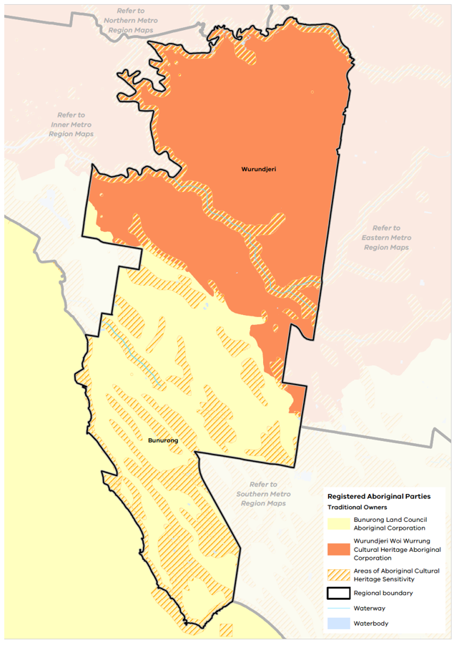

Open space and regional trails
The Inner South East Metro Region’s open spaces, river corridors and foreshore provide places for a diverse range of recreation and leisure experiences, and an opportunity to connect with others and to nature.
The Inner South East Metro Region provides for an average of 24 square metres of public open space per person, less than the metropolitan Melbourne average of 57.5 square metres (Figure 16). Boroondara provides for approximately 35.6 square metres, Bayside 32.3 square metres, Stonnington 14 square metres and Glen Eira 11.7 square metres of open space per person (Figure 16). Open space per person is shown across metropolitan Melbourne is shown in Figure 17.
While there is a shortfall of open space within the region compared to the metro average, significant open spaces exist in close proximity to the region, including the Royal Botanic Gardens, Albert Park and Fawkner Park. Ensuring good connections to these spaces by walking or cycling is essential.
The quantity of open space is only one measure of provision. The function, mix, quality, accessibility and proximity of open space also need to be considered in planning for the future.
The region provides for an extensive network of interconnected trails used by both pedestrians and cyclists for commuting to neighbouring regions and for recreation. This includes Boroondara’s Outer Circle Trail/Anniversary Trail which is a shared pedestrian and cycling path that runs from the Main Yarra Trail to Hughesdale in the south. Other trail networks follow creeks, the bay, former railway easements and the Eastern Freeway. Bike paths within Glen Eira are predominantly on-road.
Key off-road cycling routes that form connections in the region include:
- Djerring Trail – Caulfield to Dandenong shared path
- Gardiners Creek Trail – Burnley to Blackburn
- Koonung Trail – Bulleen to Donvale along Koonung Koonung Creek and the Eastern Freeway
- Rosstown Rail Trail – Hughesdale to Elsternwick along the former railway easement
- The Bay Trail – Port Melbourne to Mordialloc
- Main Yarra Trail – Southbank to Templestowe.
- Open space per person for Inner South East Metro Region LGAs
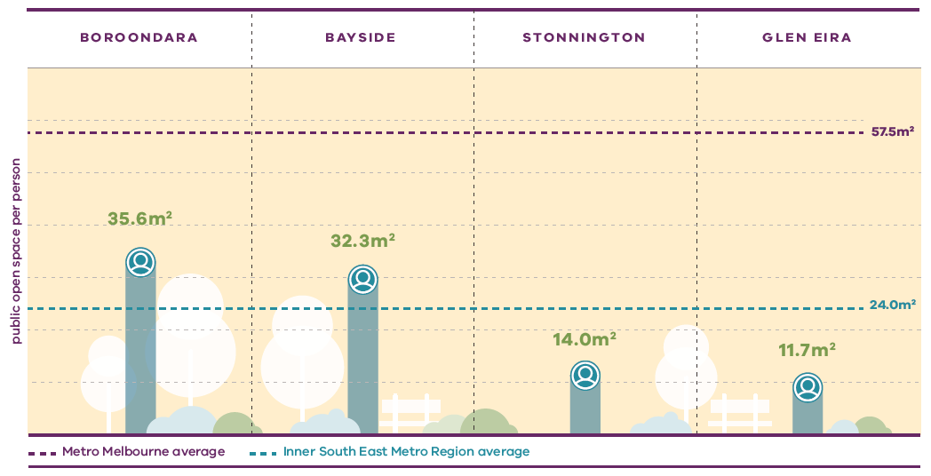
Victorian Planning Authority (2017) Metropolitan Open Space Network: Provision and Distribution, State of Victoria, Melbourne, Australia.
- Open space per person for metropolitan LGAs

Figure 17. Open space per person for metropolitan LGAs
Metro Melbourne average | 57.5 square metres public open space per person
Inner South East Metro Region average | 24.0 square metres public open space per person
Boroondara | 35.6 square metres public open space per person
Bayside | 32.3 square metres public open space per person
Stonnington | 14.0 square metres public open space per person
Glen Eira | 11.7 square metres public open space per person
Source: Victorian Planning Authority (2017) Metropolitan Open Space Network: Provision and Distribution, State of Victoria, Melbourne, Australia.

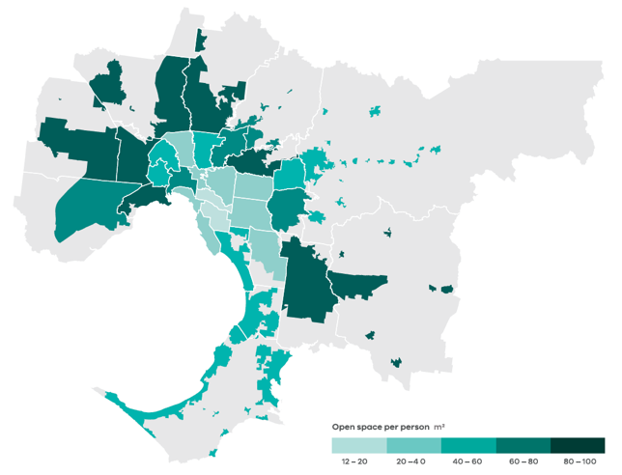
Data from the Victorian Planning Authority Metropolitan Open Space Network portal, 2016
Note: only areas within the UGB were calculated and mapped in this figure. Areas outside the UGB are shown in grey.

Regional strengths
- There are opportunities for Traditional Owners to play a greater role in the protection and management of the region’s landscapes and biodiversity.
- There is a well-established network of open spaces and recreational trails, and opportunities exist to expand this network and fill in gaps.
- The region’s waterways and coastline present opportunities to be improved as the spines of an integrated open space and biodiversity network.

Regional challenges
- Areas of heritage, landscape and biodiversity value must be protected from the impacts of development.
- Additional open space is required to meet the needs of the growing population but there is a scarcity of available land.

Directions and strategies
The directions identified to achieve the 2050 vision for the Inner South East Metro Region in terms of liveability and Outcome 4 of Plan Melbourne are:
Direction 13 | Protect and enhance the region’s landscapes, waterways, coastline and biodiversity
Direction 14 | Strengthen the network of open spaces and trail connections across the Inner South East Metro Region
Direction 15 | Create a legacy of great civic places
Each direction is implemented through regionally-specific strategies identified in this land use framework plan.
Map 6 shows how liveability will be enhanced across the Inner South East Metro Region by 2050 as a result of these directions and strategies, together with Plan Melbourne and other strategies and initiatives as outlined in Appendix 01.

- Inner South East Metro Region liveability 2050
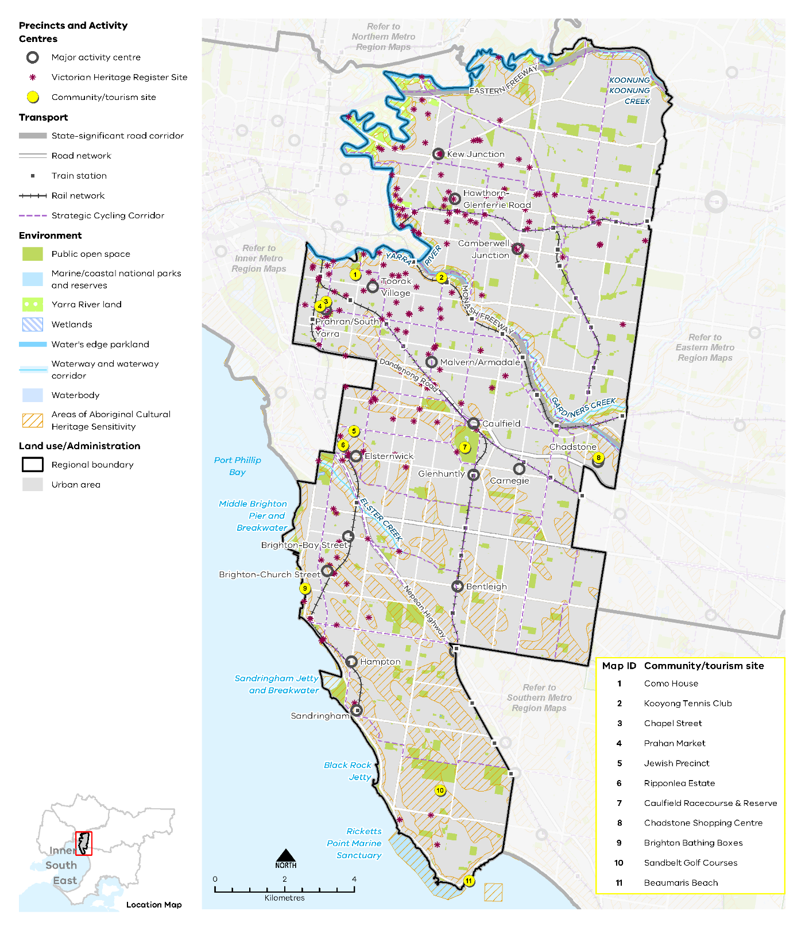

Map 6 Inner South East Metro Region liveability 2050
A map showing the key environmental and cultural features of the region in 2050, as extracted from Map 1, and also highlighting:
- Yarra River and Elster, Gardiners, Koonung Kooung creeks
- Yarra River land and water’s edge parkland along the Yarra River
- Ricketts Point Marine Sanctuary
- Community / tourism sites at:
- Como House
- Kooyong Tennis Club
- Chapel Street
- Prahan Market
- Jewish Precinct
- Ripponlea Estate
- Caulfield Racecourse & Reserve
- Chadstone Shopping Centre
- Brighton Bathing Boxes
- Sandbelt Golf Courses
- Beaumaris Beach
- Areas of Aboriginal Cultural Heritage Sensitivity frequently, but not always, associated with the coastline, rivers, creeks and water bodies
- Victorian Heritage Register sites throughout the region, with many located along the coastal areas and townships.

- Protect and enhance the region’s landscapes, waterways, coastline and biodiversity
As the Inner South East Metro Region continues to develop it will be important to protect and enhance the health of the region’s waterways, coastline and habitat areas.
Linking biodiversity corridors within and between regions, and across public and private land, will enable better habitat connections for urban wildlife. Collaboration with Traditional Owners at a regional and metropolitan level will be necessary to connect and enhance biodiversity assets.
Implementation of the Wurunderji Woi Wurrung Ancient Spirit and Lore of the Yarra and the Yarra Strategic Plan will ensure long-term protection of the Yarra River, including actions to improve its overall environmental health, enhance community access to and use of the river and adjoining parklands, improve development interfaces with the river, and recognise cultural and heritage values.
The Healthy Waterways Strategy (Yarra catchment), has identified the need to protect the values of waterways and wetlands in the region, including identifying priority areas for revegetation and enhanced stormwater management.
These strategies set out a regional approach to protecting urban biodiversity that will have broader liveability and sustainability benefits.
- Ensure the siting and design of new buildings and infrastructure on public and private land protects and enhances the region’s significant landscape features and biodiversity assets.
- Protect and enhance waterways, waterway corridors and the Port Phillip Bay coastline for their contribution to biodiversity, liveability and open space.
- Working with Traditional Owners, support ongoing improvements to the region’s major waterways of the Yarra River and Koonung Koonung, Gardiners, Scotchmans and Elster creeks as key habitat links within the region.
- Strengthen the network of open spaces and trail connections across the Inner South East Metro Region
Plan Melbourne envisages a network of accessible, attractive and connected local areas where linear parklands, river corridors, coastline and associated shared trail networks form critical regional assets. Within the Inner South East Metro Region this includes the parkland associated with the Yarra River, the Koonung Koonung, Gardiners and Elster creeks, and 17 kilometres of coastal foreshore along Port Phillip Bay.
Given the high value of land within the Inner South-East Metro Region, it is generally accepted that a significant increase in the amount of public open space will be difficult to achieve. An innovative approach to optimising use of existing open space or acquiring new open space is therefore required. This will include high-quality maintenance of existing parks, upgrading facilities to meet current needs and investigating using different types of spaces for broader public use, such as school or university grounds, golf courses, easements or cemeteries, at times and in ways that do not jeopardise their primary purpose.
Other options to create new public space include repurposing surplus public land, reclaiming road space, using rooftop space or the contribution of open space within large redevelopment sites or urban renewal precincts. In many instances, new open spaces within the region will be of a small scale and may also be privately owned or managed. It is essential that new open spaces are created in a meaningful way, with high design and amenity standards as a contribution to the broader open space network. Opportunities should be prioritised to use new open space to improve pedestrian access and recreational trail connections, link existing open spaces or open a site frontage to a waterway or parkland.
The metropolitan open space strategy Open Space for Everyone: Open Space Strategy for Metropolitan Melbourne 2020 sets out a vision for Melbourne as a city with a valued network of open spaces accessible to all, connected at the local and landscape scales. It focuses on innovation and adaptability in providing for a diversity of open spaces to meet the needs of the community, while protecting existing open space assets. Initiatives identified in the strategy for the Inner South East Metro Region include the designation of the Greater Yarra Urban Parklands along the Yarra River corridor and improved access and public recreation opportunities within the Caulfield Racecourse Reserve. It also introduces the Suburban Parks program which will see the creation of new or upgraded smaller open spaces, which are integral to the open space network of the region.
- Strengthen the role played by linear parks to connect residents to other destinations within the region such as activity centres, schools and recreation facilities.
- Support improvements and access to existing open space assets such as Caulfield Racecourse Reserve to provide a range of recreation opportunities to cater for continued population growth.
- Encourage utilisation of public land or large land holdings such as school grounds, golf courses or rail reservations for open space, recreation activities or trail connections by providing community access at times and in ways that do not jeopardise their primary purpose.
- Include the provision of new, high-quality open space as a part of major redevelopment proposals and urban renewal sites.
- Create a legacy of great civic places
The region’s rich cultural heritage provides a strong legacy for creating distinctive places which foster community pride and a sense of place. This includes celebrating and reinforcing Aboriginal cultural values within the urban and natural environment. It also includes preservation and adaptation of the region’s post-European settlement heritage.
The creation of a new architectural legacy through excellence of design will reinforce a strong sense of place and identity. The value of ensuring high design quality, preserving the region’s heritage and protecting its landscapes must be recognised and balanced with increasing development pressures.
Maintaining the green character of streets and boulevards with well-established street trees will contribute to amenity across the region. Designing streets to harvest stormwater will assist in strengthening the tree canopy and lower storey vegetation. The strategic underground placement of powerlines in key locations will also enhance the streetscape character and tree canopy.
The design of new development and public places must make a positive contribution to the region’s valued character. This is reflected in the urban design strategies of each municipality, which aim to achieve outcomes such as ensuring buildings are an appropriate scale for the context, preserving sunlight access to public streets and spaces, minimising the impact of car parking and making a positive aesthetic contribution to the streetscape.
Following the rollout of extended outdoor dining across the region, there are future opportunities for permanent replacement of laneways, road spaces and on-street parking spaces for public use (including more permanent outdoor dining) and landscaping. This has the potential to increase footpath capacity and amenity, support retail and social vibrancy and enhance urban greening.
- Identify, enhance and protect buildings and public spaces that have high civic or public value, and which contribute to people’s understanding, interaction and enjoyment of the region.
- Upgrade key pedestrian streets to foster their civic and community role and to create high amenity, active and greened streetscapes for all forms of transport.
- Engage with Aboriginal communities to incorporate cultural heritage, design and stories into the built and natural environment.
- Reflect the different layers and aspects of the region’s history in the design of new buildings, public spaces, infrastructure and public artwork.

Actions – Liveability
- Prepare a regional urban biodiversity strategy to protect existing habitat corridors, increase their interconnectivity and guide investment, including identifying physical gaps in key habitat corridors. Consider land use solutions that enable interconnected biodiversity corridors.
- Identify public land holdings that could be used for open space and/or trail connections. Provide and initiate a streamlined approach to making them publicly accessible.

Strong Communities
Plan Melbourne Outcome 5: Melbourne is a city of inclusive, vibrant and healthy neighbourhoods
The Inner South East Metro Region has many of the key attributes of strong, inclusive and healthy communities. This plan will ensure it continues to do so by providing community services, open space, hospitals, educational and cultural institutions, and transport infrastructure that keeps pace with a projected increase in population to 784,040 by 2051.
Taking a regional approach to planning will ensure social infrastructure and open space services the widest possible catchment and cross-section of people. Plan Melbourne aims to build on the fundamentals of strong, healthy and sustainable neighbourhoods by improving access to and provision of amenity, social infrastructure, health and education, open space and the promotion of walking and cycling options.
Plan Melbourne advocates for the vision of a city of ‘20-minute neighbourhoods’ in which most everyday needs can be met within a 20-minute walk, cycle or local transport trip from home. The Inner South East Metro Region is well placed to achieve this vision.

State of play

Community profile
The Inner South East Metro Region is a culturally diverse community. Around 46 per cent of the region’s population was born overseas, which is 10 per cent higher than the metropolitan Melbourne average. Prevalent countries of origin for people in the region who were born overseas are China, United Kingdom and India, which is similar to metropolitan Melbourne. However, the region has the lowest Aboriginal population of the metropolitan regions of around 1000 people (Australian Bureau of Statistics, 2016).
The Socio-Economic Index for Areas (SEIFA) ranks LGAs according to their relative socio-economic advantage and disadvantage. The 2016 SEIFA rankings for the Inner South East Metro Region are shown in Figure 18.
Compared to metropolitan Melbourne, LGAs that make up the Inner South East Metro Region have higher levels of economic advantage. In 2016 SEIFA ranked Boroondara as the municipality with the highest social economic advantage in Victoria, with Bayside, Stonnington and Glen Eira within the top six. This high ranking can be attributed to many factors including almost half of the adults within the region holding a Bachelor degree or higher (47.2 per cent) compared to 27.5 per cent across metropolitan Melbourne. Educational attainment levels are generally indicative of broader socio-economic characteristic and reinforce the relative socio-economic affluence of the region.

Health and education facilities
The Inner South East Metro Region does not contain any state-significant health precincts although many of these within adjoining regions can be easily accessed. This includes Box Hill Hospital, Alfred Hospital, Monash Medical Centre, Epworth Richmond and St Vincent’s Fitzroy which are located just outside the region.
Within the region there are 43 health facilities of different types, both public and private. These include local-scale facilities associated with major hospitals, day hospitals, rehabilitation services and medical centres. Major health facilities include Sandringham Hospital, Epworth Hawthorn, Cabrini Malvern and Caulfield General Medical Centre. These facilities and precincts provide jobs and services to surrounding neighbourhoods and support the development of 20-minute neighbourhoods. Given its relatively small size, the Inner South East Metro Region is well served by a wide range of health facilities.
At a tertiary education level, the region is dominated by Monash University’s Caulfield campus and Swinburne University in Hawthorn, both of which are education precincts of state significance. These institutions are close to the Caulfield Major Activity Centre and Hawthorn-Glenferrie Road Major Activity Centre respectively.
TAFE is represented in the Inner South East Metro Region with the Melbourne Polytechnic campus in Prahran and Holmesglen TAFE Chadstone, on the eastern edge of the region.
The Inner South East Metro Region has approximately 52 government primary schools and 13 government secondary schools and also features a range of private schools. Many of the campuses contain individually listed heritage buildings and extensive gardens, complementing the existing streetscapes of this region.
- SEIFA rankings (2016) in the Inner South East Metro Region
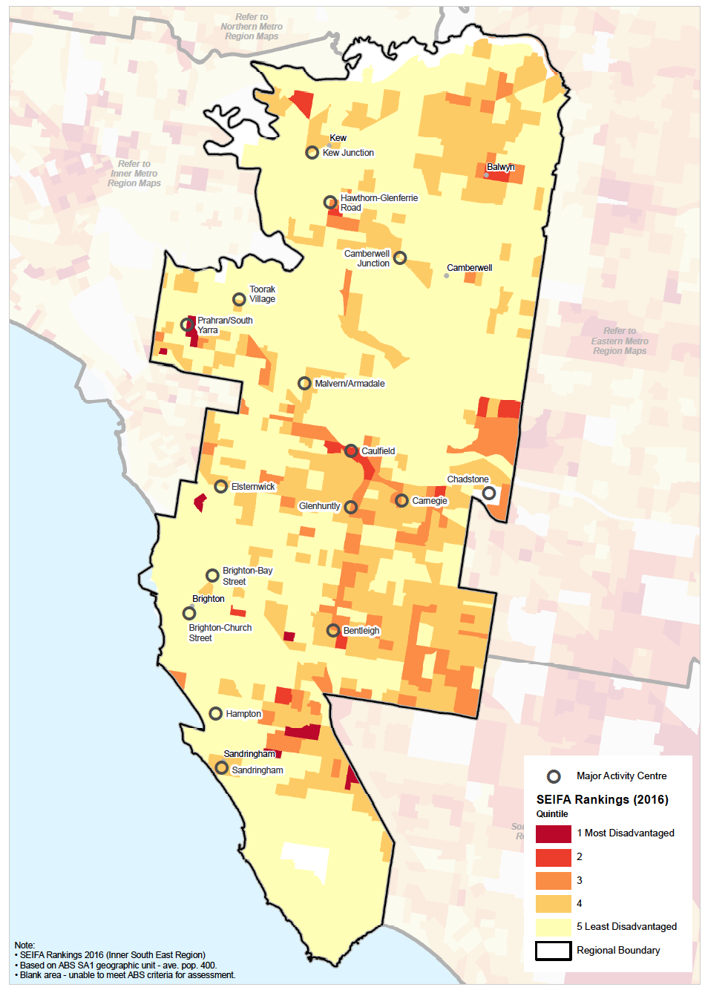

Social infrastructure
Social infrastructure includes all of the facilities, services and networks that help people to meet their social, cultural and community needs, in addition to health and education facilities.
The Inner South East Metro Region has a diversity of cultural, sporting and recreational facilities.
In terms of sport and active recreation, the region includes the major recreation facilities of the State Fencing Centre (Kew East), Victorian Weightlifting Centre (Hawthorn) and the Gymnastics High Performance Centre (Windsor).
Other regional recreation facilities include sports grounds and complexes, aquatic centres and tennis courts situated in each municipality. The Caulfield Racecourse is an important regional facility and the region is also home to several sand belt golf courses which combined cover an area of 175 hectares.
However, given the growing population, sporting infrastructure and active open space is considered to be at, or close to, capacity.
The end of horse training at Caulfield Racecourse by 2023 will make 23 hectares of Crown land available for public open space and recreation. This area is proposed to be used for both indoor and outdoor sporting and active recreation facilities and to enhance walking and cycling connectivity within the reserve and the region.
The link between health, wellbeing and nature is reflected in many Victorian Government strategies including the Public Health and Wellbeing Plan 2019-2023 and Active Victoria – A Strategic Framework for Sport and Recreation in Victoria 2017-2021. Creating healthy living environments with a high level of urban amenity, access to nature, opportunities for community connection, recreation and active transport is central to fostering long-term community wellbeing.

Regional strengths
- The region is home to two state-level tertiary education campuses and is well serviced by a variety of recreation facilities.
- There is an opportunity to expand and diversify the uses of existing social infrastructure in innovative ways to meet the needs of the community.
- While there is no state health facility within the region, there are numerous regional facilities and good access to state facilities close by.
- The region is well-placed to achieve the hallmarks of 20-minute neighbourhoods, based around its many major and neighbourhood activity centres that cater for a wide range of daily needs and are accessible by public transport.

Regional challenges
- Additional facilities for sport or active recreation will need to be provided to meet the needs of the future population.

Directions and strategies
The directions identified to achieve the 2050 vision for the Inner South East Metro Region in terms of strong communities and Outcome 5 of Plan Melbourne are:
Direction 16 | Plan for major social infrastructure at a regional level
Direction 17 | Deliver health and education services in strategic locations
Direction 18 | Support a regional network of activity centres to anchor 20-minute neighbourhoods across the Inner South East Metro Region
Each direction is implemented through regionally-specific strategies identified in this land use framework plan.
Map 7 shows how strong communities will be enhanced across the Inner South East Metro Region by 2050 as a result of these directions and strategies, together with Plan Melbourne and other strategies and initiatives as outlined in Appendix 01.

- Inner South East Metro Region strong communities 2050
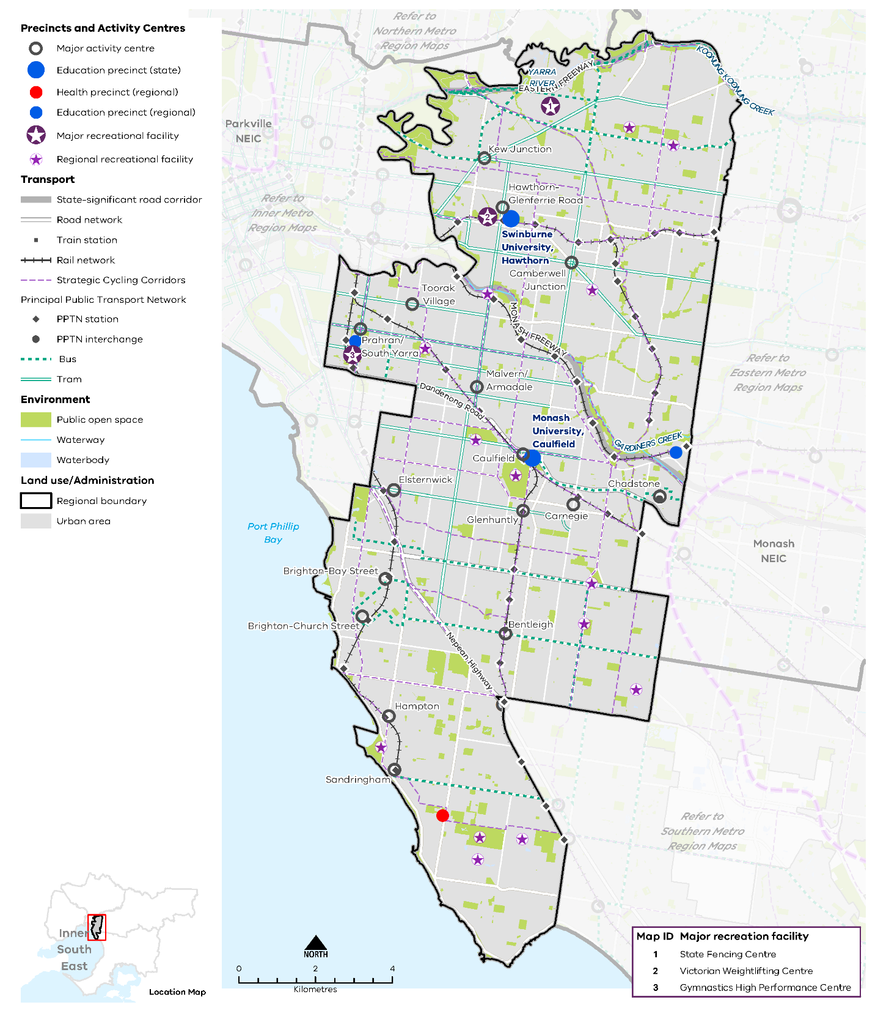

Map 7 Inner South East Metro Region strong communities 2050
A map showing the main community assets of the region in 2050 including state- and regionally-significant health and/or education precincts, as extracted from Map 1, and also highlighting:

- Major recreation facilities at:
- State Fencing Centre
- Victorian Weightlifting Centre
- Gymnastics High Performance Centre

- Regional recreation facilities including Caulfield Racecourse, aquatic centres, sports grounds, tennis courts and golf courses.

- Plan for major social infrastructure at a regional level
Planning from a regional perspective requires coordination between different levels of government to acknowledge that local councils plan for local infrastructure such as kindergartens, while the Victorian Government plans for state-level services such as government schools.
Access to community infrastructure to meet the needs of all age demographics is integral to strong and healthy communities including:
- Early years services
- Medical and care services
- Education facilities
- Multi-purpose community facilities and regional community hubs
- Arts and cultural facilities
- Libraries
- Open space
- High-quality indoor and outdoor sport and recreation facilities
- Cemeteries.
The Inner South East Metro Region is currently well serviced by performing art centres, museums, community halls, aquatic facilities, public gardens and outdoor sports grounds. However, many of these assets were designed for a single purpose, require refurbishment and are unlikely to adequately meet the projected future needs of the community. Community infrastructure will need to continue meeting the needs of an ageing population to enable residents to reside in the region.
The long-term need for sporting fields and specialist sporting facilities is not currently coordinated at a regional scale. Given the challenges associated with acquiring land and funding infrastructure, there would be significant value in taking a regional approach to planning and delivering these facilities and encouraging broader use of facilities where possible to cater for the local population.
With significant competition for land, a new approach will be needed to optimise the delivery of community infrastructure while maintaining existing community character and a sense of place.
- Encourage planning for major social infrastructure (such as libraries, cultural centres or community hubs) to be undertaken in conjunction with neighbouring regions to maximise co-location of facilities.
- Locate social infrastructure near activity centres and to be accessible by walking, cycling or public transport.
- Support the upgrade and expansion of social infrastructure to enable it to be more flexibly and intensively used.
- Encourage utilisation of public land such as school grounds or golf courses for open space, recreation activities or trail connections by providing community access at times and in ways that do not jeopardise their primary purpose.
- Support regional planning that will provide for a range of sporting and active recreation facilities to meet the needs of the growing population.
- Deliver health and education services in strategic locations
The Inner South East Metro Region comprises a number of smaller-scale health providers. To accommodate the anticipated demand for health and educational facilities, existing infrastructure will need to be updated or relocated to hubs that encourage synergies between uses. A significant portion of this demand can be accommodated through upgrading, expanding and diversifying existing services in proximity to the PPTN and educational institutions associated with the relevant health providers.
Plan Melbourne identifies state-significant health and/or education precincts. Regionally-significant health and/or education precincts (Table 9) have a regional catchment, are accessible by a range of transport options and have a specialised economic function. This identification provides opportunities for the agglomeration of ancillary health and education services, retail, commercial and accommodation uses.
Planning for activity centres, and health and education precincts, should consider their role as part of the broader network of public and private community service providers. Health infrastructure should be planned at a regional level so these facilities serve the widest possible catchment and most appropriate demographic.
- Strengthen the role of the health and/or education precincts of the Inner South East Metro Region by co-locating new health and/or education facilities within these precincts and encouraging an agglomeration of ancillary uses such as primary healthcare, retail and accommodation.
- Expand the network of health and/or education facilities and precincts across the region to meet the needs of the growing population. Ensure that these facilities and precincts are accessible by public transport, walking and cycling.
- Support the upgrade of existing health and education infrastructure to allow for more intensive use of those services.
- Acknowledge and respond to land use interface impacts between health and education facilities and neighbouring uses and utilise site-specific master planning to set clear parameters for future development.
State-significant and regionally-significant health and/or education precincts
State-significant education precinct | Regionally-significant education precinct
Swinburne University (Hawthorn)  Monash University (Caulfield) | Holmesglen Institute of TAFE (Chadstone)  Melbourne Polytechnic (Prahran)
 | Regionally-significant health precinct
 | Sandringham Hospital
- Support a regional network of activity centres to anchor 20-minute neighbourhoods across the Inner South East Metro Region
The 20-minute neighbourhood is about ‘living locally’ and giving people the ability to meet most of their daily needs within a 20-minute walk, cycle or public transport trip from home. A 20-minute neighbourhood is integral to providing a more cohesive and inclusive community and a vibrant local economy.
The Inner South East Metro Region is well placed to adopt the 20-minute neighbourhood, given its relatively small size, its extensive rail and tram network and the proximity of most residents to activity centres and corridors whether they be of a major or neighbourhood scale. Due to the region’s pre-automobile era of settlement, most people live close to transport or an activity centre, making it possible for residents to meet most daily needs within a 20-minute walk, cycle or public transport trip from home.
Major and neighbourhood activity centres are crucial to this vision. These centres serve the immediate needs of the local community by providing small supermarkets, specialised shops, cafés and service businesses. Many activity centres within the Inner South East Metro Region are located close to tram stops or railway stations. Housing strategies prepared by each of the region’s LGAs recognise that activity centres, including neighbourhood activity centres, provide opportunities for greater density that underpins the 20-minute neighbourhood principle. Planning for neighbourhood activity centres should support their economic viability while also encourage greater residential development.
The Inner South East Metro Region includes numerous neighbourhood activity centres of varying size and function such as Canterbury Village, Martin Street in Gardenvale, Alma Village, Auburn Village, Murrumbeena and McKinnon. Many of these are located close to public transport and provide a retail presence. Place-based planning for new developments will support the retention of the existing character of these centres and provide opportunities for community engagement and partnerships to ensure a sense of place is retained.
- Plan for existing and new activity centres to embed the 20-minute neighbourhood hallmarks, through a place-based, community partnership approach.
- Support a consistent designation of neighbourhood activity centres and their role in the network of activity centres across the Inner South East Metro Region.
- Support the role of neighbourhood activity centres to provide a range of retail, social infrastructure and allied health services to their respective local catchments.
- Ensure the planning and design of urban renewal precincts and major transport infrastructure projects maximises opportunities to embed the hallmarks of 20-minute neighbourhoods.

Actions – Strong communities
- Map all schools, golf courses, tertiary campuses and other large land holdings across the region to identify opportunities for shared use agreements of open space/sporting facilities out of hours.

Sustainability and Resilience
Plan Melbourne Outcome 6: Melbourne is a sustainable and resilient city
Plan Melbourne aims to create a resilient and sustainable city. It recognises the need to mitigate greenhouse gas emissions, reduce exposure to natural hazards, undertake whole of water cycle planning and design, and protect local waterways. It also encourages resource efficiency and promotes the benefits of urban cooling and greening.
Climate change challenges will be ongoing within the Inner South East Metro Region – including heatwaves, drought, increased storm intensity, stormwater inundation, storm surges and coastal inundation – requiring deliberate, coordinated steps by regional decision-makers to minimise these impacts.
The region is renowned for its vast, consistent tree canopy cover, and although the character of the region is increasingly urbanised, remnant native vegetation and biodiversity corridors remain, providing habitat for wildlife. Nevertheless, the issue of tree canopy loss is becoming acute. The ability to create opportunities for urban cooling and greening and adopt further strategies to reduce the urban heat island effect will be important to bolster community wellbeing and resilience into the future.
The region is also highly valued for its watercourses and natural landscapes including the Port Phillip Bay coastline, Yarra River and Koonung Koonung, Gardiners, Scotchmans and Elster creeks. These assets, which contain parks and recreational areas as well as habitat for local flora and fauna, will become increasingly vulnerable to the effects of climate change. The Inner South East Metro Region will experience significant challenges in maintaining and rehabilitating these resources.

State of play

Urban heat environments
Urban environments that stay cooler on hot days are more physically comfortable to humans and animals, and continue to support movement and recreation. Cooler urban environments are characterised by more tree cover, fewer impermeable surfaces, more water infiltration into the ground and less heat-absorbing materials. As the number and duration of hot days increases due to climate change, it will become even more important to improve comfort and reduce the likelihood of heat-related stress and illness.
The elderly, the very young, those with chronic illnesses and those with fewer resources to adapt are at greater risk on hot days and in prolonged periods of hot weather. Plan Melbourne notes that temperature decreases of between 1° Celsius and 2° Celsius can have a significant impact on reducing heat-related morbidity and mortality (DELWP, 2017a).
In 2018, the average land surface temperature (LST) of the Inner South East Metro Region was 33.3° Celsius, slightly lower than the average LST of metropolitan Melbourne at 33.9° Celsius. Within the region, Glen Eira LGA had the highest LST and Boroondara the lowest (Figure 19).

- Average land surface temperature by LGA, 2018
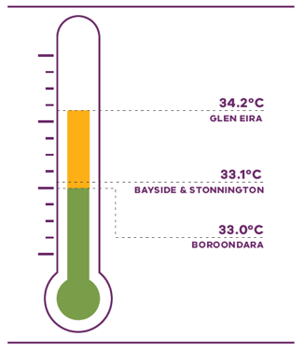
Department of Environment, Land, Water and Planning (2018) Land Surface Temperature Data, State of Victoria, Melbourne, Australia.

Figure 19. Average land surface temperature by LGA, 2018
Glen Eira | 34.2 degrees Celsius
Bayside | 33.1 degrees Celsius
Stonnington | 33.1 degrees Celsius
Boroondara | 33.0 degrees Celsius
Source: Department of Environment, Land, Water and Planning (2018) Land surface temperature data, State of Victoria, Melbourne, Australia.

- Heat vulnerability index map for the Inner South East Metro Region, 2018
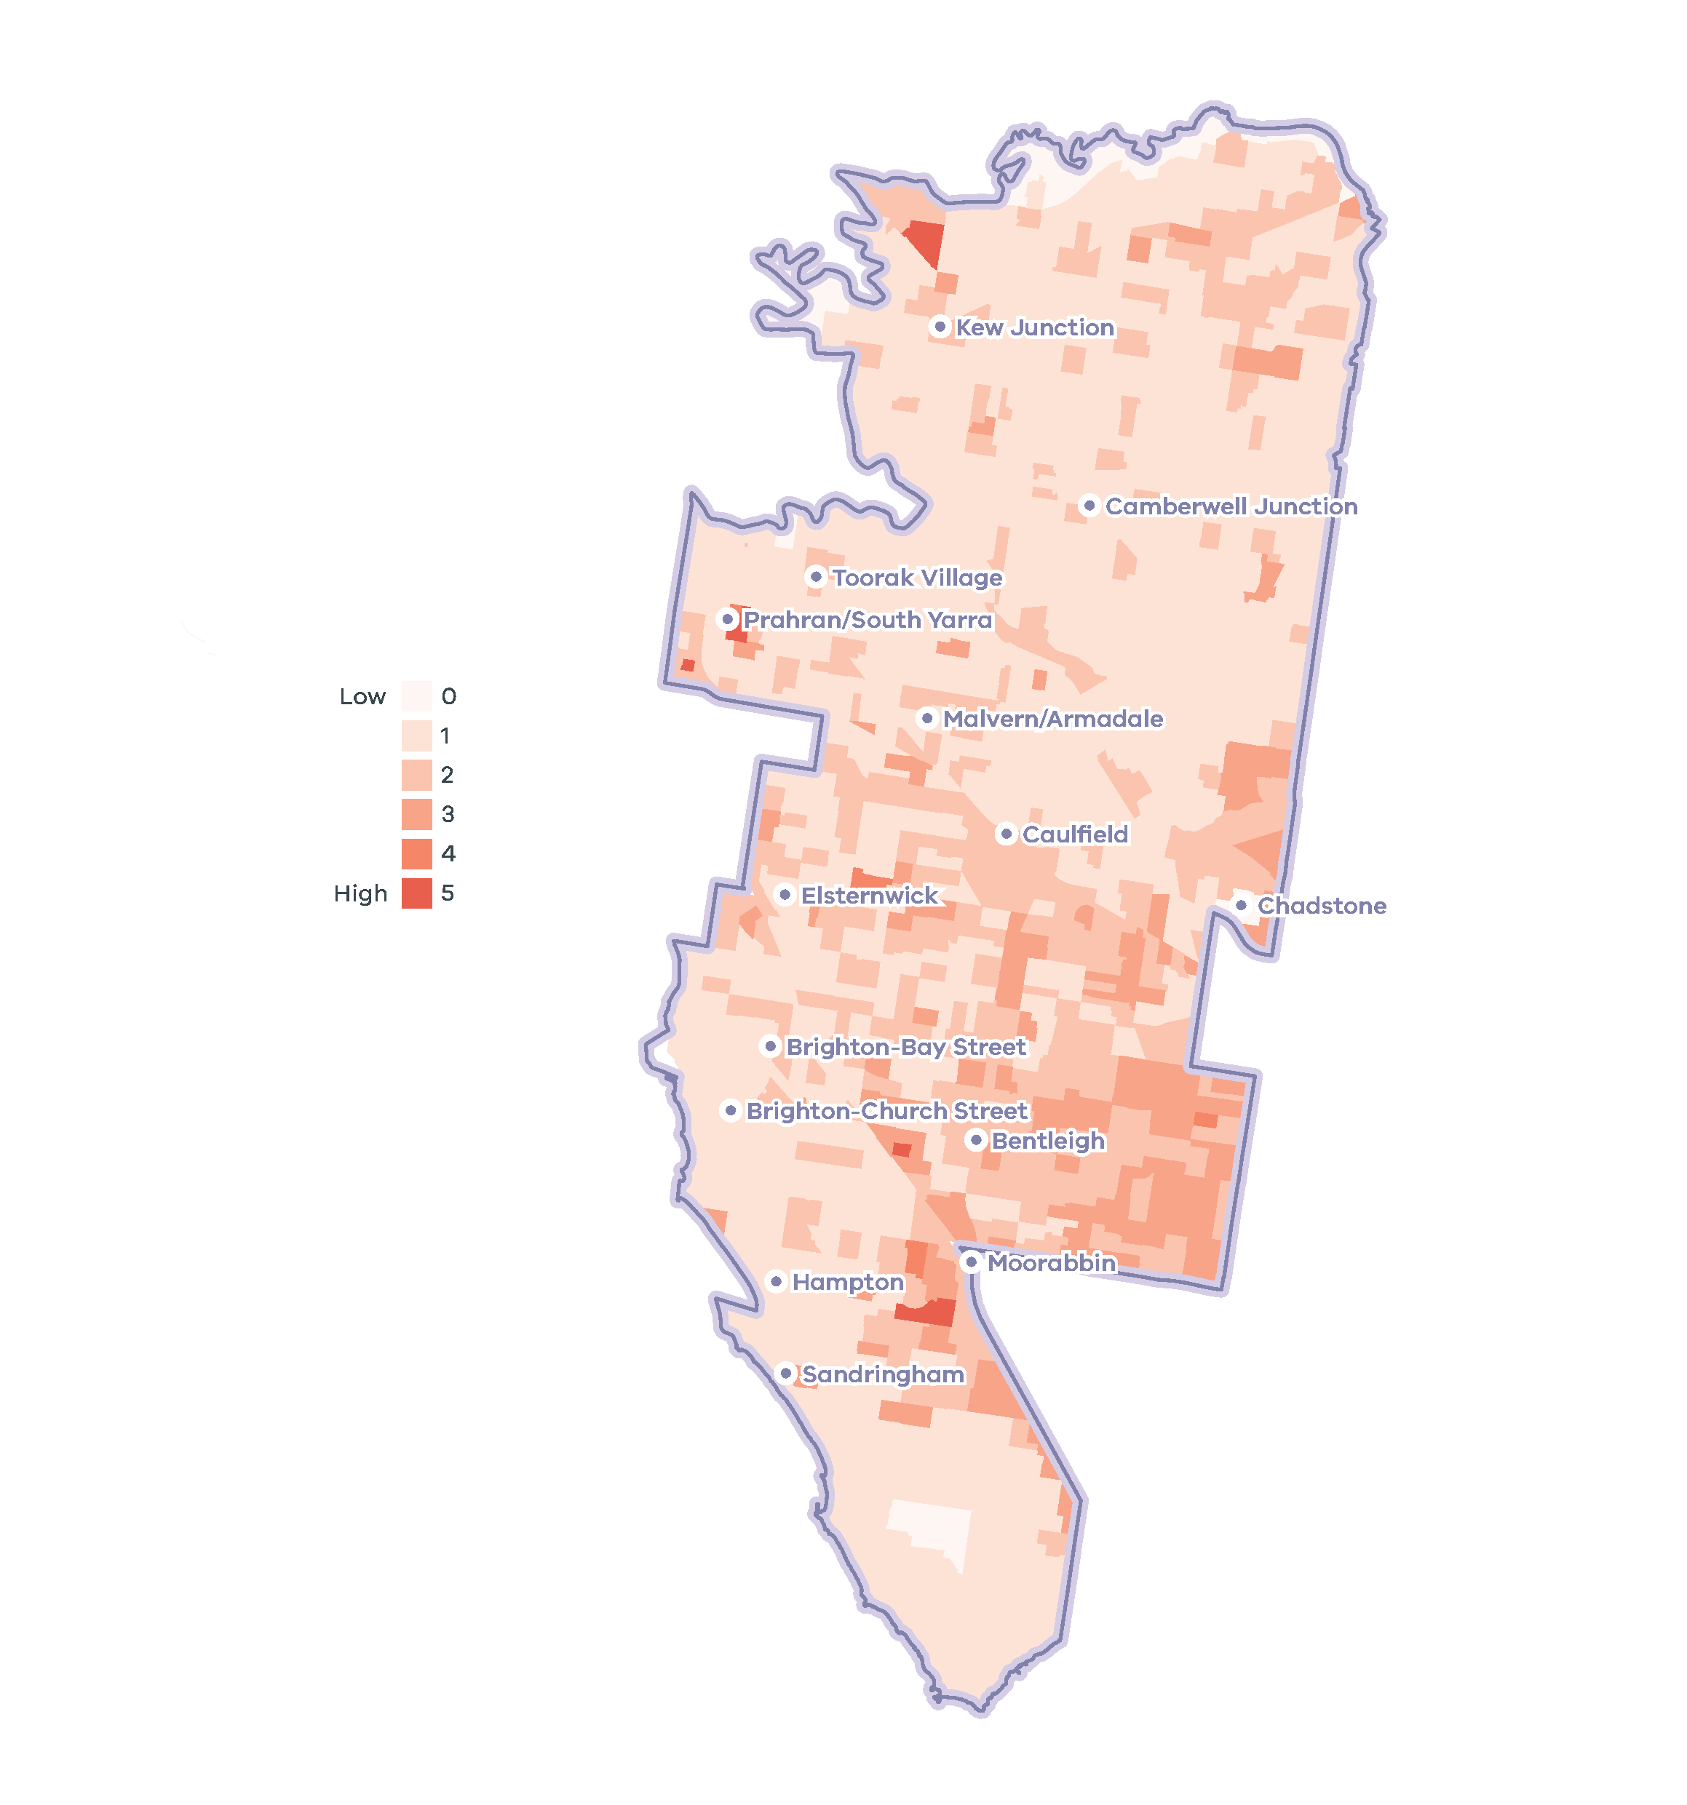

- Inner South East Metro Region tree canopy cover, 2018
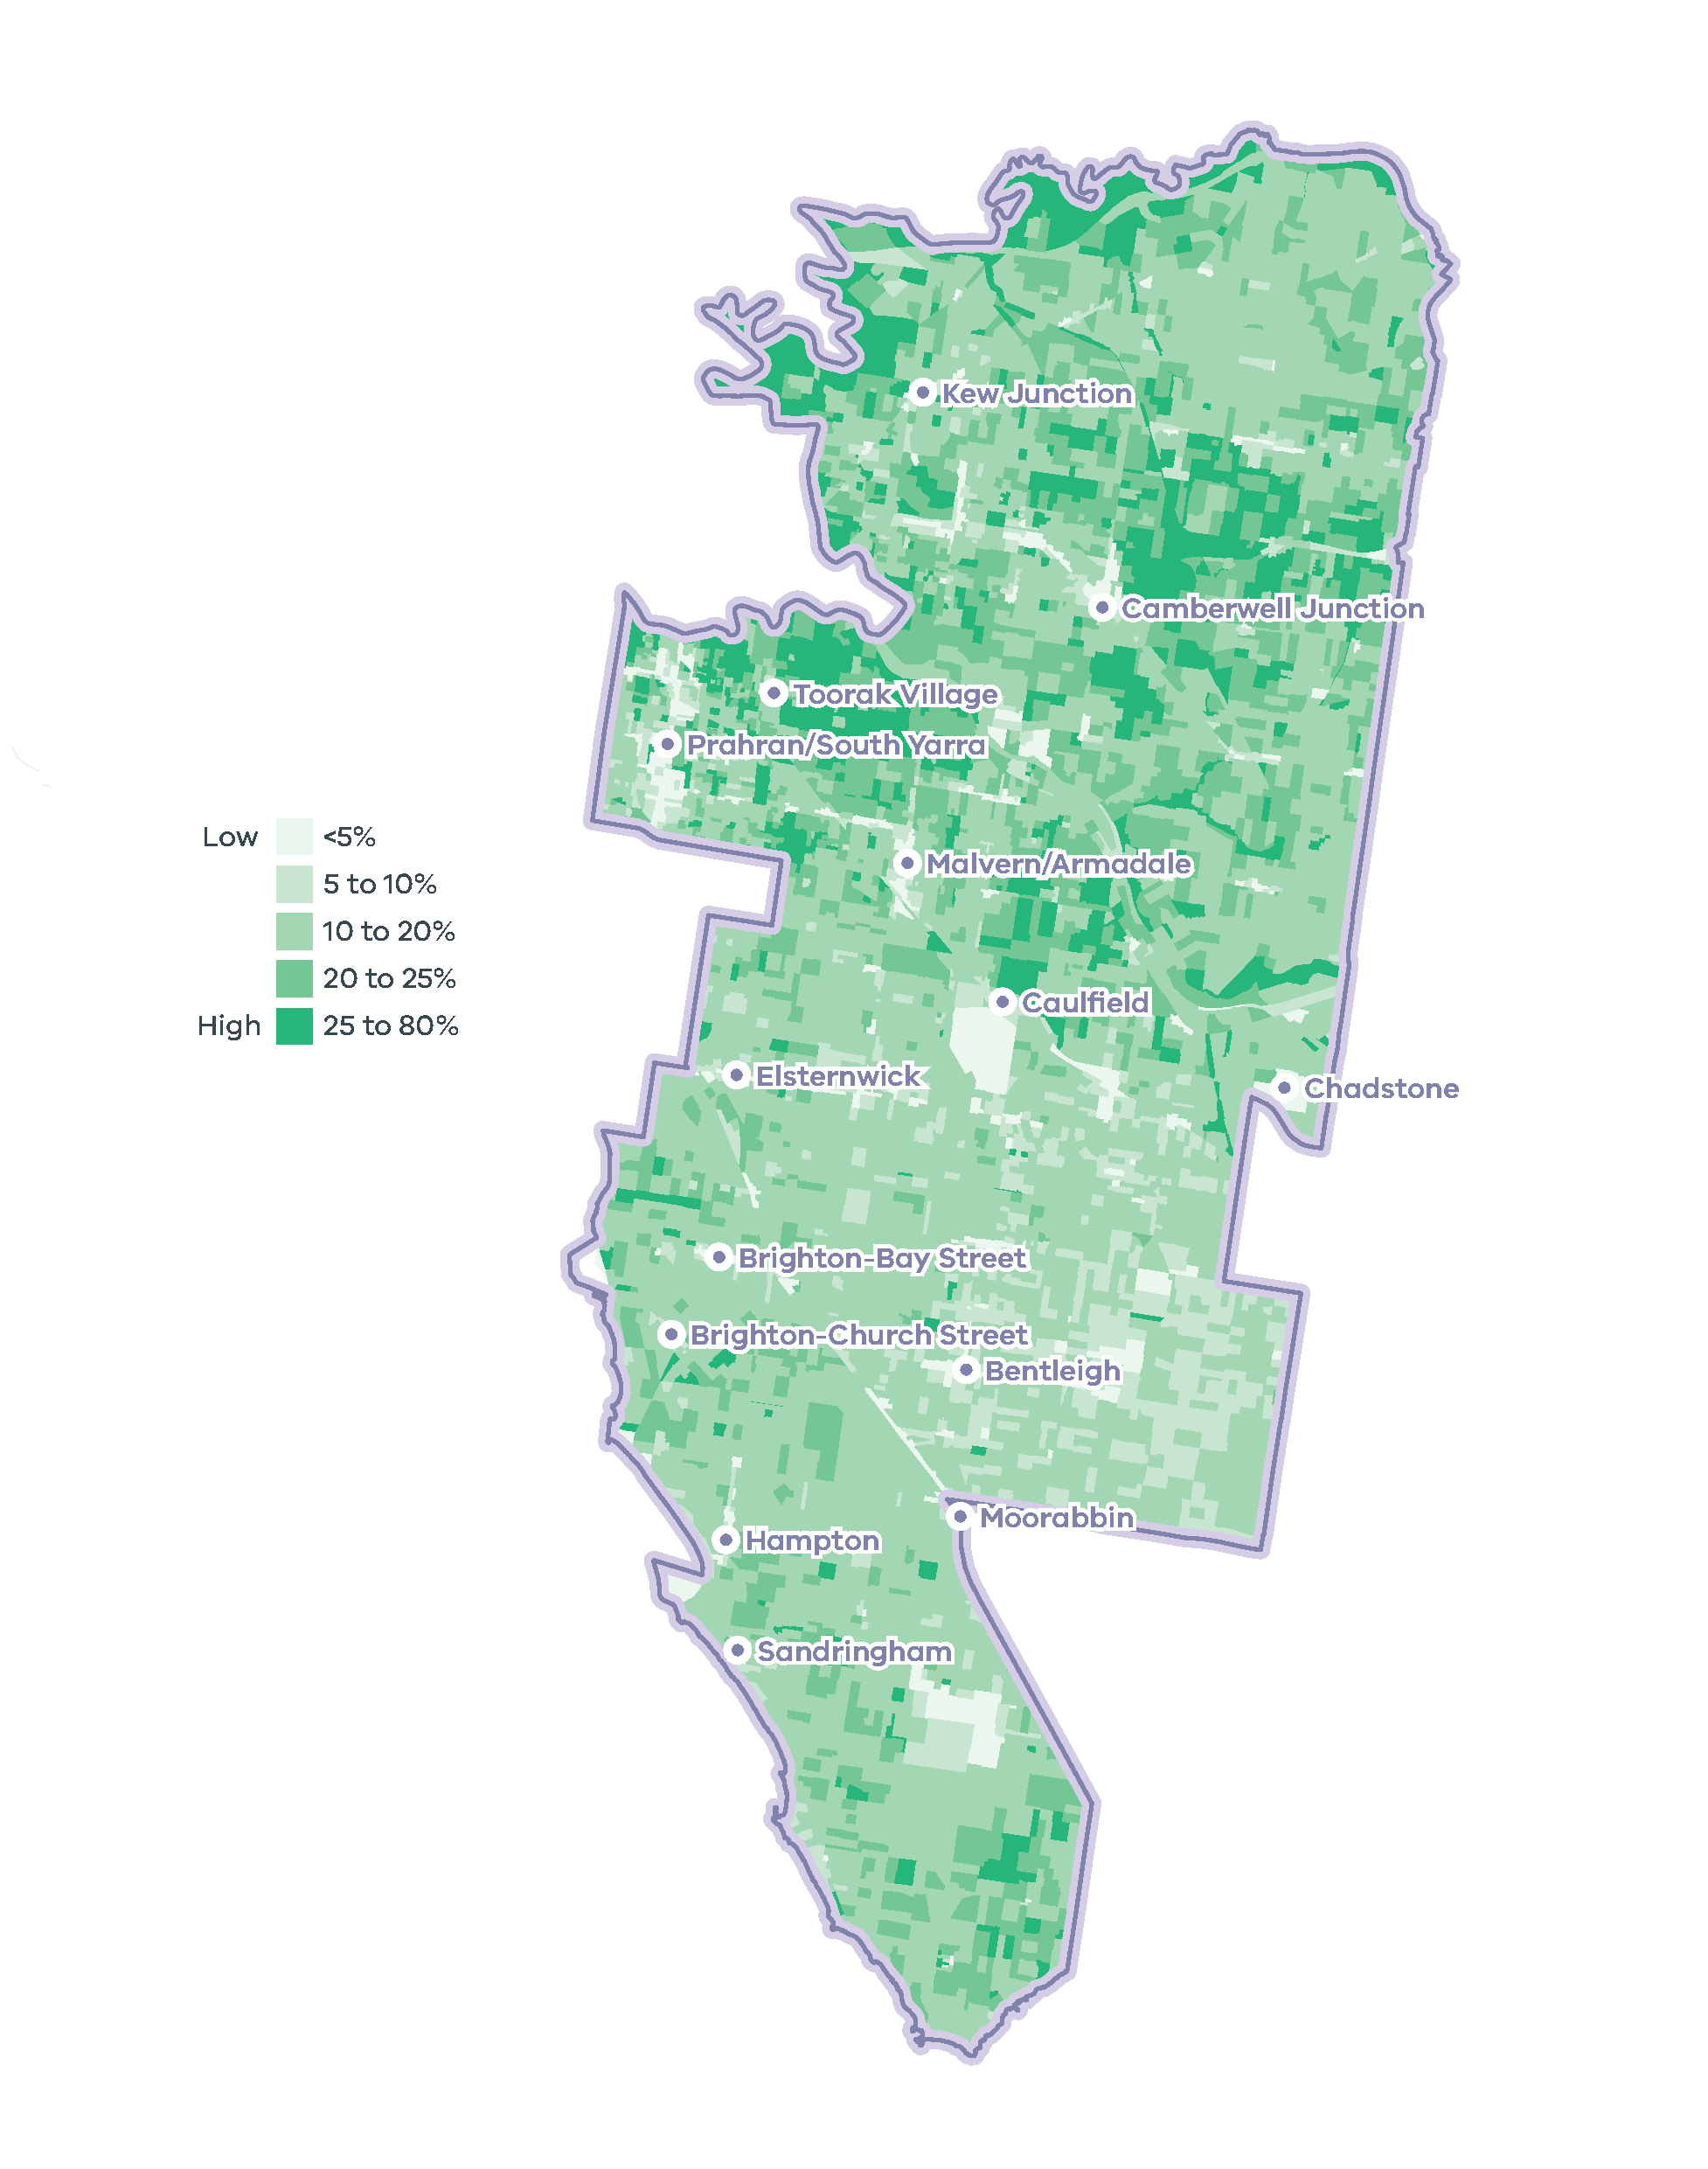

Vegetation cover
Vegetation cover is a defining feature of the Inner South East Metro Region, which in 2018 had 33.2 per cent vegetation cover and 17.4 per cent tree canopy cover, the second highest rate behind the Eastern Metro Region and 2.1 per cent greater than the metropolitan average. The Inner South East Metro Region makes a moderate contribution to Melbourne’s overall vegetation and tree canopy cover, with 5370 hectares and 2821 hectares respectively (Hurley, et al., 2019a).

Urban tree canopy
In urban areas trees provide cooling, amenity, recreation and respite to residents. They also provide habitat for wildlife and contribute to urban character.
Within the region, residential land was the largest contributor of trees, followed by infrastructure land (primarily streets) and parkland (Figure 22). Tree canopy cover varied between the four LGAs comprising the Inner South East Metro Region (Figure 23).
Although tree canopy cover in the Inner South East Region is relatively higher than most other metro regions, a relatively consistent and even distribution of tree cover loss is evident between 2014 and 2018 (Figure 23) with the greatest vegetation loss on residential land (Hurley, et al., 2019b). While the region as a whole is experiencing increased development pressure, LGAs with relatively greater tree canopy cover are generally cooler (Figure 20 and Figure 21).
- Urban tree canopy cover by land use, 2018
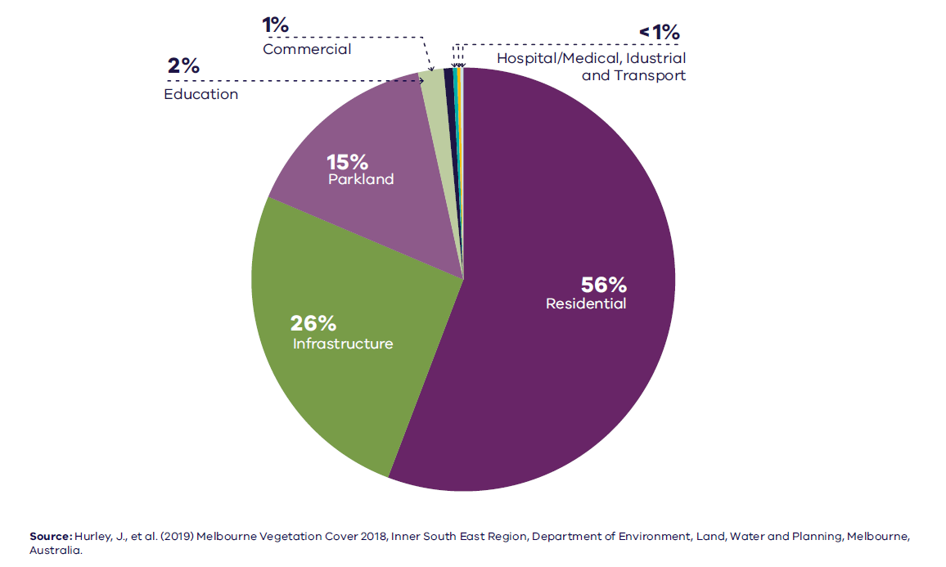
Hurley J. et al. (2019) Melbourne Urban Vegetation Cover 2018, Inner South East Region, State of Victoria, Melbourne, Australia.

Figure 22. Urban tree canopy cover by land use, 2018
Residential | 56 per cent
Infrastructure | 26 per cent
Parkland | 15 per cent
Education | 2 per cent
Commercial | 1 per cent
Hospital/medical | Less than 1 per cent
Industrial | Less than 1 per cent
Transport | Less than 1 per cent
Source: Hurley, J., et al. (2019) Melbourne Vegetation Cover 2018, Inner South East Region, Department of Environment, Land, Water and Planning, Melbourne, Australia.

- Tree canopy cover 2018 and tree canopy cover change 2014 to 2018, by LGA
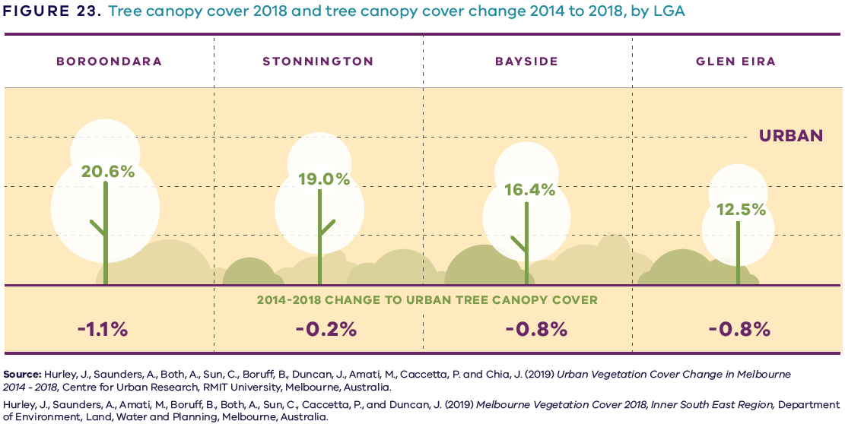

Figure 23. Tree canopy cover 2018 and tree canopy cover change 2014 to 2018, by LGA
LGA | Urban tree canopy cover 2018 | 2014 to 2018 change to urban tree canopy cover
Boroondara | 20.6 per cent | Minus 1.1 per cent
Stonnington | 19.0 per cent | Minus 0.2 per cent
Bayside | 16.4 per cent | Minus 0.8 per cent
Glen Eira | 12.5 per cent | Minus 0.8 per cent
Sources:
Hurley, J., et al. (2019) Melbourne Vegetation Cover 2018, Inner South East Region, Department of Environment, Land, Water and Planning, Melbourne, Australia.
Hurley, J., et al. (2019) Urban Vegetation Cover Change in Melbourne 2014 – 2018, Centre for Urban Research, RMIT University, Melbourne, Australia.

Flood risks and waterway health
Despite anticipated reductions in overall average annual rainfall caused by climate change, it is also predicted that heavy rainfall events will occur more frequently within the Inner South East Metro Region. Continued urban consolidation and resultant increases in impermeable surfaces will exacerbate this situation, presenting a greater risk of stormwater inundation to both private and public property (DELWP, 2018b). Increased flooding within the Elster Creek catchment, extending through Glen Eira, Kingston and Bayside LGAs, is particularly concerning as it drains into the neighbouring Inner Metro Region. This runoff concentrates in the Elwood Canal, located in Port Phillip LGA, before emptying into Port Phillip Bay. The Gardiners Creek catchment presents similar issues as it collects runoff from Boroondara and Stonnington LGAs before reaching the Yarra River. Litter and chemical contaminants flushed from the stormwater system and higher volume water flows during these flood events could further impact the water quality and health of these waterways.
The Yarra River is a vital natural resource for eastern Melbourne and forms the northern boundary of the Inner South East Metro Region. The health of the Yarra River is under similar pressure from the impacts of climate change and encroaching development. The draft Yarra Strategic Plan sets out priorities for a coordinated response to protecting and managing the river by water authorities, local and State Government, and the community. This will help rehabilitate the river from past mismanagement and future-proof it for the anticipated impacts of a changing climate.

Sea level rise, coastal inundation risk
The coastline and bay have significant value to the Victorian community for a range of cultural, recreational, environmental and economic values, but both are under pressure from urbanisation and climate change (DELWP, 2017b). Rainfall intensification will exacerbate current impacts including increased stormwater and pollutant runoff. Marine and coastal environments will experience increases in water temperature and rising sea levels. Storm surges will also become more frequent, exposing the coastline to erosion and inundation (DELWP, 2017b).
As projected average temperatures continue trending upwards through this century, so too will global warming mean sea levels rise as oceans partially absorb atmospheric heat and glaciers and polar ice caps continue to melt.
State planning policy recognises the need to plan for anticipated sea level rise to Port Phillip Bay and Western Port, with Western Port expected to experience greater levels of sea level rise than Port Phillip Bay. Given the uncertainty of our climate change future, planning policy will need to be responsive to future recalibration of sea levels (Melbourne Water, 2017).
The expected impact of tidal inundation – including storm surge, wave action and saline groundwater intrusion – will have an increasingly significant influence over the future development of the Inner South East Metro Region. To optimise positive outcomes within areas affected by tidal inundation, compromises and special consideration will need to be made between flood management agencies, local and State Government, and developers alike.
Areas of the Inner South East Metro Region vulnerable to heat stress, high surface temperatures and the impacts of climate change are shown on Map 8.

Sustainability in the built environment
In 2013, residential buildings were responsible for nearly 12 per cent of Australia’s national greenhouse gas emissions, and commercial buildings contributed just over 11 per cent. Most of these emissions were generated through the consumption of grid-supplied electricity to power appliances, lighting and predominantly heating, ventilation and cooling (HVAC) systems (Australian Sustainable Built Environment Council, 2016).
As average temperatures rise due to climate change, greater numbers of people are expected to seek comfort indoors during high heat conditions. This, combined with population growth and overall poor-performing building stock, means our city lacks energy efficiency and resilience on hot days. Maximising opportunities to incrementally improve the performance of buildings will reduce our reliance on appliances to cool buildings and contribute to a lower likelihood of blackouts during periods of hot weather.
Local councils within the Inner South East Metro Region are active in adopting policies and strategies to reduce carbon emissions and improve the sustainability of the built environment. Many are innovators and leaders in environmentally sustainable development (ESD) and are implementing practices to improve the energy efficiency of civic buildings and reduce emissions from operations.
Several LGAs are members of the Council Alliance for a Sustainable Built Environment (CASBE), an association committed to designing and applying a range of practical methodologies to increase sustainability outcomes for new buildings. The Built Environment Sustainability Scorecard (BESS) is an online tool developed by CASBE that assesses the sustainability of proposed developments. It aims to reduce waste and improve energy efficiency from the outset of the construction phase, through to occupation. As well as onsite energy generation, BESS promotes the use of energy-efficient appliances, thermally-efficient glazing, wall cladding and insulation, water-efficient fittings and fixtures, thermal comfort and overall environmentally sustainable performance.
Other rating systems increasingly used by the building design industry to measure and assess the performance of ESD principles include Green Star (Green Building Council of Australia, 2021), NatHERS (Nationwide House Energy Rating Scheme, 2021) and MUSIC (MUSIC Auditor, 2021).

- Inner South East Metro Region sustainability and resilience state of play
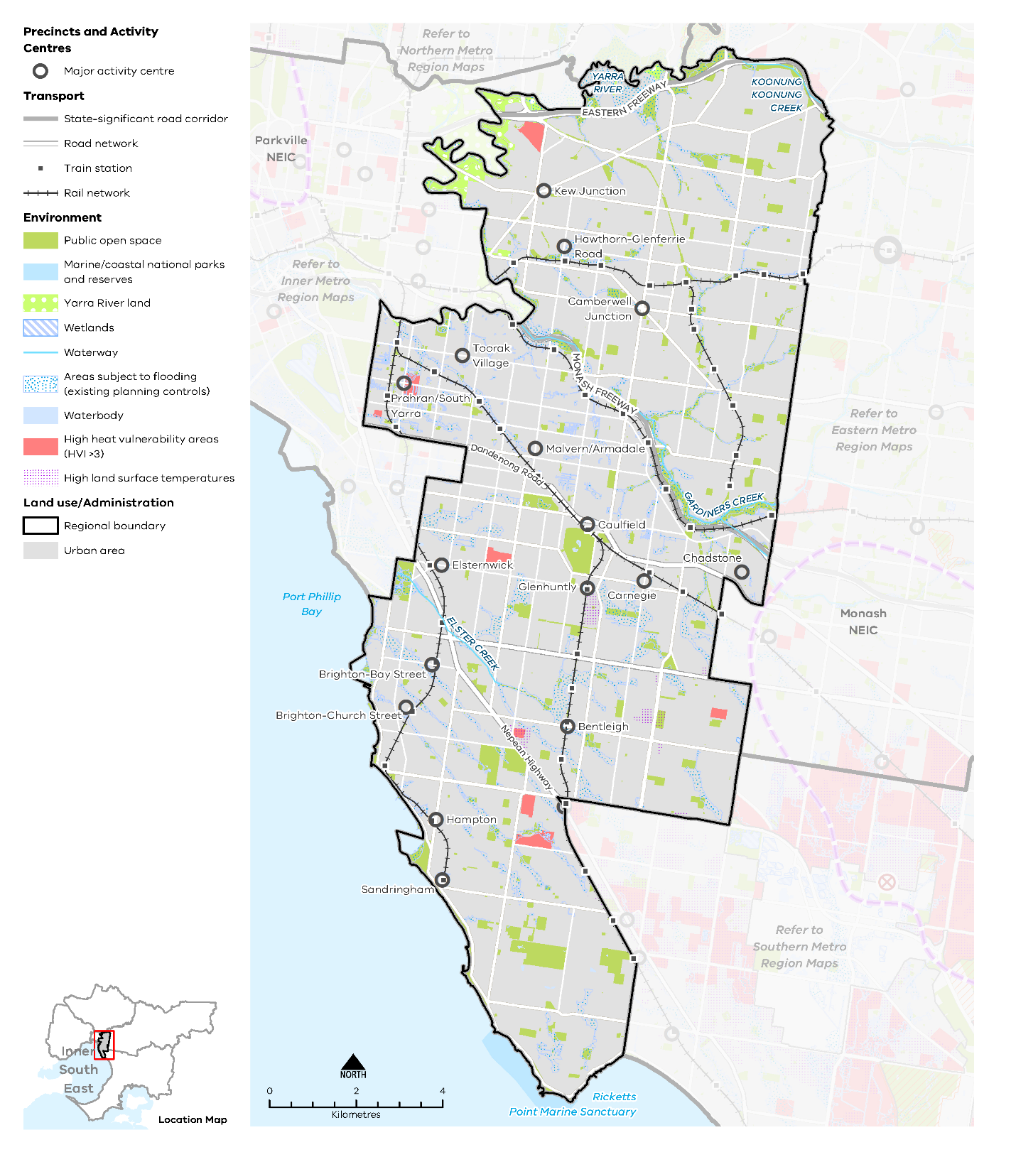

Map 8 Inner South East Metro Region sustainability and resilience state of play
A map showing the current sustainability and resilience of the Inner South East Metro Region, as extracted from Map 1, and also highlighting:
- Areas of high heat vulnerability in scattered locations throughout the region
- Several areas with high land surface temperatures
- Areas subject to flooding (existing planning controls).

Regional strengths
- A strong tree canopy is well-established in some locations, and can be extended throughout the region.

Regional challenges
- Coastal inundation and sea level rise pose significant risk to population, ecosystems, infrastructure and property.
- Large expanses of land are subject to flooding.
- Areas of high urban heat and heat vulnerable communities exist in parts of the region.

Directions and strategies
The directions identified to achieve the 2050 vision for the Inner South East Metro Region in terms of sustainability and resilience and Outcome 6 of Plan Melbourne are:
Direction 19 | Increase the tree canopy cover across the Inner South East Metro Region to achieve 30 per cent coverage by 2050
Direction 20 | Manage the impact and risk of sea level rise and tidal inundation
Direction 21 | Implement integrated water management initiatives to improve water quality, reduce the impacts of stormwater inundation and protect the region’s key watercourse assets
Direction 22 | Integrate green infrastructure with land use and infrastructure change to maintain cool urban environments
Each direction is implemented through regionally-specific strategies identified in this land use framework plan.
Map 9 shows how sustainability and resilience will be enhanced across the Inner South East Metro Region by 2050 as a result of these directions and strategies, together with Plan Melbourne and other strategies and initiatives as outlined in Appendix 01.

- Inner South East Metro Region sustainability and resilience 2050
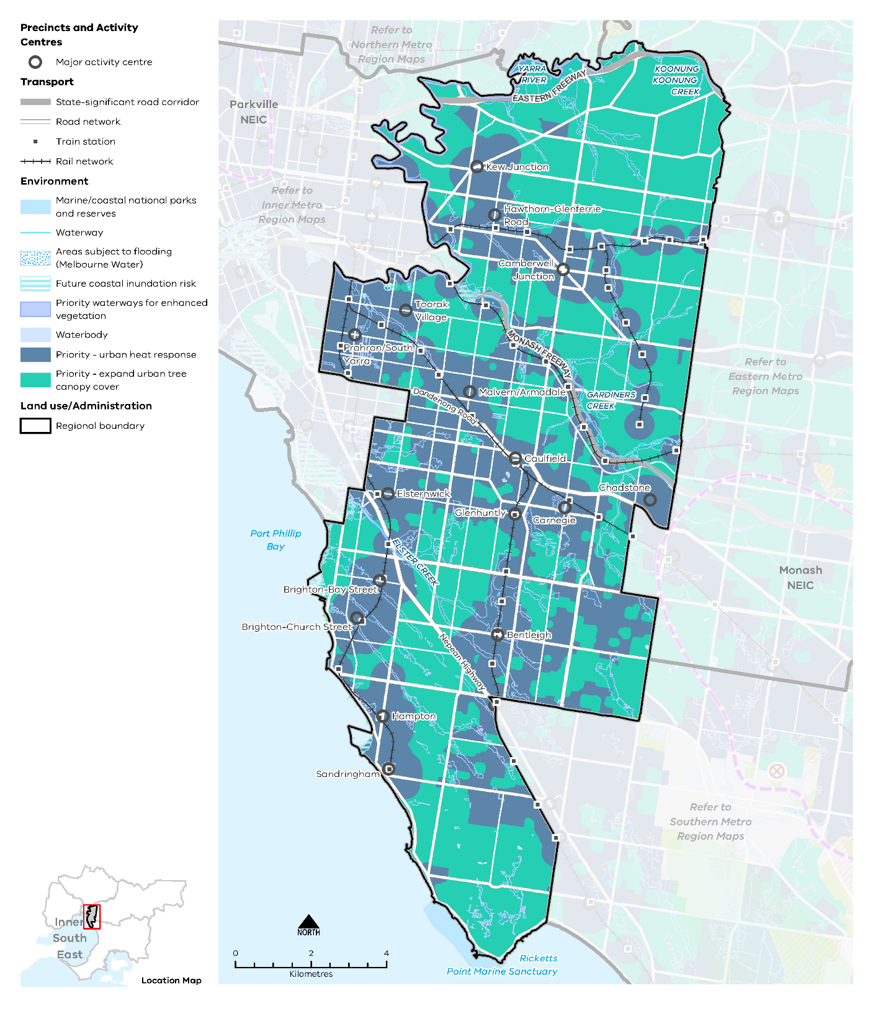

Map 9 Inner South East Metro Region sustainability and resilience 2050
A map showing the sustainability and resilience of the Inner South East Metro Region in 2050, as extracted from Map 1, and also highlighting:
- Several areas of future coastal inundation risk
- Priority waterways for enhanced vegetation
- Priority areas for an urban heat response and expanding the urban tree canopy cover
- Areas subject to flooding (updated Melbourne Water data).

- Increase the tree canopy cover across the Inner South East Metro Region to achieve 30 per cent coverage by 2050
Canopy trees are particularly effective at lowering maximum summer daytime air temperatures at ground level through transpiration and shading. Increased tree canopy cover and the clustering of trees provides the greatest response to the challenge of urban heat.
Expanding the region’s tree canopy cover can be achieved by planting new canopy trees and preserving existing vegetation. However, ongoing development and climate change will place pressure on the urban forest. While residential land presently provides most of the tree canopy cover, tree canopy should be expanded on other land uses such as rail corridors, streets, school grounds and parkland.
All Inner South East Metro Region LGAs have endorsed the Living Melbourne: Our Metropolitan Urban Forest strategy, specifying a regional target of 30 per cent total tree canopy and 50 per cent combined tree canopy and shrubs by 2050 (The Nature Conservancy and Resilient Melbourne, 2019). To support this commitment, the tree canopy target is accompanied in Table 10 by an aspirational distribution of tree canopy cover across four different land use types, adapted by DELWP from several related datasets (Hurley, et al., 2019b) (Urich & Hardy, 2020) (PSMA Australia Limited, 2021).
Inner South East Metro Region tree canopy cover target and aspirational distribution
2018 Tree Canopy Cover: 17.4%
2050 Tree Canopy Cover Target: 30%
(+12.6% or +2,030 hectares additional tree canopy cover)
Residential, commercial, industrial and primary production | 60%
Streets, roads and rail corridors | 15%
Parks, open space and waterways | 20%
Education and hospital/medical | 5%
- Retain more trees on private land outside of locations identified for higher levels of housing and mixed-use change.
- Support alternative siting of buildings and more compact building forms to retain mature canopy vegetation.
- Increase tree canopy along urban waterways and on streetscapes, public land, large developments within activity centres, open spaces and road reserves, and large commercial and industrial sites.
- Encourage revegetation as part of the redevelopment of key sites and activity centres.
- Manage the impact and risk of sea level rise and tidal inundation
Coastal areas are susceptible to rising sea levels as well as storm surges. Much work has been undertaken at the state level to determine the impact of sea level rise by 2100 in areas along Port Phillip Bay in the Inner South East Metro Region.
The impacts of storm surge and coastal inundation must be planned for (Water Technology, 2014, p. 40). Regional planning can help integrate and manage land use and infrastructure change to reduce the risk to settlements and natural assets from coastal inundation and storm surge.
DELWP is undertaking a Local Coastal Hazard Assessment for Port Phillip Bay. The Local Coastal Hazard Assessment will provide better information about the expected impacts of coastal hazards such as saline groundwater intrusion, erosion and inundation that are exacerbated by the effects of climate change. This information will better inform planning decisions in coastal areas around the bay.
Within the Port Phillip Region, an adaptation approach will be taken to protect public infrastructure and assets, coastal values and support community access to foreshores and the bay.
- Consider current forecasts of the level of sea level rise and coastal impacts on land use and infrastructure decision-making along the coast.
- Encourage settlement planning for coastal environments and communities to respond to sea level rise and natural hazard risk.
- Limit the location of major land use change in areas where there is likely to be future coastal inundation.
- Factor climate impacts into the total life cost of major public land use and infrastructure investment in the coastal areas of the Inner South East Metro Region.
- Implement integrated water management initiatives to improve water quality, reduce the impacts of stormwater inundation and protect the region’s key watercourse assets
Integrated stormwater management, reducing runoff into waterways and wetlands, and water recycling will help improve climate resilience and liveability in the Inner South East Metro Region.
Parts of the Dandenong and Yarra catchments will continue to undergo significant land use change for housing, diversification of activity centres, and new road, health and education infrastructure. This will increase stormwater runoff and flooding and negatively affect water quality and waterway health for aquatic life. Responding to this change and supporting the health of the region’s waterways, wetlands and bays will be an ongoing challenge for Port Phillip Bay, the Yarra River, Gardiners Creek, Koonung Koonung Creek and Elster Creek.
Where areas of the Inner South East Metro Region are subject to flooding overlays, such as the Special Building Overlay (SBO) and Land Subject to Inundation Overlay (LSIO), there is an opportunity to increase stormwater and floodwater harvesting capabilities. Improved stormwater storage capabilities and stormwater harvesting and management across the region could reduce the risk and cost of major rainfall events and minimise impacts such as pollution to the bay’s marine environments (DELWP, 2018b).
Local capture of stormwater, water recycling, restoration and revegetation of urban waterways and greywater systems will improve the region’s hydrological and ecological systems. Development can reduce the impacts of flooding, support healthy vegetation and prepare for drying conditions by increasing permeable areas, increasing proportions of green space, avoiding paved areas and passively irrigating vegetation.
Harvesting stormwater and increasing water infiltration is important in dense suburbs to reduce runoff and service vegetation. Harvested stormwater can help maintain water-reliant facilities and amenities such as sporting fields and gardens, contribute to more resilient vegetation and reduce demand on drinking water. Open spaces, pedestrian and cycling networks all use water sensitive urban design (WSUD) to improve urban amenity and retain water in the urban environment (DELWP, 2018b).
- Retain and harvest stormwater at a range of scales to achieve co-benefits that respond to urban heat, reduce runoff volume and velocity, service community infrastructure and trees, and diversify water needs.
- Integrate green infrastructure with land use and infrastructure change to maintain cool urban environments
Public and private land both make significant contributions to the tree canopy cover of the Inner South East Metro Region, with existing vegetation fundamental to the region’s sense of place. High levels of vegetation contribute to the region experiencing some of the lowest average urban heat in metropolitan Melbourne.
One of the challenges for increasing the tree canopy is the ability to retrofit existing urban areas with green infrastructure (trees, vegetation, green spaces and water systems) due to the availability of public and private space and the multiple functions of public land and publicly accessible places. For example, there are potential conflicts with transport movement and electrical powerlines, underground cabling, gas and stormwater pipe works and regulations (Banyule City Council, 2014).
Most of the Inner South East Metro Region’s growth is set to be accommodated in and around activity centres and corridors and areas with good access to existing services and transport infrastructure. These locations are important for growth and a sustainable city form. Some of these sites will need a site-responsive design to retain mature trees. Other sites will be less able to accommodate trees, requiring alternative cooling and greening methods.
While some locations will be more constrained, tree planting and WSUD may yield greater co-benefits, such as reducing urban temperatures, local climate regulation and stormwater benefits. Making space, providing good growing conditions and using stormwater in high use activity locations will be important to maintain comfortable outdoor environments. Locations designated for higher levels of growth and change are a priority for urban heat response measures. Other priority locations for planting and WSUD are mixed use centres, railway stations and bus stops.
- Design and develop outdoor spaces that are cool on hot days through materials, vegetation and water sensitive urban design particularly in and around activity centres and corridors, and major redevelopment sites and precincts.
- Encourage green roofs and green structures with climate-resilient planting and irrigation on apartment developments in areas with high urban heat, and large commercial and industrial sites.

Actions – Sustainability and resilience
- Identify non-residential land where additional canopy trees can be planted to offset vegetation removal.

Implementation
The Inner South East Metro Region LUFP is a planning document that will be implemented primarily through planning schemes. This will guide and support decision-making at the local level and improve the consistency of decisions at the regional level.
There are many actions under Plan Melbourne and other government programs and initiatives, such as the Metropolitan Partnerships, that will contribute to improving planning outcomes in the Inner South East Metro Region. This LUFP includes a targeted list of regional actions.
The Inner South East Metro Region LUFP identifies specific regional planning priorities for state and local government to progress the implementation of Plan Melbourne as well as address specific planning issues for the region. Other priorities will emerge over the five-year timeframe for LUFP implementation that may supersede actions in the LUFP or complement and further refine these actions.
Implementation of this LUFP will require ongoing collaboration between state government and local government in the Inner South East Metro Region. A five-year action program is outlined below.

Putting the plan into action
Local councils in the Inner South East Metro Region are already working together to address priority issues for their region. Existing metropolitan regional governance arrangements such as the Inner South East Metropolitan Partnership provide forums to bring together experts and leaders from all levels of government, business and the community to identify and progress issues of importance to the region.
The strategies outlined in this LUFP will be implemented at the local level in a range of ways. For instance, amendments will be made to the planning schemes to give relevant regional strategies status in the Planning Policy Framework and updates will be made to local housing and local industrial land use strategies. The LUFP will be used to guide and inform future strategic planning across the Inner South East Metro Region by individual local councils, the regional groupings of local councils or other entities such as the Metropolitan Partnerships.
As part of the implementation process, the Department of Treasury and Finance will update budget business case submission templates and guidance to identify how initiatives align with Plan Melbourne and the LUFPs. This will bolster the consideration of metropolitan and regional policy when business cases are drafted.
The process for implementing this LUFP is outlined in Figure 24.
- Implementation of the land use framework plans
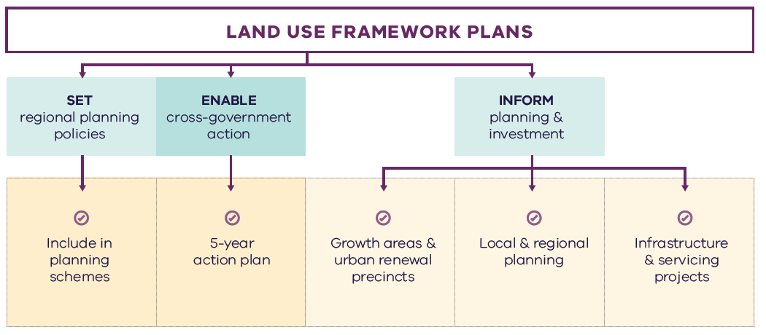

Figure 24. Implementation of the land use framework plans
Land use framework plans
- Set regional planning policies
  - Include in planning schemes
- Enable cross-government action
  - 5-year action plan
- Inform planning and investment
  - Growth areas and urban renewal precincts
  - Local and regional planning
  - Infrastructure and servicing projects

Five-year action program
A number of short- to medium-term actions are included in the Inner South East Metro Region LUFP. The five-year action program (Table 11) summarises these actions to be delivered collaboratively by the state government and councils in the Inner South East Metro Region. These actions deliver on the strategic directions identified in the LUFP and in turn, Plan Melbourne outcomes. The actions will positively and proactively address some of the challenges being experienced by the region.
Plan Melbourne and the Melbourne Industrial and Commercial Land Use Plan (MICLUP) also contain actions that may require regional collaboration and will support the outcomes sought by the LUFP. This LUFP’s five-year action program is a targeted list of actions identified during the development of the draft LUFP. It is not intended that this list duplicate existing Plan Melbourne or MICLUP actions other than where confirming a particular action was warranted given its regional implications.
In relation to transport, the following actions from Plan Melbourne Implementation Plan are identified as being well suited to being implemented at the regional level for this metro region and there is a commitment to deliver them as part of the implementation of Plan Melbourne and the LUFP:
- Action 43: Safe, efficient and accessible pedestrian networks
- Action 44: Local networks of cycling links
- Action 45: Local transport forums.
The implementation and prioritisation of the five-year action program will be driven by existing metro-regional governance arrangements including the Metropolitan Partnerships and EPWGs.
The indicative timeframes for completing actions are:
- Short term: By the end of 2023 (0–2 years)
- Medium term: By the end of 2026 (2–5 years).
Each action is allocated to a lead agency and implementation partners. Detail on the timing of actions and how they are implemented will be determined in line with normal government and council policy and budget processes. All actions requiring budget allocation will be carefully assessed against budget capacity, with rigorous business cases and cost-benefit analyses applied as part of their economic impact assessment.

Decision-making processes to support the delivery of the LUFPs
The LUFPs are a statement of policy intent. Detailed decisions about the implementation and timing of actions and infrastructure delivery will be made in line with normal government policy and budget processes.
The Victorian Government will continue its commitment to rigorous decision-making about initiatives that require funding, statutory amendments or new regulations in line with its economic and fiscal strategy, including the Government’s long-term financial management objectives.
For infrastructure projects, this will include ensuring consistency with the Victorian Government’s Investment Lifecycle and High Value/High Risk Guidelines. For all other initiatives and actions, implementation and timing will be subject to consideration of its evidence base and likely net benefits.

Monitoring, reporting and review
Action monitoring will be led by DELWP in partnership with the metropolitan region through the EPWG. DELWP will publish an annual progress report outlining the status of actions against the specified timeframe (whether an action has been ‘completed’, is ‘in progress’ or ‘not started’). These progress reports will be publicly available.
LUFP implementation will be formally reviewed every five years in conjunction with the Plan Melbourne Five-Year Implementation Plan. The review will be conducted in an open way and involve engagement with key stakeholders including Metropolitan Partnerships and EPWGs.

Actions – Implementation
- Update budget business case submission templates and guidance to identify how initiatives align with Plan Melbourne and the Land Use Framework Plans.
Five-year action program
Timeframe - Short term (S): By the end of 2023 (0–2 years). Medium term (M): By the end of 2026 (2–5 years)

 | Action | Source | Timeframe | Lead agency | Implementation partner(s)
1 | Identify activity centres where commercial development should be prioritised to accommodate future needs and generate local employment opportunities. Review the capacity of the identified major activity centres within the region to feasibly accommodate additional commercial floorspace within their relevant precinct boundary. | MICLUP | S | Councils | DELWP, VPA
2 | Undertake Precinct Planning for the Cheltenham Suburban Rail Loop Precinct with local councils and other stakeholders to guide land use change, transport integration and the creation of a liveable, walkable and prosperous precinct. |  | M | SRLA | Councils, DELWP, DJPR
3 | Implement a program of State Government-led planning projects, in partnership with local government to ensure major activity centres and urban renewal areas maximise their respective strategic opportunities. Priority will be given to those which deliver significant jobs and housing; leverage investment in state infrastructure; and play an important role in the growth corridor and/or region. State-led planning for these state- and regionally-significant places will contribute to creating liveable communities and achieving more dwellings and jobs in established areas and identify implementation and coordination actions that support growth and economic investment. |  | S | VPA | Councils, DELWP
4 | Update planning schemes to align with housing policies in Plan Melbourne and the Inner South East Metro Land Use Framework Plan and the implementation of the reformed residential zones. This includes:  - Providing capacity for 15 years of regional housing supply focusing on locations identified for housing growth in the LUFP  - Reviewing planning controls in housing investigation areas as potential locations for substantial or incremental housing change.  This may require strategic planning work to support these changes, such as preparing or updating local housing strategies or preparing structure plans to further investigate where increased densities can be supported, and determine specific changes required to planning schemes. |  | S | Councils | DELWP
5 | Identify underutilised and surplus government land that has potential to deliver additional social housing. | Plan Melbourne Five-year Implementation Plan | S | DFFH (HV) | DELWP
6 | In partnership with councils, identify a pipeline of sites in the Inner South East Metro Region for social and affordable housing. |  | M | DFFH (HV) | Councils
7 | Investigate barriers and opportunities to increase public and active transport mode share across the region to support culture change, spread demand on transport infrastructure, reduce greenhouse gas emissions and support 20-minute neighbourhood outcomes. Identify trial locations in the region to focus the investigation. |  | M | DoT | Councils
8 | Prepare a regional urban biodiversity strategy to protect existing habitat corridors, increase their interconnectivity and guide investment, including identifying physical gaps in key habitat corridors. Consider land use solutions that enable interconnected biodiversity corridors. |  | M | DELWP | Councils
9 | Identify public land holdings that could be used for open space and / or trail connections. Provide and initiate a streamlined approach to making them publicly accessible. |  | M | DELWP | Councils
10 | Map all schools, golf courses, tertiary campuses and other large land holdings across the region to identify opportunities for shared use agreements of open space/sporting facilities out of hours. |  | S | DELWP | Councils, Sports and Recreation Victoria
11 | Identify non-residential land where additional canopy trees can be planted to offset vegetation removal. |  | M | Councils
12 | Update budget business case submission templates and guidance to identify how initiatives align with Plan Melbourne and the Land Use Framework Plans. |  | S | DTF

Appendix 01.
Relevant Policies, Strategies and Initiatives
There are several current Victorian Government policies, strategies and initiatives that have implications for planning in the Inner South East Metro Region. In addition, there are existing regional initiatives, initiated by councils and/or the Metropolitan Partnerships. This appendix provides an overview of the most relevant policies, strategies and initiatives for the Inner South East Metro Region LUFP.
Plan Melbourne 2017-2050 and Plan Melbourne 2017-2050 Addendum, 2019 will guide the growth of our city. The original plan sets out the strategy for supporting jobs, housing and transport, while building Melbourne’s legacy of distinctiveness, liveability and sustainability. The addendum updates Melbourne’s projected population, housing and employment growth and the Melbourne 2050 spatial framework to align with major transport investments including SRL.
The Inner South East Metro Region has regional initiatives relevant to the LUFP. These include:
The Strategy for Vibrant Local Economies in the Inner South East Region (February 2020) prepared for the Inner South East Metropolitan Partnership supports the revitalization of local economic precincts in the Inner South East.
The Inner South-East Affordable Housing Study (April 2020) prepared for the Inner South East Metropolitan Partnership identifies a number of mechanisms to address the need for affordable key worker housing in the region over the next 20 years.
The Inner South East Metro Region Integrated Transport Framework prepared for the Metropolitan Partnership provides a consolidated view of the key transport issues and challenges facing the region, from which to advocate the region’s position on transport and related land use initiatives.
The Inner Melbourne Action Plan 2016-2026 (IMAP) is a collaboration between the Melbourne, Yarra, Port Phillip, Stonnington and Maribyrnong councils. The five councils work together through IMAP to set and implement regional priorities. The key objective of IMAP is ‘to make Inner Melbourne more liveable’. It sets out five goals to achieve this objective which relate to the economy, transport, communities, neighbourhoods and places, and environmental sustainability.
Specific Victorian Government policies, strategies and initiatives are outlined below under the relevant chapter of the LUFP to which they most strongly relate, acknowledging that many policies, strategies and initiatives are relevant to multiple chapters, or to the whole LUFP.

Productivity
The Melbourne Industrial and Commercial Land Use Plan 2019 provides an overview of current and future needs for industrial and commercial land across metropolitan Melbourne and puts in place a planning framework to support state and local government to more effectively plan for future employment and industry needs, and better inform future strategic directions.
The Unlocking Enterprise in a Changing Economy policy paper provides support for the development of enterprise precincts. The newly introduced Commercial 3 Zone aims to give preference to enterprises and reduces the planning burden for a diversity of employment uses.
The Metropolitan Partnerships are advisory groups established for each of the metropolitan regions by the Victorian Government that bring community and business together with state and local government and advise on the top priorities for jobs, services and infrastructure across the region.
Support for Victoria’s creative industries is provided through the Creative State 2016-2020 strategy which aims to grow the state’s creative and cultural economy. Work is currently underway to develop the next creative industries strategy which will guide initiatives and investment between 2020 and 2024.

Housing choice
Planning system administrative and policy reforms such as Smart Planning are reducing red tape and, in doing so, facilitating the supply of housing.
Planning Practice Notes on Residential Zones and Planning for Housing provide greater clarity for local councils on the technical aspects of how to apply the residential zones and how to plan for housing growth and protect neighbourhood character.
The Housing Development Data dashboard will provide improved access to information on the quantity and location of housing being developed.
The Better Apartments Design Standards and Apartment Design Guidelines for Victoria assists in improving the quality and functionality of apartments in Victoria.
The Future Homes Project is producing better apartment designs and helping Melbourne become a world leader in apartment design, sustainability and liveability.
Housing Outcomes in Established Melbourne 2005 to 2016 highlights how housing development data can be used to understand changes in density, development of housing in activity centres and the influence of zones and overlays on housing change.
Big Housing Build will deliver 9300 new social housing dwellings and 2900 new affordable and market homes for first homebuyers and renters across the state. It includes:
- $532 million to replace obsolete properties on Homes Victoria land and constructing new homes – this includes Fast Start projects at Victoria Street, Flemington and Elizabeth Street in Richmond.
- $948 million for ready to build and spot purchase, working with private sector to bring forward new developments ready to start construction and purchase existing residential properties.
- $1.38 billion funding for projects by the community housing sector, through the Social Housing Growth Fund.
- $2.14 billion in partnerships with the private and community housing sector – exploring options to build on surplus government owned sites.
The Social Housing Growth Fund is the vehicle for allocating new funds to suitable projects proposed by the community housing sector.
The Homelessness and Rough Sleeping Action Plan initiatives include 20 one-bedroom modular units with intensive onsite support, multidisciplinary housing teams to support complex clients to maintain stable housing, eight additional assertive outreach teams in locations of highest need, and funding therapeutic services in major inner city crisis accommodation centres to improve health, wellbeing and housing outcomes.
The redevelopment of public housing estates is a program to transform ageing public housing estates across metropolitan Melbourne and key regional centres into vibrant, well-connected neighbourhoods. This will create at least 1,800 new public housing homes.
The Building new homes to fight homelessness is a program to help Victorians escaping family violence, homelessness and life on the streets by building 1,000 new public housing properties.

Integrated transport
Suburban Rail Loop is a new radial rail link connecting Melbourne’s middle suburbs from Cheltenham to Werribee via Melbourne Airport and includes preparing detailed precinct frameworks and structure planning for all SRL precincts. Suburban Rail Loop consists of SRL East (Cheltenham to Box Hill), SRL North (Box Hill to Airport) and SRL West (Airport to Werribee).
North East Link will provide the ‘missing link’ between the Eastern Freeway and the M80 Ring Road in Melbourne’s north-east and, in doing so, reduce travel times, remove trucks from local roads and link growth areas in the north and south-east of Melbourne and enhance connections between the Western Ring Road, Hume Freeway and Eastern Freeway to Melbourne’s south-east.
Melbourne Airport Rail will connect Melbourne Airport to metropolitan and regional rail networks via Sunshine.
The West Gate Tunnel will create a second river crossing to link the Western Metro Region with the Port of Melbourne, CityLink and the CBD, and take traffic pressures off the West Gate Bridge.
The Level Crossing Removal Project will continue to provide improved travel and safety for road users, public transport users, cyclists and pedestrians by removing additional level crossings across metropolitan Melbourne.
The Urban Congestion Fund will upgrade the urban road network to reduce congestion upgrading pinch points, intersections and commuter car park upgrades at train stations.
The Victorian Infrastructure Plan seeks to build, improve and care for Victoria’s infrastructure. It responds to Infrastructure Victoria’s 30-year Infrastructure Strategy and presents priorities and future directions across nine key sectors.
The Metro Tunnel will create additional capacity on Melbourne’s rail network by running the Cranbourne, Pakenham and Sunbury lines through a new tunnel.
The Cranbourne Line Upgrade will pave the way for trains every 10 minutes on the Cranbourne Line through the duplication of track, removal of level crossings and Merinda Park Station rebuild.
Moving freight throughout the state will be enhanced as part of the Delivering the Goods: Creating Victorian Jobs – Victorian Freight Plan.
The proposed Caulfield to Rowville Link will be a connection between Caulfield and Rowville linking Caulfield Station to Monash University Clayton via Chadstone Shopping Centre then to Rowville via Waverley Park.
Victoria’s Zero Emissions Vehicle Roadmap sets out a plan to achieve half of all light vehicle sales in Victoria to be Zero Emission Vehicles by 2030.
Movement and Place is a way of thinking about the roles and challenges facing our transport system now and into the future. The Movement and Place approach recognises that transport links perform two functions: movement of people and goods and serving as a place (a destination in its own right). This way of thinking ensures that while we are planning for and developing our network, we are considering the needs for movement and placemaking simultaneously.

Liveability
The Healthy Waterways Strategy 2018 provides a framework for managing rivers, wetlands and estuaries in Melbourne’s five major catchments to ensure their value to the community is protected and improved.
The Yarra River Protection (Wilip-gin Birrarung murron) Act 2017 identifies the Yarra River as a single living and integrated natural entity for protection. It recognises intrinsic connection of the Traditional Owners to the Yarra River and its Country and further recognises them as the custodians of the land.
The Yarra River Action Plan, released in February 2017, details 30 specific actions to ensure the long-term protection of the river and its parklands.
The draft Yarra Strategic Plan sets the foundation to achieve the Yarra River 50 Year Community Vision and deliver on the aspirations contained in the Wurundjeri Woi Wurrung Cultural Heritage Aboriginal Corporation’s Nhanbu narrun ba ngargunin twarn Birrarung (Ancient Spirit & Lore of the Yarra) water policy. It includes a land use framework plan for the river corridor.
Protecting Victoria’s Environment – Biodiversity 2037 is the Victorian Government’s plan to stop the decline of the state’s biodiversity and achieve overall biodiversity improvement over the next 20 years.
Creative State 2016-2020 is the Victorian Government’s strategy to strengthen and grow the state’s creative industries and the value they bring to Victorians.
The Victorian Heritage Register lists and provides legal protection for heritage places and objects that are significant to the history and development of Victoria. It includes a wide range of places and objects, such as buildings, trees, gardens, archaeological sites and structures.

Strong communities
The 20-minute Neighbourhoods project delivers a range of initiatives to create a city of 20-minute neighbourhoods, enabling communities to live more locally.
The Statewide Design, Service and Infrastructure Plan for Victoria’s Health System 2017-2037 provides a planning framework to guide service, workforce and infrastructure investment in Victoria’s health system.
Health 2040: Advancing Health, Access and Care presents a clear vision for the health and wellbeing of Victorians and for the Victorian healthcare system.
The Victorian Public Health and Wellbeing Plan 2019-2023 seeks to ensure that all Victorians enjoy the highest attainable standard of health, wellbeing and participation at every age. The production of this Plan is legislated for under the Victorian Public Health and Wellbeing Act 2008.
The Social Isolation and Loneliness Project Report 2019 prepared for the Metropolitan Partnership captures and communicates the stories of people experiencing social isolation and loneliness within the region.
The Victorian Cycling Strategy 2018-28 guides planning and investment in cycling in the state.
Active Victoria – A Strategic Framework for Sport and Recreation in Victoria 2017-2021 provides a strategic framework for future work into Victoria’s sports and recreation sector.
The Suburban Parks Program will deliver more than 6,500 hectares of new and upgraded parks and trails across greater Melbourne.
Open Space for Everyone: Open Space Strategy for Metropolitan Melbourne 2020 supports a cooler, greener city with a network of quality open spaces to which all members of the community have access.
The Land Utilisation Assessment Program works to improve utilisation of government land.
The Suburban Revitalisation Program facilitates the delivery of urban renewal in metropolitan activity centres experiencing economic transition and/or significant levels of disadvantage. The Program is centred on a partnership between state agencies, local councils and regional stakeholders to accelerate the development and delivery of local infrastructure upgrades, small business stimulus initiatives and community connectedness activities.
The Victorian Aboriginal Affairs Framework 2018-2023 (the VAAF) is the Victorian Government’s overarching framework for working with Aboriginal Victorians, organisations and the wider community to drive action and improve outcomes.

Sustainability and resilience
Sector and whole-of-government emission reduction pledges will help achieve the Victorian Government’s target of net-zero emissions by 2050.
Adaptation Action Plans (Climate Change Act 2017) will help build the state’s resilience and help Victorians plan for the inevitable impacts of climate change.
Victoria’s Climate Change Strategy (2021) has a range of specific measures to support the uptake of renewable energy in businesses, industry and homes. It includes further reforms to drive greater energy efficiency of electrical appliances, lighting and air-conditioning/heating equipment and to improve the thermal performance of new buildings. Transport emissions will be reduced by accelerating Victoria’s transition to zero emissions vehicles, improving public transport and investing more in cycling and walking options. The Strategy will also support the circular economy reforms to Victoria’s waste management system contained in the Recycling Victoria: A New Economy action plan.
The Beach Renourishment Program in Port Phillip Bay 2019-2022 is designed to repair damaged caused by coastal erosion on Port Phillip Bay beaches.
The Victorian Climate Projections 2019 Technical Report describes how the regional climate of Victoria is likely to respond to global warming with different scenarios of human greenhouse gas emissions.
The 2020/21 Victorian State Budget delivered a landmark $2 billion for the Breakthrough Victoria Fund to drive translation and commercialisation of knowledge in Victoria. The Clean Economy is one of the five key sectors the Fund will prioritise.
The 2020/21 Victorian State Budget also provided funding for clean energy transition initiatives, including establishing renewable energy zones to develop and deliver renewable energy projects.
The Cooler, Greener Melbourne project will create more liveable and climate-adapted communities through green infrastructure and other cooling and greening initiatives. Tree planning on public land will create a cooler and greener Melbourne as part of Melbourne Water’s Urban Cooling Program. The program includes changes to planning schemes to protect and strengthen the urban forest.
Integrated Water Management Framework for Victoria provides a collaborative approach to the way we plan for and manage all elements of the water cycle, including the health of waterways and bays, wastewater management, alternative and potable water supply, stormwater management and water treatment.
Living Melbourne Urban Forest Strategy (2019) is a strategy for a greener, more liveable Melbourne, developed by Nature Conservancy and Resilient Melbourne.
The Marine and Coastal Policy (2020) sets out policies for planning and managing the marine and coastal environment, provides guidance to decision-makers in achieving the objectives of the Marine and Coastal Act 2018 and includes a Marine Spatial Planning Framework to achieve integrated and coordinated planning and management of Victorian’s marine environment.
The Renewable Energy (Jobs and Investment) Act 2017 legislates an increase of the Victorian Renewable Energy Target (VRET) to 50 per cent by 2030.
Water for Victoria is a plan for a future with less water as Victoria responds to the impact of climate change and a growing population.
The Victorian Water and Climate Initiative supports research into the impact of climate change and climate variability on Victoria’s water resources. Additional investments will be made to enhance the scientific understanding of Victoria’s climate and provide authoritative data and information on climate change to the community.
The Statewide Waste and Resource Recovery Infrastructure Plan 2018 (SWRRIP) guides future planning for waste and resource recovery infrastructure to achieve an integrated system.
The Metropolitan Waste and Resource Recovery Implementation Plan brings together the statewide priorities set out in the SWRRIP and applies them within the metropolitan context.
The Recycling Industry Strategic Plan transitions Victoria’s recycling industry to a more sustainable and resilient model.
Recycling Victoria: A New Economy outlines a plan for reform to establish a recycling system that Victorians can rely on and transforms how our economy uses materials and how our state re-uses, repairs and recycles.
The 2020/21 Victorian State Budget allocates funding for the 10-year Recycling Victoria action plan, Recycling Victoria: A New Economy to transform Victoria’s recycling sector and develop a circular economy.

Appendix 02.
Housing Choice Supporting Data
TABLE A2-1. Major housing development completed in the Inner South East Metro Region in and within 400m of activity centres (2005-2018) and in the redevelopment pipeline
Activity Centre | Major housing redevelopment completed 2005-2016* - In Centre | Major housing redevelopment completed 2005-2016* - Within 400m of Centre | Major housing redevelopment completed 2017-2018* - In Centre | Major housing redevelopment completed 2017-2018* - Within 400m of Centre | Major housing redevelopment pipeline* - In Centre | Major housing redevelopment pipeline* - Within 400m of Centre
Balaclava | NA | 48 | NA | 16 | NA | 0
Bentleigh | 202 | 104 | 446 | 136 | 229 | 14
Brighton, Bay Street | 593 | 111 | 121 | 75 | 37 | 66
Brighton, Church Street | 141 | 24 | 11 | 0 | 113 | 35
Camberwell Junction | 553 | 562 | 240 | 117 | 194 | 475
Carnegie | 571 | 252 | 700 | 131 | 479 | 114
Caulfield | 517 | 542 | 342 | 577 | 565 | 202
Chadstone | 0 | 92 | 0 | 81 | 0 | 86
Cheltenham, Southland | NA | 0 | NA | 0 | NA | 29
Cheltenham | NA | 0 | NA | 0 | NA | 0
Elsternwick | 366 | 33 | 63 | 76 | 423 | 33
Glenhuntly | 14 | 451 | 0 | 151 | 18 | 266
Hampton | 307 | 117 | 173 | 0 | 450 | 27
Hawthorn, Glenferrie Road | 798 | 1365 | 0 | 353 | 93 | 569
Kew Junction | 110 | 341 | 36 | 38 | 420 | 101
Malvern/Armadale | 80 | 205 | 30 | 170 | 332 | 190
Melbourne | NA | 19 | NA | 0 | NA | 17
Moorabbin | NA | 215 | NA | 108 | NA | 76
Oakleigh | NA | 0 | NA | 0 | NA | 21
Prahran/South Yarra | 5675 | 1084 | 997 | 129 | 1507 | 484
Richmond, Bridge Road | NA | 10 | NA | 19 | NA | 22
Richmond, Swan Street | NA | 35 | NA | 0 | NA | 100
Richmond, Victoria Street | NA | 0 | NA | 0 | NA | 0
Sandringham | 216 | 45 | 58 | 0 | 59 | 27
St Kilda | NA | 101 | NA | 126 | NA | 0
Toorak Village | 52 | 60 | 0 | 19 | 0 | 64
* Major development is defined as developments with over 10 dwellings
Note: Dwelling numbers are calculated based on constructed not net additions dwellings.
Note: Pipeline refers to projects that are: under construction, have a planning permit, have had pre-application meetings, or being sold off the plan.
Note: 400m activity centre buffer may be in multiple metro Regions.
Housing Development Data 2016, Urban Development Program – Redevelopment 2018, Urban Development Program – Redevelopment 2019

Glossary
Where the term is defined in Plan Melbourne or the Victoria Planning Provisions, that definition is used.
Aboriginal | Aboriginal refers to both Aboriginal and Torres Strait Islander peoples. They may have connections in and outside of Victoria.
Active transport | Transport requiring physical activity, typically walking and cycling.
Activity centres | Areas that provide a focus for services, employment, housing, transport and social interaction. They range in size and intensity of use from smaller neighbourhood centres to major suburban centres and larger metropolitan centres.
Affordable housing | Housing that is appropriate for the needs of a range of very low- to moderate-income households, and priced (whether mortgage repayments or rent) so these households are able to meet their other essential basic living costs.
Agglomeration | The location of businesses in close proximity to each other, which allows them to get productivity and efficiency gains through large customer bases, knowledge sharing and access to skilled workers.
Biodiversity | The variety of all life forms, the different plants, animals and microorganisms, the genes they contain and the ecosystems of which they form a part.
Central Business District (CBD) | Melbourne’s original ‘Hoddle Grid’ street layout bounded by the Yarra River, Spring Street, La Trobe Street and Spencer Street, as well as the triangular area to the north bounded by Victoria, Peel and La Trobe streets.
Central City | The area within the inner metro region that contains key capital city functions and civic facilities, as well as several precincts identified for major and strategic change. The Central City incorporates the CBD (Hoddle Grid, north to Grattan Street between Peel and Swanston streets) as well as Docklands, Southbank and St Kilda Road.
Climate change | A long-term change of the earth’s temperature and weather patterns – generally attributed directly or indirectly to human activities such as fossil fuel combustion and vegetation clearing and burning.
Commercial land | Land used for commercial purposes including land used for business services, retail, accommodation, food and other industries.
Creative industry | Media, digital screen, design, writing and publishing, literature, fashion, performing arts, digital games development, broadcasting, music, cultural heritage, arts, education and craft industries.
Enterprise precincts | Precincts that facilitate the creation and commercialisation of new ideas and support metropolitan economies by growing jobs in ways that leverage their distinct economic attributes. These districts build on and revalue the intrinsic qualities of cities: proximity, density, authenticity, and vibrant places (Brookings Institute definition).
Eastern Metro Region | Includes the municipalities of Knox, Manningham, Maroondah, Monash, Whitehorse, Yarra Ranges.
Established urban areas | Areas of Melbourne that have been urbanised for at least several decades.
Green wedges | Defined under Part 3AA of the Planning and Environment Act 1987 as “land that is described in a metropolitan fringe planning scheme as being outside an urban growth boundary”. There are 12 defined green wedges spanning parts of 17 municipalities.
Greenfield land | Undeveloped land identified for residential or industrial/commercial development, generally on the fringe of metropolitan Melbourne.
Greenhouse gas emissions | Atmospheric gas that absorbs and emits infrared or heat radiation, giving rise to the greenhouse effect. Typical greenhouse gases include carbon dioxide, methane, nitrous oxide and refrigerants.
Greyfield | Residential areas where the building stock is near or has ended its useful life and land values make redevelopment attractive.
Gross regional product (GRP) | Gross regional product is a measure of the market value of all final goods and services produced in a region over a period of time.
Growth areas | Locations on the fringe of metropolitan Melbourne designated in planning schemes for large-scale transformation, over many years, from rural to urban use.
Growth Corridor Plans | The Growth Corridor Plans are high level integrated land use and transport plans that provide a strategy for the development of Melbourne’s growth corridors over the coming decades.  The Growth Corridor Plans focus on three metropolitan growth corridors (Northern, Western and South Eastern growth corridors) and identify broad transport networks, industrial and employment areas, residential areas and recreation precincts across the city’s newest metropolitan suburbs. Relevant information from the Growth Corridor Plans have been integrated into the LUFPs containing growth corridors.
Health and education precincts | Locations to cluster synergistic health and/or education services to improve access to integrated service provision, improve outcomes, develop the health and education workforce and deliver economic benefits (such as innovation and job creation). These precincts may provide solely health, solely education, or a combination of health and education services.
Hoddle Grid | The grid pattern of streets making up Melbourne’s CBD bounded by the Yarra River, Spring Street, La Trobe Street and Spencer Street, as well as the triangular area to the north bounded by Victoria, Peel and La Trobe streets. The grid was designed by Robert Hoddle in 1837.
Housing density | The number of dwellings in an urban area divided by the area of the residential land they occupy, expressed as dwellings per hectare.
Hybrid centre | A descriptor for an activity centre typology that contains a mixed arrangement of freestanding / enclosed shopping complexes and traditional open air strip-based commercial land.
Infill | Development of unused or underutilised land in existing urban areas.
Infrastructure | Basic facilities and networks needed for the functioning of a local community or broader society.
Integrated water management (IWM) | An approach to planning that brings together all facets of the water cycle including sewage management, water supply, stormwater management and water treatment, ensuring environmental, economic and social benefits.
Inner Metro Region | Includes the municipalities of Melbourne, Port Phillip and Yarra.
Inner South East Metro Region | Includes the municipalities of Boroondara, Glen Eira, Stonnington and Bayside.
Intermodal freight terminal | A location for the transfer of freight from one transport mode to another, for example between road and rail.
Knowledge-based industries and jobs | Production and services based on knowledge-intensive activities that contribute to an accelerated pace of technical and scientific advancement. Their key characteristic is a greater reliance on intellectual capabilities than on physical inputs or natural resources.
Liveability | A measure of a city’s residential quality of life, used to benchmark cities around the world. It includes socioeconomic, environmental, transport and recreational measures.
Localised planning statement | Long-term policies for the future planning and development of areas identified as having significance to the broader Victorian community.
Major activity centres | Suburban centres that provide access to a wide range of goods and services. They have different attributes and provide different functions, with some serving larger sub-regional catchments. Plan Melbourne identifies 121 major activity centres.
Metropolitan activity centres | Higher-order centres with diverse employment options, services and housing stock, supported by good transport connections. Existing centres include Box Hill, Broadmeadows, Dandenong, Epping, Footscray, Fountain Gate/Narre Warren, Frankston, Ringwood and Sunshine. Future centres will include Lockerbie and Toolern.
Metropolitan Melbourne | The 31 municipalities that make up metropolitan Melbourne, plus part of Mitchell Shire within the UGB.
Moderate-income household | Annual household income within the income range specified as a moderate range by Order under section 3AB of the Planning and Environment Act 1987. In 2020 this was $87,671 to $131,500 for a family (with one or two parents) and dependent children.
National employment and innovation cluster (NEIC) | Designated concentrations of employment distinguished by a strong core of nationally significant knowledge sector businesses and institutions that make a major contribution to the national economy and Melbourne’s position in the global economy.
Natural hazard | A natural event that has potential to cause harm to people, property or the environment, including climate change, bushfire, flooding and sea level rise.
Neighbourhood activity centres | Local centres that provide access to local goods, services and employment opportunities and serve the needs of the surrounding community.
Northern Metro Region | Includes the municipalities of Banyule, Darebin, Hume, Mitchell (part), Moreland, Nillumbik and Whittlesea.
Open space | Includes land reserved for natural landscape, parklands, recreation and active sports, as well as waterways and bays.
Peri-urban areas | Areas beyond the green wedges made up of local government areas with a predominantly rural character, located all or partially within a 100-kilometre radius of Melbourne.
Precinct Structure Plan (PSP) | Master plans for future growth corridor developments, informed by growth corridor planning. The plans identify alignments of transport routes, town centres, open space networks, densities of residential areas, and areas for industry and employment.
Primary healthcare | Primary healthcare is generally the first contact a person has with Australia’s health system. It relates to the treatment of patients who are not admitted to hospital. It encompasses a wide range of health professionals and includes general practitioners, community nurses, midwives, pharmacists, dentists, and Aboriginal health workers, for example.
Principal Freight Network (PFN) | Part of the larger transport network over which the movement of heavy freight will be concentrated.
Principal Public Transport Network (PPTN) | A statutory land use planning tool that supports integrated land use and transport planning by providing certainty to land use planners and developers around locations that are and will be served by high-quality public transport.
Regional active open spaces | Large scale open spaces that cater for a range of recreational opportunities including informal outdoor recreation, active recreation and sports. Regional active open spaces serve a broad catchment and may comprise buildings and infrastructure to facilitate sporting or recreational activity.
Regional parks | Regional parks are large areas of open space that feature natural or semi-natural surroundings in close proximity to urban environments. They have high landscape, biodiversity and cultural values and provide a diversity of passive recreational, educational or tourism opportunities.
Regional Victoria | Includes all municipalities outside metropolitan Melbourne (except part of Mitchell Shire within the UGB).
Regionally-significant industrial precincts (RSIP) | Key industrial areas that contribute significantly to local and regional economies. Some of these areas are well established and support a range of industrial uses while others are transitioning and supporting new uses. They include future employment areas identified through Growth Corridor Plans that will support not just employment growth in outer areas, but to also meet Melbourne’s longer term industrial and logistics needs. They are to be retained and planned for to allow a range of industrial uses, or where appropriate, new and emerging businesses that require access to affordable and well-located employment land.
Renewable energy | Energy that comes from resources which are naturally replenished on a human timescale such as sunlight, wind, rain, tides, waves, and geothermal heat.
Resilience | The capacity of individuals, communities, institutions, businesses, systems and infrastructure to survive, adapt and grow, no matter what chronic stresses or shocks they encounter.
Resource recovery | Extraction of useful material or energy from a waste stream.
Social housing | A type of rental housing that is provided and/or managed by the government or by a not-for-profit organisation. Social housing is an overarching term that covers both public housing and community housing.
Social infrastructure | Encompasses all the facilities, services and networks that help families, groups and communities to meet their social, health, education, cultural and community needs.
Southern Metro Region | Includes the municipalities of Cardinia, Casey, Greater Dandenong, Frankston, Kingston and Mornington Peninsula.
State-significant industrial precinct (SSIP) | Strategically located land available for major industrial development linked to the PFN and transport gateways. They will be protected from incompatible land uses to allow continual growth in freight, logistics and manufacturing investment.  There are five state-significant industrial precincts: Western Industrial Precinct, Northern Industrial Precinct, Southern Industrial Precinct, Port of Hastings Industrial Precinct and Officer-Pakenham Industrial Precinct.
Strategic Cycling Corridor (SCC) | Strategic Cycling Corridors are important transport routes for cycling and are a subset of the Principal Bicycle Network (PBN). The SCC network supports the needs of commuter trips (to work or education) and other important trips, such as to stations, shops or schools.  The SCC network links up important destinations, including central Melbourne city, employment and activity centres, and other destinations of metropolitan and regional significance.  SCCs can be on- and off-road, on municipal and state roads, and are designed to provide a safe, lower-stress cycling for transport experience.
Strategic Extractive Resource Area (SERA) | Recognised and secured extractive resource areas of strategic importance for the construction of public infrastructure, affordable housing and private sector development now and in the future.  They cover extractive resources that actually and/or potentially occur in defined locations at various scales based on their likelihood or potential to supply growth areas, taking into account accessibility to markets, while minimising impacts on environment and other land use constraints.
Traditional Owners | People who, through membership of a descent group or clan, are responsible for caring for particular Country. A Traditional Owner is authorised to speak for Country and its heritage as a senior Traditional Owner, an Elder or, in more recent times, a registered native title claimant.
Transit-oriented development | Compact, walkable, mixed-use communities centred around high-quality train systems. Transit-oriented development assists in addressing the growing problems of climate change and global energy security by creating dense, walkable communities that greatly reduce the need for driving and energy consumption.
Transport gateway | Ports, airports and interstate terminals that serve as key locations for moving passengers and freight into and out of Victoria and also play a significant economic and employment-generating role.
20-minute neighbourhood hallmarks | The ‘hallmarks’ are established in Plan Melbourne’s Direction 5.1 — Create a city of 20-minute neighbourhoods. The ‘hallmarks’ developed in partnership with the Department of Health (DH) and the Heart Foundation (Victoria) are:  - Be safe, accessible and well connected for pedestrians and cyclists to optimise active transport  - Offer high-quality public realm and open spaces  - Provide services and destinations that support local living  - Facilitate access to quality public transport that connects people to jobs and higher-order services  - Deliver housing/population at densities that make local services and transport viable  - Facilitate thriving local economies.
Urban forest | All of the trees and other vegetation in a city as well as the soil and water that supports it.
Urban Development Program (UDP) | The Urban Development Program (UDP) provides an annual assessment of supply and consumption of industrial and residential land across metropolitan Melbourne.
Urban Growth Boundary (UGB) | A management tool to contain urban areas and limit their expansion. It divides land that is urban – to be used for housing, shops, factories – from land that is non-urban and to be used for purposes such as conservation, agriculture, mineral extraction, airports and the like. A UGB encourages urban consolidation and protects valued non-urban areas from urban development.
Urban renewal | The process of planning and redeveloping underutilised medium- and large-scale urban areas, precincts or sites for mixed land use purposes.
Very low-income household | Annual household income within the income range specified as a very low-income range under section 3AB of the Planning and Environment Act 1987. In 2020 this was up to $26,090 for a single adult.
Western Metro Region | Includes the municipalities of Brimbank, Hobsons Bay, Maribyrnong, Melton, Moonee Valley and Wyndham.
Water sensitive urban design (WSUD) | Integrating the urban water cycle into urban design to minimise environmental damage and improve recreational and aesthetic outcomes.
Wallan SA2 | Statistical Areas Level 2 (SA2) are medium-sized general purpose areas established by the ABS that represent a community that interacts together socially and economically. The Wallan SA2 is larger than the area in Mitchell within the UGB and generally follows the municipal boundary west of Wallan and extends north of Wandong and east into Kinglake National Park.
Yarra River Land | Crown and State Government-owned land within 500 metres of the Yarra River declared under the Yarra River Protection (Wilip-gin Birrarung murron) Act 2017. The declaration provides additional protection to this land. Yarra River Land that is used for public recreation forms the Greater Yarra Urban Parklands.

References
Australian Bureau of Statistics, 2016. ABS Census, Australia: Australian Bureau of Statistics.
Australian Bureau of Statistics, 2021. Regional Population 2019-20 financial year: Commonwealth of Australia, Canberra, Australia.
Australian Sustainable Built Environment Council, 2016. Low Carbon, High Performance, Surrey Hills, NSW, Australia: ASBEC.
Banyule City Council, 2014. Urban Forest Strategic Plan, Melbourne, Australia: Banyule City Council.
City of Stonnington, 2018. Stonnington Public Transport Advocacy: Reference Document.
DELWP, 2017a. Plan Melbourne, Melbourne, Australia: The State of Victoria Department of Environment, Land, Water and Planning.
DELWP, 2017b. Port Phillip Bay Environmental Management Plan 2017-2027, Melbourne, Australia: The State of Victoria Department of Environment, Land, Water and Planning.
DELWP, 2018a. Housing Development Data, Melbourne: DELWP.
DELWP, 2018b. Integrated Water Management Forums, Dandenong Strategic Directions Statement, The State of Victoria Department of Environment, Land, Water and Planning.
DELWP, 2018c. Integrated Water Management Forums, Yarra Strategic Directions Statement 2018, Melbourne, Victoria: The State of Victoria Department of Environment, Land, Water and Planning.
DELWP, 2019a. Plan Melbourne Addendum, Melbourne: State of Victoria.
DELWP, 2019b. Victoria in Future, Melbourne: DELWP.
DELWP, 2019c. Victorian Greenhouse Gas Emissions Report, Melbourne: State of Victoria.
DELWP, 2021a. Environmentally Sustainable Development of Buildings and Subdivisions - A roadmap for Victoria’s planning system, State of Victoria, Melbourne, Australia: The State of Victoria.
DELWP, 2021b. Internal analysis using Victorian Integrated Survey of Travel and Activity (VISTA) 2016-18 survey data.
DHHS, 2020. Rental Report March Quarter 2020.
Green Building Council of Australia, 2021. Green Star Rating System. [Online] Available at: https://new.gbca.org.au/rate/rating-system [Accessed March 2021].
Hurley, J. et al., 2019. Melbourne Vegetation Cover 2018, Inner South East Region, Melbourne: DELWP.
Hurley, J. et al., 2019a. Urban Vegetation Cover Change in Melbourne 2014 - 2018, Melbourne: Centre for Urban Research, RMIT University.
Jacobs, 2019b. Integrated Transport Framework for the Inner South East Metropolitan Region.
KPMG & ARUP, 2017. Travel Demand and Movement Patterns report, Melbourne: Infrastructure Victoria.
Melbourne Water, 2017. Planning for Sea Level Rise.
MGS Architects, 2020. Inner South-East Affordable Housing Study.
MUSIC Auditor, 2021. MUSIC Auditor. [Online] Available at: https://www.musicauditor.com.au [Accessed March 2021].
Nationwide House Energy Rating Scheme, 2021. Nationwide House Energy Rating Scheme. [Online] Available at: https://www.nathers.gov.au [Accessed March 2021].
PSMA Australia Limited, 2021. Buildings Spatial Data | Building GIS Data | Geoscape. [Online] Available at: https://geoscape.com.au/data/buildings/ [Accessed 2021].
SGS, 2019. ABS Census 2016 in SGS Economics & Planning, 2019, Economic, Social and Environmental Profile: Inner South East, SGS Economics & Planning.
Sun, C. et al., 2019. Urban Vegetation, Urban Heat Islands and Heat Vulnerability Assessment in Melbourne, 2018, Melbourne, Australia: Clean Air and Urban Landscapes Hub.
The Nature Conservancy and Resilient Melbourne, 2019. Living Melbourne: Our Metropolitan Urban Forest Technical Report, Melbourne: The Nature Conservancy and Resilient Melbourne.
Urich, C. & Hardy, M., 2020. Cooling and Greening Melbourne – Future scenarios, Melbourne: Cooperative Research Centre for Water Sensitive Cities.
Water Technology, 2014. Western Port Local Coastal Hazard Assessment, Erosion Hazards, Water Technology.

© The State of Victoria Department of Environment, Land, Water and Planning 2021
This work is licensed under a Creative Commons Attribution 4.0 International licence. You are free to re-use the work under that licence, on the condition that you credit the State of Victoria as author. The licence does not apply to any images, photographs or branding, including the Victorian Coat of Arms, the Victorian Government logo and the Department of Environment, Land, Water and Planning (DELWP) logo. To view a copy of this licence, visit http://creativecommons.org/licenses/by/4.0/
ISBN 978-1-76105-643-7 (pdf/online/MS word)

Disclaimer
This publication may be of assistance to you but the State of Victoria and its employees do not guarantee that the publication is without flaw of any kind or is wholly appropriate for your particular purposes and therefore disclaims all liability for any error, loss or other consequence which may arise from you relying on any information in this publication.

Credits
Green Scribble (graphic design)
Department of Jobs, Precincts and Regions (photos)
Gary Gross Photography (photos)
SDP Media (photos)
Tim Bell Studio (photos).

Accessibility
If you would like to receive this publication in an alternative format, please telephone the DELWP Customer Service Centre on 136 186, email customer.service@delwp.vic.gov.au or via the National Relay Service on 133 677 www.relayservice.com.au. This document is also available on the internet at www.delwp.vic.gov.au
Submissions can be made online at engage.vic.gov.au
For any questions or assistance please contact lufp@delwp.vic.gov.au

