Plan Melbourne 2017-2050

Draft Southern Metro

Land Use Framework Plan

Summary

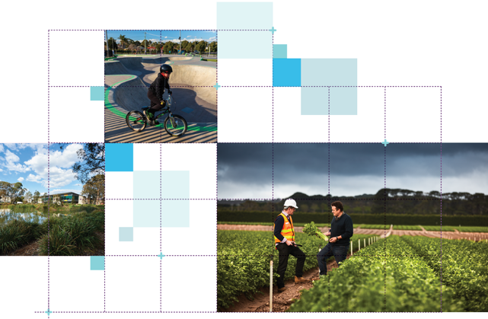

Great cities aren’t born. They’re made.
Melbourne is a great city. It’s a great place to live, work and raise a family. It’s a great place for investment and creativity. It’s a great place to visit and enjoy.
The Victorian Government has developed land use framework plans for each of the six metropolitan regions that are all about ensuring Melbourne remains a great city as it grows.
These plans mark a new era in the planning of Melbourne, building on the efforts of generations of Victorians to shape the way land is used around Port Phillip Bay.
The Southern Metro Land Use Framework Plan is a 30-year strategy for action across six local government areas – Cardinia, Casey, Greater Dandenong, Frankston, Kingston and Mornington Peninsula.
It’s about making the long-term plans and investments that protect and enhance local areas and communities while ensuring Melbourne’s south grows more prosperous, liveable, affordable and sustainable.
The Southern Metro Land Use Framework Plan is also about maximising the social, economic and environmental benefits of transformational city-shaping investments like the Metro Tunnel, Melbourne Airport Rail and Suburban Rail Loop.
This plan is all about keeping southern Melbourne marvellous – from its beaches and rivers to its wetlands and bushlands to its suburbs and towns. It’s also about building the best possible future for the Southern Metro region.
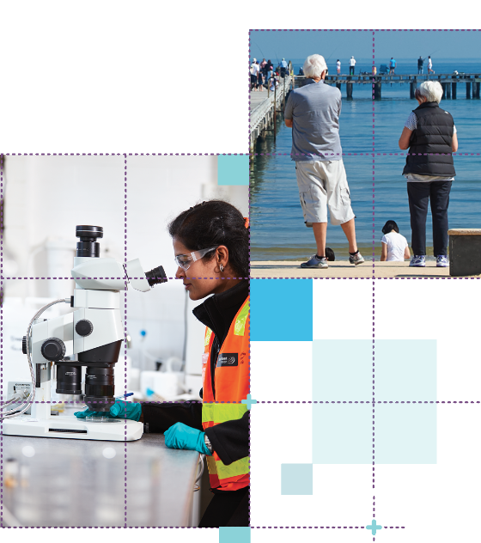

What the Southern Metro Land Use Framework Plan means for you

Productivity
- You will see the region become a national centre for advanced manufacturing and engineering.
- You will see economic opportunities in growth areas.
- You will see connected activity centres and health and education precincts.

Integrated Transport
- You will see improved east-west, inter-regional and international transport connections.

Housing Choice
- You will see a mix of housing in accessible locations, including more affordable and social housing.

Strong Communities
- You will see new, walkable 20-minute neighbourhoods in the South Eastern Growth Corridor.

Liveability
- You will see an expanded cycling and open space network.
- You will see that the region’s landscapes and natural habitats are protected.

Sustainability and Resilience
- You will see more trees, smarter water use and sustainable development, with more residents and industry using local renewable energy.

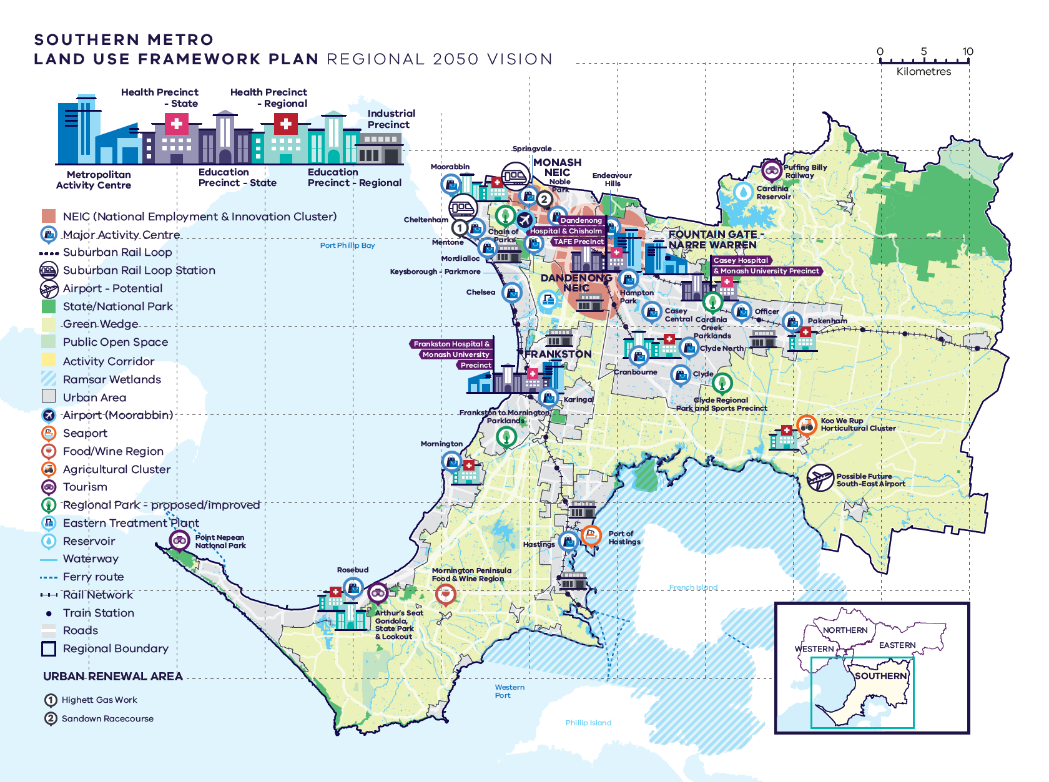
Southern Metro Region – Regional 2050 Vision

A schematic map of the Southern Metro Region in 2050 showing:

- The region’s boundary, the urban area, and green wedge land.

- Locations for growth and investment, including:
- The location and indicative boundary of the southern part of the Monash NEIC and the Dandenong NEIC, both in the north of the region
- Industrial precincts located through the western, central and southern part of the region, within its urban areas
- Dandenong, Frankston and Fountain Gate-Narre Warren Metropolitan Activity Centres
- The network of major activity centres predominantly located on the rail and road network
- State and regionally-significant health and/or education precincts, highlighting those at Frankston, Berwick, Dandenong, Cranbourne, Moorabbin, Rosebud, Mornington, Koo Wee Rup and Pakenham
- The two urban renewal areas of:

-Highett Gas Works
-Sandown Racecourse

- Suburban Rail Loop (East) (Cheltenham to Box Hill) station at Cheltenham-Southland.

- Key transport linkages and movement network including:
- New underground railway lines and train stations for Suburban Rail Loop (East) (Cheltenham to Box Hill)
- The road network including the state-significant road corridors of the Monash Freeway, Princes Freeway, Eastlink, Mornington Peninsula Freeway, South Gippsland Highway
- Transport gateways at Moorabbin Airport, Port of Hastings and the possible future South-East Airport.

- State and regional natural and cultural assets, including:
- State and National parks, the improved regional parks at Frankston to Mornington Parklands, Clyde Regional Park and Sports Precinct, Cardinia Creek Parklands and Chain of Parks, and other public open space
- Cardinia Reservoir in the west of the region and the Eastern Treatment Plant in the north-east of the region
- Food and wine regions and agricultural clusters
- Tourism areas including the Mornington Peninsula and Dandenong Ranges.

What is the Southern Metro Land Use Framework Plan?
The Southern Metro Land Use Framework Plan is an extension of Plan Melbourne 2017-2050.
Plan Melbourne is a blueprint to ensure Melbourne grows more sustainable, productive and liveable as its population approaches 8 million by 2050. It includes nine principles that outline the Victorian Government’s vision for the future of the city that Melbourne will continue to be a global city of opportunity and choice.
- A distinctive Melbourne
- A globally connected and competitive city
- A city of centres linked to regional Victoria
- Environmental resilience and sustainability
- Living locally in 20-minute neighbourhoods
- Social and economic participation
- Strong and healthy communities
- Infrastructure investment that supports balanced city growth
- Leadership and partnership.
Plan Melbourne also divides the city into six metro regions:
- Inner
- Inner South East
- Eastern
- Southern
- Western
- Northern
The Department of Environment, Land, Water and Planning (DELWP) is leading the development of land use framework plans. The purpose of the plans is to guide the application of Plan Melbourne’s nine principles, seven outcomes, 32 directions and 90 policies at a regional and local level.
The plans will support a regional approach to planning across state and local government. This document summarises how the Southern Metro Land Use Framework Plan will:
- Shape population and industry growth
- Inform plans for service and infrastructure development
- Guide public and private investment
- Protect the distinctive characteristics of the Southern Metro region
- Improve environmental resilience.
The plan covers six themes:
- Productivity
- Housing
- Integrated transport
- Liveability
- Strong communities
- Sustainability and resilience.

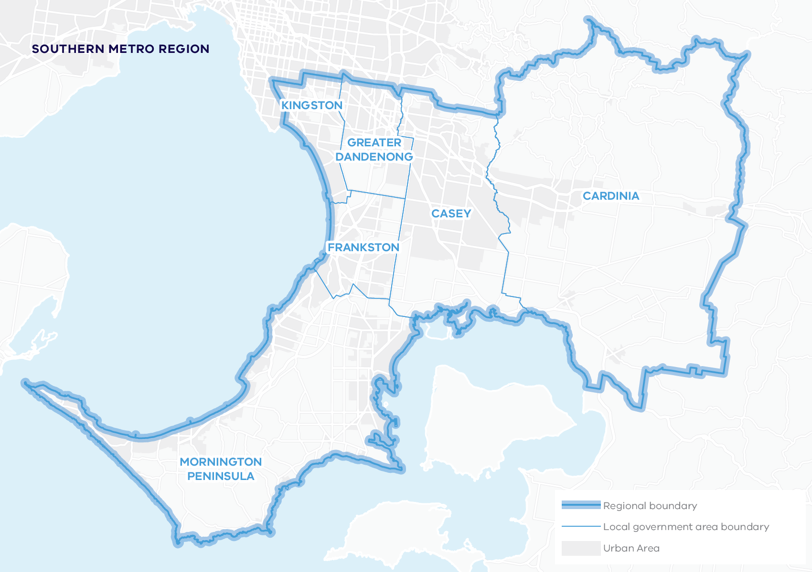

About the Southern Metro Region
The Bunurong people (in the bays and Mornington Peninsula) and the Wurundjeri Woi Wurrung people (in the north and the Dandenong Ranges) are the Traditional Owners of the lands of the Southern Metro region.
The Southern Metro region is a diverse, dynamic area.
It extends from Port Phillip Bay to Westernport Bay, the Dandenong Ranges to the Mornington Peninsula, the city’s sand-belt suburbs to the new growth area communities of the outer south-east. It has 236 kilometres of coastline, some of Australia’s most fertile farmlands and state and national parks, including Churchill and Point Nepean national parks. Its picturesque rural and beach towns are tourism drawcards.
It has a strong, diverse spread of industries, including within the Dandenong National Employment and Innovation Cluster (NEIC) and part of the Monash NEIC, with room to grow the economy and jobs in these and other locations throughout the region.
The Southern Metro region has the largest population of Melbourne’s six metro regions.
Urban areas include:
- The Nepean and Princes highways and rail corridors to Frankston, Cranbourne, Dandenong and Pakenham
- The South Eastern Growth Corridor (Clyde, Clyde North, Officer, Pakenham)
- Established coastal suburbs on the eastern side of the Mornington Peninsula (Mornington, Rosebud, Rye, Sorrento to Point Nepean National Park)
- Towns and small coastal settlements around Western Port and its hinterland (Hastings, Somerville, Flinders, Somers)
- Small towns along the Gippsland rail line (Nar Nar Goon, Garfield, Koo Wee Rup, Lang Lang)
- Coastal suburbs along Port Phillip Bay at Mordialloc and Chelsea with sand-belt golf courses, industry and Moorabbin Airport.
By 2051, the Southern Metro region’s population is projected to increase by 56 per cent from around 1.10 million to 1.76 million and the number of dwellings is projected to increase from 405,640 in 2016 to 718,600 in 2051. By 2031, employment is projected to increase from 392,250 to 520,250 jobs.

Geographically
Its footprint covers 31 per cent of metropolitan Melbourne, with more than 34 per cent designated as green wedge land.

Demographically
22 per cent of Melburnians, more than 1.1 million people, live in the region.

Economically
it generates $49 billion a year in economic activity and employs more than 392,000 people.

Environmentally
it has 20.8 per cent of metropolitan Melbourne’s open space and 15.2 per cent tree canopy cover.

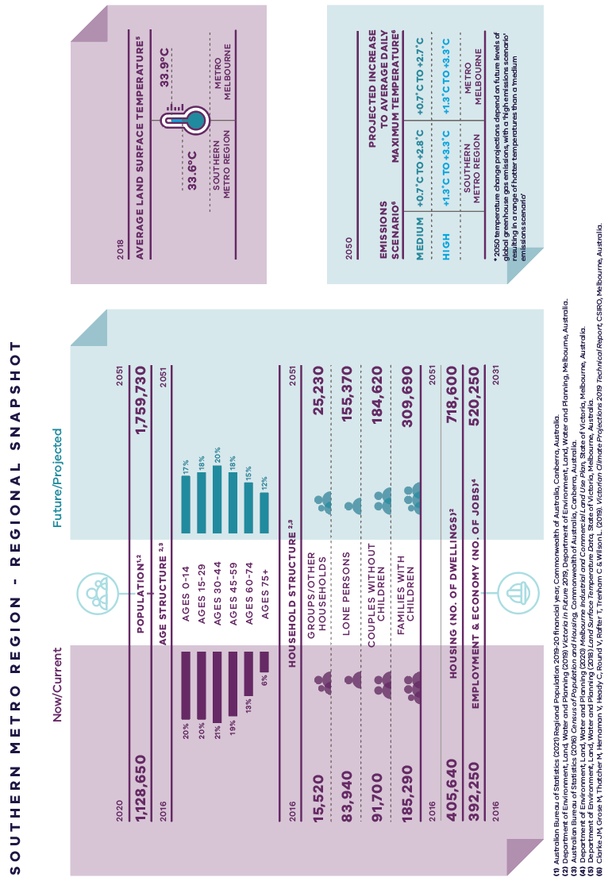
Southern Metro Region – Regional Snapshot

Southern Metro region population  Sources:  Australian Bureau of Statistics (2021) Regional Population 2019-20 financial year, Commonwealth of Australia, Canberra, Australia.  Department of Environment, Land, Water and Planning (2019) Victoria in Future 2019, Department of Environment, Land, Water and Planning, Melbourne, Australia. | 2020:  1,128,650 inhabitants | 2051:  1,759,730 inhabitants
Southern Metro region age structure  Sources:  Department of Environment, Land, Water and Planning (2019) Victoria in Future 2019, Department of Environment, Land, Water and Planning, Melbourne, Australia.  Australian Bureau of Statistics (2016) Census of Population and Housing, Commonwealth of Australia, Canberra, Australia. | 2016:  20 per cent – Ages 0 to 14  20 per cent – Ages 15 to 29  21 per cent – Ages 30 to 44  19 per cent – Ages 45 to 59  13 per cent – Ages 60 to 74  6 per cent – Ages 75 plus | 2051:  17 per cent – Ages 0 to 14  18 per cent – Ages 15 to 29  20 per cent – Ages 30 to 44  18 per cent – Ages 45 to 59  15 per cent – Ages 60 to 74  12 per cent – Ages 75 plus
Southern Metro region household structure  Sources:  Department of Environment, Land, Water and Planning (2019) Victoria in Future 2019, Department of Environment, Land, Water and Planning, Melbourne, Australia.  Australian Bureau of Statistics (2016) Census of Population and Housing, Commonwealth of Australia, Canberra, Australia. | 2016:  Groups/other households – 15,520  Lone persons – 83,940  Couples without children – 91,700  Families with children – 185,290 | 2051:  Groups/other households – 25,230  Lone persons – 155,370  Couples without children – 184,620  Families with children – 309,690
Southern Metro region housing (number of dwellings)  Source:  Department of Environment, Land, Water and Planning (2019) Victoria in Future 2019, Department of Environment, Land, Water and Planning, Melbourne, Australia. | 2016:  405,640 dwellings | 2051:  718,600 dwellings
Southern Metro region employment and economy (number of jobs)  Source:  Department of Environment, Land, Water and Planning (2020) Melbourne Industrial and Commercial Land Use Plan, State of Victoria, Melbourne, Australia. | 2016:  392,250 jobs | 2031:  520,250 jobs
2018 average land surface temperature  Source:  Department of Environment, Land, Water and Planning (2018) Land Surface Temperature Data, State of Victoria, Melbourne, Australia. | Southern Metro region:  33.6 degrees Celsius | Metro Melbourne:  33.9 degrees Celsius
2050 projected increase to average daily maximum temperature  *2050 temperature change projections depend upon future levels of global greenhouse gas emissions, with a ‘high emissions scenario’ resulting in hotter temperatures than a ‘medium emissions scenario’  Source:  Clarke J.M., et al. (2019). Victorian Climate Projections 2019 Technical Report, CSIRO, Melbourne, Australia. | Southern Metro region:  Medium emissions scenario – plus 0.7 to plus 2.8 degrees Celsius  High emissions scenario – plus 1.3 to plus 3.3 degrees Celsius | Metro Melbourne:  Medium emissions scenario – plus 0.7 to plus 2.7 degrees Celsius  High emissions scenario – plus 1.3 to plus 3.3 degrees Celsius

City-shaping projects
The Victorian Government is currently implementing the largest transport infrastructure program in the state’s history.
City-shaping projects include:
- The West Gate Tunnel – creating a second river crossing to link the Western Metro region with the Port of Melbourne, CityLink and the CBD, and taking traffic pressures off the West Gate Bridge
- Level crossing removals including along the Frankston and Dandenong railway lines, reducing congestion and unlocking land for development
- Metro Tunnel – linking Melbourne’s south-east and Gippsland to the Sunbury line in Melbourne’s west and north-west
- North East Link – connecting Melbourne’s south-east to the Eastern Freeway, the Western Ring Road and Hume Freeway
- Melbourne Airport Rail – connecting Melbourne Airport to Victoria’s regional and metropolitan train network
- Suburban Rail Loop – connecting every major passenger railway line in Melbourne from the Frankston line in the south to the Werribee line in the west.
These city-shaping projects will improve access to jobs, education and social opportunities for residents in the Southern Metro region by better connecting the region with other areas of Melbourne and Victoria. They will create opportunities to maximise social, economic and environmental benefits.
Socially – bring jobs, services and leisure opportunities closer to where people live.
Economically – reduce transport congestion, boost productivity and create jobs.
Environmentally – cut commuting times, reduce transport emissions, promote public and active transport use, and create 20-minute neighbourhoods.

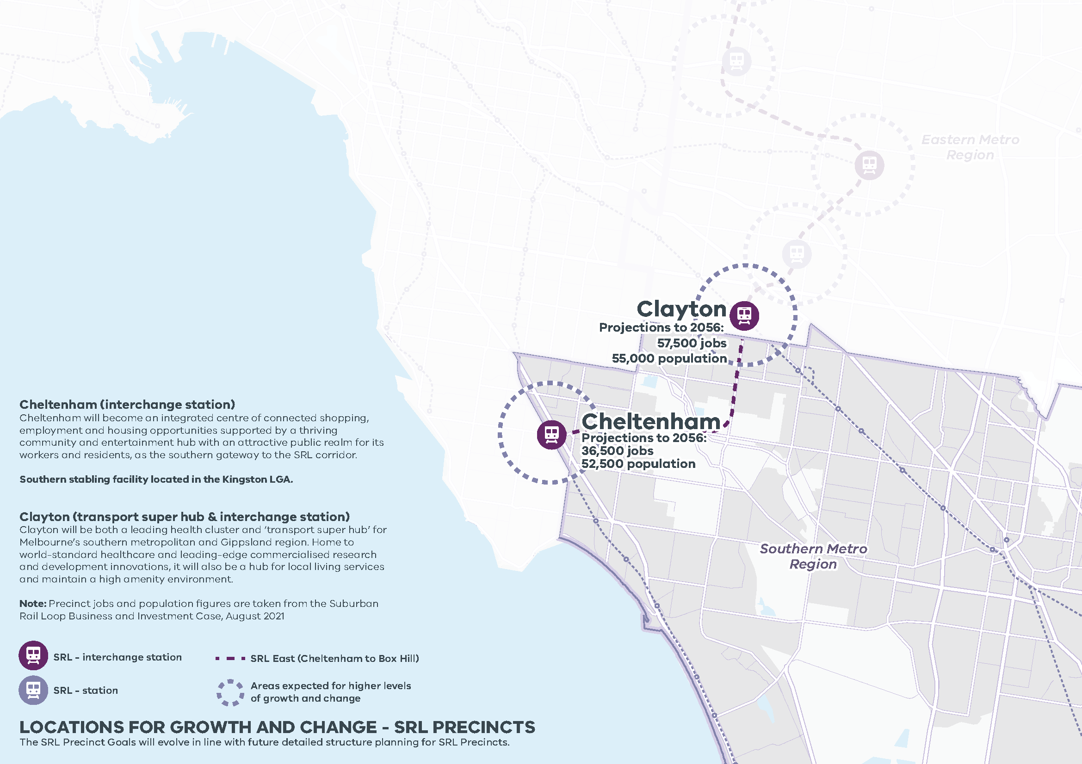

LOCATIONS FOR GROWTH AND CHANGE - SRL PRECINCTS
Cheltenham (interchange station) Cheltenham will become an integrated centre of connected shopping, employment and housing opportunities supported by a thriving community and entertainment hub with an attractive public realm for its workers and residents, as the southern gateway to the SRL corridor.
Southern stabling facility located in the Kingston LGA.
Clayton (transport super hub & interchange station) Clayton will be both a leading health cluster and ‘transport super hub’ for Melbourne’s southern metropolitan and Gippsland region. Home to world-standard healthcare and leading-edge commercialised research and development innovations, it will also be a hub for local living services and maintain a high amenity environment.

LOCATIONS FOR GROWTH AND CHANGE - SRL PRECINCTS
Southern Metro Region
The SRL Precinct Goals will evolve in line with future detailed structure planning for SRL Precincts.

Station | Projections to 2056 | Growth | SRL
Cheltenham | 36,500 jobs  52,500 population | Areas expected for higher levels of growth and change | SRL East (Cheltenham to Box Hill)
Clayton | 57,500 jobs  55,000 population | Areas expected for higher levels of growth and change | SRL East (Cheltenham to Box Hill)

Southern Metro Region strengths and challenges
Productivity | The Southern Metro region is a diverse, dynamic economic region with easy access for business to key transport gateways, including Moorabbin Airport and the Port of Hastings, and Victoria’s largest stock of existing and future industrial land. The region has all of the ingredients to continue to generate employment for Melbourne and Victoria into the future.
Housing Choice | The region is well-placed to manage growth. Its challenge is to build the right kinds of housing in the right places – catering to an ageing population, giving residents new housing that is close to jobs and services, and protecting development from increased risks of storm surge, bushfire and sea level rise.
Integrated Transport | A strong road and freight network provides connections for workers and goods across the region. The Suburban Rail Loop will improve public transport connections to key employment locations in other parts of Melbourne. However, more action is needed to address other public transport gaps and to strengthen east-west connections, particularly connecting the South Eastern Growth Corridor to other parts of the region.
Liveability | The Southern Metro region is renowned for its beautiful beaches, coastal hinterland and mountain foothills. However, additional open space is needed in established suburbs as well as growth areas to provide opportunities for escape and recreation.
Strong Communities | There are opportunities to strengthen community connections across the region by creating 20-minute neighbourhoods. Investing in services and facilties for the community and setting land aside for public use needs to be embedded in planning for growth areas.
Sustainability and Resilience | Good access to recycled wastewater from the Eastern Treatment Plant will help the region boost productivity and prepare for climate change. However, the region also needs to manage risks from urban heat, coastal inundation, sea level rise and bushfire. Strengthening and expanding the tree canopy will assist in cooling the urban environment as well as improving neighbourhood amenity.

Planning for the Southern Metro Region

Productivity
- Plan for and manage the growth of industrial precincts, including industrial and commercial development in the South Eastern Growth Corridor.
- Prioritise the development of the Dandenong and Monash NEICs, activity centres, and health and education precincts.
- Ensure that planning for the South Eastern Growth Corridor accommodates longer-term commercial and employment needs – and invest in precinct planning for the Cheltenham Suburban Rail Loop precinct.
- Protect green wedges to ensure the sustainability of agriculture, extractive resources, tourism and state infrastructure.
- Focus on future planning for land around the Port of Hastings.

Housing Choice
- Secure a 15-year supply of housing across the Southern Metro region.
- Ensure new housing is well-designed, high-quality, climate change resilient and in keeping with neighbourhood character.
- Deliver a pipeline of social and affordable housing near jobs, transport and services.
- Develop a mix of medium- and higher-density dwellings suitable for singles, older residents and families.
- Limit housing growth in the green wedge and areas at risk of natural hazards such as storm surge and bushfire.
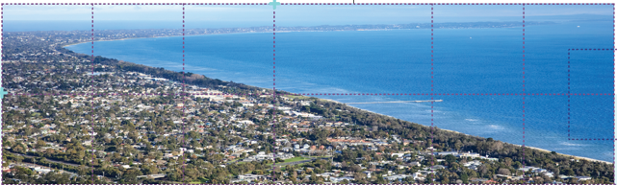

Integrated Transport
- Improve public transport, cycling and pedestrian access to Dandenong NEIC, activity centres and the Suburban Rail Loop station at Cheltenham.
- Improve freight efficiency and increase the capacity of transport gateways.
- Improve transport connections for the growth areas and the Mornington Peninsula.
- Create a network of walking and cycling paths that link to public transport.

Liveability
- Create great civic spaces that reflect the region’s environment and history – including the heritage of Aboriginal communities.
- Protect the region’s landscapes and biodiversity, including the bays and beaches, forested areas and green wedges.
- Expand the network of open spaces and trails across the region, including the Frankston to Mornington Parklands, the Chain of Parks between Dingley and Moorabbin and the proposed Clyde Regional Park.

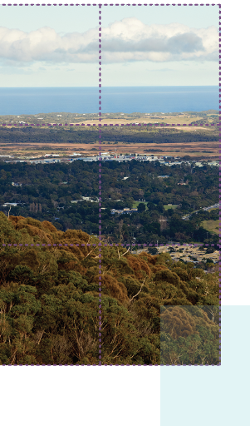

Strong Communities
- Plan for major social infrastructure (libraries, recreation facilities, cultural centres and community hubs).
- Expand the network of accessible health and education facilities and precincts – including health and education services in the South Eastern Growth Corridor.
- Create 20-minute neighbourhoods around activity centres and in close proximity to public transport.

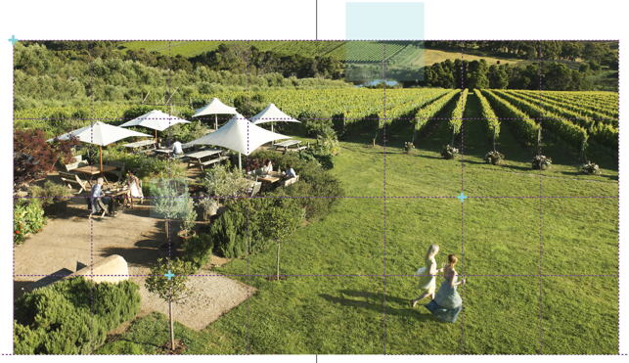

Sustainability and Resilience
- Manage the risk of sea level rise and bushfire.
- Plan for increased access to recycled water.
- Capture and reuse more stormwater.
- Ensure development supports the changing energy supply network.
- Protect the region’s existing waste and resource recovery hubs.
- Increase the region’s tree canopy to 30 per cent and design outdoor spaces that are cool in summer.

© The State of Victoria Department of Environment, Land, Water and Planning 2021
This work is licensed under a Creative Commons Attribution 4.0 International licence. You are free to re-use the work under that licence, on the condition that you credit the State of Victoria as author. The licence does not apply to any images, photographs or branding, including the Victorian Coat of Arms, the Victorian Government logo and the Department of Environment, Land, Water and Planning (DELWP) logo. To view a copy of this licence, visit http://creativecommons.org/licenses/by/4.0/
ISBN 978-1-76105-655-0 (pdf/online/MS word)

Disclaimer
This publication may be of assistance to you but the State of Victoria and its employees do not guarantee that the publication is without flaw of any kind or is wholly appropriate for your particular purposes and therefore disclaims all liability for any error, loss or other consequence which may arise from you relying on any information in this publication.

Credits
Green Scribble (graphic design); Tim Bell Studio (photos) and Department of Jobs, Precincts and Regions (photos).

Accessibility
If you would like to receive this publication in an alternative format, please telephone the DELWP Customer Service Centre on 136 186, email customer.service@delwp.vic.gov.au or via the National Relay Service on 133 677 www.relayservice.com.au. This document is also available on the internet at www.delwp.vic.gov.au
Submissions can be made online at engage.vic.gov.au
For any questions or assistance please contact lufp@delwp.vic.gov.au

