Built Environment
Climate Change Adaptation Action Plan
2022–2026

Acknowledgment of Traditional Owners and Aboriginal Victorians
The Victorian Government proudly acknowledges Victoria’s Aboriginal communities and their rich culture and pays respect to their Elders past and present. We acknowledge Aboriginal peoples as Australia’s first peoples and as the Traditional Owners and custodians of the land and water on which we live, work and play.
We recognise and value the ongoing contribution of Aboriginal people and communities to Victorian life and how this enriches our society more broadly. We embrace self-determination and reconciliation, working towards equality of outcomes, ensuring an equitable voice and developing partnerships to improve the values we cherish across our cities, towns, suburbs and regional areas.

© The State of Victoria Department of Environment, Land, Water and Planning 2022.

This work is licensed under a Creative Commons Attribution 4.0 International licence. You are free to re-use the work under that licence on the condition that you credit the State of Victoria as author. The licence does not apply to any images, photographs or branding, including the Victorian Coat of Arms and the Victorian Government logo. To view a copy of this licence, visit http://creativecommons.org/licenses/by/4.0/

ISBN 978-1-76105-880-6 (pdf/online/MS word)

Disclaimer
This publication may be of assistance to you but the State of Victoria and its employees do not guarantee that the publication is without flaw of any kind or is wholly appropriate for your particular purposes and therefore disclaims all liability for any error, loss or other consequence which may arise from you relying on any information in this publication.

Accessibility
If you would like to receive this publication in an alternative format, please email the DELWP Customer Service Centre on customer.service@delwp.vic.gov.au or call 136 186. Alternatively, contact the National Relay Service via relayservice.com.au or by calling 133 677.

Minister’s foreword
Climate change is real and affecting our lives daily.

The extensive bushfires over the 2019–20 summer, severe weather events and increasing number of heatwaves point to a changing climate.
This government is taking action. I am pleased to introduce this first Built Environment Adaption Action Plan.
Our homes and buildings, heritage places, energy system, public parks and sports fields form our built environment. We are working towards making our cities, towns and suburbs more resilient to climate impacts like bushfires, heatwaves, floods and coastal inundation.
The plan will ensure that Victoria is well placed to consider climate change impacts in decisions about how we plan for and build
communities. We will engage with people who are most at risk from the adverse effects of climate change.
Resilience and recovery are critical for highly exposed regional cities and towns. Supporting communities to tackle increasing and overlapping climate change events is vital.
Adapting our built environment to climate change is an investment in saving lives,
reducing trauma and minimising economic damage from disasters and the associated recovery costs. Given the built environment’s long life, it is important to factor adaptation into planning and management to reduce the need for upgrades and retrofits.
Communities, industry and government must work together to tackle the impacts of climate change and build climate resilience.
Over the next 5 years, this plan will strengthen and extend existing climate change responses; build adaptation capacity across government, the private sector and the community; and establish regulatory and other frameworks needed for long-term transformative action.
I look forward to a stronger safer future for us all.

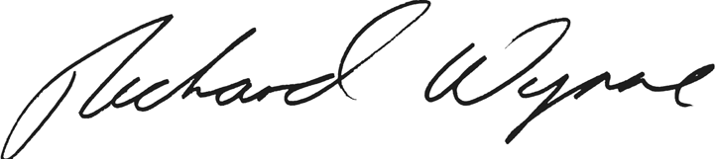

The Hon. Richard Wynne MP Minister for Planning

Contents
Minister’s foreword 3
Executive summary 5
- Introduction 7
  - A systems approach to adaptation 8
  - Community engagement 9
  - Built Environment AAP objectives 10
  - Built Environment AAP scope 13
- Governance, roles and responsibilities 16
  - Roles and responsibilities for climate adaptation in the Built Environment system 17
- Climate change and the Built Environment system 20
  - Climate change in Victoria 20
  - Climate change impacts on the Built Environment system 21
- Key climate change risks, gaps and opportunities for the Built Environment system 24
  - The exposure of communities and assets to natural hazards is changing 24
  - Planning for long-term community responses to support adaptation,
resilience and transition 37
- Climate change adaptation actions: 5 year plan 41
  - Governance and regulation 41
  - Place-based actions 44
  - Harness economic, financial and legal tools 45
- Monitoring, evaluation, reporting and improvement 46
Appendices 47
Appendix 1: Legislation and policy relevant to built environment adaptation 47
Appendix 2: Cross-system risks and responses 49
Appendix 3: Glossary and abbreviations 51
References 54

Executive summary

The Climate Change Act 2017 (the Act) requires the Victorian Government to develop plans addressing the impacts of climate change. It identifies
7 key systems that each require an adaptation action plan (AAP), including the Built Environment system.
Together, the 7 plans will harness the opportunities and tackle the impacts of climate change, while caring for our environment and bolstering our economy. They will build upon significant work already underway, including measures to reduce emissions as outlined in Victoria’s Climate Change Strategy.
The Built Environment system comprises our cities and towns along with supporting infrastructure and services, such as energy. Adapting our built environment to climate change is an investment in saving lives, reducing trauma and minimising economic damage from disasters and the associated recovery costs. Given the built environment’s long life, it is important to factor adaptation into planning
and management to reduce the need for upgrades and retrofits.
Achieving climate resilience across our cities and towns will require concerted action across multiple areas of government and the private sector. This will involve working closely with the emergency management sector and other systems including Education and Training, Health and Human Services, the Natural Environment, Primary Production, Transport and the Water Cycle.
This plan is the first of a series of AAPs for the
Built Environment system. Subsequent plans will be prepared every 5 years on a path to a climate-resilient Victoria in 2050. This plan aligns with the guiding
principles and policy objectives of the Act and of Victoria’s Climate Change Strategy. It is consistent with the Victorian Government’s policy in
Plan Melbourne 2017–2050 to take action to adapt to climate change, reduce the
likelihood and minimise the consequences of natural hazard events.
Over the next 5 years, the Built Environment system must strengthen and extend existing climate change responses; build adaptation capacity across government, the private sector and the community; and establish regulatory and other frameworks needed for long- term transformative action.
What we build, where we develop, how we live and how we make decisions must adjust, and all parts of the community should have a say in this. Public consultation
has been a critical component of this plan’s development, supporting the Act’s guiding principle of community engagement and enabling community members and organisations to inform how the Built Environment system can best support climate change adaptation.
This plan’s proposed actions are summarised overleaf.

Built Environment Climate Change Adaptation Action Plan 2022–2026 5

Governance and regulation actions
- Update planning provisions to respond to climate change.
- Review bushfire provisions in planning schemes and building standards.
- Update building standards relevant to flood, heatwaves and storm exposure.
- Pursue opportunities for upgrades of existing building stock.
- Examine strengthening energy infrastructure resilience including reviewing adequacy and robustness of existing frameworks through the Distribution Network Resilience Review
- Develop support programs for vulnerable persons and communities highly exposed to climate change impacts.
- Improve the skills and capacity of practitioners, industry and community organisations to respond to climate change.
- Extend spatial mapping and hazard exposure modelling.
- Support decision making by practitioners.

Place-based actions
- Prepare measures to help local government update planning schemes to reflect climate.
- Support climate change adaptation, risk reduction, response and recovery plans for the most exposed communities.
- Review strategic planning responses to elevated bushfire risk due to climate change.
- Support drought resilience planning for regional cities and towns.
- Support development of place-based resilient energy generation.
- Develop approaches for ongoing management of culturally significant and heritage places in risk- exposed locations.
- Develop program options to support local climate adaptation initiatives.

Harness economic, financial and legal tools
- Assess options to use economic tools to facilitate climate change adaptation outcomes.
- Assess financial measures and insurance responses to support adaptation.
- Review legal mechanisms to support climate-resilient urban development.
Please refer to Section 5 of this plan for a complete description of the proposed actions.

Introduction
The Built Environment system comprises our cities, towns, suburbs and regional areas, along with supporting infrastructure and services.
This plan sets out the Victorian Government’s proposed actions during the next 5 years to respond to climate change risks to our built environment.
The plan is needed because our climate is already changing, and decisive action to adapt now will reduce current and future risks,
build social and economic resilience, and ensure Victoria is best placed to protect our wellbeing.
An average global temperature rise of 1.5 degrees Celsius could be reached in the early 2030s, under all emissions scenarios. Without rapid, significant and sustained action to reduce global emissions, under the high
and very high scenarios, 2 degrees Celsius would be exceeded by around 2050. The frequency and intensity of extreme events is projected to

increase with each increment of additional warming, which we must be prepared for. This plan aims to be in line with Victoria’s commitment to the Paris Agreement.
Climate change threatens the integrity of the built environment’s assets and its ability to provide reliable
services. This requires action so the built environment can respond to emergencies, cope with climate-related hazards and, ultimately, transform to be climate resilient.
A climate-resilient system will support communities and
organisations to withstand the impacts of climate change.
These impacts can be cumulative and often have a complex interplay with other issues, such as social vulnerability. In responding to these challenges, we can build on existing adaptation practices, strengthening and extending them to develop resilient assets
and infrastructure that accommodate community

needs, particularly for those experiencing disadvantage or pre-existing vulnerabilities.
Governments, industry and the community all have a role to play in climate change adaptation, which must proceed alongside strong action to reduce Victoria’s contribution to greenhouse gas emissions. The Victorian Government is committed to reducing Victoria’s emissions to net zero by 2050 and
building resilient communities to deal with the impacts of climate change. The proposed actions in this plan will help our state adapt to the climate change that has already been locked in.
Developing and implementing adaptation response measures will be a process of continuous improvement, not a one-off step. It requires a program
of staged actions, with each phase adjusted in response to changing climatic conditions and knowledge gained along the way.

Figure 1. Scope of the Built Environment system

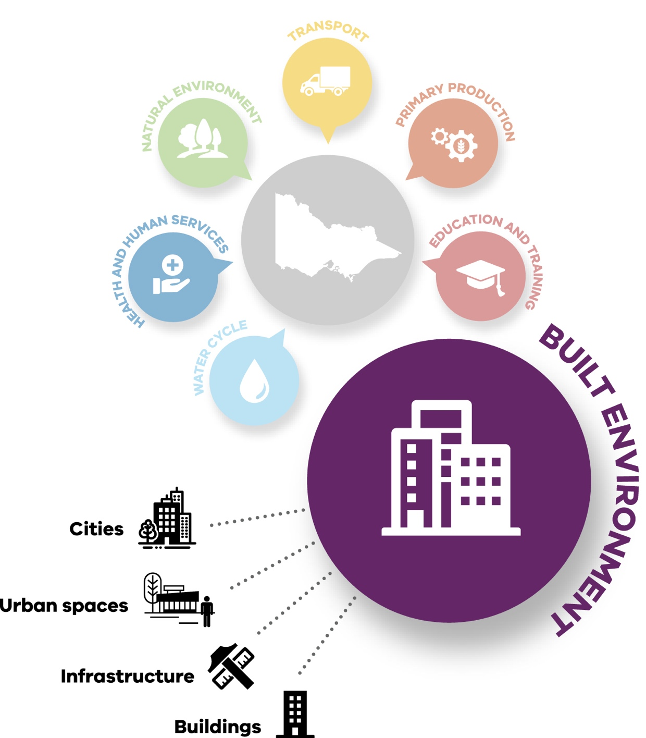

A SYSTEMS APPROACH TO ADAPTATION
The Victorian Government is taking strong and lasting action to reduce Victoria’s emissions to net zero by 2050 and to build resilient
communities prepared for the impacts of climate change.
Our state was one of the first jurisdictions in the world to legislate a net zero emissions target with The Climate Change Act 2017, and to set a strong foundation for climate
resilience with action under Victoria’s Climate Change Adaptation Plan 2017–20. Reducing our emissions will help lessen the impact of climate change but it will not prevent it. Some degree of climate change is already locked in, so we must adapt to our changing climate and its effects while also reducing future risks.
Victoria’s Climate Change Strategy sets out the Victorian Government’s current action on climate change and our
next steps. It sets adaptation objectives for the next decade and priorities for the next
5 years consisting of focus areas to:
- address current climate change impacts
- reduce barriers to adaptation
- lay the foundations for transformational adaptation.

It also outlines the enablers that will support action:
- capacity building and partnerships
- governance and strategic planning
- sustainable adaptation finance
- leadership and innovation.
Guided by Victoria’s Climate Change Strategy, the Victorian Government is planning for climate impacts and delivering adaptation action at multiple scales.
The government is preparing the first set of 7 adaptation action plans for systems
that are vulnerable to climate change impacts or are essential to Victoria’s preparation. The 7 systems are: the Built Environment,
Education and Training, Health and Human Services, the Natural Environment, Primary Production, Transport, and the Water Cycle.
This systems-based approach to climate change adaptation enables a targeted response to climate change, which focuses on each system’s unique characteristics and needs. It is complemented
at a regional scale by the development of regional adaptation strategies in partnership with regional communities to identify, prioritise and deliver place- based action informed by local knowledge and needs. These strategies are being developed for Greater Melbourne, Gippsland, Hume, Loddon Mallee, Grampians and Barwon South West.
Work also continues with local governments and community groups to understand and address climate change risks for local communities.
The Built Environment Climate Change Adaptation Action Plan 2022–2026 will iteratively guide adaptation efforts over the next 5 years, building on strong foundations and seizing opportunities to accelerate adaptation. The magnitude
of climate change impacts will depend on how quickly the international community reduces emissions. However, even if emissions ceased today, some degree of warming and its impacts will continue for many decades because of the effects of historical greenhouse gas emissions.

COMMUNITY ENGAGEMENT
Community engagement was undertaken during July and August 2021. Submissions provided valuable input, and where relevant have been incorporated into this final plan.
Individual community members are key participants in adaptation. They have a big impact on it, and will be affected by climate change and adaptation actions.
Individual leadership and community engagement are critical to support activities and programs, in order to manage risk and achieve adaptation.
This will rely on effective communication and the provision of information.

BUILT ENVIRONMENT AAP OBJECTIVES
This plan proposes actions to progressively address the Victorian Government’s 3 priority areas for climate change adaptation during the next 5 years. It expands on existing strategic policies including Plan Melbourne
2017–2050, which establishes the statewide direction: 6.2: Reduce the likelihood and consequences of natural hazard events and adapt
to climate change.¹ The Victorian Critical Infrastructure Resilience Strategy also
sets out management arrangements for critical infrastructure resilience and provides a strong framework for coordinated action between the public and private sectors to incorporate climate change considerations into existing emergency response measures.

The vision for Victoria
Our cities, towns, homes, buildings and essential infrastructure are located, designed and modified to support safe, vibrant, healthy and inclusive communities
in a changing climate and contribute to emission reduction.
In addition to the policy objectives and principles set out in The Climate Change Act 2017, this plan’s vision for Victoria is guided by the
following principles, objectives and themes for further action.

Principles for developing
the AAP
Community engagement informs the development and finalisation of this plan. Community feedback has identified key themes or
values, which are captured in the following principles and applied to this plan.
- Respect Traditional Owner and Aboriginal Victorian knowledge: Incorporate the knowledge of Traditional Owner groups and Aboriginal Victorians in adaptation decision making and ensure this is valued and respected.
- Benefits for all: Consider adaptation responses
in terms of maximising community benefits.
- Certainty: Use fit-for- purpose regulation, practical guidance and access to climate change information to support timely and consistent decision making.
- Community engagement: Trust and involve the community in setting policy directions, priorities and co- designed solutions.
- Equity: Reduce social disadvantage for vulnerable persons impacted by climate change and reduce the cost burden on future generations.
- Human rights: Implement adaptation in accordance with the Victorian Charter
of Human Rights and Responsibilities by being inclusive and respectful of the rights of people affected by climate change.
- Immediate response: Recognise the urgency required in responding to climate change.
- Nature-based: Ensure natural processes and impacts on the natural environment are carefully and respectfully evaluated in adaption responses to offer long-term environmentally sustainable benefits.
- Transformational responses: Seek adaptation responses that are integrated with economic and social processes to support long-term cross- system changes, including aligning emission reduction with adaptation responses.

- Department of Environment, Land, Water and Planning 2017 Plan Melbourne 2017–2050, page. 113.

Objectives
This plan’s objectives support the directions set out in Victoria’s Climate Change Strategy.
Table 1. Built Environment system adaptation objectives

Timing | Objective
Short-term objective  (by the end of 2026) | Policies and standards are strengthened to provide comprehensive support for climate change adaptation and emission reduction across the Built Environment system.  Institutional organisations and major infrastructure providers are committed to climate change adaptation and emission reduction as part of the way they operate across the  built environment.
Medium-term objective  (by the end of 2031) | Climate change adaptation and emission reduction is integrated into all relevant investment and decision making across the Built Environment system.
Long-term objective  (by the end of 2050) | The entire Built Environment system is adapted to climate change and contributes to emission reduction.

Themes
An action plan has been developed to achieve the vision and objectives based on the following themes:
- governance and regulation: see actions 1 to 9
- place-based: see actions 10 to 16
- harness economic, financial and legal tools: see actions 17 to 19.
Refer to Section 5 for the details of these actions.

Integrating emission reduction and adaptation
Adaptation measures need to proceed alongside strong action to reduce Victoria’s greenhouse gas emissions, including through built environment measures.
By considering adaptation and emission reduction approaches together, opportunities for more effective responses for both
objectives may be identified (Figure 2). Emission reduction responses must also apply across systems and sectors, in consideration of social, economic and environmental factors from a state-wide perspective, to ensure narrow, single use assessment does not limit options to meet these goals. This plan is designed to complement actions to reduce emissions.
To avoid the worst effects of climate change, the
international Paris Agreement aims to limit the rise in global average temperature to between 1.5 and 2 degrees Celsius. To help achieve this goal, Victoria – along with many governments around
the world – is committed to net zero emissions by 2050.

Figure 2. Relationship between urban climate change emissions reduction and adaptation

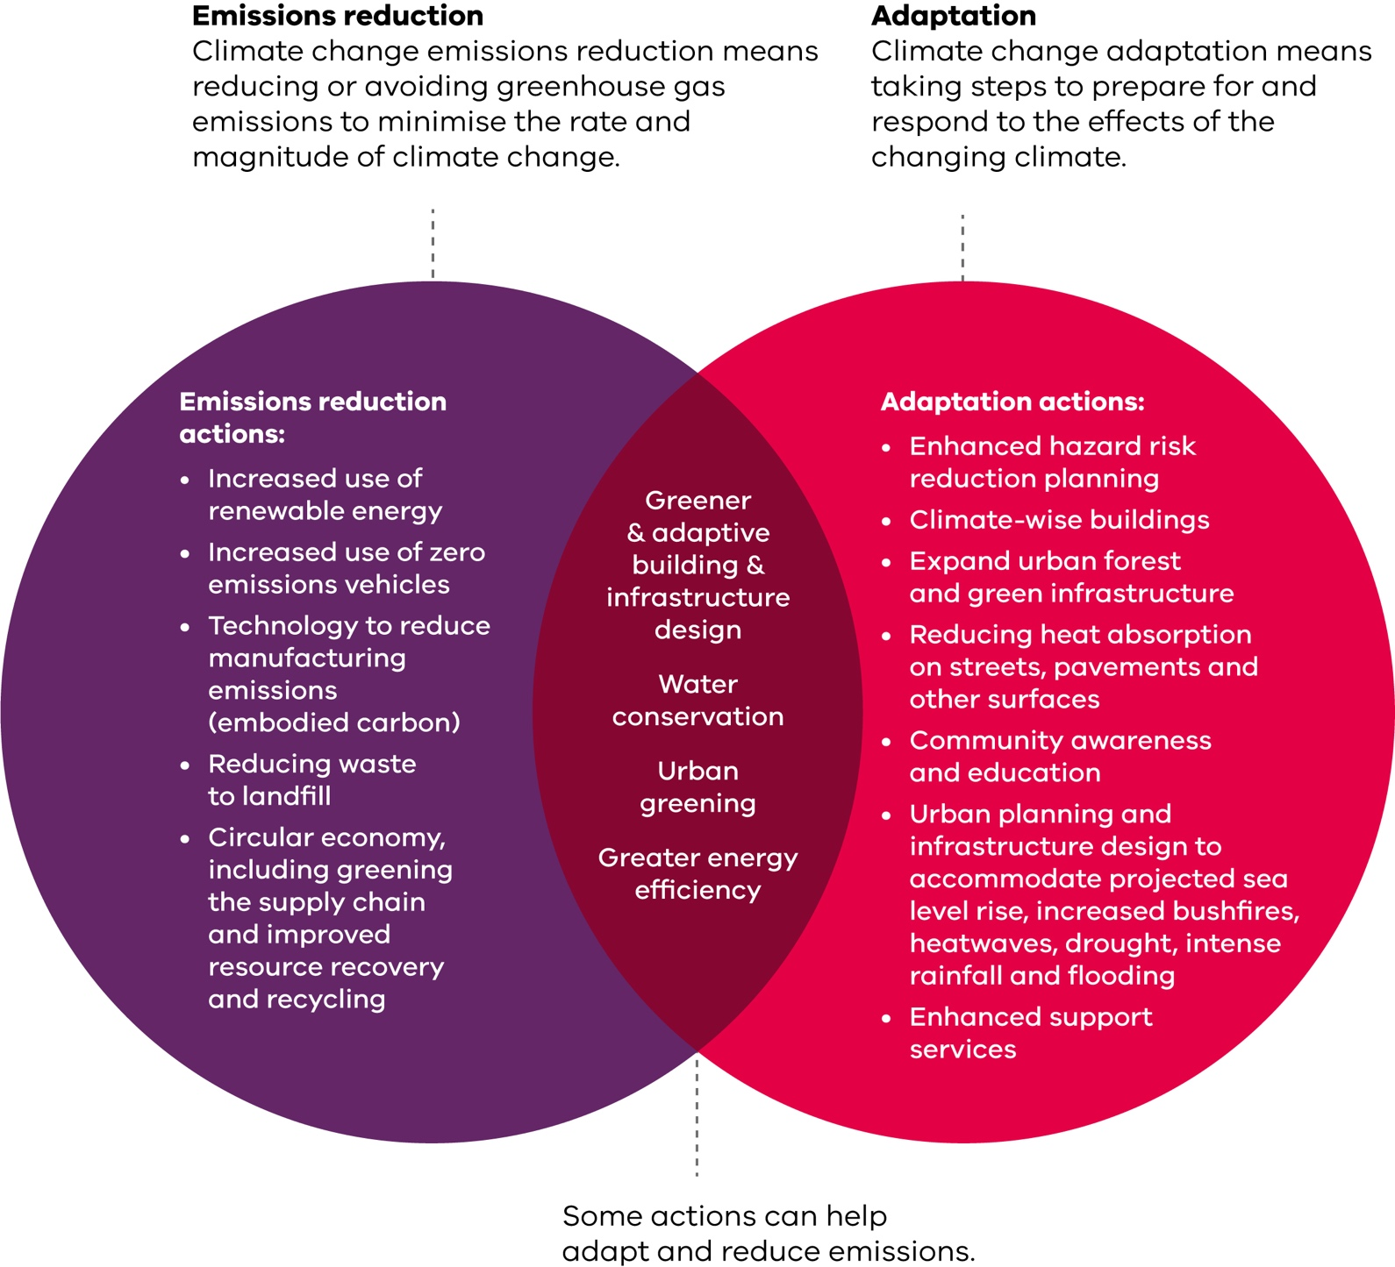

BUILT ENVIRONMENT AAP SCOPE
This adaptation action plan considers the Built
Environment system, which includes our cities, towns and regional areas, and how people use and interact with services, infrastructure,
buildings, natural and cultural features, and public places.
It is the sum of multiple interdependent processes and activities. It includes how we
enjoy and form connection to place. To achieve effective adaptation, climate change needs to be considered in all
decision making across urban functions.
Government has a key role in achieving a climate- resilient built environment through providing certainty, guidance and support to the wider community. It establishes partnerships
and builds knowledge, and it provides strategic objectives,
regulation, decision-making guidance and investment. Commerce, industry and community activities are also fundamental in shaping the built environment and will be a central element of successful climate change adaptation,
as will public and private infrastructure providers, and financial, insurance and legal service providers.

Table 2. Built Environment system scope and long-term outcomes sought

Component Adaptation outcomes sought

Cities, towns, suburbs, and regional areas

Precincts, suburbs, towns, cities and a range of facilities, such as sporting and tourism facilities, as well as individual property, such as housing and farm buildings
Outcomes sought
- New precincts, growth areas and suburbs are resilient to climate change
- Infrastructure for new and existing suburbs incorporates climate change adaptation measures
- Climate-resilient regional and rural cities and townships
- Climate change considerations incorporated into decision making about future land use planning for cities, towns, suburbs and regional areas

New and existing
buildings Homes, as well as institutional, commercial and industrial buildings and service facilities, including education, public housing and health facilities covered by other AAPs
Outcomes sought
  - Plan and construct buildings with improved resilience to climate-related hazards expected during their design life
  - Existing residential and commercial buildings retrofitted to improve thermal performance and resilience to heatwaves, with capacity for further upgrades as conditions change. Some design solutions such as improving air tightness may also have other adaptation benefits, such as reduction of infiltration of bushfire smoke
  - Upgraded energy-efficient heating and cooling systems to reduce the cost of achieving thermal comfort as a result of climate change
  - Consider the value of embodied energy contained in existing and heritage buildings

Infrastructure Energy infrastructure assets, waste infrastructure, coastal infrastructure, telecommunications, and water and transport infrastructure covered by other AAPs
Outcomes sought
  - Design and build a resilience model for infrastructure including electricity, waste management and telecommunications assets that withstand, respond to and recover from extreme events and are resilient to a changing climate, taking into account the interdependency between telecommunications and energy systems
  - Existing critical infrastructure is protected or retrofitted, and takes into account the interdependency between telecommunications and energy systems
  - Alternative water (stormwater and recycled water) is used extensively within the built environment to support drought resilience and urban cooling
  - Urban flood-reduction assets (such as levees, floodways, drains and retention basins) are funded, designed and managed to respond to predicted extremes in flash flooding and sea level rise
  - Community, sporting and tourism sites are designed to be climate resilient

Urban green spaces
Parks, corridors, nature/median strips, private spaces, lakes and waterway environments
Outcomes sought
- Managing, maintaining and protecting all urban green spaces such as parks and gardens to ensure climate change resilience
- Water supply, including from alternative water sources is available to maintain vegetation cover, parks and recreational spaces across Victoria’s cities, regional centres and towns to support urban amenity, cooling and wellbeing during periods of drought
- At least 30% tree canopy coverage (along with other vegetation) is provided across the urban landscape to support cooling and greening responses using species, design measures and infrastructure to minimise bushfire risks where necessary

Heritage Places of natural, historic, cultural, aesthetic, scientific, social, creative, technical and Traditional Owner and Aboriginal Victorian value in the built environment
Outcomes sought
  - Climate change considerations incorporated into decision making about the conservation and management of places with Aboriginal and non-Aboriginal cultural heritage values
  - Develop policies to guide the sensitive retrofitting of heritage buildings with energy-efficient systems in ways that protect their heritage values while improving their thermal performance and resilience to climate change extremes
  - Develop appropriate solutions to retrofit heritage buildings with energy-efficient systems to reduce the cost of comfort as a result of climate change
  - Identify and support conservation and adaptive reuse of heritage buildings as an alternative to new construction
  - Consider Traditional Owner and Aboriginal Victorian cultural values in decision making

Contributions to issues across multiple AAP systems
Consider
- Health, safety, liveability and community resilience
- Impacts on environmental and ecosystem values
- Financial, legal and insurance risks associated with climate change
- Greenhouse gas emissions related to adaptation (for example, energy use for cooling and prescribed burning)
- The needs of vulnerable people and highly exposed communities
- The impact of changes to the pattern of growth due to climate change to minimise impacts on biodiversity and primary production

Figure 3. Cross-system risks – Alt text: Detailed diagram shows links and interdependencies between the Built Environment system and the other six systems, with a focus on cross-system risks. Cross-cutting considerations include vulnerable communities and emergency response.

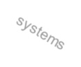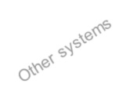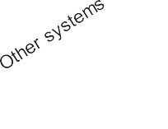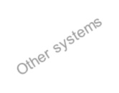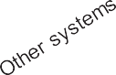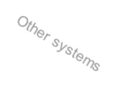
Key system
Built Environment System
Key system
•
•
Natural •
Environment
Bushfire risk
Damage to cultural heritage sites and cultural practices
•
Transport supply chain
and service delivery disruptions
Public and active transport disruption Access and egress
Transport
•
Education
and Training
•
•
Skills and training
Safe school siting
Primary Production
Built
Environment
Primary Production Transport Water Cycle
•
•
Competing demand for
water
Competing demand for land
Primary
Production
•
Water
•
•
•
•
Flooding – flash
flooding & coastal Water availability Water quality Drought management Alternative water supplies
•
•
•
•
Food safety
Heat Health
Drinking Water Quality Spread of Disease
Health and
Human Services
Vulnerable communities
Emergency response

Cross-system connections
All systems rely on the built environment to provide shelter, deliver services, undertake business and move people around. Therefore, the built environment needs to be climate resilient. This section highlights the main system risks, and connections that need to work effectively and efficiently to improve decision making and response times.
This diagram shows the key
connections between the Built Environment system and other systems.
This plan recognises that the Built Environment system provides a range of benefits to the Victorian community. It has been developed to align with other key systems and their climate change adaptation actions, and in doing so should avoid unintended negative consequences. A coordinated approach to adaptation is essential to address climate change-related risks.

Governance, roles and responsibilities

Under the Climate Change Act 2017, the Minister for Planning is responsible for leading this plan’s development and implementation. The Department of Environment, Land, Water and Planning (DELWP) will work across the Victorian Government and with the community and private sector to help deliver the plan over the next 5 years.

Figure 4. Legislation relevant to the built environment

There are 4 Victorian Acts of particular relevance to this plan.
  - The Planning and Environment Act 1987 (P&E Act) influences where and how we build, and our response to natural hazards.
  - The Building Act 1993 sets the construction standards for buildings and their resilience to a range of natural forces.
  - The Water Act 1989 covers general water management and the functions relevant to flood and drought responses.
  - The Emergency Management Act 2013 is vital in protecting the built environment as it provides a framework for emergency service coordination and is the enabling legislation for the extensive programs associated with Victoria’s Critical Infrastructure Resilience Strategy.
Most of the relevant acts provide scope for climate adaptation, though the term is not specifically used. For example, the P&E Act includes objectives to balance the present and future interests of all Victorians to provide for the protection of natural and man-made resources and to protect public utilities and other assets. The Victorian Planning Provisions (VPP), which are part of all planning schemes, specifically reference climate change and include responses to a wide range of natural hazards amplified by it.
Building standards are designed to respond to natural hazards, such as bushfire, floods and storms that affect building safety or functionality. For example, the Australian Building Codes Board (2019) takes into account construction of buildings in flood-hazard areas.
Building standards in Victoria are established through the National Construction Code (NCC). The NCC is given legal effect through the Victorian Building Regulations made under the Building Act 1993. This legislation sets out requirements for building permit processes, the application of building standards to building work, and various compliance and enforcement tools to address non-compliance or defects.
The objectives of the Building Act 1993 include protecting the health and safety of people and facilitating environmentally and energy efficient buildings. The building regulatory framework does not directly address climate change risks. However, building standards are designed to respond to conditions within the relevant Victorian climate zone using Bureau of Meteorology climatic data.²
A number of other laws affect the Built Environment system. The Aboriginal Heritage Act 2006 and Heritage Act 2017 play an important role in protecting aspects of the Built Environment system valued by the community. Other laws and policies of relevance are set out in Appendix 1.

- Australian Building Codes Board (ABCB), Climate Zone Map Victoria, the ABCB website (accessed June 2021).

ROLES AND RESPONSIBILITIES FOR CLIMATE ADAPTATION IN THE BUILT ENVIRONMENT SYSTEM
The Built Environment system incorporates a wide range of systems, services, infrastructure and processes, including:
- where we live and how we build
- our response to emergencies and climate change
- community services
- utilities and infrastructure
- natural systems and environmental management
- finance and insurance risk services.
These issues and processes are subject to government legislation, regulation, strategies and/or plans. The box below outlines some of the fundamental legislation that influences climate change adaptation across the built environment. Refer to Appendix 1 for other relevant laws and policies.
The Victorian Government is responsible for public assets functioning in the Built Environment system,
working with local government, and establishing legislation and programs to support industry and communities.
Regulation and policy making can directly facilitate climate change adaptation, as can non-regulatory activities such as working with stakeholders and communicating information. The government is also responsible for statewide planning for the security of built environment infrastructure and assets, and planning to support resilience among vulnerable persons and highly exposed communities.
Input and advice on many of these issues is provided through Victoria’s statewide network of metropolitan and
regional partnerships. These advisory groups, established by the Victorian Government, comprise community and business members who provide a strong foundation for government-community collaboration over a wide range of issues, including most aspects of climate change adaptation.

Key private sector participants in the Built Environment system
- Utilities – privately owned electricity and gas distribution and retail companies are
responsible for producing, supplying and distributing energy. Electricity and gas generation facilities and supply networks are vulnerable to damage
during hazard events. Loss of power to homes during a heatwave can have dire consequences for the very young, old and ill.
- Telecommunications – these facilities can be vulnerable to hazard events, especially from sustained power disruption to mobile phone towers, hampering warning and evacuation message distribution.
- Finance and banking sector – this sector funds investment in the built environment, and can provide incentives to infrastructure and property developers to consider natural hazards and
future climate change risks. Several Australian banks also apply their own
processes to identify climate change risks across their portfolios.
- Insurance industry – insurers assess climate- related risks and use diverse ways, such as research, advice, advocacy and pricing, to encourage clients to minimise their hazard exposure and the insurance company’s liability.
- Commerce and industry
– many peak bodies are developing climate change and disaster response programs to manage employees and support their members and community during recovery. Builders, retailers and product suppliers can also play an important role in supplying materials and services to retrofit and protect existing buildings. For example, some hardware chains offer these services.
- Service providers – many peak bodies, such as private childcare providers, schools and medical clinics have policies and procedures to respond and adapt to the impacts of natural hazards.

Key Victorian Government participants in the Built Environment system
- DELWP supports and oversees statewide adaptation of the built environment. It does so by formulating and implementing policies, plans, strategies, and
programs across several relevant departmental areas, namely energy, planning, biodiversity, forest fire management, water and catchments, and emergency management. It also plays
a role in the prevention, response and recovery for emergencies affecting the built environment including: disruptions to electricity and natural gas supply, disruptions to petroleum and liquid fuels supply, disruptions to reticulated water and waste water services and fire in state forest, national park and protected public land.
- DELWP agencies – DELWP’s portfolio includes more than 100 agencies, some of which have important roles in climate change adaptation across the built environment. These include water corporations, catchment management authorities, the Victorian Building Authority, the Victorian Planning Authority and Energy Safe Victoria.
- Department of Transport (DoT) – sets infrastructure delivery standards and service levels needed to maintain essential access during emergency incidents.
- Essential Services Commission (ESC) – promotes long-term interests of Victorian consumers regarding essential service reliability, quality and
price. Essential services include electricity, gas and water; local government, transport and Victorian energy upgrades; waste and recycling services; and domestic building insurance.
- Emergency Management Victoria (EMV) – leads emergency management in Victoria by maximising
the ability of the emergency management sector to work together and to strengthen the capacity of communities to plan for, withstand, respond to and recover from emergencies. EMV contributes to climate resilience by ensuring
a stronger emphasis on shared responsibility, community resilience, consequence management and post emergency recovery activities, and embedding emergency management across government, agencies and business.
- Department of Health (DH)
– primarily responsible for delivering policies, programs and services that support and enhance Victorians’ health and wellbeing, including climate change- influenced events such as drinking water contamination and extreme heat.
- Department of Families, Fairness and Housing (DFFH) – responsible for community wellbeing and Victoria’s social recovery. Importantly, it determines the location and design of public and community
housing, taking into account increased risks from natural hazards.

Local councils and the Built Environment system
Local councils are integral in implementing planning system responses to climate change and natural hazards. They manage planning schemes and provide local flood mitigation infrastructure. They also develop and implement Municipal Emergency Management Plans and invest in preventative measures.
Furthermore, council services that support community wellbeing complement climate change adaptation. This can include meals and home maintenance services for older citizens, and communication with residents to prepare for heatwaves.

Traditional Owners and Aboriginal Victorians
Climate change is a threat to Country, as well as the health and wellbeing of Aboriginal Victorians. The Victorian Government is committed to supporting Aboriginal self-determination, and the respectful application of Traditional Owner knowledge and Caring for Country principles, in addressing the impacts of climate change on the built environment and implementing climate change adaptation responses. Pupangarli Marnmarnepu ‘Owning Our Future’ Aboriginal Self-Determination Reform Strategy 2020-2025 outlines DELWP’s commitment to self determination.
In 2009, Australia became a signatory to the United Nations Declaration on the Rights of Indigenous Peoples (UN Declaration). The UN Declaration outlines the rights of Indigenous peoples around the world and describes self- determination as the right of Indigenous peoples to ‘freely determine their political status and pursue their economic, social and cultural development’. What that means for Traditional Owners and Aboriginal Victorians is that their future is theirs by right. Human rights cannot be given or taken away. They are inalienable. Given Australia’s history of dispossession, the Victorian Government has an obligation – on behalf of the people of Victoria – to work in partnership with Traditional Owners and Aboriginal Victorians to support their right to self-determination.
It is recognised that extreme events amplified by climate change pose risks to Country as well as to culturally significant sites. Caring for Country will be impacted
by bushfire, extreme heat, reduced runoff, sea level rise, flash flooding, extreme wind and hail, and landslides. The measures we introduce can have an impact on Country and will require a self-determination approach that is respectful and led
by Traditional Owners and Aboriginal Victorians and Country. Regarding culturally significant sites, these include increased erosion
or bushfire activity that exposes artefacts and areas of cultural heritage sensitivity. Adaptation responses – such as constructing sea walls and flood embankments, constructing fire breaks and realigning roads or other infrastructure under threat from sea level rise or other hazards – can also have adverse effects on these values. Cultural Heritage Management Plans, prepared with the relevant Registered Aboriginal Party, are one of the processes used to assess the potential implications of a proposed activity on Aboriginal cultural heritage.
Volunteer community organisations
These organisations provide disaster response and emergency services following building damage or collapse. They also help as required and are often a network
to communicate disaster preparedness messages. Individuals outside these organisations influence adaptive capacity through their choices, including their risk tolerance, preparation levels and incident responses.

Climate change and the Built Environment system

CLIMATE CHANGE IN VICTORIA
Long-term observed records show that Victoria’s climate is changing due to global
warming. Since official records began in 1910, Victoria has warmed by 1.2 degrees Celsius.³ With this amount of warming, Victoria has already experienced a decrease in average rainfall especially in cooler months, an increase
in frequency of extreme heat events, and an increase in dangerous fire weather and the length of the bushfire season.⁴
Understanding the drivers and impacts of these changes, as well as what we can expect
in the future, will help us
plan and adapt. The climate trends and associated impacts Victoria has experienced over the last decades are expected to continue. For example, the latest climate projections for Victoria suggest the following:⁵
- By the 2050s, the state’s average annual temperature may increase by up to 2.4 degrees Celsius compared to the 1986–2005 average (under a high emissions scenario) with about double the number of very hot days.
- Annual rainfall is projected to decrease, especially in the cool season.
- Due to natural variability, extreme rainfall events will still occur and are likely to be more intense, potentially
increasing the risk of flash flooding in some locations.
- The number of high fire- danger days in Victoria is expected to increase.
- Sea levels will continue rising – by the 2050s, sea level is projected to rise by about 24 cm (relative to 1986–2005) under
medium and high emissions scenarios.
The magnitude of climate change impacts will depend on how quickly the international community reduces emissions. However, even if emissions ceased today, warming and its impacts will continue well into the future because of historical emissions.

Figure 5. Current and projected climate change impacts for Victoria under high emissions

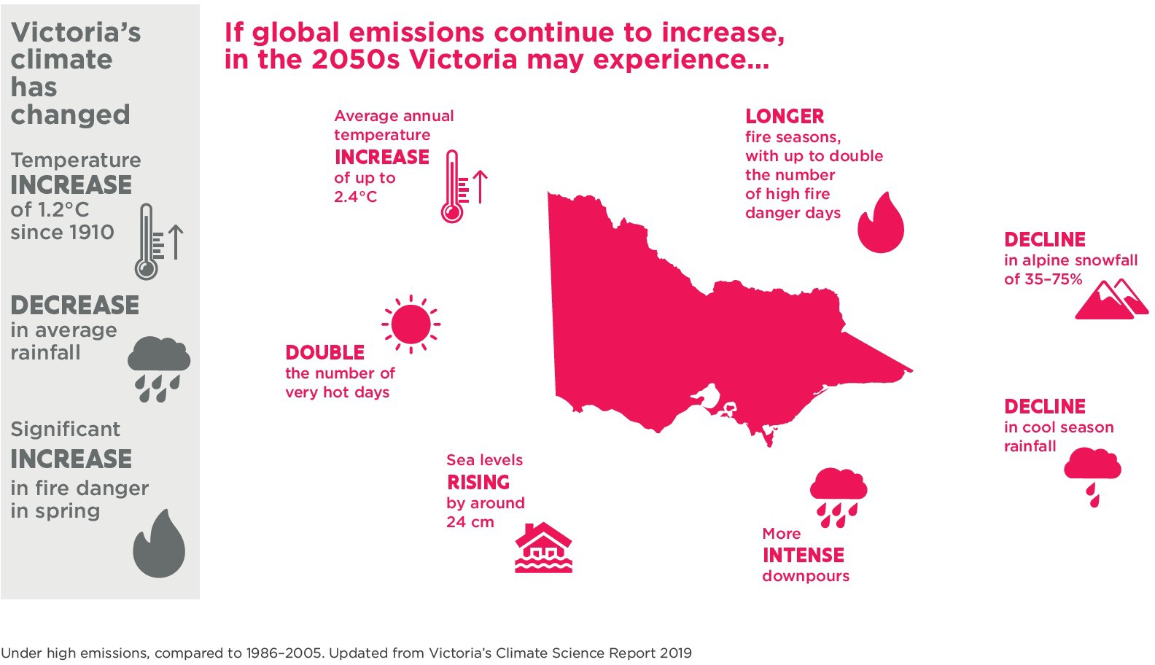

- CSIRO, Victorian Climate Projections 2019.
- Department of Environment, Land, Water and Planning, Victoria’s Climate Science Report 2019.
- CSIRO Victorian Climate Projections 2019.

Most recent climate science
The Intergovernmental Panel on Climate Change (IPCC) released the first part of the Sixth Assessment Report, Climate Change 2021: The Physical Science Basis, on 9 August 2021. The report contains the strongest statements yet about human influence on climate and the impact for all regions, increases in temperature and the intensity and frequency of extreme events. Unless there are immediate large-scale reductions in greenhouse gas emissions, limiting global warming to 1.5 degrees Celsius will be beyond reach.
The report conveys the strongest statement yet on human influence on the climate to date: widespread and rapid changes in the atmosphere, ocean, cryosphere and biosphere have occurred; it is unequivocal that human influence has warmed the atmosphere, ocean and land; and human influence has warmed the climate at a rate that is unprecedented in at least the last 2000 years.
All scenarios indicate global surface temperatures will continue to rise until at least the mid- century.
Global surface temperatures are now about 1.1 degrees Celsius higher than in 1850–1900 (pre-industrial period), while for Australia warming over land has increased by 1.4 degrees Celsius since official records began in 1910.
Contributing Australian scientists note with high confidence that recent extreme heat events in Australia were made more likely or more severe due to human influence. These events include:
- the summer of 2012–13, when more than 70% of Australia experienced extreme temperatures
- the heat leading into the Black Summer bushfires of 2019–20.
The sixth report has greater emphasis on regional information and provides regional projections of coastal hazards due to sea level rise, changing coastal storms and coastal erosion. It also suggests that sandy shorelines in places such as eastern Australia are projected to retreat by more than 100 metres, under moderate or high emissions pathways.

CLIMATE CHANGE IMPACTS ON THE BUILT ENVIRONMENT SYSTEM
Climate change will affect Victoria’s built environment in diverse ways due to the
varying exposure levels of key assets and areas.
Direct impacts could include damage to Victoria’s buildings, homes, infrastructure, recreation facilities, parks, natural sites, and Traditional Owner and Aboriginal Victorian spiritual and archaeological sites. Secondary impacts could include disruption to service delivery, business

operation, construction activity, movement of goods and people, and diminished health and wellbeing.
The cost of managing and maintaining Victoria’s built environment and related heritage assets could increase in areas prone to natural disaster and slow-onset change, such as sea level rise. Increased outlays could arise from disaster recovery expenses, physical asset damage and reduced business activity. Insurance and service provision costs could also increase.

Based on observed changes and modelled projections from Section 3.1, there is high confidence that Victoria will continue to become hotter and drier in the future and sea levels will continue to rise.
However, how these changes will affect the built environment at a local scale is less certain. Despite these complex considerations, we need to plan for change and factor in the uncertainty it will bring.
Scenario planning is an important part of responding to uncertainty. It explores the
implications of different climate

change projections on the built environment’s development and operation. Technology, economic circumstances, social trends, and government and private sector responses will shape the implications of increased hazard exposure.
Exposure risk to climate- related hazards will also vary depending on how
resilient existing buildings and infrastructure are, and how effective current protection measures are. For example, building regulations already allow a safety margin between the estimated flood level and
building floor level.
Without a resilient built environment, human health, safety and liveability will be negatively affected. We must ensure our built environment adapts to withstand the climate change we know will occur, and doesn’t contribute to further climate change.
The table below gives examples of the potential climate-related risks we might need to plan for over the
long-term. They are based on the consequences of past climate-related hazards and
assumptions made from future climate projections.
It is difficult to assess the potential impact on local built environments due to
uncertainties and complexities. Risks should also include cascading impacts from multiple disaster events,
such as communities facing floods while still recovering from bushfires. In addition, risk reduction measures are continually being developed, incorporating learnings from previous events.

Table 3. Potential range of increased built environment climate-related risks and impacts

Future climate projections7 | Associated risks |  | Associated potential impacts
Longer fire season and increase in the number of high fire-danger days8 | Bushfires increase in frequency and intensity | - Deaths from the influence of fire on buildings and urban areas  - Health impacts from smoke loss and damage to buildings and infrastructure  - Loss of services damaged by fire (for example, electricity)  - Degraded services (for example, poor water quality from ash contamination)  - A social toll on individuals and communities from loss of urban greenery and parks, loss of small town and rural character, and reduced economic activity  - Protracted underground coal mine fire  - Loss of significant heritage places
Increases in average annual temperatures and the number of very hot days⁹ | Extreme heat: increase in frequency, duration and intensity of heatwave events | - Premature deaths and heat-related illness  - Productivity reductions, service limitations (for example, deliveries)  - Restrictions on outdoor activities  - Damage to building materials and infrastructure  - Utility service outages (for example, power and public transport)  - Loss of Aboriginal bush foods due to temperature rise on land and sea  - Death of domestic and native animals  - Negative impacts on biodiversity

- The Victorian climate projections are expressed over extended timescales (20 to 30 years) and projections of impacts are variously attributed confidence levels on a scale from low to very high, consistent with the best available science. Victoria’s climate is highly variable and variations can arise from year to year.
- CSIRO, Victorian Climate Projections 2019.
- CSIRO, Victorian Climate Projections 2019.
- CSIRO, Victorian Climate Projections 2019.

Future climate projections7 | Associated risks | Associated potential impacts
Reduced rainfall especially in the cool season10 | Reduced runoff into  rivers and dams | - Less reliable filling of water storages  - Damage to sporting fields, limiting their use  - Loss of heritage gardens  - Increased cost of urban water services  - Competition for water between town supply and primary production use  - Competition for environmental and recreational water
Sea level is projected to rise by about 24 cm by 2050s (relative to 1986– 2005)¹¹ | Coastal inundation: increases in extreme sea level events (for example, storm surges) in low- lying areas and increases in coastal erosion | - Significant impacts on buildings and coastal infrastructure  - Disrupted road and rail access  - Dispersal of contaminated soils if waste storage or landfills are breached  - Loss of coastal systems, such as sand dunes, mangroves and kelp beds, which comprise living infrastructure and provide natural defences  - Weakened natural defences worsening the impact of subsequent hazard events on infrastructure and buildings  - Changes to coastal underwater environments through changes in wave action  - Loss of coastal Aboriginal and historic sites
Increased intensity of extreme rainfall events | Flash flooding:  the risk of  flash flooding increases in some locations | - Drownings and injury  - Damage to buildings and urban infrastructure  - Vehicle damage  - Disrupted road and rail access  - Isolation of communities and related issues in accessing supplies and medical care  - Scouring and degradation of urban waterways  - Disease associated with extensive sewer overflow  - Loss of services damaged by water (for example, power outages if substations are flooded)
Changes in the intensity and frequency of storms¹² | Extreme wind and hail increase in some locations | - Hail and wind damage to the built environment  - Hailstone damage to roofs and cars  - Infrastructure loss from storm damage (for example, to electricity poles and wires, which could affect statewide services)
Compound events such as more frequent bushfires followed by intense rainfall events  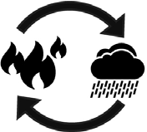 | Landslides: increased incidence of landslides and erosion | - Damage to building footings causing instability  - Damage to buried infrastructure  - Damage to downslope dwellings and infrastructure  - Dispersal of contaminated soils if waste storage or landfills are breached

- Department of Environment, Land, Water and Planning, Victoria’s Climate Science Report 2019.
- Dowdy et al 2019, Thunderstorms and climate change in Australia https://nespclimate.com.au/wpcontent/uploads/2019/11/A4_4pp_brochure_ NESP_ESCC_Thunderstorms_Nov11_2019_WEB.pdf

Key climate change risks, gaps and opportunities for the Built Environment system

The Built Environment system is complex. Minimising the impacts of a changing climate on life and property will require changes to where we develop, avoiding high-risk locations.
It will also require changes to how we develop, taking into account infrastructure availability, precinct design features and land
management practices. And it will involve changing how we build, requiring updated standards and regulations.
To be effective, built environment responses need to be system-wide and
integrated with other systems, particularly Health and Human Services, Transport and the Water Cycle. Responses need to consider impacts caused by the current climate and likely climate impacts in the future. This section looks at the risks natural hazards pose, what is already regulated or supported by existing programs, and opportunities to improve adaptation responses.

THE EXPOSURE OF COMMUNITIES AND ASSETS TO NATURAL HAZARDS IS CHANGING
Many Victorian cities and towns face increased risks from the current and projected effects of climate change, such as fire, heat and coastal
inundation. Climate-related hazards are expected to disproportionately affect low-income households and people with insufficient financial or social capital to
enable adaptation and whose homes are likely to be more susceptible to climate impacts. This section examines risks, current responses and future options in relation to key hazards affecting the built environment. Strengthening resilience to these hazards
is a long-term process that will be supported by this and subsequent adaptation action plans.

Bushfires Risk description
There has been a dramatic
increase in the number, size and severity of bushfires in Victoria over the past decade. This has contributed to a growing consensus among specialists that climate change has already increased the risk of bushfire.¹³ The number of high fire-danger days is expected to increase, especially in alpine regions.
By the 2050s, if high global greenhouse gas emissions continue, the number of high fire-danger days in Bendigo, Ballarat and Shepparton is projected to increase by more than 60% compared with
1986–2005.¹⁴ The risk is also spreading from the rural and urban-bushland interface, across more of the landscape and into towns and cities.
Increased bushfire activity will probably increase the risk to the built environment, particularly for communities
surrounded by vegetation and towns that border vegetated areas. Bushfires threaten essential infrastructure, such as energy transmission and distribution lines. These are also a potential ignition source, which can intensify bushfire risk, especially in elevated fire- danger conditions.¹⁵

Bushfires adaptation action already in place
There are extensive measures in place to respond to
bushfire threat, occurrence and recovery. The State Bushfire Plan (a sub-plan under the State Emergency Management Plan)
guides agency responses to bushfires. It outlines arrangements for bushfire management and contains
information on planning, risk reduction, response and recovery.¹⁶
Bushfire risk reduction strategies and controls for planning and building are set out in relevant regulations, including planning schemes. In

- Filkov et al., Journal of Safety Science and Resilience, Volume 1, Issue 1, 2020 ‘Impact of Australia’s catastrophic 2019/20 bushfire season on communities and environment, Retrospective analysis and current trends’. Dutta et al., Royal Society Open Science 2016, 3(2): 150241, ‘Big data integration shows Australian bush-fire frequency is increasing significantly’.
- CSIRO, Victorian Climate Projections 2019.
- 6 of the 11 most catastrophic bushfires on Black Saturday in 2009 were ignited by high voltage electric powerlines. Department of Environment, Land, Water and Planning 2020, Powerline Bushfire Safety Program – Progress Report 2012-19.
- Emergency Management Victoria 2014, State Bushfire Plan.

response to the 2009 Victorian Bushfire Royal Commission, the Victorian Government
has implemented extensive planning and building system reforms, including policies and strategies to prioritise safety, reduce building and township risk, and encourage growth
in lower-risk locations.¹⁷ Work has continued to refine and support planning and building system changes, along
with other measures to reduce bushfire risk.
In 2011, the government also established the $750 million Powerline Bushfire Safety Program to support powerline upgrades, network
controls and safety technology installations to reduce powerline bushfire risk.¹⁸ As climate change increases bushfire likelihood, this is an important measure to minimise ignition risks.
To build energy resilience of isolated communities, and communities exposed to severe weather events, the government is supporting microgrids, neighbourhood batteries, small generators and community-owned renewable energy projects. This includes funding for pilot projects in bushfire- affected communities in eastern Victoria, such as
resilient energy supply options in Mallacoota, Omeo and Corryong. The Microgrid Program – being delivered
in collaboration with AusNet Services – will provide solar panels, batteries and other
resilient energy infrastructure for households, essential service buildings, and commercial and industrial buildings to provide reliable power supply in all conditions.
Following the severe weather events that occurred in Victoria on 9 June and
29 October 2021, which interrupted power supply to hundreds of thousands of customers, the government initiated a Distribution Network Resilience Review to examine the role and obligations of distribution businesses and how to improve network resilience and response to extreme weather events
and prolonged outages. The review’s final report is expected by the second quarter of 2022.
Following the severe bushfires over the 2019–20 summer, the government established Bushfire Recovery Victoria – a new agency that works with local communities to support recovery and resilience.
Recent inquiries have recommended improvements to all aspects of bushfire response and risk management, including consideration of climate change. These inquiries include the Inspector-General for Emergency Management’s (IGEM) Review of 10 years of reform in Victoria’s emergency management sector (2020) and Inquiry into the 2019–20 Victorian Fire Season: Phase 1 Report (2020), as well as
the Royal Commission into National Natural Disaster Arrangements 2020 (the Royal Commission).
The Victorian Government’s response to the IGEM Phase 1 Report was released in October 2020.¹⁹ Its responses to the Royal Commission and IGEM’s 10-year review were released in March 2021.20 The government supported the recommendations of these inquiries. In 2020–21,
it invested $45.9 million over 2 years in the Advanced Bushfire Management initiative for immediate actions to more effectively manage bushfire risk in a changing climate, in line with Victoria’s strategic approach to bushfire management. This investment involved a focus on advancing DELWP’s strategic risk-based approach and extensive enhancement of bushfire risk
modelling. Improved modelling capabilities will include:
- updating modelled bushfire impacts on the likelihood of property loss to better estimate community risk
- expanding understanding of the likelihood of fire weather conditions to support analysis of the impact of climate change on fire weather and bushfire risk.

- Department of Environment, Land, Water and Planning 2017 Plan Melbourne 2017–2050, page. 113.
- Australian Building Codes Board (ABCB), Climate Zone Map Victoria, the ABCB website (accessed June 2021).
- CSIRO, Victorian Climate Projections 2019.
- Department of Environment, Land, Water and Planning, Victoria’s Climate Science Report 2019.

Built environment gaps and opportunities
The Royal Commission’s work on natural disasters has focused national attention on the benefits of a further review of building and planning standards.
The Royal Commission found: ‘The likelihood of increases in the severity and frequency of natural hazards should be considered in land use planning and building decisions. These decisions
should be informed by the best available data on current and future risk’.²¹ This highlights that buildings and townships destroyed by bushfire need to be rebuilt with siting and other design protection measures in place to minimise risk.
A careful review of likely future risk exposure needs to be incorporated into decisions about rebuilding in the same location, especially in very high-risk places. Some areas that seem manageable under current conditions could become higher risk over time.
Further work is also needed to understand strategic land use planning implications
at the regional scale arising from current and projected climate change impacts to direct growth towards safer locations.
Next-generation bushfire modelling that incorporates climate change scenarios will support strategic land use
assessments to review urban growth planning and long-term options for Victoria’s most highly exposed communities. This information might also assist the national building standards review.

The legacies of existing buildings and townships represent a significant ongoing risk
Legacy risks present complex challenges. They will require a mix of site and township scale planning responses in conjunction with reduction strategies from across the emergency management sector.
Managing vegetation on public and private land is a related amenity and liveability issue.
It requires finding a balance between risk management and maintaining the natural values that attracted residents to a location. Assessing different options to manage bushfire risk along with retaining suitable vegetation is another important objective.²²

Bushfires cross-system responses
Other adaptation action plan systems contribute responses that support the Built Environment system’s function and protection. These include the Natural Environment (bushfire control), Transport (access), Water Cycle (water supply and quality) and Health and Human Services (advice,
and incident support and recovery).

Heat
Risk description
Rising global temperatures and more frequent heatwaves affect human health and wellbeing. We need a resilient built environment that provides people with safe, comfortable places to live and work, which are affordable to operate.
It is not just vulnerable persons who are affected by excessive heat. High temperatures can make normally resilient people vulnerable.²³ Higher temperatures can lead to reduced productivity and economic activity, and a measurable increase in
accident and work injury rates, and mental health issues.
Heatwaves – defined as 3 or more consecutive days of unusually high day-time and night-time temperatures – cause the biggest impacts.
Isolated days of extreme heat also affect the health and wellbeing of people most at risk, commonly due to age, disability, illness, health or social isolation.
Even if households have air conditioning installed, residents might not have
the financial resources to be able to afford to maintain a safe and comfortable indoor temperature during hot weather.

- CSIRO Victorian Climate Projections 2019.
- MacLeod TA, Hahs AK, Penman TD, PLoS ONE 14(12): e0225981, 2019 ‘Balancing fire risk and human thermal comfort in fire-prone urban landscapes’.
- Natural Capital Economics 2018, Heatwaves in Victoria: A Vulnerability Assessment.

Figure 6. Number of days per year above 40 degrees Celsius across Victoria based on a high-emission scenario (RCP8.5) for 2090

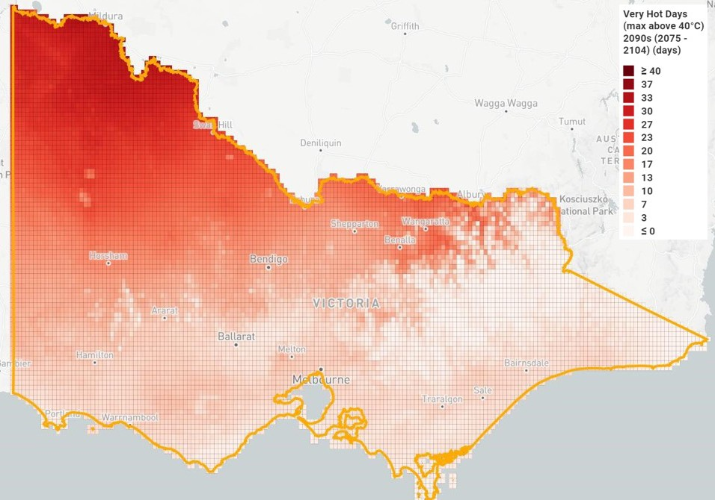

Victoria’s Heat Health Plan defines temperature thresholds above which mortality increases substantially. This is set at 30 degrees Celsius for the
Melbourne region with higher temperatures north of the dividing range, such as 34 degrees Celsius in the Mallee region.²⁴ Figure 6 below shows multi-model mean results for the number of days per year above 40 degrees Celsius across Victoria based on a high-emission scenario (RCP8.5) for 2090. Parts of
north western Victoria may have as many as 33 days over 40 degrees Celsius. See Victoria’s Future Climate Tool (indraweb.io) for further detail.
As heatwaves increase, we are more dependent on
resilient buildings, reliable and affordable energy services, vegetation cover and other site-specific strategies to assist with cooling.²⁵ These elements are critical to effective adaptation. Planning for heatwave risks and ensuring our energy system
is resilient under heat and increased demand pressures can minimise the risk of outages.²⁶ Building design, upgrades and urban cooling responses that decrease local temperatures a few degrees below the defined heat health threshold can help save lives and improve wellbeing – complementing emergency and health response services.

- Information about heat health alert thresholds is updated regularly and can be accessed on the Department of Health website.
- Low Carbon Living CRC (2017) Guide to Urban Cooling Strategies.
- Australian Energy Market Operator 2020, media release – Heatwave conditions in Victoria. See also Energy Networks Australia 2020. Fact sheet: Heatwaves and electricity supply.

Climate change may affect people and communities differently and require tailored responses
Some people may be particularly impacted by climate change because of their social or economic status. This could include, but is not limited to, Aboriginal and multicultural
communities, women, young people and children, LGBTIQ+ people, people with disability, older people and people experiencing homelessness.
In some locations whole communities may be particularly affected by climate change. Specific groups within highly exposed communities may be further disadvantaged.
For example, people with disability may be more disadvantaged than people without disability in responding to climate change. This may be because emergency responses are not inclusive, home modifications are expensive and the built environment is not always accessible. People with disability may also face barriers to receiving or understanding emergency warnings or directions when information is not in accessible formats.
For people who rely on power, such as those using an electric mobility aid or people on life support, losing power can be catastrophic. In an emergency, this puts additional pressure on the health system and is very disruptive to their lives.
It is essential that adaptation efforts involve working with people with lived experience and subject matter experts to codesign and implement accessible and inclusive communications, policies and procedures.

Figure 7 below shows the Heat Vulnerability Index (2018) for Melbourne. It shows the current situation and
is not a forecast of climate change impacts. Locations such as Caroline Springs, Sunshine, Epping, Melton and Dandenong are among the highest impacted areas
shown in dark red. The rating is determined by three components: heat exposure,
sensitivity to heat (due to land cover, population density, and age), and adaptive capacity (for example, socioeconomic advantage or disadvantage)

Heat adaptation action already in place
Incident response
The 2009 heatwave led to an estimated number of 374 deaths in Victoria over what would normally be expected. Subsequent changes under the Heat Health Plan for

Figure 7. Heat Vulnerability Index (2018) for Melbourne
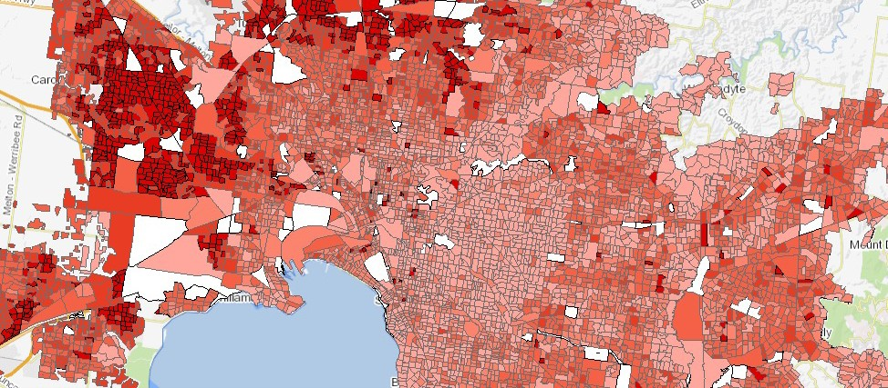

Victoria have improved communication and the provision of early alerts and support to the most at risk.27 The plan is updated each year and refined to prepare for heatwaves and provide support to people before and during emergency events.
Emergency Management Victoria (EMV) also led the development of the State Emergency Response Plan Extreme Heat Sub-plan
to support a coordinated response to heatwaves from all agencies.²⁸

Reducing exposure
Many deaths and health impacts during heatwaves happen in homes. This makes it important to improve home energy efficiency and thermal performance.
In November 2020, the government launched Victoria’s Household Energy Savings Package. The $797 million investment aims to help Victorians reduce power bills and make their homes more energy efficient. The package delivers high-efficiency heating and cooling systems for low-income households; a program of energy upgrades for social housing properties; minimum efficiency standards for rental properties, benefiting renters living in about 350,000 homes; and work to establish 7-star efficiency standards for new homes by progressing National Construction Code updates. As part of changes
to the National Construction Code 2022, Victoria will
remove barriers to installing efficient electric hot water systems, helping households capture further benefits from solar panels and supporting those who choose all-electric new homes. These measures will help homes perform better during hotter weather, improving comfort and affordability.
At a development and neighbourhood scale, Plan Melbourne 2017–2050 Action 91 recommends a whole-of- government approach to cool and green urban areas. As part of the government’s Better Apartments Design Standards, new apartment developments must incorporate cooling
and greening in their design. Urban cooling and greening goals are also supported through a specific action of Plan Melbourne, and work
is underway on proposed planning provisions to retain and extend urban tree canopy cover and specify other design responses to cool the urban environment.
In addition, the government’s
$5 million program to plant 500,000 trees in Melbourne’s western suburbs in conjunction with the Suburban Parks Program will increase the tree canopy and provide cooling across some of our more heat- exposed areas.

System resilience
The Victorian Government works closely with the Australian Energy Market Operator (AEMO) and the energy industry to reduce
reliability risks and improve network resilience. This includes regularly reviewing energy infrastructure and supply resilience, as reported annually in the Energy Sector Resilience Plan and Energy Summer Preparedness Plan.
Energy distribution businesses have obligations and
voluntary arrangements for network resilience. These include reliability standards and other regulations that set clear expectations that distribution businesses have
well-established processes to prevent and mitigate outages.
Severe weather events on 9 June and 29 October 2021 resulted in widespread and prolonged power outages.
In response the government initiated a Distribution Network Resilience Review to consider how to improve network resilience and response to extreme weather events and prolonged power outages.
The risks posed to the distribution network vary, as do the risk management methods. For example,
bushfire risk can be managed by methods that don’t work for storms. Solutions to assure network resilience need to consider the variety of risks.
Possible solutions include storage, undergrounding, microgrids, batteries, large- scale generators and other redundancies, as well as transmission and distribution network redesign.
The Distribution Network Resilience Review will

- Department of Health and Human Services 2020, Heat health plan for Victoria.
- Emergency Management Victoria 2017, State Emergency Response Plan Extreme Heat Sub-plan.

investigate these solutions, and particularly focus on microgrid works that can be undertaken in the short term at key locations identified as at risk to extreme weather events or bushfires. The review will also examine more broadly the role and obligations of distribution businesses for mitigation, response and relief for prolonged power outages.
Solutions need to meet applicable regulatory investment tests and comply with state planning policies and provisions. Where a planning permit is required, relevant planning controls that apply to the land would need to be considered. As would possible environmental impacts, such as native vegetation removal, and off-
site amenity impacts, including visual appeal. AEMO’s Integrated System Plan (ISP) provides a long-term blueprint for developing generation and transmission investment in
the National Energy Market (NEM). Victoria is working with energy market bodies and other jurisdictions to implement the ISP.
In addition, the Reliability and Emergency Reserve Trader function allows AEMO to manage reliability risks by contracting for emergency energy reserves, such
as generation or demand response. AEMO is also taking other actions to support longer-term energy system resilience to climate risks
– documented in its 2020 Integrated System Plan.²⁹ This includes the Energy
Sector Climate Information Project with CSIRO and the Bureau of Meteorology to improve climate and extreme weather information for the electricity sector.
Under the Emergency Management Act 2013, Victoria’s Critical Infrastructure Resilience Strategy includes resilience requirements for critical energy infrastructure.
Critical infrastructure assessed as ‘vital’ is subject to legislative requirements, including specific activities within a resilience improvement
cycle, such as emergency risk management planning, emergency exercises, audits and assurance reporting. The
strategy provides a framework for government and industry engagement. It includes the development of an annual Energy Sector Resilience Plan, the operation of an Energy Sector Resilience Network and provides opportunities to address climate change risk in the energy sector.

Built Environment gaps and opportunities
Planning standards, precinct design and infrastructure are needed to support cooling and greening objectives
Increasing tree canopy for all cities and towns across
Victoria can play an essential role in reducing urban heat exposure. The planning system can play a greater role by updating standards
to retain and expand tree canopy. Increasing tree cover
and parkland as part of new suburban design and delivery also helps respond to future heat risks.
Measures to support the irrigation of landscaped areas will help achieve more effective cooling. The
availability of alternative water supply (such as recycled water) to help keep planted areas green during summer, and the use of water-sensitive urban design to help recharge soil moisture, are important
to support urban tree canopy objectives, especially as the climate warms and average rainfall declines.
Urban design features, such as using lighter coloured surfaces and building materials, are also important, particularly to reduce heat build-up and elevated night- time temperatures.

Improving building infrastructure
Projected temperature increases will require improvements in thermal performance of new and renovated buildings to help keep people safe as heatwaves become more frequent over time. The
greatest impacts are likely to be experienced by residents of the 1.3 million Victorian houses built before 1991.

Heat cross-system responses
Other relevant systems include the Water Cycle (water supply) and Health and Human Services (heatwave advice, warnings and incident support).

- Australian Energy Market Operator 2020, ISP Appendix 8. Resilience and Climate Change.

Drought Risk description
In the long-term, Victoria
will be drier. There is high confidence in projected cool- season rainfall reductions, which may increase the time Victoria spends in drought in the future.^{30,} ³¹ This is expected to influence agricultural land use and where people choose to live and work. Limited urban water availability also has
the potential to increase the cost of urban water services as supply augmentation options become necessary. Insufficient water to irrigate sporting fields, parks and gardens can adversely affect tourism, lifestyle, health and recreation. It can also reduce income for some businesses. These impacts are intensified during droughts and periods of severe water restrictions.

Drought adaptation action already in place
There are a wide range of strategies and programs in place to improve drought resilience and adapt to projected long-term rainfall decline. DELWP and water corporations lead these responses, with significant stakeholder input. They include the Integrated Water Management (IWM) Program, Annual Water Outlooks, Sustainable Water Strategies, Urban Water Strategies and Drought Preparedness Plans.
Programs aimed at drought-proofing sport and recreation facilities, such
as the Sustainable Water Fund’s Community Sport and Recreation Program, have helped make important community assets more resilient to drier conditions.
All urban water corporations must prepare a Drought Preparedness Plan, as part of their Urban Water Strategy, outlining actions to prepare for and respond to water
shortages. These plans record which public open spaces
are, or will be, supplied by alternate water sources and will continue to be irrigated during restrictions.
IWM planning includes targets for increasing alternative water use for appropriate
non-drinking water purposes, such as urban and agricultural irrigation. This improves long- term system resilience by reducing the draw from other supplies. Where recycled water is available, it has the additional benefit of being largely climate independent and assisting drought adaptation.
Efficient water use is essential to making the most of our resources. Educational campaigns such as Target 155 and Target Your Water Use have helped raise awareness of this need. When planning for challenging conditions like droughts, government and the water industry aim to reduce the amount of water lost or wasted before looking to other approaches like developing alternative sources.

Built Environment gaps and opportunities
Planning will need to consider long-term rainfall decline
Some towns face water supply challenges, particularly during extended droughts. Town infrastructure and water- efficient design, coupled
with water conservation and integrated water management practices (for example, greater use of stormwater and recycled water), will improve resilience and liveability.
Regulatory options, such as rainwater tank installation and higher efficiency standards for water fittings and appliances, support water conservation.
They can be a cost-efficient way to conserve high-quality drinking water, improve long- term water security and reduce the need for restrictions during drought.

Water for greening during drought
Keeping gardens and trees alive and healthy contributes to cooling the urban environment.
Alternative water supply to keep gardens and outdoor playing fields functional is also important for social wellbeing during droughts and in our increasingly warmer, drier summers.

Drought cross-system responses
Other relevant systems include the Water Cycle (water supply), Health and Human Services (standards

- Department of Environment, Land, Water and Planning, Victoria’s Climate Science Report 2019 (p. 18 and 24).
- Earth Systems and Climate Change Hub. 2020. Scenario analysis of climate-related physical risk for buildings and infrastructure: climate science guidance.

Figure 8. The impact of heatwaves

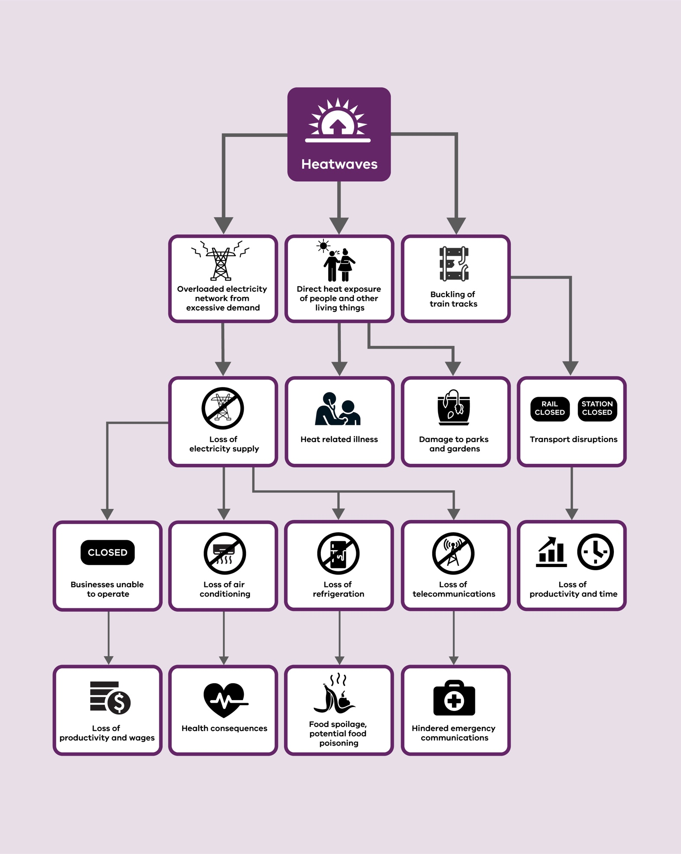

Coastal inundation, sea level rise and erosion
Risk description
Coastlines are ever changing, shaped by wind, waves, tides and sediment dynamics. Coastal erosion and inundation are natural processes; however, when they affect how we use and enjoy our marine and coastal landscapes, we often refer to them as coastal hazards that require management.
The impact of coastal hazards along Victoria’s coastline
is expected to increase in coming decades, with sea level rise and changing weather patterns.
The Intergovernmental Panel on Climate Change (IPCC) projections suggest a global sea level rise of between 0.61 and 1.10 m (above 1986–2005 levels) by 2100 under a high emissions scenario, with a global average sea level rise of 0.84 m.³² In Victoria, sea level is projected to rise by about 24 cm by the 2050s (relative to 1986–2005) under medium and high emissions scenarios. It is current state policy to plan for a sea level rise of not less than 0.8 m
by 2100.
The built environment in Victoria’s marine and coastal areas is likely to
be increasingly exposed to coastal hazards over time,
including sea level rise, inundation and erosion.
Sea level rise involves the combined effects of high tides, storm surges and waves.
If combined with extreme weather, such as heavy rainfall or flash flooding, its effects are amplified.
Insurance company IAG did a preliminary analysis of its
national flood and storm surge hazard dataset to analyse economic costs.³³ It shows
the average annual losses from coastal inundation, which are currently $3.9 million per year in Victoria, are expected to increase by 40% under a future scenario of 2 degrees of global warming, and by 170% under a future scenario of 3 degrees of global warming.
Under a high emissions scenario, 2 degrees of global warming could be reached by the 2030s to 2050s, and 3 degrees of global warming
could be reached by the 2060s to 2080s. Due to modelling uncertainties and a lack of consistent data this should
be considered a sensitivity analysis only. However, it illustrates that potential future costs could be significant.

Coastal inundation, sea level rise and erosion adaptation action already in place
Victoria’s Marine and Coastal Policy sets the direction for managing and adapting to coastal hazards.
All planning schemes include a state policy objective, which requires authorities ‘to plan for and manage the potential coastal impacts of climate change’, and a strategy to ‘plan for sea level rise of
not less than 0.8 m by 2100 and allow for the combined effects of tides, storm surges, coastal processes, and local conditions such as topography and geology when assessing risks and coastal impacts associated with climate change’.³⁴ This provides a consistent policy for land
use planning and coastal management purposes across the state.
A statewide assessment of coastal inundation hazard mapping has been completed and the Victorian Government has funded a range of more detailed assessments.³⁵ Local coastal hazard assessment locations have been prioritised using a baseline vulnerability assessment and emerging adaptation needs.³⁶ An assessment of our most populous coastline – Port Phillip Bay – is underway.37
A local coastal hazard assessment is also underway to inform adaptation planning needs for Inverloch and Venus Bay. The Victorian Coastal Monitoring Program is also providing critical data to inform detailed assessments across the state. Once the state-funded coastal hazard

- Department of Environment, Land, Water and Planning, Victoria’s Climate Science Report 2019.
- A Dyer et al., Floodplain Management Australia National Conference 2019, ‘Regional Sensitivity of Australian Flood Risk to Climate Drivers’.
- Victorian Planning Provision Clause 13.01-2S Coastal inundation and erosion.
- An example of this approach is the Port Fairy Coastal Hazard Assessment (Water Research Laboratory 2013).
- Department of Environment, Land, Water and Planning 2015, Priority locations for detailed coastal hazard mapping and adaptation planning along the Victorian coastline (unpublished).
- Department of Environment, Land, Water and Planning, Port Phillip Bay Coastal Hazard Assessment (DELWP website, accessed May 2021).

exposure and risk assessment is complete, DELWP has programs to support long- term adaptation planning
and help councils translate technical findings into planning schemes.³⁸

Built Environment gaps and opportunities
Opportunity to expand detailed coastal hazard assessments along the coastline
These areas include the Great Ocean Road local government areas, Portland Bay and Corner Inlet in South Gippsland. Progressing hazard assessment work at these and other coastal areas will help land managers and communities prepare for and adapt to increased coastal flooding and erosion. As
part of an ongoing program, detailed assessment will help provide the best available information for decision making along vulnerable parts of our coastline.

Planning for long-term resilience
Building in areas that will be inundated by sea level rise in the future will increase the
risk for people who live there, and the broader society, over time. Even with a design response in policy and/or practice, there is a question about the overall resilience
of building on low-lying land. There is also the issue of a gap between local government
approving a design and it being implemented. Strategic planning for current and future township development plans must consider long-term change in hazard exposure.
DELWP is developing a statewide approach to guide long-term adaptation planning in coastal hazard areas to help progress long-term resilience planning. This complex process benefits from extensive consultation. Starting actions early, before changes become significant, allows time to explore feasible responses.³⁹ These
adjustments also present legal and economic challenges
that will require further investigation.

The Victorian sea level rise benchmark for land use planning and management is under review
The Victorian Government will update the sea level rise planning benchmark based on the latest climate science and assessments. A review is underway based on the International Panel
on Climate Change’s (IPCC) latest projections and how they relate to our coast.⁴⁰ Programs to extend coastal hazard assessments and associated land-use planning responses will support staged, locally relevant responses.
The Marine and Coastal Policy will drive any changes to the sea level rise planning benchmark and the Marine
and Coastal Strategy will inform how sea level rise policy is implemented. This statewide strategy will provide a standardised approach for all levels of government to address sea level rise issues.

Coastal inundation, sea level rise and erosion cross- system responses
Other relevant systems include the Water Cycle (flood policy, planning referrals and infrastructure responses), Health and Human Services (flood-borne disease risk advice and services such
as mental health support for affected communities),
Transport (maintaining access and transport services) and the Natural Environment (complementary coastal public land management to protect developments inland from coastal margins).

Flooding Risk description
Flooding is Australia’s
most expensive natural hazard, when both tangible and intangible losses are considered.⁴¹ Following the 14-year drought of 1996– 2010, Victoria experienced some of the worst floods in its history. Between September 2010 and February 2011, about one-third of the state, including 70 local government areas, experienced some form of flooding or storm
damage resulting in enormous

- Department of Environment, Land, Water and Planning, Coastal planning grants program (DELWP website, accessed May 2021).
- A good example of a consultative process is the Cardno (2015) Geelong-Queenscliff Local Coastal Inundation Hazard Assessment, City of Greater Geelong.
- IPCC, 2019: IPCC Special Report on the Ocean and Cryosphere in a Changing Climate [H.- O. Pörtner, D.C. Roberts, V. Masson-Delmotte, P. Zhai, M. Tignor, E. Poloczanska, K. Mintenbeck, M. Nicolai, A. Okem, J. Petzold, B. Rama, N. Weyer (eds.)].
- Duffy et al., The Geneva Association 2020, Flood Risk Management in Australia | Research report.

community disruption. The estimated cost to the Victorian economy was
$1.3 billion.42 This had wide- ranging impacts across the built environment, including damage to community infrastructure, such as public buildings and roads; disruption to essential services,
including water, electricity and telecommunications; and environmental and public health issues resulting from sewage overflows.
As the climate warms, the intensity of extreme rainfall is expected to increase by about 7% for each degree of warming.⁴³ This will have
cost implications for Victoria. A climate sensitivity analysis by IAG insurance estimated annual average losses from the combined risk of flooding and coastal inundation in Victoria will increase by about 25% and 47% under global warming scenarios of 2 and
3 degrees respectively.⁴⁴ Due to modelling uncertainties, and a lack of consistent data, this should be considered a sensitivity analysis – but it
illustrates the potential growing costs for insurers, which could lead to increased insurance premiums for property owners.

Flooding adaptation action already in place
The Victorian Floodplain
Management Strategy was released in 2016 to guide planning and management, and $21 million was allocated to implement it over 4 years. Since then, additional
State and Commonwealth funding has been allocated to extend Victoria’s flood modelling capability across 70 of the most exposed communities.⁴⁵ The strategy includes an expectation that all new government-funded flood studies consider the impacts of climate change.⁴⁶ DELWP has released Guidelines for Development in Flood Affected Areas, which regional floodplain
managers – Melbourne Water and catchment management authorities – provide additional guidance on. The Victoria State Emergency Service (SES) and Emergency Management Victoria (EMV) lead coordinated responses to flood incidents based on the State Emergency Response Plan Flood Sub-plan, designed to reduce flood impacts on the community, infrastructure and services.

Built Environment gaps and opportunities
Considering climate change in urban planning
Traditionally, town drainage and flood-reduction infrastructure have been
designed for previous climatic conditions. Similarly, building standards and planning responses reflect historic flood patterns. Climate change means risk assumptions
about the likelihood of major floods and other disasters are outdated. Using new technical guidance, all
new drainage and flood management infrastructure should be designed to account for climate change.⁴⁷ Local government, developers and infrastructure managers need to transition to these new approaches. Design measures appropriate to regional climate will be important to support resilience across large and small developments.

Floods can seem unlikely until they happen
The projected pattern of intense rainfall events followed by prolonged drier periods
will make it challenging to ensure flood risk awareness among at-risk communities. The planning and building systems will need to communicate the need for improved flood standards in order to make timely flood reduction investments.⁴⁸ For example, the magnitude and frequency of a 1-in-100-year flood event (a flood with a 1% chance of happening in any single year) experienced in the past will be different

- Comrie, N. 2011, Review of the 2010-11 Flood Warnings and Responses, Victorian Floods Review (p. 19).
- Department of Environment, Land, Water and Planning, Victoria’s Climate Science Report 2019.
- Dyer et al., Floodplain Management Australia National Conference 2019, ‘Regional Sensitivity of Australian Flood Risk to Climate Drivers’. With these estimates of costs from the combined risks of flooding and coastal inundation, flooding contributed 96% of the costs.
- Department of Environment, Land, Water and Planning, Managing floodplains - Flood warning and mapping (DELWP website, accessed May 2021).
- DELWP guidance encourages floodplain management authorities and local councils to undertake flood studies that account for climate change. It refers authorities to Australian Rainfall and Runoff (Book 1 Chapter 6) for interim guidance and a methodology to account for climate change and expected changes in storm behaviour.
- Commonwealth of Australia (Geoscience Australia) 2019, Australian Rainfall and Runoff, A Guide To Flood Estimation (Book 9), Ch 6 Climate Change Considerations.
- Duffy et al., The Geneva Association 2020, Flood Risk Management in Australia | Research report.

to what we experience in future. Developers, planning authorities and the wider public will need guidance and advice to support decision making and accept new practices.

Updating planning scheme responses for flood risk
There is also a need to significantly reduce the time between completing flood studies and incorporating hazard mapping and risk responses into planning schemes and processes, particularly outside the Melbourne metropolitan region. DELWP is developing approaches to help local government implement planning responses. Faster implementation of these studies into planning schemes will reduce the risks to township growth.⁴⁹

Flooding cross-system responses
Other relevant systems include the Water Cycle (flood policy, planning referrals and infrastructure responses), Health and Human Services (flood-borne disease risk advice and services such
as mental health support for affected communities), and Transport (maintaining access and transport services).
The image below shows the projected sea level rise of 0.82 m at Port Fairy. An estimated 173 additional private properties would be vulnerable to future inundation compared with the present day, which would bring the total to 444 properties. There would
be impacts on recreational activities due to beach erosion and impacts on other assets such as roads, stormwater infrastructure and exposure of an old municipal tip.

- Commonwealth Government 2020, Royal Commission into National Natural Disaster Arrangements. Inspector-General for Emergency Management 2019, Review of 10 years of reform in Victoria’s emergency management sector (p. 182). Hughes et al., Floodplain Management Australia National Conference 2019, ‘Communicating planning scheme changes in Victoria’.

Figure 9. Projected sea level rise of 0.82 m at Port Fairy

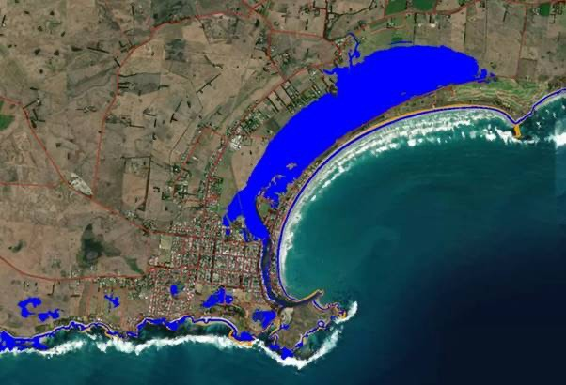

PLANNING FOR
LONG-TERM COMMUNITY RESPONSES TO SUPPORT ADAPTATION, RESILIENCE AND TRANSITION
This section examines the longer-term implications for development and adaptation of existing and new communities.
Key issues include:
- avoiding siting new buildings, infrastructure and urban precincts in high-risk locations
- strengthening design standards for new buildings and infrastructure
- retrofitting existing buildings and infrastructure to ensure they are able to adapt
and respond to increasing hazard levels and reduce their emissions
- preparing for disasters
and improving resilience of existing urban areas
- responding to and recovering from disasters
- transitioning towards place- based responses
- liaising with the financial and property industry.

Making informed choices
– minimising new development risk exposure
It will become increasingly important to redirect urban growth away from high-risk areas.⁵⁰ The suitability of undeveloped urban land in high-risk locations will also need review.51 The Royal Commission noted that ‘development in high-risk areas should be avoided unless risk can be clearly communicated and cost- effectively managed’.⁵²
The built environment is typically long-lasting, making it important to act now to

- Inspector-General for Emergency Management 2019, Review of 10 years of reform in Victoria’s emergency management sector (p. 182).
- Victorian Auditor-General Office 2020, Reducing Bushfire Risks (p. 95).
- Commonwealth Government 2020, Royal Commission into National Natural Disaster Arrangements (p. 410).

avoid poor outcomes for many years to come. Avoiding risk exposure is the cheapest
and most effective adaptation option. A $1 investment in climate adaptation or disaster risk reduction has been estimated to save between
$2 and $11 in post-disaster recovery and reconstruction costs.⁵³ Deloitte Access Economics reported broadly similar findings about avoiding property losses, and health and fatality costs.⁵⁴
Risk modelling that incorporates climate change scenarios is important for decision making. There is significant scope to improve this and present it in map form to support land use planners and other decision makers. This is underway.
Such spatial information also needs to be integrated into planning schemes to update or supplement existing hazard- related overlays. Currently these overlays are based on historic risk mapping in most cases (refer to actions 10 and 12 in Section 5 of this plan).
Current projects undertaking coastal hazard assessments and all recent Victorian Government-funded flood modelling include climate change assumptions.
Therefore, access to relevant risk mapping will improve over time, particularly as
it is given statutory effect through planning scheme incorporation. Innovative tools, such as the UNHaRMED decision support system developed at the Bushfire and Natural Hazards Cooperative Research Centre, provide more sophisticated risk reduction options for a particular location, including structural measures, land use planning changes, building hardening, changes to building codes, and land management advice.⁵⁵ These risk reduction options are referred to in Section 5, actions 7, 8, 9 and 11 of this plan.

Improving the resilience of existing cities and towns
Existing urban areas in some locations are at particular risk because some assets are not designed to deal with anticipated climate hazards. Protective measures need augmentation to respond to climate change. The most vulnerable public and private buildings and infrastructure need to be retrofitted. Some of these responses are
relatively low-cost and advice is readily available.⁵⁶ Similar measures have been applied to essential public and private infrastructure in locations such as New York, as part
of its climate resilience plan following Hurricane Sandy in
2012.⁵⁷ Existing buildings also pose particular challenges because they are not required to improve their natural hazard resilience unless a major redevelopment triggers a planning or building permit.
This is addressed in Section 5, actions 4, 5, 6, 14 and 16 of this plan.

Responding to communities facing extreme risk
As highlighted by the 2009 and 2019–20 bushfires, the recovery philosophy of ‘build back better’ following a disaster event is critical. As stated by the Royal Commission: ‘Upfront investment in stronger infrastructure and more resilient communities can save money for all levels of
government in the long term’.⁵⁸
As climate-driven conditions change over coming decades, it is likely some land designated for development – and even some parts of urban areas and towns – cannot
be sufficiently protected to safeguard residents and dwellings. For a small number of highly exposed locations, building back in the same location might pose an unacceptable risk to life and property, irrespective of the extent of possible building and infrastructure improvement.

- CSIRO 2020, Climate and Disaster Resilience.
- Deloitte Access Economics 2017, Building resilience to natural disasters in our states and territories (p. 30).
- Bushfire and Natural Hazards CRC 2019, Unharmed Framework Report.
- Melbourne Water 2020, Flood Resilient Guide to Retrofitting Your Home. Victorian Building Authority, A guide to retrofit your home for better protection from a bushfire.
- NYC Mayor’s Office of Resiliency 2020, Climate Resiliency Design Guidelines.
- Commonwealth Government 2020, Royal Commission into National Natural Disaster Arrangements (p. 481).

History can provide helpful lessons relevant to all hazards. For example, the town of Grantham was relocated to higher ground after severe flash flooding damage during the 2011 Queensland floods.⁵⁹ This required a voluntary
land-swap initiative, a special planning and building approval pathway process and an $18 million incentive program.⁶⁰
Following Hurricane Sandy in 2012, New York State defined buy-out areas for
three severely affected coastal locations.⁶¹ The East Shore Special Coastal Risk District and Rezoning plan involved voluntary buy-outs, rezoning, allowing the elevation of existing buildings to occur
as-of-right, and density limits on future land use.⁶² A 6-year process, this plan
highlighted the advantage of undertaking earlier work on these options and the need for well-supported community engagement processes.
Hazards such as rising sea levels and associated coastal erosion can impact freehold land, posing a range of property law issues that will require legal and government determinations.⁶³ Legal issues include liability considerations, development rights and cost recovery charges for protective works.⁶⁴ Governments at all
levels need to understand the financial and legal risks posed to them through inaction, as these costs will be passed onto the public into the future.
Community relocation or transition might not need to occur for many years, but
it is sensible to prepare in advance. Part of this work could involve developing contingency plans, ready for when responses are needed (see actions 17 to 19 in this plan). This includes looking at economic and planning options to support responses, and exploring legal and financial tools to ensure the
process is fair, straightforward and efficient.
Bushfire Recovery Victoria (BRV) was established in 2020 after the 2019–20 Eastern Victoria bushfires. This new organisation works directly with communities to support recovery and resilience.
Its activities will contribute to long-term resilience by
supporting community-driven responses and local economic recovery. Over coming years, extending this recovery
model to other emergency events and building long-term resilience to other hazards could be considered.

Liaising with the financial and property industry
The property industry is a key participant in investment decisions that will be affected by climate change. Property and the different stakeholders involved are dynamic participants in
the built environment – developing, building, owning, investing, managing and occupying. Contributors range from major Australian banks and international institutions to individual owners and investors. Banks and insurance providers are increasingly assessing the risks, liabilities and costs associated with exposed assets and proposed investments. This presents an opportunity to improve
climate risk awareness across all investor categories and support informed decision making by financiers and borrowers.
In Victoria, insurance costs could increase as elevated climate risk is factored into premiums. There is also a mortgage risk for properties impacted by climate change. Over time, this is likely to have implications for land use planning. Closer liaison between the insurance and
banking industry with strategic planning is a future priority.

- Okada et al., International Journal of Disaster Risk Reduction Volume 8 2014, ‘Recovery and resettlement following the 2011 flash flooding in the Lockyer Valley’.
- Brisbane Times 2020, ‘Grantham reborn: Meet the little Queensland town that moved’.
- NYC Department of City Planning, https://www1.nyc.gov/site/planning/plans/resilient-neighborhoods/east-shore-rezoning.page
- NYC Department of City Planning, https://www1.nyc.gov/site/planning/plans/resilient-neighborhoods/east-shore-rezoning.page
- NYC Department of City Planning 2017, East Shore Buyout Areas Special Coastal Risk District and Rezoning.
- The Public Land Consultancy 2019, The Coast and the Cadastre.
- Wiltshire, A et al., Victorian Centre for Climate Change Adaptation Research 2014, ‘Managing the Uncertainty and Risks of Climate Change Legal, Information and Insurance Issues’.

A homeowner cannot get a mortgage without insurance and future premium increases could make it difficult for people to pay their insurance costs, making it important to explore assistance measures. These could include supporting affected people
to improve the resilience of their property or move to an alternative location, without inadvertently creating an incentive to build in high- hazard locations. Additionally, mortgage risk needs to be measured over the term of the mortgage while insurance risk is determined on a yearly basis.

Climate change adaptation actions: 5 year plan
This plan has 3 priority areas and 19 actions. The actions are built on the extensive work and programs already underway, informed by strategies such as Victoria’s Climate Change
Adaptation Plan 2017–2020 and Plan Melbourne 2017–2050. Detailed recommendations with regard to actions have been made in submissions to the plan. When preparing work plans and programs for individual actions, these detailed recommendations will be considered as part of the approach to implementing the actions. An assessment of what the community has said will be an input into project planning.
Implementation plans will also require input from other systems identified in the plan. Coordination will ensure cross-system issues, risks and priorities are incorporated into implementation plans where applicable.

GOVERNANCE AND REGULATION
A safe and resilient built environment is essential to community wellbeing. To better manage risks, we are adapting our built environment and the way we make decisions about it. This includes considering climate change impacts in
decisions about how we plan for and build communities and engaging with people who are most at risk from the adverse effects of climate change.
Including diverse voices at all stages of planning and implementation is critical to this.
The following proposed actions contribute to the update of planning systems and processes and the reform of building and infrastructure standards.

Proposed actions Explanation

- Update planning provisions to respond to climate change based on the most current advice from relevant natural resource and emergency management authorities.
The update of planning, building and infrastructure standards is essential. The changes need to be evidence-based and tied to information availability from relevant expert authorities.
Responses include:
- Floodplain management authorities and local government.
- Review the landslide policy and strategic approach in the planning system, including the Erosion Management Overlay, as more extreme rainfall events and bushfires will increase risk.
- Update planning schemes to include new provisions aimed at reducing urban heat exposure, including targets and standards such as minimum tree canopy cover.
- Investigate approaches to consider storm risk to electricity supply reliability when assessing development.
- We also need to manage growth and development of cities and towns across the state in light of climate change. Steps to support these measures include:
- Prepare guidelines to support development of climate change adaptation and risk reduction plans.
- Include a reference to Australian Standard 5334-2013: Climate change adaptation for settlements and infrastructure: A risk-based approach in planning system documentation to support systematic approaches to climate change adaptation for built environment and infrastructure planning and development.

Proposed actions | Explanation
- Review bushfire provisions in planning schemes and building standards when bushfire risk modelling that accounts for climate change or localised bushfire risk modelling is available. | As this new capability is developed, modelling bushfire risk can be used to help understand the long-term consequences of more bushfires under climate change, and to support future strategic land-use planning and design of more resilient buildings. Consideration of local inputs will be an important part of accurately identifying risk.
- Update building standards relevant to flood, heatwaves and storm exposure to account for projected climate change hazards, consistent with the typical asset lifecycle, location and use. | Building standards must respond to elevated hazards posed by climate change. These are coordinated through a national process but Victoria can be active in supporting necessary changes, including changes specific to Victoria.
- Pursue opportunities for upgrades of existing building stock, with a focus on improvements  to housing for low-income and vulnerable Victorians to enhance resilience to increasing heat and other climate-related hazards. | Responses include:  - Pursue opportunities for energy efficiency upgrades to deliver multiple resilience benefits to increased heat from climate change (for example, improved insulation, and access to efficient heating and cooling), with a focus on vulnerable persons.  - Examine options to retrofit buildings to better withstand hazards (particularly bushfire, heat and floods), including retrofitting guidelines or minimum standards drawing on best-practice advice and learnings from existing Victorian Government programs
- The Distribution Network Resilience Review will examine strengthening energy infrastructure resilience including reviewing adequacy and robustness of existing frameworks. | The following processes currently support adaptation responses for energy infrastructure:  - The Energy Sector Resilience Network, convened by DELWP, provides an ongoing forum for operators of ‘vital’ critical infrastructure and government to discuss sector challenges, and for development of risk assessments and resilience improvement initiatives, including in response to climate change, as an input to Victoria’s Critical Infrastructure All Sectors Resilience Report.  - In 2021, the guidance provided to operators of ‘vital’ critical infrastructure, who are required to prepare an Emergency Risk Management Plan, will be assessed to ensure it adequately incorporates key emergency risks, including climate change  - Modelling of climate change impacts will be considered in future phases of the Powerline Bushfire Safety Program.
- Develop support programs for vulnerable persons and communities highly exposed to climate change impacts to improve hazard resilience. | Responses include:  - Develop a methodology to consider climate change in terms of social impacts, distributional and equity impacts, and self-determination of Traditional Owners and Aboriginal Victorians.  - Prepare a needs assessment, in partnership with government agencies, the social services sector and people with lived experience, to understand additional support measures needed for vulnerable persons living in highly exposed communities.  - Develop a program to support the self-determination of Traditional Owners and Aboriginal Victorians in finding support measures needed for their communities.  - Improve accessible and culture-specific information for vulnerable persons.  - Enhance government communication and outreach procedures to meet the needs of diverse, highly exposed communities and focus on vulnerable persons.
- Improve the skills and capacity of practitioners, industry and community organisations to understand and implement climate change management responses. | Responses include:  - Identify existing community and industry skills.  - Identify climate change leadership needs to support community-led adaptation.  - Develop approaches to train and upskill:  - community leaders in non-government organisations involved in community-led resilience and adaptation response planning, which could include advocacy services and disability services  - community leaders to act as community climate change ambassadors especially in highly exposed communities  - Traditional Owner and Aboriginal Victorian community leaders to act as community climate ambassadors  - heritage and built environment industry professionals regarding the relationship between heritage, energy efficiency, thermal performance, climate change and disaster risk management, utilising a standard risk assessment methodology tailored for heritage places and their values  - key industry professionals about design and construction methods to increase climate change resilience of existing, heritage and planned residential and commercial buildings (in conjunction with related sector capability building activities)  - strategic and statutory planners, and state and local government engineers in knowing how to reduce community exposure to climate-related hazards.
- Extend spatial mapping and hazard exposure modelling to support land use and infrastructure planning, design and investment. | Build on information products and existing tools using the Victorian Climate Projections to improve hazard-and-risk spatial representation, as well as population growth trends in light of climate change to inform decision making. A key part of this action is aligning state spatial information and modelling to support local councils and government investment in adaptation
- Support decision making by practitioners working in planning, infrastructure and building development and approval. | Responses include:  - Review scope to develop a whole-of-government framework for adaptation planning and decision making across the built environment, incorporating existing processes such as the critical infrastructure resilience framework.  - Develop a process to assist local government, institutional organisations and major infrastructure providers in developing local-scale adaptation action plans and actions.  - Examine opportunities for targeted legislative and regulatory change to integrate climate change adaptation more comprehensively.  - Work across DELWP and with EMV to incorporate plausible scenarios into strategic planning for urban land use and critical infrastructure, consistent with the National Disaster Risk Reduction Framework.  - Investigate broader use of the Marine and Coastal Policy’s pathway approach to decision making to identify thresholds or triggers for new decisions.  Review options to develop a project-focused climate framework including:  - spatial mapping of risk and impact classifications  - identifying thresholds or risk triggers  - project options assessment tools  - establishing best-practice treatments, case studies, and guidelines focused on going above and beyond minimum standards.

The outcome sought is an overarching project process to holistically resolve complex issues designed for both state, local government and industry.

PLACE-BASED ACTIONS
The State Government has a leading role in determining how we respond to natural hazards that affect the built environment, including bushfire, coastal and inland
flooding, erosion, drought and heatwaves.
Electricity loss during extreme weather events can be very damaging to local communities, sometimes forcing evacuations,
increasing hospitalisations and reducing long-term economic activity.
To protect our critical infrastructure, an ‘all hazards, all emergencies’ approach to building resilience is applied. Climate change amplifies these hazards, so adaptation responses are now being included as part of statewide processes to manage our critical infrastructure, supply chains and services.
Victoria already has a decentralised, place-based emergency response capability through Fire Rescue Victoria, the Country Fire Authority, the State Emergency Service and
Victoria Police, along with the emergency management responsibilities of local government.
To complement the work of these agencies and EMV’s coordination role, additional work is needed to support long-term resilience and risk reduction across the built environment, tailored to each region’s needs. The following actions are proposed for this.

Proposed actions | Explanation
- Prepare measures to help local government update planning scheme instruments (zones and overlays) to reflect climate change risks based on the best-available data and climate change science, including flood and sea level rise responses as priorities. | Responses include:  - Support planning scheme responses to coastal hazards in at-risk communities where a state-funded coastal hazard and risk assessment has been completed.  - Develop support measures to help local government translate new and existing flood data and flood studies into planning schemes.  - Investigate measures to improve energy system resilience in response to more frequent and intense storms.
- Support climate change adaptation, risk reduction, response and recovery plans for the most exposed regional cities and towns. | Establish an agreed framework and pilot program across all relevant emergency services, departments and local government peak bodies for all-hazard, all-agency strategic response plans complementing (and where appropriate integrating with) existing plans such as Municipal Emergency Management Plans, Regional Emergency Management Plans and Cultural Heritage Management Plans. This would include strategies to reduce impacts and build resilience for vulnerable persons and highly exposed communities through co-designing solutions. The Distribution Network Resilience Review will explore whether distribution businesses could better anticipate locations in their network more vulnerable to long-tail reconnection. It would also include working with Traditional Owners and Aboriginal Victorians on Caring for Country principles as well as self-determination approaches for their communities. An  all-hazards response includes addressing multiple hazards and where there can be overlapping events exacerbating the impacts.
- Review strategic planning responses to elevated bushfire risk due to climate change based on advice from natural resource and emergency management authorities. | When next-generation bushfire risk modelling that accounts for climate change is available, strategic planning for Victoria’s most at-risk locations can be reviewed, along with specific response plans for the most risk-exposed places.  Responses include:  - Re-examine regional-level land use, economic and community support plans.  - Undertake more extensive work for high-risk communities. Responses could build on existing Municipal Emergency Management Plans and other relevant programs (see action 11), and review township development options ranging from improvements to the level of hazard management or protection through to planned long-term retreat. Drawing on best-practice advice and learnings from Traditional Owners and Aboriginal Victorians. Extensive community consultation would be needed to review options based on advice from natural resource, emergency management and planning authorities (see action 18).
- Support drought resilience planning for regional cities and towns. | Develop planning, building and asset management options for the most exposed locations in conjunction with local government, water authorities, catchment management authorities and Traditional Owners and Aboriginal Victorians to complement Urban Water Strategies and Drought Preparedness Plans.
- Support development of place-based resilient energy generation. | Responses include:  - Support microgrids, neighbourhood batteries and community-owned renewable energy projects, including funding pilot projects in bushfire-affected communities in eastern Victoria.  - To strengthen distribution network and community resilience to prolonged power outages, the Distribution Network Resilience Review will consider the regularisation of temporary relief measures such as the Small Generator Program.
- Develop approaches for ongoing management of culturally significant and heritage places in risk-exposed locations, including emergency management activities during a hazard event. | Responses include:  - Categorise the risk status of locations and assets in culturally significant and heritage places under different climate change scenarios, and identify at-risk locations in conjunction with local government, Heritage Victoria and other groups. When culturally significant and heritage places are related to Aboriginal values, approaches should be led by Traditional Owners and Aboriginal Victorians.  - Prepare detailed assessments of the built environment’s priority assets/values facing the greatest threats from elevated fire and/or flood risk, and recommend treatments incorporating input from relevant asset managers, Traditional Owners and Aboriginal Victorians, Heritage Victoria and Aboriginal Victoria.
- Develop program options to support local climate adaptation initiatives. | Partner with and support council and community-driven projects implementing climate change adaption initiatives. Supporting tangible adaptation responses on issues that matter most to local people, particularly those from vulnerable cohorts, would be a priority.

HARNESS ECONOMIC, FINANCIAL AND LEGAL TOOLS
Climate change poses scale and magnitude challenges rarely experienced in our history. Our economic,
Proposed actions | Explanation
- Assess options to use economic tools to facilitate climate change adaptation outcomes. | Review opportunities for use of economic tools to support delivery of climate change adaptation outcomes.
- Assess financial measures and insurance responses to support adaptation. | This could involve examining national and international best practice for the built environment. It would focus on funding and investment strategies to improve the resilience of existing assets, insurance pricing and equity of access, and support for long-term resilience of the most exposed communities.
- Review legal mechanisms to support climate-resilient urban development. | Identify legal barriers and reform opportunities to support long-term adaptation by assessing options across the legal framework.
financial and legal systems are an important part of the Built Environment system and will be impacted by climate change. In turn, these systems can support the process of adapting the built environment
to climate change.
The following actions are proposed for this.

6. Monitoring, evaluation, reporting and improvement

Adaptation is a complex and ongoing process, which can be difficult to measure.
Success often means avoiding or reducing negative impacts, which makes it difficult to match outcomes to previous protective measures. There can be significant periods between intervention and measurable impacts, making it difficult to assess effectiveness compared with other projects. It can also be difficult to attribute outcomes to a particular adaptation action alongside economic, societal or technological changes happening at the same time.
Effective climate change adaptation actions depend on the local context and diverse processes across states, regions, sectors and organisations, as well as community and business responses. This means there is no off-the-shelf approach to monitoring and evaluating. However, the Victorian Government is committed to developing a robust, tailored monitoring
and evaluation system to help
ensure adaptation initiatives effectively reduce risks to the community, infrastructure, economy and environment.
DELWP is committed to building and maintaining a strong evidence-based culture. This is a critical aspect of strategic decision making, public sector accountability, efficient and effective management and continuous improvement. Monitoring
and evaluation are important aspects of the evidence-based approach because they enable us to learn, improve and demonstrate accountability.
A fit-for-purpose monitoring, evaluation and learning framework will be developed to guide this plan’s implementation.
The framework will include quantitative and qualitative data collection methods. This could include: developing
an outcome logic model, identifying key evaluation questions, data collection methods, judgement criteria and formal evaluation requirements. Data collection
to support monitoring and evaluation will be integrated in the plan’s day-to-day implementation to maximise the effectiveness and efficiency of investments.
The government will develop a best-practice monitoring and evaluation framework, which will:
- incorporate community feedback
- identify key action outputs and outcomes
- establish and measure baseline indicators
- track indicators to monitor adaptation success.
Evaluating the actions in this plan will help track the Built Environment system’s climate change adaptation progress and inform future planning.

Appendices

APPENDIX 1: LEGISLATION AND POLICY RELEVANT TO BUILT ENVIRONMENT ADAPTATION

Table 4. Legislation, strategy, policies and programs relevant to the Built Environment system

Where we live and how we build
Response to emergencies and climate change
Community services

LEGISLATION
  - Land Act 1958
  - Transfer of Land Act 1958
  - Valuation of Land Act 1960
  - Sale of Land Act 1962
  - Environment Effects Act 1978
  - Housing Act 1983
  - Land Acquisition and Compensation Act 1986
  - Planning and Environment Act 1987
  - Subdivision Act 1988
  - Building Act 1993
  - Project Development and Construction Management Act 1994
  - Regional Development Victoria Act 2002
  - Aboriginal Heritage Act 2006
  - Victorian Renewable Energy Act 2006
  - Major Transport Projects Facilitation Act 2009
  - Environment Protection Act 2017
  - Heritage Act 2017
  - Victorian Planning Authority Act 2017
  - Residential Tenancies Act 2018
POLICIES AND PROGRAMS

  - Country Fire Authority Act 1958
  - Fire Rescue Victoria Act 1958
  - Water Act 1989
  - Victoria State Emergency Service Act 2005
  - Charter of Human Rights and Responsibilities Act 2006
  - Emergency Management Act 2013
  - Climate Change Act 2017

  - Public Health and Wellbeing | Act 2008
  - Local Government Act 2020

Plan Melbourne 2017–50 Victorian Emergency Management Strategic Action Plan
Heat Health Plan for Victoria Victorian Healthy Homes Program
Victorian public health and wellbeing plan 2019–2023

Utilities and infrastructure
Natural systems and environmental management
Finance and insurance risk

LEGISLATION
  - Water Act 1989
  - Water Industry Act 1994
  - Electricity Safety Act 1998
  - Electricity Industry Act 2000
  - Safe Drinking Water Act 2003
  - Road Management Act 2004
  - Water Efficiency Labelling and Standards Act 2005
  - Transport Integration Act 2010
  - Infrastructure Victoria Act 2015

  - Crown Land (Reserves) Act 1978
  - Alpine Resorts Act 1983
  - Planning and Environment Act 1987
  - Water Act 1989
  - Catchment and Land Protection | Act 1994
  - Environment Protection Act 2017
  - Marine and Coastal Act 2018
  - Great Ocean Road and Environs Protection Act 2020

  - Standard Insurance Company Limited Act 1962
  - Victorian Managed Insurance Authority Act 1996

POLICIES AND PROGRAMS
  - Critical Infrastructure Resilience Strategy
  - Energy Efficiency and Productivity Strategy
  - Powerline Bushfire Safety Program
  - Renewable Energy Action Plan
  - Community Microgrid and Sustainable Energy Program
  - Summer Preparedness

  - Biodiversity 2037
  - Marine and Coastal Policy 2020
  - Water for Victoria
  - Victorian Floodplain Management Strategy

APPENDIX 2: CROSS-SYSTEM RISKS AND RESPONSES

Table 5. Connections between the Built Environment and other AAP systems

Scope of other AAP systems Interactions with the Built Environment system

Education and Training
The services and assets primarily engaged in the planning, development, provision and support of education and training, including future workplace skills and needs.

Health and Human Services
Services and assets primarily engaged in protecting human health from disease resulting from or associated with
communicable disease, food, water or the environment; and the services and assets that provide human physical and mental health care, social support and assistance.

Natural Environment
Land, water over that land, and the soils and biodiversity associated with that land; coastal waters of the state and the land and biodiversity under those waters; and the
ecological processes and systems associated with the things set out above. Land-based ecosystems such as grasslands and
forests, aquatic ecosystems such as rivers and wetlands, and coastal and marine ecosystems such as mangroves and sea- grass meadows. These ecosystems contain more than animals and plants. They are also about the rocks and soil that support life, and the climatic, water and fire conditions that plants and animals have evolved in.
Primary Production
Agriculture, productive fisheries and plantation forestry, alongside the infrastructure, workforce and communities that support them. This includes water management within the boundaries of the system and on-farm forestry.

- Provide skill and capability training to the building, property development and planning sectors to support responses to climate change adaptation challenges.
- Train community leaders and organisations to assist with input and contribution to climate change adaptation.
CROSS-SYSTEM RISKS: Skill and training gaps.

- Access planning for hospitals and other medical services to ensure access for staff and patients, and that communities and health services can access critical goods.
- Integrate heat event and bushfire preparedness with preventative measures, including planning, building and infrastructure measures, informed by health advice.
- Respond to increasing temperatures, periods of drought and bushfire using urban design and management actions to maintain cool, green and pleasant urban environments as much as possible to support health and wellbeing.
CROSS-SYSTEM RISKS: Impacts of heatwaves and bushfire smoke on health and wellbeing.

- Land management responses to protect communities from fire risk.
- Advice and mapping to help address potential conflicts between biodiversity and sites for urban development responding to flood or fire risk.
CROSS-SYSTEM RISKS: Biodiversity impacts from development protection works. Loss or damage to heritage or culturally significant sites from bushfire
management activities.

- Strategic land use and primary production planning to balance needs to shift urban growth away from hazard-exposed areas, against impacts of urbanisation on highly productive agricultural land where possible.
- Manage potential for competing demand between urban and agricultural water supply needs through forward planning and investment in supply options.
CROSS- SYSTEM RISKS: Competition for land and water resources.

Transport
All the components for the movement of persons and goods including physical components, including transport networks, facilities and vehicles; and services components, including passenger, freight, and other transport services to move persons and goods.

Water Cycle
The collection, storage, treatment, delivery and supply of water, including recycled water; sewerage services, including the collection, treatment and disposal through sewerage systems and treatment plants; drainage services including the operation of drainage systems; flood management – flood
management services including the operation and maintenance of infrastructure to manage floods.

- Maintain access in and out of communities in the event of a hazard.
- Maintain transport supply chains to support business and urban functions.
- Protect the safety and comfort of public transport users during heatwaves.
- Maintain public transport service continuity during heatwaves and floods (when safe to do so).
- Manage development approval near transport corridors to ensure development does not prejudice capacity to undertake bushfire and flood protection works.
- Use transport corridors to support urban greening and cooling objectives.
- Maintain and protect electricity supply to the tram and train network during hazard events.
- Seek opportunities to co-design shaded walking routes to transport nodes and standards for public transport stops.
CROSS-SYSTEM RISKS: private, public and active transport disruption; transport supply chain and service delivery disruptions. Heatwave impacts on user health
and wellbeing.

- Plan infrastructure and protection works to prevent floods from affecting the built environment, and reduce the impact of those that can’t be prevented.
- Provide flood levels and design standards that factor in climate change considerations to support urban development and building assessments.
- Play a role in funding flood/coastal inundation protection works.
- Urban water supply planning to support township growth and maintain supply during drought.
- Consider the function of new rural, residential, stock and domestic dams for firefighting in relation to the impact of reducing stream flow to downstream agricultural users and the environment.
- Integrate stormwater drainage into the built environment and/or use recycled water to support urban cooling and greening objectives.
- Collaborate on water efficiency outcomes for buildings and houses.
CROSS-SYSTEM RISKS: Water availability – competition between urban water
needs and other users. Capacity to resource referral advice in relation to climate change risks.

APPENDIX 3: GLOSSARY AND ABBREVIATIONS

Term Definition*
Aboriginal Refers to both Aboriginal and Torres Strait Islander peoples. They may have connections in and outside of Victoria. Adaptation Changes made in response to the anticipated threats and opportunities arising from climate change.
Adaptive capacity Ability of the built environment to respond to climate change to moderate potential damages, take advantage of opportunities, or cope with consequences.

Adaptation measures
Anthropogenic climate change
Actions intended to reduce impact of threats or to exploit opportunities arising from climate change. Long-term changes to the Earth’s climate caused by human activity such as greenhouse gas emission.

Assets(s) Something that has actual or potential value to the built environment.

Built environment The Climate Change Act 2017 defines the built environment as “the places and structures built or developed for human occupation, use and enjoyment”.
The Built Environment Adaptation Action Plan considers the Built Environment system, which includes our cities, towns and regional areas, and how people use and interact with services, infrastructure, buildings, natural and cultural features, and public places. It is the sum of multiple interdependent processes and activities. It includes how we enjoy and form connection to place.
Climate Average weather based on the statistical description in terms of the mean and variability of relevant quantities, such as temperature, precipitation and wind over an extended period of time.

Climate change A statistically significant variation in either the mean state of the climate or its variability, persisting for an extended period (typically decades or longer).

Climate change scenario
Difference between a climate scenario and the current climate.

Climate scenario Coherent description of a possible future state of the climate.

Co-benefits An additional benefit from an action that is undertaken to achieve a particular purpose that is not directly related to that purpose.

Communication and consultation
Community engagement
Connection to place
Processes that an organisation conducts to provide, share or obtain information and to engage in dialogue with stakeholders and others regarding the management of risk.
Communication and consultation focused on local communities.

Place attachment and connection is the bond between person and place, and processes involved in establishing this relationship. It involves feelings, memories, associations, sense of identity, practices, expressions and representations. In terms of climate change, it is increasingly experienced as the grief in loss, and threat, to place.

Consequence Outcome of an event affecting objectives.

Contingency plan Any plan of action that allows an organisation to respond to events should they occur. Control Measure that is modifying risk.

Cross-system risks
Refers to risks such as bushfire and food security that impact (and are impacted by) multiple systems and are addressed across multiple AAPs.

Drivers of change New climate information; triggers and signals; social, cultural and economic change. Embodied energy Embodied energy is the sum of all the energy required to produceany goods or services.

Emergency management
The process of planning and preparing for, responding to and recovering from emergencies, which could be bushfires or floods.

Emissions In the context of this AAP, emissions means greenhouse gases such as carbon dioxide and nitrous oxide which are produced by human activity and contribute to climate change.
Event Occurrence or change of a particular set of circumstances.

Extreme weather event (EWE)
Flexible/reversible actions
Weather phenomena that are at the extremes of the historical distribution, including especially severe or unseasonal weather.
Actions that can be easily retrofitted or upgraded.

Governance The framework of rules, relationships, systems and processes by which an enterprise is directed, controlled and held to account and whereby authority within an organisation is exercised and maintained.

Green infrastructure
The network of natural and built landscape assets, including green spaces and water systems (sometimes referred to as blue infrastructure) within and between townships and urban areas.

Hazard A situation that has the potential to cause loss of service from a system or damage to people or assets.

Heritage places Places of natural, historic, cultural, aesthetic, scientific, social, creative, technical and Traditional Owners and Aboriginal Victorians value. They may provide information of past activity, such as but not limited to, historical and archaeological sites which contain an artefact, deposit or features that are 75 or more years old. It refers to both Aboriginal and non- Aboriginal occupation of place.
Heritage values Cultural meaning found in a heritage place; it articulates why a heritage place is important to communities. A heritage place can have more than one heritage value, and places may have a range of values for different individuals or groups.

Impact A threat or an opportunity that may arise as a result of either the weather or climate change, both in the short and long term, and represents the fact that an issue is one that is constantly evolving.
Infrastructure Assets or systems of assets that support our society.

Insurance risk Loss of access to insurance due to reduction of insurance coverage at reasonable rates.

Life-cycle Time interval that commences with the identification of the need for an asset and terminates with the decommissioning of the asset or any associated liabilities.

Likelihood Chance of something happening.

Maladaptation Actions that may lead to increased risk of adverse climate-related outcomes, increased vulnerability to climate change, or diminished welfare now or in the future.

Monitoring Continual checking, supervising, critically observing or determining the status in order to identify change from the performance level required or expected.
Natural variability The degree to which climate varies from day-to-day or year-to-year in the absence of long-term climate change. No regrets actions Actions that have no net costs even in the absence of climate change.
Outcomes The way a thing turns out.

Pathways Scenarios that describe how global society and hence greenhouse gas emissions may change in the future. Physical risks Risk of actual harm to assets due to climate change.
Residual risk Risk remaining after risk treatment.
Resilience Adaptive capacity of an individual, community or organisation in a complex and changing environment.

Retreat Large-scale relocation of infrastructure or communities away from a hazard, such as removing housing from coastal areas subject to sea level rise.

Review Activity undertaken to determine the suitability, adequacy and effectiveness of the subject matter to achieve established objectives.
Risk Effect of uncertainty on objectives.

Risk analysis Process to comprehend the nature of risk and to determine the level of risk. Risk assessment Overall process of identifying, analysing and evaluating risk.
Risk identification Process of finding, recognising and describing risks.

Risk management framework
Risk management plan
Risk management policy
Risk management process
Set of components that provides the foundations and organisational arrangements for designing, implementing, monitoring, reviewing and continually improving risk management throughout the organisation.
Scheme within the risk management framework that specifies the approach, management components and resources to be applied to the management of risk.
Statement of the overall intentions and direction of an organisation related to risk management.

Systematic application of management policies, procedures and practices to the activities of communication, consulting, establishing the context, and identifying, analysing, evaluating, treating, monitoring and reviewing risk.

Risk owner Person or entity with the accountability and authority to manage the risk. Risk profile Description of any set of risks.
Risk source Element that alone or in combination has the intrinsic potential to give rise to risk. Risk treatment Process to modify the risk.
Safety margin Designing infrastructure to cope with greater than the anticipated full extent of likely climate impacts. Secondary risks A risk that will arise as a result of responding to another risk.

Sensitivity (to climate change)
Degree to which the built environment is affected, either adversely or beneficially, by climate-related stimuli.

Stakeholder Person or organisation that can affect, be affected by, or perceive themselves to be affected by a decision or activity.

Stranded assets A stranded asset is something that once had value or produced income but no longer does, or is reduced, due to external change. In the context of adaptation, it may be a devalued property in a high-risk location that can no longer receive affordable insurance.

System The 7 systems listed in the Climate Change Act 2017 (including the Built Environment system).

Transformational change
To change the fundamental attributes of a system to reduce root causes of climate change and risks from climate change.

Transitional risks Risks that are created as a result of action to reduce changes in climate or adapt to climate change.

Vulnerability (to climate change)
Degree to which a system is susceptible to, or unable to cope with, adverse effects of climate change, including climate variability and extremes.

*As described in the Australian Standard (AS 5334–2013)

REFERENCES
Australian Building Codes Board 2019, National Construction Code, https://ncc.abcb.gov.au/
Australian Building Codes Board 2012, Construction of building in flood hazard areas, https:// www.abcb.gov.au/Resources/Publications/Education-Training/Construction-of-Buildings-in-Flood- Hazard-Areas-Standard
Australian Energy Market Operator 2020, ISP Appendix 8. Resilience and Climate Change, https://aemo.com.au/-/media/files/major-publications/isp/2020/appendix--8.pdf
Commissioner of Environmental Sustainability Victoria 2012, FOUNDATION PAPER | ONE Climate Change Victoria: the science, our people, and our state of play, https://www.ces.vic.gov. au/sites/default/files/publication-documents/1-62.pdf
Commonwealth Government 2020, Royal Commission into National Natural Disaster Arrangements, https://naturaldisaster.royalcommission.gov.au/
Comrie N. ‘Review of the 2010-11 Flood Warnings and Responses’, Victorian Floods Review 2011, http://www.floodsreview.vic.gov.au/images/stories/documents/review_20101011_flood_ warnings_and_response.pdf
CSIRO 2020, Climate and Disaster Resilience, https://www.csiro.au/en/research/natural- disasters/bushfires/report-climate-disaster-resilience
CSIRO 2019, Victorian Climate Projections, https://www.climatechange.vic.gov.au/adapting-to- climate-change-impacts/victorian-climate-projections-2019
Department of Environment, Land, Water and Planning 2021, Victoria’s Climate Change Strategy, https://www.climatechange.vic.gov.au/victorias-climate-change-strategy
Department of Environment, Land, Water and Planning 2020, Powerline Bushfire Safety Program
– Progress Report 2012-19, https://www.energy.vic.gov.au/ data/assets/pdf_file/0028/481834/ PBSP_ProgressReport_FINAL_WebResolution.pdf
Department of Environment, Land, Water and Planning 2019, Guidelines for Development in Flood Affected Areas, https://www.water.vic.gov.au/ data/assets/pdf_file/0025/409570/ Guidelines-for-Development-in-Flood_finalAA.pdf
Department of Environment, Land, Water and Planning 2019, Victoria’s Climate Science Report, https://www.climatechange.vic.gov.au/ data/assets/pdf_file/0029/442964/Victorias-Climate- Science-Report-2019.pdf
Department of Environment, Land, Water and Planning 2019, Pupangarli Marnmarnepu ‘Owning Our Future’ Aboriginal Self-Determination Reform Strategy 2020-2025 https://www.delwp.vic.gov. au/ data/assets/pdf_file/0038/483887/Pupangarli-Marnmarnepu-Owning-Our-Future-Aboriginal- Self-Determination-Reform-Strategy-2020-2025.pdf
Department of Environment, Land, Water and Planning 2017, Plan Melbourne 2017–2050, https://www.planmelbourne.vic.gov.au/
Department of Environment, Land, Water and Planning 2017, Victoria’s Climate Change Adaptation Action Plan 2017–20, https://www.climatechange.vic.gov.au/ data/assets/pdf_ file/0024/60729/Victorias-Climate-Change-Adaptation-Plan-2017-2020.pdf
Department of Environment, Land, Water and Planning 2016, Victorian Floodplain Management

Strategy, https://www.water.vic.gov.au/managing-floodplains/new-victorian-floodplain- management-strategy
Department of Environment, Land, Water and Planning 2016, Victoria’s Climate Change Adaptation Plan Directions Paper, https://apo.org.au/sites/default/files/resource-files/2016-08/ apo-nid68096.pdf
Department of Health and Human Services 2020, Heat health plan for Victoria, https://www2. health.vic.gov.au/about/publications/policiesandguidelines/heat-health-plan-for-victoria-2020
Dutta et al., ‘Big data integration shows Australian bush-fire frequency is increasing significantly’, Royal Society Open Science 2016, 3(2): 150241, https://doi.org/10.1098/rsos.150241
Emergency Management Victoria 2020, State Emergency Response Plan Flood Sub-plan, https://www.ses.vic.gov.au/documents/112015/2504320/State+Emergency+Response+Plan+-
+Flood+Sub-Plan+-+Edition+1.pdf/e4d997fa-080b-39fd-366b-42b5cb23443f
Emergency Management Victoria 2020, Victoria’s Critical Infrastructure All Sectors Resilience Report, https://files.emv.vic.gov.au/2021-05/Victoria%20Critical%20Infrastructure%20 Resilience%20Report.pdf
Emergency Management Victoria 2017, State Emergency Response Plan Extreme Heat Sub- plan, https://files-em.em.vic.gov.au/public/EMV-web/SERP-StateExtremeHeatSub-plan.pdf
Emergency Management Victoria 2016, Critical Infrastructure Resilience Strategy, https://www. emv.vic.gov.au/publications/critical-infrastructure-resilience-strategy
Emergency Management Victoria 2014, State Bushfire Plan, https://www.emv.vic.gov.au/ responsibilities/semp-sub-plans/state-bushfire-plan
Filkov et al., ‘Impact of Australia’s catastrophic 2019/20 bushfire season on communities and environment, Retrospective analysis and current trends’, Journal of Safety Science and Resilience, Volume 1, Issue 1, 2020, https://www.sciencedirect.com/science/article/pii/ S2666449620300098
Fire Risk Consultants 2021, Bendigo Bushfire Mitigation Plan, https://s3.ap-southeast-2. amazonaws.com/hdp.au.prod.app.vic-engage.files/1316/1941/0994/Bendigo_BMP_-_V4.0_ Draft_2021_1.pdf
Floodplain Management Australia National Conference 2019, ‘Communicating Planning Scheme Changes in Victoria’
Floodplain Management Australia National Conference 2019, ‘Regional Sensitivity of Australian Flood Risk to Climate Drivers’
Gissing et al., ‘Planning and capability requirements for catastrophic and cascading disasters’, Bushfire and Natural Hazards CRC Unharmed Framework Report, 2020, https://www.bnhcrc. com.au/sites/default/files/managed/downloads/unharmed_framework_report.pdf
Hurlimann, A. C, Moosavi, S & Browne, G, R 2021a, Climate change transformation: a definition and typology to guide decision making in urban environments, Sustainable Cities and Society, 70, 102890
Hurlimann, A, Moosavi, S & Browne, G. R 2021b. Urban planning policy must do more to integrate climate change adaptation and mitigation actions, Land Use Policy, 105188
Inspector-General for Emergency Management 2020, Inquiry into the 2019–20 Victorian Fire Season: Phase 1 report, https://www.igem.vic.gov.au/vicfires-inquiry
Inspector-General for Emergency Management 2019, Review of 10 years of reform in Victoria’s emergency management sector, https://www.igem.vic.gov.au/review-of-10-years-of-emergency-

management-reform
Intergovernmental Panel on Climate Change (IPCC) 2021, AR6 Climate Change 2021: The Physical Science Basis, https://www.ipcc.ch/report/ar6/wg1/
Intergovernmental Panel on Climate Change (IPCC) 2019, Summary for Policymakers, Climate Change 2021: The Physical Science Basis, Contribution of Working Group I to the Sixth Assessment Report of the Intergovernmental Panel on Climate Change, (In Press).
Intergovernmental Panel on Climate Change (IPCC) 2019, The Ocean and Cryosphere in a Changing Climate, https://www.ipcc.ch/site/assets/uploads/sites/3/2019/12/SROCC_FullReport_ FINAL.pdf
Intergovernmental Panel on Climate Change 2014, Fifth Assessment Report, https://www.ipcc. ch/assessment-report/ar5/
Low Carbon Living CRC 2017, Guide to Urban Cooling Strategies, http://www.lowcarbonlivingcrc. com.au/sites/all/files/publications_file_attachments/rp2024_guide_to_urban_cooling_ strategies_2017_web.pdf
MacLeod TA, Hahs AK, Penman TD, ‘Balancing fire risk and human thermal comfort in fire-prone urban landscapes’, PLOS ONE 2019 14(12), 2019, https://doi.org/10.1371/journal.pone.0225981
Melbourne Water 2020, Flood Resilient Guide to Retrofitting Your Home
Natural Capital Economics 2018, Heatwaves in Victoria: A Vulnerability Assessment, https://www.climatechange.vic.gov.au/ data/assets/pdf_file/0029/399440/Heatwaves_ VulnerabilityAssessment_2018.pdf
NYC Department of City Planning 2017, East Shore Buyout Areas Special Coastal Risk District and Rezoning, https://www1.nyc.gov/assets/planning/download/pdf/plans-studies/resilient- neighborhoods/east-shore/east-shore-presentation-cpc.pdf
NYC Mayor’s Office of Resiliency 2020, Climate Resiliency Design Guidelines, https://www1.nyc. gov/assets/orr/pdf/NYC_Climate_Resiliency_Design_Guidelines_v4-0.pdf
Okada et al., ‘Recovery and resettlement following the 2011 flash flooding in the Lockyer Valley’, International Journal of Disaster Risk Reduction Volume 8, 2014, http://dx.doi.org/10.1016/j. ijdrr.2014.01.001
Standards Australia 2013, Australian Standard 5334-2013: Climate change adaptation for settlements and infrastructure: A risk-based approach, https://www.standards.org.au/standards- catalogue/sa-snz/building/bd-103/as--5334-2013
Sustainability 2020, ‘Transforming Built Environments: Towards Carbon Neutral and Blue-Green Cities’, https://www.mdpi.com/journal/sustainability/special_issues/Transforming_Environments_ Carbon_Neutral_Green-Blue
The Geneva Association 2020, Flood Risk Management in Australia | Research report, https:// www.genevaassociation.org/research-topics/climate-change-and-emerging-environmental-topics/ flood-risk-management-australia
The Public Land Consultancy 2019, The Coast and the Cadastre
Victorian Auditor-General’s Office 2020, Reducing Bushfire Risks, https://www.audit.vic.gov.au/ sites/default/files/2020-10/20201014-Reducing-Bushfire-presentation-script.pdf

