3D digital model submission guide

3D digital model submission
We manage and operate a Victoria wide digital 3D visualisation platform and may share data with other State Government departments and councils for planning related purposes.
This guide provides technical guidance for submitting 3D digital models for planning related purposes to the Department of Transport and Planning (DTP).
It is the submitters responsibility to ensure that the digital model is complete and accurately represents the proposal. We reserve the right to request a re-submission of the 3D digital model if these specifications are not met.

What are 3D digital models used for?
The proposed development’s 3D digital model will be inserted into the DTP 3D visualisation platform and used for detailed assessment which may include, but is not limited to:
- built form and massing compliance and impacts
- overshadowing impacts on public realm
- heritage fabric response
- context character response
- other planning and urban design related assessment.
3D digital models of live and approved applications may be visualised in our public online 3D visualisation platform for development activity monitoring and visualisation purposes.

What is the process for submitting a 3D digital model?
- Review the checklist on the following page and ensure all specifications are met.
- Send the 3D digital model and completed checklist to us for assessment.

Technical queries
3D Modelling and Visualisation team, Planning Information Services: visualisation@delwp.vic.gov.au.

3D model submission checklist
Item | Complete
(Optional) Request a 3D terrain model for the subject site from the relevant Responsible Authority. | ☐
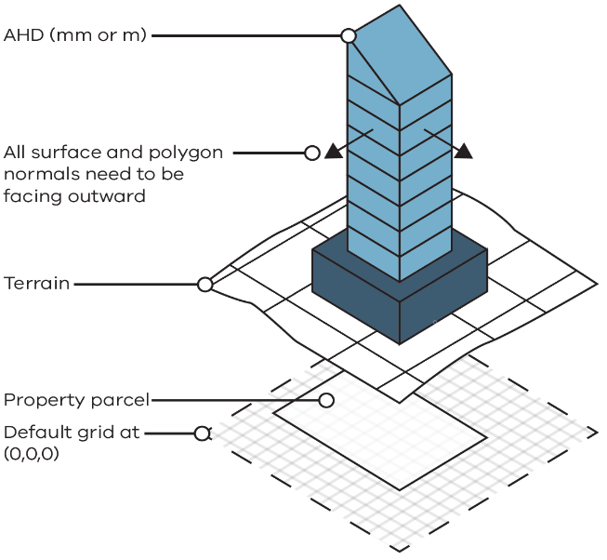  3D model position and surfaces:  - Accurately position the model at the correct AHD level as per the architectural drawings  - All model surface and polygon normal to be facing outward | ☐
Accepted units: millimetres OR metres. | ☐
Triangle Count: under five million per development
Maximum file size: 250 MB
Included:  - External building envelope and structure, canopies/significant projecting devices  - Proposed street furniture, parapets, plant rooms, lift over-runs, and building crown features. | ☐
Not included:  - Vegetation, people, cars and other entourage elements  - All internal furniture, fixtures and fixings  - MEP elements | ☐
Required formats: FBX, OBJ, 3DM  Optional additional formats: RVT, IFC | ☐
Model is named using the following convention:  Submission date YYMMDD_StreetName_StreetNumber_Status  eg: 230101_NicholsonSt_8-12_APP  Status:  - PRE – Pre application  - APP – Application  - AMD – Amendment  - PMT – Permit  - AB – As built | ☐
We will require re-submission if these requirements are not met.

