Bellarine Peninsula
Statement of Planning Policy
JULY 2023

Victoria State Government
Department of Transport and Planning

Accessible version of the document
Please email the Inclusion and Diversity team to obtain an accessible version of this document. Inclusion-diversity@transport.vic.gov.au

ISBN 978-1-76136-237-8 (pdf/online/MS word)

Authorised by the Victorian Government, Melbourne
1 Spring Street Melbourne Victoria 3000
Telephone (03) 9655 6666.

Designed and published by the Department of Transport and Planning

Contact us if you need this information in an accessible format such as large print or audio, please telephone (03) 9655 6666 or email community@transport.vic.gov.au

© Copyright State of Victoria Department of Transport and Planning

Except for any logos, emblems, trademarks, artwork and photography this document is made available under the terms of the Creative Commons Attribution 3.0 Australia licence.

Photos: Visit Victoria Content Hub, Claire Scott Planning 2020 and Greg Robinson.

Contents
Acknowledgement of Country 1
1. Introduction 2
1.1 About Victoria’s peri-urban and regional areas 2
1.2 About the Bellarine Peninsula declared area 3
1.3 About the Bellarine Peninsula Statement of Planning Policy 8
1.4 Implementation of the Statement of Planning Policy 11
2. Wadawurrung statement of significance 14
3. Our vision 16
4. Declared area framework plan 18
5. Policy domains 20
5.1 Aboriginal cultural heritage – Wadawurrung Country 21
5.2 Environment and biodiversity 24
5.3 Landscapes 29
5.4 Environmental risks and resilience 39
5.5 Historic heritage 45
5.6 Tourism, agriculture and natural resources 48
5.7 Strategic infrastructure 54
5.8 Settlements 59
6. References 82
7. Glossary 84

Acknowledgement of Country

We acknowledge and respect the Traditional Owners of the Wadawurrung lands and waters, their unique ability to care for Country and deep spiritual connection to it.

We honour Elders past and present whose knowledge and wisdom has ensured the continuation of culture and traditional practices.

We are committed to genuinely partner and meaningfully engage with Traditional Owners
to support the protection of their Country, the maintenance of spiritual and cultural practices and their broader aspirations in the 21st century and beyond.

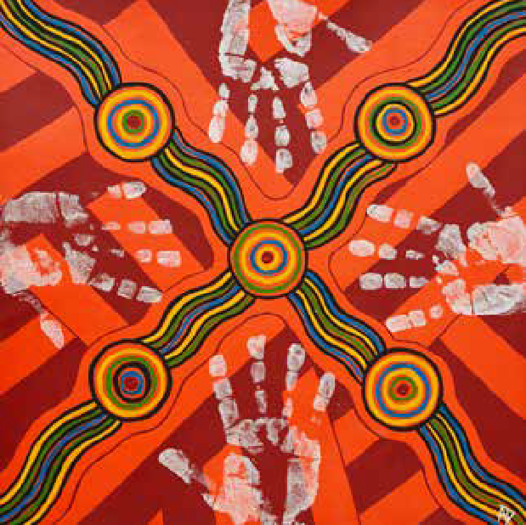

Description of artwork
Aaron (Gunaikurnai) ‘Movements Between the Five Clans’ 2019, acrylic on canvas.

‘The tracks are going between the five clans of the Gunaikurnai and the hands are the symbols of my spirit travelling around the campsites.’

This artwork was created through programs provided by the Torch. The Torch provides art, cultural and arts industry support to Indigenous offenders and ex-offenders in Victoria. The Torch aims to reduce the rate of re-offending by encouraging the exploration of identity and culture through art programs to define new pathways upon release.

1. Introduction

1.1 About Victoria’s peri-urban and regional areas

The Bellarine Peninsula, along with other peri-urban areas surrounding Melbourne, Geelong and other regional cities, includes areas of outstanding natural beauty and environmental, economic, social and cultural heritage significance.

Like other highly valued areas of Victoria, the Bellarine Peninsula has been under the safe stewardship of Traditional Owners for millennia, and it is rich in Wadawurrung living cultural heritage.

Peri-urban areas are important to Traditional Owners for the protection of Country and the maintenance of spiritual and cultural practices. They also have unique ecosystems, the native vegetation of which provides habitat for threatened and endangered species. The picturesque landscapes of peri-urban and regional areas, especially along the coasts, attract millions of local, interstate and international visitors, and tourism is a major contributor to local economies. The proximity of peri-urban and regional areas to cities means that people can easily access and connect with nature and Victoria’s rich heritage. They are also locations of productive industries and important infrastructure. These areas are central to the way of life Victorians enjoy.

The challenge facing the Victorian Government and the community is to manage Victoria’s growth while conserving and enhancing significant landscapes. We must balance the growth of Geelong, metropolitan Melbourne and regional cities and towns with the need to conserve and enhance distinctive areas and landscapes.

A sustainable approach to planning and managing peri-urban and regional areas recognises, conserves and enhances each of their unique values and distinctive attributes – their landscape character, biodiversity and environment, Aboriginal cultural heritage and historic heritage – and ensures that development responds appropriately to these values and attributes. At the same time, it must also recognise, conserve and enhance the things that make peri-urban areas prosperous: productive rural land and natural resources, local businesses, sustainable tourism, transport and essential services infrastructure, sustainable well- planned settlement growth and liveability.

1.2 About the Bellarine Peninsula declared area

The Victorian Government has legislated to protect and enhance Victoria’s distinctive areas and landscapes, so they can be enjoyed by current and future generations.

Parts of the City of Greater Geelong and all of the Borough of Queenscliffe – which together
constitute the Bellarine Peninsula – were declared a distinctive area and landscape under section 46AO of the Planning and Environment Act 1987 (the PE Act) by order of the Governor in Council published in the Government Gazette on 29 October 2019. The order came into effect on the same day. The Bellarine Peninsula was redeclared by order of the Governor in Council published in the Government Gazette on 16 September 2021, with the declaration commencing on 30 October 2021.

Table 1 lists the attributes that qualified the Bellarine Peninsula declared area as a distinctive area and landscape under section 46AO of the PE Act.

Map 1 shows the Bellarine Peninsula declared area in relation to Melbourne, Geelong and Ballarat.

Map 2 shows the declared area at a large scale.

The declared area’s boundary to the north, east and south is the coastline, including 600 m seaward of the low-water mark from Leopold to just east of Breamlea. Its western and north-western boundaries are roads to the west of Reedy Lake and Lake Connewarre: the declared area includes these lakes. The area aligns closely with the area covered by the 2015 Bellarine Peninsula Localised Planning Statement, but the western boundary is different. The Bellarine Peninsula declared area directly abuts the Surf Coast distinctive area and landscape, which was declared in September 2019.

What is a distinctive area and landscape?
Under section 46AO of the PE Act, an area of Victoria can be declared a distinctive area and landscape if it has a majority of the attributes section 46AP of the PE Act specifies – outstanding environmental, geographical, heritage, cultural, natural resources or productive land, strategic infrastructure or built- form significance – and if its attributes are under threat of significant or irreversible land use change that would affect the environmental, social or economic value of the area.
In this document, ‘the declared area’ refers to the area shown on Map 2, which has been declared a distinctive area and landscape. It includes parts of the City of Greater Geelong and all of the Borough of Queenscliffe.

Table 1: Attributes qualifying Bellarine Peninsula declared area as a distinctive area and landscape.

Item | Attribute | Distinctive features
1. | Outstanding environmental significance | The endangered native flora and fauna located in pockets of this area, particularly along river corridors. This habitat consists of various plant species, including the endangered Bitter-bush, Coast wirilda and Trailing Coast Poa.  The wetlands across the Bellarine Peninsula are Ramsar-protected wetlands and form part of a global network for migratory birds. The wetlands are home to several unique and threatened species.
2. | Significant geographical features, including natural landforms | The Heads at Point Lonsdale are a defining feature at the entrance to Port Phillip Bay. It features on numerous early artworks. It is part of a Marine National Park that includes high sand dunes, limestone cliffs and a vast intertidal rock platform that stretches across to Point Nepean.  The scenic views across the Bellarine Peninsula of rural landscapes and along the coast are highly valued for their natural beauty.
3. | Heritage and cultural significance | Bellarine Peninsula has outstanding examples of Victorian-era architecture offering a unique insight into the area’s development as a holiday destination.  Queenscliff has a rich maritime and military history characterised by Victorian and early-twentieth-century architecture, including Fort Queenscliff. A large proportion of Queenscliff is under a heritage overlay or is heritage-listed, which indicates its state significance.  Significant Wadawurrung living cultural sites exist, including shell middens archaeological sites and The Bluff at Barwon Heads for the Wadawurrung people.
4. | Natural resources or productive land of significance | The Bellarine winery area between Clifton Springs and Portarlington has a cluster of wineries that support the tourism industry.  Identified Extractive Industry Interest Areas (EIIAs) including Murradoc Hill to Portarlington area and the Lonsdale Lake surrounds.  Land in the Bellarine Peninsula is ranked with some capability for soil-based agriculture at moderate-to-high intensity.
5. | Strategic infrastructure or built form of significance | Queenscliff and Portarlington Harbour are important assets for the local economy.  Barwon Heads Road and Bellarine Highway form part of a significant transport corridor, critical to the function of the region.  The Queenscliff – Sorrento Ferry is a state-significant transport and tourism link. The Bellarine heritage rail is a popular attraction, important to the local tourism economy.

Map 1: Location of Bellarine Peninsula declared area

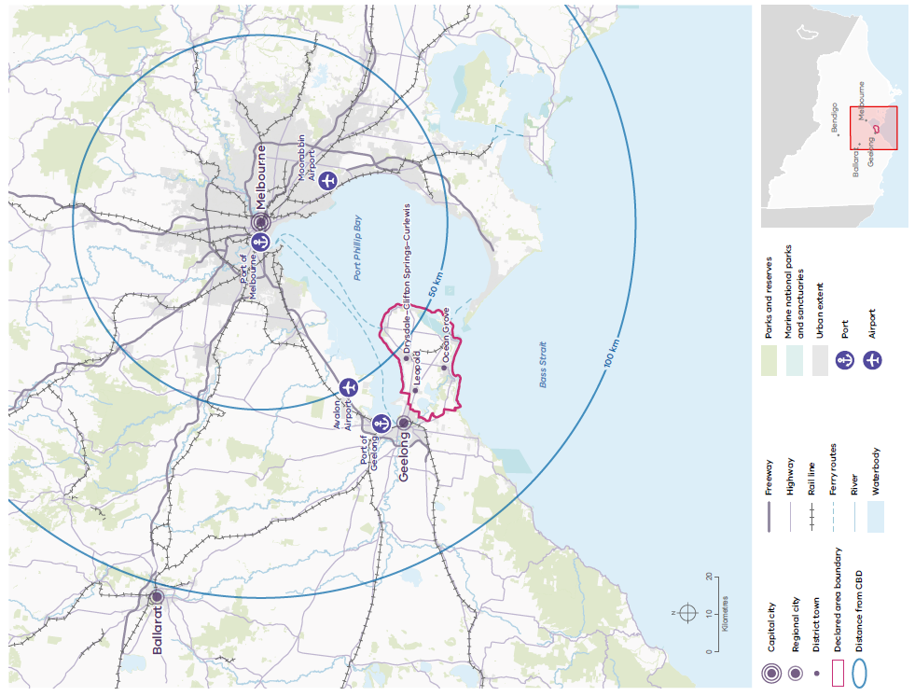
Source: DTP 2023.

Map 2: Bellarine Peninsula declared area

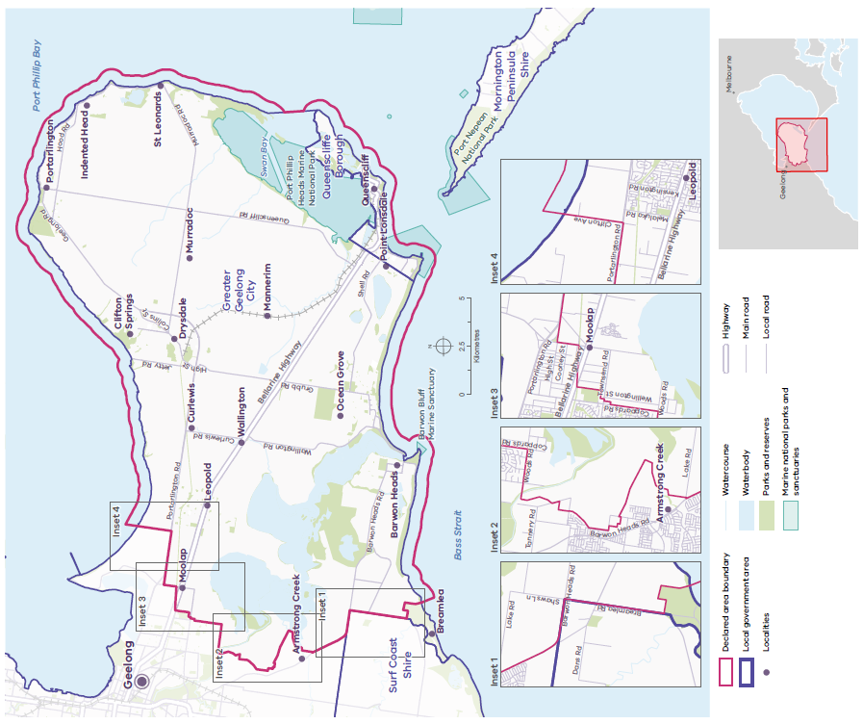
Source: DTP 2023.

1.3 About the Bellarine Peninsula Statement of Planning Policy

Under the PE Act, the Minister for Planning must prepare a Statement of Planning Policy (SPP) for a declared area, the purpose of which is to create a framework to guide the future use and development of land within the declared area to ensure appropriate protection and conservation of its distinctive attributes.

Division 3 of Part 3AAB of the PE Act also specifies the contents, consultation, endorsement, approval, commencement and amendment requirements for an SPP.

Section 46AV(1) states that the Statement of Planning Policy for a declared area must–
- set a vision for a period of at least 50 years that identifies the values, priorities and preferences of the Victorian community in relation to the distinctive attributes of the declared area, including preferences for future land use, protection and development (this can be found in 3. Our vision of the Bellarine Peninsula SPP)
- set out the long-term needs for the integration of decision-making and planning for the declared area (which is in 5. Policy domains of this SPP). Objectives and strategies are set out for each policy domain to enable integrated decision-making and planning for the declared area over the 50-year period of the vision, by providing an overarching framework for strategic and statutory planning, and by ensuring responsible public entities (RPEs) act consistently with relevant parts of the SPP when performing a function or exercising a power
- state the parts of the SPP that are binding on responsible public entities and the parts that are in the nature of recommendations to which responsible public entities are only required to have regard (in this statement, the objectives are binding on RPEs and the strategies are not: they are recommendations to which RPEs must have regard)
- include a declared area framework plan in accordance with subsection (2) (which is in 4. Declared area framework plan of this SPP)
- set out Aboriginal tangible and intangible cultural values, and other cultural and heritage values, in relation to the declared area (which is in 5.1 Aboriginal cultural heritage – Wadawurrung Country of this SPP).

The Bellarine Peninsula SPP has been prepared by the Department of Transport and Planning (DTP) in collaboration with the Wadawurrung Traditional Owners, the Borough of Queenscliffe, the City of Greater Geelong and relevant government agencies and authorities. There was extensive engagement with the Victorian community when preparing the Bellarine Peninsula SPP.

The Bellarine Peninsula SPP aims to protect the declared area’s outstanding landscapes and coastal landforms, unique natural environment, rich Wadawurrung living cultural heritage and historic heritage, and important infrastructure and natural resources. These distinctive attributes qualified the declared area as a distinctive area and landscape, and they are listed in Table 1 and the order published in the Government Gazette.

1.3.1 United Nations Sustainable Development Goals
DTP supports the objectives of the United Nations Sustainable Development Goals (UNSDGs), and it is committed to ensuring its policies reflect these goals. The Bellarine Peninsula SPP will help deliver on the UNSDGs, which provide a framework to achieve a sustainable future for all.

While the integrated delivery of all 17 UNSDGs applies to the declared area, the UNSDGs shown in Table 2 are the most relevant. They provide a foundation for the vision, objectives and strategies, as well as their implementation, monitoring and review.

Table 2: Selected United Nations Sustainable Development Goals

United Nations Sustainable Development Goal | Description
2. Zero hunger | The SPP aims to support agricultural productivity by protecting valuable agricultural land.
3. Good health and well-being | The SPP aims to support active transport and healthy communities with access to clean air and a healthy environment.
6. Clean water and sanitation | The SPP aims to protect water quality by reducing run-off, improving water management and protecting water infrastructure.
8. Decent work and economic growth | The SPP aims to achieve sustainable economic growth and the visitor economy.
9. Industry, innovation and infrastructure | The SPP aims to protect sustainable and resilient infrastructure and promote environmentally sound technologies.
11. Sustainable cities and communities | The SPP aims to provide certainty about the valued attributes to be protected while indicating preferred locations for potential long- term growth.
12. Responsible consumption and production | The SPP aims to support the protection and sustainable management and use of natural resources.
13. Climate action | The SPP aims to support the mitigation and adaptation of communities and the natural environment to climate change impacts.
14. Life below water | The SPP aims to recognise the importance and support the conservation of marine life.
15. Life on land | The SPP aims to achieve the conservation and improvement of biodiversity values.
16. Peace, justice and strong institutions | The SPP aims to ensure responsive, inclusive, participatory and representative decision-making.
17. Partnerships for the goals | The SPP aims for governments to work with communities, the private sector, other non-government groups and communities to implement its vision, objectives and strategies.

1.4 Implementation of the Statement of Planning Policy

Effective implementation of the Bellarine Peninsula SPP will require a concerted effort by all – governments, public land managers, the Wadawurrung Traditional Owners, businesses, industries, residents, tourists and the community as a whole – to work collaboratively together by taking ownership and sharing knowledge, expertise and resources to support the achievement of the long-term vision for the declared area.

1.4.1 Implementation through planning schemes
The Bellarine Peninsula SPP is operational and forms part of the state-standard provisions of the Victoria Planning Provisions. The Minister will prepare and approve an amendment to the planning scheme(s) to give effect to the SPP, as required by section 46AZB of the PE Act.

1.4.2 Implementation by responsible public entities
In addition to implementation through planning schemes, the Bellarine Peninsula SPP requires implementation by responsible public entities (RPEs) as the agencies or bodies responsible for managing land in the declared area.

In accordance with section 46AV(1)(c) of the PE Act:
- the objectives in this SPP are binding on RPEs
- the strategies in this SPP are not binding on RPEs: they are recommendations to which RPEs must have regard.

Section 46AZK of the PE Act requires that ‘A responsible public entity must not act inconsistently with any provision of the SPP that is expressed to be binding on the public entity when performing a function or duty or exercising a power in relation to the declared area.’ Therefore, RPEs must not act inconsistently with the objectives of the Bellarine Peninsula SPP when developing or implementing policies or programs or making decisions in relation to the declared area, including when performing their regular functions or duties.

RPE’s should endeavour to integrate the objectives and strategies which are relevant to it and its responsibilities into its policies, programs and decision-making in the declared area. An RPE should balance any conflicting strategies in favour of an outcome that best promotes the intent of the Bellarine Peninsula SPP for the benefit of present and future generations.

In addition, under section 46AZL of the PE Act, an RPE, when developing or implementing policies or programs or making decisions in relation to the declared area, should:
- consult with all levels of government and government agencies relevant to the decision
- use best-practice measures to protect and conserve the unique features and special characteristics of the declared area
- undertake continuous improvements to enhance the conservation of the environment in the declared area
- have regard to the principles prescribed to apply–
- to all declared areas; and
- in relation to a particular declared area.

Doing so will:
- better coordinate decision-making for land use and development across the declared area to achieve integrated management, environmental, infrastructure and development outcomes
- ensure any proposals for land use changes and development are consistent with the protection of the declared area’s significant landscapes and with state-significant and nationally-significant environmental, economic and Wadawurrung living cultural heritage values
- guide the sustainable use of natural resources in keeping with the declared area’s significant landscapes, environmental and heritage values
- reinforce the importance of building community resilience to environmental risks and climate change, including the potential effects of natural hazards (such as bushfires and flooding)
- provide greater certainty for current and future residents and businesses.

1.4.3 Monitoring and review
To provide long-term certainty for the declared area, the Minister for Planning must ensure the Bellarine Peninsula SPP is reviewed at least every 10 years. The review will be undertaken in collaboration with the Borough of Queenscliffe, the City of Greater Geelong and the Wadawurrung Traditional Owners.

The Bellarine Peninsula SPP may be reviewed earlier if strategic planning work (such as landscape assessments, biodiversity assessments or reviews of settlement frameworks or structure plans) identifies the need for an earlier review. Following a review, the Bellarine Peninsula SPP and relevant planning schemes may be amended if necessary.

Responsible Public Entities for the Bellarine Peninsula declared area are:
- Barwon Coast Committee of Management
- Barwon Water
- Bellarine Bayside Coastal Management
- Bellarine Community Health Ltd
- Bellarine Peninsula Elderly Peoples Home Society Inc
- Borough of Queenscliffe
- City of Greater Geelong
- Corangamite Catchment Management Authority
- Secretary to the Department of Energy, Environment and Climate Action
- the Head, Transport for Victoria
- Parks Victoria
- Southern Rural Water
- Victorian Fisheries Authority
- Victorian Planning Authority
- VicTrack
- Working Heritage.

2. Wadawurrung statement of significance

The following statement sets out in traditional language the significance of Wadawurrung Country and the declared area to the Traditional Owners of the Bellarine Peninsula.

Comugeen budj-o thalikiyu kin bil beng-ordi- ngadak. Ngarrwabil, boron, guli, bagurrk. Comugeen budj-o bengadak ngarr-uk dja, ngubiyt, weagoon gobata gupma wurring-wurring baap beng-ordi- nganak, djarrima murrup-nhuk bengadak.

Gobata Wadawurrung balug jumbuk didalbil murrup-nhuk bundjil monomeett beek-o weagoon. Mutjak-ak Ngan ngan borrak ngan ngan djuwewan.

Wa-ngarrwa Wadawurrung balug bengadak mirriyu boron-dja gobata-k ying, ngarrimilli, wa-ak, karrung, kuy-a, nyanayit-yanunit, djilenawurr, baap willam beng-ordi-ngadak.
Nyurrinana-ngal beng-ordi-ngadak.

Willam Yaluk Youang baap warri Wadawurrung Balug dja beng-ordi-ngadak, bullarto nerr-i-girr baap monomeett worrowing warree, gelanyi bul-boluk.

Weagoon-o Modawarree-wa, Moda baap kiang-purt. Weagoon-o Koaka-Dorla-wa Dorla.
Weeagoon-o Wurdiboluk, Gherang, Parrwang Yaluk monomeett-wa Yonbarra baap wirrapiyn, buniya, tark-a binyak-ngal.

Wa-weagoon nerr-i-gurr-o kit baap bullarto gurrin-gurrin-k wah-ak, karrung, yanikan-werreet. Corroborree bullarto wa-ik-ngitj balug-wa beng- ordi-ngadak.

Mirr wirring wurru-ngwarra dja bengadak.

Mirr-i-tonton dja Wadawurrung balug, gobata be-ak yerra-ak murrup yani-mirriyu ngarrwa-uk beng- ordi-ngadak Koling wada-ngal.

The English translation of which is …

We deeply respect our People of the past. Elders, children, men, women. We deeply respect their knowledge of Country, water, life, their care of the Traditions and of each other, we stand with their spirit.

Great spirit Bunjil told us to take care of the great life within the land. To only take what you need with no greed no harm.

Wadawurrung shared their knowledge of singing, dance, trade, camps, fishing, hunting, paintings, and homes to us to protect for our future generations.

We all need to help.

Our Wadawurrung family group lived along Rivers, Salt water and inland Country, with a large land of forested areas and wonderful banks of the ocean, near many water bodies.

Life in the Modewarre gave Musk duck and Bream. Life in the Anglesea gave Mullet.

Wurdiboluk, Gherang, Barwon River all provide ideal life to birds and fish, eels. Reeds turned into our baskets.

Life in the forest gave resources like food, medicines and lots of tools to use for trade, building, journey.

If there was plenty, we would share with our families, trade and celebrate.

We would name our Country, by what we could see and hear.

Our Country is remembered by Wadawurrung, our proud spirit walks to tomorrow to teach others the care of our earth.

Let us walk together.

3. Our vision

The vision for the Bellarine Peninsula is set out below. It is for at least 50 years, and it identifies the values, priorities and preferences of the Victorian community in relation to the unique values and distinctive attributes of the declared area, including preferences for future land use, protection and development.

The vision will be achieved by implementing the objectives and strategies under each policy domain.

By 2072, our vision for the Bellarine Peninsula declared area is that the Wadawurrung, governments, public land managers, businesses, community groups, residents and visitors work together to ensure the area’s unique values and distinctive attributes – the things people love about the area – are protected and enhanced and are not degraded over time.

The Bellarine Peninsula is a sustainable, diverse region with thriving rural and coastal communities. Its unique natural beauty, Aboriginal cultural and historic heritage, ecological significance, distinctive landscapes and identity are widely recognised and celebrated.

Aboriginal cultural heritage: Wadawurrung rights to self-determination are respected so that their aspirations for their lands, waters and culture are realised through the transfer of relevant decision- making powers. Wadawurrung knowledge and practices inform decisions about planning, and land and water management, and they help protect the environment and biodiversity. Wadawurrung living cultural heritage is highly valued, and the area is respected as a place of significance to the Wadawurrung people.

Environment and biodiversity: Indigenous plants and animals flourish within a natural environment that is healthy, well cared for and cherished by local communities and visitors. The area’s unique marine and waterway environments – the Ramsar wetlands of Swan Bay, Lake Connewarre and the Barwon Estuary – are healthy. A network of well-managed parks and reserves and private lands and gardens support fragile ecosystems and biodiversity.

Landscape: The area’s distinctive landscape features – its southern coastal bluffs, cliffs and beaches from Breamlea to Queenscliff, the gently undulating Bellarine Hills and the tranquil coastal edge of Port Phillip Bay – are cherished. Panoramic views across the peninsula and out over The Heads past Point Lonsdale and Point Nepean, vistas across Port Phillip Bay to the You Yangs and beyond, and views of Lake Connewarre and Swan Bay, are protected and accessible to residents and visitors.

Environmental risks and resilience: The declared area has reduced greenhouse gas emissions, resource use and waste to near zero, and it is resilient to the impacts of climate change (such as a warmer and drier climate, increased bushfire risk, higher sea levels and coastal erosion). Local communities and visitors embrace walking, cycling and public transport. Investment in renewable energy and integrated water management infrastructure is a priority.

Historic heritage: The area’s rich maritime, military and non-Indigenous settler heritage – its historic towns like Queenscliff and architecture like the Portarlington Grand Hotel – is preserved and respected for its contribution to the history, identity and character of the Bellarine Peninsula and its communities.

Tourism, agriculture and natural resources: The declared area is a renowned agricultural producer and world-class sustainable ecotourism destination. Water resources are secure, and they support diverse, environmentally conscious, resilient, productive and prosperous industries.

Strategic infrastructure: Community connections and health and wellbeing are strong. Accessible community health, education and social infrastructure provide for the community’s everyday needs. Sustainable active transport routes and outdoor activities help improve health, build relationships between people and connect them with their surroundings.

Settlements: The Bellarine Peninsula’s distinctive coastal and rural towns and villages offer a variety of housing and lifestyle choices where development is well-planned and sympathetic to each settlement’s unique character. Settlements are well-connected to local jobs and services, protect and enhance environmental and cultural attributes and are resilient to natural hazards and climate change impacts. The prized coastal areas and rural hinterlands that surround and separate settlements are permanently protected.

4. Declared area framework plan

The declared area framework plan to implement the vision is set out in Map 3. It reflects the objectives and strategies in this statement, which will guide the protection of attributes that make the Bellarine Peninsula a place of state and regional significance while ensuring sustainable development within the declared area.

Protected settlement boundary maps 9–17 form part of the framework plan.

The declared area framework plan is to be read in conjunction with the policy domains in 5. Policy domains, including the objectives and strategies. Maps provided in the policy domains other than the settlement maps in 5.8 Settlements, do not form part of the framework plan; they are included for context.

Section 46AV(2) of the PE Act states that the declared area framework plan must provide a framework for decision-making in relation to the future use and development of land in the declared area that:
- integrates environmental, social, cultural and economic factors for the benefit of the community and encourages sustainable development and identifies areas for protection and conservation of the distinctive attributes of the declared area
- may specify settlement boundaries in the declared area or designate specific settlement boundaries in the declared area as protected settlement boundaries.

Map 3: Bellarine Peninsula declared area framework plan

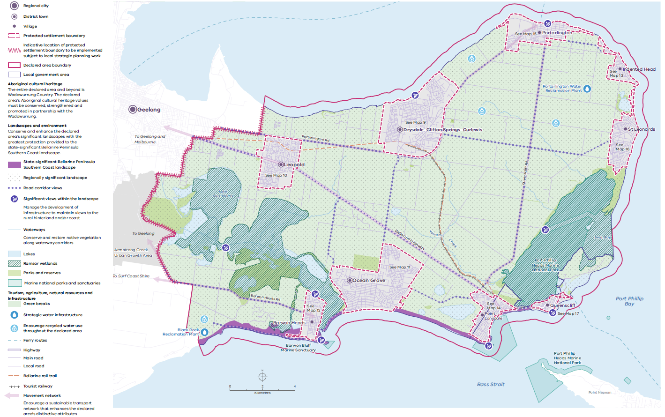
Source: DTP 2023.

5. Policy domains

The Bellarine Peninsula SPP includes eight policy domains that align with the objects for the declaration of the Bellarine Peninsula as a distinctive area and landscape in accordance with the PE Act.

The policy domains are to be read together as a whole. The long-term protection and enhancement of the declared area’s distinctive attributes result from understanding the complex interactions between each of the eight domains. The objectives and strategies for each policy domain enable integrated decision-making and planning for the declared area.

The policy domains are:
- Aboriginal cultural heritage – Wadawurrung Country
- Environment and biodiversity
- Landscapes
- Environmental risks and resilience
- Historic heritage
- Tourism, agriculture and natural resources
- Strategic infrastructure
- Settlements.

5.1 Aboriginal cultural heritage – Wadawurrung Country

Relevant United Nations Sustainable Development Goals
2. Zero hunger
14. Life below water
15. Life on land
16. Peace, justice and strong institutions
17. Partnerships for the goals

The declared area is within the Country of the Wadawurrung people, who have inhabited and cared for this area for millennia. It is rich in their spiritual and living cultural heritage, and all aspects of the landscape – lands, seas, skies, waters and tangible and intangible cultural heritage sites and places – are connected and significant. In Wadawurrung language, the Bellarine Peninsula is Bella Wiyn, which means ‘recline on the elbow by the fire’ or ‘resting place’.

In 2009, the Wadawurrung Traditional Owners Aboriginal Corporation was appointed as a Registered Aboriginal Party (RAP): as the Traditional Owner group legally recognised under the Aboriginal Heritage Act 2006 with responsibilities for managing and protecting Aboriginal cultural heritage on Country in the declared area.

Despite colonisation’s devastating impacts on Wadawurrung culture and Country, it continues as a living, resilient culture: the Wadawurrung people continue to live by and practise their cultural beliefs today.

The coastal areas wrapping around the Bellarine Peninsula from Leopold to Lake Connewarre are rich with Wadawurrung history and living culture, and inland landscapes and waterways (such as the Barwon River and Lake Connewarre) provide resources and connections to the rest of Wadawurrung Country. Place names, waterways and landforms often refer to natural resources or wildlife in the Wadawurrung language.

There are numerous sites along the declared area’s coastline with evidence of long-term habitation in the form of living spaces and large shell middens.

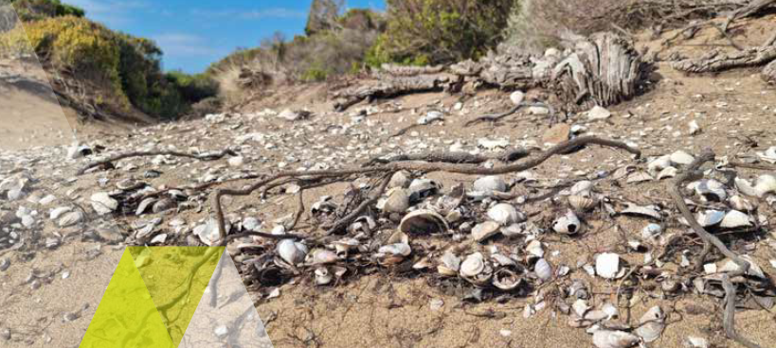

Living spaces along the coast and inland hosted housing and provided easy access to freshwater, food and other resources. In these living spaces, the Wadawurrung engaged in aquaculture and agriculture, dried and stored food and enjoyed cultural activities. Inland living spaces were usually on hilltops and at major vantage points. Resources were traded with other Aboriginal communities along the coast and between the coast and the inland of Wadawurrung Country. Complex, far-reaching trade networks spread across Wadawurrung Country and beyond.

Living spaces, large shell middens and oven mounds provide evidence of Wadawurrung residency back in the distant past, and there are places where ochre was (and still is) mined and used for ceremonies. Archaeological sites along the coast are fragile and susceptible to human disturbance and climate change impacts, including more-extreme weather events, rising sea levels and coastal erosion.

Water is the most valuable, dominant feature of Wadawurrung Country. The name of the Wadawurrung language group means ‘people who belong to the water’ in reference to the rivers, creeks, lagoons and other water sources within Wadawurrung Country. Waterways provided family groups with living spaces and freshwater, and water is central to stories and storylines that are part of the Wadawurrung cultural history and identity. The Lake Connewarre system holds great value to the Wadawurrung because of the cultural connection to stories that affirm respect and responsibility for Connewarre, the black swan. Lake Connewarre and Reedy Lake provide habitat for vast numbers of native wildlife, and keeping waterways healthy is important for ensuring that historical connections and storylines remain strong.

Wadawurrung Country, with its rich cultural history, extends beyond the declared area boundary, and it includes coastal waters. Walking tracks in the declared area connect communities to other parts of Wadawurrung Country. Development has the potential to threaten tangible and intangible connections to Country, impinging on Wadawurrung waterways and walking tracks and damaging their associated songlines and knowledge links.

In 2020, the RAP prepared its Healthy Country Plan – Paleet Tjaara Dja: Let’s make Country good together 2020 – 2030 Wadawurrung Country Plan – that land managers should use to support decision-making.

For further information, visit wadawurrung.org.au.

5.1.1 Objective and strategies

Objective 1
The following objective is binding on responsible public entities.

To conserve, strengthen and promote the declared area’s Aboriginal cultural heritage values and partner with the Wadawurrung to care for Country.

Strategies
Responsible public entities are required to have regard to the following strategies to achieve the objective when performing a function or duty or exercising a power in relation to the declared area.

Strategy 1.1 | With the Wadawurrung, identify, manage, conserve and enhance Wadawurrung living cultural heritage: places, landscapes, waterways (including unnamed waterways), natural resources and significant views.
Strategy 1.2 | With the Wadawurrung, build awareness and understanding of tangible and intangible Wadawurrung living cultural heritage knowledge, including language, oral traditions and pre-colonial cultural practices, and innovatively incorporate it when planning and managing land use and development.
Strategy 1.3 | With the Wadawurrung, encourage the use of Wadawurrung language and place names throughout the declared area.

5.2 Environment and biodiversity

Relevant United Nations Sustainable Development Goals
3. Good health and wellbeing
11. Sustainable cities and communities
13. Climate action
14. Life below water
15. Life on land
17. Partnerships for the goals

Healthy aquatic and terrestrial environments and the ecological systems they support, including high levels of biodiversity, are important values for the declared area. They provide valuable social, economic and cultural benefits and are integral to Wadawurrung living cultural heritage.

The Bellarine Peninsula’s natural environment includes coastal and marine environs, woodlands, grasslands and freshwater, semi-saline and saline waterways.

Internationally significant wetlands, including the Port Phillip Bay (Western Shoreline) and Bellarine Peninsula Ramsar Site, provide habitat and feeding grounds for many local and migratory species. Biodiversity is highly concentrated in nature and coastal reserves, including the Ocean Grove Nature Reserve, Buckley Park Foreshore Reserve, Point Richards Flora and Fauna Reserve, Edwards Point Wildlife Reserve, Port Phillip Heads Marine National Park and Barwon Bluff Marine Sanctuary.

The seagrass meadows within Swan Bay and along the northern coastline are Port Phillip Bay’s most significant concentration, and they provide important habitat and nursery grounds for marine life.

Unfortunately, many significant species (such as the Southern brown bandicoot and the Sugar glider) have become locally extinct due to land clearing, habitat alteration and destruction and the introduction of pests and weeds. Only an estimated 5% of pre-colonisation remnant vegetation survives on the Bellarine Peninsula. Many species are listed as threatened or critically endangered under the Flora and Fauna Guarantee Act 1988 and the Environment, Protection and Biodiversity Conservation Act 1999. Expanding urban development and climate change continue to threaten the declared area’s ecosystems.

5.2.1 Waterways and marine environs
The Port Phillip Heads Marine National Park and Barwon Bluff Marine Sanctuary are legally protected sanctuaries for marine plants and animals and their habitats. The Lake Connewarre wetland complex and Swan Bay – both parts of the Ramsar site – as well as the Lonsdale Lakes system, Salt Lagoon, Griggs Creek, the Begola Wetlands and smaller tributaries (such as Yarram Creek and many unnamed waterways) have high biodiversity, cultural and scenic values. They support all sorts of plant and animal species, including species listed under the Japan–Australia Migratory Bird Agreement and the China–Australia Migratory Bird Agreement, which protect migratory birds in danger of extinction. These are sensitive environments and biodiversity hotspots, and they are particularly vulnerable to urban development and climate change impacts.

Clearing native vegetation and increasing non-permeable surfaces by urbanising areas increase stormwater run-off into waterways and marine environments, and with it, pollutants from urban areas and agriculture. Downstream, pollutants can reduce water quality and increase salinity and the nutrient load (from fertiliser), which favours invasive weed species. Increasing vegetation cover and limiting hard surfaces help water infiltrate the soil, which reduces stormwater and pollutant run-off. Increasing native vegetation also provides shelter and habitat for fauna.

While much of the Bellarine Peninsula’s waterway and marine environment is Crown or public land, private ownership of riparian zones and the peninsula’s northern edge makes it difficult to manage this environment consistently. Better management of urban stormwater run-off into adjacent wetlands and waterways is a priority at many locations in the declared area and upstream areas to better protect their values. Priority locations include Barwon Heads, Leopold, Ocean Grove and Point Lonsdale and upstream urban Geelong. Better management measures include redirecting stormwater to naturally filter it before it flows into sensitive habitats and investing in infrastructure to harvest stormwater for reuse before it enters natural systems.

Climate change presents new challenges. Rising sea levels will change coastlines, and reduced rainfall will mean there is less available surface water. As a result, coastal saltmarsh and mangrove communities will migrate inland to non-urban locations, and dunal systems and cliffs will erode further. A healthy coastal environment also helps us adapt to climate change: coastal saltmarsh communities protect shorelines from storm surges and coastal erosion.

5.2.2 Biodiversity habitats and biodiversity connections (biolinks)
The declared area’s diverse native plants and animals are essential to its sustainability and liveability. Most indigenous vegetation has been cleared since colonisation, and the remaining patches are mostly in established reserves, along roadsides and in the Bellarine Rail Trail reserve. Notable examples include the Grassy Woodland ecological vegetation class (EVC) exemplified by the Ocean Grove Nature Reserve, the last remaining example of Damp Sands Herb-rich Woodland EVC in the Point Richards Flora and Fauna Reserve, the
Coastal Moonah Woodland community in the Buckley Foreshore Reserve and the treasured Bellarine yellow gum found sporadically across the peninsula. The area’s agricultural land and open rural landscapes also support biodiversity by hosting significant trees for habitat and allowing fauna free passage.

To preserve healthy habitat and biodiversity, we must protect and enhance the remaining remnant vegetation and increase the coverage of indigenous vegetation. Protecting remnant vegetation is important for habitat, landscape amenity and the community’s connection to the Bellarine Peninsula. The Victorian Government’s Biodiversity 2037
plan includes ambitious targets to stop the state’s declining biodiversity and achieve a net gain in the extent and condition of habitat across the terrestrial, waterway and marine environments. Protected and expanded biodiversity connections (biolinks) can connect core biodiversity areas, increase vegetation cover and connect habitats. They provide native fauna with safe transit routes and access to food and water, which help increase the genetic diversity of fauna populations. Biolinks also enhance the resilience of native plants and animals to threats, including climate change impacts. We must carefully manage use and development within identified biodiversity connections to maintain their integrity.

Active land management on private and public land is essential to conserve and enhance the declared area’s environmental and biodiversity values. RPEs, public land managers, private landowners and environmental and volunteer groups need to coordinate, set priorities and take action to achieve environmental objectives.

Map 4 shows the declared area’s strategic biodiversity values.

5.2.3 Objective and strategies

Objective 2
The following objective is binding on responsible public entities.

To conserve and enhance the significant biodiversity, ecological and environmental values of the declared area.

Strategies
Responsible public entities are required to have regard to the following strategies to achieve the objective when performing a function or duty or exercising a power in relation to the declared area.

Strategy 2.1 | Encourage landowners and occupiers to undertake environmentally responsible management practices to ensure the long-term protection and restoration of significant indigenous vegetation and biodiversity and the integrity of ecosystems.
Strategy 2.2 | Ensure that land use, development and land management practices achieve a net gain in the overall extent and condition of natural habitats in the declared area’s terrestrial, waterway and marine environments.
Strategy 2.3 | Encourage ecological restoration works to connect areas of high environmental and biodiversity value, including increasing biodiversity connections (biolinks) between identified biodiversity features and areas.
Strategy 2.4 | Maintain and improve the role of waterway corridors within and between settlements and coastlines as biolinks for native flora and fauna.
Strategy 2.5 | Discourage land use and development that would impact or threaten the health and function of areas of identified biodiversity and ecological value, including biodiversity connections.
Strategy 2.6 | Minimise downstream stormwater impacts from land use and development by implementing integrated, sustainable stormwater management practices (such as controlling the release, harvesting, reuse and recycling of water), including considering cumulative impacts on waterways and natural ecological processes.
Strategy 2.7 | With the Wadawurrung, utilise Wadawurrung biocultural knowledge and practices in managing biodiversity and ecological and environmental values.
Strategy 2.8 | Minimise the negative impacts of weeds and pest animals on environmental and biodiversity values by developing and implementing best-practice land management plans.
Map 4: Strategic biodiversity values

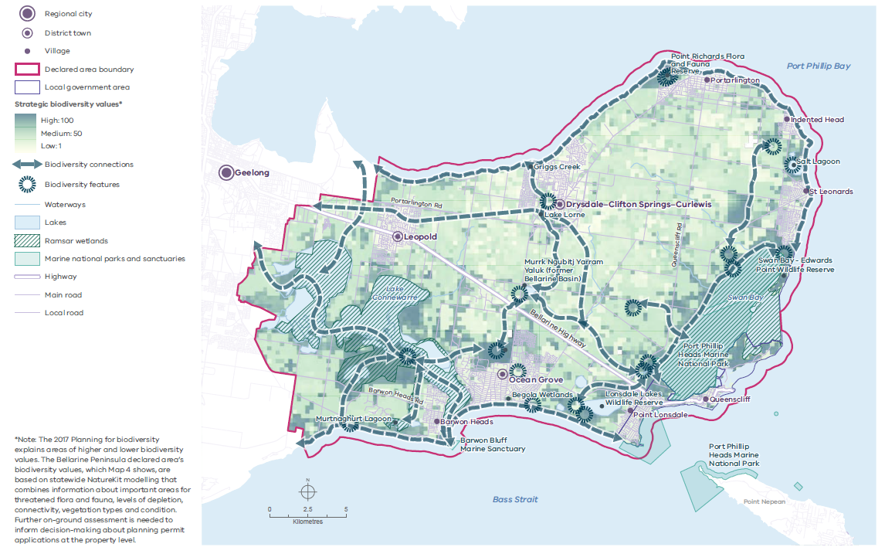
Source: DTP 2023.

5.3 Landscapes

Relevant United Nations Sustainable Development Goals
11. Sustainable cities and communities
12. Responsible consumption and production
15. Life on land

The Bellarine Peninsula declared area has many distinctive landscapes, including Port Phillip Heads, Point Lonsdale, the Lake Connewarre wetlands complex and Swan Bay wetlands, the ruggedly beautiful southern coastline and the gently undulating rural hinterland.

The area’s varied landscapes provide numerous opportunities to relish unique and expansive views, connect with nature and feel a distinct sense of place. Relaxed, characterful, coastal settlements sit within sight of rural hinterlands, rolling hills, coastlines, wetlands and working agricultural land. There are Ramsar-listed wetlands, farms, vineyards, treed windbreaks, flat and rolling topographies, coastal and riverine scenery, historic seaside towns and ships passing close to shore through The Rip at the entrance to Port Phillip Bay: these all contribute to the overall landscape character.

These areas also support the region’s biodiversity and provide an important link to Wadawurrung living cultural heritage. They are highly valued by residents and visitors for the diverse types of enjoyment they provide.

Continued pressure from urban development and encroachment, increasing visitation, climate change impacts and coastal erosion put the declared area’s significant landscapes at high risk of incremental, cumulative and irreversible damage. Long-term planning can help address these issues and safeguard the landscapes for current and future generations.

5.3.1 Significant landscapes
Map 5 shows the declared area’s four significant landscapes:
- Bellarine Peninsula Southern Coast landscape is of state significance and stretches from Breamlea to Queenscliff. The boundary of this landscape extends about 1.5 km inland from the coastal edge. The views from Queenscliff’s Ocean View Beach car park, Hardie Lookout at Point Lonsdale and The Bluff at Barwon Heads are of state significance.
- Swan Bay landscape is of regional significance. It extends from the north-facing Queenscliff coastline to Edwards Point in the north, and it includes Swan Bay and Swan Island. The landscape extends about 1 km inland. There are many formal and informal viewing locations across this landscape, with the Swan Bay Jetty assessed as of regional significance.
- Lake Connewarre and the Barwon River landscape is of regional significance. The landscape includes the Barwon River (from about 1 km inland of its confluence with Bass Strait) and adjacent public reserves, the coastal hinterland to the west of Barwon Heads including Murtnaghurt Lagoon, and Lake Connewarre including the edge of the escarpment to the north and east, as well as adjacent public land. There are many formal and informal viewing locations across this landscape, with the River Parade Boardwalk in Barwon Heads and Taits Point at Lake Connewarre assessed as being of regional significance.
- Bellarine Northern Coast and Central Hills landscape is of regional significance. This landscape comprises the remainder of the declared area and includes Reedy Lake and surrounds, the northern coast from east of Moolap to Portarlington, the north-eastern coast to St Leonards and the undulating rural hinterland.

Landscape significance and landscape character
A landscape’s level of significance is based mainly on its visual qualities, with secondary consideration of other attributes (such as Aboriginal cultural heritage, historic heritage, environmental, scientific and social values). The required level of protection of a landscape accords with its level of significance. For example, nationally significant landscapes require the highest level of protection, whereas regionally significant landscapes usually require less regulation.

Before assessing a landscape’s level of significance, it is important to understand its ‘landscape character’: its physical characteristics, including its geology, landform, vegetation, waterform and other natural features. These characteristics combine with the effects of land use and development to make landscapes different from one another. Landscape character focuses on physical features; landscape significance focuses on the landscape’s visual qualities and less-tangible values (such as memories and associations).

A detailed understanding of a landscape’s character informs how its significance is best protected and managed.

State-significant Bellarine Peninsula Southern Coast landscape
The landscape comprises a spectacular and varied collection of features, including iconic headlands and sweeping surf beaches backed by high dunes. Its interface with Bass Strait to the south gives it a wild and dramatic character, with the wind and seas continuing to shape this dynamic landscape.

Sitting on an ancient base of volcanic basalt, The Bluff at Barwon Heads has been sculpted over thousands of years. Up to around 40 m high, it supports a dense cover of coastal headland scrub, including swathes of Coastal Moonah Woodland, and it affords spectacular sea views across Thirteenth Beach towards the Torquay coast and east to The Heads. To the north, there are views over the Barwon River inlet and to the historic, timber Barwon Heads Bridge.

Home to the iconic Point Lonsdale Lighthouse, The Heads features limestone cliffs and an expansive intertidal rock platform that stretches beneath The Rip across to Point Nepean. With treacherous currents and hidden reefs, The Heads have contributed to the demise of some 200 ships, their wrecks providing a fascinating insight into Victoria’s maritime history.

High-energy surf beaches backed by extensive dunal systems dominate the landscape between the headlands for the length of this spirited southern coast. Bancoora Beach, Thirteenth Beach and Ocean Grove, Point Lonsdale and Queenscliff beaches all provide arresting sea views.

Some have relict dunes extending some 500 m inland, supporting an intact mosaic of coastal dune scrub and grassland. Various reminders of Queenscliff’s military history contribute to the significance of the landscape.

Regionally significant Swan Bay landscape
The Swan Bay environment is a tranquil, extensive and picturesque landscape comprising the shallow inlet of Swan Bay and its low-energy coastal edge. The inlet is partly enclosed by spits, barrier islands and islets (such as Edwards Point, Swan Island and Duck Island). Its saltmarsh communities and intertidal seagrass meadows provide habitat for diverse waterbird and fish species.

The focus of this landscape is Swan Bay itself, an internationally significant Ramsar site that is part of the Port Phillip Heads Marine National Park. Swan Bay is generally less than 2 m deep, with up to 1,000 ha of mangrove-supporting mudflats on display at low tide. The different facets of the shoreline and structures (such as the Swan Bay Jetty) provide a variety of panoramic and strikingly divergent views.

While Queenscliff defines the southern edge of Swan Bay and provides a unique silhouette on the horizon of views to the south, the remainder of the coastal edge (with only a few exceptions) remains largely undeveloped, resulting in an outlying and uninhabited character not available elsewhere on the peninsula.

Regionally significant Lake Connewarre and the Barwon River landscape
The Lake Connewarre and the Barwon River landscape is one of Victoria’s most visually and environmentally complex estuaries, and it is internationally significant under the Ramsar Convention. As well as its chain of waterbodies, other landscape features include extensive indigenous vegetation, including the westernmost occurrence of white mangroves in Australia and a significant Coastal Moonah Woodland community at the northern edge of Barwon Heads. This well-known and distinctive landscape is contained by the low escarpment of the Central Bellarine Hills to the north of Lake Connewarre and the high dunes of Thirteenth Beach to the south.

The mangrove-fringed channel of the Barwon River links the shallow, estuarine lagoon of Lake Connewarre to the sea, and the whole system is highly significant as a breeding site and feeding ground for large numbers of shorebirds and waterfowl. The critically endangered Orange-bellied parrot utilises the saltmarsh as its habitat.

There are open, expansive views across Lake Connewarre to its varied shoreline of inlets and small forelands, its relatively undeveloped character adding to its visual significance. In contrast, the variety of intimate views along the Barwon River also features distant views of Ocean Grove and boardwalks, which enable close examination of the textured variety of riverside species.

Regionally significant Bellarine Northern Coast and Central Hills landscape
This picturesque, rural landscape comprises terrain that is gently undulating to hilly, and the northern foreshore edge overlooks Port Phillip Bay. It includes topographical high points such as Mount Bellarine (also known as Murradoc Hill), which rises to about 145 m and is the highest peak on the peninsula. The Central Bellarine Hills form a prominent landscape backdrop to the settlements on the northern and north-eastern coast, and they offer opportunities for elevated, expansive views toward the sea.

The landscape features a stretch of prominent sea cliffs up to about 20 m high around Clifton Springs. This coastal edge has a history of instability – landslides and erosion – and includes the Edgewater Landslide at The Dell. This landslide has formed a prominent, natural amphitheatre in the high coastal cliffs, and it is also the site of the former Clifton Springs Mineral Spa Resort, established in the early 1870s. Spectacular views are available over this geological feature from a lookout point above, and there is a stunning panorama to the west across the water to the You Yangs on the horizon. Along the north-eastern coast, small headlands are separated by the sweeping curves of low, sandy beaches, backed by well-vegetated dunes in some places and open foreshore reserves in others.

Throughout the central farming area, most indigenous vegetation has been cleared for cropping and grazing, and the patchwork of paddocks crisscrossed by roads displays scenic, cultural vegetation patterns of exotic shelterbelts, historic homesteads and vineyard plantings. There are dense reserves of remnant roadside vegetation, often blocking views. There is also riparian vegetation adjacent to waterways (such as Yarram Creek in the south-east) and along the numerous intermittent and perennial waterways that dissect the landscape.

5.3.2 Landscape character areas
Map 6 shows the declared area’s five landscape character areas:
- the Mount Duneed Volcanic Plain landscape area
- the Lake Connewarre Lowlands landscape area
- the Lake Victoria, Swan Bay and Eastern Bellarine Plains landscape area
- the Bellarine Southern Coast landscape area
- the Central Bellarine Hills landscape area.

Mount Duneed Volcanic Plain landscape area
The south-western section of the Bellarine Peninsula declared area is the easternmost edge of the Mount Duneed Volcanic Plain landscape area. This area extends out from the declared area to the west to beyond Mount Duneed, and it takes in the middle and upper reaches of Thompson Creek, extending to the Torquay hinterland in the south-west. Within the declared area, this landscape area is characterised by very flat topography that allows for expansive, open views under big skies. With the coast to the south and the lakes and saltmarshes of the Lake Connewarre Lowlands to the north and east, seasonal inundation of low-lying rural lands is common.

The landscape area consists primarily of cleared, agricultural land set out in a pattern of paddocks bisected by roads. There is some remnant indigenous vegetation on roadsides and clustered sporadically across the rural landscape. Old shelterbelts planted in strong lineal arrangements contribute to the landscape character, along with a few simple, rural buildings dotted across the area.

Lake Connewarre Lowlands landscape area
This landscape area is centred on the lower reaches of the Barwon River and the Lake Connewarre complex, one of Victoria’s largest and most complex estuaries and a wetlands landscape of international significance under the Ramsar Convention. This lowland environment is flat, and substantial areas are seasonally inundated or permanently under large lakes, including Lake Connewarre. There are numerous other smaller waterbodies, swamps (such as Murtnaghurt Lagoon), marshes and mangrove and saltmarsh communities, including one of the few occurrences in Australia of white mangroves on river banks (on the banks of the Barwon River). These characterise the landscape and provide important habitat for estuarine plants and animals. Poa grassland and swathes of Melaleuca scrub add diversity to the region’s plants.

Owing to the flat topography, views are open and expansive throughout. A patchwork of farmland paddocks and low-density and rural-living developments stretch north from the banks of Reedy Lake to Leopold. The southern stretch of this landscape area contains the coastal settlement of Barwon Heads at the mouth of the Barwon River.

Lake Victoria, Swan Bay and Eastern Bellarine Plains landscape area
This landscape area is centred on the low-energy flatlands surrounding Swan Bay, a Ramsar wetlands site of international significance. The area stretches from the Lonsdale Lakes in the south to the flat, coastal frontage of Portarlington in the north. The area contains significant waterbodies and wetlands, including Swan Bay, Lake Victoria, Yarram Creek, St Leonards Salt Lagoon and the Begola and Bonnyvale wetlands areas east of Ocean Grove. The shallow sub-coastal lagoon environment of Lake Victoria contains significant saltmarsh around the lakeshore, which transitions into open, pastoral areas with lineal woodland reserves containing Moonah vegetation. High, vegetated sand dunes in the south and the transition into the Bellarine Hills in the north form important topographical backdrops to open views across the lakes system.

Bellarine Southern Coast landscape area
The entire southern edge of the Bellarine Peninsula declared area is composed of coastal cliffs and dunes forming the Bellarine Southern Coast landscape area. Wild seas and high winds have given rise to a varied and often-dramatic landscape of sandy beaches, high dunes, low cliffs and rocky headlands, which stretches from Queenscliff to Breamlea. Steep escarpments are vegetated with indigenous coastal species, and landmark features (such as The Heads at Point Lonsdale and The Bluff at Barwon Heads) punctuate a typically rugged surf coast with sweeping beaches and dunes. As well as dramatic, high dunes, the iconic landform of The Heads features limestone cliffs and a vast intertidal rock platform that stretches beneath The Rip across to Point Nepean. The Ocean Grove and Thirteenth Beach coasts feature high-energy surf beaches backed by extensive dunal systems, as well as wild and spectacular sea views.

Significant built-form, historic-heritage features in this landscape include the Point Lonsdale Lighthouse and the historic settlement of Queenscliff. The dramatic Bass Strait edge to the south contrasts with the more sedate northern frontage to Swan Bay.

Central Bellarine Hills landscape area
Covering the whole central and northern area of the Bellarine Peninsula, the Central Bellarine Hills landscape area is characterised by terrain that is gently undulating to hilly. Its high points include Mount Bellarine (also known as Murradoc Hill and which is the most dominant topographic rise in the north), Scotchmans Hill and Marcus Hill. The landscape area forms a backdrop to many settlements and offers expansive views of the coast and beyond. The hilly landscape interfaces with the coast with prominent slopes to Lake Connewarre and a steep escarpment overlooking the Bass Strait coast at Ocean Grove. There is a discernible, steeper edge to the landscape area in the north near Portarlington and Clifton Springs as it meets the coast. Before colonisation, the area would have supported a complex woodland community: now, only pockets of remnant native
vegetation remain in small clusters, including those adjacent to waterways and along roadside reserves. The balance of the land is a cleared, agricultural patchwork of paddocks and planted windbreaks, with some exotic trees around homesteads and vineyard plantings.

5.3.3 Objective and strategies

Objective 3
The following objective is binding on responsible public entities.

To protect and enhance the identified landscape character, physical features, view corridors and natural and cultural values of the declared area’s significant landscapes.

Strategies
Responsible public entities are required to have regard to the following strategies to achieve the objective when performing a function or duty or exercising a power in relation to the declared area.

Strategy 3.1 | Provide protection that accords with the level of landscape significance, with the greatest level of protection provided for the state-significant Bellarine Peninsula Southern Coast landscape.
Strategy 3.2 | Protect the coastal and hinterland settings of settlements by containing urban development within settlement boundaries.
Strategy 3.3 | Reserve green breaks between settlements for conservation, agriculture, nature-based tourism and recreation and natural resource purposes that prioritise the protection and enhancement of the significant landscapes and landscape character settings.
Strategy 3.4 | Ensure any development allowed in green breaks between settlements responds to the surrounding landscape character and maintains the visual dominance of the natural landscape by:  - being sited so buildings are responsive to the landscape and use established vegetation or new vegetation buffers to screen development when viewed from the public realm  - providing setbacks from road corridors and publicly accessible land  - using building forms, design detailing and materials and colours that immerse buildings within the landscape so they are not visually dominant.
Strategy 3.5 | Ensure development does not protrude above hilltops and ridgelines, so natural contours and vegetation remain visible.
Strategy 3.6 | Design and manage development and infrastructure to retain the dominance of views to the rural hinterland and/or coast from main movement corridors and public areas with access to significant views within the landscape.
Strategy 3.7 | Conserve and increase native coastal and indigenous vegetation, particularly along waterway and roadside corridors, within vegetation reserves and areas adjacent to existing remnant vegetation, by setting aside new reserves and revegetating land in keeping with the ecological vegetation classes.

Map 5: Significant landscapes

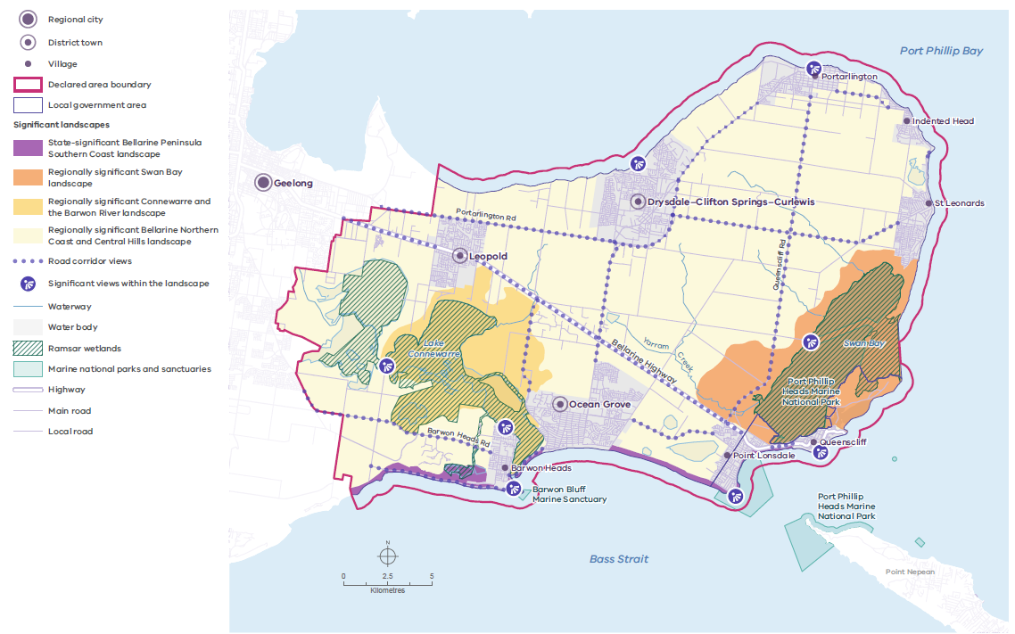

Source: DTP 2023.
Map 6: Landscape character areas

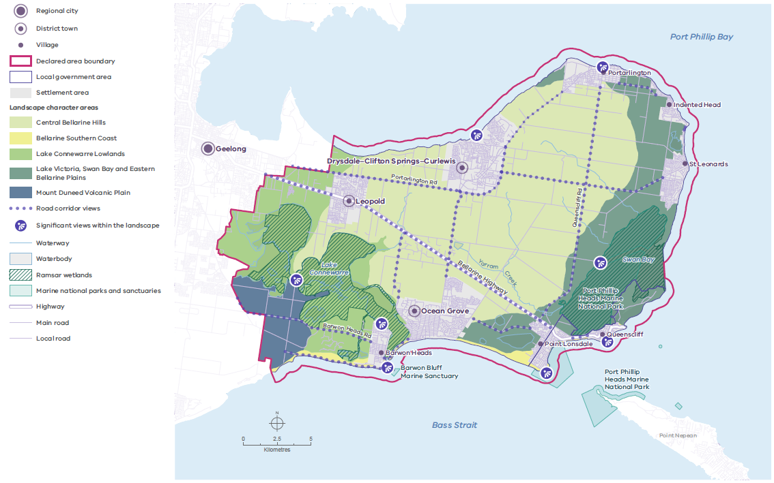

Source: DTP 2023.

5.4 Environmental risks and resilience

Relevant United Nations Sustainable Development Goals
6. Clean water and sanitation
11. Sustainable cities and communities
13. Climate action
14. Life below water
15. Life on land

Climate change and its impacts on the natural and built environments are among the most pressing issues facing Victorian settlements and their environs. They will continue to affect the declared area’s significant landscape, environmental, Wadawurrung living cultural and historic heritage values and the liveability of places.

In the coming years, the Bellarine Peninsula is forecast to experience higher average temperatures, more frequent and longer droughts, longer bushfire seasons, more frequent extreme weather events (such as heavy rainfall) and rising sea levels.

Climate change, which is happening now and is set to become more severe, will affect all the policy domains. For example, agriculture will need to adapt to hotter, drier conditions; Wadawurrung living cultural heritage sites in low-lying areas will be threatened by flooding; the beach lifestyle may become less attractive in a hotter world; and there will be more deaths from heat stress, extreme weather and diseases. The changing climate also threatens marine habitats and may change the reproductive characteristics, number and distribution of species. Settlements and non-urban areas must be able to adapt to these impacts and adequately respond to one-off events.

The Borough of Queenscliffe and the City of Greater Geelong have joined the global movement of national, regional and local governments declaring a climate emergency. Victoria’s Climate Change Act 2017 sets a target of net-zero greenhouse gas emissions by 2050. Effective, sustained measures to mitigate and adapt to climate change impacts need all levels of government, the private sector, non-governmental organisations and communities to work together.

Locally, climate change risks can be mitigated by reducing reliance on private vehicle use, prioritising sustainable transport options, protecting and enhancing the health of coastal and marine systems and maintaining and increasing vegetation cover and urban greening. These actions will help reduce carbon emissions, sequester carbon and reduce heat stress and the urban heat island effect. Ecologically sustainable and water-sensitive design can help natural areas to better cope with increased urban heat, and Wadawurrung Traditional Owners’ land management practices (such as cultural burning methods) can help to reduce bushfire risk.

5.4.1 Rising sea levels, coastal erosion, storm surges and flooding
Rising sea levels and coastal erosion are risks to coastal settlements and landscapes, particularly in low-lying areas. All low-lying coastal settlements within the declared area are predicted to be susceptible to major flooding risks by 2100. Swan Bay, Salt Lagoon, St Leonards Wildlife Reserve and Edwards Point Wildlife Reserve will also be threatened by rising sea levels, as will the plants and animals that rely on these areas for habitat.

Increasingly, beaches, cliffs, mudflats, coastal wetlands, salt marshes, mangroves and estuaries are at risk from rising sea levels, storm surges and erosion. Increased coastal erosion as a result of rising sea levels and storm surges alters the patterns and rates of longshore drift: the movement and deposition of sand, sediment and other material along the shore by waves. Coastal modifications (such as dredging, seawalls and harbours) also contribute to longshore drift.

Public and service infrastructure, including roads, recreational facilities and adjacent residential and commercial areas, particularly in low-lying areas, are at high risk of damage as sand, soil and rock erode below them. Rising sea levels, storm surges and coastal erosion also threaten Wadawurrung living cultural heritage and historic heritage sites, many of which are within or near coastal reserves.

The changing patterns of coastline erosion will force some marine and coastal plants and animals to migrate inland. Estuary and wetland vegetation (such as mangroves) adapt naturally to such patterns by migrating inland to areas that are less threatened by rising sea levels and permanent inundation, but hard infrastructure (such as seawalls and settlements) can limit this natural adaptation process. More visitors and greater use of beaches also contribute to erosion.

The Victorian Government’s 2020 Marine and Coastal Policy sets out a hierarchy and pathway approach for managing erosion and associated risks.

Floods and poor stormwater management often accelerate the erosion of river channels and damage nearby infrastructure and the natural environment. This is particularly so in areas that have been cleared of plants that protect the soil. In future, urban and non-urban areas around low-lying waterways will be at greater risk of flooding.

5.4.2 Bushfires
Bushfires are an ever-present risk in much of regional Victoria, including the Bellarine Peninsula. Climate change – warmer, drier weather and more- extreme weather events – is forecast to increase the incidence and severity of major bushfires. Grass and scrub fires are likely to be more of an issue due to the great extent of highly flammable exotic grasses and the rapid movement of grass fires.

The Code of Practice for Bushfire Management on Public Land and Victoria Planning Provision Clause 13.02-1S Bushfire planning prioritise the protection of human life over all other policy considerations. Although most of the declared area has been cleared and has a low fuel load, some coastal parks and reserves are heavily vegetated and close to settlements. Fire management regimes that draw on scientific expertise and Traditional Owners’ fire management knowledge can increase and protect biodiversity values.

Land use planning and development of existing and new settlements should consider bushfire risk and meet required Bushfire Attack Level ratings. This includes providing defendable space on sites for new developments and ensuring access to safe spaces. Any vegetation management controls should not conflict with bushfire safety objectives
and revegetation activities also need to ensure they do not increase bushfire risk.

Bushfires also have economic consequences. Tourism destinations may need to close when bushfire risk is high, and agricultural businesses in particular can lose land, stock and infrastructure. Businesses need to undertake bushfire risk mitigation planning and activities to mitigate risks.

5.4.3 Water security
To ensure its future water security, the Bellarine Peninsula must plan for declining surface and ground water availability and greater demand. Demand for water in the declared area is increasing as its population grows and demand from agricultural uses increases, but the amount of available surface water and groundwater is declining as a warming climate brings less cool-season rainfall and increases the occurrence of droughts.

Water for agriculture is particularly important for the Bellarine Peninsula. Agricultural businesses need government and industry support, including the provision of infrastructure to provide more recycled water, to adapt and develop new methods of production. Water authorities in the declared area should be supported in planning for water security through initiatives such as Barwon Water’s ‘Water for our future’. In addition, water infrastructure (such as water reclamation facilities) needs to be planned for and safeguarded within the declared area to meet business and community needs; this is examined further in 5.7.2 Water security infrastructure.

The area’s potential acid sulfate soils are threatened with disturbance by floods and increased urbanisation. These soils are prevalent around the northern and north-eastern coasts, the Barwon River, Lake Connewarre, Reedy Lake and nearby wetlands. If disturbed, they can form sulfuric acid that can trigger the release of other toxic elements, harming people, plants, animals and structures as well as contaminating drinking water.

5.4.4 Human impacts
Over time, the demand for access to the declared area’s beaches and natural assets will increase as the number of residents and visitors continues to grow. Management of this demand at peak periods must be carefully addressed.

Other human impacts that must be mitigated are littering, trampling of vegetation due to unmanaged access and illegal clearing of native vegetation. More intense rainfall events are also likely to result in greater quantities of pollutants being washed from urban and agricultural areas into waterways, wetlands and the marine environment.

To better manage future impacts, the Bellarine Peninsula SPP directs urban development within designated areas. This will ensure human impacts from development and visitation do not exacerbate threats to areas of high biodiversity, Aboriginal cultural heritage and natural resource value and to regionally and state significant landscapes.

5.4.5 Objective and strategies

Objective 4
The following objective is binding on responsible public entities.

To achieve a zero-carbon future and support the resilience of the declared area’s distinctive attributes by taking sustained measures to reduce greenhouse gas emissions, mitigate climate change and natural hazards risks and adapt to their impacts.

Strategies
Responsible public entities are required to have regard to the following strategies to achieve the objective when performing a function or duty or exercising a power in relation to the declared area.

Strategy 4.1 | Through bushfire risk-based planning, prioritise the protection of human life over all other considerations.
Strategy 4.2 | Avoid new development or sensitive land uses in or adjacent to areas at high risk of bushfire, coastal and riverine flooding and/or coastal erosion.
Strategy 4.3 | Mitigate coastal erosion risks by restoring natural systems and building infrastructure as appropriate and by adapting to irreversible occurrences of coastal erosion when making future land use and development decisions.
Strategy 4.4 | Ensure coastal and waterway infrastructure is designed to have minimal impact on existing environmental features, including vegetation, habitat, natural landforms and natural flows of water.
Strategy 4.5 | With the Wadawurrung, utilise biocultural knowledge and practices to better manage the terrestrial and aquatic environmental qualities and values of landscapes, including mitigating bushfire risk.
Strategy 4.6 | Consider cumulative impacts and implement best-practice integrated water management and water-sensitive urban design for new development, including ensuring the suitability of water for the receiving environment, to minimise negative impacts on waterways, wetlands, beaches and the marine environment.
Strategy 4.7 | Improve the energy, water and waste performance of development and infrastructure to achieve a zero-carbon future by implementing best- practice, environmentally sustainable design practices, including waste management and the use of renewable energy technology.
Strategy 4.8 | Reduce greenhouse gas emissions by prioritising safe, active transport within and between settlements and by providing and maintaining accessible and convenient public transport, walking and cycling infrastructure.
Strategy 4.9 | Maintain and increase vegetation and tree canopy cover across the declared area to sequester carbon and reduce heat island effects in urban areas.
Strategy 4.10 | Protect and enhance coastal, estuarine and freshwater ecosystems to aid in storing blue and teal carbon.
Strategy 4.11 | Avoid disturbing coastal acid sulfate soils by limiting stormwater run-off and excessive earthworks, particularly around the Barwon River and associated waterbodies, along the northern coast and west of Portarlington.
Strategy 4.12 | Minimise the impact of human recreational activities on the natural environment, including coastal areas, waterways and wetlands, parks and reserves, biodiversity and remnant vegetation

5.5 Historic heritage

Relevant United Nations Sustainable Development Goals
9. Industry, innovation and infrastructure
11. Sustainable cities and communities

Conserving and protecting the declared area’s character and rich historic heritage will strengthen its sense of place and contribute to improving the wellbeing of its residents and sustainability of its tourism industry.

The Bellarine Peninsula’s historic heritage has been shaped by its proximity to Melbourne and strategic location at the entrance to Port Phillip Bay, which contributes to its strong military and maritime heritage. Important features include the Point Lonsdale Maritime and Defence Precinct, the Shortland Bluff Lighthouse and the 50-plus shipwrecks scattered along the coastline. Monuments marking the landing of Matthew Flinders in 1802 and John Batman in 1835 at Indented Head, early farms (such as Spray Farm at Bellarine) and the short-lived Portarlington (flour) Mill are further reminders of the area’s heritage.

The arrival of colonists at the declared area began a process of dispossession of the Wadawurrung people’s lands and livelihoods. The process included forced removals, massacres and the systemic suppression of Wadawurrung culture through forced assimilation. To develop the land for their purposes, the colonists destroyed Wadawurrung resource-gathering venues and living spaces both intentionally and unintentionally, including by introducing diseases and invasive animal and plant species.

Within this troubling history, there were few cooperative engagements and discussions between the Wadawurrung people and the colonists. Both John Wedge and John Batman wrote of their observations of Wadawurrung living and resource-extraction practices from different perspectives, with the former recording Wadawurrung language and the latter attempting to buy Wadawurrung lands through an unauthorised ‘treaty’.

A little-known story has been passed down of local Wadawurrung people helping a white domestic servant in the early days of colonisation as well as providing refuge for colonial women and children during the Eureka Stockade incident.

By the early 1840s, pastoralism was well-established on the Bellarine Peninsula. The Coriyule sheep run was bought by squatters Anne Drysdale and Caroline Newcomb in 1843, and they built their homestead of the same name in 1849. The town of Drysdale and the nearby Geelong suburb of Newcomb carry their names today.

Tourism was an important early industry. Clifton Springs, a mineral spring, was commercialised in the early 1870s, and a railway line from South Geelong to Queenscliff was opened in 1879. Numerous summer houses and grand hotels (such as Portarlington’s Grand Hotel and Queenscliff’s Vue Grand Hotel) remain from those days. Prominent Victorians also built summer residences or places of retreat on the peninsula. Supreme Court Judge Thomas Howard Fellows commissioned Warringah around 1860, and Prime Minister Alfred Deakin built Ballarat, a classic, bungalow-style dwelling at Point Lonsdale in 1907–08. Most recognised heritage sites are protected by planning controls (such as heritage overlays in the Queenscliffe and Greater Geelong planning schemes) or listed on the Victorian Heritage Register or both.

While the history of the peninsula after colonisation is evident in its memorable historical buildings, there is also a less-evident social history: a story of developers, architects, builders and occupiers and how the society they began continues today. This built and social heritage makes many locations (such as the Queenscliff Town Centre) major tourism destinations and makes tourism a pillar of the local economy.

Demolition, insensitive development and excessive visitation are the main threats to the area’s colonial historic heritage, and they need to be properly managed. An ongoing commitment is required to identify historic heritage, particularly as what constitutes heritage continues to change, and to ensure the declared area’s rich post-colonial historic heritage is protected and celebrated.

5.5.1 Objective and strategies

Objective 5
The following objective is binding on responsible public entities.

To protect, strengthen and promote the declared area’s post-colonial historic heritage values.

Strategies
Responsible public entities are required to have regard to the following strategies to achieve the objective when performing a function or duty or exercising a power in relation to the declared area.

Strategy 5.1 | Ensure that significant historic heritage places within the declared area are identified and protected using best-practice conservation and management techniques.
Strategy 5.2 | Minimise the visual impacts of buildings, signage and works on heritage places by ensuring the siting and design of development and infrastructure respect the unique historic heritage character of the declared area.
Strategy 5.3 | With the community, promote post-colonial historic heritage relating to the military, maritime, early pastoral settler, shared history, tourism, transport and coastal identity of the declared area by providing interpretive signage and sustainable tourism facilities.
Strategy 5.4 | Ensure historic heritage values are considered in the planning, design and delivery of land use and development proposals, including for infrastructure.

5.6 Tourism, agriculture and natural resources

Relevant United Nations Sustainable Development Goals
8. Decent work and economic growth
9. Industry, innovation and infrastructure
11. Sustainable cities and communities
12. Responsible consumption and production
15. Life on land

The declared area supports a strong, diversifying economy and is a nature- based destination that draws visitors from around Victoria, Australia and around the world. Green breaks are fundamental to this economy, supporting significant agricultural production, natural resources and tourism.

Map 7 shows the declared area’s key tourism, agriculture and natural resources.

5.6.1 Tourism
Tourism has long been a part of the Bellarine Peninsula’s post-settlement history. Since the 19th century, maritime, military and agricultural activity and the idea that sea air was good for one’s health steadily increased visitor numbers. This established a holiday culture that continues today.

With its many attractions and experiences – golfing, food, on-water activities, wine, cultural events and natural landscapes among them – that are easily accessible by road, rail, ferry and air, the Bellarine Peninsula declared area is one of Victoria’s most popular visitor destinations, and tourism will continue to be a fundamental part of its economy.

However, increased visitation, inappropriate tourism infrastructure and development, seasonal fluctuations and climate change will increase the pressure on infrastructure and threaten the Bellarine Peninsula’s unique values and distinctive attributes. These threats must be anticipated and managed to reduce negative impacts and cement the Bellarine Peninsula as a premiere destination.

There is a need to plan for additional tourism infrastructure that is sustainable and that protects and enhances the declared area’s unique values and distinctive attributes. This includes ensuring a diverse mix of types of accommodation to meet the needs of an evolving tourism sector.

There are many opportunities to increase the diversity and quality of agritourism, arts and culture, recreation and educational experiences that celebrate the region’s historic heritage
and Wadawurrung living cultural heritage: the Wadawurrung connection to Country. These opportunities should continue to be encouraged.

Green breaks are important for tourism. They provide non-urban, open landscapes that offer sweeping views across the coastlines and rolling hills, which are valued features of the Bellarine Peninsula’s identity. Agritourism, vineyards, artisan producers, cottage industries and providers of nature-based recreational activities and accommodation benefit directly from the landscape values of green breaks. Green breaks also ensure each settlement retains its own unique identity: part of its attraction to tourists.

Accordingly, tourism development and supporting infrastructure incompatible with the landscape and environmental values of green breaks should be discouraged. This includes uses and development that are typically urban in form (such as long-term residential villages and service stations): this form of development should be directed within settlement boundaries. Appropriately scaled and located tourism accommodation and activities should be encouraged in rural areas only if they preserve productive agricultural capacity, complement and respect the rural landscape character and, where possible, enhance environmental values.

5.6.2 Agriculture
The Bellarine Peninsula has a timeless history of aquaculture and agriculture; the Wadawurrung people have utilised its land and marine resources. Post-colonisation, settlers established small commercial fisheries and engaged in broad acre cropping, cattle and sheep grazing and the production of dairy products. Aquaculture continues to be strong in the area, contributing economically, socially and culturally. Australia’s largest abalone farm is near Indented Head, and Portarlington’s annual mussel festival has grown into one of the most popular community festivals in Victoria. Agricultural activity today is mainly modified pasture grazing and intensive uses – viticulture, horticulture and vegetable cropping – of which viticulture is a growing component. Agriculture in the declared area increasingly focuses on value-adding enterprises and on the co-location of primary production with consumer-facing activities (such as wineries) to take advantage of the thriving tourism industry and enable visitors to experience the area’s produce first-hand.

Agriculture will continue to be a fundamental part of the Bellarine Peninsula’s economic future. The ‘right to farm’ must be respected by minimising the impacts of non-agricultural activities on agricultural uses and by ensuring agriculture is the primary land use in rural areas: this is integral to the declared area’s rural economy and character.

The open, rural, farming landscape makes up a large proportion of the Bellarine Peninsula’s highly valued green breaks. These green breaks contribute to the declared area’s landscape significance, identity and amenity, and they are an important part of its character and attraction to locals and visitors. The continued protection of these green breaks and support for a working, farmed landscape is a key part of the vision for the declared area. This will ensure the long-term certainty of secure agricultural land, supporting a sustainable economy.

As agricultural practices continue to evolve, agriculture in the declared area will benefit from increased investment in recycled water infrastructure, soil quality management and other emerging technologies. It will also be important to continue to protect productive agricultural land, avoid overdevelopment and the inappropriate subdivision of rural land, and preserve the integrity of farming operations, the rural landscape character and green breaks between settlements.

5.6.3 Natural resources
Extractive resources
The declared area has raw material and renewable energy resources of strategic importance to Victoria. Extractive industries provide raw materials (such as sand and stone) for use in building and construction (including renewable energy projects), manufacturing and infrastructure works.

Map 7 shows Victoria’s Extractive Industry Interest Areas (EIIA). EIIAs indicate that the land is likely to contain extractive resources and may be suitable for extractive industry. EIIAs serve as a geographic indicator for the purpose of referral of planning permit applications only and do not imply that a quarry can be established as of right. EIIAs require ongoing review and refinement as demand for resources increases and other land use pressures emerge.

It is important to protect the declared area’s environmental, landscape and Aboriginal cultural heritage values when undertaking extractive activities and identifying future extractive areas. It is also important to recognise that extractive industries are a temporary land use within rural and peri-urban landscapes. They require appropriate buffers during their operating life and rehabilitation at the end of their life in a way that is suitable to the surrounding landscape and cultural values, thereby providing a net community benefit. Identifying these areas ensures that land can be appropriately managed and rehabilitated, should the need for their resources arise in the future.

Renewable energy
The Bellarine Peninsula has an abundance of potential natural renewable energy resources; and renewable energy – solar, small-scale hydroelectricity, bioenergy and marine energy, including wave, tidal and offshore energy – that is an emerging economic opportunity for the area. Higher average temperatures, a growing population and more visitors all increase demand for electricity. Energy security – meeting peak period demand and ensuring a stable, reliable energy supply – requires ongoing investment in generation and transmission infrastructure. A move to renewable energy generation will also help mitigate climate change impacts and meet Victoria’s renewable energy targets.

5.6.4 Objective and strategies

Objective 6
The following objective is binding on responsible public entities.

To enable a diverse, sustainable and strong regional economy (including responsible tourism, agriculture and natural resource industries) that protects and promotes the declared area’s landscape significance, environment and biodiversity, agriculture and Wadawurrung living cultural heritage and historic heritage values.

Strategies
Responsible public entities are required to have regard to the following strategies to achieve the objective when performing a function or duty or exercising a power in relation to the declared area.

Strategy 6.1 | Encourage sustainable, low-impact and ecologically sensitive land use and development for visitation infrastructure that minimises impacts on landscape, environmental and cultural values.
Strategy 6.2 | Ensure visitors have access to activities and services that contribute to and celebrate the Bellarine Peninsula’s unique rural-coastal identity.
Strategy 6.3 | Ensure that land use and development for visitor and recreational activities conserve the primary rural land use and the associated buffers as well as environmental, landscape and cultural heritage values.
Strategy 6.4 | Ensure tourism infrastructure is designed, located and maintained to preserve significant landscapes and views of them.
Strategy 6.5 | With the Wadawurrung, facilitate culturally responsive tourism and related economic development that encourages people to recognise, understand and celebrate Wadawurrung living cultural heritage, rights and authority.
Strategy 6.6 | Ensure tourism uses and development responds to bushfire and natural hazard risks by being located away from high-risk areas and by adopting emergency management planning practices.
Strategy 6.7 | Encourage the use of environmentally sustainable and innovative agricultural practices (such as sustainable farming, water reuse, new technologies and value-adding) to encourage agricultural producers to adapt and respond to climate change and emerging markets.
Strategy 6.8 | Encourage the use of rural land for agriculture, nature-based tourism and natural resources and related purposes that sensitively integrate and protect landscape significance and the declared area’s environmental, biodiversity, Wadawurrung living cultural heritage and historic heritage values.
Strategy 6.9 | Direct urban use and development within settlement boundaries and ensure development outside settlement boundaries does not compromise the rural, environmental and landscape values of the green breaks.
Strategy 6.10 | Restrict the supply of rural living land to existing rural living nodes to conserve and protect agricultural uses, natural resources and their related activities and buffers.
Strategy 6.11 | Ensure land use and development for natural resource industries do not harm the declared area’s environmental, Wadawurrung living cultural heritage, historic heritage and landscape values.
Strategy 6.12 | With the Wadawurrung, facilitate culturally responsive economic development that encourages people to recognise, understand and celebrate Wadawurrung living cultural heritage, rights and authority as well as respecting the values they associate with their cultural extractive resources.
Strategy 6.13 | Protect and manage extractive resource areas and operations from encroachment by incompatible land uses and inappropriate development, including subdivision.

Map 7: Tourism, agriculture and natural resources

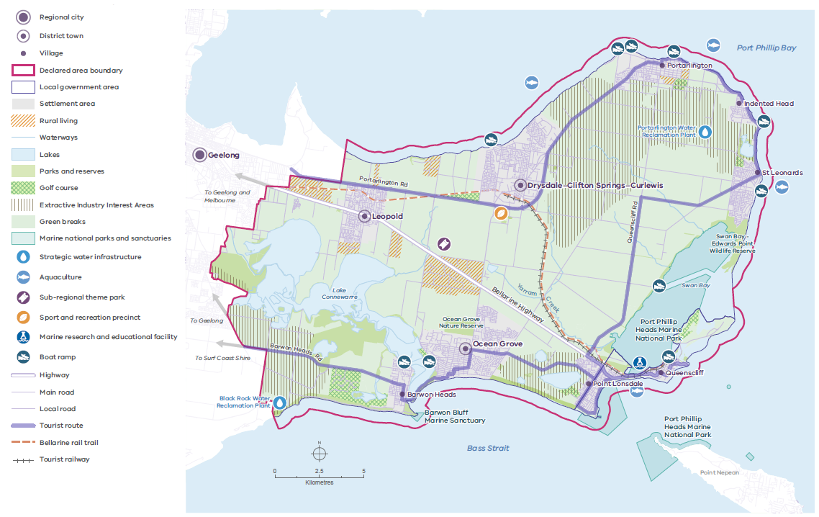

Source: DTP 2023.

5.7 Strategic infrastructure

Relevant United Nations Sustainable Development Goals
3. Good health and well-being
6. Clean water and sanitation
8. Decent work and economic growth
9. Industry, innovation and infrastructure
11. Sustainable cities and communities

The social, economic and environmental resilience of the Bellarine Peninsula depends on the provision, maintenance and upgrading of transport, essential services and community infrastructure. Growing residential and visitor populations add to demand for this infrastructure, which must be managed to protect and enhance the peninsula’s distinctive attributes and values.

Map 8 shows the declared area’s strategic infrastructure.

5.7.1 Transport infrastructure
Integrated transport and land use planning is vital for securing a sustainable future for the declared area. People and businesses depend on reliable, efficient modes of transport to get to their homes and workplaces, get goods to market and visit and tour the region.

The Bellarine Highway, Portarlington Road, Grubb Road, Barwon Heads Road, Murradoc Road and Queenscliff Road are key transport corridors between settlements across the declared area and to the wider region. These corridors are located within areas with important landscape, living cultural heritage and environmental values: for example, there are patches of remnant native vegetation in roadside reserves. They provide gateways to the declared area and offer views of significant landscape features, including Port Phillip Bay, Swan Bay and the rolling rural hinterland.

As resident, visitor and freight movements increase on the Bellarine Peninsula, transport infrastructure will need more maintenance and upgrading to provide for the growing number of visitors, and it will need to be improved in a way that protects views across the landscape. The proposed Geelong Ring Road Extension (Bellarine Link) extending from Baanip Boulevard to Portarlington Road through the western edge of the declared area remains under investigation. It is important to ensure that landscape, cultural and environmental values are protected and enhanced in the development of this infrastructure.

As motor vehicles are the main mode of transport in the declared area, a more environmentally sustainable future requires a shift to greater use of active transport: walking, cycling and public transport. To make this shift, the declared area needs ongoing investment in sustainable transport infrastructure and services. The Strategic Cycling Corridors network is a prime example of how future transport initiatives could develop on the Bellarine Peninsula to support active transport and connections to activity centres. This network links Barwon Heads, Ocean Grove, Drysdale and Leopold to Geelong.

In 2022, the Bellarine Rail Trail is the main active transport connection on the Bellarine Peninsula. It is much-used by residents and visitors, linking Geelong to Queenscliff via Leopold and Drysdale–Clifton Springs. The surrounding reserve also contains areas of remnant native vegetation, creating a pleasant natural environment for users and providing habitat for native wildlife. Improving connections to the rail trail will support greater use of active transport.

The Portarlington and Queenscliff harbours are important infrastructure connecting the Bellarine Peninsula to Melbourne and the Mornington Peninsula. They support tourism, commercial fishing and recreational activities, and they have the capacity to meet greater demand from visitors, residents and workers. As the use of these facilities increases, it will be necessary to ensure they are maintained as vibrant community assets.

5.7.2 Water security infrastructure
The Bellarine Peninsula declared area faces a hotter, drier climate, less rainfall and an increasing population, all of which are threats to water security. In the immediate future, integrated water management approaches (such as increasing the use of stormwater and recycled water) will help improve water security.

Barwon Water provides the Bellarine Peninsula with its drinking water, with supplies mainly derived from catchments from the upper Barwon and Moorabool rivers. Supplies are supplemented via the Victorian water grid during dry periods.

The Black Rock Water Reclamation Plant collects and treats sewage from the Geelong region and much of the Bellarine Peninsula. It primarily supplies recycled water outside the declared area to the Armstrong Creek growth area and Torquay–Jan Juc. It also supplies recycled water to an increasing number of properties in the declared area. The Portarlington Water Reclamation Plant supplies recycled water for agricultural purposes (primarily grape growing) to the northern Bellarine Peninsula region around Portarlington.

Increasing the output, distribution and quality of the Black Rock and Portarlington water reclamation plants and introducing programs to capture and recycle stormwater and wastewater can provide alternative water sources for agriculture and other uses across the declared area. These reclamation plants are strategic water assets essential for
the region’s future water security. They also provide further asset co-location opportunities for investment in alternative water sources, innovative waste management infrastructure (such as organics recycling) and renewable energy generation. Recycled water and stormwater infrastructure and improved management practices can help secure an environmentally responsive, sustainable economic future for the declared area.

5.7.3 Community infrastructure and essential services
Infrastructure and services in the declared area need maintenance and upgrading to respond to community needs, new technologies and climate change impacts. This includes water, electricity, renewable energy, telecommunications and waste management infrastructure, as well as schools, sporting facilities, libraries, health services and activity centres.

The Bellarine Peninsula is serviced by various educational institutions, from early childhood to marine research institutions. Governments will continue to monitor and review demand and determine whether additional educational infrastructure or school sites will be needed.

To ensure the declared area’s settlements are healthy, sustainable and liveable, health and wellbeing services must be accessible, community-based and responsive to the region’s changing demographics.

5.7.4 Objective and strategies
Objective 7
The following objective is binding on responsible public entities.

To ensure the integrated provision and protection of transport, strategic water assets, essential services and community infrastructure that meets the community’s needs while increasing resilience to climate change.

Strategies
Responsible public entities are required to have regard to the following strategies to achieve the objective when performing a function or duty or exercising a power in relation to the declared area.

Strategy 7.1 | Design and site infrastructure to be sympathetic to and strengthen the preferred settlement, landscape character, environmental and cultural heritage values by maintaining view lines from existing and new transport corridors, retaining remnant vegetation and by increasing indigenous vegetation.
Strategy 7.2 | With the Wadawurrung, ensure the provision, maintenance and upgrading of infrastructure protects, conserves and enhances sites of Wadawurrung living cultural heritage significance.
Strategy 7.3 | Protect and facilitate the provision of strategic water infrastructure (such as the Portarlington and Black Rock water reclamation plants) and associated infrastructure.
Strategy 7.4 | Reinforce the timely delivery of infrastructure and services to meet community needs in sequence with development.
Strategy 7.5 | Maintain and strengthen transport connections between the settlements of the Bellarine Peninsula, Geelong, Melbourne and other regional communities.
Strategy 7.6 | Prioritise active transport modes – walking, cycling and public transport – and sustainable infrastructure (such as electric vehicle recharging stations and bicycle parking) to encourage their use by the community and visitors and reduce greenhouse gas emissions.
Strategy 7.7 | Encourage resource recovery (such as organic material recycling) and renewable energy facilities where they do not harm the declared area’s environmental, Wadawurrung living cultural heritage, historic heritage and landscape values.
Strategy 7.8 | Encourage the capture of stormwater run-off for reuse, including to irrigate parks, reserves and street trees.
Map 8: Strategic infrastructure

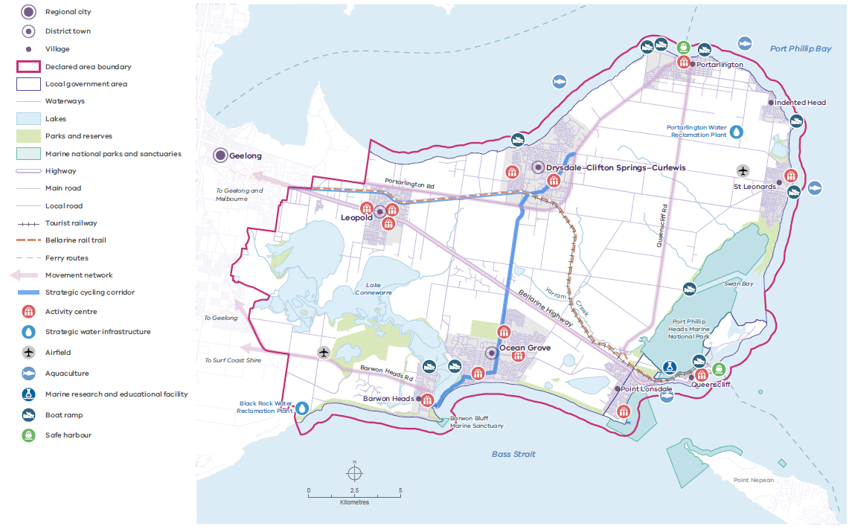

Source: DTP 2023.

5.8 Settlements

Relevant United Nations Sustainable Development Goals
3. Good health and well-being
6. Clean water and sanitation
9. Industry, innovation and infrastructure
11. Sustainable cities and communities
16. Peace, justice and strong institutions
17. Partnerships for the goals

The Bellarine Peninsula declared area is a highly desirable place to live, work and visit, given the lifestyle it offers and its proximity to Geelong and Melbourne. It has nine settlements: Barwon Heads, Drysdale–Clifton Springs– Curlewis, Indented Head, Leopold, Ocean Grove, Point Lonsdale, Portarlington, Queenscliff and St Leonards. Each has its own unique identity, character, role and function.

The population growth rate in the declared area over the last decade has been strong compared to other settlements in the G21 region and regional Victoria. As a result, the declared area’s unique values and distinctive attributes have been under pressure
from overdevelopment. To achieve the 50-year vision, settlements must be carefully planned, and ecologically sustainable development reinforced.

Barwon Heads, Ocean Grove, Point Lonsdale and Queenscliff are located adjacent to state-
significant landscape areas of Wadawurrung living cultural heritage and high biodiversity value that must be protected from urban encroachment.

All the other settlements are located within landscapes of regional significance, which have areas of cultural and environmental significance that also require protection.

The rural areas surrounding the Bellarine Peninsula’s settlements contain important non- urban uses (such as agriculture, hobby farms and agritourism businesses) that must be safeguarded.

To ensure the declared area’s unique values and distinctive attributes within and beyond settlements are protected and conserved and to provide communities with certainty, protected settlement boundaries are identified for all settlements. Green breaks between settlements are identified to ensure settlements do not coalesce and their unique identities are protected.

Development within all settlements should apply best practice, environmentally sustainable design and development principles.

These include supporting energy and resource efficiency, minimising car dependency, reducing stormwater run-off and promoting waste reduction and recycling throughout the design, construction and operational phases of developments.

5.8.1 Settlement hierarchy
Table 3 shows and describes the hierarchy designation – as a district town or village – of each settlement within the declared area.

Table 3: Hierarchy of Bellarine Peninsula declared area settlements

Settlement | Hierarchy designation | Description
Drysdale–Clifton Springs–Curlewis,  Leopold and Ocean  Grove | District town | A large town providing a diversity of housing, services and employment to support local residents, workers and visitors and provides service functions to surrounding settlements  and the hinterland.
Barwon Heads,  Indented Head, Point Lonsdale, Portarlington,  Queenscliff and St  Leonards | Village | A small town with services that support local, residents, workers and visitors (such as a general store, post office, retail premises and community services).

5.8.2 Future development
Most future urban development will be concentrated within the settlement boundaries of district towns - within activity centres, substantial change housing areas and future urban areas.

Development will be planned, managed and designed to respect the unique identities of settlements, including their highly valued landscape, environmental and heritage values and coastal characters. It will also take into account the settlement’s hierarchy designation and be designed to have regard to how it interfaces with the adjoining rural and non-urban land so as to minimise disruption of the landscape character, where applicable (refer to settlement maps).
Activity centres
Land use in town and activity centres will be generally mixed-use, reflecting the centre’s role as a subregional activity centre, town centre or neighbourhood activity centre. The built form will achieve outstanding urban design outcomes and will be at a scale in keeping with the settlement’s hierarchy designation, role, function and preferred character.

Housing change areas
Maps 9–17 show the level of change that can be expected as future housing is accommodated within the declared area. Each settlement will accommodate housing differently in line with its hierarchy designation and settlement character.

Three types of housing change areas will apply:
- minimal change: these areas should be protected because of their special neighbourhood, heritage, environmental or landscape characteristics.
- incremental change: these areas are where some housing diversity and change may occur in keeping with the existing or preferred neighbourhood character. Development may include medium-density housing and buildings may be up to two storeys. Note an area also specified in the Greater Geelong Planning Scheme as an ‘increased housing diversity area’ may have building heights of up to two-to-three storeys.
- substantial change: these areas are where increased housing diversity is encouraged. While change should be expected, new development must still respect the landscape and settlement character. Substantial change areas are located in and around town centres/activity centres, along public transport corridors and strategic development areas. Development may include higher-density housing with the highest density development located adjacent to the commercial core of the area and the lowest at the edge of the area. Buildings may be up to two-to-three storeys.

The housing change areas will be implemented through local planning provisions set out in the planning scheme, including through local planning policies, zones, overlays and particular provisions. They will be guided by strategic planning reviews.

Future urban areas
Future urban areas are undeveloped areas within settlements identified as potentially suitable for greenfield development. They will provide urban land uses, including residential, commercial, community-based and eco-tourism-related land uses. Development will be planned and designed in line with each area’s existing or preferred character. A responsible and planning authority will not consider rezoning or permitting development in these areas until comprehensive planning and infrastructure assessments have been undertaken.

Some minimal change areas within existing residential areas are identified for further investigation as to whether they may become incremental change areas. These areas may be potentially suitable for urban development subject to planning and infrastructure assessments being undertaken. Further investigation of these areas will be undertaken by the City of Greater Geelong as part of future strategic planning reviews.

Green breaks and urban-rural interface areas
Maintaining green breaks between the declared area’s settlements is important. As shown on Map 3, the green breaks together with the protected settlement boundaries will help conserve environmental and cultural heritage attributes, strategic infrastructure (such as water utilities), agricultural land and other natural resources from encroachment by urban development. Within the declared area, green breaks are mostly rural land zoned as Farming Zone, Rural Conservation Zone, Public Conservation and Recreation Zone or Rural Living Zone.

The green breaks will also help protect the character and significance of the open, rural landscapes between the Bellarine Peninsula’s settlements, the coastal wetlands bordering Barwon Heads, Ocean Grove, Point Lonsdale and St Leonards and the undulating landscape of the central and northern peninsula. They help to establish a sense of arrival and a unique identity for each settlement area by containing their outward growth and avoiding settlement areas coalescing.

Development at the periphery of settlements has the potential to impact environmental and cultural heritage attributes and the rural land uses contained within the green breaks. It can greatly change the character of the surrounding landscape of the Bellarine Peninsula and must be carefully designed to achieve a successful urban-rural interface. Providing for a soft-edge transition between urban and rural areas may be achieved through the siting, scale and appearance of development.

Lower density development with additional space around buildings for vegetation, open and rural type perimeter fencing, smaller building footprints with substantial vegetation, or a generous vegetated buffer to obscure residential and other development on the town’s edge can minimise the visibility of development. Materials and finishes that temper visibility (such as darker materials and materials that weather naturally) should also be used.

5.8.3 District towns
Drysdale–Clifton Springs–Curlewis
The three townships at the historic heart of the Bellarine Peninsula – Drysdale, Clifton Springs and Curlewis – together create a large town that provides a range of housing, commercial, light industrial, retail and community-based land uses and services to residents of the declared area and beyond. It is set within coastal, grassy plains that extend from the rural hinterland down to the sandy Port Phillip Bay foreshore and that form part of the regionally significant Bellarine Northern Coast and Central Hills landscape. This landscape is characterised by productive agricultural uses, including award-winning wineries, and it has areas of significant environmental and cultural value. Future urban development will be carefully managed through infill and greenfield development within the protected settlement boundary shown on Map 9. Built form will typically be one-to-two storeys.

Drysdale is steeped in heritage with a rural feel. Its historic town centre is vibrant and can
accommodate infill development while continuing to provide retail and community services to the northern areas of the Bellarine Peninsula. Within the town centre, infill development will respect the views of Port Phillip Bay and the characters of historic buildings and landmarks, including the Drysdale Hotel, the original five-way intersection and the heritage railway station precinct.

Development within Drysdale’s established areas will respect their existing characters. Buildings are low scale, comprising detached dwellings with generous setbacks that fit in with the Victorian, Federation and bungalow styles of existing dwellings. Dwellings are set within established gardens that include canopy trees and are designed to respond to the historic buildings and bay views. Low-density and rural living style urban development at Drysdale’s eastern and southern edges will be preserved for its highly valued urban-rural transition and high biodiversity values.

Clifton Springs is a residential area that interfaces with Port Phillip Bay. Development will preserve the highly valued foreshore and be sympathetic to the township’s existing, low-scale coastal character, which comprises detached dwellings on larger lots. Intermittent views of the bay will be preserved.

Curlewis is characterised by contemporary, urban development, with larger houses on smaller lots. Development in the western future urban area will be designed to integrate with the surrounding, regionally significant landscape. It will provide a sensitive urban-rural transition to adjacent rural land and the Bellarine Rail Trail.
The emerging activity centre in the western area of Curlewis will provide local retail functions for residents and support more diverse housing. The small, light-industrial precinct along Murradoc Road will continue to operate as an industrial precinct and provide employment in the declared area. The township also has a significant cultural, education and sports precinct: an important asset for the region with its school, recreational, cultural and arts facilities.

Leopold
Leopold is known as the gateway to the Bellarine Peninsula. It provides diverse housing, retail and community services for the declared area’s residents and visitors. It is a compact settlement located on a hillside within the regionally significant Bellarine Northern Coast and Central Hills landscape characterised by an undulating, rural hinterland. Leopold’s setting offers sweeping views across rolling, agricultural land to Corio Bay, Lake Connewarre and the You Yangs, and it is the focal point of views from the Bellarine Highway.

Urban development will be carefully managed through infill and greenfield development within the protected settlement boundary shown on Map 10. Development must be sensitively designed to fit in with the town’s established character and rural setting.

On the town’s western edge, the Leopold subregional activity centre provides retail and commercial uses and other community and entertainment services to the declared area’s residents and workers. The centre provides visitors with a distinct sense of arrival to Leopold. High quality landscaping and public spaces will further enhance the centre’s character. The centre has the capacity to expand to the north within the protected settlement boundary, subject to planning permission. The Ash Road and Dorothy Street commercial strips are neighbourhood activity centres servicing the local community.

Residential infill development within substantial change areas around the activity centres will provide housing diversity and may be up to three storeys. Development within the remainder of the established residential areas will be more incremental. It will respond to the town’s low- scale built form that consists of mainly detached dwellings of one-to-two storeys with established gardens. Low-density residential areas not identified for increased residential densities will provide a transitional urban-edge treatment and will experience minimal change. Greenfield development will occur in designated areas in the south-east within the protected settlement boundary. It will be designed sympathetically and use best practice design measures to protect the adjoining, sensitive Lake Connewarre and Reedy Lake foreshores. Views of Corio Bay, Lake Connewarre and the rural hinterland from vantage points will be preserved and celebrated.

There are small areas of larger-lot, rural, residential-style living; and rural-living lots and small farms beyond the settlement boundary that provide an urban-rural transition and accentuate Leopold’s rural surrounds.

Ocean Grove
Set within grassy, coastal plains and densely vegetated coastal dune systems, Ocean Grove is a larger town with a relaxed, coastal character. It is a regional hub that provides a diversity of housing, employment, accommodation, retail and community-based land uses and services for residents, workers and visitors. Urban development will be carefully managed through infill and greenfield development within the protected settlement boundary shown on Map 11. Ocean Grove’s built form is mostly one-to-two storeys and it uses materials and colour palettes that generally reflect a coastal character. On the hillside of the town centre and in the surrounding residential areas, there are occasional examples of three-storey development, generally in more-elevated areas, to harness views to the foreshore.

The town adjoins the state-significant Bellarine Peninsula Southern Coast landscape, characterised by high cliffs, sweeping pristine beaches and a dramatic frontage to Bass Strait. The town’s western portion intersects with the Barwon River Estuary, a complex collection of waterbodies, swamps, marshes, mangroves and saltmarshes. To the north, the town intersects with the regionally significant Bellarine Northern Coast and Central Hills landscape, characterised by its undulating, rural hinterland.

Views of surrounding rural landscapes and seascapes are well-kept, and development will be designed to enhance the significant environmental attributes of the Buckley Park Foreshore Reserve, Barwon River Estuary and Ocean Grove Nature Reserve.

Ocean Grove has three activity centres: the Ocean Grove town centre, the Shell Road activity centre and the Grubb Road neighbourhood activity centre. These centres will continue accommodating housing, retail and commercial uses and community services.

The Ocean Grove town centre is distinct from the remainder of the settlement. Development is higher density and fine-grain with taller buildings in prominent locations so long as design requirements are met to protect the coastal village feel. It showcases contemporary architectural design while reflecting the existing coastal character that has strong connections to the beach location. New development in the town centre will allow sunlight to fall on public streets and maintain glimpses across Bass Strait. Vegetation will continue to be a key feature of the public and private realms. The Shell Road and Grubb Road activity centres provide a distinct sense of arrival to Ocean Grove. They have
contemporary-designed development with sensitive landscaping and signage.

Increased housing diversity will be accommodated in residential areas surrounding the Ocean Grove town centre, Shell Road and Grubb Road activity centres with some development up to three-storeys. Development within the older parts of Ocean
Grove – south of Thacker Street and Shell Road and known as ‘old Ocean Grove’ and Collendina – will be incremental and retain the longstanding, modest-scale, archetypal character of a coastal, residential area. It will respond to the existing character: low scale, built form, set within well-vegetated lots with consistent boundary setbacks and using coastal/natural materials and muted colours. Views of Bass Strait from vantage points at higher elevations will be preserved and celebrated.

The existing low-density residential and rural-living areas within the protected settlement boundary will experience minimal change and will continue to help transition the urban area to the rural hinterland. Greenfield development will provide for a diversity of housing and be carefully designed to integrate with the town’s landscape qualities, including its
vegetation and varying topography with intermittent views of Bass Strait preserved. Urban development at the periphery of the town must be planned and designed to have regard to its relationship to the rural land adjacent to its outer boundary while responding to its coastal setting.

On the town’s south-eastern edge improved tourist related facilities and community land uses will be located within the protected settlement boundary adjacent to the foreshore providing a transitional urban-edge treatment that protects the surrounding landscape values and the significant environment and biodiversity values of the Lonsdale Lakes wetlands system and Buckley foreshore reserve.

5.8.4 Villages
Barwon Heads
Barwon Heads is a charming coastal village nestled between the Barwon River, wetlands and Bass Strait, and it has significant environmental assets. It is a popular holiday destination and a residential area for workers who commute to Geelong. There is no capacity for greenfield development within the protected settlement boundary, shown on Map 12, and infill development will be carefully managed within it.

The village straddles landscapes of state and regional significance. To the south, the state- significant Bellarine Peninsula Southern Coast landscape is characterised by the high cliffs of The Bluff, sweeping beaches and sensitive dunal and coastal vegetation. To the north, the village transitions into the regionally significant Lake Connewarre and the Barwon River landscape, which features the Barwon River Estuary and Murtnaghurt Lagoon.

The Barwon Heads town centre is low-scale, with fine-grain built form and consistent street tree plantings. Development within the town centre integrates with the existing coastal character and does not protrude beyond the existing tree canopy line. Diverse housing opportunities will be provided around the town centre.

Development within Barwon Head’s established residential areas will retain its existing low-scale, coastal character and be set within larger, well-vegetated lots with generous boundary setbacks. Built form across the residential and commercial areas is generally one-to-two storeys. Muted colours and materials will help preserve and enhance the coastal character, as will native coastal and woodland vegetation and additional canopy tree planting.

Residential areas around Warrabeen Court and Stephens Parade have significant environmental and landscape values and will experience minimal change. However, the balance of the village’s residential areas will see incremental change that fits in with the low-scale, compact urban form and boutique village character.

Development at the village’s edge will be designed to naturally interface with the Murtnaghurt Lagoon, the Barwon River Estuary, The Bluff and surrounding coastal plains.

Indented Head
Set along a stretch of sandy beach on the shores of Port Phillip Bay, Indented Head is a small village with a quaint coastal character. It has a long post-colonisation history as a seaside-holiday village. There is a small, permanent population, and the village is popular with visitors due to its environmental and cultural features (such as the bay foreshore, nature and wildlife reserves and Wadawurrung cultural artefacts).

The village is located within the regionally significant Bellarine Northern Coast and Central Hills landscape, with tranquil beaches, salt lakes and minor sea cliffs on the coastal edge. Inland, the landscape is characterised by the low and occasionally undulating rural pastures, which form a valued green break heading towards the Central Bellarine Hills.

Some incremental development will occur within the protected settlement boundary as shown on Map 13. There will be no further greenfield development within the protected settlement boundary of Indented Head.

The village is primarily residential in character with a mix of low-scale, one-to-two-storey, older-style beach shacks with some contemporary development. The relatively informal street settings and pockets of coastal woodland vegetation reinforce the village’s coastal character.

Development will be low scale and set within well-vegetated lots with boundary setbacks, which allow for retaining existing vegetation and new plantings. It will be designed to integrate with the village’s coastal, historical character.

Development located at the periphery of the village will be designed to transition to its natural surrounds: the woodlands reserve, salt lagoon and foreshore.

Point Lonsdale
Point Lonsdale is a small village with a distinct coastal character set at the head of Port Phillip Bay. It has historically been a coastal-holiday destination with a small permanent population.

Point Lonsdale adjoins the state-significant Bellarine Peninsula Southern Coast landscape, characterised by its undulating dune topography, dense Coastal Moonah vegetation and sweeping sea beaches. The iconic Point Lonsdale Lighthouse is an essential navigation aid for mariners and a beacon to the village’s maritime history.

Urban development will be carefully managed through infill and greenfield development within the protected settlement boundary shown on Map 14.

The Point Lonsdale town centre is a small neighbourhood activity centre that will continue to provide retail, hospitality and community services to the local community and visitors. Development in the village centre will respond to the fine-grain, coastal character: to the pitched roofs, timber detailing and subdued, natural-material palettes of the existing built form. It may be up to two-to-three storeys so long as the existing coastal character is preserved.

Incremental infill development will be sympathetic to the existing low-scale built form that is mostly one-to-two storeys set amongst coastal tea tree and dense Moonah vegetation on an undulating dune topography within informal streetscapes, and it will be directed towards the town centre.

Greenfield development to the west of Fellows Road will be designed to integrate with the surrounding significant landscape and environmental features, including remnant vegetation, beaches and dunes, Lake Victoria, Lakers Cutting and the rural surrounds.

Views from Point Lonsdale Road and other local landmarks out over Victory Bight to Queenscliff and Point Nepean will be preserved.

Portarlington
Portarlington is a coastal village that rises up a gentle hill from a sandy foreshore. It has scenic views of Port Phillip Bay and the surrounding landscapes, which provide a marked sense of arrival by ferry. It functions as a seaside-holiday village and has a small, permanent population. The township is located within the regionally significant Bellarine Northern Coast and Central Hills landscape, and there are unique environmental assets at Point Richards and wetlands to the west. The rolling, agricultural landscape stretching beyond the village forms an important rural green break that contributes to Portarlington’s coastal character and identity.

Future urban development will be carefully managed through infill and greenfield development within the protected settlement boundary shown on Map 15. It will be planned and designed to maintain and enhance the village’s relaxed, low-scale coastal character, which is enhanced by generous public spaces that integrate with the highly valued public foreshore, including the environmentally significant Point Richards Flora and Fauna Reserve. Views out over the bay and surrounding rural hinterland will be maintained. Built form is mostly low-scale, one-to-two storeys.

Development within and around the town centre provides more diverse housing and will be at a scale and designed to respect the historic built form character. For example, the prominence and heritage character of the Portarlington Grand Hotel’s landmark tower will be maintained. It will be sensitively designed to interface with the valued foreshore reserve and to respect the surrounding low-scale built form.

Incremental residential development will respond to Portarlington’s informal streetscape character, with dwellings set within larger lots with generous open spaces and boundary setbacks that retain existing vegetation and provide opportunities for new plantings.

New development on the village’s periphery will be sensitively designed to integrate with the surrounding landscape and village character. It will provide an attractive gateway along Portarlington Road.

St Leonards
Surrounded by salt marsh and wildlife reserves, St Leonards is a small coastal village on the shore of Port Phillip Bay. It is set among significant environmental features, including the St Leonards Salt Lagoon, bay foreshore and Swan Bay – Edwards Point Wildlife Reserve. The surrounding agricultural land also provides the village with a highly valued rural backdrop.

The village functions mainly as a holiday village. It has a small commercial centre that provides facilities and services to the small local community.

The southern portion of the village adjoins the regionally significant Swan Bay landscape, comprised of saltmarsh communities and intertidal seagrasses. To the west of the village is the regionally significant Bellarine Northern Coast and Central Hills landscape, with rolling, agricultural land that provides a green break between St Leonards and Indented Head and Portarlington.

Urban development will primarily be infill development located within the protected settlement boundary shown on Map 16. It will be planned and designed to maintain and enhance the village’s quaint seaside character. Its scale will be sympathetic to the existing one and two storey built form, enabling existing vegetation to be retained and views through to the foreshore and bay protected.

Development within the St Leonards town centre will respect the mostly single-storey built form and tree-lined streetscapes. Awnings over footpaths and a subdued palette of colours and materials will reflect the coastal setting. Views through to the bay from local streets will be retained. Development along The Esplanade, the gateway to the commercial strip, will be low-scale and designed to interface with the foreshore sensitively.

A diversity of housing will be concentrated around the town centre. Development within the village’s residential areas to the north and south will sensitively integrate with the St Leonards Salt Lagoon and Swan Bay – Edwards Point Wildlife Reserve. The lower bluff area adjacent to the wildlife reserve has a unique, semi-rural character that will be preserved.

Queenscliff
Queenscliff is a quaint, coastal village steeped in cultural, maritime and military history. A significant coastal environment bounds it, providing panoramic views.

Queenscliff’s urban and commercial areas contain many examples of Victorian and early-twentieth-century architecture, from grand, freestanding hotels and landmark buildings to intimate, single-storey cottages and the low-scale Fishermans Flat neighbourhood.

The village’s rich military and maritime history also contributes to its identity and character. At The Narrows, the Avenue of Honour of Monterey cypress trees will remain a prized gateway to the Queenscliff heritage precinct. The gently undulating terrain and consistent tree canopy, combined with expansive views of Port Phillip Bay and Swan Bay, will continue to define the village.

Queenscliff will continue to be an important tourism destination on the Bellarine Peninsula. The village is linked by road, the Bellarine Rail Trail and ferry services to the Mornington Peninsula and beyond. The town centre and surrounding residential areas contain outstanding heritage values that severely restrict significant development. Areas identified as heritage precincts are defined as minimal change areas, shown on Map 17.

Urban development will primarily be infill development located within the protected settlement boundary shown on Map 17.

Development within the Queenscliff town centre will integrate with existing heritage structures, ensure views to Swan Bay from Hesse Street are retained and avoid excessive site coverage and visually dominating built form. This will ensure a seamless contribution to the existing rhythm of the heritage streetscape.

Across the settlement, minimal infill development will be accommodated. It will be designed to respect the village’s outstanding built form heritage and scenic views and will be low-scale, one-to-two storeys. Development will be set within larger, well-vegetated lots with boundary setbacks that provide space for canopy trees. Development at the village’s periphery will be designed to integrate with the surrounding landscape, environment and historic heritage values, including the Swan Bay Ramsar site and foreshore reserves.

5.8.5 Rural-living-style areas
There are several rural-living-style nodes across the Bellarine Peninsula. Wallington is the largest of these, and it is located in the centre of the peninsula to the north of Ocean Grove. Smaller nodes are located in and around Leopold, Curlewis and Drysdale. Rural-living areas typically comprise larger (up to 10 acres) lots, providing rural-lifestyle options to people seeking a connection to the land not offered by traditional urban development. Further supply should be restricted, given these nodes are often not well-serviced with infrastructure and they remove productive agricultural land.

5.8.6 Urban Geelong and the Bellarine Peninsula
The Bellarine Peninsula declared area abuts urban Geelong: specifically, the Armstrong Creek urban growth area, Moolap and the eastern Geelong suburbs of Whittington and St Albans Park. Protected settlement boundaries will be needed for these areas to ensure the green break between urban Geelong and the Bellarine Peninsula is preserved and significant landscape and environmental values are protected.

The resolution of this protected settlement boundary is subject to the completion of local strategic planning work and public consultation, which will be led by the City of Greater Geelong in collaboration with the Wadawurrung, the Department of Transport and Planning and other relevant agencies. This work should include consideration of the design and density of development in urban-rural transition areas within the protected settlement boundary.

5.8.7 Objective and strategies

Objective 8
The following objective is binding on responsible public entities.

To plan and manage the sustainable development of settlements in the declared area consistent with the protection of the area’s landscape significance, environment and biodiversity values, Wadawurrung living cultural heritage and historic heritage values and consistent with the unique character and hierarchy designation of each settlement.

Strategies
Responsible public entities are required to have regard to the following strategies to achieve the objective when performing a function or duty or exercising a power in relation to the declared area.

Strategy 8.1 | Direct urban development to a hierarchy of settlements, through designating areas for change and clearly defining protected settlement boundaries for Drysdale–Clifton Springs–Curlewis, Leopold, Ocean Grove, Barwon Heads, Indented Head, Point Lonsdale, Portarlington, St Leonards, Queenscliff and for the Armstrong Creek urban growth area, Moolap and the eastern Geelong suburbs of Whittington and St Albans Park.
Strategy 8.2 | Ensure development is designed to respect the identity, heritage and coastal character of settlements.
Strategy 8.3 | Direct the majority of residential development within settlements to activity centres, substantial change areas and future urban areas.
Strategy 8.4 | Ensure development at the periphery of settlements within their protected settlement boundaries is planned and designed to provide an urban- to-rural transition, to protect landscape character by minimising the visibility of the settlements from surrounding rural areas.
Strategy 8.5 | Ensure development within settlements maintains and enhances view lines of the rural hinterland, foreshore and coast.
Strategy 8.6 | Ensure development within settlements actively responds to the risks associated with climate change impacts and natural hazards.
Strategy 8.7 | Facilitate commercial development, community services, visitor accommodation, infrastructure and facilities within town and activity centres.
Strategy 8.8 | Ensure development within settlements achieves best practice, environmentally sustainable design for the full life of the development by planning for net-zero emissions for new development and improving the energy, water and waste performance of existing development and infrastructure.
Strategy 8.9 | Ensure affordable and social housing is located close to activity centres and services.

Map 9: Drysdale–Clifton Springs–Curlewis settlement plan

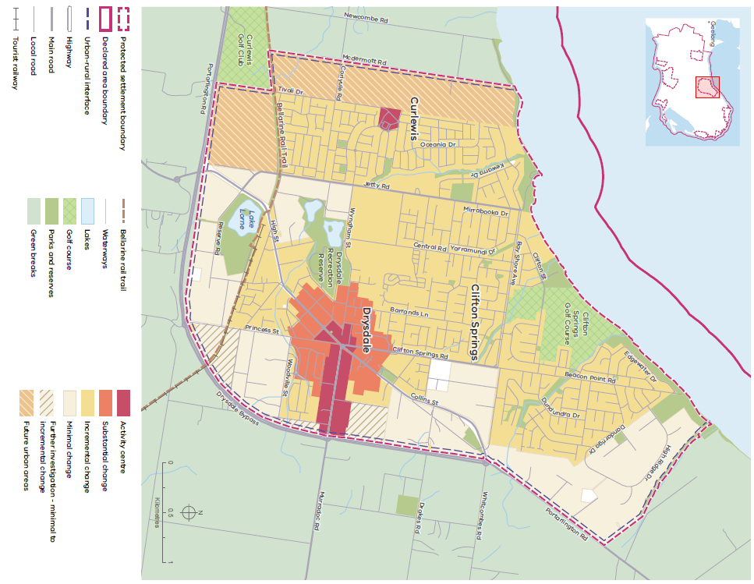

Source: DTP 2023.

Map 10: Leopold settlement plan

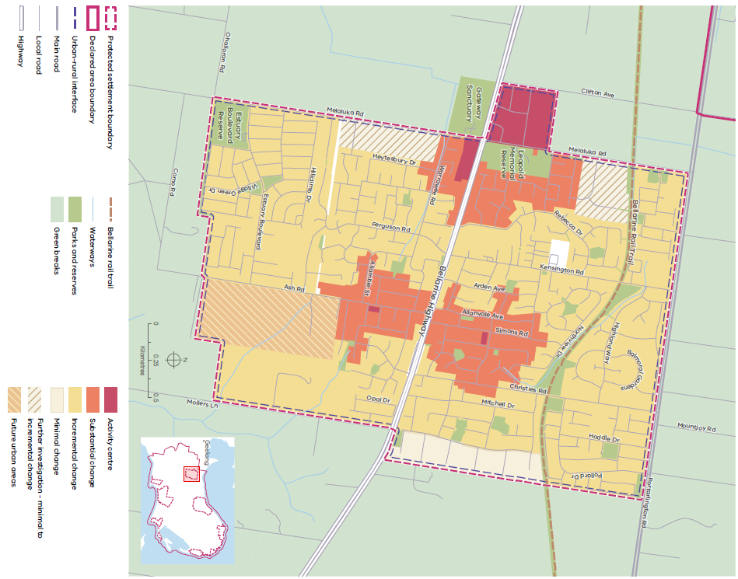

Source: DTP 2023.

Map 11: Ocean Grove settlement plan

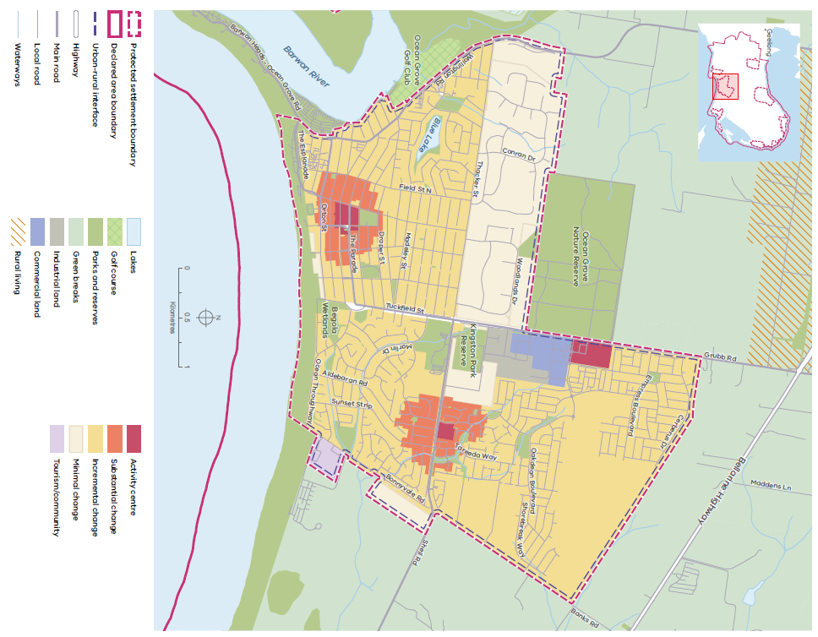

Source: DTP 2023.

Map 12: Barwon Heads settlement plan

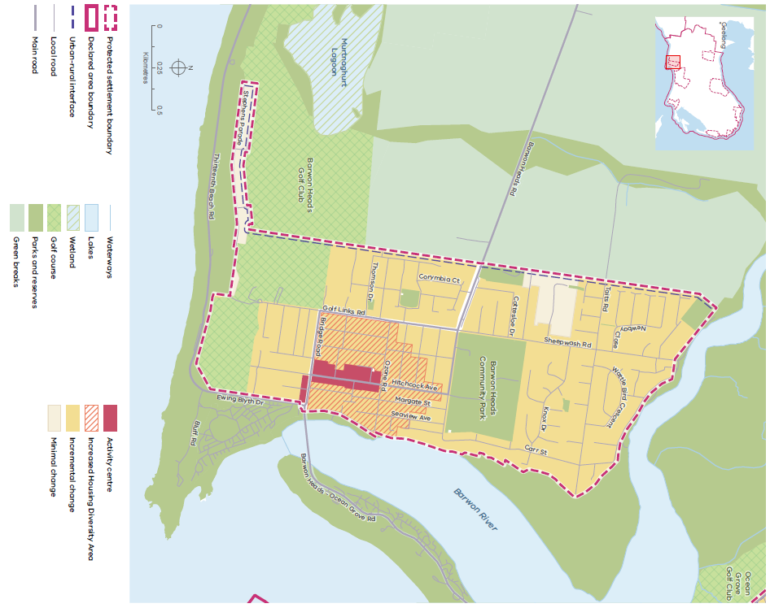

Source: DTP 2023.

Map 13: Indented Head settlement plan

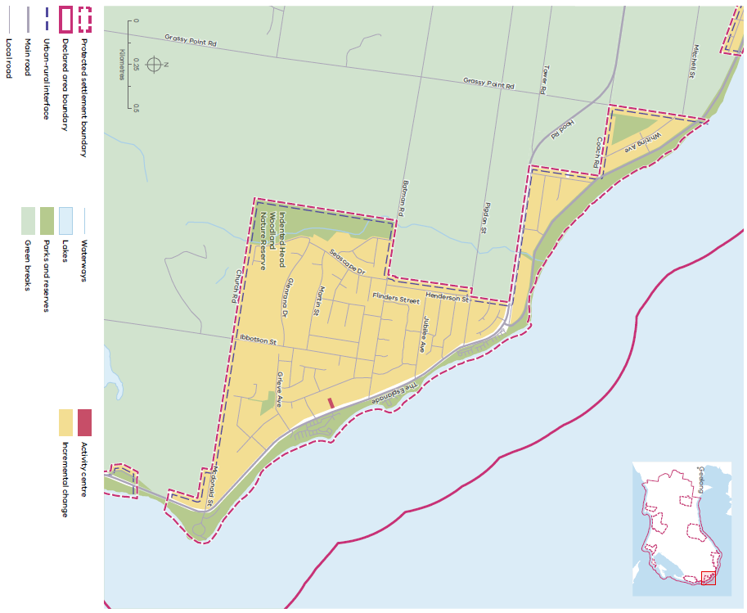

Source: DTP 2023.

Map 14: Point Lonsdale settlement plan

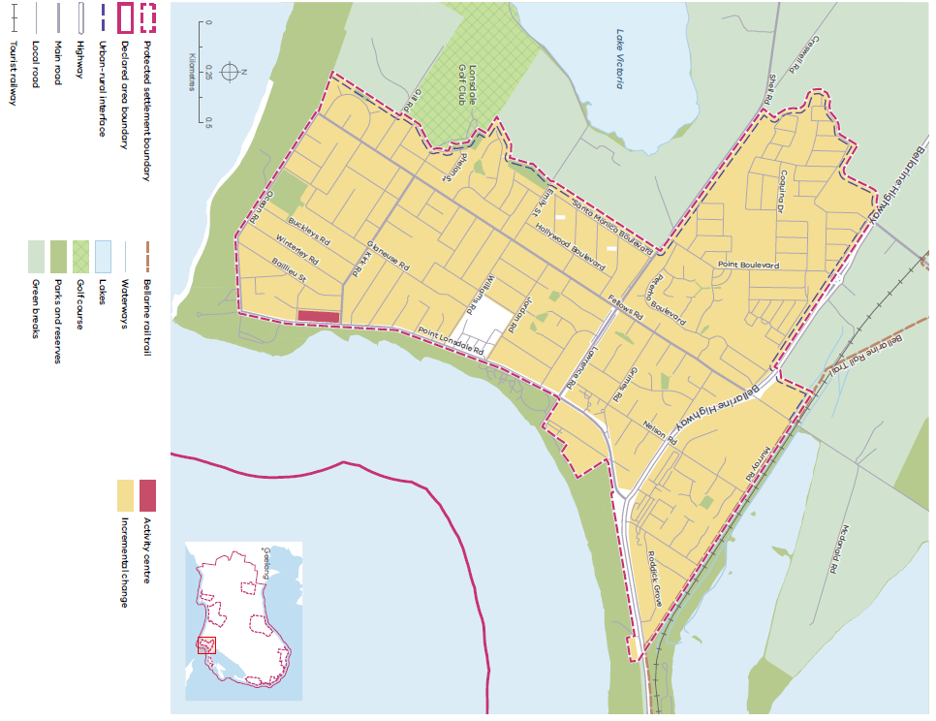

Source: DTP 2023.

Map 15: Portarlington settlement plan
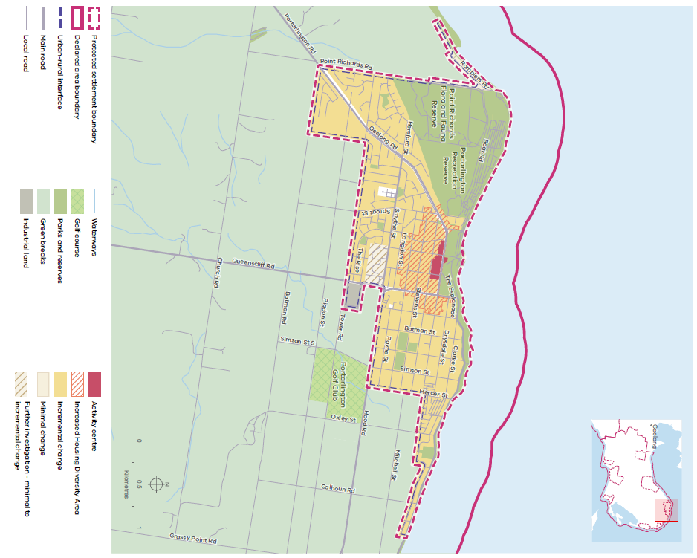

Source: DTP 2023.

Map 16: St Leonards settlement plan

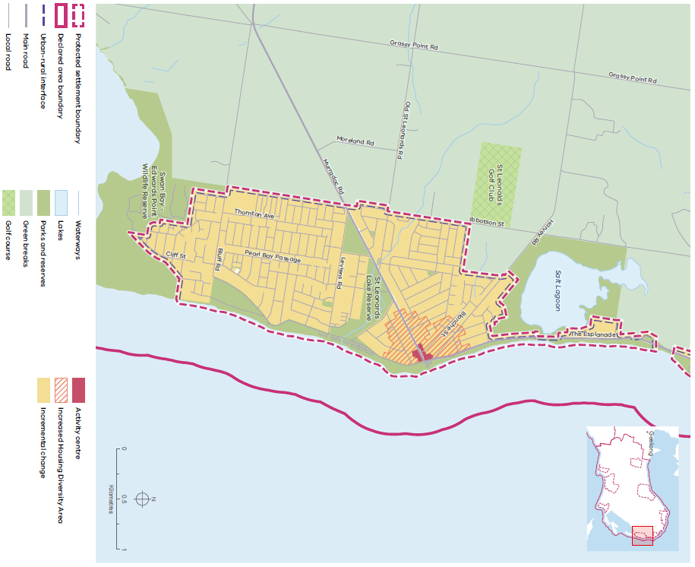

Source: DTP 2023.

Map 17: Queenscliff settlement plan

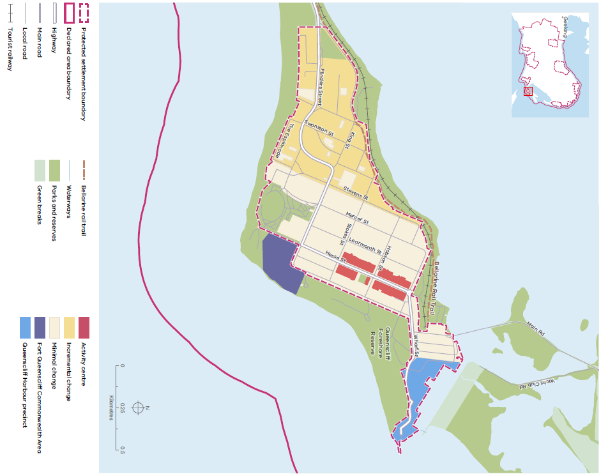

Source: DTP 2023.

6. References

Aboriginal Victoria (2019). Cultural Heritage Management Plans, Aboriginal Victoria, Melbourne.

Australian Government, Environment Protection and Biodiversity Conservation Act 1999, Australian Government, Canberra.

Barwon Water (2017). Urban Water Strategy, Barwon Water, Geelong.

Capire Consulting Group (2019). Bellarine Peninsula Distinctive Area and Landscape: Phase One Engagement Report, Capire Consulting Group, Melbourne.

Capire Consulting Group (2020). Bellarine Peninsula Distinctive Area and Landscape: Phase Two Engagement Report, Capire Consulting Group, Melbourne.

City of Greater Geelong (2007). Rural Land Use Strategy, City of Greater Geelong, Geelong.

City of Greater Geelong (2015). Managing Development in Rural Areas Planning Policy Review, City of Greater Geelong, Geelong.

City of Greater Geelong (2019). Amendment C395 – Settlement Strategy and Northern and Western Geelong Growth Areas Framework Plan, City of Greater Geelong, Geelong.

Claire Scott Planning (2020). Distinctive Areas and Landscapes: Bellarine Peninsula Landscape Assessment Review, Claire Scott Planning, Melbourne.

Department of Environment, Land, Water and Planning (2017). Protecting Victoria’s Environment – Biodiversity 2037. State of Victoria, Melbourne.

Department of Environment, Land, Water and Planning, Commonwealth Scientific and Industrial Research Organisation (2019a). Barwon Climate Projections 2019, State of Victoria, Melbourne.

Department of Environment, Land, Water and Planning (2019b). Flora and Fauna Guarantee Act 1988 – Threatened List, State of Victoria, Melbourne.

Department of Environment, Land, Water and Planning (2019c). Victoria in Future 2019. State of Victoria, Melbourne.

Department of Environment, Land, Water and Planning (2020a). Marine and Coastal Policy, State of Victoria, Melbourne.

Department of Environment, Land, Water and Planning (2020b). NatureKit, State of Victoria, Melbourne.

Department of Jobs, Precincts and Regions (2021). Strategic Extractives Resources Roadmap, State of Victoria, Melbourne.

Department of Sustainability and Environment (2008). Underpinnings of fire management for biodiversity conservation in reserves, State of Victoria, Melbourne.

Department of Sustainability and Environment (2012). Code of Practice for Bushfire Management on Public Land. State of Victoria, Melbourne.

Ethos Urban (2020). Bellarine Peninsula Distinctive Area and Landscape: Township Character Assessment, Ethos Urban, Melbourne.

Powell, Uncle Byron (2015). Interview Part 1 on the Barwon River, Wadawurrung Country, interviewed by Lucinda Horrocks, Culture Victoria, Wind and Sky Productions, 2 March 2015. Available at cv.vic.gov.au/ stories/aboriginal-culture/seeing-the-land-from- an-aboriginal-canoe/uncle-bryon-powell-interview-part-1-on-the-barwon-river-wadawurrung-country/.

Sustainability Victoria (2018). Statewide Waste and Resource Recovery Plan, Sustainability Victoria, Melbourne.

Tourism Victoria (2008). Victoria’s Nature-based Tourism Strategy, Tourism Victoria, Victoria.

Urban Enterprise (2019). Greater Geelong and the Bellarine Tourism Development Plan 2019-22, Urban Enterprise, Brunswick.

Victorian Government (2019). Victorian Government Self-Determination Reform Framework, State of Victoria, Melbourne.

Wadawurrung Traditional Owners Aboriginal Corporation (2020). Paleert Tjaara Dja: Wadawurrung Country Plan, Wadawurrung Traditional Owners Aboriginal Corporation, Ballarat/Geelong.

Wadawurrung Traditional Owners Aboriginal Corporation (2020). Paleert Tjaara Dja: Wadawurrung Country Plan, wadawurrung.org. au/healthy-country-plan-video, Wadawurrung Traditional Owners Aboriginal Corporation, Ballarat/Geelong.

Wathaurung Aboriginal Corporation (2020). Bellarine Peninsula Cultural Heritage, Wathaurung Aboriginal Corporation, Ballarat.

7. Glossary

Term | Definition
Biodiversity | All components of the living world: the number and variety of native plants, animals and other living things across our land, rivers, coast and ocean. Biodiversity includes the variety of their genetic information, their habitats and their relationship to the ecosystems within which they live.
Biodiversity connection (biolink) | A connection across the landscape that links up areas of habitat and supports natural processes that occur in a healthy environment, including the movement of species to find food and water.
Biodiversity features | A larger area (greater than 10 ha) of habitat, usually comprising either remnant vegetation or a wetland.
Blue carbon | Carbon stored in coastal and marine ecosystems (such as seagrass meadows, mangroves and tidal marshes).
Built form | The combination of features of a building, including its style, façade treatments, setbacks, height and site coverage.
Declared area | An area to which an order under Planning and Environment Act 1987 section 46AO applies. Map 2 shows the Bellarine Peninsula declared area.
Declared area framework plan | A plan required by the Planning and Environment Act 1987 section 46AV(2) to provide a framework for decision-making in relation to the future use and development of land in a declared area. Map 3 shows the Bellarine Peninsula declared area framework plan
District town | A large town providing a diversity of housing, services and employment to support local residents, workers and visitors and provides service functions to surrounding settlements and the hinterland.
Ecologically sustainable development | Defined by the 1992 National Strategy for Ecologically Sustainable Development as ‘using, conserving and enhancing the community’s resources so that ecological processes, on which life depends, are maintained, and the total quality of life, now and in the future, can be increased’.
G21 Alliance | The formal alliance of government, business and community organisations working together to improve the lives of people in the G21 region, which spans the City of Greater Geelong, Colac Otway Shire, Surf Coast Shire, Borough of Queenscliffe and Golden Plains Shire.
Green break | Predominantly rural land located in between settlement boundaries that may comprise a variety of non-urban land uses (such as agriculture, hobby farms and agritourism businesses).
Greenfield area | Rural or non-urban land designated for new or future development.
High biodiversity value area | An area with:  - larger, well-connected areas of native vegetation with higher strategic biodiversity value scores  - areas that are highly localised habitat for rare or threatened species, particularly if they are for multiple rare or threatened species  - important areas of habitat within dispersed habitats for rare or threatened species or areas of habitat for many dispersed rare or threatened species  - areas with large trees, including consideration of their age and size and areas of native vegetation that are in good condition (i.e. with higher condition scores) or an endangered ecological vegetation class  - waterways and sensitive wetlands and coastal areas, including wetlands designated under the international Ramsar Convention, wetlands listed in the Directory of Important Wetlands of Australia and internationally important sites for migratory shorebirds of the East Asian-Australasian Flyway  - national parks and conservation reserves, as well as significant roadsides and wildlife corridors.
Historic heritage | Historic types of heritage places including archaeological sites, artefacts, buildings, structures, precincts, gardens, trees, cemeteries, cultural landscapes, shipwrecks and their artefacts, and significant objects and objects associated with places. ‘Historic’ can refer to a range of periods or eras.
Increased housing diversity area | As identified in Greater Geelong City Council’s Housing Diversity Strategy 2007, a location within an urban area where a mix of high, medium and conventional density housing is encouraged, with the density of development highest within the commercial core of the area and lowest at the edge of the area
Incremental residential change area | An area where housing growth occurs within the context of existing or preferred neighbourhood character. Planning Practice Note 90: Planning for Housing (PPN90) has further details.
Infill development | The incremental development of additional dwelling(s) on individual residential sites (such as a three-unit development on a site on which there was previously a single house).
Landscape character | The sum of the physical features of an area (such as its topography, geology, waterbodies, vegetation and urban development).
Landscape significance | The designation of a landscape as special or important due to its visual, cultural heritage, environmental, scientific, social and other values.
Living space | A place where Wadawurrung people lived, with housing and access to freshwater and where aquacultural and agricultural activity, including the development of infrastructure took place.
Low biodiversity value area | An area with:  - no native vegetation  - lower strategic biodiversity value scores  - native vegetation in poor condition (i.e. with lower condition scores)  - native vegetation that is small in area and isolated from other native vegetation unless it provides highly localised habitat for rare or threatened species.
Low-scale building | A one or two-storey building.
Minimal residential change area | An area with neighbourhood, heritage, environmental or landscape characteristics that are sufficiently special to a municipality, metropolitan Melbourne or Victoria to warrant protection. Planning Practice Note 90: Planning for Housing (PPN90) has further details.
Nature-based tourism | Any type of tourism that relies on experiences directly related to natural attractions.
Peri-urban area | An area, some or all of which is less than 100 km from Melbourne, with a predominantly rural character.
Protected settlement boundary | A settlement boundary in a declared area that is protected under a SPP. Any amendment to a SPP that seeks to change a protected settlement boundary must be ratified by both Houses of Parliament.  A protected settlement boundary is a long-term settlement boundary intended to protect the valued attributes of the rural hinterland surrounding the settlement by containing its growth.
Ramsar convention | The Ramsar Convention on Wetlands of International Importance, which was the first modern treaty between nations aimed at conserving natural resources. It was signed in the Iranian city of Ramsar in 1971 and came into force in 1975. The Convention’s mission is ‘the conservation and wise use of all wetlands through local, regional and national actions and international cooperation, as a contribution towards achieving sustainable development throughout the world’. Once a wetland has been listed under the Ramsar Convention, countries agree to maintain or improve its ecological character as described at the time it was listed.
Registered Aboriginal Party (RAP) | A Traditional Owner group legally recognised under the Aboriginal Heritage Act 2006 and responsible for managing and protecting Aboriginal cultural heritage in an area. The Aboriginal Heritage Act 2006 recognises RAPs as the primary guardians, keepers and knowledge holders of Aboriginal cultural heritage.
Responsible public entity (RPE) | An agency or body responsible for managing land in the declared area. In the context of a declared area, an RPE is any of:  - the Secretary (within the meaning of the Conservation, Forests and Lands Act 1987)  - the water corporation responsible for the area in which the declared area is located  - a municipal council whose municipal district contains land in the declared area  - Parks Victoria  - the Victorian Planning Authority  - a catchment management authority for a catchment and land protection region that contains land in the declared area  - the Head, Transport for Victoria (within the meaning of the Transport Integration Act 2010)  - Victorian Rail Track  - any committee of management or trustees in relation to land in the declared area  - any Traditional Owner Land Management Board in relation to land in the declared area  - any other public entity prescribed to be an RPE in relation to the declared area.
Settlement | An area comprising township- or urban-related land uses that includes housing, community facilities, commercial and industrial areas and other uses.
Settlement boundary | A long-term boundary that marks the limit of urban development in an area and protects the valued attributes of the surrounding rural hinterland by containing the settlement’s growth. Unlike a protected settlement boundary, amendments to a settlement boundary do not need to be ratified by both Houses of Parliament.
State significance | A quality of environmental, landscape, economic and cultural heritage value important to the State of Victoria.
Statement of Planning Policy (SPP) | A Statement of Planning Policy approved under the Planning and Environment Act 1987 part 3AAB in relation to a declared area.
Substantial change area | An area where housing intensification will occur that results in a substantially different scale and intensity of housing compared to other areas of a municipality, including an area in and around an activity centre or along a public transport corridor and a strategic development area. Planning Practice Note 90: Planning for Housing (PPN90) has details.
Teal carbon | Carbon stored in inland freshwater wetlands.
Traditional Owners | An Aboriginal group with Country in a declared area. The Wadawurrung are the Traditional Owners of the Bellarine Peninsula declared area. An area that provides a soft edge between urban development
Urban-rural transition area | An area that provides a soft edge between urban development within a settlement boundary and the rural land beyond to minimise the visibility of the development and better manage the settlement’s environmental and landscape impacts.
Village | A small town with services that support local, residents, workers and visitors (such as a general store, post office, retail premises and community services).
Visitor | People travelling and staying outside their usual place of residence for holidaying, sight-seeing and recreation, and people travelling for other reasons (such as visiting friends and relatives, business, work, education and accessing medical services).
Visitor economy | The production of goods and services for consumption by visitors, including industries that directly serve visitors (such as hotels, transport providers, tour companies and attractions) and intermediaries and indirectly involved industries (such as retail and food production).
Wadawurrung living cultural heritage | Tangible heritage – Wadawurrung places, objects and ancestral remains – and intangible heritage – knowledge of or expression of Wadawurrung tradition, including oral traditions, performing arts, stories, rituals, festivals, social practices, craft, visual arts, and environmental and ecological knowledge (not including anything that is widely known to the public), as set out in the Aboriginal Heritage Act 2006.

