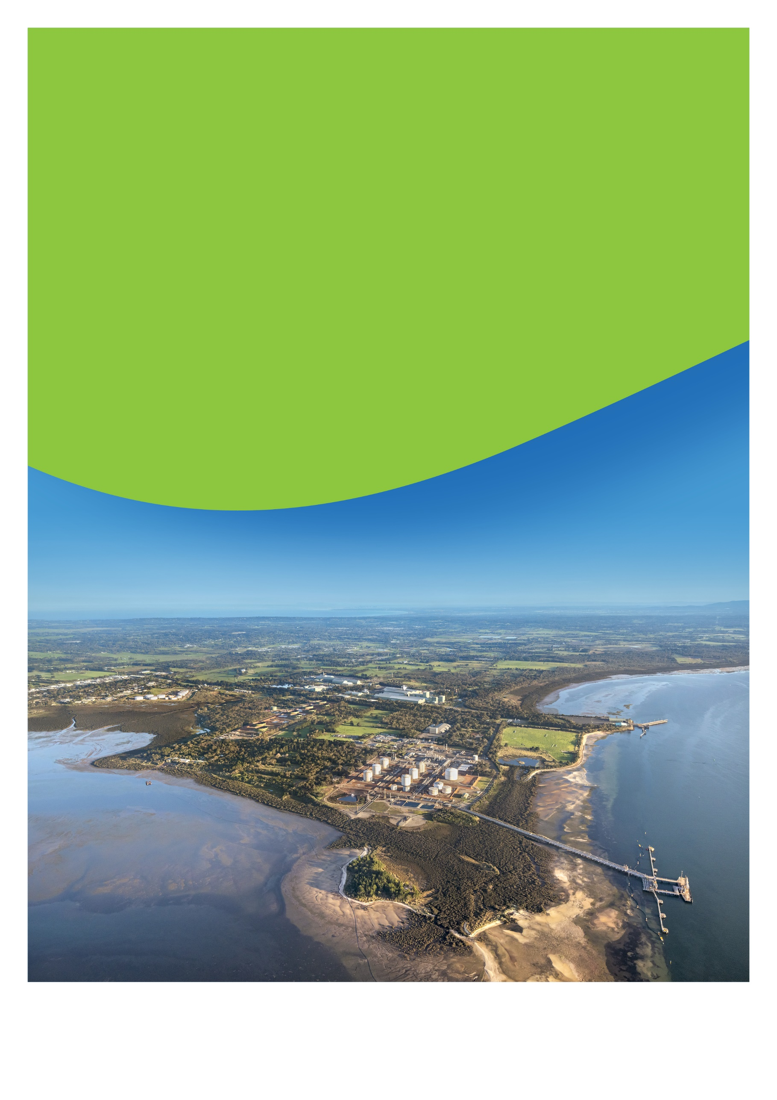
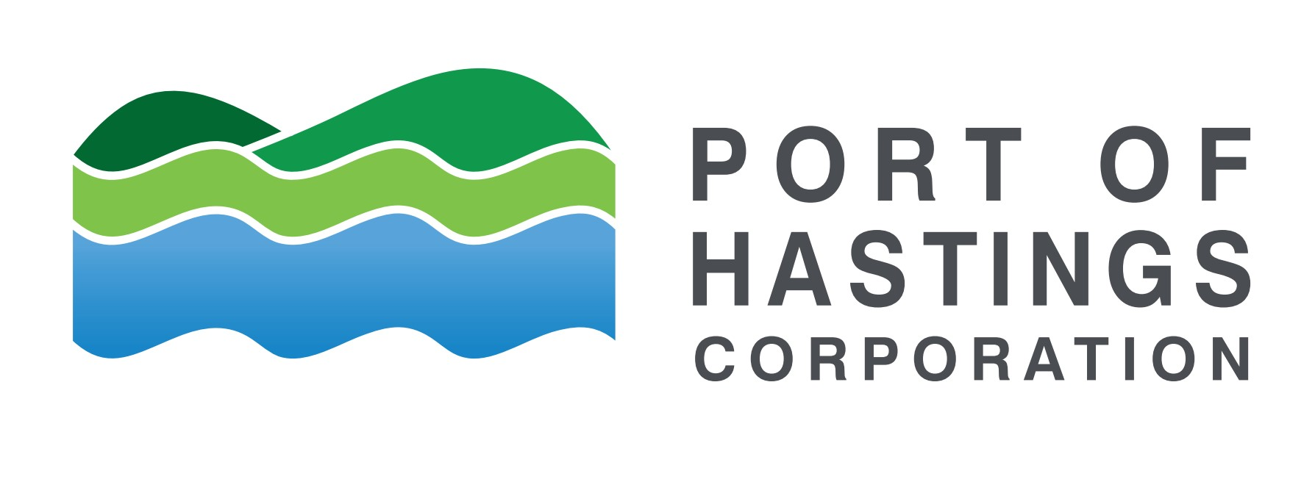

Delivered by
April 2026
The Port of Hastings Corporation (PoHC) is a public entity established in January 2012 under the Transport Integration Act 2010 (Vic).
ABN 33 737 350 749
The Consultation Plan is a working document and
will be updated as the project progresses

Victorian Renewable Energy Terminal - Consultation Plan
  - Environment effects statement (EES) process

Document Control
Project | Victorian Renewable Energy Terminal
Originator/Company | Port of Hastings Corporation
Document Title | Consultation Plan
Document No. | POH-VRE-CSE-001
Secondary No. | N/A [Add only if applicable]
Document Status | Working Version

Table of Contents
Executive summary 5
1. Introduction 7
1.1 About the Port of Hastings Corporation 7
1.2 About the Victorian Renewable Energy Terminal 8
1.3 Planning for the Victorian Renewable Energy Terminal 10
1.4 Project Design Options 10
1.5 Project objectives 11
2. Environment Effects Statement 13
2.1 EES context 13
2.2 Indicative environmental approvals timeline 13
2.3 EPBC Context 14
2.3.1 Preliminary Impact Assessment 14
3. Engagement to date 15
3.1 Stakeholder Engagement 15
3.2 Engagement methods 15
3.3 Areas of interest 16
4. Communications context 17
4.1 History and social context 17
4.2 Community profile 18
4.3 Key stakeholders 19
4.4 Traditional Custodians 20
4.5 Technical Reference Group 21
4.6 Community Reference Group 21
4.7 Neighbouring stakeholders and port users 22
5. Engagement principles and objectives 23
5.1 Government legislation and policies 23
5.2 IAP2 Spectrum of Public Participation 23
5.3 Victorian Government Public Engagement Framework 24
5.4 Committing to engagement principles 25
5.5 Communications and Engagement objectives 25
5.6 How feedback will inform the project 26
6. Engagement phases 27
7. Communication tools 30
7.1 Print communication 30
7.2 Digital communication 31
7.3 Translation and Accessibility 31
8. Engagement methods 32
8.1 Engagement activities 32
9. Processes and protocols 33
9.1 Responding to community enquiries and feedback 33
9.2 Complaints management procedure 33
9.3 Record Management 33
9.4 Data Protection and Privacy 34
10. Review and evaluation 35
11. Indicative stakeholder matrix 36

Executive summary
This plan describes the approach Port of Hastings Corporation (PoHC) will use to inform and involve Traditional Custodians, communities, stakeholders, industry, and government in the development of the proposed Victorian Renewable Energy Terminal project
Consultation is a key aspect of project development, design, and the environmental assessment process.
It helps build an understanding of the project and its potential effects and enables stakeholder knowledge and views to be considered by the project team in project development and assessments, and by the government in its assessment and approval decisions.
The primary focus of this plan is the preparation of the project design and environmental assessment process, an Environment Effects Statement (EES).
This Consultation Plan (CP) is designed to:
- Inform communities and stakeholders about PoHC, existing operations, and the proposed Terminal project.
- Build awareness of the proposal in the context of the Victorian Offshore Wind commitments and policy.
- Promote an understanding of the project and environmental assessment process (the EES process).
- Encourage participation and seek targeted input during project development and environmental assessments, to identify issues of potential concern, gain local insight, and seek feedback on measures that respond to stakeholder concerns.
- Use and respond to community and stakeholder feedback and demonstrate how it has been considered through the design development and environmental approvals.

Acknowledgment of Traditional Custodians
We acknowledge and respect Victorian Traditional Custodians as the original custodians of Victoria’s land and waters, their unique ability to care for Country, and their deep spiritual connection to it. We honour Elders past and present whose knowledge and wisdom have ensured the continuation of culture and traditional practices.
We are committed to genuinely partnering, and meaningfully engaging, with Victoria’s Traditional Custodians and Aboriginal communities to support the protection of Country, the maintenance of spiritual and cultural practices, and their broader aspirations in the 21st century and beyond.
The Bunurong Land Council Aboriginal Corporation (BLCAC) is the Registered Aboriginal Party (RAP) for the land on which our proposed project is located.

Abbreviations
The following abbreviations will be used throughout the Consultation Plan (CP)
Abbreviation | Definition
BLCAC | Bunurong Land Council Aboriginal Corporation
CALD | Culturally and Linguistically Diverse Communities
CCC | Consultative Community Committee
CMP | Complaints Management Procedure
CRG | Community Reference Group
DCCEEW | Department of Climate Change, Energy, the Environment and Water
DEECA | Department of Energy, Environment and Climate Action
DPC | Department of Premier and Cabinet
DTF | Department of Treasury and Finance
DTP | Department of Transport and Planning
EDM | Electronic Direct Mail
EES | Environment Effects Statement
EPA | Environment Protection Authority (Victoria)
EPBC Act | Environment Protection and Biodiversity Conservation Act
GW | Gigawatt
MW | Megawatt
OTRA | Old Tyabb Reclamation Area (OTRA)
OWEV | Offshore Wind Energy Victoria
PoHC | Port of Hastings Corporation
Ramsar | Internationally important wetlands
RAP | Registered Aboriginal Party
The Terminal | Victorian Renewable Energy Terminal
TRG | Technical Reference Group
UNESCO | The United Nations Educational, Scientific and Cultural Organisation

Introduction

About the Port of Hastings Corporation
The Port of Hastings is located on the shores of Western Port, approximately 70 kilometres south-east of Melbourne. It is one of four major working commercial trading ports operating in Victoria, and has been operating for close to 60 years.
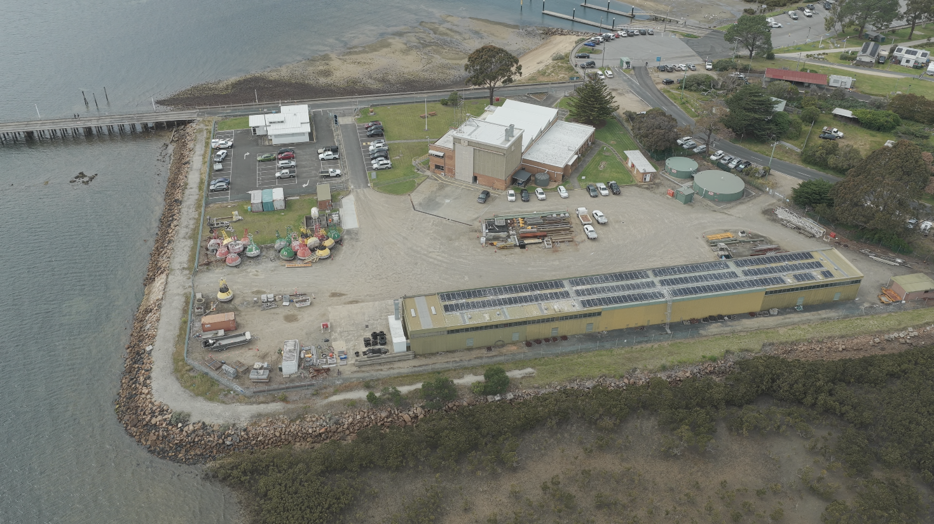
Figure 1: Stony Point Depot (Main Office)
The Port of Hastings facilities include:
- BlueScope Steel wharves
- Long Island Point jetty
- Crib Point jetty
- Stony Point jetty and depot
Our operations
The Port of Hastings' current trade groups include import/export of oil, liquid petroleum gas (LPG), steel, aviation fuel and unleaded petrol (ULP).
‍
The offshore wind industry presents an opportunity to open a new chapter in the history of the Port, one that will see the Port of Hastings at the heart of Victoria's drive to reach net zero emissions.
The Victorian Renewable Energy Terminal is a proposed dedicated assembly port that will enable the import, storage and assembly of offshore wind components, to support offshore wind farms across Victoria.
The Port of Hastings has many attributes that make it an ideal location for an offshore wind assembly port, including large areas of appropriately zoned land close to deep water channel and proximity to proposed offshore wind farms off the coast of Victoria.

About the Victorian Renewable Energy Terminal
Victoria is establishing a thriving offshore wind sector – paving the way for the state to host the first offshore wind energy project in Australia. Offshore wind projects require very large components which need to be manufactured, transported, stored and transferred to the offshore wind site for installation. The scale, length and weight of these components place unique heavy-duty operational requirements on ports and require a significant land area adjacent to ship berths, pavement strength and shipping channel capacity.
Figure 2: Artistic render of the proposed Victorian Renewable Energy Terminal
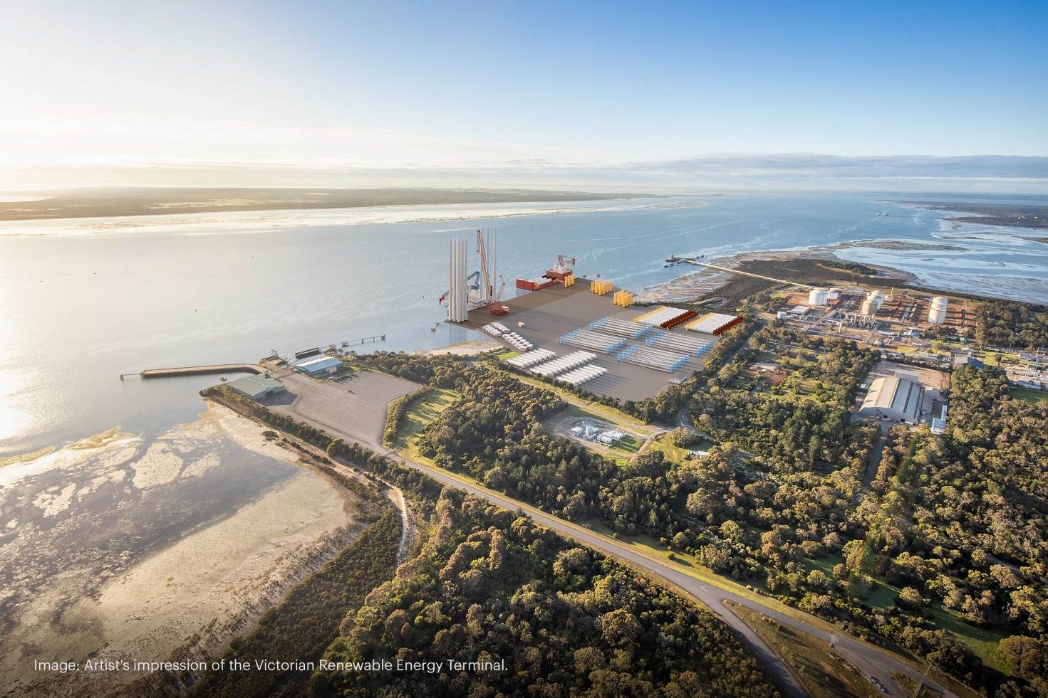
No port in Victoria is currently suitable to support offshore wind construction at scale. To accommodate this, the Victorian Government is planning the development of Victoria’s first offshore wind port facility to unlock the benefits of offshore wind.
The Port of Hastings has been selected by the Victorian Government as the preferred location for the establishment of the Victorian Renewable Energy Terminal (the Terminal)- a dedicated assembly port to support the construction of Victoria's first offshore wind farms along the Victorian coast.
The Port of Hastings is a major transport gateway supporting key industries associated with fuel imports and oil, gas and steel production. It is located approximately 70km to the southeast of Melbourne. The Terminal will receive, store, and assemble offshore wind components before they are transported to offshore wind farms off the Victorian coast for installation.
The Terminal is proposed to be developed at the Old Tyabb Reclamation Area (OTRA) and adjacent marine waters within the port precinct, situated between Esso’s Long Island Point jetty and BlueScope Steel wharves. The proposed terminal will incur into the Western Port Ramsar site, an area identified to be of international importance, in particular to waterbird habitat. The Ramsar site extends across much of Western Port, and connected to Bass Strait by a wide channel between Flinders and Phillip Island, and a narrow channel between San Remo and Phillip Island.
The project area is the area required for the development of infrastructure (excluding utility installation) and includes:
- Landside works, such as ground improvement and pavement construction
- Dredging and reclamation activities
- Marine works and quay wall construction
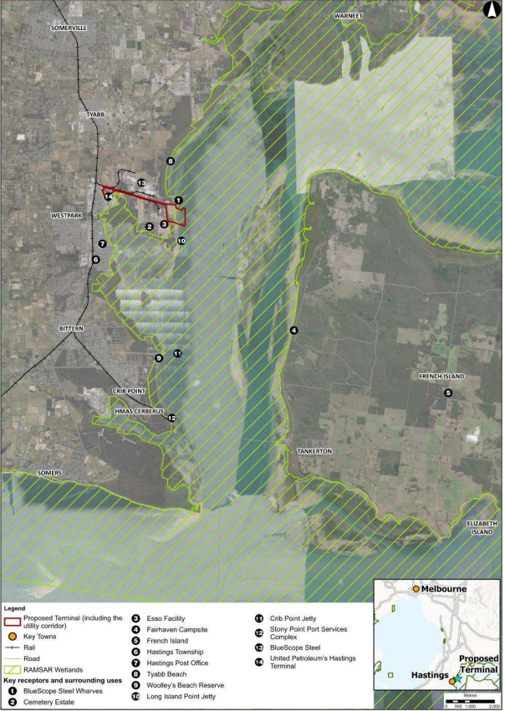
Throughout the Project’s design development, the PoHC has and will continue to consult with Traditional Custodians, communities, and industry to understand and recognise the important environmental, community and heritage values of Western Port.

Figure 3: Location of the Terminal

Planning for the Victorian Renewable Energy Terminal
The Port of Hastings Corporation (PoHC) is required to prepare an Environment Effects Statement (EES) for the proposed Victorian Renewable Energy Terminal.
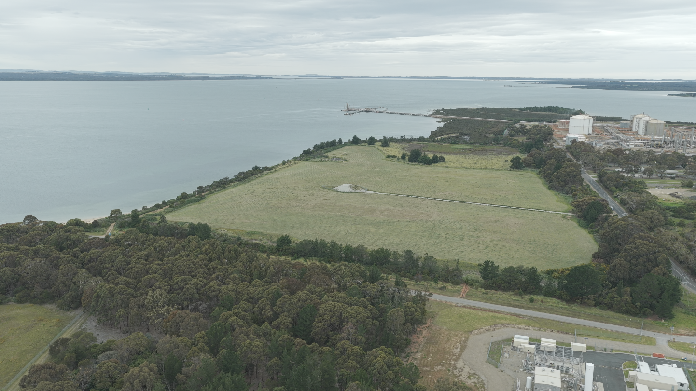
Figure 4: Old Tyabb Reclamation Area (Proposed location for the Victorian Renewable Energy Terminal)
An Environment Effects Statement (EES) is the most rigorous environmental assessment process in Victoria. The EES process is used to assess projects with potentially significant effects on the environment. It supports transparent, rigorous and integrated consideration of potential effects, to inform approval decisions.
The EES process is administered by the Department of Transport and Planning (DTP) on behalf of Victoria’s Minister for Planning under the Environment Effects Act 1978.
‍
As part of the EES process, PoHC is undertaking extensive technical studies, along with consultation with stakeholders, Traditional Custodians and the local community.
The project must complete the EES process and obtain both State and Commonwealth approvals before construction can commence.
The EES will be published for public exhibition and the project assessed by the Victorian Minister for Planning following the advice from an inquiry appointed under the Environment Effects Act 1978. For more information on an overview of processes under the Environment Effects Act, click here.
‍

Project Design Options
Several design options have been considered and continue to be assessed in defining the Victorian Renewable Energy Terminal project.
PoHC has engaged with the community on the Terminal, and PoHC will continue to make information available in the lead up to the EES exhibition via website and other communication channels.
Throughout the project development, the community will continue to have the opportunity to provide input into the design development through face-to-face meetings, consultation sessions and digital engagement channels.
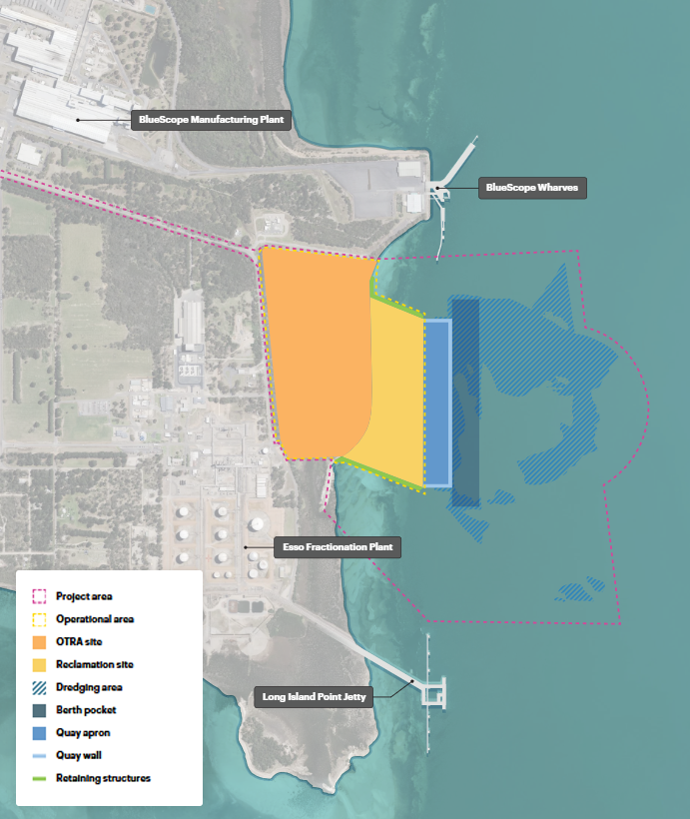
Figure 5: Map of Project area and components

Project objectives
The project aims to develop a port to support the emerging offshore wind sector. The Victorian ports system has been identified as an integral part of the shift towards the production, distribution, and use of offshore wind.
PoHC proposes to develop the Victorian Renewable Energy Terminal as a facility to serve as the primary assembly port for offshore wind developments along the coast of Victoria. In the longer term, the facility would be used to support maintenance, repowering and decommissioning activities.
The Terminal intends to:
• Support meeting Victoria’s renewable energy transition
• Enable reliable renewable energy for Victorians.
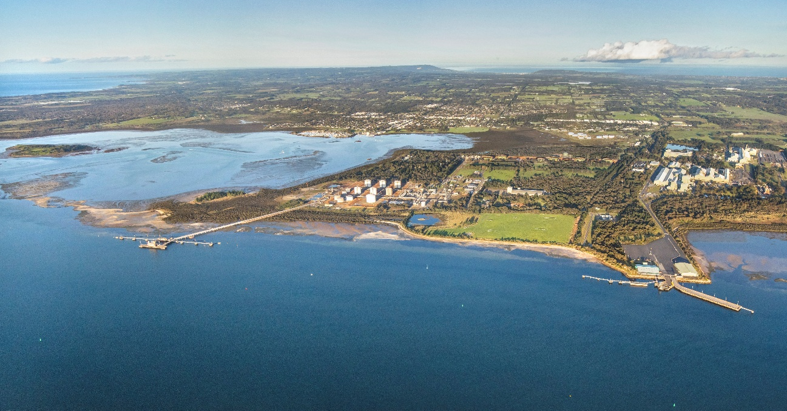
Figure 6: Drone image of Old Tyabb Reclamation Site (OTRA)

Environment Effects Statement

EES context
The Victorian Renewable Energy Terminal was referred on 11 August 2023 to the Minister for Planning.
On 11 October 2023, The Minister for Planning decided that an Environment Effects Statement (EES) was required based on the following reasons:
- the project has the potential for environmental impacts on biodiversity values, including the habitat of threatened species and communities.
- The project may pose risks to the conservation and ecological values of the Western Port Ramsar Site, including listed waterbird and migratory bird species.
- There are potential effects from the construction and operation of the facility on the marine ecosystem that may be significant, through increased sedimentation, disturbance of potential acid sulphate soils, dredging and potential introduction of pest species.
- Potential cultural and historical heritage values, including submerged Aboriginal cultural values.
- To enable an integrated, transparent assessment of the environmental effects of the project and associated uncertainties, including evaluating feasible, relevant alternatives, the effectiveness of proposed mitigation and offsetting measures, and opportunities to avoid or minimize significant adverse effects.
The Minister for Planning, The Hon Sonya Kilkenny MP, has outlined that the Port of Hastings Corporation should prepare and submit an EES consultation plan for engaging with the public and stakeholders during the preparation of the EES.
The EES consultation plan is to be implemented by the proponent, having regard to advice from the Department of Transport and Planning, and the Technical Reference Group.

Indicative environmental approvals timeline
Date | Milestone
August 2023 | EES referral lodged by the Port of Hastings Corporation
October 2023 | EES statement of decision released by the Victorian Minister for Planning
November - December 2024 | Draft EES scoping requirements exhibited
September 2025 | Updated scoping requirements exhibited
December 2025 | Final EES scoping requirements issued by the Victorian Minister for Planning
Q1 2027* | EES public exhibition period
Q2 2027* | EES Minister’s assessment of project – outcome of EES determined
Q4 2027* | Project construction commences (subject to approvals)
*Dates subject to change, indicative only.

EPBC Context
In 2025, the Port of Hastings Corporation (PoHC) prepared and lodged a new referral to the Commonwealth Department of Climate Change, Energy, the Environment and Water under the Environment Protection and Biodiversity Conservation (EPBC) Act 1999.
As the Project has the potential to impact Matters of National Environmental Significance protected under the EPBC Act (including the Western Port Ramsar Wetland), this referral was a necessary step to confirm the Commonwealth environmental assessment and approvals required for the Project to proceed.
The referral was published on 25 June 2025, following more than 18 months of detailed technical studies, preliminary impact assessments, and significant design refinements, including a 70% reduction to the proposed dredging footprint.
On 28 July 2025, the Commonwealth Government determined the proposed Victorian Renewable Energy Terminal project to be a Controlled Action. It was also decided that a Bilateral Agreement applies for the project, meaning impact on Matters of National Environmental Significance (MNES) will be assessed through the EES process.
For more information on Commonwealth approvals, including the Environment Protection and Biodiversity Conservation (EBPC) Act, click here.

Preliminary Impact Assessment
In preparing the new EPBC referral, PoHC undertook extensive scientific assessments, technical studies, and engineering work to substantially modify the project and prepare a new evidence-based referral.
The project will affect a small portion of the Western Port Ramsar Wetland. The reclamation area for the proposed Terminal will be less than 0.03% of the approximately 60,000-hectare area designated as the Ramsar wetland.
Environmental assessments to date show that potential impacts to mudflats, sedimentation, seagrass, marine life, coastal processes and waterbirds will be highly localised and manageable, with no unacceptable impact on the ecological character of the Western Port Ramsar Wetland.
For more information on the Preliminary Impact assessments, click here.

Engagement to date

Stakeholder Engagement
Since the October 2022 release of the Offshore Wind Implementation Statement 1, PoHC has engaged with key stakeholders, including local government, key community and conservation groups, and its existing Community Consultative Committee.
PoHC progressed this engagement throughout 2023 and 2024 to raise awareness about the Terminal project and to establish relationships with a wide range of interested groups and communities, through proactive briefing offers and local community events.
In 2025, the PoHC formed a dedicated Community Reference Group (CRG) for the project, to provide a direct forum to engage with community representatives on the EES process and the Terminal project, that is chaired independently.
PoHC have consulted extensively on a range of EES topics, seeking feedback to inform the EES through hosting technical roundtable sessions, community information sessions and direct engagement with stakeholders.
Conversations and feedback from community and industry continue to be constructive, with stakeholders broadly supporting the transition to renewable energy, and accepting the need for specialised port infrastructure to support the sector.

Engagement methods
Engagement has occurred through the following activities:
- Proactive offers for project briefings with community groups and project stakeholders
- Website and digital engagement
- Project updates via digital mailing list
- Attending community pop-ups at local markets
- Targeted doorknocks to residential properties nearby to investigation works and along the project’s transport route
- Attending keynote presentations at project conferences
- Technical roundtable sessions with community members and specialists preparing EES studies
- Developing and distributing introductory project fact sheets and other collateral.
- Engaging through dedicated forums such as the Community Reference Group (CRG) and Community Consultative Committee (CCC)

Areas of interest
Based on initial community feedback and conversations with stakeholders, key areas of feedback and interest have included:
- Impacts from construction of the Terminal
- Operational impacts
- Local flora and fauna
- Onshore ecology
- Economic benefit from construction and operation
- Ramsar matters (inc. Waterbird migration)
- Environmental and water impacts
- Local industry benefits and jobs
- Visual amenity
- Traffic and transport matters
  - Truck movements (construction)
  - Ship movements (operation)
  - Local road conditions
- Commonwealth approvals process
- State approvals process
- Opportunities for social benefit
- Opportunities for nature-based solutions

Communications context

History and social context
The Terminal Project site is located in the Hastings area in the Western Port region, approximately 72 kilometres from Melbourne. Western Port is a large tidal bay in southern Victoria, opening into Bass Strait, and is dominated by two large islands: French Island and Phillip Island.
The land around Western Port and the two main islands (French Island and Phillip Island) is the country of the Bunurong people of the south-eastern Kulin Nation who are the region’s Traditional Custodians.
As shown in Figure 7, The Bunurong Land Council Aboriginal Corporation (BLCAC) represents the interests of Bunurong Traditional Custodians, whose land covers parts of metropolitan Melbourne, Mornington Peninsula, Bass Coast, and west Gippsland.
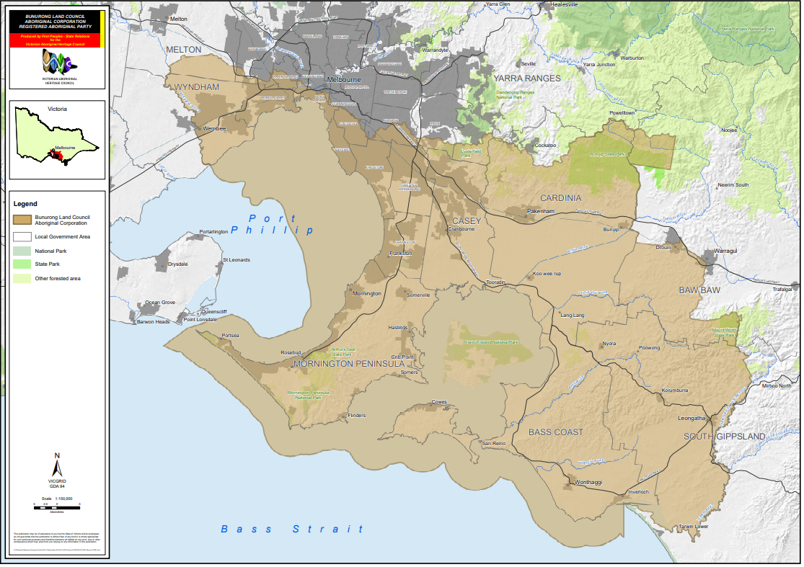
Figure 7 – BLCAC – Registered Aboriginal Party Map
The landscapes and seas surrounding the OTRA have undergone many significant changes over millennia. These natural and cultural processes have formed and continue to inform the configuration of the coastline and also shape the meanings that the Country holds for the Bunurong People.
The impact of colonisation on Bunurong people and culture has been profound and ongoing, resulting in the loss of knowledge and places of cultural value. Western Port was first visited by Europeans in 1798 when an exploration crew in a whaleboat journeyed south from Sydney to explore Australia’s south-eastern coastline. As it was the most westerly charted point at the time, it was named Western Port, which is now recognised as a misnomer as the area lies south-east of Melbourne.
Western Port is home to three Marine National Parks – French Island, Churchill Island and Yaringa. Today the area is used extensively for recreation. There is also a navy base (HMAS Cerberus) located at Hanns Inlet in Western Port Bay, Crib Point.
Western Port is within a listed Ramsar site, part of an Urban Biosphere Reserve.
The Western Port Ramsar site is one of the 1675 wetland sites around the world which cover 150 million hectares that have been designated for inclusion in the Ramsar List of Wetlands of International Importance. The site comprises four marine and coastal wetland types recognised under the classification system used by the Ramsar Convention.
Western Port forms part of the Mornington Peninsula and Western Port (MPWP) Biosphere Reserve which is part of the world network of biosphere reserves recognised by the United Nations Education, Scientific and Cultural Organisation (UNESCO) through its Man and the Biosphere Program.
Settlement of the area dates from the 1840s, with fishing being the main industry. Growth took place from the 1850s into the 1870s as the township of Hastings developed. Expansion continued in the late 1880s and 1890s, aided by the construction of the railway line and the establishment of many orchards. Significant residential development occurred during the 1960s and 1970s, spurred by industrial growth and public housing construction. Growth began to slow from the 1980s. The population has increased since the early 1990s, a result of new dwellings being added to the area.
Hastings is one of the ‘gateways’ to the lower Mornington Peninsula and the town is surrounded by farmland.
Western Port has been an active trading port since the early 1800s, featuring a wide variety of trades either derived from the sea of dependent on maritime transport (fishing, oil and gas). The Port of Hastings is home to the ExxonMobil and BlueScope manufacturing plants. Hastings also hosts many small businesses associated with the recreational boating industry.
The land surrounding the Port of Hastings has been reserved for port-related uses since the late 1960s. The port’s proximity to the oil and gas fields of Bass Strait and easy access for large vessels along the natural deep channels has given the port a key role in the energy sector.
In the 1970s the potential of Western Port was identified for the establishment of large-scale process industries, which require both deep water and extensive land adjacent to a port. Areas were identified to be set aside for port purposes so that the State's options regarding any future port development at Western Port could be preserved.

Community profile
The Port of Hastings is situated on the western side of Western Port around the suburbs of Tyabb, Hastings, Bittern and Crib Point. Nearby suburbs include Somers, Balnarring, Merricks, Merricks North, Shoreham, Red Hill, Red Hill South, Tuerong, Moorooduc, Somerville, and Pearcedale. The Port of Hastings is within the Shire of Mornington Peninsula local government area. According to 2021 Australian Bureau of Statistics (ABS) data, notes that the region of Hastings–Somers (which includes the townships of Crib Point, Somers, Balnarring Beach, Balnarring, Bittern, and Hastings) has:
- Over 24,000 people.
- A median age is 42 years, with 17.6% of the population aged under 14 years old and 22.4% aged over 65 years old.
- A gender distribution of 49.6% male (11,879) and 50.4% female (12,086).
- 2% of residents (468) identified as aboriginal and/or Torres Strait Islander
- Over 90% (21,661) used only English at home as a language, with Italian (0.3%), German (0.3%) and Tagalog (0.3%) as the three highest languages used as home, other than English
- A median family income of $1,839, and median household income of $1,407
- More than 70% have a Year 10 or higher education level.
- Full-time employed people make up 54.6% of the population, with a further 34.4% working part-time and 3.5% unemployed.
- 10.1% of people have a bachelor’s degree or higher, 26.2% have a Vocational Qualification and 43.5% of people have no qualification.
- 14.6% of Hastings residents worked in construction, 13.7% in health care and social assistance, 11.4% in retail trade, and 9.3% in manufacturing in 2021.
- 2% of the population are Aboriginal and/or Torres Strait Islander.
As identified in initial community feedback, the level of public understanding of offshore wind and Victoria’s renewable energy transition is low. Communications material is prepared using readability and accessible metrics such as the Flesh-Kincaid Grade Level or the Gunning Fog Index.
ABS demographic data has also informed methods of engagement, and the requirements for engaging with English as an Additional Language or Dialect (EAL/D)

Key stakeholders
PoHC is engaging with a broad and diverse range of stakeholders to ensure they are well-informed about the potential impacts and benefits of the Project. This includes people and community groups directly affected by the Project, as well as agencies, industry representatives, and organisations with local or specialised knowledge relevant to the Western Port region.
To guide this engagement, PoHC has developed and updated this Consultation Plan to identify existing and new stakeholders with an interest in the Terminal Project and Port of Hastings operations. These stakeholders have been engaged throughout the development of the EES, with tailored approaches to ensure meaningful participation and feedback.
Stakeholders have been categorised into 10 groups (Figure 8), including:
- Government and regulatory authorities, such as members of parliament, government entities, and local councils
- Traditional Custodians, including BLCAC
- Local community groups and environmental organisations
- Industry stakeholders, including associations and businesses.
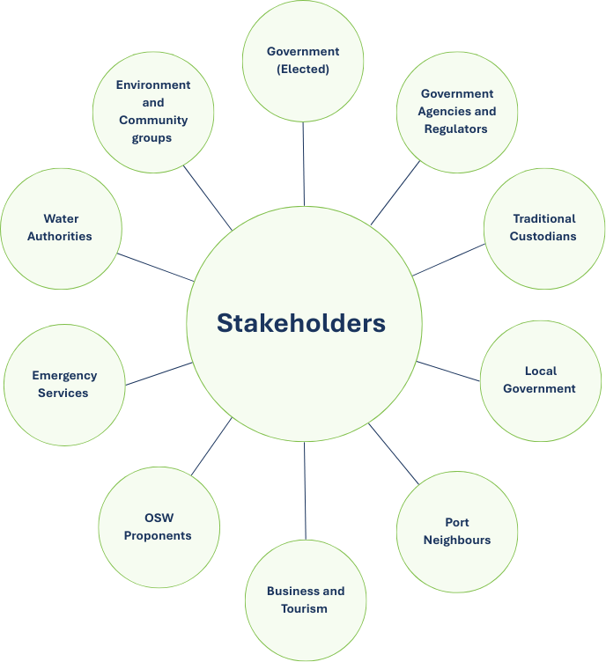
A detailed stakeholder matrix, and more information about engagement activities with these stakeholders and the broader community will be provided in the EES Stakeholder and Community Engagement Report.

Figure 8 Key stakeholders

Traditional Custodians
PoHC has engaged with Traditional Custodians through ongoing consultation during the Project’s planning and development.
This approach recognises Traditional Custodians as rights holders to land and sea (Country) on which the Project is proposed to be built and is being undertaken in accordance with the Traditional Owner and Aboriginal Engagement Framework developed by the Department of Environment, Energy and Climate Action (DEECA).
BLCAC are the Registered Aboriginal Party (RAP) of the area and are responsible for approval of the Cultural Heritage Management Plan (CHMP) being developed for the Project. BLCAC is also a member of the Project’s Technical Reference Group (TRG).

Technical Reference Group
The Victorian Department of Transport and Planning (DTP) established an inter-agency Technical Reference Group (TRG) for the Project, comprising representatives of relevant government agencies, regional authorities, municipal councils and Registered Aboriginal parties (RAPs) that have a statutory, policy or technical interest in relation to the Project.
Organisations represented on the Project EES TRG include:
- Bunurong Land Council Aboriginal Corporation (BLCAC)
- DEECA – Marine Knowledge Unit
- DEECA – Planning and Environment Assessment
- DEECA – Port Phillip Region
- DEECA – Land and Environment Policy
- DTP – Freight Victoria
- DTP – Impact Assessment Unit
- DTP – Infrastructure Assessment
- Environment Protection Authority (EPA) Victoria
- First Peoples – State Relations
- Heritage Victoria
- Melbourne Water
- Mornington Peninsula Shire Council
- Offshore Wind Energy Victoria
- Ports Victoria
- Safe Transport Victoria
- Victorian Fisheries Authority.
The TRG advises DTP and the project team on:
- applicable policies, strategies and statutory provisions;
- EES scoping requirements;
- the design and adequacy of EES technical studies;
- the proponent’s public information and stakeholder consultation program for the EES process;
- responses to issues arising from the EES investigations;
- the technical adequacy and completeness of draft EES documentation; and
- coordination of statutory processes.
PoHC has collaboratively engaged with the TRG throughout the preparation of the EES and development of the project design to ensure technical studies have been prepared in accordance with relevant requirements and adequately address any advice or issues raised. Twelve TRG meetings have been held between December 2023 and March 2026.

Community Reference Group
A dedicated Community Reference Group (CRG) was established in February 2025 following a public expression of interest, promoted in late 2024. CRG membership application were considered based on selection criteria, including living or working in the local area and/or representing on behalf of a local organisation.
The CRG is a dedicated forum made up of community representatives, providing information sharing between PoHC and the local community. The CRG meets quarterly and is chaired independently, and topics are directly informed by CRG feedback about which aspects of the Project and EES are of most interest.
Presentations to the CRG to date have covered the EES process, Terminal design, preliminary impact assessments prepared ahead of the 2025 referral under the Environment Protection and Biodiversity Conservation Act 1999 (EPBC Act), construction methodology and EES topics. The CRG includes representation from a cross-section of the community, including local scientific, conservation and advocacy groups, as well as local residents interested in the Project.
Stakeholders represented on the Terminal Project EES CRG include:
- UNESCO Western Port Biosphere Foundation
- Dolphin Research Institute
- Destination Phillip Island Regional Tourism
- Committee for Frankston and Mornington Peninsula
- Somerville Business Group
- Rotary Club of Somerville Tyabb
- Save Westernport
- Westernport and Peninsula Protection Council
- Western Port Seagrass Partnership
- Phillip Island Conservation Society
- Preserve Western Port Action Group
- Victorian National Parks Association
- Wellbeing and Health Organisation (Australia)
- Mornington Peninsula Labor Environment Action Network
- French Island Community Association
- 3x Local residents (non-affiliated).
The CRG operates independently from the Community Consultative Committee (CCC) which has been established for many years, and has also been provided updates and communication in relation to consultation opportunities on the project.

Neighbouring stakeholders and port users
The Project is located between the Esso Long Island Point Fractionation Plant and the BlueScope Steel facility. Nearby businesses include the Hastings Seafarers Centre operated by Mission to Seafarers, the Hydrogen Liquefaction and Storage Facility and the United Hastings Terminal.
Engagement with neighbouring stakeholders commenced in 2022 through targeted briefings and regular meetings with port users.
Key concerns raised by participants in these sessions included increased truck movements on Marine Parade and Long Island Drive, the need for appropriate traffic management measures, how roads will be maintained during construction, and minimising business disruption, especially access to power and marine-side facilities. Collaboration on emergency preparedness between BlueScope, Esso, PoHC, and United Petroleum was also highlighted as a core focus area.
PoHC has also undertaken direct engagement with the businesses and residents along Marine Parade to understand their concerns regarding safety and noise from the increase in truck movements.

Engagement principles and objectives

Government legislation and policies
Planned and proactive communications and consultation with interested communities and other stakeholders will help guide the development of the Terminal.
Government legislation and policies provide guidance on the need for community engagement
- Victorian Government Public Engagement Framework 2021 – 2025: See more below.
- The Planning and Environment Act 1987 provides for formal opportunities for public engagement and opportunity to provide comment on proposals during public exhibition of planning permit applications and planning scheme amendments.
- Victorian Auditor-General’s Office Public Participation in Government decision-making: provides a high-level framework for the public sector to use when deciding how best to involve the public in government decision-making and implementation.

IAP2 Spectrum of Public Participation
Additionally, the project will follow international best practice standards for engagement including:
- IAP2 Quality Assurance Standards: The Quality Assurance Standard has been designed to respond to market requirements for evidence that effective community and stakeholder engagement has been delivered in accordance with the standards of the professional community.
- IAP2 Core Values and Public Participation Spectrum: The International Association for Public Participation (IAP2) defines public participation as the involvement of those affected by a decision in the decision-making process.
IAP2 is an international organisation that is focused on advancing the practice of public participation. IAP2 has published a range of standards, including the three Pillars of Public Participation, core values, and guidelines that inform the approach to effective and meaningful engagement.
IAP2 is adopted and widely recognised among engagement professionals and will be adopted by Port of Hastings Corporation and any supporting organisations involved in implementing the communications and engagement strategies for The Terminal.
IAP2 recognises the Community Engagement Procedure that there are five levels of public participation.
The below table outlines the spectrum of public participation, which has informed the selection and methods of engagement for the Victorian Renewable Energy Terminal engagement approach.
IAP2’s Spectrum of Public Participation was designed to assist with the selection of the level of participation that defines the public’s role in any public participation process. The Spectrum is used internationally, and it is found in public participation plans around the world.

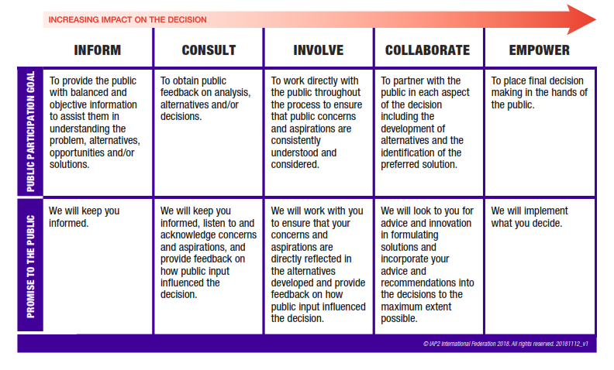
Figure 9 – IAP2 spectrum (website)

Victorian Government Public Engagement Framework
The Victorian Government Public Engagement Framework (2021 – 2025) provides principles, a guide and measures for engagement evaluation and aims to strengthen meaningful engagement practice in Victoria.
The framework includes key principles that underpin all Victorian Government public engagement.
- Meaningful: The process of Public Engagement is genuine and informs the final decision.
- Inclusive: The engagement is respectful, inclusive and accessible.
- Transparent: The engagement is clear and open about what the public can and cannot influence
- Informed: The engagement provides relevant and timely information to the public
- Accountable: The engagement is high quality and responsive to the public
- Valuable: The engagement creates value for the community and government. This can include social, economic and environmental value.

Committing to engagement principles
PoHC will commit to best practice engagement and be guided by government and industry principles. The IAP2 Public Participation Spectrum is designed to assist with the identification and selection of the level of participation stakeholders and community will have at a particular time within an engagement project.
During and leading up to the exhibition of EES reports, PoHC has engaged with stakeholder groups that are likely to submit during the public comment period. Engagement has been based on a “Consult-Involve” level of public participation as per the IAP2 methods of engagement.
Similarly, during the preparation and public exhibition of the EES, as well as public review of the EES, the project will seek to engage at an “Inform/Consult/Involve” level with relevant stakeholder groups, through methods outlined later in the Consultation Plan.

Communications and Engagement objectives
The communications and engagement approach aims to build community and stakeholder awareness, acceptance, and confidence that impacts on the Western Port environment can be adequately managed, and that the Terminal will deliver tangible local and wider benefits.
During the project development and environmental assessments, PoHC’s engagement objectives are to:
- Establish PoHC as a responsible, open, and transparent project proponent with experience managing port operations in sensitive environments.
- Provide opportunities for public participation during EES scoping, exhibition, and inquiry phases.
- Share information openly with communities and stakeholders about the Terminal project scope, how and why the Port of Hastings was identified as the preferred site, and its role in enabling offshore wind in Victoria.
- Encourage participation and input during the preparation of the EES to identify potential issues, gain local insights and seek feedback on the Terminal project, and demonstrate how this has been considered in the development of the EES.
- Consult with key stakeholders and local interest groups to identify opportunities to support local community and environment initiatives through targeted benefit-sharing and environmental improvement activities.
- Build decision-maker confidence and reduce risks to approvals, by actively identifying all major concerns before the EES is finalised and showing how these concerns have been addressed in the preparation of the EES.

How feedback will inform the project
Consultation helps build understanding around the issues and implications of projects and enables stakeholders’ knowledge and views to be considered in project planning, assessment and formal decision-making.
Aspects of project development and the EES which will be informed by community and stakeholder feedback include:
- Stakeholder and community knowledge of the area and issues of importance,
- Priorities for technical assessments to ensure all relevant impacts are assessed, and
- Potential impacts and suggested mitigations.

PoHC will collect, record, and consider all feedback received throughout the consultation and demonstrate how it has been considered in the development of the Environment Effects Statement. A number of steps are involved in this process as follows:
Collecting Feedback – PoHC will consult with the community and key stakeholders to identify issues and feedback on the project.
Recording issues – PoHC will use Consultation Manager (software) to record engagement and input feedback received from the community. Technical issues and concerns can be noted through this software and provided to technical specialists for consideration.
Analysing issues – Technical issues or concerns will be analysed by the EES technical specialists for consideration. Further technical assessment may be required to address issues raised.
Informing the Project Design and assessment - Where community feedback identifies gaps and issues not already contemplated by the project which are required to satisfy the Scoping Requirements, the project design may be revised, or mitigation measures included to address issues raised by the community.
Responding to Stakeholders – PoHC will respond to the community feedback on how their issues have been analysed and how they have informed the project development.
During the Public Exhibition of the EES, the community and stakeholders will have an opportunity to make a submission on the EES and be heard by the Inquiry and Advisory Committee appointed to examine the project’s potential environmental effects.
The Inquiry and Advisory Committee will consider submissions received in developing its recommendation to the Minister for Planning on the project’s assessment and approvals.

Engagement phases
Figure 10 provides an overview of the engagement phases and estimated timelines throughout the Victorian Renewable Energy Terminal project. Engagement phases have been designed to both align with and inform key project design and assessment activities and milestones. A description of each engagement phase is documented below:

 | 2023 |  |  |  | 2024 |  |  |  | 2025 |  |  |  | 2026 |  |  |  | 2027
Phase of Engagement | Q1 | Q2 | Q3 | Q4 | Q1 | Q2 | Q3 | Q4 | Q1 | Q2 | Q3 | Q4 | Q1 | Q2 | Q3 | Q4 | Q1 | Q2 | Q3 | Q4
Early Engagement
Engagement on Project Description
Exhibition of Draft EES Scoping Requirements
Exhibition of Updated Draft EES Scoping Requirements*
Release of Final EES Scoping Requirements
Preparing the EES*
EES Exhibition and public review*
EES Minister's Assessment*
Project approvals*
*All dates are indicative only and are subject to change.
Figure 10: EES Engagement Phase Table

Project phase | Exhibition of Draft Scoping Requirements | Release of final Scoping Requirements | Preparing the EES | Public exhibition of EES | Minister’s assessment
Engagement objectives | - Support and promote DTP public exhibition of draft Scoping Requirements and ensure stakeholders and community are aware of the opportunity to respond to the EES Scoping Requirements  - Provide opportunities for face-to-face and online engagement during exhibition  - Identify areas and topics of importance to community and stakeholders | - Seek feedback on negotiable elements of the project  - Continue to build community and stakeholder understanding of the project and EES process  - Communicate the release of final Scoping Requirements and how key issues will be assessed in studies  - Share initial outcomes of technical studies, including existing conditions, potential impacts and alternatives that have been considered | - Close the loop through a consultation report on what we heard during Project Development consultation and how this feedback is being considered in the technical studies, Reference Design development and preparation of the EES.  - Provide overview on next steps, including what is involved in EES Exhibition and how to make a submission. | - Provide information about the EES process,  - Encourage participation in the EES process and detailing how community members and stakeholders can make a submission, and  - Provide opportunities to connect people with project information and speak to technical specialists. | - To report back on outcomes of Minister's Assessment to inform the Victorian Renewable Energy Terminal proposal, including the next steps for the project.
Engagement activities | - Host online webinars to discuss project overview, explain EES process and draft scoping requirements  - Meet with local community and environment groups and other key stakeholders  - Attend local markets/events to promote project and draft scoping requirements process  - Website updates, respond to community enquiries  - Milestone communication via e-update  - Printed communication materials including factsheets and flyers | - Online information sessions/webinars – briefing on concept layout and opportunities for feedback  - Meet with local community and environment groups and other key stakeholders to share update on technical studies, introduce concept layout and seek feedback  - Information sessions to seek feedback on the concept layout  - Interactive online tool available for feedback on concept layout  - Attend/host Community Consultative Committee meeting (focused on concept layout)  - Attend/host Community Reference Group (CRG) meeting.  - Milestone communication via e-update  - Printed communication materials including factsheets and flyers | - Proactive media on project milestone and timing of next steps for the project and approvals process,  - Digital communications to promote outcomes of project development consultation (e-update, website, social media),  - Attend/host Community Consultative Committee meetings, continue to respond to community enquiries, and  - Attend/host Community Reference Group (CRG) meetings.  - Milestone communication via e-update  - Printed communication materials including factsheets and flyers  - Engagement Reports (inc. how community feedback has been considered to date)  - Doorknocks | - Project update and promotion of EES exhibition,  - Proactive media to promote Project EES exhibition,  - Drop-in information sessions to support EES exhibition, and  - Digital communications (e-update, website updates and social media) to promote exhibition of the EES and how to make a submission.  - Milestone communication via e-update  - Printed communication materials including factsheets and flyers based on topics of community interest  - Engagement Report | - Proactive media to promote outcomes of EES and next steps, including how assessment and approval requirements will inform the project’s construction and operation.  - Digital communications (e-update, website and social media) to share outcomes of the minister’s assessment and next steps for the project.  - Milestone communication via e-update
Opportunities to provide feedback | - Opportunities for local community groups to receive an introductory project briefing or project updates  - Feedback to PoHC team via in-person/digital engagement channels  - Speak with the project team and technical experts at community information sessions.  - Subscribe to e-news  - Phone calls | - Opportunities for local community groups to receive project briefing and updates  - Speak with project team and technical experts at markets and pop-up events  - Attend targeted briefings/meetings with project team members at PoHC offices or project site  - Subscribe to e-news  - Project contact number and email  - Submit survey feedback  - Access information on PoHC website | - Opportunities for local community groups to receive an introductory project briefing or project updates  - Speak with the project team and technical experts at markets and pop-up events  - Attend targeted briefings/meetings with project team members at PoHC offices or project site  - Subscribe to e-news  - Subscribe to the project newsletter to receive project updates  - Project contact number and email  - Provide feedback to the project team via engagement channels digital, face-to-face, print)  - Submit survey feedback | - Community information session(s)  - Submit a formal submission via EES engagement platform  - Provide feedback to the project team via engagement channels digital, face-to-face, print)  - Speak with the project team at markets and pop-up events  - Opportunity to participate in inquiry as part of the EES considerations | - PoHC will provide updates about key steps and dates in the EES assessment process.
Figure 11: Project Phase Table

Communication tools
PoHC is using a range of both broad and tailored engagement activities and communication tools to reach communities and stakeholders and encourage their participation. The engagement program principles and objectives in Section 11 detail how the engagement activities and tools will be used to support communication and engagement throughout the project development.

Print communication
Project newsletter
Regular newsletters or updates will be made available online and through social media and mailouts to provide information on project milestones, key EES steps and engagement opportunities.
Topics to be covered will include the publication of Scoping Requirements and the EES Consultation Plan; availability of new documents; consultation activities; Exhibition dates and activities; IAC hearing dates and process; updates on the concept design and how feedback is being considered, and updates to consultation plans and ongoing opportunities to provide input.
Newsletters and updates will be made available online as well as hard-copy mail-out to target stakeholders without online access.
Fact sheets
A suite of fact sheets providing information on the project development; the EES process and how to submit and on each technical study. Fact sheets will be made available both digitally and in hardcopy to ensure accessibility for all community members.
Surveys
Seek feedback on community values, negotiable elements of design and input to inform EES technical studies. Surveys will be made available online as well as hardcopy of survey mailed to residents with return envelopes provided to ensure all community members can access information and are provided the opportunity to engage with the project.
Environment Effects Statement (EES) Chapters and Technical Reports
Copies of the EES and accompanying technical reports and map books will be printed in hardcopy and made available at local council offices and libraries and provided online via EngageVic and the Port of Hastings websites in digital and printable to ensure accessibility.
Engagement reports
Engagement reports outlining engagement activities, participation, comments, and feedback received will be prepared to summarise phases of consultation. A summative engagement and consultation report and chapter will be prepared as part of the EES documents.
Engagement reports will be prepared quarterly.
Media and advertising
Radio, local print, and digital advertising will help to raise awareness of the engagement process, project milestones and opportunities to be involved. This will also include advertising at local libraries, youth centres, halls, public notice boards etc.
Maps and visual aids
Clear maps showing the project location including investigations area and key infrastructure to be delivered as part of the project. Maps and supporting visual aids will provide context in relation to the local region and environment.
Maps and visual aids will be used within communications materials, such as fact sheets, project updates and discussion papers, as well as being available online.
Notification – Traffic and Boating Conditions
Letter or email to notify of any changes or disruptions to traffic or boating, such as Notice to Mariners.

Digital communication

Interactive online project map
An interactive map tool will help stakeholders and community members to visualise the project area and provide feedback. This will be prepared using an online mapping platform in line with Victorian Government accessibility guidelines.
Email updates (electronic direct mail – EDM)
Regular electronic distribution of project newsletters with links to project website, fact sheets and EES documentation using the extensive existing project stakeholder database.
Project website
Updated as new information is made available, with documents directly associated with the EES to be added within one business day of the provision of final versions. Prepared in-line with necessary accessibility guidelines.
Social media
Establish a social media presence to communicate project updates, opportunities for participation and reporting on engagement activities and responding to requests for information or clarification. Social media will be used to drive users to project information and set the narrative.
Digital advertising
Includes social media advertising and sponsored posts on digital platforms to promote engagement activities and project updates.
Video
Video and animations will be used to share project information in particular complex problems. Video could be used to provide project updates and overviews of key topics. Animations could be used to show construction activities.

Translation and Accessibility
Translated and accessible materials continue to be made available for relevant project materials. Based on ABS data and engagement to date, interest in translated and accessible materials have been low.
PoHC applies the approved relayservice.gov.au prompt to the appropriate print and digital materials.
Web content is assessed regularly to ensure content is optimised for screen-reader tools and accessibility.
Documents are made available in hard copy to ensure those with accessibility requirements or limited digital access can access project information. The project uses a number of traditional communication channels, such as print advertising, letter box drops and posters to promote project engagement opportunities such as in-person meetings, information sessions and feedback surveys. These channels are used to reach those with limited digital accessibility, such as older populations and those with limited access to devices.

Engagement methods

Engagement activities
Conversations with residents and hard-to-reach community members
Acknowledging some community members and impacted stakeholders may not have access to online engagement tools and information, the project uses a range of communication channels to raise awareness of engagement opportunities, such as newspaper ads and letter box drops to encourage participation in engagement activities and provide information.
Collaborative engagement
In line with the IAP2 Spectrum of Public Participation, PoHC will employ collaborative engagement processes on aspects of the project and with stakeholders (inc. local government) where more significant partnership and participation is needed to inform this aspect of the project’s development, or where stakeholders have a strong direct interest in the decisions being made.
Collaborative approaches will include the establishment of a new Community Reference Group (CRG), briefings with local interest groups to connect them with technical experts, seeking input from interest groups and key stakeholders on aspects of the project or possible mitigation measures, exploring opportunities for delivering benefit sharing and working groups with Traditional Custodians and other parties. PoHC will also leverage existing engagement forums to raise awareness of the project and disseminate project information.
Stakeholder meetings
Building on existing relationships to maintain transparent and frequent communication with stakeholders to encourage participation and invite input. Host targeted meetings with local interest groups to provide technical information on specific topics.
Online survey
Seeking input and feedback on local values, and concept design to inform EES technical studies and project design. The use of an online platform allows participation from local community members as well as from potential international, national and intra-state users of the facility.
Webinars and online information sessions
Online interactive sessions with technical specialists and project delivery partners to engage environmental groups and community members and provide an overview of EES topics, findings of studies and project updates.
Information sessions / technical roundtable meetings / displays
Primary engagement method to present EES information and collect feedback. These will be held at a number of stages throughout the project, across a variety of locations near the project area and times to allow a wide cross-section of the community can participate. Online information sessions or webinars will supplement in person events.
Phone call and email enquiries
Recording and responding to public email enquiries and phone calls.
Technical Reference Group (TRG)
Convened by DTP to coordinate advice between DTP, the project team, and key stakeholders throughout the EES process. The project will work collaboratively with the members of the TRG, seeking their advice and considering their input in preparation of the EES.

Processes and protocols

Responding to community enquiries and feedback
Stakeholder and community enquiries protocol
- PoHC will receive community queries through a project email channel and the general phone number.
- PoHC will seek to respond to community enquiries in a timely way:
  - Acknowledgement within two business days
  - Response within five business days
- All stakeholder and community enquiries and project team responses will be recorded and detailed in a Consultation Manager database.

Complaints management procedure
Complaints management procedure
A Complaints Management Procedure (CMP) aims to establish an open and transparent complaint handling process and ensure complaints and queries are handled fairly and objectively.
The CMP will be underpinned by the following principles:
- People can make a complaint and multiple channels are available.
- Complaints are assessed and explored impartially by staff.
- Action is taken to resolve the complaint where reasonable.
- Responses to complaints are returned within established timeframes.
- Complaints are reviewed to understand issues and improve where applicable.
- Complainant information is managed in accordance with privacy laws.
The CMP will apply to all project staff.

Record Management
Port of Hastings Corporation is using Consultation Manager, a centralised stakeholder relationship management platform to record stakeholder interactions (Communications and Engagement activities).
Consultation Manager is also used as a database to store contact details of organisations engaged by the project.
The tool is regularly used to capture issues/opportunities flagged by stakeholders, and evidence of where engagement has occurred, with who, purpose, outcomes, actioned and how the engagement has influenced the project.
Data stored in Consultation Manager will be extracted to inform the Consultation Report for the EES.

Data Protection and Privacy
Port of Hastings Corporation is committed to protecting the privacy and confidentiality of personal details collected as part of communications and engagement activities undertaken by the project.

Collection of personal information
Personal information collected in preparing the EES may include names, contact details, and other relevant data provided by stakeholders. This information is collected to facilitate communication and engagement with the community.

Use and disclosure of personal information
Personal information will be used solely for the purposes of:
- Informing stakeholders about the project, including public consultation opportunities
- Storing contact information in Consultation Manager (CRM) tool for future engagement and communications through the EES process
- Capturing stakeholder sentiment, key issues and feedback to inform the EES submission
- Analysing stakeholder database
Personal information will not be disclosed as part of the EES submission, however organisations or stakeholder groups may be identified in part to contextualise engagement/communications data provided as part of the EES Consultation Report.

Data security
Data security is stored securely in compliance with the Victorian Protective Data Security Standards (VPDSS)
Access to data is restricted to ensure only authorised personnel working on the project can access stakeholder information, this may pertain to create records of meetings, communications or engagement activities, or retrieving stakeholder contact details where authorised personnel are seeking to contact a stakeholder.

Retention and disposal
Personal information will be retained only for as long as necessary to fulfil the purposes of consultation through the EES process. A record may be stored internally as evidence to provide the Minister as part of the Minister’s Assessment if requested.
Information may also be retained if relevant to record stakeholders that may be interested in Construction or Operation of the Terminal.
An audit of what information should be retained will occur following project approvals.
Any data disposed of will be safely disposed of in accordance with the Public Records Act 1973 (Vic)

Review and evaluation
The effectiveness of communications and engagement will be monitored and revised or adapted as necessary to ensure engagement objectives are met.
Baseline research of awareness and sentiment and ongoing monitoring will be used to gather reliable data to inform evaluation.
Communication and engagement measures to be evaluated include:
- participation in engagement activities including information sessions.
- comments and feedback received through engagement website, emails and phone enquiries
- participation in and content of public submissions during the EES submission process.
- comments received about the engagement process or design including content frequency and accessibility of information.
- participant questionnaires on satisfaction and potential improvements to consultation activities.
- website page visits and social media statistics.
Feedback will be recorded, collected, and considered as part of the project’s development. Data will be collected and stored in line with PoHC’s Privacy Policy.
A summary of participation and feedback received will be provided in community and stakeholder engagement reports and made available on the project website.
A report outlining the consultation undertaken, feedback received and how we respond to that feedback will be produced and included as part of the EES, in accordance with the EES Scoping Requirements.
Key stakeholders will be updated through established channels and groups regarding engagement activities and feedback throughout the project development.

Indicative stakeholder matrix
Note: All stakeholders listed are indicative and aspirational only. A full list of engaged stakeholders will be provided in the exhibited EES submission.
Stakeholder Group | Stakeholders | IAP2 Level | Interests
Government (Elected) | Minister for Environment, Energy & Climate Action  Minister for Planning  Minister for Regional Development  Minister for Ports and Freight  Treasurer of Victoria  State Member for Hastings – Paul Mercurio  Latrobe City Council Mayor and Councillors  Federal Member for Flinders – Zoe McKenzie  Minister for the Environment  Minister for Climate Change and Energy | Involve | - Understanding project rationale and benefits  - Impacts and sentiment of constituents  - Community consultation process
Technical Reference Group | Department of Transport and Planning (DTP) - Impact Assessment Unit  Department of Energy, Environment and Climate Action (DEECA) – Land and Environment Policy  DEECA – Marine Knowledge Unit  DEECA – Planning and Environment Assessment  DEECA – Port Phillip Region  DTP – State Projects Facilitation  DTP – Freight Victoria  Melbourne Water  EPA Victoria  Offshore Wind Energy Victoria  First Peoples - State Relations  Bunurong Land Council Aboriginal Corporation  Heritage Victoria  Mornington Peninsula Shire Council  Ports Victoria  Safe Transport Victoria  Victorian Fisheries Authority | Involve / Collaborate | TRG’s role is to provide technical and statutory advice to the Port of Hastings Corporation (the Proponent) and the Department of Transport and Planning (DTP), as appropriate, regarding the preparation of the EES.
Local government | Mornington Peninsula Shire Council  - CEO and Executives  - Councillors  - Coastal Planning Team  - Officers  Bass Coast Shire Council  - CEO and Executives  - Councillors  - Officers | Consult/Involve | - Understanding project rationale and benefits  - Understanding and avoiding/minimising adverse impacts on council land and assets, the local environment and businesses  - Maximising local benefits from the project  - Understanding impacts of the proposed built form and use on the local environment  - Opportunities to provide input to project planning and delivery  - Economic opportunities for local government  - Community consultation process
Government agencies and authorities – State | Department of Energy, Environment and Climate Action  Offshore Wind Energy Victoria (DEECA)  Department of Transport and Planning  Department of Jobs, Skills, Industry and Regions  Department of Premier and Cabinet | First Peoples - State Relations  Environment Protection Authority  Better Boating Victoria  Safe Transport Victoria  Ports Victoria  Parks Victoria  VicRoads  Victorian Fisheries Authority  First Peoples State Relations  Heritage Victoria  Freight Victoria  WorkSafe Victoria  InvestVic  VicGrid  Victorian Government Solicitor’s Office | Involve | - Planning process complies with applicable legislation and requirements  - Involvement in project development and assessment  - Optimal outcomes for environment and community  - Preparation of EES and conformance with EES Scoping Requirements  - Broader regulatory requirements  - Community and stakeholder consultation
Government agencies and authorities - Federal | Department of Climate Change, Energy, Environment and Water  Department of Home Affairs (Maritime Infrastructure and Security)  Department of Infrastructure and Regional Development  Department of Primary Industries  Royal Australian Navy (HMAS Cerberus)  Department of Defence  Australian Maritime Safety Authority (AMSA)  Civil Aviation Safety Authority (CASA)  CSIRO | Involve | - Planning process complies with applicable legislation and requirements  - Involvement in project development and assessment  - Optimal outcomes for environment and community  - Preparation of EES and conformance with EES Scoping Requirements  - Broader regulatory requirements Community and stakeholder consultation
Traditional Custodians | Bunurong Land Council Aboriginal Corporation  Boon Wurrung Foundation  Willum Warrain Indigenous Community House | Involve | - Understanding cultural values in Port of Hastings and surrounds  - Understanding project rationale and benefits  - Understanding and avoiding/ minimising potential adverse impacts  - Opportunities to provide input into project planning, delivery and land use  - Minimising impacts to Native Title Land  - Development and implementation of Cultural Heritage Management Plan  - Optimal outcomes for the Country including natural environment and protected places  - Opportunities for Traditional Owner business and employment
Neighbouring stakeholders | BlueScope Steel  Esso (Exxon Mobil)  Searoad Ferries (Western Port Ferry)  United Petroleum  Hastings Seafarers Centre  HMAS Cerberus  Svitzer  Yaringa Boat Harbour | Consult/Involve | - Understanding project rational and benefits  - Understanding potential impacts from project in the local area  - Ability to provide local knowledge about existing operations to enhance the project and delivery
Business, industry and tourism | AAT – Australian Amalgamated Terminals  AAA Suspension  Acciona Solar  AECOM – Architecture, Engineering, Consulting, Operations & Maintenance  Amber Aviation  Aegir Divers  Aquapower  Arche  Arup  AW Maritime AXYS Technologies Inc  Bai Communications  Bass Strait Seafood Protection Alliance  Bark In Style Grooming  Bayport  Beca Group  Bell Motorsport  Ben Line Agencies (Australia) Pty Ltd  Blue Water Shipping  BMD Group  Biosis  BMT  Borealis  Boskalis  Bouygues  Buss Energy Group  CAC-H2 – Clean Hydrogen Technologies  Chesterton  Chronicle Heritage  Clobotics  Clough Group  Coates Hire  CoreGas  Corio Generation  Deugro / Duegro  DEME Group  Direct Infrastructure  Dieseko Group  Douglas Partners  Drever Automotive Services  Dynamic Group Solutions Australia  Eddy Batur Painting  EEW Group  Elanora Offshore  EMACS  Engie  Energys  Equis Energy  Fersa Bearings  Fenris Garage  Fine Flow Plumbing and Drainage  GAC – Gulf Agency Company  GC Wind Supply  GHD  GMCG – Greater Melbourne Consulting Group  Goldhofer  Green Energy Partners  Hart Marine  Haywards  Herbert Smith Freehills Kramer  Hillview Quarry  Hyundai Engineering & Construction Co Ltd  IAG – Infrastructure Advisory Group  InForce  Inland and Coastal Marina Systems  Integrated Helicopter Services  JTX Lighting  Japan Suiso Energy  Karnaji  KBR – Kellogg, Brown & Root  Keppel Prince Engineering  Kongstein  Kyriacou Architects  Laboratories for Materials Advanced Testing Services (LMATS)  Leader Associates  Lennard Consulting  Long Duration Energy Storage Strategies (LDESS)  LRQA – Lloyd’s Register Quality Assurance  MacPherson Kelley Lawyers  Media Banc  Middleton Group  Mistral Energy  Mott MacDonald  Nation Partners  Navantia Australia  New Market  Nordex Acciona Windpower  Offshore Unlimited  Ostermark Grouting  OSMI Australia – Offshore Sustainable Marine Infrastructure Australia  Penta H Energy  PetroVietnam Technical Services Corporation (PTSC)  Port Anthony  Port of Esbjerg  Port of Newcastle  Port Phillip Sea Pilots  Precision Laser Cleaning  Principle Power  Prossor Town Planning  Poole Nominees  QUBE Logistics  Ramboll  RED Fire Engineers Pty Ltd  Reswitch  Reventus Power  Royal Haskoning DHV  RPS Group  RWE Renewables  Sarens  SeaportOPX  Seaway7  Shell Energy  Shimizu Corporation  Siemens Gamesa  SkyDive South East  Smart Business Solutions  Sparc Technologies  SPX Aids to Navigation (SPX AtoN)  Stantec  Stonestar  StormGeo  Subsea7  Supacentre Caravans  Symal Group  Synertec  Taisheng Wind Power  Terralogic  The Bays Healthcare Group  Tire Right  Tyres and More Hastings  Tony Gee  Tooradin Flying School  Typeright  UNIQ Initiatives  Vena Energy  Ventia  Vestas  Vforce Systems  Viva Energy  Wallenius Wilhelmsen  Watertech Pumps  Western Port Pump & Pool  Western Port Signs  Wilderlab  WindSCS  Yun Express  Industry bodies:  Australian Steel Institute  Boating Industry Association of Victoria (BIAV)  Seafood Industry Victoria  Smart Energy Council  South East Melbourne Manufacturers Alliance (SEMMA)  Victorian Recreational Fishing Peak Body  Regional business networks:  Committee for Frankston and Mornington Peninsula  Committee for Gippsland  Somerville Business Group  Western Port Chamber of Commerce  Government supported industry bodies:  Australian Trade and Investment Commission (Austrade)  Better Boating Victoria  Business Finland (foreign government trade office)  Gippsland Regional Development Australia Committee  Greater South East Melbourne (GSEM) (Government-supported alliance)  Industry Capability Network (ICN) (Government-supported procurement network)  Marinus Link Project (Gov infrastructure project)  Net Zero Economy Authority  Regional Development Australia (Gippsland)  South East Australian Transport Strategy (SEATS) (Government-supported regional transport body)  Trade Council of Denmark (foreign government trade body) | Consult | - Understanding project rational and benefits  - Understanding potential impacts from project in the local area  - Ability to provide local knowledge about existing operations to enhance the project and delivery  - Opportunities to provide input to the project  - Clear information and updates about the project  - Maximising local benefits from the project  - Opportunities for local business and employment
Offshore Wind proponents  (Engaged through Offshore Wind Energy Victoria) | Blue Mackerel (JERA Nex)  High Sea Wind (Ocean Winds)  Gippsland Skies (Maintstram/AGL/Reventus/DIRECT)  Gippsland 1 and 2 (Orsted)  Kut-Wut Brataulaung (Southernly Ten)  Star of the South (Southerly Ten)  Great Eastern (Corio Generation)  Navigation North (Origin/RES)  Aurora Green (Iberdrola) | Consult | - How the project may facilitate offshore wind projects and operations in Victoria and around Australia  - Progress of project  - Project design and development  - Champion project through EES process
Emergency services | Fire Rescue Victoria  Ambulance Victoria  Victoria Police  Emergency Management Victoria  Water Police  Country Fire Authority | Consult | - Understanding project rationale and benefits  - Impacts to services and operation during project duration  - Public safety  - Compliance and conformance with relevant legislation
Water authorities | South East Water  Melbourne Water  Southern Rural Water | Involve | - Understanding project rationale and benefits  - Impacts to services and operation during project duration  - Involvement in decisions which may affect land, water, licence and/or assets  - Minimising impacts on land, water, licence and/or assets
Reference groups | Community Reference Group (Victorian Renewable Energy Terminal)  - Somerville Business Group  - Rotary Club of Somerville Tyabb  - Wellbeing and Health Organisation  - Phillip Island Conservation Society  - Mornington Peninsula Labor Environment Action Network  - Save Western Port  - Dolphin Research Institute  - Committee for Frankston and Mornington Peninsula  - Western Port and Peninsula Protection Council  - Mornington Peninsula and Western Port Biosphere Foundation  - Victorian National Parks Association  - Destination Phillip Island Regional Tourism  - French Island Community Association  - Self-representatives (x3)  Community Consultative Committee (Port of Hastings Corporation)  - French Island Community Association  - Ports Victoria  - Western Port and Peninsula Protection Council  - Parks Victoria  - Save Western Port  - Mornington Peninsula and Western Port Biosphere Foundation  - BlueScope Steel  - Phillip Island Conservation Society  - United Petroleum  - Parks Victoria  - Esso  - Preserve Western Port Action Group  - Western Port Ferries  - HMAS Cerberus  - Crib Point Action Group | Involve | - Understanding project rationale and benefits  - Understanding potential impacts from project  - Ability to provide local knowledge to enhance the project and delivery and to help avoid/minimise impacts  - Opportunities to provide input to the project  - Clear information and updates about the project  - Maximising local benefits from the project  - Optimal outcomes for the environment  - Community safety and amenity
Environment, community and recreation groups | - Game Fishing Association of Victoria  - BirdLife Bass Coast  - BirdLife Mornington Peninsula  - Threatened Species Conversancy  Coastal Advisory Groups:  - Western Port South  - Western Port North  - Port Phillip South  - Port Phillip Central  - Port Phillip North  - Wellbeing and Health Organisation  - Destination Phillip Island Regional Tourism  - Phillip Island Nature Parks  - Artwork by Vicki  - Preserve Western Port  - Tooradin Foreshore Committee of Management  - Crib Point Stony Point Foreshore Committee  - Jerome Breens Driving School  - Doctors for the Environment Australia  - Peninsula Ship Society  - Flinders Community Association  - Crib Point Action Group  - Friends of Flinders Coastline  - Corinella Foreshore Reserve Committee of Management  - Victorian Wader Study Group  - Phillip Island Conservation Society  - Victorian National Parks Association  - Rotary Club of Somerville Tyabb  - Tyabb and District Ratepayers Group  - Save Westernport  - Western Port Seagrass Partnership  - Rotary Club of Mornington  - Mornington Peninsula and Western Port Biosphere Foundation  - Westernport and Peninsula Protection Council Inc.  - Dolphin Research Institute  - Peninsula Aero Club  - French Island Community Association  - Mornington Peninsula Labor Environmental Action Network  - Cemetery Estate Residents  - Bass Strait Seafood Protection Alliance  - Crisis Group  - Gippsland Climate Change Network  - Western Port Signs  - San Remo Fishing Cooperative | Consult | - Understanding project rationale and benefits  - Understanding potential impacts from project  - Ability to provide local knowledge to enhance the project and delivery and to help avoid/minimise impacts  - Opportunities to provide input to the project  - Clear information and updates about the project  - Maximising local benefits from the project  - Optimal outcomes for the environment  - Community safety and amenity
Media | Mornington Peninsula News Group  - Western Port News  - Mornington News  - Southern Peninsula News  3RPPFM  Mornington Peninsula Leader  Phillip Island and San Remo Advertiser  Somerville Times  Renew Economy  Australian Financial Review  The Guardian  The Age  NewsCorp  Insurance Marine News  Relevant industry media (e.g. Daily Cargo News) | Inform | - Clear information and updates about the project  - Involvement in key milestone media opportunities
Local partnership/  Education | Frankston Tech School  Westernport Child Care Centre and Kindergarten  Chisholm Institute  Seabed 2030  Cetacean Science  Monash University  Students in Renewable Energy  Federation University  Australian Centre for Offshore Wind  Australian Steel Institute  Australian Trade and Investment Commission  Others as determined | Consult / Involve | - Understanding project rationale and benefits  - Understanding opportunities for local partnership  - Ability to provide local knowledge to enhance the project and delivery and to help avoid/minimise impacts  - Opportunities to provide input to the project  - Clear information and updates about the project  - Maximising local benefits from the project  - Optimal outcomes for local business and education  - Future job opportunities

