Western Renewables Link: EES Scoping Requirements process
Western Renewables Link EES – Final Scoping Requirements FAQs
November 2023

What is the purpose of the scoping requirements?
Ausnet Transmission Group Pty Ltd, is preparing an environment effects statement (EES) for Western Renewables Link (previously named Western Victoria Transmission Network Project), and the EES scoping requirements set out the matters that need to be investigated and documented within the EES.
In 2020 the then Minister for Planning approved final EES scoping requirements, which were available on the former Department of Environment, Land, Water and Planning (DELWP) website.
In 2023 AusNet re-referred a modified form of the project; a new Sydenham Terminal Station and works at the Sydenham site were no longer part of the Western Renewables Link project. The Minister for Planning affirmed the need for an EES and made a new statutory decision on this EES in August 2023. The Minister has approved updated final EES scoping requirements which are available on the Planning website: https://www.planning.vic.gov.au/environmental-assessments/browse-projects/western-renewables-link.
Why is an EES required for the project?
An EES is the most comprehensive and robust assessment process available and will provide for an integrated and transparent examination of the proposed project and its effects, which is necessary because of the range of possible project options, the array of potential environmental effects and the substantial public interest in the project.
In August 2020, the Minister for Planning determined under the Environment Effects Act 1978 that Mondo must prepare an EES for the Western Victoria Transmission Network Project (now Western Renewables Link). In his procedures and requirements, the Minister identified key environmental issues that would need to be addressed in the EES, specifically:
- alternative corridors, alignments, site locations, designs or other options for the planning, construction or operation of the project;
- potential effects on biodiversity, including loss, degradation or fragmentation of habitat;
- effects on Aboriginal and historic cultural heritage values;
- impacts on visual and landscape values; and
- other effects on land uses and the community.

The EES documentation will include a detailed description of the proposed project and rigorous assessment of its potential effects on the environment and approaches to mitigation. When completed, the EES will be exhibited to inform the public and stakeholders, and to seek feedback. Ultimately it enables the Minister to issue an assessment of the environmental effects of the project at the end of the process. The Minister’s assessment will inform statutory decision-makers responsible for the project’s approvals.
The project was also referred to the Commonwealth under the Environment Protection and Biodiversity Conservation Act 1999 (EPBC Act). A delegate for the Commonwealth Minister for the Environment determined on 2 September 2020 that the project is a controlled action, as it is likely to have a significant impact on matters of national environmental significance (MNES), protected under the EPBC Act. The EES process is accredited to assess impacts on MNES under the EPBC Act through the Bilateral Assessment Agreement between the Commonwealth and the State of Victoria. The potentially impacted MNES that the EES will examine are ‘listed threatened species and communities’.

What studies must AusNet do to investigate the potential environmental effects of the project?
In preparing the EES, AusNet is undertaking a range of technical studies to investigate the potential impacts of the project. These investigations include biodiversity, Aboriginal cultural heritage, historic heritage, landscape and visual impact, land use and planning, social and socioeconomic and catchment and hydrology studies.
AusNet is also investigating alternatives for the project, including design, alignment and siting options in the context of an extensive area of interest which it presented in its 2020 and 2023 referral for the project.
These studies will inform strategies to avoid, minimise or mitigate potential impacts which will form an important part of the EES documentation.
What are the scoping requirements?
The set of matters to be investigated and documented in each EES are tailored to the project and its potential environmental impacts. The draft scoping requirements for a project are prepared by the Department of Transport and Planning (DTP) on behalf of the Minister and then exhibited for 15 business days for comment by interested parties. The draft scoping requirements for this EES were informed by the proponent’s 2020 referral and draft EES study program, as well as advice from agencies represented on the technical reference group (TRG) and advice from the then Commonwealth Department of Agriculture, Water and the Environment (now Commonwealth Department of Climate Change, Energy, the Environment and Water).
The scoping requirements broadly outline the issues that AusNet must address in the EES. Assessment of effects as required by the scoping requirements must include discussion of potential direct, indirect, cumulative, on-site and off-site effects that could result from the proposed project. Consistent with the Minister’s decision in 2020 and 2023 to require an EES, the final scoping requirements cover biodiversity and habitats, landscape, Aboriginal cultural heritage, historic heritage and social, economic, amenity and land use values.
Was there public consultation on the draft scoping requirements?
Draft scoping requirements for the EES were exhibited for a period of 15 business days, which concluded on 27 November 2020. Notice of the draft scoping requirements’ exhibition was published on the former DELWP website and via advertisements in major and local newspapers.
The former DELWP received 106 submissions during the public exhibition period. While the majority of the submissions were from individual members of the community, submissions were also received from organisations/associations including Landcare groups, Friends groups, action groups, businesses and authorities.
Many submissions acknowledged the relationship between the project and the harvesting of electricity generated from renewable energy projects in western and north-western Victoria. However, most submissions highlighted specific potential adverse impacts of the project that they considered should be covered in the EES and, in doing so, suggested changes to the draft EES scoping requirements to cover them. Key issues and concerns most frequently raised in submissions included:
    - Uncertainty about criteria to be applied in the identification, refinement and comparison of potential designs, construction methods, corridors and alignments.
    - The potential impact of the project on biodiversity values, including impacts on native vegetation, threatened species and communities and potential collision impacts, especially for birds of prey.
    - Potential impacts on heritage values.
    - Potential impacts on landscape and visual values.
    - Potential impacts on farming due to restrictions on the use of large farming equipment in the vicinity of a high-voltage easement, with flow-on consequences for downstream processing industries.
    - The potential for the project to increase bushfire risk in the area.
    - Potential impacts on aviation for farming and firefighting.
    - Potential impacts on tourism.
    - General amenity impacts during both construction and operational phases.
    - Potential impacts on human health due to electromagnetic radiation.
    - Concerns about the adequacy of compensation for directly affected landowners, lack of compensation for neighbouring landowners and potential impacts on property values.

Most issues raised in submissions were already encompassed within the draft scoping requirements, although many submissions raised points of detail at a resolution that would not normally be prescribed in scoping requirements. The broad framing of the final scoping requirements enables relevant concerns raised through submissions to be addressed in the EES. However, some refinements and editorial changes have been made to the scoping requirements to strengthen the clarity of issues and to reflect better the local context. These changes include:
  - Clearer direction about transparency in comparison of potential alternatives.
  - Stronger references to avoiding impacts as the hierarchical preference ahead of mitigation or management.
  - Stronger references to native vegetation removal as an impact.
  - Inclusion of reference to Grey-headed Flying Fox as a threatened species of concern.
  - Stronger references to weeds and pathogens in the context of both biodiversity and agriculture.
  - Stronger references to land classification in terms of the use of land for higher-value purposes.
  - Stronger references to potential human health impacts.

The Minister for Planning then issued the final EES Scoping Requirements in December 2020.
The former DELWP provided copies of submissions (redacted as necessary to meet privacy requirements) to the proponent and the matters raised were shared with the TRG to inform the ongoing development of the EES.
Why were updated final scoping requirements prepared?
Following the new EES decision by the Minister for Planning, minor updates have been made to the 2020 EES scoping requirements. These updates reflect the change to the project name, modifications to the project form, the new decision by the Minister for Planning and updated EES procedures and requirements. The updates are administrative and do not alter the scope of environmental matters and issues to be assessed in the EES.
What happens now the Minister has issued updated final scoping requirements?
The proponent will continue with the necessary information-gathering and investigations to inform the EES. This is expected to take at least several months. It will conduct its studies and prepare the EES in close consultation with DTP and a TRG consisting of lead statutory agencies and Registered Aboriginal Parties.
An integral part of the EES process is the proponent’s engagement with the public and stakeholders to identify and respond to their issues in the context of the EES studies.
AusNet has been consulting with stakeholders and the community on the EES. AusNet is preparing an updated consultation plan for the EES, which will outline the opportunities and approaches for its community engagement during the remainder of the EES process. When ready, the plan will be published on the Planning website: https://www.planning.vic.gov.au/environmental-assessments/browse-projects/western-renewables-link.
The EES consultation plan must provide for the proponent to inform the public and stakeholders about the EES process and its associated investigations, ensuring it provides opportunities for sharing information and receiving feedback about the investigations.
When AusNet believes its EES is ready, DTP will review the documentation, and the Minister for Planning will decide whether to authorise the EES to be exhibited. If authorised, the EES will be advertised for public comment for a period of 40 business days. Exhibition of the EES is the primary statutory opportunity for interested parties to make submissions about the environmental effects of the project.
The EES and the submissions received, together with relevant statutory approvals documentation, such as a draft planning scheme amendment, will be referred to an inquiry to be appointed under the Environment Effects Act 1978.
An inquiry will consider the EES and submissions, conduct a public hearing and report in writing to the Minister, who will then make his assessment and provide it to decision-makers for consideration (including the Commonwealth with regard to the required approval under the Environment Protection and Biodiversity Conservation Act 1999).
After the Minister has made an assessment, the report of the inquiry and the Minister’s assessment will be published on the Planning website.
When does AusNet expect its EES to be ready for public exhibition?
The EES is expected to go on exhibition for public comment in late 2024. Detailed arrangements for exhibition and associated engagement activities will be determined closer to the time. The updated EES procedures and requirements have extended the public comment period from 30 to 40 business days.
What is Western Renewables Link?
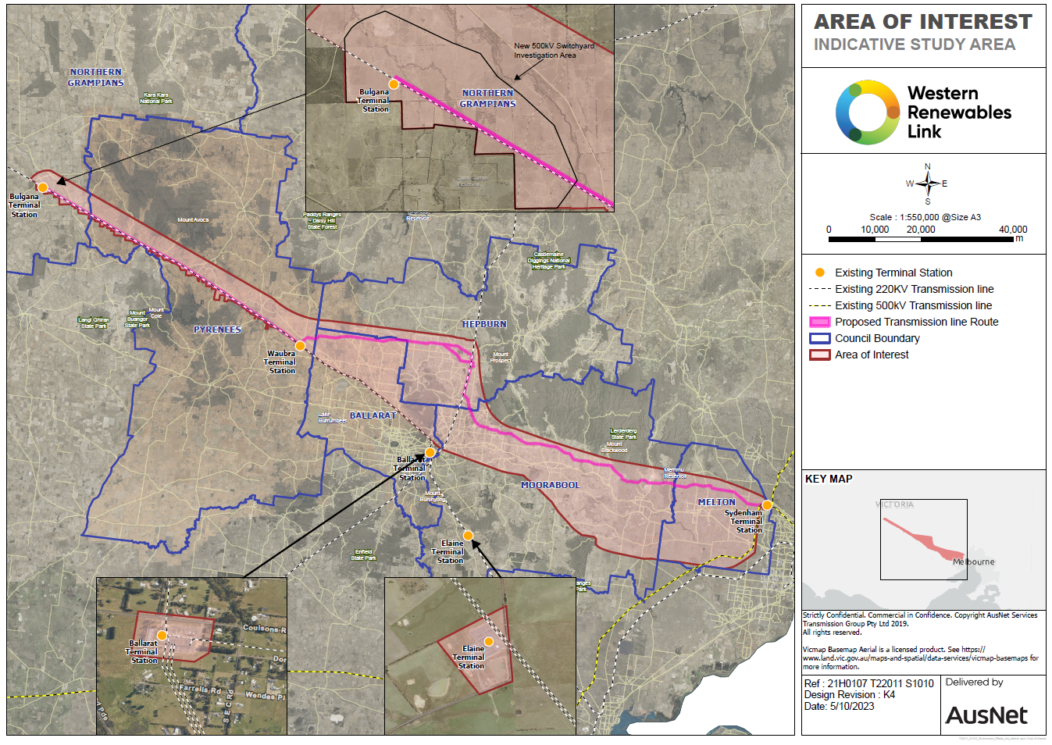
Figure 1: Location of the project, showing the area of interest under investigation for a transmission line between Bulgana and Sydenham (source: AusNet 2023).

AusNet proposes to construct a new high voltage (500 kV) transmission lines connecting an existing terminal station at Bulgana, north of Ararat, with a rebuilt terminal station at Sydenham, on the north-western outskirts of Melbourne (Figure 1). The project will include works to connect the project to both terminal stations and works to upgrade the capability of the Bulgana Terminal Station to transmit electricity at 500 kV instead of 220 kV as at present. Some works will also be required at existing terminal stations at Ballarat and Elaine (south of Ballarat). As the project will operate at the same voltage from end to end, no new mid-point terminal station is required. A new Sydenham Terminal Station alongside the existing one and any work/ rebuilding of the existing Sydenham Terminal Station are not part of the modified form of the project re-referred under the Environment Effects Act. The rebuild of the Sydenham Terminal Station comprises a separate project. The total length of the project is approximately 190km.
The EES will investigate a range of alternatives including the identification and refinement of possible alternative transmission line alignments and location options for upgrade works for the Bulgana Terminal Station.

