Plan Melbourne 2017-2050

Draft Eastern Metro

Land Use Framework Plan

Acknowledgement
We acknowledge and respect the Traditional Owners of Victoria’s lands and waters, their unique ability to care for Country and deep spiritual connection to it. We honour Elders past and present whose knowledge and wisdom has ensured the continuation of culture and traditional practices.
We are committed to genuinely partner and meaningfully engage with Traditional Owners to support the protection of their Country, the maintenance of spiritual and cultural practices and their broader aspirations in the 21st century and beyond.

Aboriginal self-determination
Pupangarli Marnmarnepu - Wadi Wadi and Mutti Mutti language for ‘Owning Our Future’ - is DELWP’s Aboriginal Self-Determination Reform Strategy 2020-2025. As the framework for supporting and enabling Aboriginal self-determination for all DELWP projects, Pupangarli Marnmarnepu forms the basis of an ongoing dialogue and partnership with Traditional Owners to influence metropolitan planning and the implementation of Plan Melbourne 2017-2050 in each of the six metropolitan regions.
Ongoing partnership opportunities with Traditional Owners are currently being explored. This process will determine the preferred involvement and level of influence Traditional Owners would like to have in shaping the outcomes and implementation of the Land Use Framework Plans.

Abbreviations
ABS | Australian Bureau of Statistics | NEIC/s | National Employment and Innovation Cluster/s
BIFT | Beveridge Interstate Freight Terminal | OMR | Outer Metropolitan Ring/E6 Transport Corridor
BMO | Bushfire Management Overlay | PBN | Principal Bicycle Network
BPA | Bushfire Prone Area | PFN | Principal Freight Network
CBD | Central Business District | PPTN | Principal Public Transport Network
DELWP | Department of Environment, Land, Water and Planning | PSP/s | Precinct Structure Plan/s
DJPR | Department of Jobs, Precincts and Regions | RSIP | Regionally-Significant Industrial Precinct
DoT | Department of Transport | SBO | Special Building Overlay
EIIA/s | Extractive Industry Interest Area/s | SEIFA | Socio-Economic Indexes for Areas
EPWG | Economy and Planning Working Group | SERA/s | Strategic Extractive Resource Area/s
ESD | Environmentally Sustainable Development | SRL | Suburban Rail Loop
GRP | Gross Regional Product | SRLA | Suburban Rail Loop Authority
HVI | Heat Vulnerability Index | SSIP | State-Significant Industrial Precinct
LGA | Local Government Area | TAFE | Technical and Further Education
LSIO | Land Subject to Inundation Overlay | UDP | Urban Development Program
LST | Land Surface Temperature | UGB | Urban Growth Boundary
LUFP | Land Use Framework Plan | VIF | Victoria In Future
MICLUP | Melbourne Industrial and Commercial Land Use Plan | VPA | Victorian Planning Authority
MRF | Materials Recovery Facility | WIFT | Western Interstate Freight Terminal

Introduction
Melbourne is the fastest growing city in Australia. The city’s population is projected to reach 8 million by 2050. This growth, in combination with a changing climate, increased globalisation and congestion, is testing the resilience of Melbourne’s built and natural environment. Victoria needs to plan for this growth and change. That is why Plan Melbourne 2017-2050 is important.
Plan Melbourne has a clear vision:
‘Melbourne will continue to be a global city of opportunity and choice.’
What this vision demonstrates is that Plan Melbourne is more than a planning document. It is a blueprint guiding the actions of planners, local councils, landowners and developers – ensuring Melbourne grows more sustainable, productive and liveable.
Plan Melbourne seeks to deliver seven outcomes. How these will be delivered in each of the six metropolitan regions is the subject of the Land Use Framework Plans (LUFPs).
Outcome 1 | Melbourne is a productive city that attracts investment, supports innovation and creates jobs
Outcome 2 | Melbourne provides housing choice in locations close to jobs and services
Outcome 3 | Melbourne has an integrated transport system that connects people to jobs and services and goods to market
Outcome 4 | Melbourne is a distinctive and liveable city with quality design and amenity
Outcome 5 | Melbourne is a city of inclusive, vibrant and healthy neighbourhoods
Outcome 6 | Melbourne is a sustainable and resilient city
Outcome 7 | Regional Victoria is productive, sustainable, and supports jobs and economic growth

Land use framework plans
Plan Melbourne identifies six metro regions within the city as illustrated on Figure 1:
- Inner (Melbourne, Port Phillip and Yarra Local Government Areas or LGAs)
- Inner South East (Bayside, Boroondara, Glen Eira and Stonnington LGAs)
- Eastern (Knox, Manningham, Maroondah, Monash, Whitehorse and Yarra Ranges LGAs)
- Southern (Cardinia, Casey, Frankston, Greater Dandenong, Kingston and Mornington Peninsula LGAs)
- Western (Brimbank, Hobsons Bay, Maribyrnong, Melton, Moonee Valley and Wyndham LGAs)
- Northern (Banyule, Darebin, Hume, Mitchell, Moreland, Nillumbik and Whittlesea LGAs).
The Victorian Department of Environment, Land, Water and Planning (DELWP) has led the development of a LUFP for each region, supported by six Economy and Planning Working Groups (EPWGs).
The six EPWGs are chaired by a chief executive officer from a council within each region and include senior representatives from the region’s local councils, DELWP, the Department of Jobs, Precincts and Regions (DJPR) and the Department of Transport (DoT).
Through the EPWGs, local councils have helped shape the vision for their regions – providing local insight into the regional opportunities and challenges that require joint action by state and local government.
Responding to these regionally-specific opportunities and challenges, the LUFPs:
- are 30-year strategic land use and infrastructure plans for Melbourne’s six metropolitan regions
- provide a common long-term framework to manage growth and land use pressures in each region
- are spatial plans that translate Plan Melbourne and the Plan Melbourne Addendum to the regional level
- focus on resolving metropolitan regional issues
- provide context for planning at the precinct or local level
- ensure the review and update of local planning schemes align with Plan Melbourne
- provide directions and strategies for state- and regionally-significant projects that are implemented through state planning policy and local planning schemes.
- drive the accommodation of the majority of Melbourne’s growth into established areas through a land use framework that identifies places of state and regional significance, and integrate greenfield growth area planning with wider metropolitan planning.
The LUFPs support the implementation of Plan Melbourne – guiding the implementation of Plan Melbourne’s nine principles, seven outcomes, 32 directions and 90 policies at a regional and local level.

- Location of the Eastern Metro Region

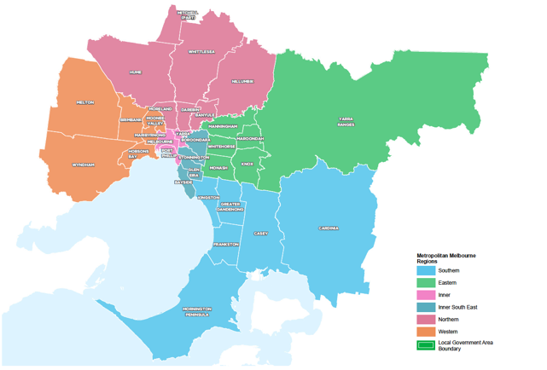How will the land use framework plans be used?
The LUFPs will be used to:
- Drive the majority of Melbourne’s population growth into established areas through a land use framework that identifies places of state and regional significance
- Guide the strategic integration of land use and infrastructure (including housing and jobs aspirations) in key areas and precincts
- Guide the development of Melbourne’s greenfield growth areas
- Facilitate collaboration by state and local government, key agencies and partners on regional planning and regional priorities
- Inform priority places for state-led planning
- Enable metropolitan councils to update their municipal strategies and policies within a clearly defined land use framework.
The LUFPs will set regional-level planning policy to be implemented into planning schemes. They will inform local councils in decision-making for precinct planning, local and regional planning strategies, and infrastructure and servicing projects.
The LUFPs include a number of short- to medium- term actions for state and local government, which will contribute to planning outcomes in each region alongside existing actions under Plan Melbourne and other government programs and initiatives. Action monitoring will be led by DELWP in partnership with the metropolitan region through the EPWGs, and the actions will be formally reviewed every five years in conjunction with Plan Melbourne 2017-2050 Five-Year Implementation Plan.
Annual progress reports outlining the status of actions will be published by DELWP as a part of Plan Melbourne monitoring. These progress reports will be publicly available.
The chapter on implementation provides further details on how the LUFPs will be used to deliver Plan Melbourne outcomes across the regions.
Appendix 01 identifies the range of related initiatives already underway by state and local government to support the implementation of Plan Melbourne. The LUFPs are designed to complement these initiatives.

The land use framework
The LUFPs establish a common land use framework across the regions (Table 1). This common framework confirms places of state significance as identified in Plan Melbourne and introduces places of regional significance for each metro region.
The land use framework will direct land use decisions and investment, better align state and local government planning, and inform the development of local council planning strategies (including housing strategies). In the process, this common framework will also ensure land use, planning and development all support the vision of Plan Melbourne.
The land use framework
Places of state significance (as identified in Plan Melbourne) | Places of regional significance
- Central City  - National employment and innovation clusters (NEICs)  - Metropolitan activity centres  - State-significant industrial precincts (SSIPs)  - Transport gateways  - State-significant health and/or education precincts  - Major urban renewal precincts | - Major activity centres  - Activity corridors  - Regionally-significant industrial precincts (RSIPs)  - Enterprise precincts  - Regionally-significant health and/or education precincts  - Inter-regional environmental features  - Regional open space  - Growth corridors  - Urban renewal areas  - Housing opportunity and investigation areas  - Green wedges

Regional planning and collaboration
Planning at a regional level is an opportunity for state and local governments to work together to manage long-term growth and change across Melbourne (Figure 2).
While the Eastern Metro Region has many unique opportunities and challenges, there are some opportunities and challenges common across all metropolitan regions, such as ensuring jobs are available close to public transport; increasing housing supply in areas with access to jobs, services and public transport; and mitigating and adapting to climate change. The LUFP allows for these differences and recognises regional initiatives already underway.
The LUFPs will guide regional planning and collaboration vertically (between state and local government) and horizontally (across local councils in partnership with other stakeholders, including Traditional Owners).
- Inter-relationship between state and local planning
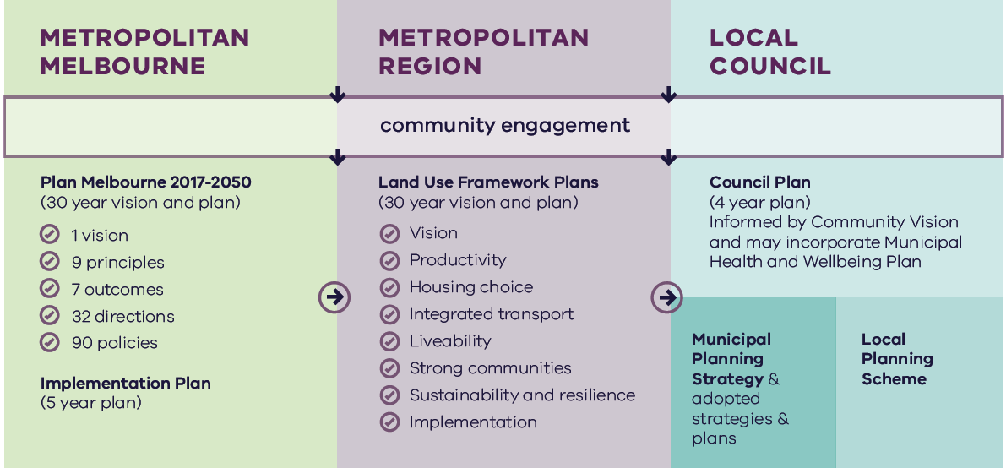

Metropolitan Melbourne | Metropolitan Region | Local Council
Is informed by community engagement. | Is informed by community engagement and Metropolitan Melbourne planning. | Is informed by community engagement, Metropolitan Melbourne planning and Metropolitan Region planning.
Includes:  - Plan Melbourne 2017-2050 (30 year vision and plan)  - 1 vision  - 9 principles  - 7 outcomes  - 90 policies  - Implementation Plan (5 year plan) | Includes:  - Land Use Framework Plans (30 year vision and plan)  - Vision  - Productivity  - Housing choice  - Integrated transport  - Liveability  - Strong communities  - Sustainability and resilience  - Implementation | Includes:  - Council Plan (4 year plan)  - Informed by Community Vision and may incorporate Municipal Heath and Wellbeing Plan  - Municipal Planning Strategy & adopted strategies & plans  - Local Planning Scheme

State-led planning
The Victorian Government has identified priority areas for state-led planning. The purpose of state-led planning in those areas is to maximise land use and infrastructure integration, attract investment, and deliver housing, jobs and services within established urban areas (Table 2).
State-led planning often involves the Victorian Government partnering with local councils and other stakeholders to develop or implement strategic plans, plan for change or respond to an investment, and/or identify key catalyst projects or programs that support growth and attract investment.
All identified places are part of the SRL led by the Suburban Rail Loop Authority.
Current places for state-led planning in the Eastern Metro Region
Places of state significance
National employment and innovation clusters
Monash
Metropolitan activity centres
Box Hill
Education Precinct
Deakin University (Burwood)
Places of Regional significance
Major activity centres
Clayton
Glen Waverley

The broader context

Climate change – the need for both mitigation and adaptation
Victoria’s Climate Change Strategy (2021) translates the Climate Change Act 2017 into concrete action by introducing ambitious but achievable interim emissions reduction targets to keep Victoria on track to net zero emissions by 2050. The Strategy includes actions to reduce emissions now and lay the foundations for future reductions across the economy, including but not limited to the following: continuing the transition to clean, renewable energy production; establishing a light vehicle sales target of 50 per cent zero emissions vehicles by 2030; investing in land restoration and carbon farming initiatives; supporting Victorian farmers to respond to the impacts of climate change; and, creating new jobs by promoting growth within the waste recycling and renewable energy sectors. These measures will help reduce the size of Melbourne’s carbon footprint and improve its resilience to the impacts of climate change.
Land use and transport integration – such as locating homes close to public transport and bike and walking paths – is critical to achieving net-zero emissions. In 2018, cars made up just over half of all transport emissions, with road vehicles responsible for almost 90 per cent of those transport emissions. Transport emissions by mode and road transport sub-categories are shown in Figure 3.
In Melbourne, despite increased public transport usage and significant public transport investment, cars remain the dominant mode of transport. In 2016, for example, private vehicles accounted for 67 per cent of trips in Melbourne. To achieve net-zero emissions, Victoria’s private vehicle use must be dramatically reduced.
The Victorian Government is working towards a more sustainable built environment through reforms to construction, planning and energy provision across metropolitan Melbourne and Victoria. These regulatory reforms will reduce the energy consumption of appliances, require improved environmentally sustainable development (ESD) outcomes in new buildings and subdivisions, and improve the efficiency of energy production and distribution.
- Transport emissions by mode and road transport sub-categories – Victoria 2018
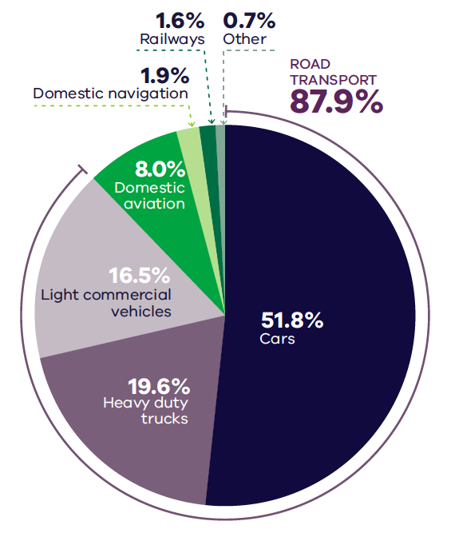
DELWP (2020) Victorian Greenhouse Gas Emissions Report 2018, State of Victoria: Melbourne, Australia.

Figure 3. Transport emissions by mode and road transport sub-categories – Victoria 2018
Cars | 51.8 per cent
Heavy duty trucks | 19.6 per cent
Light commercial vehicles | 16.5 per cent
Domestic aviation | 8.0 per cent
Domestic navigation | 1.9 per cent
Railways | 1.6 per cent
Other | 0.7 per cent
Source: Victorian Greenhouse Gas Emissions Report 2018, DELWP, 2020, State of Victoria: Melbourne, Australia.

The Victorian Government recently released its Environmentally Sustainable Development of Buildings and Subdivisions – A Roadmap for Victoria’s Planning System (the Roadmap). This document outlines updates to the planning system that support broader, state-level ESD policy objectives. It sets out additional ESD objectives and standards for the design of new buildings, as well as the layout of large-scale residential subdivisions proposed through the Victoria Planning Provisions.
The Roadmap also sets out other initiatives, including new approaches to energy management – such as renewable and distributed energy technologies, microgrids and battery farms, better stormwater management, increased landfill diversion practices, and the promotion of sustainable modes of transport.
Victoria is actively decarbonising the energy sector through the construction of better buildings and the transition to renewable energy generation (including onsite solar photovoltaic and large-scale renewable energy projects). Victoria’s planning policies will also facilitate appropriate development of low emission and zero emission energy supply infrastructure.
Good precinct structure planning can also reduce greenhouse gas emissions and make communities more climate resilient. That is why affordable and clean energy infrastructure should be used to support sustainable development and sustainable transport.

20-minute neighbourhoods
The LUFPs aim to create more 20-minute neighbourhoods in Melbourne’s six metropolitan regions by planning for established areas, growth areas and major transport infrastructure projects. The LUFPs also provide the regional direction and strategies to inform the delivery of 20-minute neighbourhoods through structure planning.

City-shaping transport projects
The Victorian Government is currently implementing the largest transport infrastructure program in the state’s history. City-shaping projects (Figure 4) include:
- The West Gate Tunnel – creating a second river crossing to link the Western Metro Region with the Port of Melbourne, CityLink and the Central Business District (CBD), and take traffic pressures off the West Gate Bridge.
- Level crossing removals including along the Belgrave and Lilydale lines, reducing congestion and unlocking land for development.
- Metro Tunnel – linking Melbourne’s south-east and Gippsland to the Sunbury line in Melbourne’s west and north-west.
- North East Link – connecting Melbourne’s south-east to the Eastern Freeway, the Western Ring Road and Hume Freeway.
- Melbourne Airport Rail – connecting Melbourne Airport to Victoria’s regional and metropolitan train network.
- Suburban Rail Loop (SRL) – connecting every major passenger railway line in Melbourne from the Frankston line in the south to the Werribee line in the west. SRL East (Cheltenham to Box Hill) is scheduled to begin in 2022. SRL East will also connect key employment and education precincts, facilitate uplift and intensive development of station precincts. SRL East Stabling Facility is planned to be located in the Kingston LGA.
These city-shaping projects will improve access to jobs, education and social opportunities in the Eastern Metro Region. They will also connect the Eastern Metro Region with other areas of Melbourne and Victoria. In addition, they are also creating opportunities to make the Eastern Metro Region more prosperous, sustainable and liveable through the integration of land use and transport planning.
The purpose of integrated land use and transport planning is to bring jobs, services and leisure opportunities closer to where people live. This means shorter trips, the option to use active transport, and less time travelling – leading to a better quality of life and the creation of 20-minute neighbourhoods. In addition, this integrated approach also frees up capacity for freight, public transport and active transport journeys – reducing transport emissions.

Coronavirus (COVID-19) impacts
The coronavirus (COVID-19) pandemic is having dramatic impacts on Victoria’s population, economy and society.
With movement restricted, migration to Victoria has been reduced almost to zero. The Australian Government’s expectations for overseas migration losses will see Victoria’s population decline slightly in 2020-21, compared with average growth of 2 per cent for most of the previous decade. International migration is expected to resume within one to two years but not return to normal until the mid-2020s at the earliest.
This interruption to growth is not expected to change the long-term future direction of Melbourne.
However, the global pandemic has had significant impacts. This includes the shift to work-from-home arrangements for large parts of the metropolitan workforce, a greater uptake of online retail services and a shift to local living, with more people are relying on their activity centres and neighbourhoods to meet their day-to-day needs. Many industry sectors impacted by COVID-19 restrictions, including tourism, the arts and international education, are still recovering.
The LUFPs will help Melbourne’s metropolitan regions manage the economic and social impacts of the pandemic especially in specific areas such as Melbourne’s CBD and the Monash and Bundoora education precincts.
The progress of each LUFP will be monitored and revisited to ensure each regional land use pathway continues to contribute to Plan Melbourne’s outcomes.

- City-shaping transport projects
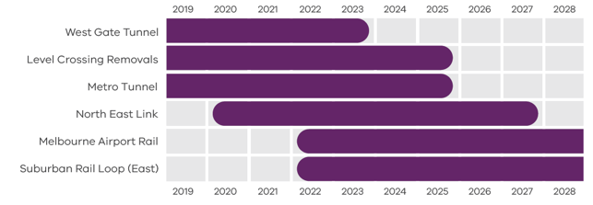
Department of Environment, Land, Water and Planning 2021

Figure 4. City-shaping transport projects
West Gate Tunnel | Pre-2019 to 2023
Level Crossings Removals | Pre-2019 to 2025
Metro Tunnel | Pre-2019 to 2025
North East Link | From 2020 to 2027
Melbourne Airport Rail | From 2022 to post-2028
Suburban Rail Loop (East) | From 2022 to post-2028
Source: Department of Environment, Land, Water and Planning 2021

Regional snapshot
The Eastern Metro Region includes the local government areas (LGAs) of Knox, Manningham, Maroondah, Monash, Whitehorse and Yarra Ranges. The region extends eastwards from the suburbs Doncaster, Box Hill and Glen Waverley to encompass the Yarra Valley and the Dandenong Ranges.
- Eastern Metro Region
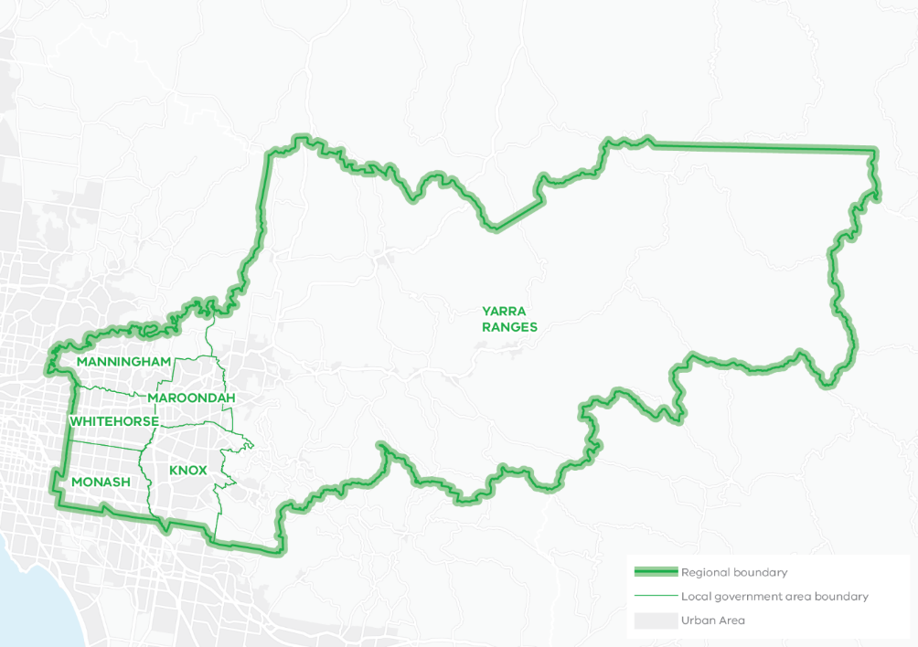
Total area: 290,333HA
33% of Metropolitan Melbourne
Over 84% of the region is designated green wedge land
The Wurundjeri people of the Kulin Nation are the Traditional Owners of the lands that now make up the majority of the Eastern Metro Region. The Taungurung people are the Traditional Owners of parts of the north-east of the region and the Bunurong people are the Traditional Owners of the southern part of the region.
The Wurundjeri people take their name from the Woi Wurrung language word ‘wurun’ meaning the Manna Gum (Eucalyptus viminalis) which is common along the Yarra River (Birrarung), and ‘djeri’, the grub which is found in or near the tree. Wurundjeri are the ‘Witchetty Grub People’ whose ancestors lived on the land for millennia (Wurundjeri Woi Wurrung Cultural Heritage Aboriginal Corporation, 2020).

Urban structure
The Eastern Metro Region’s urban geography and structure is defined by its undulating landscape, established and well-treed neighbourhoods, extensive parklands, boulevards, green wedge land and rural townships.
The Eastern Metro Region comprises an established urban area in the western third of the region with development densities generally decreasing towards the Dandenong Ranges and foothills. The other two-thirds of the region’s land area, beyond the Urban Growth Boundary (UGB), contains extensive green wedges of high scenic value with agricultural land and rural townships, state forest reserves and state-significant designated water supply catchments. The region has no new greenfield growth areas. The urban areas include:
- Existing urban areas that extend from the Yarra River at Templestowe in the north, to Monash University and Rowville in the south, and corridors of urban development extending east along the arterial road corridors of Maroondah Highway and Canterbury Road and rail corridors to Lilydale, Belgrave and Glen Waverley
- Rural townships and small established settlements through the Dandenong Ranges and Yarra Valley including Healesville, Yarra Glen, Warburton and Emerald
- Increasing densities of development along key east-west transport corridors focused on Box Hill and Ringwood in the north, Burwood and Knox in the east, and Clayton to the south
- Strong connections to important industrial and commercial precincts via Monash Freeway, Maroondah Highway, Eastern Freeway and EastLink
- Suburbs in bushland along the Yarra River and in the foothills of the Dandenong Ranges such as Warrandyte, Kilsyth, Montrose, Lysterfield.

Population and demographics
In 2020 the Eastern Metro Region had a population of 959,100 persons, or approximately 19 per cent of Melbourne’s total population.
The region’s population is projected to increase by more than 390,000 people between 2020 and 2051, to 1.35 million people. From 2016 to 2051 an additional 192,150 dwellings will be needed to accommodate this growth. Consistent with metropolitan Melbourne, the most prevalent household type is families with children and this is expected to remain so until 2051. The population aged 75 years and over is the fastest growing cohort in the region, which will have aged care and health implications.
Future population projections and industry trends suggest the Eastern Metro Region will continue to undergo significant growth and change as it experiences increased transport connectivity and consolidates its role in the health, medical technology, education, advanced technology and engineering, and retail sectors.
Outlined below are some of the key demographics and land use features of the Eastern Metro Region.
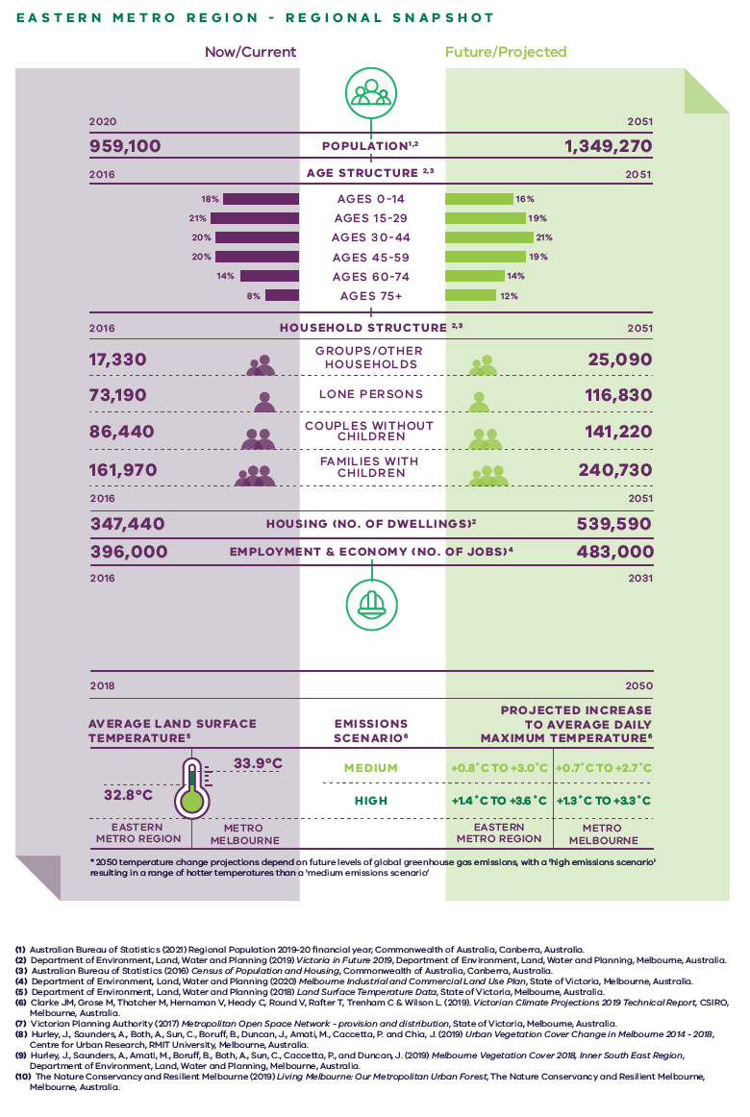
Eastern Metro Region – Regional Snapshot
Eastern Metro Region population  Sources:  Australian Bureau of Statistics (2021) Regional Population 2019-20 financial year, Commonwealth of Australia, Canberra, Australia.  Department of Environment, Land, Water and Planning (2019) Victoria in Future 2019, Department of Environment, Land, Water and Planning, Melbourne, Australia. | 2020 (now/current):  959,100 inhabitants | 2051 (projected/future):  1,349,270 inhabitants
Eastern Metro Region age structure  Sources:  Department of Environment, Land, Water and Planning (2019) Victoria in Future 2019, Department of Environment, Land, Water and Planning, Melbourne, Australia.  Australian Bureau of Statistics (2016) Census of Population and Housing, Commonwealth of Australia, Canberra, Australia. | 2016 (now/current):  18 per cent – Ages 0 to 14  21 per cent – Ages 15 to 29  20 per cent – Ages 30 to 44  20 per cent – Ages 45 to 59  14 per cent – Ages 60 to 74  8 per cent – Ages 75 plus | 2051 (projected/future):  16 per cent – Ages 0 to 14  19 per cent – Ages 15 to 29  21 per cent – Ages 30 to 44  19 per cent – Ages 45 to 59  14 per cent – Ages 60 to 74  12 per cent – Ages 75 plus
Eastern Metro Region household structure  Sources:  Department of Environment, Land, Water and Planning (2019) Victoria in Future 2019, Department of Environment, Land, Water and Planning, Melbourne, Australia.  Australian Bureau of Statistics (2016) Census of Population and Housing, Commonwealth of Australia, Canberra, Australia. | 2016 (now/current):  Groups/other households – 17,330  Lone persons – 73,190  Couples without children – 86,440  Families with children – 161,970 | 2051 (projected/future):  Groups/other households – 25,090  Lone persons – 116,830  Couples without children – 141,220  Families with children – 240,730
Eastern Metro Region housing (number of dwellings)  Source:  Department of Environment, Land, Water and Planning (2019) Victoria in Future 2019, Department of Environment, Land, Water and Planning, Melbourne, Australia. | 2016 (now/current):  347,440 dwellings | 2051 (projected/future):  539,590 dwellings
Eastern Metro Region employment and economy (number of jobs)  Source:  Department of Environment, Land, Water and Planning (2020) Melbourne Industrial and Commercial Land Use Plan, State of Victoria, Melbourne, Australia. | 2016 (now/current):  396,000 jobs | 2031 (projected/future):  483,000 jobs
2018 average land surface temperature  Source:  Department of Environment, Land, Water and Planning (2018) Land Surface Temperature Data, State of Victoria, Melbourne, Australia. | Eastern Metro Region:  32.8 degrees Celsius | Metro Melbourne:  33.9 degrees Celsius
2050 projected increase to average daily maximum temperature  *2050 temperature change projections depend upon future levels of global greenhouse gas emissions, with a ‘high emissions scenario’ resulting in hotter temperatures than a ‘medium emissions scenario’  Source:  Clarke J.M., et al. (2019). Victorian Climate Projections 2019 Technical Report, CSIRO, Melbourne, Australia. | Eastern Metro Region:  Medium emissions scenario – plus 0.8 to plus 3.0 degrees Celsius  High emissions scenario – plus 1.4 to plus 3.6 degrees Celsius | Metro Melbourne:  Medium emissions scenario – plus 0.7 to plus 2.7 degrees Celsius  High emissions scenario – plus 1.3 to plus 3.3 degrees Celsius

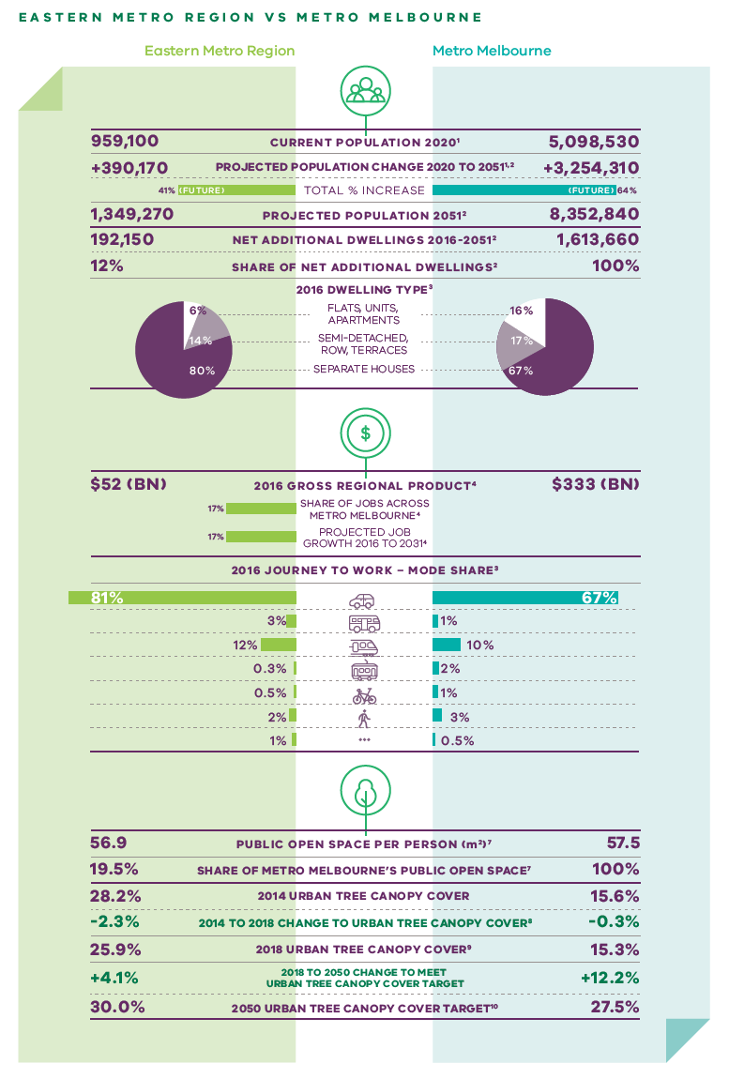
Eastern Metro Region vs Metro Melbourne
 | Eastern Metro Region | Metro Melbourne
Current population 2020  Source:  Australian Bureau of Statistics (2021) Regional Population 2019-20 financial year, Commonwealth of Australia, Canberra, Australia. | 959,100 inhabitants | 5,098,530 inhabitants
Projected population change 2020 to 2051  Sources:  Australian Bureau of Statistics (2021) Regional Population 2019-20 financial year, Commonwealth of Australia, Canberra, Australia.  Department of Environment, Land, Water and Planning (2019) Victoria in Future 2019, Department of Environment, Land, Water and Planning, Melbourne, Australia. | Plus 390,170 inhabitants | Plus 3,254,310 inhabitants
Total per cent population change (future) | 41 per cent | 64 per cent
Projected population 2051  Source:  Department of Environment, Land, Water and Planning (2019) Victoria in Future 2019, Department of Environment, Land, Water and Planning, Melbourne, Australia. | 1,349,270 inhabitants | 8,352,840 inhabitants
Net additional dwellings 2016 to 2051  Source:  Department of Environment, Land, Water and Planning (2019) Victoria in Future 2019, Department of Environment, Land, Water and Planning, Melbourne, Australia. | 192,150 dwellings | 1,613,660 dwellings
Share of net additional dwellings  Source:  Department of Environment, Land, Water and Planning (2019) Victoria in Future 2019, Department of Environment, Land, Water and Planning, Melbourne, Australia. | 12 per cent | 100 per cent
2016 dwelling type  Source:  Australian Bureau of Statistics (2016) Census of Population and Housing, Commonwealth of Australia, Canberra, Australia. | Flats, apartments, units – 6 per cent  Semi-detached, row, terraces – 14 per cent  Separate houses – 80 per cent | Flats, apartments, units – 16 per cent  Semi-detached, row, terraces – 17 per cent  Separate houses – 67 per cent
2016 gross regional product  Source:  Department of Environment, Land, Water and Planning (2020) Melbourne Industrial and Commercial Land Use Plan, State of Victoria, Melbourne, Australia. | $52 billion | $333 billion
Share of jobs across Melbourne  Source:  Department of Environment, Land, Water and Planning (2020) Melbourne Industrial and Commercial Land Use Plan, State of Victoria, Melbourne, Australia. | 17 per cent
Projected job growth to 2031  Source:  Department of Environment, Land, Water and Planning (2020) Melbourne Industrial and Commercial Land Use Plan, State of Victoria, Melbourne, Australia. | 17 per cent
2016 journey to work – mode share  Source:  Australian Bureau of Statistics (2016) Census of Population and Housing, Commonwealth of Australia, Canberra, Australia. | Private motor vehicle – 81 per cent  Bus – 3 per cent  Train – 12 per cent  Tram – 0.3 per cent  Bicycle – 0.5 per cent  Walking – 2 per cent  Other – 1 per cent | Private motor vehicle – 67 per cent  Bus – 1 per cent  Train – 10 per cent  Tram – 2 per cent  Bicycle – 1 per cent  Walking – 3 per cent  Other – 0.5 per cent
Public open space per person (metres squared)  Source:  Victorian Planning Authority (2017) Metropolitan Open Space Network: Provision and Distribution, State of Victoria, Melbourne, Australia. | 56.9 | 57.5
Share of metro Melbourne’s public open space  Source:  Victorian Planning Authority (2017) Metropolitan Open Space Network: Provision and Distribution, State of Victoria, Melbourne, Australia. | 19.5 per cent | 100 per cent
2014 urban tree canopy cover  Source:  Hurley, J., et al. (2019) Urban Vegetation Cover Change in Melbourne 2014 - 2018, Centre for Urban Research, RMIT University, Melbourne, Australia. | 28.2 per cent | 15.6 per cent
2014 to 2018 change to urban tree canopy cover | Minus 2.3 per cent | Minus 0.3 per cent
2018 urban tree canopy cover  Source:  Hurley, J., et al. (2019) Melbourne Vegetation Cover 2018, Eastern Region, Department of Environment, Land, Water and Planning, Melbourne, Australia. | 25.9 per cent | 15.3 per cent
2018 to 2050 change to meet urban tree canopy cover target | Plus 4.1 per cent | Plus 12.2 per cent
2050 urban tree canopy cover target  Source:  The Nature Conservancy and Resilient Melbourne (2019) Living Melbourne: Our Metropolitan Urban Forest, The Nature Conservancy and Resilient Melbourne, Melbourne, Australia. | 30.0 per cent | 27.5 per cent

Vision: Eastern Metro Region in 2050
The Eastern Metro Region has a significant and unique role in ensuring that “Melbourne will continue to be a global city of opportunity and choice.”
The Eastern Metro Region will be a highly connected, vibrant community. It will meet the challenges of population growth and climate change by attracting investment and jobs closer to where people live, providing diverse housing choices, offering a range of public and active transport options, and protecting the green and leafy character of the region’s urban areas and its prized rural environments, including the Yarra Valley and Dandenong Ranges.
By 2050 the region’s renowned economic, social and environmental assets will be enhanced and celebrated, and the region will become increasingly liveable and sustainable. Specifically the region will experience:
- Strong growth and job creation driven by the health, technology, education and retail sectors, and underpinned by continued investment in the Monash NEIC, the region’s metropolitan activity centres of Box Hill and Ringwood and health and education precincts
- Medium- and higher-density housing in the most accessible locations to meet the needs of a growing population and create more 20-minute neighbourhoods, including at Suburban Rail Loop precincts, activity centres, close to train stations, transport corridors and urban renewal opportunities
- An increase in the amount of social and affordable housing; and a greater choice of housing to reflect community needs, including an ageing population and the accommodation needs for workers and students associated with the Monash NEIC and the region’s health and education precincts
- Improved connectivity and accessibility activated by the Suburban Rail Loop, North East Link and an improved regional cycling network. In particular, there will be better north-south links in the west of the region and improved east-west connections in the eastern part of the region
- The transformation of key road corridors into green boulevards; and strengthening of the region’s network of civic spaces, public open space, and trail connections
- More tree canopy cover, as well as enhanced parklands and open space corridors which will continue to be key aspects of the region’s identity and liveability
- Integrated water management that supports the creation of resilient urban communities, sustains agricultural production, helps prevent flooding and maintains the health of the region’s precious open water catchments.
The region’s green wedges will continue to be valued for their landscape character, biodiversity and tourism offer. Its highly productive agricultural areas will serve as Melbourne’s primary food bowl. Townships such as Healesville, Warburton and Yarra Glen will provide services and facilities for the local population while also supporting a strong visitor economy based on promotion of the region’s local wine and food, farmers and makers markets, accommodation and outdoor activities.
For a more detailed picture of how land use in the Eastern Metro Region is expected to change in 2050 refer to Map 1.
- Eastern Metro Region 2050 Plan
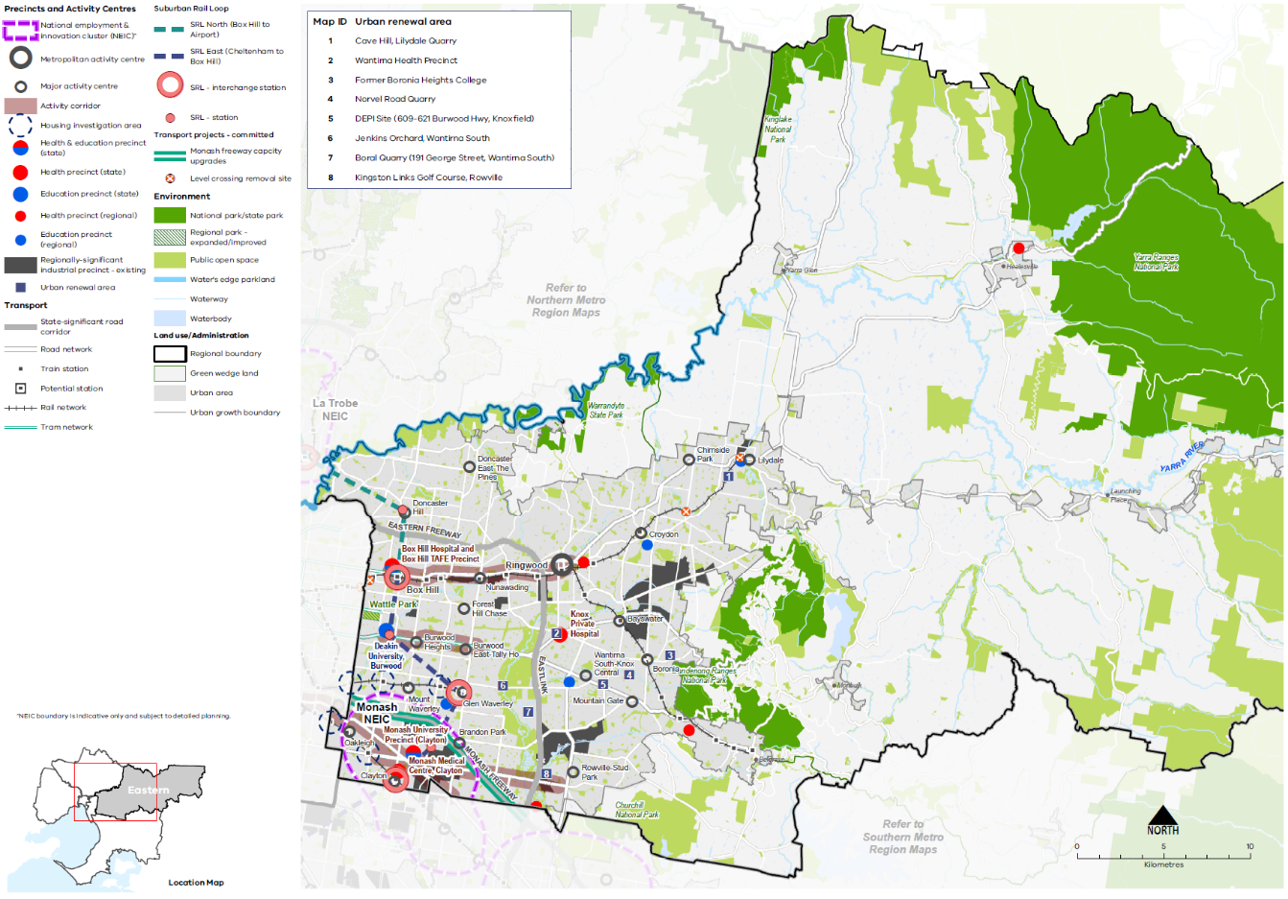

Map 1 Eastern Metro Region 2050 Map

A plan of the Eastern Metro Region in 2050 showing -

- The region’s boundary, the urban growth boundary, green wedge land and established urban area.

- Locations for growth and investment, including:
- The location and indicative boundary of the Monash NEIC in the south of the region^
- Regionally-significant industrial precincts located through the western part of the region, within its urban areas as listed in table 3
- Ringwood and Box Hill Metropolitan Activity Centres and the network of major activity centres predominantly located on the rail and road network, as listed in table 5
- Housing Investigation Areas as listed in table 10
- State- and regionally-significant health and/or education precincts, highlighting those at Knox, Monash, Burwood, Clayton, Box Hill, Ringwood, Healesville, Mulgrave, Upper Ferntree Gully, Wantirna, Lilydale, Croydon and Glen Waverley, as listed in table 12
- Eight urban renewal areas, which are numbered and listed:

Cave Hill - Lilydale Quarry
Wantirna Health Precinct
Former Boronia Heights College
Norvel Road Quarry
DEPI Site
Jenkins Orchard, Wantirna South
Boral Quarry, Wantirna South
Kingston Links Golf Course, Rowville

- Activity corridors between:

Box Hill and Ringwood metropolitan activity centres,
Deakin University and Burwood East-Tally Ho Major Activity Centre,
Caulfield Major Activity Centre (Inner South East Metro Region) and the Monash NEIC
The Monash NEIC and Rowville Major Activity Centre.

- Suburban Rail Loop (East) (Cheltenham to Box Hill) stations at Monash and Burwood, and interchange stations at Clayton, Glen Waverley and Box Hill. Suburban Rail Loop (North) (Box Hill to Airport) station at Doncaster.

- Key transport linkages and movement network including:
- New underground railway lines and train stations for Suburban Rail Loop
- The road network including the state-significant road corridors of the Eastern Freeway, Eastlink and the Monash Freeway.

- State and regional natural and cultural assets, including:
- State and National parks, the improved regional park at Wattle Park and other public open space
- Major waterway of the Yarra River corridor
- Reservoirs including Maroondah Reservoir and Silvan Reservoir in the northeast and east of the region

^ NEIC boundary is indicative only and subject to detailed planning.

Productivity
Plan Melbourne Outcome 1: Melbourne is a productive city that attracts investment, supports innovation and creates jobs
The Eastern Metro Region contributes about 16 per cent of metropolitan Melbourne’s total Gross Regional Product (GRP) and adds $52 billion to the Victorian economy. With economic specialisations in the health, technology and education sectors, the region has the second largest number of jobs and second highest share of GRP for metropolitan Melbourne after the Inner Metro Region.
SRL East (Cheltenham to Box Hill) will facilitate growth and diversity within station precincts and open up employment opportunities by connecting established precincts such as the Monash National Employment and Innovation Cluster (NEIC), Deakin University. Box Hill Metropolitan Activity Centre, and Glen Waverley and Clayton major activity centres. The north-south alignment will increase access to jobs and services and increase the reach of businesses to attract workers from across the region and beyond. This transformational infrastructure will accelerate jobs and investment in the Eastern Metro Region.
Plan Melbourne creates a city structure that strengthens Melbourne’s competitiveness for jobs and investment. It identifies NEICs, state-significant industrial precincts (SSIPs), a network of metropolitan and major activity centres, transport gateways and state-significant health and education precincts to ensure employment growth occurs outside of the Central City linked by transport.

State of play
The Eastern Metro Region contains a total of 2,573 hectares of land zoned for industrial uses with less than 10 per cent available for future development. Around 70 per cent is concentrated in Knox and Maroondah LGAs while Manningham LGA has the lowest supply of industrial land. Based on an average annual consumption rate of 11 hectares per annum, the region only has about 12 years’ supply of industrial land remaining.
A total of 761 hectares of land in the region is zoned for commercial uses. An estimated 2.8 million square metres of floorspace is occupied or available for commercial purposes on this land. Almost half of all existing floorspace supply is found in Monash and Whitehorse LGAs.
The Monash NEIC, located in the south-western corner of the Eastern Metro Region, contains the largest concentration of jobs in the region and is expected to see the most growth. The region is also home to the Upper Yarra Valley and Dandenong Ranges which are major tourism and agricultural assets producing nationally and internationally recognised wines and fresh produce.
The following places contribute to the productivity of the Eastern Metro Region:
- The Monash NEIC, supported by a network of state-significant technology, health and education precincts such as Monash University, Monash Medical Centre, Monash Children’s Hospital, Eastern Innovation Business Centre, CSIRO, Australian Synchrotron, Victorian Heart Hospital and the Melbourne Centre for Nanofabrication
- Other state-significant health and/or education precincts at Box Hill Hospital, Box Hill Institute of TAFE Precinct, Deakin University (Burwood), Monash University Precinct (Clayton) and Knox Private Hospital
- Metropolitan activity centres at Box Hill and Ringwood
- Regionally-significant industrial precincts at Bayswater Business Precinct and Scoresby-Rowville Industrial Precinct, Clayton-Mulgrave Industrial Precinct (part of Monash NEIC), Nunawading MegaMile Home and Lifestyle Precinct, Blackburn Industrial Precinct, Rooks Road and Redland Estate
- Regionally-significant health and/or education precincts at Maroondah Hospital, Healesville Hospital, Angliss Hospital, Wantirna Health Precinct and Box Hill Institute (Lilydale campus)
- A network of 19 major activity centres, including freestanding shopping centres, strip-based centres and business parks
- Major tourism attractions and significant regional agricultural production areas for wine and intensive horticulture in the region’s three green wedges of Yarra Valley and Yarra and Dandenong Ranges, Manningham and Southern Ranges.
In 2016, the region accounted for around 17 per cent of all employment across metropolitan Melbourne with over 396,000 jobs. The region’s top five employment industries are healthcare and social assistance, retail trade, education and training, manufacturing, and construction. Employment growth is projected to continue in these same five industries (Figure 6).
Projected population growth in the Eastern Metro Region is less than that projected for regions with greenfield growth areas and the Inner Metro Region, and all of this growth will be accommodated in the established urban area. By 2031, an estimated 87,000 additional jobs will be required and almost 60 per cent of these will be expected within the Monash and Whitehorse LGAs.
- Projected employment growth for the Eastern Metro Region 2016 to 2031
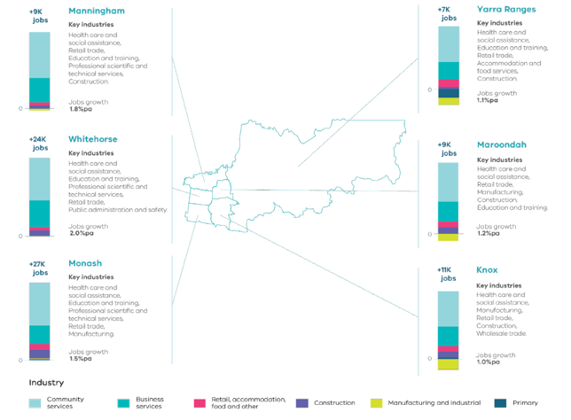
Melbourne Industrial and Commercial Land Use Plan, DELWP, 2020

Figure 6. Projected employment growth for the Eastern Metro Region 2016 to 2031
Manningham | Plus 9,000 jobs | 1.8 per cent jobs growth per annum | Key industries: healthcare and social assistance, retail trade, education and training, professional scientific and technical services, construction
Whitehorse | Plus 24,000 jobs | 2.0 per cent jobs growth per annum | Key industries: healthcare and social assistance, education and training, professional scientific and technical services, retail trade, public administration and safety
Monash | Plus 27,000 jobs | 1.5 per cent jobs growth per annum | Key industries: healthcare and social assistance, education and training, professional scientific and technical services, retail trade, manufacturing
Yarra Ranges | Plus 7,000 jobs | 1.1 per cent jobs growth per annum | Key industries: healthcare and social assistance, education and training, retail trade, accommodation and food services, construction
Maroondah | Plus 9,000 jobs | 1.2 per cent jobs growth per annum | Key industries: healthcare and social assistance, retail trade, manufacturing, construction, education and training
Knox | Plus 11,000 jobs | 1.0 per cent jobs growth per annum | Key industries: healthcare and social assistance, manufacturing, retail trade, construction, wholesale trade
Source: Department of Environment, Land, Water and Planning (2020) Melbourne Industrial and Commercial Land Use Plan, State of Victoria, Melbourne, Australia.

Regional strengths
- The region has a strong network of health and education precincts, primarily anchored by the Monash NEIC.
- A specialisation in the health, medical technology, education, advanced technology and engineering, and retail sectors will continue to grow.
- The metropolitan activity centres of Box Hill and Ringwood are well connected and will be supported by infrastructure investment and improvements.
- A network of activity centres, transport corridors and regionally-significant industrial precincts can grow and diversify the employment base of the region.
- Productive green wedges support a strong visitor economy and are a food bowl of metropolitan Melbourne.

Regional challenges
- The region doesn’t have any greenfield growth areas. This means existing employment land needs to be protected and new opportunities to expand, intensify and diversify employment activity within the existing urban context need to be explored.

Directions and strategies
The directions identified to achieve the 2050 vision for the Eastern Metro Region in terms of Productivity and Outcome 1 of Plan Melbourne are:
Direction 1 | Facilitate the development of the Monash NEIC as a globally recognised health, education, technology and advanced manufacturing centre supported by increased transport connectivity
Direction 2 | Ensure the region’s strong health and/or education precincts continue to provide local jobs while supporting the region’s growing population
Direction 3 | Support the development of a strong network of activity centres to provide jobs closer to where people live
Direction 4 | Intensify and diversify the range of employment uses within regionally-significant industrial precincts
Direction 5 | Develop activity corridors to support increased employment and housing opportunities
Direction 6 | Ensure protection of green wedges and support their role to provide agriculture, tourism and state infrastructure for the long-term benefit of all Victorians
Each direction is implemented through regionally-specific strategies identified in this LUFP.
Map 2 shows how productivity will be enhanced across the Eastern Metro Region by 2050 as a result of these directions and strategies, together with Plan Melbourne and other strategies and initiatives as outlined in Appendix 01.

- Eastern Metro Region productivity 2050
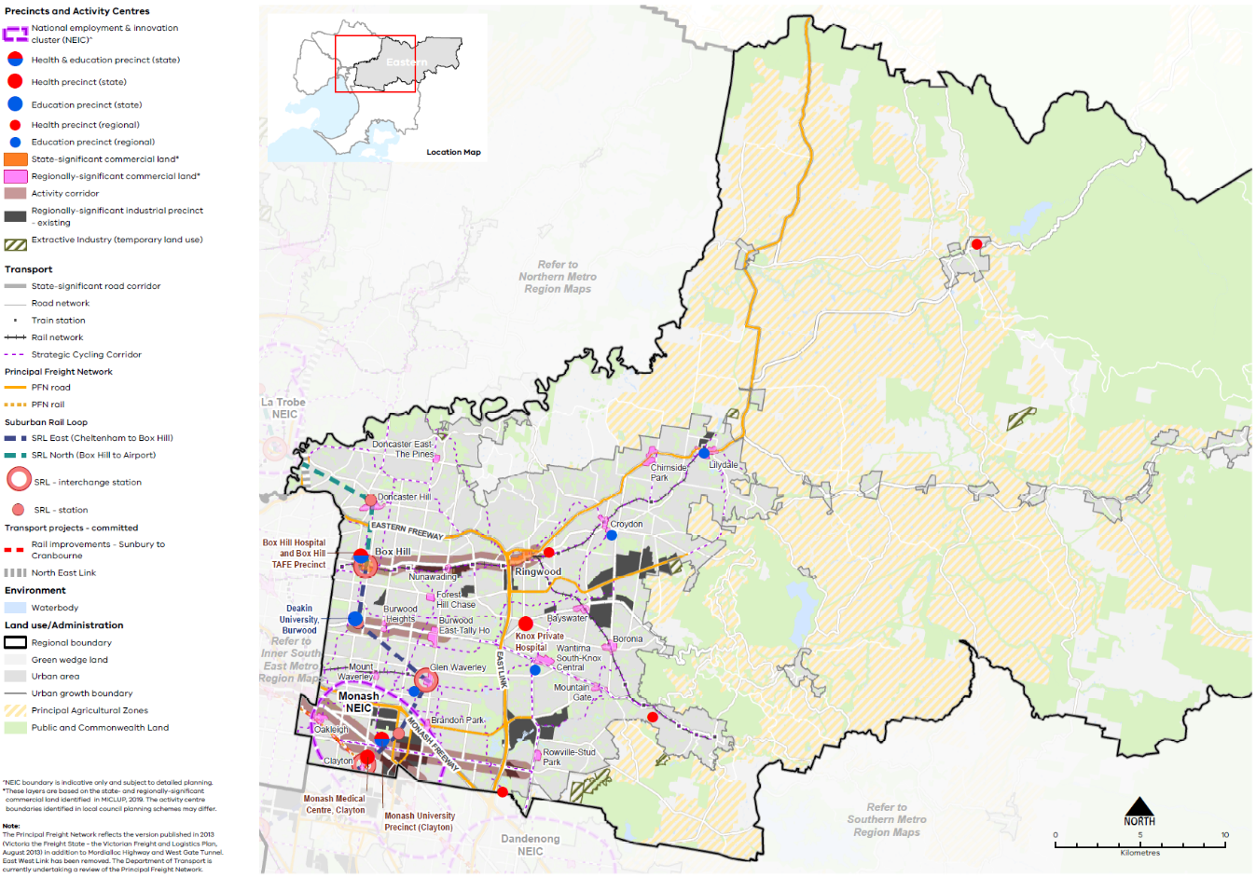

Map 2 Eastern Metro Region productivity 2050
A plan of productivity in the Eastern Metro Region in 2050, extracting the productivity features identified on Map 1 above, with the addition of:
- Existing state- and regionally-significant commercial land predominantly located along railway lines, main roads and at main road intersections (see table 5)*
- Extractive industry (temporary land use)
- Principal agricultural zones
- Principal freight networks (PFN)

*These layers are based on the state and regionally significant commercial land identified in MICLUP, 2019. The activity centre boundaries identified in local council planning schemes may differ.

NOTE: The Principal Freight Network reflects the version published in 2013 (Victoria the Freight State – the Victorian Freight and Logistics Plan, August 2013) in addition to Mordialloc Highway and West Gate Tunnel. East West Link has been removed. The Department of Transport are currently undertaking a review of the Principal Freight Network.
- Facilitate the development of the Monash NEIC as a globally recognised health, education, technology and advanced manufacturing centre supported by increased transport connectivity
The Monash NEIC (Figure 7) is expected to become a globally recognised precinct for employment, education, innovation, leading-edge technology and research.
The Monash NEIC already services the Eastern, Inner South East and Southern metro regions but once new stations are constructed in Clayton and Monash as part of SRL this could extend to the Latrobe Valley, with significant opportunities for inter-regional connectivity, investment and land use change.
A significant mixed-use activity area around the SRL station at Monash will support employment in the Monash NEIC. Further development of Clayton Major Activity Centre as a SRL precinct, as well as Clayton Business Park and regionally-significant industrial precincts, would also increase residential density, provide a range of complementary uses and enable more workers to live closer to where jobs are located.
Careful and collaborative planning across multiple municipal boundaries will ensure Monash NEIC’s connected institutions maximise shared economic opportunities. A clear governance arrangement between relevant local councils and Victorian Government departments and agencies is needed to ensure the planning objectives for the Monash NEIC are realised.
- Strengthen Monash NEIC as a pre-eminent healthcare, education, technology, advanced manufacturing and health research provider and activity cluster in the Eastern Metro Region.
- Facilitate land use and economic intensification of the Monash NEIC to leverage transport infrastructure investment and improved public transport connectivity, including Suburban Rail Loop.
- Monash National Employment and Innovation Cluster
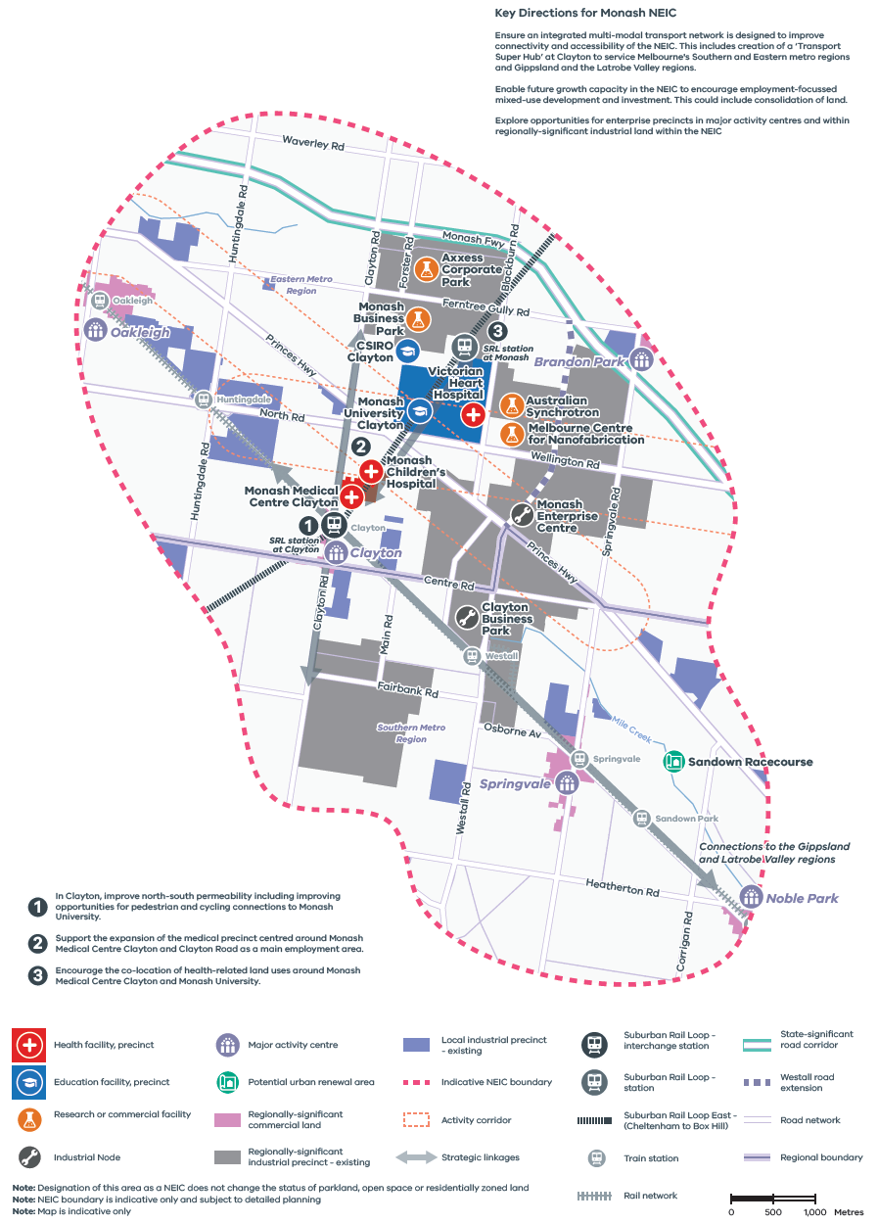

Figure 7. Monash National Employment and Innovation Cluster
A map of Monash National Employment and Innovation Cluster, showing –
- Health facility, precinct - at Monash Children’s Hospital, Monash Medical Centre Clayton, Victorian Heart Hospital
- Education facility, precinct - at Monash University Clayton, CSIRO Clayton,
- Research or commercial facility at Axxess Corporate Park, Monash Business Park, Australian Synchrotron, Melbourne Centre for Nanofabrication
- Industrial node at Monash Enterprise centre and Clayton Business Park
- Major activity centre at Oakleigh, Brandon Park, Clayton, Springvale and Nobel Park
- Potential urban renewal area at Sandown Park
- Regionally significant commercial land
- Regionally-significant industrial precinct – existing; and local industrial precinct -existing
- Indicative NEIC boundary
- Activity corridor along Princes Highway
- Strategic linkages
- Suburban Rail Loop East (Cheltenham to Box Hill)
- Suburban Rail Loop interchange station at Clayton, Suburban Rail Loop station at Monash
- Rail network and train stations
- The Monash Freeway state-significant road corridor
- Road network including the Westall road extension from the Princes Highway to Monash Freeway
- Regional boundary with the southern part of the Monash NEIC located in the Southern Metro Region.
Map Notes (numbered on the map)
- In Clayton, improve north-south permeability including improving opportunities for pedestrian and cycling connections to Monash University.
- Support the expansion of the medical precinct centred around Monash Medical Centre Clayton and Clayton Road as a main employment area.
- Encourage the co-location of health-related land uses around Monash Medical Centre Clayton and Monash University.
Key Directions for Monash NEIC
- Ensure an integrated multi-modal transport network is designed to improve connectivity and accessibility of the NEIC. This includes creation of a ‘Transport Super Hub’ at Clayton to service Melbourne's Southern and Eastern metro regions and Gippsland and the Latrobe Valley regions.
- Enable future growth capacity in the NEIC to encourage employment-focussed mixed-use development and investment. This could include consolidation of land.
- Explore opportunities for enterprise precincts in major activity centres and within regionally-significant industrial land within the NEIC
Note: Designation of this area as a NEIC does not change the status of parkland, open space or residentially zoned land
Note: NEIC boundary is indicative only and subject to detailed planning
Note: Map is indicative only
- Ensure the region’s strong health and/or education precincts continue to provide local jobs while supporting the region’s growing population
The Eastern Metro Region’s health sector supports over 58,000 jobs across 20 major health facilities and 6,000 related businesses and organisations while the education sector supports over 40,000 jobs, 30 per cent of which are in the tertiary education sector (Regional Development Australia, 2020).
As the second largest exporter of education services in Melbourne, the Eastern Metro Region would benefit from significant investment in tertiary student support and short-term stays. Access to health and education is also a key aspect of liveability that underpins the region’s economic success.
SRL has been purposely planned to connect key employment precincts and provide opportunities for ancillary businesses in the Eastern Metro Region, particularly where health and education precincts are co-located with metropolitan and major activity centres such as Box Hill, Burwood and Clayton. Precinct planning for SRL precincts would support improved inter-regional movement.
- Support significant land use change and higher-density development in SRL precincts.
- Encourage investment that will attract major anchor tenants, start-ups and specialised labour in the region’s health and/or education precincts.
- Support convenience retail, service and business uses in health and/or education precincts and SRL precincts to provide ancillary business opportunities and amenities.
- Improve transport connections between health and/or education precincts in the Eastern Metro Region, particularly north-south connectivity.
- Improve pedestrian amenity, cycling access, public transport access and linkages within and between the region’s health and/or education precincts and activity centres.
- Support the development of a strong network of activity centres to provide jobs closer to where people live
The Eastern Metro Region’s two metropolitan activity centres of Box Hill and Ringwood are located in the northern half of the region on the Belgrave-Lilydale railway line, with convenient access to the Central City.
Box Hill is a significant regional centre for retail, office, hospitality, civic, health and community uses and will play a significant regional role as the SRL interchange station integrated with the existing tram and bus network. Ringwood is predominantly retail-focused with a large-scale shopping centre. As the gateway to the Yarra Valley, Ringwood is a key employer for residents further east.
Across the region, there are 19 major activity centres that are either based around large freestanding shopping centres (e.g. Chirnside Park, Doncaster Hill, Forest Hill Chase, Glen Waverley, Nunawading and Wantirna South-Knox Central) or strip-based centres (e.g. Boronia, Croydon, Lilydale and Oakleigh).
Box Hill and Ringwood provide over 100,000 square metres of commercial floorspace each, along with three other larger major activity centres of Doncaster Hill, Glen Waverley and Wantirna South. It is anticipated that 837,000 square metres of additional commercial floorspace will be needed across the Eastern Metro Region by 2031.
With no future commercial areas identified, the Eastern Metro Region must rezone, consolidate or intensify land uses to accommodate future requirements. A significant proportion of the region’s recent office development has been in freestanding business or office parks. There is a need to identify and supply additional commercial floorspace in designated activity centres close to public transport, including underutilised land and surplus state and local government land. Existing and future commercial floorspace requirements for the Eastern Metro Region are shown in Figure 8.
SRL precincts will support significant land use change and higher-density development opportunities in the Box Hill, Doncaster Hill, Clayton, and Glen Waverley activity centres (Figure 9). There will also be flow-on development opportunities in neighbouring activity centres along SRL alignment. New stations and interchanges must be strategically located to service existing land use, drive land use change and incentivise public and private investment.
- Direct high-value jobs and higher-density development to Box Hill and Ringwood metropolitan activity centres as well as suitable major activity centres.
- Retain existing commercial zoned land and identify areas that can support future demand for commercial floorspace and new investment with a focus on metropolitan and major activity centres.
- Maximise land use and economic intensification around Suburban Rail Loop precincts, particularly those co-located with activity centres, leveraging public transport improvements
- Encourage the agglomeration of commercial investment by locating employment uses and office development in activity centres
- Existing and future commercial floorspace requirements for the Eastern Metro Region
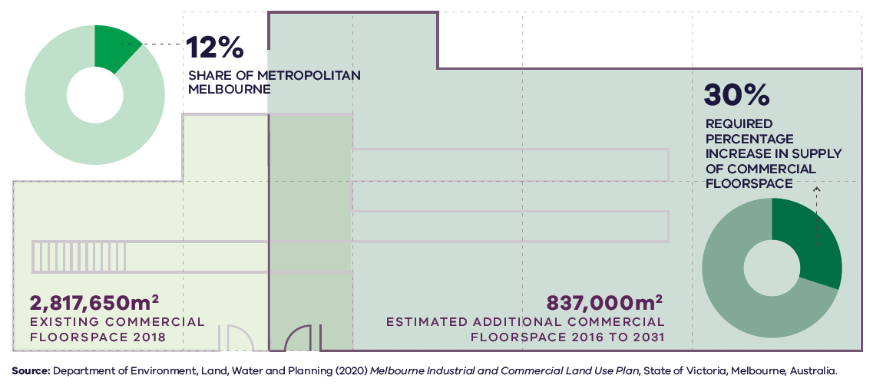

Figure 8. Existing and future commercial floorspace requirements for the Eastern Metro Region
Eastern Metro Region | 12 per cent share of metropolitan Melbourne | 2,817,650 square metres – existing commercial floorspace 2018 | 837,000 square metres – estimated additional commercial floorspace 2016 to 2031 | 30 per cent – required percentage increase in supply of commercial floorspace
Source: Department of Environment, Land, Water and Planning (2020) Melbourne Industrial and Commercial Land Use Plan, State of Victoria, Melbourne, Australia.
- Locations for growth and change – Suburban Rail Loop precincts
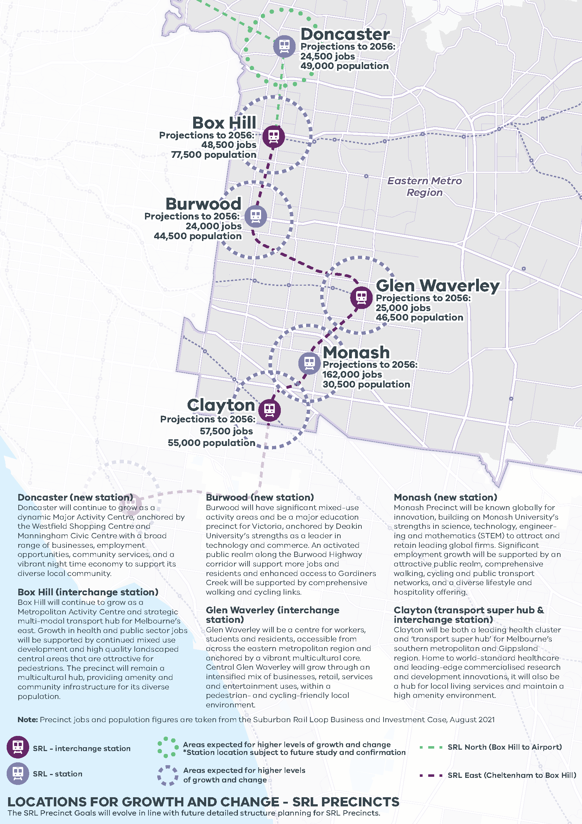

LOCATIONS FOR GROWTH AND CHANGE - SRL PRECINCTS
Doncaster (new station) Doncaster will continue to grow as a dynamic Major Activity Centre, anchored by the Westfield Shopping Centre and Manningham Civic Centre with a broad range of businesses, employment opportunities, community services, and a vibrant night time economy to support its diverse local community.
Box Hill (interchange station) Box Hill will continue to grow as a Metropolitan Activity Centre and strategic multi-modal transport hub for Melbourne’s east. Growth in health and public sector jobs will be supported by continued mixed use development and high quality landscaped central areas that are attractive for pedestrians. The precinct will remain a multicultural hub, providing amenity and community infrastructure for its diverse population.
Burwood (new station) Burwood will have significant mixed-use activity areas and be a major education precinct for Victoria, anchored by Deakin University’s strengths as a leader in technology and commerce. An activated public realm along the Burwood Highway corridor will support more jobs and residents and enhanced access to Gardiners Creek will be supported by comprehensive walking and cycling links.
Glen Waverley (interchange station) Glen Waverley will be a centre for workers, students and residents, accessible from across the eastern metropolitan region and anchored by a vibrant multicultural core. Central Glen Waverley will grow through an intensified mix of businesses, retail, services and entertainment uses, within a pedestrian- and cycling-friendly local environment.
Monash (new station) Monash Precinct will be known globally for innovation, building on Monash University’s strengths in science, technology, engineering and mathematics (STEM) to attract and retain leading global firms. Significant employment growth will be supported by an attractive public realm, comprehensive walking, cycling and public transport networks, and a diverse lifestyle and hospitality offering.
Clayton (transport super hub & interchange station) Clayton will be both a leading health cluster and ‘transport super hub’ for Melbourne’s southern metropolitan and Gippsland region. Home to world-standard healthcare and leading-edge commercialised research and development innovations, it will also be a hub for local living services and maintain a high amenity environment.
LOCATIONS FOR GROWTH AND CHANGE - SRL PRECINCTS
Eastern Metro Region
The SRL Precinct Goals will evolve in line with future detailed structure planning for SRL Precincts.
Station | Projections to 2056 | Growth | SRL
Doncaster | 24,500 jobs  49,000 population | Areas expected for higher levels of growth and change  *Station location subject to future study and confirmation | SRL North (Box Hill to Airport)
Box Hill | 48,500 jobs  77,500 population | Areas expected for higher levels of growth and change | SRL East (Cheltenham to Box Hill)
Burwood | 24,000 jobs  44,500 population | Areas expected for higher levels of growth and change | SRL East (Cheltenham to Box Hill)
Glen Waverly | 25,000 jobs  46,500 population | Areas expected for higher levels of growth and change | SRL East (Cheltenham to Box Hill)
Monash | 162,000 jobs  30,500 population | Areas expected for higher levels of growth and change | SRL East (Cheltenham to Box Hill)
Clayton | 57,500 jobs  55,000 population | Areas expected for higher levels of growth and change | SRL East (Cheltenham to Box Hill)
- Intensify and diversify the range of employment uses within regionally-significant industrial precincts to be continued generators of economic activity and employment
The regionally-significant industrial precincts in the Eastern Metro Region should be carefully planned for and protected (Table 3). As the region is fully established, no future industrial precincts have been identified. Opportunities exist for underutilised land to be redeveloped, and for buildings and land to be recycled for new industrial uses. Existing and future industrial floorspace requirements for the Eastern Metro Region are shown in Figure 10.
The Bayswater Business Precinct is a large industrial area accommodating 40,000 jobs in 730 hectares of land in the Knox, Maroondah and Yarra Ranges LGAs. A coordinated approach to planning for this precinct will benefit the Eastern Metro Region as a whole. The precinct has less than 10 per cent vacant land available for future development. To remain economically competitive the precinct should encourage adaptation by existing businesses and attract new businesses. Increasing the amenity in and around the precinct will add to Bayswater Business Precinct’s marketability for new businesses. Bayswater Major Activity Centre is located south-west of the precinct offering housing, retail and services for the precinct’s workforce.
The Scoresby-Rowville Industrial Area accommodates a range of production and service industries as well as business parks and is located with direct access to EastLink. The Clayton-Mulgrave Industrial Precinct forms part of the broader Monash NEIC and has the potential to contribute to significant growth in technology, medical and health-based industries and advanced manufacturing.
The Nunawading MegaMile Home and Lifestyle Precinct is home to over 250 businesses (mostly bulky goods retailing) and supports over 2,500 jobs. Nearby is the Blackburn Industrial Precinct as well as a number of other key industrial precincts such as Rooks Road and Redland Estate. These locations are important for small and medium-sized businesses.
The high concentration of technology and innovation-based industries already located in the Eastern Metro Region will likely see the development of creative industries, ‘start-up’ businesses and home-based businesses. The region has the potential to develop ‘enterprise precincts’ in areas that are well serviced by public transport, contain industrial land and are located close to services and amenities. Enterprise precincts facilitate the creation and commercialisation of new ideas and support metropolitan economies by growing jobs in ways that leverage their distinct economic attributes. The planning system should be flexible to support investment in these anticipated business by establishing ‘incubator’ and co-working spaces to encourage collaboration. Additionally, some regionally-significant industrial land in the region, such as land around the Monash NEIC, could transition to higher-order employment opportunities.
- Retain industrial zoned land at Bayswater Business Precinct, Scoresby-Rowville Industrial Area and Clayton-Mulgrave Industrial Precinct (within Monash NEIC) predominantly for industrial uses.
- Retain regionally-significant industrial land by managing encroachment by other uses that would cause fragmentation and may compromise the development and efficient operation of existing businesses.
- Improve the amenity, walking, cycling and public transport access of regionally-significant industrial precincts.
- Maximise investment opportunities for start-ups and/or creative industries in the Bayswater Business Precinct, Scoresby-Rowville Industrial Area and Clayton-Mulgrave Industrial Precinct (within Monash NEIC) and across the activity centre network to support innovation and collaboration.
- Identify and plan for future enterprise precincts that are well serviced by public transport, contain identified locally-significant industrial land and are located close to services and amenities provided.
Regionally-significant industrial precincts within the Eastern Metro Region
Existing precincts
- Bayswater Business Precinct
- Scoresby-Rowville Industrial Area
- Clayton Business Park (part of the Monash NEIC)
- Huntingdale Industrial Area (part of the Monash NEIC)
- Nunawading MegaMile Home and Lifestyle Precinct
- Blackburn Industrial Precinct
- Rooks Road Industrial Precinct
- Redland Estate Industrial Precinct
Melbourne Industrial and Commercial Land Use Plan, DELWP, 2020
- Existing and future industrial floorspace requirements for the Eastern Metro Region
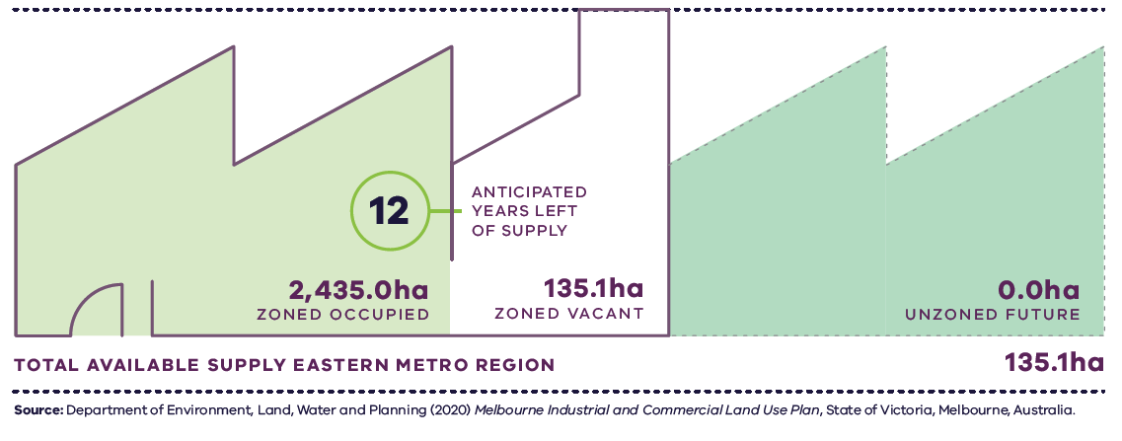
Figure 10. Existing and future industrial floorspace requirements for the Eastern Metro Region
Eastern Metro Region | 2,435.0 hectares zoned occupied | 135.1 hectares zoned vacant  12 anticipated years left of supply | 0.0 hectares unzoned future | 135.1 hectares total available supply
Source: Department of Environment, Land, Water and Planning (2020) Melbourne Industrial and Commercial Land Use Plan, State of Victoria, Melbourne, Australia.

- Develop activity corridors to support increased employment and housing opportunities
While activity centres will be the primary locations for concentrated development, the Eastern Metro Region has several ‘activity corridors’ that are heavily used by commuters or are undergoing city-shaping infrastructure upgrades. Often, they contain linear commercial, mixed-use and land zoned for increased housing densities.
Plan Melbourne supports the development of a network of activity centres linked by transport. This includes encouraging increased diversity and density of developments on the PPTN, particularly at interchanges, activity centres and where principal public transport routes intersect.
Activity corridors, given their high levels of accessibility, have the potential to link up the activity centre network and provide local-scale employment and higher-density housing. Activity corridors will become increasingly attractive locations as a result of SRL and other infrastructure projects.
Within activity corridors, existing commercial land should be retained and opportunities to support future demand for commercial floorspace investigated. Designation as an activity corridor could attract additional investment and development aligned to strategic land use objectives along each corridor. Neighbourhood activity centres in close proximity to activity corridors may also support increased housing opportunities.
The SRL station at Burwood will enable substantial uplift in jobs and housing in a well-connected precinct and growth corridor. Future employment growth should be targeted around Deakin University and existing employment areas that are well connected. It will also create an opportunity to facilitate increased investment and development along Burwood Highway.
- Encourage increased investment and development along key activity corridors in the region, specifically:
- Whitehorse Road between Box Hill and Ringwood metropolitan activity centres, including Nunawading Mega Mile Home and Lifestyle Precinct (Nunawading Major Activity Centre)
- Burwood Highway between Deakin University (state-significant education precinct and SRL station at Burwood), Burwood Heights and Burwood East-Tally Ho major activity centres
- Dandenong Road/Princes Highway between Caulfield and Chadstone major activity centres (Inner South East Metro Region) and the Monash NEIC
- North Road/Wellington Road from Monash NEIC to Rowville Major Activity Centre.
- Facilitate land use and economic intensification of the SRL Burwood Precinct given improved public transport connectivity.
- Ensure protection of green wedges and support their role to provide agriculture, tourism and state infrastructure for the long-term benefit of all Victorians
The Eastern Metro Region’s green wedges are highly productive regions, valued for their landscape character, biodiversity and tourism offer.
The green wedges are protected from urban encroachment by the UGB and planning controls are in place to protect the environment and landscape in many areas. View lines to the treed slopes of the Dandenong Foothills, the Yarra River corridor and Christmas Hills are also a key consideration for adjacent urban areas.
The region’s green wedges support the production of flowers and nursery plants, berries and orchard fruits, wine grapes, beef and grain. They also support a strong visitor economy based on local wine and food, farmers and makers markets, accommodation, outdoor activities such as walking and hiking, parklands and river corridors, cycling and horse-riding, and attractions such as Healesville Sanctuary and Puffing Billy. These significant natural landscapes and cultural values attract four million visitors each year and provide over 15,200 jobs across the region.
Non-urban areas of the Eastern Metro Region include townships such as Healesville, Warburton and Yarra Glen that provide services and facilities to the local population. Much of the land within the green wedges has significant conservation value for its natural bushland, which also brings a high bushfire risk. However, its contribution to the regional and national economy, based on rural produce and natural attractions, should be promoted and protected.
- Protect and optimise the productive potential of agricultural land for agricultural purposes to encourage jobs in the agricultural sector in the Eastern Metro Region.
- Support tourism and recreation activities that contribute to vibrant green wedge communities, economic growth, and which respect other green wedge priorities such as landscape and environmental values, biodiversity conservation, cultural heritage and agricultural production.
- Support value-adding sustainable agricultural uses and complementary tourism activities where they contribute to viable, productive operations.

Actions – Productivity
- Establish a long-term state and local government partnership to oversee, coordinate and manage land use planning for the Monash NEIC.
- Implement a program of State Government-led planning projects, in partnership with local government, to ensure metropolitan and major activity centres and urban renewal areas maximise their respective strategic opportunities. Priority will be given to those which deliver significant jobs and housing; leverage investment in state infrastructure; and play an important role in the growth corridor and/or region. State-led planning for these state- and regionally-significant places will contribute to creating liveable communities and achieving more dwellings and jobs in established areas and identify implementation and coordination actions that support growth and economic investment.
- Undertake Precinct Planning for Suburban Rail Loop Precincts with local councils and other stakeholders to guide land use change, transport integration and the creation of liveable, walkable and prosperous precincts.
Green wedges: current role and strategic opportunities
Green Wedge | Current role | Future role/strategic opportunities
Yarra Valley and Yarra and Dandenong Ranges Green Wedge | - Landscape and open space  - Environment and biodiversity  - Water supply and catchments  - Agricultural land  - Tourism and recreation  - Cultural heritage  - Rural living | - Continue to support intensive horticulture and floriculture activities of state significance, including nurseries, cut flowers, fruit and nuts, grapes, berries and vegetables, and other value-added primary activities  - Provide a variety of land uses around the foothills of the Dandenong Ranges including tourism, restaurants, wineries, recreation activities and co-located agricultural and ancillary uses  - Focus tourism clusters around existing commercial and community facilities  - Build and maintain an economy based on agriculture, leisure, accommodation and tourism (with a focus on food, wine, art, culture and the natural environment), especially in the Macclesfield/Yellingbo Rural Areas and Dixons Creek/Upper Yarra Valley, where uses can provide for the protection of productive agricultural land
Manningham Green Wedge | - Landscape and open space  - Agriculture  - Environment and biodiversity | - Support efforts to maintain environment and biodiversity in view of climate change, reduced water, risk of fire, pest management  - Provide an attractive permanent edge to urban development to manage the interface between urban and green wedge land  - Protect and enhance landscape character and environmental values when providing housing in these areas  - Provide commercial activity that complements and enhances the visual character and environmental significance of areas and does not negatively impact agricultural areas  - Support the viability of existing agricultural activities
Southern Ranges Green Wedge | - Landscape and open space  - Tourism and recreation  - Mineral, stone and resources | - Support the rural and pastoral character of the valley and hills  - Continue to support the agricultural potential of the land  - Support the operation of quarries for 20-30 years
Metropolitan and major activity centres: existing attributes and strategic opportunities
Existing attributes | What needs to be considered | Future role/strategic opportunities
Metropolitan Activity Centres
Box Hill (Whitehorse)
- Hybrid centre along Whitehorse Road and integrated with Box Hill Station and transport interchange  - Plays a major service delivery role including retail, local community hub, commercial and accommodation uses  - State-significant health and education precinct  - Medium- and high-rise apartment buildings  - Box Hill Hospital and Box Hill Institute of TAFE, Epworth Hospital, Australian Taxation Office branch  - Train (Box Hill and Mont Albert stations) and tram services | - SRL Box Hill Precinct, including an interchange station  - Level crossing removals at Mont Albert and Surrey Hills  - 20 years of apartment development approved for the activity centre core  - Connections to Box Hill Community Arts Centre and Aqualink Box Hill | - Support significant growth and investment in retail, public transport, health, justice, education, entertainment, and medium- and higher-density residential development  - Support health and public sector jobs and maximise employment growth, accommodate more intensive and diverse range of activities  - Grow the state-significant health and education precinct and attract allied sectors  - Support higher-density housing beyond activity centre core  - Maximise integration and transit-oriented development opportunities with new SRL station  - Leverage new SRL interchange and improved amenity of the station and provide active transport connections to broader transport network
Ringwood (Maroondah)
- Hybrid centre east of EastLink, north of Maroondah Highway and south of the Ringwood bypass  - Plays a major service delivery role including Eastland Shopping Centre, a major freestanding shopping centre surrounded by other large format retail and strip-based and bulky good retail along Maroondah Highway  - The Realm cultural hub and library is a gateway to the Yarra Valley  - Regionally-significant Ringwood Health Precinct  - Regionally-significant industrial land along Heatherdale Road  - Train (Ringwood and Heatherdale stations) and SmartBus services | - Mullum Mullum Creek (Aboriginal Cultural Heritage Sensitivity)  - Through traffic along Maroondah Highway is a challenge to pedestrian amenity  - Proximity to EastLink | - Reinforce role as principal retail, commercial, community, entertainment and employment focal point  - Centralise employment and office space  - Support higher-density housing development  - Consolidate small, fragmented allotments for greater opportunities to intensify development  - Maximise opportunities to attract specific industries such as health and education  - Maximise opportunities afforded by connections to EastLink
Major Activity Centres
Bayswater (Knox)
- Hybrid centre south of Mountain Highway and west of the Belgrave railway line  - Mountain High Shopping Centre and offices, and light industrial uses  - Knox Community Arts Centre  - Regionally-significant industrial land  - Train (Bayswater Station) service | - Directly to the west of the Bayswater Business Precinct (regionally-significant industrial precinct), the largest significant business location in Knox | - Support broad range of retail, commercial and community uses including retail activity within the activity centre core; office, showroom, entertainment and community uses outside retail core; and education and bulky goods uses east of railway line  - Discourage industrial uses from locating within activity centre and provide ancillary services to Bayswater Business Precinct  - Support higher-density housing opportunities beyond the commercial areas and mixed-use/residential apartments on select sites and above active commercial ground floor uses in the core of the activity centre  - Facilitate and support development as key employment destination and support transition from large format to a mix of site sizes
Boronia (Knox)
- Hybrid centre at the intersection of Boronia Road and Dorset Road  - Two freestanding shopping centres, surrounded by retail, commercial, entertainment, office and community uses on Dorset Road  - Near the foothills of the Dandenong Ranges  - Train (Boronia Station) service | - Connections to state-significant Knox Basketball Centre  - Former Boronia Heights College and Norvel Road Quarry urban renewal areas  - Protected views towards Dandenong Ranges – landscape setting and character to be respected (including building height)  - Vegetation Protection Overlay over activity centre | - Encourage increased activity while ensuring development respects Dandenong Ranges foothills  - Encourage broad range of retail, commercial and community uses  - Encourage medium-rise residential development beyond the commercial areas and mixed-use/residential apartments on select sites and above active commercial ground floor uses in the core of the activity centre
Brandon Park (Monash)
- Freestanding shopping centre at the intersection of Springvale and Ferntree Gully roads, north of Monash Freeway  - Retail, large format retail, entertainment, mixed commercial, offices, hotel and community facilities surrounded by residential uses  - Regionally-significant industrial land | - Between Monash NEIC and Glen Waverley Major Activity Centre, both future SRL station precincts  - North of regionally-significant industrial land in Mulgrave | - Support redevelopment and concentration of activity  - Locate higher-density housing in proximity to the SRL station at Monash to maximise inter- and cross-regional opportunities to access employment, educational and health services  - Support improvement to pedestrian and cycling linkages and greater public transport linkages and services
Burwood East-Tally Ho (Whitehorse)
- Freestanding business park at the intersection of Burwood Highway and Springvale Road  - A mix of large offices, information technology-based businesses, health services, retail and community uses surrounded by residential uses  - Tram and SmartBus services | - Proximity to Burwood Heights Major Activity Centre and Deakin University Burwood campus to the west  - Future SRL Burwood Precinct  - Part of the Burwood Highway Activity Corridor | - Promote as a key office, knowledge and technology-based business and innovation precinct for the region  - Encourage continued investment in high-quality office space in attractive settings with extensive landscaping  - Promote as preferred location for further retail and commercial activities  - Support and complement office precincts with growth in neighbourhood convenience retail, housing, hospitality and associated infrastructure  - Plan for and support land use change from access to SRL Burwood Precinct and role in the activity corridor
Burwood Heights (Whitehorse)
- Hybrid centre at the intersection of Burwood Highway and Middleborough Road  - A retail centre with a retirement village, the RSPCA and a 20-hectare former brickworks strategic redevelopment site including the Burwood Brickworks Shopping Centre and a mix of residential development densities  - Tram services | - Future SRL Burwood Precinct  - State significant education precinct, Deakin University – Burwood, to the west  - Regionally-significant industrial precinct to the north | - Encourage growth as a large activity centre that accommodates a mix of uses including retail, commercial, community, entertainment, health, leisure, residential and other associated requirements that respond to the needs of the local and regional population  - Accommodate significant proportion of higher-density new dwellings
Chirnside Park (Yarra Ranges)
- Freestanding shopping centre on Maroondah Highway near Manchester Road, Edward Road and Kimberly Drive  - A retail and entertainment focus with community facilities and large format retailing and redevelopment sites along Maroondah Highway  - Principal retail activity centre in Yarra Ranges LGA  - Gateway to the Yarra Ranges  - Local industrial precinct to the south | - Proximity to Lilydale Major Activity Centre  - Close to green wedge  - Identified as a priority for stormwater management  - Maroondah Highway is a barrier to activity centre integration | - Encourage a thriving, compact activity centre with mixed uses, including a broad range of retail, entertainment, commercial and community facilities  - Encourage redevelopment of key sites for community facilities, businesses and employment uses  - Promote opportunities for more intensive redevelopment including employment-generating commercial uses and higher-density housing  - Encourage provision of additional public open space in strategic locations  - Improve bus services and supporting infrastructure and increase the provision of shared use paths
Clayton (Monash)
- Strip-based centre on Clayton Road from its intersection with Carinish Road to Centre Road  - A major focus on retail, entertainment, mixed commercial, offices, apartments and community facilities  - State-significant health precinct at Monash Medical Centre to the north  - Regionally-significant industrial land to the east  - Train (Clayton Station) service | - Within the Monash NEIC and proximity to state-significant health, and health and education precincts  - Location of the future SRL Clayton interchange station  - Near potential Caulfield to Rowville Link  - At the border of Southern Metro Region, boundary of Monash and Kingston LGAs | - Support future role as a health cluster and transport super hub for the Eastern and Southern metro regions and Gippsland Region (La Trobe Valley)  - Continue support for major high-density, high amenity, lifestyle and service hub for the Monash NEIC  - Encourage the growth of health-related uses and stronger integration with Monash Medical Centre  - Encourage higher-density development  - Connect higher-density housing to the station to maximise inter- and cross-regional opportunities to access employment, educational and health services  - Encourage public and active transport improvements to existing transport infrastructure and new projects  - Support a wide range of arts, cultural and entertainment facilities, and hospitality and office uses where contiguous retail frontage is not compromised  - Maximise integration with transit-oriented development opportunities around the future SRL station
Croydon (Maroondah)
- Hybrid centre focused on Main Street and Mt Dandenong Road and dissected by the Lilydale rail line  - Strip-based retail and commercial with extensive open space and industrial, employment and education uses  - Regionally-significant education precinct at Swinburne University of Technology, Croydon  - Train (Croydon Station) service |  | - Strengthen retail, industrial, business and employment role, and opportunities for integration and mixed uses  - Provide a range of higher-density housing  - Encourage redevelopment around the Croydon Station precinct
Doncaster East -The Pines (Manningham)
- Freestanding shopping centre at the intersection of Reynolds Road and Blackburn Road  - A focus on retail, commercial and community uses  - Higher-density residential development  - PPTN interchange with SmartBus services | - Neighbouring green wedge and low-density residential, fringe of urban area  - Preservation of biosites and habitat on Andersons Park and along road reserves | - Encourage mixed-use development, higher-density housing, and arts, community, cultural and entertainment facilities  - Provide apartment-style development within and adjacent to the activity centre to maximise use of the commercial and social facilities  - Promote greater use and frequency of public transport to and from the activity centre and well-defined bicycle and pedestrian access
Doncaster Hill (Manningham)
- Freestanding shopping centre, Westfield Doncaster Shoppingtown, around the intersection of Doncaster Road and Williamsons Road  - Retail, recreation, accommodation, education, large format retailing, and community and civic uses, as well as medium- and high-rise apartment development  - PPTN interchange with SmartBus services | - Future SRL Doncaster station  - Proximity to Eastern Freeway and Doncaster Park and Ride facility  - Views of Dandenong Ranges, Kinglake Ranges and Melbourne city skyline | - Support Doncaster Hill as the civic hub for the municipality with quality civic, education, community services and facilities  - Promote as prime location for higher-density mixed-use development including residential, commercial and community uses  - Encourage the connection between higher-density housing and the train station to maximise inter- and cross-regional opportunities to access employment, educational and health services  - Support active transport improvements to existing transport infrastructure and new projects  - Maximise integration and transit-oriented development opportunities with future SRL station (Box Hill to Airport) including pedestrian, bicycle and public transport
Forest Hill Chase (Whitehorse)
- Freestanding shopping centre at the intersection of Canterbury Road and Mahoneys Road  - Retail, cinema complex and entertainment facilities  - PPTN interchange with SmartBus services |  | - Promote as preferred location for further retail, commercial, entertainment and cultural activities  - Accommodate housing growth in surrounding residential areas  - Enhance the amenity of the activity centre
Glen Waverley (Monash)
- Hybrid centre at the intersection of High Street Road and Springvale Road, including The Glen Shopping Centre and strip shopping focused around Kingsway  - Regional focus for higher-order goods, specialty retailing, department stores, entertainment, mixed commercial, offices, apartments, residential hotels, community facilities and public transport  - Civic functions including council offices  - Train (Glen Waverley Station) and SmartBus services | - Future SRL Glen Waverley Precinct  - Proximity to regionally-significant health and education precinct at Waverley Private Hospital and Holmesglen Institute of TAFE Glen Waverley Campus | - Future role as a regional business, retail, community services, civic and entertainment centre  - Encourage further development of retail, entertainment, office, medical services and community facilities  - Facilitate a wide range of arts, cultural and entertainment uses  - Encourage medium- and higher-density housing and mixed-use in appropriate locations in and around the centre  - Support active/sustainable transport improvements to existing transport infrastructure and new projects
Lilydale (Yarra Ranges)
- Gateway to the Yarra Valley  - Civic and administrative activity centre for Yarra Ranges  - Employment hub, convenience shopping, education, commercial functions  - Regionally-significant education precinct at Box Hill Institute – Lilydale Lakeside campus  - Supports agricultural producers and rural industries in Yarra Valley | - Level crossing removal at Maroondah Highway  - Benefits of the level crossing removal, and new station and bus interchange  - Lilydale Quarry urban renewal area | - Reinforce regional service role in retail, business and community services supporting tourism, agriculture and regional businesses  - Facilitate further expansion of Box Hill Institute of TAFE Precinct and improve integration with Lilydale Major Activity Centre  - Reinforce retail core and avoid further dispersal of retail activities  - Encourage redevelopment of key sites for mixed business and higher-density residential use  - Encourage provision of additional housing at higher densities within the centre
Mountain Gate (Knox)
- Hybrid centre on Ferntree Gully Road  - A focus on bulky goods, restricted retail uses, small-scale offices, and light and service industries, and includes the Mountain Gate Shopping Centre  - Scoresby-Rowville Industrial Precinct to the west | - Poor access to public transport which limits development potential (only serviced by local bus routes)  - Protected views towards Dandenong Ranges  - 609-621 Burwood Highway, Knoxfield, and the Norvel Road Quarry urban renewal areas | - Encourage and support broad range of retail activities, cafés, restaurants and community facilities, and consolidate retail uses within the retail core  - Improve public transport services (number and frequency)
Mount Waverley (Monash)
- Strip-based centre on Stephensons Road  - A focus on higher-order goods, specialty retailing, entertainment, mixed commercial, offices, apartments, hotels and community facilities  - Train (Mount Waverley Station) service | - Proximity to the Monash NEIC located to the south  - Proximity to the regionally-significant health and education precinct at Waverley Private Hospital and Holmesglen Institute of TAFE Glen Waverley Campus | - Encourage retail uses with an emphasis on food and multicultural strengths  - Support medium-rise residential development within the centre  - Encourage a wide range of arts, cultural, entertainment facilities and restaurant uses (and office uses where contiguous retail frontage is not compromised)  - Enhance pedestrian and cycling linkages, and greater public transport linkages and services
Nunawading (Whitehorse)
- Hybrid centre along Whitehorse Road, known as the Nunawading Megamile Home and Lifestyle Centre  - A focus on bulky goods retailing and motor vehicle sales  - Regionally-significant industrial land  - Train (Mitcham and Nunawading stations) and SmartBus services | - Part of the Whitehorse Road Activity Corridor and between Box Hill and Ringwood metropolitan activity centres  - Whitehorse Road which is major barrier for the activity centre | - Encourage development and promote of as one of Melbourne’s largest shopping districts for bulky goods retailing and restricted retail uses  - Support mixed-use commercial/office/residential apartments on select sites and in key hubs within the retail strip  - Promote future development opportunities with large lots
Oakleigh (Monash)
- Hybrid centre at the intersection of Atherton Road and Atkinson Street  - A focus for higher-order goods, specialty retailing, entertainment, mixed commercial, offices, apartments, hotels and community facilities, and public transport  - Multicultural and culinary shopping and community services  - Train (Oakleigh Station) and SmartBus services | - Near the Dandenong Road/Princes Highway Activity Corridor  - Precincts and buildings with heritage significance | - Encourage redevelopment and concentration of activity while maintaining historical/cultural elements  - Promote retail uses with a food emphasis and as a Greek precinct  - Develop a wide range of arts, cultural and entertainment facilities, and restaurant uses (and offices where contiguous retail frontage is not compromised)  - Promote as a preferred location for higher-density residential development  - Support higher-density housing and mixed-use development that results in integrated housing, workplaces, shopping, recreation and community services
Rowville-Stud Park (Knox)
- Hybrid centre on Stud Road  - Library, restaurants, offices large format retailing and the Stud Park Shopping Centre  - PPTN interchange serviced by SmartBus services | - Near the Wellington Road Activity Corridor and Eastlink  - Proximity to the Scoresby-Rowville Industrial Precinct  - Proposed Caulfield to Rowville Link | - Encourage a more diverse mix of activities, services, retail, dining and entertainment options and public spaces in the commercial core  - Support a variety of shops, cafés and outdoor dining with high pedestrian amenity and improved opportunities for local jobs  - Provide opportunities for higher-density housing and mixed-use development  - Support public transport improvement opportunities  - Promote Caulfield to Rowville Link as a catalyst for jobs and housing growth along this corridor
Wantirna South-Knox Central (Knox)
- Freestanding shopping centre at the intersection of Burwood Highway and Stud Road  - The Westfield Knox Shopping Centre is a local employment centre offering specialty retailing, department stores, entertainment, mixed commercial, offices and community facilities  - Higher-density residential development  - Major open space connections to the north and along Blind Creek to the east  - Regionally-significant education precinct at Swinburne University of Technology, Wantirna  - PPTN interchange serviced by SmartBus services | - Proximity to Wantirna Health Precinct (proposed mixed-use community anchored by new health facilities)  - Lewis Park and Blind Creek corridor interface  - 609-621 Burwood Highway urban renewal area | - Continue to develop activity centre’s regional retail role  - Facilitate employment growth to develop a major commercial and employment focus and intensify level of activity  - Support the expansion of the Westfield Knox City Shopping Centre and diversification of retail business and employment opportunities in existing industrial areas  - Promote development of under-utilised land for higher-density housing and mixed-use as well as institutional, employment and residential uses  - Support active/sustainable transport improvements to existing transport infrastructure and new projects  - Promote connections to future SRL stations to the west

Housing choice
Plan Melbourne Outcome 2: Melbourne provides housing choice in locations close to jobs and services.
Plan Melbourne seeks to increase the supply of housing in established areas close to jobs, services and public transport to accommodate the anticipated increase in population over the next 30 years while ensuring Melbourne remains liveable, sustainable and accessible.
The Eastern Metro Region has an established network of activity centres, linear corridors based along key transport routes for residential and employment growth, and urban renewal areas that will provide opportunities to increase the supply of housing. SRL will enhance inter-regional connectivity and create housing opportunities in proximity to the proposed stations such as the Monash NEIC. Focusing development close to these services will enable environmentally sensitive areas to be maintained.

State of play

Metropolitan Melbourne
Strong demand for housing in established inner areas with good access to jobs, services and public transport has led to increased competition for housing in inner and middle ring suburbs of Melbourne.
The residential development industry is responding to higher demands for housing by increasing supply across Melbourne. The amount and location of additional housing developed depends on the availability and suitability of land and the willingness of households to pay for it. Melbourne is seeing a significant number of homes developed in growth areas, in part due to the relative availability of zoned land which has enabled residential developers to meet demand for relatively affordable housing.
There has also been an increase in the supply of apartments in the Central City – and increasingly in inner suburbs of Melbourne – driven by investors purchasing apartments to meet increased demand for rental accommodation in the inner city. In other areas, particularly middle ring suburbs, the supply is less able to respond to demand, leading to increasing competition for a relatively fixed supply of housing.

Eastern Metro Region

Regional demographics
In 2020 the population of the Eastern Metro Region was 959,100, 19 per cent of the metropolitan Melbourne population of 5,098,530. By 2051 the population of the Eastern Metro Region will increase to around 1,349,270 people, which is 16 per cent of metropolitan Melbourne’s projected population. Anticipated growth in the region from 2016 to 2051 will require a further 192,150 dwellings. This is an increase of more than half of the 2016 housing stock of 347,440 dwellings.
Melbourne’s UGB extends along the eastern boundaries of four municipalities, limiting future development and protecting the significant landscape, agricultural and environmental values of the Upper Yarra Valley and Dandenong Ranges.
The Eastern Metro Region provides a picture of an ageing population. In 2016, 199,810 people, or 22 per cent of the region’s population, were over the age of 60 compared to 18 per cent for metropolitan Melbourne. By 2051 this will increase to 350,770 people, or 26 per cent compared to 24 per cent for metropolitan Melbourne. By 2051 the region’s largest age cohort will be people over the age of 60.
In 2016, families with children made up 48 per cent of households, with lone persons and couples without children making up 47 per cent of households in the Eastern Metro Region. By 2051 this trend will be reversed with 49 per cent of households consisting of lone persons and couples without children while families with children will make up 46 per cent of households.
Population growth differs between municipalities within the region as shown in Table 7. Between 2016 and 2036 Monash and Whitehorse are predicted to experience an increase of around 30 per cent while Maroondah will experience 25 per cent growth in population. Knox, Manningham and Yarra will each experience projected population growth of around 20 per cent (DELWP, 2019b).
Actual and projected population by Local Government Area, 2016 - 2036
LGA | 2016 | 2020 | 2026 | 2031 | 2036
Knox | 160,350 | 165,150 | 174,270 | 182,510 | 191,530
Manningham | 122,570 | 128,930 | 136,790 | 142,720 | 148,410
Maroondah | 114,800 | 119,400 | 128,800 | 135,990 | 143,790
Monash | 192,630 | 204,940 | 221,230 | 234,750 | 248,930
Whitehorse | 169,640 | 180,740 | 195,470 | 207,840 | 220,250
Yarra Ranges | 155,230 | 159,960 | 168,480 | 176,030 | 183,820
Eastern Metro Region | 915,220 | 959,100 | 1,025,030 | 1,079,840 | 1,136,730
Victoria in Future, DELWP, 2019 and Regional Population, Australian Bureau of Statistics, 2021
- Regional actual and projected population by age, 2016 – 2051
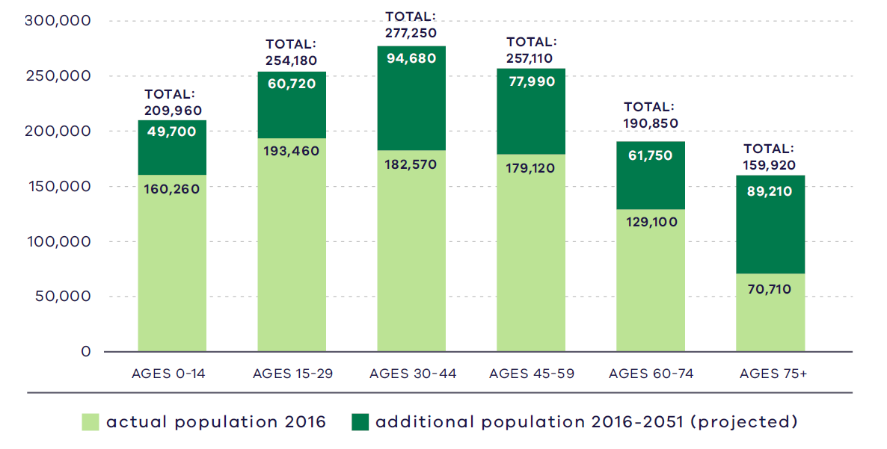
Victoria in Future, DELWP, 2019
Figure 11. Regional actual and projected population by age, 2016 - 2051
2016:  160,260 – Ages 0 to 14  193,460 – Ages 15 to 29  182,570 – Ages 30 to 44  179,120 – Ages 45 to 59  129,100 – Ages 60 to 74  70,170 – Ages 75 plus | 2051:  209,960 – Ages 0 to 14  254,180 – Ages 15 to 29  277,250 – Ages 30 to 44  257,110 – Ages 45 to 59  190,850 – Ages 60 to 74  159,920 – Ages 75 plus
Source: Department of Environment, Land, Water and Planning (2019) Victoria in Future 2019, Department of Environment, Land, Water and Planning, Melbourne, Australia.

Housing stock
Separate houses make up 80 per cent of the 2016 housing stock in the Eastern Metro Region, compared to 67 per cent for metropolitan Melbourne. Approximately 81 per cent of the dwellings in the region provide three or four bedrooms compared to 73 per cent in metropolitan Melbourne.
Flats, units and apartments make up 6 per cent of the housing stock in the region, compared to 16 per cent of metropolitan Melbourne. The remainder are largely detached dwellings, many of which were constructed in the 1950s and 1960s and are reaching the end of their useful life.

Projected housing requirements
Victoria in Future (VIF) projections are published at LGA level for a 20-year horizon from the most recent Census data (currently from 2016 to 2036). Beyond this period knowledge of land supply, dwelling construction and population distribution trends become less certain.
VIF projections indicate that based on the continuation of current trends and knowledge of long-term greenfield land supply, approximately 66 per cent of net additional dwellings across metropolitan Melbourne are expected to be in established areas and 34 per cent in greenfield growth areas. The housing distribution figures between established areas and greenfield growth areas are shown in Table 7.
Plan Melbourne provides an alternate aspirational housing distribution scenario based on achieving 70 per cent of new housing provided within Melbourne’s established areas and the remainder 30 per cent accommodated in greenfield growth areas. This scenario assumes that a total of 70,000 dwellings cross metropolitan Melbourne, which VIF 2019 projections allocated to greenfield growth areas, can be accommodated in the established area to realise the aspirational 70/30 distribution between 2019 to 2051 (Table 8).
The aspirational housing distribution scenario provides for a redistribution of 30,000 dwellings from the greenfield growth areas to the established area in the Eastern Metro Region. The Eastern Metro Region will need to accommodate 10,000 additional dwellings from the baseline VIF scenario.

Scenario 1 VIF 2019
Region | Net dwelling additions 2016 to 2051 – Total | Net dwelling additions 2016 to 2051 – Established | Net dwelling additions 2016 to 2051 – Greenfield
Inner Metro | 225,000 | 225,000 | 0
Western | 412,000 | 177,000 | 235,000
Northern | 352,000 | 167,000 | 185,000
Inner South East | 119,000 | 119,000 | 0
Eastern | 192,000 | 192,000 | 0
Southern | 313,000 | 184,000 | 129,000
Total Melbourne | 1,613,000 | 1,064,000 | 549,000
 | 100% | 66% | 34%
Scenario 2 Aspirational scenario
Region | Net dwelling additions 2016 to 2051 – Total | Net dwelling additions 2016 to 2051 – Established | Net dwelling additions 2016 to 2051 – Greenfield
Inner Metro | 235,000 | 235,000 | 0
Western | 402,000 | 197,000 | 205,000
Northern | 347,000 | 182,000 | 165,000
Inner South East | 124,000 | 124,000 | 0
Eastern | 202,000 | 202,000 | 0
Southern | 303,000 | 194,000 | 109,000
Total Melbourne | 1,613,000 | 1,134,000 | 479,000
 | 100% | 70% | 30%
Note: For the purpose of these figures, greenfield areas include land in a growth area council that is either currently under development or identified for future development
Table 9 shows the aspirational housing distribution scenario for each LGA to 2036. This is achieved by apportioning the net dwelling additions in the established area for each metropolitan region and distributing the amount between LGAs in the region. The aspirational scenario is based on the locations where most housing growth is anticipated across the established metropolitan area such as the Central City, NEICs, metropolitan and major activity centres, major urban renewal precincts and future SRL precincts. The 70/30 dwelling redistribution for the region will provide guidance for the councils to accommodate housing growth that achieves the aspirational housing distribution for metropolitan Melbourne.

Eastern Metro Region 70/30 redistribution by LGA to 2036
LGA | VIF2019 dwellings – 2021 | VIF2019 dwellings – 2036 | Including 70/30 dwellings – 2036 | 70/30 dwelling redistribution | Share of regional redistribution
Knox | 64,200 | 75,600 | 76,300 | 700 | 14%
Manningham | 49,600 | 57,800 | 58,400 | 600 | 12%
Maroondah | 48,500 | 58,300 | 58,700 | 400 | 8%
Monash | 74,100 | 91,300 | 92,900 | 1,600 | 32%
Whitehorse | 72,800 | 89,000 | 90,400 | 1,400 | 28%
Yarra Ranges | 62,600 | 73,300 | 73,600 | 300 | 6%
Eastern Metro Region | 371,800 | 445,300 | 450,300 | 5,000 | 100%
DELWP, 2021

Locations for housing growth
Between 2005 and 2016, around 45 per cent of net new dwellings in the region were constructed outside activity centres. Monash and Yarra Ranges LGAs saw 10 to 20 per cent of new dwellings constructed in and around activity centres. Knox, Manningham and Whitehorse LGAs saw between 35 and 50 per cent of medium- and higher-density housing growth in and around activity centres.
Drivers of this growth in the Monash LGA include the employment and educational opportunities provided by the Monash NEIC. The NEIC currently employs 80,000 people, with this figure predicted to double by 2035. Clayton Major Activity Centre is set to undergo substantial change that will include enhancing connections to Monash University and the Monash NEIC to the north.
Whitehorse LGA has also experienced substantial population growth due to its proximity to Melbourne’s CBD and being home to Box Hill Metropolitan Activity Centre, Box Hill Hospital, Box Hill Institute of TAFE and Deakin University, as well as being located on the Lilydale and Belgrave railway line.
To respond to housing challenges in the Eastern Metro Region, supply is needed in the right locations to meet record demand. There are over 15,500 dwellings in the redevelopment pipeline for major housing development across activity centres in the region as at 2016 (DELWP, 2016) (Figure 12). Substantial housing development in or within 400 metres of activity centres will continue, with around 14,500 dwellings in the redevelopment pipeline in the region (Appendix 02). Of these, Box Hill has over 4,000 dwellings in the pipeline, Doncaster Hill has around 1,700 dwellings and Burwood Heights and Ringwood have over 1,000 dwellings each.

Housing in the Upper Yarra Valley and Dandenong Ranges
The Upper Yarra Valley and Dandenong Ranges are renowned for their natural beauty. They include the agricultural land throughout the Yarra Valley, Yarra Ranges National Park to the east, the Dandenong Ranges to the south and state-significant water catchments and waterways.
The Upper Yarra Valley and Dandenong Ranges Regional Strategy aims to protect the special features and characteristics of the region by ensuring no net increase in the total provision of residential development in the Dandenong Ranges and no significant increase in the Yarra Valley and southern foothills.
Planning provisions also seek to minimise the impact of bushfires and flooding within this area. Development is encouraged close to transport hubs, major road corridors, activity centres and health and/or education precincts generally found in the western and central areas of the Eastern Metro Region.

Housing demand and its impact on affordability
Housing affordability is an issue across metropolitan Melbourne. Moderate-income first homebuyers are increasingly priced out of the housing market in the inner and middle parts of the Eastern Metro Region. Even though housing is more affordable in the eastern part of the region, it is still unattainable for many low-income, prospective first homebuyers. Very low-income, single person households are increasingly priced out of the rental market in much of the region.
Research undertaken on behalf of the Eastern Affordable Housing Alliance, a collaboration between six LGAs in the Eastern Metro Region, estimates that in 2016 there was a shortfall of 7,970 social housing properties in the region. This shortfall is estimated to increase to 11,420 properties in 2036, equating to 570 dwellings per year.
There are several existing Victorian Government initiatives in place to improve the supply of affordable housing, including social housing. These include Victoria’s Big Housing Build, the Social Housing Growth Fund, 1,000 Homes Initiatives and the Redevelopment of Public Housing Estates.
- Major housing in the redevelopment pipeline in or within 400 metres of an activity centre
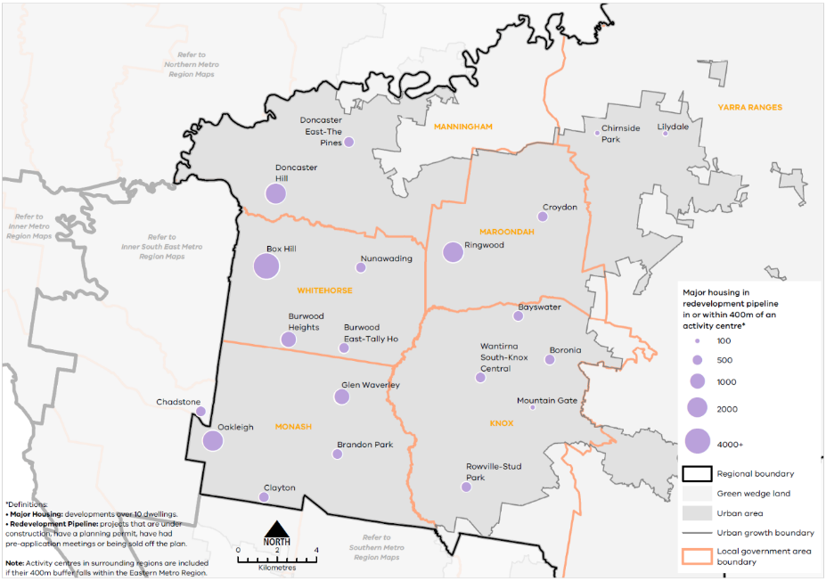
Urban Development Program 2019, Department of Environment, Land, Water and Planning
Figure 12. Major housing in the redevelopment pipeline in or within 400 metres of an activity centre
This map shows:
- Major housing redevelopment pipeline in or within 400m of an activity centre.
- Regional boundary
- Green wedge land covering land outside the urban growth boundary in Knox, Yarra Ranges, Maroondah and Manningham.
- Urban area covering land within the Urban Growth Boundary.
- Local government areas including Monash, Whitehorse, Knox, Yarra Ranges, Maroondah and Manningham.
*Definitions:
• Major Housing: developments over 10 dwellings.
• Redevelopment Pipeline: projects that are under construction, have a planning permit, have had pre-application meetings or being sold off the plan.
Note: Activity centres in surrounding regions are included if their 400m buffer falls within the Eastern Metro Region.

Location | Major housing development pipeline in or within 400m of an activity centre*
Doncaster East-The Pines | 101-500
Doncaster Hill | 1001-2000
Box Hill | 4000+
Nunawading | 101-500
Burwood Heights | 501-1000
Burwood East-Tally Ho | 101-500
Glen Waverley | 501-1000
Chadstone | 101-500
Oakleigh | 1001-2000
Brandon Park | 101-500
Clayton | 101-500
Lilydale | 11-100
Chirnside Park | 11-100
Croydon | 101-500
Ringwood | 1001-2000
Bayswater | 101-500
Wantirna South-Knox Central | 101-500
Boronia | 101-500
Mountain Gate | 11-100
Rowville-Stud Park | 101-500

Regional strengths
- There are significant opportunities to locate medium- and higher-density housing in and around metropolitan and major activity centres, the Monash NEIC, activity corridors and identified urban renewal areas, and in locations supported by good public transport, particularly the SRL.
- Urban growth boundaries applied to rural areas and townships direct housing away from areas of high sensitivity within the region’s green wedges.
- There are significant future transport connections to other metro regions and the Central City which will improve access to jobs, services and infrastructure.

Regional challenges
- The Eastern Metro Region will experience a 41 per cent growth in population from 2020 to 2051 and there will need to be an increase in housing supply and diversity.
- Housing development must be balanced with protection of employment uses particularly around regionally-significant industrial precincts, and the Monash NEIC.
- Greater housing diversity must be provided to reflect community needs, especially providing adaptable housing options for the ageing population to ‘age in place’.
Directions and strategies
The directions identified to achieve the 2050 vision for the Eastern Metro Region in terms of Housing choice and Outcome 2 of Plan Melbourne are:
Direction 7 | Increase the supply of housing in the Eastern Metro Region
Direction 8 | Prioritise housing growth in areas with access to jobs, services and good public transport
Direction 9 | Provide greater choice and diversity of housing in the Eastern Metro Region
Direction 10 | Increase the supply of social and affordable housing
Each direction is implemented through regionally-specific strategies identified in this LUFP.
Map 3 shows how housing choice will be enhanced across the Eastern Metro Region by 2050 as a result of these directions and strategies, together with Plan Melbourne and other strategies and initiatives as outlined in Appendix 01.

- Eastern Metro Region housing choice 2050
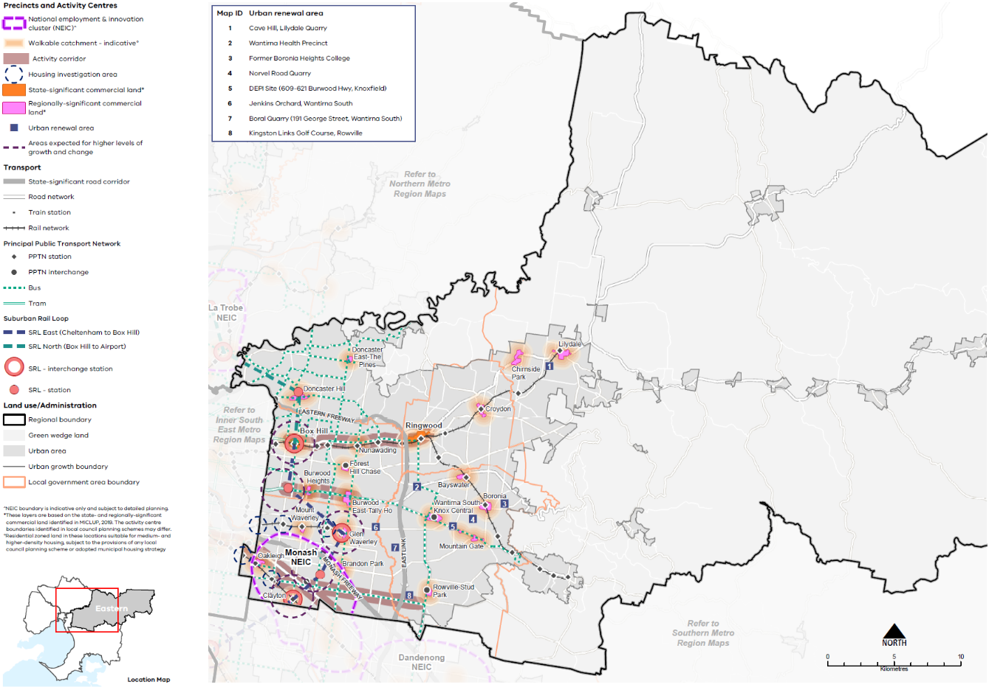

Map 3 Eastern Metro Region housing choice 2050
A map of housing choice in the Eastern Metro Region in 2050, extracting the locations for medium- and higher-density dwellings identified on Map 1 above and detailed in table 10, with the addition of 800m indicative walkable catchments° around metropolitan and major activity centres.

°Residential zoned land in these locations suitable for medium- and higher-density housing, subject to the provisions of any local council planning scheme or adopted municipal housing strategy.

- Increase the supply of housing in the Eastern Metro Region
Plan Melbourne aims for 70 per cent of net additional dwellings to be provided in Melbourne’s established areas, with the balance provided in greenfield growth areas.
With no greenfield growth areas in the Eastern Metro Region, the region’s inner and middle ring suburbs provide opportunities for well-located, medium-density housing in established areas where ageing housing stock is ready to be replaced.
Opportunities also exist in locally identified strategic sites close to activity centres, particularly those linked to SRL. The provision of housing in these areas will help achieve the overall aspiration of 70 per cent of new housing, subject to dwellings respecting the natural attributes of the region.
Substantial and incremental change areas will experience varying degrees of change relative to the existing context and not only increase the supply of housing, but also the diversity in housing types and built form outcomes. Lower density areas in the region are expected to accommodate housing growth within the context of the existing or preferred character. Minimal housing change areas are identified for their special characteristics such as neighbourhood, heritage, environmental or landscape characteristics that should be protected.
- Maximise housing development within the established areas of the Eastern Metro Region to achieve the aspirational housing distribution scenario for metropolitan Melbourne.

- Prioritise housing growth in areas with access to jobs, services and good public transport
Plan Melbourne directs medium- and higher-density housing development in and around the Monash NEIC, in and around metropolitan and major activity centres, in neighbourhood activity centres with good public transport connections, and in urban renewal areas. These areas generally contain a concentration of jobs and services and are well connected by public transport. Locating medium- and higher-density housing in these locations is important to meeting the employment, service and infrastructure needs of region’s growing population while delivering on the 20-minute neighbourhood principle.
While growth will slow in the Eastern Metro Region in the near term, there will continue to be high demand for well-located housing. Planning for transit-oriented housing development is a high priority. SRL will enhance connectivity between activity centres and employment centres within the region and to adjoining regions. A key challenge for planning for housing around public transport will be balancing the strong demand for housing with the need to provide land for employment and jobs in and around activity centres.
Greater housing density should be directed in and around Box Hill and Ringwood, along residential activity corridors and in potential urban renewal sites. Together these locations contain a significant concentration of private, government and community sector jobs and services. Substantial development has already occurred around Box Hill, Ringwood and Doncaster and structure plans are in place to guide future development in many activity centres.
Table 10 identifies locations for medium- and higher-density housing in the Eastern Metro Region.
Locations for medium- and higher-density housing in the Eastern Metro Region
Classification | Locations | Role/function for housing
National Employment and Innovation Cluster | Monash | - NEICs can provide housing opportunities in designated locations where it complements the NEICs’ primary role as a cluster of business activity of national significance.  - Monash NEIC will have two future train stations as part of SRL. Better accessibility to the NEIC will maximise inter- and cross-regional opportunities for housing, employment, education and health services.
Metropolitan activity centres | Box Hill  Ringwood | - Metropolitan activity centres are suited to medium- and higher-density housing and mixed-use development. Substantial housing change opportunities may extend to a walkable catchment of 800 metres around the centre (depending on the local context) based on the 20-minute neighbourhood principle of locating housing close to jobs, services, amenities and public transport.  - Metropolitan activity centres play a major role in supporting a broad range of other uses such as retail, commercial, entertainment and community uses to a regional catchment. Housing development in and around metropolitan activity centres will be complementary to the existing and future jobs and employment role of the centres (refer to Table 5)  - Structure planning will identify the preferred locations, densities and types for housing and development constraints or limitations in each centre.  - Box Hill Metropolitan Activity Centre is designated as an interchange station on SRL and higher-density development is supported.
Major activity centres | Bayswater  Boronia  Brandon Park  Burwood East-Tally Ho  Burwood Heights  Chirnside Park  Clayton  Croydon  Doncaster East-The Pines  Doncaster Hill  Forest Hill Chase  Glen Waverley  Lilydale  Mount Waverley  Mountain Gate  Nunawading  Oakleigh  Rowville-Stud Park  Wantirna South-Knox Central | - Major activity centres are suited to medium- and higher-density housing and mixed-use development. Substantial housing change opportunities may extend to a walkable catchment of 800 metres around the centre (depending on the local context) based on the 20-minute neighbourhood principle of locating housing close to jobs, services, amenities and public transport.  - While all major activity centres will accommodate housing change, the degree of change is relative to the existing context and characteristics of each major activity centre (refer to Table 5).  - Structure planning will identify the preferred locations, densities and types for housing and development constraints or limitations in each centre.  - Clayton, Doncaster Hill and Glen Waverley major activity centres are designated as locations for SRL stations and will provide greater opportunities for housing change.
Neighbourhood activity centres |  | - Some neighbourhood activity centres may be locations for mixed-use medium- and higher-density housing, particularly when they are serviced by good public transport. Housing opportunities may also extend to a walkable catchment of 800 metres around the centre (depending on the local context) based on the 20-minute neighbourhood principle of locating housing close to jobs, services, amenities and public transport.
Activity corridors | Whitehorse Road between Box Hill and Ringwood metropolitan activity centres, including Nunawading Mega Mile Home and Lifestyle Precinct (Nunawading Major Activity Centre)  Burwood Highway between Deakin University, Burwood Heights and Burwood East-Tally Ho major activity centres  Dandenong Road/Princes Highway between Caulfield and Chadstone major activity centres (Inner South East Metro Region) and the Monash NEIC  North Road/Wellington Road from Monash NEIC to Rowville Major Activity Centre | - Activity corridors are linear areas that are heavily used by commuters or undergoing city-shaping infrastructure upgrades. They contain a mix of commercial, retail, residential and industrial uses. Residentially zoned land in locations along the activity corridors may support medium- and higher-density housing due to its proximity to existing or future public transport.  - Regionally-significant industrial land will be retained for employment.  - Local industrial land may transition to residential uses if suitable and not required for employment purposes.  - Activity corridors are consistent with Plan Melbourne which encourages increased diversity and density of developments on the PPTN, particularly at interchanges, activity centres and where principal public transport routes intersect.
Urban renewal areas and Greyfields | Cave Hill, Lilydale Quarry  Jenkins Orchard, Wantirna South  Kingston Links Golf Course, Rowville  Norvel Road Quarry  Former Boronia Heights College  Wantirna Health Precinct  DEPI site (northern portion of 609–621 Burwood Highway, Knoxfield zoned CDZ2)  Boral Quarry (191 George Street, Wantirna South) | - Urban renewal areas identified in the LUFP are locations nominated by state or local government with opportunities for medium- and higher-density mixed-use development. These locations have regional value based on one or more of the following characteristics: land size, proximity to the PPTN or future transport infrastructure, government-owned, or require cross-municipal planning. These areas will be planned according to 20-minute neighbourhood principles. A coordinated approach to planning for these areas will maximise their development opportunity and any infrastructure needs.
Suburban Rail Loop precincts | Clayton (interchange)  Monash  Glen Waverley (interchange)  Burwood  Box Hill (interchange)  Doncaster | - SRL precincts are designated for medium- and higher-density housing development due to their proximity to future SRL stations. Housing development in SRL precincts will be supported by other uses such as commercial, retail and services and maximise their potential as transit-oriented development sites. They will undergo higher degrees of change and will be subject to further detailed precinct planning.
Housing investigation areas | Holmesglen Station (in Inner South East Metro Region)  Hughesdale Station  Jordanville Station  Huntingdale Station  Syndal Station | - Housing investigation areas are areas within an 800 metre walkable catchment of existing and future train stations that have the potential to support medium- and higher-density housing development, in line with maximising access to public transport and achieving 20-minute neighbourhood principles. These areas are outside designated metropolitan and major activity centres and are based on their access to rail infrastructure, existing zones that allow residential development and the absence of ‘special characteristics’ such as heritage, landscape, bushfire values or airport environs.  - A further assessment to determine locations within housing investigation areas suitable for substantial housing change and rezoning, in response to the local context, will be required.
- Increase the supply of medium- and higher-density housing around the Monash NEIC, in and around metropolitan and major activity centres, urban renewal areas, SRL precincts, along activity corridors, and in and around neighbourhood activity centres serviced by good public transport.
- Ensure new housing in and around the Monash NEIC does not encroach on the primary employment and innovation role of the NEIC.
- Support substantial housing change in locations where transport upgrades and improvements such as Suburban Rail Loop create opportunities to locate housing closer to jobs, services and infrastructure.
- Maximise development potential in housing investigation areas around existing train stations to leverage access to the PPTN.

- Provide greater choice and diversity of housing in the Eastern Metro Region
With no greenfield growth area, the Eastern Metro Region's population growth will be wholly accommodated in the established urban area.
The UGB, regional environmental sensitivities and existing zonings and planning controls limit the scale of residential development that can occur in these established areas, particularly in the eastern part of the region. Incremental development in suburbs that do not face such constraints could provide housing diversity and contribute to the projected housing demand.
By 2051, 26 per cent of the population in the Eastern Metro Region will be over the age of 60. Greater diversity of housing types in the established areas in proximity to community services will enable ‘ageing in place’. Smaller dwellings should also provide for more affordable arrangements and flexibility to allow ‘ageing in place’ in response to an ageing population. Residential aged care facilities and retirement homes will also be important due to the overall ageing population across metropolitan Melbourne, giving people the choice to remain in their existing communities.
With two renowned universities located in the Eastern Metro Region, demand for student accommodation close or well connected to university and higher education campuses is anticipated. There will also be demand for a variety of housing types that provide low-cost rental, supported accommodation and social housing.
- Encourage a genuine mix of dwelling types and sizes in the Eastern Metro Region particularly in the western part of the region and along SRL corridor, to accommodate the changing future needs of the region.
- Support alternative and sustainable residential development formats such as co-housing or build-to-rent in appropriate locations, and car-free residential developments models in locations with good access to alternative transport modes.
- Facilitate the development of housing that is adaptable and flexible to cater for changing demographics and to support ‘ageing in place’.
- Optimise the opportunities for student accommodation and key worker housing around health and/or education precincts in the Eastern Metro Region.
- Adopt a place-based approach to the delivery of infill housing developments to replace ageing housing stock, ensure a high-quality of design that is appropriate for the local context and contributes to housing supply and diversity.
- Increase the supply of social and affordable housing
Affordable housing is defined in the Planning and Environment Act 1987 as housing appropriate for the needs of very low-, low- and moderate-income households, and includes social housing provided by the government or a registered housing agency. The provision of social and affordable housing is not solely a planning issue. A range of programs and measures across all levels of government are required to deliver more social and affordable housing.
Housing affordability is affecting a larger number of residents across metropolitan Melbourne. Planning should facilitate the delivery of affordable housing in the Eastern Metro Region by considering opportunities to develop under-utilised or disused government-owned land for social housing. Facilitating the supply of affordable housing in locations that are closer to jobs, services and public transport — in addition to sustainable design — will lower household costs, which is particularly important to the very low-, low- and moderate-income households.
The social and affordable housing system consisting of the government, community housing sector and industry provides housing options for those unable to access the private housing market. There are currently 116,351 people living in social housing that is owned or managed by the Homes Victoria (Director of Housing) or a registered housing corporation across Victoria. Victoria has the lowest proportion of social housing in Australia and will require 4,000 homes per year for Victoria’s social housing to reach the national average of 4.2 per cent of social housing to total dwellings.
The Victorian Government’s Big Housing Build program aims to increase the existing social housing stock across Victoria by 10 per cent in the coming years and in the next five years, over 12,000 new dwellings will be built. The program is Victoria’s largest investment in social and affordable housing and Homes Victoria has been established to deliver the program as well as ensure an ongoing pipeline of social and affordable housing development beyond the Big Housing Build. In addition, existing social housing dwellings will be upgraded, maintained or replaced under the program of work.
- Facilitate more affordable housing across the region, particularly in locations that have good access to jobs, services and public transport.

Actions – Housing choice
- Update planning schemes to align with housing policies in Plan Melbourne and the Eastern Metro Region Land Use Framework Plan and the implementation of the reformed residential zones. This includes:
- Providing capacity for 15 years of regional housing supply focusing on locations identified for housing growth in the LUFP
- Reviewing planning controls in housing investigation areas as potential locations for substantial or incremental housing change.
This may require strategic planning work to support these changes such as preparing or updating local housing strategies or preparing structure plans to further investigate where increased densities can be supported, and determine specific changes required to planning schemes.
- Identify underutilised and surplus government land that has potential to deliver additional social housing.
- In partnership with councils, identify a pipeline of sites in the Eastern Metro Region for social and affordable housing.

Integrated transport
Plan Melbourne Outcome 3: Melbourne has an integrated transport system that connects people to jobs and services and goods to market.
As the Eastern Metro Region grows, this will require better integration of land use and transport planning, better use of existing roads, and increased investment in public transport, walking and cycling. Making better use of transport infrastructure, complemented by good precinct design, can improve connections without necessarily the expense and disruption of delivering new infrastructure. Land use decisions, as well as mode shift opportunities, can significantly improve access and reduce transport-generated emissions.
The Eastern Metro Region has good transport connections internally and to Melbourne’s CBD by road and rail networks. SRL will deliver significant transport benefits for the Eastern Metro Region improving access within the region and to the other metro regions.

State of play
Map 4 outlines the current state of play for transport in the Eastern Metro Region.

Road network
There are a range of road transport options for accessing jobs within the Eastern Metro Region, in adjacent regions and to Melbourne’s CBD. The region’s main north-south connection is EastLink which extends through the region connecting Ringwood to the Southern Metro Region. Other key north-south connections are Warrigal Road, Blackburn Road, Springvale Road and Stud Road.
There is a strong network of east-west connections across the region particularly in the western part of the region creating a ‘grid’ of arterial roads with the north-south routes. Major east-west road networks include Monash Freeway, Princes Highway, Maroondah Highway, Burwood Highway and the Eastern Freeway. The Maroondah and Warburton highways continue into the region’s rural east.
Congestion is increasing particularly during peak hours. By 2031, traffic volumes in the western part of the region are expected to increase by 22 per cent, while increases of about 19 per cent are expected in the outer eastern part of the region. Most arterial roads will be at or approaching capacity by 2031 (KPMG & ARUP, 2017).
Key road freight routes are the Eastern and Monash freeways linking to the Southern Industrial Precinct (SSIP) at Dandenong South, the Port of Hastings and west to Melbourne’s CBD. Construction of North East Link will better link the region to Melbourne Airport and the Northern Metro Region. There is no rail freight network in the region other than the Gippsland rail line.

- Eastern Metro Region integrated transport state of play
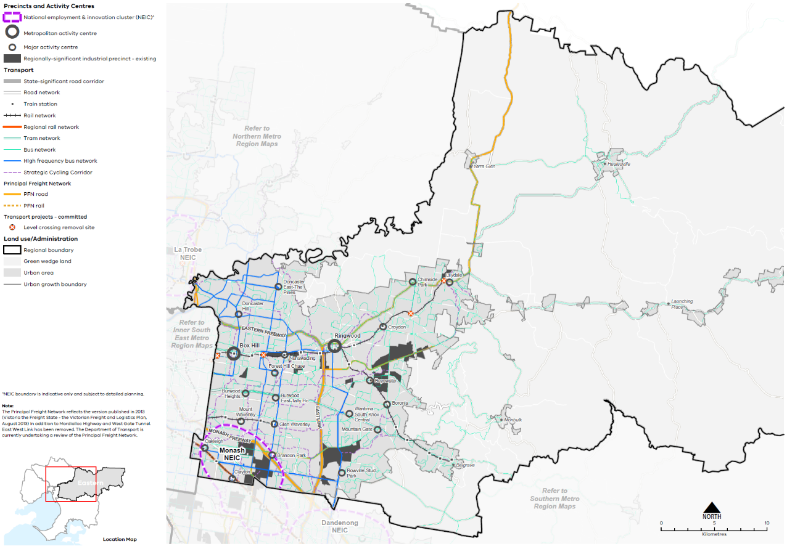

Map 4 Eastern Metro Region integrated transport state of play
A map showing the key transport features of the region in 2021, as extracted from Map 1, and also highlighting:
- The bus network and high frequency bus network
- The strategic cycling corridor network
- The principal road freight network
- Level crossing removal sites.
Note: The Principal Freight Network reflects the version published in 2013 (Victoria the Freight State - the Victorian Freight and Logistics Plan, August 2013) in addition to Mordialloc Highway and West Gate Tunnel. East West Link has been removed. The Department of Transport is currently undertaking a review of the Principal Freight Network.

- Public transport accessibility in the Eastern Metro Region
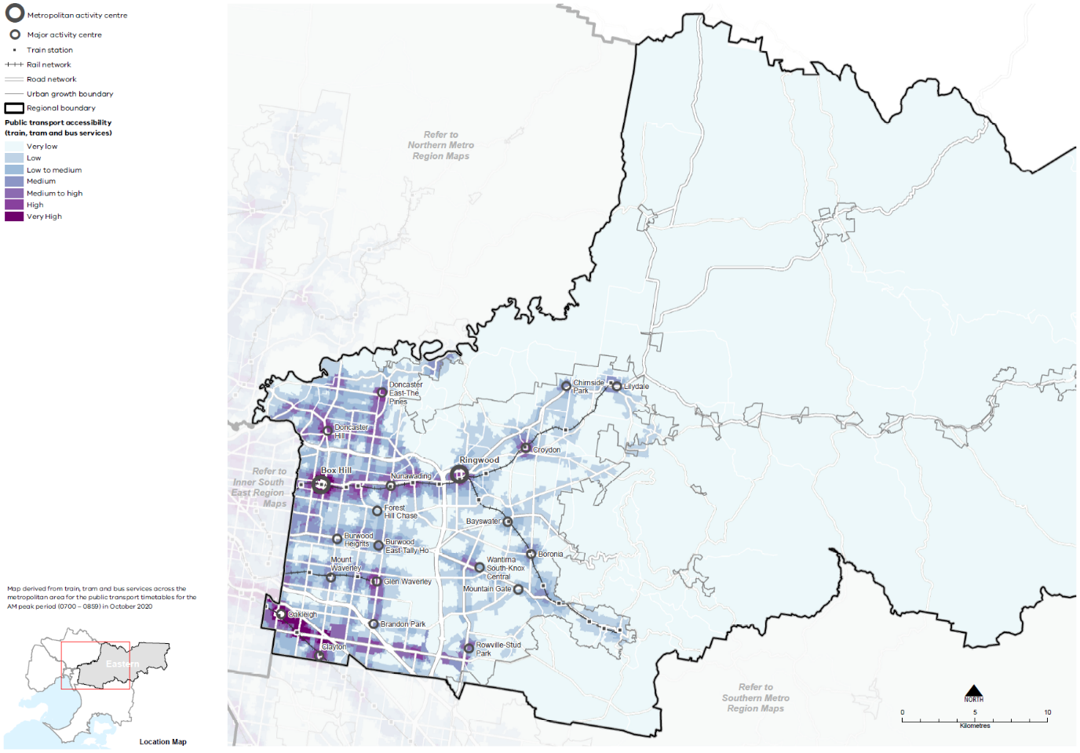

Public transport network
The Eastern Metro Region has an established public transport network, especially in the western part of the region. Figure 13 shows the accessibility to public transport for people who live within the region based on how far they need to walk to access train, tram and bus services. Inner parts of the Eastern Metro Region are well connected to Melbourne’s CBD by train, bus and tram with multiple services each hour.
The region’s rail network includes three metro passenger services to Lilydale/Belgrave, Glen Waverley and a small section of the Cranbourne/Pakenham/Gippsland rail corridor. The outer sections of the Lilydale and Belgrave lines are single track with limited capacity. Inter-regional connectivity is limited although SmartBus routes fill this gap in some locations. The tram network extends to Box Hill, Wattle Park and Vermont South.
The region has an extensive bus network particularly in the western LGAs and western areas of Yarra Ranges LGA. Complementing the rail network is the SmartBus service that uses a well-spaced network of arterial roads, especially to the west of Dandenong Creek. All nine orbital SmartBus routes service the region providing north-south and east-west connections. Manningham LGA has the highest average number of bus services per hour, per stop for the region. Whitehorse LGA also has a high average compared to other LGAs in the region indicating the bus network fills gaps left by other forms of public transport. All activity centres and most education precincts contain multi-modal transport interchanges. The Eastern Freeway includes the Doncaster Park and Ride bus interchange.

Active transport network
The Eastern Metro Region’s cycling network is well developed especially in the western, more populated part of the region including Strategic Cycling Corridors from Melbourne’s CBD to Scoresby, Box Hill to Ashburton and Chirnside Park to Mordialloc. However, further improvements are needed to make cycling a more attractive form of transport. Currently 0.5 per cent of weekday trips undertaken by residents in the region are by bicycle, compared to 1 per cent for metropolitan Melbourne. Two per cent of people walked to work in 2016, compared to 3 per cent for metropolitan Melbourne.

Regional access and movement
Figure 14 shows journeys to and from the Eastern Metro Region for work. In 2016, 57 per cent of Eastern Metro Region residents also worked in the region. The most popular work destination after the region itself is the Inner Metro Region. Popular LGA work destinations within the region include Monash and Whitehorse LGAs. A significant amount of people from the Southern Metro Region travel to the Eastern Metro Region for work, in particular from the Casey, Greater Dandenong and Kingston LGAs. There is less but still substantial movement into the region from the Inner South East Region and the Northern Metro Region. There was little connection with the Western Metro Region for the purpose of travelling to work.

- Journey to work in and out of the Eastern Metro Region
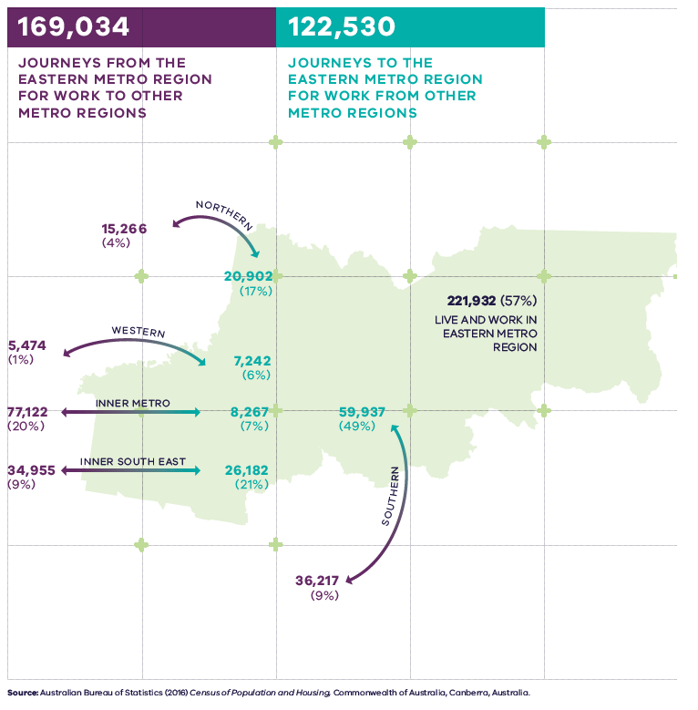
Figure 14. Journey to work in and out of the Eastern Metro Region
221,932 (57 per cent) live and work in the Eastern Metro Region | 169,034 – Journey from the Eastern Metro Region for work to other metro regions:  - 15,266 (4 per cent) – Journeys to the Northern Metro Region  - 36,217 (9 per cent) – Journeys to the Southern Metro Region  - 34,955 (9 per cent) – Journeys to the Inner South East Region  - 77,122 (20 per cent) – Journeys to the Inner Metro Region  - 5,474 (1 per cent) – Journeys to the Western Metro Region | 122,530 – Journey to the Eastern Metro Region for work from other metro regions:  - 20,902 (17 per cent) – Journeys from the Northern Metro Region  - 59,937 (49 per cent) – Journeys from the Southern Metro Region  - 26,182 (21 per cent) – Journeys from the Inner South East Region  - 8,267 (7 per cent) – Journeys from the Inner Metro Region  - 7,242 (6 per cent) – Journeys from the Western Metro Region
Source: Australian Bureau of Statistics (2016) Census of Population and Housing, Commonwealth of Australia, Canberra, Australia.

Regional strengths
There is a strong freeway network linking the region to the Southern Industrial Precinct at Dandenong South (SSIP), the Port of Hastings and Melbourne’s CBD.
The region benefits from the foundations of a strong existing bus network, multi-modal transport interchanges at train stations and the Doncaster Park and Ride bus interchange.
A strong network of east-west road connections, particularly in the western part of the region, creates a ‘grid’ of arterial roads with the north-south routes.
Access improvements for walking, cycling and public transport will result from the development of SRL stations and supplement the existing transport network.

Regional challenges
There is limited opportunity to augment, expand or extend existing major roads which are already subject to high vehicle use.
High private vehicle use is resulting in increasing congestion in the region.
There is a need to connect Monash NEIC more effectively into the broader transport network in the region.
The region’s west has poor north-south connectivity, particularly between the key destinations of Doncaster Hill, Ringwood, Box Hill and Monash NEIC.
Poor east-west connections in the eastern part of the region impacts upon access to health, education and employment areas.
Cycling for commuting is lower than the Melbourne average, with take-up higher in the western part of the region compared to the east.
There are more public transport options for residents in the western part of the region compared to the east.

Directions and strategies
The directions identified to achieve the 2050 vision for the Eastern Metro Region in terms of Integrated transport and Outcome 3 of Plan Melbourne are:
Direction 11 | Improve transport connections to support the productivity of the Eastern Metro Region
Direction 12 | Improve public and active transport access to Monash NEIC, metropolitan and major activity centres and Suburban Rail Loop precincts
Direction 13 | Improve regional cycling networks to increase the attractiveness of cycling in the region
Direction 14 | Improve active and public transport options to promote mode shift and support 20-minute neighbourhoods
Direction 15 | Allow more flexible use of the existing road network
Each direction is implemented through regionally-specific strategies identified in this LUFP.
Map 5 shows how integrated transport will be enhanced across the Eastern Metro Region by 2050 as a result of these directions and strategies, together with Plan Melbourne and other strategies and initiatives as outlined in Appendix 01.

- Eastern Metro Region integrated transport 2050
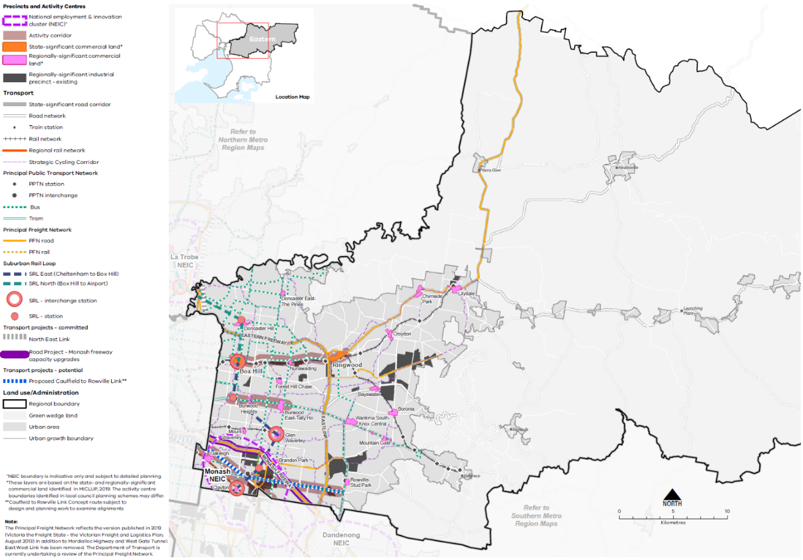

Map 5 Eastern Metro Region integrated transport 2050
A map showing the key transport features of the region in 2050, as extracted from Map 1, and also highlighting:
- North East Link
- The proposed Caulfield to Rowville link**
- Monash Freeway capacity upgrades.
**Caulfield to Rowville Link Concept route subject to design and planning work to examine alignment.
- Improve transport connections to support the productivity of the Eastern Metro Region
Sustainable population and economic growth in the Eastern Metro Region relies on improving public transport access to and between job-rich locations such as the Monash NEIC, metropolitan and major activity centres, regionally-significant industrial precincts and health and/or education precincts. This will support an expanded network of economic activity in the east which is less reliant on the car and provide more reliable, frequent public transport services to encourage mode shift and reduce road congestion.
Linking the Monash NEIC more effectively to the broader transport network will be critical to the region’s economy into the future. A number of projects are planned to better integrate and improve access to Monash NEIC including the proposed Caulfield to Rowville Link and SRL.
SRL will deliver five new train stations in the region which will intersect with the radial rail lines from Melbourne’s CBD. Linking major destinations, SRL will change the way people travel to and move around the Eastern Metro Region.
A potential road project of regional significance is the Westall Road extension. This would provide an extension of Westall Road between Dandenong Road and the Monash Freeway. This project would provide improved north-south connectivity through the Monash NEIC and between the Monash NEIC and regionally-significant employment areas in Moorabbin and Braeside.
As the region grows, resulting land use changes will alter the destinations and distances people travel, enabling more people to access jobs and education by public transport. The integration of SRL stations with surrounding land uses and public and active transport will also make sustainable modes of transport more attractive to residents and visitors to SRL destinations.
Knox and Yarra Ranges LGAs will require improved transport access to health, education and employment locations in the western part of the region. There are opportunities to better connect this area through enhancements to the public transport network and improved open space links through the Dandenong Valley Parklands. This will improve transport options for Knox residents, reduce the physical barrier of EastLink and better integrate the Bayswater Industrial Precinct to the north.
The capacity and frequency of the regional bus network needs to be enhanced to improve integration with train and tram services. This will also increase public transport options to key locations in the short to medium term until longer-term transport projects are delivered such as North East Link and SRL.
As part of the North East Link Project, a dedicated busway will provide separated lanes for buses along the Eastern Freeway from an upgraded Doncaster Park and Ride to the city.
The key regional linkages are shown in Figure 15. Decisions regarding appropriate modes for these links should consider the capacity of existing infrastructure, ongoing sustainability and providing travel choices over a longer time period including evening and late-night travel.
Regionally-significant industrial precincts generate significant freight movement. These vehicles will continue to require fast, efficient and safe movement on arterial roads with direct connections to the freeway network. North East Link will better connect the region to major freight origins and destinations in Melbourne’s Northern and Western metro regions, to sea and air-based transport gateways and to interstate markets.
Metropolitan freight volumes are expected to grow at an average annual rate of 2.6 per cent each year between 2014 and 2051. This flow-on effect of population growth and higher levels of ecommerce will increase the potential for conflicting land use, requiring state and local government to work together to plan for more efficient use of the existing network, with technology and adapting operations likely a key component of this.
This requires ongoing assessment of how the planning scheme influences urban freight outcomes, with the need to manage the economic, community and environmental impacts of freight movements while supporting effective and efficient delivery of goods.
- Improve public and active transport access to job-rich areas such as Monash NEIC, Box Hill and Ringwood metropolitan activity centres and along activity corridors which link major activity centres along Maroondah Highway, Burwood Highway and Princes Highway/Wellington Road.
- Improve public and active transport to Bayswater, Boronia, Brandon Park, Croydon, Doncaster East (The Pines), Doncaster Hill, Forest Hill Chase, Glen Waverley, Lilydale, Mount Waverley, Mountain Gate, Oakleigh, Rowville (Stud Park), and Wantirna South (Knox Central).
- Improve north-south public and active transport connections especially between Box Hill and Ringwood metropolitan activity centres and Doncaster Hill Major Activity Centre in the north, and Monash NEIC in the south.
- Provide east-west public and active transport connections especially between Knox LGA to Burwood, Glen Waverley and Clayton.
- Provide access to regionally-significant industrial precincts and health and/or education precincts by public transport, walking and cycling and better integrate these precincts into an expanded network of economic activity in the Eastern Metro Region.

- Key regional linkages –Eastern Metro Region
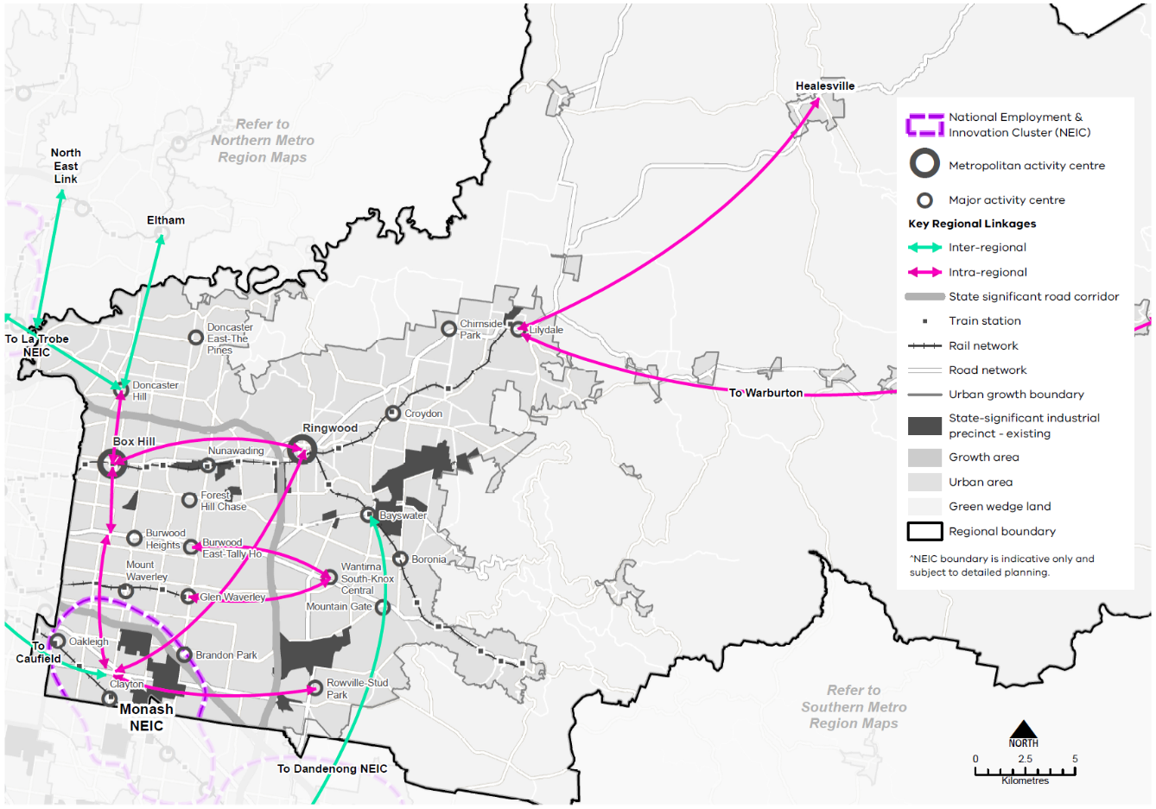
- Improve public and active transport access to Monash NEIC, metropolitan and major activity centres and Suburban Rail Loop precincts
Increasing the proportion of people using public transport, walking and cycling means making these alternatives easier, more convenient and cheaper than car travel. Continued improvement of public and active transport infrastructure and services and new and improved infrastructure for cycling and walking is vital, in particular to job-rich locations such as Box Hill and Ringwood metropolitan activity centres and major activity centres in the region.
Plan Melbourne seeks to embed an approach to 20-minute neighbourhoods in major infrastructure projects, including SRL and level crossing removal projects. This ensures communities affected by new transport infrastructure benefit from investment and growth via placed-based planning of local services. These opportunities need to be carefully considered as part of the planning and delivery of SRL precincts at Clayton and Monash (in the Monash NEIC), Glen Waverley, Burwood and Box Hill.
The location and design of SRL precincts will link in closely with other public transport and active transport routes and existing and proposed land uses.
- Improve public and active transport in the Monash NEIC, activity centres and health and education precincts to support higher-density mixed-use walkable precincts.
- Ensure the planning and design of Suburban Rail Loop precincts maximises opportunities for public and active transport connections and links between key destinations and surrounding activity centres.
- Improve bus service connectivity prior to the delivery of the Suburban Rail Loop.
- Improve regional cycling networks to increase the attractiveness of cycling in the region
As the metropolitan activity centres of Box Hill and Ringwood change to a more compact urban form and the Monash NEIC is further developed, these areas will require active transport networks that logically connect with public transport nodes. In established higher-density locations, networks should better connect to existing cycling and walking infrastructure to fill transport gaps.
A more cohesive network of active transport connections will be developed, including paths and trails, and along waterways and prioritising Strategic Cycling Corridors where they connect centres as part of the Principal Bicycle Network. Priority active transport projects will promote additional safe use of the region’s cycling and walking network.
Figure 16 shows the Strategic Cycling Corridor network for the Eastern Metro Region.
Primary routes provide a core network of Strategic Cycling Corridors that connect places of state significance – the Central City, metropolitan activity centres and National Employment and Innovation Centres (NEICs) within metropolitan Melbourne. Main routes are Strategic Cycling Corridors that provide additional connections to state significant destinations, as well as connections to major activity centres and key train stations within metropolitan Melbourne.
- Support cycling for transport through the development of Strategic Cycling Corridors in the Eastern Metro Region.
- Improve active and public transport options to promote mode shift and support 20-minute neighbourhoods
Access to public transport varies significantly across the region. Improvements to local bus, cycling and pedestrian access is needed to address gaps and support the delivery of 20-minute neighbourhoods across the Eastern Metro Region.
Thirty-six per cent of people in the region used a car when making a short trip under 5 kilometres in the region. Whereas 23 per cent of people walked, and only 1 per cent of people cycled for short trips (DELWP, 2021b). To reduce dependence on private vehicles, public transport, cycling and walking need to be more accessible. This means significant upgrades to public transport access, and improvements to pedestrian and cycling accessibility, better linking neighbourhoods to employment, and social and community services.
Priority locations for improving cycling links and pedestrian access are neighbourhoods around existing activity centres and along activity corridors.
Until SRL is completed, there are many transit-oriented development opportunities around the existing transport system and activity centre network that could accommodate growth and improve amenity of key locations.
Continued, innovative development of the bus network is a priority for the region to cater for communities with limited access to public transport.
- Create pedestrian-friendly neighbourhoods by enhancing major pedestrian links and expanding the network.
- Create a network of cycling links for local trips.
- Provide walking and cycling routes and drop-off zones to health and community services and recreation facilities.

- Allow more flexible use of the existing road network
To accommodate future travel needs and support the shift to active and sustainable modes of transport, flexible use of the existing road network will be required.
In doing so, a regional approach to the DoT’s Movement and Place Framework should be considered. This balances the needs of both transport users and place users, and designs a mix of transport modes that are appropriate to how roads and places are used by communities.
Opportunities to increase the capacity of the existing road network within this region are limited although some gains can be made through better use of existing roads for public and active transport. These alternatives need to be easier, more convenient and cheaper than car travel to increase the proportion of people using public transport, walking or cycling.
Making better use of the existing road infrastructure will be particularly important in high change locations and around key employment destinations. The potential for SRL to drive greater levels of employment and housing growth must be matched by more effective multi-modal streets and connections in key locations.
- Improve existing road infrastructure to provide for public transport, walking and cycling.
- Balance movement and place when designing and upgrading the region’s road network.

Actions – Integrated transport
- Undertake a review of the regional bus network including improvements to the SmartBus routes, Doncaster and Regional Transport (DART) and improved access to Deakin University to support regional access and movement in the short- to medium-terms and to plan integration with major public transport changes such as the SRL.

- Strategic Cycling Corridor network – Eastern Metro Region
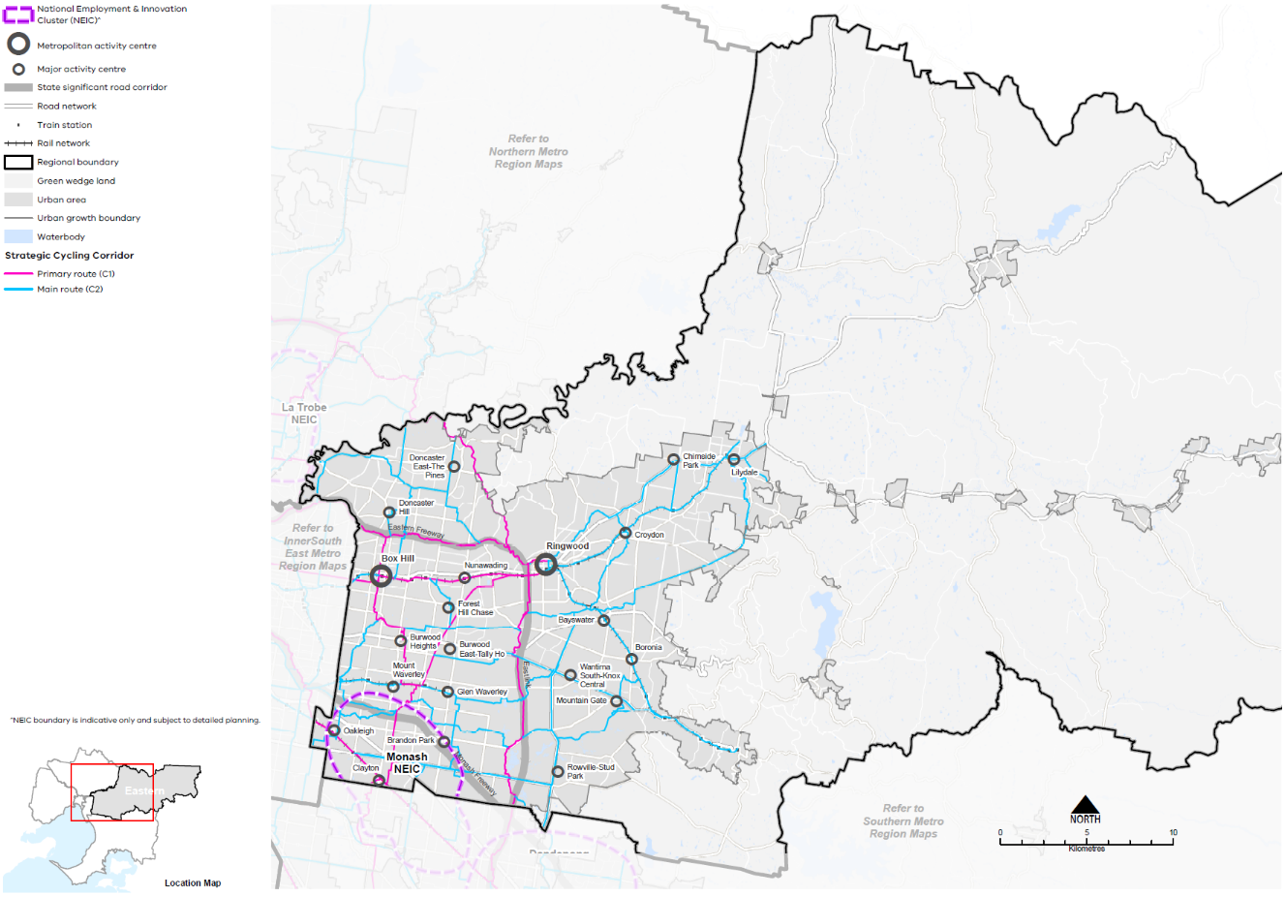

Liveability
Plan Melbourne Outcome 4: Melbourne is a distinctive and liveable city with quality design and amenity
‘Liveability’ is about the things that enhance people’s quality of life. For many years Melbourne has been regarded as one of the world’s most liveable cities due to its social and economic stability, diverse communities, distinctive heritage, high level of amenity and the opportunities it provides for a rich social and cultural life.
Plan Melbourne aims to maintain and extend the city’s liveability by celebrating its culture, diversity and distinctiveness. The challenge ahead is to design and plan for a future city that protects the best aspects of the natural and built environment, supports social and cultural diversity, and creates a strong sense of place.
The Eastern Metro Region is renowned for its distinctive and varied landscapes, which have high amenity, tourism and biodiversity values. The region has high cultural significance for Aboriginal people and a rich post-European settlement heritage. Its regional-scale landscapes and open spaces include the Yarra Ranges and Dandenong Ranges National Parks, the Yarra River (Birrarung) corridor and the Yarra Valley. It is important for these natural and cultural values to be protected into the future.

State of play

Landscapes and biodiversity
The Eastern Metro Region is defined by its distinctive landscape of mountains, forests, valleys, rolling green foothills and waterways. These landscapes are intrinsic to the region’s identity and have high biodiversity and cultural values. They are protected within the region’s three green wedges.
The rural landscapes, waterways and forests of the Eastern Metro Region’s green wedges provide highly significant areas of habitat and regional biodiversity. Within urban areas, vital pockets of biodiversity such as Blackburn Lake Sanctuary, Mullum Mullum Valley and Dandenong Valley Parkland, provide habitat for flora and fauna and a sense of escape for residents.
Throughout urban areas, the existing tree canopy, waterways and parklands are defining features and major contributors to its amenity and liveability. These features assist in extending the region’s biodiversity links into and throughout the urban area.
Protecting and enhancing these features will also provide residents with a range of benefits, such as urban cooling during heatwaves, reduced stormwater pollution and healthier ecosystems, improved neighbourhood character and aesthetics, and access to areas for social connection and recreation.
The region’s key landscapes and biodiversity areas are described in Table 11.

Aboriginal cultural heritage
The lands that now make up the Eastern Metro Region feature places and waterways of cultural significance and continuing connection for Traditional Owners. The Wurundjeri people, represented by Wurundjeri Woi Wurrung Cultural Heritage Aboriginal Corporation, are the recognised Traditional Owners for much of the Eastern Metro Region. The Taungurung people, represented by the Taungurung Land and Waters Council, and the Bunurong people, represented by the Bunurong Land Council Aboriginal Corporation, are also Registered Aboriginal Parties within the region, as shown in Figure 17.
As Registered Aboriginal Parties (RAPs), these corporations have responsibilities to protect cultural heritage assets under the Aboriginal Cultural Heritage Act 2006.
The Yarra River is central to the lands of the Wurundjeri people. The Yarra River Protection (Wilip-gin Birrarung murron) Act 2017 sets the foundation for Traditional Owner management of the river and its lands, and delivery on the aspirations of the Wurundjeri Woi Wurrung Cultural Heritage Aboriginal Corporation’s Nhanbu narrun ba ngargunin twarn Birrarung (Ancient Spirit & Lore of the Yarra) water policy.

Heritage and visitor places
Following European settlement of Melbourne, the region was one of the city’s early growth areas, due to its attractive, undulating topography, good soils and relatively high rainfall. In the early 20th century, urban development in the region closely followed the Lilydale, Belgrave and Glen Waverley rail corridors. It later radiated out to occupy the remaining available land, stopping at the environmentally sensitive Dandenong Ranges and Upper Yarra Valley, which limit Melbourne’s expansion to the east. This early settlement history is identified through a legacy of industrial heritage including timber, brick and tiling industries that evolved around the expanding train network, particularly around the Yarra Valley and Dandenong Ranges. Forestry and agriculture were of great significance in the development of the region, with orchards and farms still operating in the region.
Significant visitor places include the Heide Museum of Modern Art, Puffing Billy Railway and Schwerkolt Cottage Museum. Tourism precincts of Upper Yarra Valley and Dandenong Ranges include the Warrandyte Township, Healesville, Healesville Railway and Healesville Sanctuary, Puffing Billy Railway, Yarra Ranges Regional Museum, Dandenong Ranges Botanic Garden and William Ricketts Sanctuary. Key visitor places are shown in Figure 19.
Key landscapes and biodiversity areas in the Eastern Metro Region
Landscape and biodiversity area | Significance, protection and management
Yarra River | The Yarra River is a major environmental, biodiversity and tourism feature of the region, flowing from its source in the state-significant Upper Yarra catchment. The Yarra River Protection (Willip-gin Birrarung Murron) Act 2017 declared the river corridor, and many hundreds of parcels of public land it flows through, as ‘one living, integrated natural entity’ for protection and improvement. The Yarra River corridor is identified in Plan Melbourne as one of the city’s most significant networks of water’s edge parklands.
Waterways | Many of the region’s waterways are tributaries of the Yarra River, including the Watts and O’Shannessy rivers and the Mullum Mullum, Hoddles, Coranderrk, Koonung Koonung, Brushy and Gardiners (Kooyongkoot) creeks. Most of these waterways are now enclosed by parkland corridors and some are part of the region’s trail network. Other major waterways are the Dandenong and Scotchmans creeks.
Wetlands | Numerous wetlands exist throughout the region. Many wetlands within rural areas are located on private property and lacking in protection. The Bolin Bolin Billabong in Bulleen, Montpellier Wetland in Ivanhoe, the wetland at Spadonis Bushland Reserve in Yering and Yering Backswamp are key wetlands along the Yarra River corridor.
Dandenong Ranges | The ridgeline of Dandenong Ranges forms the highest point of elevation in metropolitan Melbourne and is a prominent natural landmark on the city’s eastern horizon.
Yarra Valley and other rural landscapes | The Dandenong Ranges, Christmas Hills and Warburton Ranges create the backdrop to the Yarra Valley, which is a picturesque and productive agricultural region of state significance. Other parts of the region’s green wedge areas comprise rolling open grazing land, densely wooded areas and pleasant rural-residential environments for people who seek to live in semi-rural surroundings.

Open space and regional trails
The Eastern Metro Region’s open space areas, river corridors and wetlands provide places for a diverse range of recreation and leisure experiences, and an opportunity to connect with others and to nature.
The Eastern Metro Region provides for an average of 58.9 square metres of public open space per person, similar to the metropolitan Melbourne average of 57.5 square metres per person. Manningham has the greatest public open space per person at 92.5 square metres while the Whitehorse provides for 36.7 square metres. Approximately 80 per cent of the Eastern Metro Region is within 400 metres of public open space.
Open space per person for the Eastern Metro Region LGAs is shown in Figure 18. Open space per person across metropolitan Melbourne is shown in Figure 19. While the quantity of open space is one measure of provision, the function, mix, quality, accessibility and proximity of open space also need to be considered.
Open space across the region includes major parklands such as the Yarra Valley Parklands along the Yarra River corridor, the six parklands that make up the Dandenong Valley Parklands along the Dandenong Creek and Lysterfield Park-Churchill National Park. Many of the region’s waterways are now enclosed by parkland corridors and some of these form part of the region’s trail network. The Dandenong Ranges Botanic Garden, the R J Hamer Arboretum and Pirianda Garden are just a few of the formal public gardens in the region.
Current open space initiatives identified in Open Space for Everyone: Open Space Strategy for Metropolitan Melbourne 2020 include the designation of the Greater Yarra Urban Parklands along the Yarra River corridor, the creation of the 3,000 hectare Yellingbo Conservation Area, completion of the Healesville Freeway Linear Park Reserve, upgrades to Wattle Park and the Warburton Mountain Bike District project.
The Eastern Metro Region has an extensive network of interconnected trails used by pedestrians and cyclists for commuting and recreation including the Main Yarra Trail, the EastLink Trail, Heathmont to Belgrave Trail, Nunawading to Syndal Creek Trail and Healesville Freeway Reservation Trail (Eastern Regional Trails Strategy, 2018, p. 2).
Construction projects are expected to link and/or extend many of these trails. The Box Hill to Ringwood Rail Trail is proposed to be extended west of Box Hill Station to Hawthorn Station and east of Ringwood Station to Croydon Station, to link up with the Carrum to Warburton Trail. Upgrades to the Glen Waverley Rail Trail are proposed to close the gaps around Jordanville, Mount Waverley and Glen Waverley stations.
Work is currently underway to build the Yarra Valley Trail. This will link Lilydale, Yarra Glen and Healesville and join into the Lilydale to Warburton Rail Trail, creating a valley-wide loop.
- Eastern Metro Region Aboriginal cultural heritage
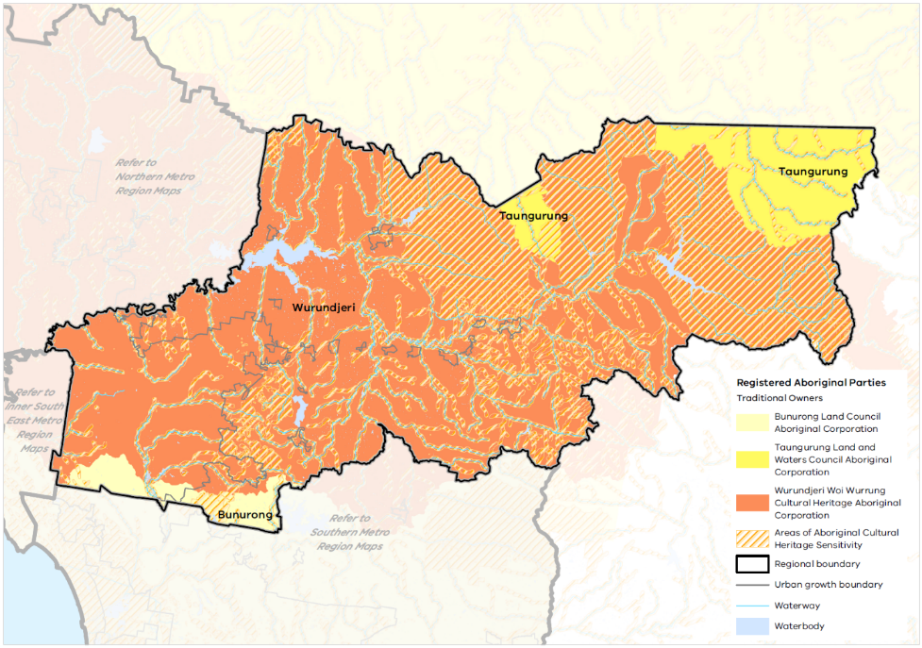

- Open space per person for Eastern Metro Region LGAs
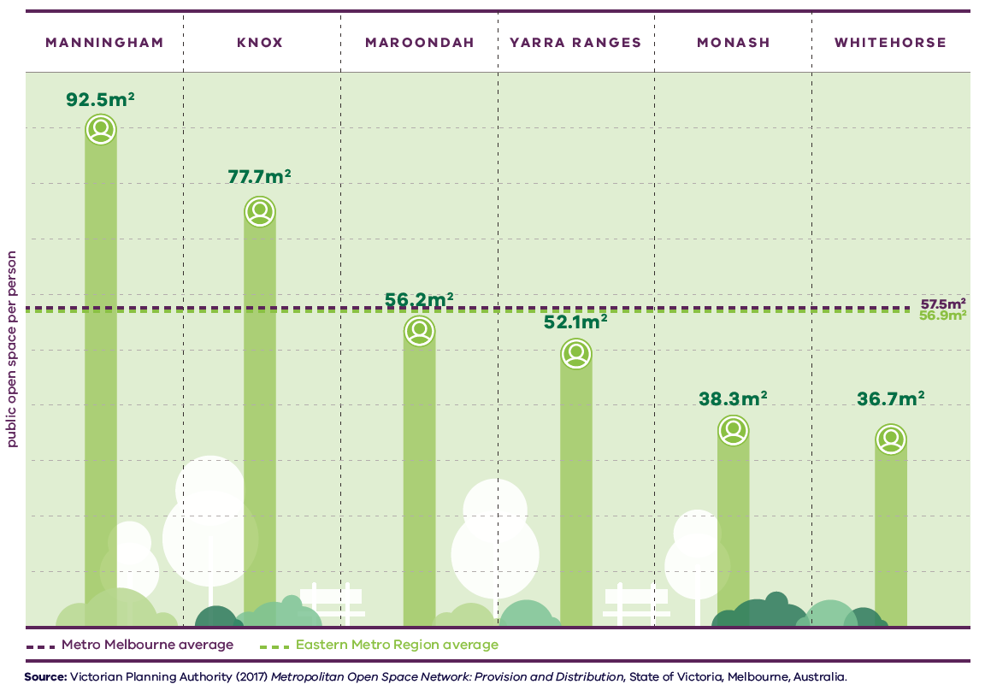

Figure 18. Open space per person for Eastern Metro Region LGAs
Metro Melbourne average | 57.5 square metres open space per person
Eastern Metro Region average | 72.9 square metres open space per person
Manningham | 92.5 square metres open space per person
Knox | 77.7 square metres open space per person
Maroondah | 56.2 square metres open space per person
Yarra Ranges | 52.1 square metres open space per person
Monash | 38.3 square metres open space per person
Whitehorse | 36.7 square metres open space per person
Source: Victorian Planning Authority (2017) Metropolitan Open Space Network: Provision and Distribution, State of Victoria, Melbourne, Australia.

Regional strengths
- There are opportunities for Traditional Owners to play a greater role in the protection and management of the region’s landscapes and biodiversity.
- The Eastern Metro Region benefits from extensive open space and recreational trails – opportunities exist to expand this network and fill in gaps.
- The region’s waterways, including the Yarra River, present opportunities for improvement as the spines of an integrated open space network.
- Green boulevards are a key feature of many of the region’s urban areas and new boulevards can be created to further enhance its sense of place.

Regional challenges
Areas of heritage, landscape and biodiversity value must be protected from the impacts of development.

Directions and strategies
The directions identified to achieve the 2050 vision for the Eastern Metro Region in terms of Liveability and Outcome 4 of Plan Melbourne are:
Direction 16 | Protect and enhance the region’s landscapes, waterways and biodiversity
Direction 17 | Create a legacy of great civic places
Direction 18 | Transform key road corridors into green boulevards
Direction 19 | Strengthen the network of open spaces and trail connections across the Eastern Metro Region
Each direction is implemented through regionally-specific strategies identified in this LUFP.
Map 6 shows how liveability will be enhanced across the Eastern Metro Region by 2050 as a result of these directions and strategies, together with Plan Melbourne and other strategies and initiatives as outlined in Appendix 01.
- Open space per person for metropolitan LGAs
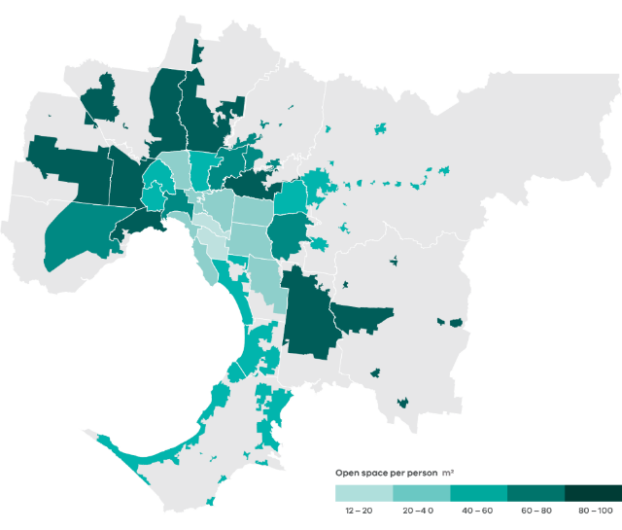
Data from the Victorian Planning Authority Metropolitan Open Space Network portal, 2016
Note: only areas within the UGB were calculated and mapped in this figure. Areas outside the UGB are shown in grey.

- Eastern Metro Region liveability 2050
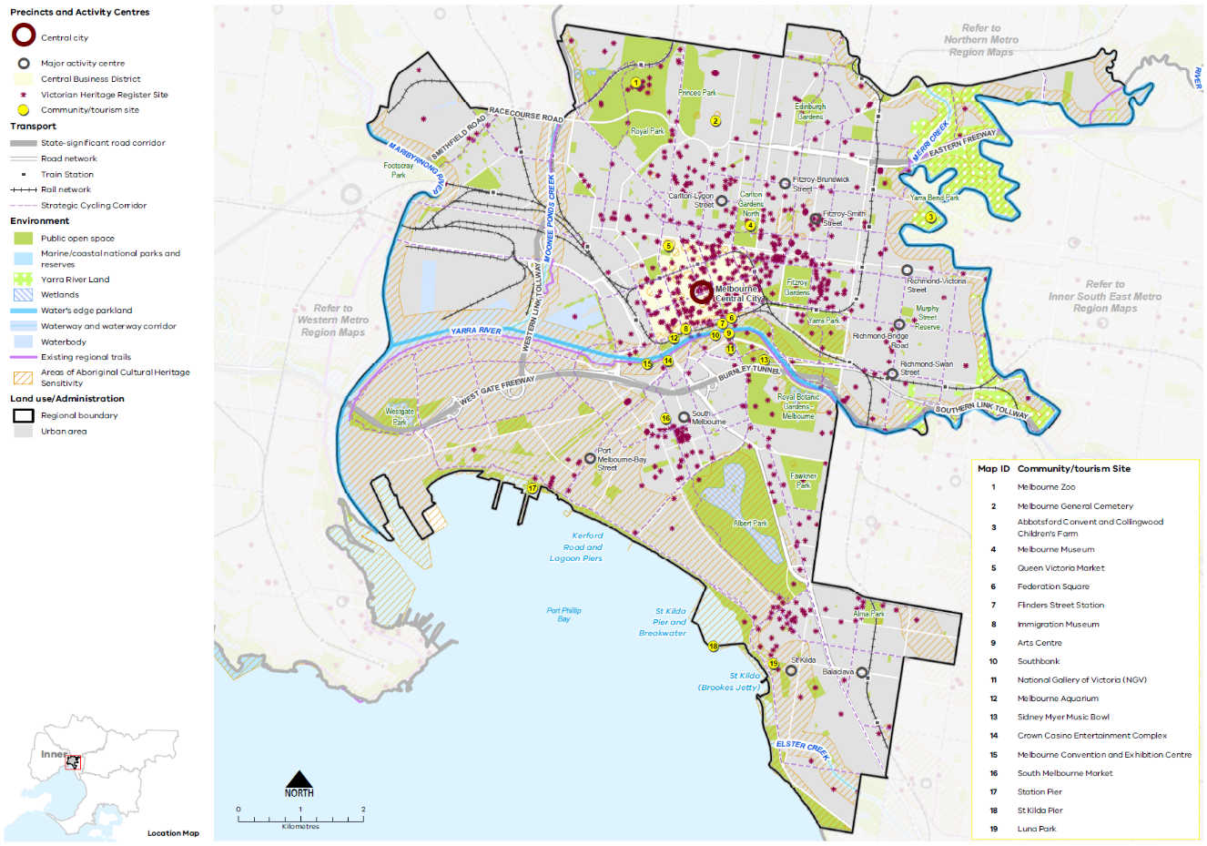

Map 6 Eastern Metro Region liveability 2050
A map showing the key environmental and cultural features of the region in 2050, as extracted from Map 1, and also highlighting:
- The Yarra River and creek network
- Yarra River Land
- The Manningham Green Wedge, the Yara Valley and Yarra and Dandenong Ranges Green Wedge and the Southern Ranges Green Wedge
- Kinglake, Yarra Ranges and Churchill National Parks, Warrandyte State Park, and the improved regional Wattle Park, and other public open spaces including the Dandenong Valley Parklands in the urban area
- Reservoirs including Maroondah Reservoir and Silvan Reservoir in the northeast and east of the region respectively
- Existing and proposed regional trails extending from the urban area into the green wedges
- Existing and potential regional green boulevards
- Community / tourism sites at:

Heide Museum of Modern Art
Box Hill Community Arts Centre
Manningham Art Gallery
Whitehorse Centre
Monash Gallery of Art
Dandenong Valley Parklands
Schwerkolt Cottage and Museum
Warrandyte Township
Karralyka Centre
Knox Community Arts Centre
Lysterfield Park
Yarra Ranges Regional Museum
William Ricketts Sanctuary
Puffing Billy Railway
Dandenong Ranges Botanic Garden
Dandenong Ranges
Yarra Valley
Healesville, Healesville Railway, Healesville Sanctuary
Warburton Township

- Areas of Aboriginal Cultural Heritage Sensitivity frequently, but not always, associated with rivers and creeks
- A number of Victorian Heritage Register sites.

- Protect and enhance the region’s landscapes, waterways and biodiversity
A range of planning policies and protections apply to the landscape and environmental values of the Eastern Metro Region’s green wedge areas (Figure 20). However, additional protection is required to ensure that development does not impact on waterways, wetlands, ridgelines and key view corridors.
Engaging with Traditional Owners and Aboriginal Victorians to include Aboriginal values and traditional ecological knowledge in biodiversity planning and management is an essential component of protecting and enhancing the region’s landscapes and biodiversity.
Implementation of the Wurunderji Woi Wurrung Ancient Spirit and Lore of the Yarra and the Yarra Strategic Plan will ensure long-term protection of the Yarra River, including actions to improve its overall environmental health, enhance community access to and use of the river and adjoining parklands, improve development interfaces with the river, and recognise cultural and heritage values.
The Healthy Waterways Strategy (Yarra and Dandenong catchments), has identified the need to protect the values of waterways and wetlands in the region, including identifying priority areas for revegetation and enhanced stormwater management.
- Work with Traditional Owners to protect and enhance the region’s significant landscapes of waterways, waterway corridors, wetlands, mountain ranges, forests and rural landscapes for their contribution to biodiversity and liveability.
- Strengthen the region’s inter- and intra-regional open space and habitat connections.
- Ensure the design of new development within the region’s green wedges responds to its landscape and biodiversity values and provides adequate buffers from areas of landscape or biodiversity sensitivity, including the rural character of land adjoining the UGB.

- Eastern Metro Region green wedge areas
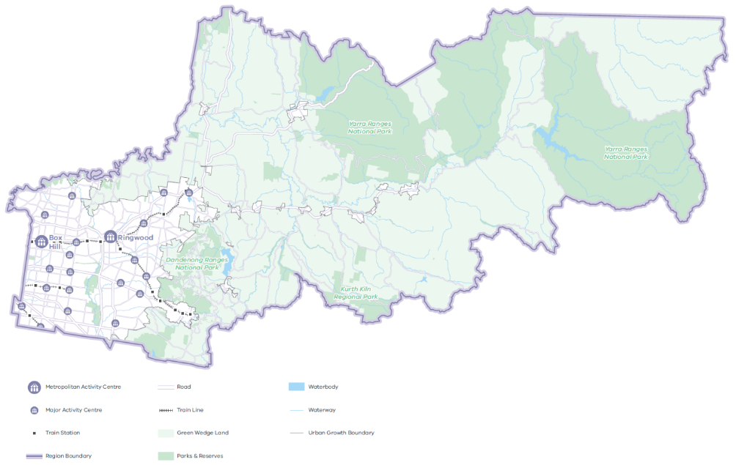
- Create a legacy of great civic places
There is already a legacy of great civic spaces and precincts across the Eastern Metro Region that are critical to establishing people’s mental map of the area and their enjoyment of place. The region’s rich cultural heritage provides a strong legacy for creating distinctive places which foster community pride and a sense of place.
Many activity centres, both large and small, include formal and informal places with high civic values that help people better understand, orientate within and appreciate where they live and visit. Existing places that establish the region’s civic legacy include the former Box Hill Town Hall, the newly established Realm in Ringwood, MC Square in Doncaster, Ringwood Lake, the Bellbird area and Blackburn Lake, the Yarra Valley Parklands and Jells Park. Heritage townships in the Upper Yarra Valley and Dandenong Ranges also have highly valued civic spaces. It is important to protect and enhance these civic places for future generations.
As the region’s activity centres grow, new civic places will be created that add to the region’s sense of place. Regionally-significant places such as the Monash NEIC have the potential to evolve as unique and memorable civic precincts.
- Identify, enhance and protect existing places and spaces that have high civic values, and which contribute to people’s understanding and enjoyment of the region.
- Ensure well designed, high-quality public spaces in new developments to foster a strong sense of place and reinforce the region’s amenity, character and identity.
- Recognise the different layers and aspects of the region’s history in the design of new buildings, public spaces, infrastructure and public artwork.
- Transform key road corridors into green boulevards
Green boulevards exist throughout the Eastern Metro Region and should be extended to other main road corridors where possible to reinforce the treed character of the region. This includes planting of canopy trees (or vegetation appropriate to the available road space) and enhancing pedestrian and cycling amenity.
Several road corridors in the region have been identified as potential green boulevards with high pedestrian and cycling amenity. These include Burwood Highway, Manningham Road, Doncaster Road, Fitzsimmons Lane/Williamson Road, Boronia Road, Mount Dandenong Road, Stud Road, Maroondah Highway, Springvale Road, Canterbury Road, Wellington Road and Ferntree Gully Road.
Maintaining the green character of streets and boulevards with well-established street trees will contribute to the amenity of the region. Designing streets to harvest stormwater would also help strengthen tree canopies and lower storey vegetation while strategic undergrounding of powerlines in key locations would enhance the streetscape character.
Design of new development along these corridors should make a positive contribution to the region’s valued character. This includes key attributes such as ensuring buildings are an appropriate scale for the local context, preserving sunlight access to public streets and spaces, minimising the impact of car parking and making a positive aesthetic contribution to the streetscape.
- Upgrade key pedestrian streets and public spaces to foster their civic and community role.

- Strengthen the network of open spaces and trail connections across the Eastern Metro Region
Plan Melbourne envisages a network of accessible, attractive and connected linear parklands, river corridors, green wedge areas and associated shared trail networks.
Within the Eastern Metro Region this includes the major parkland and river assets of the Yarra River corridor and the creation of the Greater Yarra Urban Parklands. It also includes the Scotchmans, Gardiners, Koonung Koonung and Mullum Mullum creeks, the Dandenong Valley Parklands along the Dandenong Creek corridor, the Lilydale-Warburton Rail Trail and the new Yarra Valley Rail Trail currently under construction.
Collaboration at a regional and metropolitan level and with Traditional Owners will be necessary to connect open space and enhance biodiversity assets.
Open Space for Everyone: Open Space Strategy for Metropolitan Melbourne 2020 focuses on providing a diverse range of open spaces to meet the needs of the community while protecting existing open space assets.
The Eastern Regional Trail Strategy is a planning framework and action plan prepared jointly by the region’s local councils to establish a high-quality network of integrated shared trails that link communities, destinations and urban and natural environments. It identifies immediate priorities to expand the regional trail network, including the extension of the Box Hill-Ringwood Rail Trail, connections from the Main Yarra Trail to Warrandyte, the Yarra Valley Trail and the extension of the Main Yarra Trail to Warrandyte.
Dandenong Valley Parklands is a significant open space asset and biodiversity corridor that will be even more important to the region’s liveability as the population grows. Regional cooperation is needed to plan for the future of this parkland corridor which spans three municipalities.
- Protect the region’s network of significant parklands and open space corridors as key aspects of its identity and liveability.
- Create new open space where it can serve a walkable catchment from residential areas or activity centres.
- Improve the region’s shared trail network, including key inter- and intra-regional connections, to improve access to open space and active transport opportunities.
- Support active recreation and cycling trails in the green wedges.

Actions – Liveability
- Prepare a vision for the Dandenong Valley Parklands, including defining the optimal extent of the parklands, and a framework to ensure key access points and integrated water management objectives are acknowledged in local planning decisions.

Strong Communities
Plan Melbourne Outcome 5: Melbourne is a city of inclusive, vibrant and healthy neighbourhoods
The Eastern Metro Region has many of the key attributes of strong, inclusive and healthy communities. This plan will ensure it continues to do so by providing community services, open space, hospitals, educational and cultural institutions, and transport infrastructure that keeps pace with a projected 390,000 increase in population by 2051.
Taking a regional approach to planning will ensure social infrastructure and open space services the widest possible catchment and cross-section of people. Plan Melbourne aims to build on the fundamentals of strong, healthy and sustainable neighbourhoods by improving access to and provision of amenity, social infrastructure, health and education, open space and the promotion of walking and cycling options.
The Eastern Metro Region is well placed to achieve the Plan Melbourne vision of all key services being accessible within a 20-minute walk, cycle or local transport trip from home. Having easy access to key services reduces social exclusion, improves health and wellbeing, promotes a sense of place, and reduces travel costs and traffic congestion thereby reducing carbon emissions.

State of play

Community profile
The Eastern Metro Region is a culturally diverse community with 35.4 per cent of its population born overseas. This is slightly lower than the overall metropolitan population of 36.5 per cent of people born overseas. Key countries of origin are China, United Kingdom and India, consistent with Greater Melbourne. A strong international student population and established migrant communities, such as the Chinese community centred around Box Hill, contribute to a vibrant community character.
The Socio-Economic Index for Areas (SEIFA) ranks LGAs according to their relative socio-economic advantage and disadvantage. The 2016 SEIFA rankings for the Eastern Metro Region are shown in Figure 21. Residents of the Eastern Metro Region are clustered around the upper end of the SEIFA spectrum, indicating a greater overall level of socio-economic advantage. In 2016, the Manningham LGA had the lowest level of disadvantage in the region, followed by Whitehorse. The most disadvantaged LGA was Yarra Ranges, and the rural townships within Yarra Ranges are shown to have some of the highest levels of disadvantage in the region.

Health and education facilities
The Eastern Metro Region’s high SEIFA ranking can be attributed to its outstanding, state-significant health and education precincts, social infrastructure, parkland and open spaces.
The Eastern Metro Region features 154 government primary schools and 37 government secondary schools (DELWP, 2017). Education is a strength for the Eastern Metro Region with four universities and five TAFE institutions across eight campuses, attracting both regional, national and international students.
The link between health, wellbeing and nature is reflected in many Victorian Government strategies including the Public Health and Wellbeing Plan 2019 –2023 and Active Victoria – A Strategic Framework for Sport and Recreation in Victorian 2017-2021.
The region has a total of 10 public hospitals and 13 private hospitals (excluding private day hospitals). In addition to the health facilities located in precincts listed in Table 8, Mulgrave Private Hospital, Jessie Mcpherson Private Hospital, Melbourne Eastern Private Hospital, Ringwood Private Hospital, Donvale Rehabilitation Hospital, Manningham Private Hospital and Bellbird Private Hospital, are regionally-significant facilities. The region is also well serviced by a network of allied, disability and retail health providers in the region’s activity centres.

Social infrastructure
The Eastern Metro Region features a network of galleries and art spaces that support community creative and cultural expression including Monash Gallery of Art, Karralyka Centre in Ringwood, Artspace at Realm in Ringwood and Wyneena Community Arts Centre in Croydon among others.
The region is well serviced by recreational facilities. Major recreational facilities include the State Diving Centre in Ringwood and the State Basketball Centre in Vermont South. Other regionally-significant recreation sites represent a variety of sports including aquatics, badminton, golf, netball, basketball, cricket, football and soccer. The regional recreational facilities are identified in Map 7.
The Eastern Metro Region also features one Magistrates’ Court, three Community Corrections Locations and three Justice Service Centres.
- SEIFA rankings (2016) in the Eastern Metro Region
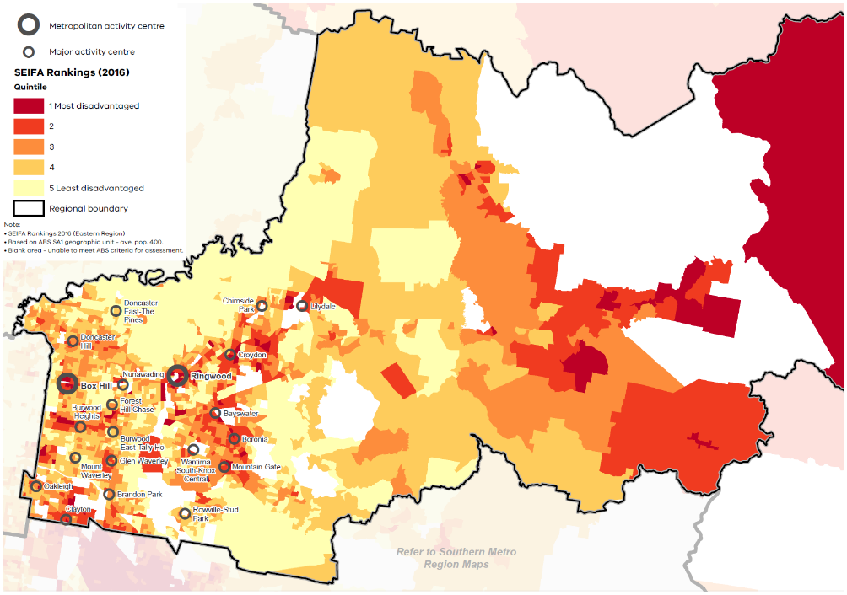

Regional strengths
- The region is well serviced by recreation facilities.
- There is an opportunity for the Eastern Metro Region to build on its state- and regionally-significant health and education precincts to keep pace with population growth.
- Use of existing social infrastructure can be expanded and diversified in innovative ways to meet the needs of residents and inter-regional visitors.
- With the region’s many activity centres, there is potential to achieve the hallmarks of 20-minute neighbourhoods.

Regional challenges
There is an uneven distribution of primary health, education and community services across the region, particularly in the outer areas and rural townships.

Directions and strategies
The directions identified to achieve the 2050 vision for the Eastern Metro Region in terms of Strong communities and Outcome 5 of Plan Melbourne are:
Direction 20 | Plan for major social infrastructure at a regional level
Direction 21 | Deliver health and education services in strategic locations
Direction 22 | Support a network of activity centres to anchor 20-minute neighbourhoods across the Eastern Metro Region
Each direction is implemented through regionally-specific strategies identified in this LUFP.
Map 7 shows how strong communities will be enhanced across the Eastern Metro Region by 2050 as a result of these directions and strategies, together with Plan Melbourne and other strategies and initiatives as outlined in Appendix 01.

- Eastern Metro Region strong communities 2050
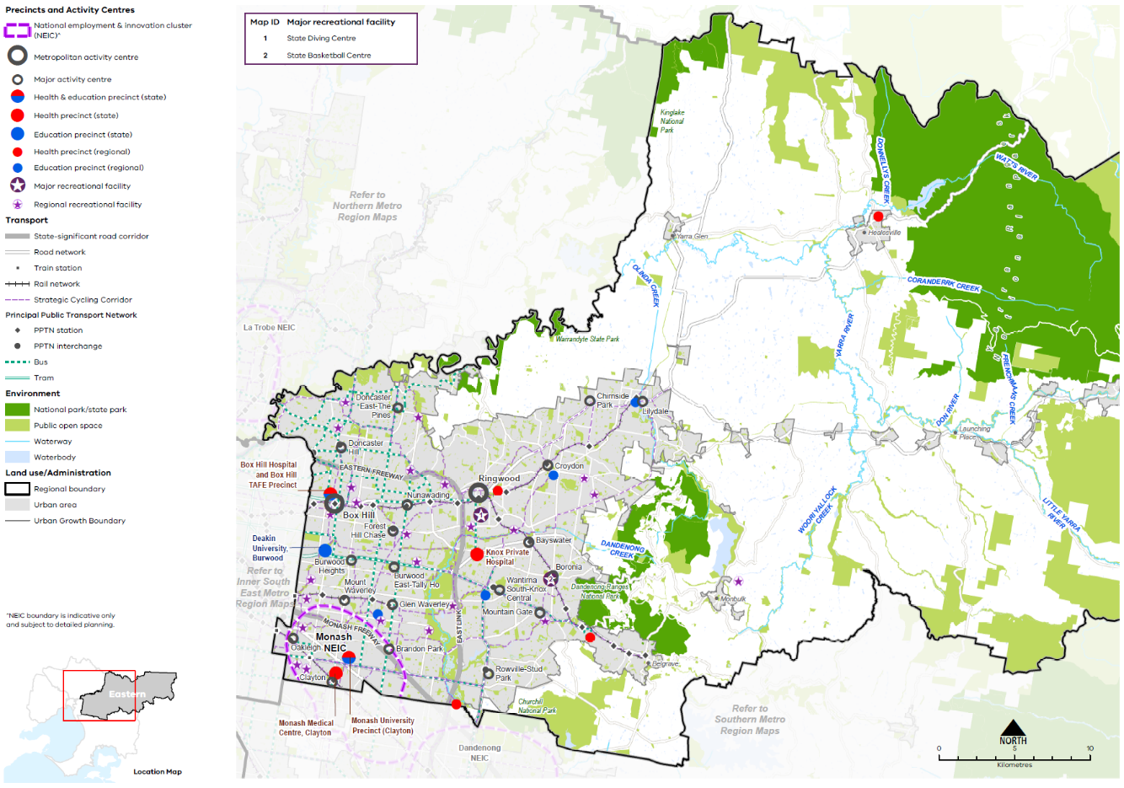

Map 7 Eastern Metro Region strong communities 2050
A map showing the main community assets of the region in 2050 including state- and regionally-significant health and/or education precinct, as extracted from Map 1, and also highlighting:

- Major recreation facilities at:
- State Diving Centre, Ringwood
- State Basketball Centre, Vermont South.

- Regional recreation facilities including aquatics, badminton, golf, netball, basketball, cricket, football and soccer.

- Plan for major social infrastructure at a regional level
Social infrastructure includes all of the facilities, services and networks that help people to meet their social, cultural and community needs, in addition to health and education facilities.
Planning from a regional perspective requires coordination between different levels of government to acknowledge that local councils plan for local infrastructure such as kindergartens, while the Victorian Government plans for state-level services such as schools.
The Eastern Metro Region has a high level of community facilities in comparison to other parts of Melbourne including performing art centres, museums, community halls, aquatic facilities, major outdoor sports grounds and indoor stadiums. However, many of these assets were designed for a single purpose and are unlikely to adequately meet the projected future needs of the community.
The Melbourne East Regional Sport and Recreation Strategy 2016 identifies current gaps in regional level sport and recreation facilities and provides a planning framework to help prioritise regional projects. With significant competition for land to build new assets, one new approach may be to better use existing social infrastructure on larger open space land holdings (such as golf courses, pipe tracks or easements) and government owned land (such as schools, universities or cemeteries) for complementary passive open space or recreational opportunities.
- Encourage planning for major social infrastructure (such as libraries, recreation facilities, cultural centres or community hubs) to be undertaken in conjunction neighbouring regions to maximise co-location of facilities.
- Locate social infrastructure near activity centres and in SRL precincts to be accessible by walking, cycling or public transport.
- Support regional planning that will provide for a range of sporting and active recreation facilities to meet the needs of the growing population.
- Support the upgrade and expansion of existing social infrastructure to enable it to be more flexibly and intensively used.
- Encourage utilisation of public land such as school grounds or golf courses for open space, recreation activities or trail connections by providing community access at times and in ways that do not jeopardise their primary purpose.
- Deliver health and education services in strategic locations
Greater demand is expected for the region’s health and education services over the next 30 years given the region’s projected population increase and cross-regional movement facilitated by SRL.
To accommodate anticipated demand, existing infrastructure will need to be updated or relocated to health and education precincts that encourage synergies between users. Plan Melbourne identifies state-significant health and/or education precincts. Regionally-significant health and/or education precincts (Table 12) have a regional catchment, are accessible by a range of transport options and have a specialised economic function. This identification provides opportunities for the agglomeration of ancillary health and education services, retail, commercial and accommodation uses.
Victorian Government is working in partnership with Knox LGA to establish an integrated health precinct for Wantirna that includes a new aged care facility and synergies with Knox Private Hospital.
Planning for activity centres and health and education precincts should consider their role as part of the broader network of public and private community service providers. Health infrastructure should be planned at a regional level. For more remote areas of the region, provision of adequate local health services is essential, in addition to transport connections to regional health services.
Additionally, a significant portion of the demand on health and education services could be accommodated through upgrading, expanding and diversifying existing services. Where necessary, outdated services should be identified for redevelopment.
Aged care service capacity should be monitored and planned for to keep pace with the expanding and ageing population in the Eastern Metro Region.
- Strengthen the role of the health and/or education precincts of the Eastern Metro Region by co-locating new health and/or education facilities within these precincts and encouraging an agglomeration of ancillary uses such as primary healthcare, retail and accommodation.
- Expand the network of health and/or education facilities and precincts across the region to meet the needs of the growing population. Ensure that these facilities and precincts are accessible by public transport, walking and cycling.
- Support the upgrade of existing health and education infrastructure to allow for more intensive use of those services.
State-significant and regionally-significant health and/or education precincts
State-significant health precinct | Regionally-significant health precinct
Knox Private Hospital  Monash Medical Centre | Maroondah Hospital (Ringwood)  Healesville Hospital (Healesville)  Mulgrave Private Hospital (Mulgrave)  Angliss Hospital (Upper Ferntree Gully)
State-significant education precinct | Regionally-significant education precinct
Deakin University (Burwood) | Swinburne University of Technology (Wantirna)  Swinburne University of Technology (Croydon)  Box Hill Institute (Lilydale)  Holmesglen Institute of TAFE Waverly Campus (Glen Waverley)
State-significant health and education precinct | Regionally-significant health and education precinct
Monash University Precinct (Clayton – including Victorian Heart Hospital)
Box Hill Hospital and Box Hill Institute of TAFE Precinct
- Support a network of activity centres to anchor 20-minute neighbourhoods across the Eastern Metro Region
The 20-minute neighbourhood is about ‘living locally’ and giving people the ability to meet most of their daily needs within a 20-minute walk, cycle or public transport trip from home.
All Eastern Metro Region LGAs recognise the importance of neighbourhood activity centres in providing convenient, accessible services and generating employment opportunities. They each have programs in place to help neighbourhood activity centres remain economically viable and to enhance the vitality of local streetscapes. The role and function of each neighbourhood activity centre should be understood to ensure an adequate provision of services across the region.
The Eastern Metro Region has the largest number of smaller scale commercial areas or centres in metropolitan Melbourne. The region contains 265 commercial areas that are not classified as a metropolitan or major activity centres. Almost 80 per cent of these are small-scale local commercial areas with less than 10,000 square metres of commercial floorspace. Collectively this network of small centres and neighbourhood activity centres provides a range of retail, hospitality, health and community functions and supports the delivery of 20-minute neighbourhood hallmarks.
Urban design for existing and new activity centres needs to support increased population densities as well as adequately plan for and integrate social infrastructure. Place-based planning for existing and new developments will support the retention of the existing sense of place of centres and provide opportunities for community engagement to ensure a sense of place is retained. This means an emphasis on walkable areas, shared trail links and public transport options to enhance connectivity to neighbourhood activity centres, open spaces, recreation and community facilities. A well planned, safe urban realm would also enable ageing members of the community to remain in their own homes with good access to essential services and facilities.
Townships in the region should also have appropriate residential, commercial, retail, community and recreational facilities.
- Plan for existing and new activity centres to embed the 20-minute neighbourhood hallmarks, through a place-based, community partnership approach.
- Support a consistent designation of neighbourhood activity centres and their role in the network of activity centres across the Eastern Metro Region.
- Embed the 20-minute neighbourhood hallmarks in planning within the catchment of major infrastructure projects.
- Support the role of neighbourhood activity centres to provide retail, community and allied health services to their respective local catchments.

Actions – Strong communities
- Assess the health services infrastructure in the region’s rural locations and prepare a regional response to improving access to services.
- Review local planning policy and provisions for identified regionally-significant health and/or education precincts to support their continued effective operation and their future growth and expansion, including in the case of health precincts, for associated allied health services.
- Develop guidance on a new approach to neighbourhood planning in partnership with local councils of the Eastern Metro Region which embeds the hallmarks of 20-minute neighbourhoods.

Sustainability and resilience
Plan Melbourne Outcome 6: Melbourne is a sustainable and resilient city
Plan Melbourne aims to create a resilient and sustainable city. It recognises the need to mitigate greenhouse gas emissions, reduce exposure to natural hazards and undertake whole of water cycle planning. It also encourages resource efficiency and promotes the benefits of urban cooling and greening.
The Eastern Metro Region has the highest tree canopy coverage in metropolitan Melbourne and lower surface temperatures than other Melbourne regions. With these benefits, however, come certain risks: forested areas and some urban areas in the Eastern Metro Region are highly susceptible to floods, bushfires and damage to property, infrastructure and public assets from extreme weather events.
Green infrastructure (trees, vegetation, green spaces and water systems) play an important role in maintaining water supply catchments, providing habitat and contributing to the character of parks and green wedges.

State of play

Urban heat environments
By 2050, the average annual temperature in the Eastern Metro Region is forecast to increase between 0.8° and 3.0° Celsius under a medium emissions climate change scenario (Clarke, et al., 2019). As our climate warms the number of people exposed to the risk of mortality from heatwaves will increase. Older people, younger people, those with pre-existing illnesses and people with fewer resources to adapt are more at risk on hot days and in prolonged periods of hot weather.
Although the Eastern Metro Region is the coolest within Metro Melbourne, it is still estimated that around 23,000 residents in the region were exposed to high urban heat conditions in 2018 (Urich, C. & Hardy, M., 2020). The average land surface temperature (LST) in the Eastern Metro Region was 32.8° Celsius, and LST was highest in Monash LGA (33.9°Celsius) and coolest in Yarra Ranges LGA (31.6°Celsius), as shown in Figure 22.
There are scattered areas of urban heat across the inner-west portion of the Eastern Metro Region including the Monash NEIC, Clayton, Glen Waverley, Bayswater, Boronia and Croydon. These areas have less trees and more hard surfaces compared to other areas possessing higher vegetation cover and, in particular, higher tree canopy cover. This means individual suburbs within the region offer different levels of amenity on hot days.

- Average land surface temperature by LGA, 2018
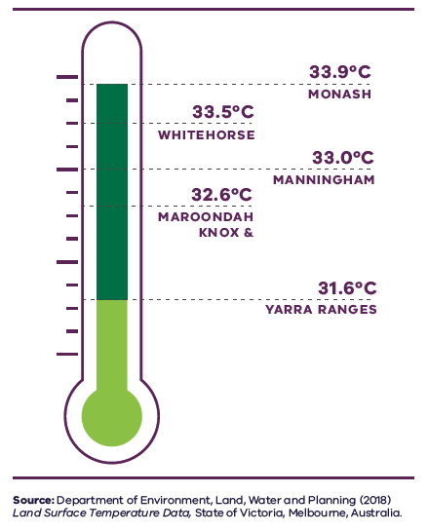
Figure 22. Average land surface temperature by LGA, 2018
Monash | 33.9 degrees Celsius
Whitehorse | 33.5 degrees Celsius
Manningham | 33.0 degrees Celsius
Knox | 32.6 degrees Celsius
Maroondah | 32.6 degrees Celsius
Yarra Ranges | 31.6 degrees Celsius
Source: Department of Environment, Land, Water and Planning (2018) Land surface temperature data, State of Victoria, Melbourne, Australia.

Urban environments that stay cooler on hot days are more physically comfortable to humans and animals and continue to support movement and recreation. As the number and duration of hot days increases, these environments will be important to reduce the likelihood of heat-related illness. Cooler urban environments are characterised by more tree cover, less hard surfaces, more water infiltration into the ground and fewer heat-absorbing building materials.

Vegetation cover
Vegetation cover is a defining feature of the Eastern Metro Region, which in 2018 had 61 per cent vegetation cover and 27 per cent tree canopy cover including both urban and non-urban areas. This is 14 per cent more vegetation cover and almost 11 per cent more tree cover than the metropolitan average and the highest of Melbourne’s metropolitan regions (Hurley, et al., 2018b). The Eastern Metro Region as a whole contributed 39,096 hectares of tree canopy cover and 88,355 hectares of combined vegetation cover (grass, shrubs and trees) to Melbourne (Hurley, et al., 2018b).
- Heat vulnerability index map for the Eastern Metro Region, 2018
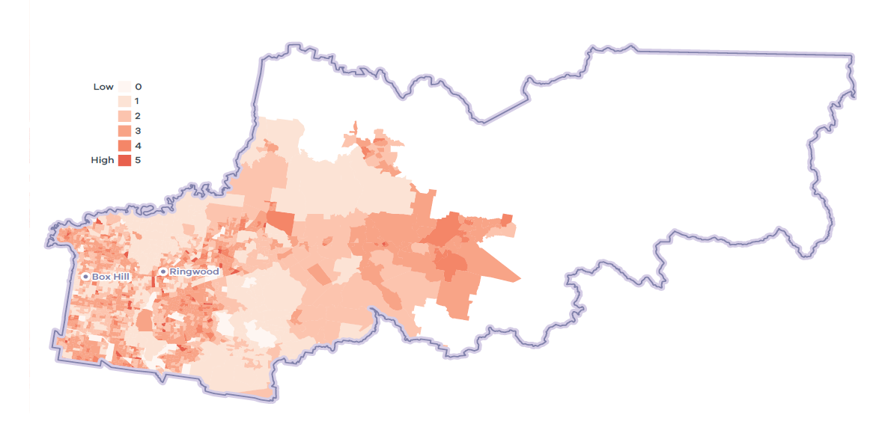
- Eastern Metro Region tree canopy cover, 2018
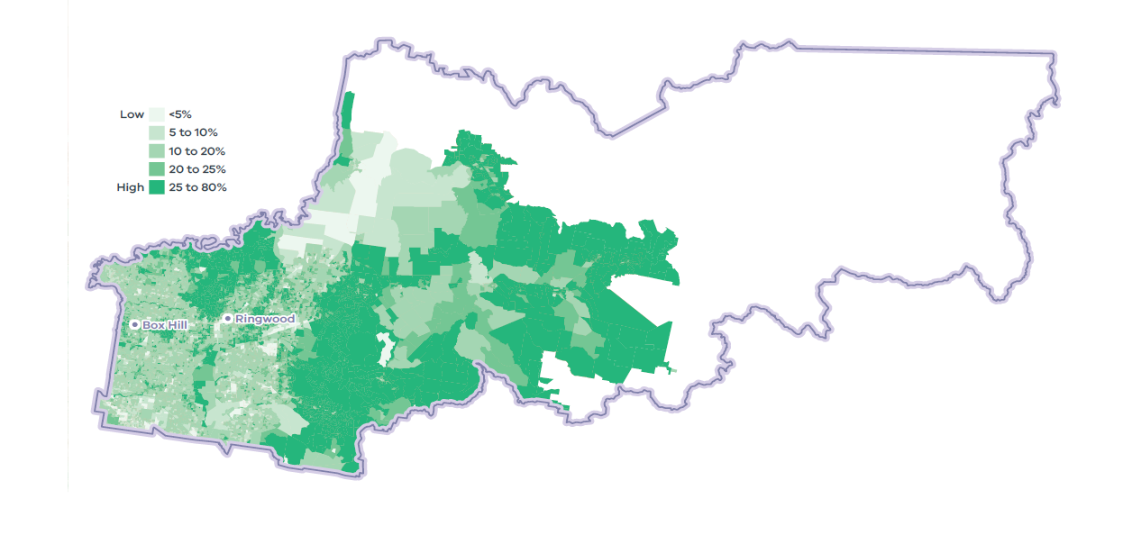

Urban tree canopy
Trees provide cooling, amenity, habitat, and recreation and respite to residents. In 2018, the Eastern Metro Region had around 26 per cent urban tree cover, higher than the metropolitan average of 15.3 per cent (Hurley, et al., 2018a).
The region accounted for 40 per cent of Melbourne’s overall tree canopy coverage in urban areas, with tree canopy varying across the region. Most urban tree canopy is on residential land, parkland and linear infrastructure such as streets (Figure 25).
In 2018, the Yarra Ranges had the highest urban tree canopy cover of almost 37 per cent, reflecting its interface with the Dandenong Ranges while Monash had around 14 per cent urban canopy cover (Figure 26) (Hurley, et al., 2018a).
Between 2014 and 2018 the Eastern Metro Region had the largest loss of tree canopy of any metropolitan region. Maroondah and Whitehorse LGAs had the highest loss of average tree canopy of all metropolitan LGAs. The high level of urban tree canopy loss in the Eastern Metro Region was offset by gains in the Inner, Western and Northern metro regions (Figure 26) (Hurley, et al., 2019).
All local councils in the Eastern Metro Region have adopted the Living Melbourne Urban Forest Strategy, specifying targets for the Eastern Metro Region of 30 per cent total tree canopy and 50 per cent total tree and shrubs canopy by 2050 (The Nature Conservancy and Resilient Melbourne, 2019).

Water supply
Melbourne sources most of its water from remote, forested mountain streams and enjoys some of the best quality natural water in world (Melbourne Water, 2020).
The Eastern Metro Region includes significant water catchment and storage areas such as the Yarra River, the Upper Yarra open water catchment and the Upper Yarra, Silvan, Maroondah and O’Shannassy reservoirs. These water catchments and storage facilities are regionally-significant assets that provide around 70 per cent of Melbourne’s drinking water.
Healesville, McCrae’s Creek, Mick’s Creek and Britannia Creek are all officially recognised as Declared Special Area Water Supply Catchments in the Eastern Metro Region.

Flooding risk
Stormwater flooding is prevalent in urban areas of the Yarra River catchment in the Eastern Metro Region. Higher volumes of stormwater during periods of heavy rain impact the health of rivers and their tributaries (DELWP, 2018a).
While overall annual rainfall will reduce as a result of climate change, the region is predicted to see more frequent and intense rainfall events that will increase the risk of flooding (DELWP, 2018a). Flooding may also be exacerbated by an increase in impervious surfaces and stormwater flows unless this risk is properly managed.
Harvesting stormwater and increasing water infiltration are important in dense suburbs to reduce runoff and service vegetation. Stormwater and recycled water can support the maintenance of water-reliant facilities and amenities such as sporting fields and gardens, contribute to more resilient vegetation, reduce demand on drinking supplies and improve the environment of receiving streams and rivers.

Bushfire risk
The Eastern Metro Region has bushfire risk at the local and landscape scale as shown in Map 8. There are large areas of land, mostly beyond the urban area in the green wedges, already governed by State planning policy for bushfire (Clause 13.02), the Bushfire Management Overlay (BMO) and Bushfire Prone Areas (BPA). The likelihood of a bushfire, its severity and intensity depend on a site’s location and surrounding landscape characteristics.
The BMO aims to strengthen community resilience to bushfire by considering bushfire measures as part of the design process and ensuring new development achieves an acceptable level of bushfire risk in areas of highest bushfire risk. However, there is still a need to strengthen the resilience of settlements and communities to bushfire. Strategic risk-based planning that prioritises the protection of human life over other policy considerations should extend to sensitive uses and uses that encourage high visitation to the green wedges during hotter months.
Bushfire risk exists in the heavily vegetated environments of the Yarra Ranges and in vegetated areas across most established urban areas the region. The frequency and intensity of bushfires in the Dandenong Ranges is forecast to increase with climate change. Bushfire poses a serious threat to the region’s communities, infrastructure and high-value forests and ecosystems (DELWP, 2018a). Planning for the risk of bushfire will be vital as the climate warms and overall rainfall decreases.
- Urban tree canopy cover by land use, 2018
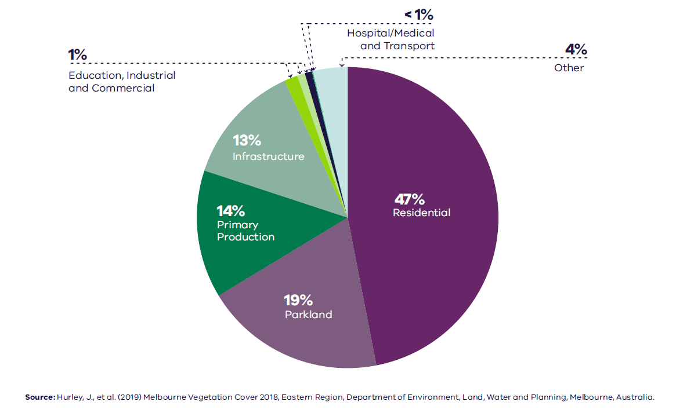

Figure 25. Urban tree canopy cover by land use, 2018
Residential | 47 per cent
Parkland | 19 per cent
Primary production | 14 per cent
Infrastructure | 13 per cent
Education | 1 per cent
Industrial | 1 per cent
Commercial | 1 per cent
Hospital/medical | Less than 1 per cent
Transport | Less than 1 per cent
Other | 4 per cent
Source: Hurley, J., et al. (2019) Melbourne Vegetation Cover 2018, Eastern Region, Department of Environment, Land, Water and Planning, Melbourne, Australia.

Sustainability in the built environment
In 2013, residential buildings were responsible for nearly 12 per cent of Australia’s national greenhouse gas emissions, and commercial buildings contributed just over 11 per cent. The majority of these emissions were generated through the consumption of grid-supplied electricity to power appliances, lighting, and predominantly heating, ventilation and cooling (HVAC) systems (Australian Sustainable Built Environment Council, 2016).
As average temperatures rise due to climate change, greater numbers of people are expected to seek comfort indoors during high heat conditions. This, combined with population growth and overall poor-performing building stock, means our city lacks energy efficiency and resilience on hot days. Maximising opportunities to incrementally improve the performance of buildings will reduce our reliance on appliances to cool buildings and contribute to a lower likelihood of blackouts during periods of hot weather.
Local councils within the Eastern Metro Region are active in adopting policies and strategies to reduce carbon emissions and improve the sustainability of the built environment. Many are innovators and leaders in environmentally sustainable development (ESD) through their strategies and are implementing new practices to improve the energy efficiency of their civic buildings and reduce emissions from operations.

- Tree canopy cover 2018 and tree canopy cover change 2014 to 2018, by LGA
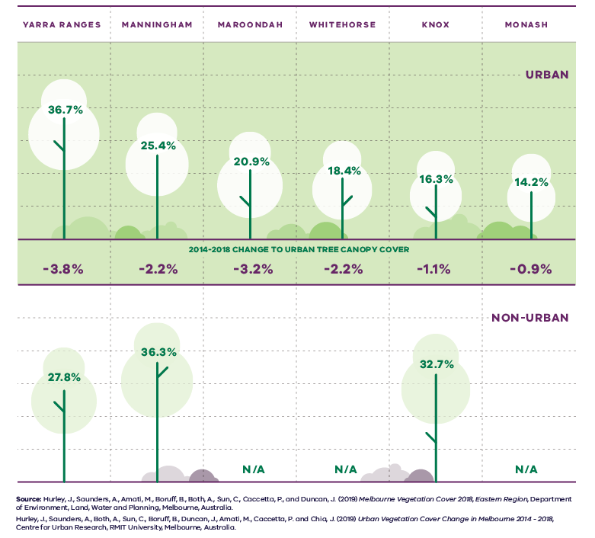
Figure 26. Tree canopy cover 2018 and tree canopy cover change 2014 to 2018, by LGA
LGA | Urban tree canopy cover 2018 | 2014 to 2018 change to urban tree canopy cover | Non-urban tree canopy cover 2018
Yarra Ranges | 36.7 per cent | Minus 3.8 per cent | 27.8 per cent
Manningham | 25.4 per cent | Minus 2.2 per cent | 36.3 per cent
Maroondah | 20.9 per cent | Minus 3.2 per cent | Not applicable
Whitehorse | 18.4 per cent | Minus 2.2 per cent | Not applicable
Knox | 16.3 per cent | Minus 1.1 per cent | 32.7 per cent
Monash | 14.2 per cent | Minus 0.9 per cent | Not applicable
Sources:
Hurley, J., et al. (2019) Melbourne Vegetation Cover 2018, Eastern Region, Department of Environment, Land, Water and Planning, Melbourne, Australia.
Hurley, J., et al. (2019) Urban Vegetation Cover Change in Melbourne 2014 – 2018, Centre for Urban Research, RMIT University, Melbourne, Australia.
All of the region’s LGAs are members of the Council Alliance for a Sustainable Built Environment (CASBE), an association committed to designing and applying a range of practical methodologies to increase sustainability outcomes for new buildings (CASBE, 2021). The Built Environment Sustainability Scorecard (BESS) is an online tool developed by CASBE that assesses the sustainability of proposed developments. It aims to reduce waste and improve energy efficiency from the outset of the construction phase, through to occupation. As well as onsite energy generation, BESS promotes the use of energy-efficient appliances, thermally-efficient glazing, wall cladding and insulation, water-efficient fittings and fixtures, thermal comfort and overall environmentally sustainable performance.
Other rating systems being increasingly utilised by the building design industry to measure and assess the performance of ESD principles include Green Star (Green Building Council of Australia, 2021), NatHERS (Department of Industry, Science, Energy and Resources, 2021) and MUSIC (eWater, 2021).

- Eastern Metro Region sustainability and resilience state of play
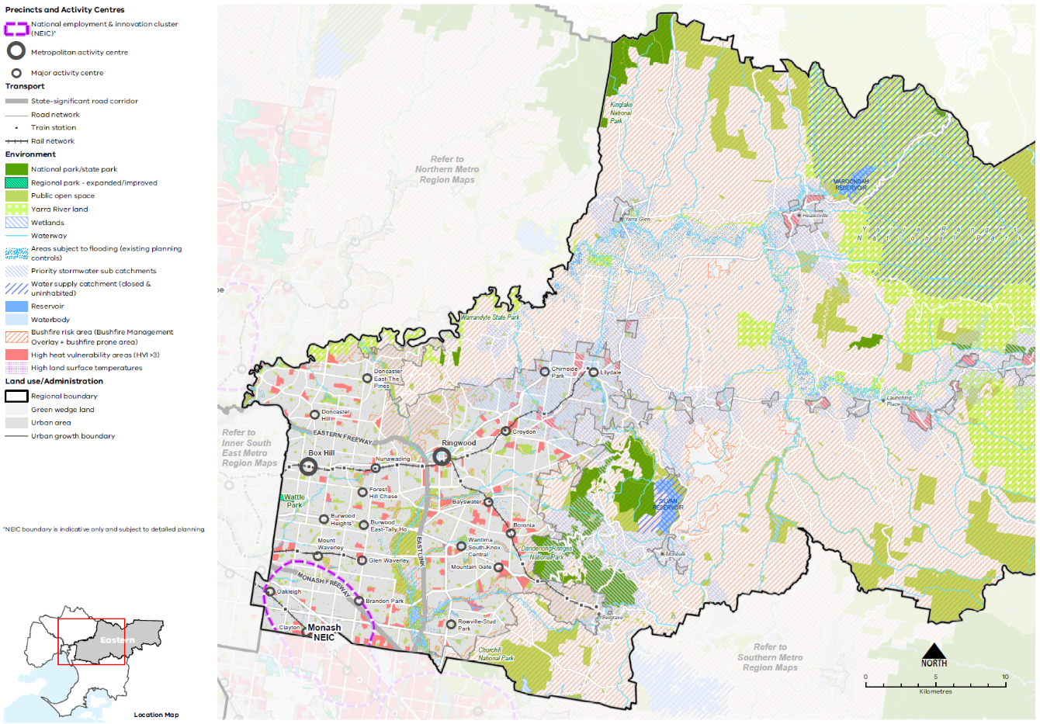
Map 8 Eastern Metro Region sustainability and resilience state of play
A map showing the current sustainability and resilience of the Eastern Metro Region, as extracted from Map 1, and also highlighting:
- Bushfire risk area (taken from the Bushfire Management Overlay and bushfire prone area) across the eastern part of the region, including some urban areas, and open spaces within the urban area
- Areas of high heat vulnerability distributed through the urban parts of the region
- Water supply catchments (closed and uninhabited) around Sylvan and Maroondah Reservoirs
- Areas subject to flooding (existing planning controls)
- Priority stormwater sub catchments.

Regional strengths
- The region has the highest tree canopy coverage in metropolitan Melbourne; however, it also has the highest rates of tree canopy loss due to continuing pressure to accommodate growth.

Regional challenges
- The region’s drinking water supply catchments are essential to Melbourne’s liveability and require protection.
- Environmental risks such as waterway health and bushfire hazards are key considerations for future planning.
- Green infrastructure can play a significant role in reducing the urban heat of public places and spaces.
- Urban stormwater management and water harvesting can assist in managing flooding risk and supporting green infrastructure.

Directions and strategies
The following directions have been developed to achieve the 2050 vision for the Eastern Metro Region in terms of maximising sustainability and climate change resilience:
Direction 23 | Minimise and reduce bushfire risk to buildings and communities
Direction 24 | Increase the network of cool places, particularly in areas with communities vulnerable to urban heat and areas with high urban heat
Direction 25 | Increase urban tree canopy across the Eastern Metro Region to achieve 30 per cent coverage by 2050
Direction 26 | Integrate green infrastructure with land use and infrastructure change to maintain cool urban environments
Direction 27 | Protect the role of the Eastern Metro Region as the major water catchment for Melbourne
Direction 28 | Increase the retention and reuse of water in the urban and rural environments to contribute water security and enhance waterways
Each direction is implemented through a number of strategies, which together will ensure the Eastern Metro Region is sustainable and resilient in accordance with Outcome 6 of Plan Melbourne.
Map 9 shows the extent of green urban areas, cool urban areas, public open space and waterway catchments across the Eastern Metro Region by 2050 as a result of these directions and strategies.

- Eastern Metro Region sustainability and resilience 2050
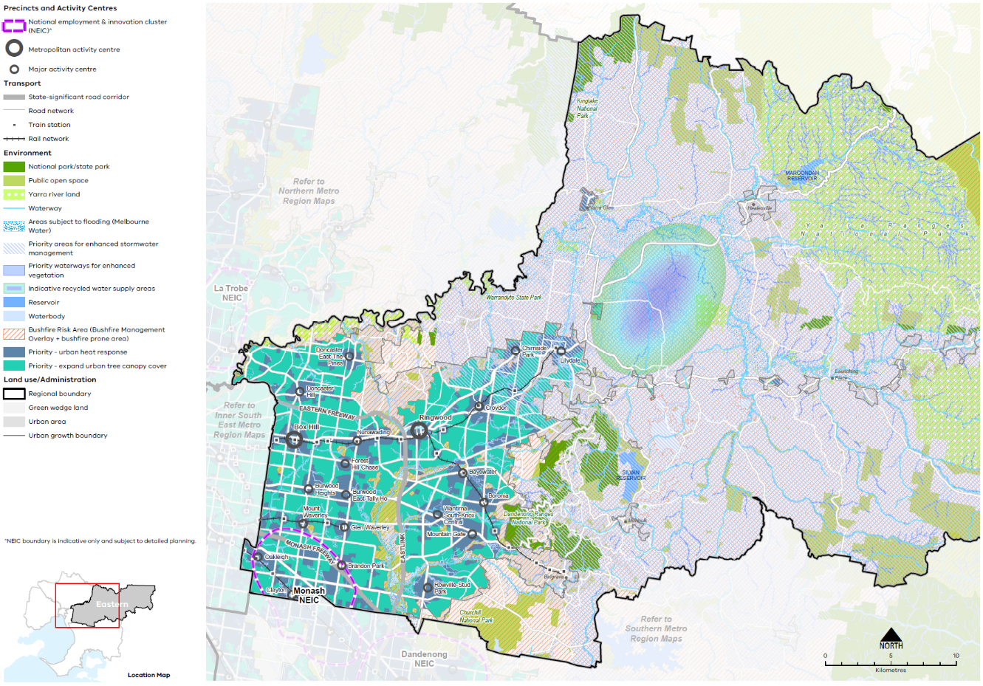
Map 9 Eastern Metro Region sustainability and resilience 2050
A map showing the sustainability and resilience of the Eastern Metro Region in 2050, as extracted from Map 1, and also highlighting:
- Priority areas for enhanced stormwater management principally in the east of the region
- Priority waterways for enhanced vegetation
- Priority areas for an urban heat response and expanding the urban tree canopy cover
- Areas subject to flooding (updated Melbourne Water data)
- Indicative recycled water supply area in the Yarra Valley and Yarra and Dandenong Ranges Green Wedge between Lilydale and Healesville.

- Minimise and reduce bushfire risk to buildings and communities
Bushfire risk, frequency and severity will continue to increase as our climate warms. The Eastern Metro Region will need to plan for the evacuation of people from areas of higher bushfire risk to safer refuge areas on days of extreme fire risk.
Bushfire risk can be reduced through land use and infrastructure planning that incorporates bushfire protection measures and seeks to maximise separation between the hazard and built form. Vegetation management, including lower risk species selection and maintenance, will have a key role in urban areas.
In order to prioritise the protection of human life from bushfire, population growth and development should be directed to low-risk locations and areas that are safely evacuated. Development within areas of the highest bushfire risk must achieve acceptable levels of risk reduction. These areas should be avoided for development that will accommodate more vulnerable populations, such as the elderly or very young, that may have difficulties evacuating in the event of a bushfire.
Careful management of vegetation and water resources will be required across the Eastern Metro Region in response to bushfire risk. River and creek corridors will continue to be important as the climate warms to provide habitat, recreation and cooling. However, given their higher levels of vegetation, they will also pose bushfire risk. Vegetation management strategies, including selecting lower risk species and maintaining vegetation, will have a key role in mitigating risk in urban areas while recognising the value of these corridors for habitat and urban cooling.
- Avoid housing growth and sensitive land uses within and in proximity to bushfire prone areas in the Yarra Ranges, Manningham, Knox and Maroondah LGAs.
- Provide new and upgraded regional social infrastructure that provides refuge in extreme bushfire and weather events.
- Recognise and manage bushfire risk posed by vegetation within waterway corridors.
- Increase the network of cool places, particularly in areas with communities vulnerable to urban heat and areas with high urban heat
More tree canopy cover, permeable surfaces and water in the urban environment will help reduce urban temperatures and create cooler, more comfortable local micro-climates across the Eastern Metro Region. Plan Melbourne notes that temperature decreases of between 1° Celsius and 2° Celsius can have a significant impact on reducing heat-related morbidity and mortality.
In addition to trees, green walls, shade structures and low heat absorbing building materials can help reduce urban surface temperatures and create cool urban areas. These techniques will be important to incorporate in the Monash NEIC and in activity centres located in the inner-west portion of the Eastern Metro Region that experience high urban heat. The residents of these communities are at a higher risk of heat-related illness during periods of multiple hot days. Within these areas, land uses frequented by older people and children, who are more vulnerable to urban heat, will need to provide for more active cooling of outdoor environments.
Buildings with vegetation and roof gardens will need to be combined with onsite rainwater harvesting and storage to maintain vegetation health and reduce potable water demand.
- Increase tree canopy and water sensitive urban design in areas with high urban heat vulnerability and high urban heat.
- Design and develop outdoor spaces that are cool on hot days through the use of water-permeable paving, vegetation and water sensitive urban design in the Monash NEIC and in the Clayton, Glen Waverley, Bayswater, Boronia and Croydon major activity centres.
- Encourage green roofs and green structures with climate resilient planting and irrigation on apartment developments in areas with high urban heat and large commercial and industrial sites.
- Increase urban tree canopy across the Eastern Metro Region to achieve 30 per cent coverage by 2050
Trees provide an essential service for the surrounding environment. In the absence of water, trees and in particular clusters of trees, make the greatest contribution to reducing surface temperatures, along with contributing to stormwater infiltration, amenity and biodiversity.
These important functions are vital for sustainability and resilience as our climate warms and the Eastern Metro Region’s population and major centres grow.
Increasing vegetation on public and private land to create corridors of vegetation will support improved biodiversity, reduce stormwater impacts and reduce urban heat. Local planning should consider the transition of some corridors to higher risk bushfire environments and guide land use, water and vegetation management to manage bushfire risk in these areas.
Infrastructure, such as streets, rail corridors, existing and new arterial roads and large at-grade car parks can play a multi-purpose role for both movement and greening to contribute to urban forest targets. Green boulevards are encouraged along road plantations and street verges.
All Eastern Metro Region LGAs have endorsed the Living Melbourne: Our Metropolitan Urban Forest strategy, specifying a regional target of 30 per cent total tree canopy and 50 per cent combined tree canopy and shrubs by 2050 (The Nature Conservancy and Resilient Melbourne, 2019). To support this commitment, the tree canopy target is accompanied in Table 13 by an aspirational distribution of tree canopy cover across four different land use types, adapted by DELWP from several related datasets (Hurley, et al., 2018a) (Urich & Hardy, 2020) (PSMA Australia Limited, 2021).
Eastern Metro Region tree canopy cover target and aspirational distribution
2018 Tree Canopy Cover: 25.9%
2050 Tree Canopy Cover Target: 30%
(+4.1% or +2,685 hectares additional tree canopy cover)
Private land: | 45%
Streets, roads and rail: | 15%
Parks, open space and waterways: | 35%
Education and community Infrastructure: | 5%
- Protect more trees on private land outside of locations identified for higher levels of housing and mixed-use change.
- Support alternative siting of buildings and more compact building forms to retain mature canopy vegetation.
- Increase tree canopy on streetscapes, public land, large development in activity centres, along urban waterways, open spaces and road reserves, and large commercial and industrial sites.

- Integrate green infrastructure with land use and infrastructure change to maintain cool urban environments
Public and private land both make significant contributions to the tree canopy cover of the Eastern Metro Region, with existing vegetation fundamental to the region’s sense of place.
One of the challenges of increasing the tree canopy is the ability to retrofit existing urban areas with green infrastructure (trees, vegetation, green spaces and water systems) due to the availability of public and private space and its multiple functions. For example, there are potential conflicts with transport movement and electrical powerlines, underground cabling, gas and stormwater pipe works and regulations.
Most of the Eastern Metro Region’s growth will be accommodated in and around activity centres and other identified locations with good access to existing services and transport infrastructure. Some areas will need a precinct or site responsive design to retain mature trees. Other sites will be less able to accommodate trees and other cooling and greening methods will be required.
While some locations will be more constrained, tree planting and water sensitive urban design (WSUD) may yield greater co-benefits, such as reduced urban temperatures, local climate regulation and stormwater benefits.
Making space, providing good growing conditions and using stormwater in high use activity locations will be important to maintain comfortable outdoor environments. Locations designated for higher levels of growth and change are a priority for urban heat response measures. Other priority locations for planting and WSUD are activity centres and activity corridors, train stations and bus stops.
- Design and develop outdoor spaces that are cool on hot days through materials, vegetation and water sensitive urban design particularly in the Monash NEIC, Box Hill and Ringwood metropolitan activity centres, major activity centres, activity corridors, and state- and regionally-significant health and education precincts.
- Provide green roofs and green structures with climate resilient planting and irrigation on apartment developments in areas with high urban heat and large commercial and industrial sites.

- Protect the role of the Eastern Metro Region as the major water catchment for Melbourne
There is limited public access to Melbourne’s declared catchments to minimise impacts on drinking water quality. However, as the Eastern Metro Region’s population grows, there may be additional pressure on bushland environments for recreational use. It is important to the resilience and sustainability of Melbourne that we continue to protect the important role of water supply catchments.
Key threats to the health of Melbourne’s water catchments include bushfire risk, and human and animal contamination. Bushfires can impact the quality and quantity of water through ash and sediment, and result in less water entering the reservoir while the forests recover from bushfire which can take over a century.
Additionally, some of Melbourne’s water is sourced from open water supply catchments, including the Mid-Yarra catchment upstream of Sugarloaf Reservoir and Yering Gorge. The Mid-Yarra catchment is Melbourne’s largest open drinking water supply catchment, at around 142,000 hectares. Of this approximately 33 per cent is zoned for primary production, 20 per cent for residential and 23 per cent for conservation. There are 90,000 residents and up to 23,000 onsite domestic wastewater systems within the catchment. It is also a popular tourist destination. Human activities that occur in the Mid-Yarra catchment mean that water supplied from Sugarloaf Reservoir requires filtration at the Winneke water treatment plant.
- Maintain protection for Declared Special Water Supply Catchments and minimise threats to catchment health through land use planning.
- Update planning protection required to manage the water quality of the mid-Yarra open water supply catchment.

- Increase the retention and reuse of water in the urban and rural environments to contribute water security and enhanced waterways
Integrated stormwater management, reduced runoff into waterways and wetlands, and water recycling will improve climate resilience and liveability across the Eastern Metro Region.
The Eastern Metro Region will undergo significant built form and land use change over the coming decades, resulting in increased impervious surfaces. More impervious surfaces increase rapid runoff and downstream flooding, and negatively affects water quality and waterway health for aquatic life.
Land around the Yarra River and Dandenong Creek, and other areas across the region, are subject to flooding overlays such as the Land Subject to Inundation Overlay (LSIO) and the Special Building Overlay (SBO).
Development can reduce the impacts of flooding, support healthy vegetation and prepare for drying conditions by increasing permeable areas, increasing proportions of green space, avoiding paved areas and passively irrigating vegetation.
In addition to managing flood risk, there is an opportunity to increase the stormwater and floodwater harvesting capabilities in the Eastern Metro Region. This is particularly important in developing urban centres where impervious areas and flooding can increase the risk and the cost of property and infrastructure damage, and at the top of catchment in priority stormwater sub-catchments (DELWP, 2018a).
Local stormwater capture, water recycling and water sensitive urban design of open spaces and new residential subdivisions will improve the region’s hydrological and ecological systems and allow for revegetation of urban waterways. A regional approach is needed to capture the full value of stormwater harvesting and accelerate the delivery of projects (DELWP, 2018a).
Development also increases the quantity of wastewater generated in urban areas, which provides another opportunity to diversity water sources. For example, wastewater can be recycled and used to irrigate public open space and sporting grounds. This will help improve water security as the climate warms and overall rainfall decreases. Further, wastewater contains nutrients and organic matter that could be used to create valuable products such as fertilisers and energy sources. Given increasing limits in resource availability, this creates an opportunity to expand the benefits of wastewater management by exploring different options for resource recovery.
Within the rural context, access to fit-for-purpose water underpins productive agriculture. A potential area for water recycling has been identified in the Yarra Valley around Coldstream. Recycled water could be supported in this location through existing wastewater treatment infrastructure and water pipe networks.
The Victorian Government’s strategies Water for Victoria and Integrated Water Management Framework for Victoria provide the strategic framework for water management in Victoria. At the regional scale, options to increase the retention and reuse of water in the urban environment should be based on the actions contained in the Yarra Catchment Scale Integrated Water Management Plan (IWM), flooding strategies, relevant sub-catchment IWM plans and local governments’ IWM plans.
These plans should be used as the basis to support governments and relevant agencies to prioritise and align water infrastructure needs and deliver integrated water management outcomes. This may include the preparation of an appropriately scaled IWM Plan (i.e. sub-catchment, precinct or local scale) by the lead planning authority in collaboration with relevant referral agencies to guide sustainable water design and development decisions.
- Improve regional water outcomes by aligning sub-catchment and local IWM planning with opportunities and directions identified at the catchment scale.
- Facilitate stormwater harvesting close to the source in priority sub-catchments.
- Facilitate stormwater harvesting at a range of scales throughout the region and places designated for high levels of change.
- Support land uses that will enable greater use of recycled wastewater to best meet water needs, particularly for agriculture and around Coldstream in the Yarra Valley.

Actions – Sustainability and resilience
- Prepare a regional bushfire response for suburban and peri-urban communities that are subject to bushfire risk.
- Update planning provisions for flooding (i.e. Special Building Overlay, Land Subject to Inundation Overlay and Urban Flood Zone) to represent current and forecast flooding data.

Implementation
The Eastern Metro Region LUFP is a planning document that will be implemented primarily through planning schemes. This will guide and support decision-making at the local level and improve the consistency of decisions at the regional level.
There are many actions under Plan Melbourne and other government programs and initiatives, such as the Metropolitan Partnerships, that will contribute to improving planning outcomes in the Eastern Metro Region. This LUFP includes a targeted list of regional actions.
The Eastern Metro Region LUFP identifies specific regional planning priorities for state and local government to progress the implementation of Plan Melbourne as well as address specific planning issues for the region. Other priorities will emerge over the five-year timeframe for LUFP implementation that may supersede actions in the LUFP or complement and further refine these actions.
Implementation of this LUFP will require ongoing collaboration between state government and local government in the Eastern Metro Region. A five-year action program is outlined below.

Putting the plan into action
Local councils in the Eastern Metro Region are already working together to address priority issues for their region. Existing metropolitan regional governance arrangements such as the Eastern Metropolitan Partnership provide forums to bring together experts and leaders from all levels of government, business and the community to identify and progress issues of importance to the region.
The strategies outlined in this LUFP will be implemented at the local level in a range of ways. For instance, amendments will be made to the planning schemes to give relevant regional strategies status in the Planning Policy Framework and updates will be made to local housing and local industrial land use strategies. The LUFP will be used to guide and inform future strategic planning across the Eastern Metro Region by individual local councils, the regional groupings of local councils or other entities such as the Metropolitan Partnerships.
As part of the implementation process, the Department of Treasury and Finance will update budget business case submission templates and guidance to identify how initiatives align with Plan Melbourne and the LUFPs. This will bolster the consideration of metropolitan and regional policy when business cases are drafted.
The process for implementing this LUFP is outlined in Figure 27.

- Implementation of the land use framework plan
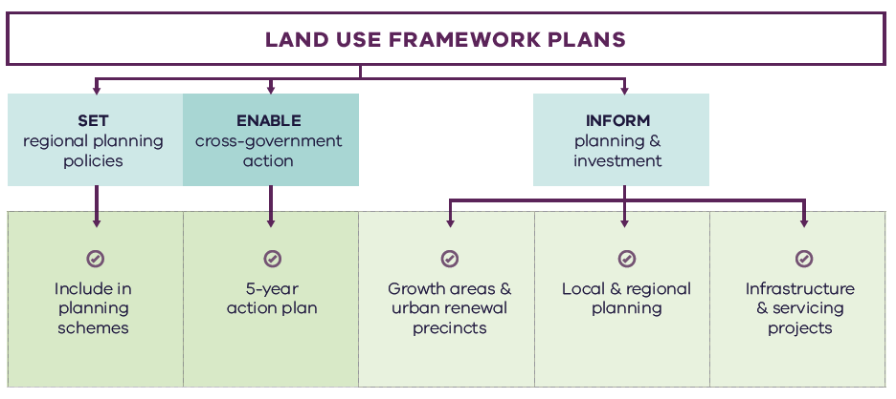
Figure 27. Implementation of the land use framework plan
Land use framework plans
- Set regional planning policies
  - Include in planning schemes
- Enable cross-government action
  - 5-year action plan
- Inform planning and investment
  - Growth areas and urban renewal precincts
  - Local and regional planning
  - Infrastructure and servicing projects

Five-year action program
A number of short- to medium-term actions are included in the Eastern Metro Region LUFP. The five-year action program (Table 14) summarises these actions to be delivered collaboratively by the state government and councils in the Eastern Metro Region. These actions deliver on the strategic directions identified in the LUFP and in turn, Plan Melbourne outcomes. The actions will positively and proactively address some of the challenges being experienced by the region.
Plan Melbourne and the Melbourne Industrial and Commercial Land Use Plan (MICLUP) also contain actions that may require regional collaboration and will support the outcomes sought by the LUFP. This LUFP’s five-year action program is a targeted list of actions identified during the development of the draft LUFP. It is not intended that this list duplicate existing Plan Melbourne or MICLUP actions other than where confirming a particular action was warranted given its regional implications.
In relation to transport, the following actions from Plan Melbourne Implementation Plan are identified as being well suited to being implemented at the regional level for this metro region and there is a commitment to deliver them as part of the implementation of Plan Melbourne and the LUFP:
- Action 43: Safe, efficient and accessible pedestrian networks
- Action 44: Local networks of cycling links
- Action 45: Local transport forums.
The implementation and prioritisation of the five-year action program will be driven by existing metro-regional governance arrangements including the Metropolitan Partnerships and EPWGs.
The indicative timeframes for completing actions are:
- Short term: By the end of 2023 (0–2 years)
- Medium term: By the end of 2026 (2–5 years).
Each action is allocated to a lead agency and implementation partners. Detail on the timing of actions and how they are implemented will be determined in line with normal government and council policy and budget processes. All actions requiring budget allocation will be carefully assessed against budget capacity, with rigorous business cases and cost-benefit analyses applied as part of their economic impact assessment.

Decision-making processes to support the delivery of the LUFPs
The LUFPs are a statement of policy intent. Detailed decisions about the implementation and timing of actions and infrastructure delivery will be made in line with normal government policy and budget processes.
The Victorian Government will continue its commitment to rigorous decision-making about initiatives that require funding, statutory amendments or new regulations in line with its economic and fiscal strategy, including the Government’s long-term financial management objectives.
For infrastructure projects, this will include ensuring consistency with the Victorian Government’s Investment Lifecycle and High Value/High Risk Guidelines. For all other initiatives and actions, implementation and timing will be subject to consideration of its evidence base and likely net benefits.

Monitoring, reporting and review
Action monitoring will be led by DELWP in partnership with the metropolitan region through the EPWG. DELWP will publish an annual progress report outlining the status of actions against the specified timeframe (whether an action has been ‘completed’, is ‘in progress’ or ‘not started’). These progress reports will be publicly available.
LUFP implementation will be formally reviewed every five years in conjunction with the Plan Melbourne Five-Year Implementation Plan. The review will be conducted in an open way and involve engagement with key stakeholders including Metropolitan Partnerships and EPWGs.

Actions – Implementation
- Update budget business case submission templates and guidance to identify how initiatives align with Plan Melbourne and the Land Use Framework Plans.

Five-year action program
Timeframe - Short term (S): By the end of 2023 (0–2 years). Medium term (M): By the end of 2026 (2–5 years)

 | Action | Source | Timeframe | Lead agency | Implementation partner(s)
1 | Establish a long-term state and local government partnership to oversee, coordinate and manage land use planning for the Monash NEIC. |  | S | DELWP, DJPR | Councils. VPA
2 | Implement a program of State Government-led planning projects, in partnership with local government, to ensure metropolitan and major activity centres and urban renewal areas maximise their respective strategic opportunities. Priority will be given to those which deliver significant jobs and housing; leverage investment in state infrastructure; and play an important role in the growth corridor and/or region. State-led planning for these state- and regionally-significant places will contribute to creating liveable communities and achieving more dwellings and jobs in established areas and identify implementation and coordination actions that support growth and economic investment. |  | S | VPA | Councils, DELWP
3 | Undertake Precinct Planning for Suburban Rail Loop Precincts with local councils and other stakeholders to guide land use change, transport integration and the creation of liveable, walkable and prosperous precincts. |  | M | SRLA | Councils, DELWP, DJPR
4 | Update planning schemes to align with housing policies in Plan Melbourne and the Eastern Metro Region Land Use Framework Plan and the implementation of the reformed residential zones. This includes:  Providing capacity for 15 years of regional housing supply focusing on locations identified for housing growth in the LUFP  Reviewing planning controls in housing investigation areas as potential locations for substantial or incremental housing change  This may require strategic planning work to support these changes such as preparing or updating local housing strategies or preparing structure plans to further investigate where increased densities can be supported, and determine specific changes required to planning schemes. |  | S | Councils | DELWP
5 | Identify underutilised and surplus government land that has potential to deliver additional social housing. | Plan Melbourne Five-Year Implementation Plan | S | DFFH (HV) | DELWP
6 | In partnership with councils, identify a pipeline of sites in the Eastern Metro Region for social and affordable housing. |  | M | DFFH (HV) | Councils
7 | Undertake a review of the regional bus network including improvements to the SmartBus routes, Doncaster and Regional Transport (DART) and improved access to Deakin University to support regional access and movement in the short to medium terms and to plan integration with major public transport changes such as the SRL. |  | S | DoT | Councils
8 | Prepare a vision for the Dandenong Valley Parklands, including defining the optimal extent of the parklands, and a framework to ensure key access points and integrated water management objectives are acknowledged in local planning decisions. |  | S | Parks Victoria | Councils, DELWP
9 | Assess the health services infrastructure in the region’s rural locations and prepare a regional response to improving access to services. |  | S | DH | Councils
10 | Review local planning policy and provisions for identified regionally-significant health and/or education precincts to support their continued effective operation and their future growth and expansion, including in the case of health precincts, for associated allied health services. |  | M | Councils | DELWP, DET, DH
11 | Develop guidance on a new approach to neighbourhood planning in partnership with local councils of the Eastern Metro Region which embeds the hallmarks of 20-minute neighbourhoods. |  | S | DELWP | Councils, DoT
12 | Prepare a regional bushfire response for suburban and peri-urban communities that are subject to bushfire risk. |  | M | DELWP | Councils, Country Fire Authority
13 | Update planning provisions for flooding (i.e. Special Building Overlay, Land Subject to Inundation Overlay and Urban Flood Zone) to represent current and forecast flooding data. |  | M | DELWP | Councils, Melbourne Water
14 | Update budget business case submission templates and guidance to identify how initiatives align with Plan Melbourne and the Land Use Framework Plans. |  | S | DTF

Appendix 01.
Relevant policies, strategies and initiatives
There are several current Victorian Government policies, strategies and initiatives that have implications for planning in the Eastern Metro Region. In addition, there are existing regional initiatives, initiated by councils and/or the Metropolitan Partnerships. This appendix provides an overview of the most relevant policies, strategies and initiatives for the Eastern Metro Region LUFP.
Plan Melbourne 2017-2050 and Plan Melbourne 2017-2050 Addendum, 2019, which will guide the growth of our city. Plan Melbourne sets out the strategy for supporting jobs, housing and transport, while building Melbourne’s legacy of distinctiveness, liveability and sustainability. The Addendum updates Melbourne’s projected population, housing and employment growth and the Melbourne 2050 spatial framework to align with major transport investments including SRL.
The Eastern Metro Region has regional initiatives relevant to the LUFP. These include:
The Melbourne East Regional Plan 2020 is a plan set out for Eastern Metro Councils, state and federal government agencies, businesses and communities of interest. The plan is future-focused to meeting the demands of increasing population, changing demographics, and evolving workforce needs in the Eastern Metro Region to manage growth.
The Eastern Affordable Housing Alliance is a collaboration between the six Local Government Authorities in the Eastern Metro Region of Melbourne aims to ensure access to safe, secure, affordable housing.
The Melbourne East Regional Sport and Recreation Strategy 2016 identifies the current gaps in regional level sport and recreation facility provision and provides clear strategic directions and a planning framework to assist stakeholders and funding providers to prioritise and develop regional projects.
The Eastern Regional Trails Strategy 2018 is a collaborative project by the region’s local governments to provide guidance on the delivery and maintenance of the regional cycling network. The strategy focuses on shared trails that are mostly off-road or recreational.
Specific Victorian Government policies, strategies and initiatives are outlined below under the relevant chapter of the LUFP to which they most strongly relate, acknowledging that many policies, strategies and initiatives are relevant to multiple chapters, or to the whole LUFP.

Productivity
The Melbourne Industrial and Commercial Land Use Plan 2019 provides an overview of current and future needs for industrial and commercial land across metropolitan Melbourne and puts in place a planning framework to support state and local government to more effectively plan for future employment and industry needs, and better inform future strategic directions.
The 2020/21 Victorian State Budget allocates funding for key Innovation and Employment Precincts, including Monash Clayton, supports delivering projects in partnership with knowledge institutes and industry stakeholders.
The Unlocking Enterprise in a Changing Economy policy paper provides support for the development of enterprise precincts. The newly introduced Commercial 3 Zone aims to provide land for creative and knowledge-based industries and to reduce the planning burden for a diversity of employment uses.
Support for Victoria’s creative industries is provided through the Creative State 2016-2020 strategy which aims to grow the state’s creative and cultural economy. Work is currently underway to develop the next creative industries strategy which will guide initiatives and investment between 2020 and 2024.
Protection of the long-term future of Melbourne’s green wedges and agricultural land is provided through the Planning for Melbourne’s Green Wedges and Agricultural Land project, which is exploring a range of planning system changes for how this can best be achieved.
The Metropolitan Partnerships are advisory groups established for each of the metropolitan regions by the Victorian Government that bring community and business together with state and local government and advise on the top priorities for jobs, services and infrastructure across the region.

Housing choice
Planning system administrative and policy reforms such as Smart Planning are reducing red tape and, in doing so, facilitating the supply of housing.
Planning Practice Notes on Residential Zones and Planning for Housing provide greater clarity for local councils on the technical aspects of how to apply the residential zones and how to plan for housing growth and protect neighbourhood character.
The Housing Development Data dashboard will provide improved access to information on the quantity and location of housing being developed.
The Better Apartments Design Standards and Apartment Design Guidelines for Victoria assists in improving the quality and functionality of apartments in Victoria.
The Future Homes Project is producing better apartment designs and helping Melbourne become a world leader in apartment design, sustainability and liveability.
Housing Outcomes in Established Melbourne 2005 to 2016 highlights how housing development data can be used to understand changes in density, development of housing in activity centres and the influence of zones and overlays on housing change.
Big Housing Build will deliver 9300 new social housing dwellings and 2900 new affordable and market homes for first homebuyers and renters across the state. It includes:
- $532 million to replace obsolete properties on Homes Victoria land and constructing new homes – this includes Fast Start projects at Victoria Street, Flemington and Elizabeth Street in Richmond.
- $948 million for ready to build and spot purchase, working with private sector to bring forward new developments ready to start construction and purchase existing residential properties.
- $1.38 billion funding for projects by the community housing sector, through the Social Housing Growth Fund.
- $2.14 billion in partnerships with the private and community housing sector – exploring options to build on surplus government owned sites.
The Social Housing Growth Fund is the vehicle for allocating new funds to suitable projects proposed by the community housing sector.
The Homelessness and Rough Sleeping Action Plan initiatives include 20 one-bedroom modular units with intensive onsite support, multidisciplinary housing teams to support complex clients to maintain stable housing, eight additional assertive outreach teams in locations of highest need, and funding therapeutic services in major inner city crisis accommodation centres to improve health, wellbeing and housing outcomes.
The redevelopment of public housing estates is a program to transform ageing public housing estates across metropolitan Melbourne and key regional centres into vibrant, well-connected neighbourhoods. This will create at least 1,800 new` public housing homes.
The Building new homes to fight homelessness is a program to help Victorians escaping family violence, homelessness and life on the streets by building 1,000 new public housing properties.

Integrated transport
North East Link will provide the ‘missing link’ between the Eastern Freeway and the M80 Ring Road in Melbourne’s north east and, in doing so, reduce travel times, remove trucks from local roads and link growth areas in the north and south-east of Melbourne and enhance connections between the Western Ring Road, Hume Freeway and Eastern Freeway to Melbourne’s south-east.
The West Gate Tunnel will create a second river crossing to link the Western Metro Region with the Port of Melbourne, CityLink and the CBD, and take traffic pressures off the West Gate Bridge.
The Level Crossing Removal Project will continue to provide improved travel and safety for road users, public transport users, cyclists and pedestrians by removing additional level crossings across metropolitan Melbourne.
The Urban Congestion Fund will upgrade the urban road network to reduce congestion upgrading pinch points, intersections and commuter car park upgrades at train stations.
The South Eastern Roads Upgrade will improve six roads within this region making it quicker, easier and safer for road users.
The Victorian Infrastructure Plan seeks to build, improve and care for Victoria’s infrastructure. It responds to Infrastructure Victoria’s 30-year Infrastructure Strategy and presents priorities and directions across nine key sectors.
Suburban Rail Loop is a new orbital rail link connecting Melbourne’s middle suburbs from Cheltenham to Werribee via Melbourne Airport and includes preparing detailed precinct frameworks and structure planning for all SRL precincts. Suburban Rail Loop consists of SRL East (Cheltenham to Box Hill), SRL North (Box Hill to Airport) and SRL West (Airport to Werribee).
The 2020/21 Victorian State Budget allocates funding for SRL East (Cheltenham to Box Hill) the first section of the SRL to be delivered.
Melbourne Airport Rail will connect Melbourne Airport to metropolitan and regional rail networks via Sunshine.
The Metro Tunnel will create additional capacity on Melbourne’s rail network by running the Cranbourne, Pakenham and Sunbury lines through a new tunnel.
The proposed Caulfield to Rowville Link will be a connection between Caulfield and Rowville linking Caulfield Station to Monash University Clayton via Chadstone Shopping Centre then to Rowville via Waverley Park.
Moving freight throughout the state will be enhanced as part of the Delivering the Goods: Creating Victorian Jobs – Victorian Freight Plan.
Movement and Place is a way of thinking about the roles and challenges facing our transport system now and into the future. The Movement and Place approach recognises that transport links perform two functions: movement of people and goods and serving as a place (a destination in its own right). This way of thinking ensures that while we are planning for and developing our network, we are considering the needs for movement and placemaking simultaneously.
Victoria’s Zero Emissions Vehicle Roadmap sets out a plan to achieve half of all light vehicle sales in Victoria to be Zero Emission Vehicles by 2030.
The 2020/21 Victorian State Budget allocates funding for road and intersection upgrades at Albert Avenue and Mountain Highway intersection, Boronia, will improve road safety and travel times.

Liveability
The Aboriginal Heritage Act 2006 acts primarily to provide for the protection of Aboriginal cultural heritage in Victoria. It allows different organisations, groups and bodies to connect and better enforce and preserve policies regarding Aboriginal Heritage
The Upper Yarra Valley and Dandenong Ranges Regional Strategy Plan was prepared by the former Upper Yarra Valley and Dandenong Ranges Authority in the late 1970s and early 1980s. The plan provides a framework to protect the special features and character of this part of the region and is legislated through the Planning and Environment Act 1987.
Protecting Victoria’s Environment – Biodiversity 2037 is the Victorian Government’s plan to stop the decline of the state’s biodiversity and achieve overall biodiversity improvement over the next 20 years.
The Victorian Heritage Register lists and provides legal protection for heritage places and objects that are significant to the history and development of Victoria. It includes a wide range of places and objects, such as buildings, trees, gardens, archaeological sites and structures.
Open Space for Everyone: Open Space Strategy for Metropolitan Melbourne 2020 supports a cooler, greener city with a network of quality open spaces to which all members of the community have access.
The Healthy Waterways Strategy 2018 provides a framework for managing rivers, wetlands and estuaries in Melbourne’s five major catchments to ensure their value to the community is protected and improved.
The Yarra River Protection (Wilip-gin Birrarung murron) Act 2017 identifies the Yarra River as a single living and integrated natural entity for protection. It recognises intrinsic connection of the Traditional Owners to the Yarra River and its Country and further recognises them as the custodians of the land.
The Yarra River Action Plan, released in February 2017, details 30 specific actions to ensure the long-term protection of the river and its parklands.
The draft Yarra Strategic Plan sets the foundation to achieve the Yarra River 50 Year Community Vision and deliver on the aspirations contained in the Wurundjeri Woi Wurrung Cultural Heritage Aboriginal Corporation’s Nhanbu narrun ba ngargunin twarn Birrarung (Ancient Spirit & Lore of the Yarra) water policy. It includes a land use framework plan for the river corridor.

Strong communities
The 20-minute Neighbourhoods project delivers a range of initiatives to create a city of 20-minute neighbourhoods, enabling communities to live more locally.
The 2020/21 Victorian State Budget allocates funding for investment in public libraries that will support the expansion of public library services in the Eastern Metro Region.
The 2020/21 Victorian State Budget allocates funding for the Community Sports Infrastructure Stimulus Program that will fast-track shovel-ready community sports infrastructure projects across Victoria.
The Victorian Cycling Strategy 2018-28 guides planning and investment in cycling in the state.
Active Victoria – A Strategic Framework for Sport and Recreation in Victoria 2017-2021 provides a strategic framework for future work into Victoria’s sports and active recreation sector.
The 2020/21 Victorian State Budget allocates funding for the redevelopment of the State Basketball Centre at Knox will create one of Australia’s premier basketball facilities.
The Suburban Parks Program will deliver more than 6,500 hectares of new and upgraded parks and trails across greater Melbourne.
The 2020/21 Victorian State Budget allocates funding for park upgrades at Jells Park, Olinda Precinct and Wattle Park will improve quality of open space for the region.
The Victorian Government has committed $675 million to the Community Hospitals Program to build ten community hospitals close to major growth areas enhancing access to health services in growing communities.
The Statewide Design, Service and Infrastructure Plan for Victoria’s Health System 2017-2037 provides a planning framework to guide service, workforce and infrastructure investment in Victoria’s health system.
Health 2040: Advancing Health, Access and Care presents a clear vision for the health and wellbeing of Victorians and for the Victorian healthcare system.
The Victorian Public Health and Wellbeing Plan 2019-2023 seeks to ensure that all Victorians enjoy the highest attainable standard of health, wellbeing and participation at every age. The production of this Plan is legislated for under the Victorian Public Health and Wellbeing Act 2008.
The 2020/21 Victorian State Budget allocates funding for the Metropolitan Health Infrastructure Fund will work with hospitals and health services to upgrade infrastructure to support the delivery of new or enhanced services to patients.
The 2020/21 Victorian State Budget allocates funding for the accelerated planning and design for the expansion of Angliss Hospital at Ferntree Gully will improve healthcare services in Melbourne’s outer east.
The Land Utilisation Assessment Program works to improve utilisation of government land.
The Victorian Aboriginal Affairs Framework 2018-2023 (the VAAF) is the Victorian Government’s overarching framework for working with Aboriginal Victorians, organisations and the wider community to drive action and improve outcomes.
The Suburban Revitalisation program facilitates the delivery of urban renewal in metropolitan activity centres experiencing economic transition and/or significant levels of disadvantage. The Program is centred on a partnership between State agencies, local councils and regional stakeholders to accelerate the development and delivery of local infrastructure upgrades, small business stimulus initiatives and community connectedness activities. The Eastern Metro Region includes Suburban Revitalisation projects in Boronia and Lilydale.

Sustainability and resilience
Sector and whole-of-government emission reduction pledges will help achieve the Victorian Government’s target of net-zero emissions by 2050.
The Climate Change Act 2017 provides Victoria with a world-leading legislative foundation to manage climate change risks, maximise the opportunities that arise from decisive action, and drive our transition to a climate resilient community and economy with net-zero emissions by 2050.
Adaption Action Plans (Climate Change Act 2017) will help build the state’s resilience and help Victorians plan for the inevitable impacts of climate change.
Victoria’s Climate Change Strategy (2021) has a range of specific measures to support the uptake of renewable energy in businesses, industry and homes. It includes further reforms to drive greater energy efficiency of electrical appliances, lighting and air-conditioning/heating equipment and to improve the thermal performance of new buildings. Transport emissions will be reduced by accelerating Victoria’s transition to zero emissions vehicles, improving public transport and investing more in cycling and walking options. The Strategy will also support the circular economy reforms to Victoria’s waste management system contained in the Recycling Victoria action plan, Recycling Victoria: A New Economy.
The Victorian State Budget 2020/21 delivered a landmark $2 billion for the Breakthrough Victoria Fund to drive translation and commercialisation of knowledge in Victoria. The Clean Economy is one of the five key sectors the Fund will prioritise.
The Victorian State Budget 2020/21 also provided funding for clean energy transition initiatives, including establishing renewable energy zones to develop and deliver renewable energy projects.
The Victorian Climate Projections 2019 Technical Report describes how the regional climate of Victoria is likely to respond to global warming with different scenarios of human greenhouse gas emissions.
The Cooler, Greener Melbourne project will create more liveable and climate-adapted communities through green infrastructure and other cooling and greening initiatives. Tree planning on public land will create a cooler and greener Melbourne as part of Melbourne Water’s Urban Cooling Program. The program includes changes to planning schemes to protect and strengthen the urban forest.
Living Melbourne: Our Urban Forest Strategy (2019) is a strategy for a greener, more liveable Melbourne, developed by Nature Conservancy and Resilient Melbourne.
The Renewable Energy (Jobs and Investment) Act 2017 legislates an increase of the Victorian Renewable Energy Target (VRET) to 50 per cent by 2030.
Water for Victoria is a plan for a future with less water as Victoria responds to the impact of climate change and a growing population.
The Victorian Water and Climate Initiative supports research into the impact of climate change and climate variability on Victoria’s water resources. Additional investments will be made to enhance the scientific understanding of Victoria’s climate and provide authoritative data and information on climate change to the community.
Integrated Water Management Framework for Victoria provides a collaborative approach to the way we plan for and manage all elements of the water cycle, including the health of waterways and bays, wastewater management, alternative and potable water supply, stormwater management and water treatment. In the Eastern Metro Region this applies to the Yarra River and Dandenong Creek catchments.
The Statewide Waste and Resource Recovery Infrastructure Plan 2018 (SWRRIP) guides future planning for waste and resource recovery infrastructure to achieve an integrated system.
The Metropolitan Waste and Resource Recovery Implementation Plan brings together the statewide priorities set out in the SWRRIP and applies them within the metropolitan context.
The Recycling Industry Strategic Plan transitions Victoria’s recycling industry to a more sustainable and resilient model.
Recycling Victoria: A New Economy outlines a plan for reform to establish a recycling system that Victorians can rely on and transforms how our economy uses materials and how our state reuses, repairs and recycles.
The 2020/21 Victorian State Budget allocates funding for the 10-year Recycling Victoria action plan, Recycling Victoria: A New Economy to transform Victoria’s recycling sector and develop a circular economy.

Appendix 02.
Housing choice supporting data
TABLE A2-1. Major housing development completed in the Eastern Metro Region in and within 400m of activity centres (2005-2018) and in the redevelopment pipeline
Activity Centre | Major housing redevelopment completed 2005-2016* - In Centre | Major housing redevelopment completed 2005-2016* - Within 400m of Centre | Major housing redevelopment completed 2017-2018* - In Centre | Major housing redevelopment completed 2017-2018* - Within 400m of Centre | Major housing redevelopment pipeline* - In Centre | Major housing redevelopment pipeline* - Within 400m of Centre
Bayswater | 192 | 10 | 121 | 0 | 193 | 0
Boronia | 222 | 0 | 97 | 0 | 225 | 27
Box Hill | 1689 | 166 | 1669 | 96 | 3889 | 195
Burwood East, Tally Ho | 69 | 19 | 13 | 0 | 136 | 236
Burwood Heights | 31 | 353 | 46 | 85 | 724 | 127
Chadstone | NA | 80 | NA | 0 | NA | 146
Chirnside Park | 77 | 12 | 176 | 0 | 46 | 0
Clayton | 30 | 61 | 0 | 0 | 21 | 146
Croydon | 360 | 152 | 125 | 50 | 129 | 38
Doncaster East, The Pines | 98 | 30 | 219 | 0 | 477 | 0
Doncaster Hill | 1502 | 346 | 699 | 391 | 845 | 439
Forest Hill Chase | 0 | 133 | 0 | 0 | 0 | 0
Glen Waverley | 137 | 47 | 266 | 10 | 618 | 74
Lilydale | 103 | 146 | 42 | 0 | 85 | 16
Mountain Gate | 82 | 50 | 59 | 44 | 23 | 0
Nunawading | 492 | 12 | 51 | 0 | 234 | 18
Oakleigh | 369 | 156 | 152 | 129 | 222 | 1005
Ringwood | 346 | 142 | 594 | 70 | 1161 | 54
Rowville, Stud Park | 146 | 12 | 84 | 99 | 57 | 127
* Major development is defined as developments with over 10 dwellings
Note: Dwelling numbers are calculated based on constructed not net additions dwellings.
Note: Pipeline refers to projects that are: under construction, have a planning permit, have had pre-application meetings, or being sold off the plan.
Note: 400m activity centre buffer may be in multiple metro Regions.
Housing Development Data 2016, Urban Development Program – Redevelopment 2018, Urban Development Program – Redevelopment 2019

Glossary
Where the term is defined in Plan Melbourne or the Victoria Planning Provisions, that definition is used.
Aboriginal | Aboriginal refers to both Aboriginal and Torres Strait Islander peoples. They may have connections in and outside of Victoria.
Active transport | Transport requiring physical activity, typically walking and cycling.
Activity centres | Areas that provide a focus for services, employment, housing, transport and social interaction. They range in size and intensity of use from smaller neighbourhood centres to major suburban centres and larger metropolitan centres.
Affordable housing | Housing that is appropriate for the needs of a range of very low to moderate income households, and priced (whether mortgage repayments or rent) so these households are able to meet their other essential basic living costs.
Agglomeration | The location of businesses in close proximity to each other, which allows them to get productivity and efficiency gains through large customer bases, knowledge sharing and access to skilled workers.
Biodiversity | The variety of all life forms, the different plants, animals and microorganisms, the genes they contain and the ecosystems of which they form a part.
Central Business District (CBD) | Melbourne’s original ‘Hoddle Grid’ street layout bounded by the Yarra River, Spring Street, La Trobe Street and Spencer Street, as well as the triangular area to the north bounded by Victoria, Peel and La Trobe streets.
Central City | The area within the inner metro region that contains key capital city functions and civic facilities, as well as several precincts identified for major and strategic change. The Central City incorporates the CBD (Hoddle Grid, north to Grattan Street between Peel and Swanston streets) as well as Docklands, Southbank and St Kilda Road.
Climate change | A long-term change of the earth’s temperature and weather patterns – generally attributed directly or indirectly to human activities such as fossil fuel combustion and vegetation clearing and burning.
Commercial land | Land used for commercial purposes including land used for business services, retail, accommodation, food and other industries.
Creative industry | Media, digital screen, design, writing and publishing, literature, fashion, performing arts, digital games development, broadcasting, music, cultural heritage, arts, education and craft industries.
Enterprise precincts | Precincts that facilitate the creation and commercialisation of new ideas and support metropolitan economies by growing jobs in ways that leverage their distinct economic attributes. These districts build on and revalue the intrinsic qualities of cities: proximity, density, authenticity, and vibrant places. (Brookings Institute definition)
Eastern Metro Region | Includes the LGAs of Knox, Manningham, Maroondah, Monash, Whitehorse, Yarra Ranges.
Established urban areas | Areas of Melbourne that have been urbanised for at least several decades.
Green wedges | Defined under Part 3AA of the Planning and Environment Act 1987 as “land that is described in a metropolitan fringe planning scheme as being outside an urban growth boundary”. There are 12 defined green wedges spanning parts of 17 municipalities.
Greenfield land | Undeveloped land identified for residential or industrial/commercial development, generally on the fringe of metropolitan Melbourne.
Greenhouse gas emissions | Atmospheric gas that absorbs and emits infrared or heat radiation, giving rise to the greenhouse effect. Typical greenhouse gases include carbon dioxide, methane, nitrous oxide and refrigerants.
Greyfield | Residential areas where the building stock is near or has ended its useful life and land values make redevelopment attractive.
Gross regional product (GRP) | Gross regional product is a measure of the market value of all final goods and services produced in a region over a period of time.
Growth areas | Locations on the fringe of metropolitan Melbourne designated in planning schemes for large-scale transformation, over many years, from rural to urban use.
Growth corridor plans | The growth corridor plans are high level integrated land use and transport plans that provide a strategy for the development of Melbourne’s growth corridors over the coming decades.  The growth corridor plans focus on three metropolitan growth corridors: Northern, Western and South Eastern growth corridors. They identify broad transport networks, industrial and employment areas, residential areas and recreation precincts across the city’s newest metropolitan suburbs. Relevant information from the growth corridor plans have been integrated into the LUFPs containing growth corridors.
Health and education precincts | Locations to cluster synergistic health and/or education services to improve access to integrated service provision, improve outcomes, develop the health and education workforce and deliver economic benefits (such as innovation and job creation). These precincts may provide solely health, solely education, or a combination of health and education services.
Hoddle Grid | The grid pattern of streets making up Melbourne’s CBD bounded by the Yarra River, Spring Street, La Trobe Street and Spencer Street, as well as the triangular area to the north bounded by Victoria, Peel and La Trobe streets. The grid was designed by Robert Hoddle in 1837.
Housing density | The number of dwellings in an urban area divided by the area of the residential land they occupy, expressed as dwellings per hectare.
Hybrid centre | A descriptor for an activity centre typology that contains a mixed arrangement of freestanding / enclosed shopping complexes and traditional open air strip-based commercial land.
Infill | Development of unused or underutilised land in existing urban areas.
Infrastructure | Basic facilities and networks needed for the functioning of a local community or broader society.
Integrated water management (IWM) | An approach to planning that brings together all facets of the water cycle including sewage management, water supply, stormwater management and water treatment, ensuring environmental, economic and social benefits.
Inner Metro Region | Includes the LGAs of Melbourne, Port Phillip and Yarra.
Inner South East Metro Region | Includes the LGAs of Boroondara, Glen Eira, Stonnington and Bayside.
Intermodal freight terminal | A location for the transfer of freight from one transport mode to another, for example between road and rail.
Knowledge-based industries and jobs | Production and services based on knowledge-intensive activities that contribute to an accelerated pace of technical and scientific advancement. Their key characteristic is a greater reliance on intellectual capabilities than on physical inputs or natural resources.
Liveability | A measure of a city’s residential quality of life, used to benchmark cities around the world. It includes socioeconomic, environmental, transport and recreational measures.
Localised planning statement | Long-term policies for the future planning and development of areas identified as having significance to the broader Victorian community.
Major activity centres | Suburban centres that provide access to a wide range of goods and services. They have different attributes and provide different functions, with some serving larger sub-regional catchments. Plan Melbourne identifies 121 major activity centres.
Metropolitan activity centres | Higher-order centres with diverse employment options, services and housing stock, supported by good transport connections. Existing centres include Box Hill, Broadmeadows, Dandenong, Epping, Footscray, Fountain Gate/Narre Warren, Frankston, Ringwood and Sunshine. Future centres will include Lockerbie and Toolern.
Metropolitan Melbourne | The 31 municipalities that make up metropolitan Melbourne, plus part of Mitchell Shire within the Urban Growth Boundary.
Moderate income household | Annual household income within the income range specified as a moderate range by Order under section 3AB of the Planning and Environment Act 1987. In 2020 this was $87,671 to $131,500 for a family (with one or two parents) and dependent children.
National employment and innovation clusters (NEIC) | Designated concentrations of employment distinguished by a strong core of nationally significant knowledge sector businesses and institutions that make a major contribution to the national economy and Melbourne’s position in the global economy.
Natural hazard | A natural event that has potential to cause harm to people, property or the environment, including climate change, bushfire, flooding and sea level rise.
Neighbourhood activity centres | Local centres that provide access to local goods, services and employment opportunities and serve the needs of the surrounding community.
Northern Metro Region | Includes the LGAs of Banyule, Darebin, Hume, Mitchell (part), Moreland, Nillumbik and Whittlesea.
Open space | Includes land reserved for natural landscape, parklands, recreation and active sports, as well as waterways and bays.
Peri-urban areas | Areas beyond the green wedges made up of local government areas with a predominantly rural character, located all or partially within a 100-kilometre radius of Melbourne.
Precinct Structure Plans (PSPs) | Master plans for future growth corridor developments, informed by growth corridor planning. The plans identify alignments of transport routes, town centres, open space networks, densities of residential areas, and areas for industry and employment.
Primary healthcare | Primary healthcare is generally the first contact a person has with Australia’s health system. It relates to the treatment of patients who are not admitted to hospital. It encompasses a wide range of health professionals and includes general practitioners, community nurses, midwives, pharmacists, dentists, and Aboriginal health workers, for example.
Principal Freight Network (PFN) | Part of the larger transport network over which the movement of heavy freight will be concentrated.
Principal Public Transport Network (PPTN) | A statutory land use planning tool that supports integrated land use and transport planning by providing certainty to land use planners and developers around locations that are and will be served by high-quality public transport.
Regional active open spaces | Large scale open spaces that cater for a range of recreational opportunities including informal outdoor recreation, active recreation and sports. Regional active open spaces serve a broad catchment and may comprise buildings and infrastructure to facilitate sporting or recreational activity.
Regional parks | Regional parks are large areas of open space that feature natural or semi-natural surroundings in close proximity to urban environments. They have high landscape, biodiversity and cultural values and provide a diversity of passive recreational, educational or tourism opportunities.
Regional Victoria | Includes all municipalities outside metropolitan Melbourne (except part of Mitchell Shire within the Urban Growth Boundary).
Regionally-significant industrial precincts (RSIP) | Key industrial areas that contribute significantly to local and regional economies. Some of these areas are well established and support a range of industrial uses while others are transitioning and supporting new uses. They include future employment areas identified through growth corridor plans that will support not just employment growth in outer areas, but to also meet Melbourne’s longer term industrial and logistics needs. They are to be retained and planned for to allow a range of industrial uses, or where appropriate, new and emerging businesses that require access to affordable and well-located employment land.
Renewable energy | Energy that comes from resources which are naturally replenished on a human timescale such as sunlight, wind, rain, tides, waves, and geothermal heat.
Resilience | The capacity of individuals, communities, institutions, businesses, systems and infrastructure to survive, adapt and grow, no matter what chronic stresses or shocks they encounter.
Resource recovery | Extraction of useful material or energy from a waste stream.
Social housing | A type of rental housing that is provided and/or managed by the government or by a not-for-profit organisation. Social housing is an overarching term that covers both public housing and community housing.
Social infrastructure | Encompasses all the facilities, services and networks that help families, groups and communities to meet their social, health, education, cultural and community needs.
Southern Metro Region | Includes the LGAs of Cardinia, Casey, Greater Dandenong, Frankston, Kingston and Mornington Peninsula.
State-significant industrial precincts (SSIP) | Strategically located land available for major industrial development linked to the Principal Freight Network and transport gateways. They will be protected from incompatible land uses to allow continual growth in freight, logistics and manufacturing investment.  There are five state-significant industrial precincts: Western Industrial Precinct, Northern Industrial Precinct, Southern Industrial Precinct, Port of Hastings Industrial Precinct and Officer-Pakenham Industrial Precinct.
Strategic Cycling Corridors (SCC) | Strategic Cycling Corridors are important transport routes for cycling and are a subset of the Principal Bicycle Network (PBN). The SCC network supports the needs of commuter trips (to work or education) and other important trips, such as to stations, shops or schools.  The SCC network links up important destinations, including central Melbourne city, employment and activity centres, and other destinations of metropolitan and regional significance.  SCCs can be on and off road, on municipal and state roads and are designed to provide a safe, lower-stress cycling for transport experience.
Strategic Extractive Resource Area (SERA) | Recognised and secured extractive resource areas of strategic importance for the construction of public infrastructure, affordable housing and private sector development now and in the future.  They cover extractive resources that actually and/or potentially occur in defined locations at various scales based on their likelihood or potential to supply growth areas, taking into account accessibility to markets, while minimising impacts on environment and other land use constraints.
Traditional Owners | People who, through membership of a descent group or clan, are responsible for caring for particular Country. A Traditional Owner is authorised to speak for Country and its heritage as a senior Traditional Owner, an Elder or, in more recent times, a registered native title claimant.
Transit-oriented development | Compact, walkable, mixed-use communities centred around high-quality train systems. Transit-oriented development assists in addressing the growing problems of climate change and global energy security by creating dense, walkable communities that greatly reduce the need for driving and energy consumption.
Transport gateway | Ports, airports and interstate terminals that serve as key locations for moving passengers and freight into and out of Victoria and also play a significant economic and employment-generating role.
20-minute neighbourhoods hallmarks | The ‘hallmarks’ are established in Plan Melbourne’s Direction 5.1 — Create a city of 20-minute neighbourhoods. The ‘hallmarks’ developed in partnership with the Department of Health and the Heart Foundation (Victoria) are:  be safe, accessible and well connected for pedestrians and cyclists to optimise active transport  offer high-quality public realm and open spaces  provide services and destinations that support local living  facilitate access to quality public transport that connects people to jobs and higher-order services  deliver housing/population at densities that make local services and transport viable  facilitate thriving local economies.
Urban forest | All of the trees and other vegetation in a city as well as the soil and water that supports it.
Urban Development Program (UDP) | The Urban Development Program (UDP) provides an annual assessment of supply and consumption of industrial and residential land across metropolitan Melbourne.
Urban Growth Boundary (UGB) | A management tool to contain urban areas and limit their expansion. It divides land that is urban – to be used for housing, shops, factories – from land that is nonurban and to be used for purposes such as conservation, agriculture, mineral extraction, airports and the like. A UGB encourages urban consolidation and protects valued non-urban areas from urban development.
Urban renewal | The process of planning and redeveloping underutilised medium- and large-scale urban areas, precincts or sites for mixed land use purposes.
Very low income household | Annual household income within the income range specified as a very low income range under section 3AB of the Planning and Environment Act 1987. In 2020 this was up to $26,090 for a single adult.
Western Metro Region | Includes the municipalities of Brimbank, Hobsons Bay, Maribyrnong, Melton, Moonee Valley and Wyndham.
Water sensitive urban design (WSUD) | Integrating the urban water cycle into urban design to minimise environmental damage and improve recreational and aesthetic outcomes.
Wallan SA2 | Statistical Areas Level 2 (SA2) are medium-sized general purpose areas established by the ABS that represent a community that interacts together socially and economically. The Wallan SA2 is larger than the area in Mitchell within the Urban Growth Boundary and generally follows the municipal boundary west of Wallan and extends north of Wandong and east into Kinglake National Park.
Yarra River Land | Crown and State Government-owned land within 500 metres of the Yarra River declared under the Yarra River Protection (Wilip-gin Birrarung murron) Act 2017. The declaration provides additional protection to this land. Yarra River Land that is used for public recreation forms the Greater Yarra Urban Parklands.

References
Australian Bureau of Statistics, 2021. Regional Population 2019-20 financial year: Commonwealth of Australia, Canberra, Australia.
Australian Sustainable Built Environment Council, 2016. Low Carbon, High Performance, Surrey Hills, NSW, Australia: ASBEC.
CASBE, 2021. Home - The Council Alliance for a Sustainable Built Environment (CASBE). [Online] Available at: https://www.casbe.org.au
Clarke, J. et al., 2019. Victorian Climate Projections 2019 Technical Report, Melbourne: CSIRO.
DELWP, 2016. Housing Development Data 2005 - 2016 - Eastern Region, Melbourne: State of Victoria.
DELWP, 2018a. Integrated Water Management Forums, Dandenong Strategic Directions Statement, The State of Victoria Department of Environment, Land, Water and Planning.
DELWP, 2018b. Integrated Water Management Forums, Yarra Strategic Directions Statement 2018, Melbourne, Victoria: The State of Victoria Department of Environment, Land, Water and Planning.
DELWP, 2019a. Plan Melbourne Addendum, Melbourne: State of Victoria.
DELWP, 2019b. Victoria in Future, Melbourne: State of Victoria.
DELWP, 2019c. Victorian Greenhouse Gas Emissions Report, Melbourne: State of Victoria.
DELWP, 2021a. Environmentally Sustainable Development of Buildings and Subdivisions - A roadmap for Victoria’s planning system, State of Victoria, Melbourne, Australia: The State of Victoria.
DELWP, 2021b. Internal analysis using Victorian Integrated Survey of Travel and Activity (VISTA) 2016-18 survey data.
Department of Industry, Science, Energy and Resources, 2021. Nationwide House Energy Rating Scheme (NatHERS). [Online] Available at: https://www.nathers.gov.au
Eastern Regional Trails Strategy, 2018. Eastern Regional Trails Strategy, Melbourne, Victoria: Victorian Government.
eWater, 2021. MUSIC (Model for Urban Stormwater Improvement Conceptualisation). [Online] Available at: https://ewater.org.au/products/music/
Green Building Council of Australia, 2021. Green Star Rating System. [Online] Available at: https://new.gbca.org.au/rate/rating-system/
Hurley, J. et al., 2018a. Melbourne Urban Vegetation Cover 2018, Eastern Region, Melbourne: DELWP.
Hurley, J. et al., 2018b. Urban Vegetation Cover Analysis, Melbourne Metropolitan Region 2018, Melbourne: State of VIctoria.
Hurley, J. et al., 2019. Urban Vegetation Cover Change in Melbourne: 2014 - 2018, Melbourne: Centre for Urban Research, RMIT University.
KPMG & ARUP, 2017. Travel Demand and Movement Patterns report, Melbourne: Infrastructure Victoria.
Melbourne Water, 2020. Water catchments. [Online] Available at: https://www.melbournewater.com.au/community-and-education/about-our-water/why-melbournes-water-tastes-great-tap/water-catchments [Accessed May 2020].
PSMA Australia Limited, 2021. Buildings Spatial Data | Building GIS Data | Geoscape. [Online] Available at: https://geoscape.com.au/data/buildings/ [Accessed 2021].
Regional Development Australia, 2020. Melbourne East Regional Plan 2020, Canberra: Commonwealth of Australia.
Sun, C. et al., 2019. Urban Vegetation, Urban Heat Islands and Heat Vulnerability Assessment in Melbourne, 2018, Melbourne, Australia: Clean Air and Urban Landscapes Hub.
The Nature Conservancy and Resilient Melbourne, 2019. Living Melbourne: Our Metropolitan Urban Forest Technical Report, Melbourne: The Nature Conservancy and Resilient Melbourne.
Urich, C. & Hardy, M., 2020. Cooling and Greening Melbourne – Future scenarios, Melbourne: Cooperative Research Centre for Water Sensitive Cities.
Wurundjeri Woi Wurrung Cultural Heritage Aboriginal Corporation, 2020. Home. [Online] Available at: https://www.wurundjeri.com.au/ [Accessed October 2020].

© The State of Victoria Department of Environment, Land, Water and Planning 2021
This work is licensed under a Creative Commons Attribution 4.0 International licence. You are free to re-use the work under that licence, on the condition that you credit the State of Victoria as author. The licence does not apply to any images, photographs or branding, including the Victorian Coat of Arms, the Victorian Government logo and the Department of Environment, Land, Water and Planning (DELWP) logo. To view a copy of this licence, visit http://creativecommons.org/licenses/by/4.0/
ISBN 978-1-76105-646-8 (pdf/online/MS word)

Disclaimer
This publication may be of assistance to you but the State of Victoria and its employees do not guarantee that the publication is without flaw of any kind or is wholly appropriate for your particular purposes and therefore disclaims all liability for any error, loss or other consequence which may arise from you relying on any information in this publication.

Credits
Green Scribble (graphic design)
Department of Jobs, Precincts and Regions (photos)
Tim Bell Studio (photos).

Accessibility
If you would like to receive this publication in an alternative format, please telephone the DELWP Customer Service Centre on 136 186, email customer.service@delwp.vic.gov.au or via the National Relay Service on 133 677 www.relayservice.com.au. This document is also available on the internet at www.delwp.vic.gov.au
Submissions can be made online at engage.vic.gov.au
For any questions or assistance please contact lufp@delwp.vic.gov.au

