Plan Melbourne 2017-2050

Draft Western Metro

Land Use Framework Plan

Summary

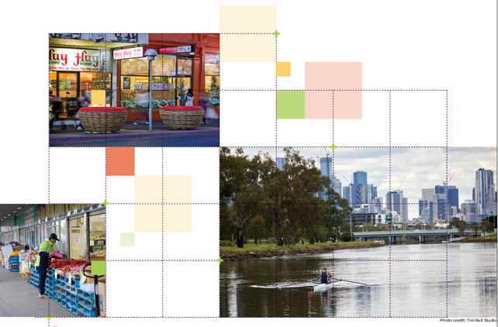

Great cities aren’t born. They’re made.
Melbourne is a great city. It’s a great place to live, work and raise a family. It’s a great place for investment and creativity. It’s a great place to visit and enjoy.
The Victorian Government has developed land use framework plans for each of the six metropolitan regions that are all about ensuring Melbourne remains a great city as it grows.
These plans mark a new era in the planning of Melbourne, building on the efforts of generations of Victorians to shape the way land is used around Port Phillip Bay.
The Western Metro Land Use Framework Plan is a 30-year strategy for action across six local government areas – Brimbank, Hobsons Bay, Maribyrnong, Melton, Moonee Valley and Wyndham.
It’s about making the long-term plans and investments that protect and enhance local areas and communities while ensuring Melbourne’s west grows more prosperous, liveable, affordable and sustainable.
The Western Metro Land Use Framework Plan is also about maximising the social, economic and environmental benefits of city-shaping transformational investments like the Metro Tunnel, West Gate Tunnel, Melbourne Airport Rail and Suburban Rail Loop.
This plan is all about keeping western Melbourne marvellous – from its beaches and rivers to its wetlands and bushlands to its suburbs and towns. It’s also about building the best possible future for the Western Metro region.
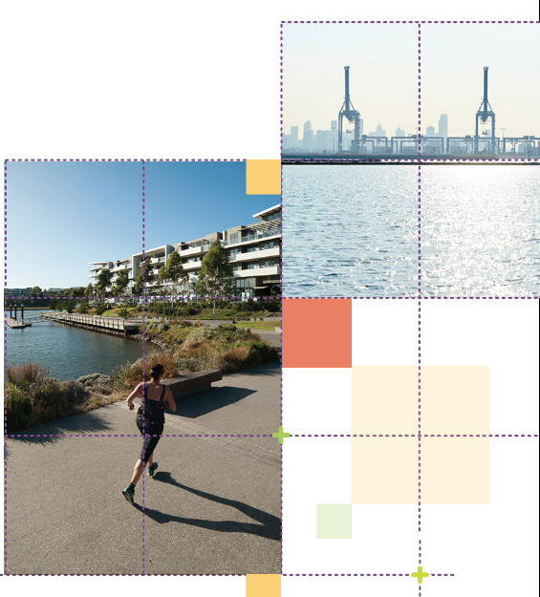

What the Western Metro Land Use Framework Plan means for you

Productivity
- You will see a greater diversity of jobs and education opportunities.
- You will see the region consolidated as south-east Australia’s major hub for freight and logistics.

Housing Choice
- You will see a network of connected, liveable suburbs with distinctive neighbourhoods and a mix of housing.

Integrated Transport
- You will see an integrated, linked public and active transport network.

Strong Communities
- You will see people living and working in 20-minute neighbourhoods.

Liveability
- You will see vibrant activity centres and lively public spaces.
- You will see the region’s diverse landscapes and waterways valued, managed and protected, including the Western Grasslands and iconic coastlines.

Sustainability and Resilience
- You will see more trees, better water management, and a statewide waste and resource recovery sector.
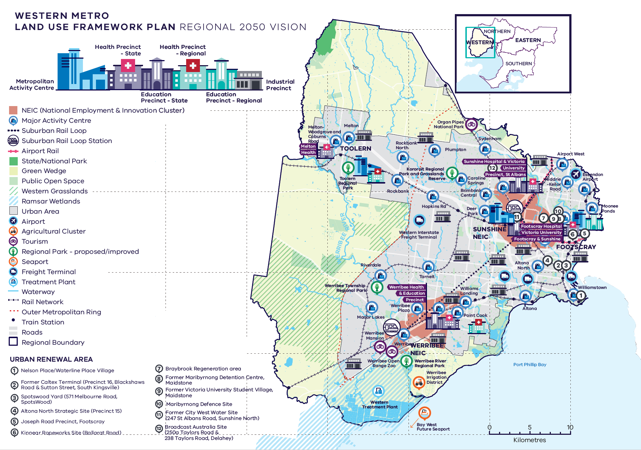
Western Metro Region – Regional 2050 Vision

A schematic map of the Western Metro Region in 2050 showing:

- The region’s boundary, the urban area, and green wedge land.

- Locations for growth and investment, including:
- The location and indicative boundaries of the Sunshine NEIC in the north-east of the urban area and Werribee NEIC in the south-west of the urban area
- Industrial precincts located through the centre of the region from east to west, from Sunshine to Werribee, and in the north of the region
- Sunshine and Footscray Metropolitan Activity Centres, and the proposed Toolern Metropolitan Activity Centre in the north-west of the urban area
- The network of major activity centres predominantly located on the rail and road network including the proposed major activity centres at Rockbank, Rockbank North, Plumpton, Hopkins Road, and Riverdale
- State- and regionally-significant health and/or education precincts at Melton, Footscray, Sunshine, St Albans, and Werribee
- The 12 urban renewal areas of:
Nelson Place/Waterline Place Village
Former Caltex Terminal (Precinct 16, Blackshaws Road & Sutton Street, South Kingsville)
Spotswood Yard (571 Melbourne Road, Spotswood)
Altona North Strategic Site (Precinct 15)
Joseph Road Precinct, Footscray
Kinnear Ropeworks Site (Ballarat Road)
Braybrook Regeneration area
Former Maribyrnong Detention Centre, Maidstone
Former Victoria University Student Village, Maidstone
Maribyrnong Defence Site
Former City West Water Site (247 St Albans Road, Sunshine North)
Broadcast Australia Site (250a Taylors Road & 238 Taylors Road, Delahey)
- Suburban Rail Loop (West) (Airport to Werribee) interchange stations at Sunshine and Werribee.

- Key transport linkages and movement network including:
- Railway lines and train stations including Suburban Rail Loop (West), proposed train stations in the growth areas, and the future Melbourne Airport Rail link
- The road network including the state-significant road corridors of the Calder Freeway, Western Ring Road, Western Freeway, Geelong Road and the Princes Freeway, and the potential Outer Metropolitan Ring / E6
- Transport gateways at Essendon Airport, the proposed Western Interstate Freight Terminal, and the possible Bay West Future Sea Port.

- State and regional natural and cultural assets, including:
- State and National parks, the Western Grasslands conservation reserve, Ramsar wetlands, regional parks, and other public open space.
- Main tourism destinations are identified including Werribee Open Range Zoo and Werribee Mansion to the south west of Werribee, and Organ Pipes National Park in the north of the region.

What is the Western Metro Land Use Framework Plan?
The Western Metro Land Use Framework Plan is an extension of Plan Melbourne 2017-2050.
Plan Melbourne is a blueprint to ensure Melbourne grows more sustainable, productive and liveable as its population approaches 8 million by 2050. It includes nine principles that outline the Victorian Government’s vision for the future of the city that Melbourne will continue to be a global city of opportunity and choice.
- A distinctive Melbourne
- A globally connected and competitive city
- A city of centres linked to regional Victoria
- Environmental resilience and sustainability
- Living locally in 20-minute neighbourhoods
- Social and economic participation
- Strong and healthy communities
- Infrastructure investment that supports balanced city growth
- Leadership and partnership.
Plan Melbourne also divides the city into six metro regions:
- Inner
- Inner South East
- Eastern
- Southern
- Western
- Northern
The Department of Environment, Land, Water and Planning (DELWP) is leading the development of land use framework plans. The purpose of the plans is to guide the application of Plan Melbourne’s nine principles, seven outcomes, 32 directions and 90 policies at a regional and local level.
The plans will support a regional approach to planning across state and local government.
This document summarises how the Western Metro Land Use Framework Plan will:
- Shape population and industry growth
- Inform plans for service and infrastructure development
- Guide public and private investment
- Protect the distinctive and historic characteristics of the Western Metro Region
- Improve environmental resilience.
The plan covers six themes:
- Productivity
- Housing
- Integrated transport
- Liveability
- Strong communities
- Sustainability and resilience.

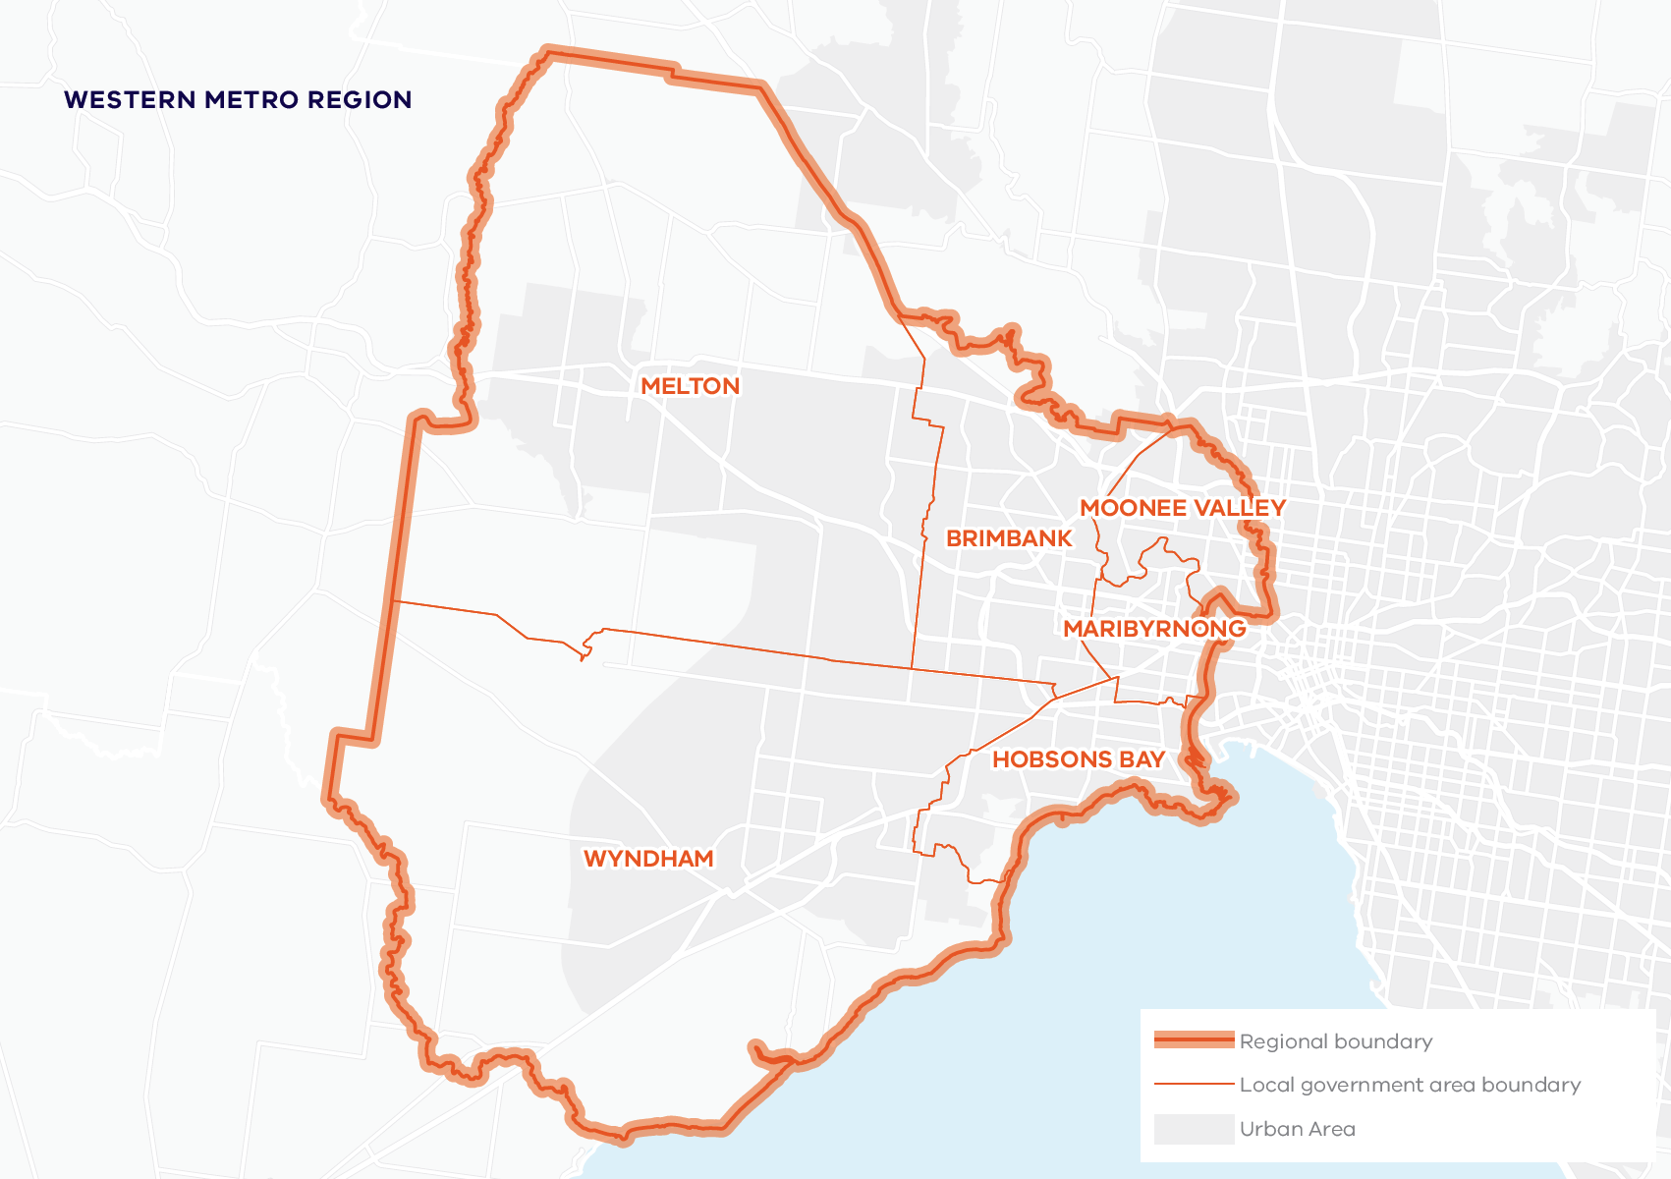

About the Western Metro Region
The Traditional Owners of the Western Metro region are the Wurundjeri Woi Wurrung, Bunurong and Wadawurrung people of the Kulin Nation.
The Western Metro region is a distinctive mix of ancient and new, city and country, urban and agricultural.
It extends from the Maribyrnong River in the east across to Little River and the Djerriwarrh Creek in the west – and from green wedges in the north to the shores of Port Phillip Bay in the south. Its inner suburbs are among Melbourne’s most diverse and dynamic residential areas.
The region’s middle and outer suburbs comprise extensive industrial areas and suburban-density housing, plus well-established urban areas of Melton and Werribee.
Beyond the outer suburban fringe, the Western Metro region is encircled by green wedges that range from agriculture and quarries to grasslands and wetlands to volcanic plains and hills.
Urban areas include:
- Werribee and Melton – with strong connections south-west (Lara and Geelong), west (Bacchus Marsh, Ballan) and beyond (Ballarat and the Macedon Ranges)
- Growth corridors – Wyndham (Tarneit, Truganina, Wyndham Vale, Williams Landing, Point Cook), Melton (Toolern, Plumpton, Rockbank North, Rockbank South, Mt Atkinson, Caroline Springs and Burnside) and Diggers Rest
- Older established areas along the Tullamarine and Calder freeways (Airport West, Niddrie, Taylors Lakes, Keilor)
- Large infill and brownfield sites for future development in inner and middle ring suburbs (including Werribee Employment Precinct)
- Inner areas along rail lines and tram lines (Footscray, Sunshine, Flemington, Moonee Ponds)
- Historic maritime suburbs of Williamstown and Newport
- Radial road connections along the Calder Freeway, Western Freeway, Princes Highway and Freeway, and the Western Ring Road.
By 2051, the Western Metro region’s population is projected to approximately double from around 0.99 million to 1.90 million. The number of dwellings is projected to more than double from 318,200 in 2016 to 730,300 in 2051. By 2031, employment is projected to increase from 294,550 to 445,550 jobs.

Geographically
its footprint covers 15 per cent of metropolitan Melbourne, with 49 per cent designated as green wedge.

Demographically
19 per cent of Melburnians, 988,970 people, live in the region.

Economically
it generates $38 billion a year in economic activity and employs more than 294,550 people.

Environmentally
it has 25.5 per cent of metropolitan Melbourne’s open space and 4.7 per cent urban tree canopy cover.

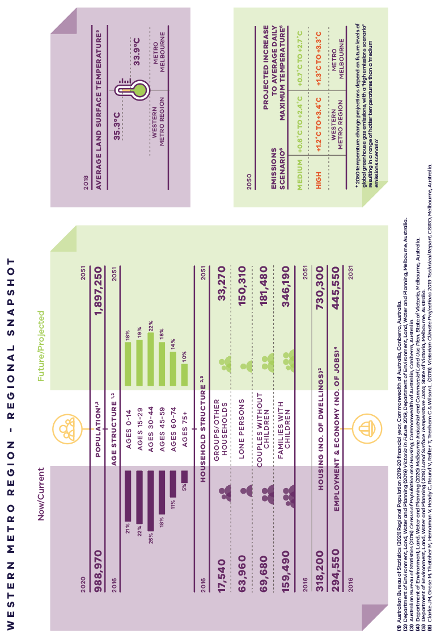
Western Metro Region – Regional Snapshot

Western Metro Region population  Sources:  Australian Bureau of Statistics (2021) Regional Population 2019-20 financial year, Commonwealth of Australia, Canberra, Australia.  Department of Environment, Land, Water and Planning (2019) Victoria in Future 2019, Department of Environment, Land, Water and Planning, Melbourne, Australia. | 2020:  988,970 inhabitants | 2051:  1,897,250 inhabitants
Western Metro Region age structure  Sources:  Department of Environment, Land, Water and Planning (2019) Victoria in Future 2019, Department of Environment, Land, Water and Planning, Melbourne, Australia.  Australian Bureau of Statistics (2016) Census of Population and Housing, Commonwealth of Australia, Canberra, Australia. | 2016:  21 per cent – Ages 0 to 14  22 per cent – Ages 15 to 29  25 per cent – Ages 30 to 44  18 per cent – Ages 45 to 59  11 per cent – Ages 60 to 74  5 per cent – Ages 75 plus | 2051:  18 per cent – Ages 0 to 14  19 per cent – Ages 15 to 29  22 per cent – Ages 30 to 44  18 per cent – Ages 45 to 59  14 per cent – Ages 60 to 74  10 per cent – Ages 75 plus
Western Metro Region household structure  Sources:  Department of Environment, Land, Water and Planning (2019) Victoria in Future 2019, Department of Environment, Land, Water and Planning, Melbourne, Australia.  Australian Bureau of Statistics (2016) Census of Population and Housing, Commonwealth of Australia, Canberra, Australia. | 2016:  Groups/other households – 17,540  Lone persons – 63,960  Couples without children – 69,680  Families with children – 159,490 | 2051:  Groups/other households – 33,270  Lone persons – 150,310  Couples without children – 181,480  Families with children – 346,190
Western Metro Region housing (number of dwellings)  Source:  Department of Environment, Land, Water and Planning (2019) Victoria in Future 2019, Department of Environment, Land, Water and Planning, Melbourne, Australia. | 2016:  318,200 dwellings | 2051:  730,300 dwellings
Western Metro Region employment and economy (number of jobs)  Source:  Department of Environment, Land, Water and Planning (2020) Melbourne Industrial and Commercial Land Use Plan, State of Victoria, Melbourne, Australia. | 2016:  294,550 jobs | 2031:  445,550 jobs
2018 average land surface temperature  Source:  Department of Environment, Land, Water and Planning (2018) Land Surface Temperature Data, State of Victoria, Melbourne, Australia. | Western Metro Region:  35.3 degrees Celsius | Metro Melbourne:  33.9 degrees Celsius
2050 projected increase to average daily maximum temperature  *2050 temperature change projections depend upon future levels of global greenhouse gas emissions, with a ‘high emissions scenario’ resulting in hotter temperatures than a ‘medium emissions scenario’  Source:  Clarke J.M., et al. (2019). Victorian Climate Projections 2019 Technical Report, CSIRO, Melbourne, Australia. | Western Metro Region:  Medium emissions scenario – plus 0.6 to plus 2.4 degrees Celsius  High emissions scenario – plus 1.2 to plus 3.4 degrees Celsius | Metro Melbourne:  Medium emissions scenario – plus 0.7 to plus 2.7 degrees Celsius  High emissions scenario – plus 1.3 to plus 3.3 degrees Celsius

City-shaping projects
The Victorian Government is currently implementing the largest transport infrastructure program in the state’s history.
City-shaping projects include:
- The West Gate Tunnel – creating a second river crossing to link the Western Metro region with the Port of Melbourne, CityLink and the CBD, and taking traffic pressures off the West Gate Bridge
- Level crossing removals including along the Werribee, Williamstown and Geelong-Ballarat railway lines, reducing congestion and unlocking land for development
- Metro Tunnel – linking Melbourne’s south-east and Gippsland to the Sunbury line in Melbourne’s west and north-west
- North East Link – connecting Melbourne’s south-east to the Eastern Freeway, the Western Ring Road and Hume Freeway
- Melbourne Airport Rail – connecting Melbourne Airport to Victoria’s regional and metropolitan train network
- Suburban Rail Loop – connecting every major passenger railway line in Melbourne from the Frankston line in the south to the Werribee line in the west.
These city-shaping projects will improve access to jobs, education and social opportunities for residents in the Western Metro region by better connecting the region with other areas of Melbourne and Victoria. They will create opportunities to maximise social, economic and environmental benefits.
Socially – bring jobs, services and leisure opportunities closer to where people live.
Economically – reduce transport congestion, boost productivity and create jobs.
Environmentally – cut commuting times, reduce transport emissions, promote public and active transport use, and create 20-minute neighbourhoods.
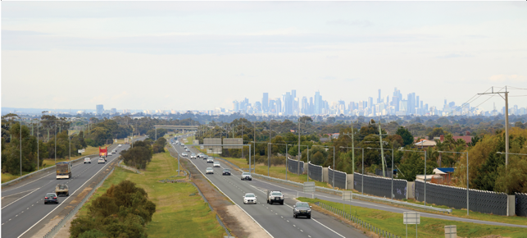

Western Metro Region strengths and challenges
Productivity | The Western Metro region’s industrial and commercial land is vital for the Melbourne economy. Industrial land must be protected, knowledge-based economic activity expanded, and new industries developed. Footscray, Sunshine and Toolern Metropolitan Activity Centres and Sunshine and Werribee NEICs will provide job opportunities for the growing region.
Housing Choice | The Western Metro region is well-placed to cater for population growth through established suburbs, urban renewal areas and the Western Growth Corridor. Its challenge is to balance housing and industrial development, deliver diverse and affordable housing, and ensure services and infrastructure keep up with growth.
Integrated Transport | As Melbourne’s fastest-growing area, the region needs smart transport investment. Access to activity centres and jobs needs to be improved; the road, public transport, cycling and pedestrian networks require expansion and integration; and protection is needed for state-significant transport corridors.
Liveability | The Western Metro region’s volcanic plains, grasslands, wetlands and coastline are like no other part of Melbourne. The region’s tourism and cultural environment should be developed. For that to happen, the region’s heritage must be protected while more open spaces are created and connected.
Strong Communities | The Western Metro region has a multicultural focus, with around half of residents born overseas. This diverse and dynamic community needs better access to aged care and health services, primary health, education and community services, and sport and recreation facilities.
Sustainability and Resilience | The Western Metro region is well-placed to use recycled water to prepare for climate change. However the region has the lowest tree canopy coverage in the city, leaving many communities vulnerable to high urban heat. There’s also a need to prepare for risks of sea level rise and bushfire.

Planning for the Western Metro Region

Productivity
- Coordinate planning for the Western Industrial Precinct and protect regionally-significant industrial land from encroachment.
- Develop the Sunshine and Werribee National Employment and Innovation Clusters (NEICs).
- Develop the network of activity centres across the region.
- Ensure the planned development of the Western Growth Corridor maximises long-term commercial and industrial opportunities.
- Protect green wedges to ensure the sustainability of agriculture, extractive resources, tourism and state infrastructure.

Housing Choice
- Secure a 15-year supply of housing across the Western Metro region.
- Ensure new housing is well-designed, high-quality, climate change resilient and in keeping with neighbourhood character.
- Deliver a pipeline of social and affordable housing near jobs, transport and services.
- Develop a mix of medium- and higher-density dwellings suitable for singles, older residents and families.
- Limit housing growth in the green wedge and areas at risk of natural hazards such as storm surge and bushfire.
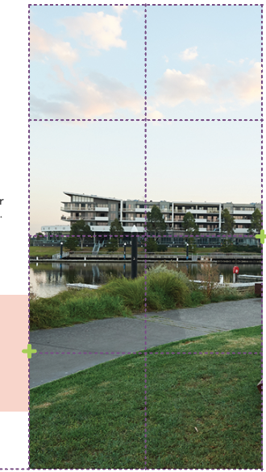

Integrated Transport
- Improve connections to peri-urban and regional areas.
- Improve transport connections to activity centres and industrial hubs, including the Sunshine and Werribee NEICs and activity centres.
- Improve transport connectivity in the growth corridor and outer suburbs.
- Support the growth of the freight and logistics sectors in the region.
- Support the development of 20-minute neighbourhoods by prioritising active and public transport.
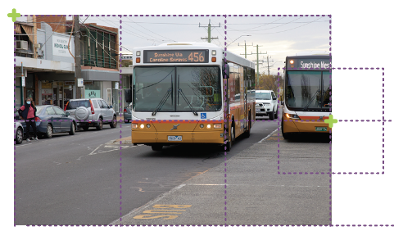

Liveability
- Create great civic spaces that reflect the region’s environment and history – including the heritage of Aboriginal communities.
- Protect waterways, landscapes and biodiversity.
- Expand the network of open spaces and trails, linking open spaces, biodiversity areas, waterways and urban areas.
- Create multi-use spaces for community gatherings, festivals, arts and events in established and growth areas.
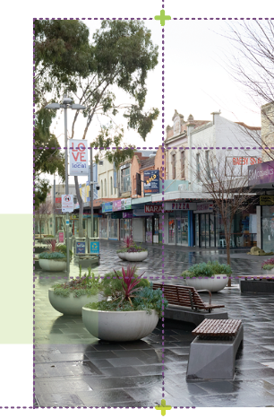
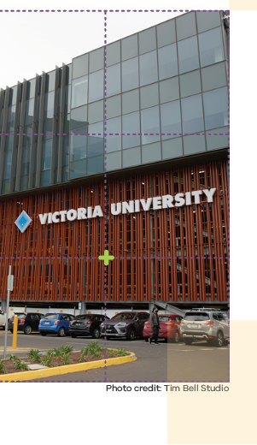

Strong Communities
- Invest in accessible social infrastructure such as libraries, recreation facilities, cultural centres and community hubs.
- Expand the network of health and education facilities and precincts.
- Support the creation of 20-minute neighbourhoods by investing in activity centres.
- Plan for sporting and active recreation facilities in established and growth areas.
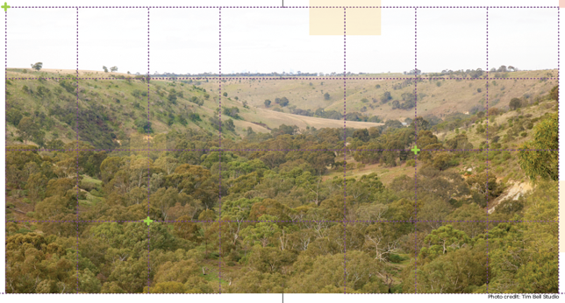

Sustainability and Resilience
- Increase the tree canopy to 20 per cent and create cool places across the region.
- Manage the impact of sea level rise and bushfire risk.
- Plan for increased access to recycled water.
- Capture and reuse more stormwater.
- Ensure development supports the changing energy supply network.
- Protect the Western Treatment Plant and the region’s future resource-recovery needs.

© The State of Victoria Department of Environment, Land, Water and Planning 2021
This work is licensed under a Creative Commons Attribution 4.0 International licence. You are free to re-use the work under that licence, on the condition that you credit the State of Victoria as author. The licence does not apply to any images, photographs or branding, including the Victorian Coat of Arms, the Victorian Government logo and the Department of Environment, Land, Water and Planning (DELWP) logo. To view a copy of this licence, visit http://creativecommons.org/licenses/by/4.0/
ISBN 978-1-76105-652-9 (pdf/online/MS word)

Disclaimer
This publication may be of assistance to you but the State of Victoria and its employees do not guarantee that the publication is without flaw of any kind or is wholly appropriate for your particular purposes and therefore disclaims all liability for any error, loss or other consequence which may arise from you relying on any information in this publication.

Credits
Green Scribble (graphic design); Tim Bell Studio (photos) and Department of Jobs, Precincts and Regions (photos).

Accessibility
If you would like to receive this publication in an alternative format, please telephone the DELWP Customer Service Centre on 136 186, email customer.service@delwp.vic.gov.au or via the National Relay Service on 133 677 www.relayservice.com.au. This document is also available on the internet at www.delwp.vic.gov.au
Submissions can be made online at engage.vic.gov.au
For any questions or assistance please contact lufp@delwp.vic.gov.au

