Surf Coast Distinctive Area and Landscape

Statement of Planning Policy
September 2022

Acknowledgment
We acknowledge and respect the Traditional Owners of the Wadawurrung land and waters, their unique ability to care for Country and deep spiritual connection to it. We honour Elders past and present whose knowledge and wisdom has ensured the continuation of culture and traditional practices.
We are committed to genuinely partner and meaningfully engage with Traditional Owners to support the protection of their Country, the maintenance of spiritual and cultural practices and their broader aspirations in the 21st century and beyond.
© The State of Victoria Department of Environment, Land, Water and Planning, 2022
This work is licensed under a Creative Commons Attribution 4.0 International licence. You are free to re-use the work under that licence, on the condition that you credit the State of Victoria as author. The licence does not apply to any images, photographs or branding, including the Victorian Coat of Arms, the Victorian Government logo and the Department of Environment, Land, Water and Planning (DELWP) logo. To view a copy of this licence, visit http:// creativecommons.org/licenses/by/4.0/
ISBN 978-1-76105-320-7 (Print)
ISBN 978-1-76105-321-4 (pdf/online/MS word)
Citation
Department of Environment, Land, Water and Planning. Surf Coast Statement of Planning Policy. State of Victoria, Melbourne.
Disclaimer
This publication may be of assistance to you, but the State of Victoria and its employees do not guarantee that the publication is without flaw of any kind or is wholly appropriate for your particular purposes and therefore disclaims all liability for any error, loss or other consequence which may arise from you relying on any information in this publication.
Accessibility
If you would like to receive this publication in an alternative format, please telephone the DELWP Customer Service Centre on 136 186, email customer. service@delwp.vic.gov.au, or telephone the National Relay Service on 133 677 (www.relayservice.com.au).

Table of Contents
Introduction 1
About Victoria’s peri-urban and regional areas 1
About the declared area 1
About the Surf Coast Statement of Planning Policy 6
Implementation of the Statement of Planning Policy 8
Monitoring and review 9
Wadawurrung statement of significance 10
Our vision 12
Declared area framework plan 14
Policy domains 16
Aboriginal cultural heritage – Wadawurrung Country 17
Environment and biodiversity 19
Landscapes 23
Environmental risks and resilience 29
Water quality and security 34
Historic heritage 36
Tourism, agriculture and natural resources 38
Strategic infrastructure 43
Settlements 47
References 60
Glossary of terms 63

Introduction

About Victoria’s peri-urban and regional areas
The Surf Coast region, along with other peri-urban areas surrounding Melbourne, Geelong and other regional cities, includes areas of outstanding natural beauty and environmental, economic, social and cultural heritage significance.
The Surf Coast, like other highly valued areas, has been under the safe stewardship of Traditional Owners for millennia, and it is rich in Wadawurrung living cultural heritage.
Peri-urban areas are important to Traditional Owners for the protection of Country and the maintenance of spiritual and cultural practices. They also have unique ecosystems, the native vegetation of which provides habitat for threatened and endangered species. Their picturesque landscapes, especially along the coast, attract millions of local, interstate and international visitors; and tourism is a major contributor to local economies. The close proximity of peri-urban areas to cities means people can easily access and connect with nature and Victoria’s rich heritage. They are also locations of productive industries and important infrastructure that enable settlements to thrive. The challenge facing the Victorian Government and communities is to manage Victoria’s growth while conserving and enhancing significant landscapes and safeguarding the state’s natural resources and infrastructure for people and businesses to benefit from today and for generations to come. The growth of metropolitan Melbourne and of regional settlements must be carefully planned and balanced to safeguard significant attributes and to provide certainty for tourism and other investment decisions.
A sustainable approach to planning and managing peri-urban areas recognises, conserves and enhances their distinctive attributes and unique values — their landscape character, biodiversity and environment and Aboriginal cultural and historic heritage values — and ensures that development responds to these attributes and values. At the same time, it must also recognise, conserve and enhance the things that make peri-urban areas prosperous: productive rural land and natural resources, local businesses, sustainable tourism, transport and essential services infrastructure, well-planned settlement growth and liveability.

About the declared area
The Victorian Government has legislated to protect and enhance Victoria’s distinctive areas and landscapes, so they can be enjoyed by current and future generations.
Parts of the Surf Coast Shire and the City of Greater Geelong were declared a distinctive area and landscape under section 46AO of the Planning and Environment Act 1987 (the Act) by order of the Governor in Council published in the Government Gazette on 19 September 2019. The order came into effect on the same day.
In September 2021, parts of the Surf Coast Shire and the City of Greater Geelong were redeclared by order of the Governor in Council published in the Government Gazette to ensure the previous declaration did not lapse and to provide sufficient time for the finalisation of this Statement of Planning Policy. The declaration commenced on 20 September 2021.
Under the Act, an area of Victoria can be declared a distinctive area and landscape if it has a majority of the attributes listed in section 46AP of the Act— outstanding environmental, geographical, heritage, cultural, natural resources or productive land, strategic infrastructure or built form significance — and if its attributes are under threat of significant or irreversible land use change that would affect the environmental, social or economic value of the area.
Table 1 lists the attributes that qualified the Surf Coast as a distinctive area and landscape under section 46AO of the Act.
- Attributes qualifying Surf Coast declared area as a distinctive area and landscape
Attribute | Distinctive Features
Outstanding environmental significance | - Creeks, wetlands, saltmarshes, woodlands and beaches in the area provide habitat for numerous state and national threatened species.  - Areas of biodiversity significance include Point Addis Marine National Park, Point Danger Marine Sanctuary, Point Impossible, Karaaf Wetlands, Breamlea Flora and Fauna Reserve, Thompson Creek, Deep Creek and remnant vegetation west of Torquay–Jan Juc
Significant geographical features, including natural landforms | - The landscape includes areas of state and national significance, particularly along the coastline.  - Bells Beach, the surrounding rugged coastline and hinterland offers scenic views from landmark cliffs, points and lookouts that define the character of the area.  - Landscape character is highly visible from main road corridors.
Heritage and cultural significance | - The area has extensive heritage and cultural value including areas of Wadawurrung heritage significance, renowned surfing locations and shipwrecks along the coastline.  - Coastal areas and waterways contain significant Wadawurrung heritage value and are gathering places for the Wadawurrung people.  - Bells Beach is an area of state heritage significance and included on the Victorian Heritage Register for its surfing, cultural and aesthetic heritage values.  - The Great Ocean Road is included on the National Heritage List: it serves as a memorial to Australian service people in the First World War and enables access to spectacular natural scenery.
Natural resources or productive land of significance | - The Surf Coast is a major nature-based tourism destination of state significance, with tourism assets including Bells Beach, the Great Ocean Road and Torquay–Jan Juc.  - Extractive industries in the area are significant, particularly for their contribution to Victoria’s supply of limestone.
Strategic infrastructure or built form of significance | - The Great Ocean Road is strategic infrastructure of national significance and is an important aspect of the tourism economy.  - The Surf Coast Highway and Anglesea Road also form part of the state transport network, which is critical for the functioning of the Surf Coast.

Map 1 shows the Surf Coast declared area in relation to Melbourne, Geelong and Ballarat.
Map 2 shows the declared area at a large scale. Its southern boundary extends along the Bass Strait coastline 600m seaward of the low water mark from the eastern edge of the Great Otway National Park to the Breamlea Flora and Fauna Reserve. It extends north to just beyond Mt Duneed and Lower Duneed roads. Land within the declared area includes the settlements of Breamlea, Torquay–Jan Juc and Bellbrae and their hinterland.

Map 1: Location of Surf Coast declared area
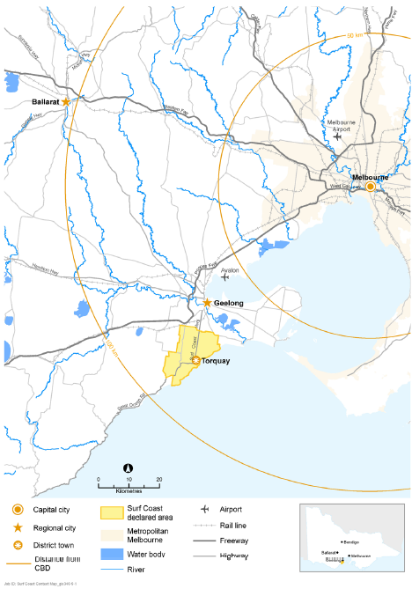

Map 2: The declared area
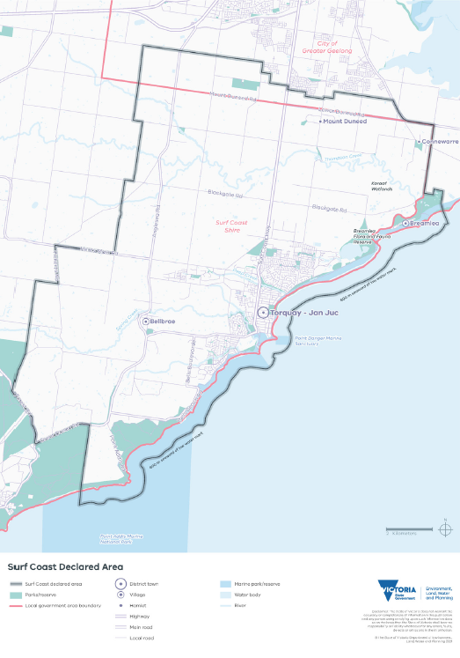

About the Surf Coast Statement of Planning Policy
Under the Act, the Minister for Planning must prepare a Statement of Planning Policy (SPP) for a declared area, the purpose of which is to create a framework to guide future use and development of land within the declared area to ensure protection and conservation of its distinctive attributes.
Division 3 of Part 3AAB of the Act specifies the content, consultation, endorsement, approval, commencement and amendment requirements for an SPP.
Section 46AV(1) states that the Statement of Planning Policy for a declared area must—
- set a vision for a period of at least 50 years that identifies the values, priorities and preferences of the Victorian community in relation to the distinctive attributes of the declared area, including preferences for future land use, protection and development (this can be found in Section 3 of the Surf Coast SPP);
- set out the long-term needs for the integration of decision-making and planning for the declared area (section 5 of the Surf Coast SPP sets out the objectives and strategies for each policy domain. These enable integrated decision-making and planning for the declared area over the 50 year vision period, by providing an overarching framework for strategic and statutory planning, and by ensuring RPEs act consistently with relevant parts of the SPP when performing a function or duty or exercising a power);
- state the parts of the Statement that are binding on responsible public entities and the parts that are in the nature of recommendations to which responsible public entities are only required to have regard (each policy domain in the Surf Coast SPP sets out objectives which are binding on RPEs and strategies which RPEs are required to have regard to);
- include a declared area framework plan in accordance with subsection (2) (this can be found in Section 4 of the Surf Coast SPP);
- set out Aboriginal tangible and intangible cultural values, and other cultural and heritage values, in relation to the declared area (this can be found in Section 5.1 of the Surf Coast SPP).

The Surf Coast SPP has been prepared by the Department of Environment, Land, Water and Planning (DELWP) in collaboration with the Wadawurrung, the Surf Coast Shire Council, the Greater Geelong City Council, relevant government agencies and authorities. There was extensive engagement with the Victorian community to prepare the Surf Coast SPP.
The Surf Coast SPP aims to protect the declared area’s outstanding landscapes and coastal landforms, unique natural environment, rich Wadawurrung living cultural heritage and historic heritage, and important infrastructure and natural resources. These are the attributes that qualified the declared area as a distinctive area and landscape, and they are listed in Table 1 and the order published in the Government Gazette.

United Nations Sustainable Development Goals
As the State Government’s lead agency promoting sustainable development, DELWP supports the objectives of the United Nations Sustainable Development Goals (UNSDGs), and it is committed to ensuring these goals are considered and reflected in policy. The Surf Coast SPP will help to deliver on the UNSDGs that provide a framework to achieve a sustainable future for all.
While the integrated delivery of all 17 UNSDGs applies to the declared area, the UNSDGs shown in Table 2 are the most relevant, and they provide a foundation for the Surf Coast SPP’s vision, objectives and strategies, as well as their implementation, monitoring and review.
- Selected United Nations Sustainable Development Goals
Sustainable Development Goal | SPP Aim
2: Zero Hunger | The SPP aims to support agricultural productivity by protecting valuable agricultural land.
3: Good health and well-being | The SPP aims to support active transport and healthy communities that have access to clean air and a healthy environment.
6: Clean water and sanitation | The SPP aims to protect water security and quality by reducing run-off, improving water management and protecting water infrastructure. This will enable future growth and augmentation to provide for the needs of current and future generations.
8: Decent work and economic growth | The SPP aims to support sustainable economic growth and the visitor economy.
9: Industry, innovation and infrastructure | The SPP aims to protect sustainable and resilient infrastructure and promote environmentally sound technologies.
11: Sustainable cities and communities | The SPP aims to provide certainty about the valued attributes to be protected while indicating preferred locations for potential long- term growth
12: Responsible consumption and production | The SPP aims to support the protection and sustainable management and use of natural resources.
13: Climate action: | The SPP aims to support the mitigation and adaptation of communities and the natural environment to climate change impacts.
14: Life below water | The SPP aims to recognise the importance of and support the conservation of marine life.
15: Life on land | The SPP aims to support the conservation management of ecosystems and biodiversity values.
16: Peace, justice and strong institutions | The SPP aims to ensure responsive, inclusive, participatory and representative decision-making.
17: Partnerships for the goals | The SPP aims for governments to work together with communities, the private sector and other non-government groups to implement its vision, objectives and strategies.

Implementation of the Statement of Planning Policy
Effective implementation of the Surf Coast SPP will require a concerted effort by all — governments, public land managers, the Wadawurrung Traditional Owners, businesses, industries, residents, tourists and the community as a whole — to work collaboratively by taking ownership and sharing knowledge, expertise and resources to support the achievement of the long-term vision for the declared area.

Implementation through planning schemes
The Surf Coast Statement of Planning Policy (SPP) becomes operational and forms part of the State standard provisions of the Victoria Planning
Provisions once the Governor in Council approves the SPP. The SPP objectives are binding and responsible public entities must have regard to the strategies.
The Minister will prepare and approve an amendment to the planning scheme(s) to give effect to the SPP, as required by section 46AZB of the Act.

Implementation by responsible public entities
In addition to implementation through planning schemes, the Surf Coast SPP requires
implementation by responsible public entities (RPEs) as the agencies or bodies responsible for managing land in the declared area.
In accordance with section 46AV(1)(c) of the Act:
- the objectives in the Surf Coast SPP are binding on RPEs
- the strategies in the Surf Coast SPP are not binding on RPEs: they are recommendations to which RPEs are required to have regard.
Section 46AZK of the Act requires that ‘A responsible public entity must not act inconsistently with any provision of the SPP that is expressed to be binding on the public entity when performing a function or duty or exercising a power in relation to the declared area.’ Therefore, RPEs must not act inconsistently with the Surf Coast SPP’s objectives when developing or implementing policies or programs or making decisions in relation to the declared area, including when performing their regular functions or duties.
An RPE should endeavour to integrate the objectives and strategies which are relevant to it and its responsibilities into its policies, programs and decision-making in the declared area. An RPE should balance any conflicting strategies in favour of an outcome that best promotes the intent of the Surf Coast SPP for the benefit of present and future generations.
As well, under section 46AZL of the Act, an RPE, when developing or implementing policies or programs or making decisions in relation to the declared area, should:
- consult with all levels of government and government agencies relevant to the decision
- use best practice measures to protect and conserve the unique features and special characteristics of the declared area
- undertake continuous improvement to enhance the conservation of the environment in the declared area
- have regard to the principles prescribed to apply—
- to all declared areas; and
- in relation to a particular declared area.
Doing so will:
- better coordinate decision-making for land use and development across the declared area to achieve integrated management, environmental, infrastructure and development outcomes
- ensure any proposals for land use changes and development are consistent with the protection of the declared area’s significant landscapes and with state- and nationally significant environmental, economic and Wadawurrung living cultural heritage and historic heritage values
- guide the sustainable use of natural resources in keeping with the declared area’s significant landscapes, environmental and heritage values
- reinforce the importance of building community resilience to environmental risks and climate change, including the potential effects of natural hazards (such as bushfires and flooding)
- provide greater certainty for current and future residents and businesses.

The identified RPEs for the Surf Coast declared area are:
- Barwon Water
- City of Greater Geelong
- Corangamite Catchment Management Authority
- Great Ocean Road Coasts and Parks Authority
- Head, Transport for Victoria
- Parks Victoria
- Secretary (within the meaning of the Conservation, Forests and Lands Act 1987)
- Southern Rural Water
- Surf Coast Shire
- Victorian Planning Authority
- VicTrack

Monitoring and review
To provide long-term certainty for the declared area, the Minister for Planning must ensure the Surf Coast SPP is reviewed at least every ten years. The review will be undertaken in collaboration with the Surf Coast Shire Council, the Greater Geelong City Council and the Wadawurrung Traditional Owners.
The Surf Coast SPP may be reviewed at an earlier date if strategic planning work (such as landscape assessments, biodiversity assessments or reviews of township framework or structure plans) identify the need for an earlier review. Following a review, the SPP and relevant planning schemes may be amended if necessary.

Wadawurrung statement of significance
The following statement sets out in traditional language the significance of Wadawurrung Country and the Surf Coast declared area to the Traditional Owners.
Comugeen budj-o thalikiyu kin bil beng-ordi-ngadak. Ngarrwabil, boron, guli, bagurrk. Comugeen budj-o bengadak ngarr-uk dja, ngubiyt, weagoon gobata gupma wurring-wurring baap beng-ordi-nganak, djarrima murrup-nhuk bengadak.
Gobata Wadawurrung balug jumbuk didalbil murrup-nhuk bundjil monomeett beek-o weagoon. Mutjak-ak Ngan ngan borrak ngan ngan djuwewan
Wa-ngarrwa Wadawurrung balug bengadak mirriyu boron-dja gobata-k ying, ngarrimilli, wa-ak, karrung, kuy-a, nyanayit-yanunit, djilenawurr, baap willam beng-ordi-ngadak.
Nyurrinana-ngal beng-ordi-ngadak.
Willam Yaluk Youang baap warri Wadawurrung Balug dja beng-ordi-ngadak, bullarto nerr-i-girr baap monomeett worrowing warree, gelanyi bul-boluk.
Weagoon-o Modawarree-wa, Moda baap kiang-purt. Weagoon-o Koaka-Dorla-wa Dorla.
Weeagoon-o Wurdiboluk, Gherang, Parrwang Yaluk monomeett-wa Yonbarra baap wirrapiyn, buniya, tark-a binyak-ngal.
Wa-weagoon nerr-i-gurr-o kit baap bullarto gurrin-gurrin-k wah-ak, karrung, yanikan-werreet.
Corroborree bullarto wa-ik-ngitj balug-wa beng-ordi- ngadak.
Mirr wirring wurru-ngwarra dja bengadak.
Mirr-i-tonton dja Wadawurrung balug, gobata be-ak yerra-ak murrup yani-mirriyu ngarrwa-uk beng-ordi- ngadak Koling wada-ngal.
The English translation of which is …
We deeply respect our People of the past. Elders, children, men, women. We deeply respect their knowledge of Country, water, life, their care of the Traditions and of each other, we stand with their spirit.
Great spirit Bunjil told us to take care of the great life within the land. To only take what you need with no greed, no harm.
Wadawurrung shared their knowledge of singing, dance, trade, camps, fishing, hunting, paintings, and homes to us to protect for our future generations.
We all need to help.
Our Wadawurrung family group lived along Rivers, Salt water and inland Country, with a large land of forested areas and wonderful banks of the ocean, near many water bodies.
Life in the Modewarre gave Musk duck and Bream. Life in the Anglesea gave Mullet.
Wurdiboluk, Gherang, Barwon River all provide ideal life to birds and fish, eels. Reeds turned into our baskets.
Life in the forest gave resources like food, medicines and lots of tools to use for trade, building, journey.
If there was plenty, we would share with our families, trade and celebrate.
We would name our Country by what we could see and hear.
Our Country is remembered by Wadawurrung, our proud spirit walks to tomorrow to teach others the care of our earth.
Let us walk together.
Written by Stephanie Skinner
Wadawurrung Women

Our vision
The vision for the declared area is set out below. It is for at least 50 years, and it identifies the values, priorities and preferences of the Victorian community in relation to the distinctive attributes of the Surf Coast declared area, including preferences for future land use, protection and development.
The vision will be achieved by implementing the objectives and strategies under each policy domain.
By 2070, our vision for the Surf Coast declared area is that the Wadawurrung, governments, public land managers, businesses, residents and visitors work together to ensure the declared area’s unique values and distinctive attributes — the things people love about the area — are conserved, protected and enhanced and are not degraded over time.
This is how people will describe the area in 50 years’ time.
Aboriginal cultural heritage: Wadawurrung traditional and living knowledge, culture and practices inform land and water planning and management decisions to better protect the declared area’s distinctive attributes.
Wadawurrung rights to self-determination and aspirations for their lands, waters and culture are realised through the transfer of relevant decision- making powers. The community highly values Wadawurrung living cultural heritage and sites, respecting the declared area as Wadawurrung Country.
Environment and biodiversity: We have conserved and restored the area’s unique ecosystems and biodiversity and have provided habitat for endangered and threatened species. Distinctive places (such as Point Addis Marine National Park, Karaaf Wetlands, Breamlea Flora and Fauna Reserve and other coastal reserves) are flourishing. We celebrate the declared area’s abundant native plant and animal life.
Landscape: We have protected and enhanced the declared area’s significant landscapes: the dramatic coastal settings, woodlands, wetlands and rural vistas between settlements. We value the declared area’s scenic beauty and its importance for the community’s health and wellbeing, for our heritage, environment and biodiversity, and for our local economy.
Environmental resilience: The declared area has adapted to, and communities have mitigated the environmental risks associated with, climate change and natural hazards including rising sea levels, coastal erosion, polluted run-off and bushfires. We have minimised greenhouse gas emissions, waste and overuse of natural resources. Development is environmentally sustainable, and people actively walk, cycle and use public transport to get around neighbourhoods and to places beyond the declared area.
Water: We have conserved and managed our water use and have water security, meeting the needs of residents and businesses, including local farmers. We understand and celebrate the social, cultural, landscape and ecological importance of water in the declared area, including its importance to the Wadawurrung Traditional Owners. We prioritise the maintenance of healthy waterways and coastal environments important to the declared area.
Historic heritage: The declared area’s rich surfing history, culture and international attractions are thriving, and there is a strong sense of place throughout the declared area. We respect and celebrate our historic heritage sites (such as Bells Beach and the nationally heritage-listed Great Ocean Road).
Tourism, agriculture and natural resources: The declared area’s distinctive cultural heritage, environment, historic heritage and landscapes support our prosperous, growing economy, which is based on sustainable tourism, environmentally conscious agricultural and natural resources and innovative manufacturing industries. Renewable energy is an emerging economic opportunity for the area.
Strategic infrastructure: The provision of new community infrastructure — transport, water, waste and resource recovery, energy, telecommunications, education, sport and recreation infrastructure — is timely and integrated and in sequence with development. Infrastructure is sensitively designed to fit in with the area’s distinctive attributes and to address climate change impacts, which enabled the achievement of net-zero emissions by 2050.
Settlements: Torquay–Jan Juc is a vibrant, cohesive regional service centre that supports the needs of residents, workers and visitors. Development is sympathetic to the coastal and hinterland landscape setting. Torquay–Jan Juc is well-connected to the surrounding area, and settlements are thriving.

Declared area framework plan
The declared area framework plan is set out in Map 3. Maps 10–14 are zoomed-in sections of Map 3 for the settlements of Torquay–Jan Juc, Bellbrae, Breamlea, Mount Duneed and Connewarre.
The framework plan maps integrate environmental, social, cultural and economic factors for the benefit of the community. They spatially represent the vision that seeks to encourage long-term sustainable development within the declared area, identifying areas for protection and conservation and for potential change subject to planning processes.
The settlement maps (maps 10-14) form part of the framework plan.
The declared area framework plan is to be read in conjunction with the policy domains, including the objectives and strategies. Maps provided in the policy domains other than the settlement maps in the settlement domain do not form part of the framework plan, and they are published only to provide context.

Map 3: Surf Coast declared area framework plan
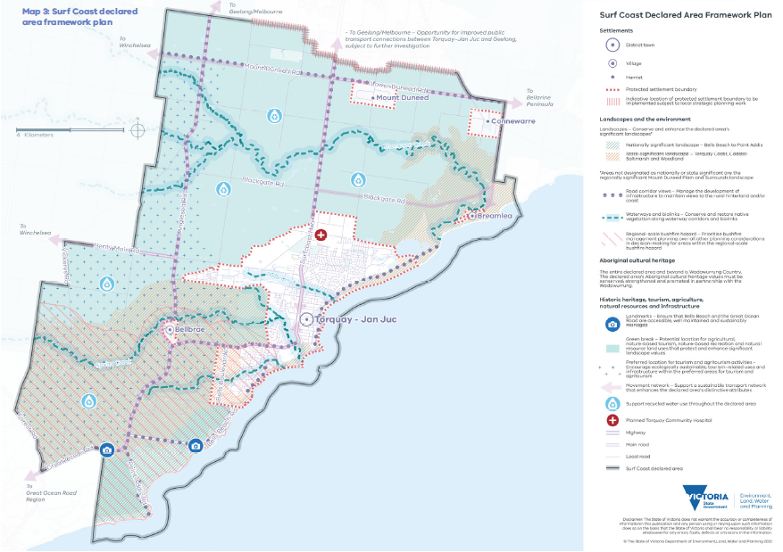

Policy domains
This Statement of Planning Policy includes nine policy domains, which align with the objects for the declaration of the Surf Coast as a distinctive area and landscape in accordance with the Act.
The policy domains are to be read together as a whole. The long-term protection and enhancement of the declared area’s distinctive attributes result from understanding the complex interaction of the area’s landscape character, biodiversity and environment, settlement patterns, infrastructure, natural resources and Wadawurrung living cultural heritage and historic heritage. The objectives and strategies for each policy domain enable integrated decision- making and planning for the declared area.
The policy domains are:
- Aboriginal cultural heritage – Wadawurrung Country
- Environment and biodiversity
- Landscapes
- Environmental risks and resilience
- Water quality and security
- Historic heritage
- Tourism, agriculture and natural resources
- Strategic infrastructure
- Settlements.

Aboriginal cultural heritage – Wadawurrung Country
Relevant United Nations Sustainable Development Goals: 2 – Zero hunger, 14 – Life below water, 15 – Life on land, 16 – Peace, justice and strong institutions, 17 – Partnerships for the goals
The declared area is within the Country of the Wadawurrung, who have inhabited and cared for this area for millennia. It is rich in their spiritual and living cultural heritage, and all aspects of the landscape — lands, seas, skies, waters and tangible and intangible cultural heritage sites and places — are connected and significant.
The Wadawurrung Traditional Owners Aboriginal Corporation was appointed as a Registered Aboriginal Party (RAP) in 2009 as the Traditional Owner group legally recognised under the Aboriginal Heritage Act 2006. It has responsibilities for managing and protecting Aboriginal cultural heritage on Country in the declared area.
Although colonisation has had a devastating impact on Wadawurrung culture and Country, it continues to be alive and resilient: the Wadawurrung continue to engage in traditional cultural practices today.
The coastal areas from Point Impossible to Point Addis overflow with Wadawurrung history and living cultural heritage. Inland landscapes and waterways including Spring Creek, Thompson Creek, Deep Creek, Jan Juc Creek and other, unnamed waterways provided access to food and shelter as well as connections to the rest of Wadawurrung Country.
There are numerous sites along the declared area’s coastline with evidence of long-term habitation in the form of living spaces and large shell middens. Living spaces along the coast and inland hosted housing and offered easy access to fresh water, food and other resources. In these living spaces, the Wadawurrung engaged in aquaculture and agriculture, dried and stored food and enjoyed cultural activities. Inland living spaces were usually on hilltops and at major vantage points. Resources were traded within and between the coast and the inland of Wadawurrung Country and with other Aboriginal communities: complex, far-reaching trade networks spread across Wadawurrung Country and beyond.
Living spaces and large shell middens provide evidence of Wadawurrung residency back to the distant past, and there are places where ochre was— and still is — mined and used for ceremonies. Archaeological sites along the coast are fragile and susceptible to climate change impacts including more extreme weather events, rising sea levels and coastal erosion.
Wadawurrung Country is strongly connected to water: to Country’s River systems, estuaries, wetlands, lakes, creeks and the Bass Strait waters. The use of living spaces depended on healthy waterways, and fresh water was always readily available. Keeping waterways healthy into the future is important for ensuring age-old connections and songlines remain strong.
Wadawurrung Country, with its rich history and contemporary uses, extends beyond the declared area’s boundary, and cultural walking tracks in the declared area connect communities to other parts of Wadawurrung Country. Having a healthy, thriving Wadawurrung culture benefits all people in the declared area by creating a sense of community and belonging. Development has the potential to threaten tangible and intangible connections to Country, impinging on Wadawurrung waterways and walking tracks and damaging their associated songlines and knowledge links.
The Wadawurrung Traditional Owners Aboriginal Corporation, on behalf of the Wadawurrung people, are the RAP for the declared area. In 2020, the RAP prepared its Healthy Country Plan — Paleet Tjaara Dja: Let’s make Country good together 2020 – 2030 Wadawurrung Country Plan — that land managers should use to support decision-making.
For further information, visit https://www.wadawurrung.org.au/.

Objective and strategies

Objective 1
The following objective is binding on RPEs.
To conserve, strengthen and promote the declared area’s Wadawurrung living cultural heritage values and partner with the Wadawurrung to care for Country.

Strategies
Responsible public entities are required to have regard to the following strategies to achieve the objective when performing a function or duty or exercising a power in relation to the declared area.
Strategy 1.1 With the Wadawurrung, identify, manage, conserve and enhance Wadawurrung living cultural heritage: sites, places, landscapes, waterways (including unnamed waterways), natural resources and significant views and viewlines.
Strategy 1.2 With the Wadawurrung, build awareness and understanding of tangible and intangible Wadawurrung living cultural heritage knowledge including language, oral traditions, and pre-colonial cultural practices, and innovatively incorporate that knowledge when planning and managing land use and development.
Strategy 1.3 With the Wadawurrung, encourage the use of Wadawurrung language and place names throughout the declared area

Environment and biodiversity
Relevant United Nations Sustainable Development Goals: 11- Sustainable cities and communities, 13 – Climate action, 14 – Life below water, 15 – Life on land, 17 – Partnerships for the goals
A healthy environment and ecological system, including high levels of biodiversity, are important values for the declared area. They provide valuable social, economic and cultural benefits, and they are integral to Wadawurrung living cultural heritage.
The declared area’s marine parks and rugged coastal cliffs, wide-open beaches and densely vegetated wetlands make its biodiversity and environment variable, dynamic and unique. Inland, there are remnant, wooded areas that connect the declared area to the Great Otway National Park. Coastal and inland areas are connected by meandering creeks, which form green spines reaching deep into the hinterland. Map 4 shows the declared area’s biodiversity values.
Ingoldsby Reef (within the Point Addis Marine National Park) and the Point Danger Marine Sanctuary provide habitat for at least 20 marine species that have been observed in the area. These species, along with many terrestrial species, are listed as threatened under the Victorian Flora and Fauna Guarantee Act 1988 and the Commonwealth Environment, Protection and Biodiversity Conservation Act 1999. The many coastal reserves including the Karaaf Wetlands, Breamlea Flora and Fauna Reserve and Point Impossible have high biodiversity values and are home to many unique species. The area is also recognised for its rich archaeological deposits: several animal fossils have been discovered in the cliffs around Bells Beach.
The Bellarine yellow gum, which is unique to the area around Torquay–Jan Juc and the Bellarine Peninsula, is a threatened species and must be protected.
Areas of remnant native vegetation west of Jan Juc and around Bellbrae add to the area’s beauty, and they provide biolinks to other areas of vegetation and habitat for native animals. Biolinks are important thoroughfares for native animals, and they increase the area’s biodiversity. Biolinks connect coastal and inland areas via waterways and represent areas of cultural heritage significance to the Wadawurrung.
Urban expansion, native vegetation removal and climate change threaten the declared area’s environment, ecology and biodiversity. Wetlands and waterways are particularly vulnerable to rising sea levels, stormwater run-off, changes to tidal flows, increased nutrient loads, increased salinity and other threats. Careful management of development is needed to limit stormwater run-off, particularly into the Karaaf Wetlands, and so restore water quality and flow regimes to pre-development levels.
As the climate becomes hotter and drier, extreme bushfires will become more likely, with a heightened risk that patches of remnant native vegetation will be destroyed. Where revegetation is encouraged (such as along biolinks), bushfire risk increases, and there is a need to provide design responses that limit development potential as well as implement bushfire protection measures.
In time and with careful management and improved planning protections, the declared area’s environment and biodiversity values should improve. Improving waterway corridors by increasing native vegetation coverage will create new biolinks and improve the ecological values of the area.

Objective and strategies

Objective 2
The following objective is binding on RPEs.
To conserve and improve the significant environmental, ecological and biodiversity attributes of the declared area.

Strategies
Responsible public entities are required to have regard to the following strategies to achieve the objective when performing a function or duty or exercising a power in relation to the declared area.
Strategy 2.1 Plan and implement environmentally and culturally responsible best practices to conserve and improve areas of remnant native vegetation and protect threatened species.
Strategy 2.2 Utilise Wadawurrung biocultural knowledge and practices in the management of environmental and biodiversity values.
Strategy 2.3 Minimise the negative impacts of weeds and pest animals on environmental and biodiversity values by undertaking best practice land management.
Strategy 2.4 Encourage ecological restoration works to connect areas of high environmental and biodiversity value, including increasing connections between sites by facilitating biolinks.
Strategy 2.5 Reinforce the role of waterway corridors within and between settlements and coastlines as biolinks for native flora and fauna.
Strategy 2.6 Ensure the collection, disposal and storage of waste do not degrade areas of high environmental, ecological and biodiversity value.
Strategy 2.7 Avoid locating new development in areas of high biodiversity value and ensure the siting of development does not affect significant native vegetation or habitat.

Map 4: Biodiversity values
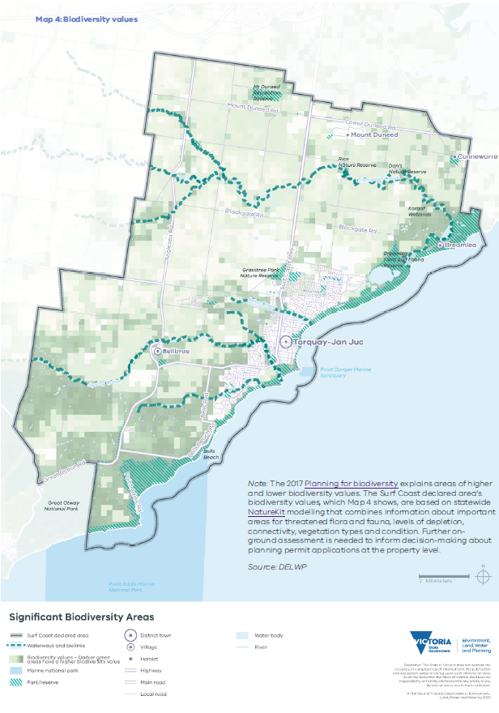
Note: The 2017 Planning for biodiversity explains areas of higher and lower biodiversity values. The Surf Coast declared area’s biodiversity values, which Map 4 shows, are based on statewide NatureKit modelling that combines information about important areas for threatened flora and fauna, levels of depletion, connectivity, vegetation types and condition. Further on- ground assessment is needed to inform decision-making about planning permit applications at the property level.

Landscapes
Relevant United Nations Sustainable Development Goals: 11- Sustainable cities and communities, 12 – Responsible consumption and production, 15 – Life on land
The declared area is renowned for its significant landscapes, which have evolved over millennia. It has stunning coastlines and diverse coastal landforms, the features of which include high cliffs, dramatic headlands, estuaries, wetlands, dunes and iconic beaches: these are the foundation for Torquay–Jan Juc’s iconic surf culture. Away from the coast, woodlands, saltmarshes, volcanic plains and the sense of rural openness between settlements characterise the scenic and highly valued hinterland.
As well as being visually significant, these landscapes support the region’s biodiversity, provide an important link to Wadawurrung living cultural heritage and have significant social meaning to the residents and visitors who enjoy them.
Continued pressure from urban development and encroachment, increasing visitation, climate change impacts and coastal erosion put the declared area’s significant landscapes at high risk of incremental, cumulative and irreversible damage. Focusing policy on the fostering of vital characteristics, places and landscape attributes is essential to ensuring the declared area’s much-loved landscapes continue to form a foundation for biodiversity, social, cultural and economic activity.

Significant landscapes
Map 5 shows the declared area’s three significant landscapes:
- the Bells Beach to Point Addis landscape, which is of national significance
- the Torquay Coast, Coastal Saltmarsh and Woodland landscape, which is of state significance
- the Mount Duneed Plain and Surrounds landscape, which is of regional significance.

About landscape significance and landscape character
A landscape’s level of significance is mainly based on its visual qualities, with secondary consideration of other attributes (such as Aboriginal cultural heritage, historic heritage, environmental, scientific and social values). The required level of protection of a landscape accord with its level of significance. For example, nationally significant landscapes require the highest level of protection, whereas regionally significant landscapes usually require less regulation.
Before assessing a landscape’s level of significance, it is important to understand its ‘landscape character’: its physical characteristics including its geology, landform, vegetation, waterform and other natural features. These characteristics combine with the effects of land use and development to make landscapes different from one another. Landscape character focuses on physical features; landscape significance focuses on the landscape’s visual qualities and less-tangible values (such as memories and associations).
A detailed understanding of a landscape’s character informs how its significance is best protected and managed.

Landscape character areas
Map 6 shows the six landscape character areas the declared area has been assessed as having.
- Mount Duneed Volcanic Plain: a flat-to-gently- undulating landscape that forms a rural, green break between Torquay–Jan Juc and Geelong. It includes the volcanic rise of Mount Duneed, Thompson Creek and a patchwork of paddocks and eucalyptus stands.
- Torquay Coast and Hinterland: a variegated landscape that provides the rural, coastal landscape setting for Torquay–Jan Juc. It includes Spring Creek and its valley, coastal cliffs, areas of heathland and scrub, the iconic Bells Beach and the Great Ocean Road.
- Dry Coastal Woodland and Heath: a landscape comprising hilly and heavily forested terrain in parts, which climbs towards the Otway Ranges and includes sections of the Great Ocean Road as well as the Bells Beach hinterland.
- Low Coastal Heath: an elevated, exposed coastal landscape including the dramatic headland of Point Addis with its high cliffs and sandy beaches and low, scrubby vegetation.
- Coastal Saltmarshes: a flat, marshy landscape centred on the Thompson Creek estuary and wetlands. This area is set behind high dunes and takes in the hamlet of Breamlea.
- Point Impossible Coastal Dunes: a long, narrow, coastal dune landscape with the rocky Point Impossible headland and stretches of low, sandy beaches extending northwards from the Deep Creek inlet.

Landscape significance statements
The following significance statements for the three landscapes of national, state or regional significance should guide strategic planning, policy directions and decision-making.

Nationally significant landscape: Bells Beach to Point Addis
Bells Beach to Point Addis is a wild, dramatic coastal landscape of visually stunning cliffs, headlands and beaches. This exposed, windswept landscape supports a dense cover of coastal headland scrub and dry forest, including significant Grass Tree, Coastal Moonah and Red Ironbark communities. The landscape edge is punctuated by numerous inlets, which form steep ravines and gullies in the coastal hinterland.
The internationally famous Bells Beach is the home of the longest-running surfing competition in the world (the Rip Curl Pro), which first took place at Easter 1962. At Bells, waves refract around the headland and elevate and curl consistently over the rugged shore platform of limestone, resulting in its reputation as one of the best surfing spots in the nation.
The constant, abrasive energy of the waves on this stretch of coastline has eroded, shifted and created the precipices and rock stacks that characterise the landscape. The cliffs that front the beaches also vary in their geology and therefore their colours and response to weathering. The remarkable limestone cliffs of Bells, the Jarosite-rich, burnt-ochre rock faces of Addiscot Beach and the calcium-rich, majestic Point Addis limestone headland all combine with the signature grey-green of the coastal heathland scrub and the blues and greys of the wild seas of Bass Strait to create an unparalleled scene on this part of the Victorian coast.
The views from the Point Addis Boardwalk, Southside Lookout and Bells Beach Lookout are of state as well as national significance.

State-significant landscape: Torquay Coast, Coastal Saltmarsh and Woodland
The Torquay Coast, Coastal Saltmarsh and Woodland landscape is a well-known and highly valued coastal and hinterland landscape. The Great Ocean Road begins its iconic journey in this landscape and travels through it to Anglesea and beyond. The landscape is one of stunning contrasts, particularly at the coastal edge, which includes the high dunes of Point Impossible; the low, flat beaches of Torquay; the limestone crags of Rocky Point; and the contrasting colours of the Jan Juc cliffs, with a unique landscape feature in the form of the Jan Juc Marl (Bird Rock), a small sea-stack that sits just off the coast.
This significant coastal area is incised by numerous creeks and their tributaries that create a hinterland of contrasting landscape features. The Thompson Creek estuary flows through and behind the dunes at Breamlea, forming a unique, lineal, coastal wetland. Further south at Torquay, Spring Creek meanders through the settlement and continues on between picturesque, rolling hills and remnant eucalypts.
South of Spring Creek, to the west of Torquay, the landscape becomes increasingly hilly, steep and elevated as it climbs towards the Otway Ranges. This change in landform also coincides with an increase in indigenous vegetation cover, which includes dense patches of dry heathy woodland that characterise the Anglesea Heath, one of the richest and most diverse vegetation communities in Victoria.
The views from Bird Rock Lookout and Jan Juc Lookout at Point Danger are of regional as well as state significance.

Regionally significant landscape: Mount Duneed Plain and Surrounds
The Mount Duneed Plain and Surrounds is a flat-to- gently-undulating landscape formed by volcanic flows of basalt. It includes the low, volcanic rise of Mount Duneed itself, with its unique geology and communities of grasslands. It also includes
Thompson Creek, which winds its way from the coast at Breamlea, its upper and middle reaches cutting a pathway through the patchwork of paddocks that characterise this agricultural landscape.
Remnant eucalypts are a further feature of this landscape, found in riparian reserves, adjacent to road corridors and scattered throughout paddocks. They contrast with the mostly exotic, lineal shelterbelt planting. This is an open, expansive landscape
of long, straight roads under big skies. It is a very important green break between the built-up areas of Geelong and Torquay and the settlements of the Bellarine Peninsula.

Objective and strategies

Objective 3
The following objective is binding on RPEs.
To conserve and enhance the declared area’s significant landscapes.

Strategies
Responsible public entities are required to have regard to the following strategies to achieve the objective when performing a function or duty or exercising a power in relation to the declared area.
Strategy 3.1 Ensure areas of landscape significance are protected from incompatible land uses and development, with the greatest level of protection to be provided for the nationally significant Bells Beach to Point Addis landscape.
Strategy 3.2 Protect the coastal and hinterland settings of settlements by containing urban growth within settlement boundaries.
Strategy 3.3 Reserve green breaks between settlements for conservation, agriculture, nature-based tourism, nature-based recreation and natural resource proposals that prioritise the protection and enhancement of the significant landscapes and landscape character settings.
Strategy 3.4 Prevent any further residential subdivision and infill development (excluding the use and development of an existing lot for a dwelling) at Addiscott Road Estate.
Strategy 3.5 Ensure any development that is allowed to be located in green breaks between settlements responds to the surrounding landscape character while maintaining the visual dominance of the natural landscape by:
- being sited so that buildings are responsive to the landscape and use established vegetation or new vegetation buffers to screen development when viewed from the public realm
- providing substantial setbacks from road corridors and publicly accessible land
- using building forms, design detailing and materials and colours that immerse buildings within the landscape, so they are not visually dominant.

Strategy 3.6 Ensure that high points and ridgelines remain free of development and associated infrastructure so that views to elevated areas of the landscape reveal the natural form of the topography and vegetation against the sky and are not visually dominated by built form or infrastructure.
Strategy 3.7 Manage development and infrastructure so that it responds to the landscape and does not visually dominate views to the rural hinterland or coast or across the landscape from main road corridors within the landscape.
Strategy 3.8 Strengthen landscape character by conserving and increasing native vegetation (particularly along waterway corridors and within vegetation reserves) and biolinks, and with revegetation in keeping with local ecological vegetation classes.

Map 5: Landscape significance areas
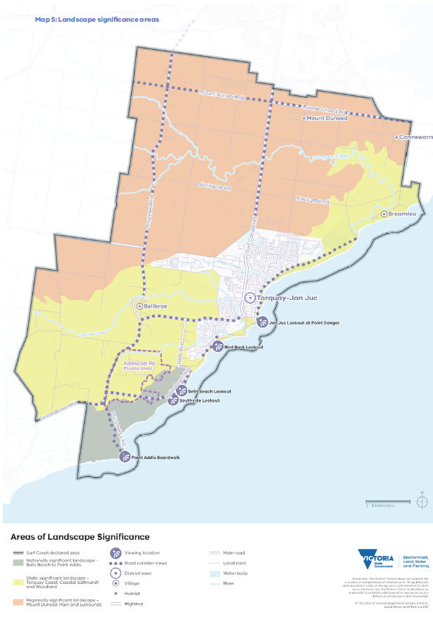
Map 6: Landscape character areas
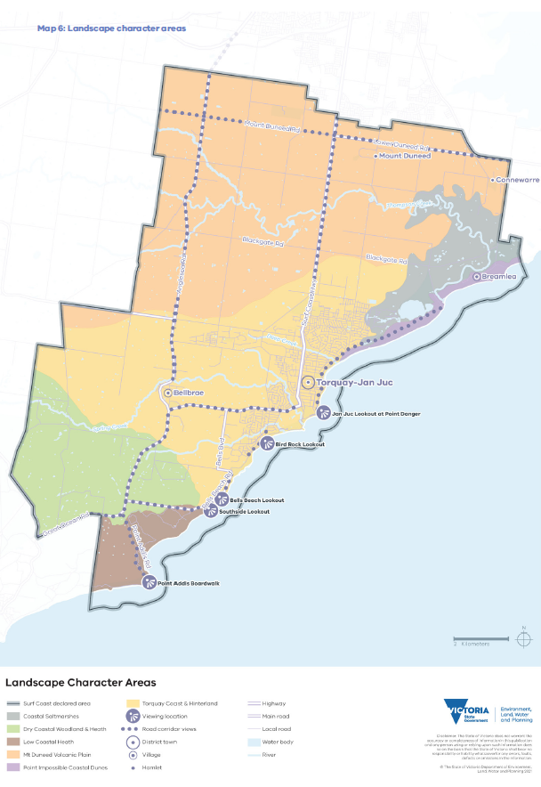

Environmental risks and resilience
Relevant United Nations Sustainable Development Goals: 6 – Clean water and sanitation, 11- Sustainable cities and communities, 13 – Climate action, 14 – Life below water, 15 – Life on land
Climate change and its impacts on the natural and built environments is one of the most pressing issues facing Victorian settlements and their environs. It will continue to affect the declared area’s significant landscape, environmental, Wadawurrung living cultural and historic heritage values and the liveability of places.
New, innovative development and land management practices must be embraced, to ensure the declared area is more resilient to the impacts of climate change. This includes supporting best practice approaches to achieving ecologically sustainable development.
In coming years, the declared area is forecast to experience higher average temperatures, declining rainfall, frequent extreme weather events (such as extreme rainfall and heat events) and rising sea levels. This will in turn lead to longer and earlier fire seasons, increased coastal inundation and flooding, decreased water security and degradation of water and soil quality. There is also a risk that marine habitats will be lost and there will be changes to the reproduction, number and distribution of species. In essence, climate change will continue to affect the viability of some land uses (such as agriculture and tourism), the resilience of natural landscapes and waterways, Wadawurrung living cultural and historic heritage. This will in turn affect local and regional economies and the environmental sustainability of the declared area.
Globally, many national, regional and local governments have formally declared a climate emergency and have committed to achieving net-zero emissions by 2050. Effective, sustained measures to mitigate and adapt to climate change impacts need all levels of government, the private sector, non-governmental agencies and communities to work together. Utilising land management approaches of the Wadawurrung (such as Wadawurrung cultural burning methods) will help to mitigate some climate change impacts.
Map 7 shows environmental risks in the declared area.

Rising sea levels, coastal erosion and flooding
Rising sea levels will challenge coastal communities, their infrastructure and the environment. In the declared area, sea levels are projected to continue to rise by up to 12cm by the 2030s and 40cm by the 2070s, resulting in flooding, intense storm surges and erosion. Bells Beach and Point Impossible will be particularly affected as the declared area’s coastal dunes, wetlands and infrastructure are exposed to rising sea levels. Increasing ocean acidity and sea- surface temperatures threaten Point Addis Marine National Park and Point Danger Marine Sanctuary, both of which are partially within the declared area.
Rising sea levels and more extreme weather events can alter the natural patterns and rates of erosion and longshore drift: the movement and deposition of sand, sediment and other material along the shore by waves. Coastal modifications (such as dredging, stormwater disposal, coastal protection structures and harbours) will be needed, but they have detrimental as well as positive effects along the coast.
Changing patterns of erosion along coastlines force marine and coastal plants and animals to migrate inland. Estuary and wetland vegetation (such as mangroves) will naturally migrate inland to areas that are less threatened by rising sea levels and permanent inundation. Hard infrastructure (such as seawalls) close to aquatic vegetation are barriers to the natural inland migration process. As a result, coastal ecosystems could decline as their adaptation processes are obstructed.
Infrastructure including recreational facilities and residential and commercial development adjacent to the coast (particularly around Torquay–Jan Juc and Breamlea) will be threatened by rising sea levels and coastal erosion. Some enterprises may need to relocate.
As the rate of coastal erosion continues to increase along with rising sea levels, responses including replenishing beaches and relocating physical infrastructure away from coastal hazards will be needed. The Victorian Government’s Marine and Coastal Policy 2020 sets out a planning and decision pathway that shows how the objectives and guiding principles of the Marine and Coastal Act 2018 are to be used when managing coastal hazard risks including erosion.
More intense rainfall events are likely to result in greater quantities of pollutants being washed from urban areas into waterways. It is important to protect and restore wetlands: wetlands, with algae, seagrasses, macroalgae, mangroves and salt marshes, are one of the most effective ecosystems at sequestering atmospheric carbon dioxide.
Areas adjacent to the coast and low-lying areas near waterways are at particular risk of flooding and storm impacts, which will at times prevent many current uses. They will also change the ecology of these areas. By 2070, the area around Breamlea will be at high risk of flooding, which will also threaten Wadawurrung living cultural heritage values, which are concentrated along the coast.

Human impacts
Visitation to and demand for residential properties in the Great Ocean Road region are forecast to increase considerably in coming years. Human impacts, particularly during peak periods, must be carefully managed to ensure they do not degrade the natural environment. Human impacts can increase erosion, littering, trampling of vegetation (with unmanaged access), disease and pest dispersal, illegal clearing of native vegetation and damage to culturally significant sites. Urban development can also change hydrological regimes.
To better manage future impacts, the Surf Coast SPP directs urban growth and tourism development to designated areas including tourism precincts within Torquay–Jan Juc. This will ensure human impacts from development and visitation do not exacerbate threats to areas of high biodiversity value, Aboriginal cultural heritage, state and nationally significant landscapes or natural resources.

Bushfire
Much of the declared area is at risk from bushfire, and the south-western part that includes settlements and the rural hinterland is at risk of regional-scale bushfire. As well as the risk to human life and property, there is an increasing likelihood of extreme bushfire events, which would further jeopardise the survival of threatened species in the declared area, other environmental values and Wadawurrung living cultural heritage sites.
Bushfires also put the declared area’s tourism industry and related economic activities at risk. Key tourist destinations — the Great Otway National Park, Bells Beach and the nationally heritage- listed Great Ocean Road — are threatened, as are agricultural businesses, which may lose productive land, stock and infrastructure. Adhering to Victoria’s bushfire management planning policy and undertaking emergency management planning and fire-mitigation activities (including cultural burning) will help minimise these risks.
To reduce the vulnerability of communities to bushfire, the Victorian Government’s bushfire risk management policy including the Victoria Planning Provisions gives priority to the protection of human life over all other planning considerations, and it requires that bushfire risk be addressed in decision- making at all stages of the planning process.
In the declared area, bushfire risk must be considered when determining the location of development, the expansion of existing settlements, the rebuilding of fire-damaged settlements, changes in land use and efforts to protect and encourage more native vegetation. Future land use and development should not increase bushfire risk in the declared area. This approach should help minimise bushfire risk and strengthen the declared area’s resilience to bushfires, so people and wildlife can thrive, and local communities can flourish.

Objective and strategies

Objective 4
The following objective is binding on RPEs.
To support the resilience of the declared area by taking sustained measures to achieve a net-zero emissions future, reduce greenhouse gas emissions, mitigate climate change and natural hazard risks and adapt to their impacts.

Strategies
Responsible public entities are required to have regard to the following strategies to achieve the objective when performing a function or duty or exercising a power in relation to the declared area.
Strategy 4.1 Through bushfire risk-based planning, prioritise the protection of human life over all other policy considerations.
Strategy 4.2 Avoid development or sensitive land uses in or adjacent to areas at high risk of bushfire, coastal and riverine flooding or coastal erosion.
Strategy 4.3 Ensure bushfire risk is considered in the design and siting of development.
Strategy 4.4 Provide fire breaks (such as shared paths, roads or open grassed areas) between vegetated biolinks and buildings (particularly residential and community uses) in a way that is suited to the landscape setting.
Strategy 4.5 With the Wadawurrung, utilize biocultural knowledge and practices to better manage the terrestrial and aquatic environmental qualities and values of landscapes including mitigating bushfire risk.
Strategy 4.6 Ensure that coastal infrastructure is designed to have minimal impact on existing environmental, cultural and landscape features including vegetation, natural landforms and waterways.
Strategy 4.7 Encourage revegetation with indigenous species in coastal and riparian areas that are vulnerable to erosion and rising sea levels.
Strategy 4.8 Ensure coastal erosion mitigation strategies and activities restore and preserve natural systems, allow for wetland migration and minimise negative impacts on coastal environments.

Map 7: Environment risks and resilience
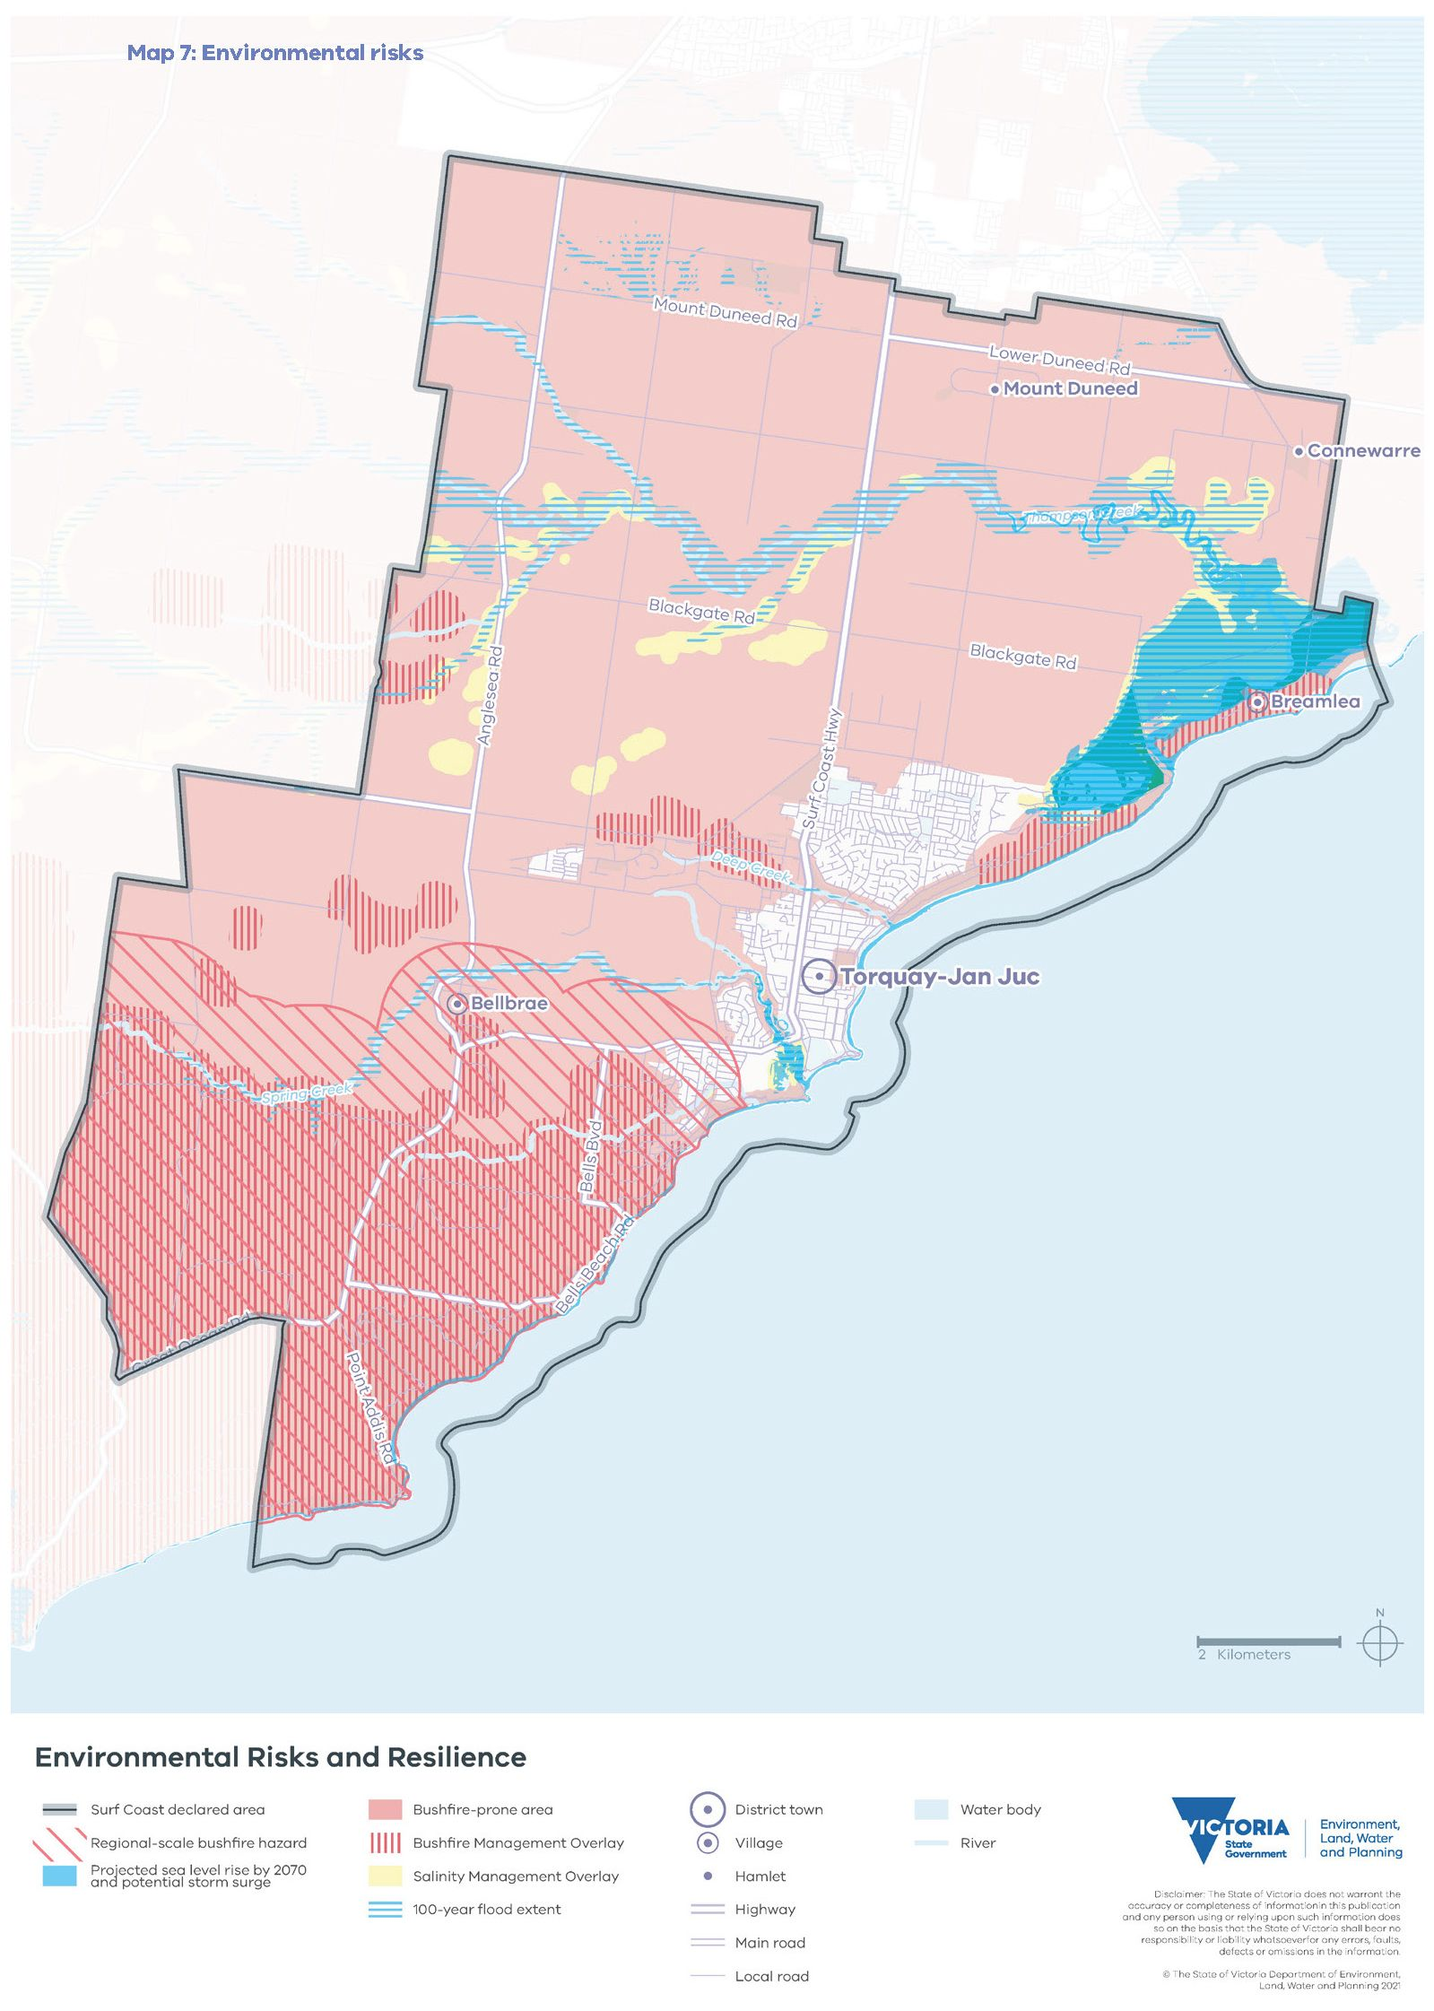

Water quality and security
Relevant United Nations Sustainable Development Goals: 6 – Clean water and sanitation, 11- Sustainable cities and communities, 14 – Life below water, 15 – Life on land,15 – Peace, justice and strong institutions
The declared area’s distinctiveness arises from its associations with water. Waterways flow through the landscape to Bass Strait including through ecologically significant wetlands in the north-east.
Much of the landscape is of cultural significance due to the relationship between land and water. The Wadawurrung Traditional Owners describe yaluk (water) as ‘the most valuable and dominant feature of Wadawurrung Country with its interlinked creation stories and storylines’. Important waterways in the declared area include Doorangwar (Spring Creek) and Kiang-Purt (Thompson Creek).
Water is essential for people living, working and visiting the area including for agricultural and urban uses (such as safe drinking water). It also supports social and recreational activities like surfing and fishing. The declared area forms part of the Corangamite catchment management area and is within the Otway Basin.

Protecting water quality and the environment
Urban development in the declared area has resulted in the clearing of vegetation and increased run-off. These changes in water flows have caused erosion around creek banks and beaches. Overland flows pose multiple risks to the Karaaf Wetlands and Breamlea Flora and Fauna Reserve and other riverine and coastal environments. Without intervention, changes to the water regime and the balance of the mix of saltwater and freshwater will continue to degrade the value of these fragile ecosystems. It is essential to prevent the discharge of untreated run-off from urban development and agricultural activities to sensitive riverine and coastal environments, to maintain the natural water cycle and protect the ecological health of our waterways.
Given the importance of catchment health in the declared area, future urban development must seek to maintain downstream flows at pre-development levels. This requires integrated water management systems at various scales, to enable the harvesting or infiltration of rainwater and stormwater: wetlands, raingardens, permeable footpaths, tree pits and rainwater tanks can do this. With climate modelling predicting more extreme rain events, less annual rainfall and more regular vegetation-destabilising bushfires, the future management of stormwater flows from urban areas will become increasingly important to maintaining water quality and sustaining the environment.

Water security
The declared area’s water supply depends on strategic water infrastructure within and outside the declared area (which Map 9 shows) and on water from reservoirs in the Otways. The compounding impacts of climate change, population growth, agricultural uses and increasing visitation put additional pressure on already declining water resources in the declared area. Less water poses a threat to biodiversity, the productivity of rural land and our way of urban life.
The Black Rock Water Reclamation Plant, which is just outside the declared area near Breamlea, services the sewage needs of Greater Geelong, the Bellarine Peninsula and much of the Surf Coast. It also provides recycled water for irrigation and other non-drinking purposes to surrounding urban and rural areas. It plays a critical role, now and in the future, for addressing water security and resources recovery within the declared area. The plant could potentially treat more wastewater and produce more recycled water, reducing demand on supplies of potable water, but any further development of the plant and its associated infrastructure needs to be sensitive to the surrounding environment.
Over time, the declared area will need to reduce water consumption by implementing more efficient practices, adopting new technologies and changing consumption behaviours. Using recycled water, stormwater and water from other climate-resilient sources will also become increasingly important as demand for water increases and the available surface water declines.

Objective and strategies

Objective 5
The following objective is binding on RPEs.
To prioritise the conservation and health of the declared area’s water catchments to protect ecological systems and to ensure a sustainable water supply.

Strategies
Responsible public entities are required to have regard to the following strategies to achieve the objective when performing a function or duty or exercising a power in relation to the declared area.
Strategy 5.1 Ensure that new land use and development implements water- sensitive design practices and integrated water cycle management to restrict stormwater flows downstream to pre-development levels, to reduce the impacts on waterways and coastal environments.
Strategy 5.2 Improve the health of the Karaaf Wetlands and Breamlea Flora and Fauna Reserve by preventing any stormwater run-off from new development and minimising the clearing of native vegetation in catchments.
Strategy 5.3 Encourage new urban development to include the on-site capacity for stormwater capture and treatment, to reduce demand on potable water supplies.
Strategy 5.4 Facilitate the provision of climate- resilient water infrastructure, to address water security and resource recovery.
Strategy 5.5 Encourage the capture of stormwater run-off for reuse, including to irrigate parks, reserves and street trees.

Historic heritage
Relevant United Nations Sustainable Development Goals: 9 – Industry, innovation and infrastructure, 11- Sustainable cities and communities
The arrival of colonists at the declared area began a process of dispossession of the Wadawurrung’s lands, waters and livelihoods. The conflict between colonists and Traditional Owners resulted in forced removals, disease, massacres and the systemic suppression of Wadawurrung culture through forced assimilation.
To develop the land for their own purposes, colonists intentionally and unintentionally destroyed Wadawurrung living spaces, food venues and resources by introducing human and wildlife diseases and invasive and predatory animal and vegetation species.
In 1841–42, the Spring Creek Station was established at Torquay. In the 1850s, farm allotments were subdivided at Mount Duneed, Bellbrae, Jan Juc and Torquay. Some of the natural features were given the names of the European squatters (such as Zeally Bay, named after Robert Zealley, who held the pre-emptive right to South Beach Station from 1856). Historic homesteads (such as Addiscot Homestead at Bells Beach) are a legacy of this era.
The appeal of the coastline, with its rugged, natural beauty and many recreational opportunities, led to the narrow strip of foreshore between Point Roadknight and Point Lonsdale being set aside as the Ocean Park Reserve in 1875. Later, the coastline became a world-renowned tourist destination known for its surf culture and as the gateway to the nationally heritage-listed Great Ocean Road. Landscape character and historic heritage features have combined to give the declared area its unique identity.
The waters off the declared area’s coastline became important for trade. There are many heritage-listed shipwrecks along the coast including Victoria Tower (wrecked in 1869) and Lucy Lee (wrecked in 1868). Further off the coast, concentrations of wrecks highlight the area’s importance as a trading thoroughfare.
From the 1880s, the rugged, natural beauty of the declared area’s coastline and its many opportunities for enjoyment drew holidaymakers: they helped Torquay and Jan Juc grow into thriving settlements. Torquay and Jan Juc grew quickly and established their own landscapes: Taylor Park in 1882, the caravan park in 1889 and the ‘cosy corner’ beach area of the foreshore — popular for camping, sports and beach recreation — in the late 1880s. Since the 1950s, the Point Danger War Memorial in the foreshore reserve has become a popular place for Anzac Day commemorations.
The Great Ocean Road attracts tourists from around the world, and it is listed on the Victorian Heritage Register and the National Heritage List, which provides protection under the Commonwealth Environment Protection and Biodiversity Conservation Act 1999. Returned servicemen built the road between 1918 and 1932, and today it offers sweeping views of the coastline and the beautiful natural landscapes. The road begins in Torquay, connects several tourist destinations and provides access to coastal settlements along its route.
In the 1920s, people started driving to the area for swimming, surfing and enjoying the beach. The Torquay Surf Life Saving Club, established in 1945, is one of the oldest clubs in Victoria, and it is an important local institution. Two iconic Australian surfing brands — Rip Curl and Quiksilver — started in Torquay. Nearby Bells Beach, a state-listed heritage site, held its first surfing competition in 1961: it has since become a major international event. Surfing locations like Winkipop are popular spots for locals and visitors, offering some of the best surfing in the country. The site is also valued for its landscape beauty and Wadawurrung living cultural heritage values.
Careful management of the threats of rising sea levels, coastal erosion and increased visitation will ensure the iconic Bells Beach and the Great Ocean Road continue to contribute to the area’s historic heritage and are conserved and improved for all to enjoy. Conserving and protecting the declared area’s historic heritage will strengthen its sense of place and contribute to improving the wellbeing of its residents and visitors.

Objective and strategies

Objective 6
The following objective is binding on RPEs.
To protect, strengthen and promote the declared area’s historic heritage values.

Strategies
Responsible public entities are required to have regard to the following strategies to achieve the objective when performing a function or duty or exercising a power in relation to the declared area.
Strategy 6.1 Ensure that significant historic heritage places within the declared area are identified, conserved and managed by using best practice techniques, particularly to enable these places to adapt to climate change impacts.
Strategy 6.2 Minimise the visual impacts of buildings and works on heritage places by ensuring the siting and design of development and infrastructure respect the unique historic heritage of the declared area, its heritage sites and their surrounds.
Strategy 6.3 Ensure land subdivision and development, including alterations and additions, maintain and protect significant historic heritage places.
Strategy 6.4 With the community, use placemaking to promote and celebrate the declared area’s historic heritage including its surfing history.
Strategy 6.5 With the Wadawurrung, ensure that Bells Beach and the nationally heritage-listed Great Ocean Road are accessible, well-maintained and sustainably managed.

Tourism, agriculture and natural resources
Relevant United Nations Sustainable Development Goals: 8 – Decent work and economic growth, 9 – Industry, innovation and infrastructure, 11- Sustainable cities and communities, 12 – Responsible consumption and production, 15 – Life on land,
The declared area is a nature-based destination that draws visitors from around Victoria, Australia and the world. Its many tourism assets include the internationally renowned Bells Beach, the nationally heritage-listed Great Ocean Road and the coastal area from Point Impossible to Point Addis.

Tourism
Bells Beach and the Great Ocean Road together draw millions of visitors a year, and visitor numbers are projected to continue to increase. As a result, there is a need to plan for the sustainable provision of additional visitor accommodation and infrastructure. There are also opportunities to develop a cultural tourism industry managed with the Wadawurrung that celebrates Wadawurrung living cultural heritage.
Torquay–Jan Juc is well-placed to provide for additional tourism accommodation and related services, given that it is part of the eastern gateway to the Great Ocean Road and that there are limited development opportunities along the Great Ocean Road itself. Map 8 shows the current preferred locations for tourism development within Torquay–Jan Juc. These locations are in or close to existing activity centres and along the identified tourism routes.
There are several potential locations within Torquay–Jan Juc that have the capacity for tourism-related development including:
- Surf Coast Gateway Precinct, Surf Coast Highway, Torquay
- Surf City Enterprise Precinct, Surf Coast Highway, Torquay
- Town Centre Foreshore Precinct, The Esplanade, Torquay
- the Bristol Road–Surf Coast Highway corner, Torquay
- Bell Street, Torquay.

These locations, and in particular the Surf City Enterprise Precinct, may change, expand or serve different functions over time to suit the needs of Torquay’s residents and visitors.
Outside Torquay–Jan Juc, Bellbrae and the surrounding rural land present opportunities for the future growth of the agritourism industry, due to their proximity to the Great Ocean Road. The development of these areas for tourism activities must be carefully planned to address bushfire risk.
Climate change impacts, urban growth and increasing visitation need to be managed to ensure nature- based tourism in the declared area is protected and remains viable. The visitor economy should continue to prioritise the sustainable management of the declared area’s landscape significance, environment and biodiversity, Wadawurrung living cultural and historic heritage values. To support this, the connection to and stewardship of Country by the Wadawurrung is integral.
There are opportunities to expand the visitor economy by increasing the number of days visitors stay in the declared area and its surroundings. The visitor economy can be supported by encouraging longer visits — at least overnight, not just day visits — by developing facilities and infrastructure for visitors and by reducing impacts on local amenity (such as traffic, parking and access to services).

Surf industry and entrepreneurial culture
The declared area has a strong manufacturing history, which is connected to the area’s surfing culture. World-renowned surfing brands Rip Curl and Quiksilver have their headquarters in Torquay, as do other surfing brands, and the surf industry is one of the declared area’s biggest sources of employment. Continuing to support the strong cultural, historical and economic contribution by surfing and the surf industry to the declared area will grow the local and regional economies and the declared area’s identity.
The surf industry’s evolution has seen many entrepreneurial businesses, often with strong environmental or social values, emerge. They include creative industries, small-scale manufacturing and home-based businesses: craft breweries, wellness and health food businesses, clothing manufacturers and visual artists among them. Growing these industries will help create prosperous, sustainable and diverse local and regional economies.

Agriculture
Agriculture — intensive farming, commercial farming (broadacre crop and hay production), lifestyle farming and agroforestry — are important for the local and regional economies. Niche agricultural industries have been established in the Surf Coast Shire in pork production, beef, wool, poultry and stock feed crops. For the declared area which has some areas of high quality agricultural soils, there is a focus on farm-gate and agri-food or agritourism.
Many small wineries and other food and beverage producers in the hinterland of Torquay–Jan Juc are important for agritourism. They include farms that offer dining experiences, wineries with cellar-doors, berry-picking experiences and farm-gate sales.
Building on the successes of these enterprises will help grow the local and regional economies and encourage more people to visit the rural hinterland.
The loss of arable farming land and important rural landscapes resulting from the expansion of settlements could greatly damage the hinterland’s economic potential. Protected settlement boundaries will ensure non-urban uses like farming can continue in the green breaks.
The declared areas’ agricultural industries will need to adapt to a changing climate: to less rainfall, warmer average temperatures and increased bushfire risk. To protect the area’s water security and more sustainably use resources, the use of recycled water, particularly on agricultural land in the green break between Torquay–Jan Juc and Geelong, must increase.

Extractive industries and construction
Extractive industries provide materials for use in construction, building, manufacturing, and infrastructure works including for building wind farms. The construction industry accounts for a large proportion of the workforce of the declared area and the Barwon South West Region. Locating extractive industries close to where materials are needed helps keep transportation and construction costs down, and it can have environmental benefits.
Extractive industries and the infrastructure required to support them must be carefully managed so that they take account of the declared area’s landscape significance, environment, and biodiversity, Wadawurrung living cultural and historic heritage values.
Quarries in the declared area produce rock, sand, and gravel. There is also an extractive industry interest area (EIIA) located towards the northern boundary of the declared area, which Map 8 shows. EIIAs indicate that the land is likely to contain extractive resources and may be suitable for extractive industry, although quarries cannot be established as of right. EIIAs ensure:
- the use and development of land for extractive industry does not harm the environment or amenity of the area during or after extraction
- excavated areas can be appropriately rehabilitated
- areas with stone resources — resources the community may need for future use — are protected from inappropriate use and development.
Extractive industries are a temporary land use within rural and peri-urban landscapes. They need buffers during their operating life, and at the end of their life they must be rehabilitated to meet community needs and to fit in with the surrounding landscape character.

Objective and strategies

Objective 7
The following objective is binding on RPEs.
To support a diverse socially and environmentally responsible economy that protects and promotes the declared area’s landscape significance, environment and biodiversity, Wadawurrung living cultural and historic heritage values.

Strategies
Responsible public entities are required to have regard to the following strategies to achieve the objective when performing a function or duty or exercising a power in relation to the declared area.
Strategy 7.1 With the Wadawurrung, facilitate culturally responsive tourism and related economic development that encourages people to recognise, understand and celebrate Wadawurrung living cultural heritage, rights and authority.
Strategy 7.2 Encourage ecologically sustainable, tourism-related uses and infrastructure within the preferred areas for tourism in Torquay–Jan Juc and agritourism in the area surrounding Bellbrae.
Strategy 7.3 Ensure the siting and design of development and infrastructure are sympathetic to the declared area’s significant landscapes and its environmental, biodiversity, Wadawurrung living cultural heritage and historic heritage values.
Strategy 7.4 Encourage the development of tourism infrastructure that highlights Torquay– Jan Juc’s surfing identity, coastal character and unique location on the Great Ocean Road tourist route.
Strategy 7.5 Encourage the development of non- tourism-related industries by building on the declared area’s entrepreneurial culture.
Strategy 7.6 Encourage the use of rural land outside settlements for agricultural, nature- based tourism and natural resource and related purposes that prioritise the declared area’s significant landscapes and its environmental, biodiversity, Wadawurrung living cultural heritage and historic heritage values.
Strategy 7.7 Use best practice measures to ensure the use and development of land for extractive industries and the rehabilitation of excavated areas avoid and minimise impacts on the declared area’s significant landscapes and its environmental, biodiversity, Wadawurrung living cultural heritage and historic heritage values.
Strategy 7.8 Encourage environmentally sustainable, innovative farming practices (such as water reuse and new technologies) to enable farming to adapt and respond to climate change and emerging markets.
Strategy 7.9 Restrict the supply of rural residential land to conserve and protect agricultural practices and other rural land uses

Map 8: Tourism, agriculture and natural resources
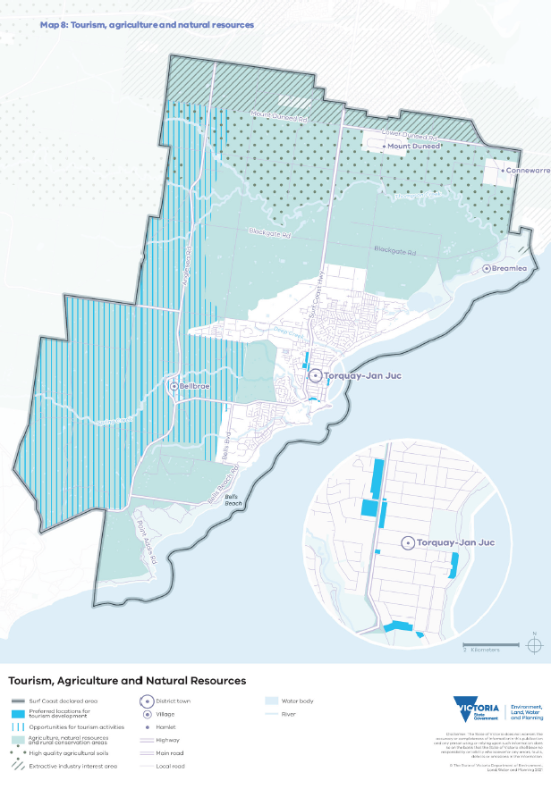

Strategic infrastructure
Relevant United Nations Sustainable Development Goals: 3 – Good health and well-being, 8 – Decent work and economic growth, 9 – Industry, innovation and infrastructure, 11- Sustainable cities and communities
To protect the declared area’s distinctive attributes and the high quality of life it offers, transport, service infrastructure and land use planning must be integrated with environmental, heritage and landscape protection. Torquay–Jan Juc needs adequate essential services and community infrastructure, to maintain its role as a regional service centre and iconic tourist destination while responding to population growth, increasing visitation and climate change.

Transport
Transport networks support community wellbeing and economic prosperity by providing access to jobs, markets, services and social opportunities. The planning and construction of transport networks must support the declared area’s vision by protecting its landscape significance, environment and biodiversity, Wadawurrung living cultural and historic heritage values and by improving its resilience to climate change impacts. This includes reducing and mitigating transport-related greenhouse gas emissions.
Motor vehicles are the main mode of transport in the declared area. Buses are the main public transport mode for residents and visitors. To help achieve the Victorian Government’s target of net-zero emissions by 2050, the declared area needs more sustainable transport infrastructure, particularly for public and
active transport options (such as walking and safer cycling). Structure planning and urban renewal projects should provide opportunities for well-designed active transport infrastructure to fit in with the landscape character and connect to the existing transport network.
The nationally heritage-listed Great Ocean Road is an internationally renowned tourist destination and key transport infrastructure that links Torquay–Jan Juc with coastal settlements to the south. It also provides life-saving access to those settlements during bushfires. The impacts on the road of increasing visitor numbers and climate change — severe weather events, coastal erosion and inundation along the whole length of the road — must be managed in a way that recognises interconnections between settlements, the environment and the road’s heritage values.
The Surf Coast Highway and Anglesea Road are regionally significant transport infrastructure. They link the declared area to Geelong and Melbourne via the Princes Freeway and provide access to services and employment opportunities. They are also important components of Victoria’s freight network. To service with growing numbers of visitors, these roads must be maintained and improved in a way that protects the sweeping views from them across the landscape.
The proposed Armstrong Creek transit corridor, a public transport connection currently being investigated, could enable a new transport interchange within Torquay–Jan Juc that could be a community activity node through integrated transport and land use planning, linking to other activity centres within Torquay–Jan Juc.
Planning for the Armstrong Creek transit corridor must ensure that:
- infrastructure is planned and designed to integrate with existing settlements in a way that is sensitive to the declared area’s landscape significance, environment and biodiversity, Wadawurrung living cultural and historic heritage values, particularly to the green break between Geelong and Torquay–Jan Juc
- any potential transport interchange is located in an area accessible to the Torquay–Jan Juc community with good connections to existing cycling, walking and public transport routes, to support and enhance the existing active transport network.
The planning process for the corridor should also aim to ensure that:
- it facilitates transport access to community services within Torquay–Jan Juc’s protected settlement boundary through co-location or integrated land use
- any potential transport interchange is located where it strengthens the local and regional transport networks
- any potential transport interchange has a residential catchment in the future, providing opportunities for housing diversity
- planning for the corridor protects the landscape significance and coastal character of Torquay–Jan Juc. For example, it should ensure development does not protrude above hilltops and ridge lines, so the natural contours and vegetation remain visible, and development should seek to establish and improve connections between areas of high environmental and biodiversity value including areas along waterways.

Essential services and community infrastructure
Torquay–Jan Juc is an important regional service centre and iconic tourist destination, and it needs adequate essential services and community infrastructure to continue to be so.
This includes water, electricity, renewable energy, telecommunications and waste management infrastructure as well as schools, sporting facilities, libraries, health services and town centres. New infrastructure must be planned and existing infrastructure expanded in an environmentally responsible manner.
Planning should support the continued consolidation of education and health services in Torquay’s north and ensure this area is well-connected to the settlement’s other activity centres. The planned Torquay Community Hospital, to be located within this cluster of civic, community and education services, will provide public healthcare: people will no longer have to travel to Geelong for it.

Objectives and strategies

Objective 8a
The following objective is binding on RPEs.
To ensure strategic infrastructure is planned and designed to enhance and minimise its impact on the declared area’s distinctive attributes.

Strategies
Responsible public entities are required to have regard to the following strategies to achieve the objective when performing a function or duty or exercising a power in relation to the declared area.
Strategy 8a.1 Ensure the provision, maintenance and upgrading of infrastructure conserves and improves landscape character, environmental and biodiversity values, Wadawurrung living cultural heritage and historic heritage values of the declared area.
Strategy 8a.2 In consultation with the Wadawurrung, ensure the provision, maintenance and upgrading of infrastructure protects, conserves and enhances sites of Wadawurrung living cultural heritage significance.
Strategy 8a.3 Design infrastructure to be sympathetic to the preferred character of settlements and landscapes by maintaining view lines and vantage points from key transport corridors and by providing vegetation that improves landscape character.

Objective 8b
The following objective is binding on RPEs.
To maintain the role of Torquay–Jan Juc as a sustainable regional service centre that supports the community’s social and economic needs and increases the declared area’s resilience to climate change impacts.

Strategies
Responsible public entities are required to have regard to the following strategies to achieve the objective when performing a function or duty or exercising a power in relation to the declared area.
Strategy 8b.1 Provide new infrastructure and/or upgrade existing infrastructure in sequence with development to meet the needs of communities, local businesses and tourists.
Strategy 8b.2 Prioritise active transport modes (such as walking, cycling and public transport) and sustainable infrastructure (such as electric vehicle recharging stations and bicycle parking) to encourage their use by the community and visitors, help minimise greenhouse gas emissions and improve resilience to climate change impacts.
Strategy 8b.3 Encourage active transport and mitigate the need for future car parking by providing safe, accessible pedestrian and bicycle connections between residential areas, activity centres, beaches and other visitor attractions.

Map 9: Strategic infrastructure
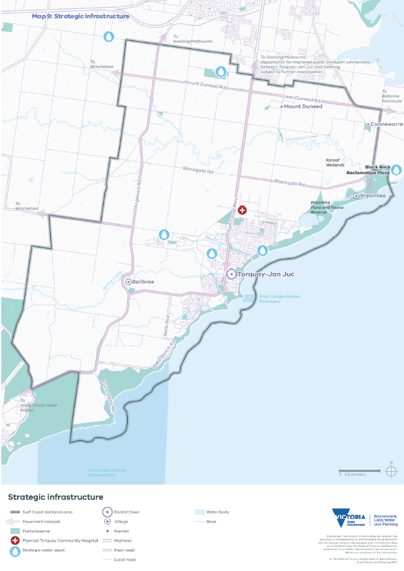

Settlements
Relevant United Nations Sustainable Development Goals: 3 – Good health and well-being, 6 – Clean water and sanitation, 9 – Industry, innovation and infrastructure, 11- Sustainable cities and communities, 16 – Peace, justice and strong institutions, 17 – Partnerships for the goals
The declared area is a highly desirable place to live, work and visit, given the lifestyle it offers and its proximity to Geelong and Melbourne. There are five settlements within the declared area, and they have a relaxed, coastal character in a rural setting.
Since 2011, the rate and amount of population growth in the declared area have been strong, compared to other settlements in the G21 region and regional Victoria. As a result, the declared area’s unique values and distinctive attributes have been under pressure from overdevelopment. Climate change is and will continue to directly affect the declared area’s landscape significance, environment and biodiversity, Wadawurrung living cultural and historic heritage values. To achieve the 50-year vision, settlements must be carefully planned and ecologically sustainable development reinforced.
Torquay–Jan Juc, Bellbrae and Breamlea are located within landscapes of state significance, and they are close to areas of Wadawurrung living cultural heritage and areas with high biodiversity values. These landscapes and areas must be protected from urban encroachment. The hamlets of Mount Duneed and Connewarre are located within landscapes of regional significance, within which are areas of cultural and environmental significance.
Protected settlement boundaries have been applied to all settlements, to provide certainty to communities about how their unique values and distinctive attributes will be conserved for the long term while designating areas for sustainable, managed growth. Green breaks will be retained between settlements, to create a sense of separation that helps settlements retain their unique identities and characters. The green breaks also provide highly valued natural backdrops, and they are important locations for agriculture, natural resource and other non-urban uses.
Development within all settlements should apply best practice, environmentally sustainable design and development principles. This includes supporting energy and resource efficiency, minimising car dependency, reducing stormwater run-off and promoting waste reduction and recycling throughout the design, construction and operation phases of a development.

Settlement hierarchy
Table 3 shows the hierarchy designation — district town, village or hamlet — of all settlements within the declared area and their role, function and future for growth.
- Hierarchy of Surf Coast declared area settlements
Settlement | Hierarchy designation | Role and function
Torquay–Jan Juc | District town: a large town providing a diversity of housing, services and employment to support local and regional communities and the visitor economy, which provides service functions to surrounding settlements and the hinterland. | Torquay–Jan Juc is the largest settlement in the declared area, and it will continue to provide housing and employment opportunities to support local and regional communities and the visitor economy. Infill and greenfield growth will occur in designated future settlement areas and substantial change areas.
Bellbrae, Breamlea | Village: a small town with limited services (such as a general store or post shop) that support the local community. | Bellbrae and Breamlea are small settlements servicing the needs of their local communities. They are designated for minimal change within their settlement boundaries with no further greenfield growth.
Mount Duneed and Connewarre | Hamlet: a small cluster of dwellings in a mainly rural area. | These settlements are low-density rural subdivisions with no services, and they are not designated for growth.

Torquay–Jan Juc
Map 10 shows the Torquay-Jan Juc protected settlement boundary. Torquay–Jan Juc will continue to be a district town providing housing choices, employment opportunities and community services for residents, workers and visitors. Urban development within Torquay–Jan Juc will be sustainably managed through a combination of infill and greenfield development within a protected settlement boundary, to safeguard the declared area’s green breaks, landscape significance, environment and biodiversity, Wadawurrung living cultural and historic heritage values.
Most development will be directed to activity centres, commercial and tourism precincts, substantial change areas and future urban areas, which will be linked through a sustainable movement network.
Affordable and social housing will be provided close to services and community facilities.
Active modes of transport (such as walking, cycling and public transport) will be encouraged by providing sustainable infrastructure and by designing the public realm to enable better access to health facilities, parks, shops and other services.
The Armstrong Creek transit corridor, currently being investigated, is an opportunity to improve public transport connections between Armstrong Creek and Torquay–Jan Juc. Any transit corridor terminal will be encouraged to co-locate with community facilities and infrastructure.

Activity centres, commercial and tourism precincts
Torquay–Jan Juc has several established activity centres and commercial, tourism and civic precincts, and development in these centres and precincts must be planned and designed to respond to the Torquay–Jan Juc coastal character statement. Their role and function are set out in the following part of this policy domain.

Torquay Town Centre
The Torquay Town Centre is located at the heart of ‘old Torquay’ adjacent to the foreshore. Centred around Gilbert Street, it has also expanded to the north and west. It is a major activity centre, with three supermarkets and a variety of small businesses. It has a wider tourism role within the region.
This area will remain the primary activity centre for Torquay–Jan Juc, with potential for future expansion. It is a preferred location for additional tourism uses and infrastructure including accommodation as well as commercial uses and community services.

Bell Street Activity Centre
The Bell Street Activity Centre has a surfing, tourist and entertainment role. Development in this area will support the continuation of this role.

Jan Juc Local Activity Centre
The Jan Juc Local Activity Centre is a small activity centre primarily serving the day-to-day needs of the local community. Development here will support the continuation of this role.

Surf City, Baines Crescent, Surf Coast Highway and Surf Coast Gateway precincts
The Surf City Precinct and the Surf Coast Gateway Precinct are surf industry hubs and have been identified as having the capacity for tourism- related development and growth. They also provide entertainment and community facilities as well as employment and innovation services. The buildings in these precincts are distinctive and home to iconic surfing brands. They contribute to the surfing identity and character of Torquay. Given their designation as tourism development precincts, these are the preferred locations for future tourism-related uses and associated infrastructure.
Commercial and residential development along the Surf Coast Highway will also continue to provide a focal point for commercial and tourism activity including the tourism development location on the Bristol Road–Surf Coast Highway corner.
The creation of an enterprise precinct in the Baines Crescent area will be encouraged, as a place with diverse, coexisting employment uses. While the changing nature of the surf retail industry may lead to changing land uses in this area, including along Baines Crescent, the area will continue to retain a tourism focus, given its highly prominent location.
As all these precincts evolve, the co-location of retail, professional and entertainment uses here will be encouraged.

Torquay North Neighbourhood Activity Centre, Torquay Community and Civic Precinct
The Torquay North Neighbourhood Activity Centre and the Torquay Community and Civic Precinct have diverse community and commercial uses including the Surf Coast Shire municipal offices, sports facilities, a secondary school, the Kurrambee Myaring Community Centre, the Grant Pavilion community hub, the planned Torquay Community Hospital and the proposed Surf Coast Aquatic and Health Centre.
Additional community, civic and commercial uses in this area are encouraged, to consolidate it as a vibrant precinct.
The proposed Armstrong Creek transit corridor, a public transport connection currently being investigated, provides an opportunity to improve access to services in this precinct.

Torquay–Jan Juc residential areas
New residential development in Torquay–Jan Juc will be directed to residential change areas in accordance with the area’s designation as for substantial, incremental or minimal change. All new development in these areas must be planned and designed to respond to the Torquay–Jan Juc coastal character statement.

Substantial change areas
Areas designated for substantial residential change and the preferred locations for urban consolidation. These areas are located around the Torquay Town Centre, to promote walkability and connection and to provide access to jobs, services and facilities.
Urban consolidation in these areas will provide for a diversity of housing types. Directing additional housing supply to these locations reduces pressure for change in Torquay–Jan Juc’s other residential areas and more sensitive coastal and rural locations.

Incremental change areas
Areas designated for moderate change where residential development occurs within the context of the existing or preferred neighbourhood character that provides for diverse housing types. They provide a transition between areas of increased density around the Torquay Town Centre and lower-density residential areas located on the edges of Torquay– Jan Juc.

Minimal change areas
Minimal change areas are generally existing, low- density residential areas located on the periphery of Torquay–Jan Juc. These areas will be retained, to provide a transition between the urban and rural landscapes.
The Strathmore Drive area is a low-density residential area located between Strathmore Drive, Great Ocean Road, Bells Boulevard and the upper tributary of Jan Juc Creek. It is a highly prominent, elevated location with significant views towards Bass Strait. As a landscape of state significance that also has substantial bushfire risk, it is identified as a minimal change area, but the area’s characteristics may make development challenging. Special consideration, as explained in the Torquay–Jan Juc coastal character statement, is required when planning residential development in the Strathmore Drive area.

Future urban areas
Future urban areas are areas within the protected settlement boundary identified as being potentially suitable for greenfield development. They will provide urban land uses including residential, employment, community infrastructure and eco-tourism.
Development will be planned and designed in line with the Torquay–Jan Juc coastal character statement.
A planning authority will not consider rezoning and/or permitting development in these areas until comprehensive planning and infrastructure assessment has been undertaken.
This statement describes Torquay–Jan Juc’s coastal character. The statement will guide the design of Torquay–Jan Juc’ development and infrastructure including planning controls for determining planning permit applications.

Torquay–Jan Juc coastal character statement
The settlement of Torquay–Jan Juc retains a strong connection with its coastal and rural landscape setting. Vegetation dominates the setting, the natural contours of the land and views of the coast are clearly visible, and development has high- quality design.
The views from streets and other public places are of native vegetation and exotic canopy trees. Visual connections through to Bass Strait are retained.
Further plantings of native vegetation (especially next to roads, along waterways, in reserves and along the coastline) enhance the coastal character.
The natural contours and vegetation of the hilltops and ridge lines surrounding the settlement remain clearly visible. In future urban areas, hilltops and ridge lines are vegetated, and development does not protrude above them. Views of the coast from the nationally heritage-listed Great Ocean Road are maintained.
Development is designed to fit in with and respect the declared area’s landscape significance, township character, environment and biodiversity, Wadawurrung living cultural and historic heritage values.
Development is an exemplar of best practice. It uses architectural styles, integrated water cycle management, environmentally sustainable designs and materials and finishes that contribute to the existing sense of place and that promote and celebrate Torquay–Jan Juc’s coastal landscape and cultural heritage. The landscaping in public places is sympathetic to the local vegetation. Locally indigenous vegetation species are used where possible.
At the urban-rural interface, generous transition areas within the protected settlement boundary provide a transition to the surrounding rural landscape, and the visibility of the settlement from green breaks is minimised. These character aspects are achieved with reduced dwelling densities, reduced building heights, smaller building footprints, larger lot sizes and substantial landscaping or generously vegetated buffers using fire-resistant indigenous species. Materials and finishes that temper visibility (such as darker materials and materials that weather naturally) are used. All development responds to bushfire risk.

Activity centres, commercial and tourism precincts
Mixed-use development with shop-top apartments and offices is supported in activity centres, and it is designed at a scale in keeping with the activity centre’s role and character.
As the primary activity centre, the Torquay Town Centre is a vibrant, mixed-use commercial centre for retail, office, business, entertainment, tourism and community uses. Development helps consolidate fragmented areas of the activity centre and improve amenity and pedestrian connectivity. Building heights within the Torquay Town Centre will generally be two-to-three-storeys. Buildings of up to four storeys may occur in locations where development can be designed to transition sensitively to street edges, where it does not overshadow the public realm, and where long range views of the coast from existing areas can be maintained. New development must respect residential interfaces, not dominate the coastal reserve and must ensure the foreshore area is protected.
Development in the Bell Street Activity Centre is at a lower scale and intensity than the Torquay Town Centre. Development is no higher than three storeys and designed to respond to the existing character of the area, and the surrounding coastal landscape and neighbourhood character of adjoining residential areas. Torquay–Jan Juc’s surfing and beach culture environment is reflected in the built form and public realm.
Development in the Jan Juc Activity Centre is no higher than two storeys and designed to respond to the existing character of the area, and the surrounding coastal landscape and neighbourhood character of adjoining residential areas.

Substantial change areas
Development in substantial change areas is designed in a way that respects older-style beach houses and the neighbourhood character of ‘Old Torquay’. It maintains the predominant pattern of front and side setbacks that allow space to retain existing and plant more vegetation including gardens and canopy trees, to soften the built form and create spacious, leafy streetscapes. Development reduces bulk with building articulations and materials and finishes that complement the existing coastal character.

Incremental change areas
Development in incremental change areas is designed to fit in with the coastal character of the existing area. It comprises low-scale built form set in well-landscaped gardens. Generous boundary setbacks help to minimise visual bulk, protect existing vegetation and allow space for additional landscaping including canopy trees. Materials and finishes reduce the visibility of development, so that the surrounding vegetation is the dominant feature.
Development along The Esplanade is designed to respect the sensitive foreshore landscape. Buildings are low-scale, and there are substantial areas of permeable land. Small building footprints allow space to retain existing and plant more vegetation including gardens and canopy trees, to ensure development does not dominate the coastal landscape.

Minimal change areas
Development in minimal change areas is low-rise on larger lots, and it is designed to fit in with the existing coastal character of the area. It is set in well-landscaped gardens that meet bushfire risk requirements, and the surrounding vegetation is the dominant feature. Generous boundary setbacks help minimise visual bulk, protect existing vegetation and allow space for additional landscaping including canopy trees. Materials and finishes reduce the visibility of development.

Strathmore Drive, Jan Juc
Development in this area is low density residential development, so it is not incongruous with the established character of Jan Juc to the east and south and with its state-significant landscape setting. Development protects the wide-ranging, open views towards Bass Strait and maintains the sense of arrival from the west to Torquay–Jan Juc. High points adjacent to the Great Ocean Road remain free of development. Buildings are low-rise structures set into the landscape. They have ample permeable land and setbacks that allow space to retain existing and plant more vegetation including gardens and canopy trees, to ensure the area is not visually dominated by built form or infrastructure, subject to requirements for bushfire-defendable space.
Development responds to the area’s proximity to the regional-scale bushfire hazard to the south-west. The introduction of vegetation on public and private land is planned and maintained in line with requirements for bushfire-defendable space. The area is planned holistically (rather than by landholding) to incorporate bushfire protection measures at a settlement scale and to ensure a landscape outcome that responds to bushfire risk and respects its significant landscape setting.

Future urban areas
Development in future urban areas reflects Torquay– Jan Juc’s coastal character, with low-rise buildings set within well-landscaped gardens that reflect the surrounding landscape significance.
High points and ridgelines remain free of development, so views to elevated areas of the landscape reveal the natural form of the topography and vegetation against the sky and are not visually dominated by built form or infrastructure.
Development of the Messmate Road future urban area urban-rural interface does not extend past the ridgeline. The prevailing landscape character to the north of the ridgeline is maintained, with development not visually intruding on the landscape north of the ridgeline.

Bellbrae
Map 11 shows the Bellbrae protected settlement boundary. Bellbrae is not identified as a location for increased housing or urban expansion. Residential development will be limited to within the protected settlement boundary. It will be designed to fit in with the existing village character: set within a treed environment and surrounded by the rural landscape of the hinterland.
Bellbrae’s spacious streetscapes dominated by vegetation will be retained, and new residential development will occur at a scale sympathetic to the existing built form. Development will integrate with the surrounding landscape and remnant coastal bushland, presenting as a soft edge to Anglesea Road. It will use materials and finishes that blend carefully into the landscape.
Non-residential urban and community uses will be focused along School Road, to activate the area and create a main-street, village feel. Buildings will be designed and sited to enhance the settlement’s village character and improve pedestrian accessibility.

Breamlea
Map 12 shows the Breamlea protected settlement boundary. Due to the environmentally sensitive coastal and estuarine environment within which Breamlea sits, there will be no development beyond the current extent of the settlement and no additional infill development within the protected settlement boundary.

Mount Duneed and Connewarre
Map 13 shows the Mount Duneed protected settlement boundary and Map 14 the Connewarre protected settlement boundary.
The Mount Duneed and Connewarre low-density residential areas are within the green break between the Armstrong Creek urban growth area in Geelong and Torquay–Jan Juc. The green break is a regionally significant landscape and provides a rural setting for the settlements. It also has significant Aboriginal cultural heritage, environmental and biodiversity values, particularly along Thompson Creek. To protect these values and to stop Geelong and Torquay–Jan Juc coalescing, the Mount Duneed and Connewarre low-density rural residential areas will be contained within protected settlement boundaries.

Armstrong Creek urban growth area
The northern boundary of the declared area abuts the Armstrong Creek urban growth area in Geelong. A protected settlement boundary will be needed for this area, to ensure greater protection of the green break between Geelong and Torquay–Jan Juc, which has been identified as a landscape of regional significance.
The resolution of this settlement boundary is subject to the completion of local strategic planning work and public consultation, which will be led by the Greater Geelong City Council in collaboration with the Department of Environment, Land, Water and Planning, other relevant agencies and the Wadawurrung. This work should include consideration of the design and density of development in urban-rural transition areas within the protected settlement boundary that support the regionally significant landscape setting.

Objectives and strategies

Objective 9
The following objective is binding on RPEs.
To plan and manage the sustainable development of settlements in the declared area consistent with the protection of the area’s landscape significance, environment and biodiversity, Wadawurrung living cultural and historic heritage values and consistent with the unique character, role and function of each settlement.

Strategies
Responsible public entities are required to have regard to, the following strategies to achieve the objective when performing a function or duty or exercising a power in relation to the declared area.
Strategy 9.1 Direct urban development to a hierarchy of settlements, through designating areas for change and clearly defining protected settlement boundaries for Torquay–Jan Juc, Bellbrae, Breamlea, Mount Duneed and Connewarre settlement areas and the Armstrong Creek urban growth area.
Strategy 9.2 Facilitate commercial development, community services, visitor accommodation, infrastructure and facilities within Torquay–Jan Juc’s activity centres, commercial and tourism precincts.
Strategy 9.3 Direct the majority of residential development within Torquay-Jan Juc to substantial change areas and future urban areas.
Strategy 9.4 Ensure development in Torquay– Jan Juc is planned and designed to respond to the Torquay–Jan Juc coastal character statement.
Strategy 9.5 Ensure development in Torquay–Jan Juc, Bellbrae and Breamlea relates to the surrounding natural landscape by providing ample permeable land and setbacks that allow space to retain existing and plant more vegetation including gardens and canopy trees.

Map 10: Torquay-Jan Juc protected settlement boundary
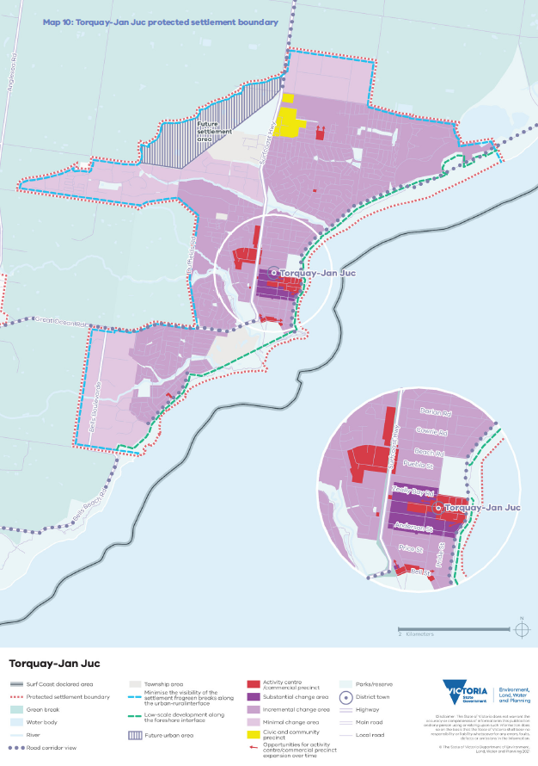

Map 11: Bellbrae protected settlement boundary
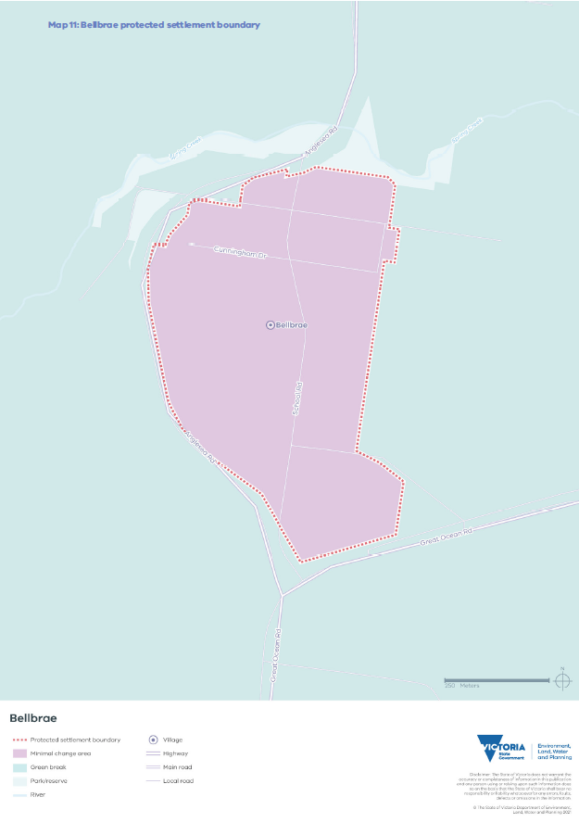

Map 12: Breamlea protected settlement boundary
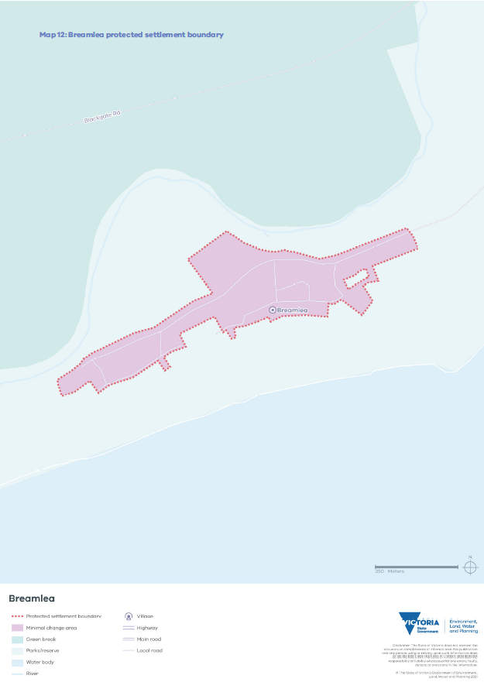

Map 13: Mount Duneed protected settlement boundary
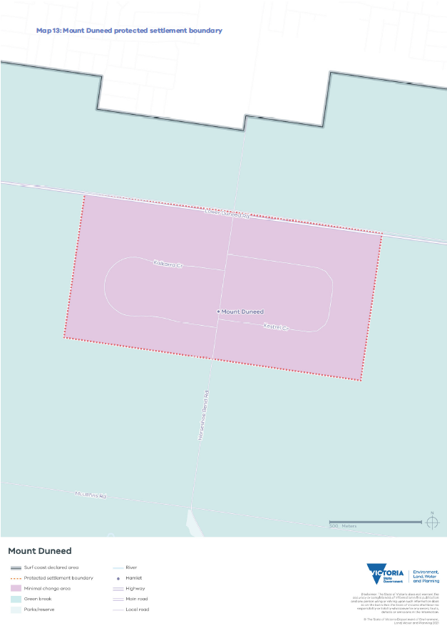

Map 14: Connewarre protected settlement boundary
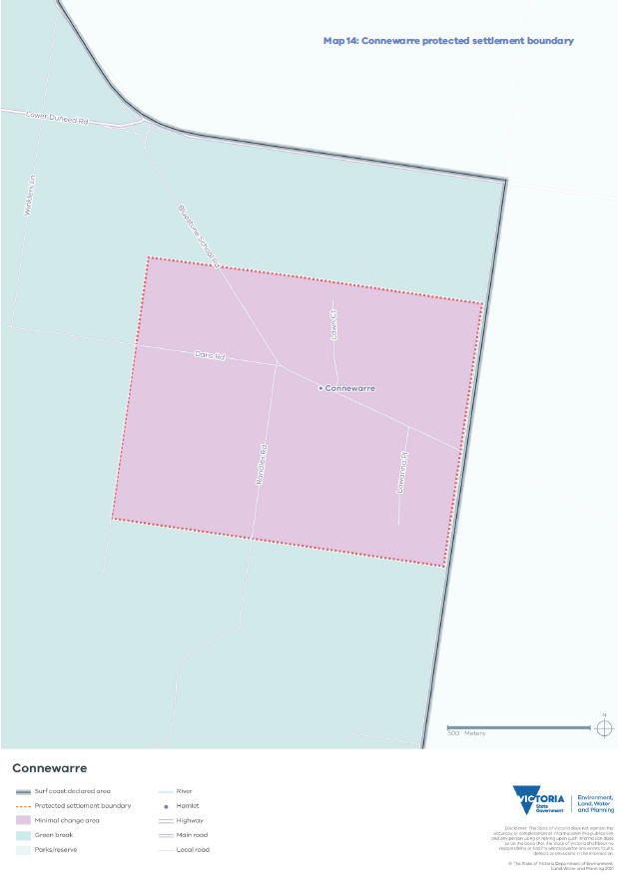

References
AEC Group (2014). Economic Value of the Surf Industry to Surf Coast Shire, AEC Group, Melbourne.
Authentic Heritage Services Pty Ltd (2009). Surf Coast Shire Heritage Study Stage 2B, Surf Coast Shire, Torquay.
Aboriginal Victoria (2019). Cultural Heritage Management Plans, Aboriginal Victoria, Melbourne. Barwon Water (2017). Urban Water Strategy, Barwon Water, Geelong.
Capire Consulting Group (2020). Surf Coast Distinctive Area and Landscape: Phase Two Engagement Report, Capire Consulting Group, Melbourne.
Claire Scott Planning (2020). Distinctive Areas and Landscapes: Surf Coast Assessment Review, Claire Scott Planning, Melbourne.
Corangamite Catchment Management Authority (2009). Corangamite Marine and Coastal Biodiversity Strategy, Corangamite CMA, Melbourne.
City of Greater Geelong (2019). Amendment C395 – Settlement Strategy and Northern and Western Geelong Growth Areas Framework Plan, City of Greater Geelong, Geelong.
Clarke JM, Grose M, Thatcher M, Round V & Heady C (2019). Barwon Climate Projections 2019, CSIRO, Melbourne.
Department of Environment, Land, Water and Planning (2020). Planning Practice Note 90: Planning for Housing (PPN90), State of Victoria, Melbourne.
Department of Environment, Land, Water and Planning (2020). NatureKit, State of Victoria, Melbourne.
Department of Environment, Land, Water and Planning (2020). Marine and Coastal Policy, State of Victoria, Melbourne.
Department of Environment, Land, Water and Planning (2020). Surf Coast Planning Scheme, State of Victoria, Melbourne.
Department of Environment, Land, Water and Planning (2020). Hydra Map Share Vic, State of Victoria, Melbourne.
Department of Environment, Land, Water and Planning (2019). Long-Term Water Resource Assessment, State of Victoria, Melbourne.
Department of Environment, Land, Water and Planning (2019). Victoria in Future 2019. State of Victoria, Melbourne.
Department of Environment, Land, Water and Planning (2019). Victoria’s Climate Science Report 2019. State of Victoria.
Department of Environment, Land, Water and Planning (2018). Great Ocean Road Action Plan, State of Victoria, Melbourne.
Department of Environment, Land, Water and Planning (2017). City of Greater Geelong Planning Scheme, State of Victoria, Melbourne.
Department of Environment, Land, Water and Planning (2017). Plan Melbourne 2017–2050 Five Year Implementation Plan, State of Victoria, Melbourne.
Department of Environment, Land, Water and Planning (2017). Plan Melbourne 2017–2050 Metropolitan Planning Strategy, State of Victoria, Melbourne.
Department of Environment, Land, Water and Planning (2017). Planning for biodiversity — Guidance, State of Victoria, Melbourne.
Department of Environment, Land, Water and Planning (2017). Protecting Victoria’s Environment – Biodiversity 2037, State of Victoria, Melbourne.
Department of Environment, Land, Water and Planning (2016). Climate Ready Barwon South West, State of Victoria, Melbourne.
Department of Environment, Land, Water and Planning (2016). Water for Victoria, State of Victoria, Melbourne.
Department of Environment, Land, Water and Planning (2015). Barwon South West Climate Change Adaption Snapshot Report, State of Victoria, Melbourne.
Department of Sustainability and Environment (2012). Code of Practice for Bushfire Management on Public Land, State of Victoria, Melbourne.
Department of Sustainability and Environment (2011). Western Region Sustainable Water Strategy, State of Victoria, Melbourne.
Ecologically Sustainable Development Steering Committee (1992). National Strategy for Ecologically Sustainable Development, Australian Government, Canberra.
Ethos Urban (2020). Surf Coast Distinctive Area and Landscape: Township Character Assessment, Ethos Urban, Melbourne.
G21 Geelong Regional Alliance (2013). G21 Regional Growth Plan, G21 Geelong Regional Alliance, Geelong.
Powell B, Tournier D, Jones DS & Roös PB (2019). Welcome to Wadawurrung Country, in Jones DS & Roös PB (eds.) 2019, Geelong’s Changing Landscape: Ecology, Development and Conservation, CSIRO Publishing, Melbourne, pp. 44-84.
Surf Coast Shire (2020) Surf Coast Torquay–Jan Juc Retail and Employment Land Strategy, Surf Coast Shire, Torquay.
Surf Coast Shire (2020). Prosperous Places: Discussion Paper, Surf Coast Shire, Torquay. Surf Coast Shire (2019). Rural Hinterlands Futures Strategy, Surf Coast Shire, Torquay.
Surf Coast Shire (2018). Surf Coast Economic Insights, Surf Coast Shire, Torquay. Surf Coast Shire (2014). Biodiversity Mapping Project, Surf Coast Shire, Torquay.
Surf Coast Shire (2014). Sustainable Futures Plan Torquay–Jan Juc 2040, Surf Coast Shire, Torquay. Surf Coast Shire (2007). Torquay and Jan Juc Structure Plan, Surf Coast Shire, Torquay.
Wadawurrung Traditional Owners Aboriginal Corporation (2020). Paleert Tjaara Dja: Wadawurrung Country Plan, Wadawurrung Traditional Owners Aboriginal Corporation Ballarat/Geelong.
Wadawurrung Traditional Owners Aboriginal Corporation (2020). Paleert Tjaara Dja: Wadawurrung Country Plan, https://www.wadawurrung.org.au/healthy-country-plan-video, Wadawurrung Traditional Owners Aboriginal Corporation Ballarat/Geelong.
Wadawurrung Traditional Owners Aboriginal Corporation (2020). Surf Coast Cultural Heritage, Wathaurung Aboriginal Corporation, Ballarat.

Glossary of terms
Term | Definition
Biodiversity | All components of the living world: the number and variety of native plants, animals and other living things across our land, rivers, coast and ocean. Biodiversity includes the variety of their genetic information, their habitats and their relationship to the ecosystems within which they live.
Biolink | A connection across the landscape that links up areas of habitat and supports natural processes that occur in a healthy environment including the movement of species to find food and water.
Built form | The combination of features of a building including its style, façade treatments, setbacks (front, side and rear), height and site coverage.
Declared area | An area to which an order under Planning and Environment Act 1987 section 46AO applies. Map 2 shows the Surf Coast declared area.
Declared area framework plan | A plan required by the Planning and Environment Act 1987 section 46AV(2) to provide a framework for decision-making in relation to the future use and development of land in the declared area.
District town | A large town providing a diversity of housing, services and employment to support local and regional communities and the visitor economy, which provide service functions to surrounding settlements and the hinterland. Within the G21 region, district towns can have populations of between 10,000 and 100,000 people.
Ecologically sustainable development | Defined by the National Strategy for Ecologically Sustainable Development (1992) as ‘using, conserving and enhancing the community’s resources so that ecological processes, on which life depends, are maintained, and the total quality of life, now and in the future, can be increased’.
G21 Alliance | The formal alliance of government, business and community organisations working together to improve the lives of people in the G21 region, which spans the City of Greater Geelong, Colac Otway Shire, Surf Coast Shire, Borough of Queenscliffe and Golden Plains Shire.
Green break | Predominantly rural land located in between settlement boundaries that may comprise a variety of non-urban land uses (such as agriculture, hobby farms and agritourism businesses).
Greenfield | Undeveloped land identified for residential or industrial/commercial development, generally on the fringe of a settlement.
Great Ocean Road region | The area south of Princes Highway between Warrnambool and Torquay including the coast. The region includes parts of the City of Warrnambool and the Moyne, Corangamite, Colac Otway and Surf Coast shires.
Hamlet/locality | A small cluster of dwellings in a mainly rural area.
High biodiversity value areas | Areas with:  - larger, well-connected areas of native vegetation with higher strategic biodiversity value scores  - areas that are highly localised habitat for rare or threatened species, particularly if they are areas of highly localised habitat for multiple rare or threatened species  - important areas of habitat within dispersed habitats for rare or threatened species or areas of habitat for many dispersed rare or threatened species  - areas with large trees, including consideration of their age and size and areas of native vegetation that are in good condition (i.e. with higher condition scores) or an endangered ecological vegetation class waterways and sensitive wetlands and coastal areas including wetlands designated under the international Ramsar Convention, wetlands listed in the Directory of Important Wetlands of Australia and internationally important sites for migratory shorebirds of the East Asian-Australasian Flyway national parks and conservation reserves, as well as significant roadsides and wildlife corridors.
Historic heritage | Historic types of heritage places which can include archaeological sites and artefacts, buildings, structures, precincts, gardens, trees, cemeteries, cultural landscapes, shipwrecks and their artefacts, and significant objects and objects associated with places. ‘Historic’ can refer to a range of periods or eras.
Incremental change area | An area where housing growth occurs within the context of existing or preferred neighbourhood character. Planning Practice Note 90: Planning for Housing (PPN90) has further details.
Infill development | Development of unused or underutilised land in existing urban areas.
Landscape character | The sum of the physical features of an area (such as its topography, geology, waterbodies, vegetation and urban development).
Landscape significance | The designation of a landscape as special or important due to its visual, cultural heritage, environmental, scientific, social and other values.
Living space | A place where Wadawurrung people lived, with housing and access to fresh water and where aquacultural and agricultural activity including the development of infrastructure took place.
Low biodiversity value area | Areas with:  - no native vegetation  - lower strategic biodiversity value scores  - native vegetation in poor condition (i.e. with lower condition scores)  - native vegetation that is small in area and isolated from other native vegetation, unless it provides highly localised habitat for rare or threatened species
Low-scale (building) | A one- or two-storey building.
Minimal change area | An area with neighbourhood, heritage, environmental or landscape characteristics that are sufficiently special to a municipality, metropolitan Melbourne or Victoria to warrant protection. Planning Practice Note 90: Planning for Housing (PPN90) has further details.
Peri-urban area | An area around a large settlement. These areas are the non-urban areas outside Melbourne and Victoria’s regional cities, extending some 100km from the Melbourne CBD or a regional centre.
Peri-urban town | A settlement outside Melbourne and Victoria’s regional cities extending some 100km from the Melbourne CBD or a regional centre.
Protected settlement boundary | A settlement boundary in a declared area that is protected under a Statement of Planning Policy. It is a long-term boundary that contains the settlement’s growth.
Recycled water | Water derived from sewerage systems or industrial processes and treated to a standard that is fit for its intended use.
Registered Aboriginal Party (RAP) | A Traditional Owner group legally recognised under the Aboriginal Heritage Act 2006 and responsible for managing and protecting Aboriginal cultural heritage in an area. The Victorian Aboriginal Heritage Act 2006 recognises RAPs as the primary guardians, keepers and knowledge holders of Aboriginal cultural heritage.
Responsible public entity (RPE) | An agency or body responsible for managing land in the declared area. In the context of a declared area, a RPE is any of:  - the Secretary (within the meaning of the Conservation, Forests and Lands Act 1987)  - the water corporation responsible for the area in which the declared area is located  - a municipal council whose municipal district contains land in the declared area  - Parks Victoria  - the Victorian Planning Authority  - a catchment management authority for a catchment and land protection region that contains land in the declared area  - the Head, Transport for Victoria  - Victorian Rail Track  - any committee of management or trustees in relation to land in the declared area  - any Traditional Owner Land Management Board in relation to land in the declared area  any other public entity prescribed to be a RPE in relation to the declared area.
Settlement | An area comprising township- or urban-related land uses including housing, community, commercial and industrial uses.
Settlement boundary | A long-term boundary that marks the limit of urban development in an area and protects the valued attributes of the surrounding rural hinterland by containing the settlement’s growth. Unlike a protected settlement boundary, amendments to a settlement boundary do not need to be ratified by both Houses of Parliament.
State significance | A quality of environmental, landscape, economic and cultural heritage value important to the State of Victoria.
Statement of Planning Policy (SPP) | A Statement of Planning Policy approved under Part 3AAB of the Planning and Environment Act 1987 in relation to a declared area.
Songlines | A track or trail across the land or sky which has a special connection with Aboriginal culture and creation stories.
Substantial change area | An area where housing intensification will occur that results in a substantially different scale and intensity of housing compared to other areas of a municipality, including an area in and around an activity centre or along a public transport corridor and a strategic development area. Planning Practice Note 90: Planning for Housing (PPN90) has details.
Traditional Owners | An Aboriginal group with Country in a declared area. The Wadawurrung are the Traditional Owners of the Surf Coast declared area.
Urban-rural transition area | An area that provides a soft edge between urban development within a settlement boundary and the rural land beyond, to minimise the visibility of the development and better manage the settlement’s environmental and landscape impacts.
Village | A small settlement with limited services (such as a general store or post shop) that support the local community.
Visitor economy | The production of goods and services for consumption by visitors including industries that directly serve visitors (such as hotels, transport providers, tour companies and attractions) and intermediaries and indirectly involved industries (such as retail and food production).
Wadawurrung living cultural heritage | Tangible heritage — Wadawurrung places, objects and ancestral remains — and intangible heritage — knowledge of or expression of Wadawurrung traditions including oral traditions, performing arts, stories, rituals, festivals, social practices, craft, visual arts, and environmental and ecological knowledge (not including anything that is widely known to the public) — as set out in the Aboriginal Heritage Act 2006.

