

Planning Practice Note 91
Using the residential zones
September 2026

This practice note provides information and guidance about how to:

implement strategic planning for housing in the planning scheme

use local policies and overlays to complement the residential zones

make use of key features in the residential zones
This practice note should be read with Planning Practice Note 90: Planning for Housing.

The residential zones
The Victoria Planning Provisions (VPP) contains a suite of standard residential zones for statewide application. These are summarised in Table 1.

Table 1: The role and application of the residential zones
planning.vic.gov.au 
Residential zone | Role and application
Low Density Residential Zone (LDRZ)  Clause 32.03 | Applied to areas on the fringe of urban settlements and townships with reticulated sewerage (0.2 ha minimum) or without reticulated sewerage (0.4 ha minimum) to ensure lots remain large enough to treat and retain all wastewater but small enough to be maintained without the need for agricultural techniques or equipment.
Mixed Use Zone (MUZ)  Clause 32.04 | Applied to areas suitable for a mixed-use function, including a range of residential, commercial, industrial and other uses.  Suitable for areas identified for residential development at higher densities including urban renewal and strategic redevelopment sites.
Township Zone (TZ)  Clause 32.05 | Applied to small towns with no specific structure of residential, commercial and industrial land uses.
Residential Growth Zone (RGZ)  Clause 32.07 | Applied to areas suitable for housing diversity and housing at increased densities in locations offering good access to services, jobs and public transport and to provide a transition between areas of more intensive use and development such as activity centres and other residential areas.
General Residential Zone (GRZ)  Clause 32.08 | Applied to areas where housing development of up to three storeys exists or is planned for in locations offering good access to services and transport.
Neighbourhood Residential Zone (NRZ)  Clause 32.09 | Applied to areas where there is no anticipated change to the predominantly single and double storey character. Also applied to areas with specific neighbourhood, heritage, environmental or landscape character values.
Housing Choice and Transport Zone (HCTZ)  Clause 32.10 | Applied to well-serviced locations and areas around activity centres with good access to jobs, services and public transport, to support high density and diverse housing. Provides transition between more intensive development and lower-scale residential areas by promoting mid-rise development.

Principles underpinning the residential zones

Principle 1

Housing change areas need to align with other strategic work to provide a residential development framework that clearly identifies future outcomes for an area.
Clear alignment of housing change areas with other strategic work ensures certainty for community and industry as to how housing growth and competing local objectives will be balanced with accessibility to jobs, public transport and community facilities and services to meet housing targets.

Principle 2

All residential zones support and allow increased housing inside established settlement boundaries, unless environmental constraints or special characteristics exist.
Planning for housing growth should recognise that serviced urban land within settlement boundaries, such as the Urban Growth Boundary, is limited. To avoid further urban sprawl, planning authorities need to plan for increased housing in all locations within settlement boundaries unless environmental constraints or special characteristics like heritage, neighbourhood character and landscape significance exist.

Principle 3

The Housing Choice and Transport Zone promotes varied housing growth and supports lot consolidation around activity centres and well-serviced locations, close to employment, services and trains and trams.
The Housing Choice and Transport Zone promotes housing growth of three to six storeys and supports lot consolidation by allowing higher building heights on larger sites. Maximum building heights are fixed by the zone and cannot be varied through a schedule to the zone.

Principle 4

The Residential Growth Zone promotes housing growth in locations close to jobs, services and facilities serviced by public transport including activity centres.
While the Residential Growth Zone promotes greater housing intensification up to four storeys, it can also be used to facilitate taller residential development by specifying a maximum building height greater than 13.5 metres in the schedule to the zone.

Principle 5

The General Residential Zone is a three-storey zone with a maximum building height of 11 metres.
The General Residential Zone should be applied to areas where housing development of three storeys exists or is planned for. It is inappropriate to apply the General Residential Zone to areas where a planning authority seeks to protect the existing single and double storey character of an area.

Principle 6

The density or number of dwellings on a lot cannot be restricted in the Neighbourhood Residential Zone unless environmental constraints or special characteristics exist.
Dwelling density is not a suitable basis for restricting development outcomes in the Neighbourhood Residential Zone. Specific tools such as overlays should be used instead to restrict the number of dwellings in areas where environmental constraints or special characteristics like heritage, neighbourhood character and landscape significance exist.

Applying the right residential zone
Planning schemes in Victoria are strategically focused and driven. Any planning control should have a clear reason to be imposed and be based on achieving a strategic, amenity or design outcome.
Residential zones must implement the municipal-wide residential development framework plan, a Municipal Planning Strategy (MPS). The MPS should be developed in response to relevant state and regional planning policies in the Planning Policy Framework (PPF).
This process for how the strategic planning and statutory implementation processes work to provide for housing change is shown in Figure 1. See Figures 2 and 3 for an example of how a residential development framework plan can be implemented using the residential zones.
There is no ‘default’ residential zone to be applied to a residential area in Victoria.
All seven residential zones can be applied to residential land in a municipality, as appropriate.
There is no prescribed percentage for how much land in a municipality should be in each residential zone. Residential zones should be applied to locations consistent with the residential framework plan and the level of housing change envisaged.
Table 2: Aligning housing change areas and residential zones
Zone | Substantial | Incremental | Minimal
Mixed Use Zone | ü | ü
Housing Choice and Transport Zone | ü | ü
Residential Growth Zone | ü | ü
General Residential Zone | ü | ü
Township Zone |  | ü | ü
Neighbourhood Residential Zone |  | ü | ü
Low Density Residential Zone |  |  | ü

A choice about which residential zone to apply will always need to be made. This choice must be based on the strategic outcomes being sought by the MPS and PPF, including providing sufficient capacity to achieve local housing targets.

The ‘test’ is whether the residential zones implement the residential development framework plan in the MPS.
The right residential zone will reflect the true development capacity of land. If land is impacted by environmental constraints that are identified in the MPS and PPF, then a residential zone should be applied that aligns with these attributes or constraints. If land has special characteristics such as specific character or heritage, then zones and policies should resolve these competing objectives in a way that will deliver the municipality’s housing target.
Applying the right residential zone also provides the opportunity to apply local requirements to achieve preferred built form outcomes identified in the MPS and local policies.
Figure 1: Strategic planning and statutory implementation when planning for housing
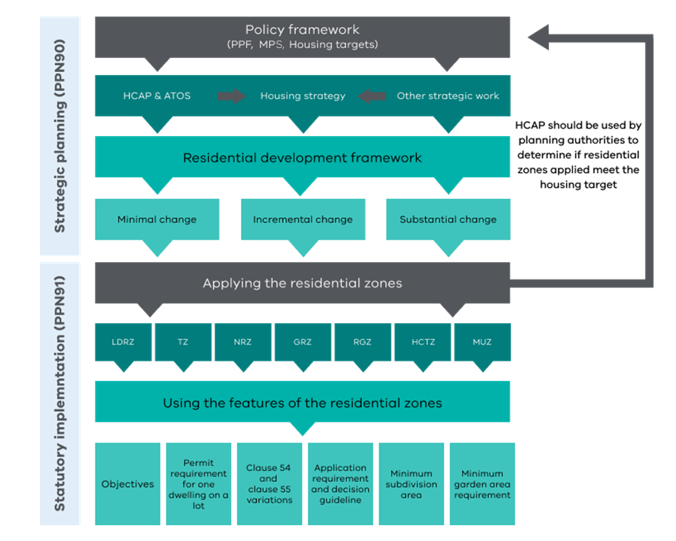
Housing Capacity Assessment Platform (HCAP) and Access to Opportunities and Services (ATOS) are explained in Planning Practice Note 90: Planning for Housing.

Housing targets and residential zones
The Housing Capacity Assessment Platform (HCAP) should be used by planning authorities to determine if the residential zones applied to the municipality meet the housing targets specified in the PPF. HCAP is designed for use by the Department of Transport and Planning (DTP) and local government strategic planners. Access to HCAP is provided through DTP at planforvictoria@transport.vic.gov.au.

Building heights and zone selection
One of the key features of the residential zones is the different maximum building height for each zone. This is a key factor to consider when selecting a residential zone to give effect to housing objectives.
As a general principle, applying a residential zone should align with either existing building heights if minimal or incremental housing change is planned for, or align with future building heights where substantial housing change is identified in strategic work.
When a varied maximum building height is sought to be specified in a schedule to a residential zone it should not exceed the maximum building height of a zone with the next highest maximum building height, unless the existing built form of the area warrants a unique approach.
For example, allowing an 11 metre / three-storey height to be specified in the NRZ would be inconsistent with the purpose of the NRZ. However, allowing the maximum building height to be increased to 10 or 11 metres may be appropriate to recognise the characteristics of existing double storey housing in an NRZ area.
The GRZ has a maximum building height of 11 metres and three storeys. It is important to remember that through the building system, a single dwelling can be constructed to a height of 11 metres and three storeys in the GRZ without the need to obtain a planning permit. If applying the GRZ, this should be considered.
Similarly, the GRZ is unlikely to be the best zone to apply to areas where new development of more than three storeys is planned for, as taller development is unlikely to be responsive to the purpose of the GRZ about neighbourhood character. A zone that promotes increased housing without reference to neighbourhood character in its purpose like the RGZ or HCTZ is likely to be a better fit.
After selecting the zones to apply, check that they align with the strategic work undertaken and any strategic objectives.

Table 3: Maximum building height matrix
Maximum building height | Zone options | Height tool | Rationale
Less than 9m or 2 storeys | NRZ | Overlay | A maximum building height lower than the NRZ cannot be specified in a zone schedule. An overlay is required to recognise the special characteristics.
9m (2 storeys) | NRZ | NRZ | The zone mandates this maximum building height and storey control.
Greater than 9m (retain 2 storeys) | NRZ | NRZ schedule | The schedule to the zone enables a greater maximum building height to be specified while maintaining the 2-storey requirement.
11m (3 storeys) | GRZ | GRZ | The zone mandates this maximum building height and storey control.
Greater than 11m (retain 3 storeys) | GRZ | GRZ schedule | The schedule to the zone enables a greater maximum building height to be specified while maintaining the 3-storey requirement.
11m (3 storeys) or  13.5m (4 storeys on large sites) | HCTZ2 | HCTZ2 | The zone mandates these maximum building heights and storey controls. A schedule to the zone cannot vary the height or storey  controls.
13.5 (4 storeys) or  21.5m (6 storeys on large sites) | HCTZ1 | HCTZ1 | The zone mandates these maximum building heights and storey controls. A schedule to the zone cannot vary the height or storey  controls.
13.5m (4 storeys) | RGZ | RGZ schedule | The schedule to the zone forces the discretionary maximum building height to be mandatory.
Greater than 13.5m and greater than 4 storeys | RGZ | Overlay | Maximum building height requirements along with other specific design and built form requirements should be included in an overlay so all built form requirements are included in the one provision.

The role of overlays and maximum building height
A maximum building height lower than the maximum building height specified in a residential zone can only be implemented by using an overlay to recognise environmental constraints or special characteristics.
In such cases, the height requirement in the overlay applies in addition to the height requirement in the zone.

Figure 2: Gumnut residential development framework plan
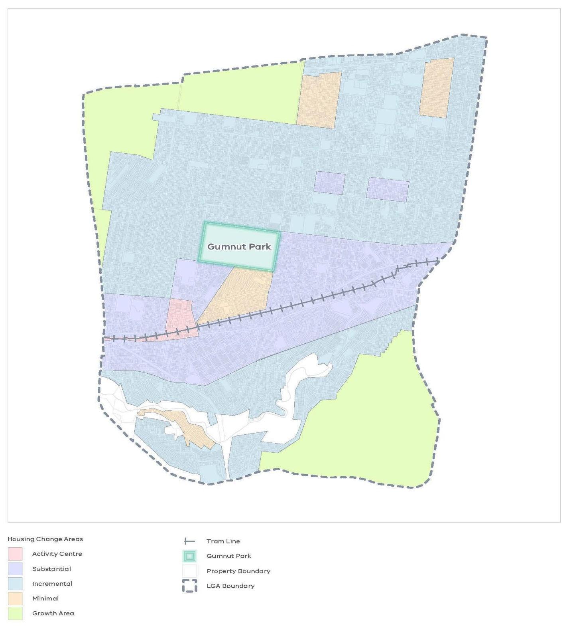

Figure 3: Gumnut residential zones application
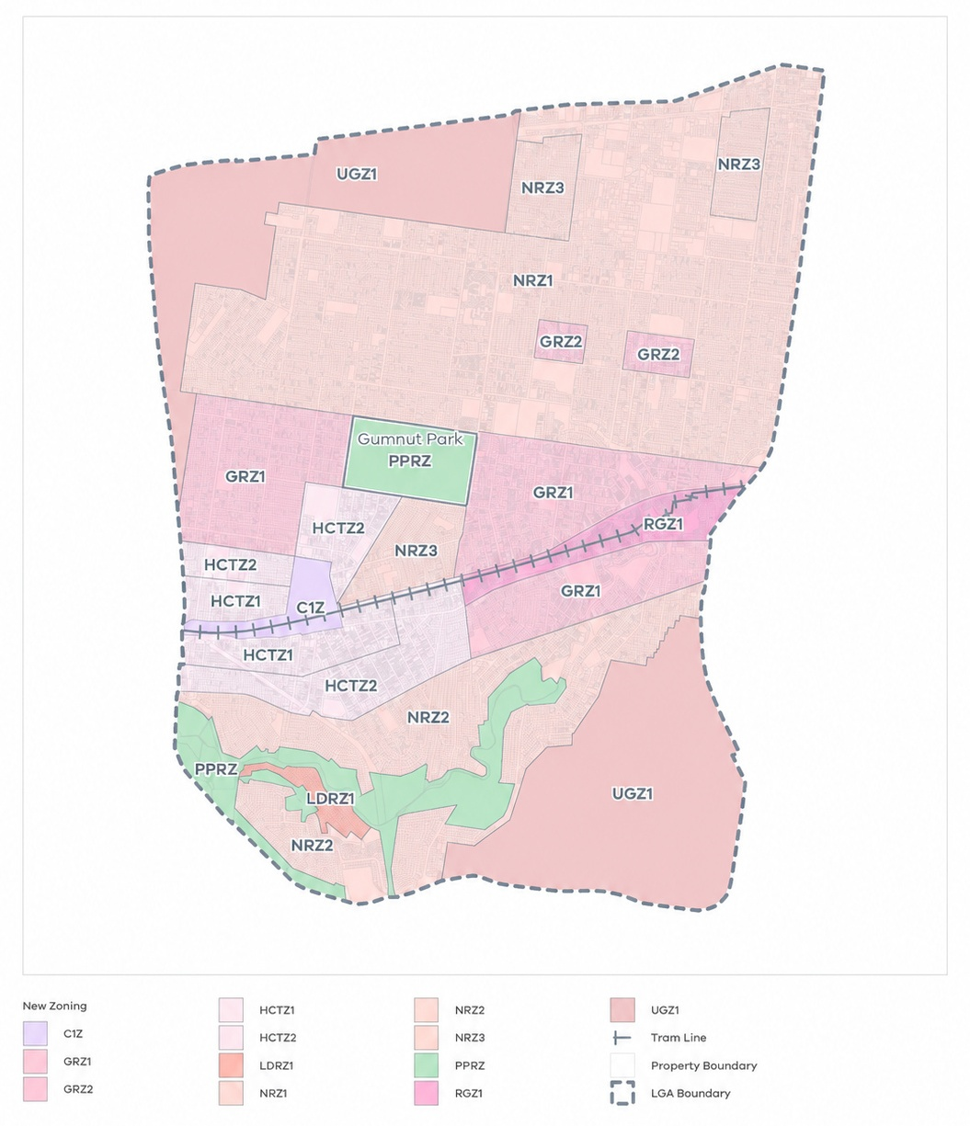

Remember
The residential zones should be applied to:
- be consistent with the residential development framework plan and implement the identified housing change areas
- support achieving municipal housing targets
- not undermine the intent of the housing change areas
- provide greater certainty to the planning authority and the community about future development in an area
- facilitate long-term housing growth and diversity in well-serviced areas
- respond to identified environmental constraints or special characteristics.

Using other VPP tools
While selecting the right residential zone is fundamental, the zone is one of several VPP tools that may be used to implement local strategic work.
Different areas have different characteristics and expectations. The VPP allows different residential requirements to be set through either a schedule to the residential zones or the application of an appropriate overlay.
Local policies also have a role to play in how discretion is exercised.

The role of local planning policy
A housing strategy in the MPS or PPF should always present a residential development framework identifying change areas.
Other elements of a housing strategy (or other strategic work) may be included in a local planning policy. This can clarify how a responsible authority will exercise discretion in decision making.
Local planning policy can be used to:
- set out how local heritage will be resolved with state housing policy to achieve municipal housing targets
- set out preferred neighbourhood character or future built form strategies that apply when a residential development standard is not met in clauses 54, 55, 57 or 58
- clarify how discretion will be exercised when a residential development standard is not met in clauses 54, 55, 57 or 58.

The role of overlays
Overlays play an important role in giving effect to preferred built form outcomes when a zone and local policy cannot fully achieve identified objectives for an area.

Neighbourhood Character Overlay
The Neighbourhood Character Overlay (NCO) can be used when the following criteria can be met:
- The area exhibits special characteristics that need to be protected or need to be changed to achieve a preferred character.
- The area, relative to the rest of the municipality, can be demonstrated to require a specific approach to neighbourhood character.
- The application of local planning policy cannot meet the neighbourhood character objectives for that area.
- The application of objectives, standards or variations to clause 54 and clause 55 cannot meet the neighbourhood character objectives for that area.
The NCO must not be used as a ‘blanket’ control across the municipality. It should be applied strategically to areas where variations to clause 54 and clause 55 standards fail to meet the specific neighbourhood character objectives and new locally tailored standards are required and can be justified.
The objectives and decision guidelines of the NCO apply in clause 57. However, the NCO cannot modify clause 57 standards.

Rewriting the standards to clause 54 and clause 55
The NCO can be used to rewrite most clause 54 and clause 55 standards, except for those standards specified in the overlay at clause 43.05-3. Any rewritten standard must be consistent with the corresponding objective and decision guideline.
The NCO cannot be used to rewrite the objectives or decision guidelines in clause 54 and clause 55. The objectives and decision guidelines continue to apply to a rewritten clause 54 and clause 55 standard in the NCO.
Additional local neighbourhood character objectives and decision guidelines may be specified in the schedule to the NCO to achieve a preferred neighbourhood character.

Demolition
The demolition control in the NCO preserves the existing pattern of development until the character features of the site and the new development have been evaluated.
The demolition control should not be used to conserve existing buildings, but rather to ensure that demolition does not occur until the responsible authority is satisfied that the new development meets the neighbourhood character objectives for the area.

Heritage Overlay
The Heritage Overlay (HO) is used to conserve and enhance places of historical or other special significance. Heritage significance is established by evaluating places against specialised criteria set by Commonwealth, state and local agencies.

Balancing heritage and housing objectives
The HO and underlying residential zoning must be consistent with the strategic directions of the MPS and PPF.
When applying or reviewing a HO in an area identified for substantial housing growth, the planning authority should be satisfied that the overlay’s objectives are supported by strategic policy and appropriately balanced against state and local housing objectives.
For example, the Housing Choice and Transport Zone (HCTZ) is intended to facilitate increased housing densities around activity centres and transport-served locations. The HCTZ may apply to land affected by a HO. In such cases, the planning authority must be satisfied that the combination of controls is strategically justified, while the responsible authority will assess individual development proposals against both the HCTZ and the HO at the permit application stage.
Understanding heritage and neighbourhood character
While all areas have a history, not all areas possess true heritage significance. Understanding this distinction is vital to applying the right planning control.
The NCO and HO serve fundamentally different purposes. The HO is used to conserve specific places of recognised heritage significance, whereas the NCO is used to manage the broader aesthetic character of an area.
The two overlays should not be applied to the same area.

Design and built form overlays
A Design and Development Overlay (DDO), Built Form Overlay (BFO), Development Plan Overlay (DPO) or Incorporated Plan Overlay (IPO) may be used to implement specific built form outcomes that cannot be achieved through a schedule to a residential zone.

Design and Development Overlay vs Neighbourhood Character Overlay
The DDO should not be used as a substitute for the NCO.
The DDO does not provide a framework for rewriting standards in clauses 54 and 55 in the way that the NCO does.
While the DDO has similar features to the NCO, it is more appropriately applied to promote specific urban design outcomes for an area that cannot be achieved by varying the standards to clauses 54, 55 and 57.

Design and built form overlays vs zone schedules
For residential development up to three storeys, clause 54 and 55 apply. An overlay may also be required where the design and built form outcomes sought cannot be achieved using clause 54 and 55 variations.
For residential development of four to six storeys, the standards of clause 57 apply. Clause 57 allows the standards to be modified by a zone or a zone schedule. It also allows the standards to be modified by an overlay or schedule to an overlay, except for the Neighbourhood Character Overlay.
For residential development of seven or more storeys, clause 58 applies. In these cases, another VPP tool is generally required to be used with the MUZ or RGZ to achieve the desired built form outcomes.
A DDO or BFO should generally be used to apply design and built form controls in a residential zone to developments greater than seven storeys.
When using the DDO, BFO, DPO or IPO to control development greater than seven storeys, all design and built form requirements (including maximum building height) should be specified in the overlay schedule instead of the schedule to the MUZ or RGZ. This provides greater clarity and transparency by ensuring all local requirements can be found in the relevant local provision.

Environmental and landscape overlays
The Environmental Significance Overlay, Significant Landscape Overlay and Vegetation Protection Overlay can be used to recognise and protect specific attributes.
These tools should be applied only to specific locations that have been identified for their unique or significant environmental and landscape values.

Other overlays
There are other overlays that recognise hazards or constraints that impact the capacity to develop residential land such as, the Bushfire Management Overlay, Melbourne Airport Environs Overlay, Restructure Overlay and Erosion Management Overlay.
These overlays should be applied as appropriate.

Using the key features of the residential zones
Each residential zone has a different role and purpose, and this is reflected in the different features provided in the schedules for each zone (see Table 4)

Table 4: Residential zone features
Feature | MUZ | RGZ | HCTZ1 | HCTZ2 | TZ | GRZ | NRZ | LDRZ
Can objectives be specified? | Yes | Yes | No | No | Yes | Yes | Yes | No
Is there a minimum garden area requirement? | No | No | No | No | No | Yes | Yes | No
Can the minimum garden area requirement be exempted? | N/A | N/A | N/A | N/A | N/A | Yes | No | N/A
Is there a minimum subdivision area requirement? | No | No | No | No | No | No | Yes | Yes
Is there a maximum building height/number of storeys requirement? | No | Yes  Discretionary  13.5m | Yes  Mandatory HCTZ1  13.5m (4 storeys) | Yes  Mandatory HCTZ2  11m (3 storeys) | Yes  Discretionary 9m | Yes  Mandatory 11m  and 3 storeys | Yes  Mandatory 9m  and 2 storeys | No
 |  |  | The maximum height of buildings constructed on a large site* within HCTZ1 is 21.5m (six storeys) | The maximum height of buildings constructed on a large site* within HCTZ2 is 13.5m (four storeys)
Can a mandatory maximum building height be specified in the schedule?  (height / storeys) | Yes  Height only | Yes  Height only and not less than 13.5m | No | No | Yes  Height only and not less than 9m | Yes  Height and storeys and not less than 11m and 3 storeys | Yes  Height and storeys and not less than 9m and 2 storeys | No
Can application requirements and decision guidelines be specified? | Yes | Yes | No | No | Yes | Yes | Yes | No
*Large site = 1,000m2 and 20m frontage

The role of local objectives
While state, regional and local planning policy sets out how discretion should be exercised, the ability to specify local objectives in some residential schedules enables detailed expression to be given to desired neighbourhood, heritage, environmental, landscape or design outcomes to be responded to within a particular area, when the residential development standards of clauses 54, 55, 57 and 58.04-1 are not met.
The Minister’s Direction - The Form and Content of Planning Schemes only allows a maximum of five objectives to be expressed in a schedule to a residential zone.
Table 5: Operation of local objectives
Zone | Operation of local objectives
MUZ | Objectives may be specified in the schedule.  There is no constraint on the type of objective that can be specified.
RGZ | Design objectives must be specified in the schedule.
HCTZ | There is no provision for specifying objectives in the schedule, as the purposes of the zone clearly express the intention of the zone.
TZ | Neighbourhood character objectives may be specified in the schedule.
GRZ | Neighbourhood character objectives may be specified in the schedule.
NRZ | Neighbourhood, heritage, environmental or landscape character objectives must be specified in the schedule.
LDRZ | There is no provision for specifying objectives in the schedule, as the purposes of the zone clearly express the intention of the zone.

Writing objectives
Clear differentiation between neighbourhood character and design objectives is essential to ensure that schedules are applied consistently.
Neighbourhood character objectives articulate the valued characteristics of an area and provide the basis for variation of particular clause 54 and clause 55 standards, where justified.
Design objectives specify the preferred built form and urban design outcomes for new development.

Writing neighbourhood character objectives
The schedules to the TZ, GRZ and NRZ enable neighbourhood character objectives to be specified.
Objectives in the schedule to the NRZ should specify the relevant neighbourhood character, heritage, environmental or landscape characteristics of the area.
Objectives in the schedule to the TZ should specify the neighbourhood character attributes to be achieved.
Objectives in the schedule to the GRZ should specify the attributes of the neighbourhood character to be achieved, in the context of a preferred built form outcome of three storeys.

Writing design objectives
Design objectives can specify matters related to built form and urban design. Design objectives should only specify public realm matters where they relate to the design of buildings that affect the function and amenity of the public realm.
Objectives in the schedule to the RGZ should specify the preferred design and built form outcomes for new residential development.

Preferred character statement or local objective?
Preferred neighbourhood character statements derived from neighbourhood character strategies are often found in local policies.
Rather than specifying preferred neighbourhood character statements in local planning policy, objectives can be specified in a schedule to a residential zone. This approach provides for a more transparent spatial representation of preferred neighbourhood character.
It is generally not necessary to have both a preferred character statement and local neighbourhood character objectives.
Table 6: Translating a preferred neighbourhood character statement into neighbourhood character objectives
Preferred neighbourhood character statement | Neighbourhood character objectives
This precinct will maintain a streetscape rhythm of detached dwellings set behind landscaped front gardens while preserving the intact nature of the streetscape.  Built form to side boundaries will be avoided, and garages, carports and second-storey development will not visually dominate dwellings or streetscapes.  Built form and hard surfaces will continue to occupy a low portion of the site area.  The built form will be a modest scale and be sympathetic to the existing heritage character of the precinct, however, innovative and unique built form that blends with the existing character will be encouraged.  New development will complement the existing landscape environment and native landscaping throughout the precinct will be encouraged. | - To maintain a streetscape rhythm of detached dwellings set behind landscaped front gardens with generous side setbacks.  - To support garages, carports and second storeys that are recessed from the ground floor facade to not visually dominate dwellings or streetscapes.  - To support built form and hard surfaces that cover a low portion of the site.  - To provide innovative and unique designs that integrate with the existing character.  - To encourage new development to provide native landscaping.

What happens where an overlay exists or is proposed?
It is not necessary to be as detailed or explicit when writing objectives for the desired outcome in the schedule to the zone affected by an existing or proposed overlay. The overlay should instead contain the detailed neighbourhood character, built form, heritage, environmental, landscape or other objectives as relevant to the land.

Heritage Overlay
Where a HO exists over a precinct or an area, as opposed to an individual site, it is unnecessary to identify detailed heritage objectives through the schedule to the relevant residential zone.
It is enough to generally specify in the schedule to the zone that the objective to be achieved is derived from the heritage values of the area. Often it is clearest to apply the same schedule to all heritage areas within that zone, within a municipality.

Design, built form, neighbourhood character, environmental, landscape and other overlays
All these overlays require some form of statement of significance or risk along with specifying detailed objectives.
In all these instances, it is generally enough to specify the relevant characteristic that is being sought to be recognised and rely on the detailed objectives and statements of significance in the overlay to articulate the desired outcome.

Minimum garden area requirement
Remember
When writing neighbourhood character objectives in residential zone schedules:
- Do be clear and specific.
- Do recognise a specific characteristic or constraint reflected through the application of an overlay.
Do not specify building heights (the zone or overlay does this).
Do not specify the type of housing change sought (the strategic framework and zone application does this).
Do not include statements of policy (this belongs in local policy).
Do not repeat objectives from other parts of the scheme, or reference other clauses in the scheme.
Do not reference policy background documents or studies or other tools in the scheme.
Do not specify scale, density, typology or number of dwellings unless strategically justified.
A minimum garden area requirement is a mandatory requirement that applies to all lots in the NRZ and GRZ that are 400 square metres or more.
A minimum percentage of the land must be set aside for a garden area at ground level in accordance with the table below.

Table 7: Minimum garden area requirement
Lot size | Minimum garden area requirement
400-500m2 | 25%
501-650m2 | 30%
>650m2 | 35%
The minimum garden area requirement cannot be exempted through a schedule in the NRZ. The minimum garden area requirement can be exempted through the schedule to the GRZ.
The decision to exempt the minimum garden area requirement in the GRZ must be based on the strategic outcomes being sought by the PPF and MPS. For example, it may be appropriate to exempt the minimum garden area requirement in the GRZ where a planning authority is seeking to recognise existing development conditions or to promote a denser urban form of housing than currently exists to achieve housing growth objectives.

Minimum subdivision area
A minimum subdivision area may only be specified in the schedule to the LDRZ or the NRZ.
Specifying a minimum lot size in the NRZ provides another mechanism to limit new housing because of environmental constraints or special characteristics, and when the area is categorised as a minimal change area.
Table 8: Minimum subdivision area
LDRZ | NRZ
Any minimum subdivision area specified in the schedule to the LDRZ must be at least:  - 0.4 ha for each lot where reticulated sewerage is not connected  - 0.2 ha for each lot with connected reticulated sewerage. | Any minimum subdivision area may be specified in the schedule to the NRZ.

Varying the residential development standards
A schedule to the MUZ, TZ, RGZ, GRZ and NRZ enables the following key siting and amenity standards of clause 54, clause 55 and clause 57 (except within the GRZ & NRZ) to be varied if it can be strategically justified:
- Standard A2-1 (clause 54.02), Standard B2-1 (clause 55.02) and Standard E2-1 (clause 57.02) Street setback
- Standard A2-5 (clause 54.02), B2-5 (clause 55.02) and E2-4 (clause 57.02) Site coverage
- Standard A3-2 (clause 54.03) and B3-5 (clause 55.03) Private open space
- Standard A2-7 (clause 54.02), B2-8 (clause 55.02) and E2-7 (clause 57.02) Front fences.
Except for a front fence, a local variation must be more permissive than the standard.

How do the varied standards operate?
An important feature of the schedules to the residential zones is that a change to a value in the schedule will affect all dwellings in the schedule, whether a planning permit is required or not. When a local value is specified in a schedule, the value replaces the relevant value in both planning scheme (the clause 54 and clause 55 standard), and in the corresponding building regulation.
Figure 4 below illustrates an example of how a schedule variation would interact with the building regulation and clauses 54 and 55.
Figure 4: Example street setback variation in the building and planning systems
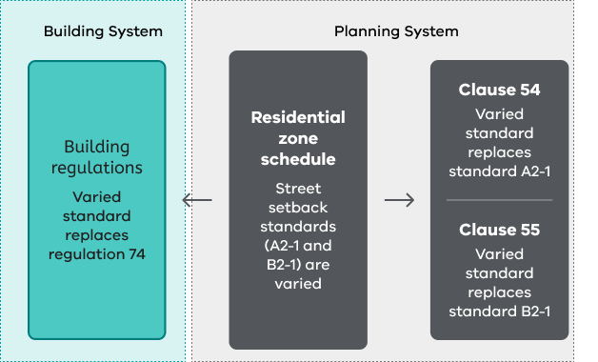

When assessing a building permit application, a building practitioner must use the value in the schedule to the residential zone, instead of the value expressed in the relevant building regulation. Schedule 6 to the Building Regulations identifies which planning schemes have schedules that specify a local value.
When assessing a planning permit application, the varied standard continues to be read with the relevant standard in clause 54, clause 55 and clause 57. The schedule simply substitutes one value for another. The remainder of the standard in clause 54, clause 55 and clause 57 continues to apply.
When a new residential zone that is not currently used in the planning scheme is proposed, and a clause 54 standard is proposed to be varied, a consequential amendment to Schedule 6 to the Building Regulations is also necessary. This is required to apply the planning scheme change to a single dwelling that does not require a planning permit in the new residential zone.
If the schedule to the building regulations is not amended to reference the new residential zone in the planning scheme, the varied standard will not apply to a single dwelling that does not require a planning permit.
This is undesirable because it adds complexity and confusion to the application of the standards between the two approval systems.

Writing varied standards
The schedule cannot be used to vary the objective or decision guideline of the relevant standard in clause 54, clause 55 and clause 57.
It is not possible to apply different standards for different types of residential development in the schedule, except for:
- Standards A2-1, B2-1 and E2-1 (street setback)
- Standards A2-5, B2-5 and E2-4 (Site coverage)
- Standards A3-2 and B3-5 (Private open space)
- Standards A2-7, B2-8 and E2-7 (Front fences).
When varying clause 54, 55 and 57 standards in the schedule, it is important to use the existing standard to determine what value can be substituted or varied. The substituted value may be a dimension, area, distance or percentage.
It is important to ensure that the variation can be understood without reference to the state standard or relevant building regulation. See Table 9 below for examples. Variations to clause 54 standards must be clear and legible for a building practitioner when issuing a building permit for one dwelling on a lot that does not require a planning permit.
Any omission of text or values between the clause 54 and clause 55 standard and the variation may have unintended consequences. It is therefore important that the variation uses the format and language of the relevant standard to ensure that there is no confusion.
Only the numerical value of the relevant standard should be changed. The schedule cannot be used to apply a different value to only some land in the zone because the building regulations refer to the application of the variation uniformly throughout the zone. A building certifier’s point of reference is what the land is zoned in the planning scheme.
Table 9: Drafting clause 54 and clause 55 variations - examples
Standard | ✓ - supported | ✗ - not supported
A2-1 and B2-1 -  Street setback | ‘Walls of buildings should be set back at least 3 metres from the front street including corner sites.  No encroachments are allowed into this setback.  Side street setback requirements specified in the table to standards A2-1 and B2-1 continue to apply.’ | 3 metres  This variation is inadequately expressed and its application may be confusing as it is unclear if the street setback standard applies to all street contexts.
A2-5 and B2- 5 - Site coverage | ‘The site area covered by buildings should not exceed 50 per cent.’ | ‘50% including all buildings, swimming pools, tennis courts, paving and other hard surfaces.’  Site coverage and permeability are separate standards and should not be combined.
A3-2 and B3-5 - Private open space | ‘A dwelling should have private open space with direct access from a living area, dining area or kitchen consisting of 20 per cent of the area of the lot but not less than 25 square metres. At least one part should consist of secluded private open space with a minimum area of 25 square metres and a minimum dimension of 2.5 metres.’ | ‘Minimum dimension of 2.5 metres.’  Even if only partially modified, for clarity, all parts of standard A3-2 that can be modified should be included in the schedule.
A2-7 and B2-8 -  Front fence height | ‘A front fence within 3 metres of a road in a Transport Zone, should not exceed 1.5 metres in height, or 1.2 metres in height for all other streets.’ | ‘Front fences should be at least 50% transparent and constructed from timber.’  The standard does not regulate the design of the fence, only the height. Additional planning controls like an overlay are required to regulate design and materials.

Remember
- The residential zone schedule simply substitutes one value for another. The remainder of the standard continues to apply to dwellings that require a planning permit under the residential zone.
- When a varied standard is specified, it applies to all dwellings in both the planning and building systems.
- When assessing a building permit application, a building certifier must use the varied standard specified in the schedule to the residential zone, instead of the value expressed in the relevant building regulation.
- When assessing a planning permit application, the variation continues to be read with the relevant objective and decision guidelines in clause 54, 55 and 57.
- The schedule cannot be used to vary the objective or decision guideline of the standard in clauses 54, 55 and 57.
- When drafting variations to a clause 54, 55 or 57 standard, it is best to start by including the variation in its entirety and modifying the numeric values of the standard as required.

Maximum building height
Maximum building height is managed in different ways, according to the role and purpose of each residential zone.
A schedule must not specify a height or number of storeys lower than the height and number of storeys specified in the zone. Only one maximum building height and number of storeys (where applicable) may be specified in each schedule.
The maximum building height only applies to a dwelling or residential building, except in the MUZ where it applies to all buildings.
The maximum building height is always mandatory when specified in a schedule to the TZ, MUZ, RGZ, GRZ and NRZ.
The mandatory maximum building height cannot be varied in a schedule to the HCTZ.
A schedule to the GRZ or NRZ should specify a maximum building height in both metres and storeys. A schedule to the MUZ, TZ and RGZ should only specify a maximum building height in metres.
If a higher discretionary maximum building height is sought in the RGZ, the schedule should not be used as specifying a maximum building height in the schedule makes the maximum building height mandatory. If a discretionary maximum building height greater than 13.5 metres is sought in the RGZ, another VPP tool such as a local policy or overlay should be used to specify an appropriate discretionary maximum building height above 13.5 metres.
The operation of maximum building heights and number of storeys in the residential zones is set out in Table 10.
Table 10: Operation of maximum building heights and number of storeys
Zone | Operation
MUZ | No maximum building height in the zone.  No control over the number of storeys.  Maximum building height may be specified in the schedule. When specified it applies to all development and is a mandatory maximum building height.
RGZ | A discretionary maximum building height of 13.5 metres applies to a dwelling or residential building.  No control over the number of storeys.  Maximum building height may be specified in the schedule. When specified it applies to a dwelling or residential building and is a mandatory maximum building height.
HCTZ1 | A mandatory maximum building height of 13.5 metres and 4 storeys applies, or 21.5 metres and 6 storeys if the building is on a large site*.  Maximum building height or number of storeys cannot be varied in the schedule.
HCTZ2 | A mandatory maximum building height of 11 metres and 3 storeys applies, or 13.5 metres and 4 storeys if the building is on a large site*.  Maximum building height or number of storeys cannot be varied in the schedule.
TZ | A discretionary maximum building height of 9 metres applies to a dwelling or residential building.  No control over the number of storeys.  Maximum building height may be specified in the schedule. When specified it applies to a dwelling or residential building and is a mandatory maximum building height.
GRZ | A mandatory maximum building height of 11 metres and 3 storeys (excluding a basement) applies to a dwelling or residential building.  Maximum building height or number of storeys may be specified in the schedule. When specified it applies to a dwelling or residential building and is a mandatory maximum building height or number of storeys.
NRZ | A mandatory maximum building height of 9 metres and 2 storeys (excluding a basement) applies to a dwelling or residential building.  Maximum building height or number of storeys may be specified in the schedule. When specified it applies to a dwelling or residential building and is a mandatory maximum building height or number of storeys.
LDRZ | No height control applies.  Maximum building height cannot be specified in a schedule.
*A large site means:
- A lot with an area of at least 1000 square metres and a frontage of at least 20 metres; or
- Two or more contiguous lots with a combined area of at least 1000 square metres and a combined frontage of at least 20 metres.

Writing application requirements and decision guidelines
Application requirements set out information and other materials required to accompany a planning permit application. The HCTZ does not have a schedule.
A schedule may specify additional application requirements to supplement those in a residential zone. A schedule should not repeat application requirements in other planning provisions. Application requirements should have a clear nexus with the provisions of the schedule and not require information about matters that are not controlled by a schedule to a residential zone.
Decision guidelines provide greater certainty about decision making for planning permit applications.
A schedule may specify additional decision guidelines to supplement those in a residential zone. A schedule should not repeat general decision guidelines, or decision guidelines in other planning provisions. Decision guidelines should have a clear nexus with the provisions of the schedule.
Some principles for drafting decision guidelines are included in Table 11.

Table 11: Principles for drafting decision guidelines - examples
Principle | ✓ - supported | ✗ - not supported
Other clauses in the planning scheme should not be referenced. | ‘Whether garages and upper floors are appropriately set back.’ | ‘Whether the development meets the objectives and standards of clause 54 or clause 55.’
Background documents should not be referenced as decision guidelines. | ‘Whether the development provides an appropriate response to the public realm.’ | ‘Whether the development is consistent with the Gumnut Town Centre Structure Plan, 2002.’
Use neutral expression and avoid introducing additional requirements. | ‘Whether the development provides adequate storage to meet the needs of future occupants.’ | ‘Whether the development provides 10 square metres of storage.’

© The State of Victoria - Department of Transport and Planning, September 2026.    This work is licensed under a Creative Commons Attribution 4.0 International licence. You are free to re-use the work under that licence, on the condition that you credit the State of Victoria as author. The licence does not apply to any images, photographs or branding, including the Victorian Coat of Arms, the Victorian Government logo and the Department of Transport and Planning (DTP) logo. To view a copy of this licence, visit http://creativecommons.org/licenses/by/4.0/  ISBN 978-0-7311-9400-1 (pdf/online/MS word)  Disclaimer  This publication may be of assistance to you but the State of Victoria and its employees do not guarantee that the publication is without flaw of any kind or is wholly appropriate for your particular purposes and therefore disclaims all liability for any error, loss or other consequence which may arise from you relying on any information in this publication. | Accessibility  If you would like to receive this publication in an alternative format, please go to planning.vic.gov.au or email planning.systems@transport.vic.gov.au

