[Project update letter advising change to precinct place.]
[Council letterhead]
[date]

To the Owner

[mail merge address of place (& owner’s name?)]

Dear Owner

[insert study name] – [insert name of heritage precinct and HO number]

[insert name] Council, is preparing the [insert heritage study name] (the Study). [insert heritage consultant name] has been appointed to undertake the Study.
Attached is an information sheet, which explains the purpose of the Study and why it is being carried out. [Note: this information sheet will be the same as used for the inception letter, with dates updated as required]
I wrote to you earlier this year to advise the Study was underway. The purpose of this letter is to inform you of the draft findings of the Study in relation to your property, which forms part of the HO[xx] [insert name] heritage precinct:
The assessment by the heritage consultant confirms that the [insert name] heritage precinct is of local heritage significance. The draft heritage citation, which explains how and why the precinct is significant and what buildings and features are important is attached. Specifically:
- The following properties are Significant. That is, they are of individual significance and contribute also to the heritage values of the precinct [Note: depending on the number of places they could be listed separately by street, as for Contributory places].
- [Insert place name and address]
- The following properties and features are Contributory to the heritage values of the precinct. [Note: list by street and use property descriptions to identify specific lots, if required, for example:]
- [Insert place name and address]
- The following properties are Non-contributory (NC) to the heritage values of the precinct and are proposed to be retained within HO[XX] as they are adjoined by Contributory heritage places.
- [Insert property addresses.]
- The following properties are NC and are proposed to be removed from HO[XX] as they are NC properties or are at the edges of the precinct and do not contain Contributory buildings. For example:
- [2, 4 and 1-11 (section containing Post-World War II buildings only), rear section of 35 Federal Street, and 59 Federal Street.]
- [29 & 31 King Street.]
- [28 Callaway Lane and adjoining vacant site.]

- It is also proposed to realign the HO[xx] boundaries to:
- [Remove the rear sections of deep blocks on the south side of Federal Street that contain no heritage buildings: Nos. 34-54 Federal Street inclusive and 24-28 King Street.]
- [Include the rear sections of 10, 12-14, 56 and 58 Federal Street to remove an anomaly where the HO33 boundary cuts through the middle of a building.]
- [insert HOxx boundary realignment explanatory text]
The plan on the following page shows the proposed HO[XX] boundary changes. [Note: see attached plan as an example. A plan may not be required for less complex changes] For example:
- [It is also recommended that external paint controls no longer apply within the precinct. This means a planning permit will no longer be required to paint a previously painted surface such as timber windows, doors, or verandahs. However, a permit will still be required to paint an unpainted surface such as brickwork or unpainted render, as this control cannot be varied.]
- [Tree controls are recommended to apply specifically to the mature Canary Island palms in Emerald Street.]
- [insert change to HO schedule controls]
In addition, draft heritage guidelines have been prepared to assist owners and managers to care for heritage places. Please note, these guidelines are not mandatory and have been prepared for information purposes only. [Note: delete or amend this paragraph, as required]
The purpose of this consultation is to provide you with an opportunity to provide feedback or seek further information on any of the above. Feedback can be provided in the following ways:
- By email to [insert email]
- By mail to [insert address]
- Or by leaving a hard copy at your local Customer Service Centre.
Please include your contact details and mark this information ‘[insert heritage study name]’ to the attention of [insert contact name]. (bolded)
The closing date for submissions is [insert date].
Once comments have been received, changes will be made, as required, and the Study is scheduled to be completed by [insert date]. At this stage, it is anticipated that the Study will be presented to Council for consideration at the meeting to be held in [insert date or dates].
If you have any further questions, please contact [insert name and contact details].
Yours faithfully

[Name, title]

[Example: Emerald Town Centre – recommended HO boundary changes]
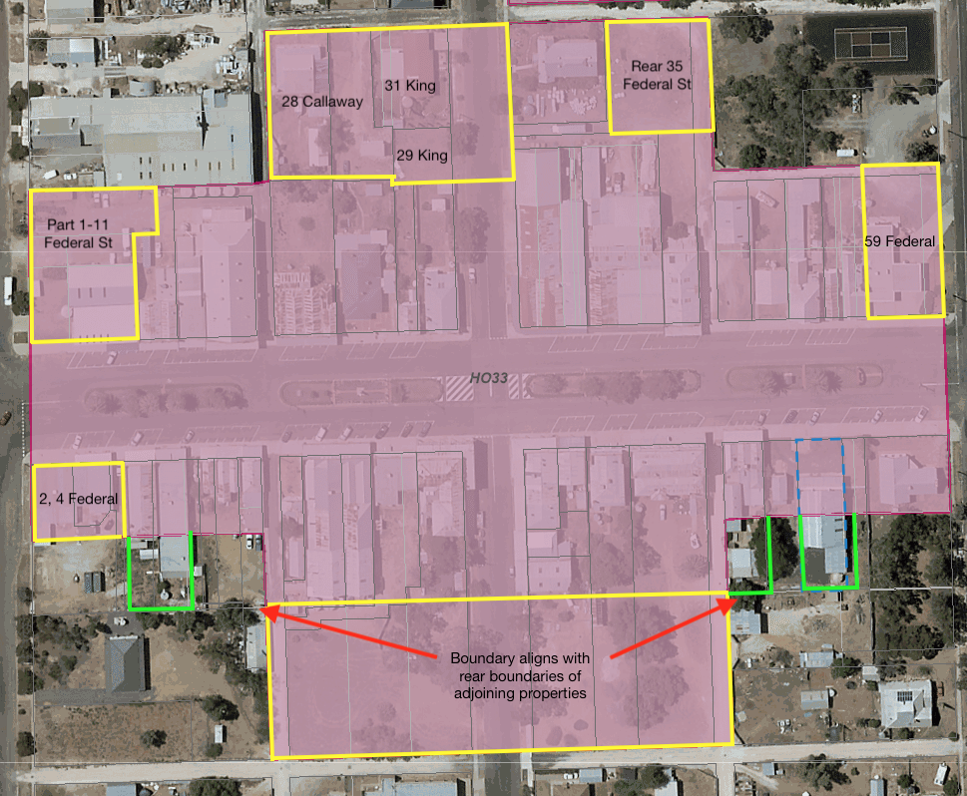
The current extent of the HO is shaded in pink.
The properties or parts of properties recommended for removal from the precinct are outlined in yellow:
- 2-4 Federal Street. Post-war (built after World War II) brick shops.
- 1-11 Federal Street (part). Section of this property containing late twentieth century commercial and industrial buildings. The pair of Federation era shops at the same address but contained on Lot 2 LP 72298 would remain within the HO33 precinct.
- Rear of 35 Federal Street. Vacant land.
- 59 Federal Street. Service Station.
- 29 King Street. Vacant site.
- 31 King Street. Post-war house.
- Callaway Lane: Post-war house at no.28 and vacant site next door.
- Removal of rear sections only:
- 34-54 Federal Street inclusive and
- 24-28 King Street.
Extension of the HO boundary (outlined in green) is recommended for four properties to remove an anomaly where the HO boundary cuts through the middle of a building:
- 10, 12-14, 56 and 58 Federal Street.

