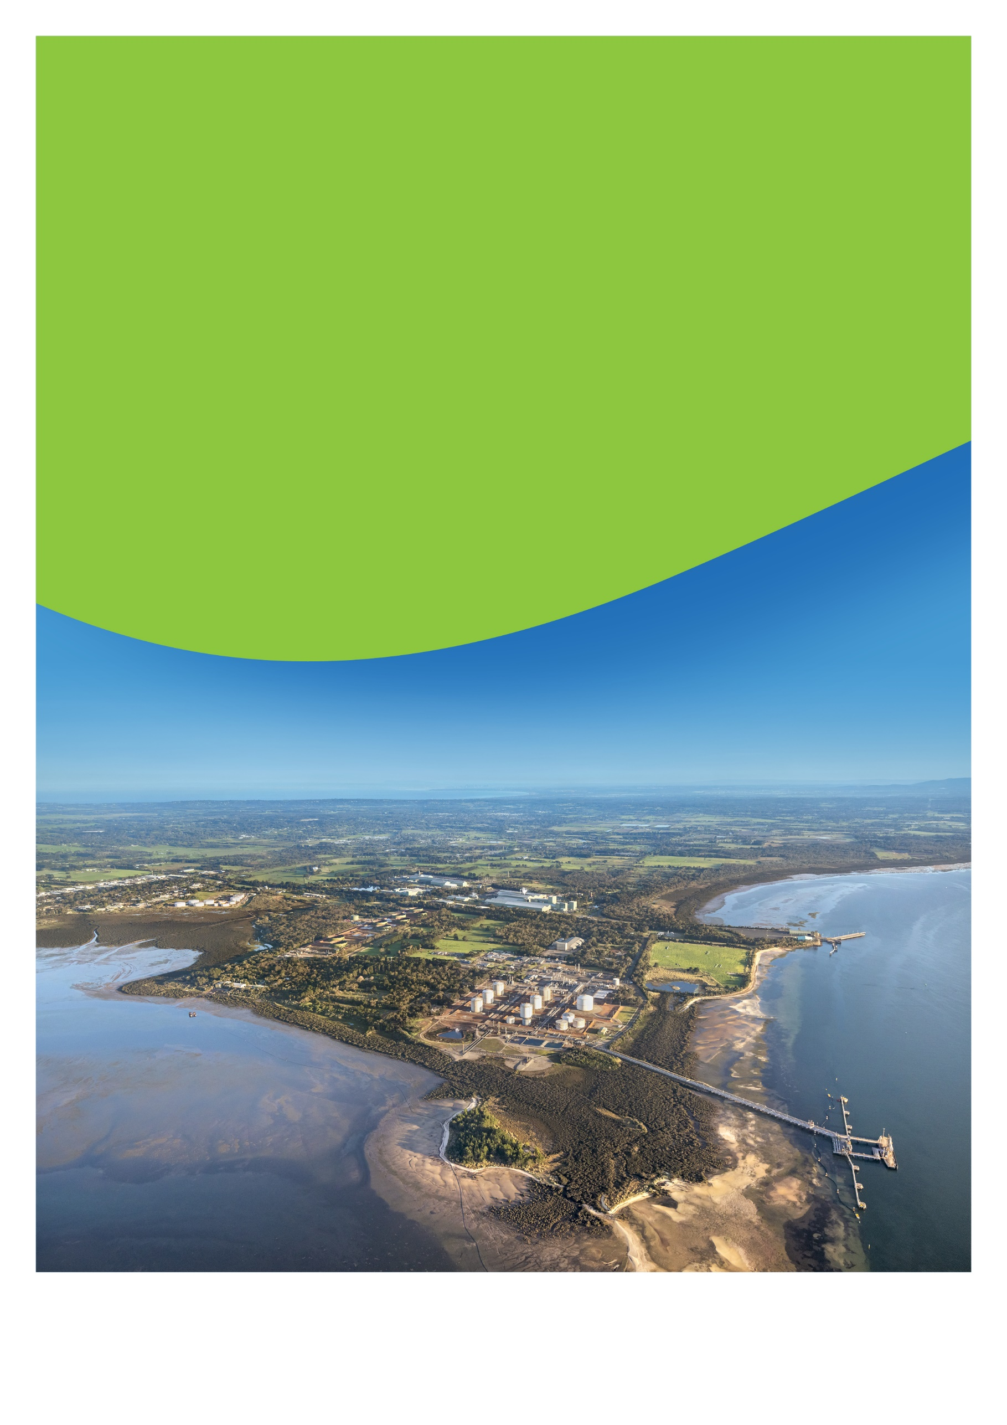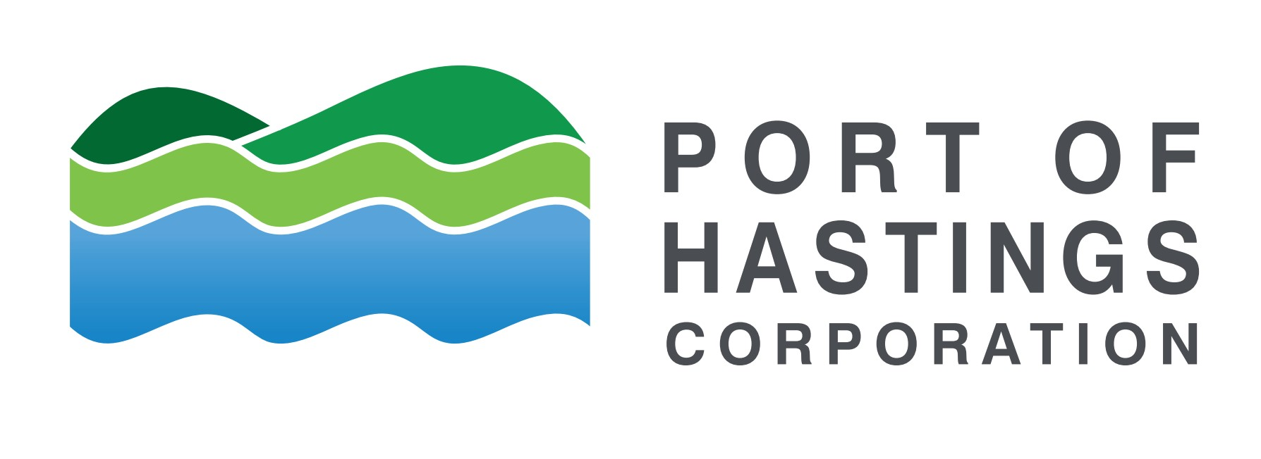

Delivered by

September 2025

The Port of Hastings Corporation (PoHC) is a public entity established in January 2012 under the Transport Integration Act 2010 (Vic).

ABN 33 737 350 749



The Consultation Plan is a working document and   
will be updated as the project progresses

Victorian Renewable Energy Terminal - Consultation Plan

Environment effects statement (EES) process

Document Control

|  |  |
| --- | --- |
| Project | Victorian Renewable Energy Terminal |
| Originator/Company | Port of Hastings Corporation |
| Document Title | Consultation Plan |
| Document No. | POH-VRE-CSE-001 |
| Secondary No. | N/A [Add only if applicable] |
| Document Status | Working Version |

Table of Contents

Executive summary 5

1. Introduction 7

1.1 About the Victorian Renewable Energy Terminal 7

1.2 Planning for the Victorian Renewable Energy Terminal 9

1.3 Project Design Options 10

1.4 Project objectives 11

2. Environment Effects Statement 12

2.1 EES context 12

2.2 Indicative environmental approvals timeline 12

3. Engagement to date 13

3.1 Stakeholder Engagement 13

3.2 Engagement methods 13

3.3 Areas of interest 13

4. Communications context 15

4.1 Project stakeholders 15

4.2 History and social context 15

4.3 Community profile 17

4.4 Traditional Custodians 17

4.5 Government stakeholder coordination 18

5. Engagement principles and objectives 19

5.1 Government legislation and policies 19

5.2 IAP2 Spectrum of Public Participation 19

5.2.1 IAP2 Spectrum of Public Participation 19

5.3 Victorian Government Public Engagement Framework 20

5.4 Committing to engagement principles 21

5.5 Communications and Engagement objectives 21

5.6 How feedback will inform the project 22

5.6.1 Project Community Reference Group (CRG) 22

6. Engagement phases 23

7. Communication tools 27

7.1 Print communication 27

7.2 Digital communication 28

7.3 Translation and Accessibility 28

8. Engagement methods 29

8.1 Engagement activities 29

9. Processes and protocols 30

9.1 Responding to community enquiries and feedback 30

9.2 Complaints management procedure 30

9.3 Record Management 30

9.4 Data Protection and Privacy 31

10. Review and evaluation 32

11. Indicative stakeholder matrix 33

11.1 Government (Elected) 33

11.2 Government agencies and authorities - State 34

11.3 Government agencies and authorities - Federal 35

11.4 Traditional Custodians 36

11.5 Local government 37

11.6 Commercial entities 37

11.7 Business and tourism 37

11.8 Offshore Wind proponents 39

11.9 Emergency services 39

11.10 Water authorities 40

11.11 Environment, community and recreation groups 40

11.12 Media 42

11.13 Local partnership/Education 44

# Executive summary

This plan describes the approach Port of Hastings Corporation (PoHC) will use to inform and involve Traditional Custodians, communities, stakeholders, industry, and government in the development of the proposed Victorian Renewable Energy Terminal project

Consultation is a key aspect of project development, design, and the environmental assessment process.

It helps build an understanding of the project and its potential effects and enables stakeholder knowledge and views to be considered by the project team in project development and assessments, and by the government in its assessment and approval decisions.

The primary focus of this plan is the preparation of the project design and environmental assessment process, an Environment Effects Statement (EES).

This Consultation Plan (CP) is designed to:

* Inform communities and stakeholders about PoHC, existing operations, and the proposed Terminal project.
* Build awareness of the proposal in the context of the Victorian Offshore Wind commitments and policy.
* Promote an understanding of the project and environmental assessment process (the EES process).
* Encourage participation and seek targeted input during project development and environmental assessments, to identify issues of potential concern, gain local insight, and seek feedback on measures that respond to stakeholder concerns.
* Use and respond to community and stakeholder feedback and demonstrate how it has been considered through the design development and environmental approvals.

Acknowledgment of Traditional Custodians

We acknowledge and respect Victorian Traditional Custodians as the original custodians of Victoria’s land and waters, their unique ability to care for Country, and their deep spiritual connection to it. We honour Elders past and present whose knowledge and wisdom have ensured the continuation of culture and traditional practices.

We are committed to genuinely partnering, and meaningfully engaging, with Victoria’s Traditional Custodians and Aboriginal communities to support the protection of Country, the maintenance of spiritual and cultural practices, and their broader aspirations in the 21st century and beyond.

The Bunurong Land Council Aboriginal Corporation (BLCAC) is the Registered Aboriginal Party (RAP) for the land on which our proposed project is located.

Abbreviations

The following abbreviations will be used throughout the Consultation Plan (CP)

|  |  |
| --- | --- |
| Abbreviation | Definition |
| BLCAC | Bunurong Land Council Aboriginal Corporation |
| CALD | Culturally and Linguistically Diverse Communities |
| CCC | Consultative Community Committee |
| CMP | Complaints Management Procedure |
| CRG | Community Reference Group |
| DCCEEW | Department of Climate Change, Energy, the Environment and Water |
| DEECA | Department of Energy, Environment and Climate Action |
| DPC | Department of Premier and Cabinet |
| DTF | Department of Treasure and Finance |
| DTP | Department of Transport and Planning |
| EDM | Electronic Direct Mail |
| EES | Environment Effects Statement |
| EPA | Environment Protection Authority (Victoria) |
| EPBC Act | Environment Protection and Biodiversity Conservation Act |
| GW | Gigawatt |
| MW | Megawatt |
| OTRA | Old Tyabb Reclamation Area (OTRA) |
| OWEV | Offshore Wind Energy Victoria |
| PoHC | Port of Hastings Corporation |
| Ramsar | Internationally important wetlands |
| RAP | Registered Aboriginal Party |
| The Terminal | Victorian Renewable Energy Terminal |
| TRG | Technical Reference Group |
| UNESCO | The United Nations Educational, Scientific and Cultural Organisation |

# Introduction

## About the Victorian Renewable Energy Terminal

Victoria is establishing a thriving offshore wind sector – paving the way for the state to host the first offshore wind energy project in Australia. Offshore wind projects require very large components which need to be manufactured, transported, stored and transferred to the offshore wind site for installation. The scale, length and weight of these components place unique heavy-duty operational requirements on ports and require a significant land area adjacent to ship berths, pavement strength and shipping channel capacity.

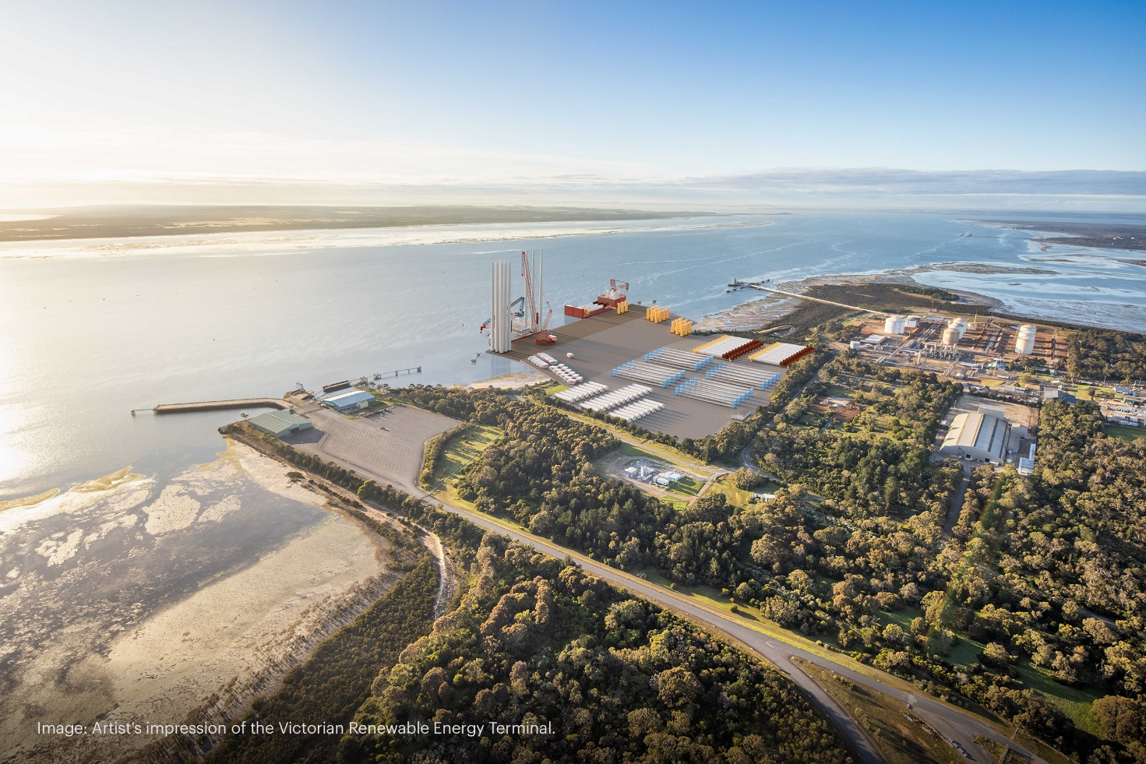Figure 1: Artistic render of the Victorian Renewable Energy Terminal

No port in Victoria is currently suitable to support offshore wind construction at scale. To accommodate this, the Victorian Government is planning the development of Victoria’s first large-scale offshore wind port facility to unlock the benefits of offshore wind.

The Port of Hastings has been selected by the Victorian Government as the preferred location for the establishment of the Victorian Renewable Energy Terminal - a dedicated assembly port to support the construction of Victoria's first offshore wind farms along the Victorian coast.

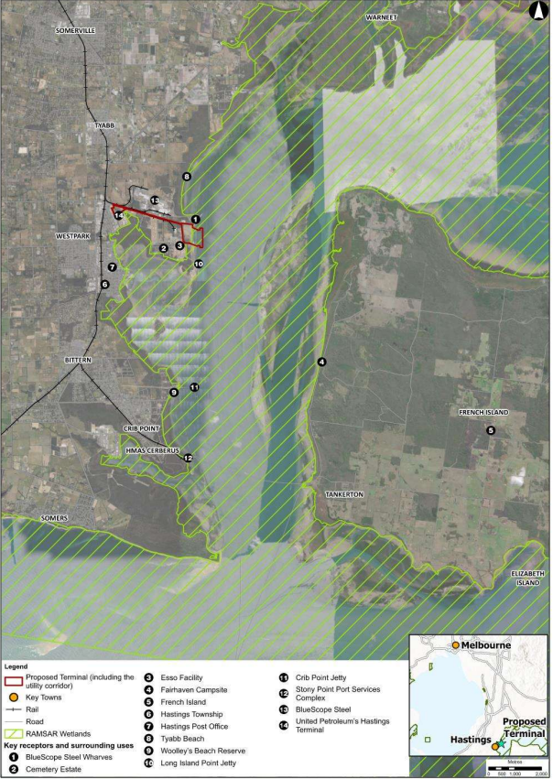The Terminal is proposed to be developed within the Port of Hastings, which is a major transport gateway supporting key industries associated with fuel imports and oil, gas and steel production. Port of Hastings is located to the southeast of Melbourne, approximately 70km south-east of Melbourne.

The Port of Hastings has many attributes that make it an ideal location for an offshore wind assembly port, including large areas of appropriately zoned land close to deep water channel and proximity to proposed offshore wind farms off the coast of Victoria. The Terminal will receive, store, and assemble offshore wind components before they are transported to offshore wind farms off the Victorian coast for installation.

**Image: Location of the Terminal**

The Terminal will be developed at the Old Tyabb Reclamation Area (OTRA) and adjacent marine waters within the port precinct between Esso’s Long Island Point jetty and BlueScope wharves. The Old Tyabb Reclamation Area (OTRA) site borders the Western Port Ramsar site, an area identified to be of international importance, particularly to waterfowl habitat. The Ramsar site extends across the Western Port area which is connected to Bass Strait by a wide channel between Flinders and Phillip Island, and a narrow channel between San Remo and Phillip Island.

The Port of Hastings Corporation will develop the Terminal in consultation with Traditional Custodians, local communities and industry, and through comprehensive assessments which recognise the important environmental, heritage and community values of Western Port.

## Planning for the Victorian Renewable Energy Terminal

The Port of Hastings Corporation (PoHC) is required to prepare an Environment Effects Statement (EES) for the proposed Victorian Renewable Energy Terminal.

An Environment Effects Statement (EES) is the most rigorous environmental assessment process in Victoria. The EES process is used to assess projects with potentially significant effects on the environment. It supports transparent, rigorous and integrated consideration of potential effects, to inform approval decisions.  
  
  
The EES process is administered by the Department of Transport and Planning (DTP) on behalf of Victoria’s Minister for Planning under the Environment Effects Act 1978.  
‍  
  
As part of the EES process, PoHC is undertaking extensive technical studies, along with consultation with the Traditional Custodians, local community and stakeholders.

The EES will be published for public exhibition and the project assessed by the Victorian Minister for Planning following the advice from an inquiry appointed under the Environment Effects Act 1978.  
  
For more information on an overview of processes under the Environment Effects Act, [click here.](https://www.planning.vic.gov.au/environmental-assessments/environmental-assessment-guides/ministerial-guidelines-for-assessment-of-environmental-effects/understanding-the-assessment-process) [‍](https://planning.vic.gov.au/environmental-assessments)The project must complete the EES process and obtain both State and Commonwealth approvals before construction can commence.

On 28 July 2025, the Commonwealth Government determined the proposed Victorian Renewable Energy Terminal project to be a Controlled Action. It was also decided that a Bilateral Agreement applies for the project, meaning impact on Matters of National Environmental Significance (MNES) will be assessed through the EES process.

For more information on Commonwealth approvals, including the Environment Protection and Biodiversity Conservation (EBPC) Act, [click here.](https://www.dcceew.gov.au/environment/epbc)

## Project Design Options

Several design options have been considered and continue to be assessed in defining the Terminal project.

PoHC has planned engagement activities with the community on the Project Description. At this time PoHC will provide information on the design options considered to arrive at the current project description.

Throughout the project development, the community will have the opportunity to provide input into the design development through face to face meetings, consultation sessions and meetings with PoHC.

**Image:** Map of Project Area and Components

## Project objectives

The Terminal Project aims to develop a port to support the emerging offshore wind sector. The Victorian ports system has been identified as an integral part of the shift towards the production, distribution, and use of offshore wind.

PoHC proposes to develop the Terminal as a facility to serve as the primary assembly port for offshore wind developments along the coast of Victoria. In the longer term, the facility would be used to support maintenance, repowering and decommissioning activities.

The Terminal intends to:

• Support meeting Victoria’s renewable energy targets

• Enable reliable renewable energy for Victorians.

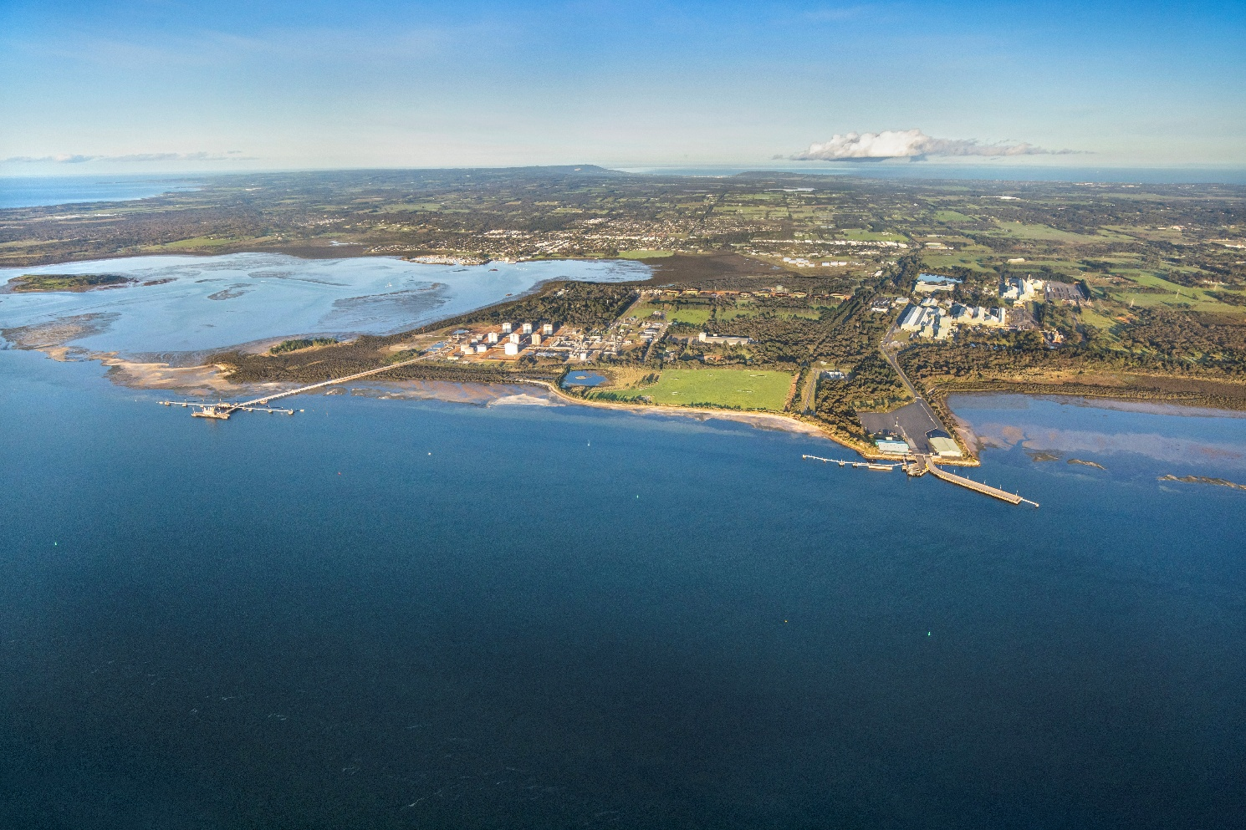

Figure 3: Drone image of Old Tyabb Reclamation Site (OTRA)

# Environment Effects Statement

## EES context

The Victorian Renewable Energy Terminal was referred on 11 August 2023 to the Minister for Planning.

On 11 October 2023, The Minister for Planning decided that an Environment Effects Statement (EES) was required based on the following reasons:

* the project has the potential for environmental impacts on biodiversity values, including the habitat of threatened species and communities.
* The project may pose risks to the conservation and ecological values of the Western Port Ramsar Site, including listed waterbird and migratory bird species.
* There are potential effects from the construction and operation of the facility on the marine ecosystem that may be significant, through increased sedimentation, disturbance of potential acid sulphate soils, dredging and potential introduction of pest species.
* Potential cultural and historical heritage values, including submerged Aboriginal cultural values.
* To enable an integrated, transparent assessment of the environmental effects of the project and associated uncertainties, including evaluating feasible, relevant alternatives, the effectiveness of proposed mitigation and offsetting measures, and opportunities to avoid or minimize significant adverse effects.

The Minister for Planning, The Hon Sonya Kilkenny MP, has outlined that the Port of Hastings Corporation should prepare and submit an EES consultation plan for engaging with the public and stakeholders during the preparation of the EES.

The EES consultation plan is to be implemented by the proponent, having regard to advice from the Department of Transport and Planning, and the Technical Reference Group.

## Indicative environmental approvals timeline

|  |  |
| --- | --- |
| Date | Milestone |
| August 2023 | EES referral lodged by the Port of Hastings Corporation |
| October 2023 | EES statement of decision released by the Victorian Minister for Planning |
| November - December 2024 | Draft EES scoping requirements exhibited |
| Q3 2025 | Updated scoping requirements exhibited |
| Q4 2025* | Final EES scoping requirements issued by the Victorian Minister for Planning |
| Q4 2026* | EES public exhibition period |
| Q3 2027* | EES Minister’s assessment of project – outcome of EES determined |
| Q4 2027* | Project construction commences (subject to approvals) |

*Dates subject to change, indicative only.

# Engagement to date

## Stakeholder Engagement

Since the October 2022 release of the Offshore Wind Implementation Statement 1, PoHC has engaged with key stakeholders, including local government, key community and conservation groups, and its existing Community Consultative Committee.

PoHC progressed this engagement throughout 2023 and 2024 to raise awareness about the Terminal project and to establish relationships with a wide range of interested groups and communities, through proactive briefing offers and local community events.

In 2025, the PoHC formed a dedicated Community Reference Group (CRG) for the project, to provide a direct forum made up of community representatives that is chaired independently.

Throughout 2025 PoHC have consulted extensively on a range of EES topics, seeking feedback to inform the EES through hosting technical roundtable sessions, community information sessions and direct engagement with stakeholders.

Conversations and feedback from community and industry continue to be constructive, with stakeholders broadly supporting the transition to renewable energy, and accepting the need for specialised port infrastructure to support the sector.

## Engagement methods

Engagement has occurred through the following activities:

* Proactive offers for project briefings with community groups and project stakeholders
* Website and digital engagement
* Project updates via digital mailing list
* Attending community pop-ups at Red Hill Market and Hastings High Street market
* Targeted doorknocks to residential properties nearby to investigation works and along the project’s transport route
* Attending keynote presentations at project conferences
* Technical roundtable sessions with community members and specialists preparing EES studies
* Developing and distributing introductory project fact sheets and other collateral.

## Areas of interest

Based on initial community feedback and conversations with stakeholders, some of the key aspects and issues raised have included:

* Environmental impacts from Terminal construction and operation
* Additional vessel movements in a Ramsar wetland
* Questions regarding the site selection criteria and “Why Hastings?”
* Visual impacts from height of pre-assembled towers at the Terminal
* Aviation impacts/safety from the height of pre-assembled towers at the Terminal
* Traffic and amenity impacts of construction and operation of the Terminal (noise, light, dust)
* Lack of awareness of renewable energy transition and offshore wind proposals
* The feasibility of offshore wind as renewable energy
* Legacy of previous project approvals
* Opportunities for local jobs and industry skills development for Port of Hastings
* Impacts to recreation activities including fishing, boating, other water sports, and beachgoers

Sentiment captured to date has been primarily positive/neutral, with some negative sentiment expressed primarily from local conservation groups about potential environmental impacts of the project.

# Communications context

## Project stakeholders

Stakeholders with an interest in the project include, but are not limited to:

* Victorian Government, including agencies, land managers, and local MPs,
* Federal Government, including agencies and MPs,
* Local community and residents,
* Traditional Custodians (Bunurong Land Council Aboriginal Corporation),
* Local government,
* Business and tourism,
* Conservation, community, special interest groups, and recreation groups,
* Emergency services,
* Water authorities,
* Offshore wind proponents, and
* Media.

*Appendix A* provides a detailed stakeholder analysis including a discussion of potential impacts and interests for each stakeholder type and the level of engagement that will be tailored to each stakeholder.

## History and social context

The Terminal Project site is located in the Hastings area in the Western Port region, approximately 72 kilometres from Melbourne. Western Port is a large tidal bay in southern Victoria, opening into Bass Strait, and is dominated by two large islands: French Island and Phillip Island.

The land around Western Port and the two main islands (French Island and Phillip Island) is the country of the Bunurong people of the south-eastern Kulin Nation who are the region’s Traditional Custodians.

As shown in Figure 4, The Bunurong Land Council Aboriginal Corporation (BLCAC) represents the interests of Bunurong Traditional Custodians, whose land covers parts of metropolitan Melbourne, Mornington Peninsula, Bass Coast, and west Gippsland.

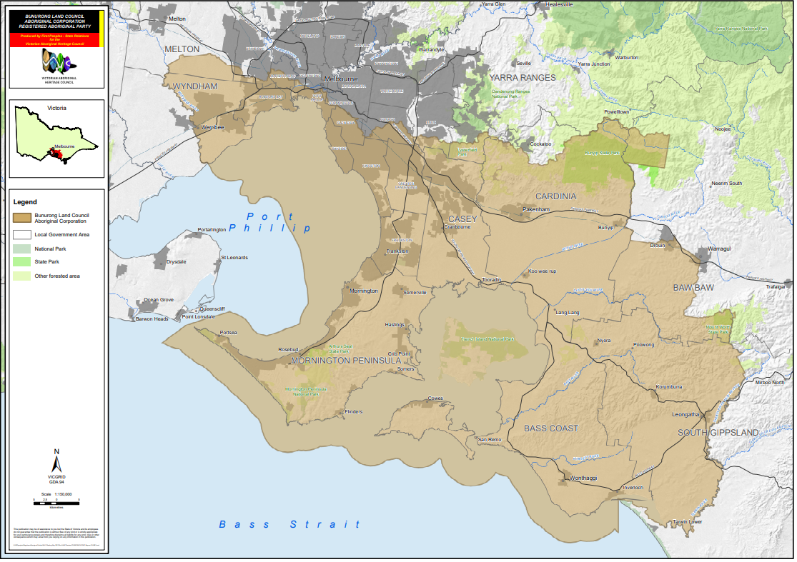

Figure 4 – BLCAC – Registered Aboriginal Party Map

The landscapes and seas surrounding the OTRA have undergone many significant changes over millennia. These natural and cultural processes have formed and continue to inform the configuration of the coastline and also shape the meanings that the Country holds for the Bunurong People.

The impact of colonisation on Bunurong people and culture has been profound and ongoing, resulting in the loss of knowledge and places of cultural value. Western Port was first visited by Europeans in 1798 when an exploration crew in a whaleboat journeyed south from Sydney to explore Australia’s south-eastern coastline. As it was the most westerly charted point at the time, it was named Western Port, which is now recognised as a misnomer as the area lies south-east of Melbourne.

Western Port is home to three Marine National Parks – French Island, Churchill Island and Yaringa. Today the area is used extensively for recreation. There is also a navy base (HMAS Cerberus) located at Hanns Inlet in Western Port Bay, Crib Point.

Western Port is within a listed Ramsar site, part of an Urban Biosphere Reserve.

The Western Port Ramsar site is one of the 1675 wetland sites around the world which cover 150 million hectares that have been designated for inclusion in the Ramsar List of Wetlands of International Importance.  The site comprises four marine and coastal wetland types recognised under the classification system used by the Ramsar Convention.

Western Port forms part of theMornington Peninsula and Western Port (MPWP) Biosphere Reserve which is part of the world network of biosphere reserves recognised by the United Nations Education, Scientific and Cultural Organisation (UNESCO) through its Man and the Biosphere Program.

Settlement of the area dates from the 1840s, with fishing being the main industry. Growth took place from the 1850s into the 1870s as the township of Hastings developed. Expansion continued in the late 1880s and 1890s, aided by the construction of the railway line and the establishment of many orchards. Significant residential development occurred during the 1960s and 1970s, spurred by industrial growth and public housing construction. Growth began to slow from the 1980s. The population has increased since the early 1990s, a result of new dwellings being added to the area.

Hastings is one of the ‘gateways’ to the lower Mornington Peninsula and the town is surrounded by farmland.

Western Port has been an active trading port since the early 1800s, featuring a wide variety of trades either derived from the sea of dependent on maritime transport (fishing, oil and gas). The Port of Hastings is home to the ExxonMobil and BlueScope manufacturing plants. Hastings also hosts many small businesses associated with the recreational boating industry.

The land surrounding the Port of Hastings has been reserved for port-related uses since the late 1960s. The port’s proximity to the oil and gas fields of Bass Strait and easy access for large vessels along the natural deep channels has given the port a key role in the energy sector.

In the 1970s the potential of Western Port was identified for the establishment of large-scale process industries, which require both deep water and extensive land adjacent to a port. Areas were identified to be set aside for port purposes so that the State's options regarding any future port development at Western Port could be preserved.

## Community profile

The Port of Hastings is situated on the western side of Western Port around the suburbs of Tyabb, Hastings, Bittern and Crib Point. Nearby suburbs include Somers, Balnarring, Merricks, Merricks North, Shoreham, Red Hill, Red Hill South, Tuerong, Moorooduc, Somerville, and Pearcedale. The Port of Hastings is within the Shire of Mornington Peninsula local government area. According to 2021 [Australian Bureau of Statistics](https://abs.gov.au/census/find-census-data/quickstats/2021/214021379) (ABS) data, notes that the region of Hastings–Somers (which includes the townships of Crib Point, Somers, Balnarring Beach, Balnarring, Bittern, and Hastings) has:

* Over 24,000 people.
* A median age is 42 years, with 17.6% of the population aged under 14 years old and 22.4% aged over 65 years old.
* A gender distribution of 49.6% male (11,879) and 50.4% female (12,086).
* 2% of residents (468) identified as aboriginal and/or Torres Strait Islander
* Over 90% (21,661) used only English at home as a language, with Italian (0.3%), German (0.3%) and Tagalog (0.3%) as the three highest languages used as home, other than English
* A median family income of $1,839, and median household income of $1,407
* More than 70% have a Year 10 or higher education level.
* Full-time employed people make up 54.6% of the population, with a further 34.4% working part-time and 3.5% unemployed.
* 10.1% of people have a bachelor’s degree or higher, 26.2% have a Vocational Qualification and 43.5% of people have no qualification.
* 14.6% of Hastings residents worked in construction, 13.7% in health care and social assistance, 11.4% in retail trade, and 9.3% in manufacturing in 2021.
* Over 90.4% of people speak English as a first language. Other languages spoken at home include Italian (0.3%), German (0.3%), Tagalog (0.3%), Thai (0.2%) and French (0.2%).
* 2% of the population are Aboriginal and/or Torres Strait Islander.

As identified in initial community feedback, the level of public understanding of offshore wind and Victoria’s renewable energy transition is low. Communications material is prepared using readability and accessible metrics such as the Flesh-Kincaid Grade Level or the Gunning Fog Index.

## Traditional Custodians

PoHC has partnered with Traditional Custodians through separate and ongoing consultation on the approach to their participation in the project’s planning and development.

This approach recognises Traditional Custodians as rights holders to land and sea (Country) on which the project will be built and is being undertaken in accordance with the Department of Environment, Energy and Climate Action’s (DEECA) Traditional Owner and Aboriginal Engagement Framework.

Bunurong Land Council Aboriginal Corporation (BLCAC) are the Registered Aboriginal Party (RAP) of the area and has delivered a Cultural Values Assessment (CVA) for the project. BLCAC will also be responsible for evaluating the Project’s Cultural Heritage Management Plan.

## Government stakeholder coordination

As the Terminal is a key component of the Victorian Government’s overall approach to delivering on offshore wind targets, it will be important for the project team to stay well-coordinated with relevant Victorian and Commonwealth Government agencies including:

* First People’s Self-Determination Division
* Impact Assessment Unit
* Forest, Fire and Regions
* Department of Climate Change, Energy, the Environment and Water (DCCEEW)
* Parks Victoria
* Department of Treasury and Finance (DTF)

This list also extends to **Technical Reference Group** members, which include:

* Bunurong Land Council Aboriginal Corporation
* Department of Energy, Environment and Climate Action (DEECA)
* Department of Premier and Cabinet (DPC) – First Peoples – State Relations
* Department of Transport and Planning (DTP)
* Environment Protection Authority (EPA)
* Freight Victoria
* Heritage Victoria
* Melbourne Water
* Mornington Peninsula Shire Council
* Offshore Wind Energy Victoria
* Ports Victoria
* Safe Transport Victoria
* Victorian Fisheries Authority

# Engagement principles and objectives

## Government legislation and policies

Planned and proactive communications and consultation with interested communities and other stakeholders will help guide the development of the Terminal.

Government legislation and policies provide guidance on the need for community engagement

* **Victorian Government Public Engagement Framework 2021 – 2025:** See more below.
* **The Planning and Environment Act 1987** provides for formal opportunities for public engagement and opportunity to provide comment on proposals during public exhibition of planning permit applications and planning scheme amendments.
* **Victorian Auditor-General’s Office Public Participation in Government decision-making:** provides a high-level framework for the public sector to use when deciding how best to involve the public in government decision-making and implementation.

## IAP2 Spectrum of Public Participation

Additionally, the project will follow international best practice standards for engagement including:

* **IAP2 Quality Assurance Standards**: The Quality Assurance Standard has been designed to respond to market requirements for evidence that effective community and stakeholder engagement has been delivered in accordance with the standards of the professional community.
* **IAP2 Core Values and Public Participation Spectrum**: The International Association for Public Participation (IAP2) defines public participation as the involvement of those affected by a decision in the decision-making process.

IAP2 is an international organisation that is focused on advancing the practice of public participation. IAP2 has published a range of standards, including the three Pillars of Public Participation, core values, and guidelines that inform the approach to effective and meaningful engagement.

IAP2 is adopted and widely recognise among engagement professionals and will be adopted by Port of Hastings Corporation and any supporting organisations involved in implementing the communications and engagement strategies for The Terminal.

IAP2 recognises the Community Engagement Procedure that there are five levels of public participation.

The below table outlines the spectrum of public participant, which has informed the selection and methods of engagement for the Victorian Renewable Energy Terminal engagement approach.

### IAP2 Spectrum of Public Participation

IAP2’s Spectrum of Public Participation was designed to assist with the selection of the level of participation that defines the public’s role in any public participation process. The Spectrum is used internationally, and it is found in public participation plans around the world.

Figure 5 – [IAP2 spectrum (website](https://iap2.org.au/wp-content/uploads/2020/01/2018_IAP2_Spectrum.pdf))

## Victorian Government Public Engagement Framework

The Victorian Government Public Engagement Framework (2021 – 2025) provides principles, a guide and measures for engagement evaluation and aims to strengthen meaningful engagement practice in Victoria.

The framework includes key principles that underpin all Victorian Government public engagement.

* **Meaningful:** The process of Public Engagement is genuine and informs the final decision.
* **Inclusive:** The engagement is respectful, inclusive and accessible.
* **Transparent:** The engagement is clear and open about what the public can and cannot influence
* **Informed:** The engagement provides relevant and timely information to the public
* **Accountable:** The engagement is high quality and responsive to the public
* **Valuable:** The engagement creates value for the community and government. This can include social, economic and environmental value.

## Committing to engagement principles

PoHC will commit to best practice engagement and be guided by government and industry principles. The IAP2 Public Participation Spectrum is designed to assist with the identification and selection of the level of participation stakeholders and community will have at a particular time within an engagement project.

PoHC will also seek to maximise access and participation in engagement, by engaging with key communities including:

* Culturally and Linguistically Diverse Communities (CALD),
* Socially disadvantaged communities
* Other vulnerabilities, and
* Engaging young people.

During and leading up to the exhibition of draft scoping, PoHC has engaged with stakeholder groups that are likely to submit during the public comment period. Engagement has been based on a “Consult-Involve” level of public participation as per the IAP2 methods of engagement.

Similarly, during the preparation and public exhibition of the EES, as well as public review of the EES, the project will seek to engage at an “Inform/Consult/Involve” level with relevant stakeholder groups, through methods outlined later in the Consultation Plan.

## Communications and Engagement objectives

The communications and engagement approach aims to build community and stakeholder awareness, acceptance, and confidence that impacts on the Western Port environment can be adequately managed, and that the Terminal will deliver tangible local and wider benefits.

During the project development and environmental assessments, PoHC’s engagement objectives are to:

* Establish PoHC as a responsible, open, and transparent project proponent with experience managing port operations in sensitive environments.
* Provide opportunities for public participation during EES scoping, exhibition, and inquiry phases.
* Share information openly with communities and stakeholders about the Terminal project scope, how and why the Port of Hastings was identified as the preferred site, and its role in enabling offshore wind in Victoria.
* Encourage participation and input during the preparation of the EES to identify potential issues, gain local insights and seek feedback on the Terminal project, and demonstrate how this has been considered in the development of the EES.
* Consult with key stakeholders and local interest groups to identify opportunities to support local community and environment initiatives through targeted benefit-sharing and environmental improvement activities.
* Build decision-maker confidence and reduce risks to approvals, by actively identifying all major concerns before the EES is finalised and showing how these concerns have been addressed in the preparation of the EES.

## How feedback will inform the project

Consultation helps build understanding around the issues and implications of projects and enables stakeholders’ knowledge and views to be considered in project planning and assessment and formal decision-making.

Aspects of the project development and the EES which will be informed by community and stakeholder feedback include:

* Stakeholder and community knowledge of the area and issues of importance,
* Priorities for technical assessments to ensure all relevant impacts are assessed, and
* Potential impacts and suggested mitigations.

PoHC will collect, record, and consider all feedback received throughout the consultation and demonstrate how it has been considered in the development of the Environment Effects Statement. A number of steps are involved in this process as follows:

**Collecting Feedback** – PoHC will consult with the community and key stakeholders to identify issues and feedback on the project.

**Recording Issues** – PoHC will use Consultation Manager (software) to input feedback received from the Community engagement. Technical issues and concerns can be noted through this software and provided to technical specialists for consideration.

**Analysing issues** – Technical issues or concerns will be analysed by the VRET specialists for consideration. Further technical assessment may be required to address issues raised.

**Informing the Project Design and assessment** - Where community feedback identifies gaps and issues not already contemplated by the project which are required to satisfy the Scoping Requirements, the project design may be revised, or mitigation measures included to address issues raised by the community.

**Responding to Stakeholders** – PoHC will respond to the community feedback on how their issues have been analysed and how they have informed the project development.

During the Public Exhibition of the EES, the community and stakeholders will have an opportunity to make a submission on the EES and be heard by the Inquiry and Advisory Committee appointed to examine the project’s potential environmental effects. The Inquiry and Advisory Committee will consider submissions received in developing its recommendation to the Minister for Planning on the project’s assessment and approvals.

### Project Community Reference Group (CRG)

A dedicated Community Reference Group (CRG) was established in February 2025 following a public expression of interest, promoted in late 2024.

The Community Reference Group (CRG) is a dedicated forum made up of community representatives, allowing for information sharing between PoHC and the local community. The CRG meets quarterly and is chaired independently.

The CRG terms of reference will be made available on the PoHC website.

The objectives of the CRG are to:

* Enable two way conversations between PoHC and the community, including through the dissemination of information from PoHC to local communities;
* Provide a local perspective on the Terminal project, inform PoHC of local conditions and priorities and, where possible, assist with resolving any community concerns as they arise;
* Encourage a broad range of community and local business representatives to participate in consultation processes of the Terminal project; and
* Provide a forum to discuss, manage and, where possible, mitigate and minimise any local impacts associated with the Terminal.

# Engagement phases

Table 1 provides an overview of the engagement phases and estimated timelines throughout the Victorian Renewable Energy Terminal project. Engagement phases have been designed to both align with and inform key project design and assessment activities and milestones. A description of each engagement phase is documented below:

|  |  |  |  |  |  |  |  |  |  |  |  |  |  |  |  |  |  |  |  |  |
| --- | --- | --- | --- | --- | --- | --- | --- | --- | --- | --- | --- | --- | --- | --- | --- | --- | --- | --- | --- | --- |
|  | 2023 | | | | 2024 | | | | 2025 | | | | 2026 | | | | 2027 | | | |
| Phase of Engagement | Q1 | Q2 | Q3 | Q4 | Q1 | Q2 | Q3 | Q4 | Q1 | Q2 | Q3 | Q4 | Q1 | Q2 | Q3 | Q4 | Q1 | Q2 | Q3 | Q4 |
| Early Engagement |  |  |  |  |  |  |  |  |  |  |  |  |  |  |  |  |  |  |  |  |
| Engagement on Project Description |  |  |  |  |  |  |  |  |  |  |  |  |  |  |  |  |  |  |  |  |
| Exhibition of Draft EES Scoping Requirements |  |  |  |  |  |  |  |  |  |  |  |  |  |  |  |  |  |  |  |  |
| Exhibition of Updated Draft EES Scoping Requirements* |  |  |  |  |  |  |  |  |  |  |  |  |  |  |  |  |  |  |  |  |
| Release of Final EES Scoping Requirements* |  |  |  |  |  |  |  |  |  |  |  |  |  |  |  |  |  |  |  |  |
| Preparing the EES* |  |  |  |  |  |  |  |  |  |  |  |  |  |  |  |  |  |  |  |  |
| EES Exhibition and public review* |  |  |  |  |  |  |  |  |  |  |  |  |  |  |  |  |  |  |  |  |
| EES Minister's Assessment* |  |  |  |  |  |  |  |  |  |  |  |  |  |  |  |  |  |  |  |  |
| Project approvals* |  |  |  |  |  |  |  |  |  |  |  |  |  |  |  |  |  |  |  |  |

*All dates are indicative only and are subject to change.

Figure 6 - Engagement Phases

|  |  |  |  |  |  |
| --- | --- | --- | --- | --- | --- |
| Project phase | Exhibition of Draft Scoping Requirements | Release of final Scoping Requirements | Preparing the EES | Public exhibition of EES | Minister’s assessment |
| **Engagement objectives** | * Support and promote DTP public exhibition of draft Scoping Requirements and ensure stakeholders and community are aware of the opportunity to respond to the EES Scoping Requirements * Provide opportunities for face-to-face and online engagement during exhibition * Identify areas and topics of importance to community and stakeholders | * Seek feedback on negotiable elements of the project * Continue to build community and stakeholder understanding of the project and EES process * Communicate the release of final Scoping Requirements and how key issues will be assessed in studies * Share initial outcomes of technical studies, including existing conditions, potential impacts and alternatives that have been considered | * Close the loop through a consultation report on what we heard during Project Development consultation and how this feedback is being considered in the technical studies, Reference Design development and preparation of the EES. * Provide overview on next steps, including what is involved in EES Exhibition and how to make a submission. | * Provide information about the EES process, * Encourage participation in the EES process and detailing how community members and stakeholders can make a submission, and * Provide opportunities to connect people with project information and speak to technical specialists. | * To report back on outcomes of Minister's Assessment to inform the Victorian Renewable Energy Terminal proposal, including the next steps for the project. |
| **Engagement activities** | * Host online webinars to discuss project overview, explain EES process and draft scoping requirements * Meet with local community and environment groups and other key stakeholders * Attend local markets/events to promote project and draft scoping requirements process * Website updates, respond to community enquiries * Milestone communication via e-update * Printed communication materials including factsheets and flyers | * Online information sessions/webinars – briefing on concept layout and opportunities for feedback * Meet with local community and environment groups and other key stakeholders to share update on technical studies, introduce concept layout and seek feedback * Information sessions to seek feedback on the concept layout * Interactive online tool available for feedback on concept layout * Attend/host Community Consultative Committee meeting (focused on concept layout) * Attend/host Community Reference Group (CRG) meeting. * Milestone communication via e-update * Printed communication materials including factsheets and flyers | * Proactive media on project milestone and timing of next steps for the project and approvals process, * Digital communications to promote outcomes of project development consultation (e-update, website, social media), * Attend/host Community Consultative Committee meetings, continue to respond to community enquiries, and * Attend/host Community Reference Group (CRG) meetings. * Milestone communication via e-update * Printed communication materials including factsheets and flyers * Engagement Reports (inc. how community feedback has been considered to date) * Doorknocks | * Project update and promotion of EES exhibition, * Proactive media to promote Project EES exhibition, * Drop-in information sessions to support EES exhibition, and * Digital communications (e-update, website updates and social media) to promote exhibition of the EES and how to make a submission. * Milestone communication via e-update * Printed communication materials including factsheets and flyers based on topics of community interest * Engagement Report | * Proactive media to promote outcomes of EES and next steps, including how assessment and approval requirements will inform the project’s construction and operation. * Digital communications (e-update, website and social media) to share outcomes of the minister’s assessment and next steps for the project. * Milestone communication via e-update |
| **Opportunities to provide feedback** | * Opportunities for local community groups to receive an introductory project briefing or project updates * Feedback to PoHC team via in-person/digital engagement channels * Speak with the project team and technical experts at community information sessions. * Subscribe to e-news * Phone calls | * Opportunities for local community groups to receive project briefing and updates * Speak with project team and technical experts at markets and pop-up events * Attend targeted briefings/meetings with project team members at PoHC offices or project site * Subscribe to e-news * Project contact number and email * Submit survey feedback * Access information on PoHC website | * Opportunities for local community groups to receive an introductory project briefing or project updates * Speak with the project team and technical experts at markets and pop-up events * Attend targeted briefings/meetings with project team members at PoHC offices or project site * Subscribe to e-news * Subscribe to the project newsletter to receive project updates * Project contact number and email * Provide feedback to the project team via engagement channels digital, face-to-face, print) * Submit survey feedback | * Community information session(s) * Submit a formal submission via EES engagement platform * Provide feedback to the project team via engagement channels digital, face-to-face, print) * Speak with the project team at markets and pop-up events * Opportunity to participate in inquiry as part of the EES considerations | * PoHC will provide updates about key steps and dates in the EES assessment process. |

# Communication tools

PoHC is using a range of both broad and tailored engagement activities and communication tools to reach communities and stakeholders and encourage their participation. The engagement program principles and objectives in Section 11 detail how the engagement activities and tools will be used to support communication and engagement throughout the project development.

## Print communication

Project newsletter

Regular newsletters or updates will be made available online and through social media and mailouts to provide information on project milestones, key EES steps and engagement opportunities.

Topics to be covered will include the publication of Scoping Requirements and the EES Consultation Plan; availability of new documents; consultation activities; Exhibition dates and activities; IAC hearing dates and process; updates one the concept design and how feedback is being considered, and updates to consultation plans and ongoing opportunities to provide input.

Newsletters and updates will be made available online as well as hard-copy mail-out to target stakeholders without online access.

Fact sheets

A suite of fact sheets providing information on the project development; the EES process and how to submit and on each technical study. Fact sheets will be made available both digitally and in hardcopy to ensure accessibility for all community members.

Surveys

Seek feedback on community values, negotiable elements of design and input to inform EES technical studies. Surveys will be made available online as well as hardcopy of survey mailed to residents with return envelopes provided to ensure all community members can access information and are provided the opportunity to engage with the project.

Environment Effects Statement (EES) Chapters and Technical Reports

Copies of the EES and accompanying technical reports and map books will be printed in hardcopy and made available at local council offices and libraries and provided online via EngageVic and the Port of Hastings websites in digital and printable to ensure accessibility.

Engagement reports

Engagement reports outlining engagement activities, participation, comments, and feedback received will be prepared to summarise phases of consultation. A summative engagement and consultation report and chapter will be prepared as part of the EES documents.

Engagement reports will be prepared quarterly.

Media and advertising

Radio, local print, and digital advertising will help to raise awareness of the engagement process, project milestones and opportunities to be involved. This will also include advertising at local libraries, youth centres, halls, public notice boards etc.

Maps and visual aids

Clear maps showing the project location including investigations area and key infrastructure to be delivered as part of the project. Maps and supporting visual aids will provide context in relation to the local region and environment.

Maps and visual aids will be used within communications materials, such as fact sheets, project updates and discussion papers, as well as being available online.

Notification – Traffic and Boating Conditions

Letter or email to notify of any changes or disruptions to traffic or boating, such as Notice to Mariners.

## Digital communication

Interactive online project map

An interactive map tool will help stakeholders and community members to visualise the project area and provide feedback. This will be prepared using an online mapping platform in line with Victorian Government accessibility guidelines.

Email updates (electronic direct mail – EDM)

Regular electronic distribution of project newsletters with links to project website, fact sheets and EES documentation using the extensive existing project stakeholder database.

Project website

Updated as new information is made available, with documents directly associated with the EES to be added within one business day of the provision of final versions. Prepared in-line with necessary accessibility guidelines.

Social media

Establish a social media presence to communicate project updates, opportunities for participation and reporting on engagement activities and responding to requests for information or clarification. Social media will be used to drive users to project information and set the narrative.

Digital advertising

Includes social media advertising and sponsored posts on digital platforms to promote engagement activities and project updates.

Video

Video and animations will be used to share project information in particular complex problems. Video could be used to provide project updates and overviews of key topics. Animations could be used to show construction activities.

## Translation and Accessibility

Translated and accessible materials will be made available for relevant project materials.

PoHC applies the approved relayservice.gov.au prompt to the appropriate print and digital materials.

Web content is assessed regularly to ensure content is optimised for screen-reader tools and accessibility.

# Engagement methods

## Engagement activities

Conversations with residents and hard-to-reach community members

Acknowledging some community members and impacted stakeholders may not have access to online engagement tools and information, phone calls will be made to encourage participation in engagement activities and provide information.

Collaborative engagement (inc. Community Consultative Committee (CCC) and Community Reference Group (CRG)

In line with the IAP2 Spectrum of Public Participation, PoHC will employ collaborative engagement processes on aspects of the project and with stakeholders (inc. local government) where more significant partnership and participation is needed to inform this aspect of the project’s development, or where stakeholders have a strong direct interest in the decisions being made.

Collaborative approaches will include the establishment of a new Community Reference Group (CRG), continuing to meet with the existing Community Consultative Committee (CCC), briefings with local interest groups to connect them with technical experts, seeking input from interest groups and key stakeholders on aspects of the project or possible mitigation measures, exploring opportunities for delivering benefit sharing and working groups with Traditional Custodians and other parties.

Stakeholder meetings

Building on existing relationships to maintain transparent and frequent communication with stakeholders to encourage participation and invite input. Host targeted meetings with local interest groups to provide technical information on specific topics.

Online survey

Seeking input and feedback on local values, and concept design to inform EES technical studies and project design. The use of an online platform allows participation from local community members as well as from potential international, national and intra-state users of the facility.

Webinars and online information sessions

Online interactive sessions with technical specialists and project delivery partners to engage environmental groups and community members and provide an overview of EES topics, findings of studies and project updates.

Phone call offers of participation (or SMS)

To directly impacted stakeholders and interested community members to ensure that hard-to-reach stakeholders an participate.

Information sessions / technical roundtable meetings / displays

Primary engagement method to present EES information and collect feedback. These will be held at a number of stages throughout the project, across a variety of locations near the project area and times to allow a wide cross-section of the community can participate. Online information sessions or webinars will supplement in person events.

Phone call and email enquiries

Recording and responding to public email enquiries and phone calls.

Technical Reference Group (TRG)

Convened by DTP to coordinate advice between DTP, the project team, and key stakeholders throughout the EES process. The project will work collaboratively with the members of the TRG, seeking their advice and considering their input in preparation of the EES.

# Processes and protocols

## Responding to community enquiries and feedback

**Stakeholder and community enquiries protocol**

* PoHC will receive community queries through a project email channel and the general phone number.
* PoHC will seek to respond to community enquiries in a timely way:
  + Acknowledgement within two business days
  + Response within five business days
* All stakeholder and community enquiries and project team responses will be recorded and detailed in a Consultation Manager database.

## Complaints management procedure

**Complaints management procedure**

A Complaints Management Procedure (CMP) aims to establish an open and transparent complaint handling process and ensure complaints and queries are handled fairly and objectively.

The CMP will be underpinned by the following principles:

* People can make a complaint and multiple channels are available.
* Complaints are assessed and explored impartially by staff.
* Action is taken to resolve the complaint where reasonable.
* Responses to complaints are returned within established timeframes.
* Complaints are reviewed to understand issues and improve where applicable.
* Complainant information is managed in accordance with privacy laws.

The CMP will apply to all project staff.

## Record Management

Port of Hastings Corporation are using Consultation Manager, a centralised stakeholder relationship management platform to record stakeholder interactions (Communications and Engagement activities).

Consultation Manager is also used a database to store contact details and organisations engaged by the project.

The tool is regularly used to captured issues/opportunities flagged by stakeholders, and evidence of where engagement has occurred, with who, purpose, outcomes, actioned and how the engagement has influenced the project.

Data stored in Consultation Manager will be extracted in preparing the Consultation Report for the EES.

## Data Protection and Privacy

Port of Hastings Corporation is committed to protecting the privacy and confidentiality of personal details collected as part of communications and engagement activities undertaken by the project.

##### Collection of personal information

Personal information collected in preparing the EES may include names, contact details, and other relevant data provided by stakeholders. This information is collected to facilitate communication and engagement with the community.

##### Use and disclosure of personal information

Personal information will be used solely for the purposes of:

* Informing stakeholders about the project, including public consultation opportunities
* Storing contact information in Consultation Manager (CRM) tool for future engagement and communications through the EES process
* Capturing stakeholder sentiment, key issues and feedback to inform the EES submission
* Analysing stakeholder database

Personal information will not be disclosed as part of the EES submission, however organisations or stakeholder groups may be identified in part to contextualise engagement/communications data provided as part of the EES Consultation Report.

##### Data security

Data security is stored securely in compliance with the Victorian Protective Data Security Standards (VPDSS)

Access to data is restricted to ensure only authorised personnel working on the project can access stakeholder information, this may pertain to create records of meetings, communications or engagement activities, or retrieving stakeholder contact details where authorised personnel are seeking to contact a stakeholder.

##### Retention and disposal

Personal information will be retained only for as long as necessary to fulfil the purposes of consultation through the EES process. A record may be stored internally as evidence to provide the Minister as part of the Minister’s Assessment if requested.

Information may also be retained if relevant to record stakeholders that may be interested in Construction or Operation of the Terminal.

An audit of what information should be retained will occur following project approvals.

Any data disposed of will be safely disposed of in accordance with the Public Records Act 1973 (Vic)

# Review and evaluation

The effectiveness of communications and engagement will be monitored and revised or adapted as necessary to ensure engagement objectives are met.

Baseline research of awareness and sentiment and ongoing monitoring will be used to gather reliable data to inform evaluation.

Communication and engagement measures to be evaluated include:

* participation in engagement activities including information sessions.
* comments and feedback received through engagement website, emails and phone enquiries
* participation in and content of public submissions during the EES submission process.
* comments received about the engagement process or design including content frequency and accessibility of information.
* participant questionnaires on satisfaction and potential improvements to consultation activities.
* website page visits and social media statistics.

Feedback will be recorded, collected, and considered as part of the project’s development. Data will be collected and stored in line with PoHC’s Privacy Policy.

A summary of participation and feedback received will be provided in community and stakeholder engagement reports and made available on the project website.

A report outlining the consultation undertaken, feedback received and how we respond to that feedback will be produced and included as part of the EES, in accordance with the EES Scoping Requirements.

Key stakeholders will be updated through established channels and groups regarding engagement activities and feedback throughout the project development.

# Indicative stakeholder matrix

Note: *All stakeholders listed are indicative and aspirational only. A full list of engaged stakeholders will be provided in the exhibited EES submission*.

## Government (Elected)

**Interests:**

* Understanding project rationale and benefits
* Impacts and sentiment of constituents
* Community consultation process

**IAP2 Level of Engagement:**

Consult

**Stakeholders:**

* Minister for Environment, Energy & Climate Action
* Minister for Planning
* Minister for Regional Development
* Minister for Ports and Freight
* Treasurer of Victoria
* State Member for Hastings
* State Member for Bass
* State Member for Frankston
* Federal Member for Flinders
* Federal Member for Dunkley
* Minister for the Environment
* Minister for Climate Change and Energy
* Mornington Peninsula Shire
* Bass Coast Shire Council
* Latrobe City Council Mayor and Councillors

## Government agencies and authorities - State

**Interests:**

* Planning process complies with applicable legislation and requirements
* Involvement in project development and assessment
* Optimal outcomes for environment and community
* Preparation of EES and conformance with EES Scoping Requirements
* Broader regulatory requirements
* Community and stakeholder consultation

**IAP2 Level of Engagement:**

Collaborate

**Stakeholders:**

* Department of Energy, Environment and Climate Action
* Department of Transport and Planning
* Department of Jobs, Precincts and Regions
* Department of Premier and Cabinet | First Peoples - State Relations
* Environment Protection Authority
* Better Boating Victoria
* Country Fire Authority
* Southern Rural Water
* Safe Transport Victoria
* Ports Victoria
* Parks Victoria
* VicRoads
* Victorian Fisheries Authority
* First Peoples State Relations
* Heritage Victoria
* Freight Victoria
* Victorian Regional Channels Authority

## Government agencies and authorities - Federal

**Interests:**

* Planning process complies with applicable legislation and requirements
* Involvement in project development and assessment
* Optimal outcomes for environment and community
* Preparation of EES and conformance with EES Scoping Requirements
* Broader regulatory requirements Community and stakeholder consultation

**IAP2 Level of Engagement:**

Collaborate

**Stakeholders:**

* Department of Climate Change, Energy, Environment and Water
* Department of Home Affairs (Maritime Infrastructure and Security)
* Department of Infrastructure and Regional Development
* Department of Primary Industries
* Royal Australian Navy (HMAS Cerberus)
* Department of Defence
* Australian Maritime Safety Authority (AMSA)
* Civil Aviation Safety Authority (CASA)
* CSIRO

## Traditional Custodians

**Interests:**

* Understanding cultural values in Port of Hastings and surrounds
* Understanding project rationale and benefits
* Understanding and avoiding/ minimising potential adverse impacts
* Opportunities to provide input into project planning, delivery and land use
* Minimising impacts to Native Title Land
* Development and implementation of Cultural Heritage Management Plan
* Optimal outcomes for the Country including natural environment and protected places

Opportunities for Traditional Custodians business and employment

**IAP2 Level of Engagement:**

Collaborate

**Stakeholders:**

* Bunurong Land Council Aboriginal Corporation
* Boon Wurrung Foundation
* Willum Warrain Indigenous Community House

## Local government

**Interests:**

* Understanding project rationale and benefits
* Understanding and avoiding/minimising adverse impacts on council land and assets, the local environment and businesses
* Maximising local benefits from the project
* Understanding impacts of the proposed built form and use on the local environment
* Opportunities to provide input to project planning and delivery
* Economic opportunities for local government
* Community consultation process

**IAP2 Level of Engagement:**

Involve

**Stakeholders:**

* Mornington Peninsula Shire
* Bass Coast Shire Council Frankston City Council

## Commercial entities

**Interests:**

* Understanding project rational and benefits
* Understanding potential impacts from project in the local area
* Ability to provide local knowledge about existing operations to enhance the project and delivery

**IAP2 Level of Engagement:**

Consult

**Stakeholders:**

* BlueScope Steel
* Esso
* Western Port Ferries
* United Petroleum

## Business and tourism

**Interests:**

* Understanding project rational and benefits
* Understanding potential impacts from project in the local area
* Ability to provide local knowledge about existing operations to enhance the project and delivery
* Opportunities to provide input to the project
* Clear information and updates about the project
* Maximising local benefits from the project

Opportunities for local business and employment

**IAP2 Level of Engagement:**

Involve

**Stakeholders:**

* Western Port Chamber of Commerce and Industry
* Committee for Frankston and Mornington Peninsula
* Committee for Gippsland
* Local Port Services and Transport
* Phillip Island Nature Park
* Local residents and businesses (*see Figure 3 for full list of suburbs*)

## Offshore Wind proponents

**Interests:**

* How the project may facilitate offshore wind projects and operations in Victoria and around Australia
* Progress of project
* Project design and development
* Champion project through EES process

**IAP2 Level of Engagement:**

Consult

**Stakeholders:**

* Victorian and Federal Offshore Wind projects and developers

## Emergency services

**Interests:**

* Understanding project rationale and benefits
* Impacts to services and operation during project duration
* Public safety
* Compliance and conformance with relevant legislation

**IAP2 Level of Engagement:**

Consult

**Stakeholders:**

* Fire Rescue Victoria
* Ambulance Victoria
* Victoria Police
* Emergency Management Victoria

## Water authorities

**Interests:**

* Understanding project rationale and benefits
* Impacts to services and operation during project duration
* Involvement in decisions which may affect land, water, licence and/or assets

Minimising impacts on land, water, licence and/or assets

**IAP2 Level of Engagement:**

Involve

**Stakeholders:**

* South East Water
* Melbourne Water

## Environment, community and recreation groups

**Interests:**

* Understanding project rationale and benefits
* Understanding potential impacts from project
* Ability to provide local knowledge to enhance the project and delivery and to help avoid/minimise impacts
* Opportunities to provide input to the project
* Clear information and updates about the project
* Maximising local benefits from the project
* Optimal outcomes for the environment
* Community safety and amenity

**IAP2 Level of Engagement:**

Inform / Consult

**Stakeholders:**

* Western Port Biosphere Reserve
* Bass Coast Landcare Network
* Birdlife Australia Mornington Peninsula
* Flinders Coastal Advisory Group
* Coastal Advisory Group (Port Phillip North)
* Coastal Advisory Group (Port Phillip Central)
* Coastal Advisory Group (Port Phillip South)
* Coastal Advisory Group (Western Port North)
* Coastal Advisory Group (Western Port South)
* “Friends of” organisations located in proximity to project
* Hastings Yacht Club
* Mornington Environment Association
* Mornington Peninsula Climate Action Network
* Mornington Peninsula and Western Port Biosphere Reserve Foundation
* Mornington Peninsula Landcare Network
* Mornington Peninsula Koala Conservation Landcare Group
* Port Phillip and Western Port Protection Council
* Preserve Western Port Action Group
* Dolphin Research Institute
* Hastings Community House
* Phillip Island Conservation Society (PICS)
* Phillip Island Nature Parks
* Save Western Port
* Western Port Seagrass Association
* Environment Victoria
* Melbourne Scuba Dive Reports
* Victorian National Parks Association
* Victorian Recreational Fishing Peak Body (VRFish)
* Sea Shepherd
* Victorian National Parks Association
* Victorian Wader Study Group
* Australian Parents for Climate Action
* Western Port Action Group
* Western Port Angling Club
* Westernport Oberon Associations
* Westernport Swamp Landscape Group
* Seabed 2030
* Western Port Protection Council
* Western Port Warrior Women
* Westernport and Peninsula Protection Council Inc
* Wildlife Coast Cruises
* Westernport Marine Alliance
* Wild About Western Port
* Western Port Marina
* Mornington Peninsula Ratepayer and Residents Association
* Crib Point Stony Point Committee of Management
* Merricks Beach Residents Association
* Somers Residents Association
* Balnarring Beach Community Association
* Crib Point Community House
* Cerberus Community Hub
* Crib Point Action Group
* Crib Point Advisory Group
* Flinders Community Association
* Mornington Peninsula Marine Alliance
* French Island Community Association
* Victorian Maritime Centre / Western port Oberon Association
* Peninsula Ship Society Inc
* Corinella Boating and Fishing Club
* Snapper Point Angling Club
* Western Port Angling Club
* Marine Life Network
* Pt Leo Boat Club
* Cowes Yacht Club
* Western Port Mariners Club
* Hastings and Western Port Yacht Clubs
* Victorian Sea Kayak Club
* Peninsula Aero Club (Tyabb Airfield)
* Cerberus Golf Club
* Game Fishing Association of Victoria

## Media

**Interests:**

* Clear information and updates about the project
* Involvement in key milestone media opportunities

**IAP2 Level of Engagement:**

Involve

**Stakeholders:**

* Western Port News
* Mornington News
* Southern Peninsula News
* Mornington Peninsula Leader
* Phillip Island and San Remo Advertiser
* Somerville Times

State and National papers (As required)

* Relevant industry media (e.g. Daily Cargo News)
* 3RPPFM

## Local partnership/Education

**Interests:**

* Understanding project rationale and benefits
* Understanding opportunities for local partnership
* Ability to provide local knowledge to enhance the project and delivery and to help avoid/minimise impacts
* Opportunities to provide input to the project
* Clear information and updates about the project
* Maximising local benefits from the project
* Optimal outcomes for local business and education
* Future job opportunities

**IAP2 Level of Engagement:**

Consult / Involve

**Stakeholders:**

* Western Port Seagrass Partnership
* Monash University
* Local high schools and primary schools
* Chisholm Institute
* Mornington Peninsula Campus
* Southern Peninsula Trade Training Centre
* Western Port Biosphere Foundation
* Students in Renewable Energy
* Others as determined