Notice of an application for a planning permit
Implementation notes: Delete these notes prior to publishing this document, and ensure you customise any of the highlighted text. You will also need to update the QR code and provided image to be specific to the application, as this is an example only. Please refer to the attached template instructions which include the legal advice for more comprehensive advice around using this template.

Will this planning application affect you?
The land affected by the application is located at:  123 Fake Street, Suburbia.  The application is for a permit to:  - Construct 4 townhouses of  - a height of 3 storeys /9 meters,  - a reduction in parking from  4 spaces to 2 spaces and  - removal of a red gum tree. | 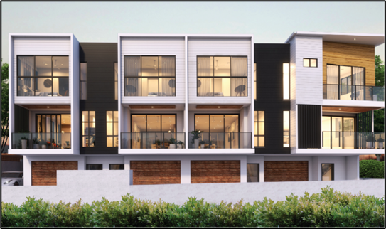  Image is indicative only – scan QR code for more info

Application details
Application reference number: | TP-20210392 | How can I find out more?  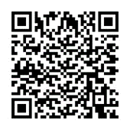  Scan the QR code | How can I make a submission?  This application has not been decided.  You can still make a submission before a decision has been made. The Responsible Authority will not decide on the application before [date].
Address: | 123 Fake Street, Suburbia | You may look at the application and any documents that support the application free of charge at: [insert address of the responsible authority's Internet site] or by scanning the QR code. | For further information please contact: [Planner’s Name or Council]  Phone number: [direct line or general line]  Email address: [direct email or general email]
Applicant name: | Example c/o  Example Architects Pty Ltd | You may also call [insert phone number] to arrange a time to look at the application and any documents that support the application at the office of [insert name of responsible authority]. This can be done during office hours and is free of charge.
[Implementation note: As per legal advice, omit applicant name if the notice is to be published on the responsible authority's Internet site and the applicant is an individual]
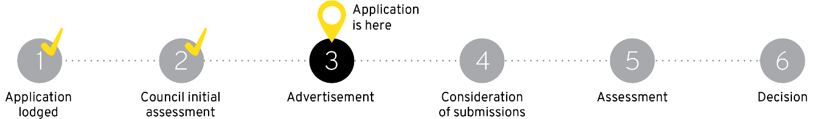

What are my options?  Any person who may be affected by the granting of the permit may object  or make other comments regarding the application to the responsible authority. | An objection must:  - be made to the Responsible Authority in writing.  - include the reasons for the objections, and  - state how the objector would be affected  If you object, the Responsible Authority will notify you of the decision when it is issued. | The Responsible Authority must make a copy of every objection available at its office for any person to inspect during office hours free of charge until the end of the period during which an application may be made for review of a decision on the application.  If you object, the Responsible Authority will notify you of the decision when it is issued.

