This practice note provides guidance about the car parking provisions of clause 52.06 (Car Parking) and clause 45.09 (Parking Overlay).
Clause 52.06 - Car Parking: Car parking sets out standard State planning scheme requirements about the number and design of car parking spaces.
Clause 45.09 - Parking Overlay: enables variations to the standard requirements in clause 52.06 for a particular area or precinct. These requirements override the standard requirements at clause 52.06. All local car parking variations must be provided using the Parking Overlay. A local policy cannot be used to apply variations.
Information about applying the Parking Overlay is set out in Planning Practice Note 57: Parking Overlay.
Car parking requirements may also be specified in other provisions of the planning scheme, such as a schedule to a zone or an overlay.

What do the car parking provisions do?
Clause 52.06 and the Parking Overlay provide five functions. They:
- Outline when and how car parking spaces can be provided.
- Determine the number of car parking spaces to be provided.
- Explain the requirements for increasing or reducing the number of car parking spaces.
- Require that new car parking spaces are designed and constructed to certain standards.
- Provide for precinct-based provisions that:
  - establish local rates in identified areas
  - provide a mechanism for financial contributions in lieu of providing car spaces
  - set local requirements, such as the design and layout of car parking spaces.

Scope of clause 52.06
Clause 52.06 applies to:
- a new use
- an increase in floor area, or site area of an existing use
- an increase to an existing use by the measure specified in Table 1 to clause 52.06-5.
The provisions may also apply when a permit is not required for a new use or for buildings and works.

In the Neighbourhood Residential Zone, General Residential Zone, Residential Growth Zone, Housing Choice and Transport Zone, Mixed Use Zone or Township Zone, clause 52.06 does not apply to the:
- extension of one dwelling, or
- construction and use of one dwelling unless the zone or a schedule to the zone specifies that a permit is required to construct or extend a dwelling, or
- construction and use of a small second dwelling.

Planning permit requirement
If the number of car parking spaces required under clause 52.06-5 or in a schedule to the Parking Overlay cannot be met on site, a planning permit is required under clause 52.06-3 to:
- reduce (including reduce to zero) the minimum number of car parking spaces
- provide some or all required car parking spaces on another site
- provide more than the maximum parking provision specified at clause 52.06-5 or in a schedule to the Parking Overlay.
A permit is not required to:
- reduce the minimum number of car parking spaces for a new use if:
- the number of car parking spaces required is less than or equal to the minimum requirement for the existing use, and
- The number of car parking spaces currently provided in connection with the existing use is not reduced after the new use commences.
- reduce the number of car parking spaces for a new use of an existing building if all of the following are met:
- the building is in the Commercial 1 Zone, Commercial 2 Zone, Commercial 3 Zone, Activity Centre Zone or Precinct Zone.
- the gross floor area of the building is not increased.
- the reduction does not exceed 10 car parking spaces.
- the building is not in a Parking Overlay with a schedule that allows a financial contribution to be paid in lieu of the provision of the required car parking spaces for the use.
- provide more car parking spaces than the maximum car parking requirement in clause 52.06-5 if:
- the existing number of car parking spaces on the land exceeds the maximum car parking requirement, and
- no new additional car parking spaces will be provided.
Additional planning permit exemptions in the schedule to clause 45.09 (Parking Overlay) may apply.
An application to reduce the required number of car parking spaces by no more than 10 spaces is assessed using the fast-track VicSmart application process under clause 59.10. For more information about VicSmart applications, go to VicSmart Permit Guide and the VicSmart Checklist 11 - Reduce a Car Parking Requirement.

How to calculate the car parking requirement
The car parking space rates at Table 1 to clause 52.06-5 apply unless a different rate or measure is specified by a schedule to the Parking Overlay or another provision in the planning scheme, such as a Comprehensive Development Zone or an Incorporated Plan Overlay. Refer to ‘Requirements for unspecified uses’ if the use is not listed in Table 1.

Using Table 1 to clause 52.06-5
Table 1 to clause 52.06-5 includes four different categories with rates for each use as follows:
- Category 1 – minimum rate
- Category 2 – minimum rate
- Category 3 – minimum and maximum rate
- Category 4 – maximum rate
The category that applies to the site is found on the Car Parking Requirement (CPR) Maps at VicPlan.
If the land is shown in two or more categories on the CPR Maps, the car parking requirement for the higher category applies to all of the land. For example, if the site is within both Category 3 and Category 4, the Category 4 rate applies to the proposal.
If the result of applying Table 1 is not a whole number, the required number of car parking spaces is to be rounded down to the nearest whole number.
Where the car parking measure is a percentage of the site area the measure includes accessways that directly abut any car parking spaces.
Diagram 1 below provides more information about how to use the new parking provisions.

Diagram 1: using the car parking provisions
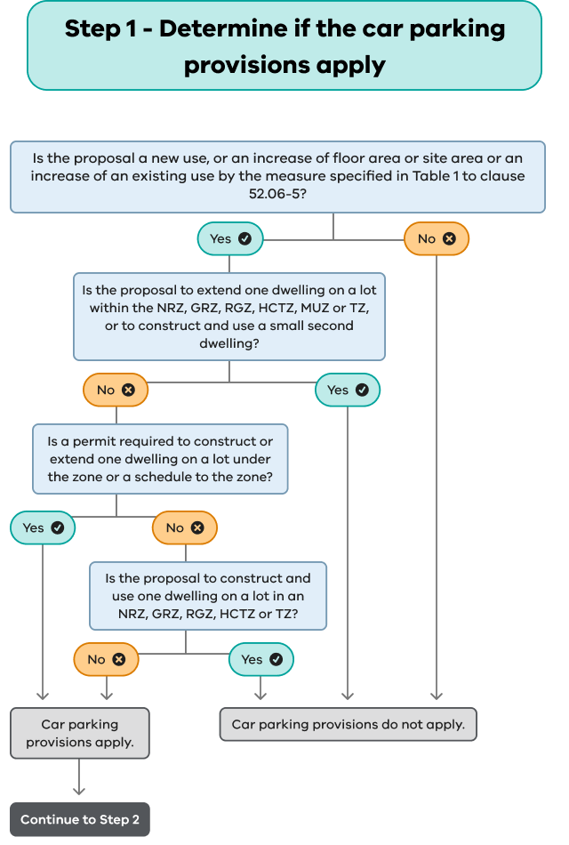

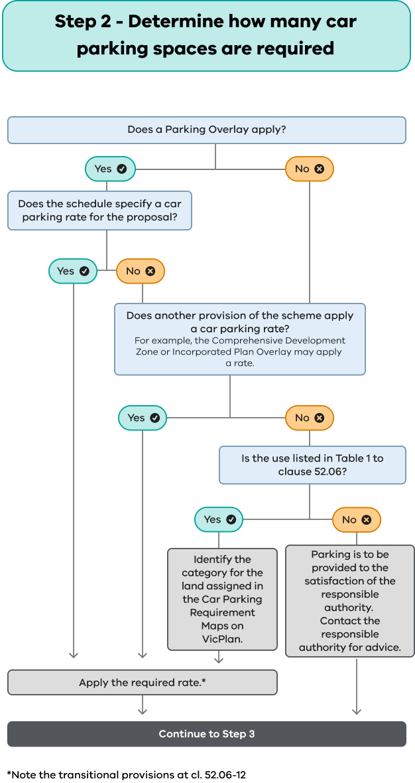
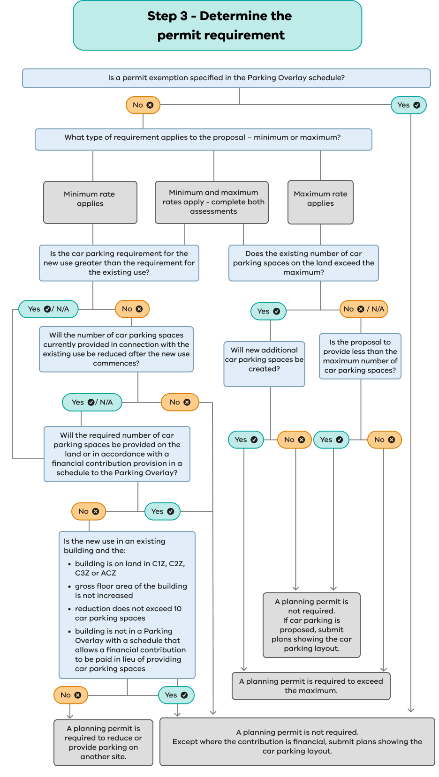

EXAMPLE
An applicant proposes a child care centre employing 10 people at any one time on land in a General Residential Zone. No other provision lists a parking requirement for the use.
The calculation to establish the car parking requirement is as follows:
Site is within Category 1
1 space (Category 1 rate) x 10 (employees) = minimum of 10 spaces
If the child care centre can meet the on-site car parking requirement of 10 spaces, no planning permit is required for car parking. However, plans are required in accordance with clause 52.06-8.
Site is within Category 4
There is no minimum rate and no maximum rate for a child care centre in Category 4.
The applicant can decide how many car parking spaces to provide. If car parking is proposed, plans are required in accordance with clause 52.06-8.

Requirements for unspecified uses
Where a use is not specified in Table 1 to clause 52.06, in another clause, or in a schedule to the Parking Overlay, the responsible authority determines the number of car parking spaces to be provided in accordance with clause 52.06-6.
The responsible authority may determine the adequacy of parking based on:
- policies
- surveys
- floor area |  | Similarities of nature and scale between the proposed and existing uses enable the responsible authority to benchmark an appropriate car parking rate.
- operational characteristics
- locational characteristics.
The planning scheme may provide guidance on the car parking requirement for a particular land use or location.
Likely car parking demand can be determined by conducting surveys at an existing establishment of the same use with a similar operating model and location to the proposal.

Can the minimum car parking rate be reduced or maximum rate be exceeded?
A planning permit can be granted to vary the minimum or maximum car parking rate under the provisions of clause 52.06-7.
An application to vary the car parking rate must be accompanied by a Car Parking Demand Assessment to help forecast the likely demand to be generated by the proposal.

Car Parking Demand Assessment
The Car Parking Demand Assessment must address the following matters:
- Multi-purpose trips within an area
A different car parking rate might be appropriate based on the number of functions a trip could serve. For example, a restaurant close to offices will draw some of its trade from local office workers who will have already travelled to the area for work.
- Variation of car parking demand over time
Car parking spaces could serve multiple uses if the car parking demand for each use peaks at different times. Efficient use of car parking would avoid oversupply. In areas with low access to public transport, the assessment should demonstrate that the net car parking demand at any time can be met.
- Short-stay and long-stay parking demand
A different car parking rate might be appropriate based on the nature of the use, the typical user’s duration of stay and the feasibility of public transport access. For example, a trip to a cinema is likely to be longer than two hours, therefore two-hour restricted car parking would not be suitable.
- Availability of public transport in the locality
Access to public transport may alter the need to provide car parking. The assessment should consider the frequency of public transport services, walking route and distance from the stop to the use and whether the service coincides with the operating hours of the use.
- Convenience of pedestrian and bicycle facilities
Walkability and cycling infrastructure including end of trip facilities, can alter the demand for car parking. Some uses also attract people that would have a lower rate of car use and are more likely to walk or cycle.
- Anticipated car ownership rates of occupants
The likely car ownership and usage patterns of residents or employees may alter the demand for car parking. For example, car ownership rates are typically lower for retirement villages and social housing.
- Any empirical assessment or case study
Parking studies, surveys, observations and other methods can inform car parking demand. For example, a survey can help predict the likelihood of a person walking, cycling or taking other transport modes to the proposed use. The respondent sample group could include:
  - local residents
  - workers and visitors in the vicinity of the subject site
  - likely users of the new use or development.

Deciding whether the car parking rate should be varied
Applications are assessed against the decision guidelines at clause 52.06-7. The decision guidelines include a range of considerations that seek to help establish:
- the likely demand for car parking spaces (technical)
- whether it is appropriate to allow the provision of fewer spaces (strategic).
If a Parking Overlay applies, any other matter specified by the Parking Overlay must also be considered.

Decision guidelines to reduce the number of required car parking spaces
- Availability of car parking
Assessing the number of available existing off-site spaces can be complex, particularly if public on-street parking is intended to contribute significantly to car parking needs. The assessment should consider as relevant, whether car parking spaces:
- match the duration of stay for the use, if they are time restricted
- are generally unoccupied at times required by the use
- are proximate to the subject land (generally within 100 metres for a short stay)
- are suitably accessible.
If relying on car parking spaces on other land, consider as relevant, the suitability of:
- commuter car parks at train stations - they often reach capacity by their intended users or may be restricted to commuters
- informal car parking on vacant private lots – these can be lost by land management changes or re-development.
Car parking spaces on land where no formal or enduring agreement exists should not be relied upon when considering the availability of car parking.
Where a proposal has a mix of uses or will use shared car parking spaces, it may not be necessary to provide all the required spaces for each use due to efficiencies gained from sharing car parking spaces.
- Reliance on on-street parking in residential zones
Commercial development should avoid relying on residential streets for car parking, unless managed with signs or meters and residents’ car parking can be met.
- The practicality of providing car parking on the site, particularly for small lots
Narrow property dimensions may make it impractical to provide car parking on small lots. The impact to on-street car parking should be considered.
- Car parking deficiency associated with the existing use of the land
A history of nonconforming car parking for a site does not justify a perpetual ‘car parking credit’.
An empirical assessment of any shortfall should be considered against current planning requirements.
- Car parking spaces provided on common land
Car parking may be provided on common property. Any change to the use or development must consider the overall onsite car parking as required by current planning requirements.

- Car parking spaces provided by a financial contribution
Where a financial contribution has been made towards the provision of new car parking (including contributions under the Parking Overlay or where a ‘special rate’ has been executed or is in place) the car parking spaces are deemed to have been provided when calculating existing car parking supply.
- Local area car parking shortfall
The context of any earlier car parking arrangements for the locality should be considered.
New development should be accountable for the car parking demand it generates but is not expected to fix a car parking shortfall in an area.

Decision guidelines to vary the maximum rate
- The nature of the land use
There may be circumstances where the frequency of public transport does not match the operating hours of the use or account for the type of activities associated with the use.
- Whether additional car parking is required for disability parking
The maximum rate includes disability car parking. However, a variation may be appropriate if the proposal requires additional disability car parking to match the accessibility needs of the occupants or customers.
- The specific circumstances of the site including access to or provision of alternative transport modes
There may be unique factors affecting the site. For example, the built or natural features impact access to the site by public transport or the public transport route has changed.

Decision guidelines to vary the minimum and maximum rates
- Any relevant local planning policy or incorporated plan
Local planning policies or relevant incorporated plans should be considered as they may provide relevant guidance, such as advice about planning for activity centres or urban design.
- An adverse economic impact that a shortfall of car parking may have on an activity centre
Where a change of use or a small extension is consistent with the strategic plan for a centre and the use relies on a car parking variation, a variation is often appropriate.
Some activity centres will have excellent public transport access, ample car parking or they mainly serve local customers who arrive on foot. In such circumstances, an increase in business and activity would increase the overall viability of the centre and the reduced number of car trips would provide positive impacts.
The potential adverse economic impact to an activity centre by not providing additional car parking should be considered.
- The future growth and development of an activity centre
Car parking should be considered on a centre-wide basis rather than on a site-by-site basis, to support a centre’s long-term viability.

- Local traffic management
Varying the car parking rate may impact on the safety and ease of accessing a car parking area or may be required to improve traffic management.
- Local amenity
Car parking may have an adverse impact on the amenity of an area, such as the loss of vegetation, pedestrian amenity, or increased noise or other disturbance to surrounding residents.
Alternatively, a proposal may enhance the local amenity or produce other positive planning outcomes and the responsible authority may be willing to vary the car parking requirement on this basis.
- The need to create safe, functional and attractive car parking areas
The impact of varying the car parking rate on the layout, landscaping and pedestrian access should be considered.
- The potential to access the site by public transport, bicycle and walking
Areas well served by public transport, bicycle and pedestrian facilities may lower the demand for car parking.
The site or proposed use may attract people with a low rate of car ownership.
- The need to respect the character of the neighbourhood or achieve a quality urban outcome
The impact of car parking on the neighbourhood character and heritage should be minimised.

Plan requirements
Where car parking spaces are proposed, clause 52.06-8 requires that plans are prepared to the satisfaction of the responsible authority. This applies whether or not a permit application is made under clause 52.06-3 or any other provision of the planning scheme.
The plans must show, as appropriate, all required car parking spaces, access lanes, driveways and associated works, tenancy allocation, landscaping and any other matter specified in clause 52.06-8 or a schedule to the Parking Overlay.

Design standards for car parking
Clause 52.06-9 sets out design standards for car parking, including the dimensions and layout of car parking spaces and accessways. The design standards recognise that the layout and design of a car park will be critical to its technical and streetscape success.
The design standard for car parking spaces and accessway dimensions varies from the Australian Standard by allocating more width to aisles and less to marked spaces to provide improved operation and access. The dimensions in Table 2 in clause 52.06-8 are to be used instead of those in the Australian Standard AS2890.1-2004 (Off-Street Car Parking).
The car parking must be constructed in accordance with approved plans before a new use commences or new buildings or works are occupied.
Any subsequent change to the extent or layout of the car park will need either a permit and/or new plans to the satisfaction of the responsible authority.

Disabled car parking spaces
Under the Building Code of Australia, some of the required number of car parking spaces must be allocated as disabled car parking spaces. The design standards for these spaces must be in accordance with Australian Standard AS2890.6-2009 (Off-street Parking for People with Disabilities) and the Building Code of Australia.
Disabled car parking spaces are longer than car parking spaces specified in the design standard at clause 52.06-9. To accommodate their additional length, disabled car parking spaces may encroach into an accessway width specified in Table 2 of clause 52.06-9 by 500mm – refer to Diagram 2 below.
Diagram 2: disabled car parking spaces
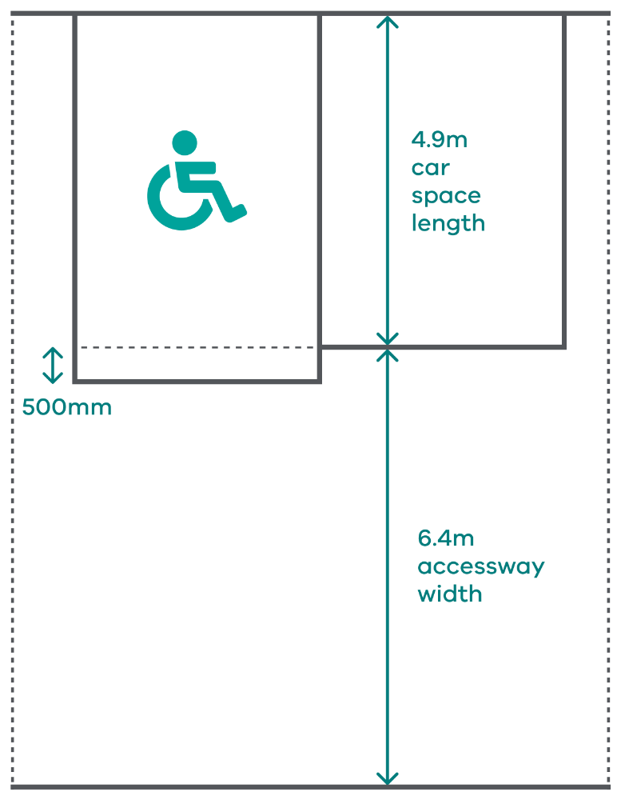

Mechanical parking
Mechanical car parking, such as stackers, can be used to achieve efficient vehicle storage.
Mechanical parking is not suitable for visitor use, unless used in a valet parking situation.
Where a stacking system requires one car to be manually moved for another car to enter or exit, the car spaces should be allocated to a single tenancy or residence.

Financial contributions under a Parking Overlay
A schedule to the Parking Overlay can be used to allow a financial contribution (such as a ‘cash-in-lieu’ payment) to be paid in place of providing car parking spaces. Where a schedule provides for this, it will set out:
- the area in which a financial contribution may be collected in place of providing car parking spaces
- the amount required in dollars to be provided in place of each car parking space
- the method of indexing the amount
- financial arrangements associated with holding and spending funds paid, including the purposes for which the funds must be used.
The schedule may also set out if appropriate:
- the ongoing monitoring and review arrangements, to reflect the change in land and construction prices
- any conditions to be included on the permit to secure the financial contribution.
To ensure transparency and accountability, financial contributions can only be sought when specifically provided for in a schedule to the Parking Overlay.
When a financial contribution is to be paid in place of providing car parking spaces, a condition should be included on the permit to secure the funds. Contributions must be collected for an identified purpose and not general revenue raising.
Each payment must be made into a ‘parking and access fund’ established by the council. The funds can only be used for the purposes identified in the schedule.

Keeping records
It is good practice for a council to keep records relating to car parking, including:
- Project funds: An accurate record of payments made as part of a financial contribution or special rates scheme for a specified project. As well as assisting council in administering the fund, this information will assist in calculating future car parking credits and financial contributions.
- Unspecified uses: A register of car parking requirements established to the satisfaction of the responsible authority for uses not specified in Table 1 in clause 52.06 or elsewhere in the planning scheme. This will help with consistent decision-making in relation to rates applied to unspecified uses.
- Plans: Where a plan is required to demonstrate that the car parking is to the satisfaction of the responsible authority, a copy of the plan and any related documents should be kept. These should be dated to enable future users to understand whether any changes have been agreed over time.

© The State of Victoria - Department of Transport and Planning, December 2025  This work is licensed under a Creative Commons Attribution 4.0 International licence. You are free to re-use the work under that licence, on the condition that you credit the State of Victoria as author. The licence does not apply to any images, photographs or branding, including the Victorian Coat of Arms, the Victorian Government logo and the Department of Transport and Planning (DTP) logo. To view a copy of this licence, visit http://creativecommons.org/licenses/by/4.0/  ISBN: 978-0-7311-9381-3 (pdf/online/MS word)  Disclaimer  This publication may be of assistance to you but the State of Victoria and its employees do not guarantee that the publication is without flaw of any kind or is wholly appropriate for your particular purposes and therefore disclaims all liability for any error, loss or other consequence which may arise from you relying on any information in this publication. | Accessibility  If you would like to receive this publication in an alternative format, please go to planning.vic.gov.au or email planning.systems@transport.vic.gov.au

