Plan Melbourne 2017-2050

Draft Southern Metro

Land Use Framework Plan

Acknowledgement
We acknowledge and respect the Traditional Owners of Victoria's lands and waters, their unique ability to care for Country and deep spiritual connection to it. We honour Elders past and present whose knowledge and wisdom has ensured the continuation of culture and traditional practices.
We are committed to genuinely partner and meaningfully engage with Traditional Owners to support the protection of their Country, the maintenance of spiritual and cultural practices and their broader aspirations in the 21st century and beyond.

Aboriginal self-determination
Pupangarli Marnmarnepu - Wadi Wadi and Mutti Mutti language for ‘Owning Our Future’ - is DELWP’s Aboriginal Self-Determination Reform Strategy 2020-2025. As the framework for supporting and enabling Aboriginal self-determination for all DELWP projects, Pupangarli Marnmarnepu forms the basis of an ongoing dialogue and partnership with Traditional Owners to influence metropolitan planning and the implementation of Plan Melbourne 2017-2050 in each of the six metropolitan regions.
Ongoing partnership opportunities with Traditional Owners are currently being explored. This process will determine the preferred involvement and level of influence Traditional Owners would like to have in shaping the outcomes and implementation of the Land Use Framework Plans.

Abbreviations
ABS | Australian Bureau of Statistics | NEIC/s | National Employment and Innovation Cluster/s
BIFT | Beveridge Interstate Freight Terminal | OMR | Outer Metropolitan Ring/E6 Transport Corridor
BMO | Bushfire Management Overlay | PBN | Principal Bicycle Network
BPA | Bushfire Prone Area | PFN | Principal Freight Network
CBD | Central Business District | PPTN | Principal Public Transport Network
DELWP | Department of Environment, Land, Water and Planning | PSP/s | Precinct Structure Plan/s
DJPR | Department of Jobs, Precincts and Regions | RSIP | Regionally-Significant Industrial Precinct
DoT | Department of Transport | SBO | Special Building Overlay
EIIA/s | Extractive Industry Interest Area/s | SEIFA | Socio-Economic Indexes for Areas
EPWG | Economy and Planning Working Group | SERA/s | Strategic Extractive Resource Area/s
ESD | Environmentally Sustainable Development | SRL | Suburban Rail Loop
GRP | Gross Regional Product | SRLA | Suburban Rail Loop Authority
HVI | Heat Vulnerability Index | SSIP | State-Significant Industrial Precinct
LGA | Local Government Area | TAFE | Technical and Further Education
LSIO | Land Subject to Inundation Overlay | UDP | Urban Development Program
LST | Land Surface Temperature | UGB | Urban Growth Boundary
LUFP | Land Use Framework Plan | VIF | Victoria In Future
MICLUP | Melbourne Industrial and Commercial Land Use Plan | VPA | Victorian Planning Authority
MRF | Materials Recovery Facility | WIFT | Western Interstate Freight Terminal

Introduction
Melbourne is the fastest growing city in Australia. The city’s population is projected to reach 8 million by 2050. This growth, in combination with a changing climate, increased globalisation and congestion, is testing the resilience of Melbourne’s built and natural environment. Victoria needs to plan for this growth and change. That is why Plan Melbourne 2017-2050 is important.
Plan Melbourne has a clear vision:
‘Melbourne will continue to be a global city of opportunity and choice.’
What this vision demonstrates is that Plan Melbourne is more than a planning document. It is a blueprint guiding the actions of planners, local councils, landowners and developers – ensuring Melbourne grows more sustainable, productive and liveable.
Plan Melbourne seeks to deliver seven outcomes. How these will be delivered in each of the six metropolitan regions is the subject of the Land Use Framework Plans (LUFPs).
Outcome 1 | Melbourne is a productive city that attracts investment, supports innovation and creates jobs
Outcome 2 | Melbourne provides housing choice in locations close to jobs and services
Outcome 3 | Melbourne has an integrated transport system that connects people to jobs and services and goods to market
Outcome 4 | Melbourne is a distinctive and liveable city with quality design and amenity
Outcome 5 | Melbourne is a city of inclusive, vibrant and healthy neighbourhoods
Outcome 6 | Melbourne is a sustainable and resilient city
Outcome 7 | Regional Victoria is productive, sustainable, and supports jobs and economic growth

Land use framework plans
Plan Melbourne identifies six metro regions within the city as illustrated on Figure 1:
- Inner (Melbourne, Port Phillip and Yarra Local Government Areas or LGAs)
- Inner South East (Bayside, Boroondara, Glen Eira and Stonnington LGAs)
- Eastern (Knox, Manningham, Maroondah, Monash, Whitehorse and Yarra Ranges LGAs)
- Southern (Cardinia, Casey, Frankston, Greater Dandenong, Kingston and Mornington Peninsula LGAs)
- Western (Brimbank, Hobsons Bay, Maribyrnong, Melton, Moonee Valley and Wyndham LGAs)
- Northern (Banyule, Darebin, Hume, Mitchell, Moreland, Nillumbik and Whittlesea LGAs).
The Victorian Department of Environment, Land, Water and Planning (DELWP) has led the development of a LUFP for each region, supported by six Economy and Planning Working Groups (EPWGs).
The six EPWGs are chaired by a chief executive officer from a council within each region and include senior representatives from the region’s local councils, DELWP, the Department of Jobs, Precincts and Regions (DJPR) and the Department of Transport (DoT).
Through the EPWGs, local councils have helped shape the vision for their regions – providing local insight into the regional opportunities and challenges that require joint action by state and local government.
Responding to these regionally-specific opportunities and challenges, the LUFPs:
- are 30-year strategic land use and infrastructure plans for Melbourne’s six metropolitan regions
- provide a common long-term framework to manage growth and land use pressures in each region
- are spatial plans that translate Plan Melbourne and the Plan Melbourne Addendum to the regional level
- focus on resolving metropolitan regional issues
- provide context for planning at the precinct or local level
- ensure the review and update of local planning schemes align with Plan Melbourne
- provide directions and strategies for state- and regionally-significant projects that are implemented through state planning policy and local planning schemes
- drive the accommodation of the majority of Melbourne’s growth into established areas through a land use framework that identifies places of state and regional significance, and integrate greenfield growth area planning with wider metropolitan planning.
The LUFPs support the implementation of Plan Melbourne – guiding the implementation of Plan Melbourne’s nine principles, seven outcomes, 32 directions and 90 policies at a regional and local level
- Location of the Southern Metro Region
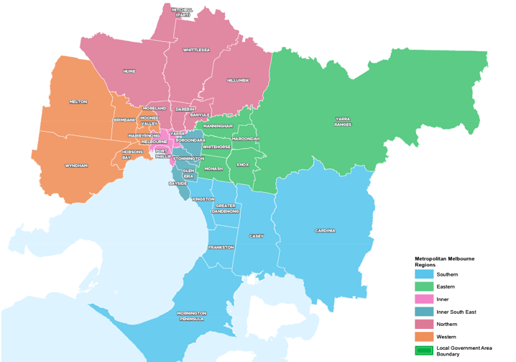

How will the land use framework plans be used?
The LUFPs will be used to:
- Drive the majority of Melbourne’s population growth into established areas through a land use framework that identifies places of state and regional significance
- Guide the strategic integration of land use and infrastructure (including housing and jobs aspirations) in key areas and precincts
- Guide the development of Melbourne’s greenfield growth areas
- Facilitate collaboration by state and local government, key agencies and partners on regional planning and regional priorities
- Inform priority places for state-led planning
- Enable metropolitan councils to update their municipal strategies and policies within a clearly defined land use framework.
The LUFPs will set regional-level planning policy to be implemented into planning schemes. They will inform local councils in decision-making for precinct planning, local and regional planning strategies, and infrastructure and servicing projects.
The LUFPs include a number of short- to medium- term actions for state and local government, which will contribute to planning outcomes in each region alongside existing actions under Plan Melbourne and other government programs and initiatives. Action monitoring will be led by DELWP in partnership with the metropolitan region through the EPWGs, and the actions will be formally reviewed every five years in conjunction with Plan Melbourne 2017-2050 Five-Year Implementation Plan.
Annual progress reports outlining the status of actions will be published by DELWP as a part of Plan Melbourne monitoring. These progress reports will be publicly available.
The chapter on implementation provides further details on how the LUFPs will be used to deliver Plan Melbourne outcomes across the regions.
Appendix 01 identifies the range of related initiatives already underway by state and local government to support the implementation of Plan Melbourne. The LUFPs are designed to complement these initiatives.

The land use framework
The LUFPs establish a common land use framework across the regions (Table 1). This common framework confirms places of state significance as identified in Plan Melbourne and introduces places of regional significance for each metro region.
The land use framework will direct land use decisions and investment, better align state and local government planning, and inform the development of local council planning strategies (including housing strategies). In the process, this common framework will also ensure land use, planning and development all support the vision of Plan Melbourne.
- The land use framework
Places of state significance (as identified in Plan Melbourne) | Places of regional significance
- Central City  - National employment and innovation clusters (NEICs)  - Metropolitan activity centres  - State-significant industrial precincts (SSIPs)  - Transport gateways  - State-significant health and/or education precincts  - Major urban renewal precincts | - Major activity centres  - Activity corridors  - Regionally-significant industrial precincts (RSIPs)  - Enterprise precincts  - Regionally-significant health and/or education precincts  - Inter-regional environmental features  - Regional open space  - Growth corridors  - Urban renewal areas  - Housing opportunity and investigation areas  - Green wedges

Regional planning and collaboration
Planning at a regional level is an opportunity for state and local governments to work together to manage long-term growth and change across Melbourne (Figure 2).
While the Southern Metro Region has many unique opportunities and challenges, there are some opportunities and challenges common across all metropolitan regions, such as ensuring jobs are available close to public transport; increasing housing supply in areas with access to jobs, services and public transport; and mitigating and adapting to climate change. The LUFP allows for these differences and recognises regional initiatives already underway.
The LUFPs will guide regional planning and collaboration vertically (between state and local government) and horizontally (across local councils in partnership with other stakeholders, including Traditional Owners).
- Inter-relationship between state and local planning
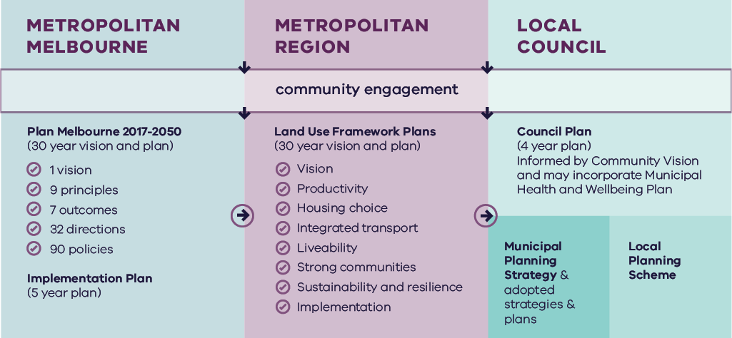
Metropolitan Melbourne | Metropolitan Region | Local Council
Is informed by community engagement. | Is informed by community engagement and Metropolitan Melbourne planning. | Is informed by community engagement, Metropolitan Melbourne planning and Metropolitan Region planning.
Includes:  - Plan Melbourne 2017-2050 (30 year vision and plan)  - 1 vision  - 9 principles  - 7 outcomes  - 90 policies  - Implementation Plan (5 year plan) | Includes:  - Land Use Framework Plans (30 year vision and plan)  - Vision  - Productivity  - Housing choice  - Integrated transport  - Liveability  - Strong communities  - Sustainability and resilience  - Implementation | Includes:  - Council Plan (4 year plan)  - Informed by Community Vision and may incorporate Municipal Heath and Wellbeing Plan  - Municipal Planning Strategy & adopted strategies & plans  - Local Planning Scheme

State-led planning
The Victorian Government has identified priority areas for state-led planning. The purpose of state-led planning in those areas is to maximise land use and infrastructure integration, attract investment, and deliver housing, jobs and services within established urban areas (Table 2).
State-led planning often involves the Victorian Government partnering with local councils and other stakeholders to develop or implement strategic plans, plan for change or respond to an investment, and/or identify key catalyst projects or programs that support growth and attract investment.
- Current places for state-led planning in the Southern Metro Region
Places of state significance
National employment and innovation clusters
Dandenong
Monash
Metropolitan activity centres
Dandenong
Frankston
Fountain Gate-Narre Warren
Places of regional significance
Major activity centres
Cheltenham-Southland
In Dandenong, Development Victoria is working in partnership with the City of Greater Dandenong, Victorian Government agencies and the private sector to achieve the goals of the Revitalising Central Dandenong initiative including facilitating new development and job-creating economic activity.
Monash NEIC and Cheltenham-Southland Major Activity Centre are part of SRL led by the Suburban Rail Loop Authority.

Growth area planning
The LUFPs provide a strategic planning framework to guide future development of Melbourne’s three growth corridors – Northern, Western and South Eastern. The LUFPs incorporate and update information from the growth corridor plans prepared by the former Metropolitan Planning Authority, now the Victorian Planning Authority (VPA).
The growth corridor plans set the strategic direction for future urban development in the growth corridors, including:
- Areas suitable for urban development and the broad form of development (residential, industrial, commercial)
- Areas of high environmental or landscape value that must be protected from development
- The integrated open space network
- Strategic transport infrastructure and options for further investigation
- Locations suitable for a wide range of employment uses.
The following principles underpin the growth corridor plans and are reflected in Plan Melbourne and the LUFPs:
Principle 1 | Create diverse and vibrant new urban communities
Principle 2 | Integrate transport and land use planning
Principle 3 | Plan for local employment creation
Principle 4 | Create growth corridors with high amenity and character
Principle 5 | Protect biodiversity, waterways and cultural heritage values
Principle 6 | Create integrated open space networks
Principle 7 | Plan for environmental sustainability
Principle 8 | Stage development to ensure the efficient and orderly provision of infrastructure and services
This Southern Metro Region LUFP replaces the South Eastern Growth Corridor Plan.
The Southern Metro Region LUFP will guide and inform the preparation, completion and implementation of the remaining Precinct Structure Plans (PSPs) in these growth areas.
This LUFP does not commit the Victorian Government to specific infrastructure, development projects or levels of service provision within the Southern Metro Region. Information included in this LUFP is intended to guide planning for future development; however, it should not be interpreted as a delivery mechanism or program committing the Victorian Government to specific infrastructure or development projects or specific levels of service provision.

The broader context

Climate change – the need for both mitigation and adaptation
Victoria’s Climate Change Strategy (2021) translates the Climate Change Act 2017 into concrete action by introducing ambitious but achievable interim emissions reduction targets to keep Victoria on track to net zero emissions by 2050. The Strategy includes actions to reduce emissions now and lay the foundations for future reductions across the economy, including but not limited to the following: continuing the transition to clean, renewable energy production; establishing a light vehicle sales target of 50 per cent zero emissions vehicles by 2030; investing in land restoration and carbon farming initiatives; supporting Victorian farmers to respond to the impacts of climate change; and creating new jobs by promoting growth within the waste recycling and renewable energy sectors. These measures will help reduce the size of Melbourne’s carbon footprint and improve its resilience to the impacts of climate change.
Land use and transport integration – such as locating homes close to public transport and bike and walking paths – is critical to achieving net-zero emissions. In 2018, cars made up just over half of all transport emissions, with road vehicles responsible for almost 90 per cent of those transport emissions. Transport emissions by mode and road transport sub-categories are shown in Figure 3.
- Transport emissions by mode and road transport sub-categories – Victoria 2018
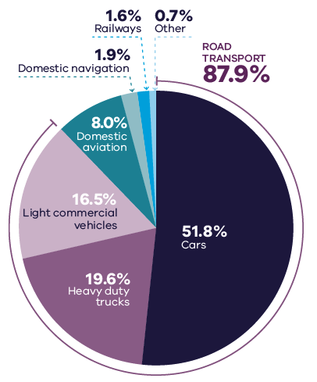
DELWP (2020) Victorian Greenhouse Gas Emissions Report 2018, State of Victoria: Melbourne, Australia

Figure 3. Transport emissions by mode and road transport sub-categories – Victoria 2018
Cars | 51.8 per cent
Heavy duty trucks | 19.6 per cent
Light commercial vehicles | 16.5 per cent
Domestic aviation | 8.0 per cent
Domestic navigation | 1.9 per cent
Railways | 1.6 per cent
Other | 0.7 per cent
Source: Victorian Greenhouse Gas Emissions Report 2018, DELWP, 2020, State of Victoria: Melbourne, Australia.

In Melbourne, despite increased public transport usage and significant public transport investment, cars remain the dominant mode of transport. In 2016, for example, private vehicles accounted for 67 per cent of trips in Melbourne. To achieve net-zero emissions, Victoria’s private vehicle use must be dramatically reduced.
The Victorian Government is working towards a more sustainable built environment through reforms to construction, planning and energy provision across metropolitan Melbourne and Victoria. These regulatory reforms will reduce the energy consumption of appliances, require improved environmentally sustainable development (ESD) outcomes in new buildings and subdivisions, and improve the efficiency of energy production and distribution.
The Victorian Government recently released its Environmentally Sustainable Development of Buildings and Subdivisions - A Roadmap for Victoria’s Planning System (the Roadmap). This document outlines updates to the planning system that support broader, state-level ESD policy objectives. It sets out additional ESD objectives and standards for the design of new buildings, as well as the layout of large-scale residential subdivisions proposed through the Victoria Planning Provisions.
The Roadmap also sets out other initiatives, including new approaches to energy management – such as renewable and distributed energy technologies, microgrids and battery farms, better stormwater management, increased landfill diversion practices, and the promotion of sustainable modes of transport.
Victoria is actively decarbonising the energy sector through the construction of better buildings and the transition to renewable energy generation (including onsite solar photovoltaic and large-scale renewable energy projects). Victoria’s planning policies will also facilitate appropriate development of low emission and zero emission energy supply infrastructure.
Good precinct structure planning can also reduce greenhouse gas emissions and make communities more climate resilient. That is why affordable and clean energy infrastructure should be used to support sustainable development and sustainable transport.

20-minute neighbourhoods
The LUFPs aim to create more 20-minute neighbourhoods in Melbourne’s six metropolitan regions by planning for established areas, growth areas and major transport infrastructure projects. The LUFPs also provide the regional direction and strategies to inform the delivery of 20-minute neighbourhoods through structure planning.

Future PSPs in growth areas will be guided by the 20-minute neighbourhoods principle and the Victorian Planning Authority’s guidelines for precinct structure planning.

City-shaping transport projects
The Victorian Government is currently implementing the largest transport infrastructure program in the state’s history. City-shaping projects (Figure 4) include:
- The West Gate Tunnel – creating a second river crossing to link the Western Metro Region with the Port of Melbourne, CityLink and the Central Business District (CBD), and take traffic pressures off the West Gate Bridge
- Level crossing removals including along the Frankston and Dandenong railway lines, reducing congestion and unlocking land for development
- Metro Tunnel – linking Melbourne’s south-east and Gippsland to the Sunbury line in Melbourne’s west and north-west
- North East Link – connecting Melbourne’s south-east to the Eastern Freeway, the Western Ring Road and Hume Freeway
- Melbourne Airport Rail – connecting Melbourne Airport to Victoria’s regional and metropolitan train network
- Suburban Rail Loop (SRL) – connecting every major passenger railway line in Melbourne from the Frankston line in the south to the Werribee line in the west. SRL East (Cheltenham to Box Hill) is scheduled to begin in 2022. SRL East will also connect key employment and education precincts, and facilitate uplift and intensive development of station precincts. SRL East Stabling Facility is planned to be located in the Kingston LGA.
These city-shaping projects will improve access to jobs, education and social opportunities in the Southern Metro Region. They will also connect the Southern Metro Region with other areas of Melbourne and Victoria. In addition, they are also creating opportunities to make the Southern Metro Region more prosperous, sustainable and liveable through the integration of land use and transport planning.
The purpose of integrated land use and transport planning is to bring jobs, services and leisure opportunities closer to where people live. This means shorter trips, the option to use active transport, and less time spent travelling – leading to a better quality of life and the creation of 20-minute neighbourhoods. In addition, this integrated approach also frees up capacity for freight, public transport and active transport journeys – reducing transport emissions.

Coronavirus (COVID-19) impacts
The coronavirus (COVID-19) pandemic is having dramatic impacts on Victoria’s population, economy and society.
With movement restricted, migration to Victoria has been reduced almost to zero. The Australian Government’s expectations for overseas migration losses will see Victoria’s population decline slightly in 2020-21, compared with average growth of 2 per cent for most of the previous decade. International migration is expected to resume within one to two years but not return to normal until the mid-2020s at the earliest.
This interruption to growth is not expected to change the long-term future direction of Melbourne.
However, the global pandemic has had significant impacts. This includes the shift to work-from-home arrangements for large parts of the metropolitan workforce, a greater uptake of online retail services and a shift to local living, with more people are relying on their activity centres and neighbourhoods to meet their day-to-day needs. Many industry sectors impacted by COVID-19 restrictions, including tourism, the arts and international education, are still recovering.
The LUFPs will help Melbourne’s metropolitan regions manage the economic and social impacts of the pandemic especially in specific areas such as Melbourne’s CBD and the Monash and Bundoora education precincts.
The progress of each LUFP will be monitored and revisited to ensure each regional land use pathway continues to contribute to Plan Melbourne’s outcomes.
- City-shaping transport projects
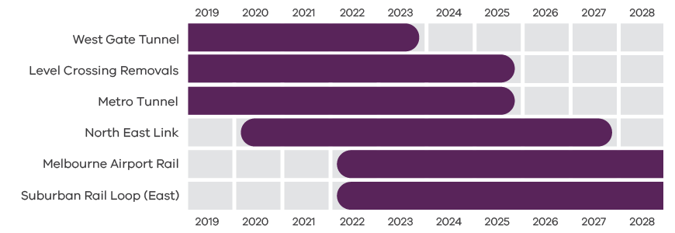
Department of Environment, Land, Water and Planning 2021

Figure 4. City-shaping transport projects
West Gate Tunnel | Pre-2019 to 2023
Level Crossings Removals | Pre-2019 to 2025
Metro Tunnel | Pre-2019 to 2025
North East Link | From 2020 to 2027
Melbourne Airport Rail | From 2022 to post-2028
Suburban Rail Loop (East) | From 2022 to post-2028
Source: Department of Environment, Land, Water and Planning 2021

Regional snapshot
The Southern Metro Region includes the local government areas (LGAs) of Cardinia, Casey, Greater Dandenong, Frankston, Kingston and Mornington Peninsula (Figure 5).
- Southern Metro Region
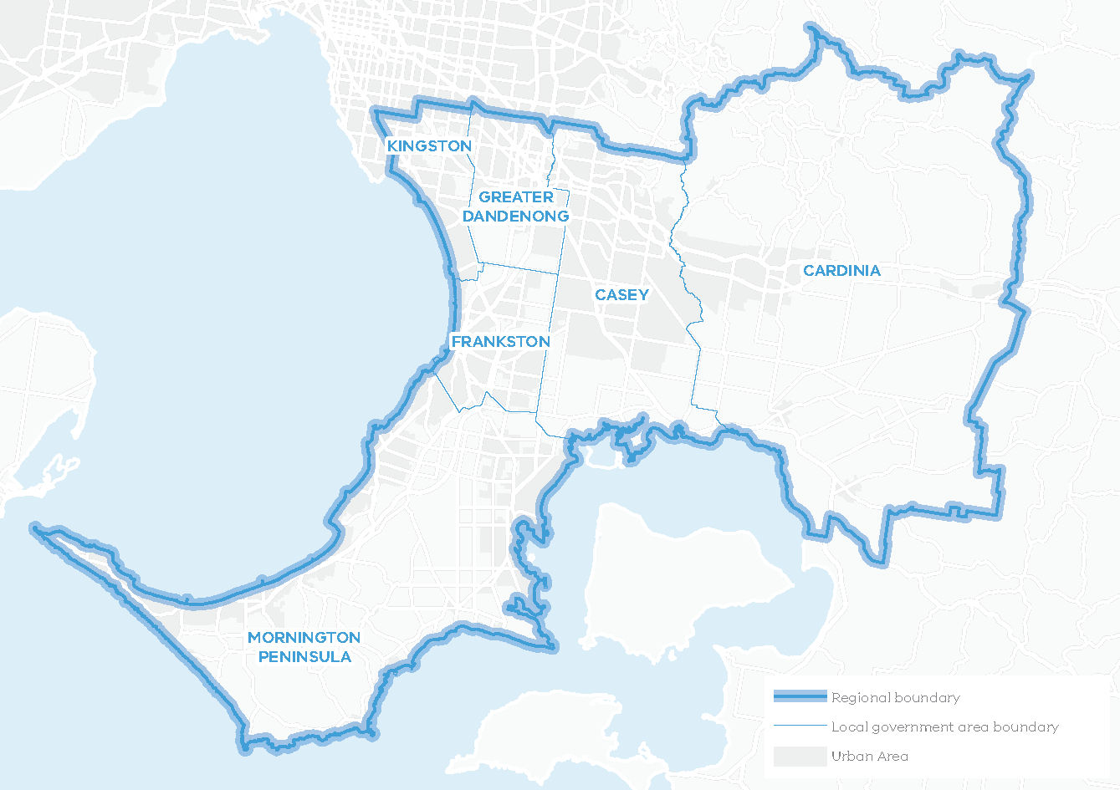
Total area: 275,632HA
31% of Metropolitan Melbourne
Over 34% of the region is designated green wedge land
The region extends southwards from the middle suburbs of Moorabbin, Mentone, Springvale and Dandenong to Port Phillip Bay and Western Port, encompassing the Mornington Peninsula, and eastwards to Bunyip beyond the Dandenong Ranges. It contains a total of 236 kilometres of coastline along Port Phillip Bay and Western Port.
The Bunurong people are the Traditional Owners of the lands that now make up the Mornington Peninsula and the bays of the Southern Metro Region. The Bunurong Land Council Aboriginal Corporation is the Registered Aboriginal Party for this part of the region.
The Wurundjeri people are the Traditional Owners of lands that include the Dandenong Ranges, within the northern part of the Southern Metro Region. They are represented by the Wurundjeri Woi Wurrung Cultural Heritage Aboriginal Corporation Registered Aboriginal Party.

Urban structure
The Southern Metro Region’s urban geography and structure is defined by its distinctive and varied landscape including the southern slopes of the Dandenong Ranges, flat agricultural plains to Western Port and the coastal and hilly terrain of the Mornington Peninsula.
The Southern Metro Region comprises two corridors of established urban development separated by green wedge land – Dandenong and Pakenham (including the rapidly growing South Eastern Growth Corridor) to the east, and Frankston and the Mornington Peninsula to the south. One third of the region is green wedge land with agriculture, tourism destinations, townships, national and state parks, coastal landscapes, wetlands, and urban utilities. The urban areas include:
- Older established urban areas along the Nepean and Princes highways and rail corridors to Frankston, Cranbourne, Dandenong and Pakenham
- South Eastern Growth Corridor – Clyde, Clyde North, Officer, Pakenham
- Pakenham – an existing regional centre and the eastern extent of the Urban Growth Boundary (UGB)
- Older established coastal suburbs on the eastern side of the Mornington Peninsula – Mornington, Rosebud, Rye, Sorrento to Point Nepean National Park
- Towns and small coastal settlements around Western Port and its hinterland – Hastings, Somerville, Flinders, Somers
- Small railway towns along the Gippsland rail line – Nar Nar Goon, Garfield, and the rural townships of Koo Wee Rup and Lang Lang
- Coastal suburbs along Port Phillip Bay at Mordialloc and Chelsea with sand-belt golf courses, flat land for industry and Moorabbin Airport.

Population and demographics
The Southern Metro Region has the largest population of the six Melbourne regions, with nearly 1.13 million people or 22 per cent of Melbourne’s total population. The region’s population is expected to grow by around 630,000 people between 2020 and 2051 to a total population of 1.76 million, or 21 per cent of Melbourne’s total population. Much of this will be accommodated in the South Eastern Growth Corridor – one of Melbourne’s three greenfield growth areas.
Future population projections and industry trends suggest the Southern Metro Region will continue to undergo significant growth and change as it consolidates its role as a state-significant area for industry, while diversifying in advanced manufacturing and knowledge-based economies, including health and education.
The most prevalent household type in the Southern Metro Region is families with children while people aged between 30-44 years old are the largest age group. The population aged 75 years and over is the fastest growing cohort in the region, which will have aged care and healthcare implications.
Outlined below are some of the key demographics and land use features of the Southern Metro Region.
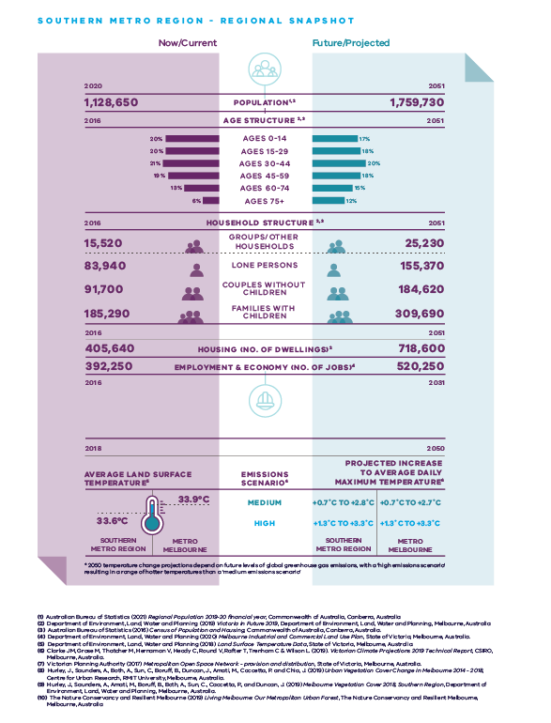
Southern Metro Region – Regional Snapshot
Southern Metro Region population  Sources:  Australian Bureau of Statistics (2021) Regional Population 2019-20 financial year, Commonwealth of Australia, Canberra, Australia.  Department of Environment, Land, Water and Planning (2019) Victoria in Future 2019, Department of Environment, Land, Water and Planning, Melbourne, Australia. | 2020 (now/current):  1,128,650 inhabitants | 2051 (projected/future):  1,759,730 inhabitants
Southern Metro Region age structure  Sources:  Department of Environment, Land, Water and Planning (2019) Victoria in Future 2019, Department of Environment, Land, Water and Planning, Melbourne, Australia.  Australian Bureau of Statistics (2016) Census of Population and Housing, Commonwealth of Australia, Canberra, Australia. | 2016 (now/current):  20 per cent – Ages 0 to 14  20 per cent – Ages 15 to 29  21 per cent – Ages 30 to 44  19 per cent – Ages 45 to 59  13 per cent – Ages 60 to 74  6 per cent – Ages 75 plus | 2051 (projected/future):  17 per cent – Ages 0 to 14  18 per cent – Ages 15 to 29  20 per cent – Ages 30 to 44  18 per cent – Ages 45 to 59  15 per cent – Ages 60 to 74  12 per cent – Ages 75 plus
Southern Metro Region household structure  Sources:  Department of Environment, Land, Water and Planning (2019) Victoria in Future 2019, Department of Environment, Land, Water and Planning, Melbourne, Australia.  Australian Bureau of Statistics (2016) Census of Population and Housing, Commonwealth of Australia, Canberra, Australia. | 2016 (now/current):  Groups/other households – 15,520  Lone persons – 83,940  Couples without children – 91,700  Families with children – 185,290 | 2051 (projected/future):  Groups/other households – 25,230  Lone persons – 155,370  Couples without children – 184,620  Families with children – 309,690
Southern Metro Region housing (number of dwellings)  Source:  Department of Environment, Land, Water and Planning (2019) Victoria in Future 2019, Department of Environment, Land, Water and Planning, Melbourne, Australia. | 2016 (now/current):  405,640 dwellings | 2051 (projected/future):  718,600 dwellings
Southern Metro Region employment and economy (number of jobs)  Source:  Department of Environment, Land, Water and Planning (2020) Melbourne Industrial and Commercial Land Use Plan, State of Victoria, Melbourne, Australia. | 2016 (now/current):  392,250 jobs | 2031 (projected/future):  520,250 jobs
2018 average land surface temperature  Source:  Department of Environment, Land, Water and Planning (2018) Land Surface Temperature Data, State of Victoria, Melbourne, Australia. | Southern Metro Region:  33.6 degrees Celsius | Metro Melbourne:  33.9 degrees Celsius
2050 projected increase to average daily maximum temperature  *2050 temperature change projections depend upon future levels of global greenhouse gas emissions, with a ‘high emissions scenario’ resulting in hotter temperatures than a ‘medium emissions scenario’  Source:  Clarke J.M., et al. (2019). Victorian Climate Projections 2019 Technical Report, CSIRO, Melbourne, Australia. | Southern Metro Region:  Medium emissions scenario – plus 0.7 to plus 2.8 degrees Celsius  High emissions scenario – plus 1.3 to plus 3.3 degrees Celsius | Metro Melbourne:  Medium emissions scenario – plus 0.7 to plus 2.7 degrees Celsius  High emissions scenario – plus 1.3 to plus 3.3 degrees Celsius

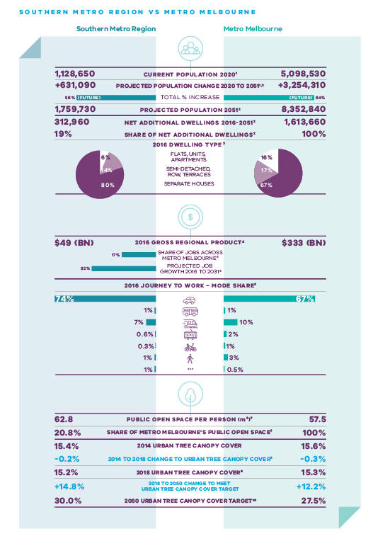
Southern Metro Region vs Metro Melbourne
 | Southern Metro Region | Metro Melbourne
Current population 2020  Source:  Australian Bureau of Statistics (2021) Regional Population 2019-20 financial year, Commonwealth of Australia, Canberra, Australia. | 1,128,650 inhabitants | 5,098,530 inhabitants
Projected population change 2020 to 2051  Sources:  Australian Bureau of Statistics (2021) Regional Population 2019-20 financial year, Commonwealth of Australia, Canberra, Australia.  Department of Environment, Land, Water and Planning (2019) Victoria in Future 2019, Department of Environment, Land, Water and Planning, Melbourne, Australia. | Plus 631,090 inhabitants | Plus 3,254,310 inhabitants
Total per cent population change | 56 per cent | 64 per cent
Projected population 2051  Source:  Department of Environment, Land, Water and Planning (2019) Victoria in Future 2019, Department of Environment, Land, Water and Planning, Melbourne, Australia. | 1,759,730 inhabitants | 8,352,840 inhabitants
Net additional dwellings 2016 to 2051  Source:  Department of Environment, Land, Water and Planning (2019) Victoria in Future 2019, Department of Environment, Land, Water and Planning, Melbourne, Australia. | 312,960 dwellings | 1,613,660 dwellings
Share of net additional dwellings  Source:  Department of Environment, Land, Water and Planning (2019) Victoria in Future 2019, Department of Environment, Land, Water and Planning, Melbourne, Australia. | 19 per cent | 100 per cent
2016 dwelling type  Source:  Australian Bureau of Statistics (2016) Census of Population and Housing, Commonwealth of Australia, Canberra, Australia. | Flats, apartments, units – 6 per cent  Semi-detached, row, terraces – 14 per cent  Separate houses – 80 per cent | Flats, apartments, units – 16 per cent  Semi-detached, row, terraces – 17 per cent  Separate houses – 67 per cent
2016 gross regional product  Source:  Department of Environment, Land, Water and Planning (2020) Melbourne Industrial and Commercial Land Use Plan, State of Victoria, Melbourne, Australia. | $49 billion | $333 billion
Share of jobs across Melbourne  Source:  Department of Environment, Land, Water and Planning (2020) Melbourne Industrial and Commercial Land Use Plan, State of Victoria, Melbourne, Australia. | 17 per cent
Projected job growth to 2031  Source:  Department of Environment, Land, Water and Planning (2020) Melbourne Industrial and Commercial Land Use Plan, State of Victoria, Melbourne, Australia. | 32 per cent
2016 journey to work – mode share  Source:  Australian Bureau of Statistics (2016) Census of Population and Housing, Commonwealth of Australia, Canberra, Australia. | Private motor vehicle – 74 per cent  Bus – 1 per cent  Train – 7 per cent  Tram – 0.6 per cent  Bicycle – 0.3 per cent  Walking – 1 per cent  Other – 1 per cent | Private motor vehicle – 67 per cent  Bus – 1 per cent  Train – 10 per cent  Tram – 2 per cent  Bicycle – 1 per cent  Walking – 3 per cent  Other – 0.5 per cent
Public open space per person (metres squared)  Source:  Victorian Planning Authority (2017) Metropolitan Open Space Network: Provision and Distribution, State of Victoria, Melbourne, Australia. | 62.8 | 57.5
Share of metro Melbourne’s public open space  Source:  Victorian Planning Authority (2017) Metropolitan Open Space Network: Provision and Distribution, State of Victoria, Melbourne, Australia. | 20.8 per cent | 100 per cent
2014 urban tree canopy cover  Source:  Hurley, J., et al. (2019) Urban Vegetation Cover Change in Melbourne 2014 - 2018, Centre for Urban Research, RMIT University, Melbourne, Australia. | 15.4 per cent | 15.6 per cent
2014 to 2018 change to urban tree canopy cover | Minus 0.2 per cent | Minus 0.3 per cent
2018 urban tree canopy cover  Source:  Hurley, J., et al. (2019) Melbourne Vegetation Cover 2018, Southern Region, Department of Environment, Land, Water and Planning, Melbourne, Australia. | 15.2 per cent | 15.3 per cent
2018 to 2050 change to meet urban tree canopy cover target | Plus 14.8 per cent | Plus 12.2 per cent
2050 urban tree canopy cover target  Source:  The Nature Conservancy and Resilient Melbourne (2019) Living Melbourne: Our Metropolitan Urban Forest, The Nature Conservancy and Resilient Melbourne, Melbourne, Australia. | 30 per cent | 27.5 per cent

Vision: Southern Metro Region in 2050
The Southern Metro Region has a significant and unique role in ensuring that “Melbourne will continue to be a global city of opportunity and choice.”
The Southern Metro Region will be a diverse and unique region, celebrated for its physical landscapes, economic vibrancy, and as a place to live and to visit. The region’s liveability will be highly regarded and founded on its distinctive lifestyle options, high-quality jobs, regional connectedness, green parklands, coastal areas, healthy waterways, and excellent educational and health facilities. The economy will be modern; driven by advanced manufacturing, innovation and knowledge with well-established international connections.
By 2050 the Southern Metro Region will experience significant planned change, including:
- A high level of self-sufficiency in terms of jobs as the region develops as a nationally significant centre for advanced manufacturing and engineering through continued investment in the Dandenong and Monash NEICs, and state- and regionally-significant industrial precincts. Industrial land will be valued for its role in generating local jobs and providing high-skilled industry expertise unique to the region.
- The growth area playing a significant role in diversification of economic opportunities in the region with key emerging industrial precincts at Officer, Pakenham and Hastings and supporting business corridors and new, well-planned activity centres at Clyde and Clyde North will contribute to the life of new suburbs.
- A network of connected activity centres and health and education precincts providing significant opportunities for jobs and housing, including further development of the Dandenong, Frankston and Fountain Gate/Narre Warren metropolitan activity centres.
- Improved east-west, inter-regional, and international transport connectivity linking people, jobs, goods and services. Regional transport infrastructure and access to it will be improved including Moorabbin Airport, a possible South-East Airport, and the Port of Hastings.
- Medium- and higher-density housing directed to the most accessible locations in established urban areas and there is greater choice in affordable and social housing.
- The growth corridor in Casey and Cardinia accommodating new, walkable neighbourhoods with a diversity of sustainable housing, services, amenities and employment opportunities, well connected by a range of public and active transport options.
- Cycling networks are expanded and public open space networks connect neighbourhoods and communities to active and passive regional open space, a network of waterways, Port Phillip Bay and the Dandenong foothills.
- More tree canopy, smart water use and sustainable public and private development with residents and industry supported by local renewable energy.
- The region’s green wedge land, iconic landscapes and natural habitats will be valued and protected. The region’s distinctive and diverse character including beaches and coastal towns, agricultural plains, and cosmopolitan urban centres will continue to attract visitors and provide a choice of lifestyle for residents of all ages.
For a more detailed picture of how land use in the Southern Metro Region is expected to change by 2050 refer to Map 1.

- Southern Metro Region 2050 Plan
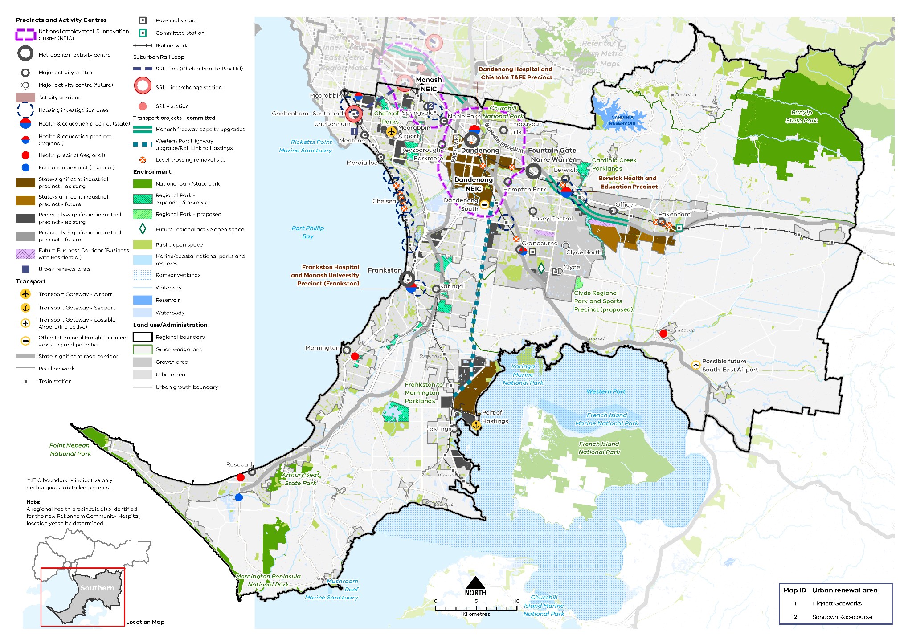
Map 1 Southern Metro Region 2050 Plan

A plan of the Southern Metro Region in 2050, showing -
- The region’s boundary, the urban growth boundary, green wedge land, established urban area and growth area.

- Locations for growth and investment, including:
- The location and indicative boundaries of the Dandenong NEIC in the north of the region and the southern part of the Monash NEIC to the northeast, on the northern boundary
- Existing and future state- and regionally- significant industrial precincts located within the northern and central parts of the region and around Hastings in the south, as listed in tables 3 and 4
- Dandenong, Frankston and Fountain Gate-Narre Warren metropolitan activity centres
- The network of existing and future major activity centres predominantly located on the rail and road network, as listed in table 7
- State- and regionally-significant health and/or education precincts at Frankston, Berwick, Dandenong, Cranbourne, Moorabbin, Rosebud, Mornington, Koo Wee Rup and Pakenham (see tables 5 and 14)
- Two urban renewal areas of:
Highett Gasworks
Sandown Racecourse
- Housing investigation areas as listed in table 12.
- Suburban Rail Loop (East) (Cheltenham to Box Hill) interchange stations and precincts at Cheltenham-Southland and Monash NEIC.

- Key transport linkages and movement network including:
- Railway lines and train stations including Suburban Rail Loop (East), proposed train stations in the growth areas and level crossing removal sites
- The road network including the state-significant road corridors of the Mornington-Peninsula Freeway, Eastlink, Monash Freeway, Princes Freeway and South Gippsland Highway
- Proposed road upgrades for the Monash Freeway and Western Port Highway
- Transport gateways at Moorabbin Airport, Port of Hastings, the Dandenong South intermodal freight terminal and the possible South-East Airport.

- State and regional natural assets, including:
- State and national parks, Ramsar wetlands, marine national parks, regional parks, future regional active open space, and other public open space
- Cardinia Reservoir.
^ NEIC boundaries are indicative only and subject to detailed planning.
Note: A regional health precinct is also identified for the new Pakenham Community Hospital, location yet to be determined.

Productivity
Plan Melbourne Outcome 1: Melbourne is a productive city that attracts investment, supports innovation and creates jobs
The Southern Metro Region is a diverse economic region with key strengths in the industrial, health and education, and population serving sectors. The region includes Victoria’s most significant stock of existing and future industrial land, with easy access to transport gateways such as Moorabbin Airport and the Port of Hastings.
The Dandenong National Employment and Innovation Cluster (Dandenong NEIC), which contains the Dandenong Metropolitan Activity Centre and a significant part of the Southern Industrial Precinct, provides employment for more than 66,300 people (DELWP, 2017a, p. 30).
The region’s top five employment industries are: healthcare and social assistance; retail trade; education and training; manufacturing; and construction. Employment growth is projected to continue in these five industries along with growth in higher-order retail, commercial, institutional and cultural services supported by Dandenong, Frankston and Fountain Gate-Narre Warren metropolitan activity centres. SRL East (Cheltenham to Box Hill) will connect the region to key employment and education precincts in other regions such as Monash NEIC and Deakin University.
Agriculture and horticulture activities also take place in the Southern Metro Region including an important dairy industry, north of Western Port, and horticulture, viticulture and tourism industries on the Mornington Peninsula.
Plan Melbourne creates a city structure that strengthens Melbourne’s competitiveness for jobs and investment. It identifies national employment and innovation clusters (NEICs), state-significant industrial precincts (SSIPs), a network of metropolitan and major activity centres, transport gateways and state-significant health and education precincts to ensure employment growth occurs outside the Central City and is linked by sustainable transport options.
Bringing jobs closer to where people live through supportive infrastructure and a commitment to commercial and industrial land supply is a fundamental part of Plan Melbourne. The Southern Metro Region LUFP supports an urban system that is regionally focused and enables regional service delivery, which provides greater certainty for government and private sector investment. Reducing the distance people need to travel for work via regional employment hubs also reduces congestion and offers other benefits for workers, business and industries.

State of play
The Southern Metro Region’s employment and activity centres framework comprises:
- The Dandenong NEIC and part of the Monash NEIC
- Metropolitan activity centres at Dandenong, Frankston and Fountain Gate-Narre Warren
- State-significant health and/or education precincts, including Frankston Hospital and Monash University Precinct (Frankston), Casey Hospital and Monash University Precinct (Berwick), Dandenong Hospital and Chisholm TAFE Precinct
- SSIPs, including the Southern Industrial Precinct (which is composed of several distinct precincts and forms part of the Dandenong NEIC), the Port of Hastings Industrial Precinct and the Officer-Pakenham Industrial Precinct. The SSIPs are referred to as the Southern SSIP, Hastings SSIP and Officer-Pakenham SSIP
- Eleven regionally-significant industrial precincts
- A network of 18 major activity centres and two future major activity centres, which have significant capacity to sustain additional investment and growth
- Two growth area business corridors including the Thompsons Road Business Corridor and the Officer-Pakenham Business Corridor
- Major tourism attractions and significant regional agricultural production areas for dairy, horticulture and viticulture.
The Southern Metro Region generates $49 billion in Gross Regional Product (GRP), which represents 15 per cent of Melbourne’s total GRP. The business service sector and the manufacturing and industrial sector combined account for just over 60 per cent of the total value add for the region. The business services sector is the largest contributor with a total value-added estimate at around $16.7 billion, while the manufacturing and industrial sector is the next largest contributor with a total value-added estimate at around $13.2 billion (DELWP, 2020a).
In 2016 the region supported around 392,250 jobs, representing 17 per cent of all employment across metropolitan Melbourne. By 2031, an estimated 128,000 additional jobs will be required, with over half of these new jobs expected to be within the growth area LGAs of Casey and Cardinia. Industries expected to experience the strongest growth are healthcare and social assistance, retail trade, manufacturing, construction, and education and training. Projected employment growth for the Southern Metro Region is shown in Figure 6.
The Southern Metro Region has around 9610 hectares of land zoned for industrial uses with around a quarter of this land currently vacant. In addition, it contains 1184 hectares of land that has been identified for future industrial purposes yet to be zoned accordingly. Of the total vacant and unzoned industrial land, approximately 36 per cent is located within the Officer-Pakenham SSIP, while approximately 31 per cent is available in the Southern SSIP and the Hastings SSIP.
A total of 855 hectares of land in the Southern Metro Region is zoned for commercial purposes. Almost 3.2 million square metres of floorspace is estimated to be used for, or is available for, commercial purposes. Approximately 43 per cent of existing floorspace supply is located in Casey and Greater Dandenong LGAs. Casey and Cardinia contain approximately 555 hectares of land identified for future commercial purposes in strategic plans.
Transport projects that will contribute to the productivity of the Southern Metro Region include:
- Cranbourne Line Upgrade
- SRL, including a proposed station at Cheltenham-Southland
- Level crossing removals
- Monash Freeway upgrade
- Mordialloc Bypass.
- Projected employment growth for the Southern Metro Region 2016 to 2031
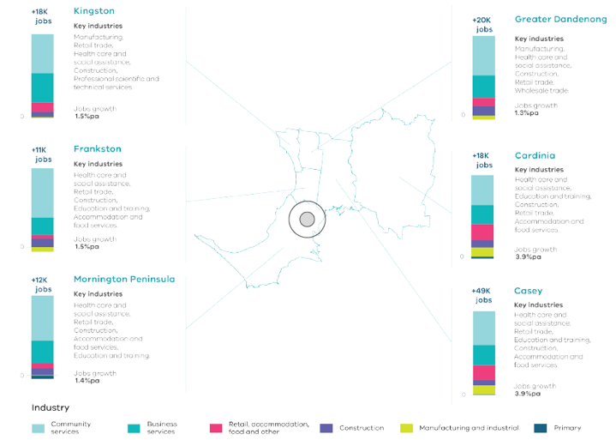
Melbourne Industrial and Commercial Land Use Plan, DELWP, 2020

Figure 6. Projected employment growth for the Southern Metro Region 2016 to 2031
Kingston | Plus 18,000 jobs | 1.5 per cent jobs growth per annum | Key industries: manufacturing, retail trades, health care and social assistance, construction, professional, scientific and technical services
Frankston | Plus 11,000 jobs | 1.5 per cent jobs growth per annum | Key industries: health care and social assistance, retail trade, construction, education and training, accommodation and food services
Mornington Peninsula | Plus 12,000 jobs | 1.4 per cent jobs growth per annum | Key industries: health care and social assistance, retail trade, construction, accommodation and food services, education and training
Greater Dandenong | Plus 20,000 jobs | 1.3 per cent jobs growth per annum | Key industries: manufacturing, health care and social assistance, construction, retail trade, wholesale trade
Cardinia | Plus 18,000 jobs | 3.9 per cent jobs growth per annum | Key industries: health care and social assistance, retail trade, education and training, construction, retail trade, accommodation and food services
Casey | Plus 49,000 jobs | 3.9 per cent jobs growth per annum | Key industries:  health care and social assistance, retail trade, education and training, construction, accommodation and food services
Source: Department of Environment, Land, Water and Planning (2020) Melbourne Industrial and Commercial Land Use Plan, State of Victoria, Melbourne, Australia.

Regional strengths
- The Dandenong NEIC, with specialisation in knowledge-based advanced manufacturing, has opportunities to grow and its success will have flow-on effects to surrounding activity centres and employment locations in Melbourne’s south-east.
- Monash NEIC, specialising in education, innovation, and leading-edge technology and research, contributes significantly to the region’s knowledge and technology-based economy.
- The region’s metropolitan activity centres of Dandenong, Frankston and Fountain Gate-Narre Warren all have significant potential to accommodate employment growth.
- A network of activity centres and employment precincts will grow and diversify the employment base of the region.
- The capacity for the Port of Hastings to become a major container port if required has significant potential to bring investment to the region.
- Growth areas will provide new employment opportunities, so more people can find work close to where they live.
- Health and education precincts will support the region’s growing population.
- Coastal settlements and diverse green wedges support the region’s cultural and recreational assets, the visitor and tourism economy, and its agribusiness.
- The region’s productive soils and reliable water supplies support agriculture and are a key part of Melbourne’s long-term food bowl.
- There is significant availability of extractive resources.

Regional challenges
- Significant stocks of employment land, industrial land and SSIPs, are under pressure from other land uses.
- Maintaining access to extractive resources in the region is important, both within and outside the UGB, close to areas of resource demand.
- Planning for growth areas should provide local jobs for residents within the region.

Directions and strategies
The directions identified to achieve the 2050 vision for the Southern Metro Region in terms of Productivity and Outcome 1 of Plan Melbourne are:
Direction 1 | Plan for and manage industrial precincts in the Southern Metro Region to be continued generators of economic activity and employment
Direction 2 | Facilitate the development of the Monash and Dandenong NEICs as major economic contributors for the regional and national economy supported by increased transport connectivity
Direction 3 | Support the development of a strong network of activity centres to provide jobs closer to where people live
Direction 4 | Ensure the South Eastern Growth Corridor accommodates longer-term industrial and commercial development opportunities
Direction 5 | Ensure health and/or education precincts continue to provide local jobs while supporting the region’s growing population
Direction 6 | Ensure protection of green wedges and support their role to provide agriculture, extractive resources, tourism and state infrastructure for the long-term benefit of all Victorians
Each direction is implemented through regionally-specific strategies identified in this LUFP.
Map 2 shows how productivity will be enhanced across the Southern Metro Region by 2050 as a result of these directions and strategies, together with Plan Melbourne and other strategies and initiatives as outlined in Appendix 01.
- Southern Metro Region productivity 2050
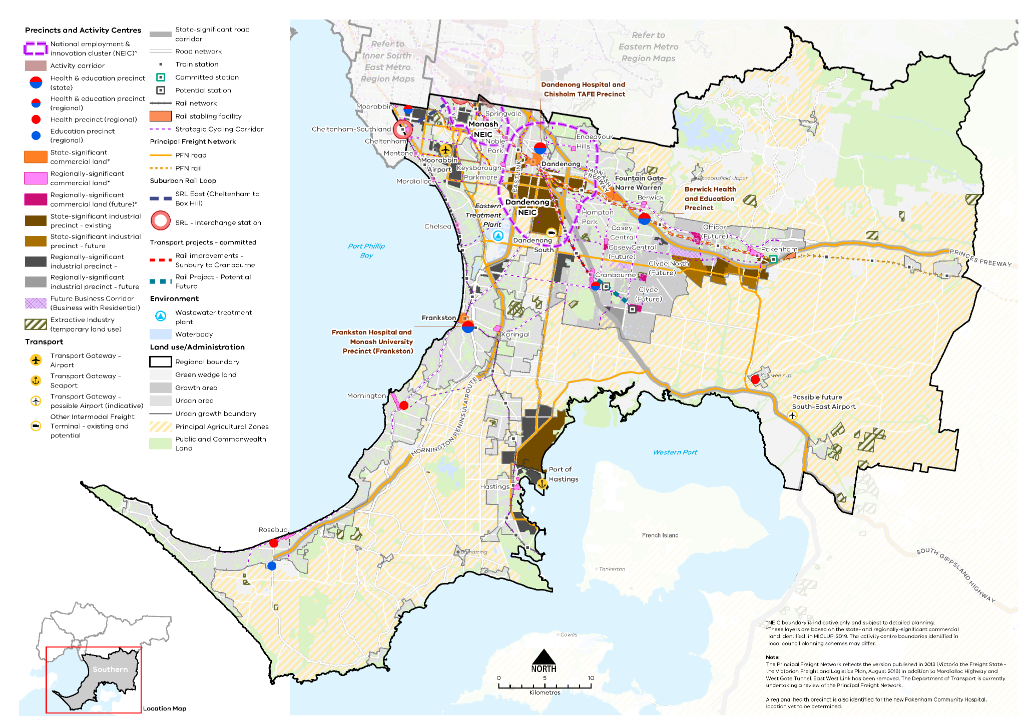

Map 2 Southern Metro Region productivity 2050

A plan of productivity in the Southern Metro Region in 2050, extracting the productivity features identified on Map 1 above, with the addition of:
- Existing and proposed state-significant commercial land at Dandenong, Officer, Pakenham and Hastings*
- Existing and proposed regionally-significant commercial land dispersed throughout the established urban area and growth area*
- Extractive industry (temporary land use)
- Principal agricultural zones
- Principal freight networks (PFN) – road and rail
- Future business corridors at Thompsons Road and Officer-Pakenham.

*These layers are based on the state and regionally significant commercial land identified in MICLUP, 2019. The activity centre boundaries identified in local council planning schemes may differ.

NOTE: The Principal Freight Network reflects the version published in 2013 (Victoria the Freight State – the Victorian Freight and Logistics Plan, August 2013) in addition to Mordialloc Highway and West Gate Tunnel. East West Link has been removed. The Department of Transport are currently undertaking a review of the Principal Freight Network.

- Plan for and manage industrial precincts in the Southern Metro Region to be continued generators of economic activity and employment
There is a need to provide and secure employment land within the Southern Metro Region for it to continue as an attractive, long-term investment destination. Well-priced industrial land needs to be supplied in appropriate, well-serviced locations to support population growth, provide local job opportunities and strengthen industry.
Strong transport connections to Moorabbin Airport and the Port of Hastings provide industrial land in the Southern Metro Region with a significant competitive advantage. SSIPs will continue to play an important economic role generating local jobs and providing high-skilled industry expertise unique to the region, with the manufacturing sector continuing to drive demand in these precincts. Freight, logistics and warehouse sectors will also expand to support growth across the region.
Under existing state planning policy, land within the Southern SSIP is protected from incompatible land uses. Despite this, industrial land supply within the Southern SSIP will be exhausted within the next decade and many established regionally-significant industrial areas such as around Moorabbin Airport and in Carrum Downs will soon offer little or no opportunity for further expansion.
With limited supply, planning for industrial land across the region needs to be carefully managed and retained to ensure its contribution to the regional economy and employment continues. While traditional industrial uses may be transitioning, there is still a need to protect large tracts of industrial land for ‘in demand’ sectors such as the logistics and advanced manufacturing sectors. With opportunities for expansion limited in more established industrial precincts, future demand for large-format industrial uses will likely be directed into neighbouring areas such as Braeside and Cranbourne West. These locations contain large areas of vacant industrial land with good transport links and access to existing supply chains and distribution networks.
In fully developed industrial precincts, opportunities to consolidate and repurpose land should be considered. In regionally-significant industrial precincts (Table 3), areas could be identified to support a broader mix of employment generating uses. This could include new and emerging businesses that require access to affordable, well-located land to grow and innovate. Offices, creative industries and start-ups that support, or are well connected to adjacent employment uses or transport connections, would be appropriate in regionally-significant industrial precincts where a broader range of employment uses is desired.
The Hastings SSIP contains a significant amount of vacant land that could support the growth of the Port of Hastings and potentially absorb future demand as established industrial precincts in the region reach capacity (Figure 7). Zoning provisions for the land, however, limit allowable uses to ‘port related’ only. This land should be investigated to determine if it is appropriate to support a broader range of industrial uses while still providing adequate buffers for the growing port and transport of hazardous materials through the port area.
- Retain regionally-significant industrial land by managing encroachment by other uses that would cause fragmentation and may compromise the development and efficient operation of existing businesses.
- Maximise investment opportunities for the location of start-ups and creative industries in regionally-significant industrial precincts as well as in the Dandenong NEIC and across the activity centre network to support innovation and collaboration.
- Integrate land use and transport planning in industrial precincts to maximise investment opportunities and continue to generate economic activity and employment in the region.
- Manage the regionally-significant industrial land outside the Hastings SSIP to complement the potential future operations of the Port of Hastings.
- Regionally-significant industrial precincts within the Southern Metro Region
Regionally-significant industrial precincts
Casey Fields South  Carrum Downs  Clayton South  Cranbourne West  Moorabbin  Moorabbin Airport | Mordialloc-Braeside  Officer-Pakenham Business Corridor  Seaford  Thompsons Road Business Corridor  Tyabb, Hastings and Cribb Point  (surrounding the Port of Hastings)
Melbourne Industrial and Commercial Land Use Plan, DELWP, 2020
- Existing and future industrial floorspace requirements for the Southern Metro Region
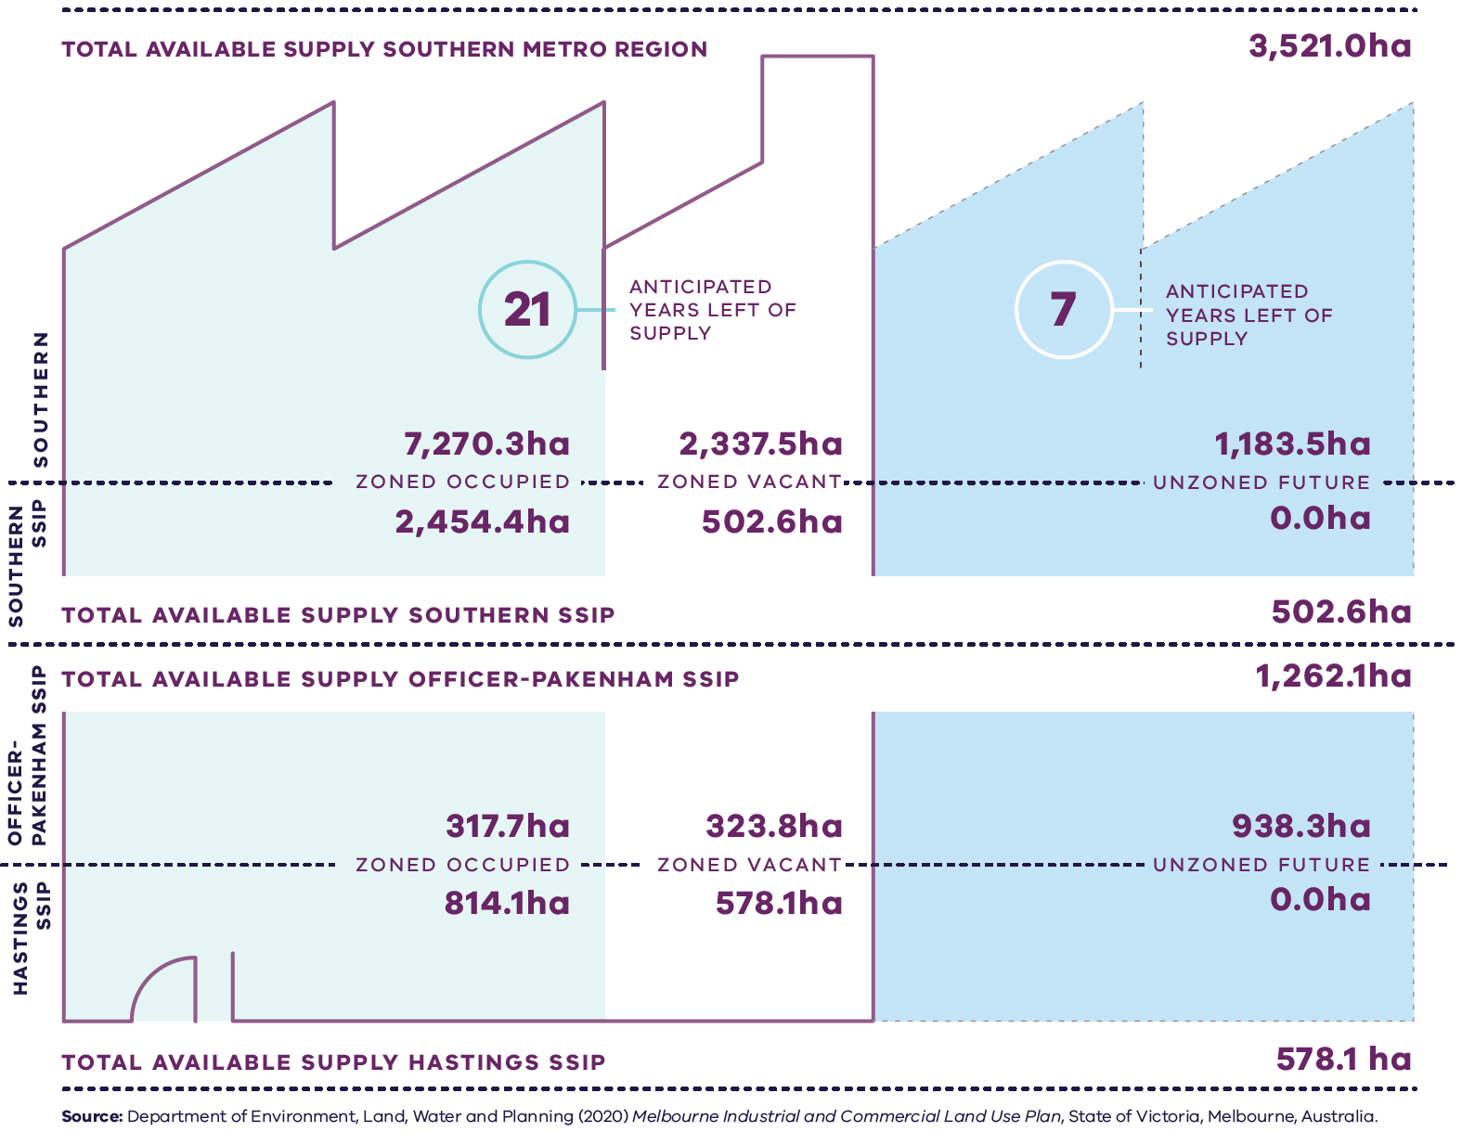

Figure 7. Existing and future industrial floorspace requirements for the Southern Metro Region
Southern Metro Region | 7,270.3 hectares zoned occupied | 2,337.5 hectares zoned vacant  21 anticipated years left of supply | 1,183.5 hectares unzoned future  7 anticipated years left of supply | 3,521 hectares total available supply
Southern SSIP | 2,454.4 hectares zoned occupied | 502.6 hectares zoned vacant | 0 hectares unzoned future | 502.6 hectares total available supply
Officer-Pakenham SSIP | 317.7 hectares zoned occupied | 323.8 hectares zoned vacant | 938.3 hectares unzoned future | 1262.1 hectares total available supply
Hastings SSIP | 814.1 hectares zoned occupied | 578.1 hectares zoned vacant | 0 hectares unzoned future | 578.1 hectares total available supply
Source: Department of Environment, Land, Water and Planning (2020) Melbourne Industrial and Commercial Land Use Plan, State of Victoria, Melbourne, Australia.

- Facilitate the development of the Monash and Dandenong NEICs as major economic contributors for the regional and national economy supported by increased transport connectivity

Dandenong NEIC
Dandenong NEIC (Figure 8) will continue to develop as the largest business district in the region and as a nationally significant cluster over the coming decades. The cluster incorporates the Southern SSIP, Dandenong Metropolitan Activity Centre, Dandenong Hospital and Chisholm TAFE Precinct. Prominent sectors in the cluster include advanced manufacturing, health, education, wholesale, retail and transport, postal services and warehouses. Dandenong NEIC has good connections to the Monash Freeway, Princes Highway and Eastlink and forms a productive industrial network with nearby Braeside, Carrum Downs, Pakenham and Knox/Bayswater.
The NEIC currently plays an influential role in the regional economy and has the potential to accommodate significant growth in jobs. Manufacturing in the NEIC is becoming more knowledge-based. For this reason the cluster should enhance its manufacturing productivity as well as research and development. Knowledge-based enterprises should be promoted within the Dandenong NEIC as a priority as well as in metropolitan activity centres and SSIPs in the region.
Dandenong Metropolitan Activity Centre is an important mixed-use centre within the NEIC. It comprises approximately 405,000 square metres of commercial floorspace and has good accessibility to Melbourne’s CBD and to the Latrobe Valley and Gippsland. The centre also plays an important civic and community role. Development Victoria is working in partnership with the City of Greater Dandenong, Victorian Government agencies and the private sector to achieve the goals of the Revitalising Central Dandenong initiative including facilitating new development and job-creating economic activity.
Located in Dandenong Metropolitan Activity Centre, the state-significant health and education precinct at Dandenong Hospital and Chisholm TAFE adds to knowledge-based resources in the area, and could support employment growth and future industry expansion. This state-significant health and education precinct will continue to expand and attract associated specialist services. The health and education sector, which is a high-value and high-growth sector, should also be targeted and developed across the NEIC.
The Metro Tunnel and SRL will directly link Dandenong NEIC with the Monash, Parkville and Sunshine NEICs. They will also provide improved public transport connections to significant precincts in Footscray, Arden, Domain, St Kilda Road and Caulfield.

Monash NEIC
The Southern Metro Region also contains a significant section of the Monash NEIC. Monash NEIC (Figure 9) is expected to become a globally recognised precinct for employment, education, innovation, leading-edge technology and research. Notable features of the Monash NEIC in the region include part of the Clayton Major Activity Centre and SRL Clayton Precinct, regionally-significant industrial land including the Clayton Business Park and the Springvale Major Activity Centre.
Further development of Clayton Major Activity Centre as part of an SRL precinct would also increase residential density, and Clayton Business Park and the regionally-significant industrial precincts will provide a range of complementary uses and enable more workers to live closer to where jobs are located.
As the regionally-significant industrial land in the Monash NEIC crosses municipal boundaries, consideration should be given to a coordinated approach that provides for consistent planning for this land.
Careful and collaborative planning across multiple municipal boundaries will ensure the Monash NEIC’s connected institutions maximise shared economic opportunities. A clear governance arrangement between relevant local councils and Victorian Government departments and agencies is needed to ensure the planning objectives for the Monash NEIC are realised.
- Facilitate land use and economic intensification of the Dandenong and Monash NEICs to leverage transport infrastructure investment and improved public transport connectivity, including Suburban Rail Loop and Metro Tunnel.
- Prioritise knowledge-based enterprises within the Dandenong NEIC.
- Encourage the co-location and development of health and education uses in the Dandenong NEIC to strengthen its role as a health and education precinct in the Southern Metro Region.
- Encourage high-value manufacturing, research and development activities in the Southern SSIP (Dandenong South) to complement the role of the Dandenong NEIC.
- Strengthen Monash NEIC as a pre-eminent healthcare, education, technology and health research provider and activity cluster in the Southern Metro Region.

- Dandenong National Employment and Innovation Cluster
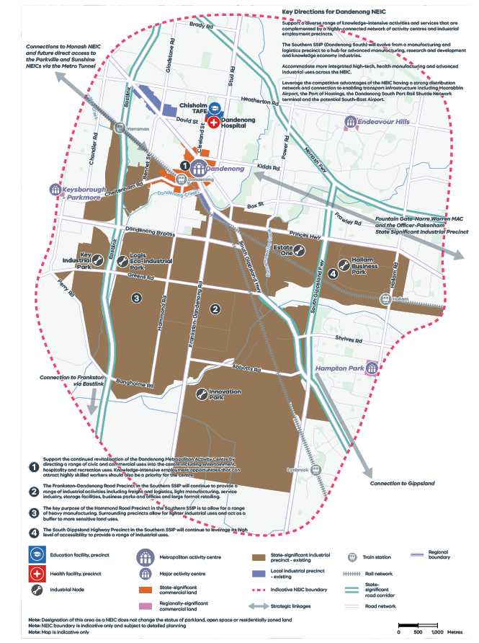
Figure 8. Dandenong National Employment and Innovation Cluster
A map of Dandenong National Employment and Innovation Cluster, showing –
- Health facility, precinct: Dandenong Hospital
- Education facility, precinct: Chisholm TAFE
- Industrial Nodes at Key Industrial Park, Logis Eco-Industrial Park, Estate One, Hallam Business Park, and Innovation Park
- Dandenong Metropolitan Activity Centre
- Keysborough – Parkmore, Endeavour Hills and Hampton Park Major Activity Centres
- State-significant and regionally-significant commercial land
- State-significant and local industrial precincts – existing
- Indicative NEIC boundary
- Strategic linkages
- Rail network and train stations
- Road network including the Monash Freeway, South Gippsland Freeway and South Gippsland Highway state-significant road corridors.
Map notes (numbered on the map)
- Support the continued revitalisation of the Dandenong Metropolitan Activity Centre by directing a range of civic and commercial uses into the centre including entertainment, hospitality and recreation uses. Knowledge-intensive employment opportunities that can attract highly skilled workers should also be a priority for the centre.
- The Frankston-Dandenong Road Precinct in the Southern SSIP will continue to provide a range of industrial activities including freight and logistics, light manufacturing, service industry, storage facilities, business parks and offices and large format retailing.
- The key purpose of the Hammond Road Precinct in the Southern SSIP is to allow for a range of heavy manufacturing. Surrounding precincts allow for lighter industrial uses and act as a buffer to more sensitive land uses.
- The South Gippsland Highway Precinct in the Southern SSIP will continue to leverage its high level of accessibility to provide a range of industrial uses.
Key Directions for Dandenong NEIC
- Support a diverse range of knowledge-intensive activities and services that are complemented by a highly-connected network of activity centres and industrial employment precincts.
- The Southern SSIP (Dandenong South) will evolve from a manufacturing and logistics precinct to a hub for advanced manufacturing, research and development and knowledge economy industries.
- Accommodate more integrated high-tech, health manufacturing and advanced industrial uses across the NEIC.
- Leverage the competitive advantages of the NEIC having a strong distribution network and connection to enabling transport infrastructure including Moorabbin Airport, the Port of Hastings, the Dandenong South Port Rail Shuttle Network terminal and the potential South-East Airport.
Note: Designation of this area as a NEIC does not change the status of parkland, open space or residentially zoned land
Note: NEIC boundary is indicative only and subject to detailed planning
Note: Map is indicative only

- Monash National Employment and Innovation Cluster
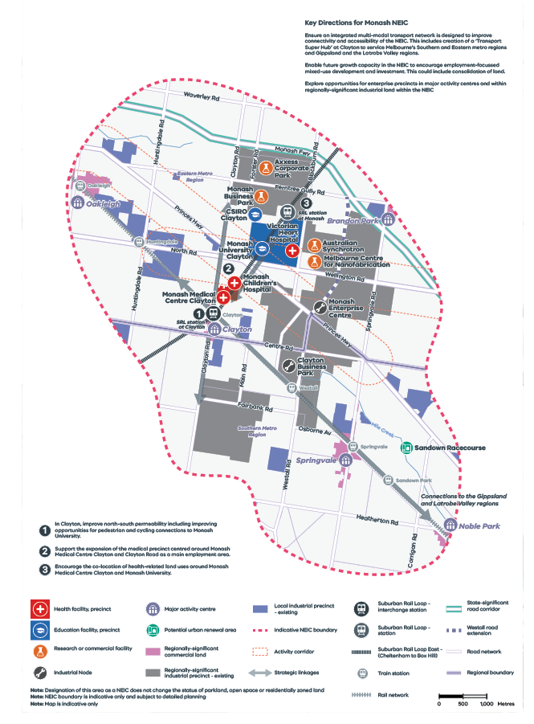

Figure 9. Monash National Employment and Innovation Cluster
A map of Monash National Employment and Innovation Cluster, showing –
- Health facility, precinct - at Monash Children’s Hospital, Monash Medical Centre Clayton, Victorian Heart Hospital
- Education facility, precinct - at Monash University Clayton, CSIRO Clayton,
- Research or commercial facility at Axxess Corporate Park, Monash Business Park, Australian Synchrotron, Melbourne Centre for Nanofabrication
- Industrial node at Monash Enterprise Centre and Clayton Business Park
- Major activity centre at Oakleigh, Brandon Park, Clayton, Springvale and Nobel Park
- Potential urban renewal area at Sandown Park
- Regionally significant commercial land
- Regionally-significant industrial precinct – existing; and local industrial precinct -existing
- Indicative NEIC boundary
- Activity corridor along Princes Highway
- Strategic linkages
- Suburban Rail Loop East (Cheltenham to Box Hill)
- Suburban Rail Loop interchange station at Clayton, Suburban Rail Loop station at Monash
- Rail network and train stations
- The Monash Freeway state-significant road corridor
- Road network including the Westall road extension from the Princes Highway to Monash Freeway
- Regional boundary with the northern part of the Monash NEIC located in the Eastern Metro Region.
Map Notes (numbered on the map)
- In Clayton, improve north-south permeability including improving opportunities for pedestrian and cycling connections to Monash University.
- Support the expansion of the medical precinct centred around Monash Medical Centre Clayton and Clayton Road as a main employment area.
- Encourage the co-location of health-related land uses around Monash Medical Centre Clayton and Monash University.
Key Directions for Monash NEIC
- Ensure an integrated multi-modal transport network is designed to improve connectivity and accessibility of the NEIC. This includes creation of a ‘Transport Super Hub’ at Clayton to service Melbourne's Southern and Eastern metro regions and Gippsland and the Latrobe Valley regions.
- Enable future growth capacity in the NEIC to encourage employment-focussed mixed-use development and investment. This could include consolidation of land.
- Explore opportunities for enterprise precincts in major activity centres and within regionally-significant industrial land within the NEIC
Note: Designation of this area as a NEIC does not change the status of parkland, open space or residentially zoned land
Note: NEIC boundary is indicative only and subject to detailed planning
Note: Map is indicative only

- Support the development of a strong network of activity centres to provide jobs closer to where people live
The Southern Metro Region’s activity centres will continue to deliver jobs, housing and services to the region over the coming decades. They play an important role by contributing to the visitor economy and drawing visitors to the local venues and attractions in the region. Table 7 details the activity centres within the region as well as their strategic role. Activity centres also play an important role in the creation of 20-minute neighbourhoods, particularly in growth areas, through providing more local commercial and employment opportunities.
The region’s network of major activity centres will provide a mix of uses and contribute to meeting projected commercial floorspace demands.
The Fountain Gate-Narre Warren Metropolitan Activity Centre comprises approximately 305,000 square metres of commercial floorspace, including the Fountain Gate Shopping Centre. The centre has strong connections to the Dandenong and Monash NEICs via rail and road links. There are significant opportunities within the centre to take advantage of large areas of available land to expand the provision of retail, commercial, entertainment, civic, and sport and active recreation uses.
Frankston Metropolitan Activity Centre and its unique location on Port Phillip Bay provides lifestyle, education and economic opportunities. It is the retail and commercial hub for the Mornington Peninsula. Traditionally a major retail centre, Frankston now contains significant hospitality, office, civic, health and education uses as well as community, arts and cultural uses. It has approximately 358,000 square metres of commercial floorspace and will continue to diversify from a primarily retail offering to a corporate office and employment location. Additional health and education uses are also encouraged in Frankston Metropolitan Activity Centre.
It is estimated that 1.4 million square metres of commercial floorspace will be required across the Southern Metro Region by 2031 (DELWP, 2020a) (Figure 10). While growth area LGAs will play an important role in providing commercial floorspace, all LGAs in the region will need to plan to accommodate floorspace within established commercial areas as well as areas that could be rezoned to accommodate additional future floorspace requirements. Approximately one third of total future commercial floorspace is expected to be located in the Greater Dandenong and Kingston LGAs by 2031.
Health and education precincts, which are all in close proximity to existing activity centres, will also deliver economic benefits and foster innovation and job creation across the region.
SRL will unlock opportunities for the SRL Cheltenham Precinct with a proposed interchange station at Cheltenham-Southland and provide an inter-regional connection to the Monash NEIC (Figure 11).
- Provide retail, commercial, entertainment, civic and active recreation uses on available land in Fountain Gate-Narre Warren Metropolitan Activity Centre.
- Encourage a diversity of employment uses in Frankston Metropolitan Activity Centre to support the centre’s development as a major corporate office and employment location.
- Retain existing commercial zoned land and identify areas that can support future demand for commercial floorspace and new investment with a focus on metropolitan and major activity centres.
- Maximise land use and economic intensification around Suburban Rail Loop Cheltenham Precinct, leveraging public transport improvements.
- Existing and future commercial floorspace requirements for the Southern Metro Region
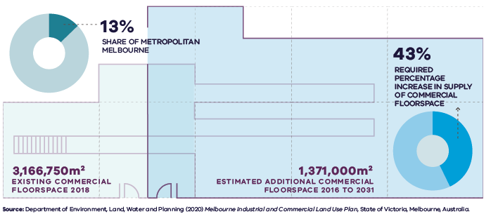
Figure 10. Existing and future commercial floorspace requirements for the Southern Metro Region
Southern Metro Region | 13 per cent share of metropolitan Melbourne | 3,166,750 square metres – existing commercial floorspace 2018 | 1,371,000 square metres – estimated additional commercial floorspace 2016 to 2031 | 43 per cent – required percentage increase in supply of commercial floorspace
Source: Department of Environment, Land, Water and Planning (2020) Melbourne Industrial and Commercial Land Use Plan, State of Victoria, Melbourne, Australia.
- Locations for growth and change – Suburban Rail Loop precincts
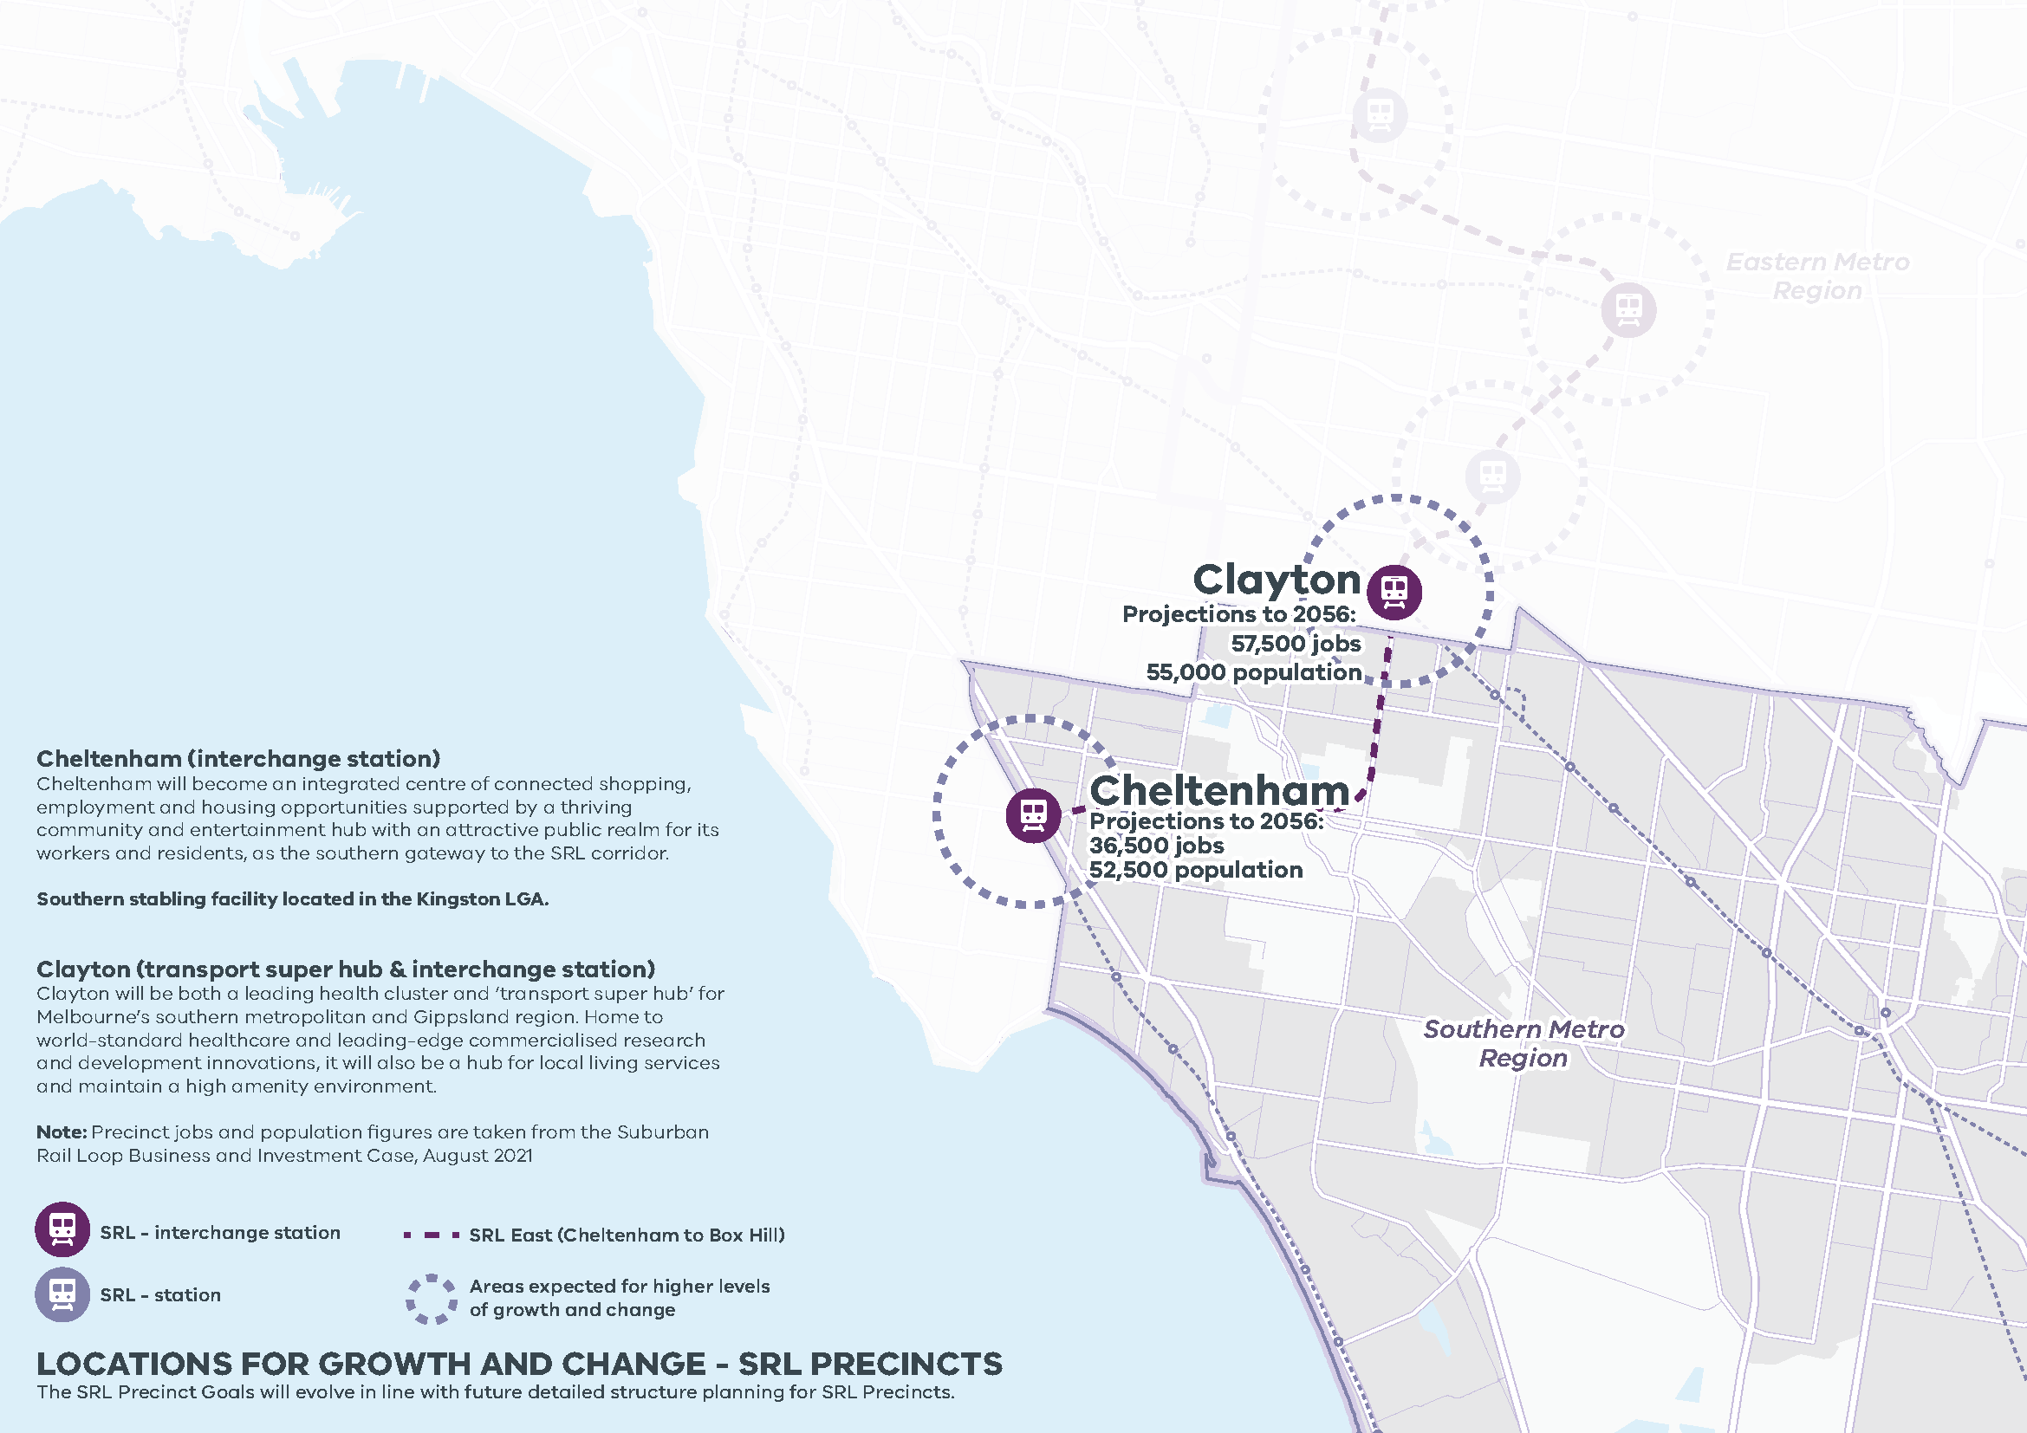

Figure 11. LOCATIONS FOR GROWTH AND CHANGE - SRL PRECINCTS

Cheltenham (interchange station) Cheltenham will become an integrated centre of connected shopping, employment and housing opportunities supported by a thriving community and entertainment hub with an attractive public realm for its workers and residents, as the southern gateway to the SRL corridor.
Southern stabling facility located in the Kingston LGA.
Clayton (transport super hub & interchange station) Clayton will be both a leading health cluster and ‘transport super hub’ for Melbourne’s southern metropolitan and Gippsland region. Home to world-standard healthcare and leading-edge commercialised research and development innovations, it will also be a hub for local living services and maintain a high amenity environment.

LOCATIONS FOR GROWTH AND CHANGE - SRL PRECINCTS
Southern Metro Region
The SRL Precinct Goals will evolve in line with future detailed structure planning for SRL Precincts.
Station | Projections to 2056 | Growth | SRL
Cheltenham | 36,500 jobs  52,500 population | Areas expected for higher levels of growth and change | SRL East (Cheltenham to Box Hill)
Clayton | 57,500 jobs  55,000 population | Areas expected for higher levels of growth and change | SRL East (Cheltenham to Box Hill)

- Ensure the South Eastern Growth Corridor accommodates longer-term industrial and commercial development opportunities
Improving self-containment of jobs in growth area LGAs is a priority for the region. This involves providing access to local jobs for residents within the region. Population growth in growth areas will create strong initial demand for population serving industries, although over time the economy will mature to support a more diverse mix of business activities and employment. To realise improved job self-containment within growth areas, there is a need to plan for the longer-term evolution of the regional economy.
The Southern Metro Region’s industrial land holdings, which are the largest across metropolitan Melbourne, are a key advantage for the region. If industrial land consumption rates remain at current levels, it is anticipated the region has approximately 21 years of supply of zoned industrial land, with unzoned areas identified for future industrial purposes providing another seven years of supply.
Growth areas will play a critical role in supporting more established industrial precincts. When supply runs out in other locations, growth areas offer large areas of unfragmented land that could be used for land-intensive uses such as freight, logistics, warehousing, transport, manufacturing and other larger-format industrial uses.
The South Eastern Growth Corridor could address regional issues of future industrial land supply by identifying suitable employment land within PSPs (Figure 12). New growth areas will provide new areas for industrial and commercial uses as well as residential neighbourhoods. Careful sequencing of the arrival of residents to new neighbourhoods will be required so that local jobs, services, infrastructure and recreational opportunities are provided in a timely manner. A coordinated approach to infrastructure provision is required to support regional economic growth in industrial precincts while minimising the impacts of traffic and freight movement on local communities.
As industrial land is increasingly under pressure from other non-industrial uses, strategic planning through the PSP process needs to appropriately allocate and deliver future industrial areas. If industrial uses are not sufficiently planned for in these areas, there will also be a reduction in employment opportunities in the Southern Metro Region.
The South Eastern Growth Corridor will need to provide industrial and commercial land for growth area communities and for the region for the longer-term. There are three timelines to consider for emerging employment land in the South Eastern Growth Corridor: the first provides for the consolidation of the existing hierarchy and supports long-term options through to 2030; the second seeks to reinforce and augment the maturing regional economy through to 2040; and the third allows for further transformation of the economy through innovation, major investment and new opportunities through to 2060.
Six precincts have been identified:
- Officer South Employment (includes the Officer-Pakenham Business Corridor)
- Cardinia Road (substantially completed)
- Pakenham West
- Pakenham South
- Thompsons Road Business Corridor
- Casey Fields South.
As the established higher-order activity centres and employment precincts mature these precincts will become important business locations containing a variety of higher-order economic activities. This will be driven by the advanced manufacturing sector and eventually high-tech, research and development activities. The precincts will need to cater for a mixture of large-format and smaller-scale manufacturing, logistics and service industries in the near term, but also improve amenity, diversity and accessibility over time. Planning for the PSPs within the Officer-Pakenham SSIP will be of particular importance, as around 80 per cent of total future unzoned supply of industrial land for the region is located within this SSIP.
Over half of required new commercial floorspace by 2031 is anticipated to be provided in the growth area LGAs of Cardinia and Casey. This new floorspace will predominantly be located in future identified activity centres as well as at two key growth area business corridors.
Business corridors in the growth areas will provide substantial office-based and knowledge-based jobs in the region. These precincts, coupled with future identified activity centres, will provide an opportunity to absorb demand for commercial floorspace. It is important for these opportunities to be captured in the PSP planning process to ensure land is safeguarded and secured to fulfil its strategic purpose. These corridors should have a primary role for economic and employment purposes with no less than 50 per cent of the land in each precinct being allocated for these purposes.
The Officer-Pakenham Business Corridor is a future business with residential precinct located adjacent to the Officer-Pakenham SSIP. This corridor will be anchored by high amenity business parks planned at Cardinia Road to the east and Minta Farm to the west. The Officer-Pakenham Business Corridor currently has excellent access to the PFN via the Princes Freeway and will be well serviced by the PPTN identified to connect to the Officer Major Activity Centre and rail line, and the broader south-eastern metropolitan area.
Adjacent to Clyde North Major Activity Centre, the Thompsons Road Business Corridor is also a business with residential precinct that will provide a mix of business services, service industry and associated uses. Detailed planning for this corridor will need to specify the type of employment and industrial uses that are appropriate, given the proximity to physical constraints, such as a transmission easement.
Several growth area precincts within the Southern Metro Region will have an emphasis on supporting economic and employment growth. Table 4 details the strategic roles and future vision for each of these six employment-focused precincts.
- Consider the future demand and need for commercial and employment land across the South Eastern Growth Corridor and ensure that Precinct Structure Plans make sufficient provision to accommodate longer-term commercial and employment needs.
- Plan for a significant quantum of employment opportunities in the Officer-Pakenham state-significant industrial precinct.
- Ensure the Officer-Pakenham Business Corridor and Thompsons Road Business Corridor contain no less than 50 per cent of land allocated for economic and employment.
- Support the development of high amenity business parks at Cardinia Road and Minta Farm to anchor the Officer-Pakenham Business Corridor.
- Provide a mix of business services, service industry and associated uses in the Thompsons Road Business Corridor.
- Employment precincts in the South Eastern Growth Corridor
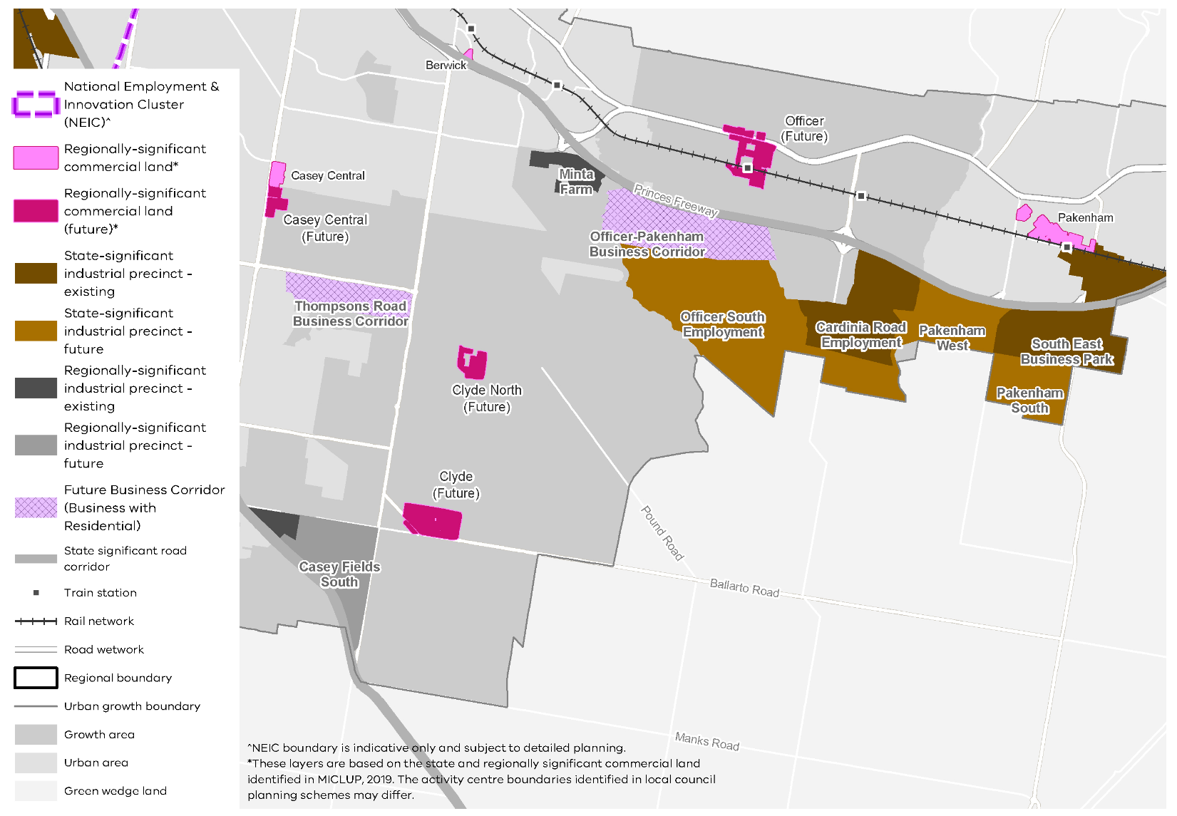
- Vision and strategic role of employment-focused growth area precincts
Precinct | Vision | Strategic Role | Specific Requirement
Officer South Employment | SSIP with strong regeneration potential, and supports leading advanced manufacturing. It is supported by and contains the Officer-Pakenham Business Corridor, a high amenity mixed employment with residential precinct | - SSIP south of Grices/Glasscocks Road  - Regionally-significant commercial area (growth area business precinct with mixed-use/residential hub)  - Excellent access to the PFN via Princes Freeway  - Supports the Cardinia Road Employment Precinct, the business park at Minta Farm and has strong links to Officer Major Activity Centre | Residential development to occupy no more than 50 per cent of land designated as regionally-significant commercial land
Cardinia Road Employment (substantially completed) | SSIP with high amenity mixed-use employment and industry strengths in manufacturing and freight/logistics | - SSIP with a business precinct in the regionally-significant commercial land area  - Part of the Officer-Pakenham Business Corridor and Pakenham Employment Corridor, excellent access to Principal Freight Network via Princes Freeway  - Strong road and high-quality public transport links to Officer Major Activity Centre and Cardinia Road train station  - Potential for health manufacturing and Research and Development, based on PFN connections to Dandenong, Frankston and Berwick health and education precincts  - Mixed-use connection over Gum Scrub Creek to Officer South Employment | Residential development to occupy no more than 50 per cent of land designated as regionally-significant commercial land
Pakenham West | SSIP will support a local Motor Sports Cluster, and South East Business Park, as well as providing land for manufacturing and logistics activities using its connectivity to the PFN | - SSIP linked to PFN on Princes Freeway, potential for freight and logistics interface with the Princes Freeway  - Renewable energy, food production/value-adding to produce from Gippsland and the Latrobe Valley  - Links to the Pakenham Motor-Sports Facility (e.g. Research and Development)  - Strong links taking freight and produce to the future Airport via new bypass, and McGregors Road upgrades
Pakenham South | SSIP supports local industries away from sensitive residential areas, with larger lots and direct connections to the PFN and potential future South-East Airport | - SSIP with excellent links to possible future South-East Airport via McGregor and Koo Wee Rup roads  - Market links to South Gippsland, Western Port Green Wedge (inputs)  - 136 ha (net) land available for freight and logistics, food/energy production, manufacturing, light and heavy industry  - Convenience centre located towards north-western part of precinct, linking to South East Business Park
Thompsons Road Business Corridor | Regionally-significant commercial land (mixed-use business park), for offices and commercial uses, with potential to cater for higher-density residential and office uses. The precinct has potential to develop as a business centre serving a broader catchment, leveraging its location on the Thompsons Road Business Corridor | - Regionally-significant commercial land area (business precinct), delivering intensive employment (service industries, offices and research), located on the future PFN (Thompsons Road), connected to Cranbourne West and Thompsons Road Business Corridor  - Thompsons Road interface preserved for industrial, freight/logistics and urban services linked to PFN  - Connected to the PPTN and large established residential catchment, with potential to expand its role to become a business centre serving a larger catchment in future, leveraging high-quality public transport links to the broader region  - Southern part residential, linked to Clyde Creek and Cardinia Creek South | Residential development to occupy no more than 50 per cent of land designated as regionally-significant commercial land
Casey Fields South | Regionally-significant industrial precinct which caters for industrial and larger commercial land uses, supporting the nearby population in Cranbourne, and the emerging Clyde area | - Regionally-significant industrial precinct with 288 ha of land for future industrial uses, including leveraging connections to the Royal Botanic Gardens Cranbourne, the Cranbourne Racecourse and the Western Port Green Wedge  - Access to the South Gippsland Highway (PFN) and a proposed new train station at Clyde  - Large residential catchment and links to Cranbourne, Devon Meadows, future Clyde Major Activity Centre, with potential to expand to a regional role with strong connections to the possible South-East Airport in future
- Ensure health and/or education precincts continue to provide local jobs while supporting the region’s growing population
The Southern Metro Region’s population is projected to grow and age over the next 30 years, which will increase demand for health-related facilities.
Health and education precincts support medical research and innovation as well as train the future workforce in a range of industries. The success of these precincts is critical in terms of supporting a growing ageing population, close to where people live.
State-significant health and education precincts in Dandenong, Berwick and Frankston are key centres for investment in both health and tertiary education and are well served by public transport (Table 5). Their specialised functions should be reinforced and should provide opportunities for ancillary health and education services. The expansion of these precincts is expected to result in land use impacts, including the demand for student and worker accommodation, both in the precincts themselves and in surrounding areas.
These areas should leverage their close proximity to metropolitan activity centres within the region and should be planned for as a network of well-distributed facilities to accommodate a range of lifestyles and employment arrangements. Planning should encourage new investment and attract major anchor tenants and start-ups. Additional health and/or education precincts will be required in the region, particularly in growth areas around Cranbourne, Officer and Pakenham.
- State-significant health and education precincts
State-significant health and education precincts
Frankston Hospital and Monash University Precinct (Frankston)
Berwick Health and Education Precinct
Dandenong Hospital and Chisholm TAFE Precinct
- Ensure the specialised functions of health and/or education precincts are reinforced, and plan for their development and expansion which will also see an increase in demand for retail, commercial and accommodation uses.
- Plan for additional health and/or education precincts in the South Eastern Growth Corridor.
- Ensure protection of green wedges and support their role to provide agriculture, extractive resources, tourism and state infrastructure for the long-term benefit of all Victorians
There are five green wedges within the Southern Metro Region:
- Mornington Peninsula Green Wedge
- Western Port Green Wedge
- South East Green Wedge
- Southern Ranges Green Wedge
- Parts of Yarra Valley, Yarra and Dandenong Ranges Green Wedge.
These green wedges should be promoted and protected as they contain a variety of different uses and attributes that contribute to the productivity and quality of life of the region.
Proximity to Melbourne, the rapid pace of growth and change, and the range of other land uses competing for space underline the need for strategic planning to ensure the valued features, assets and industries of these green wedges are protected and prioritised over other land uses.
Each green wedge has significant environmental, landscape and cultural heritage values (Table 6). These are protected within bushland reserves, coastal foreshore reserves and national and state parks and support a diversity of flora and fauna. For example, the Western Port Green Wedge includes the internationally significant Ramsar Western Port wetlands which supports migrating bird species.
Parts of the green wedges provide protection for endangered species such as the Southern Brown Bandicoot, while other areas provide important space for urban infrastructure services. For example, the South East Green Wedge area provides for buffers associated with the Moorabbin Airport and makes provision for the Eastern Treatment Plant to ensure it can continue to deliver sewerage services to protect the health and environment of a growing Melbourne.
Green Wedge Management Plans identify the values and features of each green wedge, the preferred future land use, environmental and natural resources that should be protected, and the needs of the local community. They are prepared by local councils. Green Wedge Management Plans have been prepared for all green wedges in the Southern Metro Region other than the Southern Ranges Green Wedge.
There is agricultural land in the region, particularly around Koo Wee Rup, which has some of Victoria’s most productive soils. These areas provide fruit and vegetables, dairy produce, wine and other food produce and play an important role in ensuring food security for metropolitan Melbourne. Access to water is critical for these agricultural uses and sustainable, restorative agriculture practices should be encouraged, including the development of infrastructure to enable the use of recycled water.
The natural landscapes of the Mornington Peninsula contribute to tourism and tourism-related employment in the region. The Western Port Green Wedge has seen strong investment in equine and horse racing infrastructure, with the relocation of the Pakenham Racing Club to Tynong.

Extractive Resources
The Southern Metro Region also has significant areas of commercially viable stone and sand resources, including identified Extractive Industry Interest Areas in Tynong and Garfield North (granite resource) and from Lang Lang to Grantville (sand resource).
Extractive resources are essential for the development of housing and infrastructure. Resources extracted from quarries are the foundation of our built environment, providing jobs and fuelling Victoria’s economic development.
Maintaining cost competitiveness for construction and locating extractive industry close to demand centres can help ensure that public infrastructure, housing and private sector development can be built more cost efficiently.
Extractive industries are a temporary land use and can be rehabilitated consistent with surrounding landscape character to the benefit of the local community. Existing approved and operational quarries should be protected from encroachment by sensitive land uses.
Extractive Industry Interest Areas (EIIAs) have a longstanding designation in the Southern Metro Region, particularly in Casey and the growth areas of Cardinia (Figure 13). They were established to identify land located in reasonable proximity to major population centres that is likely to contain commercially viable stone resources, and where the extractive industry is more likely to be established.
Since the identification of EIIAs, demand for resources has increased and other land use pressures have emerged resulting in diminished opportunities for extractive industries to establish in EIIAs.
The Victorian Government has established the concept of strategic extractive resource areas (SERAs), which will assist in providing greater planning certainty for the continued extraction of critical resources in identified strategic areas. They were established to provide stronger protection for strategic extractive resources.
There is an opportunity to identify and implement a SERA in the Southern Metro Region for areas of strategic importance. Extractive resources as part of the Lang Lang to Grantville sand belt should be investigated and potentially secured as a SERA within Cardinia LGA.
It is also important that post-quarrying land uses provide beneficial outcomes for local communities and the region. Post-quarrying land uses can improve the amenity and lifestyle of locations. They can make a valuable contribution towards enhancing networks of open space as well as providing important habitats for threatened species. Innovative end land uses options and progressive rehabilitation should be encouraged and developed in consultation with local communities.
- Protect and optimise the productive potential of high-quality agricultural land for agricultural purposes to encourage jobs in the agricultural sector in the Southern Metro Region.
- Support tourism and recreation activities that contribute to vibrant green wedge communities, economic growth, and which respect other green wedge priorities such as landscape and environmental values, biodiversity conservation, cultural heritage and agricultural production.
- Support value-adding sustainable agricultural uses and complementary tourism activities where they contribute to viable, productive operations.
- Protect existing quarries from incompatible use, development and subdivision to maintain supply of extractive resources.
- Identify and manage long-term strategic extractive resources in the Southern Metro Region.
- Green wedges: current role and strategic opportunities
Green Wedge | Current role | Future role/strategic opportunities
Mornington Peninsula Green Wedge | - Landscape and open space  - Environment and biodiversity  - Economy  - Rural living | - Limit fragmentation of land to protect natural systems, habitat areas and fauna species  - Engage private landowners in biodiversity conservation through a range of actions, incentives and controls to protect and improve biodiversity  - Increase the use of recycled water through projects such as the Boneo Irrigation Scheme  - Support ecotourism and agritourism, in appropriate locations, at a scale and in a form consistent with the rural character and function of the area  - Ensure that separation is retained between towns if the duplication/electrification of the Frankston/Baxter rail line occurs, or if further connections to Somerville, Hastings or Crib Point are created. This will avoid an urban corridor developing and retain the distinctive settlement pattern of the Mornington Peninsula  - Provide greater opportunities for local produce to be sold through other farm outlets, to capture some of the value of selling direct to the customer. Locate broiler farm development away from scenic landscape areas  - Limit further land fragmentation and occupation of rural land
South East Green Wedge | - Landscape and open space  - Water supply and catchments  - Environment and biodiversity  - Recreation  - State-significant infrastructure  - Economy  - Mineral, stone and resources | - Retain larger lot sizes to continue to provide opportunities for larger-scale agriculture. Support the retention of existing agricultural activities including market gardens, horticulture, poultry and egg farming, and animal husbandry to maintain food security for the Greater Melbourne area  - Integrate water harvesting techniques in low lying, prone to flooding areas of Greater Dandenong. Increase usage of Class A water from the Eastern Treatment Plant for sport and recreational areas, gardens, cleaning operations, and other uses  - Incentivise the consolidation of lots for agricultural uses. Land fragmentation in the green wedge makes large-scale operations unrealistic, however consolidation has the potential to increase niche agriculture in the area and promote uses that are consistent with the green wedge  - Limit non-airport related uses around Moorabbin Airport  - Improve the efficiency, sustainability and use of the Eastern Treatment Plant  - Continue to develop a chain of parks by rehabilitating former quarry and landfill sites to strengthen and expand green space for people and vegetation, while balancing the ongoing need to accommodate state-significant infrastructure. Support other uses in these areas such as solar parks, private recreation and plant farms that do not require substantial structures  - Ensure extractive quarry operations continue in appropriate locations to avoid resource shortages in the region and state
Southern Ranges Green Wedge | - Landscape and open space  - Water supply and catchments  - Environment and biodiversity  - Agriculture  - Rural living  - Recreation  - State-significant infrastructure | - Promote agricultural uses in areas with good soil quality  - Promote tourism surrounding the scenic qualities of the area, primarily the foothills of the Dandenong Ranges  - Ensure new development is of a scale and sited appropriately to respond to the valued built form character of the green wedge
Western Port Green Wedge | - Landscape and open space  - Water supply and catchments  - Agriculture  - Mineral, stone and resources | - Manage the effects of sea level rise along the Western Port coast and improve flooding protection and stormwater management  - Develop a Class A recycled water treatment plant to support agriculture and horticulture. South East Water has recently committed to establishing a new recycled water scheme in the Bunyip region  - Manage activities that may disturb coastal acid sulphate soils in low-lying coastal areas  - Support the longevity of agricultural businesses and the potential for agricultural diversification and production in the future. This can be done by promoting the use of recycled water and stormwater, retaining larger lots and restricting opportunities for hobby farms, rural living and other non-conservation or productive agricultural uses  - Support potential future extractive industry, particularly in the north area of the green wedge and in the Lang Lang – Grantville area  - Develop the area as a south-east daytrip region, around parks, trails and Puffing Billy  - Retain the rail corridor to Leongatha to future-proof the reconnection of the passenger train service to this area  - Assess opportunities for a Koo Wee Rup Bypass, Wonthaggi Desalination Pipeline, Port of Hastings upgrade and possible South-East Airport  - Develop community markets and regional food outlets such as farm sales and specialist local food shops to take advantage of the area’s proximity to the growing south-eastern metropolitan area  - Protect existing and future extractive industry from residential encroachment by ensuring that buffer areas are enforced and protected
Yarra, Yarra Valley and Dandenong Ranges Green Wedge | - Landscape and open space  - Agriculture  - Tourism | - Diversify with a mix of small and large agricultural, tourism, recreation, environmental businesses as well as hobby farms, due to declining conditions for potato growing  - Promote tourism surrounding the scenic qualities of the area, primarily the foothills of the Dandenong Ranges  - Ensure new development is of a scale and sited appropriately to respond to the valued built form character of the green wedge
- Extractive Industry Interest Areas in the Southern Metro Region
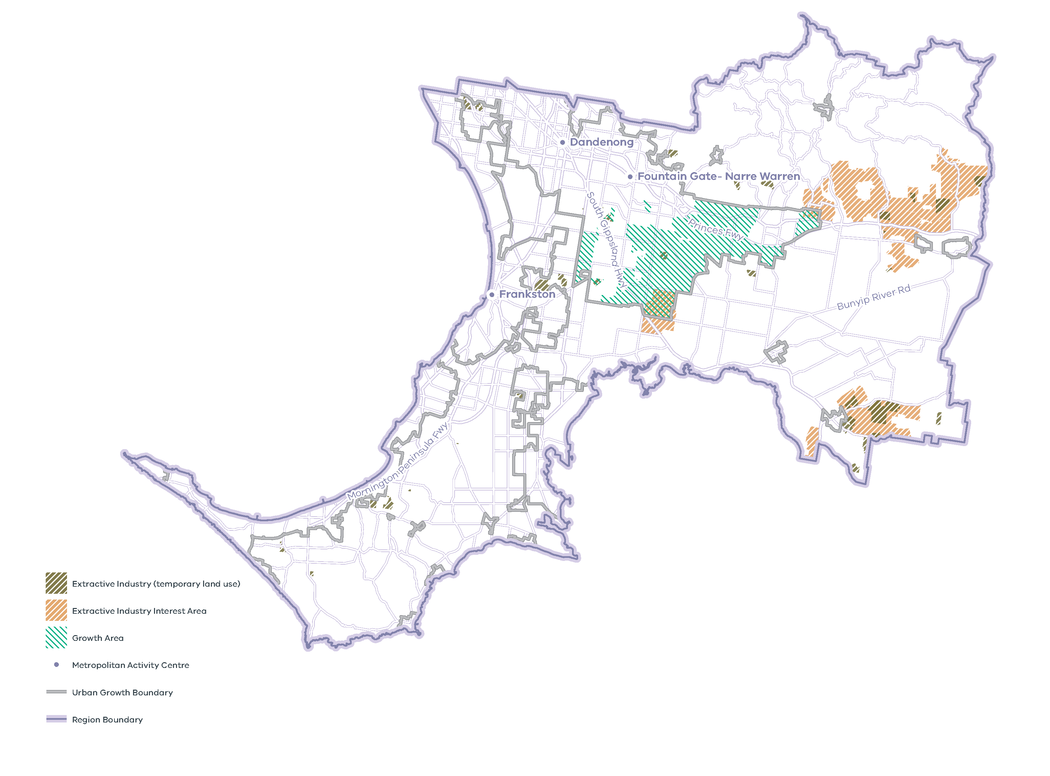
Note: EIIAs were established in the 1990s by the Geological Survey of Victoria following an assessment of land where extractive industry operations were more likely to be established, both for reasons of resource availability and where there are potentially fewer land use planning constraints. EIIAs serve as a geographic indicator in the planning scheme for the purpose of referral of planning permit applications only. EIIAs do not imply that a quarry can be established ‘as-of-right’ in these areas, nor do they preclude extractive industry from being established outside EIIAs. In growth areas, the EIIAs provide a guide to ensure the location of earth resources and the need for extractive resources to support the long-term growth of Melbourne is strategically considered in the development of PSPs. The EIIAs require ongoing review and refinement as demand for resources increases and other land use pressures emerge.

Actions – Productivity
- Implement a program of State Government-led planning projects, in partnership with local government, to ensure metropolitan and major activity centres and urban renewal areas maximise their respective strategic opportunities and contribution within the network of activity centres. Priority will be given to those which deliver significant jobs and housing; leverage investment in state infrastructure; and play an important role in the growth corridor and/or region. State-led planning for these state- and regionally-significant places will contribute to creating liveable communities and achieving more dwellings and jobs in established areas, and identify implementation and coordination actions that support growth and economic investment.
- Undertake Precinct Planning for the Cheltenham and Clayton Suburban Rail Loop Precincts with local councils and other stakeholders to guide land use change, transport integration and the creation of a liveable, walkable and prosperous precinct.
- In consultation with the Port of Hastings Development Authority and Mornington Peninsula Shire Council, investigate the potential for any Special Use Zone 1 land outside of the Port of Hastings Industrial Precinct that could allow for a broader range of industrial uses while still providing adequate buffers for the growing port.
- Investigate, identify and implement a SERA for sand resources around Lang Lang –
Grantville in the Southern Metro Region in partnership with Cardinia, South Gippsland and Bass Coast shires.
- Metropolitan and major activity centres: existing attributes and strategic opportunities
Existing attributes | What needs to be considered | Future role/strategic opportunities
Metropolitan Activity Centres
Dandenong (Greater Dandenong)
- Hybrid centre with strip-based shopping along Lonsdale Street supported by a regional shopping centre, Dandenong Plaza, on Dandenong Valley Highway  - Plays a major service delivery role with retail, including Dandenong Market, and civic and government services  - Within the Dandenong NEIC  - State-significant health and education precincts at Dandenong Hospital and Chisholm TAFE  - State-significant industrial land located to the west and south  - Train (Dandenong Station) and SmartBus services  - Transport hub at Dandenong Plaza | - Revitalise Central Dandenong Project  - Urban renewal opportunities in the core of the activity centre  - Level crossing removal at Webster Street  - Heritage significance | - Support Dandenong’s role as a regional hub for retail and commercial activity and location for higher-order jobs and industry within metropolitan Melbourne and the South Eastern Growth Corridor  - Provide supporting commercial floorspace, including a growing office precinct, and jobs in public administration, healthcare, and retail trade  - Encourage higher-density housing opportunities and mixed-use/ residential development  - Provide important community services and civic functions, as well as cultural events  - Maximise opportunities provided by regional transport linkages through the Metro Tunnel project which will link Dandenong with Monash, Parkville and Sunshine NEICs, and will also provide improved public transport connections to significant precincts at Footscray, Arden, Domain, St Kilda Road, Caulfield, Oakleigh and Chadstone
Fountain Gate – Narre Warren (Casey)
- Freestanding shopping centre with large format retail precinct located along Monash Freeway, Princes Highway and Narre Warren Road  - Plays a major service delivery role including council offices and community services at Bunjil Place and Business Park east of Narre Warren-Cranbourne Road  - Council offices and community services at Bunjil Place  - Train (Narre Warren Station) service  - PPTN interchange at Fountain Gate Shopping Centre | - Strong connections to the Dandenong NEIC and SSIP | - Consolidate the activity centre as a regional focus for retail, community, employment, entertainment, civic and recreational uses  - Facilitate investment and the uptake of large areas of land that are available for expansion, consolidation and the development of mixed uses  - Encourage higher-density housing opportunities and mixed-use/residential apartments
Frankston (Frankston)
- Hybrid activity centre with finer-grain shops between Nepean Highway and Fletcher Road  - Plays a major service delivery role with retail, commercial, arts and leisure uses, and council offices and community services  - On Port Phillip Bay and a gateway to the Mornington Peninsula  - State-significant health and education precincts at Frankston Hospital and Monash University Precinct  - Freestanding large format retail at the intersection of Moorooduc Highway and Cranbourne Road  - Train (Frankston Station) service | - Transport connections to metropolitan Melbourne and the Mornington Peninsula  - Some inundation risk with Kananook Creek along the western boundary | - Retain role as a key retail and commercial hub for the region  - Support diversification of retail offerings and the emerging role as a corporate office location and employment provider  - Continue to develop significant hospitality, office, civic, health and education uses as well as community, arts and cultural uses  - Maximise the potential for tourism based on the bayside location, entertainment and commercial facilities and proximity to Mornington Peninsula  - Encourage higher-density residential development to diversify housing options
Major Activity Centres
Berwick (Casey)
- Hybrid activity centre with strip-based shopping focused on High Street (Princes Highway)  - Retail, commercial, and service industries with community services  - State-significant health and education precincts at Casey Hospital and Monash University Precinct (Berwick) to the south  - Train (Berwick Station) service | - Connections to the state-significant health and education precinct  - Heritage and landscape significance  - Level crossing removal at Clyde Road | - Continue to strengthen street-based mixed-use development which supports an enhanced retail and commercial offer  - Facilitate the development of the Berwick Health and Education Precinct as a high-density, technology precinct, based around the Federation University, Chisholm Institute of TAFE and Casey Hospital campuses in Berwick  - Maintain the activity centre’s village character
Casey Central (Casey)
- Freestanding shopping centre on Narre Warren-Cranbourne Road south of Littlecroft Avenue  - Retail, supermarket and food retail uses  - Casey Central Town Centre PSP applies to land to the south and provides for future regionally-significant office, retail, entertainment, civic and residential uses | - Integration with the existing Casey Central Town Centre  - Adjacent to Cranbourne North established residential area  - Future Glasscocks Road realignment | - Retain primary retail core of the Casey Central Town Centre  - Provide mixed uses including convenience retail, commercial, civic, education and recreation  - Provide employment opportunities and housing in multi-storey office, commercial and mixed-use developments  - Integrate the existing activity centre with the Casey Central Town Centre PSP
Chelsea (Kingston)
- Strip-based activity centre on the western side of Nepean Highway  - Retail, restaurants, supermarket and services  - Train (Chelsea and Bonbeach stations) services | - Level crossing removals at Chelsea Road, Argyle Avenue and Swanpool Avenue  - Protect and enhance the visual and aesthetic appearance of the foreshore area  - Heritage significance | - Consolidate local retail and service role  - Encourage investment and growth in commercial development  - Promote higher-density housing opportunities and high-density mixed-use/residential apartments
Cheltenham (Kingston)
- Strip-based shopping centre on Charman Road and Station Road, adjacent to Nepean Highway  - Retail, retail food and office uses  - Community services including library and council offices located in activity centre  - Train (Cheltenham Station) service | - SRL Cheltenham Precinct  - Highett Gasworks is a significant urban renewal redevelopment opportunity (located in Bayside LGA)  - Park Road level crossing removal  - Some heritage considerations | - Consolidate local retail and service role  - Encourage growth in key employment areas  - Support a thriving community and entertainment hub  - Future role as southern gateway to SRL East (Cheltenham to Box Hill) corridor
Cheltenham – Southland (Kingston/Bayside)
- Freestanding shopping centre located across the Nepean Highway  - A focus on retail, office, commercial, service, entertainment and leisure uses  - Regionally-significant industrial land located at Moorabbin and Highett  - Train (Cheltenham Station)  service | - SRL Cheltenham Precinct  - Level crossing removal at Park Road  - Highett Gasworks (1136-1138 Nepean Highway) urban renewal site | - Continue regional role providing significant retail, commercial and community services through the Southland Shopping Centre  - Leverage investment opportunities presented through the development of the SRL interchange station
Clyde (Casey) (Future)
- Future major activity centre on Ballarto Road | - Proposed train station at Clyde  - Proximity to the Casey Fields future industrial precinct (SSIP) | - Provide a range of housing, employment, retail, business and community facilities  - Service nearby industrial and employment precincts by providing day-to-day needs  - Encourage a range of housing types, including higher-density around the future station and PPTN
Clyde North (Casey) (Future)
- Future major activity centre on Tuckers Road | - Proximity to the Thompsons Road Business Corridor, a future business with residential precinct  - Clyde Creek | - Support the development of the future activity centre as a focus for retail, business, offices and employment  - Encourage a diversity of housing types at a range of densities, within and near to the activity centre  - Provide local community and health services and a range of civic functions  - Integrate Clyde Creek into the character of the activity centre
Cranbourne (Casey)
- Hybrid centre based around High Street (South Gippsland Highway) including strip shopping and Cranbourne Park Shopping Centre  - Community services, retail uses, education and health precinct (Cranbourne Integrated Care Centre and Chisholm Institute of TAFE)  - Gateway to South Gippsland  - Cranbourne Racecourse and Royal Botanic Gardens Cranbourne to the south  - Large format retail centre to  the north  - Train (Cranbourne Station)  service | - Level crossing removal at Camms Road  - Potential/proposed train station at Cranbourne East  - Proximity to South Eastern Growth Corridor  - Heritage significance, including Avenue of Honour | - Maintain regional role serving the growing population in the South Eastern Growth Corridor and South Gippsland region  - Encourage the growth and development  of the retail core  - Promote higher-density residential  development  - Improve the activity centre’s image, built form and landscape character  - Create an attractive and accessible activity centre without detracting from its country town character
Endeavour Hills (Casey)
- Freestanding shopping centre at the intersection of Heatherton Road and Matthew Flinders Avenue  - Retail, leisure, and services including a police station  - Bus services |  | - Broaden the mix of activities to integrate commercial, community and leisure functions  - Continue local retail and services role for the residential area north-east of Dandenong  - Improve the diversity of housing opportunities within or close to the activity centre
Hampton Park (Casey)
- Freestanding shopping centre bordered by Hallam Road, Somerville Road, Stuart Avenue and Fordholm Road  - Medical, retail, retail food and community services | - Near Hampton Park Wetlands which is subject to inundation | - Consolidate local retail and service role  - Provide retail, commercial, medical and community services  - Focus on improving pedestrian movement and accessibility
Hastings (Mornington Peninsula)
- Strip-based centre along High Street between the railway line to the west and Marine Parade to the east  - On Western Port  - Retail, commercial and service role, with some regionally-significant industrial land to the north  - Hastings state-significant industrial precinct to the north  - Train (Hastings Station) service | - Environmental significance of Western Port and environs  - Flooding risk in parts of the activity centre | - Consolidate and enhance role as a higher-order service centre for the eastern side of the Mornington Peninsula  - Provide a wide range of retail, commercial and community services including visitors and non-permanent residents  - Support economic activity and the diverse needs of the community  - Support growth in commercial and community functions
Karingal (Frankston)
- Freestanding shopping centre and cinema complex at the intersection of Cranbourne Road and Peninsula Link  - Retail, commercial, entertainment, medical and community services  - Close to Ballam Park (regionally-significant active open space and recreation facility), Cruden Farm and McClelland Sculpture Park and Gallery at Langwarrin | - Connectivity to Frankston and communities east of Peninsula Link | - Focus on greater employment land use along Cranbourne Road  - Support a range of health, medical and associated commercial (non-retail) development opportunities  - Encourage higher-density housing on strategic development sites within the heart of the activity centre and along Cranbourne Road  - Provide a range of retail, entertainment and community uses
Keysborough – Parkmore (Greater Dandenong)
- Freestanding shopping centre at the intersection of Cheltenham Road and Kingsclere Avenue  - Retail and commercial uses  - SSIP located to the east | - Significant green open space at Frederick Wachter Reserve to the north | - Consolidate local retail and service role  - Provide a diverse retail offering  - Encourage residential infill and growth around the periphery of the shopping centre
Mentone (Kingston)
- Strip-based centre along Balcombe Road, Mentone Parade and Como Parade West  - A mix of retail, office, commercial and restaurant uses  - Train (Mentone Station) and SmartBus services | - Heritage significance  - Proximity to SRL Cheltenham Precinct | - Consolidate local retail and service role  - Encourage significant retail and residential growth in the activity centre core  - Maintain the activity centre’s village character
Moorabbin (Kingston)
- Strip-based centre at the intersection of the Nepean Highway and South Road  - Large format retailing along Nepean Highway, Worthing Road and the Frankston railway line  - A range of commercial uses and civic facilities  - Regionally-significant industrial land located to the east  - Regionally-significant health and education precinct at Holmesglen Private Hospital and Holmesglen Institute of TAFE  - Major recreation facility at Moorabbin Oval and regionally-significant recreation facility at Linton Street Reserve  - Train (Moorabbin Station) service | - At the junction of three LGA boundaries (Kingston, Glen Eira and Bayside) and divided by major arterial roads and railway line  - Proximity to SRL Cheltenham Precinct | - Facilitate business and employment role  - Encourage growth in retail, commercial, civic and community uses  - Consolidate role of community retail supported by significant large format commercial floor space  - Focus higher-density residential development around the station, along Nepean Highway and on key redevelopment sites  - Improve accessibility to and within the activity centre due to road and rail barriers  - Improve train-bus intermodal connections  - Activate the activity centre and enhance its cultural uses
Mordialloc (Kingston)
- Strip-based centre on the Nepean Highway  - A focus on retail and hospitality  - Mordialloc Creek  - Regionally-significant industrial land around Moorabbin Airport  - Train (Mordialloc Station) and SmartBus services | - Heritage significance along the main street, foreshore and on the Mordialloc Creek  - Managing sea level rise and land subject to inundation | - Provide a range of retail, commercial and community services for residents and visitors  - Sustain residential growth and infill while respecting the natural qualities and views to Port Phillip Bay
Mornington (Mornington Peninsula)
- Hybrid activity centre on Main Street  - A focus on retail, commercial, community services, recreation, and civic uses and includes the Mornington Central and Mornington Village shopping centres  - Regionally-significant health precinct at Peninsula Health, the Bays Hospital and Beleura Private Hospital | - Village and landscape character  - Heritage significance along the foreshore and within the activity centre | - Support regional role for retailing, commercial and community services, including for visitors  - Broaden diversity of land uses and increase housing diversity  - Support appropriate increased residential densities within and on the fringe of the activity centre  - Enhance the iconic sense of place – village ambiance and seaside atmosphere, heritage values and main street focus
Noble Park (Greater Dandenong)
- Strip-based activity centre on Douglas Street  - A focus on retail and commercial uses  - Significant open space assets  - Train (Noble Park Station) service | - Several heritage sites and trees  - Improving connectivity between commercial areas, as enabled by new elevated railway line | - Ensure major development and activity occurs in the retail core and on identified key redevelopment sites  - Improve housing opportunities that respond to the local social and cultural needs of the community and provide for well-designed, higher-density housing options to support the commercial component of the activity centre  - Improve public transport linkages, supporting infrastructure and user facilities
Officer (Cardinia)
- Future activity centre south of the Princes Highway based around Siding Avenue  - Council offices located adjacent to Officer Station  - Regionally-significant health precinct  - Train (Officer Station) service | - Future regionally-significant commercial land  - Flooding risk in parts of the activity centre | - Support local retail, commercial, community and service role  - Encourage higher-order retail supported by high-quality pedestrian access, public transport and urban design  - Provide employment-related services and facilities  - Support a range of higher-density housing types around the core retail area and within proximity to Officer Station
Pakenham (Cardinia)
- Hybrid activity centre on Main Street south of Princes Highway  - A focus on retail, large format retail, supermarkets, restaurants, take-away food and civic services, including two shopping centres (Pakenham Central Marketplace and Pakenham Place)  - The most easterly extent of the metropolitan area  - State-significant Officer-Pakenham Industrial Precinct to the south  - Train (Pakenham Station) service | - Future state-significant industrial land located to the south  - Level crossing removals at McGregor Road, Main Street and Racecourse Road  - Flooding risk in parts of the activity centre | - Strengthen the regional role of the activity centre to provide retail, community and commercial uses to support residential growth and the Officer-Pakenham SSIP  - Provide a gateway to employment precincts to the south-west  - Provide a variety of housing types, including higher-density housing within the core of the activity centre  - Encourage a mix of uses including commercial, community services, office and higher-density residential
Rosebud (Mornington Peninsula)
- Hybrid activity centre on Point Nepean Road  - A focus for tourist-oriented commercial and retail and includes the Rosebud Plaza Shopping Centre  - Regionally-significant health precinct including Rosebud Hospital, Peninsula Health and Rosebud Community Health  - Regionally-significant education precinct at Chisholm Institute of TAFE Precinct (Rosebud) | - Managing sea level rise and land subject to inundation | - Strengthen Rosebud’s role as a major activity centre and regional visitor destination  - Facilitate additional retail and commercial developments and community services  - Support the ongoing redevelopment and improvement to the building stock in the street-based elements of the activity centre, including intensification of activity and mixed-use development outcomes  - Broaden the diversity of land uses and  facilitate additional residential development
Springvale (Greater Dandenong)
- Hybrid activity centre on Springvale Road  - Vibrant multicultural retail and commercial activity with a growing health services precinct  - Regionally-significant industrial land to the east  - Train (Springvale Station) and SmartBus services | - Proximity to Monash NEIC including Monash University and SRL Clayton Precinct  - Sandown Racecourse as a potential urban renewal opportunity | - Build on the current unique cultural and Asian food retailing strengths to become a place of business growth and local employment  - Reinforce the activity centre’s role in promoting a diverse mix of land uses that include retail, commercial, industrial and residential, and continue to support housing close to public transport  - Accommodate more intensive development and provide capacity for new higher-density housing and commercial uses  - Improve amenity and provide improved public open space, community facilities, and enhancements along Springvale Road

Housing choice
Plan Melbourne Outcome 2: Melbourne provides housing choice in locations close to jobs and services
Plan Melbourne seeks to increase the supply of housing in established areas close to jobs, services and public transport to accommodate the anticipated increase in population over the next 30 years while ensuring Melbourne remains liveable, sustainable and accessible.
The Southern Metro Region is a region of housing contrasts, with established LGAs such as Kingston, Dandenong and Frankston, greenfield housing developments in Casey and Cardinia, and lifestyle properties across the Mornington Peninsula. The region is well placed to deliver a diversity of housing in locations to cater for different life stages. It features an established network of metropolitan and major activity centres supported by neighbourhood activity centres, growth areas, urban renewal areas, established suburbs, and an extensive public transport network in the established middle ring suburbs.
A priority for the region is to undertake extensive urban consolidation to meet future housing demand and make better use of existing infrastructure and services. The Southern Metro Region’s sensitive landscapes, including agricultural land, conservation reserves and coastal foreshores, will be protected from urban development. Planning for housing in the region must also consider bushfire and storm surge risks.

State of play

Metropolitan Melbourne
Strong demand for housing in established inner areas with good access to jobs, services and public transport has led to increased competition for housing in inner and middle ring suburbs of Melbourne.
The residential development industry is responding to higher demands for housing by increasing supply across Melbourne. The amount and location of additional housing developed depends on the availability and suitability of land and the willingness of households to pay for it. Melbourne is seeing a significant number of homes developed in growth areas, in part due to the relative availability of zoned land which has enabled residential developers to meet demand for relatively affordable housing.
There has also been an increase in the supply of apartments in the Central City – and increasingly in inner suburbs of Melbourne – driven by investors purchasing apartments to meet increased demand for rental accommodation in the inner city. In other areas, particularly middle ring suburbs, housing supply has been less responsive to increasing demand, leading to increasing competition for what is, in some cases, a relatively fixed supply of housing.

Southern Metro Region

Regional demographics
In 2020 the population of the Southern Metro Region was 1,128,650 people, which accounted for 22 per cent of the metropolitan Melbourne population. Between 2020 and 2051 the region’s population is projected to increase by more than 630,000 people to a total of 1,759,730, which will account for 21 per cent of metropolitan Melbourne’s projected population. The annual rate of growth in the region is expected to be 1.4 per cent, which is 0.1 per cent lower than metropolitan Melbourne’s expected annual growth. The Southern Metro Region is projected to grow less than the Western, Northern and Inner Metro Regions (DELWP, 2019).
Population growth in the Southern Metro Region differs widely between the LGAs as shown in Table 8. Casey LGA is one of the fastest growing regions in Australia, with an expected population of 522,250 people by 2036. Between 2016 and 2036, Casey LGA is estimated to grow by 209,460 people compared to Frankston LGA which will only see a small increase of 26,290 people in the same period (DELWP, 2019c). Casey and Cardinia LGAs are projected to see the most growth in the region, reflecting the growth projected in the South Eastern Growth Corridor.
The Southern Metro Region will require an additional 312,960 dwellings between 2016 and 2051 to accommodate projected population growth. This projected increase of 77 per cent will increase the total dwellings in 2051 to 718,600 (DELWP, 2019c).
The population of the Southern Metro Region is relatively evenly distributed between age groups as seen in Figure 14. Each age group under the age of 59 makes up approximately 20 per cent of the population while the population aged 60 years and above also makes up 20 per cent of the overall population. By 2051 approximately 27 per cent of the region’s population will be over the age of 60, which will make it the largest age group in the region (DELWP, 2019c). This is a similar trend to other regions across metropolitan Melbourne.
- Actual and projected population by Local Government Area, 2016 - 2036
LGA | 2016 | 2020 | 2026 | 2031 | 2036
Cardinia | 97,570 | 116,190 | 144,560 | 163,330 | 177,870
Casey | 312,790 | 364,600 | 432,450 | 481,320 | 522,250
Frankston | 139,500 | 143,340 | 151,880 | 158,470 | 165,790
Greater Dandenong | 160,220 | 168,360 | 189,140 | 203,460 | 218,560
Kingston | 158,940 | 167,290 | 179,240 | 190,600 | 201,090
Mornington Peninsula | 161,530 | 168,860 | 180,070 | 189,730 | 200,360
Southern Metro Region | 1,030,560 | 1,128,650 | 1,277,340 | 1,386,900 | 1,485,920
Victoria in Future, DELWP, 2019 and Regional Population, Australian Bureau of Statistics, 2021
- Regional actual and projected population by age, 2016 - 2051
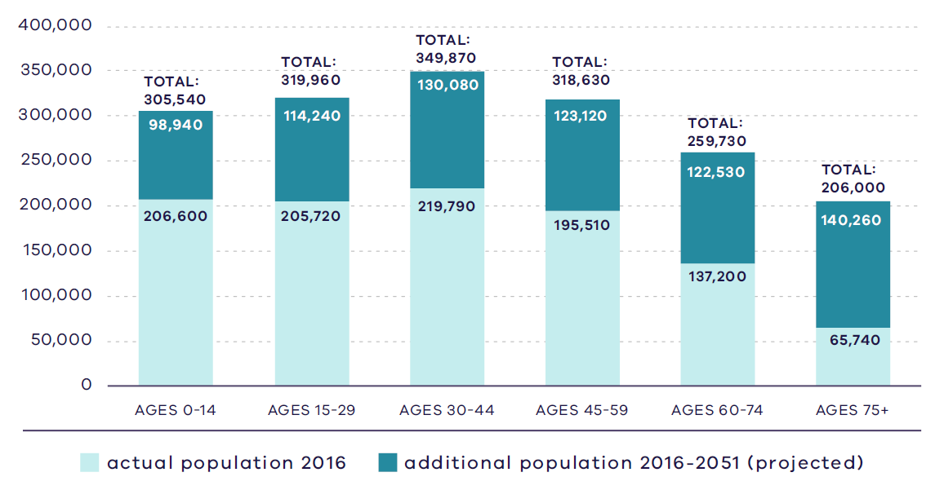
Victoria in Future 2019, DELWP
Figure 14. Regional actual and projected population by age, 2016 - 2051
2016:  206,600 – Ages 0 to 14  205,720 – Ages 15 to 29  219,790 – Ages 30 to 44  195,510 – Ages 45 to 59  137,200 – Ages 60 to 74  65,470 – Ages 75 plus | 2051:  305,540 – Ages 0 to 14  319,960 – Ages 15-29  349,870 – Ages 30 to 44  318,630 – Ages 45 to 59  259,730 – Ages 60 to 74  206,000 – Ages 75 plus
Source: Department of Environment, Land, Water and Planning (2019) Victoria in Future 2019, Department of Environment, Land, Water and Planning, Melbourne, Australia.
In 2016, almost half of the household types in the region comprised families with children, followed by couples without children at 24 per cent and lone persons at 22 per cent. The percentage of families with children is 4 per cent higher than metropolitan Melbourne which recorded 45 per cent. By 2051, it is expected couples without children households will increase to 27 per cent and families with children households will decrease to 46 percent as a proportion. Despite a decreased percentage, an increase of 124,400 families with children households is still substantial (DELWP, 2019c).

Housing stock
Eighty per cent of the 2016 housing stock in the Southern Metro Region comprised detached dwellings of which 82 per cent have three or more bedrooms. The metropolitan Melbourne average for detached dwellings is 67 per cent. Flats and units contribute 6 per cent of housing stock in the region, substantially less than the 16 per cent of this dwelling type found across metropolitan Melbourne, while semi-detached, row and terrace dwellings make up 17 per cent of the region’s housing stock compared to the metropolitan Melbourne average of 16 per cent (DELWP, 2019c).
Mornington Peninsula, Casey and Cardinia LGAs provide significant opportunities for a rural lifestyle as an alternative to urban residential areas. Similarly, the southern townships of the Mornington Peninsula, including Somers, Balnarring, Shoreham and Flinders provide a mix of permanent and holiday housing that contributes to the regional tourism economy. The Cardinia railway line to Gippsland includes a series of towns along the route that are small urban service centres for their communities.
The region is a popular holiday destination for Melburnians as well as interstate and international travellers and has a substantial holiday home offering particularly in Mornington Peninsula LGA. Many of these dwellings are vacant for over six months of the calendar year.

Projected housing requirements
Victoria in Future (VIF) projections are published at LGA level for a 20-year horizon from the most recent Census data – currently from 2016 to 2036. Beyond this period knowledge of land supply, dwelling construction and population distribution trends be less certain.
VIF projections indicate that based on the continuation of current trends, and knowledge of long-term greenfield land supply, approximately 66 per cent of net additional dwellings across metropolitan Melbourne are expected to be in established areas and 34 per cent in greenfield areas. The housing distribution figures between established areas and greenfield areas are shown in Table 9.
Plan Melbourne provides an alternate aspirational housing distribution scenario based on achieving 70 per cent of new housing in Melbourne’s established areas and the remaining 30 per cent accommodated in greenfield areas. This scenario assumes a total of 70,000 dwellings across metropolitan Melbourne, which VIF 2019 projections allocated to greenfield areas, can be accommodated in established areas to realise the aspirational 70/30 distribution between 2019 to 2051 (Table 10).
The aspirational housing distribution scenario provides for a redistribution of 20,000 dwellings from greenfield areas in the Southern Metro Region to established areas. The region is projected to accommodate 20,000 dwellings in established areas of the region, while the remaining 10,000 dwellings will be distributed among other regions’ established areas.
Table 11 shows the aspirational housing distribution scenario for each LGA to 2036. This is achieved by apportioning the net dwelling additions in the established area for each metropolitan region and distributing the amount between LGAs in the region. The aspirational scenario is based on the locations where most housing growth is anticipated across the established metropolitan area such as the Central City, NEICs, metropolitan and major activity centres, major urban renewal precincts and future SRL precincts. The 70/30 dwelling redistribution for the region will provide guidance for each LGA to accommodate housing growth that achieves the aspirational housing distribution for metropolitan Melbourne.
- Scenario 1 VIF 2019
Region | Net dwelling additions 2016 to 2051 – Total | Net dwelling additions 2016 to 2051 – Established | Net dwelling additions 2016 to 2051 – Greenfield
Inner Metro | 225,000 | 225,000 | 0
Western | 412,000 | 177,000 | 235,000
Northern | 352,000 | 167,000 | 185,000
Inner South East | 119,000 | 119,000 | 0
Eastern | 192,000 | 192,000 | 0
Southern | 313,000 | 184,000 | 129,000
Total Melbourne | 1,613,000 | 1,064,000 | 549,000
 | 100% | 66% | 34%
- Scenario 2 Aspirational scenario
Region | Net dwelling additions 2016 to 2051 – Total | Net dwelling additions 2016 to 2051 – Established | Net dwelling additions 2016 to 2051 – Greenfield
Inner Metro | 235,000 | 235,000 | 0
Western | 402,000 | 197,000 | 205,000
Northern | 347,000 | 182,000 | 165,000
Inner South East | 124,000 | 124,000 | 0
Eastern | 202,000 | 202,000 | 0
Southern | 303,000 | 194,000 | 109,000
Total Melbourne | 1,613,000 | 1,134,000 | 479,000
 | 100% | 70% | 30%
Note: For the purpose of these figures, greenfield areas include land in a growth area council that is either currently under development or identified for future development
- Southern Metro Region 70/30 redistribution by LGA to 2036
LGA | VIF2019 Dwellings – 2021 | VIF2019 Dwellings – 2036 | Including 70/30 dwellings – 2036 | 70/30 dwelling redistribution | Share of regional redistribution
Cardinia | 10,500 | 13,100 | 13,300 | 200 | 4%
Casey | 70,900 | 82,000 | 83,300 | 1,300 | 26%
Frankston | 61,000 | 71,700 | 72,300 | 600 | 12%
Dandenong | 75,200 | 94,100 | 95,100 | 1,000 | 20%
Kingston | 55,400 | 67,100 | 68,400 | 1,300 | 26%
Mornington  Peninsula | 95,500 | 113,200 | 113,800 | 600 | 12%
Southern  Metro Region | 368,500 | 441,200 | 446,200 | 5,000 | 100%
DELWP, 2021

Locations for housing growth
Housing supply in well-serviced areas, with good access to higher-paying inner-city jobs, has not kept pace with the demand. This is affecting dwelling prices, with price rises much greater in inner and middle ring suburbs than in outer suburbs and growth areas. To respond to the housing challenges in the Southern Metro Region, supply is needed in locations close to jobs, services and public transport.
Between 2005 and 2016 there was an average annual increase of 7060 new dwellings constructed in the region. Sixty-five per cent of new housing stock occurred as part of broad hectare or greenfield development, mostly within the growth areas of Casey and Cardinia LGAs. Casey and Cardinia LGAs contributed an additional 41,436 and 16,082 new dwellings respectively over this period, which meant an average of about 86 per cent of all development was greenfield development in these LGAs (DELWP, 2018a).
Housing development in established areas of the region has been lower. Greater Dandenong and Frankston LGAs contributed 8389 and 8362 new dwellings respectively, Mornington Peninsula contributed 6134 and Kingston contributed 5172 over the same period. Much of the major housing in the redevelopment pipeline is located in or within 400 metres of metropolitan and major activity centres and is occurring in the middle suburbs of the region and along the Pakenham-Cranbourne railway line. Frankston Metropolitan Activity Centre has around 500 developments, with 10 or more dwellings in and around the activity centre (Figure 15) (DELWP, 2018a).
- Major housing in the redevelopment pipeline in or within 400 metres of an activity centre
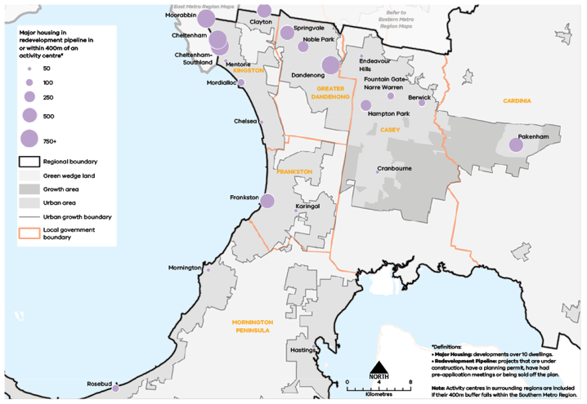
Urban Development Program 2019, Department of Environment, Land, Water and Planning

Figure 15. Major housing in the redevelopment pipeline in or within 400 metres of an activity centre
This map shows:
- Major housing redevelopment pipeline in or within 400m of an activity centre.
- Regional boundary
- Green wedge land covering land outside the urban growth boundary.
- Growth area identified within the urban growth boundary in Casey and Cardinia.
- Urban area found within the urban growth boundary.
- Local government areas including Mornington Peninsula, Frankston, Casey, Cardinia, Greater Dandenong and Kingston.
*Definitions:
• Major Housing: developments over 10 dwellings.
• Redevelopment Pipeline: projects that are under construction, have a planning permit, have had pre-application meetings or being sold off the plan.
Note: Activity centres in surrounding regions are included if their 400m buffer falls within the Southern Metro Region.
Location | Major housing development pipeline in or within 400m of an activity centre*
Moorabbin | 750+
Cheltenham | 750+
Cheltenham- Southland | 750+
Mentone | 11-50
Clayton | 251-500
Mordialloc | 51-100
Springvale | 251-500
Noble Park | 101-250
Dandenong | 750+
Endeavour Hills | 11-50
Fountain Gate -Narre Warren | 51-100
Hampton Park | 101-250
Berwick | 51-100
Cranbourne | 11-50
Chelsea | 11-50
Frankston | 251-500
Karingal | 11-50
Mornington | 11-50
Hastings | 11-50
Rosebud | 51-100
Pakenham | 251-500

Housing demand and its impact on affordability
Housing affordability is an issue across metropolitan Melbourne. Moderate-income first homebuyers are increasingly priced out of the housing market in inner and middle suburbs of the Southern Metro Region.
However, median house prices in Cardinia and Casey LGAs are below the median for metropolitan Melbourne and provide opportunities for moderate income first home buyers. The Southern Metro Region also provides the lowest rent of all metropolitan Melbourne regions, with Pakenham offering the most affordable rent for a two-bedroom flat and a three-bedroom dwelling. Even so, very low-income single person households are increasingly priced out of the rental market across much of the region.
The proportion of affordable housing differs by LGA. Homes Victoria measures how much rental housing is affordable for lower income households in Victoria where no more than 30 per cent of gross income is spent on rent (DHHS, 2020). Cardinia LGA offers the highest percentage of affordable dwellings with 26 per cent followed by Casey LGA with 17 per cent (DHHS, 2020).
There are several existing Victorian Government initiatives in place to improve the supply of affordable housing, including social housing. These include Victoria’s Big Housing Build, the Social Housing Growth Fund, 1,000 Homes Initiatives and the Redevelopment of Public Housing Estates. Casey and Cardinia LGAs have been identified as priority areas to increase the supply of social and affordable housing in the Southern Metro Region as part of Homes Victoria’s Big Housing Build program.

Regional strengths
- There are opportunities to locate medium- and higher-density housing in and around metropolitan and major activity centres, identified urban renewal areas and in locations supported by good public transport.
- Greenfield development opportunities in the South Eastern Growth Corridor can
accommodate housing supply and diversity to meet the needs of new communities and the ageing population.

Regional challenges
- The Southern Metro Region will experience significant population growth to 2051 and will need to increase housing supply and diversity.
- Housing development must be balanced with protecting employment uses, particularly around the Dandenong NEIC, SSIPs and regionally-significant industrial precincts.
- There are limited opportunities for increased housing in locations affected by storm surge, sea level rise, bushfire risks and other environmental impacts.
- Housing must be designed to reflect community needs, especially providing adaptable housing options for the ageing population to ‘age in place’.

Directions and strategies
The directions identified to achieve the 2050 vision for the Southern Metro Region in terms of Housing choice and Outcome 2 of Plan Melbourne are:
Direction 7 | Increase the supply of housing in the Southern Metro Region
Direction 8 | Prioritise housing growth in areas with access to jobs, services and good public transport
Direction 9 | Limit housing growth in the green wedge and in locations affected by natural hazards
Direction 10 | Provide greater choice and diversity of housing in the Southern Metro Region
Direction 11 | Increase the supply of social and affordable housing
Direction 12 | Improve planning processes for growth areas to ensure the delivery of diverse and vibrant new communities
Each direction is implemented through regionally-specific strategies identified in this LUFP.
Map 3 shows how housing choice will be enhanced across the Southern Metro Region by 2050 as a result of these directions and strategies, together with Plan Melbourne and other strategies and initiatives as outlined in Appendix 01.

- Southern Metro Region housing choice 2050
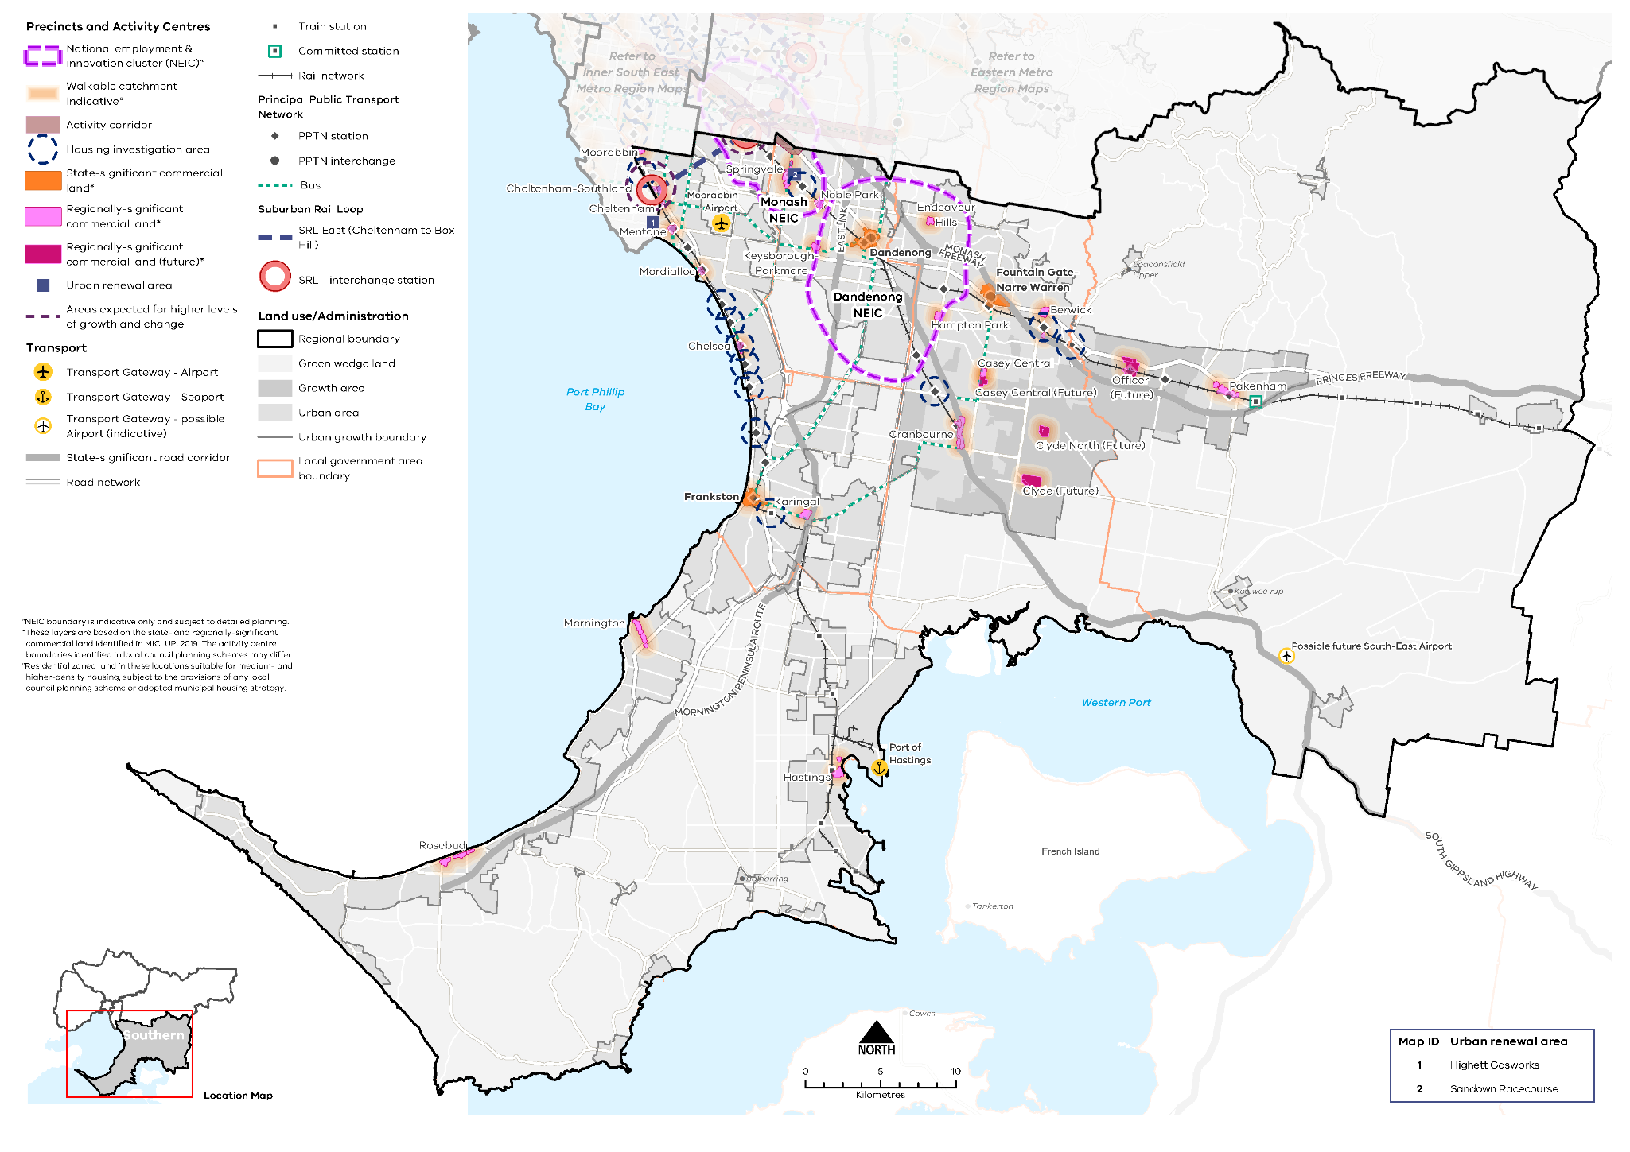

Map 3 Southern Metro Region housing choice 2050
A map of housing choice in the Southern Metro Region in 2050, extracting the locations for medium- and higher-density dwellings identified on Map 1 above and detailed in Table 12, with the addition of 800m walkable catchments° around existing and proposed metropolitan and major activity centres.

°Residential zoned land in these locations suitable for medium- and higher-density housing, subject to the provisions of any local council planning scheme or adopted municipal housing strategy.

- Increase the supply of housing in the Southern Metro Region
Plan Melbourne aims for 70 per cent of net additional dwellings to be provided in Melbourne’s established areas, with the balance provided in greenfield areas. Housing supply in the Southern Metro Region will be delivered by a mix of infill and greenfield development. Greater Dandenong and Kingston LGAs are likely to provide for the greatest amount of development close to activity centres.
The Southern Metro Region provides opportunities for well-located, higher-density housing particularly around activity centres, the PPTN, and urban renewal areas. These locations are identified in local strategies prepared by all LGAs in the region. Opportunities also exist in SRL Cheltenham Precinct. The provision of housing in these areas will help achieve the overall aspiration of 70 per cent of new housing in established areas. Future housing growth will respect and enhance the diversity of character and lifestyle options available across the region.
Substantial and incremental change areas will experience varying degrees of change relative to the existing context and not only increase the supply of housing, but also the diversity in housing types and built form outcomes. Lower-density areas in the region are expected to accommodate housing growth within the context of the existing or preferred character. Minimal housing change areas are identified for their special characteristics such as neighbourhood, heritage, environmental or landscape characteristics that should be protected.
By encouraging development in the established areas, agricultural land can be protected, along with conservation reserves, coastal foreshores, green wedge areas and creeks and waterways. Mornington Peninsula, Casey-Cardinia foothills, Western Port Green Wedge townships and Cardinia railway towns are popular destinations for people across metropolitan Melbourne for their cultural, agricultural, natural and recreational contribution. Managing change and reducing the impact on these values will be important for future developments. The supply of housing in townships in the green wedges is in some cases limited by the UGB around these settlements.
- Maximise housing development within the established areas of the Southern Metro Region to achieve the aspirational housing distribution scenario for metropolitan Melbourne.
- Prioritise housing growth in areas with access to jobs, services and good public transport
Plan Melbourne directs medium- and higher-density housing development in and around NEICs, in and around metropolitan and major activity centres, in neighbourhood activity centres with good public transport connections, and in urban renewal areas. These areas generally contain a concentration of jobs and services and are well connected by public transport. Locating medium- and higher-density housing in these locations is important for meeting the employment, service and infrastructure needs of a region’s growing population while delivering on the 20-minute neighbourhood principle.
Dandenong NEIC’s primary role is to supply land for industrial and employment uses, with a large portion of the NEIC being designated as state-significant industrial land. Sensitive land uses including residential development are prohibited in the Southern SSIP although locations around the NEIC, particularly in and around Dandenong Metropolitan Activity Centre which is part of the NEIC, may provide opportunities for housing close to jobs for the region.
A pipeline of dwelling approvals in metropolitan and major activity centres anticipates an additional 4269 dwellings across the Southern Metro Region. Dandenong Metropolitan Activity Centre has the largest number of approved major housing redevelopments, totalling 1947 projects, with each of these redevelopments providing more than 10 dwellings. Major activity centres in Cheltenham, Moorabbin, Pakenham and Springvale are expected to provide an additional 2364 approved dwellings. These approvals indicate the type and location of development expected to be constructed over the next 10 years close to, or within, activity centres. Within 400 metres of metropolitan and major activity centres 1950 dwellings were approved in the Southern Metro Region (DELWP, 2018a). Fewer developments are occurring in activity centres that are not serviced by railway lines, such as Hampton Park, Karingal, Mornington and Rosebud.
Opportunities to increase housing supply, affordability and diversity can be realised through the development of urban renewal precincts and as part of major transport infrastructure projects. Level crossing removals along the Pakenham and Frankston railway lines, and city-shaping transport infrastructure such as SRL provide the opportunity for higher-density, transit-oriented development. Cheltenham is the southern gateway for SRL with a proposed new interchange station. There will be increased opportunities for housing growth in and around Cheltenham-Southland Major Activity Centre as SRL creates closer and more efficient connections to jobs and services in other job-rich locations such as Monash and La Trobe NEICs. As the activity centre borders Bayside and Kingston LGAs, collaboration between these two LGAs, and across Victorian Government agencies, will ensure planning for Cheltenham is integrated, holistic and maximises land use opportunities.
Moorabbin Major Activity Centre is located on or close to the boundary between Kingston LGA and Bayside and Glen Eira LGAs in the Inner South East Metro Region and will benefit from inter-regional planning.
Table 12 identifies locations for medium- and higher-density housing in the Southern Metro Region.
- Locations for medium- and higher-density housing in the Southern Metro Region
Classification | Locations | Role/function for housing
NEICs | Dandenong | - NEICs can provide housing opportunities in designated locations where it complements the NEIC’s’ primary role as a cluster of business activity of national significance.  - Dandenong NEIC is predominantly a state-significant industrial precinct and the primary focus is to retain land for employment uses. Planning for housing should not impact on existing or future employment uses in the NEIC.
Metropolitan activity centres | Dandenong  Frankston  Fountain Gate-Narre Warren | - Metropolitan activity centres are locations for medium- and higher-density housing and mixed-use development. Substantial housing change opportunities may extend to a walkable catchment of 800m around the centre (depending on the local context) based on the 20-minute neighbourhood principle of locating housing close to jobs, services, amenities and public transport.  - Metropolitan activity centres play a major role in supporting a broad range of other uses such as retail, commercial, entertainment and community uses to a regional catchment. Housing development in and around metropolitan activity centres will be complementary to the existing and future jobs and employment role of the centres (refer to Table 7).  - Structure planning will identify the preferred locations, densities and types for housing and development constraints or limitations in each centre.
Major activity centres | Berwick  Casey Central  Chelsea  Cheltenham  Cheltenham-Southland  Clyde (future)  Clyde North (future)  Cranbourne  Endeavour Hills  Hampton Park  Hastings  Karingal  Keysborough-Parkmore  Mentone  Moorabbin  Mordialloc  Mornington  Noble Park  Officer  Pakenham  Rosebud  Springvale | - Major activity centres are locations for medium- and higher-density housing and mixed-use development. Substantial housing change opportunities may extend to a walkable catchment of 800m around the centre (depending on the local context) based on the 20-minute neighbourhood principle of locating housing close to jobs, services, amenities and public transport.  - While all major activity centres will accommodate housing change, the degree of change is relative to the existing context and characteristics of each major activity centre (refer to Table 7).  - Structure planning will identify the preferred locations, densities and types for housing and development constraints or limitations in each centre.  - Cheltenham-Southland Major Activity Centre is designated as a location for SRL interchange station and will provide greater opportunities for housing change.
Neighbourhood activity centres |  | - Some neighbourhood activity centres may be locations for mixed-use medium- and higher-density housing, particularly when they are serviced by good public transport. Housing opportunities may also extend to a walkable catchment of 800m around the centre (depending on the local context) based on the 20-minute neighbourhood principle of locating housing close to jobs, services, amenities and public transport.  - Approved PSPs for the South Eastern Growth Corridor identify future neighbourhood activity centres that will accommodate medium- and higher-density housing.  - Future PSPs in growth areas will be guided by the 20-minute neighbourhoods principle and the Victorian Planning Authority’s guidelines for precinct structure planning.
Urban renewal areas and greyfields | Sandown Racecourse  Highett Gasworks | - Urban renewal areas identified in the LUFP are locations nominated by state or local government with opportunities for medium- and higher-density mixed-use development. These locations have regional value based on one or more the following characteristics: land size, proximity to the PPTN or future transport infrastructure, government-owned, or require cross-municipal planning. These areas will be planned according to 20-minute neighbourhood principles. A coordinated approach to planning for these areas will maximise their development opportunity and any infrastructure needs.
Suburban Rail Loop precincts | Cheltenham (interchange) | - SRL precincts are opportunities for medium- and higher-density housing development due to their proximity to future SRL train stations. Housing development in the SRL precincts will be supported by other uses such as commercial, retail and services and maximise their potential as transit-oriented development. They will undergo substantial change and will be subject to further detailed precinct planning.
Housing investigation areas | Aspendale Station  Bittern Station  Berwick Station  Bonbeach Station  Carrum Station  Chelsea Station  Edithvale Station  Highett Station  Leawarra Station  Merinda Park Station  Parkdale Station  Seaford Station | - Housing investigation areas are areas within an 800m walkable catchment around existing and future train stations that have the potential to support medium- and higher-density housing development in line with maximising access to public transport and 20-minute neighbourhood principles. These areas are outside designated metropolitan and major activity centres and are based on their access to rail infrastructure, existing zones that allow residential development and the absence of ‘special characteristics’ such as heritage, landscape, bushfire values or airport environs.  - A further assessment to determine locations within Housing Investigation Areas suitable for substantial housing change and rezoning, in response to the local context, will be required.
Greenfield growth area | South Eastern Growth Corridor | - Growth areas are designated to provide future supply of land for development in metropolitan Melbourne. A detailed PSP process will articulate the land uses and determine suitable locations for medium- and higher-density housing in the growth corridors.
- Increase the supply of medium- and higher-density housing around the Dandenong NEIC, in and around metropolitan and major activity centres, urban renewal areas, SRL precincts and in neighbourhood activity centres serviced by good public transport.
- Ensure new housing in and around the Dandenong NEIC does not encroach on the primary employment and innovation role of the NEIC and does not impact the ongoing and future uses in the Southern SSIP.
- Support substantial housing change in locations where transport upgrades and improvements such as Suburban Rail Loop create opportunities to locate housing closer to jobs, services and infrastructure.
- Maximise development potential in housing investigation areas around existing and proposed train stations to leverage access to the PPTN.
- Limit housing growth in the green wedge and in locations affected by natural hazards
While the Southern Metro Region features a range of much-loved, natural landscapes, it is also affected by numerous natural hazards. With a total of 236 kilometres of coastline along Port Phillip Bay and Western Port, several coastal settlements in the Southern Metro Region are faced with coastal inundation, storm surges, sea level rise and soil erosion. Bushfire risk is identified in all LGAs in the Southern Metro Region and is a serious consideration with regard to the location of new housing development. Rural residential areas are more prone to bushfire risks due to the mix of grassland and high vegetation cover. Natural hazards will be managed through settlement planning and limiting housing growth in locations where the risks are higher.
The regions five green wedges contribute to the state’s economy through food and wine production on agricultural land and extractive resources. There are also significant environmental and ecological values that need protecting including endangered flora and fauna species. Residential development in the green wedges will need to consider the primary uses and values of these areas by retaining the distinct settlement patterns of the existing rural towns and responding to the valued built-form character.
- Discourage further housing development or housing intensification in locations that are impacted by natural hazards such as bushfire risk, coastal inundation, or storm surges.
- Ensure new housing in and around the Dandenong NEIC does not encroach on the primary employment and innovation role of the NEIC and does not impact on ongoing and future uses in the Southern SSIP.
- Provide greater choice and diversity of housing in the Southern Metro Region
The Southern Metro Region offers a unique diversity of lifestyle options, ranging from coastal and rural living options through to housing in new urban communities, older established suburbs and apartment living. Future housing growth will respect and enhance the diversity of character and lifestyle options available across the region. The natural landscapes and lifestyle values in the region make it a coveted location for Victorians to retire and increases the demand for residential aged care facilities and retirement homes.
By 2051, the largest age group in the region will be people over 60 years old. Housing will need to respond to an ageing population and should provide opportunities for residents to ‘age in place’ and remain in their existing communities, with access to community services, good public transport and ways of easily meeting their daily needs. Future housing development will also need to consider housing adaptability, dwelling size and type to cater for downsizing options and more affordable options for the region’s ageing population.
In terms of household type, couples without children are projected to overtake families with children in the region by 2051, which may warrant an increase in the supply of one- and two-bedroom dwellings in the Southern Metro Region. However, the significant increase in number of families with children will still require a steady supply of dwellings with three or more bedrooms. While the South Eastern Growth Corridor is providing majority of separate housing with three or more bedrooms, there are opportunities in the existing urban area to accommodate larger households too. The provision of three-bedroom units and flats may be suitable in and around established activity centres and in proximity to public transport. This will provide greater diversity in housing typology while catering for future population changes across in the region.
- Encourage a genuine mix of dwelling types and sizes in the Southern Metro Region to accommodate the changing future needs of the region.
- Facilitate the development of housing that is adaptable and flexible to cater for changing demographics and to support ‘ageing in place’.
- Adopt a place-based approach to the delivery of infill housing developments to replace ageing housing stock, ensure a high-quality of design that is appropriate for the local context and contributes to housing supply and diversity.
- Increase the supply of social and affordable housing
Affordable housing is defined in the Planning and Environment Act 1987 as housing appropriate for the needs of very low-, low- and moderate-income households, and includes social housing provided by the government or a registered housing agency. Social housing also includes public housing and community housing to accommodate people who have experienced homelessness, family violence or have other special needs. The provision of more social and affordable housing requires a range of programs and measures across all levels of government.
Housing affordability is affecting an increasing number of residents across metropolitan Melbourne. Planning should facilitate the delivery of affordable housing in the Southern Metro Region by considering opportunities to develop under-utilised or disused government-owned land for social housing. Facilitating the supply of affordable housing in locations that are closer to jobs, services and public transport - in addition to sustainable design - will lower household costs, which is particularly important to the very low-, low- and moderate-income households. By strengthening the role of planning to facilitate and deliver affordable housing opportunities will contribute to continuing to make Melbourne a liveable city for all.
Greater Dandenong LGA has the highest proportion of social housing among the other LGAs in the Southern Metro Region with over 3 per cent recorded in 2016 (Australian Bureau of Statistics, 2016). Greater Dandenong LGA also has the highest percentage of homeless people in the region recorded in the same year; at 1.2 per cent of the total population. Frankston and Casey LGAs recoded 0.4 per cent each in the same period (Australian Bureau of Statistics, 2016).
The social and affordable housing system, consisting of the government, community housing sector and industry, provides housing options for those unable to access the private housing market. There are currently 116,351 people living in social housing owned or managed by the Homes Victoria (Director of Housing) or a registered housing corporation across Victoria. Victoria has the lowest proportion of social housing in Australia and will require 4000 homes per year for Victoria’s social housing to reach the national average of 4.2 per cent of social housing to total dwellings.
The Victorian Government’s Big Housing Build program aims to increase existing social housing stock across Victoria by 10 per cent and, in the next five years, over 12,000 new dwellings will be built. The program is Victoria’s largest investment in social and affordable housing and Homes Victoria has been established to deliver the program as well as ensure an ongoing pipeline of social and affordable housing development beyond the Big Housing Build. In addition, existing social housing dwellings will be upgraded, maintained or replaced under the program. The Victorian Government has identified 21 priority LGAs for social housing development including Casey and Cardinia in the Southern Metro Region.
Addressing the supply of crisis accommodation is a key priority for the region and Victoria generally. Homes for Victoria contains initiatives that demonstrates a statewide commitment to increasing and renewing social housing stock, including construction of new crisis accommodation. Planning reforms in 2018 also clarified the provisions and permit exceptions regarding community care accommodation and crisis accommodation, and rooming houses in planning schemes.
- Facilitate more affordable housing across the region, particularly in locations that have good access to jobs, services and public transport.
- Support the delivery of social housing, particularly in Casey and Cardinia LGAs.
- Support the delivery of community care accommodation and rooming houses to provide housing requirements for Victorians in need.
- Improve planning processes for growth areas to ensure the delivery of diverse and vibrant new communities
Development of growth areas in the Southern Metro Region is guided by the South Eastern Growth Corridor Plan (Map 4). This plan outlines an overarching strategy for the development of Melbourne’s growth corridors over the coming decades, which is then realised at a local level through PSPs. PSPs set out the preferred spatial location of key land uses and infrastructure to guide decisions on staging of development, subdivision permits, building permits and infrastructure delivery. They have a specific role to address matters within the scope of the planning system, ensuring they are consistent with the regulatory environment that operates in conjunction with the planning system.
Plan Melbourne highlights the importance of an integrated approach between land use and infrastructure delivery in growth areas to ensure residents have access to workforce opportunities, education, health services and other infrastructure. Policy 2.2.5 states that planning and development in growth areas should:
- Provide around 15 years supply of land approved for development
- Over time, seek an overall increase in residential densities to more than 20 dwellings per hectare. Melbourne’s average housing density is currently 14 dwellings per hectare. Research shows that a minimum density of 25 dwellings per hectare is needed to support 20-minute neighbourhoods
- Be sequenced to ensure new precincts are contiguous with previously approved precincts.
The Southern Metro Region is estimated to have approximately 76,000 available broad hectare lots. Planning for the release and development of this land will provide for a supply of housing over the next 20 years. There are over 30 PSP areas in the South Eastern Growth Corridor designed to guide ongoing development. Development will be staged to ensure efficient and orderly provision of infrastructure and services to these communities including to new residential areas of Clyde and Clyde North focused on two future major activity centres.
New master planned estates are typically developed in phases and therefore new residents do not have immediate access to many essential services such as hospitals and schools, community services and/or retail stores to meet their everyday needs and foster social cohesion. This is compounded by a lack of adequate public transport to connect people to nearby communities (Grodach,et al., 2019). Car dependency is also high due to poor provision of community infrastructure including schools, health facilities and public transport options, early in the development process. This car dependency often continues even after community infrastructure has been provided locally (Grodach,et al., 2019).
While the PSP process often articulates a desire to stage development and delivery of facilities and transport networks, and seeks to sequence development that ‘should have regard to’ the proximity of services, infrastructure and facilities, this does not explicitly require the delivery of services and infrastructure in a timely manner. Staging development in growth areas through the PSP process will help with the timely delivery of infrastructure and 20-minute neighbourhood features in these communities.
A greater diversity of housing types is needed in the growth area. This includes medium- and higher-density housing types around the future major activity centres of Clyde and Clyde North.
- Require development in growth areas to be sequenced and staged at a regional level to better link infrastructure delivery to land release.
- Facilitate the development of medium- and higher-density housing in the growth areas to provide greater housing diversity and create 20-minute neighbourhoods close to services, jobs and public transport.

Actions – Housing choice
- Update planning schemes to align with housing policies in Plan Melbourne and the Southern Metro Region Land Use Framework Plan and the implementation of the reformed residential zones. This includes:
- Providing capacity for 15 years of regional housing supply focusing on locations identified for housing growth in the LUFP
- Reviewing planning controls in housing investigation areas as potential locations for substantial or incremental housing change.
This may require strategic planning work to support these changes such as preparing or updating local housing strategies or preparing structure plans to further investigate where increased densities can be supported, and determine specific changes required to planning schemes.
- Identify underutilised and surplus government land that has potential to deliver additional social housing.
- In partnership with councils, identify a pipeline of sites in the Southern Metro Region for social and affordable housing.
- Develop a model and seek support for a whole-of-government approach to better sequence and prioritise locations for key services, social infrastructure and public transport access in the development of growth areas to better enable walkable 20-minute neighbourhoods.
- South Eastern Growth Corridor
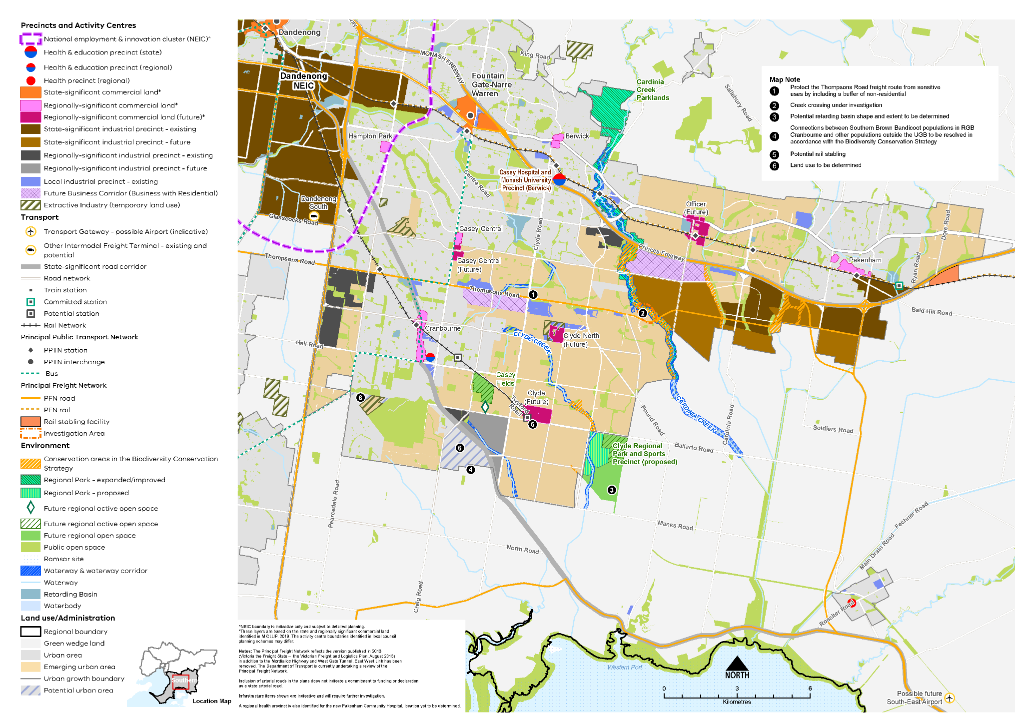

Map 4 Southern Growth Corridor Plan
A map showing the main features of the Southern Growth Corridor, highlighting:

- The existing urban area and the emerging urban areas within the Casey LGA (including Cranbourne, Clyde and Clyde North) and Cardinia LGA (including Officer and Pakenham)
- Dandenong and Monash (in part) national employment and innovation clusters and major activity centres in the existing urban area. Future major activity centres at Clyde and Clyde North, in the Casey LGA
- Existing and future state- and regionally-significant industrial areas and local industrial precincts
- Existing and future state- regionally-significant commercial land*
- State and regional health and/or education precincts
- Extractive Industry (temporary use)
- Public transport network and freight road and rail network
- Rail stabling facilities
- Investigation area at future creek crossing on Cardinia Creek at east end of Thompsons Rd, Clyde North
- Potential extension of the railway line from Cranbourne to Clyde which includes two potential stations
- Specific features including:
- Significant waterway corridors, wetlands and waterbodies
- Green wedge land, public open space, conservation areas, proposed and improved regional parks and regional active open space
Map notes (the location of each of these is shown on the map by number)
  - Protect the Thompsons Road freight route from sensitive uses by including a buffer of non-residential
  - Creek crossing under investigation (Cardinia Creek east of Thompsons Rd)
  - Potential retarding basin shape and extent to be determined (within land designated as Clyde Regional Park and Sports Precinct (Proposed) south of Ballarto Rd)
  - Connections between Southern Brown Bandicoot populations in RGB Cranbourne and other populations outside the UGB to be resolved in accordance with the Biodiversity Conservation Strategy (land in Devon Meadows and land west of Cranbourne Botanic Gardens)
  - Potential rail stabling (near Clyde Major Activity Centre (future))
  - Land use to be determined (land in Devon Meadows)

* These layers are based on the state and regionally significant commercial land identified in MICLUP, 2019. The activity centre boundaries identified in local council planning schemes may differ.

Other map notes:
^ NEIC boundary is indicative only and subject to detailed planning.
*These layers are based on the state and regionally significant commercial land identified in MICLUP, 2019. The activity centre boundaries identified in local council planning schemes may differ.
* The Principal Freight Network reflects the version published in 2013 (Victoria the Freight State – the Victorian Freight and Logistics Plan, August 2013) in addition to the Mordialloc Highway and West Gate Tunnel. East West Link has been removed. The Department of Transport is currently undertaking a review of the Principal Freight Network.
Inclusion of arterial roads in the plans does not indicate a commitment to funding or declaration as a state arterial road.
Infrastructure items shown are indicative and will require further investigation.
A regional health precinct is also identified for the new Pakenham Community Hospital, location yet to be determined.

Integrated transport
Plan Melbourne Outcome 3: Melbourne has an integrated transport system that connects people to jobs and services and goods to market.
As the Southern Metro Region grows, it will require better integration of land use and transport planning, better use of existing roads, and increased investment in public transport, walking and cycling. Making better use of transport infrastructure, complemented by good precinct design can improve connections without necessarily the expense and disruption of delivering new infrastructure. Land use decisions, as well as mode shift opportunities, can significantly improve access and reduce transport-generated emissions.
Transport in the Southern Metro Region is primarily provided by road and rail networks that radiate from the CBD, connecting through the region and onto Gippsland and other parts of the state. However, connections are limited between residential neighbourhoods and employment areas throughout the region.
The Southern Metro Region is home to transport gateways such as the Port of Hastings and Moorabbin Airport, and the proposed location for the possible South-East Airport. SRL and other committed rail and road projects will improve access within the region and to the other regions.

State of play
Map 5 outlines the current state of play for transport in the Southern Metro Region.

Road network
The Southern Metro Region road network is characterised by a grid of arterial roads in both north-south and east-west directions. These are intersected by highways, freeways and railway lines that generally radiate outwards from Melbourne’s CBD. Monash Freeway, Eastlink, Mornington Peninsula Freeway, Princes Highway and Freeway, Nepean Highway, Western Port Highway and South Gippsland Freeway and Highway all provide important connections within the region – to adjacent metropolitan regions and beyond to Gippsland.
Eastlink is an orbital north-south link through the region connecting into the Mornington Peninsula Freeway to the south and the new Mordialloc bypass to the north. Eastlink’s role will be further enhanced by the construction of North East Link, connecting the region to Melbourne’s north and north-west. Thompsons Road is a key east-west arterial road linking employment areas in Carrum Downs, Dandenong South to the South Eastern Growth Corridor. In the eastern part of the region, Healesville-Koo Wee Rup Road is an important north-south arterial road connecting Pakenham to South Gippsland.
Several parts of the existing transport network have capacity constraints, or will in the future, as the region grows, particularly passenger rail services and sections of the freeway network. Congestion is increasing, particularly during peak hours, as many residents commute beyond the region. By 2031, traffic volumes in the inner part of the Southern Metro Region are expected to increase by 33.3 per cent from 2015 (KPMG & ARUP, 2017, p. 15).

Public transport network
The rail network includes three metro passenger services to Pakenham, Cranbourne and Frankston. These services connect the Southern Metro Region and Gippsland with Melbourne’s CBD and other parts of the state.
Parts of the Southern Metro Region have good access to public transport, particularly along railway lines, in activity centres and in northern urban areas of the region. Figure 17 shows accessibility to public transport for people who live within the region based on how far they need to walk to access train, tram and bus services. The northern parts of the region are well connected to Melbourne’s CBD by train and bus with multiple services each hour. Mornington Peninsula LGA has relatively poor public transport with none of its activity centres located on a metro rail line and no direct east-west bus link across the Peninsula.
A V-Line service on a single track runs to Stony Point through Langwarrin, Baxter, Somerville and Hastings. V-Line rail and coach services also provide access to Gippsland and beyond. Public transport to new communities in the south-eastern growth areas is still developing.
The Southern Metro Region has an extensive bus network, particularly in the northern parts of the region and along either side of the Mornington Peninsula to Rosebud and Hastings. Three orbital SmartBus routes service the region providing north-south connections. The Southern Metro Region is the only region of metropolitan Melbourne not serviced by trams.
On the Mornington Peninsula, a vehicular ferry connects Sorrento to Queenscliff, and a passenger ferry connects Stony Point, French Island and Cowes. These ferries play an important tourism role for the region.

Active transport network
An existing and emerging cycling network in the Southern Metro Region provides connections, largely consistent with the region’s freeway and rail network. Strategic Cycling Corridors generally radiate out along rail lines or major roads and have often been built as part of major road projects. Examples include the shared bike path from Caulfield to Dandenong delivered as part of the Caulfield to Dandenong Level Crossing Removal Project and the Eastlink Trail.
In 2016, 0.3 per cent of residents cycled to work in the Southern Metro Region. This compares to 1 per cent that cycled to work in metropolitan Melbourne. Further improvements are needed to make cycling a more attractive form of transport including providing safe, dedicated routes for commuting, local and recreational cycling. There is also low proportion of people who walk to work, only 1 per cent of people walked to work in 2016, compared to 3 per cent for metropolitan Melbourne.

Freight network
As a national centre for manufacturing, the freight network is an integral part of the region’s economic success. The region’s freight network is well established, and the Principal Freight Network (PFN) uses both road and rail for the transport of goods. The PFN follows the major highways, freeways and railway lines including links between Frankston and the Mornington Peninsula, as well as the Thompsons Road, Pakenham and Cranbourne Corridors. The PFN links to the state- and regionally-significant industrial precincts, Port of Hastings and the possible South-East Airport.

Transport gateways
In addition to the transport gateways of Moorabbin Airport and the Port of Hastings, there is also the possible South-East Airport that would further enhance the region’s accessibility. In addition, the Dandenong South Port Rail Shuttle Network (PRSN) connection is underway.
The Port of Hastings is a key gateway for non-containerised trade such as bulk product exports, break bulk products and fuels. Around 2 million tonnes of steel, gas and petroleum products moves through the Port of Hastings, making it a significant economic gateway for Victoria. The Port of Hastings has been identified as a reserve option, behind the preferred Bay West, for a second major container port once the Port of Melbourne reaches capacity (Port of Hastings, 2018, p. 8).

Regional access and movement
After the Inner Metro Region, the Southern Metro Region has the second highest proportion of residents who work within the region. In 2016, 66 per cent of Southern Metro Region residents also worked in the region.
Figure 16 shows journeys to work in and out of the Southern Metro Region. The most common work destinations for the Southern Metro Region after the region itself were the Eastern and Inner metro regions. Greater Dandenong LGA is the top work destination followed by the Casey and Mornington Peninsula LGAs (SGS, 2019, p. 40). Most people living and working in the region come from Casey, Mornington Peninsula and Frankston LGAs. Most people working in the region from outside the region were from the Eastern Metro Region LGAs of Knox, Monash and Yarra Ranges (SGS, 2019, p. 40). There was little connection with the Northern and Western metro regions for the purpose of travelling to work.
- Journey to work in and out of the Southern Metro Region
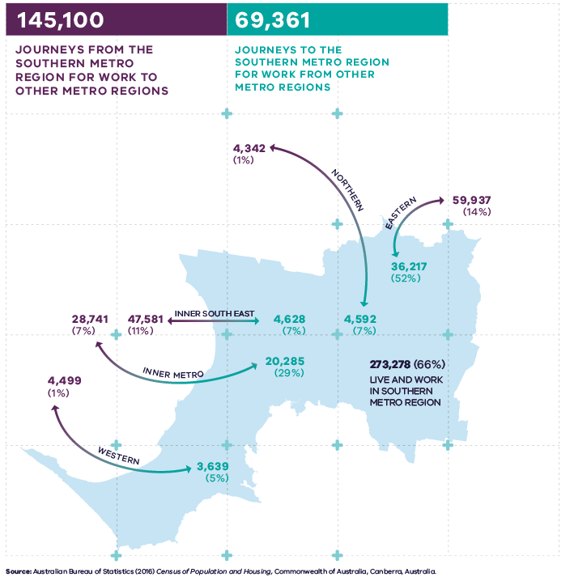
Figure 16. Journey to work in and out of the Southern Metro Region
273,278 (66 per cent) live and work in the Southern Metro Region | 145,100 – Journeys from the Southern Metro Region for work to other metro regions:  - 4,342 (1 per cent) – Journeys to the Northern Metro Region  - 59,937 (14 per cent) – Journeys to the Eastern Metro Region  - 4,499 (1 per cent) – Journeys to the Western Metro Region  - 28,741 (7 per cent) – Journeys to the Inner Metro Region  - 47,581 (11 per cent) – Journeys to the Inner South East Metro Region | 69,361 – Journeys to the Southern Metro Region for work from other metro regions  - 4,592 (7 per cent) – Journeys from the Northern Metro Region  - 36,217 (52 per cent) – Journeys from the Eastern Metro Region  - 3,639 (5 per cent) – Journeys from the Western Metro Region  - 20,285 (29 per cent) – Journeys from the Inner Metro Region  - 4,628 (7 per cent) – Journeys from the Inner South East Metro Region
Source: Australian Bureau of Statistics (2016) Census of Population and Housing, Commonwealth of Australia, Canberra, Australia.

- Southern Metro Region integrated transport state of play
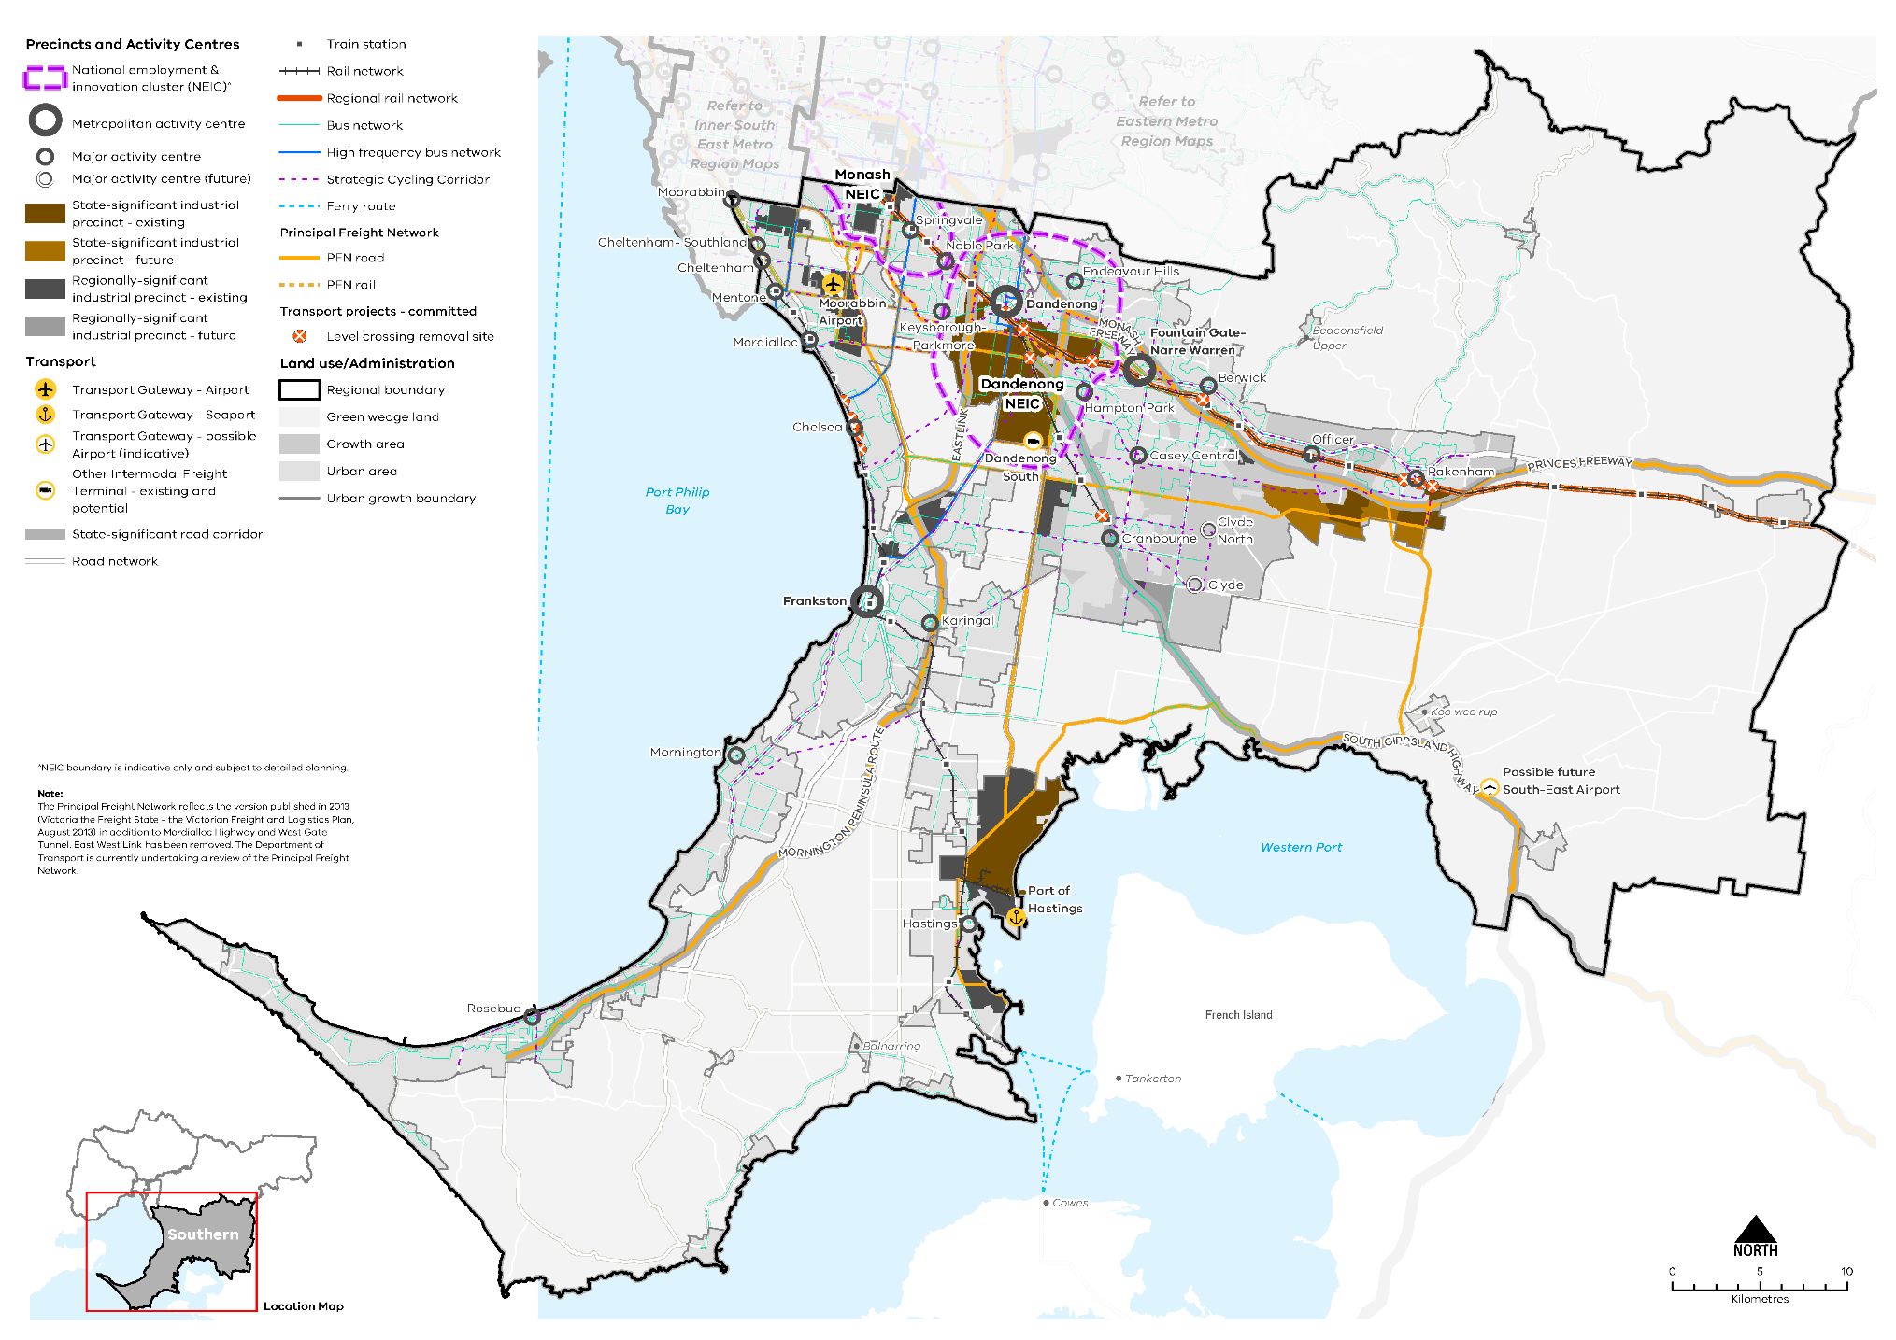

Map 5 Southern Metro Region integrated transport state of play
A map showing the key transport features of the region in 2021, as extracted from Map 1, and also highlighting:
- The route of the interstate rail network
- The regional rail network between Pakenham and Gippsland
- The bus network principally in the established urban area
- The high frequency bus network in the north of the region
- The strategic cycling network through the established urban area and growth areas
- The principal rail and road freight network.
Note: The Principal Freight Network reflects the version published in 2013 (Victoria the Freight State - the Victorian Freight and Logistics Plan, August 2013) in addition to Mordialloc Highway and West Gate Tunnel. East West Link has been removed. The Department of Transport is currently undertaking a review of the Principal Freight Network.

- Public transport accessibility in the Southern Metro Region
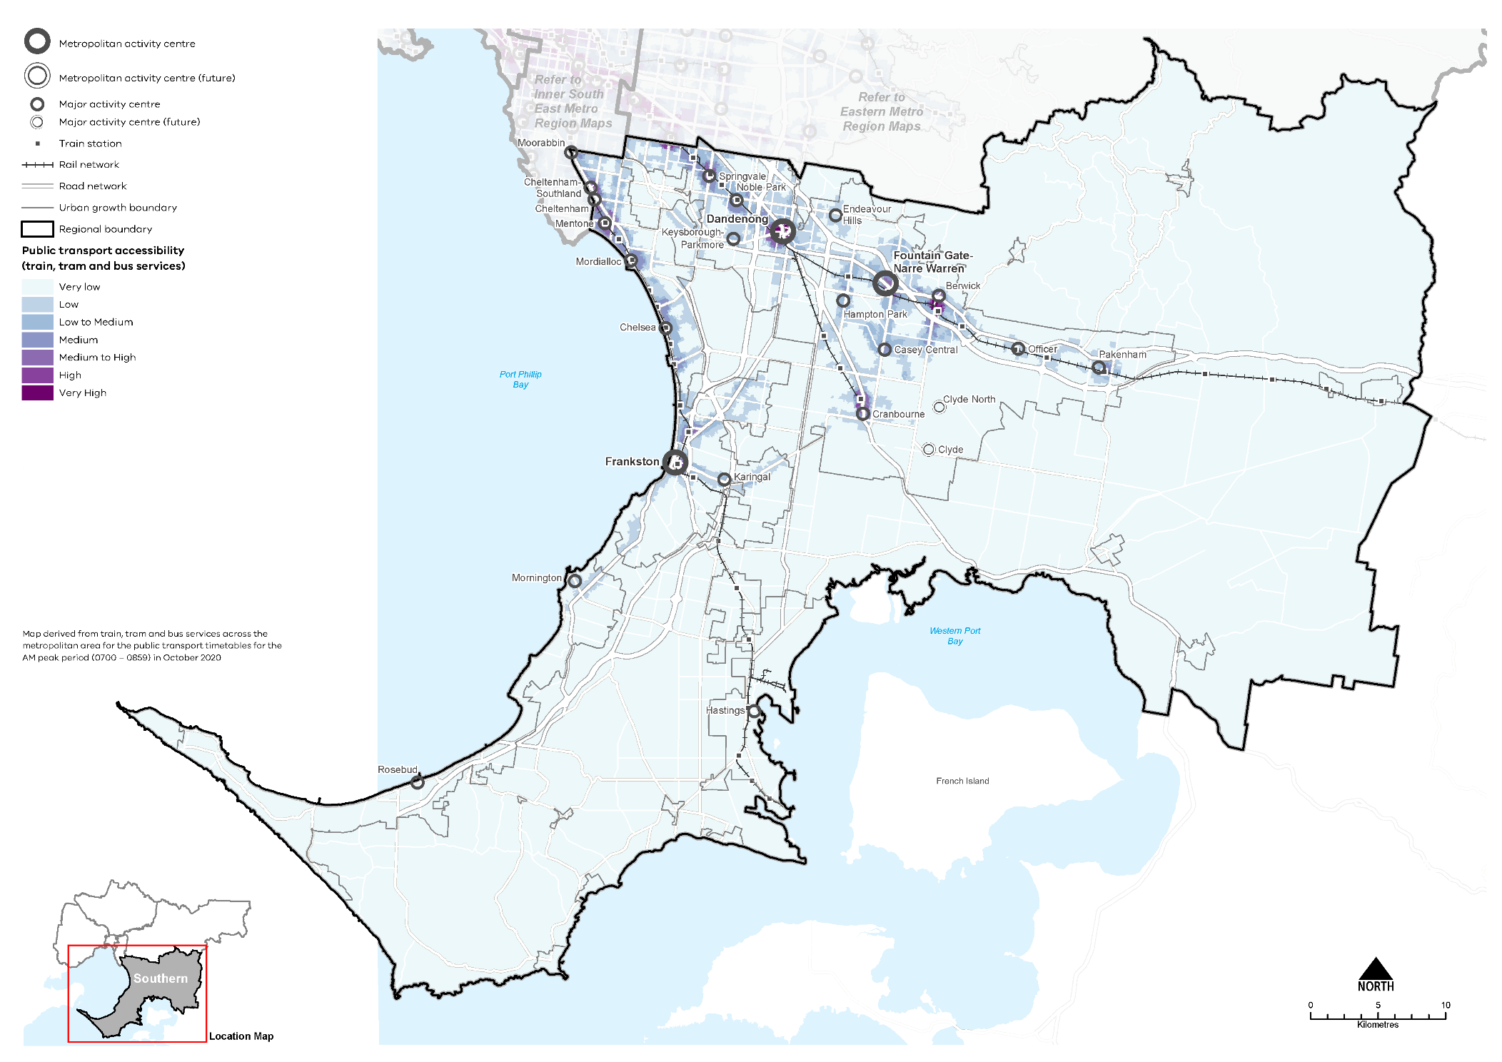

Regional strengths
- The region has a strong freeway, arterial road, and freight network.
- Moorabbin Airport, Port of Hastings and the possible South-East Airport are key transport
gateways.
- Access improvements for walking, cycling and public transport will result from the development of the SRL station and supplement the existing network.

Regional challenges
- There is a need to improve east-west connections between Pakenham, Cranbourne, Dandenong and Frankston to connect people with jobs and services.
- The region has high private vehicle use increasing congestion, and significant gaps in public transport particularly to the outer south-east.
- The provision of roads and public transport needs to be sequenced with new urban development.
- Several parts of the existing transport network have capacity constraints, or will in the future as the region grows, particularly passenger rail services and sections of the freeway network.

Directions and strategies
The directions identified to achieve the 2050 vision for the Southern Metro Region in terms of Integrated transport and Outcome 3 of Plan Melbourne are:
Direction 13 | Improve transport connections to support the productivity of the Southern Metro Region
Direction 14 | Improve public and active transport access for Dandenong NEIC, metropolitan and major activity centres and Cheltenham Precinct
Direction 15 | Improve transport linkages in the south-eastern growth area and on the Mornington Peninsula
Direction 16 | Improve active and public transport options to promote mode shift and support 20-minute neighbourhoods
Direction 17 | Improve freight efficiency and increase capacity of gateways while managing impacts on urban amenity
Each direction is implemented through regionally-specific strategies identified in this LUFP.
Map 6 shows how Integrated transport will be enhanced across the Southern Metro Region by 2050 as a result of these directions and strategies, together with Plan Melbourne and other strategies and initiatives as outlined in Appendix 01.

- Southern Metro Region integrated transport 2050
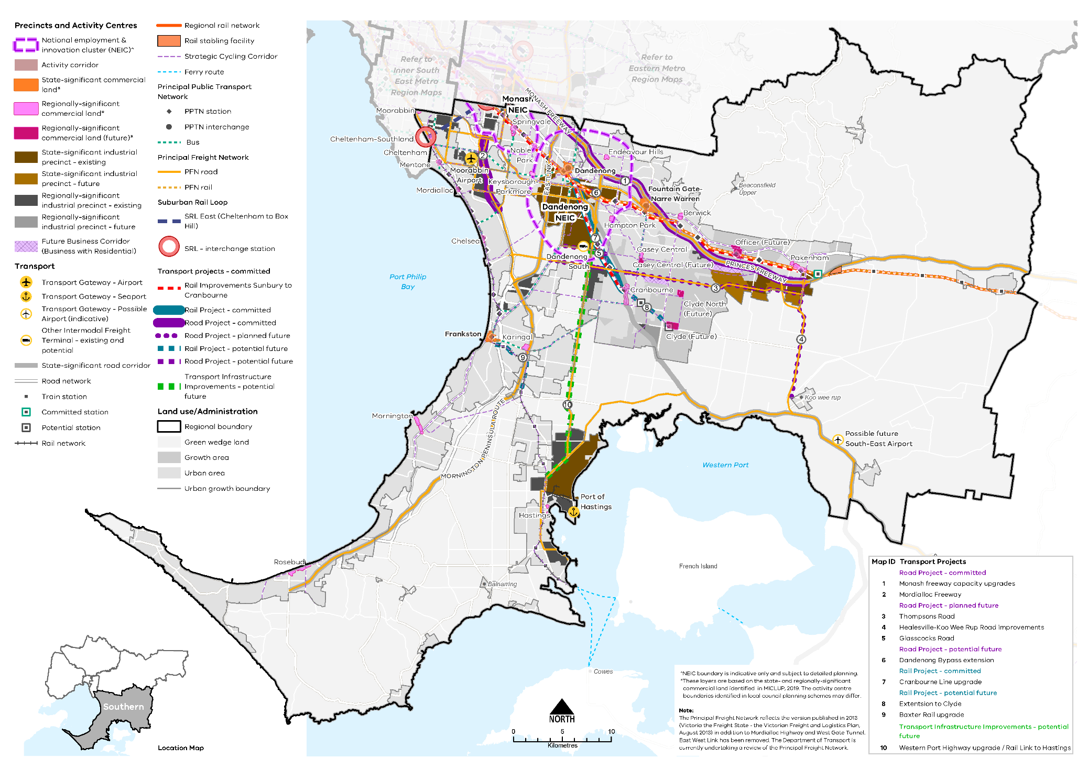

Map 6 Southern Metro Region integrated transport 2050
A map showing the key transport features of the region in 2050, as extracted from Map 1, and also highlighting:
- Rail improvements from Sunbury to Cranbourne
- PPTN stations and interchanges
- Extension of the railway line from Cranbourne to Clyde
- Potential new train stations in the growth area
- Transport projects
- Road Projects - committed
  - Monash freeway capacity upgrades
  - Mordialloc Freeway
- Road Project - planned future
  - Thompsons Road
  - Healesville-Koo Wee Rup Road improvements
  - Glasscocks Road
- Road Projects - potential future
  - Dandenong Bypass extension
- Rail Project - committed
  - Cranbourne Line upgrade
- Rail Project - potential future
  - Extension to Clyde
  - Baxter rail upgrade
- Transport Infrastructure Improvements - potential future
  - Western Port Highway upgrade / Rail Link to Hastings.

- Improve transport connections to support the productivity of
the Southern Metro Region
Sustainable population and economic growth in the Southern Metro Region relies on improving public transport access to and between job-rich locations such as the Monash and Dandenong NEICs, metropolitan and major activity centres, state- and regionally-significant industrial precincts and health and/or education precincts. This will support an expanded network of economic activity that is less reliant on private car use, with more reliable and frequent public transport services to encourage mode shift and reduce road congestion, which is significant in many parts of the region.
Capacity and efficiency improvements to the public transport system are needed to ease the pressure on the region’s roads and to provide more sustainable transport alternatives. A number of regionally-significant committed and proposed improvements to public transport infrastructure and services are outlined in Appendix 01.
The key regional linkages are shown in Figure 19. Decisions regarding appropriate modes for these links should consider the capacity of existing infrastructure, ongoing sustainability and providing travel choices over a longer time period including evening and late-night travel.
The SRL interchange station at Cheltenham will link residents to major destinations in the Eastern Metro Region including Monash NEIC and Box Hill Metropolitan Activity Centre, and in the longer term, to Melbourne Airport. SRL will change the way people travel to and move around the eastern and southern part of Melbourne by providing public transport access to key employment locations without having to travel to intersecting points on the network closer to the inner city.
An important component of SRL is a stabling facility and operations control centre for testing and commissioning of trains and infrastructure, stabling and maintenance. As SRL East (Cheltenham to Box Hill) is the first part of an orbital network around Melbourne, the Southern Metro Region is the planned location for SRL East Stabling Facility. The development and operation of SRL East will not be able to be realised without the stabling facility. The selection of the location of the stabling facility within Kingston LGA will require an assessment of different, and potentially competing, planning policy considerations in order to determine how the delivery of this critical component of SRL can achieve a net community benefit.
Increasing the reach and frequency of public transport, particularly bus routes, is the key for increasing public transport use across the region. There is a need to plan for and implement improvements to the region’s bus network, including on-road priority, increased frequencies and improved route legibility. Priorities include the introduction of services in greenfield growth areas, improvements on the Mornington Peninsula and better connectivity between residential areas and employment areas.
Strategic Cycling Corridors will connect state-significant locations and activity centres. Priority active transport projects will promote increased safe use of the region’s cycling and walking network (Figure 19).
Primary routes provide a core network of Strategic Cycling Corridors that connect places of state significance – the Central City, metropolitan activity centres and NEICs within metropolitan Melbourne. Main routes are Strategic Cycling Corridors that provide additional connections to state-significant destinations as well as connections to major activity centres and key train stations across metropolitan Melbourne.
- Improve transport connections between the Dandenong NEIC, Frankston and Narre Warren-Fountain Gate metropolitan activity centres and the Southern Employment Precinct (including Officer-Pakenham and Hastings).
- Improve bus service connectivity prior to the delivery of Suburban Rail Loop.
- Improve transport connections between the Dandenong NEIC (including the Southern Employment Precinct), Frankston and Fountain Gate-Narre Warren metropolitan activity centres and the Officer-Pakenham SSIP.
- Support cycling for transport through the development of Strategic Cycling Corridors in the Southern Metro Region.
- Improve public and active transport access for Dandenong NEIC, metropolitan and major activity centres and Cheltenham Precinct
Continuing to provide opportunities for public and active transport in and around the Dandenong NEIC, metropolitan and major activity centres will be critical to improve the amenity of these centres and make them more attractive for business investment and local residents.
As the metropolitan activity centres of Dandenong, Frankston and Fountain Gate-Narre Warren undergo change to a more compact urban form, they will require active transport networks that logically connect with public transport nodes. In established higher-density locations, networks should better connect to existing cycling and walking infrastructure to fill existing gaps.
Building SRL and delivering cross-suburb travel connections will trigger investment and economic activity in the middle suburbs – enabling clusters of jobs and businesses, as well as new quality housing and services. This will include increasing public transport and active transport connectivity to and from the SRL station at Cheltenham from nearby activity centres, urban renewal areas, employment precincts such as Moorabbin, and along key transport corridors including the Nepean Highway to enable people to access the SRL using a range of modes.
Until SRL is delivered, there are many transit-oriented development opportunities around the existing transport system and activity centre network that would accommodate growth and improve the amenity of key locations.
- Improve public and active transport access to job-rich areas including Dandenong NEIC, Dandenong, Fountain Gate-Narre Warren and Frankston metropolitan activity centres, major activity centres and the Southern SSIP and the Cheltenham Precinct.
- Ensure the planning and design of the Suburban Rail Loop station at Cheltenham Precinct maximises opportunities for public and active transport connections and links between key destinations and surrounding activity centres.

- Key regional linkages – Southern Metro Region
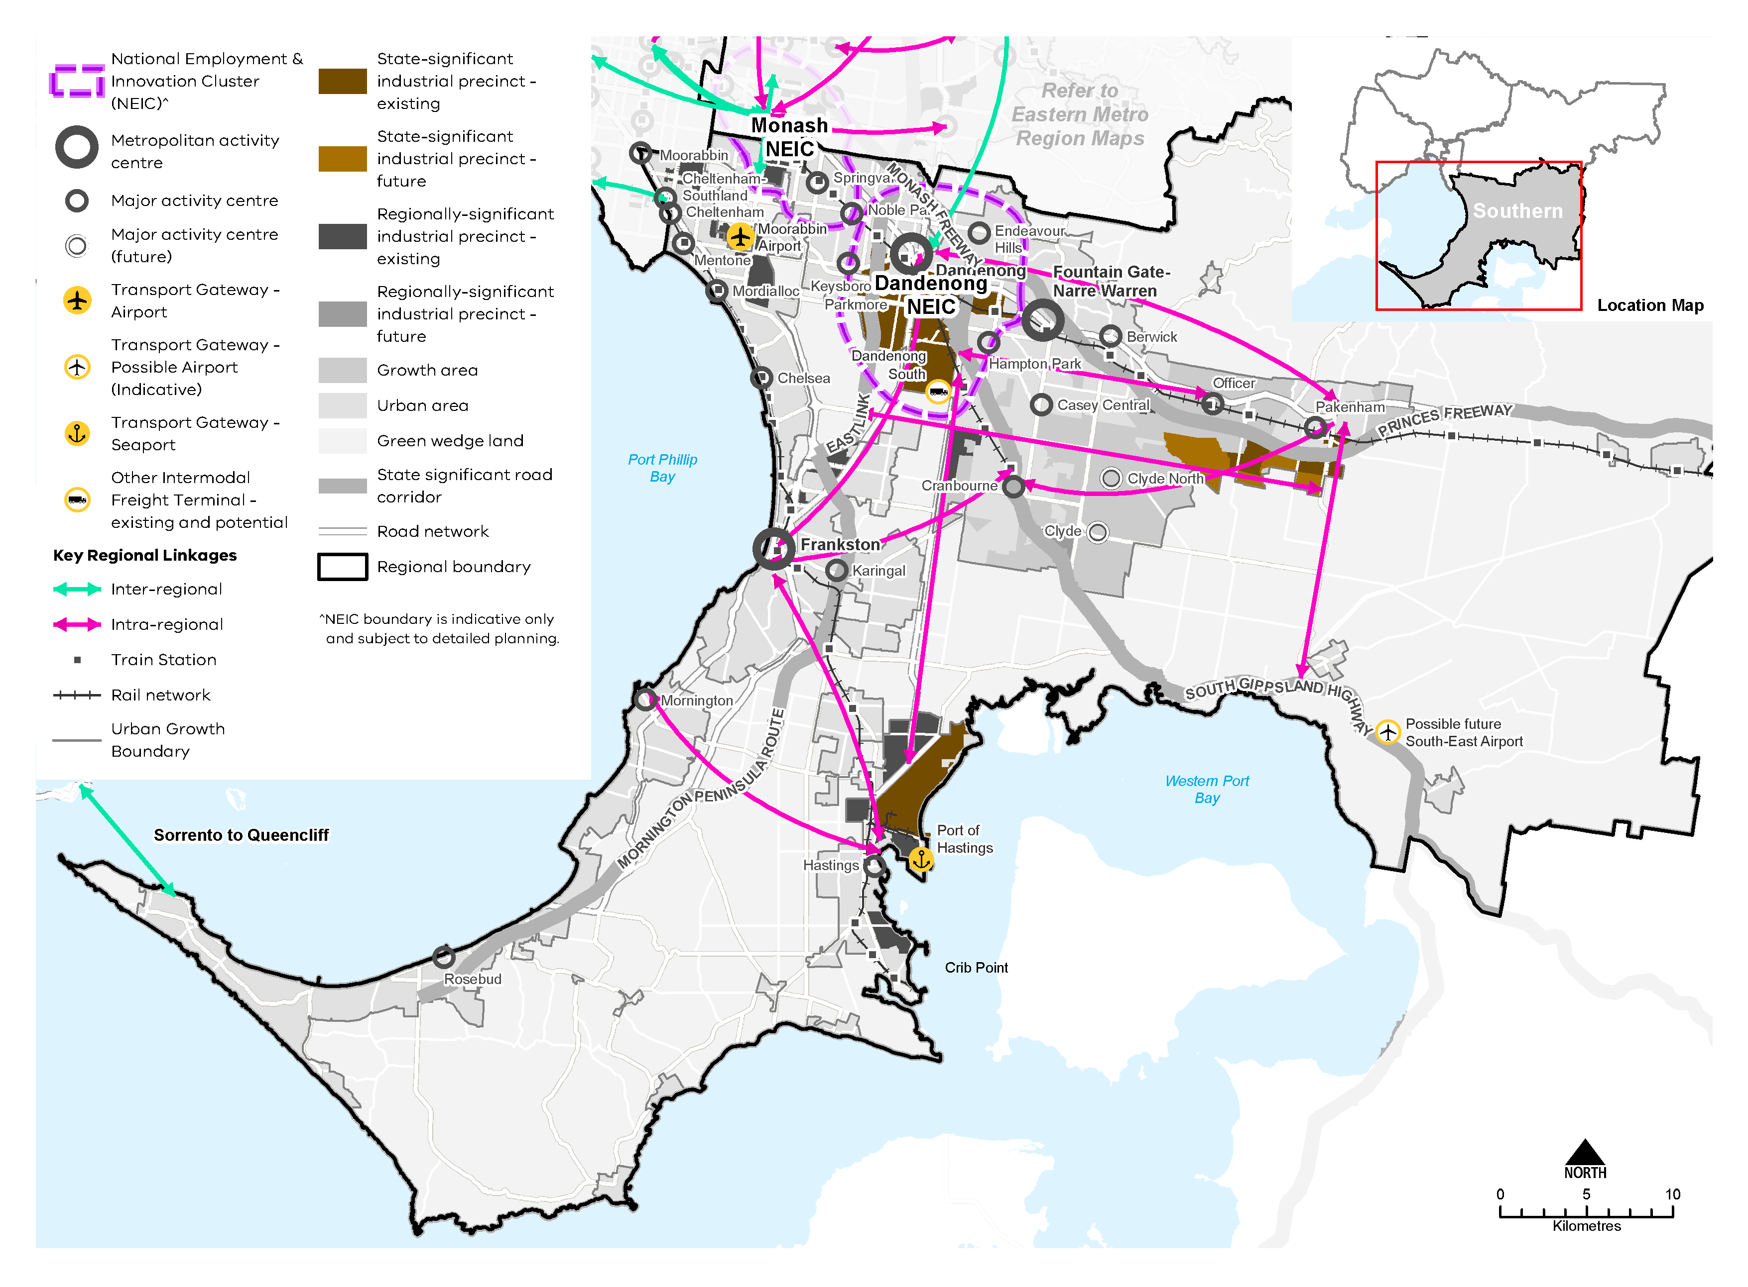
- Strategic Cycling Corridor network – Southern Metro Region
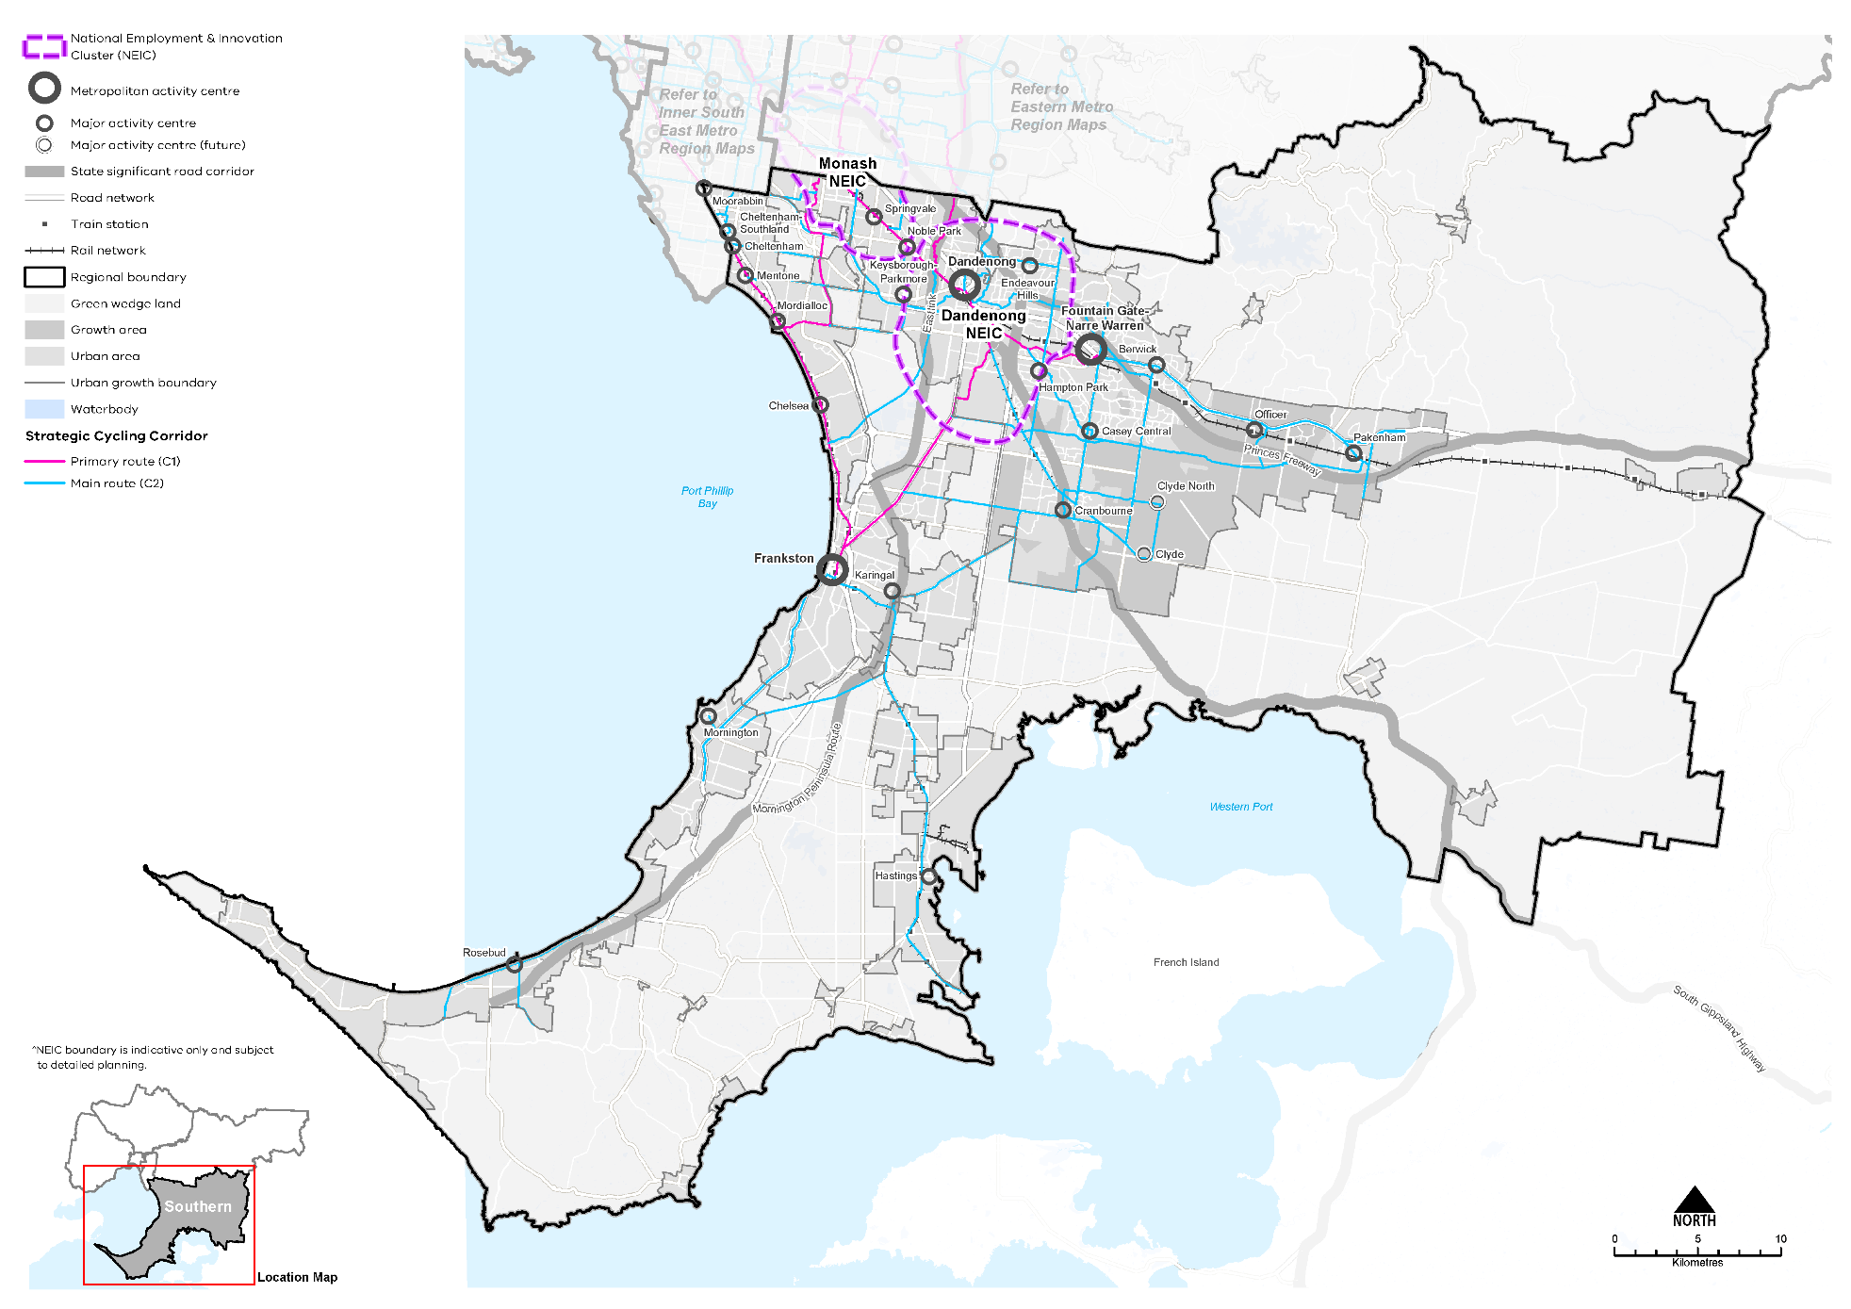

- Improve transport linkages in the south-eastern growth area and on the Mornington Peninsula
Planning will be required for the Southern Metro Region’s growth areas to deliver self-contained, liveable communities that offer more jobs and facilities and high-quality public transport and road connections.
Urban development in these growth areas is supported by two metropolitan railway lines to Pakenham and Cranbourne, with a future extension to Clyde, with connections to the bus network and other modes. The PPTN provides the basis for a potential future strategic bus network linking train stations along and between Cranbourne and Pakenham rail lines as well as connecting activity centres, employment precincts and regional open space.
Transport linkages will be important for the major activity centre at Clyde, adjacent to a new rail station along the extended Cranbourne rail line. The major activity centre Clyde North needs to be linked as part of a public transport network that goes from Cranbourne to Officer and beyond.
In greenfield growth areas, there is a need to provide key road connections and improve the efficiency of the road network. Delivery of a network of new connector roads will improve connections between existing metropolitan and major activity centres and employment nodes such as the Southern SSIP. The grid of north-south and east-west roads will need to provide links between Cranbourne, Officer and Pakenham, north-south public transport routes, and crossings of Cardinia Creek.
Parts of the arterial road network along the PPTN could be designed to accommodate higher capacity public transport networks such as busways, including between Cranbourne and Officer.
Regionally-significant road projects include:
- Thompsons Road is a critical east-west connection that connects the established urban areas north of Frankston to emerging growth areas around Cranbourne North. It is planned to extend further east to the future Officer-Pakenham Industrial Precinct
- Glasscocks Road, from Frankston-Dandenong Road to Cranbourne North, which is planned to provide improved connectivity to and within the Southern SSIP
- Improvements to the Healesville-Koo Wee Rup Road which are planned to provide an upgraded connection between Pakenham and the South Gippsland Highway, as well as providing an alternative route to travelling through Cranbourne.
Potential road projects of regional significance include:
- Western Port Highway upgrade, potentially to freeway standard in the future, to improve connectivity between Dandenong, Cranbourne and the Mornington Peninsula
- Dandenong Bypass extension, from South Gippsland Highway to South Gippsland Freeway, to provide for better connectivity to, and within, the Southern SSIP.
It is important that planning for connections such as Thompsons Road and adjacent land uses protect the function of the road for public transport and freight.
- Provide high-quality public and active transport access to job-rich areas in the greenfield growth areas as they are developed.
- Improve outer suburban public transport to ensure integration with sequenced land use and development.
- Maintain and further develop the arterial road network to support improved travel times, safety and reliability.
- Improve active and public transport options to promote mode shift and support 20-minute neighbourhoods
Access to public transport varies significantly across the region. Improvements to local transport options, including bus, cycling and pedestrian access, are needed to support the delivery of 20-minute neighbourhoods across the Southern Metro Region.
Within the region 36 per cent of people used a car when making a short trip under 5 kilometres, whereas 23 per cent of people walked, and only 2 per cent of people cycled for short trips (DELWP, 2021b). To reduce dependence on private vehicles, public transport, cycling and walking need to be more accessible. This means significant upgrades to public transport access, and improvements to pedestrian and cycling accessibility, better linking neighbourhoods to employment, and social and community services.
Priority locations for improving cycling links and pedestrian access should be identified such as neighbourhoods around existing centres, schools and along transport corridors. They should also be a key part of the delivery of major infrastructure projects, particularly for station precinct planning as part of the SRL and level crossing removal projects.
As the region grows, resulting land use changes will also change the destinations and distances people travel, enabling more people to access jobs and education by public transport. The integration of an SRL station with surrounding regional and local public and active transport is paramount to encouraging the shift from private car use to public transport, delivering 20-minute neighbourhoods and growing the Southern Metro Region.
New communities in growth areas are planned around new major activity centres. Each should be accessible by multiple transport modes and planned to support 20-minute neighbourhoods. Precinct structure planning also provides for a network of neighbourhood activity centres to provide local services as well as opportunities for higher densities of development. Continued and innovative development of the bus network is a priority for growth area communities that have the least access to public transport in the region.
- Create pedestrian-friendly neighbourhoods by enhancing major pedestrian links and expanding the network.
- Create a network of walking and cycling links for local trips that link to public transport.
- Provide walking and cycling routes and drop-off zones to health and community services and recreation facilities.
- Improve freight efficiency and increase capacity of gateways while managing impacts on urban amenity
The region’s strategic freight connections provide a strong competitive advantage for the manufacturing, export and logistics sector. Supporting the efficiency movement of goods by protecting its freight efficiency and capacity will be crucial for protecting the region’s existing sector strengths while enabling future economic growth. Effective land use planning will be an important factor in this by protecting key regionally-significant freight routes and industrial land from the encroachment of sensitive or conflicting land uses.
- Ensure the Dandenong South PRSN Intermodal Terminal, the possible South-East Airport and connecting freight corridors and industrial areas and their connecting freight corridors are protected from encroachment of sensitive or conflicting land uses.
- Protect the Thompsons Road freight route from sensitive uses by including a buffer of non-residential land uses.

Actions – Integrated transport
- Review the Principal Public Transport Network for the growth areas.
- Plan for and implement improvements to the region’s bus network, including on-road priority, increased frequencies and improved route legibility. Priority areas include the introduction of services in the growth areas, improvements on the Mornington Peninsula and better connectivity between residential areas and employment areas.

Liveability
Plan Melbourne Outcome 4: Melbourne is a distinctive and liveable city with quality design and amenity
‘Liveability’ is about the things that enhance people’s quality of life. For many years Melbourne has been regarded as one of the world’s most liveable cities due to its social and economic stability, diverse communities, distinctive heritage, high level of amenity and the opportunities it provides for a rich social and cultural life.
Plan Melbourne aims to maintain and extend the city’s liveability by celebrating its culture, diversity and distinctiveness. The challenge ahead is to design and plan for a future city that protects the best aspects of the natural and built environment, supports social and cultural diversity, and creates a strong sense of place.
The Southern Metro Region is renowned for its distinctive and varied landscapes, which have high amenity, tourism and biodiversity values. The region has high cultural significance for Aboriginal people and a rich post-European settlement heritage. Its regional-scale open spaces include the coastlines of Western Port and Port Phillip bays and the foothills of the Dandenong Ranges. It is important for these natural and cultural values to be protected into the future.

State of play

Landscapes and biodiversity
The Southern Metro Region is defined by its varied and scenic landscapes which extend from the Dandenong Ranges to the coastlines of Port Phillip and Western Port bays. The region includes popular beaches, rolling coastal hinterlands and low-lying swamps and wetlands. Picturesque pastoral lands and mountain foothills feature within the central and northern part of the region. These landscapes are intrinsic to the region’s identity, biodiversity and cultural heritage.
The region’s key landscapes and biodiversity areas are described in Table 13.
- Key landscapes and biodiversity areas in the Southern Metro Region
Landscape and biodiversity area | Significance, protection and management
Mornington Peninsula | The entire Mornington Peninsula is designated as a landscape of state significance and protected through a Localised Planning Statement incorporated into the Planning Scheme.  Both the Mornington Peninsula and Western Port are included within a UNESCO Biosphere Reserve as a coastal region of vast and relatively undisturbed mudflats with salt marsh vegetation. The area encompasses the LGAs of Mornington Peninsula and parts of Frankston, Casey and Cardinia LGAs.  The Mornington Peninsula includes several declared conservation reserves: Mornington Peninsula National Park, Point Nepean National Park, Arthurs Seat State Park, Devilbend Natural Features Reserve and Greens Bush.
Port Phillip Bay and Western Port coastline | The Southern Metro Region includes the largest area of coastline within metropolitan Melbourne. It comprises a mix of suburban beaches, conservation areas and foreshore recreation/tourism areas. The coastline extends across Kingston, Frankston, Mornington Peninsula, Casey and Cardinia LGAs.
Churchill National Park, Lysterfield Park and Dandenong Police Paddocks | These reserves form an extensive network of open spaces extending through the established urban areas and green wedges of Casey LGA into the Eastern Metro Region. They comprise a mix of remnant bushland and active recreation areas.
Mountain foothills and forests | The region’s eastern green wedges include conservation areas around the foothills of the Dandenong Ranges and Great Dividing Range. This includes Kurth Kiln Regional Park, Bunyip State Park and Beenak State Forest, parts of which are located within Casey LGA, extending into the Eastern Metro Region.
Waterways | The Southern Metro Region features a network of creek corridors throughout its green wedges, growth corridor and urban areas. This includes Kananook Creek, Clyde Creek, Cardinia Creek, Gum Scrub Creek, Mordialloc Creek, Dandenong Creek and Toomuc Creek. These waterways provide significant habitat for land and aquatic species and in many places form part of the existing, or potential future, connected open space system.
Wetlands | Western Port supports extensive wetlands which are designated as Ramsar wetlands of international biodiversity significance.  Situated on Port Phillip Bay, Edithvale-Seaford wetlands is the largest natural wetland of its type in the Port Phillip and Westernport basins and is designated as a Ramsar wetlands. Tootgarook wetlands is a groundwater-dependent, freshwater wetland.

Aboriginal cultural heritage
The lands and waterways that now make up the Southern Metro Region feature places and waterways of cultural significance and continuing connection for Traditional Owners as shown in Figure 20. The Bunurong people, represented by the Bunurong Land Council Aboriginal Corporation, is the Registered Aboriginal Party for most of the Southern Metro Region. The Wurundjeri people, represented by Wurundjeri Woi Wurrung Cultural Heritage Aboriginal Corporation, is the Registered Aboriginal Party for a small area in the northern part of the region.
Registered Aboriginal Parties have responsibility to protect cultural heritage assets under the Aboriginal Heritage Act 2006.
- Southern Metro Region Aboriginal cultural heritage
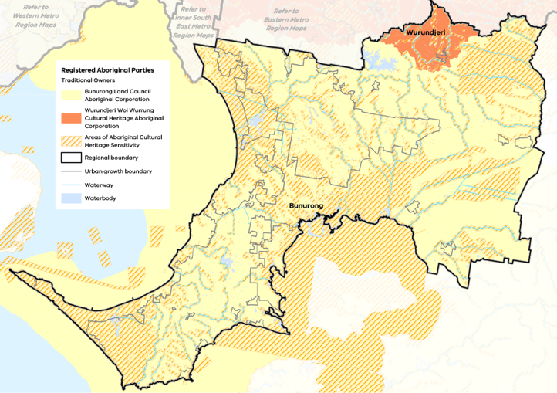

Heritage and visitor places
The Southern Metro Region is characterised by a diverse range of post-European settlement heritage and visitor places. Early settlements appeared along the coastline. Within inland areas the region’s rich soils promoted agriculture while forestry also became a major activity. The growth of Melbourne, and particularly the construction of railroads in the second half of the 19th century, promoted the outward expansion of suburban settlement and the development of the region’s ‘railway towns’. Post-war industrial development and shipping drove economic and employment growth in the 20th century. Today, many of the region’s townships along the railway line and the coast are part of the Greater Melbourne urban area.
Heritage protection is provided to individual properties, streets and precincts within the region and these places are integral to its character and identity today. There are over 70 places of state heritage significance listed on the Victorian Heritage Register, as shown in Map 7, which include lighthouses, homesteads and pastoral runs, civic halls, train stations, schools and avenues of honour.
The region’s natural assets, particularly the coastline and ranges, as well as its history and heritage are major visitor attractors.
Key visitor and community places in the region include:
- Point Nepean National Park, which is a recognised cultural landscape for its Aboriginal cultural heritage values and its quarantine station (the site is listed on the Victorian Heritage Register)
- Historic settlements and tourist townships such as Red Hill, Mount Martha, Portsea, Flinders and Sorrento
- Cranbourne Botanic Gardens, which provides 363 hectares of native and indigenous plants, and is connected by a metropolitan trail to sporting facilities at Casey Fields
- Puffing Billy Railway in the Dandenong Ranges
- Buddhist Temples in Springvale
- Cruden Farm and McClelland Sculpture Park in Langwarrin
- Dandenong Town Hall, constructed in 1890.

Open space and regional trails
Residents of the Southern Metro Region have varying levels of access to open space depending on where they live. Cardinia LGA and Casey LGA provide the highest level of open space, between 80 and 88 square metres per capita, which is much higher than the metropolitan average of 57.5 square metres. Frankston, Greater Dandenong, Kingston and Mornington Peninsula LGAs provide a much lower amount of open space of between 38 and 58 square metres per capita (VPA, 2017). Open space per person within each LGA of the region is shown in Figure 21 and open space across metropolitan Melbourne is shown in Figure 22.
While the quantity of open space is one measure of provision, the function, mix, quality, accessibility and proximity of open space also need to be considered.
Key regional open spaces include the Royal Botanic Gardens Victoria, Cranbourne Gardens, Clyde Regional Park, Casey Fields, and linear parklands along creek corridors such as Cardinia Creek Parklands. The region also benefits from extensive informal open spaces within its national and state parks and along the coastline.
Additional public open space will be required across the Southern Metro Region to accommodate anticipated population growth. The metropolitan open space strategy Open Space for Everyone: Open Space Strategy for Metropolitan Melbourne 2020 identifies a number of regional open space initiatives for the Southern Metro Region:
- The proposed Frankston to Mornington Parklands will link 1881 hectares of park and reserves between Seaford Wetlands and Mornington
- The Chain of Parks project will, over time, convert historic landfills into a series of linked parks from Moorabbin to Dingley providing a core area of 355 hectares of parkland and over 10 kilometres of linked cycling and pedestrian paths designed to connect Braeside Park and Karkarook Park, and provide secondary trails and links to the surrounding community
- The proposed Clyde Regional Park (120 hectares, co-located with the Melbourne Water retarding basin) and Cardinia Creek South Parkland (508 hectares) will each provide regional open space with active recreation and sporting facilities within this growth area
- Upgrades to the Seaford Wetlands to support environmental protection and public access, including improved walking paths and facilities, landscaping and environmental works.
A review of public racecourses is also proposed, which will examine ways of optimising the public use of this land for other recreational opportunities.
The Southern Metro Region has an extensive network of interconnected trails used by pedestrians and cyclists for commuting and recreational purposes, including horseriding. Trails are located along Eastlink, Peninsula Link and Dandenong Creek. When existing missing links are completed along The Bay Trail, it will provide an off-road network of cycling paths from Kingston to suburbs further afield throughout the north, west and east of metropolitan Melbourne.
The Caulfield to Dandenong level crossing project has delivered new open space in the form of the Djerring Trail which is a linear parkland with a shared trail connecting Monash Caulfield Campus to the Eastlink Trail in Dandenong.
Local councils within the region have each prepared bicycle and/or pedestrian strategies to prioritise works on existing and proposed bicycle pathways to enhance connections to services throughout the region.
- Open space per person for Southern Metro Region LGAs
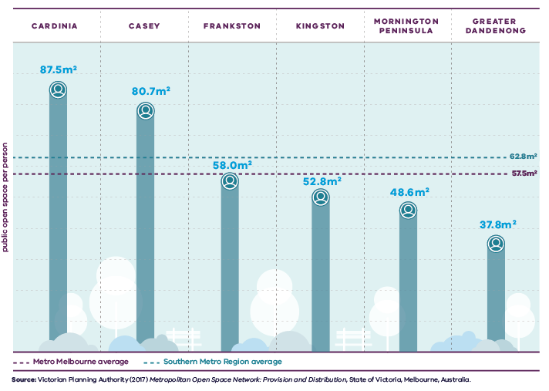
Figure 21. Open space per person for Southern Metro LGAs
Metro Melbourne average | 57.5 square metres public open space per person
Southern Metro Region average | 62.8 square metres public open space per person
Cardinia | 87.5 square metres public open space per person
Casey | 80.7 square metres public open space per person
Frankston | 58.0 square metres public open space per person
Kingston | 52.8 square metres public open space per person
Mornington Peninsula | 48.6 square metres public open space per person
Greater Dandenong | 37.8 square metres public open space per person
Source: Victorian Planning Authority (2017) Metropolitan Open Space Network: Provision and Distribution, State of Victoria, Melbourne, Australia.
- Open space per person for metropolitan LGAs
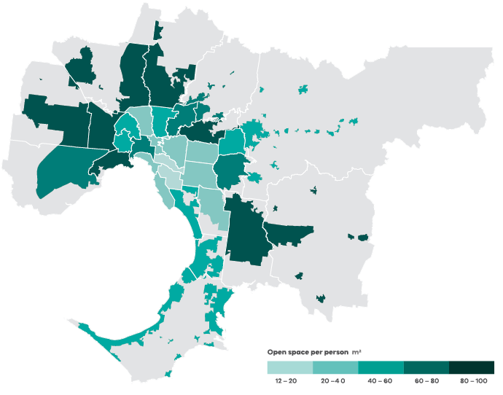
Data from the Victorian Planning Authority Metropolitan Open Space Network portal, 2016
Note: only areas within the UGB were calculated and mapped in this figure. Areas outside the UGB are shown in grey.

Regional strengths
- The region’s distinctive natural character and high value environmental assets include unique wetlands, coastlines, green wedge areas, waterways, and state and national parks.
- Significant opportunities exist for regional collaboration to create open space linkages and biodiversity corridors.

Regional challenges
- There is a need to invest in regional parks, recreation facilities and walking and cycling networks to give people better access to the region’s diverse landscapes.
- New open space is required to meet forecast population growth across the region, including within new communities in growth areas and within in some established parts of the region.

Directions and strategies
The directions identified to achieve the 2050 vision for the Southern Metro Region in terms of Liveability and Outcome 4 of Plan Melbourne are:
Direction 18 | Protect and enhance the landscapes and biodiversity of the Southern Metro Region
Direction 19 | Strengthen the network of open spaces and trail connections across the Southern Metro Region
Direction 20 | Create a legacy of great civic places
Each direction is implemented through regionally-specific strategies identified in this LUFP.
Map 7 shows how liveability will be enhanced across the Southern Metro Region by 2050 as a result of these directions and strategies, together with Plan Melbourne and other strategies and initiatives as outlined in Appendix 01.

- Southern Metro Region liveability 2050
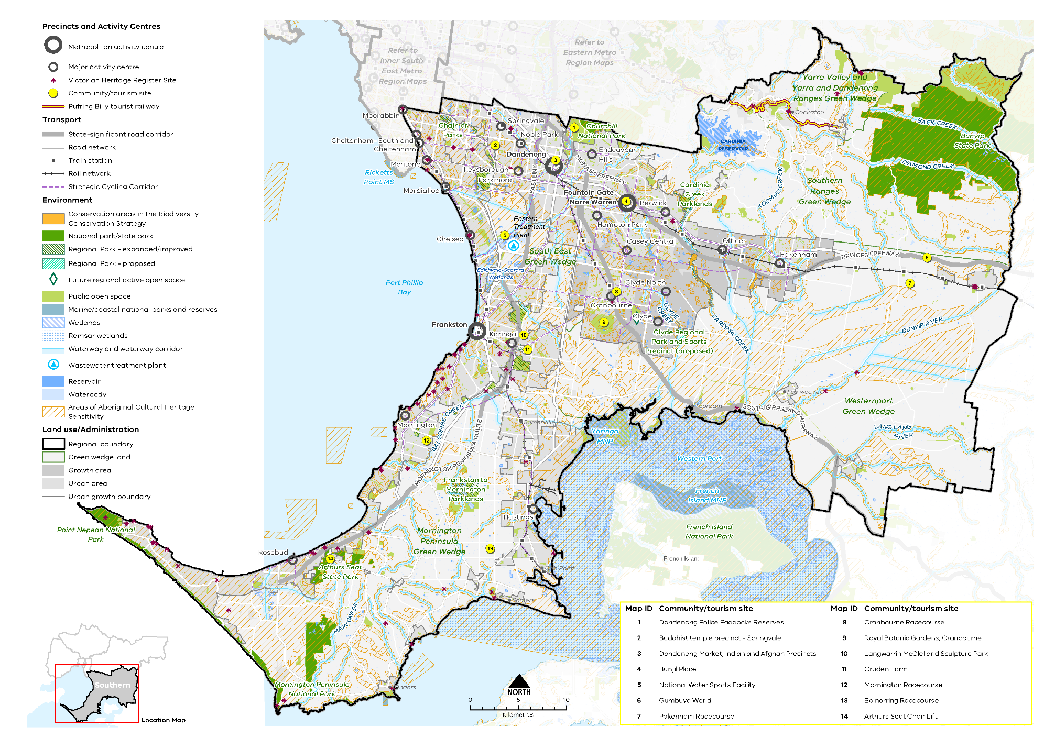
Map 7 Southern Metro Region liveability 2050
A map showing the key environmental and cultural features of the region in 2050, as extracted from Map 1, and also highlighting:
- Balcome, Clyde and Cardina creeks, Bunyip and Land Lang rivers
- The Yarra Valley and Yarra and Dandenong Ranges Green Wedge, Southern Ranges Green Wedge, Westernport Green Wedge, Mornington Peninsula Green Wedge
- Bunyip State Park, Arthurs Seat State Park, Point Nepean National Park, Churchill National Park, Mornington Peninsula National Park
- Yaringa Marine National Park
- Edithvale-Seaford Wetlands
- Cardina Creek Parklands, Frankston to Mornington Parklands, the proposed Clyde Regional Park and Sports Precinct and Chain of Parks
- Community / tourism sites at:
- Dandenong Police Paddocks Reserves
- Cranbourne Racecourse
- Buddhist temple precinct - Springvale
- Royal Botanic Gardens, Cranbourne
- Dandenong Market, Indian and Afghan Precincts
- Langwarrin McClelland Sculpture Park
- Bunjil Place
- Cruden Farm
- National Water Sports Facility
- Mornington Racecourse
- Gumbuya World
- Balnarring Racecourse
- Pakenham Racecourse
- Arthurs Seat Chair Lift
- Areas of Aboriginal Cultural Heritage Sensitivity frequently, but not always, associated with the coastline, rivers, creeks and water bodies
- Victorian Heritage Register sites throughout the region, with many located along the coastal areas and townships.

- Protect and enhance the landscapes and biodiversity of the Southern Metro Region
The landscapes of the Southern Metro Region contribute to its sense of place as well as its liveability, economy, biodiversity and the health and wellbeing of its residents.
Throughout the region, the landscape values of its waterways, wetlands, ridgelines and key view corridors should be protected from the visual impact of development or infrastructure. Many of the key landscapes in the region, such as the Port Phillip Bay, Western Port and Edithvale-Seaford Wetlands, are protected through existing legislation and planning policy. The entire Mornington Peninsula is protected through state policy.
The region’s five green wedges (Mornington Peninsula, South East, Southern Ranges, Western Port and the southern part of Yarra, Yarra Valley and Dandenong Ranges) comprise many places of high landscape amenity and biodiversity value. Planning for the region’s five green wedges will aim to ensure that the landscape and amenity values of these areas is retained into the future.
The Melbourne Strategic Assessment is an agreement with the Commonwealth to set aside land with the highest biodiversity values from urban development within Melbourne’s growth corridors. These Conservation Areas are listed in the Biodiversity Conservation Strategy for Melbourne’s Growth Corridors (2013) and protected through Commonwealth legislation. Their biodiversity values are managed for the long-term through the precinct structure planning process to preserve their intrinsic conservation and biodiversity values. Preserving conservation areas of a sufficient size to support diverse species (and which are linked to other conservation areas) is often critical to biodiversity outcomes.
Key biodiversity places within the South Eastern Growth Corridor that should be protected and integrated into the planning of new communities are:
- Cardinia Creek Corridor, which supports areas for Growling Grass Frog protection and parts of which are included within the proposed Cranbourne Regional Park
- Clyde Creek Corridor, which also supports areas for Growling Grass Frog
- Habitat for the Southern Brown Bandicoot at the Royal Botanic Gardens, Cranbourne and nearby areas. Options for the connection between bandicoot populations in RGB Cranbourne and other populations outside the UGB will be resolved in accordance with the Biodiversity Conservation Strategy.
- Clyde-Tooradin Grasslands on public land zoned for the railway corridor. The southern end of the Cranbourne line will be established as a conservation area to protect and manage Maroon Leek Orchid and Swamp Everlasting.
Within the region’s growth areas, important landscape features should also be protected into the future and incorporated into the design of new neighbourhoods. These include:
- Retention of distant views of the Dandenong Ranges to the north
- Use of the natural drainage system that flows into Western Port to create a network of open spaces that provide visual and/or physical connections through different parts of the landscape. Cardinia Creek, Clyde Creek, Gum Scrub Creek and Toomuc Creek are particularly important in this regard
- Retention of the rural character of areas adjoining the UGB. Planning and design along this interface must ensure activities do not adversely impact the function or amenity of the rural edges
- Incorporation of natural wetlands in the planning of new greenfield neighbourhoods.
The Healthy Waterways Strategy 2018-28 is a shared strategy across Melbourne Water, state and local government, water corporations and the community. It provides direction towards a regional vision for the health of rivers, estuaries and wetlands in the Port Phillip and Western Port region. The strategy has identified a need to review planning protection of environmental and amenity values for waterways, including around wetlands and headwater streams (Melbourne Water, 2018). The strategy has nominated priority waterways for revegetation to improve waterway health and biodiversity values.
The waterways, numerous small tributaries and wetland areas of the Southern Metro Region include areas of cultural heritage and provide habitat for significant native flora, native frog and fish species, and other fauna. Waterways ultimately discharge into Western Port, which requires a high level of control over the quality and quantity of surface water and discharge.
It is important to maintain efforts to support ecosystem resilience in a changing climate including reducing potential impacts from urban uses and providing buffers where possible.
- Work with Traditional Owners to protect and enhance the region’s significant landscapes of coastline, waterways, wetlands, mountain foothills and ranges, forests and rural landscapes for their contribution to biodiversity and liveability.
- Ensure the design of new buildings within the region’s green wedges and growth areas responds to its landscape and biodiversity values and provides adequate buffers from areas of landscape or biodiversity sensitivity, including the rural character of land adjoining the UGB.
- Retain natural wetlands and natural drainage networks in the planning of new greenfield neighbourhoods to achieve significant liveability and biodiversity outcomes and build resilient, sustainable, and liveable communities.
- Strengthen the network of open spaces and trail connections across the Southern Metro Region
Plan Melbourne envisages an integrated network of accessible, attractive and connected parklands, river corridors and green wedge areas, with shared trail networks.
Open Space for Everyone: Open Space Strategy for Metropolitan Melbourne 2020 aims to articulate this vision, by expanding and strengthening Melbourne’s network of open spaces, at the local and landscape scales. It focuses on innovation and adaptability to provide a diversity of open spaces that meet the needs of the community while protecting and optimising the region’s existing open space assets.
New parklands and recreational trails across the Southern Metro Region will help achieve this vision and provide an integrated open space network to meet the future amenity and recreation needs of the region. These improvements will also play a vital role in preserving the region’s natural features, character and heritage, sustaining biodiversity and nourishing healthy waterways. This is an important consideration within the existing urban context, as well as in planning for new communities within growth corridors to ensure high quality liveability outcomes.
Within the South Eastern Growth Corridor, significant opportunities exist to create new active and passive recreation areas to address the open space needs of the broader region. Where possible, new open space should be used to optimise pedestrian access and recreational trail connections, link existing open spaces or open site frontages to a waterway or parkland. Open space should also be a key factor in preserving the ecological, heritage, cultural, recreational and social values across the South Eastern Growth Corridor.
Key open space linkages within the existing network include Clyde and Cardinia creeks and the associated Growling Grass Frog corridor. These, and other waterway corridors, can serve as environmental and recreational connections through growth areas.
The co-location of the Clyde Regional Park with the Melbourne Water retarding basin will help control the quantity and quality of stormwater flows into Western Port and allow the retarding basin to be used for active and passive open space.
Larger open space land holdings, such as golf courses, pipe tracks, easements and land used for public purposes such as schools, universities or cemeteries, may provide opportunities to address open space shortfalls in the region by providing community access at times and in ways that do not jeopardise their primary purposes.
- Increase access to a range of quality open spaces and recreational trail connections throughout the region’s established areas and growth corridor to meet the needs of the growing population.
- Support the regional role of Port Phillip Bay, Western Port and the green wedge areas as major recreational assets and destinations of Melbourne.
- Investigate the opportunity to utilise large land holdings, such as golf courses, pipe tracks, easements or school grounds, for open space or trail linkages, where possible.
- Create a legacy of great civic places
There are many great public spaces and precincts across the Southern Metro Region that are critical to establishing people’s mental map of the area and their enjoyment of place. The region’s rich cultural heritage and distinctive coastlines and hills provide a strong inspiration for new urban design and placemaking.
Many of the Southern Metro Region’s activity centres, both large and small, include well-designed public places that create a strong sense of local identity. This includes:
- Multicultural precincts of Dandenong and Springvale, which include vibrant fresh food markets
- Frankston Metropolitan Activity Centre with its network of busy streets and plazas around the redeveloped station precinct and core retail area, some of which have views to the bay
- Bunjil Place, within the Fountain Gate-Narre Warren Metropolitan Activity Centre, which has a civic, community, cultural role
- Coastal activity centres of Mornington, Mt Eliza, Sorrento and Flinders which have picturesque settings, a village feel and highly valued foreshore spaces.
Creating distinctive places that foster community pride and a sense of place is essential in new design. This includes renewal of established urban areas, construction of new transport infrastructure and when planning for new communities within growth areas. The region’s valued heritage and landscapes should be protected, celebrated and integrated into new design as key aspects of regional difference.
In planning for new communities in growth areas, a sense of place will be enhanced through the design of precincts around and orientated to existing landscape or cultural features. This includes waterways, biodiversity corridors, open spaces, views to the Dandenong Ranges and highly valued public places such as Royal Botanic Gardens, Cranbourne.
Major roads and streets can be designed as boulevards or green streets to enhance the sense of place within town centres, gateways or key neighbourhood connections. Design treatment could include wider street cross-sections to allow for canopy tree planting, water sensitive urban design (WSUD) and adequate space within medians for separated pedestrian and cycle traffic.
- Protect places and spaces that have high civic or public value, and which contribute to people’s understanding, interaction and enjoyment of the region.
- Recognise the different layers and aspects of the region’s natural features, culture and in the design of new buildings, public spaces, infrastructure and public artwork.
- Design the town centre at Clyde North to be integrated with Clyde Creek and its surrounding landscape.
- Facilitate the development of Thompsons Road, Clyde North, as a new boulevard and green link through the town centre with high pedestrian and cycling amenity.

Actions – Liveability
- Review local planning schemes to ensure protection and enhancement of the landscape and biodiversity values of the region.
- Develop a plan for a publicly owned and managed network of open spaces and regional trails across the growth corridor, utilising its natural drainage system where possible to link open spaces, biodiversity areas, waterways and urban areas.

Strong Communities
Plan Melbourne Outcome 5: Melbourne is a city of inclusive, vibrant and healthy neighbourhoods
Plan Melbourne aims to build on the fundamentals of strong, healthy and sustainable neighbourhoods by improving access to and provision of amenity, social infrastructure, health and education, open space and the promotion of walking and cycling options.
Taking a regional approach to planning will ensure social infrastructure and services reach the widest possible catchment and cross-section of people. Community services, open space, hospitals, educational and cultural institutions, and transport infrastructure will need to keep pace with a projected increase in population of over 630,000 by 2051 to support a strong community.
Plan Melbourne advocates for the vision of a city of ‘20-minute neighbourhoods’ in which most everyday needs can be met within a 20-minute walk, cycle or local transport trip from home. While parts of the Southern Metro Region which have good access to public and active transport are currently well placed to achieve this vision, it will be more challenging within the more sparsely populated Mornington Peninsula or outer eastern parts of the region.

State of play

Community profile
The Southern Metro Region is a culturally diverse community with 35 per cent of its population born overseas, comparable to the cultural diversity of metropolitan Melbourne as whole.
In 2016, 65.6 per cent of the region’s population was born in Australia compared with 63.9 per cent for metropolitan Melbourne as a whole. Cultural diversity varies across the region. For example, 38.3 per cent of Greater Dandenong LGA residents were born in Australia and 31.8 per cent nominate English as their primary language. This contrasts with Cardinia, Frankston and Mornington Peninsula LGAs where between 77 and 81 per cent of all residents were born in Australia, and English is the primary language of more than 88 per cent of residents.
The Socio-Economic Index for Areas (SEIFA) ranks local government areas according to their relative socio-economic disadvantage. The 2016 SEIFA rankings for the Southern Metro Region are shown in Figure 23.
The most disadvantaged LGA was the City of Greater Dandenong with a score of 896, making it the second most disadvantaged LGA in Victoria. Dandenong is characterised by a high number of new migrants and high levels of public housing.
In 2016 Kingston LGA had the lowest level of disadvantage in the Southern Metro Region with a SEIFA index score of 1044.0, ranking it 16th out of 79 LGAs in Victoria. Mornington Peninsula LGA had a score of 1030.0 ranking it at 21.

Health and education facilities
The Southern Metro Region is well serviced by health and education services in the east of the region, which includes the specialised co-location of major health and tertiary educational facilities in state-significant health and education precincts (Table 14).
The region has 10 public and 10 private hospitals. In addition to the health facilities noted in, other regionally-significant facilities include Kingston Centre (Moorabbin), Victorian Centre For Mental Health Nunyara Centre (Officer), Kooweerup Regional Health Service, St John Of God Berwick - Gibb St (Berwick), Berwick Surgicare, The Queen Elizabeth Centre (Noble Park), St John Of God Frankston Rehabilitation Hospital, Golf Links Road Rehabilitation Centre and Carinya Residential Aged Care (Frankston) and Peninsula Private Hospital (Frankston).
Expansions of health services in Dandenong and Frankston are anticipated to contribute to greater health outcomes for the regional population. However, there are fewer GP clinics and higher rates of attendance at GP clinics and emergency services than the metropolitan average (DELWP, 2017c, p. 9). Health concerns related to obesity and an ageing population will place pressure on existing services in the region (DELWP, 2017c, p. 9).
In terms of education, the Southern Metro Region also has 150 government primary schools and 37 government secondary schools (DELWP, 2017c, p. 26). There are two tertiary institutions – Monash University in Frankston and Deakin University in Dandenong. Federation University is a dual-sector university offering tertiary and TAFE courses at its Berwick campus. There are two TAFE institutions, Holmesglen and Chisholm, with a total of seven sites across the region. Child and youth education engagement and retention continues to be a focus for the region.
- SEIFA rankings (2016) in the Southern Metro Region
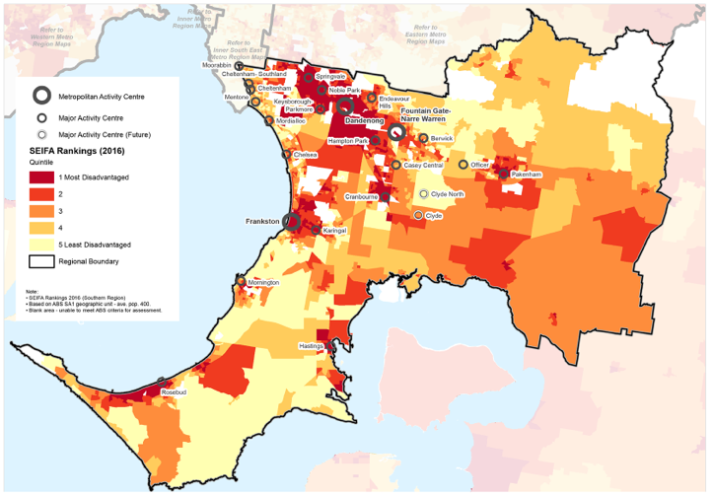

Social infrastructure
Social infrastructure includes all of the facilities, services and networks that help people to meet their social, cultural and community needs, in addition to health and education facilities.
There are contrasts between established urban areas in Kingston, Dandenong and Frankston LGAs and outer suburbs in Cardinia and Casey LGAs, with the latter experiencing rapid urban development leading to additional services and infrastructure needs.
The Southern Metro Region features a range of cultural, sporting and recreational options for residents. Arts and cultural community facilities include the Drum, Kingston Arts Centre, Bunjil Place and Frankston Arts Centre as well as a range of galleries. These assets are highly valued by residents and visitors.
The Southern Metro Region is home to approximately 50 major and regional level recreation facilities which serve both the local population and visitors, and provide for a wide range of sporting and active recreational opportunities.
Casey Fields is a 70-hectare regional sports complex, located in Cranbourne East, and the largest state-level facility. The Casey Complex, approximately 2 kilometres to the north of Casey Fields, is a major cultural facility that provides indoor sporting and cultural events. Other major sporting and active recreational assets include the National Water Sports Centre in Bangholme, State Volleyball Centre in Dandenong, State Mountain Bike Course at Lysterfield Park and Moorabbin Oval. In addition, there is a network of regional and local aquatic centres, stadiums, courts and sports grounds (DELWP, 2017c, p. 34).
Racecourses and horseriding are also popular recreational activities within the Southern Metro Region and regional level facilities are located in Mornington, Cranbourne and Balnarring.
The sandy soils of the Southern Metro Region are well suited to golf course construction. Some of the region’s ‘sandbelt’ golf courses are of international renown, including Peninsula, Commonwealth, Kingston Health, Kingswood Country Club and Mornington golf courses.
Regional justice infrastructure within the Southern Metro Region includes three Magistrates’ Courts, six Community Corrections Locations and four Justice Service Centres. Family violence and crimes against children continue to be a challenge for community services in the region (DELWP, 2017c, p. 28).

Regional strengths
- In areas such as Dandenong, Frankston and Berwick, co-located health and education facilities are supported by access to existing public transport infrastructure and can accommodate future investment.
- Within growth areas, there are opportunities to secure land and plan for public purposes such as community facilities.
- Regionally-significant health and education precincts present opportunities as hubs for health, education and community services to meet the needs of residents in established and growth areas.
- Hallmarks of 20-minute neighbourhoods can be more easily achieved in the established areas which are well connected by public and active transport modes.

Regional challenges
- There is an uneven distribution of primary health, education and community services to respond to the needs of existing residents and the growing population.
- Providing new or expanded sporting and recreation facilities to service the growing population in the middle ring suburbs is difficult due to land constraints.
- Achieving the hallmarks of 20-minute neighbourhoods in growth areas, where public and active transport connections are dispersed, is an ongoing priority.

Directions and strategies
The directions identified to achieve the 2050 vision for the Southern Metro Region in terms of Strong communities and Outcome 5 of Plan Melbourne are:
Direction 21 | Plan for major social infrastructure at a regional level
Direction 22 | Deliver health and education services in strategic locations
Direction 23 | Support a network of activity centres to anchor 20-minute neighbourhoods across the Southern Metro Region
Each direction is implemented through regionally-specific strategies identified in this LUFP.
Map 8 shows how strong communities will be enhanced across the Southern Metro Region by 2050 as a result of these directions and strategies, together with Plan Melbourne and other strategies and initiatives as outlined in Appendix 01.
- Southern Metro Region strong communities 2050
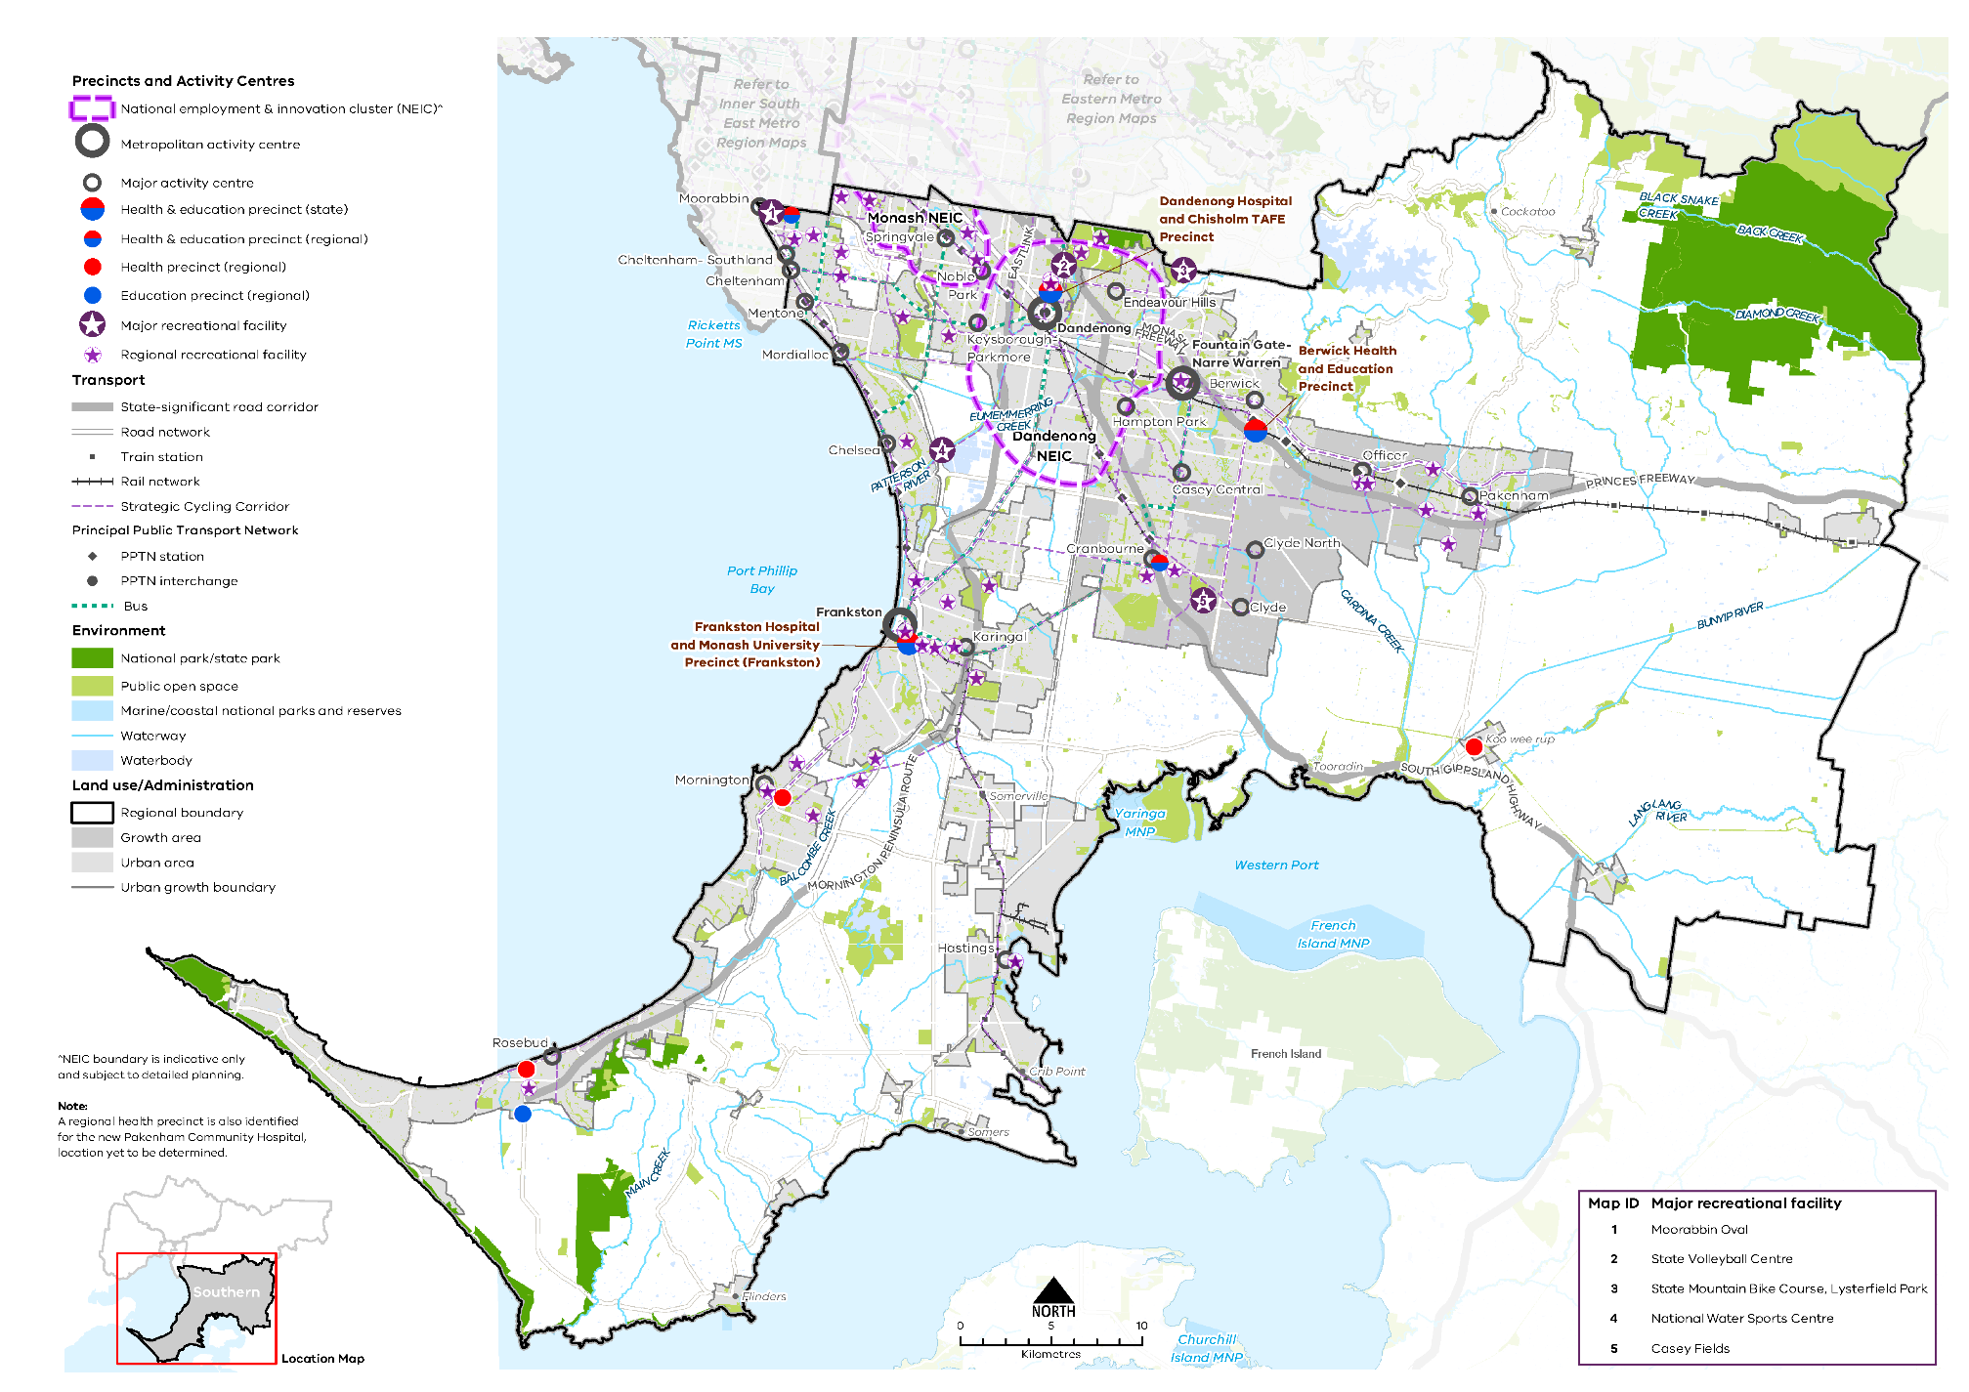
Map 8 Southern Metro Region strong communities 2050
A map showing the main community assets of the region in 2050 including state- and regionally-significant health and/or education precincts, as extracted from Map 1, and also highlighting:

- Major recreation facilities at:
- Moorabbin Oval
- State Volleyball Centre
- State Mountain Bike Course, Lysterfield Park
- National Water Sports Centre
- Casey Fields

- Regional recreation facilities including aquatic centres, stadiums, golf courses and race courses.

- Plan for major social infrastructure at a regional level
Planning from a regional perspective requires coordination between different levels of government to acknowledge that local councils plan for local infrastructure such as kindergartens, while the Victorian Government plans for state-level services such as government schools.
There is current variation in terms of access to social infrastructure across the Southern Metro Region, with the growth areas on average experiencing higher than anticipated density and household sizes. This is creating demand pressure on existing and planned social infrastructure that will require ongoing monitoring and adjustment to address demand.
There is an opportunity to enhance and diversify the role and activity of regionally-significant health and education precincts as regional focal points for communities in the Southern Metro Region. Planning for social infrastructure should prioritise locations within existing health and education precincts accessible by a range of transport options. This will also help achieve the hallmarks of 20-minute neighbourhoods.
Local-scale services, such as maternal and child health through to aged care and cemeteries, should be considered in the precinct planning for growth corridors and on major redevelopment sites (sites to which a PSP applies). Memorial parks can create a garden setting for cemetery services with a landscaped asset for the area.
The long-term need for sporting fields and specialist sporting facilities is not currently coordinated at a regional scale. Given the challenges associated with acquiring land and funding infrastructure, there would be significant value in taking a regional approach to planning and delivering these facilities.
The link between health, wellbeing and nature is reflected in many Victorian Government strategies including the Public Health and Wellbeing Plan 2019 –2023 and Active Victoria – A Strategic Framework for Sport and Recreation in Victoria 2017-2021. Creating healthy living environments, with a high level of urban amenity, opportunities for community connection and active transport, helps foster long-term community wellbeing.
- Encourage planning for major social infrastructure (such as libraries, recreation facilities, cultural centres or community hubs) to be undertaken in conjunction neighbouring regions to maximise co-location of facilities.
- Locate social infrastructure near activity centres and to be accessible by walking, cycling or public transport.
- Support regional planning that will provide for a range of sporting and active recreation facilities to meet the needs of the growing population, within existing urban areas and growth areas.
- Support the upgrade and expansion of existing social infrastructure to enable it to be more flexibly and intensively used.
- Facilitate a regionally coordinated approach to planning for ‘whole-of-life-cycle’ social infrastructure (excluding schools) for new communities within growth areas.
- Encourage utilisation of public land such as school grounds or golf courses for open space, recreation activities or trail connections by providing community access at times and in ways that do not jeopardise their primary purpose.
- Deliver health and education services in strategic locations
A key issue for the Southern Metro Region is to ensure established and new health infrastructure is appropriately positioned to respond to growing communities, especially in greenfield areas around Cranbourne, Clyde, Pakenham and Officer. Additional residential aged care capacity will be required to provide for an expanding and ageing population in Melbourne’s South Eastern Growth Corridor.
In the Southern Metropolitan Region there is an opportunity to connect health and education precincts to develop a regional network of facilities that provide a regional focal point, address gaps in service provision and meet the needs of a growing population. Local neighbourhood services and facilities also contribute to a broader network of health and education provision.
Plan Melbourne identifies state-significant health and/or education precincts to support health and education services that are well served by public transport in a range of locations across Melbourne. Regionally-significant health and/or education precincts in the region (Table 14) have a regional catchment, are accessible by a range of transport options and have a specialised economic function. This identification provides opportunities for the agglomeration of ancillary health and education services, retail, commercial and accommodation uses.
An expansion of the Frankston Hospital will meet the growing needs of the area. Community hospitals will be constructed in Pakenham and Cranbourne to provide access to in-demand medical services closer to home. Community hospitals will provide a broad range of ambulatory hospital, community health and social care services in one place, making it easier for users to receive care closer to home. Following the delivery of these hospitals, an investigation should be undertaken to determine if they meet the service needs of residents of Cardinia, with subsequent planning to support gaps in service provision.
Population growth is also expected to fuel demand for both university courses and vocational training. Continual monitoring and assessment of the capacity of existing infrastructure to meet this need is essential.
- Strengthen the role of the health and/or education precincts of the Southern Metro Region by co-locating new health and/or education facilities within these precincts and encouraging an agglomeration of ancillary uses such as primary healthcare, retail and accommodation.
- Expand the network of health and/or education facilities and precincts across the region to meet the needs of the growing population. Ensure that these facilities and precincts are accessible by public transport, walking and cycling.
- Support the upgrade of existing health and education infrastructure to allow for more intensive use of those services.
- Ensure the early provision of health and education facilities and precincts in the South Eastern Growth Corridor to support the
needs of new communities. Locate these facilities or precincts within or near activity centres to maximise the benefits of colocation with ancillary land uses.
- State-significant and regionally-significant health and/or education precincts
State-significant Health and Education Precinct | Regionally-significant Health and Education precinct
Frankston Hospital and Monash University Precinct (Frankston)  Casey Hospital and Monash University Precinct (Berwick)  Dandenong Hospital and Chisholm TAFE Precinct | Cranbourne Integrated Care Centre and Chisholm Institute of TAFE (Cranbourne)  Holmesglen Private Hospital and Holmesglen Institute of TAFE (Moorabbin)
 | Regionally-significant Health Precinct
Rosebud Hospital and allied health services (Rosebud)
Peninsula Health, the Bays Hospital, Beleura Private Hospital (Mornington)
Kooweerup Regional Health Service
Pakenham Community Hospital (proposed)
 | Regionally-significant Education Precinct
 | Chisholm Institute of TAFE (Rosebud)
- Support a network of activity centres to anchor 20-minute neighbourhoods across the Southern Metro Region
All activity centres in the Southern Metro Region play a role in terms of enabling 20-minute neighbourhoods. While neighbourhood activity centres play a local role, larger metropolitan and major activity centres service a wider catchment and play a wider role in terms of providing more local jobs and services.
A varied response will be needed across the Southern Metro Region to create 20-minute neighbourhoods. There is an opportunity to look for more innovative ways to connect people in lower-density suburbs to activity centres, services, recreation and cultural facilities.
A regionally consistent designation of neighbourhood activity centres will enable a network of 20-minute neighbourhoods where gaps in service provision can be identified and planned for, allowing for the prioritisation of investment. This is particularly important where centres straddle regional or council boundaries.
The timely delivery of new infrastructure and services, including a coordinated effort across all tiers of government, will be critical to achieving 20-minute neighbourhoods, including partnerships with private providers to deliver regional-scale infrastructure in growth areas. Place-based planning of local development, services, infrastructure and destinations will maximise the benefits of investment in new transport infrastructure. These opportunities need to be carefully considered as part of the planning and delivery of precincts around the SRL station at Cheltenham Precinct.
A 20-minute neighbourhood pilot program, initiated in 2020, identified place-based planning and community partnerships as an important component of achieving the hallmarks of 20-minute neighbourhoods. Work is underway to develop guidance tools for local councils in designating neighbourhood activity centres.
- Plan for existing and new activity centres to embed the 20-minute neighbourhood hallmarks, through a place-based, community partnership approach. This includes new activity centres within the South Eastern Growth Corridor.
- Support a consistent designation of neighbourhood activity centres and their role in the network of activity centres across the Southern Metro Region.
- Embed the 20-minute neighbourhood hallmarks in planning within the catchment of major infrastructure projects.
- Support the role of neighbourhood activity centres to provide retail, community and allied health services to their respective local catchments.

Actions – Strong communities
- Investigate the need for aged care services and facilities and identify planning considerations in their delivery.
- Review the breadth of tertiary education offerings and the location of higher educational facilities to ensure they meet local and regional needs.

Sustainability and resilience
Plan Melbourne Outcome 6: Melbourne is a sustainable and resilient city
Plan Melbourne aims to create a resilient and sustainable city. It recognises the need to mitigate greenhouse gas emissions, reduce exposure to natural hazards, undertake whole of water cycle planning and design, and protect local waterways. It also encourages resource efficiency and promotes the benefits of urban cooling and greening.
While heatwaves have a greater negative effect on population health than any other climate-related issue, the Southern Metro Region will also experience lower rainfall and more extreme rainfall events. Valued coastal environments, coastal suburbs and infrastructure will be increasingly under pressure from tidal inundation and sea level rise.
Coupled with urbanisation, increased temperatures and lower annual rainfall will place additional pressure on natural assets and marine ecosystems such as Port Phillip Bay and Western Port, Ramsar wetlands, creeks, river corridors, parks and other valued vegetation. These changes will also put pressure on agricultural production and drive the importance of whole of water cycle planning.
The Southern Metro Region has significant challenges to overcome to create a resilient, sustainable region. Key priorities include supporting existing metropolitan and regional waste and water treatment facilities, delivering better environmental services in green wedges and effectively adapting and reducing climate risk.

Urban heat environments
By 2050, the average annual temperature in the Southern Metro Region is forecast to increase between 0.7° Celsius and 2.8° Celsius under a medium emissions climate change scenario (JM, et al., 2019). As our climate warms the number of people exposed to the risk of mortality from heatwaves will increase. It is estimated around 53,000 residents in the Southern Metro Region were exposed to high urban heat conditions in 2018, particularly in growth area communities (Urich Hardy, 2019).
In 2018, the average land surface temperature (LST) in the Southern Metro Region was 33.6°Celsius. LST was highest in Casey LGA and coolest in Mornington Peninsula LGA (Figure 24). Growth areas have more people exposed to higher urban temperatures during periods of hot weather. Children, seniors, people with pre-existing illnesses and those with fewer resources to adapt are at greater risk on hot days and in prolonged periods of hot weather (Figure 25).
Urban environments that stay cooler on hot days are more physically comfortable to humans and animals and continue to support movement and recreation. As the number and duration of hot days increases, these environments will be important to reduce the likelihood of heat-related illness. Cooler urban environments are characterised by more tree cover, less hard surfaces, more water infiltration into the ground and fewer heat absorbing building materials.
There are large areas of urban heat across the Southern Metro Region including from Springvale to Pakenham in the east and Cranbourne and Clyde in the south-east. These areas have less trees and more hard surfaces, including new communities converted from agricultural land to urban purposes. Conversely, the region also features grasslands, agricultural areas, green wedge areas and coastal environments with higher levels of tree canopy. This means individual suburbs offer different levels of amenity on hot days.
- Average land surface temperature by LGA, 2018
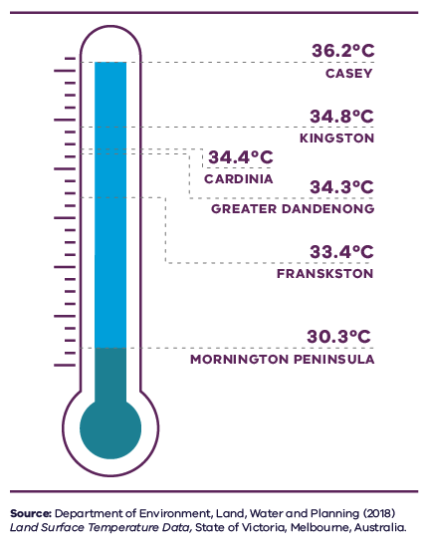
Figure 24. Average land surface temperature by LGA, 2018
Casey | 36.2 degrees Celsius
Kingston | 34.8 degrees Celsius
Cardinia | 34.4 degrees Celsius
Greater Dandenong | 34.3 degrees Celsius
Frankston | 33.4 degrees Celsius
Mornington Peninsula | 30.3 degrees Celsius
Source: Department of Environment, Land, Water and Planning (2018) Land surface temperature data, State of Victoria, Melbourne, Australia.
- Heat vulnerability index map for the Southern Metro Region, 2018
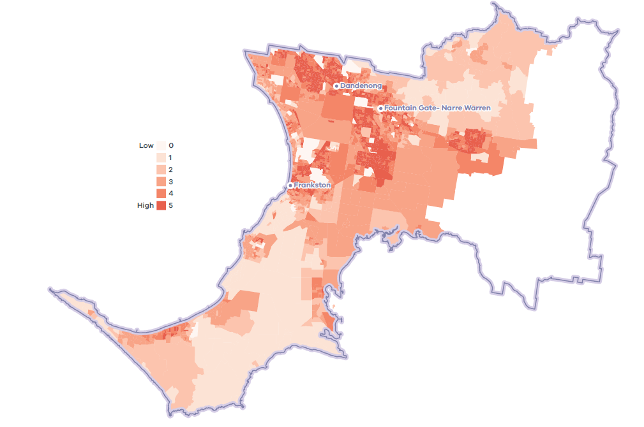

Flooding risk and waterway health
While overall annual rainfall will decrease, the Southern Metro Region is predicted to see more frequent and intense rainfall events due to climate change. More intense rainfall will increase the risk of flooding in areas such as the Dandenong Creek Valley and the Mornington Peninsula, and contribute to existing inter-regional flooding issues that extend from Mordialloc to Caufield North (Inner South East Metro Region) (DELWP, 2018b).
Currently a significant proportion of the Southern Metro Region is subject to flooding. Large expanses of land from Clyde and Pakenham in the growth areas, and east across the green wedges to the edge of the Southern Metro Region, are governed by flooding controls in planning schemes.
Continued urban consolidation and resultant increases in impermeable surfaces will exacerbate this situation, presenting a greater risk of stormwater inundation to both private and public property.

Sea level rise and coastal inundation risk
Almost 30 per cent, or 90 kilometres, of Port Phillip Bay’s coastline and 145.5 kilometres of Western Port’s coastline, is in Melbourne’s Southern Metro Region (DELWP, 2017b).
Coastal flooding occurs along the Mornington Peninsula where approximately 40 per cent of the coastline is designated as flood prone.
Much of Western Port’s coastline is low tidal mudflats and mangrove thickets. Former swamplands of Koo Wee Rup and low-lying coastal settlements around Tooradin and Blind Bight are highly susceptible to flooding (Map 9).
The coastline and bays have significant value to the Victorian community for a range of cultural, recreational, environmental and economic values (DELWP, 2017b, p. 20). The bays have pressures from urbanisation and changing land use throughout the Port Phillip and Western Port catchments. Rainfall intensification will exacerbate current impacts including increased stormwater and pollutant runoff. Marine and coastal environments will be impacted by water temperature and sea level rise. Storm surges will also become more frequent, exposing the coastline to erosion and inundation (DELWP, 2017b).
As projected average temperatures continue trending upwards through this century, so too will global mean sea levels as oceans partially absorb atmospheric heat and glaciers and polar ice caps continue to melt.
State planning policy recognises the need to plan for anticipated sea level rise to Port Phillip Bay and Western Port, with Western Port expected to experience greater levels of sea level rise than Port Phillip Bay. Given the uncertainty of our climate change future, planning policy will need to be responsive to future recalibration of sea levels (Melbourne Water, 2017).

Coastal acid sulfate soil risk
Acid sulfate soils have been identified around both Port Phillip bay and Western Port bay (Victorian Government, 2009). While these soils are naturally occurring in coastal and inland settings, modification of the landscape such as draining swampland, excavation and development can trigger the release of toxic elements that can contaminate drinking water and food. Future disturbance of low-lying coastal soils must be prevented.

Bushfire risk
In the eastern parts of the Southern Metro Region, green wedges provide non-urban landscapes interspersed with urban interfaces. While providing an important non-urban buffer, these areas have large urban and rural interfaces with identified bushfire risk in all LGAs in the Southern Metro Region. The bushfire risk extends to a significant number of suburbs and non-urban areas, with a mix of grassland and areas of high vegetation cover. Key areas of bushfire risk, high vulnerability and other sustainability factors across the Southern Metro Region are shown in Map 9.

Eastern Treatment Plant
The Eastern Treatment Plant, located in Bangholme, treats almost half of Melbourne’s sewage at 350 million litres a day. It uses innovative treatment processes to treat all sewage received at the plant to a very high quality which both protects the receiving marine environment at Boags Rocks on the southern Mornington Peninsula as well as meeting the requirements for Class A recycled water. The plant currently generates around 30 per cent of its own energy supply needs. Recycled water is used to irrigate crops, parklands and sporting fields (DELWP, 2018b). As Melbourne grows the amount of treated water generated by the plant will grow.

Urban tree canopy
Across the Southern Metro Region the tree canopy plays an important role of providing habitat and contributing to the character of parks and the green wedges. In urban areas, trees also provide cooling, amenity, recreation and respite for residents (Figure 26).
The Southern Metro Region has 15.2 per cent of urban tree canopy cover which is about the same as the metropolitan average of 15.3 per cent (Hurley, et al., 2019a). Tree canopy varies across the region. There are areas of greater coverage in southern coastal areas along Port Phillip Bay and Western Port and in the northern part of the region, north of Cardinia Reservoir. Mornington Peninsula has the highest urban tree canopy coverage of almost 22 per cent while Greater Dandenong has the lowest urban tree canopy of 6.6 per cent (Figure 27).
Across the Southern Metro Region, most of this urban tree canopy is on residential land, parkland and linear infrastructure such as streets (Figure 28).
- Urban tree canopy cover by land use, 2018
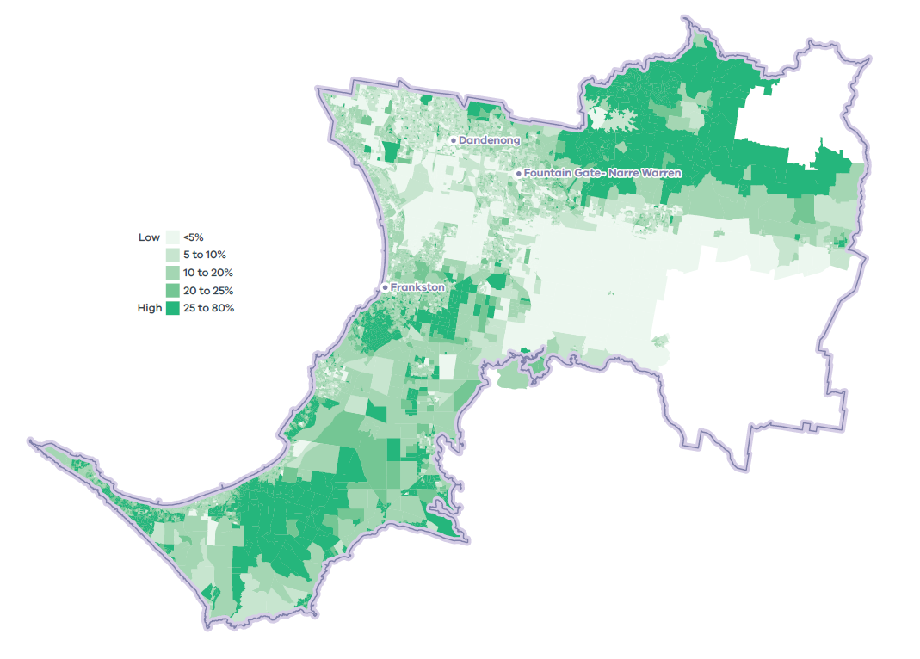
- Tree canopy cover 2018, and tree canopy cover change 2014 to 2018, by LGA
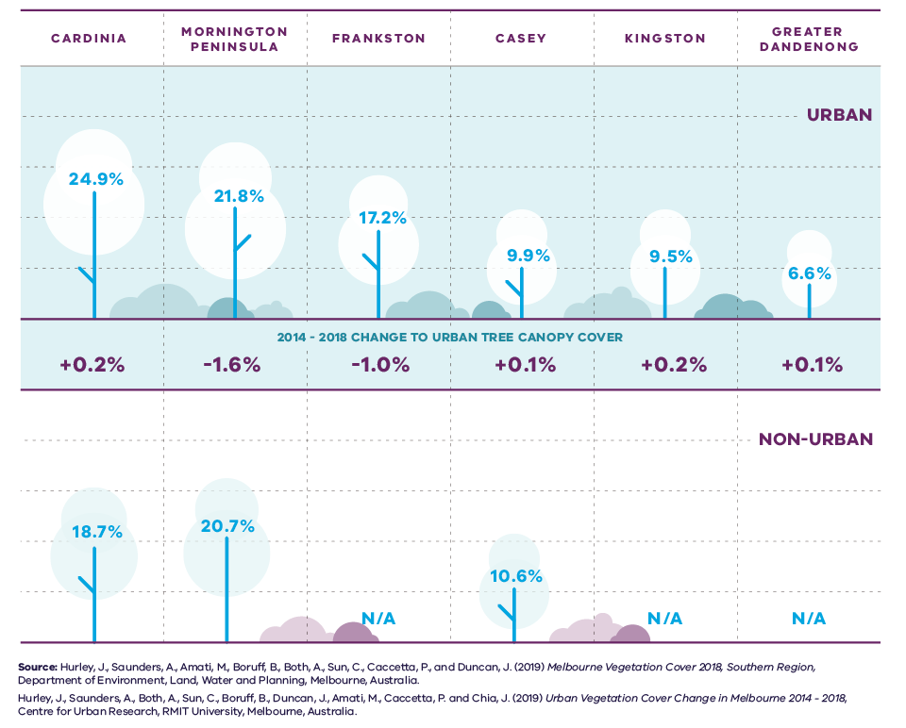
Figure 27. Tree canopy cover 2018, and tree canopy cover change 2014 to 2018, by LGA
LGA | Urban tree canopy cover 2018 | 2014 to 2018 change to urban tree canopy cover | Non-urban tree canopy cover 2018
Cardinia | 24.9 per cent | Plus 0.2 per cent | 18.7 per cent
Mornington Peninsula | 21.8 per cent | Minus 1.6 per cent | 20.7 per cent
Frankston | 17.2 per cent | Minus 1.0 per cent | Not applicable
Casey | 9.9 per cent | Plus 0.1 per cent | 10.6 per cent
Kingston | 9.5 per cent | Plus 0.2 per cent | Not applicable
Greater Dandenong | 6.6 per cent | Plus 0.1 per cent | Not applicable
Sources:
Hurley, J., et al. (2019) Melbourne Vegetation Cover 2018, Southern Region, Department of Environment, Land, Water and Planning, Melbourne, Australia.
Hurley, J., et al. (2019) Urban Vegetation Cover Change in Melbourne 2014 – 2018, Centre for Urban Research, RMIT University, Melbourne, Australia.
- Urban tree canopy cover by land use, 2018
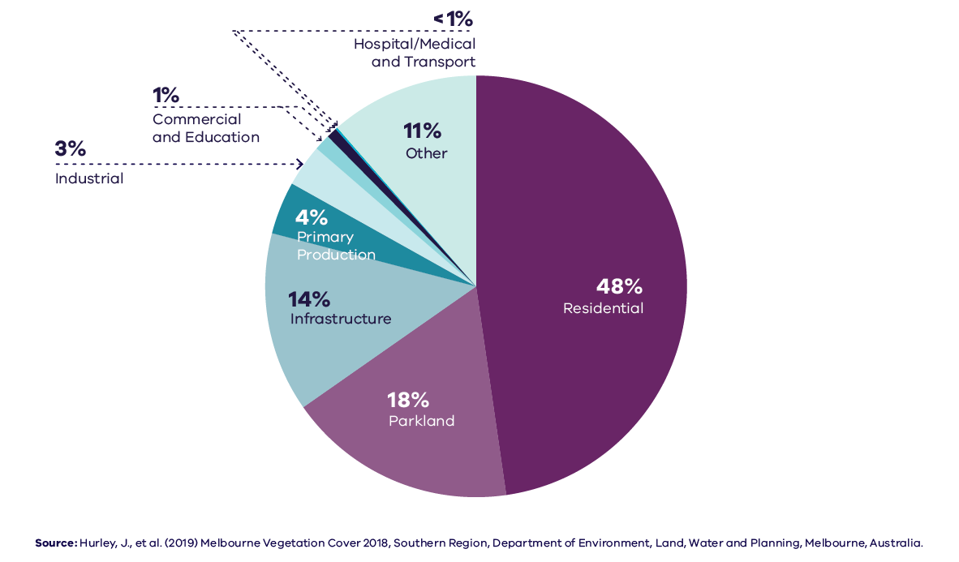
Figure 28. Urban tree canopy cover by land use, 2018
Residential | 48 per cent
Parkland | 18 per cent
Infrastructure | 14 per cent
Primary production | 4 per cent
Industrial | 3 per cent
Commercial | 1 per cent
Education | 1 per cent
Hospital/medical | Less than 1 per cent
Transport | Less than 1 per cent
Other | 11 per cent
Source: Hurley, J., et al. (2019) Melbourne Vegetation Cover 2018, Southern Region, Department of Environment, Land, Water and Planning, Melbourne, Australia.

Resource efficiency and waste and resource recovery
In 2013-14 Greater Melbourne had a 73 per cent resource recovery rate, with 805,000 tonnes of food and garden waste sent to landfill. By 2042 it is projected waste volumes will grow by 63 per cent to 16.5 million tonnes each year (Metropolitan Waste and Resource Recovery Group, 2016).
Even with greater levels of waste and resource recovery, Melbourne will not have enough land filling capacity in any of its significant landfills. The most significant landfills, designated as hubs of state importance in the Southern Metro Region, are SUEZ Hallam and SUEZ Lyndhurst. SUEZ Hallam is likely to close by 2040 and SUEZ Lyndhurst has the potential to operate beyond 2046 (Metropolitan Waste and Resource Recovery Group, 2016).

Sustainability in the built environment
In 2013, residential buildings were responsible for nearly 12 per cent of Australia’s national greenhouse gas emissions, and commercial buildings contributed just over 11 per cent. The majority of these emissions were generated through the consumption of grid-supplied electricity to power appliances, lighting, and predominantly heating, ventilation and cooling systems (Australian Sustainable Built Environment Council, 2016).
As average temperatures rise due to climate change, greater numbers of people are expected to seek comfort indoors during high heat conditions. This, combined with population growth and overall poor-performing building stock, means our city lacks energy efficiency and resilience on hot days. Maximising opportunities to incrementally improve the performance of buildings will reduce our reliance on appliances to cool buildings and contribute to a lower likelihood of blackouts during periods of hot weather.
Local councils within the Southern Metro Region are active in adopting policies and strategies to reduce carbon emissions and improve the sustainability of the built environment. Many are innovators and leaders in environmentally sustainable development (ESD) and are implementing practices to improve the energy efficiency of civic buildings and reduce emissions from operations.
Several LGAs are members of the Council Alliance for a Sustainable Built Environment (CASBE), an association committed to designing and applying a range of practical methodologies to increase sustainability outcomes for new buildings. The Built Environment Sustainability Scorecard (BESS) is an online tool developed by CASBE that assesses the sustainability of proposed developments. It aims to reduce waste and improve energy efficiency from the outset of the construction phase, through to occupation. As well as onsite energy generation, BESS promotes the use of energy-efficient appliances, thermally-efficient glazing, wall cladding and insulation, water-efficient fittings and fixtures, thermal comfort and overall environmentally sustainable performance.
Other rating systems increasingly used by the building design industry to measure and assess the performance of ESD principles include Green Star (Green Building Council of Australia, 2021), NatHERS (Nationwide House Energy Rating Scheme, 2021) and MUSIC (MUSIC Auditor, 2021).

Energy networks
Melbourne’s energy grid is transforming. The city’s future grid will have a greater ability to export energy from individual properties or a local area, presenting a more flexible approach to energy production. It will be smarter, more reliable and provide greater energy security. Regional energy generation and storage is also a potential option, and the region’s green wedge areas could provide an opportunity to support these facilities subject to environmental and landscape considerations.

Regional strengths
- Increasing volumes of treated wastewater from the Eastern Treatment Plant can be used for urban cooling and greening, agriculture and industry.
- There are opportunities for increased use of recycled water from several locations within the region.
- A strong tree canopy exists in parts of the region and can be extended to assist with urban greening and cooling.

Regional challenges
- Coastal inundation and sea level rise pose significant risk to population, ecosystems, infrastructure and property.
- Environmental hazards are significant considerations in planning for growth, such as large expanses of land subject to flooding, and bushfire risk to the community, infrastructure and high-value native forests, grasslands and ecosystems.
- Areas of high urban heat and heat vulnerable communities exist in parts of the region.

Directions and strategies
The directions identified to achieve the 2050 vision for the Southern Metro Region in terms of Sustainability and resilience and Outcome 6 of Plan Melbourne are:
Direction 24 | Manage the impact and risk of sea level rise
Direction 25 | Better plan for land use to use forecast recycled water across the region
Direction 26 | Increase the retention and reuse of water in the urban environment
Direction 27 | Respond to the transformation of the energy supply network
Direction 28 | Minimise and reduce risk from bushfire
Direction 29 | Increase the network of cool places, particularly in areas with communities vulnerable to urban heat and areas with high urban heat
Direction 30 | Increase urban tree canopy across the Southern Metro Region to achieve 30 per cent coverage by 2050
Direction 31 | Protect sites of strategic importance for recycling and plan for the expansion of key sites for future resource recovery needs
Each direction is implemented through regionally-specific strategies identified in this LUFP.
Map 10 shows how sustainability and resilience will be enhanced across the Southern Metro Region by 2050 as a result of these directions and strategies, together with Plan Melbourne and other strategies and initiatives as outlined in Appendix 01.
- Southern Metro Region sustainability and resilience state of play
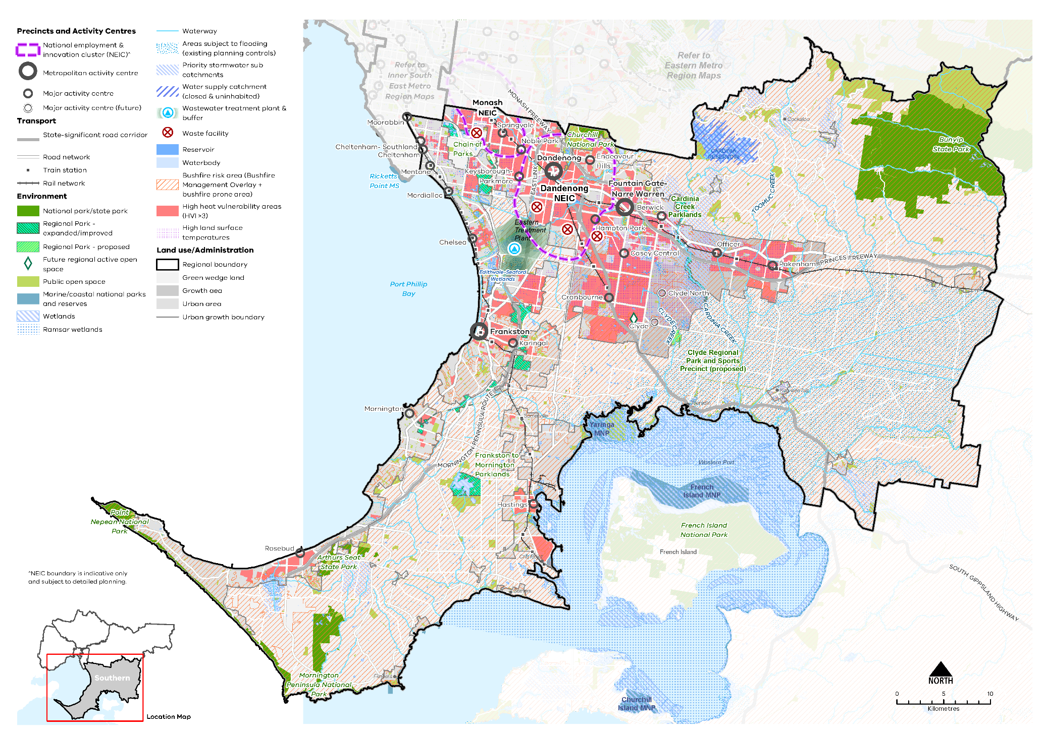

Map 9 Southern Metro Region sustainability and resilience state of play
A map showing the current sustainability and resilience of the Southern Metro Region, as extracted from Map 1, and also highlighting:
- Bushfire risk areas (taken from the Bushfire Management Overlay and bushfire prone area)
- Areas of high heat vulnerability principally in the central part of the region
- Areas with high land surface temperatures found across the urban area
- Areas subject to flooding (existing planning controls) and priority stormwater sub catchments
- Ramsar wetlands
- The Eastern Treatment Plant (wastewater) and buffer zone
- Four waste facilities of state significance: SUEZ Hallam, SUEZ Lyndhurst, Ordish Road Precinct in South Dandenong, Clayton South Precinct.

- Southern Metro Region sustainability and resilience 2050
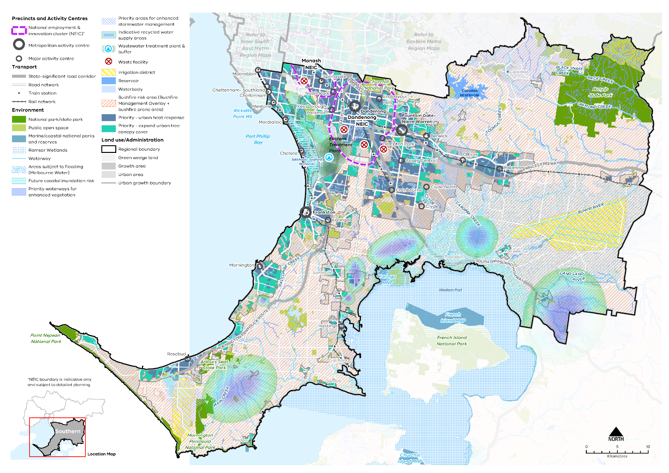

Map 10 Southern Metro Region sustainability and resilience 2050
A map showing the sustainability and resilience of the Southern Metro Region in 2050, as extracted from Map 1, and also highlighting:
- Future coastal inundation risk affecting significant areas on Port Phillip Bay and Western Port
- Priority areas for enhanced stormwater management
- Priority waterways for enhanced vegetation along waterways
- Priority areas for an urban heat response and expanding the urban tree canopy cover
- Areas subject to flooding (updated Melbourne Water data)
- Irrigation districts at Boneo, Tooradin and Canons Creek
- Indicative recycled water supply areas northwest of Koo Wee Rup and east of Lang Lang as well as on the Morning Peninsula north of Tyabb, north east of Pearcedale and between Main Ridge and Red Hill.

- Manage the impact and risk of sea level rise
Rising sea levels caused by climate change are expected to impact urban settlements, infrastructure and coastal and marine ecosystems in the Southern Metro Region, with the potential for major disruption.
More than half of the Southern Metro Region’s boundary, or almost 300 kilometres, is coastline, with half of this coastline featuring urban settlements and suburbs.
Various economic, community and environmental assets are located adjacent to the shorelines of Port Phillip bay and Western Port and lie at relatively low elevations making them vulnerable to inundation associated with sea level rise.
Land around Frankston, Chelsea, Mordialloc, Hastings, Koo Wee Rup, Warneet, Cannons Creek, Tooradin and South Gippsland Highway, including coastal wetland environments, has been identified as at risk of sea level rise and storm surge from coastal waters, drains and creeks. It is expected that mature mangroves and the establishment of mangroves on the fringe of Western Port will also be impacted by rapid erosion and increased sediments from sea level rise (Water Technology, 2014).
The impacts of storm surge and coastal inundation must be planned for (Water Technology, 2014). Regional planning can help integrate and manage land use and infrastructure change to reduce the risk to settlements and natural assets from coastal inundation and storm surge.
DELWP is undertaking a Local Coastal Hazard Assessment for Port Phillip Bay. The Local Coastal Hazard Assessment will provide better information about the expected impacts of coastal hazards such as saline groundwater intrusion, erosion and inundation that are exacerbated by the effects of climate change. This information will better inform planning decisions in public coastal areas around the bay.
Current work underway by DELWP and LGAs for the Western Port and Mornington Peninsula green wedges has identified a number of climate change issues. This includes managing the impacts of sea level rise, flooding and stormwater on coastal towns and rural areas (Victorian Government , 2021). They also identify the need to prevent further contamination from coastal acid sulphate soils.
Given the uncertainty of the impacts of climate change and sea level rise into the future, a flexible and adaptive approach to planning approach across government, agencies and LGAs is required to manage and mitigate risks holistically for the region.
- Encourage settlement planning for coastal environments and communities to respond to sea level rise and natural hazard risk.
- Limit major land use change in locations with future coastal inundation.
- Better plan for land use to use forecast recycled water across the region
Plan Melbourne supports the use of all water sources including recycled water, to ensure the city remains liveable and sustainable and to reduce reliance on drinking water. By 2050, Plan Melbourne identifies a greater contribution of recycled water to Melbourne’s water supply mix.
Recycled water is produced at water recycling plants across the Southern Metro Region, the largest being the Eastern Treatment Plant (ETP). The advanced tertiary treatment applied at ETP produces some of the best quality and lowest risk recycled water in Victoria. Recycled water not used by existing customers is discharged via the 56 kilometres South East Outfall to Bass Strait at Boags Rocks. The Melbourne Sewerage Strategy 2018 includes goals about how the use of recycled water can be optimised and contribute to Victoria’s circular economy.
Some areas of land within the Southern Metro Region are already using recycled water such as the Boneo Recycled Water Irrigation Scheme. South East Water has also recently committed to establishing a new recycled water scheme in the Bunyip region while a number of additional opportunities to expand recycled water have been identified, which if realised, could significantly increase agricultural productivity and job creation for the region.
Recycled water could also be used to irrigate open spaces, improve vegetation health and reduce the risk of bushfire. Access to recycled water could provide opportunities for a broader mix of uses, including community uses in Southern Metro Region green wedges.
As Melbourne grows the need to treat wastewater and the potential need to discharge significant amounts of water into Bass Strait will increase. The projected increase in recycled water is a major opportunity for the Southern Metro Region. Planning should support the delivery of recycled water, including diverting recycled water from the South Eastern Outfall, to agricultural and urban use.
- Support land use that will utilise and facilitate the expansion of recycled water access.
- Protect and buffer the Eastern Treatment Plant through appropriate planning zones as a waste water management hub.
- Support the use of recycled water on open spaces, including in Frankston, Mornington Peninsula and Cardinia LGAs (where appropriate).
- Support recycled water access to Gippsland irrigators and agricultural uses.
- Increase the retention and reuse of water in the urban environment
Integrated stormwater management, reducing runoff into waterways and wetlands, and water recycling will improve climate resilience and liveability across the Southern Metro Region.
Parts of the Dandenong, Port Phillip and Western Port catchments will continue to undergo significant land use change for housing, diversification of activity centres, and new industrial, health and education precincts. This will increase rapid runoff and flooding and negatively affect water quality and waterway health for aquatic life. Responding to this change and supporting the health of the region’s waterways, wetlands and bays will be an ongoing challenge.
While some areas of the Southern Metro Region are subject to flooding overlays, such as the Special Building Overlay (SBO) and Land Subject to Inundation Overlay (LSIO), there is an opportunity to increase stormwater and floodwater harvesting capabilities. Improved stormwater storage capabilities and stormwater harvesting and management across the region, could reduce the risk and cost of major rainfall events and minimise impacts, such as pollution to the bay’s marine environments (DELWP, 2018b).
Local capture of stormwater, water recycling, restoration and revegetation of urban waterways and greywater systems will improve the region’s hydrological and ecological systems.
Harvesting stormwater and increasing water infiltration is important in dense suburbs to reduce runoff and service vegetation. Harvested stormwater can help maintain water-reliant facilities and amenities such as sporting fields and gardens, contribute to more resilient vegetation and reduce demand on drinking water. Open spaces, pedestrian and cycling networks and new subdivisions can all use WSUD to improve urban amenity and retain water in the urban environment (DELWP, 2018b).
Development also increases the quantity of wastewater generated in urban areas, which provides another opportunity to diversity water sources. For example, wastewater can be recycled and used to irrigate public open space and sporting grounds. This will help improve water security as the climate warms and overall rainfall decreases. Further, wastewater contains nutrients and organic matter that could be used to create valuable products such as fertilisers and energy sources. Given increasing limits in resource availability, this creates an opportunity to expand the benefits of wastewater management by exploring different options for resource recovery.
The Victorian Government’s strategies Water for Victoria and Integrated Water Management Framework for Victoria provide the strategic framework for water management in Victoria. At the regional scale, options to increase the retention and reuse of water in the urban environment should be based on the actions contained in the Dandenong and Western Port Catchment Scale Integrated Water Management Plans (IWMs), Monash NEIC IWM strategy, Fountain Gate-Narre Warren Metropolitan Activity Centre IWM strategy, flooding strategies, relevant sub-catchment IWM plans and local government IWM plans.
These plans should be used as the basis to support governments and relevant agencies to prioritise and align water infrastructure needs and deliver integrated water management outcomes. This may include the preparation of an appropriately scaled IWM Plan (that is sub-catchment, precinct or local scale) by the lead planning authority in collaboration with relevant referral agencies to guide sustainable water design and development decisions.
- Retain and harvest stormwater in priority sub-catchments.
- Retain and harvest stormwater at a range of scales throughout the region and places designated for high levels of change.
- Encourage development to design for permeable areas, include green spaces, avoiding paved areas and passively irrigating vegetation.
- Encourage all urban and rural land use to effectively control stormwater and runoff impacts, and that controls are in place to manage increases in nitrogen and sediment loads.
- Improve regional water outcomes by aligning sub-catchment and local IWM planning with opportunities and directions identified at the catchment scale.
- Respond to the transformation of the energy supply network
In the future, electricity networks must be responsive to changing demands from traditional services while enabling new opportunities for energy resource sharing and balancing. Millions of customers generate electricity and over time will store it locally. These customers will be connected to the network and each other, enabling energy networks to act as platforms that match supply and demand and reduce the need for inefficient duplication of energy investments. At the same time, the state is working towards the decarbonisation of the broader energy supply network.
To support a renewable energy future and drive down emissions, major changes to the supply network are required. This includes the creation of local and regional renewable energy hubs across the state, improvements to crucial grid infrastructure, and support for more localised renewable energy generation and storage.
Large subdivisions and growth area development in the South Eastern Growth Corridor must be planned to support this future energy network and avoid the need to retrofit energy infrastructure.
- Ensure subdivision and greenfield development can support the emerging energy supply network.
- Minimise and reduce risk from bushfire
The Southern Metro Region is at risk from bushfire due to vegetated environments in the Mornington Peninsula and Frankston LGAs as well as grasslands in Casey and Greater Dandenong LGAs and parts of Kingston LGA’s green wedge. The need to plan for the risk of bushfire to communities, infrastructure and natural environments will continue to increase as the climate warms and overall rainfall decreases.
The likelihood of forest fires and grass fires, and their severity and intensity, depends on the location and surrounding landscape characteristics. There are large areas of land, mostly outside the urban area, already governed by state planning policy for bushfire (Clause 13.02), the Bushfire Management Overlay (BMO) and the building systems bushfire prone areas (BPA). The BMO and BPA aim to strengthen community resilience to bushfire by considering bushfire measures as part of the design process and ensuring new development achieves an acceptable level of bushfire risk. However, there is also a need to strengthen the resilience of settlements and communities to bushfire through strategic, risk-based regional planning that prioritises the protection of human life over other policy considerations.
To protect human life from bushfire, population growth and development should be directed to low-risk locations and areas that are safe to access. Infill development should be limited in interface locations, where bushfire risks should be considered and protection measures maximised to reduce exposure. Areas of high bushfire risk should be avoided for more sensitive uses, frequented by vulnerable populations such as the elderly or the very young who may have difficulty evacuating in the event of a bushfire.
Bushfire risk should be incorporated into the design of the South Eastern Growth Corridor and sub-division adjacent to green wedge land. The road, subdivision and open space design and layout, and the treatment of the interface to green wedge land, can help reduce and manage bushfire risk.
- Limit housing growth and sensitive land uses within and in proximity to bushfire prone areas.
- Ensure precinct structure planning and subdivision design in the Southern Metro Region responds to bushfire risk and the urban rural interface, and utilises road, lot, open space and water cycle design to help reduce bushfire risk.
- Increase the network of cool places, particularly in areas with communities vulnerable to urban heat and areas with high urban heat
More tree canopy cover, permeable surfaces and water in the urban environment will help reduce urban temperatures and create cooler, more comfortable local micro-climates across the Southern Metro Region.
Plan Melbourne notes that temperature decreases of between 1° Celsius and 2° Celsius can have a significant impact on reducing heat-related morbidity and mortality (DELWP, 2017a).
In addition to trees, green walls, shade structures and low heat absorbing materials can help reduce urban surface temperatures and create cool urban areas. These techniques will be important in the South Eastern Growth Corridor, Dandenong NEIC, activity centres and the Southern SSIP which have areas of high urban heat. Land uses frequented by older people and children, who are more vulnerable to urban heat, will need to provide for more active cooling of outdoor environments.
Dandenong NEIC, Fountain Gate-Narre Warren and Frankston metropolitan activity centres, along with the Cheltenham-Southland, Mordialloc, Chelsea, Springvale, Noble Park, Keysborough Parkmore, Endeavour Hills, Hampton Park, Casey Central Berwick, Cranbourne, Officer, Pakenham major activity centres have communities vulnerable to urban heat. These communities are at a higher risk of heat-related illness during periods of multiple hot days (Sun, et al., 2019). There are also large areas of high urban surface temperatures in Hastings, Crib Point, proposed growth communities and the future activity centres of Clyde and Clyde North.
Buildings with vegetation and roof gardens will need to be combined with onsite water harvesting and storage to maintain vegetation health and reduce potable water demand.
- Increase tree canopy and water sensitive urban design in areas with high urban heat vulnerability and high urban heat.
- Design and develop outdoor spaces that are cool on hot days through the use of water-permeable paving, vegetation and water sensitive urban design in the:
- Dandenong NEIC and Fountain Gate-Narre Warren metropolitan activity centres
- Cheltenham-Southland, Mordialloc, Chelsea, Springvale, Noble Park, Keysborough-Parkmore, Endeavour Hills, Hampton Park, Casey Central Berwick, Cranbourne, Officer, Pakenham, Clyde and Clyde North major activity centres.
- Encourage green roofs and green structures with climate resilient planting and irrigation on apartment developments in areas with high urban heat and large commercial and industrial sites.
- Increase urban tree canopy across the Southern Metro Region to achieve 30 per cent coverage by 2050
Trees provide an essential service to the surrounding environment. In the absence of water, trees and in particular clusters of trees, make the greatest contribution to reducing surface temperatures, along with contributing to stormwater filtration, amenity and biodiversity (Coutts Tapper, 2017) (Sun, et al., 2019). These important functions are vital for sustainability and resilience as our climate warms and the Southern Metro Region’s population grows.
A key challenge for increasing tree canopy is the ability to retrofit existing urban areas for green infrastructure due to the availability of public and private space and the multiple functions of public land and publicly accessible places. For example, there are potential conflicts with electrical powerlines, underground cabling, gas and stormwater pipe works and regulation, and transport movement.
Tree planting will need to avoid remaining areas of natural grasslands as these are some of the most precious remaining natural assets in the region.
Most of the Southern Metro Region’s growth is expected to be accommodated in the growth areas, in and around activity centres, and in areas with good access to existing services and transport infrastructure. These locations are important for growth and a sustainable urban form. Some of these sites will be less able to accommodate trees and a broader range of cooling and greening methods will be required. Outside of substantial change areas, more trees can be retained on private land and private developments can generally provide higher levels of planting. In bushfire interface areas, planting should be managed and respond to potential bushfire risk. Species selection can also help reduce bushfire risk.
While substantial change locations will likely be more constrained, tree planting may yield greater co-benefits such as reducing urban temperatures, regulating the local climate and offering stormwater benefits. Activity centres, areas with people exposed to high land surface temperatures, as well as communities in areas of high heat vulnerability should be a priority for tree planting (refer Map 10). Other priority locations for tree planting are mixed-use centres and points of access to the PPTN.
Streetscapes represent a significant opportunity to increase tree canopy cover. Trees for Cooler and Greener Streetscapes – Guidelines for Streetscape Planning and Design (DELWP, 2019b) will help increase Melbourne’s tree canopy cover by enabling trees to be prioritised on urban streets and encouraging adequate growing conditions for tree health and longevity.
Infrastructure such as rail corridors, new arterial roads and large at-grade car parks can also play a multi-purpose role for both movement and greening to help achieve urban forest targets Relocating powerlines underground in key locations should be considered to maximise the urban tree canopy.
All Southern Metro Region LGAs have endorsed the Living Melbourne: Our Metropolitan Urban Forest strategy, specifying a regional target of 30 per cent total tree canopy and 50 per cent combined tree canopy and shrubs by 2050 (The Nature Conservancy and Resilient Melbourne, 2019). To support this commitment, the tree canopy target is accompanied in Table 15 by an aspirational distribution of tree canopy cover across four different land use types, adapted by DELWP from several related datasets (Hurley, et al., 2019a) (Urich Hardy, 2019) (PSMA Australia Limited, 2021).
- Southern Metro Region tree canopy cover target and aspirational distribution
2018 Tree Canopy Cover: 15.2%
2050 Tree Canopy Cover Target: 30%
(+14.8% or +14,190 hectares additional tree canopy cover)
Residential, commercial, industrial and primary production | 60%
Streets, roads and rail corridors | 15%
Parks, open space and waterways | 20%
Education and hospital/medical | 5%
- Protect trees on private land outside locations identified for substantial levels of housing and mixed-use change.
- Increase tree canopy across the Southern Metro Region:
- Areas with high urban heat vulnerability and land surface temperature, particularly in the growth area
- Established suburbs
- Urban waterways and open spaces, including Clyde Regional Park and Cardinia Creek South Parkland
- Along streets and roadways where planting can be delivered safely.
- Protect sites of strategic importance for recycling and plan for the expansion of key sites for future resource recovery needs
The Statewide Waste and Resource Recovery Infrastructure Plan 2018 and the Metropolitan Waste and Resource Recovery Implementation Plan 2016 aim to increase resource recovery. The metropolitan plan identifies the need for a Resource Recovery Centre and Transfer Station in the Southern Metro Region of 115,000 to 168,000 tonnes per annum (tpa) capacity by 2031-2040, and Organics/Garden Reprocessor facilities and in the south-east of Greater Dandenong (100,000 tpa and 24,000 tpa) (Metropolitan Waste and Resource Recovery Group, 2016).
The Victorian Government is currently developing the Victorian Recycling Infrastructure Plan (VRIP) which will ultimately replace the existing Statewide Waste Resource Recovery Implementation Plan (and other metro and regional implementation plans) in 2022. The VRIP will continue to review and assess the need for recycling and waste facilities throughout the metro area.
Waste and resource recovery hubs provide essential services to support waste and recycling for Victorian communities. There are four existing waste and resource recovery hubs of state importance for metropolitan Melbourne in the Southern Metro Region (Sustainability Victoria, 2018, p. 44):
- SUEZ Hallam: A putrescible and solid inert landfill serving the south east of metropolitan Melbourne (Sustainability Victoria, 2018, p. 70)
- SUEZ Lyndhurst: A putrescible and prescribed industry waste landfill and soil remediation and recovery in the Southern SSIP at Dandenong South (Sustainability Victoria, 2018, p. 71)
- Ordish Road Precinct, South Dandenong: The precinct has a number of transfer stations, organics reprocessing, and recycling facilities (Sustainability Victoria, 2018, p. 71)
- Clayton South Precinct: Construction and demolition waste, organics, commercial and community transfer stations (Sustainability Victoria, 2018, p. 73).
Waste and resource recovery hubs and facilities require buffers and protections to minimise impacts on communities, the environment and public health. There is also a need to support compatible land uses in and around the hubs and to identify adequate land and appropriate locations for future resource recovery infrastructure (Sustainability Victoria, 2018).
Waste and resource recovery hubs provide significant opportunities for investment in recycling. Opportunities to develop hubs include co-location of industries operating in synergy with waste and resource recovery facilities, increasing economies of scale or co-locating industries requiring similar buffers, thereby creating jobs and increasing the volume of materials recovered (Sustainability Victoria, 2018).
Successful recycling in Victoria requires markets for recycled products. Infrastructure projects throughout the region can contribute to strengthening these markets and reducing their environmental impact by using more recycled products and less virgin materials.
- Protect and buffer the SUEZ Hallam, Ordish Road Precinct and Clayton South Precinct waste and resource recovery hubs of state importance.
- Maintain adequate buffers and provisions to protect the SUEZ Hallam and SUEZ Lyndhurst waste and resource recovery hubs from residential encroachment and incompatible land uses and preserve the importance of the hub for the long-term.
- Ensure zoning can support complementary land uses to locate in and around the SUEZ Hallam, SUEZ Lyndhurst, Ordish Road Precinct and Clayton South Precinct waste and resource recovery facilities of adequate size and location to provide additional capacity for the Southern Metro Region.

Actions – Sustainability and resilience
- Undertake detailed coastal settlement planning to identify short-, medium- and long-term options to reduce risk to population, infrastructure, agricultural land, ecosystems and property from sea level rise, storm surges, coastal erosion, tidal inundation and saline groundwater intrusion.
- Prepare a regional water infrastructure plan in conjunction with Integrated Water Management Forums to support state and local government and relevant agencies to prioritise and align water infrastructure needs and integrated water management outcomes.
- In partnership with local government, water sector agencies and stakeholders, prepare a cost benefit analysis and action plan to understand the value and options to better use water from the Eastern Treatment Plant for a range of land use types to support jobs creation, sustainability and climate resilience.
- Prepare a regional bushfire response for suburban and peri-urban communities that are subject to bushfire risk.
- Investigate options and land use protection for a Resource Recovery Centre and Transfer Station/s to support Melbourne’s future resource and recovery needs.

Implementation
The Southern Metro Region LUFP is a planning document that will be implemented primarily through planning schemes. This will guide and support decision-making at the local level and improve the consistency of decisions at the regional level.
There are many actions under Plan Melbourne and other government programs and initiatives, such as the Metropolitan Partnerships, that will contribute to improving planning outcomes in the Southern Metro Region. This LUFP includes a targeted list of regional actions.
The Southern Metro Region LUFP identifies specific regional planning priorities for state and local government to progress the implementation of Plan Melbourne as well as address specific planning issues for the region. Other priorities will emerge over the five-year timeframe for LUFP implementation that may supersede actions in the LUFP or complement and further refine these actions.
Implementation of this LUFP will require ongoing collaboration between state government and local government in the Southern Metro Region. A five-year action program is outlined below.

Putting the plan into action
Local councils in the Southern Metro Region are already working together to address priority issues for their region. Existing metropolitan regional governance arrangements such as the Southern Metropolitan Partnership provide forums to bring together experts and leaders from all levels of government, business and the community to identify and progress issues of importance to the region.
The strategies outlined in this LUFP will be implemented at the local level in a range of ways. For instance, amendments will be made to the planning schemes to give relevant regional strategies status in the Planning Policy Framework and updates will be made to local housing and local industrial land use strategies. The LUFP will be used to guide and inform future strategic planning across the Southern Metro Region by individual local councils, the regional groupings of local councils or other entities such as the Metropolitan Partnerships.
The Southern Metro Region LUFP will also guide and inform the preparation of the remaining PSPs to be completed for these growth areas, and their implementation.
Information included in this LUFP relating to urban development and infrastructure that may be required to service new communities, which has been sourced from the growth corridor plans, should not be interpreted as a delivery mechanism or program committing the Victorian Government to specific infrastructure or development projects or specific levels of service provision.
As part of the implementation process, the Department of Treasury and Finance will update budget business case submission templates and guidance to identify how initiatives align with Plan Melbourne and the LUFPs. This will bolster the consideration of metropolitan and regional policy when business cases are drafted.
The process for implementing LUFPs is outlined in Figure 29.
- Implementation of the land use framework plan
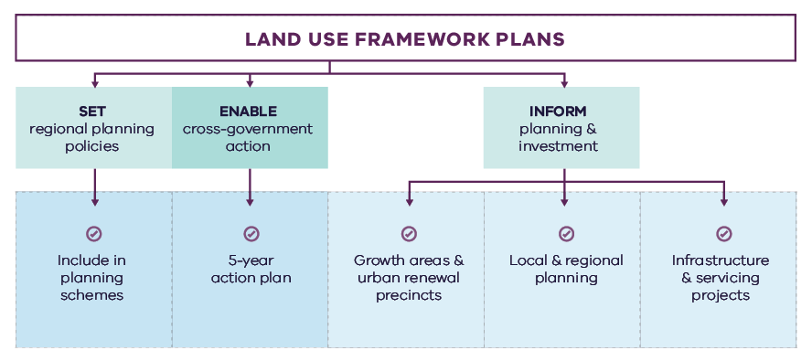
Figure 29. Implementation of the land use framework plan
Land use framework plans
- Set regional planning policies
  - Include in planning schemes
- Enable cross-government action
  - 5-year action plan
- Inform planning and investment
  - Growth areas and urban renewal precincts
  - Local and regional planning
  - Infrastructure and servicing projects

Five-year action program
A number of short- to medium-term actions are included in the Southern Metro Region LUFP. The five-year action program (Table 16) summarises these actions to be delivered collaboratively by the state government and councils in the Southern Metro Region. These actions deliver on the strategic directions identified in the LUFP and in turn, Plan Melbourne outcomes. The actions will positively and proactively address some of the challenges being experienced by the region.
Plan Melbourne and the Melbourne Industrial and Commercial Land Use Plan (MICLUP) also contain actions that may require regional collaboration and will support the outcomes sought by the LUFP. This LUFP’s five-year action program is a targeted list of actions identified during the development of the draft LUFP. It is not intended that this list duplicate existing Plan Melbourne or MICLUP actions other than where confirming a particular action was warranted given its regional implications.
In relation to transport, the following actions from Plan Melbourne Implementation Plan are identified as being well suited to being implemented at the regional level for this metro region and there is a commitment to deliver them as part of the implementation of Plan Melbourne and the LUFP:
- Action 43: Safe, efficient and accessible
pedestrian networks
- Action 44: Local networks of cycling links
- Action 45: Local transport forums.
The implementation and prioritisation of the five-year action program will be driven by existing metro-regional governance arrangements including the Metropolitan Partnerships and EPWGs.
The indicative timeframes for completing actions are:
- Short term: By the end of 2023 (0–2 years)
- Medium term: By the end of 2026 (2–5 years)
Each action is allocated to a lead agency and implementation partners. Detail on the timing of actions and how they are implemented will be determined in line with normal government and council policy and budget processes. All actions requiring budget allocation will be carefully assessed against budget capacity, with rigorous business cases and cost-benefit analyses applied as part of their economic impact assessment.

Decision-making processes to support the delivery of the LUFPs
The LUFPs are a statement of policy intent. Detailed decisions about the implementation and timing of actions and infrastructure delivery will be made in line with normal government policy and budget processes.
The Victorian Government will continue its commitment to rigorous decision-making about initiatives that require funding, statutory amendments or new regulations in line with its economic and fiscal strategy, including the Government’s long-term financial management objectives.
For infrastructure projects, this will include ensuring consistency with the Victorian Government’s Investment Lifecycle and High Value/High Risk Guidelines. For all other initiatives and actions, implementation and timing will be subject to consideration of its evidence base and likely net benefits.

Monitoring, reporting and review
Action monitoring will be led by DELWP in partnership with the metropolitan region through the EPWG. DELWP will publish an annual progress report outlining the status of actions against the specified timeframe (whether an action has been ‘completed’, is ‘in progress’ or ‘not started’). These progress reports will be publicly available.
LUFP implementation will be formally reviewed every five years in conjunction with the Plan Melbourne Five-Year Implementation Plan. The review will be conducted in an open way and involve engagement with key stakeholders including Metropolitan Partnerships and EPWGs.

Actions – Implementation
- Update budget business case submission templates and guidance to identify how initiatives align with Plan Melbourne and the Land Use Framework Plans.

- Five-year action program
Timeframe - Short term (S): By the end of 2023 (0–2 years). Medium term (M): By the end of 2026 (2–5 years)
 | Action | Source | Timeframe | Lead agency | Implementation partner(s)
1 | Implement a program of State Government-led planning projects, in partnership with local government, to ensure metropolitan and major activity centres and urban renewal areas maximise their respective strategic opportunities and contribution within the network of activity centres. Priority will be given to those which deliver significant jobs and housing; leverage investment in state infrastructure; and play an important role in the growth corridor and/or region. State-led planning for these state- and regionally-significant places will contribute to creating liveable communities and achieving more dwellings and jobs in established areas, and identify implementation and coordination actions that support growth and economic investment. |  | S | VPA | Councils, DELWP
2 | Undertake Precinct Planning for the Cheltenham and Clayton Suburban Rail Loop Precincts with local councils and other stakeholders to guide land use change, transport integration and the creation of a liveable, walkable and prosperous precinct. |  | M | SRLA | Councils, DELWP, DJPR
3 | In consultation with the Port of Hastings Development Authority and Mornington Peninsula Shire Council, investigate the potential for any Special Use Zone 1 land outside of the Hastings State Significant Industrial Precinct that could allow for a broader range of industrial uses while still providing adequate buffers for the growing port. | MICLUP | M | DJPR | Council, DELWP, Port of Hastings Development Authority
4 | Investigate, identify and implement a SERA for sand resources around Lang Lang – Grantville in the Southern Metro Region in partnership with Cardinia, South Gippsland and Bass Coast shires. |  | M | DJPR | Councils, DELWP
5 | Update planning schemes to align with housing policies in Plan Melbourne and the Southern Metro Region Land Use Framework Plan and the implementation of the reformed residential zones. This includes:  providing capacity for 15 years of regional housing supply focusing on locations identified for housing growth in the LUFP  reviewing planning controls in housing investigation areas as potential locations for substantial housing change.  This may require strategic planning work to support these changes such as preparing or updating local housing strategies or preparing structure plans to further investigate where increased densities can be supported, and determine specific changes required to planning schemes. |  | S | Councils | DELWP
6 | Identify underutilised and surplus government land that has potential to deliver additional social housing. | Plan Melbourne Five-Year Implementation Plan | S | DFFH (HV) | DELWP
7 | In partnership with councils, identify a pipeline of sites in the Southern Metro Region for social and affordable housing. |  | M | DFFH (HV) | Councils
8 | Develop a model and seek support for a whole-of-government approach to better sequence and prioritise locations for key services, social infrastructure and public transport access in the development of growth areas to better enable walkable 20-minute neighbourhoods. |  | S | VPA | Councils, DELWP, DET, DFFH (HV), DH, DoT
9 | Review the Principal Public Transport Network for the growth areas. |  | S | DoT | Councils, DELWP
10 | Plan for and implement improvements to the region’s bus network, including on-road priority, increased frequencies and improved route legibility. Priority areas include the introduction of services in the growth areas, improvements on the Mornington Peninsula and better connectivity between residential areas and employment areas. |  | M | DoT | Councils
11 | Review local planning schemes to ensure protection and enhancement of the landscape and biodiversity values of the region. |  | M | Councils | DELWP, Melbourne Water
12 | Develop a plan for a publicly owned and managed network of open spaces and regional trails across the growth corridor, utilising its natural drainage system where possible to link open spaces, biodiversity areas, waterways and urban areas. |  | S | DELWP | VPA
13 | Investigate the need for aged care services and facilities and identify planning considerations in their delivery. |  | M | DH | Councils
14 | Review the breadth of tertiary education offerings and the location of higher educational facilities to ensure they meet local and regional needs. |  | M | DET | Councils
15 | Undertake detailed coastal settlement planning to identify short-, medium- and long-term options to reduce risk to population, infrastructure, agricultural land, ecosystems and property from sea level rise, storm surges, coastal erosion, tidal inundation and saline groundwater intrusion. |  | M | DELWP | Councils
16 | Prepare a regional water infrastructure plan in conjunction with Integrated Water Management Forums to support state and local government and relevant agencies to prioritise and align water infrastructure needs and integrated water management outcomes. |  | M | DELWP | Councils, Water authorities
17 | In partnership with local government, water sector agencies and stakeholders, prepare a cost benefit analysis and action plan to understand the value and options to better use water from the Eastern Treatment Plant for a range of land use types to support jobs creation, sustainability and climate resilience. |  | M | DELWP | Councils, Melbourne Water, Water authorities
18 | Prepare a regional bushfire response for suburban and peri-urban communities that are subject to bushfire risk. |  | M | DELWP | Councils, Country Fire Authority
19 | Investigate options and land use protection for a Resource Recovery Centre and Transfer Station/s to support Melbourne’s future resource and recovery needs. |  | M | Sustainability Victoria | Councils, Environmental Protection Authority
20 | Update budget business case submission templates and guidance to identify how initiatives align with Plan Melbourne and the Land Use Framework Plans. |  | S | DTF

Appendix 01.
Relevant policies, strategies and initiatives
There are several current Victorian Government policies, strategies and initiatives that have implications for planning in the Southern Metro Region. In addition, there are existing regional initiatives, initiated by councils and/or the Metropolitan Partnerships. This appendix provides an overview of the most relevant policies, strategies and initiatives for the Southern Metro Region LUFP. These key plans and strategies are relevant to this LUFP:
Plan Melbourne 2017-2050 and Plan Melbourne 2017-2050 Addendum, 2019, which will guide the growth of our city. Plan Melbourne sets out the strategy for supporting jobs, housing and transport, while building Melbourne’s legacy of distinctiveness, liveability and sustainability. The addendum updates Melbourne’s projected population, housing and employment growth and the Melbourne 2050 spatial framework to align with major transport investments including SRL.
Growth Corridor Plans, Managing Melbourne’s Growth 2012, sets an overarching strategic planning framework to guide future development of Melbourne’s four growth corridors – North, Sunbury-Diggers Rest, West and South East. The growth corridor plans identify:
- Areas suitable for urban development and the broad form of development (residential, industrial, commercial)
- Areas of high environmental or landscape value that must be protected from development
- The integrated open space network
- Strategic transport infrastructure and options for further investigation
- Locations suitable for a wide range of employment uses.
This LUFP incorporates and updates information from the growth corridor plan.
Specific Victorian Government policies, strategies and initiatives are outlined below under the relevant chapter of the LUFP to which they most strongly relate, acknowledging that many policies, strategies and initiatives are relevant to multiple chapters, or to the whole LUFP.

Productivity
The Melbourne Industrial and Commercial Land Use Plan 2019 provides an overview of current and future needs for industrial and commercial land across metropolitan Melbourne and puts in place a planning framework to support state and local government to more effectively plan for future employment and industry needs, and better inform future strategic directions.
The Unlocking Enterprise in a Changing Economy policy paper provides support for the development of enterprise precincts. The newly introduced Commercial 3 Zone aims to promote innovative and enterprising mixed-use precincts and reduces the planning burden for a diversity of employment uses.
Support for Victoria’s creative industries is provided through the Creative State 2016-2020 strategy which aims to grow the state’s creative and cultural economy. Work is currently underway to develop the next creative industries strategy which will guide initiatives and investment between 2020 and 2024.
Protection of the long-term future of Melbourne’s green wedges and agricultural land is provided through the Planning for Melbourne’s Green Wedges and Agricultural Land project, which is exploring a range of planning system changes for how this can best be achieved.
The Metropolitan Partnerships are advisory groups established for each of the metropolitan regions by the Victorian Government that bring community and business together with state and local government and advise on the top priorities for jobs, services and infrastructure across the region.
A 30-year strategy for the Port of Hasting is articulated within the Port Development Strategy 2018. It focuses on port development, transport links, land requirements, port infrastructure and associated trade.
The Revitalising Central Dandenong initiative is a commitment from the Victorian Government to transform central Dandenong into a vibrant and thriving economic hub. Development Victoria is working in partnership with the City of Greater Dandenong, Victorian Government agencies, and the private sector to achieve the goals of the Revitalising Central Dandenong initiative, encouraging new development and job-creating economic activity.
The South East Economic Corridor Strategic Context Report to 2060 sets out a spatial framework for employment precincts and activity centres across the cities of Greater Dandenong, Casey and Cardinia Shire. It informs the planning of future Precinct Structure Plans.

Housing choice
Planning system administrative and policy reforms such as Smart Planning are reducing red tape and, in doing so, facilitating the supply of housing.
Planning Practice Notes on Residential Zones and Planning for Housing provide greater clarity for local councils on the technical aspects of how to apply the residential zones and how to plan for housing growth and protect neighbourhood character.
The Housing Development Data dashboard will provide improved access to information on the quantity and location of housing being developed.
The Better Apartments Design Standards and Apartment Design Guidelines for Victoria assists in improving the quality and functionality of apartments in Victoria.
The Future Homes Project is producing better apartment designs and helping Melbourne become a world leader in apartment design, sustainability and liveability.
Housing Outcomes in Established Melbourne 2005 to 2016 highlights how housing development data can be used to understand changes in density, development of housing in activity centres and the influence of zones and overlays on housing change.
Big Housing Build will deliver 9300 new social housing dwellings and 2900 new affordable and market homes for first homebuyers and renters across the state. It includes:
- $532 million to replace obsolete properties on Homes Victoria land and constructing new homes – this includes Fast Start projects at Victoria Street, Flemington and Elizabeth Street in Richmond.
- $948 million for ready to build and spot purchase, working with private sector to bring forward new developments ready to start construction and purchase existing residential properties.
- $1.38 billion funding for projects by the community housing sector, through the Social Housing Growth Fund.
- $2.14 billion in partnerships with the private and community housing sector – exploring options to build on surplus government owned sites.
The Social Housing Growth Fund is the vehicle for allocating new funds to suitable projects proposed by the community housing sector.
The Homelessness and Rough Sleeping Action Plan initiatives include 20 one-bedroom modular units with intensive onsite support, multidisciplinary housing teams to support complex clients to maintain stable housing, eight additional assertive outreach teams in locations of highest need, and funding therapeutic services in major inner city crisis accommodation centres to improve health, wellbeing and housing outcomes.
The redevelopment of public housing estates is a program to transform ageing public housing estates across metropolitan Melbourne and key regional centres into vibrant, well-connected neighbourhoods. This will create at least 1800 new public housing homes.
The Building new homes to fight homelessness is a program to help Victorians escaping family violence, homelessness and life on the streets by building 1000 new public housing properties.

Integrated transport
Suburban Rail Loop is a new orbital rail link connecting Melbourne’s middle suburbs from Cheltenham to Werribee via Melbourne Airport and includes preparing detailed precinct frameworks and structure planning for all SRL precincts. Suburban Rail Loop consists of SRL East (Cheltenham to Box Hill), SRL North (Box Hill to Airport) and SRL West (Airport to Werribee).
Melbourne Airport Rail will connect Melbourne Airport to metropolitan and regional rail networks via Sunshine.
The Metro Tunnel will create additional capacity on Melbourne’s rail network link by running the Cranbourne, Pakenham and Sunbury lines through a new tunnel.
The Port Rail Shuttle Network is an investment in direct rail freight between key suburban locations in Dandenong South, Somerton and Altona and the Port of Melbourne. Once fully operational, this will make a significant difference to how freight moves around Melbourne. By 2050, it is expected to move 30 per cent of Melbourne’s containers by rail, avoiding millions of truck trips on roads each year.
North East Link will connect Melbourne’s freeway network between the Eastern Freeway and the M80 Ring Road in Melbourne’s north-east. North East Link will be a safe and efficient freeway connection for up to 135,000 vehicles a day, slashing travel times, getting trucks off local roads and linking key growth areas in the north and south-east. It will enhance connections between the Western Ring Road, Hume Freeway and Eastern Freeway to Melbourne’s south-east.
The West Gate Tunnel will create a second river crossing to link the Western Metro Region with the Port of Melbourne, CityLink and the CBD, and take traffic pressures off the West Gate Bridge.
The Level Crossing Removal Project will continue to provide improved travel and safety for road users, public transport users, cyclists and pedestrians by removing additional level crossings across metropolitan Melbourne.
The Urban Congestion Fund will upgrade the urban road network to reduce congestion upgrading pinch points, intersections and commuter car park upgrades at train stations.
The Cranbourne Line Upgrade will pave the way for trains every 10 minutes on the Cranbourne Line through the duplication of track, removal of level crossings and Merinda Park Station rebuild.
The South Eastern Roads Upgrade will improve six roads within this region making it quicker, easier and safer for road users.
The Victorian Infrastructure Plan seeks to build, improve and care for Victoria’s infrastructure. It responds to Infrastructure Victoria’s 30-year Infrastructure Strategy and presents priorities and future directions across nine key sectors.
Freightage throughout the state will be enhanced as part of the Delivering the Goods: Creating Victorian Jobs – Victorian Freight Plan.
Victoria’s Zero Emissions Vehicle Roadmap sets out a plan to achieve half of all light vehicle sales in Victoria to be Zero Emission Vehicles by 2030.
The Victorian Government is currently in consultation with key stakeholders regarding a business case for the electrification of the railway line from Frankston to Baxter.
Movement and Place is a way of thinking about the roles and challenges facing our transport system now and into the future. The Movement and Place approach recognises that transport links perform two functions: movement of people and goods and serving as a place (a destination in its own right). This way of thinking ensures that while we are planning for and developing our network, we are considering the needs for movement and placemaking simultaneously.

Liveability
The Suburban Parks Program will deliver more than 6500 hectares of new and upgraded parks and trails across Greater Melbourne.
Open Space for Everyone: Open Space Strategy for Metropolitan Melbourne 2020 supports a cooler, greener city with a network of quality open spaces to which all members of the community have access.
The Healthy Waterways Strategy 2018 provides a framework for managing rivers, wetlands and estuaries in Melbourne’s five major catchments to ensure their value to the community is protected and improved.
The Land Utilisation Assessment Program works to improve utilisation of government land.
Water for Victoria is a plan for a future with less water as Victoria responds to the impact of climate change and a growing population.
Protecting Victoria’s Environment – Biodiversity 2037 is the Victorian Government’s plan to stop the decline of the state’s biodiversity and achieve overall biodiversity improvement over the next 20 years.
The Victorian Heritage Register lists and provides legal protection for heritage places and objects that are significant to the history and development of Victoria. It includes a wide range of places and objects, such as buildings, trees, gardens, archaeological sites and structures.

Strong communities
The 20-minute Neighbourhoods project delivers a range of initiatives to create a city of 20-minute neighbourhoods, enabling communities to live more locally.
The Victorian Government has committed $675 million to the Community Hospitals Program to build 10 community hospitals close to major growth areas enhancing access to health services in growing communities.
The Statewide Design, Service and Infrastructure Plan for Victoria’s Health System 2017-2037 provides a planning framework to guide service, workforce and infrastructure investment in Victoria’s health system.
Health 2040: Advancing Health, Access and Care presents a clear vision for the health and wellbeing of Victorians and for the Victorian healthcare system.
The Victorian Public Health and Wellbeing Plan 2019-2023 seeks to ensure that all Victorians enjoy the highest attainable standard of health, wellbeing and participation at every age. The production of this Plan is legislated for under the Victorian Public Health and Wellbeing Act 2008.
The Growing Suburbs Fund will provide investment in critical local infrastructure for communities in Melbourne’s growing outer suburbs. In the Southern Metro Region, the Growing Suburbs Fund is available to Cardinia, Casey and Mornington Peninsula Councils.
The 2020/21 Victorian State Budget allocates funding for the Community Sports Infrastructure Stimulus Program that will fast-track shovel-ready community sports infrastructure projects across Victoria.
The Victorian Cycling Strategy 2018-28 guides planning and investment in cycling in the state.
Active Victoria – A Strategic Framework for Sport and Recreation in Victoria 2017-2021 provides a strategic framework for future work into Victoria’s sports and active recreation sector.
The Victorian Government’s Metropolitan Health Infrastructure Fund will work with Metropolitan Melbourne’s hospitals and health services to upgrade infrastructure to support the delivery of new or enhanced services to patients.
The Suburban Revitalisation program facilitates the delivery of urban renewal in metropolitan activity centres experiencing economic transition and/or significant levels of disadvantage. The Program is centred on a partnership between State agencies, local councils and regional stakeholders to accelerate the development and delivery of local infrastructure upgrades, small business stimulus initiatives and community connectedness activities. The Southern Metro Region includes Suburban Revitalisation projects in Frankston and Noble Park.
The Victorian Aboriginal Affairs Framework 2018-2023 (the VAAF) is the Victorian Government’s overarching framework for working with Aboriginal Victorians, organisations and the wider community to drive action and improve outcomes.

Sustainability and resilience
Sector and whole-of-government emission reduction pledges will help achieve the Victorian Government’s target of net-zero emissions by 2050.
The Climate Change Act 2017 provides Victoria with a world-leading legislative foundation to manage climate change risks, maximise the opportunities that arise from decisive action, and drive our transition to a climate resilient community and economy with net-zero emissions by 2050.
The Renewable Energy (Jobs and Investment) Act 2017 legislates an increase of the Victorian Renewable Energy Target (VRET) to 50 per cent by 2030.
Adaption Action Plans (Climate Change Act 2017) will help build the state’s resilience and help Victorians plan for the inevitable impacts of climate change.
Victoria’s Climate Change Strategy (2021) has a range of specific measures to support the uptake of renewable energy in businesses, industry and homes. It includes further reforms to drive greater energy efficiency of electrical appliances, lighting and air-conditioning/heating equipment and to improve the thermal performance of new buildings. Transport emissions will be reduced by accelerating Victoria’s transition to zero emissions vehicles, improving public transport and investing more in cycling and walking options. The Strategy will also support the circular economy reforms to Victoria’s waste management system contained in the Recycling Victoria action plan, Recycling Victoria: A New Economy.
The Victorian Climate Projections 2019 Technical Report describes how the regional climate of Victoria is likely to respond to global warming with different scenarios of human greenhouse gas emissions.
The 2020/21 Victorian Budget delivered a landmark $2 billion for the Breakthrough Victoria Fund to drive translation and commercialisation of knowledge in Victoria. The Clean Economy is one of the five key sectors the Fund will prioritise.
The 2020/21 Victorian Budget also provided funding for clean energy transition initiatives, including establishing renewable energy zones to develop and deliver renewable energy projects.
The Cooler, Greener Melbourne project will create more liveable and climate-adapted communities through green infrastructure and other cooling and greening initiatives. Tree planning on public land will create a cooler and greener Melbourne as part of Melbourne Water’s Urban Cooling Program. The program includes changes to planning schemes to protect and strengthen the urban forest.
Living Melbourne Urban Forest Strategy (2019) is a strategy for a greener, more liveable Melbourne, developed by Nature Conservancy and Resilient Melbourne.
The Marine and Coastal Policy (2020) sets out policies for planning and managing the marine and coastal environment, provides guidance to decision-makers in achieving the objectives of the Marine and Coastal Act 2018 and includes a Marine Spatial Planning Framework to achieve integrated and coordinated planning and management of Victorian’s marine environment.
The Melbourne Strategic Assessment program manages the impact of urban development on significant vegetation communities, plants and animals in Melbourne’s growth areas.
Water for Victoria is a plan for a future with less water as Victoria responds to the impact of climate change and a growing population.
The Victorian Water and Climate Initiative supports research into the impact of climate change and climate variability on Victoria’s water resources. Additional investments will be made to enhance the scientific understanding of Victoria’s climate and provide authoritative data and information on climate change to the community.
Integrated Water Management Framework for Victoria provides a collaborative approach to the way we plan for and manage all elements of the water cycle, including the health of waterways and bays, wastewater management, alternative and potable water supply, stormwater management and water treatment. In the Southern Metro Region this applies to the Dandenong Creek catchment (including the Western Mornington Peninsula) and Western Port.
The Beach Renourishment Program in Port Phillip Bay 2019-2022 is designed to repair damaged caused by coastal erosion on Port Phillip Bay beaches.
The Statewide Waste and Resource Recovery Infrastructure Plan 2018 (SWRRIP) guides future planning for waste and resource recovery infrastructure to achieve an integrated system.
The Metropolitan Waste and Resource Recovery Implementation Plan 2016 brings together the statewide priorities set out in the SWRRIP and applies them within the metropolitan context.
The Recycling Industry Strategic Plan transitions Victoria’s recycling industry to a more sustainable and resilient model.
Recycling Victoria: A New Economy outlines a plan for reform to establish a recycling system that Victorians can rely on and transforms how our economy uses materials and how our state reuses, repairs and recycles.
The 2020/21 Victorian State Budget allocates funding for the 10-year Recycling Victoria action plan, Recycling Victoria: A New Economy to transform Victoria’s recycling sector and develop a circular economy.
Melbourne Sewerage Strategy 2018 is a 50-year strategy to set the direction for waste water management across metropolitan Melbourne to manage its contribution to public health and the environment.

Appendix 02.
Housing choice supporting data
Table A2-1. Major housing development completed in the Southern Metro Region in and within 400m of activity centres (2005-2018) and in the redevelopment pipeline
Activity Centre | Major housing redevelopment completed 2005-2016* - In Centre | Major housing redevelopment completed 2005-2016* - Within 400m of Centre | Major housing redevelopment completed 2017-2018* - In Centre | Major housing redevelopment completed 2017-2018* - Within 400m of Centre | Major housing redevelopment pipeline* - In Centre | Major housing redevelopment pipeline* - Within 400m of Centre
Berwick | 231 | 274 | 0 | 0 | 39 | 52
Casey Central** | 0 | 81 | 0 | 0 | 0 | 0
Chelsea | 36 | 67 | 0 | 13 | 24 | 0
Cheltenham | 147 | 105 | 396 | 44 | 424 | 291
Cheltenham, Southland | 0 | 229 | 0 | 286 | 0 | 622
Clayton | NA | 31 | NA | 125 | NA | 256
Clyde** | 0 | 0 | 0 | 0 | 0 | 0
Cranbourne | 0 | 1393 | 0 | 0 | 31 | 0
Dandenong | 949 | 281 | 38 | 37 | 716 | 85
Endeavour Hills | 18 | 0 | 0 | 0 | 42 | 0
Frankston | 14 | 110 | 82 | 45 | 218 | 72
Hampton Park | 0 | 24 | 0 | 0 | 119 | 0
Hastings | 48 | 167 | 38 | 0 | 16 | 20
Karingal | 16 | 20 | 0 | 0 | 10 | 30
Keysborough - Parkmore | 0 | 0 | 0 | 0 | 0 | 0
Mentone | 105 | 318 | 56 | 42 | 17 | 0
Moorabbin | 244 | 0 | 0 | 0 | 651 | 59
Mordialloc | 86 | 52 | 81 | 64 | 54 | 14
Mornington | 213 | 10 | 83 | 0 | 12 | 38
Narre Warren, Fountain Gate | 48 | 0 | 13 | 0 | 100 | 0
Noble Park | 74 | 138 | 0 | 0 | 175 | 61
Officer** | 0 | 162 | 0 | 0 | 0 | 0
Pakenham | 225 | 426 | 249 | 51 | 458 | 0
Rosebud | 162 | 68 | 92 | 12 | 30 | 35
Springvale | 160 | 216 | 184 | 247 | 456 | 10
* Major development is defined as developments with over 10 dwellings
** Emerging activity centres in growth areas. Redevelopment data does not cover these areas
Note: Dwelling numbers are calculated based on constructed not net additions dwellings.
Note: Pipeline refers to projects that are: under construction, have a planning permit, have had pre application meetings, or being sold off the plan.
Note: 400m activity centre buffer may be in multiple metro Regions.
Housing Development Data 2016, Urban Development Program – Redevelopment 2018, Urban Development Program – Redevelopment 2019

Glossary
Where the term is defined in Plan Melbourne or the Victoria Planning Provisions, that definition is used.
Aboriginal | Aboriginal refers to both Aboriginal and Torres Strait Islander peoples. They may have connections in and outside of Victoria.
Active transport | Transport requiring physical activity, typically walking and cycling.
Activity centres | Areas that provide a focus for services, employment, housing, transport and social interaction. They range in size and intensity of use from smaller neighbourhood centres to major suburban centres and larger metropolitan centres.
Affordable housing | Housing that is appropriate for the needs of a range of very low to moderate income households, and priced (whether mortgage repayments or rent) so these households are able to meet their other essential basic living costs.
Agglomeration | The location of businesses in close proximity to each other, which allows them to get productivity and efficiency gains through large customer bases, knowledge sharing and access to skilled workers.
Biodiversity | The variety of all life forms, the different plants, animals and microorganisms, the genes they contain and the ecosystems of which they form a part.
Central Business District (CBD) | Melbourne’s original ‘Hoddle Grid’ street layout bounded by the Yarra River, Spring Street, La Trobe Street and Spencer Street, as well as the triangular area to the north bounded by Victoria, Peel and La Trobe streets.
Central City | The area within the inner metro region that contains key capital city functions and civic facilities, as well as several precincts identified for major and strategic change. The Central City incorporates the CBD (Hoddle Grid, north to Grattan Street between Peel and Swanston streets) as well as Docklands, Southbank and St Kilda Road.
Climate change | A long-term change of the earth’s temperature and weather patterns – generally attributed directly or indirectly to human activities such as fossil fuel combustion and vegetation clearing and burning.
Commercial land | Land used for commercial purposes including land used for business services, retail, accommodation, food and other industries.
Creative industry | Media, digital screen, design, writing and publishing, literature, fashion, performing arts, digital games development, broadcasting, music, cultural heritage, arts, education and craft industries.
Enterprise precincts | Precincts that facilitate the creation and commercialisation of new ideas and support metropolitan economies by growing jobs in ways that leverage their distinct economic attributes. These districts build on and revalue the intrinsic qualities of cities: proximity, density, authenticity, and vibrant places. (Brookings Institute definition)
Eastern Metro Region | Includes the LGAs of Knox, Manningham, Maroondah, Monash, Whitehorse, Yarra Ranges.
Established urban areas | Areas of Melbourne that have been urbanised for at least several decades.
Green wedges | Defined under Part 3AA of the Planning and Environment Act 1987 as “land that is described in a metropolitan fringe planning scheme as being outside an urban growth boundary”. There are 12 defined green wedges spanning parts of 17 municipalities.
Greenfield land | Undeveloped land identified for residential or industrial/commercial development, generally on the fringe of metropolitan Melbourne.
Greenhouse gas emissions | Atmospheric gas that absorbs and emits infrared or heat radiation, giving rise to the greenhouse effect. Typical greenhouse gases include carbon dioxide, methane, nitrous oxide and refrigerants.
Greyfield | Residential areas where the building stock is near or has ended its useful life and land values make redevelopment attractive.
Gross regional product (GRP) | Gross regional product is a measure of the market value of all final goods and services produced in a region over a period of time.
Growth areas | Locations on the fringe of metropolitan Melbourne designated in planning schemes for large-scale transformation, over many years, from rural to urban use.
Growth corridor plans | The growth corridor plans are high level integrated land use and transport plans that provide a strategy for the development of Melbourne’s growth corridors over the coming decades.  The growth corridor plans focus on three metropolitan growth corridors: Northern, Western and South Eastern growth corridors. They identify broad transport networks, industrial and employment areas, residential areas and recreation precincts across the city’s newest metropolitan suburbs. Relevant information from the growth corridor plans have been integrated into the LUFPs containing growth corridors.
Health and education precincts | Locations to cluster synergistic health and/or education services to improve access to integrated service provision, improve outcomes, develop the health and education workforce and deliver economic benefits (such as innovation and job creation). These precincts may provide solely health, solely education, or a combination of health and education services.
Hoddle Grid | The grid pattern of streets making up Melbourne’s CBD bounded by the Yarra River, Spring Street, La Trobe Street and Spencer Street, as well as the triangular area to the north bounded by Victoria, Peel and La Trobe streets. The grid was designed by Robert Hoddle in 1837.
Housing density | The number of dwellings in an urban area divided by the area of the residential land they occupy, expressed as dwellings per hectare.
Hybrid centre | A descriptor for an activity centre typology that contains a mixed arrangement of freestanding / enclosed shopping complexes and traditional open air strip-based commercial land.
Infill | Development of unused or underutilised land in existing urban areas.
Infrastructure | Basic facilities and networks needed for the functioning of a local community or broader society.
Integrated water management (IWM) | An approach to planning that brings together all facets of the water cycle including sewage management, water supply, stormwater management and water treatment, ensuring environmental, economic and social benefits.
Inner Metro Region | Includes the LGAs of Melbourne, Port Phillip and Yarra.
Inner South East Metro Region | Includes the LGAs of Boroondara, Glen Eira, Stonnington and Bayside.
Intermodal freight terminal | A location for the transfer of freight from one transport mode to another, for example between road and rail.
Knowledge-based industries and jobs | Production and services based on knowledge-intensive activities that contribute to an accelerated pace of technical and scientific advancement. Their key characteristic is a greater reliance on intellectual capabilities than on physical inputs or natural resources.
Liveability | A measure of a city’s residential quality of life, used to benchmark cities around the world. It includes socioeconomic, environmental, transport and recreational measures.
Localised planning statement | Long-term policies for the future planning and development of areas identified as having significance to the broader Victorian community.
Major activity centres | Suburban centres that provide access to a wide range of goods and services. They have different attributes and provide different functions, with some serving larger sub-regional catchments. Plan Melbourne identifies 121 major activity centres.
Metropolitan activity centres | Higher-order centres with diverse employment options, services and housing stock, supported by good transport connections. Existing centres include Box Hill, Broadmeadows, Dandenong, Epping, Footscray, Fountain Gate/Narre Warren, Frankston, Ringwood and Sunshine. Future centres will include Lockerbie and Toolern.
Metropolitan Melbourne | The 31 municipalities that make up metropolitan Melbourne, plus part of Mitchell Shire within the Urban Growth Boundary.
Moderate income household | Annual household income within the income range specified as a moderate range by Order under section 3AB of the Planning and Environment Act 1987. In 2020 this was $87,671 to $131,500 for a family (with one or two parents) and dependent children.
National employment and innovation clusters (NEIC) | Designated concentrations of employment distinguished by a strong core of nationally significant knowledge sector businesses and institutions that make a major contribution to the national economy and Melbourne’s position in the global economy.
Natural hazard | A natural event that has potential to cause harm to people, property or the environment, including climate change, bushfire, flooding and sea level rise.
Neighbourhood activity centres | Local centres that provide access to local goods, services and employment opportunities and serve the needs of the surrounding community.
Northern Metro Region | Includes the LGAs of Banyule, Darebin, Hume, Mitchell (part), Moreland, Nillumbik and Whittlesea.
Open space | Includes land reserved for natural landscape, parklands, recreation and active sports, as well as waterways and bays.
Peri-urban areas | Areas beyond the green wedges made up of local government areas with a predominantly rural character, located all or partially within a 100-kilometre radius of Melbourne.
Precinct Structure Plans (PSPs) | Master plans for future growth corridor developments, informed by growth corridor planning. The plans identify alignments of transport routes, town centres, open space networks, densities of residential areas, and areas for industry and employment.
Primary healthcare | Primary healthcare is generally the first contact a person has with Australia’s health system. It relates to the treatment of patients who are not admitted to hospital. It encompasses a wide range of health professionals and includes general practitioners, community nurses, midwives, pharmacists, dentists, and Aboriginal health workers, for example.
Principal Freight Network (PFN) | Part of the larger transport network over which the movement of heavy freight will be concentrated.
Principal Public Transport Network (PPTN) | A statutory land use planning tool that supports integrated land use and transport planning by providing certainty to land use planners and developers around locations that are and will be served by high-quality public transport.
Regional active open spaces | Large scale open spaces that cater for a range of recreational opportunities including informal outdoor recreation, active recreation and sports. Regional active open spaces serve a broad catchment and may comprise buildings and infrastructure to facilitate sporting or recreational activity.
Regional parks | Regional parks are large areas of open space that feature natural or semi-natural surroundings in close proximity to urban environments. They have high landscape, biodiversity and cultural values and provide a diversity of passive recreational, educational or tourism opportunities.
Regional Victoria | Includes all municipalities outside metropolitan Melbourne (except part of Mitchell Shire within the Urban Growth Boundary).
Regionally-significant industrial precincts  (RSIP) | Key industrial areas that contribute significantly to local and regional economies. Some of these areas are well established and support a range of industrial uses while others are transitioning and supporting new uses. They include future employment areas identified through growth corridor plans that will support not just employment growth in outer areas, but to also meet Melbourne’s longer term industrial and logistics needs. They are to be retained and planned for to allow a range of industrial uses, or where appropriate, new and emerging businesses that require access to affordable and well-located employment land.
Renewable energy | Energy that comes from resources which are naturally replenished on a human timescale such as sunlight, wind, rain, tides, waves, and geothermal heat.
Resilience | The capacity of individuals, communities, institutions, businesses, systems and infrastructure to survive, adapt and grow, no matter what chronic stresses or shocks they encounter.
Resource recovery | Extraction of useful material or energy from a waste stream.
Social housing | A type of rental housing that is provided and/or managed by the government or by a not-for-profit organisation. Social housing is an overarching term that covers both public housing and community housing.
Social infrastructure | Encompasses all the facilities, services and networks that help families, groups and communities to meet their social, health, education, cultural and community needs.
Southern Metro Region | Includes the LGAs of Cardinia, Casey, Greater Dandenong, Frankston, Kingston and Mornington Peninsula.
State-significant industrial precincts (SSIP) | Strategically located land available for major industrial development linked to the Principal Freight Network and transport gateways. They will be protected from incompatible land uses to allow continual growth in freight, logistics and manufacturing investment.  There are five state-significant industrial precincts: Western Industrial Precinct, Northern Industrial Precinct, Southern Industrial Precinct, Port of Hastings Industrial Precinct and Officer-Pakenham Industrial Precinct.
Strategic Cycling Corridors (SCC) | Strategic Cycling Corridors are important transport routes for cycling and are a subset of the Principal Bicycle Network (PBN). The SCC network supports the needs of commuter trips (to work or education) and other important trips, such as to stations, shops or schools.  The SCC network links up important destinations, including central Melbourne city, employment and activity centres, and other destinations of metropolitan and regional significance.  SCCs can be on and off road, on municipal and state roads and are designed to provide a safe, lower-stress cycling for transport experience.
Strategic Extractive Resource Area (SERA) | Recognised and secured extractive resource areas of strategic importance for the construction of public infrastructure, affordable housing and private sector development now and in the future.  They cover extractive resources that actually and/or potentially occur in defined locations at various scales based on their likelihood or potential to supply growth areas, taking into account accessibility to markets, while minimising impacts on environment and other land use constraints.
Traditional Owners | People who, through membership of a descent group or clan, are responsible for caring for particular Country. A Traditional Owner is authorised to speak for Country and its heritage as a senior Traditional Owner, an Elder or, in more recent times, a registered native title claimant.
Transit-oriented development | Compact, walkable, mixed-use communities centred around high-quality train systems. Transit-oriented development assists in addressing the growing problems of climate change and global energy security by creating dense, walkable communities that greatly reduce the need for driving and energy consumption.
Transport gateway | Ports, airports and interstate terminals that serve as key locations for moving passengers and freight into and out of Victoria and also play a significant economic and employment-generating role.
20-minute neighbourhoods hallmarks | The ‘hallmarks’ are established in Plan Melbourne’s Direction 5.1 — Create a city of 20-minute neighbourhoods. The ‘hallmarks’ developed in partnership with the Department of Health and the Heart Foundation (Victoria) are:  be safe, accessible and well connected for pedestrians and cyclists to optimise active transport  offer high-quality public realm and open spaces  provide services and destinations that support local living  facilitate access to quality public transport that connects people to jobs and higher-order services  deliver housing/population at densities that make local services and transport viable  facilitate thriving local economies.
Urban forest | All of the trees and other vegetation in a city as well as the soil and water that supports it.
Urban Development Program (UDP) | The Urban Development Program (UDP) provides an annual assessment of supply and consumption of industrial and residential land across metropolitan Melbourne.
Urban Growth Boundary (UGB) | A management tool to contain urban areas and limit their expansion. It divides land that is urban – to be used for housing, shops, factories – from land that is nonurban and to be used for purposes such as conservation, agriculture, mineral extraction, airports and the like. A UGB encourages urban consolidation and protects valued non-urban areas from urban development.
Urban renewal | The process of planning and redeveloping underutilised medium- and large-scale urban areas, precincts or sites for mixed land use purposes.
Very low income household | Annual household income within the income range specified as a very low income range under section 3AB of the Planning and Environment Act 1987. In 2020 this was up to $26,090 for a single adult.
Western Metro Region | Includes the municipalities of Brimbank, Hobsons Bay, Maribyrnong, Melton, Moonee Valley and Wyndham.
Water sensitive urban design (WSUD) | Integrating the urban water cycle into urban design to minimise environmental damage and improve recreational and aesthetic outcomes.
Wallan SA2 | Statistical Areas Level 2 (SA2) are medium-sized general purpose areas established by the ABS that represent a community that interacts together socially and economically. The Wallan SA2 is larger than the area in Mitchell within the Urban Growth Boundary and generally follows the municipal boundary west of Wallan and extends north of Wandong and east into Kinglake National Park.
Yarra River Land | Crown and State-owned land within 500 metres of the Yarra River declared under the Yarra River Protection (Wilip-gin Birrarung murron) Act 2017. The declaration provides additional protection to this land. Yarra River Land that is used for public recreation forms the Greater Yarra Urban Parklands.

References
Australian Bureau of Statistics, 2016. ABS Census, Australia: Australian Bureau of Statistics.
Australian Bureau of Statistics, 2021. Regional Population 2019-20 financial year: Commonwealth of Australia, Canberra, Australia.
Australian Sustainable Built Environment Council, 2016. Low Carbon, High Performance, Surrey Hills, NSW, Australia: ASBEC.
Coutts, A. Tapper, N., 2017. Tree’s for a Cool City: Guidelines for Optimised tree placement, Melbourne, Australia: Cooperative Research Centre for Water Sensitive Cities.
DELWP, 2017a. Plan Melbourne, Melbourne, Australia: The State of Victoria Department of Environment, Land, Water and Planning.
DELWP, 2017b. Port Phillip Bay Environmental Management Plan 2017-2027, Melbourne, Australia: The State of Victoria Department of Environment, Land, Water and Planning.
DELWP, 2017c. Southern Metro Region, Regional Background Paper (Unpublished), Melbourne, Victoria: The State of Victoria Department of Environment, Land, Water and Planning.
DELWP, 2018a. Housing Development Data, Melbourne: DELWP.
DELWP, 2018b. Integrated Water Management Forums, Dandenong Strategic Directions Statement, The State of Victoria Department of Environment, Land, Water and Planning.
DELWP, 2018c. Integrated Water Management Forums, Yarra Strategic Directions Statement 2018, Melbourne, Victoria: The State of Victoria Department of Environment, Land, Water and Planning.
DELWP, 2018d. Land Surface Temperature data, Melbourne, Australia: The State of Victoria Department of Environment, Land, Water and Planning.
DELWP, 2019a. Plan Melbourne Addendum, Melbourne: State of Victoria.
DELWP 2019b. Trees for Cooler and Greener Streetscapes - Guidelines for Streetscape Planning and Design, Melbourne: DELWP.
DELWP, 2019c. Victoria in Future, Melbourne: DELWP.
DELWP, 2020a. Melbourne Industrial and Commercial Land Use Plan, Melbourne, Victoria: The State of Victoria Department of Environment, Land, Water and Planning.
DELWP, 2020b. Victorian Greenhouse Gas Emissions Report 2018, Melbourne, Australia: The State of Victoria.
DELWP, 2021a. Environmentally Sustainable Development of Buildings and Subdivisions - A roadmap for Victoria’s planning system, State of Victoria, Melbourne, Australia: The State of Victoria.
DELWP, 2021b. Internal analysis using Victorian Integrated Survey of Travel and Activity (VISTA) 2016-18 survey data.
DHHS, 2020. Rental Report March Quarter 2020.
Green Building Council of Australia, 2021. Green Star Rating System. [Online] Available at: https://new.gbca.org.au/rate/rating-system
[Accessed March 2021].
Hurley, J. et al., 2019a. Melbourne Urban Vegetation Cover 2018, Southern Region, Melbourne, Australia: DELWP.
Hurley, J. et al., 2019b. Urban Vegetation Cover Change in Melbourne 2014 - 2018, Melbourne: Centre for Urban Research, RMIT University.
JM, C. et al., 2019. Victorian Climate Projections 2019 Technical Report, Melbourne: CSIRO.
KPMG & ARUP, 2017. Travel Demand and Movement Patterns report, Melbourne: Infrastructure Victoria.
Melbourne Water, 2017. Planning for Sea Level Rise.
Melbourne Water, 2018. Healthy Waterways Strategy, Melbourne, Australia: Melbourne Water Corporation.
Metropolitan Waste and Resource Recovery Group, 2016. Metropolitan Waste and Resource Recovery Implementation Plan, Melbourne: Metropolitan Waste and Resource Recovery Group.
MUSIC Auditor, 2021. MUSIC Auditor. [Online] Available at: https://www.musicauditor.com.au [Accessed March 2021].
Nationwide House Energy Rating Scheme, 2021. Nationwide House Energy Rating Scheme. [Online] Available at: https://www.nathers.gov.au [Accessed March 2021].
Port of Hastings, 2018. Port of Hastings Port Development Strategy, Port of Hastings Development Authority.
PSMA Australia Limited, 2021. Buildings Spatial Data | Building GIS Data | Geoscape. [Online] Available at: https://geoscape.com.au/data/buildings/ [Accessed 2021].
SGS, 2019. ABS Census 2016 in SGS Economics Planning, Economic, Social and Environmental Profile: Southern Metro Region, SGS Economics Planning.
Sun, C. et al., 2019. Urban Vegetation, Urban Heat Islands and Heat Vulnerability Assessment in Melbourne, 2018, Melbourne, Australia: Clean Air and Urban Landscapes Hub.
Sustainability Victoria, 2018. Statewide Waste and Resource Recovery Infrastructure Plan, Melbourne, Victoria: Sustainability Victoria.
The Nature Conservancy and Resilient Melbourne, 2019. Living Melbourne: Our Metropolitan Urban Forest Technical Report, Melbourne: The Nature Conservancy and Resilient Melbourne.
Urich, C. Hardy, M., 2019. Cooling and Greening Melbourne – Future scenarios, Melbourne, Australia: Cooperative Research Centre for Water Sensitive Cities.
Victorian Government, 2021. Planning for Melbourne’s Green Wedge and Agricultural Land Consultation Paper, Melbourne: Victorian Government.
Victorian Government, 2009. Victorian Coastal Acid Sulfate Soils Strategy, Melbourne: Victorian Government Department of Sustainability and Environment, 2009.
VPA, 2017. Metropolitan Open Space Network, Provision and Distribution, Victorian Planning Authority.
Water Technology, 2014. Western Port Local Coastal Hazard Assessment, Erosion Hazards, Water Technology.

© The State of Victoria Department of Environment, Land, Water and Planning 2021
This work is licensed under a Creative Commons Attribution 4.0 International licence. You are free to re-use the work under that licence, on the condition that you credit the State of Victoria as author. The licence does not apply to any images, photographs or branding, including the Victorian Coat of Arms, the Victorian Government logo and the Department of Environment, Land, Water and Planning (DELWP) logo. To view a copy of this licence, visit http://creativecommons.org/licenses/by/4.0/
ISBN 978-1-76105-647-5 (pdf/online/MS word)

Disclaimer
This publication may be of assistance to you but the State of Victoria and its employees do not guarantee that the publication is without flaw of any kind or is wholly appropriate for your particular purposes and therefore disclaims all liability for any error, loss or other consequence which may arise from you relying on any information in this publication.

Credits
Green Scribble (graphic design)
Craig Moodie Photography (photos)
Department of Jobs, Precincts and Regions (photos)
Tim Bell Studio (photos).

Accessibility
If you would like to receive this publication in an alternative format, please telephone the DELWP Customer Service Centre on 136 186, email customer.service@delwp.vic.gov.au or via the National Relay Service on 133 677 www.relayservice.com.au. This document is also available on the internet at www.delwp.vic.gov.au
Submissions can be made online at engage.vic.gov.au
For any questions or assistance please contact lufp@delwp.vic.gov.au

