Plan Melbourne 2017-2050

Draft Northern Metro

Land Use Framework Plan

Summary

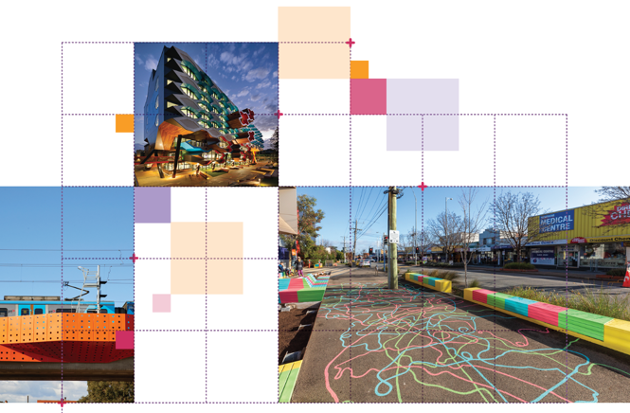

Great cities aren’t born. They’re made.
Melbourne is a great city. It’s a great place to live, work and raise a family. It’s a great place for investment and creativity. It’s a great place to visit and enjoy.
The Victorian Government has developed land use framework plans for each of the six metropolitan regions that are all about ensuring Melbourne remains a great city as it grows.
These plans mark a new era in the planning of Melbourne, building on the efforts of generations of Victorians to shape the way land is used around Port Phillip Bay.
The Northern Metro Land Use Framework Plan is a 30-year strategy for action across seven local government areas – Banyule, Darebin, Hume, Moreland, Nillumbik, Whittlesea and part of Mitchell.
It’s about making the long-term plans and investments that protect and enhance local areas and communities while ensuring Melbourne’s north grows more prosperous, liveable, affordable and sustainable.
The Northern Metro Land Use Framework Plan is also about maximising the social, economic and environmental benefits of transformational city-shaping investments like the Metro Tunnel, West Gate Tunnel, Melbourne Airport Rail and Suburban Rail Loop.
This plan is all about keeping northern Melbourne marvellous – from its established suburbs and industrial areas to its green wedge areas and growth corridors. It’s also about building the best possible future for the Northern Metro region.
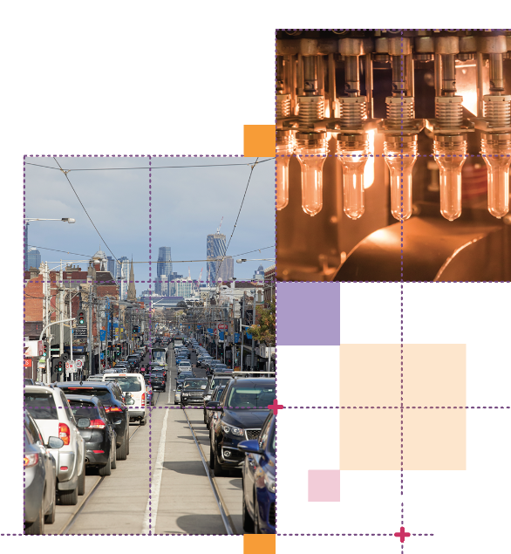

What the Northern Metro Land Use Framework Plan means for you

Productivity
- You will see economic activity around the La Trobe National Employment and Innovation Cluster (NEIC) and activity centres such as Broadmeadows, Epping and Lockerbie.
- You will see jobs created in the food and beverage, agriculture and food science, advanced manufacturing, health and logistics industries.
- You will see thriving creative precincts in Brunswick and Northcote as well as some outer areas.
- You will see the development of key industrial precincts such as the Melbourne Wholesale Fruit and Vegetable and Flower Market and the proposed Beveridge Interstate Freight Terminal.

Integrated Transport
- You will see the region remain Victoria’s interstate and international gateway
for passenger travel, freight and logistics.
- You will see cycling and pedestrian networks that support 20-minute neighbourhoods.

Housing Choice
- You will see a diversity of high-quality, affordable housing that is close to good public transport, services and amenities.

Strong Communities
- You will see people living and working in 20-minute neighbourhoods.

Liveability
- You will see that green wedge land and heritage are valued and protected.

Sustainability and Resilience
- You will see more trees across the region to help with urban greening and cooling, and improved biodiversity.

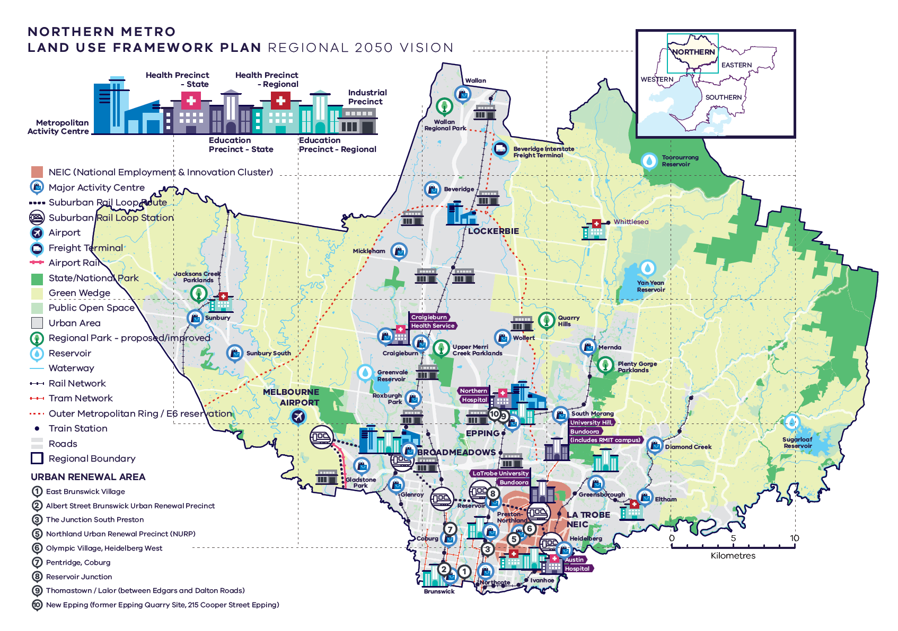
Northern Metro Region – Regional 2050 Vision
A schematic map of the Northern Metro Region in 2050 showing:
- The region’s boundary, the urban area, and green wedge land.

- Locations for growth and investment, including:
- The location and indicative boundary of the La Trobe NEIC in the south of the region
- Industrial precincts located through the centre of the region from south to north
- Broadmeadows and Epping Metropolitan Activity Centres and the proposed metropolitan activity centre at Lockerbie
- The network of major activity centres predominantly located on the rail and road network, including the proposed major activity centres at Wallan, Beveridge, Mickleham, Sunbury South, and Woolert
- State- and regionally-significant health and/or education precincts, highlighting those at Heidelberg, Preston, Brunswick, Greensborough, Bundoora, Epping, Craigieburn, Broadmeadows and Sunbury
- The 10 urban renewal areas of:

East Brunswick Village
Albert Street Brunswick Urban Renewal Precinct
The Junction South Preston
Northland Urban Renewal Precinct (NURP)
Olympic Village, Heidelberg West
Pentridge, Coburg
Reservoir Junction
Thomastown / Lalor (between Edgars and Dalton Roads)
New Epping (former Epping Quarry Site, 215 Cooper Street Epping)

- Suburban Rail Loop North (Box Hill to Airport) stations at Heidelberg, Bundoora, Reservoir, Fawkner, Broadmeadows and Melbourne Airport.

- Key transport linkages and movement network including:
- Railway lines and train stations including new stations in the growth areas, Suburban Rail Loop (North) (Box Hill to Airport) and Suburban Rail Loop (West) (Airport to Werribee) stations, and the future Melbourne Airport Rail link
- The road network including the state-significant road corridors of the Tullamarine Freeway and Metropolitan Ring Road, and the proposed Outer Metropolitan Ring / E6
- Transport gateways at Melbourne Airport and the proposed Beveridge Interstate Freight Terminal (indicative only).

- Locations for growth and investment, including:
- The location and indicative boundary of the La Trobe NEIC in the south of the region
- Industrial precincts located through the centre of the region from south to north
- Broadmeadows and Epping Metropolitan Activity Centres and the proposed metropolitan activity centre at Lockerbie
- The network of major activity centres predominantly located on the rail and road network, including the proposed major activity centres at Wallan, Beveridge, Mickleham, Sunbury South, and Woolert

- State and regional natural and cultural assets, including:
- State and National parks, proposed or improved regional parks at Plenty Gorge Parklands, Upper Merri Creek Parklands and Jacksons Creek Parklands, and other public open space.
- Reservoirs including Toorourrong Reservoir, Yan Yean Reservoir and Sugarloaf Reservoir in the north and east of the region, and Greenvale Reservoir on the edge of the urban area at Greenvale.

What is the Northern Metro Land Use Framework Plan?
The Northern Metro Land Use Framework Plan is an extension of Plan Melbourne 2017-2050.
Plan Melbourne is a blueprint to ensure Melbourne grows more sustainable, productive and liveable as its population approaches 8 million by 2050. It includes nine principles that outline the Victorian Government’s vision for the future of the city that Melbourne will continue to be a global city of opportunity and choice.
- A distinctive Melbourne
- A globally connected and competitive city
- A city of centres linked to regional Victoria
- Environmental resilience and sustainability
- Living locally in 20-minute neighbourhoods
- Social and economic participation
- Strong and healthy communities
- Infrastructure investment that supports balanced city growth
- Leadership and partnership.
Plan Melbourne also divides the city into six metro regions:
- Inner
- Inner South East
- Eastern
- Southern
- Western
- Northern
The Department of Environment, Land, Water and Planning (DELWP) is leading the development of land use framework plans. The purpose of the plans is to guide the application of Plan Melbourne’s nine principles, seven outcomes, 32 directions and 90 policies at a regional and local level.
The plans will support a regional approach to planning across state and local government.
This document summarises how the Northern Metro Land Use Framework Plan will:
- Shape population and industry growth
- Inform plans for service and infrastructure development
- Guide public and private investment
- Protect the distinctive and historic characteristics of the Northern Metro region
- Improve environmental resilience.
The plan covers six themes:
- Productivity
- Housing
- Integrated transport
- Liveability
- Strong communities
- Sustainability and resilience.

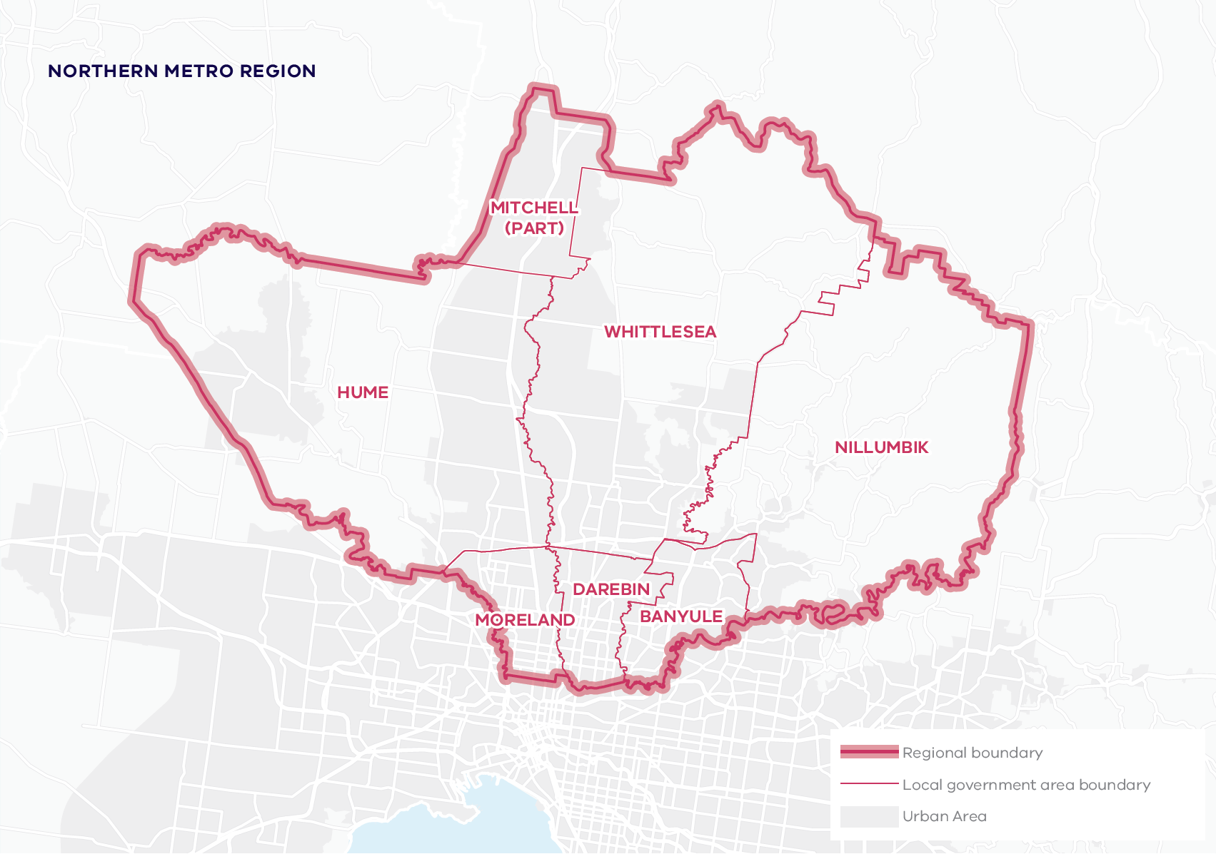

About the Northern Metro Region
The Traditional Owners of the Northern Metro region are the Wurundjeri Woi Wurrung people of the Kulin Nation.
The Northern Metro region is transitioning from a strong manufacturing-based economy towards an economy with highly-skilled and creative jobs.
It has some of the city’s newest, most dynamic and diverse communities – from the inner suburbs of Brunswick and Northcote out to the growth areas of Sunbury, Craigieburn, Mernda and Wallan. It has green wedges, farmland, river corridors and water catchments, eucalypt forests and ancient river red gums. And it is home to Melbourne Airport.
Urban areas include:
- Sunbury – a regional centre and growth corridor
- The Hume (Craigieburn- Donnybrook) and Whittlesea (Epping-Wollert, Mernda/Doreen) growth corridors
- The Wallan township and surrounding growth areas
- Older established areas along the outer metropolitan ring (Broadmeadows/Glenroy, Thomastown/Lalor)
- Established inner areas with fine-grain development and larger urban renewal sites with higher development densities along the north-south rail and tram spines (Brunswick, Coburg, Northcote, Preston, Heidelberg)
- Leafy suburbs along the Yarra and Plenty rivers (Ivanhoe, Rosanna, Greensborough, Eltham).
By 2051, the Northern Metro region’s population is projected to increase by 73 per cent from around 1.05 million to 1.82 million. The number of dwellings is projected to almost double from 355,630 in 2016 to 707,830 in 2051. By 2031, employment is projected to increase from 321,200 to 459,200 jobs.

Geographically
its footprint covers 19 per cent of metropolitan Melbourne, with more than 50 per cent designated as green wedge.

Demographically
22 per cent of Melburnians, more than 1.05 million people, live in the region.

Economically
it generates $42 billion a year in economic activity and employs more than 321,200 people.

Environmentally
it has 22.6 per cent of metropolitan Melbourne’s open space and 12.1 per cent urban tree canopy cover.

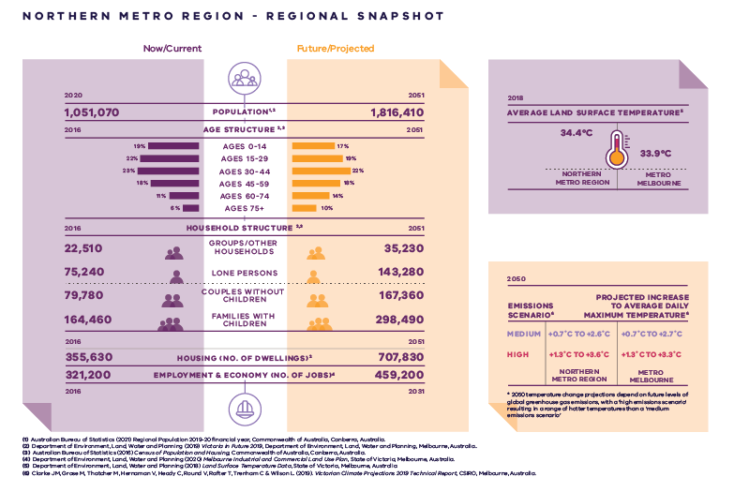
Northern Metro Region – Regional Snapshot

Northern Metro Region population  Sources:  Australian Bureau of Statistics (2021) Regional Population 2019-20 financial year, Commonwealth of Australia, Canberra, Australia.  Department of Environment, Land, Water and Planning (2019) Victoria in Future 2019, Department of Environment, Land, Water and Planning, Melbourne, Australia. | 2020:  1,051,070 inhabitants | 2051:  1,816,410 inhabitants
Northern Metro Region age structure  Sources:  Department of Environment, Land, Water and Planning (2019) Victoria in Future 2019, Department of Environment, Land, Water and Planning, Melbourne, Australia.  Australian Bureau of Statistics (2016) Census of Population and Housing, Commonwealth of Australia, Canberra, Australia. | 2016:  19 per cent – Ages 0 to 14  22 per cent – Ages 15 to 29  23 per cent – Ages 30 to 44  18 per cent – Ages 45 to 59  11 per cent – Ages 60 to 74  6 per cent – Ages 75 plus | 2051:  17 per cent – Ages 0 to 14  19 per cent – Ages 15 to 29  22 per cent – Ages 30 to 44  18 per cent – Ages 45 to 59  14 per cent – Ages 60 to 74  10 per cent – Ages 75 plus
Northern Metro Region household structure  Sources:  Department of Environment, Land, Water and Planning (2019) Victoria in Future 2019, Department of Environment, Land, Water and Planning, Melbourne, Australia.  Australian Bureau of Statistics (2016) Census of Population and Housing, Commonwealth of Australia, Canberra, Australia. | 2016:  Groups/other households – 22,510  Lone persons – 75,240  Couples without children – 79,780  Families with children – 164,460 | 2051:  Groups/other households – 35,230  Lone persons – 143,280  Couples without children – 167,360  Families with children – 298,490
Northern Metro Region housing (number of dwellings)  Source:  Department of Environment, Land, Water and Planning (2019) Victoria in Future 2019, Department of Environment, Land, Water and Planning, Melbourne, Australia. | 2016:  355,630 dwellings | 2051:  707,830 dwellings
Northern Metro Region employment and economy (number of jobs)  Source:  Department of Environment, Land, Water and Planning (2020) Melbourne Industrial and Commercial Land Use Plan, State of Victoria, Melbourne, Australia. | 2016:  321,200 jobs | 2031:  459,200 jobs
2018 average land surface temperature  Source:  Department of Environment, Land, Water and Planning (2018) Land Surface Temperature Data, State of Victoria, Melbourne, Australia. | Northern Metro Region:  34.4 degrees Celsius | Metro Melbourne:  33.9 degrees Celsius
2050 projected increase to average daily maximum temperature  *2050 temperature change projections depend upon future levels of global greenhouse gas emissions, with a ‘high emissions scenario’ resulting in hotter temperatures than a ‘medium emissions scenario’  Source:  Clarke J.M., et al. (2019). Victorian Climate Projections 2019 Technical Report, CSIRO, Melbourne, Australia. | Northern Metro Region:  Medium emissions scenario – plus 0.7 to plus 2.6 degrees Celsius  High emissions scenario – plus 1.3 to plus 3.6 degrees Celsius | Metro Melbourne:  Medium emissions scenario – plus 0.7 to plus 2.7 degrees Celsius  High emissions scenario – plus 1.3 to plus 3.3 degrees Celsius

City-shaping projects
The Victorian Government is currently implementing the largest transport infrastructure program in the state’s history.
City-shaping projects include:
- The West Gate Tunnel – creating a second river crossing to link the Western Metro region with the Port of Melbourne, CityLink and the CBD, and taking traffic pressures off the West Gate Bridge
- Level crossing removals including along the Werribee, Williamstown and Geelong- Ballarat railway lines, reducing congestion and unlocking land for development
- Metro Tunnel – linking Melbourne’s south-east and Gippsland to the Sunbury line in Melbourne’s west and north-west
- North East Link – connecting Melbourne’s south-east to the Eastern Freeway, the Western Ring Road and Hume Freeway
- Melbourne Airport Rail – connecting Melbourne Airport to Victoria’s regional and metropolitan train network
- Suburban Rail Loop – connecting every major passenger railway line in Melbourne from the Frankston line in the south to the Werribee line in the west.
These city-shaping projects will improve access to jobs, education and social opportunities for residents in the Northern Metro region. They will better connect the region with other areas of Melbourne and Victoria. They will also create opportunities to maximise social, economic and environmental benefits.
Socially – bring jobs, services and leisure opportunities closer to where people live.
Economically – reduce transport congestion, boost productivity and create jobs.
Environmentally – cut commuting times, reduce transport emissions, promote public and active transport use, and create 20-minute neighbourhoods.
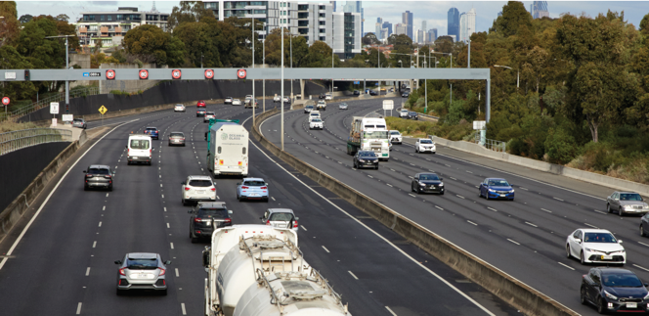

Northern Metro Region strengths and challenges
Productivity | As Victoria’s interstate and international gateway, the region is a leader in logistics and freight. It’s also a hub for agribusiness, manufacturing, health, education and research. There is growing demand for industrial land, however industrial land supply is limited. Extractive resources must also be protected.
Housing Choice | The Northern Metro region is well-placed to cater for population growth within established suburbs and the growth corridor. It needs to ensure housing supply and infrastructure keeps up with growth, including more affordable housing. There is also a need to balance residential and industrial development.
Integrated Transport | The region has a good road network and will benefit from the Suburban Rail Loop. However, congestion is an increasing issue and there is a need for more public transport, as well as improved connections for cyclists and pedestrians.
Liveability | The Northern Metro region has an established network of open spaces and parks, as well as opportunities to develop cultural and tourist attractions. However, there is a need to develop more open space, improve cycling and pedestrian trails, and protect its landscapes and heritage from development.
Strong Communities | A good network of activity centres and community infrastructure for health, education and recreation exists in the region. However, there are service gaps and areas of disadvantage. Growth areas also need more services and facilities.
Sustainability and Resilience | The green wedges and north-eastern suburbs have extensive natural assets and a good tree canopy. However, the region faces increased risks of flooding and bushfire. In addition, communities with low tree canopy are vulnerable to high urban heat. There is a need for more recycling and resource recovery.

Planning for the Northern Metro Region

Productivity
- Develop the La Trobe NEIC as a primary provider of tertiary education and health services supported by good transport connections.
- Protect the development of Melbourne Airport.
- Develop a strong network of activity centres to provide jobs closer to where people live.
- Manage the ongoing development of industrial precincts as generators of economic activity and employment.
- Ensure planning of the Northern Growth Corridor includes industrial and commercial development.
- Protect green wedges to ensure the sustainability of agriculture, extractive resources, tourism, biodiversity and state infrastructure.

Housing Choice
- Secure a 15-year supply of housing across the Northern Metro region.
- Ensure new housing is well-designed, high-quality, climate change resilient and in keeping with neighbourhood character.
- Deliver a pipeline of social and affordable housing near jobs, transport and services.
- Develop a mix of medium- and higher-density dwellings suitable for singles, older residents and families.
- Limit housing growth in the green wedge and areas at risk of natural hazards such as bushfire.
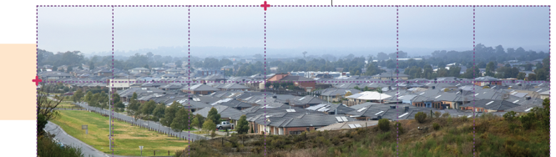

Integrated Transport
- Improve connections within the region and to peri-urban and regional areas.
- Improve public transport connections and cycling and pedestrian access to the La Trobe NEIC and activity centres. Suburban Rail Loop (Box Hill to Airport) will improve east – west public transport connections’
- Improve the road network in the Northern Growth Corridor and outer suburbs.
- Support the development of 20-minute neighbourhoods by prioritising active and public transport.
- Grow the region’s comparative advantage in freight and logistics by protecting freight corridors from encroachment or conflicting land-uses.

Liveability
- Protect the region’s waterways, landscapes and biodiversity.
- Create great civic places that reflect the region’s environment and history – including the heritage of Aboriginal communities.
- Expand the network of open spaces and trails, linking biodiversity areas, waterways and urban areas.
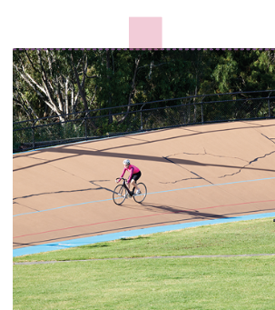
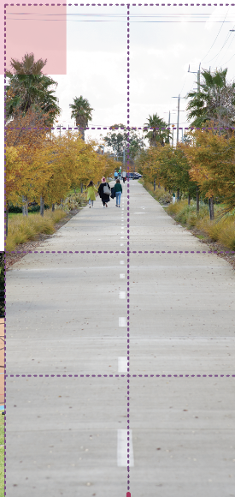
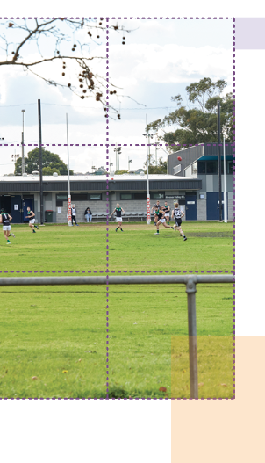

Strong Communities
- Plan for major social infrastructure (libraries, recreation facilities, cultural centres and community hubs).
- Expand the network of accessible health and education facilities and precincts – including health and education services in the Northern Growth Corridor.
- Create 20-minute neighbourhoods around activity centres and in close proximity to public transport.
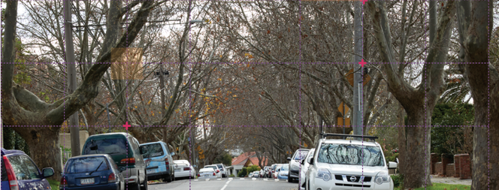

Sustainability and Resilience
- Prepare a regional bushfire plan to minimise risk to suburban and peri-urban communities.
- Investigate options for a resource recovery centre and transfer station.
- Ensure development supports the changing energy supply network.
- Increase the tree canopy to 27 per cent and harvest and reuse stormwater.
Submissions can be made online at https://engage.vic.gov.au
For any questions or assistance please contact lufp@delwp.vic.gov.au

