What is disadvantage and who does it affect?

Disadvantage occurs when an individual, family or community is deprived of resources or opportunities – enjoyed by other Victorians – that underpin social and economic wellbeing. Disadvantaged people and communities lack either material resources (income, housing, services, transport), skills/knowledge resources (education, health) or “social capital” resources (social participation, inclusion, strong governance) (Figure 10).

Figure 10. The resources that contribute to an individual, family or community’s social and economic wellbeing

Material Resources
(Economic capital)
Skills & knowledge
(Human Capital)

Education
Training
Workforce participation
Good health
Local leadership

Income, jobs
Secure housing
Services available
Infrastructure
Transport

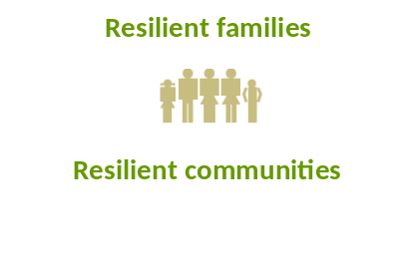

Connectedness
Social participation
Positive socialisation:
inclusive, tolerant, safe
Involvement in decision-making

Relationships
(Social Capital)

Some people and communities experience disadvantage only mildly – perhaps only on one indicator in Figure 10 – such as labour market insecurity (rather than no job) or transport limitations. These people are likely to be managing, but may be vulnerable to more severe disadvantage when the economy changes or services/facilities are relocated (the Australian Government following the European Commission reports these people as “at risk of poverty” (Australian Government 2009) (Figure 11)). The size of this group depends on the resource they do not have access to. For example, in Barwon South West, 47% of the population do not have access to the internet at home (ABS 2006), while 16% report they have experienced transport limitations in the last 12 months (CIV 2007). This group is not the main focus of this report although it is acknowledged that these inequalities make people vulnerable to more serious disadvantage and are an important subject for public policy debate.

This report focuses on the approximately 10% of the population that face multiple social and economic problems that impact significantly on their wellbeing (Australian Government 2009). These people will be experiencing a combination of material deprivation, economic precariousness, labour market disadvantage, poor health, inadequate housing and exclusion from social, educational and civic life (Australian Government 2009).

Figure 11. Disadvantage exists on a continuum from severe to mild disadvantage – relative to the rest of the population.

Disadvantaged
(approx 10% of the population)

At risk of disadvantage
(approx 10% of the population)

The remainder of the population

Determined using a European Commission measure of having incomes 60% below the national median (Australian Government 2009)
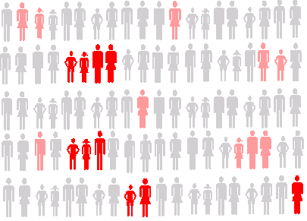

Disadvantage of this kind has been shown to be geographically concentrated (PHIDU 2010 – Atlases of census data since 1999; ABS 2010). For example, the report Dropping off the Edge (Vinson 2007) showed particular localities in Australia have the highest levels of disadvantage in terms of low incomes, housing stress, detachment from the economy (fewer employed, lower involvement in education, early school leaving), poorer service access (limited computer and internet access) and increased social problems (physical and mental disabilities, long prison admissions, child maltreatment) (Vinson 2007).

Not all population groups in Australia experience disadvantage equally. Considerable inequalities exist with some groups consistently overrepresented in data related to disadvantage. The Australian Government’s comprehensive Compendium of Social Inclusion Indicators (2009) found the groups that experience higher levels of disadvantage in Australia across a range of indicators were:
- aged persons;
- public housing renters;
- Aborigines and Torres Strait Islanders;
- single parent families; and
- people with non-English speaking backgrounds.

An Australian study of deprivation additionally found significant disadvantage in:
- the unemployed;
- private renters; and
- people with a disability (Saunders & Wong 2009).
The study of deprivation asked a representative sample of the Australian population what they thought were the minimum acceptable standards of living for Australians. This was done by asking them what they thought were essential items for living - such as a substantial meal a day (Saunders & Wong 2009). The disadvantaged population groups described above were then surveyed using the list of essential items – or minimum community standards – to see if these were met (Saunders & Wong 2009).

The second survey of the disadvantaged population groups found a proportion (between 6 and 20 percent) were so disadvantaged that they were deprived of items considered essential by the general population (Saunders & Wong 2009). Table 4 shows the percentage of select population groups that experience deprivation on the top ten essential items. It shows an significant number of Indigenous people, renters (both public and private), sole parent families and unemployed people in Australia do not have decent and secure homes, are unable to treat medical and dental issues, and are unable to provide activities for their children (Saunders & Wong 2009).

Table 4. Deprivation of the top ten essential items among population groups in Australia (%) (Saunders & Wong 2009)

Essential item | Indigenous Australians | Public Renters | Sole Parent Families | Private Renters | Unemployed People | People with a disability | Single Older Person
The percentage of the population group that did not have …. | % | % | % | % | % | % | %
Medical treatment if needed | 0.0 | 4.3 | 7.6 | 5.2 | 3.4 | 2.4 | 2.3
Warm clothes & bedding if it’s cold | 5.6 | 2.2 | 0.6 | 0.9 | 0.0 | 0.2 | 0.8
Substantial meal at least once a day | 10.5 | 8.4 | 1.9 | 2.4 | 3.4 | 2.7 | 0.8
Able to buy prescribed medicines | 33.3 | 14.0 | 11.6 | 12.3 | 10.5 | 5.7 | 4.5
Dental treatment if needed | 42.1 | 36.2 | 35.7 | 32.6 | 40.7 | 20.8 | 17.5
A decent and secure home | 22.2 | 29.3 | 21.9 | 31.2 | 14.0 | 9.5 | 8.3
School activities/outings for children | 21.1 | 16.3 | 10.4 | 7.5 | 12.5 | 6.6 | 7.1
Dental check-up for children | 27.8 | 12.8 | 22.1 | 23.6 | 24.0 | 13.0 | 6.3
A hobby or leisure activity for children | 31.6 | 20.5 | 18.6 | 13.9 | 20.0 | 9.6 | 8.0
A roof and gutters that do not leak | 5.0 | 7.6 | 11.4 | 6.3 | 6.8 | 6.2 | 4.1
Average deprivation rate | 19.9 | 15.2 | 14.2 | 13.6 | 13.5 | 7.7 | 6.0

Table 5 shows the size of population groups identified above as experiencing a greater burden of disadvantage in the Barwon South West region. Some of the groups make up very small proportions of the population. While this means the overall magnitude of disadvantage may be small (as a population percentage), the disadvantage may be severe, and these groups may additionally be marginalised, and not well catered for in communities because of a lack of their critical mass.

The groups in Table 5 will be used to examine the population composition of disadvantaged localities in Barwon South West in the following section.

Table 5. Potentially disadvantaged population groups in Barwon South West region.

 | Barwon South West | Regional measure | Metropolitan measure | Victoria measure
Older people (ABS 2006)
Percent persons aged over 65 | 15.9% | 16.0% | 12.7% | 13.6%
Percent persons aged 85+ | 2.0% | 2.0% | 1.7% | 1.8%
Percent persons aged 75 + and living alone | 2.9%  (n= 824) | 2.7%  (n= 3 038) | 2.0%  (n= 4 336) | 2.2%  (n= 7 246)
Public housing tenants (DHS 2010)
Proportion of public housing households (at 30 June 2009) | 4.6%  (n= 4 963) | Not reported | Not reported | 3.5%  (n= 62 561)
Public Housing applications on waiting lists as at 30 June 2009 | 2 984 | Not reported | Not reported | 39 940
Private housing tenants (ABS 2006)
Proportion of private housing tenant households | 18%  (n= 26 522) | 16.8%  (n=80 567 ) | 21.8%  (n=269 302 ) | 20.4%  (n=349 869 )
Aborigines & Torres Strait Islanders (ABS 2006)
Aborigines and Torres Strait Islanders (that identified in the census 2006) | 0.9%  (n= 2 276) | 1.3%  (n= 18 460) | 0.4%  (n= 15 572) | 0.6%  (n= 40 398)
Single parent families (ABS 2006)
Percentage of families that are single parent families | 15.6%  (n=8 297) | 15.4%  (n=54 645) | 15.4%  (n=135 691) | 15.4%  (n=199 004)
Children in households with income less than $650 per week | 19.2% | 21.3% | 16.6% | 17.9%
Non-English speaking (ABS 2006)
Speaks language other than English at home | 6.4%  (n= 16 186) | 4.8%  (n= 68 161) | 27.9%  (n= 1 086 155) | 21.6%  (n= 1 454 344)
New settler arrivals per 100000 population (2008-2009) (DIMIA 2009) | 195.5  (n= 496) | 148.1  (n= 2 103) | 696.1  (n= 27 099) | 549.6  (n= 37 004)
Unemployed (ABS 2010)
Unemployed March 2010 | 5.7% | 6.0% | 5.7% | 5.8%
People with a disability (ABS 2006)
Core activity need for assistance (disability) | 4.9%  (n= 12 393) | 5.0%  (n= 71 001) | 4.3%  (n= 167 400) | 4.5%  (n= 302 988)

Disadvantage occurs when an individual, family or community is deprived of resources that underpin social and economic wellbeing. Some population groups are consistently overrepresented in data related to disadvantage

Disadvantage in Barwon South West

Disadvantaged people are concentrated in particular geographic locations in Victoria (PHIDU 2010). Geographic location of disadvantage is most commonly described using the Australian Bureau of Statistics (ABS) Index of Relative Socio-economic Disadvantage (one of the Socio-Economic Indices for Areas (SEIFA)) (ABS 2010). The index combines information from a number of variables from the population census (2006) relating to income, education, occupation, wealth and living conditions. It ranks areas on a continuum of advantage to disadvantage. The average score is 1000 for Victoria as a whole, 986 for Regional Victoria (Table 6). Scores below average are relatively disadvantaged. The index is highly correlated with the earlier Vinson measures of disadvantage in Australia (r=0.8) because the two indices are based on the same ABS census data (Vinson 2004).

Table 6. Socio-economic status of geographic areas in Victoria.

 | Barwon South West | Regional measure | Metropolitan measure | Victoria measure
Index of Relative Socio-economic Disadvantage score | - | 986 | 1022 | 1000
Percentage of the population living in collector districts with a score under 1000 | 37%  (n=124952) | 52% | 31% | 37%

Figure 12 provides a summary of Relative Socio-economic Disadvantage (SEIFA RSD) across Victorian Statistical Local Areas in Victoria (more detailed maps for Barwon South West LGAs are provided in the following pages). The red in Figure 12 indicates the areas where the most disadvantaged 20% of the Victorian population live (i.e. areas ranked by SEIFA are divided into five equal proportions of the population – red equals the lowest quintile). This includes both those disadvantaged and those vulnerable to disadvantage (20%).

Figure 12. The Index of Relative Socio-economic Disadvantage in deciles for Victorian Statistical Local Areas, 2006 (SGS Economics & Planning 2009)
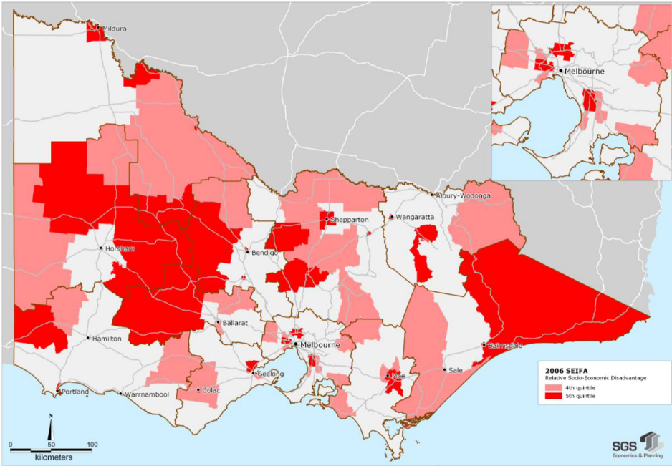
While regional Victoria contains more disadvantaged areas, a much larger number of disadvantaged people live in metropolitan locations. Nonetheless, just over a third (37%) of the Barwon South West Region population, or 124 952 people, live in collector districts with SEIFA scores under the 986 Regional Victorian average.
LGA snapshot 2
Number and percentage of the population living in collector districts with SEIFA score under the 986 Regional Victorian average, 2006 (ABS 2006)

 | Number | %
Barwon South West | 124 952 | 37%
Glenelg | 10929 | 55%
Southern Grampians | 8265 | 50%
Corangamite | 6962 | 42%
Warrnambool | 11397 | 38%
Greater Geelong | 70084 | 36%
Colac-Otway | 12400 | 23%
Moyne | 3078 | 20%
Surf Coast | 1837 | 8%
Queenscliff | - | 0%

The following pages describe the specific locations in the Barwon South West LGAs that are relatively disadvantaged. A full list of the localities can be seen at Appendix A.

Reading the Local Government Area sections that follow

Each LGA section includes:

1. A map made at the collector district level (around 200 census households) for each of the regions LGAs (DPCD 2010). The red localities in the maps indicate where the most disadvantaged 10% of the population lives.

2. A table of localities with SEIFA scores under 986 divided into large towns (populations over 3000), mid sized towns (populations between 3000 and 1000) and small towns (populations under 1000) that have Index of Relative Socio-economic Disadvantage scores under the Regional Victorian average (986). Each table describes whether the area has groups identified as overrepresented in disadvantage statistics:
- low income
- public housing tenants
- older people
- people with a disability
- single parent families
- disadvantaged children
- Aborigines and Torres Strait Islanders
- those with low English proficiency
- an indicator of access to services in those areas (households with no internet).
Red shading indicates the proportion of the indicated population is greater than the Barwon South West average.

3. Some general data about the LGA for context. This includes some employment data and service access data.

Additional context is provided in LGA snapshots for each indicator and the following three maps describing some accessibility indicators across Victoria.

Disadvantage is clustered in towns across Barwon South West. Different population groups are affected in those towns due to the different economic and demographic changes occurring in them
Figure 13. Accessibility of areas in Victoria – The Accessibility and Remoteness Index of Australia, 2006 (DHS 2009a)
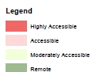
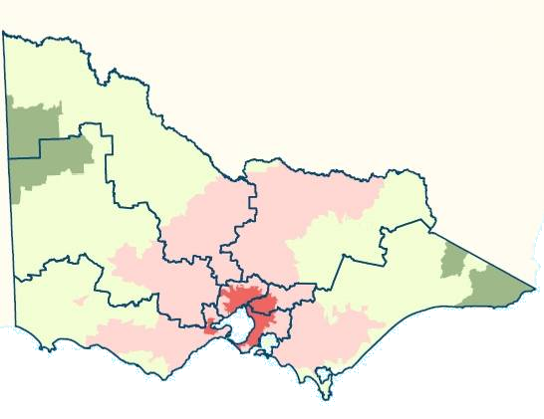

Figure 14. Households without internet connection, Local Government Areas, 2006 (ABS 2006)
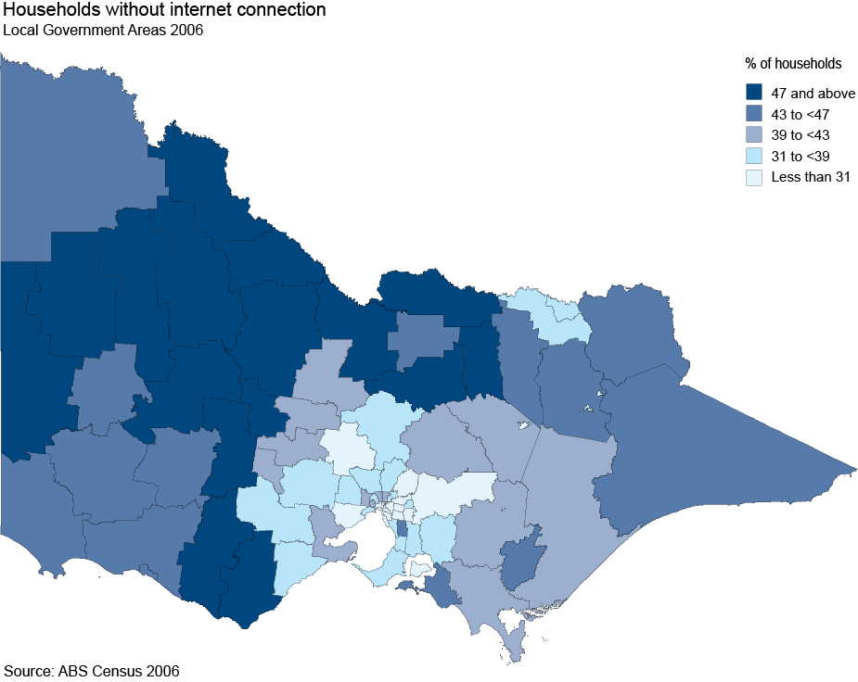

Figure 15. People that experienced transport limitation in the last 12 months, 2007 (CIV 2007)
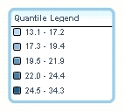
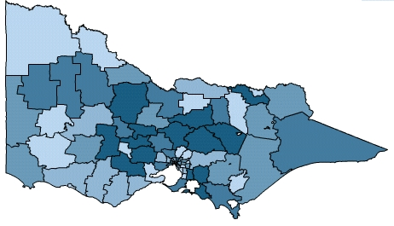
Percentage that report they experienced transport limitations in the last 12 months

