Overview
The Victorian Government has updated the car parking rates in clause 52.06 (Car parking) in the Victoria Planning Provisions (VPP) and all planning schemes.
Car parking rates have been updated to be proportionate to public transport access. Where a site has high-quality access to public transport, less parking will be required than in other locations.
Maps have been developed that align car parking rates with public transport access - Car Parking Requirement Maps (Department of Transport and Planning, December 2025) (CPR Maps).
The CPR Maps also support the introduction of maximum rates in areas with better public transport accessibility.

Public Transport Accessibility Level (PTAL)
The CPR Maps were developed using the Public Transport Accessibility Level (PTAL) methodology. The PTAL model for Victoria is a modified version of the methodology used interstate and internationally. Developed in the United Kingdom and adapted for Victorian conditions, PTAL is a measure used in transport planning to assess how well a specific location is connected to the public transport network.
PTAL scoring is based on:
- A 200m grid of locations over Victoria (with the Melbourne GPO at the centre of the first grid square).
- The General Transit Feed Specification dataset from Public Transport Victoria (PTV) for the location of metropolitan and regional stations and stops, and their scheduled service frequencies based on the main timetable.
- Street networks to calculate the walk time to the nearest stations or stops.
The PTAL calculation is based on morning peak hour services from 8am to 9am for each sampled 200m grid.
PTAL scores are determined by calculating walk times to public transport stops or stations, number of services and the reliability of each service mode. The PTAL Categories (Category 1 to 4) are assigned based on the PTAL score for each grid and demonstrated visually in the CPR maps.
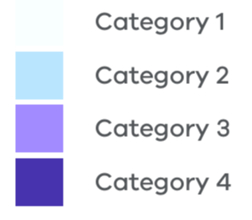
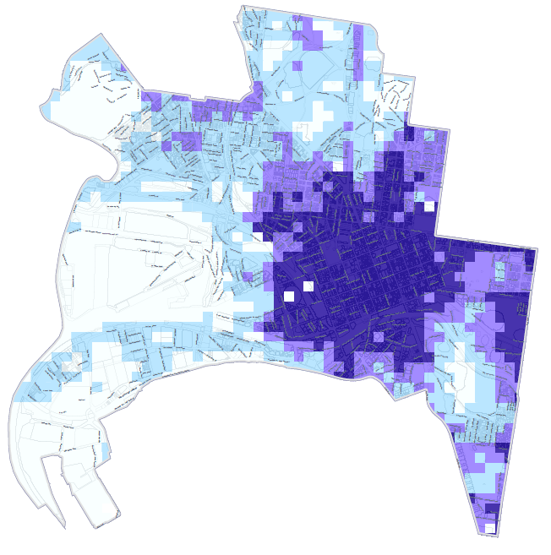
Figure 1 - Car Parking Requirement map - City of Melbourne

PTAL Calculation

PTAL and car parking requirements
Clause 52.06 of the Victoria Planning Provisions contains car parking requirements for specified land uses.
The CPR Maps have four categories that are used to determine car parking requirements for a particular land use.
Category 1 areas have the lowest PTAL scores and Category 4 areas the highest PTAL scores.
A higher PTAL score results in a lower car parking requirement as connectivity to public transport is better. Conversely, a location with a lower PTAL score (due to lesser public transport connectivity) will have a higher car parking requirement.

A location will have a higher PTAL score if:
- It is a short walking distance to the nearest stations or stops.
- Waiting times at the nearest stations or stops are short.
- More services stop at the nearest stations or stops.
- There are major rail stations nearby.
- Any combination of all the above.
Note: PTAL does not take into account the number or variety of destinations you can travel to and from each location or the ease of public transport interchange. PTAL also does not reflect levels of crowding on public transport, temporary disruptions to services, or trips by car.

Checking car parking requirements
The Victorian Government’s existing interactive mapping tool VicPlan will be updated to include a ‘Car Parking Requirement’ layer which can be selected to view which Category applies to a site. This tool can be used alongside the CPR maps to determine applicable car parking requirements.

