Trees for Cooler and Greener streetscapes - Guidelines for Streetscape Planning and Design 2019

This version of Trees for Cooler and Greener streetscapes - Guidelines for Streetscape Planning and Design 2019 has been prepared for use with screen reader software. The printed publication may contain various photographs, captions and design features that have been omitted from this version. Decorative photos have been omitted, while photos and diagrams that provide context and information have been included with alternative text captions. In other respects, this document contains identical text to that in the PDF version of the document which is available at www.planning.vic.gov.au
If you would like to receive this publication in an alternative format, please telephone the DELWP Customer Service Centre on 136186, email customer.service@delwp.vic.gov.au, or via the National Relay Service on 133 677 www.relayservice.com.au.
Document control:
Draft Issued 28 June 2019
Final Issued 26 September 2019
Prepared by E2Designlab for the Victoria Government Department of
Environment, Land, Water and Planning with collaboration from:
- City of Brimbank
- City of Melbourne
- City of Moreland
- City of Yarra
- Department of Transport
- Major Transport Infrastructure Program
- Northern Alliance for Greenhouse Action
- Public Transport Victoria
- Department of Transport (formerly VicRoads)
© The State of Victoria Department of Environment, Land, Water & Planning 2019
This work is licensed under a Creative Commons Attribution 4.0 International licence. You are free to re-use the work under that licence, on the condition that you credit the State of Victoria as author. The licence does not apply to any images, photographs or branding, including the Victorian Coat of Arms, the Victorian Government logo and the Department of Environment, Land, Water and Planning (DELWP) logo. To view a copy of this licence, visit http://creativecommons.org/licenses/by/4.0/
ISBN 978-1-76077-839-2 (Print)
ISBN 978-1-76077-840-8 (pdf/online/MS word)

Contents
Introduction to the guidelines 3
What are these guidelines about? 3
Why were these Guidelines created? 3
Why do we need cooler and greener streetscapes? 4
Who should use these guidelines? 7
How are these guidelines structured? 8
Why focus on trees in streetscapes? 8
How do these guidelines integrate with Movement and Place in Victoria? 11
Process overview 13
Stage 1: Strategic planning Identifying and prioritising streets for trees 15
Stage 2: Tree integration Creating healthy growing conditions 21
Stage 3: Street design 25
PART II: Solutions for common streetscapes 29
Introducing the common streetscapes 29
Streetscape 1: Pedestrian zones 31
Streetscape 2: Urban street 35
Streetscape 3: Neighbourhood zone 38
Streetscape 4: Suburban street 41
Streetscape 5: Activity streets 45
Streetscape 6: Boulevards 48
Streetscape 7: Major thoroughfare 51
Streetscape 8: Freeway 54
PART III: Design Component Catalogue 58
Summary of design components 58
Other resources 74
Useful references 74

Introduction to the guidelines

What are these guidelines about?
These are guidelines for planning and integrating healthier trees in urban streetscapes, with the aim of creating a cooler and greener Melbourne. The focus of these guidelines is supporting better placement and design integration of trees in roads and streets in priority urban areas to increase tree canopy cover.
They provide guidance for the planning and design process, example solutions for typical streetscapes and a design catalogue for reference in creating bespoke solutions.

What types of streetscapes are these guidelines relevant to?
These guidelines are for all types of urban streetscapes and road corridors, ranging from local streets which are typically managed by local councils, to major roadways, which are typically managed by The Department of Transport (formerly VicRoads).
These guidelines build on the work originally developed by City of Yarra, and it has been re-produced and broadened in its relevance with permission, now including contributions from a range of Melbourne local governments and State departments. These guidelines also link to the Department of Transport’s Movement and Place Framework and provide guidance for all roads.

Why were these guidelines created?
Trees are essential elements of urban streetscapes. They sustain cooler, healthier environments, support biodiversity and habitat for wildlife in urban areas, restore soil moisture levels to recharge and stabilise groundwater levels in catchments, connect people with nature in an otherwise heavily built up environment and provide valuable amenity and character.
While trees have always been important, they are needed now more than ever. Substantially increasing tree cover is a major priority for climate change adaptation in urban areas, as trees are one of the most effective providers of shading and localised cooling and contribute to improved stormwater management.
We need to mobilise efforts to increase tree canopy across the metropolitan region. Growing our urban forest to cool the city as it becomes hotter and drier is a shared responsibility and requires a diverse response.
These guidelines encourage a re-think of the way we plan and design our streetscapes to highlight trees as an integral part of all streets. However, trees can’t be just ‘squeezed in’ to traditional road designs.
Integration of healthy trees that will deliver many benefits over a long life requires prioritisation of space for trees amongst what is often a crowded ground-level and underground environment with many competing elements. This re-prioritisation is a challenge, and effort and action is needed across a range of land use types and by different land managers, including government and the community.
These guidelines were created to highlight both the common challenges and the possible solutions for better integration of trees in streetscapes.

Why do we need cooler and greener streetscapes?
In 2018, the urbanised areas of Melbourne had 15.3% tree canopy cover. Collectively residential land and parkland have 65% of urban tree canopy cover, while 16% is on streetscape and road corridors.
Streetscapes and road corridors are the largest public spaces in a city. While they aren’t often thought of as public spaces, they are in fact the most visited areas in a city, where people gather, walk, cycle, use public transport or drive every day. These major public spaces also are typically ‘hardscapes’; paved environments that have limited greenery. Hardscapes are necessarily functional, with solid surfaces to facilitate movement of people and vehicles in a safe and efficient manner. However, large areas of hardscapes across a city pose three major challenges to health and liveability:
1. The exacerbation of the urban heat island effect: where paved areas store heat that increases local temperatures and intensifies the impacts of heat waves;
2. The creation of urban stormwater runoff: where impermeable paved areas prevent rainwater from infiltrating into the ground, and instead shed water and pollution into waterways; and
3. The lack of natural features and ecosystems: where the absence of trees and vegetation severely impacts both human health (physical and mental) and ecological health in an urban environment.
The integration of more trees and healthier trees in urban streetscapes will create cooler and greener public spaces, addressing all three of these challenges.
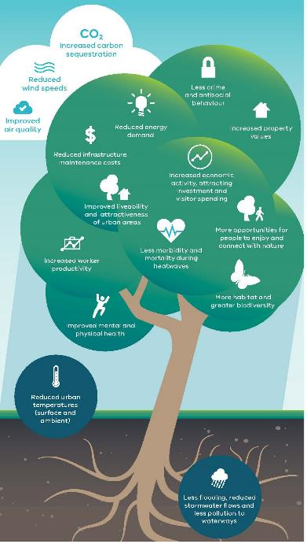
Benefits of urban greening. Source: Plan Melbourne 2017-2050

Key policy drivers for cooler and greener streetscapes
The need for a coordinated approach to the delivery of cooler and greener streetscapes is recognised in multiple policy documents.

Plan Melbourne 2017 2050
Plan Melbourne 2017-2050 is the strategic plan for growth and supports jobs, housing and transport, while building on Melbourne s legacy of distinctiveness, liveability and sustainability. It outlines several directions relating to cooling and greening the city including:
- Direction 6.3: Integrate urban development and water cycle management to support a resilient and liveable city; and
- Direction 6.4: Make Melbourne cooler and greener to combat increased heat caused by increased urban intensification.
Plan Melbourne specifically recognises the need for authorities to collaborate to deliver opportunities at all scales: from local roads managed by local councils, to major road corridors managed by the Department of Transport. Plan Melbourne Implementation Plan Action 91 outlines a whole of government approach to cooling and greening that:
- Coordinates with VicRoads, private road operators and other public land owners and managers; and
- Prepares greening strategies for state owned public land, including road corridors, achieving a balance between asset protection and urban greening.
Trees are also fundamental to delivering Outcome 4: Melbourne is a distinctive and liveable city with quality design and amenity, including:
- Policy 4.1.3: Strengthen Melbourne s network of boulevards as ‘wide, generous, tree lined spaces; and
- Policy 4.1.1: Support Melbourne s distinctiveness, as a ‘mosaic of diverse natural landscapes and urban places’.

Water for Victoria
Water for Victoria is the water plan for Victoria, which recognises that water is fundamental to our communities and to the creation of resilient and liveable cities and towns. It sets out two specific actions which aim to increase integration of greening and water management in public spaces:
- Action 5.1: Use diverse water sources to protect public spaces
- Action 5.6: Work across government for healthy and resilient urban landscapes

Transport Integration Act 2010
The Transport Integration Act 2010 is Victoria s principal transport statute. It establishes a framework for the provision of an integrated and sustainable transport system in Victoria. It recognises the role of the transport system in supporting environmental sustainability and health and wellbeing. Its provisions support an integrated response to transport system design, including the preservation, protection and improvement of the natural environment, protection of environmental public health, and reduction in transport related emissions.

Who should use these guidelines?
The successful integration of healthier trees into urban landscapes requires forethought through strategic planning, and consistent planning and design through either a new street construction process or a street reconstruction or retrofit.
Integration into these processes requires input from many disciplines, and may involve multiple organisations. Accordingly, these guidelines are for use by:
- Strategic planners involved in green infrastructure planning, climate change adaptation, city planning and development;
- Major road planning and design teams, who are planning new road corridors;
- Urban designers and landscape architects involved in planning and design of development or redevelopment areas, or enhancement of civic spaces and activity areas;
- Civil and road engineers who are planning and prioritising road improvement works, including road reconstructions, pavement renewals, traffic calming initiatives and kerb and channel upgrades;
- Drainage and water sensitive urban design (WSUD) engineers who are planning streetscape interventions to improve drainage or integrate stormwater quality improvement measures;
- Arborists who identify opportunities to enhance, replace or introduce trees in the streetscape; and
- Maintenance and operations staff who identify opportunities for improvement or retrofit of streetscapes.
While the preparation of these guidelines has been driven by Plan Melbourne 2017-2050 and the need to mitigate urban heat, they can be applied to urban roads outside of Melbourne. 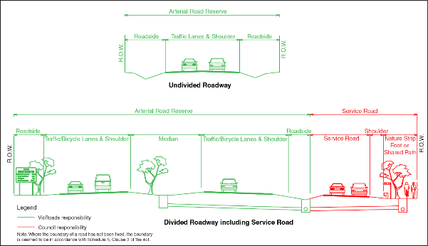
Example of responsibility for management of infrastructure in road reserves

How are these guidelines structured?
These guidelines are structured to assist in both strategic planning and delivering projects on the ground. There are three parts to these guidelines:

Part I: Planning and Design Process
An outline of key stages in the process to plan and prioritise streets for trees, design solutions using key principles, and implement measures within the streetscape to deliver the desired benefits.

Part II: Solutions for Common Streetscapes
Eight example streetscape types are discussed, each with a possible design solution provided, showing how the planning and design process has been applied.

Part III: Design Catalogue
Recognising that solutions are often unique, a catalogue of relevant design components and features are provided, which designers can use to create bespoke integrated tree solutions.

Why focus on trees in streetscapes?
The introduction of vegetation generally can create greener landscapes and promote cooling through evapotranspiration. However, trees are most effective at creating cooler streetscapes, as a healthy tree canopy can also shade pedestrian areas, roadways and adjacent buildings. The latest research in this area shows the strongest negative correlations with urban heat island (UHI) are with tree canopy cover.
Tree canopies can reduce the temperature of surfaces they shade (e.g. buildings and roads) by 10-25°C.
There is significant potential for greener streetscapes and road corridors to reduce the urban heat island effect (UHI) and improve local microclimates. A line of trees along a street becomes a ‘green corridor’, supporting active transport while creating a cooler microclimate grid across the city. Accordingly, this guidance focusses on trees, which can deliver a range of benefits to communities while creating cooler, greener streetscapes.
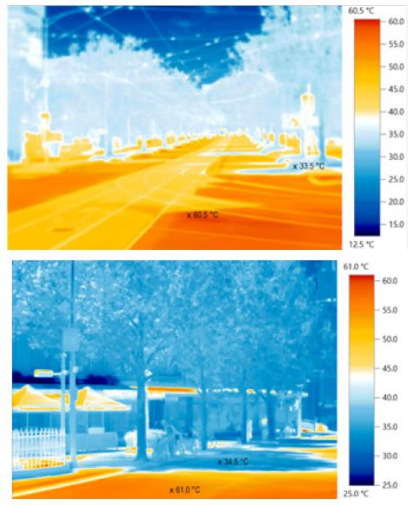
Thermal images taken in a January 2017 heatwave show the impact of urban heat islands in Melbourne.

How does planning and design impact the success of trees in the landscape?
The success of trees in the landscapes will be influenced throughout the planning, design and delivery process. Healthy trees need the right growing conditions - including space for roots and canopy to grow, and adequate access to water.
Streets can be crowded places – both with cars and people, as well as with urban infrastructure, including trees. At the street level, the integration of movement pathways, overhead powerlines, street furniture and sight lines can restrict integration of trees, while underground, the presence of utilities, road sub-base and variable urban soil conditions can make the creation of growing media and root space difficult.
More often than not, street trees must contend with a dry Melbourne climate and limited access to water.
As a result, the integration of trees in streets often hasn’t been prioritised and trees have been ‘squeezed in’ to locations and environments which most often don’t provide adequate growing conditions for healthy trees, resulting in premature tree death and sub-optimal growth outcomes. It is time for a change to ensure trees are valued and embedded into streetscapes.
Research has shown that soil volume and access to water are two key factors in the creation of healthy tree canopy in an urban environment. Firstly, a ‘typical’ tree in an urban streetscape is lucky to be provided with 2m3 of soil media as its growing volume, and this is often ‘containerised’ so that the tree doesn’t have access to deeper and surrounding soils. Soils in the roadside environment are also typically heavily compacted, and lacking nutrients and oxygen.
These soil conditions make it difficult for trees to thrive.
Secondly, it is also uncommon for trees to be provided with irrigation water, despite stormwater flowing nearby along the kerb in the street drainage system. Without access to adequate soil moisture, a tree’s growth is limited, and its lifespan is cut short.
These poor growing conditions place trees under stress and root systems expand and strain against the surrounding infrastructure in search of adequate nutrients, oxygen and moisture. This can cause pavement uplift and root interference with underground infrastructure which are often cited as reasons not to include trees in streetscapes. To create larger tree canopies and healthier trees in a streetscape, the provision of adequate healthy soil volume and soil moisture is essential.
These guidelines focus on delivering healthy trees in streetscapes, which effectively deliver cooling and greening benefits, while integrating seamlessly with other streetscape functions and infrastructure.
Adequate soil volume and soil moisture can result in:
- Double the growth rate,
- Canopy cover which is 8-10 times as large, and
- An increased the lifespan of the tree from 13 to 50 years.

How do these guidelines integrate with Movement and Place in Victoria?
The Department of Transport has developed a new approach to the planning and design of movement corridors. The Movement and Place Framework in Victoria recognises that streets not only keep people and goods moving, they’re also destinations for people to live, work and enjoy. Accordingly, the framework puts people at the centre of transport planning, and organises transport links by their place and movement roles into road and street types. These types can be categorised using the network classifications matrix, as shown in the table to the right. The matrix maps the classification of a street according to two factors:
• Place – define the land-use vision and user experience that transport needs to support. Place classifications are defined by State-level planning strategies such as Plan Melbourne’s activity centre hierarchy, the State Planning Policy framework, Planning Zones and regional growth plans.
• Movement – consider the mix of transport modes and define priority for moving people and goods safely. Movement classifications represent the mix of transport links that are required to support the overall demand for movement across a network.
All classifications within the Movement and Place Framework have a role to play in supporting a cooler and greener Melbourne. These guidelines use the Movement and Place Framework to bring together the significance of movement, the significance of place, and options for trees and water in different street and road contexts.
For example, City Hubs like Elizabeth Street in Melbourne’s CBD are dense and vibrant places that have a high demand for movement. They are also places providing focal points for businesses and culture. Trees represent essential infrastructure in City Hubs, City Streets and City Places in protecting the physical health of pedestrians, ensuring a high quality public realm and providing restorative benefits for workers in an otherwise built-up environment.
At the other end of the spectrum, Connectors include examples such as the City Link or Princes Highway, which should provide safe, reliable and efficient movement of people and goods between regions and strategic centres, while mitigating their impact on adjacent communities. Highways and other Connectors generally act as heat sinks contributing to the UHI effect. Trees are vital assets in mitigating these impacts. .
What are the Movement and Place categories?

City Hubs (Metropolitan and Major Activity Centres)
Successful City Hubs are dense and vibrant places that have a high demand for movement. They are also places providing focal points for businesses and culture. City Hubs should aim to reduce the impact of high traffic volumes while accommodating high pedestrian numbers, multi-modal journeys and access to public transport and essential emergency services.

City Streets
Successful City Streets should provide a world class pedestrian friendly environment. They aim to support businesses, on-street activity and public life while ensuring excellent connections with the wider transport network.

City Places
City Places are roads and streets with high demand for pedestrian activities and lower levels of vehicle movement. City Places are places communities value and for people and visitors to enjoy.

Activity Streets and Boulevards
Successful Activity Streets and Boulevards provide access to shops and services by all modes. There is high demand for movement as well as place with a need to balance different demands within the available road space. Activity Streets and Boulevards aim to ensure a high quality public realm with astrong focus on supporting businesses, traders and neighbourhood life.

Connectors
Successful Connectors should provide safe, reliable and efficient movement of people and goods between regions and strategic centres and mitigate the impact on adjacent communities.

Local Streets
Successful Local Streets should provide quiet, safe and desirable residential access for all ages and abilities that foster community spirit and local pride. They are part of the fabric of our neighbourhoods, where we live our lives and facilitate local community access.
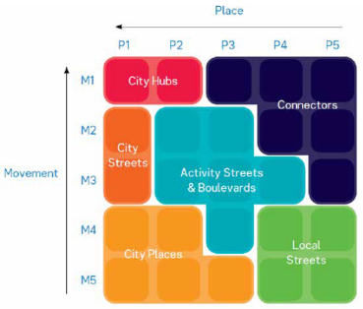
Movement and place matrix and categories.

PART I: The Planning and Design Process

Process overview
The planning and design of streets should recognise the value of trees and consider their integration early in the process. It is important to embed consideration of trees as a key component of street infrastructure at all stages, from strategic planning through to road design and construction. It is also important to take opportunities to protect and enhance existing trees, particularly given the time it takes to establish mature trees.
Finding opportunities to protect, enhance and make space for healthy trees
In new development and redevelopment areas, trees can be planned into street design from the beginning. In the existing urban environment, a lot of the opportunities to integrate or enhance trees in streetscapes will come about during planned works to upgrade a road as part of routine maintenance or renewal. Accordingly, the opportunities need to be identified at key points of this renewal process.
In either case, there are three broad stages where trees need to be considered:
- Strategic planning: Identifying and prioritising streets where trees should be located
- Tree integration: Creating healthy growing conditions
- Street design: Tailoring design solutions to site conditions
These three stages in the integration process are discussed in the following sections.
- Stage 1 Strategic Planning
- Stage 2 Tree Integration
- Stage 3 Street Design

Communication and Collaboration
Ensuring the right team members are involved throughout the design process is critical to project success. The following meetings or discussions are recommended during the design process. Some of these discussions may be combined or revisited at different stages.
Important design meetings (these may occur as separate meetings, or some may be combined)
Meeting purpose | Key representatives | Desired outcomes
Prioritisation | - Urban forest officer  - Landscape architect  - Strategic planner  - Transport planner  - WSUD engineer | - Confirm strategic context for project  - Identify opportunities to integrate works  - Agree on priorities at the street level  - Proceed to design for existing and new green infrastructure  - Agree principles for design
Approval | - Transport planner  - Civil engineer | - Confirm with coordinating road authority ability to undertake works  - Refer to Road Management Act 2004 (Code of Practice for Working in Road Reserves, Code of Practice for Utilities in Road Reserves)
Site layout | - Civil/drainage engineer  - Landscape architect  - WSUD engineer | - Confirm site layout requirements, integrating with existing streetscape factors  - Determine design footprint - required or allowed  - Consider connecting new green infrastructure assets or existing trees via underground soil trenches  - Evaluate effects of proposed solutions on drainage infrastructure and other street infrastructure
Service investigations | - Civil engineer  - WSUD/ drainage engineer  - Landscape Architect | - Review services information (site survey and service proving)  - Confirm clearance requirements or resulting constraints  - Seek specialist soil input to support the design
Planting and species selection | - Landscape architect  - Arborist | - Select appropriate plant and tree species for the given site objectives and constraints (e.g. overhead obstructions limiting tree height)
Community engagement | - Community engagement officer | - Identify relevant community stakeholders  - Agree community engagement and information strategy
Catchment and drainage elements | - Drainage/ WSUD engineer | - Identify potential downstream connection points and flow paths  - Estimate catchment area and treatment to catchment ratio
Edge treatment and safety design | - WSUD engineer  - Landscape architect  - Civil designer | - Select appropriate edge treatments considering:  - Pedestrian safety  - Aesthetics  - Lowered surface levels (extended detention depths) for ponding  - Road safety for high speed roads
Construction timing | - WSUD engineer  - Landscape architect  - Civil designer | - Review and align asset construction with other planned construction works surrounding the selected site to minimise construction costs and community disturbance

Stage 1: Strategic planning Identifying and prioritising streets for trees
Strategic planning for trees in the urban environment can help to prioritise streetscapes and movement corridors for both tree protection and enhancement (where there are existing trees) and tree integration (where tree cover is lacking). Strategic planning is important to both deliver key benefits, and to capitalise on opportunities as they arise.
When done effectively, strategic planning should result in a clear whole-of-organisation strategy, informed by strong evidence, which outlines target areas with the greatest need for tree planting, and clear implementation timelines and budgets.

Planning for strategic objectives
There are a number of strategic objectives which may be considered by councils or road managers when identifying priority streets for trees:
- Canopy cover: Existing and future tree canopy cover (considering lifetime of existing trees). Councils and land managers may have canopy cover targets in place as an overall measure of a range of benefits.
- Amenity: High-quality landscapes are likely to be prioritised in key civic and commercial activity areas and in key city entrances and movement corridors. Adding to the network of tree-lined streets also contributes to the character and legacy of Melbourne.
- Cooler places: Urban heat island intensity and vulnerability of local communities to heat could be considered as key spatial indicators for prioritisation.
- Water management: Priority areas for stormwater management (water quality or flood risk) can be identified through examination of urban catchments.
- Urban ecology: Key habitat corridors (providing linked habitat in the urban environment and resources for birds and insects) can be mapped, considering existing habitat areas, key gaps and possible connections between areas.
- Active transport: Walking, cycling and recreation routes that would benefit from shade and greening.

Planning to capitalise on opportunities
In the existing urban environment, a lot of the opportunities to integrate or enhance trees in streetscapes will come about during planned works to upgrade a road as part of routine maintenance or renewal. Accordingly, the opportunities need to be identified at key points of this renewal process.
Works regularly occur in pavements and roadways which could provide an opportunity to efficiently introduce or enhance trees in streetscapes. By planning tree integration with other works such as footpath renewals, traffic works, road renewals and redevelopments, it is possible to minimise costs and disturbance to communities.
Local governments and the Department of Transport should invest efforts in coordinating urban renewal works across multiple disciplines and delivery teams, seeking opportunities to align these works. It is helpful to map opportunities both spatially and across a timeline to understand synergies and opportunities for coordinated capital expenditure, and identify target areas with the greatest need for tree planting.
This level of planning is necessary not just for trees, but across all types of infrastructure. More generally across Australia, some great success stories occur where councils invest in integrated planning for a range of services and functions, especially within linear corridors. Linear corridors create distinct opportunities to pool investments from multiple funding streams (parks and gardens, stormwater, active transport) and deliver an integrated project through a coordinated process.

Where is cooling needed?
It is clear that there is a Melbourne-wide need for trees to realise the benefits that have been described in these guidelines. There are regional variations which make the need for trees especially important in the western, northern, and outer south-eastern suburbs. According to research undertaken by the Department of Land Environment, Water and Planning, there are large areas of urban heat in the western suburbs and the middle and outer south-eastern suburbs, along with some scattered areas of high urban heat in the northern suburbs.
Except for the Mornington Peninsula, Yarra Ranges and Nillumbik, all urban Local Government Areas of Melbourne had an average summer Urban Heat Island of over 7.0 degrees Celsius in 2018. This means these locations can be up to 7 degrees hotter than non-urban areas on hot days. Retaining, servicing and expanding our tree cover across Melbourne is important to respond to increasing temperatures.
Heat Vulnerability Index data can also help direct greening initiatives to the people and places that need it most (DELWP, 2018). The index identifies populations with high vulnerability to heat waves. It consists of three indicators: heat exposure, sensitivity to heat and adaptive capacity and creates a vulnerability rating which is scaled from 1 (low vulnerability) to 5 (high vulnerability). The index takes into account the location of vulnerable groups such as the elderly, very young and those with lower adaptive capacity using Socio-Economic Indexes for Areas (SEIFA) as an adaptive indicator.
Map 1 shows there are hot and vulnerable areas to the north, west and outer south east of Melbourne. This data can also be viewed online using the Cooling and Greening Melbourne Interactive Map.
It is important to establish and maintain tree canopy cover in all areas of Melbourne This is also true for the street and road network which offers a significant opportunity to help service and grow our existing tree cover and to expand our urban forest. In addition to areas of high vulnerability (rated 4 & 5) and areas with high urban heat, Map 2 also shows the activity centre network (Central City, Metropolitan Activity Centres and Major Activity Centres) and their walking zones, and train station walking zones. These areas are a focus for residential, business and civic activity, and change as our city grows. This map provides a preliminary framework for where tree canopy is needed at a regional scale, based on the distribution of urban heat and vulnerable populations, and the location of activity centres.
Regardless of responses to these regional challenges, high benefit opportunities will exist on a local level everywhere.
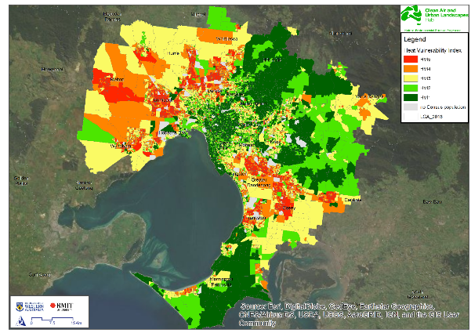
Map 1: Heat Vulnerability Index across Melbourne where 1 is low and 5 is high (2018)
Map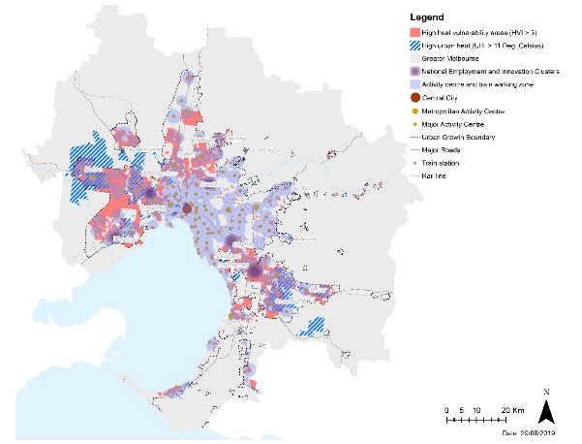
Map 2: City-wide locations where cooling is a priority

Planning trees for major roads
Trees, in particular clusters of trees, make an important contribution to reducing surface temperatures on hot days. They are assets that need to be nurtured and managed, including on major roads. There are specific considerations that should be made when planning trees alongside major roads. Higher speeds and the presence of frequent heavy vehicle movements on major roads such as arterial roads and freeways requires particular attention to two key factors:
- Appropriate placement of trees and barriers for safety
- Appropriate design to manage risks to road pavement
Maintaining a safe system
Statistics show that collisions with trees at speeds exceeding 60km/hr have a high risk of death or serious injury. Trees are not excluded from these environments, but increased measures must be taken to ensure a safe transport system is maintained. It is recognised that the safety risk posed by roadside trees is generally low if the speed limit is =50km/hr.
The Department of Transport’s Tree Policy outlines a principle-based decision-making process for deciding where trees are appropriate in higher speed roads. It considers whether there could be physical barriers or roadside parking in front of the tree, the alignment of the road and whether there is potential to reduce speeds in that area. Generally, in sections of major roads where there is higher pedestrian and cyclist movement, trees are a very important feature and there are also likely to be opportunities for lower speed zones or a clear business case to put appropriate safety measures in place.
In addition to the Tree Policy, the latest safe systems approach, Towards Zero, requires safety barriers along each side of roads and medians where speeds are >60km/hr. Existing safety barriers represent a key an opportunity to increase tree planting.
Managing soil moisture for roads and trees
There are two key risks to road pavements relating to soil moisture. Firstly, soil saturation can reduce the strength and life of the pavement. Secondly, localised variations in soil moisture (particularly in reactive soils) can cause surface levels to change and damage road pavements. In some cases, roadside trees can accelerate damage if root systems extract moisture from soils underlying the road base. This is because some soils are sensitive to changes in moisture levels, and expand and contract as a result, which commonly causes damage to pavements and roadways.
In order to promote large and healthy trees in an urban environment, irrigation is often needed to support good soil moisture. The stakeholder workshop held during the development of this guideline highlighted concerns regarding whether irrigation, particularly passive irrigation, exacerbates risks to pavements. Design and management strategies should consider:
- Mitigating the likelihood of pavement damage
- Understanding and planning for possible consequences
Mitigating the likelihood of pavement damage
There are two things we need to do to mitigate the likelihood of pavement damage:
- Increase understanding of factors that lead to heave and seasonal movement of pavements
- Use design adaptions to manage saturation and soil moisture variability
The causes of heave or seasonal movement of pavements on expansive soils are complex, with many overlaying and interrelated factors. The impact of tree roots drawing moisture out of soils is a major concern. However, our understanding of trees in this environment, is quite poor; for example, there is still little evidence to differentiate between species, and not much to go on regarding the influence of soil types and different regional weather patterns. The conflicting views expressed in the workshop and within literature serve to highlight the importance of continuing research in this area.
The needs of passively irrigated trees and road pavements are relatively compatible. A well-designed passively irrigated tree should not result in significant variations to soil moisture. The objective is generally to increase moisture levels for the tree, and to avoid saturation which overall results in reasonably stable soil moisture. Both road pavements and passively irrigated trees need subsurface drainage. Even though the soil moisture for the tree should be relatively stable, the arrangement of these subsurface drains should be designed to isolate the moisture in the tree growth zone from the moisture in the road base. This provides a further precaution.
Understanding and planning for possible consequences
Even with good design, soil moisture variation may still occur, and present a residual risk to pavements. This should not ultimately determine whether trees are included. Instead, project planning should weigh up increased lifecycle costs (maintenance and reduced design life), resulting from soil moisture variation against the overall benefits that trees provide.
These considerations align with the foundation of the Movement and Place Framework. This approach allows for recognition that the consequence of pavement damage is more tolerable for some roads than others.
Achieving cooling outcomes for roads on highly expansive soils
In highly expansive soils, particularly the basaltic clays that are common to the western areas of Melbourne, the risks to pavement due to soil moisture variation are amplified. However, little is known about the scale of the impact, and how this varies with different tree species, soil types and regional weather patterns. There is a need to continue researching this issue.
Again, project planning should weigh up increased lifecycle costs (maintenance and reduced design life) against the overall benefits that trees provide. In these challenging locations, both the lifecycle costs and the benefits will be higher.

Stage 2: Tree integration Creating healthy growing conditions

Five design principles for healthy growing conditions
To create a cooler and greener metropolitan Melbourne, we must deliver larger tree canopies and healthier trees. To achieve this, these guidelines focus on five design principles. Together, these principles support the creation of healthy trees, which contribute to the character and function of streets and will thrive for decades to come.
- Supporting place-making: Good design speaks to the local context, and leverages the opportunities to add to the character of the street and enhance its function and liveability.
- Creating room to grow: Good design caters for the horticultural needs of the tree to allow it to reach full maturity and size.
- Providing water: Good design provides water to a tree to support healthy growth, evapotranspiration for cooling, and can lead to improved stormwater outcomes.
- Integrating urban infrastructure: Good design uses innovative thinking to integrate urban infrastructure that provides space for trees and enhances the functional role provided by trees.
- Ensuring longevity: Good design anticipates the long-term outcomes and future needs of the street.

Supporting place-making
Place-making aims to support the breadth of community needs, expectations and aspirations for the places people live as well as the roads and streets people pass through. Trees are fundamental to supporting place-making through the many social services they provide, such as shade and cooling, amenity and character, and air quality improvement.
They can also support place-making in other ways when integrated into the landscape, such as inclusion of bicycle hoops, seating for edge treatment, and traffic calming.
To support place-making, designers should engage with communities to understand their needs at a local street level. They should also consider how the design will integrate with the surrounds to create a solution that is safe and supports the functionality of the space, suits the character of the streetscape, and adds value for the public.

Creating room to grow
The provision of good soil volume around trees is essential to support tree health and canopy growth. In most cases, this will require importing a high-quality sandy clay loam soil. In constrained environments, soil volume requirements may be met underneath load-bearing surfaces with permeable pavements and structural soil systems. To support trees, soil volume should be one third of projected canopy, with a minimum depth of one metre. Structural soil systems can be used if soil volume cannot be achieved due to space constraints.
However, sometimes this is not feasible and designers must work with existing soils. When working with in-situ planting in confined beds in original soil, itis important to recognise that not all soil is created equal. For heavy clays (as in the western suburbs), it would be wise to increase the rooting volume to account for the fact that heavy clay provides less effective growth resources (water, air and nutrients) for trees to grow to maturity. Rooting volumes may need to be increased by 40-50% in this instance. Similar corrections apply for sandy in-situ soils.

Providing water
Potential sources of water for trees include potable, recycled, and stormwater. Increasingly, councils are installing stormwater harvesting schemes to supply reticulated irrigation systems within parklands and sportsfields. Expanding this to street tree irrigation should be encouraged.
Sources of water can be delivered to trees in a range of ways: directly from an irrigation reticulation system (using any available water source), via manual irrigation (e.g. from water trucks), and via passive irrigation (using stormwater runoff from adjacent surfaces). The following principles should be followed to account for the fact that optimal soil moisture can not be constantly maintained:
- Mitigating risk of being too dry: Connect to underlying and surrounding soils to allow tree roots to access other moisture sources as they naturally would.
- Mitigating risk of being too wet: Ensure an aerobic soil zone is always provided for the tree, for example by ensuring the top 400-500 mm of soil is free draining in all circumstances. A subsurface drainage system may be needed.
Factors that influence soil moisture levels:
- How much irrigation is provided and when (stormwater or otherwise)
- Volume of soil dedicated to root growth
- Ability for soils to freely drain (via subsoil drains connected to local drainage, or naturally free-draining underlying soils e.g. sandy substrates)

Passive irrigation
These guidelines encourage the design of passive irrigation to provide trees with ongoing access to water and to harness improved stormwater outcomes. Passive irrigation particularly benefits good growth in young trees, but is unlikely to fully support a large tree; whose demand will grow beyond what the passive irrigation catchment area is likely to supply. To supplement passive irrigation, manual irrigation may be needed for continued accelerated tree growth and long-term resilience.
Soil volume (the volume the tree’s roots can access) and the catchment area feeding the tree play important roles in providing optimal soil moisture for healthy tree growth and canopy development. As a simple calculation, the passive irrigation catchment area (measured in square metres) should ideally be 30 times larger than the soil volume (measured in cubic metres). Additionally, in a passive irrigation system, soil moisture depends on the ‘storage’ for runoff that captures stormwater and makes it available for soils after the rainfall event has passed. A common approach is to direct runoff to a depressed soil surface surrounding the tree. Other approaches include infiltration trenches and wells that capture stormwater and direct it to the plant’s root zone.
For passive irrigation designs, soil moisture is influenced primarily by the connected catchment area and drainage arrangements. The catchment may comprise just the road and footpath to kerb and channel or include properties and roofs draining to the kerb. If the catchment area is too large there is a heightened risk the system will experience flooding or premature deaths of planting from waterlogging. If the catchment area is too small trees may perform little stormwater treatment, dry out die prematurely (without other irrigation sources). To manage these risks, overflow weirs, drainage and deep submerged water zones can potentially be incorporated into tree designs. In some cases manual irrigation may also be needed to support tree health.
Where including passive irrigation, it is also important to consider site and catchment slopes. Preferred site and catchment slopes for these tree systems are between 0.5 - 5%. Catchment slopes of 5 - 8% may be considered, but will require energy dissipation interventions.

Integrating urban infrastructure
Many projects will involve retrofitting trees into already established streets and places, where a range of infrastructure exists that will need to be accommodated with the design.
When resolving clashes with existing infrastructure, the strategic priorities should be considered to determine the best outcomes for design. Designing and choosing locations that avoid clashes is preferred, but they are often unavoidable so some reconfiguration may be required.
Designs should seek innovative solutions to integrate multiple functions into street infrastructure. Fishermans Bend is an example of where detention areas are proposed to be integrated into street design to manage flood water. The design approach at Fishermans Bend is featured across arterial roads, collector roads and local streets. See Other Resources at the back of these guidelines for more information on this approach.
Common urban infrastructure that may be encountered includes:
- Underground services (water, sewer, telecommunications, gas, electricity, stormwater)
- Overhead power
- Light poles
- Tram lines
- Traffic signals and signs
- Shop awnings
- Street furniture
- Parking spaces

Ensuring longevity
In a contested road and footpath environment, there are many competing needs that should be considered when designing for longevity, including how the tree may influence the longevity of other infrastructure and functions in the streetscape and vice versa. The strategic priorities should be considered to determine the best outcomes for the longevity of both the tree and the surrounding streetscape.
Things to consider include:
- Passive irrigation for tree health - can lead to increased tree size and canopy, longer lifespans, and faster growth rates. Where passive irrigation cannot be achieved, active irrigation of trees is likely to be required to ensure growth and longevity of the trees.
- Long-term safety of road-users and maintenance staff - for example, should barriers or other mechanisms be included to protect road users, and can maintenance staff safely access the site for routine works? This is especially important for arterial roads where traffic volumes and speeds are higher, increasing the risk.
- Future works to underground services - consider how utilities will access services adjacent to the tree without damaging the tree or its roots.
- Road pavement, especially in expansive soils - there are concerns about the potential for tree roots creating moisture differentials and damage to pavements, especially in areas with expansive soils and heavy traffic loads.
- Compatibility with ongoing and future activities - street cleaning, parking, and tree maintenance.

Stage 3: Street design

Tailoring design solutions to site conditions
Once space has been made for trees in the streetscape and good growing conditions have been created, there are a range of key considerations for street design that need to be addressed by looking at the existing context of the street and site.
Key factors include:
- Street safety
- Overhead conditions
- Underground conditions
- Street sweeping and tree maintenance
- Light and shade
A significant challenge for designers is ensuring there is adequate above- and below-ground space assigned for trees. In order for adequate space to be allocated to trees, designers will need to work closely with a range of disciplines and organisations to resolve conflicting space requirements.

Street safety
Careful consideration must be given to how tree systems interact with their environment, particularly with pedestrians, cyclists and vehicles. In respect to residential areas, tree design solutions can be used as traffic calming measures although consideration must be given to preserving lines of sight.
Two key safety considerations are: risks associated with vehicles and road users; and risks associated with tripping hazards. For higher speed environments (e.g. >60km/hr), safety barriers may be needed to protect road users. The Department of Transport’s Tree Policy outlines a principle-based decision-making process for assessing risks associated with trees and vehicles.
For pedestrians, tripping hazards are a key safety issue. Tripping issues generally arise from drop-offs next to footpaths and parking areas. Good design should aim to reduce the risk to pedestrians. Common design examples that reduce risk of tripping include dense vegetation, bicycle hoops, battered edges, altered design lines, and integrated seating on hard edges. Where surface levels are lowered, such as for passive irrigation designs, tripping hazards and appropriate offset distances need particular consideration.
Checklist
- Is the site immediately adjacent to high-speed traffic with limited space for access?
- Will trees or tall vegetation compromise traffic sight lines?
- Does the site have high pedestrian or bike traffic?
- How could maintenance staff safely access the site?

Overhead conditions
Trees can potentially conflict with other overhead infrastructure assets such as powerlines, tram lines, street awnings, and traffic lights. These pre-existing or planned constraints must be taken into consideration with plant selection, placement and maintenance.
Large tree species with expansive canopies will deliver greater contributions to cooling and canopy targets, but are not always able to be integrated with overhead infrastructure. Consideration of aerial bundling of electrical utilities or relocation of services (for existing streets), and planned, combined underground bundling of services needs to be considered (for new works and greenfield sites). Designers should check with utility providers to discuss these opportunities.
Where services cannot be bundled or relocated, designers should work with landscape architects and engineers to determine appropriate species where overhead services or infrastructure exists.
The Code of Practice for Management of Infrastructure in Road Reserves has a range of objectives to guide the allocation of standard space for utility infrastructure in road reserves including an objective to provide for the planting of street trees to ensure liveable streets.
Checklist
Use Google Street View and/or site visit, discuss with landscape architect and engineer to check:
- Are there/will there be overhead obstructions?
- Can utilities be bundled?
- What species are appropriate?

Underground conditions
Trees require a deep underground soil media layer to grow roots and treat, retain and drain stormwater. Underground services can therefore be a major constraint.
A Dial Before You Dig (DBYD) check should be undertaken once a project location has been confirmed. This will help identify potential outfall drainage points and provide early notice of services that may need to be accommodated in the design or may limit the potential for certain designs or species. Procurement for service proving should occur as soon as possible if the DBYD search indicates services may impact design works.
Design teams will need to consider whether compromises are needed to ensure there is adequate below-ground space assigned for trees. For underground conditions, this includes investigating whether services can be co-located or re-located to provide adequate room for trees.
The Code of Practice for Management of Infrastructure in Road Reserves has a range of objectives to guide the allocation of standard space for utility infrastructure in road reserves, including an objective to provide for street tree planting to ensure liveable streets.
Checklist
- Check DBYD
- Check council and utility records (stormwater, water, sewer)
- Map services on preliminary layout plan
- What design options are available for the tree design or for rearranging services?
- Early procurement of survey and services proving

Street debris and maintenance
The surface material surrounding trees is an important consideration in planning and design that will influence long-term maintenance requirements.
For conventional tree designs (not passively irrigated), leaves and organic matter may act as valuable mulch. This is not always desired or achievable. Designers may wish to consider capturing leaves in larger beds to use as compost. This can be done with understory or hedging to contain mulch and can reduce long-term maintenance and costs and minimise adjacent slip hazards.
Passive irrigation designs add another important consideration. Street debris such as litter, sediment, and organics (i.e. leaves, sticks, and weeds) are often washed into tree pits during rainfall events. After multiple events, this accumulation of local debris can reduce the effectiveness of these assets and result in stunted growth and/or premature deaths of plants.
A further consequence can be reduction in street amenity. To reduce the likelihood of these outcomes, regular street cleaning and maintenance of tree pits is required. Alternatively, the inlet can be configured to exclude litter and debris.
Checklist
For passive irrigation designs:
- Will upstream runoff carry deciduous leaf drop or high sediment loads?
- Does the site receive regular street cleaning?
Otherwise:
- Is there space to capture leaf fall in larger garden/ tree beds?

Light, shade and cooling
Trees require a suitable amount of sunlight and shade to be successful. An appropriate balance between these elements depends on the specific species used. Specific species requirements must be considered before selecting and planting.
Inappropriate plantings can result in sun damage, stunted growth, premature deaths and unusual growth paths as the species seeks out more ideal growing conditions.
In terms of cooling and climate benefits, a mix of tree species with different canopy architectures could be considered to optimise climate outcomes. Trees clustered together in groups with overlapping canopies will maximise shade. However, trees that provide the greatest shade during hot summer days can also trap heat under their canopy at night. To minimise heat trapping, street trees should be grouped in clusters, but not form a continuous canopy, thereby promoting shade, but allowing ventilation and long-wave radiation to escape.
The species, placement and number of trees will also influence how much shade and cooling they provide for the street. Street orientation influences the benefits of cooling providing by trees. In the Southern Hemisphere, trees placed on the southern side of east-west streets and the eastern side on north-south oriented streets provide the greatest shade for the street.
Checklist
Use a site visit (preferred) and/or Google Street View to check:
- Will the site get adequate sunlight?
- What is the street orientation?

PART II: Solutions for common streetscapes

Introducing the common streetscapes
This section explores eight common streetscape examples, highlighting the typical planning and design considerations and a possible solution for tree integration. The common streetscapes are classified using Victoria’s Movement and Place Framework, to demonstrate how tree integration solutions may vary across the transport network.
The selected common streetscapes showcase a diverse range of priorities with regards to significance of movement, significance of place and available space for trees.
- Pedestrian zone: Large pedestrianised paved areas such as plazas, walkways and squares.
- Neighbourhood zone: Low speed street with shared integrated pedestrian and vehicle activity.
- Urban street: Street with hard verge and significant pedestrian movement.
- Suburban street: Residential street with a nature
- Activity street: Commercial or shopping street with high pedestrian activity and significant vehicle and public transport movement.
- Boulevard: Wide street with central median.
- Major thoroughfare: Higher speed road (>60km/hr) with a grassed verge.
- Freeway: High speed (>80km/hr) major transport corridor.

Choosing a design solution
There are a number of potential design solutions that may be suitable for various common streetscapes. The following table indicates the likely suitability of potential responses for common streetscapes.
Design response matrix
l Green = Suitable l Yellow = May be suitable [ - ] = Unlikely to be suitable
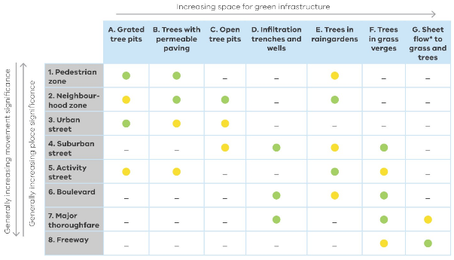
* Sheet flow refers to wide shallow movement of water across a surface, as distinct from concentrated overland flow in channels or narrow flow paths. In this context, sheet flow refers to water that spreads across the length of the roadway into the adjacent verge, rather than flowing through dedicated channels, inlets and entry points.
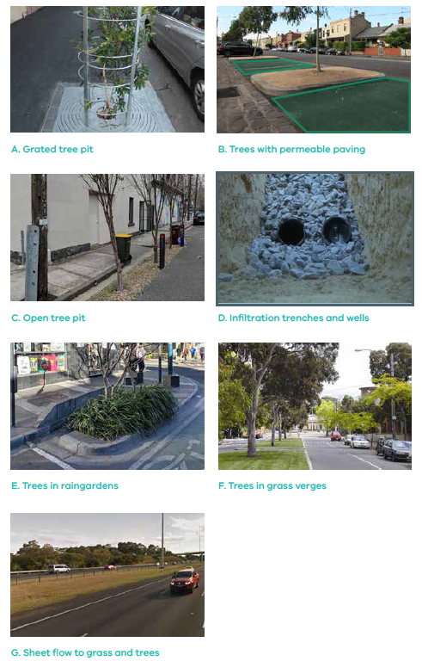

Streetscape 1: Pedestrian zones

Context
Large pedestrianised paved areas with such as plazas, walkways and squares
Examples of pedestrian zones
- Southbank
- Bourke Street
- Plazas and walkways
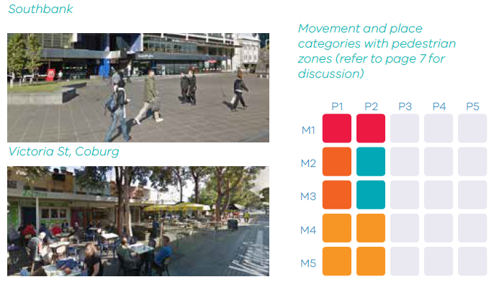

Strategic planning
Why trees are likely to be desirable in this streetscape
- Amenity: Trees can be used to beautify a civic space and highlight it as an area for public gathering and enjoyment. Research has also shown that trees in retail or commercial areas increase commercial activity and enjoyment, encouraging people to stay longer.
- Cooler spaces: Trees provide shade for pedestrians and public gatherings in a space like this. Trees can also be placed to shade adjacent buildings to improve energy efficiency.
- Urban ecology: Trees can provide habitat and ecological links for wildlife in an urban environment.
- Water management: Drainage systems in urban environments can lack capacity for stormwater which can increase the risk of flooding. Constrained urban environments may also have limited options for WSUD integration. Tree pits can be designed with both stormwater retention and stormwater treatment in mind.

Street design
Common site conditions to consider
- Light and shade: In a built-up area, it is important to consider solar orientation, such as building shade impacts on tree growth and species suitability and vice versa. For example, deciduous trees can be placed near a north facing window of a building, to allow sun to come through in winter months.
- Street safety: An area like this will have high pedestrian footfall, so it is important not to create trip hazards or obstructions to sight lines and key movement paths when locating trees. Another crucial aspect of safety is maintaining clear sight lines to public spaces and pedestrian routes. DELWP Urban Design Guidelines Objective 6.3.3 provides guidance for sight line clearances, including foliage free zones between 600 mm and 2500 mm from the ground.
- Catchment area and drainage: It may be difficult to provide passive irrigation to trees in a pedestrian zone as drainage may not shed to the planting area. In squares and plazas it may also be difficult to connect back to the existing drainage system to ensure trees don’t become water logged. Accordingly, placement should consider drainage plans.

Possible suitable solutions
- Grated tree pits
- Trees with permeable paving
- Open tree pits (where space allows)
- Trees in raingardens (where space allows) Imported soil supported with structural cells (or structural soil mix) provides room for the tree to grow and develop a mature canopy.
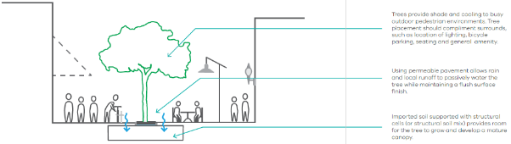

Design example - Trees with permeable paving
Tree integration
Including trees in pedestrian zones provides a range of benefits to the community by making public areas cooler and greener to combat increased heat, and by integrating water cycle management into otherwise hard, paved areas. Tree species selection should favour trees with a clear tall trunk and a wide canopy to create clear sight lines while providing shade to pedestrians and buildings.
Additional soil volume is provided in this example using an expanded growing area, created using structural soils or structural cells under the surrounding pavement. A minimum 12 m3 soil volume is preferred. Leaving the base unlined also allows the tree to expand beyond extent of the imported soil media as it matures.
In a large paved pedestrian zone, water should be harnessed from the paved area and directed to the tree growing area. Permeable paving allows rainwater to percolate through the paved surface in and around the tree to the growing media beneath while providing a flush and seamless surface for movement. In this situation, particularly in clay-based soils, it is essential to install a drainage connection to a nearby stormwater drainage system to prevent water logging. As the potential for passive irrigation is likely to be limited, active irrigation of the tree is desirable for establishment and for ongoing support of tree growth.
Large pedestrian or civic areas are more likely to include clear zones without significant underground services in place. However, due consideration should be given to movement pathways and street furniture at surface level to ensure tree planting supports functionality of the space. It may be possible to integrate seating or bike parking with the design.
The use of permeable paving will require consideration of access for cleaning. Block pavers with permeable areas between pavers may provide a more flexible option to allow for repairs and access to the tree growing area if required.

Example design solution
Large canopy trees are important amenity features and providers of shade in pedestrian zones and civic spaces. Passive irrigation can be achieved using permeable paved surfaces around or near the tree, while an expanded growing area can be created under paved surfaces. Alternatively, a garden area can be created around the tree.
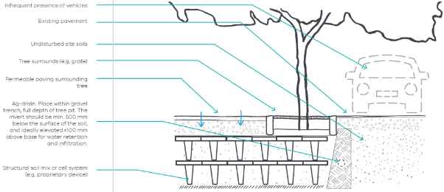
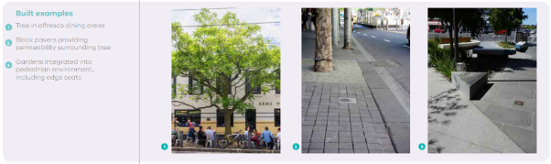

Streetscape 2: Urban street

Context
Street with hard verge and significant pedestrian movement
Example streets:
- Little Collins Street
- High Street, Northcote
- High density residential streets in inner suburbs

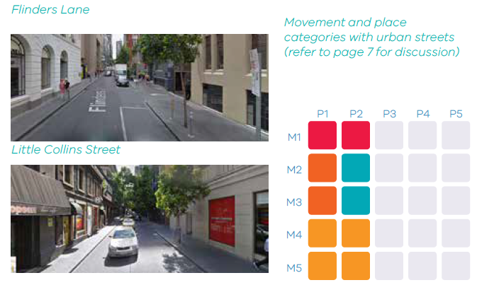Strategic planning
Why trees are likely to be desirable in this streetscape
- Canopy cover: Urban streets are generally low tree canopy cover areas, where canopy enhancement is likely to be a focus.
- Amenity: Trees are important for the character of an urban street. Research has also shown that trees in retail or commercial areas increase commercial activity and enjoyment, encouraging people to stay longer.
- Cooler spaces: Tree-lined urban streets provide cooling in a largely paved environment.
- Urban ecology: Trees can provide habitat and ecological links for wildlife in an urban environment.
- Water management: Drainage systems in urban environments can lack capacity for stormwater which can increase the risk of flooding. Constrained urban environments may also have limited options for WSUD integration. Tree pits can be designed with both stormwater retention and stormwater treatment in mind.
- Active transport: Creating shaded walking and cycling routes is a priority for most urban streets.
- Planned works: There may be opportunities to introduce trees as part of planned road maintenance or upgrade works. Trees provide shade and cooling to busy outdoor pedestrian environments. Tree placement should complement surrounds and may be limited by building awnings, lighting or on-ground obstructions.

Street design
Common site conditions to consider
- Light and shade: It is important to consider solar orientation, such as building shade impacts on tree growth and species suitability and vice versa.
- Street safety: An area like this will have high pedestrian footfall, so it is important to avoid creating trip hazards, maintain sight lines and key movement paths when locating trees. Another crucial aspect of safety is maintaining clear sight lines to public spaces and pedestrian routes.
- Catchment area and drainage: Catchment area for passive irrigation should be considered when placing trees along an urban street.
- Underground conditions: Service integration will need to be carefully considered when locating trees. In a retrofit situation, avoid clashes where possible, and minimise the number of services that need to be moved or disrupted. In new streets, services and tree integration should be co-planned.
- Overhead conditions: Planting locations should be selected to minimise clashes with shop awnings, overhead powerlines or street furniture once the tree is at its predicted full canopy.
- Local debris and litter: Integration of street cleaning protocols and preferences should be considered, particularly the design of inlets for passive irrigation to make litter collection efficient.

Possible suitable solutions
- Grated tree pits
- Trees with permeable paving
- Open tree pits (where space allows)
- Trees in raingardens (where space allows) Imported soil supported with structural cells (or structural soil mix) provides room for the tree to grow and develop a mature canopy.
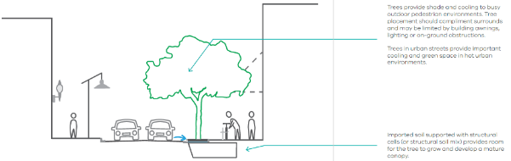

Design example - Grated tree pit
Tree integration
In an urban environment, trees play a crucial role in providing shade and cooling while supporting movement and enhancing amenity and greening within a ‘hardscape’ environment. Tree species selection should favour trees with a clear tall trunk and a wide canopy to create clear sight lines while providing shade to pedestrians and buildings. A grated tree pit can be used to create a flush surface with the footpath, so that there is no trip hazard for pedestrians in a busy urban environment.
Urban streets are often very confined in terms of both the above- and below-ground space available for trees. The soil volume provided to the tree can be expanded under the footpath using structural soil to maximise the growing area. This is often essential to support tree growth, as the surrounding soils in urban streets are likely to be variable and poor quality.
This solution harnesses stormwater runoff from the adjacent road using a side inlet in the kerb which flows into a treepit (with a soil surface level 100mm below the channel invert). Water which flows into the treepit can then pond on the surface temporarily before infiltrating into the soil. A drainage connection to adjacent street drainage is required to ensure the tree doesn’t become waterlogged.
Sites should be identified which are relatively free from underground services, though services can be integrated within the tree growing area where necessary. Ongoing access to services should be considered to minimise tree and root damage. The placement of services in extended soil areas created with structural soil can provide a simpler future access solution.
Litter and sediment will need to be cleared from the tree pit on a regular basis. Some councils prefer a grill plate to be installed on the kerb side inlet to prevent litter entering the treepit and allowing cleaning using a street-sweeper, however careful design is required to prevent clogging. Alternatively, an open side inlet can be used and the tree pit grate can be designed to be easily lifted in order to clear debris periodically.

Design solution
Minimal surface footprint in busy pedestrian area, with grated cover reducing safety risk from tripping. Kerb and channel provides opportunities for passive irrigation from a side inlet.
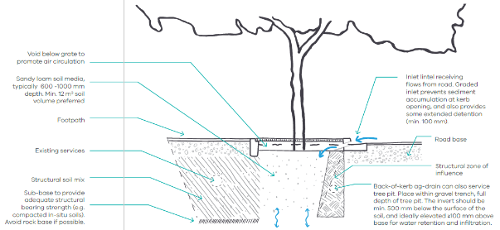

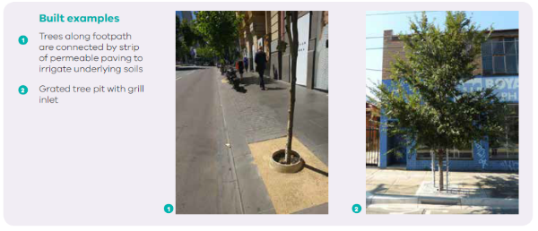

Streetscape 3: Neighbourhood zone

Context
Low speed street with shared integrated pedestrian and vehicle activity
Example streets:
• Junctions
• Traffic calming area
• Streets where trees can be integrated into streetside parking areas
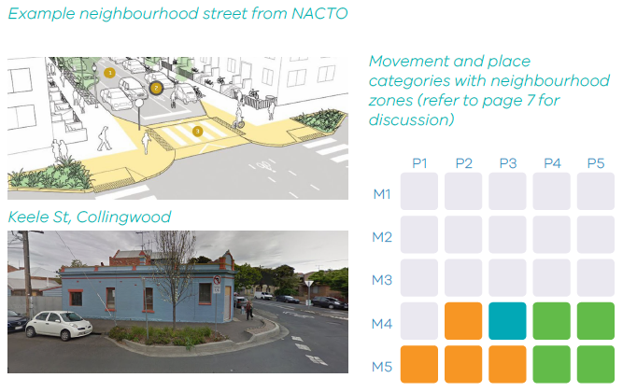

Strategic planning
Why trees are likely to be desirable in this streetscape
- Amenity: Trees can create character and delineate a neighbourhood zone as a shared space.
- Urban ecology: There may be greater scope to integrate trees with gardens as part of neighbourhood greening and habitat creation in neighbourhood zones.
- Water management: There may be opportunities to integrate WSUD features such as raingardens with tree planting areas in shared zones.
- Active transport: Creating shaded walking and cycling routes is a priority for neighbourhood zones.
- Traffic calming: There may be opportunities to introduce trees as part of traffic management works.

Street design
Common site conditions to consider
- Street safety: Trees may become part of a street safety solution, providing bump-outs in the roadway for traffic calming. Sight lines need to be considered, particularly at intersections.
- Underground conditions: In an urban street, it is likely that a tree will be placed in the footpath pavement area. Accordingly, service integration will need to be carefully considered when locating trees. In a retrofit situation, avoid clashes where possible, and minimise the number of services that need to be moved or disrupted. In new streets, services and tree integration should be co-planned.
- Overhead conditions: Planting locations should consider potential clashes with overhead powerlines. Appropriate species should be selected where there is likely to be canopy restrictions.
- Local debris and leaf litter: Placement and design should consider integration with the road managers maintenance arrangements for street sweeping and litter.

Typical suitable solutions
- Open tree pits
- Grated tree pits (where pedestrian traffic may be higher and cost is justified)
- Trees with permeable paving (e.g. adjacent permeable paving on adjacent carparks)
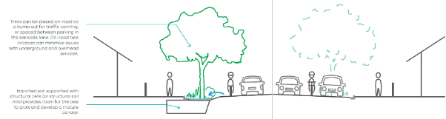

Design example - Open tree pit in ‘bump-out’
Tree integration
Trees placed on-road in neighbourhood streets provide shade, cooling, amenity and traffic calming. They provide visual cues that the streetscape is a shared space between pedestrian and vehicle movement where lower speeds are required. A dropped kerb around the planting area allows road runoff directly into the system at key points, while separating vehicles, cyclists and pedestrians from the lowered surface levels.
A large growing area may be able to be accommodated within the bump-out footprint typically 600 -1000 mm depth. depending on site conditions. Additional soil volume could be provided in this example using a structural soil mix under the adjacent footpath. A minimum 12 m3 soil volume is preferred. Leaving the base unlined also allows the tree to expand beyond extent of the imported soil media as it matures. These structural soils could also be provided under adjacent parking areas.
This design captures runoff from the road via the kerb and channel. The design features a tilted kerb inlet from the footpath edge, and ‘broken’ kerb on the road-side. As the soil surface is lower than the channel invert, water is able to pond temporarily and infiltrate into the growing media. Unless the in-situ soils are free draining, a drainage connection will be required to prevent water logging.
Locating trees in bump-outs on the road is an ideal way to get more trees into streets, particularly where traffic calming is desirable and existing footpaths are narrow. There tend to be fewer conflicts with underground services and overhead power in roadways, allowing greater choice of tree species (taller species) than back-of-kerb solutions. If structural soils expand under the footpath (as shown) where services exist or are planned, a structural soil mix is preferred over structural cells as this provides greater flexibility to excavate in the area in future.
Using a gravel trench on the roadside of the tree pit will also help protect the road pavement by discouraging tree roots from growing towards the road.

Design solution
Tree planted within garden area created in a ‘bump-out’ into the roadway, which can be also be used for traffic calming, pedestrian crossing points or parking delineation. Kerb and channel provides opportunity for passive irrigation.
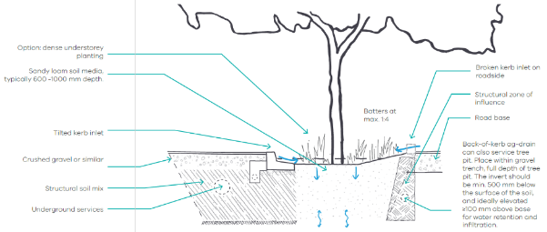
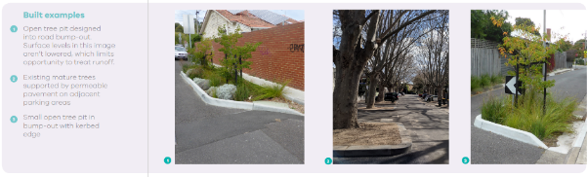

Streetscape 4: Suburban street

Context
Residential street with a nature strip
Example streets:
- Residential streets with grassed verge
- Industrial street with grassed verge
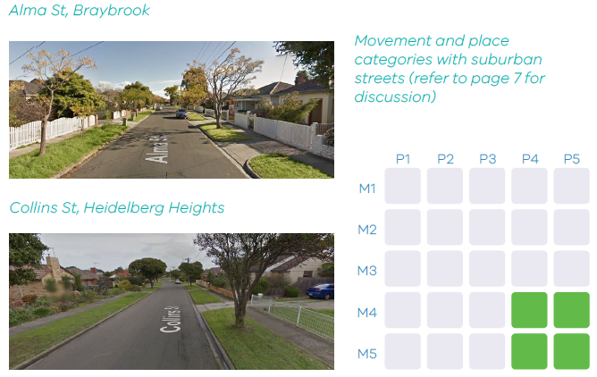

Strategic planning
Why trees are likely to be desirable in this streetscape
- Amenity: Trees can create character and enhance greener residential areas. Research has shown tree lined residential streets benefit from property price uplift.
- Urban ecology: Trees within grassed verges play an important role in providing habitat corridors.
- Water management: Passive irrigation to trees in suburban streets can help meet water quality targets in new developments, and improve stormwater quality in existing areas.
- Active transport: Creating shaded walking and cycling routes is a priority for suburban streets.
- Planned works: There may be opportunities to introduce trees as part of planned road maintenance or upgrade works.

Street design
Common site conditions to consider
- Underground conditions: In an urban street, it is likely that a tree will be placed in the footpath pavement area. Accordingly, service integration will need to be carefully considered when locating trees. In a retrofit situation, avoid clashes where
- possible, and minimise the number of services that need to be moved or disrupted. In new streets, services and tree integration should be co-planned.
- Overhead conditions: Planting locations should consider potential clashes with overhead powerlines. Appropriate species should be selected where there is likely to be canopy restrictions.
- Local debris and leaf litter: Placement and design should consider integration with the road managers maintenance arrangements for street sweeping and litter.

Typical suitable solutions
- Trees in grass verges
- Open tree pits
- Infiltration trenches (good option to use next to adjacent trees)
- Tree in raingardens (subject to space and budget)
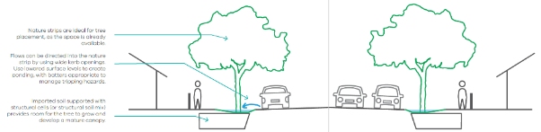

Design example - Trees in grass verges

Tree integration
Grass verges in suburban streets are a key opportunity for enhancement through the integration of trees. Trees can provide shade for pedestrians while also beautifying residential streets and supporting biodiversity. A variety of species could be used in this context, and planting can be co-designed with local residents.
A grassed verge provides a considerable soil area to support healthy tree growth. Where needed, structural soil could also be used beneath the adjacent footpath to provide an expanded area.
In new streets, grassed verges can be sunken to allow water to enter from the road via a kerb cut or dropped kerb. In existing grassed verges, passive irrigation can be achieved through the installation of infiltration trenches or wells (see Streetscape 7).
A key issue in these streetscapes is likely to be integration with overhead powerlines which commonly run adjacent to road verges. Trees are trimmed back from powerlines to avoid risk of damage or fire. In key locations there may be a case to install underground powerlines, but where this is not possible, species selection, consideration of mature canopy and tree placement is important. Where trimming is inevitable collaboration between authorities is important to ensure trimming of the canopy is minimised and is balanced to protect the structural integrity of the tree.
A wide grassed verge can be gradually sloped towards the tree to allow easy mowing. The area alongside the kerb inlet should be regularly scraped of sediment to prevent build up.

Design solution
Create raingarden or ‘moat’ around tree which allows tree to be fed by road runoff via a kerb cut or side entry.
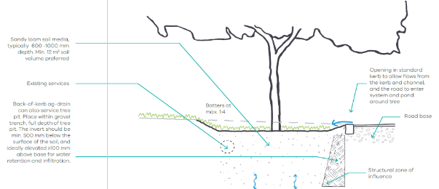
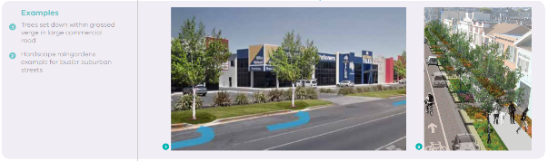

Streetscape 5: Activity streets

Context
Commercial or shopping street with high pedestrian activity and significant vehicle and public transport movement.
Example streets:
- Chapel St, Prahran
- Sydney Rd, Brunswick
- Victoria St, Richmond
- Sydney Rd, Brunswick
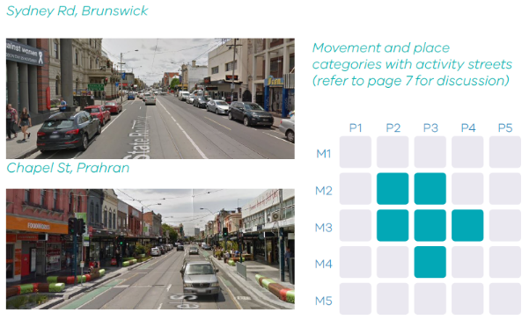

Strategic planning
Why trees are likely to be desirable in this streetscape
- Amenity: Trees are important for the enrichment of public space. Research has also shown that trees in a shopping or commercial area increase commercial activity and enjoyment.
- Cooler spaces: Trees in activity streets provide cooling in a largely paved environment.
- Water management: Drainage systems in urban environments can lack capacity for stormwater which can increase the risk of flooding. Constrained urban environments may also have limited options for WSUD integration. Tree pits can be designed with both stormwater retention and stormwater treatment in mind.
- Active transport: Creating shaded walking and cycling routes is a priority for most activity streets.
- Planned works: There may be opportunities to introduce trees as part of planned activity street upgrades, integration of bike lanes or removals of clearways.

Street design
Common site conditions to consider
- Light and shade: In a built-up area, it is important to consider building shade impacts on tree growth and species suitability.
- Street safety: An area like this will have high pedestrian footfall, so it is important not to create trip hazards or obstructions to sight lines and key movement paths when locating trees.
- Catchment area and drainage: Catchment area for passive irrigation should be considered when placing trees along an urban street.
- Underground conditions: Service integration will need to be carefully considered when locating trees. In a retrofit situation, avoid clashes where possible, and minimise the number of services that need to be moved or disrupted. In new streets, services and tree integration should be co-planned. It may be possible to locate trees in the roadway between on-road parking or alongside bike lanes, thereby avoiding most service clashes.
- Overhead conditions: Planting locations should be selected to minimise clashes with shop awnings, overhead powerlines, tram lines or street furniture once the tree is at its predicted full canopy.
- Local debris and litter: Integration of street cleaning protocols and preferences should be considered, particularly the design of inlets for passive irrigation to make litter collection efficient.

Typical suitable solutions
- Grated tree pits
- Trees with connected permeable footpaths
- Trees in raingardens (where space allows, should be designed to suit hardscape environment and consider opportunities for edges to provide public seating)
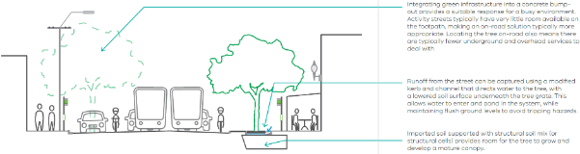

Design example - Grated tree pit in ‘bump-out’

Tree integration
In a high activity commercial area with high pedestrian traffic and shop awnings, it is often difficult to integrate trees behind the kerb. Where road configurations promote the integration of bike lanes or parking delineation (particularly on streets without clearways), there may be opportunities to integrate trees on-road between parking. A grated surface is used to allow pedestrian movement over the tree pit.
Tree growing area is likely to be confined at the surface, but can be expanded beneath adjacent parking areas or the footpath using structural soil or structural crates. The underlying substrate will affect planting depths and soil rooting volumes.
Water can be harnessed from the road kerb and channel drainage system, by ensuring the soil surface (beneath the grate) is lower than the channel invert. A drainage connection to local stormwater drainage is needed to prevent water logging.
Activity streets are highly contested spaces which need to be functional but trees are an important amenity in this context. Designs could be integrated with pedestrian crossing points, parking delineation, bike parking or seating to make the most of surface space. A benefit of including a tree in the roadway parking area is that clashes with underground services are limited.
A kerb edge to the tree pit will ensure compatibility with parking and street cleaning activities, while a grated top can be lifted to regularly clear debris.

Design solution
Bump-out into the road area between parking spaces with surface grate, with adjacent permeable paving in parking areas or bike lanes providing passive irrigation.
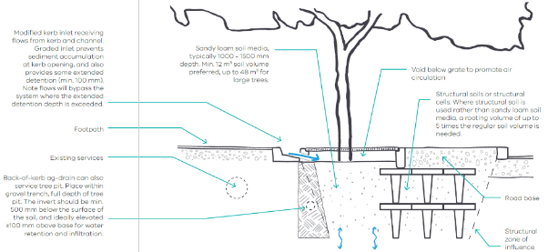
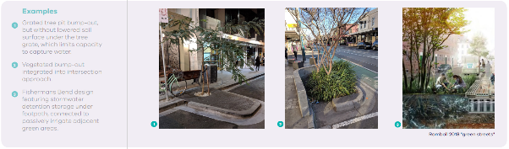

Streetscape 6: Boulevards

Context
Wide streets with a central median
Example streets:
Residential boulevards
- Drummond Street, Carlton North
- Gipps Street, East Melbourne
Connector boulevards:
- St Kilda Road
- Royal Parade
- Courtney St, North Melbourne
- Drummond St, Carlton North
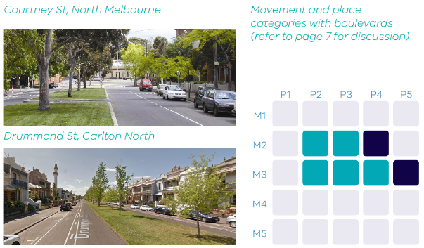

Strategic planning
Why trees are likely to be desirable in this streetscape
- Canopy cover: Central medians have the potential to support large canopy trees, where canopy can extend across both sides of the roadway without interruption.
- Amenity: Tree lined boulevards are an iconic streetscape feature.
- Planned works: There may be opportunities to introduce trees in a central median as part of planned road maintenance or upgrade works.

Street design
Common site conditions to consider
- Water management: It is often difficult to direct water to trees in the central median as the camber of the road often falls to the side rather than the centre. In new roads or road reconstructions, it may be possible to work with road engineers to invert the camber, though road safety would need to be considered and a barrier may be needed. If the camber can’t be altered it could be considered on single-lane roads whether drainage could be transferred via pipes under the road to soakage wells between trees.

Typical suitable solutions
- Trees in grass verges
- Trees in raingardens (where road camber is suitable and budget allows)
- Infiltration wells (where road camber is away from median and passive irrigation is still desired)
- Infiltration trenches (good option to use next to adjacent trees)
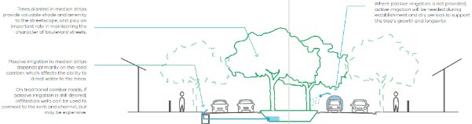

Design example - Infiltration wells

Tree integration
Central median planting is an opportunity to create a line of trees with large canopies which are less likely to be interrupted by planting area breaks (such as driveways) or overhead powerlines. When selecting tree species for boulevards, consideration should be given to creating a wide canopy and dealing with the potential lack of passive irrigation.
Central medians, when sufficiently wide, provide an excellent growing area for trees in the urban environment in terms of soil volume available. As they also are unlikely to clash with overhead lines, tree canopies can grow without restriction.
Passive irrigation by altering the road camber or cross-draining is desired. Where this can’t be achieved, active irrigation will be required during establishment and during dry periods.
Central medians do not generally house other urban infrastructure.
Active irrigation of trees in a central median where passive irrigation cannot be achieved is likely to be required to ensure growth and longevity of trees.

Design solution
Central medians planted with trees provide an attractive street environment while also providing greater opportunity for large shading canopy cover across the road.
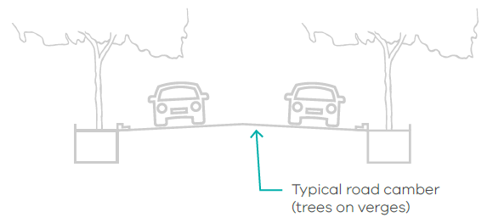
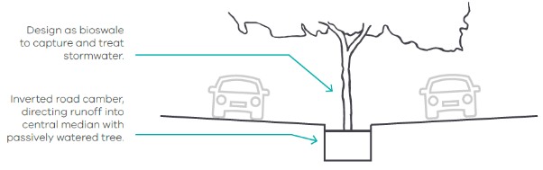
Another option providing passive irrigation is to use an infiltration well connecting nearby stormwater pits to the underlying soils. This may be expensive for most boulevards, but could be effective for roads with one lane on each side of the median.
Special consideration needs to be given to designing with shallow cover over the pipe connection.
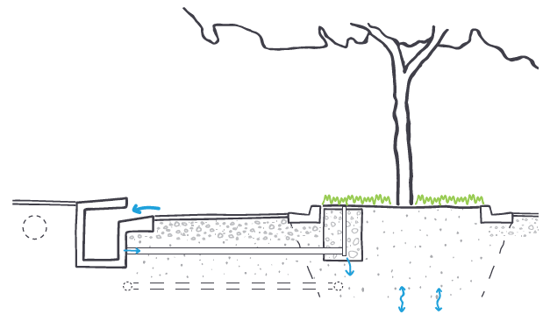

Streetscape 7: Major thoroughfare

Context
Higher speed roads (>60km/h) with a grassed verge
Example streets:
- Geelong Road, West Footscray
- Footscray Road, West Melbourne
- Wurundjeri Way, Docklands
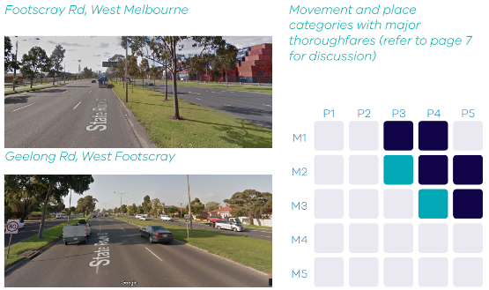

Strategic planning
Why trees are likely to be desirable in this streetscape
- Amenity: Trees are important to improve amenity in major thoroughfares and may be desirable to provide visual and noise screening for adjacent service roads.
- Cooler spaces: Major thoroughfares provide opportunities to create long cooling corridors to reduce the impacts of urban heat islands in cities. Without shade, major roads absorb significant amounts of heat and exacerbate the urban heat island effect.
- Water management: Tree pits can be designed with both stormwater retention and stormwater treatment in mind to reduce the impacts of major roads on waterways and flood risk.
- Active transport: Creating shaded walking and cycling routes is a priority in some parts of major thoroughfares. Tree integration for shading of key tram and bus stops is desirable.
- Planned works: There may be opportunities to introduce trees as part of planned road upgrades or integration of bike lanes.

Street design
Common site conditions to consider
- Street safety: Placement of trees in major thoroughfares requires careful consideration of potential collision risks where cars drift off the roadway. A principle-based decision should consider how risks can be managed and how trees can be placed to reduce risk.
- Overhead conditions: Planting locations should be selected to minimise clashes with overhead powerlines and tram lines once the tree is at its predicted full canopy.
- Local debris and litter: Integration of street cleaning protocols and preferences should be considered, particularly the design of inlets for passive irrigation to make litter collection efficient.
- Expansive soils: Placement of trees in areas with expansive soils requires careful consideration, particularly in major thoroughfares with high speed traffic movements and frequent heavy vehicle use where pavement damages are amplified by intense use. See discussion on page 13.

Typical suitable solutions
- Trees in grass verges
- Open tree pits
- Infiltration trenches (good option to use next to adjacent trees)
- Tree in raingardens (subject to space and budget)
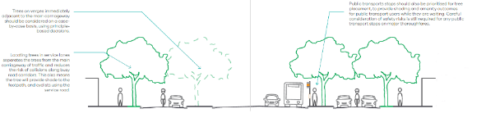

Design example - Infiltration trenches (adjacent to trees)

Tree integration
Pedestrian and cyclist movement is supported by placing trees behind the kerb of service roads. This is also a safer location for trees on high speed roads, as service roads with kerbside parking and cycle lanes tend to operate at lower speeds than main carriageways. Trees should also be included alongside the main carriageway in primary activity areas where pedestrian traffic is higher and speeds are likely to be lower, and in key locations where shade and amenity are essential (e.g. next to bus stops). Where safety concerns are present, a barrier can be installed adjacent to the tree.
Major thoroughfares can have wide adjacent verge areas which can support healthy trees.
A simple and low-cost way to introduce water from the adjacent road to the tree in a grass verge is through gravel infiltration trenches or wells which re fed via an inlet in the kerb. To lower the risk of waterlogging, these can be introduced between trees, so that water gradually spreads out in the soil area. Depending on soil conditions, a back-of-kerb sub-surface drain may still be required to prevent waterlogging.
Preliminary investigations for services will need to be conducted to locate trees accordingly. On a major thoroughfare, protection of sight lines is important, particularly around intersections and entry/exit points from service roads.
In areas with expansive soils, the potential for a tree to create moisture differentials and damage pavement is a concern and further understanding is needed. See discussion on page 13. As a current recommendation, trees should be prioritised on service roads to create increased separation between the main carriageway (where higher levels of service are needed). In addition to reducing likely damage for the main carriageway, the lower intensity of use of the service roads means pavement damages will be less amplified on this road than the main carriageway.

Design solution
Infiltration trenches adjacent to trees are a low cost option to provide passive irrigation without underdrainage.
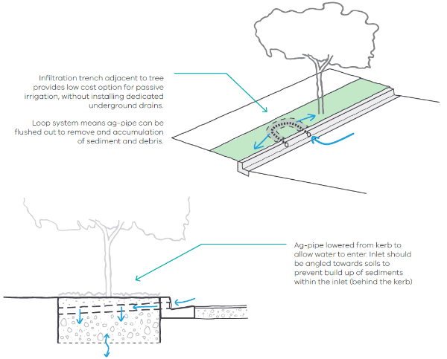

Streetscape 8: Freeway

Context
High speed (=80 km/h) major transport corridor
Example streets:
- Eastern Freeway
- North East Link
- City Link Eastern Freeway
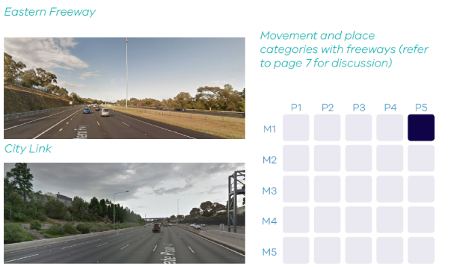

Strategic planning
Why trees are likely to be desirable in this streetscape
- Amenity: Trees are important to improve amenity along freeways and may be desirable to provide visual and noise screening for adjacent communities.
- Cooler spaces: Freeways provide opportunities to create long cooling corridors to reduce the impacts of urban heat islands in cities.
- Water management: Tree pits can be designed with both stormwater retention and stormwater treatment in mind to the risk of flooding and waterway pollution.
- Planned works: There may be opportunities to introduce trees as part of planned road works, or the integration of new barriers (which creates the opportunity for behind barrier planting).
- Air quality: Vegetation barriers can actively remove air pollution caused by motor vehicles and partially remove soil contamination caused by hydrocarbon exhaust emissions. importantly for major roads and freeways, medium-height dense vegetation (such as shrubs and small trees) further improve air quality by aiding the atmospheric dispersion of noxious motor vehicle emissions under most meteorological conditions.

Street design
Common site conditions to consider
- Street safety: Placement of trees in freeways requires careful consideration of potential collision risks where cars drift off the roadway. Trees should be planted behind barriers to minimise risk.
- Overhead conditions: Planting locations should be selected to minimise clashes with overhead powerlines once the tree is at its predicted full canopy.
- Catchment area and drainage: There is potential to shed stormwater runoff into open swale drainage alongside freeways. Trees can be integrated into this area and benefit from runoff.
- Expansive soils: Placement of trees in areas with expansive soils requires careful consideration, particularly in freeways with high speed traffic movements and frequent heavy vehicle use where pavement damages are amplified by intense use. Accordingly, trees should be set back from the road and provided with good growing conditions (soil volume and soil moisture). See further discussion on page 13.
Compacted soils: Soil compaction caused by major road construction can lead to stunted canopy growth and poor tree health. The program of works for major roads should include remediation of adequate soil volume to support tree growth and planting. Planting trees in clusters with mulch may contribute to the successful establishment of trees.

Possible suitable solutions
- Sheet flow to grass and trees
- Trees in grass verges
- Green walls on acoustic barriers
- Trees in central medians
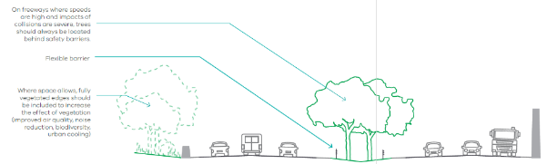

Design example: Sheet flow to grass and trees
Designing for healthy trees
Tree planting in freeways can provide important amenity and support the creation of green corridors throughout the city.
Grassed areas adjacent to freeways provide excellent planting areas from a soil volume perspective. Remediation of soils compacted through construction of roads may be needed to support healthy trees.
Water from the road can shed freely into a grassed depression alongside the freeway which can be planted with trees. Trees should not be placed at the invert of a swale, but off to the side to allow benefit from watering while not obscuring flow or becoming waterlogged.
Major freeway construction may be an opportunity to incorporate large water storage, particularly to service urban trees and vegetation as temperatures increase.
Overhead lines and freeway lighting should be considered when selecting tree species and planting locations.
Trees should be placed behind flexible barriers to ensure there is no ongoing safety risk. Potential tree canopy and height should also be considered when selecting species to protect against topple or branch drop onto roads.

Design solution
Trees can be planted behind barriers and integrated with roadside swales.
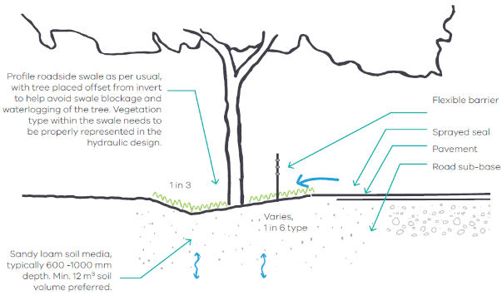
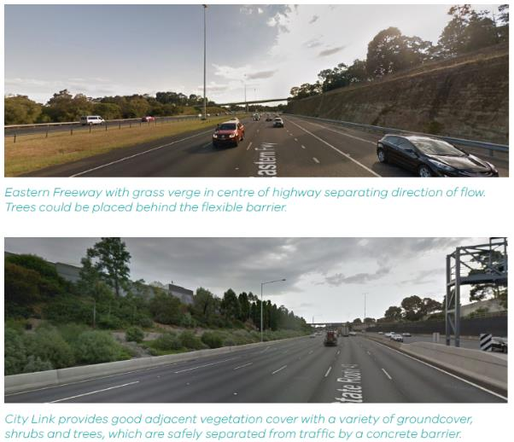

PART III: Design Component Catalogue

Summary of design components
Design components can be pieced together to create bespoke, local solutions to embed trees in a range of streetscapes. This section provides descriptions and examples of a range of common design components.
- Stormwater inlets
- Outlets
- Storage reservoir
The above components apply when designing trees with passive irrigation. Other design components include:
- Surface treatments
- Edge treatments
- Tree and plant species
- Soil media
- Structural soils

Stormwater inlets
Grill plate kerb opening inlets
- Transfer stormwater to the soil media horizontally via a grill inlet.
- Captured volumes are sensitive to the grill plate and adjacent channel design. Channels should be altered to slope to the inlet.
- Narrow openings to prevent litter entry can be prone to blockage.
- Flush stainless steel allows easy street sweeper cleaning.
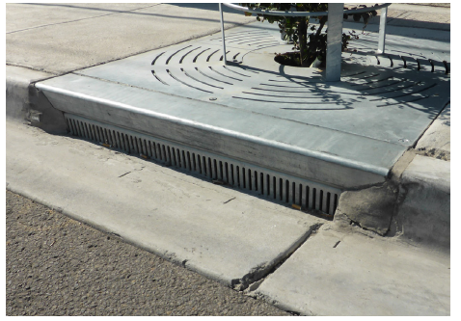
Channel Inlets
- High flow capture efficiency.
- Installed below the channel.
- Transfers stormwater to the soil media via a grated, vertical drop inlet and an underground sloped passage.
- Collects sediments and fine debris.
- Prevents the capture of large debris.
- Preserves the existing kerb design.
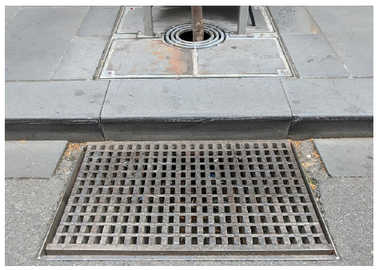
Side kerb opening inlets
- Kerb openings are formed through the creation of ‘gaps’ in the kerb to allow stormwater to freely pass horizontally to the soil media.
- Is simple to construct.
- Collects small and large debris.
- Can allow high inflow velocities. Rock at opening can be used to dissipate energy upon entry.
- Multiple kerb openings promote distributed inflows to occur.
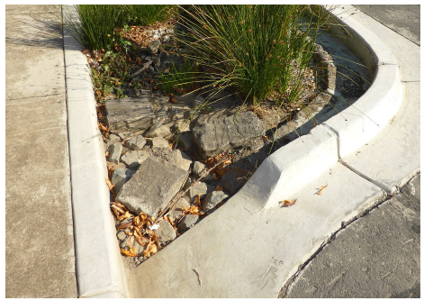
Modified kerb opening Inlet
- Bluestone kerb adapter for side entry into grated tree pit.
- Entry is large to allow free surface water entry.
- Entry height is small enough to prevent bottles entering system.
- Inlet is graded down into tree pit to prevent build up of sediments within the inlet (behind the kerb).
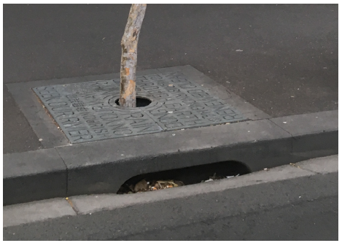
Permeable pavement
- Allow water falling onto the permeable surface to infiltrate into the underlying soils.
- Variety of permeable surfaces (see surface treatments for more information).
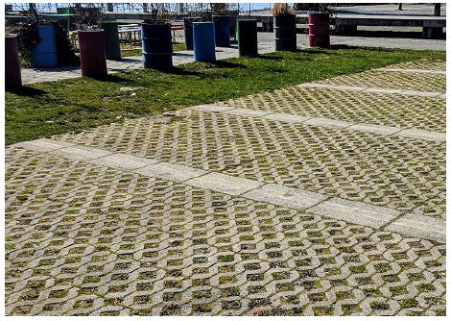
Subsurface infiltration
- Allows water to infiltrate into the soil surrounding the tree roots while maintaining flush soft finish levels at the surface.
- Configurations vary (see storage reservoirs), including:
  - Kerb adapter ag-pipe within a gravel trench located adjacent to the tree or around the tree trunk.
  - Infiltration well connected to underground inlet.
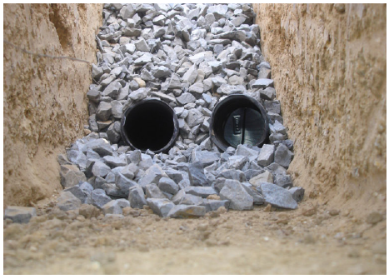

Outlets
Kerb overflows
- Outlets located on downstream-edge can be designed to allow excess stormwater to pass out of the system and continue downstream. This may occur for designs with kerb edges, where an opening is provided on the downstream edge.
- The surface level should be lower than the surroundings to ensure regular stormwater inflows pond within the system, and do not quickly pass through and exit.
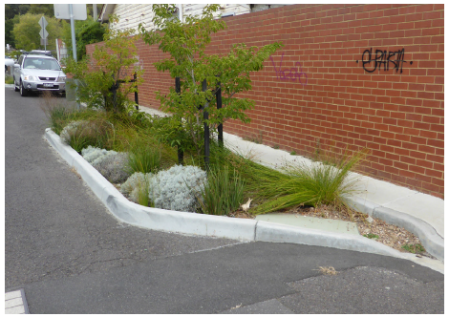
Overflow pits
- High flow capture efficiency.
- Should be raised above the surface level of the tree to create extended detention for ponding.
- Connects to underground stormwater drainage.
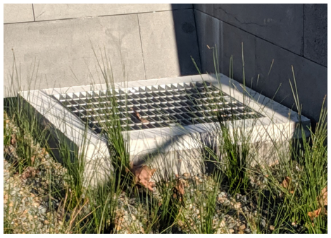
Inlet controlled outlet
- In systems with extended detention, inlets may also act as a stormwater outlet whereby flows backwater into the kerb and channel once extended detention is reached.
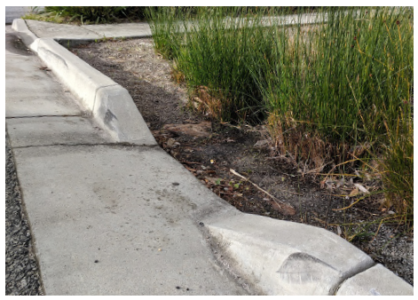

Storage reservoir
Extended detention
- Most common form of capture storage, where the surface levels are lowered from the inlet to allow water to pond and soak into the tree’s soils.
- Storage reservoir volume is dictated by the depth and area of the extended detention.
- Extended detention can also be provided under paved areas using structural soil systems with gravel in the top layer, to create void space for water storage.
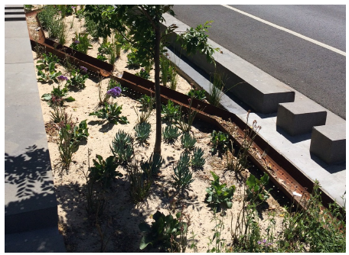
Infiltration trenches and wells
- Infiltration trench: gravel trench and slotted ag-pipe. Cheap and simple ways to achieve infiltration.
- Infiltration well: dedicated storage or soakage well. Typically filled with gravel encased in a permeable geotextile. Can be used to connect nearby underground stormwater network to tree.
- Means that soil surface levels can be flush with surrounds, instead of lowered for ponding.
- Storage reservoir volume is dictated by the void space and total volume of gravel.
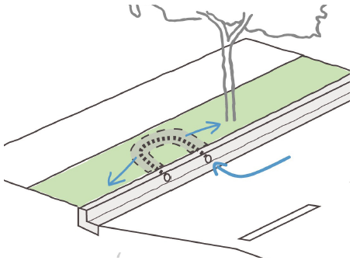
Wicking zones
- There are two types of wicking zones: a sealed dedicated wicking zone with porous wicking bed material, or less structured approach using a saturated deep soil zone (created using un elevated underdrain) over low permeability subsoils.
- Supports healthy tree growth (trees will uptake the water as they need it).
- Means that surface levels can be flush with surrounds, instead of lowered for ponding.
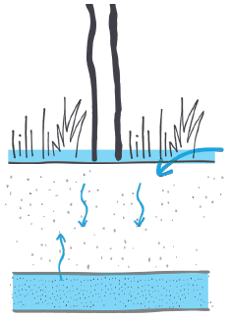

Surface treatments
Soft surface finishes
Vegetation
- Maximum vegetation and aesthetic benefits.
- Stormwater nutrient removal.
- Vegetation also provides natural mulch and surface stabilisation.
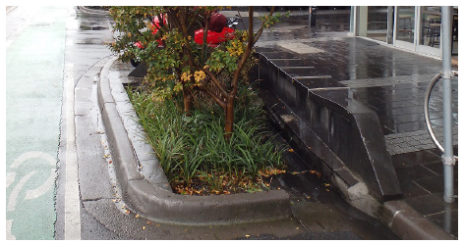
Bare soil
- Low cost soil surface finish.
- Design may be susceptible to erosion and weeds.
- Best suited to flat sites.
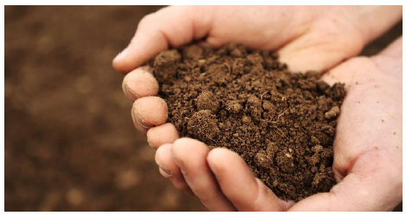
Stabilised sand
- Advantages - cheap and easy to install and replace.
- Disadvantage - can be damaged by street sweepers, and the sand can deposit in drains.
- Not ideal adjacent to permeable pavement, as the sand can clog the pavement requiring increased maintenance regimes.
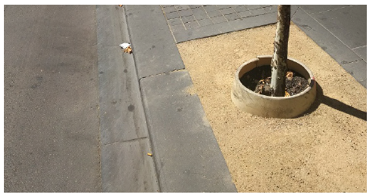
Mulch
- Light mulches with high organic content can wash into stormwater networks and damage waterways.
- Dense planting or non-floating mulch alternatives are preferred over mulch to manage weeds and moisture loss.
- Keep mulch layers to a minimum, less than 30 mm.
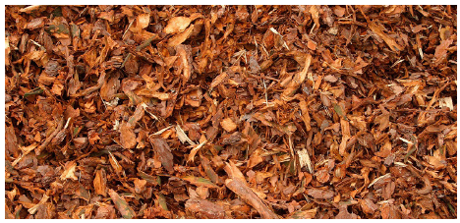
Hard surface finishes
Grates and plates
- Well suited to high pedestrian traffic, urban areas.
- Can lower surface levels under grate to provide ponding and extended detention.
- Prevent litter and debris entering system and can lift grate to clean underneath.
- Designers should include void under the grate or plate to allow airflow.
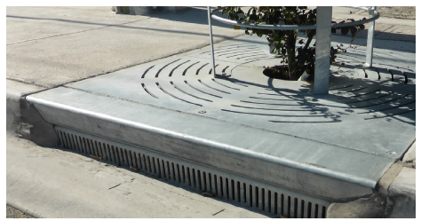
Resin-bound gravel
- Expensive.
- Good aesthetic finish.
- Suited to high profile sites with heavy pedestrian traffic.
- Available in permeable or non-permeable form.
- Will require cleaning to maintain permeability.
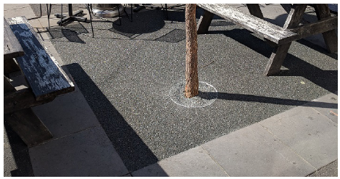
Porous asphalt, no-fines concrete
- Not ideal for aesthetics (asphalt wrapped over ree roots).
- Concrete prone to cracking, which produces dangerous edges.
- Will require cleaning to maintain permeability (pressure washing).
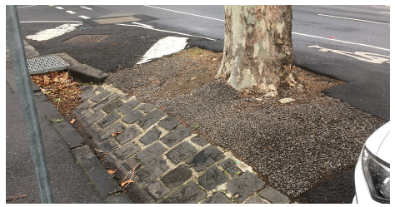
Permeable pavement
- Good aesthetic finish.
- Suited to high profile sites with heavy pedestrian traffic.
- Will require cleaning to maintain permeability (pressure washing).
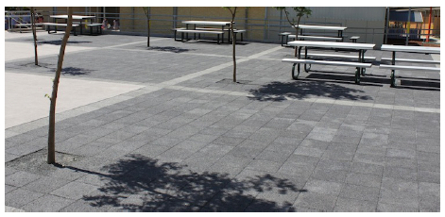

Edge treatments
Vegetation
- Can be used to create flush visual effect when garden bed is sunken below the adjacent land.
- Surface level beneath vegetation should typically be sloped on the edges (e.g. 1 in 3 batters), to avoid a tripping hazard in case someone should step into the garden bed.
- Allow water to sheet into system.
- Buffers and slows flows entering system. 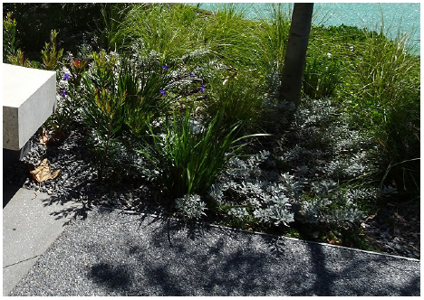
Kerb edges
- Effective in separating pedestrians, cyclists and vehicles from system.
- Cut-outs can be included in edge to allow surface flows to enter system.
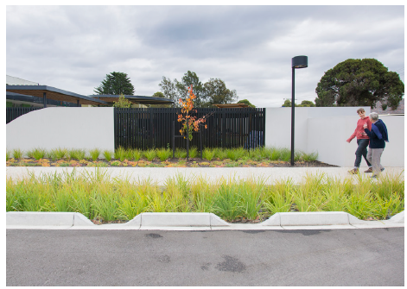
Bluestone edges
- Effective solution for heritage streets.
- Can be used to surround tree grates and along kerb for structural support of grate structure.
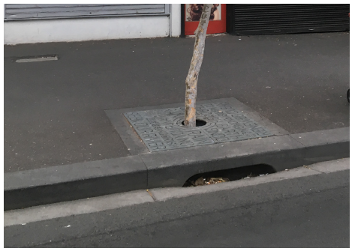
Retaining structures and seating
- Formal seat furniture can be included (which may not provide structural retaining), separating pedestrians from garden.
- Tall retaining structures can deter pedestrians from walking over the tree pit, while providing seating.
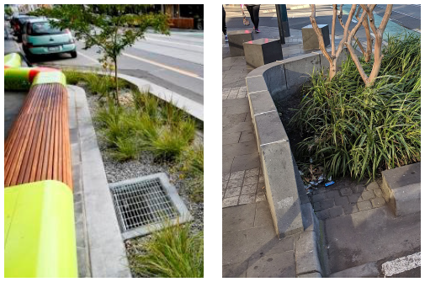
Staggered planted buffers
- For larger set-downs, staggered planted buffers can be used to deter pedestrian traffic and enhance amenity outcomes while providing a lowered surface (extended detention) for ponding stormwater.
- Creates safe set-downs.
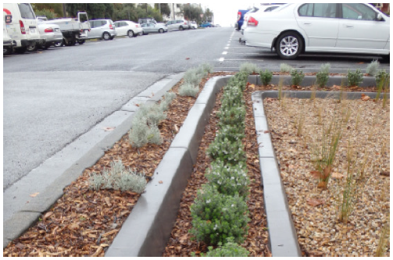
Broken concrete edge
- In this photo example, separates trees from vehicles along central median strip.
- Breaking the concrete edge allows runoff to enter the asset across the entire length of the system.
- Can also be used along one edge for solutions within nature strips, where they sit flush with adjacent land.
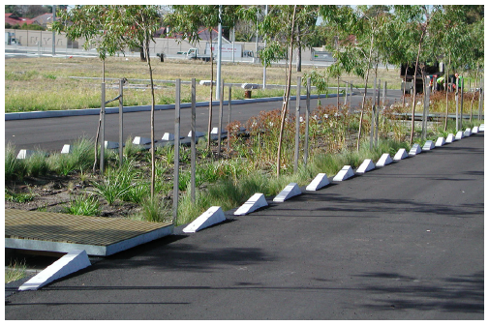

Other resources

Useful references
These guidelines form part of a suite of Victorian Government resources that provide planning and design guidance for greening and cooling across the built environment. There are also many useful references being produced across Victoria and Australia that compliment these guidelines. A sample of these are listed below.
Reference | Link | Description
Urban Design Guidelines for Victoria  Department of Environment, Land, Water and Planning, 2017 | https://www.planning.vic.gov.au/ policy-and-strategy/urban-design/ urban-design-guidelines | Aimed at state government, local  government and the urban development  sector.
Code of Practice:  Management of  Infrastructure in Road  Reserves  VicRoads, 2008 | http://www.gazette.vic.gov.au/  gazette/Gazettes2008/GG2008S269.pdf | Provides practical guidance and identifies  benchmarks of good practice for utilities and road authorities.
Fishermans Bend:  Integrated and Innovative  Water Management  Ramboll & Ethos Urban,  2018 | https://engage.vic.gov.au/download_  file/7712/1426 | Innovative approaches to water management resulting from strategic and coordinated planning of the Fishermans Bend precinct. Designs manage flooding through the installation of Blue Green  Infrastructure across the site, particularly at  street level.
Urban Forest Diversity  Guidelines,  City of Melbourne, 2011 | https://www.melbourne.vic.gov.au/  SiteCollectionDocuments/urbanforest-  diversity-guidelines.pdf | Tree species selection strategy for the City of Melbourne.
WSUD Raingarden Standard Design Scenario  Package  Moreland City Council, 2013 | https://www.moreland.vic.gov.au/  environment-and-waste/water/  wsud-design-package.html | Aimed at improving the quality of streetscape raingardens and tree pits being designed and constructed within Moreland.
Trees in Hard Landscape: A  Guide for Delivery  Trees and Design Action  Group, 2014 | http://www.tdag.org.uk/trees-inhard-  landscapes.html | Targeted at project managers and engineers.
Beyond the Pavement  NSW Roads and Maritime  Services, 2014 | https://www.rms.nsw.gov.au/  documents/projects/planningprinciples/  beyond-pavement.pdf | Award-winning urban design policy,  demonstrating a commitment to urban  design, protecting urban environments.  beyond the road corridor, and considering  the impacts of infrastructure on  communities and built and natural  environments.
Knox Liveable Streets Plan  Knox City Council, 2012 | https://knox.vic.gov.au/files/Plans/  Knox_Liveable_Streets_Plan_Sect5.  pdf | Talks to ‘Bush Boulevards’ and alternative design and planting strategies.
Trees for a Cool City:  Guidelines for optimised  tree placement,  CRC for Water Sensitive  Cities, 2017 | https://watersensitivecities.org.au/  wp-content/uploads/2017/11/Treesfor-  a-cool-city_Guidelines-foroptimised-  tree-placement.pdf | Provides guidelines for optimised tree  placement to maximise the cooling effects of  street trees and deliver the largest benefits  for human thermal comfort.

© The State of Victoria Department of Environment, Land, Water and Planning 2019
This work is licensed under a Creative Commons Attribution 4.0 International licence. You are free to re-use the work under that licence, on the condition that you credit the State of Victoria as author. The licence does not apply to any images, photographs or branding, including the Victorian Coat of Arms, the Victorian Government logo and the Department of Environment, Land, Water and Planning (DELWP) logo. To view a copy of this licence, visit http://creativecommons.org/licenses/by/4.0/
Acknowledgement
We are committed to genuinely partner, and meaningfully engage, with Victoria's Traditional Owners and Aboriginal communities to support the protection of Country, the maintenance of spiritual and cultural practices and their broader aspirations in the 21st century and beyond. We acknowledge and respect Victorian Traditional Owners as the original custodians of Victoria's land and waters, their unique ability to care for Country and deep spiritual connection to it. We honour Elders past and present whose knowledge and wisdom has ensured the continuation of culture and traditional practices.
Disclaimer
This publication may be of assistance to you but the State of Victoria and its employees do not guarantee that the publication is without flaw of any kind or is wholly appropriate for your particular purposes and therefore disclaims all liability for any error, loss or other consequence which may arise from you relying on any information in this publication.

Vegetation Cover for Metropolitan Melbourne 2018, DELWP
Double the growth rate (Grey, V. et.al 2018), Canopy 8-10x larger (Hitchmough, J. 1994), Increased lifespan from 13 to 50 years (Skiera, B. and G. Moll. 1992)
Metropolitan Melbourne Urban Heat Islands and Urban Vegetation 2018, DELWP
http://mapshare.maps.vic.gov.au/coolinggreening/
https://www.abc.net.au/news/2018-01-05/hume-freeway-melts-in-heat-in-victoria/9307344
Pauleit, 2003
Sproken-Smith & Oke, 1999
Dimoudi & Nikolopoulou, 2003; Sproken-Smith & Oke, 1999

