Star of the South

EIS/EES

Consultation Plan
MARCH 2021

Acknowledgement of Traditional Owners

We acknowledge the Gunaikurnai people as Traditional Owners of the area in which the Star of the South would be located and pay our respect to their elders past, present and future.

Document Title | Star of the South EIS/EES Consultation Plan
Revision | 2.0
Date | August 2021
Document status | Final
Written | Sarah Altmann
Reviewed | Naomi Campbell
Approved | Erin Coldham

Contents

- Introduction 5
1.1 Background 5
1.2 Purpose of this plan 5
1.3 Stakeholder and community consultation and feedback to date 6
1.4 Environmental assessment process 7
- About the project 9
- Communication and consultation framework 12
3.1 Objectives 12
3.2 Relevant legislation and best practice guidance 13
3.3 Communication and consultation approach 14
3.4 How feedback is used 15
- Traditional Owners 16
- Stakeholders 16
- Key messages 17
6.1 The project 17
6.2 Environmental assessment process 18
6.3 Indicative program
- Communication and consultation activities and program 19
7.1 Communication tools 19
7.2 Consultation activities 20
7.3 Indicative program 24
- Recording, monitoring and evaluation 23
8.1 Recording feedback 24
8.2 EIS/EES Consultation Report 24
8.3 Evaluation 24

Appendix A – Detailed Stakeholder list 25

Definitions and abbreviations

Terms and definitions

communication | means the act or process of providing public information about the project.
Community Advisory Group | means a group convened by the project team to provide an avenue for two-way communication, to facilitate information-sharing with local communities, and to obtain local advice to inform project activities and development.
consultation | means the act or process of seeking and receiving feedback from project stakeholders, such as those listed in Appendix A of this plan.
controlled action | means a proposed action that is likely to have a significant impact on a matter of national environmental significance or the environment of Commonwealth land.
EIS/EES | means the coordinated Commonwealth Environmental Impact Statement and Victorian Environment Effects Statement process being undertaken for the project
Exploration Licence | means the Exploration Licence: Licence for the conduct of offshore wind energy research and exploration near Gippsland, Victoria, which was granted by the Commonwealth Government on 29 March 2019 and specifies the rights and conditions for the exploration of the licence area off the coast of Gippsland.
feedback | means input and advice from project stakeholders, such as those listed in Appendix A of this plan, provided through formal or information consultation.
licence area | means the proposed project area situated off the coast of Gippsland, Victoria, as  specified in the Exploration Licence.
the plan | means this plan, the EIS/EES Consultation Plan, which explains how consultation will be undertaken during EIS/EES preparation and exhibition.
the project | means the proposed Star of the South project.
the project team | means Star of the South Pty Ltd, the proponent proposing to develop the Star of  the South project.
Technical Reference Group | means a group appointed by the Victorian Department of Environment, Land, Water and Planning to provide advice to the department and the proponent throughout the scoping and preparation of the EIS/EES. A Technical Working Group typically comprises representatives from government agencies, local government and statutory authorities.
List of abbreviations

CAG | Community Advisory Group
DAWE | Commonwealth Department of Agriculture, Water and Environment
DELWP | Victorian Department of Environment, Land, Water and Planning
EPBC Act | Environment Protection and Biodiversity Conservation Act 1999
EE Act | Environment Effects Act 1978 (Victoria)
EIS | Environmental Impact Statement
EES | Environment Effects Statement
EIS/EES | Coordinated Environmental Impact Statement and Environment Effects Statement
GW | Gigawatt
IAP2 | International Association for Public Participation
MW | Megawatt
RAP | Registered Aboriginal Party
TRG | Technical Reference Group

1. Introduction

Background
The Star of the South project (the project) is Australia’s first offshore wind project, proposed
to be located off the south coast of Gippsland.
The project involves installing wind turbines out at sea and using the strong and consistent offshore winds to generate electricity. The electricity would be transmitted to a connection point in the Latrobe Valley, via a transmission system of cables and substations, and connected into the National Electricity Market to deliver electricity to homes and businesses.
The project has been under development since 2012.
In March 2019 an Exploration Licence was granted by the Commonwealth Government to investigate the proposed project area. Site investigations commenced from November 2019 and are ongoing.
In April 2020 the project was referred under the Commonwealth Environment Protection and Biodiversity Conservation Act 1999 (EPBC Act) and the Victorian Environment Effects Act 1978 (EE Act).
The Commonwealth Department of Agriculture, Water and the Environment (DAWE) issued a decision that the project is a ‘controlled action’ and that an Environmental Impact Statement (EIS) is required.
The Victorian Minister for Planning determined that an Environment Effects Statement (EES) is required to assess the effects of works proposed within Victorian jurisdiction.
The project is a joint development by Australian founders and Copenhagen Infrastructure Partners - a global leader in offshore wind.

Purpose of this plan
Consultation is a key aspect of the environmental assessment process. It helps build understanding of the project and its potential effects and enables stakeholder knowledge and views to be considered by the project team in project development and assessments, and by the government in its assessment and approval decisions.
The EIS/EES Consultation plan (the plan) applies to the period of EIS/EES preparation and exhibition which is anticipated to take place between 2020-2022. It sets out how the project team will:
    - Inform communities and stakeholders about the proposed project, the EIS/EES process and opportunities for participation
    - Help people understand the project and the EIS/EES process
    - Encourage participation and seek input during preparation of the EES, in order to identify issues of potential concern, obtain local insight, and gain feedback on measures to address concerns
    - Use and respond to public input
    - Build on previous consultation to involve communities and stakeholders in project development.

Stakeholder and community consultation and feedback to date
Consultation has played an important role in the project’s development to date.
The project team began early discussions with Gippsland communities and interested stakeholders in 2016. Formal consultation during 2019 and 2020 sought to involve people in the project’s early development and obtain feedback about specific activities and aspects of the project. Consultation summary reports outlining consultation undertaken and feedback received are published on the project website starofthesouth.com.au.
Key issues and topics of interest raised by communities and stakeholders to date are:
    - Jobs, economic and industry benefits from the project
    - How environmental impacts will be identified, assessed and avoided or minimised
    - Environmental benefits from the project
    - How impacts to private property will be minimised
    - Any changes to commercial and recreational fishing and boating that could result from the project
    - The visual impact of the offshore wind farm and transmission infrastructure
    - How construction will be managed to avoid or minimise impacts on communities, landholders, marine users and the local environment
    - Support for renewable energy and new forms of power generation in Gippsland
    - Effectiveness, cost and reliability of renewable energy.
    - Feedback to date has been used to inform:
    - The project team’s understanding of local values, issues and opportunities
    - Planning and delivery of site investigations
    - The decision to use underground cables where it is technically feasible to do so, in order to minimise impacts on communities and landholders
    - Assessment of potential transmission corridors
    - Consultation methods and communication channels.

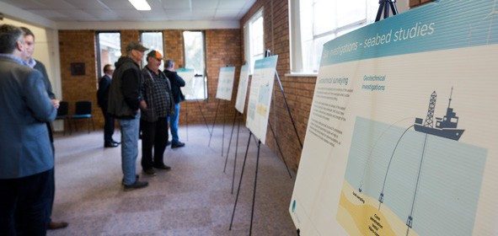
Image of attendees at Star of the South consultation session viewing project information
1.4 Environmental assessment process

A Commonwealth EIS will assess relevant aspects of the project across the entire project area, both on land and offshore.
A Victorian EES will assess relevant aspects of the project within Victorian jurisdiction, including transmission infrastructure on land and offshore elements within three nautical miles of the coast.
Both the EIS and the EES will assess direct and indirect impacts associated with the project on its own and in combination with other proposed developments.
A single EIS/EES will be prepared and timing of the Commonwealth and State processes aligned so that accessing information and participating in the process is as straightforward as possible.
The environmental assessment process provides a pathway to some of the approvals required to build and operate an offshore wind farm, however a Commonwealth licence to build, operate and decommission an offshore wind farm will also be needed.
The project components considered under existing Victorian and Commonwealth regulations are shown in Figure 1.
An indicative timeline for the integrated EIS/EES process is shown in Figure 2.
Figure 1: Project components considered under applicable regulations
Victorian land
Victorian waters
Commonwealth
waters
Grid connection Latrobe Valley
Offshore windfarm turbines
Onshore substation
Port facilities land-side development
Offshore transformer substationccc
Underground transmission cable
Export transmission cable (onshore)
PRIMARY COMMONWEALTH APPROVAL
Export cables (offshore)
Inner-array cables
Environment Protection and Biodiversity Conservation Act
PRIMARY STATE APPROVALS
Commonwealth Victorian Coordinated
National Electricity Law - Grid Connection Agreement
Environment Impact Assessment satisfying both State and Commonwealth requirements
Marine and Coastal Act consent
Cultural Heritage Management Plan
Planning Permit / Planning Scheme Amendment
Environment Effects Act
200m inland
mean high water mark
mean low water mark
3 nautical miles

Figure 2: Indicative timeline for integrated EIS/EES process

Managed by the Victorian Department of Environment, Land, Water and Planning (DELWP)
EIS
(Commonwealth)
EES
(Victoria)
Managed by the Commonwealth Department of Agriculture, Water and Environment (DAWE)

2020
Project referred under
the EE Act.
Project referred under the EPBC Act. Referral published and public comment invited to inform referral decision.

The Minister for Planning determined that an EES is
required.

2020-2022
The Commonwealth determined that the project is a ‘controlled action’ and an EIS is required.

Star of the South undertakes site investigations to collect baseline environmental data and consultation to obtain input and local knowledge.

DEWLP convenes a Technical Reference Group (TRG) to advise on EES scope and preparation.

2021
EES scoping requirements are released for public comment. Final requirements are published.
DAWE participates in the TRG and consults with relevant government departments and regulatory agencies.

EIS assessment guidelines may be released for public comment.
Final requirements are published.

2020-2022

2023
Star of the South prepares EIS/EES in accordance with government requirements and with advice from the TRG. Consultation informs technical studies and EIS/EES preparation.

EIS/EES is exhibited for public review and submissions.

Independent Inquiry considers EES and public submissions and prepares a report for the Minister for Planning.

Minister for Planning’s Assessment under the EE Act.
DAWE considers public submissions and the Star of the South’s Response to Submissions.

2023-2024
Victorian decision makers consider the Minister for Planning’s Assessment to inform
approval decisions.

Minister for the Environment’s assessment and approval under EPBC Act.

2. About the project

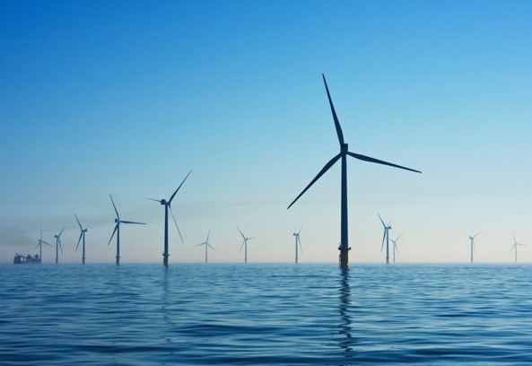

Image of an offshore wind farm

The Star of the South project is Australia’s first offshore wind project.
The proposed offshore wind farm will transmit electricity, via offshore cables, to shore in the vicinity of Reeves Beach. Onshore transmission infrastructure will then transmit electricity from the coast to the Latrobe Valley through rural areas within the Shire of Wellington and City of Latrobe.
The project is proposed to be located off the south coast of Gippsland within a 496m2 area, shown in Figure 3. This site offers:
    - Good offshore wind conditions with consistent and strong winds
    - Suitable water depths of around 20-40 metres
    - Access to existing transmission infrastructure in the Latrobe Valley, enabling connection to the National Electricity Market (NEM)
    - Proximity to a local workforce, leading education and training providers, and supply chain with electricity generation experience (Latrobe Valley) and oil and gas maritime experience (Bass Strait)
    - Proximity to existing ports for construction and operations
    - Distance from sensitive environmental areas, major shipping channels and commercial oil and gas fields.

Figure 3: Proposed project location

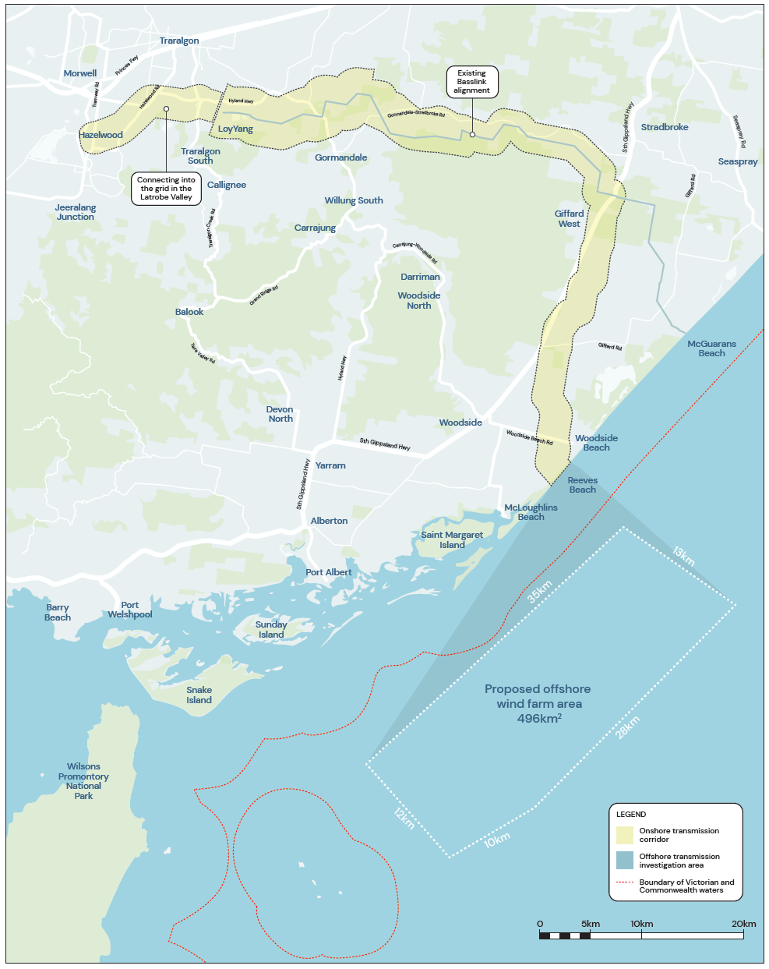

The project is made up of the following main components, as shown in Figure 4:
    - An offshore wind farm with wind turbines installed on foundations in the sea
    - An offshore transmission system of inter-array cables, offshore substations and export cables to collect and transfer electricity to shore
    - An onshore transmission system of underground (where technically feasible) cables and
    - substations to transmit electricity to the Latrobe Valley
    - Grid connection at an existing terminal station.

Figure 4: Project components
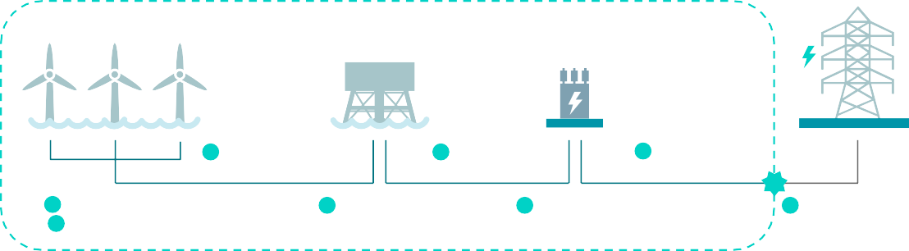
Project assets
3 Inter-array cables
5 Export cables
7 Onshore transmission
1 Turbines and 4 Offshore 6 Onshore 8 Grid
2 foundations substations substations connection point

Ports
9

Turbines: Yield electrical power from the wind.
1
Turbine foundations: Structural support for the wind turbine.
2
Inter-array cables: Network of subsea cables connecting strings of wind turbines to an offshore substation.
3
Offshore substations: Collects and transforms electricity from 66 kV to 220-275 kV for transmission.
4
Export cables: Transmits electricity from the offshore substation/s to the land.
5

Onshore substations: Transforms electricity for transmission and grid connection.
Onshore transmission: Transfers electricity to the grid connection point.
6
7
Grid connection: Connects to the grid in the Latrobe Valley, for distribution to consumers.
8
Ports: Supports a variety of construction and operational activities.
9

3. Communication and consultation framework

3.1 Objectives
During EIS/EES preparation and exhibition, our communication and consultation objectives are to:
    - Inform communities and stakeholders about the project, the EIS/EES process and opportunities to participate
    - Actively involve communities and stakeholders in the project’s development and planning to improve outcomes
    - Encourage participation and seek input during preparation of the EIS/EES, in order to identify issues of potential concern, obtain local insight and gain feedback on measures to address concerns
    - Help people understand the project and participate, by ensuring communication materials are clear and accessible
    - Demonstrate how community and stakeholder issues and feedback are being captured and used to inform project development and assessment.
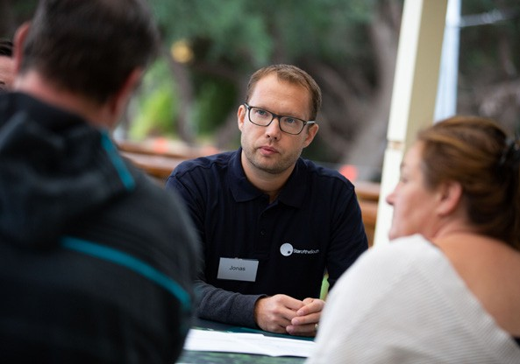

Image of attendees at Star of the South consultation session talking with the project team

3.2. Relevant legislation and best practice guidance
This plan has been developed with awareness and consideration of the following legislative requirements and best practice guidance:
    - Environment Effects Act 1978 (Vic)
    - Environment Protection and Biodiversity Conservation Act (1999) (Cth)
    - Equal Opportunity Act 2010 (Vic)
    - Charter of Human Rights and Responsibilities Act 2000 (Vic)
    - Privacy Act 1988 (Cth)
    - IAP2 Core Values and Public Participation Spectrum (see more below)
    - Victorian Auditor General’s Office – Public Participation Better Practice Guide 2015
    - National Wind Farm Commissioner recommendations
    - Clean Energy Council – Community Engagement Guidelines for the Australian Wind Industry, 2018.

3.2.2 IAP2 spectrum
The International Association for Public Participation (IAP2) defines public participation
as the involvement of those affected by a decision in the decision-making process. IAP2’s core values of public participation include promoting sustainable decisions by recognising the interests of all decision-makers, actively facilitating the involvement of those potentially affected by or interested in a decision, providing participants the information they need to participate in a meaningful way, and communicating to participants how their input affected the decision. (Source: IAP2 Federation)

The IAP2 Spectrum is an internationally recognised tool for planning public participation. It includes varying levels of public participation, ranging from:
    - Inform – To provide the public with balanced and objective information to assist them in understanding the problem, alternatives, opportunities and/or solutions.
    - Consult – To obtain public feedback on analysis, alternatives and/or decisions.
    - Involve – To work directly with the public throughout the process to ensure that concerns and aspirations are consistently understood and considered.
    - Collaborate – To partner with the public in each aspect of the decision including the
    - development of alternatives and the identification of the preferred solution.
    - Empower – To place final decision making in the hands of the public.
Consultation during EIS/EES preparation and exhibition will involve informing people about the project and consulting or involving communities and stakeholders in decisions about key aspects of the project and the management of potential impacts. Because the project is subject to legislative, safety, technical and operational requirements, opportunities to delegate decisions to the public through the EIS/EES phase are not expected.

Communication and consultation approach
The project has been founded and developed with the belief that early, sincere and respectful consultation is an essential component of successful project development.
Project planning will involve some complex decisions that require consideration of a broad range of issues. We will seek to build genuine, trust-based relationships with communities and stakeholders to enable constructive discussion and exploration of these complexities, with a view to achieving greater mutual understanding and beneficial outcomes.

3.3.1 Principles
Consultation is guided by the following principles:

Principle | What this means during EIS/EES preparation and exhibition
Open | - Listen with an open mind  - Be open and honest about considerations, impacts and opportunities  - Explain how and why decisions are being made and how input is used to inform decisions
Responsive | - Prompt acknowledgement of queries or concerns  - Respond to issues, no matter how large or small
Flexible | - Be flexible in our approach to avoiding or mitigating impacts where possible  - Be flexible about how and when we accept feedback so that timely input can shape the project to achieve beneficial outcomes  - Seek feedback on our communication and consultation approach and make any necessary adjustments in response to feedback
Inclusive | - Seek to identify and involve a broad and diverse range of stakeholders in planning and decisions  - Communicate in plain English and an accessible format  - Use a range of communication methods to reach different audiences through their preferred channels  - Use established local networks and groups to keep people informed
Transparency and integrity | - Be respectful and honest in all interactions  - Share information that allows stakeholders and communities to provide informed feedback  - Adhere to all relevant laws and requirements
Accountable | - Provide key points of contact within the project team for queries or concerns  - Take ownership for issues which may arise, particularly those that could have an impact on communities or stakeholders  - Provide access to senior team members and technical specialists at information sessions.

How feedback is used
Community and stakeholder feedback will inform various aspects of the project and preparation of the EIS/EES:

Stage | How feedback is used
Design | - Informs options development and assessment  - Considered in project scope refinement  - Considered in locating and micrositing infrastructure
Planning and environmental assessment | - Enhances our understanding of the local environment, potential issues and opportunities  - Considered in preparing impact assessments  - Considered in developing measures to avoid or minimise potential impacts  - Informs communication and consultation approach  - Informs performance requirements for construction, operation and decommissioning
Construction and operations | - Considered in construction methodology, timing and impact mitigation  - Informs communication and consultation approach.

The EIS/EES will document feedback received through consultation and the project team’s response.
We will be clear about which aspects of the project’s development and assessment can be shaped by community feedback, when and why we’re seeking feedback and how it will be used.
In instances where it is not possible to incorporate community or stakeholder preferences, the reasons will be clearly explained and the rationale and process for decision-making shared.
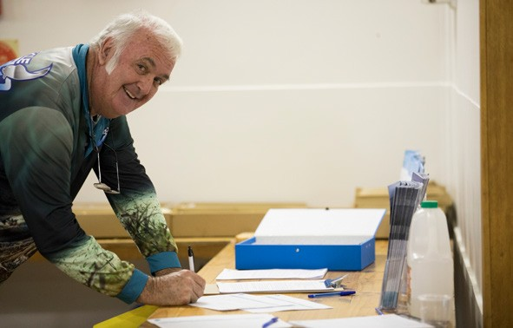

Image of community member completing a feedback form at Star of the South consultation session

4. Traditional Owners

The Gunaikurnai people are the Traditional Owners and hold native title over parts of the proposed project area.
Gunaikurnai Land and Waters Aboriginal Corporation (GLaWAC) are the Registered Aboriginal Party (RAP) and will be responsible for evaluating the project’s Cultural Heritage Management Plan. We understand that providing accurate and timely information to the Gunaikurnai people is a necessary and important responsibility of the project.
Star of the South takes a partnership approach to engaging with Traditional Owners and will seek involvement on a range of topics beyond Cultural Heritage, such as native title, project design, construction and procurement.
A dedicated Indigenous Engagement Advisor for the project supports a continual and open dialogue, provides a single point of contact on the project team and ensures appropriate and respectful engagement at all times.

5. Stakeholders

The project is expected to attract interest in the Gippsland region and potentially more broadly across Victoria and Australia. A detailed stakeholder analysis is provided in Appendix A.
The following broad types of stakeholders have an interest in the project:
- Australian and Victorian Government Ministers and Members of Parliament
- Australian and Victorian Government departments and agencies
- Local government
- Commercial fisheries – individuals and representative bodies
- Recreational fishers and boaters – individuals and representative bodies
- Residents of Gippsland, landholders and communities along the south coast of Gippsland and along the project’s transmission route
- Emergency services
- Local community groups
- Environment groups
- Electricity market operators, regulators and participants
- Industry and business representatives
- Global and local supply chain
- Local tourism businesses and agencies
- Hard to reach and vulnerable members of the community
- Education institutions
- Media outlets

6. Key messages

Key messages assist in providing clear and consistent information about the project, the EIS/EES process and opportunities for public involvement. This plan will be refined and re-published as needed to incorporate updated messages as the project and EIS/EES preparation progresses.

The project
    - Star of the South is Australia’s first offshore wind project, proposed to be located off the south coast of Gippsland.
    - It has the potential to generate up to 2.2GW of capacity.
    - It would provide large-scale, renewable energy to support Victoria’s clean, secure and affordable energy future.
    - The project involves installing wind turbines out in the sea and using the strong and consistent ocean winds to generate electricity.
    - The project would transmit electricity to a connection point in the Latrobe Valley where it would connect into the National Electricity Market to deliver electricity to homes and businesses.
    - A major infrastructure project worth $8-10 billion, it would inject $6.4 billion into the Gippsland economy and create thousands of jobs during construction and hundreds of long-term Gippsland jobs during operation.
    - If the project receives all necessary approvals, construction could begin from the mid- 2020s, to deliver power this decade.
    - To find out more please contact us by phoning 1800 340 340, emailing info@starofthesouth.com.au, visiting starofthesouth.com.au or following Star of the South Project on Facebook.
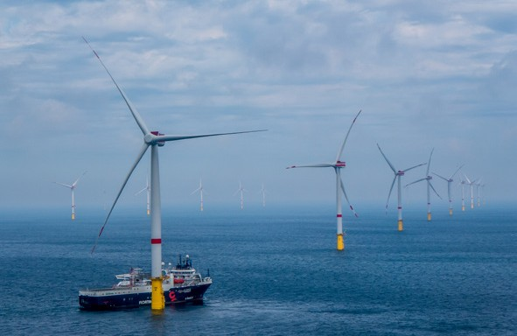

Environmental assessment process
    - The project is being assessed through a coordinated Commonwealth Environment Impact Statement (EIS) and Victorian Environment Effects Statement (EES).
    - The EIS/EES is being coordinated to make finding information and participating in the
    - process as easy as possible.
    - An EIS/EES is a comprehensive assessment of potentially significant environmental, social,
    - economic and planning aspects of a project.
    - The scope of the EIS will be determined by the Commonwealth Minister for the Environment and the scope of the EES by the Victorian Minister for Planning. Public comment will be invited on draft requirements.
    - We will prepare the EIS/EES in accordance with EIS assessment guidelines and EES scoping requirements.
    - Developing an EIS/EES involves:
    - Studies to understand existing conditions
    - Assessments to determine potential impacts
    - Identifying measures to avoid or minimise any impacts
    - Consultation with stakeholders and communities.
    - A Technical Reference Group (TRG) has been convened by the Victorian Department of Environment, Land, Water and Planning to advise on the preparation of the EIS/EES. The group includes government agencies, Traditional Owners, regional authorities and councils.
    - There will be opportunities for community and stakeholder input to the EIS/EES as studies and impact assessments are undertaken, and throughout its preparation.
    - The completed EIS/EES will be exhibited for public comment, and community members and other stakeholders will have the opportunity to make a submission.
    - Following public exhibition of the EIS/EES an Inquiry (appointed under the EE Act) will consider the environmental effects of the project. Public hearings may be held as part of the Inquiry process.
    - Outcomes of the EIS/EES process will inform government approval decisions including planning approval under the Planning and Environment Act, the Environment Protection and Biodiversity Conservation Act, and consent under the Marine and Coastal Act.
    - The project will also need a licence to construct, operate and decommission an offshore wind farm in Commonwealth waters. The Commonwealth Government is working on a new regulatory framework to enable offshore renewable energy projects like Star of South.
    - A range of communication tools will be used to share project information and updates,
    - to promote opportunities for participation in the EIS/EES process, and to share findings about the project’s potential impacts and proposed measures to avoid or minimise these effects.

7. Communication and consultation activities and program

Consultation activities and methods will be tailored to suit the project and EIS/EES phase, the matters being discussed and stakeholder preferences. Activities and methods used will evolve to ensure ongoing relevance and in response to feedback.

Communication tools

Advertising and media | Advertisements, news coverage and interviews in local newspapers, radio and TV channels and on digital news and social media channels will be used to reach a broad audience across the Gippsland region and Victoria.
Website | The project’s website provides a central location for information about the project - starofthesouth.com.au.
Videos | Videos are used to communicate information in an engaging and accessible way for a broad audience and shared with the media, posted on social media, the project website and used in presentations to stakeholder and community groups.
Social media | Facebook and LinkedIn are used to communicate project information and updates, promote discussion and respond to enquiries. Key dates and activities, such as information sessions and public exhibition, will be advertised on social media channels.
Printed and electronic newsletters | Newsletters provide project updates and information about how to get involved.  Print newsletters are sent to residents across the project area, available from the project’s community hub in Yarram and displayed in local shops, libraries and other public spaces where possible.  E-newsletters are distributed monthly to subscribers.
Information materials | A suite of project information materials is available on the project website and in hard copy at events, information sessions and the project’s community hub. Hard copy information packs are sent via post upon request and to those who have nominated to receive updates by mail. Materials are updated regularly, as the project’s development and environmental assessments progress.
Maps and visual aids | Maps and other visual aids such as diagrams, photographs and illustrations are used to show the project location, components, appearance and processes.
3D  visualisations | 3D images and videos will be used to communicate visual aspects of the project.
Posters and signage | Posters and signs in local communities, such as on community notice boards, will be used to share information with a local audience and raise awareness of the project and opportunities to participate.

  - Consultation activities

Public information sessions | Information sessions will be held to explain the assessment and consultation process, provide access to the project team and technical specialists, and accept feedback about potential concerns and suggestions from communities and stakeholders.  At the formal exhibition stage, information sessions will be held to display and discuss EIS/EES documentation.  Sessions may be held in person and/or via webinar or live online Q&A.
Community Advisory Group | Comprising local community members from different locations, members of special interest groups, Council representatives and project team members, this group facilitates two-way communication and provides local advice to the project team, including on issues being assessed as part of the EIS/EES. Meetings may be held in person and/or via video conference.
Stakeholder briefings, meetings and workshops | Briefings are undertaken to provide information about the project and updates  at milestones. Meetings and workshops are held to address and seek input  on specific matters from individuals, groups and organisations with local or specialist knowledge. Briefings, meetings and workshops may be held in person or via video conference.
Local office and community hub | The project’s community hub is open to the public (dependent on COVID-19 health advice) and provides a place where people can drop in to find information, ask questions and provide feedback or raise any concerns. It also provides a space to display information and hold community meetings, events and presentations.
Community presentations | Presentations are given to community groups with an interest in the project to share information and promote opportunities to get involved. Community presentations may be held in person or via video conference.
Local festivals, events and information displays | The project’s participation in local events provides an opportunity for informal engagement and information sharing to raise awareness of the project, the EIS/ EES process and opportunities to participate.
Consultation website – ‘Get involved’ | The project has a dedicated website for online consultation - starofthesouth. com.au/getinvolved. Online feedback methods include surveys, public Q&A, interactive maps, quick polls and a suggestions board.
Community surveys and feedback forms | Surveys and forms are used to collect data and feedback at information sessions, the project’s community hub and online.
Social research | Social research is undertaken annually to measure community awareness, views and communication preferences, and to complement formal and informal consultation activities.
Schools engagement | Engagement with local schools will be undertaken where possible to involve young people in discussions about the project and future. Schools engagement may be undertaken online or in person.
Telephone, email and online Q&A enquiries | Community enquiries are received via a free-call number, email, through a website form, online Q&A, social media and in person at the project’s community hub. All enquiries are recorded in the project’s Consultation Manager system.
Technical Reference Group (TRG) | Convened by government to coordinate advice between statutory decision makers and the project team throughout the EIS/EES process. The project team will work collaboratively with members of the TRG, sharing information, seeking advice and considering their input in preparation of the EES.

Dedicated landholder engagement
The project has a dedicated team to work with landholders where an easement is required for the project’s transmission system. This team will regularly meet with landholders and provide updates through email, phone calls and meetings. A dedicated phone number and email address is available for all landholder enquiries.

Dedicated marine user engagement
Recognising the unique needs of this important cohort, the project is working with commercial fisheries, recreational fishers, boaters and other marine users, representative groups and regulators, in order to share and seek information and promote opportunities for participation.

Hard to reach and vulnerable groups
The project team will work with local government and other service providers to identify relevant individuals, groups and those who support them. The best approach will be determined on a case-by-case basis.

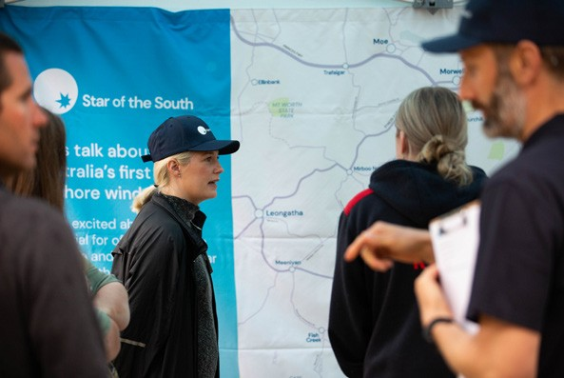

Image of community members talking with the Star of the South project team

Indicative program
Planned communication and consultation activities are shown below. For current and upcoming opportunities to get involved please visit starofthesouth.com.au/community.

EIS/EES phase and indicative timing | Communication and consultation
 | Purpose | Activities
2020-21  Site investigations* and scoping requirements/ assessment guidelines  *Investigations associated with environmental impact assessment. Additional studies may be ongoing past this timeframe to inform detailed design work. | - Build awareness and understanding of the project, the coordinated EIS/EES process and next steps  - Explain how to get involved in consultation and encourage participation  - Obtain feedback on community concerns and aspirations  for consideration in project development  - Gather information and local knowledge to inform site investigations and options assessment  - Identify consultation and communication preferences  - Promote opportunity for public comment on EES scoping requirements and EIS assessment guidelines | - Online consultation  - Stakeholder briefings and  - meetings  - Community presentations  - Live stream information updates  - and Q&As  - Project community hub  - Technical Reference Group  - Landholder engagement  - Emails and phone calls  - Social research  - Schools engagement  - Community Advisory Group  - Local events and festivals  - Newsletters (print and e-news)  - Website and social media  - Videos  - Media and advertising  - Information materials and maps  - Consultation summary report
2021-22  EIS/EES preparation, including impact assessments | - Provide information about the coordinated EIS/EES process and encourage participation  - Explain how feedback has been / is being used in project development  - Obtain feedback on specific matters to inform project development and refinement  - Involve communities and stakeholders in discussions to thoroughly understand issues and identify suitable mitigations  - Identify and implement improvements to consultation approach | As above, plus:  - Information sessions and webinars  - Stakeholder workshops  - 3D visualisations  - Consultation summary report  - Technical Reference Group

EIS/EES phase and indicative timing | Communication and consultation
 | Purpose | Activities
2022  Formal EIS/ EES exhibition,  submissions and Inquiry | - Continue to promote the coordinated process and involvement in EIS/EES process and formal consultation  - Present and explain EIS/EES  - findings and proposed mitigations  - Provide information about how to make a submission and next steps  - Explain how feedback helped inform the impact assessments and proposed environmental performance requirements  - Respond to submissions as required | - EIS/EES displays  - Formal submission process (managed by government)  - Stakeholder meetings and  - briefings  - Community presentations  - Information sessions and webinars  - Project community hub  - Emails and phone calls  - Community Advisory Group  - Local and industry events and  - festivals  - Newsletters (print and e-news)  - Website and social media  - Videos  - Media and advertising  - Information materials and maps  - EES Consultation Report
2022-23  EIS/EES process complete | - Report back on EES assessment outcomes and approvals  - Explain next steps | - Stakeholder briefings and  - meetings  - Community presentations  - Project community hub  - Emails and phone calls  - Community Advisory Group  - Newsletters (e-news)  - Website and social media  - Media and advertising  - Information materials

8. Recording, monitoring and evaluation

The effectiveness of communication and consultation activities will be continually assessed and adjusted as needed, to ensure the objectives set out in this plan are being achieved.
This Consultation Plan may be modified and updated as preparation of the EIS/EES progresses in order to make improvements, in response to feedback and preferences expressed by participants, to reflect program updates, and/or to ensure a tailored approach is taken to address any emerging issues and opportunities. Any material updates to this Plan must be endorsed by the project’s Technical Reference Group.

Recording feedback
Stakeholder interactions and feedback (both formal and informal) are recorded in the project’s Consultation Manager database. This database holds stakeholder information and enables the project team to record and classify enquiries, feedback or complaints to enable accurate record keeping and reporting.
Feedback received through formal consultation is also analysed and reported in Consultation Summary Reports. Reports are published on the project website and supplied to those who participated in consultation.
Any complaints are managed in accordance with the project’s Complaint Handling Procedure which is available on the project website.

EIS/EES Consultation Report
A report outlining consultation undertaken, feedback received and how we responded to that feedback will be produced and included as part of the EIS/EES, in accordance with the EIS assessment guidelines and EES scoping requirements.

Evaluation
Performance against the communication and consultation framework objectives set out in this plan will be measured through:
  - Feedback from the people we engage with
  - Social research findings relating to awareness, support and satisfaction
  - Quantity and content of survey responses
  - Quantity and content of enquiries
  - Website and social media statistics relating to reach, engagement and sentiment
  - Media monitoring
  - Quick polls
  - Feedback forms in the project’s local office and community hub.

Appendix A – Detailed stakeholder list

Category | Stakeholder | Key interests
Decision makers | Australian Government  - Minister for the Environment  - Minister for Energy and Emissions Reduction  - Department of Agriculture, Water and Environment  - Department of Industry, Science, Energy and Resources | - Planning process complies with legislation and requirements  - Involvement in project development and assessment  - Optimal outcomes for environment and community  - Preparation of robust EIS/EES  - Broader regulatory requirements for offshore wind  - Community and stakeholder consultation
Victorian Government
- Minister for Planning
- Minister for Energy, Environment and Climate Change
- Department of Environment, Land,
- Water and Planning
Statutory decision makers / Technical Reference Group
- Commonwealth Department of Agriculture, Water and the Environment
- Victorian Department of Environment,
- Land, Water and Planning
- Aboriginal Victoria
- Environment Protection Authority
- Gunaikurnai Land and Waters
- Aboriginal Corporation
- Heritage Victoria
- Latrobe City Council
- Regional Roads Victoria
- South Gippsland Shire Council
- Wellington Shire Council
- West Gippsland Catchment Management Authority
Registered Aboriginal Parties and Traditional Owners | Bunurong Land Council Aboriginal  Corporation | - Understanding project rationale and  - benefits  - Understanding and avoiding/ minimising potential adverse impacts  - Opportunities to provide input to project planning and delivery  - Native Title  - Cultural Heritage Management Plan  - Opportunities for indigenous businesses and job seekers
Gunaikurnai Land and Waters Aboriginal
Corporation

Category | Stakeholder | Key interests
Australian Government | Australian Energy Infrastructure Commissioner | - Understanding project rationale and  - benefits  - Understanding and avoiding/ minimising adverse impacts  - Opportunities to provide input to project planning and delivery  - Community consultation process
 | Australian Fisheries Management Authority
 | Australian Hydrographic Office
 | Australian Maritime Safety Authority
 | Bureau of Meteorology
 | Civil Aviation Safety Authority
 | CSIRO
 | Department of Defence
 | Department of Infrastructure, Transport, Regional Development and Communications
 | Geoscience Australia
 | Members of Parliament
 | National Offshore Petroleum Safety and Environmental Management Authority
 | Regional Development Australia
Victorian Government and statutory authorities | Country Fire Authority | - Understanding project rationale and benefits  - Understanding and avoiding/ minimising adverse impacts  - Opportunities to provide input to project planning and delivery  - Community consultation process
 | Department of Jobs, Precincts and Regions
 | Earth Resources
 | Emergency Management Victoria
 | Gippsland Ports Authority
 | Gippsland Water
 | Latrobe Valley Authority
 | Members of Parliament
 | Parks Victoria
 | Port of Hastings Development Authority
 | Regional Development Victoria
 | State Emergency Service
 | South Gippsland Water
 | Transport Safety Victoria
 | Victoria Police (water police)
 | Victorian Fisheries Authority

Category | Stakeholder | Key interests
Local Government | Councillors, executive and officers from the following councils:  - Latrobe City Council  - South Gippsland Shire Council  - Wellington Shire Council | - Understanding project rationale and benefits  - Understanding and avoiding/minimising adverse impacts on council land and assets, the local environment and for local residents and businesses  - Opportunities to provide input to project planning and delivery  - Opportunities to regenerate or transition local industries, businesses and the economy  - Community consultation process
Directly affected or adjacent landholders, licence holders and asset owners | AusNet Services | - Understanding project rationale and benefits  - Understanding potential impacts from project construction and operation on land, licence and/or asset  - Involvement in decisions which may affect land, licence and/or asset  - Minimising impacts on land, licence and/or asset during construction and operation  - Co-existing and/or compensation (if applicable)
 | Basslink
 | CarbonNet
 | Crown land managers
 | Commercial fishing licence and quota holders
 | Mining tenement holders
 | Petroleum/gas tenement holders
 | Private landholders along the south Gippsland coast and the project’s transmission route
 | Recreational fishing licence holders
Local community, business and tourism | Chambers of Commerce | - Understanding project rationale and benefits  - Understanding potential impacts from project construction and operation in the local area  - Ability to provide local knowledge to enhance the project and delivery and to help avoid/minimise impacts  - Opportunities to provide input to the project  - Clear information and updates about the project  - Maximising local benefits from the project  - Opportunities for local businesses and job seekers
 | Coast Guard
 | Charter and tour boat operators
 | Corner Inlet Connections
 | Fishing clubs
 | Friends of the Prom
 | Gippsland Climate Change Network
 | Gippsland Environment Group
 | Greening Australia
 | Landcare groups
 | Latrobe Valley Community Power Hub
 | Local businesses and industry
 | Residents of Gippsland and the Latrobe Valley
 | Resident / Progress / Ratepayer associations
 | Rotary clubs
 | Sporting clubs
 | Tourism agencies and operators

Category | Stakeholder | Key interests
Broader community | Victorian community | - Understanding project rationale,  - benefits and impacts  - Ability to access clear project information  - Effects on electricity prices and supply
 | Electricity consumers
Commercial fishing groups | Abalone Victoria | - Understanding project rationale and  - benefits  - Understanding potential impacts from project construction and operation on fisheries and the local environment  - Access to the project site, co-existing and/or compensation (if applicable)
Australian Southern Bluefin Tuna
Industry Association

 | Bass Strait Scallop Fishermen’s Association
 | Commonwealth Fisheries Association
 | Fisheries Research and Development Corporation
 | Lakes Entrance Fishermen’s Cooperative
 | Port Franklin Fisherman’s Association
 | Seafood Industry Australia
 | Seafood Industry Victoria
 | Small Pelagic Fishery Industry Association
 | South East Trawl Fishing Industry Association
 | Southern Shark Industry Alliance
 | Sustainable Shark Fishing Association
 | Tuna Australia
 | Victorian Bays and Inlets Fisheries Association
Victorian Rock Lobster Industry
Association
Recreational fishing groups | Australian Anglers Association (Victoria) | - Understanding project rationale and benefits  - Understanding potential impacts from project construction and operation on recreational fishing and boating, landside facilities and the local environment  - Access to the project site, co-existing  - Opportunities to improve fishing
Australian National Sportfishing
Association

 | Australian Recreational Fishing Foundation
 | Boating Industry Association of Victoria
 | Future Fish Foundation
 | Game Fishers Association of Victoria
 | Gippsland Angling Clubs Association
 | Local fishing clubs
 | VR Fish

Category | Stakeholder | Key interests
Energy market operators and regulators | Australian Energy Market Commission | - Understanding project scope, capacity and operations  - Grid connection  - Safety  - National Electricity Market operations
 | Australian Energy Market Operator
 | Clean Energy Regulator
 | Energy Security Board
 | Energy Safe Victoria
Industry groups, peak bodies and NGOs | Clean Energy Council | - Understanding project rationale,  - benefits and impacts  - Opportunities to provide input to project planning and delivery  - Opportunities to regenerate or transition local industries, businesses and the economy  - Opportunities for local businesses and job seekers
 | Committee for Gippsland
 | GROW Gippsland
 | Trade Unions
 | Victorian Trades Hall Council
 | Victorian Farmers Federation
Environment groups and NGOs | Birdlife Australia | - Understanding project rationale,  - benefits and impacts  - Understanding and avoiding/ minimising adverse impacts  - Opportunities to provide input to project planning and delivery
 | Climate Action Network
 | Climate Change Council
 | Environment Victoria
 | Friends of the Earth
 | Victorian National Parks Association
Educational institutions | Broadening Horizons Gippsland | - Clear information and updates about the project  - Future workforce needs and opportunities
 | Federation University / Federation TAFE
 | Gippsland TAFE
 | Local training providers
Local primary and secondary
schools
 | Victorian Skills Commissioner
Media | Gippsland media (print, TV, radio, online) | - Clear information and updates about the project  - Involvement in key milestone media opportunities
 | Victorian and Australian media (print, TV, radio, online)
 | Specialist media

The Trustee for The Star of the South Trust
Level 30, 55 Collins Street, Melbourne, Victoria 3000 Australia
1800 340 340
info@starofthesouth.com.au starofthesouth.com.au

