delwp.vic.gov.au

April 2019

|  |
| --- |
| Draft scoping requirements for  Yan Yean Road (Stage 2) Upgrade Environment Effects Statement  *Environment Effects Act 1978* |

|  |  |
| --- | --- |
|  |  |

|  |
| --- |
| © The State of Victoria Department of Environment, Land, Water and Planning 2018  LogoThis work is licensed under a Creative Commons Attribution 4.0 International licence. You are free to re-use the work under that licence, on the condition that you credit the State of Victoria as author. The licence does not apply to any images, photographs or branding, including the Victorian Coat of Arms, the Victorian Government logo and the Department of Environment, Land, Water and Planning (DELWP) logo. To view a copy of this licence, visit <http://creativecommons.org/licenses/by/4.0/>  Disclaimer  This publication may be of assistance to you but the State of Victoria and its employees do not guarantee that the publication is without flaw of any kind or is wholly appropriate for your particular purposes and therefore disclaims all liability for any error, loss or other consequence which may arise from you relying on any information in this publication.  Accessibility  If you would like to receive this publication in an alternative format, please telephone the DELWP Customer Service Centre on 136186, email [customer.service@delwp.vic.gov.au](mailto:customer.service@delwp.vic.gov.au), or via the National Relay Service on 133 677 [www.relayservice.com.au](http://www.relayservice.com.au). This document is also available on the internet at [www.delwp.vic.gov.au](http://www.delwp.vic.gov.au). |

Public comments invited

Public comments are invited on these draft Scoping Requirements in relation to matters that should be investigated and documented as part of the Environment Effects Statement (EES) process for the proposed Yan Yean Road (Stage 2) Upgrade project.

A copy of the draft Scoping Requirements can be downloaded from the Department of Environment, Land, Water and Planning website at [www.delwp.vic.gov.au/environmental-assessment](http://www.delwp.vic.gov.au/environmental-assessment).

The draft Scoping Requirements are open for public comment until 5:00pm on 17 May 2019.

Any comments received will be considered during the finalisation of the Scoping Requirements. Please note that any submissions on the draft Scoping Requirements will be treated as public documents.

Written comments should be posted to:  
Impact Assessment Unit, Planning  
Department of Environment, Land, Water & Planning   
PO Box 500,   
EAST MELBOURNE VIC 8002  
or emailed to: environment.assessment@delwp.vic.gov.au

Queries about the Yan Yean Road (Stage 2) Upgrade project itself should be directed to the proponent:  
Suburban Roads Upgrade  
Major Road Projects Victoria  
Telephone: 1800 105 105  
Email: [contact@roadprojects.vic.gov.au](mailto:contact@roadprojects.vic.gov.au)  
Website: <https://your.roadprojects.vic.gov.au/yan-yean-road-stage-2>

Queries about the EES process and Draft Scoping Requirement should be directed to the department:  
Impact Assessment Unit  
Telephone: 8392 5503  
Email: [environment.assessment@delwp.vic.gov.au](mailto:environment.assessment@delwp.vic.gov.au)

List of Abbreviations

DELWP Department of Environment, Land, Water and Planning

EE Act *Environment Effects Act 1978*

EES Environment effects statement

EMF Environmental management framework

EPBC Act *Environment Protection and Biodiversity Conservation Act 1999*

FFG Act *Flora and Fauna Guarantee Act 1988*

km kilometre

MNES Matters of national environmental significance

MRPV Major Roads Projects Victoria

TRG Technical reference group

Contents

1. Introduction 1

1.1 The project and setting 1

1.2 Minister’s requirements for this EES 1

2. Assessment process and required approvals 3

2.1 What is an EES? 3

2.2 The EES process 3

2.3 Accreditation of the EES process under the EPBC Act 5

3. Matters to be addressed in the EES 6

3.1 General approach 6

3.2 Content and style 6

3.3 Project description 7

3.4 Project alternatives 7

3.5 Applicable legislation, policies and strategies 8

3.6 Draft evaluation objectives 8

3.7 Environmental management framework 8

4. Assessment of specific environmental effects 10

4.1 Transport capacity and connectivity 10

4.2 Biodiversity 11

4.3 Social and cultural values 13

Appendix A 15

1. Introduction

In light of the potential for significant environmental effects, on 14 October 2018 the Victorian Minister for Planning (the Minister) determined under the *Environment Effects Act 1978* (EE Act) that Major Road Projects Victoria (MRPV) is to prepare an environment effects statement (EES) for the Yan Yean Road (Stage 2) Upgrade Project (the project). The purpose of the EES is to provide a detailed description of the project, assess its potential effects on the environment[1] and assess alternative project layouts, designs and approaches to avoid and mitigate effects. The EES will inform and seek feedback from the public and stakeholders and enable the Minister to issue an assessment of the project's environmental effects under the EE Act at the conclusion of the process. The Minister’s assessment will inform statutory decision-makers responsible for the project’s approvals.

The *Draft* *Scoping Requirements for the Yan Yean Road (Stage 2) Upgrade Project* (draft scoping requirements), set out the specific matters to be investigated and documented in the EES. The final scoping requirements will be issued by the Minister following consideration of public comments received on this draft.

While the scoping requirements are intended to cover all relevant matters, the EES will need to address other issues that emerge during the EES investigations, especially those relevant to statutory decisions that will be informed by the assessment.

## The project and setting

Yan Yean Road is a significant north-south arterial road serving the northern growth area and providing connectivity for Doreen, Yarrambat and Plenty to employment and services in established neighbouring suburbs such as Greensborough and Diamond Creek. The proposed upgrade of Yan Yean Road from Kurrak Road to Bridge Inn Road is the second stage of the Yan Yean Road upgrade (Figure 1). Stage 1, from Diamond Creek Road to north of Kurrak Road, received approvals in 2012 and construction is currently underway with a completion targeted for 2019. Stage 2 is proposed to:

* duplicate 5.5 km of Yan Yean Road, between Kurrak Road, Yarrambat, and Bridge Inn Road, Doreen, from two to four lanes;
* replace the roundabouts at Bridge Inn Road and Orchard Road with traffic lights;
* construct two new roundabouts at Heard and Jorgensen Avenues and two new signalised intersections at North Oatlands Road and Bannons Lane;
* upgrade the signalised intersection at Ironbark Road;
* upgrade street lighting at intersections, road signage and landscaping;
* construct new drainage and upgrade/relocate utility services;
* construct a shared user path on one side and a footpath on the other side for the entire length of the upgrade; and
* install continuous safety barriers along both sides of the road and in the centre median.

## Minister’s requirements for this EES

The Minister’s decision to require an EES included the procedures and requirements applicable to its preparation, in accordance with section 8B(5) of the EE Act (see Appendix A). These requirements included the following key matters for the EES to examine:

* *projected traffic growth volumes and related uncertainties for Yan Yean Road and related roads in the network;*
* *design alternatives and refinements and their associated impacts, particularly how they avoid and minimise native tree loss with proposed locations of tree and vegetation removal, no go zones and offset requirements and a demonstration that avoid and minimise principles have been applied; and*
* *consideration of carriageways, medians, shared pathways, footpaths, intersections and other treatments to minimise the loss of preferred foraging trees for the critically endangered Lathamus discolor (Swift Parrot) and avoidance of high retention trees of ecological and cultural value.*

These draft scoping requirements provide further detail on the specific matters to be in investigated in the EES in the context of *Ministerial Guidelines for Assessment of Environmental Effects under the EE Act (Ministerial Guidelines)*.

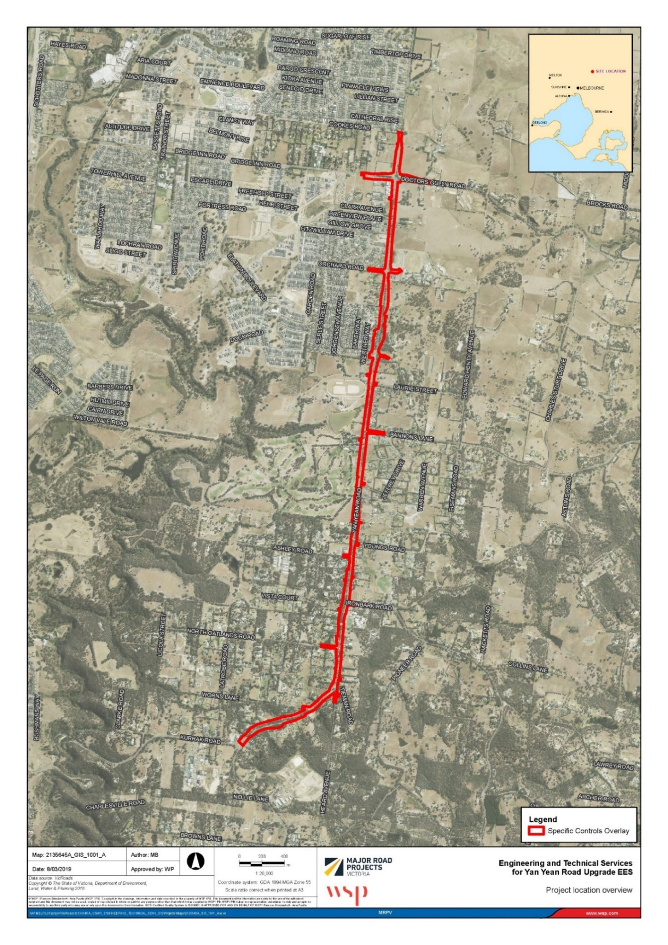

Figure 1: Location of the project (source: MRPV, 2019)

1. Assessment process and required approvals

## What is an EES?

An EES describes a project and its potential environmental effects. It should enable stakeholders and decision-makers to understand how the project is proposed to be implemented and the likely environmental effects of doing so. An EES has two main components.

1. The EES main report – an integrated, plain English document that assesses the potential impacts of the project and offers mitigation or other measures to reduce the environmental effects. The main report draws on technical studies, data and statutory requirements such as specific limits for waste discharge to the environment and should clearly identify which components of the scope are being addressed throughout.
2. The EES technical reports – specialist studies, investigations and analyses that provide the basis for the EES main report. These reports will be exhibited in full, as appendices to the main report.

## The EES process

MRPV is responsible for preparing the EES, including conducting technical studies and undertaking stakeholder consultation. The Department of Environment, Land, Water and Planning (DELWP) is responsible for managing the EES process. The EES process has the following steps:

* preparation of a draft study program and draft schedule by MRPV (completed);
* establishment of an inter-agency technical reference group (TRG) convened by DELWP (completed);
* preparation and exhibition of draft scoping requirements by DELWP on behalf of the Minister (current step);
* finalisation of the scoping requirements after considering public comments received during the advertised exhibition period, for issue by the Minister;
* review of MRPV’s EES studies and draft documentation by DELWP and the TRG[2];
* completion of the EES by MRPV;
* review of the complete EES by DELWP to establish its adequacy for public exhibition;
* exhibition of MRPV’s EES and invitation for public comment by DELWP on behalf of the Minister;
* appointment of an inquiry by the Minister to review the EES and public submissions received, conduct public hearings and provide a report to the Minister; and finally
* following receipt of the inquiry report, an assessment of the project’s environmental effects by the Minister for the consideration of statutory decision-makers.

Further information on the EES process can be found on the department’s website[3]. Figure 2 outlines the steps of the EES process.

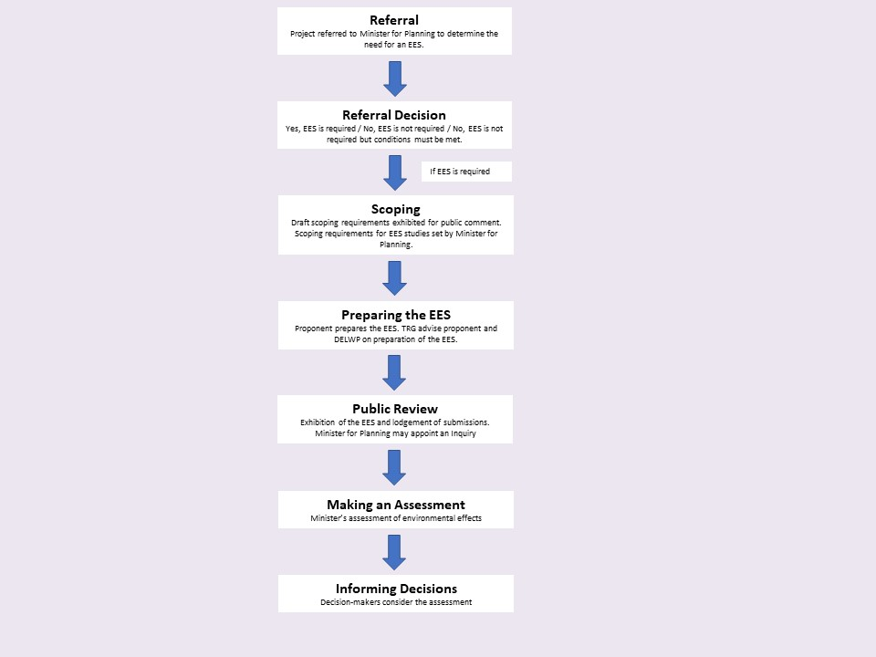

Figure 2: The EES process

### Technical reference group

DELWP has convened an agency-based TRG, comprised of representatives of relevant state government agencies and departments as well as the Nillumbik Shire Council, City of Whittlesea and the Wurundjeri Woi Wurrung Cultural Heritage Aboriginal Corporation. The TRG will advise DELWP and MRPV on:

* applicable policies, strategies and statutory provisions;
* the scoping requirements for the EES;
* the design and adequacy of technical studies for the EES;
* MRPV’s public information and stakeholder consultation program for the EES;
* responses to issues arising from the EES investigations;
* the technical adequacy of draft EES documentation; and
* coordination of statutory processes.

### Consultation plan

The proponent is responsible for informing and engaging the public and stakeholders to identify and respond to their issues in conjunction with the EES studies. Stakeholders include potentially affected parties, the local community and interested organisations and individuals, as well as government bodies. Under its EES Consultation Plan, MRPV will inform the public and stakeholders about the EES process and associated investigations and will provide opportunities for input and engagement during the EES investigations. The EES Consultation Plan is reviewed by DELWP and the TRG before it is finalised and published on the DELWP website. The EES Consultation Plan will:

* identify stakeholders;
* characterise the stakeholder groups in terms of their interests, concerns and consultation needs and potential to provide local knowledge;
* describe the consultation methods to be used and outline a schedule of consultation activities; and
* outline how inputs from stakeholders will be recorded, considered and/or addressed in the preparation of the EES.

### Statutory approvals and the EES process

The project may require a range of approvals under Victorian legislation. DELWP coordinates the EES process as closely as practicable with the approvals procedures, consultation and public notice requirements.

The key approvals required under Victorian legislation are: an approved cultural heritage management plan (CHMP) under the *Aboriginal Heritage Act 2006* and an amendment to the Whittlesea and Nillumbik planning schemes under the *Planning and Environment Act 1987*.

Other approvals are likely to be required and will be determined throughout the course of the EES.

## Accreditation of the EES process under the EPBC Act

The project was also referred to the Australian Government under the Commonwealth *Environment Protection and Biodiversity Conservation Act 1999* (EPBC Act). The delegate for the Commonwealth Minister for the Environment determined on 2 April 2019 that the project is a ‘controlled action’ and hence requires assessment and approval under the EPBC Act. The provision for the Australian Government’s controlled action decision under the EPBC Act is sections 18 and 18A, listed threatened species and ecological communities.

The EES process is accredited to assess impacts on matters of national environmental significance (MNES) under the EPBC Act through the Bilateral Assessment Agreement between the Commonwealth and the State of Victoria – refer to Schedule 1 (part 5) of the bilateral agreement. Note that what are generally termed ‘effects’ in the EES process correspond to ‘impacts’ defined in section 82 of the EPBC Act.

The Commonwealth Minister or delegate will decide whether the project is approved, approved with conditions or refused under the EPBC Act, after having considered the Minister for Planning’s assessment under the EE Act.

1. Matters to be addressed in the EES

## General approach

Preparation of the EES should be consistent with the principles of a systems approach and a risk-based approach[4], so that a greater level of effort is directed at investigating and addressing those matters that pose a relatively higher risk of adverse effects. The EES should put forward a sound rationale for the level of assessment and analysis undertaken for any environmental effect or combination of environmental effects[5] arising from construction and operational stages of the project.

In the case of potentially significant effects, analyses documented within the EES should be detailed enough to provide a good understanding of the nature of the effects including:

* The potential effects on individual environmental assets —magnitude, extent and duration of change in the values of each asset— having regard to intended avoidance and mitigation measures;
* the likelihood of adverse effects, including those caused indirectly as a result of proposed activities, and associated uncertainty of available predictions or estimates;
* further management measures that are proposed where avoidance and mitigation measures do not adequately address effects on environmental assets, including specific details of how the measures address relevant policies;
* likely residual effects, including on relevant MNES, that are likely to occur assuming the proposed measures to avoid and mitigate environmental effects are implemented; and
* proposed approach to managing and monitoring environmental performance and contingency planning.

## Content and style

The content of the EES and related investigations is to be guided by these scoping requirements and the Ministerial Guidelines. It is MRPV’s responsibility to ensure that adequate studies are undertaken to support the assessment of environmental effects, focusing primarily on significant effects (including those that might emerge during the investigations). The EES should demonstrate how the project will achieve a balance of economic, social and environmental outcomes that contribute to ecologically sustainable development and provide a net community benefit over the short and long-term.

The EES should provide a clear, well-integrated analysis of the potential effects of the proposed project, including proposed avoidance, mitigation and management measures, as well as feasible alternatives. To facilitate decisions on required approvals, the EES should also address statutory requirements associated with approvals that will be informed by the Minister’s assessment. Overall, the main report should include:

* an executive summary of the potential environmental effects of the project outlined in Section 4, including potential effects on identified MNES;
* a description of the entire project, including its objectives, rationale and key elements;
* a description of the relationship of the project to public policies and plans;
* an outline of the primary approvals required for the project to proceed;
* descriptions of the existing environment and future climate change scenarios, where these are relevant to the assessment of potential effects;
* appropriately detailed assessments of potential effects of the project on environmental values, relative to the ‘no project’ scenario, together with an estimate of the uncertainty associated with predictions;
* intended measures for avoiding, minimising, managing and monitoring effects;
* any proposed offset measures where avoidance and mitigation measures will not adequately address effects on environmental values, including the identified MNES, and discussion of how any offset package proposed meets the requirements of the Victorian Guidelines for the Removal, Destruction or Lopping of Native Vegetation and the EPBC Act Environmental Offsets Policy as it relates to MNES;
* predictions of residual effects of the project assuming implementation of proposed environmental management measures;
* responses to issues raised through public and stakeholder consultation; and
* evaluation of the implications for the project from the implementation of legislation and policy.

MRPV must also prepare a concise, graphical-based non-technical summary document (hard copy A4, no more than 25 pages) for free distribution to interested parties. The EES summary document should include details of the EES exhibition, public submission process and availability of the EES documentation.

### Content review

Close consultation by MRPV with DELWP and the TRG during the investigations and preparation of the EES will minimise the need for revisions prior to authorisation of the EES for public exhibition. Given the complexity of the project and the potential for significant environmental effects, peer review of specific key risks is also required incorporating the following:

* population growth as well as traffic demand assumptions that have been used in transport modelling;
* the consideration of context sensitive design in the proposed road design and whether it reflects an appropriate balance of economic, social and environmental objectives; and
* the ecological and cultural values of trees in the project area.

Both the TRG and peer review process will ensure that appropriate weighting and consideration of issues is contained within the EES once it is provided for public exhibition.

## Project description

The EES is to describe the project in sufficient detail to allow an understanding of all components, processes and development stages, and to enable assessment of their likely potential environmental effects. The project description should canvass the following:

* an overview of MRPV’s and/or Vic Roads' (where appropriate given MRPV's recent inception) environmental performance and track record (including in relation to any EPBC Act approvals), including experience in delivering similar projects, as well as organisation health, safety and environmental policies;
* contextual information on the project, including its objectives and rationale, its relationship to statutory policies, plans and strategies, including the justification for need and selection of the project for upgrade and implications of the project not proceeding; and
* existing and planned land uses within, and in the vicinity of, the proposed project, supported by plans and maps.

The EES, to the extent practicable, should detail the project’s components:

* location, footprint, layout and access arrangements during construction and operation;
* approach to be taken to minimise visual and landscape impacts and to contribute positively to neighbourhood character;
* proposed construction techniques, temporary occupation of land, extent of areas to be disturbed during construction and infrastructure and service relocation;
* solid waste, wastewater and hazardous material generation and management during construction and operation;
* lighting, safety, security, and traffic noise requirements during construction and operation;
* hours of construction work and a description of the expected duration of project components, including which components are temporary and which are permanent; and
* a description of any repeated or ongoing components such as anticipated maintenance.

## Project alternatives

The EES should document the project’s design development process leading to the project design presented in the EES and the consideration of relevant alternatives (project design, construction method/staging). The discussion of relevant alternatives should include:

* identification and evaluation of each of the alternatives considered;
* the environmental considerations in each alternative; and
* an explanation as to how the preferred alignment and project design was selected.

## Applicable legislation, policies and strategies

In addition to the EE Act and the EPBC Act, the EES will need to identify relevant legislation, policies, guidelines and standards, and assess their specific requirements or implications for the project, particularly in relation to required approvals.

## Draft evaluation objectives

Draft evaluation objectives are provided in Section 4 for each of the topics to be addressed in the EES. The draft evaluation objectives identify desired outcomes in the context of key legislative and statutory policies, as well as the principles and objectives of ecologically sustainable development and environment protection, including net community benefit. They provide a framework to guide an integrated assessment of environmental effects, in accordance with the Ministerial Guidelines, and for evaluating the overall implications of the project. These objectives may be refined by the proponent or DELWP as the EES is prepared.

## Environmental management framework

Inadequate management of environmental effects during project construction, operation and rehabilitation and closure could result in a failure to achieve necessary environmental outcomes and statutory requirements or sustain stakeholder confidence. Hence, the environmental management framework (EMF) in the EES should provide a transparent framework with clear accountabilities for managing and monitoring the environmental effects and hazards associated with the construction and operational phases[6]. The entity responsible for approval of environmental plans should be identified.

Legislation provides the management framework for most environmental effects of the project. However, potentially significant effects, as outlined in the Minister’s Decision, require further assessment (Section 4). In addition to these, there will be a number of localised impacts realised during construction and operation. Therefore, the EMF must outline how potential adverse effects on community, businesses and land uses with regard to air quality and noise, traffic, public safety, landscape and visual amenity, open space, built form and neighbourhood character will be avoided, minimised or mitigated.

The EMF should describe the baseline environmental conditions to allow evaluation of the residual environmental effects of the project, as well as the efficacy of applied environmental management and contingency measures. The framework should include:

* an environmental management system, with organisational responsibilities, accountabilities and governance arrangements;
* an environmental risk register that is maintained during project implementation; and
* environmental management measures proposed in the EES to address specific issues, including commitments to mitigate adverse effects and enhance environmental outcomes.

An important aspect of the EMF is community consultation, stakeholder engagement and communications during the construction and operation of the project. As the project proceeds it will largely be the EMF that outlines opportunities for local stakeholders to engage with MRPV to seek responses to issues that might arise during construction or operation. To this end the EMF will set out procedures for:

* complaints recording and resolution;
* auditing and reporting of performance including compliance with relevant statutory conditions and standards; and
* review of the effectiveness of the environmental management framework for continuous improvement.

Management measures proposed in the EES to address specific issues, including commitments to mitigate adverse effects and enhance environmental outcomes should be clearly described in the EMF. The EMF should describe proposed objectives, indicators and monitoring requirements, including for (but not limited to) managing or addressing:

* biodiversity values (including MNES);
* tree retention;
* surface runoff, flood potential and groundwater;
* landscape and visual values;
* social outcomes and community engagement;
* noise and emissions to air particularly with respect to managing impacts on amenity during construction;
* Aboriginal and historic cultural heritage values;
* transport management including managing temporary disruption and changed accessibility during construction;
* traffic during construction; and
* site reinstatement.

1. Assessment of specific environmental effects

The Minister determined an EES was required for the project due mainly to the potential significant effects on biodiversity, social and cultural values as a result of the proposed clearance of a very large number of trees and habitat, including potential cumulative effects on the *Lathamus discolor* (Swift Parrot) (Section 1.2). Therefore, the EES studies should focus on the investigation of these issues.

However, the EES should also identify other potential adverse environmental effects of the project, such as on social, land use, community amenity and planning, and canvass an environmental management approach and performance measures to ensure any effects are identified and avoided, minimised or mitigated (see Section 3.5). The framing of the draft objectives reflects the key subject matters to be investigated, relevant legislation and policies (Section 3.6), the objectives and principles of ecologically sustainable development and environmental protection, as well as environmental issues identified by MRPV in preliminary documentation and through public exhibition of the draft scoping requirements. MRPV should consult closely with DELWP and the TRG throughout the preparation of the EES to ensure that the investigation of issues is both thorough and targeted.

The following sections set out specific requirements for the assessment of effects referenced in the Minister’s Decision (Section 1.2), using the following structure for each of the matters to be investigated.

1. **Identify key issues or risks** that the project poses to achieve the draft evaluation objective.
2. **Characterise the existing environment** to underpin impact assessments having regard to the level of risk.
3. **Assess the likely effects** of the projecton the existing environment and evaluate their significance.
4. **Present design and mitigation measures** that could substantially reduce and/or mitigate the risk of significant effects. An assessment of residual effects (post mitigation) and their significance will be required to illustrate the effectiveness of the proposed mitigation measure.
5. **Propose performance objectives and management** measures to evaluate whether the project’s effects are maintained within permissible levels and propose contingency approaches if they are not.

## Transport capacity and connectivity

### Draft evaluation objective

To provide for an effective corridor through the northern outer suburbs of Melbourne, to improve travel efficiency, road safety, and capacity.

### Key issues

* Contribution to an integrated and sustainable transport system, including active transport.
* Transport connectivity and capacity across the northern outer suburbs of Melbourne, including network resilience and redundancy.
* Effects of any redistribution of traffic and implications for residents, residential areas and businesses during construction and operation.
* Connectivity of pedestrian and cycling networks across the northern outer suburbs of Melbourne and opportunities for future linkages.
* Reliability of predictions of future travel behaviour and transport demand over time.

### Existing environment

* Describe both the broader and local transport network context for the project.
* Describe relevant policies, strategies and plans for transport in the vicinity of the project.
* Establish comprehensive baseline data on vehicular (freight, private motor vehicle, public transport) and active transport (pedestrian and bicycle movements) in the area affected by the project.
* Describe the elements of the road-based transport system (including private and commercial access to properties and cycling and pedestrian networks) that might be affected by the project during the construction and operational phases of the project.
* Undertake predictive modelling of local transport network traffic flows in the absence of the project.

### Likely effects

* Undertake predictive modelling of regional, local and project transport network traffic flows following implementation of the project.
* Characterise the extent to which the project will affect:
  + the overall geographic distribution of vehicles and magnitude of changes to travel times and accessibility for road users;
  + traffic management measures on local and arterial roads;
  + traffic safety, given the predicted transport network traffic flows following implementation of the project;
  + local access of the community to residential areas, schools, stand-alone businesses, retail centres, activity centres, community facilities and open spaces;
  + accessibility and safety for pedestrians at road junctions and community facilities;
  + connectivity, accessibility, function, experience and safety for cyclists and pedestrians including use of existing and new shared use paths, and/or on-road bike paths;
  + consistency with transport and urban plans (e.g. VicRoads Movement and Place Framework, Victorian Cycling Strategy (2018-2028), Plan Melbourne (2017-2050)); and
  + interactions, including possible cumulative impacts with other relevant projects, for example, the Northern Suburban Roads Program.
* Undertake sensitivity analysis to test assumptions and inputs of transport model.

### Design and mitigation

* Describe the proposed transport network design features and approach to optimise and integrate the project with the existing or modified transport network.
* Describe the proposed transport network design features and approach to optimise and integrate the project with the existing pedestrian and bicycle network, including any proposed solutions to enhance pedestrian and bicycle access in the vicinity of the project.
* Describe traffic calming or other management tools during construction that could be used to modify travel behaviour on the project and local roads.
* Describe the proposed approach to managing transport network conditions during the project’s construction such as any staging proposed to maintain transport system function and the proposed nature and duration of diversions including for pedestrian and cycle links.

### Performance objectives

* Describe and evaluate the approach to monitoring and subsequent contingency measures to be implemented in the event of adverse residual effects requiring further management.

## Biodiversity

### Draft evaluation objective

To avoid or, at least, minimise adverse effects on native vegetation (including remnant, planted, regenerated and large old trees), listed migratory and protected species/ecological communities and then to address offset requirements consistent with relevant state and commonwealth policies.

### Key issues

* Potential for significant effects on biodiversity values including effects associated with threatening processes listed under the EPBC Act and/or *Flora and Fauna Guarantee Act 1988* (FFG Act) including, but not limited to, Swift Parrot, Matted Flax Lily, Studley Park Gum and large old trees.
* Potential for direct or indirect impact on vegetation and other landscape elements used by fauna listed under the EPBC Act, FFG Act and/or DELWP Advisory List.
* Potential loss or degradation of habitat (and/or habitat connectivity) including tree hollows, existing canopy and woody debris, due to removal of trees.
* Potential impacts to MNES through erosion, sedimentation and contamination of watercourses and groundwater near and downstream from the project site resulting from the construction and operation of the project.

### Existing environment

* Characterise species, origin, dimension, health and lifespan of trees that may be affected by the project assuming current conditions continue, and appropriate care is provided.
* Describe the biodiversity values that could be directly or indirectly affected by the project, including:
  + native vegetation and ecological communities listed under the EPBC Act, FFG Act and DELWP Advisory List; and
  + native flora and fauna species (including assessment of likelihood of presence), particularly those listed under the EPBC Act, FFG Act and DELWP Advisory Lists.
  + adequate surveys for EPBC Act listed threatened species and ecological communities should be undertaken in accordance with Commonwealth Conservation Advices and Threatened Species Recovery Plans and completed prior to exhibition of the EES.

### Likely effects

* Assess the potential effects (including facilitated) of the project (and feasible alternatives) on trees (including remnant, planted, regenerated and large old trees).
* Assess the potential effects (including facilitated) of the project (and feasible alternatives) on native vegetation, ecological communities and flora species, in particular any listed under the EPBC Act, FFG Act and DELWP Advisory list.
* Assess the potential effects (including facilitated) of the project (and feasible alternatives) to biodiversity values, including but not limited to:
  + removal or destruction of habitat (including remnant, regenerated or planted vegetation);
  + disturbance or alteration of habitat conditions or other sources of increased habitat threat;
  + initiating and/or exacerbating potentially threatening processes under the EPBC Act and FFG Act;
  + increasing risk of mortality of fauna listed under the EPBC Act, FFG Act and DELWP Advisory List;
  + introduction and/or spread of declared weeds or pathogens within or near the project area; and
  + impacts to MNES caused by water quality changes within and downstream of the project area.
* Assess the potential effects (including facilitated) on habitat connectivity and wildlife movement of fauna species listed under the EPBC Act, FFG Act and DELWP Advisory List.

### Design and mitigation

* Develop design options and measures that can avoid or minimise significant direct and indirect effects on trees and develop strategies to address the loss of trees or effects of further habitat fragmentation.
* Identify design options and measures that could avoid or minimise significant direct and indirect effects on native vegetation, listed ecological communities, or protected flora and fauna species and their habitat, including habitat connectivity and associated wildlife movement.
* Develop rehabilitation strategies to enable the recovery or restoration/replanting of vegetation that can provide habitat for protected and listed threatened species and amenity to local community, consistent with any relevant threat abatement plan or conservation action plan.
* Develop offset strategies to offset loss of native vegetation consistent with state and commonwealth policies. If translocation of Matted Flax-lily is proposed, detailed information and justification about the proposed recipient site, risks of transfer, expected losses, likelihood of long-term success of translocated plants, and any uncertainties should be provided, with reference to current scientific advice and evidence from previous examples of translocations of the species.
* Justify and describe the assumptions and level of uncertainty associated with the proposed measures achieving their desired outcomes.

### Performance objectives

* Describe and evaluate the approach to monitoring and subsequent contingency measures to be implemented in the event of adverse residual effects on biodiversity values requiring further management.
* Describe and evaluate proposed measures to manage residual effects of the project on biodiversity values, including an outline of an offset strategy and offset management plan that sets out proposed environmental offsets to satisfy commonwealth offset policy requirements.

## Social and cultural values

### Draft evaluation objective

To avoid or minimise the adverse effects on social and cultural values, including landscape values, Aboriginal and historical cultural heritage values, and remnant, planted and regenerated vegetation, and to maximise the enhancement of these values where opportunities exist.

### Key issues

* Potential for adverse impacts on social and cultural values of trees.
* Potential for adverse impact on local amenity including visual impact, such as through reduction in canopy cover.
* Potential adverse effects on Aboriginal cultural heritage places and values.
* Potential adverse effects on historical cultural heritage values, especially buildings, properties, trees, archaeological sites and precincts.
* Potential adverse effects on urban landscapes that provide a range of functions (e.g. visual amenity, cooling from vegetation and shade).

### Existing environment

* Identify the cultural and social value of trees within the project area and determine the existing amenity, cultural and ecological services value of the trees that may be affected by the project.
* Identify key landscape features and visual amenity values, as provided by trees, including urban landscape character, canopy cover, form, appearance, aesthetics and function.
* Review land use history, Aboriginal traditional knowledge, previous studies and relevant registers to identify areas with the potential for Aboriginal and historical cultural heritage values.
* Identify areas of Aboriginal cultural heritage sensitivity relevant to the project.
* Identify potentially affected sites or precincts on the Victorian Heritage Register or Heritage Inventory, within Heritage Overlays in relevant planning schemes or otherwise documented as being of heritage significance.
* Investigate the condition and cultural heritage sensitivity of identified sites and heritage precincts.

### Likely effects

* Assess the potential direct and indirect effects of the project on arboriculture elements (including remnant, planted, regenerated and large old trees).
* Assess likely extent and duration of residual adverse effects on, or improvements to, landscape aesthetics and functions.
* Assess likely effects on visual amenity values, as provided by arboriculture, including through use of photo-montages, sections and analysis drawings or other suitable methods for depicting predicted landscape changes, particularly from key viewing points.
* Assess residual effects of the project on identified or potential sites or places of Aboriginal cultural heritage and sites of historical cultural heritage, considering possible impact pathways and significance of any effects.

### Design and mitigation

* Develop potential and proposed design options and measures that can avoid or minimise significant direct and indirect effects on trees or other landscape elements.
* Develop strategies to address the loss of trees or other landscape elements.
* Describe design, management or offset measures to enhance or alternatively avoid or minimise adverse effects on landscape and visual amenity.
* Describe design, management (harm avoidance and/or minimisation strategies) circumvent or mitigate potential adverse effects on known or potential Aboriginal cultural heritage or historical cultural heritage values.

### Performance objectives

* Describe the arboriculture and landscape value outcomes that the project must achieve.
* Describe and evaluate the approach to monitoring and subsequent contingency measures to be implemented in the event of adverse residual effects on arboriculture and landscape values requiring further management.
* Describe the Aboriginal cultural heritage and historical heritage outcomes that the project must achieve including ensuring implementation of the conditions outlined in the cultural heritage management plan.

Appendix A

**Procedures and requirements under section 8B(5) of the *Environment Effects Act 1978***

The procedures and requirements applying to the EES, in accordance with both section 8B(5) and the *Ministerial guidelines for assessment of environmental effects under the Environment Effects Act 1978* (Ministerial Guidelines), are as follows.

1. The EES is to document the investigation, avoidance and minimisation of potential environmental effects of the proposed road upgrade and relevant alternatives, as well as associated environmental mitigation and management measures. The EES should address:
2. projected traffic growth volumes and related uncertainties for Yan Yean Road and related roads in the network;
3. design alternatives and refinements and their associated impacts, particularly how they avoid and minimise native tree loss with proposed locations of tree and vegetation removal, no go zones and offset requirements and a demonstration that avoid and minimise principles have been applied; and
4. consideration of carriageways, medians, shared pathways, footpaths, intersections and other treatments to minimise the loss of preferred foraging trees for the critically endangered *Lathamus discolor* (Swift Parrot) and avoidance of high retention trees of ecological and cultural value.
5. The matters to be investigated and documented in the EES will be set out in detail in scoping requirements prepared by the Department of Environment, Land, Water and Planning (the department). Draft scoping requirements will be exhibited for 15 business days for public comment, before being finalised and then issued by the Minister for Planning.
6. The level of detail of investigation for the EES studies should be consistent with the scoping requirements issued for this project and be adequate to inform an assessment of the potential environmental effects (and their acceptability) of the project and any relevant alternatives, in the context of the Ministerial Guidelines.
7. The proponent is to prepare and submit to the department a draft EES study program to inform the preparation of scoping requirements.
8. The department is to convene an inter-agency technical reference group (TRG) to advise the proponent and the department on EES scoping, adequacy of technical studies during EES preparation, and statutory approval processes.
9. The proponent is to prepare and submit to the department its proposed EES consultation plan for engaging the public and stakeholders during the preparation of the EES. Once completed to the satisfaction of the department, the consultation plan is to be implemented by the proponent, having regard to advice from the department and the TRG.
10. Following confirmation of draft scoping requirements, the proponent is to prepare and submit to the department its proposed schedule for technical studies, preparation and exhibition of the EES. The schedule will enable alignment of the proponent’s and department’s schedules, particularly for managing timely TRG review of technical investigations and EES documentation.
11. The proponent is to apply appropriate peer review and quality management procedures to enable the completion of EES studies and documentation to an acceptable standard.
12. The EES is to be exhibited for a period of 30 business days for public comment, unless the exhibition period spans the Christmas–New Year period, in which case 40 business days will apply.
13. An inquiry will be appointed under the *Environment Effects Act 1978* to consider and report on the environmental effects of the proposal.

**Notification**

The following parties (proponent and relevant decision-makers) are to be notified of this decision in accordance with sections 8A and 8B(4) of the *Environment Effects Act 1978*.

* Major Road Projects Victoria (proponent)
* Minister for Roads and Road Safety
* Minister for Energy, Environment and Climate Change
* Secretary of the Department of Environment, Land Water and Planning
* Melbourne Water
* Shire of Nillumbik
* City of Whittlesea
* Aboriginal Victoria
* Heritage Victoria

**HON RICHARD WYNNE MP**

**Minister for Planning**

1. For the purpose of assessment of environmental effects under the EE Act, the meaning of ‘environment’ includes physical, biological, heritage, cultural, social, health, safety and economic aspects (Ministerial Guidelines, p. 2).
2. For critical components of the EES studies, peer review by an external, independent expert may be appropriate.
3. See [www.planning.vic.gov.au/environmental-assessment/what-is-the-ees-process-in-victoria](http://www.planning.vic.gov.au/environmental-assessment/what-is-the-ees-process-in-victoria).
4. Ministerial Guidelines (p. 14).
5. Effects include direct, indirect, combined, facilitated, short and long-term, beneficial and adverse effects.
6. Ministerial Guidelines (p. 20).