This version of the Fact Sheet: Vegetation Exemptions – Bushfire Protection has been prepared for use with screen reader software. This document contains identical text to that in the PDF version of the document which is available at www.planning.vic.gov.au.

Fact Sheet

August 2020

Vegetation Clearing Exemptions – Bushfire Protection
This fact sheet outlines the vegetation clearing exemptions in clause 52.12 Bushfire Protection: Exemptions of the Victoria Planning Provisions and all planning schemes.

What does clause 52.12 do?
Clause 52.12 facilitates the clearing of vegetation in specified circumstances to support the protection of human life and property from bushfire around buildings and along fence lines.
It contains specific exemptions from requiring a planning permit to manage and maintain vegetation to reduce bushfire risk.
This provision was developed in response to recommendations of the 2009 Victorian Bushfires Royal Commission.

Why have the exemptions?
The exemptions give certainty to landowners and residents at risk from bushfire, so that vegetation can be cleared, and the property maintained in a fire-ready condition.

Exemptions for defendable space around existing buildings and along fence lines
There are specific requirements to meet the exemptions, such as the building must be used for accommodation and have been constructed before specific dates. Refer to information below.

What are the exemptions?
The exemptions are known as the 10m, 30m and 50m rules and fence line rule.
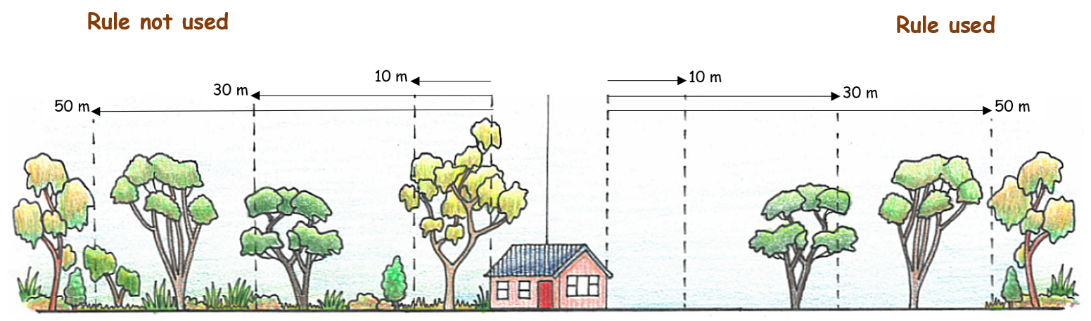
Figure 1. 10/30/50 rules
Figure 1. is a diagram showing a house with the 10/30 and 10/50 rules applied and the rules not applied.
10 metre rule
This rule allows landowners and residents to clear any vegetation within 10m of an existing building. This exemption only applies to buildings:
- located in an area that is designated as a bushfire prone area under the Building Act 1993; and
- used for accommodation, such as a house, that was:
  - constructed before 10 September 2009; or
  - approved by a planning permit or a building permit issued before 10 September 2009; or
  - constructed to replace a dwelling or dependent person’s unit that was damaged or destroyed by a bushfire that occurred between 1 January 2009 and 31 March 2009.
Break out box –The 10m rule applies in the Bushfire Management Overlay (BMO). The BMO is included in bushfire prone areas.
30 metre rule
This rule allows landowners and residents to clear any vegetation other than trees within 30m of an existing building. This exemption only applies to buildings:
- located in an area that is designated as a bushfire prone area under the Building Act 1993; and
- used for accommodation, such as a house, that was:
  - constructed before 10 September 2009; or
  - approved by a planning permit or a building permit issued before 10 September 2009; or
  - constructed to replace a dwelling or dependent person’s unit that was damaged or destroyed by a bushfire that occurred between 1 January 2009 and 31 March 2009.
50 metre rule
This rule allows landowners and residents to clear any vegetation other than trees within 50m of an existing building. This exemption only applies to buildings:
- located in the Bushfire Management Overlay; and
- used for accommodation, such as a house, that was:
  - constructed before 10 September 2009; or
  - lawfully constructed without a planning permit before 18 November 2011; or
  - approved by a planning permit or a building permit issued before 10 September 2009 and constructed before 18 November 2011; or
  - constructed to replace a dwelling or dependent person’s unit that was damaged or destroyed by a bushfire that occurred between 1 January 2009 and 31 March 2009.
Fence line rule
This rule allows landowners and residents to clear any vegetation along a boundary fence between properties in different ownership where the fence:
- is in an area that is designated as a bushfire prone area under the Building Act 1993; and
- was constructed before 10 September 2009.
The clearing along both sides of the fence when combined must not exceed 4 metres in width, except where land has already been cleared 4 metres or more along one side of the fence, then up to 1 metre can be cleared along the other side of the fence.
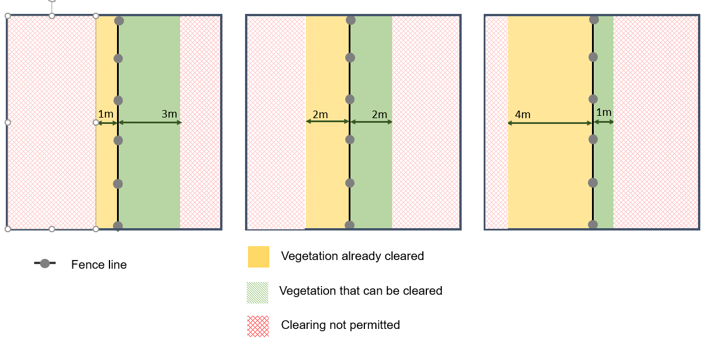
Figure 2. The 4m rule
Figure 2. comprises three boxes showing clearing 1 metre on one side and 3 metres on theother; 2 metres on either side; and 4 metres on one side and 1 metre on the other.

Do the exemptions apply everywhere?
No. The exemptions do not apply to all areas.
The 10m, 30m and fence line rules apply in areas designated as a bushfire prone area under the Building Act 1993.
The 50m rule applies to areas in the Bushfire Management Overlay.
Figure 3. Where the rules apply
Figure 3. is a map indicating where there is no bushfire hazard and no exemptions apply, where only the BPA applies and the 10/30 and fence line rules apply, and where the BMO applies and the 10/50 and fence line rules apply.
Break out box –The 10m rule and fence line rule apply in the Bushfire Management Overlay (BMO). The BMO is included in bushfire prone areas.

What does clear vegetation mean?
The clearing of vegetation includes the removal, destruction and lopping of vegetation.

What is defendable space?
Defendable space is an area of land around a building where vegetation (fuel) is modified and managed to reduce the effects of bushfire attack.
Defendable space breaks up and reduces the amount of fuel available to burn during a bushfire and creates separation between the bushfire hazard/fuel (e.g. vegetation, flammable material) and a building. It is an effective tool that helps create a more fire-ready property.

What is meant by ‘a building used for accommodation’?
Clause 74 of all planning schemes defines ‘Accommodation’ as ‘land used to accommodate persons.’ A building used for accommodation includes dwellings (houses) and other types of accommodation such as a dependent person’s unit, group accommodation and a bed and breakfast.
Break out box – The following is a list of the uses that are defined as Accommodation: Camping and caravan park; Corrective Institution; Dependent person’s unit; Dwelling, including Bed and breakfast and Caretaker’s house; Group accommodation; Host farm; Residential aged care facility; Residential building, including Community care accommodation, Residential hotel, Motel, Rooming house; Residential village; Retirement village.

Do the exemptions only apply if the building or fence are in the bushfire prone area (BPA) or the Bushfire Management Overlay (BMO)?
Yes. The mapping of BPA and the BMO is based on bushfire hazards, not property boundaries. It is common for properties to only be partially included in mapped areas.
The vegetation exemptions are only triggered if the building or fence is located on the part of the property that is in a BPA or BMO.
Below are examples of when the defendable space exemptions applies and doesn’t apply. Where part of the building is in either a BPA or BMO, vegetation can be managed and maintained around the entire perimeter of the building to the allowable distance. This includes those areas located outside of the BPA or BMO.
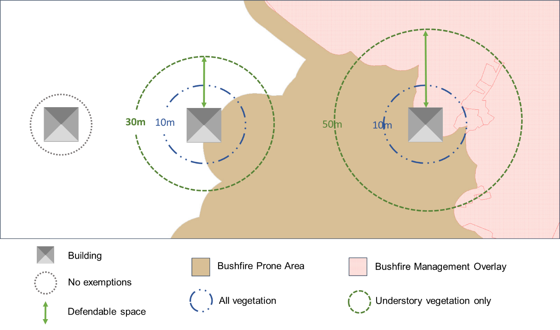
Figure 4. When the 10/30/50 rules apply
Figure 4. shows three houses where: no bushfire controls apply; where the BPA only applies and where the BMO applies. For the BPA it shows a 10 metre circle around the house where everything including trees can be cleared and a 30 metre circle around the house where everything except trees can be cleared. For the BMO it shows the house partly in the BPA and partly in the BMO with a 10 metre circle around the house where everything including trees can be cleared, and a 50 metre circle around the house including in the BPA area where everything except trees can be cleared.
Below are examples of when the fence line exemption applies. Where part of the fence is in a BPA , vegetation can be managed and maintained alongside that part of the fence in the BPA. This includes the adjoining side of the fence outside a BPA.
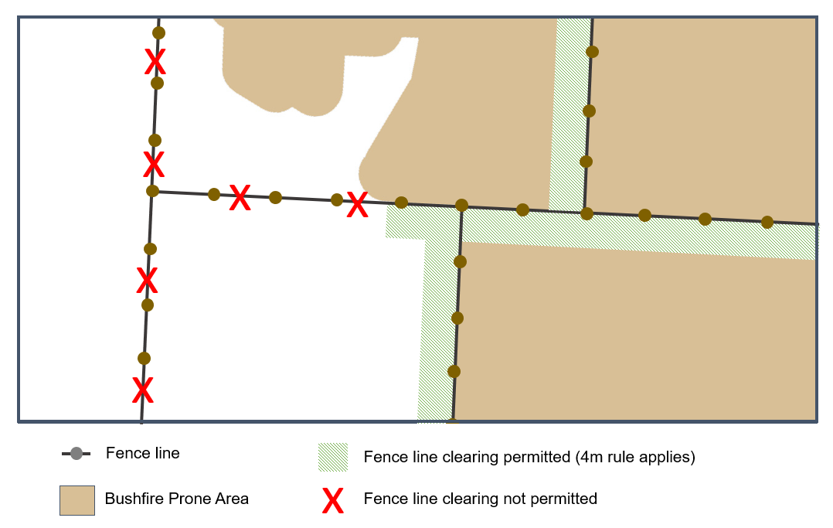
Figure 5. When the fence line rule applies. Refer to Figure 2 about the 4 metre rule.
Figure 5. shows the fence abutting BPA areas where the fence line rule applies and not abutting BPA areas where the fence line rule does not apply.

What if my building or fence was not constructed before the specified dates?
If the building or fence was not constructed before the specified dates, then the exemptions do not apply.
A planning permit may be required to clear vegetation to create defendable space or along a fence line. For more information about planning permit requirements in your area contact your local council.

Do the exemptions apply to proposed buildings and fences?
No. As set out above, the exemptions only apply to existing buildings and fences that meet the requirements of clause 52.12.

Do the exemptions apply to both native and non-native vegetation?
Yes. The exemptions apply to both native and non-native vegetation.

Do the exemptions override other planning requirements?
Overlay requiring a permit to remove vegetation
Yes. The exemptions apply to any requirement of the planning scheme, including any requirement to obtain a planning permit to remove, destroy or lop vegetation.
Erosion Management Overlay – landslide risk
Some councils have identified areas that are prone to landslide by applying the Erosion Management Overlay.
Landslide risk can be increased by the removal of vegetation, particularly deep-rooted, established trees and plants that have a large root system.
An existing planning permit issued for buildings in areas which are identified as being prone to landslide may include conditions requiring the establishment or protection of vegetation to assist with minimising the risk of landslide. In some cases, the design and construction of the building will have been based on a geotechnical or engineering assessment that factored in the establishment or retention of vegetation.
While vegetation can be removed without a permit in areas prone to landslide, landowners and residents are advised to retain vegetation to minimise landslide risk or to seek expert advice before removing vegetation.
Vegetation required to be maintained or protected by an existing permit condition
Yes. Where the exemptions in clause 52.12 apply they override any planning permit, including any condition which has the effect of prohibiting the removal, destruction or lopping of vegetation.
An existing planning permit issued for a dwelling may include a condition requiring landscaping to be undertaken and maintained. Under clause 52.12 vegetation in the landscaped areas can be removed for bushfire protection provided the specific limits are not exceeded. Vegetation beyond the exemptions continues to be bound by the requirements and conditions of the planning permit.
Vegetation protected by a legal agreement or covenant?
No. The exemptions do not override legal agreements or covenants that have the effect of prohibiting the removal, destruction or lopping of vegetation. To obtain further advice, contact your local council or a planning legal professional.

Do other existing planning permit exemptions for vegetation removal continue to apply?
Yes. There are other exemptions for fire prevention, including the ability to clear vegetation that poses an immediate risk to people or property, to allow access in case of an emergency, or for firefighting purposes. The planning scheme also contains exemptions for a range of activities that involve vegetation removal, such as farming activities, mining and weed control. To determine if these exemptions apply, contact your local council.

Can a landowner or resident remove vegetation from neighbouring land?
Only with permission from the landowner. Before any vegetation is removed from neighbouring land written permission must first be obtained from the landowner or land manager.

I am in the Shire of Yarra Ranges. What am I able to do?
Not all the exemptions apply in the Shire of Yarra Ranges because existing clause 51.03 of the Yarra Ranges Planning Scheme applies.
Check with your council for any vegetation requirements that apply specifically to Yarra Ranges.

Exemptions for defendable space around dwellings under clause 44.06 Bushfire Management Overlay (BMO)

What are the exemptions?
The exemptions facilitate the clearing of vegetation to create defendable space for dwellings considered under the Bushfire Management Overlay.

When do the exemptions apply?
The exemptions only apply if land is in the BMO and in one of the following zones: General Residential Zone, Residential Growth Zone, Neighbourhood Residential Zone, Urban Growth Zone, Low Density Residential Zone, Township Zone, Rural Living Zone, Farming Zone or Rural Activity Zone.

What do the exemptions apply to?
The exemptions apply to the removal of vegetation:
- for the footprint of a new dwelling
- for the footprint of alterations or extensions to an existing dwelling
- for the creation of defendable space for a new dwelling
- for the creation of defendable space for an altered or extended dwelling – the whole dwelling, not just that part that is extended or altered.

Are there limits on the distance where vegetation can be cleared?
Yes. There are limits on the distance where vegetation can be managed and maintained using the exemption. This distance is decided as part of your planning application and is normally based on your bushfire management statement.
Where there is a requirement for the provision of defendable space as part of a planning permit issued after 31 July 2014 then the exemption applies for the distance that is specified in the planning permit.

Do the exemptions apply to outbuildings?
Yes. Clause 73.03 of all planning schemes defines ‘Dwelling’. The definition ‘includes outbuildings and works normal to a dwelling’.
An outbuilding can include things like garages, carports, studios, barns, gazebos, sheds and stables and storage. Contact your local council about what other structures are included as outbuildings.

More information
More bushfire related information is available at: www.planning.vic.gov.au

© The State of Victoria Department of Environment, Land, Water and Planning 2020.
This work is licensed under a Creative Commons Attribution 4.0 International licence. You are free to
re-use the work under that licence, on the condition that you credit the State of Victoria as author. The licence does not apply to any images, photographs or branding, including the Victorian Coat of Arms, the Victorian Government logo and the Department of Environment, Land, Water and Planning (DELWP) logo. To view a copy of this licence, visit creativecommons.org/licenses/by/4.0/

ISBN 978-1-76105-207-1 (pdf/online/MS word)

Disclaimer
This publication may be of assistance to you but the State of Victoria and its employees do not guarantee that the publication is without flaw of any kind or is wholly appropriate for your particular purposes and therefore disclaims all liability for any error, loss or other consequence which may arise from you relying on any information in this publication.

Accessibility
If you would like to receive this publication in an alternative format, please telephone the DELWP Customer Service Centre on 136 186, or email customer.service@delwp.vic.gov.au, or via the National Relay Service on 133 677, www.relayservice.com.au. This document is also available on the internet at www. planning.vic.gov.au

