Plan Melbourne 2017-2050

Draft Western Metro

Land Use Framework Plan

Acknowledgement
We acknowledge and respect the Traditional Owners of Victoria’s lands and waters, their unique ability to care for Country and deep spiritual connection to it. We honour Elders past and present whose knowledge and wisdom has ensured the continuation of culture and traditional practices.
We are committed to genuinely partner and meaningfully engage with Traditional Owners to support the protection of their Country, the maintenance of spiritual and cultural practices and their broader aspirations in the 21st century and beyond.

Aboriginal self-determination
Pupangarli Marnmarnepu - Wadi Wadi and Mutti Mutti language for ‘Owning Our Future’ - is DELWP’s Aboriginal Self-Determination Reform Strategy 2020-2025. As the framework for supporting and enabling Aboriginal self-determination for all DELWP projects, Pupangarli Marnmarnepu forms the basis of an ongoing dialogue and partnership with Traditional Owners to influence metropolitan planning and the implementation of Plan Melbourne 2017-2050 in each of the six metropolitan regions.
Ongoing partnership opportunities with Traditional Owners are currently being explored. This process will determine the preferred involvement and level of influence Traditional Owners would like to have in shaping the outcomes and implementation of the Land Use Framework Plans.

Abbreviations
ABS | Australian Bureau of Statistics | NEIC/s | National Employment and Innovation Cluster/s
BIFT | Beveridge Interstate Freight Terminal | OMR | Outer Metropolitan Ring/E6 Transport Corridor
BMO | Bushfire Management Overlay | PBN | Principal Bicycle Network
BPA | Bushfire Prone Area | PFN | Principal Freight Network
CBD | Central Business District | PPTN | Principal Public Transport Network
DELWP | Department of Environment, Land, Water and Planning | PSP/s | Precinct Structure Plan/s
DJPR | Department of Jobs, Precincts and Regions | RSIP | Regionally-Significant Industrial Precinct
DoT | Department of Transport | SBO | Special Building Overlay
EIIA/s | Extractive Industry Interest Area/s | SEIFA | Socio-Economic Indexes for Areas
EPWG | Economy and Planning Working Group | SERA/s | Strategic Extractive Resource Area/s
ESD | Environmentally Sustainable Development | SRL | Suburban Rail Loop
GRP | Gross Regional Product | SRLA | Suburban Rail Loop Authority
HVI | Heat Vulnerability Index | SSIP | State-Significant Industrial Precinct
LGA | Local Government Area | TAFE | Technical and Further Education
LSIO | Land Subject to Inundation Overlay | UDP | Urban Development Program
LST | Land Surface Temperature | UGB | Urban Growth Boundary
LUFP | Land Use Framework Plan | VIF | Victoria In Future
MICLUP | Melbourne Industrial and Commercial Land Use Plan | VPA | Victorian Planning Authority
MRF | Materials Recovery Facility | WIFT | Western Interstate Freight Terminal

Chapter 01.
Introduction
Melbourne is the fastest growing city in Australia. The city’s population is projected to reach 8 million by 2050. This growth, in combination with a changing climate, increased globalisation and congestion, is testing the resilience of Melbourne’s built and natural environment. Victoria needs to plan for this growth and change. That is why Plan Melbourne 2017-2050 is important.
Plan Melbourne has a clear vision:
‘Melbourne will continue to be a global city of opportunity and choice.’
What this vision demonstrates is that Plan Melbourne is more than a planning document. It is a blueprint guiding the actions of planners, councils, landowners, and developers – ensuring Melbourne grows more sustainable, productive and liveable.
Plan Melbourne seeks to deliver seven outcomes. How these will be delivered in each of the six metropolitan regions is the subject of the Land Use Framework Plans (LUFPs).
Outcome 1 | Melbourne is a productive city that attracts investment, supports innovation and creates jobs
Outcome 2 | Melbourne provides housing choice in locations close to jobs and services
Outcome 3 | Melbourne has an integrated transport system that connects people to jobs and services and goods to market
Outcome 4 | Melbourne is a distinctive and liveable city with quality design and amenity
Outcome 5 | Melbourne is a city of inclusive, vibrant and healthy neighbourhoods
Outcome 6 | Melbourne is a sustainable and resilient city
Outcome 7 | Regional Victoria is productive, sustainable, and supports jobs and economic growth

Land use framework plans
Plan Melbourne identifies six metro regions within the city as illustrated in Figure 1:
- Inner (Melbourne, Port Phillip and Yarra Local Government Areas or LGAs)
- Inner South East (Bayside, Boroondara, Glen Eira and Stonnington LGAs)
- Eastern (Knox, Manningham, Maroondah, Monash, Whitehorse and Yarra Ranges LGAs)
- Southern (Cardinia, Casey, Frankston, Greater Dandenong, Kingston and Mornington Peninsula LGAs)
- Western (Brimbank, Hobsons Bay, Maribyrnong, Melton, Moonee Valley and Wyndham LGAs)
- Northern (Banyule, Darebin, Hume, Mitchell, Moreland, Nillumbik and Whittlesea LGAs).
The Victorian Department of Environment, Land, Water and Planning (DELWP) has led the development of an LUFP for each region, supported by six Economy and Planning Working Groups (EPWGs).
The six EPWGs are chaired by a chief executive officer from a council within each region and include senior representatives from the region’s local councils, DELWP, the Department of Jobs, Precincts and Regions (DJPR) and the Department of Transport (DoT).
Through the EPWGs, councils have helped shape the vision for their regions – providing local insight into the regional opportunities and challenges that require joint action by state and local government.
Responding to these regionally-specific opportunities and challenges, the LUFPs:
- are 30-year strategic land use and infrastructure plans for Melbourne’s six metropolitan regions
- provide a common long-term framework to manage growth and land use pressures in each region
- are spatial plans that translate Plan Melbourne and the Plan Melbourne Addendum to the regional level
- focus on resolving metropolitan regional issues
- provide context for planning at the precinct or local level
- ensure the review and update of local planning schemes align with Plan Melbourne
- provide directions and strategies for state- and regionally-significant projects that are implemented through state planning policy and local planning schemes
- drive the accommodation of the majority of Melbourne’s growth into established areas through a land use framework that identifies places of state and regional significance, and integrates greenfield growth area planning with wider metropolitan planning.
The LUFPs support the implementation of Plan Melbourne – guiding the implementation of Plan Melbourne’s nine principles, seven outcomes, 32 directions and 90 policies at a regional and local level.

- Location of the Western Metro Region
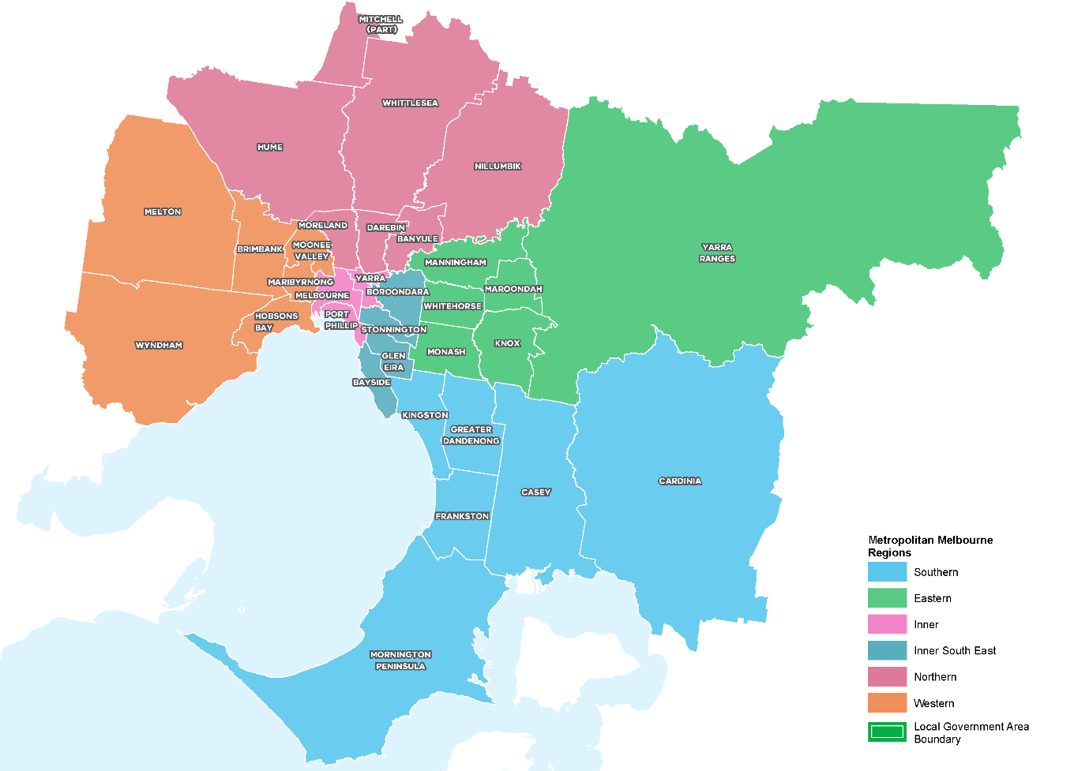

How will the land use framework plans be used?
The LUFPs will be used to:
- Drive the majority of Melbourne’s population growth into established areas through a land use framework that identifies places of state and regional significance
- Guide the strategic integration of land use and infrastructure (including housing and jobs aspirations) in key areas and precincts
- Guide the development of Melbourne’s greenfield growth areas
- Facilitate collaboration by state and local government, key agencies and partners on regional planning and regional priorities
- Inform priority places for state-led planning
- Enable metropolitan councils to update their municipal strategies and policies within a clearly defined land use framework.
The LUFPs will set regional-level planning policy to be implemented into planning schemes. They will inform local councils in decision-making for precinct planning, local and regional planning strategies, and infrastructure and servicing projects.
The LUFPs include a number of short- to medium- term actions for state and local government, which will contribute to planning outcomes in each region alongside existing actions under Plan Melbourne and other government programs and initiatives. Action monitoring will be led by DELWP in partnership with the metropolitan region through the EPWGs, and the actions will be formally reviewed every five years in conjunction with Plan Melbourne 2017-2050 Five-Year Implementation Plan.
Annual progress reports outlining the status of actions will be published by DELWP as a part of Plan Melbourne monitoring. These progress reports will be publicly available.
The chapter on implementation provides further details on how the LUFPs will be used to deliver Plan Melbourne outcomes across the regions.
Appendix 01 identifies the range of related initiatives already underway by state and local government to support the implementation of Plan Melbourne. The LUFPs are designed to complement these initiatives.

The land use framework
The LUFPs establish a common land use framework across the regions (Table 1). This common framework confirms places of state significance as identified in Plan Melbourne and introduces places of regional significance for each metro region.
The land use framework will direct land use decisions and investment, better align state and local government planning, and inform the development of local council planning strategies (including housing strategies). In the process, this common framework will also ensure land use, planning and development all support the vision of Plan Melbourne.
The land use framework
Places of state significance (as identified in Plan Melbourne) | Places of regional significance
- Central City  - National employment and innovation clusters (NEICs)  - Metropolitan activity centres  - State-significant industrial precincts (SSIPs)  - Transport gateways  - State-significant health and/or education precincts  - Major urban renewal precincts | - Major activity centres  - Activity corridors  - Regionally-significant industrial precincts (RSIPs)  - Enterprise precincts  - Regionally-significant health and/or education precincts  - Inter-regional environmental features  - Regional open space  - Growth corridors  - Urban renewal areas  - Housing opportunity and investigation areas  - Green wedges

Regional planning and collaboration
Planning at a regional level is an opportunity for state and local governments to work together to manage long-term growth and change across Melbourne (Figure 2).
While the Western Metro Region has many unique opportunities and challenges, there are some opportunities and challenges common across all metropolitan regions, such as ensuring jobs are available close to public transport; increasing housing supply in areas with access to jobs, services and public transport; and mitigating and adapting to climate change. The LUFP allows for these differences and recognises regional initiatives already underway.
The LUFPs will guide regional planning and collaboration vertically (between state and local government) and horizontally (across local councils in partnership with other stakeholders, including Traditional Owners).
Figure 2. Inter-relationship between state and local planning
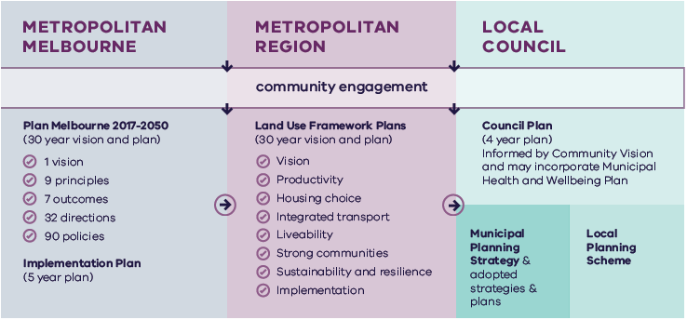

Metropolitan Melbourne | Metropolitan Region | Local Council
Is informed by community engagement. | Is informed by community engagement and Metropolitan Melbourne planning. | Is informed by community engagement, Metropolitan Melbourne planning and Metropolitan Region planning.
Includes:  - Plan Melbourne 2017-2050 (30 year vision and plan)  - 1 vision  - 9 principles  - 7 outcomes  - 90 policies  - Implementation Plan (5 year plan) | Includes:  - Land Use Framework Plans (30 year vision and plan)  - Vision  - Productivity  - Housing choice  - Integrated transport  - Liveability  - Strong communities  - Sustainability and resilience  - Implementation | Includes:  - Council Plan (4 year plan)  - Informed by Community Vision and may incorporate Municipal Heath and Wellbeing Plan  - Municipal Planning Strategy & adopted strategies & plans  - Local Planning Scheme

State-led planning
The Victorian Government has identified priority areas for state-led planning. The purpose of state-led planning in those areas is to maximise land use and infrastructure integration, attract investment, and deliver housing, jobs and services within established urban areas (Table 2).
State-led planning often involves the Victorian Government partnering with local councils and other stakeholders to develop or implement strategic plans, plan for change or respond to an investment, and/or identify key catalyst projects or programs that support growth and attract investment.
The Victorian Department of Transport is leading the whole-of-government delivery and coordination of Sunshine as a transport precinct. The Victorian Department of Jobs, Precincts and Regions is leading the strategic development of Footscray as a Business Precinct and Werribee NEIC.
Current places for state-led planning in the Western Metro Region
Places of state significance
National employment and innovation clusters
Sunshine
Werribee
Metropolitan activity centres
Sunshine
Footscray

Growth area planning
The LUFPs provide a strategic planning framework to guide future development of Melbourne’s three growth corridors – Northern, Western and South Eastern. The LUFPs incorporate and update information from the growth corridor plans prepared by the former Metropolitan Planning Authority, now the Victorian Planning Authority (VPA).
The growth corridor plans set the strategic direction for future urban development in the growth corridors, including:
- Areas suitable for urban development and the broad form of development (residential, industrial, commercial)
- Areas of high environmental or landscape value that must be protected from development
- The integrated open space network
- Strategic transport infrastructure and options for further investigation
- Locations suitable for a wide range of employment uses.

The following principles underpin the growth corridor plans and are reflected in Plan Melbourne and the LUFPs:
Principle 1 | Create diverse and vibrant new urban communities.
Principle 2 | Integrate transport and land use planning.
Principle 3 | Plan for local employment creation.
Principle 4 | Create growth corridors with high amenity and character.
Principle 5 | Protect biodiversity, waterways and cultural heritage values.
Principle 6 | Create integrated open space networks.
Principle 7 | Plan for environmental sustainability.
Principle 8 | Stage development to ensure the efficient and orderly provision of infrastructure and services.
This Western Metro Region LUFP replaces the West Growth Corridor plan.
The Western Metro Region LUFP will guide and inform the preparation, completion and implementation of the remaining Precinct Structure Plans (PSPs) in these growth areas.
This LUFP does not commit the Victorian Government to specific infrastructure, development projects or levels of service provision within the Western Metro Region. Information included in this LUFP is intended to guide planning for future development, however, should not be interpreted as a delivery mechanism or program committing the Victorian Government to specific infrastructure or development projects or specific levels of service provision.

The broader context

Climate change – the need for both mitigation and adaptation
Victoria’s Climate Change Strategy (2021) translates the Climate Change Act 2017 into concrete action by introducing ambitious but achievable interim emissions reduction targets to keep Victoria on track to net zero emissions by 2050. The Strategy includes actions to reduce emissions now and lay the foundations for future reductions across the economy, including but not limited to the following: continuing the transition to clean, renewable energy production; establishing a light vehicle sales target of 50 per cent zero emissions vehicles by 2030; investing in land restoration and carbon farming initiatives; supporting Victorian farmers to respond to the impacts of climate change; and, creating new jobs by promoting growth within the waste recycling and renewable energy sectors. These measures will help reduce the size of Melbourne’s carbon footprint and improve its resilience to the impacts of climate change.
Land use and transport integration – such as locating homes close to public transport and bike and walking paths – is critical to achieving net-zero emissions. In 2018, cars made up just over half of all transport emissions, with road vehicles responsible for almost 90 per cent of those transport emissions. Transport emissions by mode and road transport sub-categories are shown in Figure 3.

- Transport emissions by mode and road transport sub-categories – Victoria 2018
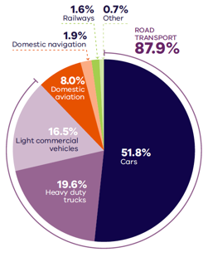
DELWP (2020) Victorian Greenhouse Gas Emissions Report 2018, State of Victoria: Melbourne, Australia.

Figure 3. Transport emissions by mode and road transport sub-categories – Victoria 2018
Cars | 51.8 per cent
Heavy duty trucks | 19.6 per cent
Light commercial vehicles | 16.5 per cent
Domestic aviation | 8.0 per cent
Domestic navigation | 1.9 per cent
Railways | 1.6 per cent
Other | 0.7 per cent
Source: Victorian Greenhouse Gas Emissions Report 2018, DELWP, 2020, State of Victoria: Melbourne, Australia.

In Melbourne, despite increased public transport usage and significant public transport investment, cars remain the dominant mode of transport. In 2016, for example, private vehicles accounted for 67 per cent of trips in Melbourne. To achieve net-zero emissions, Victoria’s private vehicle use must be dramatically reduced.
The Victorian Government is working towards a more sustainable built environment through reforms to construction, planning and energy provision across metropolitan Melbourne and Victoria. These regulatory reforms will reduce the energy consumption of appliances, require improved environmentally sustainable development (ESD) outcomes in new buildings and subdivisions, and improve the efficiency of energy production and distribution.
The Victorian Government recently released its Environmentally Sustainable Development of Buildings and Subdivisions – A Roadmap for Victoria’s Planning System (the Roadmap). This document outlines updates to the planning system that support broader, state-level ESD policy objectives. It sets out additional ESD objectives and standards for the design of new buildings, as well as the layout of large-scale residential subdivisions proposed through the Victoria Planning Provisions.
The Roadmap also sets out other initiatives, including new approaches to energy management – such as renewable and distributed energy technologies, microgrids and battery farms, better stormwater management, increased landfill diversion practices, and the promotion of sustainable modes of transport.
Victoria is actively decarbonising the energy sector through the construction of better buildings and the transition to renewable energy generation (including on-site solar photovoltaic and large-scale renewable energy projects). Victoria’s planning policies will also facilitate appropriate development of low emission and zero emission energy supply infrastructure.
Good precinct structure planning can also reduce greenhouse gas emissions and make communities more climate resilient. That is why affordable and clean energy infrastructure should be used to support sustainable development and sustainable transport.

20-minute neighbourhoods
The LUFPs aim to create more 20-minute neighbourhoods in Melbourne’s six metropolitan regions by planning for established areas, growth areas and major transport infrastructure projects. The LUFPs also provide the regional direction and strategies to inform the delivery of 20-minute neighbourhoods through structure planning.
Future PSPs in growth areas will be guided by the 20-minute neighbourhoods principle and the Victorian Planning Authority’s guidelines for precinct structure planning.

City-shaping transport projects
The Victorian Government is currently implementing the largest transport infrastructure program in the state’s history. City-shaping projects (Figure 4) include:
- The West Gate Tunnel – creating a second river crossing to link the Western Metro Region with the Port of Melbourne, CityLink and the CBD, and take traffic pressures off the West Gate Bridge
- Level crossing removals including along the Werribee, Williamstown and Geelong-Ballarat railway lines, reducing congestion and unlocking land for development
- Metro Tunnel – linking Melbourne’s south-east and Gippsland to the Sunbury line in Melbourne’s west and north-west
- North East Link – connecting Melbourne’s south-east to the Eastern Freeway, the Western Ring Road and Hume Freeway
- Melbourne Airport Rail – connecting Melbourne Airport to Victoria’s regional and metropolitan train network
- Suburban Rail Loop (SRL) – connecting every major passenger railway line in Melbourne from the Frankston line in the south to the Werribee line in the west. SRL East (Cheltenham to Box Hill) is scheduled to begin in 2022. SRL East will also connect key employment and education precincts, and facilitate uplift and intensive development of station precinct.
These city-shaping projects will improve access to jobs, education and social opportunities in the Western Metro Region. They will also connect the Western Metro Region with other areas of Melbourne and Victoria. In addition, they are also creating opportunities to make the Western Metro Region more prosperous, sustainable and liveable through the integration of land use and transport planning.
The purpose of integrated land use and transport planning is to bring jobs, services and leisure opportunities closer to where people live. This means shorter trips, the option to use active transport, and less time spent travelling – leading to a better quality of life and the creation of 20-minute neighbourhoods. In addition, this integrated approach also frees up capacity for freight, public transport and active transport journeys – reducing transport emissions.

Coronavirus (COVID-19) impacts
The coronavirus (COVID-19) pandemic is having dramatic impacts on Victoria’s population, economy and society.
With movement restricted, migration to Victoria has been reduced almost to zero. The Australian Government’s expectations for overseas migration losses will see Victoria’s population decline slightly in 2020-21, compared with average growth of 2 per cent for most of the previous decade. International migration is expected to resume within one to two years but not return to normal until the mid-2020s at the earliest.
This interruption to growth is not expected to change the long-term future direction of Melbourne.
However, the global pandemic has had significant impacts. This includes the shift to work-from-home arrangements for large parts of the metropolitan workforce, a greater uptake of online retail services and a shift to local living, with more people are relying on their activity centres and neighbourhoods to meet their day-to-day needs. Many industry sectors impacted by COVID-19 restrictions, including tourism, the arts and international education, are still recovering.
The LUFPs will help Melbourne’s metropolitan regions manage the economic and social impacts of the pandemic especially in specific areas such as Melbourne’s CBD and the Monash and Bundoora education precincts.
The progress of each LUFP will be monitored and revisited to ensure each regional land use pathway continues to contribute to Plan Melbourne’s outcomes.
- City-shaping transport projects
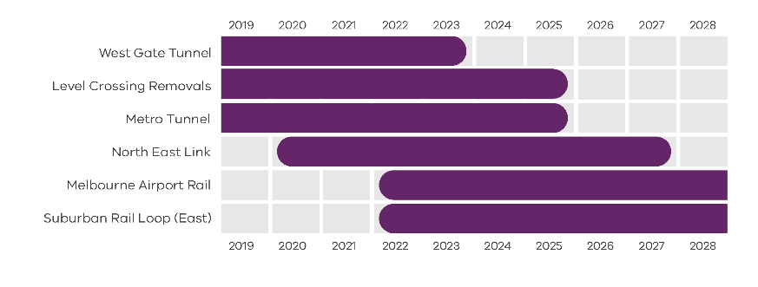
Department of Environment, Land, Water and Planning 2021
Figure 4. City-shaping transport projects
West Gate Tunnel | Pre-2019 to 2023
Level Crossings Removals | Pre-2019 to 2025
Metro Tunnel | Pre-2019 to 2025
North East Link | From 2020 to 2027
Melbourne Airport Rail | From 2022 to post-2028
Suburban Rail Loop (East) | From 2022 to post-2028
Source: Department of Environment, Land, Water and Planning 2021

Chapter 02.
Regional snapshot
The Western Metro Region includes the local government areas (LGAs) of Brimbank, Hobsons Bay, Maribyrnong, Melton, Moonee Valley and Wyndham.
- Western Metro Region
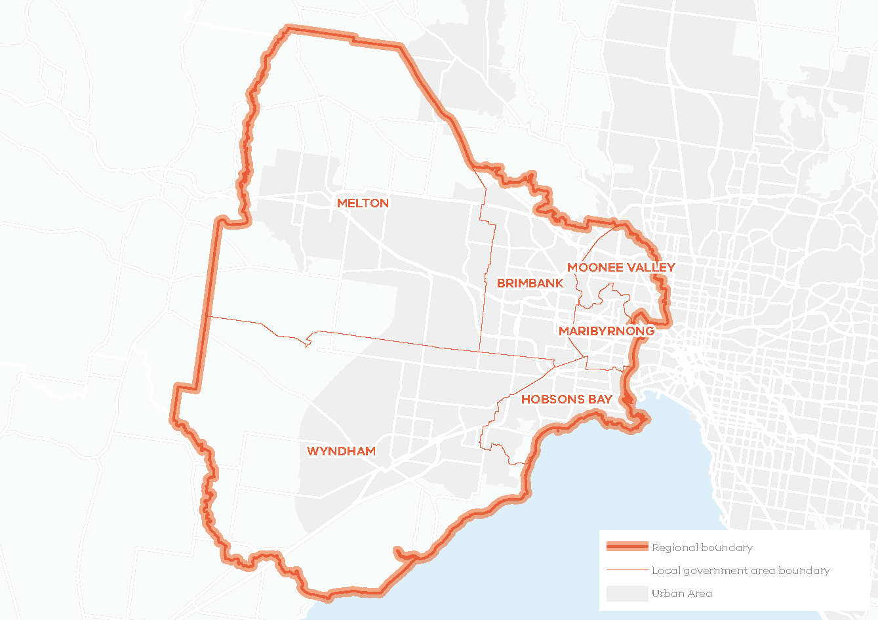
Total area: 133,190HA
15% of Metropolitan Melbourne
Over 49% of the region is designated green wedge land
The region sits on the Victorian Volcanic Plain and its natural environment is characterised by its extensive southern coastline, sweeping plains, a network of waterways and protected grasslands with significant biodiversity values. The Wurundjeri, Bunurong and Wadawurrung people of the Kulin Nation are the Traditional Owners of the lands that make up the Western Metro Region of Melbourne.

Urban structure
The Western Metro Region’s urban geography and structure is defined by the Maribyrnong River, the Port Phillip coastline and a distinctively flat and open terrain of the Western Volcanic Plains with views to the Melbourne CBD to the east and You Yangs to the west. The urban structure is three concentric bands of development – inner suburbs, middle ring suburbs and outer suburbs. The middle and outer areas of the region have extensive areas of state-significant industrial land which divides the two growth areas towards Melton to the west and south-west to Werribee.
The inner suburbs were developed as housing for working class and new immigrants and have a mix of cottage, terrace and detached housing. The middle ring suburbs are largely dominated by industrial land with lower-density housing while outer suburbs are at varying stages of development with well-established satellite towns of Werribee and Melton, and others still being planned in the growth areas. The region’s green wedges encircle the urban area providing for agriculture, extractive resources and conservation areas including the Western and Derrimut Grassland Reserves, volcanic hills and cones including Mt Kororoit and Mt Cottrell and Port Phillip Bay (Western Shoreline) Ramsar wetlands.
The Western Metro Region comprises very distinct and often physically separated suburbs – some of which are well-established, some which are growing rapidly, and some which are planned. These include:
- Werribee and Melton – existing regional centres and growth corridors with strong connections to the periurban areas including south west to Lara and beyond to Geelong, and west to Bacchus Marsh, Ballan and beyond to Ballarat and the Macedon Ranges
- Growth corridors – Wyndham (Tarneit, Truganina, Wyndham Vale, Williams Landing, Point Cook), Melton (Toolern, Plumpton, Rockbank North, Rockbank South, Mt Atkinson, Caroline Springs and Burnside) and Diggers Rest in the north of the region
- Older established areas along the Tullamarine and Calder freeways – Airport West, Niddrie, Taylors Lakes, Keilor
- Large infill and brownfield sites for future development in inner and middle ring suburbs including Werribee Employment Precinct
- Inner areas along rail lines and tram lines – Footscray, Sunshine, Flemington, Moonee Ponds
- Historic maritime suburbs of Williamstown and Newport
- Radial road connections along Calder Freeway, Western Freeway, Princes Highway and Freeway, and the Western Ring Road.

Population and demographics
In 2020, the Western Metro Region had a population of 988,970 or 19 per cent of Melbourne’s total population. The region has experienced the fastest population growth in recent years and the population is projected to continue increasing to a total of almost 1.9 million people by 2051. The region will accommodate 23 per cent of metropolitan Melbourne’s population in 2051 with the highest annual growth rate of 2.1 per cent among all the regions (DELWP, 2019b).
The region will require an additional 412,100 dwellings from 2016 to accommodate this growth by 2051 (DELWP, 2019b). Consistent with metropolitan Melbourne, the most prevalent household type in the Western Metro Region is families with children and this is expected to remain the same to 2051.
Outlined below are some of the key demographics and land use features of the Western Metro Region.
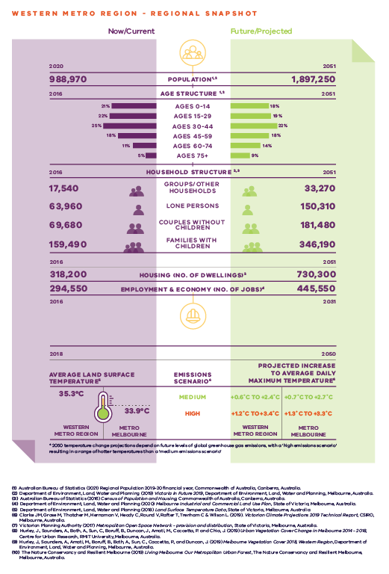
Western Metro Region – Regional Snapshot
Western Metro Region population  Sources:  Australian Bureau of Statistics (2021) Regional Population 2019-20 financial year, Commonwealth of Australia, Canberra, Australia.  Department of Environment, Land, Water and Planning (2019) Victoria in Future 2019, Department of Environment, Land, Water and Planning, Melbourne, Australia. | 2020 (now/current):  988,970 inhabitants | 2051 (projected/future):  1,897,250 inhabitants
Western Metro Region age structure  Sources:  Department of Environment, Land, Water and Planning (2019) Victoria in Future 2019, Department of Environment, Land, Water and Planning, Melbourne, Australia.  Australian Bureau of Statistics (2016) Census of Population and Housing, Commonwealth of Australia, Canberra, Australia. | 2016 (now/current):  21 per cent – Ages 0 to 14  22 per cent – Ages 15 to 29  25 per cent – Ages 30 to 44  18 per cent – Ages 45 to 59  11 per cent – Ages 60 to 74  5 per cent – Ages 75 plus | 2051 (projected/future):  18 per cent – Ages 0 to 14  19 per cent – Ages 15 to 29  22 per cent – Ages 30 to 44  18 per cent – Ages 45 to 59  14 per cent – Ages 60 to 74  9 per cent – Ages 75 plus
Western Metro Region household structure  Sources:  Department of Environment, Land, Water and Planning (2019) Victoria in Future 2019, Department of Environment, Land, Water and Planning, Melbourne, Australia.  Australian Bureau of Statistics (2016) Census of Population and Housing, Commonwealth of Australia, Canberra, Australia. | 2016 (now/current):  Groups/other households – 17,540  Lone persons – 63,960  Couples without children – 69,680  Families with children – 159,490 | 2051 (projected/future):  Groups/other households – 33,270  Lone persons – 150,310  Couples without children – 181,480  Families with children – 346,190
Western Metro Region housing (number of dwellings)  Source:  Department of Environment, Land, Water and Planning (2019) Victoria in Future 2019, Department of Environment, Land, Water and Planning, Melbourne, Australia. | 2016 (now/current):  318,200 dwellings | 2051 (projected/future):  730,300 dwellings
Western Metro Region employment and economy (number of jobs)  Source:  Department of Environment, Land, Water and Planning (2020) Melbourne Industrial and Commercial Land Use Plan, State of Victoria, Melbourne, Australia. | 2016 (now/current):  294,550 jobs | 2031 (projected/future):  445,550 jobs
2018 average land surface temperature  Source:  Department of Environment, Land, Water and Planning (2018) Land Surface Temperature Data, State of Victoria, Melbourne, Australia. | Western Metro Region:  35.3 degrees Celsius | Metro Melbourne:  33.9 degrees Celsius
2050 projected increase to average daily maximum temperature  *2050 temperature change projections depend upon future levels of global greenhouse gas emissions, with a ‘high emissions scenario’ resulting in hotter temperatures than a ‘medium emissions scenario’  Source:  Clarke J.M., et al. (2019). Victorian Climate Projections 2019 Technical Report, CSIRO, Melbourne, Australia. | Western Metro Region:  Medium emissions scenario – plus 0.6 to plus 2.4 degrees Celsius  High emissions scenario – plus 1.2 to plus 3.4 degrees Celsius | Metro Melbourne:  Medium emissions scenario – plus 0.7 to plus 2.7 degrees Celsius  High emissions scenario – plus 1.3 to plus 3.3 degrees Celsius

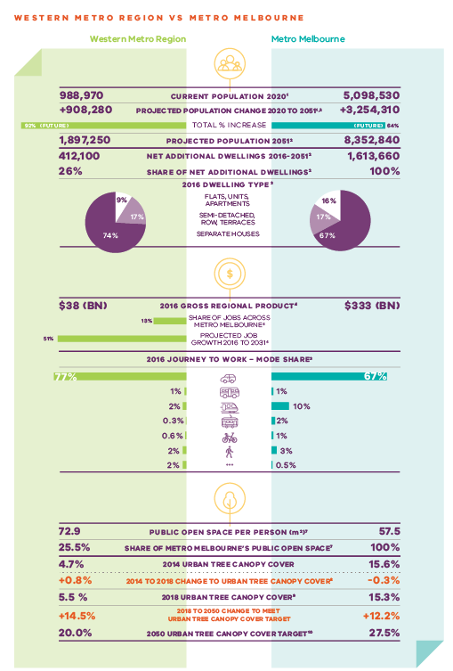

Western Metro Region vs Metro Melbourne
 | Western Metro Region | Metro Melbourne
Current population 2020  Source:  Australian Bureau of Statistics (2021) Regional Population 2019-20 financial year, Commonwealth of Australia, Canberra, Australia. | 988,070 inhabitants | 5,098,530 inhabitants
Projected population change 2020 to 2051  Sources:  Australian Bureau of Statistics (2021) Regional Population 2019-20 financial year, Commonwealth of Australia, Canberra, Australia.  Department of Environment, Land, Water and Planning (2019) Victoria in Future 2019, Department of Environment, Land, Water and Planning, Melbourne, Australia. | Plus 908,280 inhabitants | Plus 3,254,310 inhabitants
Total per cent population change (future) | 92 per cent | 64 per cent
Projected population 2051  Source:  Department of Environment, Land, Water and Planning (2019) Victoria in Future 2019, Department of Environment, Land, Water and Planning, Melbourne, Australia. | 1,897,250 inhabitants | 8,352,840 inhabitants
Net additional dwellings 2016 to 2051  Source:  Department of Environment, Land, Water and Planning (2019) Victoria in Future 2019, Department of Environment, Land, Water and Planning, Melbourne, Australia. | 412,100 dwellings | 1,613,660 dwellings
Share of net additional dwellings  Source:  Department of Environment, Land, Water and Planning (2019) Victoria in Future 2019, Department of Environment, Land, Water and Planning, Melbourne, Australia. | 26 per cent | 100 per cent
2016 dwelling type  Source:  Australian Bureau of Statistics (2016) Census of Population and Housing, Commonwealth of Australia, Canberra, Australia. | Flats, apartments, units – 9 per cent  Semi-detached, row, terraces – 17 per cent  Separate houses – 74 per cent | Flats, apartments, units – 16 per cent  Semi-detached, row, terraces – 17 per cent  Separate houses – 67 per cent
2016 gross regional product  Source:  Department of Environment, Land, Water and Planning (2020) Melbourne Industrial and Commercial Land Use Plan, State of Victoria, Melbourne, Australia. | $38 billion | $333 billion
Share of jobs across Melbourne  Source:  Department of Environment, Land, Water and Planning (2020) Melbourne Industrial and Commercial Land Use Plan, State of Victoria, Melbourne, Australia. | 13 per cent
Projected job growth to 2031  Source:  Department of Environment, Land, Water and Planning (2020) Melbourne Industrial and Commercial Land Use Plan, State of Victoria, Melbourne, Australia. | 51 per cent
2016 journey to work – mode share  Source:  Australian Bureau of Statistics (2016) Census of Population and Housing, Commonwealth of Australia, Canberra, Australia. | Private motor vehicle – 77 per cent  Bus – 1 per cent  Train – 2 per cent  Tram – 0.3 per cent  Bicycle – 0.2 per cent  Walking – 2 per cent  Other – 2 per cent | Private motor vehicle – 67 per cent  Bus – 1 per cent  Train – 10 per cent  Tram – 2 per cent  Bicycle – 1 per cent  Walking – 3 per cent  Other – 0.5 per cent
Public open space per person (metres squared)  Source:  Victorian Planning Authority (2017) Metropolitan Open Space Network: Provision and Distribution, State of Victoria, Melbourne, Australia. | 72.9 | 57.5
Share of metro Melbourne’s public open space  Source:  Victorian Planning Authority (2017) Metropolitan Open Space Network: Provision and Distribution, State of Victoria, Melbourne, Australia. | 25.5 per cent | 100 per cent
2014 urban tree canopy cover  Source:  Hurley, J., et al. (2019) Urban Vegetation Cover Change in Melbourne 2014 - 2018, Centre for Urban Research, RMIT University, Melbourne, Australia. | 4.7 per cent | 15.6 per cent
2014 to 2018 change to urban tree canopy cover | Plus 0.8 per cent | Minus 0.3 per cent
2018 urban tree canopy cover  Source:  Hurley, J., et al. (2019) Melbourne Vegetation Cover 2018, Western Region, Department of Environment, Land, Water and Planning, Melbourne, Australia. | 5.5 per cent | 15.3 per cent
2018 to 2050 change to meet urban tree canopy cover target | Plus 14.5 per cent | Plus 12.2 per cent
2050 urban tree canopy cover target  Source:  The Nature Conservancy and Resilient Melbourne (2019) Living Melbourne: Our Metropolitan Urban Forest, The Nature Conservancy and Resilient Melbourne, Melbourne, Australia. | 20.0 per cent | 27.5 per cent

Chapter 03.
Vision: Western Metro Region in 2050
The Western Metro Region has a significant and unique role in ensuring that “Melbourne will continue to be a global city of opportunity and choice.”
The Western Metro Region will be Melbourne’s fastest growing region offering diverse employment and education opportunities for its residents, and diverse and affordable housing and lifestyles. The region will have an efficient internal transport network, linking a strong network of activity centres and employment nodes to support local economic growth and investment.
By 2050, the Western Metro Region will experience significant change including:
- A greater diversity of jobs and education opportunities through continued investment in the Sunshine and Werribee NEICs and the delivery of Melbourne Airport Rail and the Metro Tunnel. The growth areas of Wyndham and Melton play a significant role in diversification of the region including well-planned development of the Toolern Metropolitan Activity Centre.
- Integrating the Western Interstate Freight Terminal, Western Industrial Precinct and Bay West port option to consolidate the Western Metro Region as south-east Australia’s major hub for freight and logistics. This includes protecting valued employment land and fully integrating it into the transport network with more freight on rail.
- An integrated, linked public and active transport network to address growth, provide equitable access to jobs, health and education, and improved north-south, inter-regional connections including to Melbourne and Avalon airports and regional Victoria.
- Liveable and well-planned suburbs comprising a well-connected network of distinctive neighbourhoods and activity nodes that provide a mix of housing catering for a changing population and retaining and attracting a diverse workforce.
- The growth areas of Wyndham and Melton are well-planned, locally-distinctive neighbourhoods with a diverse range of housing, employment, open space, transport options and access to local services through a network of connected regional and local activity centres.
- The region’s activity centres will be vibrant with high-quality development and lively public spaces for celebrating the cultural and social diversity of the region’s people.
- The region boasts an expanded tree canopy, a regional approach to water management, and is Victoria’s waste and resource recovery ‘centre of excellence’.
The region’s green wedge land and diverse landscapes will be valued and managed, and its unique natural environments, including the Western Grasslands and iconic coastlines, will be protected. The region’s connected waterways will support biodiversity and provide high-quality open space and active transport links for residents and visitors.
A more detailed picture of how land use in the Western Metro Region is expected to change in 2050 is provided in Map 1.

- Western Metro Region 2050 Plan
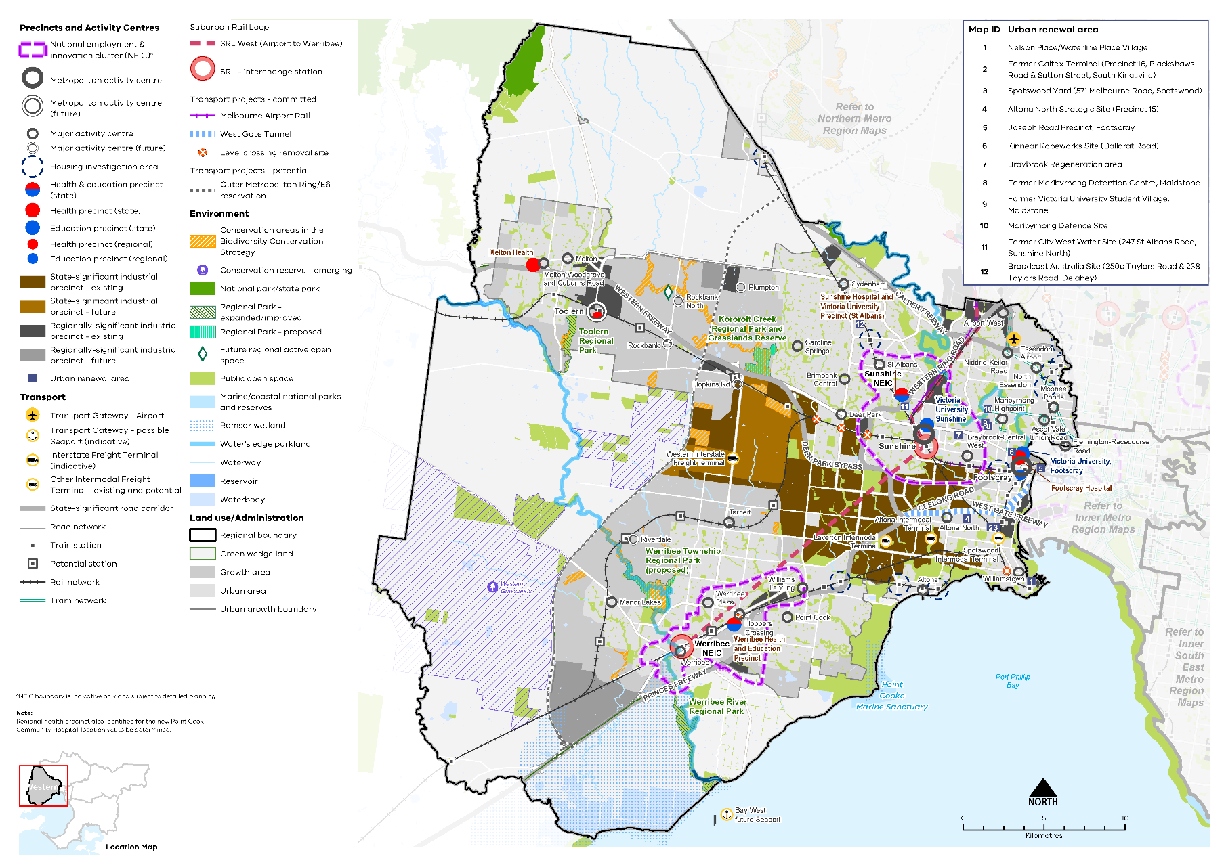
Map 1 Western Metro Region 2050 Plan

A plan of the Western Metro Region in 2050, showing –

- The region’s boundary, the urban growth boundary, green wedge land, established urban area and growth areas.

- Locations for growth and investment, including:

- The location and indicative boundaries of the Sunshine NEIC in the north-east of the region and Werribee NEIC in the south-west of the established area*
- Existing and future state- and regionally- significant industrial precincts located through the centre of the region from east to west, from Sunshine to Werribee, and in the north of the region, as listed in tables 3 and 4
- Sunshine and Footscray metropolitan activity centres, and the proposed Toolern Metropolitan Activity Centre
- The network of existing and future major activity centres predominantly located on the rail and road network, as listed in table 7
- State- and regionally-significant health and/or education precincts at Melton, Footscray, Sunshine, St Albans and Werribee (see tables 5 and 14)
- The 12 urban renewal areas of:
Nelson Place/Waterline Place Village
Former Caltex Terminal (Precinct 16, Blackshaws Road & Sutton Street, South Kingsville)
Spotswood Yard (571 Melbourne Road, Spotswood)
Altona North Strategic Site (Precinct 15)
Joseph Road Precinct, Footscray
Kinnear Ropeworks Site (Ballarat Road)
Braybrook Regeneration area
Former Maribyrnong Detention Centre, Maidstone
Former Victoria University Student Village, Maidstone
Maribyrnong Defence Site
Former City West Water Site (247 St Albans Road, Sunshine North)
Broadcast Australia Site (250a Taylors Road & 238 Taylors Road, Delahey)
- Housing investigation areas as listed in table 12.
- Suburban Rail Loop (West) (Airport to Werribee) interchange stations and precincts at Sunshine and Werribee NEICs.

- Key transport linkages and movement network including:

- Railway lines and train stations including Suburban Rail Loop (West), proposed train stations in the growth areas, the future Melbourne Airport Rail link and level crossing removal sites
- The road network including the state-significant road corridors of the Calder Freeway, Western Ring Road, Western Freeway, Geelong Road and the Princes Freeway, the future West gate tunnel, and the potential Outer Metropolitan Ring / E6
- Transport gateways at Essendon Airport, the proposed Western Interstate Freight Terminal, other existing and potential intermodal freight terminals at Laverton, Altona and Spotswood and the possible Bay West Future Sea Port.

- State and regional natural assets, including:

- Conservation areas in the Biodiversity Conservation Strategy, state and national parks, the Western Grasslands conservation reserve, Ramsar wetlands, regional parks, future regional active open space, and other public open space.

* NEIC boundary is indicative only and subject to detailed planning.

Note: Regional health precinct also identified for the new Point Cook Community Hospital, location yet to be determined.

Note: NEIC boundary is indicative only and subject to detailed planning.

Chapter 04.
Productivity
Plan Melbourne Outcome 1: Melbourne is a productive city that attracts investment, supports innovation and creates jobs
The Western Metro Region has a legacy of transport, logistics and manufacturing industries. It continues to be home to significant areas of unfragmented industrial land, including the Western Industrial Precinct which is one of the largest state-significant industrial precincts (SSIPs) in metropolitan Melbourne. The considerable amount of unfragmented industrial land in the region is an advantage.
Complementing industrial land and activity, are the Sunshine and Werribee National Employment and Innovation Clusters (NEICs), which include major education and health precincts, a network of activity centres and access to extensive air, road and rail infrastructure, reaching local, regional, interstate and international markets.
Key transport gateways in the Western Metro Region include the Melbourne Airport, Avalon Airport and Australia’s busiest container port, the Port of Melbourne. Further investment in road and rail infrastructure such as the Melbourne Airport Rail, SRL, the proposed Outer Metropolitan Ring/E6 Transport Corridor (OMR), the proposed Western Interstate Freight Terminal (WIFT) and the potential Bay West container port will further enhance transport connections. While the region is well positioned to meet strong population growth, with access to a range of jobs, there is a need to support the transition of the local economy towards higher order, knowledge intensive jobs in line with global trends.
Plan Melbourne creates a city structure that strengthens Melbourne’s competitiveness for jobs and investment. It identifies NEICs, SSIPs, a network of metropolitan and major activity centres, transport gateways and state-significant health and education precincts to ensure employment growth occurs outside the Central City and is linked by sustainable transport. The Western Metro Region is well placed to leverage its existing strengths to support economic growth and innovation.

State of play
The Western Metro Region’s employment and activity framework comprises:
- Western Industrial Precinct SSIP
- Sunshine and Werribee NEICs
- Footscray, Sunshine and Toolern (future) metropolitan activity centres
- Transport gateway at Essendon Airport, with important connections to Melbourne Airport and Avalon Airport, and the Port of Melbourne
- Proposed WIFT and proposed Bay West container port
- State-significant health and/or education precincts at Footscray Hospital (known as Western Hospital in Plan Melbourne), Victoria University (Footscray), Sunshine Hospital and Victorian University Precinct (St Albans), Werribee Health and Education Precinct, Melton Health and Victoria University (Sunshine)
- A network of 25 existing and five future major activity centres that are based around larger freestanding shopping centres and strip-based centres that vary in size, role and function
- Western Growth Corridor consisting of growth areas in Wyndham and Melton
- Significant waste and recovery facilities including the Melbourne Regional Landfill at Ravenhall, Western Treatment Plant, and the Werribee Refuse Disposal Facility
- Agricultural industries, waste management, resource extraction and tourism in the green wedge areas.
The Western Metro Region contributes $38 billion to metropolitan Melbourne’s economy, which is about 11 per cent of the total Gross Regional Product (GRP) across metropolitan Melbourne (DELWP, 2020a). The region’s largest economic contributor is the business service sector with a total value-add estimated at $13.3 billion. The manufacturing and industrial sector is the second largest contributor with an estimated contribution of $11.1 billion (DELWP, 2020a). These industries account for almost 64 per cent of the region’s total GRP (DELWP, 2020a).
In 2016, the region supported approximately 294,550 jobs or 13 per cent of all jobs in metropolitan Melbourne (DELWP, 2020a). Employment growth is expected in the healthcare and social assistance, transport, postal and warehousing, retail trade, education and training and manufacturing industries (Figure 6). An estimated 151,000 additional jobs will be located across the Western Metro Region by 2031 with over half of the new jobs located in the Melton and Wyndham LGAs.
The Western Metro Region has a total of 8640 hectares of zoned land set aside for industrial uses, of which around 5820 hectares is currently occupied (DELWP, 2020a). An additional 2880 hectares of land has been identified for future industrial purposes that is not yet zoned. The Western Industrial Precinct has numerous established industrial sites including the Coode Island storage facilities and the Mobil Altona refinery.
Currently, a total of 949 hectares of land has been identified as zoned for commercial purposes across the Western Metro Region (DELWP, 2020a). An additional 559 hectares of future planned commercial land has been identified in other strategic plans, in the Melton and Wyndham growth areas. The region has significant issues regarding contaminated land which may impact on the availability of some land for future development without remedial works being undertaken.
The region is strategically located as a hub for logistics with access to Melbourne Airport and Avalon Airport and the Port of Melbourne. Essendon Airport is located in the north-east of the region as well as the Royal Australian Air Force at Base Point Cook. The Western Metro Region also contains key interstate road connections and rail links to the regional centres of Geelong, Ballarat and Bendigo (Figure 7). Key road transport links include the Western Highway, Princes Highway and Freeway and the Western Ring Road.

- Projected employment growth for the Western Metro Region 2016 to 2031
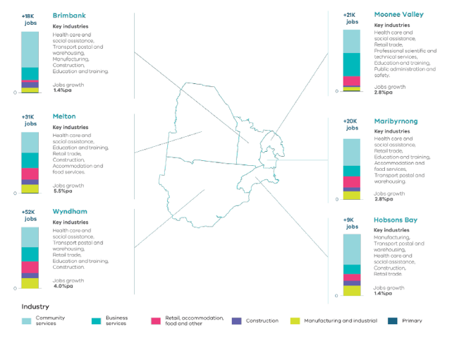
Melbourne Industrial and Commercial Land Use Plan, DELWP, 2020

Figure 6. Projected employment growth for the Western Metro Region 2016 to 2031
Brimbank | Plus 18,000 jobs | 1.4 per cent jobs growth per annum | Key industries: health care and social assistance, transport postal and warehousing, manufacturing, construction, education and training
Melton | Plus 31,000 jobs | 5.5 per cent jobs growth per annum | Key industries: health care and social assistance, education and training, retail trade, construction, accommodation and food services
Wyndham | Plus 52,000 jobs | 4.0 per cent jobs growth per annum | Key industries: health care and social assistance, transport postal and warehousing, retail trade, education and training, construction
Moonee Valley | Plus 21,000 jobs | 2.8 per cent jobs growth per annum | Key industries: health care and social assistance, retail trade, professional scientific and technical services, education and training, public administration and safety
Maribyrnong | Plus 20,000 jobs | 2.8 per cent jobs growth per annum | Key industries: health care and social assistance, retail trade, education and training, accommodation and food services, transport postal and warehousing
Hobsons Bay | Plus 9,000 jobs | 1.4 per cent jobs growth per annum | Key industries:  Manufacturing, transport postal and warehousing, health care and social assistance, construction, retail trade
Source: Department of Environment, Land, Water and Planning (2020) Melbourne Industrial and Commercial Land Use Plan, State of Victoria, Melbourne, Australia.

Regional strengths
- Strong industrial and commercial activity, and significant stocks of existing and future industrial land including SSIPs and the Western Industrial Precinct, Sunshine and Werribee NEICs.
- Opportunities to maximise the benefits of future transport infrastructure by supporting the growth of the Sunshine and Werribee NEICs, with a focus on knowledge-based businesses and leveraging the education, health, technology and research, retail and professional services industries.
- State-significant infrastructure such as treatment plants, waste and resource recovery facilities, pipelines, prisons, petrochemical facilities and quarries.
- Diverse green wedges that support agricultural production, cultural, sports and recreational assets and the visitor economy including tourism and agribusiness.

Regional challenges
- Pressure on employment land from other uses and the challenge of growing knowledge-based jobs while retaining and diversifying industrial land, including SSIPs.
- Increased access to and within the region from planned transport infrastructure investment.
- The need to facilitate employment in the region’s metropolitan activity centres of Footscray, Sunshine and Toolern (future) and reinvest in established activity centres to provide a diversity of local job opportunities for significant population growth in region.
- Maintaining access to extractive resources in the region within and outside the Urban Growth Boundary (UGB), close to areas of demand.

Directions and strategies
The directions identified to achieve the 2050 vision for the Western Metro Region in terms of productivity and Outcome 1 of Plan Melbourne are:
Direction 1 | Manage and plan for industrial precincts in the Western Metro Region to be continued generators of economic activity and employment
Direction 2 | Facilitate the development of the Sunshine and Werribee NEICs as major economic contributors for the regional and national economy
Direction 3 | Support the development of a strong network of activity centres to provide jobs closer to where people live
Direction 4 | Ensure the Western Growth Corridor accommodates longer-term industrial and commercial development opportunities
Direction 5 | Ensure protection of green wedges and support their role to provide agriculture, extractive resources, tourism and state infrastructure for the long-term benefit of all Victorians

Each direction is implemented through regionally-specific strategies identified in this LUFP.
Map 2 shows how productivity will be enhanced across the Western Metro Region by 2050 as a result of these directions and strategies, together with Plan Melbourne and other strategies and initiatives as outlined in Appendix 01.

- Western Metro Region productivity 2050
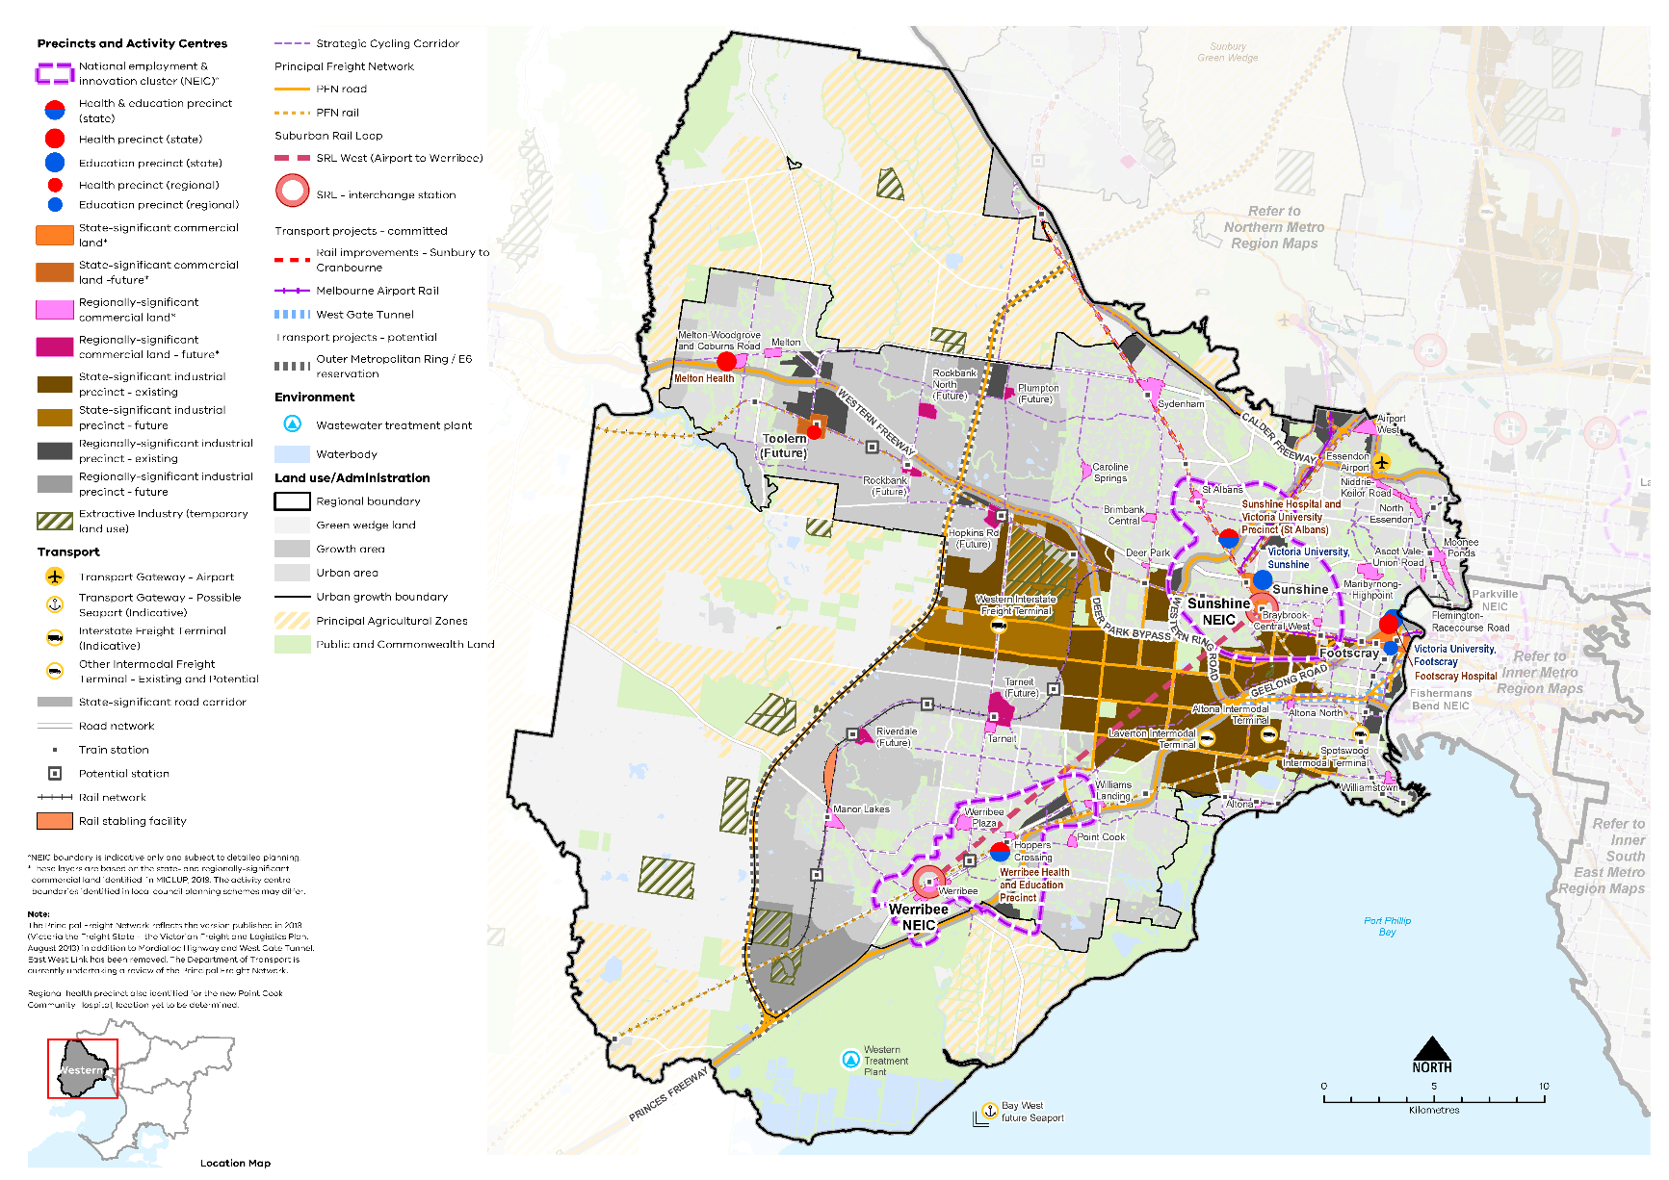

Map 2 Western Metro Region productivity 2050
A plan of productivity in the Western Metro Region in 2050, extracting the productivity features identified on Map 1 above, with the addition of:
- Existing and proposed state-significant commercial land at Footscray and Sunshine; and Toolern respectively*
- Existing and proposed regionally-significant commercial land dispersed throughout the established urban area and growth area*
- Extractive industry (temporary land use)
- Principal agricultural zones
- Principal freight networks (PFN) – road and rail.
*These layers are based on the state and regionally significant commercial land identified in MICLUP, 2019. The activity centre boundaries identified in local council planning schemes may differ.

NOTE: The Principal Freight Network reflects the version published in 2013 (Victoria the Freight State – the Victorian Freight and Logistics Plan, August 2013) in addition to Mordialloc Highway and West Gate Tunnel. East West Link has been removed. The Department of Transport are currently undertaking a review of the Principal Freight Network

- Manage and plan for industrial precincts in the Western Metro Region to be continued generators of economic activity and employment
The Western Industrial Precinct is Melbourne’s largest SSIP and a centre for logistics (Table 3). The purpose of the Western Industrial Precinct is to provide strategically located land for major industrial development linked to the Principal Freight Network (PFN) and transport gateways. It will be protected from incompatible land uses to allow for its future growth in freight, logistics and manufacturing investment. The precinct contains 7,200 hectares of existing and future land identified for industrial purposes.
Access and connectivity with major infrastructure will need to be maintained to preserve the future productivity of the area. Significant transport road corridors service the Western Industrial Precinct including the Western Ring Road, and Princes and Western highways.
Significant unfragmented industrial sites are a key advantage for the region, particularly for freight, logistics, warehousing, transport, manufacturing and other larger format industrial uses (Figure 8).
Demand for industrial land in the region has been strong for the freight and logistics sector which requires large parcels of land with ready access to rail and road networks. This sector accounted for approximately 15 per cent of workplaces in the Western Industrial Precinct in 2016-17, which was proportionately high compared to five per cent of workplaces across metropolitan Melbourne as a whole (DELWP, 2020a). Growth in these sectors is expected to continue to drive demand for industrial land within the region, particularly given its relatively good level of access to major road and rail, the proposed development of the WIFT and easy access to the proposed second container port at Bay West.
The Western Industrial Precinct is spread across five LGAs (Maribyrnong, Hobsons Bay, Brimbank, Melton and Wyndham) and a coordinated approach needs to be adopted when planning for the precinct and addressing its significant challenges. Some of these challenges include managing land contamination, preventing encroachment from incompatible uses, planning for and managing impacts of existing and future transport infrastructure improvements, maintaining and enhancing connections to road and rail freight routes, and improving amenity and attracting investment. Planning to manage these challenges is particularly pertinent for Brooklyn and the nearby areas of Tottenham and West Footscray, which form a contiguous large industrial area that draws employees from across the region.
The portion of the Western Industrial Precinct that is located within Hobsons Bay LGA contains a large amount of SSIP land with longstanding restrictive planning controls in place that are intended to reduce the risks of public exposure to petrochemical industries. Appropriately managing land around hazardous facilities is of upmost importance and is supported by state planning policy. However, these existing planning controls which include employee density restrictions, should be reviewed and could be replaced by a more nuanced and hazard-specific planning response. Additionally, improvements to risk management and new technology highlight the need to review the existing controls, as they currently may inhibit innovation and constrain opportunities for new industries within the SSIP.
State-significant industrial precincts within the Western Metro Region
Existing precincts | Future/emerging precincts
- Derrimut  - Brooklyn  - Altona and Altona North | - Truganina, Truganina North and Tarneit
Melbourne Industrial and Commercial Land Use Plan, DELWP, 2020.
Regionally-significant industrial precincts within the Western Metro Region
Existing precincts | Future/emerging precincts
- Tullamarine, Keilor Park and Keilor East Industrial Precincts  - Toolern Employment Precinct  - Station Road Precinct and Orica Precinct  - Yarraville Port and Mobil Terminal Precincts  - Spotswood Precinct  - Williamstown Marine Precinct  - Hoppers Crossing Industrial Precinct | - Melton Highway Industrial Precinct  - South West Quarries Industrial Node
Melbourne Industrial and Commercial Land Use Plan, DELWP, 2020.
Between 2000-01 and 2017-18 a total of 840 hectares of industrial land was rezoned across the region for non-industrial uses. More than half of this land was rezoned to allow for mixed-use or residential development. There is continued pressure to rezone older industrial areas into predominantly residential uses, particularly in Maribyrnong and Hobsons Bay LGAs. In addition to the SSIPs, regionally-significant industrial land is identified to reinforce existing and future planned industrial precincts and their continued use for industrial and related purposes (Table 4). Together with local significant industrial areas, these will continue to play an important role in encouraging the agglomeration of businesses and providing local employment opportunities within the region.
Industrial areas close to existing communities, transport and services provide the opportunity for flexible uses such as affordable workspaces for new and emerging industries. Industrial areas in Footscray, Tottenham and Brooklyn offer affordable workspace options for new industries, including creative industries and may develop as future enterprise precincts. The ongoing erosion of industrial land for residential uses needs to be managed to examine if these areas can continue to contribute to ongoing employment in the region and should be fully investigated prior to any rezoning. Industrial areas often contain zoning that can provide for a diversity of uses and is well suited as affordable workspaces for new and emerging industries in areas that are well connected to adjacent employment uses or transport connections.
The Western Metro Region has traditional industrial uses and major hazard facilities including petrochemical areas, pipelines, waste recovery sites and quarries. They make an ongoing contribution to the state, regional and metropolitan economy and need to be managed to ensure any amenity impacts, such as noise or odour emissions, are mitigated and located appropriately away from homes and other sensitive uses.
Where traditional industries have ceased to operate in the SSIP, land should be encouraged to transition to other employment generating industrial uses. These areas should continue to be protected from incompatible land uses and set up to allow continued growth in freight, logistics and manufacturing investment.
- Use a coordinated and consistent approach to planning for the Western Industrial Precinct to ensure it continues to provide important employment land for the region in the future.
- Ensure regionally-significant industrial land remains as key industrial areas or as locations that can provide for, or transition to, a broader range of employment opportunities.
- Identify industrial areas that could provide for other employment uses that support or are well connected to adjacent employment uses or transport connectionsI
- Strengthen the national logistics role of the west of Melbourne, including the development of the Western Interstate Freight Terminal, subject to completion of a business case, and leverage both local and regional economic growth opportunities from this investment.
- Retain regionally-significant industrial land by managing encroachment by other uses that would cause fragmentation and may compromise the development and efficient operation of existing businesses.

- Western Metro Region key regional connections
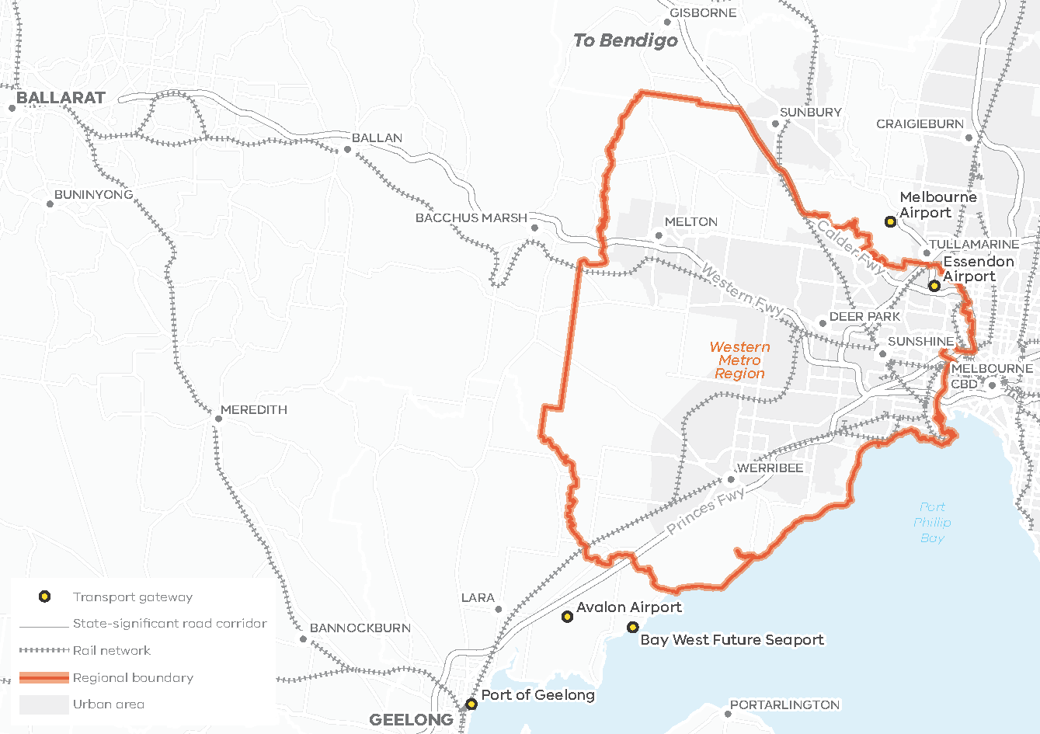
- Existing and future industrial floorspace requirements for the Western Metro Region
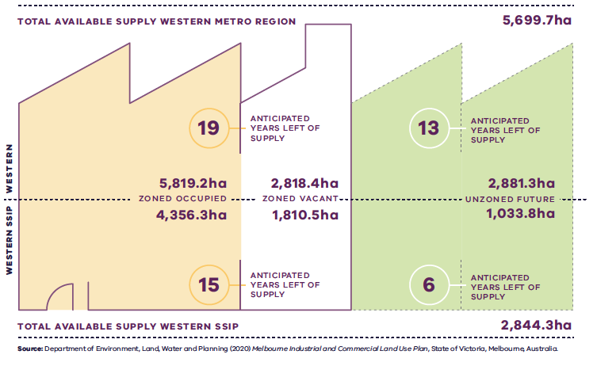

Figure 8. Existing and future industrial floorspace requirements for the Western Metro Region
Western Metro Region | 5,819.2 hectares zoned occupied | 2,818.4 hectares zoned vacant  19 anticipated years left of supply | 2,881.3 hectares unzoned future  13 anticipated years left of supply | 5,699.7 hectares total available supply
Western SSIP | 4,356.3 hectares zoned occupied | 1,810.5 hectares zoned vacant  15 anticipated years left of supply | 1,033.8 hectares unzoned future  6 anticipated years left of supply | 2,844.3 hectares total available supply
Source: Department of Environment, Land, Water and Planning (2020) Melbourne Industrial and Commercial Land Use Plan, State of Victoria, Melbourne, Australia.

- Facilitate the development of the Sunshine and Werribee NEICs as major economic contributors for the regional and national economy supported by increased transport connectivity
The Sunshine and Werribee NEICs are designated concentrations of employment that will continue to grow to make a major contribution to the national economy. Sunshine and Werribee NEICs foster knowledge-based industries and provide opportunities to concentrate businesses linked to co-located state-significant health and/or education precincts, as well as technology, research, retail and professional services.
The region’s economy, while currently underrepresented in knowledge intensive jobs, is also evolving in line with global trends and innovative, creative and problem-solving enterprises and co-working spaces are emerging. The region will need to continue to evolve its employment diversity while also protecting its industrial skills, assets and legacy. The NEICs are ideal locations for knowledge-based business to leverage the education, health, technology and research, retail and professional services industries.
Both Sunshine and Werribee NEICs have strong transport connections to Geelong, peri-urban areas and regional Victoria including Ballarat and Bendigo. Growth in the health and education sectors of these NEICS presents a particularly strong opportunities for the regional economy. With several health and education facilities located within the NEICs (Table 5), they are well positioned and connected by transport infrastructure to serve regional catchments and to strengthen this link to regional Victoria over time.
Melbourne Airport Rail will connect Melbourne Airport to all metropolitan and regional rail lines through Sunshine. SRL will facilitate growth and increase interregional access with interchange stations at both Sunshine and Werribee. Increasing connectivity in the region and beyond will provide opportunities and incentives for new businesses and future industries to locate in the region and bring further economic development and growth.

Sunshine NEIC
The Sunshine NEIC (Figure 9), is a significant economic driver that will continue to emerge as a major provider of tertiary education, health-related training, healthcare services, medical research, education, transport, business and retail services. It currently supports approximately 14,600 jobs and will be planned for substantial growth in tertiary education, health-related training, research, healthcare, retail and professional services sectors to attract more skilled workers.
The Sunshine NEIC has excellent access to major road and metropolitan and regional rail networks. Connectivity will be further improved with the completion of the Metro Tunnel providing a direct link to the Melbourne CBD, and to other key health, research and education, development and employment precincts including Dandenong, Monash and Parkville. Through Melbourne Airport Rail, Sunshine will be the first metropolitan activity centre destination from the Melbourne Airport. This is a key strategic advantage for the Sunshine NEIC and there is an opportunity to leverage this connection by incorporating accommodation, hospitality and conference facilities within the NEIC.
Population growth and infrastructure investment in the Sunshine Metropolitan Activity Centre will support the centre’s economic significance. It contains approximately 271,100 square metres of commercial floorspace along with a significant retail and office offering. It has been a significant contributor to job growth within the Sunshine NEIC. Key drivers for commercial floor space demand within the centre have included public sector employment with the location of VicRoads and Brimbank City Council offices, as well as professional services growth due to the emergence of a Justice and Legal Services cluster. With population growth fuelling growth in population servicing industries, Sunshine Metropolitan Activity Centre is likely to continue to play an important role as a regional services hub.
The Victorian Department of Transport is leading the whole-of-government delivery and coordination of Sunshine as a transport precinct

Werribee NEIC
The Werribee NEIC (Figure 10), is a major employment and knowledge intensive cluster with various health and education institutions and a range of high-tech research companies in the food and agricultural industries. It currently provides around 8400 jobs but has potential for more than 50,000 jobs in health, education and high technology research. A total of 106 hectares of future commercial land is identified within the Werribee NEIC, which represents 19 per cent of the region’s identified future commercial land (DELWP, 2020a). This underlines the importance of the NEIC in the provision of future jobs for the region. The NEIC can continue to build on its existing assets by maximising opportunities presented by the significant availability of land for future commercial and industrial purposes.
While Werribee NEIC currently has challenges regarding the adequacy of existing transport infrastructure, future transport infrastructure will have the ability to catalyse investment and should be a priority for the NEIC to fulfill its potential. This includes Geelong Fast Rail, which will efficiently connect the NEIC to Geelong and Melbourne’s CBD, and includes stations at Werribee and Hoppers Crossing activity centres. Additionally, SRL will radially connect the Werribee NEIC directly to the Sunshine NEIC.
These important infrastructure investments present substantial opportunities for the development of the Werribee NEIC and land use planning needs to revaluate the centre and ensure an integrated approach to transport is embedded within the design of the NEIC.
The Victorian Department of Jobs, Precincts and Regions is leading the strategic development of Werribee NEIC as a Business Precinct.
- Strengthen Sunshine and Werribee NEICs as health and education providers and activity clusters in the Western Metro Region.
- Facilitate land use and economic intensification of Sunshine and Werribee NEICs to leverage transport infrastructure investment and improved public transport connectivity, including Suburban Rail Loop and Geelong Fast Rail.
- Encourage tertiary education, health-related training, health care, and retail and professional service uses in the Sunshine NEIC.
- Develop Sunshine Metropolitan Activity Centre as a state-significant precinct and fully multifunctional centre and services hub, and support the emergence of a Justice and Legal Services precinct in the centre.
- Support accommodation, entertainment and conference facility uses in the Sunshine Metropolitan Activity Centre to capitalise on transport infrastructure investments, including Melbourne Airport Rail Link.
- Encourage high value manufacturing uses within the Sunshine NEIC’s industrial precincts to provide a diversity of employment uses.
- Develop the Werribee NEIC by facilitating growth in the health, education and high-tech research sectors.
State-significant health and/or education precincts in the Western Metro Region
Health precinct | Education precinct | Health and education precinct
- Footscray Hospital (known as Western Hospital in Plan Melbourne)  - Melton Health | - Victoria University (Footscray)  - Victoria University (Sunshine) | - Sunshine Hospital and Victoria University Precinct (St Albans)  - Werribee Health and Education Precinct

- Sunshine National Employment and Innovation Cluster
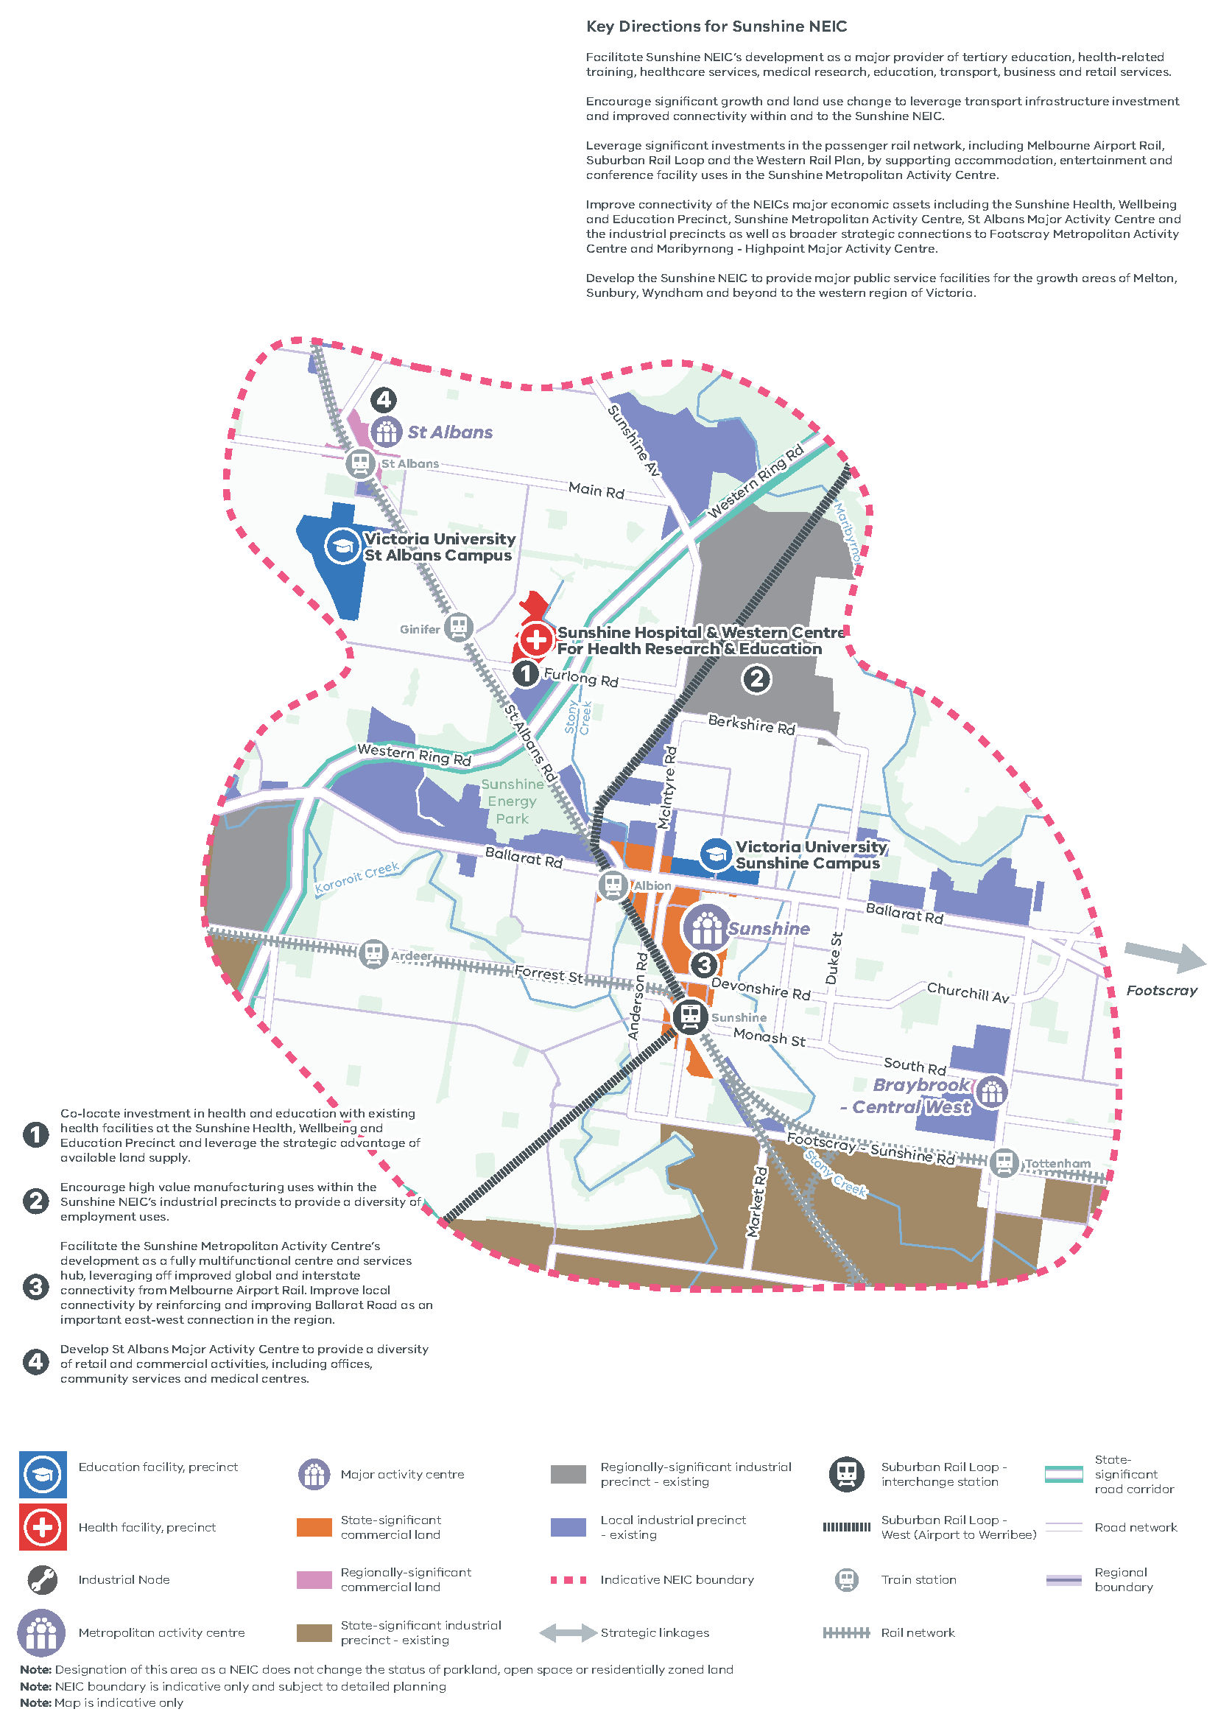
Figure 9. Sunshine National Employment and Innovation Cluster
A map of Sunshine National Employment and Innovation Cluster, showing –
- Indicative NEIC boundary
- Education facility, precinct at Victoria University Sunshine Campus
- Health facility, precinct at Sunshine Hospital and Western Centre for Heath Research and Education
- Industrial Node
- Sunshine Metropolitan Activity Centre, St Albans Activity Centre and Braybrook – Central West Major Activity Centres
- State-significant and regionally-significant commercial land
- Exiting state-significant and regionally-significant industrial precincts
- Existing local industrial precinct
- Strategic linkages
- Suburban Rail Loop West (Airport to Werribee)
- Suburban Rail Loop – interchange station at Sunshine
- Rail Network and train Stations
- Road network and the Western Ring Road state-significant road corridor
Map notes (numbered on the map)
- Co-locate investment in health and education with existing health facilities at the Sunshine Health, Wellbeing and Education Precinct and leverage the strategic advantage of available land supply.
- Encourage high value manufacturing uses within the Sunshine NEIC’s industrial precincts to provide a diversity of employment uses.
- Facilitate the Sunshine Metropolitan Activity Centre’s development as a fully multifunctional centre and services hub, leveraging off improved global and interstate connectivity from Melbourne Airport Rail. Improve local connectivity by reinforcing and improving Ballarat Road as an important east-west connection in the region.
- Develop St Albans Major Activity Centre to provide a diversity of retail and commercial activities, including offices, community services and medical centres.
Key Directions for Sunshine NEIC
- Facilitate Sunshine NEIC’s development as a major provider of tertiary education, health-related training, healthcare services, medical research, education, transport, business and retail services.
- Encourage significant growth and land use change to leverage transport infrastructure investment and improved connectivity within and to the Sunshine NEIC.
- Leverage significant investments in the passenger rail network, including Melbourne Airport Rail, Suburban Rail Loop and the Western Rail Plan, by supporting accommodation, entertainment and conference facility uses in the Sunshine Metropolitan Activity Centre.
- Improve connectivity of the NEICs major economic assets including the Sunshine Health, Wellbeing and Education Precinct, Sunshine Metropolitan Activity Centre, St Albans Major Activity Centre and the industrial precincts as well as broader strategic connections to Footscray Metropolitan Activity Centre and Maribyrnong - Highpoint Major Activity Centre
- Develop the Sunshine NEIC to provide major public service facilities for the growth areas of Melton, Sunbury, Wyndham and beyond to the western region of Victoria
Note: Designation of this area as a NEIC does not change the status of parkland, open space or residentially zoned land
Note: NEIC boundary is indicative only and subject to detailed plan
Note: Map is indicative only
NEIC boundary is indicative only and subject to detailed planning.
Source: Plan Melbourne, DELWP 2017

- Werribee National Employment and Innovation Cluster
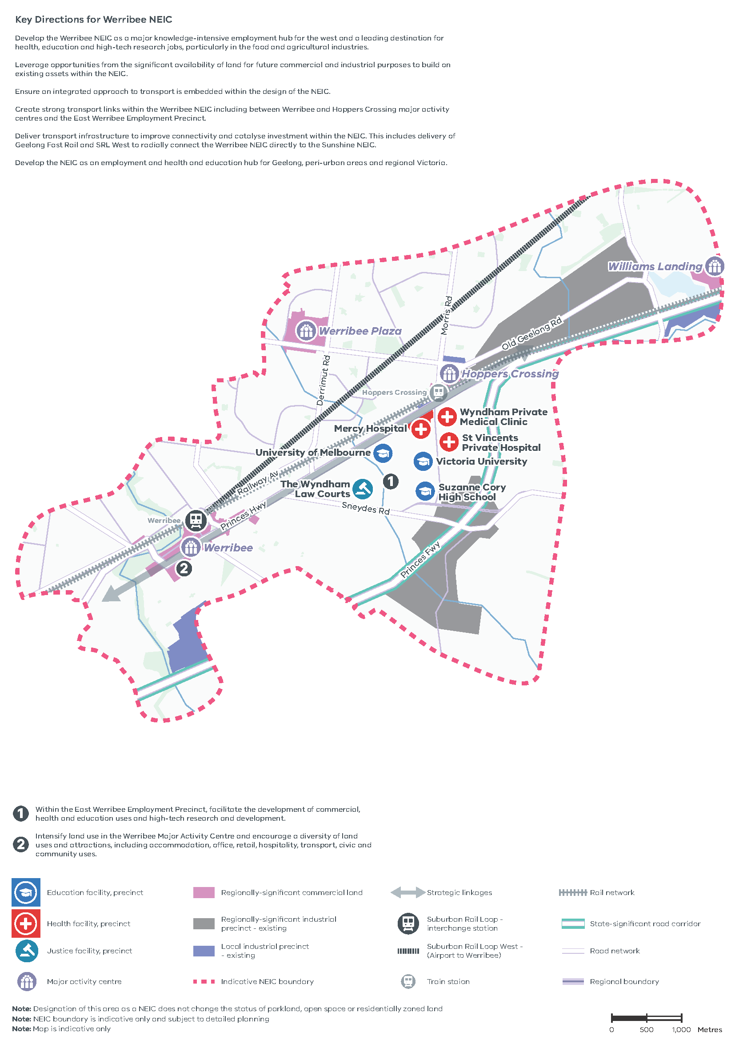

Figure 10. Werribee National employment and Innovation Cluster
A map of Werribee National employment and Innovation Cluster, showing –
- Indicative NEIC boundary
- Education facility, precinct - University of Melbourne, Victoria University, and Suzanne Cory High School
- Health facility, precinct – Mercy Hospital, Wyndham Private Medical Clinic, and St Vincents Private Hospital,
- Justice facility, precinct – the Wyndham Law Courts
- Major activity centres at Werribee, Werribee Plaza and Hoppers Crossing
- Regionally-significant commercial land
- Existing regionally-significant industrial precinct and local industrial precinct
- Strategic linkages
- Suburban Rail Loop West (Airport to Werribee)
- Suburban Rail Loop – interchange station at Werribee
- Rail Network and train stations
- Road network and Princes Freeway state-significant road corridor
Map notes (numbered on the map)
- Within the East Werribee Employment Precinct, facilitate the development of commercial, health and education uses and high-tech research and development.
- Intensify land use in the Werribee Major Activity Centre and encourage a diversity of land uses and attractions, including accommodation, office, retail, hospitality, transport, civic and community uses.
Key Directions for Werribee NEIC
- Develop the Werribee NEIC as a major knowledge-intensive employment hub for the west and a leading destination for health, education and high-tech research jobs, particularly in the food and agricultural industries.
- Leverage opportunities from the significant availability of land for future commercial and industrial purposes to build on existing assets within the NEIC.
- Ensure an integrated approach to transport is embedded within the design of the NEIC.
- Create strong transport links within the Werribee NEIC including between Werribee and Hoppers Crossing major activity centres and the East Werribee Employment Precinct.
- Deliver transport infrastructure to improve connectivity and catalyse investment within the NEIC. This includes delivery of Geelong Fast Rail and SRL West to radially connect the Werribee NEIC directly to the Sunshine NEIC.
- Develop the NEIC as an employment and health and education hub for Geelong, peri-urban areas and regional Victoria.
Note: Designation of this area as a NEIC does not change the status of parkland, open space or residentially zoned land
Note: NEIC boundary is indicative only and subject to detailed planning
Note: Map is indicative only
Source: Plan Melbourne, DELWP 2017

- Support the development of a strong network of activity centres to provide jobs closer to where people live
There are two existing metropolitan activity centres located in the Western Metro Region at Footscray and Sunshine. Toolern is identified as a future metropolitan activity centre.
The Victorian Department of Jobs, Precincts and Regions is leading the strategic development of Footscray as a Business Precinct.
The region has a network of 25 major activity centres, including five future centres that support the metropolitan activity centres by providing a suburban focus for the region. This includes a mix of both larger freestanding shopping centres (for example, Airport West, Highpoint, Watergardens, Werribee Plaza and Woodgrove) as well as strip-based centres (for example, Altona, Ascot Vale-Union Road, Moonee Ponds, St Albans, Werribee and Williamstown). These activity centres have varying capacities and opportunities for growth which are detailed in Table 7. Activity centres in the Western Metro Region are more widely dispersed given the size of the urban area when compared to metropolitan Melbourne as a whole. Some major activity centres such as Brimbank Central, Caroline Springs, Deer Park and Werribee Plaza are not easily accessible by train or tram.
As the Western Metro Region is expected to experience an 18 per cent increase in population by 2031, future employment land is important to secure access to and supply local jobs. This scale of population growth will require activity centres to play an important role in the provision of jobs, services, retail, health and civic opportunities for the region’s residents. A total of 53 per cent of residents in the Western Metro Region currently live and work within the region while 31 per cent of residents travel to the Inner Metro Region for work.
There are eight activity centres in the region that have more than 100,000 square metres of commercial floorspace. These larger centres account for half of the identified commercial floorspace in the region and make a significant contribution to providing the jobs, services and amenities.
Activity centres will play an important role in supplying future accessible commercial floorspace. Around 1.5 million square metres of commercial floorspace will be required across the region by 2031 (Figure 11). This future floorspace requirement is second behind only the Inner Metro Region, with around 40 per cent of the 1.5 million square metres expected to be in existing urban areas. Brimbank, Hobsons Bay, Maribyrnong and Moonee Valley LGAs in particular will need to identify and accommodate land for commercial uses within existing urban areas. This will provide local jobs and services particularly for new communities in the growth areas of Melton and Wyndham.
Activity centres also play an important role in the creation of 20-minute neighbourhoods, particularly in growth areas, through providing more local commercial and employment opportunities.
- Direct high-value jobs and higher-density development to activity centres, in particular the Footscray and Sunshine metropolitan activity centres as well as suitable major activity centres.
- Support the viability of existing activity centres by discouraging out-of-centre commercial development.
- Retain existing commercial zoned land and identify areas that can support future demand for commercial floorspace and new investment with a focus on metropolitan and major activity centres.
- Existing and future commercial floorspace requirements in the Western Metro Region
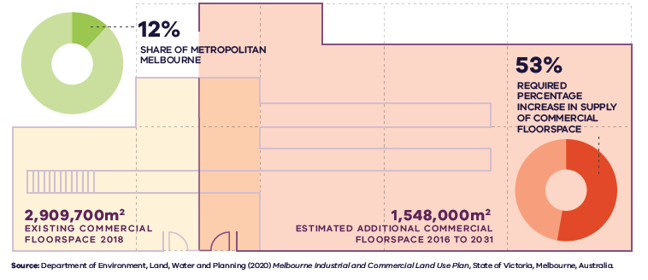

Figure 11. Existing and future commercial floorspace requirements in the Western Metro Region
Western Metro Region | 12 per cent share of metropolitan Melbourne | 2,909,700 square metres – existing commercial floorspace 2018 | 1,548,000 square metres – estimated additional commercial floorspace 2016 to 2031 | 53 per cent – required percentage increase in supply of commercial floorspace
Source: Department of Environment, Land, Water and Planning (2020) Melbourne Industrial and Commercial Land Use Plan, State of Victoria, Melbourne, Australia.

- Ensure the Western Growth Corridor accommodates longer-term industrial and commercial development opportunities
There is a need to support the creation of jobs in the Western Growth Corridor and provide local jobs for people who live in the outer areas of the Western Metro Region. This could be achieved by:
- Encouraging investment in areas identified for industrial uses
- Protecting industrial and employment land for the longer term
- Improving transport access to employment for residents within the region
- Supporting the establishment of small and medium-sized businesses in the outer suburbs and growth areas
- Creating flexible spaces for business to grow.
The Western Metro Region’s growth areas offer large areas of unfragmented land (identified as SSIP land) that could be used for land intensive uses such as freight, logistics, warehousing, transport, manufacturing and other larger format industrial uses. This supply of unfragmented land is important for the region, particularly as opportunities for new industrial land are constrained in existing locations.
Approximately 1848 hectares of key future industrial precincts are expected to develop in growth areas. Additionally, around 60 per cent of the Western Metro Region’s required future commercial floorspace by 2031 is projected to be located in the growth area LGAs of Melton and Wyndham. Future major activity centres and local centres in growth areas will be the key to realising employment growth for the region. Several future and planned centres are located on rail corridors to improve connectivity across the region. A breakdown of the quantum of industrial and commercial land supply for the region is also detailed in the Melbourne Industrial and Commercial Land Use Plan.
There are notable employment precincts in the Western Growth Corridor, and planned upgrades to freeways and freight facilities, that will reinforce the region’s importance to the industrial sectors in the future:
- Toolern Industrial Employment Precinct: Contains approximately 350 hectares of land for industrial purposes adjacent to the Melton Industrial Park to the north. The precinct has direct access to the PFN (road and rail) and will be serviced by the future Toolern Metropolitan Activity Centre to the south.
- Melton Highway Industrial Precinct: Contains approximately 330 hectares of land for future industrial purposes. The precinct will have direct access to Melton Highway and the OMR. As such, it will easily link to Melbourne’s north and the proposed WIFT.
- South West Quarries Industrial Node: Contains approximately 1400 hectares of land for industrial purposes. The precinct will have direct access to the Princes Freeway and the proposed WIFT via the proposed OMR. This area will support the operation of adjacent quarry sites and needs to be carefully planned to ensure that sensitive land uses do not adversely impact their ability to operate now or into the future.
- Princes Highway Industrial Precinct: Precinct will help to contribute to the development of the emerging Werribee NEIC and broaden the employment base of the sub-region by providing suitable industrial land for larger footprint uses.
The future Toolern Metropolitan Activity Centre will reinforce its civic and service centre role for peri-urban communities and its role as a key centre and transport hub for the north-western portion of the Western Growth Corridor. The centre’s connections to the growth corridor and regional areas, via the Western Freeway, Ballarat railway line and the bus network along Ferris Road, will support this role.
Toolern will include a major employment precinct and a mixed-use area that will play an important role in providing around 70,000 square metres of land for higher order employment, education and health facilities, including the new Melton Hospital. The activity centre will contain office space, a business park and industrial uses that require access to a large labour force servicing the needs of other nearby industrial and commercial businesses.
Currently unzoned areas identified for future industrial purposes could provide around 13 years of supply of zoned industrial land. This potential supply needs to be retained for employment uses and secured as future industrial land, particularly in Toolern, Plumpton, and south-west of Werribee. Similarly, the 559 hectares of commercial land that is strategically identified for commercial purposes within the growth areas of Melton and Wyndham also needs to be protected. It is important for these opportunities to be captured in the PSP planning process to ensure land is safeguarded to fulfil its strategic purpose.
Consideration should be given to the composition of future commercial areas. While single use (retail) large format shopping centres may meet current market demand, future potential for these centres to grow into higher-density mixed-use areas should be preserved. Planning must ensure they are not hemmed by residential development that may diminish their opportunity to grow and adapt. Careful consideration will be required through the PSP process to ensure adequate provisions are made to accommodate medium- and longer-term commercial development. Approaches that support the delivery of 20-minute neighbourhoods should be used to offer a finer grain network of activity centres.
Map 4 shows an updated growth corridor plan for the Western Metro Region to guide the PSP process.
- Consider the future demand and need for commercial and employment land across the Western Growth Corridor and ensure that Precinct Structure Plans make sufficient provision to accommodate longer-term commercial and employment needs.
- Retain and preserve future industrial land identified in the Western Industrial Precinct and at Toolern, Plumpton and south of Werribee for industrial uses.
- Encourage commercial precincts in the Western Growth Corridor to diversity and incorporate higher-density and finer-grain development as they mature over time.
- Coordinate and manage the delivery of the Toolern Metropolitan Activity Centre between state and local governments to ensure Toolern develops into a state-significant location in the Western Metro Region.
- Ensure protection of green wedges and support their role to provide agriculture, extractive resources, tourism and state infrastructure for the long-term benefit of all Victorians
The Western Metro Region contains four green wedges, including Werribee South, Western Plains South, Western Plains North and part of the Sunbury Green Wedge. These green wedges play an important role in the regional and metropolitan economy. They support a wide range of non-urban land uses and need to be carefully planned for to ensure their ongoing productivity and preservation of significant environmental, landscape and cultural heritage values. The role and strategic opportunities for the green wedges in the region are detailed in Table 6.
The Werribee Food Bowl is an important contributor to food security and the region’s economy and contains productive agricultural land that requires ongoing protection. There is an opportunity to continue to develop the agricultural sector and provide more regional job supply. Continued access to recycled water will be important to the success of agriculture in the region.
Significant tourism assets include the natural and distinctive landscapes within the region’s green wedges, the Maribyrnong River corridor and the Werribee Park and Werribee Open Range Zoo. Effective management of natural assets will ensure their continued popularity does not erode in the long term.
The Melbourne Regional Landfill at Ravenhall is a protected state-significant waste and resource recovery hub that will help serve the city’s waste infrastructure needs into the future. Other regionally-significant, productive facilities in the Western Metro Region include the Western Treatment Plant and the Werribee Refuse Disposal Facility that exist in, or close to, existing/planned urban areas. Separation of these facilities (along with existing petrochemical facilities) from sensitive uses, is critical to the ongoing productive operation of this infrastructure.

Extractive Resources
Significant extractive resources also exist within the Western Metro Region. In 2018/19, Wyndham produced 12 per cent of all hard rock supply in Victoria and is forecast to demand the second highest amount of hard rock in Victoria from 2015 to 2050 (PwC, 2016).
Existing approved and operational quarries should be protected from encroachment by sensitive land uses. Designated industrial or commercial development activities located adjacent to existing quarry sites within/adjacent to the UGB would be rezoned to Urban Growth Zone. Any proposed uses or development in these precincts proximate to the title boundary of such quarries should be subject to appropriate risk assessments.
Extractive resources need to be secured close to where they are used to maintain cost competitiveness for construction, particularly as demand for these resources is expected to double by 2050 (PwC, 2016).
Maintaining cost competitiveness for construction and locating extractive industry close to demand centres, can help ensure that public infrastructure, housing and private sector development can be built more cost efficiently.
Extractive industry interest areas (EIIAs) have a longstanding designation in the Western Metro Region (Figure 12). They were established to identify land located in reasonable proximity to major population centres that is likely to contain commercially viable stone resources, and where the extractive industry is more likely to be established.
Since the identification of EIIAs, demand for resources has increased and other land use pressures have emerged resulting in diminished opportunities for extractive industries to establish in EIIAs. The Victorian Government has established the concept of strategic extractive resource areas (SERAs), which will assist in providing greater planning certainty for the continued extraction of critical resources in identified strategic areas. They were established to provide stronger protection for strategic extractive resources.
Implementation of identified SERAs in Wyndham will help provide greater planning certainty for the continued extraction of critical resources. There is an opportunity to identify and implement further SERAs in the Western Metro Region for areas of strategic importance, particularly in Melton.
It is also important that post-quarrying land uses provide beneficial outcomes for local communities and the region. Post-quarrying land uses can improve the amenity and lifestyle of locations. They can make a valuable contribution towards enhancing networks of open space as well as providing important habitats for threatened species. Innovative end land uses options and progressive rehabilitation should be encouraged and developed in consultation with local communities.
- Protect the operation of state-significant infrastructure assets such as freight and transport corridors, waste management facilities and resource extraction.
- Ensure the ongoing operation, expansion, or development of new state-significant infrastructure assets avoids or minimises impacts on other green wedge priorities such as agriculture and biodiversity conservation, cultural heritage, landscape and environmental values.
- Protect and optimise the productive potential of agricultural land for agricultural purposes to encourage jobs in the agricultural sector in the Western Metro Region.
- Identify and manage long-term strategic extractive resources in the Western Metro Region.
- Extractive Industry Interest Areas in the Western Metro Region
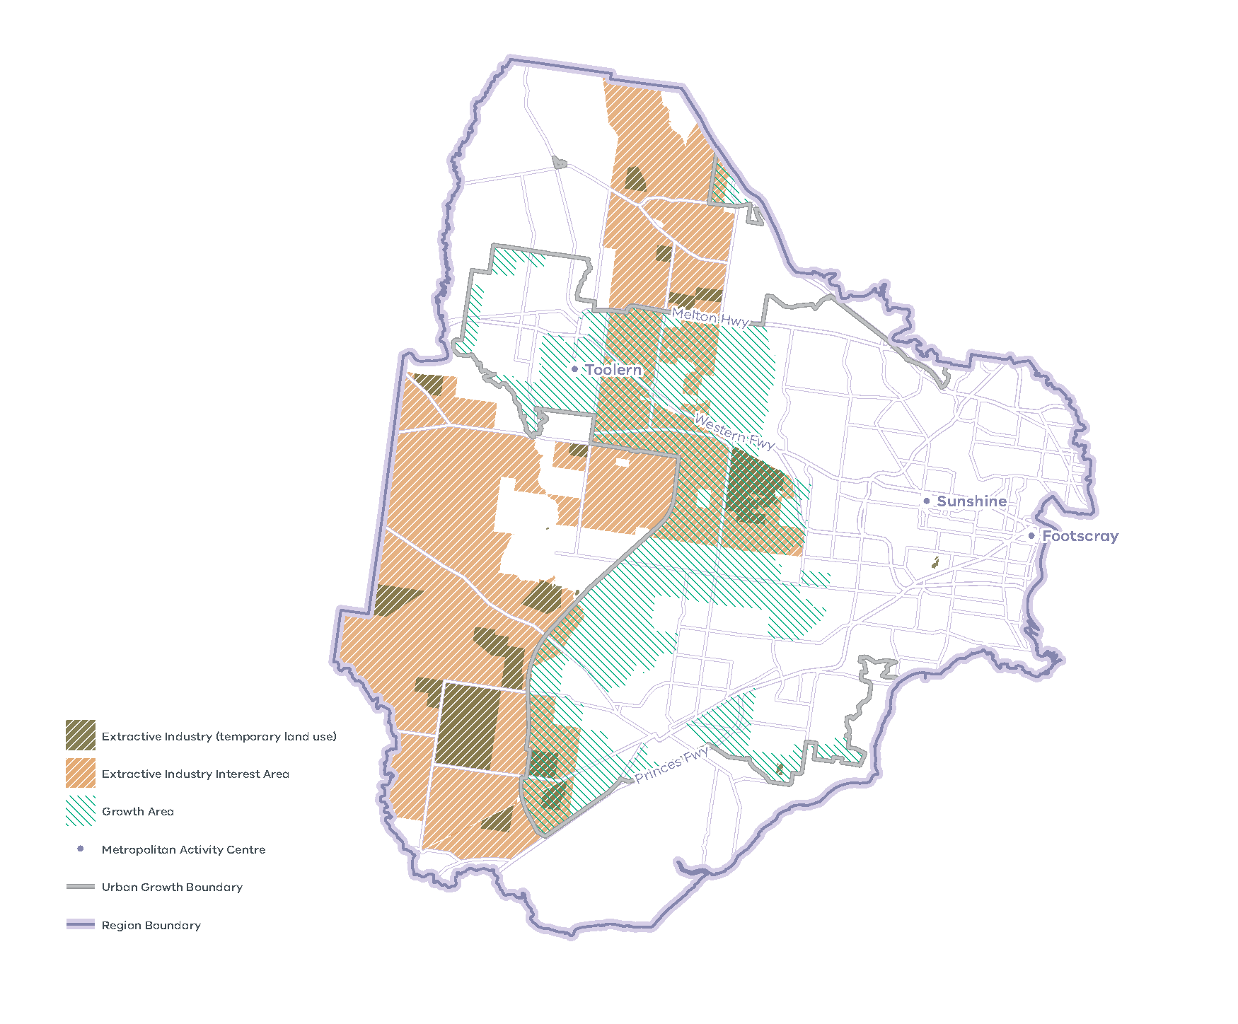
Note: EIIAs were established in the 1990s by the Geological Survey of Victoria following an assessment of land where extractive industry operations were more likely to be established, both for reasons of resource availability and where there are potentially fewer land use planning constraints. EIIAs serve as a geographic indicator in the planning scheme for the purpose of referral of planning permit applications only. EIIAs do not imply that a quarry can be established ‘as-of-right’ in these areas, nor do they preclude extractive industry from being established outside EIIAs. In growth areas, the EIIAs provide a guide to ensure the location of earth resources and the need for extractive resources to support the long-term growth of Melbourne is strategically considered in the development of PSPs. The EIIAs require ongoing review and refinement as demand for resources increases and other land use pressures emerge.

Green wedges: current role and strategic opportunities
Green Wedge | Current role | Future role/strategic opportunities
Werribee South Green Wedge | - Landscape and open space  - Environment and biodiversity  - Water supply and catchments  - Agriculture  - Tourism  - State-significant infrastructure | - Protect the Point Cook Coastal Park from the impacts of increasing population, and specifically the increased stormwater runoff, in Point Cook. The area will require buffering from residential uses  - Provision of a reliable quantity and quality of water to the Werribee Irrigation District to increase productivity and resilience of the district. Increase the health of waterways, sanctuaries, wetlands and coastal parks by managing stormwater runoff from urban areas and reducing overgrazing and poor cultivation of crops that leads to erosion and water pollution  - Protect agricultural activity in existing agricultural areas even where this may result in a loss of amenity to surrounding non-agricultural land users  - Continue to use farming areas to form part of a long-term green wedge that contain native grasslands that are suitable for future restoration of native vegetation  - Provide tourism and recreation that incorporates environmental gains through the rejuvenation and rehabilitation of natural assets including coastal and waterway environs  - Areas on the coastline such as the Werribee South coastline should continue to be provided with public access  - Limit further residential development but continue to allow the provision of additional infrastructure
Western Plains North Green Wedge | - Landscape and open space  - Environment and biodiversity  - Water supply and catchments  - Agriculture | - Promote the effective use of agricultural land including:  - encouraging protection of areas with secure water resources for agricultural uses  - diversifying farming and agricultural operations to include tourism, recreation and entertainment activities associated with the rural environment  - providing equine related uses which benefit from the areas existing reputation and location  - Appropriately manage land to ensure agricultural uses remain viable in the area long term  - Maximise the use of Class B recycled water from the Sunbury Wastewater Treatment for agricultural and other uses  - Increase passive and low impact tourism opportunities. An increasing urban population in proximity to the green wedge can allow for increased rural and environmental recreation and leisure activities including walking tracks and equestrian trails  - Ensure fill occurs at legal sites to allow for environmental and amenity concerns to be appropriately addressed  - Ensure inappropriate uses are not located in the green wedge due to the area’s proximity to Melbourne  Preserve the Western Grasslands Reserve as a highly valuable ecosystem
Western Plains South Green Wedge | - Landscape and open space  - Environment and biodiversity  - Water supply and catchments  - Agriculture | - Promote agricultural uses in areas where they are viable and either currently have, or could have in the future, access to water  - Where agricultural land use is constrained, consider alternative land uses such as low impact tourism that respond to environmental and landscape values and that do not compromise the operation or productivity of adjacent agricultural land  - Ensure fill occurs at legal sites to allow for environmental and amenity concerns to be appropriately addressed

Actions – Productivity
- Implement a program of State Government-led collaborative planning projects to ensure priority metropolitan and major activity centres and urban renewal areas maximise their respective strategic opportunities. Priority will be given to those which deliver significant jobs and housing; leverage investment in state infrastructure; and play an important role in the growth corridor and/or region. State-led planning for these state and regionally-significant places will contribute to creating liveable communities and achieving more dwellings and jobs in established areas and identify implementation and coordination actions that support growth and economic investment.
- Prepare a report that sets out a spatial framework for employment precincts and activity centres across the Western Growth Corridor. It will consider the future demand for and need for commercial and employment land across the growth areas and ensure that Precinct Structure Plans make adequate and sufficient provision to accommodate longer-term commercial and employment needs.
- Coordinate the whole of government delivery of the Sunshine NEIC to catalyse economic activity and maximise the value of infrastructure investment in the area.
- Separate to the SERA Pilot Project, identify and implement a SERA in the Western Metro Region in partnership with local government.

Metropolitan and major activity centres: existing attributes and strategic opportunities
Existing attributes | What needs to be considered | Future role/strategic opportunities
Metropolitan Activity Centres
Footscray (Maribyrnong)
- Hybrid centre anchored by Barkly/Hopkins Street, Nicholson Street, Paisley Street and Leeds Street; bordered by the Maribyrnong River to the east and Geelong Road to the west  - Plays a major service delivery role with mixed-use function including retail, residential, educational, medical and community services and Footscray Market  - State significant health precinct at Footscray Hospital (Western Health)  - State-significant education precinct at Victoria University  - Train (Footscray Station) and tram services | - Heritage significance  - Proximity to Kinnear Ropeworks and Joseph Road Precinct urban renewal areas and future Dynon Road industrial corridor  - State and regionally-significant industrial areas (Western SSIP, Yarraville Port Precinct, Mobile Oil Terminal Precinct)  - Major recreation facility at Whitten Oval to the west and regionally-significant recreation facility at Henry Turner South Reserve to the north  - Proximity to future West Gate Tunnel  - Future Melbourne Airport Rail and Metro Tunnel train services; associated improvements to Footscray Station  - Flooding risks in parts of the activity centre | - Reinforce role as principal mixed-use residential, retail, commercial and community services centre  - Support higher-density housing development beyond centre core; better utilise the mixed-use potential of the area around the Maribyrnong River  - Develop the Victoria University campus and Footscray as a ‘university neighbourhood’  - Capitalise on proximity/connectivity to surrounding industrial areas and Melbourne CBD to support development as a key employment hub  - Maximise integration and transit-oriented development opportunities with future Melbourne Airport Rail and Metro Tunne
Sunshine (Brimbank)
- Hybrid centre anchored by Hampshire Road and Devonshire Road  - Plays a major service delivery role with mixed-use functions including retail, office, residential, educational, medical, industrial and regional community services  - City West Plaza, Sunshine Marketplace and Sunshine Plaza shopping centres  - Part of the Sunshine NEIC  - State-significant education precinct at Victoria University  - Train (Sunshine and Albion stations) and SmartBus services, and gateway to the Regional Rail Link to Western Growth Corridor, Avalon Airport and Geelong | - Proximity to state-significant industrial precinct to the south (Western SSIP)  - Future Melbourne Airport Rail and Metro Tunnel train services  - Future SRL West (Airport to Werribee) interchange station  - Flood risk to the north of the activity centre  - Urban renewal opportunities including the Albion Quarter | - Evolve into a fully multi-functional activity centre, core destination and services hub for retail, commercial, office, civic, social, residential, leisure and community facilities  - Capitalise on proximity/connectivity to surrounding industrial areas and Sunshine NEIC; and continue development as a key employment hub  - Maximise integration and transit-oriented development opportunities with future Melbourne Airport Rail, Metro Tunnel and SRL  - Develop Victoria University Sunshine Skills Hub
Toolern (also known as Cobblebank) (Melton) (Future)
- Future metropolitan activity centre in the centre of the Toolern PSP area, with Ferris Road as the gateway and spine of the centre  - Forms part of Western Growth Corridor  - Future state-significant commercial land in the activity centre  - Regionally-significant industrial land located north known as Cobblebank Employment and Mixed Use area (CEMU)  - Bounded to the west by Toolern Creek  - Regional train (Cobblebank Station) service | - Projected to serve a population of 55,000 people within the larger Toolern PSP area  - Integration of new Melton Hospital  - Proximity to the OMR  - Area subject to environmental audit overlay to the north-west | - Establish role as primary activity centre and transport hub for Toolern and wider community including the peri-urban areas  - Promote a range of regional and local employment, civic, retail, education, medical, residential, recreational and entertainment uses and a mixture of shops, offices and dwellings  - Improve the quantum and quality of local employment opportunities in the region by supporting investment and job creation  - Provide a range of housing at average density of at least 15 dwellings per hectare, with higher-density housing generally located in the activity centre  - Develop transit-oriented urban structure, with a road network that supports local bus routes within 400 metres of most homes, provides direct connections to key destinations in Melton Township and higher-order public transport connections at Melton Station and Cobblebank Station and bus interchange  - Provide network of landscaped open spaces to contribute to amenity
Major Activity Centres
Altona (Hobsons Bay)
- Strip-based centre focused on Pier Street, terminating at Altona Pier/Beach  - Mixed-use functions including supermarket, retail, office, residential, medical, light industrial, community services and civic functions  - Train (Altona Station) and SmartBus services | - Proximity to Western Industrial Precinct to the north  - Significant flood and coastal inundation risk | - Continue to provide a beachside destination for Western Metro Region residents and visitors  - Expand mixed-use residential, retail, commercial and community services  - Improve access to public transportation services for local community, commuters and tourists
Altona North (Hobsons Bay)
- Hybrid centre comprising strip-based centre and freestanding Altona Gate Shopping Centre on west side of Millers Road south of West Gate Freeway, and also includes three additional strip-based and large format retail clusters further south on Millers Road  - Mixed-use functions including supermarket, retail, office, residential, medical, light industrial and community services  - PPTN interchange at Altona Gate Shopping Centre with SmartBus services | - Immediate access to West Gate Freeway to the north  - Proximity to West Gate Tunnel project  - Proximity to Western Industrial Precinct  - ‘Precinct 15’ strategic redevelopment site to the east via Blackshaws Road  - Flood risk to Millers Road south of Blackshaws Road | - Improve pedestrian movement and accessibility  - Encourage development in residential areas surrounding the Altona Gate Shopping Centre
Airport West (Moonee Valley)
- Freestanding shopping centre (Westfield Airport West) bordered by mixture of residential and industrial land to the south  - Supermarket, retail, industrial and commercial services  - PPTN interchange with tram and SmartBus services | - Essendon Fields/Essendon Airport to the east and Melbourne International Airport to the north-west  - Regionally-significant industrial precincts to the south and west | - Encourage development in residential areas to the south of Westfield Airport West Shopping Centre  - Expand appropriate leisure, recreational and entertainment uses near and within the Westfield Airport West Shopping Centre
Ascot Vale-Union Road (Moonee Valley)
- Strip-based centre based on Union Road  - A mix of retailing, accommodation, business, medical and hospitality services  - Train (Ascot Vale Station) and tram services | - Proximity to Melbourne Showgrounds Village to the south  - Heritage significance  - Flood risk along southern end of Union Road | - Develop a thriving retail and business sector with employment-generating uses  - Encourage residential development that is sympathetic to heritage character  - Improve connectivity between Union Road and the Melbourne Showgrounds Village
Brimbank Central (Brimbank)
- Freestanding shopping centre (Brimbank Central) at the intersection of Station Road and Neale Road  - A mix of supermarket, retail, food and community services including Deer Park Library  - Bus services (stops on Station Road and Neale Road) | - Includes Deer Park Library as a separate stand-alone building from the larger shopping centre  - Improved public transport integration | - Offer a broad range of non-retail commercial activities, providing services and employment opportunities for the local community, including small commercial offices and service businesses  - Improve public transport connectivity, and cycling and pedestrian accessibility  - Encourage residential development in areas surrounding the shopping centre  - Expand medical, entertainment and leisure facilities  - Increase local community services and facilities
Braybook Central West (Maribyrnong)
- Freestanding shopping centre bordered by Sunshine Road, Ashley Street and Barkly Street  - Employment and business-based function with retail uses  - State-significant industrial land (Braybrook Industrial Precinct and Business Park) used for logistics, storage and distribution businesses  - Train (Tottenham Station) and major interstate rail freight services | - Braybrook as an urban renewal area | - Transform into mixed-use retail, commercial, residential and community services centre  - Facilitate transition from manufacturing to services-based industries  - Investigate potential for intensification of retail, industrial and commercial uses  - Support growth in creative industries through provision of affordable workspaces  - Increase housing intensification  - Focus on community and amenity  - Improve access from Tottenham Station to Braybrook Central West and with adjoining residential areas  - Improve pedestrian access within the centre and to neighbouring residential areas
Caroline Springs (Brimbank)
- Freestanding shopping centre on Lake Street  - Supermarket, retail, convenience, medical and accommodation services  - Caroline Lake with surrounding open space at the core of the activity centre  - Train (Caroline Springs Station), 3.5km to the south, and PPTN interchange bus services | - Links to future activity centres in the growth area to the west and Watergardens – Sydenham Major Activity Centre to the north-east  - Improved public transport integration | - Offer a broad range of non-retail commercial activities, providing services and employment opportunities for the local community, including small commercial offices and professional services
Deer Park (Brimbank)
- Strip-based centre at the intersection of Station Road and Ballarat Road  - Supermarket and specialty retail services  - Train (Deer Park Station) service | - State and regionally-significant industrial areas to the south and west  - Major Hazard Facility to the south-east  - Metropolitan Ring Road to the east  - Level crossing removal at Station Road/Mt Derrimut Road (Deer Park Station) | - Encourage residential development in surrounding areas  - Encourage non-retail commercial activities, speciality shops, medical, leisure and entertainment facilities
Flemington-Racecourse Road (Moonee Valley)
- Strip-based centre on Racecourse Road between Ascot Vale Road and Wellington Street  - Regional community and tourism assets at Flemington Racecourse and Flemington Community Hub  - Train (Flemington, Newmarket, Kensington and Macaulay stations) and tram services | - Proximity to Arden and Macaulay major urban renewal areas  - Precincts and buildings with heritage significance | - Provide more retail uses and increased levels of higher-density development  - Leverage proximity to Arden and Macaulay major urban renewal areas  - Maintain a ‘main street’ feel
Hoppers Crossing (Wyndham)
- Freestanding shopping centre at the intersection between Heaths Road and Morris Road  - Large format retail and light industrial uses  - Regionally-significant industrial land at Old Geelong Road Precinct to the north-east  - State-significant health and education precinct at Werribee Health and Education Precinct  - Train (Hoppers Crossing Station) service | - Level crossing removal at Old Geelong Road | - Support role as the gateway to the Werribee NEIC  - Increase retail opportunities  - Facilitate more intensive development to the east and west, associated with level crossing removal  - Encourage higher-density development
Maribyrnong - Highpoint (Maribyrnong)
- Freestanding shopping centre based along Raleigh Road, Wests Road and Van Ness Avenue  - Retail including bulky goods, with offices, entertainment, services and residential development  - Cultural and tourism facility at Jack’s Magazine, and regional recreation facility Maribyrnong Aquatic Centre  - Bus and tram services  - PPTN interchange located at Highpoint Shopping Centre | - Urban renewal areas include former Maribyrnong Defence Site and Detention Centre, and former Victoria University Student Village, Maidstone  - Urban renewal areas require substantial public transport intervention to alleviate existing road network bottlenecks  - Heritage significance | - Realise potential for broad range of uses, and transform into a mixed-use retail, commercial, residential and community services centre  - Increase housing intensification, with capacity for medium- and higher-density housing development  - Improve public transport services between Footscray and Maribyrnong-Highpoint using opportunities such as tram prioritisation  - Support community services and recreation facilities
Melton (Melton)
- Strip-based centre on High Street  - A regional commercial role with retail and services such as health, community, civic and wholesaling  - Train (Melton Station) service | - Regionally-significant industrial precinct to the east  - Heritage significance | - Continue to provide a diversity of uses, public spaces and community facilities  - Encourage medium- and higher-density residential development  - Develop better connection to Melton Station
Melton – Woodgrove and Coburns Road (Melton)
- Two separate freestanding shopping centres at Woodgrove Shopping Centre and Coburns Central Shopping Centre, between High Street and the Western Freeway to the south, and Coburns Road to the east  - Regional retail function  - State-significant health precinct at Melton Health  - Bus services | - Connection to Melton Town Centre and Melton Station  - Flooding risk in parts of the activity centre | - Continue role as a retail centre and health precinct  - Encourage greater provision of community facilities  - Increase mixed-use development to build on existing retail role
Manor Lakes (Wyndham)
- Freestanding shopping centre between Armstrong Road, Ballan Road and Manor Lakes Boulevard  - Manor Lakes Central Shopping Centre and community services  - Train (Wyndham Vale Station) service | - Heritage dry stone walls on Ballan Road | - Consolidate local retail and commercial role to serve areas west of the Werribee River  - Accommodate a strong mix of community facilities and services  - Leverage the activity centre’s key location adjacent to an existing railway station to deliver a high-intensity mixed-use town centre
Moonee Ponds (Moonee Valley)
- Hybrid centre to the east of the railway line and main activity centre to the west of Mount Alexander and Ascot Vale Road  - A regional retail centre and the major site for professional and financial services in Melbourne’s north-west region  - Higher-density residential development in activity centre core  - Civic centre with council and other administration offices  - Major recreation facility at Moonee Valley Racecourse  - Train (Moonee Ponds Station), tram and bus services | - Heritage significance  - Moonee Valley Racecourse Precinct Urban Renewal Area | - Strengthen role as professional services node in the inner north-west and regional role in diverse and comprehensive retail, community and cultural services  - Encourage a diverse range of medium- to higher-density and affordable housing
Hopkins Road (also known as Mt Atkinson) (Melton) (Future)
- Future major activity centre south of the Western Freeway and west of Hopkins Road  - Approved PSP which provides a diversity of housing, commercial and industrial land | - Proposed railway station  - Proposed Truganina Terminal Station  - Future regionally-significant commercial land  - Western SSIP to the east  - Outer Metropolitan Ring reservation to the west  - Key landscape characteristics of Mt Atkinson | - Encourage a variety of employment, infrastructure and community facilities  - Maximise opportunities for industrial land to support employment activity  - Provide diverse housing opportunities
Niddrie – Keilor Road (Moonee Valley)
- Strip-based centre on Keilor Road south of the Calder and Tullamarine freeways  - Complements the North Essendon Major Activity Centre  - A mix of land uses, entertainment and some commercial activity  - Tram and SmartBus services | - Regionally-significant industrial land, Airport West industrial precinct, located to the north  - Transport gateway with Essendon Airport located to the north separated by the Tullamarine and Calder freeways | - Encourage a strong mixed-use centre for local and regional catchments  - Maximise opportunities for local employment, day and night-time activity and active ground floor frontages  - Continue to provide a bulky goods and trade supplies area
North Essendon (Moonee Valley)
- Strip-based centre on Mt Alexander Road south of Tullamarine Freeway  - Complements the Niddrie-Keilor Road Major Activity Centre  - Retail and specialty shopping  - Regional recreation facility at Windy Hill football ground  - Train (Essendon and Glenbervie stations) tram and SmartBus services | - Redevelopment opportunities along Mt Alexander Road  - Heritage significance of date palm avenue along Mt Alexander Road | - Develop as a local centre that provides a range of retail, commercial, and leisure services and facilities  - Promote as a gateway to Melbourne’s inner-northern suburbs  - Encourage a variety of housing types and densities
Plumpton (Melton) (Future)
- Future major activity centre between Plumpton Road, Melton Highway and Beattys Road  - Pastoral and agricultural land uses  - Approved PSP | - Future regionally-significant commercial land  - Future regionally-significant Melton Highway Industrial Precinct located to the west  - Future public transport connections as the activity centre is not on a rail line | - Encourage local and regional employment precincts in business/professional and industrial services  - Accommodate residential growth and social infrastructure
Point Cook (Wyndham)
- Hybrid centre north of Dunnings Road and east of Boardwalk Boulevard with street-based spine along Main Street  - Primary sub-regional shopping centre with retail, office and community services | - Linkages to Werribee NEIC and East Werribee Employment Precinct | - Grow local employment through retail and offices
Riverdale (Wyndham) (Future)
- Future major activity centre around Sayers Road  - Approved PSP | - Future Wyndham City Stadium, Tarneit  - Proximity to Werribee River  - Adjacent to the Regional Rail Link alignment and future Sayers Road Station | - Service the local catchment providing local shopping, business, medical, leisure, recreation and community needs while allowing opportunities for local specialisation  - Accommodate major community facilities for Tarneit West and the wider surrounding region  - Encourage a variety of medium- and higher-density housing  - Integrate the proposed train station into the activity centre
Rockbank (Melton) (Future)
- Future major activity centre on Leakes Road, south of the Western Freeway  - Approved PSP  - Community facilities including school and recreation reserve  - Train (Rockbank Station) service | - Future regionally-significant commercial land  - Heritage significance of dry-stone walls | - Provide a sub-regional function  - Encourage higher-density residential options that connect to the train station  - Provide key social infrastructure, local shopping centres, schools and public transport to support the growing residential population  - Develop a transport precinct around Rockbank Station
Rockbank North (Melton) (Future)
- Future major activity centre east of Leakes Road and north of the Western Freeway  - Approved PSP | - Future regionally-significant commercial land | - Develop as a regional focal point for higher-order employment, retail, health and education services with a principal catchment focused north of the Western Freeway  - Encourage a range of housing opportunities including medium- and higher-density housing
St Albans (Brimbank)
- Strip-based centre around Alfrieda Street and St Albans Road  - A sub-regional function including education (Victoria University campus), community and industrial uses to the south  - Part of the Sunshine NEIC  - Fresh food, multicultural market-style centre  - Train (St Albans Station) and bus services | - Potential redevelopment of Victoria University  - Sunshine Health and Wellbeing Education Precinct to the south | - Provide a broad range of retail and commercial activities, providing services and employment opportunities for the local community, including commercial offices, service business and service industry  - Accommodate medium- and higher-density residential uses, local community services, medical centres, and commercial activities  - Develop better integration between Victoria University and the activity centre  - Maximise transport interchange incorporating a redeveloped railway station and bus interchange
Sydenham (Brimbank)
- Freestanding shopping centre at Watergardens, the largest retail centre in the Brimbank LGA, south of Melton Highway and west of Kings Road  - Large format retail  - Civic and community services and facilities around Sydenham Library  - Train (Watergardens Station) and bus services | - Rail line and Melton Highway are barriers to movement to and from the activity centre  - Substantial mixed-use development potential on surrounding land parcels which form part of Watergardens  - Environmental significance associated with Taylors Creek | - Encourage mixed-use development including retail, non-retail commercial activities, medical services, community services and leisure and entertainment activities, and grow as an employment centre  - Encourage medium- and higher-density residential development  - Maximise transport linkages to the existing station  - Improve connections to surrounding areas
Tarneit (Wyndham)
- Hybrid centre mostly north of Leakes Road, south of Dohertys Road and east of Derrimut Road  - Tarneit Central Shopping Centre  - Adjacent to the Regional Rail Link  - Train (Tarneit Station) service | - Future regionally-significant commercial land  - Adjacent to Skeleton Creek | - Encourage role as a key retail and commercial activity centre to serve the northern areas of Wyndham  - Encourage commercial office, non-retail, retail employment activities more comprehensive and specialist education, health and community facilities  - Leverage key location adjacent to an existing railway station to deliver a high-intensity mixed-use street-based town centre
Werribee (Wyndham)
- Established strip-based centre around Watton Street  - Retail and commercial spaces, and a mix of business and services for the entire Wyndham region  - Civic functions including council offices  - In the Werribee NEIC and near the East Werribee Employment Precinct  - Werribee River and Werribee Regional Park  - Train (Werribee Station) service | - Future SRL West (Airport to Werribee) interchange station  - Level crossing removals at Werribee Street and Cherry Street  - Geelong Fast Rail  - Heritage significance in Watton Street as well as Werribee Racecourse  - Environmental significance associated with Werribee River | - Encourage role as a major employment centre with further expansion and broader role as the Werribee NEIC develops  - Encourage diverse and higher-density housing  - Promote as major mixed-use hub including retail, commercial, office and residential
Werribee Plaza (Wyndham)
- Freestanding shopping centre at the intersection of Derrimut Road and Heaths Road  - Large concentration of retail  - Regional recreation facility at AquaPulse  - PPTN interchange and bus services | - Flood risk along drainage easement to southwest | - Promote opportunities to intensify and future develop existing land  - Increase mixed-use, non-retail commercial and office functions  - Provide social and community infrastructure
Williams Landing (Wyndham)
- Hybrid centre with freestanding shopping centre near train station and strip-based retail along Palmers Road and Overton Road  - Commercial offices, retail and transit-oriented development around train station  - Regionally-significant industrial land  - Conservation reserves to the west  - Train (Williams Landing Station) service | - Linkages to Werribee NEIC, East Werribee Employment Precinct and Point Cook  - Linkages to existing health and education precinct at Werribee and proposed health precinct at Point Cook | - Develop mixed use with retail, restricted retail, commercial and residential  - Accommodate a substantial commercial office component as part of a transit-oriented development leveraging Williams Landing Station  - Deliver high-order business services and professional service sector employment opportunities  - Accommodate bulky goods retail
Williamstown (Hobsons Bay)
- Strip-based centre focused on Ferguson Street and Douglas Parade and extending to Nelson Place  - Hospitality, retail and tourism role including Nelson Place and waterfront  - Regionally-significant industrial land known as Williamstown Marine Precinct  - Regional recreation facility at Williamstown Sailing Club  - Train (Williamstown and North Williamstown stations) service and Williamstown ferry to Melbourne CBD | - Level crossing removal at Ferguson Street  - Proximity to Major Hazard Facilities (Gellibrand Pier)  - Port-related activities (part of Port of Melbourne) close to the activity centre (Gellibrand and Breakwater Piers)  - Urban renewal areas at Nelson Place/Waterline Place Village  - Heritage significance | - Retain activity centre’s character and existing hospitality uses  - Encourage purpose-built offices to accommodate businesses currently occupying retail premises  - Provide a mix of uses including retail, office, commercial, tourism and residential

Chapter 05.
Housing choice
Plan Melbourne Outcome 2: Melbourne provides housing choice in locations close to jobs and services
Plan Melbourne seeks to increase the supply of housing in established areas close to jobs, services and public transport to accommodate the anticipated increase in population over the next 30 years while ensuring Melbourne remains liveable, sustainable and accessible.
The Western Metro Region is characterised by three distinct urban structures offering a range of housing types. In the inner areas of the region such as Footscray and Moonee Ponds, higher-density development is continuing to occur due to the proximity to Melbourne’s CBD and good public transport services. The middle suburbs are largely dominated by industrial land with low- to medium-density residential areas in suburbs such as St Albans, Laverton and Altona. The outer urban areas of the region are greenfield growth areas with new, predominantly lower-density detached housing.
Future housing development will largely be accommodated in the Melton and Wyndham growth areas, in large urban renewal areas in the established urban area, and in metropolitan and major activity centres, along with distributed infill development across the region.

State of play

Metropolitan Melbourne
Strong demand for housing in established inner areas, with good access to jobs, services and public transport, has led to increased competition for housing in inner and middle ring suburbs of Melbourne.
The residential development industry is responding to this higher demand by increasing supply across Melbourne. The amount and location of additional housing developed depends on the availability and suitability of land and the willingness of households to pay for it. Melbourne is seeing a significant number of homes developed in growth areas, in part due to the availability of zoned land which has enabled residential developers to meet demand for relatively affordable housing.
There has also been an increase in the supply of apartments in the Central City – and increasingly in the inner suburbs of Melbourne – driven by investors purchasing apartments to meet increased demand for rental accommodation in the inner city. In other areas, particularly middle ring suburbs, housing supply has been less responsive to increasing demand, leading to increasing competition for what is in some cases a relatively fixed supply of housing.

Western Metro Region

Regional demographics
In 2020 the population of the Western Metro Region was 988,970 people, which accounted for 19 per cent of the metropolitan Melbourne population. Between 2020 and 2051 the region’s population is projected to increase by more than 900,000 people to a total of 1,897,250, which will account for 23 per cent of metropolitan Melbourne’s projected population of 8,352,840 (DELWP, 2019b). The annual rate of growth in the region is expected to be 2.1 per cent, which is 0.6 per cent higher than metropolitan Melbourne’s expected annual growth. The Western Metro Region is projected to be the fastest growing region in metropolitan Melbourne.
Population growth differs between municipalities within this region as shown in Table 8. Wyndham LGA will continue to accommodate the majority of the region’s population growth, contributing 31 per cent by 2036, followed by Melton LGA with 23 per cent (DELWP, 2019b). Hobsons Bay and Maribyrnong LGAs are expected to accommodate the smallest amount of the region’s population in the same period.
In 2016 the Western Metro Region had 318,200 dwellings and will require an additional 412,100 between 2016 and 2051 to accommodate projected population growth. This will more than double the 2016 housing stock to increase the total dwellings in 2051 to 730,300.
In 2016, the largest age group in the Western Metro Region was between 30-44 years old and this is estimated to remain the same through to 2051. However, the region is projected to have a three-fold increase in the number of people aged 75 years old and over. In 2051, the population aged 60 years old and over will be 23 per cent of the region’s total population (Figure 13). The region’s population age structure in 2051 is consistent with the projected trend for metropolitan Melbourne.
Families with children accounted for over 50 per cent of the Western Metro Region’s household composition in 2016, similar to metropolitan Melbourne and is projected to remain the majority household type for the region in 2051. Households of lone persons and couples without children will see a small percentage increase between 2016 and 2051 at a rate comparable with metropolitan Melbourne.
Actual and projected population by Local Government Area, 2016 - 2036
LGA | 2016 | 2020 | 2026 | 2031 | 2036
Brimbank | 204,190 | 208,250 | 223,100 | 233,390 | 244,500
Hobsons Bay | 93,450 | 98,190 | 107,000 | 113,940 | 120,600
Maribyrnong | 86,940 | 94,980 | 117,310 | 133,570 | 147,460
Melton | 141,420 | 172,500 | 223,930 | 276,430 | 332,050
Moonee Valley | 122,870 | 131,750 | 145,900 | 156,660 | 167,780
Wyndham | 227,010 | 283,290 | 354,540 | 406,650 | 459,220
Western Metro Region | 875,880 | 988,970 | 1,171,790 | 1,320,640 | 1,471,610
Victoria in Future, DELWP, 2019 and Regional Population, Australian Bureau of Statistics, 2021

- Regional actual and projected population by age, 2016 - 2051
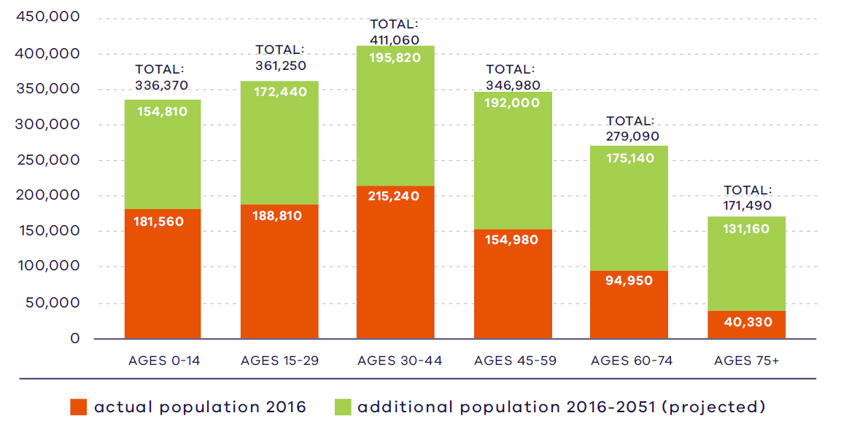
Victoria in Future, DELWP, 2019

Figure 13. Regional actual and projected population by age, 2016 to 2051
2016:  181,560 – Ages 0 to 14  188,810 – Ages 15 to 29  215,240 – Ages 30 to 44  154,980 – Ages 45 to 59  94,950 – Ages 60 to 74  40,330 – Ages 75 plus | 2051:  336,370 – Ages 0 to 14  361,250 – Ages 15 to 29  411,060 – Ages 30 to 44  346,980 – Ages 45 to 59  270,090 – Ages 60 to 74  171,490 – Ages 75 plus
Source: Department of Environment, Land, Water and Planning (2019) Victoria in Future 2019, Department of Environment, Land, Water and Planning, Melbourne, Australia.

Housing stock
Housing stock in the Western Metro Region is predominantly made up of detached houses accounting for 74 per cent of the total dwellings in 2016. This is significantly higher than metropolitan Melbourne with 67 per cent of dwellings as separate houses but consistent with other metropolitan regions with growth areas. Flats, units and apartments account for 9 per cent of the dwelling types in the region, a little over half of the metropolitan Melbourne average of 16 per cent. The percentage of dwellings with three or more bedrooms in the Western Metro Region is 81 per cent, which is 8 per cent higher than the average housing stock across metropolitan Melbourne.

Projected housing requirements
Victoria in Future (VIF) projections are published at LGA level for a 20-year horizon from the most recent Census data – currently from 2016 to 2036. Beyond this period knowledge of land supply, dwelling construction and population distribution trends is less certain.
VIF projections indicate that based on the continuation of current trends, and knowledge of long-term greenfield land supply, approximately 66 per cent of net additional dwellings across metropolitan Melbourne are expected to be in established areas and 34 per cent in greenfield areas. The housing distribution figures between established areas and greenfield areas are shown in Table 9.
Plan Melbourne provides an alternate aspirational housing distribution scenario based on achieving 70 per cent of new housing in Melbourne’s established areas and the remaining 30 per cent accommodated in greenfield areas. This scenario assumes a total of 70,000 dwellings across metropolitan Melbourne, which VIF 2019 projections allocated to greenfield areas, can be accommodated in established areas to realise the aspirational 70/30 distribution between 2019 to 2051 (Table 10).
The aspirational housing distribution scenario provides for a redistribution of 30,000 dwellings from greenfield areas to established areas in the Western Metro Region. The region will accommodate 20,000 dwellings in established areas of the region, while the remaining 10,000 will be distributed among the other regions’ established areas.
Scenario 1 VIF 2019
Region | Net dwelling additions 2016 to 2051 – Total | Net dwelling additions 2016 to 2051 – Established | Net dwelling additions 2016 to 2051 – Greenfield
Inner Metro | 225,000 | 225,000 | 0
Western | 412,000 | 173,000 | 239,000
Northern | 352,000 | 167,000 | 185,000
Inner South East | 119,000 | 119,000 | 0
Eastern | 192,000 | 192,000 | 0
Southern | 313,000 | 184,000 | 129,000
Total Melbourne | 1,613,000 | 1,060,000 | 549,000
 | 100% | 66% | 34%
Scenario 2 Aspirational scenario
Region | Net dwelling additions 2016 to 2051 – Total | Net dwelling additions 2016 to 2051 – Established | Net dwelling additions 2016 to 2051 – Greenfield
Inner Metro | 235,000 | 235,000 | 0
Western | 402,000 | 197,000 | 205,000
Northern | 347,000 | 182,000 | 165,000
Inner South East | 124,000 | 124,000 | 0
Eastern | 202,000 | 202,000 | 0
Southern | 303,000 | 194,000 | 109,000
Total Melbourne | 1,613,000 | 1,134,000 | 479,000
 | 100% | 70% | 30%
Note: For the purpose of these figures, a greenfield area is land in a growth area council that is either currently under development or identified for future development
Table 11 shows the aspirational housing distribution scenario for each LGA to 2036. This is achieved by apportioning the net dwelling additions in the established area for each metropolitan region and distributing the amount between LGAs in the region. The aspirational scenario is based on the locations where most housing growth is anticipated across the established metropolitan area such as the Central City, NEICs, metropolitan and major activity centres, major urban renewal precincts and future SRL precincts. The 70/30 dwelling redistribution for the region will provide guidance for each LGA to accommodate housing growth that achieves the aspirational housing distribution for metropolitan Melbourne.
Western Metro Region 70/30 redistribution by LGA to 2036
LGA | VIF2019 dwellings – 2021 | VIF2019 dwellings – 2036 | Including 70/30 dwellings – 2036 | 70/30 dwelling redistribution | Share of regional redistribution
Brimbank | 71,600 | 84,500 | 86,800 | 2300 | 23%
Hobsons Bay | 38,200 | 46,900 | 47,800 | 900 | 9%
Maribyrnong | 42,100 | 65,000 | 66,200 | 1200 | 12%
Melton | 14,600 | 17,500 | 18,400 | 900 | 9%
Moonee Valley | 60,600 | 76,100 | 78,300 | 2200 | 22%
Wyndham | 27,700 | 32,700 | 35,200 | 2500 | 25%
Western Metro Region | 254,800 | 322,700 | 332,700 | 10,000 | 100%
Source: DELWP, 2021

Locations for housing growth
Consistent with government policy to maximise the use of existing infrastructure and encourage compact and walkable neighbourhoods, the inner and middle areas of the Western Metro Region are experiencing residential growth around transport corridors, designated activity centres and urban renewal of older industrial land.
Housing at greater densities is encouraged around activity centres, in urban renewal areas and in areas that have good public transport. The Western Metro Region has a strong network of activity centres in the established inner suburbs that are well developed and have opportunities for renewal. Some activity centres are accessible by train and bus services. Sunshine and Footscray metropolitan activity centres will be the focus of significant growth and coordinated planning due to their linkages with key transport infrastructure and their strategic locations close to the Melbourne CBD, employment areas, and Melbourne Airport. As future anchors for employment within the region, medium- and higher-density housing will develop around these centres.
Further west, Werribee NEIC will provide employment opportunities within the region and areas around the NEIC will provide opportunities for more housing. Future centres have also been identified in growth areas which will over time provide opportunities for housing at a range of densities.
Importantly, the Western Metro Region has a strong industrial legacy and is home to the Western Industrial Precinct, one of the largest industrial precincts in metropolitan Melbourne. The region has an established statewide role in the petrochemical industry, based around Altona, and a strong freight and logistics base including Essendon Airport, the proposed WIFT and Bay West container port, and close proximity to Melbourne Airport and Avalon Airport. Appropriate distances between these ongoing and future industrial uses and future residential developments must be maintained for the safety and amenity of residents.
Between 2005 and 2016, the majority of residential development in the Western Metro Region occurred outside activity centres (DELWP, 2018a) . Locating housing, and encouraging higher-density housing, closer to and within activity centres is a key challenge for all LGAs in the region to support better access to jobs, services and public transport and greater housing choice. Housing developments with 10 or more dwellings are classified as major housing developments. Figure 14 shows the pipeline of major housing redevelopment in and around existing metropolitan and major activity centres across the Western Metro Region.
- Major housing in the redevelopment pipeline in or within 400 metres of an activity centre
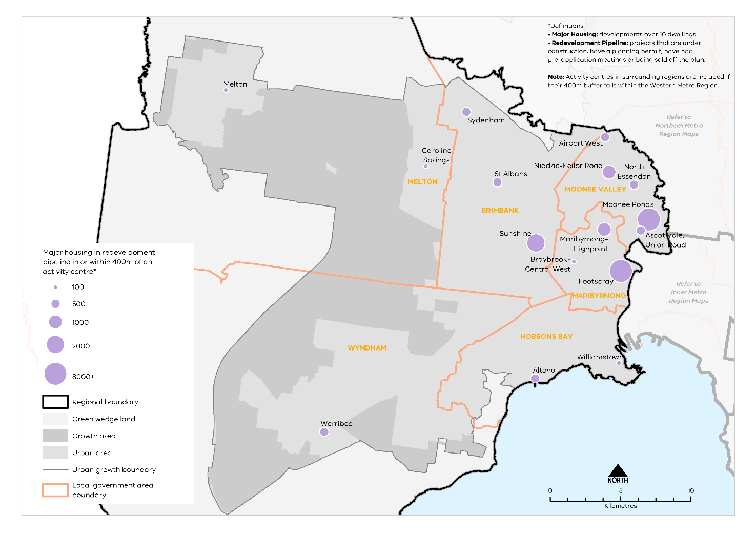
Urban Development Program 2019, Department of Environment, Land, Water and Planning

Figure 14. Major housing in the redevelopment pipeline in or within 400 metres of an activity centre
This map shows:
- Major housing redevelopment pipeline in or within 400m of an activity centre.
- Regional boundary
- Green wedge land covering land outside the urban growth boundary in Melton and Wyndham.
- Growth area identified within the urban growth boundary in Melton and Wyndham.
- Urban area covering Hobsons Bay, Maribyrnong, Moonee Valley and Brimbank. Urban area is also identified in Melton around Melon and Caroline Springs and in Wyndham around Werribee.
- Local government areas including Moonee Valley, Maribyrnong Hobsons Bay, Brimbank, Melton and Wyndham.
Definitions:
• Major Housing: developments over 10 dwellings.
• Redevelopment Pipeline: projects that are under construction, have a planning permit, have had pre-application meetings or being sold off the plan.
Note: Activity centres in surrounding regions are included if their 400m buffer falls within the Western Metro Region.

Location | Major housing development pipeline in or within 400m of an activity centre*
Melton | 11-100
Sydenham | 101-500
Caroline Springs | 11-100
St Albans | 101-500
Airport West | 101-500
Niddrie-Keilor Road | 501-1000
North Essendon | 101-500
Moonee Ponds | 8000+
Ascot Vale, Union Road | 101-500
Maribyrnong- Highpoint | 501-1000
Sunshine | 1001-2000
Braybrook- Central West | 11-100
Footscray | 8000+
Williamstown | 11-100
Altona | 101-500
Werribee | 101-500

Housing demand and its impact on affordability
Housing supply in well-serviced areas with good access to higher paying inner-city jobs across metropolitan Melbourne has generally not kept pace with demand. This is impacting dwelling prices, with price rises much greater in inner and middle ring suburbs than in outer suburbs and growth areas across metropolitan Melbourne.
Housing affordability is an issue across metropolitan Melbourne. Compared with other metropolitan regions, the Western Metro Region is considered relatively affordable. The region has the highest proportion of new lettings of affordable dwellings to lower-income households. In the rental market, Melton and Wyndham LGAs have the highest proportion of affordable dwellings with 41 per cent and 33 per cent recorded respectively (DHHS, 2020). In contrast, Moonee Valley LGA is among one of the least affordable LGAs in metropolitan Melbourne with less than 1 per cent of dwellings being affordable (DHHS, 2020).
There are several existing Victorian Government initiatives in place to improve the supply of affordable housing, including social housing. These include Victoria’s Big Housing Build, the Social Housing Growth Fund, 1,000 Homes Initiatives and the Redevelopment of Public Housing Estates. Four of the six LGAs in the Western Metro Region have been identified as priority areas for projects to increase the supply of social and affordable housing in the region as part of Homes Victoria’s Big Housing Build program.

Regional strengths
- The Western Metro Region has a diversity of housing choices from growth corridor to emerging urban renewal areas and established inner and suburban areas.
- Opportunity to locate medium- and higher-density housing in and around metropolitan and major activity centres, Sunshine and Werribee NEICs, identified urban renewal areas, and in locations supported by good public transport.
- Greenfield development opportunities in the West Growth Corridor can accommodate housing supply and diversity required in the region to meet the needs of new and maturing communities.
- There are significant existing and future transport connections to regional Victoria, Melbourne Airport, other metro regions and the Central City which will improve access to jobs, services and infrastructure.

Regional challenges
- The Western Metro Region will experience high projected population growth to 2051 and will need to increase housing supply and diversity for the increase in population.
- Balancing housing development with employment uses particularly around SSIPs and regionally-significant industrial precincts.
- Limited opportunities for housing in locations close to major hazard facilities and other infrastructure such as pipelines. Land contamination of potential urban renewal areas may also constrain housing growth.
- Need to provide greater housing diversity to reflect community needs, especially providing adaptable housing options for the ageing population to ‘age in place’.
- The supply of affordable housing is disproportionate to the level of lower-income residents in the Western Metro Region and the number of lower-income residents being exceptionally higher than other metro regions.

Directions and strategies
The directions identified to achieve the 2050 vision for the Western Metro Region in terms of housing choice and Outcome 2 of Plan Melbourne are:
Direction 6 | Increase the supply of housing in the Western Metro Region
Direction 7 | Prioritise housing growth in areas with access to jobs, services and good public transport
Direction 8 | Provide greater choice and diversity of housing across the Western Metro Region
Direction 9 | Increase the supply of social and affordable housing
Direction 10 | Improve planning processes for growth areas to ensure the delivery of diverse and vibrant new communities
Each direction is implemented through regionally-specific strategies identified in this LUFP.
Map 3 shows how housing choice will be enhanced across the Western Metro Region by 2050 as a result of these directions and strategies, together with Plan Melbourne and other strategies and initiatives as outlined in Appendix 01.

- Western Metro Region housing choice 2050
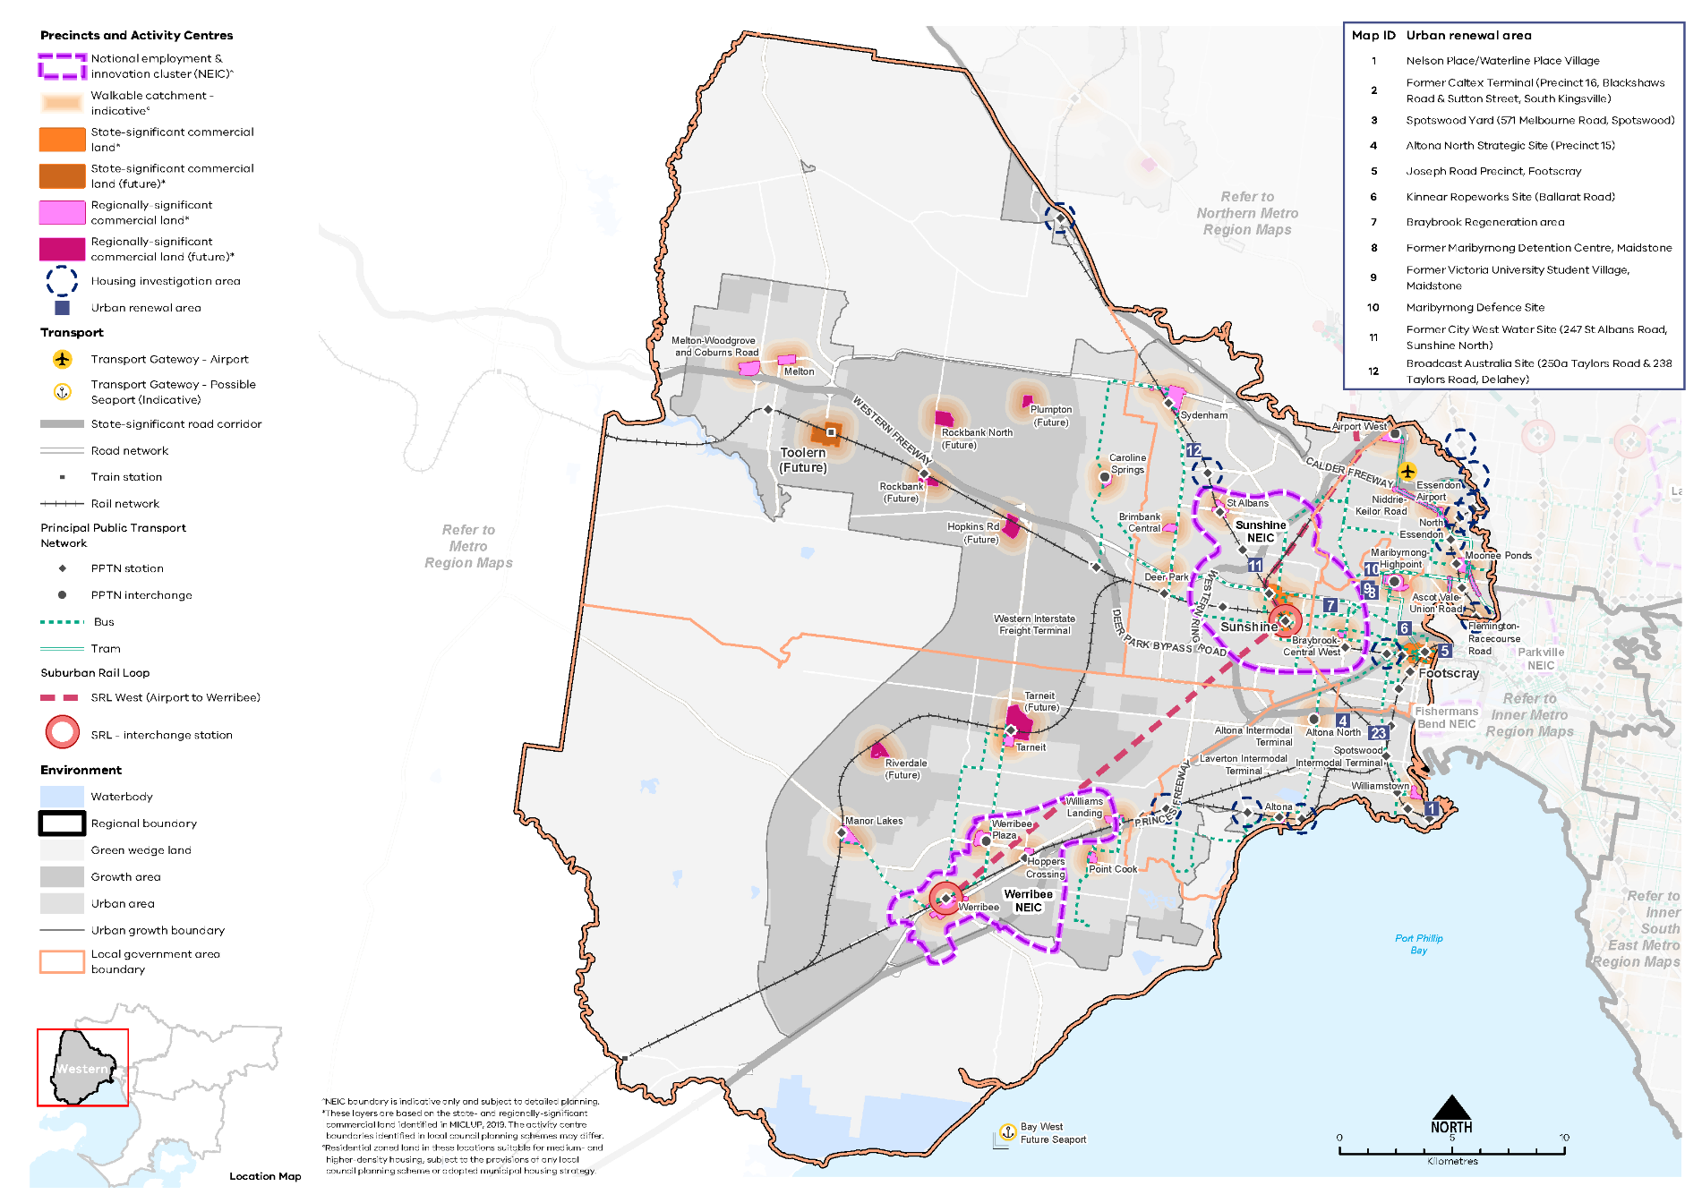
Map 3 Western Metro Region housing choice 2050
A map of housing choice in the Western Metro Region in 2050, extracting the locations for medium- and higher-density dwellings identified on Map 1 above and detailed in Table 12, with the addition of 800m indicative walkable catchments** around existing and proposed metropolitan and major activity centres.

**Residential zoned land in these locations suitable for medium- and higher-density housing, subject to the provisions of any local council planning scheme or adopted municipal housing strategy.

- Increase the supply of housing in the Western Metro Region
Plan Melbourne aims for 70 per cent of net additional dwellings to be provided in Melbourne’s established areas, with the balance provided in greenfield areas. The inner and middle ring suburbs of the Western Metro Region provide opportunities for well-located, higher-density housing particularly around activity centres, the Principal Public Transport Network (PPTN), and in locally identified strategic sites and urban renewal areas. Future opportunities also exist in locations identified as SRL precincts as part of the SRL West (Airport to Werribee). The provision of housing in these areas will help achieve the overall aspiration of 70 per cent of new housing in established areas. There are some opportunities to transition former industrial sites to other uses. There are also greyfield areas in the region where housing stock is near, or has reached, the end of its useful life and could be redeveloped into more dwellings. The supply of housing in these established areas will help achieve the overall aspiration set out in Plan Melbourne, taking advantage of existing amenities, proximity to job-rich locations, services and public transport.
Substantial and incremental change areas will experience varying degrees of change relative to the existing context and not only increase the supply of housing, but also the diversity in housing types and built form outcomes. Lower-density areas in the region are expected to accommodate housing growth within the context of the existing or preferred character. Minimal housing change areas are identified for their special characteristics such as neighbourhood, heritage, environmental or landscape characteristics that should be protected.
Housing growth is not expected to be evenly distributed across the activity centre network with some centres, such as Williamstown and Altona, being particularly constrained by sea level rise, land use buffers and heritage values and Deer Park being constrained by major hazard facility buffers. Parts of the inner urban area of the Western Metro Region such as Williamstown, Footscray and Maribyrnong have heritage values to be protected while some residential areas are affected by bushfire risk.
- Maximise housing development within the established areas of the Western Metro Region to achieve the aspirational housing distribution scenario for metropolitan Melbourne.
- Prioritise housing growth in areas with access to jobs, services and good public transport
Plan Melbourne directs greater housing density development in the Western Metro Region in and around the Werribee NEIC, within metropolitan and major activity centres, in neighbourhood activity centres with good public transport access, and in urban renewal areas. Sunshine and Footscray metropolitan activity centres will accommodate high levels of population growth and economic activity. A coordinated approach between state and local government will ensure that land use opportunities in these locations are maximised. Much of the planning for these locations focuses on increasing jobs and economic growth for the Western Metro Region, with Sunshine playing a significant regional role as a transport hub. Residential development should be planned so that it does not inhibit employment opportunities in these key locations.
Between 2005 and 2016, Footscray Metropolitan Activity Centre had the largest number of approved major housing developments within and around 400 metres of the centre totalling 8881 new developments (DELWP, 2018e). Moonee Ponds Major Activity Centre recorded the second higher number of major housing redevelopment projects in the pipeline while all other activity centres, including Sunshine Metropolitan Activity Centre recorded less than 1,000 new major housing redevelopments projects in the pipeline (DELWP, 2018e). Sunshine and Werribee NEICs have been identified as key transport interchange stations for SRL West (Airport to Werribee). Once developed, SRL will provide efficient connections between Sunshine and Werribee and further afield to Melbourne Airport, La Trobe and Monash NEIC. Maximising future opportunities for higher-density housing, integrated with employment and services in and around Sunshine and Werribee, will be critical.
In addition to SRL, the Western Metro Region will benefit from numerous public transport upgrades including new railway stations at Riverdale and Hopkins Road and the Metro Tunnel which will connect the Sunbury train line to Pakenham and Cranbourne in the Southern Metro Region via the CBD. These city-shaping infrastructure projects will open opportunities for increased housing at medium to higher densities closer to jobs, services and public transport.
Land contamination is a major concern for the Western Metro Region and poses a constraint for redeveloping older industrial land for ‘sensitive uses’ including residential uses. Some large urban renewal sites (and some strategic redevelopment areas identified at the local level), including identified urban renewal areas around Sunshine NEIC, have potentially contaminated land that requires a process of site remediation before proposed ‘sensitive uses’ are allowed. Furthermore, with ongoing industrial uses across the Western Metro Region, including petrochemical industries and major hazard facilities, appropriate buffers between these uses and residential uses must be maintained. New housing or higher-density housing should not be encouraged around these locations to protect residents from odours and other air quality issues. Parts of the region also have pipelines that may impact on housing development.
Table 12 identifies locations for medium- and higher-density housing in the Western Metro Region.

Locations for medium- and higher-density housing in the Western Metro Region
Classification | Location | Description
NEICs | Sunshine  Werribee | - NEICs can provide housing opportunities in designated locations where it complements the NEICs’ primary role as a cluster of business activity of national significance.  - Sunshine and Werribee NEIC will have a future railway station as part of SRL West (Airport to Werribee). Better accessibility to the NEIC will maximise inter- and cross-regional opportunities for housing, employment, education and health services
Metropolitan activity centres | Footscray  Sunshine  Toolern (future) | - Metropolitan activity centres are locations for medium- and higher-density housing and mixed-use development. Substantial housing change opportunities may extend to a walkable catchment of 800 metres around the centre (depending on the local context) based on the 20-minute neighbourhood principle of locating housing close to jobs, services, amenities and public transport.  - Metropolitan activity centres play a major role in supporting a broad range of other uses such as retail, commercial, entertainment and community uses to a regional catchment. Housing development in and around metropolitan activity centres will be complementary to the existing and future jobs and employment role of the centres. (refer to Table 7)  - Structure planning will identify the preferred locations, densities and types for housing and development constraints or limitations in each centre.  - Sunshine is identified as an interchange station in SRL and higher-density development is supported
Major activity centres | Airport West  Altona  Altona North  Ardeer  Ascot Vale-Union Road  Braybrook-Central West  Brimbank Central  Caroline Springs  Deer Park  Flemington-Racecourse Road  Mt Atkinson (future)  Hoppers Crossing  Manor Lakes  Maribyrnong-Highpoint  Melton  Melton-Woodgrove and Coburns Road  Moonee Ponds  Niddrie-Keilor Road  North Essendon  Plumpton (future)  Point Cook  Riverdale (future)  Rockbank (future)  Rockbank North (future)  St Albans  Sydenham  Tarneit  Werribee  Werribee Plaza  Williams Landing  Williamstown | - Major activity centres are locations for medium- and higher-density housing and mixed-use development. Substantial housing change opportunities may extend to a walkable catchment of 800 metres around the centre (depending on the local context) based on the 20 minute neighbourhood principle of locating housing close to jobs, services, amenities and public transport.  - While all major activity centres will accommodate housing change, the degree of change is relative to the existing context and characteristics of each major activity centre. (refer to Activity centres – function and strategic opportunities)  - Structure planning will identify the preferred locations, densities and types for housing and development constraints or limitations in each centre.  - Werribee Major Activity Centre is designated as a location for a SRL interchange station and will provide a greater opportunity for housing change.
Neighbourhood activity centres |  | - Some neighbourhood activity centres may be locations for mixed-use medium- and higher-density housing, particularly when they are serviced by good public transport. Housing opportunities may also extend to a walkable catchment of 800 metres around the centre (depending on the local context) based on the 20-minute neighbourhood principle of locating housing close to jobs, services, amenities and public transport.  - Approved PSPs for the Western Growth Corridor identify future neighbourhood activity centres that will accommodate medium- and higher-density housing.  - Future PSPs in growth areas will be guided by the 20-minute neighbourhoods principle and the Victorian Planning Authority’s guidelines for precinct structure planning.
Urban renewal areas and greyfields | Maribyrnong Defence Site  Bradmill Factory Site  Kinnears Ropeworks Site (Ballarat Road)  Joseph Road Precinct, Footscray  Moonee Valley Racecourse Precinct  Former Caltex Terminal (Precinct 16, Blackshaws Road and Sutton Street, South Kingsville)  Altona North Strategic Site (Precinct 15)  Spotswood Yard (571 Melbourne Road, Spotswood)  River Valley, Sunshine North  Nelson Place/Waterline Place Village  Former City West Water Site (247 St Albans Road, Sunshine North)  Former Victoria University Student Village, Maidstone  Former Maribyrnong Detention Centre, Maidstone  Braybrook Regeneration area  Broadcast Australia Site (250a Taylors Road and 238 Taylors Road, Delahey) | - Urban renewal areas identified in the LUFP are locations nominated by local councils or State Government with opportunities for medium- and higher-density mixed-use development. These locations have regional value based on one or more the following characteristics: land size, proximity to the PPTN or future transport infrastructure, government-owned, or require cross-municipal planning. These areas will be planned according to 20-minute neighbourhood principles. A coordinated approach to planning for these areas will maximise their development opportunity and any infrastructure needs.
Suburban Rail Loop precincts | Sunshine (interchange)  Werribee (interchange) | - SRL precincts are opportunities for medium- and higher-density housing development due to their proximity to future SRL train stations. Housing development in the SRL precincts will be supported by other uses such as commercial, retail and services and maximise their potential as transit-oriented development. They will undergo substantial change and will be subject to further detailed precinct planning.
Housing opportunity area | St Albans Road (between Ginifer Railway Station and St Albans Major Activity Centre)  Ballarat Road  Derrimut Road (between Werribee Plaza and Tarneit Railway Station) | - Housing opportunity areas are identified by local councils as areas where substantial or incremental housing change is anticipated as a result of being located on the PPTN or along main roads. These locations are generally zoned as Residential Growth Zone where housing at increased densities and housing diversity is expected.
Housing investigation areas | Diggers Rest Railway Station  Essendon Railway Station  Glenbervie Railway Station  Keilor Plains Railway Station  Laverton Railway Station  Newmarket Railway Station  Oak Park Railway Station  Pascoe Vale Railway Station  Seaholme Railway Station  Strathmore Railway Station  West Footscray Railway Station  Westona Railway Station  Wyndham Vale Railway Station  Truganina Railway Station (proposed)  David Road Railway Station (proposed)  Black Forest Road North Railway Station (proposed) | - Housing investigation areas are areas within an 800 metre walkable catchment around existing and future railway stations that have the potential to support medium- and higher-density housing development in line with maximising access to public transport and 20-minute neighbourhood principles. These areas are outside designated metropolitan and major activity centres and are based on their access to rail infrastructure, existing zones that allow residential development and the absence of ‘special characteristics’ such as heritage, landscape, bushfire values or airport environs.  - A further assessment to determine locations within housing investigation areas suitable for substantial housing change and rezoning, in response to the local context, will be required.
Greenfield growth area | Western Growth Corridor | - Growth areas are designated to provide future supply of land for development in metropolitan Melbourne. A detailed PSP process will articulate the land uses and determine suitable locations for medium- and higher-density housing in the growth corridors.
- Increase the supply of medium- and higher-density housing around Sunshine and Werribee NEICs, in and around metropolitan and major activity centres, urban renewal areas, SRL precincts, and neighbourhood activity centres serviced by good public transport.
- Ensure new housing in and around the Sunshine and Werribee NEICs does not encroach on the primary employment and innovation role of the NEICs.
- Support substantial housing change in locations where transport upgrades and improvements such as Suburban Rail Loop, Melbourne Airport Rail Link or Regional Rail Link create opportunities to locate housing closer to jobs, services and infrastructure.
- Maximise development potential in housing investigation areas around existing and proposed railway stations to leverage access to the PPTN.
- Provide greater choice and diversity of housing across the Western Metro Region
Housing stock in the Western Metro Region is predominantly separate houses, with the majority of dwellings having three or more bedrooms. This is in part due to new housing developments occurring in growth areas such as Melton, Wyndham and Brimbank LGAs. Families with children households will continue to be the largest household type in the region through to 2051 and the demand for dwellings with three or more bedrooms will continue to increase. As the growth areas provide cheaper options relative to the established inner and middle ring suburbs, housing diversity in these locations will likely be in the form of medium-density townhouses and duplexes rather than apartments or flats.
The inner suburbs of Moonee Ponds and Footscray will continue to provide higher-density housing developments as they attract young professionals and students who commute to the Central City. As the region develops more local employment in locations such as Sunshine and Werribee, flats and apartments will provide greater housing choices in housing stock and dwelling type within the Western Metro Region. There is also a greater opportunity for large urban renewal sites to offer greater housing diversity, sustainability initiatives (for example, greywater reuse, green energy initiatives and increased onsite greening and cooling), local services and social infrastructure.
There is an anticipated increase in single persons and couples without children households, as well as people over the age of 60 (DELWP, 2019b). This means the Western Metro Region will require greater housing diversity by providing smaller dwellings, adaptable housing options, affordable arrangements, residential aged care facilities and retirement homes to cater for this increase in an older population. The Western Growth Corridor also provides opportunities for more residential aged care facilities to support the increasing ageing population in the outer areas of the region. The region should provide opportunities for residents to ‘age in place’ in their existing communities, with access to community services and public transport that meets their daily needs. Providing increased supply of student accommodation around health and education precincts is also encouraged.
- Encourage a genuine mix of dwelling types and sizes in the Western Metro Region to accommodate the changing future needs of the region.
- Facilitate the development of housing that is adaptable and flexible to cater for changing demographics and to support ‘ageing in place’, including residential aged care facilities and retirement housing.
- Optimise the opportunities for student accommodation and key worker housing around health and/or education precincts in the Western Metro Region.
- Adopt a place-based approach to the delivery of infill housing developments to replace ageing housing stock, ensure a high-quality of design that is appropriate for the local context and contributes to housing supply and diversity.
- Increase the supply of social and affordable housing
Affordable housing is defined in the Planning and Environment Act 1987 as housing appropriate for the needs of very low-, low- and moderate-income households, and includes social housing provided by the government or a registered housing agency. Social housing also includes public housing and community housing to accommodate people who have experienced homelessness, family violence or have other special needs. The provision of more social and affordable housing requires a range of programs and measures across all levels of government.
Housing affordability is affecting an increasing number of residents across metropolitan Melbourne. Planning should facilitate the delivery of affordable housing in the Western Metro Region by considering opportunities to develop under-utilised or disused government-owned land for social housing. Facilitating the supply of affordable housing in locations that are closer to jobs, services and public transport — in addition to sustainable design — will lower household costs, which is particularly important to the very low-, low- and moderate-income households. By strengthening the role of planning to facilitate and deliver affordable housing opportunities will contribute to continuing to make Melbourne a liveable city for all.
The social and affordable housing system, consisting of the government, community housing sector and industry, provides housing options for those unable to access the private housing market. There are currently 116,351 people living in social housing owned or managed by Homes Victoria (Director of Housing) or a registered housing corporation across Victoria. Victoria has the lowest proportion of social housing in Australia and will require 4000 homes per year for Victoria’s social housing to reach the national average of 4.2 per cent of social housing to total dwellings.
The Victorian Government’s Big Housing Build program aims to increase existing social housing stock across Victoria by 10 per cent and, in the next five years, over 12,000 new dwellings will be built. The program is Victoria’s largest investment in social and affordable housing and Homes Victoria has been established to deliver the program as well as ensure an ongoing pipeline of social and affordable housing development beyond the Big Housing Build. In addition, existing social housing dwellings will be upgraded, maintained or replaced under the program. The Victorian Government has identified 21 priority LGAs for social housing development of which Brimbank, Maribyrnong, Melton and Wyndham are identified in the Western Metro Region.
- Facilitate more affordable housing across the region, particularly in locations that have good access to jobs, services and public transport.
- Support the delivery of social housing, particularly in Brimbank, Maribyrnong, Melton and Wyndham LGAs.
- Improve planning processes for growth areas to ensure the delivery of diverse and vibrant new communities
Development of growth areas in the Western Metro Region is guided by the Western Growth Corridor Plan (Map 4). This plan outlines an overarching strategy for the development of Melbourne’s growth corridors over the coming decades, which is then realised at a local level through PSPs. PSPs set out the preferred spatial location of key land uses and infrastructure to guide decisions on staging of development, subdivision permits, building permits and infrastructure delivery. They have a specific role to address matters within the scope of the planning system, ensuring they are consistent with the regulatory environment that operates in conjunction with the planning system.
Plan Melbourne highlights the importance of an integrated approach between land use and infrastructure delivery in growth areas to ensure residents have access to workforce opportunities, education, health services and other infrastructure. Policy 2.2.5 states that planning and development in growth areas should:
- Provide around 15 years supply of land approved for development (11.02-1S Victoria Planning Provisions)
- Over time, seek an overall increase in residential densities to more than 20 dwellings per hectare. Melbourne’s average housing density is currently 14 dwellings per hectare. Research shows that a minimum density of 25 dwellings per hectare is needed to support 20-minute neighbourhoods
- Be sequenced to ensure new precincts are contiguous with previously approved precincts.
The Western Growth Corridor is expected to accommodate a population of 377,000 people or more by 2051 and projected to supply 239,000 additional dwellings based of VIF 2019. 2018 data estimates the Melton growth area currently has 42 years’ land supply, while Wyndham has 16 years’ land supply.
Future activity centres are planned along the Regional Rail Link and Melton rail line to be accessible by multiple transport modes. Creeks and waterways will also connect new neighbourhoods via the metropolitan trail network and local trails such as Kororoit Creek providing an east-west link across the OMR.
New master planned estates are typically developed in phases and therefore new residents do not have immediate access to many essential services such as hospitals and schools, community services and/or retail stores to meet their everyday needs and foster social cohesion. This is compounded by a lack of adequate public transport to connect people to nearby communities. (Grodach,et al., 2019) Car dependency is also high due to poor provision of community infrastructure including schools, health facilities and public transport options, early in the development process. This car dependency often continues even after community infrastructure has been provided locally (Grodach, et al., 2019).
While the PSP process often articulates a desire to stage development and delivery of facilities and transport networks, and seeks for sequencing of development that “should have regard to” the proximity of services, infrastructure and facilities, this often does not explicitly require the delivery of services and infrastructure in a timely manner (Grodach, et al., 2019). Staging the development in growth areas through the PSP process will help in the timely delivery of infrastructure and 20-minute neighbourhood features in these communities.
- Require development in growth areas to be sequenced and staged at a regional level to better link infrastructure delivery to land release.
- Facilitate the development of medium- and higher-density housing in the growth areas to provide greater housing diversity and create 20-minute neighbourhoods close to jobs, services and public transport.

- Western Growth Corridor Plan
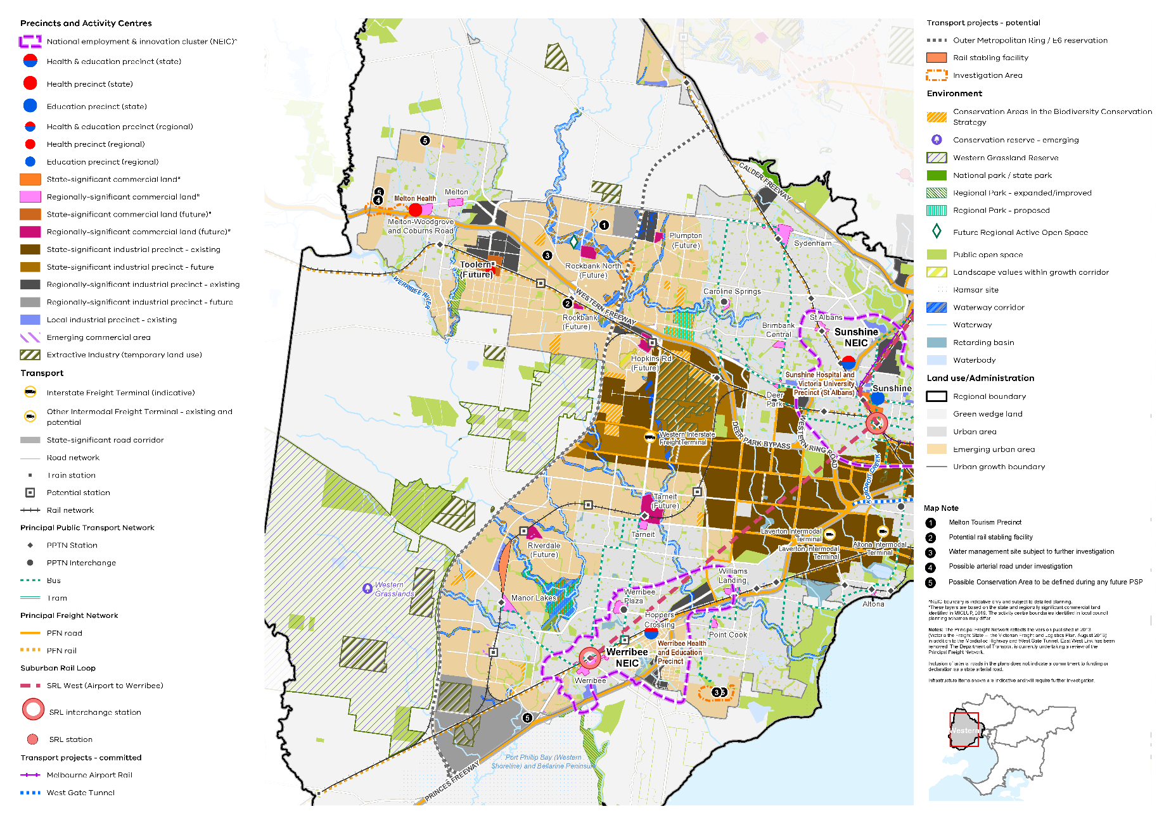

Map 4 Western Growth Corridor Plan
A map showing the main features of the Western Growth Corridor, highlighting:

- The existing urban area and the emerging urban areas comprising the two growth areas, one in the Melton LGA (extending from Caroline Springs to Melton) and in Wyndham LGA
- Werribee and Sunshine national employment and innovation clusters* and major activity centres in the existing urban area. The proposed metropolitan activity centre at Toolern and future major activity centres at Hopkins Road, Plumpton, Rockbank, Rockbank North, all in Melton local government area. Also a future major activity centre at Riverdale and further development of Tarneit Major Activity Centre (Wyndham)
- Existing and future state- and regionally-significant industrial precincts and local industrial precincts
- Existing and future state- and regionally-significant commercial land**
- State and regional health and/or education precincts
- Extractive Industry (temporary use)
- SRL interchange stations at Werribee and Sunshine and SRL West (Airport to Werribee) alignment
- Public transport network and principal freight road and rail network
- Outer Metropolitan Ring bisecting the growth corridor extending from Princes Highway in the south to the north east through the Melton growth corridor to south of Diggers Rest
- Investigation areas for road infrastructure between Rockbank and Plumpton where the proposed Outer Metropolitan Ring will intersect with Taylors Rd and west of Melton
- Potential new railway stations and rail stabling facility north of Manor Lakes and near Rockbank
- Specific features including:
- Significant waterway corridors and waterbodies
- Green wedge land, public open space, conservation areas, proposed and improved regional parks, proposed regional active open space at Rockbank North, the Western Grassland Reserves and the growth area’s landscape values
Map notes (the location of each of these is shown on the map by number)
  - Melton Tourism Precinct
  - Potential rail stabling facility (in Rockbank South)
  - Water management site subject to further investigation on north side of Western Highway between Melton and Rockbank South
  - Possible arterial road under investigation west of Melton
  - Possible Conservation Areas in the north-west of the region and south (to be defined during any future Precinct Structure Plan)

* NEIC boundary is indicative only and subject to detailed planning.
** These layers are based on the state and regionally significant commercial land identified in MICLUP, 2019. The activity centre boundaries identified in local council planning schemes may differ.
Notes: The Principal Freight Network reflects the version published in 2013 (Victoria the Freight State – the Victorian Freight and Logistics Plan, August 2013) in addition to the Mordialloc Highway and West Gate Tunnel. East West Link has been removed. The Department of Transport is currently undertaking a review of the Principal Freight Network.
Inclusion of arterial roads in the plans does not indicate a commitment to funding or declaration as a state arterial road.
Infrastructure items shown are indicative and will require further investigation.

Actions – Housing choice
- Update planning schemes to align with housing policies in Plan Melbourne and the Western Metro Region Land Use Framework Plan and the implementation of the reformed residential zones. This includes:
- Providing capacity for 15 years of regional housing supply focusing on locations identified for housing growth in the LUFP;
- Reviewing planning controls in housing investigation areas as potential locations for substantial or incremental housing change.
This may require strategic planning work to support these changes such as preparing or updating local housing strategies or preparing structure plans to further investigate where increased densities can be supported, and determine specific changes required to planning schemes.
- Identify underutilised and surplus government land that has potential to deliver additional social housing.
- In partnership with councils, identify a pipeline of sites in the Western Metro Region for social and affordable housing.
- Develop a model and seek support for a whole-of-government approach to better sequence and prioritise locations for key services, social infrastructure and public transport access in the development of growth areas to better enable walkable 20-minute neighbourhoods.

Chapter 06.
Integrated transport
Plan Melbourne Outcome 3: Melbourne has an integrated transport system that connects people to jobs and services and goods to market.
As the Western Metro Region grows it will require better integration of land use and transport planning, better use of existing roads, and increased investment in public transport, walking and cycling. Making better use of transport infrastructure, complemented by good precinct design, can improve connections without necessarily the expense and disruption of delivering new infrastructure. Land use decisions, as well as mode shift opportunities, can significantly improve access and reduce transport-generated emissions.
As Melbourne’s fastest growing region, integrated transport is vital to the future productivity and liveability of the Western Metro Region. The Victorian Government is investing in major transport projects that will improve the connectivity of the region with other parts of metropolitan Melbourne. These investments include the West Gate Tunnel, SRL, Melbourne Airport Rail and Geelong Fast Rail.
Recent transport investments have improved accessibility and made it easier for people and businesses to get around in some areas. However, the region still faces challenges in terms of freeway congestion, the coherency and structure of the network, an underdeveloped road network in greenfield areas and limited transport choices. The region will work towards an efficient internal transport network providing access between activity centres and employment nodes as well as improving connections beyond the region to Melbourne’s CBD and Melbourne Airport.

State of play
Map 5 outlines the current state of play for transport in the Western Metro Region.

Road network
The Western Metro Region’s major road networks include the Princes, West Gate and Western freeways. The M80 Ring Road provides cross-town connectivity to the north of the city, and the Calder Freeway links north-western Victoria to Melbourne. Other major east-west arterial roads include Ballarat Road, Geelong Road and Melton Highway. North-south road connections are less developed but include Hopkins Road/Derrimut Road in the outer west.
Several parts of the existing transport network already have capacity constraints, or will in the future, as the region grows, particularly passenger rail services and sections of the freeway network. Congestion is increasing particularly during peak hours, as many residents commute by car. By 2031, traffic volumes in the outer part of the region are expected to increase by 35.5 per cent from 2015 (KPMG & ARUP, 2017). While there is expected to be a reduction in average trip distance in the outer west, there will be an increase in average trip time with time spent on roads approaching capacity and forecast to increase significantly in 2051 relative to 2015. These trends are likely to impact residents’ ability to access office jobs (professionals, clerical and administrative workers) who are more likely to work in inner city areas and travel during peak periods, with higher than average delays (KPMG & ARUP, 2017).

Public transport network
The rail network in Western Metro Region features:
- Metro passenger services to Werribee, Williamstown and Sunbury (via Sunshine), plus sections of the Craigieburn Line
- Regional passenger services to Bendigo, Ballarat (via Deer Park and Melton) and Geelong (via Regional Rail Link)
- Interstate passenger and freight lines between Adelaide/Perth and Melbourne (via Ararat and Geelong) and between Brisbane/Sydney (via Sunshine and Albury) and Melbourne.
Currently there is no metro passenger rail service directly from Werribee to Geelong as Regional Rail Link does not connect to Werribee. In addition, the rail line to Melton (from Sunshine) is not electrified. Cobblebank railway station supports the future Toolern Metropolitan Activity Centre and there are other potential railway stations identified in the growth corridor at Paynes Road and Hopkins Road on the Melton line, and Truganina, Davis Road, Riverdale and Black Forest Road on the Regional Rail Link.
The tram network services inner areas of the region in Moonee Valley and Maribyrnong LGAs. The bus network has a relatively even spread of services, except for the Western Industrial Precinct in the middle of the region. There are two SmartBus routes in the region providing orbital links: Altona to Mordialloc and Airport West to Chelsea.
Figure 15 shows the accessibility to public transport for people who live within the region based on how far they need to walk to access train, tram and bus services. Public transport accessibility is greatest in the inner north west in Moonee Valley LGA and Sunshine and Footscray where older established networks exist. The middle ring and outer suburbs and growth areas have very low levels of accessibility reflecting their industrial or undeveloped land uses, or newer residential areas that rely on local bus networks.

- Western Metro Region integrated transport state of play
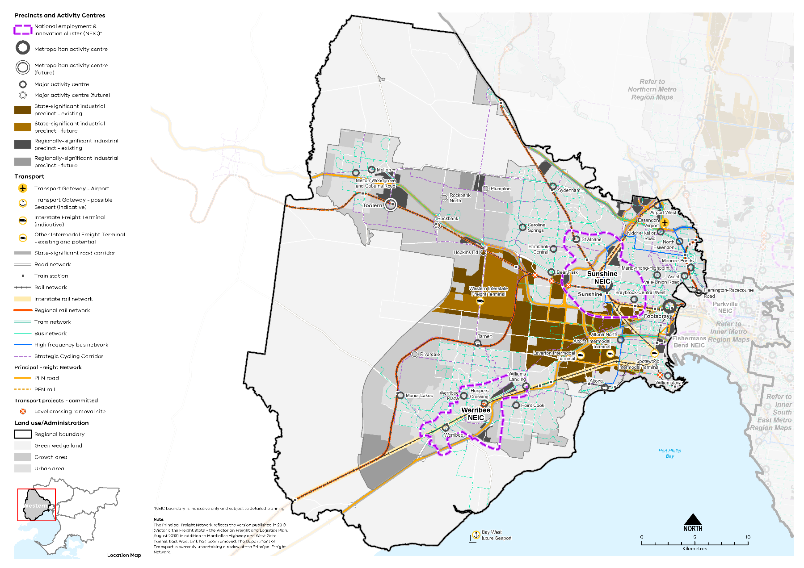

Map 5 Western Metro Region integrated transport state of play
A map showing the key transport features of the region in 2021, as extracted from Map 1, and also highlighting:
- The route of interstate rail network
- The regional rail network from Bendigo, Ballarat and Geelong to Southern Cross Station
- The bus network principally in the established urban area
- The high frequency bus network in the east of the region
- The strategic cycling network through the established urban area and growth areas
- The principal rail and road freight network.
Note: The Principal Freight Network reflects the version published in 2013 (Victoria the Freight State - the Victorian Freight and Logistics Plan, August 2013) in addition to Mordialloc Highway and West Gate Tunnel. East West Link has been removed. The Department of Transport is currently undertaking a review of the Principal Freight Network.

- Public transport accessibility in the Western Metro Region
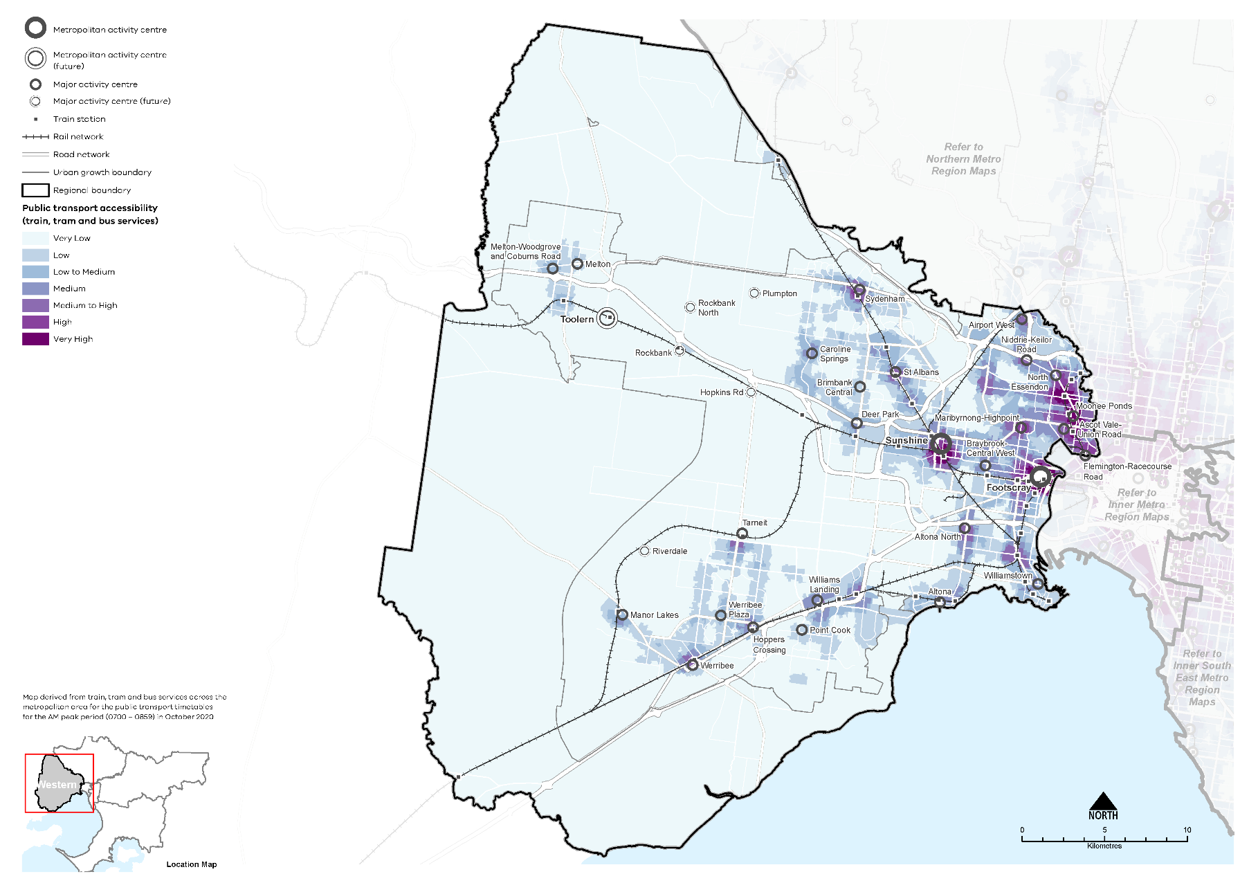

Active transport network
There are existing cycling networks in the region although mode share is low in the west, particularly outside inner Melbourne. In 2016, 0.6 per cent of residents cycled to work compared to one per cent for metropolitan Melbourne. Two per cent of residents walked to work in the Western Metro Region, this compares to three per cent for metropolitan Melbourne.

Transport gateways
The Western Metro Region has a significant competitive advantage with good freight connections to transport gateways including Melbourne, Avalon and Essendon airports, the Port of Melbourne and the proposed Bay West container port.

Freight network
In terms of freight and business trips, the region lacks a higher order arterial road grid (especially in its west) to support more intensive development.
The rail freight network in the west comprises significant rail corridors including:
- Tottenham-Newport-Altona-Geelong corridor, including Melbourne-Adelaide-Perth mainline
- Tottenham-Sunshine-Melton-Ballarat corridor
- Sunshine-Sydenham-Bendigo corridor
- Sunshine-Brooklyn-Newport corridor including the Sunshine grain terminal and Hanson’s quarry terminal.
Three intermodal terminals are located at Altona, Spotswood and Laverton. Significant freight traffic carrying interstate goods moves through inner parts of the Western Metro Region, causing congestion on key major roads in the network.

Regional access and movement
In 2016 approximately half (53 per cent) of Western Metro Region residents worked within the region. Workers from Wyndham and Brimbank LGAs were the most likely to both live and work in the Western Metro Region. Figure 16 shows journeys to work in and out of the Western Metro Region in 2016.
The most common work destination other than the Western Metro Region was the Inner Metro Region where 31 per cent of residents travel to work, mainly to the City of Melbourne LGA. The main destinations for work after the City of Melbourne were Wyndham and Brimbank LGAs (SGS, 2019). The most common origin of people working in the Western Metro Region outside the region itself was the Northern Metro Region. There was little connection with the Southern, Eastern and Inner South East Metro Regions for work.

- Journey to work in and out of the Western Metro Region
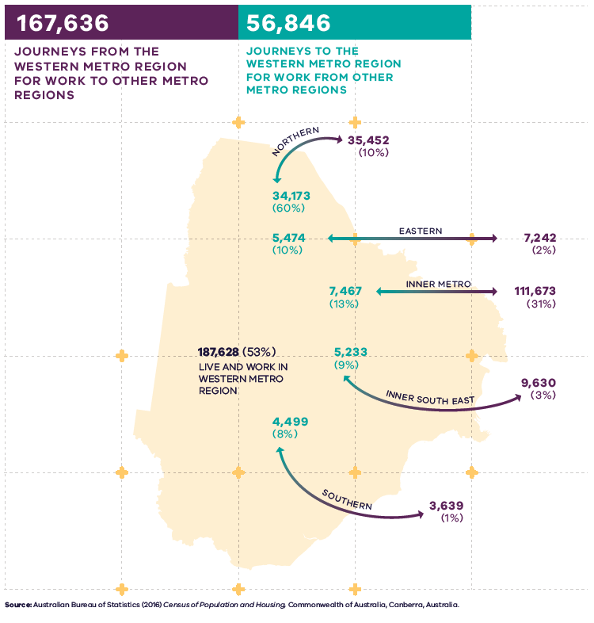
Figure 16. Journey to work in and out of the Western Metro Region
187,628 (53 per cent) live and work in the Western Metro Region | 167,636 – Journeys from the Western Metro Region for work to other metro regions:  - 35,452 (10 per cent) – Journeys to the Northern Metro Region  - 7,242 (2 per cent) - Journeys to the Eastern Metro Region  - 111,673 (31 per cent) – Journeys to the Inner Metro Region  - 9,630 (3%) – Journeys to the Inner South East Metro Region  - 3,639 (1%) – Journeys to the Southern Metro Region | 56,846 – Journeys to the Western Metro Region for work from other metro regions:  - 34,173 (60 per cent) – Journeys from the Northern Metro Region  - 5,474 (10 per cent) – Journeys from the Eastern Metro Region  - 7,467 (13 per cent) – Journeys from the Inner Metro Region  - 5,233 (9 per cent) – Journeys from the Inner South East Metro Region  - 4,499 (8 per cent) – Journeys from the Southern Metro Region
Source: Australian Bureau of Statistics (2016) Census of Population and Housing, Commonwealth of Australia, Canberra, Australia.

Regional strengths
- The region’s competitive advantage in freight and logistics given its position close to industry, transport gateways and major road and rail networks
- Strong freeway and freight network with a need to meet the growing needs of industrial and freight activity in the region, particularly for the Port of Melbourne and Melbourne Airport
- Essendon Airport as a transport gateway, and key interrelationships with Melbourne Airport, Avalon Airport and the Port of Melbourne
- Access improvements from Suburban Rail Loop and Melbourne Airport Rail.

Regional challenges
- Need for improved access between activity centres and employment nodes within and beyond the region
- Lack of coherency and structure to road network and limited north-south transport links
- Underdeveloped road network in greenfield growth areas
- Increasing and forecast road congestion
- Population growth emphasises the need for modal shift, to improve active and public transport, including the bus network
- Achieving positive amenity outcomes around major transport projects such as the OMR and West Gate Tunnel
- Planning for and protecting transport gateways and corridors including the WIFT, Melbourne Airport environs, Essendon Airport, Port of Melbourne environs, and Bay West option and the PFN
- Need to align inter-regional infrastructure investment with local and regional public and active transport improvements
- Poor frequency in rail services for outer train stations.

Directions and strategies
The directions identified to achieve the 2050 vision for the Western Metro Region in terms of integrated transport and Outcome 3 of Plan Melbourne are:
Direction 11 | Strengthen connections to the peri-urban and regional areas, to support their role providing services to the regions
Direction 12 | Improve transport connections to support the productivity of the Western Metro Region
Direction 13 | Improve public and active transport access for Sunshine and Werribee NEICs, metropolitan and major activity centres
Direction 14 | Improve transport connectivity in the Western Growth Corridor and outer suburbs
Direction 15 | Improve active and public transport options to promote mode shift and support 20-minute neighbourhoods
Direction 16 | Support and grow the freight and logistics function of the Western Metro Region
Each direction is implemented through regionally-specific strategies identified in this LUFP.
Map 6 shows how integrated transport will be enhanced across the Western Metro Region by 2050 as a result of these directions and strategies, together with Plan Melbourne and other strategies and initiatives as outlined in Appendix 01.

- Western Metro Region integrated transport 2050
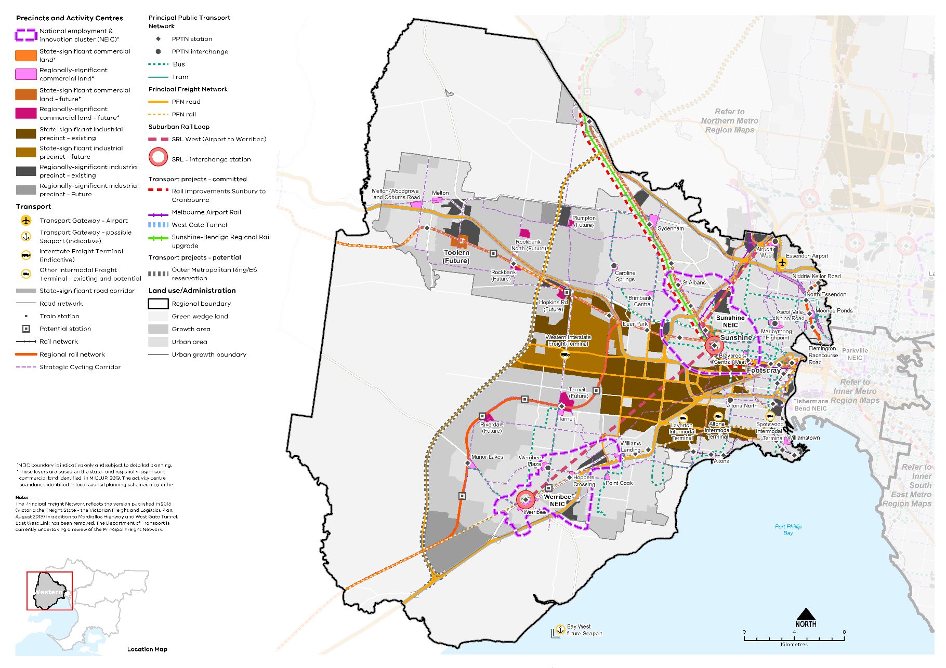

Map 6 Western Metro Region integrated transport 2050
A map showing the key transport features of the region in 2050, as extracted from Map 1, and also highlighting:
- Rail improvements from Sunbury to Cranbourne
- Sunshine - Bendigo Regional Rail upgrade
- PPTN stations and interchanges
- Potential new train stations in the growth areas
- Expanded PFN serving the industrial areas of the region.
Note: The Principal Freight Network reflects the version published in 2013 (Victoria the Freight State - the Victorian Freight and Logistics Plan, August 2013) in addition to Mordialloc Highway and West Gate Tunnel. East West Link has been removed. The Department of Transport is currently undertaking a review of the Principal Freight Network.

- Strengthen connections to the peri-urban and regional areas, to support their role providing services to the regions
Improving connections and collaboration with neighbouring major regional cities, such as Ballarat, Bendigo and Geelong, will boost tourism in the Western Metro Region and position it as a gateway to central Melbourne. Werribee and Melton also provide regional-scale services for catchments beyond the region, including Bacchus Marsh, Lara and other peri-urban areas. As these areas grow, demand for access to these services will increase.
Previously, the rail line connecting Geelong and the Western District to central Melbourne ran through Werribee. Regional Rail Link has improved access to new growth areas and regional areas from central Melbourne however its route means there is now no direct rail link between Geelong and Werribee.
Electrification will enable more frequent and reliable services to meet increased demand to and from Ballarat and Geelong. Other links also need to be strengthened to position the Western Metro Region as a gateway. Priority links to improve movement out of the region include:
- A spur from Regional Rail Link that directly links Werribee to Geelong
- OMR to link the region to Melbourne Airport, Avalon Airport and interstate and regional destinations while also linking residential and employment growth areas in the north and west of Melbourne and improving access to Avalon Airport, Werribee, Melton, Melbourne Airport, Mickleham and Donnybrook
- Potential upgrades to the Calder and Western freeways.
- Provide public transport connections from the region to peri-urban areas, regional areas and via Werribee to Geelong.
- Improve links to Melbourne Airport, Avalon Airport and interstate and regional destinations while also linking residential and employment growth areas in the north and west of Melbourne and improving access to Avalon Airport, Werribee, Melton, Melbourne Airport, Mickleham and Donnybrook via the OMR.
- Improve transport connections to support the productivity of the Western Metro Region
Better transport networks for the Western Metro Region will provide people with more transport choices and make it easier to travel to activity centres and employment nodes. This will reduce congestion on the region’s radial network of freeways and arterial roads including the Princes Freeway and the Western Highway.
The inner and middle areas of the region require a more legible transport network to function effectively and provide transport choices. Between the radial rail corridors, public transport provision can be poor with higher levels of car dependence and increasingly congested road networks. High car dependence also leads to smaller workforce catchments for major employment areas, compromising the ability to attract and retain office-related employment, one of the priorities for the Western Metro Region.
The West Gate Freeway acts as a barrier to access between the north and south of the region and inner areas such as Footscray, Altona and Tottenham which have inefficient and fragmented road networks that need to be improved to reduce congestion and delays. The West Gate Tunnel will provide a second Yarra River (Birrarung) crossing for the region with access to the Port of Melbourne and Melbourne’s CBD. The proposed OMR will further enhance intra-metropolitan regional network connections, cutting through the middle of the region connecting Werribee with Wallan in the Northern Metro Region.
The key regional linkages for the region are shown in Figure 17. Decisions regarding appropriate modes for these links should consider the capacity of existing infrastructure, ongoing sustainability and providing travel choices over a longer time period including evening and late-night travel.
There is a need to improve access to transport gateways and employment hubs beyond the region such as Melbourne Airport and Avalon Airport to complement the future Melbourne Airport Rail. This includes improving connectivity and frequency of public transport services and bus connections from interchange hubs servicing residential areas. Improving access to these destinations will increase employment opportunities for residents in these job-rich locations as well as business-to-business connections. Parts of the Western Metro Region are close to Avalon Airport and this proximity should be leveraged. Rail connections to Avalon Airport could enhance connectivity and redirect movement patterns in and around the region.
A number of priority road projects have been identified for the Western Metro Region including improved north-south connections and connections over freeways such as Palmers Road, Point Cook, Derrimut Road, Truganina and the Duncans Road interchange in Werribee South.
Priority regional public transport improvements and connections are:
- Continuing to progress major improvements in passenger rail by providing additional rail services, such as the Metro Tunnel, which will create a new end-to-end rail line from Sunbury in the west to Cranbourne/Pakenham in the south-east
- The duplication of the Altona Loop and new railway stations
- Melbourne Airport Rail connecting from Melbourne CBD, via Sunshine to Melbourne Airport
- Commuter car parking and bike storage facilities at railway stations
- Greater frequency and availability of after-hours and weekend bus services.
Making active and on-road public transport a real choice for local trips to access activity centres, work and school and stations will provide better and safer local and regional journey choices. This includes improving the amenity of key transport interchanges.
A more cohesive network of active transport connections should be developed in the Western Metro Region, including paths and trails, prioritising the development of Strategic Cycling Corridors where they connect centres, and continuing work to identify and fill gaps in the network within and beyond the region (Figure 18).
Primary routes provide a core network of Strategic Cycling Corridors that connect places of state significance – the Central City, metropolitan activity centres and NEICs within metropolitan Melbourne. Main routes are Strategic Cycling Corridors that provide additional connections to state-significant destinations as well as connections to major activity centres and key railway stations across metropolitan Melbourne.
Priorities include completing a cycling connection between Sunshine, Footscray and Melbourne’s CBD and exploring improvements to north-south strategic cycling connections in the inner west.
- Improve connections for the Western Metro Region to Avalon Airport.
- Plan new infrastructure to better integrate existing and future communities in the west, rather than creating barriers between them.
- Improve connectivity and frequency of public transport services and bus connections from interchange hubs servicing residential areas.
- Locate public transport stops and routes to support late night travel in the Western Metro Region.
- Plan major infrastructure projects and changes to the freight network to reduce the impact on existing urban areas.
- Support cycling for transport through the development of Strategic Cycling Corridors in the Western Metro Region, in particular between Sunshine, Footscray and the CBD and north-south regional connections and to the Western Industrial Precinct.

- Key regional linkages – Western Metro Region
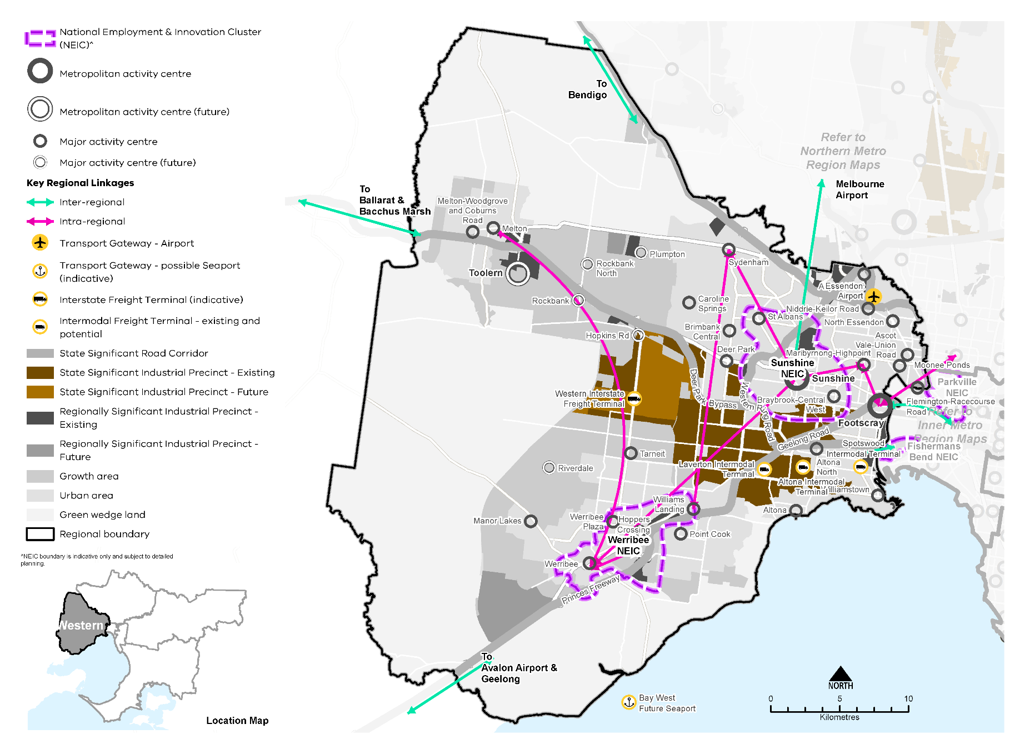

- Strategic Cycling Corridor network – Western Metro Region
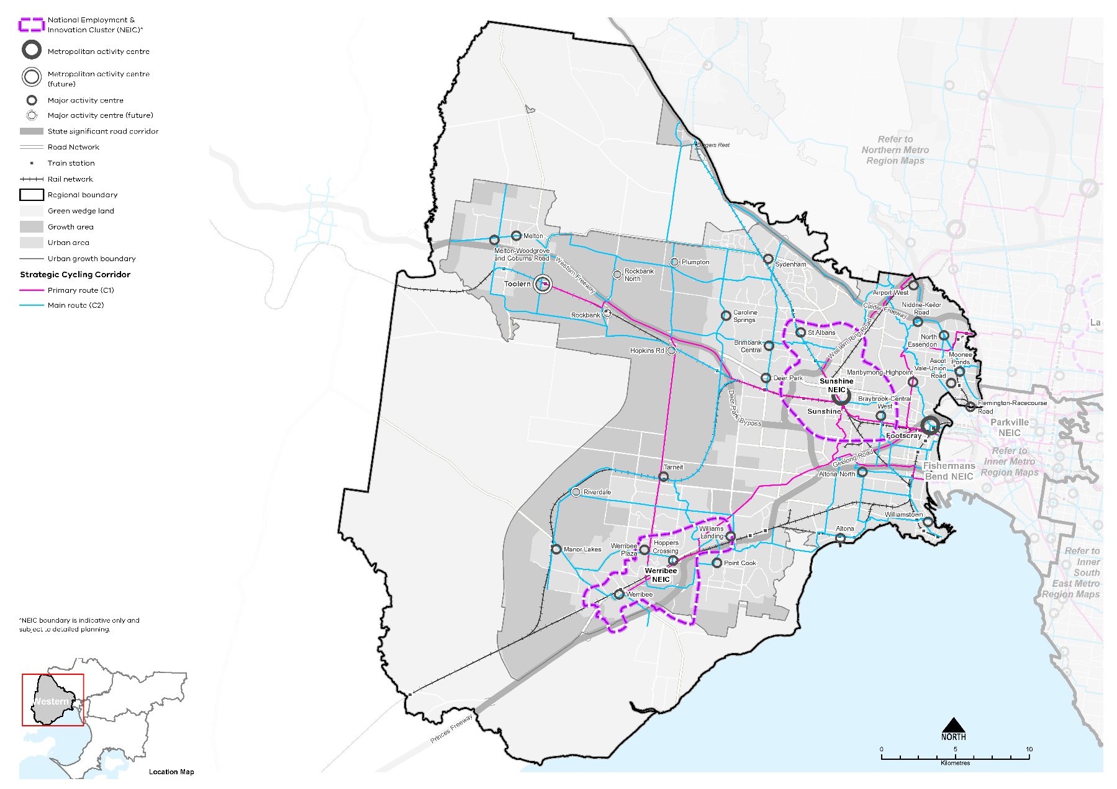

- Improve public and active transport access for Sunshine and Werribee NEICs, metropolitan and major activity centres
Melbourne Airport Rail, SRL and faster rail to Geelong and Ballarat will expand the catchments of the Sunshine NEIC, which includes the Metropolitan Activity Centre, and the Werribee NEIC. These projects will also improve connections for the region’s activity centres and industrial areas.
Emerging employment precincts such as Werribee NEIC and Toolern Metropolitan Activity Centre will provide a greater diversity of jobs for the region and require a transport network that provides high-quality access across the region, including rail and road interchanges, public transport services and well-integrated active transport networks.
SRL will link Werribee, Sunshine, Melbourne Airport and other activity centres in Melbourne. Railway station interchanges at Werribee and Sunshine offer opportunities to catalyse land use change, given the increased accessibility. Furthermore, this investment can support regional and local public transport and active transport linkages. The foundations for an improved bus network should complement planned SRL upgrades to better move people around the NEICs.
Melbourne Airport Rail will connect via Sunshine to the CBD, a further catalyst for land use change. Sunshine NEIC at the confluence of these rail connections will become one of Melbourne’s most accessible destinations with faster trains to allow more people in Melbourne and regional Victoria to access jobs, housing and services in Sunshine. This will support the Western Metro Region’s capacity for growth compared to other regions.
There is an opportunity to improve the connectivity of the Sunshine NEICs’ various economic assets. This includes improving connectivity of the Sunshine Health, Wellbeing and Education Precinct to the Sunshine Metropolitan Activity Centre, facilitating integration between the nearby industrial precincts and the developing River Valley precinct within the NEIC, as well as broader strategic connections between Sunshine and Maribyrnong-Highpoint Major Activity Centre.
- Provide high-quality public transport access to job rich areas such as Footscray, Sunshine and Toolern metropolitan activity centres, major activity centres, the SSIP and the Werribee NEIC.
- Improve bus service connectivity prior to the delivery of the Suburban Rail Loop.
- Ensure the planning and design of Suburban Rail Loop maximises opportunities for active transport connections.
- Improve the amenity, walking, cycling and public transport access of the NEICs, activity centres, state- and regionally-significant industrial precincts.
- Provide rail and road interchanges, public transport services and well-integrated active transport networks for emerging employment precincts Werribee NEIC and the Toolern Metropolitan Activity Centre.

- Improve transport connectivity in the growth areas and outer suburbs
While rapid development in the greenfield growth areas is creating greater housing choice and opportunities, employment and services are not keeping up and are mostly in inner areas, often meaning long travel times for residents. For growth area communities, transport infrastructure such as arterial and local roads, rail services and railway stations, bus services and active transport networks will be important.
Development in the growth areas will be supported by three main rail spines:
- Planning for rail services and railway station development along the Melton railway line, including multi-modal integration, to support metropolitan and major activity centres, as well as strategically located park and ride facilities
- A reservation exists for the extension of the existing metropolitan rail line from Werribee to Wyndham Vale
- Regional Rail Link with existing railway stations at Tarneit and Wyndham Vale, and planning for future railway stations at Truganina, Davis Road, Riverdale and Black Forest Road in the longer term.
Higher-density and mixed use development opportunities are focused along these rail lines.
Public transport networks also need be improved to link the two parts of the growth corridor through the western part of the Western Industrial Precinct. The northern part of the corridor will need to be served by high-quality transport that links new urban areas north and south of the Melton railway line to stations and activity centres. Planning for higher capacity public transport, initially in the form of SmartBus-type services, but with the potential to be upgraded to a higher capacity transport mode will be undertaken. Local bus networks will also be planned for as part of preparation of the PSPs.
Planning for the growth areas will deliver a new grid of north-south and east-west arterial roads, crossing the OMR and Western rail/freeway corridor. These roads will provide critical links between communities, and to housing, jobs and services. Sections of the arterial road network requiring further planning include the east-west arterial road network across the OMR, north of the Western Freeway, including a possible new interchange and a potential crossing to service the PPTN, and the future arterial road network and its relationship to the Princes Freeway and Regional Rail Link.
Existing and new employment locations in the growth areas will need to be linked to public and active regional and local transport networks as they are developed. As trunk transport infrastructure is delivered, these also need to be linked to regional and local public and active transport networks.
Some of Melbourne’s growing western suburbs are serviced by regional rail lines. Electrification of the Ballarat and Geelong rail lines to Wyndham Vale and Melton will increase service frequency and reliability, resulting in improved transport choices and faster and more reliable travel. Likewise, the Sunbury rail line frequency would benefit from improvements to frequency to reflect other metropolitan services.
A network of potential local bus routes is planned for as part of the preparation of PSPs in the growth areas. Bus services need to be better integrated with sequenced land use planning to encourage public transport use and lessen car dependency.
Existing bus services requiring improvement include along Melton Highway from Toolern to Watergardens to new estates without a bus service. Other activity centres needing better bus connections between them include Caroline Springs, Plumpton, Rockbank and Toolern.
- Improve arterial road connections in the greenfield areas and outer suburbs to support improved travel times, safety and reliability.
- Improve outer suburban public transport, particularly the bus network, to ensure integration with sequenced land use planning and development.
- Plan local bus networks as part of preparation of the PSPs.
- Link trunk transport infrastructure to regional and local public and active transport networks.

- Improve active and public transport options to promote mode shift and support 20-minute neighbourhoods
Access to public transport varies significantly across the region as shown in Figure 15. Inner areas and areas along railway lines have better foundations for 20-minute neighbourhoods whereas outer areas have poorer access to public transport leading to car dependence.
Improvements to transport options including bus, cycling and pedestrian access are needed to support the delivery of 20-minute neighbourhoods. Thirty-eight per cent of people in the region used a car when making a short trip under 5 kilometres in the region, whereas 26 per cent of people walked, and only 2 per cent of people cycled for short trips (DELWP, 2021b). To reduce dependence on private vehicles, public transport, cycling and walking need to be more accessible. This means significant upgrades to public transport access, and improvements to pedestrian and cycling accessibility, better linking neighbourhoods to employment, and social and community services.
New communities in the growth areas are planned around new major activity centres such as Mt Atkinson, Plumpton, Rockbank North and South in the Melton corridor, and along Regional Rail Link at Tarneit, Riverdale and Wyndham Vale in Wyndham. Each will be accessible by multiple transport modes and should be planned to support 20-minute neighbourhoods. Continued and innovative development of the bus network is a priority for communities living in the growth areas who have the least access to public transport in the region. Local travel options must be elevated in planning for activity centres and regional health and education destinations and between centres in the region.
As the metropolitan activity centres of Footscray, Sunshine and Toolern undergo change to a more compact urban form, they will require active transport networks that logically connect with public transport nodes. In established higher-density locations, networks should better connect with existing cycling and walking infrastructure to fill transport gaps.
- Provide active and public transport in new growth area communities.
- Create a network of walking and cycling links for local trips that link to public transport
- Provide a connected activity centre network through public and active transport.
- Create pedestrian-friendly neighbourhoods by enhancing major pedestrian links and expanding the network.
- Prioritise sustainable transport in activity centres and health and education precincts to support higher-density mixed-use walkable precincts.
- Provide walking and cycling routes and drop-off zones to health and community services and recreation facilities.
- Support and grow the freight and logistics function of the Western Metro Region
The Western Metro Region’s intermodal transport links and significant logistics hubs provide essential links to international markets and domestic markets.
The proposed WIFT at Truganina will be an important future asset for the distribution of freight from industrial and commercial production in the Western Metro Region linking to interstate freight networks and international markets via the Port of Melbourne. It will include a rail freight terminal, modern terminal facilities and a warehousing precinct that will improve the efficiency of freight distribution within the region. It will also reinforce the important role of the region in the national freight and logistics network.
Industrial areas within the region need to be appropriately planned to ensure there is high-quality arterial road access and freight rail connections to the future WIFT. Planning for the WIFT will also need to designate a preferred rail corridor to support the Western Industrial Precinct and the future freight terminal. It will also need to link with the proposed OMR.
Bay West (on Port Phillip Bay, south of the Werribee River mouth near Werribee) is the preferred location for a new container port once the Port of Melbourne reaches capacity of 8 million TEU (cargo capacity) around 2055 (Infrastructure Victoria, 2017). The site is also well suited to becoming Melbourne’s future port in the longer term.
The success of major industrial precincts such as WIFT and the future Bay West relies on coordinated state and local government land use and transport planning to ensure appropriate protections for future industrial use and to leverage the economic value of private sector investment. Early planning protections and risk mitigations for both WIFT and Bay West will be critical to reduce the potential for urban amenity impacts from noise and air pollution.
The PFN provides transparency to local government and the wider community regarding the primary way goods will be moved throughout the region. This allows government to consider freight needs during the planning process to protect the end-to-end freight journeys from conflicting land uses or use tools to mitigate environmental or amenity risk through planning permit requirements.
The PFN should also be used to support a more consistent approach to land use planning in freight precincts and corridors – such as protecting buffer zones – to manage potential negative amenity impacts.
- Reserve and protect the land and its freight connections for WIFT and Bay West from the encroachment of sensitive or conflicting land uses.
- Manage the impact of changing transport access for industrial land in the inner west ahead the completion of the West Gate Tunnel Project.
- Plan for the WIFT as a major precinct that will integrate with the surrounding area and adjoining transport network.
- Minimise negative impacts of major transport improvements such as the OMR and West Gate Tunnel Project on urban amenity.
- Ensure high-quality arterial road access and designate a preferred rail corridor for the WIFT.

Actions – Integrated transport
- Investigate barriers and opportunities to increase public and active transport mode share across the region to support culture change, spread demand on transport infrastructure, reduce greenhouse gas emissions and support 20-minute neighbourhood outcomes. Identify trial locations in the region to focus the investigation.
- Undertake a review of the regional bus network to support regional access and movement in the short and medium terms. This should include:
- early planning of integration with major public transport changes including Suburban Rail Loop, Melbourne Airport Rail
- future bus networks in the growth areas, and
- bus infrastructure for late night travel options.
- Review the Principal Public Transport Network for the growth areas.

Chapter 07.
Liveability
Plan Melbourne Outcome 4: Melbourne is a distinctive and liveable city with quality design and amenity
‘Liveability’ is about the things that enhance people’s quality of life. For many years Melbourne has been regarded as one of the world’s most liveable cities due to its social and economic stability, diverse communities, distinctive heritage, high level of amenity and the opportunities it provides for a rich social and cultural life.
Plan Melbourne aims to maintain and extend the city’s liveability by celebrating its culture, diversity and distinctiveness. The challenge ahead is to design and plan for a future city that protects the best aspects of the natural and built environment, supports social and cultural diversity, and creates a strong sense of place.
The Western Metro Region is renowned for its distinctive and varied landscapes, which have high amenity, tourism and biodiversity values. The region has high cultural significance for Aboriginal people and a rich post-European settlement heritage. Its regional-scale open spaces and biodiversity areas include major waterways, the Port Phillip Bay coastline and grasslands of the Western Plains. It is vital that places of natural and cultural value are protected into the future. This is particularly important given the projected population growth in the region whereby these places may come under increasing pressure either for visitation or redevelopment.

State of play

Landscapes and biodiversity
The Western Metro Region is defined by its open and flat topography which is punctuated by volcanic hills and cones, rivers, creeks and valleys. Mountain ranges define the region’s northern extent, with the coastline of Port Phillip Bay defining the region to the south.
The region’s key landscapes and biodiversity areas are described in Table 13.
Key landscapes and biodiversity areas in the Western Metro Region
Landscape and biodiversity area | Significance, protection, and management
Port Phillip Bay coastline | The region’s coastline features beaches at Williamstown, Newport and Altona, wetlands, estuaries, cliffs and coastal reserves. Places of high significance include Truganina Coastal Parklands, Cheetham Wetlands and Point Cook Coastal Park and Marine Sanctuary.
Wetlands | The Cheetham Wetlands and Western Treatment Plant form part of the Port Phillip Bay (Western Shoreline) and Bellarine Peninsula Ramsar Site which is recognised as a wetland of international significance.
Victorian Volcanic Plains | The Victorian Volcanic Plains is a widespread area of natural temperate grasslands which stretch from Melbourne to the South Australian border and encompass the northern and the western parts of the Western Metro Region.  The plains are home to the contiguous Western Plains Grasslands ecosystem. They are the largest remnant of volcanic plains grasslands in Australia which also include ephemeral wetlands, waterways, red gum swamps, rocky knolls and open grassy woodlands. The Western Grasslands Reserve has been set aside to protect this highly valuable ecosystem and will eventually total 15,000 hectares.
Mountain foothills and volcanic cones | The topography rises up in northern parts of the region into the foothills of the Toolern Vale Hills and the Pyrete Range. Volcanic cones of Mount Cottrell, Mount Kororoit and Mount Atkinson punctuate the flat topography of the volcanic plain. These elevated areas provide expansive views across Melbourne and Port Phillip Bay.
Waterways | The Western Metro Region features a network of creek corridors throughout its green wedges, growth corridor and urban areas.  The five major natural waterways that run through the Green Wedge are the Laverton Creek, Skeleton Creek, Lollypop Creek, Little River and Werribee River.  These waterways provide significant habitat for land and aquatic species, such as the Growling Grass Frog, and in many places form part of the existing, or potential future, connected open space system through existing urban areas, green wedges and growth areas.  The open spaces formed around the landscape features of the Maribyrnong and Werribee river corridors and the coastline of Port Phillip Bay are identified in Plan Melbourne as regionally-significant networks of water’s edge parklands.
Werribee River | The Werribee River is also a significant ecosystem which features river red gums, the Graham’s Reserve estuary, the K Road Cliffs, and spectacular views across its flood plain to the You Yangs and Brisbane Ranges.  The Growling Grass Frog inhabits a section of the growth corridor along the lower Werribee River. Land will continue to be acquired where possible to create a 15,000 hectare parkland to protect and manage this landscape.
Forested areas | Areas of heavily vegetated forest exist within the region, located across hilltops or near waterway corridors. These forested areas are important enclaves of remnant indigenous vegetation. Forested areas also include a section of the Lerderderg State Park which is located within the western part of the region.  Other areas which have federal or state protected flora and fauna include Djerriwarrh Creek, Toolern Vale Hills and Long Forest Flora and Fauna Reserve which contain important remnant native Mallee vegetation.
The waterways, numerous small tributaries and wetland areas of the Western Metro Region include areas of cultural heritage and provide habitat for significant native flora, native frog and fish species, and other fauna. Waterways ultimately discharge into Port Phillip Bay, including the Western Shoreline internationally recognised Ramsar wetlands. This necessitates a high level of control over the quality and quantity of surface water and discharge. Opportunities exist to create biodiversity corridors between waterways, utilising public or private land.
Waterways in the region’s urban areas have been heavily impacted by development and industry which has resulted in the loss of habitat and contamination in some areas. The Waterways of the West Action Plan (to be released in 2021) is a plan to protect and rehabilitate rivers, creeks and coastal wetlands, including the Maribyrnong (Mirrangbamurn), Moonee Ponds (Moonee Moonee) and Werribee (Wirribi Yaluk) catchments and their parklands.
It will include a community-developed vision, promote the waterways’ amenity and significance and ensure the Traditional Owners are included in management and planning. It will identify opportunities for revegetation, improved open space and new connections.

Aboriginal cultural heritage
The lands that now make up the Western Metro Region feature places and waterways which have cultural significance and continuing connection for Traditional Owners, illustrated in recognised locations of Cultural Heritage Sensitivity (Figure 19).
The Wadawurrung people, represented by the Wadawurrung Traditional Owners Aboriginal Corporation, are the recognised Traditional Owners of the southwest part of the Western Region. The Wurundjeri people, represented by Wurundjeri Woi Wurrung Cultural Heritage Aboriginal Corporation, are the recognised Traditional Owners of the north of the region. The Bunurong Land Council Aboriginal Corporation are the recognised Traditional Owners of the southeast part of the region. As Registered Aboriginal Parties (RAPs), these corporations have responsibilities to protect cultural heritage assets under the Aboriginal Heritage Act 2006.

- Western Metro Region Aboriginal cultural heritage
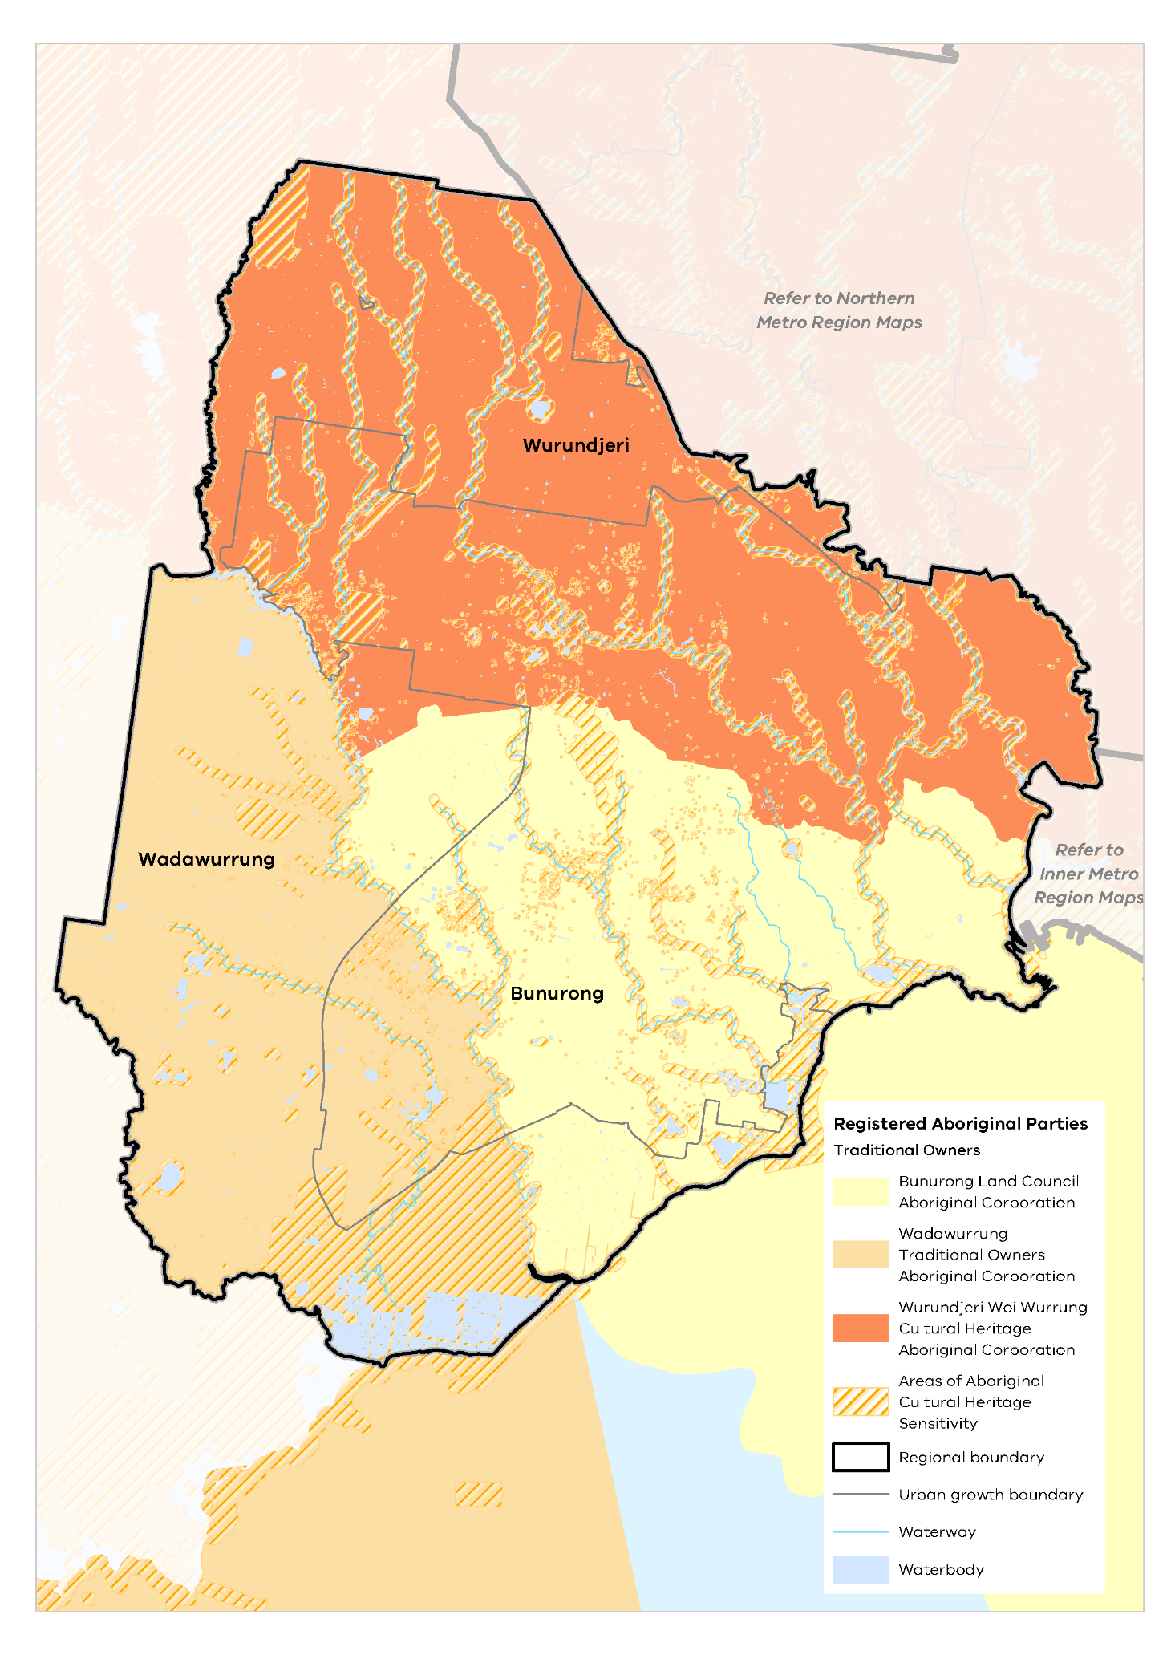

Heritage and visitor places
Heritage sites in the Western Metro Region mark historic and culturally significant events and places, reflecting the region’s diversity and providing a range of cultural experiences. Key cultural assets that contribute to the character of the region include the Werribee Mansion, Overnewton Castle and historic Keilor Hotel, Jack’s Magazine and the 19th century streetscapes and maritime heritage of Williamstown. The region’s industrial and agricultural legacy, as well as its gateway role to pastoral areas in regional Victoria, is reflected in heritage-protected places such as its historic factories, bridges and infrastructure. Early hotels, which began their lives as wayside stops or places of accommodation for travellers, are still evident today. The highly distinctive dry stone walls and European ‘shelter belts’ (lines of large-scale trees to protect against the wind) criss-cross the remaining areas of rural landscape, representing its agricultural history. The inner western suburbs also feature riverside industrial development, Victorian villa housing and strip shopping streets integrated with railway stations and prominent hotels.
Heritage protection is provided to individual properties, streets and precincts within the region and these places are integral to its character and identity today. There are over 110 places of state heritage significance listed on the Victorian Heritage Register, as shown in Map 7. These include a wide range of sites: major water infrastructure for metropolitan Melbourne of the Main Outfall Sewer, water supply systems and tanks; homesteads, pastoral runs and farm buildings, such as Eynesbury Homestead and Werribee Mansion; stone bridges, trestle bridges and railway viaducts; churches, schools, civic buildings; factories and warehouses; residential development.
The cultural heritage of the region contributes to its sense of place and provides opportunities for developing the visitor economy. Tourism assets include Werribee Zoo, Werribee Township Regional Park, Scienceworks, Seaworks, The Substation in Newport and the beaches of Altona, Williamstown and Point Cook. The Ramsar wetlands at Western Treatment Plant is a significant nature-based tourism asset for the region.
Arts and creative activities provide opportunities for community expression, innovation and improved health and wellbeing. Emerging creative hubs include a range of events, places and spaces, such as the Wyndham Arts Incubator, the Clocktower Centre, Hunt Club Community Arts Centre and Gallery and the Footscray Community Arts Centre. There are opportunities for the Western Metro Region to continue to expand its vibrant arts and cultural community; this is particularly important in creating a sense of community and place within the new growth area neighbourhoods.

Open space and regional trails
The Western Metro Region provides for an average of 72.9 square metres of public open space per person, which is greater than the metropolitan average of 57.5 square metres However, there are significant differences in provision of open space between each LGA, ranging from 107 square metres per person in Hobsons Bay LGA to 41.8 square metres within Maribyrnong LGA. Open space per person for the Western Metro Region LGAs is shown in Figure 20. Open space per person across metropolitan Melbourne is shown in Figure 21.

- Open space per person for Western Metro Region LGAs
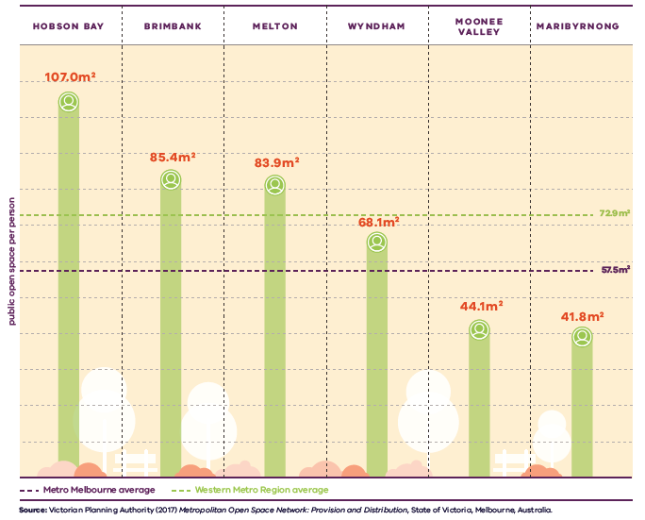

Figure 20. Open space per person for Inner Metro Region LGAs
Metro Melbourne average | 57.5 square metres public open space per person
Western Metro Region average | 72.9 square metres public open space per person
Hobsons Bay | 107.0 square metres public open space per person
Brimbank | 85.4 square metres public open space per person
Melton | 83.9 square metres public open space per person
Wyndham | 68.1 square metres public open space per person
Moonee Valley | 44.1 square metres public open space per person
Maribyrnong | 41.8 square metres public open space per person
Source: Victorian Planning Authority (2017) Metropolitan Open Space Network: Provision and Distribution, State of Victoria, Melbourne, Australia.

- Open space per person for metropolitan LGAs
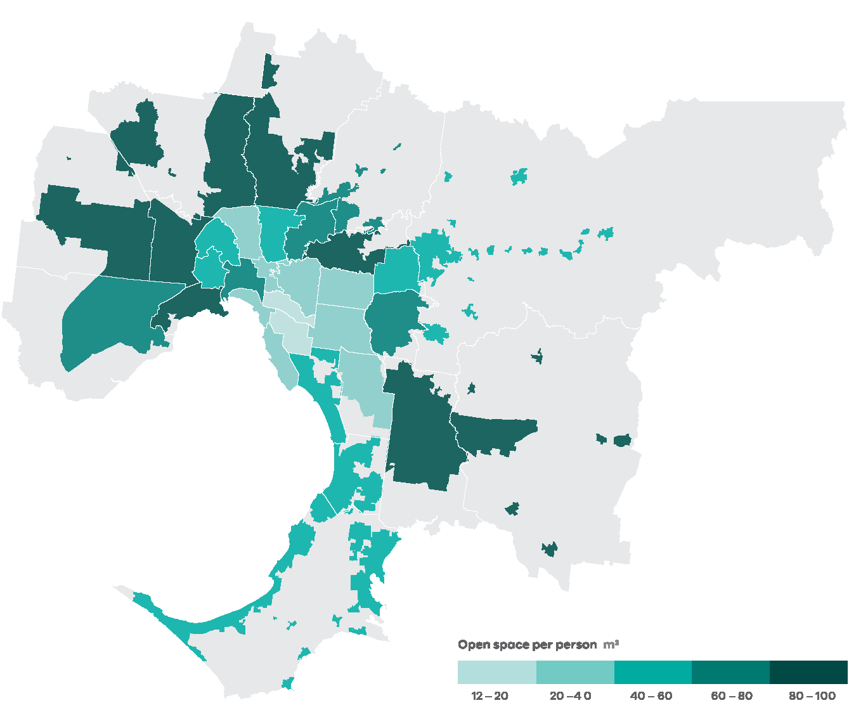
Data from the Victorian Planning Authority Metropolitan Open Space Network portal, 2016
Note: only areas within the UGB were calculated and mapped in this figure. Areas outside the UGB are shown in grey.

While the quantity of open space is one measure of provision, the function, mix, quality, accessibility and proximity of open space also need to be considered.
There are several major projects underway to improve open space opportunities and link open space networks across the Western Metro Region.
The Greening the Pipeline project will create a new 27-kilometre parkland along the heritage-listed Main Outfall Sewer between Spotswood and Werribee, which currently comprises the Federation Trail. The project is being undertaken in sections and aims to ultimately transform the reserve into a green corridor, community space and active transport connection. The pilot section at Williams Landing has been completed.
The metropolitan open space strategy Open Space for Everyone: Open Space Strategy for Metropolitan Melbourne 2020 identifies additional regional open space initiatives for the Western Metro Region:
- Through the suburban parks program, land will continue to be acquired to create proposed new regional parklands to support growing communities: Toolern Regional Park at Melton (110 hectares); Werribee River Park at Wyndham (276 hectares); Kororoit Creek Regional Park (260 hectares, including both grasslands conservation areas and active open space); and Werribee Township Regional Park (340 hectares)
- Zone 5 of the Greening the Pipeline project, a 3.8 kilometre section between Lawrie Emmins Reserve and Skeleton Creek in Wyndham
- Opportunities for improved open space and connections of significant waterways identified in The Waterways of the West Action Plan
- A review of public racecourses which will examine ways of optimising the public use of this land for other recreational opportunities including Moonee Valley and Flemington racecourses.
The Western Metro Region has an extensive network of interconnected trails located along creek corridors, freeway reservations and the coastline which are used for commuting and active recreation. Local councils within the region have identified opportunities to improve the trail network through the West Trails Strategy. A key priority is to improve the Federation Trail as a major east-west cycling route that connects Werribee to the CBD and joins with other north-south links such as the Werribee River Trail and Kororoit Creek Trail.

Regional strengths
- Distinctive landscapes and environmental assets of volcanic plains and cones, grasslands, waterways, clusters of forest, wetlands and coastline.
- Opportunities to work with Traditional Owners to protect and enhance the region’s unique landscapes, cultural heritage, environmental assets and biodiversity values, including its waterway corridors and green wedge areas.
- Significant opportunities for tourism and cultural development to create vibrant, attractive urban environments.

Regional challenges
- Need for additional open space, or improved access to open space, particularly by walking and cycling.
- Ongoing protection of the region’s natural, built and cultural heritage given the pressure for development, particularly in growth areas.
- Lack of access to and diversity of community and cultural facilities to meet the needs of the region’s communities and visitors.
- Need to improve parks and walking and cycling networks to give people better access to the region’s diverse landscapes and promote active living.

Directions and strategies
The directions identified to achieve the 2050 vision for the Western Metro Region in terms of liveability and Outcome 4 of Plan Melbourne are:
Direction 17 | Draw on the region’s cultural heritage to create its future sense of place and identity
Direction 18 | Protect and enhance the landscapes and biodiversity of the Western Metro Region
Direction 19 | Strengthen the open space network to support community access and connection to nature
Direction 20 | Create a legacy of great public spaces
Each direction is implemented through regionally-specific strategies identified in this LUFP.
Map 7 shows how liveability will be enhanced across the Western Metro Region by 2050 as a result of these directions and strategies, together with Plan Melbourne and other strategies and initiatives as outlined in Appendix 01.

- Western Metro Region liveability 2050
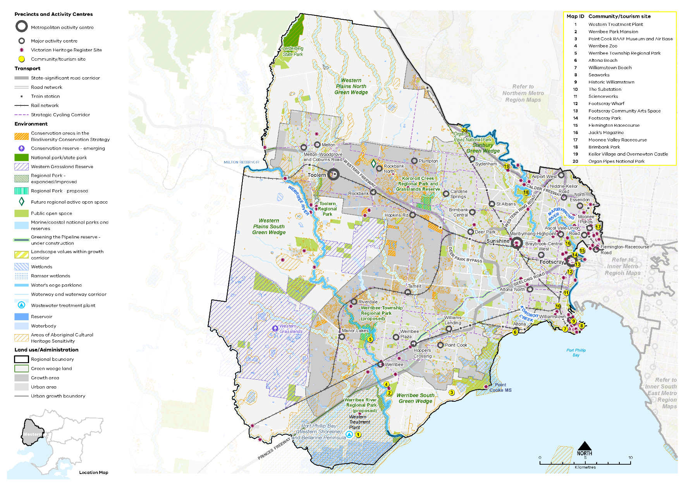

Map 7 Western Metro Region liveability 2050
A map showing the key environmental and cultural features of the region in 2050, as extracted from Map 1, and also highlighting:
- The Maribyrnong and Werribee Rivers and Kororoit Creek
- The Werribee South Green Wedge, Western Plains South Green Wedge, Western Plains North Green Wedge, and Sunbury Green Wedge
- Lerderderg State Park
- The Kororoit Creek and Toolern Regional Parks and the proposed Werribee River Regional Park and Werribee Township Regional Park
- The Western Grasslands and Kororoit Creek Grasslands
- Point Cooke Marine Sanctuary
- Areas of landscape value within growth corridors
- Future regional active open space at Kororoit Creek northwest of Rockbank North
- Greening the Pipeline linear open space
- Community / tourism sites at:
- Western Treatment Plant
- Werribee Park Mansion
- Point Cook RAAF Museum and Air Base
- Werribee Zoo
- Werribee Township Regional Park
- Altona Beach
- Williamstown Beach
- Seaworks
- Historic Williamstown
- The Substation
- Scienceworks
- Footscray Wharf
- Footscray Community Arts Space
- Footscray Park
- Flemington Racecourse
- Jack's Magazine
- Moonee Valley Racecourse
- Brimbank Park
- Keilor Village and Overnewton Castle
- Organ Pipes National Park
- Areas of Aboriginal Cultural Heritage Sensitivity frequently, but not always, associated with the coastline, rivers, creeks and water bodies
- Victorian Heritage Register sites predominantly, but not limited to, the east of the region, around Williamstown, and along the Maribyrnong and Werribee Rivers and Kororoit Creek.

- Draw on the region’s cultural heritage to create its future sense of place and identity
The Western Metro Region’s rich cultural heritage provides a strong legacy for creating distinctive places which foster community pride and a sense of place.
For the Wadawurrung people, partnerships in Caring for Country must be guided by principles that include: respect and acknowledgement for Wadawurrung Traditional Owners’ cultural, ancestral, spiritual and historical connections to Country; Wadawurrung people’s right to access and care for Country as an expression of their cultural obligation, responsibilities connectedness, well-being and as their economic basis; and that Country is interconnected, alive with dreaming and creation stories, imprinted with cultural values and social history – there is no separation between cultural and natural resources and people.
Further engagement with Traditional Owners is important to fully recognise the cultural significance of places and landscapes (such as the Maribyrnong River, Kororoit Creek, Laverton Creek, Skeleton Creek, Lollypop Creek, Stony Creek and Moonee Ponds Creek). Places will be protected by collaborative efforts between new and existing stakeholders and all tiers of government (including Aboriginal Victoria and catchment management authorities).
The Waterways of the West project will enable Traditional Owners to play a key role in determining the ongoing management of these environments. It will also set the foundation for the integration of waterways into the urban environment as linked parkland and amenity corridors, and for establishing future planning controls to protect them from development impacts.
The post-European settlement heritage of the Western Metro Region is also an integral aspect of its environment and reflects a diversity of social values and customs. The region’s legacy of agriculture and industry, as well as its role as a gateway to western Victoria, can be seen in the port facilities, historic factories, warehouses and silos which remain today.
Planning for places of cultural heritage sensitivity and post-settlement heritage is vital given the pressure for urban expansion and redevelopment across the region.
Providing community gathering places and spaces for festivals and events will further activate local areas. Alongside their intrinsic value, cultural assets and events also enhance the visitor economy and add to the vibrancy of the Western Metro Region. The region’s history needs to be protected for the way it contributes to a sense of place as well as visitor economy opportunities.
- Reflect the different layers and aspects of the region’s history in the design of its major buildings, new communities and public spaces.
- Support places of assembly and multi-use community spaces to provide for community gatherings, festivals, arts and events in the established urban areas and the growth areas.
- Work with Traditional Owners, stakeholders and government to identify and protect places of cultural heritage significance.

- Protect and enhance the landscapes and biodiversity of the Western Metro Region
The distinctive and diverse landscapes of the Western Metro Region – volcanic plains and cones, grasslands, mountain ranges, remnant forests, waterways and coastline – contribute to its character and liveability, its biodiversity and the health and wellbeing of its residents.
Throughout the region, the cultural and environmental values of its landscapes and biodiversity areas should be protected from the visual impact of development or infrastructure. While many of the key landscapes in the region, including large areas of grasslands, major waterways and the coastline, are protected through existing legislation and planning policy, some aspects of the landscape and environmental significance require greater protection and management.
The region’s four green wedge areas of the Western Plains North, Western Plains South, Werribee South and Sunbury (part) contain a mix of non-urban uses providing important natural resources, food resources, essential infrastructure and industries, as well as lifestyle housing options and recreational assets. These natural landscape features and parts of the green wedge areas have high amenity and biodiversity values that must be protected.
The Western Growth Corridor contains extensive sites of significant biodiversity value. The Melbourne Strategic Assessment is an agreement with the Commonwealth to set aside land with the highest biodiversity values from urban development within Melbourne’s growth corridors. These areas are listed in the Biodiversity Conservation Strategy for Melbourne’s Growth Corridors (2013) and protected through Commonwealth legislation (shown on Map 4). Their biodiversity values are managed for the long-term through the precinct structure planning process to preserve their intrinsic conservation and biodiversity values. Preserving conservation areas of a sufficient size to support diverse species and which are linked to other conservation areas is often critical to biodiversity outcomes.
Within the Western Growth Corridor large areas of habitat remain for threatened fauna species of the Golden Sun Moth, Growling Grass Frog and Striped Legless Lizard. Nationally important plants such as Spiny Rice Flower and Large Fruit Groundsel have been identified. Habitat set aside for these species includes the key waterways of the Werribee River, Kororoit Creek and its tributaries, and Lollypop and Davis creeks, as well as Deanside Wetlands and Point Cook Swamp.
Areas of significant grasslands have also been identified. While some are currently protected within reserves or by planning overlays, a much wider area of protection will be achieved in the future through the creation or extension of grasslands reserves. This includes the Western Grasslands Reserve and Kororoit Creek Regional Park Grasslands Reserve.
Important landscape features within the growth corridor should also be protected into the future and incorporated into the design of new neighbourhoods. This includes:
- The region’s waterways which form a natural drainage system and the spine of the open space network connecting different parts of the corridor in both visual and landscape terms. The Werribee River and Kororoit, Skeleton/Dry, Davis and Lollipop creeks are particularly important
- Volcanic cones of Mount Atkinson and Mount Cottrell which are important landscape features within the Western Volcanic Plain. Urban areas will benefit from vistas to these features from a range of vantage points
- Distant views to the CBD, You Yangs, Brisbane Ranges and the Great Dividing Range
- Finer grained and recurring elements across the landscape such as dry stone walls and original 19th century mile grid subdivision pattern which should be incorporated into the new urban landscape where possible
- Retention of the rural character of areas adjoining the UGB. Planning and design along this interface must ensure activities do not adversely impact the function or amenity of the rural edges
- Incorporation of natural wetlands in the planning of new greenfield neighbourhoods.
The Healthy Waterways Strategy 2018-28 is a shared strategy across Melbourne Water, state and local government, water corporations and the community and provides direction towards a regional vision for the health of rivers, estuaries and wetlands in the Port Phillip and Western Port region. It has identified a need to review planning protection of environmental and amenity values for waterways, including around wetlands and headwater streams (Melbourne Water, 2018). The strategy has nominated priority waterways for revegetation to improve waterway health and biodiversity values. Throughout the region, waterways make an important contribution to the sense of place across urban areas, green wedges and growth areas.
The alignment of the OMR road corridor will also affect waterways and flood plains and the passage of fauna through the landscape. These issues will need to be considered in development of stormwater systems servicing the Western Growth Corridor and the management of waterways.
It is important to maintain efforts to support ecosystem resilience in a changing climate including reducing potential impacts from urban uses and providing buffers where possible.
- Work with Traditional Owners to protect and enhance the landscape qualities and biodiversity of the region’s volcanic plains and cones, grasslands, waterways and waterway corridors and coastline.
- Create breaks for vegetation and biodiversity in urban areas and along waterways and natural drainage networks to foster biodiversity links and provide an opportunity for escape to nature.
- Encourage the design of new buildings or neighbourhoods within green wedge areas and growth corridors to respond to the region’s natural landscape features such as waterways and ridgelines.
- Maximise the opportunity to enhance the sense of place by incorporating the region’s waterways into the design of new communities or urban renewal sites in established urban areas.
- Retain natural wetlands in the planning of new greenfield neighbourhoods to achieve significant liveability and biodiversity outcomes.
- Retain the rural character of land adjoining the UGB and provide buffers from areas of landscape or biodiversity sensitivity.

- Strengthen the open space network to support community access and connection to nature
Plan Melbourne envisages a network of accessible, attractive and connected parklands, river corridors and green wedge areas, with shared trail networks. New parklands and cycling trails across the Western Metro Region will help achieve this vision.
Open Space for Everyone: Open Space Strategy for Metropolitan Melbourne 2020 envisions Melbourne as a city with a valued network of open spaces accessible to all, connected at the local and landscape scales. It focuses on innovation and adaptability to provide a diversity of open spaces that meet the needs of the community, while protecting and optimising the region’s existing open space assets.
Current initiatives and investment in the region’s open space network will increase the amount and quality of open space and improve connections across the shared trail network. This includes improved integration of the region’s waterways and Port Phillip Bay coastline within the open space network, new or improved regional parks, and smaller open spaces in activity centres.
An integrated open space network plays a vital role in preserving the region’s natural features, character and heritage, sustaining biodiversity, and nourishing healthy waterways.
Within the Western Growth Corridor, significant opportunities exist to create new active and passive recreation areas to address the open space needs of the broader region. Waterway corridors can serve as important environmental and recreational connections through the growth areas. Where possible, creation of new open space should optimise pedestrian access and recreational trail connections, link existing open spaces or open site frontages to a waterway or parkland.
The proposed Western Grassland Reserves will provide significant passive open space opportunities. Public access to these reserves will focus visitors into areas where the impact on biodiversity can be minimised.
- Facilitate and deliver major new investments in the regional active and passive open space network to respond to increased population and growth.
- Support the regional role of Port Phillip Bay, the green wedge areas, waterways and regional parklands as major open space and recreational assets for liveability, wellbeing and biodiversity.
- Extend the local and inter-regional trail network to connect open spaces with activity centres, residential neighbourhoods and the broader active transport network.
- Ensure urban renewal areas incorporate and provide for open space and recreational opportunities to support the future population in the area.

- Create a legacy of great public spaces
Established areas of the inner west feature many well-loved public spaces, streets and precincts. This includes the Footscray Gardens, Mall and Market, Yarraville village and the Maribyrnong river frontage. Outer areas of Melton and Werribee also have vibrant town centres with key civic and community uses, a pedestrian-focused environment and distinctive character.
Creating distinctive places which foster community pride and a sense of place is essential in new design. This includes renewal of established urban areas, the construction of new transport infrastructure or the planning of new communities within the growth areas. The region’s valued heritage and landscapes should be protected, celebrated and integrated into new design as key aspects of regional difference.
Existing and future activity centres in the Western Metro Region should be planned to support active and vibrant streetscapes and public spaces. The region’s state-significant health and education precincts also have the potential to foster campus style development around walkable and attractive neighbourhoods.
State and local government have a role to play in creating high-quality public places when planning for centres and other public areas in the longer term through structure planning or precinct planning. Enhancing and creating great public spaces and streets should be integral to the future planning of Sunshine NEIC, Werribee NEIC, Footscray and the future Toolern Metropolitan Activity Centre and all major activity centres.
In planning for new communities in growth areas, a sense of place will be enhanced through the design of precincts around and orientated towards existing landscape or cultural features. This includes waterways, biodiversity corridors, volcanic cones, open spaces, grasslands and views to the You Yangs, Brisbane Ranges or Melbourne’s CBD.
Town centres at Tarneit, Sayers Road and Leakes Road (Rockbank) adjoin, or are close to, waterways and can be designed to integrate these waterways into the character of the town. Waterways also provide opportunities for recreational trail connections between communities.
Within existing urban areas, large redevelopment sites should incorporate high-quality urban design and allow for pedestrian streets, open spaces and urban greening.
Major roads and streets can be designed as boulevards or green streets to enhance the sense of place in town centres, gateways or key neighbourhood connections. Design treatment could include wider cross-sections to allow for canopy tree planting, water sensitive urban design (WSUD) and adequate space within medians for separated pedestrian and cycle traffic.
Potential opportunities for creation of new boulevards in the Western Metro Region include:
- North-south connections between Wyndham and Melton via Hopkins and Tarneit roads
- East-west connections via Leakes and Dohertys Roads, Taylors Road and Hume Drive in Tarneit
- A boulevard link from Sunshine and Footscray to central Melbourne via the Ballarat Road corridor.
- Identify, enhance and protect existing places and spaces that have high civic or public value, and which contribute to people’s understanding, interaction and enjoyment of the region.
- Identify opportunities for smaller parks and plazas within all activity centres, and the creation of active street spaces that foster outdoor life and a sense of community connection.
- Enable the creation of new public spaces and active streetscapes within the planning and design of future town centres, such as Toolern Metropolitan Activity Centre.
- Facilitate the creation of active streets, new urban spaces and urban greening within the redevelopment of urban renewal sites within established urban areas.

Actions – Liveability
- Develop a plan to implement a publicly owned and managed network of regional trails and open spaces across the region’s growth corridor, using its natural drainage system where possible to link open spaces, biodiversity areas, waterways and urban areas.
- Prepare a regional biodiversity strategy to protect, manage and enhance habitat corridors and increase their interconnectivity across urban and rural areas.
- Review local planning schemes in the Western Metro Region to ensure protection and enhancement of the landscape and biodiversity values of the region.

Chapter 08.
Strong communities
Plan Melbourne Outcome 5: Melbourne is a city of inclusive, vibrant and healthy neighbourhoods
The Western Metro Region has many of the key attributes of strong, inclusive and healthy communities. However, there are significant parts of the region that have some of the highest levels of disadvantage in metropolitan Melbourne.
Community services, hospitals, educational and cultural institutions and transport infrastructure are all essential to community health and well-being. The provision of these services will need to keep pace with over 900,000 additional people living in the region by 2051.
Taking a regional approach to planning will ensure social infrastructure and open space serve the widest possible catchment and cross-section of people. Plan Melbourne aims to build on the fundamentals of strong, healthy and sustainable neighbourhoods by improving access to and provision of amenity, social infrastructure, health and education, open space and the promotion of walking and cycling options.
Plan Melbourne advocates for the vision of a city of ‘20-minute neighbourhoods’ in which most everyday needs can be met within a 20-minute walk, cycle or local transport trip from home. The established suburbs within the Western Metro Region are well placed to achieve this vision. Realising the hallmarks of 20-minute neighbourhoods in the region’s growth areas will require integrated land use and infrastructure to support liveable, strong communities.

State of play

Community profile
The Western Metro Region has emerged as a multicultural hub in metropolitan Melbourne especially in the Wyndham, Maribyrnong and Hobsons Bay LGAs, where more people (47 to 55 per cent) were born overseas than the average for metropolitan Melbourne (41 per cent) and Victoria (35 per cent) (ABS, 2016). The region is home to diverse communities of post-World War II migrants, many of whom arrived as refugees, and all of whom have contributed to the cultural heritage of the area.
The region also has a high proportion of newly arrived migrants from refugee backgrounds who require additional health and community services to respond to their needs, across all age groups.
As a rapidly growing region, with land designated for future urban growth in the Wyndham and Melton LGAs, population growth is likely to expand in outer suburban areas including Melton, Tarneit, Werribee and Point Cook. Inner areas such as Footscray and Sunshine are also expected to intensify and renew.
The Western Metro Region has an ageing demographic profile in established areas while growth areas typically have a younger age profile. Moonee Valley and Hobsons Bay LGAs have the largest proportion of people of retirement age and the lowest proportion of children. Conversely, Melton and Wyndham LGAs, in the Western Growth Corridor, have the lowest proportion of retirees and the largest proportion of young adults and children.
The Western Metro Region is characterised as having lower levels for crime and drug crime than the metropolitan average, although it experiences higher rates of family violence and child protection issues (DELWP, 2017c).
The Socio-Economic Index for Areas (SEIFA) ranks local government areas according to their relative socio-economic advantage and disadvantage. The 2016 SEIFA rankings for the region are shown in Figure 22. Areas of high disadvantage are evident within both established suburbs, including Footscray, Sunshine, Deer Park, Melton and Werribee, and the rural and growth area communities within the LGAs of Wyndham and Melton. The highest relative levels of socio-economic advantage can be found within and around the suburbs of Essendon, Keilor, Williamstown and Point Cook.

Health and education facilities
The Western Metro Region features 10 public and three private hospitals, but has fewer GP clinics and allied health services than the metropolitan average to provide for the day-to-day, sub-acute health needs of the community.
The region has four major hospitals. Public hospital services are provided by Western Health, which operates Sunshine Hospital (which includes the Western Centre for Health Research and Education in St Albans), Footscray Hospital and Williamstown Hospital (which also includes acute care and an emergency department). Mercy Hospitals operate the Ursula Frayne Mental Health Unit in Footscray and the Mercy Public Hospital in Werribee, while Djerriwarrh Health Services operate Melton Health.
Private hospital services are provided by St Vincent’s Private Hospital Melbourne Limited, which operates St Vincent’s Private Hospital in Werribee, Stanlake Private Hospital Pty Ltd which manages Western Private Hospital in Footscray, and Wyndham Clinic Pty Ltd which operates Wyndham Clinic. These facilities and precincts provide jobs and services to surrounding neighbourhoods and contribute to the development of 20-minute neighbourhoods.
In terms of education, the Western Metro Region has 90 government primary schools and 27 government secondary schools. (DELWP, 2017c) The region features seven university campuses and four TAFE institutions operating across a total of nine sites. This includes Victoria University campuses in Footscray, Sunshine, St Albans and Werribee campuses that are of state significance. Additional education facilities of regional significance include RMIT flight school at Point Cook, and the University of Melbourne satellite Veterinary Hospital campus and University of Notre Dame in Werribee.
Tertiary and TAFE facilities are spread across the region and are in reasonable proximity to the Western Growth Corridor. The proximity of The University of Ballarat, and Deakin University and Gordon TAFE make them accessible to students within the Western Metro Region.

- SEIFA rankings (2016) in the Western Metro Region
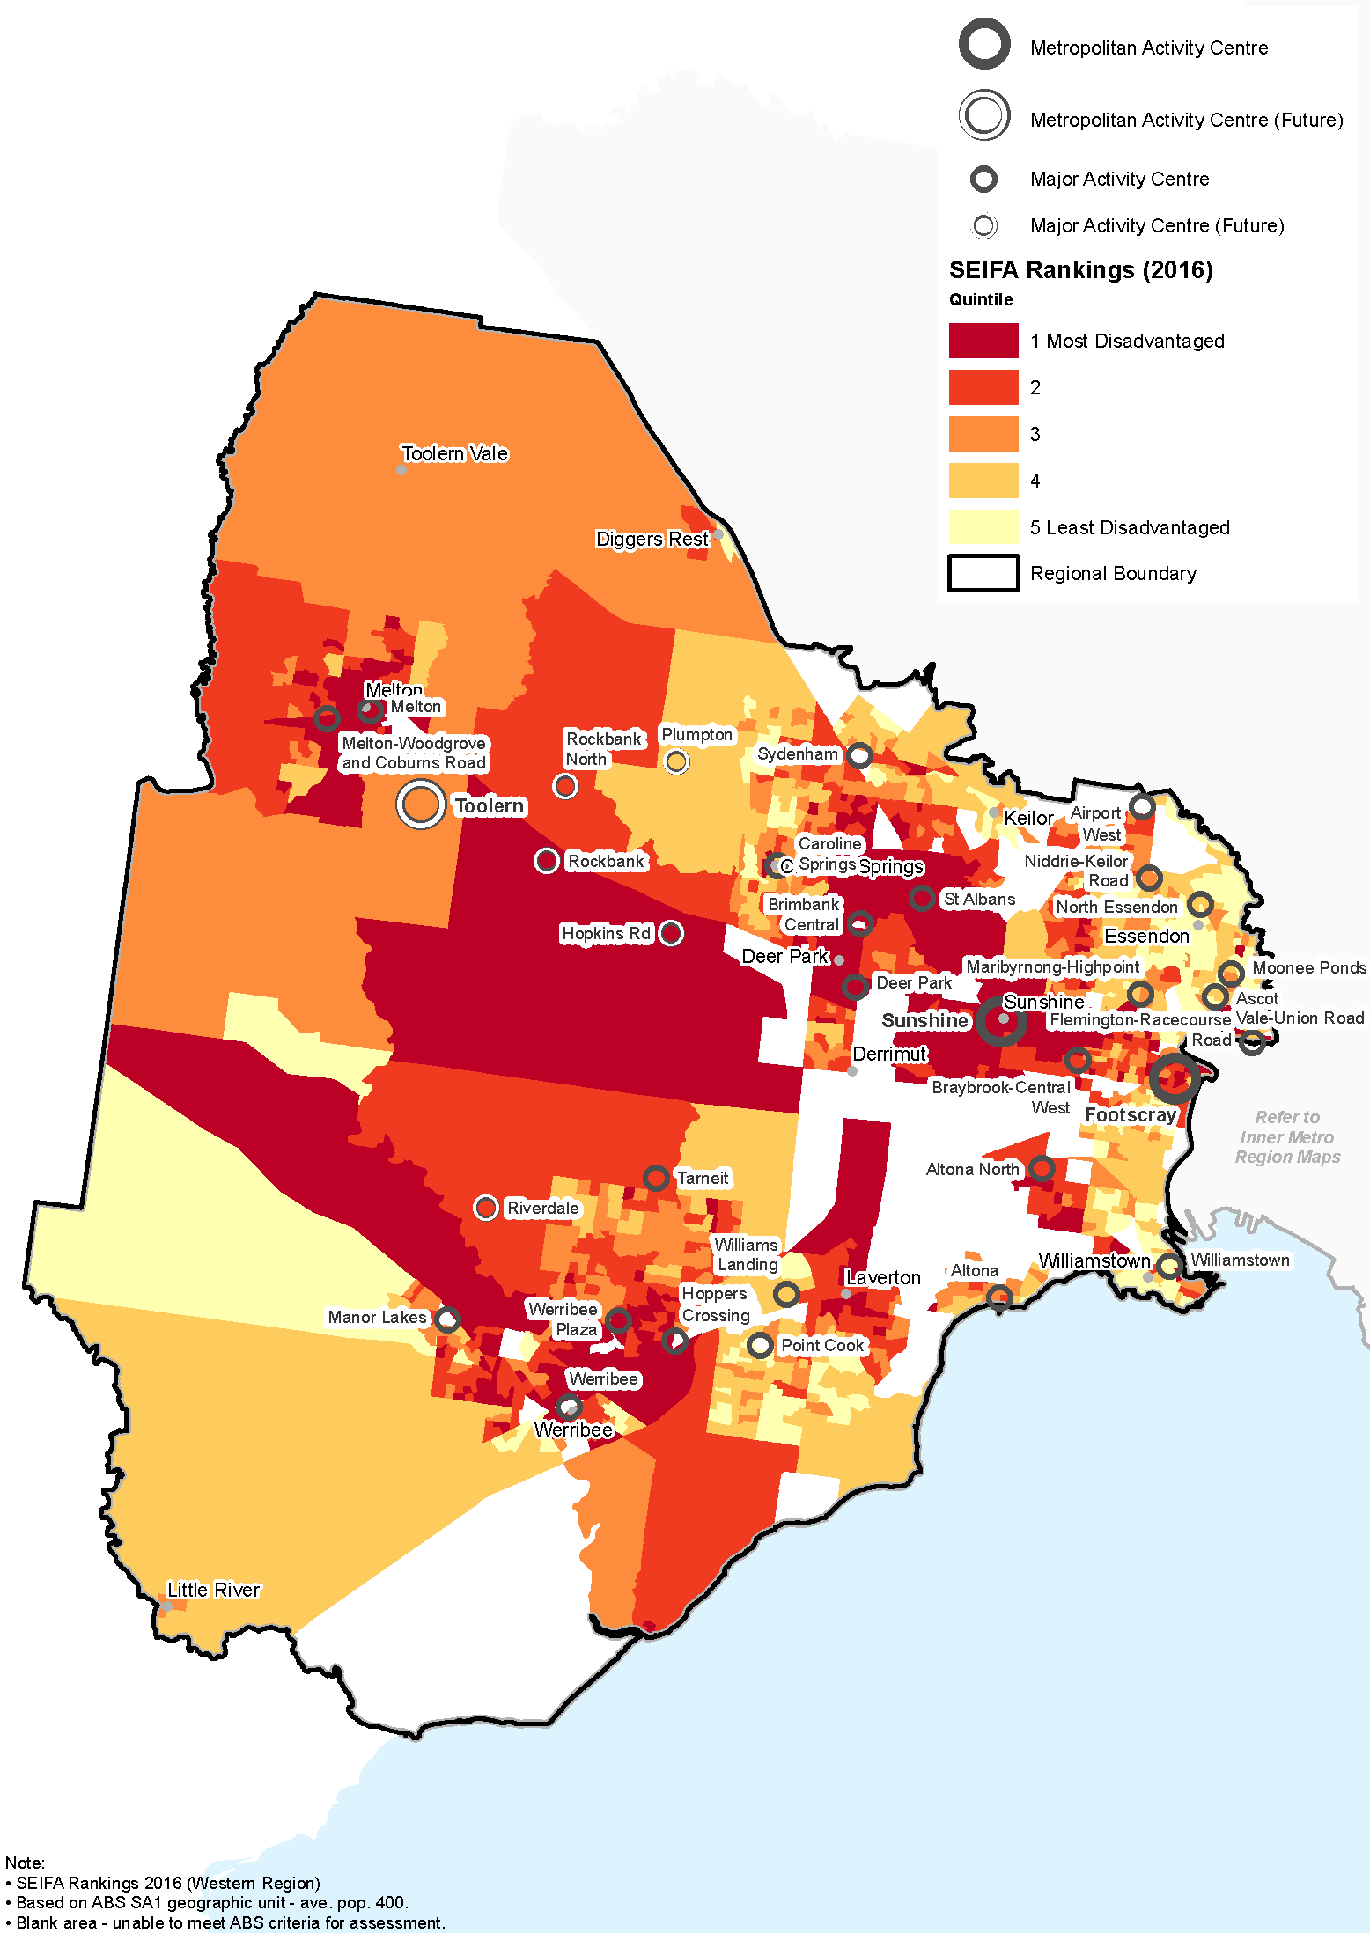

Social infrastructure
Access to social infrastructure varies across the Western Metro Region. Many state and regional facilities are located within the middle and inner urban areas. As the population grows, additional facilities will be required to adequately service new communities within the growth areas.
The region has a range of active recreation and sports facilities and benefits from its natural landscape areas for outdoor activities, especially along the Port Phillip Bay coastline. It is home to over 20 significant recreation facilities which serve the local population and beyond with a wide range of sports and active recreation opportunities.
Major sporting and active recreation assets include the Werribee Park Equestrian Centre, State Baseball Softball Centre in Altona, Wyndham City Stadium in Tarneit, Whitten Oval in Footscray, Moonee Valley Racecourse and Calder Park Raceway. Other regional level facilities include Windy Hill football ground in Essendon and Eagle Stadium in Werribee. Williamstown and Altona also feature yachting and sailing clubs.
These facilities are generally located in the inner and middle ring suburbs, while there are no regional-scale, multi-use sporting facilities in the growth corridor. Additional regional-scale, multi-use sporting facilities will be required to keep pace with population growth across the region.
Key cultural and creative facilities include Wyndham Arts Incubator, the Clocktower Centre, Hunt Club Community Arts Centre and Gallery and the Footscray Community Arts Centre. Additional regionally-significant multi-use community spaces are needed to allow for diverse uses and gatherings such as markets, events, performing arts and food places.
Regional justice infrastructure within the Western Metro Region includes two Magistrates Courts, four Community Corrections Locations, one Justice Service Centre and two youth justice locations at Footscray and Sunshine. (DELWP, 2017c)

Regional strengths
- Established state and regional level facilities for health, education, recreation and other social infrastructure that cater for a wide range of community needs.
- Opportunities to expand and better connect the open space and trail network around the region’s waterways and coastline, and through growth areas.
- Strong network of activity centres within the inner suburbs, many of which are vibrant, accessible community focal points, that achieve (or exceed) the principle of the 20-minute neighbourhood.

Regional challenges
- Varied levels of access to aged care and health services across the region, with critical services located closer to the metro region requiring travel for residents in the outer sing suburbs.
- Access to primary health, education, community services and sport and recreation facilities within established communities and growth areas.
- Achieving the hallmarks of 20-minute neighbourhoods in the region’s growth areas.

Directions and strategies
The directions identified to achieve the 2050 vision for the Western Metro Region in terms of strong communities and Outcome 5 of Plan Melbourne are:
Direction 21 | Plan for major social infrastructure at a regional level
Direction 22 | Deliver health and education services in strategic locations
Direction 23 | Support a network of activity centres to anchor 20-minute neighbourhoods across the Western Metro Region
Each direction is implemented through regionally-specific strategies identified in this LUFP.
Map 8 shows how strong communities will be enhanced across the Western Metro Region by 2050 as a result of these directions and strategies, together with Plan Melbourne and other strategies and initiatives as outlined in Appendix 01.

- Western Metro Region strong communities 2050
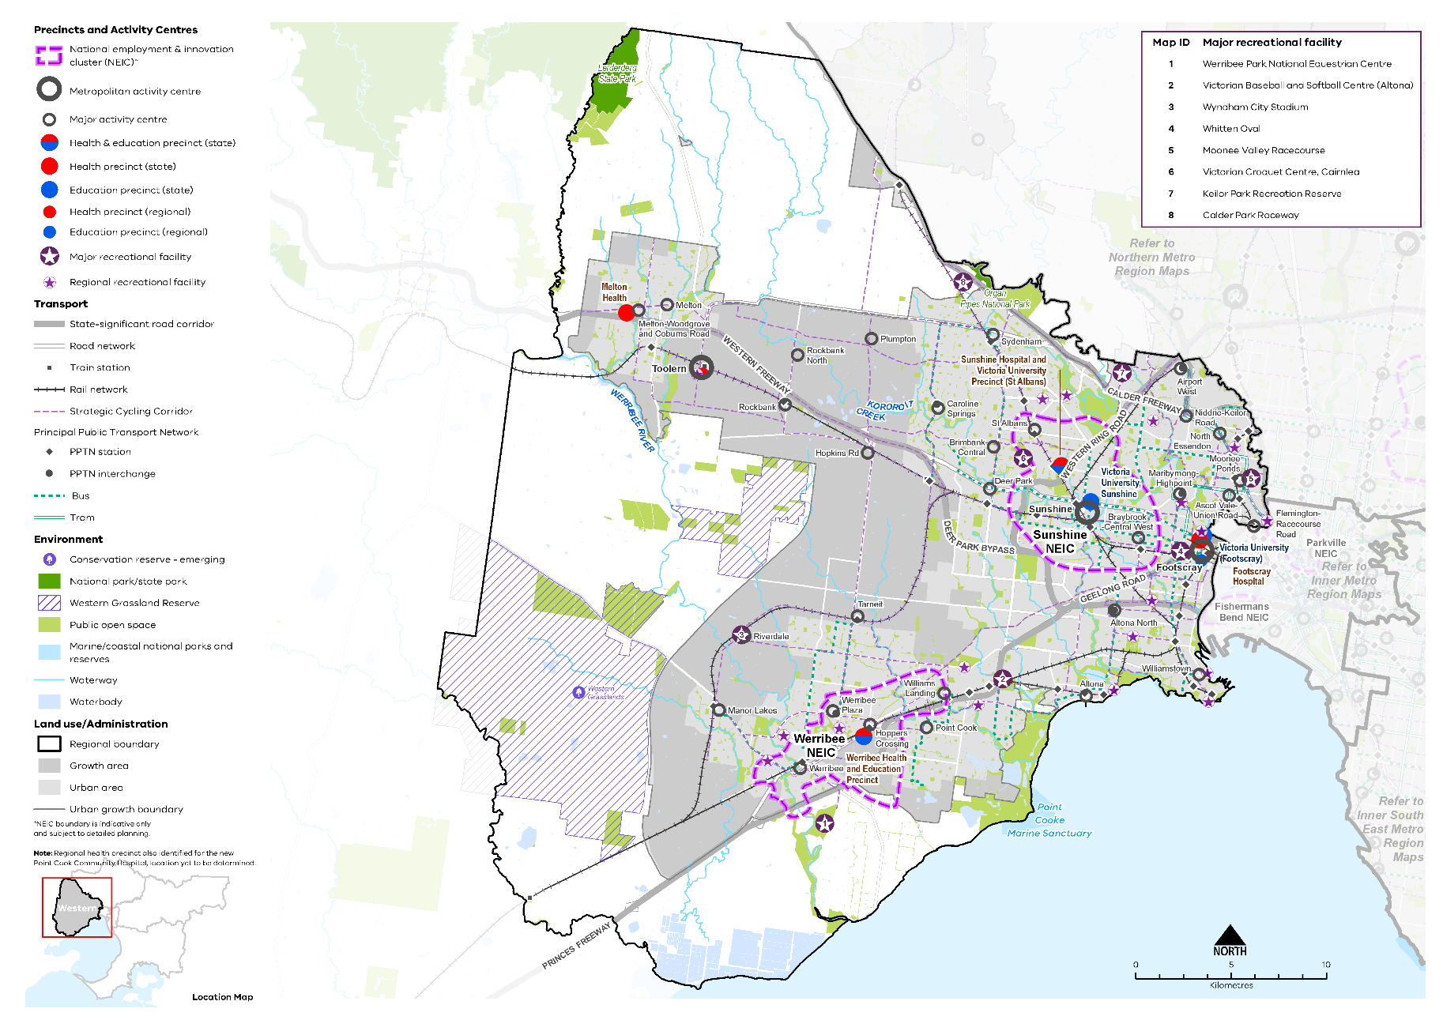

Map 8 Western Metro Region strong communities 2050
A map showing the main community assets of the region in 2050 including state- and regionally-significant health and/or education precincts, as extracted from Map 1, and also highlighting:

- Major recreation facilities at:
- Werribee Park National Equestrian Centre
- State Baseball Softball Centre Merton Street Altona
- Wyndham City Stadium
- Whitten Oval
- Moonee Valley Racecourse
- Victorian Croquet Centre, Cairnlea
- Keilor Park Recreation Reserve
- Calder Park Raceway

- Regional recreation facilities including Windy Hill football ground in Essendon, the Eagle Stadium in Werribee, and yachting and sailing clubs at Williamstown and Altona.

- Plan for major social infrastructure at a regional level
Planning from a regional perspective requires coordination between different levels of government to acknowledge that local councils plan for local infrastructure such as kindergartens, while the Victorian Government plans for state-level services such as government schools.
Major activity centres in the Western Metro Region should be planned within the context of their role in local communities, ensuring centres have complementary roles that fit with the broader activity centre network. Planning for high-order social infrastructure should prioritise locations in activity centres and, where appropriate, enhance and align with the centre’s identified role within the region. Local services should be planned for as a network of well distributed, complementary facilities to accommodate a range of lifestyles and employment arrangements. There is an opportunity to create a network of community hubs in the Western Metro Region that have a mix of uses and align with the existing public transport network.
The full range of ‘whole of life cycle’ facilities – from maternal and child health to aged care to cemeteries – should be considered and coordinated in precinct planning for new communities within the growth corridors as well as within existing activity centres. A major new cemetery is currently proposed for Harkness on a 128-hectare site which will serve an expanding community.
There are opportunities to link regional sporting assets such as Eagle Stadium (Werribee), Wyndham City Stadium (Tarneit) and the Victorian Baseball and Softball Centre (Altona) with nearby activity centres. Planning is underway for the Wyndham City Stadium to anchor a transit-oriented, mixed-use development, with major and minor stadiums, training facilities, a sports science facility, short-stay accommodation, commercial and residential precincts near the future Riverdale railway station. This represents an important opportunity to develop a major recreational asset for the Western Metro Region and link tourism and sporting assets with Strategic Cycling Corridors and public transport, to enhance visitor experiences and provide access choices.
The link between health, wellbeing and nature is reflected in many Victorian Government strategies including the Public Health and Wellbeing Plan 2019 –2023 and Active Victoria – A Strategic Framework for Sport and Recreation in Victoria 2017-2021.
There is an opportunity to enhance and diversify the role of essential social infrastructure within the Western Metro Region so that existing and future resources are used to their full capacity, and their role as focal points for the community is reinforced. Partnerships with the private sector can provide opportunities for community access to facilities. Victoria University’s Footscray Park campus provides community value through Footscray University Town project and high levels of community use of facilities including the gym and swimming pool.
There are opportunities for the Western Metro Region to build on a vibrant arts and cultural community. More regionally-significant multi-use community spaces are needed to allow for diverse uses and gatherings such as markets, events, performing arts and food places. Current developments in the region include the expansion of the Footscray Libraries Community and Cultural Hub – NeXT. The Defence Site Maribyrnong provides a significant opportunity for community use to support new residential development.
- Facilitate a regionally coordinated approach to planning for ‘whole of life cycle’ social infrastructure (excluding schools), within existing communities and the Western Growth Corridor.
- Encourage planning for major social infrastructure (such as libraries, recreation facilities, cultural centres or community hubs) to be undertaken in conjunction with neighbouring regions to maximise co-location of facilities.
- Locate social infrastructure near activity centres and to be accessible by walking, cycling or public transport.
- Support the upgrade and expansion of social infrastructure to enable it to diversify uses and be more flexibly and intensively used, including libraries, recreation facilities and if required and appropriate, schools.
- Ensure planning for urban renewal areas facilitates access to community uses, particularly the Defence Site Maribyrnong.
- Support regional planning that will provide for a range of sporting and active recreation facilities to meet the needs of the growing population within existing urban areas and growth areas.

- Deliver health and education services in strategic locations
A key issue for the Western Metro Region is to ensure established and new health infrastructure is appropriately positioned to respond to growing communities, especially in greenfield areas within the Melton and Wyndham LGAs.
In the Western Metro Region there is an opportunity to connect health and education precincts to develop a regional network of facilities that provide a community focal point, address gaps in service provision and meet the needs of a growing population. Local neighbourhood services and facilities also contribute to a broader network of health and education provision.
Plan Melbourne identifies state-significant health and/or education precincts to support health and education services that are well served by public transport in a range of locations across Melbourne.
Regionally-significant health and/or education precincts (Table 14) have a regional catchment, are accessible by a range of transport options and have a specialised economic function. This identification provides opportunities for the agglomeration of ancillary health and education services, retail, commercial and accommodation uses.
Access to healthcare, including hospitals, medical and allied health services, should be coordinated and build on existing health and precincts in Sunshine, Footscray, Melton and Werribee. This includes areas experiencing high population growth and new communities in growth areas that may require additional acute and primary health services. The Sunshine Health, Wellbeing and Education Precinct is well positioned to provide major public services facilities for the growth areas of Melton, Sunbury, Wyndham and beyond to the western region of Victoria.
More comprehensive and specialist education, health and community facilities should be considered for the higher order activity centres including the Sydenham - Watergardens and Werribee Plaza activity centres, and other activity centres identified at Toolern, Tarneit and Manor Lakes.
In meeting the needs of residents in growth areas, particularly on the metro-regional fringe, strategic planning should prioritise health services and facilities in regionally-significant health and/or education precincts that encourage the co-location of services to support 20-minute neighbourhoods.
Residential aged care facilities should also be considered in relation to these precincts to support equitable access to health services. Additional aged care services will be required to provide for an expanding and ageing population in Melbourne’s west. Current facilities located near Melbourne’s CBD are outdated and pose access barriers for patients and families in outer suburbs.
Population growth is also expected to fuel demand for both university courses and vocational training. Continual monitoring and assessment of the capacity of existing infrastructure to meet this need is essential.
The growth of education precincts will provide opportunities for greater engagement of young people in education and promote a culture of learning.

State-significant and regionally-significant health and/or education precincts
State-significant Health Precinct | Regionally-significant Health Precinct
Footscray Hospital (known as Western Hospital in Plan Melbourne)  Melton Health (Melton West) | Melton Hospital at Cobblebank (Toolern) and allied health services (proposed)  Point Cook Community Hospital and allied health services (proposed)
State-significant education Precinct | Regionally-significant education Precinct
Victoria University (Footscray)  Victoria University (Sunshine) | Victoria University (Footscray Nicholson Campus)
State-significant health and education Precinct
Sunshine Hospital and Victoria University Precinct (St Albans)
Werribee Health and Education Precinct

Formal partnerships are being developed with Victoria University and other tertiary institutions to explore precinct development opportunities, including within Sunshine and Werribee NEICs. Tertiary education expansion priorities at Footscray University Town will closely align with the vision for the Footscray Learning Precinct and support the precinct’s goal to enable seamless transitions from early learning and school to adult education. There is a need for improved transport links between Footscray railway station and the health and education precinct to improve accessibility.
Key health facilities developments in the Western Metro Region include:
- New Footscray Hospital (Western Health) and redevelopment of Footscray University Town
- Expansion of Tweddle Child & Family Health Service, Footscray
- New Joan Kirner Hospital and St Albans Health and Wellbeing Hub
- New Melton Hospital at Cobblebank (Toolern Metropolitan Activity Centre) creating a new health precinct with private and public hospital services
- Expansion of the Sunbury Community Hospital (Western Health)
- Critical infrastructure works at Western Health (Footscray and Sunshine)
- New Point Cook Community Hospital (Western Health) to provide access to a broad range of in-demand medical and social services in one facility
- Major expansions proposed for Werribee Mercy Hospital.
- Strengthen the role of the health and/or education precincts of the Western Metro Region by co-locating new health and/or education facilities within these precincts and encouraging an agglomeration of ancillary uses such as primary healthcare, retail and accommodation.
- Expand the network of health and/or education facilities and precincts across the region to meet the needs of the growing population. Ensure that these facilities and precincts are accessible by public transport, walking and cycling.
- Support the upgrade of existing health and education infrastructure to allow for more intensive use of those services.
- Ensure the early provision of health and education facilities and precincts in the Western Growth Corridor to support the needs of new communities. Locate these facilities or precincts within or near activity centres to maximise the benefits of colocation with ancillary land uses.
- Provide residential aged care, primary healthcare and remediation facilities in and around health precincts.
- Support the development of a health and education precinct in Toolern.

- Support a network of activity centres to anchor 20-minute neighbourhoods across the Western Metro Region
While individual neighbourhood activity centres are not regionally significant, when combined these centres are important for delivering 20-minute neighbourhoods and supporting strong communities in the Western Metro Region. A network-wide approach will identify gaps in provision, enable better planning and prioritisation of services and facilities and better planning for neighbourhood activity centres.
In growth areas, land dissected by major freeways and areas of industrial land constrain achieving 20-minute neighbourhoods. Planning and design of new communities should consider ways in which these barriers can be overcome and the hallmarks of 20-minute neighbourhoods can be achieved.
Having a consistent approach to planning for neighbourhood activity centres will help people live locally for their day-to-day needs. Consistent designation and planning approaches are particularly important where centres straddle regional or local council boundaries such as in Sunshine and Sydenham.
- Plan for existing and new activity centres to embed the 20-minute neighbourhood hallmarks, through a place-based, community partnership approach.
- Support a consistent designation of neighbourhood activity centres and their role in the network of activity centres across the Western Metro Region.
- Embed the 20-minute neighbourhood hallmarks in planning within the catchment of major infrastructure projects.
- Support the role of neighbourhood activity centres to provide retail, community and allied health services to their respective local catchments.
- Embed the hallmarks of 20-minute neighbourhoods in planning for new communities within the Western Growth Corridor.

Actions – Strong communities
- Develop guidance on a new approach to neighbourhood planning in partnership with local councils of the Western Metro Region which embeds the hallmarks of 20-minute neighbourhoods.

Chapter 09.
Sustainability and resilience
Plan Melbourne Outcome 6: Melbourne is a sustainable and resilient city
Plan Melbourne aims to create a resilient and sustainable city. It recognises the need to mitigate greenhouse gas emissions, reduce exposure to natural hazards, undertake whole of water cycle planning and design, and protect local waterways. It also encourages resource efficiency and promotes the benefits of urban cooling and greening.
The Western Metro Region includes established urban areas in its east, rolling grasslands in its west, productive agriculture and globally recognised wetlands in its far south, and growing suburbs in its south, centre and north-west. To retain and enhance this valued diversity, regional decision-makers must implement policies and practices that respond to the region’s future conditions.
Mitigating and adapting to climate change is a key challenge for the Western Metro Region. Heat waves have a greater negative effect on population health than any other climate-related issue, and by 2050 the Western Metro region will be hotter and drier. It will also experience lower rainfall and more extreme rainfall events and increased storm intensity. Valued coastal environments, coastal suburbs and infrastructure will be increasingly under pressure from storm surge, tidal inundation and sea level rise.
Coupled with urbanisation, increased temperatures and lower annual rainfall will place additional pressure on natural assets and marine ecosystems such as the Port Phillip Bay, Ramsar wetlands, creeks, river corridors, parks and other valued vegetation. These changes will also place pressure on agricultural production and drive the importance of whole of water cycle planning.
Ongoing challenges resulting from climate change, including bushfire risk, in combination with significant population growth will require deliberate, coordinated action by government agencies and authorities to create a sustainable, resilient Western Metro Region.

State of play

Energy networks
Melbourne’s energy grid is transforming. The city’s future grid will have a greater ability to export energy from individual properties or a local area, presenting a more flexible approach to energy production. It will be smarter, more reliable and provide greater energy security. Regional energy generation and storage is also a potential option, and the region’s green wedge areas could provide an opportunity to support these facilities subject to environmental and landscape considerations.

Urban heat environments
By 2050 the average annual temperature in the Western Metro Region is forecast to increase between 0.9°C and 2.4°C under a medium emissions climate change scenario (Clarke, et al., 2019). As our climate warms the number of people exposed to the risk of mortality from heatwaves will increase. In 2018, it is estimated that around 285,000 residents in the Western Metro Region were exposed to high urban heat conditions, particularly in growth area communities (CRCWSC, 2019).
In 2018 the average land surface temperature (LST) in the Western Metro Region was 35.3°C, 1.3°C more than the metropolitan average. (DELWP, 2018c) LST was highest in Melton (36.3°C) and Brimbank (36.0°C) LGAs and coolest in Hobsons Bay LGA (33.7°C) as shown in Figure 23.
- Average land surface temperature by LGA, 2018
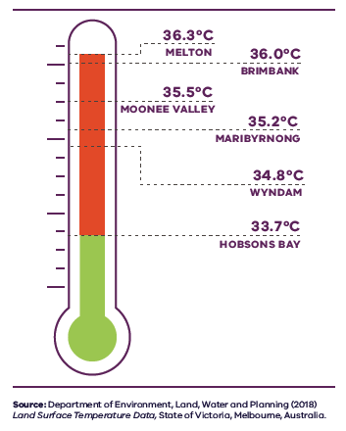
Figure 23. Average land surface temperature by LGA, 2018
Melton | 36.3 degrees Celsius
Brimbank | 36.0 degrees Celsius
Moonee Valley | 35.5 degrees Celsius
Maribyrnong | 35.2 degrees Celsius
Wyndham | 34.8 degrees Celsius
Hobsons Bay | 33.7 degrees Celsius
Source: Department of Environment, Land, Water and Planning (2018) Land surface temperature data, State of Victoria, Melbourne, Australia.

The combination of fewer trees and more hard surfaces means most of the Western Metro Region is exposed to higher urban temperatures during extreme and prolonged heat events. Older people, younger children, people with underlying health issues and those with fewer resources to adapt are more at risk on hot days and prolonged periods of hot weather.
The urban heat island effect refers to temperature differences attributable to urbanisation where suburbs perform differently due to variation in trees, vegetation and hard surfaces which can have multiple impacts on health, resource use and air quality (Sun et al., 2019).
Apart from the bayside Hobsons Bay LGA, the remainder of the Western Metro Region experiences high levels of urban heat, primarily due to lower levels of vegetation and large areas of land and surfaces without tree cover and access to water (Figure 25 and Figure 26).

Urban tree canopy
In urban areas, trees positively contribute to urban cooling and neighbourhood character, offer amenity and recreation for residents and provide habitat for wildlife. In 2018 the Western Metro Region’s total vegetation cover was 29 per cent, its combined shrub and tree cover was 11 per cent and its tree canopy cover was 6 per cent (Hurley et al., 2019a).
Within the region, residential land was the largest contributor of trees, followed by infrastructure land (primarily streets) and parkland (Figure 24) (Hurley, et al., 2019a).
Tree canopy cover varied between the six local government areas comprising the Western Metro Region, with the greatest proportion in established eastern LGAs including Moonee Valley and Maribyrnong and the least in growing western LGAs such as Melton and Wyndham (Hurley, et al., 2019b). All LGAs within the Western Metro Region experienced modest gains in tree canopy cover between 2014 and 2018 (Figure 27), most likely due to a significant focus in creating green public spaces in the western suburbs (Hurley, et al., 2019a). However, these gains were from a low base. The region had the lowest baseline tree canopy cover (5.8 per cent) compared to all other metropolitan regions.

- Urban tree canopy cover by land use, 2018
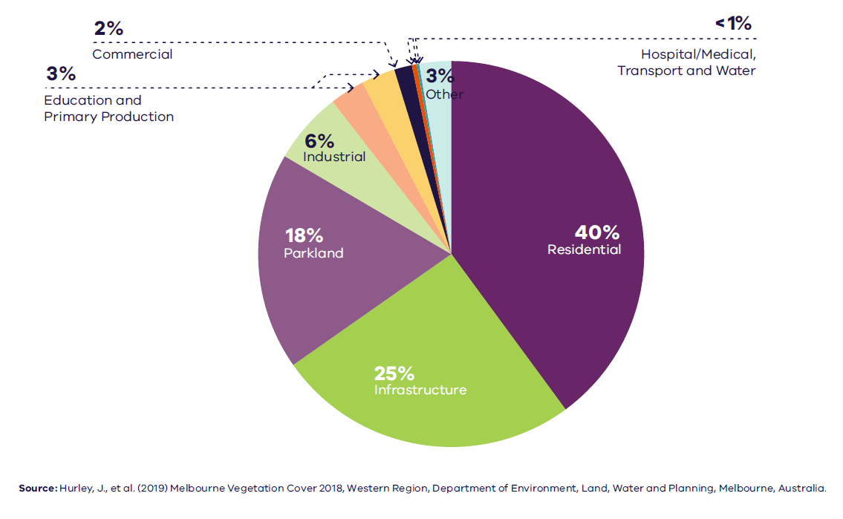

Figure 24. Urban tree canopy cover by land use, 2018
Residential | 40 per cent
Infrastructure | 25 per cent
Parkland | 18 per cent
Industrial | 6 per cent
Education | 3 per cent
Primary Production | 3 per cent
Commercial | 2 per cent
Hospital/medical | Less than 1 per cent
Transport | Less than 1 per cent
Water | Less than 1 per cent
Other | 3 percent
Source: Hurley, J., et al. (2019) Melbourne Vegetation Cover 2018, Western Region, Department of Environment, Land, Water and Planning, Melbourne, Australia.

- Heat vulnerability index map for the Western Metro Region, 2018
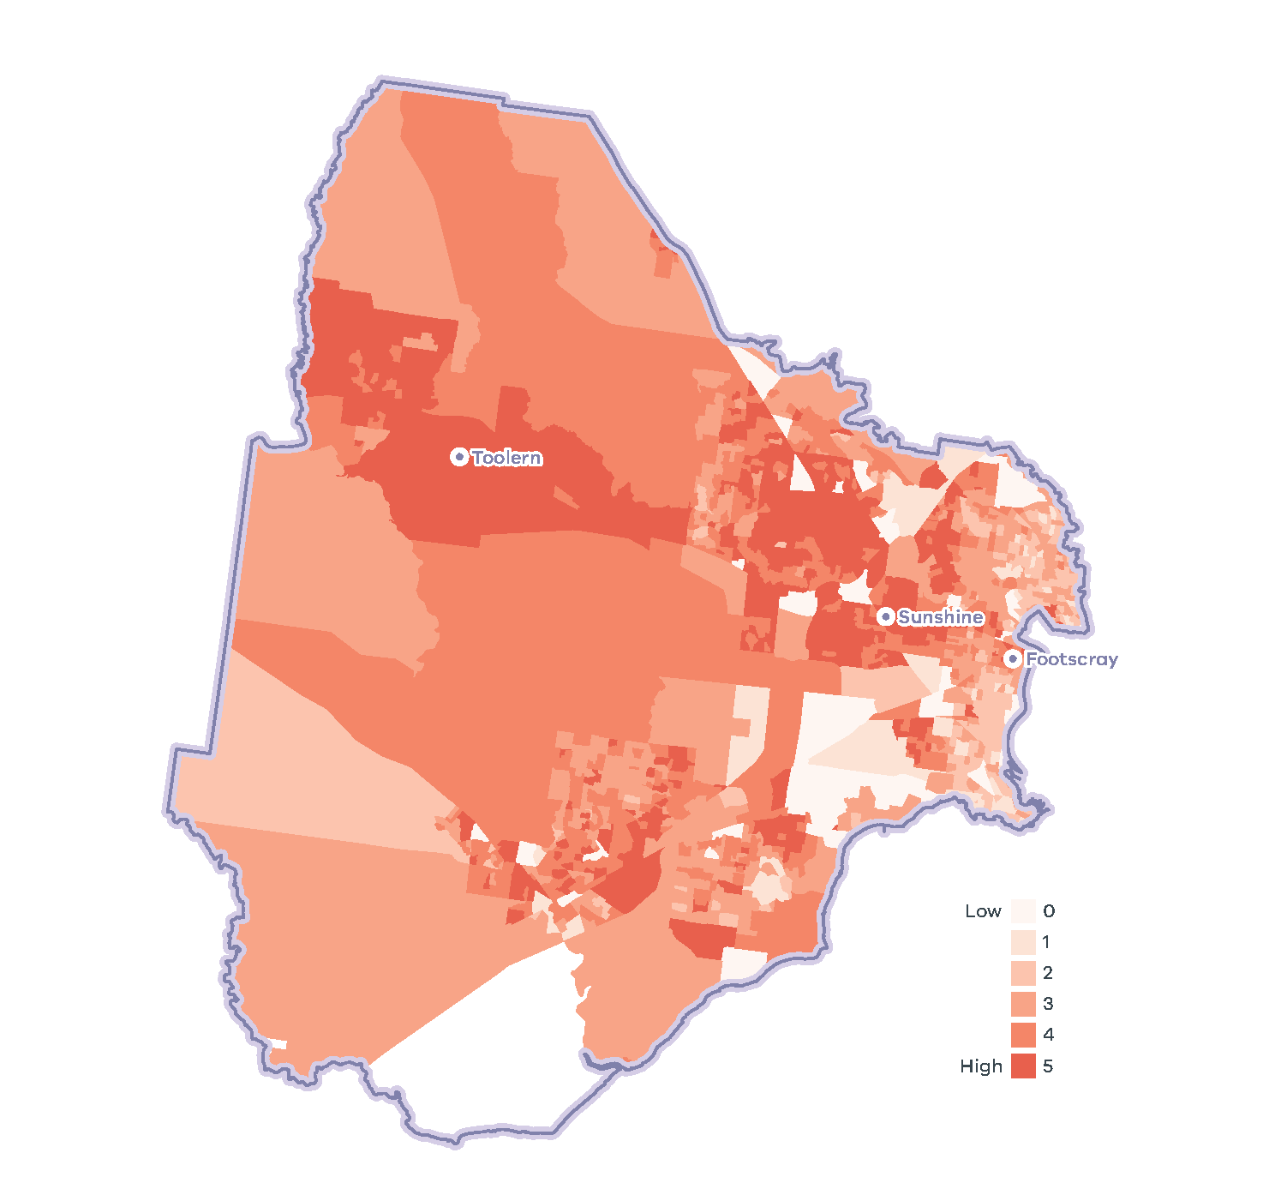
- Western Metro Region tree canopy cover, 2018
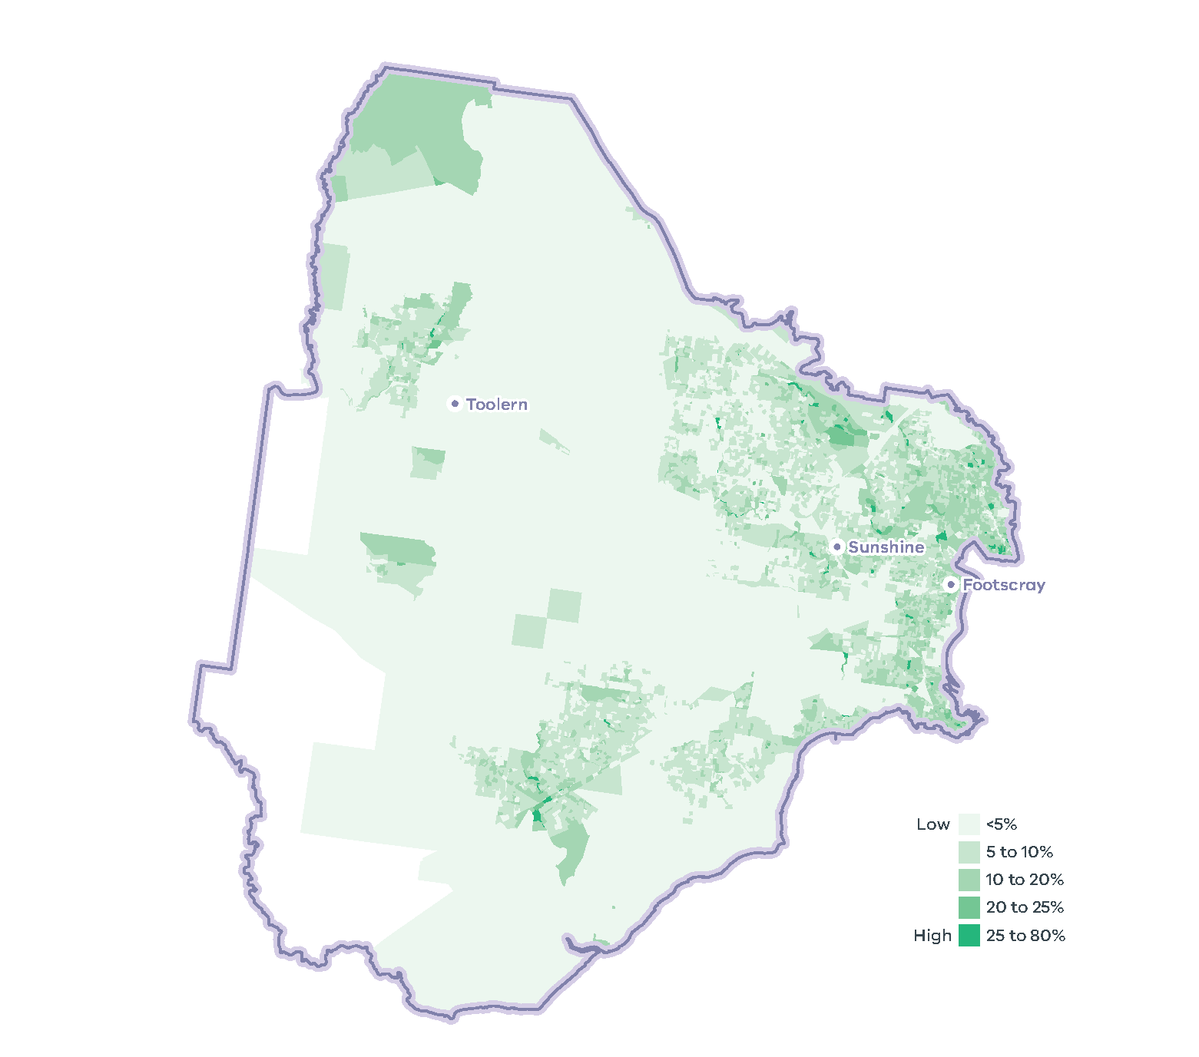
- Tree canopy cover 2018, and tree canopy cover change 2014 to 2018, by LGA
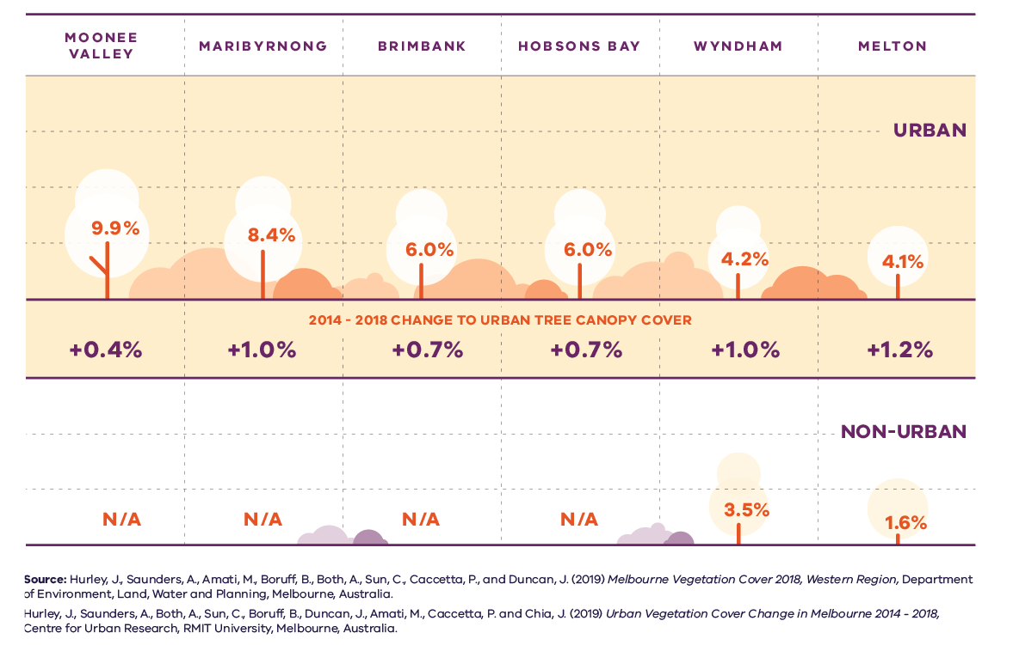
Figure 27. Tree canopy cover 2018, and tree canopy cover change 2014 to 2018, by LGA
LGA | Urban tree canopy cover 2018 | 2014 to 2018 change to urban tree canopy cover | Non-urban tree canopy cover 2018
Moonee Valley | 9.9 per cent | Plus 0.4 per cent | Not applicable
Maribyrnong | 8.4 per cent | Plus 1.0 per cent | Not applicable
Brimbank | 6.0 per cent | Plus 0.7 per cent | Not applicable
Hobsons Bay | 6.0 per cent | Plus 0.7 per cent | Not applicable
Wyndham | 4.2 per cent | Plus 1.0 per cent | 3.5 per cent
Melton | 4.1 per cent | Plus 1.2 per cent | 1.6 per cent
Sources:
Hurley, J., et al. (2019) Melbourne Vegetation Cover 2018, Western Region, Department of Environment, Land, Water and Planning, Melbourne, Australia.
Hurley, J., et al. (2019) Urban Vegetation Cover Change in Melbourne 2014 – 2018, Centre for Urban Research, RMIT University, Melbourne, Australia.

Natural hazards – bushfire risk
Bushfire risk within the Western Metro Region primarily exists due to the forests and extensive grasslands situated in its west. Large areas of this land are subject to state planning policy for bushfire (Clause 13.02), Bushfire Prone Areas (BPA) and the Bushfire Management Overlay (BMO). The likelihood of a bushfire, its severity and intensity depend on a site’s location and surrounding landscape characteristics.
The BMO aims to strengthen community resilience to bushfire by considering bushfire measures as part of the design process and ensuring new development achieves an acceptable level of bushfire risk in areas of highest bushfire risk. However, there is still a need to strengthen the resilience of settlements and communities to bushfire. Strategic risk-based planning that prioritises the protection of human life over other policy considerations should extend to sensitive uses and uses that encourage high visitation to the green wedges during hotter months.
The frequency and intensity of bushfires and grassfires in the Western Metro Region is forecast to increase with climate change, posing a serious threat to the region’s communities, infrastructure and high-value forests, grasslands and ecosystems. Planning for the risk of bushfire will be vital as the climate warms and overall rainfall decreases.

Flooding risk and waterway health
Despite anticipated reductions in the overall average annual rainfall, it is predicted that climate change will result in a greater incidence of heavy rainfall events in the Western Metro Region. This will present a greater risk of stormwater inundation to both private and public property in low-lying urban areas in the Maribyrnong Catchment as well as middle and emerging outer suburbs in the Werribee Catchment (DELWP, 2018a). Rainfall intensification and resultant higher volume stormwater flows will also accelerate riverbank erosion and flush litter and chemicals from the stormwater system, degrading the water quality of the region’s creeks, rivers, wetlands and coastline.
Harvesting stormwater and increasing water infiltration are important in dense suburbs to reduce runoff and service vegetation. Stormwater and recycled water can support the maintenance of water-reliant facilities and amenities such as sporting fields and gardens, contribute to more resilient vegetation, reduce demand on drinking supplies and improve the environment of receiving streams and rivers.

Sea level rise and coastal inundation risk
The coastline and bay have significant value to the Victorian community for a range of cultural, recreational, environmental and economic values, but both are under pressure from urbanisation and climate change (DELWP, 2017b). Coastal suburbs, including Altona, Seaholme and Williamstown, lie on relatively flat terrain, with some parts lower than sea level. Damage to these areas from flash flooding, storm surges and tidal inundation from Port Phillip Bay will continue to impact public and private infrastructure (DELWP, 2018a). Additionally, marine and coastal environments will experience increases in water temperature and rising sea levels. Storm surges will become more frequent, exposing riverine estuaries and the coastline to tidal inundation and erosion (DELWP, 2017b).
As projected average temperatures continue trending upwards through this century, so too will global mean sea levels as oceans partially absorb atmospheric heat and glaciers and polar ice caps continue to melt. Accordingly, state planning policy recognises the need to plan for anticipated sea level rise to Port Phillip Bay (Melbourne Water, 2017). Given the uncertainty of our climate change future, planning policy will need to be responsive to future recalibration of sea levels.

Wastewater treatment facilities
Located south-west of Werribee, Melbourne Water’s Western Treatment Plant processes approximately half of Melbourne’s sewerage and provides an internationally recognised wetland habitat for migratory birds. (DELWP, 2018a) In addition, City West Water operates the smaller Altona Treatment Plant, and the Melton Recycled Water Plant also treats wastewater (DELWP, 2018a).
Together these facilities produce around 40 billion litres of recycled water for non-drinking purposes, which is distributed throughout the region to irrigate crops, public open spaces and residential properties as well as support industrial and manufacturing processes (DELWP, 2018a). As the region’s population and urban land area continues to grow, demand for water will grow as well. Increased competition between various recycled water users will challenge regional water services to significantly expand the recycled water network and improve its output and efficiency.

Resource efficiency and waste and resource recovery
In 2013/14 Greater Melbourne had a 73 per cent resource recovery rate, with 805,000 tonnes of food and garden waste sent to landfill. By 2042, it is projected waste volumes will grow by 63 per cent to 16.5 million tonnes each year (Metropolitan Waste and Resource Recovery Group, 2016).
There are several sites across the Western Metro Region undertaking waste and/or resource recovery activities, which are important at the state level, including the Ravenhall Precinct, the Wyndham Refuse Disposal and Recycling Facility, the Brooklyn Precinct, the Laverton Precinct and the Owens Illinois glass reprocessing facility in Spotswood (Sustainability Victoria, 2018).

Sustainability in the built environment
In 2013, residential buildings were responsible for nearly 12 per cent of Australia’s national greenhouse gas emissions, and commercial buildings contributed just over 11 per cent. The majority of these emissions were generated through the consumption of grid-supplied electricity to power appliances, lighting, and predominantly heating, ventilation and cooling (HVAC) systems (Australian Sustainable Built Environment Council, 2016).
As average temperatures rise due to climate change, greater numbers of people are expected to seek comfort indoors during periods of hot weather. This, combined with population growth and overall poor-performing building stock, means our city lacks energy efficiency and resilience on hot days. Maximising opportunities to incrementally improve the performance of buildings will reduce our reliance on appliances to cool buildings and contribute to a lower likelihood of blackouts during periods of hot weather.
Local councils within the Western Metro Region are active in adopting policies and strategies to reduce carbon emissions and improve the sustainability of the built environment. Many are innovators and leaders in environmentally sustainable design (ESD) and are implementing new practices to improve the energy efficiency of civic buildings and reduce emissions from operations.
Several LGAs are members of the Council Alliance for a Sustainable Built Environment (CASBE), an association committed to designing and applying a range of practical methodologies to increase sustainability outcomes for new buildings. The Built Environment Sustainability Scorecard (BESS) is an online tool developed by CASBE that assesses the sustainability of proposed developments. It aims to reduce waste and improve energy efficiency from the outset of the construction phase, through to occupation. As well as onsite energy generation, BESS promotes the use of energy-efficient appliances, thermally-efficient glazing, wall cladding and insulation, water-efficient fittings and fixtures, thermal comfort and overall environmentally sustainable performance.
Other rating systems being increasingly utilised by the building design industry to measure and assess the performance of ESD principles include Green Star (Green Building Council of Australia, 2021), NatHERS (Department of Industry, Science, Enregy and Resources, 2021) and MUSIC (eWater, 2021).

Regional strengths
- Opportunities for increased use of recycled water from several locations within the region.

Regional challenges
- Large areas of high urban heat and heat vulnerable communities
- Coastal environments, coastal suburbs and infrastructure under increasing risk from storm surge, tidal inundation and sea level rise
- Access to treated wastewater from the Western Treatment Plant
- Need for State Waste and Resource Recovery Hubs and to advance resource efficiency and recycling
- Bushfire and grassfire risk to community, infrastructure and high-value grasslands and ecosystems.

Directions and strategies
The directions identified to achieve the 2050 vision for the Western Metro Region in terms of sustainability and resilience and Outcome 6 of Plan Melbourne are:
Direction 24 | Increase the number of cool places across the region, particularly for communities vulnerable to urban heat and areas experiencing high urban heat
Direction 25 | Increase the tree canopy across the Western Metro Region to 20 per cent coverage by 2050
Direction 26 | Manage the impact and risk of sea level rise
Direction 27 | Plan for future land use to utilise forecast recycled water from the Western Treatment Plant
Direction 28 | Increase the retention and reuse of water in the urban environment
Direction 29 | Minimise and reduce risk from bushfire in Wyndham and Melton.
Direction 30 | Respond to the transformation of the energy supply network
Direction 31 | Protect sites of strategic importance for recycling and plan for the expansion of key sites for future resource recovery needs
Each direction is implemented through regionally-specific strategies identified in this LUFP.
Map 10 shows how sustainability and resilience will be enhanced across the Western Metro Region by 2050 as a result of these directions and strategies, together with Plan Melbourne and other strategies and initiatives as outlined in Appendix 01.

- Western Metro Region sustainability and resilience state of play
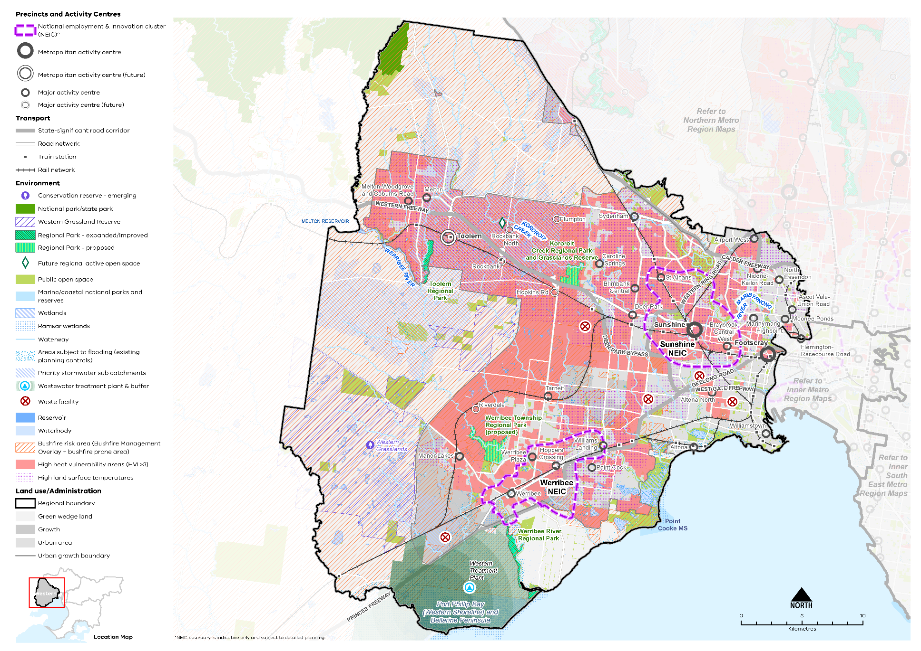

Map 9 Western Metro Region sustainability and resilience state of play
A map showing the current sustainability and resilience of the Western Metro Region, as extracted from Map 1, and also highlighting:
- Bushfire risk areas (taken from the Bushfire Management Overlay and bushfire prone area)
- Areas of high heat vulnerability principally in the north and west of the region
- Areas with high land surface temperatures found across the urban area
- Areas subject to flooding (existing planning controls) and priority stormwater sub catchments
- Ramsar wetlands
- The Western Treatment Plant (wastewater) and buffer zone
- Five waste facilities of state significance: Brooklyn Precinct, Wyndham Refuse Disposal and Recycling Facility, Ravenhall Precinct, Laverton Precinct, and Owens Illinois, Spotswood.
- Western Metro Region sustainability and resilience 2050
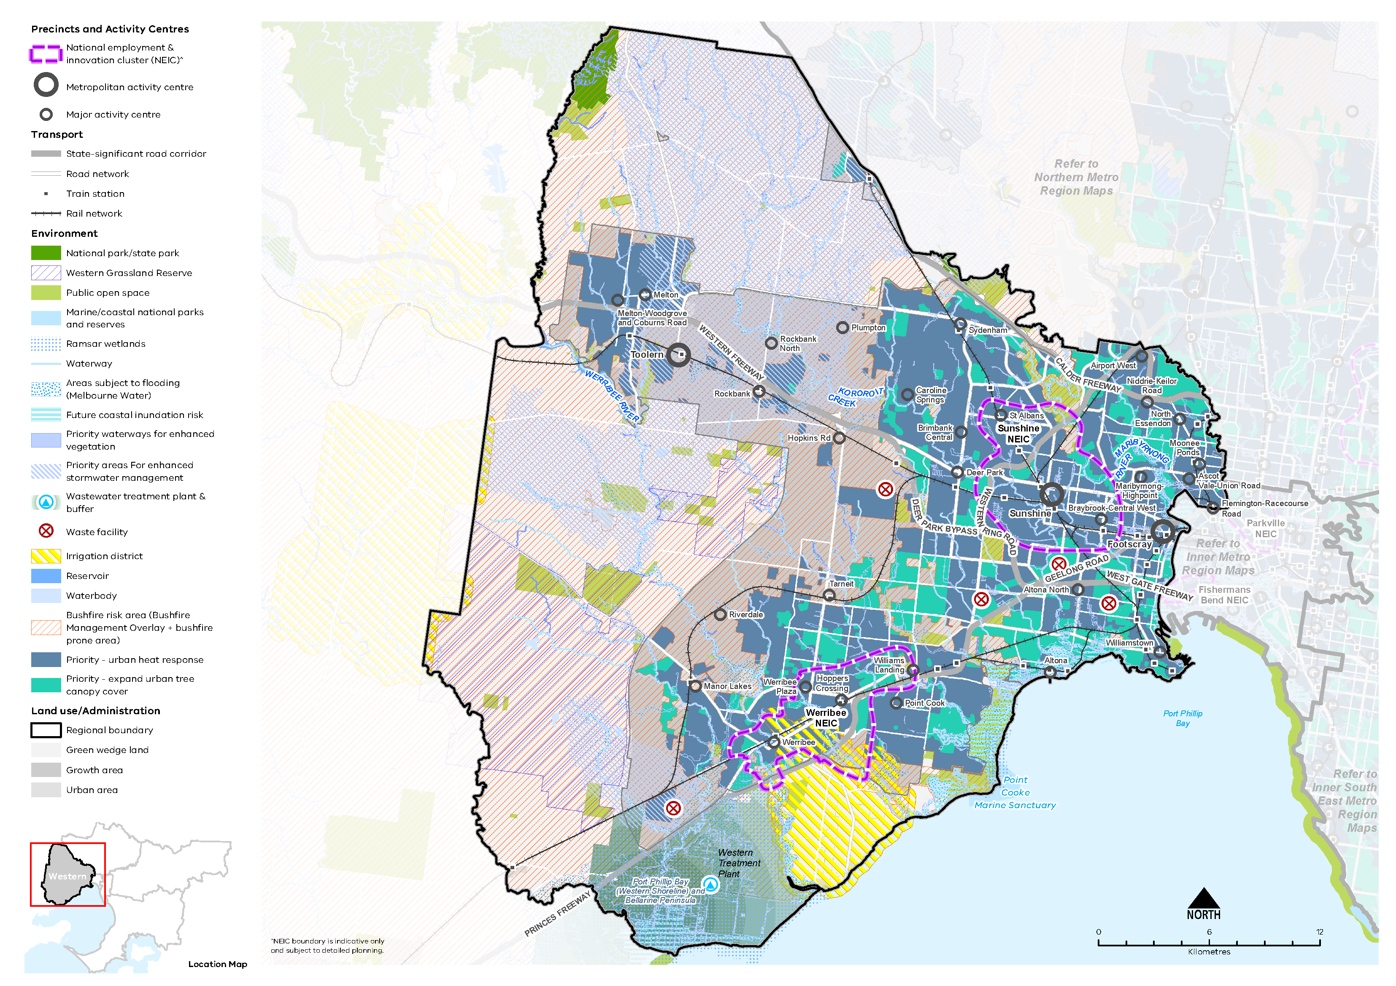

Map 10 Western Metro Region sustainability and resilience 2050
A map showing the sustainability and resilience of the Western Metro Region in 2050, as extracted from Map 1, and also highlighting:
- Future coastal inundation risk affecting significant areas in the south east of the region
- Priority areas for enhanced stormwater management principally in the north and west of the region
- Priority waterways for enhanced vegetation
- Priority areas for an urban heat response and expanding the urban tree canopy cover
- Areas subject to flooding (updated Melbourne Water data)
- An irrigation district south of Werribee and north east of the Western Treatment Plant.
- Increase the number of cool places across the region, particularly for communities vulnerable to urban heat and areas experiencing high urban heat
Large areas of the Western Metro Region have high land surface temperature and heat vulnerable communities. Plan Melbourne notes that temperature decreases of between one degree Celsius and two degrees Celsius can have a significant impact on reducing heat-related morbidity and mortality (DELWP, 2017a).
Urban environments that stay cooler on hot days are more physically comfortable and continue to support physical movement and recreation. As the number and duration of hot days increases, these environments will be important to reduce the likelihood of heat-related illness. Cooler urban environments are characterised by more tree cover, fewer impermeable surfaces, more water infiltration into the ground and fewer heat-absorbing materials. Cooler places will help reduce urban temperatures and create comfortable local micro-climates in the Western Metro Region.
In addition to trees, green walls, shade structures and low heat absorbing materials can help reduce urban surface temperatures. Mitigating urban heat will be important in inner areas of the region, activity centres, the Sunshine and Werribee NEICs and around education and recreation facilities. Areas and facilities frequented by older people and children will need to provide for more active cooling of outdoor environments.
Buildings with vegetation and roof gardens will need to be combined with onsite water harvesting and storage to ensure vegetation health and reduce potable water demand.
Footscray and Sunshine metropolitan activity centres have communities vulnerable to urban heat, along with Melton, Melton-Woodgrove and Coburns Road, Sydenham, Airport West, Caroline Springs, Niddrie-Keilor Road, St Albans, Brimbank Central, Deer Park, Maribyrnong-Highpoint, Braybrook-Central West, Altona North, Tarneit, Manor Lakes, Williams Landing, Werribee, Hoppers Crossing, Werribee Plaza and Point Cook major activity centres. These communities are at a higher risk of heat-related illness during periods of multiple hot days (Sun, et al., 2019).
As shown in Map 9 there are also large areas of high urban surface temperatures in suburbs to the east and west of the Metropolitan Ring Road, and north and south of the Western Freeway, which absorb and retain heat.
- Increase tree canopy in areas with high urban heat vulnerability and high urban heat locations.
- Design and develop outdoor spaces that are cool on hot days through materials, vegetation and water sensitive urban design, particularly in:
- Footscray and Sunshine metropolitan activity centres
- Melton, Melton-Woodgrove and Coburns Road, Sydenham, Airport West, Caroline Springs, Niddrie-Keilor Road, St Albans, Brimbank Central, Deer Park, Maribyrnong-Highpoint, Braybrook-Central West, Altona North, Tarneit, Manor Lakes, Williams Landing, Werribee, Hoppers Crossing, Werribee Plaza and Point Cook major activity centres.
- Encourage green roofs and green structures with climate resilient planting and irrigation particularly on apartment developments in areas with high urban heat and large commercial, industrial, education and health developments.
- Increase the tree canopy across the Western Metro Region to 20 per cent coverage by 2050
Canopy trees are particularly effective at lowering daytime air temperatures at ground level through transpiration and shading. In the absence of water, increased tree canopy cover and the clustering of trees provides the greatest response to the challenge of urban heat.
Expanding the region’s tree canopy cover can be achieved by planting new canopy trees and preserving existing vegetation. However, ongoing development and climate change will place pressure on the urban forest above and beyond limitations already experienced in the Western Metro Region due to its relatively hot, dry microclimate. Reliable, consistent access to water for irrigation will be critical to the expansion of the region’s tree canopy cover. Species selection and soil attenuation will also be important to ensure the success of planting in the Western Metro Region.
While residential land currently provides most of the tree canopy cover in the region, tree canopy should be expanded on other land uses. For example, rail corridors, streets, school grounds and parklands can contribute to achieving an increased tree canopy cover. Waterway corridors offer considerable opportunity to expand tree cover along their riparian zones, which play a key role in improving waterway health.
A key challenge for increasing tree canopy is the ability to retrofit existing urban areas for trees and green infrastructure due to the availability of public and private space and the multiple functions of public land and publicly accessible places. For example, there are potential conflicts with electrical powerlines, underground cabling, gas and stormwater pipe works and regulation, and transport movement.
In the Western Metro Region, tree planting will need to avoid remaining areas of natural treeless grassland as these are some of the most precious remaining natural assets in the region.
The Greening the West program brings together government departments, agencies and other stakeholders to coordinate and accelerate greening across the region.
All Western Metro Region LGAs have endorsed the Living Melbourne: Our Metropolitan Urban Forest strategy, specifying a regional target of 20 per cent total tree canopy and 30 per cent combined tree canopy and shrubs by 2050 (The Nature Conservancy and Resilient Melbourne, 2019). To support this commitment, the tree canopy target is accompanied in Table 15 by an aspirational distribution of tree canopy cover across four different land use types, adapted by DELWP from several related datasets (Hurley, et al., 2019a) (Urich & Hardy, 2020) (PSMA Australia Limited, 2021).
Western Metro Region tree canopy cover target and aspirational distribution
2018 Tree Canopy Cover: 5.5%
2050 Tree Canopy Cover Target: 20%
(+14.5% or +7,680 hectares additional tree canopy cover)
Residential, commercial, industrial and primary production | 45%
Streets, roads and rail | 25%
Parks, open space and waterways | 25%
Education and hospital/medical | 5%
- Increase the tree canopy across the Western Metro Region particularly in:
- emerging areas in Wyndham and Melton LGAs experiencing high urban heat vulnerability
- established areas within Moonee Valley, Maribyrnong and Brimbank LGAs experiencing high urban heat.
- Protect more trees on private land outside of locations identified for higher levels of housing and mixed-use change.
- Support alternative siting of buildings and more compact building forms to retain mature canopy vegetation.
- Increase tree canopy along urban waterways and on streetscapes, public land, large developments within activity centres, open spaces and road reserves, and large commercial and industrial sites.
- Use the region’s open space network to strengthen its tree canopy and urban greening, aided by water sensitive urban design and stormwater harvesting.
- Encourage tree planting as part of the redevelopment of key sites and activity centres and along key pedestrian and active transport links.

- Manage the impact and risk of sea level rise
Coastal areas are susceptible to rising sea levels as well as storm surges. Much work has been undertaken at the state level to determine the impact of sea level rise by 2100 in areas along Port Phillip Bay in the Western Metro Region.
Future planning must anticipate the impacts of storm surge and coastal inundation. Several significant assets are located on or within close proximity to the coastline, including the Western Treatment Plant and the productive agricultural land surrounding it, the Ramsar wetlands and the suburbs of Altona, Seaholme and Williamstown. Regional planning must adopt a strategic approach to integrate and manage land use and infrastructure change to reduce the risk to communities, infrastructure and natural assets from coastal inundation and storm surge.
DELWP is undertaking a Local Coastal Hazard Assessment for Port Phillip Bay. The Local Coastal Hazard Assessment will provide better information about the expected impacts of coastal hazards such as erosion and inundation that are exacerbated by the effects of climate change. This information will better inform planning decisions in coastal areas around the bay.
- Consider current forecasts of the level of sea level rise and coastal impacts in land use and infrastructure decision-making along the coast.
- Encourage settlement planning for coastal environments and communities to respond to sea level rise and natural hazard risk.
- Limit the location of major land use change in locations with future coastal inundation.
- Factor climate impacts into the total life cost of major public land use and infrastructure investment in the coastal areas of the Western Metro Region.

- Plan for future land use to utilise forecast recycled water from the Western Treatment Plant
Plan Melbourne supports the use of all water sources, including recycled water, to ensure the city remains liveable and sustainable and to reduce reliance on drinking water. By 2050, Plan Melbourne identifies a greater contribution of recycled water to Melbourne’s water supply mix.
Recycled water is produced in the Western Metro Region at the Western Treatment Plant, the Altona Treatment Plant and the Melton Recycled Water Plant. However, excess salinity presently degrades the quality of the recycled water produced by these facilities – particularly by the Western Treatment Plant – and this must be resolved before its benefit can be fully realised throughout the region.
Some areas of land within the Western Metro Region are already using recycled water, particularly the Werribee Irrigation District adjacent to the Western Treatment Plant. Opportunities to expand recycled water have been identified which, if realised, could significantly increase agricultural productivity and job creation for the region. Recycled water could also be used to irrigate additional open spaces, improve vegetation health and reduce the risk of bushfire and contribute to the resilience of the region. Access to recycled water could provide opportunities for a broader mix of uses, including uses in the green wedges.
As Melbourne grows, the need to treat wastewater and the potential need to discharge significant amounts of water into Port Phillip Bay will increase. This projected increase in recycled water is a major opportunity for the region. Planning should support the delivery of recycled water to agricultural and urban uses.
- Protect and buffer the Western Treatment Plant through appropriate planning zones as a waste-water management hub.
- Support land use that will enable greater recycled water use from the Western Treatment Plant (to best meet water needs as determined by the Central Sustainable Water Strategy, Melbourne Metropolitan Urban Water System Strategy and Integrated Water Management Forums).
- Implement integrated water management initiatives that improve water quality, reduce the impacts of stormwater inundation, and protect the region’s key watercourse assets.

- Increase the retention and reuse of water in the urban environment
Planning for water is essential to support liveability, healthy ecosystems and urban cooling and greening. Integrated stormwater management, reducing runoff into waterways and wetlands, and water recycling will improve climate resilience and liveability. The Victorian Government’s strategies Water for Victoria and Integrated Water Management Framework for Victoria provide the strategic framework for water management in Victoria.
Integrated stormwater management, reducing runoff into waterways and wetlands, and water recycling will improve climate resilience and liveability.
Parts of the Maribyrnong and Werribee catchments will continue to undergo significant land use change for housing, diversification of activity centres, and new road, health and education infrastructure. This will increase stormwater runoff and flooding and negatively affect water quality and waterway health for aquatic life. Responding to this change and supporting the health of the region’s creeks, rivers, wetlands, estuaries and coastline will be an ongoing challenge to Port Phillip Bay, the Maribyrnong River, the Werribee River and Kororoit Creek.
Where areas of the Western Metro Region are subject to flooding, there is an opportunity to increase stormwater and floodwater harvesting capabilities. Improved stormwater storage capabilities and stormwater harvesting and management across the region could reduce the risk and cost of major rainfall events and minimise impacts such as pollution of the bay’s marine environments.
Local capture of stormwater, water recycling, restoration and revegetation of urban waterways and greywater systems will improve the region’s hydrological and ecological systems. This will reduce the impacts of flooding, support healthy vegetation and prepare for drying conditions by increasing permeable areas, increasing proportions of green space, avoiding paved areas and passively irrigating vegetation.
Development also increases the quantity of wastewater generated in urban areas, which provides another opportunity to diversify water sources. For example, wastewater can be recycled and used to irrigate public open space and sporting grounds. This will help improve water security as the climate warms and overall rainfall decreases. Further, wastewater contains nutrients and organic matter that could be used to create valuable products such as fertilisers and energy sources. Given increasing limits in resource availability, this creates an opportunity to expand the benefits of wastewater management by exploring different options for resource recovery.
Harvesting stormwater and increasing water infiltration is important in dense suburbs to reduce runoff and service vegetation. Harvested stormwater can help maintain water-reliant facilities and amenities such as sporting fields and gardens. It can also contribute to more resilient vegetation and reduce demand on drinking water. Open spaces, pedestrian and cycling networks can all use WSUD to improve urban amenity and retain water in the urban environment.
There is a need to plan for integrated water management at a regional level to align state, regional and local policies. Within the Western Metro Region this relates particularly to planning for new communities in growth areas. However, improved integrated water management can also be achieved within the redevelopment of large sites or precincts in established urban areas.
- Improve regional water outcomes by aligning sub-catchment and local integrated water management planning with opportunities and directions identified at the catchment scale.
- Facilitate stormwater harvesting close to the source in priority sub-catchments.
- Facilitate stormwater harvesting at a range of scales throughout the region to achieve co-benefits that respond to urban heat, reduce runoff volume and velocity, service social infrastructure and trees.
- Embed integrated water management outcomes in the planning for growth areas and redevelopment within existing urban areas to deliver greater community benefits for liveability, water security and waterway health.

- Minimise and reduce risk from bushfire in Wyndham and Melton
The Western Metro Region is at risk from bushfires due to forest and grassland areas in Wyndham and Melton LGAs. The need to plan for the risk of bushfire to communities, infrastructure and natural environments will continue to increase as the climate warms and overall rainfall decreases.
The likelihood of bushfires and grassfires, and their severity and intensity, depends on the site’s location and surrounding landscape characteristics. There are large areas of land, mostly beyond the urban area, already designated as bushfire prone areas governed by the state planning policy for bushfire (Clause 13.02) and the BMO. The BMO aims to strengthen community resilience to bushfire through development, by considering bushfire measures as part of the design process and by ensuring new development achieves an acceptable level of bushfire risk. However, there is also a need to strengthen the resilience of settlements and communities to bushfire through strategic, risk-based regional planning that prioritises the protection of human life over other policy considerations.
In order to prioritise the protection of human life from bushfire, population growth and development should be directed to low risk locations and areas that are safely evacuated. Development within areas of the highest bushfire risk must achieve acceptable levels of risk reduction. These areas should be avoided for development that will accommodate more vulnerable populations, such as the elderly or very young, that may have difficulties evacuating in the event of a bushfire.
Careful management of vegetation and water resources will be required across the Western Metro Region in response to bushfire risk. River and creek corridors will continue to be important as the climate warms to provide habitat, recreation and cooling. However, given their higher levels of vegetation, they will also pose bushfire risk. Vegetation management strategies, including selecting lower risk species and maintaining vegetation, will have a key role in mitigating risk in urban areas while recognising the value of these corridors for habitat and urban cooling.
- Avoid housing growth and sensitive land uses within and in proximity to bushfire prone areas in the Melton and Wyndham LGAs.
- Provide new and upgraded regional social infrastructure that provides refuge in extreme bushfire and weather events.
- Recognise and manage bushfire risk posed by vegetation within waterway corridors.
- Respond to the transformation of the energy supply network
In the future, electricity networks must be responsive to changing demands from traditional services while enabling new opportunities for energy resource sharing and balancing. Millions of customers generate electricity and over time will store it locally. These customers will be connected to the network and each other, enabling energy networks to act as platforms that match supply and demand and reduce the need for inefficient duplication of energy investments. At the same time, the state is working towards the decarbonisation of the broader energy supply network.
To support a renewable energy future and drive down emissions, major changes to the supply network are required. This includes the creation of local and regional renewable energy hubs across the state, improvements to crucial grid infrastructure, and support for more localised renewable energy generation and storage.
Large subdivisions and growth area development in the Western Growth Corridor must be planned to support this future energy network and avoid the need to retrofit energy infrastructure.
- Ensure subdivision and greenfield development can support the emerging energy supply network.

- Protect sites of strategic importance for recycling and plan for the expansion of key sites for future resource recovery needs
The Statewide Waste and Resource Recovery Infrastructure Plan 2018 and the Metropolitan Waste and Resource Recovery Implementation Plan 2016 aim to increase resource recovery. The metropolitan plan states there is sufficient capacity within existing resource recovery centres and transfer stations in the Western Metro Region. However, it identifies the need for additional organics/garden reprocessing within the north-west of the region – primarily within the Wyndham LGA – of 35,000 tonnes per annum capacity (Metropolitan Waste and Resource Recovery Group, 2016)
Waste and resource recovery hubs provide essential services to support waste and recycling for Victorian communities. There are five waste and resource recovery hubs of state importance for metropolitan Melbourne in the Western Metro Region:
- Brooklyn Precinct: reprocesses around 40 per cent of the state’s metals as well as materials from the construction and demolition sector
- Wyndham Refuse Disposal and Recycling Facility: putrescible and solid inert landfill
- Ravenhall Precinct (including Boral Quarry and Cleanaway Melbourne Regional Landfill Ravenhall): largest putrescible landfill in the state, reprocessing construction and demolition materials
- Laverton Precinct: reprocesses metals, construction and demolition materials
- Owens Illinois, Spotswood: reprocesses used glass back into glass materials (Sustainability Victoria, 2018).
Waste and resource recovery hubs require buffers and protections to minimise impacts on communities, the environment and public health. There is also a need to support compatible land uses in and around the hubs and to identify adequate land and appropriate locations for future resource recovery infrastructure (Sustainability Victoria, 2018).
Waste and resource recovery hubs provide significant opportunities for investment in recycling. This includes co-location of industries operating in synergy with waste and resource recovery facilities, increasing economies of scale or co-locating industries requiring similar buffers, thereby creating jobs and increasing the volume of materials recovered (Sustainability Victoria, 2018).
Successful recycling in Victoria requires markets for recycled products. Infrastructure projects throughout the region help to strengthen these markets and reduce overall environmental impacts by using more recycled products and less virgin materials.
- Protect and buffer waste and resource recovery hubs of state importance, including the Brooklyn, Ravenhall and Laverton precincts and the Wyndham Refuse Disposal and Recycling Facility.
- Maintain adequate buffers and provisions to protect the Brooklyn, Ravenhall and Laverton precincts from residential encroachment and incompatible land uses and preserve the importance of the hubs for the long term.
- Ensure zoning can support complementary land uses to locate in and around the Brooklyn, Ravenhall and Laverton precincts and Wyndham Refuse Disposal and Recycling Facility.

Actions – Sustainability and resilience
- Prepare a regional water infrastructure plan in conjunction with Integrated Water Management Forums to support state and local government and relevant agencies to prioritise and align water infrastructure needs and integrated water management outcomes
- Investigate options and land use protection for a Resource Recovery Centre and Transfer Station/s to support Melbourne’s future resource and recovery needs.
- Prepare a regional bushfire response for suburban and peri-urban communities that are subject to bushfire risk.

Chapter 10.
Implementation
The Western Metro Region LUFP is a planning document that will be implemented primarily through planning schemes. This will guide and support decision-making at the local level and improve the consistency of decisions at the regional level.
There are many actions under Plan Melbourne and other government programs and initiatives, such as the Metropolitan Partnerships, that will contribute to improving planning outcomes in the Western Metro Region. This LUFP includes a targeted list of regional actions.
The Western Metro Region LUFP identifies specific regional planning priorities for state and local government to progress the implementation of Plan Melbourne as well as address specific planning issues for the region. Other priorities will emerge over the five-year timeframe for LUFP implementation that may supersede actions in the LUFP or complement and further refine these actions.
Implementation of this LUFP will require ongoing collaboration between state government and local government in the Western Metro Region. A five-year action program is outlined below.

Putting the plan into action
Local councils in the Western Metro Region are already working together to address priority issues for their region. Existing metropolitan regional governance arrangements such as the Western Metropolitan Partnership provide forums to bring together experts and leaders from all levels of government, business and the community to identify and progress issues of importance to the region.
The strategies outlined in this LUFP will be implemented at the local level in a range of ways. For instance, amendments will be made to the planning schemes to give relevant regional strategies status in the Planning Policy Framework and updates will be made to local housing and local industrial land use strategies. The LUFP will be used to guide and inform future strategic planning across the Western Metro Region by individual local councils, the regional groupings of local councils or other entities such as the Metropolitan Partnerships.
The Western Metro Region LUFP will also guide and inform the preparation of the remaining PSPs to be completed for these growth areas, and their implementation.
Information included in this LUFP relating to urban development and infrastructure that may be required to service new communities, which has been sourced from the growth corridor plans, should not be interpreted as a delivery mechanism or program committing the Victorian Government to specific infrastructure or development projects or specific levels of service provision.
As part of the implementation process, the Department of Treasury and Finance will update budget business case submission templates and guidance to identify how initiatives align with Plan Melbourne and the LUFPs. This will bolster the consideration of metropolitan and regional policy when business cases are drafted.
The process for implementing this LUFP is outlined in Figure 28.

- Implementation of the land use framework plan
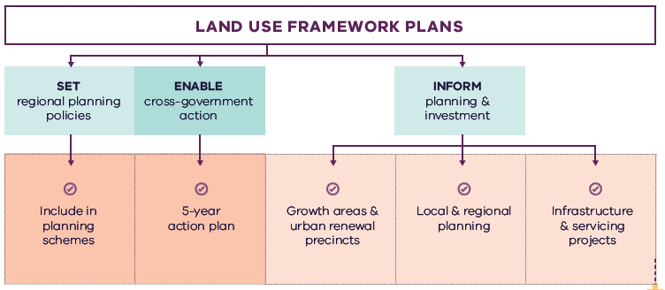

Figure 28. Implementation of the land use framework plan
Land use framework plans
- Set regional planning policies
  - Include in planning schemes
- Enable cross-government action
  - 5-year action plan
- Inform planning and investment
  - Growth areas and urban renewal precincts
  - Local and regional planning
  - Infrastructure and servicing projects

Five-year action program
A number of short- to medium-term actions are included in the Western Metro Region LUFP. The five-year action program (Table 16) summarises these actions to be delivered collaboratively by the state government and councils in the Western Metro Region. These actions deliver on the strategic directions identified in the LUFP and in turn, Plan Melbourne outcomes. The actions will positively and proactively address some of the challenges being experienced by the region.
Plan Melbourne and the Melbourne Industrial and Commercial Land Use Plan (MICLUP) also contain actions that may require regional collaboration and will support the outcomes sought by the LUFP. This LUFP’s five-year action program is a targeted list of actions identified during the development of the draft LUFP and it is not intended that this list duplicate existing Plan Melbourne or MICLUP actions with some exceptions where confirming a particular action was warranted given its regional implications.
In relation to transport, the following actions from Plan Melbourne Implementation Plan are identified as being well suited to being implemented at the regional level for this metro region and there is a commitment to deliver them as part of the implementation of Plan Melbourne and the LUFP:
- Action 43: Safe, efficient and accessible pedestrian networks
- Action 44: Local networks of cycling links
- Action 45: Local transport forums.
The implementation and prioritisation of the five-year action program will be driven by existing metro-regional governance arrangements including the Metropolitan Partnerships and EPWGs.
The indicative timeframes for completing actions are:
- Short term: By the end of 2023 (0–2 years)
- Medium term: By the end of 2026 (2–5 years).
Each action is allocated to a lead agency and implementation partners. Detail on the timing of actions and how they are implemented will be determined in line with normal government and council policy and budget processes. All actions requiring budget allocation will be carefully assessed against budget capacity, with rigorous business cases and cost-benefit analyses applied as part of their economic impact assessment.

Decision-making processes to support the delivery of the LUFPs
The LUFPs are a statement of policy intent. Detailed decisions about the implementation and timing of actions and infrastructure delivery will be made in line with normal government policy and budget processes.
The Victorian Government will continue its commitment to rigorous decision-making about initiatives that require funding, statutory amendments or new regulations in line with its economic and fiscal strategy, including the Government’s long-term financial management objectives.
For infrastructure projects, this will include ensuring consistency with the Victorian Government’s Investment Lifecycle and High Value/High Risk Guidelines. For all other initiatives and actions, implementation and timing will be subject to consideration of its evidence base and likely net benefits.

Monitoring, reporting and review
Action monitoring will be led by DELWP in partnership with the metropolitan region through the EPWG. DELWP will publish an annual progress report outlining the status of actions against the specified timeframe (whether an action has been ‘completed’, is ‘in progress’ or ‘not started’). These progress reports will be publicly available.
LUFP implementation will be formally reviewed every five years in conjunction with the Plan Melbourne Five-Year Implementation Plan. The review will be conducted in an open way and involve engagement with key stakeholders including Metropolitan Partnerships and EPWGs.

Actions – Implementation
- Update budget business case submission templates and guidance to identify how initiatives align with Plan Melbourne and the LUFPs.

Five-year action program
Timeframe - Short term (S): By the end of 2023 (0–2 years). Medium term (M): By the end of 2026 (2–5 years)
 | Action | Source | Timeframe | Lead agency | Implementation partner(s)
1 | Implement a program of State Government-led collaborative planning projects to ensure priority metropolitan and major activity centres and urban renewal areas maximise their respective strategic opportunities. Priority will be given to those which deliver significant jobs and housing; leverage investment in state infrastructure; and play an important role in the growth corridor and/or region. State-led planning for these state and regionally-significant places will contribute to creating liveable communities and achieving more dwellings and jobs in established areas and identify implementation and coordination actions that support growth and economic investment. |  | S | VPA | Councils, DELWP
2 | Prepare a report that sets out a spatial framework for employment precincts and activity centres across the Western Growth Corridor. It will consider the future demand for and need for commercial and employment land across the growth areas and ensure that Precinct Structure Plans make adequate and sufficient provision to accommodate longer-term commercial and employment needs. | MICLUP 2019 | S | DELWP | Councils, VPA
3 | Coordinate the whole of government delivery of the Sunshine NEIC to catalyse economic activity and maximise the value of infrastructure investment in the area. |  | M | DoT | Councils, DELWP,  VPA
4 | Separate to the SERA Pilot Project, identify and implement a SERA in the Western Metro Region in partnership with local government. |  | M | DJPR | Councils, DELWP
5 | Update planning schemes to align with housing policies in Plan Melbourne and the Western Metro Region Land Use Framework Plan and the implementation of the reformed residential zones. This includes:  - Providing capacity for 15 years of regional housing supply focussing on locations identified for housing growth in the LUFP  - Reviewing planning controls in Housing Investigation Areas as potential locations for substantial housing change.  This may require strategic planning work to support these changes such as preparing or updating local housing strategies or preparing structure plans to further investigate where increased densities can be supported, and determine specific changes required to planning schemes. |  | S | Councils | DELWP
6 | Identify underutilised and surplus government land that has potential to deliver additional social housing. | Plan Melbourne Implementation Plan | S | DFFH (HV) | DELWP
7 | In partnership with councils, identify a pipeline of sites in the Western Metro Region for social and affordable housing. |  | M | DFFH (HV) | Councils
8 | Develop a model and seek support for a whole-of-government approach to better sequence and prioritise locations for key services, social infrastructure and public transport access in the development of growth areas to better enable walkable 20-minute neighbourhoods. |  | S | VPA | Councils, DELWP, DET, DFFH (HV), DH, DoT
9 | Investigate barriers and opportunities to increase public and active transport mode share across the region to support culture change, spread demand on transport infrastructure, reduce greenhouse gas emissions and support 20-minute neighbourhood outcomes. Identify trial locations in the region to focus the investigation. |  | M | DoT | Councils
10 | Undertake a review of the regional bus network to support regional access and movement in the short to medium terms and to plan integration with major public transport changes including Suburban Rail Loop Melbourne Airport Rail and future bus networks in the growth areas and bus infrastructure for late night travel options. |  | S | DoT | Councils
11 | Review the Principal Public Transport Network for the growth areas. |  | S | DoT | Councils, DELWP
12 | Develop a plan to implement a publicly owned and managed network of regional trails and open spaces across the region’s growth corridor, using its natural drainage system where possible to link open spaces, biodiversity areas, waterways and urban areas. |  | S | DELWP | Councils, VPA
13 | Prepare a regional biodiversity strategy to protect, manage and enhance habitat corridors and increase their interconnectivity across urban and rural areas. |  | M | DELWP | Councils
14 | Review local planning schemes in the Western Metro Region to ensure protection and enhancement of the landscape and biodiversity values of the region. |  | M | Councils | DELWP, Melbourne Water
15 | Develop guidance on a new approach to neighbourhood planning in partnership with local councils of the Western Metro Region which embeds the hallmarks of 20-minute neighbourhoods. |  | S | DELWP | Councils, DoT, VPA
16 | Prepare a regional water infrastructure plan in conjunction with Integrated Water Management Forums to support state and local government and relevant agencies to prioritise and align water infrastructure needs and integrated water management outcomes |  | M | DELWP | Councils, Water authorities
17 | Investigate options and land use protection for a Resource Recovery Centre and Transfer Station/s to support Melbourne’s future resource and recovery needs. |  | M | Sustainability Victoria | Councils, Environment Protection Authority
18 | Prepare a regional bushfire response for suburban and peri-urban communities that are subject to bushfire risk. |  | M | DELWP | Councils, Country  Fire Authority
19 | Update budget business case submission templates and guidance to identify how initiatives align with Plan Melbourne and the LUFPs. |  | S | DTF

Appendix 01.
Relevant policies, strategies and initiatives
There are several current Victorian Government policies, strategies and initiatives that have implications for planning in the Western Metro Region. In addition, there are existing regional initiatives, initiated by councils and/or the Metropolitan Partnerships. This appendix provides an overview of the most relevant policies, strategies and initiatives for the Western Metro Region LUFP.
Plan Melbourne 2017-2050 and Plan Melbourne 2017-2050 Addendum, 2019, which will guide the growth of our city. Plan Melbourne sets out the strategy for supporting jobs, housing and transport, while building Melbourne’s legacy of distinctiveness, liveability and sustainability. The addendum updates Melbourne’s projected population, housing and employment growth and the Melbourne 2050 spatial framework to align with major transport investments including SRL.
Growth Corridor Plans, Managing Melbourne’s Growth 2012, sets an overarching strategic planning framework to guide future development of Melbourne’s four growth corridors – North, Sunbury-Diggers Rest, West and South East. The Growth Corridor Plans identify:
- Areas suitable for urban development and the broad form of development (residential, industrial, commercial)
- Areas of high environmental or landscape value that must be protected from development
- The integrated open space network
- Strategic transport infrastructure and options for further investigation
- Locations suitable for a wide range of employment uses.
This LUFP incorporates and updates information from the Growth Corridor Plan.
The Western Metro Region also contains regional initiatives that are relevant for the LUFP. These include:
The Western Metropolitan Region Integrated Transport Framework prepared for the Metropolitan Partnership provides a consolidated view of the key transport issues and challenges facing the region, from which to advocate the region’s position on transport and related land use initiatives.
The Western Metropolitan Regional Trails Strategic Plan ‘West Trails’ provides a framework to improve the quality and usage of regional trails in Western Metropolitan Melbourne over the next decade including addressing gaps in the network and improvements to infrastructure.
The Inner Melbourne Action Plan 2016-2026 (IMAP) is a collaboration between the Melbourne, Yarra, Port Phillip, Stonnington and Maribyrnong councils. The five councils work together through IMAP to set and implement regional priorities. The key objective of IMAP is ‘to make Inner Melbourne more liveable’. It sets out five goals to achieve this objective which relate to the economy, transport, communities, neighbourhoods and places, and environmental sustainability.
Specific Victorian Government policies, strategies and initiatives are outlined below under the relevant chapter of the LUFP to which they most strongly relate, acknowledging that many policies, strategies and initiatives are relevant to multiple chapters, or to the whole LUFP.

Productivity
The Melbourne Industrial and Commercial Land Use Plan 2019 provides an overview of current and future needs for industrial and commercial land across metropolitan Melbourne and puts in place a planning framework to support state and local government to more effectively plan for future employment and industry needs, and better inform future strategic directions.
The Unlocking Enterprise in a Changing Economy policy paper provides support for the development of enterprise precincts. The newly introduced Commercial 3 Zone aims to provide land for creative and knowledge-based industries and to reduce the planning burden for a diversity of employment uses.
Support for Victoria’s creative industries is provided through the Creative State 2016-2020 strategy which aims to grow the state’s creative and cultural economy. Work is currently underway to develop the next creative industries strategy which will guide initiatives and investment between 2020 and 2024.
Protection of the long-term future of Melbourne’s green wedges and agricultural land is provided through the Planning for Melbourne’s Green Wedge and Agricultural Land project, which is exploring a range of planning system changes for how this can best be achieved.
The Metropolitan Partnerships are advisory groups established for each of the metropolitan regions by the Victorian Government that bring community and business together with state and local government and advise on the top priorities for jobs, services and infrastructure across the region.
Business Precincts represent areas across Melbourne that have significant potential for job and population growth and distinctive, liveable and sustainable urban areas. They are already home to major businesses, existing state infrastructure projects, investment and strategic government land holdings. The Business Precincts are Fishermans Bend, Docklands, Footscray and Parkville (including the Melbourne Biomedical Precinct). The Victorian Government through the Department of Jobs, Precincts and Regions, drives the strategic development of these precincts.
Transport Precincts help grow Victoria’s economy by connecting Melbourne to jobs, services and providing an opportunity for future growth. The Transport Precincts are Arden, Sunshine and Richmond to Flinders Street corridor. The Victorian Government through the Department of Transport leads the whole-of-government delivery and coordination of the designated transport precincts.

Housing choice
Planning system administrative and policy reforms such as Smart Planning are reducing red tape and, in doing so, facilitating the supply of housing.
Planning Practice Notes on Residential Zones and Planning for Housing provide greater clarity for local councils on the technical aspects of how to apply the residential zones and how to plan for housing growth and protect neighbourhood character.
The Housing Development Data dashboard will provide improved access to information on the quantity and location of housing being developed.
The Better Apartments Design Standards and Apartment Design Guidelines for Victoria assists in improving the quality and functionality of apartments in Victoria.
The Future Homes Project is producing better apartment designs and helping Melbourne become a world leader in apartment design, sustainability and liveability.
Housing Outcomes in Established Melbourne 2005 to 2016 highlights how housing development data can be used to understand changes in density, development of housing in activity centres and the influence of zones and overlays on housing change.
Big Housing Build will deliver 9300 new social housing dwellings and 2900 new affordable and market homes for first home buyers and renters across the state. It includes:
- $532 million to replace obsolete properties on Homes Victoria land and constructing new homes – this includes Fast Start projects at Victoria Street, Flemington and Elizabeth Street in Richmond.
- $948 million for ready to build and spot purchase, working with private sector to bring forward new developments ready to start construction and purchase existing residential properties.
- $1.38 billion funding for projects by the community housing sector, through the Social Housing Growth Fund.
- $2.14 billion in partnerships with the private and community housing sector – exploring options to build on surplus government owned sites.
The Social Housing Growth Fund is the vehicle for allocating new funds to suitable projects proposed by the community housing sector.
The Homelessness and Rough Sleeping Action Plan initiatives include 20 one-bedroom modular units with intensive onsite support, multidisciplinary housing teams to support complex clients to maintain stable housing, eight additional assertive outreach teams in locations of highest need, and funding therapeutic services in major inner city crisis accommodation centres to improve health, wellbeing and housing outcomes.
The redevelopment of public housing estates is a program to transform ageing public housing estates across metropolitan Melbourne and key regional centres into vibrant, well-connected neighbourhoods. This will create at least 1800 new` public housing homes.
The Building new homes to fight homelessness is a program to help Victorians escaping family violence, homelessness and life on the streets by building 1000 new public housing properties.

Integrated transport
Suburban Rail Loop is a new orbital rail link connecting Melbourne’s middle suburbs from Cheltenham to Werribee via Melbourne Airport and includes preparing detailed precinct frameworks and structure planning for all SRL precincts. Suburban Rail Loop consists of SRL East (Cheltenham to Box Hill), SRL North (Box Hill to Airport) and SRL West (Airport to Werribee).
The West Gate Tunnel will create a second river crossing to link the Western Metro Region with the Port of Melbourne, CityLink and the CBD, and take traffic pressures off the West Gate Bridge.
Melbourne Airport Rail will connect Melbourne Airport to metropolitan and regional rail networks via Sunshine.
North East Link will provide the ‘missing link’ between the Eastern Freeway and the M80 Ring Road in Melbourne’s north east and, in doing so, reduce travel times, remove trucks from local roads and link growth areas in the north and south-east of Melbourne and enhance connections between the Western Ring Road, Hume Freeway and Eastern Freeway to Melbourne’s south-east.
The Level Crossing Removal Project will continue to provide improved travel and safety for road users, public transport users, cyclists and pedestrians by removing additional level crossings across metropolitan Melbourne.
The Victorian Infrastructure Plan seeks to build, improve and care for Victoria’s infrastructure. It responds to Infrastructure Victoria’s 30-year Infrastructure Strategy and presents priorities and future directions across nine key sectors.
The Metro Tunnel will create additional capacity on Melbourne’s rail network by running the Cranbourne, Pakenham and Sunbury lines through a new tunnel.
Freightage throughout the state will be enhanced as part of the Delivering the Goods: Creating Victorian Jobs – Victorian Freight Plan.
The Urban Congestion Fund will upgrade the urban road network to reduce congestion upgrading pinch points, intersections and commuter car park upgrades at train stations.
The Western Roads Upgrade is a project to improve eight main roads across the west, repair and resurface 37 roads and strengthen 7 structures, mostly bridges.
A range of priority road projects have been identified, including:
- Duncans Road interchange, Werribee/Werribee South
- Palmers Road upgrade, Princes Freeway to Western Freeway, Truganina
- Derrimut Road upgrade, Sayers Road to Dohertys Road, Tarneit
- Leakes Road upgrade, Fitzgerald Road to Derrimut Road, Truganina
- Dohertys Road upgrade, Fitzgerald Road to Grieve Parade, Laverton North
- Dohertys Road upgrade, Foundation Road to Palmers Road, Truganina
- Princes Freeway/Forsyth Road interchange upgrade, Hoppers Crossing
- Mt Derrimut Road and Robinsons Road, Deer Park, and Fitzgerald Road, Ardeer level crossing removals (within the Western SSIP)
- Old Geelong Road, Hoppers Crossing level crossing removal (connection to the Werribee NEIC)
- Safety upgrades to the Melton Highway between Regency and Sunshine.
Western Rail Plan sets out the future investments for a fast, high-capacity rail network servicing our growing suburbs and growing regional cities. It consists of three major connected projects:
- Two new electrified metro rail lines through to growth areas in Melton and Wyndham Vale
- Increased capacity between Sunshine and the CBD to cater for faster and more frequent metro and regional trains
- Major investment in the Geelong and Ballarat lines to run trains faster than 160km/h. This will include exploration of electrification of these lines and new, fast electric regional trains.
Geelong Fast Rail Stage 1 - Werribee to Newport will deliver faster services between Geelong and Melbourne’s CBD with a travel time of around 50 minutes enabled through a major investment to the Werribee corridor.
The Port Rail Shuttle Network is an investment in direct rail freight between key suburban locations in Dandenong South, Somerton and Altona and the Port of Melbourne. Once fully operational, this will make a significant difference to how freight moves around Melbourne. By 2050, it is expected to move 30 per cent of Melbourne’s containers by rail, avoiding millions of truck trips on roads each year.
The 2020/2021 Victorian State Budget allocates funding to progress planning for the Bulla Bypass. This will include provision for a six lane arterial road and will connect to the Outer Metropolitan Ring/E6, supporting future traffic volumes in the region and provide an improved connection from Melbourne Airport to the city’s north and west.
Victoria’s Zero Emissions Vehicle Roadmap sets out a plan to achieve half of all light vehicle sales in Victoria to be Zero Emission Vehicles by 2030.
Movement and Place is a way of thinking about the roles and challenges facing our transport system now and into the future. The Movement and Place approach recognises that transport links perform two functions: movement of people and goods and serving as a place (a destination in its own right). This way of thinking ensures that while we are planning for and developing our network, we are considering the needs for movement and placemaking simultaneously.

Liveability
Open Space for Everyone: Open Space Strategy for Metropolitan Melbourne 2020 supports a cooler, greener city with a network of quality open spaces to which all members of the community have access.
The Suburban Parks Program will deliver more than 6500 hectares of new and upgraded parks and trails across Greater Melbourne.
Waterways of the West (WoW) Action Plan (to be released in 2021) will include steps to better protect the waterways of the region and their parklands within the context of increased population growth. It encompasses the network of waterways within the Maribyrnong and Werribee catchments.
The Healthy Waterways Strategy 2018 provides a framework for managing rivers, wetlands and estuaries in Melbourne’s five major catchments to ensure their value to the community is protected and improved.
Water for Victoria is a plan for a future with less water as Victoria responds to the impact of climate change and a growing population.
Protecting Victoria’s Environment – Biodiversity 2037 aims to stop the decline of Victoria’ native plants and animals and improve the natural environment.
The Land Utilisation Assessment Program works to improve utilisation of government land.

Strong communities
The 20-minute Neighbourhoods project delivers a range of initiatives to create a city of 20-minute neighbourhoods, enabling communities to live more locally. 20-Minute Neighbourhood Pilot Projects were undertaken in Sunshine West and Strathmore, delivered in partnership with Councils, Victoria Walks and the Heart Foundation (Victoria). The pilot projects demonstrated the benefits of a community partnerships approach in planning to realise the hallmarks of 20-minute neighbourhoods.
The Victorian Government has committed $675 million to the Community Hospitals Program to build 10 community hospitals close to major growth areas enhancing access to health services in growing communities.
The Statewide Design, Service and Infrastructure Plan for Victoria’s Health System 2017-2037 provides a planning framework to guide service, workforce and infrastructure investment in Victoria’s health system.
Health 2040: Advancing Health, Access and Care presents a clear vision for the health and wellbeing of Victorians and for the Victorian healthcare system.
The Victorian Public Health and Wellbeing Plan 2019-2023 seeks to ensure that all Victorians enjoy the highest attainable standard of health, wellbeing and participation at every age. The production of this Plan is legislated for under the Victorian Public Health and Wellbeing Act 2008.
The Growing Suburbs Fund will provide investment in critical local infrastructure for communities in Melbourne’s growing outer suburbs.
The 2020/21 Victorian State Budget allocates funding for the Community Sports Infrastructure Stimulus Program that will fast-track shovel-ready community sports infrastructure projects across Victoria.
The Victorian Cycling Strategy 2018-28 guides planning and investment in cycling in the state.
Active Victoria – A Strategic Framework for Sport and Recreation in Victoria 2017-2021 provides a strategic framework for future work into Victoria’s sports and active recreation sector.
The Victorian Government’s Metropolitan Health Infrastructure Fund will work with Metropolitan Melbourne’s hospitals and health services to upgrade infrastructure to support the delivery of new or enhanced services to patients.
The Suburban Revitalisation program facilitates the delivery of urban renewal in metropolitan activity centres experiencing economic transition and/or significant levels of disadvantage. The Program is centred on a partnership between state agencies, local councils and regional stakeholders to accelerate the development and delivery of local infrastructure upgrades, small business stimulus initiatives and community connectedness activities.
The Victorian Aboriginal Affairs Framework 2018-2023 (the VAAF) is the Victorian Government’s overarching framework for working with Aboriginal Victorians, organisations and the wider community to drive action and improve outcomes.

Sustainability and resilience
Sector and whole-of-government emission reduction pledges will help achieve the Victorian Government’s target of net-zero emissions by 2050.
The Climate Change Act 2017 provides Victoria with a world-leading legislative foundation to manage climate change risks, maximise the opportunities that arise from decisive action, and drive our transition to a climate resilient community and economy with net-zero emissions by 2050.
The Renewable Energy (Jobs and Investment) Act 2017 legislates an increase of the Victorian Renewable Energy Target (VRET) to 50 per cent by 2030.
Adaption Action Plans (Climate Change Act 2017) will help build the state’s resilience and help Victorians plan for the inevitable impacts of climate change.
Victoria’s Climate Change Strategy (2021) has a range of specific measures to support the uptake of renewable energy in businesses, industry and homes. It includes further reforms to drive greater energy efficiency of electrical appliances, lighting and air-conditioning/heating equipment and to improve the thermal performance of new buildings. Transport emissions will be reduced by accelerating Victoria’s transition to zero emissions vehicles, improving public transport and investing more in cycling and walking options. The Strategy will also support the circular economy reforms to Victoria’s waste management system contained in the Recycling Victoria action plan, Recycling Victoria: A New Economy.
The Victorian Climate Projections 2019 Technical Report describes how the regional climate of Victoria is likely to respond to global warming with different scenarios of human greenhouse gas emissions. The 2020/21 Victorian State Budget delivered a landmark $2 billion for the Breakthrough Victoria Fund to drive translation and commercialisation of knowledge in Victoria. The Clean Economy is one of the five key sectors the Fund will prioritise.
The 2020/21 Victorian State Budget also provided funding for clean energy transition initiatives, including establishing renewable energy zones to develop and deliver renewable energy projects.
The Cooler, Greener Melbourne project will create more liveable and climate-adapted communities through green infrastructure and other cooling and greening initiatives. Tree planning on public land will create a cooler and greener Melbourne as part of Melbourne Water’s Urban Cooling Program. The program includes changes to planning schemes to protect and strengthen the urban forest.
The Marine and Coastal Policy (2020) sets out policies for planning and managing the marine and coastal environment, provides guidance to decision-makers in achieving the objectives of the Marine and Coastal Act 2018 and includes a Marine Spatial Planning Framework to achieve integrated and coordinated planning and management of Victorian’s marine environment.
Living Melbourne Urban Forest Strategy (2019) is a strategy for a greener, more liveable Melbourne, developed by Nature Conservancy and Resilient Melbourne.
The Melbourne Strategic Assessment program manages the impact of urban development on significant vegetation communities, plants and animals in Melbourne’s growth areas.
The Victorian Water and Climate Initiative supports research into the impact of climate change and climate variability on Victoria’s water resources. Additional investments will be made to enhance the scientific understanding of Victoria’s climate and provide authoritative data and information on climate change to the community.
Integrated Water Management Framework for Victoria provides a collaborative approach to the way we plan for and manage all elements of the water cycle, including the health of waterways and bays, wastewater management, alternative and potable water supply, stormwater management and water treatment.
The Beach Renourishment Program in Port Phillip Bay 2019-2022 is designed to repair damaged caused by coastal erosion on Port Phillip Bay beaches.
The Statewide Waste and Resource Recovery Infrastructure Plan 2018 (SWRRIP) guides future planning for waste and resource recovery infrastructure to achieve an integrated system.
The Metropolitan Waste and Resource Recovery Implementation Plan brings together the statewide priorities set out in the SWRRIP and applies them within the metropolitan context.
The Recycling Industry Strategic Plan transitions Victoria’s recycling industry to a more sustainable and resilient model.
Recycling Victoria: A New Economy outlines a plan for reform to establish a recycling system that Victorians can rely on and transforms how our economy uses materials and how our state reuses, repairs and recycles.
The 2020/21 Victorian State Budget allocates funding for the 10-year Recycling Victoria action plan, Recycling Victoria: A New Economy to transform Victoria’s recycling sector and develop a circular economy.
Melbourne Sewerage Strategy 2018 is a 50-year strategy to set the direction for wastewater management across metropolitan Melbourne to manage its contribution to public health and the environment.

Appendix 02.
Housing choice supporting data
Table A2-1. Major housing redevelopment completed in the Western Metro Region in and within 400m of activity centres (2005-2018) and in the redevelopment pipeline
Activity Centre | Major housing redevelopment completed 2005-2016* - In centre | Major housing redevelopment completed 2005-2016* - Within 400m of centre | Major housing redevelopment completed 2017-2018* - In centre | Major housing redevelopment completed 2017-2018* - Within 400m of centre | Major housing redevelopment pipeline* - In centre | Major housing redevelopment pipeline* - Within 400m of centre
Airport West | 0 | 11 | 10 | 0 | 105 | 0
Altona | 168 | 69 | 29 | 10 | 212 | 0
Altona North | 0 | 0 | 0 | 11 | 0 | 22
Ascot Vale, Union Road | 187 | 51 | 22 | 0 | 255 | 36
Boardwalk | 0 | 655 | 0 | 0 | 0 | 0
Braybrook, Central West | 20 | 104 | 0 | 0 | 10 | 0
Caroline Springs | 0 | 358 | 0 | 0 | 0 | 101
Deer Park, Brimbank Central | 0 | 0 | 0 | 0 | 0 | 0
Deer Park Central** | 0 | 0 | 0 | 0 | 0 | 0
Flemington, Racecourse Road | 106 | 884 | 409 | 0 | 645 | 96
Footscray | 1263 | 215 | 618 | 19 | 6767 | 1370
Hoppers Crossing** | 0 | 0 | 0 | 0 | 0 | 0
Laverton | 0 | 1627 | 196 | 148 | 96 | 140
Manor Lakes | 0 | 50 | 0 | 0 | 0 | 0
Maribyrnong, Highpoint | 241 | 652 | 458 | 214 | 629 | 102
Melton | 20 | 19 | 0 | 0 | 10 | 41
Melton, Woodgrove and Coburns Road | 0 | 289 | 0 | 0 | 0 | 0
Moonee Ponds | 483 | 168 | 847 | 13 | 2467 | 82
Niddrie, Keilor Road | 244 | 59 | 12 | 0 | 570 | 63
North Essendon | 890 | 143 | 215 | 42 | 114 | 0
Plumpton** | 0 | 0 | 0 | 0 | 0 | 0
Rockbank** | 0 | 0 | 0 | 0 | 0 | 0
Rockbank North** | 0 | 0 | 0 | 0 | 0 | 0
St Albans | 87 | 0 | 65 | 0 | 443 | 0
Sunshine | 144 | 0 | 28 | 10 | 991 | 125
Sydenham | 92 | 30 | 0 | 20 | 126 | 47
Tarneit | 0 | 308 | 0 | 0 | 0 | 0
Toolern** | 0 | 97 | 0 | 0 | 0 | 0
Werribee | 26 | 62 | 36 | 18 | 112 | 175
Werribee Plaza | 0 | 40 | 0 | 0 | 0 | 0
Williamstown | 0 | 53 | 10 | 14 | 14 | 12
* Major development is defined as developments with over 10 dwellings.
** Emerging activity centres in growth areas. Redevelopment data does not cover these areas
Note: Dwelling numbers are calculated based on constructed not net additions dwellings.
Note: Pipeline refers to projects that are: under construction, have a planning permit, have had pre application meetings, or being sold off the plan.
Note: 400m activity centre buffer may be in multiple metro Regions.
Housing Development Data 2016, Urban Development Program – Redevelopment 2018, Urban Development Program – Redevelopment 2019

Glossary
Where the term is defined in Plan Melbourne or the Victoria Planning Provisions, that definition is used.
Aboriginal | Aboriginal refers to both Aboriginal and Torres Strait Islander peoples. They may have connections in and outside of Victoria.
Active transport | Transport requiring physical activity, typically walking and cycling.
Activity centres | Areas that provide a focus for services, employment, housing, transport and social interaction. They range in size and intensity of use from smaller neighbourhood centres to major suburban centres and larger metropolitan centres.
Affordable housing | Housing that is appropriate for the needs of a range of very low to moderate income households, and priced (whether mortgage repayments or rent) so these households are able to meet their other essential basic living costs.
Agglomeration | The location of businesses in close proximity to each other, which allows them to get productivity and efficiency gains through large customer bases, knowledge sharing and access to skilled workers.
Biodiversity | The variety of all life forms, the different plants, animals and microorganisms, the genes they contain and the ecosystems of which they form a part.
Central Business District (CBD) | Melbourne’s original ‘Hoddle Grid’ street layout bounded by the Yarra River, Spring Street, La Trobe Street and Spencer Street, as well as the triangular area to the north bounded by Victoria, Peel and La Trobe streets.
Central City | The area within the inner metro region that contains key capital city functions and civic facilities, as well as several precincts identified for major and strategic change. The Central City incorporates the CBD (Hoddle Grid, north to Grattan Street between Peel and Swanston streets) as well as Docklands, Southbank and St Kilda Road.
Climate change | A long-term change of the earth’s temperature and weather patterns – generally attributed directly or indirectly to human activities such as fossil fuel combustion and vegetation clearing and burning.
Commercial land | Land used for commercial purposes including land used for business services, retail, accommodation, food and other industries.
Creative industry | Media, digital screen, design, writing and publishing, literature, fashion, performing arts, digital games development, broadcasting, music, cultural heritage, arts, education and craft industries.
Enterprise precincts | Precincts that facilitate the creation and commercialisation of new ideas and support metropolitan economies by growing jobs in ways that leverage their distinct economic attributes. These districts build on and revalue the intrinsic qualities of cities: proximity, density, authenticity, and vibrant places. (Brookings Institute definition)
Eastern Metro Region | Includes the LGAs of Knox, Manningham, Maroondah, Monash, Whitehorse, Yarra Ranges.
Established urban areas | Areas of Melbourne that have been urbanised for at least several decades.
Green wedges | Defined under Part 3AA of the Planning and Environment Act 1987 as “land that is described in a metropolitan fringe planning scheme as being outside an urban growth boundary”. There are 12 defined green wedges spanning parts of 17 municipalities.
Greenfield land | Undeveloped land identified for residential or industrial/commercial development, generally on the fringe of metropolitan Melbourne.
Greenhouse gas emissions | Atmospheric gas that absorbs and emits infrared or heat radiation, giving rise to the greenhouse effect. Typical greenhouse gases include carbon dioxide, methane, nitrous oxide and refrigerants.
Greyfield | Residential areas where the building stock is near or has ended its useful life and land values make redevelopment attractive.
Gross regional product (GRP) | Gross regional product is a measure of the market value of all final goods and services produced in a region over a period of time.
Growth areas | Locations on the fringe of metropolitan Melbourne designated in planning schemes for large-scale transformation, over many years, from rural to urban use.
Growth corridor plans | The growth corridor plans are high level integrated land use and transport plans that provide a strategy for the development of Melbourne’s growth corridors over the coming decades.  The growth corridor plans focus on three metropolitan growth corridors: Northern, Western and South Eastern growth corridors. They identify broad transport networks, industrial and employment areas, residential areas and recreation precincts across the city’s newest metropolitan suburbs. Relevant information from the growth corridor plans have been integrated into the LUFPs containing growth corridors.
Health and education precincts | Locations to cluster synergistic health and/or education services to improve access to integrated service provision, improve outcomes, develop the health and education workforce and deliver economic benefits (such as innovation and job creation). These precincts may provide solely health, solely education, or a combination of health and education services.
Hoddle Grid | The grid pattern of streets making up Melbourne’s CBD bounded by the Yarra River, Spring Street, La Trobe Street and Spencer Street, as well as the triangular area to the north bounded by Victoria, Peel and La Trobe streets. The grid was designed by Robert Hoddle in 1837.
Housing density | The number of dwellings in an urban area divided by the area of the residential land they occupy, expressed as dwellings per hectare.
Hybrid centre | A descriptor for an activity centre typology that contains a mixed arrangement of freestanding / enclosed shopping complexes and traditional open air strip-based commercial land.
Infill | Development of unused or underutilised land in existing urban areas.
Infrastructure | Basic facilities and networks needed for the functioning of a local community or broader society.
Integrated water management (IWM) | An approach to planning that brings together all facets of the water cycle including sewage management, water supply, stormwater management and water treatment, ensuring environmental, economic and social benefits.
Inner Metro Region | Includes the LGAs of Melbourne, Port Phillip and Yarra.
Inner South East Metro Region | Includes the LGAs of Boroondara, Glen Eira, Stonnington and Bayside.
Intermodal freight terminal | A location for the transfer of freight from one transport mode to another, for example between road and rail.
Knowledge-based industries and jobs | Production and services based on knowledge-intensive activities that contribute to an accelerated pace of technical and scientific advancement. Their key characteristic is a greater reliance on intellectual capabilities than on physical inputs or natural resources.
Liveability | A measure of a city’s residential quality of life, used to benchmark cities around the world. It includes socioeconomic, environmental, transport and recreational measures.
Localised planning statement | Long-term policies for the future planning and development of areas identified as having significance to the broader Victorian community.
Major activity centres | Suburban centres that provide access to a wide range of goods and services. They have different attributes and provide different functions, with some serving larger sub-regional catchments. Plan Melbourne identifies 121 major activity centres.
Metropolitan activity centres | Higher-order centres with diverse employment options, services and housing stock, supported by good transport connections. Existing centres include Box Hill, Broadmeadows, Dandenong, Epping, Footscray, Fountain Gate/Narre Warren, Frankston, Ringwood and Sunshine. Future centres will include Lockerbie and Toolern.
Metropolitan Melbourne | The 31 municipalities that make up metropolitan Melbourne, plus part of Mitchell Shire within the Urban Growth Boundary.
Moderate income household | Annual household income within the income range specified as a moderate range by Order under section 3AB of the Planning and Environment Act 1987. In 2020 this was $87,671 to $131,500 for a family (with one or two parents) and dependent children.
National employment and innovation clusters (NEIC) | Designated concentrations of employment distinguished by a strong core of nationally significant knowledge sector businesses and institutions that make a major contribution to the national economy and Melbourne’s position in the global economy.
Natural hazard | A natural event that has potential to cause harm to people, property or the environment, including climate change, bushfire, flooding and sea level rise.
Neighbourhood activity centres | Local centres that provide access to local goods, services and employment opportunities and serve the needs of the surrounding community.
Northern Metro Region | Includes the LGAs of Banyule, Darebin, Hume, Mitchell (part), Moreland, Nillumbik and Whittlesea.
Open space | Includes land reserved for natural landscape, parklands, recreation and active sports, as well as waterways and bays.
Peri-urban areas | Areas beyond the green wedges made up of local government areas with a predominantly rural character, located all or partially within a 100-kilometre radius of Melbourne.
Precinct Structure Plans (PSPs) | Master plans for future growth corridor developments, informed by growth corridor planning. The plans identify alignments of transport routes, town centres, open space networks, densities of residential areas, and areas for industry and employment.
Primary healthcare | Primary healthcare is generally the first contact a person has with Australia’s health system. It relates to the treatment of patients who are not admitted to hospital. It encompasses a wide range of health professionals and includes general practitioners, community nurses, midwives, pharmacists, dentists, and Aboriginal health workers, for example.
Principal Freight Network (PFN) | Part of the larger transport network over which the movement of heavy freight will be concentrated.
Principal Public Transport Network (PPTN) | A statutory land use planning tool that supports integrated land use and transport planning by providing certainty to land use planners and developers around locations that are and will be served by high-quality public transport.
Regional active open spaces | Large scale open spaces that cater for a range of recreational opportunities including informal outdoor recreation, active recreation and sports. Regional active open spaces serve a broad catchment and may comprise buildings and infrastructure to facilitate sporting or recreational activity.
Regional parks | Regional parks are large areas of open space that feature natural or semi-natural surroundings in close proximity to urban environments. They have high landscape, biodiversity and cultural values and provide a diversity of passive recreational, educational or tourism opportunities. Regional parks are places where Traditional Owners can connect with their heritage and continue cultural practices.
Regional Victoria | Includes all municipalities outside metropolitan Melbourne (except part of Mitchell Shire within the Urban Growth Boundary).
Regionally-significant industrial precincts  (RSIP) | Key industrial areas that contribute significantly to local and regional economies. Some of these areas are well established and support a range of industrial uses while others are transitioning and supporting new uses. They include future employment areas identified through growth corridor plans that will support not just employment growth in outer areas, but to also meet Melbourne’s longer term industrial and logistics needs. They are to be retained and planned for to allow a range of industrial uses, or where appropriate, new and emerging businesses that require access to affordable and well-located employment land.
Renewable energy | Energy that comes from resources which are naturally replenished on a human timescale such as sunlight, wind, rain, tides, waves, and geothermal heat.
Resilience | The capacity of individuals, communities, institutions, businesses, systems and infrastructure to survive, adapt and grow, no matter what chronic stresses or shocks they encounter.
Resource recovery | Extraction of useful material or energy from a waste stream.
Social housing | A type of rental housing that is provided and/or managed by the government or by a not-for-profit organisation. Social housing is an overarching term that covers both public housing and community housing.
Social infrastructure | Encompasses all the facilities, services and networks that help families, groups and communities to meet their social, health, education, cultural and community needs.
Southern Metro Region | Includes the LGAs of Cardinia, Casey, Greater Dandenong, Frankston, Kingston and Mornington Peninsula.
State-significant industrial precincts (SSIP) | Strategically located land available for major industrial development linked to the Principal Freight Network and transport gateways. They will be protected from incompatible land uses to allow continual growth in freight, logistics and manufacturing investment.  There are five state-significant industrial precincts: Western Industrial Precinct, Northern Industrial Precinct, Southern Industrial Precinct, Port of Hastings Industrial Precinct and Officer-Pakenham Industrial Precinct.
Strategic Cycling Corridors (SCC) | Strategic Cycling Corridors are important transport routes for cycling and are a subset of the Principal Bicycle Network (PBN). The SCC network supports the needs of commuter trips (to work or education) and other important trips, such as to stations, shops or schools.  The SCC network links up important destinations, including central Melbourne city, employment and activity centres, and other destinations of metropolitan and regional significance.  SCCs can be on and off road, on municipal and state roads and are designed to provide a safe, lower-stress cycling for transport experience.
Strategic Extractive Resource Area (SERA) | Recognised and secured extractive resource areas of strategic importance for the construction of public infrastructure, affordable housing and private sector development now and in the future.  They cover extractive resources that actually and/or potentially occur in defined locations at various scales based on their likelihood or potential to supply growth areas, taking into account accessibility to markets, while minimising impacts on environment and other land use constraints.
Traditional Owners | People who, through membership of a descent group or clan, are responsible for caring for particular Country. A Traditional Owner is authorised to speak for Country and its heritage as a senior Traditional Owner, an Elder or, in more recent times, a registered native title claimant.
Transit-oriented development | Compact, walkable, mixed-use communities centred around high-quality train systems. Transit-oriented development assists in addressing the growing problems of climate change and global energy security by creating dense, walkable communities that greatly reduce the need for driving and energy consumption.
Transport gateway | Ports, airports and interstate terminals that serve as key locations for moving passengers and freight into and out of Victoria and also play a significant economic and employment-generating role.
20-minute neighbourhoods hallmarks | The ‘hallmarks’ are established in Plan Melbourne’s Direction 5.1 — Create a city of 20-minute neighbourhoods. The ‘hallmarks’ developed in partnership with the Department of Health and the Heart Foundation (Victoria) are:  - be safe, accessible and well connected for pedestrians and cyclists to optimise active transport  - offer high-quality public realm and open spaces  - provide services and destinations that support local living  - facilitate access to quality public transport that connects people to jobs and higher-order services  - deliver housing/population at densities that make local services and transport viable  - facilitate thriving local economies.
Urban forest | All of the trees and other vegetation in a city as well as the soil and water that supports it.
Urban Development Program (UDP) | The Urban Development Program (UDP) provides an annual assessment of supply and consumption of industrial and residential land across metropolitan Melbourne.
Urban Growth Boundary (UGB) | A management tool to contain urban areas and limit their expansion. It divides land that is urban – to be used for housing, shops, factories – from land that is nonurban and to be used for purposes such as conservation, agriculture, mineral extraction, airports and the like. A UGB encourages urban consolidation and protects valued non-urban areas from urban development.
Urban renewal | The process of planning and redeveloping underutilised medium and large-scale urban areas, precincts or sites for mixed land use purposes.
Very low income household | Annual household income within the income range specified as a very low income range under section 3AB of the Planning and Environment Act 1987. In 2020 this was up to $26,090 for a single adult.
Western Metro Region | Includes the municipalities of Brimbank, Hobsons Bay, Maribyrnong, Melton, Moonee Valley and Wyndham.
Water sensitive urban design (WSUD) | Integrating the urban water cycle into urban design to minimise environmental damage and improve recreational and aesthetic outcomes.
Wallan SA2 | Statistical Areas Level 2 (SA2) are medium-sized general purpose areas established by the ABS that represent a community that interacts together socially and economically. The Wallan SA2 is larger than the area in Mitchell within the Urban Growth Boundary and generally follows the municipal boundary west of Wallan and extends north of Wandong and east into Kinglake National Park.
Yarra River Land | Crown and State owned land within 500 metres of the Yarra River declared under the Yarra River Protection (Wilip-gin Birrarung murron) Act 2017. The declaration provides additional protection to this land. Yarra River Land that is used for public recreation forms the Greater Yarra Urban Parklands.

References
Australian Bureau of Statistics, 2016. ABS Census data, Australia: Australian Bureau of Statistics.
Australian Bureau of Statistics, 2021. Regional Population 2019-20 financial year: Commonwealth of Australia, Canberra, Australia.
Australian Sustainable Built Environment Council, 2016. Low Carbon, High Performance, Surrey Hills, NSW Australia: SDBEC.
Banyule City Council, 2014. Urban Forest Strategic Plan, Melbourne, Australia: Banyule City Council.
Clarke, J. M. et al., 2019. Victorian Climate Projects 2019 Technical Report, Melbourne: CSIRO.
Coutts, A. & Tapper, N., 2017. Trees for a Cool City: Guidelines for optimised tree placement, Melbourne: Cooperative Research Centre for Water Sensitive Cities.
DELWP, 2017a. Plan Melbourne, Melbourne: DELWP.
DELWP, 2017b. Port Phillip Bay Environmental Management Plan 2017-2027, Melbourne, Australia: The State of Victoria Department of Environment, Land, Water and Planning.
DELWP, 2017c. Protecting Victoria’s Biodiversity 2037, Melbourne: DELWP.
DELWP, 2017d. Northern Metro Region: Regional Background Paper, Melbourne: DELWP.
DELWP, 2018a. Housing Development Data, Melbourne: DELWP.
DELWP, 2018b. Integrated Water Management Forum: Dandenong Strategic Directions Statement 2018, Melbourne: DELWP.
DELWP, 2018c. Integrated Water Management Forums: Yarra Strategic Directions Statement 2018, Melbourne: DELWP.
DELWP, 2018d. Land Surface Temperature data, Melbourne: DELWP.
DELWP, 2018e. Urban Development Program - Metropolitan Melbourne Broadhectare 2018, Melbourne: DELWP.
DELWP, 2018f. Urban Development Program - Redevelopment 2018, Melbourne: DELWP.
DELWP, 2019a. Plan Melbourne Addendum, Melbourne: DELWP.
DELWP, 2019b. Victoria in Future, Melbourne: DELWP.
DELWP, 2020a. Melbourne Industrial and Commercial Land Use Plan, Melbourne: DELWP.
DELWP, 2020b. Victorian Greenhouse Gas Emissions Report 2018, Melbourne, Australia: The State of Victoria.
DELWP, 2021a. Environmentally Sustainable Development of Buildings and Subdivisions - A roadmap for Victoria’s planning system, Melbourne: DELWP.
DELWP, 2021b. Internal analysis using Victorian Integrated Survey of Travel and Activity (VISTA) 2016-18 survey data.
DELWP, 2021c. Planning for Melbourne’s Green Wedge and Agricultural Land Consultation Paper, Melbourne: DELWP.
Department of Industry, Science, Enregy and Resources, 2021. Nationwide House Energy Rating Scheme (NatHERS). [Online] Available at: https://www.nathers.gov.au [Accessed March 2021].
DEPI, 2013. Biodiversity and Conservation Strategy, Melbourne: DEPI.
DHHS, 2020. Rental Report March Quarter 2020, Melbourne: DHHS.
eWater, 2021. MUSIC (Model for Urban Stormwater Improvement Conceptualisation). [Online] Available at: https://ewater.org.au/products/music/ [Accessed March 2021].
Green Building Council of Australia, 2021. Green Star Rating System. [Online] Available at: https://new.gbca.org.au/rate/rating-system [Accessed March 2021].
Grodach, C., Kamruzzaman, L. & Harper, L., 2019. 20-minute Neighbourhood - Living Locally Research, Melbourne: Monash University.
Hurley, J. et al., 2019a. Melbourne Urban Vegetation Cover 2018, Western Region, Melbourne, Australia: DELWP.
Hurley, J. et al., 2019b. Urban Vegetation Cover Change in Melbourne 2014 - 2018, Melbourne: Centre for Urban Research, RMIT University.
KPMG & ARUP, 2017. Travel Demand and Movement Patterns report.
Melbourne Airport, 2018. Melbourne Airport Masterplan 2018, Melbourne: Melbourne Airport.
Melbourne Water, 2017. Planning for Sea Level Rise, Melbourne: Melbourne Water Corporation.
Melbourne Water, 2018. Health Waterways Strategy, Melbourne: Melbourne Water Corporation.
Metropolitan Waste and Resource Recovery Group, 2016. Metropolitan Waste and Resource Recovery Implementation Plan, Melbourne: Metropolitan Waste and Resource Recovery Group.
MUSIC Auditor, 2021. MUSIC Auditor. [Online] Available at: https://www.musicauditor.com.au [Accessed March 2021].
NAGA, 2014. Integrated Regional Vulnerability Assessment - Adaptation in the north. Volume 1, p. 74.
Nationwide House Energy Rating Scheme, 2021. Nationwide House Energy Rating Scheme. [Online] Available at: http://www.nathers.gov.au [Accessed March 2021].
PSMA Australia Limited, 2021. Buildings Spatial Data | Building GIS Data | Geoscape. [Online] Available at: https://geoscape.com.au/data/buildings/ [Accessed 2021].
PwC, 2016. Extractive Resources in Victoria, Demand and Supply Study 2015-2050, Melbourne: DJPR.
Sun, C. et al., 2019. Urban Vegetation, Urban Heat Islands and Heat Vulnerability Assessment in Melbourne, 2018, Melbourne: Clean Air and Urban Landscapes Hub.
Sustainability Victoria, 2018. Statewide Waste and Resource Recovery Infrastructure Plan, Melbourne: Sustainability Victoria.
The Nature Conservancy and Resilient Melbourne, 2019. Living Melbourne: Our Metropolitan Urban Forest Technical Report, Melbourne: The Nature Conservancy and Resilient Melbourne.
Urich, C. & Hardy, M., 2020. Cooling and Greening Melbourne - Future scenarios, Melbourne: Cooperative Research Centre for Water Sensitive Cities.
VPA, 2017. Metropolitan Open Space Network, Provision and Distribution, Melbourne: VPA.

© The State of Victoria Department of Environment, Land, Water and Planning 2021
This work is licensed under a Creative Commons Attribution 4.0 International licence. You are free to re-use the work under that licence, on the condition that you credit the State of Victoria as author. The licence does not apply to any images, photographs or branding, including the Victorian Coat of Arms, the Victorian Government logo and the Department of Environment, Land, Water and Planning (DELWP) logo. To view a copy of this licence, visit http://creativecommons.org/licenses/by/4.0/
ISBN 978-1-76105-644-4 (pdf/online/MS word)

Disclaimer
This publication may be of assistance to you but the State of Victoria and its employees do not guarantee that the publication is without flaw of any kind or is wholly appropriate for your particular purposes and therefore disclaims all liability for any error, loss or other consequence which may arise from you relying on any information in this publication.

Credits
Green Scribble (graphic design)
Craig Moodie Photography (photos)
Department of Jobs, Precincts and Regions (photos)
Steven Crabtree (photos)
Tim Bell Studio (photos).

Accessibility
If you would like to receive this publication in an alternative format, please telephone the DELWP Customer Service Centre on 136 186, email customer.service@delwp.vic.gov.au or via the National Relay Service on 133 677 www.relayservice.com.au. This document is also available on the internet at www.delwp.vic.gov.au
Submissions can be made online at engage.vic.gov.au
For any questions or assistance please contact lufp@delwp.vic.gov.au

