Schedule to Clause 72.01 responsible authority for this planning scheme
31/01/2019
C376pt1ggee
1.0 Responsible authority for administering and enforcing this planning scheme:
31/07/2018
VC148

The Greater Geelong City Council is the responsible authority for administering and enforcing the planning scheme, except for matters specified in Clause 72.01-1 and matters listed in this schedule.
2.0 Responsible authority for administering and enforcing a provision of this planning scheme:
--/--/----
Proposed GC104
The Minister for Planning is the responsible authority for administering and enforcing the Waurn Ponds Train Maintenance and Stabling Facility Project Incorporated Document, June 2019 and any other provision of the scheme as it applies to the use or development of land for the purpose of the Waurn Ponds Train Maintenance and Stabling Facility Project.
The Minister for Planning is the responsible authority for administering and enforcing the planning scheme for land in the Avalon Airport Rail Link Area shown in Clause 9.0 of Schedule 11 to Clause 37.01 (Special Use Zone).
The Minister for Planning is the responsible authority for matters under Divisions 1, 1A, 2 and 3 of Part 4 of the Planning and Environment Act 1987 and matters required by a permit or the planning scheme to be endorsed, approved, or done to the satisfaction of the responsible authority, in relation to land within the Minister for Planning Responsible Authority Area identified in Figure 1 in this schedule if the application, use, construction of a building, or construction or carrying out of works is any of the following:
- The use of land, construction of a building or the construction or carrying out of works with a gross floor area exceeding 5000 square metres.
- The use of land, construction of a building or the construction or carrying out of works of five or more storeys, excluding a basement.
- The use of land, construction of a building or construction or carrying out of works for 50 or more dwellings.
This does not apply to:
- The use or development of land that is undertaken in accordance with a building permit that was issued under the Building Act 1993 before the commencement of Amendment C355 to this planning scheme.
- The use or development of land that is undertaken in accordance with a planning permit that was issued before the commencement of Amendment C355 to this planning scheme.
- An application made before the commencement of Amendment C355 to this planning scheme. For applications made before the commencement of Amendment C355 to this planning scheme, the requirements of this schedule as they were in force immediately before the commencement of Amendment C355, continue to apply.
The Minister for Planning is the responsible authority for land at 28 Malop Street, Geelong (Lot 1 TP684567) and 184-186 Ryrie Street, Geelong (Lot 1 TP958791).
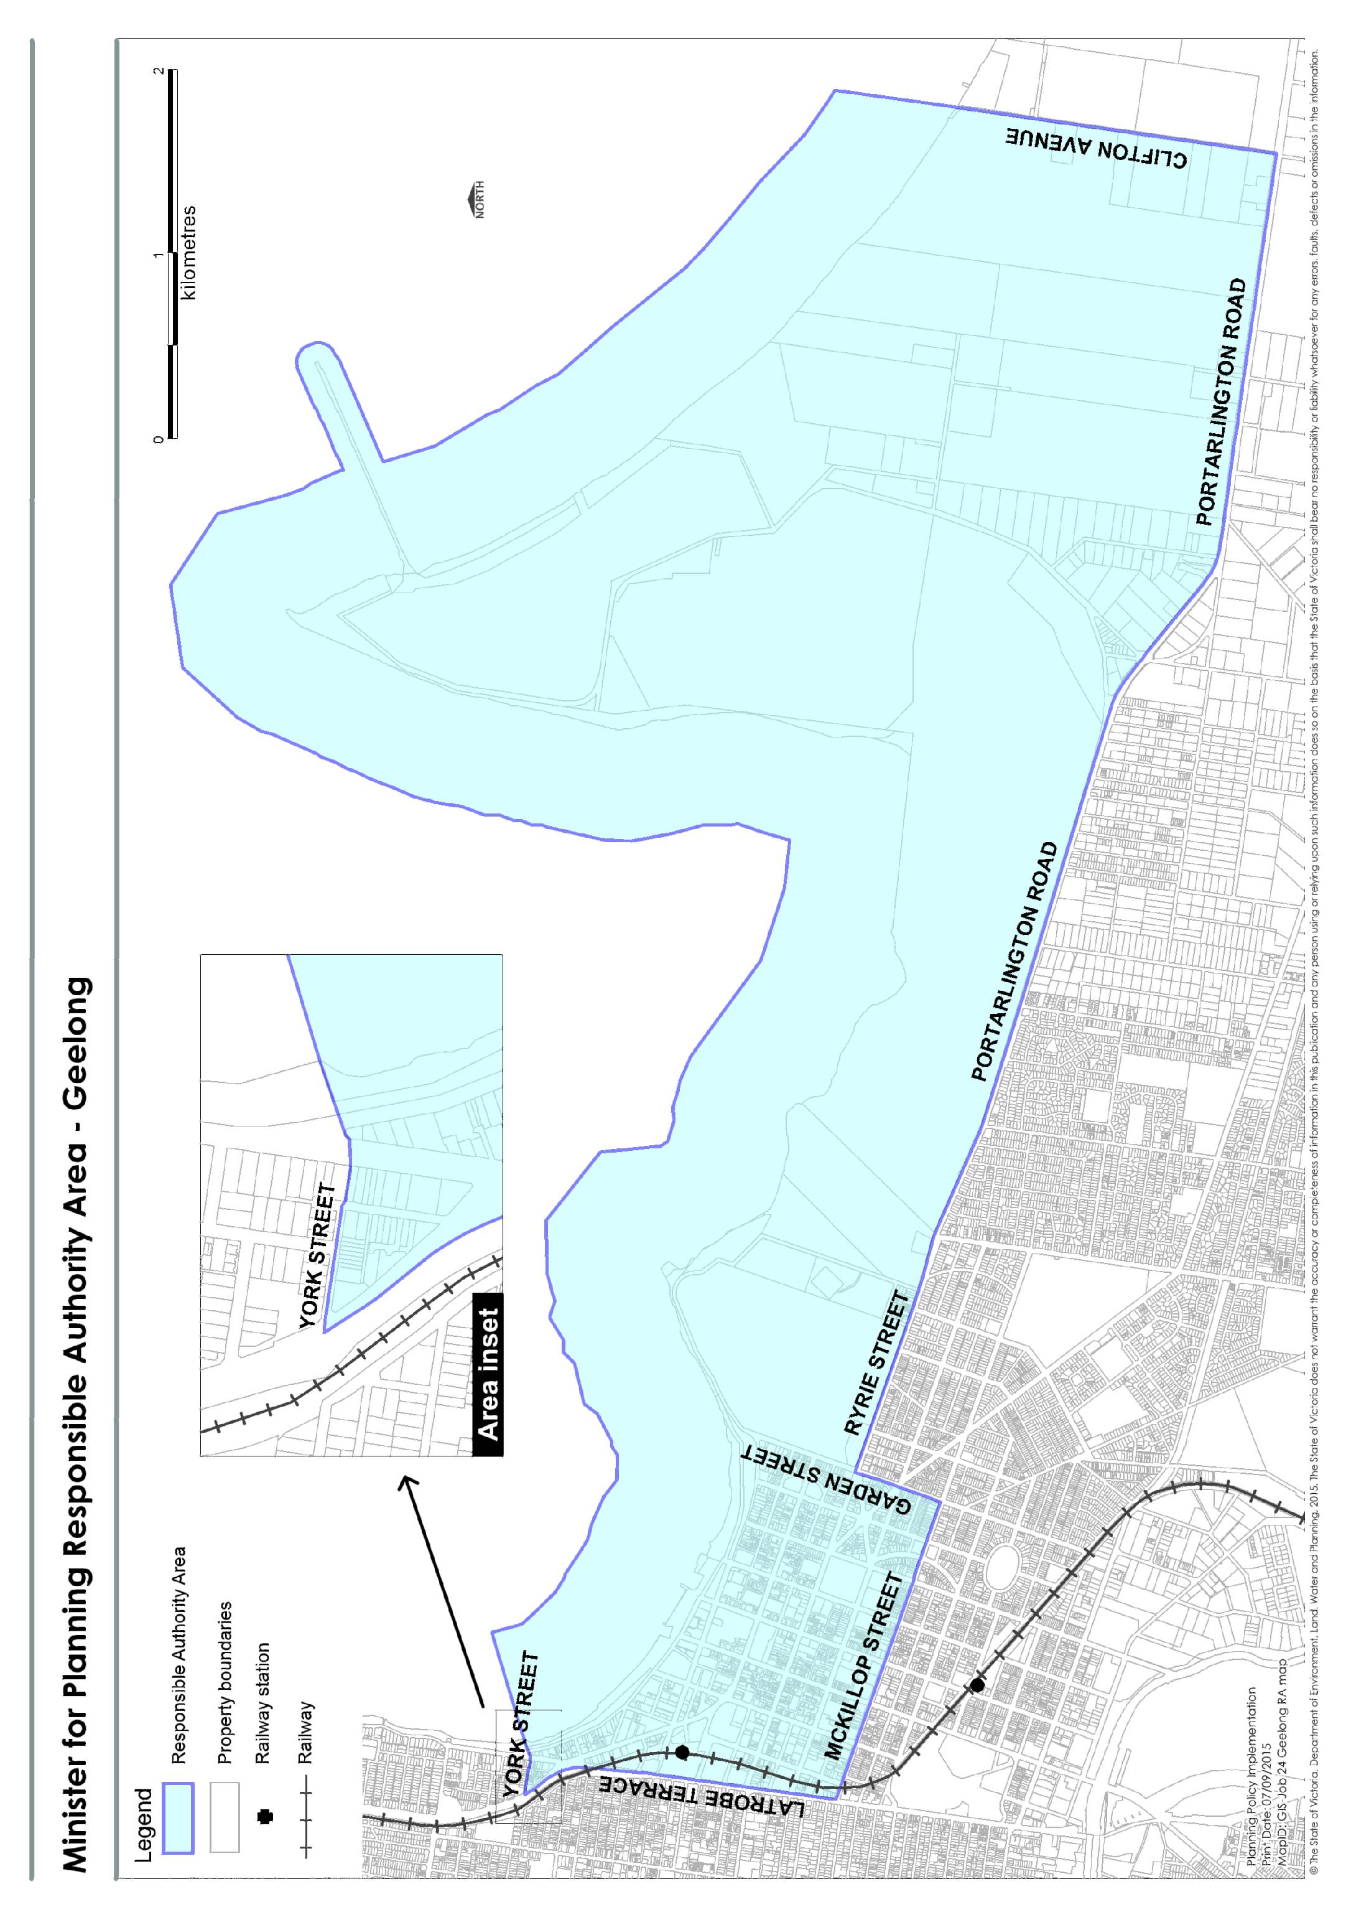
Figure 1
3.0 Person or responsible authority for issuing planning certificates:
31/07/2018
VC148
The City of Greater Geelong.
4.0 Responsible authority for VicSmart applications:
31/07/2018
VC148
The Chief Executive Officer of the Greater Geelong City Council is the responsible authority for considering and determining VicSmart applications to which Clause 71.06 applies, in accordance with Divisions 1, 1A, 2 and 3 of Part 4 of the Act.

