In this issue …

Welcome to Issue 71 of *Research Matters*, the Department of Environment, Land, Water & Planning’s quarterly planning research bulletin, featuring DELWP research and analysis, news about recently released data, and research from other sources. If you have any questions or comments, you can contact us at:

spatialanalysis.research@dtpli.vic.gov.au

Contents

**1 In this issue …**

**2 New projections released**

Victoria in Future 2015 now available

**4 So you think you know the history of Melbourne’s parklands ?**

**6 Conference review**

International Conference on Population Geographies, Brisbane.

**6 Publication released**

Better Apartments. Minister’s Forum Context Report.

This issue of *Research Matters* celebrates the release of the latest *Victoria in Future* population projections. In the past, these have been produced every 2-4 years but this year’s release marks the beginning of an annual projections cycle. An outline of key highlights is presented in this edition.

From looking into the future, to looking into the past, we present some interesting and unusual stories about selected parklands of Melbourne. Many of us who use Melbourne’s parks may be surprised to find out about their varied origins.

In the review section, a report on a major population conference is provided and a recent government publication on apartments is reviewed.

New projections released: VIF 2015 now available

**Victoria in Future 2015**

In a speech to the *Melbourne at 8 Million* conference on August 6th, the Minister for Planning launched the new state government population projections, *Victoria in Future 2015* (VIF2015), produced by the Forward Policy & Research team. The projections provide a view of the future based on demographic and land use trends. They are used by planners and decision makers to manage growth and plan for the delivery of vital infrastructure and services such as transport, schools and hospitals. VIF2015 replaces the previous 2014 projections, while remaining broadly consistent with the VIF2014 figures used in *Plan Melbourne*.

VIF2015 projects continued strong growth for Victoria's population, with the state growing from its current 5.8 million people to 10 million by 2051 (figure 1). Growth is driven by strong migration numbers from overseas and interstate, plus significant natural increase (more births than deaths). The majority of the growth is expected to be in Greater Melbourne, increasing from 4.4 million now to 7.8 million by 2051, but the regions are also expected to grow significantly, adding 800,000 people to reach a population of 2.2 million.

In regional Victoria, the strongest growth is in the three municipalities with the largest populations – Greater Geelong, Greater Bendigo and Ballarat (figure 2). Between them they are expected to account for 47% of regional growth to 2031.

*Figure 1: Components of population change, Victoria 2011 to 2051*

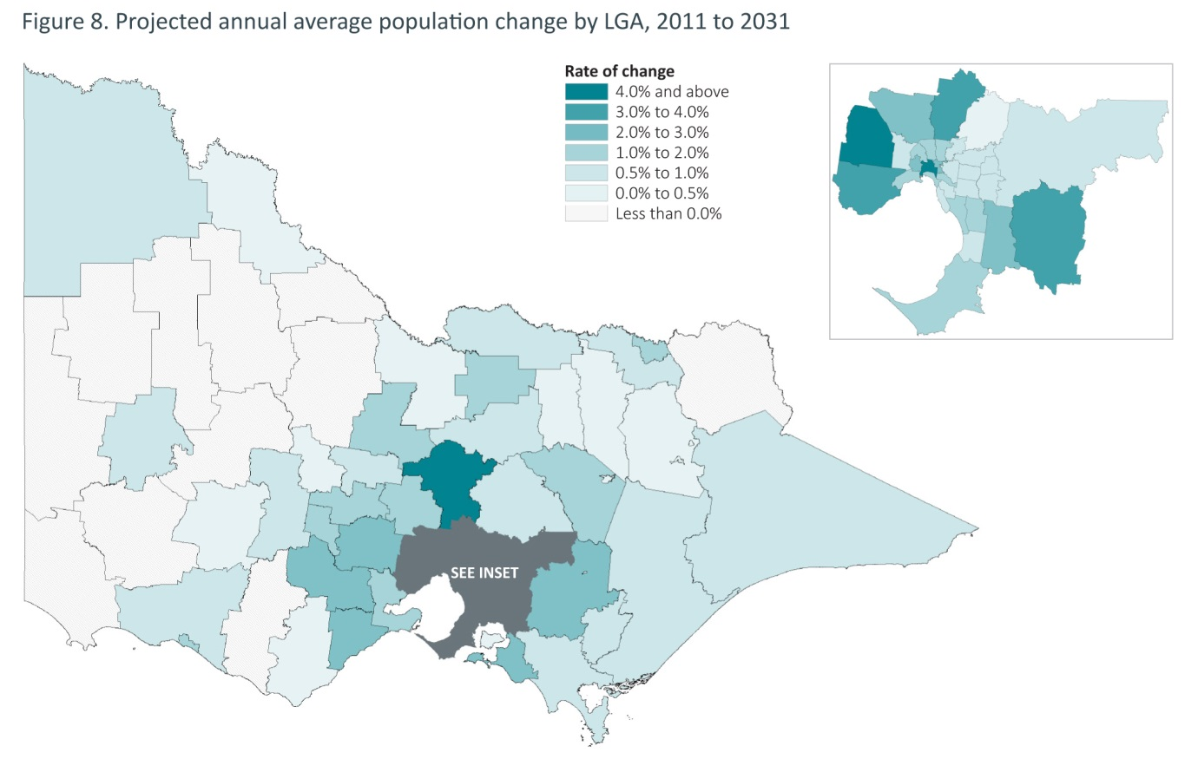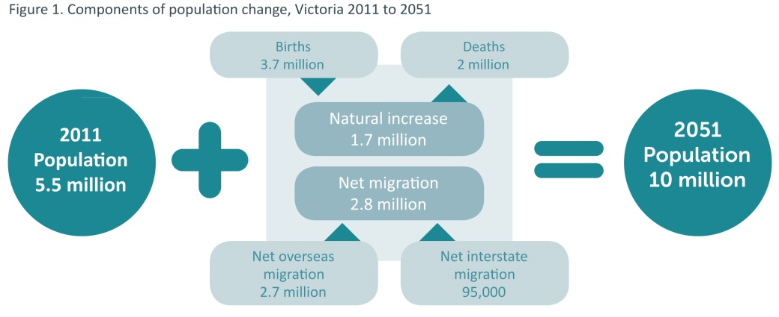

*Source: Victoria in Future 2015*

All areas in Melbourne are expected to grow. Those with the greatest capacity to add extra dwellings are expected to grow the most – the Growth Area LGAs (50%) and the five inner city LGAs (16%) account for two-thirds of Melbourne's growth to 2031.

The population is projected to increase across all age groups. The number of Victorians aged 65 and over is set to triple by 2051 and the number aged 85 and over to quadruple over the same period. While falling fertility rates and slower population growth led to a fairly stable number of births in Victoria for nearly 40 years, these conditions have changed and the number of children in the population is expected to increase by over 60% by 2051. Proportionally, the population aged 18 to 64 will decrease from 64% to 58% over this period.

The *Victoria in Future 2015* report, plus a range of data products and one page profiles for regions and local government areas are available on the DELWP website: [www.delwp.vic.gov.au/victoria-in-future](http://www.delwp.vic.gov.au/victoria-in-future).

So you think you know the history of Melbourne’s parklands?

Those who have studied Melbourne’s early history may recall that many of its large parks and gardens were established by Lieutenant-Governor La Trobe when he arrived in the Port Phillip District in 1839. The grand city plan had already been laid out by Robert Hoddle but, by the time La Trobe handed over to Governor Hotham in 1854, there had been a gold rush and a major population explosion. La Trobe left Melbourne with an impressive legacy of proclaimed 'public lands' around the growing city.

While we do owe a debt to the vision of the early founders of Melbourne, the real story of many of our parks and reserves owes more to the ebb and flow of historic fortune (and misfortune) than to a single planning vision. With just a little research, these parks can reveal the history of our suburbs.

For example, **Fritsch Holzer Park** is located next to a recently constructed major residential project in Hawthorn East. When one of our analysts was investigating the residential project, the inevitable question arose: ‘who is Fritsch Holzer?’ As it turns out, there is no Fritsch Holzer, but an ‘Augustus Fritsch’ and the ‘Holzer Brothers’ who formed the Upper Hawthorn Brick Company on this site back in 1883. The local council purchased the site in 1972, and used it for waste disposal purposes for over a decade before developing it into a park in the 1990s. Having piqued our curiosity, investigation was undertaken of several other parks and a treasure trove of local history revealed.

**Pipemaker’s Park** in Maribyrnong has a wonderful history. This site was the location of several significant historical industrial enterprises including: an early boiling-down works; railway engineering foundry; one of Australia's earliest and largest meat canneries; the first meat freezing works in Australia; and one of the first reinforced concrete pipe works in Australia. The site was notable enough in its meat freezing days to garner an engraving (figure 1). In the 1980s the Melbourne Metropolitan Board of Works (MMBW) purchased the site and developed it as parkland. It is now home to Melbourne’s ‘Living Museum of the West’, which occupies the historic bluestone buildings for its office, resource centre and exhibition space.

*Figure 1: The Melbourne meat preserving company works at the Saltwater (Maribyrnong) River 1868*

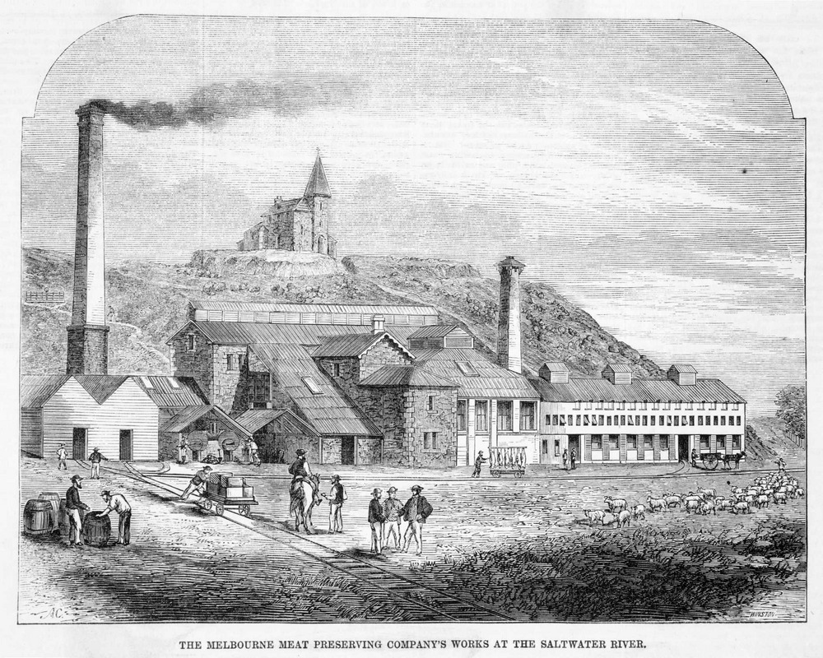

*Source: State Library of Victoria Digital Archive 2015*

**Dendy Park** in Brighton was part of the 5,100 acres of land bought back in 1840 by Henry Dendy at a mere 1 pound per acre. Dendy’s vision was to develop the land known as ‘Brighton Estate’. Unfortunately, the land did not have ready resources for water and sales were slow. A financial depression came, and his plan for emigration and land sales failed. He died a pauper in 1881. Dendy Park is now home to a large playground, athletics track and tennis club.

Born in Liverpool, England in 1825, William Murray Ross emigrated to Melbourne in 1852. One of his many ambitions was to build a sugar beet mill in close proximity to the city, served by a dedicated railway line to transport the processed sugar from the mill to Elsternwick (figure 2). Construction of the railway began in September 1883 and was eventually completed in 1888, however, the railway was never used for its intended (or any other) purpose, and quickly fell into disrepair. Thanks to William Ross and his dreams, we are left with a historic, signposted route to walk, cycle or drive along; known as the ‘**Rosstown Rail Trail**’.

*Figure 2: The Rosstown Railway*

*Source: Wikipedia 2014*

Not all parks originate as sites of industry. In fact one was marked by a tragedy of industry, or at least of one of the machines it produced. Charles James (Jimmy) Melrose (1913-1936) was an Australian aviator who held a number of flying records, including making a record-breaking solo flight from Australia to England in 1934, and being the youngest and only solo flier to finish the Centenary Air Race from England to Australia that same year. In 1936, his Heston Phoenix crashed in bad weather in Melton South, killing Jimmy and his passenger. He was only 22 years old. The crash site is marked by a cairn at the **Jimmy Melrose Reserve** at Brookfield.

While the built form of Melbourne owes a debt to La Trobe and Hoddle, we should not forget the role that economic and demographic change have made to our city parks. From meatworks to plane crashes, the parks and reserves of the city hold a rich vein of history waiting to be explored.

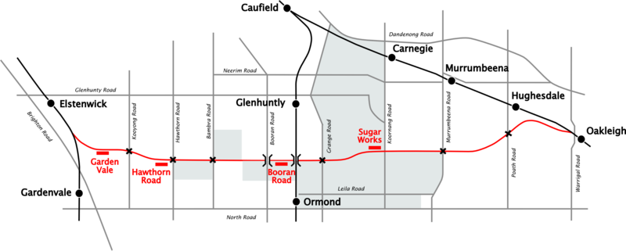

**References**

All internet references were accessed on 6th July 2015

‘Jimmy Melrose, the forgotton (sic) hero of South Australia’ *The Advertiser*, Adelaide, 13th September 2013 <http://www.adelaidenow.com.au/lifestyle/sa-lifestyle/jimmy-melrose-the-forgotton-hero/story-fnizi7vf-1226718496366>

Bate, W. 2005, ‘Dendy, Henry (1800-1881)’, originally published in the *Australian Dictionary of Biography*, Supplementary Volume, (MUP), 2005 <http://adb.anu.edu.au/biography/dendy-henry-12883>

Melbourne's Living Museum of the West Inc. 1996, *Pipemakers Park Van Ness Avenue, Maribyrnong. Heritage Conservation Analysis & Plan*, Prepared for Melbourne Parks & Waterways, by Melbourne's Living Museum of the West Inc with KaZOO, Highpoint City, Victoria. <http://www.livingmuseum.org.au/download%20pdf/PipmakersParkConservationAnalysis1996.pdf>

*State Library of Victoria Digital Archive ‘*The Melbourne Meat Preserving Company’s works at the Saltwater River’, Photo of a wood engraving by A.C. Cooke 1868[*http://digital.slv.vic.gov.au/*](http://digital.slv.vic.gov.au/)

Wikipedia 2014 ‘Rosstown Railway’, image of Railway based on diagrams in Jowett D. & Weickhardt I 1978, *Return To Rosstown – Railways, Land Sales and Sugar Beet Ventures in Caulfield*. Rosstown Historical Research Group. <https://en.wikipedia.org/wiki/Rosstown_Railway>

Wikipedia 2015, “Hawthorn East Victoria”, <https://en.wikipedia.org/wiki/Hawthorn_East,_Victoria>,

Conference review Publication released

**International Conference on Population Geographies**

Three members of the Forward Policy and Research branch attended the International Conference on Population Geographies (ICPG) at the University of Queensland, Brisbane in early July. The ICPG conference is an international gathering of population geographers and spatial demographers and has been held at two year intervals since 2001. This year’s gathering in Brisbane was the first time that the conference had been held in the southern hemisphere. It was attended by over 200 delegates from 36 countries.

Themes addressed during the three-day conference included:

* Ethnicity & segregation
* Indigenous demography
* Official statistics
* Population projections
* Family and the life course
* Health and mortality
* Population ageing
* Immigration and settlement
* Internal migration

The FP&R team gave two presentations at the conference: the first by David Sykes and Beatrice Derody on ‘Regional population roadmap’ and the second by Fiona McKenzie on ‘Attraction, retention and return: migration histories of a regional work force in Australia’.

The variety of topics presented at the conference confirmed that some demographic issues are similar all over the world: ageing; migration; concentration of population in urban centres; population losses in more remote areas; the difficulty of obtaining good data, and the fickleness of projections.

A selection of presentations given at the conference is available from the following website:

<http://www.gpem.uq.edu.au/icpg-presentations>

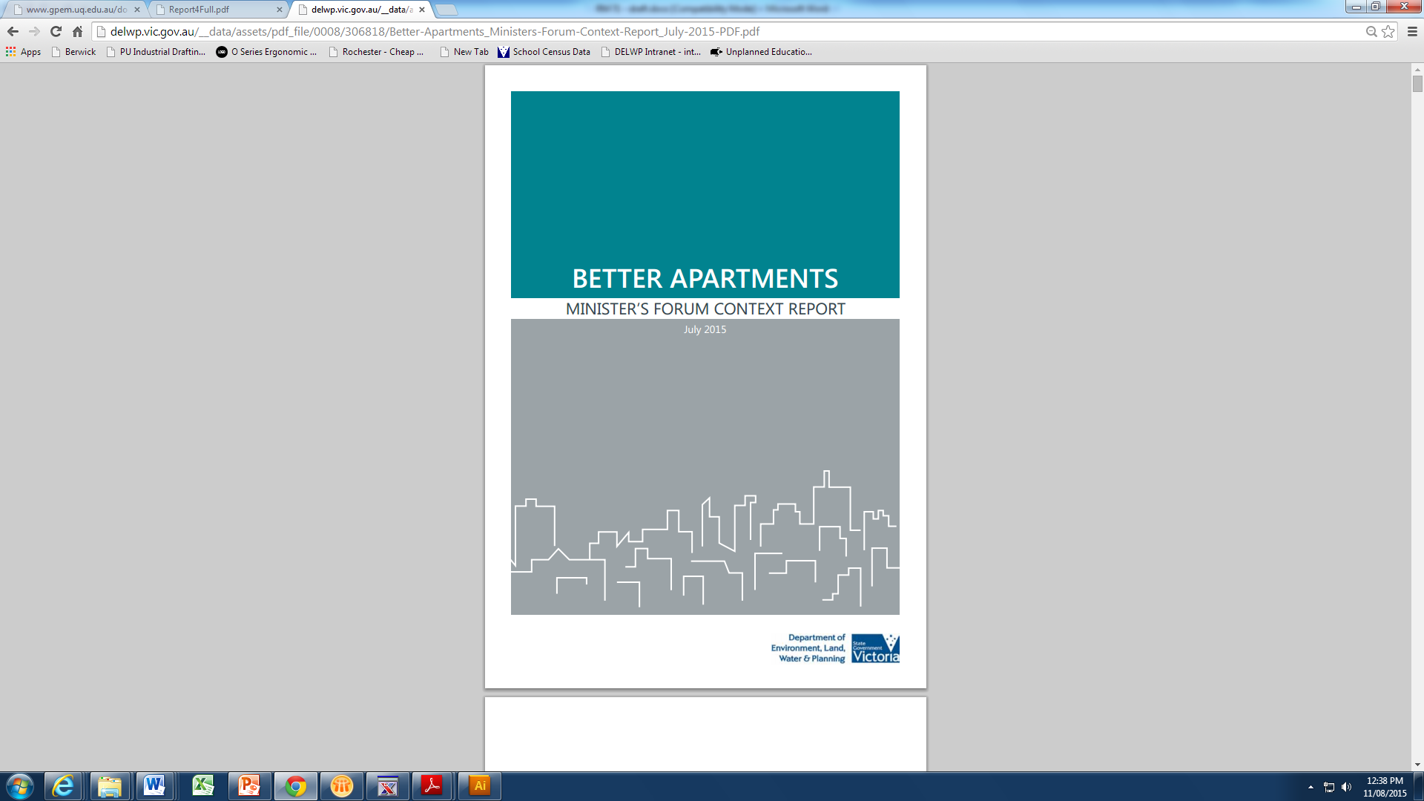

DELWP has recently released the report: *Better Apartments - Minister’s Forum Context Report,* a companion to the *Better Apartments* *Discussion Paper* released in May. These publications aim to generate discussion among community and industry as new apartment design guidelines are developed.

The *Context Report* provides background information on past and current apartment regulation in Victoria and other jurisdictions. Data on population and household change is also presented along with a discussion of other drivers of apartment development. Trends in apartment size and price are also included in the report and a comprehensive reference list allows readers to explore these issues further.

To view or download the report, visit: <http://delwp.vic.gov.au/__data/assets/pdf_file/0008/306818/Better-Apartments_Ministers-Forum-Context-Report_July-2015-PDF.pdf>