Create and submit a request
Development Facilitation Portal
Purpose
The following guide steps applicants through the use of the Development Facilitation Portal, where requests can be submitted and tracked for Priority Projects.
It is a requirement that the applicant create an account prior to submitting requests. Please see the guide ‘How to create an account’ for further details.

Create and save a request 1
Access and edit a saved request (Including uploading additional attachments) 3
Submit a request 4
Respond to a request for further information 6
Withdraw a request 8
Checking on a request status 9
Printing a copy of the request 10
Share a request 10
Need further assistance? 10

Create and save a request
- Go to the Development Facilitation Portal: https://priorityprojects.atlassian.net/servicedesk/customer/user/login.
- Enter credentials to sign in or select Sign up to create an account.
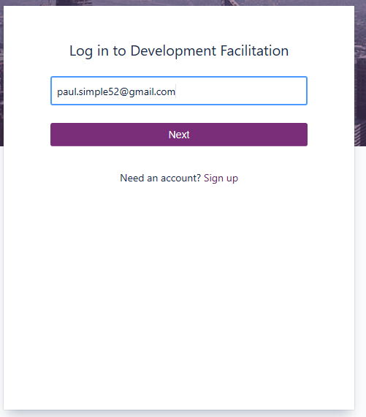
2
- Select the link to Priority Project Request.
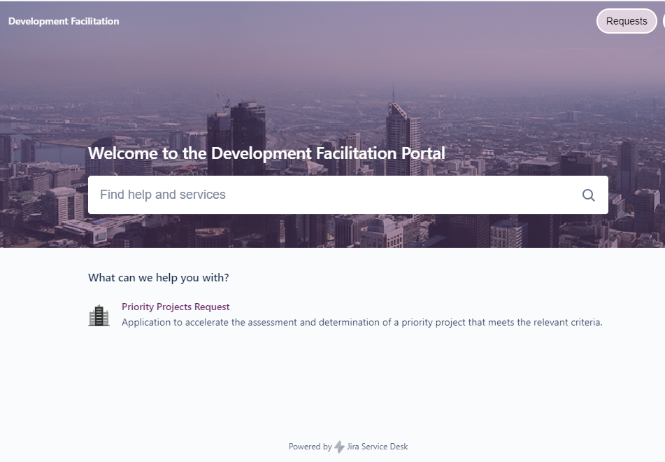
3

- Complete the fields on the form. You must complete all fields prior to submission; however you can fill in the mandatory fields initially to save and to return to the form at a later stage to complete and submit.
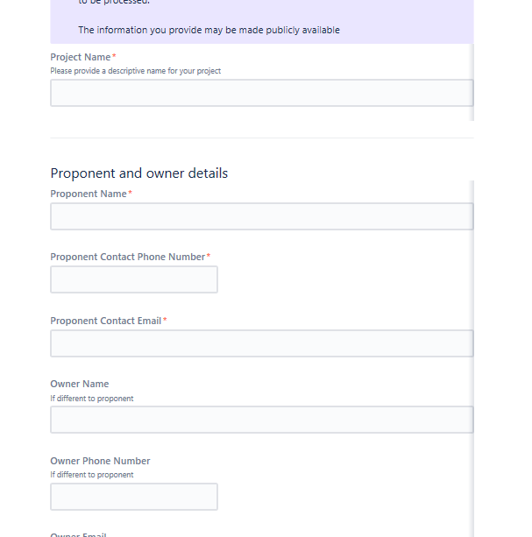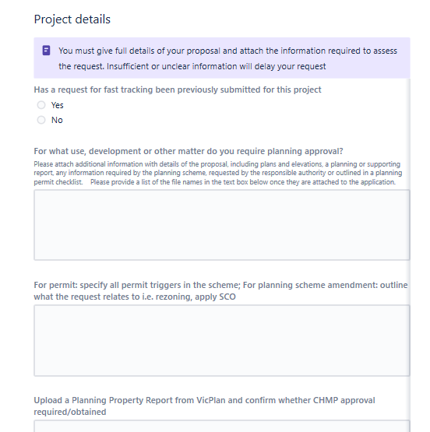
4
- Scroll to the top of the form and upload all attachments (*please see required file naming convention) to support the request. It is recommended that you attach all relevant documentation prior to the initial save as you are able to upload multiple files at the one time. You can still upload files after saving, however files can only be individually uploaded via the comment field (under Activities).
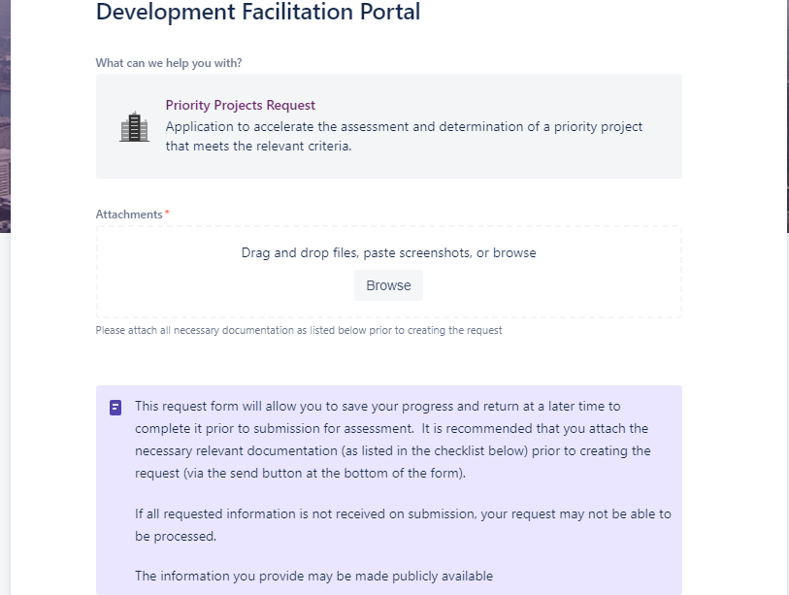
5

*Required file naming convention: Document title-Project Name OR Address-Date
For example:
- Development Plans-Smiths Battery Farm-250919
- Application to Amend Permit-66 Pheasants Rd and 67 Link Parade Smithstown-300320
- At the top of the form, complete the Attachment Checklist.
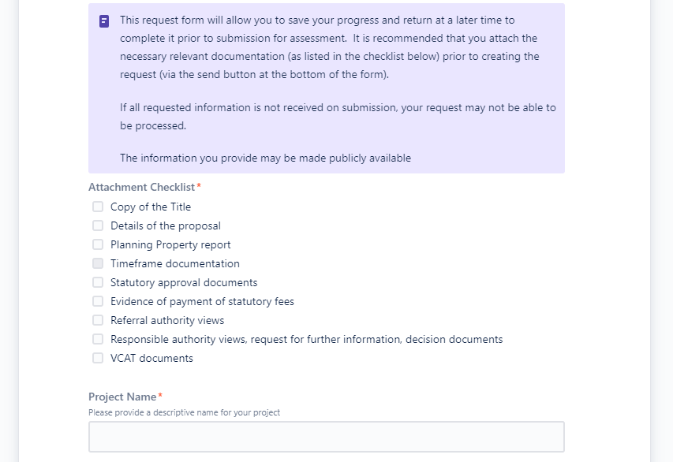
6

- Once all fields have been completed and documents uploaded, review the Privacy statement and select Send to save the form and attachments. The request will not yet be submitted to the department and you can return to the request form to complete and upload additional attachments if needed. 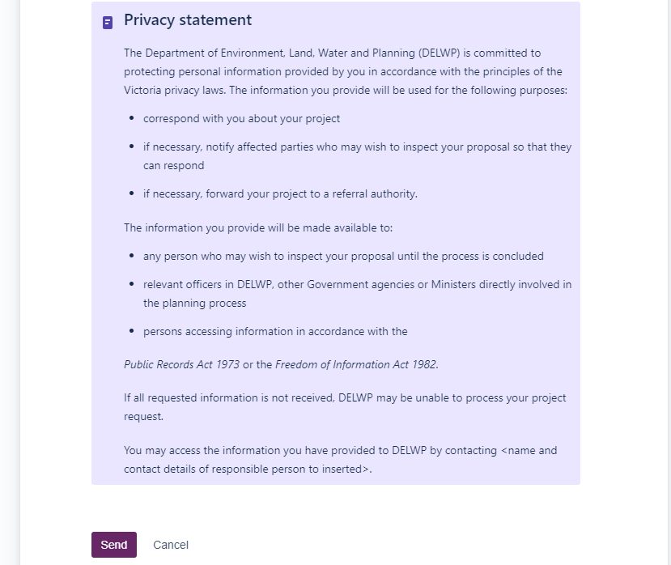
7

- When Send is selected (ie request is saved) the status of the request will be CREATED.
Refer to the Submit a request section of this guide when ready to lodge the request with the department.
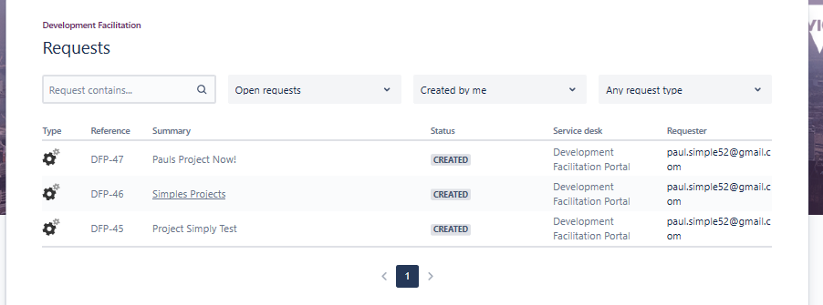
8

Access and edit a saved request (Including uploading additional attachments)
- Ensure you are logged into the Development Facilitation Portal.
- Select Requests, Created by Me (created and submitted by you) or All (includes requests shared with you).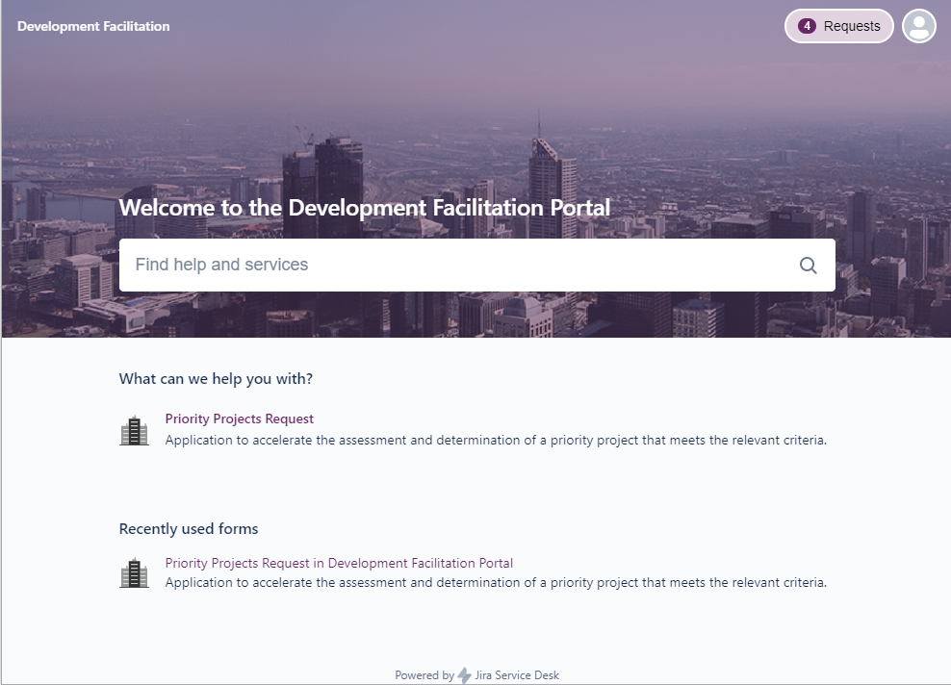
10
- Select the Reference for the specific request.
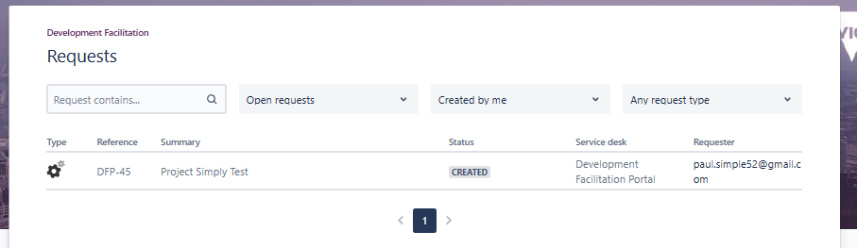
11
- Select Edit from the top of the form to open and add additional data as required.
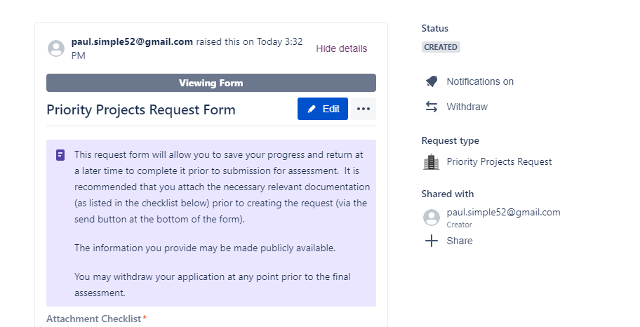
12
- Any changes to the form will need to be saved. Scroll back to the top of the form and select Save. 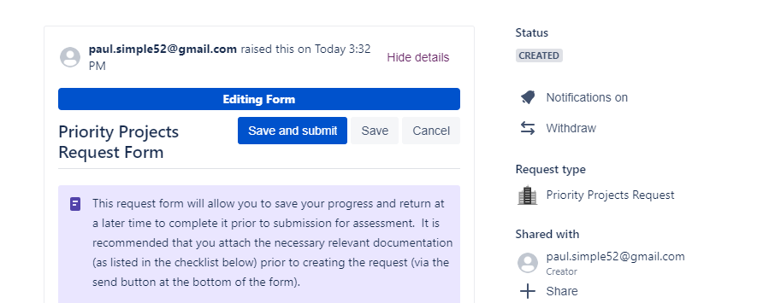
13
- Scroll to the end of the form (below the Activity section) to add any comments, links or to upload further supporting documentation.
- To upload further supporting documentation, select the Files & Images icon in the comments box and select the files from your device. More than one file can be uploaded into the comment box.
- Select Save when complete.
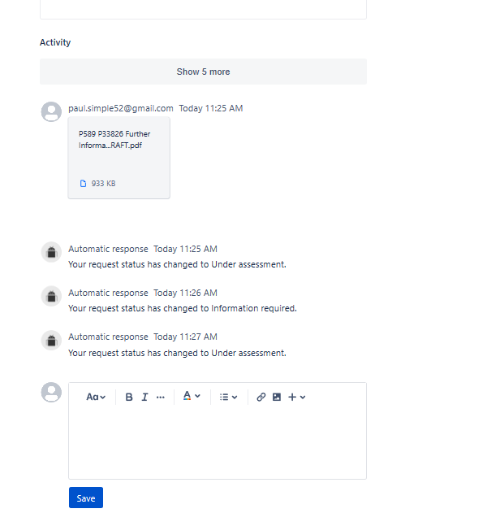
14
15
16
- If ready to submit, follow steps 22 through to 25.

Submit a request
Once a request is submitted, the form will be locked so it is important all fields are checked, and documents uploaded prior to submission.
- Ensure you are logged into the portal. Select Requests and then click on Created by Me or All (to see requests created by others but shared with you). 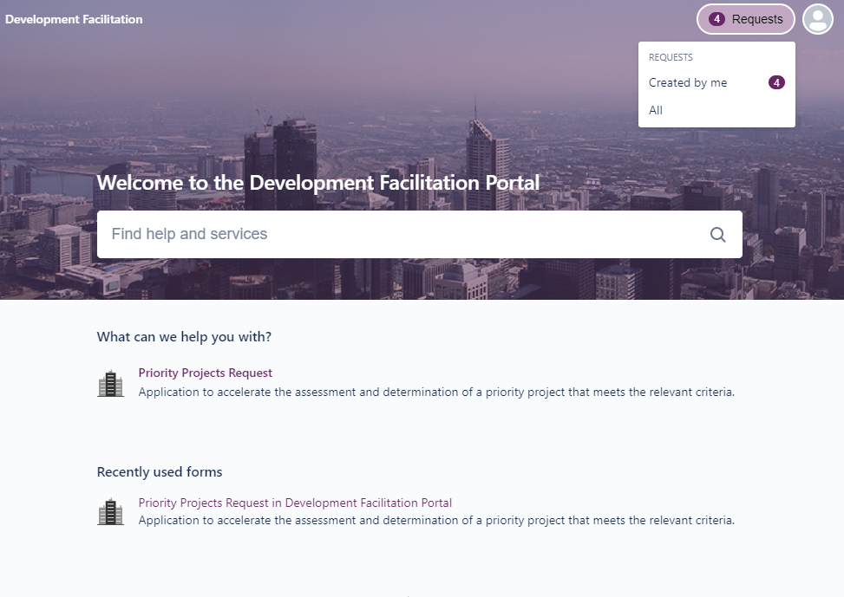
18

- Select the Reference for the request that is ready to lodge.
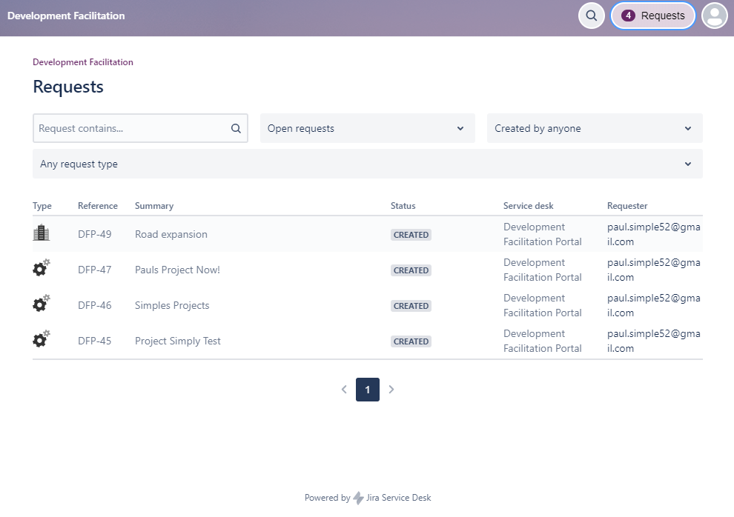
19
- Scroll to the top of the form and select Edit to open the form.
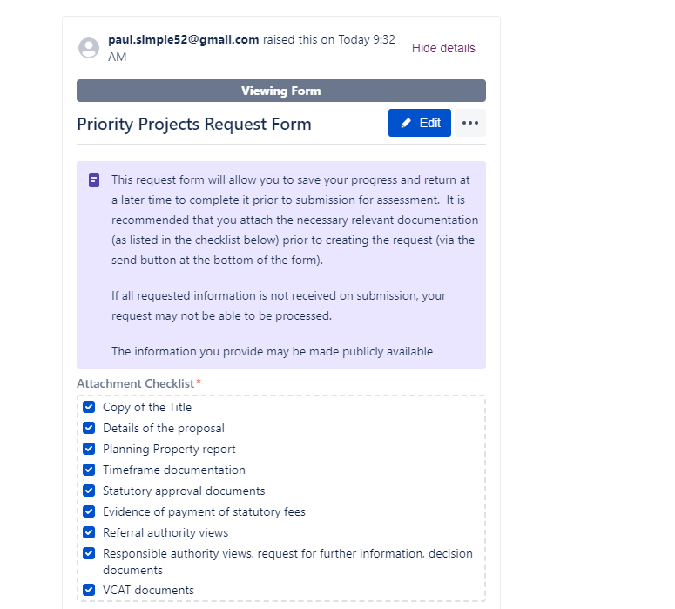
20

- Scroll through the form and update as required. Refer to step 14 if you need to add additional supporting documentation.
- Once completed, at the top of the form, select Save and submit (or Submit if no changes made). 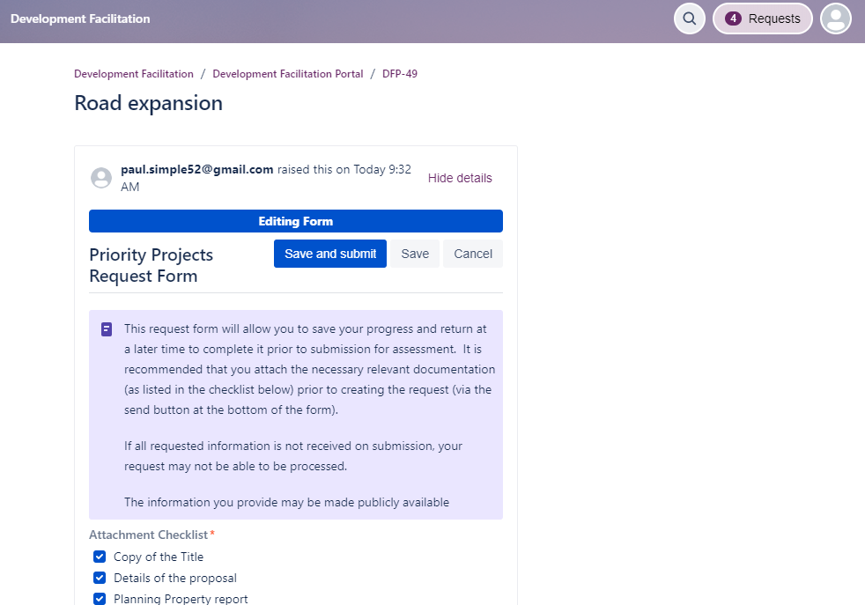
22
- Select Submit to confirm form submission. (or Cancel to continue editing the form).
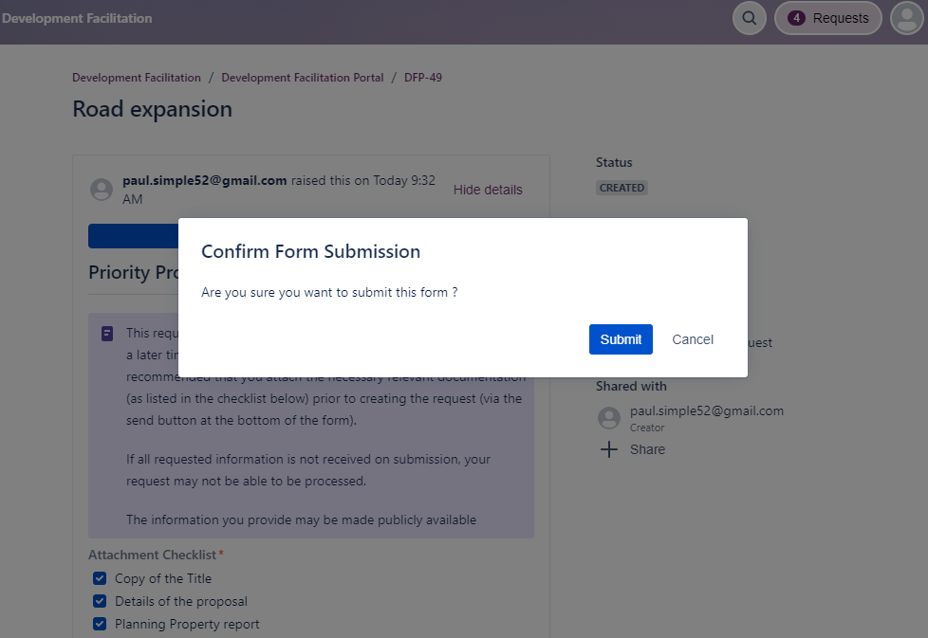
23

- After refreshing the webpage, the status will appear as SUBMITTED.
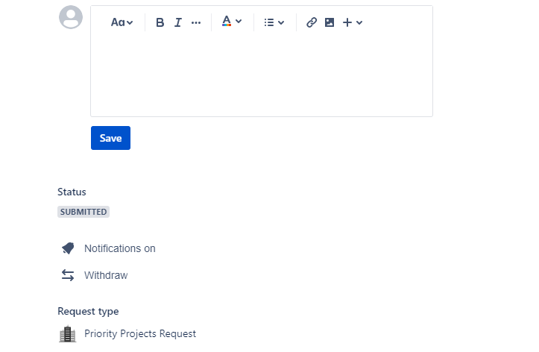
24

- You will receive an email confirming the request has been updated to Submitted.
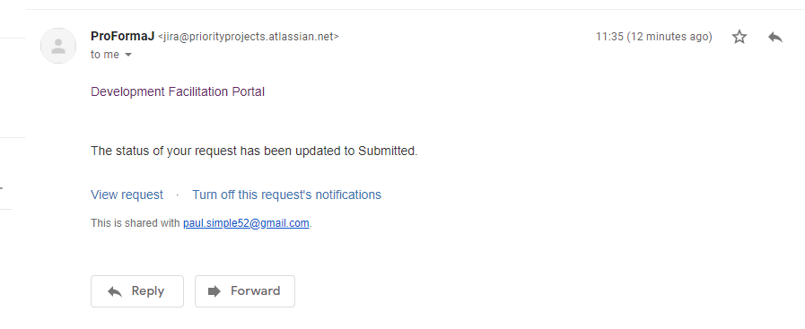
25
Note: Once the form is submitted, you will no longer be able to make any changes, however, you can add comments or upload attachments by scrolling to the end of the form and enter items as needed.
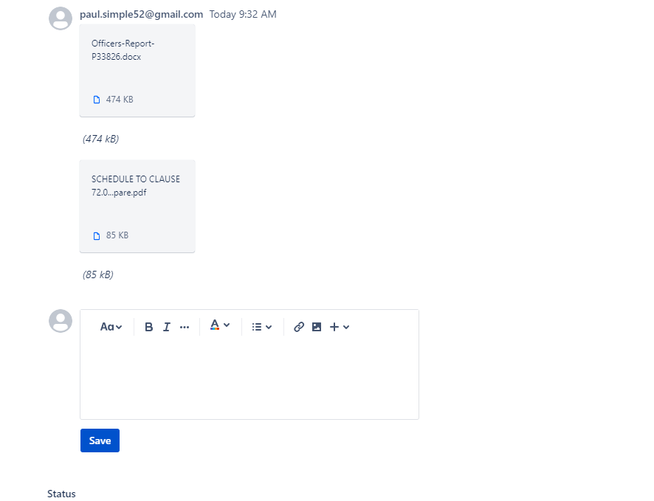

Respond to a request for further information
As the department review the request, they may require more information and you will be notified by email.
- If the form is incomplete due to significant gaps in information, the form may be reopened by the department’s Planner for the applicant to update. Follow steps 22 to 25 to update the form.
- If the form is complete but additional supporting documents or commentary is required, follow the below steps.
- Log into the Portal and select Requests and Created by me or All.
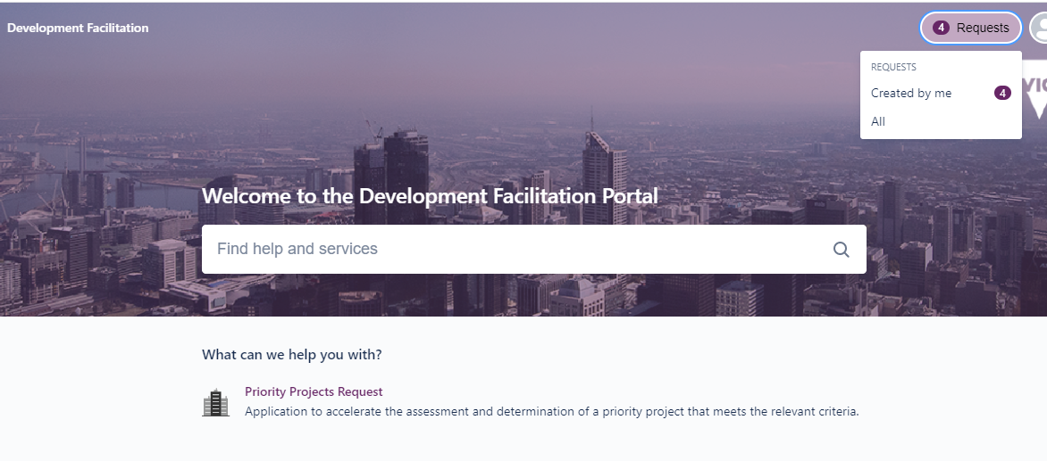
26

- Locate and select the Reference field for the request that has the Status of INFORMATION REQUIRED. 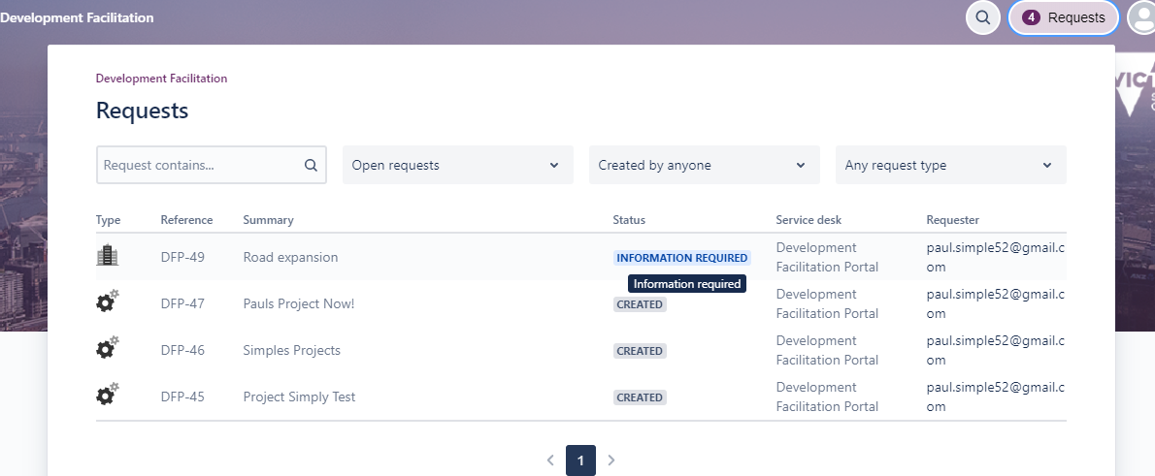
27

- Scroll to the top of the form and select Edit. You will now be able to edit any fields as required.
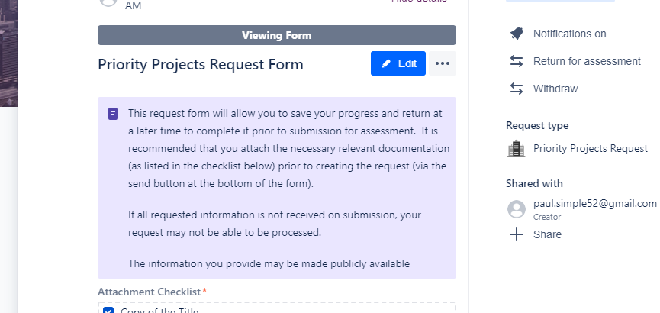
28
- Once the form is updated and any further supporting documents uploaded, scroll to the end of the form (just above the Activity section) and select Save and submit. 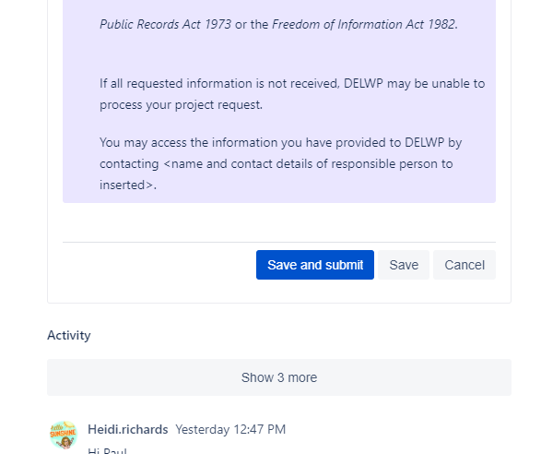
29
- Select Submit at the confirmation screen.
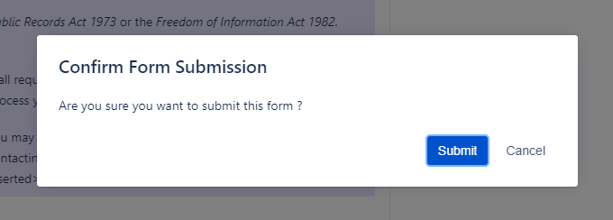
30
- To upload any additional supporting documents or comments, scroll to the end of the form and select the Image & files icon in the comments box, add comments if needed. Select Save.
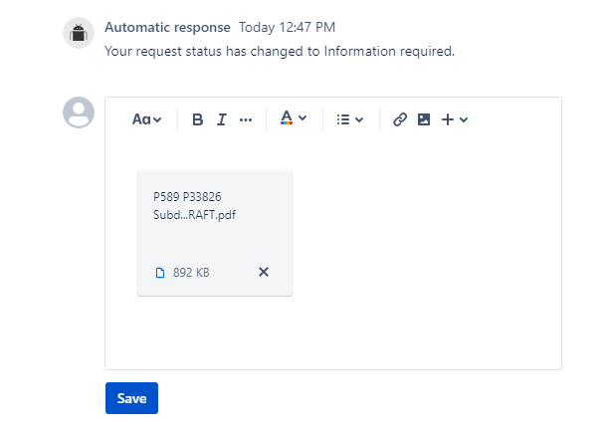
31
- Select Return for assessment.
32
- Add any further comments if needed and select Return for assessment.
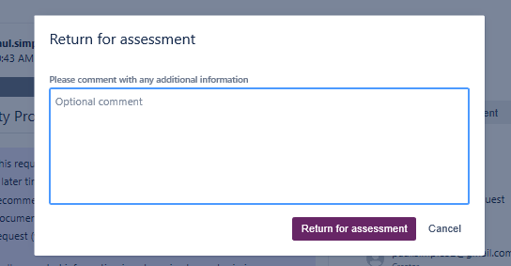
33
- The form will be resubmitted to the department for review and the status will update to UNDER ASSESSMENT. 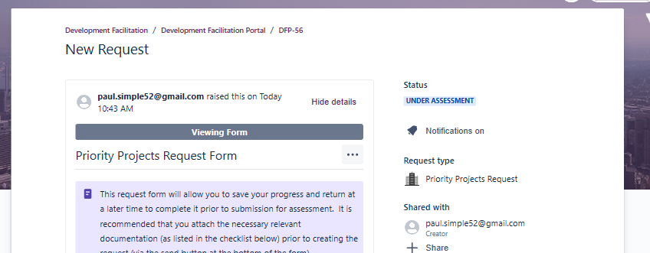
34

Withdraw a request
The request can be withdrawn at any point up until the final assessment recommendation is made by using the following steps.
- Log into the Portal and select Requests and Created by me or All.
35
- Locate and select the Reference field for the request to be withdrawn.
36
- Scroll to the top of the form and select Withdraw.
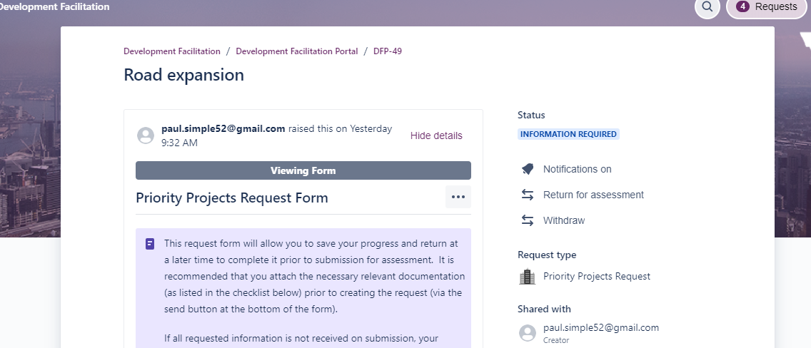
37
- Add a comment with any additional information (optional only).
- Select Withdraw to confirm you with to cancel the request.
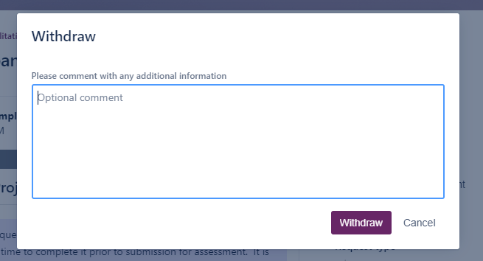
38
39
- The status will update to WITHDRAWN
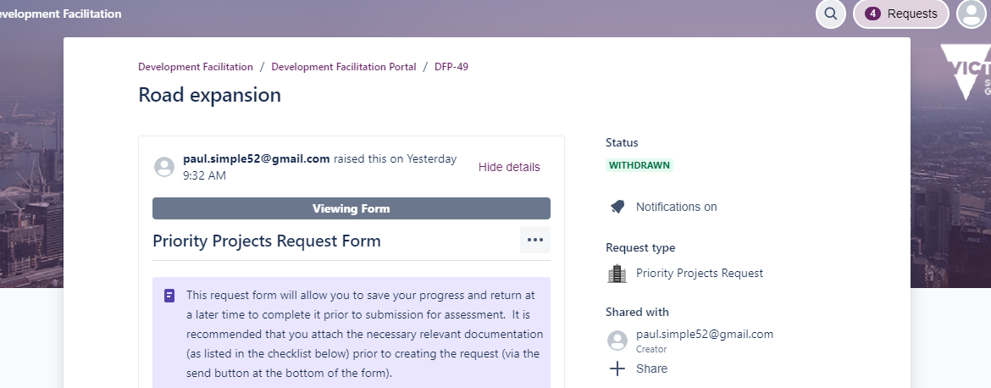
40

Checking on a request status
- When logged into the portal follow steps 9 to 10 to access the copy of the request form.
- Locate the request and check the Status column.
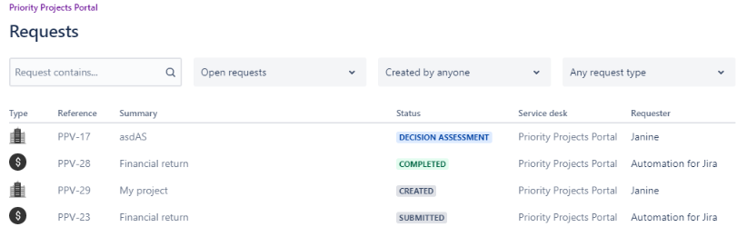
42

Printing a copy of the request
- When logged into the portal follow steps 9 to 11 to access the copy of the request form.
- Scroll to the top of the form and select the ellipses ‘…’
- Select Download Rich PDF for a good quality print of the request form. The file may open automatically or you may be prompted to open. You can also check your downloads folder on your device to open the file.
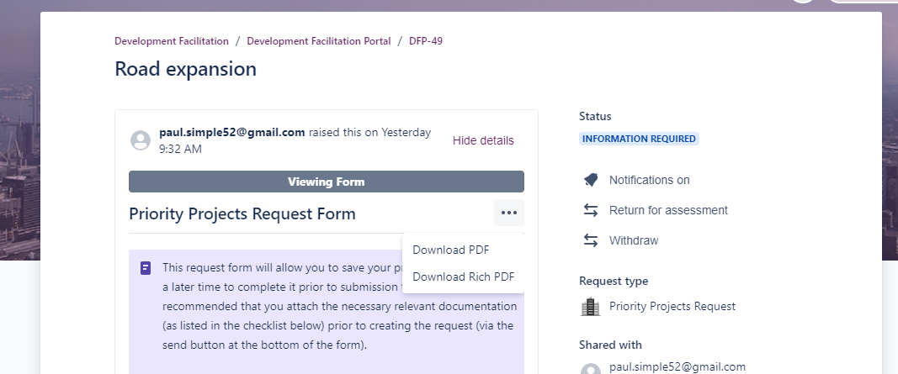
44
45

Share a request
- When logged into the portal follow steps 9 to 11 to access the copy of the request form.
- Select +Share.
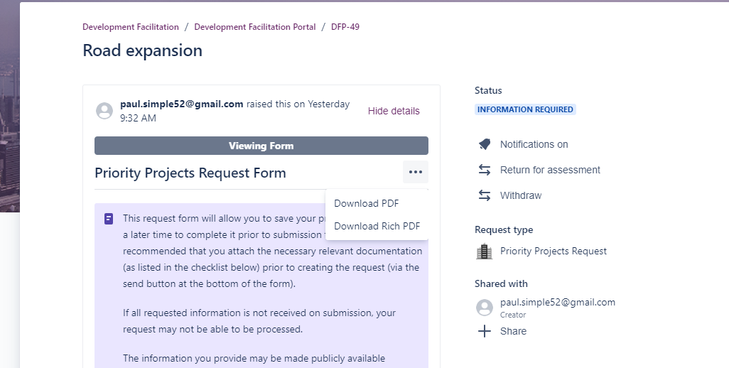
47

- Enter the email address of the person you wish to share with.
- Select Add. If the recipient of the shared link does not have an account to access the portal, they will first be prompted to create an account and will receive another email with a link to the portal and the specific request form.
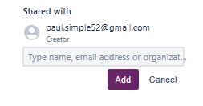
49
48

Need further assistance?
If you require further assistance with your request, contact the Development Facilitation team development.facilitation@delwp.vic.gov.au.

