REFERRAL OF A PROJECT FOR A DECISION ON THE NEED FOR ASSESSMENT UNDER THE ENVIRONMENT EFFECTS ACT 1978

REFERRAL FORM

The Environment Effects Act 1978 provides that where proposed works may have a significant effect on the environment, either a proponent or a decision-maker may refer these works (or project) to the Minister for Planning for advice as to whether an Environment Effects Statement (EES) is required.

This Referral Form is designed to assist in the provision of relevant information in accordance with the Ministerial Guidelines for assessment of environmental effects under the Environment Effects Act 1978 (Seventh Edition, 2006). Where a decision-maker is referring a project, they should complete a Referral Form to the best of their ability, recognising that further information may need to be obtained from the proponent.

It will generally be useful for a proponent to discuss the preparation of a Referral with the Impact Assessment Unit (IAU) at the Department of Environment, Land, Water and Planning (DELWP) before submitting the Referral.

If a proponent believes that effective measures to address environmental risks are available, sufficient information could be provided in the Referral to substantiate this view. In contrast, if a proponent considers that further detailed environmental studies will be needed as part of project investigations, a more general description of potential effects and possible mitigation measures in the Referral may suffice.

In completing a Referral Form, the following should occur:
- Mark relevant boxes by changing the font colour of the ‘cross’ to black and provide additional information and explanation where requested.
- As a minimum, a brief response should be provided for each item in the Referral Form, with a more detailed response provided where the item is of particular relevance. Cross-references to sections or pages in supporting documents should also be provided. Information need only be provided once in the Referral Form, although relevant cross-referencing should be included.
- Responses should honestly reflect the potential for adverse environmental effects. A Referral will only be accepted for processing once IAU is satisfied that it has been completed appropriately.
- Potentially significant effects should be described in sufficient detail for a reasonable conclusion to be drawn on whether the project could pose a significant risk to environmental assets. Responses should include:
- a brief description of potential changes or risks to environmental assets resulting from the project;
- available information on the likelihood and significance of such changes;
- the sources and accuracy of this information, and associated uncertainties.
- Any attachments, maps and supporting reports should be provided in a secure folder with the Referral Form.
- A USB copy of all documents will be needed, especially if the size of electronic documents may cause email difficulties. Individual documents should not exceed 10MB as they will be published on the Department’s website.
- A completed form would normally be between 15 and 30 pages in length. Responses should not be constrained by the size of the text boxes provided. Text boxes should be extended to allow for an appropriate level of detail.
- The form should be completed in MS Word and not handwritten.

The party referring a project should submit a covering letter to the Minister for Planning together with a completed Referral Form, attaching supporting reports and other information that may be relevant. This should be sent to:

Postal address Couriers

Minister for Planning Minister for Planning
PO Box 500 Level 16, 8 Nicholson Street
EAST MELBOURNE VIC 8002 EAST MELBOURNE VIC 3002
In addition to the submission of the hardcopy to the Minister, separate submission of an electronic copy of the Referral via email to ees.referrals@delwp.vic.gov.au is required. This will assist the timely processing of a referral.

______________________________________________________________

PART 1 PROPONENT DETAILS, PROJECT DESCRIPTION & LOCATION

1. Information on proponent and person making Referral

Name of Proponent: | Fosterville Gold Mine Pty Ltd (FGM)
Authorised person for proponent: | Felicia Binks
Position: | Director Environment and Government Relations
Postal address: | McCormicks Road, Fosterville, Victoria 3557
Email address: | fbinks@kl.gold
Phone number: | 03 5439 9132
Facsimile number:
Person who prepared Referral: | Skye Brown
Position: | Technical Director – Environment
Organisation: | AECOM Australia Pty Ltd
Postal address: | Level 10, 727 Collins St, Docklands 3008
Email address: | Skye.Brown@aecom.com
Phone number: | +61 3 9653 1234
Facsimile number: | N/A
Available industry & environmental expertise: (areas of ‘in-house’ expertise & consultancy firms engaged for project) | Proponent  The Project is being undertaken by Fosterville Gold Mine Pty Ltd (FGM), which is a wholly owned subsidiary of Kirkland Lake Gold Ltd. (KLG)  KLG is a senior gold producer with operations in Canada and Australia.  FGM has extensive ‘in-house’ expertise in operation of the Fosterville Gold Mine.  The proponent’s in-house expertise includes:  - Civil mining and geotechnical engineering, including open pit design & waste rock dump design  - Metallurgical functions including biohydrometallurgy, Preg-robbing management/High temperature conditioning, future ore source evaluation, colloidal gold recovery.  - Water management and tailings management.  - Project management expertise, including financial  - Ventilation system design.  - Environmental monitoring and management (groundwater, surface water, noise, air quality & ground vibration)  - Cultural heritage identification and awareness certification  - Native vegetation assessment and revegetation  - Stakeholder engagement  AECOM has been engaged as the Lead Consultant to coordinate specialist environmental and planning assessments. AECOM provided environmental and regulatory support and input for this referral.

2. Project – brief outline

Project title: Fosterville Gold Mine Sustained Operations Project (Sustained Operations Project)
Project location: (describe location with AMG coordinates and attach A4/A3 map(s) showing project site or investigation area, as well as its regional and local context)

Figure 1 Location Overview provides detail of the Sustained Operations Project location

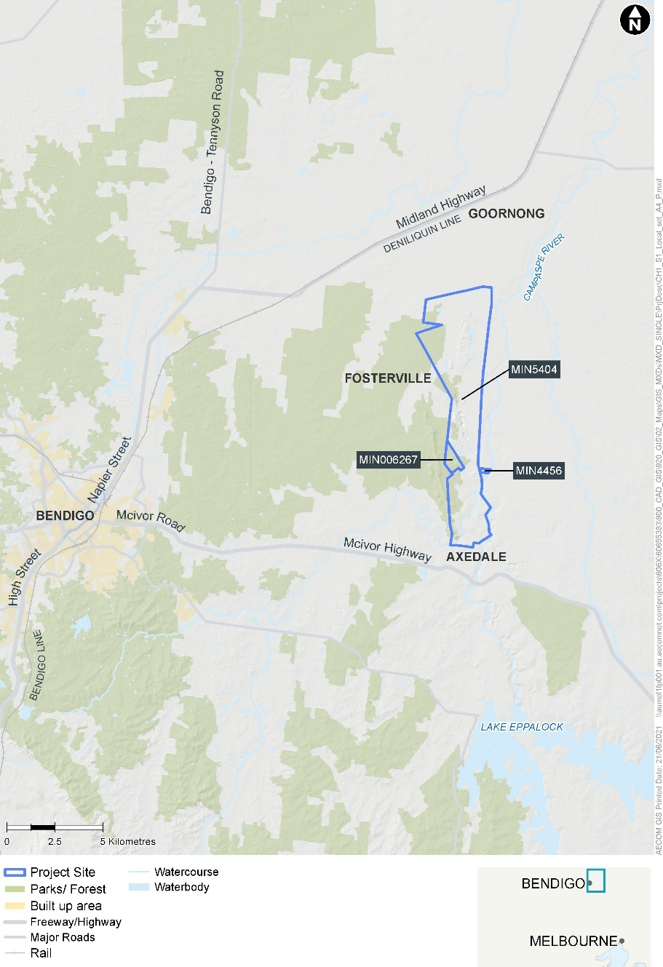
Figure 1: Location overview
The Fosterville Gold Mine is an operational underground gold mine located on mining lease MIN5404, about 20km northeast of the city of Bendigo in Victoria, Australia, between the rural towns of Goornong (to the north) and Axedale (to the south).
The Sustained Operations Project will allow for the continued operation of the mine and will be undertaken predominantly within the current mining licence boundary for MIN5404. Underground mining is also proposed to be undertaken to the west of the current mining licence into an area subject to a mining licence application (MIN006267). No activities are proposed within MIN4456.
Land surrounding the mine is characterised by agricultural uses (including grazing, cropping and vineyards), with rural residential lots to the south of the mine and Mt Sugarloaf Nature Conservation Reserve to the west. The Campaspe River runs roughly parallel to the eastern lease boundary at a distance of approximately 1km. Minor watercourses traverse the mining lease, including Gunyah Creek in the north and Axe Creek in the south.
Coordinates for MIN5404 are shown in Table 1 below.
Table 1 – Mining Licence coordinates
Mining Licence boundary | Easting | Northing
MIN5404 SE corner | 278505.7698 | 5927927.049
MIN5404 SW corner | 276377.8094 | 5927388.79
MIN5404 NW corner | 275117.1994 | 5940180.929
MIN5404 NE corner | 278520.1296 | 5940809.169

Short project description (few sentences):
The Sustained Operations Project consists of proposed activities that are required to support the continuation of existing gold mining operations at Fosterville Gold Mine beyond the next two years. These activities include an extension of current underground mining operations in MIN5404 to the south, north and west, cutbacks (extension) to existing open pits, construction and operation of new tailings storage facilities within existing tailings compound or within existing open pits, construction and operation of a new brine evaporation pond, construction of a new waste rock dump, transfer/sale of CIL tailings, management of waste paste and a managed aquifer recharge (MAR) program to inject treated mine water to the fractured rock aquifer.
Mining operations would continue as per the current operation, with ore mined using the same underground mining methods and processed through the same treatment plant. The Sustained Operations Project does not propose any increase in mining rates above the nominal capacity of the existing processing plant or changes to existing approved mining and processing methods.
The Sustained Operations Project life is anticipated to be a minimum of 10 years.

3. Project description

Aim/objectives of the project (what is its purpose / intended to achieve?):
The key objective of the Sustained Operations Project is to continue mining operations at the Fosterville Gold Mine into previously unmined areas of MIN5404 (and application area MIN006267) and to provide adequate additional storage space for mine-generated waste products (e.g., tailings, waste rock, mine water) for another ten years of mining.

Background/rationale of project (describe the context / basis for the proposal, eg. for siting):
Fosterville Gold Mine is an operational high-grade, low-cost modern underground gold mine and is currently Victoria’s largest gold producer. The mine currently employs approximately 595 personnel and 237 contractors, mostly from around Bendigo and sustains many more jobs in mining and other services in the Bendigo region and Victoria. In the 2020 calendar year, the operation directly contributed around $303 million in goods, services and wages to the local economy. The Sustained Operations Project is intended to sustain these jobs and drive future discoveries and production.
The processing plant at the mine produces two types of tailings:
- flotation tailings and neutralization residue; and
- cyanide bearing tailings (CIL Tails).
The flotation/neutralization tails produced are 95% of mill feed and are classified as non-acid forming (NAF). The CIL tailings produced are 5% of mill feed and due to the traces of cyanide species, the residue is deliberately stored separately to that of the flotation residue. The CIL tailings are elevated in antimony, arsenic, sulphate and sulphides and the tailings are stored in dedicated storage facilities and hardstands.
Fosterville Gold Mine produced 640,467 ounces of gold in 2020 and is targeting annual production of up to 414,000 ounces by 2021. Mineral reserves as at December 31, 2018 were 2.7 million ounces worth approximately $6.6 billion at current prices. The mine operation had the world’s best mineralised gold equivalent drill intersection for the first half of the 2017 calendar year – a further three intersections were included in the total ten gold equivalent drill intersections reported worldwide in the same period.
The operation has a long history of coexisting with its neighbouring landholders and communities. FGM has implemented a social responsibility strategy that includes a 3 year, $5million community partnership program providing essential support to organisations and community groups within the wider Greater Bendigo Region.
Fosterville Gold Mine is located on the historic Ellesmere goldfield, now known as Fosterville, where mining first commenced in 1894. Exploration and production recommenced in the early 1980s, and Bendigo Gold Limited (BGL) prepared an EES for the site in 1988. In 1990, BGL merged with Brunswick NL and proceeded with operations under the approved EES.
The operations were purchased by Perseverance Corporation Limited in 1992, who submitted an EES in 1996 for mining and processing of deeper sulphide ore and for project expansion. Following approval of the work plan, Fosterville Gold Mine commenced operation in 2005. Since then, various Work Plan Variations have been approved under the Mineral Resources (Sustainable Development) Act 1990 in order for mining to continue to the present day.
The current operation and all associated infrastructure, including the processing plant, tailings storage facilities and waste rock dumps, are located on MIN5404. In October 2018, MIN5404 was renewed and will expire on 24 August 2035. MIN5404 was varied in March 2019 to extend the licence area to the north and south as shown in Figure 1 and 2. MIN006267 is a mining licence to the west of MIN5404 and is under application.
The components that make up the Sustained Operations Project, as described below, are required to allow the mine to continue operating at current rates for the next ten years.

Main components of the project (nature, siting & approx. dimensions; attach A4/A3 plan(s) of site layout if available):
Figure 2 shows the proposed site layout for the Sustained Operations Project.

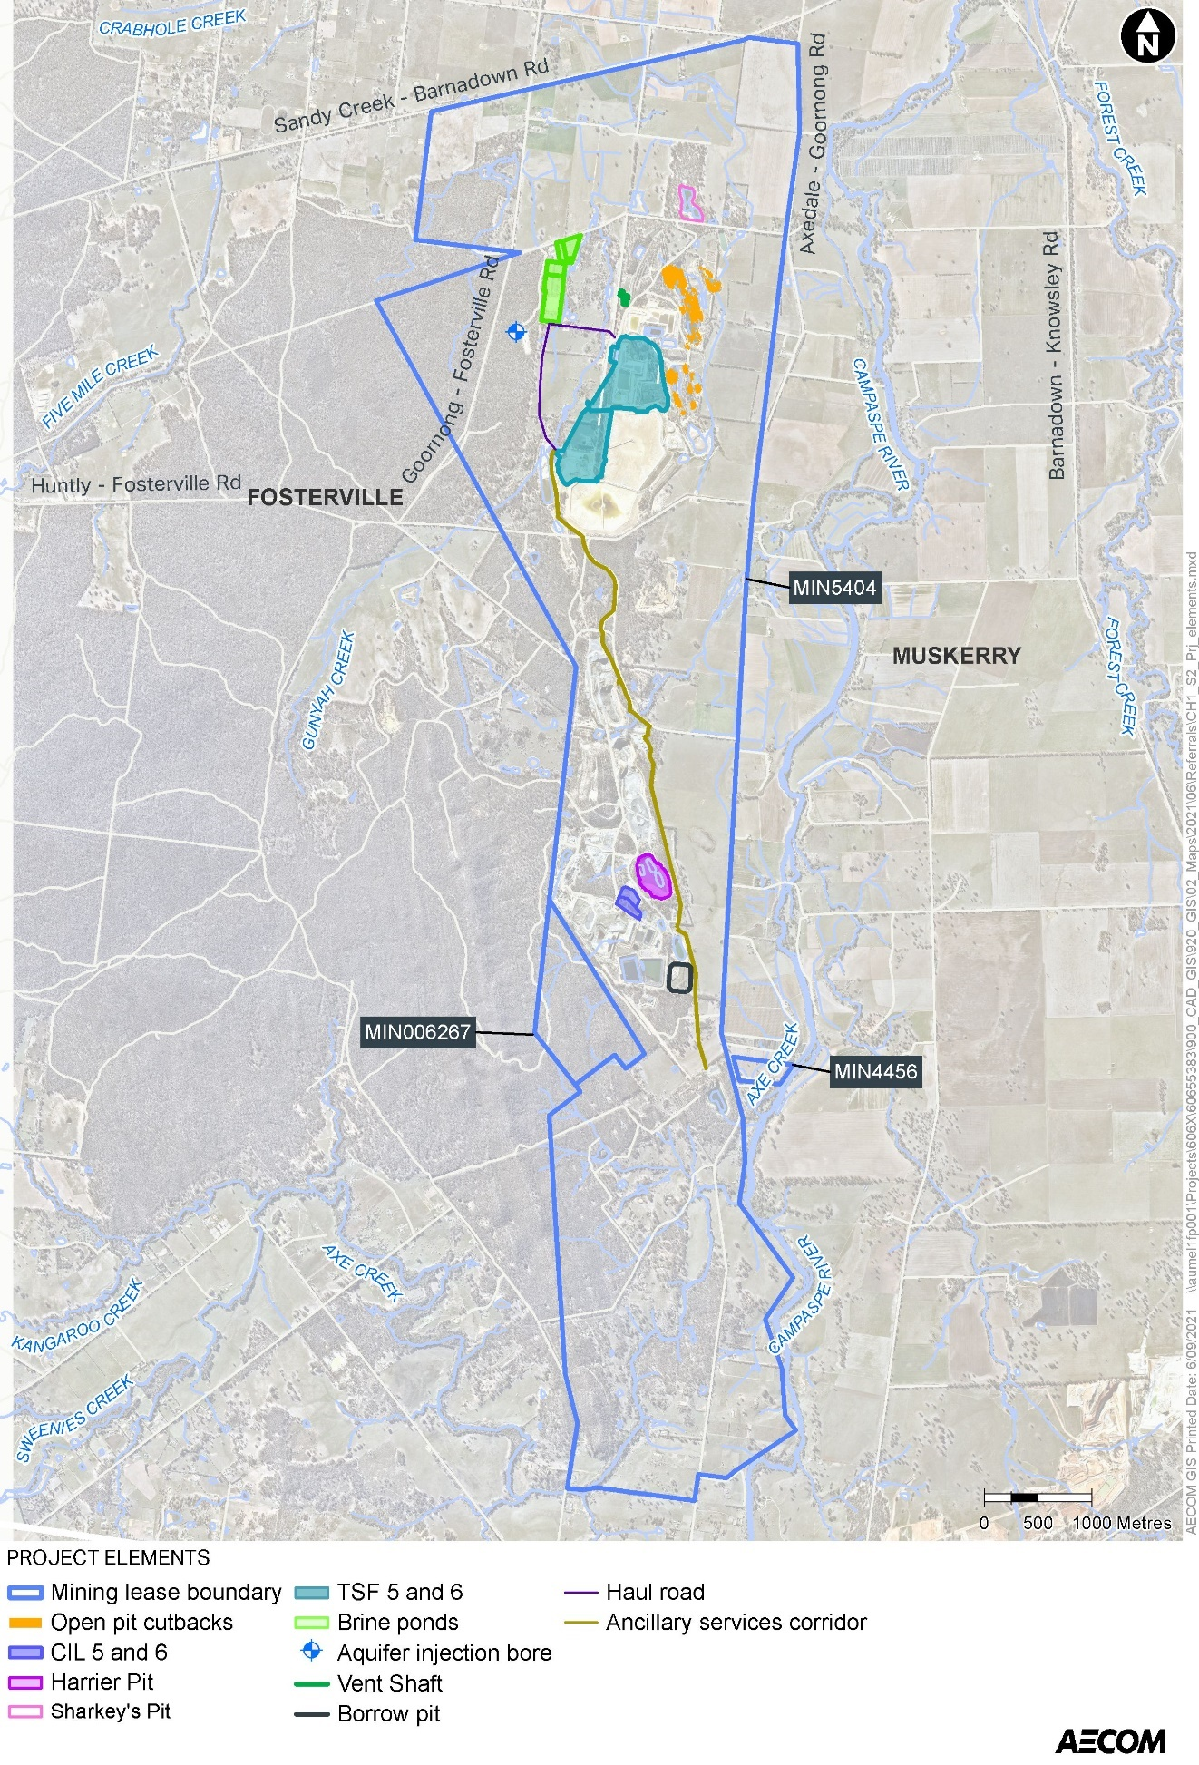
Figure 2: Project elements and location
The components of the Sustained Operations Project are:
- Underground mining development to extend the existing underground mining operations within the Mining Licence Boundary and into MIN006267
- Open pit mining cutbacks (extensions) at existing open pits (no new pits are proposed)
- An above ground waste rock dump (WRD) at the existing Harrier Pit (at the conclusion of backfilling operations of the existing open pit)
- Storage of waste from the paste plant (together with waste rock) in Harrier Pit/Harrier WRD
- Construction and operation of new flotation and neutralization tailings storage facilities (TSFs) within the existing TSF compound in the northern part of MIN5404 (TSF 5 and 6)
- Construction and operation of new in-pit tailings storage facilities for flotation and neutralization tailings in existing open pits in the northern area of the mining lease (including the four pits being extended by cutbacks)
- Construction and operation of additional carbon-in-leach (CIL) tailings hardstands as an extension of the existing CIL hardstand area south of the processing plant (CIL 5 and 6)
- Transport/sale of CIL tailings off the mining lease
- Construction and operation of a brine evaporation pond to the northwest of the flotation TSF area
- Managed aquifer recharge (MAR) within the fractured rock aquifer in the north western part of MIN5404
- A vent shaft to the north of the TSF area to support the northern underground mine extension
- Supporting infrastructure, including haul roads within the mining lease, borrow pits for construction materials, and a combined services corridor for energy supply and water / paste reticulation.
Underground mining
The existing underground mining operation would be extended to the south and the north within the mining lease. The proposed southern mine extension would commence at the depths of existing declines ranging from 600m to 1,600m below ground level (deepening to the south) and would be informed by the outcome of exploration activities.
Development of underground mining to the north is proposed to access and exploit the mineral resource, which is known to extend to within 250-300m below surface. Development to the north would be informed by future exploration activities. A vent shaft to surface would be required to support the northern extension of the mine.
Exploration drives are proposed going west from the current underground mine into the area subject to mining licence application MIN006267. Underground mining to the west would be informed by future exploration activities.
Mining operations in the new areas would use the same mining methodologies and rates of production as current operations.
Open pit cutbacks
Cutbacks are proposed for four existing open pits in the northern area of MIN5404. No new pits are proposed. The duration of open pit cutback operations at each pit would range from approximately six months to two years, after which the pits will be prepared for in-pit tailings storage (discussed below).
Waste rock dump
An above-ground waste rock dump (WRD) is proposed at the location of the existing Harrier Pit following the completion of tailings backfilling operations. The backfilling operations are already approved and are expected to provide at least four years of storage at current mining rates prior to the above-ground WRD being required.
Flotation and neutralization tailings storage facility
Two new above-ground tailings storage facilities (TSFs) 5 and 6 for flotation and neutralization tailings are proposed in the existing tailings storage area in the north of MIN5404. The TSFs would be located next to and keyed into existing TSF1 and TSF4.
In-pit tailings facilities will be constructed in existing open pits in the northern area of the mining lease, including within the four open pits that are proposed to be extended by cutback operations.
Carbon-in-leach tailings storage
New carbon-in-leach (CIL) tailings Hardstands 5 and 6 are proposed to be placed in the existing CIL Tailings Storage Precinct on the northern side of CIL Hardstands 1 to 4.
There is also potential for CIL tailings to be sold and transported offsite by a third party. Transport of tailings beyond the MIN boundary and treatment of the tailings would be the responsibility of the third party.
Mine water management
There are two elements to the mine water management components of the Sustained Operations Project: a new brine pond and managed aquifer recharge (MAR).
A brine evaporation pond is proposed to be constructed in the northern area of MIN5404 to the northwest of the existing TSF area. The brine evaporation pond would replace the existing ponds north of TSF1, which would be displaced by the proposed TSF6. Brine from the mine water treatment plant would be sent to the ponds to allow the water to evaporate.
MAR is proposed for management of surplus mine water generated by the dewatering of the underground mining operations. The MAR scheme would be phased with initially one injection bore located on Crown land within MIN5404 to the west of the TSF area. The full MAR project would be implemented following a proposed two-year trial phase. Mine water would be treated in the mine water treatment plant (which was commissioned in 2019-20) to remove arsenic, antimony and sulphates and to reduce hardness prior to injection into the fractured rock aquifer via up to three injection wells at a rate of up to 1.25ML/day.
Waste Paste
It is proposed to store waste from the paste plant commissioned in early 2020 within Harrier Pit, along with other waste rock. The paste plant mixes the combined tailings (flotation tails and neutralization tail) produced at the processing plant with Epsom Water Treatment Plant Class B recycled water, mine water brine, or a combination and a binder (lime, cement, slag or a blend) and creates a weak form of concrete paste that is directed down a borehole to backfill underground stopes. Testing of the concrete paste indicates that the samples had low sulphide contents, moderate to high neutralising capacities (ANC), strongly negative net acid producing potentials (NAPPs) and this indicates non-acid forming potential (NAF).
The paste backfilling stabilizes the underground voids and allows mining of ore that would otherwise be left behind. During normal mining operations, paste from previous backfilled stopes is removed and becomes waste paste. Waste paste is currently stored in underground voids however the storage space is finite and the long-term solution for storage of waste paste is to comingle with waste rock within Harrier Pit.
Waste paste currently makes up between two to five per cent of all underground waste rock, which will continue for the Sustained Operations Project. .
Ancillary components of the project (eg. upgraded access roads, new high-pressure gas pipeline; off-site resource processing):
Ancillary components of the Sustained Operations Project include:
- New haul roads to replace haul roads displaced by TSF 5 and 6
- A borrow pit to the east of the CIL Hardstand storage area (south of John’s Pit) to provide additional material for rehabilitation (if required)
- A vent shaft to surface from the northern underground mine extension of Robbins Hill decline
- Construction of an embankment across a portion of Hunt’s Pit crest to provide additional freeboard to the decant water pond that services TSFs 5 and 6
- A combined services corridor (following existing infrastructure) for:
  - Energy supply from the Fosterville Terminal Station in the southeast of MIN5404 to the northern precinct
  - Pipelines at surface for water, air and paste reticulation

Key construction activities:
Key construction activities for the Sustained Operations Project would include:
- Clearing of vegetation, removal and stockpiling of topsoil and subsoil for rehabilitation
- Relocation of existing ancillary infrastructure as required (e.g., haul roads, pipelines, power supply)
- Construction of TSF 5 and 6, CIL Hardstand 5 and 6, in-pit storage facilities and brine evaporation ponds (activities include foundation preparation, excavation of base and underdrainage sumps, bunds, liner installation)
- Construction of additional site drainage and stormwater management systems, including diversion drains and sedimentation ponds, where required.
- Drilling and installation of injection bores for MAR and groundwater monitoring bores for the MAR project and around the new TSFs, in-pit storage facilities and brine ponds
- Construction of the vent shaft for the northern underground mine extension
- Construction of underground declines, drives and drilling platforms
- Construction of the Harrier Pit waste rock dump.
The timing and duration of construction activities differs by project component. Construction of each stage of TSF5 and 6 would take approximately 12-15 months. CIL hardstands would be constructed in approximately nine months each.

Key operational activities:
As explained in section 2 above, the Sustained Operations Project is intended to allow for the continuation of existing operations at Fosterville Gold Mine beyond the next two years. Key operational activities for the Sustained Operations Project include:
- Continuation of underground mining activities via extensions to the south, north and west, including exploration, development and production, and using the same techniques used currently at Fosterville Gold Mine (i.e., drilling, blasting, conventional underground mining equipment)
- Open pit cutbacks using conventional earth moving equipment and mining techniques
- Continuation of existing mine waste management activities at proposed new facilities, including:
  - Disposal of overburden / waste rock and waste paste to the Harrier Pit WRD (following its backfilling)
  - Disposal of flotation and neutralisation tailings to TSFs 5 and 6 and in-pit facilities
  - Disposal of CIL tailings to CIL Hardstands 5 and 6
- Transport/sale of CIL tailings off the mining lease
- Treatment of mine water and injection to the fractured rock aquifer
- Storage and evaporation of brine water in the brine evaporation ponds
- Environmental monitoring and community engagement
- Progressive rehabilitation
All other operations at Fosterville Gold Mine will continue as per existing operations at existing production rates of up to a nominal plant capacity of 960,000 tonnes/year and will continue to operate 24 hours/day, 365 days/year.

Key decommissioning activities (if applicable):
The current approved work plan for Fosterville Gold Mine includes a Rehabilitation Plan as required under the Mineral Resources (Sustainable Development) Act 1990. As per the approved rehabilitation plan concept and rehabilitation objectives, final land uses would aim to return sites to a similar vegetation function and structure as existed prior to mining operations disturbance. Therefore, FGM would aim to return agricultural land to an agricultural land use – for example cropping or grazing.
Where opportunity exists, water bodies such as surface water dams would remain, particularly when near or on agricultural land.
FGM would also aim to return areas of native forest back to a self-sustaining native forest while also taking opportunities to increase the number of indigenous species and link up biodiversity corridors where possible.
Industrial or commercial use of surface facilities has also been highlighted with the community and remains an option for future use. Concepts for final landforms would continue to be investigated and discussed with the local community and regulators as operation continues and would be further detailed in the lead up to closure.
At this stage, it is proposed that final landforms would most likely consist of the following features:
- Pit lakes
- Rehabilitated waste dumps
- Backfilled pits to natural surface
- Agricultural land
- Native forests
- Drainage lines and catchment dams.
The current Rehabilitation Plan would be updated to incorporate the additional areas disturbed by the Sustained Operations Project components and would form part of the work plan prepared as part of the approval process.
Is the project an element or stage in a larger project?
❒ No  Yes If yes, please describe: the overall project strategy for delivery of all stages and components; the concept design for the overall project; and the intended scheduling of the design and development of project stages).
Fosterville Gold Mine is an operating gold mine. The Sustained Operations Project consists of extensions to the existing mining areas and mine waste storage areas to sustain and continue mining operations for at least the next ten years. Current operations are undertaken in accordance with an approved Work Plan and approved Variations to the Work Plan under the Mineral Resources (Sustainable Development) Act 1990 (MRSDA).

Is the project related to any other past, current or mooted proposals in the region?
❒ No Yes If yes, please identify related proposals.
The proposal for a southerly mining extension was the subject of a draft Work Plan Variation under the MRSDA (WPV PLN-001507). This Work Plan Variation has been officially withdrawn.
What is the estimated capital expenditure for development of the project?
The estimated capital expenditure for the Sustained Operations Project is $40 million.

4. Project alternatives

Brief description of key alternatives considered to date (eg. locational, scale or design alternatives. If relevant, attach A4/A3 plans):
Sustained Operations Project alternatives considered to date include:
- Locations for TSF 5 and 6 – FGM conducted an analysis of potential alternate sites for TSF 5 and 6. The proposed locations were selected on the basis of land ownership (mostly company-owned and a road reserve in the process of being acquired), geology, proximity to existing storages, relatively low visual impact and availability of construction materials.
- Alternative brine pond locations have been assessed. The preferred location has been selected due to its distance from residences, and position outside of overland flows associated with the ephemeral Gunyah Creek
- Design of the MAR project – FGM investigated aquifer injection scenarios to inform the MAR project. The alternative to this project is larger scale evaporation ponds.
- Vent shafts from the underground mine – vent shaft requirements and locations for the southern extension were considered by FGM. Based on current knowledge and understanding of existing reserves in MIN5404 South, there is unlikely to be a requirement for a ventilation shaft in this region. If however a new vent shaft was required due to a discovery of significant new ore reserves and the existing ventilation system was unable to adequately ventilate new mining fronts, it would be selected based on land ownership, distance to receptors and biodiversity impacts.
- Borrow pit locations have been assessed and a site to the east of the CIL precinct (south of John’s Pit) has been selected due to availability of clay alluvium in this area, consolidation with existing infrastructure and avoidance of vegetation.
- Northern Mining infrastructure precinct (including vent shaft) – location was chosen considering land ownership, avoidance of native vegetation and areas of high cultural sensitivity, proximity to existing infrastructure corridors and previous disturbance to the area.
- Ancillary linear infrastructure locations have been chosen to parallel existing routes and avoid additional vegetation clearance.

Brief description of key alternatives to be further investigated (if known):
Alternatives that require further investigation include:
- CIL hardstand closure designs
- TSF closure designs

5. Proposed exclusions

Statement of reasons for the proposed exclusion of any ancillary activities or further project stages from the scope of the project for assessment:
To sustain existing operations at Fosterville Gold Mine over the next two years, a number of projects are required in the immediate future, which will be subject to a separate Work Plan Variation under the MRSDA and are specifically excluded from the Sustained Operations Project subject to this referral.. These excluded projects are:
- Underground exploration to the south – exploration of the orebody in the MIN5404 southern area via underground drives. Works are required to inform prospective areas within the MIN5404 southern area and to adequately define viable ore zones. The proposed works will extend the currently approved exploration drives in the southern area.
- Waste rock management – proposed lift on the existing in pit waste storage at Falcon Pit. This is required as an alternative surface location for waste rock to allow progressive rehabilitation to be undertaken during the extension of McCormick’s WRD (already approved).
- CIL Hardstand 4 – stage 4 is the first additional stage of CIL hardstands and storage ponds beyond the existing storage area, which will allow dry stacking of CIL tailings until 2023. Stage 4 represents an additional 0.2 ha of CIL hardstand area (approximately 1% increase to current hardstand area).

6. Project implementation

Implementing organisation (ultimately responsible for project, ie. not contractor):
Fosterville Gold Mine Pty Ltd
Implementation timeframe:
The proposed timeframe for the construction and operation of the Sustained Operations Project is 2023-2033 allowing for a minimum ten-year mine life.
Proposed staging (if applicable):
Subject to receiving all required project approvals, the Sustained Operations Project would commence in 2023.
The proposed staging is:
- 2021-2023: Assessment and approvals phase
- 2023: Commence construction (TSF 5 and 6, in pit tailings, brine evaporation ponds, CIL hardstands 5 and 6, supporting infrastructure)
- 2023-2033: Operations phase (underground mining extensions, open pit cutbacks, tailings deposition and management, brine evaporation operations, MAR)
- Progressive rehabilitation throughout the life of the project
- Approx. 2027: commence Harrier Pit WRD operations
- 2034: Final decommissioning and closure phase

7. Description of proposed site or area of investigation

Has a preferred site for the project been selected?
❒ No Yes If no, please describe area for investigation.
If yes, please describe the preferred site in the next items (if practicable).
General description of preferred site, (including aspects such as topography/landform, soil types/degradation, drainage/ waterways, native/exotic vegetation cover, physical features, built structures, road frontages; attach ground-level photographs of site, as well as A4/A3 aerial/satellite image(s) and/or map(s) of site & surrounds, showing project footprint):
The mining lease contains engineered landforms and structures related to past and current mining operations including: open pits, waste rock dumps, tailings storage facilities, drainage lines and water storages, the processing plant, water treatment plants, offices, workshops, haul roads, powerlines and pipelines.
The preferred location for each of the individual components is for the proposed new works to be co-located with (or in close proximity to) existing components used for the same purpose (e.g., new TSFs with existing TSFs). All components are to be located within MIN5404.
Topography/Landform
The regional landform can be described as low rolling hills and undulating rises which enclose the narrow alluvial flats along the Campaspe River. The mine lies at the foot of a north-north-west trending ridge with a maximum elevation at Mt Sugarloaf of about 265 metres Australian Height Datum (mAHD).
A lower ridge (170 mAHD) crosses the mine site in an NNW-SSE direction along the Fosterville fault. The site is flat to gently undulating, with an overall slope toward the east-northeast.
The topography of the Fosterville area is dominated by the Campaspe River to the east and the Sugarloaf Range to the west. Between these topographic features lie a progression of landforms, the narrow alluvial flats along the river are enclosed by the low undulating rises, which are bounded by low rolling hills which in turn are bounded by the Sugarloaf Range. These landforms range in elevation from 145m above sea level (ASL) along the Campaspe River, to 265m ASL at the summit of Mount Sugarloaf.
The original landforms have been modified by mining operations at the site, including historical mining and current mining activities. These changes include the excavation of open pits and new landforms associated with heap leach facilities, tailings storage facilities, and the addition of the waste rock dumps.
Soil and Groundwater
Fosterville Goldfield is located within the Fosterville Structural Zone in the Lachlan Fold Belt. The lithology of the Fosterville area consists of a sequence of Lower Ordovician marine sedimentary rocks (turbidites) including greywackes, sandstones, siltstones and shales. Fine grained alluvial and colluvial soils a few metres thick overlie the Ordovician sequence within the mining leases.
The turbidite sequence in the Fosterville area is tightly folded and contains two major faults – Fosterville Fault and O’Dwyer’s Fault. Both faults dip steeply and trend in a north-northwest direction parallel to antiform axial plains and the regional strike of the Ordovician sequence.
The Fosterville Fault is greater than 8km long and crosses the total length of the Mining Lease. The width of the Fosterville Fault ranges between 2m and 30m depending on the host lithology (the fault zone tends to be wide in sandstones and narrow in the fine-grained rocks). The O’Dwyer’s Fault is about 1.5km east of the Fosterville Fault. Several secondary splay faults are developed in association with the main fault zones.
At Central North and Central Ellesmere, the Fosterville Fault dips steeply to the west at around 80 degrees. Gold mineralisation within the mining lease is associated with the fault zones. The Rehe’s, Fosterville, Central North, Central Ellesmere, Harrington’s Hill, Harrington’s Hill South, and Daley’s Hill deposits are all located along the Fosterville Fault. The Sharkey’s and Robbins Hill deposits are located on the O’Dwyer’s Fault.
The hydrostratigraphic units in the area include:
- Alluvial aquifer systems, which are best developed around:
  - the Campaspe River (the Tertiary Campaspe Deep Lead aquifer) and
  - about 1km to the north of the mining lease (the Shepparton Formation)
- The underlying fractured rock aquifer (FRA).
Drainage & waterways
Fosterville Gold Mine is located in Central Victoria and the Murray-Darling Basin. The site lies within river terraces between the Sugarloaf Range (Gunyah Creek), Axe Creek and the Campaspe River. The mine is located within the catchments of the Campaspe River and Bendigo Creek.
The northern part of the mine site is drained northwards by a small ephemeral watercourse, Gunyah Creek, which traverses west of the TSF area and the northern end of Hunts Pit towards Bendigo Creek. The southern part of the site is drained by several intermittent watercourses eastward across the site toward to the floodplain of the Campaspe River, including Axe Creek, an ephemeral creek, which flows around the Sugarloaf Ranges and merges with the Campaspe River.
The main surface drainage in the Fosterville region is the Campaspe River, which flows northwards approximately 1.5-2 km east of the site to the Barnadown weir and into the Murray River further downstream.
Native vegetation
Fosterville Gold Mine is located within the Goldfields Bioregion. Ecological Vegetation Class (EVC) modelling indicates that the area would have supported the now depleted Box Ironbark Forest (EVC 61) prior to European settlement.
Much of the vegetation within the Sustained Operations Project area has previously been cleared for agricultural use, or for historical and current mining activity, and as a result is dominated by introduced pasture grasses or bare ground.
Some remnant Box Ironbark Forest (EVC61) has been recorded within the Sustained Operations Project area. The dominant eucalyptus species in this EVC include Grey Box, Red Box, Yellow Box, White Box and Red Ironbark. The proposed location of TSF 5 and TSF 6 contains a patch of native vegetation that meets the condition threshold for the nationally significant ecological community Grey Box (Eucalyptus macrocarpa) Grassy Woodlands and Derived Native Grasslands of South-eastern Australia. A total of 67 large trees in patches and 28 scattered trees (18 large and 10 small trees) were recently recorded in the TSF area (Attachment 1 - EHP 2021a). Removal of these trees will need to be offset in accordance with the Victorian Guidelines for the removal, destruction or lopping of native vegetation.
In areas of remnant vegetation in the proposed TSF area (Figure 3), the overstorey is dominated by Waxy Yellow Gum Eucalyptus leucoxylon subsp. pruinosa, Grey-box Eucalyptus microcarpa and Yellow-box Eucalyptus melliodora. The understorey in the TSF area is generally sparse, but includes Gold-dust Wattle Acacia acinacea, Drooping Cassinia Cassinia arcuata, Berry Saltbush Atriplex semibaccata, Saloop Einadia hastata, Spear-grasses Austrostipa spp. and Wallaby-grasses Rytidosperma sp.
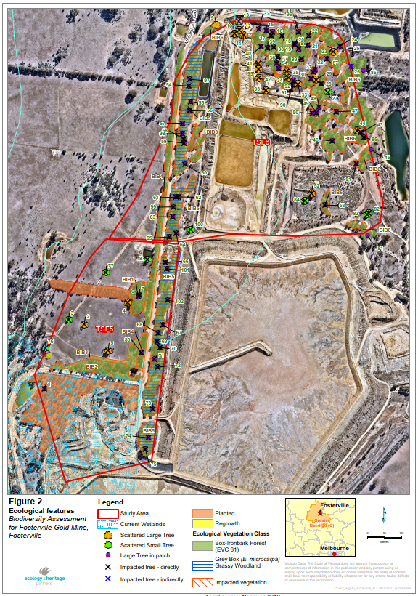
Figure 3: Vegetation in TSF area
Within the proposed brine ponds area, several patches of native vegetation and scattered native trees have been recorded (Attachment 2 - EHP, 2021b). The remainder of the brine ponds area comprises introduced and planted vegetation, present as pasture grass and ornamental gardens. The majority of the vegetation within the brine ponds area (Figure 4) has previously been cleared as a result of agricultural and residential use and is dominated by introduced flora species. The site was previously occupied by a residential dwelling and horse arenas. Box Ironbark Forest (EVC 61), was recorded within the study area in poor condition (Attachment 2 - EHP 2021b).
A total of 18 large trees in patches and 42 scattered trees (22 large and 20 small scattered trees) were recorded in the brine ponds area (Attachment 2- EHP 2021b). All large trees in patches and all scattered trees were either Grey Box or Waxy Yellow-gum. These trees would once have been part of the Box Ironbark Forest EVC, but the understorey vegetation now consists of predominantly introduced species (mainly exotic pasture grasses) and the trees no longer form a patch of native vegetation. Three areas of planted indigenous vegetation (Waxy Yellow Gum) were also recorded within the brine pond area.
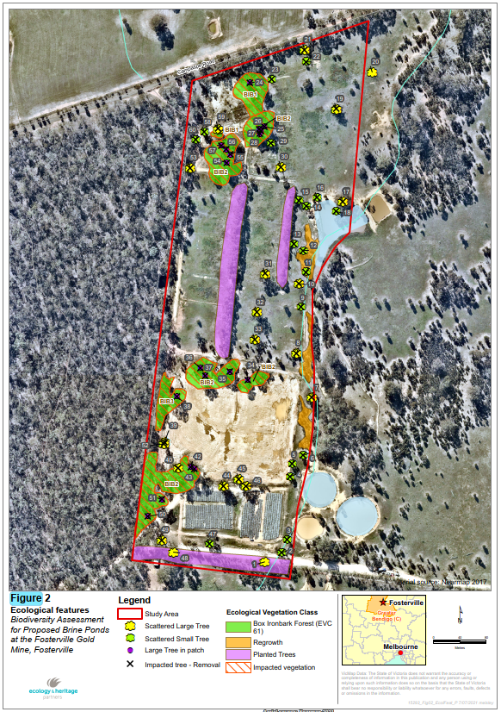
Figure 4: Vegetation in Brine Pond area
Built structures
The main road frontages to the project area are:
- Axedale-Goornong Road
- Campaspe Road
- Huntly-Fosterville Road
- Goornong-Fosterville Road
- Epsom-Barnadown Road
- Fosterville North Road
- McCormicks Road
Site area (if known): The mining lease and licence areas cover approx. 2,850ha of land, including the existing mine site, rural land, rural residential land and native forest.
The above-ground footprint area of the Sustained Operations Project site totals approximately 100 ha, with all above-ground project components located within the footprint of the existing operations. The above-ground footprint comprises:
- TSF5 – approx. 23ha
- TSF6 – approx. 38ha
- Brine evaporation pond – approx. 16ha
- CIL Hardstands 5 and 6 – approx. 6ha
- Open pit cutbacks – approx. 10ha
- Harrier WRD – approx. 7ha
- Northern vent shaft and associated infrastructure – approx. 0.5ha (construction footprint reducing to 20m x 20m during operations)

Route length (for linear infrastructure) approx. 10.5. (km) and width …approx. 12..(m)
Proposed linear infrastructure includes:
- Haul road (west of TSFs) – approx. 2km
- Combined services corridor – approx. 8.5km (co-located parallel to existing infrastructure on previously disturbed land)

Current land use and development:
Current land use is divided between the mining operations, agriculture (grazing, crops, vineyards) on private and company owned land, native forest and Crown Land.
The main land use within the Sustained Operations Project area is the existing Fosterville Gold Mine. The proposed MAR bore location is within a patch of Crown Land in Wellsford State Forest near Rehe’s Pit.
The current mining operations consist of back filled pits, open pits, in-pit tailings facilities, the underground mine, four surface tailings facilities and associated dams and infrastructure.
The Fosterville tenement originally contained areas of pasture, previously cleared for grazing and cropping, and scattered remnants of a vegetation community, the majority of which is Box-Ironbark Forest. The dominant eucalyptus species in the forest include Grey Box, Red Box, Yellow Box, White Box and Red Ironbark. The majority of the scattered forest communities are comprised of regrowth due to clearing and disturbance by historic mining activities and timber harvesting.
The Sustained Operations Project area contains small rural farms and covers foothills and old river terraces between the Sugarloaf Range and the Campaspe River, which runs roughly parallel to the eastern lease boundary at a distance of approximately 1 km.
Description of local setting (eg. adjoining land uses, road access, infrastructure, proximity to residences & urban centres):
There are approximately 100 dwellings within 2km of the project area, mostly in the southern extension area toward Axedale.
Land surrounding the mine is predominantly characterised by agricultural uses (grazing, cropping and vineyards), with rural residential lots to the south of the mine, Mt Sugarloaf Nature Conservation Reserve to the west and Wellsford State Forest to the northwest.
The Campaspe River runs roughly parallel to the eastern lease boundary at a distance of approximately 1km.
The town of Axedale is located about 1km south of the MIN5404 southern boundary and Goornong is about 3.5km north of the northern boundary.
The mine can be accessed from:
- Axedale-Goornong Road on the eastern side
- Huntly-Fosterville Road from the western side
Planning context (eg. strategic planning, zoning & overlays, management plans):
Loddon Mallee South Regional Growth Plan
The principles that are outlined to achieve the vision of the Loddon Mallee South Regional Growth Plan include to “strengthen and diversify our economy” and the Plan recognises strategic opportunities for the growth of the region’s economic base, including minerals industries (Victorian Government 2014).
State Planning Policy Framework (SPPF)
The relevant clauses of the SPPF in relation to mining are:
- Clause 11.01-1R – Settlement - Loddon Mallee South
- Clause 12.01 – Biodiversity
- Clause 12.05 – Significant environments and landscapes
- Clause 13.01 – Climate change impacts
- Clause 13.02 – Bushfire
- Clause 13.03 – Floodplains
- Clause 13.04 – Soil degradation
- Clause 13.05 – Noise
- Clause 13.06 – Air quality
- Clause 13.07 – Amenity and safety
- Clause 14.01 – Agriculture
- Clause 14.02 – Water
- Clause 14.03 – Earth and energy resources
- Clause 15.02 – Sustainable development
- Clause 15.03 – Heritage
Clause 11.01-1R of the State Planning Policy Framework relates to the Loddon Mallee South region, which includes Bendigo, Castlemaine, Gisborne, Kyneton and Maryborough. The strategies include supporting Bendigo as the regional city and major population and economic growth hub for the region, offering a range of employment and services.
Local Planning Policy Framework
Relevant clauses include:
- Clause 21.02 – Key issues and influences (including economic development, environment and cultural heritage)
- Clause 21.03 – Environment and landscape values
- Clause 21.07 – Economic development (including earth and energy resources industry)
- Clause 21.08 – Environment
- Clause 22.06 – Heritage Policy
Clause 21.07 includes a subclause (21.07-9) for earth and energy resources industry. The objective of clause 21.07-9 is to support existing mineral and extractive industry sites in Greater Bendigo.
Zones and overlays
The project area and surrounds are subject to five planning zones and five overlays under the Greater Bendigo Planning Scheme.
The five relevant zones (Figure 5) are:
- The Sustained Operations Project area is predominantly within the Farming Zone (FZ)
- Surrounding areas to the west are zoned Public Conservation and Resource Zone (PCRZ) for areas of Wellsford State Forest and Mt Sugarloaf Nature Conservation Reserve, as well as patches of remnant vegetation within MIN5404
- The southern extent of MIN5404 is largely zoned Rural Living Zone (RLZ)
- Rural Conservation Zone (RCZ) covers a small area at the southern extent of MIN5404
- Goornong-Axedale Road is zoned Road Zone Category 2 (RDZ2).
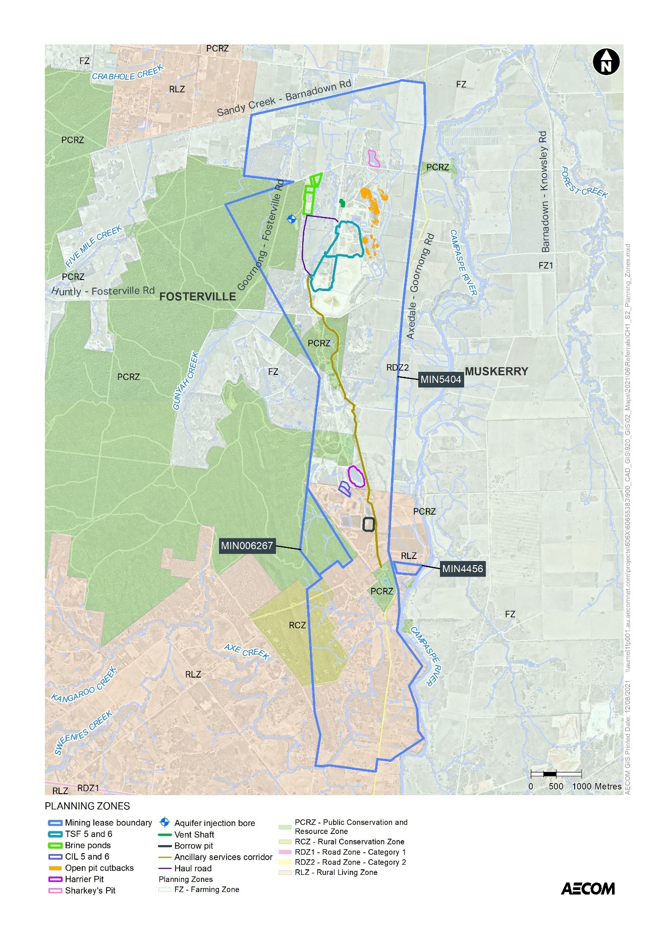
Figure 5: Planning zones

The five relevant overlays (Figure 6) are:
- Bushfire Management Overlay (BMO) applies to much of the western and southern edges of the project area and the patches of remnant vegetation within MIN5404
- Vegetation Protection Overlay (VPO2 and VPO3) cover areas of vegetation within the central area of MIN5404 near the mine offices, the northern area of MIN5404, the southwestern corner of MIN5404 and small areas to the west of MIN5404.
- Environmental Significance Overlay (ESO1) applies to watercourses in and near the Sustained Operations project area, including Axe Creek and Campaspe River
- Heritage Overlay (HO424 - Adelaide Vale Homestead and Outbuildings) covers an area of land between Axedale-Goornong Road and Campaspe River
- Salinity Management Overlay (SMO) covers areas along Axe Creek to the southwest
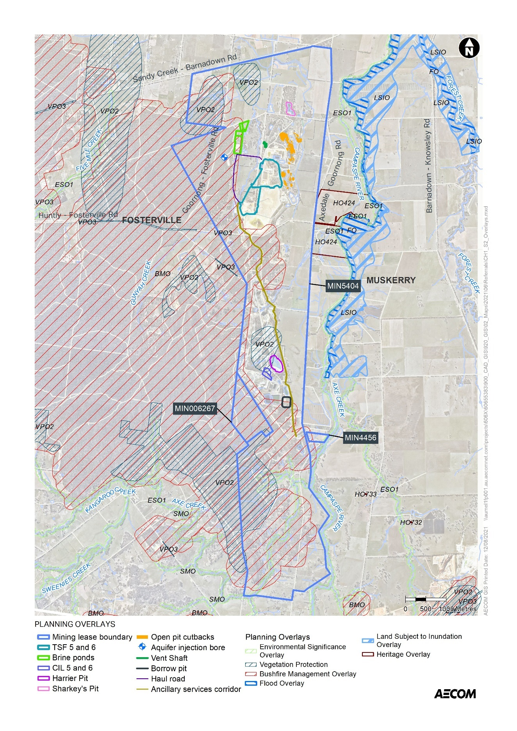
Figure 6: Planning overlays

Local government area(s):
City of Greater Bendigo

8. Existing environment

Overview of key environmental assets/sensitivities in project area and vicinity (cf. general description of project site/study area under section 7):
Overview
The existing environment is that of a highly developed modern operating gold mine, within a historical mining district. The area has been highly modified by generations of mining. At commencement of the Sustained Operations Project, the Fosterville Gold Mine will already have implemented the excluded projects discussed at Section 5 (i.e., Falcon Pit WRD, CIL Hardstand 4 and the southerly exploration drives).
Groundwater
The Victorian Aquifer Framework (VAF) defines the Sustained Operations Project area as being located near the northern margin of the central highlands. The VAF recognises that Victoria’s groundwater basins lie to the north, south and west of the central highlands and that, although groundwater can be found in the fractured rock of the highland areas, the rate and volume of water that can be extracted is highly variable. The Murray Basin is located to the north of the mine.
The hydrostratigraphic units in the Sustained Operations Project area include:
- Alluvial aquifer systems, which are best developed around the Campaspe River and about 1km to the north of the mining lease
- The underlying fractured rock aquifer (FRA).
The alluvial aquifer systems comprise the Tertiary Campaspe Deep Lead and the Shepparton Formation.
Alluvial aquifers
The Tertiary Campaspe Deep Lead is a major regional aquifer that runs along the eastern margin of MIN5404. The Campaspe Deep Lead trends north-south and is joined by the east-west trending Huntly Deep Lead about 5km to the north of the mining lease. FGM monitoring bores along the eastern boundary of the mining lease indicate that the saturated thickness ranges to 11m.
To the north of the mining lease, the Tertiary Campaspe Deep Lead alluvial aquifers are overlain by colluvium and alluvium sediments of the Shepparton Formation. The Shepparton Formation aquifer in this area deepens to more than 25 m below ground level. While surface geological mapping shows the Shepparton Formation to extend inside the mining lease (along Gunyah Creek), drilling investigations conducted in this area have showed that the Shepparton Formation Aquifer is absent in this area.
The majority of private bores in the area target the Shepparton Formation >1km to the north of the mining lease where the aquifer deepens. The location and status of private bores was confirmed during a bore census undertaken in 2015 and results showed that the nearest groundwater users are at least 250m to the north of the current mining lease boundary (and greater than 5km north of the current underground mine area).
Based on the available groundwater level data (obtained from FGM monitoring bores and the VVG database) shows that the regional groundwater flow in the alluvial aquifers is directed towards the north northeast, potentially discharging to the Campaspe River to the north east of the mining lease. Paired monitoring bores positioned on the eastern margin of the mining lease (which monitor the alluvium and the shallow FRA) showed groundwater levels in the alluvium aquifers are similar or slightly higher than pre-mining groundwater levels of the underlying FRA. There is no evidence in site monitoring data to indicate that mine dewatering from the FRA has impacted the alluvium aquifers.
Available groundwater salinity data from site monitoring bores along the eastern boundary of the current mining lease, and historic bores to the south indicate the groundwater salinity ranges from 250 mg/L to 600 mg/L. Results of groundwater sampling of private bores undertaken as part of the 2015 bore census conducted by FGM revealed groundwater salinities of the Shepparton Formation to the north of the mining lease were typically less than 1,200 mg/L.
The Lower Campaspe Valley Water Supply Protection Area also covers the Sustained Operations Project area.
Fractured Rock Aquifer (FRA)
The geology of the FRA comprises a folded and faulted sequence of Lower Ordovician marine sedimentary rock including sandstone, greywacke siltstones and shales. With respect to the groundwater flow conditions, the FRA system can broadly be subdivided into:
- An upper weathered zone about 30 m thick of low hydraulic conductivity and localised groundwater. Due to a high degree of weathering, the fractures associated with the main structural features tend to be closed and infilled with product of weathering resulting in a low permeability.
- Main fresh rock zone with hydraulic conductivity enhanced by regional faults and associated fractures.
The major structural features in the area are the NNW-SSE trending faults. The Fosterville Fault and O’Dwyer’s Fault (both steep westerly dipping) within the current mining lease are of considerable hydrogeological importance.
Previous investigations have identified the Fosterville Fault and O’Dwyer’s Faults as zones of higher permeability (hydraulic conductivities (K) of 0.3 m/d to 0.4 m/d). Outside of these fault zone, the bedrock has low permeability (K = 0.01 m/d) and bore yields are generally low (less than 1 L/sec). Most of the permeability in the bedrock aquifer is secondary, being due to fracturing or faulting, and the amount of groundwater stored in the formation is relatively small. Recharge to the bedrock aquifer is mainly by direct infiltration of rainfall in areas where the bedrock is exposed or by vertical movement of water through overlying soils.
Pre-mining groundwater contours produced from groundwater levels obtained from monitoring bores suggest that groundwater flowed from the Sugarloaf Ranges to the E-NE and SE direction. The contraction of groundwater level contours in the downstream part of the Campaspe River in the north east suggest the river may be gaining groundwater. This groundwater flow pattern has since been altered by mine dewatering.
Potentiometric groundwater elevation (m AHD) contours for the FRA have been produced from groundwater levels measured in December 2016. Mining and dewatering operations have resulted in a ‘tight’ cone of groundwater level depression within the FRA. The cone of depression is in a north-south orientation along the Fosterville Fault and this was first established when the Falcon/Ellesmere Pits were dewatered between 2004 and 2007. The estimated dewatering rate was in the order of 1.25 ML/d during this period. The cone of drawdown has been maintained by dewatering of the underground mine at average rates of 2.2 ML/day. Studies have shown that the effects of mine dewatering are localised, with steep gradients around the mining perimeter. This indicates low hydraulic connectivity with strata outside the fault.
The depth to groundwater at the proposed Managed Aquifer Recharge (MAR) investigation area in the north of the site is currently at 28 m to 30 m below ground level (bgl) and long-term decline is observed due to the expansion of the cone of drawdown progressing northward to the MAR site. This has created additional storage in the FRA for the MAR project.
FGM groundwater monitoring bores within the current mining lease indicate that the FRA is typically saline (3,000 mg/L to 12,000 mg/L TDS). The FRA is too saline for stock, domestic and irrigation uses and as such there are no third-party wells targeting the FRA except for five operational stock and domestic private bores documented by FGM to exist within or in the vicinity of the southern extension area which, due to their positioning outside the extent of mapped alluvium are assumed to target the FRA.
Mine water, which is pumped from the underground mine, comprises groundwater that seeps into the underground mine workings from the FRA. Water quality parameters of mine water based on long-term average concentration measured in mine water storage facilities shows the average TDS of mine water is ~6,500 mg/L, which is consistent with surrounding groundwater in the FRA.
Ambient groundwater quality results show that arsenic has been reported above the ANZECC (2000) freshwater aquatic guideline value in two monitoring bores, and that copper and zinc are present above the ANZECC (2000) freshwater aquatic guideline value in most background monitoring bores.
Whilst the presence of groundwater dependent ecosystems (GDEs) have not been confirmed, DSE 2010 suggest that riparian GDEs are likely to exist along watercourses, such as River Red Gums along the Campaspe River, accessing shallow groundwater. GDEs are unlikely to be supported by groundwater from the underlying FRA.
FGM monitors changes in groundwater level in both the FRA and shallow alluvium near the Campaspe River via paired groundwater monitoring bores along the eastern margin of the mine lease. Monitoring results to date have not detected any impacts to the shallow alluvium along the western terrace of the Campaspe River.
Surface water
The site is located in the North Central Catchment Management Area at the east of Bendigo region and north of the Eppalock Lake. The major catchments relevant to Fosterville Gold Mine are related to the minor creeks and water courses in the surroundings of the site.
The Campaspe River is the main watercourse of the largest draining catchment in the proximity of the site, covering an extensive area of ~120km up to the end of the site. The Campaspe River flows northwards approximately 1.5-2 km east of the site to the Barnadown weir and into the Murray River further downstream. The Campaspe River originates from the Great Dividing Range and the Eppalock Dam extending from the south to the Murray River in the north, a total distance of approximately 150 km. The catchment has an average width of approximately 25km for a total area in the region of 4,000km² (including the Eppalock Dam catchment).
Monthly historical flow data (1977-2020) recorded from regional gauging stations (Campaspe River 406201) and (Axe Creek 406214) showed greater flows in the months of July to October.
Surface water flows have been altered by historical mining practices and since modern mining began in the 1980s at the site. Several open pits at Fosterville Gold Mine are currently used for mine water storage (Harrier, Johns, Daley’s Hill and Robbins Hill). The site’s water management network encompasses water storage locations containing, or potentially containing, mine affected water. FGM diverts clean runoff from western catchments covering the Mount Sugarloaf nature conservation reserve around the main infrastructure, allowing flows to reach the Campaspe River and local aquifers. The site’s southern drainage system includes the northern diversion drain and the southern diversion drain, which divert clean runoff from the upstream western catchments to the floodplain area east of the site.
Retention dams and old pits have been designed to prevent stormwater runoff from reaching clean runoff. The harvested water is stored until it either evaporates or infiltrates. The retention dams have the capacity to contain a 10% AEP. Harrier and Johns Pits have been designed to prevent any surrounding stormwater runoff from entering and maintain sufficient freeboard to contain a 1% AEP 4.5 Hour rainfall event. Other minor site water storages include the raw water dams and processing ponds.
Biodiversity
Native vegetation
Within the Goldfields bioregion, Box Ironbark Forest, Heathy Dry Forest and Grassy Dry Forest ecosystems dominate the lower slopes or poorer soils. The granitic and sedimentary terrain was once dominated by Grassy Woodlands, much of which has been cleared. Occasional low-lying corridors of alluvial valleys between the uplands are dominated by Low Rises Grassy Woodland and Alluvial Terraces Herb-rich Woodland ecosystems.
The majority of the vegetation within the project area has previously been cleared as a result of agricultural use and mining activity, and is dominated by introduced flora and pasture grasses, or comprises bare ground. However, several patches of native vegetation representative of Box Ironbark Forest (EVC 61) and scattered native trees remain within the project area.
A review of the EPBC Act protected matters search tool identified the that two threatened ecological communities are likely to occur within or surrounding the project area:
- Grey Box (Eucalyptus microcarpa) Grassy Woodlands and Derived Native Grasslands of South-eastern Australia (endangered)
- White Box-Yellow Box-Blakely's Red Gum Grassy Woodland and Derived Native Grassland (critically endangered)
Recent biodiversity assessments undertaken at Fosterville Gold Mine have concluded that a patch (approx. 5 ha) of native vegetation within the study area for the proposed TSFs meets the condition thresholds for the nationally significant ecological community Grey Box (Eucalyptus macrocarpa) Grassy Woodlands and Derived Native Grasslands of South-eastern Australia. This threatened ecological community is listed as endangered. This vegetation did not meet the condition thresholds of any state-significant ecological communities.
The assessments found that, given the absence of any key indicator species for White Box-Yellow Box-Blakely's Red Gum Grassy Woodland and Derived Native Grassland, the vegetation does not meet the threshold for this ecological community.
The vegetation within the proposed brine ponds study area did not meet the condition thresholds for any nationally significant ecological community due to small patch size (less than 0.5 ha) and the low diversity of native flora and the high cover of exotic vegetation.
Flora
The Victorian Biodiversity Atlas (VBA) contains records of one nationally significant flora species and seven state-significant flora species previously recorded within 10 kilometres of the study area. The Commonwealth Protected Matters Search Tool (PMST) nominated an additional four nationally significant species which have not been previously recorded but have the potential to occur in the locality.
Golden Wattle Acacia pycnantha, Gold-dust Wattle acacia acinacea sl. and Drooping Cassinia Cassinia arcuata, all protected under the Flora and Fauna Guarantee Act (FFG Act), have recently been recorded within the study area.
Fauna
The patches of Box Ironbark Forest within the project area provide potential resources for birds and other arboreal fauna. Eucalypt and Wattle trees provide foraging habitat for nectivores (nectar-eating) and frugivorous (fruit-eating) bird species. Many eucalypts are mature and have the potential to provide an array of small, medium and large hollows, bark fissures and crevices. These are likely to be used for shelter and nesting by a range of hollow-dependent fauna including parrots, microbats, possums, gliders and owls. The open paddock areas, which contain improved exotic pastures, are likely to be used as a foraging resource by common generalist bird species which are tolerant of modified open areas, as well as a grazing resource for kangaroos.
The VBA contains records of four nationally significant fauna species and 11 state significant fauna species previously recorded within 10 kilometres of the study area. The Commonwealth PMST nominated an additional 13 nationally significant species which have not been previously recorded but have the potential to occur in the locality.
Recent biodiversity assessments at Fosterville Gold Mine have found there is suitable habitat within the project area for one fauna species (Swift Parrot Lathamus discolor). Given the apparent degraded condition of the majority of the study area and its close proximity to large areas of higher quality habitat (i.e., Mount Sugarloaf Nature Conservation Reserve) it is considered unlikely that the project area provides critical or limiting habitat for the species. The area is only likely to be used opportunistically by Swift Parrot on route to larger areas of suitable habitat. Vegetation connectivity surrounding the study area will be maintained, sustaining passage between key habitat areas. As such, it is considered unlikely that the proposed vegetation removal will have a significant impact on Swift Parrot.

Aboriginal cultural heritage
The Traditional Aboriginal Owners have been identified as clans speaking a dialect of the East Kulin language known as Dja Dja Wurrung (Attachment 4 - Clark 1990 in Heritage Insight 2021).
The Dja Dja Wurrung language area incorporated land from Creswick to just south of Charlton and west from the Richardson River and Mount Avoca, east to Castlemaine and Bendigo. The Dja Dja Wurrung language group comprised several clans. Although it is acknowledged that each clan held a specific area within the tribal country, accounts of the specific number of Dja Dja Wurrung clans varies.
The Victorian Aboriginal Heritage Register (VAHR), accessed through the Aboriginal Cultural Heritage Register and Information System (ACHRIS), indicates that there are areas of cultural heritage sensitivity within and adjacent to the project area (Figure 7), including:
- Areas within 200m of Gunyah Creek, Axe Creek and Campaspe River.
- Areas within 50m of registered places
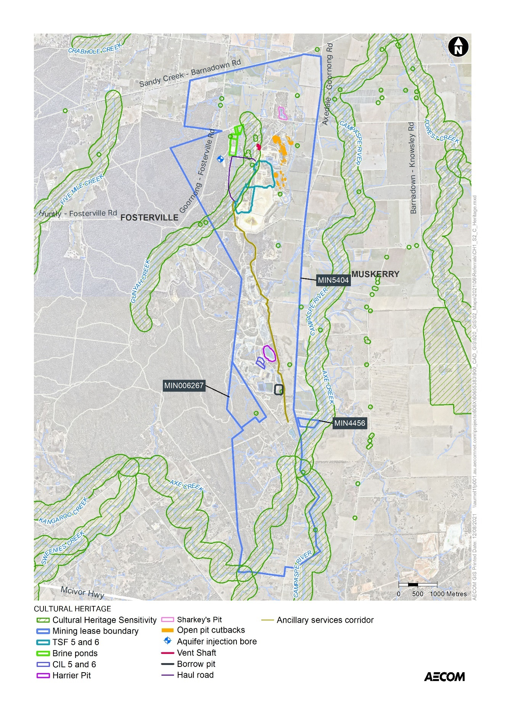
Figure 7: Areas of Aboriginal cultural heritage sensitivity
A Cultural Heritage Management Plan (CHMP 15553) was developed for the TSF5 and 6 area (Attachment 5 - Heritage Insight, 2018) and approved by the Dja Dja Wurrung Clans Aboriginal Corporation as the Registered Aboriginal Party. The assessment for the CHMP identified that there are sixteen registered Aboriginal places on the VAHR within a 2km radius of the TSF 5 and 6 Activity Area. This included 15 scarred trees, of which nine were located along Gunyah Creek, and one artefact scatter. One of these scarred trees along Gunyah Creek (VAHR 7724-0101) is within 200m of, but outside of, the proposed TSF6 footprint.
A more recent assessment was undertaken of the southerly and northerly extensions to MIN5404 (Attachment 4 - Heritage Insight, 2021). There are two Aboriginal places (VAHR 7724-0126 and VAHR 7724-0127) in the northern extent of MIN5404, which are both scar trees located on the Goornong-Fosterville Road. The site inspection found that further assessment of another Aboriginal place (VAHR 7824-0062), an artefact scatter in the northern area, is required to address inconsistencies in the site interpretation and registration. Another scarred tree (VAHR 7824-0075) is located outside of but within 200m of the northern boundary of MIN5404.
The assessment found that the south study area did not contain any registered Aboriginal places. However, three places were discovered during the assessment. The location of a ground edge axe which is held by a resident within the study area, several quartz artefacts which were discovered near a historic sheep dip/sheep yard, and a scar tree located on the banks of Axe Creek. This Aboriginal cultural heritage is yet to be registered in accordance with section 24 of the Aboriginal Heritage Act 2006. Areas of cultural heritage sensitivity in the southern area include land within 200m of the Campaspe River, Axe Creek and its associated floodplains.
Non-indigenous cultural heritage
Fosterville was established as a gold mining town in 1852 and was originally named Ellesmere. Extensive mine workings began more than 40 years later in 1894. Several companies and individuals operated mines in the area and by the end of 1896 there were 800 mine employees. A school was opened in 1898, and Anglican and Bible Christian church services were conducted.
A search of the Victorian Heritage Database (Figure 8) identified:
- One site listed on the Victorian Heritage Register (VHR H0304 – Adelaide Vale Homestead and Outbuildings) on Axedale-Goornong Road (also locally-listed as HO424; see planning overlays map at Figure 6)
- Sixteen archaeological sites listed on the Victorian Heritage Inventory (VHI), fourteen of which are located within the mining licence area, mostly located in the central area of Fosterville Gold Mine. These sites are mostly associated with historical mining and minerals processing. Details of these sites can be found in Table 2.
A recent study undertaken of the northerly and southerly mine extension areas for MIN5404 (Attachment 4 - Heritage Insight 2021) found no historic sites in the north study area. Findings in the southern study area include site H7824-0074, the Riley & Fitzpatrick Cyanide Works (included in the 16 sites discussed at Table 2). Two other historic sites were discovered in the southern area which require further research and assessment, a sheep dip/sheep yard located in the north central part of the south study area and a dry stone wall located along the southern end of the study area.
Only three of the VHI-listed heritage places within MIN5404 are considered to be intact: H7724-0611, H7724-0610 (both located west of the existing Harrier Pit) and H7824-0074 (the southernmost heritage place within MIN5404).
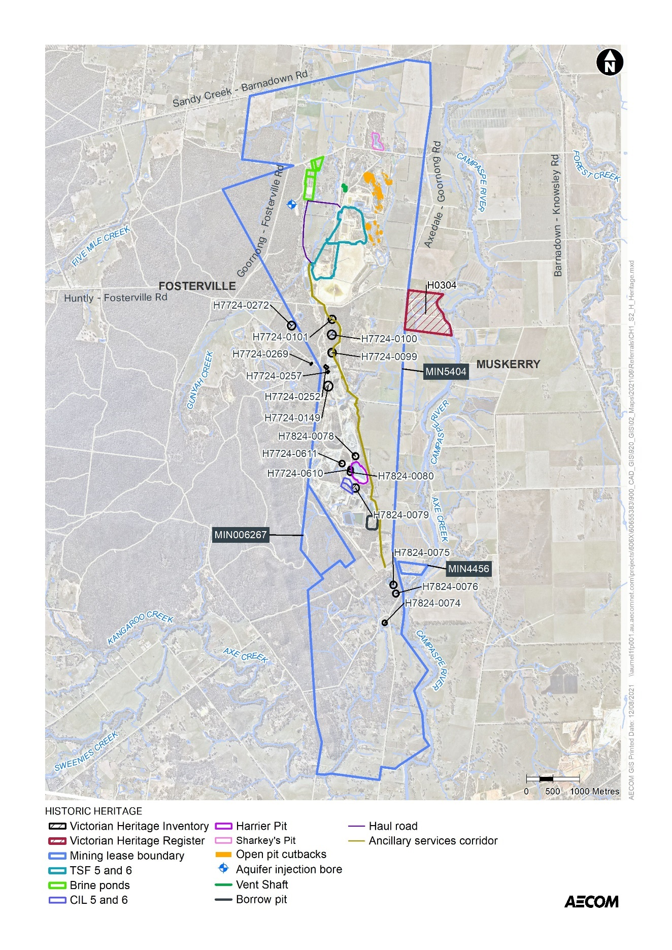
Figure 8: Historic heritage

Table 2 Historic heritage places
Registered Place Number | Place Name | Place Type | Known Site Condition
H7724-0101 | McCormacks Battery & Cyanide Works | Archaeological Site | Possibly subject to salvage for 1996 EES and removed
H7724-0100 | Hunts Reef Cyanide Works | Archaeological Site | Poor condition. May have been removed
H7724-0099 | Thomas’s Mine Workings | Archaeological Site | Possibly subject to salvage for 1996 EES and removed
H7724-0252 | Fosterville Site 33 – Iron Boiler | Archaeological Site | Appears to have been removed
H7724-0257 | Fosterville Hotel | Archaeological Site | Removed. Archaeological salvage undertaken
H7724-0149 | Government Deep Shaft | Archaeological Site | Possibly subject to salvage for 1996 EES and removed
H7824-0078 | Stewarts United Mine | Archaeological Site | Possibly subject to salvage for 1996 EES and removed
H7724-0611 | Fosterville Mud Brick House | Archaeological Site | Poor condition but archaeologically intact
H7824-0080 | Site 18 Central Ellesmere Pit Cyanide Vats | Archaeological Site | Possibly subject to salvage for 1996 EES and removed
H7724-0610 | Adams House | Archaeological Site | Poor condition but archaeologically intact
H7824-0075 | Daley & Westons Mine | Archaeological Site | Appears to have been removed
H7824-0076 | Daleys Hill Battery & Cyanide Works | Archaeological Site | Possibly subject to salvage for 1996 EES and removed
H7824-0079 | Mine Foundations Site 21 | Archaeological Site | Possibly subject to salvage for 1996 EES and removed
H7724-0272 | Gold Cyanide Works | Archaeological Site | Outside MIN5404
H7724-0269 | St Andrews Church of England Site | Archaeological Site | Outside MIN5404
H7824-0074 | Riley & Fitzpatrick Cyanide Works | Archaeological Site | Cyanide tanks, mounded tailings evident
H0304  (Greater Bendigo HO424) | 1060 Axedale Road  Adelaide Vale Homestead and Outbuildings | Built Heritage (Domestic) | Outside MIN5404

Landscape and visual amenity
The topography surrounding Fosterville Gold Mine is undulating and changes by only approximately 20m over 1km in most directions. The exception is a ridge line that runs north to south, approximately 1km from the mine’s southwestern boundary, where the elevation rises from 185m at the mine’s boundary to about 260m at the crest of the ridge. Natural surface elevations across the site range from 150m to 185m above sea level. Elsewhere, from north to south and west to east, the topography varies by less than 100m in height across 10km.
The area contains many small productive rural farms and covers foothills and old river terraces between the Mount Sugarloaf Nature Conservation Reserve and the Campaspe River. Wellsford State Forest is also located to the west to the mining lease.
Fosterville Gold Mine is on a mixture of private, company owned and Crown land. The private land is mainly used for agricultural purposes, although there is an area of rural residential living to the south of the mining lease.
Changes to the landscape and topography have permanently occurred within the operation due to construction of open pits, overburden waste dumps and surface tailings facilities. Both historical and current mining operations have contributed to these changes. The changes have impacted on the private property visual amenity.
There are no significant landscape overlays in the project area.
Air quality
The relatively low population density in the area and lack of industrial activities other than Fosterville Gold Mine, the neighbouring Axedale Quarry and farming activities, mean that air quality is not expected to be impacted significantly by other emissions sources, such as traffic, domestic wood burning or industry. The most significant source of particulates in the area is likely to be from Fosterville Gold Mine and to a lesser extent Axedale Quarry (approx. 5km southeast of the mine).
The key air emissions sources at the mine are from operations (grader, loading trucks, staking dry tailings, bulldozing waste, wheel generated dust and drilling), crushing and wind erosion (of the Ellesmere saddle, waste rock pit, ROM pad, TSFs and CIL tailings).
FGM conducts 1-in-6 day particulate monitoring (PM₁₀ and PM_{2.5}) using high volume air samplers (HVAS) at three locations (one to the west, one to the south and a newly commissioned [March 2021] background device, 4.5km south of the operation), and conducts monthly dust deposition monitoring at 11 gauge locations (around the perimeter of MIN5404).
Monitoring data from 2014 to 2020 shows that PM₁₀ and PM_{2.5} concentrations are generally higher in the warmer, drier summer months and are influenced by bushfire events with the highest levels recorded in January – February 2020. PM₁₀ concentrations recorded at the western HVAS are typically higher than those recorded at the southern HVAS. Average summer PM₁₀ concentrations at the western HVAS vary from year to year over a range of 25 to 45 µg/m³ and winter PM₁₀ concentrations at this HVAS vary from 3.0 to 10.0 µg/m³. Average PM2.5 concentrations at this HVAS vary from 15 to 30 µg/m³ in summer (with 48 µg/m³ in 2020 during the summer bushfires) and from 2.0 to 6.0 µg/m³ in winter.
Local meteorological conditions influence the dispersion of air pollutants. Temperature statistics from Bendigo Airport weather station show mean maximum temperatures range from about 13°C in winter to about 30°C in the summer months, while mean minimum temperatures range from around 3°C in winter to about 14°C in summer.
Wind roses for Bendigo Airport show that overall, winds from the south-southeast are dominant, with very few winds from the east. This pattern is even stronger in summer and autumn, but slightly weaker in winter. This data aligns with the PM₁₀ levels being higher west of the mine site than they are to the south. The monitored PM10 and PM2.5 concentrations, and especially antimony and arsenic concentrations, measured at HVAS-1 are greater than those monitored at HVAS-2.
Dust deposition rates at monitoring locations are low, which suggests that the majority of monitored dust deposition is primarily due to background, rather than mine activities.
Noise
Land surrounding the plant consists of a combination of forest and flat cleared grazing land with scattered rural residences. The ground is generally hard and rocky throughout the project site. Land to the west of the mine is treed crown land with no residences. The nearest noise sensitive receptor (residential) locations are generally to the east, north and south. The area to the south is a rural living zone with residences on allotments of varying size up to 30 acres. There are approximately 100 dwellings within 2km of the mining lease.
Nine sensitive receptors are monitored for amenity disturbances (air quality & noise) around the mine, which are mostly private residences. The distance to the receptors from the central mining operation varies from 1 km to over 6 km.
The existing noise environment is influenced by current mining operations, which emit noise from the following noise-generating sources:
- Fixed infrastructure (including vent shaft fans, drill rigs, processing plant)
- Mobile plant
- Operations (including haulage of ore, rock breaking, crushing)
As with air quality, local meteorological conditions can affect noise propagation. Prevailing winds are in a north westerly direction.
The following criteria apply to the site and are captured in the approved work plan. These criteria are consistent with the Noise limit and assessment protocol for the control of noise from commercial, industrial and trade premises and entertainment venues (EPA Publication 1826.4) (Noise Protocol).
Monitoring Sites | Day  (0700 – 1800 hours) | Evening  (1800 – 2200 hours) | Night  (2200 – 0700 hours)
Farming Zone  (Sites 2, 3, 4, 5, 7, 8, 10) | 46 dBA | 41 dBA | 36 dBA
Rural Living Zone  (Sites 1 and 9) | 45 dBA | 38 dBA | 33 dBA

In accordance with the Civil construction, building and demolition guide (EPA publication 1834), higher daytime (7am-6pm) noise levels of up to 10dBA can occur during construction activities.
Scheduled noise monitoring is conducted as per a monitoring schedule. In 2020, 579 individual noise monitoring sessions were conducted at different sensitive receptors, across the day, night and evening time periods. Of these sessions, 1.4%, or 8 sessions, recorded a 30 minute Leq above the Noise Protocol limits.
The FGM Noise Management Plan includes procedures for responding to noise complaints. Under the Noise Management Plan, in addition to regular monitoring for compliance with prescribed noise limits, FGM undertakes noise monitoring as required to investigate off-site noise emissions and identify potential noise reduction strategies.

9. Land availability and control

Is the proposal on, or partly on, Crown land?
❒ No Yes If yes, please provide details.
There is approximately 580ha of Crown land within MIN5404 (Figure 9)
The following Sustained Operations Project components are proposed to be on Crown land:
- The MAR injection bores are proposed to be within Wellsford State Forest on Crown land (SPI 86A\PP2585).
- The above ground tailings storage facilities (TSF5 and TSF6) would displace an existing road that is currently Crown Land. FGM is in the process of acquiring this parcel of land (SPI 2039\PP2585).
- The western mining extension into MIN006267 would occur underground beneath a Crown land parcel (SPI 3A~9\PP2034)
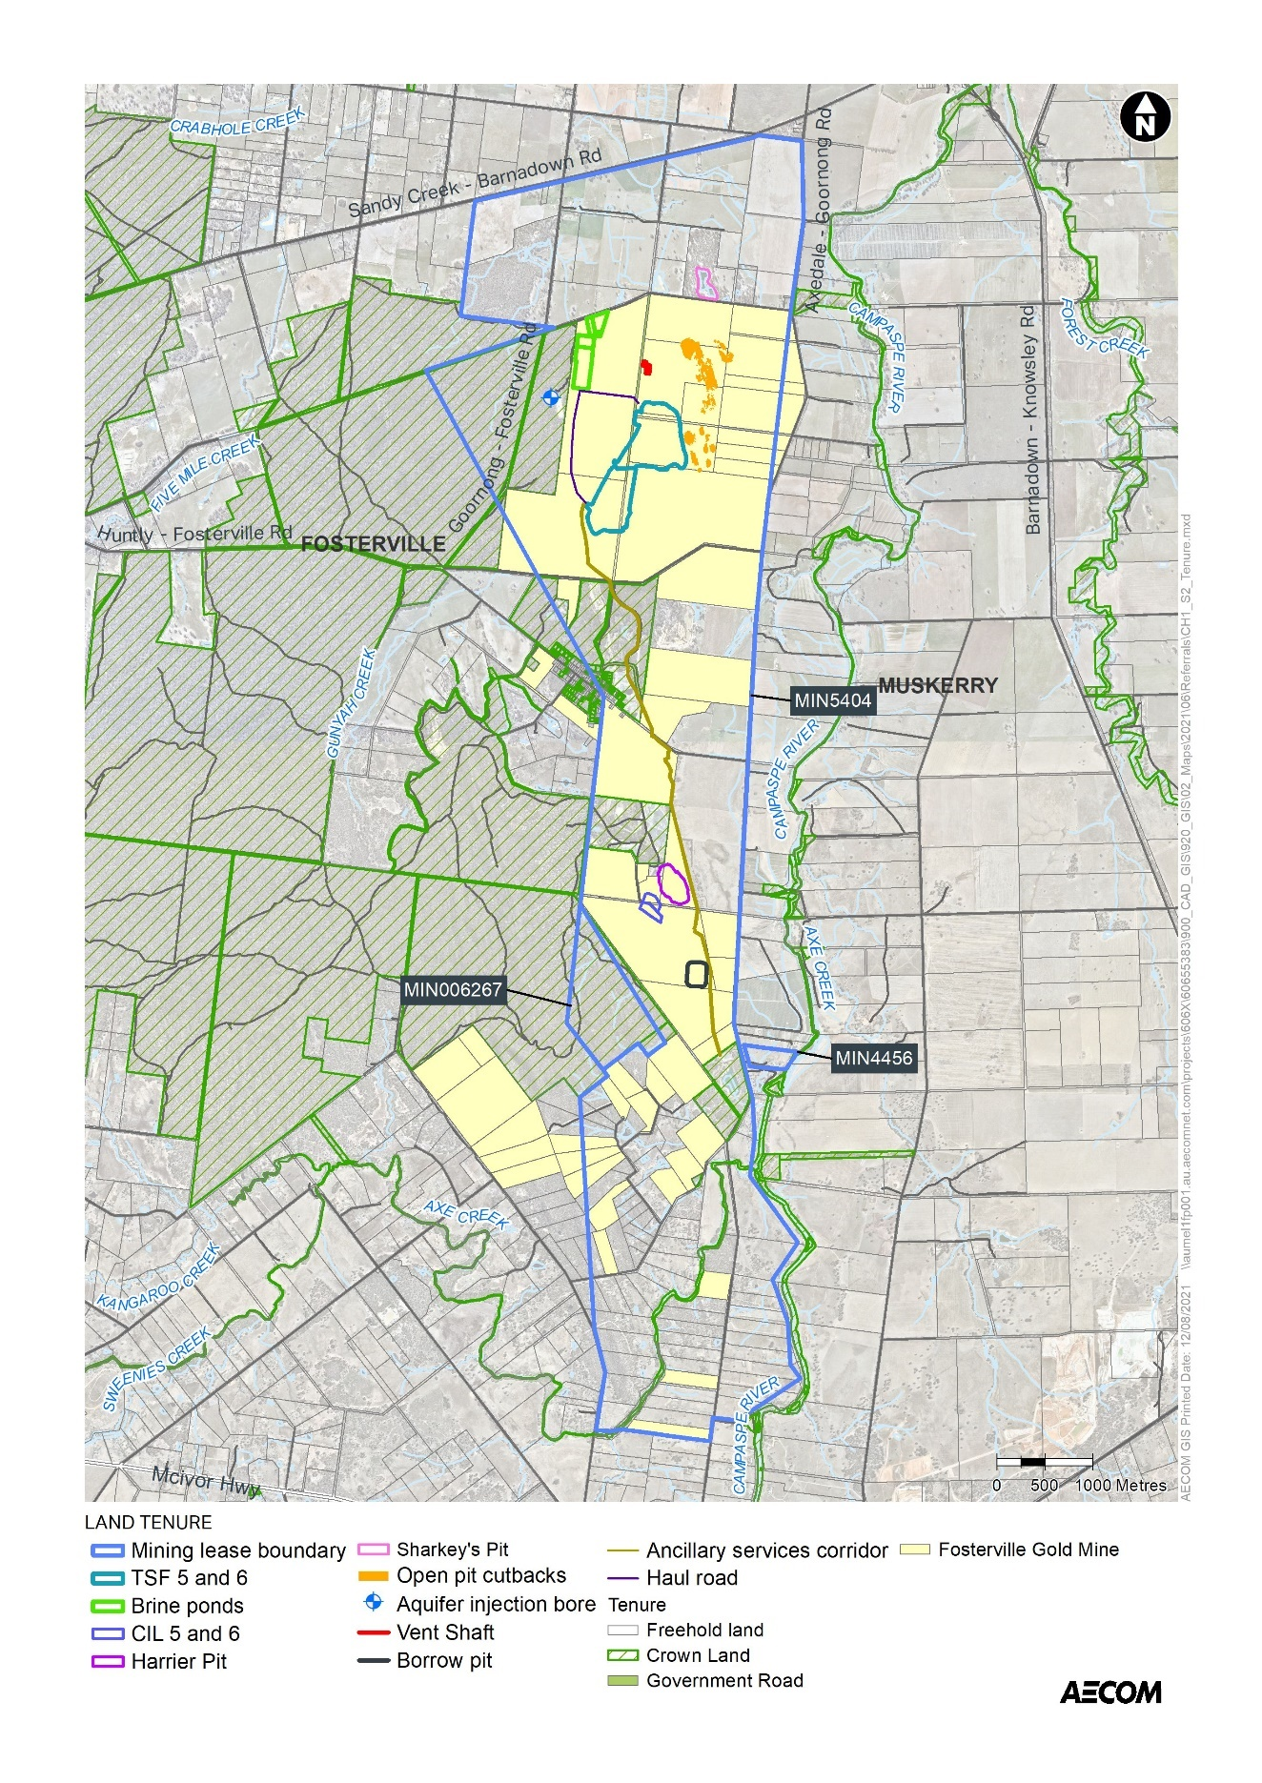
Figure 9: Land tenure

Current land tenure (provide plan, if practicable):
The operating gold mine is located on land that is predominantly owned by FGM.
The following Sustained Operations Project components are proposed to be located on FGM-owned land:
- The majority of TSF 5 and 6, except for the portion on the road reserve listed above as Crown land (SPI 89\PP2585, 86\PP2585, 92\PP2585)
- The expanded CIL hardstand areas will be on FGM-owned land (3\PS411770, 30A\PP2585)
- The open pit cutbacks and associated in pit tailings are on FGM-owned land (92\PP2585, 2\TP172280, 2\TP81613, 1\TP81613, 2\TP820967)
- In pit tailings at Sharkey’s Pit is on private property (40\PP2585)
- The brine pond location is on FGM-owned land (86\PP2585)
- Harrier Pit WRD location is on FGM-owned land (1\PS412918)
The southerly underground mining extension extends 600m – 1,200m beneath an area covered by private land parcels, some of which are owned by FGM, in the Rural Living Zone.
Intended land tenure (tenure over or access to project land):
FGM is seeking to acquire land parcel 2039\PP2585 in the location of TSF 5, which is currently a road reserve.
Other interests in affected land (eg. easements, native title claims):
MIN5404 is not subject to any Native Title claims.
FGM is currently engaging with the traditional owners of the land within MIN006267 to reach an agreement for the Native Title for this mining licence area.

10. Required approvals

State and Commonwealth approvals required for project components (if known):
Commonwealth
Environment Protection and Biodiversity Conservation Act 1999
The Sustained Operations Project will be referred to the Commonwealth Minister for the Environment under the EPBC Act. If it is determined to be a ‘controlled action’, formal assessment and approval will be required under the EPBC Act.

State
The following approvals will be required under State legislation:
Legislation | Approval Required | Agency
Mineral Resources (Sustainable Development) Act 1990 | Approval of a Work Plan (and Variations) will be required for the Sustained Operations Projects | Earth Resources Regulation Victoria
Environment Protection Act 2017 | A Development Licence and an Operating Licence will be required under the Environment Protection Act 2017 for the managed aquifer recharge (MAR) project. | EPA Victoria
Aboriginal Heritage Act 2006 | A Cultural Heritage Management Plan (CHMP) will be required to be assessed and approved. | Dja Dja Wurrung Clans Aboriginal Corporation
Flora and Fauna Guarantee Act 1988 | A permit to take protected flora and fauna may be required | DELWP
Road Management Act 2004 | Road closure, diversion or opening permits (if required) | VicRoads
Water Act 1989 | Works on waterway permit as required (e.g., for haul road crossings of Gunyah Creek) | North Central CMA
 | Approval of underground disposal under s76 for the MAR project  Licence to construct a dam under s67 for embankment at crest of Hunt’s Pit, TSF 5 and 6 and the brine ponds | GMW
Wildlife Act 1975 | Authority to control wildlife | DELWP

Have any applications for approval been lodged?
❒ No Yes If yes, please provide details.
The proposal for a southerly mining extension was the subject of a draft Work Plan Variation under the MRSDA (WPV PLN-001507), however this was officially withdrawn in 2020.
Approval agency consultation (agencies with whom the proposal has been discussed):
FGM has been engaging formally and informally about the Sustained Operations Project components over the past 12 months with the following agencies:
- City of Greater Bendigo
- Department of Environment, Land, Water and Planning
- Earth Resources Regulation Victoria (Department Jobs, Precincts and Regions)
- Department of Jobs, Precincts and Regions
- Regional Development Victoria
- Invest Victoria - Department of Treasury and Finance
- EPA Victoria

Other agencies consulted:
Through the Environment Review Committee for Fosterville Gold Mine, Goulburn Murray Water has been introduced to the Sustained Operations Project.
PART 2 POTENTIAL ENVIRONMENTAL EFFECTS

11. Potentially significant environmental effects

Overview of potentially significant environmental effects (identify key potential effects and comment on their significance and likelihood, as well as key uncertainties):
This assessment of potentially significant environmental effects has been informed by:
- An initial risk screening that was undertaken to identify potential risks during construction and operation of the Sustained Operations Project.
- The considerable body of knowledge currently available as a result of studies and monitoring at the existing operating mine site on matters such as surface water quality, groundwater, air quality, noise and other amenity aspects raised through ongoing consultation.
Based on the above, it is considered that there are some technical areas where comprehensive studies may be required to address uncertainties and assess impacts. For other technical areas - where material impacts are unlikely or studies to date suggest limited impacts - a lesser level of technical investigation may be warranted.
Issues that have been identified as requiring a detailed assessment include the following:
- Groundwater, with regard to underground mining and water management.
- Flora and fauna impacts, with regard to construction of the TSFs and brine ponds.
- Geotechnical and ground conditions, with regard to construction and operation of the TSFs (noting that the location of the TSFs is in close proximity to the existing facilities), underground mining extensions and construction and operation of Harrier Waste Rock Dump.
- Hazard and risk associated with the new TSF facilities and potential for impact on surface water.
- Amenity issues related to air quality, noise and vibration with regard to construction and operation of the new infrastructure and the proposed extension of underground mining. Although amenity issues will require detailed assessment, amenity impacts are predicted to be of a similar nature and scale as existing conditions.
Other matters, where the certainty of environmental risks and potential impacts are better known and/or where impacts are unlikely to be increased as a result of the Project, include greenhouse gas emissions, landscape and visual impacts, Aboriginal cultural heritage, historic heritage, land use planning and traffic and transport.
Detail of the potential impacts for each of these aspects is provided in the following sections.

12. Native vegetation, flora and fauna

Native vegetation
Is any native vegetation likely to be cleared or otherwise affected by the project?
❒ NYD  No  Yes If yes, answer the following questions and attach details.
Native vegetation would be cleared during construction of the brine ponds and TSFs. Other project components such as supporting infrastructure may also require some limited native vegetation clearance during construction, but impacts would be minimised through siting and colocation with existing easements and infrastructure corridors.
What investigation of native vegetation in the project area has been done? (briefly describe)
Biodiversity and native vegetation assessments and advice for the project have been undertaken by Ecology & Heritage Partners. The following reports are summarised below:
- Ecology & Heritage Partners, 2021. Biodiversity Assessment: Proposed Tailings Dams (TSF5 and TSF6) within Fosterville Gold Mine, July 2021 (Attachment 1).
- Ecology & Heritage Partners, 2021. Biodiversity Assessment for proposed Brine Ponds: Fosterville Gold Mine, July 2021 (Attachment 2).
The assessments included desktop assessments and field investigations to assess the native vegetation proposed to be removed and impacts on threatened flora, fauna and ecological communities.
What is the maximum area of native vegetation that may need to be cleared?
❒ NYD Estimated area: 17.3 ha
Brine ponds: the extent of proposed removal was calculated to be 3.5 hectares of native vegetation (Box Ironbark Forest), including 37 large trees (18 large trees in patches and 19 large scattered trees) and 20 small scattered trees.
TSF 5 and 6: the extent of proposed removal was calculated to be 13.8 hectares of native vegetation (Box Ironbark Forest), including 85 large trees (67 large trees in patches and 18 large scattered trees) and 10 small scattered trees.
Other project components, including the linear infrastructure (i.e., haul roads and combined services corridor) and a vent shaft for the northern underground mining extension, also have the potential to require vegetation removal during construction; however, these components have been located to minimise vegetation impacts as much as practicable by using existing easements and infrastructure corridors and previously cleared areas. A detailed assessment for these components is yet to be undertaken.
Native vegetation losses would need to be offset in accordance with DELWP requirements under the Guidelines for the removal, destruction or lopping of native vegetation.
How much of this clearing would be authorised under a Forest Management Plan or Fire Protection Plan?
❒ N/A ………………………. approx. percent (if applicable)
Which Ecological Vegetation Classes may be affected? (if not authorised as above)
❒ NYD  Preliminary/detailed assessment completed. If assessed, please list.
EVC 61 Box Ironbark Forest (depleted)
Have potential vegetation offsets been identified as yet?
❒ NYD  Yes If yes, please briefly describe.
Offset requirement were determined, and a Native Vegetation Removal report was generated for the removal of vegetation at the brine ponds and TSF areas. The offset requirements are:
- Brine ponds – 1.105 General Habitat Units and 37 large trees (with a minimum strategic biodiversity value of 0.397)
- TSF area – 5.428 General Habitat Units and 85 large trees (with a minimum strategic biodiversity value of 0.272)
Potential sites have been identified within North Central CMA which meet the requirements for general offsets.
Other information/comments? (eg. accuracy of information)
N/A
NYD = not yet determined

Flora and fauna
What investigations of flora and fauna in the project area have been done?
(provide overview here and attach details of method and results of any surveys for the project & describe their accuracy)
Biodiversity and native vegetation assessments and advice for the Sustained Operations Project have been undertaken by Ecology & Heritage Partners.
- Ecology & Heritage Partners, 2021. Biodiversity Assessment for proposed Brine Ponds: Fosterville Gold Mine, July 2021.
- Ecology & Heritage Partners, 2021. Biodiversity Assessment: Proposed Tailings Dams (TSF5 and TSF6) within Fosterville Gold Mine, July 2021.
Biodiversity assessments for the TSF and brine ponds areas included desktop studies of relevant literature, online resources and government databases and field assessments. Based on the findings of the desktop assessments and field investigations, no targeted surveys have been undertaken at these sites.
Detailed assessments of other project components are yet to be undertaken.

Have any threatened or migratory species or listed communities been recorded from the local area?
❒ NYD  No  Yes If yes, please:
- List species/communities recorded in recent surveys and/or past observations.
- Indicate which of these have been recorded from the project site or nearby.
Listed communities
The results of both desktop studies showed that four nationally listed ecological communities are predicted to occur within 5km of the project area:
- Buloke Woodlands of the Riverina and Murray-Darling Depression Bioregions
- Grey Box (Eucalyptus microcarpa) Grassy Woodlands and Derived Native Grasslands of South-eastern Australia
- Natural Grasslands of the Murray Valley Plains
- White Box-Yellow Box-Blakely’s Red Gum Grassy Woodland and Derived Native Grassland,
Field assessments found that a patch of native vegetation (approx. 5 ha) within the TSF area meets the condition thresholds for Grey Box (Eucalyptus microcarpa) Grassy Woodlands and Derived Native Grasslands of South-eastern Australia. The condition thresholds were not met for the other three vegetation communities due to the absence of key indicator species, the low diversity of native flora and high cover of exotic vegetation.
Listed flora
The VBA contains records of three nationally significant, six state significant and 10 regionally significant flora species previously recorded within 10 kilometres of the study area. The PMST nominated an additional six nationally significant species which have not been previously recorded but have the potential to occur in the locality.
None of these species have previously been recorded within the study area, including during the recent assessments. Of these species, only one flora species has a moderate likelihood of occurring within the study area based on limited previous records of this species within the local vicinity and poor or limited habitat observed throughout the site. This species is the regionally significant Sand Rush Juncus psammophilus, which was recorded just outside the southwest corner of the study area in 1996. Extant populations are confined to River Red Gum Eucalyptus camaldulensis or sometimes Grey Box Eucalyptus microcarpa woodlands along the sandy or silty banks of streams or in seasonal swamps and depressions. Therefore, there is potential for this species to be present along waterways within and near the mining lease.
Occasional Golden Wattle Acacia pycnantha and Gold-dust Wattle Acacia acinaceae, both protected under the Flora and Fauna Guarantee Act (FFG Act), were recorded within the study area.
Given that the study area is highly modified, predominantly comprising pasture paddocks on relatively flat plains, and old mining land (old heap leach pads, process water storage dams and topsoil piles), the landscape context and the proximity of previous records, it is considered highly unlikely to provide suitable habitat for any additional significant species due to the absence of suitable habitat.
Listed fauna
The VBA contains records of four nationally significant, nine State significant and four regionally significant fauna species previously recorded within 10 kilometres of the study area. The PMST nominated an additional 14 nationally significant species which have not been previously recorded but have the potential to occur in the locality.
None of these previous records occurred within the study area, although, of these species, six are considered to have a moderate likelihood of occurring within the study area:
- Swift Parrot Lathamus discolor.
- Chestnut-rumped Heathwen Calamanthus pyrrhopygius.
- Diamond Firetail Stagonopleura guttata.
- White-throated Needletail Hirundapus cadacutus.
- Black-eared Cuckoo Chrysococcux asculans.
- Spotted Quail-thrush Cinclosoma punctatuam.
These species are considered to have a moderate likelihood of occurring in the area on the basis of previous records of the species in the local area, and/or the study area contains some characteristics of the species’ preferred habitat. These species include several woodland bird species that have previously been recorded within close proximity to the study area and are likely to utilise habitat within the study area, for foraging or breeding purposes.
Of these species, there is considered to be suitable habitat within the project area for one listed fauna species, Swift Parrot.
The assessments found that given the degraded condition of the majority of the study area and the proximity to large areas of higher quality habitat to the west (i.e., Mount Sugarloaf Nature Conservation Reserve), it is considered unlikely that the study area provides critical or limit habitat for the species. In the context of the broader landscape which offers higher quality and key foraging habitat for Swift Parrot, the study area is only likely to be used opportunistically by the species en route to larger areas of suitable habitat. Furthermore, given the presence of intact areas of habitat surrounding the study area, vegetation connectivity surrounding the study area will be maintained, sustaining passage between key habitat areas.
If known, what threatening processes affecting these species or communities may be exacerbated by the project? (eg. loss or fragmentation of habitats). Please describe briefly.
The key threatening processes are summarised below:
- Direct loss of remnant vegetation, flora and fauna habitat due to land clearance for construction
- Habitat fragmentation as a threatening process for fauna in Victoria
- TSF failure resulting in increase in sediment input and/or toxic substances into Victorian rivers and streams due to human activities
- Indirect disturbance or degradation to flora, vegetation and fauna habitat through increased erosion and dust deposition, introduction of pathogens, introduction or spread of weeds, contamination from accidental spills of hazardous materials, or changes to groundwater.
- Potential injury or death of fauna from vegetation clearing, earthworks or vehicle movements.
Are any threatened or migratory species, other species of conservation significance or listed communities potentially affected by the project?
❒ NYD  No  Yes If yes, please:
- List these species/communities:
- Indicate which species or communities could be subject to a major or extensive impact (including the loss of a genetically important population of a species listed or nominated for listing) Comment on likelihood of effects and associated uncertainties, if practicable.
Listed communities
Approximately 5 ha of the nationally-listed ecological community Grey Box (Eucalyptus microcarpa) Grassy Woodlands and Derived Native Grasslands of South-eastern Australia in the TSF area would be removed by the Sustained Operations Project. Listed flora
The project could impact three FFG Act-listed flora species: Golden Wattle Acacia pycnantha, Gold-dust Wattle Acacia acinaceae and Drooping Cassinia Cassinia arcuate.
As most of the land affected is privately owned, a permit under the FFG Act would not be required for these areas.
Listed fauna
Given the degraded nature of the study area, and its close proximity to large areas of higher quality habitat (i.e. Mount Sugarloaf Nature Conservation Reserve), it is considered unlikely that habitat within the study area provides critical or limiting habitat for any listed fauna species. As such, it is considered unlikely that the proposed vegetation removal will have a significant impact on any of the listed fauna species, including Swift Parrot.

Is mitigation of potential effects on indigenous flora and fauna proposed?
❒ NYD  No  Yes If yes, please briefly describe.
Mitigation measures for flora and fauna include incorporating the findings from detailed habitat suitability surveys into project designs to avoid areas of threatened fauna habitat (should they be identified) to the extent practicable.
The location of CIL Hardstands 5 and 6 was selected to avoid remnant native vegetation. The location of the WRD at Harrier Pit was chosen to avoid any additional vegetation clearance. Linear infrastructure components, including haul roads, have also been sited within previously cleared areas to avoid and minimise impacts on native vegetation.
The residual biodiversity losses due to removal of a nationally-listed ecological community would be offset in accordance with the requirements of the EPBC Act Environmental Offsets Policy.
Other information/comments? (eg. accuracy of information)
N/A

13. Water environments

Will the project require significant volumes of fresh water (eg. > 1 Gl/yr)?
❒ NYD  No  Yes If yes, indicate approximate volume and likely source.
FGM’s water requirements are met through treating up to 2 ML/day Epson WWTP effluent water, with the Sustained Operations Project not requiring a change to the mine’s water requirements.
Will the project discharge waste water or runoff to water environments?
❒ NYD  No  Yes If yes, specify types of discharges and which environments.
With the exception of the MAR component (discussed below), FGM intends to continue operating the mine as a no-discharge site. Any potential for sedimentation of watercourses within MIN5404 during construction and operation activities for the TSFs and brine ponds and from the Harrier WRD will be managed in accordance with the Surface Water Management Plan, which would be updated with management measures as required for the Sustained Operations Project.
The MAR component of the Sustained Operations Project proposes to discharge treated mine water to the water environment of the local fractured bedrock aquifer. This aspect of the project will require development and operating licences from the EPA under the Environment Protection Act 2017.

Are any waterways, wetlands, estuaries or marine environments likely to be affected?
❒ NYD  No  Yes If yes, specify which water environments, answer the following questions and attach any relevant details.
No effects on waterways are expected as a result of the Sustained Operations Project.
The development of the mine has necessarily altered the pre-development surface hydrology of the study area including flow patterns, catchment sizes, and runoff conditions. Surface run-off from the disturbed areas of the site is directed to sedimentation dams at various locations around the site. These dams are designed to capture water and allow settlement prior to re-use of the water or discharge as overland flow if it meets the requirements of the Environment Reference Standard. The capacities of the dams provide 200m³ per ha of catchment or containment for a 1 in 10 ARI.
In the unlikely event that environmental management measures are not implemented effectively, potential impacts from the Sustained Operations Project include alteration of the surface waters in the receiving environment resulting in reduced capacity to support environmental values of water in the surrounding area. Current operations and altered land use have changed the timing and rate of catchment runoff in minor watercourses, however, there have been no negative impacts to the quantity and or reliability of water available to surface water users.
Further assessment will inform designs and management measures for the Sustained Operations Project to ensure that new infrastructure is designed to meet storage and flow requirements.
Are any of these water environments likely to support threatened or migratory species?
❒ NYD  No  Yes If yes, specify which water environments.
Are any potentially affected wetlands listed under the Ramsar Convention or in 'A Directory of Important Wetlands in Australia'?
❒ NYD  No  Yes If yes, please specify.
Could the project affect streamflows?
❒ NYD  No  Yes If yes, briefly describe implications for streamflows.
There is the potential for increase of flows at specific locations in the proximity of the mine site as a result of the Sustained Operations Project. The farming users at the east of the site have accelerated and concentrated flows as compared to the pre-development condition due to the construction of two diversion drains that channel surface water flows from non-mining areas to the south and west of the operation, around operational areas of the mine, draining into old river terraces on private property to the east. Further assessment of potential changes in streamflows will inform design and management measures for the project.
Flows to Campaspe River are dominated by surface water releases from Lake Eppalock and the Campaspe River is generally known to lose water to the alluvial and FRA groundwater systems. Groundwater levels in the vicinity of the river indicates that there could be areas where groundwater contributes to baseflow in the Campaspe River and Axe Creek. Modelling of dewatering in the southern extension shows that the lowering of the groundwater levels in the FRA would result in a very small reduction in baseflow to the Campaspe River (from 0.45 ML/d to 0.29 ML/d) and Axe Creek (from 0.08 ML/d to <0.01 ML/d) from past and future underground mining phases (Attachment 3 - Golder, 2020). This is negligible in comparison to the overall measured flows in these watercourses, representing 0.03% of average flows (480 ML/d) for the Campaspe River and 0.2% of average flows (30 ML/d) to Axe Creek. Overall falling groundwater levels in the FRA due to the southern mine extension would have little impact on flow over this reach of the Campaspe River. To inform project design, further assessment is required to assess the effect of project operations in the northern and western extensions on groundwater contribution to nearby watercourse reaches.
Could regional groundwater resources be affected by the project?
❒ NYD  No  Yes If yes, describe in what way.
Mine Dewatering:
There is no evidence in site monitoring data to indicate that existing mine dewatering from the Fractured Rock Aquifer (FRA) has impacted the alluvium aquifers (Shepparton Formation or Deep Lead) and a localised extension to cone of drawdown is predicted to occur around the new southern and northern mine areas as part of the Sustained Operations Project.
Groundwater level decline in three private bores assumed to target the FRA situated within the mining lease boundary and near the southern extension area are predicted to range from 2m to 10m due to the southern extension.
During the mining of the southern extension area, the maximum reduction to saturated thickness in the Campaspe River and Axe Creek alluvium is predicted to occur in a very localised area near the confluence of Axe Creek tributary and Campaspe River (where the mine passes beneath the creek), however recent drilling in this area revealed that the alluvium near Axe Creek was currently unsaturated. Elsewhere, the alluvium would experience drawdowns of less than 1m throughout mining in the southern extension area (Attachment 3 – Golder, 2020).
Further assessment is required to assess the effect of project operations in the northern and western extensions of the current underground mining activities on groundwater resources.
Managed Aquifer Recharge:
A preliminary risk assessment of the MAR project considered the water quality impacts (metals and nutrients) on environmental values of groundwater (including groundwater dependent ecosystems and primary contract recreation), contaminant migration through the FRA, over pressurisation, hydraulic impacts, upward leakage of groundwater, turbidity impacts and introduced pathogens. The residual risks from the MAR project were all rated low.
Tailings Storage:
The Sustained Operation Project includes construction and operation of TSF5 and 6, plus in-pit tailings storage in up to four (4) former pits, with evidence based on current facilities showing minor, high localised, mounding from seepage. Incorporation of liners and underdrain elements to the design is anticipated to minimise effects on the Fractured Rock Aquifer.

Could environmental values (beneficial uses) of water environments be affected?
❒ NYD  No  Yes If yes, identify waterways/water bodies and beneficial uses (as recognised by State Environment Protection Policies)
The southern and northern diversion drains channel surface water flows from non-mining areas to the south and west of the operation, around operational areas of the mine, draining into old river terraces on private property, minimising any lasting effects to environmental values in downstream locations. Potential unplanned release of impacted waters from the site are unlikely to cause persistent alterations to surface water quality downstream of operations. Further assessment is required to assess effects of the project on environmental values of surface water environments.
The project proposes to reinject treated mine water into the Fractured Rock Aquifer (FRA). The water injected would not be recovered from the aquifer. FGM is proposing to conduct an aquifer reinjection trial with the intent to inject approximately 0.5 ML/day and increase up to 1.25 ML/d for the full scheme.
In the absence of pre-treatment, the injected water has the potential to impact environmental values of groundwater. However, mine water would be treated to remove salts and metals prior to aquifer injection. The injection of treated mine water is not expected to affect the groundwater composition, with the exception of elevated nitrate concentrations (largely derived from underground mining activities). Nitrate concentrations in the treated mine water are above the ANZECC (2000) freshwater aquatic guideline value (average concentration of 21.71 mg/L compared with the guideline of 1.7 mg/L). Potential treatment options to remove nitrate are currently being determined.
Potential seepage of contaminants (sulphate and metals) from the new TSFs, in-pit storage facilities and brine evaporation ponds have the potential to impact environmental values of the receiving groundwater environment. This is considered to be a low risk as facilities would be designed as per existing facilities to ANCOLD guidelines and to avoid and minimise seepage, would include the use of plastic liners and underdrains.
A decant water pipeline will be required from TSF5 and TSF6, which would discharge into the existing decant water pond at TSF2 (formerly Hunt’s Pit). The recovered water would be returned to the processing plant for reuse via existing pipework. To minimise overtopping risks, the Sustained Operations Project would include construction of an embankment across a portion of Hunt’s Pit to provide additional freeboard to the decant water pond that services TSFs 5 and 6.

Could aquatic, estuarine or marine ecosystems be affected by the project?
❒ NYD  No  Yes If yes, describe in what way.
The modelled lowering of groundwater levels due to the southern mining extension show no impact to surface water flows and consequently it is unlikely to reduce water availability to potential GDEs associated with these watercourses (Attachment 3 - Golder, 2020). Further assessment is required on the effect of the northern and western extensions of underground mining on GDEs.
Detailed assessment of potential impacts to aquatic ecosystems from changes to surface water as a result of the project is yet to be undertaken.

Is there a potential for extensive or major effects on the health or biodiversity of aquatic, estuarine or marine ecosystems over the long-term?
❒ No  Yes If yes, please describe. Comment on likelihood of effects and associated uncertainties, if practicable.
FGM collects all surface run off and only discharges overland flow if it meets the requirements of the Environment Reference Standard. It is intended to continue operating the mine as a no-discharge site (with the exception of the MAR project). Major effects on the health or biodiversity of aquatic ecosystems is not expected.

Is mitigation of potential effects on water environments proposed?
❒ NYD  No  Yes If yes, please briefly describe.
Potential for seepage to groundwater or overflow from tailings storage and brine evaporation ponds will be managed through design of the facilities, which will include drainage channels, underdrainage sumps, impermeable liners and monitoring bores behind the liner to monitor performance. Any seepage that is intercepted in the interception bores, as determined through analysis of groundwater samples, would be removed via bores that are equipped as extraction bores before being captured and pumped to the return water pond.
FGM has an existing Surface Water Management Plan that applies to all surface and underground mining, exploration and ancillary operations undertaken within Mining Licence MIN5404. FGM also has an existing Groundwater Management Plan. These plans are to ensure impacts from the mining operations on sensitive receptors and environmental values are managed and minimised as far as reasonably practicable.
The overall objective is to ensure that there is no detrimental impact to adjacent waterways, such as the Campaspe River, Axe Creek and Gunyah Creek, or surrounding aquifers, such as the alluvial aquifer associated with the Campaspe River and the Campaspe Deep Lead.
The management plans aim to ensure early detection of any potential impacts to the adjacent waterways or aquifers and allows a strategy to be put in place to control and mitigate any detrimental impacts. FGM currently maintains an extensive groundwater and surface water monitoring program to monitor the condition of groundwater and surface water resources and detect responses to current mining operations.
The existing Fosterville Gold Mine Groundwater Management Plan includes requirements for ongoing monitoring of groundwater quality adjacent to and down gradient from surface tailings storage facilities and in-pit tailings storage facilities, and to monitor any potential seepage and/or groundwater contamination associated with the CIL cyanide leach residue (CIL tails) facility. The Groundwater Management Plan will be updated to cover the components of the project, including ongoing monitoring requirements.
The following mitigation measures will be undertaken in preparation for and during mining in the southern underground extension:
- Install additional paired monitoring bores targeting alluvium and the FRA, as mining progresses into the southern extension
- Investigate with regional Catchment Management Authority the installation of additional in-stream gauging in Campaspe River and the installation of in-stream gauges in Axe Creek and commence background monitoring
- Validate current conceptual and numerical groundwater models by monitoring groundwater levels in new and existing bores and with surface water levels in Campaspe River and Axe Creek
- With respect to private bores in the southern area, investigate pump depth, water level, bore integrity and water use (subject to landholder consent), and where possible negotiate installation of new bores to monitor potential impact on existing private bores if required
- Determine the presence of high value riparian Groundwater Dependent Ecosystems (GDEs) in areas along water courses if/where a reduction in saturated thickness of the alluvium is identified
- Assess the presence of stygofauna in the alluvial aquifer
- Investigate permeability of faulted areas in southern extension, if/when intercepted and compare to modelled groundwater inflow values
- Continuously verify model predictions and model adjustment in response to outcomes to ensure risks have not altered (incorporate into annual groundwater monitoring review)
- Recalibrate the groundwater model if mine inflows are substantially higher than model prediction or when there is significant deviation in observed groundwater level response from the predicted response
- Continue external reviews of groundwater model every three years (or earlier if required)
A trigger action response plan (TARP) has been developed to identify and respond to potential adverse groundwater related outcomes. Specific trigger levels alert FGM to observe parameters responses which are outside of normal variation and/or predicated response, or where observed parameter values do not follow anticipated trends.
Specific mitigation and contingency measures for surface water for the project would be included in the Surface Water Management Plan. Any additional mitigation and contingency measures for groundwater impacts due to the northern or western extension areas would be incorporated into the Groundwater Management Plan.
The MAR project would be undertaken in accordance with all relevant guidelines for MAR, including Guidelines for managed aquifer recharge (MAR) – health and environmental risk management (EPA Publication 1290) and Policies for Managing Section 76 Approvals under the Water Act – Managed Aquifer Recharge: Technical Advisory Notes to Delegates as well as the requisite development and operating licences under the Environment Protection Act 2017.
Other information/comments? (eg. accuracy of information)
N/A

14. Landscape and soils

Landscape
Has a preliminary landscape assessment been prepared?
❒ No  Yes If yes, please attach.
A preliminary landscape assessment has not yet been prepared specifically for the Sustained Operations Project. The above-ground components of the project are all located within the existing Fosterville Gold Mine site and, as such, visual impacts of the project are not expected to be significant. A detailed landscape and visual assessment would be undertaken to better understand potential effects on landscape values and to inform project designs to minimise the effects.
Is the project to be located either within or near an area that is:
- Subject to a Landscape Significance Overlay or Environmental Significance Overlay?
❒ NYD  No  Yes If yes, provide plan showing footprint relative to overlay.
The Environmental Significance Overlay (ESO1) applies to watercourses in and near the Project area, including Axe Creek and Campaspe River

- Identified as of regional or State significance in a reputable study of landscape values?
❒ NYD  No  Yes If yes, please specify.
- Within or adjoining land reserved under the National Parks Act 1975 ?
❒ NYD  No  Yes If yes, please specify.
- Within or adjoining other public land used for conservation or recreational purposes ?
❒ NYD  No  Yes If yes, please specify.
The mine is adjacent the Mount Sugarloaf Nature Conservation Reserve.
A landscape and visual assessment will be undertaken to assess whether significant impacts to visual amenity and landscape values are anticipated and to inform the detailed design of the Sustained Operations Project.
Is any clearing vegetation or alteration of landforms likely to affect landscape values?
❒ NYD  No  Yes If yes, please briefly describe.
The Sustained Operations Project will alter landforms within the existing Fosterville Gold Mine site, including the creation of new landforms adjacent to existing facilities, including the above-ground TSFs, the new Harrier WRD, the brine ponds, and additional CIL tailings. The existing landform will be altered through increases to the area of existing open pits subject to pit cutbacks. Landscape amenity impact is reduced by progressive rehabilitation of final landforms.
Is there a potential for effects on landscape values of regional or State importance?  NYD  No  Yes Please briefly explain response.
Is mitigation of potential landscape effects proposed?
❒ NYD  No  Yes If yes, please briefly describe.
A landscape and visual assessment would be undertaken to better understand potential effects on landscape values and to inform project designs to minimise the effects.
Other information/comments? (eg. accuracy of information)

Note: A preliminary landscape assessment is a specific requirement for a referral of a wind energy facility. This should provide a description of:
- The landscape character of the site and surrounding areas including landform, vegetation types and coverage, water features, any other notable features and current land use;
- The location of nearby dwellings, townships, recreation areas, major roads, above-ground utilities, tourist routes and walking tracks;
- Views to the site and to the proposed location of wind turbines from key vantage points (including views showing existing nearby dwellings and views from major roads, walking tracks and tourist routes) sufficient to give a sense of the overall site in its setting.

Soils
Is there a potential for effects on land stability, acid sulphate soils or highly erodible soils?
❒ NYD  No  Yes If yes, please briefly describe.
The Fosterville Gold Mine monitoring program includes acid-base accounting of waste rock samples and kinetic column leach tests, which to date has shown that the majority of waste rock generated from underground mining is non-acid-forming and contains a significant inherent Acid Neutralizing Capacity (ANC) that is available to offset isolated acid formation. There is high sulphur content black shale material however, column leach data from one sample has not indicated significant concentrations of antimony or arsenic were being leached from the sample and the pH has remained circumneutral to date. Further tests on black shale indicates that the material behaves as non-acid forming due to residual quantities of ANC that negates any acid potential. Black shale material is intercepted intermittently, in relatively low volumes during mining and therefore presents a low risk.
Further assessment will be undertaken to assess whether potential acid sulphate soils are anticipated to inform the detailed design of the Sustained Operations Project. However, preliminary assessment shows that the geology in the new mining areas to the north and south does not vary significantly and waste rock generated will be comparable to that currently managed.
There is potential for land stability issues due to the extension of underground mining, from open pit cutback operations and from surface water interaction with engineered TSFs and brine ponds. The risks associated with acid sulphate soils and land stability are well understood by FGM and are managed in accordance with existing procedures and management plans. Further assessment would be undertaken to inform the detailed design of the Sustained Operations Project.

Are there geotechnical hazards that may either affect the project or be affected by it?
❒ NYD  No  Yes If yes, please briefly describe.
A geotechnical study was conducted in 2009 by DEDJTR Earth Resources Regulation. The major findings were that there are not considered to be any major stability issues that could extend significantly outside the mining area itself.
Stability impacts related to all surface and underground mining is managed according to the site Ground Control Management Plan. Monitoring and review are integral elements of plans developed to manage stability related issues. A geotechnical assessment will be undertaken to assess geotechnical hazards and to inform the detailed design of the Sustained Operations Project.
TSF facilities would be designed to meet ANCOLD requirements to manage geotechnical impacts. In addition, the facilities would require third party audits and would be managed in accordance with the Operating Manual Flotation Tailings and Operating Manual CIL Tailings.
Other information/comments? (eg. accuracy of information)
Geochemical test-work and waste rock characterisation has been undertaken throughout the operational history of Fosterville Gold Mine, including kinetic column leach testing of the main waste rock lithologies that has been ongoing for several years to further understand the long-term leaching characteristics of the main overburden lithologies. Kinetic leach columns replicate environmental exposure to waste materials in an accelerated time scale and test the Acid-Based Accounting results.
It is intended that the current waste rock characterisation program will be ongoing into the future.

15. Social environments

Is the project likely to generate significant volumes of road traffic, during construction or operation?
❒ NYD  No  Yes If yes, provide estimate of traffic volume(s) if practicable.
The Sustained Operations Project is located at an operating gold mine and is not expected to generate significant new traffic volumes during construction or operation.

Is there a potential for significant effects on the amenity of residents, due to emissions of dust or odours or changes in visual, noise or traffic conditions?
❒ NYD  No  Yes If yes, briefly describe the nature of the changes in amenity conditions and the possible areas affected.
Air quality
Air quality modelling and monitoring is undertaken at the site and nearby sensitive receptors for existing operations. There have been periods of exceedances of the adopted criterion at monitoring locations surrounding the operation, generally recorded during the warmer, drier months.
The project has the potential for air quality impacts through an increase in air emissions from mining and processing activities, wind erosion from exposed surfaces and stockpiles, waste rock management operational traffic and tailings hard stacking.
Short term construction phase impacts are also expected from earthworks and excavations for the TSFs, brine evaporation ponds and CIL hard stands.
These activities have the potential to increase dust emissions, resulting in increased particulate matter (PM₁₀ and PM_{2.5}) and associated metals concentrations which may impact nearby sensitive receptors, including residences. Particulate matter can affect health and cause nuisance effects.
Further assessment will be undertaken to assess whether there is potential for significant effects on the amenity of residents due to particulate matter and dust deposition with the project. An air quality impact assessment of the proposed project will be prepared using the Victorian regulatory model, AERMOD, to determine maximum ground level concentrations in accordance with the Environmental Reference Standard, including maximum incremental (project only) and cumulative (project plus background) ground level concentrations. The project will also be required to demonstrate compliance with the Environment Protection Act 2017, including the general environmental duty.
Noise and vibration
Noise
The Sustained Operations Project is not anticipated to result in a significant increase in noise emissions from Fosterville Gold Mine. There is some potential that the Sustained Operations Project will result in temporary noise emissions from increased vehicle and plant movement to and from the sites during the construction phase for the new infrastructure and during open pit cutback operations. Noise emissions from the continuation of underground mining and from operational equipment and vehicles are not predicted to increase.
The Noise Protocol (EPA Publication 1826.4) provides the methods to set noise criteria in rural areas for earth resources. It is proposed that the Sustained Operations Project would comply with the limits in the Noise Protocol. Temporary noise increases due to construction activities would be managed in accordance with EPA Publication 1834. To meet the requirements of these guidelines, noise monitoring and noise modelling is proposed to be undertaken to quantify potential noise emissions, assess the potential for significant amenity effects for nearby receptors and to inform design and project planning.
Vibration
Blasting for underground mining is anticipated to result in ground vibration effects for surrounding residents, particularly in the southern extension area. The area is low density with no more than 20 properties within a 500-metre zone around the extension of mining. Blasting will preferentially be undertaken during standard blasting hours, generally between the hours of 6:30am to 7:00am or 6:30pm to 7:00pm, seven days per week. There may be additional requirement to undertake development blasting at other times.
FGM operates under the Mining License MIN5404 Condition 35 which addresses air blast and ground vibration impacts. The blasting criteria specified in the following conditions:
- Condition 35.1 – ground vibration measured at a sensitive place (as peak particle velocity) – 5 mm/s for 95% of blasts fired in a 12-month period and must not exceed 10 mm/s at any time
- Condition 35.2 – air blast overpressure – 115dBL for 95% of blasts fired in 1 12-month period and must not exceed 120dBL at any time.
The expected scale of blasting and the associated effects for MIN5404 southerly extension were based upon an analysis of the recorded vibration levels monitored during previous mining.
It is anticipated that the maximum level of vibration that could be expected from the blasting achieves compliance with the 5mm/s vibration criterion at each of the adjacent sensitive receivers. It is expected that blasting for the proposed southern extension can remain compliant with the vibration criterion.
The maximum predicted vibration level is between 3 and 4mm/s and occurs when mining the northern end of the south extension orebody (closer to the existing mining) and when blasting with a weight of 120 kilograms per blasthole. The level of vibration is not expected to exceed 4mm/s at any location on the surface. Blasting with an explosive weight per blasthole up to 100 kilograms will not generate vibration levels exceeding 3mm/s on the surface. The modelling suggests that perceptible vibration may extend as far as 1000 metres.
Further assessment will be undertaken to assess whether there is potential for significant effects on the amenity of residents due to vibration associated with the northern and western extensions and open pit cutback operations.
Is there a potential for exposure of a human community to health or safety hazards, due to emissions to air or water or noise or chemical hazards or associated transport?
❒ NYD  No  Yes If yes, briefly describe the hazards and possible implications.
As noted in Section 8 (Existing Environment), antimony and arsenic concentrations have been measured in dust deposited at HVAS-1 Concentrations of arsenic in samples collected at HVAS-1 exceeded the criterion for samples taken between 2014 and 2020. Dust containing elevated concentrations of metals or silica may cause human health impacts. The project may result in increases in dust impacts. Further assessment will be undertaken to assess whether there is potential for exposure to the community to hazardous air particles.
Is there a potential for displacement of residences or severance of residential access to community resources due to the proposed development?
❒ NYD  No  Yes If yes, briefly describe potential effects.
Are non-residential land use activities likely to be displaced as a result of the project?
❒ NYD  No  Yes If yes, briefly describe the likely effects.
Do any expected changes in non-residential land use activities have a potential to cause adverse effects on local residents/communities, social groups or industries?
❒ NYD  No  Yes If yes, briefly describe the potential effects.
Is mitigation of potential social effects proposed?
❒ NYD  No  Yes If yes, please briefly describe.
The Sustained Operations Project would be operated in accordance with updated management plans for the Fosterville Gold Mine, and updated risk treatment plans associated with the Work Plan Variation, including the existing:
- ENVF-MPL-002 Air Quality Management Plan
- ENVF-MPL-009 Blasting & Ground Vibration Management Plan
- ENVF-MPL-004 Noise Management Plan
These management plans have been created to assist in compliance with the current Work Plan and associated Mining Licence limits and would be updated with new project components.
Prior to commencement of underground mining in any new areas such as in the southern and northern extension, or MIN006267, FGM would review and extend the surface vibration monitoring network as required, to suitably monitor potential impacts on sensitive receptors. FGM would continue to engage with residents within and surrounding the mining lease area as per its Community Engagement Plan (CEP) and inform residents of the mining activities and provide a feedback mechanism for future reference. In the event of a concern or blast-related complaint by a resident, a monitoring program for vibration would be undertaken until such time that enough data are available to allow a satisfactory assessment of vibration values from the blast design. The FGM Blast Design Plan and implementation procedures will continue to be implemented and vibration results will be reviewed annually to assess trends or changes.
Specific mitigation and contingency measures for air quality, blasting and ground vibration, and noise for the project would be included in the relevant management plans.
Other information/comments? (eg. accuracy of information)

Cultural heritage
Have relevant Indigenous organisations been consulted on the occurrence of Aboriginal cultural heritage within the project area?
❒ No If no, list any organisations that it is proposed to consult.
❒ Yes If yes, list the organisations so far consulted.
The Registered Aboriginal Party (RAP) Dja Dja Warrung Clans Aboriginal Corporation was consulted during the preparation of Cultural Heritage Management Plan (CHMP) 15553 (Attachment 5- Heritage Insight, 2018) for TSF 5 and 6, which was approved on 28 June 2018.
Future consultation will be undertaken with the RAP during the EES referral process and future Project stages.
What investigations of cultural heritage in the project area have been done?
(attach details of method and results of any surveys for the project & describe their accuracy)

The CHMP 15553 prepared for TSF 5 and 6 in 2018 includes desktop and standard assessment. The desktop assessment concluded that it is reasonably possible that Aboriginal cultural heritage will be present within the activity area. The standard assessment was conducted in April 2018 and concluded that the vast majority of the activity area has undergone some level of disturbance from works associated with mining activity, including construction of the existing dams and roads, and stockpiling of topsoils and waste rock.
Survey areas to the west of McCormicks Road were considered to be of low archaeological potential, whereas survey areas to the east of McCormicks Road contain negligible potential for Aboriginal cultural heritage due to the massive visible disturbance to these areas.
Further desktop assessment and site inspection was carried out in 2021 for the original MIN5404 area and the additional areas to the north and south (Attachment 4 - Heritage Insight, 2021).

Is any Aboriginal cultural heritage known from the project area?
❒ NYD  No  Yes If yes, briefly describe:
- Any sites listed on the AAV Site Register
- Sites or areas of sensitivity recorded in recent surveys from the project site or nearby
- Sites or areas of sensitivity identified by representatives of Indigenous organisations
The assessment for CHMP15553 for the TSF area identified that there are sixteen registered Aboriginal places on the VAHR within a 2km radius of the TSF 5 and 6 Activity Area. This included 15 scarred trees, of which nine were located along Gunyah Creek, and one artefact scatter. One of these scarred trees along Gunyah Creek (VAHR 7724-0101) is within 200m of, but outside of, the proposed TSF6 footprint.
None of these Aboriginal places are impacted by the Sustained Operations Project.
A more recent assessment was undertaken of the southerly and northerly extensions to MIN5404 (Attachment 4 - Heritage Insight, 2021). There are two Aboriginal places (VAHR 7724-0126 and VAHR 7724-0127) in the northern extent of MIN5404, which are both scar trees located on the Goornong-Fosterville Road. The site inspection found that further assessment of another Aboriginal place (VAHR 7824-0062), an artefact scatter in the northern area, is required to address inconsistencies in the site interpretation and registration. Another scarred tree (VAHR 7824-0075) is located outside of but within 200m of the northern boundary of MIN5404.
The assessment found that the south study area did not contain any registered Aboriginal places. However, three places were discovered during the assessment which are yet to be registered in accordance with section 24 of the Aboriginal Heritage Act 2006. Areas of cultural heritage sensitivity in the southern area include land within 200m of the Campaspe River, Axe Creek and its associated floodplains.
None of the places in the southern or northern areas would be impacted, as the only project activity proposed in these areas is underground mining, which would take place at depths greater than 200m below ground level.
Are there any cultural heritage places listed on the Heritage Register or the Archaeological Inventory under the Heritage Act 1995 within the project area?
❒ NYD  No  Yes If yes, please list.
The Victorian Heritage Database shows MIN5404 contains fourteen archaeological sites listed on the Victorian Heritage Inventory, mostly located in the central area of Fosterville Gold Mine to the east of the site offices and north of Harrier Pit. Heritage assessments have found that of the listed sites, only three within the mining lease are considered to still be intact: H7724-0611, H7724-0610 (both located west of the existing Harrier Pit) and H7824-0074 (in the south).
Is mitigation of potential cultural heritage effects proposed?
❒ NYD  No  Yes If yes, please briefly describe.
CHMP 15553 describes the cultural heritage management requirements for TSF5 and TSF6 , including to have a copy of the CHMP on site, undertake a cultural heritage induction, notification to the RAP of the commencement and conclusion of the activity, compliance inspections, communication with the RAP and contingency plans.
A mandatory CHMP would be prepared under the Aboriginal Heritage Act 2006 if any project activities cannot avoid areas of cultural heritage sensitivity (for example; the haul road), or in the case that an EES is required for the Sustainable Operations Project.
The CHMP would include measures to manage and mitigate potential impacts to both known and unknown sites of Aboriginal cultural heritage.
Project activities are proposed in the vicinity of the historic heritage places; however, the activities avoid these heritage places and no impacts are expected. During design development, infrastructure would be located to avoid impacts to heritage places.
Other information/comments? (eg. accuracy of information)
16. Energy, wastes & greenhouse gas emissions

What are the main sources of energy that the project facility would consume/generate?
❒ Electricity network. If possible, estimate power requirement/output ………………….
❒ Natural gas network. If possible, estimate gas requirement/output …………………...
❒ Generated on-site. If possible, estimate power capacity/output ……………………….
❒ Other. Please describe.
Please add any relevant additional information.
Energy supply will be required to power project components, including the underground mine extensions and for pumps at the TSFs, brine ponds and in-pit tailings facilities.
It is proposed to connect power supply to these facilities via the combined services corridor from the Fosterville Terminal Station in the south east of MIN5404.
The Project would also require petrol / diesel for vehicles and machinery during construction and operation.
The Project is not likely to result in a significant increase in energy use relative to existing operations; however, energy requirements are yet to be assessed in detail.

What are the main forms of waste that would be generated by the project facility?
❒ Wastewater. Describe briefly.
❒ Solid chemical wastes. Describe briefly.
❒ Excavated material. Describe briefly.
❒ Other. Describe briefly.
Please provide relevant further information, including proposed management of wastes.
There are three process waters that are generated at Fosterville Gold Mine, which would continue to be generated by the Sustained Operations Project components: mine water, CIL water and flotation tails water.
- Mine water is infiltrated groundwater dewatered from underground mine. The project proposes to reinject treated mine water into the FRA. Mine water is also reused in the underground operations, stored in open pits and used as top up water in the processing plant.
- CIL water is the water collected from the CIL tails, which is treated by the existing ASTER plant at Fosterville Gold Mine prior to being reused back through the CIL circuit in the processing plant or evaporated.
- Flotation tails water is the process water that is collected from the flotation tails storage facilities and 100% of this water is pumped back into the processing plant via the process water storage tank, where it is reticulated around the plant for use.
Fosterville Gold Mine produces two types of tailings from the treatment of sulphide ore in the processing plant: flotation tailings/neutralization residue and carbon-in-leach (CIL) tailings. To support continued underground mining operations, new tailings storage facilities would be constructed as part of the Sustained Operations Project to provide another ten years of storage capacity.
Waste rock (overburden) from current operations is managed in accordance with the Fosterville Waste Rock Management Plan. Any waste material that cannot be placed underground is brought to the surface and dumped within the confines of the Ellesmere, Harrier and Falcon Pits. FGM has approval to extend McCormicks WRD and is currently seeking approval for a WRD at Falcon Pit. To provide additional future storage capacity, the project would also involve an above ground waste rock dump at Harrier Pit.

What level of greenhouse gas emissions is expected to result directly from operation of the project facility?
❒ Less than 50,000 tonnes of CO₂ equivalent per annum
❒ Between 50,000 and 100,000 tonnes of CO₂ equivalent per annum
❒ Between 100,000 and 200,000 tonnes of CO₂ equivalent per annum
❒ More than 200,000 tonnes of CO₂ equivalent per annum
Please add any relevant additional information, including any identified mitigation options.
A greenhouse gas assessment was undertaken in 2021 for the existing mine operations.
For the financial year 2019-2020, FGM’s estimated greenhouse gas emissions in tonnes of carbon dioxide equivalent (tCO2-e) are:
- Scope 1 – 16,361 tCO2-e
- Scope 2 – 118,841 tCO2-e
- Scope 3 – 27,142 tCO2-e
The total Fosterville Gold Mine annual greenhouse gas emissions were calculated to be 162,344 tCO2-e annually and 4,058,601 tCO2-e over the lifetime of the mine (assumed to be 25 years). The main contributor to the estimated greenhouse gas inventory is emissions from the purchase of electricity from the grid for on-site use, which accounts for 118, 841 tCO2-e (73%) of the total estimated emissions. The second contributor is diesel consumption for contractors’ vehicles used off-site (Scope 3), with 19,531 tCO2-e (12%) of the total emissions.
In comparison to 2018 Australian and Victorian total greenhouse gas emissions, Fosterville Gold Mine accounts for 0.03% of total Australian emissions and 0.16% of Victorian emissions.
For the Sustained Operations Project, direct Scope 1 emissions would arise from combustion of liquid fuels for stationary purposes and transport purposes and from wastewater treatment. Indirect emissions would include consumption of purchased electricity (Scope 2) and combustion of liquid fuels for transport and stationary purposes by contractors (Scope 3).
It is expected that the project would have minimal impact, if any, on GHG emissions rates from FGM’s existing operations. Greenhouse gas emissions attributable to the project will be assessed in accordance with National Greenhouse and Energy Reporting (NGER) requirements.
KLG announced in March 2021 that they would be targeting net zero greenhouse emissions as a company by 2050 or sooner.

17. Other environmental issues

Are there any other environmental issues arising from the proposed project?
❒ No  Yes If yes, briefly describe.
The preliminary risk screening undertaken for the Sustained Operations Project did not identify any other potential environmental impacts other than those discussed in this referral. It is expected that any other environmental impacts that have not been identified could be managed using standard management measures and through existing FGM Environmental Management Plans.

18. Environmental management

What measures are currently proposed to avoid, minimise or manage the main potential adverse environmental effects? (if not already described above)
❒ Siting: Please describe briefly
All project components are located within MIN5404 or MIN006267. Their locations have been selected to consolidate new components with existing facilities. The new above ground project facilities would be situated adjacent to existing infrastructure within the current mining area boundary. TSF5 and TSF6 would be located in the existing tailings precinct in the northern area of MIN5404. The two new CIL Hardstands are proposed as an extension to existing CIL Hardstands 1 to 4.
Infrastructure will be sited with consideration of minimising clearance of native vegetation and other environmental and amenity impacts to the extent practicable.
❒ Design: Please describe briefly
The new TSFs would be designed in accordance with current guidelines on Tailings Dams, including DJPR’s Management of Tailings Storage Facilities and ANCOLD Guidelines.
The foundation of the CIL hardstand pad would be constructed using compacted fill sourced from nearby stockpiles. A Geosynthetic Clay Liner, with finger drainage would be constructed above the raised foundation to prevent migration of the CIL water into the underlying soils. A layer of CIL tailings would be placed above the liner to prevent drying, cracking and deterioration of the liner. This would ensure the integrity of the liner is maintained throughout the required life of the facility. The perimeter drains would be lined with a Geosynthetic Clay Liner (or approved equivalent) with a cover protection layer for added seepage protection and a layer of rock protection for erosion control.
Management of the brine ponds would be similar to existing water storages on site. These water storages are lined with plastic and are designed to promote evaporation. The ponds would have a single HDPE liner with flow net underdrainage on the inside of the pond, HDPE liner anchorage systems at the top and bottom of slopes and over the pond floor, emergency spillways and lined sumps for pond dewatering and underdrainage sumps for collecting seepage.
As with the siting of project components, designs to-date have also been informed by consideration of potential environmental effects. Further investigations will continue to inform detailed designs with consideration of minimising impacts to the extent practicable.

❒ Environmental management: Please describe briefly.
As an operating gold mine regulated under the MRSDA, FGM operates under a comprehensive suite of management plans for the site, including:
- ENVF-MPL-001 Waste Management Plan
- ENVF-MPL-002 Air Quality Management Plan
- ENVF-MPL-003 Waste Rock Management Plan
- ENVF-MPL-004 Noise Management Plan
- ENVF-MPL-005 Groundwater Management Plan
- ENVF-MPL-006 Surface Water Management Plan
- ENVF-MPL-007 Rehabilitation Plan
- ENVF-MPL-009 Blasting & Ground Vibration Management Plan
- ENVF-MPL-015 Risk Management Plan
- COMF-MPL-001 Community Engagement Plan
Assessments for the project will inform mitigation measures to reduce environmental effects, which will be used to update the existing Environmental Management Framework. The framework would include specific measures to reduce and manage impacts during construction, operation and rehabilitation.
As per the current management framework, measures will be included for performance monitoring and reporting requirements and review processes throughout the life of the project.

❒ Other: Please describe briefly
Add any relevant additional information.

19. Other activities

Are there any other activities in the vicinity of the proposed project that have a potential for cumulative effects?
❒ NYD  No  Yes If yes, briefly describe.
The Sustainable Operations Project is made up of components that are proposed to be implemented at the currently operating Fosterville Gold Mine. As such, the impacts of the Project will be cumulative with respect to the existing environmental effects of mining.

20. Investigation program

Study program
Have any environmental studies not referred to above been conducted for the project?
❒ No  Yes If yes, please list here and attach if relevant.
Has a program for future environmental studies been developed?
❒ No  Yes If yes, briefly describe.
As part of its existing operations, FGM undertakes ongoing specialist investigations and consultation and has done so since mining commenced in 2005. FGM has a sound understanding of the studies required to ensure all the potential impacts are appropriately assessed to enable the appropriate avoidance, mitigation and management measures to be implemented.
A draft study program is being developed for the Sustainable Operations Project and will be finalised in consultation with State and Commonwealth government stakeholders. AECOM has been engaged as the Lead Consultant to coordinate specialist environmental and planning assessments.
Primary environmental studies requiring detailed investigation include:
- Hydrogeology – with regard to dewatering, MAR and tailings storage aspects.
- Flora and fauna - with regard to construction of the TSFs and brine ponds.
- Geotechnical and ground conditions - with regard to construction and operation of the TSFs (noting that the location of the TSFs is in close proximity to the existing facilities), underground mining extensions and construction and operation of Harrier Waste Rock Dump.
- Hazard and risk associated with the new TSF facilities and potential for impact on surface water.
- Amenity issues related to air quality, noise and vibration with regard to construction and operation of the new infrastructure and the proposed extension of underground mining.
Other matters, where the certainty of environmental risks and potential impacts are better known and/or where impacts are unlikely to be increased as a result of the Project, include:
- Greenhouse gas emissions
- Landscape and visual impacts
- Aboriginal cultural heritage
- Historic heritage
- Land use planning
- Traffic and transport.
It is anticipated that a more targeted scope may be undertaken in these areas in order to support project approvals.

Consultation program
Has a consultation program conducted to date for the project?
❒ No  Yes If yes, outline the consultation activities and the stakeholder groups or organisations consulted.
FGM undertakes regular consultation with the community in line with the existing FGM Community Engagement Plan.
November 2019 – Departmental Quarterly Meeting: DJPR, ERR, RDV, DTF, DELWP, COGB
July 2020 – Departmental Quarterly Meeting: DJPR, ERR, RDV, DELWP, COGB
December 2020 – Departmental Quarterly Meeting: DJPR, ERR, DTF, DELWP, COGB
February 2021 – Environmental Review Committee: ERR, EPA, GMW, COGB, DELWP
May 2021 – Environmental Review Committee: ERR, EPA, GMW, COGB, DELWP

Has a program for future consultation been developed?
❒ NYD  No  Yes If yes, briefly describe.
A consultation plan for the project is currently in development and will build upon the FGM Community Engagement Plan.

Authorised person for proponent:
I, Felicia Binks (full name),
Director Environment and Government Relations (position), confirm that the information contained in this form is, to my knowledge, true and not misleading.

Signature 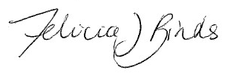
Date 02/09/2021

Person who prepared this referral:
I, Skye Brown (full name),
Technical Director – Environment (position), confirm that the information contained in this form is, to my knowledge, true and not misleading.

Signature 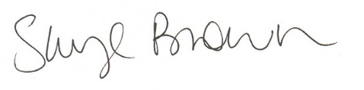
Date 02/09/2021

REFERENCES
EHP 2021a. Biodiversity Assessment: Proposed Tailings Dams (TSF5 and TSF6) within Fosterville Gold Mine. Ecology & Heritage Partners. July 2021.
EHP 2021b. Biodiversity Assessment for proposed Brine Ponds: Fosterville Gold Mine. Ecology & Heritage Partners. July 2021.
EPA 2021. Noise limit and assessment protocol for the control of noise from commercial, industrial and trade premises and entertainment venues. EPA Victoria Publication 1826.4. May 2021.
Golder, 2020. Fosterville Gold Mine – Southern Mine Extension Groundwater Assessment. 17 April 2020.
Heritage Insight, 2018. Fosterville Gold Mine Tailings Dams Cultural Heritage Management Plan (CHMP 15553). 13 June 2018.
Heritage Insight, 2021. Fosterville Gold Mine, McCormicks Road, Fosterville, Victoria – Additional Areas Preliminary Heritage Study. 1 February 2021.

