Melbourne Industrial and Commercial
Land Use Plan

Produced by the Department of Environment, Land, Water and Planning

Acronyms used in this report

ABS Australian Bureau of Statistics
BIFT Beveridge Interstate Freight Terminal
CBD Central Business District
GRP Gross Regional Product
GSP Gross State Product
NEICs National Employment and Innovation Clusters
OMR Outer Metropolitan Ring / E6 Transport Corridor
PFN Principal Freight Network
PSPs Precinct Structure Plans
SSIPs State-Significant Industrial Precincts
UDP Urban Development Program
UGB Urban Growth Boundary
WIFT Western Interstate Freight Terminal

© The State of Victoria Department of Environment, Land, Water and Planning 2020
This work is licensed under a Creative Commons Attribution 4.0 International licence. You are free to re-use the work under that licence, on the condition that you credit the State of Victoria as author. The licence does not apply to any images, photographs or branding, including the Victorian Coat of Arms, the Victorian Government logo and the Department of Environment, Land, Water and Planning (DELWP) logo. To view a copy of this licence, visit http://creativecommons.org/licenses/by/4.0/

ISBN 978-1-76105-122-7 (pdf/online/MS word)

Disclaimer
This publication may be of assistance to you but the State of Victoria and its employees do not guarantee that the publication is without flaw of any kind or is wholly appropriate for your particular purposes and therefore disclaims all liability for any error, loss or other consequence which may arise from you relying on any information in this publication.

Accessibility
If you would like to receive this publication in an alternative format, please telephone the DELWP Customer Service Centre on 136186, email customer.service@delwp.vic.gov.au, or via the National Relay Service on 133 677 www.relayservice.com.au. This document is also available on the internet at www.delwp.vic.gov.au.

Table of contents

Executive Summary v
Introduction 1
PART A: OVERVIEW OF INDUSTRIAL AND COMMERCIAL LAND ACROSS MELBOURNE 3
A changing economy 4
Victoria and Melbourne’s economy, industry structure and workforce 4
Key factors that will change the future of work 8
Supporting Melbourne and Victoria’s economic growth and development 9
Industry sector strategies 9
Freight and logistics 11
Enhanced rail and road networks 12
The need to plan for industrial and commercial land 13
Projected population and employment growth 13
The legacy of long-term strategic planning 14
Land use strategies and policies 15
Industrial and commercial land across metropolitan Melbourne 19
Supply and demand for industrial land 19
Supply and demand for commercial land 23
Approach to planning for industrial and commercial land 28
Principles and strategies to guide planning for industrial and commercial land 29
Planning framework for industrial and commercial land 30
PART B: REGIONAL SUMMARIES AND DIRECTIONS 36
Inner Metro Region 37
Regional snapshot 37
Key industrial and commercial areas 39
Supply and demand for industrial and commercial land across the region 40
Planning framework for industrial and commercial land across the region 44
Western Region 46
Regional snapshot 46
Key industrial and commercial areas 48
Supply and demand for industrial and commercial land across the region 51
Planning framework for industrial and commercial land across the region 55
Northern Region 57
Regional snapshot 57
Key industrial and commercial areas 59
Supply and demand for industrial and commercial land across the region 61
Planning framework for industrial and commercial land across the region 66
Eastern Region 68
Regional snapshot 68
Key industrial and commercial areas 70
Supply and demand for industrial and commercial land across the region 71
Planning framework for industrial and commercial land across the region 75
Southern Region 77
Regional snapshot 77
Key industrial and commercial areas 79
Supply and demand for industrial and commercial land across the region 81
Planning framework for industrial and commercial land across the region 86
Inner South East Region 88
Regional snapshot 88
Key industrial and commercial areas 90
Supply and demand for industrial and commercial land across the region 90
Planning framework for industrial and commercial land across the region 94
APPENDICES 96
Appendix 1 – Methodology 97
Appendix 2 – Developing local industrial land use strategies 99
Appendix 3 – Glossary 100

Executive Summary
The Victorian Government is committed to ensuring policies and strategies are in place to improve economic performance and productivity in order to contribute to improved living standards for all Victorians.
Between 2016 and 2031 metropolitan Melbourne is projected to grow by around 1.6 million people – from a population of 4.7 million to a population of around 6.3 million people. By 2051 the Greater Melbourne area is projected to grow to around 8.5 million people.
To support this growth, it is estimated that the total number of jobs required across Melbourne by 2031 will be around 3.1 million, and by 2051 around 4.1 million. This will require the provision of another 857,000 jobs by 2031, and another 1.8 million jobs by 2051. The Inner Metro Region will continue to be a key focus for jobs growth; however, it is also anticipated that there will be strong demand for more jobs in Melbourne’s growth areas to support population growth.
Plan Melbourne 2017-2050 (Plan Melbourne) outlines how Melbourne's growth and change will be managed over the next three decades and sets out the strategy for supporting jobs and growth, while building on Melbourne’s legacy of distinctiveness, liveability and sustainability. As outlined in Plan Melbourne, in order to remain prosperous Melbourne must remain attractive to investment. That means ensuring well-priced commercial and industrial land is available in locations that can support and strengthen industry and support our expected population growth.
The Victorian economy has undergone significant change in recent decades and will continue to undergo change for some time as it transitions away from one based on manufacturing, to a more service and knowledge-based economy. These changes have spatial implications and requirements such as a growing preference for dense, accessible and amenity-rich enterprise precincts.
While the manufacturing sector is declining as a proportion of all jobs, its contribution to the Victorian economy remains steady at around $30 billion in 2017-18. In addition, demand for industrial land remains high for uses such as logistics and advanced manufacturing. These sectors continue to require large tracts of land, and as such, the provision of a well-suited supply of industrial land will continue to be required to support the contemporary Victorian economy.
Our economy is also being reshaped by population changes taking place. As our population ages, so too does our demand on health, community and waste management services. These population serving industries will grow significantly over the coming decades as will retailing and business services that support these sectors. This will drive demand for premises in commercial areas closer to growing populations.
Understanding these changes and what they mean for future industrial and commercial land requirements will support better planning for our future needs.
The Melbourne Industrial and Commercial Land Use Plan builds on policies, strategies and actions in Plan Melbourne and its associated Plan Melbourne 2017-2050 Five-Year Implementation Plan (Plan Melbourne Implementation Plan). It provides an overview of current and future needs for industrial and commercial land across metropolitan Melbourne and puts in place a planning framework to support state and local government to plan more effectively for future employment and industry needs, and better inform future strategic directions.
The plan will play an important role in supporting Melbourne’s industrial and commercial areas to thrive and will help to facilitate a more diverse industrial and commercial base, while also providing long-term business and employment opportunities.

Supply and demand for industrial land
Across metropolitan Melbourne approximately 33,300 hectares of existing and future industrial land has been identified. Of this, approximately 19,800 hectares are occupied and just under 13,500 hectares are available. Of the available supply, there is almost 6,600 hectares currently zoned and approximately 6,900 hectares unzoned and identified for future industrial purposes.
Over two-thirds of the vacant zoned industrial land supply (approximately 4,190 hectares of a total of approximately 6,560 hectares) is located within Melbourne’s five state-significant industrial precincts (SSIPs).
Of the future unzoned land identified, approximately 63 per cent is located within one of three SSIPs (Western, Northern and Officer-Pakenham). The remaining future supply of land is located in key industrial areas identified through Growth Corridor Plans – Managing Melbourne’s Growth (Growth Corridor Plans) or other strategic plans. All of these areas are yet to be planned for and zoned for industrial purposes but will be critical in providing future industrial land supply across the metropolitan area.

Table ES1: Industrial land supply
Region / SSIP | Occupied zoned land (ha) | Vacant zoned land (ha) | Future unzoned land (ha) | Total vacant zoned and unzoned land supply (ha)
Inner Metro Region | 459.4 | 28.0 | 0.0 | 28.0
Western Region | 5,819.2 | 2,818.4 | 2,881.3 | 5,699.7
Western SSIP | 4,356.3 | 1,810.5 | 1,033.8 | 2,844.3
Northern Region | 3,718.6 | 1,241.2 | 2,866.9 | 4,108.1
Northern SSIP | 2,400.7 | 978.2 | 2,393.7 | 3,371.9
Eastern Region | 2,435.0 | 135.1 | 0.0 | 135.1
Southern Region | 7,270.3 | 2,337.5 | 1,183.5 | 3,521.0
Southern SSIP | 2,454.4 | 502.6 | 0.0 | 502.6
Officer-Pakenham SSIP | 317.7 | 323.8 | 938.3 | 1,262.1
Hastings SSIP | 814.1 | 578.1 | 0.0 | 578.1
Inner South East Region | 140.7 | 2.3 | 0.0 | 2.3
Total | 19,843.2 | 6,562.5 | 6,931.7 | 13,494.2
Source: Department of Environment, Land, Water and Planning, Urban Development Program – Melbourne Metropolitan Industrial 2018 and internal analysis

Industrial land consumption across metropolitan Melbourne over the period 2015-16 to 2017-18 averaged just over 280 hectares per annum. Approximately 80 per cent of the industrial land consumed during this period across Melbourne was in the Western, Northern, Southern or Officer-Pakenham SSIPs, with the greatest level of consumption in the Western SSIP.
Based on these levels of supply and consumption, metropolitan Melbourne as a whole is estimated to have approximately 23 years supply of zoned industrial land available and approximately 17 years supply of unzoned land that has been identified as future supply for industrial purposes.
While this may seem reasonable, there are distinct supply constraints at regional and local levels. The Southern SSIP is likely to exhaust all supply by the mid-2020s. The Western SSIP has approximately 15 years supply of zoned land and only 6 years supply of unzoned land.
With little opportunity available for additional industrial land in these locations, their ongoing protection and retention for industrial uses will be critical, as will retaining other key industrial areas that can accommodate industry needs for land into the future.

Supply and demand for commercial land
As the population of Victoria continues to grow and the economy becomes more service based, it is expected there will be strong demand for commercial floorspace. Commercial land and corresponding floorspace can be occupied by a range of office, retail, entertainment, food and accommodation uses. It can include floorspace both at the ground level and any level above.
Almost 5,300 hectares of land has been identified across metropolitan Melbourne that is zoned predominantly for commercial purposes. On this land, it is estimated that there is approximately 24.2 million square metres of floorspace used for, or available for, commercial purposes. Approximately 38 per cent of this floorspace is located within the Inner Metro Region, of which 80 per cent is within the City of Melbourne.
Beyond the Central City, metropolitan Melbourne hosts a range of centres providing retail, entertainment and local professional services. Excluding the City of Melbourne, there is approximately 17 million square metres of commercial floorspace that has been identified across the metropolitan area in over 1,100 centres. These range from smaller local convenience centres to larger freestanding shopping centres and metropolitan activity centres.

Table ES2: Commercial floorspace
Region | Existing floorspace  2018 (m²) | Estimated additional commercial floorspace  2016 to 2031 (m²)
Inner Metro | 9,067,350 | 4,007,000
Western | 2,909,700 | 1,548,000
Northern | 3,239,150 | 1,414,000
Eastern | 2,817,650 | 837,000
Southern | 3,166,750 | 1,371,000
Inner South East | 2,991,200 | 783,000
Total | 24,191,800 | 9,960,000
Source: Department of Environment, Land, Water and Planning, unpublished data (2020)
Between 2016 and 2031 it is estimated that approximately 10 million square metres of additional commercial floorspace is likely to be required across metropolitan Melbourne to meet projected demand. Of the total additional floorspace estimated to be required, 70 per cent of it is anticipated to be for office uses.
The Inner Metro Region, and particularly the City of Melbourne, will continue to be a key focus for growth, with the region anticipated to need almost 40 per cent (approximately 4 million square metres) of the total metropolitan commercial floorspace projected by 2031. Almost 83 per cent of this demand will be made up of office floorspace.
Projected demand for commercial floorspace in other regions of metropolitan Melbourne, while not as great as the Inner Metro Region, is still significant at approximately 6 million square metres. Around 60 per cent of this demand will be for office floorspace.
There is expected to be significant commercial floorspace required in the Western, Southern and Northern Regions, with each of these regions anticipated to require upward of a 40 per cent increase in their supply of commercial floorspace. Much of this additional floorspace will be needed in the growth area municipalities.
Just over 1,320 hectares of land has been identified for future commercial purposes through Growth Corridor Plans and PSPs. Nearly 85 per cent of this land is located in the Western and Southern regions.
Options to accommodate projected demand for commercial floorspace in other locations will need to be identified within existing commercial areas, as well as considering areas that could accommodate future floorspace requirements through rezoning.

Approach to planning for industrial and commercial land
Ensuring there is enough industrial and commercial land to meet future demand for economic activity and employment purposes, will help to support Victoria’s competitive advantage in attracting investment.
To ensure industrial and commercial areas are able to operate efficiently and effectively and remain viable, there is a need for clarity and certainty around how these areas are planned. To support planning for industrial and commercial land, a number of principles have been developed. These principles are supported by strategies and have been developed to guide future planning for industrial and commercial areas across metropolitan Melbourne.

Principles to guide future planning for industrial and commercial land
Principle 1: Adequate long-term commercial and industrial land supply will be identified and set aside to support future industry and business growth.
Principle 2: Industrial and commercial areas that provide an ongoing economic, urban servicing or employment contribution to local communities, regions and the state will be recognised and retained as a critical economic resource.
Principle 3: Planning for industrial and commercial land will provide clarity and certainty about how and where industry and business can grow over time to support and guide long term investment and locational decisions.
Principle 4: Planning will support industry and business to innovate and grow in areas identified for these purposes.
To further support how we plan for industrial and commercial land a classification system will be put in place to assist how these areas are planned for. Industrial and commercial land will be categorised as being either of state, regional or local significance. This will assist with identifying land that should be retained or considered primarily for industrial or other business or employment focussed purposes, and land that could be considered for alternative uses.
For industrial land, the following framework will be put into place.
- State-significant industrial precincts: These are identified in the Metropolitan Planning Strategy – Plan Melbourne. They provide strategically located land for major industrial development linked to the Principal Freight Network and transport gateways. It is state policy that these areas are to be protected from incompatible land uses to allow continual growth in freight, logistics and manufacturing investment.
- Regionally-significant industrial precincts: These are key industrial areas that contribute significantly to local and regional economies. Some of these areas are well established and support a range of industrial uses while others are transitioning and supporting new uses. They include future employment areas identified through Growth Corridor Plans. These areas need to be planned for and retained either as key industrial areas or locations that can transition to a broader range of employment opportunities. Criteria has been developed as a basis for identifying these locations.
- Local industrial precincts: If an area is not identified as being of state or regional significance, then it is of local significance. Councils are best placed to determine how these industrial areas are to be planned for. This could include identifying when industrial land should be retained, when it could transition to other employment generating uses, or if it is no longer required, when it could transition to other uses.
To support councils to plan for industrial areas, draft guidance for the development of local industrial land use strategies has been developed (Appendix 2). This will be further developed into a practice note to assist councils in undertaking this strategic work, including criteria for considering changes of land use.

For commercial land, the following framework will be put into place.
- State-significant commercial areas: These are commercial areas and places identified in Plan Melbourne as being of state significance. Included is the Central City which provides for growth of knowledge-intensive and high-skilled firms while continuing to be a major area for tourism, retail, residential, entertainment, sporting and cultural activities. Also included are metropolitan activity centres identified in Plan Melbourne to provide a diverse range of jobs and play a major role in providing for retail and commercial opportunities.
- Regionally-significant commercial areas: These include commercial areas and places identified in Plan Melbourne as major activity centres as well as growth area business with residential precincts identified in Growth Corridor Plans. They should provide for and support access to a wide range of goods and services, including office and retail development, and provide for a wide range of employment opportunities. They are expected to deliver more intensive forms of employment uses including office and commercial activity.
- Local commercial areas: These include neighbourhood activity centres and other small local centres that provide access to local goods, services and employment opportunities and serve the needs of the local and surrounding community. Planning for these areas should create opportunities for local businesses and new jobs and deliver better access to local services and facilities.
To support councils to plan for commercial areas a range of practice notes and guidance material is available.

Implementation
In addition to the metropolitan wide framework to be put in place, this report also examines the six metropolitan regions across Melbourne and for each provides:
- a snapshot of the region
- an overview of the key industrial and commercial precincts
- an analysis of supply and demand for industrial land and commercial floorspace
- a planning framework outlining specific planning approaches that should be pursued
- maps for industrial and commercial land.

To support planning for industrial and commercial land the following actions will be undertaken.
Action 1: The Department of Environment, Land, Water and Planning (DELWP) will implement new and updated policy into the Victoria Planning Provisions to support state and regionally-significant industrial and commercial precincts based on the Melbourne Industrial and Commercial Land Use Plan.
Action 2: In consultation with key stakeholders, DELWP will develop and implement a more sophisticated methodology and approach to assess future supply and demand for industrial land taking into account business needs and land use requirements.
Action 3: DELWP will expand the Urban Development Program to include updates to the commercial floorspace estimates into the future and will explore the appropriate timing and updating cycle for this work.
Action 4: DELWP will review the commercial and industrial zones to better understand how they are applied and operating. In particular consideration will be given to the role and function of dwellings as a section 1 use in the Commercial 1 Zone and the role and purpose of the Commercial 2 Zone and how it applies and operates, particularly in industrial locations. Consideration will also be given to the range of uses permitted within industrial zones, and in particular, non-industrial focussed uses.
Action 5: Councils should prepare and implement municipal-wide industrial land use strategies and activity centre strategies, or similar strategic work for precincts, to guide future development of industrial and commercial land.
Action 6: Building on the guidance included at Appendix 2, DELWP will work with local councils to develop a practice note to support the development of local industrial strategies.
Action 7: The state government will investigate options available to preserve and create affordable workspace in inner Melbourne and other strategic locations.
Action 8: The state government will work with local councils to look at future opportunities for industry in the Brooklyn, Tottenham and West Footscray area, including improving connectivity. This will look at ways that state-significant industrial land could regenerate and support industry into the future.

Engagement
The draft Melbourne Industrial and Commercial Land Use Plan was made available for public comment and feedback on the Engage Victoria web page for a two-month period from 1 November 2019 to.31 December 2019. A total of 107 submission were received. A separate report – Melbourne Industrial and Commercial Land Use Plan Summary of Submissions – summarises what was heard through the engagement process.
This report has been updated to take account of the feedback provided through the engagement period.

Introduction
Victoria’s competitive advantage in attracting economic investment and employment relies in part on there being sufficient industrial and commercial land supply across metropolitan Melbourne to meet future demand.
The global and Melbourne economies have been transformed over the past two decades by influences including globalisation, reduced trade barriers and the technological revolution incorporating the increased use of automation and artificial intelligence. While Melbourne still maintains a significant industry sector, the economy has experienced a broad decline in the relative importance of large-scale manufacturing. There has been strong growth however in knowledge and service-based industries and sectors such as construction, freight and logistics are increasing in importance to serve our growing population.
Ensuring there is sufficient land to meet future demand for a range of existing and emerging business and employment purposes will set favourable economic conditions and help support Victoria’s competitive advantage in attracting economic investment.

Purpose of this report
The Melbourne Industrial and Commercial Land Use Plan builds on the relevant policies and actions of Plan Melbourne 2017-2050 (Plan Melbourne) and the associated Plan Melbourne 2017-2050 Five-Year Implementation Plan (Plan Melbourne Implementation Plan). It provides an overview of current and future needs for industrial and commercial land across metropolitan Melbourne and puts in place a planning framework that will enable state and local government to more effectively plan for future employment and industry needs, and better inform strategic directions.
To assist in providing an improved approach for the planning of industrial and commercial land, the objectives of the Melbourne Industrial and Commercial Land Use Plan are to:
- Develop an understanding of the demand for, and take-up, of industrial and commercial land across metropolitan Melbourne.
- Assess whether there is adequate supply and opportunity, both existing and in the future, in the right locations to support the city’s economic growth.
- Identify ways in which industrial and commercial land should be planned for and protected for employment purposes, to ensure an appropriate supply of industrial and commercial land to serve the needs of metropolitan Melbourne.
- Identify where there are opportunities for new industries and commerce to emerge and grow.
- Better understand the circumstances in which industrial or commercial land could be considered for alternate uses, such as mixed-use or residential, based on applying strategic principles and criteria and a clear planning framework.
This plan will play an important role in supporting Melbourne’s industrial and commercial areas to thrive and will help to facilitate a more diverse industrial and commercial base, while also providing long-term business and employment opportunities. It encourages and promotes investment and renewal by establishing a planning framework, principles and criteria to be applied by planning authorities in regions across metropolitan Melbourne.

Implementing Plan Melbourne
The Plan Melbourne Implementation Plan contains two key actions relating to planning for industrial and commercial land and future employment needs across metropolitan Melbourne.
Action 8 Significant industrial precincts
Work with local government to strengthen regionally-significant industrial precincts in established urban areas for employment-generating activities by:
- Ensuring that sufficient land is zoned for employment purposes and that sensitive land uses such as housing are not permitted to be established in them.
- Retaining larger industrial precincts for local manufacturing, service industries, warehousing and distribution.
- Promoting the renewal of older industrial areas that are no longer well suited to industrial activities.
- Facilitating improved information and communications technology infrastructure, access and amenity within these areas.
- Reviewing planning, building and environmental regulations to ensure that these are not barriers to the affordable conversion of designated areas for alternative employment-generating activities.
- Identifying areas no longer required for employment activities.
Action 12 Planning for future employment growth
Assist councils to plan for future employment needs by:
- Addressing how metropolitan regional employment demand forecasts can be translated into floorspace requirement, land-use and zoning frameworks.
- Providing direction for assessing the ongoing suitability of established industrial and commercial areas for different types of employment purposes.
- Providing direction about when such areas should be retained for employment purposes and when they should be considered for rezoning to mixed-use or residential.

Structure of this report
The Melbourne Industrial and Commercial Land Use Plan is divided into two parts.
Part A provides an overview of industrial and commercial land supply and demand across Melbourne, examining the drivers of economic growth and development in a state-wide context, the relationship to population growth and the need to plan for industrial and commercial land. This section identifies the overarching principles and strategies to guide the planning framework and the strategic planning process to achieve this at a metropolitan and regional level.
Part B examines each of the six metropolitan regions across Melbourne in more detail. For each region an overview provides an understanding of locational context, economic drivers, and projected population and employment growth. The role and function of key industrial and commercial precincts is outlined together with an analysis of supply and demand for industrial land and commercial floorspace. A planning framework identifies key challenges and opportunities and specific planning approaches that should be pursued. Future directions for industrial and commercial land have been mapped for each region.
Appendices to the report include an approach to developing a local industrial land use strategy, methodology and a glossary.

PART A: OVERVIEW OF INDUSTRIAL AND COMMERCIAL LAND ACROSS MELBOURNE

A changing economy

Victoria and Melbourne’s economy, industry structure and workforce
Victoria has a diverse economy and the second highest Gross State Product (GSP) of all Australian states and territories. With GSP at $424 billion in 2017-18, it accounts for over 23 per cent of the national economy.
The Victorian economy has undergone significant structural change since the late 1980s. While manufacturing’s output ($ millions) remains similar to what it was 25 years ago, other industry sectors have grown significantly. In particular, the contribution of the financial and professional services sectors to the state’s GSP have increased significantly since the late 1980s, as the economy has transitioned to a more service and knowledge-based one. Health care and social assistance has also increased significantly as the population grows and ages and expectations of care increase.
This has resulted in a decline in manufacturing’s share of the economy as a whole, from around 14 per cent in the early 1990s to around 7 per cent in 2016.

Figure 1: Victorian Gross State Product, selected industries, 1989-90 to 2017-18

Source: ABS catalogue number 5220.0 (2018)

Figure 2: Share of Victorian Gross State Product, selected industries, 1989-90 to 2017-18

Source: ABS catalogue number 5220.0 (2018)

In recent decades Melbourne’s industry structure has also undergone significant changes, transitioning away from its traditional manufacturing base to more service-based and knowledge-based industries, and over coming decades is likely to be vastly different from the recent past.
Between 1996 and 2016 the total number of jobs across metropolitan Melbourne grew by almost 800,000, an increase from around 1.5 million jobs in 1996 to around 2.3 million jobs in 2016.
Jobs in retail, accommodation and food services now account for around 22 per cent of all jobs, and business services account for around 28 per cent. These sectors combined, now account for 50 per cent of all jobs across metropolitan Melbourne and between 1996 and 2016 these sectors experienced almost a 60 per cent increase in job numbers.
While manufacturing jobs declined between 1996 and 2016 the transport, postal and warehousing sector saw almost an 80 per cent increase in job numbers, from around 67,800 jobs in 1996 to 121,600 jobs in 2016. When combined with other traditional industrial jobs in sectors such as electricity, gas, water and waste services and wholesale trade these sectors account for over 428,000 jobs across metropolitan Melbourne, accounting for around 20 per cent of all jobs, and continue to drive significant growth in the state’s economy.
While the above sectors are significant in terms of the overall number of jobs they generate, the industries that experienced the largest growth rates between 1996 and 2016 have been those in community services (94 per cent increase in job numbers) and construction (126 per cent increase in job numbers). This growth reflects a strong link between population serving industries and population growth, as does the growth in retail, accommodation and food services and business services.

Figure 3: Number of jobs, metropolitan Melbourne, 1996 to 2016

Source: Department of Environment, Land, Water and Planning, internal analysis of ABS census 2016 adjusted with ABS Labour Force data (2016)

As was outlined in Plan Melbourne, the distribution of jobs across Melbourne is uneven. There are more jobs in inner areas, and the distribution of jobs is not evenly spread. These distinctions become even more evident when specific industry sectors are looked at. Business services and manufacturing and industrial jobs are highly concentrated to particular areas, whereas jobs based in the retail, accommodation and food sector are more dispersed across the metropolitan area.
Manufacturing and industrial jobs can generally be seen to locate in state-significant industrial precincts (SSIPs), however there are many other significant areas where these jobs are concentrated. These areas include the Melbourne Airport and its surrounds in the Northern and Western Regions, areas around the Port of Melbourne in the Inner Metro Region, areas around Clayton, Moorabbin, Braeside and Carrum Downs in the Southern Region, and areas around Rowville-Scoresby and Bayswater-Kilsyth in the Eastern Region.
Jobs based in retail, accommodation, food and other industries are more dispersed. While heavily concentrated in the Inner Metro and Inner South East Regions, there are many other locations across the metropolitan areas that exhibit high concentrations of these jobs. These include suburbs with large free-standing shopping centres such as Werribee, Maribyrnong, Sydenham, Epping, Preston, Doncaster, Ringwood, Wantirna, Narre Warren, Cheltenham and Chadstone.
Jobs in the business services sector are very concentrated with the Inner Metro Region and to a lesser extent the northern part of the Inner South East Region. Beyond these locations, these types of jobs are limited to very few locations. The largest concentrations can be noted in the Eastern Region around Doncaster, Box Hill to Ringwood and south to Clayton.

Figure 4: Jobs across Melbourne 2016, select industries *

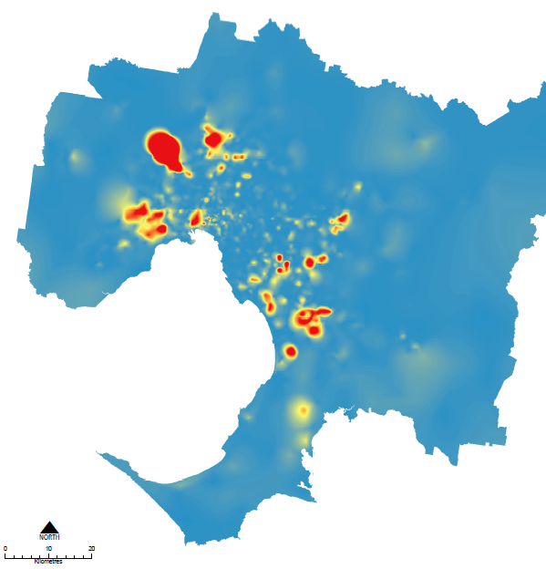Manufacturing and industrial
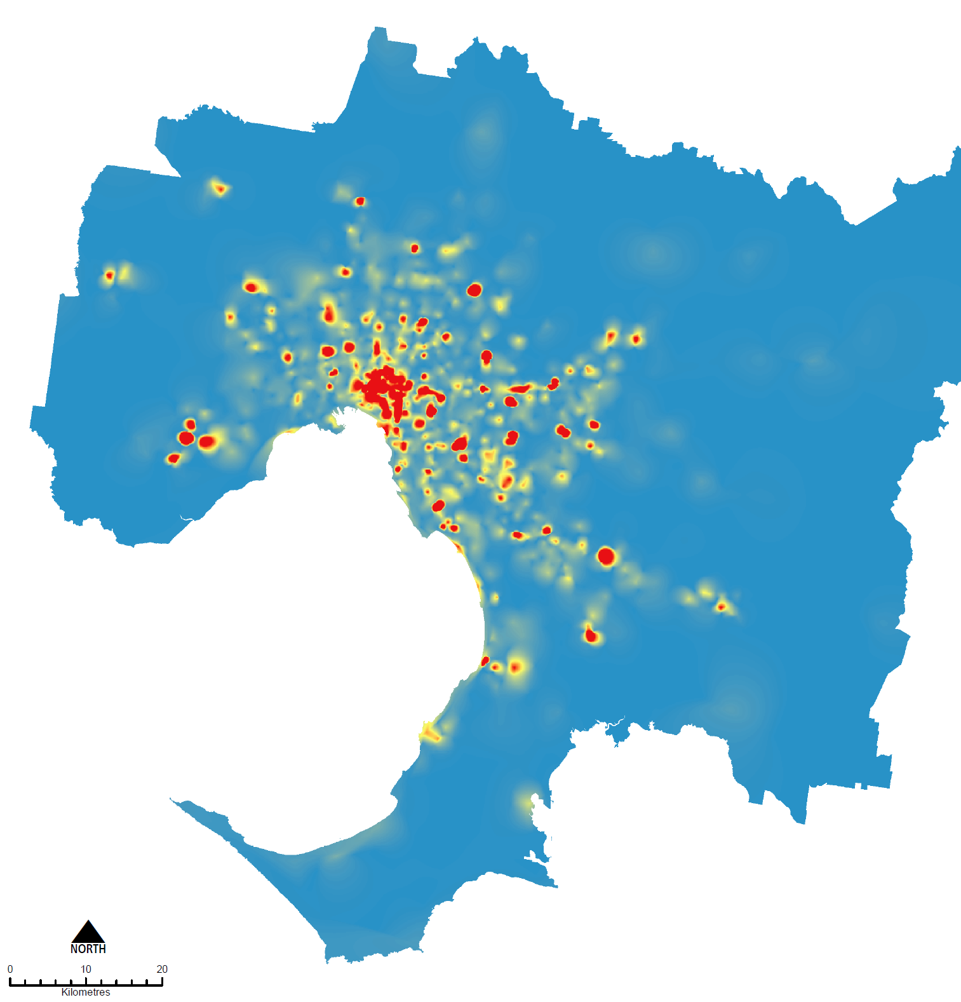Retail, accommodation, food and other
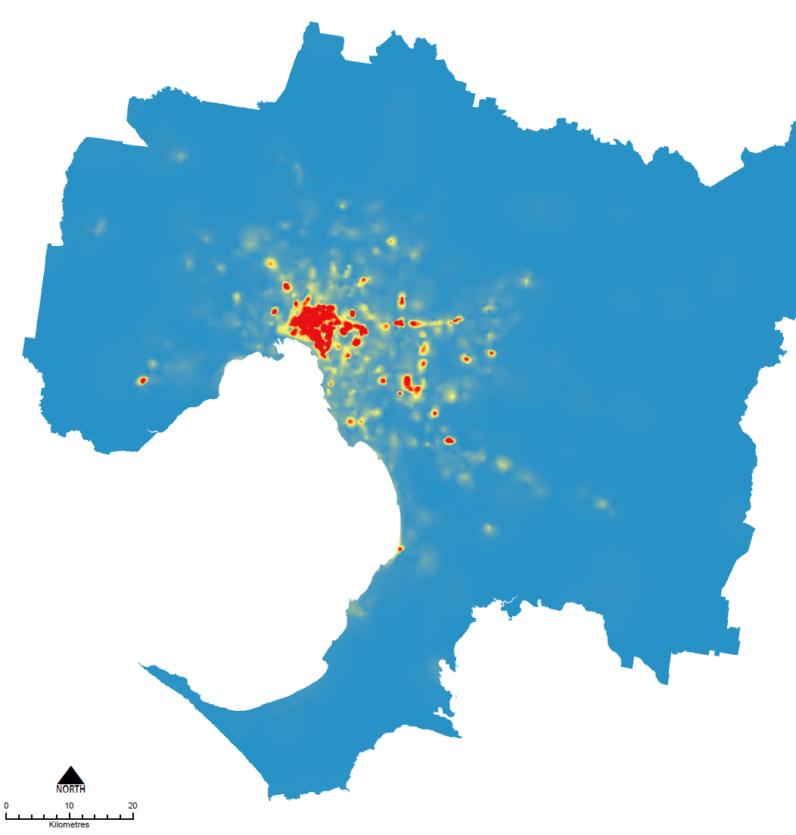Business services 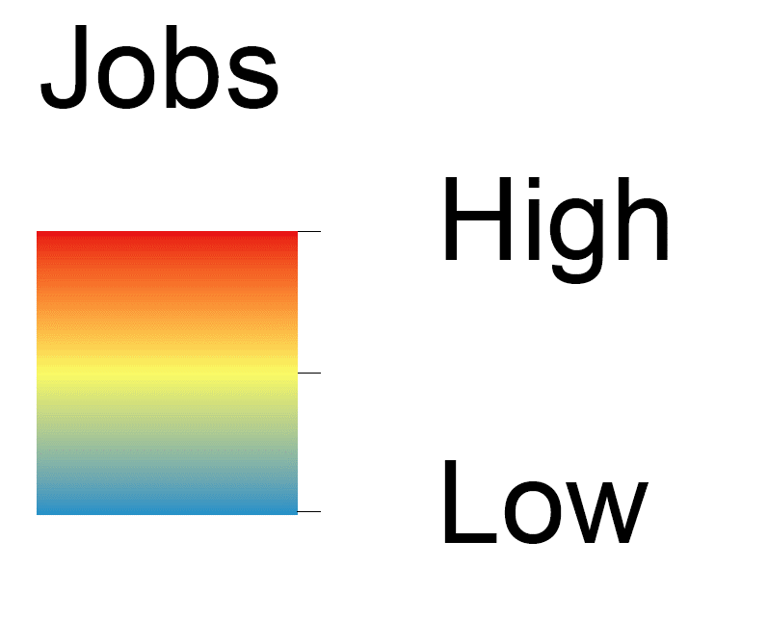

* Industrial jobs are depicted by job numbers, whereas office and retail jobs are depicted by job density.
Source: Department of Environment, Land, Water and Planning, internal analysis of ABS census 2016 adjusted with ABS Labour Force data (2016)

Our work, workforce and workplaces are changing

Between 2000 and 2016, Victoria’s labour market has exhibited a number of changes to the type of work, the workforce and workplace as follows.

The type of work has changed (industry, occupation, tasks, job contract)
- Virtually all jobs growth in service sectors (fewer jobs in manufacturing).
- Decline in routine manual jobs over a number of decades.
- Decline in routine cognitive jobs over the past 15 years.
- Technology is augmenting tasks within occupations and creating new occupations.
- 50 per cent of new jobs have been part-time.
- Approximately 20 per cent of jobs are casual, similar to 2001.

The workforce has changed (supply of labour)
- Female participation continues to increase, and male participation continues to decline.
- Victorians are retiring at an older age.
- More Victorians have a higher qualification.
- The underutilisation rate has increased (largely explained by youth underemployment).
- The time taken for bachelor degree graduates to find full-time work is increasing.

The workplace has changed (location and structure)
- Many workplaces are increasingly digitised.
- Increase in Melbourne co-working spaces and start-ups.
- Location of workplaces have become increasingly concentrated around Melbourne.
- The prevalence of lengthy commutes (>45 mins) has increased.
- The production of goods and services are increasingly carried out wherever the required resources are available.

Driven by:
- Population growth and ageing.
- Global competition (specialisation and offshoring).
- Changing consumption patterns.
- Technology (including automation).
- Greater flexibility for businesses to scale up or down.
- Greater flexibility for workers to balance work-life preferences.

Key factors that will change the future of work
To remain competitive there is a need to support growth and innovation across all industries and regions.
Rapid advances in technology, globalisation and changing consumer patterns will see businesses and industries disrupted at a faster pace over the next decade. The nature and pace of this change will be difficult to predict, businesses will transform how they operate, people will be employed in occupations that do not yet exist, labour and capital will be (more than ever) globally mobile and technology will significantly change occupations, tasks and skill requirements.
The nature of work and how business is done, will continue to change in response to global and domestic factors and this will influence how industrial and commercial land is used and planned for.
These expected changes will present significant new employment and economic opportunities for Victoria, and transitional challenges. There are opportunities to anticipate, respond and capitalise on these expected changes in how we plan for our city.

Supporting Melbourne and Victoria’s economic growth and development
The Victorian Government has a range of high-level policies and strategies in place which are focussed on improving economic performance and productivity, in order to contribute to improved living standards for all Victorians.
Economic Building Blocks for Victoria is an outcomes-focused strategy based on six building blocks. The aim of this strategy is to create more jobs, especially high-skill, high-wage jobs that people can easily access by a quality transport system. Equity and inclusion are promoted. Maintaining Victoria’s liveability is also encouraged. The six building blocks are:
- Jobs Now - Working to create more opportunities and more jobs.
- Future Jobs - Working to create more high-skill, high wage jobs.
- Quality Transport - Working to deliver transport that works for people.
- Fairness and Equity - Working to make sure everyone shares in Victoria’s prosperity.
- Thriving Communities - Working to build vibrant and diverse communities.
- Liveable Places - Working to improve liveability across the state.

Industry sector strategies
The Victorian Government has a number of strategies focused on key industry sectors with growth potential and are a target for government’s investment and activity.
Advancing Victoria's Manufacturing: A Blueprint for the Future provides the vision for the Victorian manufacturing industry, focusing on industry growth, preparing Victorians for the jobs of the future, encouraging innovation, building scale, capability and supply chain excellence, and fostering a globally competitive business environment. It identifies that Victoria is ideally placed to advance and grow, with a highly skilled workforce, connected supply chains, exceptional design and engineering expertise, world-class infrastructure and leading education and research and development.
Creative State is the state government's strategy to strengthen and grow the state's creative industries and the value they bring to Victorians. It contains 40 targeted actions that together provide an integrated plan to grow the state's creative and cultural economy, provide more opportunities for Victorians to embark on creative careers, enjoy creative experiences and position Victoria as a globally recognised creative state.
Victoria's Health and Medical Research Strategy 2016-2020, outlines the Government's key priorities to support new and evolving fields of world-class medical research such as precision medicine, health services research and big data. The strategy aims to create jobs and deliver economic benefits for Victoria and the nation by investing in areas of excellence and addressing areas in need of further development.
Recycling Victoria: A new economy is the Government’s 10-year policy and action plan for waste and recycling, transforming how our economy uses materials and how our state reuses, repairs and recycles. The plan supports the development a circular economy to reduce the environmental impacts of production and consumption, while enabling economic growth through more productive use of natural resources. One of the actions of the plan is to plan for waste and resource recovery infrastructure over the long term. This will make sure land use planning systems support important waste and resource recovery infrastructure, including waste to energy facilities, hazardous waste and recycling
In addition, the government has developed a suite of Future Industries sector strategies. These strategies support investment in high-growth industries through industry excellence and development projects, including establishing collaborative networks and building supply chain readiness capabilities.

Victoria’s Future Industries strategies
- Construction technologies: outlines better ways of doing things in construction, including technological improvements such as increased use of digital technologies, improvements in technology in sharing information, off-site construction methods and new construction materials and products.
- Defence technologies: focusses on improving defence technology, engaging with suppliers (including global suppliers) and winning future defence projects.
- Food and fibre: supports an integrated approach, focusing in key areas along the food and fibre value chain. It emphasises business innovation through technology as well as developing market opportunities and infrastructure.
- International education: focusses on improving student experiences, collaborating with a range of stakeholders regarding the broader benefits of international education and marketing a high-quality international education sector to the rest of the world.
- Medical technologies and pharmaceuticals: promote a skilled workforce, health and medical research, building business scale and capabilities to secure and grow the sector in a globally competitive market, creating increased economic activity and jobs.
- New energy technologies: encourages investment in clean energy generation technology, collaboration with universities, businesses, professionals and potential workers, promoting new consumer-driven markets and expanding potential markets.
- Professional services: focusses on engineering and design (urban design, engineering, environmental technology and mining services) and financial services (financial technology, banking, business advice, superannuation, wealth management, insurance and infrastructure finance) with an emphasis on branding for the sector, attracting international investment, supporting industry networks and streamlining regulations.
- Transport technologies: advocates for the Victorian Government to use Victorian made transport infrastructure, invest in education to build new technologies and networking to expand Victoria’s role in growing markets.

Freight and logistics
Victoria’s freight and logistics sector is made up of thousands of Victorian businesses, large and small. These businesses and their employees move and distribute goods around Victoria and to interstate and international markets, ready for delivery to their destinations. In 2017-18 the value of all goods exported from Victoria was $29 billion while $89 billion worth of goods were imported. With increased imports, freight volumes are predicted to increase from around 360 million tonnes in 2014 to nearly 900 million tonnes by 2051.
Supporting goods to move efficiently around our city and state is crucial to enabling economic growth. The Principal Freight Network (PFN) is the strategic network of current and recognised future freight places and connecting movement corridors that are of national, state or regional significance and accommodate freight of significant quantity, value or importance. A review of the PFN is currently underway and it is anticipated to be updated later in 2020.
Delivering the Goods outlines the initiatives the Victorian Government will take, either on its own, or in partnership with industry, other tiers of government or the community, over the next five years, to improve how Victorian goods are moved to their local, interstate and overseas markets. It also sets out longer-term directions for the freight network, in a way that enables Victoria to respond to the pace of change and adapt to circumstances as they arise.

Delivering the Goods
Delivering the Goods sets out short, medium and long-term priorities to support the freight and logistics system. It includes a range of initiatives and actions particularly relevant to how we plan for and manage existing and proposed freight corridors and places linked to key industrial areas.
Review and enhance the Principal Freight Network (PFN)
- Review and update the existing PFN to include significant freight places, shipping channels and over-dimensional routes.
- Strengthen the protection of the PFN in the relevant planning schemes.
- Assess the long term metropolitan industrial land needs and designate appropriate areas for the future.
- Recognise the existing and planned regional intermodal terminals in the PFN.
- With local councils, review existing, and identify and reserve sites for new freight terminals/precincts.
- Reserve land for the locations of Victoria’s new interstate intermodal terminals – the Western Interstate Freight Terminal (WIFT) at Truganina and the Beveridge Interstate Freight Terminal (BIFT), and their connecting transport corridors. Include these land reservations in the new PFN.
- Prepare a business case for the development of WIFT. Subject to the business case outcome, develop WIFT.
- Protect Webb Dock and the existing and new transport corridor connections to the port under the new PFN.
Improve landside efficiency around the Port of Melbourne
- Develop the former Melbourne Market site for use for truck marshalling associated with the Port of Melbourne and for improvements in empty container management.
- Undertake the necessary land use and transport network planning and protect the former Melbourne Market and South Dynon precincts for port and urban freight related uses for the long term.
Plan for Bay West as Victoria’s second container port whilst retaining the Port of Hastings as an option in reserve
- Further investigate the feasibility of Bay West as a container port, including:
- Determining the location of the port site at Bay West.
- Identifying preferred land transport corridors and the required land area.
- Commence a baseline environmental program for the Bay West port site.
- Monitor key indicators to inform future decisions such as the size of container vessels.
- Subject to study outcomes, progressively plan, reserve land, and prepare for development of Bay West as a container port.

Map 1: Showing key freight routes and facilities
Source: Department of Environment, Land, Water and Planning

Enhanced rail and road networks
A well-connected and efficient transport network is critical to Melbourne’s liveability, but also to its economic activity, productivity and competitiveness. Victoria is currently in a transport construction boom with $38 billion of transport projects currently under construction. Further, there is significant planning underway for a number of major projects that are set to further transform the way in which we move around our city.
The Level Crossing Removal Project was established by the Victorian Government to oversee the largest rail infrastructure project in the state's history. Central to the project is the elimination of 75 level crossings across metropolitan Melbourne by 2025, in addition to upgrading or constructing more than 27 train stations, laying many kilometres of new track and making associated rail improvements. Over the past two and a half years, 29 level crossings have been removed and 15 train stations have been rebuilt.
The $11 billon Metro Tunnel will create a new end-to-end rail line from Sunbury in the west to Cranbourne and Pakenham in the south-east, with high capacity trains and five new underground stations. The project will enable more trains to be able to run more often, on five other lines across the metropolitan rail network. It will also create capacity on the network, to enable more than a half a million additional passengers per week across Melbourne’s train network, to use the rail system during the peak periods.
The West Gate Tunnel Project will provide direct access to the port, an alternative to the West Gate Bridge and reduce the need for trucks to travel on congested residential streets in the inner west. It will provide the freight industry with a more direct and efficient route from the west to the port and the rest of Melbourne. The project will increase opportunities to use High Productivity Freight Vehicles, particularly for trips to and from the port. This will allow greater volumes of freight to be moved with fewer trips, improving productivity and providing operational efficiencies.
The North East Link will complete the ring road between the Eastern Freeway and the M80 Ring Road, connecting the growing northern and south-eastern suburbs. The project has a strong focus on supporting business and jobs growth in Melbourne’s north, east and south east, while also improving cross-city connectivity and helping to address critical traffic, freight and amenity issues. The link will boost the capacity and efficiency of the city’s freight network by creating a continuous freeway-standard road for freight, drawing trucks away from the arterial road network and reducing pressure on the M1 corridor. In addition, it will enhance access to major suburban business and employment centres and improve orbital road connectivity across Melbourne.
The Suburban Rail Loop is a new underground rail link connecting Melbourne’s middle suburbs. It will include new stations and connect major railway lines from the Frankston line to the Werribee line via Melbourne Airport. Suburban Rail Loop will connect Melbourne’s middle suburbs to priority growth precincts, and link all Victorians to major health, education and employment centres.

The need to plan for industrial and commercial land

Projected population and employment growth
As the official state projections, Victoria in Future, outlines that Victoria has grown by a million people since 2011 and is expected to add another million by 2026.
Between 2016 and 2031 Melbourne is projected to grow by around 1.6 million people, from a population of 4.7 million to around 6.3 million. More than half of these new residents will come from interstate or overseas attracted by a range of education and employment opportunities. The largest population increases will occur in the Western, Northern and Southern Regions, reflecting the significant capacity in Melbourne’s growth areas.
In 2016 metropolitan Melbourne was home to around 2.3 million jobs. It is estimated that the total number of jobs required to accommodate growth by 2031 will be close to 3.1 million, and by 2051 around 4.1 million. This will require the provision of another 857,000 jobs by 2031 and another 1.8 million jobs by 2051.
The Inner Metro Region will continue to be a key focus for jobs growth accounting for over 30 per cent of all Melbourne’s jobs growth between 2016 and 2031. There is also projected to be strong jobs growth in the Western, Northern and Southern Regions correlating with strong population growth.

Table 1: Employment across metropolitan Melbourne, 2016
Region | Employment | Share
Inner Metro | 682,800 | 30%
Western | 294,550 | 13%
Northern | 321,200 | 14%
Eastern | 396,000 | 17%
Southern | 392,250 | 17%
Inner South East | 220,500 | 10%
Total | 2,307,300 | 100%
Source: Department of Environment, Land, Water and Planning, internal analysis of ABS census 2016 adjusted with ABS Labour Force data (2016)
There will continue to be strong growth in population serving sectors such as retail trade and accommodation and food services, however health care and social assistance as well as professional, scientific and technical services will experience the largest growth in jobs between 2016 and 2031. Currently these sectors account for around 23 per cent of all jobs. By 2031 they are projected to account for around 28 per cent of all jobs.
Across metropolitan Melbourne, traditional industrial sectors such as manufacturing are expected to see very little change in overall job numbers over the 15-year period from 2016 to 2031, however the wholesale trade and transport, postal and warehousing sectors will see overall growth. These industries typically gravitate to industrial areas where large and affordable sites are available.

Figure 5: Projected employment growth, metropolitan Melbourne, 2016 to 2031
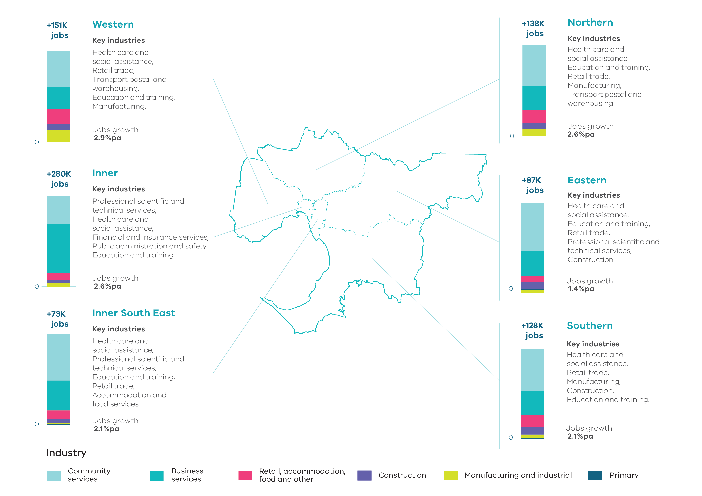Source: Department of Jobs, Precincts and Regions, internal analysis (2019)
NOTE: Job figures have been rounded to the nearest thousand.

The legacy of long-term strategic planning
Melbourne has benefitted greatly from its long-term, orderly planning legacy of setting aside land for future development, making it an attractive place to invest over many years.
The 1954 Metropolitan Melbourne Planning Scheme developed by the former Melbourne and Metropolitan Board of Works (MMBW) supported decentralisation of industry and retailing from central Melbourne, however the 1954 scheme outlined concerns that growth was occurring haphazardly. To remedy this approach the 1954 Metropolitan Melbourne Planning Scheme:
- set aside significant amounts of industrial land across parts of the metropolitan area for immediate expansion and future growth
- designated five district business centres at Footscray, Preston, Box Hill, Moorabbin and Dandenong that over time had the potential to become locations for cultural and entertainment facilities, department stores, business and public administration and courts of law,
- identified a hierarchy of existing shopping centres classified as Major Shopping Centres, Secondary Shopping Centres, Minor Shopping Centres and Local Shops.
To varying degrees, subsequent metropolitan plans have built on the industrial and commercial policies of the 1954 plan, and the legacy of those policies and decisions still influence our planning for industrial and commercial land today.
Across Melbourne there is a strong network of just over 1,100 existing centres that vary in size and function to serve local communities. In addition to this network, new activity centres and business areas have been identified to serve new communities in the growth areas, and strategically located industrial land has been identified and set aside for future industries.
The Victorian economy will continue to undergo change for some time as it transitions away from one based on manufacturing, to a more service and knowledge-based economy.
While the manufacturing sector is declining as a proportion of all jobs, its contribution to the Victorian economy remained steady at around $30 billion in 2017-18. In addition, demand for industrial land remains high from other industrial uses such as logistics and advanced manufacturing. These sectors continue to require large tracts of land, and as such, the provision of a well-suited supply of industrial land will continue to be required to support the contemporary Victorian economy.
The Victorian economy is also being reshaped by changes in the population, with economic output in health and community services increasing as the population ages. Population serving industries will grow significantly over the coming decades and retailing and business services that support these sectors will require premises in commercial areas close to growing populations.
Understanding these changes and what they mean for future industrial and commercial land requirements will support better planning for our future needs.

Land use strategies and policies

Plan Melbourne
Plan Melbourne outlines how Melbourne's growth and change will be managed over the next three decades. It is the state’s long-term land use, infrastructure and transport plan that sets out the strategy for supporting jobs and growth, while building on Melbourne’s legacy of distinctiveness, liveability and sustainability.
Melbourne’s current employment geography is determined by Plan Melbourne which identifies places of state-significance as a focus for future investment and growth, each with a specific role and purpose.
State-significant places that are particularly relevant to industrial and commercial areas or have a particular focus for jobs and employment include the Central City, national employment and innovation clusters, metropolitan activity centres, state-significant industrial precincts and transport gateways.
In addition to these locations, other locations such as major urban renewal precincts, health and education precincts, major activity centres and other industrial areas play an important regional role in accommodating industry and business and supporting jobs growth.
Plan Melbourne policies in relation to industrial and commercial land are implemented as part of the Planning Policy Framework included in the Victoria Planning Provisions. Policies seek to ensure appropriately located supplies of commercial and industrial land is available for development and that these locations are planned for and protected to support investment and economic growth.

Planning for growth areas
Growth Corridor Plans provide a framework to guide the planning of new communities in each of Melbourne’s growth corridors. They guide delivery of key housing, employment and transport infrastructure in Melbourne’s new suburbs and provide a clear strategy for the development of the growth corridors over the next 30 to 40 years.
Building on Growth Corridor Plans, more detailed Precinct Structure Plans (PSPs) guide development at a more localised level. They typically make provision for employment and business growth through the development of a network of activity centres that can grow and change over time, and by setting aside sufficient employment land so that businesses can grow and expand into the future. They may include mixed-use areas associated with town centres and smaller industrial areas providing for the needs of local businesses. They may also provide for larger, state and regionally-significant employment precincts and industrial areas.

Land use framework plans and other place-based plans
The Victorian Government is working with local councils to develop land use framework plans for Melbourne’s six metropolitan regions. The land use framework plans are 30-year strategic land use and infrastructure plans that will provide a common long-term framework to manage growth and land use pressures in each of the six metropolitan regions. These are spatial plans that will translate Plan Melbourne to the regional level, focus on resolution of metropolitan regional issues and provide the context for planning at a precinct or local scale.
Structure plans and other place-specific plans are another way in which state and regional policy directions are translated to guide development at a local and precinct level. It is the role of these place-based plans to undertake more detailed strategic work to determine the most appropriate structural layout and zoning mix in accordance with state and regional policy frameworks. Through these processes there will be a need to balance any competing planning objectives appropriately.

Planning for buffer areas and incompatible land uses
A buffer is an area of land which is used to separate or manage incompatible land uses, to avoid land use conflicts and protect uses that are considered sensitive from unintended off-site impacts. Off-site impacts from industry operations can pose amenity, health and safety risks to communities, while the encroachment uses of a sensitive nature, such as residential development, into buffers may compromise the efficient ongoing operation of existing businesses. Buffers are therefore an important planning tool to provide certainty for industry.
Buffer areas can also be used to accommodate businesses, urban services and other uses that are more compatible with industries with potential off-site impacts or nearby uses of a sensitive nature.
State planning policy aims to protect industry and infrastructure from encroachment of incompatible uses, including the protection of major hazard facilities, airports, state significant industrial land, extractive resources and waste infrastructure.
The government also supports the ‘agent of change’ principle being applied to existing quarries. This principle puts the onus on the applicant proposing a new use or development that encroaches within buffers of an existing quarry to take measures to mitigate any impacts from those existing or planned activities.
Local industrial land use strategies will enable councils to identify the location and nature of existing priority industry and potential off-site impacts. These local strategies may identify appropriate management strategies for incompatible uses, including buffers to uses of a sensitive nature, land use transition over time and where use and development should be restricted.

Planning for enterprise precincts
Unlocking Enterprise in a Changing Economy is the state government’s policy to understand and support enterprise precincts as hubs for the emerging economy increasingly characterised by start-ups, entrepreneurs, creative industries, co-working spaces, and small-scale manufacturers. The ‘Factors Driving the Success of Enterprise Precincts’ framework provides a holistic approach to assess the strengths and weaknesses of enterprise precincts and is a useful aid in determining where to target efforts to attract, retain and support the emerging economy.
The Commercial 3 Zone has been developed to support this framework and can be applied to help facilitate business growth and innovation in select parts of Victoria. It is a mixed-use employment zone which is intended to facilitate the establishment and growth of creative industries, small manufacturers and start-up businesses. The zone promotes the creation of dense, economically diverse, affordable, accessible and amenity-rich precincts which are attractive to new and emerging businesses. It aims to reduce the planning burden for a host of employment uses – from urban manufacturers and makers to co-working spaces – while allowing for complementary yet limited retail and residential uses where these uses are considered appropriate to support enterprise to flourish.

Figure 6: Factors driving the success of enterprise precincts
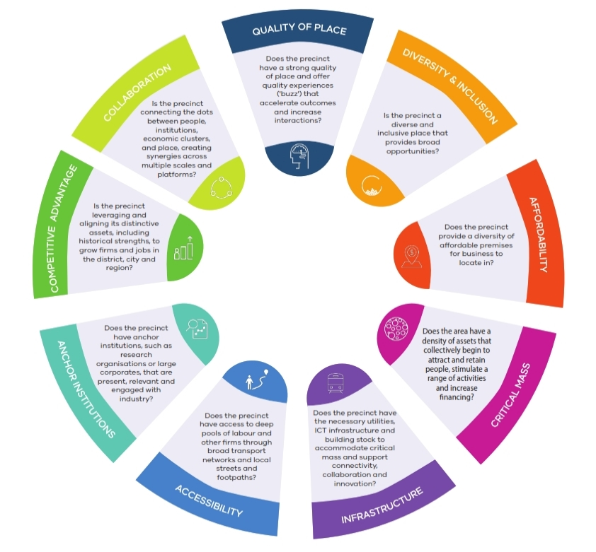
Source: Department of Environment, Land, Water and Planning

CASE STUDY: Laverton North
The outcomes of strategic planning often lie in the distant future. The development of the industrial area around Laverton North is an example of the legacy of the original planning by the Melbourne and Metropolitan Board of Works in 1954. The land was activated with the construction of the Western Ring Road in the 1990s and is now one of the most active industrial land markets in the country.

Government’s primary roles in Laverton North were specific to the area, such as:
- Providing preconditions for development by zoning suitable land and planning transport infrastructure.
- Providing long term market certainty by maintaining the industrial zoning for the area.
- Investing in transport infrastructure by providing funding for the Western Ring Road.
The role of the private sector in the development of Laverton North is more diffuse and is related to changing market conditions, such as:
- Demand for large parcels of land by logistics users.
- Access to transport gateways such as the Port of Melbourne and roads to other locations across the metropolitan area and interstate.
- Increasing flexibility of institutional investors by providing premises for lease to end users.

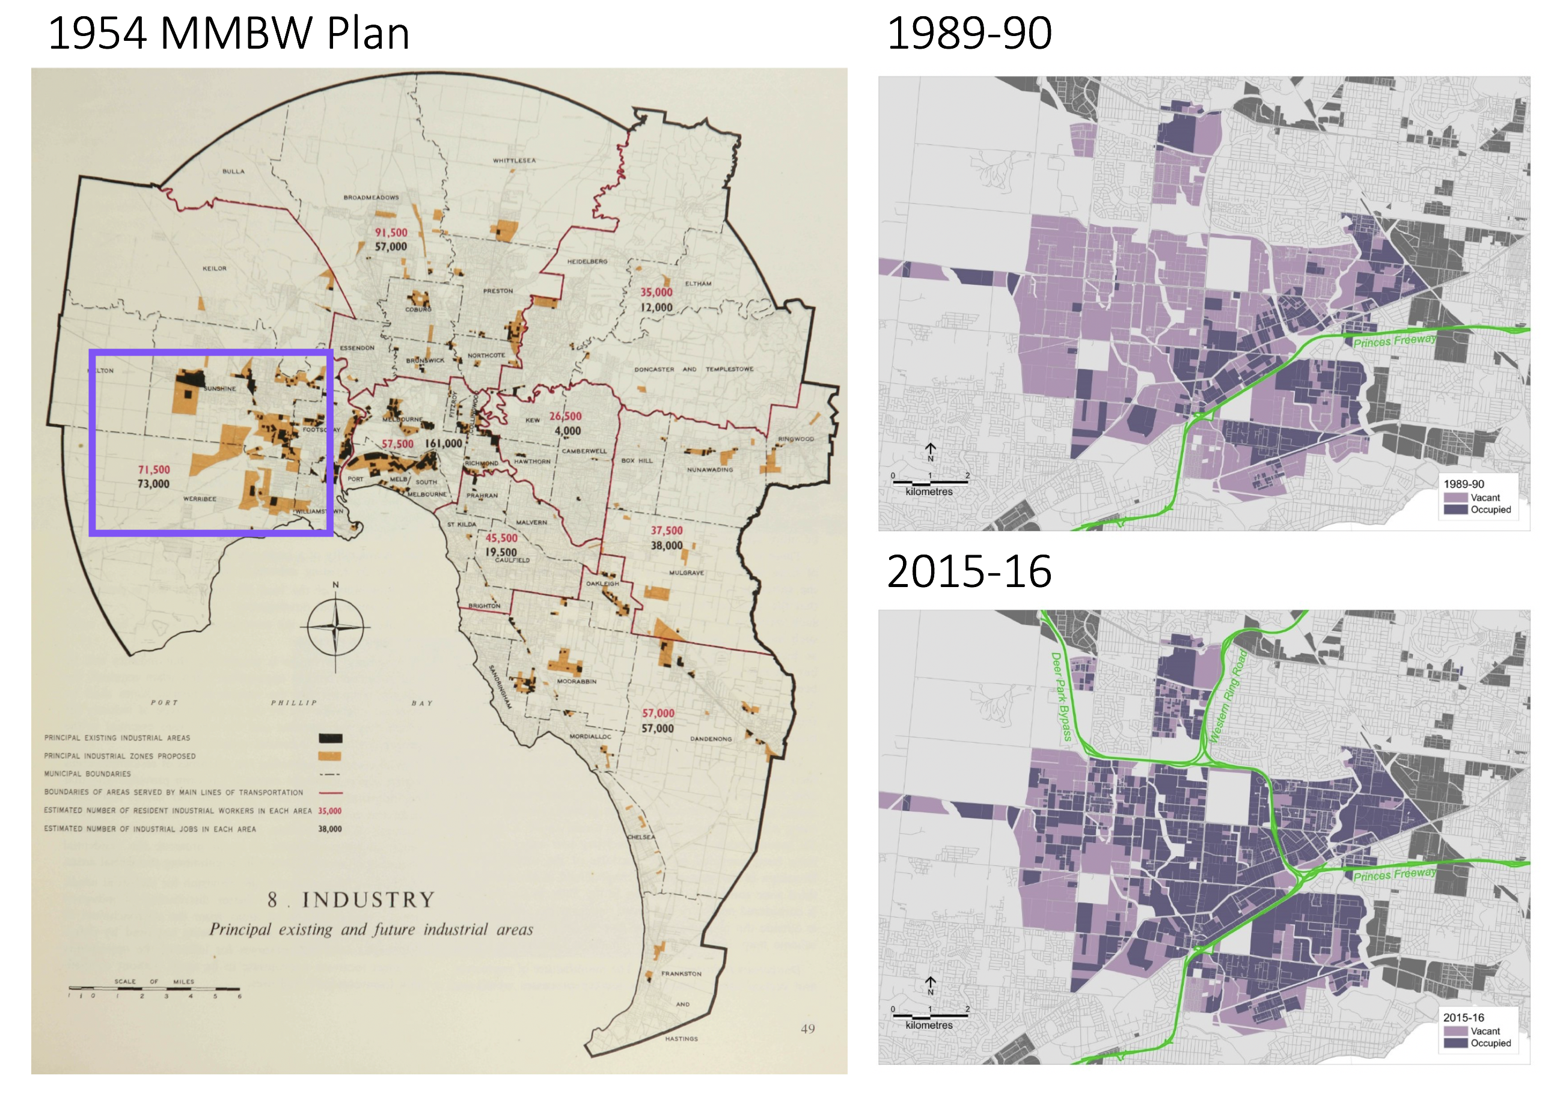
Source: Elliott, P. 2017, “Why strategic planning matters: a case study approach to examining industrial land use planning and development in Melbourne.” paper presented to the State of Australian Cities Conference 2017, Adelaide, South Australia, 28 to 30 November 2017.

Industrial and commercial land across metropolitan Melbourne
The Urban Development Program (UDP) is an annual program that analyses the supply and demand for residential and industrial land across metropolitan Melbourne. The program aims to ensure the ongoing provision of land and supporting infrastructure. Information and feedback to inform the preparation of the UDP is drawn from across state and local government.
Plan Melbourne identifies SSIPs as areas of economic activity that provide strategically located land for major industrial development linked to the Principal Freight Network (PFN) and transport gateways. The UDP provides separate analysis of industrial land in the SSIPs including an estimate of the exhaustion time frame of vacant land in the SSIPs.
For the purpose of this plan, industrial land identified and reported through the UDP has been used as a basis.
The UDP does not currently provide coverage of commercial land. The work undertaken as part of this report is a first step in identification and monitoring of commercial land.
An approach to identify commercial land and land uses has been developed. This has included identifying all Commercial 1 zoned land across the metropolitan area (or Business 1, 2 or 5 zoned land where still applicable) as well as land within Special Purpose zones where retail and office uses are generally encouraged and allowed as-of-right. More detail on the approach and methodology for the identification of commercial land can be found at Appendix 1.

Supply and demand for industrial land
Melbourne’s industrial sector continues to grow and evolve and is one of the strongest in the nation.
Online retailing is becoming more prevalent creating demand for fulfilment centres and supporting infrastructure to move goods quickly and efficiently around the city. Warehouse automation is increasing, and multi-level warehousing is now being considered, particularly in inner city locations where land is scarce and costs are higher.
Major infrastructure projects will improve connectivity and congestion, linking key employment locations to workers and major freight networks, providing direct benefit to the industrial sector. Such improvements will enhance supply chains, reduce business costs, increase access to markets, enhance access to core skilled workers and enhance business to business interactions.
While demand for industrial land across metropolitan Melbourne can fluctuate from year to year, over the long term it remains strong. Recent strong leasing activity and limited additions to the supply of vacant industrial sites has meant that vacancy rates for industrial space are currently at very low levels and land values continue to increase. This has been most evident in Melbourne’s west where land values for lots under five hectares increased by 40 per cent over the last year.
The provision of sufficient land for industries with large lot land requirements, is required to enable freight and logistics, and advanced manufacturing industries to expand, together with creating supportive operating conditions that minimise land use conflicts.
Improved management of industrial land supply is needed, to ensure an ongoing adequate supply across the city.

Supply of industrial land
In 2018, there were approximately 26,400 hectares of zoned industrial land across metropolitan Melbourne, of which 19,843 hectares were identified as occupied and 6,563 hectares were identified as vacant. Nearly two-thirds of vacant zoned industrial land (4,193 hectares of a total of 6,563 hectares) is located within the SSIPs, with the largest availability in the Western and Northern SSIPs.
The Hastings SSIP in Mornington Peninsula has significant vacant land identified, however this land is zoned specifically for port related uses, effectively making it unavailable for general industrial purposes.
In addition, there are approximately 6,930 hectares of unzoned land identified for future industrial purposes.

Table 2: Zoned industrial land supply, occupied and vacant
Region / SSIP | Occupied (ha) | Vacant  (ha) | Total  (ha)
Inner Metro Region | 459.4 | 28.0 | 487.4
Western Region | 5,819.2 | 2,818.4 | 8,637.6
Western SSIP | 4,356.3 | 1,810.5 | 6,166.8
Northern Region | 3,718.6 | 1,241.2 | 4,959.8
Northern SSIP | 2,400.7 | 978.2 | 3,378.9
Eastern Region | 2,435.0 | 135.1 | 2,570.2
Southern Region | 7,270.3 | 2,337.5 | 9,607.8
Southern SSIP | 2,454.4 | 502.6 | 2,957.0
Officer-Pakenham SSIP | 317.7 | 323.8 | 641.5
Hastings SSIP | 814.1 | 578.1 | 1,392.2
Inner South East Region | 140.7 | 2.3 | 143.0
Total | 19,843.2 | 6,562.5 | 26,405.8
Source: Department of Environment, Land, Water and Planning, Urban Development Program – Melbourne Metropolitan Industrial 2018 and internal analysis

Table 3: Available industrial land supply, vacant zoned and future unzoned
Region / SSIP | Zoned vacant (ha) | Future unzoned(ha) | Total(ha)
Inner Metro Region | 28.0 | 0.0 | 28.0
Western Region | 2,818.4 | 2,881.3 | 5,699.7
Western SSIP | 1,810.5 | 1,033.8 | 2,844.3
Northern Region | 1,241.2 | 2,866.9 | 4,108.1
Northern SSIP | 978.2 | 2,393.7 | 3,371.9
Eastern Region | 135.1 | 0.0 | 135.1
Southern Region | 2,337.5 | 1,183.5 | 3,521.0
Southern SSIP | 502.6 | 0.0 | 502.6
Officer-Pakenham SSIP | 323.8 | 938.3 | 1,262.1
Hastings SSIP | 578.1 | 0.0 | 578.1
Inner South East Region | 2.3 | 0.0 | 2.3
Total | 6,562.5 | 6,931.7 | 13,494.2
Source: Department of Environment, Land, Water and Planning, Urban Development Program – Melbourne Metropolitan Industrial 2018 and internal analysis

Map 2: Existing and future industrial land.
Source: Department of Environment, Land, Water and Planning

Industrial land rezonings
At a metropolitan level, Melbourne has been losing industrial land through rezonings.
Between 2000-01 and 2017-18 a total of 2,423 hectares of industrial land was rezoned to allow for other uses. Of all the industrial land rezoned, approximately 50 per cent was for residential or mixed-use purposes. Once industrial land is rezoned for these types of uses, it is unlikely ever to be returned to an industrial or employment use.
Losses of industrial land were mainly in Melbourne’s inner and middle suburbs particularly along the train and tram lines in the municipalities of Port Phillip, Maribyrnong, Brimbank, Moreland, Darebin, Monash and Yarra. Around 65 per cent of all sites rezoned were less than two hectares in area. The largest single rezonings occurred in Port Phillip (215 hectares) and Melton (197 hectares). In both these instances, rezonings enabled residential or mixed-use development.

Figure 7: Change of zoned industrial land, metropolitan Melbourne, 2000-01 to 2017-18
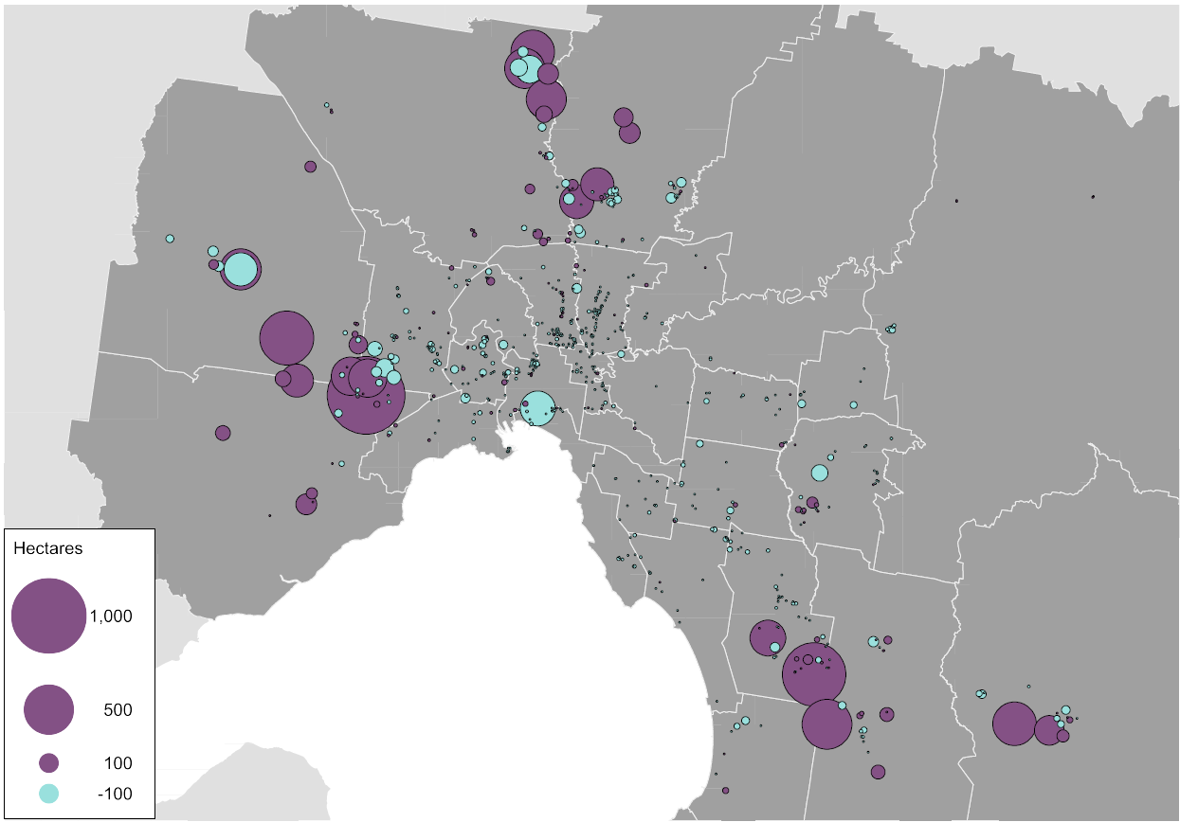
Source: Department of Environment, Land, Water and Planning, Urban Development Program – Melbourne Metropolitan Industrial 2018

Demand for Industrial land
There is strong ongoing demand for industrial land across metropolitan Melbourne.
Industrial land consumption across metropolitan Melbourne over the last three years (2015-16 to 2017-18) has been at a rate of around 280 hectares per annum. This is roughly equivalent to the area of the Melbourne CBD and Southbank combined. By comparison, in 2016, 2017 and 2018, take-up of industrial land in Greater Sydney averaged 152 hectares per annum.
Of all the industrial land consumed over the last three years across Melbourne almost 43 per cent of this land was within the Western SSIP. The Southern SSIP also saw strong demand for industrial land, accounting for nearly 23 per cent of land consumed over the period. While overall consumption in the Northern SSIP over the same period was not as high, annual consumption has increased significantly over the last couple of years as serviced land has become available. Combined these three SSIPs have accounted for three quarters of all industrial land consumed across metropolitan Melbourne over the last three years.

Table 4: Industrial land consumption, 2015-16 to 2017-18
Region / SSIP | 2015-16 (ha) | 2016-17 (ha) | 2017-18 (ha)
Inner Metro Region | -1.1 | -0.7 | -19.6
Western Region | 144.0 | 153.9 | 100.9
Western SSIP | 133.0 | 149.8 | 78.9
Northern Region | 24.3 | 34.4 | 52.0
Northern SSIP | 15.8 | 26.2 | 43.3
Eastern Region | 17.8 | 12.7 | 3.5
Southern Region | 102.0 | 109.3 | 110.2
Southern SSIP | 55.9 | 71.4 | 63.3
Officer-Pakenham SSIP | 15.5 | 12.4 | 13.9
Hastings SSIP | -1.0 | -0.3 | -18.3
Inner South East Region | -0.9 | 0.4 | 0.6
Total | 286.1 | 310.0 | 247.6
Source: Department of Environment, Land, Water and Planning, Urban Development Program – Melbourne Metropolitan Industrial 2018

Supply and demand for commercial land
As the population of Victoria continues to grow and its economy continues to transition to one based on services, it is expected that there will continue to be strong growth for commercial space, for both retail and office uses.
Professions such as accountants, lawyers and web designers, require access to office space. In recent times most of the increase in office-based employment has been located in the Central City, however there are also other areas, such as Cremorne, that are the locations for significant amounts of office space and major employers. Given the changing nature of the economy, it is expected that the demand for office space in the Central City and across metropolitan Melbourne will continue.
Metropolitan Melbourne also hosts a wide range of centres that provide services, such as retailing, entertainment and local professionals, to regional and local populations. These centres range from very large activity centres, such as the identified metropolitan activity centres, to local strip shopping centres. Given the projected levels of population growth, it is anticipated that there will continue to be demand for this type of space.
However, many industries in these sectors are experiencing a level of disruption to their traditional business models, such as on-line sales for retailing and flexible office space for office users. We are at the start of this disruptive activity. While it is unclear how this or future disruptions will impact land use, the role of planning for commercial space is to ensure that opportunities for current and future businesses are maintained and not lost.

Supply of commercial land
Almost 5,300 hectares of land zoned for commercial purposes has been identified across metropolitan Melbourne.
In addition, just over 1,320 hectares of land has been identified for future commercial purposes through Growth Corridor Plans and PSPs. Nearly 85 per cent of this land is located in the Western and Southern regions.

Table 5: Commercial land supply
Region | Existing zoned commercial land (ha) | Future commercial land identified (ha) | Total (ha)
Inner Metro | 1,158 | 0 | 1,158
Western | 949 | 559 | 1,508
Northern | 1,086 | 208 | 1,294
Eastern | 761 | 0 | 761
Southern | 855 | 555 | 1,410
Inner South East | 515 | 0 | 515
Total | 5,324 | 1,322 | 6,646
Source: Department of Environment, Land, Water and Planning, unpublished data (2020)

Commercial land and corresponding floorspace is occupied by a range of office, retailing, service, entertainment, restaurant and dining activities. It can include floorspace both at the ground level and any level above ground level.
It is estimated that there is approximately 24.2 million square metres of floorspace used or available for, commercial purposes across metropolitan Melbourne. Approximately 38 per cent of this is located within the Inner Metro Region, of which 80 per cent is located within the City of Melbourne.

Table 6: Commercial floorspace supply
Region | Existing floorspace  (m²) | Share of metro
Inner Metro¹ | 9,067,350 | 37%
Western | 2,909,700 | 12%
Northern | 3,239,150 | 13%
Eastern | 2,817,650 | 12%
Southern | 3,166,750 | 13%
Inner South East | 2,991,200 | 12%
Total | 24,191,800 | 100%
Source: Department of Environment, Land, Water and Planning, unpublished data (2020)
- Includes floorspace identified through the City of Melbourne’s Census of Land Use and Employment (2017) being used for Office, Commercial Accommodation, Indoor Entertainment, Retail or Performances, Conferences and Ceremonies.

Metropolitan Melbourne’s largest commercial centre is the Central City area which includes the Melbourne CBD and adjacent areas such as Docklands, Southbank and St Kilda Road. Beyond this area, commercial centres across metropolitan Melbourne demonstrate an historical pattern of development based on population growth along and around the public transport network, particularly the rail and tram network.
Excluding the City of Melbourne, there is approximately 17 million square metres of commercial floorspace across the metropolitan area in over 1,100 centres. These centres can vary greatly in both the size and range of retailing and services they offer, from smaller local centres offering local convenience retailing, to larger freestanding centres or larger metropolitan activity centres with a range of retail, services and office uses. Nearly 90 centres have in excess of 50,000 square metres of floorspace and three quarters of all centres identified (863 centres) have less than 10,000 square metres of floorspace.
There is a much denser distribution of centres within a 10 to 15-kilometre ring of the Melbourne CBD and along railway lines, adjacent to railway stations and along tram routes. This distribution pattern is most prevalent to the north, east and south-east of the CBD.

Figure 8: Commercial centres across metropolitan Melbourne
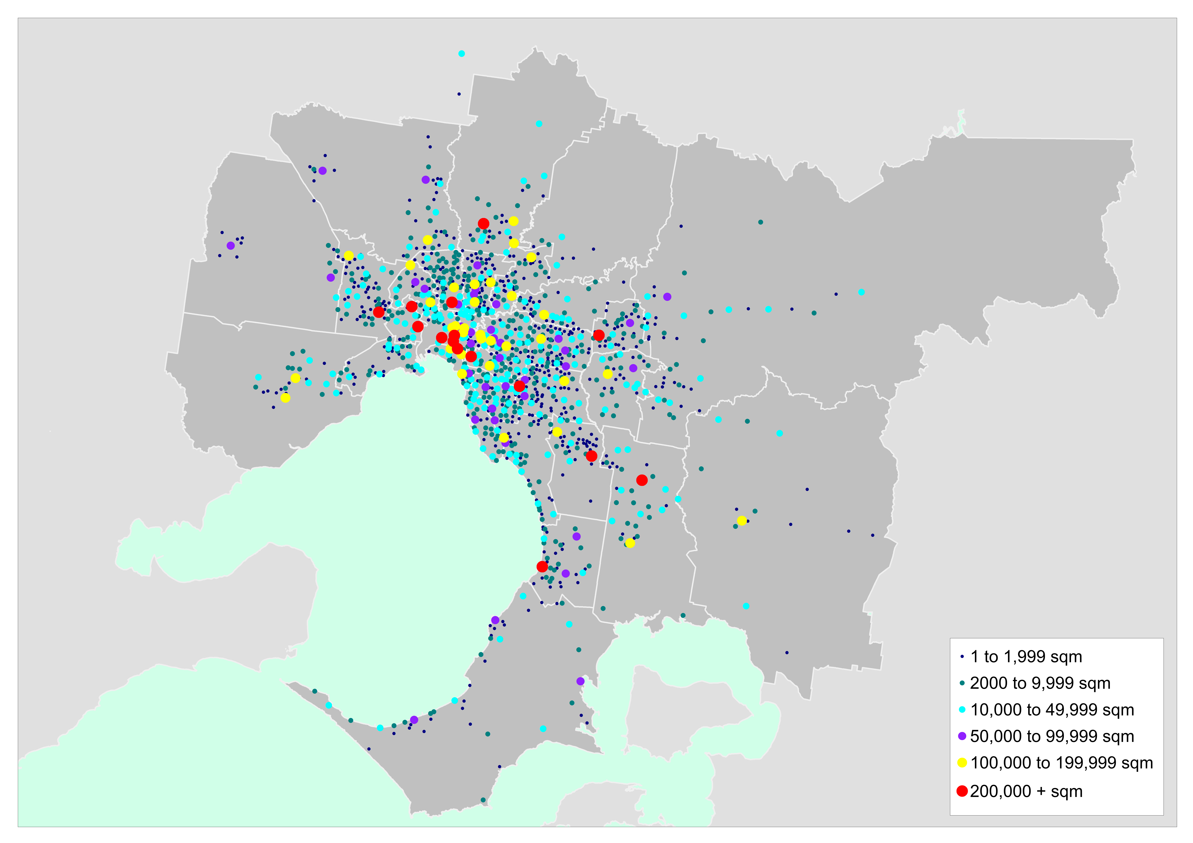Source: Department of Environment, Land, Water and Planning, unpublished data (2019)

Table 7: Number of centres and total floorspace by centre size
Commercial centre floorspace (m²) | Number of centres | Total floor space (m²)
Less than 2,000 | 493 | 469,900
2,000 to 9,999 | 370 | 1,691,800
10,000 to 49,999 | 200 | 4,423,000
50,000 to 99,999 | 39 | 2,794,450
100,000 + | 49 | 14,812,650
Total | 1,151 | 24,191,800
Source: Department of Environment, Land, Water and Planning, unpublished data (2020)

Map 3: Existing and future commercial land
Source: Department of Environment, Land, Water and Planning

Demand for commercial land
Demand for and growth in office floorspace in Melbourne’s CBD over the last 50 years has been relatively strong. Melbourne’s growth has been tracking fairly closely with Sydney’s although the overall supply of CBD office space in Melbourne has increased at a somewhat greater rate than Sydney.
Fifty years ago, Melbourne’s CBD had around half the office floorspace of Sydney’s CBD, whereas now each have office supply of between around 4.5 and 5 million square metres. This increase in Melbourne office space reflects the way the economy has evolved over time, with growth occurring in office-based employment such as finance, insurance and professional services showing strong demand for office floorspace.

Figure 9: Stock of office floorspace, Sydney CBD and Melbourne CBD, 1970 to 2017
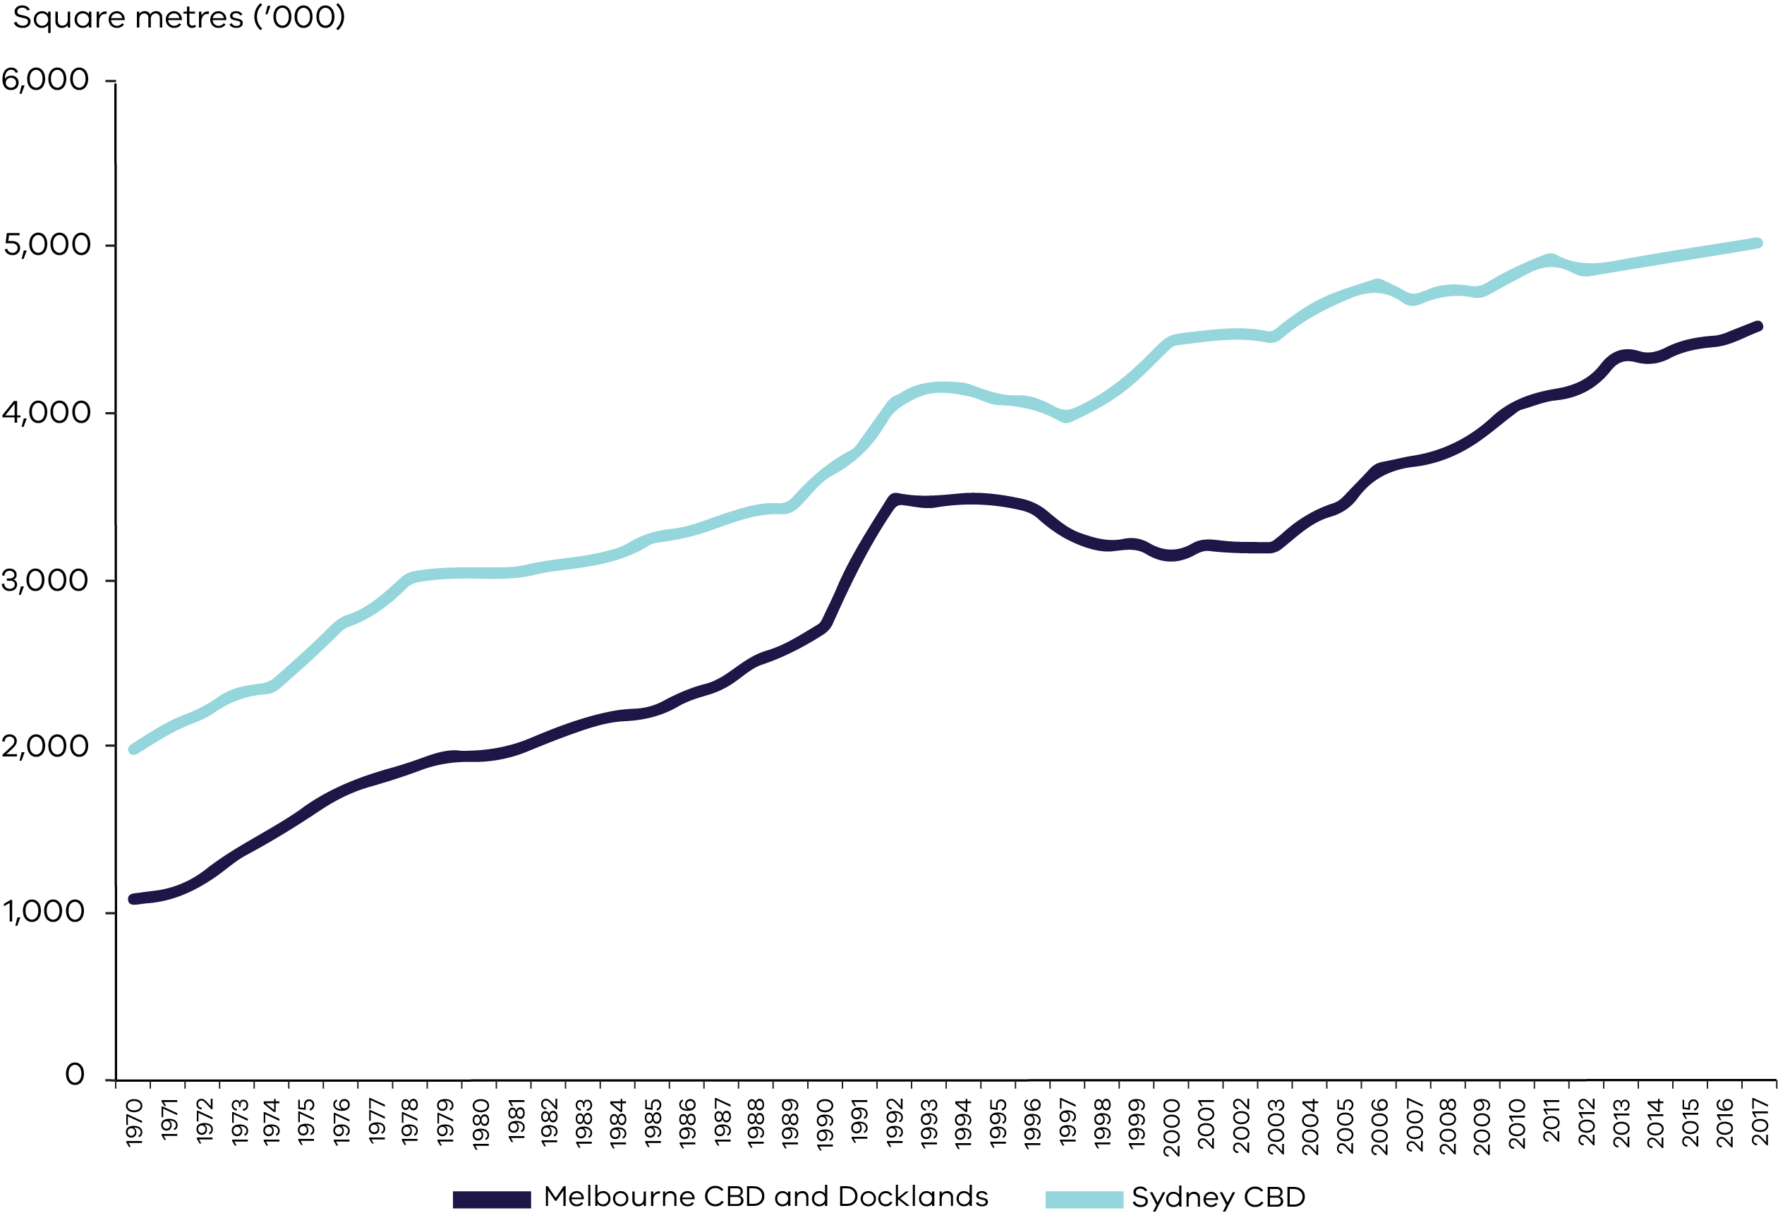
Source: BIS Oxford Economics and Savills

Between 2016 and 2031 it is estimated that nearly 10 million square metres of additional commercial floorspace will be required across metropolitan Melbourne to meet projected demand.
The Inner Metro Region, and particularly the City of Melbourne, will continue to be a key focus for growth, with the region anticipated to need almost 40 per cent (approximately 4 million square metres) of the total metropolitan commercial floorspace required by 2031. Over 80 per cent of this demand will be required for office floorspace.

Table 8: Commercial floorspace by region, existing and future
Region | Existing commercial floorspace  2018 (m²) | Estimated additional commercial floorspace  2016 to 2031 (m²)
Inner Metro | 9,067,350 | 4,007,000
Western | 2,909,700 | 1,548,000
Northern | 3,239,150 | 1,414,000
Eastern | 2,817,650 | 837,000
Southern | 3,166,750 | 1,371,000
Inner South East | 2,991,200 | 783,000
Total | 24,191,800 | 9,960,000
Source: Department of Environment, Land, Water and Planning, unpublished data (2020)

There is also expected to be significant commercial floorspace required in the Western, Southern and Northern Regions, with each of these regions anticipated to require upward of a 40 per cent increase in their supply of commercial floorspace. Much of this demand for commercial floorspace will be in the growth area municipalities.

Figure 10: Estimated additional commercial floorspace by region, 2016 to 2031
Source: Department of Environment, Land, Water and Planning, unpublished data (2020)

Approach to planning for industrial and commercial land
As Melbourne’s population continues to grow so too does demand for industrial and commercial space to support this growth.
There is strong growth forecast in the financial and professional services sectors as well as other population serving industries such as education and health care and social assistance. While the Central City will continue to play a key role in accommodating jobs growth, there will also be a need for significant commercial space to support population and jobs growth in suburban locations, particularly in Melbourne’s growth areas.
With Melbourne’s economy transitioning away from traditional manufacturing towards one focussed on the production and delivery of services, it is increasingly reliant on an efficient freight and logistics system. As such, the use of industrial land is transforming. Traditional manufacturing plants within industrial areas are now joined by a range of other services and uses that support the city as it grows. More and more, industrial areas are being utilised for a much broader range of uses, including retailing and professional services. While some of these uses may complement industrial uses, they can also have a negative impact by increasing land values and rents and potentially impact on day-to-day operations.
While these changes may lead to a belief that there is no longer a need to provide a substantial supply of industrial land, it will continue to be important to ensure there is enough industrial and commercial land to meet future demand for economic activity and employment purposes.
Work undertaken has highlighted a range of issues and matters that require consideration as follows:
- There is need to ensure that strategic planning for industrial and commercial areas is robust and appropriate and does not reduce viability for industry and commerce.
- There is ongoing pressure to rezone or use industrial land for other non-industrial uses such as accommodation or retail uses which are best located in activity centres. Key industrial areas need to be retained as a source of business activity and employment.
- There is a need to retain sufficient opportunities for commercial development, particularly on Commercial 1 zoned land, and balance the ongoing demand to develop residential uses above ground floor levels. Once developed for a residential use, it is unlikely to be available to the market for future commercial purposes.
- The business needs of developers, land owners and end users and their operating environment need to be better understood to inform policy development.
- Planning frameworks need to enable new business models to be accommodated and employment areas to evolve over time.
- In select locations there is a need to promote the creation of dense, economically diverse, affordable, accessible and amenity-rich enterprise precincts which are attractive to new and emerging businesses.
- Road, rail, airport and port infrastructure needs to support industry and allow for efficient freight, logistics and distribution of goods across the city as the population and economy grows.
- There is a need to recognise that many industrial areas will have lower relative job densities and will not be locations for jobs growth, however they will continue to play a critical role as places for industry and economic activity.
- There is a need to plan for amenity and interface issues that may arise where sensitive uses locate close to or adjacent to industrial operations.
- There are a range of urban services required across the city, such as mechanics, self-storage facilities, construction services, cabinetry manufacturers and the like, that need to locate in proximity to their customers. Opportunity for these to establish and operate need to be retained.

Principles and strategies to guide planning for industrial and commercial land
To ensure industrial and commercial areas are able to operate efficiently and effectively and remain viable, there is a need for clarity and certainty around how these areas are planned.
To support and guide planning for industrial and commercial land, the following principles and strategies have been developed. Some strategies have been derived from existing strategies within the Planning Policy Framework of the Victoria Planning Provisions, and others are new and have been developed to support the principles.

Principle 1
Adequate long-term commercial and industrial land supply will be identified and set aside to support future industry and business growth.
Strategies
- Provide an overarching land use planning framework for industrial and commercial areas.
- Identify how growth will be accommodated over the long term (at least 30 years) through state, regional and local assessments of land supply and demand.
- Provide and retain an adequate supply of well-located zoned land to accommodate growth for industrial and commercial uses, including sufficient stocks of larger sites for strategic investment.
- Retain and protect land identified for strategic long-term growth for its intended purpose.
- Ensure proposals for land use change identify either how they will accommodate local and regional employment needs, or how these can be satisfied by alternative means.
- Ensure the location and attributes of planned commercial and industrial areas will support their intended strategic function and user needs.
- Monitor development trends, land supply and demand for industrial and commercial land.

Principle 2
Industrial and commercial areas that provide an ongoing economic, urban servicing or employment contribution to local communities, regions and the state will be recognised and retained as a critical economic resource.
Strategies
- Ensure that state, regional and local policies are aligned to support industrial and commercial areas.
- Clarify and strengthen the role and function of commercial centres as primary locations for commercial development and employment, prioritising economic activity and business synergies.
- Prioritise industrial uses in industrial areas and avoid the approval of non-industrial land uses that will prejudice the availability of land in identified industrial areas for future industrial uses.
- Ensure that land identified as being of local significance for industrial purposes is only considered for mixed-use or residential purposes where strategic analysis can clearly demonstrate that the land is no longer required for industry, business or employment purposes and long-term demand can be met.
- Plan for land use transition by identifying areas of expected change and protecting land which will be required for future and emerging industry over the longer term.

Principle 3
Planning for industrial and commercial land will provide clarity and certainty about how and where industry and business can grow over time to support and guide long term investment and locational decisions.
Strategies
- Provide clear direction on locations where growth should occur.
- Protect state-significant industrial precincts from incompatible land uses to allow for future growth.
- Ensure that significant regional and local industrial and commercial precincts are retained through appropriate zones.
- Ensure that sensitive uses do not limit the operation of business in state or regionally-significant industrial precincts, through the provision of adequate separation and buffer areas.

Principle 4
Planning will support industry and business to innovate and grow in areas identified for these purposes.
Strategies
- Provide opportunities for a wide range of industry and business activities to establish and operate both across Melbourne and in local areas.
- Support the development or re-use of buildings that provide affordable, flexible and innovative spaces for businesses.
- Encourage the development and expansion of specialised industry clusters.
- Provide for significant local employment opportunities to encourage local trip making and a compact city.
- Provide for large scale industrial or regional employment generators in locations suitable for such uses.
- Support the development of infrastructure and services which facilitate the development or growth of industrial and commercial areas.

Planning framework for industrial and commercial land
To support planning for industrial and commercial land, it is proposed to put in place a classification system that can assist how these areas are planned.
The following framework has been developed to enable industrial and commercial land to be categorised as being either of state, regional or local significance to provide greater clarity about the strategic land use intent.
The level of significance in the hierarchy does not in itself indicate whether land should be retained for current industrial or employment uses, or considered for alternative uses. Future land use will need to be determined by the relevant planning agencies through their strategic land use plans, including Plan Melbourne.
All planning agencies will need to give weight to the classification of the land in the hierarchy and the directions in this plan and other state policy when considering future land use and development opportunities. A classification of state, regional, or local significance reflects the policy aspiration for the area or precinct. The classification may arise because either a location has been assigned a level of significance through a strategic land use plan, or because of the location’s existing attributes. State government will be responsible for designating state and regionally-significant industrial and commercial land when undertaking metropolitan, or regional wide planning.

Changes to state and regionally-significant industrial and commercial land
State-significant places are identified and put in place through the metropolitan planning strategy – Plan Melbourne. They are supported by state and regional policy included within the Planning Policy Framework in the Victoria Planning Provisions. Any future changes to these places would normally occur through a review of Plan Melbourne.
Regionally-significant industrial and commercial land is identified through the Melbourne Industrial and Commercial Land Use Plan and are intended to be supported by regional policy in the Planning Policy Framework in the Victoria Planning Provisions. Any future changes to the extent of these areas would only be anticipated to occur following broader strategic work being led by either state or local government that justifies such a change. Subsequent planning scheme amendments would be required.
Examples of the type of strategic work that might require subsequent changes to the extent of regionally-significant industrial or commercial land includes strategic work being undertaken and led by state government such as the development of Land Use Framework Plans, planning for national employment and innovation clusters and priority precincts, precinct structure planning for growth areas and other major infrastructure projects such as the Suburban Rail Loop.
There may also be instances where strategic planning work being led by local government, either municipal-wide or at a larger precinct-scale, may require subsequent changes to the extent of the regionally-significant industrial or commercial land. An example of such planning is the work underway by the City of Darebin for the Northland Urban Renewal Precinct in East Preston. This area includes the Northland Major Activity Centre and an area of industrial land identified as a regionally-significant industrial precinct by the Melbourne Industrial and Commercial Land Use Plan. It also forms part of the broader La Trobe National Employment and Innovation Cluster.
The Northland Urban Renewal Precinct is a long-term planning project with an horizon of 30+ years. Considerable strategic work has already been completed by council, with objectives to facilitate greater diversity of employment and increased residential population within the precinct. Upon completion of this work by council realignment or changes to the overall extent of commercial and industrial land will likely be required.

Industrial precincts

State-significant industrial precincts
State-significant industrial precincts (SSIPs) are identified in Plan Melbourne and the Victoria Planning Provisions. There are five SSIPs identified across metropolitan Melbourne: Western SSIP, Northern SSIP, Southern SSIP, Officer-Pakenham SSIP and Hastings SSIP.
As outlined in that strategy, the purpose of SSIPs is to provide strategically located land for major industrial development linked to the PFN and transport gateways. Future state-significant industrial land has also been identified to ensure there is sufficient land supply available for major industrial development.
It is state policy that these areas are to be protected from incompatible land uses to allow continual growth in freight, logistics and manufacturing investment.

Regionally-significant industrial precincts
Across metropolitan Melbourne there are numerous key industrial and employment areas that contribute significantly to local and regional economies. Some of these areas are well established and support a range of industrial uses while others are transitioning to support higher order uses and providing a broader range of employment opportunities. In addition, future employment areas have been identified through Growth Corridor Plans to support not just employment growth in outer areas, but to also meet Melbourne’s longer term industrial and logistics needs.
To support economic growth, industrial areas of regional-significance have been identified. These areas need to be planned for and retained either with a focus as a key industrial area or as a location that can provide for, or transition to, a broader range of employment opportunities. Industrial focussed precincts would normal provide for a range of traditional industrial uses such as manufacturing, warehousing and other industry. In other precincts there may be a desire to promote a different employment focussed outcome offering a higher amenity to workers and economic vibrancy. This could include a greater focus on office or business park development or support for new and emerging innovation and enterprise-based businesses.
State or local government will generally be responsible for planning regionally-significant industrial precincts as part of developing local industrial land use strategies, or other strategic plans.
Appropriate land use outcomes for such precincts should be determined through these processes having regard to the principles and strategies of this plan and achieving sufficient land supply to support the long-term economic interests of the region and the state.
The following criteria has been used as a basis for identifying regionally-significant industrial precincts. For a precinct to be considered regionally-significant, it should generally satisfy at least one aspect of two of the following criteria.

Criterion 1: Policy alignment
- The area exhibits a strong relationship with or supports other places of state significance such as national employment and innovation clusters (NEICs) or transport gateways.
- The area has been identified through growth area planning as a larger industrial estate offering good freeway and arterial road access and can provide for the industrial land requirements of firms that serve metropolitan wide, national or international markets.
- The area has been identified in council strategies as being a core or primary industrial area that should be retained, or that provides for significant employment opportunities by virtue of the size of the area.

Criterion 2: Accessibility and business clustering
- The area or precinct can leverage off existing or proposed rail, road and data networks and infrastructure, including the PFN.
- The area provides for, or has the potential to provide for, the clustering of industrial and employment uses with limited or no residential intrusion and can be adequately buffered from sensitive uses.
- The precinct provides for contiguous areas of industry or employment with similar, related or dependent industrial or commercial activities, such as economic clusters and supply chains.

Criterion 3: Economic or employment contribution
- The area generates, or has the potential to generate, a relatively high and ongoing economic output contributing to the region and state’s economy.
- Within that region the area either is, or has the potential to be, a location of relatively high levels of employment and/or capital goods, generating wider regional employment and economic benefits.
- The area supports critical or specialised urban services which play a unique function in the region and enable and support other economic activity.

Local industrial precincts
If an area is not identified as being of state or regional significance, then it is of local significance. Being identified as a local industrial precinct does not mean that it is not still important to be retained either for industrial purposes or other employment purposes.
Councils are best placed to determine how these industrial areas are to be planned for. This could include identifying when industrial land should be retained, when it could transition to other employment generating uses, or if it is no longer required, when it could transition to other mixed-use or non-employment focussed uses.
Councils should undertake an industrial land use strategy, or similar strategic work for precincts, to support their planning policies for industrial land. Draft guidance for developing an industrial land use strategy is provided at Appendix 2. This will be further developed into a practice note to assist councils in undertaking this strategic work, including criteria for considering changes of land use.

Planning for industrial precincts
State-significant industrial precincts  Purpose:  To provide strategically located land for major industrial development linked to the Principal Freight Network and transport gateways.  They will be protected from incompatible land uses to allow continual growth in freight, logistics and manufacturing investment. | Zone guidance:  - Industrial 1 Zone would usually be applied to land within a state-significant industrial precinct.  - Industrial 2 Zone should be applied in specific instances where manufacturing industries and storage facilities require a substantial threshold distances so as not to affect the safety and amenity of local communities.  - Industrial 3 Zone could be applied to provide a buffer between industry and local communities where required.  - Commercial 2 Zone could be applied in some situations, for examples, to business precincts identified in growth corridor plans where the land is located within a SSIP.  - Special Purpose Zones may apply in some circumstances. This would occur where there is a specific industry or asset that requires special consideration, for example, petrochemical facilities.
Regionally-significant industrial precincts  Purpose:  To provide opportunities for industry and business to grow and innovate in appropriate locations for a range of industrial and other employment uses that can contribute significantly to regional and local economies.  They will be retained and planned to allow a range of industrial and other employment uses, and where appropriate, new and emerging types of businesses that require access to affordable and well-located land to grow and innovate.  They may serve broader city functions or support activities which benefit from scale with some precincts offering opportunity to transition to a broader range of employment opportunities offering a higher amenity to workers and economic vibrancy. | Zone guidance:  - Industrial 1 Zone would usually be applied to precincts focussed on allowing for traditional industrial uses.  - Industrial 3 Zone could be applied to provide a buffer between industry and local communities where required.  - Commercial 2 Zone could be applied to precincts where a broader range of employment uses are desirable.  - Commercial 3 Zone may be applied to help facilitate business growth and innovation in select areas.
Local industrial precincts  Purpose:  To provide for a range of local industry and employment opportunities that support local communities and other businesses operating in the local area.  They will be planned to support local service trades and the needs of smaller businesses serving more localised markets. They should be retained for industrial or employment purposes unless a planning authority has identified them for an alternate non-employment purpose. | Zone guidance:  - Industrial 1 Zone would usually be applied to precincts focussed on allowing for traditional industrial uses.  - Industrial 3 Zone could be applied to provide a buffer between industry and local communities where required.  - Commercial 2 Zone could be applied to precincts where a broader range of employment uses are desirable.  - Commercial 3 Zone may be applied to help facilitate business growth and innovation in select areas.

Commercial areas
For the purpose of this report, the existing activity centre classification is used as a basis for classifying the role and purpose of commercial land.
There are various practice notes and guidance materials available to assist councils in planning for activity centres.

State-significant commercial areas
Melbourne’s Central City is identified in Plan Melbourne as being of state significance. It is to provide for the continued growth of knowledge-intensive and high-skilled firms in the Central City while continuing to be a major area for tourism, retail, residential, entertainment, sporting and cultural activities.
Metropolitan activity centres identified in Plan Melbourne are of state significance. They are to provide a diverse range of jobs, activities and housing for regional catchments that are well served by public transport. These centres will play a major service delivery role, including government, health, justice and education services, as well as retail and commercial opportunities.

Regionally-significant commercial areas
Major activity centres identified in Plan Melbourne should be considered as places of regional significance. While they have different attributes and provide different functions, with some serving larger sub-regional catchments, they should provide for and support access to a wide range of goods and services.
Growth area business and residential precincts are identified in Growth Corridor Plans and are considered as places of regional significance able to provide for a wide range of employment opportunities. These areas are expected to deliver more intensive forms of employment uses including service industries, office and commercial activity, research and development and some large format retailing. The precincts may also include residential, cultural, recreational and civic uses as part of a broader mix of activities supporting the overall employment activities. These precincts should have a primary role for economic and employment purposes with no less than 50 per cent of the land in each precinct being allocated for these purposes.

Local commercial areas
Neighbourhood activity centres are local centres that provide access to local goods, services and employment opportunities and serve the needs of the surrounding community. These centres are essential in providing local employment opportunities and make a crucial contribution to the role, character and functioning of our city. Planning for these areas should create opportunities for local businesses and new jobs and deliver better access to local services and facilities.

Implementation
The following actions will be undertaken to support planning for industrial and commercial land.
Action 1:
The Department of Environment, Land, Water and Planning (DELWP) will implement new and updated policy into the Victoria Planning Provisions to support state and regionally-significant industrial and commercial precincts based on the Melbourne Industrial and Commercial Land Use Plan.
Action 2:
In consultation with key stakeholders, DELWP will develop and implement a more sophisticated methodology and approach to assess future supply and demand for industrial land taking into account business needs and land use requirements.
Action 3:
DELWP will expand the Urban Development Program to include updates to the commercial floorspace estimates into the future and will explore the appropriate timing and updating cycle for this work.
Action 4:
DELWP will review the commercial and industrial zones to better understand how they are applied and operating. In particular, consideration will be given to the role and function of dwellings as a section 1 use in the Commercial 1 Zone and the role and purpose of the Commercial 2 Zone and how it applies and operates, particularly in industrial locations. Consideration will also be given to the range of uses permitted within industrial zones, and in particular, non-industrial focussed uses.
Action 5:
Councils should prepare and implement municipal-wide industrial land use strategies and activity centre strategies, or undertake similar strategic work for precincts, to guide future development of industrial and commercial land.
Action 6:
Building on the guidance included at Appendix 2, DELWP will work with local councils to develop a practice note to support the development of local industrial strategies.
Action 7:
The state government will investigate options available to preserve and create affordable workspace in inner Melbourne and other strategic locations.
Action 8:
The state government will work with local councils to look at future opportunities for industry in the Brooklyn, Tottenham and West Footscray area, including improving connectivity. This will look at ways that state-significant industrial land could regenerate and support industry into the future.

PART B: REGIONAL SUMMARIES AND DIRECTIONS

Inner Metro Region

Regional snapshot
The Inner Metro Region comprises the municipalities of Melbourne, Port Phillip and Yarra. The region includes the Melbourne CBD and major urban renewal precincts including Docklands, Fishermans Bend, Arden, Macaulay, Dynon and the Flinders Street Station to Richmond Station corridor. These precincts will play a key role in the further evolution of central Melbourne as a destination to live, work, visit and invest.
The areas from Richmond to Docklands through the Central City and Southbank, include the sporting precincts of the Melbourne Cricket Ground and Melbourne Park, the Arts Precinct, Melbourne Aquarium, museums and other key destinations for local, interstate and international visitors. The region is home to many sites of environmental significance including the Yarra and Maribyrnong Rivers and Port Phillip Bay. The extensive open space areas in the region are integral to Melbourne’s liveability.
The Central City is the city’s highest order centre and also supports key sporting, cultural, tourism and leisure precincts and public institutions. The economic strengths of the Central City are supported by two national employment and innovation clusters (NEICs). The first located at Parkville is focussed on health, education, research, professional and technical industries. The second is Fishermans Bend with a strong specialisation in innovation, design and manufacturing. These NEICs will provide for 21st century jobs adjacent to the CBD.
The business service sector is the largest contributor to the economy for the region, with a total value-added estimate at around $72.8 billion. Manufacturing and industrial is the next largest contributor with a total value-added estimate at around $14.9 billion. Combined, these sectors account for around 78 per cent of the total value-add for the region.

Fast facts
PEOPLE  Population in 2006 242,603  Population in 2016 347,617  That’s 43% more people  Melbourne = +65,942  Port Phillip = +18,986  Yarra = +20,086 | JOBS  Jobs in 2006  492,950  Jobs in 2016  682,800  That’s 39% more jobs  Melbourne = +156,300  Port Phillip = +8,700  Yarra = +24,850 | ECONOMY  GRP for the region  $117 billion  Share of metropolitan Melbourne’s total GRP  35%  Melbourne = $90.5 billion  Port Phillip = $13.6 billion  Yarra = $13.1 billion
Source: Department of Environment, Land, Water and Planning, unpublished data (2019)
The region was home to around 347,600 people in 2016. By 2031 it is projected that the region will grow by 191,700 people to a total population of around 539,300. The municipality of Melbourne will experience the strongest population growth over this period.

Figure 11: Projected population growth, Inner Metro Region, 2016 to 2031

Source: Department of Environment, Land, Water and Planning, Victoria in Future 2019 (July 2019).
In 2016 the region supported 682,800 jobs accounting for around 30 per cent of all employment in metropolitan Melbourne.
By 2031 it is projected that approximately 280,000 additional jobs will be located across the region. Approximately 70 per cent of new jobs in the region are expected to be within the municipality of Melbourne.
The industries that are expected to experience the strongest growth are: professional, scientific and technical services; health care and social assistance; financial and insurance services; public administration and safety; Education and training.

Figure 12: Projected employment growth, Inner Metro Region, 2016 to 2031
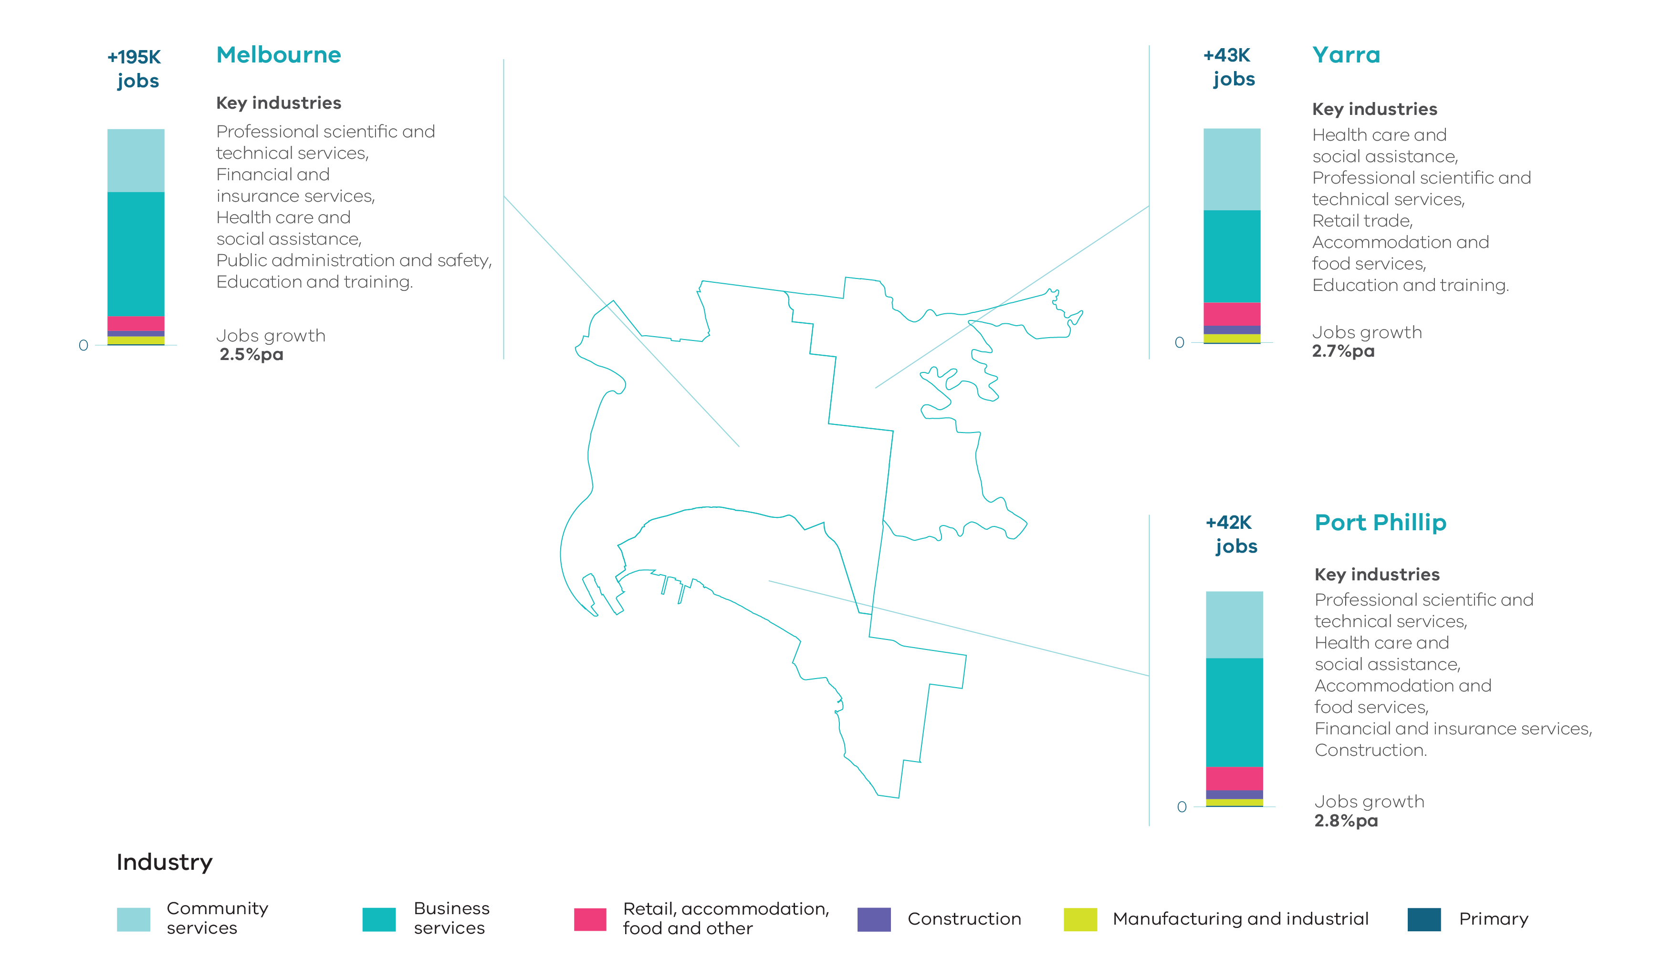
Source: Department of Jobs, Precincts and Regions, internal analysis (2019)
NOTE: Job figures have been rounded to the nearest thousand.

Key industrial and commercial areas
The Central City incorporates the CBD (Hoddle grid, north to Grattan Street between Peel and Swanston Streets) as well as Docklands, Southbank and St Kilda Road. It is home to the largest concentration of jobs across the city and is metropolitan Melbourne’s principal centre for commerce, professional, business and financial services. It will continue to be the key location for business services offering a range of office, retail and tourism. Increasingly these areas are becoming locations for housing. St Kilda Road is a significant mixed-use and commercial area that transverses the City of Melbourne and City of Port Phillip. It comprises large concentrations of existing offices and accommodation and will be further enhanced with the proposed Anzac Station as part of the Melbourne Metro rail project.
Fishermans Bend NEIC has direct access to West Gate Freeway and CityLink and is strategically located, adjacent to the Port of Melbourne, the CBD and Docklands. The employment precinct is currently home to approximately 13,000 jobs. The Fishermans Bend Framework outlines a vision for the precinct to become internationally renowned as a centre of innovation in advanced manufacturing, engineering and design, building on the presence of the University of Melbourne at the former General Motors Holden site and significant investment in public transport. It is anticipated that there will be up to 40,000 jobs in this precinct by 2050. The Framework also envisages significant opportunity for increased commercial floorspace and jobs in the mixed-use precincts, particularly in the Sandridge precinct. These mixed-use precincts will transition away from industrial uses and it is projected that 40,000 jobs will be provided across the mixed-use precincts, potentially creating a total of 80,000 jobs in Fishermans Bend by 2050.
The Parkville NEIC has a range of education, research, health, professional and technical industries as well as significant parkland. It is an established, internationally renowned research centre, particularly in biomedical sciences, on the doorstep of the CBD. It comprises a range of institutions including the University of Melbourne, Monash University (Faculty of Pharmacy and Pharmaceutical Sciences), RMIT University, Royal Melbourne Hospital, Doherty Institute, the Victorian Comprehensive Cancer Centre, the Walter and Eliza Hall Institute of Medical Research, the Florey Institute and the Commonwealth Serum Laboratories. The cluster has a high level of public transport access, with tram routes via Swanston and Elizabeth Streets. Accessibility will be improved with the establishment of a new, state-of-the-art train station at Parkville as part of the Metro Tunnel project.
Arden and Macaulay located in Kensington and North Melbourne have been identified as major urban renewal areas which have the potential to transition away from traditional industries to new areas for knowledge-based employment, extending from the Central City to the Parkville NEIC. The Arden area will be further enhanced by a new train station as part of the Metro Tunnel project. A number of sites have been rezoned from industrial to mixed-use. Arden Central will provide an extension of the Parkville Biomedical Precinct, providing an estimated 34,000 jobs and 15,000 residents (Arden Vision, July 2018). The area around Macaulay provides opportunity to create a mid-rise, mixed use neighbourhood with sustainable transport, new open spaces and community facilities.
The Port of Melbourne is the largest international container terminal, automotive and general cargo port in Australia. It operates 24 hours per day, 365 days per year, and it handles around 36 per cent of Australia’s container trade. The port plays a vital role in generating jobs and economic prosperity for Victoria and south-eastern Australia, with a total trade of more than $90 billion annually. Planning and development for land uses within and near the port area needs to protect the viability of the port’s operation and Melbourne’s position as a leader in freight and logistics.
West Melbourne and Dynon Road industrial area is an industrial area located in West Melbourne. It accommodates a range of freight and industrial uses. Council’s strategy supports the ongoing manufacturing, wholesale transport and distribution industries in the precinct. The precinct is located adjacent to the Port of Melbourne and has direct access to the PFN.
In the City of Yarra, there are a number of industrial precincts in Abbotsford along the Yarra River. The Carlton and United Breweries (CUB) site is an anchor use in this area and has been identified for ongoing industrial and business needs. These precincts are identified by council to be retained for a range of employment uses including manufacturing, offices and urban services.
The Gipps Street precinct in Collingwood is home to creative sectors such as architecture and design, software and interface design and visual arts. Council strategies support commercial office conversions, small office complexes, light industry and office warehouse developments in the area.
The Cremorne precinct is strategically located adjacent to CityLink and Richmond Station and is emerging as one of Melbourne’s premier destinations for creative design, particularly tech and digital design. It is an area that has experienced a transition from manufacturing uses to more contemporary uses such as small creative industry firms as well as large web-based companies. It is home to global companies as well as small to medium sized firms, start-ups and co-working spaces. The Victorian Planning Authority is currently working with the City of Yarra to support Cremorne’s continued growth as a thriving enterprise precinct.
The South Melbourne Central Business Precinct in the City of Port Phillip offers a mixture of service industries and showrooms, offices and warehouses. This precinct is a long-standing key location for creative industries such as design, music, film and television as well as photography. The area enjoys a premium location adjacent to the South Melbourne Major Activity Centre. It has close proximity to the CBD and Fishermans Bend as well as good access to a skilled workforce and public transport services.
The Activity Centres network in the region is anchored by the Central City and supported by 10 major activity centres and numerous smaller neighbourhood activity centres across the region. These activity centres are generally located on the Principal Public Transport Network. They vary in size, role and function and offer different potential for growth.
Victoria Gardens, a large free-standing shopping centre, together with Victoria Street, offers a significant retail presence, serving a larger, sub-regional catchment. In other parts of the region, strip-based centres such as Balaclava, Carlton-Lygon Street, Fitzroy-Brunswick Street, Bay Street Port Melbourne, Richmond-Bridge Road and Swan Street, Clarendon Street South Melbourne and Acland Street and Carlisle Street St Kilda offer a range of retailing, office, restaurant, entertainment, tourism, accommodation and community uses.

Supply and demand for industrial and commercial land across the region

Industrial land
There are 460 hectares of zoned industrial land within the Inner Metro Region. Most of this land is occupied with only 28 hectares of land being vacant. The majority of vacant industrial land is located within the City of Melbourne, adjacent to the Port of Melbourne in the Dynon Precinct.

Table 9: Industrial land supply, Inner Metro Region
Council | Zoned occupied (ha) | Zoned vacant (ha) | Future supply (ha) | Total available supply (ha)
Melbourne | 310.0 | 25.5 | 0.0 | 25.5
Port Phillip | 12.7 | 0.8 | 0.0 | 0.8
Yarra | 136.7 | 1.7 | 0.0 | 1.7
Total | 459.4 | 28.0 | 0.0 | 28.0
Source: Department of Environment, Land, Water and Planning, Urban Development Program – Melbourne Metropolitan Industrial 2018

Table 10: Industrial land consumption, Inner Metro Region, 2015-16 to 2017-18
Council | 2015-16 (ha) | 2016-17 (ha) | 2017-18 (ha)
Melbourne | -1.0 | -0.3 | -18.3
Port Phillip | 0.0 | -0.1 | -0.7
Yarra | -0.1 | -0.3 | -0.6
Total | -1.1 | -0.7 | -19.6
Source: Department of Environment, Land, Water and Planning, Urban Development Program – Melbourne Metropolitan Industrial 2018

Consumption figures provided here and in the UDP are for net activity. A negative figure indicates that building demolition activity was greater than the level of building construction activity (consumption). In locations such as the Inner Metro Region, most of the land is occupied by an existing building and use. In many instances, in order to develop land for new industrial use, the existing building needs to be demolished. Therefore, a negative consumption figure will be recorded until the site is redeveloped for further industrial development activity. The former GMH site is an example of this where the building was demolished, however the site will be used for a new building or use at a point in time in the future.
Between 2000-01 and 2017-18 a total of 326 hectares of industrial land was rezoned across the region for non-industrial uses.
The largest single loss of industrial land over this period was within the City of Port Phillip with approximately 216 hectares of land rezoned to Capital City Zone within Fishermans Bend. Of the remaining industrial land rezonings over this period, the vast majority (77 per cent) were sites of less than 2 hectares in size.
Of all the industrial land rezoned over the period, 87 per cent was rezoned to allow for mixed-use or residential development. This included the land at Fishermans Bend rezoned to Capital City Zone.
While there is limited land available for industrial purposes across the region, growth in manufacturing and industrial jobs will account for almost 4 per cent of all new jobs over the period 2016 to 2031. Therefore, opportunities will need to continue to be provided across the region to accommodate these types of jobs.

Figure 13: Change of zoned industrial land, Inner Metro Region, 2000-01 to 2017-18
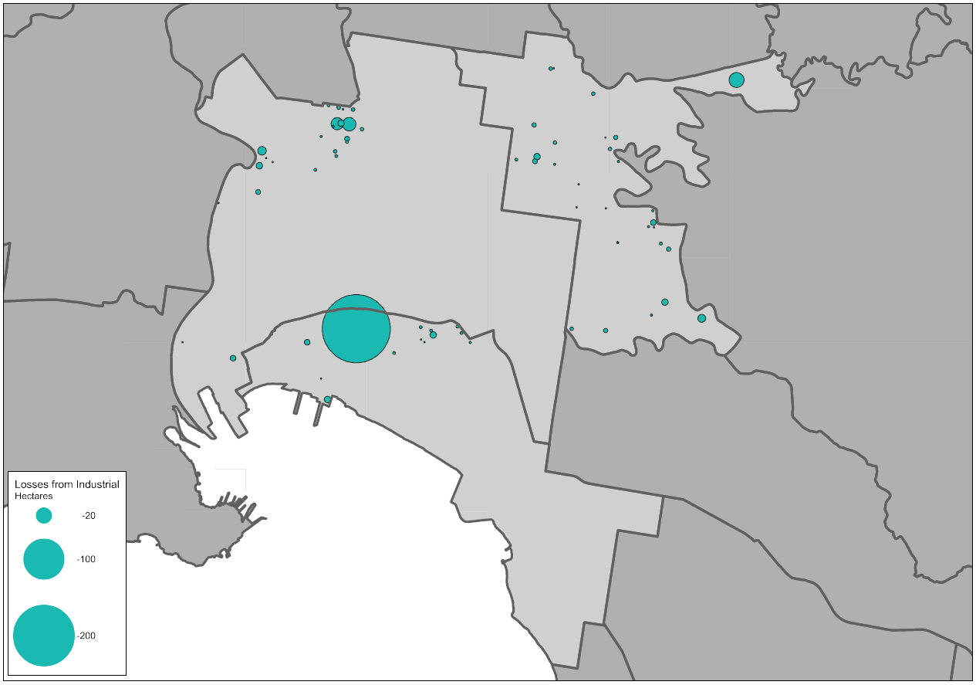
Source: Department of Environment, Land, Water and Planning, 2018, Urban Development Program – Melbourne Metropolitan Industrial 2018

Commercial land
Currently across the region there is a total of 1,158 hectares of land that has been identified as being zoned for commercial purposes. It is estimated that there is approximately 9 million square metres of floorspace used or available for commercial purposes on this land.
Across the region, a total of 72 commercial areas or centres have been identified. Of these, 35 have less than 10,000 square metres of floorspace and 19 centres have between 10,000 and 49,999 square metres.
Thirteen commercial areas have more than 100,000 square metres of floorspace, including the key office locations of Victoria Parade, Docklands, Southbank and St Kilda Road (both in the City of Melbourne and the City of Port Phillip) as well as retail areas such as Lygon Street, St Kilda and Smith Street. These centres account for approximately 89 per cent of all commercial floorspace supply in the region, and of this approximately 86 per cent is located within the City of Melbourne.

Table 11: Existing commercial floorspace by centre size, Inner Metro Region
Council |  | Less than 2,000 (m²) |  | 2,000 to 9,999 (m²) |  | 10,000 to 49,999 (m²) |  |  |  | 50,000 to 99,999 (m²) |  | Greater than 100,000 (m²)
 | No. of centres |  | Floorspace (m²) | No. of centres | Floorspace (m²) |  | No. of centres | Floorspace (m²) | No. of centres |  | Floorspace (m²) |  | No. of centres | Floorspace (m²)
Melbourne | 2 |  | 3,300 | 4 | 20,500 |  | 7 | 177,100 | 0 |  | 0 |  | 7 | 7,011,600
Port Phillip | 4 |  | 3,050 | 10 | 50,300 |  | 5 | 125,700 | 1 |  | 52,700 |  | 3 | 689,700
Yarra | 9 |  | 8,450 | 6 | 26,250 |  | 7 | 215,550 | 4 |  | 271,700 |  | 3 | 411,450
Total | 15 |  | 14,800 | 20 | 97,050 |  | 19 | 518,350 | 5 |  | 324,400 |  | 13 | 8,112,750
Source: Department of Environment, Land, Water and Planning, unpublished data (2020)

Based on projected growth, it is anticipated that an additional 4 million square metres of commercial floorspace will be required across the Inner Metro Region by 2031. Approximately 3.3 million square metres will be required for office uses and the remaining 700,000 square metres will be required for retail. Almost 71 per cent of this additional floorspace is anticipated to be located within the City of Melbourne.
Options to accommodate projected demand for commercial floorspace in the region need to be identified within existing commercial areas, as well as considering areas that could accommodate future floorspace requirements through rezoning.

Table 12: Commercial floorspace supply and estimate, Inner Metro Region
Council | Existing commercial  floorspace 2018 (m2) | Estimated additional commercial floorspace  2016 to 2031 (m2)
Melbourne | 7,212,500 | 2,841,000
Port Phillip | 921,450 | 618,000
Yarra | 933,400 | 548,000
Total | 9,067,350 | 4,007,000
Source: Department of Environment, Land, Water and Planning, unpublished data (2020)
*Existing commercial floorspace for the City of Melbourne has been based on their 2017 Census of Land Use and Employment Summary Report.

Figure 14: Estimated additional commercial floorspace by type and municipality, Inner Metro Region, 2016 to 2031
Source: Department of Environment, Land, Water and Planning, unpublished data (2020)

Planning framework for industrial and commercial land across the region
The Inner Metro Region contains the largest supply of commercial land in the metropolitan area, however there is a relatively small amount of industrial land. Even so, the region is home to industrial areas critical to the State’s economy and ongoing prosperity. They provide employment and economic functions which are significant at state, regional and local levels.
Industrial land has been decreasing across the region and commercial uses are being increasingly displaced by accommodation and other uses. This trend potentially has negative impacts for the region’s economy and employment. Improved monitoring, oversight and protection of remaining industrial and commercial land is therefore required.
Significant opportunity exists at major urban renewal sites across the region to accommodate future growth of appropriate industries and businesses, however, there remain a number of challenges for the region in planning for industrial and commercial land.
Maintaining a supply of affordable and appropriately located industrial land for a range of industries, including creative industries and service industries, will be important to support businesses and residents in the region as well as the broader metropolitan area. A key challenge for such industries will be ensuring they are able to establish and operate effectively.
There is also a need to carefully balance planning for industrial and commercial areas with pressure for ongoing residential development. New residential or mixed-use development adjacent to industrial areas will need careful consideration, so as not to limit the ability of businesses to continue to operate. Consideration should be given to ways in which any potential conflicts can be mitigated or managed.
Planning for the region should:
- Retain land in the Fishermans Bend NEIC employment precinct, around the Port of Melbourne at Dynon and in Abbotsford predominantly for industrial uses.
- Retain and support areas in and around Collingwood, Cremorne and South Melbourne to continue to develop as key locations creative industry uses.
- Investigate opportunities in areas such as Arden Central and Domain to support other employment uses that are well connected to adjacent employment uses, including the Parkville NEIC and the Central City.
- Identify precincts and opportunities where commercial development should be prioritised and can be accommodated to meet future needs.

Map 4: Inner Metro Region - industrial land
Source: Department of Environment, Land, Water and Planning

Map 5: Inner Metro Region - commercial land
Source: Department of Environment, Land, Water and Planning

Western Region

Regional snapshot
The Western Region comprises the municipalities of Brimbank, Hobsons Bay, Maribyrnong, Melton, Moonee Valley and Wyndham. It is the fastest growing region in metropolitan Melbourne, and home to the Western Growth Corridor with two major growth fronts, Melton to the north and Wyndham to the south.
The region has good connections to transport gateways along key roads and railways, although road capacity is creating some constraints within the Western state-significant industrial precinct (Western SSIP). Significant competitive advantages exist for the region having easy access to Avalon, Essendon and Melbourne Airports as well as the Port of Melbourne and proposed Bay West container port. There are also substantial synergies provided by complementary industries nearby.
The proposed Western Interstate Freight Terminal (WIFT) is an important future asset for the distribution of freight from industrial and commercial production in the Western Region linking to freight networks in other regions and interstate. The key transport links include the Western Highway, Princes Highway and Freeway and the Western Ring Road connecting through to the Hume Highway. The region also has three key railway links through the region and beyond to regional Victoria. These provide important connections to industrial areas across the region and to existing and proposed transport gateways via the PFN. The proposed Outer Metropolitan Ring / E6 Transport Corridor (OMR) further enhances intra metropolitan regional network connections, together with connections to regional Victoria including Geelong, Ballarat and Bendigo via Regional Rail Link and the Calder Freeway.
The business service sector is the largest contributor to the economy for the region with a total value-added estimate at around $13.3 billion. The manufacturing and industrial sector is the next largest contributor with a total value-added estimate at around $11.1 billion. Combined, these sectors account for almost 64 per cent of the total value-add for the region.

Fast facts
PEOPLE  Population in 2006  625,128  Population in 2016  875,876  That’s 40% more people  Brimbank = + 29,959  Hobsons Bay = + 9,539  Maribyrnong = + 21,424  Melton = + 60,825  Moonee Valley = + 17,154  Wyndham = + 111,847 | JOBS  Jobs in 2006  213,850  Jobs in 2016  294,550  That’s 38% more jobs  Brimbank = + 20,900  Hobsons Bay = + 4,900  Maribyrnong = + 7,850  Melton = + 14,550  Moonee Valley = + 5,650  Wyndham = + 26,850 | ECONOMY  GRP for the region  $38 billion  Share of metropolitan Melbourne’s total GRP  11%  Brimbank = $9.0 billon  Hobsons Bay = $5.4 billon  Maribyrnong = $5.3 billon  Melton = $3.6 billon  Moonee Valley = $5.4 billon  Wyndham = $9.4 billon

Source: Department of Environment, Land, Water and Planning, unpublished data (2019)

The region was home to around 875,900 people in 2016. By 2031 it is projected that the region will grow by another 444,800 people to a total population of around 1.3 million. The growth area municipalities of Wyndham and Melton will experience the strongest population growth over this period and by 2031 are likely to be home to over 683,100 people.

Figure 15: Projected population growth, Western Region, 2016 to 2031

Source: Department of Environment, Land, Water and Planning, Victoria in Future 2019 (July 2019).

In 2016 the region supported just over 294,500 jobs, accounting for 13 per cent of all employment across the metropolitan area.
By 2031 it is projected that approximately 151,000 additional jobs will be located across the region. Over half of the new jobs in the region are expected to be within the growth area municipalities of Wyndham and Melton.
The industries that are expected to experience the strongest growth are: health care and social assistance; transport, postal and warehousing; retail trade; education and training; manufacturing.

Figure 16: Projected employment growth, Western Region, 2016 to 2031
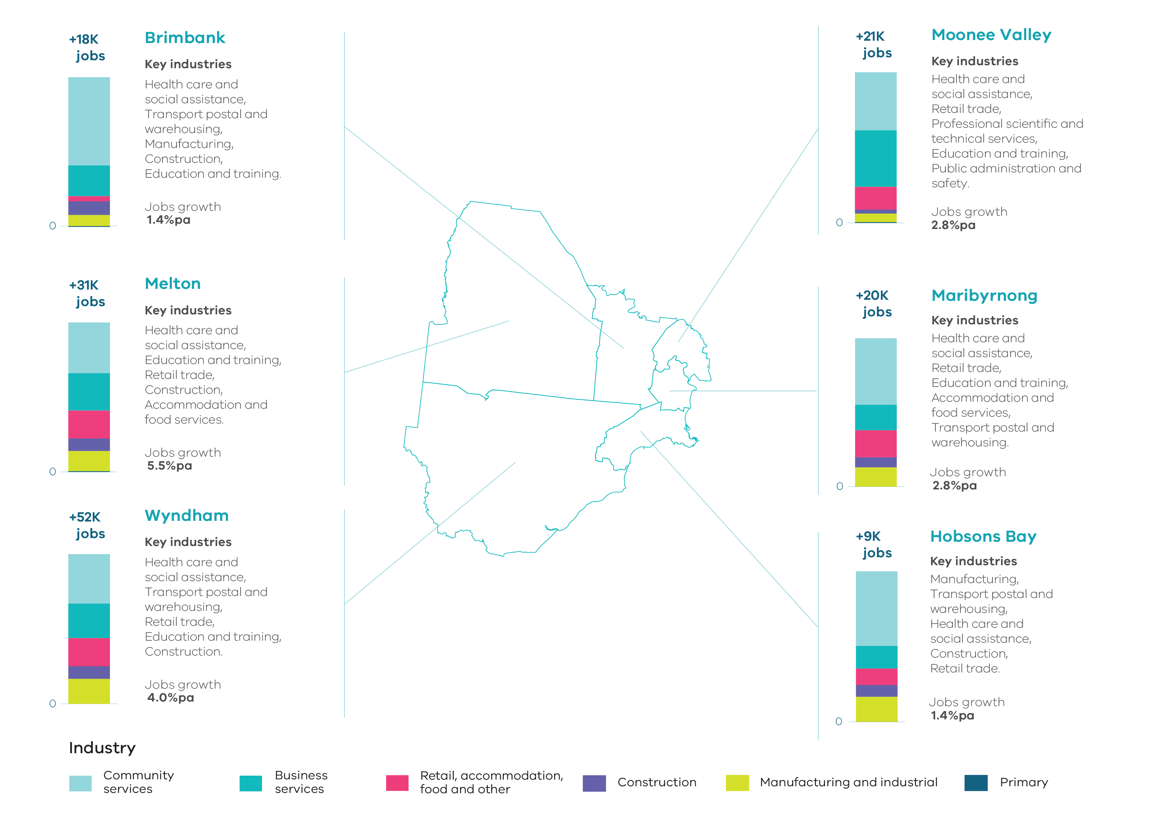 Source: Department of Jobs, Precincts and Regions, internal analysis (2019)
NOTE: Job figures have been rounded to the nearest thousand.

Key industrial and commercial areas
The Western state-significant industrial precinct (Western SSIP) is Melbourne’s largest SSIP. It comprises 7,200 hectares of existing and future zoned and unzoned land identified for industrial purposes across the municipalities of Brimbank, Hobsons Bay, Maribyrnong, Melton and Wyndham. The SSIP has access to significant transport infrastructure such as the Western Ring Road, Princes and Western Highways, and has a number of distinct precincts as follows:
- Derrimut is one of the two locations in metropolitan Melbourne of Industrial 2 Zoned land. This land is designed for uses that require large threshold distances as well as uses that may have an impact on the amenity of local communities. This area contains both long established hazardous uses as well as newer manufacturing and logistics uses that take advantage of the area’s access to the Western Ring Road.
- Brooklyn currently supports a range of uses including quarries, landfills and other heavy industry, and increasingly freight and logistics operations. The nearby areas of Tottenham and West Footscray are contiguous with Brooklyn, creating a large industrial area that draws employees from across the region. These industrial areas provide for logistics, container storage, food processing and production, manufacturing, chemical production and warehousing functions and feature older industrial stock. When complete, the West Gate Tunnel will provide alternative access to the area and new truck bans on east west roads in the inner west will reduce heavy vehicle access to some areas.
- Altona and Altona North provide regional employment and accommodate major petroleum complexes, intermodal freight terminals and food manufacturing with direct access to Kororoit Creek Road and the Princes Freeway. The Mobil Altona Refinery operates year-round as a key supplier in the fuel supply chain, processing crude oil into a range of petroleum products and providing around half of Victoria’s refined fuel needs. Significant buffers are required to this facility. Surrounding areas provide space for transport, warehouse and distribution businesses and general manufacturing.
- Truganina, Truganina North and Tarneit are planned for transport, storage industry, construction and the property and business services sectors with industry, manufacturing and storage uses encouraged towards the core of the SSIP. The Ravenhall landfill and Boral Quarry are located to the north with an interface to three correctional facilities. Further south an interface industrial area is located adjacent to the Port Phillip Prison and light industry, research and development and other business uses are encouraged along Palmers and Leakes Roads. The WIFT is proposed for this area.
Tullamarine, Keilor Park and Keilor East Industrial Precincts are adjacent to Melbourne Airport, Calder Freeway and Western Ring Road and are established with very little vacant industrial land supply. The Keilor Park industrial precinct forms part of a larger office park area that extends and connects to the Melbourne Airport Business Park. These precincts are generally affected by the Melbourne Airport Environs Overlay, which places limits on particular uses. They offer excellent access to major road networks and are strategically located relative to Melbourne Airport.
Essendon Airport is a key employment area with aviation and retail uses. Currently zoned as Commonwealth land, there are plans to further develop Essendon Airport as a centre for aviation, technology and retail with up to 25,000 jobs.
Airport West is the largest area of industrial land in the municipality of Moonee Valley and is located on the western side of the Tullamarine Freeway, adjacent to Essendon Airport. The area is fully established and identified by Council as a technology and enterprise precinct. The area has excellent access to Tullamarine Freeway, Western Ring Road and Calder Freeway as well as Essendon and Melbourne Airports.
Station Road Precinct and Orica Precinct along the Western Highway provide a range of industrial and employment uses. The western half of the Orica Precinct is within the Western SSIP, linking to the broader SSIP located to the south. An existing facility on site requires significant buffers to sensitive uses. The eastern half of the Orica Precinct is vacant and not part of the SSIP. This site, along with other areas along Station Street and north of Ballarat Road, are important buffers between sensitive uses and the western portion of the Orica site within the SSIP.
Yarraville Port and Mobil Terminal Precincts in Maribyrnong and Spotswood Precinct in Hobsons Bay offer significant industrial land holdings strategically located adjacent to the Port of Melbourne. These areas house a mix of industrial uses with a focus on port related uses such as transport and logistics. The storage and operation of petrochemical industries within and adjacent to the precincts require significant buffers which need to be protected. The Yarraville Port Precinct is increasingly becoming a preferred location for a range of small and medium creative industries to establish.
Williamstown Marine Precinct is an important precinct associated with the operation of the Port of Melbourne and ship building, marine engineering and marine related industries.
The Sunshine NEIC is centrally located between the Melbourne CBD and the two western growth areas. Anchored by the Sunshine Metropolitan Activity Centre, Sunshine Hospital and Victoria University, it has excellent access to major road and metropolitan and regional rail networks and supports approximately 14,600 existing jobs, with potential growth in tertiary education, health-related training, research, health care, retail and professional services sectors. Improvements and expansions to the rail network, including the proposed Airport Rail Link and Suburban Rail Loop, will further enhance opportunities in this location. The Sunshine Metropolitan Activity Centre comprises approximately 271,100 square metres of commercial floorspace with substantial retail and office and a growing food and drink offer.
The Werribee NEIC is located on a large 775 hectares site with around 8,400 jobs and potential for more than 50,000 jobs in health, education and high-technology research. The cluster includes the University of Melbourne Veterinary Hospital, the University of Notre Dame, St Vincent’s Private Hospital, Victoria University, the Werribee Mercy Hospital, the Wyndham Private Medical Centre, the CSIRO, the Suzanne Cory High School and a range of high-technology research companies in the food and agricultural industries. Significant provision is made for future commercial and industrial land within the NEIC.
Hoppers Crossing Industrial Precinct is located north-east of the Werribee NEIC and is strategically located between the Hoppers Crossing and Williams Landing railway stations. The precinct is established with little vacant industrial land and has direct access to the PFN (road and rail). It is well linked to Werribee NEIC and beyond to Werribee Major Activity Centre.
The Footscray Metropolitan Activity Centre is an important regional, mixed-use centre with high accessibility to the Melbourne CBD. It comprises of a range of uses including commercial floorspace with civic, health and education facilities, including two Victoria University campuses. It provides a range of retailing, office and food and drink premises with a growing residential population.
The broader activity centre network across the region comprises 24 existing major activity centres which vary in size, role and function and offer different potential for growth. Some are limited in size with minimal prospects for growth, while others provide substantial opportunities. Larger free-standing shopping centres such as Airport West, Highpoint, Watergardens (Sydenham), Werribee Plaza and Woodgrove offer significant retailing, serving larger sub-regional catchments. In other parts of the region, strip-based centres such as Altona, Ascot Vale-Union Road, Moonee Ponds, St Albans, Werribee and Williamstown offer a range of retailing, office and community uses. These centres are supported by a range of large and small neighbourhood activity centres.
It is envisaged that the growth corridors will play a significant role in the diversification of the broader region over time. The Hopkins Road Business Precinct, together with existing and planned activity centres, will provide significant new opportunities for jobs, investment and services within the region.
The region will also continue to play a vital role in meeting Victoria’s industrial, freight and logistics needs over the long term, whilst diversifying the employment offer in the region. The Growth Corridor Plan for the Western Region identifies a number of areas for future industrial purposes that are of regional importance and combined with planned upgrades to freeways and freight facilities, will reinforce the region’s importance to the industrial sectors in the future.
The Melton Highway Industrial Precinct at Plumpton sets aside approximately 330 hectares of land for future industrial purposes. The precinct will have direct access to Melton Highway and the proposed OMR. As such, it will easily link to Melbourne’s north and the proposed WIFT.
The Toolern Employment Precinct sets aside around 350 hectares of land for industrial purposes adjacent to the Melton Industrial Park to the north. The precinct has direct access to the PFN (road and rail) and will be serviced by the future Toolern Metropolitan Activity Centre to the south.
The South West Quarries Industrial Node adjacent to the Princes Freeway, sets aside approximately 1,400 hectares of land for industrial purposes. The precinct will have direct access to the Princes Freeway and the proposed WIFT via the proposed OMR. This area has been set aside to support the operation of adjacent quarry sites and needs to be carefully planned to ensure that sensitive land uses do not adversely impact their ability to operate now or into the future.
The future Toolern Metropolitan Activity Centre will have an important regional role with approximately 100 hectares of land having been identified for future development of the town centre.
To further support the activity centre network in the region, five future major activity centres have been identified through the Growth Corridor Plan. To complement this network, further town centres and convenience centres have also been identified through the PSP process.
All of these future centres will be important locations for future commercial development.

Supply and demand for industrial and commercial land across the region

Industrial land
The Western Region contains metropolitan Melbourne’s second largest holdings of industrial land. The region has a total of around 8,640 hectares of zoned land set aside for industrial uses. Of this, almost 5,820 hectares is currently occupied, and around 2,820 hectares is currently zoned for industrial purposes and vacant. An additional 2,880 hectares of land has been identified for future industrial purposes that is yet to be zoned.

Table 13: Industrial land supply, Western Region
Council / SSIP | Zoned occupied (ha) | Zoned vacant (ha) | Future supply (ha) | Total available supply (ha)
Brimbank | 1,679.7 | 396.1 | 0.0 | 396.1
Hobsons Bay | 1,261.3 | 328.3 | 0.0 | 328.3
Maribyrnong | 477.1 | 16.4 | 0.0 | 16.4
Melton | 519.4 | 1,150.4 | 1,189.6 | 2,340.0
Moonee Valley | 54.3 | 0.7 | 0.0 | 0.7
Wyndham | 1,827.4 | 926.5 | 1,691.7 | 2,618.2
Western Region | 5,819.2 | 2,818.4 | 2,881.3 | 5,699.7
Western SSIP | 4,356.3 | 1,810.5 | 1,033.8 | 2,844.3
Source: Department of Environment, Land, Water and Planning, Urban Development Program – Melbourne Metropolitan Industrial 2018 and internal analysis
Across the region there are approximately 5,700 hectares of vacant zoned and unzoned industrial land available for development. Of this, approximately 2,845 hectares is located within the Western SSIP. A portion of this land will be required to accommodate the proposed WIFT and ancillary uses.
Of the remaining 2,855 hectares of available land, approximately 1,848 hectares are unzoned within key future industrial precincts in growth areas.
Demand for industrial land in the region has been strong for the freight and logistics sector which requires large parcels of land with ready access to rail and road networks. This sector accounted for approximately 15 per cent of work places in the Western SSIP in 2016-17 compared to five per cent of work places across Melbourne as a whole. These operations are likely to continue to drive demand for land within the region given easy access to major road and rail, the proposed development of the WIFT and easy access to a potential second container port at Bay West.

Table 14: Industrial land consumption, Western Region, 2015-16 to 2017-18
Council / SSIP | 2015-16 (ha) | 2016-17 (ha) | 2017-18 (ha)
Brimbank | 42.3 | 47.3 | 19.7
Hobsons Bay | 15.5 | 3.3 | 6.6
Maribyrnong | 0.7 | -4.3 | 8.6
Melton | 31.0 | 24.6 | 20.6
Moonee Valley | -0.2 | -0.2 | 0.3
Wyndham | 54.7 | 83.2 | 45.1
Western Region | 144.0 | 153.9 | 100.9
Western SSIP | 133.0 | 149.8 | 78.9
Source: Department of Environment, Land, Water and Planning, Urban Development Program – Melbourne Metropolitan Industrial 2018
Over the last three years, the average annual rate of consumption of industrial land in the region has been around 133 hectares per annum. Consumption rates decreased slightly last year to just over 100 hectares per annum, however during the periods 2015-16 and 2016-17 consumption was much higher at an average of just under 150 hectares per annum. The vast majority of industrial land consumed within the region occurs within the Western SSIP.
If consumption rates return to around 150 hectares per annum, then the region as a whole would have approximately 19 years supply of zoned industrial land. Unzoned areas identified for future industrial purposes could provide another 13 years of supply, however this is dependent on future planning for these areas as part of the PSP process.
Of the total zoned and unzoned supply of vacant land, around 50 per cent is within the Western SSIP. Over the last three years, the consumption of industrial land in the Western SSIP has averaged around 120 hectares per annum. There was a significant decline in consumption over the last year, and prior to that consumption was averaging around 140 hectares per annum.
If consumption rates in the Western SSIP remain at around 120 hectares per annum, then this would provide almost 15 years of zoned supply and just over 6 years of unzoned supply. If consumption rates in the SSIP increased again to around 140 hectares per annum, then there would be around 13 years of zoned supply and 5 years of unzoned supply. The establishment of the proposed WIFT has the potential to bring forward much of this consumption.

Figure 17: Change of zoned industrial land, Western Region, 2000-01 to 2017-18
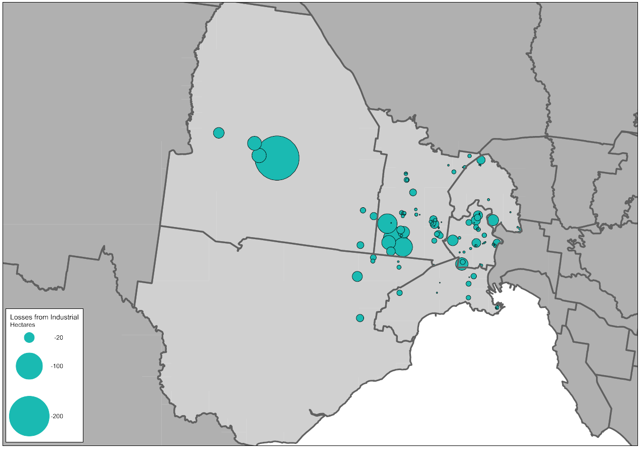
Source: Department of Environment, Land, Water and Planning, Urban Development Program – Melbourne Metropolitan Industrial 2018
Between 2000-01 and 2017-18 a total of 840 hectares of industrial land was rezoned across the region for other non-industrial uses.
The largest single loss of industrial land over this period was within Melton where a site of just under 200 hectares of industrial land was rezoned to allow for residential development. Of the remaining industrial land rezonings that occurred over this period, 49 per cent involved sites of less than 2 hectares in size.
Of all the industrial land rezoned over the period, more than half (54 per cent) was rezoned to allow for mixed-use or residential development.

Commercial land
Currently across the region there is a total of 949 hectares of land that has been identified as being zoned for commercial purposes. It is estimated that there is approximately 2.9 million square metres of floorspace used or available for commercial purposes on this land. Approximately 47 per cent of all the existing floorspace supply is located within the municipalities of Brimbank and Moonee Valley.
Across the region a total of 187 commercial areas or centres, have been identified. Of these, 140 have less than 10,000 square metres of floorspace.
Eight centres have more than 100,000 square metres of floorspace. This includes free-standing shopping centres such as Pacific Werribee and Highpoint in Maribyrnong, and strip-based centres such as Moonee Ponds. Combined these centres account for half of the identified commercial floorspace across the region.
Brimbank has the largest number of centres (62) and Melton the fewest (14).

Table 15: Existing commercial floorspace by centre size, Western Region
Council | Less than 2,000 (m²) |  | 2,000 to 9,999 (m²) |  | 10,000 to 49,999 (m²) |  | 50,000 to 99,999 (m²) |  | Greater than 100,000 (m²)
 | No. of centres | Floorspace (m²) | No. of centres | Floorspace (m²) | No. of centres | Floorspace (m²) | No. of centres | Floorspace (m²) | No. of centres | Floorspace (m²)
Brimbank | 37 | 35,050 | 16 | 63,600 | 7 | 169,700 | 0 | 0 | 2 | 445,650
Hobsons Bay | 16 | 19,800 | 13 | 65,350 | 8 | 177,050 | 0 | 0 | 0 | 0
Maribyrnong | 3 | 1,650 | 8 | 33,300 | 5 | 105,600 | 0 | 0 | 2 | 494,450
Melton | 8 | 800 | 3 | 17,750 | 1 | 19,350 | 2 | 148,650 | 0 | 0
Moonee Valley | 6 | 5,300 | 11 | 69,850 | 8 | 191,500 | 2 | 146,900 | 2 | 247,850
Wyndham | 11 | 7,300 | 8 | 42,350 | 6 | 143,550 | 0 | 0 | 2 | 257,350
Total | 81 | 69,900 | 59 | 292,200 | 35 | 806,750 | 4 | 295,550 | 8 | 1,445,300
Source: Department of Environment, Land, Water and Planning, unpublished data (2020)

In addition to the existing zoned commercial land, approximately 559 hectares of land has been identified through other strategic plans such as Growth Corridor Plans and PSPs for future commercial purposes. These areas are confined to Melton and Wyndham.
A significant proportion of the land identified for future commercial purposes is within the Werribee NEIC (106 hectares). This land accounts for 19 per cent of all future commercial land identified for the region and some of this land is also generally suitable for a range other employment purposes, including industrial uses.

Table 16: Future commercial land supply, Western Region
Council | Future commercial land (ha) | Share of metropolitan Melbourne
Melton | 222 | 17%
Wyndham | 336 | 25%
Total | 559 | 42%
Source: Department of Environment, Land, Water and Planning, unpublished data (2020)
Based on projected growth, by 2031 it is anticipated that around 1.5 million square metres of commercial floorspace will be required across the Western Region. Almost 800,000 square metres will be required for office uses and the remaining 700,000 million square metres will be required for retail. Around 60 per cent of this additional floorspace is projected to be located in the growth area municipalities of Melton and Wyndham. These councils have land identified for future commercial purposes.
The municipalities of Brimbank, Hobsons Bay, Maribyrnong and Moonee Valley will need to identify options to accommodate projected demand for commercial floorspace within existing commercial areas, as well as considering areas that could accommodate future floorspace requirements through rezonings.

Table 17: Commercial floorspace supply and estimate, Western Region
Council | Existing commercial  floorspace 2018 (m²) | Estimated additional commercial floorspace  2016 to 2031 (m²)
Brimbank | 714,000 | 106,000
Hobsons Bay | 262,200 | 64,000
Maribyrnong | 635,000 | 194,000
Melton | 186,550 | 348,000
Moonee Valley | 661,400 | 267,000
Wyndham | 450,550 | 569,000
Total | 2,909,700 | 1,548,000
Source: Department of Environment, Land, Water and Planning, unpublished data (2020)

Figure 18: Estimated additional commercial floorspace by type and municipality, Western Region, 2016 to 2031
Source: Department of Environment, Land, Water and Planning, unpublished data (2020)

Planning framework for industrial and commercial land across the region
There is a large amount of industrial land across the region providing state, regional and locally-significant employment and economic functions. The region has excellent arterial road, freeway and fixed rail connections to major transport gateways such as the Port of Melbourne, Port of Geelong, Melbourne and Avalon Airports and the proposed Bay West container port and WIFT. These networks will be further enhanced by the proposed OMR.
The region has a significant number of unfragmented site available for industrial uses that can provide for freight, logistics, warehousing, transport, manufacturing and other larger format industrial uses. It also has traditional industrial and major hazard facilities operating within regulatory requirements, requiring buffers, and minimal restraints imposed by sensitive uses.
While there is opportunity for industrial land supply to increase over time in area in the municipalities of Wyndham and Melton, other municipalities are reducing their industrial land area through rezonings, which may potentially have negative impacts for the region’s future economic and employment opportunities.
Previous planning for new greenfield industrial areas has in some cases reduced the overall amount of land set aside for industrial purposes. Future industrial land identified in the Western SSIP and at Toolern, Plumpton and south of Werribee needs to be retained and protected for future industrial uses. Other areas that should be retained and protected include precincts adjacent to major transport gateways such as the Port of Melbourne and Melbourne Airport.
There will need to be a significant increase in the amount of commercial floorspace to serve growing populations in the municipalities of Melton and Wyndham in particular. The Werribee NEIC provides significant opportunity, however its role as an NEIC should be prioritised. Significant opportunity will still need to be made across the region and growth areas for future retail development.
Careful consideration will be required through the PSP processes to ensure adequate provision is made to accommodate medium and longer term commercial development. Approaches that will support delivery of 20-minute neighbourhoods should be put in place offering a finer grain network of activity centres.
Within the established areas of Maribyrnong and Moonee Valley, and to a lesser extent, Brimbank and Hobsons Bay, there will be an ongoing need to allow for expansion of commercial facilities. In addition to this, there will be ongoing pressure in older industrial areas to convert to predominantly residential uses, particularly in Maribyrnong and Hobsons Bay. The ongoing erosion of industrial land to residential uses needs to be better managed.

Planning for the region should:
- Investigate industrial areas that could support other employment uses that support or are well connected to adjacent employment uses or transport connections.
- Consider the future demand for and need for, commercial and employment land across the growth areas and ensure that PSPs make adequate and sufficient provision to accommodate longer-term commercial and employment needs.

Map 6: Western Region - industrial land
Source: Department of Environment, Land, Water and Planning

Map 7: Western Region - commercial land
Source: Department of Environment, Land, Water and Planning

Northern Region

Regional snapshot
The Northern Region comprises the municipalities of Banyule, Darebin, Hume, Moreland, Nillumbik, Whittlesea and the area within the urban growth boundary (UGB) in the Shire of Mitchell. The region includes the Northern Growth Corridor which makes significant provision for future industry and housing.
The region has good connections to transport gateways and the freight network along key roads and railways. While east-west linkages across the region are a limiting factor, there is significant appeal for businesses wanting eastern seaboard access from Melbourne to Sydney and Brisbane. Significant competitive advantages are created by the region having good access to Essendon and Melbourne Airports and there are substantial synergies that can be gained with the Melbourne Wholesale Markets and complementary industries. The region also contains significant high-quality extractive resources that are critical to support the development and ongoing functioning of the city.
The proposed Beveridge Interstate Freight Terminal (BIFT) is an important future asset for the region with direct access to the PFN and the propose Outer Metropolitan Ring / E6 Transport Corridor (OMR) and North East Link will further enhance connections within the region and beyond.
The region has a strong and vibrant network of activity centres closer to the city, as well as three existing and future metropolitan activity centres and the La Trobe National Employment and Innovation Cluster (La Trobe NEIC).
The business service sector is the largest contributor to the economy for the region, with a total value-added estimate at just under $14 billion. The manufacturing and industrial sector is the next largest contributor with a total value-added estimate at around $11.2 billion. Combined, these sectors account for almost 62 per cent of the total value-add for the region.

Fast facts
PEOPLE  Population in 2006  744,267  Population in 2016  949,887  That’s 27% more people  Banyule = + 9,484  Darebin = + 22,827  Hume = + 54,244  Mitchell (Wallan SA2) = +6,417  Moreland = + 31,422  Nillumbik = + 2,659  Whittlesea = + 78,567 | JOBS  Jobs in 2006  250,050  Jobs in 2016  321,200  That’s 28% more jobs  Banyule = + 5,100  Darebin = + 7,000  Hume = + 24,700  Mitchell (Wallan SA2) = +2,150  Moreland = + 8,550  Nillumbik = + 1,700  Whittlesea = + 21,950 | ECONOMY  GRP for the region  $42 billion  Share of metropolitan Melbourne’s total GRP  13%  Banyule = $5.5 billon  Darebin = $7.1 billon  Hume = $13.7 billon  Mitchell (Wallan SA2) = $0.4 billon  Moreland = $5.8 billon  Nillumbik = $1.9 billon  Whittlesea = $7.5 billon
Source: Department of Environment, Land, Water and Planning, unpublished data (2019)
The region was home to around 949,900 people in 2016. By 2031 it is projected that the region will grow by around 375,100 people to a total population of around 1.3 million people. The growth area municipalities of Hume and Whittlesea will account for 60 per cent of the projected growth in the region by 2031. The area in Mitchell Shire (Wallan SA2) will also experience relatively significant growth over this period.

Figure 19: Projected population growth, Northern Region, 2016 to 2031

Source: Department of Environment, Land, Water and Planning, Victoria in Future 2019 (July 2019).

In 2016 the region supported around 321,200 jobs, accounting for around 14 per cent of all employment across the metropolitan area.
By 2031 it is projected that approximately 138,000 additional jobs will be located across the region. Over half of the new jobs in the region are expected to be located within the growth area municipalities of Hume and Whittlesea.
The industries that are expected to experience the strongest growth are: health care and social assistance; education and training; retail trade; manufacturing; transport, postal and warehousing.

Figure 20: Projected employment growth, Northern Region, 2016 to 2031
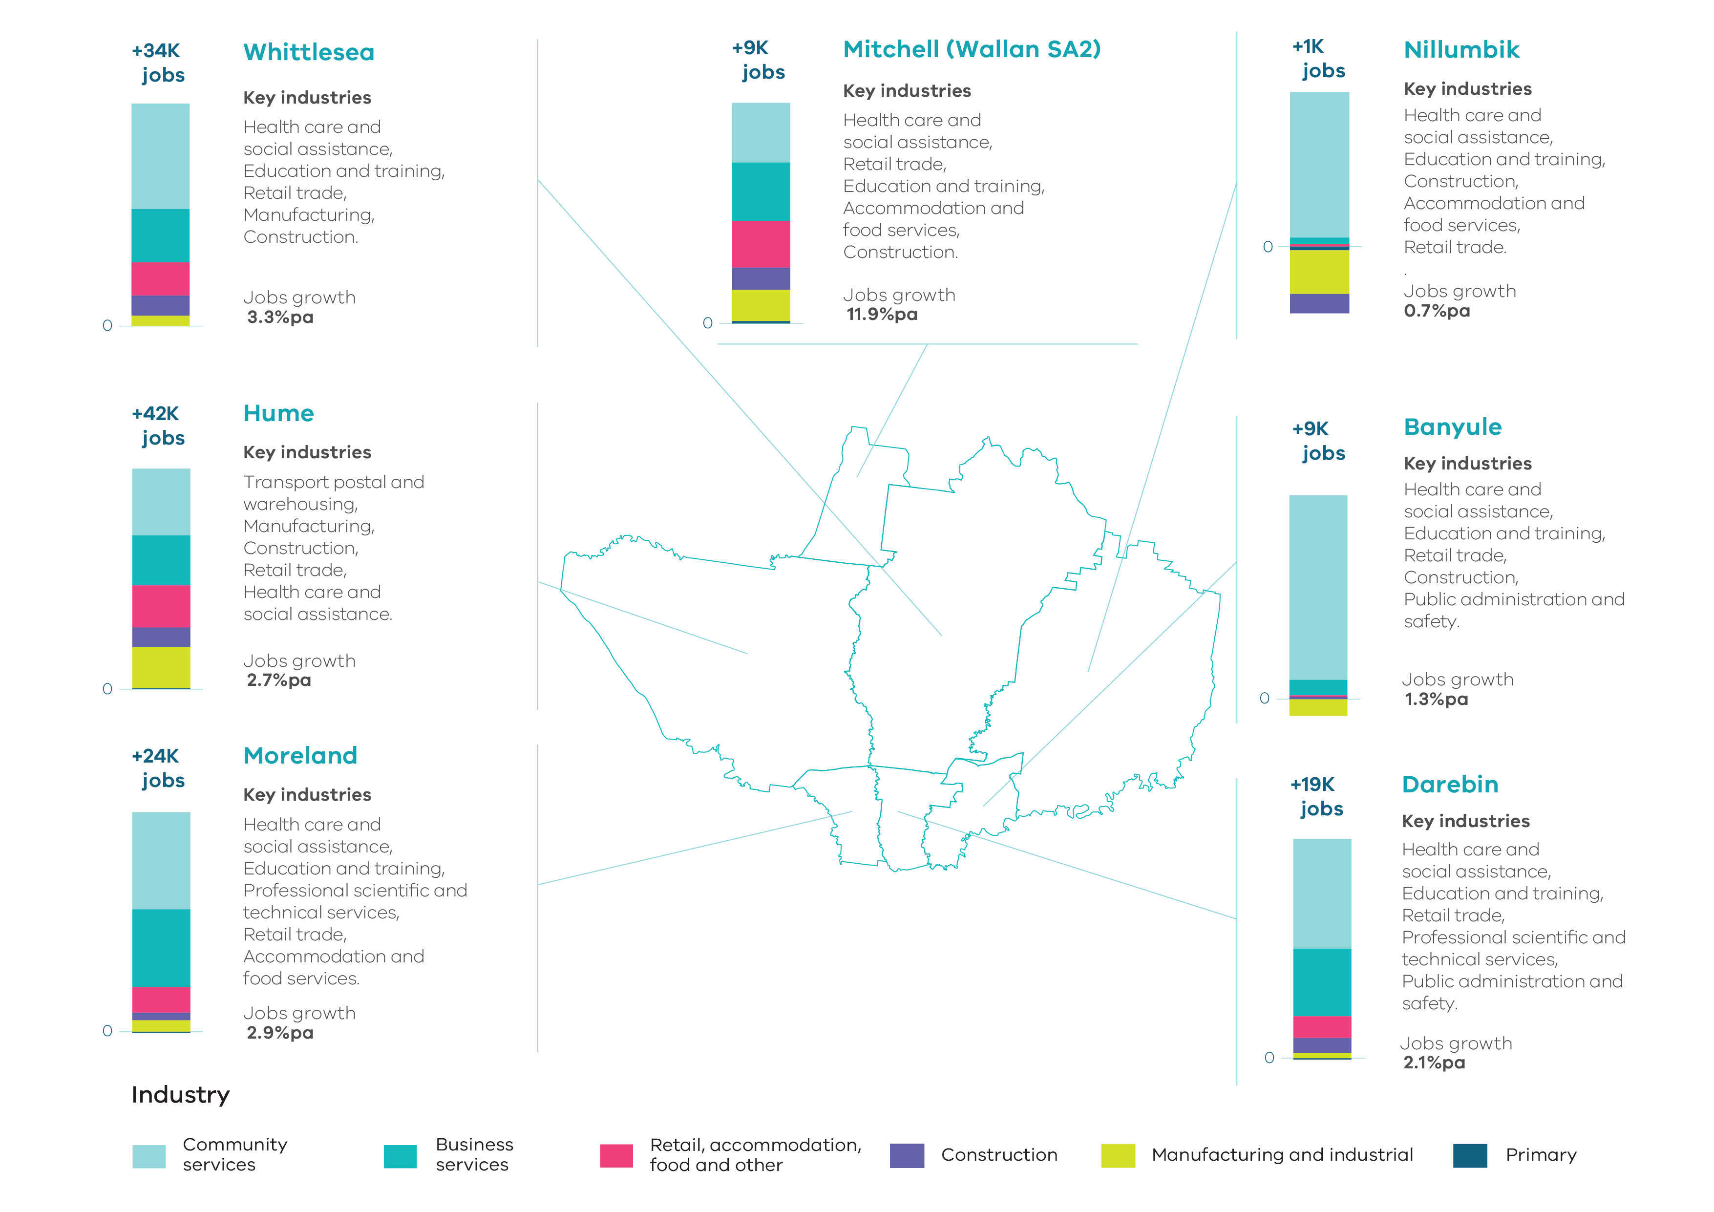Source: Department of Jobs, Precincts and Regions, internal analysis (2019).
NOTE: Job figures have been rounded to the nearest thousand.

Key industrial and commercial areas
The Northern state-significant industrial precinct (Northern SSIP) is Melbourne’s second largest SSIP. It comprises almost 5,770 hectares of existing and future zoned and unzoned land identified for industrial purposes across the municipalities of Hume, Whittlesea and Mitchell. It has access to significant transport infrastructure including interstate rail freight connections and the key roads of the Hume Highway and Freeway, Metropolitan Ring Road, and potential OMR which could provide important orbital connections to industrial land throughout the region and beyond. The Northern SSIP has been expanded to include approximately 1,590 hectares of land identified within the proposed BIFT and the Craigieburn South Employment Precinct. The Northern SSIP is well placed with easy road and rail access to interstate markets along the eastern seaboard and has a number of distinct precincts as follows:
- The Thomastown precinct supports a range of manufacturing, warehousing and services industries. It has excellent access to the Western Ring Road and the Hume Freeway via the Craigieburn Bypass. To the north is the Cooper Street employment precinct. As well as being home to the Melbourne Wholesale Fruit, Vegetable and Flower Market, it is also an increasingly attractive location for warehousing and freight and logistics businesses.
- The Campbellfield precinct extends from the Metropolitan Ring Road north to Cooper Street and Somerton Road. It is home to a range of manufacturing and storage facilities as well as the former Ford site. It is a finer grain, densely developed industrial area and a major employment area for the municipality of Hume. It has excellent freight connections to regional Victoria and interstate via both road and rail. It also has easy access to Melbourne Airport and its surrounding businesses via the Metropolitan Ring Road.
- Somerton is located north of the Campbellfield precinct with excellent access to major road and rail networks. The area is used predominantly for logistics, warehousing and distribution and includes an inter-modal freight terminal at the Austrak Business Park. There is also a bulk cement terminal in this location.
- A number of future industrial areas have also been identified for future expansion of the Northern SSIP. Areas around Craigieburn, Donnybrook and Mickleham offer opportunities for future industrial development with easy access to freight networks and larger land holdings suitable for warehousing, freight and logistics. These locations can provide for a range of employment and business opportunities. Development is underway at the Merrifield Business Park adjacent to Donnybrook Road with Dulux establishing its brand new, state-of-the-art paint manufacturing facility there.
- The proposed Beveridge Interstate Freight Terminal (BIFT) will be an important future asset for the Northern Region. Approximately 1,500 hectares of land has been set aside for a major freight hub supporting a range of other businesses which benefit from being co-located with major terminals including distribution centres and warehousing. The terminal will play a vital role in enabling the transfer of interstate freight across Australia and is located adjacent to the Melbourne-Sydney-Brisbane rail line, Hume Freeway and proposed OMR.
- The Craigieburn South Employment Precinct is a site of approximately 190 hectares located adjacent to the Craigieburn North Employment Precinct within the Northern SSIP. To its east are a number of existing quarries. It provides the opportunity for future industrial development with excellent access to rail and road available.
Beyond the Northern SSIP, there are a number of other industrial areas considered to be of state or regional significance.
To the north on Donnybrook Road, the Shenstone Park PSP area includes approximately 280 hectares of industrial land identified through the North Growth Corridor Plan and PSP process. This land provides an important buffer to existing and proposed quarry operations, a proposed sewerage treatment plant to the south, and nearby residential land uses. This precinct has good access to the Hume Freeway from Donnybrook Road.
In Wollert, 160 hectares of land for industrial uses is set aside adjacent to the proposed OMR. The Wollert PSP identifies the land as a future general light industrial precinct with large format retailing on its south west corner. This industrial land functions as a buffer to existing quarry and landfill sites.
In Sunbury South there is just under 60 hectares of land set aside for future industrial purposes. As well as providing important employment land with good access, the area also provides an important buffer to existing landfill and quarrying operations.
Melbourne Airport is the region’s largest employer with key industrial precincts located to its south and east. The Melbourne Airport will continue to play an important role in providing for a range of aviation and non-aviation uses. East and south of the airport are established precincts, that combined with the Tullamarine and Keilor Park Industrial Precinct in Brimbank, form a large cluster of industrial land located adjacent to the airport, that support a range of transport and logistics, wholesale trade and other sectors that require easy access to the airport.
The La Trobe NEIC includes La Trobe University, the Northland Shopping Centre and the Austin Biomedical Alliance Precinct, plus a concentration of other health, research, commercial and retail activities in and around the Heidelberg Major Activity Centre. It has strengths in education, research, health and retail with approximately 28,700 jobs in the cluster. La Trobe University is continuing to expand its education and research activities, particularly in the biosciences.
The Heidelberg West Business Park is the main industrial area in the municipality of Banyule and is located adjacent to La Trobe University within the La Trobe NEIC. It houses a range of manufacturing, construction, wholesale trade and motor industry businesses. There is opportunity for it to evolve supporting higher technology production and services.
Further to the south, the East Preston Industrial Precinct is Darebin’s largest industrial area including manufacturing, light industrial and restricted retailing. It is included in the Northland Urban Renewal Precinct, a long-term planning project with an horizon of 30+ years being undertaken by council. The Fairfield Industrial Precinct is used for industry, wholesale and retail trade as well as service industries and includes higher density built form. These precincts have a good access to a skilled workforce, however they are limited by adjacent residential uses and lack direct access to major road and rail networks.
The West Reservoir precinct is located generally between Edwardes Park Lake and the Merri Creek within Darebin and extends southwards to adjoin the Newlands Road Industrial Precinct within Moreland. These areas are used predominantly for a range of manufacturing and light industrial uses and are surrounded by residential land uses.
Beyond the Newlands Road Precinct, there are two other large concentrations of industrial zoned land in Moreland at North Coburg and Brunswick. These areas have been identified to be retained for industry and employment uses and are increasingly supporting a range of creative industries including makers spaces, film studios, recording studios and specialist 3D artwork production as well as a designated “Design District” in Brunswick centred around RMIT’s campus.
The activity centres network in the region is anchored by the two existing metropolitan activity centres of Broadmeadows and Epping and a future metropolitan activity centre at Lockerbie.
The Epping Metropolitan Activity Centre is an important centre with good accessibility throughout the region via rail and road. It comprises approximately 230,300 square metres of commercial floorspace and provides a range of retailing and food and drink premises with a small but growing residential population. It also includes health and education facilities and there are large areas of land available for expansion.
The Broadmeadows Metropolitan Activity Centre is important due to its location within the fast-growing northern region and as a major hub for transport to both metropolitan and key regional centres. It comprises approximately 623,700 square metres of commercial floorspace and is an important regional mixed-use centre providing significant retailing, entertainment, civic, office, health and education facilities. There is significant opportunity for expansion and urban renewal to the east of the existing centre.
The future Lockerbie Metropolitan Activity Centre will have an important regional role with approximately 60 hectares of land identified for future commercial purposes. This will be complemented by substantial employment and residential areas between the railway line and Hume Freeway and at the nearby Northern SSIP.
There are 19 existing major activity centres that vary in size, role and function and five future major activity centres identified across the region. These activity centres vary in their potential for growth. Some are limited in size with minimal prospects for growth, while others provide substantial opportunities. Larger free-standing shopping centres such as Craigieburn Town Centre, Epping Plaza, Gladstone Park, Greensborough, Preston-Northland and Plenty Valley (South Morang) offer significant retail activity, which serves larger sub-regional catchments. In other parts of the region, strip-based centres such as Brunswick, Coburg, Ivanhoe, Northcote and Heidelberg offer a range of retailing, office and community uses. Future activity centres such as Beveridge and Sunbury South offer an opportunity to provide for additional employment while Wallan will play an increasingly important role in the corridor and beyond to regional townships. This network of centres is supported by a range of neighbourhood and local centres, both existing and proposed.

Supply and demand for industrial and commercial land across the region

Industrial land
The Northern Region contains metropolitan Melbourne’s third largest holding of industrial land. The region has a total of around 4,960 hectares of zoned land set aside for industrial uses. Of this, almost 3,720 hectares is currently occupied and just over 1,240 hectares is currently zoned for industrial purposes and vacant. An additional 2,867 hectares of land has been identified for future industrial purposes that are yet to be re-zoned.
Approximately 5,773 hectares of all industrial land in the region is located within the Northern SSIP.
Across the region there are 4,108 hectares of vacant zoned and unzoned industrial land available for development, of which 3,372 hectares is located within the Northern SSIP. A portion of this land will be required to accommodate the proposed BIFT and ancillary uses.
Of the remaining 736 hectares of available land, approximately 473 hectares are unzoned within key future industrial precincts in growth areas.

Table 18: Industrial land supply, Northern Region
Council / SSIP | Zoned occupied (ha) | Zoned vacant (ha) | Future supply (ha) | Total available supply (ha)
Banyule | 116.5 | 1.4 | 0.0 | 1.4
Darebin | 288.6 | 16.0 | 0.0 | 16.0
Hume | 2,141.9 | 859.0 | 490.1 | 1,349.1
Moreland | 246.7 | 13.2 | 0.0 | 13.2
Nillumbik | 29.2 | 0.1 | 0.0 | 0.1
Whittlesea | 889.7 | 328.1 | 1,642.3 | 1,970.4
Wallan (within UGB) | 6.0 | 23.4 | 734.5 | 757.9
Northern Region | 3,718.6 | 1,241.2 | 2,866.9 | 4,108.1
Northern SSIP | 2,400.7 | 978.2 | 2,393.7 | 3,371.9
Source: Department of Environment, Land, Water and Planning, Urban Development Program – Melbourne Metropolitan Industrial 2018 and internal analysis
Demand for industrial land in the Northern Region has been variable in recent years but has steadily increased, with the region continuing to be an important location for the manufacturing sector. This sector accounted for approximately 33 per cent of work places in the Northern SSIP in 2016-17 compared to 22 per cent of work places for Melbourne as a whole. These operations are likely to continue to drive demand for land within the region, given easy access to major road, rail and transport gateways at Melbourne and Essendon Airports.
There is also future opportunity for the region to expand in the freight and logistics sector, given the proposed development of the BIFT adjacent to the Hume Freeway and interstate rail.

Table 19: Industrial land consumption, Northern Region, 2015-16 to 2017-18
Council / SSIP | 2015-16 (ha) | 2016-17 (ha) | 2017-18 (ha)
Banyule | 1.6 | -0.1 | -0.1
Darebin | 0.0 | 0.0 | 0.1
Hume | 20.4 | 24.5 | 28.5
Moreland | 0.8 | 1.5 | 0.0
Nillumbik | 0.0 | -0.1 | 0.0
Whittlesea | 1.5 | 8.6 | 23.5
Wallan (within UGB) | N/A | N/A | N/A
Northern Region | 24.3 | 34.4 | 52.0
Northern SSIP | 15.8 | 26.2 | 43.3
Source: Department of Environment, Land, Water and Planning, Urban Development Program – Melbourne Metropolitan Industrial 2018

Over the last three years the average rate of consumption of industrial land in the region has been around 37 hectares per annum. If average annual consumption rates continue at these levels, then the region as a whole has approximately 34 years supply of zoned industrial land. Unzoned areas identified for future industrial purposes could provide another 53 years of supply, but this is dependent on future planning for these areas as part of the PSP process. The vast majority of industrial land supply and consumption for the region is within the Northern SSIP. Based on average consumption rates over the last three years there are approximately 26 years supply of zoned land and around 44 years supply of unzoned land within the Northern SSIP.
However, consumption rates have increased significantly in the Northern Region. In 2017-18 the rate of consumption was 52 hectares for the region as a whole and 43 hectares in the Northern SSIP. Based on these consumption rates, it is estimated that there is approximately 24 years of zoned land supply in the region overall. Unzoned land could provide for approximately 37 years of additional supply, however if the future land set aside for the proposed BIFT is removed from the future supply, then there would only be around 12 years of unzoned future industrial land supply available in the region.
Of the total zoned and unzoned supply of vacant land, over 82 per cent is within the Northern SSIP. If consumption rates in the Northern SSIP remain at around 43 hectares per annum, then this would provide around 23 years of zoned supply and almost 38 years of unzoned supply. If land for the proposed BIFT is removed from the unzoned supply, then there would only be around 14 years of unzoned future industrial land supply available in the Northern SSIP. If consumption rates in the Northern SSIP were to increase further, then supply would be exhausted more quickly.

Figure 21: Change of zoned industrial land, Northern Region, 2000-01 to 2017-18
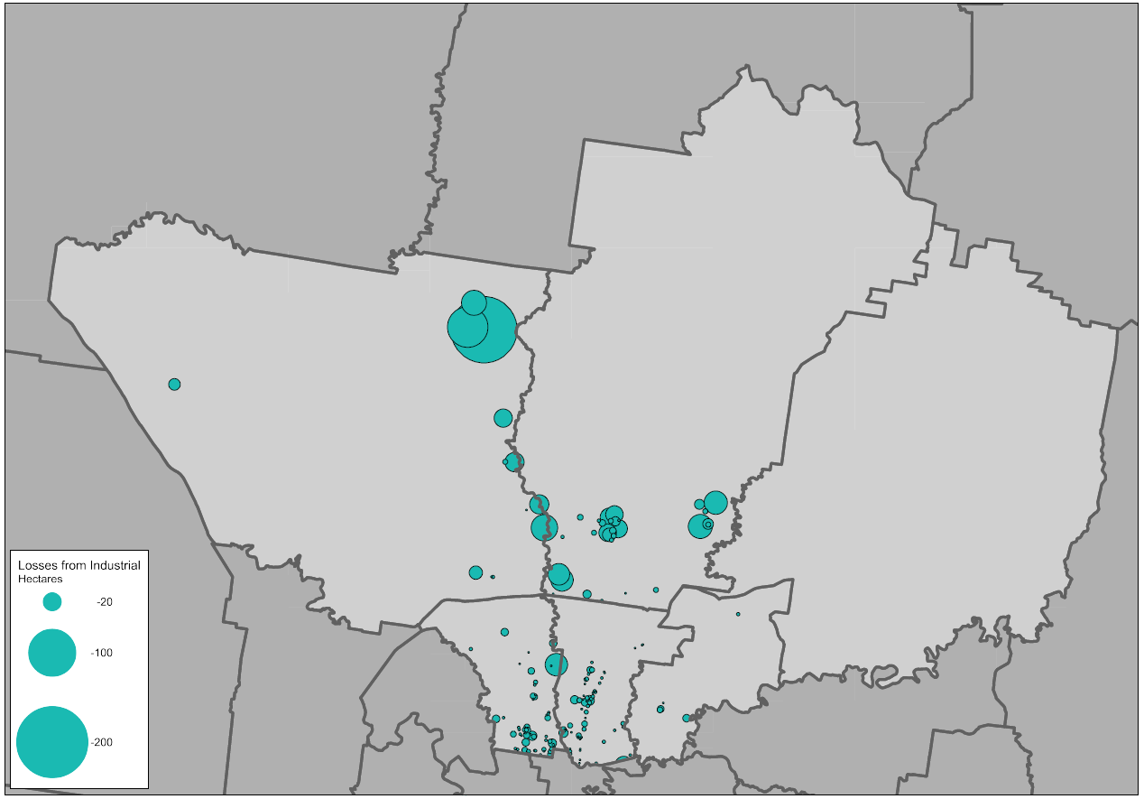
Source: Department of Environment, Land, Water and Planning, Urban Development Program – Melbourne Metropolitan Industrial 2018

Between 2000-01 and 2017-18 a total of 669 hectares of industrial land was rezoned across the region for other non-industrial uses.
The largest single loss of industrial land over this period was within Hume, where almost 145 hectares of land was rezoned as Commonwealth Land for the Post-Entry Quarantine Facility in Mickleham. Of the remaining rezonings that occurred over this period in the region, approximately 72 per cent involved sites of less than 2 hectares in size.
Of all the industrial land rezoned over the period, around 28 per cent was rezoned to allow for mixed-use or residential development. While this is the lowest overall percentage of all metropolitan regions, there are great variances across the region with over 60 per cent of industrial land rezoned in Moreland allowing for mixed-use or residential development.

Commercial land
Currently across the region there is a total of 1,086 hectares of land that has been identified as being zoned for commercial purposes. It is estimated that there is approximately 3.2 million square metres of floorspace used or available for commercial purposes on this land. Just under 50 per cent of all existing floorspace supply is located within the municipalities of Darebin and Moreland.
Across the region a total of 238 commercial areas or centres have been identified. Of these, 190 have less than 10,000 square metres of floorspace.
Eleven centres have more than 100,000 square metres of floorspace. This includes free-standing shopping centres like Northland and Epping and strip-based centres such as Brunswick. Combined these centres account for over half of the region’s total existing commercial floorspace.
Darebin has the largest number of centres (60) and Nillumbik (8) and Mitchell (2) the fewest.

Table 20: Existing commercial floorspace by centre size, Northern Region
Council | Less than 2,000 (m²) |  | 2,000 to 9,999 (m²) |  | 10,000 to 49,999 (m²) |  | 50,000 to 99,999 (m²) |  | Greater than 100,000 (m²)
 | No. of centres | Floorspace (m²) | No. of centres | Floorspace (m²) | No. of centres | Floorspace (m²) | No. of centres | Floorspace (m²) | No. of centres | Floorspace (m²)
Banyule | 21 | 23,300 | 12 | 50,300 | 3 | 43,950 | 1 | 50,750 | 2 | 212,550
Darebin | 29 | 31,450 | 17 | 72,800 | 8 | 156,650 | 3 | 194,050 | 3 | 357,600
Hume | 23 | 15,800 | 10 | 59,150 | 4 | 96,900 | 2 | 149,400 | 1 | 198,700
Moreland | 21 | 23,300 | 30 | 121,400 | 5 | 116,300 | 1 | 92,450 | 2 | 409,300
Nillumbik | 5 | 5,700 | 1 | 4,050 | 2 | 51,600 | 0 | 0 | 0 | 0
Whittlesea | 11 | 8,700 | 9 | 44,750 | 7 | 130,900 | 0 | 0 | 3 | 494,500
Mitchell (within UGB) | 1 | 600 | 0 | 0 | 1 | 22,250 | 0 | 0 | 0 | 0
Total | 111 | 108,850 | 79 | 352,450 | 30 | 618,550 | 7 | 486,650 | 11 | 1,672,650
Source: Department of Environment, Land, Water and Planning, unpublished data (2020)

In addition to existing zoned commercial land, there are approximately 208 hectares of land that have been identified through other strategic plans such as Growth Corridor Plans and PSPs for future commercial purposes. These areas are confined to Hume, Whittlesea and the area of Mitchell within the UGB.
The future Lockerbie Metropolitan Activity Centre will be a key location for future commercial development.

Table 21: Future commercial land supply, Northern Region
Council | Future commercial land (ha) | Share of metropolitan Melbourne
Hume | 92 | 7%
Mitchell (within UGB) | 12 | 1%
Whittlesea | 104 | 8%
Total | 208 | 16%
Source: Department of Environment, Land, Water and Planning, unpublished data (2020)

Based on projected growth, by 2031 it is anticipated that approximately 1.4 million square metres of additional commercial floorspace will be required across the Northern Region. Approximately 800,000 square metres will be required for office uses and 600,000 square metres will be required for retail.
Around 65 per cent of additional floorspace will need to be provided in the growth area municipalities of Hume, Whittlesea and Mitchell (within UGB). All of these councils have land identified for future commercial purposes. If this floorspace is not able to be provided across new planned centres, then consideration will need to be given to ways to either provide additional opportunity for commercial development or increase the density of commercial development.
Moreland and Darebin is projected to need an additional 471,000 square metres of commercial floorspace by 2031, and Banyule and Nillumbik will need an additional 21,000 square metres of commercial floorspace. These councils will need to look at ways to accommodate projected demand for commercial floorspace within existing commercial areas, as well as considering areas that could accommodate future floorspace requirements through rezonings.

Table 22: Commercial floorspace supply and estimate, Northern Region
Council | Existing commercial  floorspace 2018 (m2) | Estimated additional commercial floorspace  2016 to 2031 (m2)
Banyule | 380,850 | 19,000
Darebin | 812,550 | 194,000
Hume | 519,950 | 468,000
Moreland | 762,750 | 277,000
Nillumbik | 61,350 | 2,000
Whittlesea | 678,850 | 342,000
Mitchell (within UGB) | 22,850 | 112,000
Total | 3,239,150 | 1,414,000
Source: Department of Environment, Land, Water and Planning, unpublished data (2020)

Figure 22: Estimated additional commercial floorspace by type and municipality, Northern Region, 2016 to 2031
Source: Department of Environment, Land, Water and Planning, unpublished data (2020)

Planning framework for industrial and commercial land across the region
There is a large amount of industrial and commercial land across the region providing state, regionally and locally-significant employment and economic functions. There is reasonably good arterial road, freeway and fixed rail accessibility within the region and to the Port of Melbourne, Melbourne Airport and to the proposed BIFT, however east-west links across the region are limited.
The region accommodates a range of traditional industrial and manufacturing industries. While the decline of the automotive industry has impacted significantly on the region, there is opportunity to grow in high-technology manufacturing, niche manufacturing and food and beverage manufacturing, given proximity to the Melbourne Wholesale Fruit and Vegetable Market. There is also opportunity for the freight and logistics sector given the established and proposed freight network and easy access to interstate markets along the eastern seaboard.
The region also has large areas set aside with significant high-quality extractive resources for quarrying operations. A shortfall in extractive resources close to market means that the cost of construction will rise as these materials are sourced from further afield. These operations need to be protected both now and into the future to secure adequate long-term supply of quality and competitively priced extractive resources for growing Victoria’s population and economy, especially with demand for extractive resources expected to double between 2015 and 2050.
While the region has substantial land set aside for future industrial purposes, site fragmentation, the disjointed nature of precincts and site access often makes securing suitable larger sites limiting. While this may not limit certain industries, others such as those operating large format uses or freight and logistics may find it difficult to secure a site.
While new industrial land is set aside in the municipalities of Hume and Whittlesea, other municipalities are losing industrial land and are under increasing pressure from gentrification of residential areas and repurposing of land for mixed-use or residential development. This could have potential negative impacts for the region’s economy and employment opportunities.
There will need to be a significant increase in the amount of commercial floorspace in growth area municipalities to serve growing populations in Whittlesea and Hume, and to a lesser extent, Mitchell.
Careful consideration will be required through the PSP processes to ensure adequate provision is made to accommodate medium and longer term commercial development. Approaches that will support delivery of 20-minute neighbourhoods should be put in place offering a finer grain network of activity centres.
Within the established areas of the region, there will be an ongoing need to allow for expansion of commercial facilities. While areas within the La Trobe NEIC could provide some opportunity, it’s prime role as a provider of tertiary education and health facilities, may not lend itself to accommodate the floorspace required. In addition to this, there will be ongoing pressure in older industrial areas to convert to predominantly residential uses, particularly in Darebin and Moreland. The ongoing erosion of industrial land to residential uses needs to be better managed.

Planning for the region should:
- Investigate opportunities to consolidate land holdings in the Northern SSIP and limit and discourage subdivision that would lead to the creation of small lots.
- Investigate and identify regionally-significant industrial precincts that could support other employment uses, including creative industries, that support or are well connected to adjacent employment uses or transport infrastructure.
- Consider the future demand for and need for commercial and employment land across the growth areas and ensure that PSPs make adequate and sufficient provision to accommodate longer-term commercial and employment needs.

Map 8: Northern Region - industrial land
Source: Department of Environment, Land, Water and Planning

Map 9: Northern Region - commercial land

Source: Department of Environment, Land, Water and Planning

Eastern Region

Regional snapshot
The Eastern Region comprises the municipalities of Knox, Manningham, Maroondah, Monash, Whitehorse and Yarra Ranges.
The region has good connections with the Maroondah Highway, Monash Freeway, Eastern Freeway, and Eastlink providing important connections to industrial and commercial areas throughout the region as well as to other adjoining regions.
While many still travel outside the region for work, the Eastern Region is home to the largest number of jobs and highest share of GRP for metropolitan Melbourne outside of the Inner Region. The area in and around the Monash NEIC has one of the largest concentrations of jobs outside of the Central City. The Bayswater Business Precinct offers another major concentration of employment for the region with over 5,000 businesses and more 33,000 jobs. The region has a significant range of health and education facilities.
A significant part of the region lies beyond the UGB in the Shire of Yarra Ranges. The Upper Yarra Valley and Dandenong Ranges contribute significantly to the region’s economy and include a number of major tourism attractions and are home to significant regional agricultural production areas for wine and intensive horticulture.
The business services sector is the largest contributor to the economy for the region with a total value-added estimate at around $19.4 billion. The manufacturing and industrial sector is the next largest contributor with a total value-added estimate at around $10.8 billion. Combined, these sectors account for just over 60 per cent of the total value-add for the region.

Fast facts
PEOPLE  Population in 2006  825,039  Population in 2016  915,215  That’s 11% more people  Knox = + 10,078  Manningham = + 8,656  Maroondah = + 13,370  Monash = + 25,615  Whitehorse = + 20,624  Yarra Ranges = + 11,833 | JOBS  Jobs in 2006  350,500  Jobs in 2016  396,000  That’s 13% more jobs  Knox = + 5,050  Manningham = + 7,050  Maroondah = + 4,550  Monash = + 16,550  Whitehorse = + 8,700  Yarra Ranges = + 3,600 | ECONOMY  GRP for the region  $52 billion  Share of metropolitan Melbourne’s total GRP  16%  Knox = $ 8.8 billon  Manningham = $4.8 billon  Maroondah = $5.5 billon  Monash = $16.7 billon  Whitehorse = $11.0 billon  Yarra Ranges = $5.2 billon
Source: Department of Environment, Land, Water and Planning, unpublished data (2019)

Figure 23: Projected population growth, Eastern Region, 2016 to 2031

Source: Department of Environment, Land, Water and Planning, Victoria in Future 2019 (July 2019).
The region was home to around 915,200 people in 2016. By 2031 it is projected that the region will grow by around 164,600 people to a total population of around 1.1 million people.
In 2016 the region supported just over 396,000 jobs, accounting for around 17 per cent of all employment across the metropolitan area.
By 2031 it is projected that approximately 87,000 additional jobs will be located across the region. Almost 60 per cent of the new jobs in the region are expected to be within the municipalities of Monash and Whitehorse.
The industries that are expected to experience the strongest growth are: health care and social assistance; education and training; retail trade; professional, scientific and technical services; construction.

Figure 24: Projected employment growth, Eastern Region, 2016 to 2031
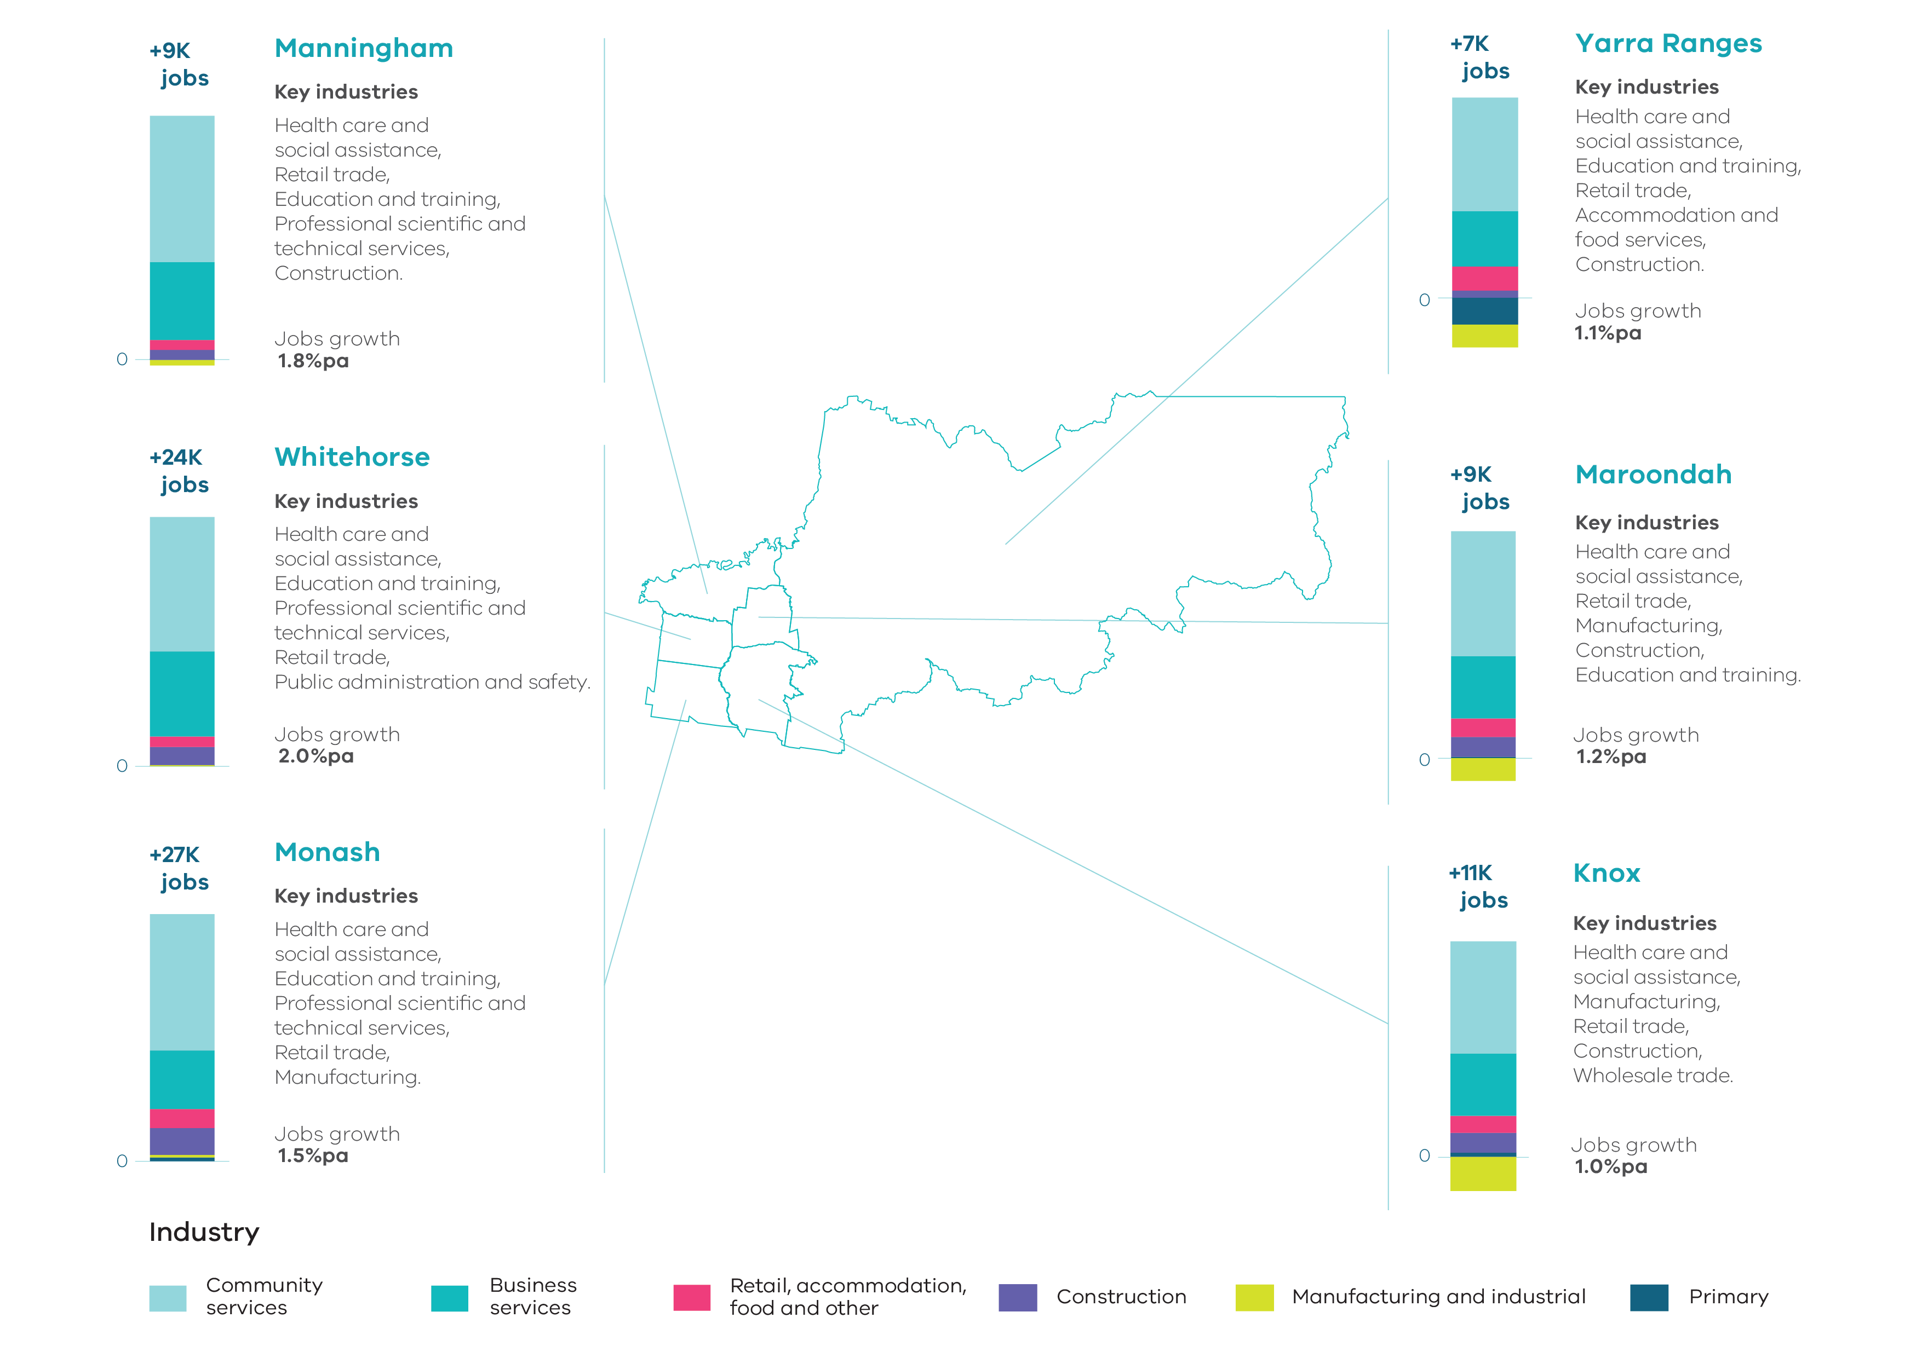 Source: Department of Jobs, Precincts and Regions, internal analysis (2019).
NOTE: Job figures have been rounded to the nearest thousand.

Key industrial and commercial areas
There are a number of key industrial areas of regional significance that should be protected and carefully planned for as key economic contributors to the region.
The Bayswater Business Precinct extends across the municipalities of Knox, Maroondah and Yarra Ranges with a large industrial land holding of 730 hectares which accommodates over 33,000 jobs. The precinct is almost fully developed with less than 10 per cent of the land vacant and available for future development. The Bayswater Major Activity Centre is located to the south-west of the precinct. Strategically located close to a skilled workforce and transport links, the precinct is important in generating employment and economic value in the region.
The Scoresby-Rowville Industrial Area is located adjacent to Eastlink in the City of Knox. The Rowville-Stud Park Major Activity Centre is located to the south-east. The precinct accommodates a range of production and service industries as well as business parks. It has good access to a skilled workforce and markets and has direct access to EastLink.
The Monash NEIC contributes significantly to Melbourne’s economy and includes the Monash University, Monash Medical Centre, Monash Children’s Hospital, Monash Enterprise Centre, CSIRO, Australian Synchrotron and the Melbourne Centre for Nanofabrication focussing on research and technology. It is the largest concentration of employment outside the Central City with approximately 75,000 jobs in the cluster. It is well linked to existing industrial areas with Huntingdale and Clayton offering further employment. With its educational and scientific institutions, high amenity employment precincts, access to a skilled workforce and direct access to the PFN, it will continue to play an important role in generating jobs and wealth in the region.
The MegaMile Home and Lifestyle Precinct extends along Whitehorse Road between Blackburn and Mitcham. It is home to more than 250 businesses supporting more than 2,500 jobs. The precinct largely consists of large format retailing. Adjacent to this area is the Blackburn Industrial Precinct. Along with a number of key industrial precincts in Whitehorse, such as Rooks Road and the Redland Estate, these precincts perform an important role in providing locations for small and medium sized businesses in the region. These areas have become more significant, as industrial businesses in the inner city have been displaced as a result of rezoning of industrial land for alternative uses. They also play an important role in meeting strong demand for businesses which serve industry in Melbourne’s outer eastern region.
The Box Hill Metropolitan Activity Centre is a significant regional mixed-use centre with high accessibility to the Melbourne CBD. It comprises approximately 182,860 square metres of commercial floorspace with significant retailing, office, accommodation, restaurant, civic, health and education facilities.
The Ringwood Metropolitan Activity Centre has an important regional role, with good accessibility to the Melbourne CBD and the Eastern Region via rail and road links, with relatively large areas of land for expansion, consolidation and mixed-uses. It comprises approximately 256,570 square metres of commercial floorspace with substantial retailing uses. The centre has been predominantly retail focussed but is increasingly moving towards a range of accommodation, food and drink and office uses.
There are 19 major activity centres across the region which offer significant retailing, serving larger sub-regional catchments. Larger free-standing shopping centres and restricted retailing uses are found at Chirnside Park, Doncaster Hill, Forest Hill Chase, Glen Waverley, Nunawading and Wantirna South-Knox Central. In other parts of the region, strip-based centres such as Boronia, Croydon, Lilydale and Oakleigh offer a range of retailing, office and community uses. Tally Ho Major Activity Centre acts as a regional employment node with significant office space accommodating a range of professional services as well as government offices and headquarters for large corporations. These centres are supported by a range of large and small neighbourhood activity centres.

Supply and demand for industrial and commercial land across the region

Industrial land
The Eastern Region contains a total of 2,570 hectares of land zoned for industrial uses. Of this land, 2,435 hectares is currently occupied and 135 hectares is vacant. There is no future land identified for industrial purposes in the region.

Table 23: Industrial land supply, Eastern Region
Council | Zoned occupied (ha) | Zoned vacant (ha) | Future supply (ha) | Total available supply (ha)
Knox | 771.2 | 44.1 | 0.0 | 44.1
Manningham | 13.1 | 0.0 | 0.0 | 0.0
Maroondah | 425.8 | 49.8 | 0.0 | 49.8
Monash | 703.5 | 7.6 | 0.0 | 7.6
Whitehorse | 226.2 | 2.9 | 0.0 | 2.9
Yarra Ranges | 295.3 | 30.7 | 0.0 | 30.7
Eastern Region | 2,435.0 | 135.1 | 0.0 | 135.1
Source: Department of Environment, Land, Water and Planning, Urban Development Program – Melbourne Metropolitan Industrial 2018
Overall, there is very little available supply of zoned industrial land across the region. Around 70 per cent of the overall supply in the region is located within the municipalities of Knox and Maroondah.
Manningham has the lowest supply of zoned industrial land in the region, none of which is vacant. The vast majority of this land is located within one precinct, where Manningham and Templestowe Roads intersect. This land is proposed to be used as an interchange for the North East Link.
While there is limited remaining vacant land available across the region, there is opportunity for existing underutilised land to be redeveloped and evidence of buildings being demolished and the land being recycled for new industrial uses.

Table 24: Industrial land consumption, Eastern Region, 2015-16 to 2017-18
Council | 2015-16 (ha) | 2016-17 (ha) | 2017-18 (ha)
Knox | 7.6 | 13.9 | 1.2
Manningham | 0.0 | 0.0 | 0.0
Maroondah | 3.4 | 3.6 | 1.8
Monash | 6.6 | 3.0 | -1.4
Whitehorse | -1.5 | 1.8 | 0.3
Yarra Ranges | 1.7 | -9.6 | 1.6
Eastern Region | 17.8 | 12.7 | 3.5
Source: Department of Environment, Land, Water and Planning, Urban Development Program – Melbourne Metropolitan Industrial 2018
Over the period 2015-16 to 2017-18 a total of 34 hectares of industrial land was consumed in the region at an average annual rate of approximately 11 hectares per annum. Consumption of industrial land dropped off significantly during the 2017-18 period (3.5 hectares). Prior to that period the rate of consumption was much higher.
Based on an average annual consumption rate of 11 hectares per annum, there is approximately 12 years supply of industrial land remaining in the region, with the only significant supplies in Knox (4 years supply), Maroondah (4.5 years supply) and Yarra Ranges (just under 3 years supply).

Figure 25: Change of zoned industrial land, Eastern Region, 2000-01 to 2017-18
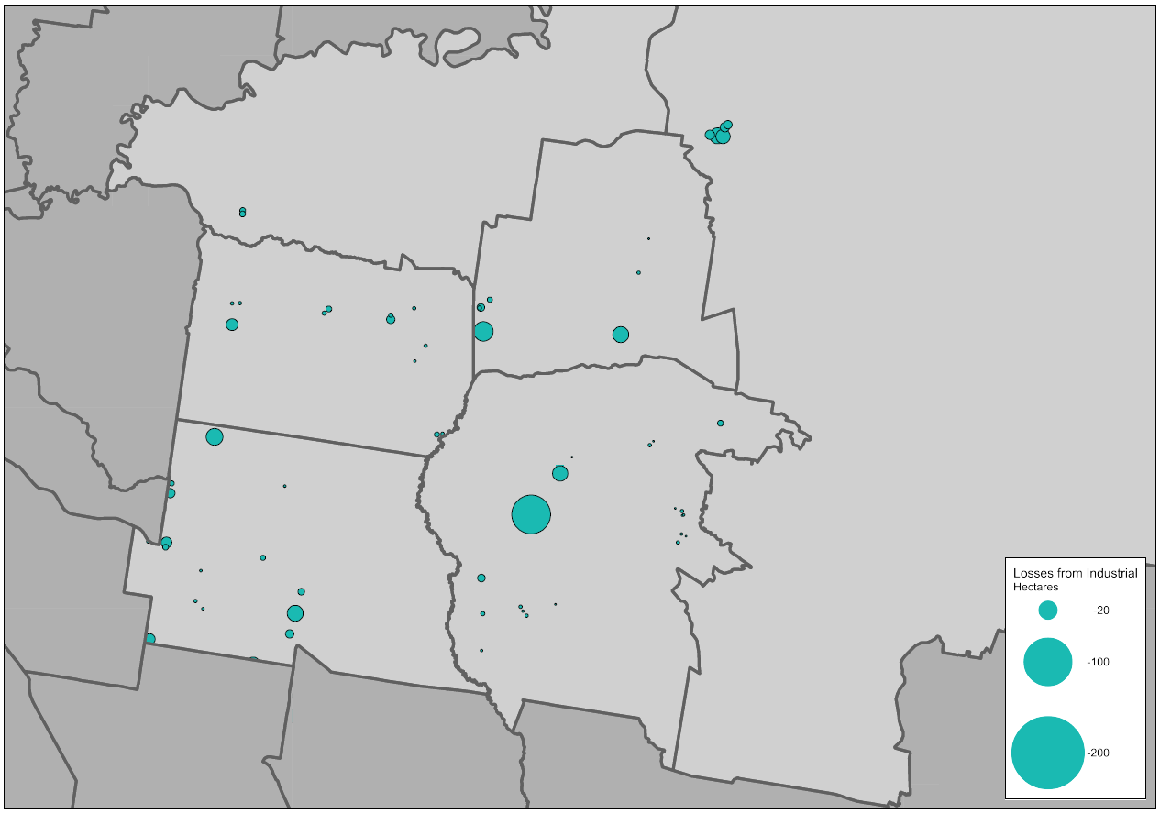
Source: Department of Environment, Land, Water and Planning, Urban Development Program – Melbourne Metropolitan Industrial 2018
Between 2000-01 and 2017-18 a total of 231 hectares of industrial land was rezoned across the region for non-industrial uses. The largest loss of industrial land over this period was within Knox where 20 sites were rezoned resulting in an overall loss of 80 hectares of industrial land.
The largest single loss of industrial land over this period was in Knox where a site of just over 56 hectares was rezoned from industrial land to allow for residential development.
Of the remaining rezonings that occurred over this period, approximately 65 per cent involved sites of less than 2 hectares in size. Of all the industrial land rezoned over the period, almost 60 per cent were rezoned to allow for residential development.

Commercial land
Currently across the region there is a total of 761 hectares of land that has been identified as being zoned for commercial purposes. It is estimated that there is approximately 2.8 million square metres of floorspace used or available for commercial purposes on this land. Approximately 49 per cent of all the existing floorspace supply is located within the municipalities of Monash and Whitehorse.
Across the region, a total of 286 commercial areas or centres have been identified. This is the most of all metropolitan regions, and of these almost 80 per cent (226 centres) have less than 10,000 square metres of floorspace. While numerous in number, these smaller centres only account for around 16 per cent of the region’s total floorspace.
Only five centres in the region have more than 100,000 square metres of floorspace. All of these centres include large free-standing shopping centres at Doncaster, Ringwood, Wantirna South, Glen Waverley and Box Hill. Combined, these centres account for 32 per cent of all identified floorspace across the region.
Monash has the largest number of centres (73) and Knox the fewest (31).

Table 25: Existing commercial floorspace by centre size, Eastern Region
Council | Less than 2,000 (m²) |  | 2,000 to 9,999 (m²) |  | 10,000 to 49,999 (m²) |  | 50,000 to 99,999 (m²) |  | Greater than 100,000 (m²)
 | No. of centres | Floorspace (m²) | No. of centres | Floorspace (m²) | No. of centres | Floorspace (m²) | No. of centres | Floorspace (m²) | No. of centres | Floorspace (m²)
Knox | 10 | 6,900 | 12 | 55,300 | 7 | 28,250 | 1 | 94,250 | 1 | 153,100
Manningham | 17 | 17,850 | 8 | 37,800 | 7 | 120,500 | 0 | 0 | 1 | 176,850
Maroondah | 22 | 21,600 | 14 | 58,850 | 2 | 25,600 | 1 | 53,100 | 1 | 256,550
Monash | 45 | 45,950 | 13 | 37,650 | 12 | 307,600 | 2 | 157,700 | 1 | 133,800
Whitehorse | 34 | 35,250 | 17 | 68,250 | 9 | 181,050 | 3 | 233,300 | 1 | 180,850
Yarra Ranges | 22 | 12,100 | 12 | 52,350 | 10 | 182,750 | 1 | 82,550 | 0 | 0
Total | 150 | 139,650 | 76 | 310,200 | 47 | 845,750 | 8 | 620,900 | 5 | 901,150
Source: Department of Environment, Land, Water and Planning, unpublished data (2020)

Based on projected growth, by 2031 it is anticipated that 837,000 square metres of additional commercial floorspace will be required across the Eastern Region. Approximately 614,000 square metres will be required for office uses and the remaining 223,000 square metres will be required for retail. Around 53 per cent of this additional floorspace will need to be provided in the municipalities of Monash and Whitehorse.
As there are no future commercial areas identified in the region, councils will need to look at ways to accommodate project demand for commercial floorspace within existing commercial areas, as well as considering areas that could accommodate future floorspace requirements through rezonings.

Table 26: Commercial floorspace supply and estimate, Eastern Region
Council | Existing commercial  floorspace 2018 (m²) | Estimated additional commercial floorspace  2016 to 2031 (m²)
Knox | 337,800 | 121,000
Manningham | 353,000 | 84,000
Maroondah | 415,700 | 87,000
Monash | 682,700 | 214,000
Whitehorse | 698,700 | 229,000
Yarra Ranges | 329,750 | 102,000
Total | 2,817,650 | 837,000
Source: Department of Environment, Land, Water and Planning, unpublished data (2020)

Figure 26: Estimated additional commercial floorspace by type and municipality, Eastern Region, 2016 to 2031
Source: Department of Environment, Land, Water and Planning, unpublished data (2020)

Planning framework for industrial and commercial land across the region
The Eastern Region has relatively moderate levels of industrial and commercial land compared to other regions, however it’s contribution to metropolitan Melbourne’s economy is significant and second only to the Inner Metro Region. Overall it accounts for around 16 per cent of metropolitan Melbourne’s GRP generating significant employment and economic functions.
The region is home to a number of significant industrial precincts at Clayton-Mulgrave, Scoresby-Rowville and Bayswater-Kilsyth, important not just to the region, but also to broader metropolitan areas. The industrial areas around Clayton-Mulgrave form part of the broader Monash NEIC and the areas around Scoresby-Rowville and Bayswater-Kilsyth have good and relatively easy access to broader metropolitan areas via EastLink. A number of other smaller industrial areas at Ringwood, Mitcham and Nunawading, while not as large, are also considered important to the broader region.
To support and maintain the contribution these industrial areas make to the region’s economy and as important places of employment, they should be retained and carefully planned for. As many of the precincts traverse municipal boundaries, consideration should be given to a coordinated approach that provides for consistent planning for the areas.
As an established region, there is limited opportunity for expansion of commercial areas beyond those that exist. Areas around Chirnside Park offer some opportunity for new commercial development, however in other areas there will be an ongoing need to allow for expansion and development through intensification of commercial facilities.
The metropolitan activity centres of Box Hill and Ringwood provide opportunities to consolidate as significant locations for commercial development. In addition to this, a number of larger major activity centres across the region could also offer opportunities to accommodate future growth. The Monash NEIC also offers significant opportunity to accommodate future growth, particularly for office development.

Planning for the region should:
- Retain industrial zoned land at Clayton-Mulgrave, Scoresby-Rowville and Bayswater-Kilsyth predominately for industrial uses and limit encroachment by other uses that would fragment the industrial land.
- Investigate and identify areas within regionally-significant industrial precincts that could support other employment uses, including offices, creative industries and start-ups, that support or are well connected to adjacent employment uses or transport connections.
- Identify areas that can support future demand for commercial floorspace and new investment in the region and plan for these areas to support future growth.

Map 10: Eastern Region - industrial land
Source: Department of Environment, Land, Water and Planning

Map 11: Eastern Region - commercial land
Source: Department of Environment, Land, Water and Planning

Southern Region

Regional snapshot
The Southern Region comprises the municipalities of Cardinia, Casey, Frankston, Greater Dandenong, Kingston and Mornington Peninsula. The region includes the South East Growth Corridor and makes significant provision for future industry and housing. The region has three state-significant industrial precincts (SSIPs).
There are good road and rail connections across the region. The key roads of Eastlink, Monash Freeway, Mornington Peninsula Freeway, the Princess Highway and Freeway, Nepean Highway, Western Port Highway and South Gippsland Freeway and Highway provide important connections throughout the region and beyond to other regions, including regional Victoria. Three rail lines provide connections to Frankston and Stony Point, Cranbourne and Pakenham.
Significant competitive advantages exist for the region, having easy access to Moorabbin Airport and the Port of Hastings. A potential intermodal freight terminal at Lyndhurst could support the Southern SSIP and the distribution network across the region and a possible South-East Airport would further enhance the region’s accessibility.
The region has three metropolitan activity centres at Dandenong, Frankston and Fountain Gate-Narre Warren providing retail, commercial, civic, institutional and cultural services.
The business service sector is the largest contributor to the economy for the region with a total value-added estimate at around $16.7 billion. The manufacturing and industrial sector is the next largest contributor with a total value-added estimate at around $13.2 billion. Combined, these sectors account for just over 60 per cent of the total value-add for the region.

Fast facts
PEOPLE  Population in 2006  806,313  Population in 2016  1,030,555  That’s 28% more people  Cardinia = + 39,623  Casey = + 92,349  Frankston = + 19,354  Greater Dandenong = + 30,154  Kingston = + 20,551  Mornington Peninsula = +22,211 | JOBS  Jobs in 2006  315,600  Jobs in 2016  392,250  That’s 24% more jobs  Cardinia = + 10,150  Casey = + 23,000  Frankston = + 8,750  Greater Dandenong = + 19,700  Kingston = + 3,150  Mornington Peninsula = +11,900 | ECONOMY  GRP for the region  $49 billion  Share of metropolitan Melbourne’s total GRP  15%  Cardinia = $3.3 billon  Casey = $8.8 billon  Frankston = $5.4 billon  Greater Dandenong = $13.4 billon  Kingston = $10.8 billon  Mornington Peninsula = $7.6 billon
Source: Department of Environment, Land, Water and Planning, unpublished data (2019)
The region was home to over 1 million people in 2016. By 2031 it is projected that the region will grow by around 356,300 people to a total population of around 1.4 million people. The growth area municipalities of Cardinia and Casey will experience the strongest population growth over this period and by 2031, are likely to be home to over 644,700 people.

Figure 27: Projected population growth, Southern Region, 2016 to 2031

Source: Department of Environment, Land, Water and Planning, Victoria in Future 2019 (July 2019).
In 2016 the region supported around 392,250 jobs, accounting for 17 per cent of all employment across the metropolitan area.
By 2031 it is projected that approximately 128,000 additional jobs will be located across the region. Over half of the new jobs in the region are expected to be within the growth area municipalities of Casey and Cardinia. The municipalities of Kingston and Greater Dandenong are also expected to experience substantial growth in jobs.
The industries that are expected to experience the strongest growth are: health care and social assistance; retail trade; manufacturing; construction; education and training.

Figure 28: Projected employment growth, Southern Region, 2016 to 2031
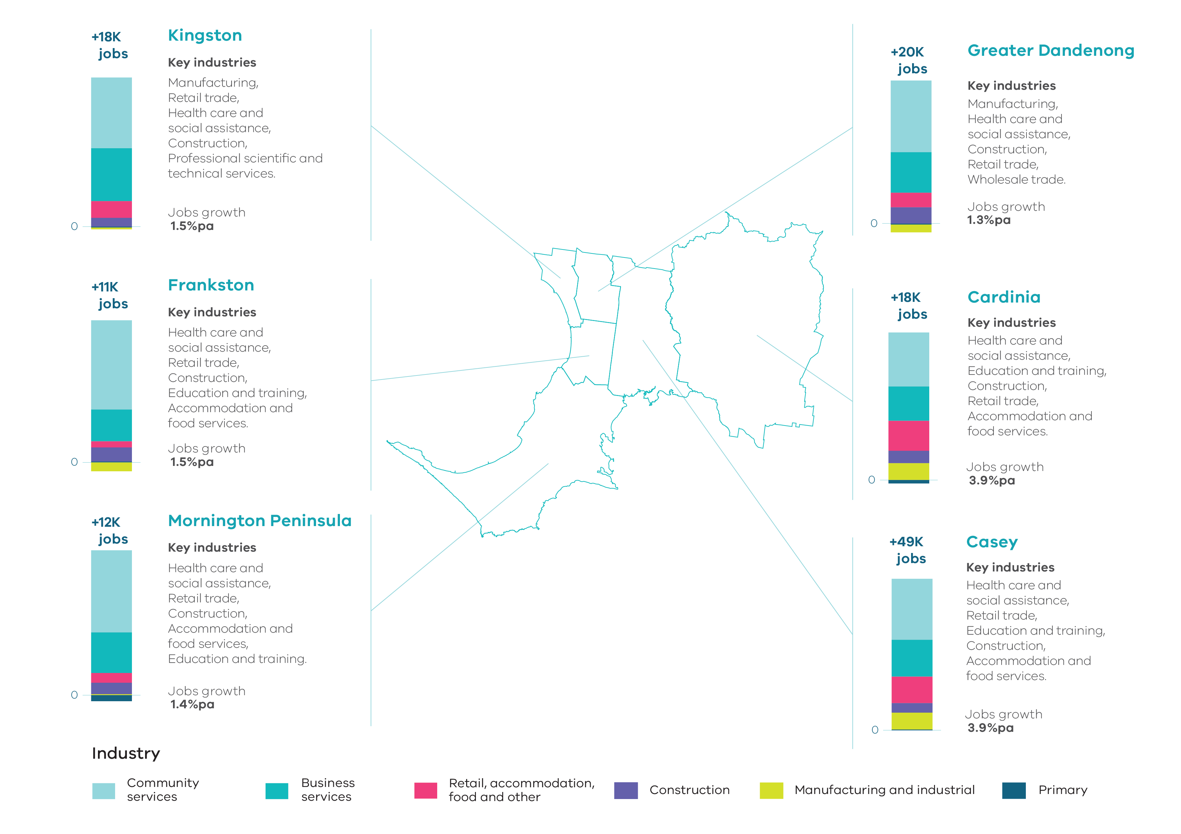
Source: Department of Jobs, Precincts and Regions, internal analysis (2019).
NOTE: Job figures have been rounded to the nearest thousand.

Key industrial and commercial areas
The Southern Region has the largest overall supply of zoned and unzoned industrial land supply across metropolitan Melbourne.
The Southern state-significant industrial precinct (Southern SSIP) is Melbourne’s third largest SSIP, comprising 2,957 hectares of zoned land within the municipalities of Greater Dandenong and Casey. It forms part of the Dandenong National Employment and Innovation Cluster (NEIC) and has easy access to significant transport infrastructure including, rail freight connections and the key roads of Eastlink, Western Port Highway, the South Gippsland Highway and Freeway and Monash Freeway. It includes several distinct precincts as follows:
- The Hammond Road Precinct is centrally located within the Southern SSIP and adjacent to Eastlink. It is one of only two areas of Industrial 2 zoned land in metropolitan Melbourne and the only supply in the region. A key purpose of this land is to allow for a range of heavy manufacturing. Surrounding are several precincts that allow for lighter industrial uses and act as a buffer to more sensitive land uses. These generally comprise business park, service industry or logistics uses.
- The Frankston-Dandenong Road Precinct extends east of the Hammond Road Precinct to the Cranbourne railway line. It contains a range of industrial activities including freight and logistics, light manufacturing, service industry, storage facilities and business parks and offices, with a strong presence of large format retailers along Frankston-Dandenong Road.
- The Lyndhurst Precinct is the southern-most precinct within the Southern SSIP and is adjacent to green wedge land. It has the largest supply of vacant land, and new development is used for manufacturing and increasingly warehousing and distribution.
- The South Gippsland Highway Precinct extends from Greater Dandenong into Hallam in the City of Casey. It has a high level of accessibility and comprises a range of warehousing and distribution uses as well as general manufacturing.

The Officer-Pakenham state-significant industrial precinct (Officer-Pakenham SSIP) is the largest area of industrial land in Cardinia. It is located adjacent to the Princes Highway and extends south to the edge of the UGB. Development has started at the eastern most part of the SSIP near Pakenham. Most of the remaining land is currently not zoned for industrial purposes and is required to undergo a PSP process before it can be used. For the Officer South and Cardinia Road Employment PSP areas, proposed place based strategic planning to develop PSPs may require reconfiguring the state-significant industrial precinct. This is to support the establishing community at Cardinia Road to improve connectivity, provide land for schools or community facilities and achieve an improved urban land use interface. Through this process, should reconfiguration of any state-significant industrial land be required, there must be no net loss of overall state-significant industrial land provision, maintaining contiguity, and orderly and efficient layout for industrial purposes.
The Hastings state-significant industrial precinct (Hastings SSIP) is located to the north of Long Island Jetty and includes the BlueScope Steel Wharves. The land could support growth of the Port of Hastings should it ever be required to operate as a major container port. While there is a significant amount of vacant land in this location, the zoning provisions require that any industrial use must be dependent on or gain significant economic advantage from proximity to deep water port facilities, be directly associated with such a use or be a marine service industry.
Industrial precincts in Moorabbin and Clayton South are older, established industrial areas that are essentially fully developed with limited vacant industrial land available. Industrial areas in Moorabbin are identified by the council as supporting a range of manufacturing and services industries, as well as restricted retailing, and with good access to major roads. The Clayton South precinct abuts the South East Green Wedge to the south and the Monash NEIC is located to the north. The green wedge area between these precincts houses a number of golf courses and parks as well as quarrying and land fill sites. The Victorian Planning Authority has been directed to undertake a planning project specific to the Clayton Business Park. Resolution of future land uses for this site will be determined through this project which is currently underway.
Moorabbin Airport is located south of these precincts within the green wedge. While the airport is Commonwealth land and not subject to provisions in Kingston Planning Scheme, it supports a range of aviation, light industry, logistics, office and retail uses. An Airport Environs Overlay limits adjacent land uses and built form to protect aviation uses.
The Mordialloc-Braeside industrial precincts adjacent to Moorabbin Airport are well established with some vacant industrial land supply. These precincts have excellent access to Moorabbin Airport and major road networks. The proposed extension to the Mornington Peninsula Freeway is set aside along the eastern boundary of these precincts. The precincts accommodate a diverse range of industrial activities and are located close to markets and a skilled labour force. Despite their age and physical constraints, these areas will continue to play an important role in generating jobs and wealth in the region.
Carrum Downs industrial area is the largest industrial area in Frankston and has direct access to EastLink and the Mornington Peninsula Freeway. There is very limited supply remaining in the precinct and there is no ability to expand due to its location adjacent to the UGB. The Seaford precinct to the south is developed for a range of manufacturing, light industry and large format retailing. These industrial areas play a vital role in generating employment and wealth for the area and broader region.
In the vicinity of Tyabb, Hastings and Cribb Point there is a significant supply of Special Use Zone 1 land set aside for port related uses. Like the Hastings SSIP, these areas are not available for general industrial use and development, and are set aside to support port operations, including storage and export of gas and oil.
The Cranbourne West industrial precinct is identified in the South East Growth Corridor Plan as a future industrial area. It has access to the PFN along Western Port Highway and is located approximately two to three-kilometres south of the Southern SSIP. Development is occurring in the northern portion of the precinct. A current proposal seeks to rezone a significant amount of the existing industrial land in this precinct to allow for residential development. This would reduce the stock of industrial land available in Casey by over 20 per cent.
The Casey Fields South future industrial precinct adjacent to the South Gippsland Highway near Clyde is identified in the South East Growth Corridor Plan as a future industrial node with approximately 288 hectares of land identified for future industrial uses. This precinct enjoys direct access to the South Gippsland Highway and a proposed new railway station and major activity centre immediately to its north at Clyde. It has the potential to accommodate a range of future industrial uses.
The Thompsons Road Business Corridor is identified in the South East Growth Corridor Plan as a future high amenity business with residential precinct to support a mix of business services, service industry and associated uses. It will have easy access to the future major activity centre at Clyde North and will be readily accessible to the Principal Public Transport Network by a series of north-south connections. Planning for the area should ensure that a potential freight route along Thompsons Road is protected from sensitive uses.
The Officer-Pakenham Business Corridor identified in the South East Growth Corridor Plan is adjacent to the Officer-Pakenham SSIP and has excellent access to the PFN via the Princes Freeway. It has been identified to support a high amenity business park at Minta Farm and a range of advanced manufacturing and commercial enterprises.
The Dandenong NEIC incorporates the Southern SSIP as well as the Dandenong Metropolitan Activity Centre and Dandenong Hospital and Chisholm TAFE Precinct. The Dandenong Metropolitan Activity Centre is an important regional mixed-use centre with good accessibility to the Melbourne CBD and Southern Region. It comprises approximately 405,000 square metres of commercial floorspace with significant retail, office, restaurant, civic and accommodation uses.
The Fountain Gate–Narre Warren Metropolitan Activity Centre has an important regional role with good accessibility to the eastern region of Victoria via rail and road links. It comprises approximately 305,000 square metres of commercial floorspace with large areas of land for expansion, consolidation and mixed-uses. The centre includes the Fountain Gate Shopping Centre as well as a range of other retail, commercial, entertainment, civic and recreational uses.
The Frankston Metropolitan Activity Centre is an important regional centre comprising approximately 358,000 square metres of commercial floorspace. It has significant retail, hospitality, office, civic, health and education use as well as community, arts and cultural uses. It is located adjacent to Port Phillip Bay and the Frankston railway line provides access to the Melbourne CBD. It is also well served by road infrastructure with EastLink, the Frankston Freeway, Moorooduc Highway, and Nepean Highway connecting the centre within metropolitan Melbourne and to the Mornington Peninsula.
The broader activity centre network across the region comprises 20 existing major activity centres and two identified future major activity centres. Larger free-standing shopping centres such as Casey Central, Cheltenham-Southland, Keysborough-Parkmore, and Karingal offer significant retailing, serving larger sub-regional catchments. In other parts of the region, strip-based centres such as Cranbourne, Mentone, Mornington and Springvale offer a range of retailing, office and community uses.

Supply and demand for industrial and commercial land across the region

Industrial land
The Southern Region contains metropolitan Melbourne’s largest holdings of industrial land and has three SSIPs. The region has a total of around 9,610 hectares of zoned land set aside for industrial uses. Of this around 7,270 hectares is currently occupied, and 2,338 hectares is currently zoned for industrial purposes and vacant. An additional 1,184 hectares of land has been identified for future industrial purposes that is yet to be zoned.

Table 27: Industrial land supply, Southern Region
Council / SSIP | Zoned occupied (ha) | Zoned vacant (ha) | Future supply (ha) | Total available supply (ha)
Cardinia | 380.9 | 375.2 | 938.3 | 1,313.5
Casey | 670.7 | 367.5 | 245.2 | 612.7
Frankston | 368.4 | 21.6 | 0.0 | 21.6
Greater Dandenong | 2,448.2 | 469.6 | 0.0 | 469.6
Kingston | 1,217.3 | 75.9 | 0.0 | 75.9
Mornington Peninsula | 2,184.8 | 1,027.7 | 0.0 | 1,027.7
Southern Region | 7,270.3 | 2,337.5 | 1,183.5 | 3,521.0
Southern SSIP | 2,454.4 | 502.6 | 0.0 | 502.6
Officer-Pakenham SSIP | 317.7 | 323.8 | 938.3 | 1,262.1
Hastings SSIP | 814.1 | 578.1 | 0.0 | 578.1
Source: Department of Environment, Land, Water and Planning, Urban Development Program – Melbourne Metropolitan Industrial 2018 and internal analysis
Across the region there are approximately 3,520 hectares of vacant zoned and unzoned industrial land available for development, of which approximately 1,260 hectares is located within the Officer-Pakenham SSIP, and approximately 1,080 hectares of zoned vacant land is available within the Southern and Hastings SSIPs. Beyond the SSIPs there is approximately 1,180 hectares of vacant zoned and unzoned land available for industrial purposes.
While there is significant zoned vacant supply available within Mornington Peninsula, the vast majority of this supply (approximately 980 hectares) is zoned Special Use Zone 1. In accordance with the provisions of that zone, the land is unable to be used for general industrial purposes and is intended for selected port and industrial uses, which depend upon or gain significant economic advantages from the natural deep water channels in Western Port. Aside from the Special Use Zone 1 land in Mornington Peninsula, there is just under 48 hectares of vacant land available. Frankston and Kingston have limited amounts of vacant industrial land.
Demand for industrial land in the Southern Region, and particularly in the Southern SSIP, has been strong for the manufacturing sector. This sector accounted for approximately 32 per cent of workplaces in the Southern SSIP in 2016-17 compared to 22 per cent of workplaces across Melbourne as a whole. While these types of operations will continue to drive demand for land within the region, increasingly the freight, logistics and warehouse sectors will grow to support strong projected population growth in the region.

Table 28: Industrial land consumption, Southern Region, 2015-16 to 2017-18
Council / SSIP | 2015-16 (ha) | 2016-17 (ha) | 2017-18 (ha)
Cardinia | 15.1 | 12.8 | 14.8
Casey | 4.1 | 7.8 | 9.4
Frankston | 10.6 | 8.7 | 8.3
Greater Dandenong | 53.7 | 74.2 | 57.5
Kingston | 14.6 | 2.8 | 13.4
Mornington Peninsula | 3.9 | 3.0 | 6.8
Southern Region | 102.0 | 109.3 | 110.2
Southern SSIP | 55.9 | 71.4 | 63.3
Officer-Pakenham SSIP | 15.5 | 12.4 | 13.9
Hastings SSIP | 0.0 | 0.0 | -3.6
Source: Department of Environment, Land, Water and Planning, Urban Development Program – Melbourne Metropolitan Industrial 2018
Over the last three years, the average rate of consumption of industrial land in the region has been 107 hectares per annum. Consumption rates have been higher than this over the last two years and during the period 2017-18 was at 110 hectares. Almost 60 per cent of this consumption occurred within the Southern SSIP (63 hectares).
If consumption rates remain at last year’s level, it is anticipated that the region as a whole has approximately 21 years supply of zoned industrial land. If land in Mornington Peninsula zoned Special Use Zone 1 is removed from supply, there would be just over 12 years supply of zoned industrial land.
Unzoned areas identified for future industrial purposes could provide another 7 years of supply, but this is dependent on future planning for these areas as part of the PSP process. Of the total future unzoned supply, around 80 per cent is located within the Officer-Pakenham SSIP.
It is estimated that land supply in the Southern SSIP will become significantly constrained in the early 2020s and be exhausted by the mid-2020s. When this occurs, demand transfer is likely to occur at the closest industrial areas.
The exhaustion of industrial land within the Southern SSIP within the next decade will likely direct future demand for large-format, regionally-significant industrial uses into neighbouring areas, such as Braeside and Cranbourne West. In these locations there are relatively large contiguous tracts of vacant industrial land with easy access to the Principal Freight Network for large heavy vehicles and access to existing supply chains and distribution networks. Development will progressively move to the Officer-Pakenham SSIP as land in these locations is exhausted and new major road connections, such as the North East Link, are delivered.

Figure 29: Change of zoned industrial land, Southern Region, 2000-01 to 2017-18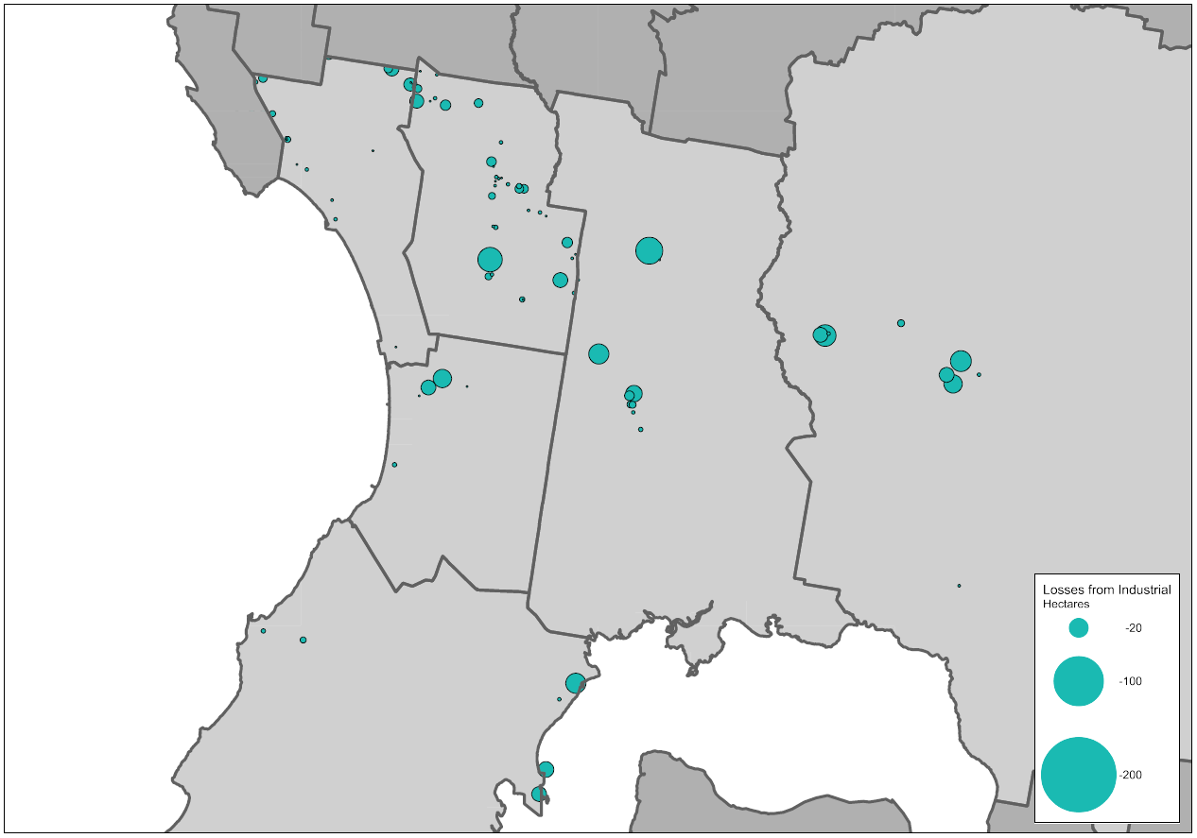
Source: Department of Environment, Land, Water and Planning, Urban Development Program – Melbourne Metropolitan Industrial 2018
Between 2000-01 and 2017-18 a total of 328 hectares of industrial land was rezoned across the region for other non-industrial uses.
The largest single loss of industrial land over this period was within Casey, where just under 28 hectares of industrial land was rezoned to allow for residential development. Of the remaining industrial land rezonings that occurred over this period, almost 60 per cent involved sites of less than 2 hectares in size.
Of all the industrial land rezoned over the period, around 37 per cent was rezoned to allow for mixed-use or residential development.

Commercial land
Currently across the region there is a total of 855 hectares of land that has been identified as being zoned for commercial purposes. It is estimated that there is almost 3.2 million square metres of floorspace used for or available for commercial purposes on this land. Approximately 43 per cent of all the existing floorspace supply is located within the municipalities of Casey and Greater Dandenong.
Across the region a total of 216 commercial areas or centres have been identified. Of these, 171 have less than 10,000 square metres of floorspace.
Seven centres have more than 100,000 square metres of floorspace. This includes large free-standing shopping-centre based locations such as Fountain Gate-Narre Warren and Cheltenham-Southland, and traditional strip-based centres such as Dandenong and Frankston. Combined these centres account for 46 per cent of the identified commercial floorspace across the region.
Kingston has the largest number of centres (49) and Cardinia the fewest (16). Only 7 per cent of all the existing floorspace supply is located within the municipality of Cardinia.

Table 29: Existing commercial floorspace by centre size, Southern Region
Council | Less than 2,000 (m²) |  | 2,000 to 9,999 (m²) |  | 10,000 to 49,999 (m²) |  | 50,000 to 99,999 (m²) |  | Greater than 100,000 (m²)
 | No. of centres | Floorspace (m²) | No. of centres | Floorspace (m²) | No. of centres | Floorspace (m²) | No. of centres | Floorspace (m²) | No. of centres | Floorspace (m²)
Cardinia | 7 | 1,100 | 4 | 21,700 | 4 | 72,350 | 0 | 0 | 1 | 111,550
Casey | 10 | 11,900 | 15 | 87,050 | 7 | 198,700 | 0 | 0 | 2 | 420,650
Frankston | 17 | 18,050 | 14 | 56,200 | 2 | 22,500 | 2 | 113,800 | 1 | 274,700
Greater Dandenong | 25 | 26,200 | 6 | 24,100 | 3 | 82,950 | 0 | 0 | 2 | 520,650
Kingston | 22 | 24,300 | 16 | 72,250 | 8 | 178,600 | 2 | 176,150 | 1 | 144,450
Mornington Peninsula | 22 | 20,150 | 13 | 59,800 | 7 | 183,500 | 3 | 243,400 | 0 | 0
Total | 103 | 101,700 | 68 | 321,100 | 31 | 738,600 | 7 | 533,350 | 7 | 1,472,000
Source: Department of Environment, Land, Water and Planning, unpublished data (2020)

In addition to the existing zoned commercial land, approximately 555 hectares of land has been identified through other strategic plans (such as Growth Corridor Plans and PSPs) for future commercial purposes. These areas are confined to Cardinia and Casey.
A significant proportion of this land has been identified in areas designated as future business with residential precincts in the municipalities of Cardinia (160 hectares) and Casey (85 hectares). These areas are intended to be suitable for a range of other employment uses, including some industrial uses, as well as some residential uses. This land accounts for just over 44 per cent of all future commercial land identified for the region and nearly 20 per cent of all future supply for the entire metropolitan area.

Table 30: Future commercial land supply, Southern Region
Council | Future commercial land (ha) | Share of metropolitan Melbourne
Cardinia | 300 | 23%
Casey | 255 | 19%
Total | 555 | 42%
Source: Department of Environment, Land, Water and Planning, unpublished data (2020)

Based on projected growth, by 2031 it is anticipated that an additional 1.4 million square metres of commercial floorspace will be required across the Southern Region. Approximately 800,000 square metres will be required for office uses and 571,000 square metres will be required for retail. Over half of this additional floorspace is anticipated to be provided in the growth area municipalities of Cardinia and Casey. These councils have land identified for future commercial purposes. Around one-third of the future commercial floorspace projected is expected to be located in Greater Dandenong and Kingston.
The municipalities of Frankston, Greater Dandenong, Kingston and Mornington Peninsula will need to identify options to accommodate projected demand for commercial floorspace within existing commercial areas, as well as considering areas that could accommodate future floorspace requirements through rezonings.

Table 31: Commercial floorspace supply and requirement, Southern Region
Council | Existing commercial  floorspace 2018 (m2) | Estimated additional commercial floorspace  2016 to 2031 (m2)
Cardinia | 206,700 | 217,000
Casey | 718,300 | 541,000
Frankston | 485,250 | 75,000
Greater Dandenong | 653,900 | 213,000
Kingston | 595,750 | 218,000
Mornington Peninsula | 506,850 | 107,000
Total | 3,166,750 | 1,371,000
Source: Department of Environment, Land, Water and Planning, unpublished data (2020)

Figure 30: Estimated additional commercial floorspace by type and municipality, Southern Region, 2016 to 2031
Source: Department of Environment, Land, Water and Planning, unpublished data (2020)

Planning framework for industrial and commercial land across the region
There is a large amount of industrial and commercial land providing state, regionally and locally-significant employment and economic functions in the Southern Region. Across the region there are good arterial road, freeway and fixed rail connections to major transport gateways such as the Port of Hastings, Moorabbin Airport, the possible South-East Airport and beyond to the Gippsland region.
The region’s significant industrial land holding is a key advantage. However, many established industrial areas such as those in Kingston around Moorabbin Airport, in Frankston around Carrum Downs and in Greater Dandenong in the Southern SSIP, will soon offer little or no opportunity for further expansion. These areas need to be protected and retained and opportunities to consolidate and recycle land should be considered in these locations.
Crucial in supporting these areas will be new industrial areas that have been set aside. These can provide large areas of unfragmented land providing the required land area for freight, logistics, warehousing, transport, manufacturing and other larger format industrial uses once supply runs out in other locations. While significant land is available in the Hastings area, it is limited to port related uses and cannot be developed for general industrial purposes.
While the region has significant land set aside for future industrial purposes, it is increasingly under pressure for other non-industrial purposes. Reduction in land available for future industrial purposes will further reduce employment opportunities in the region, but particularly in growth areas.
Planning for industrial land across the region needs to be carefully managed to ensure it continues to support the regional economy. Areas significant to the region need to be protected and retained to support the region’s economy and employment opportunities into the future.
Considerable provision has been identified for future commercial development at future activity centres in growth areas as well as at two key growth area business with residential precincts in Cardinia and Casey. Future activity centres will play an important role in providing for future retail and office floorspace and supporting the delivery of 20-minute neighbourhoods. The growth areas business with residential precincts also offer an opportunity to provide for significant office development and higher-order, knowledge-based jobs in the region. Combined these areas provide an opportunity to accommodate demand for future commercial floorspace and deliver more jobs in the region.
Careful consideration will be required through the PSP processes to ensure adequate provision is made to accommodate medium and longer term industrial and commercial development.
Planning for the region should:
- Retain industrial land at Clayton South, Moorabbin, Moorabbin Airport, Braeside, Carrum Downs, Seaford, Cranbourne West and Casey Fields South predominately for industrial uses, limit encroachment by other uses that would fragment this land and protect them from encroachment of sensitive uses that may compromise development and efficient operation of businesses in these locations.
- Investigate and identify areas within regionally-significant industrial precincts that could support other employment uses, including offices, creative industries and start-ups, that support or are well connected to adjacent employment uses or transport connections.
- In consultation with the Port of Hastings Development Authority and Mornington Peninsula Shire Council, investigate the potential for any Special Use Zone 1 land outside of the Hastings SSIP that could allow for a broader range of industrial uses.
- Support the development of growth area business with residential precincts for predominately commercial development providing for higher-order, knowledge-based jobs and businesses. These precincts should have a primary role for economic and employment purposes with no less than 50 per cent of the land in each precinct being allocated for these purposes.
- Consider the future demand for and need for commercial and employment land across the growth areas and ensure that PSPs make adequate and sufficient provision to accommodate longer-term commercial and employment needs.

Map 12: Southern Region - industrial land
Source: Department of Environment, Land, Water and Planning

Map 13: Southern Region - commercial land
Source: Department of Environment, Land, Water and Planning

Inner South East Region

Regional snapshot
The Inner South East Region comprises the municipalities of Bayside, Boroondara, Glen Eira and Stonnington. The region is well served by public transport with an extensive tram network and numerous rail lines. The key roads of Nepean Highway, Dandenong Road-Princes Highway, Monash Freeway and the Eastern Freeway provide important connections throughout the region and beyond.
The region is well established with easy access to the Central City and extends from Port Phillip Bay in the south to the Yarra River and Eastern Freeway in the north.
In 2016 the region was home to around 539,800 people. By 2031 it is projected that the region will grow by 99,500 people to a total population of around 639,200 people.
The region has very little traditional industry remaining and is dominated by a largely service-orientated economy. There is a very large retail offer available in the region and a number of major education facilities.
The business service sector is the largest contributor to the economy for the region with a total value-added estimate at around $13.7 billion. The manufacturing and industrial sector’s value-added contribution to the region’s economy is estimated at around $5.7 billion. Combined, these sectors account for just under 60 per cent of the total value-add for the region.

Fast facts
PEOPLE  Population in 2006  472,942  Population in 2016  539,774  That’s 14% more people  Bayside = + 12,105  Boroondara = + 17,671  Glen Eira = + 20,109  Stonnington = + 16,947 | JOBS  Jobs in 2006  182,500  Jobs in 2016  220,500  That’s 21% more jobs  Bayside = + 5,950  Boroondara = + 12,450  Glen Eira = + 8,650  Stonnington = + 10,950 | ECONOMY  GRP for the region  $35 billion  Share of metropolitan Melbourne’s total GRP  10%  Bayside = $5.6  Boroondara = $12.8  Glen Eira = $6.7  Stonnington = $9.5
Source: Department of Environment, Land, Water and Planning, unpublished data (2019)

Figure 31: Projected population growth, Inner South East Region, 2016 to 2031

Source: Department of Environment, Land, Water and Planning, Victoria in Future 2019 July 2019.
In 2016 the region supported 220,500 jobs, accounting for around 10 per cent of all employment across the metropolitan area.
By 2031 it is projected that approximately 73,000 additional jobs will be located across the region. Over two-thirds of the new jobs in the region are expected to be needed in the municipalities of Boroondara and Stonnington.
The industries that are expected to experience the strongest growth are: health care and social assistance; professional, scientific and technical services; education and training; retail trade; accommodation and food services.

Figure 32: Projected employment growth, Inner South East Region, 2016 to 2031
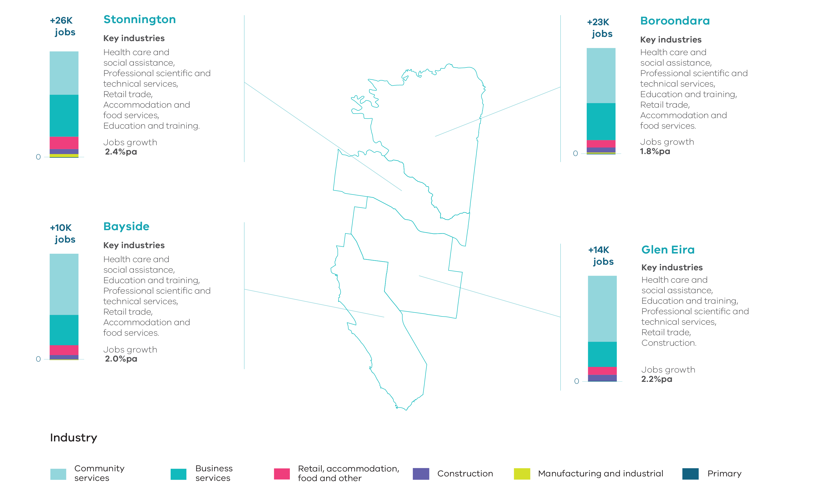
Source: Department of Jobs, Precincts and Regions, internal analysis (2019).
NOTE: Job figures have been rounded to the nearest thousand.

Key industrial and commercial areas
The Bayside Business District in Cheltenham surrounds the Cheltenham Memorial Park Cemetery and is the largest area of industrial land within the region. Having been identified by Bayside Council as an area to transition from its traditional manufacturing base to a more business services focus, it provides for a range of manufacturing and industrial uses as well as a growing commercial role. Other industrial land within the region is located either along major roads or in smaller isolated pockets.
In East Bentleigh a large area of industrial land has been identified and is being planned for as a new mixed-use precinct, with a focus on innovative employment and education opportunities. It is currently proposed to include new commercial and office development along East Boundary Road, a new retail precinct and, over time, transition the existing industrial and service businesses along North Road to commercial and other employment uses.
The activity centres network in the region is quite dense and extensive, anchored by 16 major activity centres. While most are retail based, a number are supported by other commercial uses as well as education and health services.
Chadstone Major Activity Centre is metropolitan Melbourne’s largest free-standing shopping centre. It has a significant retail and entertainment offer and is increasingly expanding its uses to include office uses and a hotel development.
The Prahran-South Yarra Major Activity Centre centred on Chapel Street also offers a range of retail activity, office accommodation and entertainment facilities such as cinemas and nightclubs.
The major activity centres of Camberwell Junction and Hawthorn-Glenferrie Road offer a range of retail and commercial uses while the adjacent areas along Burwood and Camberwell Roads are significant corridors for office and commercial development.
Other strip-based major activity centres such as Bentleigh, Brighton-Bay Street, Brighton-Church Street, Carnegie, Caulfield, Elsternwick, Glenhuntly, Hampton, Kew Junction, Malvern-Armadale, Sandringham and Toorak Village offer a range of retail, office, food and drink and community uses. These centres are supported by a range of smaller neighbourhood activity centres serving local communities and smaller catchments.

Supply and demand for industrial and commercial land across the region

Industrial land
The Inner South East Region contains metropolitan Melbourne’s smallest holdings of industrial land. The region has a total of only 143 hectares of land set aside for industrial uses. Of this land, 141 hectares are occupied and just over 2 hectares are currently vacant and available for industrial purposes. No land has been identified for future industrial purposes.

Table 32: Industrial land supply, Inner South East Region
Council | Zoned occupied (ha) | Zoned vacant (ha) | Future supply (ha) | Total available supply (ha)
Bayside | 73.7 | 1.9 | 0.0 | 1.9
Boroondara | 20.1 | 0.4 | 0.0 | 0.4
Glen Eira | 43.2 | 0.0 | 0.0 | 0.0
Stonnington | 3.7 | 0.0 | 0.0 | 0.0
Inner South East Region | 140.7 | 2.3 | 0.0 | 2.3
Source: Department of Environment, Land, Water and Planning, Urban Development Program – Melbourne Metropolitan Industrial 2018

The only supply of vacant zoned industrial land remaining in the region is in Bayside (1.9 hectares) and Boroondara (0.4 hectares). Stonnington has the smallest supply of zoned industrial land in the region, none of which is vacant. Almost 85 per cent of all the land identified for industrial purposes in the region is zoned Commercial 2 Zone. Given the amount of vacant industrial land, any new industrial development in the region would require either the reuse of an existing building or demolition and redevelopment of an existing industrial site.
Over the period 2015-16 to 2017-18 consumption of industrial zoned land in the region has been small with just over half a hectare consumed in 2017-18. Consumption figures provided here and in the UDP are for net activity. A negative figure indicates that building demolition activity was greater than the level of building construction activity (consumption). In locations such as the Inner South East Region, most of the land is occupied by an existing building and use. In many instances, in order to develop land for new industrial use, the existing building needs to be demolished. Therefore, a negative consumption figure will be recorded until the site is redeveloped for further industrial development activity.

Table 33: Industrial land consumption, Inner South East Region, 2015-16 to 2017-18
Council | 2015-16 (ha) | 2016-17 (ha) | 2017-18 (ha)
Bayside | -0.2 | 0.0 | 0.2
Boroondara | -0.1 | -0.4 | 0.3
Glen Eira | -0.6 | 0.8 | 0.1
Stonnington | 0.0 | 0.0 | 0.0
Inner South East Region | -0.9 | 0.4 | 0.6
Source: Department of Environment, Land, Water and Planning, Urban Development Program – Melbourne Metropolitan Industrial 2018

Between 2000-01 and 2017-18 a total of 29 hectares of industrial land was rezoned across the region for non-industrial uses. The largest loss of industrial land over this period was within Glen Eira where 14 sites were rezoned, resulting in an overall loss of 14 hectares of industrial land. Bayside also lost 14 hectares of industrial land over the period through rezonings at 7 sites.
Of the rezonings that occurred over this period, almost 80 per cent involved sites of less than 2 hectares in size. In Glen Eira 55 per cent of land rezoned allowed for mixed-use or residential development and in Bayside more than 90 per cent of land was rezoned for mixed-use or residential development.

Figure 33: Change of zoned industrial land, Inner South East Region, 2000-01 to 2017-18

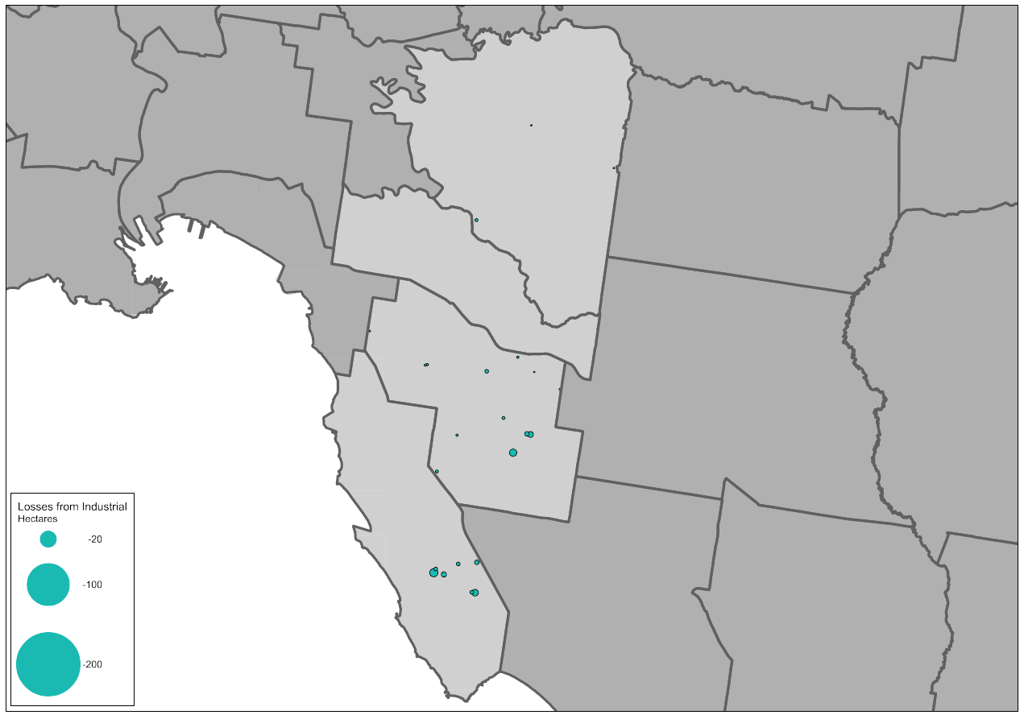
Source: Department of Environment, Land, Water and Planning, Urban Development Program – Melbourne Metropolitan Industrial 2018

Commercial land
Currently across the region there is a total of 515 hectares of land that has been identified as being zoned for commercial purposes. It is estimated that there is almost 3 million square metres of floorspace used for or available for commercial purposes on this land. Over 70 per cent of all the existing floorspace supply is located within the municipalities of Boroondara and Stonnington.
Across the region a total of 152 commercial areas or centres have been identified. Of these, 101 have less than 10,000 square metres of floorspace. While accounting for around two-thirds of all centres across the region, these smaller centres only make up around 12 per cent of the region’s total floorspace.
Five centres have more than 100,000 square metres of floorspace. These include strip-based centres like Camberwell, Hawthorn, Malvern-Armadale and Chapel Street as well as Chadstone, which is the largest free-standing shopping centre in metropolitan Melbourne. Combined these centres account for 40 per cent of the region’s existing commercial floorspace.
Boroondara has the largest number of centres (51). Although Stonnington has the fewest number of centres (25), it has the largest commercial floorspace supply and accounts for 38 per cent of the region’s overall supply.

Table 34: Existing commercial floorspace by centre size, Inner South East Region
Council | Less than 2,000 (m²) |  | 2,000 to 9,999 (m²) |  | 10,000 to 49,999 (m²) |  | 50,000 to 99,999 (m²) |  | Greater than 100,000 (m²)
 | No. of centres | Floorspace (m²) | No. of centres | Floorspace (m²) | No. of centres | Floorspace (m²) | No. of centres | Floorspace (m²) | No. of centres | Floorspace (m²)
Bayside | 6 | 5,950 | 15 | 65,850 | 8 | 190,100 | 1 | 60,200 | 0 | 0
Boroondara | 10 | 9,100 | 22 | 122,200 | 13 | 272,350 | 4 | 285,700 | 2 | 303,750
Glen Eira | 14 | 17,950 | 20 | 74,500 | 9 | 249,300 | 3 | 187,700 | 0 | 0
Stonnington | 3 | 2,000 | 11 | 56,250 | 8 | 183,250 | 0 | 0 | 3 | 905,050
Total | 33 | 35,000 | 68 | 318,800 | 38 | 895,000 | 8 | 533,600 | 5 | 1,208,800
Source: Department of Environment, Land, Water and Planning, unpublished data (2020)
Based on projected growth, by 2031 it is anticipated that around 784,000 square metres of additional commercial floorspace will be required across the Inner South East Region. Approximately 571,000 square metres will be required for office uses and 212,000 square metres will be required for retail. Around 70 per cent of this additional floorspace is anticipated to be located in Boroondara and Stonnington.
As there are no future commercial areas identified in the region, councils will need to look at ways to accommodate project demand for commercial floorspace within existing commercial areas, as well as considering areas that could accommodate future floorspace requirements through rezonings.

Table 35: Commercial floorspace supply and requirement, Inner South East Region
Council | Existing commercial  floorspace 2018 (m²) | Estimated additional commercial floorspace  2016 to 2031 (m²)
Bayside | 322,100 | 99,000
Boroondara | 993,100 | 243,000
Glen Eira | 529,450 | 113,000
Stonnington | 1,146,550 | 328,000
Total | 2,991,200 | 784,000
Source: Department of Environment, Land, Water and Planning, unpublished data (2020)

Figure 34: Estimated additional commercial floorspace by type and municipality, Inner South East Region, 2016 to 2031
Source: Department of Environment, Land, Water and Planning, unpublished data (2020)

Planning framework for industrial and commercial land across the region
While the Inner South East Region offers significant commercial floorspace across its network of activity centres, it contains the smallest supply of industrial land of all Melbourne’s regions with the majority of this located within the municipality of Bayside.
Strip-based major activity centres such as Prahran-South Yarra, Glenferrie Road Hawthorn and Camberwell Junction offer significant retailing and office development. In addition to this, Chadstone Major Activity Centre continues to expand its commercial offerings beyond retail.
Industrial land supply across the region has been gradually decreasing. The largest remaining industrial area within the region is the Bayside Business District in Cheltenham. This area has been gradually transforming from a more traditional industrial area towards a more general business area allowing for a mix of activities including existing and new industrial uses as well as office-based facilities.
Across the region there is ongoing pressure for residential development and a key challenge will be ensuring that rezoning proposals do not further diminish opportunity for industry and businesses to serve the region.
Planning for the region should:
- Ensure the Bayside Business District is protected from encroachment of incompatible uses that would fragment the land and could compromise its development and efficient operation as a business location.
- Review local industrial areas and identify areas important for retention as employment land to support local communities.
- Identify activity centres where commercial development should be prioritised to accommodate future needs.
- Identify locations where there is opportunity to support increased commercial development, and particularly office-based development with an employment focus.

Map 14: Inner South East Region - industrial land
Source: Department of Environment, Land, Water and Planning

Map 15: Inner South East Region - commercial land
Source: Department of Environment, Land, Water and Planning

APPENDICES

Appendix 1 – Methodology

Industrial land supply and take-up across metropolitan Melbourne has used the Urban Development Program (UDP) as a basis. In some instances, additional areas have been identified that the UDP does not report on.
For further information on the methodology of the UDP, please visit: https://www.planning.vic.gov.au/land-use-and-population-research/urban-development-program

The identification of existing commercial land in metropolitan Melbourne planning schemes includes land in the following zones:
- Commercial 1 and Business 1, 2 and 5 Zones.
- Activity Centre Zone – excluding precincts identified for industrial, residential or other non-commercial purposes.
- Capital City Zone – Schedules 1, 2, 3, 4, 5 and 6 in City of Melbourne and Schedule 1 in City of Port Phillip.
- Docklands Zone – Schedules 2, 3, 5 and 6 in City of Melbourne.
Other Special Purpose Zones (such as the Comprehensive Development Zone or Special Use Zone) where the predominant use has been identified as a commercial use.

Commercial centres comprise clusters of zoned commercial land.

Commercial centre floorspace is calculated from the following sources:
- City of Melbourne Census of Land Use and Employment data provides comprehensive information about land use, employment and economic activity in the City of Melbourne and has informed the calculation of commercial centre floorspace within the City of Melbourne.
- Property Council of Australia (PCA) Shopping Centre Directory has been used to calculate net shopping centre floorspace for enclosed shopping centres. The directory includes details on centre ownership, size, management, tenancy mix and site area.
- Building footprint and height data was used to estimate commercial floor space for each building. This was calculated for commercial land located outside the City of Melbourne and commercial land not included in the PCA Shopping Centre Directory. Each storey was assumed to be 4 metres high and the estimated floor area is the product of the footprint area multiplied by the number of storeys. The estimated floor area was further refined by using one of four mutually exclusive filters.
- Where the location of a commercial building is the same as the Housing Development Data (HDD), it is assumed that only the ground floor is available for commercial uses with the remaining storeys used for apartments.
- If the building is less than 4 storeys high, it was assumed that only the ground floor is available for commercial uses with the remainder used for apartments.
- If the building is taller than 4 storeys, the total floor area of the building was assumed to be used for commercial uses.
- For the land in the City of Port Philip located on St Kilda Road, a visual inspection (using Google Street View) was used. Where a building appeared to be an apartment block the ground floor was assumed to be available for commercial uses. Where the building appeared to be a commercial use then the total floor area of the building was assumed to be used for commercial purposes.

Future commercial land includes proposed future Commercial 1 Zone land identified in PSPs and areas identified for future commercial purposes in Growth Corridor Plans.
Future Commercial 2 Zone land identified in PSPs, that is small in size and located adjacent to future Commercial 1 Zone land identified in PSPs is also identified as future commercial land.
Future ‘business with residential’ areas identified in Growth Corridor Plans have also been identified as future commercial land and discounted to 50 per cent of land area to account for potential residential development.

Future commercial floorspace estimates
Employment projections and floorspace per worker by industry have been developed in conjunction with the Department of Jobs, Precincts and Regions (Figure 1). These are used as the bases for determining future commercial floorspace estimates.
Commercial retail floorspace is defined as floorspace used by retail, accommodation, food and other industries.
Commercial office floorspace is defined as floorspace used by business service industries (Figure 1).
Future commercial floorspace estimates have been calculated based on the following floorspace requirement per worker.
Figure 1: Floorspace per worker
6-industry classifications | Australian and New Zealand Standard Industry Classification (ANZSIC) | Floor area sqm/employee
Business Service | Administrative and support services | 25
 | Financial and insurance services | 19
 | Information media and telecommunications | 24
 | Professional, scientific and technical services | 22
 | Public administration and safety | 19
 | Rental, hiring and real estate services | 34
Retail, accommodation, food and other | Accommodation and food services | 26
 | Other services | 43
 | Retail trade | 30

Appendix 2 – Draft guidance for developing local industrial land use strategies

The key aim for developing a local industrial land use strategy is to plan for and develop a shared vision for a council’s industrial land, and to identify the type and scope of change projected and anticipated over time. A local industrial land use strategy should be a tool to help manage, influence, and where appropriate, facilitate change within identified industrial precincts, in accordance with the directions of state planning policy.

What should a local industrial land use strategy include?
The strategy should be concise and relevant but detailed enough to be translated into a clear implementation program that includes statutory and strategic actions.
The strategy should address the following:

Introduction
- Outline the background, purpose and approach to the strategy.

Vision
- Develop a concise vision and framework, which sets out the objectives for industrial land, other employment areas and transitional areas.

Policy and planning context
- Clarify the role and function of industrial land in the municipality in the context of state, regional and local planning policy.

Undertake a strategic analysis and identify key issues
- Identify and analyse future population growth and employment trends at a local level and understand the regional context.
- Identify and analyse industrial and employment land supply, use and demand at a local level and understand the regional context.
- Understand the outlook for existing industries and identify any possible new employment related uses.
- Understand how much industrial land and floor space will be needed for local and regional functions and where or how this should be accommodated.
- Identify the existing and proposed transport connections, including the Principal Freight Network, that can support development of industrial precincts and determine if new access routes will be required or are planned.
- Identify any local issues, pressures, trends or opportunities. These should include:
  - Identifying the location of industrial uses that may require buffers to sensitive uses.
  - Identifying any contamination and environmental issues.
  - Identifying any waterways and habitats that require consideration or protection.
  - Identifying sites of significant industrial heritage which should be protected or incorporated into new industrial developments.
  - Identifying areas of Aboriginal Cultural Heritage significance in consultation with Traditional Owners.
  - Understanding any urban design and built form requirements for precincts and potential for landscaping, open space and amenity for workers and visitors.

Develop objectives and strategies
- Develop objectives and strategies to manage growth and change.
- Identify where industrial land should be retained for industrial purposes, where it could transition to other employment uses or where it is no longer required and could transition to non-employment uses.

Precinct plans
- Identify and assess key industrial precincts, scope existing conditions and issues, and provide guidance for future direction, land use and development.
- Develop precinct plans which clearly identify:
  - Industrial land of state, regional and local significance that is to be retained.
  - Industrial land that can transition to other employment uses.
  - Industrial land that is no longer needed or appropriate for employment activities and could be considered for other uses.

Monitoring and implementation plan
- Provide a detailed implementation program including a statutory framework and strategic initiatives.
- Develop an industrial land monitoring and evaluation strategy.

Appendix 3 – Glossary

Activity centres | Areas that provide a focus for services, employment, housing, transport and social interaction. They range in size and intensity of use from smaller neighbourhood centres to major suburban centres and larger metropolitan centres.
Australian New Zealand Standard Industry Classifications (ANZSIC) | A classification that provides a framework for organising data about businesses by grouping business units carrying out similar productive activities.
Business service industries | Includes the following ANZSIC industry classifications: administrative and support services; financial and insurance services; information media and telecommunications; professional, scientific and technical services; public administration and safety; rental, hiring and real estate services.
Census of Land Use and Employment (CLUE) | Census of Land Use and Employment (CLUE) provides comprehensive information about land use, employment and economic activity across the City of Melbourne.  Data includes:  - industry structure and type (ANZSIC code and number of establishments or business locations)  - floor space type and use (office, retail, industrial, accommodation or entertainment and office vacancy rates)  - employment type (full-time, part-time, casual or contractor)  - building information (number of floors, year of construction, gross floor area and lettable area)  - venue and capacity measures (cafe or restaurant seats, child care centre spaces, off-street car parking spaces, bicycle and shower facilities, residential dwellings, student dwellings, student beds, theatre and stadium seats, conference and meeting seats and gaming machines)  - spatial distribution (maps, CLUE small areas, blocks and customised regions).
Central Business District (CBD) | Melbourne’s original ‘Hoddle Grid’ street layout bounded by the Yarra River, Spring Street, La Trobe Street and Spencer Street, as well as the triangular area to the north bounded by Victoria, Peel and La Trobe streets.
Central City | The area within the inner region that contains key capital city functions and civic facilities, as well as several precincts identified for major and strategic change. It is a larger area than the Melbourne CBD.
Commercial floorspace | Floorspace used by retail, accommodation, food and other industries, and business service industries.
Commercial land | Land used for commercial purposes including land used for business service; retail, accommodation, food and other industries.
Community service industries | Includes the following ANZSIC industry classifications: arts and recreation services; education and training; health care and social assistance.
Creative industry | Media, digital screen, design, writing and publishing, literature, fashion, performing arts, digital games development, broadcasting, music, cultural heritage, arts, education and craft industries.
Eastern Region | Includes the municipalities of Knox, Manningham, Maroondah, Monash, Whitehorse and Yarra Ranges.
Employment land | Land that is generally zoned or otherwise identified for either industrial or commercial purposes. It generally allows for a range of manufacturing industries, the storage and distribution of goods, retail, office, business, entertainment and other associated uses.
Greater Melbourne area | Defined by the ABS, the area contains not only the urban area of the city, but also the surrounding and non-urban areas where much of the population has strong links to the capital city. It includes the 31 Local Government Areas which make up metropolitan Melbourne, plus the surrounding Statistical Areas Level 2 (SA2) of Bacchus Marsh, Gisborne, Macedon, Romsey, Riddells Creek, Wallan and Kinglake.
Green wedges | Defined under Part 3AA of the Planning and Environment Act 1987 as “land that is described in a metropolitan fringe planning scheme as being outside an urban growth boundary”. There are 12 defined green wedges spanning parts of 17 municipalities.
Gross regional product (GRP) | Gross regional product is a measure of the market value of all final goods and services produced in a region over a period of time.
Gross state product (GSP) | Gross state product is defined equivalently to gross domestic product (GDP) but refers to production within a state or territory rather than to the nation as a whole. GDP is the total market value of goods and services produced in Australia within a given period after deducting the cost of goods and services used up in the process of production but before deducting allowances for the consumption of fixed capital.
Growth area business with residential precincts | Growth area business with residential precincts are large flexible multi-use areas identified in Growth Corridor Plans. They are generally located adjacent to town centres or along Principal Public Transport Network routes. These precincts are expected to deliver more intensive forms of employment generating uses in comparison to industrial areas. They will accommodate a wide range of employment generating uses including service industry, office and commercial activity, and research and development and some large format retailing.
Growth Corridor Plans | The Growth Corridor Plans are high level integrated land use and transport plans that provide a strategy for the development of Melbourne’s growth corridors over the coming decades.  The Growth Corridor Plans focus on four metropolitan growth corridors (North, West, Sunbury and South East Growth Corridor) and identify broad transport networks, industrial and employment areas, residential areas and recreation precincts across the city’s newest metropolitan suburbs.
Industrial land | Areas that are zoned for industrial purposes from the planning scheme.  - Industrial 1, 2 and 3 Zones;  - Business 3 and 4 Zones;  - Commercial 2;  - Special Use 2, 3, 4, and 5 Zones in the City of Hobsons Bay, Special Use 1 Zone in the Shire of Mornington Peninsula (which is identified for industrial uses associated with the Port of Hastings and is not a general industrial zone) and Special Use Zone 6 in the City of Monash;  - Comprehensive Development Zone 2 in the City of Hume and Comprehensive Development Zone 2 in the City of Whittlesea;  - Precincts with Activity Centre Zones that are industrial in character;  - Land within the Melbourne and Moorabbin Airport Business Parks; and;  - Urban Growth Zone land identified as industrial in Precinct Structure Plans.  Also included are PSP areas where planning has not yet commenced, but the land has been identified for employment purpose.
Inner Region | Includes the municipalities of Melbourne, Port Phillip and Yarra City.
Inner South East Region | Includes the municipalities of Bayside, Boroondara, Glen Eira and Stonnington.
Intermodal freight terminal | A location for the transfer of freight from one transport mode to another, for example between road and rail.
Industry value-added | The total value of goods and services produced by an industry, after deducting the cost of goods and services used in the process of production.
Knowledge-based industries and jobs | Production and services based on knowledge-intensive activities that contribute to an accelerated pace of technical and scientific advancement. Their key characteristic is a greater reliance on intellectual capabilities than on physical inputs or natural resources.
Local industrial precincts | Industrial areas that are not identified as being of state or regional significance.
Major activity centres | Suburban centres that provide access to a wide range of goods and services. They have different attributes and provide different functions, with some serving larger sub-regional catchments. Plan Melbourne identifies 121 major activity centres.
Manufacturing and industrial industries | Includes the following ANZSIC industry classifications: electricity, gas, water and waste services; manufacturing; transport, postal and warehousing; wholesale trade.
Metropolitan activity centres | Higher-order centres with diverse employment options, services and housing stock, supported by good transport connections. Existing centres include Box Hill, Broadmeadows, Dandenong, Epping, Footscray, Fountain Gate-Narre Warren, Frankston, Ringwood and Sunshine. Future centres will include Lockerbie and Toolern.
Metropolitan Melbourne | The 31 municipalities that make up metropolitan Melbourne, plus part of Mitchell Shire within the urban growth boundary.
National employment and innovation clusters (NEICs) | Designated concentrations of employment distinguished by a strong core of nationally significant knowledge sector businesses and institutions that make a major contribution to the national economy and Melbourne’s positioning in the global economy.
Neighbourhood activity centres | Local centres that provide access to local goods, services and employment opportunities and serve the needs of the surrounding community.
Northern Region | Includes the municipalities of Banyule, Darebin, Hume, Mitchell (part), Moreland, Nillumbik and Whittlesea.
Population serving industries | Includes the following industries: health care and social assistance, education and training and accommodation and food services.
Precinct structure plans (PSPs) | Master plans for future growth corridor developments, informed by Growth Corridor Plans. The plans identify alignments of transport routes, activity centres, open space networks, residential areas, and areas for industry and employment.
Primary industries | Includes the following ANZSIC industry classifications: agriculture, forestry and fishing; mining.
Principal Freight Network (PFN) | Part of the larger transport network over which the movement of heavy freight will be concentrated.
Principal Public Transport Network (PPTN) | A statutory land-use planning tool that supports integrated land-use and transport planning by providing certainty to land-use planners and developers around locations that are and will be served by high‑quality public transport.
Regionally-significant industrial precincts | Key industrial areas that contribute significantly to local and regional economies. Some of these areas are well established and support a range of industrial uses while others are transitioning and supporting new uses. They include future employment areas have been identified through Growth Corridor Plans to support not just employment growth in outer areas, but to also meet Melbourne’s longer term industrial and logistics needs. They are to be retained and planned for to allow a range of industrial uses or where appropriate new and emerging businesses that require access to affordable and well-located employment land.
Retail, accommodation, food and other industries | Includes the following ANZSIC industry classifications: Accommodation and food services; Other services; Retail trade.
St Kilda Road | A major north-south arterial spine which connects the Melbourne CBD to the suburb of St Kilda. St Kilda Road straddles the City of Port Phillip and the City of Melbourne and supports both commercial and residential apartment development.
Southern Region | Includes the municipalities of Cardinia, Casey, Frankston, Greater Dandenong, Kingston and Mornington Peninsula.
State-significant industrial precincts (SSIPs) | Strategically located land available for major industrial development linked to the Principal Freight Network and transport gateways. They will be protected from incompatible land uses to allow continual growth in freight, logistics and manufacturing investment.  There are five state-significant industrial precincts: Western Industrial Precinct, Northern Industrial Precinct, Southern Industrial Precinct, Port of Hastings Industrial Precinct and Officer-Pakenham Industrial Precinct.
Western Region | Includes the municipalities of Brimbank, Hobsons Bay, Maribyrnong, Melton, Moonee Valley and Wyndham.
Urban Development Program (UDP) | The Urban Development Program (UDP) provides an annual assessment of supply and consumption of industrial and residential land across metropolitan Melbourne.
Urban Growth Boundary (UGB) | A management tool to contain urban areas and limit their expansion. It divides land that is urban – to be used for housing, shops, factories – from land that is non-urban and to be used for purposes such as conservation,  agriculture, mineral extraction, airports and the like. An urban growth boundary encourages urban consolidation and protects valued non-urban areas from urban development.
Wallan SA2 | Statistical Areas Level 2 (SA2) are medium-sized general purpose areas established by the ABS that represent a community that interacts together socially and economically. The Wallan SA2 is larger than the area in Mitchell within the UGB and generally follows the municipal boundary west of Wallan and extends north of Wandong and east into Kinglake National Park.

