This version of Planning Practice Note 36: Implementing a Coastal Settlement Boundary has been prepared for use with screen reader software. The printed publication contains various design features that have been necessarily omitted from this version. In other respects this document contains identical text to that in the PDF version of the document which is available at planning.vic.gov.au

Practice Note 36

Implementing a Coastal Settlement Boundary

November 2016
The purpose of this practice note is to provide guidance about implementing a coastal settlement boundary in a planning scheme for settlements outside Metropolitan Melbourne.
The growth of existing coastal settlements presents significant future challenges for governments as local populations increase and pressures for lifestyle properties intensify. The Victorian Coastal Strategy 2014 (VCS) helps to conserve and manage the Victorian coast. The VCS provides a shared vision to guide decision-making along the coast and outlines principles for coastal development.
The VCS identifies the need to provide direction for the location and scale of use and development on the coast. Planning schemes are the primary tool to manage growth of coastal settlements and land outside existing settlement boundaries. Action 4.2a of the 2008 VCS encouraged the establishment of coastal settlement boundaries in planning schemes as the mechanism to guide the extent of use and development in coastal settlements. The 2014 VCS continues this approach (Section 2.2 Policy 1).
A settlement boundary which is clearly articulated in the planning scheme provides an appropriate level of transparency and necessary statutory weight to help guide decision-making.

What is a coastal settlement boundary?
A coastal settlement boundary defines the allowable extent of urban use and development for a settlement. It is a fixed outer boundary of urban development and represents the future growth expectations for a settlement.
A coastal settlement boundary is established through a strategic planning process which involves an analysis of land opportunities and constraints with a minimum 10 year planning horizon.
A coastal settlement boundary is given statutory weight in a planning scheme through objectives, strategies and implementation measures and an associated Framework Plan in the Local Planning Policy Framework (LPPF).

Why identify a settlement boundary?
Unmanaged growth can lead to loss of environmental and landscape values, the inability to provide cost effective infrastructure and other urban services, a proliferation of urban uses on rural land and a loss of productive agricultural land.
It is the desire to protect these values and productive agricultural land that leads to the need for managed growth and the application of coastal settlement boundaries.
A settlement boundary that defines the allowable extent of urban use and development enables landowners and authorities to make investment decisions about land use and development both inside and outside the settlement boundary with greater certainty.
A settlement boundary in a coastal setting has a number of positive outcomes. These are:
- preventing ribbon development along the coast and maintaining a non-urban break between towns
- containing outward growth and safeguarding conservation areas, coastal landscapes and productive agricultural land
- encouraging more compact and efficient urban settlements
- establishing defined areas for future housing and other development and allowing for the long term planning of infrastructure needs
- reducing land-use conflict at the urban/rural interface.

Defining the extent of a settlement
Coastal settlement boundaries should be clear and easy to justify.
The location of a coastal settlement boundary should be established through a strategic planning process with a 10 year planning horizon. This process should identify the:
- desired future vision for a settlement
- role and function of the settlement in comparison with other settlements within the region
- constraints on development such as topography, native vegetation, rural land-use activity and areas of environmental or landscape significance and sensitivity
- areas with susceptibility to flooding (both river and coastal inundation), landslip, erosion, coastal acid sulfate soils, salinity, wildfire or geotechnical risk
- supply/demand of land within a 10 year planning horizon and opportunities for future growth (if any).
In some cases coastal settlement boundaries will already exist in planning schemes. In these instances it is unnecessary to do any additional strategic work. Councils should however bring the provisions in line with the structure outlined in this practice note as part of the planning scheme review process.
Strategic documents such as township strategies, structure plans, housing strategies and urban design frameworks help to define the logical extent of coastal settlements. These documents provide a basis for identifying coastal settlement boundaries in planning schemes.
Unless a coastal settlement boundary has been strategically identified and implemented into the planning scheme, the boundary of a settlement is defined by the extent of existing urban zoned land and any land identified on a plan in the planning scheme for future urban settlement.

Implementing a coastal settlement boundary in a planning scheme

The settlement boundary
The recommended approach for applying a coastal settlement boundary in planning schemes is:
- inclusion of policy objectives and strategies for coastal settlements in the LPPF (see model provisions)
- identification of the coastal settlement boundary on a map linked to the objectives and strategies in the LPPF
- identification of opportunities and constraints that support the location of the settlement boundary
- identification of areas suitable for future urban development inside the settlement boundary.

Showing a boundary on a plan
- Use a consistent symbol to show the location of the boundary.
- Map the boundary along a cadastral feature such as a lot boundary, waterway, road.
- Use a scale that easily identifies individual parcels of land.
- Arrows or other directional imagery should not be used.
Ensure the plan is suitable for black and white reproduction.

Other policies
In addition to identifying a coastal settlement boundary, a planning authority may also develop supporting strategies and local planning policies such as:
- the role of each coastal settlement within the region
- use and development of land identified within the coastal settlement boundary not yet zoned for urban use
- use and development outside the settlement boundary
- landscaping considerations and urban design issues
- environmental expectations and coastal influences.

Reviewing a coastal settlement boundary
There may be a need to review a coastal settlement boundary over time due to emerging information about the environmental values of an area, increased infrastructure capacity or other strategic considerations.
Any change to a coastal settlement boundary should be the product of a comprehensive strategic review. This will involve assessment of progress against the established coastal settlement boundary in the context of other planning issues arising across the municipality.
The extent of the review will depend on the issues to be addressed. There must be adequate recognition and consideration of the Victorian Coastal Strategy including an analysis of the hierarchy of principles for coastal planning and management and consistency with the strategy’s objectives.

More information
See also Planning Practice Note 53: Managing coastal hazards and the coastal impacts of climate change on the department’s website at planning.vic.gov.au .

Example of Municipal Strategic Statement – Clause 22.04

Gumnut Planning Scheme
21.04 COASTAL SETTLEMENT BOUNDARIES
21.04-1 Overview
Coastal settlements are expected to experience housing growth as the lifestyle and recreational opportunities in the area attract residents and visitors.
New urban development will be directed to areas where growth can be accommodated while respecting existing urban character, reducing impacts on the environment and ensuring appropriate infrastructure is available to service new residents.
A settlement boundary has been identified for each coastal settlement. The boundary of each coastal settlement is shown on the Settlement Boundary Plans. Urban development will be contained within the settlement boundary.
In areas outside the identified settlement boundary, land will be managed to protect its non-urban purpose. Emphasis is placed on retaining farming and other agricultural activity and to protect landscapes that are visually significant or have environmental conservation values.
21.04-2 Key issues
- Maintaining a capacity to accommodate some growth in accommodation for both residents and visitors within the municipality.
- Containing urban development within the defined settlement area.
- Minimising impacts on the adjoining sensitive coastal environment.
- Reducing the impact of development on the rural landscape.
21.04-3 Objective
To consolidate urban development within defined coastal settlement boundaries to protect adjoioning rural land and valued environmental assets.
21.04-4 Strategies
- Define a settlement boundary for each coastal settlement.
- Contain urban development within the defined coastal settlement boundary.
- Protect the continued rural use of land outside the coastal settlement boundary from urban development.
- Protect areas of environmental and landscape value outside the coastal settlement boundary from urban development.
2.04-5 Implementation
The settlement boundary for each coastal settlement is shown on the Settlement Boundary Plan of this clause.
Reference document
Gumnut Coastal Settlement Strategy, 2006.
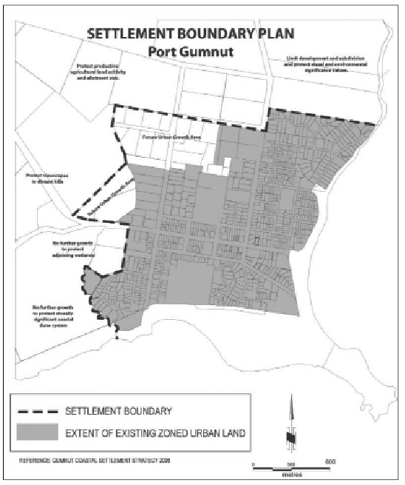
© The State of Victoria Department of Environment, Land, Water and Planning 2016
This work is licensed under a Creative Commons Attribution 4.0 International licence. You are free to re-use the work under that licence, on the condition that you credit the State of Victoria as author. The licence does not apply to any images, photographs or branding, including the Victorian Coat of Arms, the Victorian Government logo and the Department of Environment, Land, Water and Planning (DELWP) logo. To view a copy of this licence, visit http://creativecommons.org/licenses/by/4.0/
Printed by (insert printing company name, suburb).
ISBN 1-74152-467-9 (pdf)
Disclaimer
This publication may be of assistance to you but the State of Victoria and its employees do not guarantee that the publication is without flaw of any kind or is wholly appropriate for your particular purposes and therefore disclaims all liability for any error, loss or other consequence which may arise from you relying on any information in this publication.
Accessibility
If you would like to receive this publication in an alternative format, please telephone the DELWP Customer Service Centre on 136 186, or email customer.service@delwp.vic. gov.au (or relevant address), or via the National Relay Service on 133 677, www.relayservice.com.au. This document is also available on the internet at planning.vic.gov.au

DOCUMENT ENDS

