Plan Melbourne 2017-2050
Draft Inner Metro

Land Use Framework Plan

Acknowledgement
We acknowledge and respect the Traditional Owners of Victoria's lands and waters, their unique ability to care for Country and deep spiritual connection to it. We honour Elders past and present whose knowledge and wisdom has ensured the continuation of culture and traditional practices.
We are committed to genuinely partner and meaningfully engage with Traditional Owners to support the protection of their Country, the maintenance of spiritual and cultural practices and their broader aspirations in the 21st century and beyond.

Aboriginal self-determination
Pupangarli Marnmarnepu - Wadi Wadi and Mutti Mutti language for ‘Owning Our Future’ - is DELWP’s Aboriginal Self-Determination Reform Strategy 2020-2025. As the framework for supporting and enabling Aboriginal self-determination for all DELWP projects, Pupangarli Marnmarnepu forms the basis of an ongoing dialogue and partnership with Traditional Owners to influence metropolitan planning and the implementation of Plan Melbourne 2017-2050 in each of the six metropolitan regions.
Ongoing partnership opportunities with Traditional Owners are currently being explored. This process will determine the preferred involvement and level of influence Traditional Owners would like to have in shaping the outcomes and implementation of the Land Use Framework Plans.

Abbreviations
ABS | Australian Bureau of Statistics | NEIC/s | National Employment and Innovation Cluster/s
BIFT | Beveridge Interstate Freight Terminal | OMR | Outer Metropolitan Ring/E6 Transport Corridor
BMO | Bushfire Management Overlay | PBN | Principal Bicycle Network
BPA | Bushfire Prone Area | PFN | Principal Freight Network
CBD | Central Business District | PPTN | Principal Public Transport Network
DELWP | Department of Environment, Land, Water and Planning | PSP/s | Precinct Structure Plan/s
DJPR | Department of Jobs, Precincts and Regions | RSIP | Regionally-Significant Industrial Precinct
DoT | Department of Transport | SBO | Special Building Overlay
EIIA/s | Extractive Industry Interest Area/s | SEIFA | Socio-Economic Indexes for Areas
EPWG | Economy and Planning Working Group | SERA/s | Strategic Extractive Resource Area/s
ESD | Environmentally Sustainable Development | SRL | Suburban Rail Loop
GRP | Gross Regional Product | SRLA | Suburban Rail Loop Authority
HVI | Heat Vulnerability Index | SSIP | State-Significant Industrial Precinct
LGA | Local Government Area | TAFE | Technical and Further Education
LSIO | Land Subject to Inundation Overlay | UDP | Urban Development Program
LST | Land Surface Temperature | UGB | Urban Growth Boundary
LUFP | Land Use Framework Plan | VIF | Victoria In Future
MICLUP | Melbourne Industrial & Commercial Land Use Plan | VPA | Victorian Planning Authority
MRF | Materials Recovery Facility | WIFT | Western Interstate Freight Terminal

Chapter 01.
Introduction
Melbourne is the fastest growing city in Australia. The city’s population is projected to reach 8 million by 2050. This growth, in combination with a changing climate, increased globalisation and congestion, is testing the resilience of Melbourne’s built and natural environment. Victoria needs to plan for this growth and change. That is why Plan Melbourne 2017-2050 is important.
Plan Melbourne has a clear vision:
‘Melbourne will continue to be a global city of opportunity and choice.’
What this vision demonstrates is that Plan Melbourne is more than a planning document. It is a blueprint guiding the actions of planners, councils, landowners and developers – ensuring Melbourne grows more sustainable, productive and liveable.
Plan Melbourne seeks to deliver seven outcomes. How these will be delivered in each of the six metropolitan regions is the subject of the Land Use Framework Plans (LUFPs).
Outcome 1 | Melbourne is a productive city that attracts investment, supports innovation and  creates jobs
Outcome 2 | Melbourne provides housing choice in locations close to jobs and services
Outcome 3 | Melbourne has an integrated transport system that connects people to jobs and services and goods to market
Outcome 4 | Melbourne is a distinctive and liveable city with quality design and amenity
Outcome 5 | Melbourne is a city of inclusive, vibrant and healthy neighbourhoods
Outcome 6 | Melbourne is a sustainable and resilient city
Outcome 7 | Regional Victoria is productive, sustainable, and supports jobs and economic growth

Land use framework plans
Plan Melbourne identifies six metropolitan regions within the city as illustrated in Figure 1:
- Inner (Melbourne, Port Phillip and Yarra Local Government Areas or LGAs)
- Inner South East (Bayside, Boroondara, Glen Eira and Stonnington LGAs)
- Eastern (Knox, Manningham, Maroondah, Monash, Whitehorse and Yarra Ranges LGAs)
- Southern (Cardinia, Casey, Frankston, Greater Dandenong, Kingston and Mornington Peninsula LGAs)
- Western (Brimbank, Hobsons Bay, Maribyrnong, Melton, Moonee Valley and Wyndham LGAs)
- Northern (Banyule, Darebin, Hume, Mitchell, Moreland, Nillumbik and Whittlesea LGAs).
The Victorian Department of Environment, Land, Water and Planning (DELWP) has led the development of an LUFP for each region, supported by six Economy and Planning Working Groups (EPWGs).
The six EPWGs are chaired by a chief executive officer from a council within each region and include senior representatives from the region’s local councils, DELWP, the Department of Jobs, Precincts and Regions (DJPR) and the Department of Transport (DoT).
Through the EPWGs, councils have helped shape the vision for their regions – providing local insight into the regional opportunities and challenges that require joint action by state and local government.
Responding to these regionally-specific opportunities and challenges, the LUFPs:
- are 30-year strategic land use and infrastructure plans for Melbourne’s six metropolitan regions
- provide a common long-term framework to manage growth and land use pressures in each region
- are spatial plans that translate Plan Melbourne and the Plan Melbourne Addendum to the regional level
- focus on resolving metropolitan regional issues
- provide context for planning at the precinct or local level
- ensure the review and update of local planning schemes align with Plan Melbourne
- drive the accommodation of the majority of Melbourne’s growth into established areas through a land use framework that identifies places of state and regional significance, and integrates greenfield growth area planning with wider metropolitan planning.
The LUFPs support the implementation of Plan Melbourne – guiding the implementation of Plan Melbourne’s nine principles, seven outcomes, 32 directions and 90 policies at a regional and local level.

- Location of the Inner Metro Region
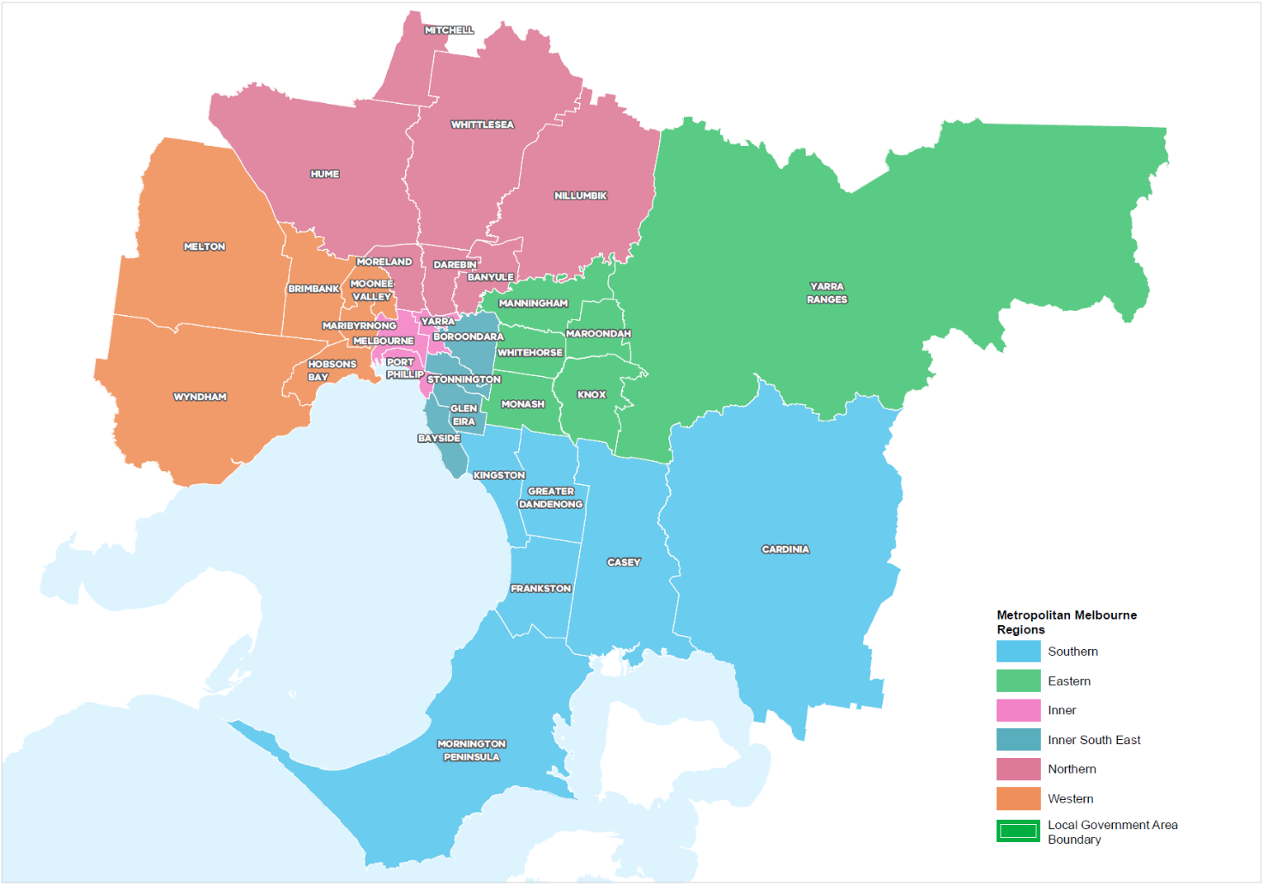

How will the land use framework plans be used?
The LUFPs will be used to:
- Drive the majority of Melbourne’s population growth into established areas through a land use framework that identifies places of state and regional significance
- Guide the strategic integration of land use and infrastructure (including housing and jobs aspirations) in key areas and precincts
- Guide the development of Melbourne’s greenfield growth areas
- Facilitate collaboration by state and local government, key agencies and partners on regional planning and regional priorities
- Inform priority places for state-led planning
- Enable metropolitan councils to update their municipal strategies and policies within a clearly defined land use framework.
The LUFPs will set regional-level planning policy to be implemented into planning schemes. They will inform local councils in decision-making for precinct planning, local and regional planning strategies, and infrastructure and servicing projects.
The LUFPs include a number of short- to medium- term actions for state and local government, which will contribute to planning outcomes in each region alongside existing actions under Plan Melbourne and other government programs and initiatives. Action monitoring will be led by DELWP in partnership with the metropolitan region through the EPWGs, and the actions will be formally reviewed every five years in conjunction with Plan Melbourne 2017-2050 Five-Year Implementation Plan.
Annual progress reports outlining the status of actions will be published by DELWP as a part of Plan Melbourne monitoring. These progress reports will be publicly available.
The chapter on implementation provides further details on how the LUFPs will be used to deliver Plan Melbourne outcomes across the regions.
Appendix 01 identifies the range of related initiatives already underway by state and local government to support the implementation of Plan Melbourne. The LUFPs are designed to complement these initiatives.

The land use framework
The LUFPs establish a common land use framework across the regions (Table 1). This common framework confirms places of state significance as identified in Plan Melbourne and introduces places of regional significance for each metro region.
The land use framework will direct land use decisions and investment, better align state and local government planning, and inform the development of local council planning strategies (including housing strategies). In the process, this common framework will also ensure land use, planning and development all support the vision of Plan Melbourne.
The land use framework
Places of state significance  (as identified in Plan Melbourne) | Places of regional significance
- Central City  - National employment and innovation clusters (NEICs)  - Metropolitan activity centres  - State-significant industrial precincts (SSIPs)  - Transport gateways  - State-significant health and/or education precincts  - Major urban renewal precincts | - Major activity centres  - Activity corridors  - Regionally-significant industrial precincts (RSIPs)  - Enterprise precincts  - Regionally-significant health and/or education precincts  - Inter-regional environmental features  - Regional open space  - Growth corridors  - Urban renewal areas  - Housing opportunity and investigation areas  - Green wedges

Regional planning and collaboration
Planning at a regional level is an opportunity for state and local governments to work together to manage long-term growth and change across Melbourne (Figure 2).
While the Inner Metro Region has many unique opportunities and challenges, there are some opportunities and challenges common across all metropolitan regions, such as ensuring jobs are available close to public transport; increasing housing supply in areas with access to jobs, services and public transport; and mitigating and adapting to climate change. The LUFP allows for these differences and recognises regional initiatives already underway.
The LUFPs will guide regional planning and collaboration vertically (between state and local government) and horizontally (across local councils in partnership with other stakeholders, including Traditional Owners).
- Inter-relationship between state and local planning
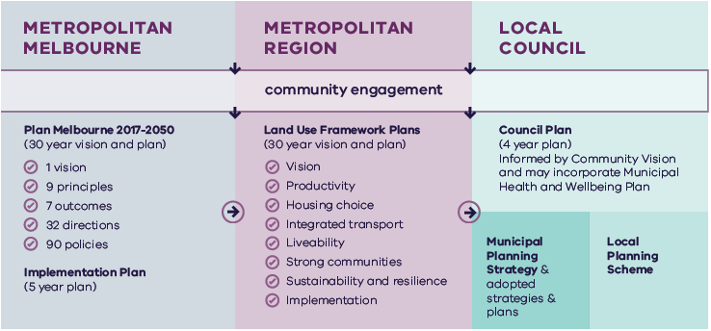
Metropolitan Melbourne | Metropolitan Region | Local Council
Is informed by community engagement. | Is informed by community engagement and Metropolitan Melbourne planning. | Is informed by community engagement, Metropolitan Melbourne planning and Metropolitan Region planning.
Includes:  - Plan Melbourne 2017-2050 (30 year vision and plan)  - 1 vision  - 9 principles  - 7 outcomes  - 90 policies  - Implementation Plan (5 year plan) | Includes:  - Land Use Framework Plans (30 year vision and plan)  - Vision  - Productivity  - Housing choice  - Integrated transport  - Liveability  - Strong communities  - Sustainability and resilience  - Implementation | Includes:  - Council Plan (4 year plan)  - Informed by Community Vision and may incorporate Municipal Heath and Wellbeing Plan  - Municipal Planning Strategy & adopted strategies & plans  - Local Planning Scheme

State-led planning
The Victorian Government has identified priority areas for state-led planning. The purpose of state-led planning in those areas is to maximise land use and infrastructure integration, attract investment, and deliver housing, jobs and services within established urban areas (Table 2).
State-led planning often involves the Victorian Government partnering with local councils and other stakeholders to develop or implement strategic plans, plan for change or respond to an investment, and/or identify key catalyst projects or programs that support growth and attract investment.
The Victorian Department of Transport is leading the whole-of-government delivery and coordination of Arden and the Richmond to Flinders Street corridor (part of the Richmond to Docklands corridor) as transport precincts. The Victorian Department of Jobs, Precincts and Regions is leading the strategic development of Fishermans Bend, Docklands and Parkville (including the Melbourne Biomedical Precinct) as business precincts.
Current places for state-led planning in the Inner Metro Region
Places of state significance
National employment and innovation clusters
Fishermans Bend
Parkville
State significant commercial land
The Central City
Major urban renewal areas
Arden
Fishermans Bend
Richmond to Docklands corridor
E-Gate
Dynon
Macaulay
Places of regional significance
Enterprise precincts
Cremorne
South Melbourne
Arden
Collingwood

The broader context

Climate change – the need for both mitigation and adaptation
Victoria’s Climate Change Strategy (2021) translates the Climate Change Act 2017 into concrete action by introducing ambitious but achievable interim emissions reduction targets to keep Victoria on track to net zero emissions by 2050. The Strategy includes actions to reduce emissions now and lay the foundations for future reductions across the economy, including but not limited to the following: continuing the transition to clean, renewable energy production; establishing a light vehicle sales target of 50 per cent zero emissions vehicles by 2030; investing in land restoration and carbon farming initiatives; supporting Victorian farmers to respond to the impacts of climate change; and, creating new jobs by promoting growth within the waste recycling and renewable energy sectors. These measures will help reduce the size of Melbourne’s carbon footprint and improve its resilience to the impacts of climate change.
Land use and transport integration – such as locating homes close to public transport, and bike and walking paths – is critical to achieving net-zero emissions. In 2018, cars made up just over half of all transport emissions, with road vehicles responsible for almost 90 per cent of those transport emissions. Transport emissions by mode and road transport sub-categories are shown in Figure 3.
- Transport emissions by mode and road transport sub-categories – Victoria 2018
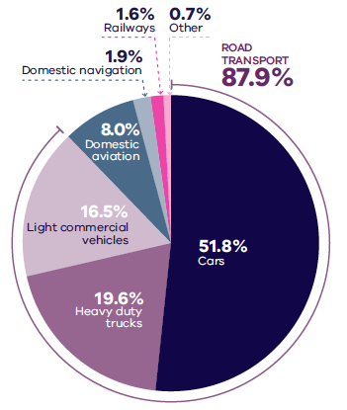
DELWP (2020) Victorian Greenhouse Gas Emissions Report 2018, State of Victoria: Melbourne, Australia
Figure 3. Transport emissions by mode and road transport sub-categories - Victoria 2018
Cars | 51.8 per cent
Heavy duty trucks | 19.6 per cent
Light commercial vehicles | 16.5 per cent
Domestic aviation | 8.0 per cent
Domestic navigation | 1.9 per cent
Railways | 1.6 per cent
Other | 0.7 per cent
Source: Victorian Greenhouse Gas Emissions Report 2018, DELWP, 2020, State of Victoria: Melbourne, Australia.

In Melbourne, despite increased public transport usage and significant public transport investment, cars remain the dominant mode of transport. In 2016, for example, private vehicles accounted for 67 per cent of trips in Melbourne. To achieve net-zero emissions, Victoria’s private vehicle use must be dramatically reduced.
The Victorian Government is working towards a more sustainable built environment through reforms to construction, planning and energy provision across metropolitan Melbourne and Victoria. These regulatory reforms will reduce the energy consumption of appliances, require improved environmentally sustainable development (ESD) outcomes in new buildings and subdivisions, and improve the efficiency of energy production and distribution.
The Victorian Government recently released its Environmentally Sustainable Development of Buildings and Subdivisions – A Roadmap for Victoria’s Planning System (the Roadmap). This document outlines updates to the planning system that support broader, state-level ESD policy objectives. It sets out additional ESD objectives and standards for the design of new buildings, as well as the layout of large-scale residential subdivisions proposed through the Victoria Planning Provisions.
The Roadmap also sets out other initiatives, including new approaches to energy management – such as renewable and distributed energy technologies, microgrids and battery farms, better stormwater management, increased landfill diversion practices, and the promotion of sustainable modes of transport.
Victoria is actively decarbonising the energy sector through the construction of better buildings and the transition to renewable energy generation (including onsite solar photovoltaic and large-scale renewable energy projects). Victoria’s planning policies will also facilitate appropriate development of low emission and zero emission energy supply infrastructure.
Good precinct structure planning can also reduce greenhouse gas emissions and make communities more climate resilient. That is why affordable and clean energy infrastructure should be used to support sustainable development and sustainable transport.

20-minute neighbourhoods
The LUFPs aim to create more 20-minute neighbourhoods in Melbourne’s six metropolitan regions by planning for established areas, growth areas and major transport infrastructure projects. The LUFPs also provide the regional direction and strategies to inform the delivery of 20-minute neighbourhoods through structure planning.

City-shaping transport projects
The Victorian Government is currently implementing the largest transport infrastructure program in the state’s history. City-shaping projects (Figure 4) include:
- The West Gate Tunnel – creating a second river crossing to link the Western Metro Region with the Port of Melbourne, CityLink and the Central Business District (CBD), and take traffic pressures off the West Gate Bridge
- Metro Tunnel – linking Melbourne’s south-east and Gippsland to the Sunbury line in Melbourne’s west and north-west
- North East Link – connecting Melbourne’s south-east to the Eastern Freeway, the Western Ring Road and Hume Freeway
- Melbourne Airport Rail – connecting Melbourne Airport to Victoria’s regional and metropolitan train network
- Suburban Rail Loop (SRL) – connecting every major passenger railway line in Melbourne from the Frankston line in the south to the Werribee line in the west. SRL East (Cheltenham to Box Hill) is scheduled to begin in 2022. SRL East will also connect key employment and education precincts, facilitate uplift and intensive development of station precinct.
These city-shaping projects will improve access to jobs, education and social opportunities in the Inner Metro Region. They will also connect the Inner Metro Region with other areas of Melbourne and Victoria. In addition, they are also creating opportunities to make the Inner Metro Region more prosperous, sustainable and liveable through the integration of land use and transport planning.
The purpose of integrated land use and transport planning is to bring jobs, services and leisure opportunities closer to where people live. This means shorter trips, the option to use active transport, and less time spent travelling – leading to a better quality of life and the creation of 20-minute neighbourhoods. In addition, this integrated approach also frees up capacity for freight, public transport and active transport journeys – reducing transport emissions.

Coronavirus (COVID-19) impacts
The coronavirus (COVID-19) pandemic is having dramatic impacts on Victoria’s population, economy and society.
With movement restricted, migration to Victoria has been reduced almost to zero. The Australian Government’s expectations for overseas migration losses will see Victoria’s population decline slightly in 2020-21, compared with average growth of 2 per cent for most of the previous decade. International migration is expected to resume within one to two years but not return to normal until the mid-2020s at the earliest.
This interruption to growth is not expected to change the long-term future direction of Melbourne.
However, the global pandemic has had significant impacts. This includes the shift to work-from-home arrangements for large parts of the metropolitan workforce, a greater uptake of online retail services and a shift to local living, with more people are relying on their activity centres and neighbourhoods to meet their day-to-day needs. Many industry sectors impacted by COVID-19 restrictions, including tourism, the arts and international education, are still recovering.
The Inner Metro Region is expected to experience the greatest short-term slowdown in growth compared to the other metro regions due to its reliance on overseas migration.
The LUFPs will help Melbourne’s metropolitan regions manage the economic and social impacts of the pandemic especially in specific areas such as Melbourne’s CBD and the Monash and Bundoora education precincts.
The progress of each LUFP will be monitored and revisited to ensure each regional land use pathway continues to contribute to Plan Melbourne’s outcomes.

- City-shaping transport projects
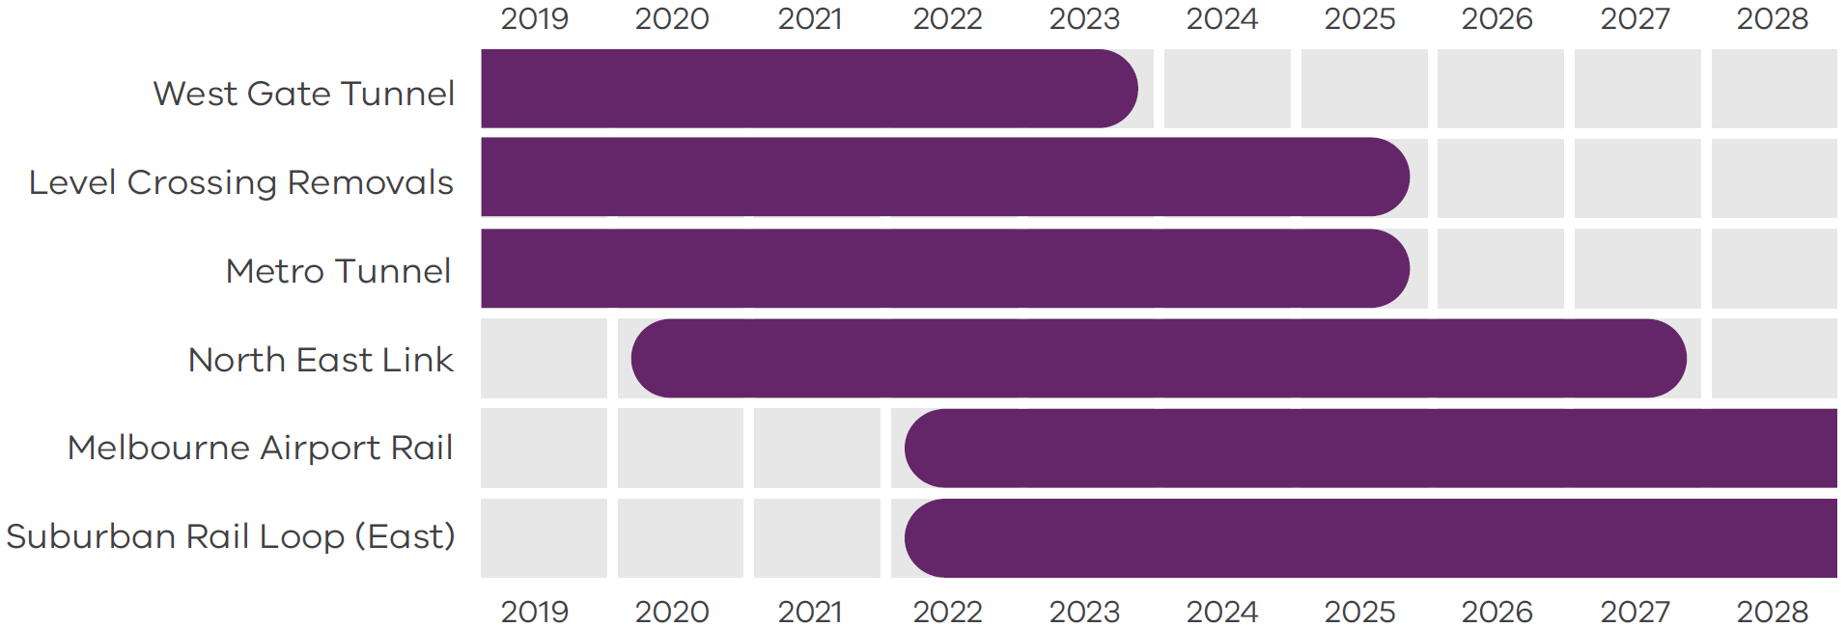
Department of Environment, Land, Water and Planning 2021

Figure 4. City-shaping transport projects
West Gate Tunnel | Pre-2019 to 2023
Level Crossings Removals | Pre-2019 to 2025
Metro Tunnel | Pre-2019 to 2025
North East Link | From 2020 to 2027
Melbourne Airport Rail | From 2022 to post-2028
Suburban Rail Loop (East) | From 2022 to post-2028
Source: Department of Environment, Land, Water and Planning 2021

Chapter 02.
Regional snapshot
The Inner Metro Region comprises the Melbourne, Yarra and Port Phillip local government areas (LGAs). The Wurundjeri Woi Wurrung and Bunurong people of the Kulin Nation are the Traditional Owners of the lands that now make up the Inner Metro Region of Melbourne. The region contains Melbourne’s CBD, dense, established inner suburbs as well as Port Phillip Bay beaches to the south, the Yarra River (Birrarung) traversing through the region and the Maribyrnong River to the west.
- Inner Metro Region
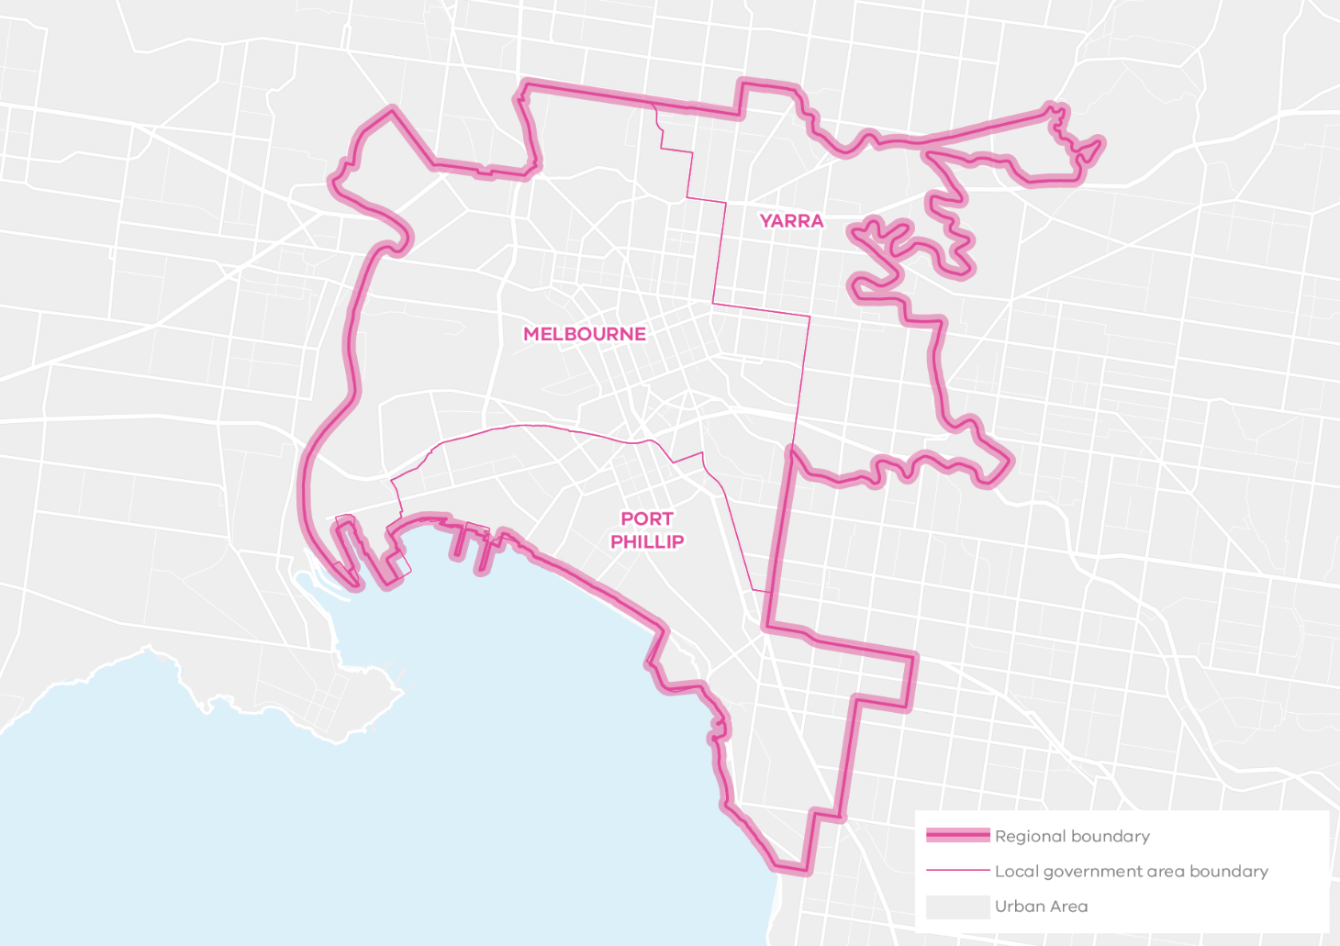
Total area: 7,830 HA
0.9% of Metropolitan Melbourne area
The ‘Hoddle Grid’ was established following the Victorian Gold Rush, from which came the funds to build fine heritage buildings, a system of parks, the development of the Port of Melbourne, inner suburban development and housing, and the establishment of educational institutions.
The Inner Metro Region quickly developed as a business, service and trade centre for Victoria’s broader economy, from agricultural and manufacturing to associated finance activities.
Since then, the region has consolidated as the hub of metropolitan Melbourne and the State of Victoria, supported by significant infrastructure investment. It is now the historic heart of Melbourne’s civic, political and economic life. The Inner Metro Region is also home to a high concentration of jobs, global business operations, a bustling 24-hour cultural life and world-class sporting, arts and cultural precincts.

Urban structure
The Inner Metro Region’s geography and urban structure is defined by the Yarra and Maribyrnong rivers, flat to undulating terrain and the Port Philip coastline.
The Inner Metro Region is characterised by high-density residential and commercial development in the Central City core and established strip centre shopping streets along tram routes in surrounding inner suburbs with retail, food and entertainment precincts. Finer-grain inner suburbs with Victorian and Edwardian-era heritage buildings feature prominently across the region and are highly valued, as are the environmental landscapes of the lower Yarra and Maribyrnong rivers, and the coastal assets of Port Phillip Bay. The region also contains large urban renewal areas, some which are well-advanced and some which are planned. The urban areas include:
- Historic inner suburbs with low rise, fine-grain settlements in Collingwood, Carlton, Richmond, East Melbourne and North Melbourne
- Urban renewal areas with higher-density apartment developments including Docklands, Southbank and in other former industrial areas such as Port Melbourne and Fishermans Bend
- Historic suburbs by the bay and Albert Park Lake with vibrant mixed-use neighbourhoods including South Melbourne, St Kilda and Elsternwick
- Large established inner-city parklands and significant recreation facilities which surround the Melbourne CBD – Flemington Racecourse, Melbourne Cricket Ground and Marvel Stadium in Docklands
- Underground City Loop rail system and radial rail network to all metropolitan regions
- West Gate Bridge (connecting the region to Melbourne’s west), the Bolte Bridge (connecting the region to Melbourne’s north) and the Burnley and Domain tunnels and freeway network
- Port of Melbourne and Coode Island at the confluence of the Yarra and Maribyrnong rivers
- Distinctive, much-loved local neighbourhoods, each with a different identity and character.

Population and demographics
In 2020, the Inner Metro Region had a population of 403,360 people which accounted for 8 per cent of Melbourne’s total population. The region’s population is projected to increase by 85 per cent by 2051 to a total population of 746,150 people. Between 2016 and 2051 an additional 225,080 dwellings will be needed to accommodate this growth.
The Inner Metro Region’s population is unlike other regions in metropolitan Melbourne, with the largest percentage aged between 15 and 29 years old and the most prevalent household type recorded in 2016 being lone person households. In all other regions across metropolitan Melbourne most households were families with children.
Outlined below are some of the key demographics and land use features of the Inner Metro Region.
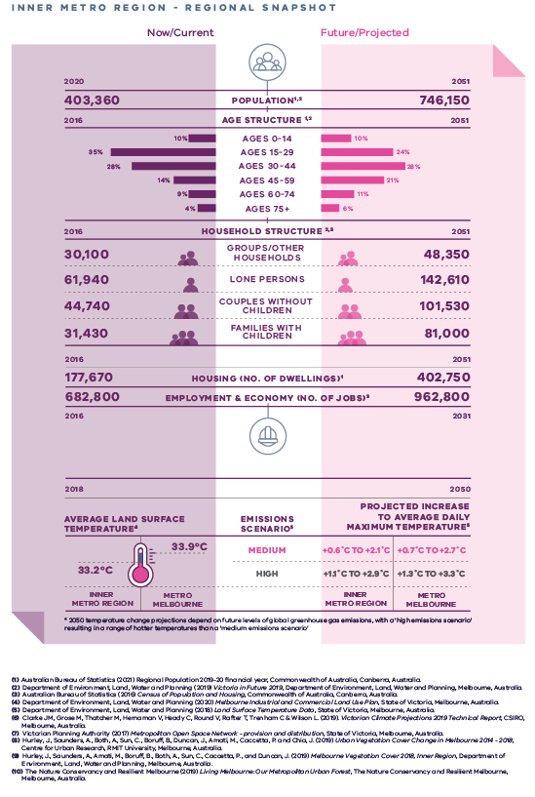
Inner Metro Region - Regional Snapshot
Inner Metro Region population  Sources:  Australian Bureau of Statistics (2021) Regional Population 2019-20 financial year, Commonwealth of Australia, Canberra, Australia.  Department of Environment, Land, Water and Planning (2019) Victoria in Future 2019, Department of Environment, Land, Water and Planning, Melbourne, Australia. | 2020 (now/current):  403,360 inhabitants | 2051 (projected/future):  746,150 inhabitants
Inner Metro Region age structure  Sources:  Department of Environment, Land, Water and Planning (2019) Victoria in Future 2019, Department of Environment, Land, Water and Planning, Melbourne, Australia.  Australian Bureau of Statistics (2016) Census of Population and Housing, Commonwealth of Australia, Canberra, Australia. | 2016 (now/current):  10 per cent – Ages 0 to 14  35 per cent – Ages 15 to 29  28 per cent – Ages 30 to 44  14 per cent – Ages 45 to 59  9 per cent – Ages 60 to 74  4 per cent – Ages 75 plus | 2051 (projected/future):  10 per cent – Ages 0 to 14  24 per cent – Ages 15 to 29  28 per cent – Ages 30 to 44  21 per cent – Ages 45 to 59  11 per cent – Ages 60 to 74  6 per cent – Ages 75 plus
Inner Metro Region household structure  Sources:  Department of Environment, Land, Water and Planning (2019) Victoria in Future 2019, Department of Environment, Land, Water and Planning, Melbourne, Australia.  Australian Bureau of Statistics (2016) Census of Population and Housing, Commonwealth of Australia, Canberra, Australia. | 2016 (now/current):  Groups/other households – 30,100  Lone persons – 61,940  Couples without children – 44,740  Families with children – 31,430 | 2051 (projected/future):  Groups/other households – 48,350  Lone persons – 142,610  Couples without children – 101,530  Families with children – 81,000
Inner Metro Region housing (number of dwellings)  Source:  Department of Environment, Land, Water and Planning (2019) Victoria in Future 2019, Department of Environment, Land, Water and Planning, Melbourne, Australia. | 2016 (now/current):  177,670 dwellings | 2051 (projected/future):  402,750 dwellings
Inner Metro Region employment and economy (number of jobs)  Source:  Department of Environment, Land, Water and Planning (2020) Melbourne Industrial and Commercial Land Use Plan, State of Victoria, Melbourne, Australia. | 2016 (now/current):  628,800 jobs | 2031 (projected/future):  962,800 jobs
2018 average land surface temperature  Source:  Department of Environment, Land, Water and Planning (2018) Land Surface Temperature Data, State of Victoria, Melbourne, Australia. | Inner Metro Region:  33.2 degrees Celsius | Metro Melbourne:  33.9 degrees Celsius
2050 projected increase to average daily maximum temperature  *2050 temperature change projections depend upon future levels of global greenhouse gas emissions, with a ‘high emissions scenario’ resulting in hotter temperatures than a ‘medium emissions scenario’  Source:  Clarke J.M., et al. (2019). Victorian Climate Projections 2019 Technical Report, CSIRO, Melbourne, Australia. | Inner Metro Region:  Medium emissions scenario – plus 0.6 to plus 2.1 degrees Celsius  High emissions scenario – plus 1.1 to plus 2.9 degrees Celsius | Metro Melbourne:  Medium emissions scenario – plus 0.7 to plus 2.7 degrees Celsius  High emissions scenario – plus 1.3 to plus 3.3 degrees Celsius

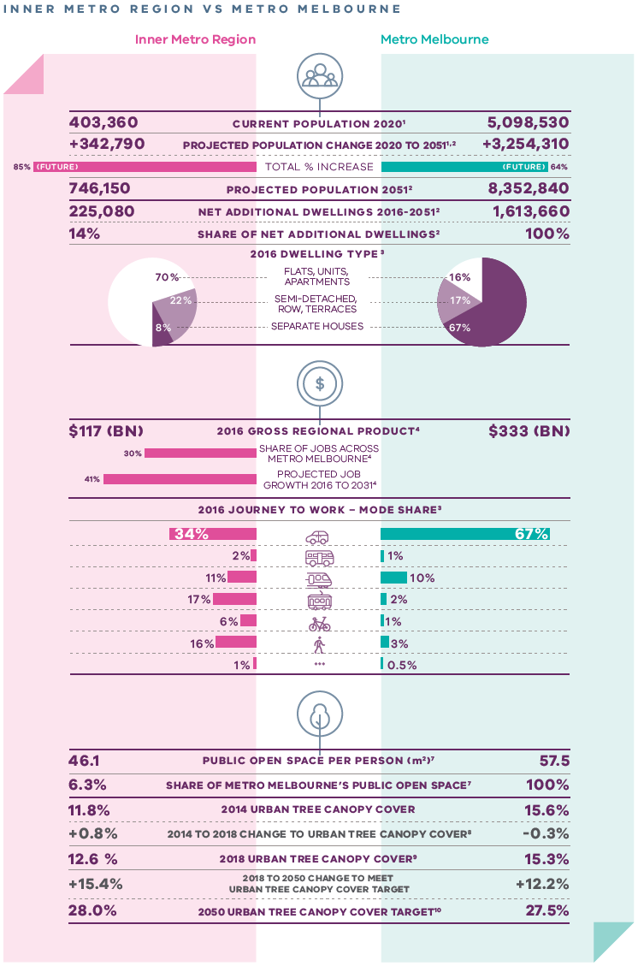
Inner Metro Region vs Metro Melbourne
 | Inner Metro Region | Metro Melbourne
Current population 2020  Source:  Australian Bureau of Statistics (2021) Regional Population 2019-20 financial year, Commonwealth of Australia, Canberra, Australia. | 403,360 inhabitants | 5,098,530 inhabitants
Projected population change 2020 to 2051  Sources:  Australian Bureau of Statistics (2021) Regional Population 2019-20 financial year, Commonwealth of Australia, Canberra, Australia.  Department of Environment, Land, Water and Planning (2019) Victoria in Future 2019, Department of Environment, Land, Water and Planning, Melbourne, Australia. | Plus 342,790 inhabitants | Plus 3,254,310 inhabitants
Total per cent population change (future) | 85 per cent | 64 per cent
Projected population 2051  Source:  Department of Environment, Land, Water and Planning (2019) Victoria in Future 2019, Department of Environment, Land, Water and Planning, Melbourne, Australia. | 746,150 inhabitants | 8,352,840 inhabitants
Net additional dwellings 2016 to 2051  Source:  Department of Environment, Land, Water and Planning (2019) Victoria in Future 2019, Department of Environment, Land, Water and Planning, Melbourne, Australia. | 225,080 dwellings | 1,613,660 dwellings
Share of net additional dwellings  Source:  Department of Environment, Land, Water and Planning (2019) Victoria in Future 2019, Department of Environment, Land, Water and Planning, Melbourne, Australia. | 14 per cent | 100 per cent
2016 dwelling type  Source:  Australian Bureau of Statistics (2016) Census of Population and Housing, Commonwealth of Australia, Canberra, Australia. | Flats, apartments, units – 70 per cent  Semi-detached, row, terraces – 22 per cent  Separate houses – 8 per cent | Flats, apartments, units – 16 per cent  Semi-detached, row, terraces – 17 per cent  Separate houses – 67 per cent
2016 gross regional product  Source:  Department of Environment, Land, Water and Planning (2020) Melbourne Industrial and Commercial Land Use Plan, State of Victoria, Melbourne, Australia. | $117 billion | $333 billion
Share of jobs across Melbourne  Source:  Department of Environment, Land, Water and Planning (2020) Melbourne Industrial and Commercial Land Use Plan, State of Victoria, Melbourne, Australia. | 30 per cent
Projected job growth to 2031  Source:  Department of Environment, Land, Water and Planning (2020) Melbourne Industrial and Commercial Land Use Plan, State of Victoria, Melbourne, Australia. | 41 per cent
2016 journey to work – mode share  Source:  Australian Bureau of Statistics (2016) Census of Population and Housing, Commonwealth of Australia, Canberra, Australia. | Private motor vehicle – 34 per cent  Bus – 2 per cent  Train – 11 per cent  Tram – 17 per cent  Bicycle – 6 per cent  Walking – 16 per cent  Other – 1 per cent | Private motor vehicle – 67 per cent  Bus – 1 per cent  Train – 10 per cent  Tram – 2 per cent  Bicycle – 1 per cent  Walking – 3 per cent  Other – 0.5 per cent
Public open space per person (metres squared)  Source:  Victorian Planning Authority (2017) Metropolitan Open Space Network: Provision and Distribution, State of Victoria, Melbourne, Australia. | 46.1 | 57.5
Share of metro Melbourne’s public open space  Source:  Victorian Planning Authority (2017) Metropolitan Open Space Network: Provision and Distribution, State of Victoria, Melbourne, Australia. | 6.3 per cent | 100 per cent
2014 urban tree canopy cover  Source:  Hurley, J., et al. (2019) Urban Vegetation Cover Change in Melbourne 2014 - 2018, Centre for Urban Research, RMIT University, Melbourne, Australia. | 11.8 per cent | 15.6 per cent
2014 to 2018 change to urban tree canopy cover | Plus 0.8 per cent | Minus 0.3 per cent
2018 urban tree canopy cover  Source:  Hurley, J., et al. (2019) Melbourne Vegetation Cover 2018, Inner Region, Department of Environment, Land, Water and Planning, Melbourne, Australia. | 12.6 per cent | 15.3 per cent
2018 to 2050 change to meet urban tree canopy cover target | Plus 15.4 per cent | Plus 12.2 per cent
2050 urban tree canopy cover target  Source:  The Nature Conservancy and Resilient Melbourne (2019) Living Melbourne: Our Metropolitan Urban Forest, The Nature Conservancy and Resilient Melbourne, Melbourne, Australia. | 28.0 per cent | 27.5 per cent

Chapter 03.
Vision: Inner Metro Region in 2050
The Inner Metro Region has a significant and unique role in ensuring that
“Melbourne will continue to be a global city of opportunity and choice.”
The Inner Metro Region will be recognised globally as an exemplar urban environment with its liveable, affordable and sustainable places. It will be the knowledge capital of the Southern Hemisphere, Australia’s research capital and a leading producer of applied knowledge skills. The region has a compact, dense and mixed-use form and will be a world leader in urban environmental sustainability. It will also be internationally recognised as one of the world’s best tourism and major events destinations.
By 2050 the Inner Metro Region will experience significant planned change, including:
- The Parkville and Fishermans Bend NEICs will join the Central City as the major employers within the region. The broader Fishermans Bend Urban Renewal Area will contribute 80,000 new jobs with a focus on education, design, the creative industries and advanced manufacturing, including engineering, transport and defence industries. It will be supported by high-quality and high capacity, sustainable transport links.
- Major urban renewal areas of Fishermans Bend, Arden, Macaulay, Docklands, and the St Kilda Road and Southbank precincts make a significant contribution to jobs and housing while also developing and supporting new communities.
- Housing caters for families, students, older people, group housing, key workers and people with disabilities with new affordable and social housing stock and renewal of older public housing estates.
- Efficient transport routes that will prioritise public transport, walking and cycling. There is a completed network of safe and efficient cycling and pedestrian routes that will provide high amenity, safe active transport links.
- A public transport network that is well connected, frequent, simple and easy to navigate with an expanded reach and more choice of modes between key destinations across all parts of the region and beyond.
- Distinctive precincts, villages and neighbourhoods that continue to preserve their own unique character while attracting businesses, start-ups and scale-ups. They will provide high-quality public places, open space and community facilities that meet the needs of a fast-growing population of residents, workers and visitors.
- An urban and natural environment that respects, reflects and celebrates the region’s Aboriginal and cultural heritage. Iconic public spaces such as the Port Phillip foreshore, the Yarra River, Maribyrnong River, Royal Park, Fawkner Park and Royal Botanic Gardens are protected and highly valued by the community.
- More tree canopy cover and green infrastructure to create resilient and low carbon places that help the region respond to climate change including water scarcity and heatwaves.
For a more detailed picture of how land use in the Inner Metro Region is expected to change by 2050 refer to Map 1.

- Inner Metro Region 2050 Plan
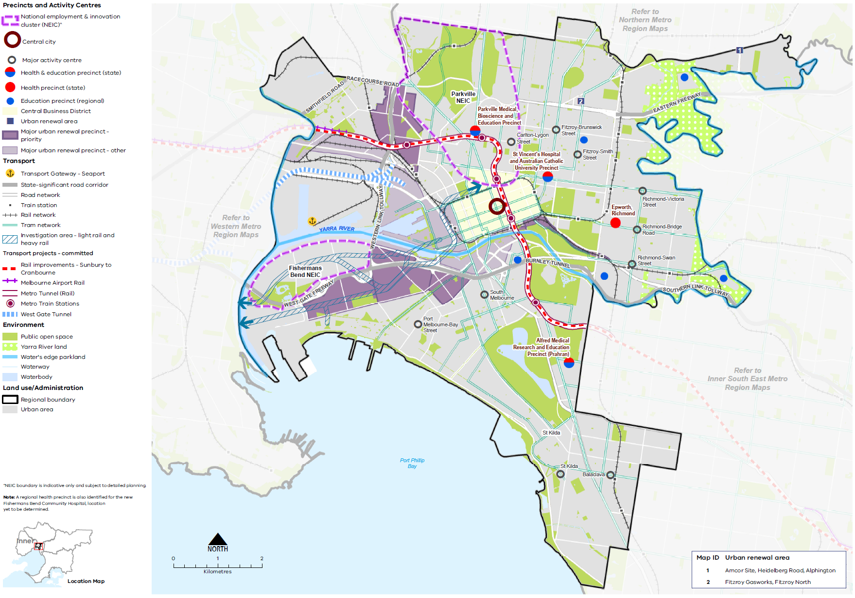

Map 1 Inner Metro Region 2050 Map

A map of the Inner Metro Region in 2050 showing -

- The region’s boundary and the established urban area.

- Locations for growth and investment, including:

- The Central City
- The Central Business District
- Fishermans Bend and Parkville National Employment and Innovation Clusters^
- Major urban renewal precincts at Fishermans Bend, Arden, Macaulay, Dynon, E-Gate, Southbank and Docklands as listed in tables 4 and 5
- The network of major activity centres, as listed in table 6
- State- and regionally-significant health and/or education precincts, highlighting those at Parkville, Richmond, East Melbourne/Fitzroy, Prahran, Burnley, Southbank, Fairfield, and Collingwood as listed in table 13
- Urban renewal areas at the Amcor Site, Heidelberg Road, Alphington; and the Fitzroy Gasworks, Fitzroy North.

- Key transport linkages and movement network, including:
- The rail and tram network including the proposed Melbourne Airport Rail, and Metro Tunnel with five new underground stations, and the Sunbury to Cranbourne rail improvements
- The road network including the state-significant West Gate Freeway, Western Link Tollway, and Burney Tunnel; and the West Gate Tunnel
- The Port of Melbourne transport gateway
- The area of investigation for light rail and heavy rail serving Fishermans Bend.

- State and regional and cultural natural assets, including:
- The Yarra River running east-west through the region into Port Phillip Bay
- Yarra River Land in the north-east and east of the region
- Public open spaces including a number of formal gardens such as the Royal Botanic Gardens and other formal and informal open spaces.

^ NEIC boundaries are indicative only and subject to detailed planning.

Notes: A regional health precinct is also identified for the new Fishermans Bend Community Hospital, location yet to be determined.

Chapter 04.
Productivity
Plan Melbourne Outcome 1: Melbourne is a productive city that attracts investment, supports innovation and creates jobs
The Inner Metro Region will continue make a significant contribution to the state’s economic output, particularly as the Victorian economy continues to transition to a more service and knowledge-based economy. This will be driven by the Central City, which is metropolitan Melbourne’s principal centre for commerce, professional, business and financial services.
The region’s economic locations, including its two NEICs, will underpin its resilience and adaptability as ongoing and inevitable change occurs, while providing the necessary ingredients for innovation.
The region has several important urban renewal precincts for Melbourne including Fishermans Bend, Arden, Macaulay and, over the longer term, Dynon and E-Gate. These precincts provide key opportunities for the region’s economic future and will better connect the workforce in Melbourne’s west. The Richmond to Docklands renewal precinct provides an opportunity to strengthen the region’s entertainment and visitor offering.
The Inner Metro Region’s 10 major activity centres provide local services for residents while also attracting visitors from across the state.
There is an emergence of new spaces for enterprise and innovation, facilitated by proximity to the CBD and the region’s existing heritage character including Cremorne, Collingwood, South Melbourne and Arden. These areas provide affordable opportunities for start-ups and emerging enterprises.
The region also contains the Port of Melbourne and freight terminals at Dynon, which are logistics infrastructure assets of state and national significance.

State of play
The following places contribute to the productivity of the Inner Metro Region:
- The Central City, which includes the CBD (Hoddle Grid, north to Grattan Street between Peel and Swanston streets) as well as Docklands, Southbank and St Kilda Road
- Parkville and Fishermans Bend NEICs
- Transport gateway at the Port of Melbourne
- Major urban renewal precincts at Docklands, Fishermans Bend (Lorimer), Fishermans Bend (Montague), Fishermans Bend (Sandridge), Fishermans Bend (Wirraway), Arden, Macaulay, E-Gate, and Dynon
- State-significant health and/or education precincts at Parkville Medical, Bioscience and Education Precinct, St Vincent’s Hospital and Australian Catholic University Precinct (East Melbourne/Fitzroy), Epworth Hospital (Richmond), Alfred Medical Research and Education Precinct (Prahran)
- A network of 10 existing major activity centres that are generally strip-based centres
- Enterprise precincts at Cremorne, Collingwood (Gipps Street), South Melbourne and within the Arden major urban renewal precinct
- Premier tourism assets including the Sports Precinct and Arts Precinct and the Richmond to Dockland renewal precinct.
The Inner Metro Region contributes $117 billion to metropolitan Melbourne’s economy, which is about 35 per cent of the total Gross Regional Product (GRP). The business service sector is the largest contributor to the regional economy with a total value-added estimate at around $72.8 billion. This is followed by the manufacturing and industrial sector, with a total value-added estimate at around $14.9 billion. The region contains globally competitive industries, including biotechnology, healthcare, technology and education.
In 2016, the region supported approximately 682,800 jobs which accounted for around 30 per cent of all employment in metropolitan Melbourne. Employment growth is expected in the following industries: professional, scientific and technical services; healthcare and social assistance; financial and insurance services; public administration and safety; and education and training (Figure 6). A projected 280,000 additional jobs will be located across the Inner Metro Region by 2031, with approximately 70 per cent of new jobs in the region expected to be within the Melbourne LGA.
The region contains a total of 460 hectares of industrial zoned land, with only 28 hectares vacant. Over the period 2016 to 2031, manufacturing and industrial jobs will account for almost 4 per cent of all new jobs.
There is a total of 1158 hectares of land identified as being zoned for commercial purposes, with approximately 9 million square metres of floorspace used or available for commercial purposes on this land. By 2031, it is anticipated that an additional 4 million square metres of commercial floorspace will be required.
- Projected employment growth for the Inner Metro Region 2016 to 2031
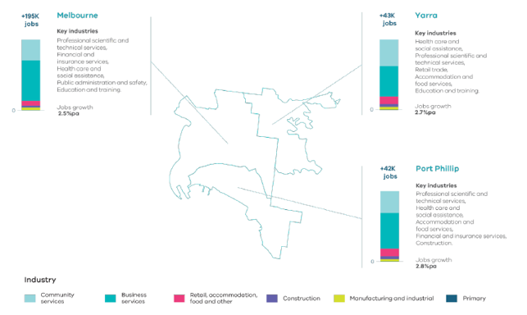
Melbourne Industrial and Commercial Land Use Plan, DELWP, 2020

Figure 6. Projected employment growth for the Inner Metro Region 2016 to 2031
Melbourne | Plus 195,000 jobs | 2.5 per cent jobs growth per annum | Key industries: professional scientific and technical services, financial and insurance services, health care and social assistance, public administration and safety, education and training
Yarra | Plus 43,000 jobs | 2.7 per cent jobs growth per annum | Key industries: health care and social assistance, professional scientific and technical services, retail trade, accommodation and food services, education and training
Port Phillip | Plus 42,000 | 2.8 per cent jobs growth per annum | Key industries: Professional scientific and technical services, health care and social assistance, accommodation and food services, financial and insurance services, construction
Source: Department of Environment, Land, Water and Planning (2020) Melbourne Industrial and Commercial Land Use Plan, State of Victoria, Melbourne, Australia.

Regional strengths
- The Central City is home to the largest concentration of jobs across metropolitan Melbourne with a focus on commerce, professional, business and financial services.
- The Inner Metro Region is the research and knowledge capital of Australia and provides a nucleus for university campuses that attract students, knowledge and talent.
- Parkville NEIC is a leading location for biomedical, education, health, research, professional and technical industries, and Fishermans Bend NEIC will be a leading location for innovation in design, engineering and advanced manufacturing services.
- Leading or emerging enterprise precincts at Cremorne, Collingwood, Arden and South Melbourne present opportunities to deliver employment growth.
- The region’s major urban renewal precincts and established network of activity centres can generate employment growth and diversity in the employment base of the region.
- The region is internationally recognised as a tourism and major events destination with the sports, arts and entertainment precincts being safe, accessible and vibrant places.

Regional challenges
- Accommodating the large daily influx of visitors from across metropolitan Melbourne. Visitors come into the region for a variety of reasons including work, professional and medical services, and visits to cultural, sporting and retail precincts and attractions.
- Planning for and providing infrastructure, services and a high-quality urban environment to sustain population growth in the region’s major urban renewal areas.
- Public realm improvements and well-designed new developments that are environmentally sustainable and adaptable are needed to attract high-quality, diverse employers and labour.
- Public transport improvements and sustainable transport connections between the region’s activity centres and employment precincts are needed to support growth in high value sectors and build a resilient and adaptable economy.
- Conversion of commercial land to residential uses in the Central City.
- Securing affordable workspace for enterprise, start-ups and creative industries.

Directions and strategies
The directions identified to achieve the 2050 vision for the Inner Metro Region in terms of productivity and Outcome 1 of Plan Melbourne are:
Direction 1 | Support the Central City to become the pre-eminent and largest commercial centre in Australia by 2050
Direction 2 | Strengthen the Inner Metro Region as a local and international destination for sport, arts, culture and entertainment to attract investment and visitors
Direction 3 | Facilitate the development of the Parkville and Fishermans Bend NEICs as major economic contributors for the regional and national economy supported by increased transport connectivity
Direction 4 | Enhance the Inner Metro Region’s vibrant and diverse activity centres and their contribution to the identity of the region
Direction 5 | Retain existing and support emerging employment areas, including industrial and enterprise precincts, across the Inner Metro Region
Direction 6 | Facilitate well-designed, high-amenity and quality medium- and higher-density environments in major urban renewal precincts to provide employment growth
Direction 7 | The Port of Melbourne will continue to be a nationally-significant distribution and transport gateway

Each direction is implemented through regionally-specific strategies identified in this land use framework plan
Map 2 shows how productivity will be enhanced across the Inner Metro Region by 2050 as a result of these directions and strategies, together with Plan Melbourne and other strategies and initiatives as outlined in Appendix 01.

- Inner Metro Region productivity 2050
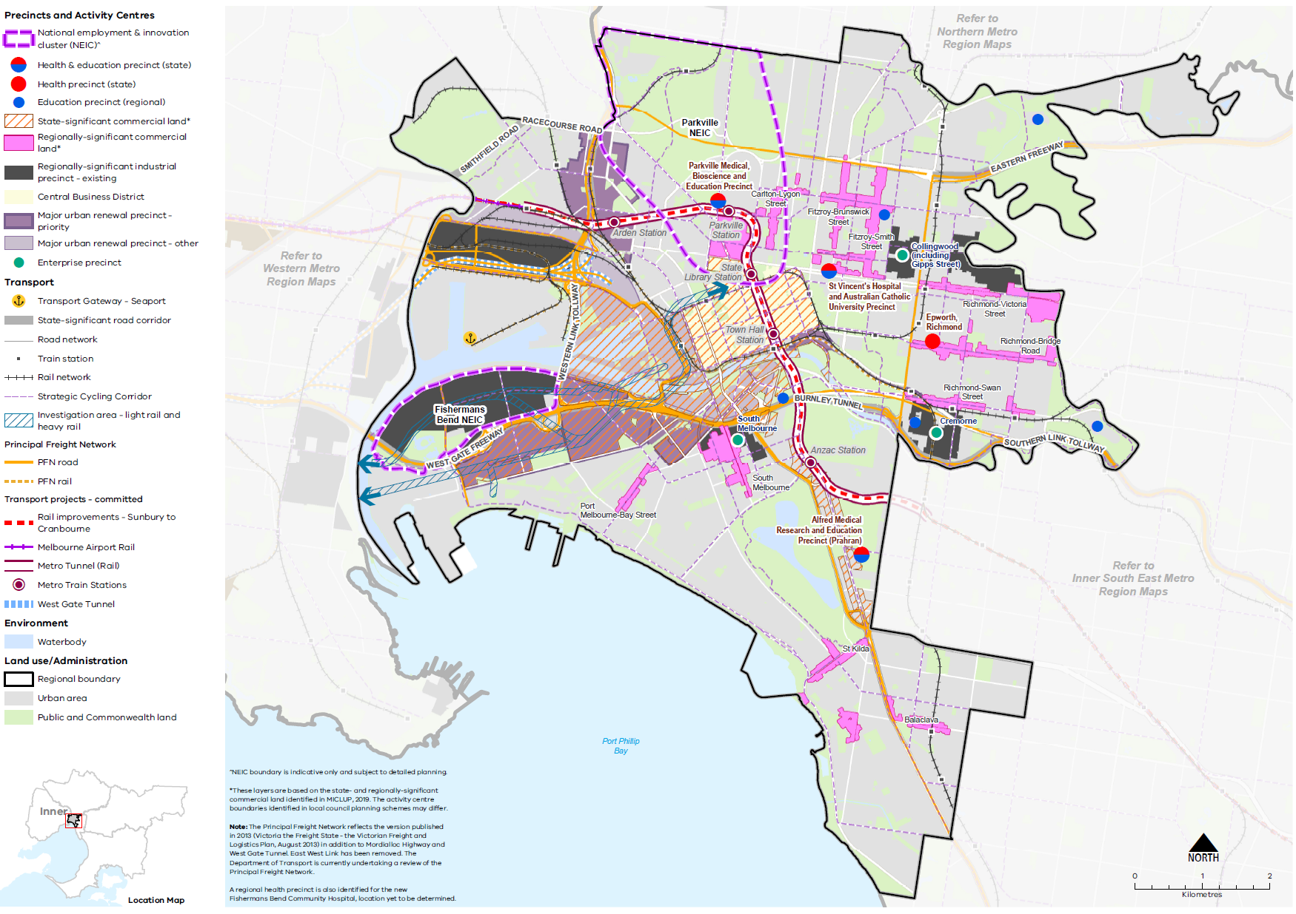

Map 2 Inner Metro Region productivity 2050
A plan of productivity in the Inner Metro Region in 2050, extracting the productivity features identified on Map 1 above, with the addition of:
- Existing state-significant commercial land including the CBD, Southbank, Docklands, Fishermans Bend, and St Kilda Road*
- Existing regionally-significant commercial land including the region’s major activity centres*
- Emerging enterprise precincts at Cremorne, Gipps Street (Collingwood), and South Melbourne
- The principal freight network for road and rail.

*These layers are based on the state and regionally significant commercial land identified in MICLUP, 2019. The activity centre boundaries identified in local council planning schemes may differ.

NOTE: The Principal Freight Network reflects the version published in 2013 (Victoria the Freight State – the Victorian Freight and Logistics Plan, August 2013) in addition to Mordialloc Highway and West Gate Tunnel. East West Link has been removed. The Department of Transport are currently undertaking a review of the Principal Freight Network.

- Support the Central City to become the pre-eminent and largest commercial centre in Australia by 2050
The Central City has the largest concentration of jobs in metropolitan Melbourne and will continue to accommodate much of the region’s new jobs, focused largely on knowledge-based industries. It is a location of state significance and a major focus for investment and growth. The Central City incorporates the CBD (Hoddle Grid, north to Grattan Street between Peel and Swanston streets) as well as Docklands, Southbank and St Kilda Road. It’s strong and diverse offering of retail and tourism activities will also continue to drive job growth in the region.
The Central City is well placed to build on its many strengths including high-quality civic and cultural offers, a comparatively well-connected transport system and access to a broad and diverse labour market. Continued growth in the role of the Central City needs to be guided by both a recognition of its role as the focal point for innovation, business and tourism, as well as acknowledgement of the contribution made by surrounding destinations and activity centres to its overall success. Major urban renewal precincts in and around the Central City will deliver new neighbourhoods and a mix of uses that will feed into and strengthen the Central City.
The Central City’s balance of community, culture and commerce will be achieved by:
- Enhancing the city’s national and global standing
- Maintaining and enhancing liveability
- Facilitating employment and housing growth
- Improving sustainable transport networks
- Supporting environmental resilience and sustainability
- Providing certainty for public and private-sector investment decision-making.
There is a need to balance competition for land for commercial and residential purposes in the Central City. For example, the proposed ANZAC Station as part of the Metro Tunnel will further improve the accessibility and demand for land along St Kilda Road. Managing land and the allocation of land for employment purposes will be achieved by:
- Using appropriate planning controls to allow for the right mix of land uses in the right locations, while also helping to realise employment growth
- Protecting places of heritage and cultural significance to recognise their contribution to local character and identity, and their role in attracting workers and investment
- Maintaining attractive public areas including active open spaces and providing appropriate and accessible services and facilities to support the workforce.
Providing a diversity of employment spaces, including affordable spaces that can accommodate small to medium-sized businesses, will also be important to ensure an innovative and resilient Central City.
- Improve land use arrangements, amenities, public transport and sustainable transport connectivity in the Central City to support agglomeration and productivity benefits for the knowledge and services sectors.
- Strengthen connections to destinations around the Central City, including major activity centres, major urban renewal precincts and health and/or education precincts, to support the success of the Central City.
- Provide affordable and diverse workspaces to build an innovative and resilient Central City.
- Balance planning for industrial and commercial areas with pressure for ongoing residential development.

- Strengthen the Inner Metro Region as a local and international destination for sport, arts, culture and entertainment to attract investment and visitors
The Inner Metro Region’s vibrant urban character includes heritage buildings and places, modern architecture, diverse open spaces, waterways and unique streetscapes and laneways. The region is also home to nationally-significant sport and art precincts and is renowned for its entertainment and retail offering. This mix of activities attracts visitors from across Melbourne, interstate and internationally. The tourism and visitor economy is also complemented by the retail and hospitality offerings of the region’s activity centres.
Existing tourism assets in the region should be protected and supplemented by other entertainment and creative uses. Entertainment and cultural events can be facilitated by protecting and providing affordable spaces and venues for cultural production and performance. Tourism development should also be encouraged to attract events and further develop the region as a competitive domestic and international tourist destination.
Public realm and transport infrastructure upgrades are needed to continue to drive improvements in the visitor experience across the region. Better public transport (both day and night), walking and cycling links between key visitor destinations are also needed to improve access by more people within and outside the region.
The Richmond to Docklands renewal precinct will be a world-class destination for sport, arts, culture and entertainment linked by the Yarra River and significant parklands. The precinct will:
- Strengthen the relationship between the city and the river by improving connections to and along the river
- Improve the quality and quantity of public open spaces along the corridor
- Improve the sense of arrival at major transport interchanges and pedestrian and cycle connections.
Major urban renewal precincts will provide opportunities to increase the diversity and offerings at tourism destinations. These precincts will need to be well supported by improved sustainable transport networks and high-quality public realm improvements to attract residents and visitors to these experiences.
- Grow the visitor economy, night-time economy, sport and entertainment uses, and uses in the creative sector that contribute to local and international tourism in the Inner Metro Region.
- Retain existing entertainment and cultural activity spaces in the region and encourage a diversity of complementary uses to ensure the provision of venues serve industry and community needs.
- Provide affordable spaces for cultural production and performance to support the local creative and cultural industry and to attract and host international touring creatives.

- Facilitate the development of the Parkville and Fishermans Bend NEICs as major economic contributors for the regional and national economy supported by increased transport connectivity
The Parkville and Fishermans Bend NEICs are concentrations of business activity and employment at different stages of development, that will continue to grow as important contributors to the national economy. Both are designated as business precincts, with their strategic development being led by the Victorian Department of Jobs, Precincts and Regions.

Parkville NEIC
Parkville NEIC (Figure 7) is an internationally-renowned research centre that contains a variety of sectors including biomedical, education, research, health, professional and technical industries. It is home to a range of institutions and significant parkland. The education sector is well represented within Parkville and is a key contributor to the Victorian economy. It is expected that over half of new residents in Victoria by 2031 will be attracted by a range of education and employment opportunities.
The spatial clustering of complementary industries (for example, innovation in health and medical research) provides for economies of scale, sharing of knowledge and technology, and access to a wider pool of skilled workers and clients. The Parkville NEIC is well placed to grow high value jobs in the medical technologies, pharmaceuticals and international education sectors. The NEIC will accommodate some housing, although it will be limited to designated locations to support the NEIC’s primary economic and research focus.
Planning challenges that face the Parkville NEIC, include:
- Improving connectivity and addressing existing barriers to unlock opportunities associated with clustered industries. Currently there are barriers to connectivity such as the Haymarket roundabout
- Development limitations and limited land availability considering the mature nature of the Parkville NEIC.
Directing demand for residential uses to suitable locations and, where appropriate, supporting residential development that is associated with institutions in the NEIC.
Clustering will also focus on attracting small businesses, start-ups and social enterprises through a partnership between the City of Melbourne, the University of Melbourne and RMIT University. This will include initiatives that focus on the public realm including active open space, enterprise activation, digitally enabled technology and institutional design. Parkville NEIC will have an important relationship with the Arden urban renewal precinct supplementing its role and fostering complementary growth.
Parkville NEIC will have a high level of public transport access with tram routes via Swanston and Elizabeth streets and a new railway station at Parkville as part of the Metro Tunnel which will provide direct connections to Melbourne’s north-west including Melbourne Airport and to the south-eastern suburbs. This will catalyse growth in jobs and education opportunities through improved access and movement to and from the NEIC as well as between the NEIC, Arden and Melbourne CBD.

- Parkville National Employment and Innovation Cluster
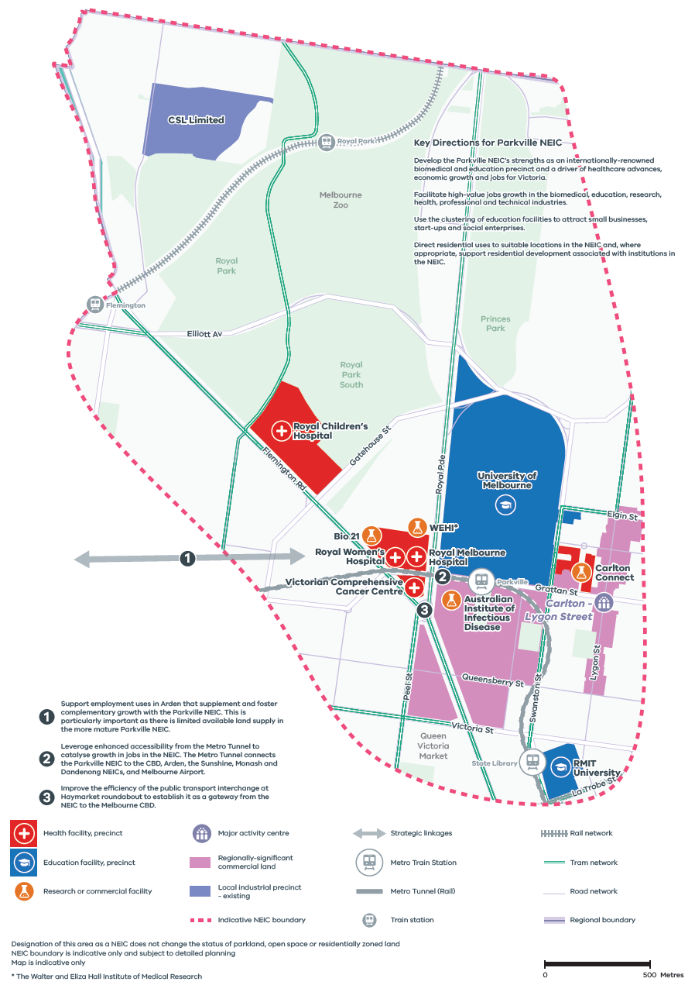
Plan Melbourne, DELWP 2017

Figure 7. Parkville National Employment and Innovation Cluster
A Map of Parkville National Employment and Innovation Cluster , showing –
- Indicative NEIC boundary
- Health facility, precinct: Royal Children’s Hospital, Royal Melbourne Hospital, Royal Women’s Hospital, and Victorian Comprehensive Cancer Centre
- Education facility, precinct: University of Melbourne, RMIT University
- Research or commercial facility: Bio21, The Walter and Eliza Hall Institute of Medical Research, Australian Institute of Infection Disease, and Carlton Connect
- Carlton-Lygon Street Major Activity Centre
- Regionally-significant commercial land
- Local industrial precinct - existing
- Strategic linkages
- Metro tunnel (rail) and metro train stations
- Rail network and train stations
- Road and tram network
- Regional boundary, the northern edge of the NEIC abutting the Northern Metro Region.
Map notes (numbered on the map)
- Support employment uses in Arden that supplement and foster complementary growth with the Parkville NEIC. This is particularly important as there is limited available land supply in the more mature Parkville NEIC.
- Leverage enhanced accessibility from the Metro Tunnel to catalyse growth in jobs in the NEIC. The Metro Tunnel connects the Parkville NEIC to the CBD, Arden, the Sunshine, Monash and Dandenong NEICs, and Melbourne Airport.
- Improve the efficiency of the public transport interchange at Haymarket roundabout to establish it as a gateway from the NEIC to the Melbourne CBD.
Key Directions for Parkville NEIC
- Develop the Parkville NEIC’s strengths as an internationally-renowned biomedical and education precinct and a driver of healthcare advances, economic growth and jobs for Victoria.
- Facilitate high-value jobs growth in the biomedical, education, research, health, professional and technical industries.
- Use the clustering of education facilities to attract small businesses, start-ups and social enterprises.
- Direct residential uses to suitable locations in the NEIC and, where appropriate, support residential development associated with institutions in the NEIC.
Note: Designation of this area as a NEIC does not change the status of parkland, open space or residentially zoned land
Note: NEIC boundary is indicative only and subject to detailed planning
Note: Map is indicative only.

Fishermans Bend NEIC
Fishermans Bend NEIC (Figure 8) has a rich industrial history, supporting road infrastructure and is adjacent to the Port of Melbourne. It has large sites and under-utilised land, providing opportunities for intensification of employment and the attraction of new manufacturing businesses and corporate headquarters, focused on research and technology.
Planning for the Fishermans Bend NEIC will consolidate its strengths in aerospace, defence research, manufacturing and transport, and logistics industries, and establish it as the leading location for innovation in design, engineering and advanced manufacturing. There will be up to 40,000 jobs in this precinct by 2050. The development of the government-owned General Motors Holden (GMH) site will anchor the transition of the area over the next 30 years and support innovation and jobs growth centred around advanced manufacturing, engineering and design. Given the large amount of employment land available at the NEIC, a detailed precinct plan will need to address how it becomes an attractive, active place for work. There is a need to secure affordable workspaces for enterprise, start-ups and creative industries
Planning for potential light and heavy rail between Fishermans Bend and the CBD is needed to ensure future transport connections keep pace with long-term demand and support development.
To realise its potential as a globally recognised precinct and promote innovative design and manufacturing employment, Fishermans Bend NEIC will need to have higher levels of amenity than would ordinarily be associated with traditional industrial precincts. This includes high-quality buildings, public realm and streetscapes, provision of open space and design outcomes that respect the local heritage character. Some areas of the NEIC will require a finer grain urban form to respond to smaller-scale users, and the adaptive re-use of buildings should be encouraged to utilise spaces that are in transition and provide reference points to the area’s history. There should be a sustainable approach in planning for, and responding to, flooding and urban heat risks.
- Strengthen Parkville NEIC as Melbourne’s premier location for biomedical, education, health, research, professional and technical industries in the Inner Metro Region.
- Prioritise Parkville NEIC’s main role for economic, education and research activities, and ensure residential uses do not compromise its primary function. Residential development should be associated with and benefit the institutions in the NEIC.
- Develop the Fishermans Bend NEIC as a leading location for innovation in design, engineering and advanced manufacturing.
- Protect land in the Fishermans Bend NEIC for advanced manufacturing and industrial uses.
- Provide public transport connections to Fishermans Bend NEIC (and major urban renewal precinct) to support investment and support future employment and population needs.

- Fishermans Bend National Employment and Innovation Cluster
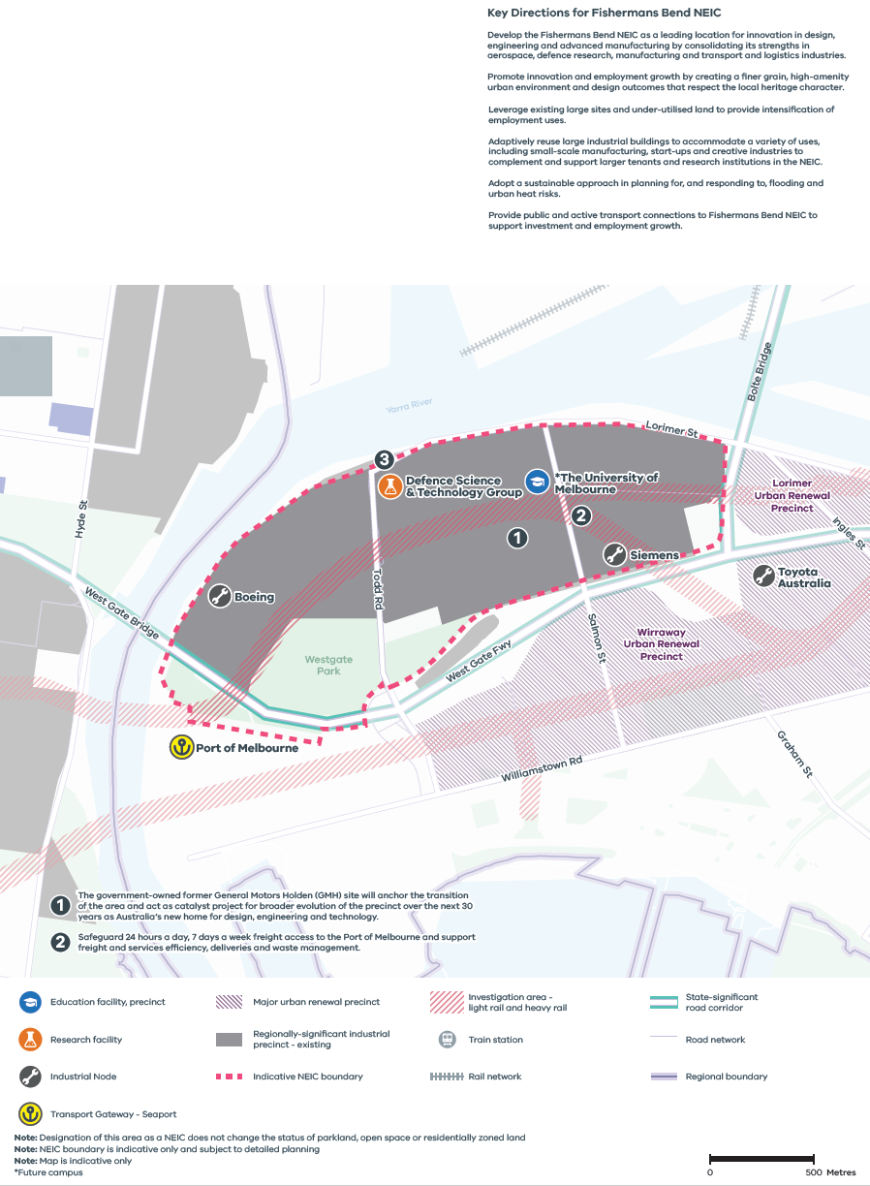
Plan Melbourne, DELWP 2017

Figure 8. Fishermans Bend National Employment and Innovation Cluster
A Map of Fishermans Bend National Employment and Innovation Cluster, showing –
- Indicative NEIC boundary
- Education facility, precinct: Future campus of the University of Melbourne
- Research facility: Defence Science and Technology Group
- Industrial Nodes at Boeing, Siemens and Toyota Australia
- The Port of Melbourne Seaport Transport Gateway
- Fishermans Bend major urban renewal precincts to the south and east of the NEIC
- Investigation area for light rail and heavy rail
- Road network the West Gate Freeway state-significant road corridor
- Western Metro Region boundary close to the west of the NEIC
Map notes (numbered on the map)
- The government-owned former General Motors Holden (GMH) site will anchor the transition of the area and act as catalyst project for broader evolution of the precinct over the next 30 years as Australia’s new home for design, engineering and technology.
- Safeguard 24 hours a day, 7 days a week freight access to the Port of Melbourne and support freight and services efficiency, deliveries and waste management.
Key Directions for Fishermans Bend NEIC
- Develop the Fishermans Bend NEIC as a leading location for innovation in design, engineering and advanced manufacturing by consolidating its strengths in aerospace, defence research, manufacturing and transport and logistics industries.
- Promote innovation and employment growth by creating a finer grain, high-amenity urban environment and design outcomes that respect the local heritage character.
- Leverage existing large sites and under-utilised land to provide intensification of employment uses
- Adaptively reuse large industrial buildings to accommodate a variety of uses, including small-scale manufacturing, start-ups and creative industries to complement and support larger tenants and research institutions in the NEIC.
- Adopt a sustainable approach in planning for, and responding to, flooding and urban heat risks.
- Provide public and active transport connections to Fishermans Bend NEIC to support investment and employment growth.

Note: Designation of this area as a NEIC does not change the status of parkland, open space or residentially zoned land
Note: NEIC boundary is indicative only and subject to detailed planning
Note: Map is indicative only

- Enhance the Inner Metro Region’s vibrant and diverse activity centres and their contribution to the identity of the region
The region’s major activity centres provide a diverse range of jobs, housing and services. They are generally strip-based centres with a distinctive cultural and retail offering that serve visitors and tourists as well as residents. Many of these centres have renowned entertainment, hospitality and live music venues. In these centres, quality of place will enable innovation and growth of the knowledge-based industries, which rely on agglomeration and interaction in dense urban places, allowing for the sharing of knowledge, skills and ideas.
The spatial arrangement and complexity of employment land in the Inner Metro Region is also quite distinct to the region, as it contains employment areas that capture a broad range of interwoven uses.
Currently the Inner Metro Region contains 37 per cent of all commercial floorspace in metropolitan Melbourne (Figure 9). Thirteen commercial areas have more than 100,000 square metres of floorspace, accounting for approximately 89 per cent of all commercial floorspace supply in the region. This includes parts of the Central City as well as activity centres within the region. It is anticipated an additional 4 million square metres of commercial floorspace will be required by 2031, representing a 44 per cent increase. This additional floorspace also serves a metropolitan role with a large number of workers travelling to the Inner Metro Region for work.
Additional areas within major activity centres, as well as other areas, will need to be identified to accommodate projected demand for commercial floorspace. Planning for activity centres will need to balance the need for commercial land with demand for housing and other uses, and may require a coordinated approach to understand land use requirements across the region holistically.
A changing retail sector and emerging retail vacancies in the region are key issues. Activity centres in the region will need to strengthen their role in servicing their local areas while also providing a variety of different employment uses. Maintaining strong local connections as well as a providing a diversity of employment uses will help build the resilience of activity centres in the region. This is particularly pertinent for the Inner Metro Region as many activity centres have a strong, symbiotic relationship with key employment precincts in the region.
- Ensure the region’s activity centres provide adequate jobs, services and opportunities for recreation and entertainment to service workers and visitors from across metropolitan Melbourne.
- Retain existing commercial zoned land and identify areas that can support future demand for commercial floorspace and new investment with a focus on major activity centres and major urban renewal areas.
- Encourage a diversity of employment uses in major activity centres and facilitate the provision of key services to complement other employment precincts within the Inner Metro Region.

- Existing and future commercial floorspace requirements for the Inner Metro Region
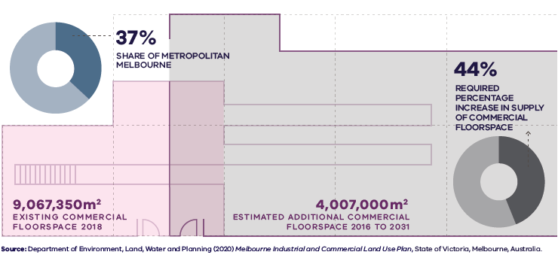

Figure 9. Existing and future commercial floorspace requirements for the Inner Metro Region
Inner Metro Region | 37 per cent share of metropolitan Melbourne | 9,067,350 square metres – existing commercial floorspace 2018 | 4,007,000 square metres – estimated additional commercial floorspace 2016 to 2031 | 44 per cent – required percentage increase in supply of commercial floorspace
Source: Department of Environment, Land, Water and Planning (2020) Melbourne Industrial and Commercial Land Use Plan, State of Victoria, Melbourne, Australia.

- Retain existing and support emerging employment areas, including industrial and enterprise precincts, across the Inner Metro Region
Most of the industrial land in the Inner Metro Region is located in the Melbourne LGA, adjacent to the Port of Melbourne. Existing regionally-significant industrial land in the region is identified in Table 3.
Industrial land has been diminishing across the region for several years, being displaced by mixed-use or residential development (Figure 10). Despite limited and diminishing land for industrial purposes, growth in manufacturing and industrial jobs will account for almost 4 per cent of new jobs to 2031. Existing industrial land should be retained as it complements the evolving, flexible and diverse nature of employment and creative industries. Securing a range of diverse employment spaces at different price points across the region is an ongoing challenge and crucial for enabling an innovative, diverse economy. There needs to be improved monitoring and protection of remaining industrial and commercial land.
Regionally-significant industrial precincts in the Inner Metro Region
Regionally-significant industrial areas
Fishermans Bend NEIC
West Melbourne and Dynon Road industrial area
Abbotsford industrial precincts
Cremorne precinct
Gipps Street precinct, Collingwood
South Melbourne Central Business Precinct
Melbourne Industrial and Commercial Land Use Plan, DELWP, 2020
Emerging enterprise precincts provide employment opportunities with affordable, flexible and quality floorspace for start-ups, and contribute to a more resilient regional economy, with a range of types and sizes of businesses. Enterprise precincts are designated concentrations of employment distinguished by a strong core of knowledge sector businesses and institutions. They combine an ecosystem of economic, physical and networking assets to foster innovation (Katz & Wagner, 2014). They allow for critical mass to be attained, reinforcing competitive advantage and brand, and promoting agglomeration benefits, knowledge sharing and services (DELWP, 2018b).
These precincts provide a unique offering to the traditional, larger floorplate and established business precincts. Enterprise precincts are critical in supporting the broader economic ecosystem and providing the space for business formation and idea development. The Inner Metro Region is well placed to foster successful enterprise precincts due to a wide range of services, amenities and cultural assets offered by the Central City that attract creative minds. Proximity to the Central City, amenity and built form character attracts businesses seeking space close to workers, customers, clients, supply chains and other firms.
Emerging enterprise precincts in the Inner Metro Region include:
- Cremorne – start-ups, creative industries, tech and digital enterprises
- Gipps Street precinct, Collingwood – design services such as architecture, software and interactive design, and visual arts
- South Melbourne Central Business Precinct – design, music, film and television, photography, media and communications.
Arden major urban renewal precinct will be a mixed-use precinct with a diversity of floorspaces and types providing well-located, affordable employment floorspace suitable for IT start-ups, bespoke manufacturing and shared office spaces. It will also support the health and education research functions of Parkville NEIC. Health and education precincts are linked to creative industries, with many skills, trades and crafts taught in the region’s tertiary institutions providing a skills base to support enterprise precincts and activity centres.

- Existing and future industrial floorspace requirements for the Inner Metro Region
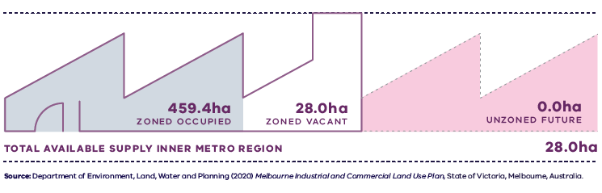
Figure 10. Existing and future industrial floorspace requirements for the Inner Metro Region
Inner Metro Region | 459.4 hectares zoned occupied | 28.0 hectares zoned vacant | 0.0 hectares unzoned future | 28.0 hectares total available supply
Source: Department of Environment, Land, Water and Planning (2020) Melbourne Industrial and Commercial Land Use Plan, State of Victoria, Melbourne, Australia.

- Support the development of enterprise precincts in Cremorne, South Melbourne, Arden and Collingwood and encourage their continued development as key locations for creative industry uses.
- Maintain a variety of uses and lot sizes in enterprise precincts to retain commercial affordability for start-ups and small businesses and ensure the agglomeration of complementary uses.
- Retain regionally-significant industrial land by managing encroachment by other uses that would cause fragmentation and may compromise the development and efficient operation of existing businesses.
- Identify and plan for areas that can support future demand for employment uses and new investment.

- Facilitate well-designed, high-amenity and quality medium- and higher-density environments in major urban renewal precincts to provide employment growth
The shift towards knowledge-based industries and jobs in the Inner Metro Region has seen former industrial land uses migrate towards middle and outer ring suburbs, freeing up land for urban redevelopment. The redevelopment opportunities in and around Melbourne’s CBD have been identified as major urban renewal precincts. They will provide mixed-use development opportunities until 2056 and will contribute new employment and residential development and create new communities close to existing transport networks, social infrastructure and jobs in the Central City.
Many major urban renewal precincts are located adjacent to established neighbourhoods and will contribute to the evolving amenity and services in these mixed-use communities. Each precinct is at a different stage of development – maturing, renewing and future (Table 5). Each has an economic focus and will play an important role in the future economic prosperity of Victoria (Table 4 and Figure 11). ‘Maturing’ urban renewal precincts are well-established but will continue to evolve and change requiring monitoring and refinement of planning policy, and investments in the public realm and services. ‘Renewing’ precincts are currently in the planning process for renewal and growth, and ‘future’ precincts provide longer-term options that will need further planning investigation.
The Fishermans Bend Urban Renewal Area will also contain mixed-use precincts that will provide an additional 40,000 jobs. These precincts can also make an important contribution to employment by connecting with other activity centres and employment precincts across the region. There are substantial challenges that must be overcome if Fishermans Bend Urban Renewal Area is to successfully accommodate projected increases in population and fully realise its economic potential which includes:
- An upgraded public realm and street network
- High-quality transport connectivity
- Open space for future populations
- Drainage and flood mitigation solutions
- Mitigation of high urban heat.
The Metro Tunnel will be a transformative connection between the western suburbs around Footscray and the major urban renewal precincts of Arden and Macaulay. It will support economic growth for these major urban renewal precincts by connecting workers from the west of Melbourne to new employment opportunities.
Planning for future urban renewal precincts should consider:
- Integrated water management to reduce the impacts of flooding in affected areas
- Land decontamination
- High-quality public realm and recognition of cultural heritage and place
- The role of each precinct, any complementary uses between precincts and the staging of future development
- Transport infrastructure investment to interconnect these areas into a regional network of economic activity.
- Support employment uses in Arden that complement adjacent and nearby employment uses, including the Parkville NEIC.
- Encourage development that is consistent with the specialised employment role of Fishermans Bend Urban Renewal Area and Arden major urban renewal precinct.
- Maintain the current industrial roles of Dynon and E-Gate major urban renewal precincts while recognising their longer-term urban renewal opportunities.
- Ensure the mixed-use precincts within the Fishermans Bend Urban Renewal Area provide adequate land for employment purposes which complement or service the adjacent Fishermans Bend NEIC.
- Deliver a high-quality public realm and urban design in major urban renewal precincts, and through the region’s employment precincts including activity centres and enterprise precincts.

- Major urban renewal precincts in the Inner Metro Region
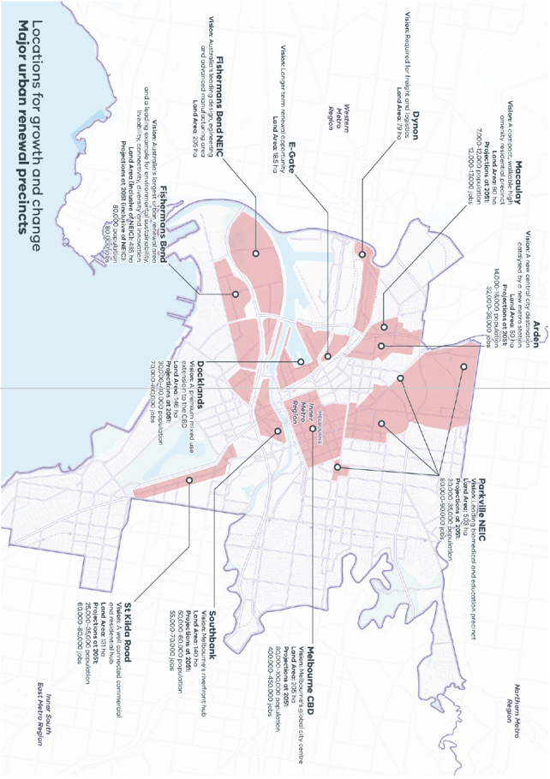

Figure 11. Major urban renewal precincts in the Inner Metro Region
Locations for growth and change  Major urban renewal precincts | Vision | Land Area | Projections at 2051
Arden | A new central city destination catalysed by a new metro station | 50 ha | 14,000-16,000 population  32,000-36,000 jobs
Macaulay | A compact, walkable high amenity residential precinct | 80 ha | 7,000-12,000 population  12,000-17,000 jobs
Dynon | Required for freight and logistics | 79 ha
E-Gate | Longer term renewal opportunity | 18.5 ha
Fishermans Bend NEIC | Australia’s leading design, engineering and advanced manufacturing area | 205 ha
Fishermans Bend | Australia’s largest urban renewal area and a leading example for environmental sustainability, liveability, connection, diversity and innovation. | 485 ha | (Inclusive of NEIC)  80,000 population  80,000 jobs
Docklands | A premium mixed use extension to the CBD | 146 ha | 30,000-40,000 population  70,000-80,000 jobs
Parkville NEIC | Leading biomedical and education precinct | 503 ha | 30,000-35,000 population  80,000-90,000 jobs
Melbourne CBD | Melbourne’s global city centre | 205 ha | 80,000-100,000 population  400,000-450,000 jobs
Southbank | Melbourne’s riverfront hub | 140 ha | 50,000-60,000 population  55,000-70,000 jobs
St Kilda Road | A well connected commercial and residential hub | 131 ha | 25,000-35,000 population  60,000-80,000 jobs

Major urban renewal precincts in the Inner Metro Region
Precinct | Designation | Status | Strategic Direction
The Central Business District | Key Precinct (part of the Central City) | Maturing | The CBD will continue to be Melbourne’s global city centre
St Kilda Road | Key Precinct (part of the Central City) | Maturing | State-significant commercial precinct and key transport corridor also containing high-density residential
Southbank | Major Urban Renewal Precinct (part of the Central City) | Maturing | Melbourne’s riverfront arts, entertainment and tourist hub
Docklands | Major Urban Renewal Precinct (part of the Central City) | Maturing | Provides high-value financial and professional service jobs, high-density residential and a range of retail, sporting and entertainment uses
Parkville NEIC | National Employment and Innovation Cluster | Maturing | A leading biomedical and education precinct
Fishermans Bend | Major Urban Renewal Precinct (part of the Central City) | Renewing | Australia’s largest urban renewal area and a leading example of environmental sustainability, liveability, connectivity, diversity and innovation supported by potential light rail and heavy rail transport connections
Fishermans Bend NEIC | National Employment and Innovation Cluster | Renewing | Australia’s leading design, engineering and advanced manufacturing area supported by potential light rail and heavy rail transport connections
Arden | Major Urban Renewal Precinct | Renewing | A vibrant international innovation hub with a primary focus on technology, life sciences, health and education. It will also be supported by mixed-use and residential development and catalysed by a new metro rail station
Macaulay | Major Urban Renewal Precinct | Renewing | A compact, walkable, high amenity residential precinct supported by commercial infrastructure and commercial services
E-Gate | Major Urban Renewal Precinct | Future | In the medium term, E-Gate will continue to play an important transport, construction storage and maintenance role, while in the long term it could provide a link from Docklands to Arden and Macaulay in the north and Dynon and Footscray in the west
Dynon | Major Urban Renewal Precinct | Future | In the medium term Dynon will remain as an important hub for freight and logistics with long-term potential to accommodate other economic uses
- The Port of Melbourne will continue to be a nationally-significant distribution and transport gateway
The Port of Melbourne is Australia’s largest port, with container movement expected to grow in the coming decades. The Port links with the national road and rail network. Its central location makes it the preferred location for national distribution centres. Once completed in 2022, the West Gate Tunnel will provide an additional direct link to the Port from the West Gate Freeway.
Planning for the Port must balance the needs of a critical piece of economic infrastructure with community expectations for safety and amenity.
A proactive approach should restrict incompatible urban development near the Port, while managing and safeguarding key freight transport connections to provide 24/7 access and minimise the impact on residential areas. There is a strategic need to support the ongoing operation and expansion of the Port while providing a safe, high amenity environment for a diversity of Central City activities in adjacent areas.
Planning for the Port should consider:
- Protection of key infrastructure from the encroachment of incompatible surrounding land uses with the provision of appropriate buffers
- Preservation of areas of sufficient industrial land close to the Port that have good road and rail access
- The type and amount of cargo that will move through the Port, and vessel profile (number, type, size)
- Road and rail connections to efficiently move goods to, from and within the Port
- The facilities, services and technology needed to make Port operations safe and efficient
- Urban encroachment issues from surrounding land uses.
- Protect the critical operations of the Port of Melbourne and freight movements from the encroachment of surrounding incompatible land uses.
- Balance freight movement with the need to protect the amenity of the Fishermans Bend Urban Renewal Area.
- Support increased freight movements on rail.

Actions – Productivity
- Identify precincts and opportunities where new commercial land can be supplied which can help to accommodate future needs. This may include intensification of commercial uses within existing commercial zoned land, or the rezoning of existing land for commercial uses.
- Implement a program of State Government-led planning projects, in partnership with local government, to ensure metropolitan and major activity centres and urban renewal areas maximise their respective strategic opportunities and contribution within the network of activity centres. Priority will be given to those which deliver significant jobs and housing, leverage investment in state infrastructure, and play an important role in the growth corridor and/or region. State-led planning for these state- and regionally-significant places will contribute to creating liveable communities and achieving more dwellings and jobs in established areas, and identify implementation and coordination actions that support growth and economic investment.

Major urban renewal precincts – future economic focus
Major Urban Renewal Precinct | Status | Cultural and visitor | Professional services | Financial | Retail | Education | Health and research | Engineering, Advanced Manufacturing | Technology | Freight and Logistics
St Kilda Road | Maturing | Y | Y | Y
Southbank | Maturing | Y |  |  | Y
Docklands | Maturing | Y | Y | Y | Y
Parkville NEIC | Maturing | Y |  |  |  | Y | Y |  | Y
Fishermans Bend Urban Renewal Area | Renewing | Y | Y |  | Y | Y |  | Y | Y
Fishermans Bend NEIC | Renewing |  |  |  |  | Y |  | Y | Y
Arden | Renewing |  | Y |  |  | Y | Y |  | Y
E-Gate | Future |  |  |  |  |  |  |  |  | Y
Dynon | Future |  |  |  |  |  |  |  |  | Y
Note: Macaulay is primarily a residential precinct. It will include supporting infrastructure and uses.
Note: St Kilda Road is designated as a Key precinct in Plan Melbourne and is included in this table to recognise its role in the region.

Major activity centres: existing attributes and strategic opportunities
Existing attributes | What needs to be considered | Future role/strategic opportunities
Major Activity Centres
Balaclava (Port Phillip)
- Strip-based centre on Carlisle Street  - A focus on commercial uses, convenience and specialty retail shopping, and civic and community facilities and services  - Train (Balaclava Station) and tram services | - Heritage significance  - Sections of the activity centre subject to inundation by overland flows from the urban drainage system  - Community housing around Balaclava Station  - Proximity to the St Kilda Major Activity Centre | - Evolve as an increasingly mixed-use precinct, anchored by its traditional retail strip, and its function as a community services and public transport ‘hub’  - Increase housing diversity, including affordable housing  - Support the renewal of Carlisle Street precinct  - Recognise Balaclava’s unique and enduring history for Melbourne’s Jewish community
Carlton – Lygon Street (Melbourne)
- Strip-based centre on Lygon Street  - Provides a broad mix of uses including entertainment, retail and hospitality  - Part of the Parkville NEIC and close to the University of Melbourne  - Close to notable community and/or tourism sites including the Melbourne Museum, Queen Victoria Market and the Melbourne Cemetery  - Tram services | - Proximity to the future Parkville and CBD North train stations as part of the Metro Tunnel  - Proximity to state-significant health and education precinct: Parkville Medical, Bioscience and Education Precinct  - Proximity to the Central City and other activity centres at Brunswick and Fitzroy – Brunswick Street  - Heritage significance | - Recognise Lygon Street’s unique and enduring history for Melbourne’s Italian community and its cosmopolitan role  - Provide entertainment and hospitality uses for local community and visitors  - Provide opportunities for residential development in keeping with the scale and character of the activity centre  - Provide convenience shopping to the local residential and working communities
Fitzroy – Brunswick Street (Yarra)
- Strip-based centre on Brunswick Street  - A focus on hospitality, entertainment, retail, art galleries and studios, and non-government community service uses  - Close to notable community tourism site the Melbourne Museum  - Tram services | - Proximity to the Fitzroy North former Gasworks urban renewal area  - Proximity to state-significant health and education precinct: St Vincent’s Hospital and Australian Catholic University Precinct  - Heritage significance  - Potential contamination issues on some sites | - Provide a strong retail, hospitality and 24-hour entertainment focus while still serving local needs  - Recognise Brunswick Street’s artistic and bohemian expression in the streetscape and mix of uses
Fitzroy – Smith Street (Yarra)
- Strip-based centre on Smith Street  - A focus on retail, entertainment, hospitality, convenience and commercial uses  - Regionally-significant education precinct, Melbourne Polytechnic Collingwood  - To the east of the activity centre is a major recreation facility at Victoria Park  - Tram services | - Close to the Fitzroy North-former Gasworks urban renewal site  - Proximity to state-significant health and education precinct: St Vincent’s Hospital and Australian Catholic University Precinct  - Close to the Enterprise Precinct and regionally-significant industrial land at the Gipps Street Precinct, Collingwood  - Heritage significance  - Proximity to Brunswick, Smith, Street, Fitzroy, Gipps Street, Collingwood  - Potential contamination issues on some sites  - Proximity to the Central City and the Fitzroy – Brunswick Street Major Activity Centre | - Continue its strong retail, hospitality, office and entertainment focus and regional role while still serving local needs  - Provide affordable housing and community services
Port Melbourne – Bay Street (Port Phillip)
- Strip-based centre on Bay Street  - A focus on retail, convenience shopping, civic and community uses  - Close to the notable community and/or tourism sites at Station Pier and Albert Park Lake  - Tram services | - Close to the Enterprise Precinct and regionally-significant industrial land at the South Melbourne Central Business Precinct  - Proximity to the Fishermans Bend major urban renewal precinct and the Central City  - Heritage significance  - Sections subject to inundation by overland flows from the urban drainage system | - Provide a vibrant multifunctional activity centre with convenient access to a wide range of goods and services  - Diversify the activity and business mix along Bay Street  - Accommodate residential growth that has a mix of densities  - Retain the village feel of the precinct and the relationship with Port Melbourne heritage and foreshore area
Richmond – Bridge Road (Yarra)
- Strip-based centre on Bridge Road  - A focus on entertainment, hospitality and commercial with diverse mix of retail including large format/homewares, boutiques and some outlet stores; also has an education, civic and health role  - Gleadell Street food market, community facilities  - State-significant health precinct at the Epworth Hospital  - Regionally-significant industrial land  - Train (West Richmond Station) and tram services | - Heritage significance  - Potential contamination issues on some sites  - Proximity to Richmond – Victoria Street and Richmond – Swan Street activity centres | - Continue its strong retail, hospitality and entertainment focus while still serving local needs  - Develop its education, civic and health role, leveraging the redevelopment of Epworth Hospital  - Ensure protection of heritage buildings and streetscapes
Richmond – Swan Street (Yarra)
- Strip-based centre on Swan Street  - A focus on commercial, entertainment, hospitality and light industrial uses  - Notable community and/or tourism sites, including major recreation facilities at AAMI Park, Melbourne Cricket Ground, and Melbourne and Olympic parks and regional facilities at Goschs Paddock and Burnley Golf Course  - Regionally-significant education precincts at Melbourne University Burnley and Kangan Batman Institute of TAFE  - Train (Richmond Station) and tram services | - Close to the Enterprise Precinct and regionally-significant industrial land at Cremorne  - Proximity to Richmond – Victoria Street and Richmond – Bridge Road activity centres  - Proximity to the Richmond to Docklands renewal precinct  - Heritage significance  - Potential contamination issues on some sites | - Provide mixed uses including strong retail, hospitality and entertainment  - Continue to attract tourists and destination shoppers  - Accommodate new housing and commercial growth, while protecting heritage fabric
Richmond – Victoria Street (Yarra)
- Hybrid centre on Victoria Street, including Victoria Gardens Shopping Centre  - A focus on retail, hospitality, entertainment, recreational uses, office, bulky goods and commercial uses  - Regionally-significant industrial land  - Train (North Richmond Station) and tram services, including Church Street tram connecting to Richmond – Bridge Road and Richmond – Swan Street | - Proximity to Richmond – Swan Street and Richmond – Bridge Road major activity centres  - Borders the Yarra River corridor, a significant landscape feature  - Heritage significance  - Potential contamination issues on some sites | - Recognise Victoria Street’s unique and enduring history for Melbourne’s Vietnamese community  - Promote opportunities for office-based businesses  - Increase retail, personal and business services, community facilities and recreation activities  - Increase residential development including medium- and high density
South Melbourne (Port Phillip)
- Strip-based centre on Clarendon Street  - A focus on commercial uses, industrial and bulky goods, and cultural, civic education and community uses; also an employment centre supporting a media and post-production cluster, growing creative industries sector including game development, and professional services such as marketing and sales  - Notable community and/or tourism sites at the South Melbourne Market and adjacent to Albert Park Lake which has major recreation facilities at Albert Park: the Victorian State Sailing Centre, Lakeside Oval Stadium and Melbourne Sports and Aquatic Centre  - Enterprise Precinct and regionally-significant industrial land at the South Melbourne Central Business Precinct  - Tram services | - Proximity to future Metro Tunnel station at Domain  - Proximity to the Fishermans Bend major urban renewal precinct and the Central City  - Heritage significance | - Continue as a sustainable mixed-use precinct  - Provide a unique urban village character and street life, while the number of residents, workers and visitors continue to grow  - Support existing industry clusters and further develop profile as a location for employment and creative industries  - Provide a variety of land uses to integrate social, cultural, economic and environmental outcomes  - Provide a mix of housing types and affordability  - Improve access and economic links between the creative clusters of South Melbourne and the Southbank Arts Precinct
St Kilda (Port Phillip)
- Strip-based centre on Carlisle and Fitzroy streets  - A focus on retail, convenience shopping, hospitality and entertainment uses  - Link between St Kilda foreshore and pier, and character and function of the area  - Close to the notable community and/or tourism sites at Albert Park Lake, Luna Park, Palais Theatre and the Port Phillip Bay foreshore  - Close to major recreation facility at the Victorian Cricket and Community Centre (Junction Oval)  - Regionally-significant commercial land along Fitzroy Street  - Tram services | - Close to state-significant commercial land as part of the St Kilda Road (part of the Central City)  - Proximity to Prahran/South Yarra and Balaclava major activity centres  - Heritage significance  - Sections subject to inundation by overland flows from the urban drainage system | - Support retail, office and residential growth and continue to serve the local catchment with local services, and retail and convenience shopping  - Provide regional-scale entertainment uses  - Provide a mix of housing types and improve the provision of social and affordable housing  - Continue to attract tourists by providing a mix of uses including hospitality and entertainment

Chapter 05.
Housing choice
Plan Melbourne Outcome 2: Melbourne provides housing choice in locations close to jobs and services
The Inner Metro Region is the core of Melbourne’s business and jobs activity, services, tourism, amenity, and high-density residential living. Although the smallest geographically, the Inner Metro Region is forecast to experience consistent population growth between 2020 and 2051 with an annual average growth rate of 2 per cent.
Beyond the Central City, the region’s established linear activity centres and inner suburbs are compact, mixed-use and steeped in rich heritage making them highly desirable locations for housing. The region has significant large-scale urban renewal opportunities in established, walkable neighbourhoods close to the city and well-serviced by multiple modes of public transport. For this reason, it offers new residential development opportunities at much higher densities compared to other regions in metropolitan Melbourne.
The future growth in the Inner Metro Region will largely be catered for by major urban renewal precincts such as Fishermans Bend Urban Renewal Area, Arden and Macaulay, as well as high-rise development in the Central City. The region’s network of activity centres will also continue to support new housing of mixed-use, medium- and higher-density built forms while supporting the existing and future economic role and function for each centre.

State of play

Metropolitan Melbourne
The residential development industry is responding to higher demand for housing by increasing supply across metropolitan Melbourne. The number of dwellings and location of additional housing depends on the availability and suitability of land and the willingness and ability of households to pay. Due to the availability of land zoned for residential uses, a significant number of homes are being developed in Melbourne’s outer suburb growth areas. This has enabled residential developers to meet the demand for relatively affordable housing.
There has also been an increase in the supply of apartments in the Central City and increasingly in Melbourne’s inner suburbs. This is driven by investors purchasing apartments to meet increased demand for rental accommodation in the inner city. In other areas, particularly established middle ring suburbs, the supply of housing is less responsive to increasing housing demand. Strong demand has led to increased competition for housing in inner and middle ring suburbs of Melbourne that have good access to jobs, services and public transport.

Inner Metro Region

Regional demographics
In 2020 the population of the Inner Metro Region was 403,360 people which accounted for 8 per cent of the metropolitan Melbourne population. Between 2020 and 2051 the region’s population is projected to increase by 342,790 people to a total of 746,150, which will account for 9 per cent of metropolitan Melbourne’s projected population of 8,352,840. The annual rate of growth in the region is expected to be 2 per cent, which is 0.5 per cent higher than metropolitan Melbourne’s expected annual growth. The Inner Metro Region’s growth is only 0.1 per cent lower than the fastest growing region, the Western Metro Region.
The majority of the population in the Inner Metro Region lives in the City of Melbourne and this will remain the case. By 2036, almost 50 per cent of the region’s total population will live in the City of Melbourne, with Port Phillip and Yarra LGAs accommodating 27 per cent and 23 per cent respectively (Table 7).
To accommodate this additional population growth, it is estimated a net additional 225,080 dwellings will be required in the Inner Metro Region from 2016 to reach the projected 402,750 dwellings by 2051.
Compared to other regions in metropolitan Melbourne, the Inner Metro Region has a higher proportion of younger residents. In 2016, the largest age group in the Inner Metro Region was between 15-29 years old, making up 35 per cent of the region’s population. By 2051, it is estimated this will shift and the largest age group will be between 30-44 years old with an increase of 111,780 people. The age group between 15-29 years old will be the second largest age group. In terms of the older population, only 13 per cent of the region was aged over 60 in 2016, compared to 18 per cent for metropolitan Melbourne. By 2051 an additional 82,400 people are expected to be aged 60 and above, accounting for 17 per cent of the region’s population compared to 24 per cent for metropolitan Melbourne.
In terms of household type, lone person households were the most prevalent in the Inner Metro Region in 2016, making up 37 per cent of households, while families with children made up 19 per cent of the region’s households. In comparison, across metropolitan Melbourne, 45 per cent of households were families with children in 2016. The Inner Metro Region is the only region in metropolitan Melbourne where families with children is not the largest percentage of household types. By 2051, the projected percentage of lone person households for the Inner Metro Region will remain the highest at 38 per cent while 22 per cent of households will be families with children.
Actual and projected population by Local Government Area, 2016 - 2036
 | 2016 | 2020 | 2026 | 2031 | 2036
Melbourne | 146,100 | 183,760 | 242,210 | 270,540 | 292,630
Port Phillip | 108,630 | 116,480 | 131,890 | 142,880 | 159,450
Yarra | 92,890 | 103,130 | 115,590 | 125,860 | 136,450
Inner Metro Region | 347,620 | 403,360 | 48,680 | 539,280 | 588,530
Victoria in Future, DELWP, 2019 and Regional Population, Australian Bureau of Statistics, 2021
- Regional actual and projected population by age, 2016 - 2051
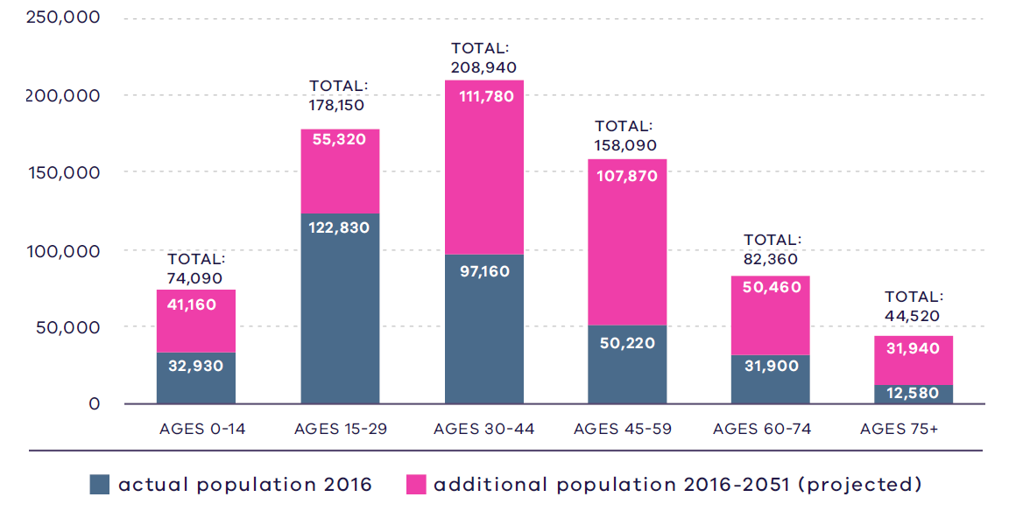
VIF, 2019

Figure 12. Regional actual and projected population by age, 2016 - 2051
2016:  32,930 – Ages 0 to 14  122,830 – Ages 15 to 29  97,160 – Ages 30 to 44  50,220 – Ages 45 to 59  31,900 – Ages 60 to 74  12,580 – Ages 75 plus | 2051:  74,090 – Ages 0 to 14  178,150 – Ages 15 to 29  208,940 – Ages 30 to 44  158,090 – Ages 45 to 59  82,360 – Ages 60 to 74  44,520 – Ages 75 plus
Source: Department of Environment, Land, Water and Planning (2019) Victoria in Future 2019, Department of Environment, Land, Water and Planning, Melbourne, Australia.

Housing stock
The Inner Metro Region has a tight-knit network of neighbourhoods with a diverse range of housing types. The region is a highly sought-after place to live due to its connections to jobs, services, infrastructure and entertainment, and also its highly valued heritage character. Fine-grain, inner suburbs such as Fitzroy, Collingwood and Richmond are dominated by Victorian-era housing which, initially built for the working class, are characterised by smaller lots and one and two-storey buildings. In the 1920s, flats were a typical housing type in South Yarra and St Kilda to serve people working in the Central City. Much of the building stock constructed from 1850 to 1950 remains. The region contains pockets of higher-density apartment development outside the Central City including in older urban renewal areas such as Southbank, Docklands and Beacon Cove in Port Melbourne, which were generally constructed in the 1980s and 1990s, and clusters of low- and high-rise public housing in areas such as Flemington, North Melbourne and Richmond.

Projected housing requirements
Victoria in Future (VIF) projections are published at LGA level for a 20-year horizon from the most recent Census data – currently from 2016 to 2036. Beyond this period knowledge of land supply, dwelling construction and population distribution trends become less certain.
VIF projections indicate that based on the continuation of current trends and knowledge of long-term greenfield land supply, approximately 66 per cent of net additional dwellings across metropolitan Melbourne are expected to be in established areas and 34 per cent in greenfield areas. The housing distribution figures between established areas and greenfield areas are shown in Table 8.
Plan Melbourne provides an alternate aspirational housing distribution scenario based on achieving 70 per cent of new housing provided within Melbourne’s established areas and the remainder 30 per cent accommodated in greenfield areas. This scenario assumes that a total of 70,000 dwellings across metropolitan Melbourne, which VIF 2019 projections allocated to greenfield areas, could be accommodated in established areas to realise the aspirational 70/30 distribution between 2019 to 2051 (Table 9).
Scenario 1 VIF 2019
Region | Net dwelling additions 2016 to 2051 – Total | Net dwelling additions 2016 to 2051 – Established | Net dwelling additions 2016 to 2051 – Greenfield
Inner Metro | 225,000 | 225,000 | 0
Western | 412,000 | 177,000 | 235,000
Northern | 352,000 | 167,000 | 185,000
Inner South East | 119,000 | 119,000 | 0
Eastern | 192,000 | 192,000 | 0
Southern | 313,000 | 184,000 | 129,000
Total Melbourne | 1,613,000 | 1,064,000 | 549,000
 | 100% | 66% | 34%
Scenario 2 Aspirational scenario
Region | Net dwelling additions 2016 to 2051 – Total | Net dwelling additions 2016 to 2051 – Established | Net dwelling additions 2016 to 2051 – Greenfield
Inner Metro | 235,000 | 235,000 | 0
Western | 402,000 | 197,000 | 205,000
Northern | 347,000 | 182,000 | 165,000
Inner South East | 124,000 | 124,000 | 0
Eastern | 202,000 | 202,000 | 0
Southern | 303,000 | 194,000 | 109,000
Total Melbourne | 1,613,000 | 1,134,000 | 479,000
 | 100% | 70% | 30%
Note: For the purpose of these figures, greenfields is land in a growth area LGA that is either currently under development or identified for future development
The Inner Metro Region will need to accommodate 10,000 additional dwellings from the baseline VIF scenario.
Table 10 shows the aspirational housing distribution scenario for each LGA in the Inner Metro Region to 2036. This is achieved by apportioning the net dwelling additions in the established area for each metropolitan region and distributing these between LGAs in the region. The aspirational scenario is based on the locations where most housing growth is anticipated across the established metropolitan area such as the Central City, NEICs, metropolitan and major activity centres, major urban renewal precincts and future SRL precincts. The 70/30 dwelling redistribution for the region will provide guidance to local councils for accommodating housing growth that achieves the aspirational housing distribution for metropolitan Melbourne.
Inner Metro Region 70/30 redistribution by LGA to 2036
LGA | VIF2019 dwellings – 2021 | VIF2019 dwellings – 2036 | Including 70/30 dwellings – 2036 | 70/30 dwelling redistribution | Share of regional redistribution
Melbourne City | 108,800 | 156,000 | 158,500 | 2500 | 50%
Port Phillip | 65,600 | 92,100 | 93,800 | 1700 | 34%
Yarra | 52,800 | 69,200 | 70,000 | 800 | 16%
Inner Metro | 227,200 | 317,300 | 322,300 | 5000 | 100%
DELWP, 2021

Locations for housing growth
Between 2005 and 2016, most residential development in the Inner Metro Region occurred within activity centres (Appendix 2). Melbourne LGA recorded 81 per cent of its net dwelling developments in the Central City and major activity centres while Yarra LGA recorded 57 per cent of its residential development in major activity centres. Dwelling development outside the 400-metre radial area around activity centres was low in both Melbourne and Yarra LGAs, with 7 per cent and 13 per cent respectively. Port Phillip LGA saw more even distribution of net dwelling development across the LGA with 36 per cent of net dwellings developed in activity centres, 37 per cent within the 400-metre buffer around activity centres and 27 per cent outside activity centres.
Most growth in the Inner Metro Region will be focused on major urban renewal precincts including Docklands, Fishermans Bend Urban Renewal Area (Montague, Lorimer, Sandridge and Wirraway), Arden, Macaulay, Dynon, E-Gate and the Flinders Street Station to Richmond Corridor. These state-significant precincts will be resilient, walkable, distinctive places that contribute to the diversity and appeal of the Inner Metro Region.
New housing development in the Central City will continue to provide high-density apartment-type living with studio, one- and two-bedroom units. Significant housing redevelopment is taking place in established neighbourhoods close to the city such as Fitzroy, Collingwood, Richmond, South Melbourne and Port Melbourne. Areas within 400 metres of the Inner Metro Region’s major activity centre network will provide mixed-use residential development close to key commercial and retail, services and amenities, as shown in Figure 13.
- Major housing in the redevelopment pipeline in or within 400 metres of an activity centre
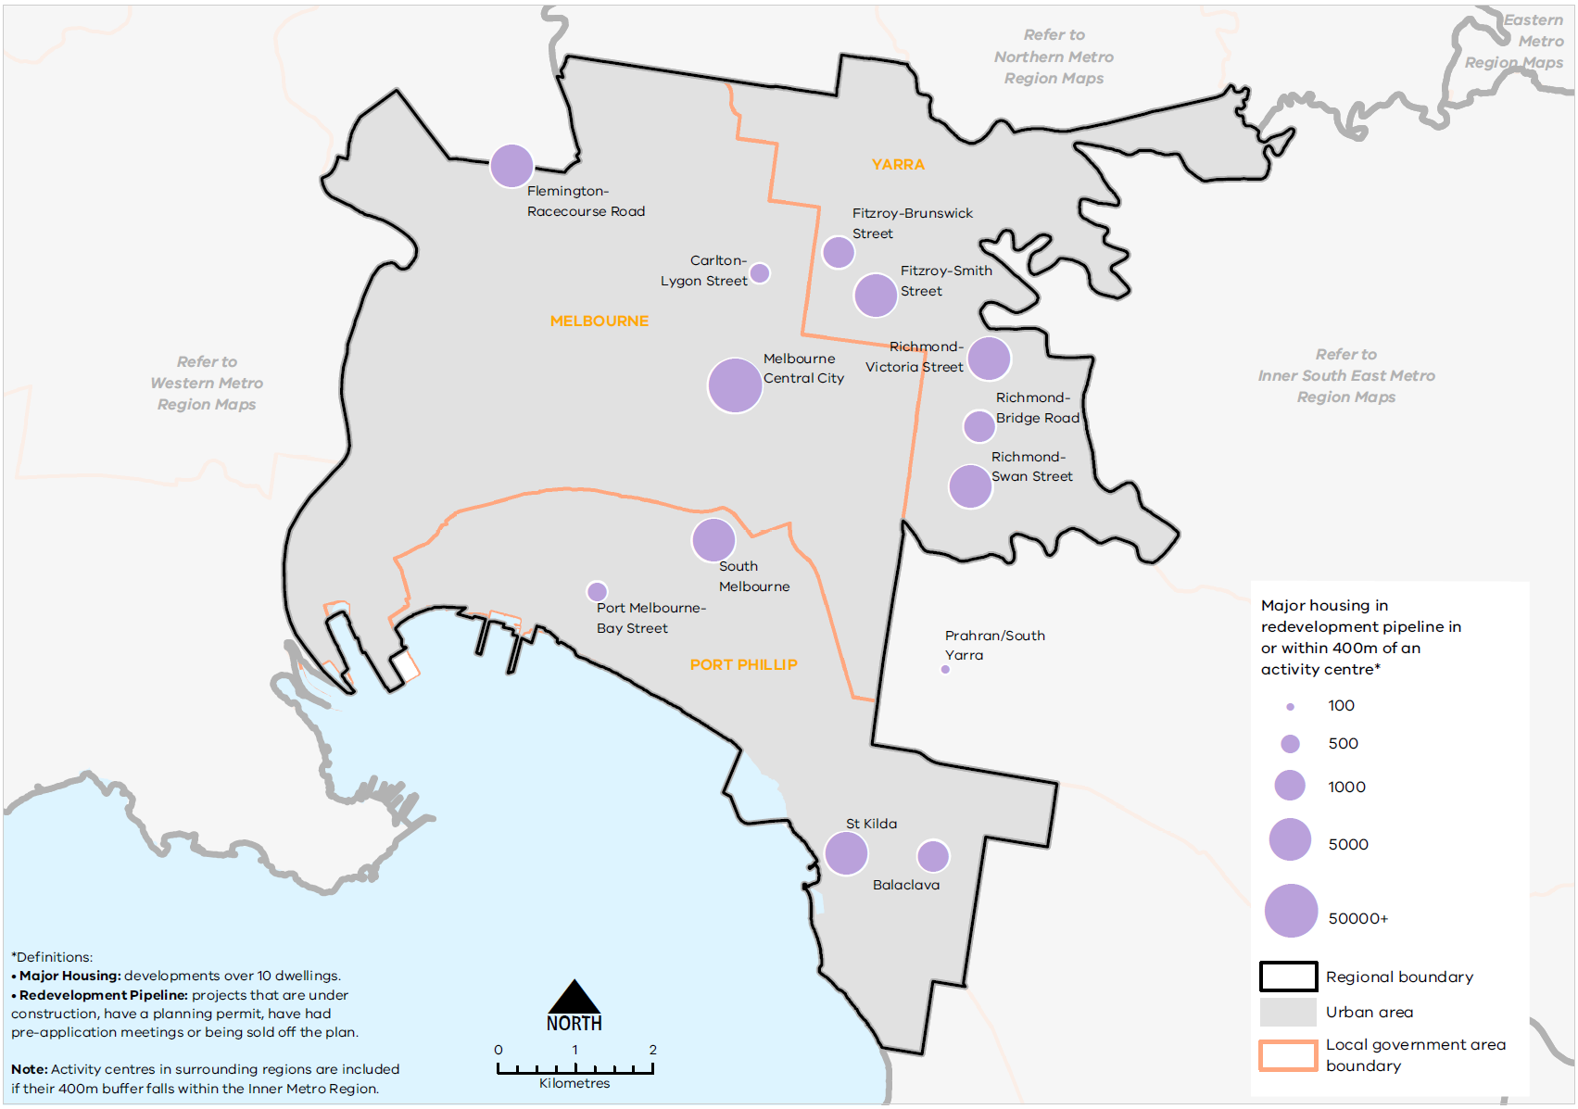
Urban Development Program 2019, Department of Environment, Land, Water and Planning
Figure 13. Major housing in the redevelopment pipeline in or within 400 metres of an activity centre
This map shows:
- Major housing redevelopment pipeline in or within 400m of an activity centre.
- Regional boundary
- Urban area covering the local government areas.
- Local government areas including Yarra, Melbourne and Port Phillip.
*Definitions:
• Major Housing: developments over 10 dwellings.
• Redevelopment Pipeline: projects that are under construction, have a planning permit, have had pre-application meetings or being sold off the plan.
Note: Activity centres in surrounding regions are included if their 400m buffer falls within the Inner Metro Region.
Location | Major housing development pipeline in or within 400m of an activity centre*
Flemington-Racecourse Road | 1001-5000
Carlton-Lygon Street | 101-500
Melbourne Central City | 50000+
Fitzroy-Brunswick Street | 501-1000
Fitzroy-Smith Street | 1001-5000
Richmond-Victoria Street | 1001-5000
Richmond-Bridge Road | 501-1000
Richmond-Swan Street | 1001-5000
South Melbourne | 1001-5000
Port Melbourne-Bay Street | 101-500
St Kilda | 1001-5000
Balaclava | 501-1000
Prahran/South Yarra | 11-100

Housing demand and its impact on affordability
Between 2011 and 2017, the Inner Metro region experienced increasing median prices for detached dwellings, with Port Phillip LGA maintaining the highest median house price compared to Melbourne and Yarra LGAs. For apartments and units, prices have fluctuated over the same time period with a general overall increase (SGS, 2019b).
In terms of rental affordability, the Inner Metro Region is one of the least affordable. Port Phillip and Yarra are among the LGAs with the lowest proportion of affordable rental dwellings in metropolitan Melbourne (less than 1 per cent of affordable rental housing). Melbourne LGA has between 1 and 2 per cent affordable rental dwellings (DHHS, 2020).
There are several existing Victorian Government initiatives in place to improve the supply of affordable housing, including social housing. These include Victoria’s Big Housing Build, the Social Housing Growth Fund, 1000 Homes initiative and the Redevelopment of Public Housing Estates. Port Phillip LGA has been identified as a priority area to increase the supply of social and affordable housing in the Inner Metro Region as part of Homes Victoria’s Big Housing Build program.

Regional strengths
- Major urban renewal precincts identified in and around the Central City provide opportunities for high-density housing in new mixed-use neighbourhoods, leveraging existing jobs, services and infrastructure in the Central City.
- Well-established network of major activity centres in the Inner Metro Region with walkable neighbourhoods, serviced by good public transport, with a good mix of jobs, services and amenities.
- Highly valued heritage and neighbourhood character contributes to the identity of the region.

Regional challenges
- Balancing housing development with employment uses particularly in state-significant commercial land in the CBD.
- Need to provide greater housing diversity to reflect community needs, especially providing adaptable and flexible housing options that supports working from home and the ageing population to ‘age in place’.
- The supply of affordable housing is disproportionate to the level of lower income residents in the Inner Metro Region and the housing prices are exceptionally higher than other metro regions.
- New housing needs to be high-quality, well-designed, durable, environmentally sustainable and resilient to climate change.

Directions and strategies
The directions identified to achieve the 2050 vision for the Inner Metro Region in terms of housing choice and Outcome 2 of Plan Melbourne are:
Direction 8 | Increase the supply of housing in the Inner Metro Region and ensure housing matches the needs of the growing and changing population
Direction 9 | Provide greater choice and diversity of housing in the Inner Metro Region
Direction 10 | Increase the supply of social and affordable housing

Each direction is implemented through regionally-specific strategies identified in this land use framework plan
Map 3 shows how housing choice will be enhanced across the Inner Metro Region by 2050 as a result of these directions and strategies, together with Plan Melbourne and other strategies and initiatives as outlined in Appendix 01.

- Inner Metro Region housing choice 2050
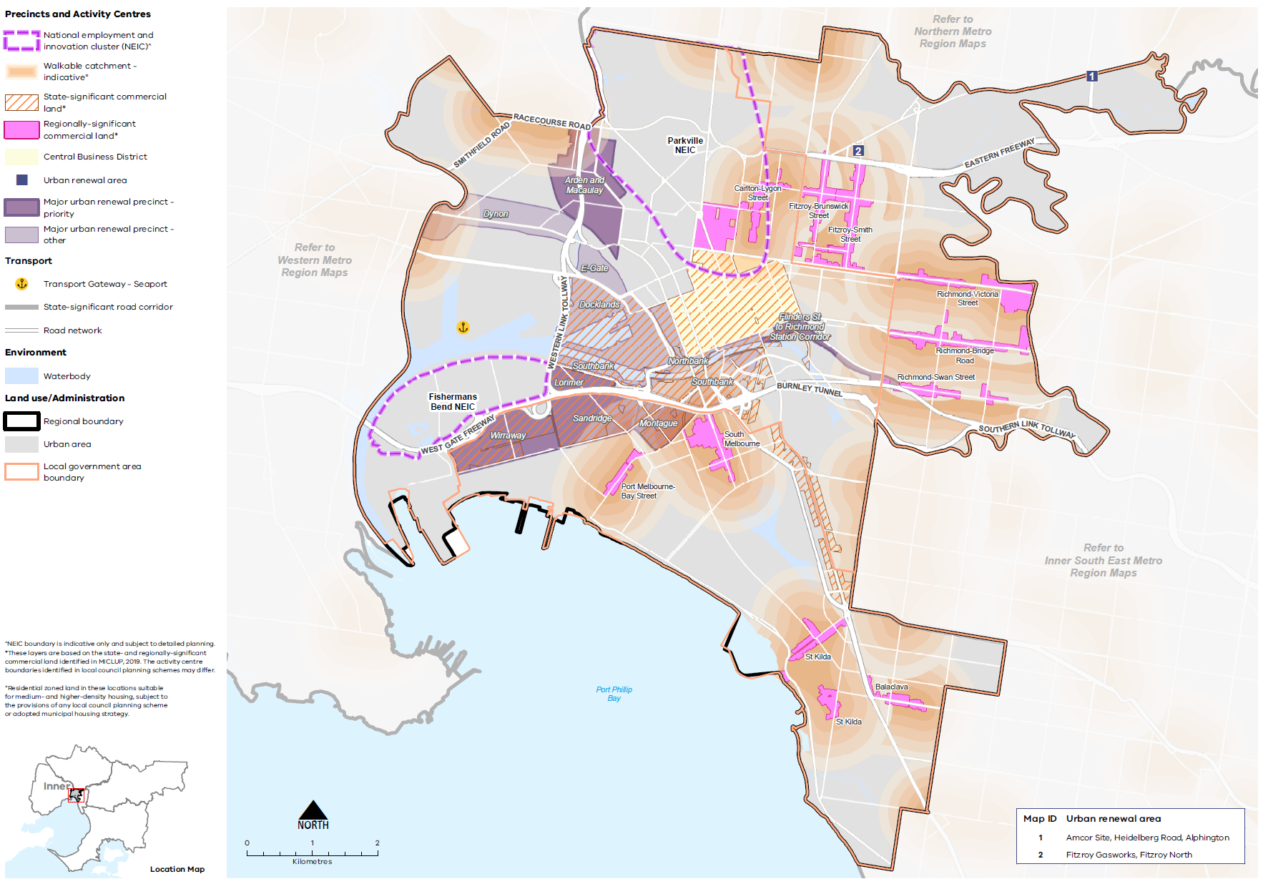

Map 3 Inner Metro Region housing choice 2050
A map of housing choice in the Inner Metro Region in 2050, extracting the locations for medium- and higher-density dwellings identified on Map 1 above and detailed in Table 11, with the addition of 800m walkable catchments around major activity centres.°

° Residential zoned land in these locations suitable for medium- and higher-density housing, subject to the provisions of any local council planning scheme or adopted municipal housing strategy.
- Increase the supply of housing in the Inner Metro Region and ensure housing matches the needs of the growing and changing population
Plan Melbourne aims for 70 per cent of net additional dwellings to be provided within Melbourne’s established areas and the balance in greenfield areas. As the Inner Metro Region has no greenfield areas, its contribution must be accommodated in the established urban area. The Inner Metro Region is well-serviced by the Principal Public Transport Network (PPTN) with most areas having access to multiple modes of public transport. The compact, fine-grain development structure makes neighbourhoods in the region more walkable. This allows the Inner Metro Region to provide much higher-density housing than other regions as it is well connected to employment opportunities, services and amenities, including public open space.
The Central City is expected to continue to provide high-density, high-rise apartment buildings that support a vibrant public realm, as well as contribute to housing near jobs, services and transport. By increasing the density in the Central City, this alleviates the need to increase residential densities in other parts of the region which may not be well-placed to support substantial change.
Major urban renewal precincts where significant housing growth is anticipated are being planned using 20-minute neighbourhood principles to ensure they are well-designed spaces, with a genuine mix of uses and safe, healthy living environment for all residents. Planning will also ensure future precincts provide sufficient active open space and service amenities for future residents as well as suitable job opportunities to support communities in these precincts.
Outside the Central City, the activity centre network in the Inner Metro Region will accommodate new medium- and higher-density housing through a range of new housing types, such as townhouses, units and apartments. Development in these centres will help provide diverse housing across the region, with built forms including low- and mid-rise buildings. Most of the major activity centres in the region such as Carlton-Lygon Street, Fitzroy-Brunswick Street and Richmond-Bridge Road are based on a linear ‘high-street’ form with fine-grain subdivisions. This includes existing two- or three-storey buildings protected by heritage overlays which may be more difficult to redevelop into new medium- to higher-density dwelling developments.
Substantial and incremental change areas will experience varying degrees of change relative to the existing context and will not only increase the supply of housing, but also contribute to a diversity of housing types and built form outcomes. Lower-density areas are expected to accommodate housing growth within the context of the existing or preferred character. Minimal housing change areas are identified for their special characteristics such as neighbourhood, heritage, environmental or landscape characteristics that should be protected. The Inner Metro Region has a strong European, post-settlement heritage character particularly along the linear major activity centres and significant landscape values along the Yarra River. These values are fundamental to the character and desirability of the region as a place to work and live, and the development in these locations must respect and protect this character in line with existing planning controls.
Table 11 identifies locations for medium- and higher-density housing in the Inner Metro Region.
- Maximise housing development within the established areas of the Inner Metro Region to achieve the aspirational housing distribution scenario for metropolitan Melbourne.
- Encourage high-density housing in the Central City while supporting its commercial role through genuine mixed-use developments.
- Increase the supply of medium- and higher-density housing in appropriate locations in major activity centres, major urban renewal precincts, urban renewal areas, and in neighbourhood activity centres along tram corridors and serviced by good public transport.
- Balance employment uses with residential uses in major urban renewal precincts, major activity centres and large mixed-use developments to achieve a genuine mix of uses in locations identified for both employment uses and medium- and higher-density housing.
- Support adaptive and innovative approaches in the design of new residential development that respects the heritage and neighbourhood character of the locality.
Locations for medium- and higher-density housing in the Inner Metro Region
Classification | Locations | Role/function for housing
Central City | The CBD  St Kilda Road  Southbank  Docklands | The Central City (which comprises the CBD as well as Docklands, Southbank and St Kilda Road) is the largest commercial and residential centre which will accommodate well-designed, high-density residential development.
NEICs | Fishermans Bend  Parkville | NEICs can provide housing opportunities in designated locations where they complement the NEICs’ primary role as a cluster of business activity of national significance.  Parkville and Fishermans Bend NEICs have a primary function of providing speciality employment uses. In the Parkville NEIC, residential uses may be appropriate in suitable locations and where it supports institutions in the NEIC.
Major urban renewal precincts | Docklands  Fishermans Bend Urban Renewal Area (Lorimer, Montague, Sandridge, Wirraway) (priority precinct)  Arden (priority precinct)  Macaulay  E-Gate  Dynon | Major urban renewal precincts are a major source of medium- and higher-density mixed-use development and will develop a mix of uses and deliver high-quality, distinct and diverse neighbourhoods beyond 2051.
Major activity centres | Balaclava  Carlton-Lygon Street  Fitzroy-Brunswick Street  Fitzroy-Smith Street  Port Melbourne-Bay Street  Richmond-Bridge Road  Richmond-Swan Street  Richmond-Victoria Street  South Melbourne  St Kilda | Major activity centres are suited to medium- and higher-density housing and mixed-use development. Substantial housing change opportunities may extend to a walkable catchment of 800 metres around the centre (depending on the local context) based on the 20-minute neighbourhood principle of locating housing close to jobs, services, amenities and public transport.  While all major activity centres will accommodate housing change, the degree of change is relative to the existing context and characteristics of each major activity centre (Table 6).
Neighbourhood activity centres | Neighbourhood activity centres | Some neighbourhood activity centres may be suitable for mixed-use medium- and higher-density housing, particularly when they are serviced by good public transport. Housing opportunities may also extend to a walkable catchment of 800 metres around the centre (depending on the local context) based on the 20-minute neighbourhood principle of locating housing close to jobs, services, amenities and public transport.
Urban renewal areas and greyfields | Amcor Site, Heidelberg Road, Alphington  Fitzroy Gasworks, Fitzroy North | Urban renewal areas identified in the LUFP are locations nominated by the local councils or State Government with opportunities for medium- and higher-density mixed-use development. These locations have regional value based on one or more the following characteristics: land size; proximity to the PPTN or future transport infrastructure; government-owned; or requiring cross-municipal planning.  These areas will be planned according to 20-minute neighbourhood principles. A coordinated approach to planning for these areas will maximise their development opportunity and any infrastructure needs.
Housing opportunity areas | St Kilda Road North Precinct  St Kilda Road South | Housing opportunity areas are identified by local councils as areas where substantial housing change is anticipated as a result of being located on the PPTN or along main roads. These locations are generally zoned as Residential Growth Zones where housing at increased densities and housing diversity is expected.
- Provide greater choice and diversity of housing in the Inner Metro Region
The Inner Metro Region’s housing stock largely comprises apartments, units and flats, which in 2016 accounted for over 70 per cent of housing stock in the region. Unlike other metropolitan regions where separate houses dominate the residential stock, the Inner Metro Region only has 7.5 per cent separate dwellings. Most housing stock is two-bedroom dwellings and there is a shortage of three- and four-bedroom dwellings in the region compared to metropolitan Melbourne. Dwellings with three bedrooms or more accounted for 26 per cent of all dwellings, compared to the metropolitan average of 73 per cent.
Providing greater housing diversity in the Inner Metro Region will give residents more opportunities to stay in the region as their lifestyles or circumstances change. The population demographic in the region is younger than other regions in metropolitan Melbourne and mostly comprises lone persons or couples without children. It is projected the age structure will shift slightly by 2051 with the largest age group being between 30 and 44 years old. Residents looking to expand their families should have the opportunity to remain in their existing neighbourhoods. Wirraway and Montague are planned to be predominantly family-friendly neighbourhoods and will provide housing diversity in the form of small- to medium-scale apartment buildings as well as some higher-rise developments.
Developing new housing stock that caters for population change and encouraging dwellings with more bedrooms, or more flexibility generally, will accommodate a more vibrant and inclusive community. This applies to older people and people with disabilities who rely on services and amenities in their existing communities in the Inner Metro Region.
The number of internationally recognised education institutions has catalysed the growth of student accommodation in the region. In certain areas such as City North in the Melbourne LGA, student housing has dominated the residential market and contributed to the lack of housing choice in the area. Ensuring greater housing diversity and a genuine mix of uses in these locations will create greater amenity for residents and more diverse communities.
Providing housing choices suitable and affordable for key workers such as teachers, childcare workers, nurses and other essential service workers is important for the region to retain high-quality employees in state-significant health and/or education precincts and NEICs. Many of these workers are on moderate incomes and are unable to afford living close to their place of work due to the high rental and property prices in the Inner Metro Region.
Not only should housing stock be more diverse, new residential developments, including student accommodation, should be high-quality, environmentally sustainable and durable to meet the changing needs of occupants. The Victorian Government’s Better Apartments Design Standards aim to improve the liveability and sustainability of apartments including new standards around the provision of communal and private open space, landscaping and integration with the street. Improved quality of external materials for buildings will ensure longevity and easier maintenance of the building, while canopy tree cover will contribute to cooling and greening initiatives.
- Encourage a genuine mix of dwelling types and sizes in the Inner Metro Region, including providing larger dwellings suitable for families and shared households in apartment developments, to accommodate the changing future needs of the region.
- Support alternative and sustainable residential development formats such as co-housing or build-to-rent in appropriate locations, and car-free residential development models in locations with good access to alternative transport modes.
- Facilitate the development of housing that is adaptable and flexible to cater for changing demographics and can accommodate different household types and configurations over the building’s lifetime.
- Optimise the opportunities for student accommodation and key worker housing within or close to Carlton-Lygon Street, Fitzroy-Smith Street, and Richmond-Bridge Road major activity centres and around health and/or education precincts in the Inner Metro Region.
- Ensure new residential development is well designed, durable, resilient to climate change and built to a high-quality standard.
- Adopt a place-based approach to the delivery of infill housing developments to replace ageing housing stock, ensure a high-quality of design that is appropriate for the local context and contributes to housing supply and diversity.
- Recognise the value of mixed housing tenures in the Inner Metro Region and its contribution to greater diversity in local communities.

- Increase the supply of social and affordable housing
Affordable housing is defined in the Planning and Environment Act 1987 as housing appropriate for the needs of very low-, low- and moderate-income households, and includes social housing provided by the government or a registered housing agency. The provision of social and affordable housing is not solely a planning issue and a range of programs and measures across all levels of government are required to deliver more social and affordable housing.
Planning should facilitate the delivery of affordable housing in the Inner Metro Region by considering opportunities to renew existing public housing stock and developing under-utilised or disused government-owned land for social housing. Locations that are closer to jobs, services and public transport, as well as sustainable design, will help lower household costs, which is particularly important to very low-, low- and moderate-income households. Strengthening the role of planning to facilitate and deliver affordable housing opportunities will help make Melbourne a liveable city for all.
The social and affordable housing system, consisting of government, the community housing sector and industry, provides housing options for those unable to access the private housing market. There are currently 116,351 people living in social housing owned or managed by Homes Victoria (Director of Housing) or a registered housing corporation across Victoria. Victoria has the lowest proportion of social housing in Australia and will require 4000 homes per year for Victoria’s social housing to reach the national average of 4.2 per cent of social housing to total dwellings.
The Victorian Government’s Big Housing Build program aims to increase existing social housing stock across Victoria by 10 per cent and, in the next five years, over 12,000 new dwellings will be built. The program is Victoria’s largest investment in social and affordable housing and Homes Victoria has been established to deliver the program as well as ensure an ongoing pipeline of social and affordable housing development beyond the Big Housing Build. In addition, existing social housing dwellings will be upgraded, maintained or replaced under the program. The Victorian Government has identified 21 priority LGAs for social housing development including Port Phillip in the Inner Metro Region.
The three local councils in the Inner Metro Region have collaborated to develop a regionally consistent methodology to calculate affordable housing need. Each local council has recently completed, or is undergoing, strategic planning to address the provision of affordable housing in its municipality.
- Facilitate more affordable housing across the region, particularly in locations that have good access to jobs, services and public transport.
- Support a regional approach to determining social and affordable housing needs.
- Support the improvement and retention of existing social housing development within the Inner Metro Region.

Actions – Housing choice
- Update planning schemes to align with housing policies in Plan Melbourne and the Inner Metro Region Land Use Framework Plan and the implementation of the reformed residential zones. This includes providing capacity for 15 years of regional housing supply focusing on locations identified for housing growth in the LUFP.
This may require strategic planning work to support these changes such as preparing or updating local housing strategies or preparing structure plans to further investigate where increased densities can be supported, and determine specific changes required to planning schemes.
- Identify underutilised and surplus government land that has the potential to deliver additional social housing.
- In partnership with councils, identify a pipeline of sites in the Inner Metro Region for social and affordable housing.

Chapter 06.
Integrated transport
Plan Melbourne Outcome 3: Melbourne has an integrated transport system that connects people to jobs and services and goods to market.
As the Inner Metro Region grows, it will require better integration of land use and transport planning, better use of existing roads, and increased investment in public transport, walking and cycling. Making better use of transport infrastructure, complemented by good precinct design, can improve connections without necessarily the expense and disruption of delivering new infrastructure. Land use decisions, as well as mode shift opportunities, can significantly improve access and reduce transport-generated emissions.
The Inner Metro Region has strong transport connections to all metropolitan regions, regional Victoria and national and international gateways through road and public transport networks that radiate from the CBD. There is a strong sustainable transport culture in comparison to other regions, with cycling and walking undertaken in high numbers for short trips. The way the Inner Metro Region manages and supports sustainable transport access will influence the way people move through surrounding areas and impact the broader transport network.
Home to the Port of Melbourne, freight is an important aspect of transport for the Inner Metro Region. The Metro Tunnel, Melbourne Airport Rail, West Gate Tunnel and other rail upgrades will improve access to and through the region as well as to other regions.

State of play
Map 4 outlines the current state of play for transport in the Inner Metro Region.

Road network
The Inner Metro Region’s road network is set within a radial transport network that provides:
- Efficient access from across metropolitan Melbourne
- A relatively flat topography suitable for walking and cycling paths
- The world’s largest tram network, which adds character to many inner-city streets.
Key east-west roads that converge on the Inner Metro Region include the City Link (Southern Link), Monash Freeway, the Eastern Freeway, and the West Gate Freeway (and West Gate Bridge). The Domain and Burnley tunnels that transect the heart of the region, connect northern and western suburbs to south-eastern suburbs. Major north-south roads include City Link (and the Bolte Bridge) to the west of the CBD, Western Link – Tullamarine Freeway to the north, and Hoddle Street and Punt Road to the east.
Given the central location of the Inner Metro Region, the road network experiences significant pressure from traffic originating outside the region and from through traffic. This is an ongoing issue for the management of the road-based transport network by local councils and impacts on the amenity of the region and the ability to achieve greater levels of active and sustainable transport by residents and visitors to the region. By 2031, traffic volumes in the Inner Metro Region are expected to increase by 7.3 per cent from 2015 (KPMG & ARUP, 2017).

Public transport network
The region is well serviced by all modes of public transport (train, tram and bus), although orbital connections are limited and primarily serviced by bus. All metropolitan rail lines and Victoria’s regional train lines terminate in the Inner Metro Region. Major transport interchanges such as Flinders Street and Southern Cross stations, and Richmond Station, are key gateways for workers and visitors to the city as well as City Loop stations around the CBD. Water-based transport exists on the Yarra River but is largely underdeveloped and for tourism purposes.
Most of Melbourne’s tram network also runs through the Inner Metro Region and some of Melbourne’s most patronised buses, including the Doncaster Area Rapid Transit (DART), also terminate in the Inner Metro Region.
Due to the high provision of public transport options, all Inner Metro Region LGAs have a higher average number of hourly services than metropolitan Melbourne. Melbourne LGA has the highest average of hourly public transport services, reflecting its position as the transport hub of metropolitan Melbourne and Victoria. Figure 14 shows the accessibility to public transport for people who live within the region based on how far they need to walk to access train, tram and bus services. Although there is high public transport accessibility across the region, particularly in the CBD and the St Kilda Road transport corridor, there are gaps in public transport accessibility in Fishermans Bend, the Port of Melbourne, Port Phillip Bay coastline and in Alphington in the north corner of the region.

- Inner Metro Region integrated transport state of play
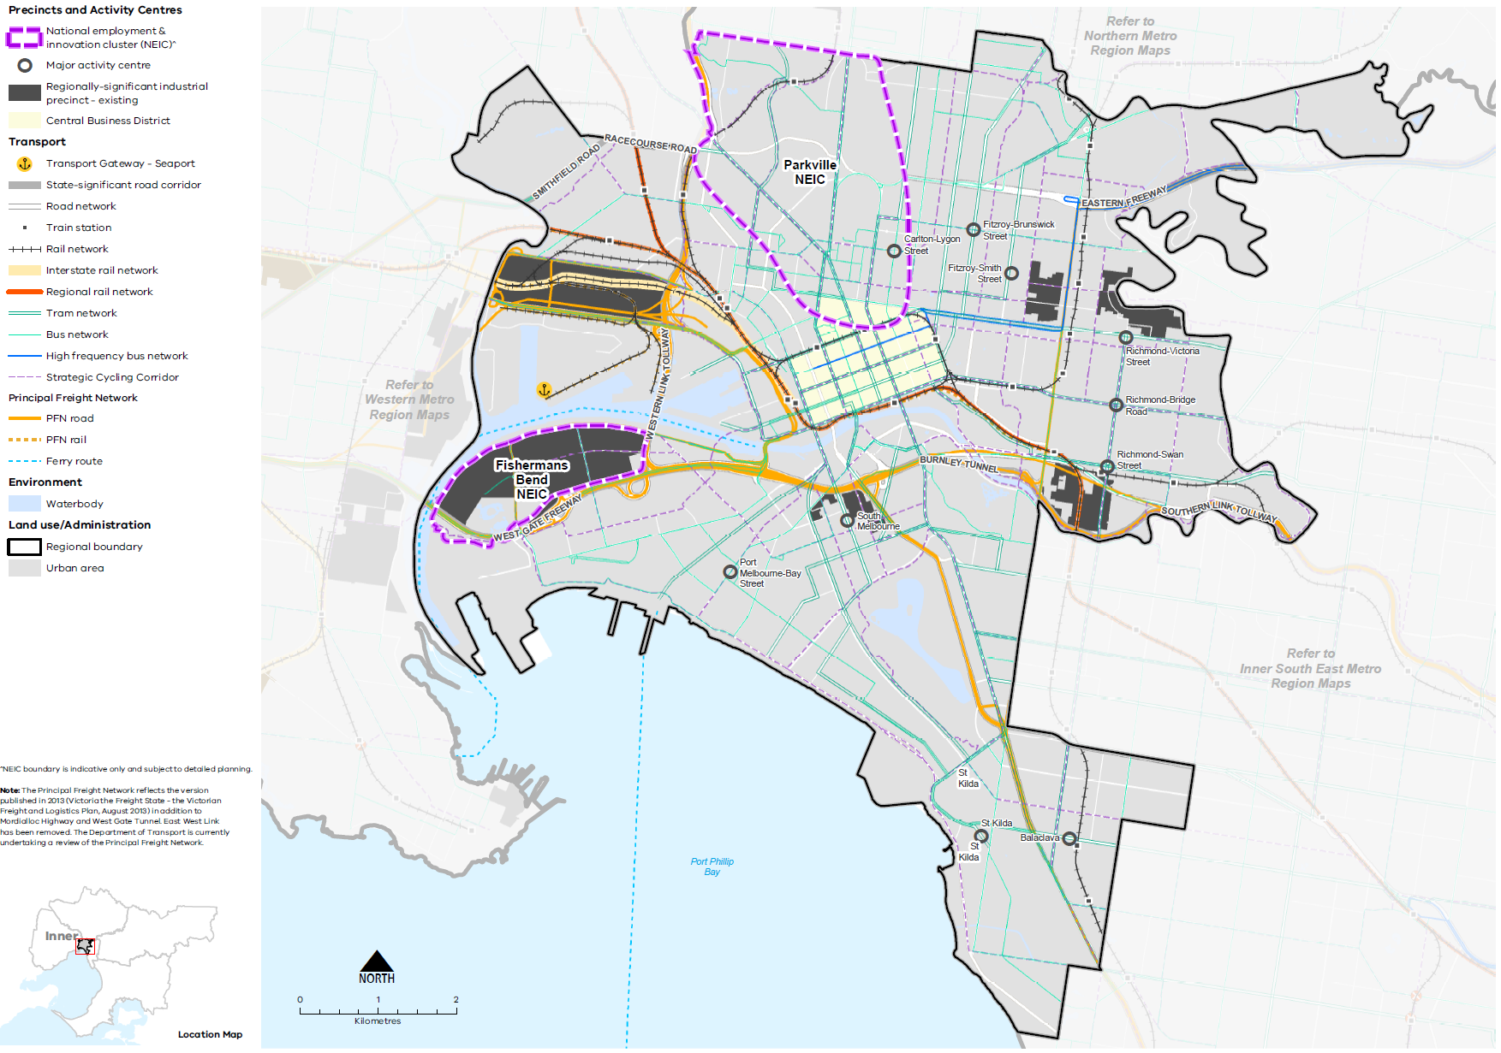
Map 4 Inner Metro Region integrated transport state of play
A map showing the key transport features of the region in 2021, as extracted from Map 1, and also highlighting:
- The route of the interstate rail network
- The regional rail network connecting the region to Geelong, Ballarat, Bendigo, Shepperton, Wodonga, and Bairnsdale
- The bus and tram network, including the high frequency bus network
- The strategic cycling corridor network
- The principal freight network.
Note: The Principal Freight Network reflects the version published in 2013 (Victoria the Freight State - the Victorian Freight and Logistics Plan, August 2013) in addition to Mordialloc Highway and West Gate Tunnel. East West Link has been removed. The Department of Transport is currently undertaking a review of the Principal Freight Network.

- Public transport accessibility in the Inner Metro Region
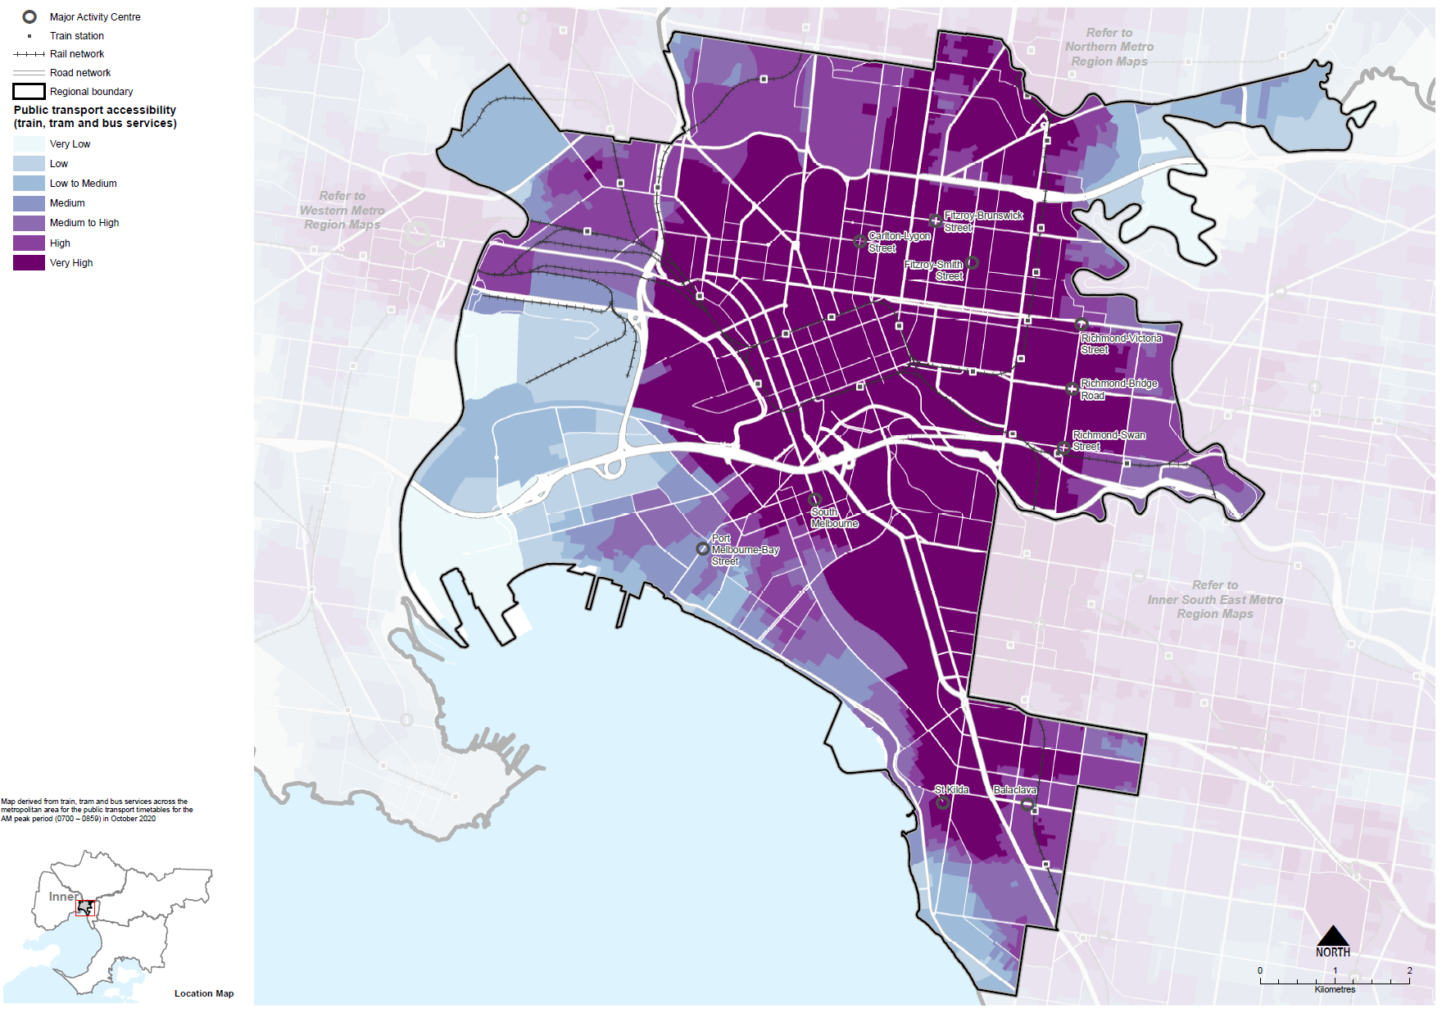

Active transport network
Public and active transport are the most common way to get to work for residents of all Inner Metro Region LGAs. Strategic Cycling Corridors in this area include St Kilda Road and the Capital City Trail. In 2016, 16 per cent of residents walked to work in the Inner Metro Region. This compares to 3 per cent for metropolitan Melbourne. Six per cent of residents cycled to work, which compares to 1 per cent for metropolitan Melbourne. Most households in Yarra and Port Phillip LGAs own one car, while most households in Melbourne LGA do not have a car.

Freight movement
The Inner Metro Region is a critical component of Victoria’s freight network, both in terms of the significant freight distribution assets in the region but also as a key destination for urban deliveries. The Port of Melbourne is essential to Victoria, providing a gateway to international markets and contributing to the economy as Australia’s largest container and general cargo port.

Regional access and movement
In 2016, 73 per cent of Inner Metro Region residents lived and worked in the region. This is the highest level of self-containment – that is, where people both live and work in the same region – of all of the metropolitan regions. Most residents work in Melbourne LGA followed by Yarra and Port Phillip LGAs (SGS, 2019a).
Figure 15 shows journeys to work in and out of the Inner Metro Region. Few residents from the Inner Metro Region travel outside the region to work. The most common destination for journeying to work after the region itself is the Inner South East Metro Region, where 10 per cent of residents travel for work, namely Stonnington and Boroondara LGAs (SGS, 2019a). The most common origins of workers were from the Northern and Western Metro Regions, followed by the Inner South East Metro Region. LGAs with the most journeys to work in the Inner Metro Region were those located close to the region, namely Moreland, Boroondara and Darebin LGAs (SGS, 2019a).
- Journey to work in and out of the Inner Metro Region
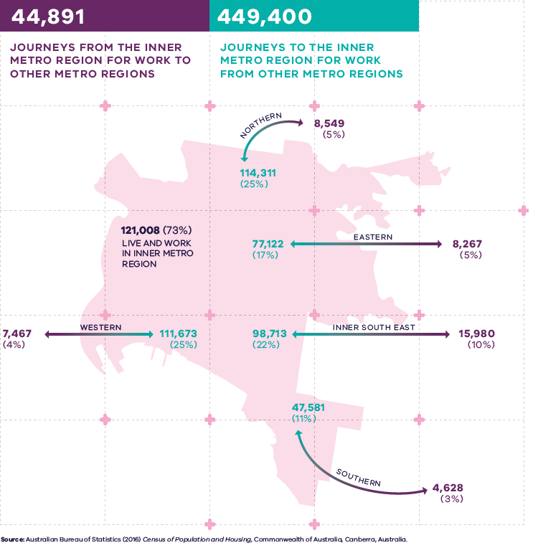

Figure 15. Journey to work in and out of the Inner Metro Region
121,008 (73 per cent) live and work in the Inner Metro Region | 44,891 – Journeys from the Inner Metro Region for work to other metro regions:  - 8,549 (5 per cent) – Journeys to the Northern Metro Region  - 8,267 (5 per cent) – Journeys to the Eastern Metro Region  - 15,980 (10 per cent) – Journeys to the Inner South East Metro Region  - 4,628 (3 per cent) – Journeys to the Southern Metro Region  - 7,467 (4 per cent) – Journeys to the Western Metro Region | 449,400 – Journeys to the Inner Metro Region for work from other metro regions:  - 114,311 (25 per cent) – Journeys from the Northern Metro Region  - 77,122 (17 per cent) – Journeys from the Eastern Metro Region  - 98,713 (22 per cent) – Journeys from the Inner South East Metro Region  - 47,581 (11 per cent) – Journeys from the Southern Metro Region  - 111,673 (25 per cent) – Journeys from the Western Metro Region
Source: Australian Bureau of Statistics (2016) Census of Population and Housing, Commonwealth of Australia, Canberra, Australia.

Regional strengths
- Strong freeway, arterial road and freight network and the transport gateway of the Port of Melbourne.
- Strong public transport and active transport networks in comparison to other regions.
- Planned major transport investments.

Regional challenges
- Growing number of trips within, to and around the region and demand for road and footpath space will require people to use more space-efficient forms of transport.
- Congestion on arterial roads and demand for on-street parking will worsen without intervention.
- Making connections between established and new areas to encourage people to move away from private vehicle use.
- Improving the frequency, connectivity, reliability and capacity of the public transport system.
- Provision of early investment in public transport routes to connect new urban renewal areas to the rest of the Inner Metro Region and beyond.
- Larger volumes of freight transported by smaller vehicles on congested networks in urban areas.
- Pedestrian and cycling safety and making better use of road space especially around transport hubs.

Directions and strategies
The directions identified to achieve the 2050 vision for the Inner Metro Region in terms of integrated transport and Outcome 3 of Plan Melbourne are:
Direction 11 | Improve transport connections to support the region’s competitive advantage as the economic, cultural and services hub of metropolitan Melbourne and Victoria
Direction 12 | Improve public and active transport access for the Parkville and Fishermans Bend NEICs and major urban renewal precincts
Direction 13 | Improve active and public transport options to promote mode shift and support 20-minute neighbourhoods
Direction 14 | Plan for transport interchanges as destinations and places for movement
Direction 15 | Improve freight efficiency and increase capacity of gateways while managing impacts on urban amenity

Each direction is implemented through regionally-specific strategies identified in this land use framework plan.
Map 5 shows how integrated transport will be enhanced across the Inner Metro Region by 2050 as a result of these directions and strategies, together with Plan Melbourne and other strategies and initiatives as outlined in Appendix 01.

- Inner Metro Region integrated transport 2050
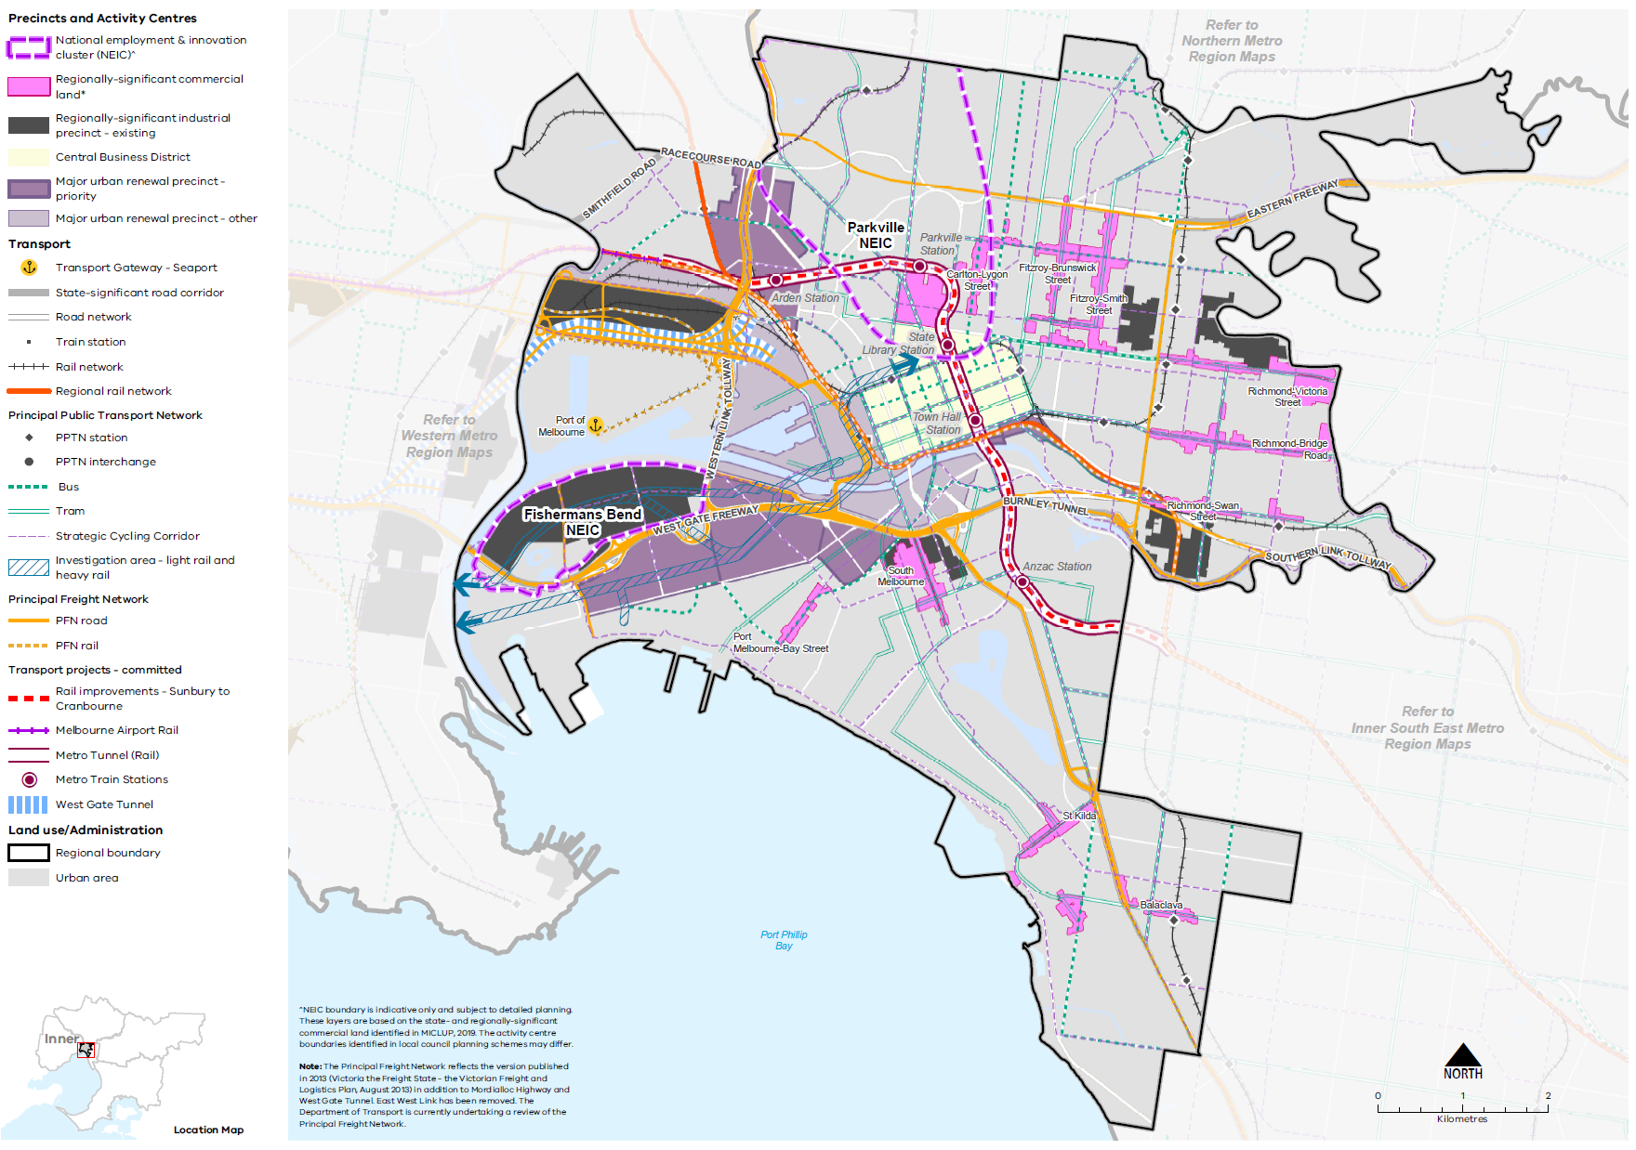

Map 5 Inner Metro Region integrated transport 2050
A map showing the key transport features of the region in 2050, as extracted from Map 1, and also highlighting:
- Rail improvements from Sunbury to Cranbourne, Metro Tunnel and the Melbourne Airport Rail
- West Gate Tunnel
- PPTN stations and interchanges.

- Improve transport connections to support the region’s competitive advantage as the economic, cultural and services hub of metropolitan Melbourne and Victoria
The Inner Metro Region is the heart of the city for workers, residents, visitors from across Melbourne, regional Victoria and beyond, requiring a diversity of responses to create city-wide efficient transport connections.
As well as a vast array of economic and cultural infrastructure, the transport network plays a key role in supporting the daily functions, opportunities and experiences in the Inner Metro Region. Businesses need access to a broad and deep labour pool, and derive benefits from the knowledge transfer, innovation and productivity gains that come from dense, vibrant and high amenity locations in the CBD and inner suburbs. If there is not sufficient transport capacity to provide access for these businesses, many would locate in other cities, rather than alternative metropolitan locations.
As Melbourne’s population grows, additional access to the Inner Metro Region will be required. Major transport and infrastructure investments include the construction of the Metro Tunnel, a transformative rail project that will allow greater cross movement and enable 39,000 more passengers to use the rail system during each peak period and create five new stations.
Melbourne Airport Rail and the West Gate Tunnel will provide greater capacity and better connectivity for more people and businesses outside the region. Future road projects should be complemented by investment in public and active transport along these corridors. The Geelong Fast Rail Project will improve linkages to Werribee NEIC and Geelong.
Greater capacity creates the catalyst for more integrated planning for transport giving people more options to travel to the city including public transport, cycling and walking and increasing the influence of sustainable options in the Inner Metro Region’s multi-modal transport network. Greater capacity can also be achieved by reducing the number of multi-leg (in-and-out) indirect trips through the CBD through better connections and behaviour change.
However, there are still connections that need to be improved for the region. Key regional linkages are shown in Figure 16. Decisions regarding appropriate modes for these links should consider the capacity of existing infrastructure, ongoing sustainability and providing travel choices over a longer time period including evening and late-night travel.
Greater focus needs to be placed on improving transport connections in the outer areas of the region – as the transport infrastructure moves radially out from the CBD. Connections across suburbs, north-south and east-west as well as across the Yarra River should be considered. Future priority access linkages include from Melbourne’s inner west to the CBD and Fishermans Bend.
The Inner Metro Region contains orbital movement corridors that are used by a mix of cars, buses, freight vehicles and bicycles. Key movement corridors in the region include Victoria Parade, Alexandra Parade, Johnston/Elgin Street to Grattan Street running east-west and Hoddle Street running north to south. These movement corridors require further planning and investigation in terms of their role as orbital connectors across the region. The St Kilda Road corridor is a transport corridor with many tram routes that has a gateway function from the southern suburbs to the CBD.
Strategic Cycling Corridors will connect state-significant locations and activity centres. Priority active transport projects will promote increased safe use of the region’s cycling and walking network (Figure 17).
Primary routes provide a core network of Strategic Cycling Corridors that connect places of state significance – the Central City, metropolitan activity centres and NEICs within metropolitan Melbourne. Main routes are Strategic Cycling Corridors that provide additional connections to state-significant destinations as well as connections to major activity centres and key railway stations across metropolitan Melbourne.
Strategic Cycling Corridors will provide continuous and protected bike lanes to ensure the safety and convenience of the network for all ages and abilities. Key missing links need to be addressed particularly those that provide access into the CBD and key employment nodes such as the St Kilda Road bicycle lanes and a high-quality, all ages cycle corridor from Princes Hill to St Kilda. End-of-trip facilities should be planned, particularly as part of major commercial developments.
- Ensure major road and rail projects include public and active transport improvements and connections.
- Improve public and active transport connections to, from and through the Inner Metro Region for work, education and leisure.
- Improve public and active transport connections from the inner west of Melbourne to the CBD and Fishermans Bend.
- Improve public and active transport connections across the Yarra River, orbitally within the region and between major activity centres and regionally-significant places.
- Improve orbital movement corridors across the region.
- Support cycling for transport through the development of Strategic Cycling Corridors in the Inner Metro Region.
- Facilitate land use change to respond to access improvement delivered by major public transport projects.

- Key regional linkages – Inner Metro Region
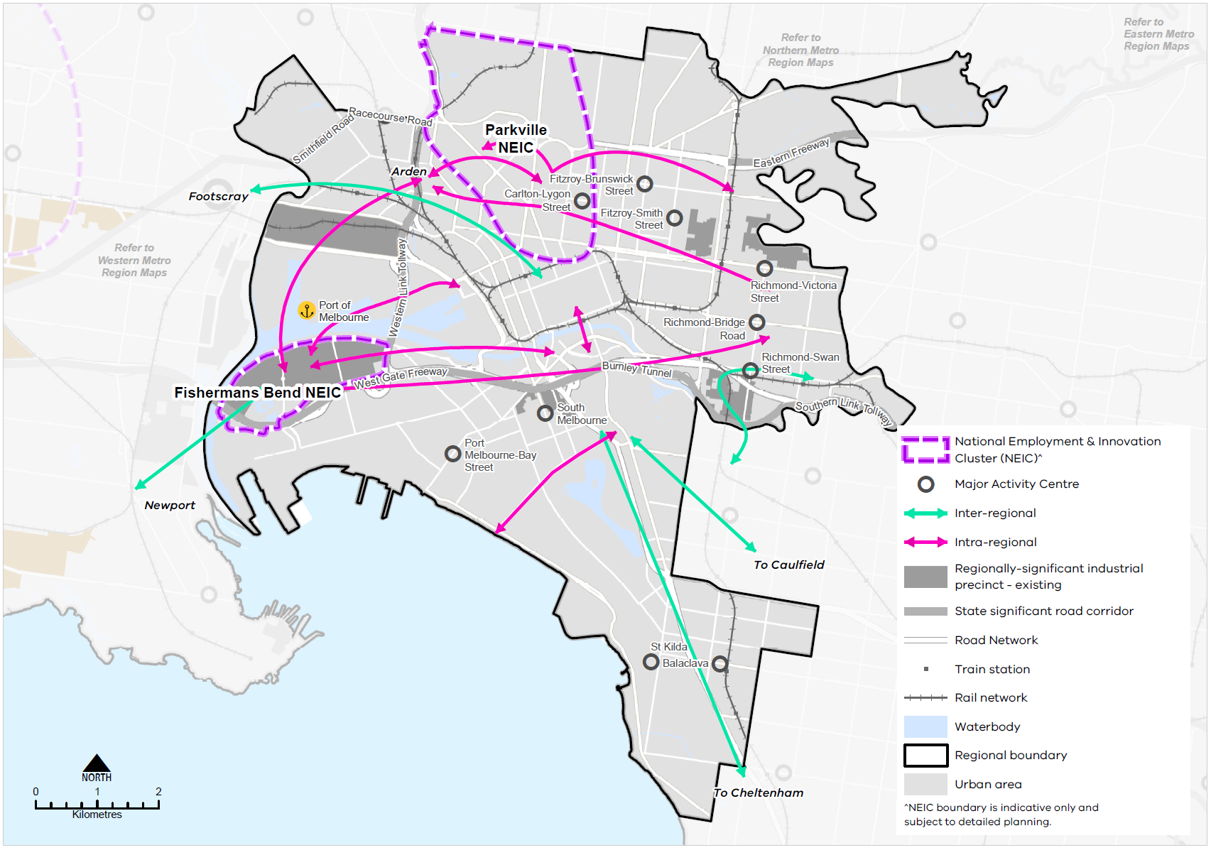
- Strategic Cycling Corridor network – Inner Metro Region
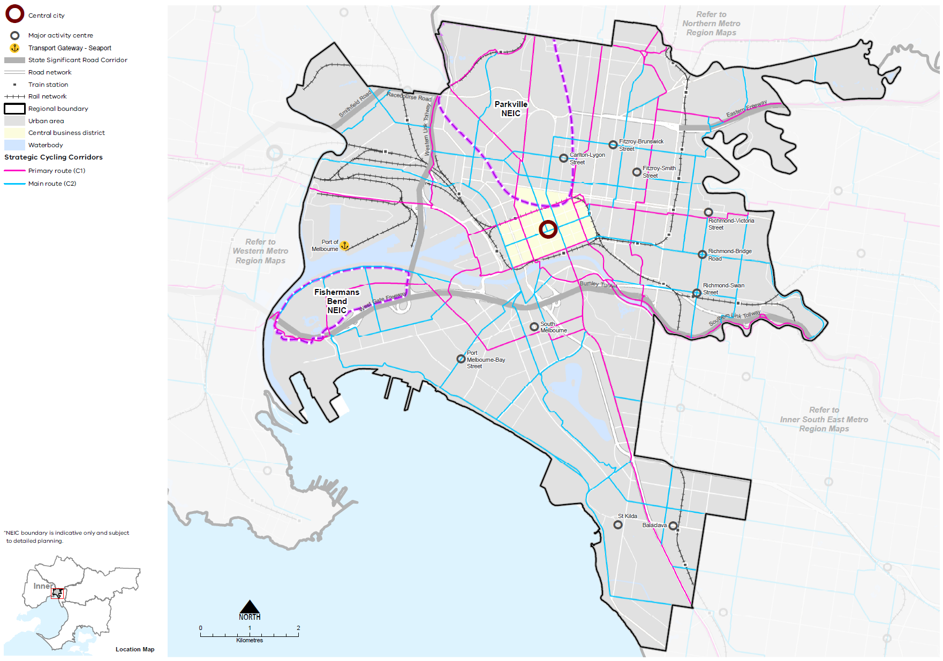

- Improve public and active transport access for the Parkville and Fishermans Bend NEICs and major urban renewal precincts
NEICs, major urban renewal precincts and major activity centres in the Inner Metro Region need improved public and active transport access. This will be critical to improve the amenity of these centres and make them more attractive for business investment and local residents. Improved access plays a major role in supporting urban renewal, connecting precincts to the urban fabric of the inner city, allowing people to access the precinct, and catalysing other major investments to improve local amenity and infrastructure. Improving accessibility reduces transaction costs for businesses through increased opportunities to interact with suppliers and customers face-to-face and, crucially, increases access to a skilled labour force.
For Fishermans Bend to realise the ambition of accommodating 40,000 jobs, significant transport improvements will be necessary. The limited public transport, active transport and a generally poor pedestrian environment that currently may constrain economic development.
The transformation of the industrial area in Arden is also centred on major access improvements being realised as part of the Metro Tunnel, supported by significant public realm and other infrastructure investments. Linking precincts such as Arden to the Parkville NEIC, the CBD and Sunbury and Cranbourne/Pakenham open these precincts up to a larger workforce and make them attractive locations for business and investment.
Facilitating walking and cycling as key modes for local trips within NEICs and to major urban renewal precincts, such as Arden, is also important. These modes often represent the first and last legs of public transport trips. The focus needs to be on creating safe, attractive environments that prioritise walking, cycling and surface transit in these locations.
To realise the ambition of accommodating jobs in the NEICs and major urban renewal precincts, early transport investment is needed to ‘knit’ emerging precincts into the broader fabric of the Inner Metro Region. This will provide links to the CBD and other parts of the region and metropolitan Melbourne and encourage urban form that prioritises sustainable transport modes and a sustainable transport culture.
- Design major urban renewal precincts with an urban form that prioritises sustainable transport use.
- Support NEICs and major urban renewal precincts with early public transport investment.
- Improve public and active transport connections to employment and enterprise precincts.
- Provide high-quality public and active transport to job-rich areas including Parkville and Fishermans Bend NEICs, major urban renewal precincts and the major activity centres.

- Improve active and public transport options to promote mode shift and support 20-minute neighbourhoods
Improvements to local transport options, including bus, cycling and pedestrian access, are needed to support the delivery of 20-minute neighbourhoods across the Inner Metro Region. More sustainable transport options and choices will make it easier for people to move within the region.
Fifteen per cent of people in the Inner Metro Region use a car when making a short trip under 5 kilometres in the region whereas 54 per cent of people walked, and only 4 per cent cycled for short trips (DELWP, 2021). To reduce dependence on private vehicles, public transport, cycling and walking need to be more accessible. This means significant upgrades to public transport access, and improvements to pedestrian and cycling accessibility, better linking neighbourhoods to employment, and social and community services.
A world-class public transport network supports population and economic growth, further strengthening the region’s competitive advantages. Investment should focus on improving existing services, prioritising trams and buses on roads to increase reliability and exploring options to extend the coverage and reach of public transport. To become a global city, frequencies need to move from a peak hour commuter network, and into an all day, every day network for all types of trips. Improvements to the performance of on-road public transport, new public transport connections and better cycling and walking facilities will provide better access to many of these centres and help them thrive.
A review of the bus network should consider additional bus routes, providing more frequency for existing services as well as using buses to fill public transport gaps. Physical improvements to on-road bus priority, active transport and streetscapes are also required.
Planning for safe and efficient pedestrian movement at a regional level, such as between key destinations, for example the CBD to Fishermans Bend, will be an increasingly important consideration. This includes identifying and addressing ‘dead zones’ between key destinations across the region, which provide barriers to walkability such as major arterial roads, elevated rail and roads, and natural barriers. Reducing conflict with shared pedestrian areas and ensuring the safe movement of all users should be a design priority to encourage walking as well as cycling. A key feature of the Inner Metro Region is its walkable neighbourhoods. Safe and attractive pedestrian connections should be prioritised.
While challenging to deliver, there are also water-based transport opportunities that could be investigated as an alternative form of transport to connect key locations along the Yarra and in Port Phillip Bay.
- Enhance public transport coverage, frequency and capacity, improving access to destinations across the network.
- Deliver a convenient, safe and attractive pedestrian network connecting key destinations, and linking regionally-significant places and key cultural and sporting destinations.
- Improve walking and cycling access to train stations to support medium- and higher-density housing outcomes.
- Provide walking and cycling routes and drop-off zones to health and community services, and recreation facilities.
- Plan for place in transport connector improvements.

- Plan for transport interchanges as destinations and places for movement
Transport interchanges and corridors are destinations in their own right as well as key parts of the transport network. In the Inner Metro Region, Federation Square is both a destination and a key part of the transport network, facilitating movements between the river’s edge, tram network and Flinders Street Station.
Richmond Station is another regionally-significant transport interchange for train lines, tram corridor and bus routes as well as facilitating movements to the Sports Precinct. Planning new transport interchanges and upgrading existing ones should consider and appropriately respond to their context and create destinations across the region for residents and visitors that are easy for pedestrians to transition between modes.
The Metro Tunnel will deliver major improvements to the transport network and the new stations of Arden, Parkville, State Library, Town Hall and ANZAC will become transport interchanges. Long-term objectives for each transport interchange, and the corridor it is located within, need to be identified by state and local government, and the design of infrastructure and places should meet these objectives. The Movement and Place Framework can support the redefinition of streets in key locations to support this process.
- Ensure the design of transport interchanges and corridors improves active travel, public areas and their functions, and contributes to a sense of place.
- Balance movement and place when designing and upgrading the region’s road network.
- Design streets that provide for sustainable transport modes and improve the public realm.

- Improve freight efficiency and increase capacity of gateways while managing impacts on urban amenity
As population growth and changing consumer patterns continue to develop, effective land use and transport planning will be an important part of proactively planning for resilient, adaptable and sustainable growth in the Inner Metro Region’s freight sector.
The significant growth in the volume of freight means planning for the Port of Melbourne and associated infrastructure needs to provide protection from encroachment by incompatible uses. Combined with the intensification of other activities in central Melbourne, the impact of freight movements on other significant uses also needs to be mitigated.
Planning and development of urban renewal precincts and development intensification in established areas near freight routes such as in Fishermans Bend and Port Melbourne, require planning protections, such as buffers, to balance and protect strategic freight corridors from competing amenity and environmental considerations.
The Principal Freight Network (PFN) supports this, by providing transparency to local government and the community regarding the primary way goods are moved throughout the region. This allows government to consider freight needs during the planning process to protect end-to-end freight journeys from conflicting land uses or use tools to mitigate environmental or amenity risk.
The under-construction Port Rail Shuttle Network is indicative of the opportunity to change how freight moves around Melbourne by supporting an increasing shift to rail freight. Supported by under-construction intermodal terminals such as Somerton and Altona, these projects will reduce truck numbers and alleviate congestion. Upgrades to the Dynon Terminal, Webb Dock and on-dock rail terminals will also facilitate the Port’s sustainable growth. Other projects include West Gate Tunnel and Monash Freeway Upgrade, which will better link existing freeways and relieve key bottlenecks.
The growing urban freight delivery task is also a significant consideration in the Inner Metro Region, requiring coordinated state and local government planning to support more efficient use of the network. By 2050, it is predicted Victoria will observe an aggregate freight demand of almost 900 million tonnes in line with consumption growth, representing a 250 per cent increase from 2014 volumes and a doubling of metropolitan freight demand. International best practice examples, such as urban consolidation centres and the use of cargo bikes, should be trialled as a means of reducing inner-city freight congestion, making better use of the network and delivering more environmentally sustainable solutions.
Population growth, economic growth and other trends mean the number of small-scale deliveries will increase, and last kilometre freight deliveries will need to be more effectively planned for.
- Support innovative approaches to urban deliveries, such as consolidation centres, cargo bike trials and out of hours deliveries, to reduce congestion and improve environmental outcomes.
- Ensure major land use and transport infrastructure projects appropriately consider the impacts of last kilometre freight movements while seeking to implement measures to improve the efficiency of urban freight deliveries.

Actions – Integrated transport
- Apply the Movement and Place Framework to the Inner Metro Region’s arterial road network and allocate priorities for transport connector improvements such as improving road space allocation for public and active transport, identify priority streets for walking and cycling, and road management and use arrangements. This should include a focus on transport interchanges and transport corridors.

Chapter 07.
Liveability
Plan Melbourne Outcome 4: Melbourne is a distinctive and liveable city with quality design and amenity
‘Liveability’ is about the things that enhance people’s quality of life. For many years Melbourne has been regarded as one of the world’s most liveable cities due to its social and economic stability, diverse communities, distinctive heritage, high level of amenity and the opportunities it provides for a rich social and cultural life.
Plan Melbourne aims to maintain and extend the city’s liveability by celebrating its culture, diversity and distinctiveness. The challenge ahead is to design and plan for a future city that protects the best aspects of the natural and built environment, supports social and cultural diversity, and creates a strong sense of place.
The Inner Metro Region is the historic and cultural centre of Melbourne. It is defined by its location around Port Phillip Bay and the confluence points of the Yarra River (Birrarung), Maribyrnong River and the Moonee Ponds Creek. The region has high cultural significance for Aboriginal people who have lived on this land for tens of thousands of years. As the place of the first European settlement of Melbourne the region has a great legacy of heritage buildings and streetscapes. The identity of the region is being continually redefined by new design and development and the influences of its many different cultural groups and changing population.

State of play

Landscapes and biodiversity
The Inner Metro Region is nestled between the paths of the Yarra and Maribyrnong rivers, the Merri, Darebin, Moonee Ponds and Elster creeks, and the Port Phillip Bay coastline. These water systems define the region’s urban setting.
While landscapes of the Inner Metro Region have been significantly altered since European settlement, elements of its pre-settlement landscapes are still evident in its topography, waterways and coastline. These landscape features are complemented by constructed landscapes such as the region’s iconic parks and gardens.
The region’s various landscape elements, both natural and human-formed, are integral to its amenity, character, culture and environment. They provide opportunities for respite and escape, connect trails and habitat corridors and are important recreation assets.
The region’s key landscapes and biodiversity areas are described in Table 12.
Key landscapes and biodiversity areas in the Inner Metro Region
Landscape and biodiversity area | Significance, protection and management
Port Phillip Bay coastline | The Port Phillip Bay coastline of the Inner Metro Region extends from the Port of Melbourne to Elwood Beach.  The coastline provides a range of functions: port facilities for freight and passenger shipping; recreational sailing and boating; a major open space corridor including playgrounds and recreation areas; an important cycling and pedestrian corridor; a place for festivals and events.  A considerable amount of native vegetation exists along the foreshore which has regional ecological significance. The coastline also features stands of exotic Canary Island date palms and Norfolk Island pines, formal parks and expansive open lawns. The Inner Metro Region’s coast and waterways have been heavily impacted by European settlement and urbanisation. There is a strong community and government commitment to their ongoing rehabilitation.
Waterways | The Yarra River flows into Melbourne from the Yarra Ranges, winding its way past Clifton Hill, Abbotsford and Richmond before changing course at Burnley to pass through the CBD, and ultimately meeting Port Phillip Bay. The Maribyrnong River and the Moonee Ponds Creek form in the hinterland to the north and west of Melbourne and discharge into the Yarra River at its delta. The Merri Creek meets the Yarra River at Dights Falls and the Darebin Creek in Alphington.  The Yarra River corridor is iconic to central Melbourne and offers a natural break for residents, workers and visitors alike. It contains active recreation trails, is used by commuters, and is often a place for quiet reflection, particularly within its many parklands: the Yarra Bend Park, Dights Falls, Burnley Park, Birrarung Marr and the Royal Botanic Gardens. Elster Creek is a significant watercourse through the southern part of the region that now forms the Elwood Canal.
Wetlands | Wetlands that existed prior to European settlement have now mostly been reclaimed, including the ‘Blue Lake’ to the west of the CBD (near where Southern Cross Station stands today) which supported teeming birdlife and abundant food. Today, Albert Park Lake remains as a remnant of a former wetland and a reminder of the ancient landscape. Parts of the lake system at the Royal Botanic Gardens are remnants of a natural wetlands system of the Birrarung.
Yarra Bend Park and Royal Park | Yarra Bend Park and Royal Park contain the largest areas of natural bushland in the region and are a haven for urban wildlife. Other smaller areas of biodiversity form ‘hotspots’ throughout the urban area. Many are linked by habitat corridors along waterways.
Formal gardens | The Inner Metro Region contains numerous formal gardens, some of which attract high visitation. These gardens serve an important role in the display of botanical species and are also integral habitat connections. Many support significant old trees, some of which pre-date European settlement. They offer an important opportunity for refuge in the city and a sense of connection to the region’s underlying landscape.  Formal gardens include: the Kings Domain and Royal Botanic Gardens; the Fitzroy, Treasury and Carlton Gardens in the City of Melbourne; Alma Park, Catani Gardens and St Kilda Botanical Gardens in the City of Port Phillip; Burnley Gardens and Edinburgh Gardens in the City of Yarra.

Aboriginal cultural heritage
The Wurundjeri Woi Wurrung people of the Kulin Nation, represented by the Wurrundjeri Woi Wurrung Cultural Heritage Aboriginal Corporation, are the recognised Traditional Owners of the northern part of the Inner Metro Region. The Bunurong people are the recognised Traditional Owners of the southern part of the region, represented by the Bunurong Land Council Aboriginal Corporation. As Registered Aboriginal Parties (RAPs), both have responsibilities to protect cultural heritage assets under the Aboriginal Heritage Act 2006.
The lands that now make up the Inner Metro Region feature places and waterways that have cultural significance and continuing connection for Traditional Owners and Aboriginal Victorian communities, which is illustrated in the recognised locations of Cultural Heritage Sensitivity (Figure 18). Support should be provided to Traditional Owners to protect and manage these cultural heritage sites, cultural landscapes and waterways.
Publicly known sites of cultural significance in the Inner Metro Region include the Birrarung (Yarra River), Yarra Park, Birrarung Marr, Bunurong Corroboree Tree (the ‘Ngargee’ Tree, Albert Park), Kulin Nation Gathering Place (MCG), The Moreton Bay Fig Tree (Carlton Gardens), pre-colonial Red River Gums (University of Melbourne) and Birrarung Wilam (campsite on the Birrarung).
Fitzroy is an important location for Aboriginal people in the region and this is noted by significant cultural sites and activities such as the Stolen Generations Marker, the Smith Street Dreaming Festival and the use of Woi Wurrung language to name the Bargoonga Nganjin community space in North Fitzroy.
Key strategic work in the region includes the draft Yarra Strategic Plan, which sets out the foundation for achieving the Yarra River 50 Year Community Vision and delivering on the aspirations contained in the Wurundjeri Woi Wurrung Cultural Heritage Aboriginal Corporation’s Nhanbu narrun ba ngargunin twarn Birrarung (Ancient Spirit and Lore of the Yarra) water policy and in line with the Yarra River Protection (Wilip-gin Birrarung murron) Act 2017.
The Waterways of the West Action Plan (to be released 2021) will ensure that Traditional Owners are included in future management and planning of all other waterways within the region.
The Inner Metro Region is home to a number of regionally-significant Aboriginal cultural heritage organisations including the Wilin Centre for Indigenous Arts and Cultural Development and Wilin Garden (Faculty of the VCA and MCM, University of Melbourne), Bunjilaka Aboriginal Cultural Centre (Melbourne Museum) and the Koorie Heritage Trust (Federation Square).
- Inner Metro Region Aboriginal cultural heritage
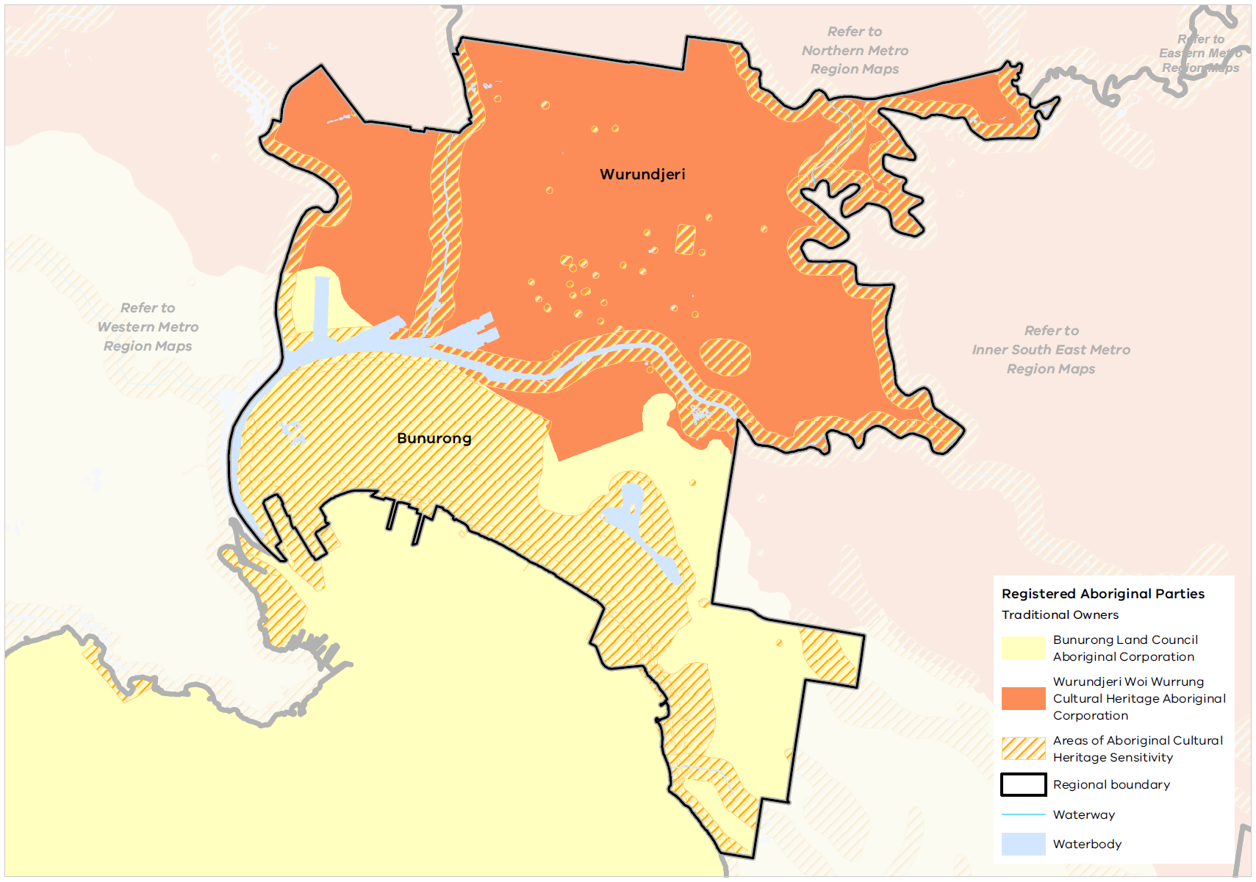

Post-European settlement heritage
The Inner Metro Region has a rich legacy of post-European settlement heritage, being the first part of Melbourne settled by Europeans from 1835.
The CBD is laid out on the Hoddle Grid on the northern banks of the Yarra River. This distinctive urban structure provided the foundations for the city’s now renowned laneway network, which is woven between the grid’s expansive street blocks and sets the scene for a vibrant city life.
The early city on the river soon expanded to a ring of adjacent suburbs including Fitzroy, Carlton, North and South Melbourne, Middle Park, Kensington and Richmond. The bayside suburb of St Kilda was populated as a holiday destination. The low-lying flats of the Yarra River were established as Melbourne’s early industrial areas, including Collingwood, Abbotsford, Southbank and Fishermans Bend.
The Inner Metro Region contains numerous buildings of national, state and regional significance, and many are included on the National Heritage List or the Victorian Heritage Register. They reflect all aspects of the city’s evolution since European settlement. They include much-loved landmarks such as Flinders Street Station, the National Gallery of Victoria, the State Library, the silos and Nylex clock of the Richmond Maltings site, and the Rippon Lea Estate. The Royal Exhibition Building is included on the UNESCO World Heritage List as a site of international cultural significance.
Heritage overlays are applied extensively to precincts and sites of local significance throughout the region, demonstrating the important role heritage plays in defining the region’s identity and character. These include: the streets of Victorian-era workers’ cottages, grand terraces, Californian bungalows or Art Deco flats; intact historic commercial streetscapes which define many of the region’s activity centres; the modern skyscrapers of Melbourne’s CBD and St Kilda Road; the civic institutions of town halls, schools, court houses and libraries; maritime features of the Yarra River delta and the bay; parks, gardens and trees; and infrastructure such as bridges, stations, tram stops and light poles.
The Inner Metro Region’s cultural heritage is also defined through present-day cultural precincts which reflect the various immigrant groups that have made the region home: the Vietnamese community based around Victoria Street in Richmond; the Jewish community in Balaclava and St Kilda; Little Bourke Street’s Chinatown; the Greek precinct around Lonsdale Street; and the Italian community around Lygon Street in Carlton.

Creativity, culture and entertainment
The Inner Metro Region’s unique urban environment, comprising a rich cultural and built heritage, tourism assets, high-quality urban and architectural design and creative neighbourhoods, attracts new residents and a growing number of visitors.
The region is home to many of Melbourne’s iconic cultural and entertainment institutions that anchor the state’s global profile and reputation for cultural achievement. An annual calendar of major art and entertainment events attracts local, interstate and international visitors and contributes to the liveability of the region.
The clustering of key assets in the sports precinct (which also holds entertainment events), Melbourne arts precinct and St Kilda Road performing arts precinct contribute to a vibrant and internationally recognisable city. Key assets include:
- National Gallery of Victoria (NGV) on St Kilda Road
- Federation Square (which houses The Ian Potter Centre: NGV Australia, and Australian Centre for the Moving Image)
- Australian Centre for Contemporary Art
- Melbourne Theatre Company
- Malthouse Theatre
- Ballet Victoria
- Hamer Hall
- Sidney Myer Music Bowl
- Exhibition Centre
- Princess Theatre
- Comedy Theatre
- Her Majesty’s Theatre
- Regent Theatre
- Immigration Museum
- Queen Victoria and South Melbourne markets
- State Library of Victoria
- Royal Botanic Gardens
- Shrine of Remembrance
- St Kilda Pier
- Station Pier
- Palais Theatre
- Abbotsford Convent
- Collingwood Children’s Farm.
The region also features multi-use outdoor spaces that accommodate a range of entertainment uses including:
- Melbourne Park
- Birrarung Marr
- Albert Park
- St Kilda foreshore
- Flemington Racecourse
- Federation Square Swanston Street forecourt.
These larger venues and spaces are supported by a network of small- to medium-sized performing arts and music venues, studios, galleries, exhibition spaces and multi-use and outdoor sites. These spaces contribute to the development of artistic, creative and educational innovation. Clustering of live music and performing arts venues in Brunswick, Fitzroy, Collingwood, Abbotsford, Melbourne City, Richmond and St Kilda also contribute to distinctive and creative neighbourhoods, places and precincts.
The Inner Metro Region’s creative industries – spanning arts, culture, screen, design, publishing and advertising – are nationally recognised. Prominent broadcasting, film and sound recording, and specialised design services sectors are located in Docklands, South Melbourne and Richmond/Cremorne. Melbourne is listed as a UNESCO City of Literature, demonstrating the significance of its literary culture. Creative organisations and artists enrich the liveability of places and spaces through cultural expression and are integral to the development of vibrant communities and a sense of place.
While the Inner Metro Region features a breadth of creative and entertainment assets, the accessibility and safety of venues and streets continues to be a priority. Key performing arts assets in locations such as Sturt Street in the Melbourne LGA, require greater connection with the wider Melbourne Arts Precinct. Land prices and urban densification continue to be a challenge for retaining creative small organisations, micro businesses and sole practitioners in the region.

Open space and regional trails
The Inner Metro Region provides for an average of 44 square metres of public open space per person (as defined as land that is publicly owned and provided for outdoor recreation), which is below the metropolitan average of 57.5 square metres (Victorian Planning Authority, 2017). There is high variation in open space provision across the region. Melbourne LGA provides the highest level of open space per person, at 61.1 square metres; Yarra LGA provides 38 square metres and Port Phillip LGA provides 33 square metres (Figure 19). This reflects the presence of the major state and regional open spaces in the Central City.
Open space per person across metropolitan Melbourne is shown in Figure 20. While the quantity of open space is one measure of provision, the function, mix, quality, accessibility and proximity of open space also need to be considered.

- Open space per person for Inner Metro Region LGAs
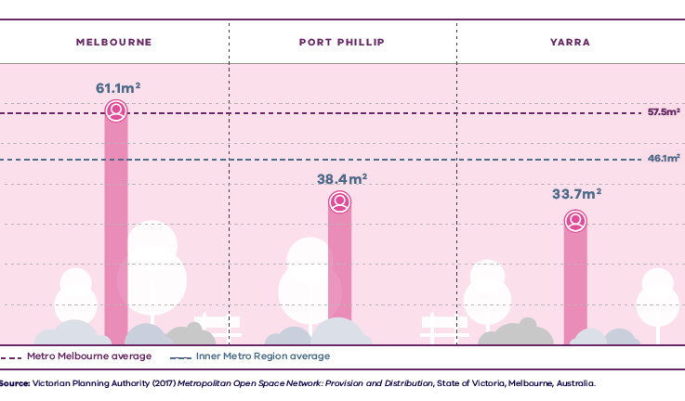

Figure 19. Open space per person for Inner Metro Region LGAs
Metro Melbourne average | 57.5 square metres public open space per person
Western Metro Region average | 72.9 square metres public open space per person
Melbourne | 61.1 square metres public open space per person
Port Phillip | 38.4 square metres public open space per person
Yarra | 33.7 square metres public open space per person
Source: Victorian Planning Authority (2017) Metropolitan Open Space Network: Provision and Distribution, State of Victoria, Melbourne, Australia.

- Open space per person for metropolitan LGAs
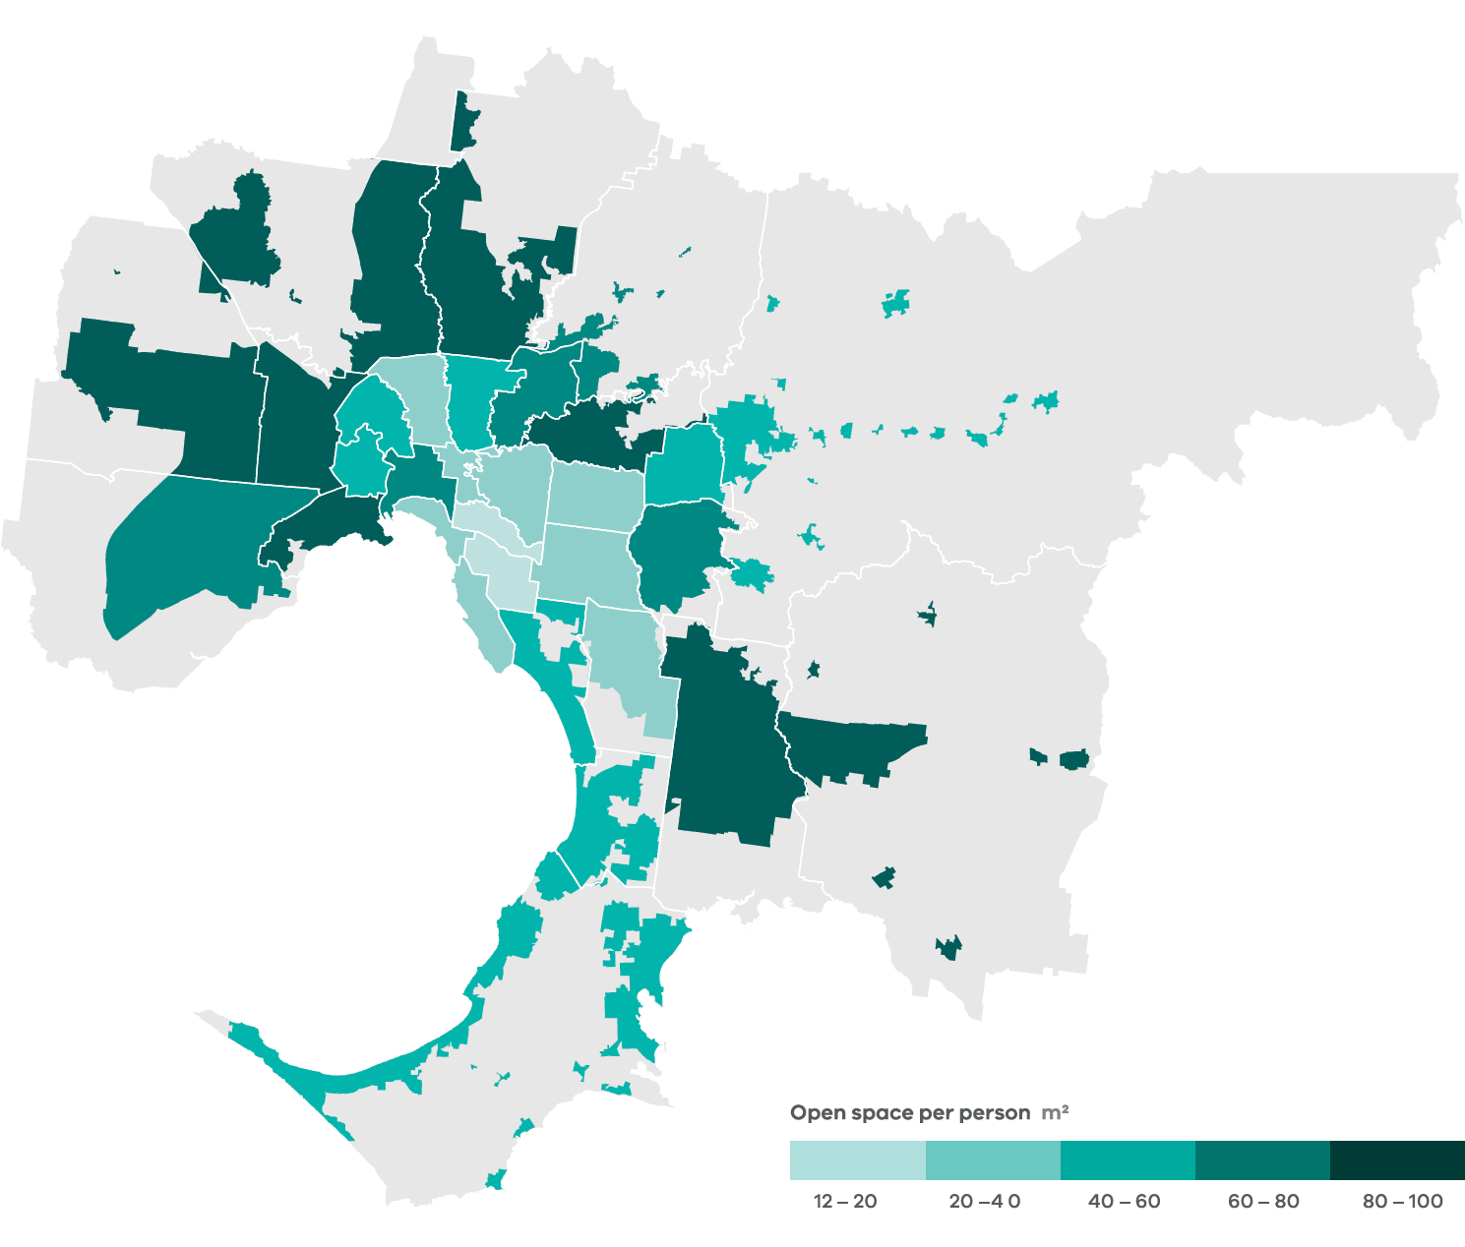
Data from the Victorian Planning Authority Metropolitan Open Space Network portal, 2016
Note: only areas within the UGB were calculated and mapped in this figure. Areas outside the UGB are shown in grey.
The Inner Metro Region has an established network of regional open spaces, many of which were created soon after Melbourne’s settlement and are of high cultural significance. This includes numerous parklands, formal gardens and other types of urban public space such as the Royal Botanic Gardens and Domain, Fitzroy Gardens, Carlton Gardens, Edinburgh Gardens, Yarra Bend Park, Fawkner Park, Albert Park and Royal Park.
Major open spaces within the region are also located along its waterway corridors of the Yarra River, Maribyrnong River, and the Moonee Ponds, Merri and Darebin creeks, as well as Port Phillip Bay coastline and foreshore.
The Inner Metro Region features numerous smaller, incidental open spaces which make an important contribution to the broader public realm. This includes urban plazas such as those at Queen Victoria Market, quasi-public space within private development interfaces, forecourt spaces to public buildings, parklets and transport corridors. Increased use of footpaths and road space for outdoor dining is also expanding and diversifying the region’s open space provision.
The Inner Metro Region has an extensive network of interconnected trails located along waterway corridors, freeway reservations and the coastline, and through its major parklands, which are used for commuting and active recreation. The Capital City Trail circles through Melbourne and Yarra LGAs, the Main Yarra Trail connects the Central City to the eastern suburbs and the Bay Trail connects the beachside suburbs to the CBD via the Port Melbourne light rail corridor.
As the region’s population and development densities continue to grow, provision of open space and recreation facilities that serve residents and visitors will become increasingly important. There are several major projects underway to improve open space opportunities in the region and link open space networks:
- Establishment of the Greater Yarra Urban Parklands which comprises public land along the Yarra River corridor
- The redevelopment of the Richmond to Docklands renewal precinct, the St Kilda Road Arts Precinct, and the emergence of the Fishermans Bend, Arden and Macaulay urban renewal precincts will all see the creation of new public space assets
- Southbank Boulevard Upgrade, which will introduce 2.5 hectares of new public space.

Regional strengths
- Significant landscapes, habitats and biodiversity corridors including Port Phillip Bay, the Yarra River and its estuary, extensive urban waterway systems (Moonee Ponds Creek, Merri Creek, Darebin Creek), large areas of remnant vegetation in Royal and Yarra Bend Parks.
- Well-established open space network which includes informal and formal parklands, recreational trails and gardens.
- The region’s role as a premier location for tourism, events, sport, recreation, arts and culture.
- Rich creative and cultural life which is the foundation of its liveability and amenity, and integral to the regional economy.
- Numerous heritage buildings, streetscapes and precincts.

Regional challenges
- Lack of available land to provide additional open space for growing resident and worker populations.
- Ongoing protection of the region’s natural, built and cultural heritage given the pressure for development.

Directions and strategies
The directions identified to achieve the 2050 vision for the Inner Metro Region in terms of liveability and Outcome 4 of Plan Melbourne are:
Direction 16 | Draw on the region’s culture and heritage to create a rich and layered urban environment and distinctive places
Direction 17 | Strengthen the network of open spaces and trail connections to support outdoor life, active recreation and connection to nature
Direction 18 | Create a legacy of great streets and public spaces that serve the needs of visitors, residents and businesses
Direction 19 | Protect the region’s landscapes and biodiversity

Each direction is implemented through regionally-specific strategies identified in this land use framework plan.
Map 6 shows how liveability will be enhanced across the Inner Metro Region by 2050 as a result of these directions and strategies, together with Plan Melbourne and other strategies and initiatives as outlined in Appendix 01.

- Inner Metro Region liveability 2050
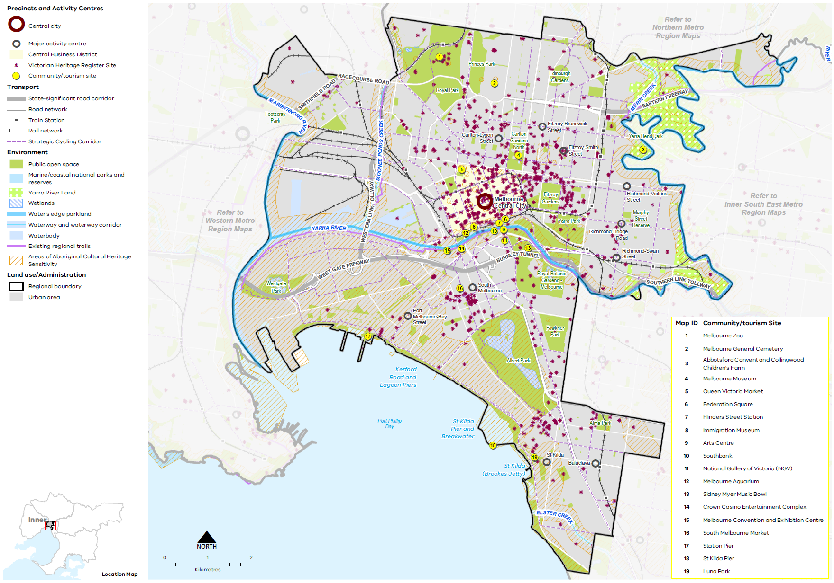

Map 6 Inner Metro Region liveability 2050
A map showing the key environmental and cultural features of the region in 2050, as extracted from Map 1, and also highlighting:

- The Maribyrnong and Yarra rivers; Merri and Moonee Ponds creeks
- Yarra River Land in the north-east and east of the region
- Public open spaces including the Royal Botanic Gardens, Albert Park, Yarra Park, Fitzroy Gardens, Carlton Gardens, Royal Park, Princes Park, Edinburgh Gardens and Westgate Park
- Existing regional trails along the Yarra River and Moonee Ponds Creek
- A significant number of Victorian Heritage Register sites predominately in the centre and east of the region, and clustered around the Central Business District, South Melbourne and St Kilda areas
- Large areas of Aboriginal Cultural Heritage Sensitivity predominantly in the south-west of the region and along waterways
- Community / tourism sites are numbered and listed at:
Melbourne Zoo
Melbourne General Cemetery
Abbotsford Convent and Collingwood Children's Farm
Melbourne Museum
Queen Victoria Market
Federation Square
Flinders Street Station
Immigration Museum
Arts Centre
Southbank
National Gallery of Victoria (NGV)
Melbourne Aquarium
Sidney Myer Music Bowl
Crown Casino Entertainment Complex
Melbourne Convention and Exhibition Centre
South Melbourne Market
Station Pier
St Kilda Pier
Luna Park

- Draw on the region’s culture and heritage to create a rich and layered urban environment and distinctive places
Across the Inner Metro Region, Aboriginal and post-European settlement cultural heritage assets and distinctive landscapes continue to be recognised, protected and celebrated, supporting the region’s vibrancy.
The region’s rich cultural heritage provides a strong legacy for creating urban places which foster community pride and a sense of place. This drives demand for redevelopment and densification, meaning places can change rapidly, and be impacted by crowding, competition for space and reduced liveability.
Engagement with Aboriginal communities is needed when planning for places in the Inner Metro Region, and particularly places of Aboriginal cultural heritage and ongoing cultural significance. Their ongoing management and protection should be a collaborative process between Traditional Owners, existing stakeholders and all tiers of government. This should focus on celebrating and reinforcing Aboriginal cultural values and requires cultural sensitivity, collaboration and acknowledgment that competing interests may arise around the protection of significant landscapes. Cultural heritage interpretation and Indigenous art and design can be found across the Inner Metro Region. The presence of visual markers in the region is crucial for residents and visitors to understand the pre-colonial history of the region and the ongoing cultural significance of Country to Traditional Owners.
The region’s post-settlement heritage has intrinsic value for residents and visitors as a symbol of a shared history and community building. While extensive heritage controls are applied throughout the region, there are places and precincts of significance that require protection and local councils are working to achieve this aim.
Heritage management also includes facilitating innovative, adaptive re-use of heritage buildings and investigating opportunities for interpretation of heritage places to broaden the community’s understanding of their significance. Planning in the Inner Metro Region will need to consider the evolving nature of heritage management and the identification of sites that are not yet formally recognised in the planning system yet have significant cultural and social importance for communities.
Protecting and supporting land uses for the region’s rich array of cultural activity and creative industries will enable the Inner Metro Region to build on and maintain its reputation as a cultural and innovative city for locals and visitors.
- Engage with Aboriginal communities to incorporate cultural heritage, design and stories into built and natural environment.
- Reflect the different eras, layers and aspects of the region’s history in the design of contemporary buildings, public spaces, infrastructure and public artwork where appropriate.
- Ensure the ongoing identification and protection of heritage places, precincts and streetscapes and support their adaptive re-use where appropriate, particularly for creative and cultural uses.

- Strengthen the network of open spaces and trail connections to support outdoor life, active recreation and connection to nature
Plan Melbourne envisages a network of accessible, attractive and connected local areas where linear parklands, river corridors, coastline and associated shared trail networks form critical regional assets.
For the Inner Metro Region, provision of quality open space has numerous benefits: ensuring access to nature and recreation; opportunities for social connection; increased neighbourhood amenity; cooling and greening of the urban environment.
Expanding the open space network to meet the needs of a growing population, particularly in Yarra and Port Phillip LGAs where a shortfall of open space currently exists, will be an ongoing challenge within the Inner Metro Region due to high land values and competition for land for residential and commercial uses.
The recently released Open Space for Everyone: Open Space Strategy for Metropolitan Melbourne 2020 sets out a vision for Melbourne as a city with a valued network of open spaces accessible to all, connected at the local and landscape scales. It focuses on innovation and adaptability in providing for a diversity of open spaces to meet the needs of the community, while protecting existing open space assets.
Within the Inner Metro Region, an innovative approach to optimising use of existing open space or acquiring new open space will be required. This will include high-quality maintenance of existing parks, upgrading facilities to meet current needs and investigating sharing of different types of spaces for broader public use, such as school or university grounds, golf courses or cemeteries. Options to create new public space include repurposing surplus public land, reclaiming road space, using rooftop space or the contribution of open space within large redevelopment sites or urban renewal precincts. Consultation with respective facilities should be explored on a case-by-case basis and consider site context and local circumstances.
In many instances, new open spaces within the region will be of a small scale and may also be privately owned or managed. It is essential that new, quality open spaces are created in a meaningful way, with high design and amenity standards and as a contribution to the broader open space network. Opportunities to use new open space to improve pedestrian access and recreational trail connections, link existing open spaces or open a site frontage to a waterway or parkland should be prioritised wherever possible.
- Make better use of the existing open space network through ongoing investment to ensure it meets community needs.
- Establish new open spaces within large development sites and urban renewal precincts that contribute to the regional open space network.
- Create safe and efficient links between public spaces and the shared trail network.
- Investigate opportunities to repurpose existing public land, such as easements, as part of the open space network.
- Utilise the region’s open space network to strengthen its tree canopy and urban greening, aided by water sensitive urban design and stormwater harvesting.

- Create a legacy of great streets and public spaces that serve the needs of visitors, residents and businesses
The Inner Metro Region is defined by its diverse public spaces, quality design, grand boulevards, characteristic neighbourhoods and atmospheric laneways.
Preservation and adaptation of the region’s highly valued built heritage, coupled with the creation of a new architectural legacy through excellence of design, will reinforce a strong sense of place and identity. The value of ensuring high design quality, preserving the region’s heritage and protecting its landscapes must be recognised and balanced with increasing development pressures. The public realm must also be designed to accommodate all ages, cultures and levels of mobility.
Boulevards and other major tree-lined streets are a defining characteristic of the Inner Metro Region. The grand boulevards of St Kilda Road, Royal Parade, Victoria Parade and Beaconsfield Parade are iconic streetscapes. The St Kilda Road boulevard and its framing of the Shrine vista from the Central City has a ceremonial function. The creation of new boulevards has the potential to further expand the network, as envisaged in Plan Melbourne. These boulevards will play an increasingly important role in the future by enhancing local distinctiveness and offering a high amenity streetscape experience. They include:
- The redesign of existing major roadways such as Southbank Boulevard, City Road and Sturt Street
- A proposed new boulevard from the Central City to Footscray, along the Ballarat-Flemington Road corridor
- The ‘Shrine to Sea’ project which will create a boulevard connection between Domain Gardens and Port Phillip Bay along Albert and Kerferd roads
- Harbour Esplanade which is a key boulevard created within the Docklands urban renewal precinct
- Station Pier and surrounds, including improved linkages to the CBD, given its important role for tourism and as a passenger ship terminal
- Other major streets offering potential future or ongoing improvement as boulevards such as St George’s Road, Queens Road, Kings Way and Dandenong Road.
The St Kilda Junction is a major intersection of roadways and future boulevards, which includes land within three municipalities. Redesign of this road space is an important consideration to improve its amenity, appearance and pedestrian connectivity.
Maintaining the green character of streets and boulevards with well-established street trees will contribute to the amenity within the Inner Metro Region. Designing streets to harvest stormwater will assist in strengthening the tree canopy and lower-storey vegetation. The strategic placement of underground powerlines in key locations will enhance the streetscape character and tree canopy.
The design of new development and public places must make a positive contribution to the region’s valued character. This is reflected in the various urban design strategies prepared by each municipality, which aim to achieve outcomes such as ensuring buildings are an appropriate scale for the local context, preserving sunlight access to public streets and spaces, minimising the impact of car parking and making a positive aesthetic contribution to the street.
- Identify, enhance and protect existing places and spaces that have high civic or public value, and which contribute to people’s understanding, interaction and enjoyment of the region.
- Ensure that future planning of the region’s precincts, activity centres and urban renewal areas enhances and celebrates their distinctive assets, heritage and local character.
- Upgrade key pedestrian streets and public spaces within each activity centre to foster their civic and community role and to ensure they are accessible and inclusive. Within urban renewal precincts, create new pedestrian streets and public spaces to serve this role.
- Encourage road space allocation to prioritise pedestrian movement and spaces within key streets in activity centres and employment precincts.
- Identify opportunities to expand the network of boulevards through the region, creating high amenity, green streetscapes that prioritise sustainable and active transport modes.
- Ensure the public realm design of the Inner Metro Region’s night-time precincts promotes a high level of safety and amenity.

- Protect the region’s landscapes and biodiversity
The waterways and coastline of the Inner Metro Region underpin its biodiversity, identity and cultural heritage. Strategies to address urban forests, urban ecology and healthy ecosystems have been developed by local councils in the Inner Metro Region to identify, protect and enhance the region’s unique biodiversity. Engaging with Traditional Owners and Aboriginal Victorians to include Aboriginal values and traditional ecological knowledge in biodiversity planning and management is an essential part of protecting and enhancing the region’s landscapes and biodiversity.
The Healthy Waterways Strategy 2018-28 is a shared strategy across Melbourne Water, state and local government, water corporations and the community. It provides a regional vision for the health of rivers, estuaries and wetlands in the Port Phillip region. The strategy identifies a need to review planning protection of environmental and amenity values for waterways, particularly urban waterways with a highly degraded environmental condition (Melbourne Water, 2018). It nominates priority waterways for revegetation to improve waterway health and biodiversity values.
The Wurundjeri Woi Wurrung Cultural Heritage Aboriginal Corporation’s Nhanbu narrun ba ngargunin twarn Birrarung (Ancient Spirit and Lore of the Yarra) water policy, together with the implementation of the draft Yarra Strategic Plan, will enable Traditional Owners to play a key role in determining the ongoing management and protection of the Birrarung (Yarra River) and environs. These policies include actions to improve the overall environmental health of the river, enhance community access to the river and adjoining parklands, improve development interfaces with the river, and recognise cultural and heritage values.
Strategic planning for the Inner Metro Region’s other major waterways through the Waterways of the West Action Plan – in particular, Moonee Ponds Creek, Maribyrnong River and the Merri Creek – will support their ongoing recognition, protection and contribution to the region’s natural and urban environment. Consideration will be given to the riparian vegetation, natural riverbank topography, terrestrial and aquatic habitat, the impact of development on stormwater flows and the ability to function as landscape spines within a larger, regional and inter-regional network of biodiversity and open space corridors.
Opportunities to restore sections of covered or lined waterways to natural or near natural condition should be explored to improve amenity and potentially provide stormwater benefits by reducing peak flows and increasing flow duration. This includes the lower section of the Moonee Ponds Creek and the Elwood Canal, which are channellised, and the Williams Creek which currently runs under Elizabeth Street in Melbourne’s CBD.
Green spaces are a key component of thriving biodiversity, healthy ecosystems, and a society connected to nature. As the potential to provide new green spaces is limited, efforts to improve biodiversity outcomes should enhance existing areas of vegetation and better link disparate patches of habitat across the region. Enhancing the extent and coverage of native habitat will improve protection and free movement of wildlife, while increasing overall vegetation and canopy coverage. There may be opportunities to achieve this by improving links between Royal Park and Yarra Bend (potentially via Park Street), and along the Yarra River corridor to its estuary and Port Phillip Bay. New habitat links within urban renewal areas, such as Fishermans Bend, will also assist in creating opportunities for improved biodiversity.
Streets, linear parks and transport corridors also provide opportunities for linking and greening. Other areas of focused biodiversity and habitat plantings include public and private green spaces, parks and reserves and private gardens.
- Work with Traditional Owners to plan, manage and protect assets and places of high cultural, landscape and biodiversity value.
- Ensure the siting and design of new buildings and infrastructure responds to the region’s significant landscape features.
- Reinvigorate and restore urban waterways, recognising their important role in providing biodiversity, open space, water management and movement corridors.

Actions – Liveability
- Develop and implement an Indigenous design approach to incorporate Aboriginal cultural heritage, design and stories into the region’s built and natural environment. This process will involve extensive collaboration and engagement with Aboriginal and Torres Strait Islander peoples across the region. This could be a pilot project suitable for other regions.
- Work with Traditional Owners and research organisations to develop specific and measurable actions to increase biodiversity and resilience of urban ecosystems, particularly those that do not have high biodiversity value.

Chapter 08.
Strong Communities
Plan Melbourne Outcome 5: Melbourne is a city of inclusive, vibrant and healthy neighbourhoods
Plan Melbourne aims to build on the fundamentals of strong, healthy and sustainable neighbourhoods through provision of and improving access to social infrastructure, health and education, open space and the promotion of walking and cycling.
Taking a regional approach to planning will ensure social infrastructure and services reach the widest possible catchment and cross-section of people. Community services, open space, hospitals, educational and cultural institutions, and transport infrastructure will need to keep pace with a projected increase in population of over 630,000 by 2051 to support a strong community.
Plan Melbourne advocates for the vision of a city of ‘20-minute neighbourhoods’ in which most everyday needs can be met within a 20-minute walk, cycle or local transport trip from home. The Inner Metro Region is well placed to achieve this vision. The region’s compact urban structure, accessible street network, extensive public transport and cycling routes and a high number of jobs and services mean the daily needs of many residents are likely to be close to home, and in many instances, less than 20 minutes away.

State of play

Community profile
The Inner Metro Region is a socially and culturally diverse community. Historically, the region has attracted a large proportion of overseas migrants, resulting in a multicultural population. In 2017, the Inner Metro Region accounted for 17 per cent of Melbourne’s overseas migration. The cultural composition of Yarra and Port Phillip LGAs largely reflects Victorian and metropolitan averages. Melbourne LGA has a larger proportion of residents born in South East Asia and a lower proportion of people born in Australia compared to the other LGAs in the Inner Metro Region. This is likely due to its concentration of tertiary institutions where overseas students comprise a high number of enrolments.
The Inner Metro Region supports not only a large resident population, but also workers, visitors and students from outside the region. The total daily number of visitors to the region vastly outnumbers the resident population. Residents of the Inner Metro Region have higher life expectancies than residents of metropolitan Melbourne as a whole.
The Socio-Economic Index for Areas (SEIFA) ranks local government areas according to their relative socio-economic advantage and disadvantage. The 2016 SEIFA rankings for the Inner Metro Region are shown in Figure 21.
Most Inner Metro Region residents are classified as having a high-income level and overall, the region shows high levels of advantage, with Port Phillip ranked as the eighth most advantaged municipality in Victoria. However, clusters of disadvantage are evident throughout the region, particularly close to central Melbourne and within parts of Richmond, South Yarra, North Melbourne and Carlton. These areas reflect the large public housing estates in the region. Homelessness is also a significant issue in the Inner Metro Region, which has almost three times the number of homeless people than the metropolitan average. This is largely due to the concentration of support services located in central Melbourne.

Health and education facilities
The Inner Metro Region supports several clusters of state-significant health and/or education precincts. This includes five of the six specialist tertiary hospitals in metro Melbourne: the Royal Women’s Hospital, Royal Children’s Hospital, Peter MacCallum Cancer Centre and Royal Victorian Dental Hospital in the Parkville Biomedical Precinct; and the Royal Victorian Eye and Ear Hospital in the St Vincent’s and Australian Catholic University Precinct in East Melbourne. The Epworth Hospital in Richmond supports a cluster of allied health services and the Alfred Medical and Research Precinct in Prahran is also a state-significant precinct.
The Inner Metro Region is home to 1736 Commonwealth-supported aged care sites, 10 private hospitals and nine public hospitals. The Lowitja Institute (Drummond Street, Carlton), a research organisation focused on the health and wellbeing of Aboriginal and Torres Strait Islander peoples, is also located in the region.
The region has 17 university campuses and eight TAFE institutions operating across 12 sites. Major educational institutions include the University of Melbourne, RMIT University and Victoria University. There are also a number of smaller institutions across the CBD, such as the William Angliss Institute and the Australian Institute of Music, or in other parts of the region including the Kangan Institute in Richmond, the Melbourne University horticulture campus at Burnley and the Australian National Academy of Music in South Melbourne.
- SEIFA rankings (2016) in the Inner Metro Region
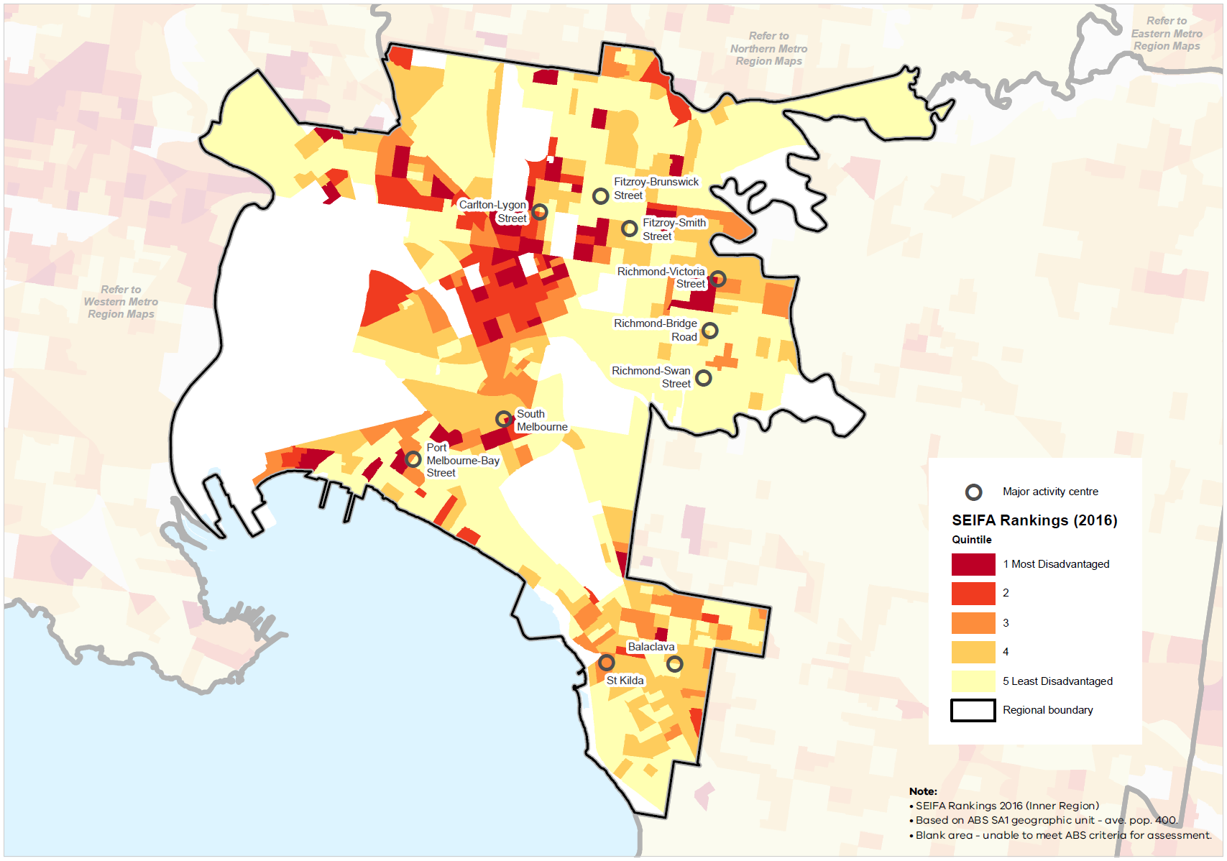
The Inner Metro Region has 22 government primary schools and nine government secondary schools. The region is also home to larger and/or specialist secondary schools which attract students from across the region and the state including the Victorian College of the Arts secondary school, Melbourne High School and MacRobertsons High School and the Victorian College for the Deaf.
Compared to other regions, the Inner Metro Region has high worker and visitor populations and a proportionately higher number of apartment dwellers. Visitors, workers and residents require health, education and other community services, in addition to the state-level role the region’s facilities play.
The challenges of access to health, education and community services in the Inner Metro Region continue to be around ‘whole of life cycle’ services for a diverse, growing population particularly for Aboriginal children, those who are homeless or rough sleepers, older residents, people from culturally and linguistically diverse backgrounds, those at risk of chronic diseases and educational pathways for young people.

Social infrastructure
Social infrastructure includes all of the facilities, services and networks that help people to meet their social, cultural and community needs, in addition to health and education facilities.
The Inner Metro Region is home to a wide range of state-significant cultural, sporting and recreational activities for residents and people from outside the region. Therefore, it is important the social infrastructure needs of residents and workers within the region continue to be met as the population grows.
In terms of sport and active recreation, the region includes numerous major facilities. Victoria’s premier sporting precinct, comprising the Melbourne Cricket Ground (MCG), AAMI Park, Melbourne Park tennis complex and Rod Laver Arena, draws a wide audience from across the region, the state, interstate and internationally.
Other major sport and recreation facilities within the region include:
- Marvel Stadium in Docklands
- The Albert Park sports precinct which includes the Melbourne Sports and Aquatic Centre (MSAC), Victorian State Sailing Centre and the Grand Prix circuit
- Punt Road Oval, Richmond
- Princes Park, Carlton
- Flemington Racecourse
- State Netball Hockey Centre, Parkville.
Many regional open spaces include active recreation facilities such as tennis courts, golf courses and football ovals.
The Inner Metro Region performs a key role in the state’s legal and justice system. The region is home to numerous justice infrastructure facilities, with a large cluster of these located around the western end of the Central City:
- The Supreme Court, County Court, Children’s Court, Coroner’s Court, the Victims of Crime Assistance Tribunal, and the Victorian Civil and Administrative Tribunal
- The Melbourne Assessment Prison and Parkville Youth Justice Precinct
- Victoria Police Centre state headquarters
- Two Magistrates Courts, two Community Corrections Locations and two Justice Service Centres.
The Inner Metro Region experiences higher per capita rates of crime, drug offences and youth crime compared to the Melbourne metropolitan average.

Regional strengths
- State-level facilities for health, education, recreation and other social infrastructure that caters for a wide range of community needs.
- Well-established open space network and trail connections.
- Strong network of activity centres, many of which are vibrant, accessible community focal points, that achieve (or exceed) the principle of the 20-minute neighbourhood.

Regional challenges
- Providing adequate access to social infrastructure for a growing resident, worker and visitor population.
- Creating new open space and trail connections to meet the needs of the growing population, given a lack of available land.
- Ensuring urban renewal precincts, redevelopment areas and transit-oriented development areas embed the principle of the 20-minute neighbourhood.

Directions and strategies
The directions identified to achieve the 2050 vision for the Inner Metro Region in terms of building strong communities and Outcome 5 of Plan Melbourne are:
Direction 20 | Plan for major social infrastructure at a regional level to meet the needs of residents, workers and visitors
Direction 21 | Support the region’s role in delivering state-significant health and education services while providing for the local community
Direction 22 | Strengthen the Inner Metro Region’s network of 20-minute neighbourhoods
Each direction is implemented through regionally-specific strategies identified in this land use framework plan.
Map 7 shows how strong communities will be enhanced across the Inner Metro Region by 2050 as a result of these directions and strategies, together with Plan Melbourne and other strategies and initiatives as outlined in Appendix 01.

- Inner Metro Region strong communities 2050
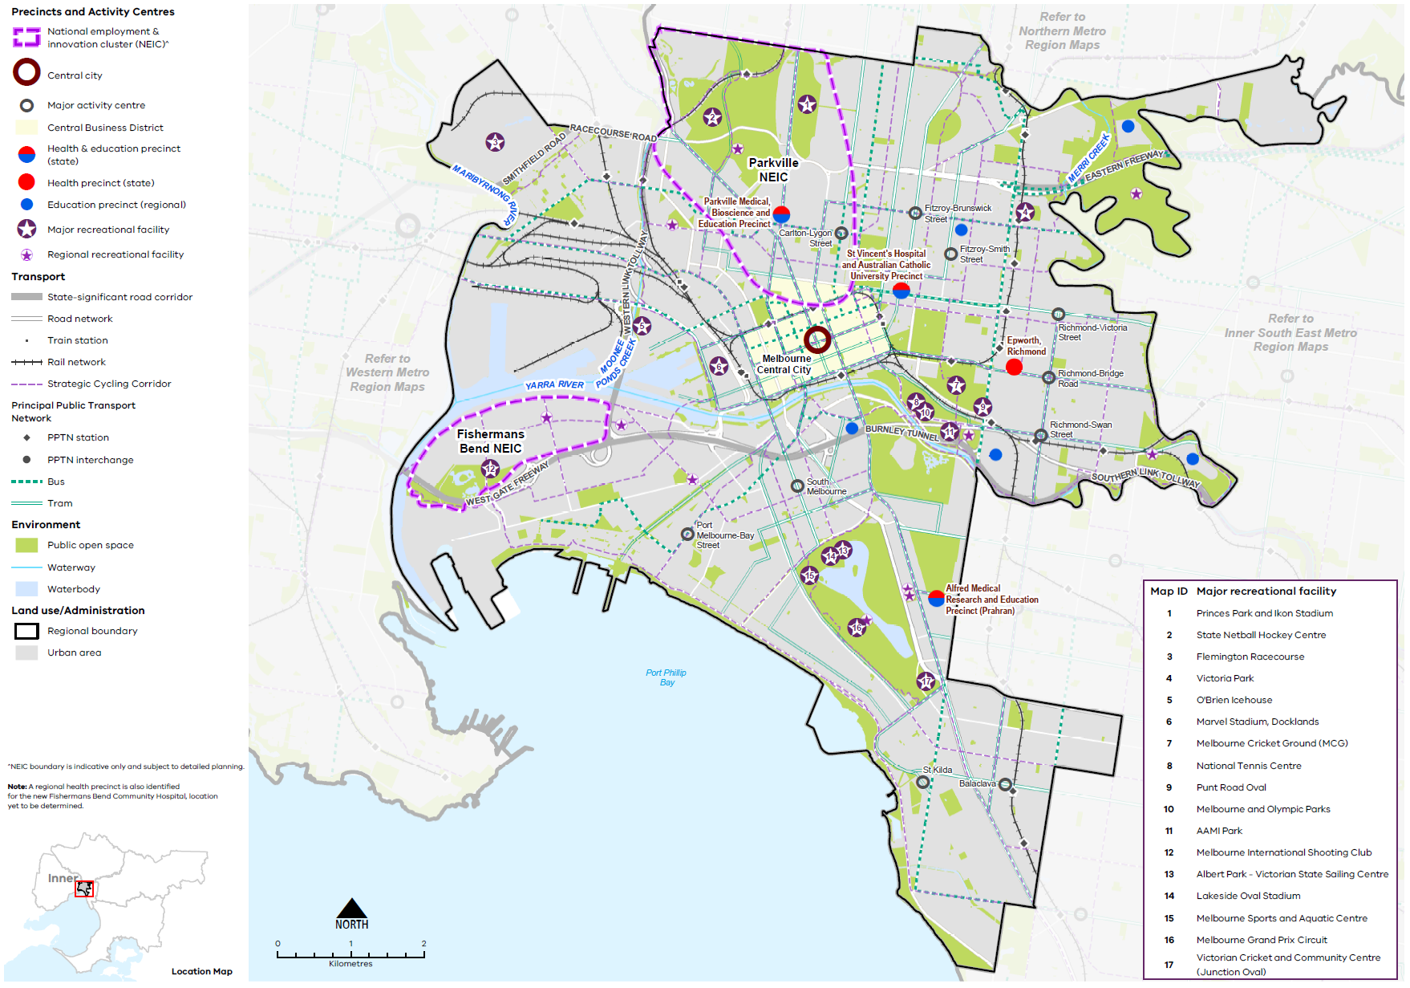

Map 7 Inner Metro Region strong communities 2050
A map showing the main community assets of the region in 2050 including state- and regionally-significant health and/or education precincts, as extracted from Map 1, and also highlighting:

- Major recreation facilities at:

- Princes Park and Ikon Stadium
- State Netball Hockey Centre
- Flemington Racecourse
- Victoria Park
- O'Brien Icehouse
- Marvel Stadium, Docklands
- Melbourne Cricket Ground (MCG)
- National Tennis Centre
- Punt Road Oval
- Melbourne and Olympic Parks
- AAMI Park
- Melbourne International Shooting Club
- Albert Park - Victorian State Sailing Centre
- Lakeside Oval Stadium
- Melbourne Sports and Aquatic Centre
- Melbourne Grand Prix Circuit
- Victorian Cricket and Community Centre (Junction Oval)

- Regional recreation facilities including tennis courts, golf courses and football ovals, many of which are located within parkland.

- Plan for major social infrastructure at a regional level to meet the needs of residents, workers and visitors
The unique nature of the Inner Metro Region will require a different approach to other metropolitan regions when planning for social infrastructure. The region’s significant projected growth in its resident population and the number of workers from other regions (currently 449,000 each day) will place greater pressure on existing services and infrastructure. This includes consideration of the region’s changing demographics, with an increased proportion of young adults, older residents, and people from culturally and linguistically diverse backgrounds.
The link between health, wellbeing and nature is reflected in many Victorian Government strategies including the Public Health and Wellbeing Plan 2019-2023 and Active Victoria – A Strategic Framework for Sport and Recreation in Victoria 2017-2021. Creating healthy living environments, with a high level of urban amenity, access to nature, opportunities for community connection and recreation, and active transport connections, helps foster long-term community wellbeing.
The provision of social infrastructure to support the growing population should be integrated into planning for the Central City, activity centres and urban renewal areas, in addition to planning for housing and employment. This will help alleviate heightened demand on existing social infrastructure and be an integral part of meeting the principle of the 20-minute neighbourhood.
The long-term need for sporting fields and specialist sporting facilities is not currently coordinated at a regional scale. Given the challenges associated with acquiring land and funding infrastructure, there would be significant value in taking a regional approach to planning and delivering these facilities and encouraging broader use of facilities, where possible, to cater for the local population.
Supporting creative and cultural activities also must be factored into the demand for developable land. Integrating creative industries and cultural spaces with other community services in urban renewal areas such as Fishermans Bend, Arden and Macaulay, will support local community connection and sense of place.
Access to social infrastructure to meet the needs of all age demographics is integral to strong and healthy communities including:
- Early years services
- Medical, aged and disability care services
- Education facilities
- Multi-purpose community facilities and regional community hubs
- Arts and cultural facilities
- Libraries
- Open space
- High-quality indoor and outdoor sport and recreation facilities
- Cemeteries.
- Review the demand for, and opportunity to, upgrade and expand existing social infrastructure such as libraries or facilities for recreation, health or education, to enable them to be more flexibly and intensively used.
- Plan for the early delivery of community hubs and other social infrastructure in urban renewal areas to appropriately service their future populations.
- Encourage planning for major social infrastructure (such as libraries, recreation facilities, cultural centres or community hubs) to be undertaken in conjunction neighbouring regions to maximise co-location of facilities.
- Locate social infrastructure near activity centres and to be accessible by walking, cycling or public transport.
- Support regional planning that will provide for a range of sporting and active recreation facilities to meet the needs of the growing population.

- Support the region’s role in delivering state-significant health and education services while providing for the local community
State-significant health and education precincts offer specialised and acute services and facilities, attracting people from across Victoria. They play a critical role in the state’s health system. The co-location and dense concentration of hospitals, research facilities and academic campuses within the Inner Metro Region provides significant agglomeration benefits of knowledge sharing and access to skilled workers, and is an important aspect of the region’s economy and employment.
A key issue for the Inner Metro Region is to ensure it can continue to perform its vital state role in health and education while providing for the needs of a growing and diversifying regional population.
To accommodate anticipated demand, existing infrastructure will need to be updated or relocated to health and education precincts that encourage synergies between users. Plan Melbourne identifies state-significant health and/or education precincts. Regionally-significant health and/or education precincts (Table 13) have a regional catchment, are accessible by a range of transport options and have a specialised economic function. This identification provides opportunities for the agglomeration of ancillary health and education services, retail, commercial and accommodation uses.
Planning from a regional perspective requires coordination between different levels of government to meet all of the community’s needs, acknowledging that local councils plan for local infrastructure such as kindergartens, maternal and child health through to aged care, while the Victorian Government plans for state-level services such as government schools and hospitals. Within the Inner Metro Region planning for regional facilities must be considered in the context of limited space and available land, as well as the significant costs to renew older infrastructure.
Prioritising health and education in urban renewal areas will ensure early delivery of these essential services and help establish partnerships between state agencies, local government, developers and research institutions. Facilities such as the new Royal Women’s Hospital planned for Arden and the community hospital in Fishermans Bend can create such opportunities.
Co-location of health and education services with other social infrastructure will support greater accessibility and integration of allied facilities. New community hubs can seek innovative approaches to the delivery of community facilities in multi-level, mixed-use developments, given the lack of available land, with easy access to public transport, walking and cycling links. Planning for the needs of at risk and disadvantaged communities should consider the location of health and education services within a 20-minute walk of social and affordable housing.
State-significant and regionally-significant health and/or education precincts
State significant health precinct
Epworth Hospital (Richmond)
Regionally significant health precinct | Regionally-significant education precinct
Fishermans Bend Community Hospital (proposed) | Melbourne University (Burnley)  Melbourne University (Southbank)  Melbourne Polytechnic (Fairfield)  Melbourne Polytechnic (Collingwood)  Kangan Institute of TAFE (Richmond)
State-significant health and education precinct
Parkville Medical, Bioscience and Education Precinct (Parkville)
St Vincent’s and Australian Catholic University Precinct (East Melbourne/Fitzroy)
Alfred Medical Research and Education Precinct (Prahran)
- Strengthen the role of health and/or education precincts of the Inner Metro Region by co-locating new health and/or education facilities within these precincts and encouraging an agglomeration of ancillary uses such as primary healthcare, retail and accommodation.
- Expand the network of health and education facilities and precincts across the region to meet the needs of the growing population. Ensure that these facilities and precincts are accessible by public transport, walking and cycling.
- Support the upgrade of existing health and education infrastructure to encourage more intensive use of those services.
- Facilitate health and education facilities in major urban renewal precincts as an integral part of the region’s social infrastructure network and economy.

- Strengthen the Inner Metro Region’s network of 20-minute neighbourhoods
Having easy access from home to key services for day-to-day living has numerous benefits. It helps reduce social exclusion, improves health and wellbeing, promotes a sense of place, and reduces travel costs and traffic congestion thereby reducing carbon emissions. Many parts of the Inner Metro Region are already functioning well as 20-minute neighbourhoods as they are based on historic street patterns developed prior to the advent of car travel, and walkable and well-connected as a result. Some parts of the region exceed the principle of the 20-minute neighbourhood.
There is abundant ground level floorspace within existing activity centres across the Inner Metro Region which allows opportunities for small businesses to meet local shopping and service needs, including providing local employment opportunities. Many of the region’s activity centres are well-located on high streets with good access via public transport, walking or cycling.
Planning for major urban renewal precincts, including Fishermans Bend, Arden, Macaulay, and potentially Dynon and E Gate, presents significant opportunities to respond to the principle of 20-minute neighbourhoods. Similarly, the planning and delivery of new or revitalised precincts around transport infrastructure such as the Metro Tunnel stations present opportunities for a place-based response that includes new public spaces and community facilities.
- Plan for existing and new activity centres to embed the 20-minute neighbourhood hallmarks, through a place-based, community partnership approach.
- Support a consistent designation of neighbourhood activity centres and their role in the network of activity centres across the Inner Metro Region.
- Support the role of neighbourhood activity centres to provide a range of retail, community and allied health services to their respective local catchments.
- Ensure the planning and design of urban renewal precincts and major transport infrastructure projects maximises opportunities to embed the hallmarks of 20-minute neighbourhoods.

Actions – Strong communities
- Develop a methodology for a social infrastructure strategy for the Inner Metro Region. This would consider social infrastructure such as libraries, multi-use community and recreation facilities, and assess how they can be used more flexibly and intensively. This could be a pilot project suitable for other regions.

Chapter 09.
Sustainability and resilience
Plan Melbourne Outcome 6: Melbourne is a sustainable and resilient city
Plan Melbourne aims to create a resilient and sustainable city. It recognises the need to mitigate greenhouse gas emissions, reduce exposure to natural hazards, undertake whole of water cycle planning and design, and protect waterways. It also encourages resource efficiency and promotes the benefits of urban cooling and greening.
The Inner Metro Region is the most urbanised built environment in metropolitan Melbourne. It faces significant challenges resulting from climate change including the urban heat island effect, heatwaves, drought, increased storm intensity, stormwater inundation, storm surges and coastal inundation, in combination with expected population growth.
Maximising opportunities to integrate urban cooling and greening to tackle climate change while accommodating significant growth will be vital to ensure the Inner Metro Region remains a safe, healthy place to live, work and visit to 2050. Large urban renewal sites, waterways, open spaces and the movement network provide opportunities to tackle these challenges in innovative, connected ways. The Inner Metro Region will require deliberate, coordinated action by government agencies and authorities to maintain a high standard of living for its current and future residents.

State of play

Urban heat environments
By 2050, the average annual temperature in the Inner Metro Region is forecast to increase between 0.6° and 2.1° Celsius under a medium emissions climate change scenario (Clarke, et al., 2019) As our climate warms, the number of people exposed to the risk of mortality from heatwaves will increase. It is estimated that around 287,000 residents were exposed to high urban heat conditions within the Inner Metro Region in 2018, and if current development practices and population trends continue this exposure rate is projected to substantially increase by 2051 (Urich & Hardy, 2020).
In 2018, the average land surface temperature (LST) in the Inner Metro Region was 33.2° Celsius, which was 0.7° Celsius less than the metropolitan Melbourne average. LST was highest in the City of Yarra at 33.4° Celsius, followed by the City of Melbourne at 33.3° Celsius and the City of Port Phillip at 32.8° Celsius (Figure 22) (DELWP, 2018a). Children, seniors, people with underlying illnesses and those with fewer resources to adapt are at greater risk on hot days and in prolonged periods of hot weather. Plan Melbourne notes that temperature decreases of between 1° Celsius and 2° Celsius can have a significant impact on reducing heat-related morbidity and mortality (DELWP, 2017a).

- Average land surface temperature by LGA, 2018
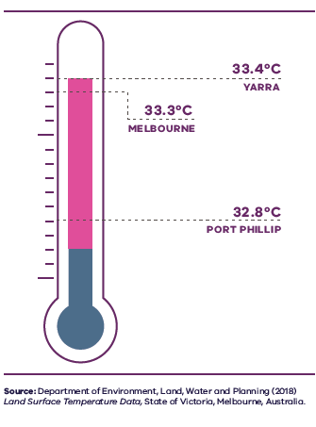

Figure 22. Average land surface temperature by LGA, 2018
Yarra | 33.4 degrees Celsius
Melbourne | 33.3 degrees Celsius
Port Phillip | 32.8 degrees Celsius
Source: Department of Environment, Land, Water and Planning (2018) Land surface temperature data, State of Victoria, Melbourne, Australia.

Areas of high urban heat vulnerability (areas of high recorded heat in addition to a greater population density or high numbers of people likely to experience heat sensitivity) have been mapped for the Inner Metro Region. These are scattered across the region, but there are concentrated areas located in the north, central and south-west parts of the region affected more significantly (Figure 23).
Urban environments that stay cooler on hot days are more physically comfortable and continue to support physical movement and recreation. Cooler urban environments are characterised by more tree cover, less hard surfaces, more water infiltration into the ground and fewer heat absorbing building materials (Figure 24). As the number and duration of hotter days increases, these environments will be important to reduce the likelihood of heat-related illness and support healthy communities.

- Heat vulnerability index map for the Inner Metro Region, 2018
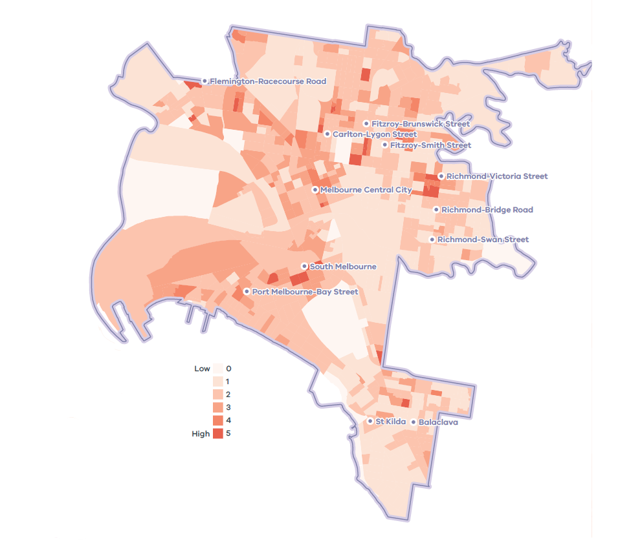

- Inner Metro Region tree canopy cover, 2018
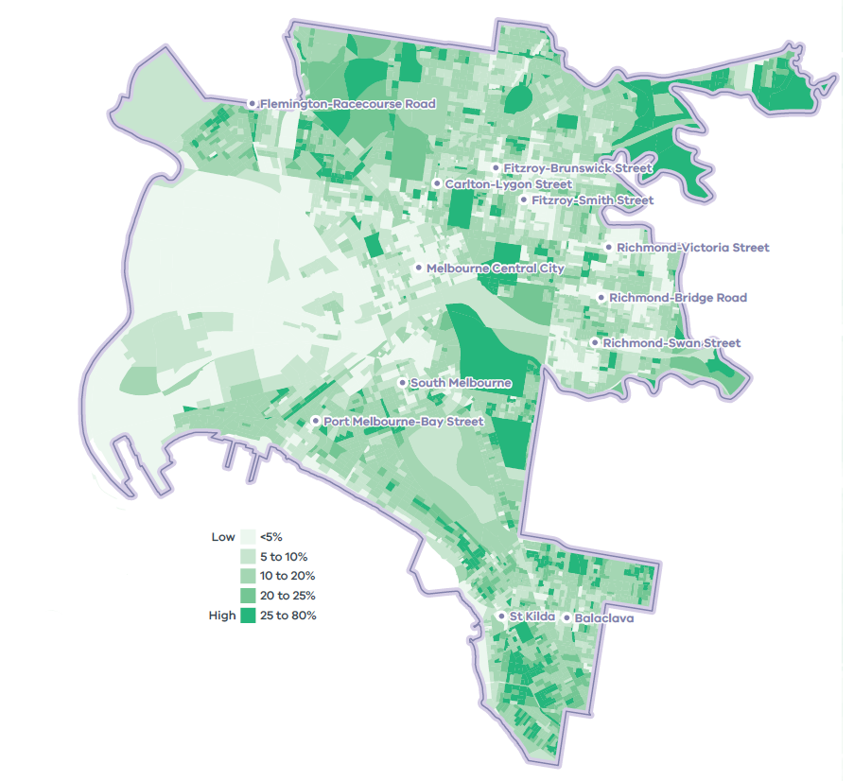

Urban tree canopy
In urban areas, trees and vegetation contribute to neighbourhood character, provide amenity and recreation for residents and provide habitat for wildlife. In 2018, the Inner Metro Region’s total vegetation cover was 26.8 per cent, its combined shrub and tree cover was 17.4 per cent and its tree canopy cover was 12.6 per cent (Hurley, et al., 2019a) The fine-grain distribution of urban tree canopy cover relative to the total land areas of Yarra, Port Phillip and Melbourne LGAs is shown in Figure 25.
A comparison of tree canopy cover within the Inner Metro Region in 2014 and 2018 identifies an increase from 11.8 per cent to 12.6 per cent (from 915 to 981 hectares). This reflects efforts to increase tree canopy, largely on public land such as parkland and on infrastructure land (primarily streets) which increased by 1.4 per cent and 1.2 per cent respectively. Residential land also saw an increase in tree canopy of 0.7 per cent (Figure 26). Yarra LGA experienced gains in canopy cover in its residential, infrastructure and parkland areas; Melbourne LGA in residential and parkland; and the Port Phillip LGA in parkland only (Hurley, et al., 2019b).
Within the region, parkland was the largest contributor of trees, followed by infrastructure land (primarily streets) and residential (Figure 26) (Hurley, et al., 2019b).
- Tree canopy cover 2018, and tree canopy cover change 2014 to 2018, by LGA
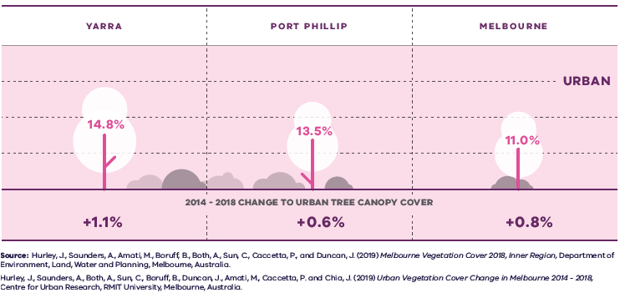
Figure 25. Tree canopy cover 2018 and tree canopy cover change 2014 to 2018, by LGA
LGA | Urban tree canopy cover 2018 | 2014 to 2018 change to urban tree canopy cover
Yarra | 14.8 per cent | Plus 1.1 per cent
Port Phillip | 13.5 per cent | Plus 0.6 per cent
Melbourne | 11.0 per cent | Plus 0.8 per cent
Sources: Hurley, J., et al. (2019) Melbourne Vegetation Cover 2018, Western Region, Department of Environment, Land, Water and Planning, Melbourne, Australia.
Hurley, J., et al. (2019) Urban Vegetation Cover Change in Melbourne 2014 – 2018, Centre for Urban Research, RMIT University, Melbourne, Australia.

- Urban tree canopy cover by land use, 2018
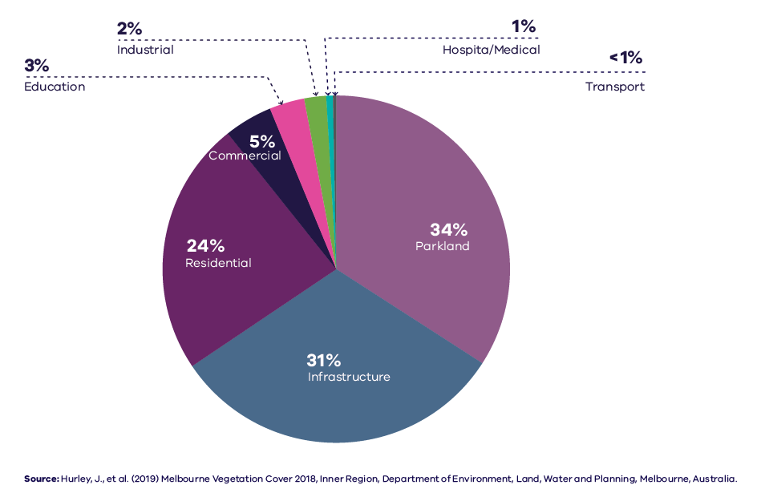
Figure 26. Urban tree canopy cover by land use, 2018
Parkland | 34 per cent
Infrastructure | 31 per cent
Residential | 24 per cent
Commercial | 5 per cent
Education | 3 per cent
Industrial | 2 per cent
Hospital/medical | 1 per cent
Transport | Less than 1 percent
Source: Hurley, J., et al. (2019) Melbourne Vegetation Cover 2018, Inner Region, Department of Environment, Land, Water and Planning, Melbourne, Australia.

Flooding risk and waterway health
Despite anticipated reductions in overall average annual rainfall caused by climate change, it is also predicted that heavy rainfall events will occur more frequently within the Inner Metro Region including within its NEICs, urban renewal areas and large development sites. Continued urban consolidation and resultant increases in impermeable surfaces will exacerbate this situation, presenting a greater risk of stormwater inundation to both private and public property. Ageing drainage infrastructure within this historical region also intensifies the impacts of flooding. These challenges will require innovative solutions to maximise the capture, storage and re-use of stormwater.
The Inner Metro Region is located at the confluence of the Maribyrnong, Yarra and Dandenong catchments and includes many significant waterways and tidal estuaries: the Yarra River, the Maribyrnong River, Moonee Ponds Creek and Elster Creek. Heavy rainfall events in outlying areas and regions drain into these waterways and concentrate within the Inner Metro Region, making low-lying areas particularly vulnerable to stormwater inundation before runoff drains into the Yarra River and Port Phillip Bay. Litter and chemical contaminants flushed from the stormwater system and higher volume water flows during flood events will present further impacts to water quality and the health of the region’s waterways and natural environments.
The Yarra River is a vital natural resource for eastern Melbourne and forms a significant landmark for the Inner Metro Region. The health of the Yarra River is under similar pressure from the impacts of climate change and encroaching development. The draft Yarra Strategic Plan sets out priorities for a coordinated response to the protection and management of the river by water authorities, local and state government and the community, to continue the rehabilitation of the river from past mismanagement and to future-proof it for the anticipated impacts of a changing climate.

Sea level rise and coastal inundation risk
Port Phillip Bay and its coastline have significant value to the Victorian community for a range of cultural, recreational, environmental and economic reasons but is under pressure from urbanisation and climate change. Rainfall intensification will exacerbate current impacts including increased stormwater and pollutant runoff. Marine and coastal environments will experience increases in water temperature and rising sea levels. Storm surges will also become more frequent, exposing the coastline to erosion and inundation (DELWP, 2017b).
As projected average temperatures continue trending upwards through this century, so too will global mean sea levels as oceans partially absorb atmospheric heat and glaciers and polar ice caps continue to melt. State planning policy recognises the need to plan for anticipated sea level rise in Port Phillip Bay. Given the uncertainty of our climate change future, planning policy will need to be responsive to future recalibration of sea levels.
The expected impact of tidal inundation – including storm surge, wave action and saline groundwater intrusion – will have an increasingly significant influence over future development in the Inner Metro Region, particularly in low-lying urban renewal precincts at Fishermans Bend, Arden, Macaulay and in established areas at Southbank, St Kilda, Balaclava and Elwood. Efforts made to protect property by ensuring ground floor levels (freeboard) of new buildings are constructed above projected flood levels will inadvertently present challenges in creating future mixed-use precincts that present active frontages at the street level. To optimise positive urban-scale outcomes within areas affected by tidal inundation, compromises and special consideration will need to be made between flood management agencies, local and state government and developers alike.

Sustainability in the built environment
In 2013, residential buildings were responsible for nearly 12 per cent of Australia’s national greenhouse gas emissions, and commercial buildings contributed just over 11 per cent. The majority of these emissions were generated through the consumption of grid-supplied electricity to power appliances, lighting, and predominantly heating, ventilation and cooling (HVAC) systems (Australian Sustainable Built Environment Council, 2016).

As average temperatures rise due to climate change, greater numbers of people are expected to seek comfort indoors during periods of hot weather. This, combined with population growth and overall poor-performing building stock, means our city lacks energy efficiency and resilience on hot days. Maximising opportunities to incrementally improve the performance of buildings will reduce our reliance on appliances to cool buildings and contribute to a lower likelihood of blackouts during periods of hot weather.
Local councils within the Inner Metro Region are active in adopting policies and strategies to reduce carbon emissions and improve the sustainability of the built environment. Many are innovators and leaders in ESD and are implementing new practices to improve the energy efficiency of civic buildings and reduce emissions from operations.
Several LGAs are members of the Council Alliance for a Sustainable Built Environment (CASBE), an association committed to designing and applying a range of practical methodologies to increase sustainability outcomes for new buildings. The Built Environment Sustainability Scorecard (BESS) is an online tool developed by CASBE that assesses the sustainability of proposed developments. It aims to reduce waste and improve energy efficiency from the outset of the construction phase, through to occupation. As well as onsite energy generation, BESS promotes the use of energy-efficient appliances, thermally-efficient glazing, wall cladding and insulation, water-efficient fittings and fixtures, thermal comfort and overall environmentally sustainable performance. Other rating systems increasingly used by the building design industry to measure and assess the performance of ESD principles include Green Star (Green Building Council of Australia, 2021), NatHERS (Nationwide House Energy Rating Scheme, 2021) and MUSIC (MUSIC Auditor, 2021).

Regional strengths
- Relatively high tree canopy cover can continue to be expanded while accommodating growth and change.

Regional challenges
- Flood events, storm surge, coastal inundation and sea level rise pose significant risk to population, ecosystems, infrastructure and property.
- Areas of high urban heat and heat vulnerable communities.

Directions and strategies
The directions identified to achieve the 2050 vision for the Inner Metro Region in terms of maximising sustainability and resilience are:
Direction 23 | Integrate cooling and greening initiatives with land use and infrastructure change to assist in managing urban heat
Direction 24 | Increase the tree canopy cover across the Inner Metro Region to achieve 28 per cent cover by 2050
Direction 25 | Implement integrated water management initiatives to improve water quality, reduce the impacts of stormwater inundation, utilise stormwater and protect the region’s key water assets
Direction 26 | Design urban renewal precincts and major redevelopment sites to support zero emissions and climate resilient urban areas
Direction 27 | Manage the impact and risk of coastal inundation and sea level rise

Each direction is implemented through regionally-specific strategies identified in this land use framework plan.
Map 8 shows areas of the Inner Metro Region that are vulnerable to heat stress, high surface temperatures and the impacts of climate change.
Map 9 shows how sustainability and resilience will be enhanced across the Inner Metro Region by 2050 as a result of these directions and strategies, together with Plan Melbourne and other strategies and initiatives as outlined in Appendix 01.

- Inner Metro Region sustainability and resilience state of play
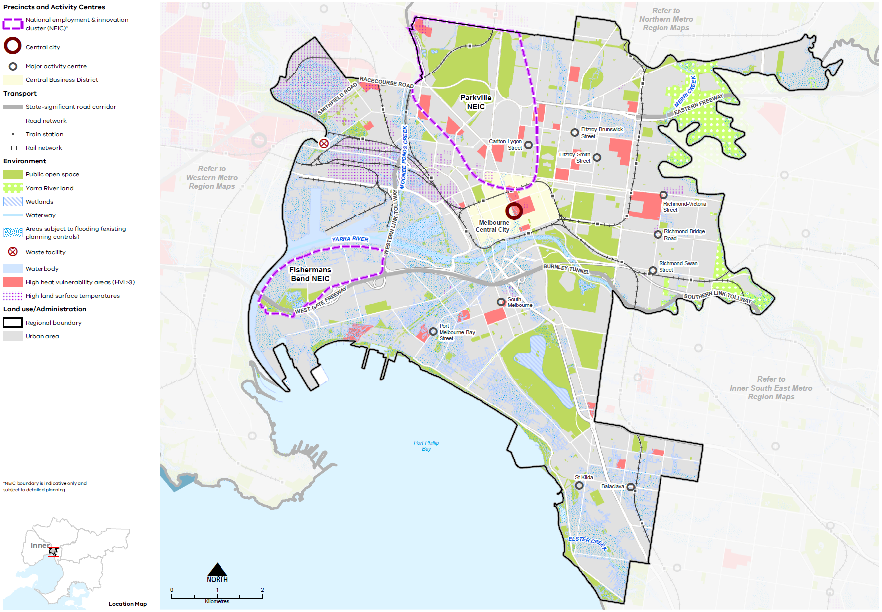

Map 8 Inner Metro Region sustainability and resilience state of play
A map showing the current sustainability and resilience of the Inner Metro Region, as extracted from Map 1, and also highlighting:
- Areas of high heat vulnerability
- Areas with high land surface temperatures
- Areas subject to flooding (existing planning controls) and priority stormwater sub catchments
- The Dynon Road Resource Recovery Centre & Waste Transfer Station.

- Inner Metro Region sustainability and resilience 2050
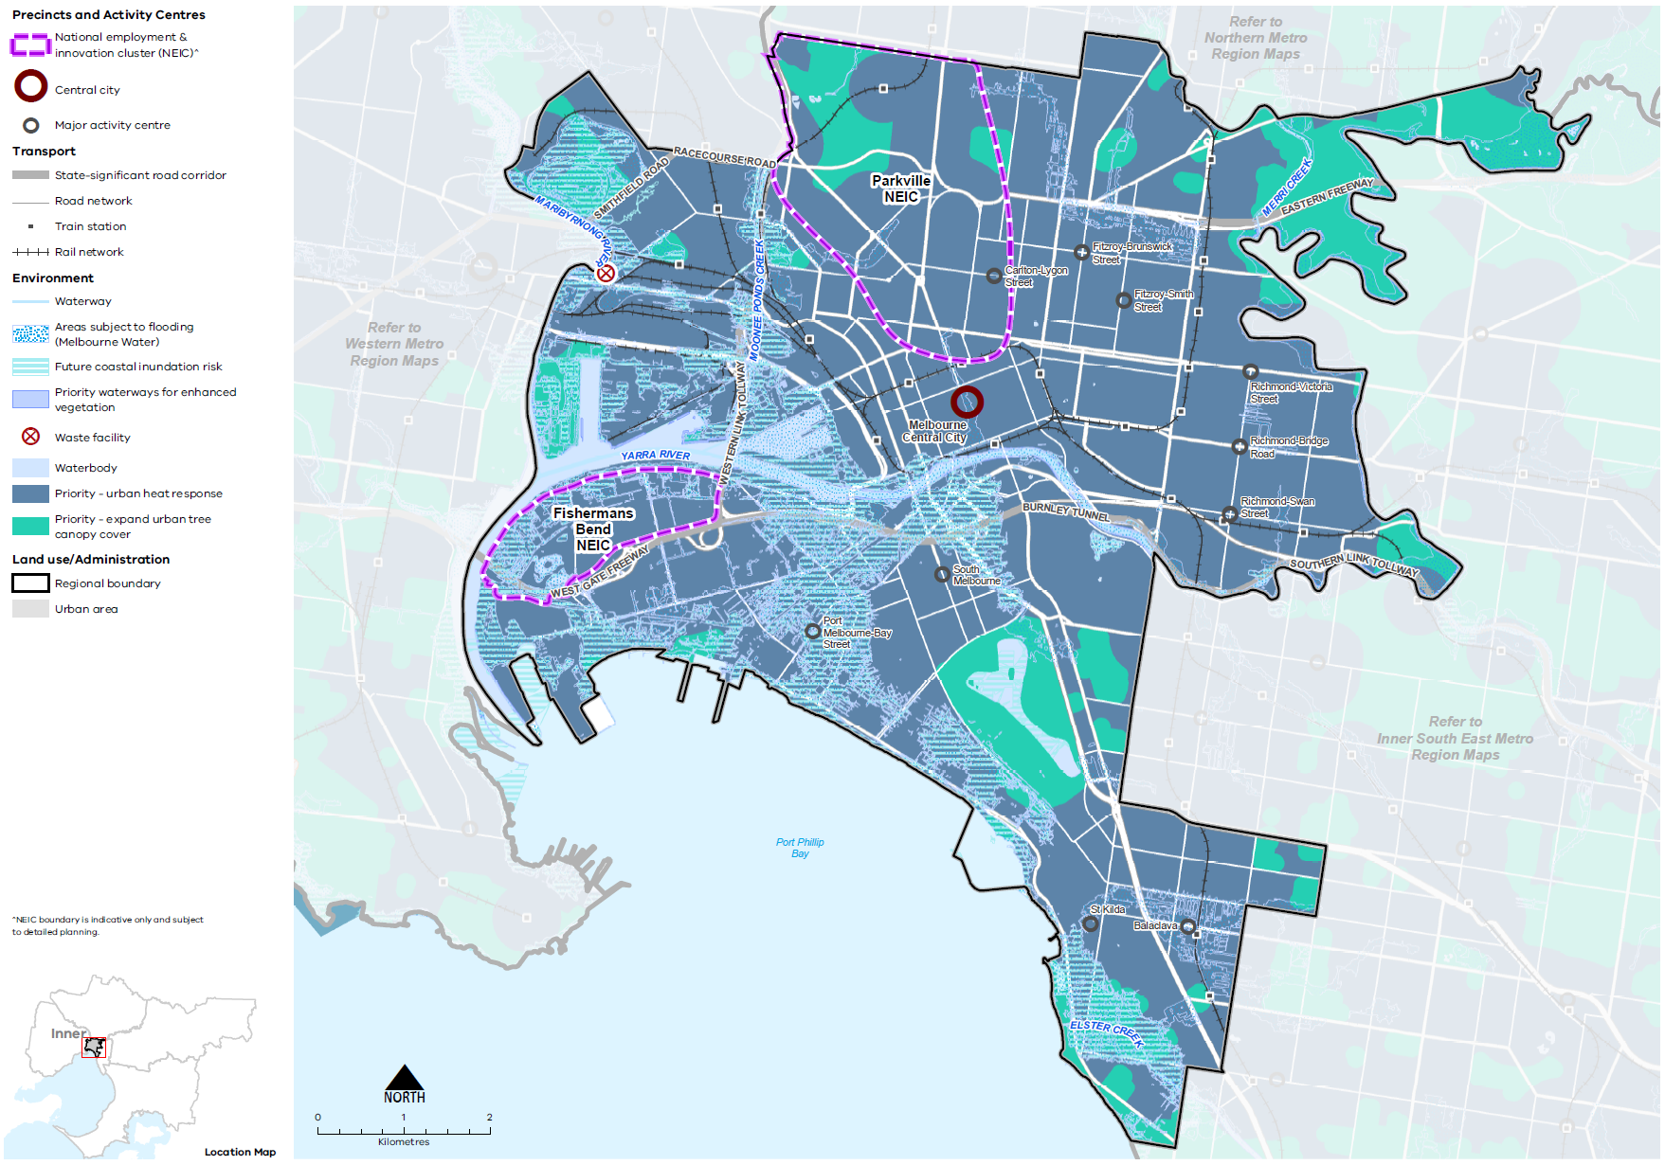

Map 9 Inner Metro Region sustainability and resilience 2050
A map showing the sustainability and resilience of the Inner Metro Region in 2050, as extracted from Map 1, and also highlighting:
- Future coastal inundation risk affecting significant areas in the south and west of the region
- Areas subject to flooding (updated Melbourne Water data)
- Priority waterways for enhanced vegetation
- Priority areas for an urban heat response and expanding the urban tree canopy cover.

- Integrate cooling and greening initiatives with land use and infrastructure change to assist in managing urban heat
Expansion of the tree canopy is the most effective measure to reduce the impact of urban heat.
However, due to the compact urban form of many parts of the Inner Metro Region and lack of space for new canopy trees, other forms of cooling and greening infrastructure will need to be used. This includes vertical and rooftop greening, green façades and planting more compact forms of vegetation within laneways, streets or narrow building setbacks. Cooling and greening needs to be considered for buildings, open spaces and pedestrian connections between key destinations.
Even in small spaces, urban greening and the use of water sensitive urban design (WSUD) will yield significant co-benefits of reducing urban temperatures, local climate regulation and stormwater management.
With most of the region’s growth expected to occur within already densely developed areas of the Central City and around activity centres, a site-responsive approach will be required in new development to protect existing trees and accommodate other forms of cooling and greening.
An innovative approach to finding available space for greening is needed to accommodate planting and watering systems and to avoid conflicts with pedestrian movement, transport infrastructure, powerlines and underground services.
- Design and develop outdoor spaces that are cool on hot days through materials, vegetation and water sensitive urban design particularly in and around activity centres, within the Central City, on major redevelopment sites and within urban renewal precincts.
- Encourage the greening of roofs, façades, walls or building setbacks with irrigated, climate resilient planting within apartment developments and large commercial or industrial sites.

- Increase the tree canopy cover across the Inner Metro Region to achieve 28 per cent cover by 2050
Trees provide an essential service for the region’s environment and biodiversity. They are integral to managing urban heat and are important contributors to amenity and liveability. In the absence of water, trees and in particular clusters of trees, make the greatest contribution to reducing surface temperatures, along with contributing to stormwater filtration, amenity and biodiversity (Coutts & Tapper, 2017; Sun, et al., 2019).
Canopy trees are particularly effective at lowering maximum summer daytime air temperatures at ground level through transpiration and shading (The Nature Conservancy and Resilient Melbourne, 2019). Increased tree canopy cover and the clustering of trees provides the greatest response to the challenge of urban heat.
By 2051, it is estimated that continuing current development practices within the Inner Metro Region will reduce urban tree canopy by 7 per cent (or 0.3 square kilometres) and expose 612,000 people to high urban heat environments (CRCWSC, 2019).
Expanding the region’s tree canopy cover can be achieved by preserving existing vegetation and planting new trees. Many parts of the Inner Metro Region achieve an appropriate proportion of tree canopy coverage, however, ongoing development and climate change will place pressure on the urban forest.
While residential land presently provides most of the tree canopy cover, tree canopy should also be expanded on other land uses such as rail corridors, streets, school grounds and parkland.
All three Inner Metro Region LGAs have endorsed the Living Melbourne: Our Metropolitan Urban Forest strategy, specifying a regional target of 28 per cent total tree canopy and 33 per cent combined tree canopy and shrubs by 2050 (The Nature Conservancy and Resilient Melbourne, 2019). To support this commitment, the tree canopy target is accompanied in Table 14 by an aspirational distribution of tree canopy cover across four different land use types, adapted by DELWP from several different related datasets (Hurley, et al., 2019a) (Urich & Hardy, 2020) (PSMA Australia Limited, 2021).
Inner Metro Region tree canopy cover target and aspirational distribution
2018 Tree Canopy Cover: 12.6%
2050 Tree Canopy Cover Target: 28%
(+15.4% or +1,190 hectares additional tree canopy cover)
Residential, commercial, industrial and primary production | 40%
Streets, roads and rail | 25%
Parks, open space and waterways | 30%
Education and hospital/medical | 5%

- Support alternative siting of buildings and more compact building forms to retain mature canopy vegetation.
- Increase tree canopy along urban waterways and on streetscapes, public land, large developments within activity centres, open spaces and road reserves, and large commercial and industrial sites.
- Require revegetation within the redevelopment of key sites, activity centres and urban renewal precincts to allow for the irrigation and spatial requirements of a healthy urban forest and dense tree canopy cover.

- Implement integrated water management initiatives to improve water quality, reduce the impacts of stormwater inundation, utilise stormwater and protect the region’s key water assets
Integrated stormwater management and stormwater re-use will help reduce runoff into waterways and wetlands and improve the climate resilience and liveability of the Inner Metro Region.
As the region’s population, economic activity and development continues to grow, so does the volume of stormwater runoff and risk of flooding. This can negatively affect water quality and waterway health for aquatic life and riparian habitat. Responding to this change and supporting the health of the region’s waterways, wetlands and the bay will be an ongoing challenge. Within the Inner Metro Region many low-lying areas which are particularly flood prone are subject to major redevelopment proposals, such as Fishermans Bend, Arden and Macaulay. An innovative approach to stormwater management is required.
Numerous organisations have regulatory and delivery responsibilities associated with the management of the Inner Metro Region catchment, including local councils, water corporations, catchment management authorities, Traditional Owner groups and State Government. A collaborative approach between affected stakeholders will be required to ensure integrated water management actions are balanced and respond to the needs of each individual organisation as well as the needs of the broader catchment.
Where areas of the Inner Metro Region are subject to flooding provisions, such as the Special Building Overlay (SBO) and Land Subject to Inundation Overlay (LSIO), there is an opportunity to increase stormwater and floodwater harvesting capabilities. Improved stormwater storage and stormwater harvesting and management across the region could reduce the risk and cost of major rainfall events and minimise impacts to the environment, infrastructure and property (DELWP, 2019). To accomplish this, however, flood provisions must be frequently reviewed and amended to accurately reflect the projected extent of flood events resulting from climate change.
Local capture of stormwater, water recycling, restoration and revegetation of urban waterways and greywater systems will improve the region’s hydrological and ecological systems. Development can reduce the impacts of flooding, support healthy vegetation and prepare for drying conditions by increasing permeable areas, enlarging green spaces, avoiding paved areas and passively irrigating vegetation.
Harvesting stormwater and increasing water infiltration is important in dense suburbs to reduce runoff and service vegetation. Harvested stormwater can help maintain water-reliant facilities and amenities such as sporting fields and gardens, contribute to more resilient vegetation and reduce demand on drinking water. Open spaces, pedestrian and cycling networks should all use WSUD to improve urban amenity and retain water in the urban environment (DELWP, 2019).
- Implement a regional approach to floodplain management and waterway drainage.
- Retain and harvest stormwater at a range of scales to achieve co-benefits that respond to urban heat, reduce runoff volume and velocity, service community infrastructure and trees, and reduce reliance on potable water for urban greening.
- Design development to provide passive irrigation to onsite vegetation and on adjacent public land not affected by industrial contamination and/or seawater infiltration.

- Design urban renewal precincts and major redevelopment sites to support zero emissions and climate resilient urban areas
Within the Inner Metro Region, urban renewal precincts and large redevelopment sites have significant potential to embrace and demonstrate leading sustainable development practices. Designing large sites anew presents an opportunity to adopt a site layout that maximises passive heating and cooling, showcases enhanced thermal efficiency across multiple buildings, and demonstrates a selection of low-carbon materials that are durable and assist with lowering surface temperatures.
Allowance can be made for new canopy trees of an appropriate species to be established over time to provide shade and amenity. Increased drought-tolerant landscaping, shade structures, roof gardens and green walls/façades can all be incorporated into the site planning. Other measures to optimise sustainability outcomes that may be achievable within a new development scenario include onsite stormwater and rainwater harvesting to support landscaping or for domestic use, water recycling, the use of smart technology to improve energy efficiency and car sharing schemes.
- Maximise the thermal efficiency and ability to support renewable and smart energy technology of the built environment through site layout and precinct design in major redevelopment sites and urban renewal precincts.
- Design buildings and the public realm with future stormwater needs and opportunities as a priority consideration to inform other precinct and building design outcomes and enhance pedestrian environments.

- Manage the impact and risk of coastal inundation and sea level rise
Coastal areas are susceptible to rising sea levels as well as storm surges. To this end, much work continues to be undertaken at the state level to determine the impacts of sea level rise by 2100 in areas along Port Phillip Bay in the Inner Metro Region.
Future planning must respond to the impacts of storm surge and coastal inundation. In addition to residential communities, several significant public and commercial assets, as well as densely populated communities, are located on or within close proximity to the coastline, including the Port of Melbourne, Station Pier, the St Kilda Pier and Marina, and beaches and foreshore infrastructure stretching from Port Melbourne to Elwood. Regional planning can help integrate and manage land use and infrastructure change to reduce the risk to communities, infrastructure and natural assets from coastal inundation and storm surge.
DELWP is undertaking a Local Coastal Hazard Assessment for Port Phillip Bay. The Local Coastal Hazard Assessment will provide additional information about the expected impacts of coastal hazards such as saline groundwater intrusion, erosion and inundation that are exacerbated by the effects of climate change. This information will better inform planning decisions in coastal areas around the bay.
- Encourage settlement planning for coastal environments and communities to respond to sea level rise and natural hazard risk.
- Limit major land use change in locations with future coastal inundation.

Actions – Sustainability and resilience
- Identify non-residential land where additional canopy trees can be planted to offset vegetation removal.
- Investigate options to develop a pilot fund to underground powerlines to support expanded tree canopy cover.
- Undertake detailed coastal settlement planning to identify short-, medium- and long-term options to reduce risk to population, infrastructure, ecosystems and property from sea level rise, storm surges, coastal erosion, tidal inundation and saline groundwater intrusion.

Chapter 10.
Implementation
The Inner Metro Region LUFP is a planning document that will be implemented primarily through planning schemes. This will guide and support decision-making at the local level and improve the consistency of decisions at the regional level.
There are many actions under Plan Melbourne and other government programs and initiatives, such as the Metropolitan Partnerships, that will contribute to improving planning outcomes in the Inner Metro Region. This LUFP includes a targeted list of regional actions.
The Inner Metro Region LUFP identifies specific regional planning priorities for state and local government to progress the implementation of Plan Melbourne as well as address specific planning issues for the region. Other priorities will emerge over the five-year timeframe for LUFP implementation that may supersede actions in the LUFP or complement and further refine these actions.
Implementation of this LUFP will require ongoing collaboration between state government and local government in the Inner Metro Region. A five-year action program is outlined below.

Putting the plan into action
Local councils in the Inner Metro Region are already working together to address priority issues for their region. Existing metropolitan regional governance arrangements such as the Inner Metropolitan Partnership provide forums to bring together experts and leaders from all levels of government, business and the community to identify and progress issues of importance to the region.
The strategies outlined in this LUFP will be implemented at the local level in a range of ways. For instance, amendments will be made to the planning schemes to give relevant regional strategies status in the Planning Policy Framework and updates will be made to local housing and local industrial land use strategies. The LUFP will be used to guide and inform future strategic planning across the Inner Metro Region by individual local councils, the regional groupings of local councils or other entities such as the Metropolitan Partnerships.
As part of the implementation process, the Department of Treasury and Finance will update budget business case submission templates and guidance to identify how initiatives align with Plan Melbourne and the LUFPs. This will bolster the consideration of metropolitan and regional policy when business cases are drafted.
The process for implementing this LUFP is outlined in Figure 27.

- Implementation of the land use framework plan
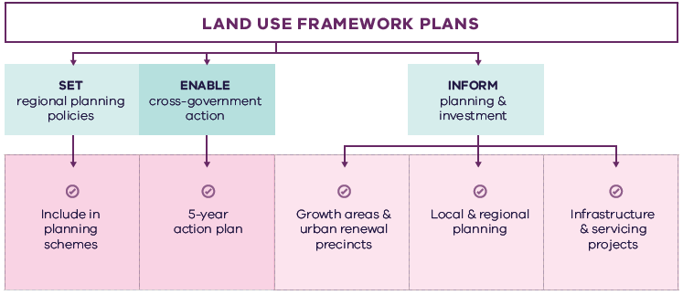

Figure 27. Implementation of the land use framework plan
Land use framework plans
- Set regional planning policies
  - Include in planning schemes
- Enable cross-government action
  - 5-year action plan
- Inform planning and investment
  - Growth areas and urban renewal precincts
  - Local and regional planning
  - Infrastructure and servicing projects

Five-Five-year action program
A number of short- to medium-term actions are included in the Inner Metro Region LUFP. The five-year action program (Table 15) summarises these actions to be delivered collaboratively by the state government and councils in the Inner Metro Region. These actions deliver on the strategic directions identified in the LUFP and in turn, Plan Melbourne outcomes. The actions will positively and proactively address some of the challenges being experienced by the region.
Plan Melbourne and the Melbourne Industrial and Commercial Land Use Plan (MICLUP) also contain actions that may require regional collaboration and will support the outcomes sought by the LUFP. This LUFP's five-year action program is a targeted list of actions identified during the development of the draft LUFP and it is not intended that this list duplicate existing Plan Melbourne or MICLUP actions with some exceptions where confirming a particular action was warranted given its regional implications.
In relation to transport, the following actions from Plan Melbourne Implementation Plan are identified as being well suited to being implemented at the regional level for this metro region and there is an commitment to deliver them as part of the implementation of Plan Melbourne and the LUFP:
- Action 43: Safe, efficient and accessible pedestrian networks
- Action 44: Local networks of cycling links
- Action 45: Local transport forums.
The implementation and prioritisation of the five-year action program will be driven by existing metro-regional governance arrangements including the Metropolitan Partnerships and EPWGs.
The indicative timeframes for completing actions are:
- Short term: By the end of 2023 (0–2 years)
- Medium term: By the end of 2026 (2–5 years).
Each action is allocated to a lead agency and implementation partners. Detail on the timing of actions and how they are implemented will be determined in line with normal government and council policy and budget processes. All actions requiring budget allocation will be carefully assessed against budget capacity, with rigorous business cases and cost-benefit analyses applied as part of their economic impact assessment.

Decision-making processes to support the delivery of the LUFPs
The LUFPs are a statement of policy intent. Detailed decisions about the implementation and timing of actions and infrastructure delivery will be made in line with normal government policy and budget processes.
The Victorian Government will continue its commitment to rigorous decision-making about initiatives that require funding, statutory amendments or new regulations in line with its economic and fiscal strategy, including the Government’s long-term financial management objectives.
For infrastructure projects, this will include ensuring consistency with the Victorian Government’s Investment Lifecycle and High Value/High Risk Guidelines. For all other initiatives and actions, implementation and timing will be subject to consideration of its evidence base and likely net benefits.

Monitoring, reporting and review
Action monitoring will be led by DELWP in partnership with the metropolitan region through the EPWG. DELWP will publish an annual progress report outlining the status of actions against the specified timeframe (whether an action has been ‘completed’, is ‘in progress’ or ‘not started’). These progress reports will be publicly available.
LUFP implementation will be formally reviewed every five years in conjunction with the Plan Melbourne Five-Year Implementation Plan. The review will be conducted in an open way and involve engagement with key stakeholders including Metropolitan Partnerships and EPWGs.

Actions – Implementation
- Update budget business case submission templates and guidance to identify how initiatives align with Plan Melbourne and the LUFPs.

Five-year action program
Timeframe - Short term (S): By the end of 2023 (0–2 years). Medium term (M): By the end of 2026 (2–5 years)
 | Action | Source | Timeframe | Lead agency | Implementation partner(s)
1 | Identify precincts and opportunities where new commercial land can be supplied which can help to accommodate future needs. This may include intensification of commercial uses within existing commercial zoned land, or the rezoning of existing land for commercial uses. | MICLUP | S | Councils | DELWP, DJPR, VPA
2 | Implement a program of state government-led planning projects, in partnership with local government, to ensure Metropolitan and major activity centres and urban renewal areas maximise their respective strategic opportunities and contribution within the network of activity centres. Priority will be given to those which deliver significant jobs and housing, leverage investment in state infrastructure, and play an important role in the growth corridor and/or region. State-led planning for these state- and regionally-significant places will contribute to creating liveable communities and achieving more dwellings and jobs in established areas, and identify implementation and coordination actions that support growth and economic investment. |  | S | VPA | Councils, DELWP
3 | Update planning schemes to align with housing policies in Plan Melbourne and the Inner Metro Region Land Use Framework Plan and the implementation of the reformed residential zones. This includes providing capacity for 15 years of regional housing supply focusing on locations identified for housing growth in the LUFP.  This may require strategic planning work to support these changes such as preparing or updating local housing strategies or preparing structure plans to further investigate where increased densities can be supported, and determine specific changes required to planning schemes. |  | S | Councils | DELWP
4 | Identify underutilised and surplus government land that has the potential to deliver additional social housing. | Plan Melbourne Implementation Plan | s | DFFH (HV) | DELWP
5 | In partnership with councils, identify a pipeline of sites in the Inner Metro Region for social and affordable housing. |  | M | DFFH (HV) | Councils
6 | Apply the Movement and Place Framework to the Inner Metro Region’s arterial road network and allocate priorities for transport connector improvements such as improving road space allocation for public and active transport, identify priority streets for walking and cycling, and road management and use arrangements. This should include a focus on transport interchanges and transport corridors. | Plan Melbourne Implementation Plan | S | DoT | Councils
7 | Develop and implement an Indigenous design approach to incorporate Aboriginal cultural heritage, design and stories into the region’s built and natural environment. This process will involve extensive collaboration and engagement with Aboriginal and Torres Strait Islander peoples across the region. This could be a pilot project suitable for other regions. |  | S | DELWP | Aboriginal Victoria, Councils
8 | Work with Traditional Owners and research organisations to develop specific and measurable actions to increase biodiversity and resilience of urban ecosystems, particularly those that do not have high biodiversity value. |  | S | DELWP | Aboriginal Victoria, Councils
9 | Develop a methodology for a social infrastructure strategy for the Inner Metro Region. This would consider social infrastructure such as libraries, multi-use community and recreation facilities, and assess how they can be used more flexibly and intensively. This could be a pilot project suitable for other regions. |  | M | DELWP | Councils, DH, VPA
10 | Identify non-residential land where additional canopy trees can be planted to offset vegetation removal. |  | M | Councils
11 | Investigate options to develop a pilot fund to underground powerlines to support expanded tree canopy cover. |  | M | DELWP | Councils, Energy authorities
12 | Undertake detailed coastal settlement planning to identify short-, medium- and long-term options to reduce risk to population, infrastructure, ecosystems and property from sea level rise, storm surges, coastal erosion, tidal inundation and saline groundwater intrusion. |  | M | DELWP | Councils
13 | Update budget business case submission templates and guidance to identify how initiatives align with Plan Melbourne and the LUFPs. |  | S | DTF

Appendix 01.
Relevant policies, strategies and initiatives
There are several current Victorian Government policies, strategies and initiatives that have implications for planning in the Inner Metro Region. In addition, there are existing regional initiatives, initiated by councils and/or the Metropolitan Partnerships. This appendix provides an overview of the most relevant policies, strategies and initiatives for the Inner Metro Region LUFP.
Plan Melbourne 2017-2050 and Plan Melbourne 2017-2050 Addendum, 2019 will guide the growth of our city. The original plan sets out the strategy for supporting jobs, housing and transport, while building Melbourne’s legacy of distinctiveness, liveability and sustainability. The addendum updates Melbourne’s projected population, housing and employment growth and the Melbourne 2050 spatial framework to align with major transport investments including SRL.
The Inner Metro Region has regional initiatives relevant to the LUFP. These include:
The Inner Melbourne Action Plan 2016-2026 (IMAP) is a collaboration between the Melbourne, Yarra, Port Phillip, Stonnington and Maribyrnong councils. The five councils work together through IMAP to set and implement regional priorities. The key objective of IMAP is ‘to make Inner Melbourne more liveable’. It sets out five goals to achieve this objective which relate to the economy, transport, communities, neighbourhoods and places, and environmental sustainability.
Specific Victorian Government policies, strategies and initiatives are outlined below under the relevant chapter of the LUFP to which they most strongly relate, acknowledging that many policies, strategies and initiatives are relevant to multiple chapters, or to the whole LUFP.

Productivity
The Melbourne Industrial and Commercial Land Use Plan 2019 provides an overview of current and future needs for industrial and commercial land across metropolitan Melbourne and puts in place a planning framework to support state and local government to more effectively plan for future employment and industry needs, and better inform future strategic directions.
The Unlocking Enterprise in a Changing Economy policy paper provides support for the development of enterprise precincts. The newly introduced Commercial 3 Zone aims to give preference to enterprises and reduce the planning burden for a diversity of employment uses.
Support for Victoria’s creative industries is provided through the Creative State 2016-2020 strategy which aims to grow the state’s creative and cultural economy. Work is currently underway to develop the next creative industries strategy which will guide initiatives and investment between 2020 and 2024.
The Metropolitan Partnerships are advisory groups established for each of the metropolitan regions by the Victorian Government that bring community and business together with state and local government and advise on the top priorities for jobs, services and infrastructure across the region.
The 2050 Port Development Strategy outlines the high-level plans and approach for developing the capacity and efficiency of the Port for the next 30 years, while also providing a planning framework which is adaptable and responsive to changing needs over time.

Housing choice
Planning system administrative and policy reforms such as Smart Planning are reducing red tape and, in doing so, facilitating the supply of housing.
Planning Practice Notes on Residential Zones and Planning for Housing provide greater clarity for local councils on the technical aspects of how to apply the residential zones and how to plan for housing growth and protect neighbourhood character.
The Housing Development Data dashboard will provide improved access to information on the quantity and location of housing being developed.
The Better Apartments Design Standards and Apartment Design Guidelines for Victoria assists in improving the quality and functionality of apartments in Victoria.
The Future Homes Project is producing better apartment designs and helping Melbourne become a world leader in apartment design, sustainability and liveability.
Housing Outcomes in Established Melbourne 2005 to 2016 highlights how housing development data can be used to understand changes in density, development of housing in activity centres and the influence of zones and overlays on housing change.
Big Housing Build will deliver 9300 new social housing dwellings and 2900 new affordable and market homes for first homebuyers and renters across the state. It includes:
- $532 million to replace obsolete properties on Homes Victoria land and constructing new homes – this includes Fast Start projects at Victoria Street, Flemington and Elizabeth Street in Richmond
- $948 million for ready to build and spot purchase, working with private sector to bring forward new developments ready to start construction and purchase existing residential properties
- $1.38 billion funding for projects by the community housing sector, through the Social Housing Growth Fund
- $2.14 billion in partnerships with the private and community housing sector – exploring options to build on surplus government owned sites.
The Social Housing Growth Fund is the vehicle for allocating new funds to suitable projects proposed by the community housing sector.
The Homelessness and Rough Sleeping Action Plan initiatives include 20 one-bedroom modular units with intensive onsite support, multidisciplinary housing teams to support complex clients to maintain stable housing, eight additional assertive outreach teams in locations of highest need, and funding therapeutic services in major inner city crisis accommodation centres to improve health, wellbeing and housing outcomes.
The redevelopment of public housing estates is a program to transform ageing public housing estates across metropolitan Melbourne and key regional centres into vibrant, well-connected neighbourhoods. This will create at least 1800 new` public housing homes.
The Building new homes to fight homelessness is a program to help Victorians escaping family violence, homelessness and life on the streets by building 1000 new public housing properties.

Integrated transport
The West Gate Tunnel will create a second river crossing to link the Western Metro Region with the Port of Melbourne, CityLink and the CBD, and take traffic pressures off the West Gate Bridge.
Melbourne Airport Rail will connect Melbourne Airport to metropolitan and regional rail networks via Sunshine.
North East Link will provide the ‘missing link’ between the Eastern Freeway and the M80 Ring Road in Melbourne’s north east and, in doing so, reduce travel times, remove trucks from local roads and link growth areas in the north and south-east of Melbourne and enhance connections between the Western Ring Road, Hume Freeway and Eastern Freeway to Melbourne’s south-east.
The Victorian Infrastructure Plan seeks to build, improve and care for Victoria’s infrastructure. It responds to Infrastructure Victoria’s 30-year Infrastructure Strategy and presents priorities and future directions across nine key sectors.
Moving freight throughout the state will be enhanced as part of the Delivering the Goods: Creating Victorian Jobs – Victorian Freight Plan.
The Metro Tunnel will create additional capacity on Melbourne’s rail network by running the Cranbourne, Pakenham and Sunbury lines through a new tunnel.
Suburban Rail Loop is a new orbital rail link connecting Melbourne’s middle suburbs from Cheltenham to Werribee via Melbourne Airport and includes preparing detailed precinct frameworks and structure planning for all SRL precincts. Suburban Rail Loop consists of SRL East (Cheltenham to Box Hill), SRL North (Box Hill to Airport) and SRL West (Airport to Werribee).
The Port Rail Shuttle Network is an investment in direct rail freight between key suburban locations in Dandenong South, Somerton and Altona and the Port of Melbourne. Once fully operational, this will make a significant difference to how freight moves around Melbourne. By 2050, it is expected to move 30 per cent of Melbourne’s containers by rail, avoiding millions of truck trips on roads each year.
Sixty-five High-Capacity Metro Trains which will be capable of carrying 1100 passengers – 20 per cent more than any other train on the network. Along with new high-capacity signalling, there will be more trains more often, travelling at intervals of just two to three minutes.
Planning work investigating options for the potential tram route for the Fishermans Bend tram including options for a river crossing, and potential corridors along Turner and Plummer streets.
The Western Rail Plan sets out the future investments for a fast, high-capacity rail network servicing our growing suburbs and growing regional cities. It consists of three major connected projects:
- Two new electrified metro rail lines through to growth areas in Melton and Wyndham Vale
- Increased capacity between Sunshine and the CBD to cater for faster and more frequent metro and regional trains
- Major investment in the Geelong and Ballarat lines to run trains faster than 160 kilometres per hour. This will include exploration of electrification of these lines and new, fast electric regional trains.
Geelong Fast Rail Stage 1 – Werribee to Newport will deliver faster services between Geelong and Melbourne’s CBD with a travel time of around 50 minutes enabled through a major investment to the Werribee corridor.
Safer CBD cycling connections will deliver pop-up lanes to help relieve congestion and provide an alternative to public transport for those living closer to the city. The changes will improve travel options from inner-Melbourne areas such as Footscray, Northcote and St Kilda.
St Kilda Road bike lanes is funded for a new layout for one of Victoria’s busiest corridors, combining both central safety zone bike lanes and protected kerbside bike lanes.
The Level Crossing Removal Project will continue to provide improved travel and safety for road users, public transport users, cyclists and pedestrians by removing additional level crossings across metropolitan Melbourne.
The Urban Congestion Fund will upgrade the urban road network to reduce congestion upgrading pinch points, intersections and commuter car park upgrades at train stations.
Victoria’s Zero Emissions Vehicle Roadmap sets out a plan to achieve half of all light vehicle sales in Victoria to be Zero Emission Vehicles by 2030.
Movement and Place is a way of thinking about the roles and challenges facing our transport system now and into the future. The Movement and Place approach recognises that transport links perform two functions: movement of people and goods and serving as a place (a destination in its own right). This way of thinking ensures that while we are planning for and developing our network, we are considering the needs for movement and placemaking simultaneously.

Liveability
The Suburban Parks Program will deliver more than 6500 hectares of new and upgraded parks and trails across greater Melbourne.
Open Space for Everyone: Open Space Strategy for Metropolitan Melbourne 2020 supports a cooler, greener city with a network of quality open spaces to which all members of the community have access.
The Healthy Waterways Strategy 2018 provides a framework for managing rivers, wetlands and estuaries in Melbourne’s five major catchments to ensure their value to the community is protected and improved.
The Yarra River Protection (Wilip-gin Birrarung murron) Act 2017 identifies the Yarra River as a single living and integrated natural entity for protection. It recognises intrinsic connection of the Traditional Owners to the Yarra River and its Country and further recognises them as the custodians of the land.
The Yarra River Action Plan, released in February 2017, details 30 specific actions to ensure the long-term protection of the river and its parklands.
The draft Yarra Strategic Plan sets the foundation to achieve the Yarra River 50 Year Community Vision and deliver on the aspirations contained in the Wurundjeri Woi Wurrung Cultural Heritage Aboriginal Corporation’s Nhanbu narrun ba ngargunin twarn Birrarung (Ancient Spirit and Lore of the Yarra) water policy. It includes a land use framework plan for the river corridor.
Waterways of the West (WoW) Action Plan (to be released 2021) will include steps to better protect the waterways of the region and their parklands within the context of increased population growth. It encompasses the network of waterways within the Maribyrnong and Werribee catchments.
The Land Utilisation Assessment Program works to improve utilisation of government land.
Water for Victoria is a plan for a future with less water as Victoria responds to the impact of climate change and a growing population.
Protecting Victoria’s Environment – Biodiversity 2037 is the Victorian Government’s plan to stop the decline of the state’s biodiversity and achieve overall biodiversity improvement over the next 20 years.
The Victorian Heritage Register lists and provides legal protection for heritage places and objects that are significant to the history and development of Victoria. It includes a wide range of places and objects, such as buildings, trees, gardens, archaeological sites and structures.

Strong communities
The 20-minute Neighbourhoods project delivers a range of initiatives to create a city of 20-minute neighbourhoods, enabling communities to live more locally.
The Statewide Design, Service and Infrastructure Plan for Victoria’s Health System 2017-2037 provides a planning framework to guide service, workforce and infrastructure investment in Victoria’s health system.
Health 2040: Advancing Health, Access and Care presents a clear vision for the health and wellbeing of Victorians and for the Victorian healthcare system.
The Victorian Public Health and Wellbeing Plan 2019-2023 seeks to ensure that all Victorians enjoy the highest attainable standard of health, wellbeing and participation at every age. The production of this Plan is legislated for under the Victorian Public Health and Wellbeing Act 2008.
The 2020/21 Victorian State Budget allocates funding for the Community Sports Infrastructure Stimulus Program that will fast-track shovel-ready community sports infrastructure projects across Victoria.
The Victorian Cycling Strategy 2018-28 guides planning and investment in cycling in the state.
Active Victoria – A Strategic Framework for Sport and Recreation in Victoria 2017-2021 provides a strategic framework for future work into Victoria’s sports and active recreation sector.
The Victorian Government’s Metropolitan Health Infrastructure Fund will work with metropolitan Melbourne’s hospitals and health services to upgrade infrastructure to support the delivery of new or enhanced services to patients.
The Suburban Revitalisation Program facilitates the delivery of urban renewal in metropolitan activity centres experiencing economic transition and/or significant levels of disadvantage. The program is centred on a partnership between state agencies, local councils and regional stakeholders to accelerate the development and delivery of local infrastructure upgrades, small business stimulus initiatives and community connectedness activities. The Southern Region includes Suburban Revitalisation Program projects in Frankston and Noble Park.
The Victorian Aboriginal Affairs Framework 2018-2023 (the VAAF) is the Victorian Government’s overarching framework for working with Aboriginal Victorians, organisations and the wider community to drive action and improve outcomes.

Sustainability and resilience
Sector and whole-of-government emission reduction pledges will help achieve the Victorian Government’s target of net-zero emissions by 2050.
The Climate Change Act 2017 provides Victoria with a world-leading legislative foundation to manage climate change risks, maximise the opportunities that arise from decisive action, and drive our transition to a climate resilient community and economy with net-zero emissions by 2050.
Adaption Action Plans (Climate Change Act 2017) will help build the state’s resilience and help Victorians plan for the inevitable impacts of climate change.
Victoria’s Climate Change Strategy (2021) has a range of specific measures to support the uptake of renewable energy in businesses, industry and homes. It includes further reforms to drive greater energy efficiency of electrical appliances, lighting and air-conditioning/heating equipment and to improve the thermal performance of new buildings. Transport emissions will be reduced by accelerating Victoria’s transition to zero emissions vehicles, improving public transport and investing more in cycling and walking options. The Strategy will also support the circular economy reforms to Victoria’s waste management system contained in the Recycling Victoria action plan, Recycling Victoria: A New Economy.
The Beach Renourishment Program in Port Phillip Bay 2019-2022 is designed to repair damaged caused by coastal erosion on Port Phillip Bay beaches.
The 2020/2021 Victorian Budget delivered a landmark $2 billion for the Breakthrough Victoria Fund to drive translation and commercialisation of knowledge in Victoria. The Clean Economy is one of the five key sectors the Fund will prioritise.
The 2020/21 Victorian Budget also provided funding for clean energy transition initiatives, including establishing renewable energy zones to develop and deliver renewable energy projects.
The Victorian Climate Projections 2019 Technical Report describes how the regional climate of Victoria is likely to respond to global warming with different scenarios of human greenhouse gas emissions.
The Cooler, Greener Melbourne project will create more liveable and climate-adapted communities through green infrastructure and other cooling and greening initiatives. Tree planning on public land will create a cooler and greener Melbourne as part of Melbourne Water’s Urban Cooling Program. The program includes changes to planning schemes to protect and strengthen the urban forest.
Integrated Water Management Framework for Victoria provides a collaborative approach to the way we plan for and manage all elements of the water cycle, including the health of waterways and bays, wastewater management, alternative and potable water supply, stormwater management and water treatment. Within the Inner Metro Region this applies to the Yarra River, Maribyrnong River and Dandenong Creek catchments.
Living Melbourne Urban Forest Strategy (2019) is a strategy for a greener, more liveable Melbourne, developed by Nature Conservancy and Resilient Melbourne.
The Marine and Coastal Policy (2020) sets out policies for planning and managing the marine and coastal environment, provides guidance to decision-makers in achieving the objectives of the Marine and Coastal Act 2018 and includes a Marine Spatial Planning Framework to achieve integrated and coordinated planning and management of Victorian’s marine environment.
The Renewable Energy (Jobs and Investment) Act 2017 legislates an increase of the Victorian Renewable Energy Target (VRET) to 50 per cent by 2030.
Water for Victoria is a plan for a future with less water as Victoria responds to the impact of climate change and a growing population.
The Victorian Water and Climate Initiative supports research into the impact of climate change and climate variability on Victoria’s water resources. Additional investments will be made to enhance the scientific understanding of Victoria’s climate and provide authoritative data and information on climate change to the community.
The Statewide Waste and Resource Recovery Infrastructure Plan 2018 (SWRRIP) guides future planning for waste and resource recovery infrastructure to achieve an integrated system.
The Metropolitan Waste and Resource Recovery Implementation Plan (SWRRIP) brings together the statewide priorities set out in the SWRRIP and applies them within the metropolitan context.
The Recycling Industry Strategic Plan transitions Victoria’s recycling industry to a more sustainable and resilient model.
Recycling Victoria: A New Economy outlines a plan for reform to establish a recycling system that Victorians can rely on and transforms how our economy uses materials and how our state re-uses, repairs and recycles.
The 2020/21 Victorian State Budget allocates funding for the 10-year Recycling Victoria action plan, Recycling Victoria: A New Economy to transform Victoria’s recycling sector and develop a circular economy.

Appendix 02.
Housing choice supporting data
TABLE A2-1. Major housing development completed in the Inner Metro Region in and within 400m of activity centres (2005-2018) and in the redevelopment pipeline
Activity Centre | Major housing redevelopment completed 2005-2016* - In Centre | Major housing redevelopment completed 2005-2016* - Within 400m of Centre | Major housing redevelopment completed 2017-2018* - In Centre | Major housing redevelopment completed 2017-2018* - Within 400m of Centre | Major housing redevelopment pipeline* - In Centre | Major housing redevelopment pipeline* - Within 400m of Centre
Balaclava | 419 | 480 | 188 | 261 | 147 | 468
Brunswick | NA | 0 | NA | 20 | NA | 13
Carlton,  Lygon Street | 602 | 1474 | 54 | 492 | 0 | 232
Elsternwick | NA | 37 | NA | 10 | NA | 0
Fitzroy,  Brunswick Street | 543 | 544 | 116 | 611 | 254 | 483
Fitzroy,  Smith Street | 1358 | 1198 | 757 | 273 | 1141 | 328
Flemington, Racecourse Road | NA | 464 | NA | 17 | NA | 1819
Ivanhoe | NA | 0 | NA | 31 | NA | 0
Melbourne | 35,040 | 4847 | 14,376 | 2012 | 49,448 | 4204
Port Melbourne, Bay Street | 2169 | 50 | 73 | 0 | 46 | 79
Prahran/  South Yarra | NA | 59 | NA | 38 | NA | 10
Richmond,  Bridge Road | 1193 | 819 | 257 | 720 | 456 | 120
Richmond,  Swan Street | 808 | 225 | 159 | 118 | 1309 | 0
Richmond,  Victoria Street | 1899 | 1845 | 16 | 696 | 795 | 1211
South Melbourne | 184 | 1156 | 455 | 233 | 43 | 1075
St Kilda | 720 | 1818 | 51 | 480 | 142 | 875
* Major development is defined as developments with over 10 dwellings
Note: Dwelling numbers are calculated based on constructed not net additions dwellings.
Note: Pipeline refers to projects that are: under construction, have a planning permit, have had pre application meetings, or being sold off the plan.
Note: 400m activity centre buffer may be in multiple metro Regions.
Housing Development Data 2016, Urban Development Program – Redevelopment 2018, Urban Development Program – Redevelopment 2019

Glossary
Where the term is defined in Plan Melbourne or the Victoria Planning Provisions, that definition is used.
Aboriginal | Aboriginal refers to both Aboriginal and Torres Strait Islander peoples. They may have connections in and outside of Victoria.
Active transport | Transport requiring physical activity, typically walking and cycling.
Activity centres | Areas that provide a focus for services, employment, housing, transport and social interaction. They range in size and intensity of use from smaller neighbourhood centres to major suburban centres and larger metropolitan centres.
Affordable housing | Housing that is appropriate for the needs of a range of very low- to moderate-income households, and priced (whether mortgage repayments or rent) so these households are able to meet their other essential basic living costs.
Agglomeration | The location of businesses in close proximity to each other, which allows them to get productivity and efficiency gains through large customer bases, knowledge sharing and access to skilled workers.
Biodiversity | The variety of all life forms, the different plants, animals and microorganisms, the genes they contain and the ecosystems of which they form a part.
Central Business District (CBD) | Melbourne’s original ‘Hoddle Grid’ street layout bounded by the Yarra River, Spring Street, La Trobe Street and Spencer Street, as well as the triangular area to the north bounded by Victoria, Peel and La Trobe streets.
Central City | The area within the inner metro region that contains key capital city functions and civic facilities, as well as several precincts identified for major and strategic change. The Central City incorporates the CBD (Hoddle Grid, north to Grattan Street between Peel and Swanston streets) as well as Docklands, Southbank and St Kilda Road.
Climate change | A long-term change of the earth’s temperature and weather patterns – generally attributed directly or indirectly to human activities such as fossil fuel combustion and vegetation clearing and burning.
Commercial land | Land used for commercial purposes including land used for business services, retail, accommodation, food and other industries.
Creative industry | Media, digital screen, design, writing and publishing, literature, fashion, performing arts, digital games development, broadcasting, music, cultural heritage, arts, education and craft industries.
Enterprise precincts | Precincts that facilitate the creation and commercialisation of new ideas and support metropolitan economies by growing jobs in ways that leverage their distinct economic attributes. These districts build on and revalue the intrinsic qualities of cities: proximity, density, authenticity, and vibrant places. (Brookings Institute definition).
Eastern Metro Region | Includes the municipalities of Knox, Manningham, Maroondah, Monash, Whitehorse, Yarra Ranges.
Established urban areas | Areas of Melbourne that have been urbanised for at least several decades.
Green wedges | Defined under Part 3AA of the Planning and Environment Act 1987 as “land that is described in a metropolitan fringe planning scheme as being outside an urban growth boundary”. There are 12 defined green wedges spanning parts of 17 municipalities.
Greenfield land | Undeveloped land identified for residential or industrial/commercial development, generally on the fringe of metropolitan Melbourne.
Greenhouse gas emissions | Atmospheric gas that absorbs and emits infrared or heat radiation, giving rise to the greenhouse effect. Typical greenhouse gases include carbon dioxide, methane, nitrous oxide and refrigerants.
Greyfield | Residential areas where the building stock is near or has ended its useful life and land values make redevelopment attractive.
Gross regional product (GRP) | Gross regional product is a measure of the market value of all final goods and services produced in a region over a period of time.
Growth areas | Locations on the fringe of metropolitan Melbourne designated in planning schemes for large-scale transformation, over many years, from rural to urban use.
Growth corridor plans | The Growth Corridor Plans are high level integrated land use and transport plans that provide a strategy for the development of Melbourne’s growth corridors over the coming decades.  The Growth Corridor Plans focus on three metropolitan growth corridors (Northern, Western and South Eastern growth corridors) and identify broad transport networks, industrial and employment areas, residential areas and recreation precincts across the city’s newest metropolitan suburbs. Relevant information from the Growth Corridor Plans have been integrated into the LUFPs containing growth corridors.
Health and education precincts | Locations to cluster synergistic health and/or education services to improve access to integrated service provision, improve outcomes, develop the health and education workforce and deliver economic benefits (such as innovation and job creation). These precincts may provide solely health, solely education, or a combination of health and education services.
Hoddle Grid | The grid pattern of streets making up Melbourne’s CBD bounded by the Yarra River, Spring Street, La Trobe Street and Spencer Street, as well as the triangular area to the north bounded by Victoria, Peel and La Trobe streets. The grid was designed by Robert Hoddle in 1837.
Housing density | The number of dwellings in an urban area divided by the area of the residential land they occupy, expressed as dwellings per hectare.
Hybrid centre | A descriptor for an activity centre typology that contains a mixed arrangement of freestanding / enclosed shopping complexes and traditional open air strip-based commercial land.
Infill | Development of unused or underutilised land in existing urban areas.
Infrastructure | Basic facilities and networks needed for the functioning of a local community or broader society.
Integrated water management (IWM) | An approach to planning that brings together all facets of the water cycle including sewage management, water supply, stormwater management and water treatment, ensuring environmental, economic and social benefits.
Inner Metro Region | Includes the municipalities of Melbourne, Port Phillip and Yarra.
Inner South East Metro Region | Includes the municipalities of Boroondara, Glen Eira, Stonnington and Bayside.
Intermodal freight terminal | A location for the transfer of freight from one transport mode to another, for example between road and rail.
Knowledge-based industries and jobs | Production and services based on knowledge-intensive activities that contribute to an accelerated pace of technical and scientific advancement. Their key characteristic is a greater reliance on intellectual capabilities than on physical inputs or natural resources.
Liveability | A measure of a city’s residential quality of life, used to benchmark cities around the world. It includes socioeconomic, environmental, transport and recreational measures.
Localised planning statement | Long-term policies for the future planning and development of areas identified as having significance to the broader Victorian community.
Major activity centres | Suburban centres that provide access to a wide range of goods and services. They have different attributes and provide different functions, with some serving larger sub-regional catchments. Plan Melbourne identifies 121 major activity centres.
Metropolitan activity centres | Higher-order centres with diverse employment options, services and housing stock, supported by good transport connections. Existing centres include Box Hill, Broadmeadows, Dandenong, Epping, Footscray, Fountain Gate/Narre Warren, Frankston, Ringwood and Sunshine. Future centres will include Lockerbie and Toolern.
Metropolitan Melbourne | The 31 municipalities that make up metropolitan Melbourne, plus part of Mitchell Shire within the UGB.
Moderate income household | Annual household income within the income range specified as a moderate range by Order under section 3AB of the Planning and Environment Act 1987. In 2020 this was $87,671 to $131,500 for a family (with one or two parents) and dependent children.
National employment and innovation clusters (NEIC) | Designated concentrations of employment distinguished by a strong core of nationally significant knowledge sector businesses and institutions that make a major contribution to the national economy and Melbourne’s position in the global economy.
Natural hazard | A natural event that has potential to cause harm to people, property or the environment, including climate change, bushfire, flooding and sea level rise.
Neighbourhood activity centres | Local centres that provide access to local goods, services and employment opportunities and serve the needs of the surrounding community.
Northern Metro Region | Includes the municipalities of Banyule, Darebin, Hume, Mitchell (part), Moreland, Nillumbik and Whittlesea.
Open space | Includes land reserved for natural landscape, parklands, recreation and active sports, as well as waterways and bays.
Peri-urban areas | Areas beyond the green wedges made up of local government areas with a predominantly rural character, located all or partially within a 100-kilometre radius of Melbourne.
Precinct Structure Plans (PSPs) | Master plans for future growth corridor developments, informed by growth corridor planning. The plans identify alignments of transport routes, town centres, open space networks, densities of residential areas, and areas for industry and employment.
Primary healthcare | Primary healthcare is generally the first contact a person has with Australia’s health system. It relates to the treatment of patients who are not admitted to hospital. It encompasses a wide range of health professionals and includes general practitioners, community nurses, midwives, pharmacists, dentists, and Aboriginal health workers, for example.
Principal Freight Network (PFN) | Part of the larger transport network over which the movement of heavy freight will be concentrated.
Principal Public Transport Network (PPTN) | A statutory land use planning tool that supports integrated land use and transport planning by providing certainty to land use planners and developers around locations that are and will be served by high-quality public transport.
Regional active open spaces | Large scale open spaces that cater for a range of recreational opportunities including informal outdoor recreation, active recreation and sports. Regional active open spaces serve a broad catchment and may comprise buildings and infrastructure to facilitate sporting or recreational activity.
Regional parks | Regional parks are large areas of open space that feature natural or semi-natural surroundings in close proximity to urban environments. They have high landscape, biodiversity and cultural values and provide a diversity of passive recreational, educational or tourism opportunities. Regional parks are places where Traditional Owners can connect with their heritage and continue cultural practices.
Regional Victoria | Includes all municipalities outside metropolitan Melbourne (except part of Mitchell Shire within the UGB).
Regionally-significant industrial precincts  (RSIP) | Key industrial areas that contribute significantly to local and regional economies. Some of these areas are well established and support a range of industrial uses while others are transitioning and supporting new uses. They include future employment areas identified through Growth Corridor Plans that will support not just employment growth in outer areas, but to also meet Melbourne’s longer term industrial and logistics needs. They are to be retained and planned for to allow a range of industrial uses, or where appropriate, new and emerging businesses that require access to affordable and well-located employment land.
Renewable energy | Energy that comes from resources which are naturally replenished on a human timescale such as sunlight, wind, rain, tides, waves, and geothermal heat.
Resilience | The capacity of individuals, communities, institutions, businesses, systems and infrastructure to survive, adapt and grow, no matter what chronic stresses or shocks they encounter.
Resource recovery | Extraction of useful material or energy from a waste stream.
Social housing | A type of rental housing that is provided and/or managed by the government or by a not-for-profit organisation. Social housing is an overarching term that covers both public housing and community housing.
Social infrastructure | Encompasses all the facilities, services and networks that help families, groups and communities to meet their social, health, education, cultural and community needs.
Southern Metro Region | Includes the municipalities of Cardinia, Casey, Greater Dandenong, Frankston, Kingston and Mornington Peninsula.
State-significant industrial precincts (SSIP) | Strategically located land available for major industrial development linked to the PFN and transport gateways. They will be protected from incompatible land uses to allow continual growth in freight, logistics and manufacturing investment.  There are five state-significant industrial precincts: Western Industrial Precinct, Northern Industrial Precinct, Southern Industrial Precinct, Port of Hastings Industrial Precinct and Officer-Pakenham Industrial Precinct.
Strategic Cycling Corridors (SCC) | Strategic Cycling Corridors are important transport routes for cycling and are a subset of the Principal Bicycle Network (PBN). The SCC network supports the needs of commuter trips (to work or education) and other important trips, such as to stations, shops or schools.  The SCC network links up important destinations, including central Melbourne city, employment and activity centres, and other destinations of metropolitan and regional significance.  SCCs can be on- and off-road, on municipal and state roads and are designed to provide a safe, lower-stress cycling for transport experience.
Strategic Extractive Resource Area (SERA) | Recognised and secured extractive resource areas of strategic importance for the construction of public infrastructure, affordable housing and private sector development now and in the future.  They cover extractive resources that actually and/or potentially occur in defined locations at various scales based on their likelihood or potential to supply growth areas, taking into account accessibility to markets, while minimising impacts on environment and other land use constraints.
Traditional Owners | People who, through membership of a descent group or clan, are responsible for caring for particular Country. A Traditional Owner is authorised to speak for Country and its heritage as a senior Traditional Owner, an Elder or, in more recent times, a registered native title claimant.
Transit-oriented development | Compact, walkable, mixed-use communities centred around high-quality train systems. Transit-oriented development assists in addressing the growing problems of climate change and global energy security by creating dense, walkable communities that greatly reduce the need for driving and energy consumption.
Transport gateway | Ports, airports and interstate terminals that serve as key locations for moving passengers and freight into and out of Victoria and also play a significant economic and employment-generating role.
20-minute neighbourhoods hallmarks | The ‘hallmarks’ are established in Plan Melbourne’s Direction 5.1 — Create a city of 20-minute neighbourhoods. The ‘hallmarks’ developed in partnership with the Department of Health (DH) and the Heart Foundation (Victoria) are:  - be safe, accessible and well connected for pedestrians and cyclists to optimise active transport  - offer high-quality public realm and open spaces  - provide services and destinations that support local living  - facilitate access to quality public transport that connects people to jobs and higher-order services  - deliver housing/population at densities that make local services and transport viable  - facilitate thriving local economies.
Urban forest | All of the trees and other vegetation in a city as well as the soil and water that supports it.
Urban Development Program (UDP) | The Urban Development Program (UDP) provides an annual assessment of supply and consumption of industrial and residential land across metropolitan Melbourne.
Urban Growth Boundary (UGB) | A management tool to contain urban areas and limit their expansion. It divides land that is urban – to be used for housing, shops, factories – from land that is nonurban and to be used for purposes such as conservation, agriculture, mineral extraction, airports and the like. A UGB encourages urban consolidation and protects valued non-urban areas from urban development.
Urban renewal | The process of planning and redeveloping underutilised medium- and large-scale urban areas, precincts or sites for mixed land use purposes.
Very low income household | Annual household income within the income range specified as a very low-income range under section 3AB of the Planning and Environment Act 1987. In 2020 this was up to $26,090 for a single adult.
Western Metro Region | Includes the municipalities of Brimbank, Hobsons Bay, Maribyrnong, Melton, Moonee Valley and Wyndham.
Water sensitive urban design (WSUD) | Integrating the urban water cycle into urban design to minimise environmental damage and improve recreational and aesthetic outcomes.
Wallan SA2 | Statistical Areas Level 2 (SA2) are medium-sized general purpose areas established by the ABS that represent a community that interacts together socially and economically. The Wallan SA2 is larger than the area in Mitchell within the UGB and generally follows the municipal boundary west of Wallan and extends north of Wandong and east into Kinglake National Park.
Yarra River Land | Crown and State Government-owned land within 500 metres of the Yarra River declared under the Yarra River Protection (Wilip-gin Birrarung murron) Act 2017. The declaration provides additional protection to this land. Yarra River Land that is used for public recreation forms the Greater Yarra Urban Parklands.

References
Australian Bureau of Statistics, 2021. Regional Population 2019-20 financial year: Commonwealth of Australia, Canberra, Australia.
Australian Sustainable Built Environment Council 2016. Low Carbon, High Performance, Surrey Hills, NSW, Australia: ASBEC.
Clarke, J. et al., 2019. Victorian Climate Projections 2019 Technical Report, Melbourne: CSIRO.
Coutts, A. & Tapper, N., 2017. Tree’s for a Cool City: Guidelines for Optimised tree placement, Melbourne, Australia: Cooperative Research Centre for Water Sensitive Cities.
CRCWSC, 2019. Cooling and Greening Melbourne – Future scenarios, DELWP.
DELWP, 2017a. Plan Melbourne, Melbourne, Australia: The State of Victoria Department of Environment, Land, Water and Planning.
DELWP, 2017b. Port Phillip Bay Environmental Management Plan 2017-2027, Melbourne, Australia: The State of Victoria Department of Environment, Land, Water and Planning.
DELWP, 2018a. Land Surface Temperature data, Melbourne, Australia: The State of Victoria Department of Environment, Land, Water and Planning.
DELWP, 2018b. Unlocking Enterprise in a Changing Economy.
DELWP, 2019. Integrated Water Management Forums Dandenong Strategic Directions Statement, The State of Victoria Department of Environment, Land, Water and Planning.
DELWP, 2021. Internal analysis using Victorian Integrated Survey of Travel and Activity (VISTA) 2016-18 survey data.
DHHS, 2020. Rental Report March Quarter 2020.
Green Building Council of Australia, 2021. Green Star Rating System. [Online] Available at: https://new.gbca.org.au/rate/rating-system
[Accessed March 2021].
Hurley, J. et al., 2019a. Melbourne Vegetation Cover 2018, Inner Metro Region, Melbourne: DELWP.
Hurley, J. et al., 2019b. Urban Vegetation Cover Change in Melbourne 2014 - 2018, Melbourne: Centre for Urban Research, RMIT University.
Katz, B. & Wagner, J., 2014. The Rise of Innovation Districts: A New Geography of Innovation in America, Brookings Institution.
KPMG & ARUP, 2017. Travel Demand and Movement Patterns report, Melbourne: Infrastructure Victoria.
Melbourne Water, 2018. Healthy Waterways Strategy, Melbourne, Australia: Melbourne Water Corporation.
MUSIC Auditor, 2021. MUSIC Auditor. [Online]
Available at: https://www.musicauditor.com.au
[Accessed March 2021].
Nationwide House Energy Rating Scheme, 2021. Nationwide House Energy Rating Scheme. [Online]
Available at: https://www.nathers.gov.au
[Accessed March 2021].
PSMA Australia Limited, 2021. Buildings Spatial Data | Building GIS Data | Geoscape. [Online] Available at: https://geoscape.com.au/data/buildings/
[Accessed 2021].
SGS, 2019a. ABS Census 2016 in SGS Economics & Planning, Economic, Social and Environmental Profile: Inner Metro Region, SGS Economics & Planning.
SGS, 2019b. Economic, social and environmental profile: Inner Metro Region, prepared for Infrastructure Victoria.
Sun, C. et al., 2019. Urban Vegetation, Urban Heat Islands and Heat Vulnerability Assessment in Melbourne, 2018, Melbourne, Australia: Clean Air and Urban Landscapes Hub.
Sustainability Victoria, 2018. Statewide Waste and Resource Recovery Infrastructure Plan, Melbourne, Victoria: Sustainability Victoria.
The Nature Conservancy and Resilient Melbourne, 2019. Living Melbourne: Our Metropolitan Urban Forest Technical Report, Melbourne: The Nature Conservancy and Resilient Melbourne.
Urich, C. & Hardy, M., 2020. Cooling and Greening Melbourne – Future scenarios, Melbourne: Cooperative Research Centre for Water Sensitive Cities.
VPA, 2017a. Melbourne Open Space: Land Management Reform for Net Community Benefit.
VPA, 2017b. Metropolitan Open Space Network, Provision and Distribution, Victorian Planning Authority.
Victorian Government, 2021. Planning for Melbourne’s Green Wedge and Agricultural Land Consultation Paper, Melbourne: Victorian Government.
Water Technology, 2014. Western Port Local Coastal Hazard Assessment, Erosion Hazards, Water Technology.

© The State of Victoria Department of Environment, Land, Water and Planning 2021
This work is licensed under a Creative Commons Attribution 4.0 International licence. You are free to re-use the work under that licence, on the condition that you credit the State of Victoria as author. The licence does not apply to any images, photographs or branding, including the Victorian Coat of Arms, the Victorian Government logo and the Department of Environment, Land, Water and Planning (DELWP) logo. To view a copy of this licence, visit http://creativecommons.org/licenses/by/4.0/
ISBN 978-1-76105-642-0 (pdf/online/MS word)

Disclaimer
This publication may be of assistance to you but the State of Victoria and its employees do not guarantee that the publication is without flaw of any kind or is wholly appropriate for your particular purposes and therefore disclaims all liability for any error, loss or other consequence which may arise from you relying on any information in this publication.

Credits
Green Scribble (graphic design)
Department of Jobs, Precincts and Regions (photos)
Lynton Crabb Photography (photos)
Steven Crabtree (photos)
Tim Bell Studio (photos).

Accessibility
If you would like to receive this publication in an alternative format, please telephone the DELWP Customer Service Centre on 136 186, email customer.service@delwp.vic.gov.au or via the National Relay Service on 133 677 www.relayservice.com.au. This document is also available on the internet at www.delwp.vic.gov.au
Submissions can be made online at engage.vic.gov.au
For any questions or assistance please contact lufp@delwp.vic.gov.au

