Plan Melbourne 2017-2050

Draft Northern Metro

Land Use Framework Plan

Acknowledgement
We acknowledge and respect the Traditional Owners of Victoria's lands and waters, their unique ability to care for Country and deep spiritual connection to it. We honour Elders past and present whose knowledge and wisdom has ensured the continuation of culture and traditional practices.
We are committed to genuinely partner and meaningfully engage with Traditional Owners to support the protection of their Country, the maintenance of spiritual and cultural practices and their broader aspirations in the 21st century and beyond.

Aboriginal self-determination
Pupangarli Marnmarnepu - Wadi Wadi and Mutti Mutti language for ‘Owning Our Future’ - is DELWP’s Aboriginal Self-Determination Reform Strategy 2020-2025. As the framework for supporting and enabling Aboriginal self-determination for all DELWP projects, Pupangarli Marnmarnepu forms the basis of an ongoing dialogue and partnership with Traditional Owners to influence metropolitan planning and the implementation of Plan Melbourne 2017-2050 in each of the six metropolitan regions.

Ongoing partnership opportunities with Traditional Owners are currently being explored. This process will determine the preferred involvement and level of influence Traditional Owners would like to have in shaping the outcomes and implementation of the Land Use Framework Plans.

Abbreviations
ABS | Australian Bureau of Statistics | NEIC/s | National Employment and Innovation Cluster/s
BIFT | Beveridge Interstate Freight Terminal | OMR | Outer Metropolitan Ring/E6 Transport Corridor
BMO | Bushfire Management Overlay | PBN | Principal Bicycle Network
BPA | Bushfire Prone Area | PFN | Principal Freight Network
CBD | Central Business District | PPTN | Principal Public Transport Network
DELWP | Department of Environment, Land, Water and Planning | PSP/s | Precinct Structure Plan/s
DJPR | Department of Jobs, Precincts and Regions | RSIP | Regionally-Significant Industrial Precinct
DoT | Department of Transport | SBO | Special Building Overlay
EIIA/s | Extractive Industry Interest Area/s | SEIFA | Socio-Economic Indexes for Areas
EPWG | Economy and Planning Working Group | SERA/s | Strategic Extractive Resource Area/s
ESD | Environmentally Sustainable Development | SRL | Suburban Rail Loop
GRP | Gross Regional Product | SRLA | Suburban Rail Loop Authority
HVI | Heat Vulnerability Index | SSIP | State-Significant Industrial Precinct
LGA | Local Government Area | TAFE | Technical and Further Education
LSIO | Land Subject to Inundation Overlay | UDP | Urban Development Program
LST | Land Surface Temperature | UGB | Urban Growth Boundary
LUFP | Land Use Framework Plan | VIF | Victoria In Future
MICLUP | Melbourne Industrial and Commercial Land Use Plan | VPA | Victorian Planning Authority
MRF | Materials Recovery Facility | WIFT | Western Interstate Freight Terminal

Chapter 01.
Introduction
Melbourne is the fastest growing city in Australia. The city’s population is projected to reach 8 million by 2050. This growth, in combination with a changing climate, increased globalisation and congestion, is testing the resilience of Melbourne’s built and natural environment. Victoria needs to plan for this growth and change. That is why Plan Melbourne 2017-2050 is important.
Plan Melbourne has a clear vision:
‘Melbourne will continue to be a global city of opportunity and choice.’
What this vision demonstrates is that Plan Melbourne is more than a planning document. It is a blueprint guiding the actions of planners, councils, landowners, and developers – ensuring Melbourne grows more sustainable, productive and liveable.
Plan Melbourne seeks to deliver seven outcomes. How these will be delivered in each of the six metropolitan regions is the subject of the Land Use Framework Plans (LUFPs).
Outcome 1 | Melbourne is a productive city that attracts investment, supports innovation and creates jobs
Outcome 2 | Melbourne provides housing choice in locations close to jobs and services
Outcome 3 | Melbourne has an integrated transport system that connects people to jobs and services and goods to market
Outcome 4 | Melbourne is a distinctive and liveable city with quality design and amenity
Outcome 5 | Melbourne is a city of inclusive, vibrant and healthy neighbourhoods
Outcome 6 | Melbourne is a sustainable and resilient city
Outcome 7 | Regional Victoria is productive, sustainable and supports jobs and economic growth

Land use framework plans
Plan Melbourne identifies six metro regions within the city as illustrated in Figure 1:
- Inner (Melbourne, Port Phillip and Yarra Local Government Areas or LGAs)
- Inner South East (Bayside, Boroondara, Glen Eira and Stonnington LGAs)
- Eastern (Knox, Manningham, Maroondah, Monash, Whitehorse and Yarra Ranges LGAs)
- Southern (Cardinia, Casey, Frankston, Greater Dandenong, Kingston and Mornington Peninsula LGAs)
- Western (Brimbank, Hobsons Bay, Maribyrnong, Melton, Moonee Valley and Wyndham LGAs)
- Northern (Banyule, Darebin, Hume, Mitchell, Moreland, Nillumbik and Whittlesea LGAs).
The Victorian Department of Environment, Land, Water and Planning (DELWP) has led the development of a LUFP for each region, supported by six Economy and Planning Working Groups (EPWGs).
The six EPWGs are chaired by a chief executive officer from a council within each region and include senior representatives from the region’s local councils, DELWP, the Department of Jobs, Precincts and Regions (DJPR) and the Department of Transport (DoT).
Through the EPWGs, local councils have helped shape the vision for their regions – providing local insight into the regional opportunities and challenges that require joint action by state and local government.
Responding to these regionally-specific opportunities and challenges, the LUFPs:
- are 30-year strategic land use and infrastructure plans for Melbourne’s six metropolitan regions
- provide a common long-term framework to manage growth and land use pressures in each region
- are spatial plans that translate Plan Melbourne and the Plan Melbourne Addendum to the regional level
- focus on resolving metropolitan regional issues
- provide context for planning at the precinct or local level
- ensure the review and update of local planning schemes align with Plan Melbourne
- provide directions and strategies for state- and regionally-significant projects that are implemented through state planning policy and local planning schemes
- drive the accommodation of the majority of Melbourne’s growth into established areas through a land use framework that identifies places of state and regional significance, and integrate greenfield growth area planning with wider metropolitan planning.
The LUFPs support the implementation of Plan Melbourne – guiding the implementation of Plan Melbourne’s nine principles, seven outcomes, 32 directions and 90 policies at a regional and local level.

- Location of the Northern Metro Region
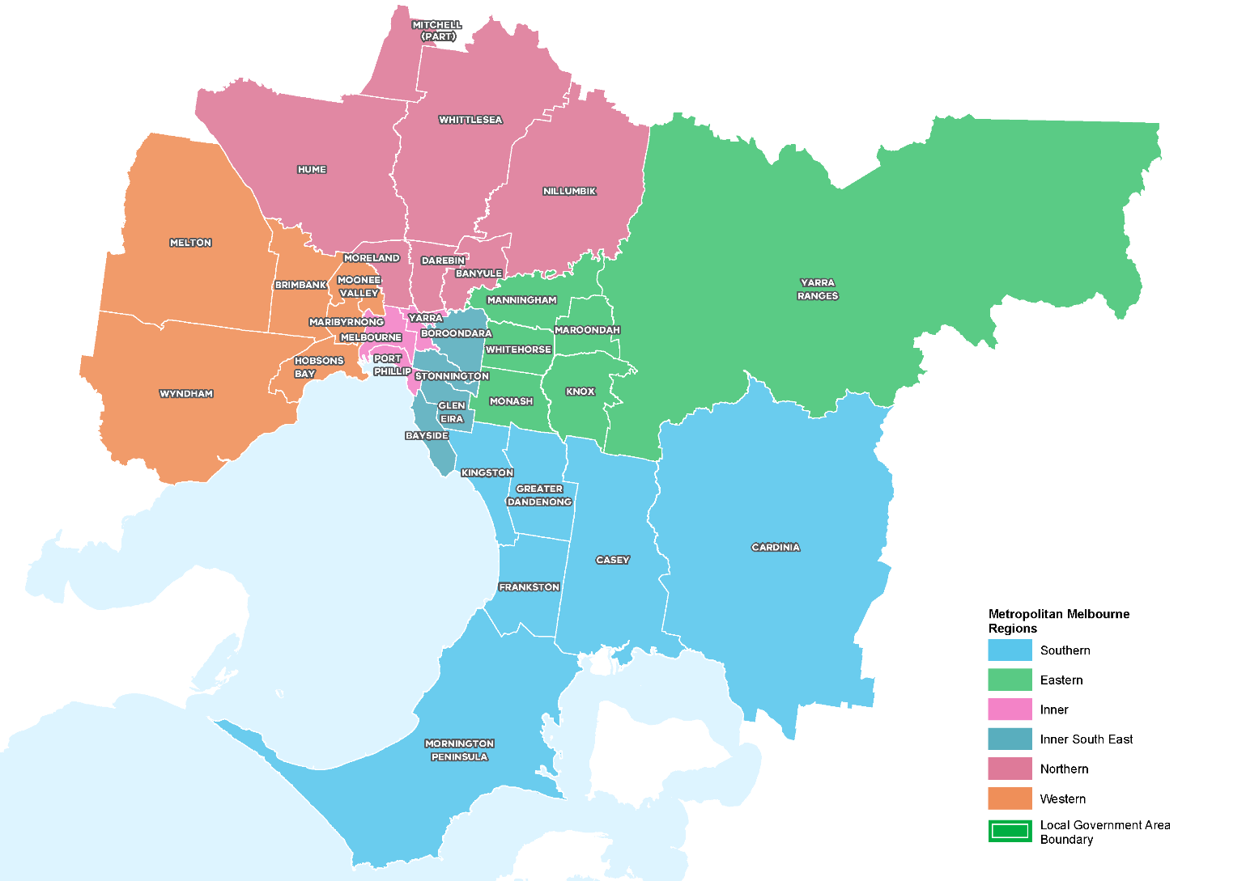

How will the land use framework plans be used?
The LUFPs will be used to:
- Drive the majority of Melbourne’s population growth into established areas through a land use framework that identifies places of state and regional significance
- Guide the strategic integration of land use and infrastructure (including housing and jobs aspirations) in key areas and precincts
- Guide the development of Melbourne’s greenfield growth areas
- Facilitate collaboration by state and local government, key agencies and partners on regional planning and regional priorities
- Inform priority places for state-led planning
- Enable metropolitan councils to update their municipal strategies and policies within a clearly defined land use framework.
The LUFPs will set regional-level planning policy to be implemented into planning schemes. They will inform local councils in decision-making for precinct planning, local and regional planning strategies, and infrastructure and servicing projects.
The LUFPs include a number of short- to medium- term actions for state and local government, which will contribute to planning outcomes in each region alongside existing actions under Plan Melbourne and other government programs and initiatives. Action monitoring will be led by DELWP in partnership with the metropolitan region through the EPWGs, and the actions will be formally reviewed every five years in conjunction with Plan Melbourne 2017-2050 Five-Year Implementation Plan.
Annual progress reports outlining the status of actions will be published by DELWP as a part of Plan Melbourne monitoring. These progress reports will be publicly available.
The chapter on implementation provides further details on how the LUFPs will be used to deliver Plan Melbourne outcomes across the regions.
Appendix 01 identifies the range of related initiatives already underway by state and local government to support the implementation of Plan Melbourne. The LUFPs are designed to complement these initiatives.

The land use framework
The LUFPs establish a common land use framework across the regions (Table 1). This common framework confirms places of state significance as identified in Plan Melbourne and introduces places of regional significance for each metro region.
The land use framework will direct land use decisions and investment, better align state and local government planning, and inform the development of local council planning strategies (including housing strategies). In the process, this common framework will also ensure land use, planning and development all support the vision of Plan Melbourne.
The land use framework
Places of state significance (as identified in Plan Melbourne) | Places of regional significance
- Central City  - National employment and innovation clusters (NEICs)  - Metropolitan activity centres  - State-significant industrial precincts (SSIPs)  - Transport gateways  - State-significant health and/or education precincts  - Major urban renewal precincts | - Major activity centres  - Activity corridors  - Regionally-significant industrial precincts (RSIPs)  - Enterprise precincts  - Regionally-significant health and/or education precincts  - Inter-regional environmental features  - Regional open space  - Greenfield growth areas  - Urban renewal areas  - Housing opportunity and investigation areas  - Green wedges

Regional planning and collaboration
Planning at a regional level is an opportunity for state and local governments to work together to manage long-term growth and change across Melbourne (Figure 2).
While the Northern Metro Region has many unique opportunities and challenges, there are some opportunities and challenges common across all metropolitan regions, such as ensuring jobs are available close to public transport; increasing housing supply in areas with access to jobs, services and public transport; and mitigating and adapting to climate change. The LUFP allows for these differences and recognises regional initiatives already underway.
The LUFPs will guide regional planning and collaboration vertically (between state and local government) and horizontally (across local councils in partnership with other stakeholders, including Traditional Owners).
- Inter-relationship between state and local planning
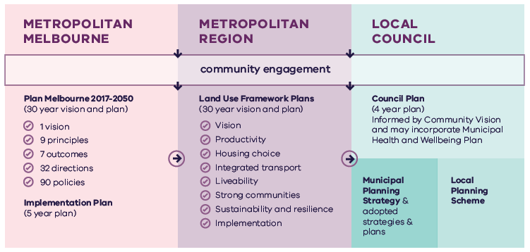
Metropolitan Melbourne | Metropolitan Region | Local Council
Is informed by community engagement. | Is informed by community engagement and Metropolitan Melbourne planning. | Is informed by community engagement, Metropolitan Melbourne planning and Metropolitan Region planning.
Includes:  - Plan Melbourne 2017-2050 (30 year vision and plan)  - 1 vision  - 9 principles  - 7 outcomes  - 90 policies  - Implementation Plan (5 year plan) | Includes:  - Land Use Framework Plans (30 year vision and plan)  - Vision  - Productivity  - Housing choice  - Integrated transport  - Liveability  - Strong communities  - Sustainability and resilience  - Implementation | Includes:  - Council Plan (4 year plan)  - Informed by Community Vision and may incorporate Municipal Heath and Wellbeing Plan  - Municipal Planning Strategy & adopted strategies & plans  - Local Planning Scheme

State-led planning
The Victorian Government has identified priority areas for state-led planning. The purpose of state-led planning in those areas is to maximise land use and infrastructure integration, attract investment, and deliver housing, jobs and services within established urban areas (Table 2).
State-led planning often involves the Victorian Government partnering with local councils and other stakeholders to develop or implement strategic plans, plan for change or respond to an investment, and/or identify key catalyst projects or programs that support growth and attract investment.
Current places for state-led planning in the Northern Metro Region
Places of state significance
National employment and innovation clusters
La Trobe
Metropolitan activity centres
Broadmeadows Epping Lockerbie

Growth area planning
The LUFPs provide a strategic planning framework to guide future development of Melbourne’s three growth corridors – Northern, Western and South Eastern. The LUFPs incorporate and update information from the growth corridor plans prepared by the former Metropolitan Planning Authority, now the Victorian Planning Authority (VPA).
The growth corridor plans set the strategic direction for future urban development in the growth areas, including:
- Areas suitable for urban development and the broad form of development (residential, industrial, commercial)
- Areas of high environmental or landscape value that must be protected from development
- The integrated open space network
- Strategic transport infrastructure and options for further investigation
- Locations suitable for a wide range of employment uses.
The following principles underpin the growth corridor plans and are reflected in Plan Melbourne and the LUFPs:
Principle 1 | Create diverse and vibrant new urban communities
Principle 2 | Integrate transport and land use planning
Principle 3 | Plan for local employment creation
Principle 4 | Create growth corridors with high amenity and character
Principle 5 | Protect biodiversity, waterways and cultural heritage values
Principle 6 | Create integrated open space networks
Principle 7 | Plan for environmental sustainability
Principle 8 | Stage development to ensure the efficient and orderly provision of infrastructure and services
This Northern Metro Region LUFP replaces the North and Sunbury/Diggers Rest growth corridor plans.
The Northern Metro Region LUFP will guide and inform the preparation, completion and implementation of the remaining Precinct Structure Plans (PSPs) in these growth areas.
This LUFP does not commit the Victorian Government to specific infrastructure, development projects or levels of service provision within the Northern Metro Region. Information included in this LUFP is intended to guide planning for future development; however it should not be interpreted as a delivery mechanism or program committing the Victorian Government to specific infrastructure or development projects or specific levels of service provision.

The broader context

Climate change – the need for both mitigation and adaptation
Victoria’s Climate Change Strategy (2021) translates the Climate Change Act 2017 into concrete action by introducing ambitious but achievable interim emissions reduction targets to keep Victoria on track to net zero emissions by 2050. The Strategy includes actions to reduce emissions now and lay the foundations for future reductions across the economy, including but not limited to the following: continuing the transition to clean, renewable energy production; establishing a light vehicle sales target of 50 per cent zero emissions vehicles by 2030; investing in land restoration and carbon farming initiatives; supporting Victorian farmers to respond to the impacts of climate change; and creating new jobs by promoting growth within the waste recycling and renewable energy sectors. These measures will help reduce the size of Melbourne’s carbon footprint and improve its resilience to the impacts of climate change.
Land use and transport integration – such as locating homes close to public transport and bike and walking paths – is critical to achieving net-zero emissions. In 2018, cars made up just over half of all transport emissions, with road vehicles responsible for almost 90 per cent of those transport emissions. Transport emissions by mode and road transport sub-categories are shown in Figure 3.
- Transport emissions by mode and road transport sub-categories – Victoria 2018
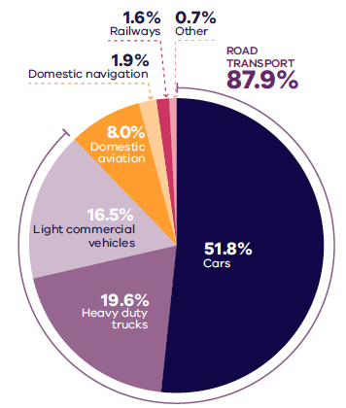
DELWP (2020) Victorian Greenhouse Gas Emissions Report 2018, State of Victoria: Melbourne, Australia.

Figure 3. Transport emissions by mode and road transport sub-categories - Victoria 2018
Cars | 51.8 per cent
Heavy duty trucks | 19.6 per cent
Light commercial vehicles | 16.5 per cent
Domestic aviation | 8.0 per cent
Domestic navigation | 1.9 per cent
Railways | 1.6 per cent
Other | 0.7 per cent
Source: Victorian Greenhouse Gas Emissions Report 2018, DELWP, 2020, State of Victoria: Melbourne, Australia.

In Melbourne, despite increased public transport usage and significant public transport investment, cars remain the dominant mode of transport. In 2016, for example, private vehicles accounted for 67 per cent of trips in Melbourne. To achieve net-zero emissions, Victoria’s private vehicle use must be dramatically reduced.
The Victorian Government is working towards a more sustainable built environment through reforms to construction, planning and energy provision across metropolitan Melbourne and Victoria. These regulatory reforms will reduce the energy consumption of appliances, require improved environmentally sustainable development (ESD) outcomes in new buildings and subdivisions, and improve the efficiency of energy production and distribution.
The Victorian Government recently released its Environmentally Sustainable Development of Buildings and Subdivisions – A Roadmap for Victoria’s Planning System (the Roadmap). This document outlines updates to the planning system that support broader, state-level ESD policy objectives. It sets out additional ESD objectives and standards for the design of new buildings, as well as the layout of large-scale residential subdivisions proposed through the Victoria Planning Provisions.
The Roadmap also sets out other initiatives, including new approaches to energy management – such as renewable and distributed energy technologies, microgrids and battery farms, better stormwater management, increased landfill diversion practices, and the promotion of sustainable modes of transport.
Victoria is actively decarbonising the energy sector through the construction of better buildings and the transition to renewable energy generation (including onsite solar photovoltaic and large-scale renewable energy projects). Victoria’s planning policies will also facilitate appropriate development of low emission and zero emission energy supply infrastructure.
Good precinct structure planning can also reduce greenhouse gas emissions and make communities more climate resilient. That is why affordable and clean energy infrastructure should be used to support sustainable development and sustainable transport.

20-minute neighbourhoods
The LUFPs aim to create more 20-minute neighbourhoods in Melbourne’s six metropolitan regions by planning for established areas, growth areas and major transport infrastructure projects. The LUFPs also provide the regional direction and strategies to inform the delivery of 20-minute neighbourhoods through structure planning.

Future PSPs in growth areas will be guided by the 20-minute neighbourhoods principle and the Victorian Planning Authority’s guidelines for precinct structure planning.

City-shaping transport projects
The Victorian Government is currently implementing the largest transport infrastructure program in the state’s history. City-shaping projects (Figure 4) include:
- The West Gate Tunnel – creating a second river crossing to link the Western Metro Region with the Port of Melbourne, CityLink and the Central Business District (CBD), and take traffic pressures off the West Gate Bridge
- Level crossing removals including along the Hurstbridge, Mernda and Upfield railway lines, reducing congestion and unlocking land for development
- Metro Tunnel – linking Melbourne’s south-east and Gippsland to the Sunbury line in Melbourne’s west and north-west
- North East Link – connecting Melbourne’s south-east to the Eastern Freeway, the Western Ring Road and Hume Freeway
- Melbourne Airport Rail – connecting Melbourne Airport to Victoria’s regional and metropolitan train network
- Suburban Rail Loop (SRL) – connecting every major passenger railway line in Melbourne from the Frankston line in the south to the Werribee line in the west. SRL East (Cheltenham to Box Hill) is scheduled to begin in 2022. SRL East will also connect key employment and education precincts, facilitate uplift and intensive development of station precincts.
These city-shaping projects will improve access to jobs, education and social opportunities in the Northern Metro Region. They will also connect the Northern Metro Region with other areas of Melbourne and Victoria. In addition, they are also creating opportunities to make the Northern Metro Region more prosperous, sustainable and liveable through the integration of land use and transport planning.
The purpose of integrated land use and transport planning is to bring jobs, services and leisure opportunities closer to where people live. This means shorter trips, the option to use active transport, and less time spent travelling – leading to a better quality of life and the creation of 20-minute neighbourhoods. In addition, this integrated approach also frees up capacity for freight, public transport and active transport journeys – reducing transport emissions.

Coronavirus (COVID-19) impacts
The coronavirus (COVID-19) pandemic is having dramatic impacts on Victoria’s population, economy and society.
With movement restricted, migration to Victoria has been reduced almost to zero. The Australian Government’s expectations for overseas migration losses will see Victoria’s population decline slightly in 2020-21, compared with average growth of 2 per cent for most of the previous decade. International migration is expected to resume within one to two years but not return to normal until the mid-2020s at the earliest.
This interruption to growth is not expected to change the long-term future direction of Melbourne.
However, the global pandemic has had significant impacts. This includes the shift to work-from-home arrangements for large parts of the metropolitan workforce, a greater uptake of online retail services and a shift to local living, with more people are relying on their activity centres and neighbourhoods to meet their day-to-day needs. Many industry sectors impacted by COVID-19 restrictions, including tourism, the arts and international education, are still recovering.
The LUFPs will help Melbourne’s metropolitan regions manage the economic and social impacts of the pandemic especially in specific areas such as Melbourne’s CBD and the Monash and Bundoora education precincts.
The progress of each LUFP will be monitored and revisited to ensure each regional land use pathway continues to contribute to Plan Melbourne’s outcomes.
- City-shaping transport projects
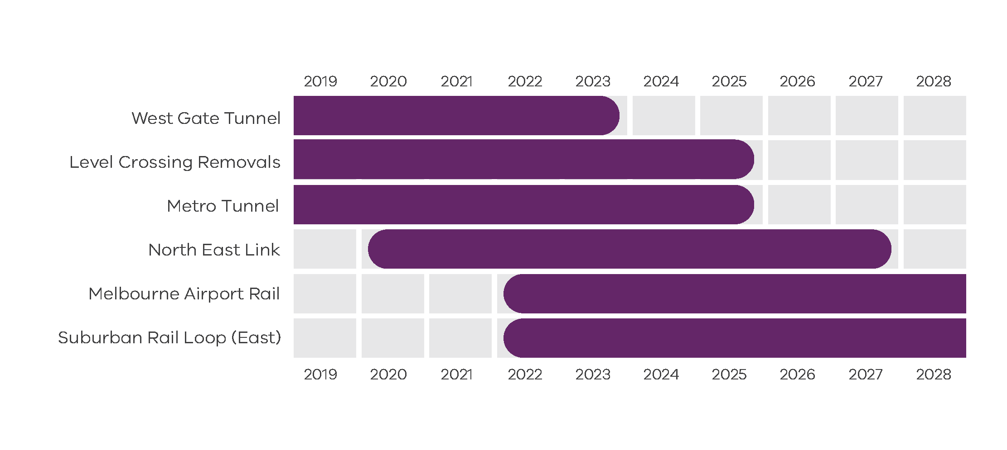
Department of Environment, Land, Water and Planning 2021

Figure 4. City-shaping transport projects
West Gate Tunnel | Pre-2019 to 2023
Level Crossings Removals | Pre-2019 to 2025
Metro Tunnel | Pre-2019 to 2025
North East Link | From 2020 to 2027
Melbourne Airport Rail | From 2022 to post-2028
Suburban Rail Loop (East) | From 2022 to post-2028
Source: Department of Environment, Land, Water and Planning 2021

Chapter 02.
Regional snapshot
The Northern Metro Region includes the local government areas (LGAs) of Banyule, Darebin, Hume, Mitchell (part), Moreland, Nillumbik and Whittlesea.
- Northern Metro Region
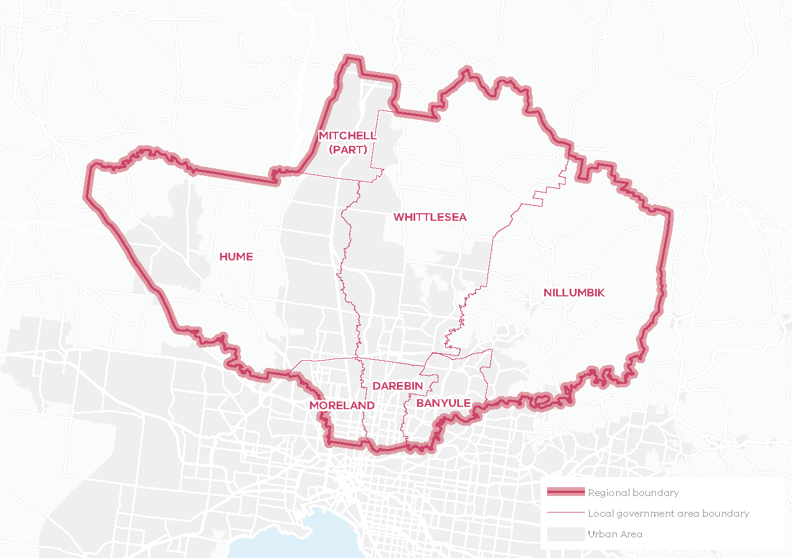
Total area: 167,350HA
19% of Metropolitan Melbourne
Over 50% of the region is designated green wedge land
The region extends from the inner suburbs of Brunswick, Coburg, Preston, Northcote, Heidelberg and Ivanhoe to some of the city’s newest communities in Sunbury, Craigieburn, Mernda and Wallan. Figure 5 shows the total area of the Northern Metro Region in hectares and its percentage of metropolitan Melbourne.
The Wurundjeri Woi Wurrung people of the Kulin Nation are the Traditional Owners of the lands that now make up the Northern Metro Region of Melbourne whose ancestors lived on the land for millennia.

Urban structure
The Northern Metro Region’s urban geography and structure is defined by river corridors, treed suburbs and rural landscapes in the east, volcanic plains with dormant volcanic cones and new urban growth in the north and west with views to the Great Dividing Range. The urban structure corresponds to three concentric bands of development – inner suburbs, middle ring suburbs and outer suburbs. The satellite towns of Sunbury and Wallan, which are the exceptions to this evolution of development, function as both outer suburban areas as well as regional centres. A central spine of industrial land clustered around the Hume Freeway separates the growth areas of Hume and Whittlesea.
Green wedges, beyond the Urban Growth Boundary (UGB), include Melbourne Airport to the west. They also include incised valleys, agriculture, grassy eucalypt woodlands and scattered old river red gums to the north, as well as bushland and reservoirs. Settlements in the green wedges include Whittlesea, Panton Hill and St Andrews.
The Northern Metro Region comprises very distinct and often physically separated suburbs – some of which are well established, some which are growing rapidly and some which are planned. These include:
- Sunbury – an existing regional centre and growth corridor
- Growth corridors – Hume (Craigieburn-Donnybrook) and Whittlesea (Epping-Wollert, Mernda/Doreen)
- The Wallan township and surrounding growth areas
- Older established areas along the Metropolitan Ring Road (OMR) – Broadmeadows/Glenroy, Thomastown/Lalor
- Inner areas with older, fine-grain development and pockets of larger urban renewal sites with higher development densities along the north-south rail and tram spines – Brunswick, Coburg, Northcote, Preston, Heidelberg
- Suburbs in a treed landscape along the Yarra and Plenty rivers – Ivanhoe, Rosanna, Greensborough, Eltham.
Population and demographics
The Northern Metro Region has played a major role in accommodating Melbourne’s recent population growth amid significant change and transformation in its industry structure, employment and demographic profile.
The region’s population is expected to grow by around 765,000 people between 2020 and 2051 to a total population of 1.8 million people or 22 per cent of Melbourne’s total population.
Future population projections and industry trends suggest Melbourne’s north will continue to undergo significant growth and change as it transitions from traditional manufacturing to a more diverse and technology-focused industry base.
The most prevalent household type in the Northern Metro Region is couples with children and the largest age group is the 30-44 year olds. This age group is projected to remain the largest age group in 2051 indicating the potential for a growth in young families.
Outlined below are some of the key demographics and land use features of the Northern Metro Region.
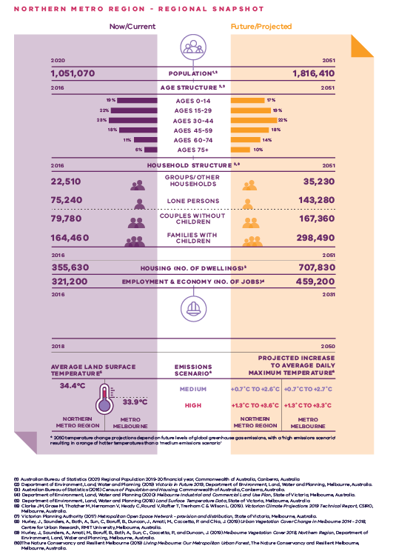
Northern Metro Region - Regional Snapshot
Northern Metro Region population  Sources:  Australian Bureau of Statistics (2021) Regional Population 2019-20 financial year, Commonwealth of Australia, Canberra, Australia.  Department of Environment, Land, Water and Planning (2019) Victoria in Future 2019, Department of Environment, Land, Water and Planning, Melbourne, Australia. | 2020 (now/current):  1,051,070 inhabitants | 2051 (projected/future):  1,816,410 inhabitants
Northern Metro Region age structure  Sources:  Department of Environment, Land, Water and Planning (2019) Victoria in Future 2019, Department of Environment, Land, Water and Planning, Melbourne, Australia.  Australian Bureau of Statistics (2016) Census of Population and Housing, Commonwealth of Australia, Canberra, Australia. | 2016 (now/current):  19 per cent – Ages 0 to 14  22 per cent – Ages 15 to 29  23 per cent – Ages 30 to 44  18 per cent – Ages 45 to 59  11 per cent – Ages 60 to 74  6 per cent – Ages 75 plus | 2051 (projected/future):  17 per cent – Ages 0 to 14  19 per cent – Ages 15 to 29  22 per cent – Ages 30 to 44  18 per cent – Ages 45 to 59  14 per cent – Ages 60 to 74  10 per cent – Ages 75 plus
Northern Metro Region household structure  Sources:  Department of Environment, Land, Water and Planning (2019) Victoria in Future 2019, Department of Environment, Land, Water and Planning, Melbourne, Australia.  Australian Bureau of Statistics (2016) Census of Population and Housing, Commonwealth of Australia, Canberra, Australia. | 2016 (now/current):  Groups/other households – 22,510  Lone persons – 75,240  Couples without children – 79,780  Families with children – 164,460 | 2051 (projected/future):  Groups/other households – 35,230  Lone persons – 143,280  Couples without children – 167,360  Families with children – 298,490
Northern Metro Region housing (number of dwellings)  Source:  Department of Environment, Land, Water and Planning (2019) Victoria in Future 2019, Department of Environment, Land, Water and Planning, Melbourne, Australia. | 2016 (now/current):  355,630 dwellings | 2051 (projected/future):  707,830 dwellings
Northern Metro Region employment and economy (number of jobs)  Source:  Department of Environment, Land, Water and Planning (2020) Melbourne Industrial and Commercial Land Use Plan, State of Victoria, Melbourne, Australia. | 2016 (now/current):  321,200 jobs | 2031 (projected/future):  459,200 jobs
2018 average land surface temperature  Source:  Department of Environment, Land, Water and Planning (2018) Land Surface Temperature Data, State of Victoria, Melbourne, Australia. | Northern Metro Region:  34.4 degrees Celsius | Metro Melbourne:  33.9 degrees Celsius
2050 projected increase to average daily maximum temperature  *2050 temperature change projections depend upon future levels of global greenhouse gas emissions, with a ‘high emissions scenario’ resulting in hotter temperatures than a ‘medium emissions scenario’  Source:  Clarke J.M., et al. (2019). Victorian Climate Projections 2019 Technical Report, CSIRO, Melbourne, Australia. | Northern Metro Region:  Medium emissions scenario – plus 0.7 to plus 2.6 degrees Celsius  High emissions scenario – plus 1.3 to plus 3.6 degrees Celsius | Metro Melbourne:  Medium emissions scenario – plus 0.7 to plus 2.7 degrees Celsius  High emissions scenario – plus 1.3 to plus 3.3 degrees Celsius

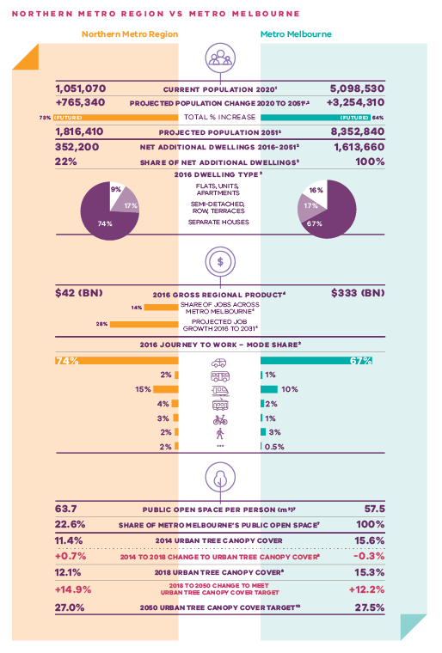
Northern Metro Region vs Metro Melbourne
 | Northern Metro Region | Metro Melbourne
Current population 2020  Source:  Australian Bureau of Statistics (2021) Regional Population 2019-20 financial year, Commonwealth of Australia, Canberra, Australia. | 1,051,070 inhabitants | 5,098,530 inhabitants
Projected population change 2020 to 2051  Sources:  Australian Bureau of Statistics (2021) Regional Population 2019-20 financial year, Commonwealth of Australia, Canberra, Australia.  Department of Environment, Land, Water and Planning (2019) Victoria in Future 2019, Department of Environment, Land, Water and Planning, Melbourne, Australia. | Plus 765,340 inhabitants | Plus 3,254,310 inhabitants
Total per cent population change (future) | 73 per cent | 64 per cent
Projected population 2051  Source:  Department of Environment, Land, Water and Planning (2019) Victoria in Future 2019, Department of Environment, Land, Water and Planning, Melbourne, Australia. | 1,816,410 inhabitants | 8,352,840 inhabitants
Net additional dwellings 2016 to 2051  Source:  Department of Environment, Land, Water and Planning (2019) Victoria in Future 2019, Department of Environment, Land, Water and Planning, Melbourne, Australia. | 352,200 dwellings | 1,613,660 dwellings
Share of net additional dwellings  Source:  Department of Environment, Land, Water and Planning (2019) Victoria in Future 2019, Department of Environment, Land, Water and Planning, Melbourne, Australia. | 22 per cent | 100 per cent
2016 dwelling type  Source:  Australian Bureau of Statistics (2016) Census of Population and Housing, Commonwealth of Australia, Canberra, Australia. | Flats, apartments, units – 9 per cent  Semi-detached, row, terraces – 17 per cent  Separate houses – 74 per cent | Flats, apartments, units – 16 per cent  Semi-detached, row, terraces – 17 per cent  Separate houses – 67 per cent
2016 gross regional product  Source:  Department of Environment, Land, Water and Planning (2020) Melbourne Industrial and Commercial Land Use Plan, State of Victoria, Melbourne, Australia. | $42 billion | $333 billion
Share of jobs across Melbourne  Source:  Department of Environment, Land, Water and Planning (2020) Melbourne Industrial and Commercial Land Use Plan, State of Victoria, Melbourne, Australia. | 14 per cent
Projected job growth to 2031  Source:  Department of Environment, Land, Water and Planning (2020) Melbourne Industrial and Commercial Land Use Plan, State of Victoria, Melbourne, Australia. | 28 per cent
2016 journey to work – mode share  Source:  Australian Bureau of Statistics (2016) Census of Population and Housing, Commonwealth of Australia, Canberra, Australia. | Private motor vehicle – 74 per cent  Bus – 2 per cent  Train – 15 per cent  Tram – 4 per cent  Bicycle – 3 per cent  Walking – 2 per cent  Other – 2 per cent | Private motor vehicle – 67 per cent  Bus – 1 per cent  Train – 10 per cent  Tram – 2 per cent  Bicycle – 1 per cent  Walking – 3 per cent  Other – 0.5 per cent
Public open space per person (metres squared)  Source:  Victorian Planning Authority (2017) Metropolitan Open Space Network: Provision and Distribution, State of Victoria, Melbourne, Australia. | 63.7 | 57.5
Share of metro Melbourne’s public open space  Source:  Victorian Planning Authority (2017) Metropolitan Open Space Network: Provision and Distribution, State of Victoria, Melbourne, Australia. | 22.6 per cent | 100 per cent
2014 urban tree canopy cover  Source:  Hurley, J., et al. (2019) Urban Vegetation Cover Change in Melbourne 2014 - 2018, Centre for Urban Research, RMIT University, Melbourne, Australia. | 11.4 per cent | 15.6 per cent
2014 to 2018 change to urban tree canopy cover | Plus 0.7 per cent | Minus 0.3 per cent
2018 urban tree canopy cover  Source:  Hurley, J., et al. (2019) Melbourne Vegetation Cover 2018, Northern Region, Department of Environment, Land, Water and Planning, Melbourne, Australia. | 12.1 per cent | 15.3 per cent
2018 to 2050 change to meet urban tree canopy cover target | Plus 14.9 per cent | Plus 12.2 per cent
2050 urban tree canopy cover target  Source:  The Nature Conservancy and Resilient Melbourne (2019) Living Melbourne: Our Metropolitan Urban Forest, The Nature Conservancy and Resilient Melbourne, Melbourne, Australia. | 27.0 per cent | 27.5 per cent

Chapter 03.
Vision: Northern Metro Region in 2050
The Northern Metro Region has a significant and unique role in ensuring that “Melbourne will continue to be a global city of opportunity and choice.”
The Northern Metro Region is Victoria’s interstate and international gateway with communities well connected to jobs, activity centres, and the broader region by a high-quality transport network. The region is an attractive and affordable place to live and work that has transitioned from a traditional manufacturing area to a region of highly-skilled employment opportunities. By 2050 the Northern Metro Region will experience significant planned change including:
- Confirmation of the region as Victoria’s interstate and international gateway, with strategic connections through Melbourne Airport, the Beveridge Interstate Freight Terminal, the Hume Freeway, the Melbourne-Sydney-Brisbane rail line and interstate rail and logistics hubs.
- Protected and well-planned industrial precincts continue to attract strong economic investment and are integrated through the road and rail network and significant hubs including the Melbourne Wholesale Fruit and Vegetable and Flower Market and the Beveridge Interstate Freight Terminal.
- The La Trobe NEIC as the region’s economic focal point supported by a network of vibrant and attractive activity centres anchored by Broadmeadows, Epping and Lockerbie, each containing well-developed health, education, retail and commercial assets delivering significant employment growth.
- Thousands of jobs created in the food and beverage industry, agriculture and food science, advanced manufacturing, health and logistics industries, attracted by Melbourne Wholesale Fruit and Vegetable and Flower Market and La Trobe University’s established food and agriculture capability. Creative precincts thrive in and around Brunswick, Northcote and in some outer suburban and green wedge areas.
- The region has high-quality, affordable housing with most housing in well-designed activity centres and locations with good public transport, services and amenities. A diversity of housing and lifestyle opportunities from inner urban living, bush and rural settings to greenfield areas. Its outer areas are vibrant, well-serviced communities each with a distinct character defined by its natural setting – the foothills, woodlands, creeks and waterways.
- Residents and workers enjoy public spaces and cycling and pedestrian networks that support 20-minute neighbourhoods. The open space network has more accessible passive and active open space and is interconnected across the region. By 2050, the local urban environment is cooler with more tree canopy, and new public and private development is environmentally sustainable.
- Communities are well-connected to jobs and activity centres and the Northern Metro Region boasting a new, high-quality transport network.
The region’s green wedge land including farmland, natural habitats, significant grasslands and waterways are valued and protected. The Yarra River creek corridor network with its characteristic river red gums, enhance the region’s distinctiveness, liveability, biodiversity and resilience to climate change.
For a more detailed picture of how land use in the Northern Metro Region is expected to change by 2050 refer to Map 1.

- Northern Metro Region 2050 Plan
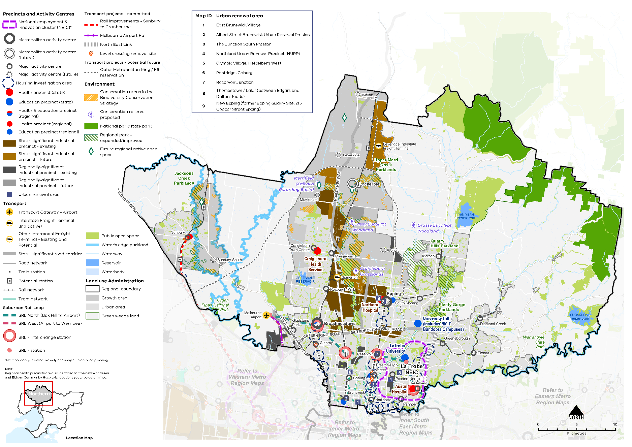
Map 1 Northern Metro Region 2050 Plan

A plan of the Northern Metro Region in 2050 showing -
- The region’s boundary, the urban growth boundary, green wedge land, established urban area and growth areas.

- Locations for growth and investment, including:
- The location and indicative boundary of the La Trobe NEIC in the south of the region^
- Existing and future state- and regionally- significant industrial precincts principally located through the centre of the region from south to north, as listed in tables 3 and 4
- Broadmeadows and Epping Metropolitan Activity Centres and the proposed metropolitan activity centre at Lockerbie
- The network of existing and future major activity centres predominantly located on the rail and road network, including the proposed major activity centres at Wallan, Beveridge, Mickleham, Sunbury South, and Wollert, as listed in table 6
- State- and regionally-significant health and/or education precincts, highlighting those at Heidelberg, Preston, Brunswick, Greensborough, Bundoora, Epping, Craigieburn, Broadmeadows and Sunbury, as listed in table 13
- The 10 urban renewal areas of:

East Brunswick Village
Albert Street Brunswick Urban Renewal Precinct
The Junction South Preston
Northland Urban Renewal Precinct (NURP)
Olympic Village, Heidelberg West
Pentridge, Coburg
Reservoir Junction
Thomastown / Lalor (between Edgars and Dalton Roads)
New Epping (former Epping Quarry Site, 215 Cooper Street Epping)

- Housing investigation areas as listed in table 11.
- Suburban Rail Loop North (Box Hill to Airport) stations at Bundoora and Melbourne Airport, and interchange stations at Heidelberg, Reservoir, Fawkner, and Broadmeadows.

- Key transport linkages and movement network including:
- Railway lines and train stations including new stations in the growth areas, Suburban Rail Loop (North) (Box Hill to Airport), Suburban Rail Loop (West) (Airport to Werribee) stations, the future Melbourne Airport Rail link and level crossing removal sites
- The road network including the state-significant road corridors of the Tullamarine Freeway and Metropolitan Ring Road, and the proposed Outer Metropolitan Ring / E6
- Transport gateways at Melbourne Airport and the proposed Beveridge Interstate Freight Terminal (indicative only).

Map 1 Northern Metro Region 2050 Plan continued

- State and regional natural and cultural assets, including:
- State and national parks, proposed or improved regional parks at Plenty Gorge Parklands, Quarry Hills, Upper Merri Creek Parklands and Jacksons Creek Parklands, and other public open space
- Reservoirs including Toorourrong Reservoir, Yan Yean Reservoir and Sugarloaf Reservoir in the north and east of the region, and Greenvale Reservoir on the edge of the urban area at Greenvale.

Notes:
- ^ NEIC boundary is indicative only and subject to detailed planning
- Regional health precincts are also identified for the new Whittlesea and Eltham Community Hospitals, locations yet to be determined.

Chapter 04.
Productivity
Plan Melbourne Outcome 1: Melbourne is a productive city that attracts investment, supports innovation and creates jobs
The Northern Metro Region is Victoria’s interstate and international gateway providing strategic connections through Melbourne Airport, the Hume Freeway and via rail to existing and proposed freight and logistics hubs within and beyond the region. The Northern Metro Region contributes $42 billion to the Victorian economy which amounts to 13 per cent of metropolitan Melbourne’s Gross Regional Product (GRP).
With connections into Victoria’s agricultural regions, the Northern Metro Region is a leader in innovation in the food and beverage industry across production, manufacturing, distribution, education and research.
Established health precincts and partnerships generate significant employment in the Northern Metro Region as well as opportunities to strengthen links between education and clinical research to support investment and innovation.
Plan Melbourne creates a city structure that strengthens Melbourne’s competitiveness for jobs and investment. It identifies national employment and innovation clusters (NEICs), state-significant industrial precincts (SSIPs), a network of metropolitan and major activity centres, transport gateways and state-significant health and education precincts to ensure employment growth occurs outside of the Central City linked by transport. The Northern Metro Region can be guided by this structure and has a strong basis from which to grow.

State of play
The employment and activity centres framework for Melbourne’s Northern Metro Region comprises the following major elements:
- The La Trobe NEIC, including La Trobe University, Northland Major Activity Centre, Austin Biomedical Alliance Precinct and the Heidelberg Major Activity Centre
- Metropolitan activity centres at Broadmeadows, Epping and Lockerbie (future)
- Melbourne Airport
- Northern SSIP
- Beveridge Interstate Freight Terminal (BIFT)
- Melbourne Wholesale Fruit, Vegetable and Flower Market
- Important waste and resource recovery facilities including the Cooper Street Waste and Resource Recovery Hub
- A network of 19 existing and five future major activity centres generally located on public transport corridors
- Older industrial and employment precincts, which are undergoing considerable change but still play an important role in providing affordable locations for new businesses and emerging industries
- Newer and planned employment precincts located along the Hume Freeway and Outer Metropolitan Ring/E6 transport corridor (OMR).
There is a large amount of industrial and commercial land across the Northern Metro Region providing state-, regionally- and locally-significant employment and economic functions. The region includes the Northern Growth Corridor which makes significant provision for future industry and housing.
A significant proportion of the region is green wedge land where there is a strong focus on productive land, landscape and open space and environment and biodiversity protection.
The region features the Sunbury, Whittlesea and Nillumbik green wedges. It also has substantial areas identified as containing stone resources that could sustain quarrying operations. These areas include sections within the Sunbury and Whittlesea green wedges, as well as an extensive portion within the UGB.
Key food and beverage facilities in the Northern Metro Region include the Melbourne Wholesale Fruit, Vegetable and Flower Market in Epping, La Trobe University’s established food and agriculture capability, RMIT University’s Food Research and Innovation Centre and Melbourne Polytechnic’s School of Food, Plant and Animal Industries.
The region has good connections to transport gateways such as the Port of Melbourne, Melbourne and Essendon airports, and the freight network along key roads and railway lines, with excellent access to the eastern seaboard.
In 2016, the region supported around 14 per cent of all employment across the metropolitan area, or 321,200 jobs. By 2031, approximately 138,000 additional jobs will be located across the region, with over half of these new jobs expected to be in Hume and Whittlesea LGAs. Industries expected to experience the strongest growth are healthcare and social assistance, education and training, retail trade, manufacturing and construction (Figure 6).
The Northern Metro Region has around 4960 hectares of land currently zoned for industrial uses. About a quarter of this land is vacant to accommodate future industrial uses. Based on the 2017-18 industrial land consumption rate of 52 hectares, there is an estimated 24 years’ supply of zoned industrial land in the region. An additional 2867 hectares is identified for future industrial purposes that is yet to be rezoned, which will add an additional 12 years of unzoned future industrial land supply (accounting for the land set aside for the proposed BIFT and its ancillary uses).
Regarding commercial floorspace, based on projected growth, by 2031 it is anticipated that approximately 1.4 million square metres of additional floorspace will be required across the Northern Metro Region. Approximately 800,000 square metres will be required for office uses and 600,000 square metres will be required for retail (DELWP, 2020a).

- Projected employment growth for the Northern Metro Region 2016 to 2031
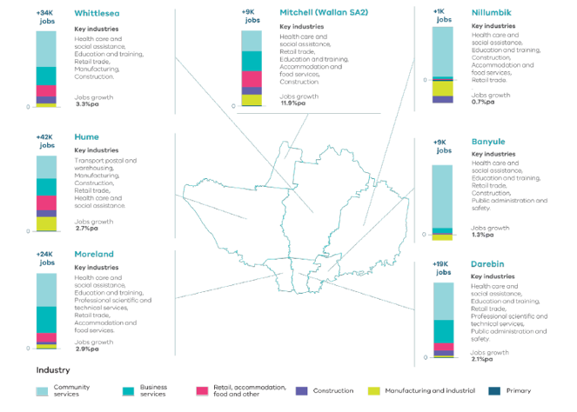
Melbourne Industrial and Commercial Land Use Plan, DELWP, 2020

Figure 6. Projected employment growth for the Northern Metro Region 2016 to 2031
Whittlesea | Plus 34,000 jobs | 3.3 per cent jobs growth per annum | Key industries: health care and social assistance, education and training, retail trade, manufacturing, construction
Hume | Plus 42,000 jobs | 2.7 per cent jobs growth per annum | Key industries: Transport, postal and warehousing, manufacturing, construction, retail trade, health care and social services
Moreland | Plus 24,000 jobs | 2.9 per cent jobs growth per annum | Key industries: health care and social assistance, education and training, professional scientific and technical services, retail trade, accommodation and food services
Mitchell (Wallan SA2) | Plus 9,000 jobs | 11.9 per cent jobs growth per annum | Key industries: health care and social assistance, retail trade, education and training, accommodation and food services, construction
Nillumbik | Plus 1,000 jobs | 0.7 per cent jobs growth per annum | Key industries: health care and social assistance, education and training, construction, accommodation and food services, retail trade
Banyule | Plus 9,000 jobs | 1.3 per cent jobs growth per annum | Key industries: health care and social assistance, education and training, retail trade, construction, public administration and safety
Darebin | Plus 19,000 jobs | 2.1 per cent jobs growth per annum | Key industries: health care and social assistance, education and training, retail trade, professional scientific and technical services, public administration and safety
Source: Department of Environment, Land, Water and Planning (2020) Melbourne Industrial and Commercial Land Use Plan, State of Victoria, Melbourne, Australia.

Regional strengths
- A strong network of major economic assets of Melbourne Airport, La Trobe NEIC, Broadmeadows and Epping metropolitan activity centres, and the future metropolitan activity centre at Lockerbie will attract investment and jobs.
- There is an important regional role for freight and logistics, particularly the future BIFT.
- Opportunities presented by SRL include the development of new stations or interchange stations as hubs for new activity.
- Creative industries in areas such as Brunswick and Northcote are a growing aspect of the region’s economy.
- The region’s green wedge includes important agricultural land, as well as a range of cultural and recreational assets that support the visitor economy, including tourism and agribusiness opportunities.
- Significant opportunities exist for economic, health and community activity from public transport improvements across the region.
- Growth areas will provide new employment and increase the containment of jobs, including opportunities to accommodate a diversity of uses.

Regional challenges
- Existing and proposed employment land needs to be protected from conversion to residential uses.
- Encroachment of sensitive uses must be managed, while growing and expanding the state-significant transport gateways and industrial precincts to attract higher order jobs.
- Extractive resources in the region, within and outside the UGB, require protection.
- A diversity of industrial land lot sizes should be provided, while responding to demand for large sites that can provide large-format uses or freight and logistics.
- There is a limited supply of employment and industrial land in the region.

Directions and strategies
The directions identified to achieve the 2050 vision for the Northern Metro Region in terms of Productivity and Outcome 1 of Plan Melbourne are:
Direction 1 | Facilitate the development of the La Trobe NEIC as a primary provider of tertiary education and health services supported by increased transport connectivity
Direction 2 | Protect and support the development of Melbourne Airport
Direction 3 | Support the development of a strong network of activity centres to provide jobs closer to where people live
Direction 4 | Manage and plan for industrial precincts in the Northern Metro Region to be continued generators of economic activity and employment
Direction 5 | Ensure the Northern Growth Corridor accommodates longer-term industrial and commercial development opportunities
Direction 6 | Ensure protection of green wedges and support their role to provide agriculture, extractive resources, tourism and state infrastructure for the long-term benefit of all Victorians

Each direction is implemented through regionally-specific strategies identified in this LUFP.
Map 2 shows how productivity will be enhanced across the Northern Metro Region by 2050 as a result of these directions and strategies, together with Plan Melbourne and other strategies and initiatives as outlined in Appendix 01.

- Northern Metro Region productivity 2050
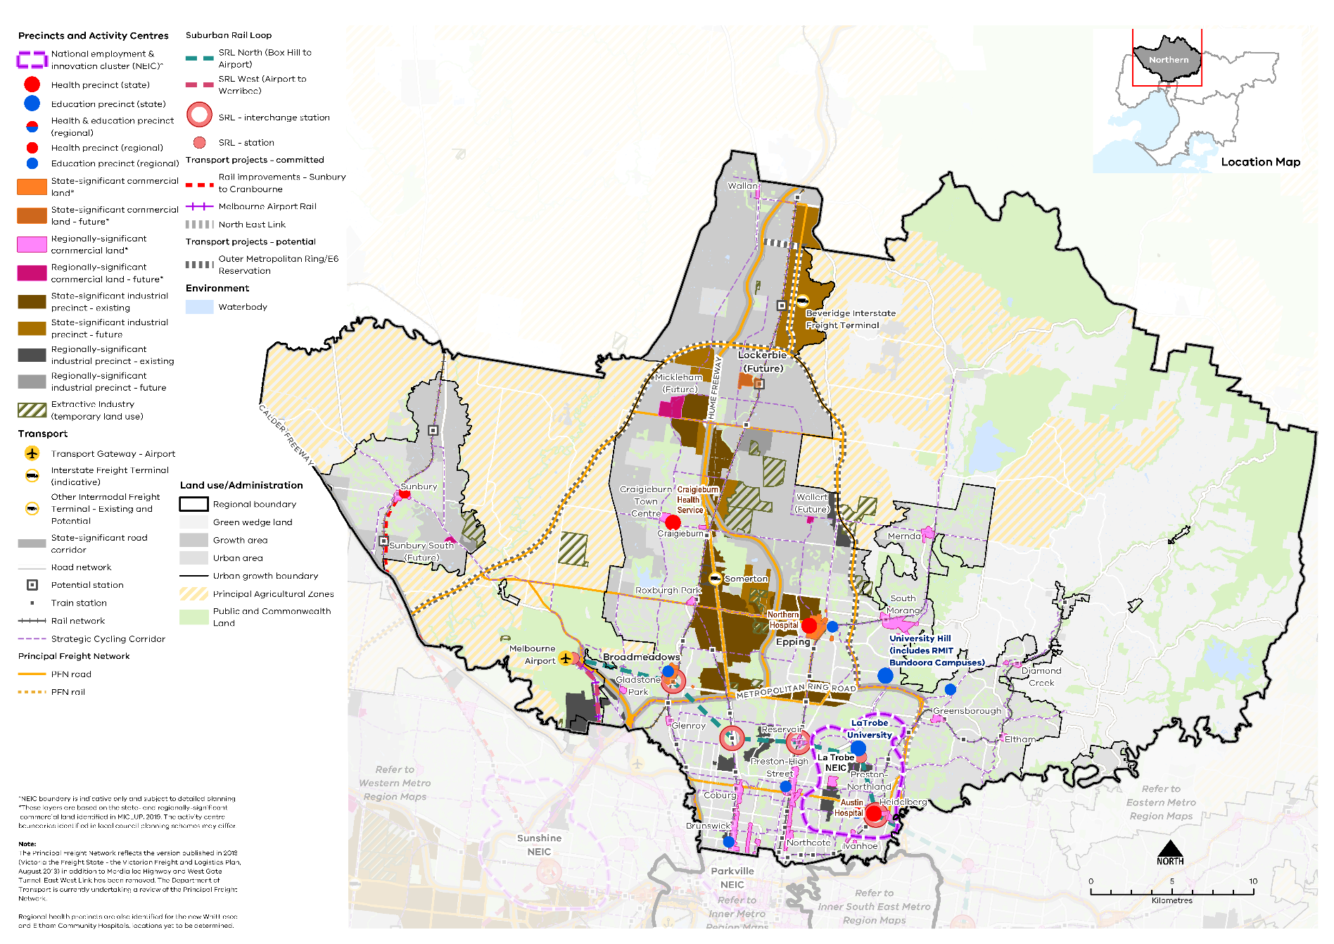
Map 2 Northern Metro Region productivity 2050
A plan of productivity in the Northern Metro Region in 2050, extracting the productivity features identified on Map 1 above, with the addition of:
- Existing state-significant commercial land at the metropolitan activity centres of Epping and Broadmeadows; and proposed state-significant commercial land at the proposed Lockerbie (future) Metropolitan Activity Centre*
- Existing and proposed regionally-significant commercial land dispersed throughout the established urban area and growth areas*
- Extractive industry (temporary land use)
- Principal agricultural zones
- Principal freight networks (PFN) – road and rail.
* These layers are based on the state- and regionally-significant commercial land identified in MICLUP, 2019. The activity centre boundaries identified in local council planning schemes may differ.
Note: The Principal Freight Network reflects the version published in 2013 (Victoria the Freight State - the Victorian Freight and Logistics Plan, August 2013) in addition to Mordialloc Highway and West Gate Tunnel. East West Link has been removed. The Department of Transport is currently undertaking a review of the Principal Freight Network.

- Facilitate the development of the La Trobe NEIC as a primary provider of tertiary education and health services supported by increased transport connectivity
Each NEIC identified across Melbourne is anchored by a specialised activity that provides the foundations for future economic specialisation and growth. The La Trobe NEIC’s strengths are in education, agricultural and health research, healthcare provision and retail (Figure 7).
To attract investment to La Trobe NEIC, high levels of amenity and improved connectivity will be needed as well as effective governance arrangements. Land use planning should ensure specialised activity within the NEIC is protected and able to grow, and that connections with complementary regional economic assets are strengthened, particularly the Melbourne Wholesale Fruit, Vegetable and Flower Market in Epping and the proposed Epping Food Hub.
A planned approach to integrated transport needs to occur within the La Trobe NEIC. Early land use and infrastructure planning, including bus access improvements, should be undertaken to support La Trobe NEIC and to maximise opportunities for land use and economic intensification. This could be unlocked through improved public transport connectivity arising from SRL, as well as access into the centre from the North East Link.
La Trobe University, Bundoora and its Research and Innovation Precinct is an integral part of the La Trobe NEIC. Its large land area, education and health role, and regional and inter-regional relationships are a significant opportunity for the future of the NEIC. Their close proximity to the Melbourne Wholesale Fruit, Vegetable and Flower Market at Epping and the proposed Epping Food Hub further enhances Victoria’s agriculture, food and fibre value chain, particularly in post-farm gate activities. Stronger university-industry links should be encouraged within the NEIC, including stronger connections to Heidelberg.
The Heidelberg Health Precinct is Victoria’s second largest medical precinct. It has significant capability in health services, training and research including Austin Health. The precinct and its supporting industries and services will continue to expand to deliver high-end health outcomes and boost innovation and employment diversity at the La Trobe NEIC. Co-location and clustering of allied health, research and education activities should be encouraged within the NEIC’s established institutions.
The East Preston Industrial Precinct, which is included in the Northland Urban Renewal Precinct, is a regionally-significant industrial precinct within the NEIC and has a diversity of lot sizes suitable for creative industries. The Heidelberg West Business Park, adjacent to La Trobe University and within the La Trobe NEIC, houses a range of manufacturing, construction, wholesale trade and motor industry businesses. It can continue to evolve to support higher technology production and services.
- Strengthen La Trobe NEIC as the pre-eminent healthcare, education, agriculture and health research provider and activity cluster in the Northern Metro Region.
- Facilitate land use and economic intensification of the La Trobe NEIC to leverage transport infrastructure investment and improved public transport connectivity.
- Encourage manufacturing, research and development, education and logistics uses in the Epping Food Hub to strengthen its role as an export and innovation food hub.

- La Trobe National Employment and Innovation Cluster

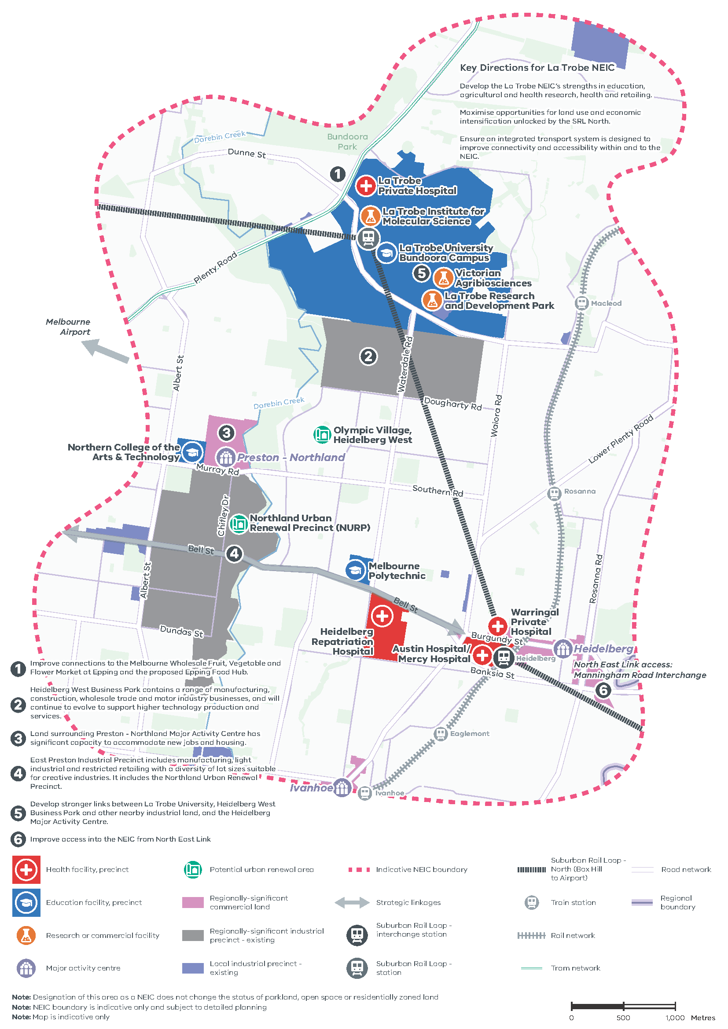

Figure 7. La Trobe National Employment and Innovation Cluster
A map of La Trobe National Employment and Innovation Cluster, showing –
- Indicative NEIC boundary
- Health facility, precinct identified at Heidelberg Repatriation Hospital, Austin Hospital / Mercy Hospital, Warringal Private Hospital and La Trobe Private Hospital
- Education facility, precinct identified at La Trobe University Bundoora Campus, Northern College of the Arts and Technology and Melbourne Polytechnic
- Research or commercial facility at La Trobe Institute for Molecular Science, Victorian Agribiosciences, La Trobe Research and Development Park
- Major activity centres at Heidelberg and Preston – Northland
- Potential urban renewal area at Olympic Village, Heidelberg West
- Regionally-significant commercial land
- Regionally-significant industrial precinct – existing, and local industrial precinct -existing
- Strategic linkages
- Suburban Rail Loop North (Box Hill to Airport)
- Suburban Rail Loop inter change station at Heidelberg, and station at Bundoora
- Rail network and train stations
- The road and tram network
- The regional boundary, with the Eastern Metro Region to the south-east of the NEIC.
Map notes (numbered on the ap)
- Improve connections to the Melbourne Wholesale Fruit, Vegetable and Flower Market at Epping and the proposed Epping Food Hub.
- Heidelberg West Business Park contains a range of manufacturing, construction, wholesale trade and motor industry businesses, and will continue to evolve to support higher technology production and services.
- Land surrounding Preston - Northland Major Activity Centre has significant capacity to accommodate new jobs and housing.
- East Preston Industrial Precinct includes manufacturing, light industrial and restricted retailing with a diversity of lot sizes suitable for creative industries. It includes the Northland Urban Renewal Precinct.
- Develop stronger links between La Trobe University, Heidelberg West Business Park and other nearby industrial land, and the Heidelberg Major Activity Centre.
- Improve access into the NEIC from North East Link
Key Directions for La Trobe NEIC
- Develop the La Trobe NEIC’s strengths in education, agricultural and health research, health and retailing.
- Maximise opportunities for land use and economic intensification unlocked by the SRL North.
- Ensure an integrated transport system is designed to improve connectivity and accessibility within and to the NEIC.
Note: Designation of this area as a NEIC does not change the status of parkland, open space or residentially zoned land
Note: NEIC boundary is indicative only and subject to detailed planning
Note: Map is indicative only.

- Protect and support the development of Melbourne Airport
Melbourne Airport will continue to provide an important role as the primary gateway for air passengers and air freight for Melbourne over the coming decades. In 2016-2017 the 2663-hectare site contributed $17.6 billion to the state economy and moved about 463,000 tonnes of freight (Melbourne Airport, 2018).
Melbourne Airport is the biggest employment hub in the Northern Metro Region. There is forecast to be an increase of 23,000 jobs at the airport by 2033, an increase in air freight by 30 per cent (to 900,000 tonnes) and doubling of passenger movement by 2038 (DELWP, 2020a) (Melbourne Airport, 2018). Apart from aviation uses, the airport consists of four employment precincts with primary uses for distribution and industrial warehouses, storage facilities, logistics, commercial facilities including showrooms, and ancillary services such as childcare centres and hotels. The 24-hour status of Melbourne Airport needs to be retained.
Access to the airport is primarily reliant on the Tullamarine Freeway and a lack of public transport or continuous cycling routes is the key challenge to its growth. An opportunity to connect to Essendon Airport by an airport corridor would enhance its location as a transport and logistics hub.
Melbourne Airport will benefit from improved access, particularly by public transport to Melbourne and the Region. SRL and the proposed Melbourne Airport Rail will underpin further development of the airport. These improved connections offer an important opportunity for further land use change.
Planning for Melbourne Airport should ensure land is made available for major industrial and commercial development, particularly for uses that require immediate access to the airport as a transport gateway. While the Australian Government oversees the development of the airport, it will be important to support future development through new infrastructure projects such as Melbourne Airport Rail, upgrades to the road freight network and by avoiding conflicts with neighbouring land uses that may compromise airport’s operations.
Supporting Melbourne Airport will impact on broader land use change around key flight paths in the surrounding area, including potential new development in the Broadmeadows Metropolitan Activity Centre. Any new use or development should not prejudice the optimum usage of Melbourne Airport.
- Support the role and operation of Melbourne Airport with appropriate land use planning.
- Ensure planning for Melbourne Airport maximises opportunities from the proposed Suburban Rail Loop and Airport Rail Link.
- Support the development of a strong network of activity centres to provide jobs closer to where people live
The Northern Metro Region’s network of metropolitan and major activity centres creates opportunities for residents to access a diverse range of goods and services, jobs, and housing. Some centres also include state-significant health or education precincts.
Many parts of the region have low levels of local job availability compared to population numbers and are also considered some of the most disadvantaged in metropolitan Melbourne. Activity centres will play an important role in addressing this and providing floorspace to increase regional job generation and improve access to a variety of jobs (Figure 8). They will also play an important role in the creation of 20-minute neighbourhoods, particularly in growth areas, through providing more local commercial and employment opportunities. The activity centres have varying capacities and opportunities for growth which are detailed in Table 6.
Broadmeadows and Epping metropolitan activity centres present significant opportunities for urban renewal and increased density and diversity of uses.
Broadmeadows Metropolitan Activity Centre is planned to be the largest retail and employment centre in the region. Significant planning and investment has been made in the centre including civic and community facilities and a freestanding shopping centre. Increasing fine-grain development and completion of upgrades to the train station and bus interchange will support this growth. There is significant opportunity for expansion and urban renewal to the east of the existing centre and on the proposed alignment of SRL.
A major employment hub for the Northern Metro Region, Epping Metropolitan Activity Centre includes the Northern Hospital (a state-significant health precinct), Melbourne Polytechnic and the Melbourne Wholesale Fruit, Vegetable and Flower Market. The centre is well served by public transport but has poor walking and cycling access due to low connectivity between key nodes. Connections between the centre and the adjacent Cooper Street Employment Area could be improved as well as to the Melbourne Wholesale Fruit, Vegetable and Flower Market to the west. The centre could develop a focus on food and health with the delivery of the Epping Food Hub and expansion of the health precinct around the Northern Hospital.
There are 19 existing major activity centres, and five future major activity centres in the Northern Growth Corridor. These centres vary in size, role and function, and their potential for growth. Some are limited in size with minimal prospects for growth while others provide substantial opportunities. Table 6 outlines activity centres within the Northern Metro Region as well as information about their current composition and future strategic role.
By 2031, an additional 492,000 square metres of commercial floorspace will be required within Moreland, Darebin, Banyule and Nillumbik LGAs in established areas of the region. These LGAs will need to look at ways to accommodate projected demand, as well as considering areas that could accommodate future floorspace requirements.
Local councils have undertaken strategic work, including detailed structure plans, to guide and support the Northern Metro Region’s activity centre network. There is a need to refocus efforts on structure planning for centres that do not have them over the next five years and update local policies to align with Plan Melbourne. Centres should be prioritised for structure planning based on state investment such as transport infrastructure, capacity for growth and their role and function.
These centres also need to be supported by next generation telecommunications infrastructure to ensure the region remains globally competitive and continues to leverage its existing knowledge economy. Investment in new telecommunications infrastructure will need to take place in areas of the region with poor coverage, such as the outer north.
- Encourage the diversity of employment and economic activity in the Broadmeadows and Epping metropolitan activity centres.
- Retain existing commercial zoned land and identify areas that can support future demand for commercial floorspace and new investment with a focus on metropolitan and major activity centres.
- Existing and future commercial floorspace requirements for the Northern Metro Region
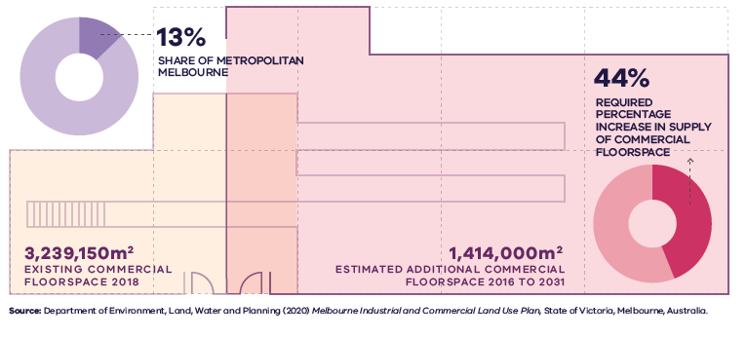

Figure 8. Existing and future commercial floorspace requirements for the Northern Metro Region
Northern Metro Region | 13 per cent share of metropolitan Melbourne | 3,239,150 square metres – existing commercial floorspace 2018 | 1,414,000 square metres – estimated additional commercial floorspace 2016 to 2031 | 44 per cent - required percentage increase in supply of commercial floorspace
Source: Department of Environment, Land, Water and Planning (2020) Melbourne Industrial and Commercial Land Use Plan, State of Victoria, Melbourne, Australia.

- Manage and plan for industrial precincts in the Northern Metro Region to be continued generators of economic activity and employment
The Northern Metro Region contains metropolitan Melbourne’s third largest holding of industrial land providing state, regional and locally-significant employment and economic functions.
Melbourne’s second largest SSIP, the Northern SSIP comprises around 5773 hectares of existing and future zoned and unzoned land identified for industrial purposes across Hume, Whittlesea and Mitchell LGAs (Figure 9). The Northern SSIP provides strategically located land for major industrial development linked to the Principal Freight Network (PFN) and transport gateways including the proposed BIFT. It will be protected from incompatible land uses to allow for continued growth in freight, logistics and manufacturing investment. Future expansion of the SSIP has also been identified in areas around Craigieburn, Donnybrook and Mickleham.
The Northern SSIP comprises several distinct precincts as shown in Table 3. A breakdown of the quantum of industrial land supply for the region is also detailed in the Melbourne Industrial and Commercial Land Use Plan.
While the region has substantial land set aside for future industrial purposes, site fragmentation, the disjointed nature of precincts and poor site access often limits the ability to secure suitable larger sites. Industries operating large format uses or freight and logistics may find it difficult to secure a site.
Existing and future regionally-significant industrial land also contributes to local and regional economies. These areas will be retained and planned to allow for a range of industrial land and other employment uses, and where appropriate, new and emerging types of businesses that require access to affordable, well-located land to grow and innovate. Future industrial land in Sunbury/Diggers Rest (part of the Northern Growth Corridor) will play an important role in providing affordable industrial land, which has been a considerable competitive advantage for Melbourne in the past. It is important for these opportunities to be captured in the precinct structure planning process to ensure land is safeguarded and secured to fulfil its strategic purpose.
Regionally-significant industrial precincts identified in the Northern Metro Region are shown in Table 4. The Northland Urban Renewal Precinct, which forms part of the East Preston Industrial Precinct, may require subsequent changes to the current extent of identified regionally-significant industrial due to strategic planning work being led by the City of Darebin at a larger precinct scale.
- Ensure the supply of and access to industrial land in the Northern SSIP can support industries with large lot and land area needs.
- Retain regionally-significant industrial land by managing encroachment by other uses that would cause fragmentation and may compromise the development and efficient operation of existing businesses.
- Limit and discourage subdivision in the Northern SSIP that leads to the creation of small lots.
- Identify and plan for regionally-significant industrial precincts that could support other employment uses, such as creative industries, or are well connected to adjacent employment uses or transport infrastructure.
- Plan for the north of Melbourne to become a national logistics hub, including the future development of the Beveridge Interstate Freight Terminal, and leverage both local and regional economic growth opportunities from this investment.

- Existing and future industrial floorspace requirements for the Northern Metro Region
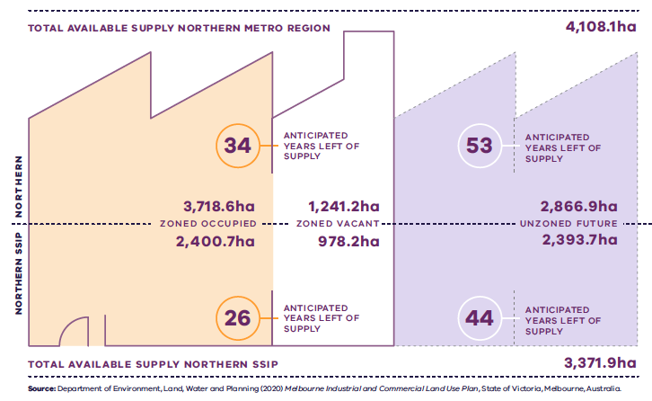

Figure 9. Existing and future industrial floorspace requirements for the Northern Metro Region
Northern Metro Region | 3,718.6 hectares zoned occupied | 1241.2 hectares zoned vacant  34 anticipated years left of supply | 2,866.9 hectares unzoned future  53 anticipated years left of supply | 4,108.1 hectares total available supply
Northern SSIP | 2,400.7 hectares zoned occupied | 978.2 hectares zoned vacant  26 anticipated years left of supply | 2,393.7 hectares unzoned future  44 anticipated years left of supply | 3,371.9 hectares total available supply
Source: Department of Environment, Land, Water and Planning (2020) Melbourne Industrial and Commercial Land Use Plan, State of Victoria, Melbourne, Australia.

State-significant industrial precincts within the Northern Metro Region
Existing precincts | Future/emerging precincts
- Thomastown  - Cooper Street Employment Precinct  - Campbellfield  - Somerton (including an intermodal freight terminal) | - Craigieburn North Employment Precinct  - Donnybrook  - Mickleham (including Merrifield Business Park)  - Beveridge Interstate Freight Terminal (proposed)  - Craigieburn South Employment Precinct
Melbourne Industrial and Commercial Land Use Plan, DELWP, 2020
Regionally-significant industrial precincts within the Northern Metro Region
Existing precincts | Future/emerging precincts
- Heidelberg West Business Park  - East Preston Industrial Precinct  - West Reservoir and Newlands Road Industrial Precinct  - North Coburg  - Brunswick  - Shenstone Park  - Wollert  - Sunbury South | - Donnybrook Road Industrial Precinct
Melbourne Industrial and Commercial Land Use Plan, DELWP, 2020
- Ensure the Northern Growth Corridor accommodates longer-term industrial and commercial development opportunities
There is a need to support the creation of jobs in the Northern Growth Corridor and make it easier for people who live in the north to access jobs in established middle and inner areas. This could be achieved by:
- Encouraging investment in areas identified for industrial uses
- Protecting industrial and employment land for the longer-term
- Supporting the establishment of small- and medium-size businesses in the outer suburbs and growth areas
- Creating flexible spaces for business to grow.
By 2031, just under 60 per cent of additional commercial floorspace will be needed in the growth area LGAs of Hume, Whittlesea and Mitchell. Each of these local councils has identified land for future commercial purposes. If this additional floorspace is not able to be provided across new future activity centres, consideration will need to be given to additional opportunities for commercial development or increased density of commercial development.
Careful consideration will be required through the precinct structure planning process to ensure adequate provisions are made to accommodate medium and longer-term commercial development. Approaches that support the delivery of 20-minute neighbourhoods should be used to create a finer grain network of activity centres.
The future Lockerbie Metropolitan Activity Centre provides significant economic opportunities, along with the BIFT, for a regional economic centre to service the north of the region.
Lockerbie is located along the Melbourne-Sydney railway line which will service the northern parts of Hume and Whittlesea and the southern part of Mitchell. Future planning of the centre and surrounding area needs to ensure Lockerbie is adequately serviced by regional-level community and public transport infrastructure and can develop a health and education focus. The centre’s growth will be supported by the proposed OMR and a proposed train station. The existing town centre is adjacent to the Merri Creek and careful design will be required to ensure that biodiversity and amenity issues are addressed while also creating a strong link between the town centre and the proposed station.
Lockerbie is located on the boundary of three municipalities requiring a joint state and local government partnership to prioritise planning and infrastructure provision. Complementary planning for a network of activity centres nearby will also be required to realise Lockerbie’s potential. A proposed high-capacity public transport route along Aitken Boulevard will link Lockerbie and its future train station with Mickleham, Beveridge, Wallan and Craigieburn major activity centres and significant employment areas identified north and south of Merrifield. This network will also support the BIFT.
Improving connections from the growth areas to La Trobe NEIC, Melbourne Airport and other established employment areas within the region will also provide residents with greater employment options.
- Consider the future demand and need for commercial and employment land across the Northern Growth Corridor and ensure that Precinct Structure Plans make sufficient provision to accommodate longer-term commercial and employment needs.
- Facilitate investment in the Northern Growth Corridor to increase local access to employment.
- Ensure planning for the Northern Growth Corridor provides sufficient land and infrastructure provision to accommodate longer-term commercial and employment needs.
- Enable Lockerbie’s development as a metropolitan activity centre with early planning and ensuring infrastructure provisions are in place.
- Ensure protection of green wedges and support their role to provide agriculture, extractive resources, tourism and state infrastructure for the long-term benefit of all Victorians
Green wedges are beneficial for all Victorians due to their agricultural, tourism, recreation, environmental, biodiversity and water supply roles. Each green wedge provides employment across multiple sectors.
Cropping, orcharding, grazing, dairying, viticulture, equine uses and animal husbandry occur in these green wedge areas. A range of parks, reserves, cultural heritage sites, local food producers and a network of trails contribute to the region’s visitor economy. Other important economic sectors in the region’s green wedges include freight and logistics, manufacturing, waste management, and resource extraction.
Agriculture in Melbourne’s green wedges and peri-urban areas is under threat from pressure to convert land to other uses including housing and smaller non-agricultural uses. The viability of farming is also being impacted by changing markets and consumer preferences, advances in technology and innovation, declining terms of trade, and government and investment decisions.
The Northern Metro Region’s green wedges provide an important infrastructure function for Melbourne that includes freight and transport corridors, waste management facilities and resource extraction. They also provide opportunities for local and international tourism in close proximity to Melbourne. In the future, it is possible the Northern Metro Region green wedges could play a key role in energy production and storage. These important functions must be balanced with other green wedge priorities.
The region’s green wedges also play an important role in providing a transition and urban-rural interface with landscape buffers to protect areas and corridors with biodiversity and landscape values.
The green wedges are protected from urban encroachment by the UGB and planning controls are in place to protect identified environmental and landscape values.

Extractive Resources
Extractive resources are essential for the development of housing and infrastructure. Construction materials such as concrete, bricks, asphalt, paving, road base and aggregates are made from resources extracted from quarries across Victoria. Extractive resources need to be secured close to where they are used to maintain cost competitiveness for construction, particularly as demand for these resources is expected to double by 2050 (PwC, 2016).
Mitchell and Whittlesea LGAs are among the top strategic resource locations that supply a relatively significant proportion of the state’s total extractive resources. Hume, Whittlesea and Moreland LGAs are among the top municipalities that will require a large quantity of extractive resources in the future to sustain growth. Given this, strategic extractive resource locations in the Northern Metro Region warrant increased policy focus to protect existing resources and facilitate licensing of new quarries in the area.
Existing approved and operational quarries should be protected from encroachment by sensitive land uses. Designated industrial or commercial development activities located adjacent to existing quarry sites within/adjacent to the UGB would be rezoned to Urban Growth Zone. Any proposed uses or development in these precincts proximate to the title boundary of such quarries should be subject to appropriate risk assessments.
Extractive Industry Interest Areas (EIIAs) have a longstanding designation in the Northern Metro Region (Figure 10). They were established to identify land located in reasonable proximity to major population centres that is likely to contain commercially viable stone resources, and where the extractive industry is more likely to be established.
Since the identification of EIIAs, demand for resources has increased and other land use pressures have emerged. In the Northern Metro Region, opportunities for extractive industries to establish in EIIAs have been foregone due to new housing developments or other uses establishing. This includes policy tension between land within the UGB and EIIA designated land.
EIIAs in the Northern Metro Region need to be refreshed and refocused to give recognition to these important resource locations. There are also extractive industries currently operating outside of EIIAs that require long-term protection from incompatible land uses.
The Victorian Government has established the concept of strategic extractive resource areas (SERAs), which will assist in providing greater planning certainty for the continued extraction of critical resources in identified strategic areas. They were established to provide stronger protection for strategic extractive resources.
There is an opportunity to identify and implement a SERA in the Northern Metro Region for areas of strategic importance.
It is also important that post-quarrying land uses provide beneficial outcomes for local communities and the region. Post-quarrying land uses can improve the amenity and lifestyle of locations. They can make a valuable contribution towards enhancing networks of open space as well as providing important habitats for threatened species. Innovative end land use options and progressive rehabilitation should be encouraged and developed in consultation with local communities.
- Protect the operation of state-significant infrastructure assets such as freight and transport corridors, waste management facilities, and resource extraction.
- Protect and support agriculture as a primary land use in the Northern Metro Region’s green wedges, including their key role in protecting the curfew-free status of the airport, protecting landscape and biodiversity values, and marginal opportunities for agriculture.
- Ensure the ongoing operation, expansion, or development of new state-significant infrastructure assets avoids or minimises impacts on other green wedge priorities such as agriculture and biodiversity conservation, cultural heritage, landscape and environmental values.
- Support sustainable tourism and recreation opportunities that complement key green wedge values and land uses including biodiversity, open space and trail networks, cultural heritage, agriculture, and scenic rural landscapes.
- Ensure there are adequate extractive resources to support the cost-effective development of housing and infrastructure.
- Protect existing quarries from incompatible development to maintain supply of extractive resources.
- Identify and manage long-term strategic extractive resources in the Northern Metro Region.

- Extractive Industry Interest Areas in the Northern Metro Region
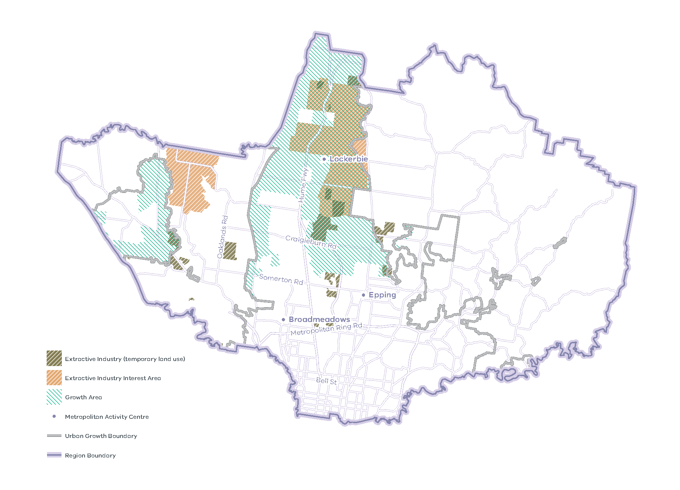
Note: EIIAs were established in the 1990s by the Geological Survey of Victoria following an assessment of land where extractive industry operations were more likely to be established, both for reasons of resource availability and where there are potentially fewer land use planning constraints. EIIAs serve as a geographic indicator in the planning scheme for the purpose of referral of planning permit applications only. EIIAs do not imply that a quarry can be established ‘as-of-right’ in these areas, nor do they preclude extractive industry from being established outside EIIAs. In growth areas, the EIIAs provide a guide to ensure the location of earth resources and the need for extractive resources to support the long-term growth of Melbourne is strategically considered in the development of Precinct Structure Plans. The EIIAs require ongoing review and refinement as demand for resources increases and other land use pressures emerge.
Green wedges: current role and strategic opportunities
Green wedge | Current role | Future role/strategic opportunities
Nillumbik Green Wedge | - Landscape and open space  - Environment and biodiversity  - Water supply and catchments  - Agriculture  - Tourism | - Protect the natural environment, particularly the flora and fauna links within the Yarra River corridor  - Retain the Skyline Road and St Andrews land system for environmental conservation. These areas should only be used for agriculture where the use or development proposed does not compromise the quality of the environment  - Protect Sugarloaf Reservoir, a key state asset nestled in Christmas Hills that has been supplying water to metropolitan Melbourne since 1980  - Protect and support existing agricultural activities and soil. Encourage agriculture to make the most of its proximity to Melbourne Wholesale Fruit, Vegetable and Flower Market at Epping and also consider other forms of productivity including agricultural tourism  - Focus economic activity within the green wedge in Hurstbridge, St Andrews and Panton Hill  - Maintain and enhance Nillumbik’s trail network with an emphasis on Diamond Creek Trail, Maroondah Aqueduct and Pipeline Trails, Kangaroo Ground to Panton Hill Trail  - Continue to align tourism work as a mechanism for cooperation and efficiency. Encourage environment and agriculture-based tourism and small-scale cafes where they demonstrate environmental, social and economic benefits
Sunbury Green Wedge | - Landscape and open space  - Environment and biodiversity  - State-significant infrastructure | - Maintain the urban-rural interface around Sunbury and the conservation and landscape buffer in Mickleham  - Protect the following view lines from inappropriate development:  - from Organ Pipes National Park across grassy plains and rocky outcrops  - across Maribyrnong Valley to mountain ranges from Sydenham Park  - Develop a habitat corridor along Maribyrnong River and protect remnant grasslands at McNabbs Weir, Sydenham Park and Organ Pipes National Park  - Investigate potential recycled water opportunities including a pipeline from Sunbury to Melbourne Airport, and a pipeline to follow the OMR corridor to bring recycled water from eastern urban catchments or from Sunbury recycled water plant  - Discourage inappropriate development in agricultural areas including non soil-based agriculture in areas with high soil quality. It is also important to reinforce the agricultural role of Keilor Market Gardens  - Support tourism uses focused on local produce and eco-tourism  - Promote open space/recreation corridor connecting Brimbank Park to Organ Pipes National Park and between Maribyrnong River and Kororoit Creek  - Maintain Melbourne Airport buffer and curfew
Whittlesea Green Wedge | - Landscape and open space  - Environment and biodiversity  - Waterways and catchments  - Agriculture  - Extractive industries | - Protect identified visual character areas of Plenty Valley, Plenty Ranges, The Hills and the Western Plains  - Minimise vegetation removal which contributes to salinity and bushfire and protect river red gum habitat in order to maintain biodiversity and increase the connectivity of habitat areas  - Improve environmental water quality and health of rivers, creeks and waterways by managing development of adjacent to waterways  - Use buffers to safeguard the amenity and environment of land surrounding extractive industries

Actions – Productivity
- Establish a long-term state and local government partnership to prioritise planning and infrastructure provision for Lockerbie as a metropolitan activity centre for the Northern Growth Corridor.
- Establish a state and local government partnership to coordinate and manage land use planning for the La Trobe NEIC.
- Implement a program of State Government-led planning projects, in partnership with local government, to ensure metropolitan and major activity centres and urban renewal areas maximise their respective strategic opportunities. Priority will be given to those which deliver significant jobs and housing; leverage investment in state infrastructure; and play an important role in the growth corridor and/or region. State-led planning for these state- and regionally-significant places will contribute to creating liveable communities and achieving more dwellings and jobs in established areas, and identify actions that support growth and economic investment.
- Identify and implement a SERA in the Northern Metro Region in partnership with local government.
Metropolitan and major activity centres: existing attributes and strategic opportunities
Existing attributes | What needs to be considered | Future role/strategic opportunities
Metropolitan Activity Centres
Broadmeadows (Hume)
- Freestanding shopping centre based around Pascoe Vale Road, Johnstone Street and Camp Road  - Plays a major service delivery role, including government, health, justice and education services, as well as retail and commercial opportunities  - A retail and commercial focus with some leisure and entertainment, community, and civic functions including Hume Global Learning Centre  - Regionally-significant education precinct at Kangan Batman TAFE  - State-significant commercial land  - Train (Broadmeadows Station) and SmartBus services | - State-significant industrial land to the east  - Future SRL North (Box Hill to Airport) interchange station  - Upgrades to Broadmeadows Station  - Barrier of Pascoe Vale Road  - Key flight paths to and from Melbourne Airport which may impact land use changes and building heights | - Strengthen role as major anchor for the region to support the emerging growth in Northern Growth Corridor  - Intensify mixed-use development within the core of the activity centre  - Provide a diversity of uses including offices, higher-density housing and a range of leisure, entertainment and cultural facilities  - Balance planning for bulky goods retailing to also allow intensive fine-grain uses to continue to develop  - Strengthen civic services and expand existing health facilities  - Mitigate east-west divide created by the railway line and Pascoe Vale Road
Epping (Whittlesea)
- Freestanding shopping centre based around High and Cooper streets  - Plays a major service delivery role, including government, health, justice and education services, as well as retail and commercial opportunities  - A focus on retail, commercial, education and health with Melbourne Polytechnic and Northern Centre for Health and Education Research  - State-significant health precinct at the Northern Hospital  - Specialist food focus at the Melbourne Wholesale Fruit, Vegetable and Flower Market and Cooper Street Employment Precinct  - State-significant industrial land  - Train (Epping Station) and SmartBus services  - PPTN interchange at Epping Plaza Shopping Centre | - Proposed Epping Food Hub  - New Epping and Thomastown/Lalor urban renewal areas | - Continue to develop a regional role for the activity centre  - Intensify mixed-use development within the core of the activity centre  - Focus on healthcare and allied science, technology, engineering, arts and mathematics research/innovation, with a new medical precinct to play a major employment-generating role  - Expand and redevelop existing shopping centre into mixed-use precincts  - Accommodate expanding office and retail uses  - Improve connectivity within the activity centre
Lockerbie (Hume/Whittlesea/Mitchell) (Future)
- Future metropolitan activity centre based around Cloverton Boulevard  - Future state-significant commercial land | - Conservation area, based on the Biodiversity Conservation Strategy for Melbourne’s growth areas, to the east  - Adjacent to the Merri Creek open space corridor  - Proposed Beveridge Interstate Freight Terminal to the north  - Potential train station  - Potential high-capacity public transport route linking to other proposed activity centres in the growth corridor | - Support future role as an activity centre with an employment focus to service the outer area of the Northern Metro Region  - Play a major service delivery role, including government, health, justice and education services, as well as retail and commercial opportunities  - Intensify mixed-use development within the core of the activity centre  - Develop as a destination for retail, entertainment and civic purposes  - Develop as a health and education centre with a regional focus  - Create a strong link between the town centre and proposed train station
Major Activity Centres
Beveridge (Mitchell) (Future)
- Future major activity centre to the west of the existing Beveridge township, and the Hume Freeway | - Proposed Beveridge Interstate Freight Terminal located to the east  - Potential Outer Metropolitan Ring/E6 transport corridor | - Provide higher-order services, retail and employment  - Rapid increase in residential growth  - Provide social and community facilities for future residents
Brunswick (Moreland)
- Strip-based centre on three parallel roads – Sydney Road, Lygon Street and Nicholson Street  - Diverse commercial and retail uses and civic functions  - Regionally-significant education precinct at RMIT University (Brunswick)  - Regionally-significant industrial land west of Sydney Road, creative/ enterprise precinct located at Brunswick Creative Hub  - CERES Community Environment Park located at the northern edge  - Train (Brunswick, Moreland, Anstey and Jewell stations) and tram services | - Coburg Major Activity Centre located to the north  - Urban renewal areas – Albert Street Brunswick Urban Renewal Precinct and East Brunswick Village  - Heritage significance of Sydney Road, Lygon Street and Nicholson Street | - Retain industry and employment uses while supporting a range of creative industries  - Redevelop sites that are former industrial transition areas
Coburg (Moreland)
- Strip-based centre on Sydney Road and Bell Street  - Commercial and retail with some civic uses  - Regionally-significant industrial land  - Train (Coburg, Batman and Moreland stations), tram and SmartBus services | - Regionally-significant industrial land to the north-west  - Level crossing removals at Bell Street, Moreland Road, Reynard Street and Munro Street  - Brunswick Major Activity Centre to the south  - The Coburg Initiative and Pentridge urban renewal areas  - Heritage significance | - Retain industry and employment uses while supporting a range of creative industries  - New hospital or major health facility as part of Coburg Initiative urban renewal area  - Maximise urban renewal opportunities from level crossing removals along the Upfield railway line
Craigieburn (Hume)
- Hybrid centre with both freestanding and enclosed shopping at the intersection of the Hume Highway and Craigieburn Road  - Retail and local services  - State-significant industrial land to the east  - Train (Craigieburn Station) service | - Future state-significant industrial precinct to the east  - Craigieburn Town Centre Major Activity Centre to the west | - Consolidate local retail and service role  - Maximise opportunities for medium- and higher-density housing near train station
Craigieburn Town Centre (Hume)
- Freestanding shopping centre at the intersection of Craigieburn Road and Aitken Boulevard  - Retail, including bulky goods retailing, recreation and substantial civic services  - State-significant health precinct at Craigieburn Health Services  - Regional recreation facility at Splash Aqua Park and Leisure Centre | - Craigieburn Major Activity Centre and Craigieburn Station to the east  - Potential high-capacity public transport route identified along Aitken Boulevard | - Facilitate growth to meet employment needs and provide retail, leisure, health and services to surrounding growth areas  - Focus on future role as a regional health precinct with supplementary education uses
Diamond Creek (Nillumbik)
- Strip-based centre on Main Hurstbridge Road and Chute Street dissected by Hurstbridge train line  - Retail and commercial with some local industrial land  - Diamond Creek runs north, and trails and public open space are located to the west  - Train (Diamond Creek Station) service | - Significant habitat for local flora and fauna  - Semi-rural township character  - Located in a bushfire risk area | - Continue to consolidate local retail and service role, and potential tourism opportunities  - Develop a retail-focused compact core east of the train line on Main Hurstbridge Road
Eltham (Nillumbik)
- Strip-based centre on Main Road between Dudley Street and Luck Street  - Diamond Creek runs west of the train station with trails and public open space between the creek and train station  - Train (Eltham Station) and SmartBus services | - Village and landscape character  - Eltham Gateway is a significant landscape area  - Located in a bushfire risk area | - Continue to consolidate local retail and service role including community and professional services  - Increase retail floorspace to serve increased demand and a growing population
Gladstone Park (Hume)
- A freestanding shopping centre at the intersection of Tullamarine Freeway and Mickleham Road  - Retail, commercial and community facilities  - Regionally-significant industrial land  - SmartBus services | - Proximity to Melbourne Airport which limits development | - Service the local population and surrounding area, improve retail offering and local economy  - Enhance connections between shopping centre and surrounding residential and employment areas
Glenroy (Moreland)
- Strip-based centre on Pascoe Vale Road, Glenroy Road, Wheatsheaf Road and Hartington Street  - Retail, commercial and community facilities  - Train (Glenroy Station) service | - Level crossing removal at Glenroy Road | - Service the local population and surrounding area, improve retail offering and local economy  - Provide a broad mix of retail uses, commercial and cultural activities, employment options, and administrative and civic functions
Greensborough (Banyule)
- Hybrid centre with freestanding shopping centre and strip-based retail along Main Street, Grimshaw Street, The Circuit and Para Road  - Retail, commercial and community facilities  - Civic and recreational functions including WaterMarc regional recreation facility  - Train (Greensborough Station) and SmartBus services | - Redevelopment of Greensborough Station  - Connection to Plenty River Valley and vegetation protection  - Proposed North East Link to the west along Grimshaw Road | - Consolidate regional role for shopping, business and entertainment for the north-east of the Northern Metro Region  - Provide a range of residential, leisure, recreational, retail, health and wellbeing, and commercial opportunities  - Maximise transit-oriented development opportunities around Greensborough Station  - Support emerging medical precinct
Heidelberg (Banyule)
- Hybrid centre consisting of both strip-based retail and a freestanding shopping centre around Burgundy Street and Rosanna Road extending on the western end into Bell Street  - Part of the Latrobe NEIC  - Prominent health and education focus with large employment-generating function  - State-significant health precinct at Austin Hospital and Warringal Private Hospital  - Retail and commercial uses, and some civic and community uses  - Train (Heidelberg Station) and SmartBus services | - SRL station/interchange – future SRL North (Box Hill to Airport)  - Proposed North East Link which intersects with Banksia Street  - Proximity to La Trobe University, Heidelberg West Industrial Precinct and Preston-Northland Major Activity Centre, as part of the La Trobe NEIC  - Links to Bell Street commercial, health and education uses to the west including Heidelberg Repatriation Hospital  - Preferred location for higher-density development in Banyule LGA  - Traffic congestion from health precincts and retail uses  - Undulating and vegetated urban landscape with mature trees on ridgelines and in streets  - Network of small civic spaces around Burgundy Street  - Regional parklands and recreational spaces along Yarra River are highly valued, and warrant protection and enhancement | - Consolidate regional role for shopping and employment, and promote cultural and entertainment opportunities  - Intensify mixed-use development within the core of the activity centre and residential development along Bell Street  - Strengthen role as a health precinct while also developing commercial and administrative uses
Ivanhoe (Banyule)
- Strip-based centre on Upper Heidelberg Road  - Diverse commercial and retail uses with civic precinct  - Train (Ivanhoe, Eaglemont and Darebin stations) services | - Heritage significance of Upper Heidelberg Road | - Service the local population and surrounding area  - Accommodate growth in housing, commercial activity and community facilities
Mernda (Whittlesea)
- Hybrid centre at the intersection of Plenty Road and Bridge Inn Road and adjacent to Mernda Station  - Proposed retail and commercial uses, and some civic and community uses  - Train (Mernda Station) service | - Native vegetation protection applies across this part of Plenty Valley  - Several sites have identified heritage significance | - Support role as a regional activity centre and transport hub  - Increase growth in employment-generating uses, new centre with significant future growth potential and mixed-use development  - Deliver community facilities such as higher education campus or health facility
Mickleham (Hume) (Future)
- A future major activity centre on Donnybrook Road with a focus on commercial and industrial employment uses  - Under development  - Part of the Northern Industrial Precinct (SSIP) | - Integrating town centre with residential areas to the west, employment areas to east and Merrifield Park to north  - Proximity to the Lockerbie Metropolitan Activity Centre (future)  - Close to future state-significant industrial land identified for expansion of the Northern SSIP  - Potential high-capacity public transport route identified along Aitken Boulevard connecting to Beveridge and Lockerbie to the north and Craigieburn to the south  - Proximity to the Kalkallo Retarding Basin and potential sports and leisure hub | - Serve the growth area north of Mount Ridley Road as an employment-focused centre  - Provide regional health and education services as well as large-scale office development and community facilities  - Develop street-based hospitality and speciality retail surrounding enclosed shopping/entertainment facilities in the town centre core
Northcote (Darebin)
- Strip-based centre on High Street between Darebin Road and Clarke Street  - Diverse commercial and retail uses with focus on live music venues and arts culture  - Cluster of creative industries with business incubator at Melbourne Innovation Centre  - Westgarth Cinema to the south  - Train (Northcote, Croxton, Merri and Westgarth stations) and tram services | - Heritage significance of High Street | - Provide a mix of uses, services and facilities to enhance economic, social and environmental viability  - Encourage diverse living and working opportunities with a focus on maintaining and providing affordable housing and employment spaces  - Encourage retention of industrial land to support creative industries  - Develop regional arts and culture node with range of visual arts and live music venues, and support services for the arts and design community
Preston – High Street (Darebin)
- Strip-based centre along High Street, Bell Street and St Georges Road  - Business and retail with Preston Market at its core, and civic, community and recreation uses  - Regionally-significant education precincts at RMIT Brunswick campus and Melbourne Polytechnic  - Train (Preston, Bell and Regent stations), tram and SmartBus services | - Level crossing removals at Murray Road, Cramer Street, Bell Street and Oakover Road  - The Junction South Preston urban renewal area  - Heritage significance | - Provide regional retail, service, office, business, entertainment and community services, and residential role  - Maintain Preston Market as a central community and shopping precinct  - Encourage multi-level mixed-use development
Preston – Northland (Darebin)
- Freestanding shopping centre on Murray Road  - Part of La Trobe NEIC  - Mixed-use with retail, commercial and entertainment uses  - Large format retailing on south side of Murray Road  - Regionally-significant industrial area extending south to Bell Street  - SmartBus services  - PPTN interchange at Northland Shopping Centre | - Northland Urban Renewal Precinct and Olympic Village, Heidelberg West urban renewal areas  - La Trobe University, a state-significant education precinct, to the north-east | - Provide a range of retail, commercial, residential, leisure and other commercial activities  - Continue to intensify development and encourage mixed uses including commercial offices to support economic investment and employment growth in the Latrobe NEIC
Reservoir (Darebin)
- Strip-based centre predominantly on Edwardes Street and Broadway  - A focus on retail, commercial and community and civic uses  - Train (Reservoir Station) service | - SRL Reservoir Precinct - future SRL North (Box Hill to Airport)  - Proximity to the La Trobe NEIC  - Reservoir Junction urban renewal area | - Establish as preferred location for higher-density residential development  - Provide a wide range of retail, employment, business, community, entertainment and transport services  - Maximise integration with SRL station (future SRL North), including transit-oriented development opportunities, and strengthen links to public and active transport networks
Roxburgh Park (Hume)
- Freestanding shopping centre on Somerton Road  - A focus on retail and community uses  - Industrial precinct to the south  - Train (Roxburgh Station) and SmartBus services | - Immediately adjacent to the Northern Industrial Precinct (SSIP) | - Consolidate local retail and service role for local employment areas  - Facilitate development that provides for an integrated activity centre, and improve pedestrian and cycling connections linking land uses and activity on both sides of Somerton Road
South Morang (Whittlesea)
- Freestanding shopping centre on McDonalds Road  - A focus on retail, entertainment, civic and community uses  - Train (South Morang Station) and SmartBus services | - Retention of existing vegetation (river red gum native species trees)  - Road improvements and connections required for new development within some parts  - Dispersed and fragmented with large terminal station to the north | - Continue to provide significant retail, commercial, civic and community services  - Ensure land is not compromised for future higher-density residential development by incompatible non-residential uses or lower-density residential development  - Extend Civic Drive to facilitate higher-density development close to the train station
Sunbury (Hume)
- Hybrid centre around Horne Street and Evans Street  - A focus on retail, medical and professional services and community and civic uses  - Regionally-significant health precinct at Sunbury Community Hospital  - Notable tourism site at Rupertswood Mansion  - Train (Sunbury Station) service | - Level crossing removal at Gap Road  - Connection to the potential Outer Metropolitan Ring/E6 transport corridor  - Established township with historic and semi-rural character and natural setting to be preserved  - Jacksons and Emu creeks | - Develop as a large regional hub with higher-order facilities to enable greater level of self-containment in retail, commercial, entertainment and leisure, education, health, recreation, community services and employment  - Complement a series of smaller town centres in the growth area that will meet local shopping and other needs of residents  - Provide higher-density residential and mixed uses to provide housing diversity  - Improve local transport links, including creek crossings, and improved capacity on the main approach roads to the activity centre are required  - Establish accessible open space along Jacksons and Emu creeks
Sunbury South (Hume) (Future)
- A future major activity centre on Sunbury Road | - Close to future regionally-significant industrial land  - Buffers around existing landfill and extractive industry sites  - Proposed train station to the west near Vineyard Road | - Develop a regional retail, commercial, employment and community services function, second only to the established Sunbury Major Activity Centre
Wallan (Mitchell) (Future)
- Strip-based centre on High Street  - A focus on retail and community uses | - Close to future state-significant industrial land, including the proposed Beveridge Interstate Freight Terminal  - Train station located to the east away from the activity centre’s core  - Flooding risk in parts of the activity centre  - Close interrelationship with Wallan South and Wallan East Precinct Structure Plans | - Play an anchoring role as the northern end of the Northern Growth Corridor serving the rural hinterland  - Support anticipated residential growth  - Cater to the retail needs of the growing population and retain role as retail destination for rural townships in Mitchell LGA  - Leverage employment opportunities arising from proximity to the proposed BIFT  - Develop Wallan as a key node for the Northern Growth Corridor, with improved transport connections
Wollert (Whittlesea) (Future)
- A future major activity centre on Boundary Road | - Regionally-significant industrial precinct to the west adjacent to the proposed E6 road reservation  - Industrial land functions as a buffer to existing quarry and landfill sites and will also meet local and regional employment needs, and service local business uses and the freight-based industry  - Near potential high-capacity public transport connecting Epping to Craigieburn | - Develop as a self-sustaining community defined by its urban villages, and provide retail, commercial, education and other community facilities

Chapter 05.
Housing choice
Plan Melbourne Outcome 2: Melbourne provides housing choice in locations close to jobs and services.
Plan Melbourne seeks to increase the supply of housing in established areas close to jobs, services and public transport to accommodate the anticipated increase in population over the next 30 years while ensuring Melbourne remains liveable, sustainable and accessible.
The Northern Metro Region has a diversity of housing choices from established inner and suburban areas, to greenfield growth areas and emerging urban renewal precincts. It also provides housing options in rural and semi-rural locations and townships including Whittlesea. The region has an established network of metropolitan and major activity centres supported by neighbourhood activity centres, growth areas and urban renewal areas that will provide opportunities to increase the supply of housing.
SRL will enhance inter-regional connectivity in the future and create housing opportunities in proximity to the proposed train stations. Focusing new development in established areas, around the activity centre network and close to public transport will help maintain the UGB and protect environmentally sensitive areas.

State of play

Metropolitan Melbourne
Strong demand for housing in established inner areas, with good access to jobs, services and public transport, has led to increased competition for housing in inner and middle ring suburbs of Melbourne.
The residential development industry is responding to this higher demand by increasing supply across Melbourne. The amount and location of additional housing developed depends on the availability and suitability of land and the willingness of households to pay for it. Melbourne is seeing a significant number of homes developed in growth areas, in part due to the relative availability of zoned land which has enabled residential developers to meet demand for relatively affordable housing.
There has also been an increase in the supply of apartments in the Central City – and increasingly in inner suburbs of Melbourne – driven by investors purchasing apartments to meet increased demand for rental accommodation in the inner city. In other areas, particularly middle ring suburbs, housing supply has been less responsive to increasing demand, leading to increasing competition for what is in some cases a relatively fixed supply of housing.

Northern Metro Region

Regional demographics
In 2020 the population of the Northern Metro Region was 1,051,070 people, which accounted for 21 per cent of the metropolitan Melbourne population. Between 2020 and 2051 the region’s population is projected to increase by more than 765,000 people to a total of 1,816,410, which will account for 22 per cent of metropolitan Melbourne’s projected population. The annual rate of growth in the region is expected to be 1.8 per cent, which is 0.3 per cent higher than metropolitan Melbourne’s expected annual growth. The Northern Metro Region is projected to grow 0.3 per cent less than the fastest growing region, the Western Metro Region (DELWP, 2019b).
Population growth differs between LGAs within this region as shown in Table 7. Between 2016 and 2036, the populations of Hume and Whittlesea LGAs are projected to increase by around 65-75 per cent, whereas Moreland and Darebin LGAs are projected to increase by around 35-40 per cent. The population within that part of Mitchell LGA within the Northern Metro Region is projected to increase by around 280 per cent being largely growth area. The projected population increase is lower for the Banyule LGA, with a projected increase of 20 per cent, and Nillumbik LGA, which has a projected population increase of 10 per cent (DELWP, 2019b).
The Northern Metro Region has 355,630 dwellings and will require an additional 352,200 between 2016 and 2051 to accommodate projected population growth. This will double the existing number of dwellings to a projected total in 2051 to 707,830 (DELWP, 2019b).
The largest age group in the Northern Metro Region in 2016 was aged between 30 and 44 and this is projected to remain the same through to 2051. Notably, the number of people aged over 60 in 2016 was 163,290 or 17 per cent of the region’s population (DELWP, 2019b). The number of people aged over 60 is expected to more than double by 2051 to 428,080 people (Figure 11).
In terms of household type, families with children were the most prevalent in the Northern Metro Region in 2016 with over 48 per cent, while group/other households made up 7 per cent of the region’s households (DELWP, 2019b). This is consistent with the average across metropolitan Melbourne. By 2051, it is expected that families with children will remain the largest household type in the Northern Metro Region and across metropolitan Melbourne despite an overall decrease in the proportion of households in the category. A larger increase of 3 per cent is expected in households of couples without children.
Actual and projected population by Local Government Area, 2016 - 2036
LGA | 2016 | 2020 | 2026 | 2031 | 2036
Banyule | 127,450 | 131,940 | 139,080 | 144,680 | 150,760
Darebin | 155,130 | 166,430 | 182,410 | 196,030 | 210,650
Hume | 207,040 | 241,190 | 286,530 | 316,240 | 343,990
Moreland | 172,290 | 188,760 | 209,080 | 225,000 | 241,540
Nillumbik | 64,170 | 65,220 | 66,760 | 68,410 | 70,310
Whittlesea | 207,060 | 236,540 | 285,920 | 327,470 | 364,450
Mitchell (part) | 16,750 | 20,990 | 33,080 | 47,160 | 64,020
Northern Metro Region | 949,890 | 1,051,070 | 1,202,860 | 1,324,980 | 1,445,740
Victoria in Future, DELWP, 2019 and Regional Population, Australian Bureau of Statistics, 2021
- Regional actual and projected population by age, 2016 – 2051
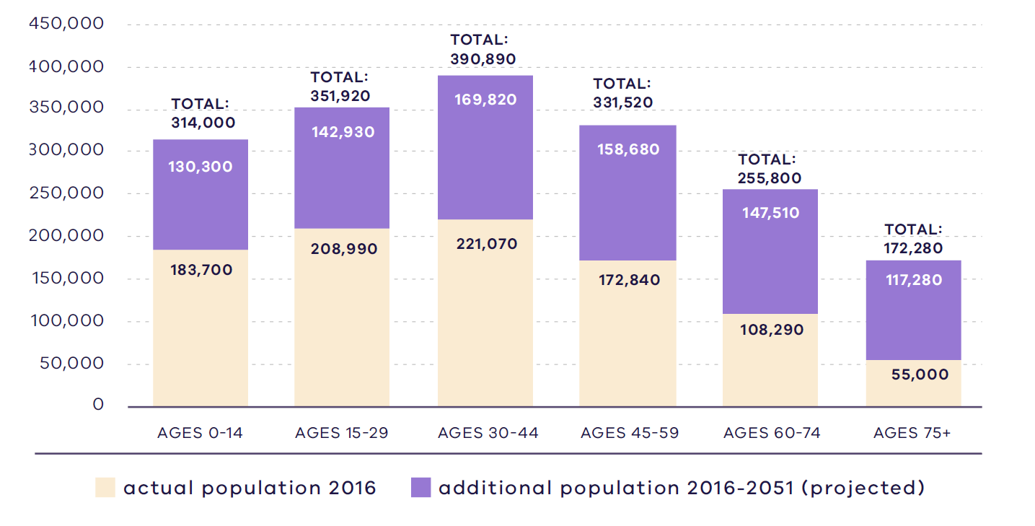
Victoria in Future, DELWP, 2019

Figure 11. Regional actual and projected population by age, 2016 - 2015
2016:  183,700 – Ages 0 to 14  208,990 – Ages 15 to 29  221,070 – Ages 30 to 44  172,840 – Ages 45 to 59  108,290 – Ages 60 to 74  55,000 – Ages 75 plus | 2051:  314,000 – Ages 0 to 14  351,920 – Ages 15 to 29  390,890 – Ages 30-44  331,520 – Ages 45 to 59  255,800 – Ages 60 to 74  172,280 – Ages 75 plus
Source: Department of Environment, Land, Water and Planning (2019) Victoria in Future 2019, Department of Environment, Land, Water and Planning, Melbourne, Australia.

Housing stock
In 2016 separate houses make up 74 per cent of the housing stock in the Northern Metro Region, compared to 67 per cent for metropolitan Melbourne. Approximately 76 per cent of the dwellings in the region provide for three or four bedrooms compared to 73 per cent in metropolitan Melbourne (DELWP, 2019b).
Semi-detached, row and terrace housing make up 17 per cent of the region’s housing stock, which is the same for metropolitan Melbourne. Flats, units and apartments make up 9 per cent of housing stock, 7 per cent less in comparison to 16 per cent of metropolitan Melbourne (DELWP, 2019b).

Projected housing requirements
Victoria in Future (VIF) projections are published at LGA level for a 20-year horizon from the most recent Census data – currently from 2016 to 2036. Beyond this period knowledge of land supply, dwelling construction and population distribution trends be less certain.
VIF projections indicate that based on the continuation of current trends, and knowledge of long-term greenfield land supply, approximately 66 per cent of net additional dwellings across metropolitan Melbourne are expected to be in established areas and 34 per cent in greenfield areas. The housing distribution figures between established areas and greenfield areas are shown in Table 8.
Plan Melbourne provides an alternate aspirational housing distribution scenario based on achieving 70 per cent of new housing in Melbourne’s established areas and the remaining 30 per cent accommodated in greenfield areas. This scenario assumes a total of 70,000 dwellings across metropolitan Melbourne, which VIF 2019 projections allocated to greenfield areas, can be accommodated in established areas to realise the aspirational 70/30 distribution between 2019 to 2051 (Table 9).
The aspirational housing distribution scenario provides for a redistribution of 20,000 dwellings from greenfield areas in the Northern Metro Region to established areas. The region is projected to accommodate 15,000 dwellings in established areas of the region, while the remaining 5,000 dwellings will be distributed among other regions’ established areas.
Table 10 shows the aspirational housing distribution scenario for each LGA to 2036. This is achieved by apportioning the net dwelling additions in the established area for each metropolitan region and distributing the amount between LGAs in the region. The aspirational scenario is based on the locations where most housing growth is anticipated across the established metropolitan area such as the Central City, NEICs, metropolitan and major activity centres, major urban renewal precincts and future SRL precincts. The 70/30 dwelling redistribution for the region will provide guidance for each LGA to accommodate housing growth that achieves the aspirational housing distribution for metropolitan Melbourne.
Scenario 1 VIF 2019
Region | Net dwelling additions 2016 to 2051 – Total | Net dwelling additions 2016 to 2051 – Established | Net dwelling additions 2016 to 2051 – Greenfield
Inner Metro | 225,000 | 225,000 | 0
Western | 412,000 | 177,000 | 235,000
Northern | 352,000 | 167,000 | 185,000
Inner South East | 119,000 | 119,000 | 0
Eastern | 192,000 | 192,000 | 0
Southern | 313,000 | 184,000 | 129,000
Total Melbourne | 1,613,000 | 1,064,000 | 549,000
 | 100% | 66% | 34%
Scenario 2 Aspirational scenario
Region | Net dwelling additions 2016 to 2051 – Total | Net dwelling additions 2016 to 2051 – Established | Net dwelling additions 2016 to 2051 – Greenfield
Inner Metro | 235,000 | 235,000 | 0
Western | 402,000 | 197,000 | 205,000
Northern | 347,000 | 182,000 | 165,000
Inner South East | 124,000 | 124,000 | 0
Eastern | 202,000 | 202,000 | 0
Southern | 303,000 | 194,000 | 109,000
Total Melbourne | 1,613,000 | 1,134,000 | 479,000
 | 100% | 70% | 30%
Note: For the purpose of these figures, greenfield areas include land in a growth area council that is either currently under development or identified for future development
Northern Metro Region 70/30 redistribution by LGA to 2036
LGA | VIF2019 dwelling within established areas – 2021 | VIF2019 dwelling within established areas – 2036 | Including 70/30 dwellings – 2036 | 70/30 dwelling redistribution | Share of regional redistribution
Banyule | 53,800 | 61,700 | 62,700 | 1,000 | 13%
Darebin | 71,400 | 90,500 | 92,000 | 1,500 | 20%
Hume | 33,600 | 39,700 | 41,900 | 2,200 | 29%
Moreland | 81,800 | 103,600 | 104,600 | 1,000 | 13%
Nillumbik | 23,500 | 26,600 | 27,200 | 600 | 8%
Whittlesea | 35,300 | 41,900 | 43,100 | 1,200 | 16%
Mitchell (part)¹ | 0 | 0 | 0 | 0 | 0
Northern Metro Region | 299,400 | 364,000 | 371,500 | 7,500 | 100%
¹For the purposes of this table there are no areas within Mitchell Shire within the UGB defined as established areas.

Locations for housing growth
Housing supply in well-serviced areas, with good access to higher-paying inner-city jobs, has not kept pace with the demand in the Northern Metro Region. This is impacting on the price of dwellings, with price rises much greater in inner and middle ring suburbs than in outer suburbs and growth areas. To respond to the housing challenges in the Northern Metro Region, supply is needed in locations close to jobs, services and public transport.
Between 2005 and 2016, a total of 16,803 new dwellings were constructed in and within 400 metres of metropolitan and major activity centres in the Northern Metro Region. In the same period, 63,496 dwellings were constructed outside metropolitan and major activity centres. Of the new dwellings outside activity centres, 74 per cent were located in LGAs with growth areas (DELWP, 2018a).
Moreland LGA has the largest number of development approvals in the major housing redevelopment pipeline which accounts for projects with more than 10 dwellings. This has included over 5000 approvals across the three major activity centres of Brunswick, Coburg and Glenroy (Appendix 02 Table A2-1). Figure 12 shows the pipeline of major housing development in the Northern Metro Region is clustered in inner ring activity centres such as Brunswick, Coburg, Heidelberg and Preston-High Street.
A range of constraints can limit where dwellings and other land uses are accommodated. In the Northern Metro Region, planning controls associated with the protection of Melbourne Airport and its environs apply to some properties in the Hume and Whittlesea LGAs. These planning controls limit the capacity of these areas to accommodate certain land uses and development, including new dwellings.

- Major housing in the redevelopment pipeline in or within 400 metres of an activity centre
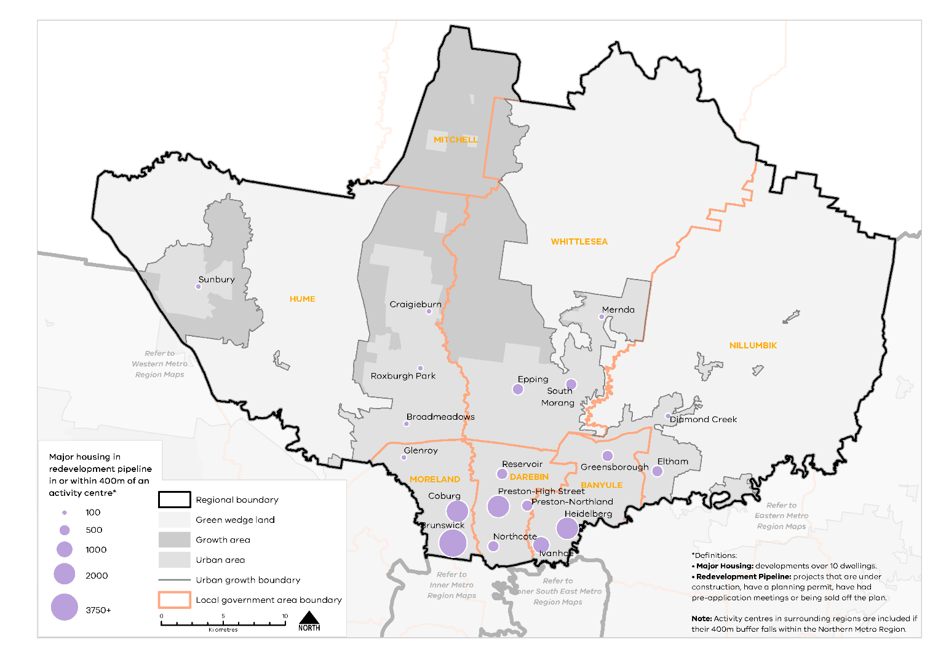
Urban Development Program 2019, Department of Environment, Land, Water and Planning

Figure 12. Major housing in the redevelopment pipeline in or within 400 metres of an activity centre
This map shows:
- Major housing redevelopment pipeline in or within 400m of an activity centre.
- Regional boundary
- Green wedge land covering land outside the urban growth boundary in Nillumbik, Whittlesea and Hume.
- Growth area identified within the urban growth boundary in Hume, Mitchell and Whittlesea.
- Urban area covering Moreland, Darebin and Banyule. Urban Area is also identified Hume, Mitchell, Whittlesea and Nillumbik.
- Local government areas including Moreland, Darebin, Banyule, Hume, Mitchell, Whittlesea and Nillumbik.

*Definitions:
• Major Housing: developments over 10 dwellings.
• Redevelopment Pipeline: projects that are under construction, have a planning permit, have had pre-application meetings or being sold off the plan.
Note: Activity centres in surrounding regions are included if their 400m buffer falls within the Northern Metro Region.
Location | Major housing development pipeline in or within 400m of an activity centre*
Sunbury | 11-100
Craigieburn | 11-100
Epping | 101-500
Roxburgh Park | 11-100
South Morang | 101-500
Mernda | 11-100
Diamond Creek | 11-100
Broadmeadows | 11-100
Glenroy | 11-100
Eltham | 101-500
Greensborough | 101-500
Reservoir | 101-500
Coburg | 1001-2000
Brunswick | 3750+
Preston-High Street | 1001-2000
Preston-Northland | 101-500
Heidelberg | 1001-2000
Northcote | 101-500
Ivanhoe | 501-1000

Urban Development Program 2019, Department of Environment, Land, Water and Planning

Housing demand and its impact on affordability
Housing affordability is an issue across metropolitan Melbourne. Moderate-income first home buyers are being increasingly priced out of the housing market in the inner and middle parts of the Northern Metro Region. The median price for detached houses in the region has been increasing between 2011 and 2017 while the median prices for apartments and units have been more stable. Housing is most affordable in the northern parts of the region, with Mitchell and Hume LGAs recording the lowest median detached house and apartment/unit prices across the region (DELWP, 2019b). However, for low- and very low-income, and prospective first homebuyers home ownership is still largely unattainable. Very low-income single person households are being increasingly priced out of the rental market.
A lack of social housing is also an issue for the region. Despite a higher proportion of social housing in Darebin and Banyule LGAs, compared to the metropolitan Melbourne average, the proportion of homeless people in the region is also high (Australian Bureau of Statistics, 2016). Those waiting for social housing in the region have a priority need due to homelessness, family violence, disability or other special housing needs.
There are several existing Victorian Government initiatives in place to improve the supply of affordable housing, including social housing. These include Victoria’s Big Housing Build, the Social Housing Growth Fund, 1,000 Homes Initiatives and the Redevelopment of Public Housing Estates. Five of the six LGAs in the Northern Metro Region have been identified as priority council areas for projects to increase the supply of social and affordable housing as part of Homes Victoria’s Big Housing Build program.
Regional strengths
- The Northern Metro Region has a diversity of housing choices from growth areas to emerging urban renewal areas and established inner and suburban areas.
- Opportunities exist to locate medium- and higher-density housing in and around metropolitan and major activity centres, the La Trobe NEIC, identified urban renewal areas, SRL precincts and in locations supported by good public transport.
- Greenfield development opportunities in the Northern Growth Corridor can accommodate housing supply and diversity to meet the needs of new and maturing communities.
Regional challenges
- The Northern Metro Region will experience high projected population growth to 2051 and will need to increase housing supply and diversity to provide for an increasing population.
- Housing development must be balanced with providing for employment uses, particularly around SSIPs and regionally-significant industrial precincts.
- The Northern Growth Corridor needs to provide more housing diversity and ensure infrastructure keeps pace with growth.
- The supply of affordable housing is disproportionate to the number of lower income residents in the Northern Metro Region, which is significantly higher than other metro regions.

Directions and strategies
The directions identified to achieve the 2050 vision for the Northern Metro Region in terms of Housing choice and Outcome 2 of Plan Melbourne are:
Direction 7 | Increase the supply of housing in the Northern Metro Region
Direction 8 | Prioritise housing growth in areas with access to jobs, services and good public transport
Direction 9 | Provide greater choice and diversity of housing in the Northern Metro Region
Direction 10 | Increase the supply of social and affordable housing
Direction 11 | Improve planning processes for growth areas to ensure the delivery of diverse and vibrant new communities
Each direction is implemented through regionally-specific strategies identified in this LUFP.
Map 3 shows how housing choice will be enhanced across the Northern Metro Region by 2050 as a result of these directions and strategies, together with Plan Melbourne and other strategies and initiatives as outlined in Appendix 01.

- Northern Metro Region housing choice 2050
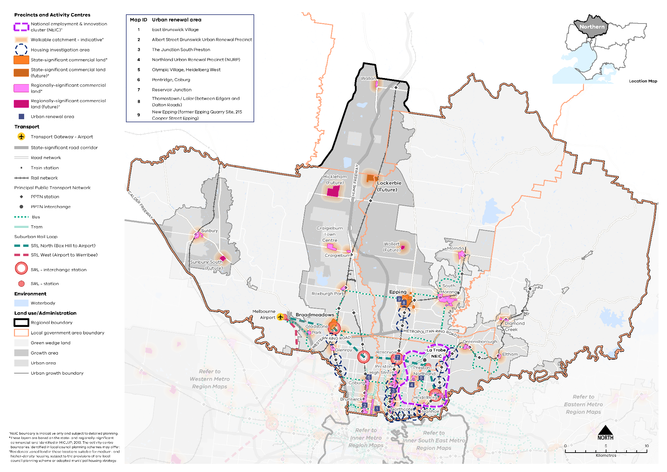
Map 3 Northern Metro Region housing choice 2050
A map of housing choice in the Northern Metro Region in 2050, extracting the locations for medium- and higher-density dwellings identified on Map 1 above and detailed in Table 11, with the addition of 800m walkable catchments around existing and proposed metropolitan and major activity centres*.

* Residential zoned land in these locations suitable for medium- and higher-density housing, subject to the provisions of any local council planning scheme or adopted municipal housing strategy.

- Increase the supply of housing in the Northern Metro Region
Plan Melbourne aims for 70 per cent of net additional dwellings to be provided in Melbourne’s established areas, with the balance provided in greenfield areas. The inner and middle ring suburbs of the Northern Metro Region provide opportunities for well-located, higher-density housing particularly around activity centres, the Principal Public Transport Network (PPTN), and in locally identified strategic sites and urban renewal areas. Future opportunities also exist in locations identified as SRL precincts as part of the later stages of SRL. The provision of housing in these areas will help achieve the overall aspiration of 70 per cent of new housing in established areas.
Substantial and incremental change areas will experience varying degrees of change relative to the existing context and not only increase the supply of housing, but also the diversity in housing types and built form outcomes. Lower density areas in the region are expected to accommodate housing growth within the context of the existing or preferred character. Minimal housing change areas are identified for their special characteristics such as neighbourhood, heritage, environmental or landscape characteristics that should be protected.
Areas in the east of the urban area including South Morang, Mernda, Eltham, Heidelberg and Greensborough are covered by vegetation protection overlays, environmental significance overlays and significant landscape overlays. Some inner-region major activity centres such as Brunswick and Northcote include heritage values that require careful consideration in terms of the density or built form.
- Maximise housing development within the established areas of the Northern Metro Region to achieve the alternate aspirational housing distribution scenario for metropolitan Melbourne.

- Prioritise housing growth in areas with access to jobs, services and good public transport
Plan Melbourne directs greater housing density development in the Northern Metro Region in and around the La Trobe NEIC, within metropolitan and major activity centres, in neighbourhood activity centres with good public transport access, and in urban renewal areas.
Between 2005 and 2016 the percentage of net new dwellings developed across the Northern Metro Region in and within 400 metres of activity centres varied across the region. Moreland, Darebin and Banyule LGAs provided 50 per cent of medium- and higher-density growth in and around activity centres. Whereas Whittlesea, Nillumbik, Hume and Mitchell LGAs provided only 10 to 20 per cent of dwellings in and around activity centres, the majority of net dwellings being located outside activity centres.
Increasing the supply of housing in and around existing activity centres and the La Trobe NEIC will result in people being closer to local jobs, services and good public transport. However, planning for increased densities in these locations will require a balanced approach so that land for employment and job opportunities in activity centres is not diminished. Consistent with the principle of 20-minute neighbourhoods, opportunities in an 800-metre walking catchment around activity centres exist to support medium- and higher-density housing in locations with job, services and access to public transport.
Housing supply should more effectively capitalise on close proximity to major public transport infrastructure. Planning for increased densities and transit-oriented development around the PPTN is a priority for the Northern Metro Region. SRL is not expected to impact the Northern Metro Region in the short- or medium-term with planning and construction of the new line and stations to occur in later stages of the project. SRL precincts have been identified in the region at Heidelberg (interchange), Bundoora, Reservoir (interchange), Fawkner (interchange) and Broadmeadows (interchange). There will likely be greater opportunities for medium- and higher-density development in these locations in the future. Planning in the short- and medium-term for these locations will need to be considerate of the future uses and opportunities for mixed-use and higher-density development.
The region has also seen large infill housing development in middle ring suburbs in recent decades such as Gowanbrae in the west, Preston South and in Coburg North. Most of these types of opportunities are now exhausted. There are also greyfield areas in the region where housing stock is near, or has reached, the end of its useful life and could be redeveloped. Additional housing in these established areas would help achieve Plan Melbourne’s overall aspirations by taking advantage of existing amenities and being close to job-rich locations, services and public transport.
Table 11 identifies locations for medium- and higher-density housing in the Northern Metro Region.

Locations for medium- and higher-density housing in the Northern Metro Region
Classification | Location | Description
NEICs | La Trobe | - NEICs can provide housing opportunities in designated locations where it complements the NEICs’ primary role as a cluster of business activity of national significance  - La Trobe NEIC will have a future train station as part of SRL North. Better accessibility to the NEIC will maximise inter- and cross-regional opportunities for housing, employment, education and health services
Metropolitan activity centres | Broadmeadows  Epping  Lockerbie (future) | - Metropolitan activity centres are locations for medium- and higher-density housing and mixed-use development. Substantial housing change opportunities may extend to a walkable catchment of 800 metres around the centre (depending on the local context) based on the 20-minute neighbourhood principle of locating housing close to jobs, services, amenities and public transport  - Metropolitan activity centres play a major role in supporting a broad range of other uses such as retail, commercial, entertainment and community uses to a regional catchment. Housing development in and around metropolitan activity centres will be complementary to the existing and future jobs and employment role of the centres (Table 6)  - Structure planning will identify the preferred locations, densities and types for housing and development constraints or limitations in each centre  - Broadmeadows Metropolitan Activity Centre is identified as an interchange train station in SRL North (Box Hill to Airport) and higher-density development is supported
Major activity centres | Beveridge (future)  Brunswick  Coburg  Craigieburn  Craigieburn Town Centre  Diamond Creek  Eltham  Gladstone Park  Glenroy  Greensborough  Heidelberg  Ivanhoe  Mernda  Mickleham (future)  Northcote  Preston High Street  Preston Northland  Reservoir  Roxburgh Park  South Morang  Sunbury  Sunbury South (future)  Wallan (future)  Wollert (future) | - Major activity centres are locations for medium- and higher-density housing and mixed-use development. Substantial housing change opportunities may extend to a walkable catchment of 800 metres around the centre (depending on the local context) based on the 20-minute neighbourhood principle of locating housing close to jobs, services, amenities and public transport  - While all major activity centres will accommodate housing change, the degree of change is relative to the existing context and characteristics of each major activity centre (Table 6)  - Structure planning will identify the preferred locations, densities and types for housing and development constraints or limitations in each centre  - Heidelberg and Reservoir major activity centres are designated as locations for SRL stations and will provide greater opportunities for housing change
Neighbourhood activity centres |  | - Some neighbourhood activity centres may be locations for mixed-use medium- and higher-density housing, particularly when they are serviced by good public transport. Housing opportunities may also extend to a walkable catchment of 800 metres around the centre (depending on the local context) based on the 20-minute neighbourhood principle of locating housing close to jobs, services, amenities and public transport  - Approved PSPs for the Northern Growth Corridor identify future neighbourhood activity centres that will accommodate medium- and higher-density housing  - Future PSPs in growth areas will be guided by the 20-minute neighbourhoods principle and the Victorian Planning Authority’s guidelines for precinct structure planning.
Urban renewal areas and greyfields | Albert Street Brunswick Urban Renewal Precinct  Bell Street (Bell Station), Preston  East Brunswick Village  New Epping (former Epping Quarry Site, 215 Cooper Street Epping)  Northland Urban Renewal Precinct (NURP)  Pentridge, Coburg  Reservoir Junction  The Junction South Preston  The Coburg Initiative  Olympic Village, Heidelberg West  Thomastown / Lalor (Edgars to Dalton roads) | - Urban renewal areas identified in the LUFP are locations nominated by state and local government with opportunities for medium- and higher-density mixed-use development. These locations have regional value based on one or more the following characteristics: land size, proximity to the PPTN or future transport infrastructure, government-ownership, or require cross-municipal planning. These areas will be planned according to 20-minute neighbourhood principles. A coordinated approach to planning for these areas will maximise their development opportunity and any infrastructure needs
Suburban Rail Loop precincts | Heidelberg (interchange)  Bundoora  Reservoir (interchange)  Fawkner (interchange)  Broadmeadows (interchange) | - SRL precincts are opportunities for medium- and higher-density housing development due to their proximity to future SRL train stations. Housing development in SRL precincts will be supported by other uses such as commercial, retail and services and maximise their potential as transit-oriented development. They will undergo substantial change and will be subject to further detailed precinct planning
Housing investigation areas | Alphington Station  Bell Station  Croxton Station  Darebin Station  Dennis Station (Northcote)  Donnybrook Station  Fairfield Station  Fawkner Station  Glenbervie Station  Hawkestowe Station  Lalor Station  Jacana Station  Macleod Station  Middle Gorge Station  Oak Park Station  Pascoe Vale Station  Regent Station  Rosanna Station  Strathmore Station  Thomastown Station  Thornbury Station  Westgarth Station (Northcote)  Watsonia Station | - Housing investigation areas are areas within an 800 metre walkable catchment around existing and future train stations that have the potential to support medium- and higher-density housing development in line with maximising access to public transport and 20-minute neighbourhood principles. These areas are outside designated metropolitan and major activity centres and are based on their access to rail infrastructure, existing zones that allow residential development and the absence of ‘special characteristics’ such as heritage, landscape, bushfire values or airport environs  - A further assessment to determine locations within housing investigation areas suitable for substantial housing change and rezoning, in response to the local context, will be required
Greenfield growth area | Northern Growth Corridor | - Growth areas are designated to provide future supply of land for development in metropolitan Melbourne. A detailed PSP process will articulate the land uses and determine suitable locations for medium- and higher-density housing in the growth areas
- Increase the supply of medium- and higher-density housing around the La Trobe NEIC, in and around metropolitan and major activity centres, urban renewal areas, SRL precincts and in and around neighbourhood activity centres serviced by good public transport.
- Ensure new housing in and around the La Trobe NEIC does not encroach on the primary employment and innovation role of the NEIC.
- Support substantial housing change in locations where transport upgrades and improvements such as Suburban Rail Loop or level crossing removals create opportunities to locate housing closer to jobs, services and infrastructure.
- Maximise development potential in housing investigation areas around existing and proposed train stations to leverage access to the PPTN.

- Provide greater choice and diversity of housing in the Northern Metro Region
The Northern Metro Region, like metropolitan Melbourne, is mostly made of separate houses with 74 per cent of the housing stock. The percentage of flats, units and apartments in the region is 9 per cent, which is almost half of the metropolitan Melbourne average. A majority of the dwellings have three or more bedrooms. Between 2016 and 2050, families with children households are projected to increase by 134,030 in the Northern Metro Region. Continuing to provide dwellings with three or more bedrooms will accommodate this growth. There will be opportunities for three-bedroom apartments to also cater for this population growth in locations where higher-density development is appropriate.
The number of people aged over 60 in the Northern Metro Region is projected to increase by 162 per cent between 2016 and 2050. Although the overall percentage is in line with what is expected across metropolitan Melbourne, the demographic population change within the region is substantial and needs to be planned for now. The Northern Metro Region will require greater housing diversity by providing smaller dwellings, adaptable housing options, affordable arrangements, residential aged care facilities and retirement homes to cater for this increase in an older population. The Northern Growth Corridor also provides opportunities for additional residential aged care facilities to support the growing and ageing population in the outer areas of the region. The region should provide opportunities for residents to ‘age in place’ in their existing communities, with access to community services and public transport that meets their daily needs.
The Northern Metro Region has significant health and education industries with four state-significant health and/or education precincts. Providing an increased supply of student accommodation around education precincts and key worker accommodation near health precincts will better connect education and employment opportunities.
There is also an opportunity for a greater diversity of housing in the Northern Growth Corridor. Planning for the growth areas will provide for a variety of housing choices to meet the needs of new communities as they mature over time.
- Encourage a genuine mix of dwelling types and sizes in the Northern Metro Region to accommodate the changing future needs of the region.
- Facilitate the development of housing that is adaptable and flexible to cater for changing demographics and to support ‘ageing in place’.
- Optimise the opportunities for student accommodation and key worker housing around health and/or education precincts in the Northern Metro Region.
- Ensure new residential development is well-designed, durable, resilient to climate change and built to a high-quality standard.
- Adopt a place-based approach to the delivery of infill housing developments to replace ageing housing stock, ensure a high-quality of design that is appropriate for the local context and contributes to housing supply and diversity.

- Increase the supply of social and affordable housing
Affordable housing is defined in the Planning and Environment Act 1987 as housing appropriate for the needs of very low-, low- and moderate-income households, and includes social housing provided by the government or a registered housing agency. Social housing also includes public housing and community housing to accommodate people who have experienced homelessness, family violence or have other special needs. The provision of more social and affordable housing requires a range of programs and measures across all levels of government.
Housing affordability is affecting an increasing number of residents across metropolitan Melbourne. Planning should facilitate the delivery of affordable housing in the Northern Metro Region by considering opportunities to develop under-utilised or disused government-owned land for social housing. Facilitating the supply of affordable housing in locations that are closer to jobs, services and public transport — in addition to sustainable design — will lower household costs, which is particularly important to the very low-, low- and moderate-income households. By strengthening the role of planning to facilitate and deliver affordable housing opportunities will contribute to continuing to make Melbourne a liveable city for all.
The social and affordable housing system, consisting of the government, community housing sector and industry, provides housing options for those unable to access the private housing market. There are currently 116,351 people living in social housing owned or managed by Homes Victoria (Director of Housing) or a registered housing corporation across Victoria. Victoria has the lowest proportion of social housing in Australia and will require 4000 homes per year for Victoria’s social housing to reach the national average of 4.2 per cent of social housing to total dwellings.
The Victorian Government’s Big Housing Build program aims to increase existing social housing stock across Victoria by 10 per cent and, in the next five years, over 12,000 new dwellings will be built. The program is Victoria’s largest investment in social and affordable housing and Homes Victoria has been established to deliver the program as well as ensure an ongoing pipeline of social and affordable housing development beyond the Big Housing Build. In addition, existing social housing dwellings will be upgraded, maintained or replaced under the program. The Victorian Government has identified 21 priority LGAs for social housing development of which Darebin, Hume, Moreland, Mitchell and Whittlesea are identified in the Northern Metro Region.
- Facilitate more affordable housing across the region, particularly in locations that have good access to jobs, services and public transport.
- Support the delivery of social housing, particularly in Darebin, Hume, Moreland, Mitchell and Whittlesea LGAs.
- Improve planning processes for growth areas to ensure the delivery of diverse and vibrant new communities
Development of growth areas in the Northern Metro Region is guided by the Northern Growth Corridor Plan (Map 4). This plan outlines an overarching strategy for the development of Melbourne’s growth areas over the coming decades, which is then realised at a local level through PSPs. PSPs set out the preferred spatial location of key land uses and infrastructure to guide decisions on staging of development, subdivision permits, building permits and infrastructure delivery. They have a specific role to address matters within the scope of the planning system, ensuring they are consistent with the regulatory environment that operates in conjunction with the planning system.
Plan Melbourne highlights the importance of an integrated approach between land use and infrastructure delivery in growth areas to ensure residents have access to workforce opportunities, education, health services and other infrastructure. Policy 2.2.5 states that planning and development in growth areas should:
- Provide around 15 years supply of land approved for development (11.02-1S Victoria Planning Provisions)
- Over time, seek an overall increase in residential densities to more than 20 dwellings per hectare. Melbourne’s average housing density is currently 14 dwellings per hectare. Research shows that a minimum density of 25 dwellings per hectare is needed to support 20-minute neighbourhoods
- Be sequenced to ensure new precincts are contiguous with previously approved precincts.
2018 data estimates suggest that the Whittlesea growth area currently has 22 years of land supply and the Hume-Mitchell growth area has 30 years of supply. In 2018, lot densities in the Northern Metro Region were approximately 29 dwellings per hectare (DELWP, 2018e).
Existing townships in the Northern Growth Corridor such as Beveridge, Kalkallo and Donnybrook have established residential neighbourhoods. Planning will need to consider how to integrate these existing communities with new development as well as the provision of services and facilities including public transport. In Sunbury/Diggers Rest, Jacksons Creek is a defining landscape feature that also poses a challenge to connectivity and movement for new communities east of the creek. Linkages across Jacksons Creek will enable residents to access the facilities in the established parts of Sunbury including the proposed rail station.
New master planned estates are typically developed in phases and therefore new residents do not have immediate access to many essential services such as hospitals and schools, community services and/or retail stores to meet their everyday needs and foster social cohesion. This is compounded by a lack of adequate public transport to connect people to nearby communities (Grodach, et al., 2019). Car dependency is also high due to poor provision of community infrastructure early in the development process. This car dependency often continues even after community infrastructure has been provided locally (Grodach, et al., 2019).
While the PSP process often articulates a desire to stage development and delivery of facilities and transport networks, and seeks to sequence development that ‘should have regard to’ the proximity of services, infrastructure and facilities, this does not explicitly require the delivery of services and infrastructure in a timely manner. Staging development in growth areas through the PSP process will help with the timely delivery of infrastructure and 20-minute neighbourhood features in these communities.
Due to highly erosive waterways in the upper catchment of the Northern Metro Region, development may also need to be carefully staged in some areas to allow for construction of appropriate stormwater management infrastructure. Construction of the proposed OMR will be a consideration in local stormwater management along the road’s alignment. Planning and development will need to consider and respond appropriately, including careful staging of development and construction of stormwater management infrastructure.
- Require development in growth areas to be sequenced and staged at a regional level to better link infrastructure delivery to land release.
- Facilitate the development of medium- and higher-density housing in the growth areas to provide greater housing diversity and create 20-minute neighbourhoods close to services, jobs and public transport.

Actions – Housing choice

- Update planning schemes to align with housing policies in Plan Melbourne and the Northern Metro Region Land Use Framework Plan and the implementation of the reformed residential zones. This includes:
- Providing capacity for 15 years of regional housing supply focusing on locations identified for housing growth in the LUFP
- Reviewing planning controls in housing investigation areas as potential locations for substantial or incremental housing change.
This may require strategic planning work to support these changes such as preparing or updating local housing strategies or preparing structure plans to further investigate where increased densities can be supported, and determine specific changes required to planning schemes.
- Identify underutilised and surplus government land that has potential to deliver additional social housing.
- In partnership with councils, identify a pipeline of sites in the Northern Metro Region for social and affordable housing.
- Develop a model and seek support for a whole-of-government approach to better sequence and prioritise locations for key services, social infrastructure and public transport access in the development of growth areas to better enable walkable 20-minute neighbourhoods.

- Northern Growth Corridor

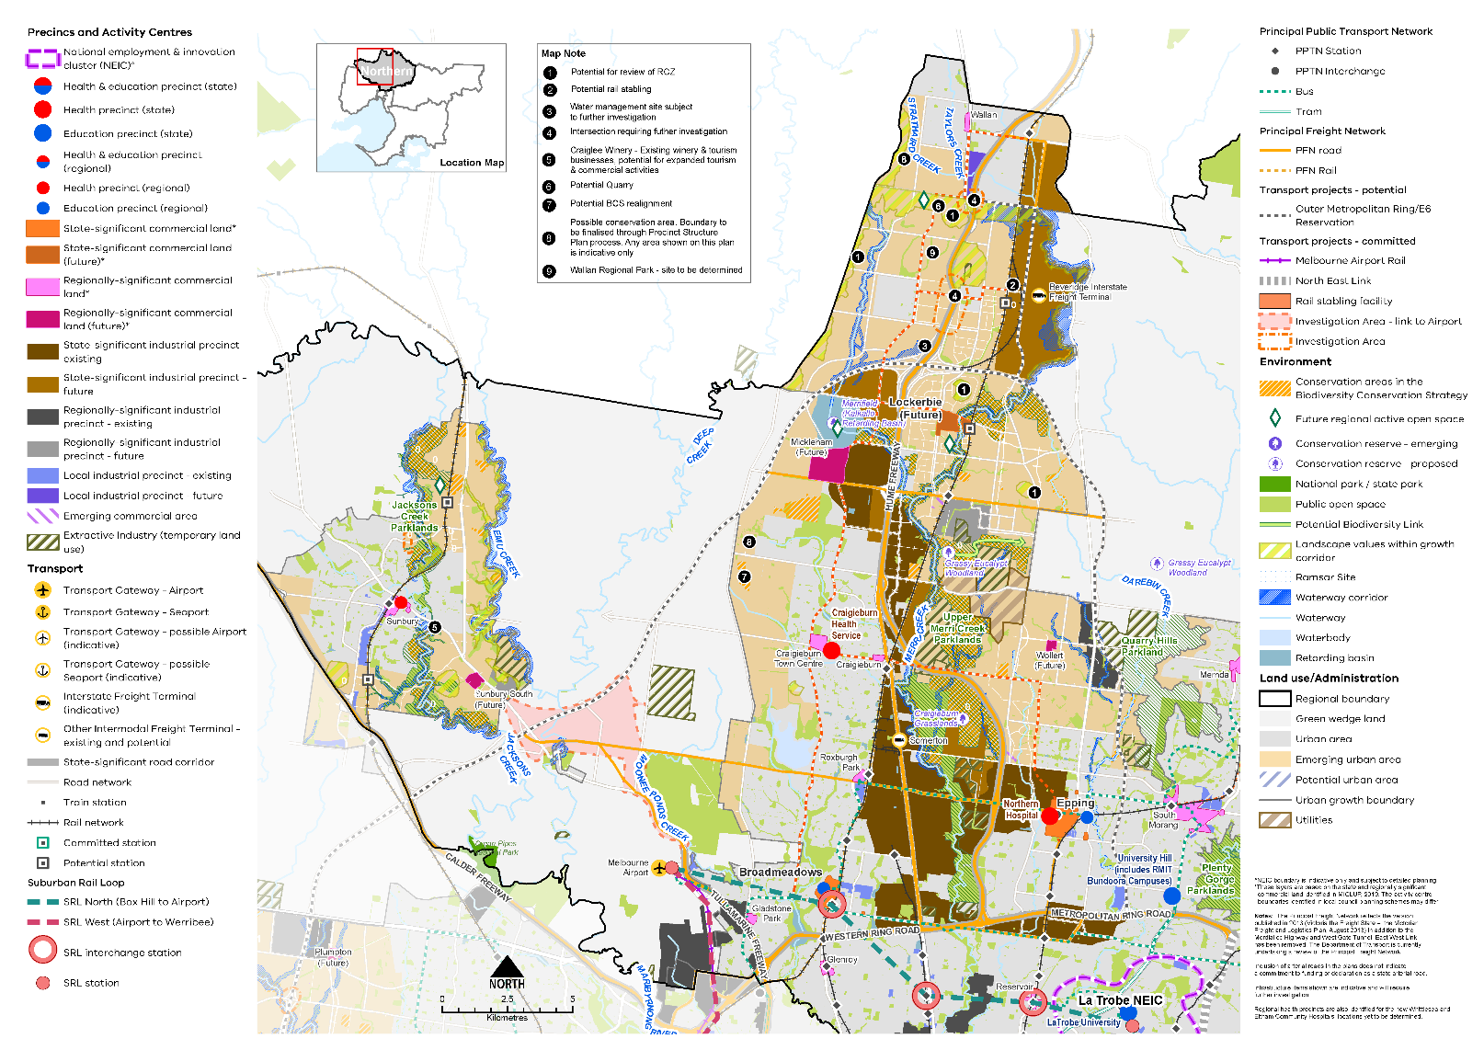

Map 4 Northern Growth Corridor Plan
A map showing the main features of the Northern Growth Corridor, highlighting:
- The existing urban area and the emerging growth areas around Sunbury and Craigieburn-Donnybrook (Hume), Epping-Wollert and Mernda/Doreen (Whittlesea) and around Wallan (Mitchell)
- La Trobe National Employment and Innovation Cluster^
- Metropolitan and major activity centres in the existing urban area. The proposed metropolitan activity centre at Lockerbie and future major activity centres at Beveridge and Wallan (Mitchell), Mickleham and Sunbury South (Hume), and Wollert (Whittlesea)*
- Existing and future state- and regionally-significant industrial areas and local industrial precincts
- State and regional health and/or education precincts
- Extractive Industry (temporary use) in various locations across the growth area
- SRL North interchange stations at Broadmeadows, Fawkner and Reservoir, SRL stations at the Airport and Bundoora. SRL West (Airport to Werribee) alignment
- Public transport network and freight road and rail network
- Outer Metropolitan Ring / E6 reservation linking the Calder Freeway in the west to the Metropolitan Ring Road at University Hill, running to the north of the future Lockerbie Metropolitan Activity Centre and then south to Epping
- Investigation areas for road infrastructure including a possible link to the airport from Sunbury South (Future major activity centre) and two new intersection/crossing on the Hume Freeway west of the future state-significant industrial area and Beveridge Interstate Freight Terminal
- Potential new railway stations north and south of Sunbury, at the future Lockerbie Metropolitan Activity Centre, and the Beveridge Interstate Freight Terminal with potential rail stabling
- Large area identified for utilities west of Wollert Major Activity Centre (future)
- Significant waterway corridors and waterbodies
- Green wedge land, public open space, proposed and expanded/improved regional parks, proposed regional active open space, emerging conservation reserves, potential biodiversity links, and the growth area landscape values.
Map note (the location of each of these is shown on the map by number)
  - Potential for review of RCZ (Rural Conservation Zone) in four location in the emerging urban area
  - Potential rail stabling west of the proposed Beveridge Interstate Freight Terminal
  - Water management site subject to further investigation west of the Hume Freeway, north of the intersection with the Outer Metropolitan Ring/E6 reservation
  - Two intersections requiring further investigation on the Hume Freeway west of the future state-significant industrial area and Beveridge Interstate Freight Terminal
  - Craiglee Winery - Existing winery & tourism businesses, potential for expanded tourism & commercial activities
  - Potential quarry west of the Hume Freeway between Beveridge and Wallan
  - Potential conservation area (Biodiversity Conservation Strategy) realignment south of Mt Ridley Road, Mickleham

8. Possible conservation area north of Mt Ridley Road, Mickleham. Boundary to be finalised through Precinct Structure Plan process. Any area shown on this plan is indicative only
9. Wallan Regional Park – site to be determined.

Other map notes
^ NEIC boundary is indicative only and subject to detailed planning.
*These layers are based on the state and regionally significant commercial land identified in MICLUP, 2019. The activity centre boundaries identified in local council planning schemes may differ.
The Principal Freight Network reflects the version published in 2013 (Victoria the Freight State – the Victorian Freight and Logistics Plan, August 2013) in addition to the Mordialloc Highway and West Gate Tunnel. East West Link has been removed. The Department of Transport is currently undertaking a review of the Principal Freight Network.
Inclusion of arterial roads in the plans does not indicate a commitment to funding or declaration as a state arterial road. Infrastructure items shown are indicative and will require further investigation.
Regional health precincts are also identified for the new Whittlesea and Eltham Community Hospitals, locations yet to be determined.

Chapter 06.
Integrated transport
Plan Melbourne Outcome 3: Melbourne has an integrated transport system that connects people to jobs and services and goods to market.
As the Northern Metro Region grows, it will require better integration of land use and transport planning, better use of existing roads, and increased investment in public transport, walking and cycling. Making better use of transport infrastructure, complemented by good precinct design, can improve connections without necessarily the expense and disruption of delivering new infrastructure. Land use decisions, as well as mode shift opportunities, can significantly improve access and reduce transport-generated emissions.
Transport in the Northern Metro Region is primarily provided by road and rail networks that radiate from the CBD, connecting through the region and onto the north of the state. However, connections are limited between residential areas and employment areas throughout the region.
The Northern Metro Region is home to the transport gateway of Melbourne Airport as well as the proposed BIFT. SRL and other committed road and rail projects will improve access within the region as well as better connecting the region to other parts of Melbourne and the state.

State of play
Map 5 outlines the current state of play for transport in the Northern Metro Region.

Road network
The region’s main north-south connection is the Hume Freeway, one of Melbourne’s most strategically important pieces of transport infrastructure, connecting the region with Melbourne’s CBD, regional Victoria and New South Wales. The M80 Ring Road is the critical east-west link across the region. The Calder Freeway connects to the M80 Ring Road, linking Sunbury and the north-west of Victoria. Melbourne Airport, a state-significant transport gateway, is connected to Melbourne’s CBD via the Tullamarine Freeway and CityLink. Both the Hume Freeway and Melbourne Airport are key economic regions and gateways for Australia’s national economy.
As the region grows, road congestion will increase, with the impact of congestion highest on residents in outer areas. By 2031, traffic volumes in the outer area of the Northern Metro Region will increase around 47 per cent from 2015 levels (KPMG & ARUP, 2017). Congestion hotspots include Epping Road and Plenty Road. The duration of morning and evening peak periods lengthens with distance from Melbourne’s city centre, and for outer regions, the morning peak is forecast to begin half an hour earlier by 2031 (KPMG & ARUP, 2017).

Public transport network
The Northern Metro Region has an established public transport network, especially in the southern part of the region as shown in Figure 15. The inner suburbs of the Northern Metro Region are well connected to Melbourne’s CBD by both train and tram. The region’s rail network includes:
- Metro passenger services to Sunbury, Upfield, Mernda, Hurstbridge and Craigieburn
- Regional passenger services to Bendigo, Albury and Shepparton
- Interstate passenger and freight lines from Melbourne to Sydney and Brisbane (via Albury).
The outer sections of all lines are limited by single tracks. The Upfield line connects to the Craigieburn line at Roxburgh Park but is not used for metropolitan passenger services beyond Upfield. Regional passenger services operate for the growth areas beyond Craigieburn to Wallan. The tram network extends to Coburg (three lines), Brunswick (two lines) and Bundoora.
The Northern Metro Region’s bus network is mainly concentrated in the southern LGAs. Three orbital SmartBus routes provide east-west connections. All existing activity centres and the La Trobe NEIC contain multi-modal transport interchanges.
Figure 13 shows the accessibility to public transport for people who live within the region based on how far they need to walk to access train, tram and bus services. Whittlesea, Nillumbik and Hume LGAs have the lowest average hourly frequencies of public transport per stop compared to other local councils in the region. Congestion in the region’s inner suburbs is increasing, with more activity, traffic and freight movements, and limited north-south and east-west arterial corridors. Between the region’s radial rail corridors, public transport provision can be poor, with higher levels of car dependency and increasingly congested road networks.

- Northern Metro Region integrated transport state of play
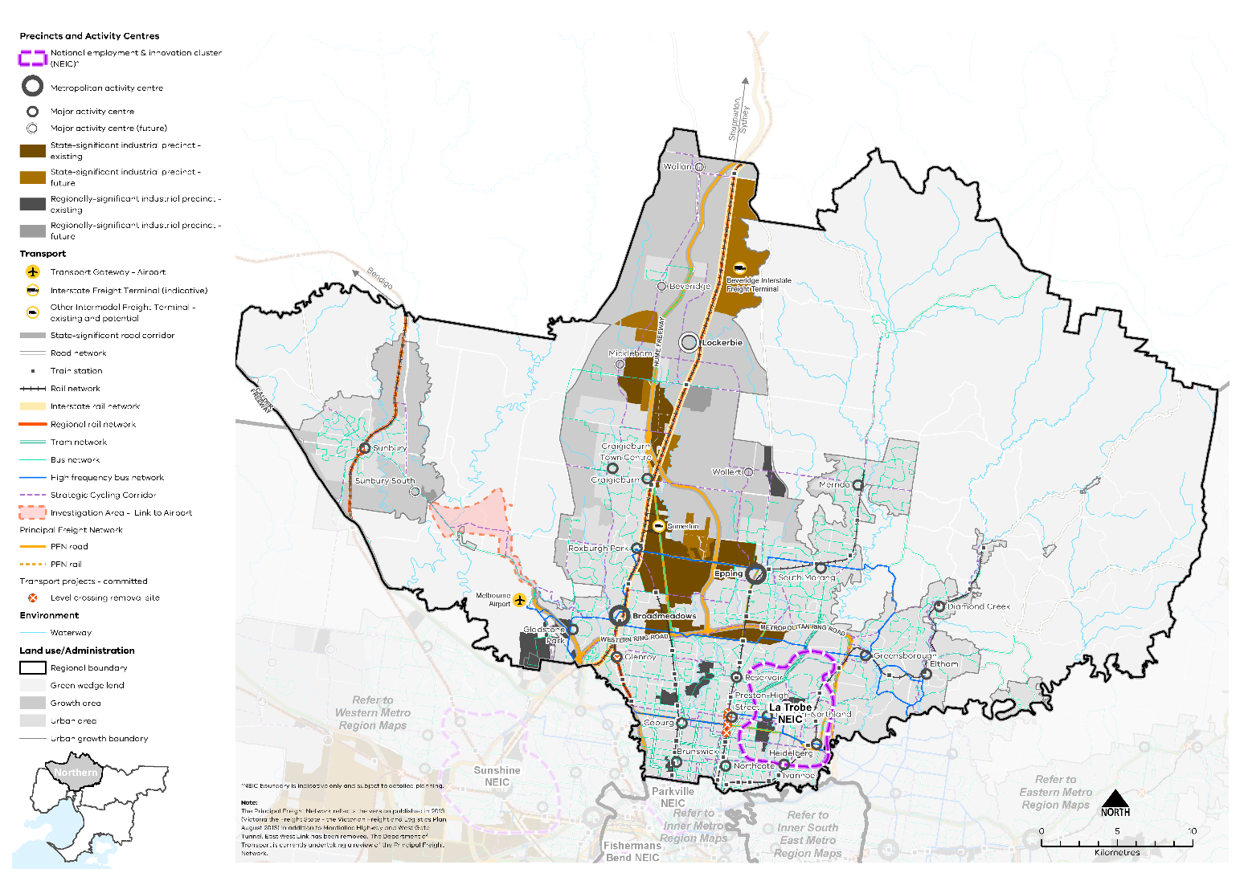

Map 5 Northern Metro Region integrated transport state of play
A map showing the key transport features of the region in 2021, as extracted from Map 1, and also highlighting:
- The route of the interstate rail network to northern Victoria and Sydney
- The regional rail network from Shepparton
- The bus network principally in the established urban area and the high frequency bus network
- The strategic cycling network through the established urban area and growth areas
- The principal rail and road freight network including the intermodal freight terminal at Somerton.
Note: The Principal Freight Network reflects the version published in 2013 (Victoria the Freight State - the Victorian Freight and Logistics Plan, August 2013) in addition to Mordialloc Highway and West Gate Tunnel. East West Link has been removed. The Department of Transport is currently undertaking a review of the Principal Freight Network.
- Public transport accessibility in the Northern Metro Region
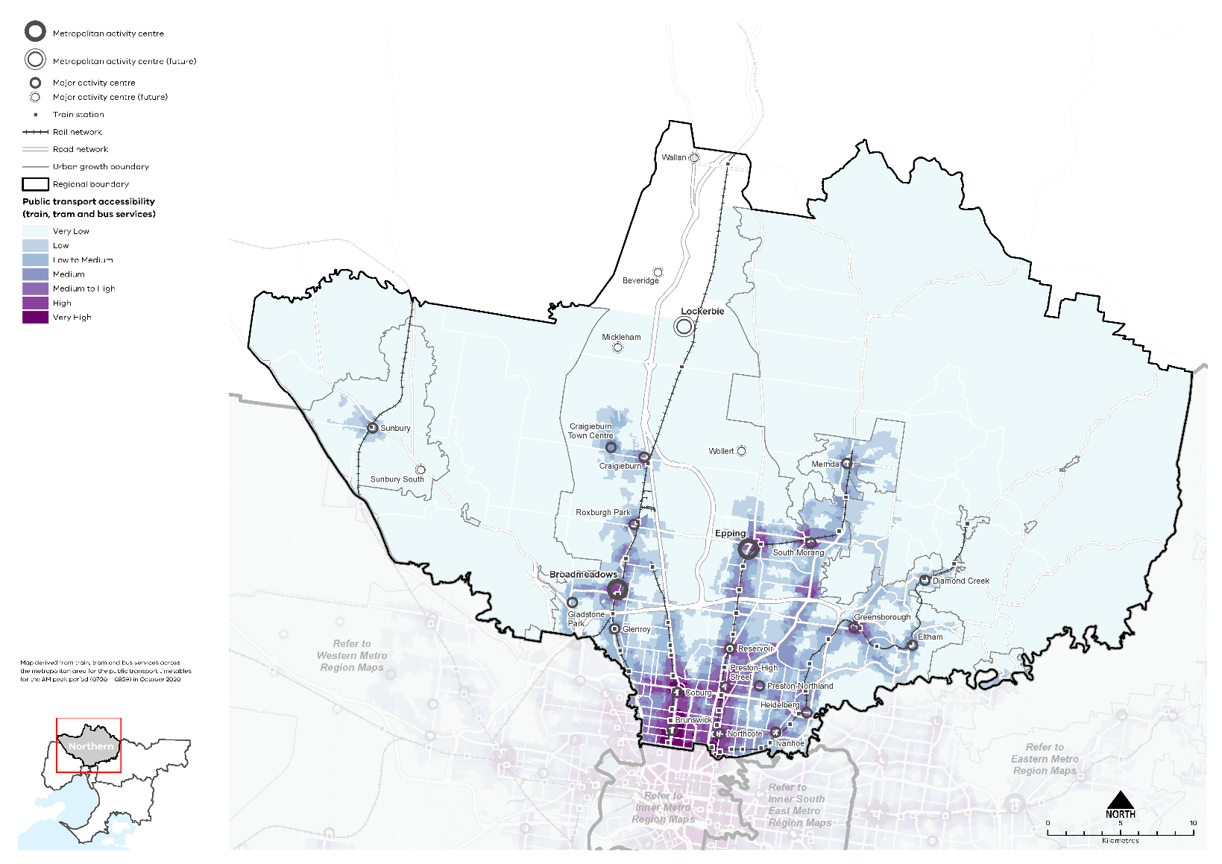

Active transport network
The cycling network is well developed in the southern, more populated part of the region, with established off road trails along waterway corridors and Strategic Cycling Corridors. These trails extend from Melbourne’s CBD to activity centres such as Broadmeadows, Coburg, Preston and Heidelberg and La Trobe University. However, further improvements are needed to make cycling a more attractive form of transport, particularly in the outer areas. In 2016, 3 per cent of residents cycled to work in the Northern Metro Region. This compares to 1 per cent for metropolitan Melbourne. 2 per cent of residents walked to work in the Northern Metro Region, which compares to 3 per cent for metropolitan Melbourne.

Regional access and movement
Around half of the residents of the Northern Metro Region also work in the region. Figure 14 shows journeys in and out of the Northern Metro Region in 2016. The most common work destination for the Northern Metro Region after the region itself was the Inner Metro Region. The most common work destination for residents in 2016 was Melbourne LGA, followed by the local LGAs of Hume and Whittlesea (Australian Bureau of Statistics, 2016). Whittlesea and Hume were also the most common origin of people working in the region, followed by Banyule and Darebin LGAs. Workers also travelled from LGAs in the Western Metro Region, including Brimbank, Moonee Valley and Melton LGAs.
A substantial number of workers travel from outside the region, mainly from the Western Metro Region. After the LGAs within the Northern Metro Region, workers travel from Brimbank, Moonee Valley, Melton and Manningham LGAs for jobs located in the Northern Metro Region (Australian Bureau of Statistics, 2016).

- Journey to work in and out of the Northern Metro Region
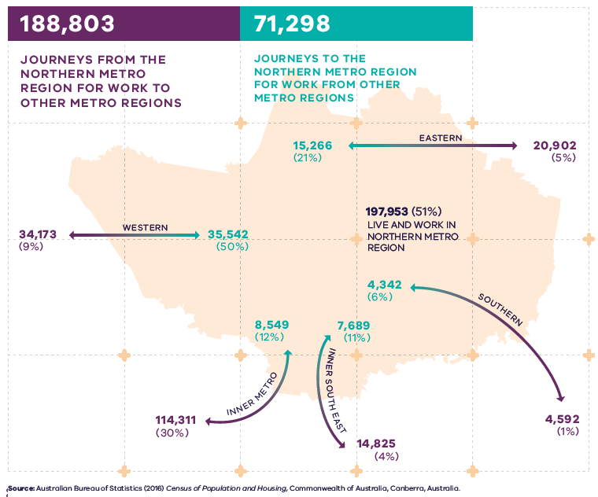

Figure 14. Journey to work in and out of the Northern Metro Region
197,953 (51 per cent) live and work in the Northern Metro Region | 188,803 – Journeys from the Northern Metro Region for work to other metro regions:  - 20,902 (5 per cent) – Journeys to the Eastern Metro Region  - 4,592 (1 per cent) – Journeys to the Southern Metro Region  - 14,825 (4 per cent) – Journeys to the Inner South East Metro Region  - 114,311 (30 per cent) – Journeys to the Inner Metro Region  - 34,173 (9 per cent) – Journeys to the Western Metro Region | 71,298 – Journeys to the Northern Metro Region for work from other metro regions:  - 15,266 (21 per cent) – Journeys from the Eastern Metro Region  - 4,342 (6 per cent) – Journeys from the Southern Metro Region  - 7,689 (11 per cent) – Journeys from the Inner South East Metro Region  - 8,549 (12 per cent) – Journeys from the Inner Metro Region  - 35,542 (50 percent) – Journeys from the Western Metro Region
Source: Australian Bureau of Statistics (2016) Census of Population and Housing, Commonwealth of Australia, Canberra, Australia.

Regional strengths
- There are significant existing and future transport connections to regional Victoria, Melbourne Airport, other metro regions and the Central City which will improve access to jobs, services and infrastructure.
- The region benefits from a strong freeway, arterial road and freight network, including the proposed BIFT.
- The region will benefit from access improvements through the Suburban Rail Loop.
- The region is home to the transport gateway of Melbourne Airport which will become better connected to the rest of Melbourne via Melbourne Airport Rail.

Regional challenges
- There is a lack of capacity in many of the north-south corridors and a need to create better transport interchanges at key locations such as train stations in the Northern Growth Corridor.
- East-west connections across the region need to be increased and improved.
- The region has higher levels of car dependency and congested road networks, there is a need to increase the number of trips taken by walking, bicycle, and public transport.

Directions and strategies
The directions identified to achieve the 2050 vision for the Northern Metro Region in terms of integrated transport and Outcome 3 of Plan Melbourne are:
Direction 12 | Improve transport connections to support the productivity of the Northern Metro Region
Direction 13 | Improve public and active transport access for the La Trobe NEIC, metropolitan and major activity centres
Direction 14 | Improve transport connectivity in the Northern Growth Corridor and outer suburbs
Direction 15 | Improve active and public transport options to promote mode shift and support 20-minute neighbourhoods
Direction 16 | Protect and grow the Northern Metro Region’s comparative advantage in freight and logistics
Each direction is implemented through regionally-specific strategies identified in this LUFP.
Map 6 shows how Integrated transport will be enhanced across the Northern Metro Region by 2050 as a result of these directions and strategies, together with Plan Melbourne and other strategies and initiatives as outlined in Appendix 01.

- Northern Metro Region integrated transport 2050

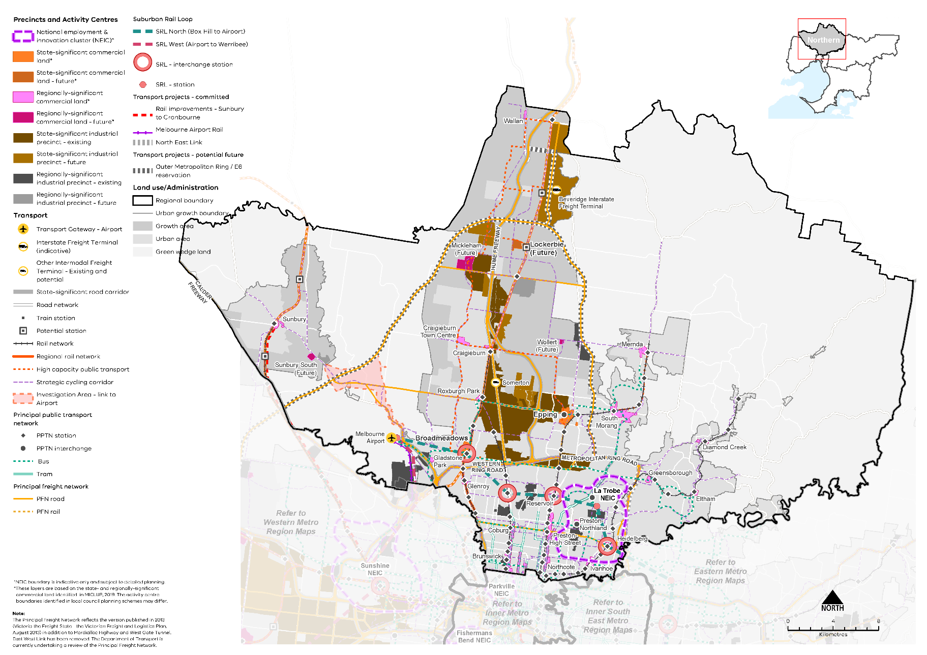
Map 6 Northern Metro Region integrated transport 2050

A map showing the key transport features of the region in 2050, as extracted from Map 1, and also highlighting:
- Rail improvements from Sunbury to Cranbourne
- PPTN stations and interchanges
- Potential new train stations in the growth areas at Sunbury South and North, Lockerbie, Beveridge
- Expanded PPFN including along the Outer Metropolitan Ring / E6 reservation.
- High capacity public transport route along Aitken Boulevard to north of the region, and through Wollert
- Investigation Area – Link to Airport (between Melbourne Airport and Sunbury)
- Expanded PFN including along the Outer Metropolitan Ring / E6 reservation.

Note: The Principal Freight Network reflects the version published in 2013 (Victoria the Freight State - the Victorian Freight and Logistics Plan, August 2013) in addition to Mordialloc Highway and West Gate Tunnel. East West Link has been removed. The Department of Transport is currently undertaking a review of the Principal Freight Network.

- Improve transport connections to support the productivity of the Northern Metro Region
As Broadmeadows, Epping and other important employment centres across the Northern Metro Region grow, such as Lockerbie, Mickleham and Wollert, public transport connections to these centres will need to be expanded. They will also require active transport networks that logically connect with public transport nodes and improved transport interchanges. Train station master planning will be important at key locations such as metropolitan activity centres and train stations in the Northern Growth Corridor.
Improved east-west transport connections will support the development of regional employment opportunities reducing the need for long commutes. In established urban areas, existing public transport connections comprise bus routes on heavily congested roads. In the Northern Growth Corridor there are few east-west public transport options. It will become increasingly important to improve these connections to better link residents to jobs and services in key nodes such as the La Trobe NEIC, Melbourne Airport, Broadmeadows, Epping and Lockerbie metropolitan activity centres.
The key regional linkages are shown in Figure 15. Decisions regarding appropriate modes for these links should consider the capacity of existing infrastructure, ongoing sustainability and providing travel choices over a longer time period including evening and late-night travel.
Key east-west, multi-modal connections requiring further development are:
- Bell Street (through inner-middle Melbourne from the Tullamarine Freeway to Heidelberg and the southern part of the La Trobe NEIC connecting into SRL)
- M80 Ring Road and Mahoneys Road (linking Melbourne Airport through Broadmeadows and Thomastown, and La Trobe NEIC)
- Cooper Street and Somerton Road (linking Roxburgh Park to Epping, and connecting with the Hume Highway Corridor, Melbourne Wholesale Fruit, Vegetable and Flower Market and Epping)
- Donnybrook Road, Craigieburn East Road, Findon Road and the M80 Ring Road duplications (ultimately connecting the OMR from Mickleham Road in the west through Lockerbie and the proposed BIFT and to Plenty Road to the east).
The proposed OMR will improve access to Melbourne Airport, Epping and Lockerbie metropolitan activity centres and Sunbury Major Activity Centre.
Increasing the capacity of north-south corridors, in particular in the growth areas in Hume and Whittlesea LGAs, is critical to improve access and reduce travel time to Melbourne’s CBD and inner suburbs. This includes increasing rail capacity, completing the arterial road network and planning for its flexible use to accommodate active, sustainable modes of transport.
As the city grows, the links between the Northern Metro Region, peri-urban areas and central Victoria will continue to be important. Major activity centres such as Sunbury and Craigieburn in the region’s north will become stronger service hubs, while proposed employment centres such as Lockerbie and the BIFT will become job locations for residents in peri-urban and regional areas. This will require better connections between the Northern Metro Region and towns and centres in peri-urban and central Victoria, particularly by public transport.
Key metropolitan inter-regional linkages are from Melbourne’s north to western, eastern and southern economic nodes such as Sunshine, Ringwood, Box Hill, Clayton and Dandenong, and to the Melbourne CBD and Port of Melbourne.
The capacity of the regional bus network needs to be enhanced to improve integration with train and tram services and provide alternative high-capacity transport options in the growth areas. This will also increase public transport options to key locations in the short- to medium-term while longer-term transport projects are delivered such as North East Link and SRL.
Inner northern suburbs have recently transitioned to higher-density, compact suburbs with strong walking, cycling and public transport cultures. While there has been progress in implementing the Principal Bicycle Network (PBN) there is still a challenge to elevate cycling as a genuine alternative transport choice and introduce safer cycling routes to meet demand. Public and active transport access for workers to industrial precincts should also be improved to reduce car use and car parking demands in these locations.
Quality off-road and protected on-road bicycle connections are needed, especially to key destinations such as La Trobe NEIC and the Melbourne CBD.
Strategic Cycling Corridors will connect state-significant locations and activity centres. Priority active transport projects will promote increased safe use of the region’s cycling and walking network (Figure 16).
Primary routes provide a core network of Strategic Cycling Corridors that connect places of state significance – the Central City, metropolitan activity centres and NEICs within metropolitan Melbourne. Main routes are Strategic Cycing Corridors that provide additional connections to state-significant destinations as well as connections to major activity centres and key train stations across metropolitan Melbourne.
- Provide high-quality public transport access to job-rich areas such as La Trobe NEIC, Broadmeadows and Epping metropolitan activity centres, and Melbourne Airport.
- Provide high-quality public transport connections to planned employment areas including Lockerbie Metropolitan Activity Centre (future), Beveridge and Merrifield (Mickleham) major activity centres, significant employment areas identified north and south of Merrifield and the proposed BIFT.
- Improve east-west arterial road connections and east-west bus connectivity.
- Improve north-south transport connections including public transport provision and capacity, arterial road connections and supporting infrastructure including improved and integrated transport interchanges in metropolitan and major activity centres.
- Enhance public transport connections to peri-urban areas, Bendigo, Seymour and other centres in central and northern Victoria.
- Integrate major public transport with the activity centre and active transport network by connecting cycling and pedestrian links to major transport nodes.
- Support cycling for transport through the development of Strategic Cycling Corridors in the Northern Metro Region.

- Key regional linkages – Northern Metro Region

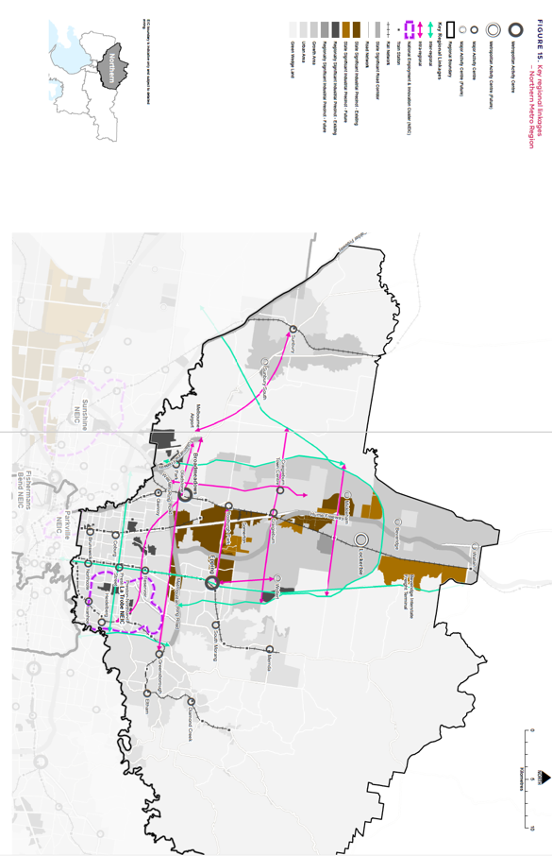

- Strategic Cycling Corridor network – Northern Metro Region
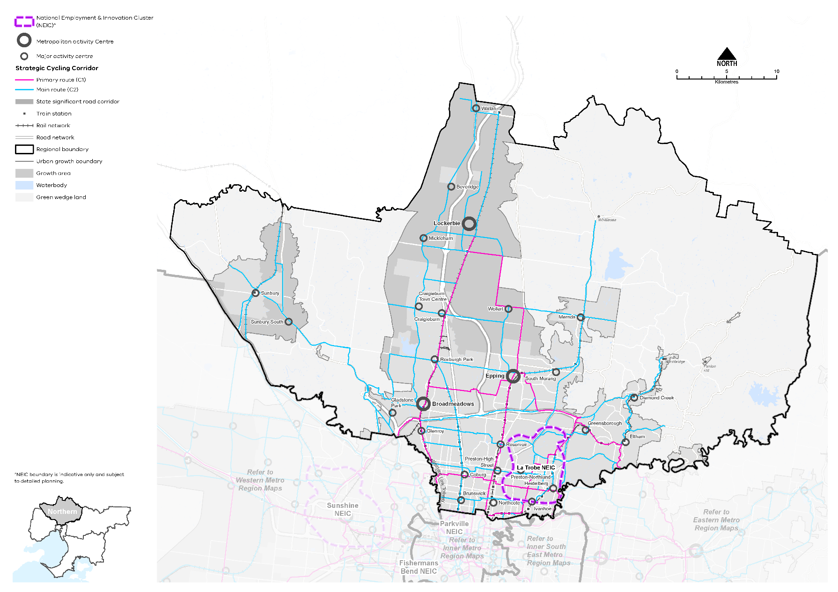

- Improve public and active transport access for the La Trobe NEIC, metropolitan and major activity centres
Continuing to provide opportunities for public and active transport in and around the NEIC, metropolitan and major activity centres will be critical to improve the amenity of these centres and make them more attractive for business investment and local residents. In the longer term, SRL North (Box Hill to Airport) will improve east-west connectivity within the region by linking the La Trobe NEIC and activity centres within the region and also improving linkages with other regions. Melbourne Airport will connect to Broadmeadows, Fawkner, Reservoir, Bundoora, and onto Heidelberg and other activity centres in Melbourne. SRL will change the way people travel to and move around the Northern Metro Region.
The location and design of interchanges will link in closely with other public transport and active transport routes. It will also enhance access to centres to the north of SRL such as Epping. The train station interchanges offer opportunities to catalyse land use change, given the increased accessibility. The foundations for an improved bus network should complement the planned SRL upgrades to better move people around the NEIC and activity centres.
- Ensure the planning and design of Suburban Rail Loop maximises opportunities for public and active transport connections and links between key destinations and surrounding activity centres.
- Improve bus service connectivity prior to the delivery of Suburban Rail Loop.
- Improve transport connectivity in the Northern Growth Corridor and outer suburbs
While rapid development in the Northern Growth Corridor is creating greater housing choice and opportunities, employment and services are mostly to the south, often meaning long travel times for residents.
High-capacity, interconnected public transport in the central part of the corridor, as well as its western and eastern flanks, is planned. This would initially be in the form of rapid bus transport on the arterial road network, supported by a network of local bus connections. A higher capacity public transport route is identified to run along Aitken Boulevard supporting Mickleham, Beveridge, Craigieburn and through the significant employment areas identified north and south of Merrifield. This would require dedicated bus lanes on existing or new roads and other infrastructure to support its delivery.
Extending and enhancing rail connections into the growth areas will also provide greater transport choices for residents, including upgrading of the Upfield Corridor with the duplication of the Upfield line between Gowrie and Upfield, the extension and linking of the Upfield and Craigieburn lines near Roxburgh Park, the electrification of the line between Craigieburn and Wallan and the potential extension of rail to Wollert. Providing these upgrades in a timely way will be in line with the objective of sequencing growth area planning with the provision of vital transport infrastructure in the north.
Key features of public transport network planning for the Northern Growth Corridor include planning for services and train station development along the Sydney-Melbourne rail line, including multi-modal integration, to support Donnybrook, Craigieburn and the future Lockerbie Metropolitan Activity Centre, as well as strategically located park and ride facilities. Key land use considerations include the strategic allocation of land for public transport infrastructure and optimising interactions between key movements and modes.
Further development of the arterial road network will improve inter-regional connectivity and opportunity for an expanded regional and local bus network and will be delivered sooner with contiguous sequencing of land use planning and development.
The Northern Growth Corridor includes the existing townships and neighbourhoods of Beveridge, Kalkallo, Donnybrook and Mandalay. PSPs will need to carefully consider how these should be integrated with new development, and how services and facilities, including public transport, are to be provided, and where, as part of emerging growth. It will be important that existing communities and networks are sustained and given the opportunity to be enhanced over time.
Wallan and Beveridge will require good transport connections to the services and facilities planned in the Northern Growth Corridor. Their communities will rely on connectivity to the growth areas for a range of employment, economic and community facilities. Wallan can be linked into the Corridor via public transport links into the Aitken Boulevard PPTN and Sydney-Melbourne railway line. Electrification of the northern end of the corridors rail infrastructure will assist. Additional arterial road connections are identified to link Wallan and the Northern Growth Corridor, in addition to the existing Hume Freeway and Northern Highway.
In the longer term, the OMR will provide additional road and rail access between Melbourne’s west and the Hume Freeway. A connection between Sunbury and Craigieburn which includes the Bulla Bypass as well as the possibility to utilise the OMR and an extended Tullamarine Freeway to provide the link is also identified for investigation.
Planning for the Northern Growth Corridor recognises the potential for additional access to the Hume Freeway, north and south of the OMR. It also recognises the need for further investigation of interchanges. There is a need to ensure this important national freight route does not become congested with local traffic as well as provide some additional access to the Hume Freeway for new communities.
- Maintain and further develop the arterial road network in the Northern Growth Corridor and outer suburbs to support improved travel times, safety and reliability.
- Provide north-south public and active transport connections between Broadmeadows Metropolitan Activity Centre and the proposed Lockerbie Metropolitan Activity Centre and in the Epping corridor.
- Improve outer suburban public transport to ensure integration with sequenced land use planning and development.
- Improve active and public transport options to promote mode shift and support 20-minute neighbourhoods
Access to public transport varies significantly across the Northern Metro Region. Improvements to local transport, such as bus, cycling and pedestrian routes, are needed to address gaps. Continued and innovative development of the bus network is a priority for communities with the least access to public transport.
Thirty-six per cent of people in the region used a car when making a short trip under 5 kilometres in the region, whereas 27 per cent of people walked, and only 3 percent of people cycled for short trips. To reduce dependence on private vehicles, public transport, cycling and walking need to be more accessible. This means significant upgrades to public transport access, and improvements to pedestrian and cycling accessibility, better linking neighbourhoods to employment, and social and community services.
As development densities in Epping and Broadmeadows metropolitan activity centres increase, they will require active transport networks that logically connect to public transport nodes. In established, higher-density locations, networks should better connect to existing cycling and walking infrastructure to fill existing gaps.
A more cohesive network of active transport connections, including paths and trails, will be developed to prioritise connection between centres as part of the PBN. Priority active transport projects will promote safety and increased use of the region’s cycling and walking network. Northern Metro Region local councils have undertaken significant work on regional trails. However, there are still opportunities to deliver connecting trails to join activity centres, existing trails along waterway corridors and open space. This could be achieved as part of major transport projects, open space improvements or through better use of government-owned land.
Decisions about the location of health and community services and sport and recreational facilities in the Northern Metro Region need to consider public access. Site selection should align with the existing public transport network to maximise its use wherever possible, and to ensure local communities are connected to their nearest regional social infrastructure. The full cost of providing access should be considered as part of the development of business cases.
- Create pedestrian-friendly neighbourhoods by enhancing major pedestrian links and expanding the network.
- Create a network of walking and cycling links for local trips that link to public transport.
- Improve active and public transport in the La Trobe NEIC, activity centres and health and education precincts to support higher-density mixed-use walkable precincts.
- Provide walking and cycling routes and drop-off zones to health and community services and recreation facilities.

- Protect and grow the Northern Metro Region’s comparative advantage in freight and logistics
The Northern Metro Region’s role as a critical gateway to domestic and international markets requires ongoing, integrated land use and transport planning to preserve and sustainably develop the region’s freight and logistics sector.
The region is Victoria’s domestic freight hub, connecting Victoria to key trade routes such as New South Wales and Queensland via the Hume Highway, Epping Market freight node and Somerton intermodal terminal. The proposed BIFT precinct will further contribute to this, providing an opportunity for state and local government to leverage private investment in the precinct and drive further economic growth.
The under-construction direct Port Rail Shuttle Link between Somerton Intermodal Hub and the Port of Melbourne is another significant investment in freight movement in Melbourne’s north. Due for completion in 2022, the project will facilitate greater uptake of rail freight to reduce network congestion and make rail freight more cost effective. When completed, this will contribute to a fundamental shift in how freight moves in Melbourne via the Port Rail Shuttle Network. The Somerton Link alone will reduce trucks on suburban Melbourne roads by as much as 20,000 trips annually.
In addition, the 1700 kilometre Inland Rail alignment will link Melbourne and Brisbane via regional Victoria, New South Wales and Queensland. The route uses the existing interstate line from Melbourne in Victoria to Illabo in New South Wales, which will be enhanced to accommodate double-stacked trains, allowing them to carry up to twice as many containers.
Metropolitan freight volumes are expected to grow at an average annual rate of 2.6 per cent each year between 2014 and 2051. The flow on effects of population growth and increased e-commerce could result in conflicting land use.
To support these investments in supply chain efficiencies and manage the growing freight task, coordinated state and local government planning is needed to balance and protect strategically significant freight precincts and corridors from sometimes competing economic, amenity and environmental considerations.
The PFN provides transparency to local government and community regarding the primary way goods will be moved throughout the region. This allows government to consider freight needs during the planning process to protect the end-to-end freight journeys from conflicting land uses or use tools to mitigate environmental or amenity risk through planning permit requirements.
The Northern Metro Region has a comparative advantage in freight and logistics linked to the location of Melbourne Airport and the Hume Freeway which act as gateways to interstate and international markets. Without undertaking the necessary planning and engagement as a priority, the future success of the BIFT and other regionally-significant industrial precincts could be undermined. Planning considerations include protecting end-to-end freight access routes from the encroachment of residential and other sensitive uses.
The regional road network planned to carry freight as a key function includes:
- The Hume Freeway
- The OMR/E6 Transport Corridor road reservation
- The proposed Melbourne Airport Rail/Bulla Bypass
- Donnybrook Road
- Somerton Road/Cooper Street
- The Metropolitan M80 Ring Road.
The region’s rail freight network which extends from the Western and Inner metro regions includes:
- Tottenham-Jacana-Somerton-Beveridge corridor (including the Melbourne-Sydney-Brisbane mainline)
- Kensington-Essendon-Jacana corridor
- North Melbourne-Upfield-Roxburgh Park corridor.
The proposed BIFT site is ideally located considering its location alongside the Melbourne-Sydney-Brisbane railway line, Hume Freeway and proposed OMR.
Approximately 1500 hectares of land has been set aside for a major freight hub supporting a range of businesses such as distribution centres and warehousing. The terminal will play a vital role in enabling the transfer of interstate freight across Australia.
- Ensure the BIFT precinct and its connecting freight corridors are protected from encroachment of sensitive or conflicting land uses.

Actions – Integrated transport
- Undertake a review of the regional bus network to support regional access and movement in the short- to medium-terms and to plan integration with major public transport changes including SRL.
- Review the Principal Public Transport Network for the growth areas.

Chapter 07.
Liveability
Plan Melbourne Outcome 4: Melbourne is a distinctive and liveable city with quality design and amenity
‘Liveability’ is about the things that enhance people’s quality of life. For many years Melbourne has been regarded as one of the world’s most liveable cities due to its social and economic stability, diverse communities, distinctive heritage, high level of amenity and the opportunities it provides for a rich social and cultural life.
Plan Melbourne aims to maintain and extend the city’s liveability by celebrating its culture, diversity and distinctiveness. The challenge ahead is to design and plan for a future city that protects the best aspects of the natural and built environment, supports social and cultural diversity, and creates a strong sense of place.
The Northern Metro Region’s distinctive and diverse landscapes are formed around the corridors of its waterways, including the Yarra (Birrarung), Plenty and Maribyrnong rivers. Its green wedges and regional open spaces have high recreational and biodiversity value. The region has high cultural significance for Aboriginal people and a rich post-European settlement heritage.

State of play

Landscapes and biodiversity
The diverse landscapes of the Northern Metro Region range from the rolling hills in the region’s east to the volcanic plains in the west. The region’s landscapes are defined by waterways, remnant forests, grasslands and woodlands, volcanic cones and incised valleys. They are integral to its character and sense of place.
The region’s key landscapes and biodiversity areas are described in Table 12.
While much of the Northern Metro Region’s biodiversity has been altered through urbanisation, there are many important natural assets that support biodiversity and provide critical habitat for the survival of some of our most threatened species.
Key landscapes and biodiversity areas in the Northern Metro Region
Landscape and biodiversity area | Significance, protection and management
Waterways | The Yarra River flows into Melbourne from the Yarra Ranges, winding its way along the region’s southern boundary from Christmas Hills to Ivanhoe. The region’s major waterways of the Plenty River, Maribyrnong River, Moonee Ponds Creek, Diamond Creek, Merri Creek and Darebin Creek all flow into the Yarra River. Other waterways include Jacksons, Kalkallo, Emu and Steele creeks. The region’s waterways are an important aspect of its landscape and biodiversity, and offer the opportunity for regional habitat and parkland connections.
Regional parks | The Northern Metro Region’s north and north-east contain large areas of passive open space such as Quarry Hills Parkland, Plenty Gorge Park, the Organ Pipes National Park and Kinglake National Park which protect biodiversity and offer a connection to the underlying landscape.
Biodiversity areas | Sensitive ecosystems exist within grassy eucalypt woodlands throughout the region’s green wedges. Craigieburn Grasslands, Merrifield/Kalkallo retarding basin and land conserved around water reservoirs offer areas of high biodiversity value. Substantial areas of river red gums are also scattered across the landscape.  The region’s waterways and green wedges provide highly significant areas of habitat for regional biodiversity, including endangered species such as the Growling Grass Frog and the Golden Sun Moth.

Aboriginal cultural heritage
The lands that now make up the Northern Metro Region feature places and waterways of cultural significance and continuing connection for Traditional Owners as shown in Figure 17. The Wurundjeri people, represented by Wurundjeri Woi Wurrung Cultural Heritage Aboriginal Corporation and as a Registered Aboriginal Party (RAP), have a responsibility for the protection and management of cultural heritage assets under the Aboriginal Heritage Act 2006.
The Taungurung people, represented by the Taungurung Land and Waters Council, are the recognised Traditional Owners of the lands to the north-east outside the Northern Metro Region boundary and have interest in the boundary area as shown in Figure 17.
The Yarra River has served and cared for people living in what we now call the Northern Metro Region for thousands of years. It is a sacred natural asset whose uncompromised health is everyone’s responsibility (DELWP, 2018b). The Yarra River is paramount to the life of the Northern Metro Region and Melbourne. It is one of a number of waterways in the Northern Metro Region that is highly valued by the community and has continued significance for Traditional Owners.
The Yarra River is central to the lands of the Wurundjeri people. The Yarra River Protection (Wilip-gin Birrarung murron) Act 2017 sets the foundation for Traditional Owner management of the river and its lands, and delivery on the aspirations of the Wurundjeri Woi Wurrung Cultural Heritage Aboriginal Corporation’s Nhanbu narrun ba ngargunin twarn Birrarung (Ancient Spirit & Lore of the Yarra) water policy.

Heritage and visitor places
Protected heritage sites tell the story of the early European settlement and pastoral activity, including Ned Kelly’s birthplace at Beveridge, Mickelham School and Post Office, Victoria Bridge at Kalkallo and Emu Bottom Homestead. Historic infrastructure such as the Yan Yean and Maroondah water supply systems and the Preston Tramway Workshops represent early phases of Melbourne’s development.
Key visitor places in the Northern Metro Region’s rural areas include Montsalvat artists’ colony in Eltham, St Andrews weekend market and Rupertswood Mansion in Sunbury. Within urban areas, the region is renowned for its lively cultural precincts in Brunswick, Northcote, Preston and Thornbury which support numerous arts and creative industries. Creative places and spaces across the region contribute to its vibrant neighbourhoods and sense of place. Important community gathering places include the CERES environmental park in Brunswick, Preston Market, Westgarth Cinema and Thornbury Picture House.
Heritage protection is provided to individual properties, streets and precincts within the region and these places are integral to its character and identity today. There are over 100 places of state heritage significance listed on the Victorian Heritage Register, as shown in Map 7. These include a wide range of sites: major infrastructure, such as the Yan Yean water supply system; homesteads, pastoral runs and farm buildings, such as Emu Bottom Homestead and Rupertswood Mansion, Sunbury; stone bridges, trestle bridges and railway viaducts; churches, schools, civic buildings; and residential development including the Mount Eagle Estate, Eaglemont, designed by Walter Burley Griffin and Marion Mahony Griffin.
- Northern Metro Region Aboriginal cultural heritage
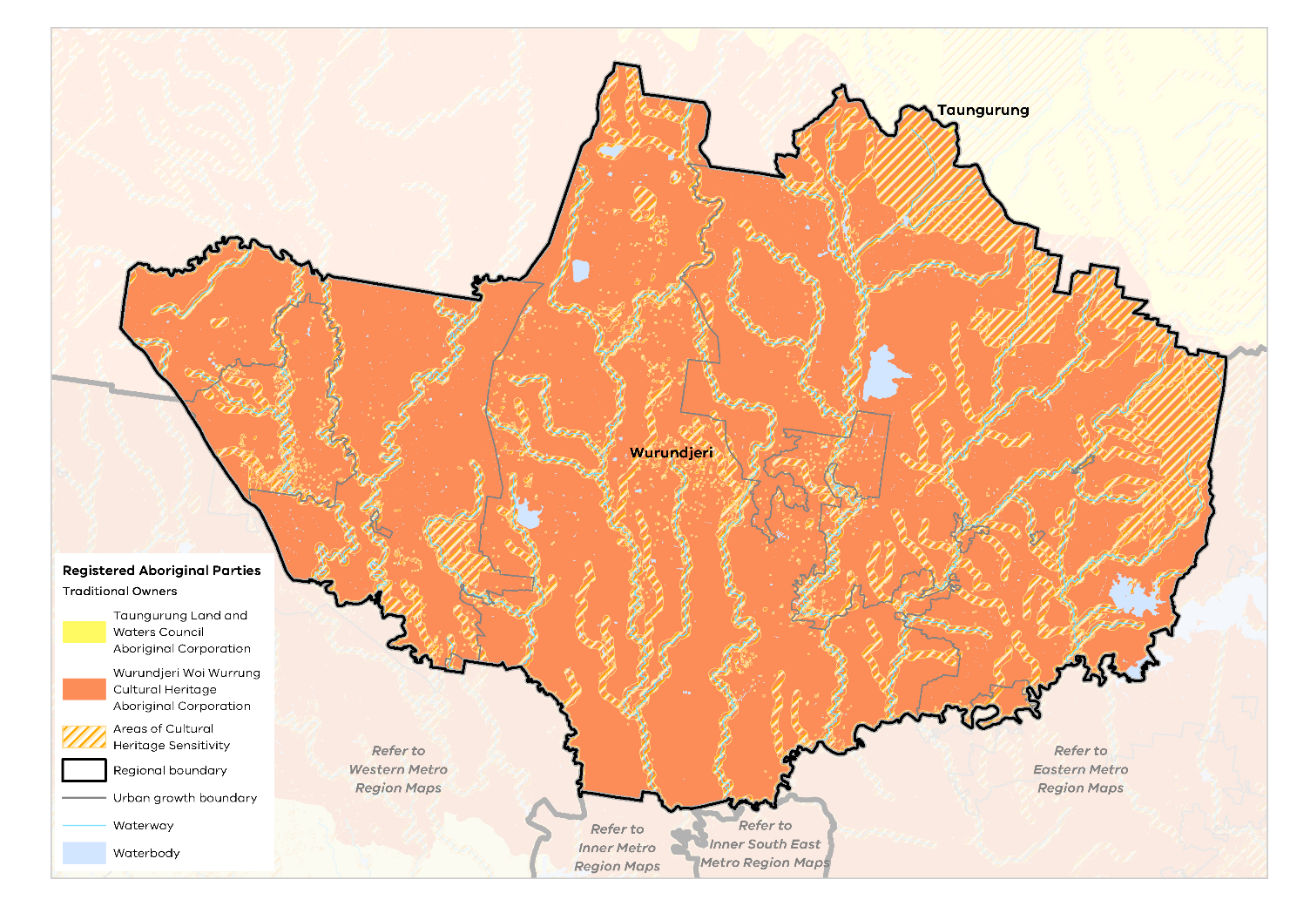

- Open space per person for Northern Metro Region LGAs
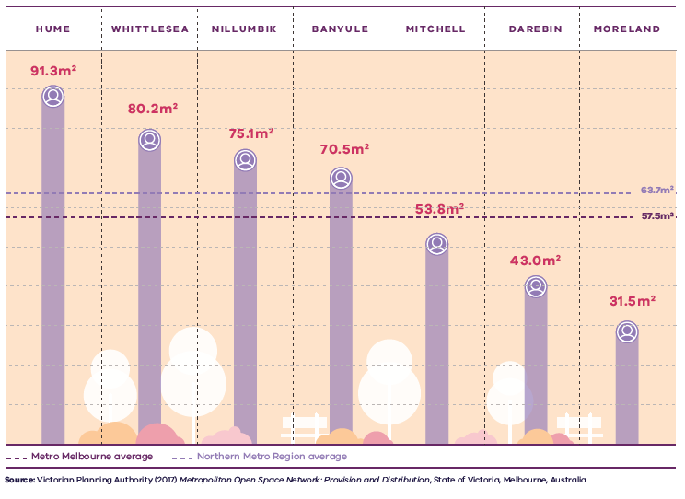

Figure 18. Open space per person for Norther Metro Region LGAs
Metro Melbourne average | 57.5 square metres public open space per person
Northern Metro Region average | 63.7 square metres public open space per person
Hume | 91.3 square metres public open space per person
Whittlesea | 80.2 square metres public open space per person
Nillumbik | 75.1 square metres public open space per person
Banyule | 70.5 square metres public open space per person
Mitchell | 53.8 square metres public open space per person
Darebin | 43.0 square metres public open space per person
Moreland | 31.5 square metres public open space per person
Source: Victorian Planning Authority (2017) Metropolitan Open Space Network: Provision and Distribution, State of Victoria, Melbourne, Australia.

Open space and regional trails
Residents of the Northern Metro Region have varying levels of access to open space depending on where they live. Nillumbik, Hume, Banyule and Whittlesea provide between 70 and 91 square metres per capita, much higher than the metropolitan average of 57.5 square metres. However, the inner LGAs of Moreland and Darebin offer much less open space per capita of 31.5 square metres and 43 square metres respectively. Mitchell LGA is also below the metropolitan average providing 53.8 square metres per capita (Figure 18) (VPA, 2017). Open space per person across metropolitan Melbourne is shown in Figure 19. While the quantity of open space is one measure of provision, the function, mix, quality, accessibility and proximity of open space also need to be considered.
The Northern Metro Region contains large areas of passive open space including Quarry Hills Parkland, Plenty Gorge Park and Kinglake National Park. Within the region’s green wedges and growth areas, waterways such as Deep Creek, Jacksons Creek, Merri Creek and Emu Creek form existing and potential open space corridors. Within the inner areas, regional open spaces are formed along the Darebin and Merri creeks and the Yarra and Plenty river corridors.
Passive regional open space in outer LGAs, such as Whittlesea and Nillumbik, is not well served by public transport.

- Open space per person for metropolitan LGAs
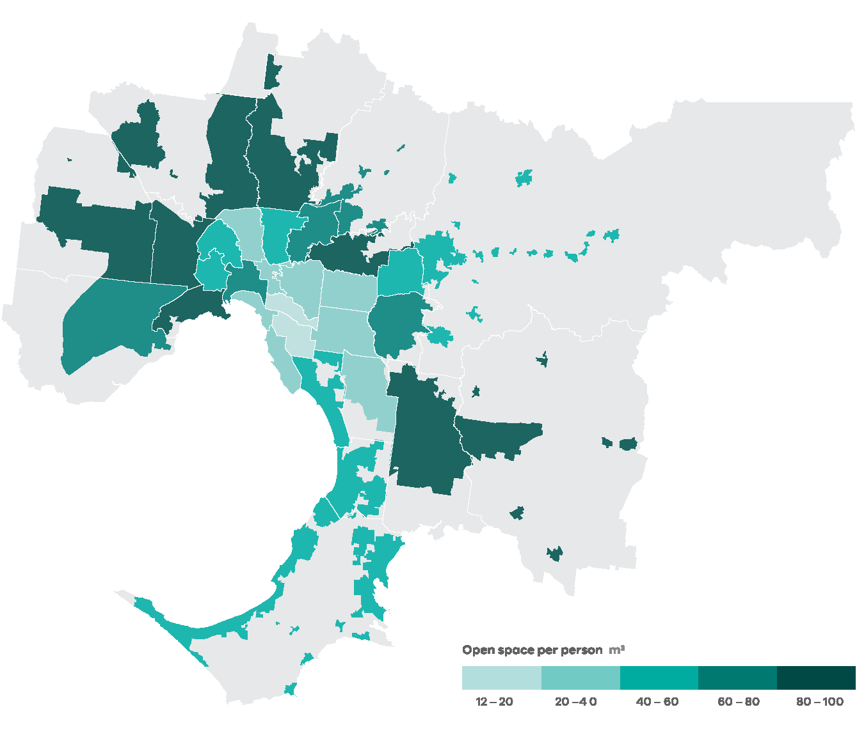
Data from the Victorian Planning Authority Metropolitan Open Space Network portal, 2016
Note: only areas within the UGB were calculated and mapped in this figure. Areas outside the UGB are shown in grey.
Open Space for Everyone: Open Space Strategy for Metropolitan Melbourne 2020 identifies several major initiatives for the Northern Metro Region through its Suburban Parks Program:
- Creation of the Jacksons Creek Parklands, to extend from Diggers Rest to Sunbury and link up land across an area of around 1000 hectares, creating new open space and trail connections and areas for biodiversity
- Creation of the Upper Merri Creek Parklands, planned to extend from Campbellfield to Beveridge, which will also link up land across a significant area for recreation and biodiversity connections
- Feasibility study for the proposed 1000 hectare Wallan Regional Park, which will consider potential linkages with the proposed Upper Merri Creek Parklands
- Creation of the Quarry Hills Regional Park, which contains significant biodiversity, geological, cultural heritage and landscape values (project under development with Whittlesea LGA)
- Completion of the Plenty River Trail, including an extra 17 kilometres of walking and cycling trail from Mernda to the Western Ring Road at Greensborough
- Northern metropolitan trails project, encompassing new cycling and walking trails in the Banyule, Nillumbik, Whittlesea, Hume and Darebin LGAs.
There are several regional walking and cycling trails in the Northern Metro Region, some of which cross through the region or connect to adjoining regions, such as the Main Yarra Trail and Capital City Trail.

Regional strengths
- There are significant opportunities to work with Traditional Owners to protect and enhance the region’s unique landscapes, cultural heritage, environmental assets and biodiversity values, including its waterway corridors and green wedge areas.
- Well-established open space networks of regional, state and national parks throughout the region preserve a rich biodiversity.
- There is potential for increased tourism and cultural development which will assist in creating vibrant, attractive urban environments.

Regional challenges
- Additional open space is required to meet the needs of the future population.
- Improved access to open space, particularly by walking, cycling and public transport will foster opportunities for more active living.
- Ongoing protection of the region’s natural, built and cultural heritage is essential, given the pressure for development.

Directions and strategies
The directions identified to achieve the 2050 vision for the Northern Metro Region in terms of Liveability and Outcome 4 of Plan Melbourne are:
Direction 17 | Protect and enhance the region’s network of waterway corridors
Direction 18 | Protect and enhance the landscapes and biodiversity of the Northern Metro Region
Direction 19 | Strengthen the network of open spaces and trail connections across the Northern Metro Region
Direction 20 | Create a legacy of great civic places
Each direction is implemented through regionally-specific strategies identified in this LUFP.
Map 7 shows how liveability will be enhanced across the Northern Metro Region by 2050 as a result of these directions and strategies, together with Plan Melbourne and other strategies and initiatives as outlined in Appendix 01.

- Northern Metro Region liveability 2050
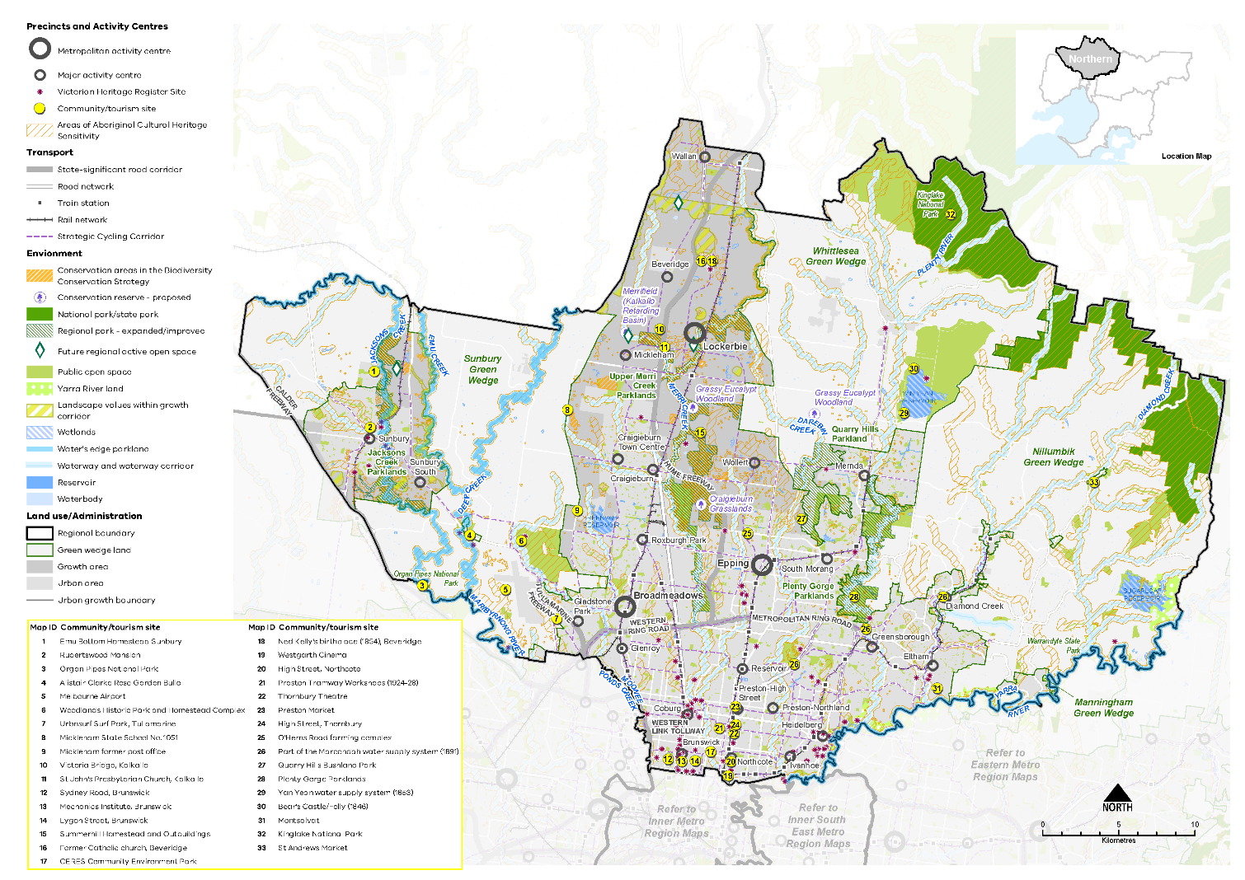

Map 7 Northern Metro Region liveability 2050
A map showing the key environmental and cultural features of the region in 2050, as extracted from Map 1, and also highlighting:
- The Maribyrnong, Yarra, and Plenty rivers, and Diamond, Darebin, Merri, Moonee Ponds, Deep, Emu and Jacksons creeks
- Kinglake National Park in the north-east of the region and Organ Pipes National Park in the west of the region
- The Nillumbik Green Wedge, Whittlesea Green Wedge, and Sunbury Green Wedge
- Conservation areas and places of identified landscape value within the growth corridors
- Proposed conservation reserves at Kalkallo retarding basin, two areas of Grassy Eucalypt Woodland around the Merri and Darebin creeks and the proposed Craigieburn grasslands conservation reserve
- Yarra River land along the Yarra River corridor
- Expanded or improved regional parklands of Jacksons Creek Parklands, Upper Merri Creek Parklands, Quarry Hills Parkland, Plenty Gorge Parklands
- Future regional active open space at Wallan, the Kalkallo retarding basin, Donnybrook and south of Emu Bottom wetlands, Sunbury
- Community / tourism sites at:
- Emu Bottom Homestead Sunbury
- Rupertswood Mansion
- Organ Pipes National Park
- Alistair Clarke Rose Garden Bulla
- Melbourne Airport
- Woodlands Historic Park and Homestead Complex
- Urbnsurf Surf Park, Tullamarine
- Mickleham State School No. 1051
- Mickleham former post office
- Victoria Bridge, Kalkallo
- St John's Presbyterian Church, Kalkallo
- Sydney Road, Brunswick
- Mechanics Institute, Brunswick
- Lygon Street, Brunswick
- Summerhill Homestead and Outbuildings
- Former Catholic church, Beveridge
- CERES Community Environment Park
- Ned Kelly's birthplace (1854), Beveridge
- Westgarth Cinema
- High Street, Northcote
- Preston Tramway Workshops (1924-28)
- Thornbury Theatre
- Preston Market
- High Street, Thornbury

- O'Herns Road farming complex
- Part of the Maroondah water supply system (1891)
- Quarry Hills Bushland Park
- Plenty Gorge Parklands
- Yan Yean water supply system (1853)
- Bear's Castle/Folly (1846)
- Montsa lvat
- Kinglake Nati onal Park
- St Andrews Market
- Areas of Aboriginal Cultural Heritage Sensitivity frequently, but not always, associated with rivers, creeks and water bodies
- Victorian Heritage Register sites predominantly, but not limited to, the south of the region.

- Protect and enhance the region’s network of waterway corridors
The rivers, creeks and drainage easements in the Northern Metro Region provide the opportunity to create a connected network of waterways, linking green spaces, wetlands and biodiversity areas. Part of this network already exists, as shown in Map 7. These natural features provide habitat for significant native flora and fauna including frog and fish species. They also have landscape, social, amenity and cultural heritage values. They also provide places for a diverse range of recreation and leisure experiences and an opportunity to connect with others and with nature.
Waterways need to be maintained and developed as movement and recreational corridors while protecting their environmental values and role as natural drainage systems.
The Metropolitan Trail Network connects the Moonee Ponds, Westbreen, Edgars, Darebin and Merri creeks to Quarry Hills Regional Park. In other parts of the region, Deep, Emu, Jacksons and Kalkallo creeks could offer additional waterway links to form part of the regional open space and biodiversity network. The Yarra River is a key waterway corridor in the southern part of the region.
Regional strategic projects, such as the Healthy Waterways Strategies (Yarra and Maribyrnong), identify the need to protect the values of these waterways from urban development, from headwater streams to lower reaches, and recognised significant wetlands.
The Yarra River is paramount to the life of the Northern Metro Region and Melbourne. The Yarra River Action Plan and the Yarra River Protection (Willip-gin Birrarung Murron) Act 2017 recognises the Yarra River, and the many hundreds of parcels of public land it flows through, as one living, integrated natural entity for protection and improvement.
The Waterways of the West Action Plan (to be released in 2021) is a plan to protect and rehabilitate rivers, creeks and their parklands, including the Maribyrnong (Mirrangbamurn) and Moonee Ponds (Moonee Moonee) catchments within the Northern Metro Region.
- Protect and enhance the interconnected network of waterway and habitat corridors in the region and the diverse landscape, cultural, biodiversity and community values they provide.
- Retain natural wetlands and natural drainage networks in the planning of new greenfield neighbourhoods to achieve significant liveability and biodiversity outcomes and build resilient, sustainable, and liveable communities.

- Protect and enhance the landscapes and biodiversity of the Northern Metro Region
The Northern Metro Region’s natural assets and green wedges form the basis of its amenity and biodiversity values. A healthy natural environment provides life-sustaining services for humans and biodiversity. It underpins many of the activities that are fundamental to economic prosperity, and people’s physical and mental health (DELWP, 2017d). The region’s landscapes are also a key aspect of its sense of place and regional distinctiveness.
As part of supporting ecosystem resilience in a changing climate and reducing potential impacts from urban encroachment, a range of planning policies and protections apply to the Northern Metro Region’s green wedge areas. The landscape values of the region’s waterways, wetlands, ridgelines and key view corridors should also be protected from the visual impact of development or infrastructure.
The Melbourne Strategic Assessment is an agreement with the Commonwealth to set aside land with the highest biodiversity values from urban development within the Northern Growth Corridor. These Conservation Areas are listed in the Biodiversity Conservation Strategy for Melbourne’s Growth Corridors 2013 and protected through Commonwealth legislation (shown on Map 4). Their biodiversity values are managed for the long-term through the precinct structure planning process to preserve their intrinsic conservation and biodiversity values.
Preserving conservation areas of a sufficient size to support diverse species (and which are linked to other conservation areas) is often critical to biodiversity outcomes.
Within the Northern Growth Corridor areas of Lockerbie, West Beveridge, Mickleham and Wollert, important landscape features should be retained and protected, including:
- Views to the hills and ridgelines that flank the Northern Growth Corridor to the west, north and east
- Distant views from the growth corridor to the Great Dividing Range to the north and north-east
- Red volcanic cones at Mount Frazer and Bald Hill, and the protection of vistas to these features from a range of vantage points across the Northern Growth Corridor
- The natural drainage system across the Northern Growth Corridor, which includes the Merri, Kalkallo and Darebin creeks.
Key landscape features of Sunbury/Diggers Rest include:
- Jacksons Hill, Mount Holden and Burke Hill in the established part of Sunbury or outside the Urban Growth Boundary
- The combination of steep hills, incised valleys and escarpment edges and elevated plateaus that provides a unique natural setting for Sunbury
- Emu Creek and its tributaries, which flank the eastern edge of Sunbury, and Jacksons Creek, which traverses Sunbury/Diggers Rest; both of which have deeply incised valleys and support tributaries and wetlands
- The semi-rural character to the main approach roads to Sunbury and Diggers Rest.
A 1200 hectare Grassy Woodland Reserve outside the Urban Growth Boundary, southwest of Whittlesea, will be created to protect highly valuable Grassy Eucalypt Woodland (DEPI, 2013). This reserve will be assembled over time through land acquisition.
Within urban areas, waterways and parklands provide key habitat links and places of recreation. It is essential that infrastructure and urban renewal projects enhance and link these areas. For example, protection and enhancement of the Darebin Creek within the Northland Urban Renewal Precinct should be prioritised in planning and development, as well as protection and enhancement of wetlands and vegetation in and around the La Trobe NEIC.
- Work with Traditional Owners to protect and enhance the landscape and conservation values of the distinctive hills and ridgelines, volcanic cones, waterways and grasslands of the Northern Metro Region and integrate these features into growth area planning.
- Ensure the design of new development within the region’s green wedges and growth areas responds to its landscape biodiversity values. Provide adequate buffers from areas of landscape or biodiversity sensitivity, including the rural character of land adjoining the Urban Growth Boundary.

- Strengthen the network of open spaces and trail connections across the Northern Metro Region
Open Space for Everyone: Open Space Strategy for Metropolitan Melbourne 2020 establishes a vision of Melbourne as a city with a valued network of open spaces that are accessible to all, connected at the local and landscape scales. It focuses on innovation and adaptability in providing for a diversity of open spaces to meet the needs of the community, while protecting and optimising the region’s existing open space assets. The strategy identifies opportunities to make better use of existing open space, including ways that existing public land could be opened up for broader recreational use.
Within the region’s greenfield growth areas, integrated planning of active and passive open space networks can play a key role in protecting environmental, heritage and drainage values. Regional parklands can provide for a range of recreation needs of the community and help to establish the liveability and ‘sense of place’ of the growth areas.
Opportunities to use new open space to improve pedestrian access and recreational trail connections should be prioritised wherever possible, including linking existing open spaces or opening site frontages to a waterway or parkland.
Melbourne Water’s proposed upgrade of the retarding basin at Kalkallo offers the potential for a regional recreation opportunity and conservation site in Melbourne’s north, in addition to its primary role in floodway management.
With the inner LGAs of the Northern Metro Region offering relatively less open space per capita and the population forecast to increase, strategies are needed to better use existing open space to meet future demand for recreation opportunities. This could include high-quality maintenance of existing parks, targeted upgrading of facilities to meet current needs and improved connections to regional open spaces.
Options to create new public space within inner urban areas include re-purposing surplus public land, reclaiming road space, using rooftop space or providing open space within large redevelopment sites or urban renewal precincts. In some instances, new open spaces will be of a small scale and may also be privately owned or managed. It is essential that new open spaces are created in a meaningful way, with high design and amenity standards and as a positive contribution to the broader open space network.
Larger open space land holdings, such as golf courses, pipe tracks, easements and land used for public purposes such as schools, universities or cemeteries, may provide opportunities to address open space shortfalls in the region, by providing community access at times and in ways that do not jeopardise their primary purposes.
The proposed regional open spaces and trail connections identified in the Suburban Parks Program and Northern Regional Trails Strategy will significantly improve the regional network of open spaces and trail corridors. The draft Yarra Strategic Plan also addresses many of these movement, recreation and environmental challenges as part of continuing to develop this major river corridor.
- Increase access to a range of quality regional and local open space throughout the region.
- Identify opportunities to expand and better link the open space network through linear open space and trail connections and improved public transport accessibility.

- Create a legacy of great civic places
There is a proud legacy of great civic places and precincts in the Northern Metro Region. Many activity centres, both large and small, include formal and informal places with high civic and natural values that help people better understand, orientate within, meet and enjoy the areas in which they live and visit.
The Northern Metro Region has places that provide public benefit and amenity including Sydney Road in Brunswick, Preston Market and High Street, CERES Community Environment Park, Hume Global Learning Centre in Broadmeadows, Plenty Gorge Parklands and Yan Yean Reservoir, Sunbury Town Centre and smaller towns such as Whittlesea and St Andrews. As the La Trobe NEIC develops it is expected to become a much-loved civic precinct.
St George’s Road is an established boulevard through the region’s inner suburbs which provides a wide, dedicated shared trail which is separated from car traffic and planted with avenue trees. Aitken Boulevard will be designed as a high amenity north-south roadway between the future Lockerbie Metropolitan Activity Centre and Mickleham, Beveridge and Craigieburn major activity centres.
The Northern Metro Region’s rich cultural heritage provides a strong legacy for creating distinctive places which foster community pride and a sense of place. The region’s post-settlement heritage has intrinsic value for residents and visitors as a symbol of a shared history and community-building. While extensive heritage controls are applied throughout the region, there are places and precincts of significance that still require protection and local councils are working to achieve this.
Ongoing population increases and economic growth presents a risk that assets from the early post settlement era are demolished or destroyed. In new suburbs there is an opportunity to protect and integrate these assets and provide a point of difference. In green wedge areas, assets should be preserved and, where relevant, recognised and celebrated as visitor attractions.
State and local government have a role to play in creating high-quality public places when planning for centres and other public areas for the longer term-through structure planning or precinct planning. Well designed public spaces, and utilising natural features to create a strong sense of place, should be integral to the future planning of Broadmeadows, Epping and Lockerbie as metropolitan activity centres. As these places are developed, a key consideration should be to provide an enduring civic legacy for future generations.
- Protect places and spaces that have high civic or public value, and which contribute to people’s understanding, interaction and enjoyment of the region.
- Ensure future planning for activity centres utilises natural features and public spaces to create a strong sense of place.
- Recognise the different layers and aspects of the region’s history in the design of new buildings, public spaces, infrastructure and public artwork.
- Support the development of Aitken Boulevard as a high-quality active transport link with high pedestrian and cycling amenity.

Actions – Liveability
- Develop a plan to implement a publicly owned and managed network of regional trails and open spaces across the region’s growth corridors, utilising its natural drainage system where possible to link open spaces, biodiversity areas, waterways and urban areas.
- Prepare a regional biodiversity strategy to protect, manage and enhance habitat corridors and increase their interconnectivity across urban and rural areas.
- Review local planning schemes in the Northern Metro Region to ensure protection and enhancement of the landscape and biodiversity values of the region.

Chapter 08.
Strong communities
Plan Melbourne Outcome 5: Melbourne is a city of inclusive, vibrant and healthy neighbourhoods
The Northern Metro Region has many of the key attributes of strong, inclusive and healthy communities. However, many middle ring communities in the region have high levels of disadvantage, and growth area communities have comparatively lower levels of accessibility to services.
This plan will help to identify the community services, open space, hospitals, educational and cultural institutions, and transport infrastructure to keep pace with a projected increase in population of over 765,000 by 2051.
Taking a regional approach to planning will ensure social infrastructure and open space services the widest possible catchment and cross-section of people. Plan Melbourne aims to build on the fundamentals of strong, healthy and sustainable neighbourhoods by improving access to and provision of amenity, social infrastructure, health and education, open space and the promotion of walking and cycling options.
Plan Melbourne advocates for the vision of a city of ‘20-minute neighbourhoods’ in which most everyday needs can be met within a 20-minute walk, cycle or local transport trip from home. The established suburbs within the southern part of the Northern Metro Region are well placed to achieve this vision. Realising the hallmarks of 20-minute neighbourhoods in the region’s growth areas will require integrated land use and infrastructure to support liveable, strong communities.

State of play

Community profile
The Northern Metro Region is a culturally diverse community. It has the highest Aboriginal population of the six metropolitan regions in metropolitan Melbourne, with more than 6200 Aboriginal people. Most people who identify as Aboriginal live in Darebin, Hume and Whittlesea LGAs (Australian Bureau of Statistics, 2016).
Approximately 34 per cent of the region’s population was born overseas. This is relatively consistent with metropolitan average (36.5 per cent) but lower than the Inner Metro Region where 46 per cent of residents were born overseas. India, Italy and the United Kingdom are the top three overseas origins in the region.
The Socio-Economic Indexes for Areas (SEIFA) ranks areas according to their relative socio-economic advantage and disadvantage. The SEIFA rankings for the Northern Metro Region indicate some of the region’s older established areas in middle ring suburbs, such as parts of Broadmeadows, Thomastown, Fawkner, Lalor, Campbellfield and Roxburgh Park, have higher levels of relative socio-economic disadvantage when compared to other parts of Victoria (Figure 20). Areas with higher levels of socio-economic disadvantage may have higher demand for community, education and health services.
In contrast, some areas in the region’s inner suburbs and further north-east along the Yarra and Plenty rivers, such as parts of Ivanhoe, Greensborough and Eltham, have higher levels of relative socio-economic advantage when compared to other parts of Victoria.

Health and education facilities
The Northern Metro Region is economically and socially diverse, encompassing many areas of high need and/or limited access to health and community services and long waiting lists for existing services.
The region has seven private hospitals (excluding private day hospitals) and 10 public hospitals (including public day hospitals).
In terms of education, the Northern Metro Region also has 135 government primary schools and 33 government secondary schools (DELWP, 2017c).
Higher education providers with campuses in the Northern Metro Region include Latrobe University, RMIT, Kangan Institute, Melbourne Polytechnic and Northern College of the Arts and Technology in Preston.
People living in growth areas have lower rates of accessibility to these services compared to elsewhere in the region and metropolitan Melbourne. However, unprecedented population growth and an ageing population are also putting pressure on existing health and community services in established suburbs. Access to health and education services continues to be a focus for the region.
- SEIFA rankings (2016) in the Northern Metro Region
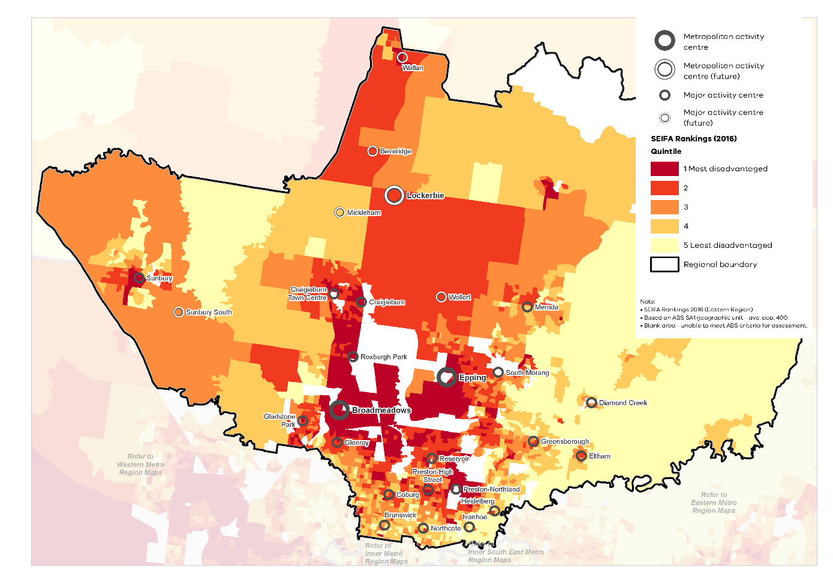

Social infrastructure
Social infrastructure includes all of the facilities, services and networks that help people to meet their social, cultural and community needs, in addition to health and education facilities.
Access to social infrastructure varies across the Northern Metro Region. The region’s structure is defined by the Hume Freeway and the M80 Ring Road, which dissect it into four quadrants. Regional facilities in one part of the region can be difficult for others across the region to access, affecting catchments for regional social infrastructure. The growth areas will house much of the region’s future population growth. As the population grows in inner areas such as Moreland and Darebin LGAs, there will be greater competition for community services and facilities.
A range of sport and recreation facilities are located across the region including local and regional indoor stadiums, aquatic and leisure centres, outdoor sport courts and sports grounds.
Major recreational facilities include: Darebin International Sports Centre in Thornbury which is a multi-sports complex for state lawn bowls, cycling and soccer; Epping Stadium; the Hangar in Tullamarine and CB Smith Reserve, Fawkner.
Other regional-scale active recreation facilities include La Trobe University Sports Park in Bundoora, WaterMarc in Greensborough, Splash Aqua Park and Leisure Centre in Craigieburn, and Diamond Valley Sports and Fitness Centre in Greensborough. These facilities are located in the inner and middle ring suburbs, while there are no regional-scale, multi-use sporting facilities in the Northern Growth Corridor. Additional regional-scale, multi-use sporting facilities will be required to keep pace with population growth across the region.
Regional justice infrastructure within the Northern Metro Region includes two Magistrates’ Courts, four Community Corrections Locations, one Justice Service Centre and a Youth Justice location in Preston.

Regional strengths
- The region has established regional-level facilities for health, education, recreation and other social infrastructure that cater for a wide range of community needs.
- A strong network of activity centres exists within the inner suburbs, many of which are vibrant, accessible community focal points that achieve (or exceed) the principle of the 20-minute neighbourhood.

Regional challenges
- Adequate access to social infrastructure must be provided to service the growing population.
- Ensuring development in growth areas embeds the principle of the 20-minute neighbourhood is an ongoing challenge.
- Access to primary health, education, community services and sport and recreation facilities needs to be improved in established communities and growth areas.

Directions and strategies
The directions identified to achieve the 2050 vision for the Northern Metro Region in terms of Strong communities and Outcome 5 of Plan Melbourne are:
Direction 21 | Plan for major social infrastructure at a regional level
Direction 22 | Deliver health and education services in strategic locations
Direction 23 | Support a network of neighbourhood activity centres to anchor 20-minute neighbourhoods
Each direction is implemented through regionally-specific strategies identified in this LUFP.
Map 8 shows how strong communities will be enhanced across the Northern Metro Region by 2050 as a result of these directions and strategies, together with Plan Melbourne and other strategies and initiatives as outlined in Appendix 01.

- Northern Metro Region strong communities 2050

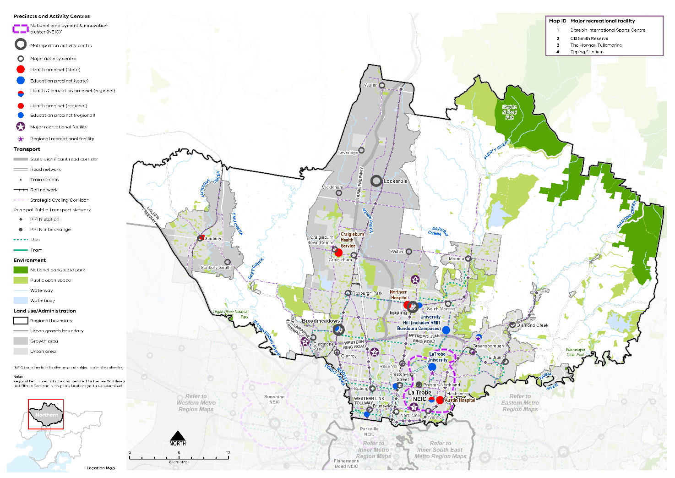

Map 8 Northern Metro Region strong communities 2050
A map showing the main community assets of the region in 2050 including state- and regionally-significant health and/or education precinct, as extracted from Map 1, and also highlighting:

- Major recreation facilities at:
- Darebin International Sports Centre
- CB Smith Reserve
- The Hangar, Tullamarine
- Epping Stadium
- Regional recreation facilities including La Trobe University Sports Park in Bundoora, WaterMarc in Greensborough, Splash Aqua Park and Leisure Centre in Craigieburn, and Diamond Valley Sports and Fitness Centre in Greensborough.

- Plan for major social infrastructure at a regional level
In the Northern Metro Region, access to social infrastructure varies, with current shortfalls in community centre provision in Banyule, Darebin, Mitchell, Moreland and Whittlesea LGAs. This needs to be addressed to provide more equitable distribution of this infrastructure across the region. In addition, the scale of recent and forecast population growth, especially in the Northern Growth Corridor, poses social infrastructure and accessibility challenges.
The link between health, wellbeing and nature is reflected in many Victorian Government strategies including the Public Health and Wellbeing Plan 2019 –2023 and Active Victoria – A Strategic Framework for Sport and Recreation in Victoria 2017-2021. The creation of healthy living environments which have a high level of urban amenity, access to nature, opportunities for community connection and active transport options are also key elements of fostering community wellbeing.
Social infrastructure and community facilities – from maternal and child health to schools and aged care to cemeteries – should be considered and coordinated in PSPs for new communities within the growth areas as well as within existing activity centres. Higher-order social infrastructure should be regionally planned and, where appropriate, enhance and align with each activity centre’s identified role.
The Northern Metro Region has a limited number of regional-scale sporting and recreation facilities, particularly in the Northern Growth Corridor. The long-term need for sporting fields and specialist sporting facilities, accessible via a range of transport options, is not currently coordinated at a regional scale. Given the challenges associated with acquiring land and funding infrastructure, a regional approach to funding (through grants or developer contributions), planning and delivery of these facilities would be valuable.
As a part of this process, state and local government will work together to identify a location for a regional-scale sports precinct to serve established and new communities in the Northern Growth Corridor. Opportunities for new active and passive recreation facilities that could be delivered through developer contributions as a part of new open space, include:
- South of Wallan town centre
- Along Merri Creek, between Campbellfield and Beveridge
- Beveridge North West regional active open space
- Kalkallo retarding basin
- Sunbury, south of Emu Bottom wetlands, part of the Jacksons Creek parklands corridor.
- Support regional planning that will provide for a range of sporting and active recreation facilities to meet the needs of the growing population.
- Facilitate a regionally coordinated approach to planning for ‘whole of life cycle’ social infrastructure in order to ensure adequate provision of social infrastructure across the region.
- Support the upgrade and expansion of social infrastructure to enable it to diversify uses and be more flexibly and intensively used.
- Locate social infrastructure near activity centres and to be accessible by walking, cycling or public transport.
- Support a regional network of community hubs to anchor social infrastructure and services.

- Deliver health and education services in strategic locations
Access to health services varies substantially across the Northern Metro Region and is a key issue for the Northern Growth Corridor that has a lack of health and education precincts.
Local councils in the Northern Metro Region have expressed concern about a shortfall of hospital beds in the region. There is a need for equitable access to health and education services across the region and to better support residents with mental illness, children, youth, women at risk, Aboriginal people and Torres Strait Islanders, migrants from refugee backgrounds, ageing residents and those at risk of chronic diseases, particularly obesity.
Improvements will be made to the delivery of public healthcare in suburban and regional Victoria by expanding the public hospital network through the Community Hospitals Program. In the Northern Metro Region this will involve upgrading and expanding existing community hospitals in Craigieburn and Sunbury and developing new community hospitals in the Whittlesea and Eltham areas. Community hospitals play an integral role in providing a broad range of ambulatory, community health and social services in one place.
In the Northern Metro Region there is an opportunity to connect health and education precincts to develop a regional network of facilities that addresses gaps in service provision and meets the needs of a growing population.
Plan Melbourne identifies state-significant health and/or education precincts to support health and education services that are well served by public transport in a range of locations across Melbourne. There is also a range of regionally-significant health and/or education precincts that complement these services (Table 13). This identification highlights their specialised economic functions and provides opportunities for the agglomeration of ancillary health and education services, retail, commercial and accommodation uses.
At the regional level, there is an opportunity to identify new and existing health and/or education precincts to enhance and broaden the role of health and education facilities to serve as regional focal points for a range of services.
Regionally-significant health precincts are accessible via a range of transport options, have an agglomeration of primary healthcare services, contribute to regional employment and where possible, seek opportunities to integrate with the education sector. Regionally-significant education precincts feature tertiary, TAFE or dual-use campuses accessible via a range of transport options. They also provide an agglomeration of services to meet students’ and staff daily needs, contribute to regional employment and where possible seek opportunities to integrate with the health sector.
Planning should consider the need to upgrade existing facilities or relocate within health and education precincts that are accessible via a range of transport options. As health services are delivered by the private and public sectors, private health facilities should be encouraged to locate near major public health facilities. This will support synergies between different service providers and provide opportunities for connections between tertiary and TAFE facilities and health providers.
The identification and development of health precincts in growth areas will encourage an agglomeration of primary health services in line with population changes. Planning for the development of education precincts in the growth areas should prioritise locations accessible by public transport and provide a range of ancillary services.
- Strengthen the role of the health and/or education precincts of the Northern Metro Region by co-locating new health and/or education facilities within these precincts and encouraging an agglomeration of ancillary uses such as primary healthcare, retail and accommodation.
- Expand the network of health and/or education facilities and precincts across the region to meet the needs of the growing population. Ensure that these facilities and precincts are accessible by public transport, walking and cycling.
- Support the upgrade of existing health and education infrastructure to allow for more intensive use of those services.
- Ensure the early provision of health and education facilities and precincts in the Northern Growth Corridor to support the needs of new communities. Locate these facilities or precincts within or near activity centres to maximise the benefits of colocation with ancillary land uses.
- Plan for more comprehensive and specialised education, health and community facilities in higher-order centres including Broadmeadows, Lockerbie and Mickleham.
State-significant and regionally-significant health and/or education precincts
State-significant health precinct | Regionally-significant health precinct
Austin Hospital (Heidelberg)  Northern Hospital (Epping)  Craigieburn Health Service | Sunbury Community Hospital Whittlesea Community Hospital (proposed) Eltham Community Hospital (proposed)
State-significant education precinct | Regionally-significant education precinct
La Trobe University (Bundoora)  University Hill (includes RMIT Bundoora campus) | Melbourne Polytechnic (Epping, Preston and Greensborough)  Kangan Batman TAFE (Broadmeadows)  RMIT University (Brunswick)
State-significant health and education precinct | Regionally-significant health and education precinct
 | Melbourne Polytechnic Heidelberg and Heidelberg Repatriation Hospital

- Support a network of neighbourhood activity centres to anchor 20-minute neighbourhoods
All activity centres in the Northern Metro Region play a role in enabling a city of 20-minute neighbourhoods. While neighbourhood activity centres play a local role, larger metropolitan and major activity centres service a wider catchment and play a wider role in terms of providing more local jobs and services.
A regionally consistent designation of neighbourhood activity centres will enable a network of 20-minute neighbourhoods where gaps in service provision can be identified and planned for, allowing for the prioritisation of investment. This is particularly important where centres straddle regional or council boundaries.
The timely delivery of new infrastructure and services, including a coordinated effort across all tiers of government and partnerships with private providers to deliver regional-scale infrastructure in growth areas, will be critical to achieving 20-minute neighbourhoods. Place-based planning of local development, services, infrastructure and destinations will maximise the benefits of investment in the catchment of new transport infrastructure. These opportunities need to be carefully considered as part of the planning and delivery of the precincts around new and existing train stations on SRL.
A 20-minute neighbourhood pilot program initiated in 2020 identified place-based planning approaches and community partnerships as an important component of achieving the hallmarks of 20-minute neighbourhoods. Work is underway to develop guidance tools for local councils in designating neighbourhood activity centres.
- Support a consistent designation of neighbourhood activity centres and their role in the network of activity centres.
- Plan for existing and new activity centres to embed the 20-minute neighbourhood hallmarks, through a place-based, community partnership approach. In particular, this includes planning for new communities within the Northern Growth Corridor.
- Support the role of neighbourhood activity centres to provide retail, community and allied health services to their respective local catchments.
- Prioritise neighbourhood planning in activity centres within the catchment of major infrastructure projects.

Actions – Strong communities
- Develop a methodology for a social infrastructure strategy for the Northern Metro Region. This would consider social infrastructure such as libraries, multi-use community and recreation facilities and assess how they can be used more flexibly and intensively. This could be a pilot project suitable for other regions.

Chapter 09.
Sustainability and resilience
Plan Melbourne Outcome 6: Melbourne is a sustainable and resilient city
Plan Melbourne recognises the need to mitigate greenhouse gas emissions, reduce exposure to natural hazards, undertake whole of water cycle planning and design, and protect local waterway corridors. It also encourages resource efficiency and promotes the benefits of urban cooling and greening.
Although heatwaves have a greater negative impact on population health than any other climate-related issue, the Northern Metro Region will also experience lower average annual rainfall and more frequent extreme rainfall events (DELWP, 2018b).
Coupled with urbanisation, increased temperatures and drier weather conditions (on average) will also put additional pressure on drinking water supplies and natural assets such as creeks, river corridors, parks and vegetation.
Responding to climate challenges and finite resources must be a central pillar of planning for liveable, vibrant, sustainable and resilient communities and environments, and reducing climate risk in the Northern Metro Region.

State of play

Energy networks
Melbourne’s energy grid is transforming. The city’s future grid will have a greater ability to export energy from individual properties or a local area, presenting a more flexible approach to energy production. It will be smarter, more reliable and provide greater energy security. Regional energy generation and storage is also a potential option, and the region’s green wedge areas could provide an opportunity to support these facilities subject to environmental and landscape considerations.

Urban heat environments
By 2050, the average daily maximum temperature for the Northern Metro Region is forecast to increase between 0.7° Celsius and 2.6° Celsius under a medium emissions climate scenario (Clarke, et al., 2019). As our climate warms, the number of people exposed to the risk of mortality from heatwaves will increase. In 2018, it is estimated that around 131,000 residents in the Northern Metro Region were exposed to high urban heat conditions (Ulrich & Hardy, 2020), particularly in inner areas and growth area communities.
In 2018, the average land surface temperature (LST) in the Northern Metro Region was 34.4°C – 0.5°C greater than the average LST for metropolitan Melbourne (DELWP, 2018d). LST was highest in Whittlesea LGA (35.1°C) and coolest in Nillumbik LGA (32.4°C) (Figure 21). The combination of higher-density living, less trees and more hard surfaces means inner suburbs, along with Hume LGA, are exposed to higher urban temperatures during extreme and prolonged heat events (Figure 22). Older people, young children, people with underlying health issues and those with fewer resources to adapt are more at risk on hot days and in prolonged periods of hot weather.
- Average land surface temperature by LGA, 2018
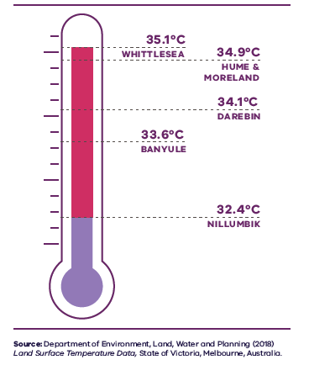

Figure 21. Average land surface temperature by LGA, 2018
Whittlesea | 35.1 degrees Celsius
Hume | 34.9 degrees Celsius
Moreland | 34.9 degrees Celsius
Darebin | 34.1 degrees Celsius
Banyule | 33.6 degrees Celsius
Nillumbik | 32.4 degrees Celsius
Source: Department of Environment, Land, Water and Planning (2018) Land surface temperature data, State of Victoria, Melbourne, Australia.
There are a variety of urban environments across the Northern Metro Region creating different urban heat outcomes. Inner, higher-density suburbs retain heat and are hotter during periods of hot weather. They have fewer canopy trees, more hard surfaces and greater levels of urbanisation than outer suburbs. Conversely, the region also features significant waterway corridors and areas with high levels of tree canopy which are cooler during periods of hot weather. This means individual suburbs perform differently and provide different levels of amenity on hot days.
- Heat vulnerability index map for the Northern Metro Region, 2018
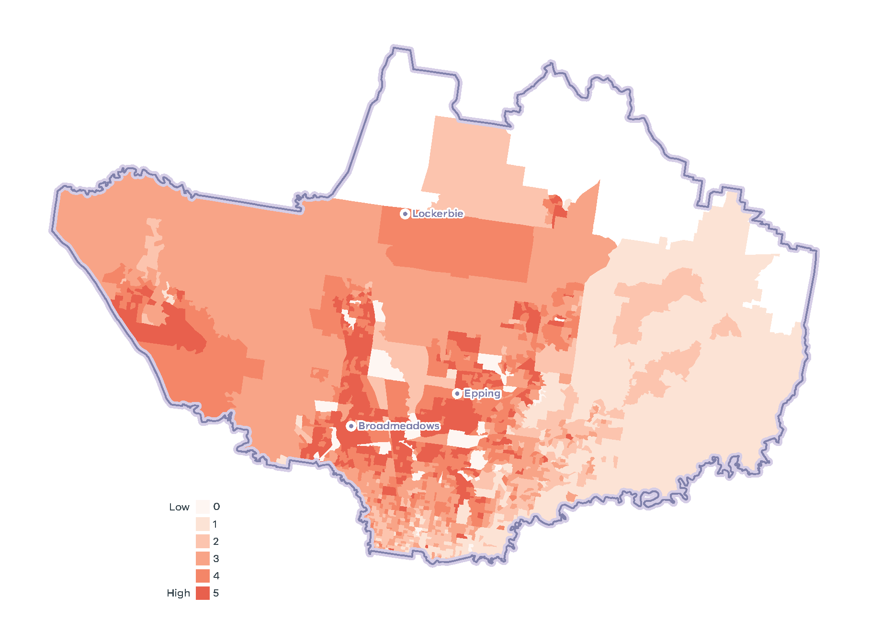
- Northern Metro Region tree canopy cover 2018
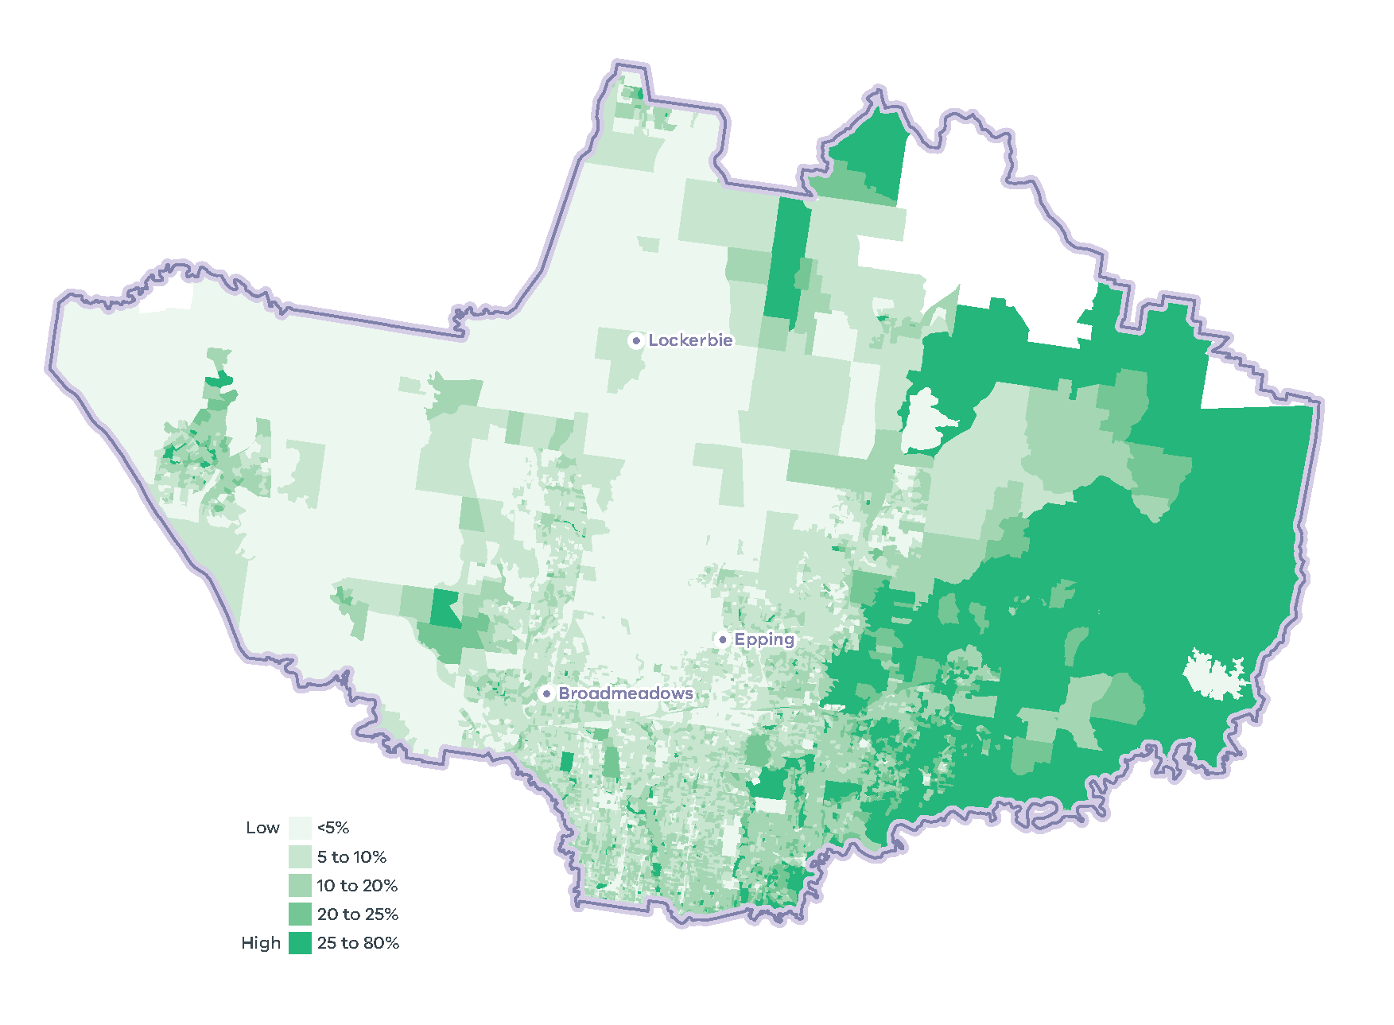
As the frequency and duration of hot days increases, so too will the need for future urban environments to actively reduce heat and improve comfort – not only to support outdoor leisure and recreation, but also to reduce the likelihood of heat-related illness.
Active urban environments, characterised by higher-density development and limited physical space for canopy trees, will need to become ‘cooler urban environments’. These environments will need to apply a range of alternative measures to reduce urban heat, including water sensitive urban design (WSUD) to increase soil permeability and provide passive irrigation to landscaped areas, heat-reflective materials on building roofs and walls, shade structures to protect windows and open spaces, and alternative landscaping to maximise limited space such as roof gardens and green walls. The balance of land in less-dense urban environments must become ‘green areas’, where additional drought-tolerant vegetation is introduced, particularly canopy trees on both private and public property to provide shade and shelter.

Urban tree canopy
Across the Northern Metro Region tree canopy plays an important role in maintaining our water supply catchments, providing habitat and contributing to the character of parks and green wedges. In urban areas, trees also provide cooling, amenity, recreation and respite to residents. In 2018, the Northern Metro Region had 12.1 per cent of urban tree canopy cover which was lower than the metropolitan average of 15.3 per cent (Hurley, et al., 2019a). Tree canopy varies across the region. There are areas of greater coverage to the north-east of the region and along waterway corridors. Nillumbik LGA has the highest urban tree canopy coverage of 31.1 per cent while Hume LGA has the lowest urban tree canopy cover of 6.4 per cent (Figure 24).
Across the Northern Metro Region most of the urban tree canopy is on residential land, parkland and linear infrastructure such as roads (Figure 25). This is due in part to large areas of land being used for residential and transport purposes.

- Tree canopy cover 2018, and tree canopy cover change 2014 to 2018, by LGA
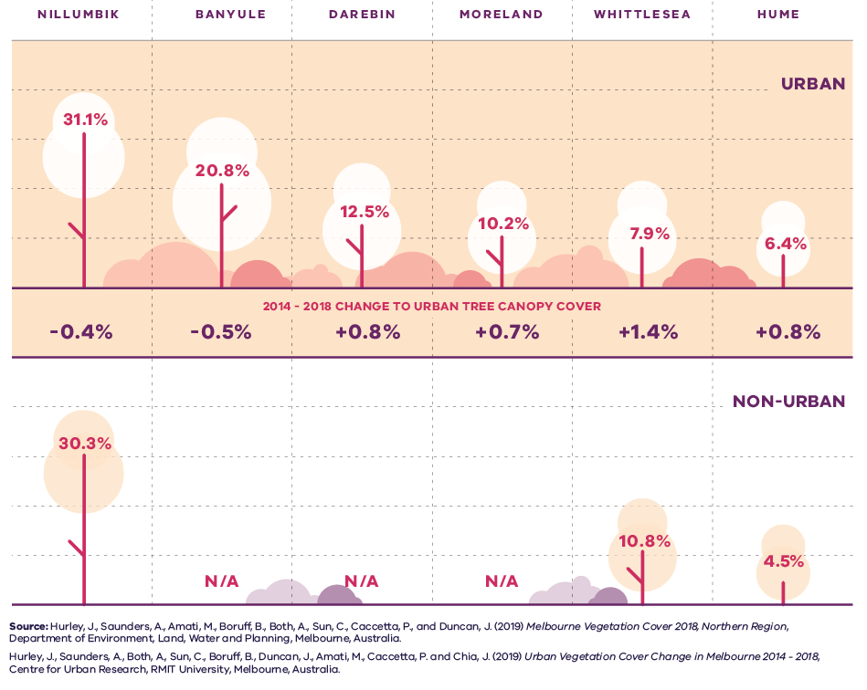

Figure 24. Tree canopy cover 2018, and tree canopy cover change 2014 to 2018, by LGA
LGA | Urban tree canopy cover 2018 | 2014 to 2018 change to urban tree canopy cover | Non-urban tree canopy cover 2018
Nillumbik | 31.1 per cent | Minus 0.4 per cent | 30.3 per cent
Banyule | 20.8 per cent | Minus 0.5 per cent | Not applicable
Darebin | 12.5 per cent | Plus 0.8 per cent | Not applicable
Moreland | 10.2 per cent | Plus 0.7 per cent | Not applicable
Whittlesea | 7.9 per cent | Plus 1.4 per cent | 10.8 per cent
Hume | 6.4 per cent | Plus 0.8 per cent | 4.5 per cent
Sources:
Hurley, J., et al. (2019) Melbourne Vegetation Cover 2018, Western Region, Department of Environment, Land, Water and Planning, Melbourne, Australia.
Hurley, J., et al. (2019) Urban Vegetation Cover Change in Melbourne 2014 – 2018, Centre for Urban Research, RMIT University, Melbourne, Australia.

- Urban tree canopy cover by land use, 2018
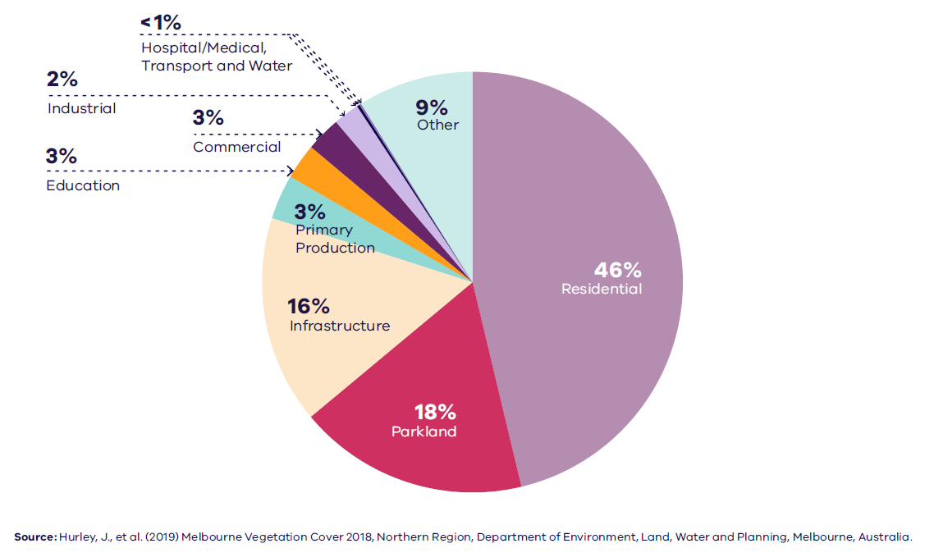

Figure 25. Urban tree canopy cover by land use, 2018
Residential | 46 per cent
Parkland | 18 per cent
Infrastructure | 16 per cent
Primary production | 3 per cent
Education | 3 per cent
Commercial | 3 per cent
Industrial | 2 per cent
Hospital/medical | Less than 1 per cent
Transport | Less than 1 per cent
Water | Less than 1 per cent
Other | 9 per cent
Source: Hurley, J., et al. (2019) Melbourne Vegetation Cover 2018, Northern Region, Department of Environment, Land, Water and Planning, Melbourne, Australia.

Natural hazards – flooding and bushfire
Stormwater flooding is prevalent in urban areas of the Yarra and Maribyrnong catchments in the Northern Metro Region. Higher volumes of stormwater during periods of heavy rain impact the health of rivers and their tributaries. While overall annual rainfall will reduce, the region is forecast to experience more frequent and intense rainfall events that will increase the risk of flooding as a result of climate change (DELWP, 2018c). Flooding may also be exacerbated by an increase in impervious surfaces and stormwater flows unless the risk is properly managed.
Inner areas of the Northern Metro Region, such as Darebin, Moreland and Banyule LGAs, have a high flooding risk. Conversely, outer areas of the region such as Nillumbik and Whittlesea LGAs, which have large urban and rural interfaces and high vegetation cover, have a high risk of bushfire (NAGA, 2014).

Resource efficiency and waste and resource recovery
In 2013-14 Greater Melbourne had a 73 per cent resource recovery rate, with 805,000 tonnes of food and garden waste sent to landfill. By 2042, it is projected waste volumes will grow by 63 per cent to 16.5 million tonnes each year. The most significant landfill in the Northern Metro Region, the Hanson Landfill in Wollert has all relevant approvals in place to meet forecast capacity, as does an inert landfill in Bulla (Metropolitan Waste and Resource Recovery Group, 2016).

Sustainability in the built environment
In 2013, residential buildings were responsible for nearly 12 per cent of Australia’s national greenhouse gas emissions, and commercial buildings contributed just over 11 per cent. The majority of these emissions were generated through the consumption of grid-supplied electricity to power appliances, lighting, and predominantly heating, ventilation and cooling (HVAC) systems (Australian Sustainable Built Environment Council, 2016).
As average temperatures rise due to climate change, greater numbers of people are expected to seek comfort indoors during periods of hot weather. This, combined with population growth and overall poor-performing building stock, means our city lacks energy efficiency and resilience on hot days. Maximising opportunities to incrementally improve the performance of buildings will reduce our reliance on appliances to cool buildings and contribute to a lower likelihood of blackouts during periods of hot weather.
Local councils within the Northern Metro Region are active in adopting policies and strategies to reduce carbon emissions and improve the sustainability of the built environment. Many are innovators and leaders in Environmentally Sustainable Development (ESD) and are implementing new practices to improve the energy efficiency of civic buildings and reduce emissions from operations.
Several LGAs are members of the Council Alliance for a Sustainable Built Environment (CASBE), an association committed to designing and applying a range of practical methodologies to increase sustainability outcomes for new buildings. The Built Environment Sustainability Scorecard (BESS) is an online tool developed by CASBE that assesses the sustainability of proposed developments. It aims to reduce waste and improve energy efficiency from the outset of the construction phase, through to occupation. As well as onsite energy generation, BESS promotes the use of energy-efficient appliances, thermally-efficient glazing, wall cladding and insulation, water-efficient fittings and fixtures, thermal comfort and overall environmentally sustainable performance.
Other rating systems being increasingly utilised by the building design industry to measure and assess the performance of ESD principles include Green Star (Green Building Council of Australia, 2021), NatHERS (Department of Industry, Science, Energy and Resources, 2021) and MUSIC (eWater, 2021).

Regional strengths
- The region has extensive natural assets and a well-established tree canopy, particularly in the north-east and parts of the green wedges.

Regional challenges
- Flooding poses a risk to people, property and infrastructure.
- Some urban areas have a low tree canopy and heat vulnerable communities.
- There are bushfire risks to the community, infrastructure and high-value native ecosystems at the urban-rural interface.
- There is a need for a new resource recovery centre and transfer station to advance resource efficiency and recycling.

Directions and strategies
The directions identified to achieve the 2050 vision for the Northern Metro Region in terms of Sustainability and resilience and Outcome 6 of Plan Melbourne are:
Direction 24 | Respond to the transformation of the energy supply network
Direction 25 | Increase the network of cool places, particularly in areas with communities vulnerable to urban heat and areas with high urban heat
Direction 26 | Increase urban tree canopy across the Northern Metro Region to achieve 27 per cent coverage by 2050
Direction 27 | Increase the retention and reuse of water in the urban environment
Direction 28 | Minimise and reduce risk from bushfire in Nillumbik, Whittlesea, Hume and Mitchell
Direction 29 | Protect sites of strategic importance for recycling and plan for the expansion of key sites for future resource recovery needs
Each direction is implemented through regionally-specific strategies identified in this LUFP.
Map 10 shows how sustainability and resilience will be enhanced across the Northern Metro Region by 2050 as a result of these directions and strategies, together with Plan Melbourne and other strategies and initiatives as outlined in Appendix 01.

- Northern Metro Region sustainability and resilience state of play 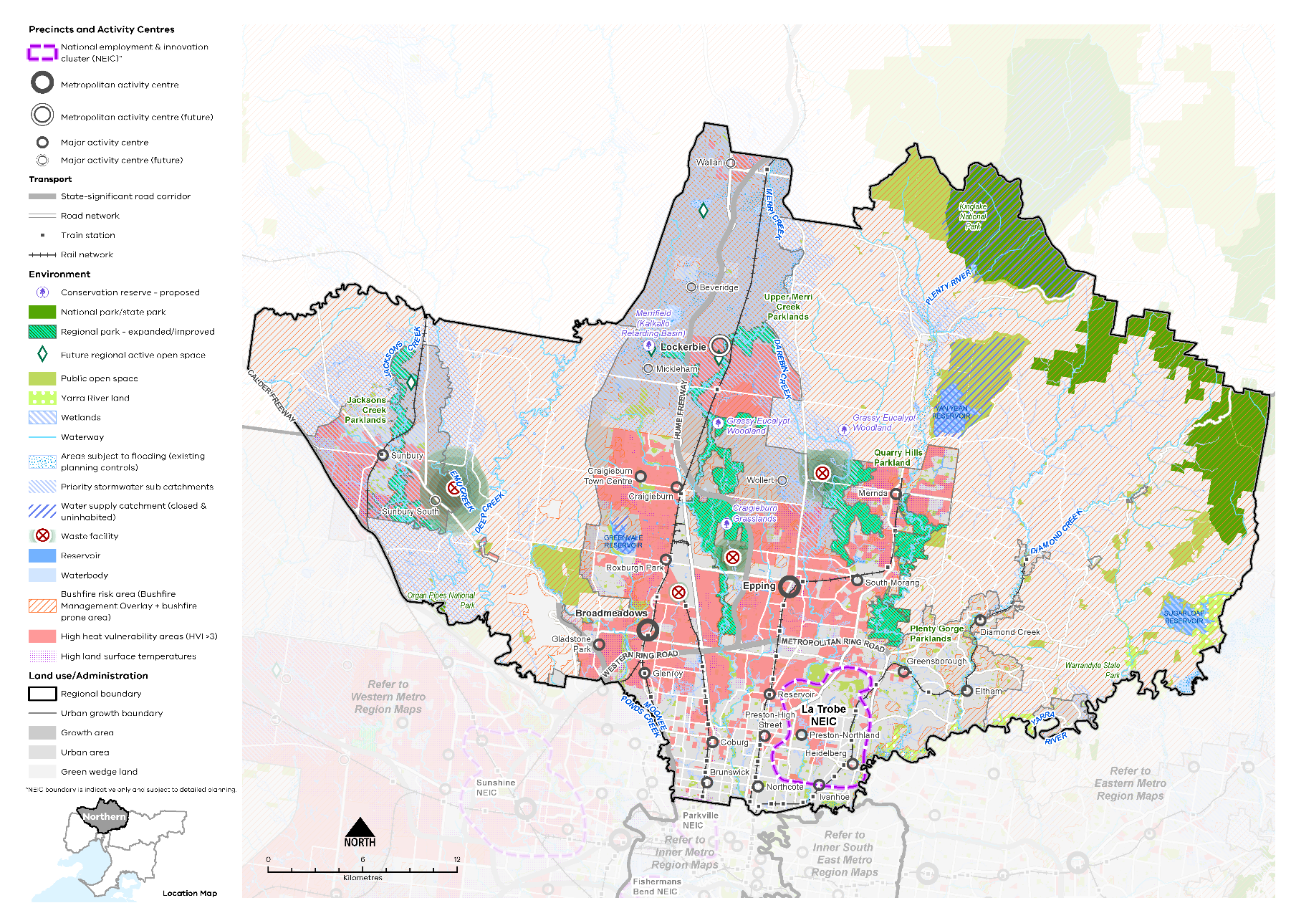

Map 9 Northern Metro Region sustainability and resilience state of play
A map showing the current sustainability and resilience of the Northern Metro Region, as extracted from Map 1, and also highlighting:
- Bushfire risk areas (taken from the Bushfire Management Overlay and bushfire prone area)
- Areas of high heat vulnerability principally in the centre of the region and around Sunbury
- Areas with high land surface temperatures found across the urban area
- Waters supply catchments (closed and uninhabited)
- Areas subject to flooding (existing planning controls) and priority stormwater sub catchments
- Four existing waste and resource recovery hubs of state importance: Hanson Landfill Wollert; Cooper Street precinct, Epping; Cleanaway (formerly SKM) Materials Recovery Facility (MRF), Coolaroo; and Veolia Organics Facility, Bulla.

- Northern Metro Region sustainability and resilience 2050
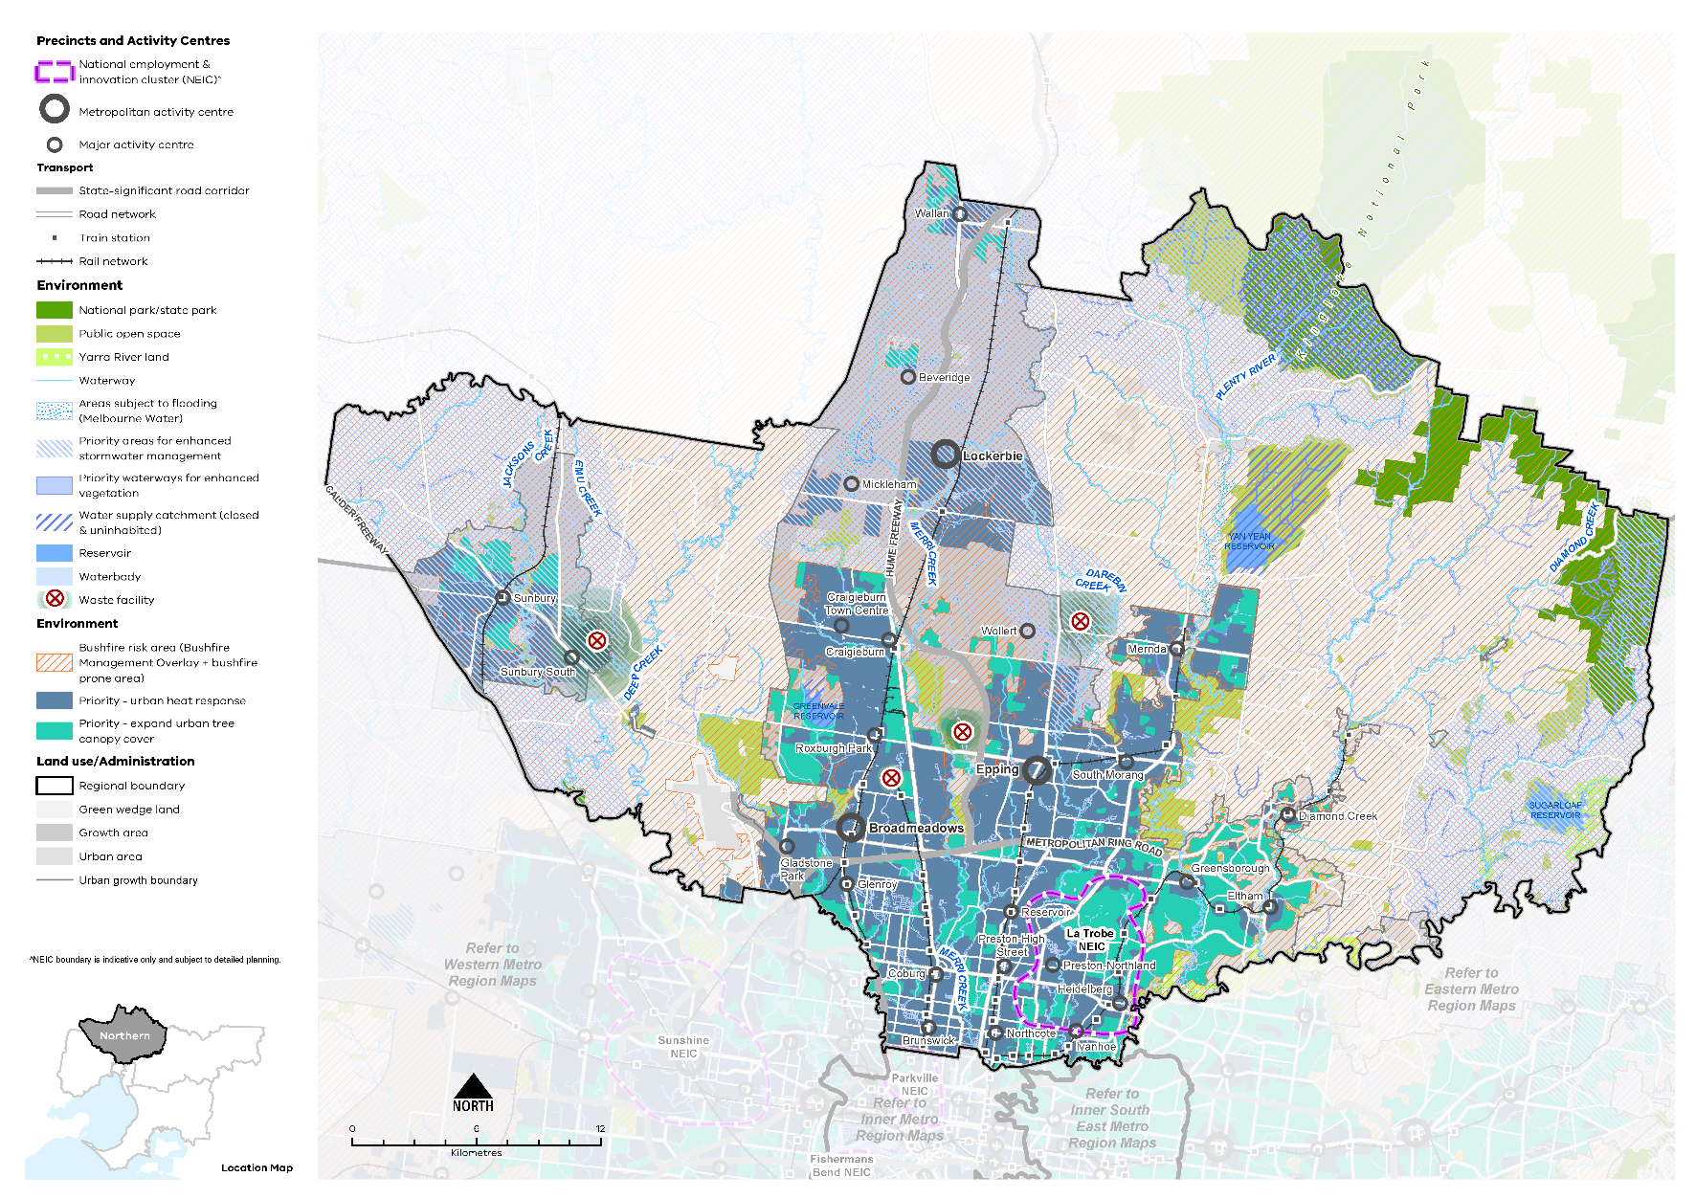

Map 10 Northern Metro Region sustainability and resilience 2050
A map showing the sustainability and resilience of the Northern Metro Region in 2050, as extracted from Map 1, and also highlighting:
- Priority areas for enhanced stormwater management principally in the west, north-east and south-east of the region, and around the perimeters of the growth areas
- Priority waterways for enhanced vegetation
- Priority areas for an urban heat response and expanding the urban tree canopy cover
- Areas subject to flooding (updated Melbourne Water data).

- Respond to the transformation of the energy supply network
In an increasingly decentralised energy system, future electricity networks will need to be responsive to changing demands from traditional services while enabling new opportunities for energy resource sharing and balancing. Millions of customers in Melbourne generate electricity, and over time they will store electricity too. These customers will be connected to the network and each other, enabling energy networks to act as platforms that match supply and demand and reduce the need for inefficient duplication of energy investments.
Large subdivisions, growth area development and urban renewal in the Northern Growth Corridor and large urban renewal areas should be planned to support this future energy network and avoid the need to retrofit energy infrastructure.
- Ensure subdivision and growth area development can support the emerging energy supply network.

- Increase the network of cool places, particularly in areas with communities vulnerable to urban heat and areas with high urban heat
More tree canopy cover, permeable surfaces and water in the urban environment will help reduce urban temperatures and create comfortable local micro-climates in the Northern Metro Region.
Plan Melbourne notes that temperature decreases of between 1° Celsius and 2° Celsius can have a significant impact on reducing heat-related morbidity and mortality (DELWP, 2017a). Major activity centres and higher-density areas would benefit from a ‘cooling’ approach while lower-density areas would benefit from a ‘greening’ approach.
In addition to trees, green walls, shade structures and low heat absorbing materials can help reduce urban surface temperatures. These techniques will be important in inner areas of the region, activity centres, La Trobe NEIC, and around education and recreation facilities which have areas of high urban heat. Land uses frequented by older people and children will need to provide for more active cooling of outdoor environments.
Buildings with vegetation and roof gardens will need to be combined with onsite water harvesting and storage to ensure vegetation health and reduce potable water demand.
Epping, Broadmeadows and Lockerbie metropolitan activity centres have communities vulnerable to urban heat, along with Brunswick, Coburg, Preston (High Street), Reservoir, Glenroy, Gladstone Park, South Morang, Roxburgh Park, Mernda, Craigieburn and Sunbury major activity centres. These communities are at a higher risk of heat-related illness during periods of multiple hot days (Sun & et al., 2019).
As shown in Figure 22, there are also large areas of high urban surface temperatures in the suburbs to the north and south of the Metropolitan Ring Road and suburbs around the Hume Freeway which absorb and retain heat.
- Design and develop outdoor spaces that are cool on hot days through materials, vegetation and water sensitive urban design in:
- Broadmeadows, Epping, and Lockerbie metropolitan activity centres
- Coburg, Preston (High Street), Reservoir, Glenroy, Gladstone Park, South Morang, Roxburgh Park, Mernda, Craigieburn and Sunbury major activity centres
- Locations with high urban heat vulnerability and high urban heat.
- Encourage green roofs and green structures with climate resilient planting and irrigation on apartment developments, particularly in areas with high urban heat and large commercial and industrial sites.
- Increase urban tree canopy across the Northern Metro Region to achieve 27 per cent coverage by 2050
Trees provide an essential service to the surrounding environment. In the absence of water, trees and in particular clusters of trees, make the greatest contribution to reducing surface temperatures, along with contributing to stormwater infiltration and amenity and biodiversity outcomes (Coutts & Tapper, 2017) (Sun & et al., 2019).
These important functions are vital for sustainability and resilience as our climate warms and the Northern Metro Region’s population grows.
All local councils in the region have adopted the Living Melbourne Urban Forest Strategy (2019). This strategy specifies targets for the Northern Metro Region of 27 per cent total tree canopy and 39 per cent total tree and shrubs canopy by 2050.
The target of 27 per cent tree canopy coverage by 2050 is accompanied by an aspirational distribution of tree canopy across land uses to guide action in the Northern Metro Region (Table 14).
A key challenge for increasing tree canopy is the ability to retrofit existing urban areas for green infrastructure due to the availability of public and private space and the multiple functions of public land and publicly accessible places. For example, there are potential conflicts with electrical powerlines, underground cabling, gas and stormwater pipe works and regulation, and transport movement (Banyule City Council, 2014). Tree planting will need to avoid remaining areas of natural treeless grassland as these are some of the most precious remaining natural assets in the region.
The Greening the North program has recently been established between government departments, agencies and other stakeholders to coordinate and accelerate greening across the Northern Metro Region.
Most of the Northern Metro Region’s growth is expected to be accommodated in and around activity centres and areas with good access to existing services and transport infrastructure. Some of these sites will be less able to accommodate trees and a broader range of cooling and greening methods will be required.
Outside these locations are urban areas that are not as well located to infrastructure. In these locations, private land can retain more trees while development can provide higher levels of planting. In bushfire interface areas, planting should be managed so that it responds to potential bushfire risk.
While some locations will be more constrained, tree planting may yield greater co-benefits, such as reducing urban temperatures, local climate regulation and stormwater benefits. Areas where many people are exposed to high urban heat environments, as well as areas with high surface temperatures in inner suburbs, should be a priority (refer to Priority Urban Heat Response areas in (Map 10). Other priority locations for planting are activity centres and points of access to the PPTN.
Infrastructure, such as streets, rail corridors, new arterial roads and large at-grade car parks can play a multi-purpose role for both movement and greening to help achieve urban forest targets. Relocating powerlines underground in key locations should be considered to maximise the urban tree canopy. Transport corridors such as the Metropolitan Ring Road and Hume Freeway, as well as railway lines, also provide an opportunity to increase tree canopy.
All Northern Metro Region LGAs have endorsed the Living Melbourne: Our Metropolitan Urban Forest strategy, specifying a regional target of 27 per cent total tree canopy and 30 per cent combined tree canopy and shrubs by 2050 (The Nature Conservancy and Resilient Melbourne, 2019). To support this commitment, the tree canopy target is accompanied in Table 14 by an aspirational distribution of tree canopy cover across four different land use types, adapted by DELWP from several related datasets (Hurley, et al., 2019a) (Ulrich & Hardy, 2020) (PSMA Australia Limited, 2021).
Northern Metro Region tree canopy cover target and aspirational distribution
2018 Tree Canopy Cover: 12.1%
2050 Tree Canopy Cover Target: 27%
(+14.9% or +8,505 hectares additional tree canopy cover)
Residential, commercial, industrial and primary production | 55%
Streets, roads and rail | 20%
Parks, open space and waterways | 20%
Education and hospital/medical | 5%
- Retain more trees on private land outside locations identified for higher levels of housing and mixed-use change.
- Increase tree canopy across the Northern Metro Region to 27 per cent coverage by 2050. Priority locations for this to be achieved are:
- Areas with high urban heat vulnerability in the Northern Growth Corridor
- High urban heat locations in Moreland, Hume, Whittlesea and Banyule LGAs
- Urban waterways and open spaces.
- Increase the retention and reuse of water in the urban environment
Integrated stormwater management, reducing runoff into waterways and wetlands, and water recycling will improve climate resilience and liveability. The Northern Metro Region is predicted to be 59 per cent more impervious within the next 50 years (Melbourne Water, 2018). This will increase rapid runoff and flooding, and negatively affect water quality and the health for aquatic life.
While some areas of the region are subject to flooding overlays, such as the Special Building Overlay (SBO) and Land Subject to Inundation Overlay (LSIO), there is an opportunity to increase stormwater and floodwater harvesting capabilities. This is particularly important in developing urban centres where impervious surfaces and flooding can increase the risk and cost of property and infrastructure damage (DELWP, 2018c).
Urban stormwater management and water harvesting is needed in the Northern Metro Region to manage flooding risk to property and infrastructure, and to support green infrastructure.
Local stormwater capture, water recycling and greywater systems will improve the region’s hydrological and ecological systems, along with restoration and revegetation of urban waterways, and WSUD in public realm projects, particularly in open spaces and new residential subdivisions.
Harvesting stormwater and increasing water infiltration is important in dense suburbs to reduce runoff and service vegetation. Harvested stormwater can help maintain water-reliant facilities and amenities such as sporting fields and gardens, contribute to more resilient vegetation, reduce demand on drinking water and improve the receiving environment of streams and rivers. Development can reduce the impacts of flooding, support healthy vegetation and prepare for drying conditions by increasing permeable areas, increasing proportions of green space, avoiding paved areas and passively irrigating vegetation.
Development also increases the quantity of wastewater generated in urban areas, which provides another opportunity to diversity water sources. For example, wastewater can be recycled and used to irrigate public open space and sporting grounds. This will help improve water security as the climate warms and overall rainfall decreases. Further, wastewater contains nutrients and organic matter that could be used to create valuable products such as fertilisers and energy sources. Given increasing limits in resource availability, this creates an opportunity to expand the benefits of wastewater management by exploring different options for resource recovery.
The Victorian Government’s strategies Water for Victoria and Integrated Water Management Framework for Victoria provide the strategic framework for water management in Victoria. At the regional scale, options to increase the retention and reuse of water in the urban environment should be based on the actions contained in the Yarra and Maribyrnong Catchment Scale Integrated Water Management Plans, flooding strategies, relevant sub-catchment integrated water management plans (including the Sunbury and Upper Merri Creek plans), and local council integrated water management plans.
These plans should be used as the basis to support governments and relevant agencies to prioritise and align water infrastructure needs and deliver integrated water management outcomes. This may include the preparation of appropriately-scaled integrated water management plans (i.e. sub-catchment, precinct or local scale) by the lead planning authority in collaboration with relevant referral agencies to guide sustainable water design and development decisions.
- Retain and harvest stormwater in priority sub-catchments and inner suburbs of the Northern Metro Region.
- Support the development of water sensitive neighbourhoods through precinct planning and IWM plans.
- Support opportunities to deliver alternative water supply to green wedges to provide for agriculture and minimise extraction from natural waterways.

- Minimise and reduce risk from bushfire in Nillumbik, Whittlesea, Hume and Mitchell
Heavily vegetated environments in Nillumbik and Whittlesea LGAs and grassland areas in Hume and Mitchell LGAs pose significant bushfire risks for the region (Map 9). The need to plan for the risk of bushfire to communities, infrastructure and natural environments will continue to increase as the climate warms and overall rainfall decreases.
The likelihood of forest fires and grassfires, and their severity and intensity, depends on a site’s location and the surrounding landscape. State planning policy for bushfire (Clause 13.02) and the Bushfire Management Overlay (BMO) already applies to large areas of the Northern Metro Region, mostly beyond the urban area. The BMO aims to strengthen community resilience to bushfire by considering bushfire measures as part of building design and ensuring new development achieves an acceptable level of bushfire risk. However, there is a need to strengthen the resilience of settlements and communities to bushfire through strategic, risk-based regional planning that prioritises the protection of human life over other policy considerations.
In order to prioritise the protection of human life from bushfire, population growth and development should be directed to low-risk locations and areas that are safely evacuated. Development within areas of the highest bushfire risk must achieve acceptable levels of risk reduction. These areas should be avoided for development that will accommodate more vulnerable populations, such as the elderly or very young, that may have difficulties evacuating in the event of a bushfire.
Careful management of vegetation and water resources will be required across the Northern Metro Region in response to bushfire risk. River and creek corridors will continue to be important as the climate warms to provide habitat, recreation and cooling. However, given their higher levels of vegetation, they will also pose bushfire risk. Vegetation management strategies, including selecting lower risk species and maintaining vegetation, will have a key role in mitigating risk in urban areas while recognising the value of these corridors for habitat and urban cooling.
- Avoid housing growth and sensitive land uses within and in proximity to bushfire prone areas of Nillumbik, Whittlesea, Hume and Mitchell LGAs.
- Provide new and upgraded regional social infrastructure that provides refuge in extreme bushfire and weather events.
- Recognise and manage bushfire risk posed by vegetation within waterway corridors.
- Protect sites of strategic importance for recycling and plan for the expansion of key sites for future resource recovery needs
The Statewide Waste and Resource Recovery Infrastructure Plan 2018 (Sustainability Victoria, 2018) and the Metropolitan Waste and Resource Recovery Implementation Plan 2016 aim to increase resource recovery across Victoria. The metropolitan plan identifies the need for a Resource Recovery Centre and Transfer Station in the Northern Metro Region of 17,000 to 43,000 tonnes per annum capacity by 2031-2040 (Metropolitan Waste and Resource Recovery Group, 2016).
Waste and resource recovery hubs provide essential services to support waste and recycling for Victorian communities. There are four existing waste and resource recovery hubs of state importance for metropolitan Melbourne in the Northern Metro Region (Sustainability Victoria, 2018). They are:
- Hanson Landfill Wollert: A significant putrescible and solid inert landfill serving the metropolitan and neighbouring regions with the potential to operate over the long term. The Wollert landfill is well located and close to major transport routes (Sustainability Victoria, 2018)
- Cooper Street precinct, Epping: Compatible activities could provide additional resource recovery activities and markets for the recovered goods (Sustainability Victoria, 2018)
- Cleanaway (formerly SKM) Materials Recovery Facility (MRF), Coolaroo: Largest material recovery facility in Victoria, accepting commingled recyclable streams from metropolitan and regional areas likely to continue in current role for the foreseeable future.
- Veolia Organics Facility Bulla: Major hub undertaking a range of waste and resource recovery activities including composting organics and asbestos and demolition disposal (Sustainability Victoria, 2018).
Waste and resource recovery hubs and facilities require buffers and protections to minimise impacts on communities, the environment and public health. There is also a need to support compatible land uses in and around the hubs and to identify adequate land and appropriate locations for future resource recovery infrastructure (Sustainability Victoria, 2018).
Waste and resource recovery hubs can provide significant opportunities to leverage benefits and facilitate investment in recycling facilities. Opportunities to develop hubs include co-location of industries that have synergies with waste and resource recovery facilities, increasing economies of scale or co-locating industries requiring similar buffers, creating jobs and increasing volume of materials recovered (Sustainability Victoria, 2018). Development of a strategic plan for the Cooper Street Precinct hub has commenced, with similar plans due to be developed for other hubs by the Metro Waste and Resource Recovery Groups.
Successful recycling in Victoria requires markets for recycled products. Infrastructure projects throughout the region can contribute to strengthening these markets and reducing the environmental impact by using more recycled products and less virgin materials.
- Protect and buffer the Wollert landfill, Coolaroo MRF and Bulla waste and resource recovery hubs of state importance.
- Maintain adequate buffers and provisions to protect the Cooper Street precinct and Wollert waste and resource recovery hub from residential encroachment and incompatible land uses and preserve the importance of the hubs for the long term.
- Ensure zoning can support complementary land uses to locate in and around the Cooper Street, Wollert landfill and Bulla waste and resource recovery facilities of adequate size and location to provide additional capacity for the Northern Metro Region.

Actions – Sustainability and resilience
- Prepare a regional bushfire response for suburban and peri-urban communities that are subject to bushfire risk.
- Investigate options and land use protection for a Resource Recovery Centre and Transfer Station/s to support Melbourne’s future resource and recovery needs.

Chapter 10.
Implementation
The Northern Metro Region LUFP is a planning document that will be implemented primarily through planning schemes. This will guide and support decision-making at the local level and improve the consistency of decisions at the regional level.
There are many actions under Plan Melbourne and other government programs and initiatives, such as the Metropolitan Partnerships, that will contribute to improving planning outcomes in the Northern Metro Region. This LUFP includes a targeted list of regional actions.
The Northern Metro Region LUFP identifies specific regional planning priorities for state and local government to progress the implementation of Plan Melbourne as well as address specific planning issues for the region. Other priorities will emerge over the five-year timeframe for LUFP implementation that may supersede actions in the LUFP or complement and further refine these actions.
Implementation of this LUFP will require ongoing collaboration between state government and local government in the Northern Metro Region. A five-year action program is outlined below.

Putting the plan into action
Local councils in the Northern Metro Region are already working together to address priority issues for their region. Existing metropolitan regional governance arrangements such as the Northern Metropolitan Partnership provide forums to bring together experts and leaders from all levels of government, business and the community to identify and progress issues of importance to the region.
The strategies outlined in this LUFP will be implemented at the local level in a range of ways. For instance, amendments will be made to the planning schemes to give relevant regional strategies status in the Planning Policy Framework and updates will be made to local housing and local industrial land use strategies. The LUFP will be used to guide and inform future strategic planning across the Northern Metro Region by individual local councils, the regional groupings of local councils or other entities such as the Metropolitan Partnerships.
The Northern Metro Region LUFP will also guide and inform the preparation of the remaining PSPs to be completed for these Northern Growth Area, and their implementation.
Information included in this LUFP relating to urban development and infrastructure that may be required to service new communities, which has been sourced from the growth corridor plans, should not be interpreted as a delivery mechanism or program committing the Victorian Government to specific infrastructure or development projects or specific levels of service provision.
As part of the implementation process, the Department of Treasury and Finance will update budget business case submission templates and guidance to identify how initiatives align with Plan Melbourne and the LUFPs. This will bolster the consideration of metropolitan and regional policy when business cases are drafted.
The process for implementing this LUFP is outlined in Figure 26.
- Implementation of the land use framework plan
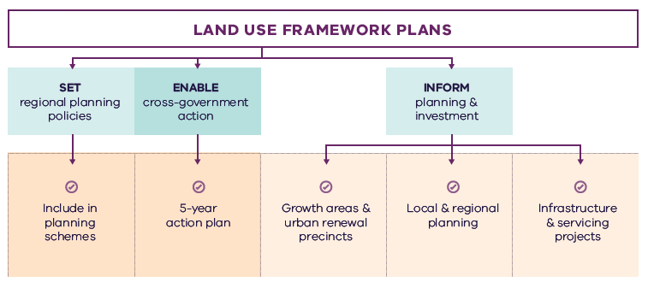
Figure 26. Implementation of the land use framework plan
Land use framework plans
- Set regional planning policies
  - Include in planning schemes
- Enable cross-government action
  - 5-year action plan
- Inform planning and investment
  - Growth areas and urban renewal precincts
  - Local and regional planning
  - Infrastructure and servicing projects

Five-year action program
A number of short- to medium-term actions are included in the Northern Metro Region LUFP. The five-year action program (Table 15) summarises these actions to be delivered collaboratively by the state government and councils in the Northern Metro Region. These actions deliver on the strategic directions identified in the LUFP and in turn, Plan Melbourne outcomes. The actions will positively and proactively address some of the challenges being experienced by the region.
Plan Melbourne and the Melbourne Industrial and Commercial Land Use Plan (MICLUP) also contain actions that may require regional collaboration and will support the outcomes sought by the LUFP. This LUFP’s five-year action program is a targeted list of actions identified during the development of the draft LUFP. It is not intended that this list duplicate existing Plan Melbourne or MICLUP actions other than where confirming a particular action was warranted given its regional implications.
In relation to transport, the following actions from Plan Melbourne Implementation Plan are identified as being well suited to being implemented at the regional level for this metro region and there is a commitment to deliver them as part of the implementation of Plan Melbourne and the LUFP:
- Action 43: Safe, efficient and accessible pedestrian networks
- Action 44: Local networks of cycling links
- Action 45: Local transport forums.
The implementation and prioritisation of the five-year action program will be driven by existing metro-regional governance arrangements including the Metropolitan Partnerships and EPWGs.
The indicative timeframes for completing actions are:
- Short term: By the end of 2023 (0–2 years)
- Medium term: By the end of 2026 (2–5 years).
Each action is allocated to a lead agency and implementation partners. Detail on the timing of actions and how they are implemented will be determined in line with normal government and council policy and budget processes. All actions requiring budget allocation will be carefully assessed against budget capacity, with rigorous business cases and cost-benefit analyses applied as part of their economic impact assessment.

Decision-making processes to support the delivery of the LUFPs
The LUFPs are a statement of policy intent. Detailed decisions about the implementation and timing of actions and infrastructure delivery will be made in line with normal government policy and budget processes.
The Victorian Government will continue its commitment to rigorous decision-making about initiatives that require funding, statutory amendments or new regulations in line with its economic and fiscal strategy, including the Government’s long-term financial management objectives.
For infrastructure projects, this will include ensuring consistency with the Victorian Government’s Investment Lifecycle and High Value/High Risk Guidelines. For all other initiatives and actions, implementation and timing will be subject to consideration of its evidence base and likely net benefits.

Monitoring, reporting and review
Action monitoring will be led by DELWP in partnership with the metropolitan region through the EPWG. DELWP will publish an annual progress report outlining the status of actions against the specified timeframe (whether an action has been ‘completed’, is ‘in progress’ or ‘not started’). These progress reports will be publicly available.
LUFP implementation will be formally reviewed every five years in conjunction with the Plan Melbourne Five-Year Implementation Plan. The review will be conducted in an open way and involve engagement with key stakeholders including Metropolitan Partnerships and EPWGs.

Actions – Implementation
- Update budget business case submission templates and guidance to identify how initiatives align with Plan Melbourne and the Land Use Framework Plans.
Five-year action program
Timeframe - Short term (S): By the end of 2023 (0–2 years). Medium term (M): By the end of 2026 (2–5 years)
 | Action | Source | Timeframe | Lead agency | Implementation partner(s)
1 | Establish a long-term state and local government partnership to prioritise planning and infrastructure provision for Lockerbie as a metropolitan activity centre for the Northern Growth Corridor. |  | S | DELWP | Councils, VPA
2 | Establish a state and local government partnership to coordinate and manage land use planning for the La Trobe NEIC. |  | S | DELWP | VPA, DJPR, Hume, Whittlesea, Mitchell LGAs
3 | Implement a program of State Government-led planning projects, in partnership with local government, to ensure metropolitan and major activity centres and urban renewal areas maximise their respective strategic opportunities. Priority will be given to those which deliver significant jobs and housing; leverage investment in state infrastructure; and play an important role in the growth corridor and/or region. State-led planning for these state- and regionally-significant places will contribute to creating liveable communities and achieving more dwellings and jobs in established areas, and identify implementation and coordination actions that support growth and economic investment. |  | S | VPA | Councils, DELWP
4 | Identify and implement a SERA in the Northern Metro Region in partnership with local government. |  | M | DJPR | Councils, DELWP
5 | Update planning schemes to align with housing policies in Plan Melbourne and the Northern Metro Region Land Use Framework Plan and the implementation of the reformed residential zones. This includes:  Providing capacity for 15 years of regional housing supply focusing on locations identified for housing growth in the LUFP  Reviewing planning controls in housing investigation areas as potential locations for substantial or incremental housing change.  This may require strategic planning work to support these changes such as preparing or updating local housing strategies or preparing structure plans to further investigate where increased densities can be supported, and determine specific changes required to planning schemes. |  | S | Councils | DELWP
6 | Identify underutilised and surplus government land that has potential to deliver additional social housing. | Plan Melbourne Five-Year Implementation Plan | S | DFFH (HV) | DELWP
7 | In partnership with councils, identify a pipeline of sites in the Northern Metro Region for social and affordable housing. |  | M | DFFH (HV) | Councils
8 | Develop a model and seek support for a whole-of-government approach to better sequence and prioritise locations for key services, social infrastructure and public transport access in the development of growth areas to better enable walkable 20-minute neighbourhoods. |  | S | VPA | Councils, DELWP, DET, DFFH (HV), DH, DoT
9 | Undertake a review of the regional bus network to support regional access and movement in the short- to medium-terms and to plan integration with major public transport changes including SRL. |  | S | DoT | Councils
10 | Review the Principal Public Transport Network for the growth areas. |  | S | DoT | Councils, DELWP
11 | Develop a plan to implement a publicly owned and managed network of regional trails and open spaces across the region’s growth corridors, utilising its natural drainage system where possible to link open spaces, biodiversity areas, waterways and urban areas. |  | S | DELWP | Councils, VPA
12 | Prepare a regional biodiversity strategy to protect, manage and enhance habitat corridors and increase their interconnectivity across urban and rural areas. |  | M | DELWP | Councils
13 | Review local planning schemes in the Northern Metro Region to ensure protection and enhancement of the landscape and biodiversity values of the region. |  | M | Councils | DELWP, Melbourne Water
14 | Develop a methodology for a social infrastructure strategy for the Northern Metro Region. This would consider social infrastructure such as libraries, multi-use community and recreation facilities and assess how they can be used more flexibly and intensively. This could be a pilot project suitable for other regions. |  | M | DELWP | Councils, DH, VPA
15 | Prepare a regional bushfire response for suburban and peri-urban communities that are subject to bushfire risk. |  | M | DELWP | Councils, Country Fire Authority
16 | Investigate options and land use protection for a Resource Recovery Centre and Transfer Station/s to support Melbourne’s future resource and recovery needs. |  | M | Sustainability Victoria | Councils, Environment Protection Authority
17 | Update budget business case submission templates and guidance to identify how initiatives align with Plan Melbourne and the Land Use Framework Plans. |  | S | DTF

Appendix 01.
Relevant policies, strategies and initiatives
There are several current Victorian Government policies, strategies and initiatives that have implications for planning in the Northern Metro Region. In addition, there are existing regional initiatives, initiated by councils and/or the Metropolitan Partnerships. This appendix provides an overview of the most relevant policies, strategies and initiatives for the Northern Metro Region LUFP.
Plan Melbourne 2017-2050 and Plan Melbourne 2017-2050 Addendum, 2019, which will guide the growth of our city. Plan Melbourne sets out the strategy for supporting jobs, housing and transport, while building Melbourne’s legacy of distinctiveness, liveability and sustainability. The addendum updates Melbourne’s projected population, housing and employment growth and the Melbourne 2050 spatial framework to align with major transport investments including SRL.
Growth Corridor Plans, Managing Melbourne’s Growth 2012, sets an overarching strategic planning framework to guide future development of Melbourne’s four growth corridors – North, Sunbury-Diggers Rest, West and South East. The growth corridor plans identify:
- Areas suitable for urban development and the broad form of development (residential, industrial, commercial)
- Areas of high environmental or landscape value that must be protected from development
- The integrated open space network
- Strategic transport infrastructure and options for further investigation
- Locations suitable for a wide range of employment uses.
This LUFP incorporates and updates information from the growth corridor plan.
The Northern Metro Region has regional initiatives relevant to the LUFP. These include:
The Northern Horizons – 50-year Infrastructure Strategy for Melbourne’s North sets future directions for short, medium and long-term priorities for the region.
The Northern Regional Trails Strategy provides a framework to develop and maintain the recreational off-road trail network known as the Northern Regional Trail Network.
Specific Victorian Government policies, strategies and initiatives are outlined below under the relevant chapter of the LUFP to which they most strongly relate, acknowledging that many policies, strategies and initiatives are relevant to multiple chapters, or to the whole LUFP.

Productivity
The Melbourne Industrial and Commercial Land Use Plan 2019 provides an overview of current and future needs for industrial and commercial land across metropolitan Melbourne and puts in place a planning framework to support state and local government to more effectively plan for future employment and industry needs, and better inform future strategic directions.
The Unlocking Enterprise in a Changing Economy policy paper provides support for the development of enterprise precincts. The newly introduced Commercial 3 Zone aims to give preference to enterprises and reduce the planning burden for a diversity of employment uses.
Support for Victoria’s creative industries is provided through the Creative State 2016-2020 strategy which aims to grow the state’s creative and cultural economy. Work is currently underway to develop the next creative industries strategy which will guide initiatives and investment between 2020 and 2024.
Protection of the long-term future of Melbourne’s green wedges and agricultural land is provided through the Planning for Melbourne’s Green Wedge and Agricultural Land project, which is exploring a range of planning system changes for how this can best be achieved.
The Metropolitan Partnerships are advisory groups established for each of the metropolitan regions by the Victorian Government that bring community and business together with state and local government and advise on the top priorities for jobs, services and infrastructure across the region.
The Broadmeadows Urban Revitalisation package of infrastructure initiatives will revitalise the Broadmeadows Metropolitan Activity Centre by activating major Victorian Government, local council, VicTrack and VicRoads land holdings for development of housing demonstration sties, office and commercial floor space, premium open space and a multi-deck car park.

Housing choice
Planning system administrative and policy reforms such as Smart Planning are reducing red tape and, in doing so, facilitating the supply of housing.
Planning Practice Notes on Residential Zones and Planning for Housing provide greater clarity for local councils on the technical aspects of how to apply the residential zones and how to plan for housing growth and protect neighbourhood character.
The Housing Development Data dashboard will provide improved access to information on the quantity and location of housing being developed.
The Better Apartments Design Standards and Apartment Design Guidelines for Victoria assists in improving the quality and functionality of apartments in Victoria.
The Future Homes Project is producing better apartment designs and helping Melbourne become a world leader in apartment design, sustainability and liveability.
Housing Outcomes in Established Melbourne 2005 to 2016 highlights how housing development data can be used to understand changes in density, development of housing in activity centres and the influence of zones and overlays on housing change.
Big Housing Build will deliver 9,300 new social housing dwellings and 2,900 new affordable and market homes for first home buyers and renters across the state. It includes:
- $532 million to replace obsolete properties on Homes Victoria land and constructing new homes – this includes Fast Start projects at Victoria Street, Flemington and Elizabeth Street in Richmond
- $948 million for ready to build and spot purchase, working with private sector to bring forward new developments ready to start construction and purchase existing residential properties
- $1.38 billion funding for projects by the community housing sector, through the Social Housing Growth Fund
- $2.14 billion in partnerships with the private and community housing sector – exploring options to build on surplus government owned sites.
The Social Housing Growth Fund is the vehicle for allocating new funds to suitable projects proposed by the community housing sector.
The Homelessness and Rough Sleeping Action Plan initiatives include 20 one-bedroom modular units with intensive onsite support, multidisciplinary housing teams to support complex clients to maintain stable housing, eight additional assertive outreach teams in locations of highest need, and funding therapeutic services in major inner city crisis accommodation centres to improve health, wellbeing and housing outcomes.
The redevelopment of public housing estates is a program to transform ageing public housing estates across metropolitan Melbourne and key regional centres into vibrant, well-connected neighbourhoods. This will create at least 1,800 new` public housing homes.
The Building new homes to fight homelessness is a program to help Victorians escaping family violence, homelessness and life on the streets by building 1,000 new public housing properties.
Melbourne Airport Environs Strategy Plan is a framework of planning controls and initiatives to manage the interests of both the Melbourne Airport and the significant airport environs. The Melbourne Airport Environs Safeguarding Standing Advisory Committee is currently providing advice to the Minister for Planning on improvements to the planning provisions safeguarding Melbourne Airport and its environs.

Integrated transport
Suburban Rail Loop is a new radial rail link connecting Melbourne’s middle suburbs from Cheltenham to Werribee via Melbourne Airport and includes preparing detailed precinct frameworks and structure planning for all SRL precincts. Suburban Rail Loop consists of SRL East (Cheltenham to Box Hill), SRL North (Box Hill to Airport) and SRL West (Airport to Werribee).
Melbourne Airport Rail will connect Melbourne Airport to metropolitan and regional rail networks via Sunshine.
The Metro Tunnel will create additional capacity on Melbourne’s rail network by running the Cranbourne, Pakenham and Sunbury lines through a new tunnel.
North East Link will provide the ‘missing link’ between the Eastern Freeway and the M80 Ring Road in Melbourne’s north east and, in doing so, reduce travel times, remove trucks from local roads and link growth areas in the north and south-east of Melbourne and enhance connections between the Western Ring Road, Hume Freeway and Eastern Freeway to Melbourne’s south-east.
The 2020/2021 Victorian State Budget allocates funding to progress planning for the Bulla Bypass. This will include provision for a six lane arterial road and will connect to the Outer Metropolitan Ring/E6, supporting future traffic volumes in the region and provide an improved connection from Melbourne Airport to the city’s north and west.
The West Gate Tunnel will create a second river crossing to link the Western Metro Region with the Port of Melbourne, CityLink and the CBD, and take traffic pressures off the West Gate Bridge.
The Level Crossing Removal Project will continue to provide improved travel and safety for road users, public transport users, cyclists and pedestrians by removing additional level crossings across metropolitan Melbourne.
The M80 Ring Road Upgrade will widen the freeway, widen on and off ramps and install a new freeway management system along 38 kilometres of road from Laverton North to Greensborough.
Upgrades to the Sunbury line will deliver power upgrades, platform extensions at 10 stations, wheelchair boarding at eight stations and train stabling upgrades at Sunbury, Calder Park and Watergardens.
Upgrades to the Hurstbridge line will include a new train station at Greensborough, duplication of 3 kilometres of tracks between Greensborough and Montmorency and duplication of 1.5 kilometres of tracks between Diamond Creek and Wattle Glen.
The Port Rail Shuttle Network is an investment in direct rail freight between key suburban locations in Dandenong South, Somerton and Altona and the Port of Melbourne. Once fully operational, this will make a significant difference to how freight moves around Melbourne. By 2050, it is expected to move 30 per cent of Melbourne’s containers by rail, avoiding millions of truck trips on roads each year.
The Urban Congestion Fund will upgrade the urban road network to reduce congestion upgrading pinch points, intersections and commuter car park upgrades at train stations.
Upgrades will occur on six main roads, local footpaths and road infrastructure across Melbourne’s northern suburbs through the Suburban Roads Upgrade Program.
The Victorian Infrastructure Plan seeks to build, improve and care for Victoria’s infrastructure. It responds to Infrastructure Victoria’s 30-year Infrastructure Strategy and presents priorities and future directions across nine key sectors.
Moving freight throughout the state will be enhanced as part of the Delivering the Goods: Creating Victorian Jobs – Victorian Freight Plan.
Victoria’s Zero Emissions Vehicle Roadmap sets out a plan to achieve half of all light vehicle sales in Victoria to be Zero Emission Vehicles by 2030.
Movement and Place is a way of thinking about the roles and challenges facing our transport system now and into the future. The Movement and Place approach recognises that transport links perform two functions: movement of people and goods and serving as a place (a destination in its own right). This way of thinking ensures that while we are planning for and developing our network, we are considering the needs for movement and placemaking simultaneously.
Inland Rail is a 1700 kilometre freight rail line that will connect Melbourne and Brisbane via regional Victoria, New South Wales and Queensland. It is national infrastructure funded by the Australian Government.

Liveability
The Yarra River Protection (Wilip-gin Birrarung murron) Act 2017 identifies the Yarra River as a single living and integrated natural entity for protection. It recognises intrinsic connection of the Traditional Owners to the Yarra River and its Country and further recognises them as the custodians of the land.
The Yarra River Action Plan, released in February 2017, details 30 specific actions to ensure the long-term protection of the river and its parklands.
The draft Yarra Strategic Plan sets the foundation to achieve the Yarra River 50 Year Community Vision and deliver on the aspirations contained in the Wurundjeri Woi Wurrung Cultural Heritage Aboriginal Corporation’s Nhanbu narrun ba ngargunin twarn Birrarung (Ancient Spirit & Lore of the Yarra) water policy. It includes a land use framework plan for the river corridor.
Waterways of the West (WoW) Action Plan (to be released 2021) will include steps to better protect the waterways of the region and their parklands within the context of increased population growth. It encompasses the network of waterways within the Maribyrnong catchment.
The Healthy Waterways Strategy 2018 provides a framework for managing rivers, wetlands and estuaries in Melbourne’s five major catchments to ensure their value to the community is protected and improved.
The Growing Suburbs Fund will provide investment in critical local infrastructure for communities in Melbourne’s growing outer suburbs. In the Northern Metro Region, the Growing Suburbs Fund is available to Hume, Mitchell, Nillumbik and Whittlesea local councils.
The Suburban Parks Program will deliver more than 6,500 hectares of new and upgraded parks and trails across greater Melbourne.
Open Space for Everyone: Open Space Strategy for Metropolitan Melbourne 2020 supports a cooler, greener city with a network of quality open spaces to which all members of the community have access.
Protecting Victoria’s Environment – Biodiversity 2037 aims to stop the decline of Victoria’ native plants and animals and improve the natural environment.
The Biodiversity Conservation Strategy for Melbourne’s Growth Corridors 2013 outlines how areas of biodiversity value (State and Commonwealth) within the growth areas will be managed and spatially identifies how outcomes for matters of national environmental significance will be delivered.
The Land Utilisation Assessment Program works to improve utilisation of government land.

Strong communities
The 20-minute Neighbourhoods project delivers a range of initiatives to create a city of 20-minute neighbourhoods, enabling communities to live more locally.
The Victorian Government has committed $675 million to the Community Hospitals Program to build ten community hospitals close to major growth areas enhancing access to health services in growing communities.
The Statewide Design, Service and Infrastructure Plan for Victoria’s Health System 2017-2037 provides a planning framework to guide service, workforce and infrastructure investment in Victoria’s health system.
Health 2040: Advancing Health, Access and Care presents a clear vision for the health and wellbeing of Victorians and for the Victorian healthcare system.
The Victorian Public Health and Wellbeing Plan 2019-2023 seeks to ensure that all Victorians enjoy the highest attainable standard of health, wellbeing and participation at every age. The production of this Plan is legislated for under the Victorian Public Health and Wellbeing Act 2008.
The Growing Suburbs Fund will provide investment in critical local infrastructure for communities in Melbourne’s growing outer suburbs.
The 2020/21 Victorian State Budget allocates funding for the Community Sports Infrastructure Stimulus Program that will fast-track shovel-ready community sports infrastructure projects across Victoria.
The Victorian Cycling Strategy 2018-28 guides planning and investment in cycling in the state.
Active Victoria – A Strategic Framework for Sport and Recreation in Victoria 2017-2021 provides a strategic framework for future work into Victoria’s sports and active recreation sector.
The Victorian Government’s Metropolitan Health Infrastructure Fund will work with Metropolitan Melbourne’s hospitals and health services to upgrade infrastructure to support the delivery of new or enhanced services to patients.
The Suburban Revitalisation program facilitates the delivery of urban renewal in metropolitan activity centres experiencing economic transition and/or significant levels of disadvantage. The Program is centred on a partnership between State agencies, local councils and regional stakeholders to accelerate the development and delivery of local infrastructure upgrades, small business stimulus initiatives and community connectedness activities.
The Victorian Aboriginal Affairs Framework 2018-2023 (the VAAF) is the Victorian Government’s overarching framework for working with Aboriginal Victorians, organisations and the wider community to drive action and improve outcomes.

Sustainability and resilience
Sector and whole-of-government emission reduction pledges will help achieve the Victorian Government’s target of net-zero emissions by 2050.
The Climate Change Act 2017 provides Victoria with a world-leading legislative foundation to manage climate change risks, maximise the opportunities that arise from decisive action, and drive our transition to a climate resilient community and economy with net-zero emissions by 2050.
Adaption Action Plans (Climate Change Act 2017) will help build the state’s resilience and help Victorians plan for the inevitable impacts of climate change.
Victoria’s Climate Change Strategy (2021) has a range of specific measures to support the uptake of renewable energy in businesses, industry and homes. It includes further reforms to drive greater energy efficiency of electrical appliances, lighting and air-conditioning/heating equipment and to improve the thermal performance of new buildings. Transport emissions will be reduced by accelerating Victoria’s transition to zero emissions vehicles, improving public transport and investing more in cycling and walking options. The Strategy will also support the circular economy reforms to Victoria’s waste management system contained in the Recycling Victoria action plan, Recycling Victoria: A New Economy.
The Victorian Budget 2020/21 delivered a landmark $2 billion for the Breakthrough Victoria Fund to drive translation and commercialisation of knowledge in Victoria. The Clean Economy is one of the five key sectors the Fund will prioritise.
The Victorian Budget 2020/21 also provided funding for clean energy transition initiatives, including establishing renewable energy zones to develop and deliver renewable energy projects.
The Victorian Climate Projections 2019 Technical Report describes how the regional climate of Victoria is likely to respond to global warming with different scenarios of human greenhouse gas emissions.
The Cooler, Greener Melbourne project will create more liveable and climate-adapted communities through green infrastructure and other cooling and greening initiatives. Tree planning on public land will create a cooler and greener Melbourne as part of Melbourne Water’s Urban Cooling Program. The program includes changes to planning schemes to protect and strengthen the urban forest.
Living Melbourne: Our Urban Forest Strategy (2019) is a strategy for a greener, more liveable Melbourne, developed by Nature Conservancy and Resilient Melbourne.
The Melbourne Strategic Assessment program manages the impact of urban development on significant vegetation communities, plants and animals in Melbourne’s growth areas.
The Victorian Water and Climate Initiative supports research into the impacts of climate change and climate variability on Victoria’s water resources. Additional investments will be made to enhance the scientific understanding of Victoria’s climate and provide authoritative data and information on climate change to the community.
Integrated Water Management Framework for Victoria provides a collaborative approach to the way we plan for and manage all elements of the water cycle, including the health of waterways and bays, wastewater management, alternative and potable water supply, stormwater management and water treatment. In the Northern Metro Region these apply to the Yarra, Maribyrnong and Sunbury catchments.
The 2019/20 Victorian Budget includes funding to extend protections for waterways in Melbourne’s west and to continue to improve management of the Yarra River.
The Our Water Future for the Upper Merri Creeks Communities project will develop an integrated water management plan for the Upper Merri Creek sub-catchment.
The Renewable Energy (Jobs and Investment) Act 2017 legislates an increase of the Victorian Renewable Energy Target (VRET) to 50 per cent by 2030.

The Statewide Waste and Resource Recovery Infrastructure Plan 2018 (SWRRIP) guides future planning for waste and resource recovery infrastructure to achieve an integrated system.
The Metropolitan Waste and Resource Recovery Implementation Plan brings together the statewide priorities set out in the SWRRIP and applies them within the metropolitan context.
The Recycling Industry Strategic Plan transitions Victoria’s recycling industry to a more sustainable and resilient model.
Recycling Victoria: A New Economy outlines a plan for reform to establish a recycling system that Victorians can rely on and transforms how our economy uses materials and how our state reuses, repairs and recycles.
The 2020/21 Victorian State Budget allocates funding for the 10-year Recycling Victoria action plan, Recycling Victoria: A New Economy to transform Victoria’s recycling sector and develop a circular economy.

Appendix 02.
Housing choice supporting data
Table A2-1. Major housing redevelopment completed in the Northern Metro Region in and within 400m of activity centres (2005-2018) and in the redevelopment pipeline
Activity Centre | Major housing redevelopment completed 2005-2016* - In centre | Major housing redevelopment completed 2005-2016* - Within 400m of centre | Major housing redevelopment completed 2017-2018* - In centre | Major housing redevelopment completed 2017-2018* - Within 400m of centre | Major housing redevelopment pipeline* - In centre | Major housing redevelopment pipeline* - Within 400m of centre
Airport West | NA | 0 | NA | 0 | NA | 0
Beveridge** | 0 | 0 | 0 | 0 | 0 | 0
Broadmeadows | 84 | 109 | 0 | 10 | 76 | 0
Brunswick | 3770 | 491 | 1727 | 272 | 3107 | 660
Craigieburn | 0 | 0 | 0 | 13 | 0 | 14
Coburg | 313 | 326 | 67 | 280 | 1883 | 85
Craigieburn Town Centre | 444 | 85 | 0 | 219 | 0 | 0
Diamond Creek | 0 | 115 | 0 | 16 | 0 | 10
Eltham | 0 | 56 | 30 | 0 | 208 | 17
Gladstone Park | 0 | 0 | 0 | 0 | 0 | 0
Glenroy | 28 | 0 | 12 | 23 | 11 | 26
Greensborough | 36 | 13 | 36 | 10 | 75 | 32
Heidelberg | 426 | 111 | 580 | 48 | 1651 | 221
Ivanhoe | 346 | 0 | 334 | 14 | 428 | 146
Moonee Ponds | NA | 0 | NA | 0 | NA | 0
Mernda | 0 | 1001 | 0 | 0 | 0 | 10
Northcote | 499 | 237 | 376 | 115 | 341 | 82
Preston, High Street | 421 | 437 | 266 | 194 | 1069 | 395
Preston, Northland | 0 | 36 | 0 | 12 | 182 | 152
Reservoir | 82 | 48 | 56 | 0 | 63 | 60
Roxburgh Park | 109 | 22 | 0 | 0 | 0 | 54
South Morang | 214 | 932 | 126 | 15 | 293 | 114
Sunbury | 17 | 182 | 10 | 22 | 23 | 79
Wallan** | 0 | 29 | 0 | 0 | 0 | 0
* Major development is defined as developments with over 10 dwellings
** Emerging activity centres in growth areas. Redevelopment data does not cover these areas
Note: Dwelling numbers are calculated based on constructed not net additions dwellings.
Note: Pipeline refers to projects that are: under construction, have a planning permit, have had pre application meetings, or being sold off the plan.
Note: 400m activity centre buffer may be in multiple metro Regions.
Housing Development Data 2016, Urban Development Program – Redevelopment 2018, Urban Development Program – Redevelopment 2019

Glossary
Where the term is defined in Plan Melbourne or the Victoria Planning Provisions, that definition is used.
Aboriginal | Aboriginal refers to both Aboriginal and Torres Strait Islander peoples. They may have connections in and outside of Victoria.
Active transport | Transport requiring physical activity, typically walking and cycling.
Activity centres | Areas that provide a focus for services, employment, housing, transport and social interaction. They range in size and intensity of use from smaller neighbourhood centres to major suburban centres and larger metropolitan centres.
Affordable housing | Housing that is appropriate for the needs of a range of very low to moderate income households, and priced (whether mortgage repayments or rent) so these households are able to meet their other essential basic living costs.
Agglomeration | The location of businesses in close proximity to each other, which allows them to get productivity and efficiency gains through large customer bases, knowledge sharing and access to skilled workers.
Biodiversity | The variety of all life forms, the different plants, animals and microorganisms, the genes they contain and the ecosystems of which they form a part.
Central Business District (CBD) | Melbourne’s original ‘Hoddle Grid’ street layout bounded by the Yarra River, Spring Street, La Trobe Street and Spencer Street, as well as the triangular area to the north bounded by Victoria, Peel and La Trobe streets.
Central City | The area within the inner metro region that contains key capital city functions and civic facilities, as well as several precincts identified for major and strategic change. The Central City incorporates the CBD (Hoddle Grid, north to Grattan Street between Peel and Swanston streets) as well as Docklands, Southbank and St Kilda Road.
Climate change | A long-term change of the earth’s temperature and weather patterns – generally attributed directly or indirectly to human activities such as fossil fuel combustion and vegetation clearing and burning.
Commercial land | Land used for commercial purposes including land used for business services, retail, accommodation, food and other industries.
Creative industry | Media, digital screen, design, writing and publishing, literature, fashion, performing arts, digital games development, broadcasting, music, cultural heritage, arts, education and craft industries.
Enterprise precincts | Precincts that facilitate the creation and commercialisation of new ideas and support metropolitan economies by growing jobs in ways that leverage their distinct economic attributes. These districts build on and revalue the intrinsic qualities of cities: proximity, density, authenticity, and vibrant places. (Brookings Institute definition)
Eastern Metro Region | Includes the LGAs of Knox, Manningham, Maroondah, Monash, Whitehorse, Yarra Ranges.
Established urban areas | Areas of Melbourne that have been urbanised for at least several decades.
Green wedges | Defined under Part 3AA of the Planning and Environment Act 1987 as “land that is described in a metropolitan fringe planning scheme as being outside an urban growth boundary”. There are 12 defined green wedges spanning parts of 17 municipalities.
Greenfield land | Undeveloped land identified for residential or industrial/commercial development, generally on the fringe of metropolitan Melbourne.
Greenhouse gas emissions | Atmospheric gas that absorbs and emits infrared or heat radiation, giving rise to the greenhouse effect. Typical greenhouse gases include carbon dioxide, methane, nitrous oxide and refrigerants.
Greyfield | Residential areas where the building stock is near or has ended its useful life and land values make redevelopment attractive.
Gross regional product (GRP) | Gross regional product is a measure of the market value of all final goods and services produced in a region over a period of time.
Growth areas | Locations on the fringe of metropolitan Melbourne designated in planning schemes for large-scale transformation, over many years, from rural to urban use.
Growth corridor plans | The growth corridor plans are high level integrated land use and transport plans that provide a strategy for the development of Melbourne’s growth corridors over the coming decades.  The growth corridor plans focus on three metropolitan growth corridors: Northern, Western and South Eastern growth corridors. They identify broad transport networks, industrial and employment areas, residential areas and recreation precincts across the city’s newest metropolitan suburbs. Relevant information from the growth corridor plans have been integrated into the LUFPs containing growth corridors.
Health and education precincts | Locations to cluster synergistic health and/or education services to improve access to integrated service provision, improve outcomes, develop the health and education workforce and deliver economic benefits (such as innovation and job creation). These precincts may provide solely health, solely education, or a combination of health and education services.
Hoddle Grid | The grid pattern of streets making up Melbourne’s CBD bounded by the Yarra River, Spring Street, La Trobe Street and Spencer Street, as well as the triangular area to the north bounded by Victoria, Peel and La Trobe streets. The grid was designed by Robert Hoddle in 1837.
Housing density | The number of dwellings in an urban area divided by the area of the residential land they occupy, expressed as dwellings per hectare.
Hybrid centre | A descriptor for an activity centre typology that contains a mixed arrangement of freestanding / enclosed shopping complexes and traditional open air strip-based commercial land.
Infill | Development of unused or underutilised land in existing urban areas.
Infrastructure | Basic facilities and networks needed for the functioning of a local community or broader society.
Integrated water management (IWM) | An approach to planning that brings together all facets of the water cycle including sewage management, water supply, stormwater management and water treatment, ensuring environmental, economic and social benefits.
Inner Metro Region | Includes the LGAs of Melbourne, Port Phillip and Yarra.
Inner South East Metro Region | Includes the LGAs of Boroondara, Glen Eira, Stonnington and Bayside.
Intermodal freight terminal | A location for the transfer of freight from one transport mode to another, for example between road and rail.
Knowledge-based industries and jobs | Production and services based on knowledge-intensive activities that contribute to an accelerated pace of technical and scientific advancement. Their key characteristic is a greater reliance on intellectual capabilities than on physical inputs or natural resources.
Liveability | A measure of a city’s residential quality of life, used to benchmark cities around the world. It includes socioeconomic, environmental, transport and recreational measures.
Localised planning statement | Long-term policies for the future planning and development of areas identified as having significance to the broader Victorian community.
Major activity centres | Suburban centres that provide access to a wide range of goods and services. They have different attributes and provide different functions, with some serving larger sub-regional catchments. Plan Melbourne identifies 121 major activity centres.
Metropolitan activity centres | Higher-order centres with diverse employment options, services and housing stock, supported by good transport connections. Existing centres include Box Hill, Broadmeadows, Dandenong, Epping, Footscray, Fountain Gate/Narre Warren, Frankston, Ringwood and Sunshine. Future centres will include Lockerbie and Toolern.
Metropolitan Melbourne | The 31 municipalities that make up metropolitan Melbourne, plus part of Mitchell Shire within the Urban Growth Boundary.
Moderate income household | Annual household income within the income range specified as a moderate range by Order under section 3AB of the Planning and Environment Act 1987. In 2020 this was $87,671 to $131,500 for a family (with one or two parents) and dependent children.
National employment and innovation clusters (NEIC) | Designated concentrations of employment distinguished by a strong core of nationally significant knowledge sector businesses and institutions that make a major contribution to the national economy and Melbourne’s position in the global economy.
Natural hazard | A natural event that has potential to cause harm to people, property or the environment, including climate change, bushfire, flooding and sea level rise.
Neighbourhood activity centres | Local centres that provide access to local goods, services and employment opportunities and serve the needs of the surrounding community.
Northern Metro Region | Includes the LGAs of Banyule, Darebin, Hume, Mitchell (part), Moreland, Nillumbik and Whittlesea.
Open space | Includes land reserved for natural landscape, parklands, recreation and active sports, as well as waterways and bays.
Peri-urban areas | Areas beyond the green wedges made up of local government areas with a predominantly rural character, located all or partially within a 100-kilometre radius of Melbourne.
Precinct Structure Plans (PSPs) | Master plans for future growth corridor developments, informed by growth corridor planning. The plans identify alignments of transport routes, town centres, open space networks, densities of residential areas, and areas for industry and employment.
Primary healthcare | Primary healthcare is generally the first contact a person has with Australia’s health system. It relates to the treatment of patients who are not admitted to hospital. It encompasses a wide range of health professionals and includes general practitioners, community nurses, midwives, pharmacists, dentists, and Aboriginal health workers, for example.
Principal Freight Network (PFN) | Part of the larger transport network over which the movement of heavy freight will be concentrated.
Principal Public Transport Network (PPTN) | A statutory land use planning tool that supports integrated land use and transport planning by providing certainty to land use planners and developers around locations that are and will be served by high-quality public transport.
Regional active open spaces | Large scale open spaces that cater for a range of recreational opportunities including informal outdoor recreation, active recreation and sports. Regional active open spaces serve a broad catchment and may comprise buildings and infrastructure to facilitate sporting or recreational activity.
Regional parks | Regional parks are large areas of open space that feature natural or semi-natural surroundings in close proximity to urban environments. They have high landscape, biodiversity and cultural values and provide a diversity of passive recreational, educational or tourism opportunities.
Regional Victoria | Includes all municipalities outside metropolitan Melbourne (except part of Mitchell Shire within the Urban Growth Boundary).
Regionally-significant industrial precincts (RSIP) | Key industrial areas that contribute significantly to local and regional economies. Some of these areas are well established and support a range of industrial uses while others are transitioning and supporting new uses. They include future employment areas identified through growth corridor plans that will support not just employment growth in outer areas, but to also meet Melbourne’s longer term industrial and logistics needs. They are to be retained and planned for to allow a range of industrial uses, or where appropriate, new and emerging businesses that require access to affordable and well-located employment land.
Renewable energy | Energy that comes from resources which are naturally replenished on a human timescale such as sunlight, wind, rain, tides, waves, and geothermal heat.
Resilience | The capacity of individuals, communities, institutions, businesses, systems and infrastructure to survive, adapt and grow, no matter what chronic stresses or shocks they encounter.
Resource recovery | Extraction of useful material or energy from a waste stream.
Social housing | A type of rental housing that is provided and/or managed by the government or by a not-for-profit organisation. Social housing is an overarching term that covers both public housing and community housing.
Social infrastructure | Encompasses all the facilities, services and networks that help families, groups and communities to meet their social, health, education, cultural and community needs.
Southern Metro Region | Includes the LGAs of Cardinia, Casey, Greater Dandenong, Frankston, Kingston and Mornington Peninsula.
State-significant industrial precincts (SSIP) | Strategically located land available for major industrial development linked to the Principal Freight Network and transport gateways. They will be protected from incompatible land uses to allow continual growth in freight, logistics and manufacturing investment.
Strategic Cycling Corridors (SCC) | Strategic Cycling Corridors are important transport routes for cycling and are a subset of the Principal Bicycle Network (PBN). The SCC network supports the needs of commuter trips (to work or education) and other important trips, such as to stations, shops or schools.  The SCC network links up important destinations, including central Melbourne city, employment and activity centres, and other destinations of metropolitan and regional significance.  SCCs can be on and off road, on municipal and state roads and are designed to provide a safe, lower-stress cycling for transport experience.
Strategic Extractive Resource Area (SERA) | Recognised and secured extractive resource areas of strategic importance for the construction of public infrastructure, affordable housing and private sector development now and in the future.  They cover extractive resources that actually and/or potentially occur in defined locations at various scales based on their likelihood or potential to supply growth areas, taking into account accessibility to markets, while minimising impacts on environment and other land use constraints.
Traditional Owners | People who, through membership of a descent group or clan, are responsible for caring for particular Country. A Traditional Owner is authorised to speak for Country and its heritage as a senior Traditional Owner, an Elder or, in more recent times, a registered native title claimant.
Transit-oriented development | Compact, walkable, mixed-use communities centred around high-quality train systems. Transit-oriented development assists in addressing the growing problems of climate change and global energy security by creating dense, walkable communities that greatly reduce the need for driving and energy consumption.
Transport gateway | Ports, airports and interstate terminals that serve as key locations for moving passengers and freight into and out of Victoria and also play a significant economic and employment-generating role.
20-minute neighbourhoods hallmarks | The ‘hallmarks’ are established in Plan Melbourne’s Direction 5.1 — Create a city of 20-minute neighbourhoods. The ‘hallmarks’ developed in partnership with the Department of Health and the Heart Foundation (Victoria) are:  be safe, accessible and well connected for pedestrians and cyclists to optimise active transport  offer high-quality public realm and open spaces  provide services and destinations that support local living  facilitate access to quality public transport that connects people to jobs and higher-order services  deliver housing/population at densities that make local services and transport viable  facilitate thriving local economies.
Urban forest | All of the trees and other vegetation in a city as well as the soil and water that supports it.
Urban Development Program (UDP) | The Urban Development Program (UDP) provides an annual assessment of supply and consumption of industrial and residential land across metropolitan Melbourne.
Urban Growth Boundary (UGB) | A management tool to contain urban areas and limit their expansion. It divides land that is urban – to be used for housing, shops, factories – from land that is nonurban and to be used for purposes such as conservation, agriculture, mineral extraction, airports and the like. A UGB encourages urban consolidation and protects valued non-urban areas from urban development.
Urban renewal | The process of planning and redeveloping underutilised medium and large-scale urban areas, precincts or sites for mixed land use purposes.
Very low income household | Annual household income within the income range specified as a very low income range under section 3AB of the Planning and Environment Act 1987. In 2020 this was up to $26,090 for a single adult.
Western Metro Region | Includes the municipalities of Brimbank, Hobsons Bay, Maribyrnong, Melton, Moonee Valley and Wyndham.
Water sensitive urban design (WSUD) | Integrating the urban water cycle into urban design to minimise environmental damage and improve recreational and aesthetic outcomes.
Wallan SA2 | Statistical Areas Level 2 (SA2) are medium-sized general purpose areas established by the ABS that represent a community that interacts together socially and economically. The Wallan SA2 is larger than the area in Mitchell within the Urban Growth Boundary and generally follows the municipal boundary west of Wallan and extends north of Wandong and east into Kinglake National Park.
Yarra River Land | Crown and State owned land within 500 metres of the Yarra River declared under the Yarra River Protection (Wilip-gin Birrarung murron) Act 2017. The declaration provides additional protection to this land. Yarra River Land that is used for public recreation forms the Greater Yarra Urban Parklands.

References
Australian Bureau of Statistics, 2016. ABS Census data, Australia: Australia Bureau of Statistics.
Australian Bureau of Statistics, 2021. Regional Population 2019-20 financial year: Commonwealth of Australia, Canberra, Australia.
Australian Sustainable Built Environment Council, 2016. Low Carbon, High Performance, Surrey Hills, NSW Australia: SDBEC.
Banyule City Council, 2014. Urban Forest Strategic Plan, Melbourne, Australia: Banyule City Council.
Clarke, J. M. et al., 2019. Victorian Climate Projects 2019 Technical Report, Melbourne: CSIRO.
Coutts, A. & Tapper, N., 2017. Trees for a Cool City: Guidelines for optimised tree placement, Melbourne: Cooperative Research Centre for Water Sensitive Cities.
DELWP, 2017a. Plan Melbourne, Melbourne: DELWP.
DELWP, 2017b. Port Phillip Bay Environmental Management Plan 2017-2027, Melbourne, Australia: The State of Victoria Department of Environment, Land, Water and Planning.
DELWP, 2017c. Protecting Victoria’s Biodiversity 2037, Melbourne: DELWP.
DELWP, 2017d. Northern Metro Region: Regional Background Paper, Melbourne: DELWP.
DELWP, 2018a. Housing Development Data, Melbourne: DELWP.
DELWP, 2018b. Integrated Water Management Forum: Dandenong Strategic Directions Statement 2018, Melbourne: DELWP.
DELWP, 2018c. Integrated Water Management Forums: Yarra Strategic Directions Statement 2018, Melbourne: DELWP.
DELWP, 2018d. Land Surface Temperature data, Melbourne: DELWP.
DELWP, 2018e. Urban Development Program - Metropolitan Melbourne Broadhectare 2018, Melbourne: DELWP.
DELWP, 2018f. Urban Development Program - Redevelopment 2018, Melbourne: DELWP.
DELWP, 2019a. Plan Melbourne Addendum, Melbourne: DELWP.
DELWP, 2019b. Victoria in Future, Melbourne: DELWP.
DELWP, 2020a. Melbourne Industrial and Commercial Land Use Plan, Melbourne: DELWP.
DELWP, 2020b. Victorian Greenhouse Gas Emissions Report 2018, Melbourne, Australia: The State of Victoria.
DELWP, 2021a. Environmentally Sustainable Development of Buildings and Subdivisions - A roadmap for Victoria’s planning system, Melbourne: DELWP.
DELWP, 2021b. Internal analysis using Victorian Integrated Survey of Travel and Activity (VISTA) 2016-18 survey data.
DELWP, 2021c. Planning for Melbourne’s Green Wedge and Agricultural Land Consultation Paper, Melbourne: DELWP.
Department of Industry, Science, Enregy and Resources, 2021. Nationwide House Energy Rating Scheme (NatHERS). [Online] Available at: https://www.nathers.gov.au [Accessed March 2021].
DEPI, 2013. Biodiversity and Conservation Strategy, Melbourne: DEPI.
DHHS, 2020. Rental Report March Quarter 2020, Melbourne: DHHS.
eWater, 2021. MUSIC (Model for Urban Stormwater Improvement Conceptualisation). [Online] Available at: https://ewater.org.au/products/music/ [Accessed March 2021].
Green Building Council of Australia, 2021. Green Star Rating System. [Online] Available at: https://new.gbca.org.au/rate/rating-system [Accessed March 2021].
Grodach, C., Kamruzzaman, L. & Harper, L., 2019. 20-minute Neighbourhood - Living Locally Research, Melbourne: Monash University.
Hurley, J. et al., 2019a. Melbourne Urban Vegetation Cover 2018, Northern Region, Melbourne, Australia: DELWP.
Hurley, J. et al., 2019b. Urban Vegetation Cover Change in Melbourne 2014 - 2018, Melbourne: Centre for Urban Research, RMIT University.
KPMG & ARUP, 2017. Travel Demand and Movement Patterns report.
Melbourne Airport, 2018. Melbourne Airport Masterplan 2018, Melbourne: Melbourne Airport.
Melbourne Water, 2017. Planning for Sea Level Rise, Melbourne: Melbourne Water Corporation.
Melbourne Water, 2018. Health Waterways Strategy, Melbourne: Melbourne Water Corporation.
Metropolitan Waste and Resource Recovery Group, 2016. Metropolitan Waste and Resource Recovery Implementation Plan, Melbourne: Metropolitan Waste and Resource Recovery Group.
MUSIC Auditor, 2021. MUSIC Auditor. [Online] Available at: https://www.musicauditor.com.au [Accessed March 2021].
NAGA, 2014. Integrated Regional Vulnerability Assessment - Adaptation in the north. Volume 1, p. 74.
Nationwide House Energy Rating Scheme, 2021. Nationwide House Energy Rating Scheme. [Online] Available at: http://www.nathers.gov.au [Accessed March 2021].
PSMA Australia Limited, 2021. Buildings Spatial Data | Building GIS Data | Geoscape. [Online] Available at: https://geoscape.com.au/data/buildings/ [Accessed 2021].
PwC, 2016. Extractive Resources in Victoria, Demand and Supply Study 2015-2050, Melbourne: DJPR.
Sun, C. & et al., 2019. Urban Vegetation, Urban Heat Islands and Heat Vulnerability Assessment in Melbourne, 2018, Melbourne: Clean Air and Urban Landscapes Hub.
Sustainability Victoria, 2018. Statewide Waste and Resource Recovery Infrastructure Plan, Melbourne: Sustainability Victoria.
The Nature Conservancy and Resilient Melbourne, 2019. Living Melbourne: Our Metropolitan Urban Forest Technical Report, Melbourne: The Nature Conservancy and Resilient Melbourne.
Ulrich, C. & Hardy, M., 2020. Cooling and Greening Melbourne - Future scenarios, Melbourne: Cooperative Research Centre for Water Sensitive Cities.
VPA, 2017. Metropolitan Open Space Network, Provision and Distribution, Melbourne: VPA.

© The State of Victoria Department of Environment, Land, Water and Planning 2021
This work is licensed under a Creative Commons Attribution 4.0 International licence. You are free to re-use the work under that licence, on the condition that you credit the State of Victoria as author. The licence does not apply to any images, photographs or branding, including the Victorian Coat of Arms, the Victorian Government logo and the Department of Environment, Land, Water and Planning (DELWP) logo. To view a copy of this licence, visit http://creativecommons.org/licenses/by/4.0/
ISBN 978-1-76105-645-1 (pdf/online/MS word)

Disclaimer
This publication may be of assistance to you but the State of Victoria and its employees do not guarantee that the publication is without flaw of any kind or is wholly appropriate for your particular purposes and therefore disclaims all liability for any error, loss or other consequence which may arise from you relying on any information in this publication.

Credits
Green Scribble (graphic design)
Craig Moodie Photography (photos)
Department of Jobs, Precincts and Regions (photos)
Tim Bell Studio (photos).

Accessibility
If you would like to receive this publication in an alternative format, please telephone the DELWP Customer Service Centre on 136 186, email customer.service@delwp.vic.gov.au or via the National Relay Service on 133 677 www.relayservice.com.au. This document is also available on the internet at www.delwp.vic.gov.au
Submissions can be made online at engage.vic.gov.au
For any questions or assistance please contact lufp@delwp.vic.gov.au

