Using Victoria’s Planning System

Chapter 3: Planning Permits

Contents

3.1 Planning permits overview 72
3.1.1 What is a planning permit? 72
3.1.2 The regular permit process 72
3.1.3 The VicSmart permit process 73
3.2 The application 75
3.2.1 For the applicant – preparing an application 75
3.2.2 For the responsible authority – preliminary steps for an application 79
3.2.3 Application fees 80
3.2.4 The register of applications 80
3.2.5 Planning scheme check 81
3.2.6 Verification of information 81
3.2.7 Amending an application – before notice is given 82
3.2.8 Who can inspect an application? 83
3.3 Considering an application – procedural steps 84
3.3.1 Referring an application under section 55 84
3.3.2 Further information requirement 90
3.3.3 Notice of an application – ‘advertising’ 93
3.3.4 Objections 98
3.3.5 Amending an application – after notice is given 99
3.4 Making a decision on an application 100
3.4.1 Can an application be refused without giving notice? 101
3.4.2 Can a responsible authority reject or ignore an objection? 101
3.4.3 When may the responsible authority decide the application? 101
3.4.4 When must a decision be made? 103
3.4.5 What must the responsible authority consider? 103
3.4.6 Inappropriate applications 105
3.4.7 Drafting a permit 106
3.5 Implementing the responsible authority’s decision 107
3.5.1 Grant of a permit 107
3.5.2 Refusal to grant a permit 109
3.5.3 Review of a decision to grant or refuse a permit 109
3.6 After a permit is issued 110
3.6.1 When does a permit begin? 110
3.6.2 When does a permit expire and how is the time extended? 110
3.6.3 Post permit processes 112
3.6.4 Correcting mistakes in a permit 113
3.6.5 Amending a permit 113
3.7 Cancellation or amendment of a permit by VCAT 117
3.7.1 Under what circumstances can a permit be cancelled or amended? 117
3.7.2 Making a request to cancel or amend a permit 118
3.7.3 Hearing a request to cancel or amend a permit 118
3.7.4 VCAT’s decision 119
3.7.5 Order to stop development 119
3.7.6 Compensation for permit cancellation or amendment 120
3.8 Applications in special circumstances 120
3.8.1 Subdividing land 120
3.8.2 Applications for licensed premises 121
3.8.3 Restrictive covenants 123
3.8.4 Earth and energy resources industry 125
3.8.5 Pipelines 126
3.8.6 Applications that could have a significant effect on the environment 126
3.8.7 Applications that require an EPA works approval or licence 127
3.8.8 Applications relating to marine and coastal Crown land 128
3.8.9 Registered heritage places 132
3.8.10 Applications called in by the Minister 132
3.8.11 Applications on land owned or controlled by a responsible authority 133
3.8.12 Applications by a Minister or government department 134
3.8.13 Permits issued under the Town and Country Planning Act 1961 134
3.8.14 VicSmart permit process 135

3.1 Planning permits overview

3.1.1 What is a planning permit?
PEA ss 6, 62, 68
Planning schemes regulate the use and development of land. One way they do this is by requiring that certain types of use or development can only be carried out if a planning permit is granted.
A planning permit is a legal document that allows a certain use or development to proceed on a specified parcel of land. The benefit of the permit generally attaches to the land for which it has been granted although a permit is sometimes made specific to a nominated owner or operator. A permit is always subject to a time limit and will expire under specified circumstances. The responsible authority will impose conditions when granting a permit and endorsed plans will also usually form part of the permit. The proposal must satisfy all of the conditions on a planning permit.
The planning permit is the preferred form of development approval in the Victorian planning system. Planning schemes allow a wide range of uses to be considered in each zone through the permit process.
A permit is not always required to use or develop land. Planning schemes allow some changes in land use without the need for a permit, provided conditions are met. Some uses or development may be prohibited.
BA s 24(1)(c)–(d)
A planning permit should not be confused with a building permit. A building permit is issued under the Building Act 1993 and generally relates only to the construction aspects of a particular building or development. If a planning permit is required, a permit under section 24 of the Building Act 1993 cannot be granted unless the building surveyor is satisfied that any relevant planning permit has been obtained and the building permit will be consistent with that planning permit or other prescribed approval.
Any building permit issued must be consistent with the requirements of the planning permit, including conditions and endorsed plans.

3.1.2 The regular permit process
PEA s 13
Planning schemes cl 72.01
The authority in charge of administering the planning scheme, including granting permits, is the responsible authority. In most cases the council is the responsible authority. The responsible authority may also be the Minister administering the Planning and Environment Act 1987 (PE Act), or some other person or authority specified in the planning scheme. The council is the usual first point of contact for permit applications.
PEA ss 47–86
The procedure a responsible authority must follow in deciding whether or not to issue a permit is shown in Figure 3.1. The procedure formally begins when a completed application form is lodged with the responsible authority, accompanied by a complete description of the proposal (which may include plans, supporting information and copy of title), the prescribed fee and where the metropolitan levy applies and a copy of the levy certificate (see ‘Metropolitan Planning Levy’ in Chapter 3.2.1). In practice, the applicant will benefit from discussing the proposal in detail with the responsible authority before lodging the formal application. Many problems can be avoided in this way.
With many proposals, the views of other agencies will be required before the responsible authority can make a decision. These agencies will be prescribed in the planning scheme based on the proposal, the location and other factors. The responsible authority will send a copy of the application to these agencies for their comment.
In some instances, the responsible authority will give notice or require notice to be given to adjoining owners and occupiers, unless it concludes that material detriment will not be caused to any person, or the planning scheme specifically provides for an exemption from the notice requirements. There are several standard procedures for giving notice of an application.
The responsible authority may also ask for more information to be provided before it makes a decision.
Once notice (if required) has been given and the relevant time has elapsed for submission of objections or comments by any referral authority, the responsible authority can decide the application.
Depending on its view and whether or not objections have been received, the responsible authority will issue a permit, a notice of decision to grant a permit or a notice of refusal to grant a permit.
An application can also be made to the responsible authority to amend an existing permit. The application is processed in the same way as an application for a permit, with the responsible authority ultimately issuing an amended permit, a notice of decision to grant an amendment to a permit or a notice of decision to refuse to grant an amendment to a permit.
An applicant and in many cases an objector may have the decision reviewed by the Victorian Civil and Administrative Tribunal (VCAT) in particular circumstances.

3.1.3 The VicSmart permit process
PEA s 6(2)(hb)
The PE Act enables the planning scheme to set out different procedures for particular classes of applications for permits.
Planning schemes cl 59 and 71.06
The VicSmart permit process is a specific procedure for assessing straightforward applications that are consistent with the policy objectives for the area and the zoning of the land. The VicSmart process has fewer steps than the regular permit process. It involves a more tightly focused planning assessment and shorter statutory timeframes apply.
The chief executive officer of the council is the responsible authority for deciding a VicSmart permit application.
Clauses 59 and 71.06 of the planning scheme set out the specific provisions that apply to VicSmart applications. These provisions contain information requirements and decision guidelines for each class of VicSmart application, and exempt VicSmart applications from certain requirements of the PE Act.
More information about the VicSmart process is provided in Chapter 3.8.14.

Figure 3.1: Planning permits – an overview (non-VicSmart applications)
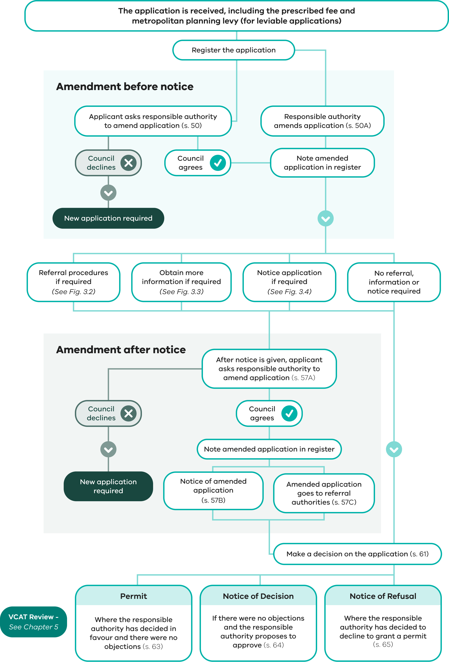

3.2 The application

3.2.1 For the applicant – preparing an application

Is a permit required?
The starting point is to find out from the responsible authority if a planning permit is required.
PEA s 47(1)
There is no point in making an application for a use or development for which a permit cannot be granted (because it is prohibited) or is unnecessary (because it is allowed ‘as-of-right’ by the planning scheme). An application is appropriate only if a planning scheme requires a permit to be obtained.
Planning schemes cl 65 and 71.03-2
Just because a person is able to apply for a permit does not imply that a permit should or will be granted. The responsible authority has to decide whether the proposal will produce acceptable outcomes in line with the statewide and local sections of the Planning Policy Framework (PPF), the Municipal Planning Strategy (MPS), the purpose and decision guidelines of the planning scheme requirements, and any other decision guidelines in clause 65 of the scheme.
Planning scheme controls can relate to the use of the site, to all development on the site or to some aspect of the proposed development.
Clause 72.06 of planning schemes provides that if the scheme allows a particular use of land, it may be developed for that use provided all the requirements of the scheme are met. In some cases, a permit to use the land may be all that is required, while in others, the use may not require a permit at all, although construction of buildings and works may.
PEA ss 60(1), 47(1)(c)
Applicants can help themselves and the responsible authority by making sure that the application is related strictly to those aspects of the proposal that require a permit.

Preliminary discussion with the council’s planning officer
It is advisable to discuss a proposed application with planning officers of the responsible authority before the application is finalised and submitted. This can avoid both cost and delay.
Planning officers can provide advice on:
whether a permit is required and why
whether the application is a VicSmart application
the nature and amount of supporting information to submit with an application
any state and local planning policies (including the MPS) that should be addressed as part of the application
any relevant guidelines, requirements, particular provisions or VicSmart provisions that may apply
any referral authorities relevant to the application that must be notified.

Pre-application discussions with neighbours
Permit applicants are encouraged to discuss their initial plans with neighbours so that they can ascertain their neighbours’ concerns and attempt to address them before the proposal is fully developed and finalised.
Applicants are not required to do this, but these discussions may avoid an objection at the application stage. Most people appreciate the opportunity to discuss plans before the formal notice process commences, although it will not always be possible to make changes that satisfy everybody.

Information required as part of the application for permit, including an application to amend a permit
PEA ss 47(1), (1A); PE Regs regs 13, 14
The nature and amount of information that should form part of an application will depend on the proposal and its location. Applicants should make sure that the application:
adequately identifies the land affected and fully describes the proposal, including plans, reports and photographs and that sketches and plans supplied can be readily understood by all interested parties
clearly identifies the permit to be amended and the amendment to be made to that permit, if the application is to amend a permit
states clearly the use, development or other matter for which the permit is required, or if the application is to amend a permit, states clearly the amendment applied for
describes the existing use of the land
states the estimated cost of any development for which a permit may be required
clearly states whether the land is affected by any registered restrictive covenant and, if so, is accompanied by a copy of that covenant
contains the specific information required by the VicSmart provisions, if the application is a VicSmart application
contains any specific information required by a relevant planning scheme provision.
The department’s website provides standard checklists for the following common application types:
VicSmart applications
dwelling
industry
business
signs
car parking waiver
subdivision.
These checklists can be used as a guide for the information to submit with an application, but it is important to check with the council on its specific requirements, and if the council has any local planning policies in its planning scheme that may require specific information to be submitted as part of the application.
Some planning practice notes also provide guidance for particular categories of application. Planning practice notes are available on the department’s website.
The application should include all the information needed for the responsible authority to adequately consider it, including:
any potential environmental, social and economic impacts associated with the proposal
a description of how the proposal is consistent with the relevant state planning policies, the MPS, and the local sections of the PPF
a description of how the application responds to or is consistent with the purpose and particular requirements of the zone and overlay provisions, or other particular provisions that may apply to the application
a response to any relevant decision guidelines set out in the planning scheme which the responsible authority must consider in deciding the application
the written consent of the public land manager if the application relates to land in a public land zone.
Planning schemes cl 59, 66, 71.06
If the application is a VicSmart application, it should include all the information listed in clauses 59.01–59.14 or in the schedule to clause 59.16 of the planning scheme that is applicable to that class of application. Additionally, if the VicSmart application is a type that requires referral under clause 66 of the planning scheme, the referral requirements of clause 71.06-2 must be met prior to being lodged as a VicSmart application (see Chapter 3.8.14).

Pre-lodgement certification
Some councils offer a pre-lodgement certification process to help achieve faster processing and decision times.
The pre-lodgement certification process involves an applicant employing a council-accredited certifier to quality check their application before it is lodged with the council. The process may also include a pre-application meeting with the council planners and immediate neighbours of the subject land. The certifier will advise the applicant on measures to ensure that the application contains all the required information and is of an adequate standard.
The service helps prevent delays often associated with incomplete applications. Some councils also offer guarantees on maximum decision timeframes as part of the service.

How to apply for a permit
PEA ss 47, 48; PE (Fees) Regs regs 9; 11; PE Regs regs 13, 14
An application must be made to the responsible authority in accordance with the Planning and Environment Regulations 2015 and be accompanied by the prescribed fee and information required by the planning scheme.
Applicants should use the relevant council’s ‘Application for Planning Permit’ form available on the council’s website.
Where the Minister is the responsible authority, see the Planning approvals webpage at planning.vic.gov.au to learn about the different planning approval pathways and access the relevant form.
The application must be signed by the owner of the land or accompanied by a declaration that the applicant has notified the owner about the application.
An applicant who is not the owner of the land for which the permit is being sought should be aware that although an application may have been signed by the owner, it does not necessarily carry the owner’s permission to use the land as proposed.
In the particular case of Crown land, consent by the Crown land manager to the application being made must not be taken as agreement to the use or development of the land as proposed. This must be negotiated through the appropriate lease or licence agreements.
The nature of the application will affect the fee to be paid to the responsible authority and the authority’s consideration of it. Therefore, it is important to take great care in analysing the requirements of the planning scheme and preparing an application. Care at this stage can avoid misunderstanding, cost and delay later.
It is also helpful when preparing the application to consider how it will be interpreted if notice of the application is to be given. The application should use plain English terms to accurately describe what is proposed in addition to any relevant land use term such as ‘Place of assembly’. It is not necessary to include references to specific planning scheme controls or clause numbers to accurately describe a proposal. If this part of the application is not clear, giving notice (and the consideration of the application) may be delayed if the responsible authority needs to negotiate modifications to the application before notice can be given.

How to apply for an amendment to a permit
PEA s 73
An application to amend a permit follows the same procedure as an application for a permit (sections 47–62 of the PE Act). Further information on amending a permit is found in Chapter 3.6.5.

Metropolitan Planning Levy
PEA ss 47(1A)–(1B), 73(1A)
PEA Division 5A of Part 4
Before making a permit application in metropolitan Melbourne for a development with an estimated cost that exceeds the ‘threshold amount’, a Metropolitan Planning Levy must be paid to the State Revenue Office Victoria (SRO).
After the levy has been paid, the SRO will issue a levy certificate which must be submitted to the responsible authority with the application. The estimated cost of the development stated on the levy certificate must be equal to or greater than the estimated cost of the development stated in the application. If the applicant does not comply with these requirements, the application is void. To ensure compliance, it is important that care is taken when estimating the cost of development so that it accurately reflects the costs associated with the development for which planning permission is required.
These requirements do not apply to an application to amend a planning permit under section 72 of the PE Act, even if the total estimated cost of development allowed by the permit as amended is more than the threshold amount.
The threshold amount is indexed by the Consumer Price Index every financial year. The SRO publishes the indexed threshold amount by 31 May each year.
If the levy certificate is not used within 90 days of being issued by the SRO, it expires and can no longer be submitted with an application. The expiry date cannot be extended and no refund of the levy is permitted unless there was a mathematical error in calculating the amount of the levy required to be paid.
The Metropolitan Planning Levy applies to applications in Metropolitan Melbourne, as defined by the planning scheme.
Planning Practice Note 82 – Applying the Metropolitan Planning Levy provides further explanation of Metropolitan Planning Levy and guidance on how to comply with the requirements of the PE Act.

The Aboriginal Heritage Act 2006 and the planning permit process
AHA s 52; AH Regs reg 7
The Aboriginal Heritage Act 2006 (AH Act) and Aboriginal Heritage Regulations 2018 (AH Regulations) require permit applicants to prepare a Cultural Heritage Management Plan (CHMP) if all or part of the:
activity is a listed high-impact activity resulting in significant ground disturbance; and
activity area is an area of cultural heritage sensitivity which has not been subject to significant ground disturbance.
If a CHMP is prepared for an activity, it is also important to ensure that a proposal is consistent with its recommendations and that a copy of the CHMP is provided with the application.
Planning Practice Note 45 – The Aboriginal Heritage Act and the Planning Permit Process provides further explanation of the AH Act and how it interacts with the planning permit process.

3.2.2 For the responsible authority – preliminary steps for an application

Pre-application meetings
Reduce inconvenience and delay in processing an application by discussing the details of the application and information to be submitted with the applicant before the application is lodged. This is particularly important for VicSmart applications as the prescribed time for assessing these applications is short. Pre-application meetings will reduce the likelihood of further information having to be sought.

Guidelines for applicants
It is helpful if the responsible authority provides guidelines for applicants indicating the type of information required for common types of applications. These should draw attention to any guidelines or codes that need to be considered or complied with, and procedural requirements such as the format of documents to be provided (for example, hard copy or digital) and how they are to be lodged.

Checking an application
PEA s 47(1)(a); PE Regs regs 13, 14
Every application must be made in accordance with the Regulations. The application must include sufficient supporting information (such as plans, reports and photographs) to fully describe the proposal.
When the application is submitted check that:
it is accompanied by any information required by the planning scheme
an accurate description of the land has been given
the proposal has been described satisfactorily
it includes a copy of any registered restrictive covenant affecting the land
the application addresses the PPF and MPS as applicable
the application addresses the relevant planning scheme provisions including zones, overlays and any relevant particular provisions, general provisions or VicSmart provisions
the application fee has been paid
a current levy certificate for the estimated cost of development has been included where the application is a ‘leviable application’ to which the Metropolitan Planning Levy applies
the applicant is the owner of the land or has notified the owner of the land about the application.
These matters can often be checked at the counter if the application is lodged in person.

3.2.3 Application fees
PE (Fees) Regs regs 9, 11
In most cases, a fee must be paid when an application is made. The amount is prescribed in the Planning and Environment (Fees) Regulations 2016. The fee is paid to the responsible authority to consider an application. It is not a permit fee and is not refunded if the application is refused.
PE (Fees) Regs regs 10, 13
If an application relates to a combination of use, development (other than subdivision), subdivision and varying or removal of easements, restrictions or covenants, the total amount payable is the sum of the highest fee plus 50 per cent of the others.
The Fees Regulations prescribe fees for different classes of applications. The class of application – and therefore the fee – will depend on the planning scheme and why a permit is needed:
In some instances, a permit may be needed to either use or develop land, but not both. In those cases, the application and the fee should be confined to the items for which a permit is needed.
In some instances, a permit for development may only be required for part of the project, such as construction of access to a main road. In those cases, the application and the fee should be confined to the items for which a permit is needed.
The application fees for the development or use and development of a single dwelling, or development ancillary to the use of land for a single dwelling, are separate to other development and fall within classes 2 to 6 of the Fees Regulations subject to the development costs being less than $2,000,000.
In the Fees Regulations, unless specified to the contrary, words in the singular include the plural.
If a permit is needed for development, the applicable fee depends on the cost of the proposed development as stated on the application form.
An applicant must make a realistic estimate of the cost and the responsible authority may ask for information to support this. The cost (for calculating the fee) is the estimate (or contract) cost of undertaking the work for which a permit is required. Any increase in property or land values resulting from the development is not relevant to calculating the cost.
PE (Fees) Regs reg 20
Regulation 20 of the Fees Regulations sets out circumstances under which the responsible authority may waive or rebate fees. Responsible authorities have the discretion to reduce fees, rather than waiving them completely by offering rebates. Responsible authorities will develop their own policies and procedures for this.
Further information about planning fees is available on the department’s website.

3.2.4 The register of applications
PEA ss 49, 197A(2)
The responsible authority must keep a register of all applications received and specified information about those applications and must make the register available to the public free of charge in accordance with the public availability requirements of the PE Act by either making it available for inspection:
in person at their office at any time during office hours; or
on its website as well as on request by any person at their offices at an agreed time during office hours.
PE Regs reg 15
The register must contain the information prescribed in the Regulations. The register must also specify whether an application is a VicSmart application. A responsible authority may decide on the format of its register, but the register must contain all the information required by the Regulations. The information can also be stored electronically and a printed version made available for public inspection. The register could also record additional information useful to the responsible authority or the public.

3.2.5 Planning scheme check
The application should be checked against the planning scheme provisions at an early stage and the applicant advised quickly if no permit is required or the proposal is prohibited. Pre-application discussion with applicants should largely avoid such applications being lodged.
Where an invalid application is made, the responsible authority should explain the situation and give the applicant the opportunity to withdraw the application.
The planning scheme should also be checked to determine whether the application is a VicSmart application because specific provisions and procedural requirements apply to these applications.
If a landowner or occupier wants formal verification that a use or development does not require a planning permit, they may wish to apply for a certificate of compliance in accordance with Part 4A of the PE Act (see Chapter 4.1).
Many councils also offer informal processes for seeking written planning advice that are sometimes referred to as planning information requests.

3.2.6 Verification of information
PE Regs reg 21
Regulation 21 of the Regulations allows a responsible authority to verify information either included in an application or supplied as more information under section 54 of the PE Act.
PEA ss 48(2), 87(1)(a)
Section 48(2) of the PE Act provides a penalty for attempting to obtain a permit by making false representations.
Section 87(1)(a) allows an application to VCAT to be made for cancellation or amendment of a permit if there has been a material mis-statement or concealment of fact in relation to the application. In accordance with section 94(4)(b), no compensation for cancellation or amendment is payable in these circumstances.
A responsible authority may consider it important in some special circumstances to verify information by asking the applicant to make a statutory declaration of certain facts. This may be appropriate if that information is critical to the application and is not otherwise readily verifiable. A false statutory declaration constitutes perjury.
Responsible authorities should note that this provision relates to information contained in the application or supplied under section 54 (more information) of the PE Act. It does not cover procedural matters such as a statement by an applicant that notice has been given. Anyone who makes a false statement about giving notice of an application risks cancellation or amendment of any permit issued.

3.2.7 Amending an application – before notice is given
PEA s 50, 50A, 57A
An applicant or a responsible authority with the agreement of the applicant may amend an application before notice is first given under section 52 of the PE Act. An applicant may also ask the responsible authority to amend an application after notice has been given (see Chapter 3.3.5).
PEA ss 50(1)–(2)

Amendment of application at the request of the applicant – before notice is given
An applicant may ask the responsible authority to amend an application before notice is given under section 52 of the PE Act. An amendment to an application may include an amendment to:
the use or development mentioned in the application
the description of the land to which the application applies
any plans and other documents forming part of or accompanying the application.
PEA s 50(3)
A request for amendment must:
be accompanied by the prescribed fee (if any)
be accompanied by any required information in relation to the planning scheme or a restrictive covenant that was not provided with the original application
if the applicant is not the owner, be signed by the owner or include a declaration that the applicant has notified the owner of the request.
PEA ss 50(4)–(5)
The responsible authority must amend the application in accordance with the request. However, it may refuse to amend the application if it considers that the amendment is so substantial that a new application for a permit should be made.
PEA ss 50(6)–(7)
The responsible authority must make a note in the register of the amendment to the application.
PEA ss 50A(1)–(2)

Amendment of application by the responsible authority – before notice is given
A responsible authority may make any amendment to an application that it thinks necessary before notice is given. The amendment must be made with the agreement of the applicant and after giving notice to the owner. As with an amendment initiated by the applicant, an amendment to an application initiated by the responsible authority may include:
the use or development mentioned in the application
the description of the land to which the application applies
any plans and other documents forming part of or accompanying the application.
PEA s 50A(3)
The responsible authority may require the applicant to notify the owner and make a declaration that notice to the owner has been given.
PEA ss 50A(4)–(5)
The responsible authority must make a note in the register of the amendment to the application.

What happens to timeframes?
PEA s. 50(7), 50A(5)
The amended application is taken to be the application for the purposes of the PE Act and to have been received on the day that the request for amendment was received by the responsible authority or (in the case of an amendment to an application by the responsible authority) the day that the applicant agreed to the amendment.
This means that the statutory clock begins upon receipt of the amended application.

3.2.8 Who can inspect an application?
PEA ss 51, 57(5), 70, 197A
A responsible authority must make the application, including the accompanying plans and documents, available for inspection by anyone free of charge in accordance with the public availability requirements by either making the application available for inspection:
in person at the offices of the responsible authority at any time during office hours; or
electronically on its website as well as on request by any person at the offices of the responsible authority at an agreed time during office hours.
Some councils also provide an online resource on their website that allows applicants, objectors and interested parties to lodge and view application documents and track planning applications online. The relevant council website should be consulted to establish if an online service is available.
PEA s 51
An application must be made available free of charge from the time it is made:
until the end of the last application for review period in relation to the application; or
if an application for a review is made, until that application is determined by VCAT or withdrawn.
PEA ss 70, 197A
Accessing an application file after this period may incur a file search fee, but the council must make a copy of every permit that it issues, including any plans forming part of that permit, available in accordance with the public availability requirements.
The council is not obliged to give copies of an application, although it can if it wishes. As long as the planning documents are used for the purpose of the public planning process, including relevant community consultation, no breach of copyright will occur. Administrative charges can, if necessary, be made for copying.
Planning Practice Note 74 – Making Planning Documents Available to the Public gives further advice about making available copies of plans and other material relating to planning applications.
Victoria’s Privacy and Data Protection Act 2014 sets standards for the collection and handling of personal information. More information can be obtained from the Office of the Victorian Information Commissioner website at ovic.vic.gov.au.

3.3 Considering an application – procedural steps

3.3.1 Referring an application under section 55
PEA ss 55, 62(1)
Section 55 of the PE Act provides for applications to be referred to authorities specified in the planning scheme as referral authorities. A referral authority can be any person, group, agency, public authority or other body specified in the planning scheme or the PE Act whose interests may be particularly affected by the grant of a permit for a use or development.
The key objective of the referrals process is to provide authorities whose interests may be affected by the grant of a permit with the opportunity to ensure that a permit is not granted that would adversely affect that authority’s responsibilities or assets.
Referral requirements under section 55 are listed in clause 66 of the planning scheme.
A planning scheme will identify a referral authority as either:
a determining referral authority; or
a recommending referral authority.
PEA s 56(1)
Both types of referral authority can object to the grant of a permit, decide not to object or specify conditions to be included on a permit. However, the effect of that advice on the final outcome of an application is different for each type of referral authority.
If a determining referral authority objects, the responsible authority must refuse the application, and if it specifies conditions, those conditions must be included in any permit granted.
In contrast, a responsible authority must consider a recommending referral authority’s advice but is not obliged to refuse the application or to include any recommended conditions. A recommending referral authority can seek a review at VCAT if it objects to the granting of a permit or it recommends conditions that are not included in the permit by the responsible authority.
The process for referring an application is the same for both types of referral authority. The referral authority:
must be given a copy of the application (section 55(1))
may ask for more information (section 55(2))
must consider every application it receives (section 56(1))
must keep a register of applications it receives (section 56A)
must give to the applicant without delay a copy of any:
- request it makes to the responsible authority for more information (section 55(3))
- decision and comments it gives to the responsible authority (section 56(3A))
may object to an application or request that conditions be included on a permit (section 56(1))
may give comments on the application (section 56(3)).

What must a responsible authority do?
PEA s 55(1); MRA ss. 77TE, 77TG; PE Regs reg 19; Planning schemes cl 52.09-3
A responsible authority must send the application and prescribed information, without delay, to every referral authority specified in clause 66 of the planning scheme for that type of application. The responsible authority is exempt from this requirement if:
the referral authority has already considered the proposal within the past three months and stated, in writing, that it does not object to the granting of a permit; or
in its opinion, the proposal satisfies requirements or conditions previously agreed in writing between the responsible authority and the referral authority; or
the application concerns an extractive industry work plan or variation to a work plan and the work plan (or variation) was given to an authority under section 77TE of the Mineral Resources (Sustainable Development) Act 1990.
A copy of the application together with the information prescribed in the Regulations must be given to the referral authority. The prescribed information is:
the application reference number
the date the responsible authority received the application
a description of why a permit is required (using the same words that appear in the permit requirement(s) in the planning scheme)
a list of clauses in the planning scheme that require the application to be referred to that referral authority
the description in clause 66 of the kind of application required to be referred to that referral authority
whether the referral authority is a determining referral authority or a recommending referral authority for the application.
PEA ss 59(2)–(3); PE Regs reg 24
A responsible authority must not decide on an application that has been referred until the prescribed period of 28 days has elapsed. However, if within 21 days of being given a copy of the application, the referral authority tells the responsible authority that it needs further information, the prescribed period is 28 days from the day on which the responsible authority gives that information.
The prescribed time can also be extended by the Minister. Other factors in the application process will also affect when a responsible authority may make a decision, such as the public notice period under section 52 of the PE Act. In these instances, a decision must not be made until the 14-day notice period has elapsed.
PEA s 60(1)(d)
Before deciding on an application, the responsible authority must consider any decision or comments it has received from a referral authority.

Action in response to determining referral authority advice
PEA ss 61(2), 62(1)(a)
In response to a determining referral authority’s decision, the responsible authority must:
refuse to grant a permit if the authority objected to the grant of the permit
include any conditions on the permit required by the authority.
PEA s 62(1)(b)
A responsible authority must not include additional conditions that may conflict with any condition that a determining referral authority specifies.
PEA ss 65(2), 66(5)
If a responsible authority decides to refuse to grant a permit, the notice of decision must state whether the grounds of refusal were those of the responsible authority or a determining referral authority.

Action in response to recommending referral authority advice
PEA ss 61(2A), 62(2)(ab)
In response to a recommending referral authority’s decision, the responsible authority may:
refuse to grant a permit if the authority objected to the grant of the permit
include a condition on the permit recommended by the authority.
PEA s 66
The responsible authority must give a copy of any decision to each determining referral authority and if it did not object or recommend a condition, a copy to each recommending referral authority. A notice of the decision is given to a recommending referral authority when it has objected or if any recommended condition of the authority is not imposed on the permit.

Grant of permit where notice of decision has been issued
PEA ss 64A, 82AAA; PE Regs reg 36
The responsible authority must not issue the permit to the applicant:
until after the 21-day ‘review period’ (the period within which a recommending referral authority may apply to VCAT for a review of a decision to grant a permit where the authority either objected to the application or sought the inclusion of a permit condition that was not included); or
if an application for review is made within that 21-day period, until the application is determined by VCAT or withdrawn.

Application for amendment of permit
PEA ss 72-76A
The responsible authority is subject to equivalent referral obligations when processing an application to amend a permit under Division 1A of the PE Act.

What must a referral authority do?
PEA ss 54(1)–(2), 55(2)–(3); PE Regs reg 20
When a referral authority receives an application from a responsible authority, it should first consider whether it needs more information to assist its assessment. A referral authority has 21 days from receipt of the application to tell the responsible authority in writing that it needs more information.
The referral authority must also, without delay, give the applicant a copy of any such request. The responsible authority may then follow with a request to the applicant to provide the required information (see Chapter 3.3.2).
PEA ss 56(1), 56(3)
A referral authority must consider every application referred to it and tell the responsible authority in writing if it:
does not object to the granting of a permit
does not object to the granting of a permit providing that certain conditions are included on the permit, or that certain matters are done to its satisfaction
objects to the granting of a permit on specified grounds.
The referral authority may, in addition to giving directions to the council, provide any other advice which it believes is relevant to the application and may assist the council in reaching its decision. Such advice should be clearly distinguished from any directions.
PEA s 61(2)
While a determining referral authority can direct refusal of a permit by objecting to the grant of the permit, it cannot direct that a permit be issued.
PEA ss 59(2), 197; PE Regs reg 24
A referral authority must act promptly and in accordance with the times prescribed in the Regulations to avoid unreasonable and unnecessary delay.
There is no time within which a referral authority must give its advice or comments, however, the responsible authority may proceed to make a decision without the referral authority’s advice after:
28 days from the day on which the referral authority is given a copy of the application; or
if within 21 days of being given a copy of the application the referral authority tells the responsible authority it needs further information, 28 days from the day on which the responsible authority gives that information.
PEA s 56(4)
If a referral authority requires more time to consider an application (for example, an application for a major or complex proposal) it may apply to the Minister for more time, indicating how much time it considers is necessary. If the Minister agrees, both the referral authority and the council will be notified of the extra time allowed. It is good practice however, for a referral authority to discuss its needs with the council first, with an aim to establish a mutually agreed extended timeframe before making a formal request to the Minister.

Record keeping duties for a referral authority
PEA ss 56A, 197A; PE Regs reg 23
A referral authority is required to keep a register of all permit applications, including amended applications, referred to it. The register must be made available in accordance with the public availability requirements.
Basic administrative details are required to be kept such as the application number, address of the land and dates of receipt and decision. The decision or recommendation of the referral authority is also required to be kept on the register.

VCAT reviews and referral authorities
PEA s 82AAA
A recommending referral authority may apply to VCAT for review of the responsible authority’s decision:
to grant a permit, where the authority objected to the grant of the permit; or
to not include a condition on the permit that the authority recommended.

Figure 3.2: Referral requirements and procedures
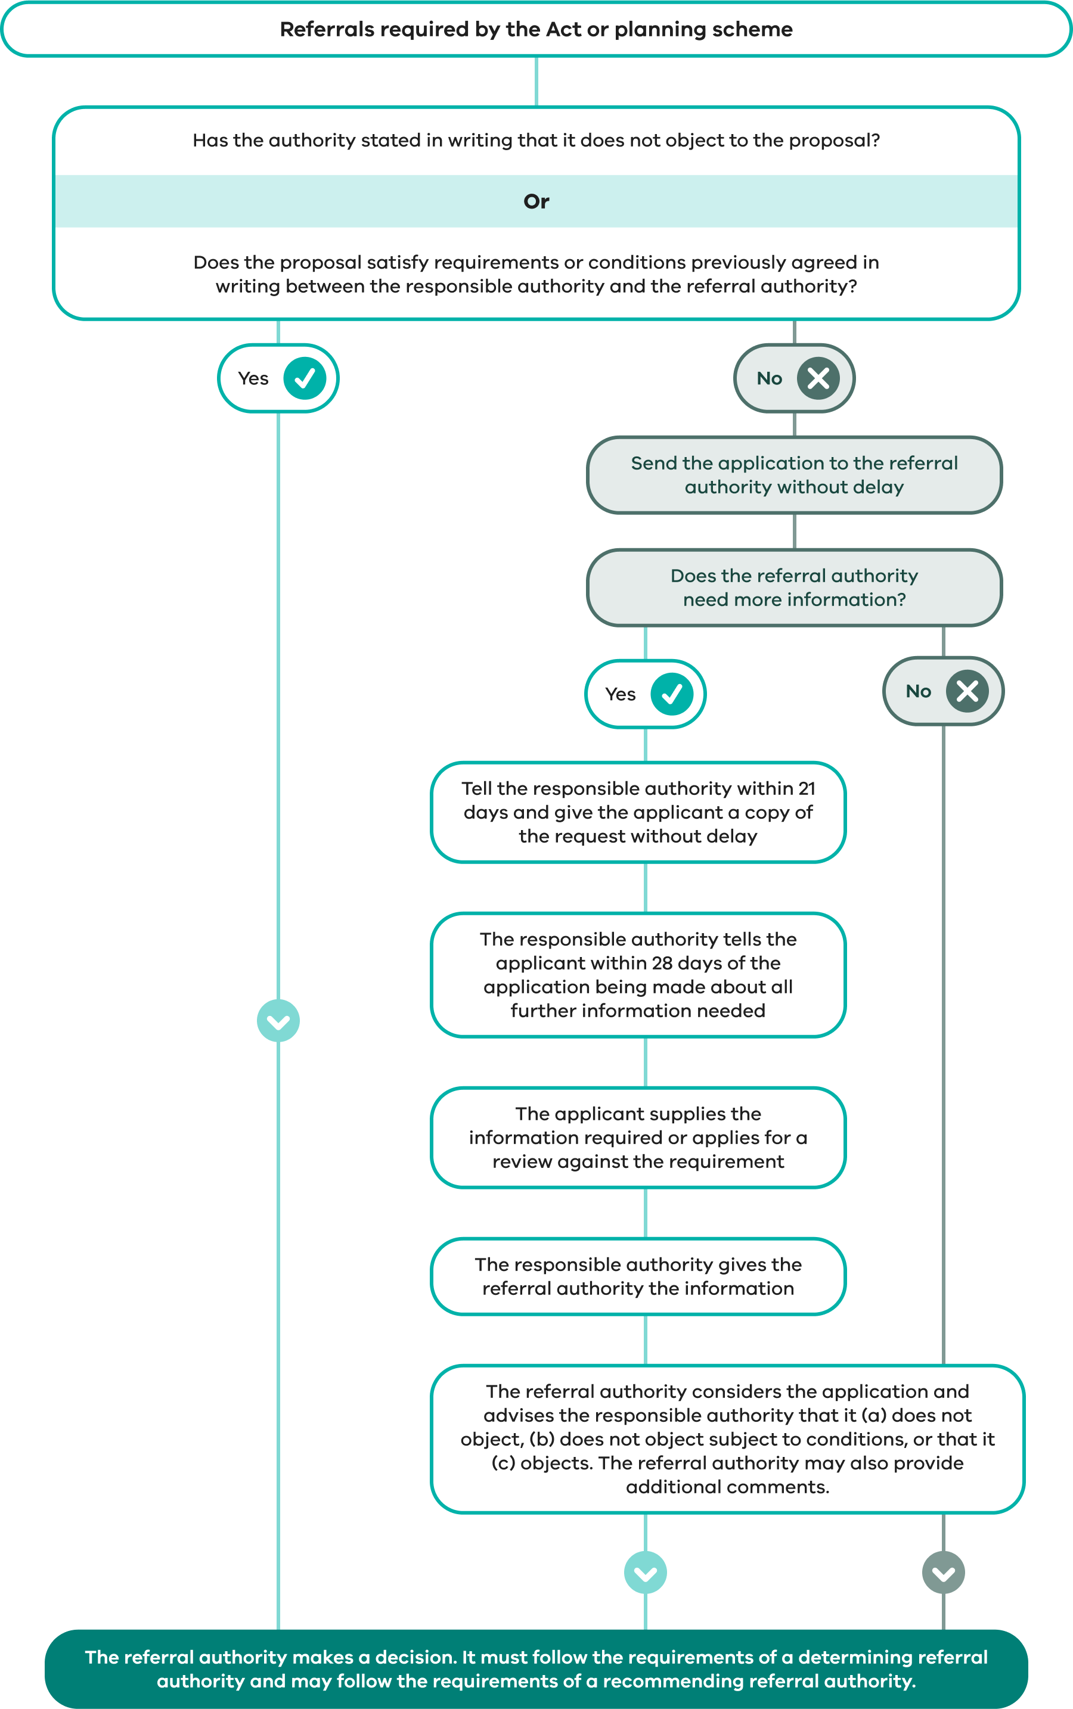

PEA ss 83(1), (3), 83AB
A referral authority is a party to a proceeding for a VCAT review of a decision of the responsible authority in the following circumstances:
Determining referral authority | A proceeding for review of a refusal to grant a permit where:  - the authority had objected to the granting of the permit; or  - it was refused because a condition the authority required conflicted with a condition of another referral authority.  A proceeding for review of a permit condition that the authority had required to be included on the permit.
Recommending referral authority | A proceeding for review where the authority is given notice of an application for review as required under the PE Act – including a review of a refusal to grant a permit if it objected to the grant of the permit or a review of a permit condition if it had recommended the subject condition.

Making the referral system efficient and effective
Responsible and referral authorities should have processes in place to minimise delays and to facilitate effective decision making. Advice on good practice is provided in Planning Practice Note 54 – Managing Referrals and Notice Requirements.

Notice to an authority under section 52
PEA s 52
A planning scheme or the PE Act may require that other authorities be given notice of certain applications in accordance with section 52(1)(c) of the PE Act, or that the views of other authorities be considered.
There is a clear distinction between section 55 referrals and section 52 notice provisions, particularly in the case of a determining referral authority’s ability to veto an application. A responsible authority should specify to the authority whether comments are being sought under section 52 or 55 of the PE Act, or whether non-statutory advice is being sought.
If an objection is lodged by the authority, the objection must be taken into consideration under the normal provisions of the PE Act. The authority has the same review rights as any other objector.
A responsible authority is not bound to refuse to grant a permit if there is an objection or include any specified conditions. If no objections or comments are received within the specified time, consideration of the application need not be delayed. This process also relieves the authority from having to respond to the application if it has nothing to say.

Seeking advice and comments
A responsible authority may seek the views of any other person, authority or body which it believes can provide a useful contribution to its decision-making process (such as expert knowledge or resources). There are no procedures laid down for providing such expert advice.

3.3.2 Further information requirement
PEA s 54(1)
The responsible authority can require the applicant to provide more information about a proposal, either for itself or on behalf of a referral authority.
Processes for obtaining more information are summarised in Figure 3.3.
PEA ss 54(1A)–(1C)
The request for further information must be in writing setting out the information to be provided. If the request for further information is made within the prescribed time, the request must also specify a date by which the information must be received.
PE Regs reg 18
The prescribed time for a VicSmart application is five business days after the responsible authority received the application. For all other applications, the prescribed time is 28 days after the responsible authority received the application.
An application lapses if the requested information is not provided by the date specified by the responsible authority. The lapse date must not be less than 30 days after the date of the notice requesting the information. An application that has lapsed cannot be recommenced. It is important that applicants are made aware of the consequences of allowing an application to lapse. One mechanism is that a council might put a note about the meaning of the lapse date in its letter requesting information.
A responsible authority should not routinely specify this minimum time of 30 days. The date specified by the responsible authority must be reasonable, given the nature of the application and the type of information requested. A responsible authority should also be specific about the information requested rather than asking for an opinion or generalised comments.
PEA ss 54, 79; PE Regs regs 32
A request for more information within the prescribed period means that the ‘statutory clock’ is stopped. (Note: the statutory clock counts the number of days until the applicant may apply for a review of the failure of the responsible authority to determine the application. The clock starts again from zero when a satisfactory response to the responsible authority’s request is received).
PEA ss 54, 76(b)
Information can be requested after the prescribed period, but if this information is not provided, the responsible authority is not protected from an application for review of its failure to determine the application. It is important therefore to ensure that the initial request is comprehensive, as an applicant can apply for a review against a requirement for more information.
The time limits for responsible and referral authorities mean that requirements for more information must be determined quickly. The responsible authority, in particular, needs to liaise with referral authorities so that the applicant is presented with a coordinated request clearly setting out what information is required, who requires it and to whom it should be sent. The applicant can send information required by a referral authority (particularly technical information specific to it) directly to that authority. A copy should be sent at the same time to the responsible authority.
Authorities are encouraged to maximise use of electronic data transfer to expedite decision making.
Applicants can minimise the likelihood of requirements for more information and inevitable delay in considering the application by:
having prior discussions with the responsible authority to determine what information is required
seeking agreement from referral authorities before making an application
considering in advance the matters which the responsible authority must take into account when considering the application (such as the decision guidelines in zones and overlays)
considering the information which all affected authorities may require to make a decision on the application.

Extending the time to provide further information
PEA ss 54A(1)–(2)
An applicant can apply to the responsible authority to extend the date specified to provide further information. The request to extend the date must be made before the lapse date.
PEA ss 54A(3)–(5)
The responsible authority may decide to extend the time to provide the requested information or refuse to extend the time. It must give its decision to the applicant in writing. If the responsible authority decides to extend the time, it must give a new lapse date for the application.
PEA s 54A(6)
If a request to extend the time is refused by the responsible authority, the applicant will have 14 days from that refusal to supply the information.
PEA s 81(2); PE Regs reg 34(2)
An applicant has the right of review to VCAT if the responsible authority refuses to extend the time for providing the required information. An application for review must be made before the lapse date.

Figure 3.3: Requirement for more information about an application
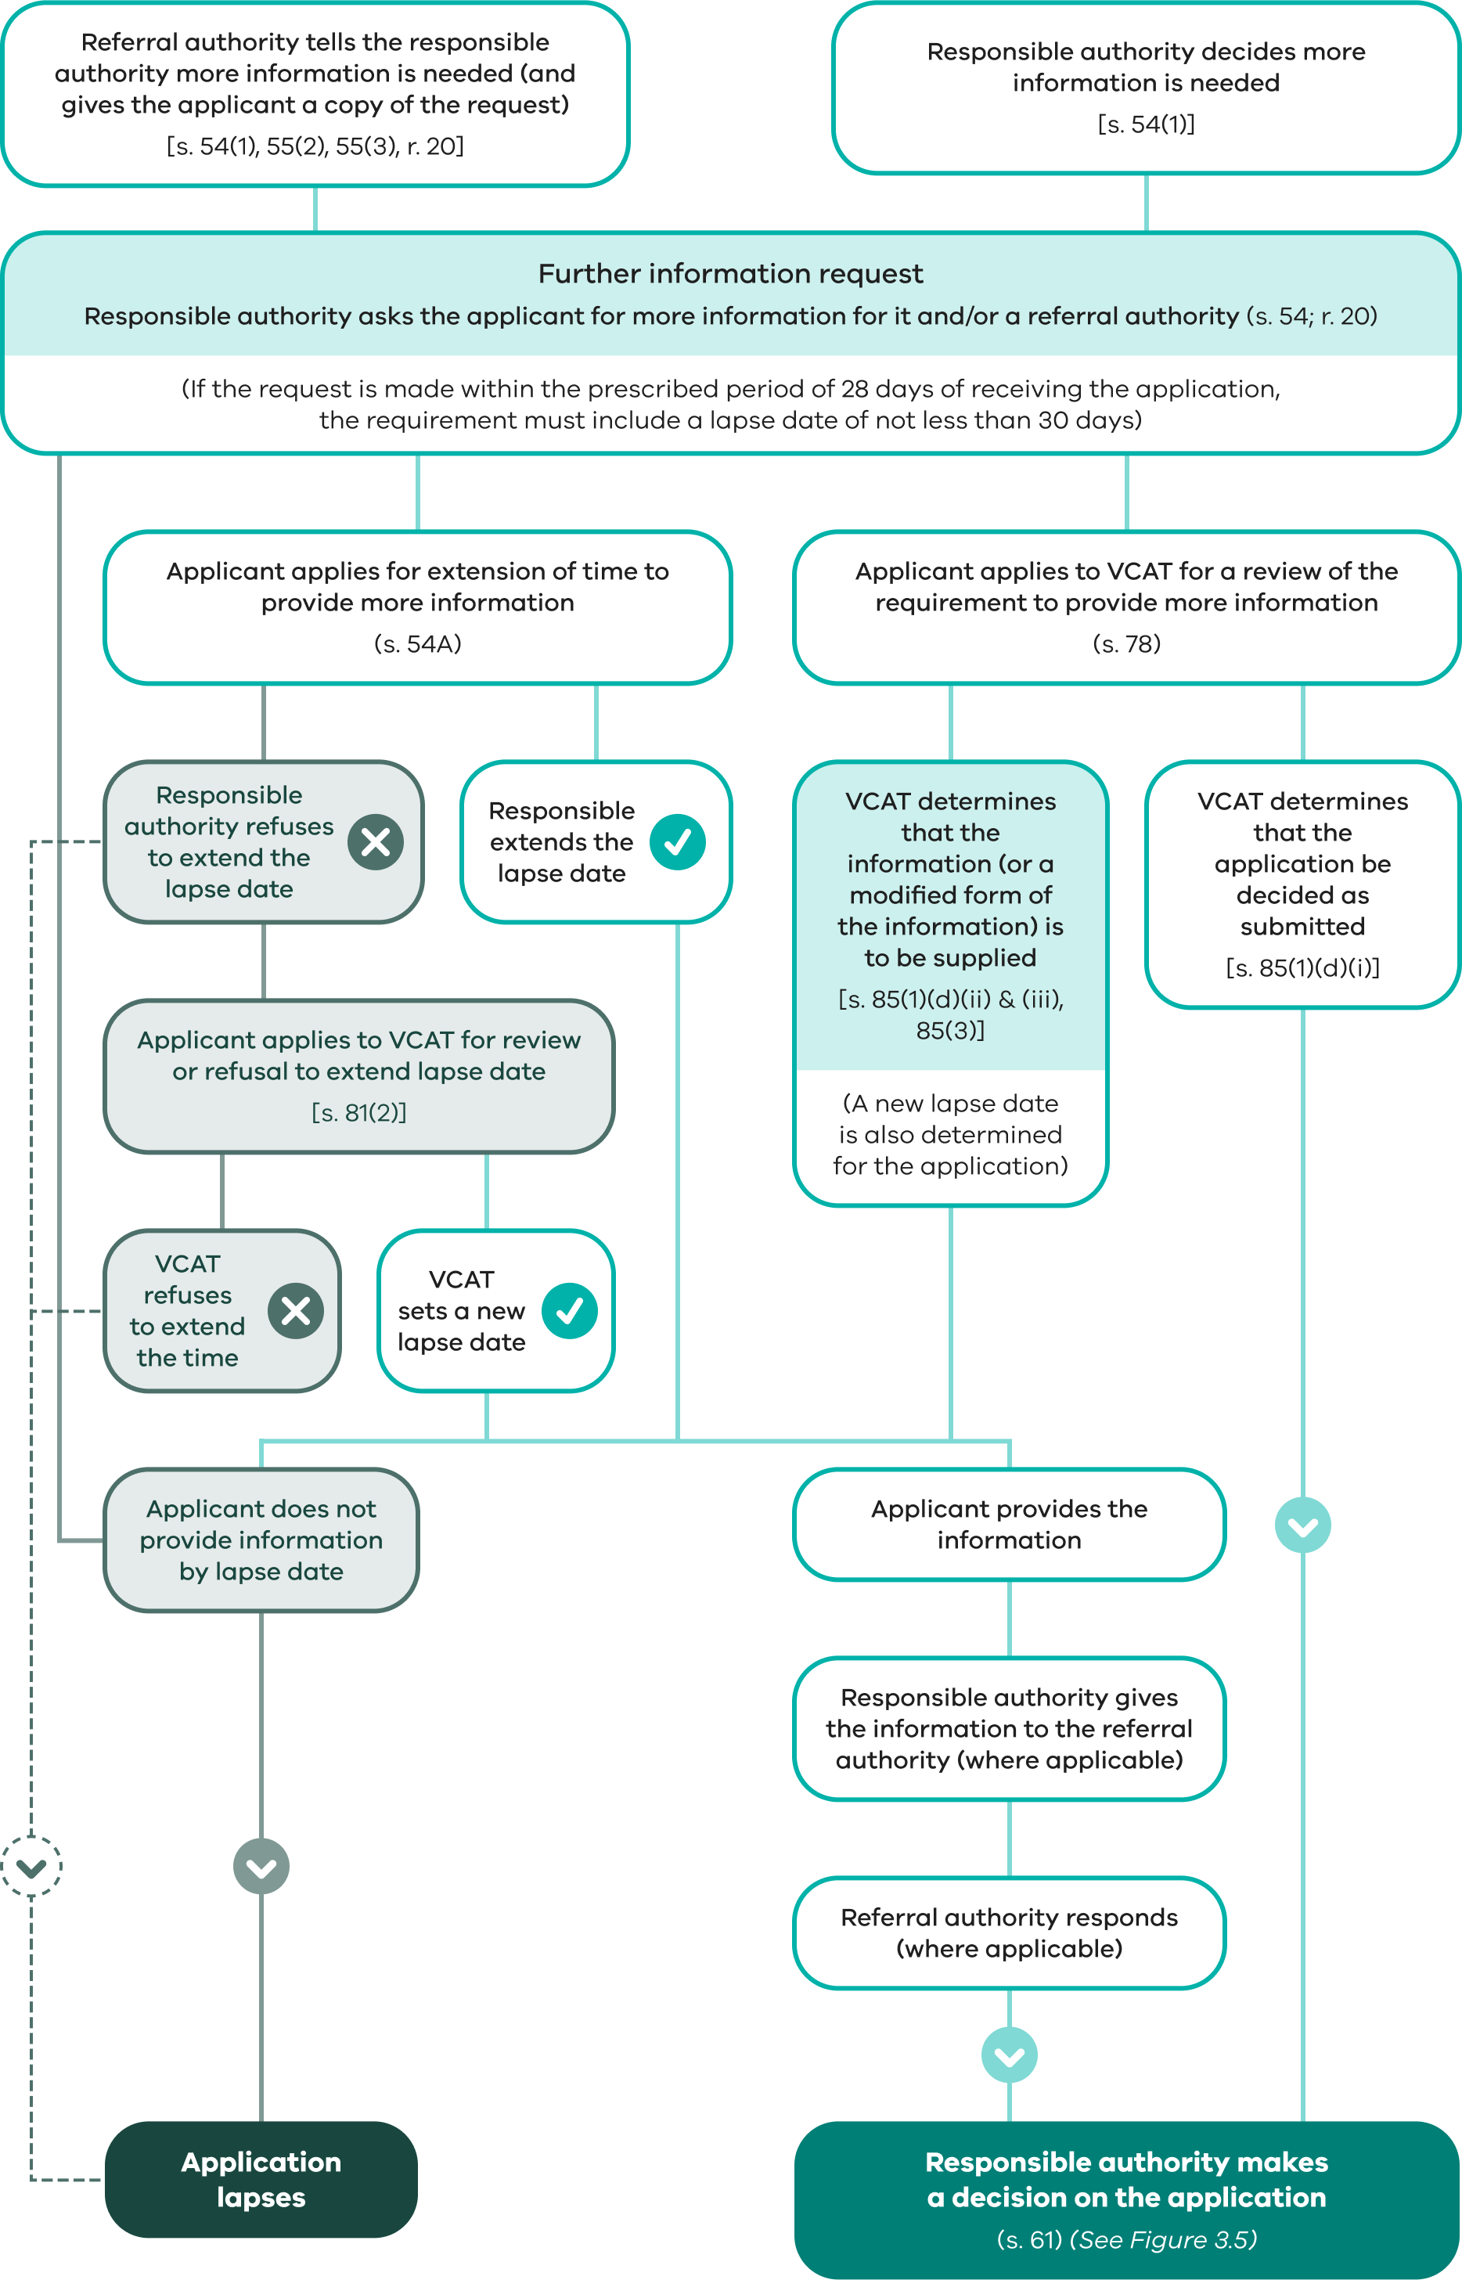

3.3.3 Notice of an application – ‘advertising’

Is notice required?
PEA s 52
The requirements for giving notice of an application are set out in section 52(1) of the PE Act. A planning scheme can also specify particular requirements for giving notice.
If a planning scheme sets out specific notice requirements about a particular type of application, those requirements must be followed. Otherwise, the responsible authority must directly consider the likely effect of the use or development proposed.
PEA s 52(4)
A planning scheme may exempt any class or classes of application from some or all of the notice requirements that may otherwise apply under section 52(1) of the PE Act. In these cases, there is no opportunity for other people to make submissions or objections in relation to the application. The application must still be referred to any referral authority and the responsible authority must still take into account all relevant planning considerations in deciding the application.
An exemption from the notice requirements must be included in the planning scheme.
There are many examples of exemptions from notice requirements in planning schemes. The exemptions most commonly arise where the application is a VicSmart application, or where a permit is unlikely to have a significant planning impact or where the use or development generally complies with a policy or plan that has been previously subject to public scrutiny as part of its approval process.
PEA s 47(2)
The notice requirements of the PE Act under section 52 do not apply to an application to remove a restriction over land that has been used or developed for more than 2 years (before the date of the application) in a manner that would have been lawful under the PE Act but for the existence of the restriction.
The processes for giving notice of an application are summarised in Figure 3.4.
PEA ss 52(1), (4)
The PE Act places the onus on the responsible authority to give notice (or to require the applicant to give notice) of an application. Notice of the application must be given to the owners and occupiers of land adjoining the subject land to which the application applies unless the responsible authority is satisfied that the grant of a permit would not cause material detriment to any person or the planning scheme contains a specific exemption from the notice requirements.
If the responsible authority forms an opinion that material detriment may be caused to one or more adjoining owners or occupiers, notice must be given to all adjoining owners and occupiers.
Notice to all adjoining owners and occupiers must be given unless the responsible authority in each case forms an opinion that material detriment will not be caused. This should be carefully recorded and a report on the application should contain clear reasons why the responsible authority is satisfied on this point.
The PE Act does not specify what matters may be taken into account by the responsible authority in deciding whether or not material detriment may be caused. Each application must be considered on its merits. As a basic rule however, it should be possible to link detriment to specific matters such as restriction of access, visual intrusion, unreasonable noise, overshadowing or some other specific reason. General terms such as ‘amenity’ and ‘nuisance’ are not specific enough, nor is the fact that the matter is controversial a conclusive test that a person may suffer material detriment. Conversely, agreement to the proposal by the owners and occupiers of adjoining land is not conclusive, although it may help the responsible authority form an opinion. Careful judgement of the situation by the responsible authority is necessary.
Notice must be given to any persons specified in the planning scheme.
Notice must also be given to the council if the application applies to or may materially affect land within the municipal district. This is particularly important if the council is not the responsible authority. It is also significant in the case of a proposal in one municipality that may have an effect in another municipality.
Notice must be given to owners and occupiers of land benefited by a registered restrictive covenant if the application applies for anything that would result in breach of a restrictive covenant or if the application is to remove or vary the covenant.
The responsible authority must also consider whether any other persons would be caused material detriment by the proposal and if so, notice must be given to them also. In that case, the responsible authority will need to consider how that notice should be given.
ILA s 38
The definition of person in the Interpretation of Legislation Act 1984 includes a body politic or corporate as well as an individual. Therefore, consideration of who may be affected should be comprehensive as companies, incorporated associations and public bodies may need to be notified.
More information on the notice provisions is provided in Planning Practice Note 54 – Managing Referrals and Notice Requirements.
PEA s 89(1)(a)
A responsible authority will not help an applicant by narrowly interpreting the notice requirements. This is because a person who believes they should have received notice but did not, can seek cancellation or amendment of the permit. (See Chapter 3.7)
PEA s 78(a)
Conversely, the responsible authority must carefully consider the reasonableness of extensive notice requirements as the applicant can apply for a review of an unreasonable requirement.
In deciding who to notify, particularly under section 52(1)(d), the responsible authority should keep in mind the objectives of planning in Victoria, as well as any specific objectives stated in the planning scheme.
PEA s 96C
For applications made through the combined permit and amendment process under Part 4 - Division 5 of the PE Act, separate notification requirements apply.

Figure 3.4: Giving notice of an application
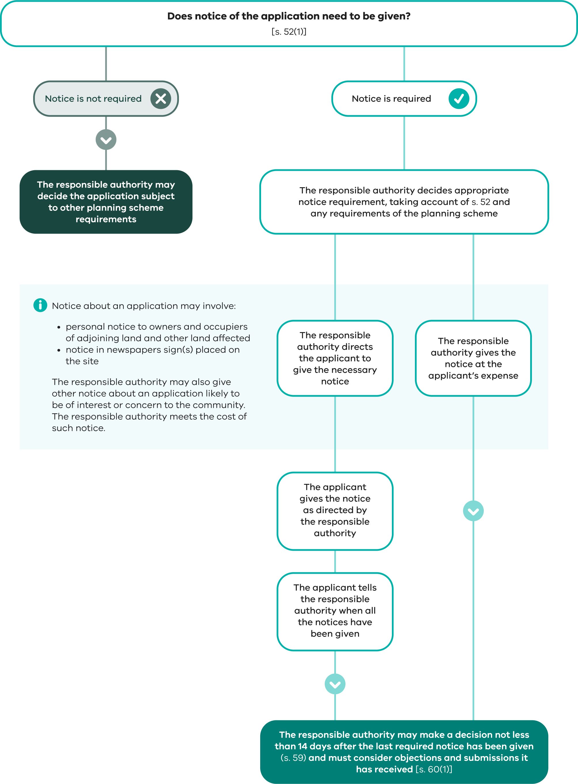

How is notice of an application given?
The methods for giving notice of an application are set out in section 52, which recognises the three most commonly used methods:
written notice to specified persons
a sign or signs on the land
a notice in a newspaper circulating in the area.
It also allows other methods of giving notice where appropriate.
PEA ss 51, 197A
The responsible authority must make a copy of the application available in accordance with the public availability requirements until the application is finalised. Refer to Chapter 3.2.8 for more information about public access to application material.
PEA s 52(1); PE Regs regs 16–17, Forms 2 and 3
The notice must be in the format prescribed under the PE Regs (Forms 2 and 3).
PEA ss 52(1), 53(3)
Notice is to be given by the responsible authority, unless the authority requires the applicant to give the notice. In either case, the applicant pays the costs involved.
PEA s 139
A council’s rates records can be used as evidence that a person is an owner or occupier of land.
PEA ss 3, 145
In the case of public land, the owner or occupier to whom notice should be given will usually be the Minister or public authority that manages or controls the land. The council can usually assist in identifying the relevant public land manager.
PEA ss 145, 147; ILA s 49
Because of the difficulty in identifying some owners or occupiers, the PE Act also allows for a notice to simply be sent by post to ‘the owner’ or ‘the occupier’ at an address.
It is important that all addresses are covered (including each separate unit and, where relevant, a body corporate for apartments or multiple dwellings) and that both owners and occupiers are covered (so that for leased premises both the landowner and tenant will receive notice). Unless proved otherwise, the notice is considered to have been given when the letter would have been delivered in the ordinary course of post.
It is not essential that individual notices be sent by post. Personal delivery by the applicant may be appropriate. However, should there be a query about notification procedures, the applicant will need to be able to demonstrate to the responsible authority, and possibly to VCAT, that the required notices were given on a particular date. Careful records should therefore be kept of the notification procedures.
PEA . 52(3)
If a responsible authority considers that a proposal is likely to be of interest or concern to the broader community, it may itself give notice it considers appropriate. This would be in addition to any further notice given by an applicant or the responsible authority in accordance with section 52(2). It could include publicity in the media, public meetings, newspaper articles, letterbox drops or any other appropriate method. These actions would be at the expense of the responsible authority.
PE Regs reg. 16–17, Forms 2 and 3
When preparing the notice of application for a permit, care should be taken to ensure that the notice clearly communicates to people what is proposed and where it is proposed. Adequate attention to preparing a notice can avoid any misunderstandings or undue anxiety and opposition to a proposal. A well-prepared notice will assist the applicant, the responsible authority and the public.
The description of the use should be both technically accurate and clearly explained. The notice must be consistent with the actual application. If the application uses land use terms like ‘Place of assembly’, the responsible authority may wish to discuss the precise nature of the use with the applicant and include this description in the notice, so the proposal can be clearly understood.
In many cases, it may assist in the understanding of a proposal to enclose a plan with any notices, or to display a plan with an on-site notice. This may be a reduced-scale version of plans or an outline sketch prepared for the purpose. The actual form of such plans will need to be considered in each case, taking account of the complexity of the plans, the cost to the applicant of preparing copies and the physical conditions under which an on-site notice must be displayed. In any case, it will be important to ensure that the plans accurately represent the proposal so that those affected are not misled either by a false sense of security or by unnecessary alarm.
Similarly, property descriptions should allow the reader to clearly identify the extent and location of the land concerned. Descriptions such as ‘the north-east corner of First and Second Streets…’ should be used where possible.
The instructions to the person carrying out the notice should also be very specific. Thought needs to be given in every case to the:
number, size and location of notices on the land
properties or persons to be notified (a list of names and addresses and/or a plan should normally be provided)
length of time any notice must be maintained on a site.
Try to avoid holiday periods if possible.
Whether the applicant or the responsible authority gives the notice, it is desirable to coordinate the timing of different forms of notice. This avoids unnecessary delay and potential confusion about when a decision may be made on the application. Be aware of the closing time for inserting notices in a newspaper. Missing this time will cause delay and result in individual or site notices indicating that a decision could be made earlier than is the case.
The responsible authority should consider preparing guidelines and a checklist for applicants, setting out the procedure for giving notice, and enclose these with every direction to give notice.
PEA ss 53(2), 89(1), 94(4)(b)
If the applicant is required to give the notice, the responsible authority needs to be satisfied that this has been done. The responsibility for ensuring that the notice is correctly given rests with the applicant. The applicant should be able to verify that correct notice was given in case of subsequent action on the grounds that a person should have been given notice but was not. Such a person could take action to cancel the permit and, if the applicant falsely claimed to have given the notices required, no claim for compensation could be made by the applicant for any permit that was subsequently cancelled.
PEA s 59(3)
There is no closing date for objections. The responsible authority must consider any objection it receives up until the time it makes a decision. The responsible authority may make a decision after 14 days from when the last required notice was given. The responsible authority must specify in the notice a date before which it will not make a decision. This cannot be less than 14 days after the date of the notice, but it can be a longer period.

What if the responsible authority is slow in giving directions about notice?
PEA s 52(2A)
The applicant may proceed to give a standard form of notice to the extent specified in section 52(2B) of the PE Act if it has not been told by the responsible authority about the notice requirements within 10 business days of receiving the application.
PEA ss 52(2A)–(2B)
An applicant faced with a delay about the notice requirements should confer with the responsible authority before proceeding to give notice.
If the responsible authority requires that further information be submitted, or the application be modified, the whole process may need to be started again with consequent extra cost.
A responsible authority can minimise delay by delegating decisions about giving notice to appropriate council officers.

3.3.4 Objections
PEA ss 57(1)–(2)
Anyone who may be affected by the grant of a permit may submit an objection to the responsible authority.
An objection must:
be in writing
state reasons for the objection
state how the objector would be affected by the grant of a permit.
Most councils have a standard objection form, but it is not essential that it be used as long as the objection is:
typed or clearly written
addressed to the council
includes the permit application reference number and the address of the land
includes the objector’s name and current contact details
is signed and dated
lodged within the 14-day notice period.
Some councils also offer an electronic lodgement process for objections on their website.
PEA s 60(1B)
A responsible authority or VCAT must (where appropriate) have regard to the number of objectors in considering whether the use or development may have a significant social effect. However, this is only one of the considerations that a responsible authority or VCAT must take into account in making a decision.
PEA s 57(2A)
An objection will carry more weight if it is rational, specifically addresses the proposal and clearly describes how the objector will be affected. Constructive suggestions on how any impacts could be reduced (or even eliminated) by possible changes to the plans are also useful. Most applicants will try to address reasonable concerns.
The responsible authority may reject an objection that it considers to have been made primarily to secure or maintain a direct or indirect commercial advantage for the objector.
PEA s 57(3)
A group of people may make one objection. They should nominate one contact person. If no person is named, the responsible authority will normally send a notice only to the first named individual who signed the objection.
The responsible authority may find it useful to keep a running sheet of the names and addresses of objectors as objections are received. This way, the number received at any time is known, which can assist in responding to enquiries, and a mailing list can easily be produced for notices which will ultimately be required.

Supporting submissions
There is no specific provision for making or considering submissions in support of an application. However, there is no reason why supporters should not tell the responsible authority about their support for a proposal and for the authority to consider this in making its decision. Letters in support of a proposal need not be treated as objections, but good practice suggests that an authority should tell any supporters about its decision on an application.

Public viewing of objections
PEA ss 57(5), 197A
The responsible authority must make a copy of every objection available for inspection free of charge in accordance with the public availability requirements of the PE Act by either making the objection available for inspection:
in person at the offices of the responsible authority at any time during office hours; or
electronically on its website as well as on request by any person at the offices of the responsible authority at an agreed time during office hours.
Free public access to objections must be maintained until the period for lodging objections has expired. The responsible authority is not obliged to provide copies of objections, although it can if it wishes.
Planning Practice Note 74 – Making Planning Documents Available to the Public gives further advice about making available copies of plans and other material relating to a planning application.

3.3.5 Amending an application – after notice is given
PEA ss 57A(1)–(2)
An applicant may ask the responsible authority to amend an application after notice is given under section 52 of the PE Act. An amendment to an application may include:
an amendment to the use or development mentioned in the application
an amendment to the description of the land to which the application applies
an amendment to any plans and other documents forming part of or accompanying the application.
PEA s 57A(3); PE (Fees) Regs reg 12
A request for amendment must:
be accompanied by the prescribed fee
be accompanied by any required information in relation to the planning scheme or a registered restrictive covenant that was not provided with the original application
if the applicant is not the owner, be signed by the owner or include a declaration that the applicant has notified the owner of the request.
PEA ss 57A(4)–(5)
The responsible authority must amend the application in accordance with the request. However, it may refuse to amend the application if it considers that the amendment is so substantial that a new application for a permit should be made.
PEA ss 57A(6)–(7)
The responsible authority must make a note in the register of the amendment to the application.
All objections to the original application are to be taken as objections to the amended application.

Notice of amended application
PEA s 57B
If an application is amended under section 57A, the responsible authority must determine if further notice should be given of the amended application, taking into account whether, as a result of the amendment, the grant of a permit would cause material detriment to any person.
PEA ss 57A(7)(b), 57B(2)
It is not necessary to re-notify those persons originally notified unless the changes to the application may cause those persons material detriment.
The responsible authority must consider the objections and submissions made to the original application and any new objections or submissions in making a decision on the application. All parties who make an objection or submission will continue to have a right to ask VCAT to review a decision to grant a permit.
PEA s 57C
The responsible authority must give a copy of the amended application to every referral authority unless it considers that the amendment to the application would not adversely affect the interests of the referral authority.

What happens to timeframes?
PEA ss 57A(7)(a), 59(2)–(3)
The amended application is taken to be the application for the purposes of the PE Act and to have been received on the day that the responsible authority received the request for the amendment. This means that the statutory clock will begin upon receipt of the amended application.
Because of this, if the responsible authority decides that notification of the amended application is necessary, it must not make a decision in less than 14 days from the giving of the last notice.
If the responsible authority decides that referral of the amended application is necessary, it must not make a decision less than 28 days from giving the amended application to the referral authorities or after receiving all the replies from referral authorities.

3.4 Making a decision on an application
The process of making a decision about an application is summarised in Figure 3.5.

3.4.1 Can an application be refused without giving notice?
PEA ss 52(1A), 83B
A responsible authority may decide to refuse an application without giving notice. In this case, if the applicant applies for review, VCAT may direct the applicant or the responsible authority to give notice.

3.4.2 Can a responsible authority reject or ignore an objection?
PEA s 60(1)(c)
In most cases an authority must consider any objection or other submission it receives before it makes a decision on the application, even if it thinks the objection is misguided, ill-informed or obstructive.
However, there are two situations in which a responsible authority can reject or disregard an objection:
PEA ss 57(2A)–(2B)
if the responsible authority considers an objection has been made primarily to secure or maintain a direct or indirect commercial advantage for the objector, the PE Act applies as if the objection had not been made
PEA s 60(3)
if no notice is required to be given under section 52(1) or 57B of the PE Act or the planning scheme, the responsible authority is not required to consider any objection or submission it receives.
Responsible authorities are advised to take a cautious approach to rejecting or ignoring an objection. A person who made the objection may initiate action at VCAT to have the permit cancelled or amended on the ground that a material mistake was made in granting the permit. This involves the possibility of the responsible authority being required to pay compensation if the permit is cancelled or amended.

3.4.3 When may the responsible authority decide the application?
PEA s 59
The responsible authority may decide an application as soon as:
14 days have elapsed after the last of any notices of application for permit have been given; and
all replies from referral authorities have been received or the prescribed period for replies (28 days or any extension by the Minister) has elapsed.
ILA s 49(1)
These times must be measured from when the notices were given, not from when they were dated, or put in the post. A notice sent by post is deemed to have been given at the time the letter would have been received through normal postal delivery. As a rule of thumb, this is usually considered to be up to a week for mail within Australia. For overseas mail, delivery times vary from country to country. See the Australia Post website for estimated delivery times.
PEA s 59(1)
If notice of the application was not given, and it did not need to be sent to any referral authority, the responsible authority may decide the application without delay.

Figure 3.5: Making a decision about an application
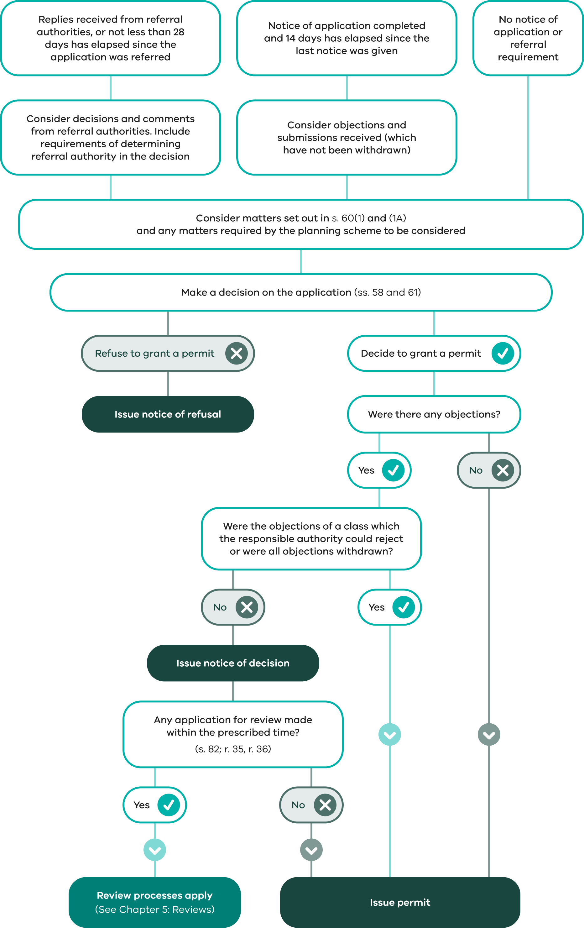

3.4.4 When must a decision be made?
PEA s 79
If the responsible authority does not make a decision within the prescribed time, an applicant may apply to VCAT for a review of a failure to grant the permit within the prescribed time.
There are important rules about when the prescribed time starts and when it stops. The prescribed time is:
PEA s 3; ILA s 44(1); PE Regs reg 32
VicSmart applications: 10 business days. A business day means a day other than a Saturday, Sunday or a day appointed under the Public Holidays Act 1993 as a public holiday or public half-holiday. In calculating the 10 business days for a VicSmart application, the first business day (that is, the day the application is received) is excluded and the last business day is included.
All other applications: 60 days. In calculating the 60 days for any other application, the first day (that is, the day the application is received) is excluded and the last day is included. Weekends and public holidays are included in the 60 days. However, if the last day falls on a weekend or public holiday, the 60 days expires on the next business day.
The prescribed time starts from the date the responsible authority receives the application (or amended application) unless:
Further information has been sought within the prescribed time under section 54 of the PE Act. The prescribed time starts from the day on which the information is given.
The applicant has applied for a review of a requirement to give further information and VCAT has confirmed or changed the requirement. The prescribed time starts from the day on which the information is given.
The prescribed time does not run (the clock stops but does not go back to zero):
if the responsible authority requires the applicant to give notice under section 52(1) or 52(1AA), for the time between the making of that requirement and the giving of the last required notice; and
for any extension of time granted by the Minister to a referral authority. The prescribed time does not include the time between the responsible authority being advised by the Minister and the time at which the extension ends.
Refer to Chapter 3.6.3 for details about timeframes for decisions on post permit processes (such as, secondary consents and extension of time requests).

3.4.5 What must the responsible authority consider?
Before making a decision on an application, the responsible authority must consider a number of matters specified in the PE Act and in various places in the planning scheme. All relevant controls in the planning scheme need to be considered.
PEA ss 6(2)(kcb), 60(3A)
A planning scheme may exempt a class or classes of application from some or all of the requirements of sections 60(1)(b) to (f) and (1A). VicSmart applications are exempt from some of these requirements.

Planning and Environment Act 1987
PEA s 60(1)
The PE Act specifies that the responsible authority, when deciding an application, must consider:
the relevant planning scheme
the objectives of planning in Victoria
all objections or submissions that have been received up to the time of making a decision
any decision or comment of a referral authority
any significant effects that the proposal may have on the environment, or the environment may have on the proposal
any significant social or economic effects that the proposal may have.
It should be clear from both the report to the responsible authority on the application and the statement of the responsible authority’s decision that these matters have been considered.
PEA s 60(1A)
In addition, where relevant, the responsible authority may consider any:
approved strategy plan or adopted amendment under:
- Part 3A of the PE Act – Upper Yarra Valley and Dandenong Ranges - Regional Strategy Plan
- Part 3C of the PE Act – Melbourne Airport Environs Strategy Plan
- Part 3D of the PE Act – Williamstown Shipyard Strategy Plan
relevant state environment protection policy
strategic plan, policy statement, code or guideline adopted by a Minister, government department, public authority or council
amendment to the planning scheme which has been adopted by the planning authority but is not yet in force
section 173 agreement affecting the land
other relevant matter.
PEA s 60(1B)
A responsible authority must (where relevant) have regard to the number of objectors in considering whether the use or development may have a significant social effect. However, this is only one of the considerations.
PEA s 61(4)
If the grant of a permit would authorise anything that would result in the breach of a registered restrictive covenant, the responsible authority must refuse to grant the permit unless a permit has been issued, or a decision made to grant a permit to allow the removal or variation of the covenant.

Planning scheme provisions
PEA s 60(1A); Planning schemes cl 65
The responsible authority is required to consider the relevant planning scheme before deciding on an application and must decide whether the proposal will produce acceptable outcomes in terms of the following:
the statewide sections (state and regional) of the PPF – which set out the state planning policies applying to Victoria
the MPS – which sets out the local strategic directions for a municipality
the local sections of the PPF – which set out the local planning policies, focusing on specific areas and issues in a municipality
the purpose and decision guidelines of the relevant planning scheme provisions and any other decision guidelines in clause 65 of the scheme
any other matter set out in the planning scheme that must be taken into account, either generally or in particular circumstances.

Referral authority comments
PEA ss 60(1)(d), 61(2), 62(1)
Although the requirement of section 60(1)(d) is to ‘consider’ any decisions and comments of a referral authority, the following extra requirements need to be noted:
The responsible authority must refuse to grant the permit if a determining referral authority objects to the grant of the permit.
In deciding to grant a permit, the responsible authority must include any conditions which a determining referral authority requires to be included and it must not include any additional conditions that conflict with those required by a determining referral authority.

Deciding VicSmart applications
Planning schemes cl 71.06
When deciding a VicSmart application, the responsible authority is exempted from considering sections 60(1)(b), (c), (e) and (f) and 60(1A)(b) to (h) and (j) of the PE Act. However, the responsible authority must consider the relevant planning scheme and may consider any agreement made under section 173 of the PE Act affecting the subject land.
Planning schemes cl 59
Clauses 59.01 to 59.14 and the schedule to clause 59.16 set out the specific decision guidelines for each class of VicSmart application that the responsible authority must consider.

3.4.6 Inappropriate applications
PEA s 131
If an application is made for a permit which cannot be granted, either because the use or development is prohibited by the scheme or by an order given under section 131 of the PE Act, or is allowed as-of-right, the responsible authority should suggest that it be withdrawn.
In the case of an application for a use or development allowed in accordance with the scheme, the applicant may instead wish to apply for a certificate of compliance in accordance with Part 4A of the PE Act for documented verification of the proposal’s compliance (see Chapter 4.1).
If the applicant insists on the application for a prohibited use or development being considered, the responsible authority must do so. The only decision the authority can validly make in such a case where the use or development is prohibited is to refuse to grant a permit. This provides the applicant with an opportunity to test the authority’s interpretation of the scheme quickly by applying for a review to VCAT. An exception to this is an application made under the combined amendment and permit process. (See Chapter 2.14.)

Where a cultural heritage management plan (CHMP) is required under the Aboriginal Heritage Act 2006
AHA ss 52(1), 52(3); AH Regs reg. 7
If a CHMP is required for a proposed use or development under the AH Act and AH Regulations, the responsible authority cannot issue a planning permit until it receives a copy of the approved CHMP for the proposal.
The responsible authority also cannot grant a planning permit for a proposal that is inconsistent with an approved CHMP.
Planning Practice Note 45 – The Aboriginal Heritage Act and the Planning Permit Process provides further explanation of the AH Act and how it interacts with the planning permit process.

3.4.7 Drafting a permit
PEA s 61; PE Regs reg 22, Form 4
The form of a permit (other than a permit granted under Division 5 or Division 6 of the PE Act) is Form 4 in Schedule 1 of the Regulations. The information to be included in the permit is set out in Form 4. The manual Writing Planning Permits (Department of Transport and Planning, 2023) provides guidance on preparing planning permits. (For amendments to permits, see Chapter 3.6.5)

The preamble – what the permit allows
A permit should be given for a specific use and/or development and the description of what the permit allows should include all aspects of the proposal that require approval.
When specifying what a permit allows, first check exactly what was applied for. Ensure that the permit covers the whole proposal and gives approval for those aspects of the proposal that require approval under the planning scheme. For example, if the application is only to carry out works, while the proposed use of the land is as-of-right, the permit does not need to specify the use.
It is important to be clear about what the permit will allow, for example:
use of land only
development of land only
use and development of land
any other matter (such as the reduction of car parking requirements, variation or removal of an easement or restriction).
When specifying what a permit allows, the responsible authority must be careful not to use a broad land use term that may encapsulate specific land uses which are not intended to be approved. For example, a permit for ‘Food and drink premises’ includes, among other things, a hotel, convenience restaurant and tavern. If all that is intended is restaurant, then the permit should say so. The permit preamble should refer to the use or development at the lowest level of the nesting diagram in the planning scheme (clause 73.04), or simply use a plain English term that clearly describes what is being approved.

Permit conditions
PEA ss 61(1)(b), 62, 85(1)(b)(ii)
A permit must include conditions required by:
the planning scheme
a determining referral authority
VCAT.
The permit can also include any other condition that the responsible authority considers appropriate, including a condition:
that plans, drawings or other documents be submitted for approval before the use or development starts
requiring the landowner to enter into an agreement with the responsible authority under section 173 within a specified time
put forward by a recommending referral authority.
PEA ss 62(1)(b), (4), 62(6)
The responsible authority must not include a condition that:
conflicts with any condition required by the planning scheme or a determining referral authority
is inconsistent with the Building Act 1993, and regulations under that Act or a relevant determination of the Building Appeals Board under the Building Act
requires a person to pay an amount for or provide works, services or facilities except in accordance with section 62(6).
The PE Act lists various types of conditions under section 62 that may be included. The list is not exhaustive.
PEA s 80; PE Regs reg 33
An applicant can apply to VCAT for review of any condition imposed except for a condition included under section 62(1)(aa) regarding registered restrictive covenants.
Some basic principles have been established about the validity of conditions. Each condition must:
be reasonable
relate to the planning permission being granted
fulfil a planning purpose
accurately convey its intended effect and avoid uncertainty and vagueness.
A permit must be written so that the applicant and anyone else will easily understand it. The Writing Planning Permits (Department of Transport and Planning, 2023) manual provides guidance on writing conditions.
Section 24(1) of the Building Act 1993 requires the building surveyor to ensure any building permit issued is consistent with the relevant planning permit, including the endorsed plans. For more information on ensuring consistency between building permits and planning permits, see Building Practice Note 06 – Building Permit and Planning Permit Consistency (Victorian Building Authority, 2021).

3.5 Implementing the responsible authority’s decision

3.5.1 Grant of a permit

Grant of permit where no objections have been received
PEA ss 63, 64A, 66; PE Regs reg. 22, Form 4
The responsible authority can issue the permit immediately if:
no objections have been received (including from a recommending referral authority); or
the only objection(s) received have been rejected by the responsible authority under section 57(2A) of the PE Act; or
no notice was required to be given under section 52(1) or 57B of the PE Act or the planning scheme; and
any conditions specified by a recommending referral authority have been included on the permit.
A copy of the permit must be sent to any referral authority that was given the application under section 55 of the PE Act. This does not apply where a recommending referral authority objected or sought a condition that was not imposed on the permit. In that case, the authority will have received a notice of refusal or a notice of decision to grant a permit.

Grant of permit where objections have been received
PEA ss 64, 66; PE Regs reg 26 Form 5, reg 35
If objections have been received, the responsible authority must issue a notice of decision to grant a permit (also known as an ‘NOD’).
The responsible authority must give a notice of decision to the applicant, any referral authority (as prescribed in sections 64A and 66 of the PE Act) and each objector. The notice should be dated on the day it was actually sent out. This is especially important in the case of objectors because the period in which an objector can apply for review starts from the date of the notice. The notice sets out conditions the responsible authority intends to apply to the permit.
A notice of decision is also issued when no objections have been lodged but a condition proposed by a recommending referral authority is not included on the permit.
PEA ss 64(3), 82, 82AAA; PE Regs regs 35, 36
Once a notice of decision has been given, the responsible authority cannot issue the permit:
until the end of the 28-day ‘review period’ – the period within which an objector or a recommending referral authority may lodge an application for review of the decision to VCAT); or
if an application for review is made within that period, until VCAT directs that a permit be issued.
An application for review must be made to VCAT within the prescribed period by or on behalf of the person seeking a review of the decision. If an application for review is not made within the prescribed time, the responsible authority may issue the permit. (See Chapter 5 ‘Reviews’, Table 5.1.)
ILA s 49(1)
A responsible authority must take care in calculating the time after which a permit can be issued. Under section 64 of the PE Act, the time begins from when the responsible authority gave notice which, if the notice was sent by post, is the time the notice would have been received, not the date it was sent. This is, however, not relevant in the case of objectors. The period for objectors is calculated from the date of the notice of the decision and not the date that the objector would have received the notice.
The responsible authority should set in place an administrative system to ensure that an application for review is not overlooked and a permit mistakenly issued. This could happen if, for example, a person addresses an application for review to the chief executive officer of a council, while the planning office, not having seen it, issues a permit.
To assist responsible authorities, VCAT publishes a list of all applications for review it has received from objectors under section 82 of the PE Act on its website. This list is updated daily. Responsible authorities should check this list to confirm that no application for review has been commenced before it issues any permit for an application that has received objections.

3.5.2 Refusal to grant a permit
PEA s 65; PE Regs re. 28 Form 7
A notice of refusal must be set out as in Form 7 in Schedule 1 of the Regulations.
PEA ss 65(2), 66(5)
The notice must state the grounds on which the application was refused and indicate whether the grounds were those of the responsible authority or a determining referral authority.
The PE Act states that the notice must set out specific grounds. Therefore, broad generalisations such as ‘loss of amenity’ should be avoided or at least made reasonably specific as to how loss of amenity is expected to come about. Grounds should also avoid just referring to non-compliances with planning scheme provisions by clause number without identifying the real reasons for the refusal. The grounds of refusal may be tested at a review hearing and requests for further particulars or directions hearings may be required if they are not sufficiently clear.
PEA ss 65, 66
A notice of refusal must be given to the applicant and all objectors. The responsible authority must also give a recommending referral authority a notice of refusal if it:
objected to the grant of the permit; or
recommended a condition be included on the permit.
Anyone who made a submission, rather than an objection, can be advised of the decision by letter.
PEA ss 61(2), 61(2A)
The responsible authority must refuse to grant a permit if a determining referral authority objected to the proposal but is not obliged to refuse the grant of the permit if a recommending referral authority objected to the proposal.
If a refusal is issued because the use or development proposed is prohibited by the scheme, the notice should make this clear.

3.5.3 Review of a decision to grant or refuse a permit
PEA ss 77, 80, 82, 82AAA; PE Regs regs 35, 36
An application for review must be made to VCAT within the prescribed time and a copy of the application for review must be given to the responsible authority. In the case of an objector’s review against a decision to grant a permit, an application for review must be lodged within 28 days from when the notice of decision was given.
A recommending referral authority also has 28 days to lodge an application for review of a decision to grant a permit, a refusal or a decision not to include a condition recommended by the authority.
An applicant has 60 days to apply for review of a decision to refuse to grant a permit or for a review of any condition in a permit.
Refer to Chapter 5 for more information about other types of decisions that can be reviewed by VCAT and the relevant procedures for VCAT reviews.

3.6 After a permit is issued

3.6.1 When does a permit begin?
PEA s 67
A permit operates from:
the date specified on the permit; or
the date of VCAT’s decision if no date is specified and the permit was issued at the direction of VCAT (in this case it will need to be backdated to the VCAT decision date); or
the date on which it was issued (where no date is specified).

3.6.2 When does a permit expire and how is the time extended?
A permit can expire in three ways:
if the permit is not acted upon; or
if the use is discontinued as set out in section 68 of the PE Act; or
if a permit condition provides that a use may only be conducted until a certain time or that works must be removed after a certain time.

Permits not acted upon
PEA ss 68, 68A; Planning schemes cl 52.09-5
The PE Act specifies the conditions under which a permit will expire. These vary depending on the type of permit (for example, use, subdivision, other forms of development, or a combination of these). In general, the usual period given is two years to commence but the exact period should depend on the nature of the use or development. In the case of subdivision, two years is allowed for the certification of the plan under the Subdivision Act 1988, with expiry occurring five years after certification.
The responsible authority may specify a different time (either shorter or longer) for commencement. In the case of a permit for development other than subdivision, the responsible authority may specify a different time for completion, as appropriate to the particular case. These alternative times must be stated in the permit.
If a permit expiry is specified on a permit, this should be done as a statement in accordance with section 68 of the PE Act. It is not a condition of the permit.
A responsible authority should set practical expiry times and avoid setting unnecessarily short expiry times that are likely to lead to requests for extensions.
If a permit for development does not specify a commencement expiry period, the default completion expiry period set out in the PE Act is two years after the issue of the permit. For use permits, where the permit does not specify a commencement expiry period, the default commencement period set out in the PE Act is two years after the issue of the permit.
There can be exceptions to the normal two-year period, such as extractive industry uses, with this type of use benefiting from a minimum five-year commencement period. Where there is a longer-term commitment, time limits of six to eight years may be appropriate. A person who has been granted a permit should recognise that development rights do not necessarily run forever. Site circumstances and policy context can change. Specifying an expiry date gives the responsible authority the opportunity to review the situation when considering an application for extension of time.

Extension of time
PEA ss 69(1), (1A)
The owner or the occupier of land to which a permit applies, or another person with the written consent of the owner, may ask the responsible authority for an extension of time for a permit where:
a use or development allowed by the permit has not yet started and the application is made either before the permit expires or within six months of the expiry date; or
development allowed by the permit has lawfully started and the application is made within 12 months after the permit expires.
More than one extension of time can be granted for a permit. In deciding whether to grant an extension, a responsible authority should reassess the proposal in the present context, taking into account the following considerations:
whether there have been any changes to relevant planning controls or planning policy
the likelihood of a permit being granted if a fresh application was made for the proposal
the total elapsed time, taking into account whether the originally imposed time limit was adequate
whether the landowner is seeking to ‘warehouse’ the permit (that is, store the permit without intending to act upon it)
intervening circumstances, including:
- action taken by the applicant in the context of any legislative and policy uncertainties, including under other jurisdictions
- whether conditions on adjoining land may have changed in a way that would affect the proposal
the economic burden imposed on the landowner by the permit, including whether the cost of having to comply with the permit conditions was so onerous that the time available for compliance was inadequate.
The above considerations are widely applied and are known as the ‘Kantor principles’. They stem from a decision of the Supreme Court in Kantor v Murrindindi Shire Council (1997) 18 AATR 285.
PEA ss 69(2)–(3)
The responsible authority may extend the time within which a use is to be started or the development or any stage of it must be started or completed.
If the decision to extend the time is not made until after the permit has expired, the extension operates from the day the permit expired so that there is no break in its validity.
The responsible authority should consider whether or not the views of a referral authority should be sought regarding the extension and seek those views before deciding whether the extension should be granted.
The responsible authority should notify both the applicant and the owner of the land of its decision and send a copy of the decision to any relevant referral authority.
PEA ss 81(1), (3)
Any person affected may apply to VCAT for review of a decision to refuse an extension of time or failure to make a decision within one month of the request for extension. The responsible authority and VCAT have no power to consider an extension of time if the request is made after the timeframes set out in sections 69(1) and (1A) of the PE Act.

Use discontinued
PEA ss 68(3)(d), 68A(1)
The PE Act also provides that a permit to use land expires if the use is discontinued for two years. In the case of extractive industry permits, a period of 10 years is allowed before these types of permits expire. The permit may be extended in the same way as a permit which has not been acted upon, provided the request for an extension is made within six months of the permit expiry.
It may be difficult to determine when the right to apply for an extension actually expires as there may be no set date to indicate when the use ceased. The responsible authority may need to rely on evidence from the landowner or occupier and other enquiries in a similar way to deciding when established use rights cease in accordance with section 6(4) of the PE Act.

Permit ceases at a given time
If it is intended that a proposal be permitted only under the following circumstances, the permit should include a condition that the use must cease (and that any development permitted be removed) at that time:
until a particular event occurs; or
for a fixed period of time; or
for a period of time specified by the responsible authority (who may wish to review the operation of the proposal afterwards).
This time cannot be ‘extended’ using the procedures under the PE Act for extension of time. In these circumstances the responsible authority could consider amending the permit. Alternatively, the provisions of section 87 may apply and VCAT could amend the permit. Otherwise, a new application is necessary.

3.6.3 Post permit processes

Complying with permit conditions
PEA s 62 (2) (i) (j)
The Act allows a responsible authority to place conditions on a planning permit that require an applicant to undertake a certain action or submit further information for approval including plans, reports or other documents. These conditions may require information not provided as part of the approved application. These conditions may also enable the ongoing monitoring and enforcement of the permit.
Each condition will specify what information is required, the relevant approving authority and when the required information must be provided (such as prior to construction, occupation, a use commencing).
Once the responsible authority is satisfied that the submitted information meets the relevant permit condition, the applicant will be provided with an endorsed copy. The complete endorsed documents form part of the planning permit and enable the commencement of development, or the land use approved under the planning permit.
Separate approvals may also be required under different legislation such as building permits, liquor licences, EPA development licences, etc.

When must a decision be made?
PEA ss. 149(1)– (3), PE Regs reg. 54, PE Regs reg. 81
The prescribed time for a responsible authority to decide on a request for consent or where a matter must be done to the satisfaction of a specified body (usually council) is 30 days. These requests may include assessing submissions for endorsed plans or documents, secondary consents and extensions of time (see Chapter 3.6.2 and 3.6.5).
If the responsible authority does not decide within 30 days, an applicant may apply to VCAT for a review of a failure to decide within the prescribed time.
Responsible authorities are encouraged to monitor timeframes for post permit requests to ensure applications are determined within the required time.
Applicants are encouraged to contact the responsible authority to understand processing timeframes and requirements to satisfy conditions, before pursuing a review at VCAT.

3.6.4 Correcting mistakes in a permit
PEA s 71
The PE Act allows the responsible authority to correct a permit (including a permit issued at the direction of VCAT) where it contains a clerical mistake or omission, a miscalculation of figures or a mistake in any description of a person, thing or property.
A copy of the corrected permit should be prepared with the original date of issue. A note should be included at the end of the permit indicating the nature and date of the correction.
If possible, copies of the original incorrect permit should be recovered and marked superseded. Then the corrected permit can simply be substituted. A copy of the corrected permit should be sent to the owner, the applicant and any relevant referral authority. The correction must be noted in the register of permits held by the responsible authority.

3.6.5 Amending a permit
The Victorian planning system recognises that a permit holder’s intentions may change over time. Rather than requiring a new permit application to be made every time a change is proposed, the following processes may be applied, depending on the circumstances of the change being sought:
application to amend a planning permit
secondary consent, where a condition of a permit allows for this.
An applicant should discuss their revised proposal with a council planner before submitting their application to determine the best course of action.

Application to amend a permit
PEA ss 72(1), 72(3), 73(1); PE Regs reg 14; PE (Fees) Regs reg 11
An application to amend a permit, including any plans, drawings or other documents approved under a permit, follows the same process as an application for a permit (under sections 47 to 62 of the PE Act). It has the same requirements for giving notice and referral. However, the assessment for an application to amend a permit focuses only on the amendment itself and avoids reopening all the issues associated with the approved use or development. It also avoids the proliferation over time of permits for different aspects of the use and development of a parcel of land.
There is no limit to the number of times an applicant can request an amendment.
A correction of a mistake is not required to undergo the same process (see Chapter 3.6.4).
PEA ss 72(2), 85(1A)
A permit issued at the direction of VCAT cannot be amended under this process if VCAT has specifically directed that the permit (or a part of the permit) must not be amended by the responsible authority. Instead, an application will need to be made to VCAT under section 87 or 87A of the PE Act.
PEA s 72(2)(b)
Any permit issued by the Minister under Part 4 of Division 6 of the PE Act cannot be amended by the responsible authority. Only the Minister can amend this type of permit.

Who may request an amendment to a permit?
PEA ss 48(1), 72(1)
A person who is entitled to use or develop land in accordance with a permit may apply to the responsible authority for an amendment to a permit. The permit ’runs’ with the land, not an individual person.
If the applicant is not the owner, section 48(1) provides for the application either to be signed by the owner or for a declaration by the applicant that the applicant has notified the owner about the application.

What is the procedure for an application to amend a permit?
PEA s 73; PE Regs reg 17, Form 3
Because an amendment to a permit is considered in the same way as an application for a permit, the responsible authority must consider whether:
more information is required under section 54
notification of the application is required under section 52
referral is required under section 55.
The same statutory timeframes apply. This includes timeframes relating to notification, referral and review.
Consideration of the application to amend a permit, including notification and referral, should be based only on the changes proposed by the applicant.

Amended permit
PEA ss 73(2)–(3), 74
If the responsible authority has decided to amend a permit, it must issue an amended permit to the applicant if:
notice was required to be given under section 52(1) or 57B of the PE Act and:
- no objections have been received; or
- the only objection(s) received have been rejected by the responsible authority under section 57(2A) of the PE Act
a recommending referral authority has not objected to the grant of the amendment to the permit
all conditions recommended by a recommending referral authority have been included on the amended permit.
The conditions on the permit must relate to the amendments and they form part of the permit when it is issued.
PE Regs reg 22, Form 4
An amended permit must include a table indicating the date and nature of the amendment. This is prescribed in the Regulations.

Notice of decision to amend a permit
PEA ss 75, 75A, 76A(2); PE Regs reg 27, Form 6
If there are objections to the amendment (including an objection from a recommending referral authority) and the responsible authority has decided in favour of the application, then a notice of decision to amend a permit must be issued. The notice must set out any conditions to which the amendment to the permit will be subject. The form for the notice of decision is prescribed in the Regulations.
If a condition specified by a recommending referral authority is not included on the amended permit, a notice of decision to amend a permit must also first be issued before the final decision.

Refusal of amendment
PEA s 76; PE Regs reg 28, Form 7
If the responsible authority decides to refuse to grant an amendment to the permit, a notice of refusal to amend a permit must be issued. The notice must set out the grounds on which the application is refused and whether the grounds are those of the responsible authority or a determining referral authority. The form for the notice of refusal is prescribed in the Regulations.

Notice to referral authority
PEA ss 76A, 76C
The responsible authority must give each determining referral authority a copy of the amended permit if it decides to grant a permit, or a copy of any notice of decision to grant a permit or notice of refusal. Similarly, a recommending referral authority must be given a copy of notice if it did not object to the grant of the amended permit or did not specify conditions for the amended permit.
Where a recommending referral authority objected to the grant of the amended permit or specified conditions that were not included, a notice must be given to the authority. The notice gives the authority a right of review against the responsible authority’s decision.

When does an amended permit begin and expire?
PEA ss 69, 76B
An amended permit replaces the original permit.
Once a permit has been amended, the original form of the permit is superseded, and can no longer be acted on. Amending a permit does not change its expiry date, although the person seeking an amendment may at the same time ask for an extension of time under section 69 if the person is the owner or occupier.
It is good practice to include the specific date the permit expires on the planning permit. A permit should always show both the original issue date (a mandatory requirement) and the date on which the permit expires.
PEA s 49
The register of permit applications should record the latest version of the permit. There is no need to cancel previous versions of the permit. However, it would be useful for applicants and the responsible authority to denote file copies appropriately (for example, by marking the original permit as ‘superseded’).

Review of decision on amendment
PEA s 76C
The same rights of review exist for an amendment to a permit as for an application for a permit.
If the responsible authority determines not to issue an amended permit, the applicant has a right of review to VCAT. The applicant also has a right of review against any conditions placed on the amended permit.
Relevant third parties will have a right of review against the decision to grant an amendment to a permit. A recommending referral authority may also seek review of a responsible authority’s decision to not include a permit condition that it specified.
More information about reviews is included in Chapter 5.

Secondary consent
A permit condition may provide that some future or further changes be carried out ‘to the satisfaction of the responsible authority’ or not be carried out ‘except with the further consent of the responsible authority’. For example, a condition may limit the operation of a use to particular hours but may also provide for the hours to be altered with the consent of the responsible authority. This is known as a ‘secondary consent’.
A primary consent relates to the planning scheme requirement for a permit, whereas a secondary consent is a less formal planning approval commonly available under permit conditions. The distinction between the two is described in the VCAT decision Cook v Mornington Peninsula SC [2017] VCAT 1129.
The most common type of secondary consent provision included on a permit relates to compliance with endorsed plans. The usual words are:
‘The (use and) development as shown on the endorsed plans must not be altered without the written consent of the responsible authority.’
A secondary consent given under a permit condition does not substitute for any new permission required by the planning scheme. For example, where an existing building is to be extended, in addition to obtaining secondary consent to vary the plans of the original permit, it may be necessary to obtain a new permission, because a new planning provision has been introduced since the permit was granted.
The following considerations, known as the ‘Westpoint principles’ (see the VCAT decision Westpoint Corporation v Moreland City Council [2005] VCAT 1049 at paragraph 38) are generally applied when deciding if the use of secondary consent is appropriate. That is, the secondary consent process is considered suitable for a proposed amendment to a permit, when the amendment:
does not result in a transformation of the proposal
does not authorise something for which primary consent is required under the planning scheme
is of no consequence having regard to the purpose of the planning control under which the permit was granted
is not contrary to a specific requirement (permit condition) as distinct from an authorisation within the permit, which itself cannot be altered by consent.
The permit holder may lodge an application for review of a responsible authority’s decision or its failure to make a decision with VCAT in relation to an application for secondary consent under a condition of a permit. Third parties have no formal right of objection or right of review in relation to the merits of a responsible authority’s decision on a secondary consent application.
A permit condition may also provide for a secondary consent to be exercised by a Minister, public authority or referral authority.
The secondary consent process can only be used where changes are proposed to the plans or conditions.
Where a secondary consent is not appropriate, a new permit application or an application to amend a permit should instead be made.
Responsible authorities need to carefully consider any proposal to amend a permit by secondary consent. If a secondary consent is subsequently found to be inappropriate or inconsistent with a permit, there may be grounds for an affected person to request that the permit be amended under section 87 of the PE Act. This process is addressed in the following part.
See Writing Planning Permits (Department of Transport and Planning, 2023) for more information about secondary consents.

3.7 Cancellation or amendment of a permit by VCAT

3.7.1 Under what circumstances can a permit be cancelled or amended?
PEA s 87(1)
VCAT can cancel or amend any permit if it considers that there has been:
a material mis-statement or concealment of fact in relation to the application for the permit
any substantial failure to comply with the conditions of the permit
any material mistake in relation to the grant of the permit
any material change of circumstances which has occurred since the grant of the permit
any failure to give notice in accordance with the PE Act
any failure to comply with the requirements of a referral authority in respect to sections 55, 61(2) or 62(1) of the PE Act.
PEA s 87A
VCAT can cancel or amend a permit that has been issued at its direction if it considers it appropriate to do so. A cancellation or amendment under section 87A can only be undertaken at the request of the owner or occupier or any person who is entitled to use or develop the land concerned.
PEA s 87(2)
VCAT can amend any permit to comply with the Building Act 1993. It can do this if a building permit cannot be obtained under the Building Act 1993 (for the development for which the permit was issued) because the development does not comply with the Building Regulations 2018.
PEA ss 87(5)–(7)
VCAT can cancel or amend a permit it has granted. However, it cannot cancel or amend permits required by Ministers or government departments granted by the Governor in Council under section 95 of the PE Act. To prevent repetitious reviews, a permit cannot be cancelled or amended on grounds related to mis-statement or concealment of fact, a mistake in granting the permit, or failure to comply with referral requirements if these matters have been previously raised in a review about the permit.

PEA s 88
There is no limitation on the time when a permit can be cancelled or amended if it relates to the use of land. However, if it relates to either the development of land or construction of buildings or works, it can only be cancelled or amended before the development has been substantially carried out.

3.7.2 Making a request to cancel or amend a permit
PEA s 87(3)
A request to amend or cancel a planning permit can be made by:
the responsible authority (usually the local council)
a referral authority
the owner or occupier of the land
any person who is entitled to use or develop the land
any person who objected or would have been entitled to object to the issue of a permit if the person believes that he or she:
PEA ss 87(3)(b), 89(1)
- should have been given notice of the application for the permit and was not given that notice; or
- has been adversely affected by:
  - a material mis-statement or concealment of fact in relation to the application for the permit
  - any substantial failure to comply with the conditions of the permit
  - any material mistake in relation to the grant of the permit.
Before making a request, careful consideration should be given to which ground or grounds as specified in section 87 of the PE Act will be relied upon. It will be necessary at the hearing of the request to produce evidence to satisfy VCAT that one of these grounds existed. Consideration should also be given to whether or not to seek an order to stop development (see Chapter 3.7.5).
Any request must be in writing. Forms containing notes and guidance for a person requesting cancellation or amendment of a permit or seeking an order to stop development are available from VCAT.
PEA s 89(3)
VCAT may refuse to consider a request if it is not satisfied that the request was made as soon as practicable after the facts became known to the person or authority making the request.

3.7.3 Hearing a request to cancel or amend a permit
PEA s 90
VCAT must give the following parties the opportunity to be heard:
the responsible authority
the owner and occupier of the land
the person who asked for the cancellation or amendment of the permit
the Minister
a relevant referral authority.
VCAT has discretion to give any other person who appears to have a material interest in the outcome an opportunity to be heard.
PEA s 91(3)
If the request was made by an objector or person who would be entitled to object, VCAT must be satisfied before it makes a direction to amend or cancel a permit that:
there would be substantial disadvantage to the person making the request
the person did not receive notice of the application and therefore could not have become aware of the application in time to lodge an objection
it would be fair and just to amend or cancel a permit.

3.7.4 VCAT’s decision
PEA s 91
VCAT may direct the responsible authority to cancel or amend a planning permit and to take any other actions as required.
PEA s 92
The responsible authority must comply with VCAT’s direction without delay and forward a copy of the notice of cancellation or amendment to any person entitled to be heard by the tribunal in accordance with the Regulations.
PE Regs regs 38, 39
A notice of cancellation or amendment of a permit under section 92 of the PE Act must be given within seven days of the responsible authority receiving VCAT’s decision and must give:
sufficient information to identify the permit
details of the amendment or amendments made to the permit or a statement that the permit has been cancelled
the ground or grounds for each amendment or for cancellation.
A notice must contain advice that there may be a right to compensation under the PE Act.

3.7.5 Order to stop development
PEA s 93
If the circumstances warrant, VCAT may immediately make an order to direct that all or part of a development cease until the outcome of a hearing. It may further direct the responsible authority to give notice of the order, without delay, to a specified person in a specified manner.
PEA s 94(1)
The responsible authority or person making the request, where that person has given an undertaking as to damages, may be liable for compensation if the planning permit is not subsequently cancelled or amended.
PEA s 93(1A)
Before making an order, VCAT must consider whether the person making the request should give any undertaking as to damages.
PEA s 93(3)
It is an offence for a person to fail to comply with an order to stop development.

3.7.6 Compensation for permit cancellation or amendment
PEA s 94
If a permit is cancelled or amended, the responsible authority may be liable to pay compensation to any person who has incurred expenditure or is liable for expenditure as a result of the issue of a permit.
This applies particularly where expenditure is wasted because a permit is cancelled or amended or when additional land must be bought to develop in the required manner.
PEA s 94(2A)
A referral authority is liable to pay this compensation instead of the responsible authority, if the permit is cancelled or amended because of a material mistake in relation to the issue of the permit that arose from an act or omission of the referral authority.
PEA s 94(4)
Compensation is not payable if the permit is cancelled or amended in the following circumstances:
if there has been a failure to satisfy permit conditions
the permit was granted following an application in which there was a material mis-statement or concealment of facts
if the cancellation is on the ground of a material mistake in relation to the grant of the permit, and if VCAT considers that the mistake in the grant of a permit was due to an action or omission by or on behalf of the applicant
if the permit must be amended to enable the development to comply with regulations made under the Building Act 1993.
PEA s 94(5)
It should be noted that provisions of the Land Acquisition and Compensation Act 1986, parts 10 and 11 and section 37 (regarding the determination of disputes and claims where no offers have been made) would apply as necessary where compensation has to be determined.
PEA ss 150(4)–(5)
Section 150(4) of the PE Act provides for compensation to be paid by a person if VCAT is satisfied that the person has brought proceedings vexatiously, frivolously or primarily to secure or maintain a direct or indirect commercial advantage. If VCAT determines that the circumstances set out in section 150(4) have occurred, it may order the person who brought the proceedings (or another person who sponsored the bringing of the proceedings) to pay compensation as well as costs.

3.8 Applications in special circumstances

3.8.1 Subdividing land
PEA s 3; Planning scheme cl 72.06
The subdivision of land involves three main stages:
planning permit application
certification
statement of compliance.
A planning permit is generally required for subdivision unless a planning scheme provision allows for or exempts a class of subdivision from the need for a planning permit.
The Subdivision Act 1988 sets out the procedures to be followed by councils in certifying plans and issuing statements of compliance.

Planning permit application
The approval process for a planning permit application to subdivide land is the same as for any other type of planning permit application.
It is essential that councils and referral authorities give proper consideration to subdivision at the planning stage as it will not be possible to place additional requirements on a subdivision once a planning permit is issued.
Conditions on permits should cover the full range of matters that both the council and referral authorities require to be addressed.
An application for subdivision can run in parallel with the certification process under the Subdivision Act 1988. A plan cannot, however, be certified before a planning permit is issued. If planning and certification applications are processed concurrently, the prescribed time under the PE Act applies.

Certification
SA s 6(1)(a)
A plan must be certified by the relevant council when the planning permit or planning scheme requirements have been met or arrangements have been made to meet those requirements, along with any other matter set out in section 6(1) of the Subdivision Act 1988.
A plan certified under the Subdivision Act 1988 has a life of five years. The plan lapses if it is not registered with Land Use Victoria within that time.
Each council must keep a register of plans and decisions made.

Statement of compliance
The statement of compliance is the main tool that councils use to seek compliance with the requirements placed on subdivisions through the planning system or under the Subdivision Act 1988.
A statement of compliance cannot be issued before a plan is certified and it must be obtained before a plan can be registered at Land Use Victoria.
SA s 21
Before a statement of compliance can be issued, written advice from a licensed surveyor must be provided to the council in a prescribed form. This should be to the effect that the subdivision (including all lots, roads, common property and reserves) has been marked out or defined.
The council must issue a statement of compliance as soon as the applicant has provided all the prescribed information and has satisfied all requirements under the planning system and the Subdivision Act 1988.
For more information about subdivision procedures, refer to the Subdivision Act User Guide (November 2012).

3.8.2 Applications for licensed premises
Planning scheme cls 52.27, 66.03, 66.04
In addition to other requirements of the planning scheme, a permit is required under clause 52.27 if it is proposed to issue or vary a licence to sell or consume liquor.
A permit is required to use land to sell or consume liquor if any of the following apply:
a licence is required under the Liquor Control Reform Act 1998
a different licence or category of licence is required from that which is in force
the hours of trading allowed under any licence are to be extended
the number of patrons allowed under a licence is to be increased
the area that liquor is allowed to be consumed or supplied under a licence is to be increased.
Clause 52.27 sets out some exceptions to this permit requirement, such as a variation that reduces the number of patrons allowed under a licence or if the schedule to clause 52.27 specifies that a permit is not required to use land to sell or consume liquor under a particular type of licence. The schedule to clause 52.27 may also specify that a permit cannot be granted to use land to sell or consume liquor under a particular type of licence.
If a planning permit is required for modifications to a licensed premises, such as an extension of the building area, a permit will also be needed under this clause where a change to the liquor licence is required. The application must make it clear that it is an application for approval under clause 52.27, in addition to any other use or development approval required.
This means that even if a licensed premises has long-standing existing use rights, a permit is still needed if the licence is to be changed.
An application under clause 52.27 associated with a hotel, tavern or nightclub that will operate after 1.00 am must be referred to Liquor Control Victoria (LCV). Notice of the same application must also be given to the Chief Commissioner of Victoria Police under section 52(1)(c) of the PE Act.

Cumulative impact
In assessing an application for a licensed premises, a responsible authority has to consider the possible impacts of that premises in relation to any existing cluster of licensed premises in the locality – the ‘cumulative impact’. Planning Practice Note 61 – Licensed Premises: Assessing Cumulative Impact provides guidance on assessing the cumulative impacts of licensed premises.

The role of local government in the issuing of a liquor licence
LCR Regs reg.10(1)
Under the Liquor Control Reform Act 1998, appropriate planning permission, or evidence that an application for such permission has been made, must be lodged with a new licence application and certain licence variation applications to the Victorian Gambling and Casino Control Commission (VGCCC).
It is important to note the following:
a licence can be issued before a relevant planning permit is issued, but a licence does not come into effect until the planning permit is issued
liquor trading hours approved on a liquor licence will not exceed trading hours specified in the planning approval
licensees are required, as a condition of their liquor licence, to comply with planning permit conditions.
LCRA ss 33(2), 40
A copy of an application for a licence under the Liquor Control Reform Act 1998 must be given to the council. The council may object to the granting of the licence on the grounds that the licence would detract from, or be detrimental to, the amenity of the area in which the premises are situated. In addition, a council may object to a proposal relating to a packaged liquor licence on the ground that the grant, variation or relocation would be conducive to or encourage the misuse or abuse of alcohol.
LCRA s 91(1)(b)(iii)
A council may also initiate disciplinary proceedings through the VGCCC against a licensee on the grounds that the licensee has conducted the business in a manner that is detrimental to the amenity of the area or other relevant concern. The council must set out the reasons in its request to the commission.
A comprehensive range of fact sheets and other resources about liquor licensing are available at justice.vic.gov.au.

3.8.3 Restrictive covenants
PEA s 47(1)(d)
If a registered restrictive covenant applies to the land, the applicant must submit a copy of the covenant with the permit application affecting the land. As a registered restrictive covenant is defined as a restriction under the Subdivision Act 1988, the applicant will need to check both the plan of subdivision (if the land is a lot on a plan) for restrictions and the Register Search Statement for restrictive covenants registered or recorded on the title. A title Register Search Statement can be obtained from Land Use Victoria’s website at land.vic.gov.au.
PEA s 47(1)(e)
If the permit authorises anything that would result in a breach of a registered restrictive covenant, the applicant must provide information clearly identifying each allotment or lot benefited by the covenant and any information that is required by the Regulations.
The applicant is encouraged to ask a qualified person to obtain this information, because determining which land is benefited by the covenant may not be straightforward.
If an applicant does not submit details of land benefited by a restrictive covenant because he or she considers there would be no breach and if the responsible authority disagrees and considers a breach would result, the responsible authority should inform the applicant without delay.
If there is disagreement between the responsible authority and the applicant about whether there is a breach or what land is affected, the matter may need to be referred to VCAT for determination.
PEA ss 52(1)(ca)–(cb), 52(1AA)
If a permit would authorise anything that would result in breach of a restrictive covenant or if the application is to remove or vary a restrictive covenant, the responsible authority must, in addition to complying with existing notice provisions of the PE Act:
give notice (or require the applicant to give notice) to owners and occupiers of land benefited by the restrictive covenant;
place (or require the applicant to place) a sign on the land; and
PEA s 57(1A)
publish a notice (or require the applicant to publish a notice) in a newspaper circulating in the area.
If the permit would allow the removal or variation of a registered restrictive covenant or if anything authorised by the permit would result in a breach of the covenant, an owner or occupier of land affected by the covenant is deemed to be a person affected by the grant of a permit. Therefore, no objection can be disregarded on the basis that the owner or occupier is not affected.

PEA s 47(2)
The notice and referral requirements of the PE Act under section 52 and 55 do not apply to an application to remove a restriction over land that has been used or developed for more than two years (before the date of the application) in a manner that would have been lawful under the PE Act but for the existence of the restriction.
PEA s 61(4)
If the grant of a permit would authorise anything that would result in a breach of a registered restrictive covenant, the responsible authority must refuse to grant the permit, except where a permit has been issued, or a decision has been made to grant a permit, to allow the removal or variation of the covenant.
If a responsible authority considers it must refuse an application because the proposal would result in a breach of a registered restrictive covenant, it should discuss the following options with the applicant to avoid a refusal:
- Apply for a separate permit to remove or vary the covenant. If a permit is first granted to remove or vary the covenant, the responsible authority could then issue the original permit. The responsible authority could consider both applications together. As long as it issues a permit to remove or vary the covenant, it can issue the original permit. If that permit is granted, it must include a condition that the permit is not to come into effect until the covenant is removed or varied.
- Apply to the Supreme Court for an order to remove or vary the covenant. If the court orders the removal or variation and if the necessary steps to actually remove or vary the covenant are completed, the responsible authority can then grant or decide to grant the permit.
- Ask the council, as planning authority, to prepare an amendment to the planning scheme to remove or vary the covenant. If the amendment is prepared and approved, and if the necessary steps to actually remove or vary the covenant are completed, the responsible authority can then grant or decide to grant the permit.
- Ask the council, as planning authority, to prepare an amendment to the planning scheme to remove or vary the covenant and, at the same time, consider a permit application that would otherwise authorise something that would result in breach of the covenant. If the amendment is prepared and approved to remove or vary the covenant, a permit can be simultaneously granted to authorise something that would otherwise result in breach of the covenant. The permit must include a condition that it does not come into effect until the covenant is removed or varied.
PEA s 62(1)(aa)
If the grant of a permit would authorise anything that would result in a breach of a registered restrictive covenant, the responsible authority must include a condition that the permit is not to come into effect until the covenant is removed or varied.
In effect, this permit can only be granted in the circumstances described in section 61(4); that is, if a permit is granted or a decision has been made to grant a permit to remove or vary a covenant. This ensures that an owner takes the necessary steps under the Subdivision Act 1988 to actually remove or vary the restrictive covenant. It also means that failure to do so is an offence. A responsible authority can prosecute or apply for an enforcement order against the offence.

3.8.4 Earth and energy resources industry
Planning schemes cl 52.08
The VPP seeks to encourage land to be used and developed for exploration and extraction of earth and energy resources in accordance with acceptable environmental standards.
The mining and stone extraction industries are regulated by the Mineral Resources (Sustainable Development) Act 1990 (MRSD Act). Other earth and energy resources industries are regulated by the Greenhouse Gas Geological Sequestration Act 2008, the Geothermal Energy Resources Act 2005 and the Petroleum Act 1998.
In general, a planning permit is not required to use and develop land for earth and energy resources industry where it complies with the relevant legislation governing these land uses. It is important that planning controls are consistent with this legislation.

Extractive industry
Planning scheme cl 52.09
The VPP specifically recognise the importance of sand and stone resources and the need to ensure that land used for extractive industry does not adversely affect the environment or amenity of an area.
The statutory approval process for extractive industry takes three steps:
statutory endorsement of a work plan
issue of a planning permit (if required); and
grant of a work authority.
The MRSD Act regulates the work plan and work authority processes, addressing the operational aspects of the industry. The PE Act regulates the planning permit process.
Planning scheme cl 52.08-1, MRSDA s 77T
The use and development of land for extractive industry will not require a planning permit where it complies with the provisions of the MRSD Act regarding the preparation of an Environment Effects Statement (EES).
Planning scheme cls 52.09-2, 52.09-3
If a planning permit is required, most applications will need to be accompanied by a copy of a work plan that has been statutorily endorsed in accordance with section 77TD of the MRSD Act. The submission of the statutorily endorsed work plan with a planning permit application means that the usual referral requirements will not apply (with the exception of the referral requirements for Head of Transport for Victoria).
Before preparing an application for a work plan or a planning permit, it is important to meet with the relevant authorities to discuss the proposal.
Planning Practice Note 89 – Extractive Industry and Resources provides more information and guidance on the extractive industry approvals process.

Environment Effects Statement (EES)
The EES process provides an alternative mechanism to the planning permit assessment process for the use of land for extractive industry and mining. Matters that are normally addressed in a planning permit assessment process are addressed in the EES process.
The Ministerial Guidelines for Assessment of Environmental Effects and further information about the EES process can be viewed on the department’s website at planning.vic.gov.au.

3.8.5 Pipelines
Pipelines Act s 85
If a licence is issued under the Pipelines Act 2005 to construct and operate a pipeline, a planning permit is not required for the use or development of land, including the removal, destruction and lopping of native vegetation, or the doing or carrying out of any matter or thing for the purpose of the pipeline.

3.8.6 Applications that could have a significant effect on the environment
PEA s 60(1)(e)
The PE Act requires a responsible authority to take account of any significant effects a use or development may have on the environment or that the environment may have on the use or development. Under section 54 of the PE Act, a responsible authority can ask the applicant for more information on the possible environmental effects of a use or development.
A proposal can be referred to the Minister under the Environment Effects Act 1978 to decide whether an EES will be required by:
a proponent directly seeking the advice of the Minister
another Minister, or an authority that grants permits, licences or approvals, referring a proposal to the Minister
any person or group requesting the Minister to decide whether the proposal should be subject to an EES.
The Ministerial Guidelines for Assessment of Environmental Effects under the Environment Effects Act 1978 (June 2006) provide guidance on referrals and what could be considered to be a potentially significant environmental effect. The Minister may also direct that a referral be made.
EEA ss 3(1), 8B(7)
The Environment Effects Act 1978 (EE Act) can apply to any works (public or private). When the Minister gives notice under the EE Act that an EES is required, he or she determines that the EE Act applies to the works. The EE Act can also apply to declared public works by Order of the Minister published in the Government Gazette.
EEA s 8
Section 8 of the Environment Effects Act 1978 provides for proponents and relevant decision makers to refer proposals to the Minister to determine whether an EES is required.
EEA s 8A
The Minister may notify decision makers to put decisions about projects on hold until the Minister has advised whether an EES should be prepared.
Section 8C of the Environment Effects Act 1978 requires that no decision be made about a project until the EES has been prepared and the Minister’s assessment of the project has been considered by the relevant decision maker. This includes any decision made under the PE Act to grant or refuse a permit.
PEA s 97B(1)(c)
As a general practice, when an EES is required, the Minister will consider calling in a planning application prior to the responsible authority making a decision.
EEA ss 4, 8B
The Environment Effects Act 1978 allows the Minister to make one of three decisions on the referred proposal:
an EES is not required
an EES is not required if certain conditions are met
an EES is required to be prepared by the proponent.
An EES process provides for the analysis of a proposal’s potential effects on the environment and identifies means of avoiding and minimising those effects, including through refinement of the proposal, feasible alternatives and appropriate environmental management measures.
In considering whether an EES will be required for a proposal, the Minister considers the extent to which the project is capable of having a significant effect on the environment, taking into account the project’s consistency with applicable policy frameworks, uncertainties and complexities of potential effects, any suitable alternative statutory assessment processes, feasible alternatives and the level of public interest.
For more information about the EES process, refer to the Ministerial Guidelines for Assessment of Environmental Effects under the Environment Effects Act 1978 available on the department’s EES webpage.

Impacts on matters of national environmental significance
Where a proposal may have a potentially significant impact on a matter of national environmental significance, a separate assessment may also be required under the Commonwealth’s Environment Protection and Biodiversity Conservation Act 1999. Further information on the operation of this legislation is available from the relevant Commonwealth Environment Department.
It is possible for Victoria to assess proposals that the Commonwealth has determined as ‘controlled actions’ that are likely to have a significant impact on matters of national environmental significance. The accredited state processes are set out in the Bilateral Agreement on environmental assessment between the Australian Government and Victoria. More information on environmental assessments can be found at planning.vic.gov.au.

3.8.7 Applications that require an EPA works approval or licence
Planning scheme cl 66.02
Clause 66.02-1 of planning schemes establishes Environment Protection Authority Victoria (EPA) as a referral authority for any application that requires a permit under the planning scheme, where a licence or a licence amendment is required under the Environment Protection Act 2017.
As the planning scheme requires referral of applications to EPA for a use or development needing a licence, the two processes can be undertaken either concurrently or separately.
An applicant can apply for a planning permit first, in which case the responsible authority will have the benefit of EPA advice on the potential environmental effects of the proposal. EPA, as a determining referral authority, can require incorporation of conditions or refusal of a permit.
The planning permit can then set out the main conditions that should apply to the project before the more detailed documentation needed for the works approval is prepared.
Applications can also be made simultaneously and the cross-referral provisions enable consideration and notice by the responsible authority and EPA to be coordinated.
In the event of objections, assuming that the responsible authority and EPA approved the project:
the responsible authority would decide to grant a permit in accordance with section 64 of the PE Act; and
EPA would grant a licence under sections 69(1), 74(1) or 78(1) of the Environment Protection Act 2017. In the case of a development licence, the EPA is required to impose a condition stating that the licence does not take effect until a planning permit has been issued and a copy is provided to EPA.
Alternatively, a refusal could be issued by both bodies and the applicant could apply for a review against these refusals or against any conditions. Applications for review to VCAT would then likely be combined and heard together.
EPA s 69(2), EP Regs reg 22
If an application is made to EPA for a development licence, EPA will refer the application to the responsible authority. EPA must also refer an application for a significant development licence to the Secretary of the Department of Health, any protection agency EPA considers may be directly affected and, if it relates to exploration for minerals or mining, to the Minister administering the MRSD Act. Notice must be given in a newspaper circulating throughout Victoria.
EPA ss 52, 69(3)
Public consultation occurs at the development licence stage. EPA is required to publish a notice of a development licence application on its website and in at least one other publication which is selected based on EPA’s Charter of Consultation and the characteristics of the application. Other publications can include statewide, regional or local media, or websites such as that of Engage Victoria. EPA must allow a minimum period of 15 business days during which public comments or submissions are invited. Any comments received during this time must be considered by EPA in determining whether to issue the development licence.
EP Regs reg 22(3)
The responsible authority must advise EPA in writing on the planning status of the proposal within 15 business days of the day on which the application was sent. Within 32 business days, the responsible authority must indicate its support, non-objection, or objection. The responsible authority may ask EPA to include specified conditions in the works approval (if it is issued).
EPA s 71
When a development licence is issued before a planning permit is obtained, the works approval or licence must be issued subject to a condition that it does not take effect until a planning permit is issued by the responsible authority and a copy is given to EPA.

3.8.8 Applications relating to marine and coastal Crown land
MACA s 65
Before marine and coastal Crown land is used or developed, the written consent of the Minister responsible for the Marine and Coastal Act 2018 needs to be obtained. This consent is in addition to any requirement for a planning permit under the planning scheme affecting the land.
MACA s 4
Under the Marine and Coastal Act 2018, marine and coastal Crown land comprises Crown land (whether or not covered by water):
to a depth of 200 metres below the surface of that land
between the outer limit of Victorian coastal waters and 200 metres inland of the high-water mark of the sea.
It also includes any water covering that land:
from time to time
to a depth of 200 metres below the surface of that land that is:
- more than 200 metres inland of the high-water mark of the sea; and
- reserved under the Crown Land (Reserves) Act 1978 for the purposes of the protection of the coastline.
The Governor in Council, by Order published in the Government Gazette, may declare any additional area of Crown land (whether or not covered by water) and any water covering that land to be marine and coastal Crown land for the purposes of the Marine and Coastal Act 2018.
The Governor in Council may also declare land not to be marine and coastal Crown land.
While coastal Crown land extends to the limit of any sea in Victoria (three nautical miles or approximately 5.5 kilometres offshore), the limit of planning schemes varies between coastal municipalities ranging from the low water mark (the municipal boundary) to 600 metres offshore.
MACA s 68
The Marine and Coastal Act 2018 provides a consent process for the use and development of coastal Crown land. Consent can be obtained by applying directly to the department or if a planning permit is required, as part of the planning permit process. The approval process is illustrated in Figure 3.6.
To streamline the approval process, prior consent has been granted to some ’low impact’ uses and developments (subject to some conditions and limitations). Low impact uses and developments generally comprise day-to-day maintenance, repairs and safety works. They do not include new works, works that increase the height or footprint of structures or excavation of land. Further information on prior consents can be obtained from the department.
If a council is unsure about whether consent is required under the Marine and Coastal Act 2018, it can either require the applicant to provide more information about this or it can contact the department to seek confirmation about whether consent is required.
MACA s 68(3)
If a planning permit application is referred to the relevant state environment Minister and an application for consent has not been made, the referred application is deemed to be an application for consent under the Marine and Coastal Act 2018.
MACA s 70
Upon receiving a copy of the application for consent, the Minister has 60 business days to:
request additional information; or
consent to the use or development with or without conditions; or
refuse to consent to the use or development.
If the Minister fails to make a decision within 60 business days, the Minister is deemed to have refused to consent to the use or development.
There is no right of review of a decision to refuse consent under the Marine and Coastal Act 2018.
PEA s 61(3)(a)(b)
The responsible authority must not decide to grant a permit to use or develop coastal Crown land unless consent, or consent with conditions, has been granted by the Minister under the Marine and Coastal Act 2018. If the Minister has refused consent, the planning permit must be refused.
PEA s 82AA
There is no right to apply to VCAT for a review of a decision by the responsible authority to refuse to grant a permit if Marine and Coastal Act 2018 consent has been denied.
The Use, Development and Works on Marine and Coastal Land – Fact Sheet (Department of Environment, Land, Water and Planning, 2018) provides further information on the consent process under the Marine and Coastal Act 2018.
When assessing planning permit applications on coastal Crown land, consider:
the Marine and Coastal Crown Land policy at clause 12.02-2 of the PPF and other relevant provisions in the planning scheme
the Marine and Coastal Strategy (Department of Environment, Land, Water and Planning, 2022)
Native title that may exist over any coastal Crown land (the department will consider all planning permit applications with native title implications)
the Siting and Design Guidelines for Structures on the Victorian Coast (Department of Environment, Land, Water and Planning, May 2020) available at marineandcoasts.vic.gov.au.

Figure 3.6: Approval process under the Marine and Coastal Act 2018
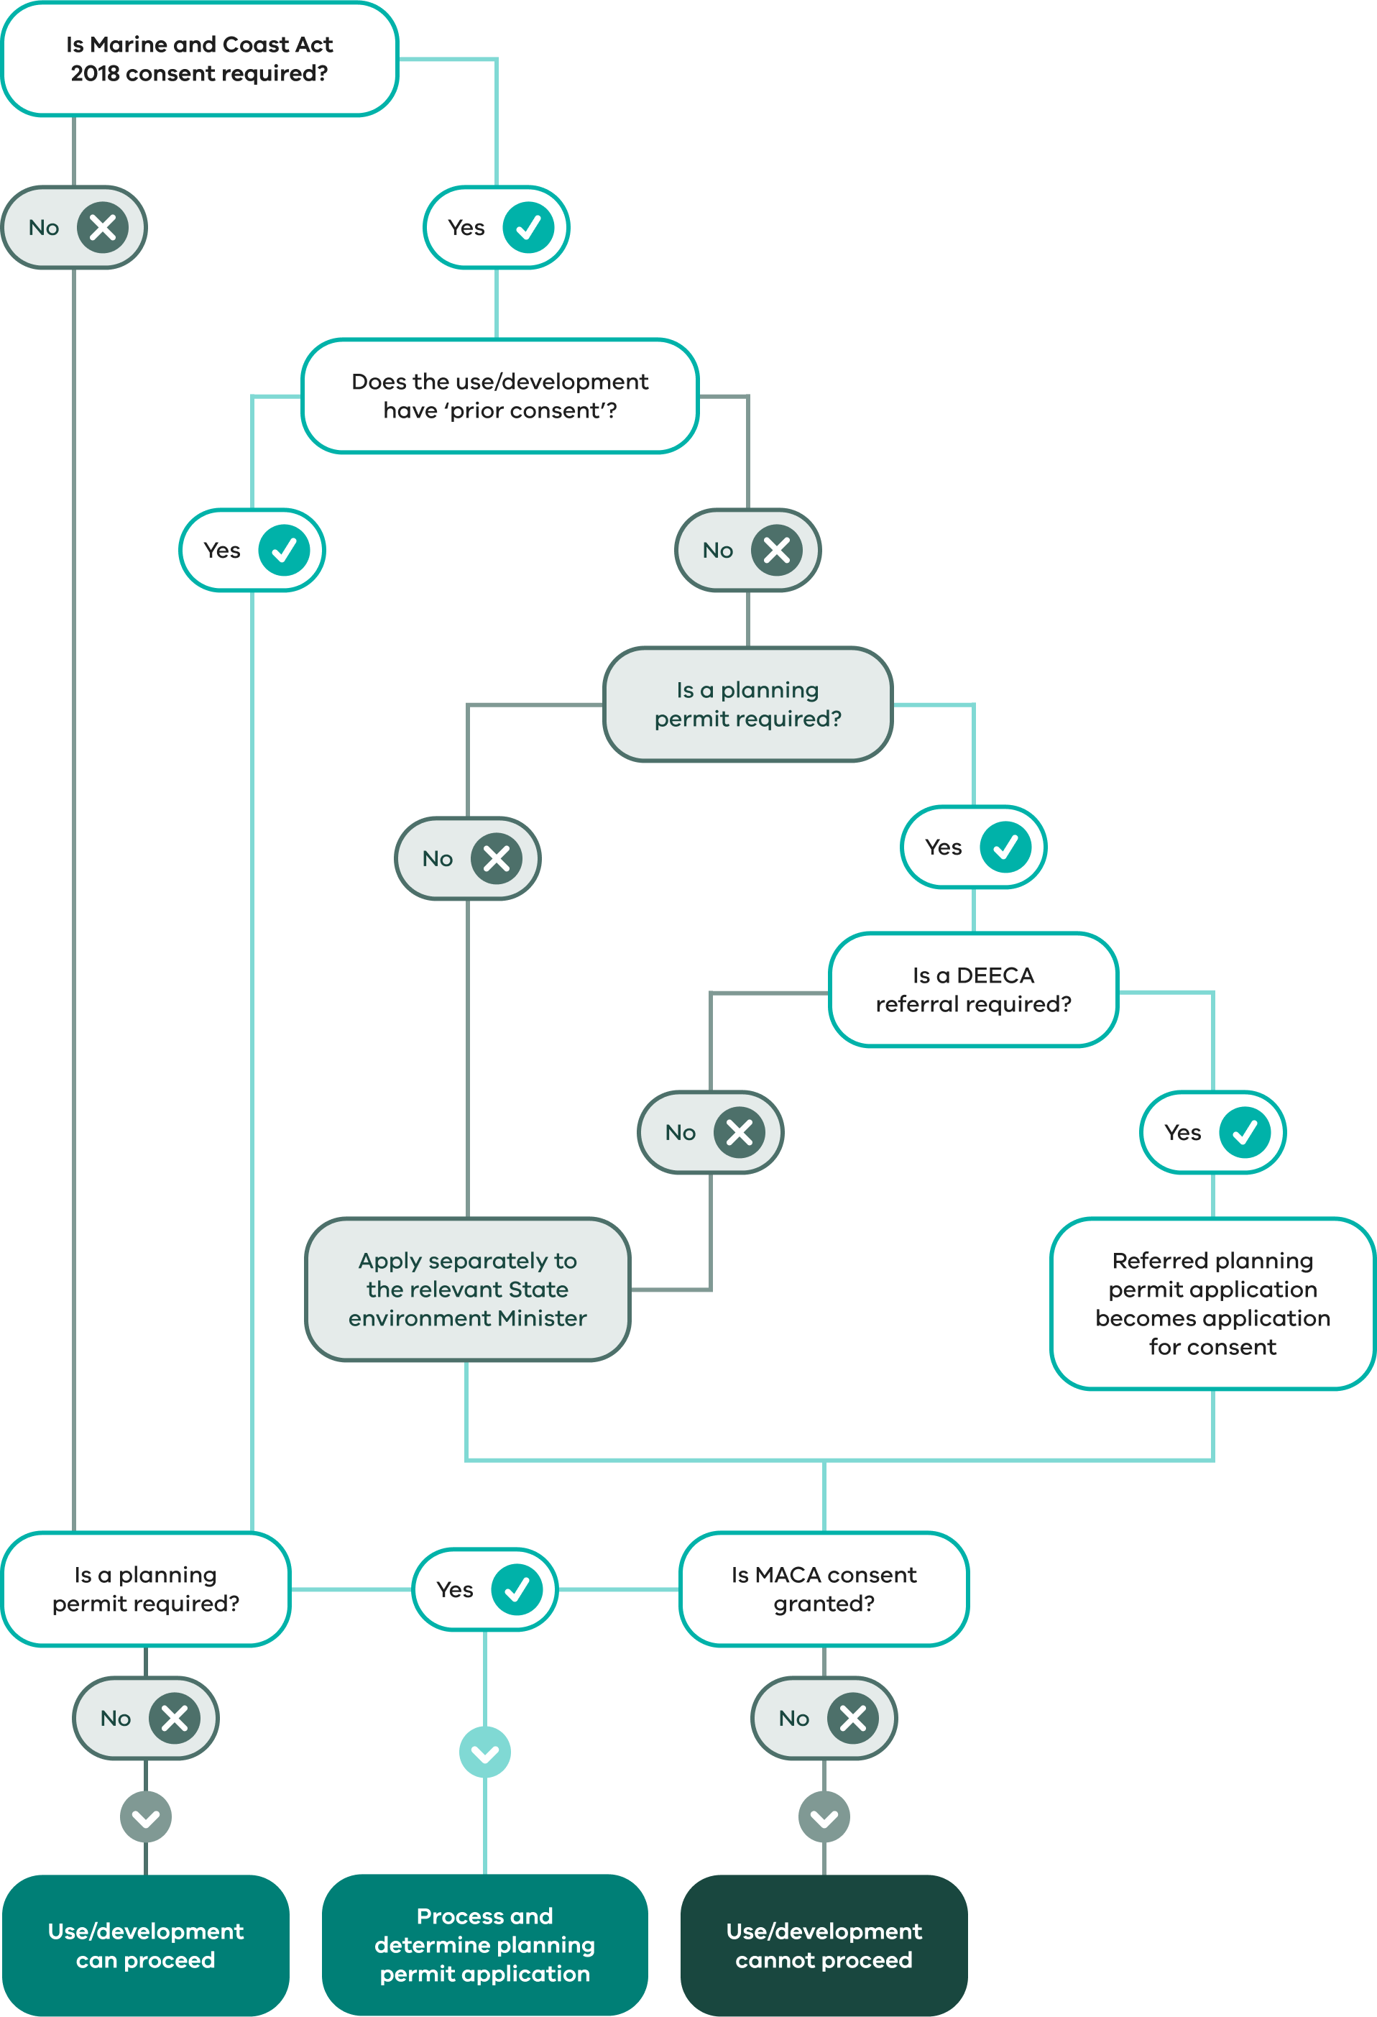

3.8.9 Registered heritage places
Although places registered in the Victorian Heritage Register are listed in the schedule to the Heritage Overlay, these places are subject to the requirements of the Heritage Act 2017 not the planning scheme. In other words, if a permit for development has been granted under the Heritage Act 2017 (or the development is exempt under section 92 of that Act), a planning permit is not required under the Heritage Overlay. However, this does not apply to applications to subdivide a heritage place that is included in the Victorian Heritage Register or other planning provisions that may still apply to the use or development.
Planning Practice Note 1 – Applying the Heritage Overlay provides further advice on the use of this overlay.

3.8.10 Applications called in by the Minister
PEA Part 4 Div. 6
Part 4 of Division 6 of the PE Act sets out the procedure to be followed if the Minister calls in a planning permit application that has not been decided by a responsible authority.
In the first instance, a planning permit application is always made to the responsible authority to whom the prescribed fee must be paid. There is no provision for an application to be made directly to the Minister (unless the Minister is the responsible authority under the planning scheme or the PE Act, in which case the application would not be called in).
If an application is called in by the Minister, the responsible authority must give the Minister any documents relating to the application. Any actions taken by the responsible authority (such as giving notice of the application) are taken to have been done by the Minister. All further steps until the decision is made are to be taken by the Minister. The responsible authority may make a formal submission about the application.
PEA s 97B
The Minister may call in an application being considered by a responsible authority if it appears that:
the application raises a major issue of policy and the determination of the application may have a substantial effect on the achievement or development of planning objectives; or
the decision on the application has been unreasonably delayed to the disadvantage of the applicant; or
the use or development to which the application relates is also required to be considered by the Minister under another Act or regulation, and that consideration would be facilitated by the referral of the application to the Minister.
VCATA Sch. 1 cl 58
The first of these criteria is the same as that for the Minister when calling in a review under the Victorian Civil and Administrative Tribunal Act 1998.
PEA s 97C
The responsible authority may also request the Minister to call in an application.
PEA ss 97E–97G
The process for considering an application called in by the Minister includes the referral of submissions to a panel, which then advises the Minister about the application. Details are set out in sections 97E to 97G of the PE Act.
PEA s 6(2)(kf)
These processes are different for some amendments to referred wind energy facility permits. A planning scheme can specify that applications to amend a referred wind energy facility permit are wholly exempted from the requirement to refer objections and submissions to a panel or are instead required to be referred to an advisory committee established under section 151 of the PE Act.
The responsible authority is (subject to section 97H) responsible for the administration and enforcement of the PE Act and the planning scheme in relation to any permit issued by the Minister, and for entering details of decisions in the Register.

3.8.11 Applications on land owned or controlled by a responsible authority
PEA s 96
The PE Act provides that if the responsible authority, or some other person, proposes to use land that is managed, occupied or owned by the responsible authority and a permit is required, a permit must be obtained from the Minister, unless the planning scheme gives an exemption from this requirement.
PEA s 6(2)(ka); Planning scheme cl 67
Clause 67 of planning schemes has the effect of exempting specified classes of use or development from this requirement. Effectively, all applications are exempt.
Notice of an application must be given to the owners and occupiers of adjoining land. The responsible authority does not have the option to avoid this notice on the basis that the grant of a permit would not cause material detriment to any person. Notice must also be given to the National Trust of Australia (Victoria) if the application relates to land on which there is a building classified by the trust.
The notice requirements do not apply to an application:
to which the exemption from notice and review in clause 52.31–2 applies; or
for a sign or advertisement; or
to remove, destroy or lop native vegetation under clause 52.17 of the planning scheme; or
where a permit is only required under particular overlays listed in clause 67.02.
An application to remove, destroy or lop native vegetation under clause 52.17 of the scheme does, however, require notice to be given under section 52(1) of the PE Act (refer also to clause 66.05 of the scheme) to the Secretary to the Department of Environment, Land, Water and Planning (now the Department of Energy, Environment and Climate Action) as constituted under Part 2 of the Conservation, Forests and Lands Act 1987.
In addition, clause 62.02-1 exempts a council from any requirement in the planning scheme relating to buildings or works with an estimated cost of $1,000,000 or less, carried out by or on behalf of the municipality. Clause 52.31-1 also exempts any requirement in a zone or a schedule to a zone to obtain a permit to construct a building or construct or carry out works for the development of land carried out by or on behalf of a municipal council with the exception of a development:
with an estimated cost of more than $10 million
in the Urban Floodway Zone unless the development is carried out to the satisfaction of the relevant floodplain management authority
associated with the use of land for accommodation, earth and energy resources industry, energy generation facility, industry or warehouse
for which an EES has been, or is required to be, prepared under the Environment Effects Act 1978
for which the Minister for Planning has decided that an assessment through an EES under the Environment Effects Act 1978 is not required if the Minister’s decision is subject to conditions.
Any requirements for the development of land carried out by or on behalf of a municipal council in the Floodway Overlay, Land Subject to Inundation Overlay and Special Building Overlay are also exempt from the need to obtain a permit to the satisfaction of the relevant floodplain management authority.

3.8.12 Applications by a Minister or government department

Section 16 exemption
PEA s 16
A planning scheme is binding on all members of the public, on every Minister, government department, public authority and council.
Exemptions may be provided by a Governor in Council Order published in the Government Gazette.
Current exemptions under section 16 of the PE Act apply to the Minister administering the Conservation, Forests and Lands Act 1987, the Minister for Health, the Minister for Education and the Minister for Skills and Workforce Participation. Exemptions have also been made for specific sites and projects.
However, even when they have been exempted from any legal need to comply with planning scheme requirements, the ministers concerned should, as a matter of practice, consult from an early stage with relevant responsible authorities on proposed works. This consultation fosters cooperative involvement of local government in state planning and development matters. Consultation needs to be effective and therefore should be more than the mere circulation of proposals.

Orders under section 95
PEA s 95
Section 95 of the PE Act provides for:
the Governor in Council to publish an Order in the Government Gazette requiring that specified applications by Ministers or government departments must be referred to the Minister administering the PE Act; and
the Minister to direct the responsible authority to refer an application to the Minister if conditions in the PE Act are met.
There is no review against a determination by the Governor in Council.
Unless either of these actions are taken, applications to which section 95 of the PE Act could apply are dealt with in the usual way by the responsible authority.

3.8.13 Permits issued under the Town and Country Planning Act 1961
PEA s. 208
Any permit issued under the Town and Country Planning Act 1961 which was in force immediately before the Act came into effect, continues in force and is treated as though it were issued under that Act.

PEA s. 208(2)
Note that the PE Act provides for the expiry of such permits under certain circumstances. This means that some older permits that previously may have had an indefinite life will now have expired.

3.8.14 VicSmart permit process
PEA s 6(2)(hb)
The PE Act enables planning schemes to set out different procedures for particular classes of applications for permits. The VicSmart permit process is a specific procedure for straightforward, low-impact applications.
Key features of the VicSmart permit process include:
the responsible authority is expected to assess an application within 10 business days of receiving the application
the classes of application to which the process applies are set out in the planning scheme
applications are exempt from the notice requirements in section 52 of the PE Act
applications are exempt from certain decision-making considerations in sections 60 and 84B of the PE Act
the application is only assessed against specific decision guidelines set out in the planning scheme
the chief executive officer (CEO) of the council is the responsible authority for the application.
There are two types of VicSmart application: state VicSmart applications and local VicSmart applications.
State VicSmart applications are established by the Minister and apply in all planning schemes. Local VicSmart applications are put in place by the council for its planning scheme and may be different in each scheme.

Differences between VicSmart and the regular permit process
The two processes differ in some important respects. The VicSmart process has fewer steps than the regular permit process; it involves a more tightly focused planning assessment; and different statutory times apply for requesting further information and deciding an application. Also, the council CEO is the responsible authority for VicSmart applications whereas the council is typically the responsible authority for regular applications.
The VicSmart and regular permit processes are illustrated in Figure 3.7.

Figure 3.7: The two permit processes
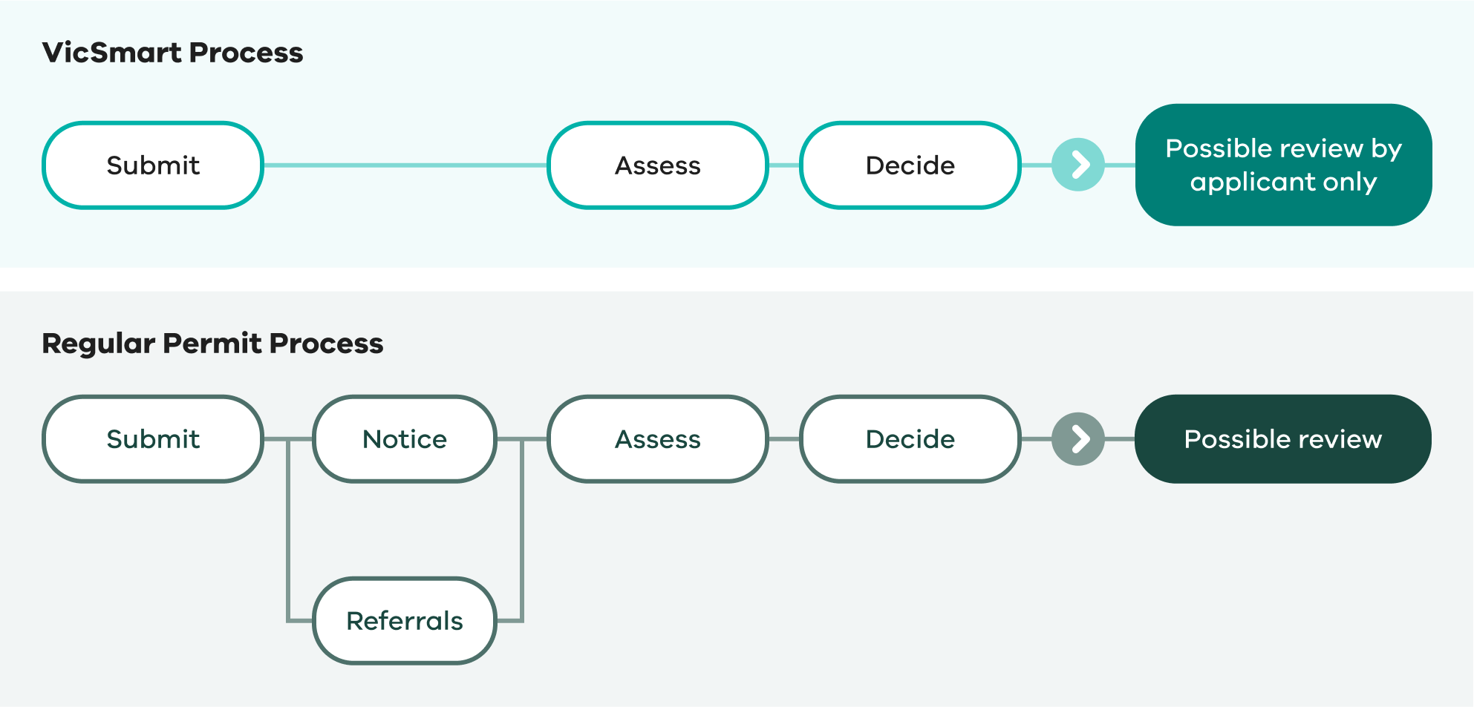

The VicSmart planning provisions
Planning schemes cl 59 and 71.06
Specific provisions in clauses 59 and 71.06 of the planning scheme apply to VicSmart applications. These provisions set out:
the operational requirements for assessing VicSmart applications, including the criteria for when an application is a VicSmart application and exemptions from certain procedural requirements of the PE Act (clause 71.06)
the classes of state VicSmart application, in the applicable permit requirement in a zone, overlay or particular provision
information requirements and decision guidelines for each class of state VicSmart application (clauses 59.01 to 59.14)
the classes of local VicSmart application (schedule to clause 59.15)
information requirements and decision guidelines for each class of local VicSmart application (schedule to clause 59.16).
More information about the VicSmart planning provisions can be found in the VicSmart Permits in 10 Days - Planner and Practitioner Guide 2019 (DELWP) on the department’s website.

Responsible authority for VicSmart applications
PEA s 13; Planning schemes cl 72.01
Section 13 of the PE Act enables a planning scheme to specify a person other than the municipal council or the Minister as the responsible authority for a class or classes of applications.
The responsible authority for considering and deciding VicSmart applications is the CEO of the council. This is specified in clause 72.01 of the planning scheme.
PEA s 188
Under section 188 of the PE Act, the CEO may delegate responsibility for administering and deciding VicSmart applications to other officers of the council.

PEA s 61A; LGA s 130
Section 130 of the Local Government Act 2020 applies to the CEO and any other council officer that may exercise a power, duty or function as a responsible authority. Section 130 requires a council officer to disclose any conflict of interest and to exclude themselves from the decision-making process and refrain from exercising that power, duty or function if he or she has a conflict of interest. Under section 61A of the PE Act, the officer must delegate the power to another council officer.

Identifying a VicSmart application
An application is a VicSmart application if:
it is identified as a VicSmart application under the permit requirement in a zone, overlay or particular provision, or in the schedule to clause 59.15
all the permit triggers for the application are identified as a VicSmart application under the permit requirement in a zone, overlay or particular provision or in the schedule to clause 59.15
nothing authorised by the grant of a permit would result in a breach of a registered restrictive covenant
the application has been considered by the referral authority, if the application requires referral to a referral authority, within the three months prior to the application being made, and the referral authority has stated in writing that it does not object to the proposal.
If an application does not meet all of these requirements, it is not a VicSmart application and the regular permit process applies.

Preparing and submitting a VicSmart application
Before lodging an application, the applicant should discuss the proposal with the council to confirm that it is a VicSmart application, identify the applicable information requirements and decision guidelines, and obtain any checklists that will assist in preparing the application.
Checklists for each class of state VicSmart application are available on the department’s website.
PEA s 47; PE Regs regs 13, 14; Planning schemes cls 59.01–59.14
A VicSmart application must be made in accordance with the Regulations and be accompanied by the information required by the PE Act and the planning scheme.
The information requirements for state VicSmart applications are set out in clauses 59.01 to 59.14 of the planning scheme and the information requirements for local VicSmart applications are listed in the schedule to clause 59.16.
PE (Fees) Regs regs 9, 11
A fee must be paid when a VicSmart application is made. The Planning and Environment (Fees) Regulations 2016 prescribe fees for different classes of application and are based on why a permit is needed. There are specific prescribed fees for VicSmart applications.

Amending a VicSmart application
PEA ss 50, 50A, 57A
A VicSmart application may be amended in the same way that amendments to a regular application may be made. The requirements for amending an application are explained in Chapter 3.2.7.
The responsible authority should check any amendment carefully to determine whether the application may continue to be processed in the VicSmart permit process. For example, if an application is amended to seek permission under a planning scheme provision that is not listed under the permit requirement in the zone, overlay or particular provision or the schedule to clause 59.16, the application ceases to be a VicSmart application and the regular permit process applies.

Referral
PEA s 55; Planning schemes cls 66, 71.06
An application may require referral to a referral authority specified in clause 66 of the planning scheme. The application may be dealt with under the VicSmart permit process if the applicant satisfies the responsible authority that:
the referral authority has considered the proposal within the past three months from when the application was made to the responsible authority;
the referral authority has stated in writing that it does not object to the granting of a permit; and
the written statement and plans endorsed by the referral authority are submitted with the application.

Further information
PEA s 54(1)
The responsible authority can require an applicant to provide further information about a VicSmart application. If the request for further information is made within the prescribed time of five business days of receiving the application, the request must also specify a date by which the information must be received. An application lapses if the requested information is not provided by the specified date. Refer to Chapter 3.3.2 for more details about an application lapsing.
A request for further information within the prescribed time of five business days means that the ‘clock’ is stopped. (Note: the clock counts the 10 business days until the applicant may apply for a review of the failure of the responsible authority to determine the application. The clock starts again from zero when a satisfactory response to the responsible authority’s request is received).

Advertising
PEA s 52; Planning schemes cl 71.06
VicSmart applications are exempt from the notice requirements of sections 52(1)(a), (b), (c) and (d) of the PE Act under clause 71.06 of the planning scheme.

Making a decision on a VicSmart application
PEA ss 60, 79
There is no time limit for a responsible authority to make a decision on a VicSmart application. However, if the responsible authority does not make a decision within the prescribed time, an applicant may apply to VCAT for review of a failure to grant the permit within the prescribed time.
PE Regs reg 32
The prescribed time is 10 business days. The time starts from the date on which the responsible authority receives the application unless:
further information has been sought within the prescribed time of five business days under section 54 of the PE Act. The 10 business days starts from the day on which the information is given.
the applicant has applied for a review of a requirement to give further information and VCAT confirmed or changed the requirement. The 10 business days starts from the day on which the information is given.
Refer to Chapter 3.4.4 for more information about calculating the prescribed time.
PEA s 60; Planning schemes cl 71.06
Before making a decision on an application, the responsible authority must consider particular matters specified in the PE Act and particular decision guidelines specified in the planning scheme.
The responsible authority must consider the planning scheme, any decision or comments received from a referral authority and any section 173 agreement affecting the land. However, the responsible authority is not required to consider the other matters specified in section 60 of the PE Act because VicSmart applications are exempted from those matters, as set out in clause 71.06 of the planning scheme.
Planning schemes cls 59.01–59.14, sch to cl 59.16
The VicSmart planning provisions set out specific decision guidelines for each class of VicSmart application. In some cases, the decision guidelines enable the responsible authority to consider a relevant local planning policy in the planning scheme or the decision guidelines of a zone, overlay or particular provision. A responsible authority cannot consider the decision guidelines in clause 65 of the scheme.

VCAT review of VicSmart applications
PEA ss
Refer to Chapter 5.6.1 for more information about the VCAT review procedure for VicSmart applications.

