Residential Land
bulletin
ISSN 1035 9168 September Quarter 2010

Overview
■ The September 2010 quarter for metropolitan Melbourne continued to have the highest number of lots in subdivision plans for a quarter since recording began in 1996.
■ There was a 21% decline in the number of residential lots released in metropolitan Melbourne this quarter after a strong June 2010 quarter.
■ The number of dwelling approvals for metropolitan Melbourne increased by 20% and is the highest number of dwelling approvals for a quarter since recording began in 1996.
7 quarter moving average
Lots in subdivision plans: The seven quarter moving average for lots in subdivision plans remained stable at 10,543, a 1% increase on the previous seven quarter moving average. Of this, 49% of lots in subdivision plans were from growth area municipalities while the remaining 51% came from established municipalities.
Lots released: There was a slight decrease in the seven quarter moving average for the number of lots released to 7,263 (down 3% from the previous seven quarter moving average).
Dwelling approvals: The seven quarter moving average for dwelling approvals was 9,729, a 9% increase from the previous seven quarter moving average and the highest seven quarter moving average on record since recording began in March 1996.
Figure 1: Key land development indicators for metropolitan Melbourne – 7 quarter moving average
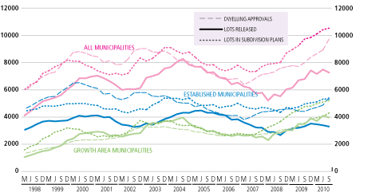
Source: Spatial Analysis and Research Branch Survey of Councils
Figure 2: Key land development indicators for metropolitan Melbourne by region – 7 quarter moving average
West
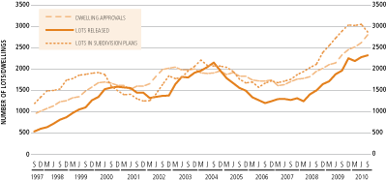
North
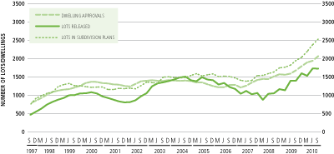
Inner
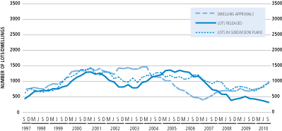
East
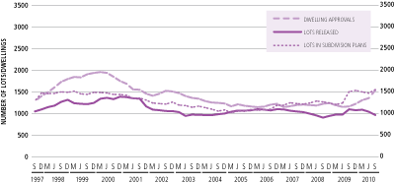
South
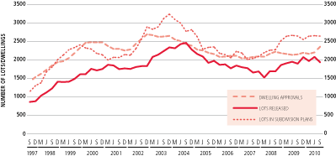

Residential lots in subdivision plans (see table 1)
■ In the last four quarters there was a total of 43,699 lots in subdivision plans submitted to metropolitan councils. This is a 6% increase from the previous 4 quarters.
■ The number of lots in subdivision applications increased to 11,894 for the September quarter. This is the highest number for any quarter since recording began in 1996. This is a 2% increase from the previous quarter although not as sharp a rate of increase as that experienced in the June quarter which was a 6% increase from the previous quarter.
■ The municipalities that experienced the greatest percent increase from the previous quarter were Port Phillip (up 509%), Darebin (up 263%) and Manningham (up 187%).
■ The greatest percent declines from the previous quarter were the municipalities of Melbourne (down 70%), Moonee Valley (down 70%) and Greater Dandenong (down 63%).

Residential lots released
(see table 4)
■ In the last four quarters there was a total of 29,456 lots released by metropolitan councils. This is only a 1% decrease from the previous four quarters.
■ There was a total of 6,686 lots released in metropolitan Melbourne for the September quarter. This is a 21% decrease from the previous quarter. This was mainly due to less lots being released in growth areas (down 41%) from previous quarter. In established councils there was actually a 20% increase in the number of lots being released for the September quarter compared to the previous quarter.
■ 38% of lots released in metropolitan Melbourne were located in the Western municipalities, 25% were located in the Southern municipalities, 24% were located in the Northern municipalities, 12% were located in the Eastern municipalities and 1% were located in the inner municipalities.

Dwelling approvals
(see table 5)
■ In the last four quarters there was a total of 42,509 dwelling approvals. This is a 31% increase from the previous four quarters. Of these approvals 43% were located in growth area municipalities and 57% were located in established areas.
■ Dwelling approvals for the September quarter increased to 12,486, a 20% increase from the previous quarter and the highest on record since recording began in 1996. 26% of dwelling approvals were located in the Western municipalities, 23% were located in the Southern municipalities, both Northern and Eastern municipalities had 19% and 13% were located in the Inner municipalities.
■ The highest percent increase of dwelling approvals in metropolitan municipalities from the previous quarter were Stonnington (up 705%), Moonee Valley (up 193%) and Melbourne city (up 121%).
■ The greatest percent decrease of dwelling approvals in metropolitan municipalities from the previous quarter were for Port Phillip (down 79%), Boroondara (down 54%) and Maroondah (down 52%).

Table 1: Residential lots in subdivision plans submitted to councils
Municipality | Number of Lots per Quarter
Municipality | Sep  ‘09 | Dec  ‘09 | Mar  ‘10 | Jun  ‘10 | Sep  ‘10
Melbourne 154 256 631 1,031 310
Port Phillip 194 282 194 82 499
Yarra 232 223 86 326 540
Inner 580 761 911 1,439 1,349
Brimbank 281 330 224 124 193
Hobsons Bay 113 115 115 153 139
Maribyrnong 161 137 202 84 170
Melton 910 363 647 770 446
Moonee Valley 40 153 182 423 128
Wyndham 2,028 1,742 1,378 1,188 1,012
West 3,533 2,840 2,748 2,742 2,088
Bayside 86 319 N/A N/A N/A
Cardinia 103 103 745 424 852
Casey 499 322 948 838 1,253
Frankston 355 349 191 412 217
Glen Eira 182 120 185 245 225
Greater
Dandenong 168 232 482 670 248
Kingston 180 296 198 199 271
Mornington
Peninsula 328 254 280 209 517
South 1,901 1,995 3,029 2,997 3,583
Banyule 99 69 63 131 122
Darebin 218 246 259 102 370
Hume 887 177 813 640 681
Moreland 333 246 496 413 559
Nillumbik 21 89 52 44 47
Whittlesea 1,374 1,328 1,312 1,625 1,344
North 2,932 2,155 2,995 2,955 3,123
Boroondara 237 80 82 156 195
Knox 82 101 57 113 301
Manningham 138 133 104 71 204
Maroondah 164 210 12 296 94
Monash 263 361 205 279 133
Stonnington 386 116 187 214 381
Whitehorse 170 143 453 N/A 218
Yarra Ranges 850 352 180 333 225
East 2,290 1,496 1,280 1,462 1,751
Growth area
municipalities 5,801 4,035 5,843 5,485 5,588
Established
municipalities 5,435 5,212 5,120 6,110 6,306
TOTAL
MELBOURNE 11,236 9,247 10,963 11,595 11,894
Source: Spatial Analysis and Research Branch Survey of Councils N/A: Not Available
Note: Growth area municipalities highlighted
Table 2: Water supply conditions accepted for residential lots
Municipality | Number of Lots per Quarter
Municipality | Sep  ‘09 | Dec  ‘09 | Mar  ‘10 | Jun  ‘10 | Sep  ‘10
Melbourne 19 10 20 6 99
Port Phillip 2 2 N/A N/A N/A
Yarra 9 18 10 N/A 12
Inner 30 30 30 6 111
Brimbank 348 287 257 49 64
Hobsons Bay 6 7 8 18 4
Maribyrnong 56 12 36 17 57
Melton 181 423 335 702 718
Moonee Valley 58 5 16 66 17
Wyndham 1,487 1,057 1,676 1,200 872
West 2,136 1,791 2,328 2,052 1,732
Bayside 10 6 7 N/A N/A
Cardinia 479 262 63 N/A 2
Casey 669 384 58 N/A N/A
Frankston 612 117 13 N/A N/A
Glen Eira 8 6 21 N/A N/A
Greater
Dandenong 5 183 34 N/A N/A
Kingston 22 22 15 N/A N/A
Mornington
Peninsula 93 81 42 N/A N/A
South 1,898 1,061 253 N/A 2
Banyule 135 150 89 N/A 282
Darebin N/A 415 160 N/A 97
Hume 641 541 330 133 967
Moreland 468 293 288 N/A 225
Nillumbik 412 357 252 N/A 177
Whittlesea 613 953 754 N/A 964
North 2,269 2,709 1,873 133 2,712
Boroondara 180 220 284 N/A 106
Knox 25 13 34 N/A N/A
Manningham 78 77 64 N/A 59
Maroondah 142 202 119 N/A 157
Monash 142 165 205 N/A 111
Stonnington 17 106 36 N/A 369
Whitehorse 171 196 100 N/A 65
Yarra Ranges 122 207 119 N/A 61
East 877 1,186 961 N/A 928
Growth area
municipalities 4,070 3,620 3,216 2,035 3,523
Established
municipalities 3,140 3,157 2,229 156 1,962
TOTAL
MELBOURNE 7,210 6,777 5,445 2,191 5,485
Source for Sept 2010 quarter: City West Water, Western Water and Yarra Valley Water Note: Data from South East Water unavailable for September 2010 quarter
Note: Growth area municipalities highlighted
Table 3: Certification of residential lots
Municipality | Number of Lots per Quarter
Municipality | Sep  ‘09 | Dec  ‘09 | Mar  ‘10 | Jun  ‘10 | Sep  ‘10
Melbourne 0 0 2 0 0
Port Phillip 27 38 19 20 33
Yarra 49 225 33 86 98
Inner 76 263 54 106 131
Brimbank 326 116 113 444 90
Hobsons Bay 142 214 105 118 97
Maribyrnong 168 112 208 91 189
Melton 605 618 494 311 383
Moonee Valley 44 107 149 409 93
Wyndham 1,588 1,759 1,016 1,755 1,147
West 2,873 2,926 2,085 3,128 1,999
Bayside 0 0 N/A
Cardinia 84 84 532 585 732
Casey 514 538 236 996 518
Frankston 470 401 351 315 354
Glen Eira 184 147 134 160 207
Greater
Dandenong 132 106 166 187 199
Kingston 163 203 144 147 90
Mornington
Peninsula 230 501 157 331 304
South 1,777 1,980 1,720 2,721 2,404
Banyule 44 52 31 57 49
Darebin 19 6 35 9 9
Hume 673 408 68 517 377
Moreland 402 282 191 200 550
Nillumbik 12 65 25 67 32
Whittlesea 1,200 1,061 1,281 1,327 971
North 2,350 1,874 1,631 2,177 1,988
Boroondara 203 87 60 60 171
Knox 103 122 72 98 135
Manningham 77 59 66 116 79
Maroondah 16 24 10 62 75
Monash 154 123 235 209 166
Stonnington 111 340 55 88 117
Whitehorse 46 129 41 N/A 225
Yarra Ranges 533 116 199 186 43
East 1,243 1,000 738 819 1,011
Growth area
municipalities 4,664 4,468 3,627 5,491 4,128
Established
municipalities 3,655 3,575 2,601 3,460 3,405
TOTAL
MELBOURNE 8,319 8,043 6,228 8,951 7,533
Source: Spatial Analysis and Research Branch Survey of Councils N/A: Not Available
Note: Growth area municipalities highlighted

Table 4: Residential lots released

Municipality | Number of Lots per Quarter
Municipality | Sep  ‘09 | Dec  ‘09 | Mar  ‘10 | Jun  ‘10 | Sep  ‘10
Melbourne 317 4 168 35 1
Port Phillip 22 26 15 26 28
Yarra 95 227 42 135 53
Inner 434 257 225 196 82
Brimbank 314 379 43 124 59
Hobsons Bay 65 63 43 53 45
Maribyrnong 127 207 206 85 168
Melton 352 781 458 528 450
Moonee Valley 58 79 66 63 425
Wyndham 862 1,550 1,132 1,758 1,370
West 1,778 3,059 1,948 2,611 2,517
Bayside 13 2 N/A N/A N/A
Cardinia 228 228 317 658 268
Casey 277 888 556 696 292
Frankston 136 457 200 364 281
Glen Eira 259 137 158 181 218
Greater
Dandenong 127 112 105 230 199
Kingston 170 244 142 149 100
Mornington
Peninsula 284 446 189 286 313
South 1,494 2,514 1,667 2,564 1,671
Banyule 50 136 73 55 52
Darebin 40 15 21 40 116
Hume 282 356 90 629 328
Moreland 326 334 198 220 405
Nillumbik 16 71 31 26 23
Whittlesea 484 998 782 1,437 673
North 1,198 1,910 1,195 2,407 1,597
Boroondara 136 66 96 119 79
Knox 130 90 82 76 144
Manningham 96 49 51 79 78
Maroondah 4 10 2 6 17
Monash 173 135 118 201 193
Stonnington 84 149 278 83 79
Whitehorse 93 84 83 N/A 121
Yarra Ranges 351 145 109 106 108
East 1,067 728 819 670 819
Growth area
municipalities 2,485 4,801 3,335 5,706 3,381
Established
municipalities 3,486 3,667 2,519 2,742 3,305
TOTAL
MELBOURNE 5,971 8,468 5,854 8,448 6,686
Source: Spatial Analysis and Research Branch Survey of Councils N/A: Not Available
Note: Growth area municipalities highlighted
Table 5: Dwelling approvals

Municipality | Number of Lots per Quarter
Municipality | Sep  ‘09 | Dec  ‘09 | Mar  ‘10 | Jun  ‘10 | Sep  ‘10
Melbourne 665 528 251 435 963
Port Phillip 50 180 146 263 56
Yarra 206 224 220 288 572
Inner 921 932 617 986 1,591
Brimbank 483 347 337 321 267
Hobsons Bay 90 136 81 176 150
Maribyrnong 289 224 112 278 199
Melton 710 480 517 691 512
Moonee Valley 198 165 171 243 712
Wyndham 1,445 1,319 1,445 1,430 1,390
West 3,215 2,671 2,663 3,139 3,230
Bayside 111 87 129 155 136
Cardinia 457 464 442 423 503
Casey 623 704 719 713 675
Frankston 193 193 251 312 507
Glen Eira 141 198 191 218 202
Greater
Dandenong 138 283 203 224 155
Kingston 144 166 163 283 310
Mornington
Peninsula 313 309 288 251 442
South 2,120 2,404 2,386 2,579 2,930
Banyule 145 139 117 124 132
Darebin 191 222 357 293 231
Hume 575 567 362 425 516
Moreland 205 397 363 304 292
Nillumbik 64 56 40 62 54
Whittlesea 1,094 950 995 765 1,091
North 2,274 2,331 2,234 1,973 2,316
Boroondara 240 202 202 347 161
Knox 97 120 109 112 172
Manningham 165 235 102 195 334
Maroondah 141 283 74 180 86
Monash 190 279 331 212 288
Stonnington 262 119 601 112 901
Whitehorse 153 213 227 142 267
Yarra Ranges 171 149 176 386 210
East 1,419 1,600 1,822 1,686 2,419
Growth area
municipalities 4,904 4,484 4,480 4,447 4,687
Established
municipalities 5,045 5,454 5,242 5,916 7,799
TOTAL
MELBOURNE 9,949 9,938 9,722 10,363 12,486
Source: Australian Bureau of Statistics catalogue number 8731.2
Note: Growth area municipalities highlighted

Estates’ sales activity in Growth Area municipalities
Figure 3: Residential lots released and average lot size for estates in Growth Area municipalities, reported by councils in the September 2010 quarter
Note: Data is collected for estates releasing five or more dwellings and may not be a complete record of lots released.
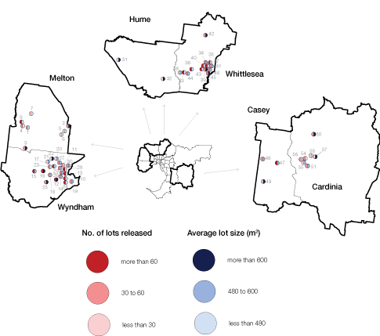

No. on map | Estate | Number of lots released | Average Lot Size (m²)
1 | 9 Petrea Place | 34 | 100
2 | Taylors Hill | 48 | 700
3 | Eynesbury | 54 | 800
4 | Riverina at Brookfield | 60 | 450
5 | 8-12 Manora Retreat | 14 | 160
6 | The Domain | 23 | 350
7 | 4 Black Knight Way | 12 | 200
8 | Botanica Springs | 84 | 450
10 | Alamanda | 64 | 355
11 | Arndell | 50 | 425
12 | Featherbrook | 68 | 680
13 | Innisfail | 99 | 472
14 | Karinya | 36 | 565
15 | Manor Lakes | 82 | 512
16 | McGraths Road | 79 | 603
17 | Reflections | 125 | 473
18 | Rosella Avenue | 33 | 488
19 | Saltwater Coast | 60 | 510
20 | Rose Grange Clearwater Rise | 17 | 598
21 | Tarneit Rise | 21 | 505
22 | Tarneit Gardens | 16 | 614
23 | The Reserve | 45 | 456
24 | Thirty30 | 116 | 463
25 | Vineyard | 42 | 1230
26 | Waterhaven | 36 | 495
27 | Westmeadows Lane | 51 | 492
28 | Williams Landing | 95 | 397
29 | Wyndella | 54 | 575
30 | Wyndham Waters | 48 | 482
31 | 210 Reservoir Road 3 | 15 | 800
32 | Linlithgow Court 3 | 11 | 1500
33 | Aurora | 146 | 421
34 | Berry Lane | 31 | 510
35 | Bridge Inn Rise Estate | 63 | 405
36 | Eucalypt | 211 | 400
37 | Laurimar - Harrisons View | 82 | 480
38 | Lyndarum | 14 | 550
39 | Mayfield | 36 | 750
40 | Mernda Villages | 252 | 420
41 | Panorama | 52 | 520
42 | Plenty River Views | 35 | 1070
43 | Renaissance Rise | 90 | 475
44 | Summerhill | 40 | 550
45 | The Ridge | 49 | 1490
46 | Vantage Point | 43 | 550
47 | The Avenue Estate | 85 | 600
48 | Echo Gardens Estate | 50 | 500
49 | Botanic Ridge Estate | 24 | 800
50 | Heritage Springs | 42 | 809
51 | Arden | 31 | 548
54 | Devonia Park | 32 | 465
55 | Devonia Park | 20 | 484
56 | Arena | 34 | 446
57 | LP140849 | 25 | 624
58 | PS546344 | 25 | 363

Source: Spatial Analysis and Research Branch Survey of Councils

Figure 4: Average lot size (m²) in Growth Area LGAs
Note: Data up to June quarter 2010 only as September 2010 quarter is incomplete and data is subject to revision. Data includes sales within and outside estates.
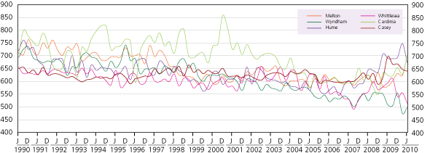

Figure 5: Number of lots sold in Growth Area LGAs
Note: Data only available up to March 2010 quarter as June 2010 data is incomplete and data is subject to revision. Please see explanation in body of main text.
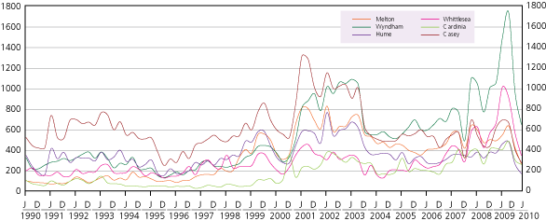
Figure 6: Median Vacant Lot Price in Growth Area LGAs
Note: Data up to June quarter 2010 only as September 2010 quarter is incomplete and data is subject to revision.
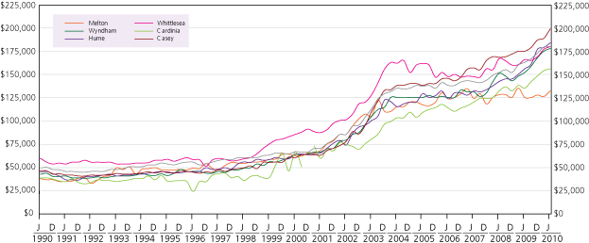

Source: Valuer-General
Figure 7: Percentage of lots sold in Growth Area estates
Note: December quarter based on October and November data only as aggregates not available for the month of December
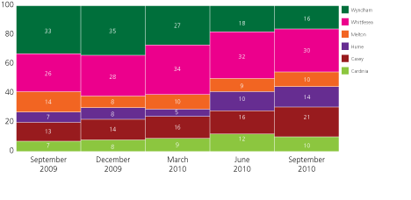
Source: Oliver Hume Research

Review of lots sold in growth area LGAs
Average lot size (m²) in growth area LGAs (see Figure 4)
The mean vacant lot size for metropolitan Melbourne for the June quarter was 643 m² compared with 610 m² for the growth areas. Melton, Wyndham and Cardinia all increased mean vacant lot size (up by between 5-12%) whilst Hume, Whittlesea and Casey declined in mean vacant lot size (down by between 1-10%). Vacant lot sizes were the highest in Cardinia and Melton (701m² and 700m² respectively).
Number of lots sold in growth area LGAs (see Figure 5)
Note: Data only available up to March 2009 quarter as June 2010 quarter is incomplete. There can be a significant lag in the number of lots reportedly sold for each quarter as lot sales may be subject to conditions such as the completion of construction of a dwelling or the provision of utilities. These lots may then not be reported until subsequent quarters. The data reproduced here is revised every quarter. The revised figures for the December 2009 quarter for the number of lots sold in growth area estates is 2,910 and for the March 2010 quarter is 1,959.
Price of vacant lots in growth area LGAs (see Figure 6)
In the June 2010 quarter Melton continued to have the lowest median vacant lot price out of the growth area municipalities with a median of $132,000 per lot and Casey remained the highest with $199,000 per lot. Both Melton and Casey’s median vacant lot price increased by 5% from the previous quarter whilst Cardinia only increased by 1%.
Percentage of lots sold in growth area estates (see Figure 7)
Please note June quarter figures have been revised in this edition due to data updates. Whittlesea continues to have the highest proportion of lots sold for a growth area with 30% for the September quarter. The other growth areas had similar proportions to the previous quarter with the exception of Casey which increased to 21% in the September quarter from 15% in the June quarter.

Glossary
Residential lots are parcels of land intended for housing development. In fringe areas there would generally (but not in all cases) be one dwelling built on each lot. In established areas residential lots may be parcels of land created by subdividing larger properties or redeveloping land from other uses, often for multi-purpose construction. While technically still defined as residential lots, the latter may more usefully be considered as dwelling units. Only metropolitan Melbourne is included.
Residential lots in subdivision plans: Councils provide the number of residential lots which were submitted to them in subdivision plans where a planning permit is required for subdivision.
Water supply conditions accepted for residential lots: Water supply authorities provide the number of formal offers made by these authorities and accepted by land owners for the provision of water supply to residential lots in plans.
Certification of residential lots: Councils provide the number of residential lots for which certification has been given. Certification is given when a plan complies with the conditions of the planning permit or planning scheme provisions.
Residential lots released: Councils provide the number of lots which have been completed to the satisfaction of the Council and have been issued with a Statement of Compliance. At this point the subdivision requirements have been satisfied for roadworks, drainage, water supply and any other construction.
Dwelling approvals: The Australian Bureau of Statistics provide the number of “houses” and “other residential” dwellings approved for each municipality.
Note: Totals in Tables 1 – 5 exclude municipalities where data was not available.

Published by Spatial Analysis and Research, a branch in the Department of Planning and Community Development
1 Spring Street Melbourne
Victoria 3000
Telephone (03) 9208 3000
December 2010
© Copyright State Government of Victoria 2010
This publication is copyright. No part may be reproduced by any process except in accordance with the provisions of the Copyright Act 1968.
Authorised by the Victorian Government, Melbourne
Printed by Stream Solutions,
157 Spring Street, Melbourne
Designed by Judy Bennett Design
29 Yorkshire Street, Richmond
This publication may be of assistance to you but the state of Victoria and its employees do not guarantee that the publication is without flaw of any kind or is wholly appropriate for your particular purposes and therefore disclaims all liability for any error, loss or other consequences which may arise from you relying on any information in this publication.
Editor: Suzanne Slegers
Email: spatialanalysis.research@dpcd.vic.gov.au
Internet: www.dpcd.vic.gov.au/research/urbanandregional

