This practice note provides information and guidance about how to:

* use the residential zones to implement strategic work for housing and neighbourhood character
* use local policies and overlays to complement the residential zones
* make use of key features in the residential zones

### This practice note should be read with *Planning Practice Note 90: Planning for housing.*

# Reforms to the residential zones

Reforms to the Neighbourhood Residential Zone (NRZ), General Residential Zone (GRZ), and Residential Growth Zone (RGZ) were approved on 27 March 2017 through Amendment VC110 to the Victoria Planning Provisions (VPP). Changes were also made to the Mixed Use Zone (MUZ) and Township Zone (TZ) to bring them into line with the key new reforms.

The reformed residential zones provide more certainty and consistency about housing growth and built form outcomes by creating consistent and strengthened maximum building height controls and the introduction of a minimum garden area requirement in the GRZ and the NRZ.

Further refinements to the residential zones were introduced by Amendment VC143 on 15 May 2018 to clarify the operation of the garden area requirement along with changes to permissible uses in the RGZ.

# The residential zones

The VPP contains a suite of standard residential zones for statewide application. These are summarised in **Table 1** below.

Table 1: The role and application of the residential zones

| **Residential zone** | **Role and application** |
| --- | --- |
| Clause 32.03 - Low Density Residential Zone (LDRZ) | Applied to areas on the fringe of urban settlements and townships with reticulated sewerage (0.2 ha minimum) or without reticulated sewerage (0.4 ha minimum) to ensure lots remain large enough to treat and retain all wastewater but small enough to be maintained without the need for agricultural techniques or equipment. |
| Clause 32.04 - Mixed Use Zone (MUZ) | Applied to areas suitable for a mixed-use function, including a range of residential, commercial, industrial and other uses. Suitable for areas identified for residential development at higher densities including urban renewal and strategic redevelopment sites. |
| Clause 32.05 - Township Zone (TZ) | Applied to small towns with no specific structure of residential, commercial and industrial land uses. |
| Clause 32.07 - Residential Growth Zone (RGZ) | Applied to areas suitable for housing diversity and housing at increased densities in locations offering good access to services, jobs and public transport, and to provide a transition between areas of more intensive use and development such as activity centres and other residential areas. |
| Clause 32.08 - General Residential Zone (GRZ) | Applied to areas where housing development of three storeys exists or is planned for in locations offering good access to services and transport. |
| Clause 32.09 - Neighbourhood Residential Zone (NRZ) | Applied to areas where there is no anticipated change to the predominantly single and double storey character. Also, to areas that have been identified as having specific neighbourhood, heritage, environmental or landscape character values, that distinguish the land from other parts of the municipality or surrounding area. |

## Principles underpinning the residential zones

### Principle 1

**Housing and neighbourhood character plans need to be consistent and align with one another when specifying preferred future housing and neighbourhood character outcomes for an area.**

Inconsistencies between housing and neighbourhood character objectives do not provide certainty for the community or industry about whether housing growth or the protection of existing neighbourhood character is to be prioritised in a defined area or neighbourhood.

### Principle 2

**All residential zones support and allow increased housing, unless special neighbourhood character, heritage, environmental or landscape attributes, or other constraints and hazards exist.**

Planning for urban growth requires the development of compact urban areas that are based around existing and planned activity centres to maximise accessibility to these facilities and services, including considering opportunities for the consolidation, redevelopment and intensification of existing urban areas more generally.

### Principle 3

**The Residential Growth Zone promotes housing intensification in locations close to jobs, services and facilities serviced by public transport including activity centres.**

While the Residential Growth Zone promotes greater housing intensification up to four storeys, it can also be used to facilitate taller residential development by specifying a maximum building height greater than 13.5 metres in the schedule to the zone.

### Principle 4

**The General Residential Zone is a three-storey zone with a maximum building height of 11 metres.**

The General Residential Zone should be applied to areas where housing development of three storeys exists or is planned for. It is inappropriate to apply the General Residential Zone to areas where a planning authority seeks to respect the existing single and double storey character of an area.

### Principle 5

**The density or number of dwellings on a lot cannot be restricted in the Neighbourhood Residential Zone unless special neighbourhood character, heritage, environmental or landscape attributes, or other constraints and hazards exist.**

Dwelling density is no longer the basis for restricting development outcomes in the Neighbourhood Residential Zone.

It is no longer appropriate to limit housing growth in existing urban areas just because an area is perceived to be remote from jobs, services and public transport.

# Applying the right residential zone

Planning schemes in Victoria are strategically focused and driven. Any planning control should have a clear reason to be imposed and be based on achieving a strategic, amenity or design outcome.

Applying the right residential zone must be derived from the municipal-wide strategic framework plan or residential development framework plan contained in a Municipal Planning Strategy (MPS). The MPS should be developed in response to relevant state and regional planning policies in the Planning Policy Framework (PPF).

This process for how the strategic planning and statutory implementation processes work to balance housing growth and neighbourhood character is shown in **Figure 1**. See **Figures 2 and 3** for an example of how a residential development framework plan can be implemented using the residential zones.

Figure 1: Balancing housing growth with protection of neighbourhood character

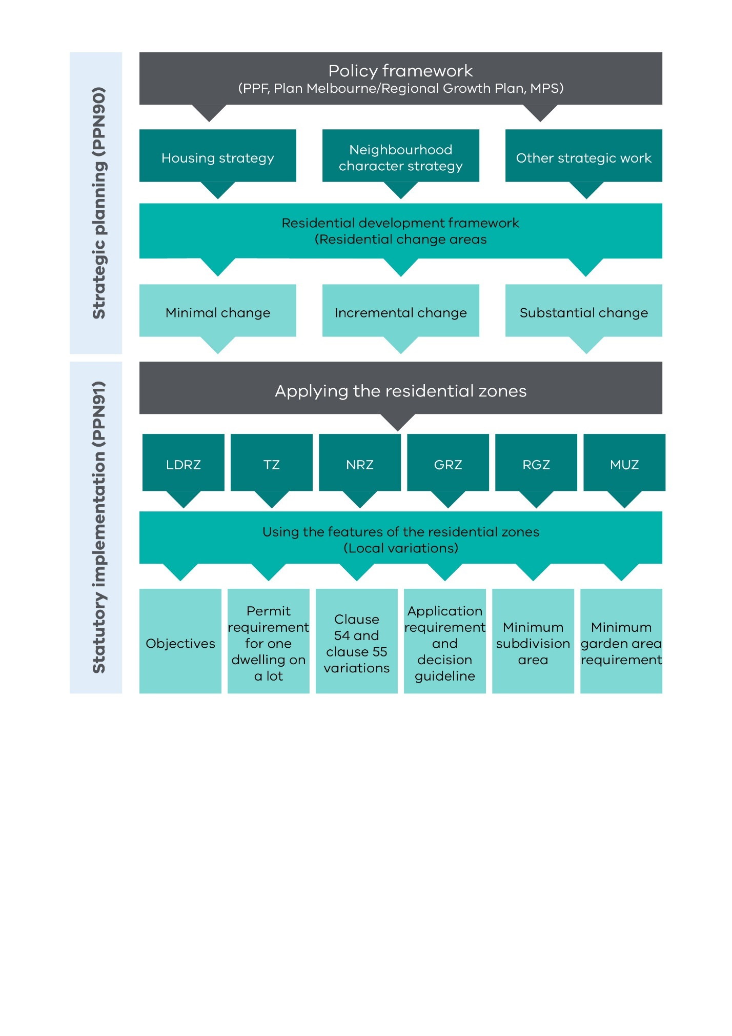

There is no ‘default’ residential zone to be applied to a residential area in Victoria.

All six residential zones can be applied to residential land in a municipality, as appropriate.

There is no prescribed percentage for how much land in a municipality should be in each residential zone.

A choice about which residential zone to apply will always need to be made. This choice must be based on the strategic outcomes being sought by the MPS and PPF.

The ‘test’ is whether the residential zone implements the relevant strategic framework plan or residential development framework plan in the MPS.

The right residential zone will reflect the true development capacity of the land. If land is impacted by special attributes or physical constraints that are identified in the MPS and PPF, then a residential zone should be applied that aligns with these attributes or constraints.

Applying the right residential zone also provides the opportunity to apply local requirements to achieve preferred built form outcomes identified in the MPS and local policies.

Table 2: Aligning housing change areas and residential zones

|  |  |  |  |
| --- | --- | --- | --- |
| **­Zone** | **Minimal** | **Incremental** | **Substantial** |
| Low Density Residential Zone | ✓ |  |  |
| Mixed Use Zone |  | ✓ | ✓ |
| Township Zone | ✓ | ✓ |  |
| Residential Growth Zone |  | ✓ | ✓ |
| General Residential Zone |  | ✓ | ✓ |
| Neighbourhood Residential Zone | ✓ | ✓ |  |

## Building heights and zone selection

One of the key features of the reformed residential zones is the different maximum building height for each zone. This is a key factor to consider when selecting a residential zone to give effect to housing and neighbourhood character objectives.

As a general principle, applying a residential zone should align with either existing building heights if they are sought to be maintained, or align with future building heights identified in strategic work.

When a varied maximum building height is sought to be specified in a schedule to a residential zone it should not exceed the maximum building height of a zone with the next highest maximum building height, unless the existing built form of the area warrants a unique approach.

For example, allowing an 11 metre / three-storey height to be specified in the NRZ would be inconsistent with the purpose of the NRZ. However, allowing the maximum building height to be increased to 10 or 11 metres may be appropriate to recognise the characteristics of existing double storey housing in an NRZ area.

The GRZ has a maximum building height of 11 metres and three storeys. It is important to remember that through the building system, a single dwelling can be constructed to a height of 11 metres and three storeys in the GRZ without the need to obtain a planning permit. If applying the GRZ, this should be considered.

If an area has an existing single and double storey character that is sought to be maintained, applying the GRZ is likely to be inconsistent with this preferred neighbourhood character outcome.

While the purpose of the GRZ includes *‘To encourage development that respects the neighbourhood character of the area’*, it is unlikely that neighbourhood character can be respected if existing development is single and double storey. However, the GRZ may be the appropriate zone to apply to areas with existing three-storey development.

After selecting the zones to apply, check that they align with the strategic work undertaken and any strategic objectives.

Table 3: Maximum building height matrix

| **­Maximum building height** | **Best zone** | **Best height tool** | **Rationale** |
| --- | --- | --- | --- |
| Less than 9m or 2 storeys | NRZ | Overlay | A maximum building height lower than the NRZ cannot be specified in a zone schedule. An overlay is required to recognise the special characteristics. |
| 9m (2 storeys) | NRZ | NRZ | The zone mandates this maximum building height and storey control. |
| Greater than 9m (retain 2 storeys) | NRZ | NRZ schedule | The schedule to the zone enables a greater maximum building height to be specified while maintaining the 2-storey requirement. |
| 11m (3 storeys) | GRZ | GRZ | The zone mandates this maximum building height and storey control. |
| Greater than 11m (retain 3 storeys) | GRZ | GRZ schedule | The schedule to the zone enables a greater maximum building height to be specified while maintaining the 3-storey requirement. |
| 13.5m (4 storeys) | RGZ | RGZ schedule | The schedule to the zone forces the discretionary maximum building height to be mandatory. |
| Greater than 13.5m and greater than 4 storeys | RGZ | Overlay | Maximum building height requirements along with other specific design and built form requirements should be included in an overlay so all built form requirements are included in the one provision. |

## The role of overlays and maximum building height

A maximum building height lower than the maximum building height specified in a residential zone can only be implemented by using an overlay to recognise a special neighbourhood, heritage, environmental, and landscape value or constraint.

In such cases, the height requirement in the overlay applies in addition to the height requirement in the zone.

Figure 2: Gumnut residential development framework plan

Gumnut Residential Framework Plan, showing:
Housing change areas - Activity centre, Substantial 1, Substantial 2, Incremental, Minimal and Growth area
Character precincts - Suburban, Riverside, Inner Urban, Urban, Central, Traditional, Lifestyle and Growth area.

|  |
| --- |
| Remember  A residential development framework plan:   * is a plan that is included in the MPS or local planning policy * implements identified housing and neighbourhood objectives * balances housing growth with the protection of neighbourhood character * is municipal-wide * is forward looking with at least a 15 year horizon, and should align with the relevant regional plan (Plan Melbourne or Regional Growth Plan) * is regularly reviewed based on the changing conditions. |

Figure 3: Gumnut residential zones application

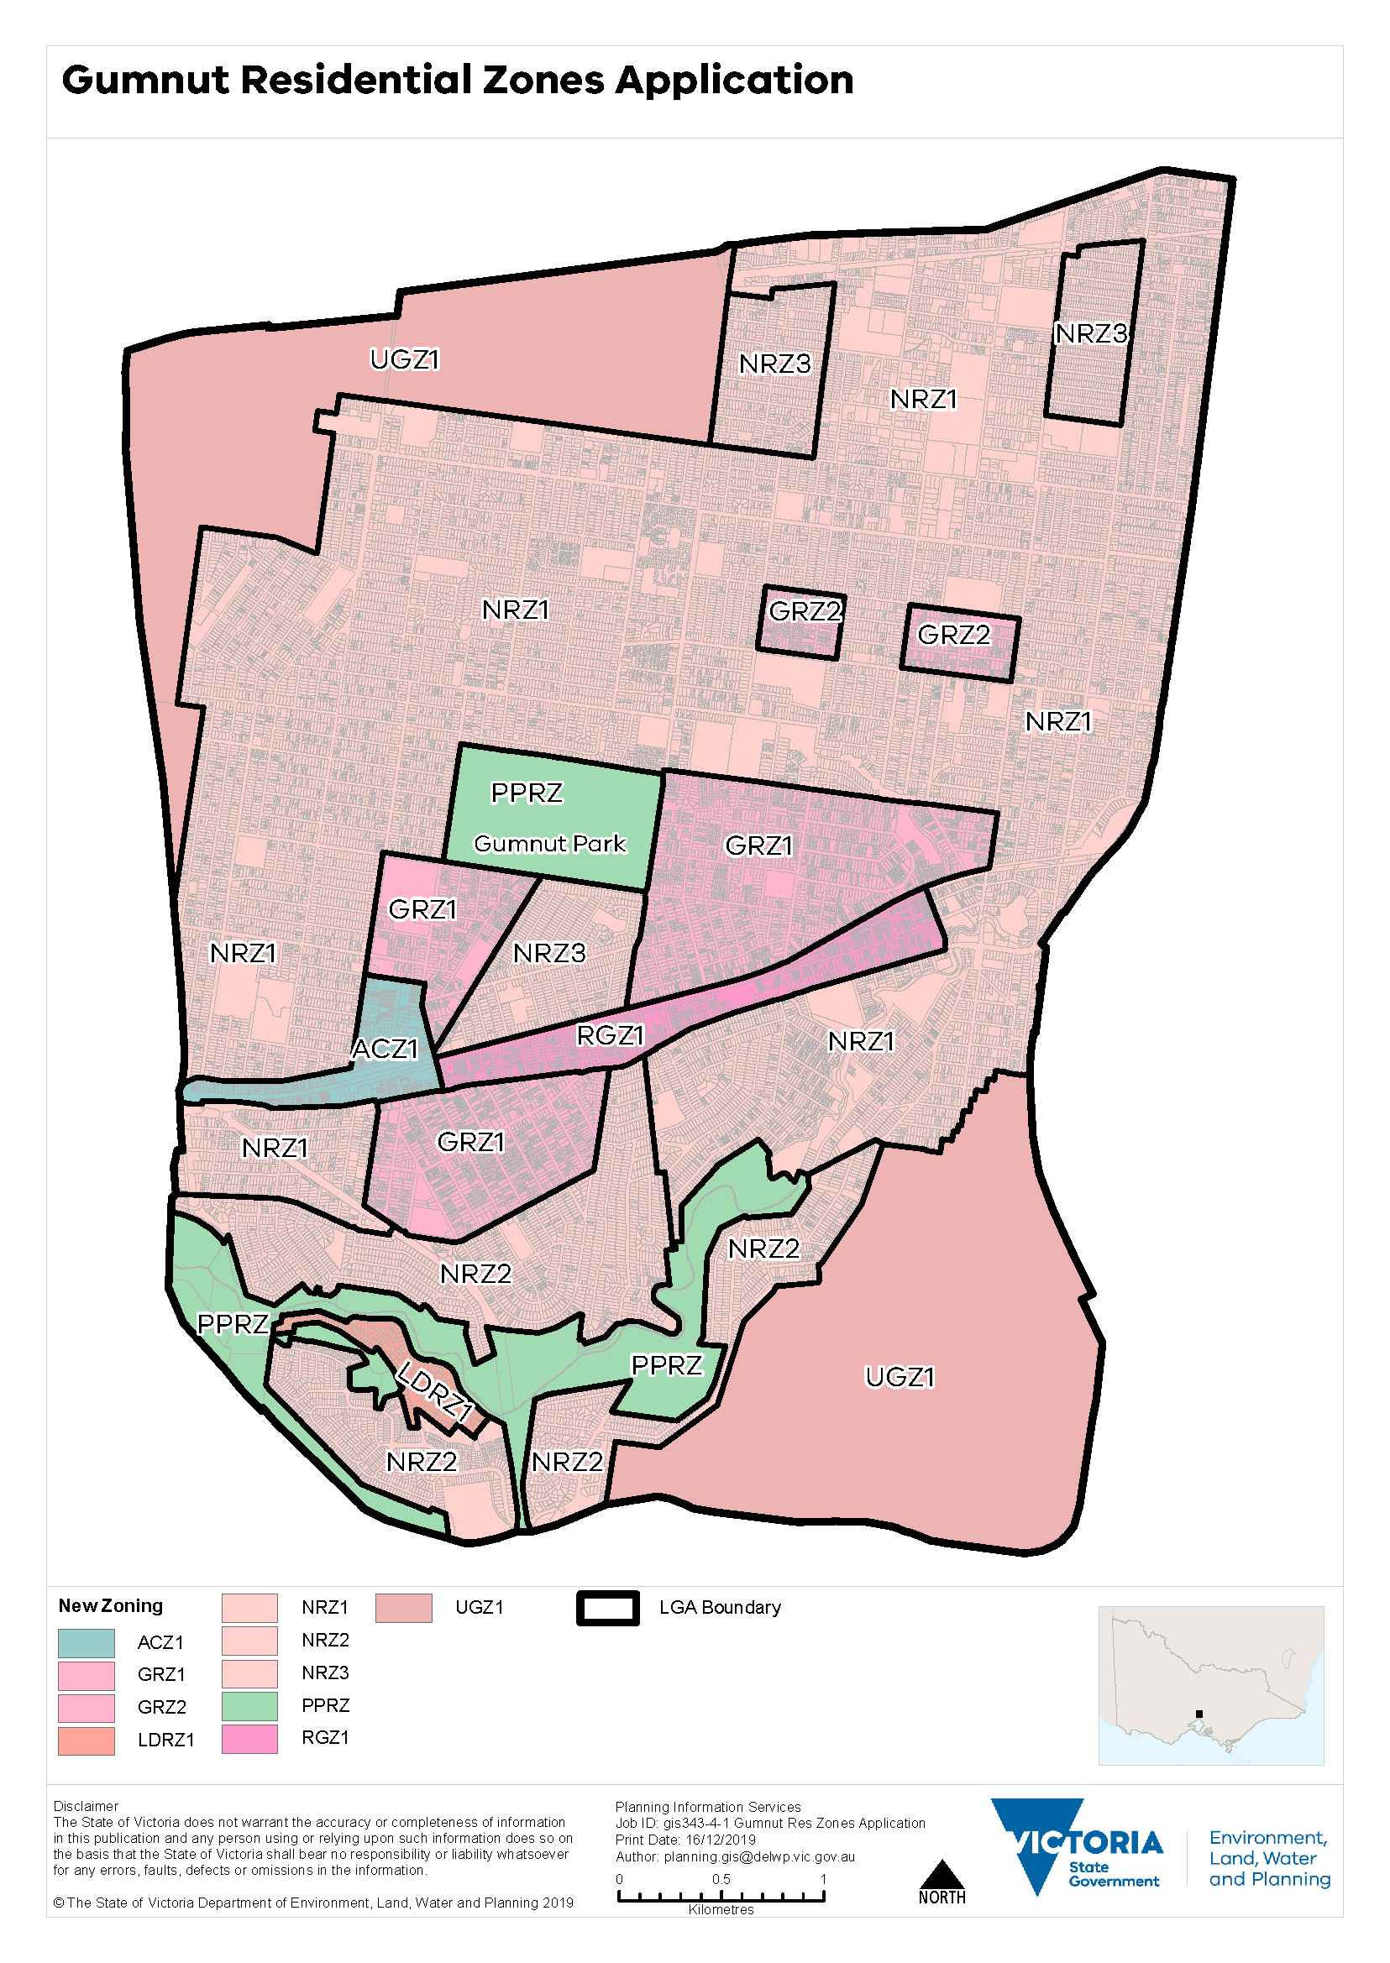

|  |
| --- |
| Remember  Applying the residential zones should:   * be consistent with the residential development framework plan and implement the identified housing change areas * not undermine the intent of the housing change areas * provide greater certainty to the planning authority and the community about future development in an area * facilitate long-term housing growth and diversity as well as protection of neighbourhood character in the right locations. |

# Using other VPP tools

While selecting the right residential zone is fundamental, the zone is one of several VPP tools to implement local strategic work.

Different areas have different characteristics and expectations. The VPP allows different residential requirements to be set through either a schedule to the residential zones or the application of an appropriate overlay.

Local policies also have a role to play in how discretion is exercised.

## The role of local planning policy

Key elements of a housing strategy or neighbourhood character strategy may be included in a local planning policy. This can clarify how a responsible authority will exercise discretion in decision making.

When housing and neighbourhood character objectives have been established and the intended outcomes are clear, a local planning policy may be warranted.

Local planning policy can be used to:

* set out housing change areas
* set out neighbourhood character precincts
* set out preferred neighbourhood character statements
* include maps to show housing change areas and neighbourhood character precincts
* specify how housing or neighbourhood character should be considered across the municipality, or for an area
* clarify how discretion will be exercised to achieve objectives in clauses 54, 55 or 58.

## The role of overlays

Overlays play an important role to give effect to preferred built form outcomes when a zone will not fully achieve the identified housing or neighbourhood character objectives for an area.

### Neighbourhood Character Overlay

The Neighbourhood Character Overlay (NCO) can be used when the following criteria can be met:

* the proposed area exhibits existing characteristics that need to be protected, or need to be changed to achieve a preferred character
* the area, relative to the rest of the municipality, can be demonstrated to require a specific approach to neighbourhood character
* the application of local planning policy cannot meet the neighbourhood character objectives for that area
* the application of objectives, standards or variations to clause 54 and clause 55 cannot meet the neighbourhood character objectives for that area.

The NCO should not be used as a ‘blanket’ control across the municipality. It should be applied strategically to areas where variations to clause 54 and clause 55 standards fail to meet the specific objectives for neighbourhood character, and new locally tailored standards are required and can be justified.

#### Rewriting the standards to clause 54 and clause 55

The NCO can be used to rewrite most clause 54 and clause 55 standards, except for several standards specified in the overlay at clause 43.05-3. Any rewritten standard must be consistent with the relevant objective and decision guideline in clause 54 or clause 55.

The NCO **cannot** be used to rewrite the objectives or decision guidelines in clause 54 and clause 55. The objectives and decision guidelines continue to apply to a rewritten clause 54 and clause 55 standard in the NCO.

Additional local neighbourhood character objectives and decision guidelines may be specified in the schedule to the NCO to achieve a preferred neighbourhood character.

#### Demolition

The demolition control in the NCO holds the existing pattern of development until the character features of the site and the new development have been evaluated.

The demolition control should not be used to conserve existing buildings, but rather to ensure that demolition does not occur until the planning authority is satisfied that the new development meets the neighbourhood character objectives for the area.

### Heritage Overlay

It is important to understand the differences between neighbourhood character and heritage.

While all areas have a history or a heritage, not all areas are historically significant. Heritage significance is determined by recognised criteria set by Commonwealth, state and local agencies, with reference to the [Burra Charter](https://australia.icomos.org/publications/burra-charter-practice-notes/).

The Heritage Overlay (HO) should be used where the objective is to conserve the existing building or buildings.

The HO has different objectives from the NCO and is not intended to operate as a neighbourhood character control. However, heritage descriptors may also contribute to the neighbourhood character of an area.

The NCO and HO should not be applied to the same areas.

The application of the HO and underlying residential zoning, should be consistent with the strategic intent outlined in the MPS and PPF.

For example, if an area is zoned for housing change, a planning authority must satisfy itself that this is compatible with the conservation of existing buildings, otherwise, a direct conflict occurs between the purpose of the zone and the overlay, making it difficult to interpret and apply the controls.

### Design and built form overlays

A Design and Development Overlay (DDO), Development Plan Overlay (DPO) or Incorporated Plan Overlay (IPO) may be used to implement specific built form outcomes that cannot be achieved through a schedule to a residential zone.

***Design and Development Overlay vs Neighbourhood Character Overlay***

The DDO should not be used as a substitute for the NCO.

The schedule to the DDO does not provide a specific framework for rewriting standards in clauses 54 and 55 in the way that the NCO does. If using a DDO, it should be clear about the neighbourhood character objective it is seeking to achieve.

While the DDO has similar features to the NCO, it is more appropriately applied to promote specific urban design outcomes for an area that cannot be achieved by varying the standards to clause 54 and clause 55. This occurs when a built form different from the existing neighbourhood character is sought.

#### Built form overlay vs zone schedules

For areas in the RGZ, clause 54 and clause 55 variations do not apply to developments greater than four storeys. If residential development greater than four storeys is sought, it is likely that another VPP tool is required to be used with the RGZ, to achieve the desired built form outcomes.

The DDO can apply built form controls to developments greater than four storeys.

When using the DDO (or DPO or IPO) to control development greater than four storeys, all built form requirements (including maximum building height) should be specified in the DDO (or DPO or IPO) instead of the schedule to the zone. This provides greater clarity and transparency by ensuring all local requirements can be found in the relevant local provision.

For residential development up to four storeys, an overlay may also be required to be used if built form outcomes sought are substantially different from ResCode and cannot be achieved using clause 54 and clause 55 variations.

### Environmental and landscape overlays

The Environmental Significance Overlay, Significant Landscape Overlay and Vegetation Protection Overlay can be used to recognise and protect specific attributes.

### Other overlays

There are other overlays that recognise hazards or constraints that impact the capacity to develop residential land such as, the Bushfire Management Overlay, Melbourne Airport Environs Overlay, Restructure Overlay and Erosion Management Overlay.

These overlays should be applied as appropriate.

# Using the key features of the residential zones

Each residential zone has a different role and purpose, and this is reflected in the different features in the schedules for each zone.

Table 4: Residential zone features

| Feature | LDRZ | MUZ | TZ | RGZ | GRZ | NRZ |
| --- | --- | --- | --- | --- | --- | --- |
| Can objectives be specified? | **No** | **Yes** | **Yes** | **Yes** | **Yes** | **Yes** |
| Is there a minimum garden area requirement? | **No** | **No** | **No** | **No** | **Yes** | **Yes** |
| Can the minimum garden area requirement be exempted? | **N/A** | **N/A** | **N/A** | **N/A** | **Yes** | **No** |
| Is there a minimum subdivision area requirement? | **Yes** | **No** | **No** | **No** | **No** | **Yes** |
| Is there a maximum building height/number of storeys requirement? | **No** | **No** | **Yes**  Discretionary 9m | **Yes**  Discretionary 13.5m | **Yes**  Mandatory  11 metres and 3 storeys | **Yes**  Mandatory  9 metres and 2 storeys |
| Can a mandatory maximum building height be specified in the schedule? | **No** | **Yes**  Height only | **Yes**  Height only and not less than 9 metres | **Yes**  Height only and not less than 13.5 metres | **Yes**  Height and storeys and not less than 11 metres and 3 storeys | **Yes**  Height and storeys and not less than 9 metres and 2 storeys |
| Can application requirements and decision guidelines be specified? | **No** | **Yes** | **Yes** | **Yes** | **Yes** | **Yes** |

## The role of local objectives

While state, regional and local planning policy sets out how discretion should be exercised, the ability to specify local objectives in a residential schedule enables detailed expression to be given to desired neighbourhood, heritage, environmental, landscape or design outcomes to be achieved for an area.

The [*Minister’s Direction - The Form and Content of Planning Schemes*](https://www.planning.vic.gov.au/guides-and-resources/guides/ministerial-directions) only allows a maximum of five objectives to be expressed in a schedule to a residential zone.

Table 5: Operation of local objectives

| **­Zone** | **Operation of local objectives** |
| --- | --- |
| LDRZ | There is no provision for specifying objectives in the schedule, as the purposes of the zone clearly express the intention of the zone. |
| MUZ | Objectives **may** be specified in the schedule.  There is no constraint on the type of objective that can be specified. |
| TZ | Neighbourhood character objectives **may** be specified in the schedule. |
| RGZ | Design objectives **must** be specified in the schedule. |
| GRZ | Neighbourhood character objectives **may** be specified in the schedule. |
| NRZ | Neighbourhood, heritage, environmental or landscape character objectives **must** be specified in the schedule. |

## Writing neighbourhood character objectives

The schedules to the TZ, GRZ and NRZ enable neighbourhood character objectives to be specified to provide clear direction on preferred neighbourhood character outcomes.

Neighbourhood character objectives in the schedule also provide a basis for varying clause 54 and clause 55 standards where variations can be strategically justified.

Objectives in the schedule to the NRZ should specify the relevant neighbourhood character, heritage, environmental or landscape characteristics of the area.

Objectives in the schedule to the GRZ should specify the attributes of the neighbourhood character to be achieved, in the context of a preferred built form outcome of three storeys.

### Writing design objectives

Objectives in the schedule to the RGZ should specify the preferred design and built form outcomes for new residential development.

Design objectives can specify matters related to built form and urban design. Design objectives should only specify public realm matters where they relate to the design of buildings that affect the function and amenity of the public realm.

### Preferred character statement or local objective?

Preferred neighbourhood character statements typically found in local policies can often translate into objectives.

Rather than specifying preferred neighbourhood character statements in local planning policy, objectives can be specified in a schedule to a residential zone to implement the preferred neighbourhood character.

It is generally not necessary to have both a preferred character statement and local neighbourhood character objectives.

|  |  |
| --- | --- |
| **Preferred neighbourhood character statement** | **Neighbourhood character objectives** |
| This precinct will maintain a streetscape rhythm of detached dwellings set behind landscaped front gardens while preserving the intact nature of the streetscape.  Built form to side boundaries will be avoided, and garages, carports and second-storey development will not visually dominate dwellings or streetscapes.  Built form and hard surfaces will continue to occupy a low portion of the site area.  The built form will be a modest scale and be sympathetic to the existing heritage character of the precinct, however, innovative and unique built form that blends with the existing character will be encouraged.  New development will complement the existing landscape environment and native landscaping throughout the precinct will be encouraged. | To maintain a streetscape rhythm of detached dwellings set behind landscaped front gardens with generous side setbacks.  To support garages, carports and second storeys that are recessed from the ground floor facade to not visually dominate dwellings or streetscapes.  To support built form and hard surfaces that cover a low portion of the site.  To provide innovative and unique designs that integrate with the existing character.  To encourage new development to provide native landscaping. |

Table 6: Translating a preferred neighbourhood character statement into neighbourhood character objectives

### What happens where an overlay exists or is proposed?

It is not necessary to be as detailed or explicit when writing objectives for the desired outcome in the schedule to the zone affected by an existing or proposed overlay, because the overlay contains detailed objectives.

#### Heritage Overlay

Where a HO exists over a precinct or an area, as opposed to an individual site, it is unnecessary to identify detailed heritage objectives through the schedule to the relevant residential zone.

Heritage *evaluators* (the way a heritage place is valued) are dealt with by applying the HO.

It is enough to generally specify in the schedule to the zone that the objective to be achieved is derived from the heritage values of the area.

#### Design, built form, neighbourhood character, environmental, landscape and other overlays

All these overlays require some form of statement of significance or risk along with specifying detailed objectives.

In all these instances, it is generally enough to specify the relevant characteristic that is being sought to be recognised and rely on the detailed objectives and statements of significance in the overlay to articulate the desired outcome.

|  |
| --- |
| Remember  When writing neighbourhood character objectives in residential zone schedules:   * Do be sufficiently clear and specific. * Do recognise a specific characteristic or constraint reflected through the application of an overlay. * Do not specify building heights (the zone or overlay does this). * Do not specify the type of housing change sought (the strategic framework and zone application does this). * Do not include statements of policy (this belongs in local policy). * Do not repeat objectives from other parts of the scheme, or reference other clauses in the scheme. * Do not reference policy background documents or studies or other tools in the scheme. * Do not specify scale, density, typology or number of dwellings unless strategically justified. |

## Minimum garden area requirement

A minimum garden area requirement is a mandatory requirement that applies to all lots in the NRZ and GRZ that are 400 square metres or more.

A minimum percentage of the land must be set aside for a garden area at ground level in accordance with the table below.

|  |  |
| --- | --- |
| **Lot size** | **Minimum garden area requirement** |
| 400-500m2 | 25% |
| 501-650m2 | 30% |
| >650m2 | 35% |

Table 7: Minimum garden area requirement

The minimum garden area requirement **cannot** be exempted in the NRZ. The minimum garden area requirement **can** be exempted through the schedule to the GRZ.

The decision to exempt the minimum garden area requirement in the GRZ must be based on the strategic outcomes being sought by the PPF and MPS. For example, it may be appropriate to exempt the minimum garden area requirement in the GRZ where a planning authority is seeking to recognise existing development conditions or to promote a denser urban form of housing than currently exists to achieve other housing objectives.

## Minimum subdivision area

A minimum subdivision area may only be specified in the schedule to the LDRZ or the NRZ.

Specifying a minimum lot size in the NRZ provides another mechanism to protect existing neighbourhood character for an area categorised as minimal change.

Table 8: Minimum subdivision area

|  |  |
| --- | --- |
| **LDRZ** | **NRZ** |
| Any minimum subdivision area specified in the schedule to the LDRZ must be at least:   * 0.4 ha for each lot where reticulated sewerage is not connected * 0.2 ha for each lot with connected reticulated sewerage. | Any minimum subdivision area may be specified in the schedule to the NRZ. |

## Varying the residential development standards

A schedule to the MUZ, TZ, RGZ, GRZ and NRZ enables the following key siting and amenity standards of clause 54 and clause 55 to be varied if it can be strategically justified:

* Standard A3 (clause 54.03) and B6 (clause 55.03) Minimum street setback
* Standard A5 (clause 54.03) and B8 (clause 55.03) Site coverage
* Standard A6 (clause 54.03) and B9 (clause 55.03) Permeability
* Standard B13 Landscaping (clause 55.03)
* Standard A10 (clause 54.04) and B17 (clause 55.04) Side and rear setbacks
* Standard A11 (clause 54.04) and B18 (clause 55.04) Walls on boundaries
* Standard A17 (clause 54.05) and B28 (clause 55.05) Private open space
* Standard A20 (clause 54.06) and B32 (clause 55.06) Front fences.

### How do the varied standards operate?

An important feature of the schedules to the residential zones is that a change to a value in the schedule will affect all dwellings in the schedule, whether a planning permit is required or not. When a local value is specified in a schedule, the value replaces the relevant value in both the clause 54 and clause 55 standard, and in the corresponding building regulation.

Clause 55.03 - Standard B13 - Landscaping is the only exception to the above. It only applies to an application for two or more dwellings on a lot.

Figure 4 below illustrates an example of how a schedule variation would interact with the building regulation and clauses 54 and 55.

Figure 4: Example minimum street setback variation in the building and planning systems

Diagram showing Building System and Planning System relationship:
Residential zone schedule relates to: Building Regulations (replaces regulation 74); and clause 54 (replaces Standard A3) and clause 55 (replaces Standard B6) 

**When assessing a building permit application**, a building practitioner must use the value in the schedule to the residential zone, instead of the value expressed in the relevant building regulation. Schedule 6 to the Building Regulations identifies which planning schemes have schedules that specify a local value.

**When assessing a planning permit application**, the varied standard continues to be read with the relevant objective and decision guidelines in clause 54 and clause 55. The schedule simply substitutes one value for another. The remainder of the standard in clause 54 and clause 55 continues to apply.

When a new residential zone that is not currently used in the planning scheme is proposed, and a clause 54 standard is proposed to be varied, a consequential amendment to Schedule 6 to the Building Regulations is also necessary. This is required to apply the planning scheme change to a single dwelling that does not require a planning permit in the new residential zone.

If the schedule to the building regulations is not amended to reference the new residential zone in the planning scheme, the varied standard will not apply to a single dwelling that does not require a planning permit.

This is undesirable because it:

* undermines the strategic intent that all dwellings are developed to achieve the preferred neighbourhood character outcomes for an area
* adds complexity and confusion to the application of the standards between the two approval systems.

### Writing varied standards

The schedule cannot be used to vary the objective or decision guideline of the relevant standard in clause 54 and clause 55.

It is not possible to apply different standards for different types of residential development in the schedule, except for private open space (standards A17 and B28) which allows for a distinction between single dwellings and two or more dwellings on a lot. This is because a different method of measurement applies for calculating open space for one dwelling on a lot under the building regulations.

When varying clause 54 and clause 55 standards in the schedule, it is important to use the existing standard to determine what value can be substituted or varied. The substituted value may be a dimension, area, distance or percentage.

It is important to ensure that the variation can be understood without reference to the state standard or relevant building regulation. See Table 9 below for examples. Variations to clause 54 standards must be clear and legible for a building practitioner when issuing a building permit for one dwelling on a lot that does not require a planning permit.

Any omission of text or values between the clause 54 and clause 55 standard and the variation may have unintended consequences. It is therefore important that the variation uses the format and language of the relevant standard to ensure that there is no confusion.

Only the numerical value of the relevant standard should be changed. The schedule cannot be used to apply a different value to only some land in the zone because the building regulations refer to the application of the variation uniformly throughout the zone. A building certifier’s point of reference is what the land is zoned in the planning scheme.

Table 9: Drafting clause 54 and clause 55 variations

| **Standard** | **✓** | **🗶** |
| --- | --- | --- |
| A3 and B6 - Minimum street setback | Walls of buildings should be set back at least **3 metres** from the front street including corner sites.  No encroachments are allowed into this setback.  Side street setback requirements specified in the table to standards A3 and B6 continue to apply. | **3 metres**  This variation is inadequately expressed, and its application may be confusing as it is unclear if the street setback standard applies to all street contexts. |
| A5 and B8 - Site coverage | The site area covered by buildings should not exceed **50 per cent.** | **50%, including all buildings, swimming pools, tennis courts, paving and other hard surfaces.**  Site coverage and permeability are separate standards and should not be combined. |
| A17 - Private open space | A dwelling should have private open space consisting of an area of 80 square metres or 20 per cent of the area of the lot, whichever is the lesser, but not less than 40 square metres. At least one part of the private open space should consist of secluded private open space with a minimum area of 25 square metres and a **minimum dimension of 4 metres** at the side or rear of the dwelling with convenient access from a living room. | **Minimum dimension of 4 metres.**  Even if only partially modified, for clarity, all parts of standard A17 that can be modified should be included in the schedule. |
| A20 and B32 - Front fence height | A front fence within 3 metres of a road in a Road Zone, Category 1 should not exceed **1.5 metres** in height, or **1.2 metres** for all other streets. | **Front fences should be at least 50% transparent and constructed from timber.**  The standard does not regulate the design of the fence, only the height. Additional planning controls like an overlay are required to regulate design and materials. |

|  |
| --- |
| Remember   * The residential zone schedule simply substitutes one value for another. The remainder of the standard continues to apply to dwellings that require a planning permit under the residential zone. * When a varied standard is specified, it applies to all dwellings in both the planning and building systems. * When assessing a building permit application, a building certifier must use the varied standard specified in the schedule to the residential zone, instead of the value expressed in the relevant building regulation. * When assessing a planning permit application, the variation continues to be read with the relevant objective and decision guidelines in clause 54 and clause 55. * The schedule cannot be used to vary the objective or decision guideline of the standard in clauses 54 and 55. * A17 and B28 Private open space is the only standard that allows a different standard to be specified for each of clause 54 and clause 55. * It is not possible to specify a variation to the landscaping standard (B13) for a single dwelling. * When drafting variations to a clause 54 and clause 55 standard, it is best to start by including the variation in its entirety and modifying the numeric values of the standard as required. |

## Maximum building height

Maximum building height is managed in different ways, according to the role and purpose of each residential zone.

A schedule must not specify a height or number of storeys lower than the height and number of storeys specified in the zone. Only one maximum building height and number of storeys (where applicable) may be specified in each schedule.

The maximum building height only applies to a dwelling or residential building, except in the MUZ where it applies to all buildings.

The maximum building height is always mandatory when specified in a schedule to the TZ, MUZ, RGZ, GRZ and NRZ.

A schedule to the GRZ or NRZ should specify a maximum building height in both metres and storeys. A schedule to the MUZ, TZ and RGZ should only specify a maximum building height in metres.

If a higher discretionary maximum building height is sought in the RGZ, the schedule should not be used as specifying a maximum building height in the schedule makes the maximum building height mandatory. If a discretionary maximum building height greater than 13.5 metres is sought in the RGZ, another VPP tool such as a local policy or overlay should be used to specify an appropriate discretionary maximum building height above 13.5 metres.

The operation of maximum building heights and number of storeys in the residential zones is set out in Table 10.

Table 10: Operation of maximum building heights and number of storeys

| Zone | Operation |
| --- | --- |
| **LDRZ** | No height control applies.  Maximum building height cannot be specified in a schedule. |
| **MUZ** | No maximum building height in the zone.  No control over the number of storeys.  Maximum building height may be specified in the schedule. When specified it applies to all development and is a mandatory maximum building height. |
| **TZ** | A discretionary maximum building height of 9 metres applies to a dwelling or residential building.  No control over the number of storeys.  Maximum building height may be specified in the schedule. When specified it applies to a dwelling or residential building and is a mandatory maximum building height. |
| **RGZ** | A discretionary maximum building height of 13.5 metres applies to a dwelling or residential building.  No control over the number of storeys.  Maximum building height may be specified in the schedule. When specified it applies to a dwelling or residential building and is a mandatory maximum building height. |
| GRZ | A mandatory maximum building height of 11 metres and 3 storeys (excluding a basement) applies to a dwelling or residential building.  Maximum building height or number of storeys may be specified in the schedule. When specified it applies to a dwelling or residential building and is a mandatory maximum building height or number of storeys. |
| NRZ | A mandatory maximum building height of 9 metres and 2 storeys (excluding a basement) applies to a dwelling or residential building.  Maximum building height or number of storeys may be specified in the schedule. When specified it applies to a dwelling or residential building and is a mandatory maximum building height or number of storeys. |

## Writing application requirements and decision guidelines

Application requirements set out information and other materials required to accompany a planning permit application.

A schedule may specify additional application requirements to supplement those in a residential zone. A schedule should not repeat application requirements in other planning provisions. Application requirements should have a clear nexus with the provisions of the schedule, and not require information about matters that are not controlled by a schedule to a residential zone.

Decision guidelines provide greater certainty about decision making for planning permit applications.

A schedule may specify additional decision guidelines to supplement those in a residential zone. A schedule should not repeat general decision guidelines, or decision guidelines in other planning provisions. Decision guidelines should have a clear nexus with the provisions of the schedule.

Some principles for drafting decision guidelines are included in Table 11.

Table 11: Principles for drafting decision guidelines

| **Principle** | **✓** | **🗶** |
| --- | --- | --- |
| Other clauses in the planning scheme should not be referenced. | Whether garages and upper floors are appropriately set back. | Whether the development meets the objectives and standards of clause 54 or clause 55. |
| Background documents should not be referenced as decision guideline criteria. | Whether the development provides an appropriate response to the public realm. | Whether the development is consistent with the *Gumnut Town Centre Structure Plan, 2002.* |
| Use neutral expression and avoid introducing additional requirements. | Whether the development provides adequate storage to meet the needs of future occupants. | Whether the development provides 10 square metres of storage. |

# More information

Related planning practice notes include:

* PPN27: Understanding the residential development provisions
* PPN43: Understanding neighbourhood character
* PPN84: Applying the minimum garden area requirement
* PPN90: Planning for housing.

See these and other planning practice notes on the planning practice notes page at [planning.vic.gov.au](https://www.planning.vic.gov.au/resource-library/planning-practice-notes).

## Reformed residential zones

* [Amendment VC110](https://planning-schemes.app.planning.vic.gov.au/All%20schemes/amendments/VC110?schemeCode=alpi)
* [Reformed residential zones booklet](https://www.planning.vic.gov.au/__data/assets/pdf_file/0011/32132/DELWP0055_-ResidentialZoneReview_v8_weba.pdf)

* [Amendment VC143](https://planning-schemes.app.planning.vic.gov.au/All%20schemes/amendments/VC143?schemeCode=alpi)
* [Planning Advisory Note 69 Amendment VC143](https://www.planning.vic.gov.au/guides-and-resources/guides/planning-advisory-notes)

|  |  |
| --- | --- |
| © The State of Victoria - Department of Transport and Planning, July 2023  LogoThis work is licensed under a Creative Commons Attribution 4.0 International licence. You are free to re-use the work under that licence, on the condition that you credit the State of Victoria as author. The licence does not apply to any images, photographs or branding, including the Victorian Coat of Arms, the Victorian Government logo and the Department of Transport and Planning (DTP) logo. To view a copy of this licence, visit <http://creativecommons.org/licenses/by/4.0/>  ISBN 978-0-7311-9270-0 (pdf/online/MS word)  Disclaimer  This publication may be of assistance to you but the State of Victoria and its employees do not guarantee that the publication is without flaw of any kind or is wholly appropriate for your particular purposes and therefore disclaims all liability for any error, loss or other consequence which may arise from you relying on any information in this publication. | Accessibility  If you would like to receive this publication in an alternative format, please go to [planning.vic.gov.au](https://www.planning.vic.gov.au/) or contact our Customer Service Centre on  136 186 or email [customer.service@delwp.vic.gov.au](mailto:customer.service@delwp.vic.gov.au) |

* [Amendment VC169](https://planning-schemes.app.planning.vic.gov.au/Victoria%20Planning%20Provisions/amendments/VC169)