Suburban Rail Loop Stage One

Environment Effects Statement

Scoping Requirements
Suburban Rail Loop Stage One EES – Final Scoping Requirements FAQs
July 2021
What is the purpose of the scoping requirements?
The Suburban Rail Loop Authority (SRLA) is preparing an environment effects statement (EES) for the Suburban Rail Loop Stage One. The scoping requirements set out the matters to be investigated and documented within the EES.
The EES will include a description of the proposed project, rigorous assessment of its potential effects on the environment and approaches to mitigation.
The EES scoping requirements have been issued by the Minister for Planning and are available on the Department of Environment, Land, Water and Planning (DELWP) website:
https://www.planning.vic.gov.au/environment-assessment/browse-projects/projects/suburban-rail-loop-stage-one
Did the public have an opportunity to comment on the scoping requirements?
Yes. Draft scoping requirements for the EES were exhibited on the Engage Victoria website for 15 business days until 19 April 2021. Notice of the draft scoping requirements’ exhibition was advertised in metropolitan and local newspapers.
A total of 86 submissions were received during the public exhibition period. Most of the submissions were from individuals. Others were from organisations including local groups, businesses and sporting clubs, Monash and Deakin Universities, the City of Whitehorse and the City of Kingston.
Many of these submissions related to the proposed stabling yard at Heatherton. Concerns were raised about the loss of proposed parkland at Heatherton and the impacts on amenity for residents and the surrounding neighbourhood. Submitters requested that alternative locations for project infrastructure be evaluated, especially the stabling yard. Impacts to businesses, parks, cultural heritage, amenity, trees, wildlife and the transport system also featured within submissions.
Submissions received have been provided to the proponent to inform the ongoing development of the EES.
What revisions have been made to the draft scoping requirements in response to public submissions?
In many instances, the draft scoping requirements adequately addressed the concerns raised by submitters. However, refinements and editorial changes to the scoping requirements were made to address specific issues and clarify requirements. These changes included:
- requiring the EES to include maps of the tunnel alignment, areas proposed for construction or permanent infrastructure and surplus land for future development;
- strengthening urban design to mitigate effects on visual amenity, social, land use, water, arboriculture, biodiversity and transport values;
- elevating the perspective of the transport user consistent with the principles in the Transport Integration Act 2010, and including the need to consider the ease, comfort and accessibility of transit for users, especially for vulnerable groups;
- clarifying that parks and recreational users and educational institutions are to be considered with regards to changes in amenity and environmental quality;
- the need to engage with businesses to identify their sensitivities to project impacts;
- recognising that design of built form and landscape should seek to promote climate resilience and biodiversity outcomes;
- recognising the loss of proposed public open space as a key issue;
- considering the consistency of the project with masterplans for large scale institutions;
- requiring the approach to minimising constraints on land development while protecting the tunnel and other permanent infrastructure be described;
- requiring impacts on community safety be assessed;
- recognising the contribution of urban heat to amenity impacts that can affect social wellbeing and public health;
- requiring potential impacts to groundwater users and groundwater dependent ecosystems be assessed;
- strengthening engagement with cultural groups to further opportunities for enhancement and celebration of cultural and historical heritage values;
- requiring the cumulative impact of tree loss from concurrent projects be assessed;
- requiring impacts to wildlife from noise and lighting be assessed; and
- other minor changes to improve clarity and flow in the document.
What happens now the Minister has issued the final scoping requirements?
SRLA will gather information and conduct investigations to examine impacts and address the matters set out in the scoping requirements. The proponent’s investigations and documentation will be prepared in close consultation with DELWP and a technical reference group comprised of representatives from government agencies with a statutory or policy interest in the project and its effects.
SRLA will engage the public and stakeholders about the potential environmental effects of the project and its environmental investigations, ensuring opportunities are provided for input and feedback during the EES preparation. SRLA’s EES consultation plan can be viewed at: planning.vic.gov.au/environment-assessment/.
When the EES has been completed in accordance with the scoping requirements, the Minister for Planning will authorise the EES for exhibition and public comment, typically for a period of 30 business days.
An inquiry will be appointed for the Suburban Rail Loop Stage One EES under the Environment Effects Act 1978. The inquiry will consider the EES and submissions received about the EES, undertake a formal hearing process and report to the Minister, who will then make an assessment of the project’s environmental effects.
After the Minister has made an assessment, the inquiry report and the Minister’s assessment will be published on the DELWP website.
The Minister’s assessment will be considered by statutory decision-makers responsible for the project’s approvals.
When does SRLA expect to publicly exhibit its environment effects statement?
The EES is expected to be on public exhibition in late 2021. During this period, the public can make submissions on the EES.
What is the Suburban Rail Loop Stage One?
The Suburban Rail Loop is a new 90-kilometre rail line that will connect Melbourne’s metropolitan train lines from the Frankston Line in the east to the Werribee Line in the west.
The first stage of the Suburban Rail Loop is the south-east segment, from Cheltenham to Box Hill, comprising twin rail tunnels, six new stations and a stabling yard in Heatherton (Figure 1).
SRLA is managing the project on behalf of the Victorian Government.
Why is an EES required for the Suburban Rail Loop Stage One?
In December 2020, the Minister for Planning declared the works proposed for the Suburban Rail Loop Stage One as public works, requiring an EES.
As a large-scale infrastructure project, constructed over several years, the Suburban Rail Loop Stage One works have potential to significantly affect nearby residents, businesses and public open space.
An EES process is the most comprehensive and robust assessment process available in Victoria. An EES provides an integrated and transparent examination of the proposed project and its environmental effects.

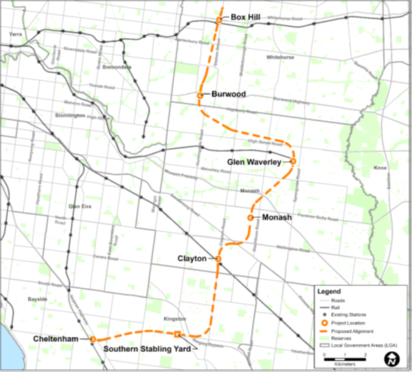Figure 1: Location of the six stations and the stabling yard for Suburban Rail Loop Stage One

