This version of Planning Practice Note 11: Applying for a planning permit under the flood provisions has been prepared for use with screen reader software. The printed publication may contain various photographs, captions and design features that have been necessarily omitted from this version. In other respects this document contains identical text to that in the PDF version of the document which is available at www.delwp.vic.gov.au/planning

Planning Practice Note 11
Applying for a planning permit under the flood provisions

August 2015

This practice note has been prepared in conjunction with Melbourne Water as a guide for councils, referral authorities and applicants.
This practice note provides guidance about making an application for a planning permit where flooding is a consideration and explains how an application will be assessed.
This practice note is one of two practice notes on planning for flooding.
The other is Planning Practice Note 12: Applying the Flood Provisions in Planning Schemes – A guide for councils which provides guidance about applying the flood provisions in planning schemes including the preparation of policy, identifying land affected by flooding, preparing a local floodplain development plan and the application and operation of the flood provisions.
Flooding results in significant financial cost and personal hardship for the community.
“The long term average of flood damage in Victoria is estimated at $350 million per annum. This includes both direct physical damage to properties and assets and indirect damage arising from disruption of normal social and economic activities.” (Source: Review of the 2010-11 Flood Warnings & Response, Final Report by Neil Comrie AO, APM, 1 December 2011).
Flood risk must be considered in planning decisions to avoid intensifying the impact of flooding through inappropriately located uses and developments. Areas affected by flooding should be identified on the planning scheme maps and appropriate controls on the use and development of land introduced through the use of the flood zone and overlays in the VPP. Local floodplain development plans should also be prepared and incorporated into the planning scheme to guide decision-making on applications for development on land in the flood zone or overlay.
Floodplains are natural water storage areas which contain depressions through which water flows continuously or intermittently. They include wetlands, swamps, billabongs, meanders and anabranches. Historically, floodplains have attracted development and rural pursuits because they can be attractive places in which to live and their fertility favours agriculture. They also provide environmental benefits as they support plants and animals, preserve aquatic habitat, trap sediments, recycle nutrients and maintain water quality.
In some parts of Victoria there are still considerable pressures to subdivide and develop floodplains for urban and rural residential uses. The redevelopment of sites in established urban areas has also made it necessary to adopt stringent measures to minimise flood risk.
Land use planning is one mechanism that is used to minimise the risk of flooding to life and property. It is also a means of protecting the environmental values of the floodplain as part of an overall catchment strategy.

Abbreviations
ARI: Average Recurrence Interval
CMA: Catchment Management Authority
DELWP: Department of Environment, Land, Water and Planning
DFE: Design Flood Event
EPA: Environment Protection Authority
FMA: Floodplain Management Authority
FO: Floodway Overlay
LPPF: Local Planning Policy Framework
LSIO: Land Subject to Inundation Overlay
MSS: Municipal Strategic Statement
NPL: Nominal Protection Level
PMF: Probable Maximum Flood
SBO: Special Building Overlay
UFZ: Urban Floodway Zone

What are the flood provisions?
The flood provisions include:
- the State Planning Policy Framework (Clause 13.02 – Floodplains)
- the Local Planning Policy Framework (MSS and local planning policy where relevant)
- Urban Floodway Zone (Clause 37.03)
- Floodway Overlay (Clause 44.03)
- Land Subject to Inundation (Clause 44.04)
- Special Building Overlay (Clause 44.05)
- Decision guidelines (Clause 65)
- Referrals (Clause 66)

SPPF and LPPF
The SPPF provides the broad framework for the integration of flood policy and provisions into the planning scheme. It provides guidance on how land affected by flooding should be treated in planning schemes and in planning decisions. Flood risk must be considered when decisions are made about the use and development of land. If accurate flood information is available, the level of flood risk should be reflected in the type of flood provisions that have been applied to the land. Where accurate flood information is not available, but the land is known to be subject to inundation, flood risk should still be considered in decision-making.
The SPPF specifies particular uses that should not be allowed in floodplains, such as emergency facilities, and developments and uses which involve the storage of hazardous materials associated with industrial or agricultural uses.
In the LPPF, the MSS may highlight local flooding issues identified in the Regional Catchment Strategy, any floodplain management plans developed by the catchment management authority and the council’s objectives and strategies for flooding. Councils may also use a local planning policy for flooding to guide decision-making on applications for planning permits in flood affected areas.

Flood zone and overlays
Within a planning scheme, every parcel of land is assigned a zone and may also have one or more overlays. For example, a property may be in a General Residential Zone with a Heritage Overlay over the whole of the land and an SBO over part of the land. In this case, only development on that part of the land within the SBO needs to comply with the provisions of the SBO. Obviously, the provisions of the General Residential Zone and the Heritage Overlay also need to be complied with.
Each of the flood provisions provides differing degrees of flexibility for the development of flood-affected land directly related to the flood risk.
The zone or overlay will specify whether a permit is required for a particular use or development, including the construction of buildings or carrying out of works, or subdivision of land. In weighing up whether a planning permit should be granted for a development, the council needs to consider a range of matters, such as the requirements of any local floodplain development plan. The ‘Guidelines for development’ included in this practice note can also assist in understanding development requirements for flood-affected land (such as building floor levels), as well as the types of use and development that should not be encouraged in areas of potentially high flood risk.
The Building Regulations 2006 also include flood-related responsibilities for councils such as the assessment of the flood risk of a site subject to inundation, and the setting of minimum floor levels in consultation with the relevant floodplain management authority. These requirements should be known at the time a planning permit application is being prepared.

The Urban Floodway Zone
The UFZ applies to mainstream flooding in urban areas where the primary function of the land is to convey active flood flows. It also applies to urban floodway areas where the potential flood risk is high due to the presence of existing development or pressures for new or more intensive development. Unlike the overlays, the UFZ controls land use as well as development, with land use being restricted to low intensity uses such as recreation and agriculture. Development is generally not encouraged in the UFZ.

The Floodway Overlay
The FO applies to mainstream flooding in both rural and urban areas. These areas convey active flood flows or store floodwater in a similar way to the UFZ, but with a lesser flood risk. The FO is suitable for areas where there is less need for control over land use, and the focus is more on the control of development. Particular types of development are not encouraged in floodway areas, however, as this overlay is for rural as well as urban application, some buildings and works associated with low intensity uses (such as agriculture) may be permitted. Key considerations include whether the development will obstruct flood flows or increase flood risk.

The Land Subject to Inundation Overlay
The LSIO applies to mainstream flooding in both rural and urban areas. In general, areas covered by the LSIO have a lower flood risk than UFZ or FO areas. The LSIO can also be used as an interim measure to identify flood-affected areas where detailed information to define the floodway is not available.

The Special Building Overlay
The SBO applies to stormwater flooding in urban areas only. With the redevelopment of existing urban areas and the proposed development of new areas, there is growing pressure to develop within overland flow path areas. The purpose of the SBO is to set appropriate conditions and building floor levels to address the flood risk and to ensure that flood waters are not obstructed or diverted by development.
The Guidelines for Development in Flood-prone Areas (2007) prepared by Melbourne Water Corporation apply to development in flood-prone areas throughout the Melbourne metropolitan region.

Decision guidelines
Clause 65 of the planning scheme extends the consideration of flood issues to all planning permit applications regardless of whether the site is affected by a flood zone or overlay. Clause 65 requires that for the approval of an application or plan, the council must consider, among other things, the degree of flood risk associated with the location of the land and the use, development or management of the land so as to minimise flood risk.
In addition to Clause 65, the flood zone and overlays contain their own decision guidelines that the council must consider when assessing an application. The LSIO and SBO contain more detailed decision guidelines in the absence of the requirement for a flood risk report.

What activities require a permit in flood-affected areas?

Land use
Increasing the intensity of land use or a change in land use can increase flood risk, therefore in areas of highest flood risk and with a potential for land use intensification, it may be appropriate that land use is restricted. As with any other zone, the UFZ controls the use of land in identified floodway areas. In all other circumstances, the zone operating with the flood overlay will control land use.

Buildings and works
Structures such as dwellings, commercial and industrial buildings, earthworks, levees, fences, roads and channel embankments can interfere with the free passage of floodwater resulting in substantial flood damage and flood risk. They may also increase the number of people living in the floodplain. For these reasons, most buildings and works require a permit under the flood zone and overlays provisions. Some buildings may not be allowed or may need to be redesigned or relocated to meet the objectives of the flood provisions. Building floor levels should be consistent with the Building Regulations 2006.
Some buildings and works are exempt from requiring a permit. This includes flood mitigation works carried out by the responsible authority or floodplain management authority, underground services and open-type fencing that is unlikely to interfere with flood flows. The schedule to an overlay may also be used to exempt certain buildings and works.
The SPPF requires that emergency and community facilities (including hospitals, ambulance stations, police stations, fire stations, transport facilities, communications facilities, community shelters and schools) be located outside the 100-year ARI floodplain and, where possible, above the PMF level.

What is a 100-year ARI flood?
The 100-year ARI flood is a flood which occurs on average once every 100 years. It is used as the basis for defining the flood zone and overlays in planning schemes, for declaring flood levels and flood areas under the Water Act 1989 and setting minimum building floor levels under the Building Act 1993.
Larger floods are possible. The PMF is the maximum possible extent and height of flooding and defines the largest flood that could conceivably occur at a particular location and normally covers a greater area than the 100-year ARI flood.

Earthworks
Earthworks include land forming, laser grading, levee banks, lanes, tracks, aqueducts, surface and subsurface drains and any associated structures.
Significant earthworks, including levees and raised roads, are inappropriate for floodway land. The construction of inappropriate earthworks can obstruct or divert flood flows, reduce natural flood storage areas, impact on environmental values and increase flood flows, flow velocities and flood damage. In rural areas, private levees may be constructed without regard for the potential effects of these works beyond the farm boundaries. In urban areas, earthworks can interfere with local drainage and divert floodwater onto other properties.
As earthworks are a type of ‘works’ under the planning scheme, a permit is required for earthworks associated with a use that requires a permit under the zone or an overlay (including the flood zone and overlays). A planning permit may also be required for earthworks under a specific requirement in the Green Wedge Zone, Green Wedge A Zone, Rural Living Zone, Rural Conservation Zone, Farming Zone or Rural Activity Zone.

Subdivision
A permit is required for subdivision under the flood zone and overlays. Where possible, floodway land should be maintained in large parcels and not be fragmented by multiple property boundaries. The subdivision provisions aim to achieve this objective by not allowing new lots to be created in the UFZ or FO, other than to realign the boundaries of existing lots.
The creation of lots that are wholly within the UFZ or FO is also discouraged.
Subdivision provisions for the LSIO and the SBO are less stringent than for floodway areas. However, the intensification of development in flood storage areas or natural habitats should be discouraged. Any subdivision that could result in long-term intensification of development in flood-storage areas should be carefully assessed.

Making an application for a planning permit
Before an application is prepared, check the application requirements in the flood zone or overlay that applies to the land.
These requirements must be met for the council to properly consider the application.
As with any planning permit application, the application should address the SPPF, MSS and any relevant local planning policy. It should also be accompanied by the following information where relevant to the particular application:
- the existing and proposed use of the site
- the number of people expected on-site during normal operations
- the existing natural surface levels and proposed finished surface levels
- the existing and proposed buildings, including floor levels
- the existing and proposed earthworks, including crest levels
- the existing and proposed roads, including centre lines, kerbs, footpaths and crest levels
- the existing and proposed drainage systems, including waterways, pipelines, drains, culverts and bridges
- details of any other physical features that may affect flows, such as levee banks, fences and retaining walls.
Information about the properties surrounding the site and about important physical features upstream and downstream of the site may also be useful for the council and floodplain management authority.

Local floodplain development plan
A feature of the flood provisions is the ability for a local floodplain development plan to be prepared by the council (in consultation with the floodplain management authority). A local floodplain development plan is a set of requirements and guidelines for development in a particular area. If a local floodplain development plan exists for the area and has been incorporated into the council’s planning scheme, an application must be consistent with the plan.

Preparing a flood risk report
If a local floodplain development plan has not been incorporated into the planning scheme, a flood risk report must be prepared by the applicant if the land is in the UFZ or the FO and lodged with the planning permit application.
A flood risk report is a detailed flood assessment supporting a particular development proposal. Its purpose is to provide information about the subject property, the proposed development and the relevant flood impacts. It should also justify whether the proposed development is compatible with the flood risk, in terms of the risk to the development itself and the risk transferred by the development to other parts of the floodplain.
A flood risk report must be prepared by the applicant to the satisfaction of the council and should address the following matters where relevant to the particular application:
- details of the proposed development and site conditions
- the flood extent, flood levels and flow directions relevant to the site
- the frequency, duration, depth and velocity of flooding and flood warning time applicable to the development site and access way
- the susceptibility of the development to flood damage
- the potential flood risk to life, health and safety
- the effect of the development on reducing flood storage and on redirecting or obstructing floodwater, stormwater or drainage water
- the effect of the development on environmental values, for example, flora, fauna and wetlands
- whether the proposed development could be located on flood-free land or land with a lesser flood hazard.
When preparing the report, an applicant should use all available flooding information from the council and floodplain management authority applicable to the site and local area. The level of detail required in a flood risk report will vary from case to case, and this should be established with the council at the outset.
Preparing a flood risk report is not intended to be an onerous requirement. Rather, the level of information needs to be matched to the complexity of the proposal and the flood risk issues.
As the floodplain management authority is generally the holder of most information on flooding, it is important that the council consults with the floodplain management authority on the level of information necessary for a flood risk report. To streamline the approvals process, the council and floodplain management authority should work closely together so that both understand and agree on the level of reporting required for different classes of applications or for an individual application. This should then be clearly articulated to the applicant.
In the case of a small development, such as a dwelling or minor subdivision, the report can be simple and concise and may be prepared by the landowner. For a larger development, a more detailed report will be required and specialist advice may need to be sought.
An example of a simple flood risk report for a dwelling on a rural property is attached.

How will a planning permit application be assessed?
The Process Diagram (Figure 1) shows the process for assessing a planning permit application under the flood provisions for council and the floodplain management authority as referral authority.

Referral of applications
Applications must be referred to the floodplain management authority under section 55 of the Planning and Environment Act 1987, except where there is an exemption in the schedule to an overlay, or where the council has made a written agreement with the floodplain management authority regarding conditions or requirements for particular types of development. An exemption or agreement may be appropriate in the following situations:
- where a local floodplain development plan has been prepared and provides sufficiently explicit guidelines for development
- in those LSIO areas which act as flood fringe and where there is potential for only a minor infill development, subject to minimum floor level requirements
- in those LSIO areas where it can be agreed that development is unlikely to have a significant impact on flood risk, flood storage and the environment.
Whenever necessary, particularly along rivers that flow through more than one catchment management area or on the State border at the Murray River, a coordinated approach to referrals is encouraged.

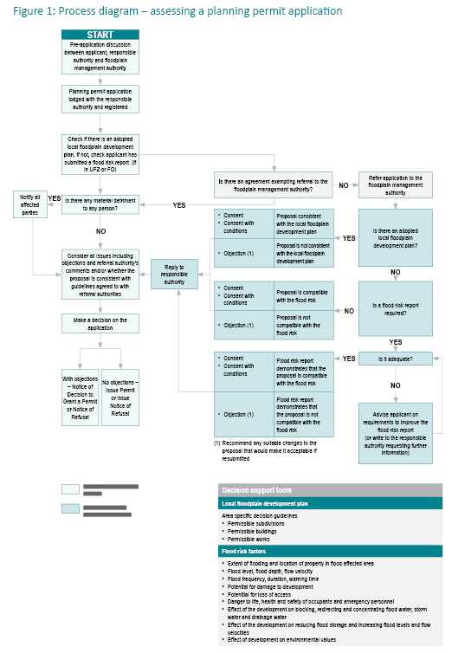

Making a decision
A council or floodplain management authority should consider the following decision guidelines when deciding or commenting on an application:
- A development must be consistent with:
- the SPPF (Clause 13.02)
- any flood-related statements made in the MSS (Clause 21) and local planning policies (Clause 22) of the planning scheme
- any flood-related guidelines incorporated in the planning scheme
- any regional catchment strategy or floodplain management strategy adopted by the CMA
- any local floodplain development plan adopted by a council
- any other development guidelines agreed to by the council and the floodplain management authority.
- The potential impact of an extreme event larger than the 100-year ARI flood on life, health, safety and damage.
- Emergency facilities should be located above the 100-year ARI flood level, and preferably above the PMF level.
- The possibility of relocating that development to land which is flood-free or which has a lesser risk.
- Residential, commercial and industrial buildings are not generally an appropriate development on floodway land in view of their potential for flood hazard and for obstruction of flood flows.
- Significant earthworks, such as levee banks, channel banks and raised roads are not appropriate on floodway land in view of their potential for obstruction of flood flows.
- The incremental long-term effects of developments. While a single development may not cause a significant change, the cumulative effect of several similar developments may be substantial.
- The design of buildings should adopt flood-proofing measures that minimise the physical effects of flooding on the building structure and its contents.
- Activities that generate or store significant quantities of nutrients or noxious or hazardous materials should not be located on land subject to inundation; for example, sewage treatment and pumping plants, intensive animal industries, sanitary landfill depots and food-processing plants.
- A development should be refused if it is likely to cause an unacceptable increase in flood risk in the following situations:
- it is likely to result in danger to the life, health and safety of the occupants due to flooding of the site
- it relies on low-level access to and from the site
- it is likely to increase the burden on emergency services and the risk to emergency personnel
- it is likely to increase the amount of flood damage to public or private assets
- it is likely to raise flood levels or flow velocities to the detriment of other properties. Potentially adverse effects on upstream and downstream areas must be identified and addressed. Development should not transfer flooding problems from one location to another
- it is likely to obstruct flood flows or reduce natural flood storage. The capacity of land subject to inundation to convey and store floodwater must be maintained
- it is likely to be detrimental to natural habitats, waterway stability, water quality or sites of significance
- if any subdivision, development or redevelopment is likely to increase the number of buildings located in a floodway area.

Permit conditions
The council and the floodplain management authority (as the referral authority) may set permit conditions. In determining appropriate and reasonable conditions, any relevant guidelines developed in the local floodplain development plan should be taken into account. Permit conditions may address:
- the location and extent of buildings and works
- the maximum height and extent of landfill and earthworks, including levees
- minimum building floor levels
- floor level and size requirements for building extensions
- flood-proofing measures for buildings, such as type of materials, method of construction and flood gates
- restrictions on storage of goods or materials that may create pollution or a floating hazard during floods
- land drainage and effluent disposal requirements
- requirements for access roads and tracks
- measures required to offset environmental impacts
- tree planting and removal of vegetation
- endorsement on subdivision plans that all or parts of the property are subject to inundation.
Remember that conditions should be enforceable and relevant to the proposal.

General guidelines for development
General guidelines for development that reflect current best practice in floodplain management are attached. The guidelines are intended to assist the council and floodplain management authority when deciding on proposals for subdivisions, buildings and works or in developing local floodplain development plans.
To maintain consistency with the requirements of the Building Act 1993, the guidelines also include minimum floor level and other associated building guidelines.

More information

Planning scheme information
For information on a planning scheme, or on how to make a planning permit application for a change of land use, buildings, works or subdivision, contact the local council, or visit the department’s website at www.delwp.vic.gov.au/planning.

Flood information and advice
For information on flood risks and other flooding matters in an area, contact the relevant floodplain management authority.

Regional Victoria
Ten FMA’s operate across Victoria comprising nine CMA’s within rural provincial areas of Victoria and Melbourne Water within the Port Phillip and Western Port Catchment Management Region. They are: Corangamite CMA, East Gippsland CMA, Glenelg Hopkins CMA, Goulburn Broken CMA, Mallee CMA, North Central CMA, North East CMA, West Gippsland CMA, Wimmera CMA, and Melbourne Water.
For more information see the department’s Catchment Management Authorities web page.

Greater Melbourne area
Contact the relevant local retail water company City West Water, South East Water, or Yarra Valley Water first as they issue property information statements, including flood risk information, on behalf of Melbourne Water.
For further flood information and advice, contact the Land Development Team of Melbourne Water on (03) 9679 7517.

Flood Risk Report
This is a sample flood risk report prepared by an applicant. The proposal may or may not be agreed to by the council or floodplain management authority. In this case, because suitable sites are available which are not subject to flooding, the applicant may be asked to amend the application by relocating the proposed house site to land outside the LSIO.

PROPOSED DWELLING AND ACCESS TRACK

LOT 1, CA 18B, BROWNS ROAD, JOHNSVILLE

Proposed development
The land is located on the north side of Browns Road, 500 m east of Cross’s Road, and is bounded to the north by the Yellow River. The land is 140 hectares in area and is vacant rural land currently used for sheep grazing. The site plan shows the location of the property and the site of the proposed dwelling and access track from Browns Road. It also shows natural ground levels in metres AHD, and the designation of the Floodway Overlay and the Land Subject to Inundation Overlay on the land under the Gumnut Planning Scheme.
The proposed house site is located in the LSIO area.
The proposed brick-veneer dwelling will be 11 m x 20 m and located on an earth-fill pad. The access track will be constructed from crushed rock at ground level. A 150 mm diameter pipe culvert will be placed under the access track where it crosses a small depression.

Flood conditions
About 70 per cent of the property is subject to flooding from the Yellow River. The floodplain management authority has advised that the relevant 100-year ARI flood level for the property is 138.2 m AHD. During times of flood, flood flows from the Yellow River cross the property from west to east, first filling a number of small depressions and then becoming more widespread.
The northern portion of the property near the river floods about every five years. The higher parts of the property, closer to Browns Road (and including the proposed house site) have only flooded twice in the past 50 years. In the 1993 flood, land near the river was under more than a metre of water and the water was flowing quite quickly, while the floodwater was shallower and slower away from the river.
Flood warning times for this part of the river are fairly long and are adequate to respond to an approaching flood. In 1993, flood warnings issued by the Bureau of Meteorology for Johnsville, some 4 km upstream of the property, predicted major flooding eight hours before the flood peak arrived.
The surveyed ground levels show that the 100-year ARI flood depth above natural ground level at the house site is 0.5 m and reaches up to 0.7 m along the access track at the culvert crossing.

Flood impacts
At the house site, a building pad will be raised above ground level up to the 100-year ARI flood level, and the dwelling floor level will be 300 mm above flood level (138.5 m AHD). Because the house will be raised above the flood level and the floodwater will be shallow and flowing slowly, any flood damage to the house will be minimal.
The maximum flood depth over the access track will be 0.7 m, which is not difficult for a four-wheel-drive vehicle to pass through.
There are no special environmental assets in this part of the floodplain and the development should have no environmental impacts.

Flood Risk Report Site Plan
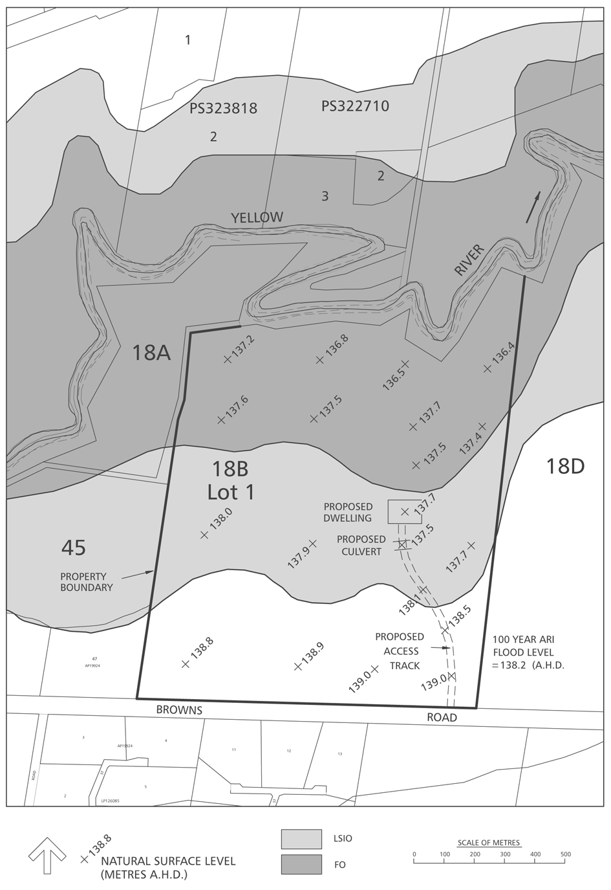

Guidelines for development
These guidelines reflect current best practice for floodplain development in Victoria and are intended to assist councils and floodplain management authorities when deciding on proposals for buildings, works and subdivision where flooding is an issue.
They are general guidelines only and should be tailored or developed further for application to a specific area. They could be included in a local planning policy or a local floodplain development plan where appropriate.
Guidelines for Development in Flood-prone Areas (2007) prepared by the Melbourne Water Corporation, Waterways and Drainage assists councils, Melbourne Water and proponents in achieving best practice outcomes for developments on land affected by overland flows associated with the underground drainage system. These guidelines should be applied to development in overland flow paths throughout the Melbourne metropolitan region. Land affected by overland flows is usually identified in the planning scheme by a Special Building Overlay.
For development in floodplains (other than stormwater overland flow paths identified by the SBO) in the Melbourne metropolitan area and in regional Victoria, the guidelines below should apply.

Building floor levels
Regulation 802 of the Building Regulations 2006 requires the consent of the council for a building permit if a site is subject to inundation. The council must specify a minimum floor level for the proposed building in consultation with the relevant floodplain management authority and assess the flood risk associated with the site. The council must not consent to a permit if it believes that there is a likely danger to the life, health and safety of the occupants of the building due to flooding of the site.
The council must specify a minimum floor level with a freeboard margin of at least 300 mm above the 100-year ARI flood level (this minimum floor level is referred to as the ‘nominal protection level’ or NPL), unless the floodplain management authority consents to a lower level. The regulations do not apply to a Class 10 building (non-habitable garage, carport or shed), an unenclosed floor area of a building or an extension to an existing building which is less than 20m².

Floor levels for residential buildings
The guidelines below are intended as an overall guide and are minimum requirements. Each council and floodplain management authority should agree on their own local guidelines which reflect the severity of flooding and the nature of surrounding development. For example, more stringent requirements should be applied in floodway areas, where the flood risk is high and in urban areas where additional building development can impact on neighbouring properties.
- The minimum floor level for any new building should always be set to at least the NPL in order to minimise flood damage to the building and its contents and flood risk to its occupants. This also applies to the complete replacement of an existing building.
- The minimum floor level of any extension to an existing building located on floodway land must be the NPL unless the floor area of the extension is less than 20 m2. The combined floor area of multiple extensions below the NPL must not exceed these limits.
- The minimum floor level of any extension to an existing building located on land outside the floodway must be the NPL, unless the floor area of the extension is less than 40 m2 and is less than 50 per cent of the existing floor area. The combined floor area of multiple extensions below the NPL must not exceed these limits.
- The floodplain management authority must consent to any floor levels being set below the NPL.
- When issuing a permit for a building with a minimum floor level set below the NPL, a council should advise the applicant of the risks associated with over-floor flooding.
- The location, floor level and design of any new building or extension should consider adequate drainage for the site and any adverse hydraulic effects on neighbouring properties.

Commercial and industrial buildings
Many applications for commercial and industrial development and redevelopment will involve large floor areas with a significant potential for flood damage and obstruction of flood flows. Requests will be made to relax the minimum floor level for this type of building. The following guidelines should be applied:
- The floodplain management authority must consent to any floor levels being set below the NPL.
- The preferred minimum floor level is the NPL in order to minimise flood damage to the building and its contents.
- If it is not practical to set the floor level at the NPL, the minimum floor level should be set at or above the 100-year ARI flood level with flood proofing provided up to the NPL. This should be the minimum standard for commercial buildings.
- For some industrial buildings, floor levels below the 100-year ARI flood level may be considered in special circumstances, with flood proofing provided up to the NPL where practical. In some cases, flood proofing for industrial buildings is not practical, for example, in buildings with large openings or with metal cladding.
- Floor levels lower than the NPL can be considered for the following situations:
- where setting a floor level at the NPL may be incompatible with existing adjacent building floor levels, footpath levels and vehicle access
- where it can be clearly demonstrated that the use of the building (in terms of the building materials, type of contents, practices undertaken, safety of occupants, and demands on emergency services) would not result in significant flood risk or damage
- where any future changes to the proposed building use are not likely to increase the flood risk or damage potential.
- When issuing a permit for a building with a minimum floor level set below the NPL, the council should advise the applicant of the risks associated with over-floor flooding. The council may also request the applicant to prepare a flood response plan that sets out appropriate actions to minimise flood damage, risk to occupants, and demands on emergency services.
- The location, floor level and design of any new building or extension should consider adequate drainage for the site and any adverse hydraulic effects on neighbouring properties. Where possible, the building should be aligned to minimise the obstruction to flood flows.
- Flood markers should be installed inside and outside the building showing the height of the 100-year ARI flood and other historic floods.

Flood-proofing
Flood-proofing involves a number of measures which can be incorporated into the design, construction and alteration of a building in order to reduce damage caused by the contact of floodwater with the building structure or its contents. Floodproofing measures should include:

Residential buildings
- Water-resistant building materials should be used for foundations, footings, floors and walls, and should be provided up to the NPL.
- Electrical fittings should comply with any requirements of the relevant power authority and should preferably be fixed above the NPL.
- Sewer fixtures should comply with any requirements of the relevant water authority and inlets should be fixed above the NPL.
- Windowsill levels should be set above the NPL.

Commercial and industrial buildings
- All the flood-proofing measures listed above for residential buildings should be provided where possible.
- Doors and other openings should be protected with effectively sealed gates, shutters or drop-boards and installed up to the NPL where possible.
- Details of proposed flood-proofing measures should be included in the building application.
- All flood-proofing measures should be maintained and tested for operation by the owner.
- Adequate storage areas and shelving should be provided above the NPL for the storage of valuable goods and hazardous materials.

Freeboard
Under the building regulations, the nominated freeboard margin for building floor levels is 300 mm above the 100-year ARI flood level. This margin is intended as a safety factor to account for uncertainties in flood levels and for wave action. A larger freeboard margin (perhaps 450 mm or 600 mm) is appropriate in some situations where, for example, the reliability of flood information is poor, the land is in a high-risk floodway, the flood profile is steep, or additional allowance is required for long-term climatic effects. The size of the freeboard margin should reflect the level of accuracy and confidence of the flood level prediction. In the Gippsland Lakes area, for example, the greenhouse effect on rising sea levels indicates that an additional freeboard margin should be considered.

Estimation techniques
In some cases there may be no available flood-level information and the floodplain management authority must assist the council to determine an appropriate flood level for setting a minimum floor height. This situation often arises in rural areas where no previous flood investigations have been carried out. In the absence of detailed information, the floodplain management authority may use best-estimate techniques to approximate the average flood depth for well-defined riverine floodplains. The relevant CMA may be able to assist.
For rural areas which are subject to shallow and widespread overland sheet flooding, an average floor height above the general surrounding ground surface level can be adopted; for example, a height of 450mm to 600mm depending on the perceived average depth of flooding.

© The State of Victoria Department of Environment, Land, Water and Planning 2015
This work is licensed under a Creative Commons Attribution 4.0 International licence. You are free to re-use the work under that licence, on the condition that you credit the State of Victoria as author. The licence does not apply to any images, photographs or branding, including the Victorian Coat of Arms, the Victorian Government logo and the Department of Environment, Land, Water and Planning (DELWP) logo. To view a copy of this licence, visit http://creativecommons.org/licenses/by/4.0/
ISBN 978-1-74146-754-3 (pdf)
Disclaimer
This publication may be of assistance to you but the State of Victoria and its employees do not guarantee that the publication is without flaw of any kind or is wholly appropriate for your particular purposes and therefore disclaims all liability for any error, loss or other consequence which may arise from you relying on any information in this publication.
Accessibility
If you would like to receive this publication in an alternative format, please telephone DELWP Customer Service Centre 136 186, email customer.service@delwp.vic.gov.au, via the National Relay Service on 133 677 www.relayservice.com.au. This document is also available in accessible Word format at
www.delwp.vic.gov.au/planning

DOCUMENT ENDS

