Draft Preliminary Land Use Vision

Latrobe Valley Regional Rehabilitation Strategy

Public Consultation – What we’ve heard – Opportunities and options

October 2019

This version of the Draft Preliminary Land Use Vision for the Latrobe Valley Regional Rehabilitation Strategy has been prepared for use with screen reader software. The printed publication may contain various photographs, captions and design features that have been necessarily omitted from this version. In other respects, this document contains identical text to that in the PDF version of the document which is available at www.planning.vic.gov.au
If you would like to receive this publication in an alternative format, please telephone the DELWP Customer Service Centre on 136186, email customer.service@delwp.vic.gov.au, or via the National Relay Service on 133 677 www.relayservice.com.au.

Part 1: Context

1.1 Introduction

1.1.1 Purpose of the report
This report provides a Preliminary Land Use Vision for land use and development in the Latrobe Valley, as this region undergoes significant change over time through the closure and rehabilitation of the three major open-cut coal mines and associated power stations.
It has been prepared to inform land use options as part of the preparation of the Latrobe Valley Regional Rehabilitation Strategy (LVRRS), which is a central Victorian Government response to the Hazelwood Mine Fire Inquiry.
This Preliminary Vision provides a long-term land use planning outlook for coming decades for the rehabilitating the landscape of the Latrobe mine region. It will be used to develop a land use framework, which will be tested against geotechnical and water regional studies (currently underway) to inform and enable the best possible land use outcomes.
It is intended to provide a set of guiding directions for future land use and development, based on achieving positive social, economic and environmental outcomes.
The purpose of this report is to:
- Inform and contribute land use planning inputs to the Latrobe Valley Regional Rehabilitation Strategy (LVRRS) development
- Capture the results of stakeholder engagement activities in 2018 and 2019
- Reflect current economic development and land use planning strategies, such as Live Work Latrobe provide a context for land use planning issues of the coal mine land and surrounding areas.
The Vision will inform ongoing land use planning work, along with other LVRRS work streams, including:
- Geotechnical assessments
- Water assessments
- Mine rehabilitation plans.

1.1.2 Project Context
The Hazelwood Mine Fire Inquiry (HMFI) was announced immediately after the Hazelwood mine fire which along with other factors contributed to the Hazelwood mine and power station ceasing operations. The HMFI considered the context of Victoria’s and the Latrobe Valley’s bushfire vulnerability, and the fire risk posed by open cut brown coal mines.
The preparation of the Latrobe Valley Regional Rehabilitation Strategy (LVRRS) is a central Victorian Government response which seeks to examine and address some of the key knowledge gaps and unresolved issues identified through the Inquiry. Ultimately, the LVRRS seeks to set a safe, stable and sustainable landform for the Latrobe Valley coal mine voids and surrounding areas.
This Preliminary Land Use Vision process and report forms part of the investigation of future land use options, which may be implementable through rehabilitation of the Latrobe Valley mines.

1.1.3 Strategic Context
The Gippsland Regional Growth Plan (2014) was produced through a partnership between the Victorian Government and all local governments in Gippsland (including Latrobe City Council) and establishes strategic direction for growth and development across Gippsland.
The plan identifies future directions for Gippsland for the economy, environment and heritage, and regional infrastructure and Regional Infrastructure. Latrobe City is the major regional City in Gippsland with a key role as a service hub for the region and eastern Victoria.
Live Work Latrobe (2018) is a comprehensive and integrated strategic planning initiative prepared by Latrobe City Council, which seeks to make the most of the Latrobe City’s built and natural assets to create jobs, ensure that housing meets the needs of community and enable new investment opportunities.
The initiative encompasses three key land use strategies:
- Housing Strategy
- Rural Land Use Strategy
- Industrial and Employment Strategy.
Live Work Latrobe is proposed to be implemented into the Latrobe Planning Scheme via Planning Scheme Amendment C105. Neither Live Work Latrobe nor Amendment C105 seeks to substantially change planning controls affecting the coal mine licence areas.
Along with the shires of Baw Baw and Wellington the Latrobe City Council has been identified as an Economic Growth Zone. The government is supporting the transition of the region through joint projects to facilitate land use system changes and planning activities. The region is also supported by the Latrobe Valley Authority (LVA) which works to bring together Latrobe Valley locals, industry and government to build on the regions strengths.

1.1.4 Process
This report has been informed by a series of stakeholder and community engagement forums:
Community engagement
- Public consultation workshop (half day), Morwell, 24 May 2018;
- Public consultation workshop (evening), Moe, 6 August 2018;
- Public consultation workshop (evening), Traralgon, 13 August 2018;
- Public consultation workshop (evening), Morwell, 14 August 2018;
- Workshop with local secondary school students, September 2018.
Stakeholder engagement
- Stakeholder workshop: council officers and government stakeholders, 14 June 2018;
- Stakeholder workshop, industry and government stakeholders, 14 August 2018;
- Stakeholder workshops (two) attended by officers from the Department of Land, Water and Planning (DELWP), Latrobe City Council, the Victorian Planning Authority and the Latrobe Valley Authority, focussing on specific and detailed content and discussion, February 2019.
The feedback received at these workshops has been recorded and collated, and used in the development of the Preliminary Land Use Vision.
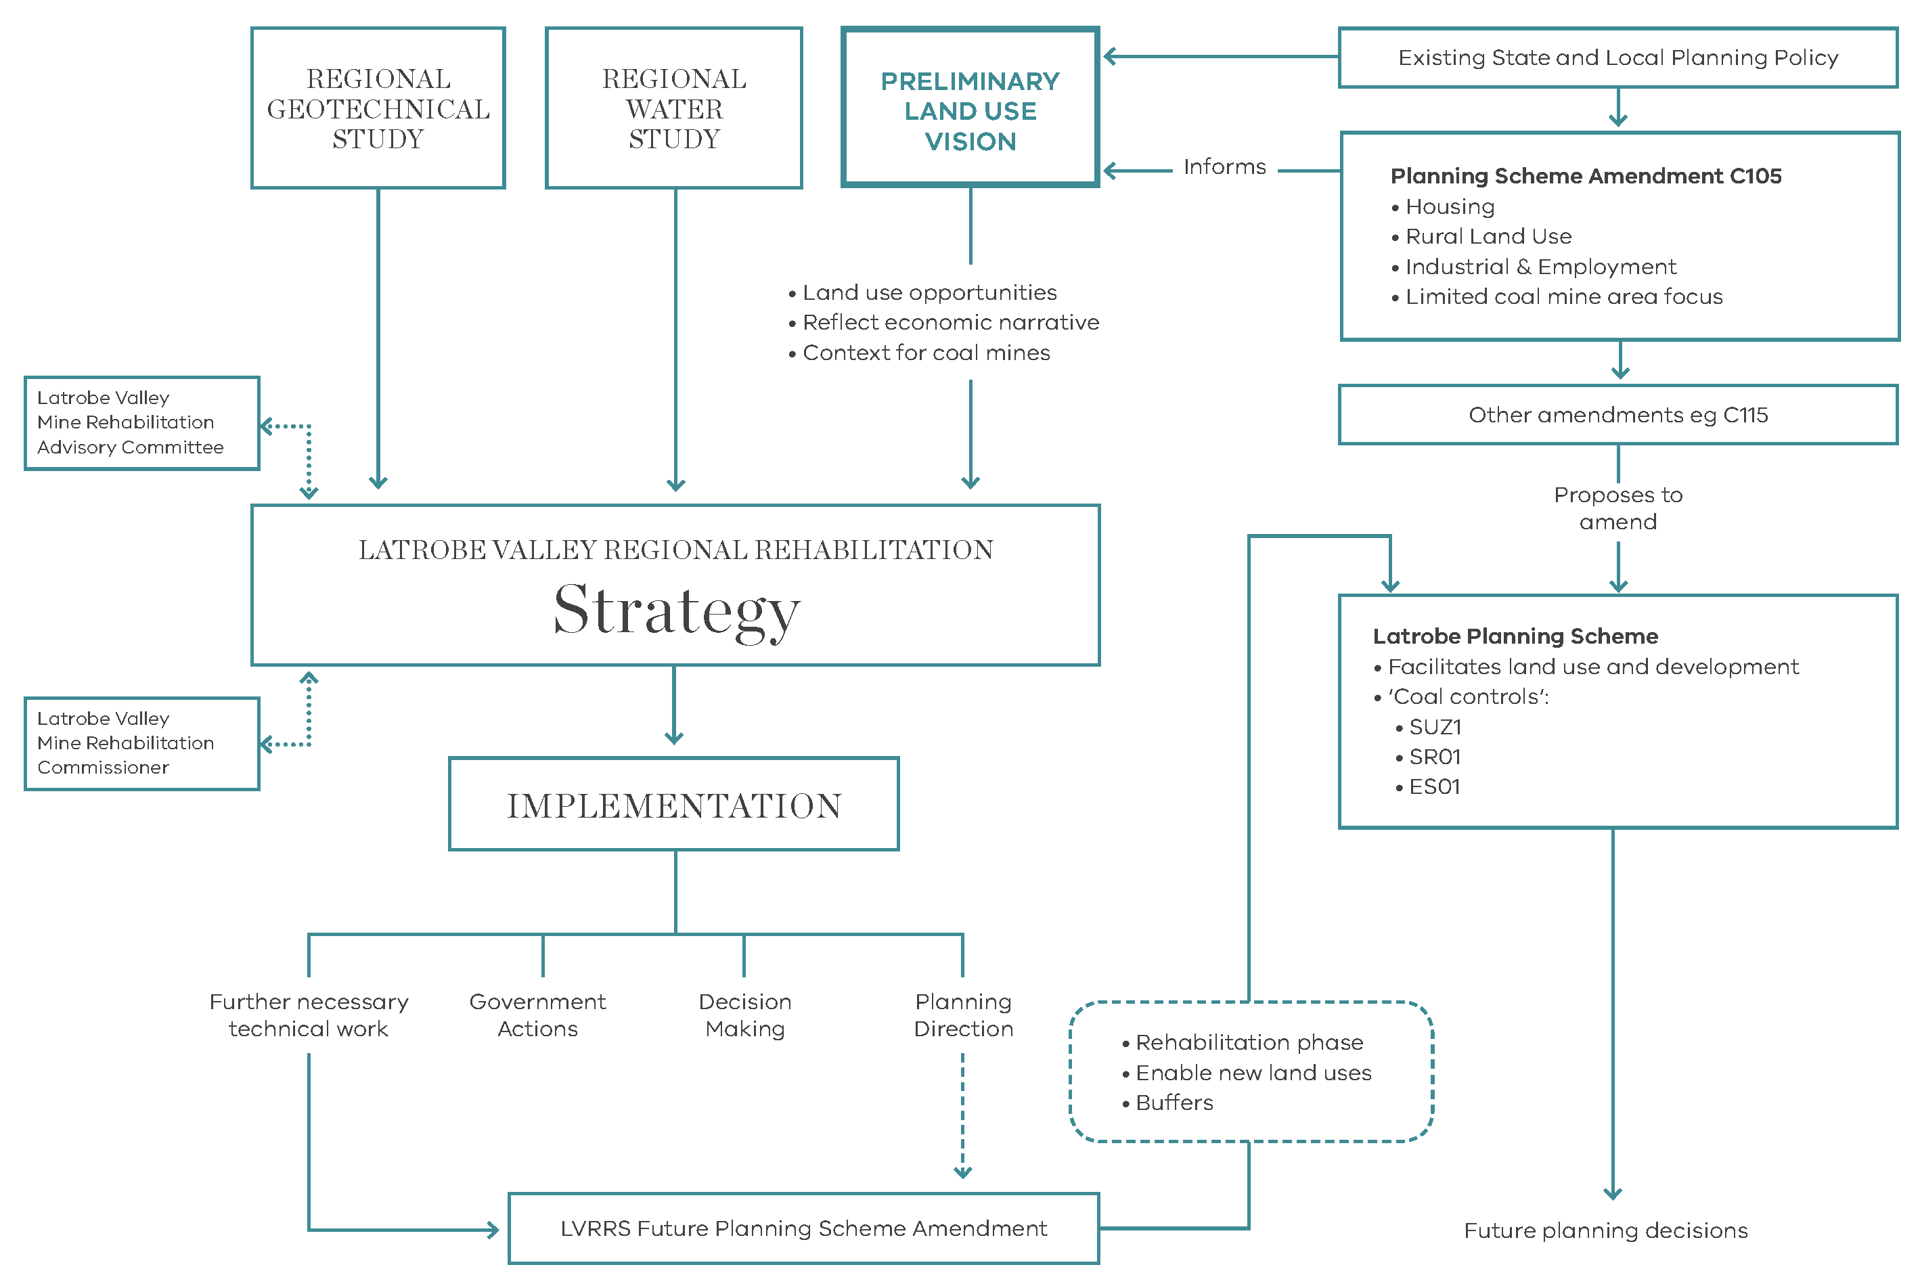

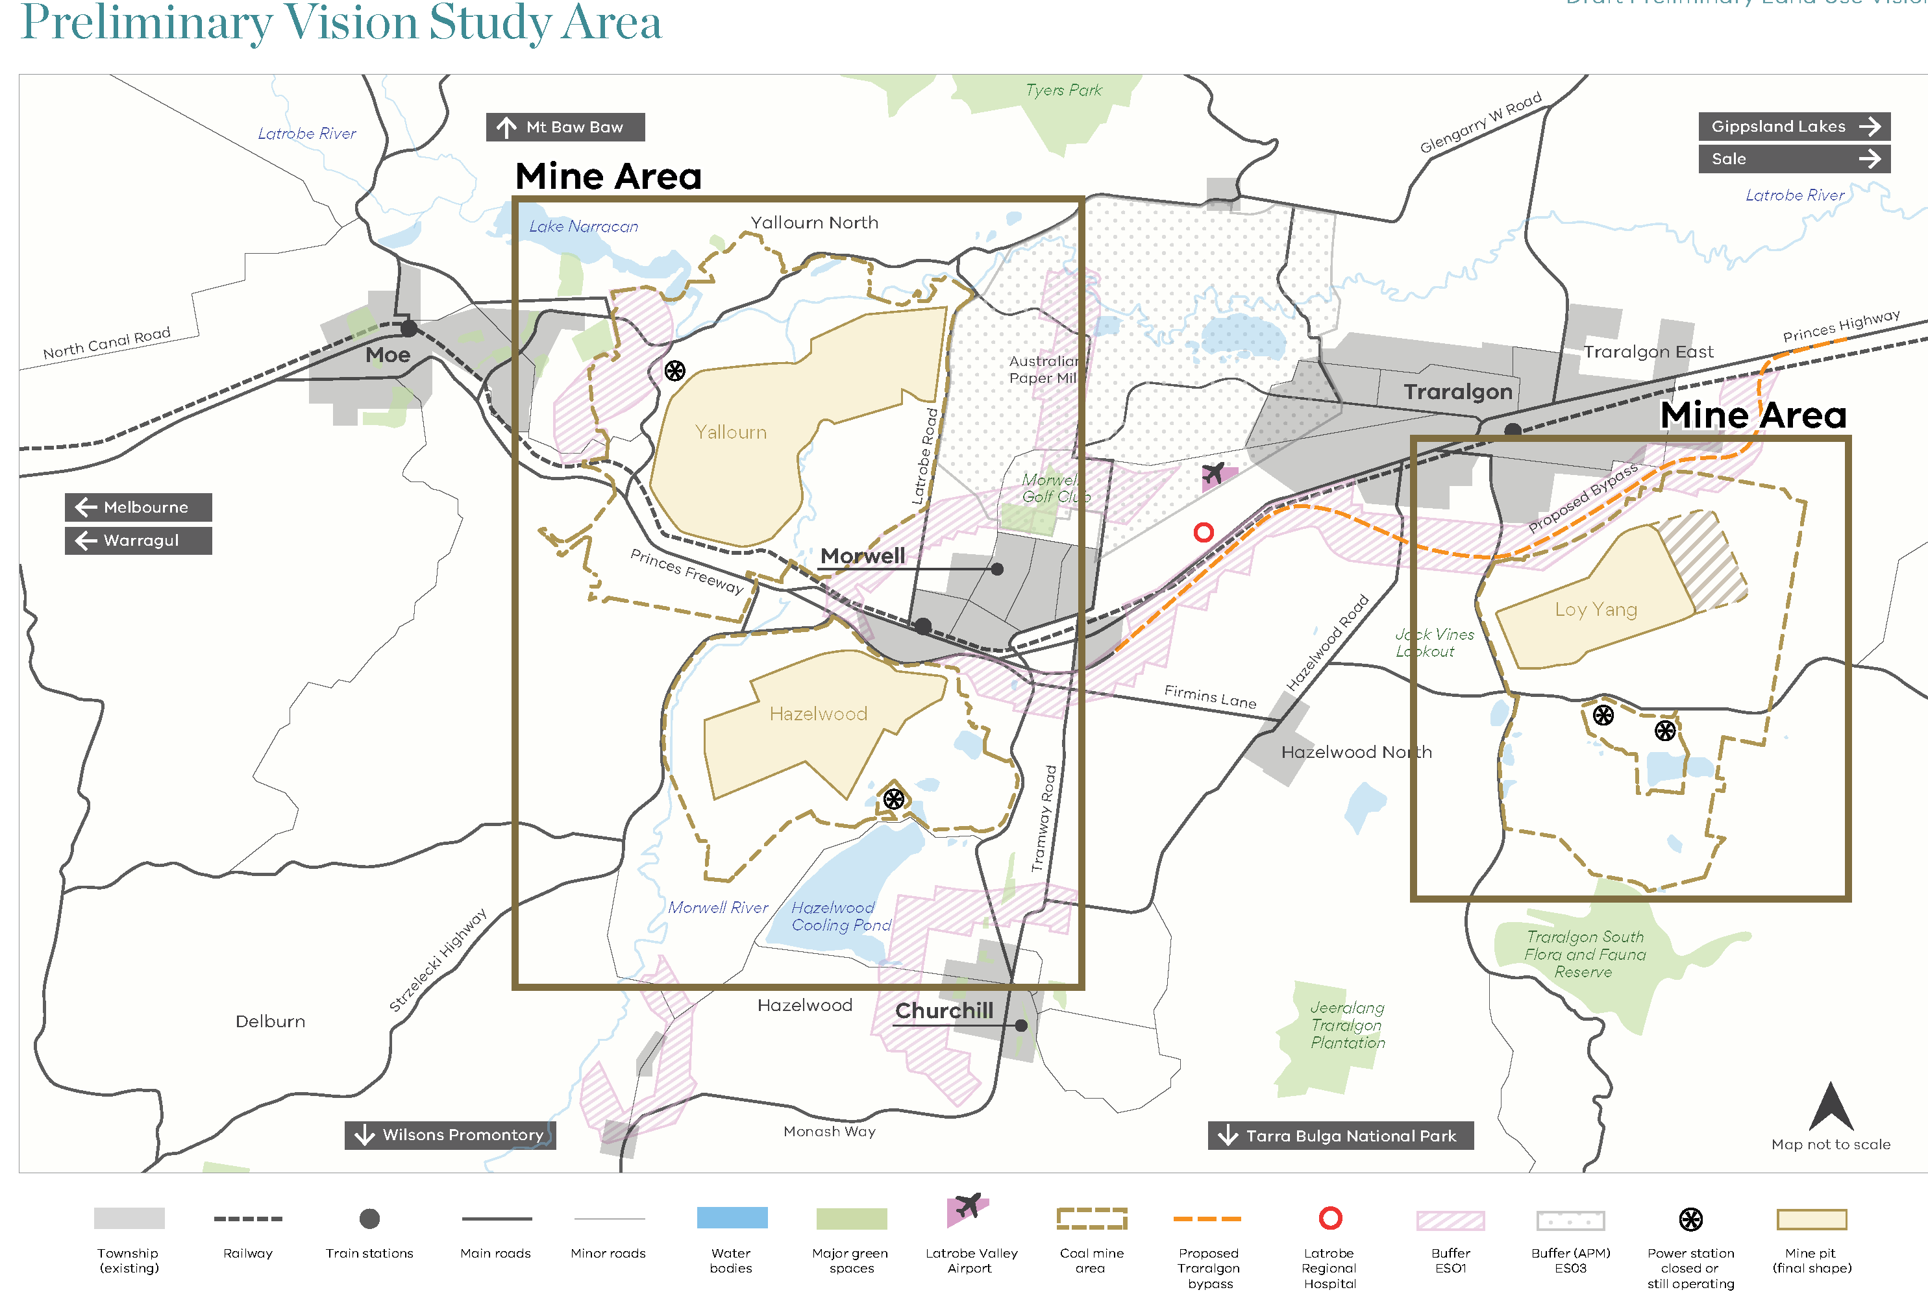

1.2 The Latrobe Valley Regional Rehabilitation Strategy
This Preliminary Land Use Vision forms part of the wider LVRRS, a Victorian Government initiative to plan for the rehabilitation of the region as the coal mines close incrementally over an extended period of time.
As part of the LVRRS process, a series of parallel studies into geotechnical and water conditions will be prepared in 2019 and 2020. These studies comprise detailed and complex analyses of future scenarios for rehabilitation of the mine pits, including as potential water bodies, to achieve a safe, stable and sustainable solution for each mine.
Several geotechnical studies are underway to ensure the safe, stable and sustainable rehabilitation of the mines and assess land movements that may impact infrastructure and assets.
Various water studies are also underway to test the feasibility of mine pit water bodies and investigate water availability and the use of water resources. These studies will assess the possible impacts of climate change and climate variability, along with water quality, ground water and surface water effects, and impacts on aquatic ecosystems and downstream water users.
The Preliminary Land Use Vision recognises that this major transition for the region has the potential to bring positive shifts in the local economy, stimulate growth and employment opportunities, and lead to improved amenity, increased tourism and changed visitation patterns, and other opportunities.

1.2.1 LVRRS Process
2016. Stage 1. Project initiation planning, stakeholder engagement, establishment of project team and governance.
2017. Stage 2. Review of existing conditions, including data availability, baseline conditions and knowledge gaps.
2018-19. Stage 3. Modelling and analysis, prediction of effects and assessment of impacts. Note: The Preliminary Land Use Vision is part of this stage and will be tested and resolved during Stage 4.
2019-2020. Stage 4. Integration of findings including cumulative impact and feasibility assessment.

1.3 Policy context
1.3.1 Safe, stable and sustainable
The Victorian Government is committed to ensuring the safe, stable and sustainable rehabilitation of the three Latrobe Valley open-cut coal mines. The government is working with the local communities near the mines, the mine operators and other stakeholders to establish a clear land use vision to help and realise opportunities for beneficial outcomes.

1.3.2 Energy
The government acknowledges that the Yallourn and Loy Yang power stations will continue to play important roles in providing power supply into the future. Hazelwood power station has ceased active operation and is now in a closure and rehabilitation phase. Plans for demolition of Hazelwood are being progressed.
While there may be a sense of loss and uncertainty with the closure of these power supply facilities, opportunities for new power-generating technologies and renewable energy can emerge from the transition.
The Victorian and Commonwealth governments are supporting a major pilot project, the Hydrogen Energy Supply Chain (HESC) pilot, being undertaken with AGL (Loy Yang), Kawasaki Heavy Industries and other Japanese companies to develop hydrogen transportation technologies. Success in the HESC pilot may help secure new markets for coal-derived energy products. This project has links with the broader potential of carbon storage. Hydrogen transportation and carbon storage systems are areas of investigation that may create a new energy from coal and potential export products.
The HESC pilot will provide many transferable learnings for future green hydrogen supply chain development and exploration of regulatory barriers to large-scale production and export. These opportunities will be explored further in the Victorian Hydrogen Investment Program.
Beyond coal energy, the Latrobe Valley and Gippsland are providing new renewable energy with expanded capacity through solar and wind energy investment that can benefit from established transmission systems. Already across Gippsland, solar and wind energy are contributing to the energy mix, including the licensed exploration studies to support Australia’s first offshore wind farm.

1.3.3 Renewed landscape and economy
Over time, the closure and rehabilitation of the power stations and mines will enable the surrounding land to host new land uses. The scale of the Latrobe Valley landscape and the industrial enterprises it has hosted for over 100 years offer unique tourism opportunities. The existing Latrobe Valley tourist routes, such as Power Drive Scenic Route 98, have the potential to showcase the enormous size of the power generation undertaken by the State Electricity Commission Victoria and the legacy of mine operators.
Water availability is being carefully investigated through assessments of water quality and quantity, environmental impacts and climate change. If mine pit water bodies are determined to be feasible, there may be potential to provide water-based activities.
The mine sites include large land areas adjoining the mine pits and power plant infrastructure. Generally, these areas are used for cattle grazing, along with other low-intensity uses. Over time, more of these land parcels, which total hundreds of hectares, might be put to new land uses.
It may take several decades for these activities to emerge, once safe, stable and sustainable milestones are achieved.
The three Latrobe Valley mines operate in complex policy, strategy and regulatory environment governed by key legislation:

Land use planning
The Planning and Environment Act 1987, subordinate strategies including the Gippsland Regional Growth Plan, and the Latrobe Planning Scheme form the basis for land use decision making.
The Latrobe Planning Scheme is regularly amended to implement new policies and planning controls, such as those proposed through Live Work Latrobe and Amendment C105.
The Latrobe Planning Scheme currently includes planning controls specific to coal mining and power generation:
- Special Use Zone Schedule 1 (SUZ1) - facilitates coal mining and power station uses
- State Resource Overlay Schedule 1 (SRO1) - identifies underlying coal resources
- Environment Significance Overlay Schedule 1 (ESO1) - provides a buffer between mines and urban uses.
Areas of land that are subject to different types of environmental hazards and risks, such as bushfire and flooding, are also addressed through the planning scheme.
The government has commenced a coal fields review to confirm the requirements for long-term protection of resources, and consider whether there are any unnecessary reservations under the State Resources Overlay. This review will help inform land use options in the surrounding area and assess whether existing planning controls are suitable to support rehabilitation processes and to enable preferred land use outcomes.

Urban Growth and Rural Land Uses
The Gippsland Regional Growth Plan provides a settlement framework and articulates where urban and population growth, and regional infrastructure and service investment are encouraged. It is a background document to the Latrobe Planning Scheme and is referenced throughout its planning policy framework.
The council is undertaking a significant planning scheme amendment (Amendment C105) to give effect to Live Work Latrobe. Latrobe City Council has adopted Amendment C105, however, final decision making on the amendment rests with the Minister for Planning.
The potential for impacts on existing and planned urban and rural land uses will be assessed as part of the LVRRS to guide planning to achieve safe, stable and sustainable rehabilitation outcomes.

Mining and earth resources
In the history of the State Electricity Commission of Victoria it is noted that the Morwell Coal Mining Company was producing coal from the bank of the Morwell River in the early 1890s. It was soon identified that there were good economic deposits of brown coal in Victoria at Anglesea, Bacchus Marsh and in the Latrobe Valley. The Latrobe Valley deposits were the best suited to large scale mining. The State set up a commission in 1918 to create a State electricity system which immerged some three years later as the State Electricity Commission of Victoria (SECV). Sir John Monash was appointed as the Chairman. The first Yallourn power station commenced construction in 1921. By 1924 coal was feeding power production which was flowing down massive transmission lines to Melbourne.
Since the privatisation of the Victorian electricity supply system, the long-term regulation of the mines has been led by Earth Resources Regulation.
The Mineral Resources Sustainable Development Act 1990 and associated regulations provide the regulatory framework for the operations of the active mines and long-term rehabilitation.
The Act makes provision for rehabilitation concept plans and rehabilitation and closure plans.
Closure of the mines and power stations will require teams to help decommission the infrastructure and rehabilitate the sites. The Environment Protection Authority regulates emissions and discharges and disposal of hazardous wastes from all sites.
The Statement on Future Uses of Brown Coal, which was released in 2017, provides clarity to industry and local communities about uses of Victoria’s brown coal reserves in a low-emissions setting. The policy supports projects that create highly-skilled jobs and boost investment in areas like the Latrobe Valley.
Following the Hazelwood Mine Fire Inquiry, the government also established the Latrobe Valley Mine Rehabilitation Advisory Committee to provide the Minister for Resources with broad stakeholder views on mine rehabilitation. In addition, an independent Mine Rehabilitation Commissioner has been appointed to monitor and report to the Minister on various aspects of rehabilitation planning and engagement.
The Government passed changes to the Mineral Resources Sustainable Development Act in September 2019 which allow for a new Mine Land Rehabilitation Authority and greater oversight of post-closure rehabilitation activities.
Following the Hazelwood Mine Fire Inquiry, the government also established the Latrobe Valley Mine Rehabilitation Advisory Committee to provide the Minister for Resources with broad stakeholder views in relation to mine rehabilitation. In addition, an independent Mine Rehabilitation Commissioner has been appointed to monitor and report to the Minister on various aspects of rehabilitation planning.

Water and climate change

Water
The Water Act 1989 provides the legislative and regulatory framework for the provision and supply of water across the state of Victoria. It also intersects with the Water Industry Act 1994 and provisions relating to the Essential Services Commission and the Catchment and Landscape Protection Act 1994. The Gippsland Sustainable Water Strategy provides the context for the overall water management in response to competing demands in the Gippsland region. DELWP is currently undertaking major studies into water issues relevant to mine rehabilitation.

Climate Change
The Climate Change Act 2017 commits Victoria to a long-term emissions reduction target of net zero greenhouse gas emissions by 2050.
The Victorian Government is supporting increased development of renewable energy sources and the transition of households and businesses to clean energy technologies.
Under the Climate Change Act 2017, a Climate Change Strategy will be produced every five years to set out how Victoria will meet its emissions reduction targets, adapt to the impacts of climate change, and transition to a net zero emissions future. System-based adaptation action plans will be prepared by nominated Ministers for key systems (such as primary production, transport and the built environment) that are either vulnerable to climate change, or essential to ensure Victoria is better prepared.

Economic and community growth in the Latrobe Valley
The Latrobe Valley is a key region of Victoria undergoing significant economic adjustment. The government has established the Latrobe Valley Authority to coordinate across government to assist and support communities through the economic transition. The Latrobe Valley Authority works with the local communities of Baw Baw, Latrobe City and Wellington Shire and has identified a range of economic actions to support local economic growth. Programs underway include: establishing the Gippsland Hi-Tech Precinct, community facilities funding, worker transition programs, Supporting Businesses to Grow packages, the Back to Work scheme and sports and community packages.

1.4 Constraints and challenges
The various constraints and challenges to land use planning for Latrobe Valley coal mine land include the following:

1.4.1 Timing
While the Hazelwood Power Station and coal mine have already ceased operation, the Yallourn mine (expected to cease operation in 2032) and Loy Yang mine (expected to cease operation in 2048) provide a longer timeframe for landform transition. Rehabilitation of the mine voids may take several decades after operations have ceased at each mine.
Planning for timeframes of up to 50 years or more is very challenging, given the unknown social, economic, environmental and technological circumstances into the future. However, beginning the strategic land use planning early is essential to informing ongoing technical and strategic work.

1.4.2 Geotechnical Impacts
There have been a number of major ground instability events due to coal mining in the Latrobe Valley since operations began in the early 1900s, and several have occurred in recent years.
Planning for rehabilitation of the coal mines needs to consider the local geotechnical conditions, so that the post-mining landscape is safe, stable and sustainable. A major geotechnical assessment is being conducted in parallel to work on the Preliminary Land Use Vision to investigate the feasibility of filling the mines with water as a rehabilitation option.

1.4.3 Water limits
The potential to rehabilitate the open cut mines as future potential mine pit water bodies has been raised in many of the workshops, particularly as an opportunity for recreational use. Aspirations for a future where three potential mine pit water bodies occur at each closure is part of the feasibility testing of the LVRRS project.
Ensuring a sufficient supply of water for rehabilitation is a constraining factor to be considered along with potential water quality implications and wider water system and environmental impacts.

1.4.4 Climate change
The unknown extent and impact of the changing climate creates further uncertainty for long-term planning. Early modelling indicates that climate change will impact water supply and availability, agricultural production, energy demands, liveability, transport, among many other things. These factors will influence the type of water bodies that may be feasible for the mine voids in the Valley.

1.4.5 Availability of land
The extent of land available for urban development around Latrobe City is relatively constrained by factors such as industry, mining, mine buffers, infrastructure corridors and environmental constraints. Therefore, the extent of new urban development will continue to be influenced by these factors, as well as future geotechnical and environmental constraints.

1.4.6 Land ownership
Following privatisation of the Victorian electricity supply system, the mine land areas and power stations were sold to private entities and are no longer owned by the government. Much like any private landowner, the current owners may seek in the long term to reuse or sell parts or all of this land, subject to the need for rehabilitation and the planning scheme controls of the day. This will make planning for the sites complex, including allowing for public access.
Part 2: Vision
The Preliminary Land Use Vision Statement has arisen through stakeholder engagement processes in 2018 and 2019.
The key objectives of the Preliminary Vision are to:
- Inform the development of the LVRRS.
- Provide a multifaceted approach, spanning a range of directions and areas for development and action over time.
- Build on existing assets and values.
- Enhance the qualities of places, and create a new image and brand for the region.
- Provide frameworks for land use, comprising opportunities ‘on the ground’ such as agri-tourism to support a range of outcomes across the region.

2.1 Vision statement
Drawing from discussions with stakeholders and communities across the Latrobe Valley, the following draft vision is proposed:
It is 2080, and the Latrobe Valley has transformed into a new kind of sustainable, productive, prosperous and liveable regional city, in concert with a green and attractive rural hinterland. This transformation has been achieved through strategic advancement across a range of economic and social drivers.
The Latrobe Valley is nationally and internationally recognised as a unique and distinctive place, characterised by vibrant, dynamic and welcoming towns, set in a picturesque and inviting landscape environment, with strong connections to Melbourne and the Gippsland region.

Vision
- Latrobe Valley is a great brand
- The Valley is a highly liveable place
- The Valley is a great place for business and to work
- The Valley is a key part of Victoria’s food bowl
- The Valley is a great place to visit, eat and drink
- The Valley has a major role in energy production and transmission
- Latrobe City is a regional service hub
- The Valley is an educational attractor.

2.1.1 Desired outcomes
The following statements build on aspects of the Vision statement and outline the place that the Latrobe Valley could become.

Latrobe Valley is a great brand
The image of the Latrobe Valley has evolved to reflect a clean, green, fun and engaging place, which invites adventure, exploration and enjoyment, across a wide range of experiences: hills and trails, water features, biodiversity corridors and dynamic regional towns.

The Valley is a highly liveable place
Increased populations across the city have created a critical mass to support local businesses, facilities and services, which in turn support high liveability outcomes.
New urban growth as well as urban consolidation provide a range of lifestyle opportunities.
Enhanced connections and transport enable the individual towns to function effectively as an integrated city, with a central role in the wider region.

The Valley is a great place for business and to work
An entrepreneurial business environment helps drive commercial activity and innovation, and supports the high-quality and diverse local employment opportunities. The urban environments attract skilled workers, who seek lifestyle and recreation advantages alongside professional opportunities. This provides a strong local workforce.
Businesses and institutions collaborate within an overarching economic development framework focused on local strengths.
The Economic Growth Zone has developed into a significant place for business and commerce, facilitating strategic connections, cross sector collaboration and strong business support. The Valley is recognised for innovation, and research and development in health and medical care, energy and infrastructure, and advanced manufacturing and industry.

The Valley is a key part of Victoria’s food economy
Intensive, sustainable agriculture provides a strong and sustainable food system that connects the wider Gippsland region with Melbourne and export markets.
Food growing is attuned to local opportunities arising from water recycling, energy production, soil qualities and climatic conditions, while protecting natural ecosystems.

The Valley is a great place to visit, eat and drink
Regional rehabilitation has leveraged and reinforced existing natural assets and created new recreational and tourism opportunities where mining once dominated. Flora and fauna thrive in rehabilitated landscapes and biodiversity corridors linking north to south. Trail networks provide for walking and cycling in the landscape.
Excellent local produce and a distinctive landscape setting support a range of unique food and dining experiences across the region, with tourism routes linking places to visit.
Food producers connect with tourism routes to provide distinctive agri-tourism experiences.

The Valley has a major role in energy production and transmission
A significant renewable energy industry in the Latrobe Valley incorporates energy infrastructure
production and maintenance, energy generation, and sophisticated transmission and supply systems.
Water is carefully managed across the region, with conservation and recycling supporting agriculture, industry and recreation.

Latrobe City is a regional service hub
Latrobe City provides advanced, diverse and high-quality health services for the urban populations and wider region.
Increased populations support a wide range of high-quality government and non-government services in Latrobe City.

The Valley is an educational attractor
High-quality educational facilities attract residents to Latrobe City, and provide a range of learning experiences and opportunities for people in all stages of life.
Education and training are connected to and supported by business and industry, providing residents with opportunities for ongoing development, and transitioning between learning and work.
Part 3: Themes
The Preliminary Land Use Vision is structured around four Themes that build on the Vision statement and desired outcomes already outlined. The Themes are highly integrated, which reflects the integrated nature of the issues raised in stakeholder discussions.

3.1 Theme 1: Tourism, Liveability, Recreation
This theme includes consideration of:
- An aspirational vision for the future
- Brand and image of the Latrobe Valley
- Environment and landscape and biodiversity
- Tourism strategy and coordination, leveraging existing natural assets, and developing new tourism attractors
- Urban development, quality of life, residential attractors.
This links to the other Themes in the following ways:
- Agriculture can play a key role in tourism, such as through agri-tourism and food-based visitation
- Local services support liveability for the wider region
- Business and commerce, and local employment, are essential components of liveability, population growth and skills retention.

3.1.1 How will the Latrobe Valley be recognised?

Connected landscapes
The creation of new and enhanced landscapes to form connections across the region presents opportunities for biodiversity protection, touring, and trails for walking and cycling.

Healed landscapes
The rehabilitation of coal mines will form the centrepiece of a Valley- wide program of landscape rejuvenation and reconnection. Planning for this outcome will build on existing assets (topography, views, links, reservations, plantations) and future assets (potential mine pit water bodies, biodiversity areas) across the Latrobe Valley.

‘Biolink’ green habitat corridor
Latrobe City Council has carried out extensive investigations to inform the creation of a ‘biolink’ corridor spanning north-south across the Latrobe Valley, between the Strzelecki Ranges and the southern fall of the Victorian Alpine region, comprising a broad, landscape-based corridor, and potentially encompassing:
- Biodiversity conservation areas
- Forestry
- Agriculture
- Public open space
- Trails
- Waterbodies, including a Morwell River Wetlands Corridor south- east of Yallourn
- Wildlife underpass under the freeway.
The biolink and conservation initiatives could originate from the rehabilitated landscape at the Yallourn North Extension mine, which ceased operation in 1989.

Industrial tourism
Mining spaces and infrastructure present opportunities for retention and conservation as part of an industrial tourism framework - to experience the history of the place after the major transition of mining activity. This initiative could involve an expanded program at the established PowerWorks facility in Morwell.
Major tourism destination
Through a coordinated and networked approach, the Valley will become a major and popular destination for Victorian, national and international tourists, spanning day trips, weekend visits and longer stays.
Food and wine tourism
Similar to other recognised regions such as the Yarra Valley, Mornington Peninsula and Barossa Valley, the Latrobe Valley has the potential to become a significant destination for food and wine-based tourism and visitation. This framework could contain ‘base’ locations in the established towns,
with links to nodes and destinations in surrounding rural areas, including existing food producers and restaurants.
Creative arts hub
An expanded focus on cross-city distribution of arts facilities will support liveability, tourism and education activities, and reinforce the regional role of Latrobe City. This will build on established facilities at Traralgon (Latrobe Performing Arts) and Morwell (Latrobe Regional Gallery).
Latrobe sporting events
The Latrobe City sporting events calendar provides year-round multi-sports and codes events. Participants and spectators are drawn from across Victoria and Australia to participate in tennis, football, soccer and cycling.

3.1.2 Essential components for this vision
Rehabilitated mine pits
The mine pits will transition to rehabilitated landscapes, with potential water features, as a central component of the tourism vision.
Biodiversity connections
Landscapes will be connected and biodiversity areas supported, including across major roads and the rail corridor.
Network of tourism-based facilities and nodes
An integrated tourism planning framework will be developed, and nodes and destinations coordinated to support and enhance the tourist experience.
Culture-based tourism framework
Culture-based tourism will be established, including Traditional Owner walks, industrial tourism and food and wine tourism, to support a unique, distinctive visitor experience.
Long-term landscape view and attention
The region will undergo large-scale and long-term landscape rehabilitation, development and conservation as a key element of the vision for tourism and liveability.
Reinforced creative arts hub
Established and future creative arts hubs, such as the Grey Street Hub in Traralgon, will be strengthened over time, alongside initiatives in partnership with academia and business, and other towns
Lakes-based opportunities
An aspiration arose through stakeholder workshops to rehabilitate the mine pits as a series of mine pit water bodies, potentially of varied depths, coupled with expansive rejuvenation of landscapes and waterways, to substantially redefine the image and identity of the Latrobe Valley.
Reference was made to natural lakes districts around the world such as the Lakes District, UK, the Great Lakes, US, and Lake Como, Italy, as locations for tourism and visitation defined by their lake-based landscapes.
Such an opportunity may arise if recreational lakes are feasible. Water availability, water quality and
geophysical need for a filled mine void will all influence the potential for this opportunity to be realised in one, two, three or none of the rehabilitated pits.

3.1.3 What needs to be in place to achieve this aspirational vision?
Identified early actions to start working towards the Vision include:
- Community and government commitment: Ensure continuing alignment on policy and
implementation actions, to ensure coordinated delivery.
- Rehabilitation and environmental monitoring: E Establish a clear plan of the work on rehabilitation across various sites with monitoring of progress and environmental outcomes.
- Support for biolink program: Provide strategic and policy support for establishing and developing a major biodiversity corridor.
- Broader council strategy for tourism and events: Develop a comprehensive, integrated tourism strategy and framework, with associated land use requirements, to encompass emerging eco-tourism and other opportunities associated with a potential economic transition away from coal mining.
- Create a pilot tourism node with rehabilitated landscape: Develop a demonstration project to show what is possible, and to assess the tourism and liveability benefits. This could be established at Yallourn North and/or Hazelwood.
- Continue to understand water availability and the feasibility of supplying water to support this opportunity in the context of climate change, the impacts on other water users and the environment, and the future economic development of the region.
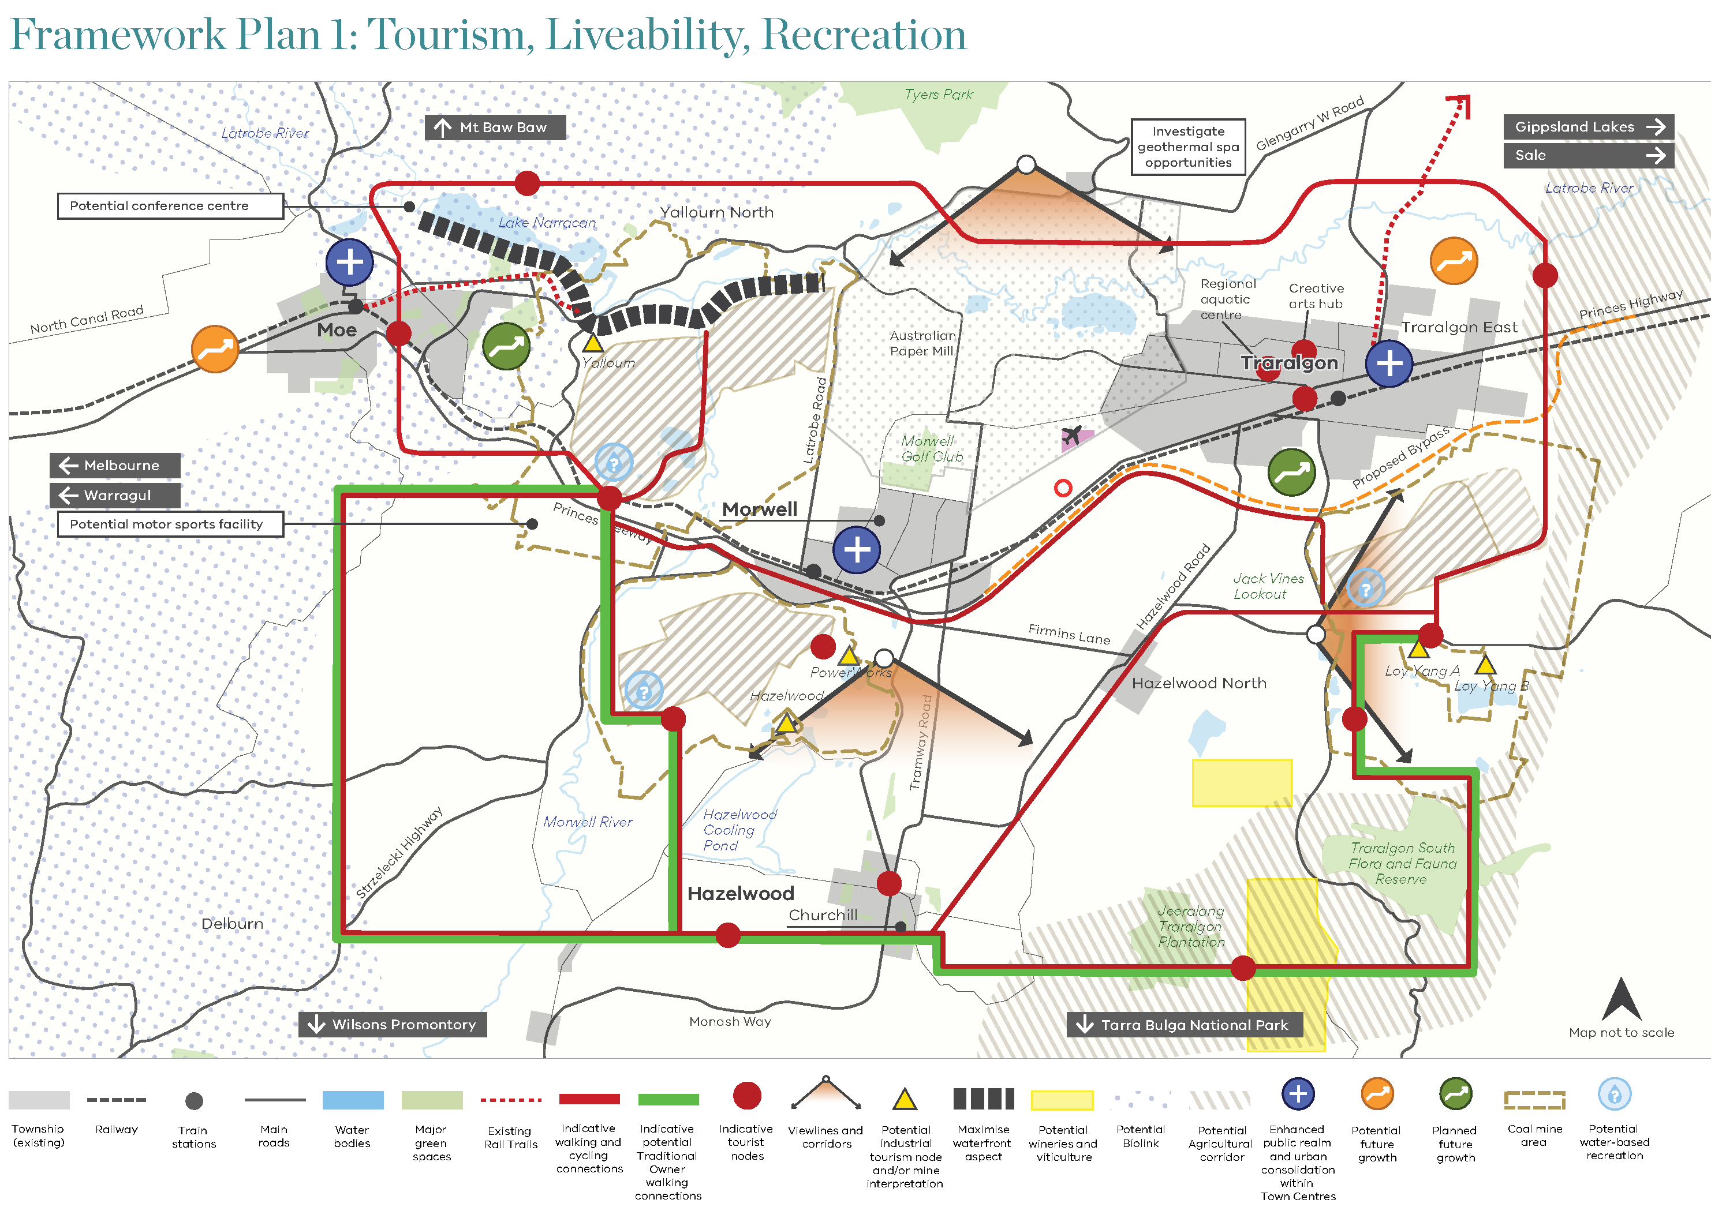

3.2 Theme 2: Industry, Business, Commerce
This Theme includes consideration of:
- An aspirational vision for the future
- Job creation
- Developing new economic drivers and employment sectors.
- Reinforcing established industrial nodes.
This links to the other Themes in the following ways:
- Tourism, agriculture and energy will continue to support economic development and employment
- Industrial tourism is an identified opportunity associated with mining and power generation infrastructure
- Services provide the largest employment sector currently, and this regional role may expand
- Liveability is essential to attracting and retaining skilled workers and businesses.

3.2.1 How will the Latrobe Valley be recognised?
Premier centre for business and industry
Latrobe City will have an elevated brand as a recognised place for business, which attracts major corporations and supports smaller and local businesses through strong business support networks.
Engineering capital of Victoria
Building on local history and achievements, the Latrobe Valley will expand its recognition as a nationally significant hub for engineering and advanced industry. This initiative may focus on the Morwell High-Tech Precinct, the emerging Morwell-Traralgon economic spine, and Traralgon’s logistics hub.
Mature urban centre
The City will mature as a connected, vibrant urban cluster of discrete yet integrated towns, providing the full range of services and support, and direct access to a strong and skilled local labour force.
Skilled workforce, diverse business mix
The vision is to build a diverse business environment, supported by, and supporting, a diverse and skilled workforce, within a sustainable, productive and prosperous business environment.

3.2.2 Essential components for this vision
Housing, liveability and marketing
Ensuring the availability of high-quality, high-amenity housing will develop the liveability of the area, and attract skilled workers, business leaders and families. Marketing these opportunities effectively, by communicating the enhanced liveability of the area, is an important aspect of developing business activity.
Transport connectivity
Faster rail connections to Melbourne will support business integration and broader workforce access. The recent Commonwealth Government pledge supporting high-speed rail to Geelong is expected to almost halve the travel time from one hour, to 32 minutes. A similar approach in Traralgon may reduce travel times from more than two hours, to approximately one hour, which would dramatically change perceptions of the area and its accessibility.
Freight movement and rail-based goods transport will also be key aspects of connecting the regional city with its rural hinterland and with Melbourne and other export markets.
Enabling infrastructure
Business and industry expansion is expected to require increased infrastructure including water, utilities, digital infrastructure and transport. These are fundamental requirements to attracting and facilitating business activity.
Digital connectivity
Advanced industry, services, corporations and an emerging innovation and entrepreneurial sector will depend on optimal digital connectivity. This is also considered essential to the city’s operation as an integrated cluster of individual towns.

3.2.3 What land use elements need to be in place to achieve this aspirational vision?
Identified early land use elements and actions to start working towards the Vision include:
- Long term plan and programmed delivery of infrastructure: Project future demand and requirements, and ensure the timing of the delivery does not hamper commercial activity.
- Place-based marketing and promotion: effectively communicate the distinctive qualities of the city and region as an improved location.
- Education: Ensure that educational sites, facilities and hubs enable development and expansion of local education and training opportunities, as key to developing the resident workforce.

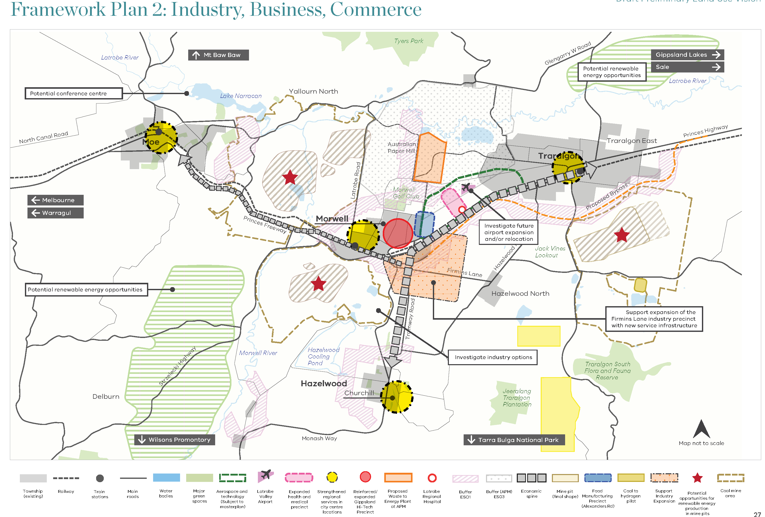

3.3 Theme 3: Agriculture, Energy, Water
This Theme includes consideration of:
- An aspirational vision for the future.
- Intensive agriculture and food production.
- Strategic links with the wider Gippsland region.
- Coal to Hydrogen supply chain innovations and geothermal opportunities.
- Water resources including potential future mine pit water bodies, river health and recreation.
This links to the other Themes in the following ways:
- High amenity and interesting landscapes are a key aspect of future tourism and recreation opportunities.
- Agriculture can also contribute to tourism attractors, as well as supporting a wider food industry.
- Industry and commerce depend on appropriate infrastructure and access to energy and water.

3.3.1 How will the Latrobe Valley be recognised?

Building climate change resilience
Responding to climate change and building resilience to climate- related and other impacts will be key to sustaining the Preliminary Land Use Vision, including achieving the objectives for tourism, agricultural and liveability.

Increasing water efficiency
As water becomes an increasingly valuable and constrained resource, it will be essential to develop systems that maximise the efficiency of water use across all aspects of the region, particularly for potential mine pit water bodies and to offset the likely reduction in rainfall and water availability.

Maximising resources
The utilisation and value of other resources must be maximised, including increasing energy
efficiency and extracting mineral resources.

Creating investment and jobs
Driving business activity and creating diverse local job opportunities are central objectives for the planned transition away from coal-fired power generation.

Establishing an agricultural corridor
A broad corridor of intensive agriculture, spanning north-south across the Latrobe Valley to the east of Traralgon, will form a green ‘bookend’ to the city cluster (coupled with the biolink ‘bookend’ to the west), and a highly-advanced food production precinct close to the processing and export hubs in and around Traralgon.

Renewable energy provider
Manufacturing and maintenance of renewable energy generation infrastructure and equipment is seen as a major economic opportunity for this region, and is already starting to happen.

Renewable energy supplier
Opportunities for geothermal, wind and solar energy generation will allow the Latrobe Valley to continue to supply electricity across Victoria and into the national grid. The Latrobe Valley’s strong electricity infrastructure, skilled workforce and proximity to world class wind resources from Bass Strait has led to the exploration licence for Star of the South, Australia’s first offshore wind farm proposal.

3.3.2 Essential components for this vision
Changed farming practices
Transitioning to optimal efficiency, sustainability and productivity in farming and agriculture will support expanded economic and employment opportunities. This will include multi-uses of resources and other efficiencies.

Water conservation efforts
Conservation across the water cycle and spanning infrastructure, industry, agriculture and urban development will be necessary to support a sustainable region.

Export hub for the region
Latrobe City can expand its role as an export and logistics hub for produce from the wider Gippsland region, including food for international export via a strong regional airport.

Building on the established food industry
Established activities in food production and food processing will be expanded and developed into a comprehensive industry sector for this region. This will build on the established Latrobe City food and manufacturing precinct in Morwell.

3.3.3 What needs to be in place to achieve this aspirational vision?
Identified early actions to start working towards the Vision include:
- Understanding water resources: Use region-wide thinking and planning through sustainable water strategies for water efficiency to identify pathways, opportunities and constraints to water use.
- Consideration of agriculture as part of the ‘bigger picture’: Position agriculture with a wider regional system of activities associated with water, such as landscape rehabilitation, industry and tourism, to inform how agriculture is practised and regulated into the future.
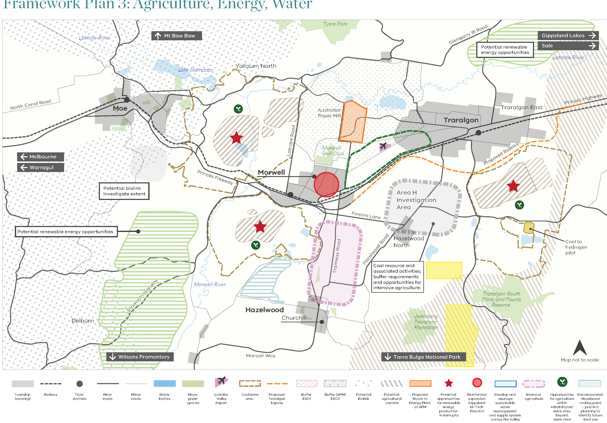
3.4 Theme 4: Services, Education, Training
This Theme includes consideration of:
- An aspirational vision for the future.
- The services sector and role of the regional city within the region.
- Health services as a focus, alongside government services located in the Regional City.
- Education opportunities across primary, secondary and tertiary levels, and skills/vocational training.
This links to the other Themes in the following ways:
- Services sector as key business and economic driver and employment generator.
- Education and training aligned with, and integral to, business and rehabilitation activities.
- Educational opportunities and advancement supporting liveability for population growth and retention.

3.4.1 How will the Latrobe Valley be recognised?
Centre of excellence: energy, agriculture, health, aerospace
The Latrobe Valley will become a centre of excellence across multiple industry sectors, reflecting a bold and aspirational vision that builds on existing assets, and which can drive education, business and employment activity into the future.
Initiatives such as the planned Australian Paper energy-from-waste facility and other infrastructure
initiatives will provide broad educational opportunities, and opportunities for other businesses.
Economic spine
The strategic linking of Morwell with Traralgon to the east and Churchill to the south will create a dynamic economic and business cluster, encompassing a health services precinct, advanced and high-tech industry, and high-level education facilities. Moe, at the eastern end of the integrated Latrobe City, will create its own niche opportunities with proximity to Melbourne, and gateway and tourism opportunities.
Connectivity: physical and digital
Seamless connections within the regional city, across the region, and to and from Melbourne and nationally will support the development of businesses and educational facilities locally.
City with a regional role
Latrobe City will be recognised as the hub of the wider Latrobe Valley and Gippsland, with an integral connection to the region, reinforced by the city’s role as a regional services hub, and the accessibility of educational opportunities within the city, for the region.

3.4.2 Essential components for this vision
Mine rehabilitation as a major skillset
It is essential to build the technical skills and knowledge locally, to effectively carry out this long-term task over three mine sites.
Strong links between business, industry and education
Partnerships that benefit business, industry and the community can be established, to advance innovation, commercial and employment opportunities.
Unique study and education opportunities
The unique challenge and long-term action envisaged for the mine sites provides the foundation for delivery of unique, world-leading education opportunities.

3.4.3 What needs to be in place to achieve this aspirational vision?
Identified early actions to start working towards the Vision include:
- Funding the Business case process: Develop proposals and business cases to show the viability and return on investment for facilities that support the ‘centre of excellence’ vision across various sectors.
- Addressing education gaps: Fill current service gaps including secondary schools and further tertiary opportunities as an important starting point.
- Research and development Partnerships: Reinforce links between academia and industry to support research, innovation and new, sustainable solutions to pressing challenges, and create new educational and employment opportunities.
- Support for planned energy-from-waste facility: Australian Paper’s proposal can provide an early-stage investment boost and employment in an important and challenging sector of waste management.
- Reinforced connections to the university and High-Tech Precinct: The existing Federation University at Churchill can be linked to Morwell’s emerging High-Tech Precinct, and on to Traralgon via the identified economic corridor or ‘spine’.

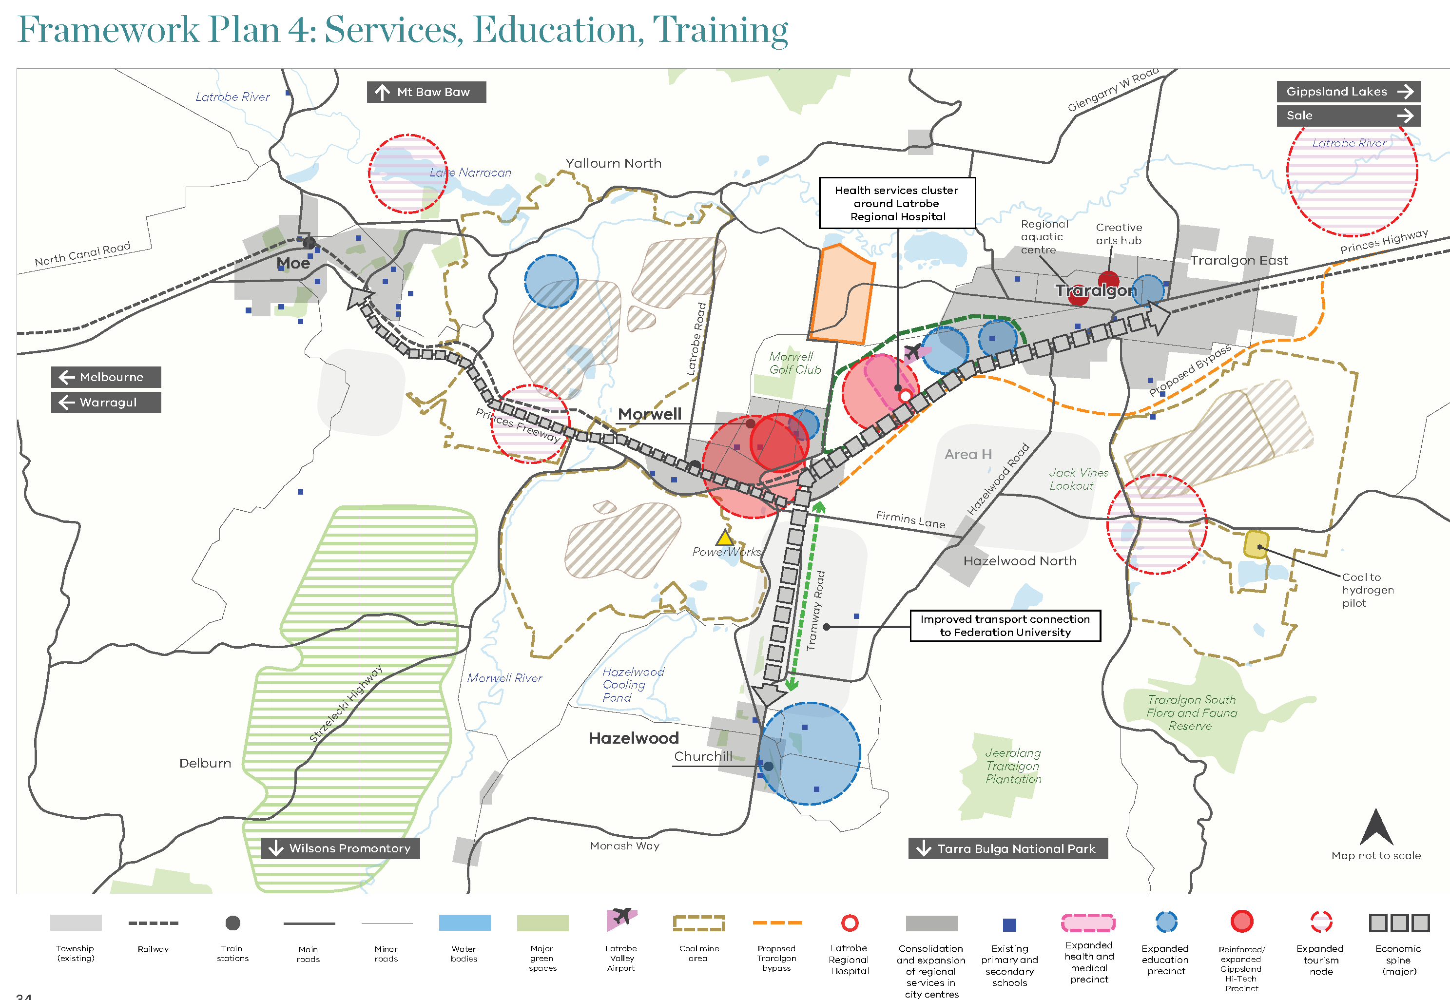
Part 4: Implementation
The Preliminary Land Use Vision will inform the elements of the LVRRS relating to future beneficial land uses and land use systems arising from the rehabilitation of the mines.
The Vision will also provide a strategic basis for future detailed land use investigations at the mine and precinct level. Determination of specific land use provisions will be subject to further work and will evolve as mine rehabilitation plans provide site-specific information.
4.1 Implementation and timing
It is important to consider the evolution of the Latrobe Valley towards the desired land use and land form outcomes over an extended period. This will occur in four indicative phases aligned with the closure and rehabilitation of the mines: Hazelwood ceased operation in 2017, Yallourn is planned to cease operation in 2032, and Loy Yang will cease operation in 2048.
Phase A (current) 2019: Hazelwood (Morwell) Rehabilitation and closure; Yallourn (Moe) Operations; and Loy Yang (Traralgon) Operations
Phase B: Hazelwood (Morwell) Rehabilitation and closure; Yallourn (Moe) Closure process (2032 - special note below); and Loy Yang (Traralgon) Operations.
Phase C: Hazelwood (Morwell) Post-closure; Yallourn (Moe) Rehabilitation and closure; and Loy Yang (Traralgon) Closure process (2048 – special note below).
Phase D: Hazelwood (Morwell) Post-closure; Yallourn (Moe) Post-closure; and Loy Yang (Traralgon) Rehabilitation and closure/Final land form.
Special Note: Note that the phasing and actions for land use change reflect the projected order of mine closures, and the potentially extended rehabilitation periods that may be required. This phasing and the dates shown are indicative only, as the timing will depend on a range of major environmental and economic factors
The formal regulation of the mines provides for three phases:
1. Operations - operating mine including progressive rehabilitation.
2. Closure process - includes decommissioning and final rehabilitation, with completion criteria to be met.
3. Post closure - includes monitoring and maintenance - desired land form achieved.

Part 5: Next steps and further studies

5.1 Next steps
This Preliminary Land Use Vision report will be progressed within the wider LVRRS project through five key phases:
- Community and stakeholder consultation on the draft Preliminary Land Use Vision
- Consideration and response to submissions made on the Preliminary Land Use Vision
- Identification of any new opportunities in response to community and stakeholder consultation
- Testing of the Preliminary Land Use Vision in light of the geotechnical and water regional studies
- Contribution to the development of a broader regional land use framework as part of LVRRS
to be prepared by the government in 2020.

5.2 Further studies
Further land use planning work will need to be undertaken to determine future land use issues and options for mine sites and surrounds. The regional geotechnical and water studies will help identify constraints and opportunities.
Other issues that may need to be addressed to support consideration of future land use options include:
- Capacity of mine land areas to support different types of new land uses, including a consideration of any Crown land.
- Suitability of current planning controls for the closure and rehabilitation phase.
- Physical infrastructure, including protecting existing infrastructure and any future needs associated with new land uses.
- The temporal nature of land conditions over time.
- Work with Traditional Owners to identify opportunities for recognition of Aboriginal values in the rehabilitated landscapes.
- On-site contamination, with assessments conducted by mine operators working with the Environment Protection Authority, the council and LVRRS partners to understand the issues and implications.
- Water availability, with implications for land use options.
- Landform scenarios assessment and implications for land use options.
- Fire risk issues.
- Drainage issues.
- Access issues associated with new land uses and land forms, including public access issues.
- Principles and requirements for land use buffers for mines during rehabilitation, and any future mineral resource extraction areas.
- The suitability of current planning controls to support preferred future land use outcomes and the need for precinct-scale planning for mine sites.

© The State of Victoria Department of Environment, Land, Water and Planning 2019
This work is licensed under a Creative Commons Attribution 4.0 International licence. You are free to re-use the work under that licence, on the condition that you credit the State of Victoria as author. The licence does not apply to any images, photographs or branding, including the Victorian Coat of Arms, the Victorian Government logo and the Department of Environment, Land, Water and Planning (DELWP) logo. To view a copy of this licence, visit http://creativecommons.org/licenses/by/4.0/
Acknowledgement
We are committed to genuinely partner, and meaningfully engage, with Victoria's Traditional Owners and Aboriginal communities to support the protection of Country, the maintenance of spiritual and cultural practices and their broader aspirations in the 21st century and beyond. We acknowledge and respect Victorian Traditional Owners as the original custodians of Victoria's land and waters, their unique ability to care for Country and deep spiritual connection to it. We honour Elders past and present whose knowledge and wisdom has ensured the continuation of culture and traditional practices.
ISBN 978-1-76077-823-1 (pdf/online/MS word)
Disclaimer
This publication may be of assistance to you but the State of Victoria and its employees do not guarantee that the publication is without flaw of any kind or is wholly appropriate for your particular purposes and therefore disclaims all liability for any error, loss or other consequence which may arise from you relying on any information in this publication.

END OF DOCUMENT

