Proposed Amendment GC104 to
the Greater Geelong and Surf Coast planning schemes
  - Information Sheet
  - 5 August 2019

Have your say on proposed planning scheme Amendment GC104 to the Greater Geelong and Surf Coast planning schemes, which seeks to facilitate the Waurn Ponds Train Maintenance and Stabling Facility
Rail Projects Victoria (RPV) has requested that the planning provisions for land at and surrounding 255 Reservoir Road, Waurn Ponds be changed to facilitate the Waurn Ponds Train Maintenance and Stabling Facility (project).
The Minister for Planning has referred the proposal to the Government Land Standing Advisory Committee (advisory committee) for consideration and to provide recommendations on the suitability of the proposed planning scheme changes.
Project details:
The project is proposed to occupy privately-owned land approximately 350 metres south and 50 metres north of the existing railway corridor at 255 Reservoir Road, Waurn Ponds, as shown on the attached Public Acquisition Overlay map.
Wider project land is proposed to be used for ancillary infrastructure and construction purposes and includes land north of the existing railway corridor at 255 Reservoir Road, Waurn Ponds and parts of the existing railway corridor from west of Pettavel Road to east of Bogans Lane and the existing road reservations of Reservoir Road, Bogans Lane and Pettavel Road.
What is the Public Acquisition Overlay?
The Public Acquisition Overlay identifies land that is proposed to be acquired for a public purpose. It has the effect of reserving the land under the Land Acquisition and Compensation Act 1986. The authority acquiring the land and the purpose of the acquisition must be set out in the schedule to the Public Acquisition Overlay.
What is the Government Land Standing Advisory Committee?
The advisory committee comprises independent experts in statutory and strategic planning, land development, economics, and social and environmental issues.
The aim of the advisory committee is to provide a timely, transparent and consultative process for the consideration of changes to planning provisions for land owned, proposed to be acquired, or to land required to facilitate the delivery of priority projects by the Victorian Government.

Key dates
Exhibition opens | Monday 5 August 2019
Information session | Thursday 22 August, 6.30 – 7.30 pm, The High Ground (Wurdi Youang), Geelong Library and Heritage Centre, level 5, 51 Little Malop Street, Geelong
Exhibition closes | 5pm, Monday 16 September 2019
Directions Hearing | Wednesday 25 September 2019, 11 am Geelong West Town Hall, Supper Room  153 Pakington Street, Geelong West
Public Hearing | In the week commencing 21 October 2019 (date to be confirmed)
Advisory Committee report to the Minister | Late November 2019

Proposed changes
RPV has requested the following changes to the planning provisions for the site:
- Apply the Public Acquisition Overlay to facilitate acquisition;
- Apply the Specific Controls Overlay;
- Introduce the Waurn Ponds Train Maintenance and Stabling Facility Project Incorporated Document, June 2019 as an incorporated document; and
- Make the Minister for Planning the responsible authority.
Currently, existing zones and overlays are not proposed to change.
Copies of the current and proposed planning scheme provisions can be found at www.planning.vic.gov.au/glps

Where can I get more information?
The following documents can be viewed online at planning.vic.gov.au/glps:
- A planning report and supporting documents which provide details on the project and why the proposed planning provisions were selected; and
- The proposed planning provisions.
Hard copies of this information are also available to be viewed at:
- City of Greater Geelong
100 Brougham Street, Geelong, 3220
- City of Greater Geelong Customer Service Centre, Waurn Ponds Library
230 Pioneer Road, Grovedale, 3216
- Surf Coast Shire Council
1 Merrijig Drive, Torquay, 3228
What will the advisory committee do?
The advisory committee will consider the proposal and any submissions made to it. The advisory committee will also visit the site as part of its deliberations.
Further detail is set out in the advisory committee Terms of Reference available at: engage.vic.gov.au/glsac.
The advisory committee will host a public information session on Thursday 22 August, 6.30 – 7.30 pm, The High Ground (Wurdi Youang), Geelong Library and Heritage Centre, level 5, 51 Little Malop Street, Geelong. The public information session will provide an opportunity to ask questions about the advisory committee process and timing and to ask RPV questions about the proposal.
Have your say – make a submission
You are invited to make a submission to the advisory committee on the proposed planning provision changes which must be made online at: planning.vic.gov.au/glps.
Submissions must be directed to the advisory committee

and can address any matter the submitter considers relevant, including whether the proposal is supported or objected to or if alternative planning controls may be appropriate.
All submissions must state the name and address of the person making the submission and will be treated as public documents.
Written submissions will be accepted by post in instances where internet access is not available. Written submission must be accompanied by a completed and signed submissions coversheet. Please call (03) 8392 5121 to request the coversheet.
Can I make a presentation at the Public Hearing?
You can also make a verbal presentation at the public hearing to be held by the advisory committee. If you would like to make a presentation at the public hearing, you must make a written submission and complete the relevant section of the online form.
Further details regarding the public hearing will be made available after the exhibition period has finished and once scheduling has been finalised.
How can I find out about the final outcome?
The Minister for Planning will consider the recommendations of the advisory committee and will make the final decision on the proposed changes to the planning provisions for the site.
The final decision and relevant documents will be available online at: planning.vic.gov.au/glps.
Contact information
If you have questions about the site and the proposed planning changes, please contact RPV on 1800 105 105 or email regionalrailrevival@railprojects.vic.gov.au.
If you have questions about the advisory committee process, contact Planning Panels Victoria on (03) 8392 5121 or email planning.panels@delwp.vic.gov.au.
All other questions should be directed to the Government Land Planning Service on (03) 9637 8628 or email glp.service@delwp.vic.gov.au.

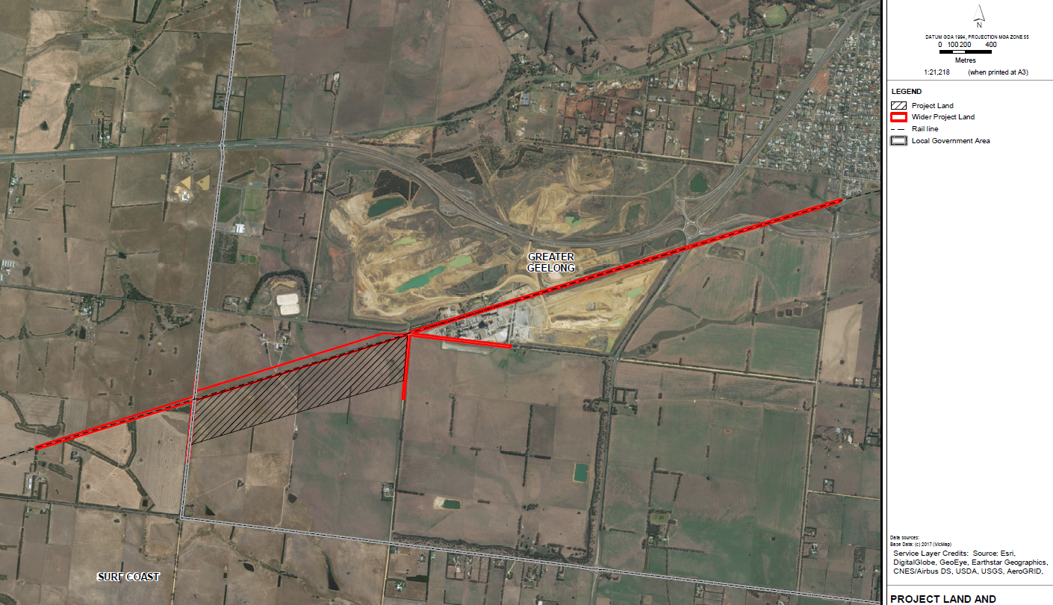
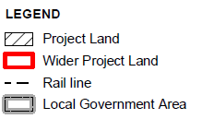
Proposed project map:

