In this issue …
Welcome to Issue 69 of Research Matters, the Department of Environment, Land, Water & Planning’s quarterly planning research bulletin, featuring DELWP research and analysis, news about recently released data, and research from other sources. If you have any questions or comments, you can contact us at:
spatialanalysis.research@dtpli.vic.gov.au

Contents
1 In this issue …

2 Six million Victorians for Christmas?

3 Small towns: change and adaptation in the Wimmera and Mallee.

5 Conference review: Australian Population Association.
Demographic analysis reveals a glimpse forward to consider Victoria’s sixth millionth resident, using a range of data to speculate on that person’s age, ethnic background and family characteristics.
Research Matters then heads to the western edge of Victoria to review a number of small towns that, while declining in size, have not left the map. The story of such towns provides interesting examples of adaptation in the face of major economic and social change.
A review of the Australian Population Association Conference is also provided in this edition.
.
Six million Victorians for Christmas?
The resident population of Victoria currently sits at an estimated 5.9 million. The current growth rate is nearly two per cent per year, representing more than 100,000 people a year. This growth is being driven by high birth numbers, strong migration from overseas and record interstate arrivals. According to Victoria in Future 2014 (VIF2014) population projections, Victoria can expect to reach the six million mark at around Christmas 2015.
What might the six millionth Victorian (Six-mil-Vic) be like? Where will they live? How will they enter our population and where will they come from?
For starters, there is a nine-out-of-ten chance they will live in Melbourne. While Greater Melbourne has 75 per cent of the state's population, it's currently accounting for about 90 per cent of the growth.
It is quite likely that the Six-mil-Vic will be a migrant from overseas. Almost half (47 per cent) of the entrants to the population have arrived in the last couple of years. If Six-mil-Vic is one of 125,000 overseas migrants, perhaps they will be a permanent migrant (20 per cent of all migrant arrivals). However, they are more likely to be here on a temporary visa and staying for more than 12 months (55 per cent of recent migrant arrivals). This could be as a student (over a quarter of all migrant arrivals) or as a working holiday-maker or a temporary skilled worker (457 visa). It is worth noting, though, that in recent times about three out of every five temporary migrants has applied for, and been granted, permanent status.
Where might Six-mil-Vic have come from? Interestingly, they are quite likely to be an Australian who has been overseas for more than 12 out of the past 16 months (and has therefore been counted out of the Victorian population), or a New Zealander. These two categories account for 25 per cent of migrant arrivals. If they are not an Australian/NZ citizen, their most likely country of origin is the UK, China or India.
If not from overseas, then Six-mil-Vic is slightly more likely to have been born in Victoria (29 per cent) than having arrived from interstate (24 per cent).
Six-mil-Vic might also be a newborn in late December 2015. If so, there is a good chance they will be born in Melbourne – nearly 80 per cent of the 75,000-plus births expected this year will be. If this is the case, they could well be born in the Casey or Wyndham areas. There are around 4,000 births per annum in each of these areas – combined, that's more births than in an inner region stretching all the way from Brunswick to Windsor, and from Footscray to Hawthorn. If they are born in regional Victoria, they could well be one of the 2,300 born in Geelong, the 1,800 in Ballarat, or the 1,300 in Bendigo. Wherever Six-mil-Vic may be born, they'll be slightly more likely to be a boy than a girl – about 106 boys are born for every 100 girls.
Or they could be one of the 70,000 annual interstate arrivals. In this case, they'll most likely be from NSW (34 per cent) or Queensland (29 per cent).
In conclusion, Six-mil-Vic might be a student from China, a 457 worker from the UK, a humanitarian arrival from Myanmar, a newborn in outer Melbourne, or a retiree from Taree. However they get here and wherever they come from, Six-mil-Vic will be a valuable addition to our state. But will they be here to see the arrival of Sev-mil-Vic? We'll find out in January 2025... on a Tuesday... about 10pm.

Small towns: change and adaptation in the Wimmera and Mallee
The population of many small Victoria towns has seen a gradual decrease in recent decades. Evolving farming practices coupled with increased car ownership and extensive road infrastructure has led to fewer farmers and farm workers ‘living on the land’. Many farmers and their families now choose to commute from regional centres such as Horsham where they enjoy easy access to work, school and services.
Agriculture is the main driver of the Wimmera and Mallee economies which are key grain production areas in Victoria. The Wimmera Southern Mallee and Loddon Mallee North Regional Growth Plans are the Victorian Government’s strategies to guide the development of these regions and support their economic growth and diversification.
Despite the trend towards the concentration of populations in regional centres, some small towns are proving resilient to changes in economy, population, housing and employment patterns. These towns provide valuable insights into local dynamics – economic, social and demographic.
Murtoa: small school a drawcard
The town of Murtoa had a population of 783 at the time of the 2011 census. Located 25 kilometres north east of Horsham, the town’s proximity to the regional centre has led to a rather unusual pattern of ‘reverse commuting’ by a group of Horsham-based school children.
The local school, Murtoa College, caters for children in grades Prep through to Year 12 and has become an attractive option for families in Horsham who want to send their children to a smaller, community-based school – a strong point of difference compared with the larger schools in Horsham. Murtoa College also draws students from the small surrounding towns of Rupanyup, Glenorchy and Minyip with around 300 children currently attending the school.

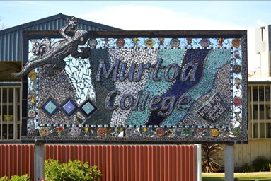
Murtoa College (photo: Fiona McKenzie 2014)
Rather than shrinking and closing, the school has been able to draw upon a much larger pool of potential students from Horsham to maintain a thriving small school community. Within this regional network it provides a unique schooling option.
Tresco: a commuter community
Tresco is located on the edge of the Mallee, five kilometres from Lake Boga and 16 kilometres from Swan Hill. It had a population of 53 in 2011, too small to even be counted as a ‘rural locality’ by the Australian Bureau of Statistics. While undertaking research for the Lake Boga study in 2010, Depart-mental researchers often heard Tresco referred to as a ‘ghost town’. Having expected tumbleweeds, empty houses and broken windows, the researchers were surprised to find occupied houses.
A historic plaque documented every business that had been established since the town’s inception and included when the businesses had opened and when they had closed (figure 1). The plaque serves as a marker of economic change in the region by chronicling the businesses that opened up, boomed, changed and then shut their doors. The last business had closed twenty years ago, suggesting that Tresco is a ghost town, at least in an economic sense, so why did the town still exist? Why were people still living there? One answer is because it is a community. Nowadays, thanks to cars and a good road network, residents can work and shop in nearby Lake Boga or Swan Hill. Tresco has evolved into a viable community that functions as an outer suburb of Swan Hill or Lake Boga.

Figure 1: Services in Tresco township 1910 to 2005
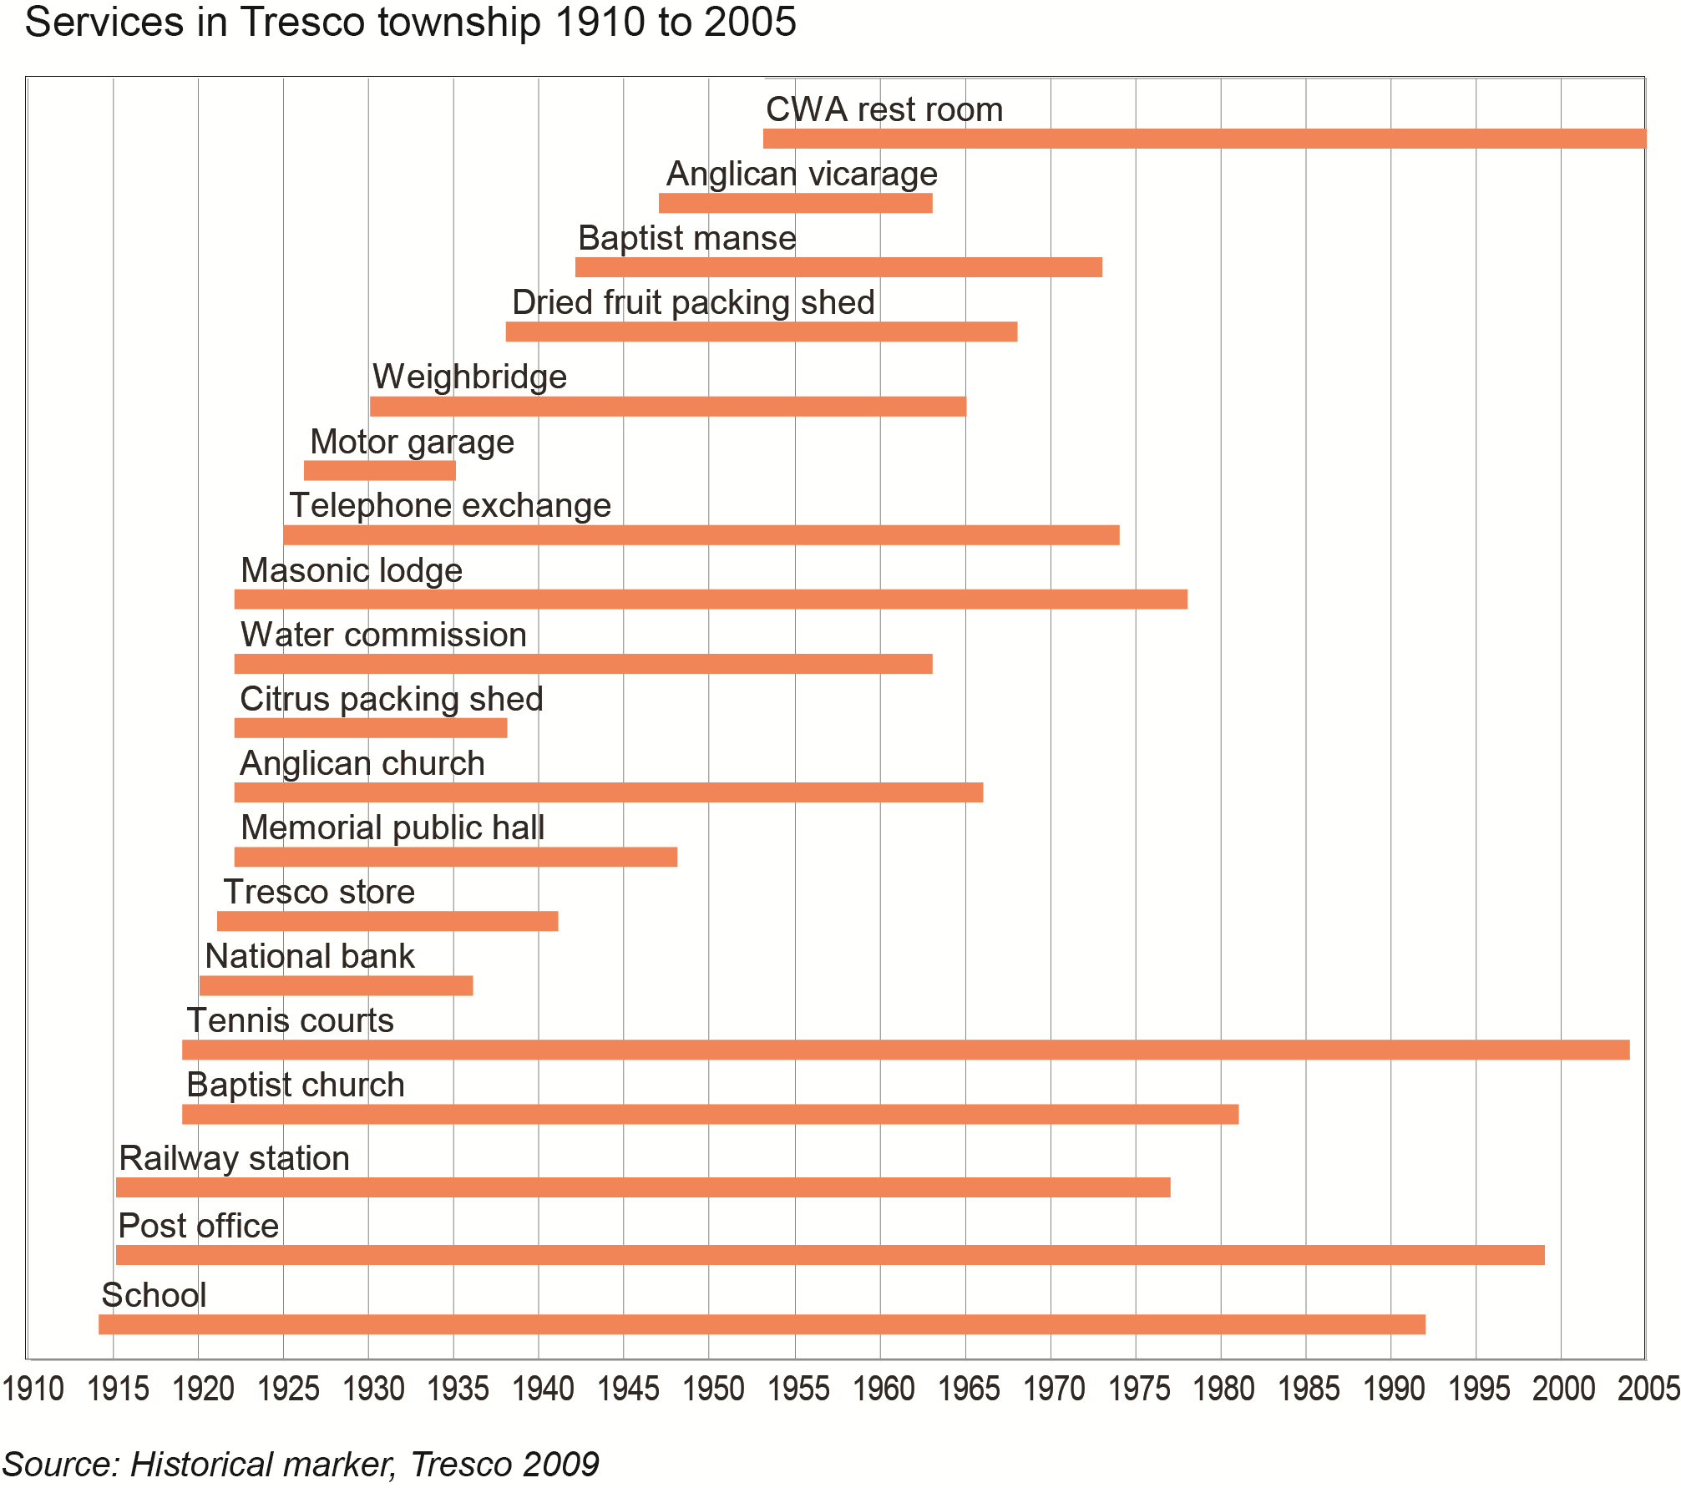
Source: Historical marker, Tresco 2009

Natimuk: a hot spot for rock climbers
Natimuk is located 22 kilometres west of Horsham and at the time of the 2011 census the town’s population was recorded as 392.
View from Mt Arapiles (photo: Jeremy Reynolds 2011)

The main street of the town has many historic buildings which form part of a local heritage walk. Plaques on these buildings provide descriptions of the banks, businesses and other services, painting a vivid picture of life in the town’s commercial heyday 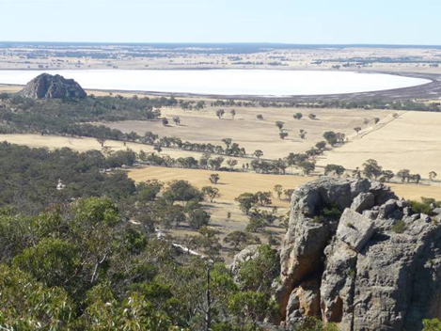in the early 20th Century.
The main street can be almost deserted mid-week, but the weekends bring tourist traffic, particularly rock climbers on their way to Mount Arapiles, a world renowned rock-climbing destination which is only 10 minutes drive from the town.
There is a stylish café located on one corner, another business selling rock climbing equipment, and a small but thriving arts community. Most of the former businesses in the main street are signposted ‘private residence’, signifying to visitors that, while the buildings are historic, they are now people’s homes.

Conference review: Australian Population Association
The Australian Population Association Conference, Australia’s population in a global world, was held in Hobart in December 2014. The conference provides an opportunity to exchange ideas and reinforce ties between those who are interested in population and demographic issues. Australian and international contributors covered topics of direct relevance for forecasters and policy makers.
In her address on ageing, an international perspective, Professor Sarah Harper, from the University of Oxford, highlighted that around two thirds of the world has fertility rates below replacement level. Increased longevity and ageing are more important factors for population growth than births. In Europe, the number of young adults ready to enter the labour market is already below the number of older people ready to leave it. This is expected in North America by 2030, and in Latin America and Asia by 2040. By 2050, 10% of the developed world will be aged over 80. People of labour force age will have to support an increased proportion of retirees. The changes in life expectancy raise scientific, ethical and economic questions: Is longer life equivalent to healthy life? What is the cost of longer life? Will it be reserved for a happy few?
Professor Martin Bell, from the University of Queensland, delivered the W.D.Borrie Lecture on the theme of time and space in demography, arguing that “methods and models are needed that link individuals with aggregate analyses, bridge geographic scales, and couple space and time”.
Bjorn Jarvis, from the Australian Bureau of Statistics (ABS), highlighted a modernisation project within the ABS to develop statistical solutions to meet key statistical requirements of users. The reform of survey data into a single, integrated, continuous and modular survey (the ‘Australian Population Survey’) and more generalised approaches to link multiple data sources are among mooted future changes.
A recurrent theme of the conference was the self-reinforcing spiral of sub-national depopulation. A growing population may hide the signs of forthcoming population decline. If the growth is mostly concentrated in the older age groups, and there is out-migration of young adults, population decrease is likely to eventuate sooner rather than later, with few avenues for turning the trend around. Several presenters addressed this situation, as it is unfolding already in several regions of Tasmania and New Zealand. Professor Natalie Jackson, from the University of Waikato, has put together a set of early warning indicators of this advanced structural ageing¹.
Several sessions were dedicated to the analysis of migration (overseas and regional). Overseas migration has increased and its composition has changed. Interstate/regional migration has been declining recently. In the last intercensal period, the migration effectiveness index, which measures the re-distribution effect of migration, has declined. The average age of movers has declined overall. Patterns of sea-change and tree-change are no longer as important.
A wide range of other issues were raised including:
- ageing population in ‘at risk’ locations and how to evacuate in case of emergency;
- how to predict future numbers of centenarians;
- the use of demographic numbers for democracy and finance (e.g. electoral boundaries and GST distribution);
- possible causes of the increase in household size apparent in the 2011 Census;
- long term labour force dynamics in Australia and how the globalisation of job markets , robotisation and computerisation may reduce the need for workers and their economic value.

Several presentations dealt with demographic projections methods and validation of results. Victorian State Government projections (Victoria in Future²) were found to perform well and our methods deemed sound.
NOTES:
1. For details, see her article: Jackson, N. 2014, ‘Subnational depopulation in search of a theory adding New Zealand and a diagnostic framework to the international evidence base’, New Zealand Population Review 40.
2. see: www.dtpli.vic.gov.au/data-and-research/population/census-2011/victoria-in-future-2014

