|  |
| --- |
| Inclusionary Housing Pilot 16-20 Dumbarton Street, Reservoir |
| Information Sheet – August 2021 |

Inclusionary Housing Pilot Update

The Inclusionary Housing Pilot (IHP) is part of the Government’s housing strategy, Homes for Victorians, and will deliver up to 100 new social hosing homes across six surplus government land sites. It’s a new and innovative way of thinking about housing.

The sites will be developed by the private sector, in partnership with a community housing provider as a competitive Expression of Interest (EOI) process has concluded. The sites are being developed in close consultation with government and the relevant local council and will showcase leading mixed tenure and place making design

## The site

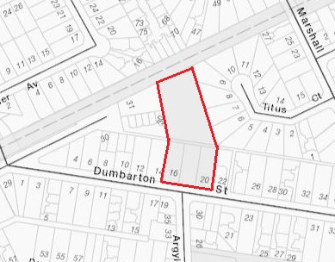The land at 16-20 Dumbarton Street, Reservoir is vacant and has an area of approximately 0.59 ha. The site is vacant and contains some mature trees.

## Current planning controls

|  |  |
| --- | --- |
| Zone | General Residential Zone – Schedule 1 |
| Overlay | Development Contributions Overlay – Schedule 1 |
| Particular provision | Minister for Planning is responsible authority for part of the site |
| Context | The site is vacant and located in a residential area. |

The successful developer will have the preferred design reviewed by an Advisory Committee at the same time as consideration of the proposed planning controls.

## The next steps

The successful developer is Metricon, and new zones and overlays will be developed for the site to inform the preferred design to be reviewed by an Advisory Committee.

## Contact information

If you have any questions about the Inclusionary Housing Pilot, contact 136 186 or email [inclusionary.housing@delwp.vic.gov.au](mailto:inclusionary.housing@delwp.vic.gov.au).

|  |  |
| --- | --- |
| © The State of Victoria Department of Environment, Land, Water and Planning 2021  LogoThis work is licensed under a Creative Commons Attribution 4.0 International licence. You are free to re-use the work under that licence, on the condition that you credit the State of Victoria as author. The licence does not apply to any images, photographs or branding, including the Victorian Coat of Arms, the Victorian Government logo and the Department of Environment, Land, Water and Planning (DELWP) logo. To view a copy of this licence, visit http://creativecommons.org/licenses/by/4.0/l  Disclaimer  This publication may be of assistance to you but the State of Victoria and its employees do not guarantee that the publication is without flaw of any kind or is wholly appropriate for your particular purposes and therefore disclaims all liability for any error, loss or other consequence which may arise from you relying on any information in this publication. | Accessibility  If you would like to receive this publication in an alternative format, please telephone the DELWP Customer Service Centre on 136 186, email [customer.service@delwp.vic.gov.au](mailto:customer.service@delwp.vic.gov.au), or via the National Relay Service on 133 677 [www.relayservice.com.au](http://www.relayservice.com.au). This document is also available on the internet at [www.delwp.vic.gov.au](http://www.delwp.vic.gov.au). |