Responding to a request for financial information
Development Facilitation Portal
Purpose
The following guide steps applicants through the process of replying to a request for financial information.
During the assessment phase, if an application is proceeding for further assessment, the applicant will be requested to supply financial information.

Access and complete the Financials Request form
- Ensure you are logged into the Development Facilitation Portal
- Select Requests, Created by Me (created and submitted by you) or All (includes requests shared with you). 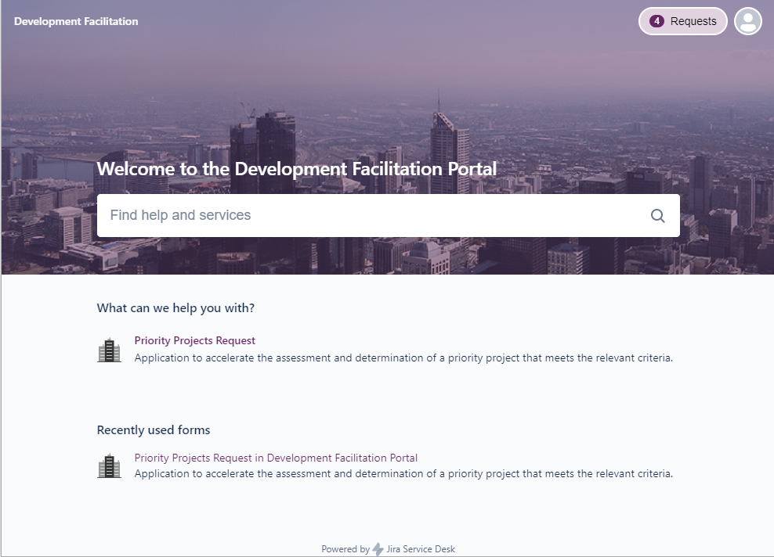
2
- Select the Reference for the specific request that has the status of FINANCIALS REQUESTED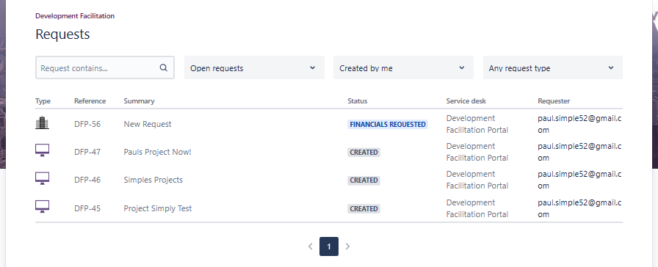
3
- Select the Financials Request form.
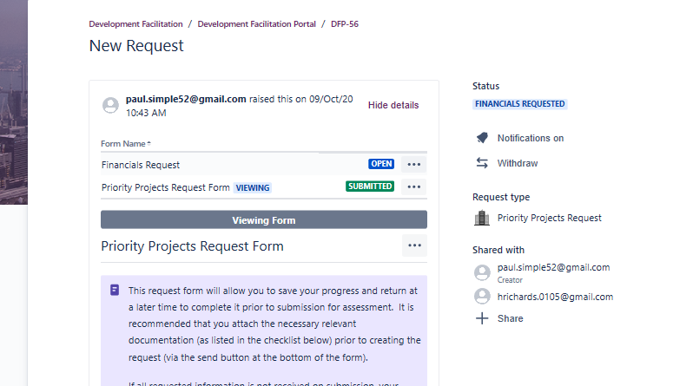
4
- Update the checklist ensuring that all the necessary financial documents are uploaded in the attachments section. 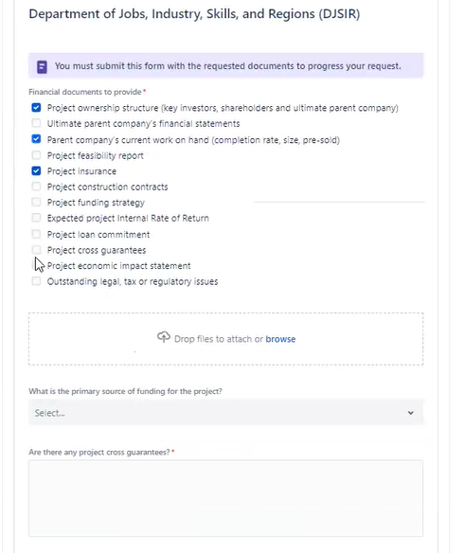
5
- Once the form is updated (and only after all documents have been uploaded), select Save and submit (or Save to return to the form to complete and submit at a later time). Once submitted, the form will be locked.
6
- Select Submit to confirm the submission.
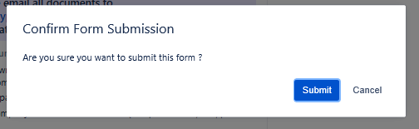
7
- Once submitted, reload the web page (press F5) and the status will change to UNDER ASSESSMENT. 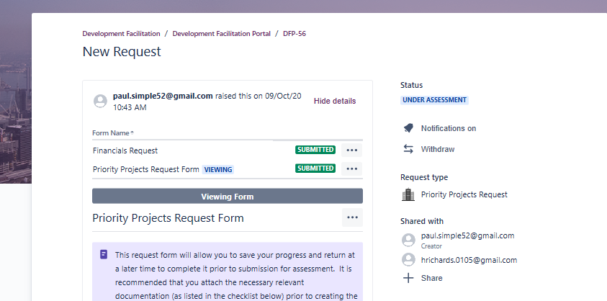
8
- A team member from the department will review the form and check that all financial information meets the criteria, and you will be advised of the outcome as soon as possible.

Need further assistance?
If you require further assistance with your request, contact the Development Facilitation team via development.facilitation@delwp.vic.gov.au.

